Removal of Trace Organic Compounds in Domestic Wastewater using Recirculating Packed-Bed Media Filters

A Thesis Presented for the
Master of Science
Degree
The University of Tennessee, Knoxville

Brittani Nikole Perez
December 2015

Copyright © 2015 by Brittani N. Perez
All rights reserved.
ACKNOWLEDGEMENTS

ABSTRACT
Pharmaceuticals and personal care products (PPCPs) are commonly detected in the environment resulting from their survival from conventional wastewater treatment systems. More information is needed about the fate and transfer of these trace organic compounds in domestic wastewater and their associated risks so that efficient strategies for their removal can be developed for both large/small scale treatment systems. This study aimed to determine whether onsite wastewater treatment systems were capable of providing PPCP removal in addition to quantifying different forms of removal (biodegradation/sorption). A column study was constructed to determine the removal efficiencies of 3 target PPCPs, endocrine disrupting compound triclosan (TRI) and non-steroidal anti-inflammatory drugs ibuprofen (IBU) and naproxen (NAP), in a small-scale recirculating media filter. To ensure bioreactor productivity the pH, chemical oxygen demand (COD), total organic carbon (TOC), and total nitrogen (TN) of the influent and effluent were analyzed. All columns showed consistent neutralization of pH, coupled with a large removal of COD and TOC (>98%). Nitrifying/denitrifying conditions were attained, presenting removal of TN between 35-85% in all columns. Spiked experimental columns with the target PPCPs were compared to one controlled column. Averaged total removal of the trace organics were moderately high; IBU (71.8%), NAP (78.9%), and TRI (82.3%). Sorption of the PPCPs onto biofilm was determined; TRI experienced the highest sorption (2.4%), followed by IBU and NAP (both 0.4%). Therefore, calculated degradation percentages of parent compounds for IBU, NAP, and TRI were 71.4%, 78.5%, and 79.9%, respectively. DNA extraction and qPCR analysis was performed on the biofilm to quantify both nitrifying and denitrifying bacteria. No significant differences of populations were seen between columns (P=0.17), however differences in column depth were (P>0.01). Although relative abundances of amoA and nirS genes showed the system’s capability of both nitrification and denitrification, no links could be made to PPCP biodegradation.

TABLE OF CONTENTS

CHAPTER I: Introduction and Literature Review 1
Background 1
Source, Occurrence, and Threat of PPCPs 1
PPCPs and Wastewater Treatment 5
Large Scale Treatment 5
Small Scale Treatment 10
Recirculating Media Filters (RMFs) 12
PPCP Removal Studies from OWTSs 15
PPCP Fate and Transfer 16
Fate in WWTPs 16
PPCP Sorption 16
PPCP Degradation 18
Quantifying PPCPs in Wastewater Samples 21
Extraction Methods 21
Detection Methods 23
Literature Review for PPCP Removal from Wastewater 24
Literature Review for PPCP Microbial Degradation 26
Research Hypothesis and Goals 27

CHAPTER II: Target Compounds 28
Compound Introductions 28
Non-Steroidal Anti-Inflammatory Drugs 29
2-(4-isobutylphenyl)propanoic acid 30
(2S)-2-(6-methoxynaphthalen-2-yl)propanoic acid 32
Endocrine Disrupting Compounds 34
5-chloro-2-(2,4dichlorophenoxy)phenol 35
Metabolite Research 37

CHAPTER III: Materials and Methods 39
Chemicals and Working Standards 39
Wastewater Source 39
Project Description and Design 41
Materials and Construction 41
System Operation 41
Hydraulic/Organic Loading Rates 44
Sampling Procedures 47
Collection 47
Storage 47
Preparation 47
Effluent Analysis 48
Water Quality 48
Quantifying PPCP Release 48
Biofilm Analysis 50
Quantifying PPCP Sorption 50
DNA Extraction of Biofilm 50
qPCR Analysis 51
Facilities and Equipment 52

CHAPTER IV: Results 53
Preliminary Testing of Experimental Apparatus 53
PPCP Compound Extraction and Detection 62
Qualitative Methods of SPE and GC-MS Analysis 62
Traditional Water Quality Analysis 67
pH Stabilization 67
COD and TOC Reduction 68
TN Reduction 70
PPCP Removal Analysis 72
PPCP Effluent Release 73
PPCP Adsorption to Biofilm 78
PPCP Microbial Degradation 80
Biofilm qPCR Analysis 80
Quantification of amoA genes 80
Quantification of nirS genes 82

CHAPTER V: Discussion 85
RMF Effluent Quality 85
PPCP Removal 85
Total Reductions 85
Negative Mass Balances 86
Biofilm qPCR Analysis 87

CHAPTER VI: Conclusions 89
Conclusions 89

LIST OF REFERENCES 91
APPENDIX 98
VITA 99

LIST OF TABLES
Table 1. Detection frequency of PPCPs in streams. 4
Table 2. List of removal effectiveness on PPCPs through selected wastewater treatment processes. 10
Table 3. Typical effluent quality values from properly designed RMFs. 13
Table 4. Comparison of average extraction efficiencies of Oasis HLF and c18 cartridges for both acidic and phenolic PPCPs. 24
Table 5. Detection frequency and average concentration of PPCPs in influent and effluent from WWTP secondary treatment. 29
Table 6. Various chemical properties of the target compounds. 30
Table 7. Commonly used NSAIDs and their delivered dosing. 31
Table 8. Commonly found EDCs and corresponding applications. 36
Table 9. A list of toxic byproducts of triclosan after undergoing photodegradation. 37
Table 10. WQ results of untreated domestic wastewater before the addition of methanol standard. 54
Table 11. Average extraction efficiency of SPE procedures at varying concentrations of standard additions. 65
Table 12. Corresponding retention times of the target compounds. 69

LIST OF FIGURES
Figure 1. Sources of PPCPs and their transfer into the environment. 2
Figure 2. Primary clarifier tank at Hill Canyon WWTP in Ventura County, California. 5
Figure 3. Aeration tanks promoting the growth of activated sludge 7
Figure 4. A trickling filter that is evenly discharging wastewater over medium. 7
Figure 5. Shown above is an image of the world’s largest reverse osmosis desalination plant, located in Hadera, Isreal. Photo credit: Slate Magazine. 8
Figure 6. Components of an onsite wastewater treatment system. 12
Figure 7. Shown above is an example of an RMS. This site is located at Murfreesboro, Tennessee and it sees typically 30,000 GPD. 14
Figure 8. Cross sectional area of the RSF shown in Figure 7. 15
Figure 9. Experimental data showing a positive correlation between log K_{ow} coefficient of trace organic compounds and their sorption onto sewage sludge. 18
Figure 10. 12-port vacuum system for solid phase extraction; GL Sciences. 23
Figure 11. Chemical structures of parent compound ibuprofen and major metabolites hydroxy ibuprofen and carboxy ibuprofen. 33
Figure 12. Chemical structures of parent compound naproxen and metabolites naproxen acyglucuronide and 6-O-desmethylnaproxen acylglucuronide. 34
Figure 13. Chemical structures of parent compound triclosan and metabolites 2,8-dichlorodibenzo-p-dioxin, 2,4-dichlorophenol, 2,4,6-trichlorophenoland methyl triclosan. 38
Figure 14. Collection site of wastewater and contributing homes. 41
Figure 15. RSF configuration with (a) media column, (b) 5L supply tank, (c) effluent collection, (d) recirculated collection, (e) three-way valve, and (f) two-way valve. 43
Figure 16. Schematic of experimental design. 44
Figure 17. pH during preliminary weeks of monitoring; n = 2 weeks. Day 0 represents the sampling of the supply jugs after the methanol addition. Day 1, 2, 3, respectively represent sampling from the effluent collected after column treatment. Two-way ANOVA analysis showed no significant differences between columns and weeks (P=0.433, alpha=0.05). 55
Figure 18. COD during preliminary weeks of monitoring; n = 2 weeks. Day 0 represents the sampling of the supply jugs after the methanol addition. Day 1, 2, 3, respectively represent sampling from the effluent collected after column treatment. Two-way ANOVA analysis showed no significant differences between columns and weeks (P=0.988, alpha=0.05). 57
Figure 19. TOC during preliminary weeks of monitoring; n = 2 weeks. Day 0 represents the sampling of the supply jugs after the methanol addition. Day 1, 2, 3, respectively represent sampling from the effluent collected after column treatment. Two-way ANOVA analysis showed no significant differences between columns and weeks (P=0.861, alpha=0.05). 58
Figure 20. External wastewater supply containers. 59
Figure 21. pH within the RMF supply over a 5 day period after methanol solution addition; n = 2 weeks. Two-way ANOVA analysis showed no significant changes in pH (P=0.77, alpha=0.05), maintaining a mean pH of 7.32±0.07. 60
Figure 22. COD within the RMF supply over a 5 day period after methanol solution addition; n = 2 weeks. Two-way ANOVA analysis showed no significant changes in COD (P=0.45, alpha=0.05), maintaining a mean COD of 191±18.1. 60
Figure 23. TOC within the RMF supply over a 5 day period after methanol solution addition; n = 2 weeks. Two-way ANOVA analysis showed no significant changes in TOC (P=0.85, alpha=0.05), maintaining a mean TOC of 120±11.7. 61
Figure 24. pH within the external wastewater supply over a 7 day period; n = 2 weeks. Two-way ANOVA analysis showed no significant changes in pH (P=0.78, alpha=0.05), maintaining a mean pH 7.21±0.11. 61
Figure 25. COD within the external wastewater supply over a 7 day period; n = 2 weeks. Two-way ANOVA analysis showed no significant changes in COD (P=0.99, alpha=0.05), maintaining a mean COD of 106±9.31. 62
Figure 26. TOC within the external wastewater supply over a7 day period; n = 2 weeks. Two-way ANOVA analysis showed no significant changes in TOC (P=0.54, alpha=0.05), maintaining a mean TOC of 43.6±1.77. 62
Figure 27. Calibration curves of target compounds; points 1, 2, 3, and 4 are concentrations at 0.4, 0.8, 2.0, and 4.0 respectively. 67
Figure 28. Corresponding retention times of the target PPCPs at different concentrations (1.0 ppm and 2.0 ppm). Top to bottom: IBU, NAP, TRI. 68
Figure 29. pH in each column throughout the length of study. Minimum, maximum, median, and 1st - 3rd quartiles shown; sample size n = 8 weeks. No significant changes were seen between the columns and days (P=0.99). 71
Figure 30. Means of pH of effluent for each week; n = 7 days. No significant changes were seen between columns and weeks (P=0.37, P=0.96) with a mean effluent pH of 7.03±0.21. 71
Figure 31. COD concentrations in each column throughout the length of study. Minimum, maximum, median, and 1st - 3rd quartiles shown; sample size n = 8 weeks. Significant changes were seen over the days (P>0.01), but none between columns (P=0.98) 72
Figure 32. Means of COD of effluent for each week; n = 7 days. No significant changes were seen between columns (P=0.98), but were slightly significant between weeks (P=0.06). Mean effluent COD of 65.5±36.4 mg/L. 72
Figure 33. TOC concentrations in each column throughout the length of study. Minimum, maximum, median, and 1st, 2nd, and 3rd quartiles shown; sample size n = 8 weeks. Significant changes were seen over the days (P>0.01), but none between columns (P=0.33) 73
Figure 34. Means of TOC of effluent for each week; n = 7 days. No significant changes were seen between columns (P=0.39), and significant between weeks (P=0.03). Mean effluent TOC of 12.6±8.38 mg/L. 73
Figure 35. TN concentration in each column for the last four weeks of study. Minimum, maximum, median, and 1st, 2nd, and 3rd quartiles shown; sample size n = 4 weeks. Significant changes were seen over the days (P=0.09), a well as between weeks (P=0.92). 75
Figure 36. Means of TN of effluent for each week; n = 7 days. Significant changes were seen between columns and weeks (P>0.01). Mean effluent TOC of 15.2±5.93 mg/L. 75
Figure 37. Third week of PPCP concentrations from collected water samples for each of the columns: Original wastewater (WW), after standard addition (after spike), and days after treatment 78
Figure 38. Seventh week of PPCP concentrations from collected water samples for each of the columns: Original wastewater (WW), after standard addition (after spike), and days after treatment 79
Figure 39. Total averaged removal rates from 8 weeks of treatment within each of the columns 80
Figure 40. Total averaged removal rates from 8 weeks of treatment within each of the columns 81
Figure 41. Differences in means of total removal for all of the columns between Weeks 1-4 and Weeks 5-8, n=4 weeks. 82
Figure 42. Percentage of organics present within each of the layers of each columns; n = 3. ANOVA std. of columns are: 0.2% control, 0.5% ibuprofen, 0.07% naproxen, and 0.06% triclosan. 83
Figure 43. Mean trace organic concentrations per gram of media for each of the columns at varying locations (top, middle, bottom layers); n = 2. 84
Figure 44. Normalized amoA populations (cells/g) of columns, separated by location (top, middle, bottom layers) 86
Figure 45. Normalized nirS populations (cells/g) of columns, separated by location (top, middle, bottom layers) 87
Figure 46. Mean column comparisons of population counts (cells/gram of media) between the targeted amoA and nirS genes, n=4 columns. 88

LIST OF ABBREVIATIONS
AOB Ammonia Oxidizing Bacteria
IBU Ibuprofen
COD Chemical Oxygen Demand
DO Dissolved Oxygen
EDC Endocrine Disrupting Compound
GAC Granular Activated Carbon
GCMS Gas Chromatography Mass Spectrometry
HLR Hydraulic Loading Rate
HRT Hydraulic Retention Time
NAP Naproxen
NSAID Non-Steroidal Anti-Inflammatory Drug
OLR Organic Loading Rate
OWTS Onsite Wastewater Treatment System
PBMF Packed-Bed Media Filter
PPCP Pharmaceuticals and Personal Care Products
RSF Recirculating Sand Filter
SPE Solid Phase Extraction
SRT Solids Retention Time
TN Total Nitrogen
TOC Total Organic Carbon
TRI Triclosan
WWTP Waste Water Treatment Plant

CHAPTER I: Introduction and Literature Review

Background
In the world today many human and animal maladies can be alleviated or cured from the consumption of pharmaceuticals. According to an ongoing study since 2007, over 50% of Americans use at least one or two prescription drugs per month (CDC, 2013). While there are people who do question the potential overuse of pharmaceuticals, the concern is more focused on personal safety rather than environmental safety. Some pharmaceuticals present a real danger towards the environment; however they are not the only concern. Active ingredients found in personal care products such as soaps, detergents, lip balm, deodorant, and fragrances, are also being detected in the environment. Further, there are other groups of compounds that have the ability to mimic hormones of the endocrine system, known as endocrine-disrupting compounds (EDCs), and have been documented as having adverse effects on both humans and animals (Snyder et al., 2003). Together, these trace organics are termed pharmaceuticals and personal care products (PPCPs) and they are listed as “emerging contaminants” due to their recent detection in the environment. It should be noted, however, that ‘emerging’ is a misleading title because these compounds have been present in our nation’s waters for as long as they have been designed, but their detection at has only become possible until recently.

Source, Occurrence, and Threat of PPCPs
There is a multitude of ways that trace organic compounds enter into the environment. Figure 1 (Halford 2008) accurately depicts many sources, including wastewater treatment effluent, septic systems, stormwater and agricultural runoff, leaching from landfills, and illegal or improper disposal.
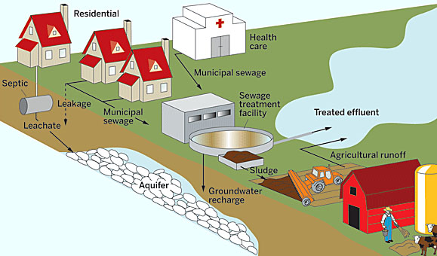
Figure 1. Sources of PPCPs and their transfer into the environment.

Most compounds are carried into the environment after being dissolved in water, but some have the ability to adsorb onto other materials, such as sludge or soil. However, the most significant source is from wastewater treatment plant effluent (Halford 2008). While conventional wastewater treatment plants (WWTPs) provide an excellent job of removing many contaminants from domestic and municipal wastewater, they were not designed with PPCP removal in mind. There are almost no regulations that limit the release of these compounds into receiving streams (Pasquini et al. 2014), however, many projects are underway to update current treatment plants. It is a discouraging fact that no single treatment is able to completely removal all compounds down to a non-detectable level (Kummerer 2009). It is well documented that WWTPS are only effective at removing trace compounds that are readily biodegradable. Most treatment processes are able to degrade many trace compounds down to nearly non-detectable concentrations; although, there are some compounds that remain persistent. A few compounds that have been known to survive municipal wastewater treatment systems include, but are not limited to, carbamazepine, fluoxetine, clofibric acid, mefenamic acid, phenazone, diclofenac, and dimethylaminophenazone.
There are over 10,500 different chemicals used in personal care products, but unfortunately only 11% have been tested for human health safety, while even less for environmental safety (Lubliner et al. 2010). Pharmaceutical occurrences in the environment are largely becoming a concern to many scientists because of their frequent detection in surface water, groundwater, drinking water, and sediment samples, as shown in table 1 (Daughton and Jones-Lepp, 2001). Numerous pharmaceuticals have been detected in water samples at concentrations as low as in the ng/L range. (Xia et al., 2005).
The frequent detection of PPCPs are a rising concern because of the potential adverse effects on the environment. Side effects on aquatic life have already been documented in multiple studies. For example, Vajda et al. (2008) analyzed effluent coming from a WWTP outfall and found high concentrations of alkylphenols, bisphenol-A, and reproductive steroids. Collecting fish from both upstream and downstream of the outfall, they found noticeable differences in the male to female ratios: upstream was roughly equal, while downstream was 90% female and 10% male. Further, most of the remaining males had severely abnormal reproductive organs. The study concluded that the released compounds from the incoming wastewater effluent were causing sexual disruption and reproductive failure among the native fish.

  - Table 1. Detection frequency of PPCPs in streams.
PPCPs (mean conc., ppm) | Category |  | Detection Frequency
Triclosan (0.03)  Phenol (0.04) |  | Disinfectant | >90%
Cholesterol (0.83)  Coprostanol (0.88) |  | Steriods | 89%
Acetaminophen (0.11)  Caffeine (0.081)  Ibuprofen (0.2)  Cotinine (0.05) |  | Nonprescription Drugs | 81%
DEET (0.06) |  | Insect Repellent | 66%
Erythromycin (0.1)  Ciproflaxin (0.02)  Sulfamethoxazole (0.15) |  | Antibiotics | 48%
17α-ethinly estradiol (0.073)  Estrone (0.027) |  | Reproductive hormones | 37%
Codeine (0.012)  Diltiazem (0.021)  Fluooxetine (0.012) |  | Other prescription drugs | 32%
Acetophenone (0.15) |  | Fragrances | 27%

PPCPs and Wastewater Treatment

Large Scale Treatment
Treating wastewater is important because it is not only a matter of caring for our environment, but public health as well. The purpose of a wastewater treatment plant (WTTP) is to reduce the amount of pollutants within wastewater before releasing back into the environment. These pollutants can be anything from suspended solids, biodegradable organics, pathogens, and nutrients. This is done by implementing three different levels of treatment called primary, secondary, and tertiary treatment (World Bank Group 2015).
Primary treatment is where suspended and floating solids are removed either through screening or sedimentation by gravity. The level has also been called physical treatment because there is a mechanical system that catches floating solids, however sometimes chemicals are added instead. Once the trash is removed, sludge is collected at the bottom of the tank and sent to a digestion tank where it can be properly managed and disposed.
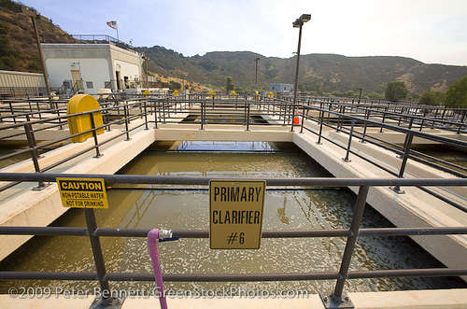
Figure 2. Primary clarifier tank at Hill Canyon WWTP in Ventura County, California.
While primary treatment is able to remove trash and larger solids from wastewater, it is only successful at removing about 50-60% of suspended solids and is not able to remove the dissolve organic material. Therefore, secondary treatment is required to remove most of these constituents that pass through primary treatment. Using biological processes, secondary treatment utilizes active microorganisms within the wastewater to appropriately degrade the biodegradable organic matter. These microorganisms break down organic compounds as a food/energy source and converts them into water, CO₂, and new cells. The organic matter that is broken down promotes the growth of more microbial life, and therefore aeration within the tanks is needed to satisfy the growing oxygen demand. In addition, this growth generates the formation of biological flocs, called activated sludge, which is collected during clarification and sent for further treatment. This level of treatment is very successful and is able to degrade over 80% of the suspended solids and organic matter within the wastewater. Two more common methods of utilizing microorganisms for wastewater treatment are suspended growth and fixed film systems.
Suspended growth systems are a type of treatment process where the microorganisms are suspended by turbulence within the containment. In contrast, fixed-film systems, or sometimes called attached-growth systems, use some sort of medium (gravel, sand, synthetic material) for the microorganisms to bind and grow on rather than freely moving. One example of this is called a trickling filter. A trickling filter consists of a fixed bed of media where the wastewater trickles through, and forms a biological film on the media. As wastewater passes through this film the active bacteria continually breakdown organic material, leaving treated wastewater to exit at the bottom. There are pros and cons to each type of treatment, but generally suspended growth systems are for urban facilities that process large wastewater volumes on limited land resources, whereas fixed film systems are for smaller communities, as land is more available.
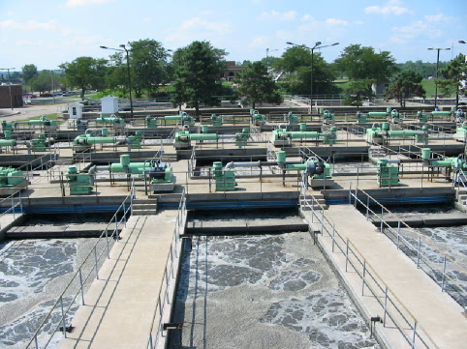
Figure 3. Aeration tanks promoting the growth of activated sludge

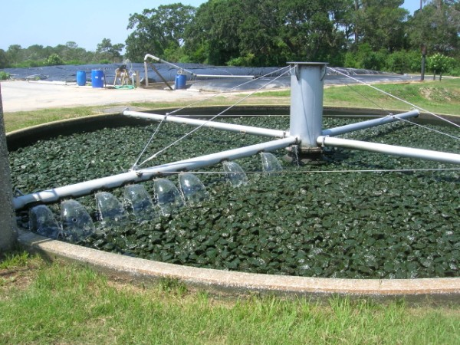

Figure 4. A trickling filter that is evenly discharging wastewater over medium.

Although primary and secondary treatment work well at removing most of the pollutants from wastewater, there are some compounds that are more persistent and require further treatment. The tertiary treatment of wastewater, often called an “effluent polishing”, is focused on further improving the effluent quality through filtration, disinfection or nutrient removal, and is able to remove almost 99% of impurities. This allows the production of an effluent that is almost drinking water quality (Malik 2014). While immensely successful, these treatments are very expensive and require a large amount of energy and management to ensure proper treatment. Final treatment can be accomplished through a number of different methods such as filtration, reverse osmosis, and extended secondary treatment (nutrient removal).
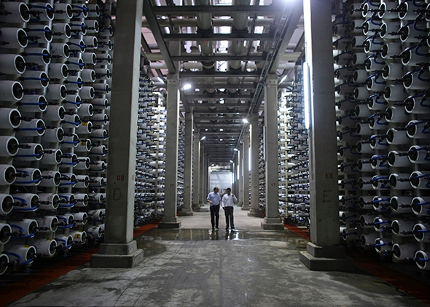
Figure 5. Shown above is an image of the world’s largest reverse osmosis desalination plant, located in Hadera, Isreal. Photo credit: Slate Magazine.

Unfortunately, even with the wide variety of treatment processes that are applied, trace amounts of PPCPs are still able to survive WWTPs and exit with the treated effluent. It is argued that one of the main reasons for their survival is that PPCPs were designed to be biologically active at low concentrations (Grenni et al. 2013). Different treatments have been shown to break down certain PPCPs, but as it was mentioned before, there is no single process that has been successful in removing all. Many researchers have experimented with different styles of treatment, to see what works best or not at all.
Lee et al. (2009) evaluated over 20 research articles and summarized their findings as shown in table 2. This report lists granular activated carbon (GAC), nanofiltration, and reverse osmosis as the three treatment processes that experienced the highest PPCP removal rates. It is important to note that GAC is an excellent adsorbent that is used to remove many dissolved compounds from water; there is little degradation that is occurring in this type of process because the compounds are simply being transferred from one source of media to another. On another note, nanofiltration and reverse osmosis are typically types of potable water treatment processes, not necessarily wastewater treatment processes. But as the data shows, these can be applied to wastewater treatment as well and do show promise for contaminant removal.
Research is underway to help update current treatment plants so that they may be able to better remove PPCPs from wastewater influent and effluent. Many European studies, such as Germany, Switzerland, and the Netherlands, have tried to find different pharmaceutical “cocktails”, which is a mix of different advanced treatment systems to determine which provides the best elimination. It is expected that WWTPs with multiple advanced treatments will increase the costs substantially, and that is why they are not fully implemented to other facilities (Hernandez 2010).

  - Table 2. List of removal effectiveness on PPCPs through selected wastewater treatment processes.
 |  |  | Average Removal of PPCPs
Process | Studies | Compounds | No Removal | Below 50% | Above 90%
Membrane Bioreactor | 12 | 49 | 14 | 33 | 39
Activated Sludge | 12 | 33 | 9 | 64 | 27
Nanofiltration | 15 | 57 | - | 17 | 82
Reverse Osmosis | 15 | 60 | - | 12 | 82
Granular Activated Carbon | 10 | 29 | - | - | 97
Powdered Activated Carbon | 10 | 71 | 6 | 31 | 41

Small Scale Treatment
Although different options on PPCP removal have been extensively researched, most studies only focus on large-scale treatment plants, while very few exist on decentralized small-scale treatment systems. This is important to note, because almost 25% of the estimated 115 million occupied homes in the United States are served by some type of onsite wastewater treatment systems (OWTSs). New Hampshire and Maine both report that almost half of all their homes are served by individual treatment systems (Wayland and Opellet 2003). OWTSs are used to treat wastewater discharged from individual homes and/or small communities, typically seeing no more than 100,000 gallons per day of influent. Figure 6 shows a single-origin septic system that collects wastewater through a series of underground plumbing that eventually will extend to a pretreatment component before release into the environment (Lesikar et al. 2015).
However, a single septic system should not be confused with a decentralized system. A decentralized system is an OWST that collects wastewater originating from a small group of homes/businesses to one common system, where it will then be treated and released.
The pretreatment components of OWTSs can provide secondary treatment and remove many contaminants that reside in wastewater or are at least able to remove them down to a low enough concentration that is acceptable for environmental treatment. These types of treatment systems are a good option for low population areas because they are low-cost and are able to provide results comparable to that of a large-scale treatment facility.

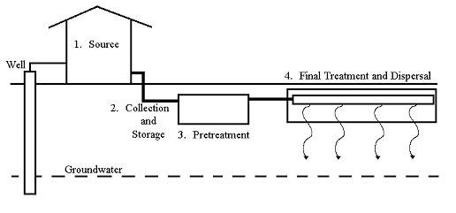
Figure 6. Components of an onsite wastewater treatment system.

Scientists and engineers have been able to develop diverse OWTSs with their own unique way of pollutant removal, and that can be applied anywhere. Septic systems are generally the more common OWTS to be found, however the use of recirculating media filters have been slowly growing in popularity.

Recirculating Media Filters (RMFs)
Much like a municipal trickling filter, recirculating media filters are aerobic, fixed-film bioreactors that provide advanced secondary treatment of the wastewater. Media filters are some of the oldest onsite wastewater treatment technologies known. If properly designed, constructed, and maintained, a RMF can produce a very high quality effluent (Gerlich 2013), providing removal values as shown in table 3 (Hantzch 2007).
An added bonus of these treatment systems are that they are able to provide both nitrification and denitrification. Nitrification is a two-step process that involves the biological oxidation of ammonia or ammonium to nitrite, performed by ammonia oxidizing bacteria (AOB) and ammonia oxidizing archaea (AOA), and then followed by the oxidation of nitrite to nitrate, performed by nitrite-oxidizing bacteria (NOB). The first step of nitrification is generally represented by the Nitrosimonas species, while the second is represented by the Nitrobacter species. Unbalanced chemical equations of both steps are shown below in equations 1 and 2.

  - Table 3. Typical effluent quality values from properly designed RMFs.
 |  | Typical Effluent Conc. (ppm)
Tested Parameter | Average Removal | Summer | Winter
Biochemical Oxygen Demand (BOD) | 96% | 2 - 10 | 3 - 15
Total Suspended Solids (TSS) | 96% | 2 – 10 | 2 – 10
Ammonia (NH₃) | 87% | ND – 5 | 1 – 20
Phosphorus (P) | 50% | 3 – 5 | 3 – 5
Dissolved Oxygen (DO) | n/a | 3 - 5 | 6 – 12

$${NH}_{4}+ O_{2}\underset{→}{ NItrosimonas } H^{+}+ {NO}_{2}+ H_{2}O+new cells$$ | (Eq. 1)
$${NO}_{2}+ O_{2}\underset{→}{ Nitrobacter } {NO}_{3}+ new cells$$ | (Eq. 2)

Likewise, RMFs are also capable of providing denitrification, however this is typically not as easily achieved as nitrification. Denitrification depends on nitrogen present in the form of nitrates, a relative amount of organic carbon for an energy source, and an anaerobic environment because this process is mainly driven by large groups of heterotrophic facultative anaerobic bacteria (Yang and Zhang 1996). Denitrification can be tricky to achieve within these systems because there must be definite anoxic conditions present. The concentration of the dissolved oxygen (DO) will control whether the denitrifying bacteria use nitrate or oxygen as the electron acceptor; if DO levels are too high the bacteria will instead oxidize the organic matter present, rather than the nitrate (Buchanan 2011). The need for a proper anaerobic environment, coupled with the fact that nitrification is environmentally sensitive (pH, temperature, DO, loading rates, ect…), nitrogen removal percentages from RMFs are variable, typically between 40 – 80% removal.

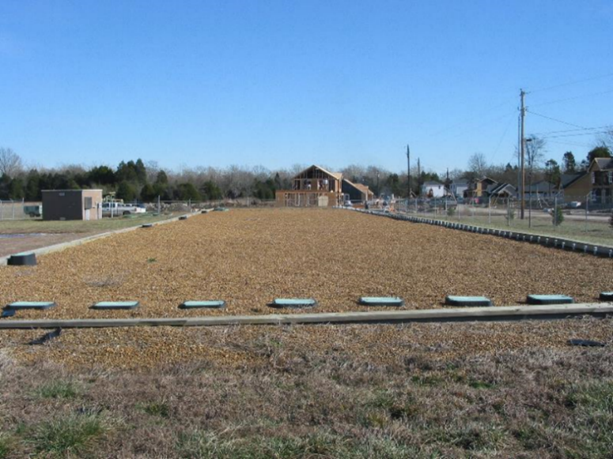
Figure 7. Shown above is an example of an RMS. This site is located at Murfreesboro, Tennessee and it sees typically 30,000 GPD.

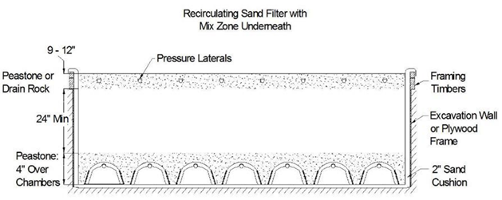
Figure 8. Cross sectional area of the RSF shown in Figure 7.

In a RSF, wastewater trickles downwards through the media and is collected at the bottom where a large fraction of the flow is recycled back (recirculation) to the media filter (Wayland III 2002). Dosing frequencies onto these filter beds vary, but typical treatment is around 1-3 times per hour (Krkosek-Payne and Gagnon 2014). Another factor, the recirculation ratio, is the amount of wastewater that flows through the media filter divided by the amount of wastewater that is sent to the final treatment and dispersal component. Recirculation ratios are usually between 3:1 and 5:1 and can be changed depending on the desired level of treatment. Typical design criteria for these type of treatment systems are that the media depth is at least 60 cm (24 in) in depth, contains some sort of durable, inert media, and has a hydraulic loading rate less than 0.203 m/day (5.00 gpd/ft²) and an organic loading rate of 0.026 - 0.107 g/m²/day (0.002 - 0.0080 lb BOD₅/ft²/day) (Solomon et al., 1998).

PPCP Removal Studies from OWTSs
As mentioned before, not much focus has been placed on the capabilities of OWTSs removing PPCPs from wastewater, but there are a select few that have done small experiments. For example, one study compared the effluent from several different OWTSs after one day of treatment to determine the removal of selected organic wastewater contaminants (OWCs) and PPCPs. 7 different OWTs were studied: single-pass media filter bed, a standard septic system, an aerobic treatment unit, a peat treatment system, an absorbent synthetic porous foam media bed, a sulfur denitrification system, and a recirculating media filter. Though concentrations were not provided, there were 13 confirmed OWCs and PPCPs in the untreated wastewater used. After treatment, it was found that the standard septic systems had the highest removal (3 confirmed OWCs and PPCPs), and the sulfure denitrification system has the lowest removal (10 confirmed OWCs and PPCPs). Likewise, final concentrations were not provided.
Another study compared 13 different small scale systems, mainly biological sand filters, compact biofilters, and vertical/horizontal flow constructed wetlands (Matamoros 2008). While all systems were able to degrade over 80% of the identified PPCPs within the untreated wastewater, vertical flow constructed wetlands showed to consistently perform better for PPCP removal, hypothesized to be from the unsaturated flow (better oxygenation). Although, they did conclude that while the vertical flow systems performed better, all options were deemed feasible technologies for the removal of a wide variety of PPCPs.

PPCP Fate and Transfer

Fate in WWTPs
WWTP discharge is the primary route for PPCP introduction into the environment. Because WWTPs were not designed with PPCP removal in mind, most of these trace compounds are removed in unintentional methods, resulting in variable elimination. The topic of how PPCPs survive/degrade and move through the wastewater treatment process and environment is not a simple, mainly because no two compounds are alike. The majority of PPCPs react differently once they enter into the wastewater system; some are degraded easily, some remain completely unchanged, and others can be transformed prior to human excretion, only to be re-transformed back into the parent compound during treatment (Karnjanapiboonwong et al., 2010).

PPCP Sorption
Sorption is an important pathway of PPCP removal within wastewater systems. Sewage sludge is frequently separated during wastewater treatment, and after further treatment on the sludge, the resulting biosolids are EPA-approved for land application. Many WWTPs allow portions of the biosolids to be sent to farmers as a source of nutrition for their non-food crops. Unfortunately, many PPCPs in wastewater adsorb onto sewage sludge and onto the treated biosolids. The binding of these compounds typically causes a loss is detectability, which only further make it more difficult to analyze. This uninterrupted pathway into the environment allows PPCPs to potentially travel through agricultural runoff into receiving streams or leaching into the groundwater.
It’s important to know that each class of PPCPs are extremely complex with their own chemical properties. For example, one property is the octanol-water partition coefficient (K_{ow}) on pH. Smith et al. (1988) defined K_{ow} as “the ratio of the compound's concentration in a known volume of n-octanol to its concentration in a known volume of water after the octanol and water have reached equilibrium.” This concept is important because many PPCPs are known to have low to moderately low K_{ow} values and studies have shown that the likeliness of compound sorption onto sewage sludge from secondary treatment correlated positively with their log K_{ow}. This said relationship was documented (Dobbs et al. 1989) and is shown in figure 9.

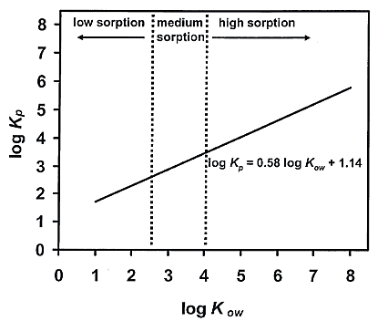
Figure 9. Experimental data showing a positive correlation between log K_{ow} coefficient of trace organic compounds and their sorption onto sewage sludge.

PPCP Degradation
Evidence has shown that many PPCPs are able to be broken down during various stages of wastewater treatment, whether it be through physical, chemical, or biological operations. While PPCP removal through degradation during primary treatment does occur, the amount removed is relatively insignificant, and therefore not studied in detail. It has been frequently noted that a significant fraction of most trace organic compounds can be removed through secondary treatment (Larsson et al., 2014). The microorganisms that flourish during this level of treatment can be a powerful ally when removing PPCPs from wastewater, such as with easily degraded acidic pharmaceuticals like ibuprofen or naproxen. Biological degradation has been said to potentially one of the more promising “clean-up” technologies for PPCP removal because of its low cost and ability to remove a large amount of pollutants (Tran et al. 2013).
The biodegradation of PPCPs varies significantly between different WWTPs, and the main reason for this is because of both the treatment systems in use and the quality of influent they are dealing with. Although the topic of PPCP within wastewater has been researched more and more over the past decade, researchers are still undecided on what the controlling factor is in understanding the biodegradation of PPCPs. For example, some researchers claim that biodegradation is dependent on PPCP physiochemical properties and chemical structures, while other put more focus on WWTP operation parameters (pH, HRT, SRT, and temperature), and others believe that is falls more on the nature of the microorganisms and their enzymes involved in biodegradation (Tran et al. 2013).
The biodegradation of a compound is known as converting large molecular weight compounds into those with a lower complexity. With organic compound, generally they are broken down into simple inorganic molecules such as water or carbon dioxide. Biodegradation pathways of organic compounds can occur in two ways, either through metabolism, where the organic compounds are completely broken down and used for cell growth, and/or co-metabolism, where the organic compounds are not the sole carbon or energy source to maintain growth, meaning the presence of another growth substrate is needed (Tran et al. 2013). The fact that many PPCPs are often present in wastewater effluent at trace concentrations shows that co-metabolism does occur – this pathways generally results only in the modification and transformation of organic compounds, and does not end with complete destruction. Still today, it remains unclear which biodegradation pathway is predominant in PPCP removal.
For trace organics to be removed through metabolism, it is required that the compound should not be anyway toxic or harmful to the microbial growth and that its presence should be at a high enough concentration that will allow the biomass to remain obtained. Although, it is unknown which PPCPs are able to initiate these metabolic activities. However, it is known that microorganisms that participate in such are heterotrophic bacteria. Quintana et al. (2005) studied possible metabolic degradation pathways of five different PPCPs by ensuring that each compound was the sole carbon source under aerobic conditions. The results from this experiment showed that only ketoprofen, an NSAID, showed removal through degradation while the other pharmaceuticals did not. However, the study was still not able to conclude ketoprofen as being the sole carbon source to induce degradation, saying that the oxidative enzymes could have used dead cells instead.
Unlike typical organic compounds, PPCPs are either toxic or resistant to microorganisms. Because of this, the energy that the microorganisms take from these trace organics is usually not enough to support microbial growth and induce the necessary enzymes involved in biodegradation; therefore, the presence of another growth substrate is necessary. Unfortunately, co-metabolism is a common pathway for many PPCPs and this has been shown to be ore detrimental then the original presence of the compounds. Many times, especially with EDCs, the incomplete breakdown of a compound produces a new compound that can shows properties more toxic than the parent (Haiss and Kummerer 2006). Co-metabolism degradation can take place under both aerobic and anaerobic conditions, although most studies show that aerobic co-metabolism is more predominant.
Co-metabolism of PPCPs are more noted with autotrophic bacteria, such as ammonia oxidizers through non-specific enzymes, such as ammonia monooxygenase (AMO), which is a key enzyme in nitrification. Literature reviews have suggested that the presence of ammonia oxidizing bacteria (AOB) during nitrifying conditions can promote certain PPCP degradation. One often researched AOB is Nitrosomonas euopea (N.europea) because of its ability to degrade estrogens and some antibiotics (Shi et al., 2004). Due to the AMO enzyme, N.europea has also been documented to catalyze the oxidation of many different aromatic compounds, such as benzene and phenol. It is also speculated that other dominant AOBs present specifically in activated sludge, such as N.mobilis, N.eutropha, and N.halophila, may play a role in other PPCP degradation (Juretschko et al., 1998).
Although co-metabolism has been stated to be the major removal mechanisms of PPCPs (Hai et al. 2013), both ammonia oxidizing and heterotrophic bacteria can participate in degradation. While AOBs are generally associated with co-metabolisms, heterotrophs can perform both co-metabolism and metabolism, depending on the concentration of the PPCPs present and their level of toxicity to the microorganism (Tran et al. 2013). There have also been studies that have shown AOBs and heterotrophs working cooperatively together to degrade a compound. Khunjar et al. 2011 documented that while studying the degradation of EE2, an EDC found in birth control, AOBs were able to quickly break down the compound, while the heterotrophs mineralized the PPCP independently of the AOB activity and degrade the metabolites created from the AOBs.
Despite the information provided, the question of autotrophs vs. heterotrophs for PPCP degradation cannot be answered. More insight is needed into the involvement of both of these microorganisms in the biodegradation of PPCPs.

Quantifying PPCPs in Wastewater Samples

Extraction Methods
There are multiple methods of extraction for PPCPs residing within wastewater because one method cannot identify all types of organic compounds. Typically, one type of process will extract only a certain group of compounds with similar physiochemical structures and properties. Because multiple methods of extraction and detection of PPCPs, analysis can be costly and time consuming.
When extraction PPCP from a water sample, processes such as liquid-phase microextraction, solid-phase extraction, solid-phase microextraction, and polar organic chemical integrative samplers are more successful methods (Samaras et al., 2010). Solid-phase extraction (SPE) is favored highly amongst researchers because of its high extraction efficiency for a wide range of analytes.
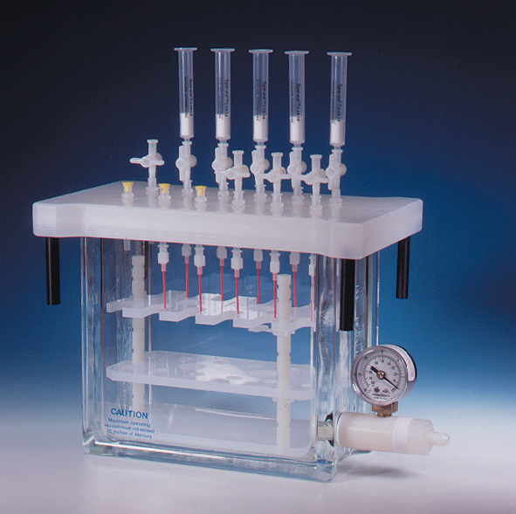
Figure 10. 12-port vacuum system for solid phase extraction; GL Sciences.

SPE is an extraction procedure that allows dissolved compounds (analytes) from a liquid matrix. Cartridges with different based packing materials manufactured are provided so that the highest extraction efficiency can be achieved. For example, reversed-phase cartridges are for analytes that are non-polar to moderately polar compounds, normal-phase cartridges are for higher polar compounds, and ion-exchange cartridges are for compounds that have strong/weak cation/anion exchanges.
Researchers that want to extract acidic pharmaceuticals, such as naproxen and ibuprofen, typically look to the commercial Oasis® HLB, while the reversed phase of c18 cartridges are used for moderately polar compounds, such as triclosan. Few studies have looked into the simultaneous extraction and detection of different PPCPs, however, Samamas et al. (2010) looked into extracting a somewhat-board range of PPCPs with different cartridges and found similar, if not identical, extraction efficiencies, as shown in table 4.
  - Table 4. Comparison of average extraction efficiencies of Oasis HLF and c18 cartridges for both acidic and phenolic PPCPs.
Compound | C18, % | Oasis HLB, %
Ibuprofen | 77±1 | 76±2
Naproxen | 85±1 | 84±2
Triclosan | 67±1 | 65±11

Detection Methods
There are multiple methods that can be used for the detection of PPCPs once they have been appropriately extracted, some examples being pressurized liquid extraction, microwave assisted extraction, and ultrasound sonification (Samaras et al., 2010). However, the most commonly used detection methods are gas chromatograph coupled to mass spectrometry (GC-MS, GC-MS/MS) or liquid chromatography coupled to mass spectrometry (LC-MS, LC-MS/MS). Sometimes tandem mass spectrometry is needed for the detection of low-concentrated compounds (ηg/L range) that are present in a highly complex water sample, such as untreated wastewater. Both methods of detection have their own advantages, for example, GC-MS has been noted to be reliable in the detection of neutral and acidic pharmaceuticals, while LC-MS is used for highly polar compounds (Gomez et al., 2007). While both popular, these detection methods are also not without faults; they are susceptible to background noise and signal suppression/enhancement, especially with older MS instruments, which can both affect sensitivity and proper compound detection (Samaras et al., 2010). Generally, GC-MS is favored over LC-MS because of built-in databases of known compounds and the cost is substantially less. However, LC-MS does not require an additional step known as derivatization, which will be discussed next, and therefore can analyze a much wider range of analytes than GC-MS. LC-MS is usually best suited for discovery-based approaches when researching unknown analytes (Danielson and Gallagher 2000).
When using GC-MS for the detection of trace organics, samples must first go through derivatization immediately after extraction. This step is important because PPCPs are not stable or volatile enough for detection. This procedures allows the elimination of hydroxyl, anime, and thiol groups while targeting oxygen, sulfate, nitrogen, and phosphorous groups, thus increasing volatility, stability, detectability, and sensitivity. There are a number of different types of derivatization, however the most prevalent approach is through silylation, where active hydrogens are replaced with a trimethylsilyl (TMS) group. The solvents required to perform silylation must be as pure as possible to ensure the elimination of excessive peaks. More studies that focus on PPCP extraction and detection use either BSTFA+1%TMCS or MSTFA+1%TMCS as silylating reagents, and pyridine or acetonitrile as solvents.

Literature Review for PPCP Removal from Wastewater
PPCP removal from WWTPs has recently become an exciting area of research for many scientists. The chemical diversity of PPCPs and their fate in the environmental has made their complete removal from wastewater challenging. Microbial degradation is a known and partially effective method of pharmaceutical removal, however, in depth research on this has only recently become popular amongst researchers. For example, Burke et al. (2013) studied the performance of microorganisms and their ability to degrade PPCPs under both aerobic and anaerobic conditions. This study was thus able to prove that organic pollutants are redox-sensitive, and the results confirmed that their biodegradation was influenced directly from the redox environment. In a separate study (Lubliner et al.,2010), it was noted that operating the WWTPs with a longer solids retention time (SRT), allowing a longer biological contact time, increased PPCP removal rates. After a series of experiments, they documented that pH changes within a treatment system would either increase or decrease the rate of antibiotic removals. The most effective processes that have been documented so far are biological treatments such as conventional activated sludge and membrane bioreactors coupled with nitrification (Meige et al., 2008).
There are other methods applied to help in the removal of pharmaceuticals. For example, one study analyzed the removal efficiency of PPCPs from urban wastewater in both a vertical and horizontal flow constructed wetlands, comparing these results against a typical sand filter (Matamoros et al., 2007). The main reason for this comparison was to evaluate the influence of vegetation on PPCP removal. Along with determining the concentration of the compounds both prior and after testing, dissolved oxygen, temperature, and pH of the influent and effluent measurements were also collected. At the end of the experiment, it was found that on average a vertical flow constructed wetland (73-98% removal) was more efficient at PPCP removal than a horizontal flow (16-96% removal), presumed to be from a more oxygenated bed, and comparable to the results received from the sand filter (82-98% removal). Studies that focused on using media filters as a way to remove organic pollutants from water samples have been published as well. For example, one study focused on the biodegradation of mononitophenols, commonly used in the agriculture industry, in a packed-bad aerobic reactor (Halecky et al., 2013). They discovered that while operating under a low hydraulic retention time (HRT) removal efficiencies were above 85%, and under a high HRT removal efficiencies were above 98%.
One pathway into the environment that PPCPs have known to take is through sorption onto other materials such as biological film, activated sludge (untreated and treated) and soil. Literature reviews that focused on the quantification of PPCP concentrations after sorption are few, and all showing different methods and results. Mohapatra et al. (2011) were trying to determine the occurrence of BPA in both wastewater and sludge samples, particularly looking at the partitioning of the compounds in both soil and liquid fractions. BPA was found to be present in all samples (influent, effluent, mixed sludge) within the range of 0.07-1.68 μg/L, but they were particularly surprised with the concentrations (0.104 – 0.312 μg/L) that were detected in dewatered sludge. Thus, they concluded their study by questioning the reuse of “treated” sludge for environmental purposes, such as landfill and crop nutrition. Another literature review was documenting the transport of numerous PPCPs, namely atenolol, carbamazepine, cotinine, caffeine, gemfibrozil, naproxen, ibuprofen, acetaminophen, sulfamethoxazole, triclosan and triclocarban, in runoff from plots that received liquid and dewatered municipal solids for crop growth (Sabourin et al., 2009). They found that trace organic compounds with a >3 K_{ow} were found to have little transport potential. Likewise, the compounds with lower K_{ow} values were detected in the runoff from the plots, with an average concentrations range of 0.0034 – 0.1097 μg/L.

Literature Review for PPCP Microbial Degradation
Little is known about how specific bacterial communities interact in the fate of pharmaceuticals and personal care products through the wastewater treatment process. While it is known that aerobic conditions are more successful than anaerobic, it is difficult to pinpoint the specific microbes responsible for this degradation. It is important identify such bacteria because it will allow scientists to potentially spike incoming wastewater with these microbial communities and promoting important degradation pathways.
One study was interested in finding microorganisms related to PPCP degradation and found that the white rot fungus, Phanerochaete chrysosporium, was able to almost completely degrade both NSAIDs ibuprofen and diclofenac in fed-batch bioreactors (Langenhoff et al., 2012). Denaturing gradient gel electrophoresis (DGGE) analysis of the samples collected from this study showed evidence of a highly enriched bacterial culture that originated from the inoculum from the wastewater treatment plant. By the end of the study, all 250 mg/L of the added ibuprofen and 75% of the added 300 mg/L of diclofenac was degraded. This study was able to conclude that specific ibuprofen and diclofenac degrading bacteria was present in original inoculum and, while not being able to identify specifically, concluded through DGGE that at least two bacterial species were responsible.

Research Hypothesis and Goals
This research hopes to answer the following critical questions:
- Can a laboratory scale packed-bed recirculating media filter provide comparable trace organic removal rates to that of a large scale treatment system?
- Can we quantify and distinguish the differences in removal of the trace organics between microbial degradation and biofilm sorption?
- Can we quantify both ammonia oxidizing and nitrifying bacterial populations within each of the columns and their differences based on column depth?
It is hypothesized that over 80% of the investigated trace organic compounds will be removed via microbial degradation or adsorption, such as seen in large-scale treatment facilities. With the conclusion of this project, it is hoped that similarly constructed OWTSs will allow small communities to remove most trace organic compounds from their domestic wastewater and allow the renovated water to be safely discharged back into the environment.

CHAPTER II: Target Compounds

Compound Introductions
The three target compounds of this study are the acidic NSAIDs ibuprofen (IBU) and naproxen (NAP), and the phenolic EDC triclosan (TRI). These compounds are known for their worldwide high consumption and toxic effects on the environment. These compounds are frequently detected in many environmental samples and have shown time and time again that a large percentage of the compounds survive typical WWTPs, as can be seen in table 5. While different in regards to their toxicity, compound makeup, and metabolite formation, these compounds are physiochemically similar when comparing molecular weight, Log K_{ow}, water solubility, and pK_{a}. These values are given in table 4.

  - Table 5. Detection frequency and average concentration of PPCPs in influent and effluent from WWTP secondary treatment.
Compound | Detection Frequency, % | Mean Influent, ppb | Mean Effluent, ppb
Ibuprofen | 97 | 146.0 | 19.6
Naproxen | 81 | 264.0 | 18.9
Triclosan | 100 | 13.4 | 6.8

  - Table 6. Various chemical properties of the target compounds.
Compound | Formula | Molecular Weight | Log K_{ow} | Water Solubility, mg/L @ 25˚C | pK_{a} | Compound Structure
Ibuprofen (IBU) | C₁₃H₁₈O₂ | 206.28 | 3.97 | 21.0 | 4.91 | 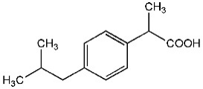
Naproxen (NAP) | C₁₄H₁₄O₃ | 230.26 | 3.18 | 15.9 | 4.15 | 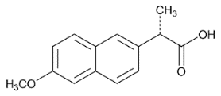
Triclosan (TRI) | C₁₂H₂₄O | 220.36 | 4.48 | 10.0 | 7.9 | 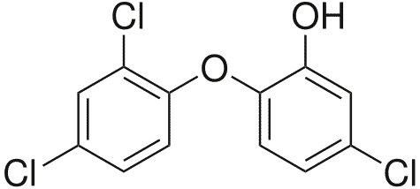

Non-Steroidal Anti-Inflammatory Drugs
Non-steriodial anti-inflammatory drugs, or NSAIDs, are one of the most prescribed type of drugs in the world for pain relief. While they are given for mild to moderate pain relief, they are also used for the reducing inflammation and fever within the human body, as well as the prevention of blood clotting (OrthoInfo 2009). These drugs work by preventing an enzyme named cyclooxygenase (COX) from triggering changes within the body from doing what they would do naturally. Most NSAIDs are weak acids, typically having a pK_{a} value around 3-5. While there are many different forms that NSAIDs take on, table 7 lists a few of the most popular and their commonly delivered doses.

  - Table 7. Commonly used NSAIDs and their delivered dosing.
NSAID | Brand Names | Typical Dose (mg)
Aspirin | Several companies | 650-925
Ibuprofen | Motrin®, Advil® | 400-800
Naproxen | Naprosen®, Aleve® | 250
Nabumetone | Relafen® | 500-100

2-(4-isobutylphenyl)propanoic acid
2-(4-isobutylphenyl)propanoic acid, or more commonly known as ibuprofen (IBU), is a common fever reducer that moderates the hormones that cause inflammation and pain in our bodies. This compound was listed as the 3rd most popular drug in the world and is normally distributed in a solid pill form within a dose range of 600 – 1200 mg/day (Buser et al. 1999).
Because of the attached carboxyl group (C(O)OH), IBU is classified as a propanoic acid derivative along with a number of other compounds. Since IBU is an NSAID, it works by inhibiting COX enzymes within the human body, but in a different way than other NSAIDs such as aspirin. Rather than forming a covalent bond with the enzyme, IBU works through reverse inhibition by binding non-covalently and competing with the enzyme’s natural substrate (Flower 2003).
IBU is normally administered orally, however there are some reports of topical and intravenous administration. This compound is partly metabolized within the human body, with research showing that about 44% of the drug is passed through urine and feces within 24 hours; 80% of that being 2-hydroxy and carboxy IBU, which are two major corresponding metabolites. 1-hydroxy and 3-hydroxy IBU have also been recorded, but in much smaller concentration (Davies 1998). IBU and its major metabolites are shown in figure 11 (Kummerer 2008).
Although a large amount of IBU is degraded during the wastewater treatment process, trace amount of the compound are released into the environment. Because of the physiochemical properties of IBU, this compound has been shown to have a high mobility and low volatility in the aquatic environment, giving a reason as to why it frequently survives treatment. While not one of the most dangerous drugs in regard to environmental health, there have been reports on potential links to fish health and aquatic plant growth (University of Exeter 2014).

(2S)-2-(6-methoxynaphthalen-2-yl)propanoic acid
Naproxen (NAP), like IBU, is a NSAID that focuses on alleviating pain in the body through hormone regulation. While not as frequently used worldwide as IBU, NAP is still listed as one of the more commonly used drugs and is typically administered around 250 mg/day. It also joins IBU as another propanoic acid derivative. In many ways, NAP and IBU are identical, however they differ based on reaction speed and targeted enzymes (Curiosity Aroused 2015). IBU works as a quick pain relief and is a non-selective NSAID, inhibiting both COX-1 and COX-2 enzymes. NAP is slower than IBU, but provides a longer pain relief and is a selective NSAID, focusing on only COX-2. Because of the lower dose range and more specific enzyme targeting, NAP is easier on the human heart than IBU. Also unlike IBU, the breakdown of NAP is quick and nearly complete, with less than 1% of the parent compound found in urine samples. Almost all of the drug is excreted as corresponding conjugates; 51% as NAP-acylglucuronide, 14% as 6- O-desmethyl-NAP acylglucuronide, and 6-7% as their respective isoglucuronides (Davies 1997).

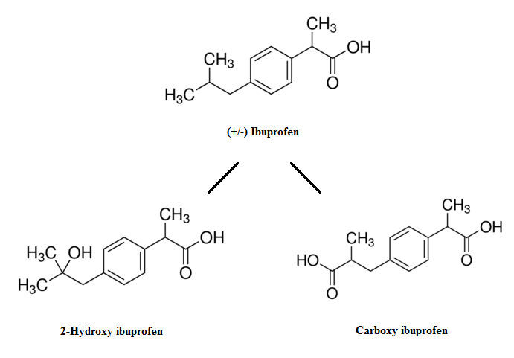
Figure 11. Chemical structures of parent compound ibuprofen and major metabolites hydroxy ibuprofen and carboxy ibuprofen.

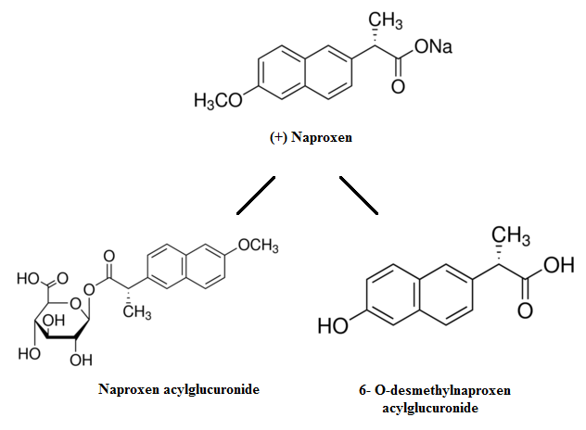
Figure 12. Chemical structures of parent compound naproxen and metabolites naproxen acyglucuronide and 6-O-desmethylnaproxen acylglucuronide.

Although a large amount of NAP is excreted through urine and bio-transformed into corresponding conjugates, a small percentage of the compound remains unchanged and untreated as it passed through wastewater treatment, not unlike its NSAID counterpart IBU. While a weak acid just as IBU, NAP is easily degraded and weakly adsorbed onto other substances (Yu et al., 2011).

Endocrine Disrupting Compounds
According to the National Institute of Environmental Health Sciences (NIH), endocrine disrupting compounds (EDCs) are chemicals that may interfere with the body’s endocrine system and produce adverse developmental, reproductive, neurological, and immune effects in both humans and wildlife (NIH 2015). These chemicals can be found in a variety of products such as pharmaceuticals, plastics, cleaning products, and cosmetics because of their useful properties. EDCs work by disrupting or mimicking certain endocrine pathways through direct hormone interaction. These interactions can cause chemical changes in the body anywhere from sexual development, metabolism, and brain development. The chemical structure of EDCs more often very different from one another, making it very difficult to determine if a compound is an EDC by simply looking at the structure. Because of this variability and unpredictability they are sometimes synthesized unintentionally. Table 8 includes a list of a few common EDCs and their applications (Hess-Fischl 2015).

  - Table 8. Commonly found EDCs and corresponding applications.
EDC | Applications
Bisphenol A (BPA) |  | Toys, plastics, food containers, receipts
Dichlorodiphenyltrichloroethane (DDT) |  | Pesticides (now banned)
Polychlorinated biphenyls (PCBs) |  | Electronics, building materials
Triclosan |  | Antibacterial products

5-chloro-2-(2,4dichlorophenoxy)phenol
As one of the more frequently detected PPCPs in environmental samples, 5-chloro-2-(2,4dichlorophenoxy)phenol, TRI, it is a compound that can be found in almost every household. TRI is an ingredient that is added to many consumer products such as soaps, detergents, and cosmetics to help prevent or reduce bacterial contamination. While it has not been proven to be harmful to humans, it has been widely researched to be extremely toxic to aquatic life and algae species from altering hormone regulation. However, researchers who specialize in bacterial studies have suggested that TRI is making certain bacteria resistant to many antibiotics (FDA 2013).
TRI is a chlorinated aromatic compound that is highly soluble in water, and has functional groups made of both ethers and phenols, which often show anti-bacterial properties. This compound works by effectively stopping the fatty acid chain growth of through the inhibition of a bacterial enzyme, thus stopping the growth of the cell. This makes TRI an extremely powerful agent and is only needed in very low concentrations (>0.3%) (Angkadjaja 2007).
TRI was not intended for oral consumption, and therefore is not metabolized within the human body. It does not easily undergo biodegradation during wastewater treatment from its being a stable lipophilic compounds with a relatively high octanol water partitioning coefficient (K_{ow}). In actuality, TRI is a large cause of concern in many WWTPs because its presence has been linked to the destabilization of important microbial communities that help treat sewage. However, research has shown that TRI is susceptible to photodegradation, but not without the production of certain byproducts which have been proven to be even more toxic than the parent compound (Ricart et al., 2010). Other byproducts of TRI are listed in table 9 (Sanchez-Prado et al., 2006).
  - Table 9. A list of toxic byproducts of triclosan after undergoing photodegradation.
Byproduct | Description
2,8-Dichlorodibenzo-p-dioxin(2,8-DCDD) | Type of dioxin
2,4-Dichlorophenol(2,4-DCP) | Endocrine disrupting compound
2,4,6-trichlorophenol (2,4,6-TCP) | Endocrine disrupting compound
Chloroform | A carcinogen
Methyl triclosan | A toxic metabolite more bioaccumulative than TRI

TRI is largely an environmental concern because of the almost non-existent elimination after wastewater treatment processes. This compound has a high sorption rate, and typically binds to solids such as sediment and sludge (Walker and Watson 2010). The sewage sludge that originated from treatment plants are often re-used and sent to many agricultural sites as a source of nutrition and from there TRI leaches through the soil, contaminating both surface and ground waters. Because of this, TRI is highly regulated by the FDA and EPA.

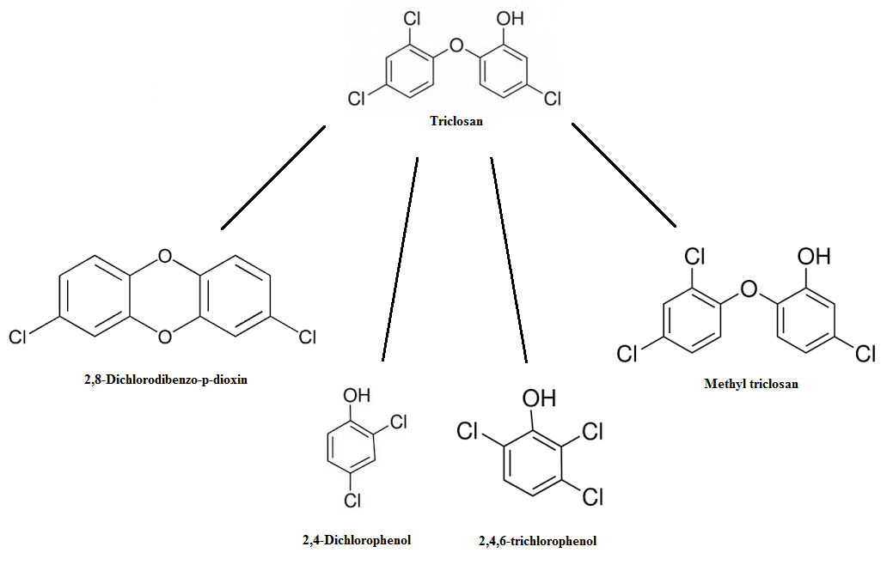
Figure 13. Chemical structures of parent compound triclosan and metabolites 2,8-dichlorodibenzo-p-dioxin, 2,4-dichlorophenol, 2,4,6-trichlorophenoland methyl triclosan.

There is a great deal that still remains unknown about the fate and transfer of this compound in the environment. There are a few known metabolic pathways of TRI; most are speculated because it has been difficult for researches to give a definite answer (Fang et al. 2010).

Metabolite Research
The more PPCPs are studied, the more it is discovered that not only are the parent compounds important to understand, but their metabolic transformations are as well. Many PPCPs are biologically transformed by organisms such as bacteria and fungi once they are consumed or absorbed in the human body, introduced into WWTPs, or from various environmental factors (such as sunlight). Although a good percentage of the parent compound are removed in typical wastewater treatment processes, their metabolites are still present, granted at extremely low levels of concentration. It is important to identify these transformed compounds because it has been shown that they able to form brand new molecules with different physicochemical properties than originally was with their parent compound. This results in an altogether different fate and transfer in the environment. While it would be ideal to analyze both the influent and effluent of wastewater samples for both the parent compound and respective metabolite s, most of the time this simply cannot be done. These metabolites are typically are much lower concentrations that sometimes cannot be detected by most analytical methods.

CHAPTER III: Materials and Methods

Chemicals and Working Standards
The three compounds of interest were each purchased at their highest purity (>98%) from Sigma Aldrich (St. Louis, MO, USA), Campbell Science (Rockford, IL, USA) and Fischer Scientific (Waltham, MA, USA). Working standards of each of the chosen compounds were prepared separately at 150 ppm in 99% HPLC grade methanol and diluted for analytical procedures. HPLC grade chemicals for analytical procedures such as ethyl-acetate, MSTFA + 1% TMCS, and acetonitrile were also purchased from Fischer Scientific and Campbell Science.

Wastewater Source
Domestic wastewater samples were collected from The University of Tennessee’s Little River Animal and Environmental Unit of East Tennessee Research & Education Center (ETREC) in Walland, Tennessee. This sites primary use is dairy farming and was opened in 2011 to begin research on animal and environmental best management practices, supporting a herd of 200-250 milking cows. The wastewater collected was primarily sourced from four on-site homes, as seen in figure 14. This wastewater is purely from domestic use, not agricultural, and has only undergone primary treatment.

Figure 14. Collection site of wastewater and contributing homes.

Project Description and Design

Materials and Construction
Four experimental stainless steel columns (0.6 m (24 in) depth, 0.09 m (3.5 in) width) were placed parallel on a constructed wooden stand. Figure 15 shows the layout for one of the experimental columns for this study. The media column (A), was filled with a small gravel that was sieved to ensure a consistent 3-5mm particle size. The bottom of the column was filled with #55 crushed limestone rock to prevent the smaller media from clogging the system. To compare the amount of free volume space allowed for biological growth, water flow, and air to passively travel through, both particle and bulk densities for each of the media and it was found that the upper media has an estimated 5% porosity while the crushed limestone has 20%.

System Operation
Wastewater was introduced into the system from the 5L supply tank (B) located on the top right of the column. When the float switch within the recirculation jar (D) was triggered, the two-way valve (F) beneath the supply tank opens and allow the wastewater to be discharged. When at least 2L had been discharged, the float switch then triggered the two-way valve to close until needed again. A polytetrafluoroethylene coated diaphragm pump was also programmed to deliver a 50 mL dose of wastewater every hour from the recirculation jar. This system was on a 5:1 recirculation ratio, therefore every 5th pass through the system and the columns effluent was diverted using a three-way value (E) to the final effluent jar (C), while all other will be brought back to the recirculation jar. After 0.5 L has been pumped from the recirculation jar, the float switch will once again trigger and open the two way valve underneath the supply tank to allow wastewater discharge once again.
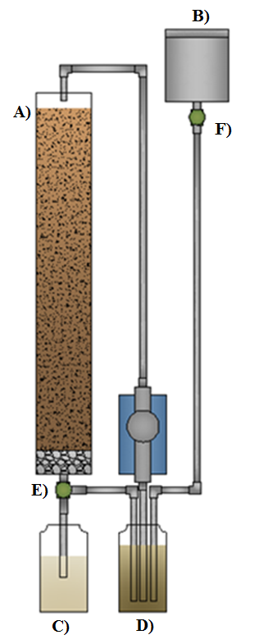
Figure 15. RSF configuration with (a) media column, (b) 5L supply tank, (c) effluent collection, (d) recirculated collection, (e) three-way valve, and (f) two-way valve.
Four experimental units were set up in parallel next to the other as shown in figure 16. The first unit was designated as the control column, meaning that this column only received the non-spiked methanol standard from the corresponding supply tank. The other three columns received an equal amount of wastewater with the addition of the corresponding compound and methanol. The standard that was added to the three columns maintained a 0.1 ppm concentration of the specific trace organic compound to that column: the IBU supply tank was administered an IBU standard, NAP with a NAP standard, and TRI with TRI standard. Each standard contained one compound that was dissolved in a methanol solution. To remain consistent in any changes to the influent, the control supply tank received an equal amount of methanol, but with the absence of the compounds.
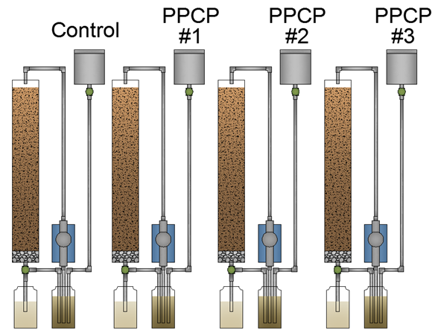
Figure 16. Schematic of experimental design.

Hydraulic/Organic Loading Rates
Two important calculations that must be made to determine the design of a RSF are the hydraulic and organic loading rates. They are critical design factors, and if not appropriately set, they could result in the improper treatment of wastewater. The hydraulic loading rate (HLR) is determined from the volume of wastewater that is applied to a surface area (Zhou 2007). Simply put, it is the amount of water applied over an area within a certain time.
 | $$Hydraulic Loading Rate=\frac{Design Flow (\frac{gal}{day})}{Area (ft^{2})}$$ | (Eq. 3)
While there are many different design criteria for the HLR, it is typical to ensure a loading rate of 0.085 – 0.142 L/m²/day (3 – 5 gal/ft²/day) (Solomon et al., 1998). For this research, the HLR was calculated to be 0.135 L/m²/day (4.76 gal/ft²/day), which is within design specification.
Similar to the HLR, the organic loading rate (OLR) is the amount of organic matter that is applied to a specific area over a certain time, and this is typically dependent on the biochemical oxygen demand (BOD). BOD is defined as the amount of oxygen that must be present within a water sample for microorganisms to break down any organic material present. BOD₅ is a measure of this oxygen to degrade organic material within a 5 day time period. This is a common method for determining organic material present within wastewater. Once a BOD₅ test has been performed, a simple equation can be applied to determine the organic material present.
 | $$Organic Matter= \frac{{BOD}_{5}\left(\frac{mg}{L}\right)*3.785(\frac{L}{gal})}{453,600 (\frac{mg}{lb})}$$ | (Eq. 4)
To determine the OLR, you simply need to consider the volume of water and area of application. Typical BOD₅ values of domestic wastewater lie within the range of 150 – 300 mg/L, however there is always the possibility of higher strength areas depending on location and population. It is extremely important that the designed RSF does not exceed design criteria for OLRs because a system will soon become “clogged”, resulting in a shorter filter life. It is recommended that a system stay within the range of 0.005 – 0.039 kg BOD₅/m² (0.001 – 0.008 lb BOD₅/ft²-day).
 | $$Organic Loading Rate=\frac{Organic Matter \left(\frac{{lbs BOD}_{5}}{gal}\right)*Design Flow\left(\frac{gal}{day}\right)}{Area \left(ft^{2}\right)}$$ | (Eq. 5)
This research did not measure BOD₅, but instead measured the chemical oxygen demand (COD). COD is a way of indirectly measuring the amount of organic compounds within the water. It does not require to wait the 5 day incubation period to determine a measurement, and that is why it was chosen. Since there was no equation found to calculate organic matter using COD rather than BOD₅, a literature review was discovered that modelled the relationship between the two (Dubber and Gray 2009). It discussed that a COD:BOD ratio was typically noted to be from 1.2-2.5, however it tended to be numerically constant when targeting specific wastewater. Therefore, a generic model was discovered for domestic wastewater:
 | $$COD=1.64*{BOD}_{5}+11.36$$ | (Eq. 6)
Using this model, the average COD measurement for the added wastewater into the system after spiking with the standards was used to determine the BOD₅ variable needed. Thus, the OLR was calculated to be 0.003 lb BOD₅/ft²-day, which was within reasonable design criteria.

Sampling Procedures

Collection
Domestic wastewater samples were collected from The University of Tennessee’s Little River Animal and Environmental Unit. Wastewater was pumped from the unit’s housing septic tank, which has only undergone primary treatment. The collection was pumped into three plastic containers and shaded from sunlight. After the wastewater had been administered into the system, samples of the supply tanks before and after standard additions were collected. Effluent samples were collected daily, with each treatment series lasting one week. At the end of the experiment, the media within the columns was collected for biofilm analysis and separated based on location (top, middle, and bottom of column).

Storage
5 L were dispensed into each of the stainless steel supply tanks weekly with the corresponding standard added. The recirculation jar and final effluent jar were both wrapped in aluminum foil to prevent any photodegradation from occurring before the collection. The influent, effluent, and media samples were stored at 4°C (39.2°F). If analysis could not begin immediately after collection, samples were kept in the dark to prevent photodegradation.

Preparation
It was found mid-way through the research that the standards, even though refrigerated and kept in the dark, were still exhibiting some compound degradation. Therefore standards of each of the compound were made fresh every other month. High purity stock solution standards were prepared with a 500 mL Erlenmeyer flask in methanol at 150 ppm. To achieve a 0.1 ppm concentration, 0.665 mL of the standard was mixed with each liter of wastewater added to the supply tanks. Daily effluent samples were collected, passed through glass fiber filters, and separated: 300 mL was saved for solid phase extraction (SPE), while the rest remained for COD, pH, TOC, and TN analysis. Those samples sent for SPE were acidified to 2-3 pH by the addition of 50 μl of sulfuric acid.

Effluent Analysis

Water Quality
Multiple parameters were tested for overall water quality: pH, COD, TOC, and TN. A Hach (Loveland, CO) HQ_{40d} dual probe multi-parameter meter was used to measure pH values after calibrating the probe with pH 2, pH 7, and pH 10 buffers. COD standards were created in lab; potassium dichromate, K₂Cr₂O₇, and sulfuric acid, H₂SO₄, standards were made when needed. For one COD sample, 1.5 mL of K₂Cr₂O₇, 3.5 mL of H₂SO₄, and 2.5 mL of the wastewater sample were mixed together and placed in a COD digester and heated to 150°C for 2 hours. Finished samples were analyzed and linearly graphed against calibrated COD standards (50, 100, 200, 400, 600, 800 mg/L) to accurately determine concentration. TOC and TN samples were analyzed with a Shimadzu Analyzer (Colombia, MD) equipped with a TOC-V_{CPH} and TNM-1 measuring units.

Quantifying PPCP Release
While there are different extraction materials to choose from, C18 cartridges (6 ml, 500mg) were used because they are ideal for nonpolar to moderately polar compounds and contain a hydrophobic reverse phase material for compounds residing within a liquid matrix. The SPE process requires four critical steps: conditioning, loading, washing, and elution. The cartridges were conditioned with 3x2 mL (meaning three separate sets of 2 mL loadings within the cartridges) ethyl acetate, 3x2 mL methanol, and finally 3x2 mL of distilled water after allowing the cartridges to soak for 2 minutes while not under vacuum. The conditioning was performed under low vacuum settings. 4 mL of acidified distilled water (pH 2-3) were then added for additional conditioning. The acidified wastewater samples collected (300 mL) were sent pulled the cartridge under a low vacuum. After loading, the cartridges were washed with another 2 mL of acidified distilled water and left to dry under vacuum for 1 hour. Finally, the elution of the target compounds was performed by collecting 3x2 mL of ethyl acetate by gravity into a 10 mL glass tube. The samples were then evaporated to 1 mL under a gentle stream of nitrogen, transferred into 2 mL analytical vials for GC-MS and evaporated once again, this time to dryness.
Newly evaporated samples from SPE were reconstituted with 0.25 mL of bis(trimethlysily)triflortoscetamide and 1% trimethyl chlorosilane (BSTFA+1%TMCS) and 0.25 mL of acetonitrile. After being vortex mixed for one minute (about 15 pulses each), they were brought to 70˚C for 1 hour and 15 minutes. After cooling, they were placed in a desiccator overnight and subjected to GC-MS analysis within a 3-day period of time.
To ensure an accurate analysis of the target compounds, a full scale mode was used. The Gas chromatographic analysis was carried out through a Shimadzu (GCMS-Q2010) with a Shimadzu SHR5xLB (30m x 25mm x 0.25µm film) capillary column. 1 µL samples were performed at splitless mode at 280°C with helium being the carrier gas at a constant flow mode of 0.9 mL/min. Other conditions include: the electron impact (EI) spectra mode will be at 70 eV, the transfer line will be at 280°C, and an ion source temperature of 180°C. It is expected that the m/z ion ratio will be 50-400. The temperature program for the GC-MS will be set to 80°C for 1 minute, 80°C to 248°C at 15°C/min, 248°C for 1 minute, and finally from 248°C to 280°C at 3°C/min also held for 1 minute.

Biofilm Analysis

Quantifying PPCP Sorption
At the end of the experiment, after all water samples were collected, the media within each of the columns was collected. The media was separated by location within the columns (top, middle, and bottom layer). A portion of the collected samples were analyzed for the estimated sorption of the compound into the biofilm on the media. For each location, three replicates were taking using centrifuge tubes. Each tube was filled to 25 mL with the addition of 2.5 mL methanol and distilled water, and placed on an orbital mixer for 24 hours. Once thoroughly mixed, the media was removed and the remaining mixture was centrifuged at 5000rpm for 10 minutes. The supernatant was collected, combined into one sample, and dried under nitrogen gas until 1 mL has been reached. The 1 mL solution was added to 200 mL of acidified distilled water (pH 2-3). After this, normal SPE procedures can be performed on the newly reconstituted samples.

DNA Extraction of Biofilm
A separate collection of the media was sent to another lab for DNA analysis. The biofilm on the media was extracted using a MoBio (Carlsbad, CA) PowerSoil DNA Extraction Kit. This analysis was done to quantify amoA and nirS genes using qPCR, which code for the specific enzymes responsible for nitrification and denitrification, respectively. This analysis was able to give an estimation of the population sizes of potential AOB and denitrifying bacteria within the biofilm. Multiple centrifuge tubes were filled to the 25 mL volumetric mark with media and rinsed with 10 mL of sterile 10 mM phosphate buffer (PBS, pH 7.4) to dislodge organic matter. The buffer was decanted, and then 25 mL of fresh buffer was re-added. The samples were placed on a lateral displacement platform shaker at maximum speed for 15 minutes. 15 mL of the supernatant was transferred to a 50 mL conical tube and centrifuged at 5000 rpm for 30 minutes. The supernatant was removed, and then the pellet was re-suspended in 1.5 mL of the phosphate buffer, and then transferred to a 2 mL centrifuge tube. The sample was centrifuged again at 10000xg for 10 minutes. The supernatant was removed and the pellet was kept frozen at -20˚C prior to extraction.

qPCR Analysis
Methods developed by Harms et al. (2003) were used for the quantification of the amoA genes, and Throbäck et al. (2004) for the nirS genes. Quantitative PCR assays were developed for the quantification of bacterial 16S rDNA, N. oligotropha-like amoA, and nirS gene. SYBR Green qPCR assays were used for amplification of the amoA and nirS genes instead of the more commonly used TaqMan assays. The primers amoNO550D2f and amoNO754r were used to target the amoA genes of AOB found in the biofilm on the media samples, while the nirS primers and standards were made in lab based on the reference material. 5 μL of the samples collected from the extracted biofilm were combined with the SYBR Green Supermix (Hercules, CA) and primers and then analyzed. PCR amplifications consisted of 3 minutes at 50˚C, 10 minutes at 95˚C, 55 cycles at 95˚C for 30 seconds, and 56˚C for 60 seconds, as what was used from Harms et al. All real-time PCR assays were performed using three replicates per sample. Gene copies were calculated by the comparison of the threshold cycle obtained in the PCR runs from known standard DNA concentrations. Standard curves for bacterial 16S rDNA provided a PCR efficiency of 101% and r²=0.99, N. oligotropha amoA a PCR efficiency of 88.7% and r²=0.99, and nirS a PCR efficiency of 91% and r²=0.97. The linear range of detection for the bacterial 16S rDNA was 4 orders of magnitude, from 4.5x10⁴ to 4.5x10⁸ copies per PCR, and a detection limit of 4.5x10³ target DNA copies. For the chosen N. oliotropha amoA PCR assay, the linear range of detection was at least 6 orders of magnitude, from 30 to 3.0x10⁷.

Facilities and Equipment
All equipment and facilities used were located at The University of Tennessee in Knoxville, Tennessee. All experimental procedures were performed primarily at the Biosystems Engineering & Soil Science building located on the Agricultural Campus.

CHAPTER IV: Results

Preliminary Testing of Experimental Apparatus
After extensive research had been done on the literature review of the project, it was important to perform some preliminary experiments. Once construction was completed, each of the columns were inoculated with untreated domestic wastewater for two weeks. Bacterial inoculation is extremely important within a media filter to ensure that an appropriate population of microorganisms are present. During this period, the effluent was continually monitored for basic water quality parameters: pH, COD, and TOC levels. Once appropriate levels were reached, 1 mL of methanol was added to each of the supply jugs to represent the addition of the PPCP standards. This was monitored for another two weeks to see if the sharp increase in organic content interfered with the system. Table 10 represents the measurement of each of the parameters of the wastewater effluent before the addition of methanol.
Figure 17 depicts the first two weeks of this monitoring. It is apparent that a neutralization of pH occurs initially and is maintained throughout the weeks, which is appropriate of a RMF system. Week 2 shows much less variability in the data when compared to Week 1, suggesting that the columns became more stabilized over time.

  - Table 10. WQ results of untreated domestic wastewater before the addition of methanol standard.
 | WQ Parameters
Week Sampled | pH | COD (mg/L) | TOC (mg/L)
1 | 7.18 | 87.80 | 41.63
1 | 7.29 | 98.57 | 38.25
1 | 7.36 | 110.47 | 39.19
2 | 7.28 | 122.30 | 48.53
2 | 7.33 | 111.83 | 46.80
2 | 7.27 | 105.64 | 45.08
Average WW Level | 7.29±0.1 | 106.10±12 | 43.24±4.1

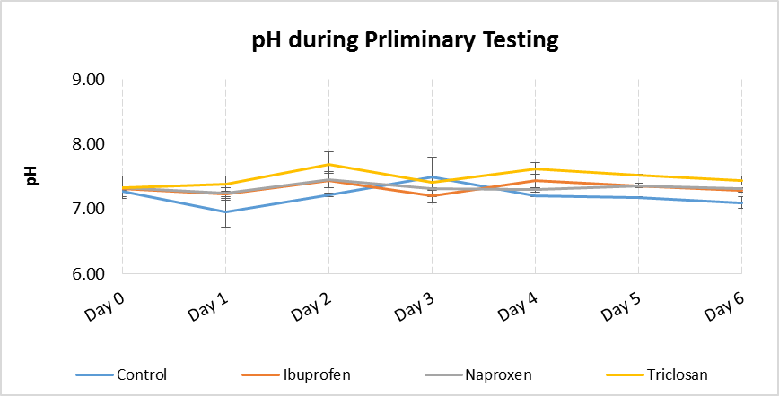
Figure 17. pH during preliminary weeks of monitoring; n = 2 weeks. Day 0 represents the sampling of the supply jugs after the methanol addition. Day 1, 2, 3, respectively represent sampling from the effluent collected after column treatment. Two-way ANOVA analysis showed no significant differences between columns and weeks (P=0.433, alpha=0.05).

While no changes were expected from the pH after the addition of methanol, this was not the same for both COD and TOC levels. With the addition of more organic content, the oxygen demand should rise in turn as well as the amount of organic compounds present. Figure 18 shows that after the addition of methanol, the COD measurement nearly doubled in comparison to the initial wastewater level shown in table 10. However, a large reduction in the oxygen demand can be seen only after one day of treatment. After the first week, the total COD reductions for each column were calculated (85.2% control column, 85.7% IBU column, 90.4% NAP column, and 84.3% TRI column). Likewise, reductions were calculated for the second week (86.1% control column, 92.7% IBU column, 84.8% NAP column, and 90.2% TRI column). As what was noted previously, the reduction rates increased with the second week (2%-7% increase), suggesting that the system promoted more treatment after longer operation.
Similar results were expected with TOC levels as with COD, because both should rise with the addition of methanol. Figure 19 shows an appropriately large increase in organic content from the original level listed in table 10. While a sharp reduction was not noticed the day after addition, as was seen with COD levels, a large decrease in organic matter was seen throughout the entirety of the week. After the first week, the total TOC reductions for each column were calculated (85.3% control column, 73.4% IBU column, 73.2% NAP column, and 73.9% TRI column). Reductions were calculated for the second week as well (72.7% control column, 78.8% IBU column, 74.1% NAP column, and 73.9% TRI column). Differences in the changes of reduction rates over the two week can be seen, when compared to COD values. While COD reduction rates slightly increase with the second week, TOC values remained constant around 75% reduction, showing little if any change.

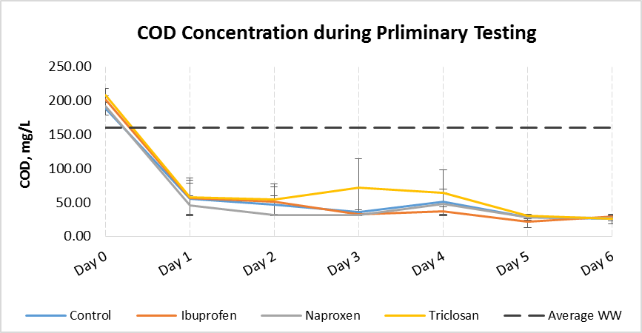
Figure 18. COD during preliminary weeks of monitoring; n = 2 weeks. Day 0 represents the sampling of the supply jugs after the methanol addition. Day 1, 2, 3, respectively represent sampling from the effluent collected after column treatment. Two-way ANOVA analysis showed no significant differences between columns and weeks (P=0.988, alpha=0.05).

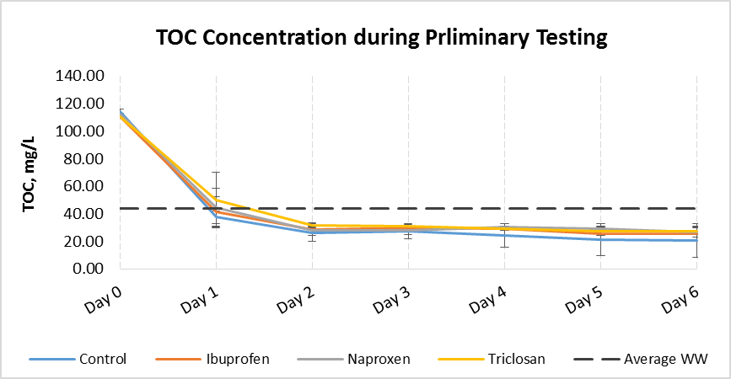
Figure 19. TOC during preliminary weeks of monitoring; n = 2 weeks. Day 0 represents the sampling of the supply jugs after the methanol addition. Day 1, 2, 3, respectively represent sampling from the effluent collected after column treatment. Two-way ANOVA analysis showed no significant differences between columns and weeks (P=0.861, alpha=0.05).

The lower reduction rates in TOC represent that although the oxygen demand of the wastewater decreased exceptionally (>90% reduction), organic compounds still remained within the system and were not able to be completely removed (>75% reduction).
In addition to monitoring the influent and effluent levels of the system, it was also important to ensure that changes in water quality were not occurring before entering the system. pH, COD, and TOC values were measured in both the system’s stainless steel supply tanks and supplemental water supply outside the project that has not been added yet. These levels were also monitored over a two week period.
The wastewater supply that had not been added yet sat beside the system in plastic containers that were partially exposed to light, as seen in the image below. Because of these factors, it was extremely important to monitor the water on a daily basis.
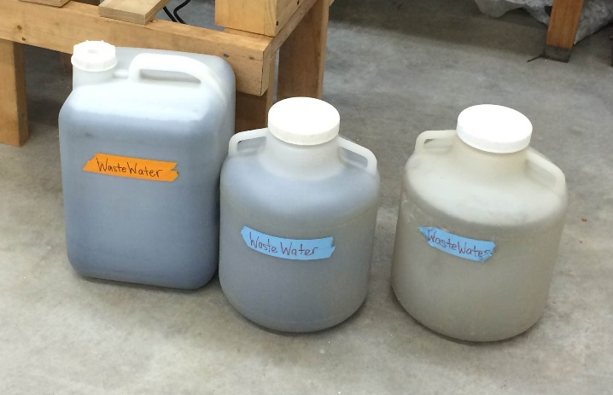
Figure 20. External wastewater supply containers.

The results in figure 21-23 show that very little, if any, changes of the target parameters occurred over a week’s time period within the external supply jugs. The test was repeated a second time, with similar results. The final conclusion for this experiment was that no concern would be needed from any biological changes to the wastewater before its addition into the system.
Likewise with the data shown in figure 24-26, very little change is seen within the supply tanks for each of the columns. Samples were collected three days after methanol addition. It was important to ensure that with the increase in organic content that the natural microorganisms within the wastewater did not begin degradation until the influent that a chance to be treated through the system. While it can be seen from the COD and TOC results from the first week that there was a slight decrease after the second day, the levels returned to its original measurement, thus this small change can be attributed to normal sample variation.
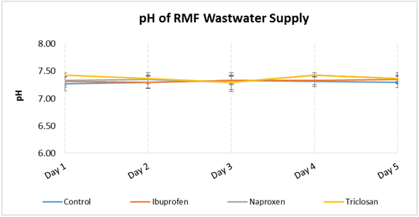
Figure 21. pH within the RMF supply over a 5 day period after methanol solution addition; n = 2 weeks. Two-way ANOVA analysis showed no significant changes in pH (P=0.77, alpha=0.05), maintaining a mean pH of 7.32±0.07.

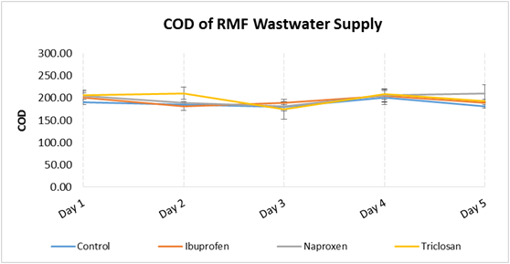
Figure 22. COD within the RMF supply over a 5 day period after methanol solution addition; n = 2 weeks. Two-way ANOVA analysis showed no significant changes in COD (P=0.45, alpha=0.05), maintaining a mean COD of 191±18.1.

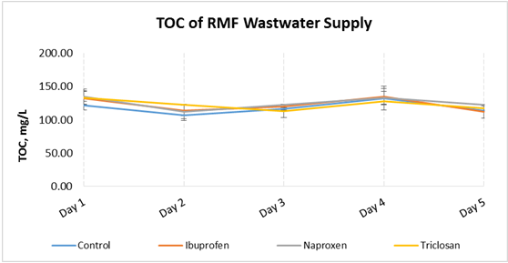
Figure 23. TOC within the RMF supply over a 5 day period after methanol solution addition; n = 2 weeks. Two-way ANOVA analysis showed no significant changes in TOC (P=0.85, alpha=0.05), maintaining a mean TOC of 120±11.7.

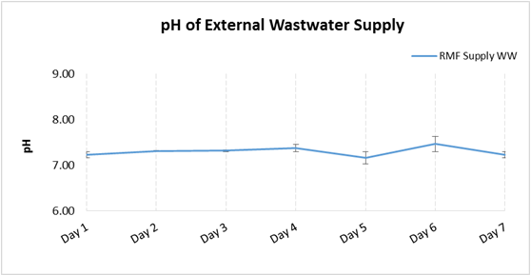
Figure 24. pH within the external wastewater supply over a 7 day period; n = 2 weeks. Two-way ANOVA analysis showed no significant changes in pH (P=0.78, alpha=0.05), maintaining a mean pH 7.21±0.11.


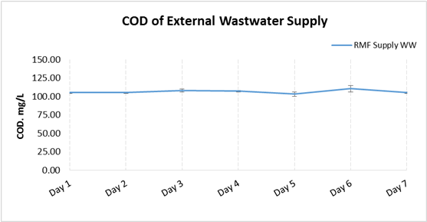
Figure 25. COD within the external wastewater supply over a 7 day period; n = 2 weeks. Two-way ANOVA analysis showed no significant changes in COD (P=0.99, alpha=0.05), maintaining a mean COD of 106±9.31.

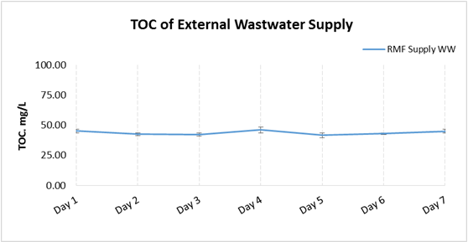
Figure 26. TOC within the external wastewater supply over a7 day period; n = 2 weeks. Two-way ANOVA analysis showed no significant changes in TOC (P=0.54, alpha=0.05), maintaining a mean TOC of 43.6±1.77.

PPCP Compound Extraction and Detection
Alongside proper inoculation of the system, it was also important to be able to appropriately determine each of the target compounds through GC-MS analysis at varying concentrations. Four standards of each of the analytes were created at concentrations of 0.1, 0.5, 1.0, and 2.0 ppm. They were dissolved in a methanol solution. Three procedures were required: solid phase extraction (SPE), derivatization, and GC-MS analysis. However, it was first important to be able to determine the retention time of IBU, NAP, and TRI.

Qualitative Methods of SPE and GC-MS Analysis
Standard samples were prepared differently during SPE and derivatization to help determine what outcome provided the best retention time and compound identification of all three compounds during GC-MS. These differences included experimenting with different cartridge base packing, elution material, and derivation solutions.
To ensure that the SPE procedures were done appropriately, different options were considered through literature review and lab testing. It was important that different types of cartridges, solvents, and volume amounts were tested. Focusing on only acidic and phenolic compounds for this project, reverse phase type cartridges were selected, and C-8 and C-18 base packages were studied. C-18 cartridges were found to not only provide a higher extraction efficiency, but were able to appropriately extract all target compounds. The SPE procedure mentioned in the previous chapter is what was decided upon as best for detecting all three target compounds. This procedures was heavily influenced from Samaras et al., 2010.
When performing SPE, it is impossible to extract 100% of the target compounds from the water sample. Therefore, it is necessary to determine the overall extraction efficiency of the procedure. To do this, two sample sets were created: one that underwent SPE and one that will not. The samples that were to not go through SPE were instead directly sent through derivatization and then GC-MS, so that no compounds would be lost. For the other sample set, distilled water samples were spiked to varying concentrations and SPE performed. The extraction efficiency of each of the samples, when compared to those that weren’t extracted, are shown below in Table 11. One-way ANOVA showed a significant difference between expected concentrations and extracted concentrations (P>0.01, alpha = 0.5)

  - Table 11. Average extraction efficiency of SPE procedures at varying concentrations of standard additions.
 | Extraction Efficiency
Expected Concentration | Ibuprofen | Naproxen | Triclosan
0.1 ppm | 85.1% ± 0.02 | 74.9% ± 0.01 | 70.7% ± 0.01
0.5 ppm | 78.8% ± 0.01 | 75.6% ± 0.01 | 76.6% ± 0.02
1.0 ppm | 77.7% ± 0.04 | 73.5% ± 0.03 | 72.6% ± 0.01
2.0 ppm | 83.8% ± 0.12 | 80.4% ± 0.08 | 75.1% ± 0.07
Average Efficiency | 81.3% ± 0.05 | 76.1% ± 0.03 | 73.7% ± 0.03

Different combinations of silyating reagents at different volumes were experimented with, and it was decided that 0.25 mL of BSTFA+1%TMCS and acetonitrile supplied the best results. After derivatization samples were heated for 1 hour and placed in a desiccator overnight, they were analyzed with GC-MS. This analytical procedure was copied from Samaras et al., (2010) and not changed. Calibration of the system was important to determine if different concentrations of the analytes could be linearly graphed, as seen in figure 27. Initially, the varying concentrations were set to 0.4, 0.8, 2.0 and 4.0 ppm, and later checked again with lower concentrations down to 0.1 ppm.
With the calibration of each compound, the next step was to determine appropriate retention times. As each compound is pulled through the GC oven, they are done so at different speeds because of their differences in molecular make-up. Therefore, the compounds are each detected with the MS at a different time, thus all having a unique retention time. The GCMS instrument is able to take each compound’s retention time, calculate the area under the curve of the intensity of the compound, and read it as a corresponding concentration. Figure 28 appropriately shows the intensity of each of the compounds detected at concentrations of 0.5 and 1.0 ppm at its own retention time. Therefore, knowing the retention times, as shown in table 12, will allow the researcher to identify the compound in an unknown sample.

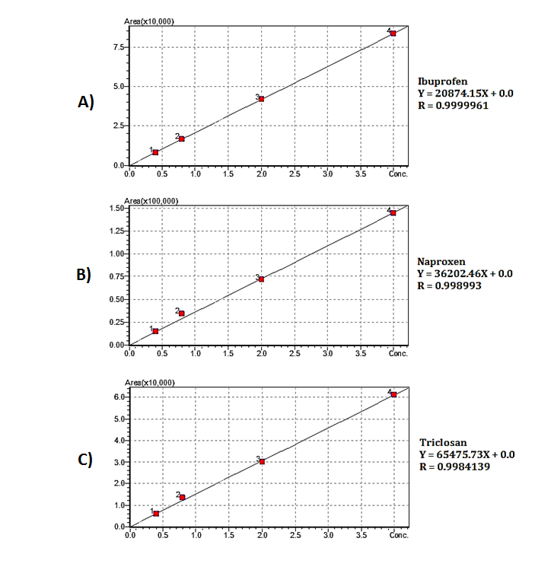
Figure 27. Calibration curves of target compounds IBU (a), NAP (b), and TRI (c); points 1, 2, 3, and 4 are concentrations at 0.4, 0.8, 2.0, and 4.0 respectively.
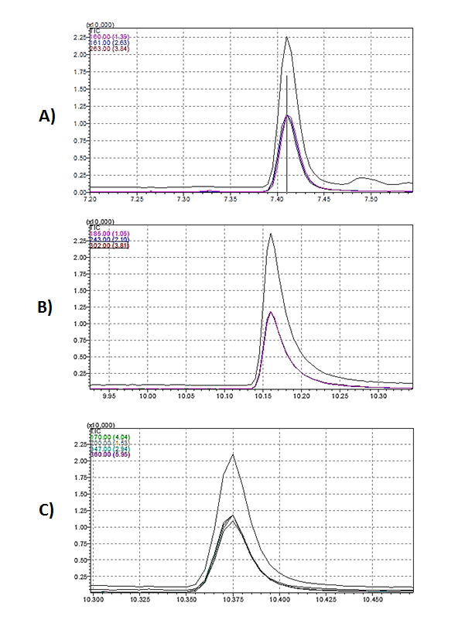
Figure 28. Corresponding retention times of the target PPCPs, IBU (a), NAP (b), and TRI (c), at 1.0 ppm and 2.0 ppm.

  - Table 12. Corresponding retention times of the target compounds.
Target Compound | Retention time (min)
Ibuprofen | 7.4
Naproxen | 10.2
Triclosan | 10.4

Traditional Water Quality Analysis
RMFs are intended for the treatment of domestic wastewater. These systems are not monitored around the clock as typical of large-scale treatment plants, so it is important that these systems are stand-alone and designed to handle most levels of wastewater strength. Before the effluent from these systems is released back into the environment, it is important that RMFs are tested early on for basic water quality treatment. Although this was a lab-scale study and treating a small amount of water, these parameters were still equally as important to monitor.
There are three experimental columns, and one controlled column. The experimental columns, titled after the target compound administered into the supply tank, were all compared to each other and the control column, which received no compound addition. However, because the standards were the compounds dissolved in a methanol solution, and equal amount of methanol was added to the control column to control the amount of variability between columns.

pH Stabilization
Over the entire course of the study, pH levels stayed relatively neutral within 6.3 – 7.9, as can be seen in figure 29 and 30. Two-way ANOVA with replication showed no significant changes of pH means between columns and days (P = 0.99, alpha = 0.05), as well as the effluent between weeks (P=0.97, alpha=0.05). The overall mean pH of the effluent was 7.03±0.21. These are adequate for nitrification. If pH levels were to drop or increase significantly, nitrification could be inhibited. Results have shown that there is little to no variability between columns when it comes to monitoring pH levels, and likewise when comparing initial values to final effluent values.

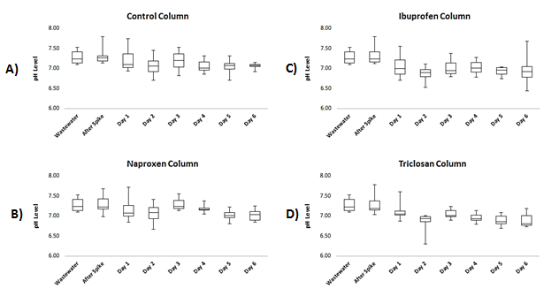
Figure 29. pH in each column throughout study; Control (a), IBU (b), NAP (c), and TRI (d). Minimum, maximum, median, and 1st - 3rd quartiles shown; sample size n = 8 weeks. No significant changes were seen between the columns and days (P=0.99).

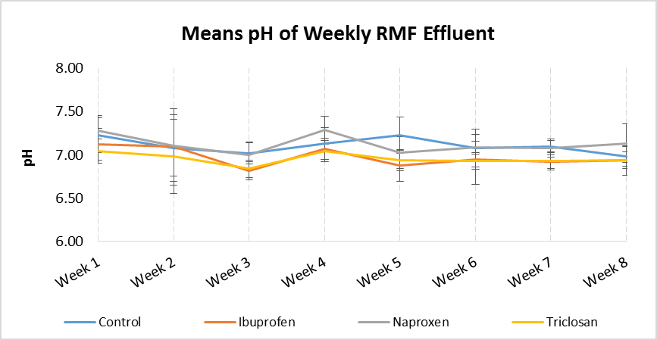
Figure 30. Means of pH of effluent for each week; n = 7 days. No significant changes were seen between columns and weeks (P=0.37, P=0.96) with a mean effluent pH of 7.03±0.21.

COD and TOC Reduction
Figure 31 shows that the mean COD and TOC measurement for the initial wastewater were measured to be 184.0±18.3 and 16.8±9.42 mg/L, respectively, with an almost three-fold increase in levels after the addition of the methanol standard. For COD, two-way ANOVA means comparison show a significant difference (P>0.1, alpha=0.5) between original wastewater, after spike, and the days following, however there were no significant differences between columns (P=0.98, alpha=0.05). There were also slightly significant differences of the mean effluent each week (P=0.06, alpha=0.05), but none between columns (P=0.98, alpha=0.05). The overall COD of the effluent was 65.5±36.4 mg/L. Likewise for TOC, ANOVA mean comparison showed a significant difference (P>0.01, alpha=0.05) between wastewater, after spike, and the days following, and no significant changes between columns (P=0.33, alpha=0.05). There were significant differences between the mean effluent over the weeks (P=0.03, alpha=0.05), but none between columns (P=0.39, alpha=0.05). The mean TOC of the effluent was 12.6±8.38.
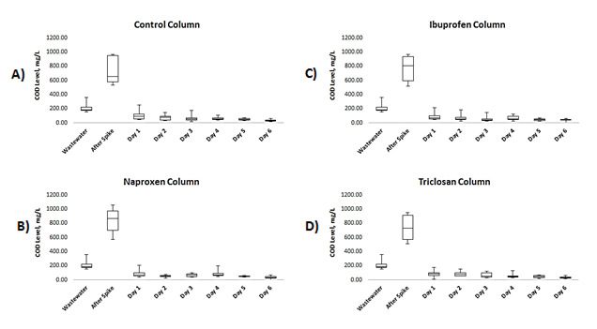
Figure 31. COD in each column throughout study; Control (a), IBU (b), NAP (c), and TRI (d). Minimum, maximum, median, and 1st - 3rd quartiles shown; sample size n = 8 weeks. Significant changes were seen over the days (P>0.01), but none between columns (P=0.98).

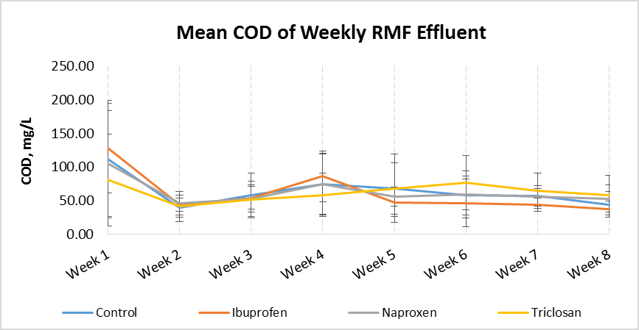
Figure 32. Means of COD of effluent for each week; n = 7 days. No significant changes were seen between columns (P=0.98), but were slightly significant between weeks (P=0.06). Mean effluent COD of 65.5±36.4 mg/L.
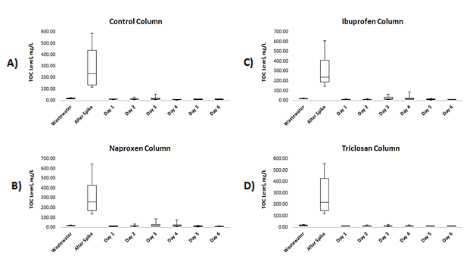
Figure 33. TOC in each column throughout study; Control (a), IBU (b), NAP (c), and TRI (d). Minimum, maximum, median, and 1st - 3rd quartiles shown; sample size n = 8 weeks. Significant changes were seen over the days (P>0.01), but none between columns (P=0.33)

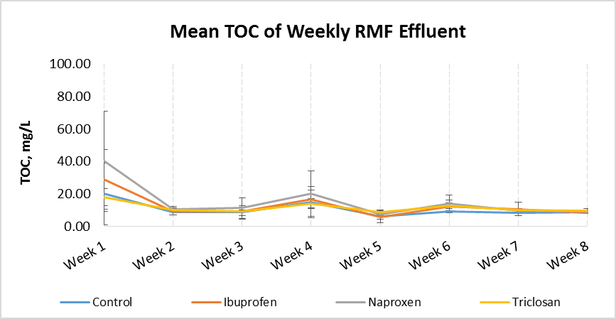
Figure 34. Means of TOC of effluent for each week; n = 7 days. No significant changes were seen between columns (P=0.39), and significant between weeks (P=0.03). Mean effluent TOC of 12.6±8.38 mg/L.

TN Reduction
An important note is that TN was not monitored until halfway through the project, therefore the data only represents four weeks of collected data. The average TN levels of the original wastewater was approximately 35±2.97 mg/L, which is considered average for domestic wastewater. Each column experiences a wide range of TN reduction, anywhere from 28.5 – 83.9% reduction from original levels. Two-way ANOVA means comparison showed that slightly significant differences were found between the original wastewater, after spike, and following days (P>0.01, alpha=0.05), and there were also significant differences between the weeks (P=0.01, alpha=0.05). There were also significant differences of the mean effluent each week and the columns (P>0.01, alpha=0.05). The overall COD of the effluent was 15.2±5.3 mg/L.
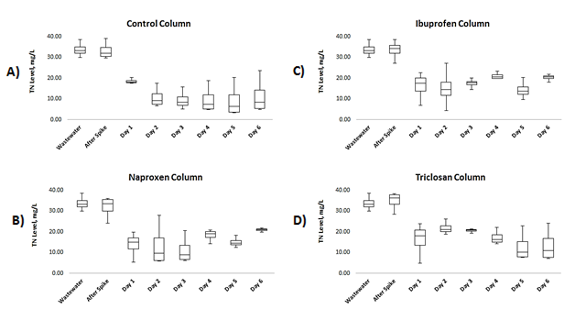
Figure 35. TN concentration in each column for the last four weeks of study. Minimum, maximum, median, and 1st, 2nd, and 3rd quartiles shown; sample size n = 4 weeks. Significant changes were seen over the days (P=0.09), a well as between weeks (P=0.92).

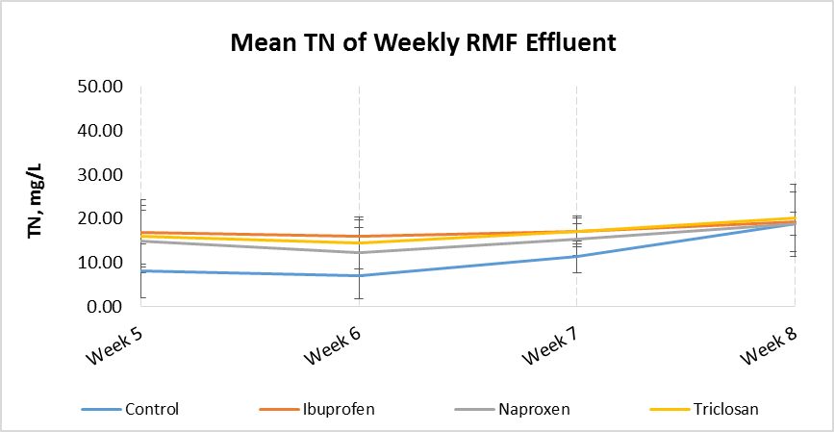
Figure 36. Means of TN of effluent for each week; n = 7 days. Significant changes were seen between columns and weeks (P>0.01). Mean effluent TOC of 15.2±5.93 mg/L.

What is interesting to note are the differences in reduction from column to column, which is unlike what was seen when monitoring pH, COD, and TOC. The control column, which received no additional compound, had an early drop in N levels after treatment and generally shown no large changes from that point out, settling around 5 - 10 mg/L until a shift in the final week. The TRI column showed a gradual decrease of nitrogen, finally ending around 8 – 10 mg/L, not unlike the control column. In comparison, the IBU and NAP columns showed the lowest removal rates, with an average concentration o20 mg/L by the end of each week.

PPCP Removal Analysis
The law of conservation states that matter cannot be created or destroyed, and therefore, anything that entered into the system ultimately was removed from the system. However, this removal occurs in different forms, such as effluent release, adsoption, and microbial degradation. A mass balance equation, Eq. 1 and Eq. 2, is shown below to help calculate these different removals.
 | $$\sum{{PPCPs}_{in}}= \sum{{PPCPs}_{out}}$$ | (Eq. 7)
 | $${PPCSs}_{ww}+{PPCSs}_{added}= \\ {PPCPs}_{released}+{PPCPs}_{sorption}+{PPCPs}_{degraded}$$ | (Eq. 8)
When calculating removal rates, it is important to understand that there already is a small concentration of trace organics already present within the wastewater. Calculating how much is added into the system will allow you to have your true input concentration of the PPCPs. Total removal is calculated as the “disappearance” of the organics, comparing the concentration of the effluent to the influent. This “disappearance” can be further evaluated by the determination of the organics that have become adsorbed into the collected sludge or biofilm within the system. Once this has been determined, a percentage of removal from either sorption of microbial degradation can be found.

PPCP Effluent Release
PPCP removal was seen almost immediately after treatment began, as can be seen in figure 37. The example graph represents data collected three weeks into treatment. The control column experienced the highest removal, with the complete disappearance of IBU and NAP, and >90% of TRI. The experimental columns experienced similar removal rates of IBU (89-93%), NAP (86-100%), and TRI (83-90%). This trend was common during the first half of the project. However, after 5 weeks of treatment there were noticeable changes in removal rates in all experimental columns, but not the control. An example of this change can be seen in figure 38, which is showing seventh week of treatment.

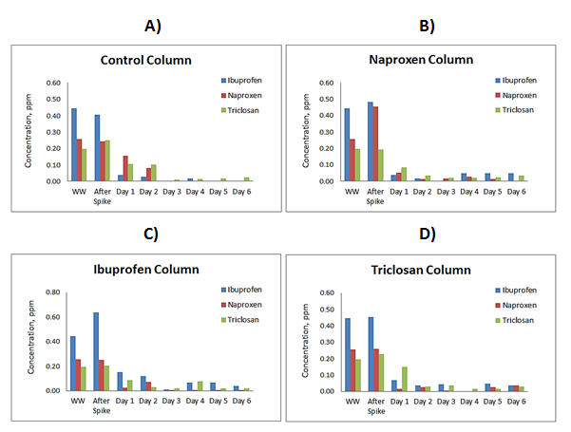
Figure 37. Third week of PPCP concentrations from collected water samples for each of the columns: Original wastewater (WW), after standard addition (after spike), and days after treatment

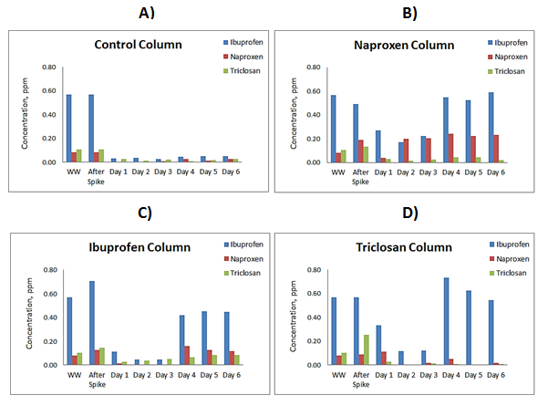
Figure 38. Seventh week of PPCP concentrations from collected water samples for each of the columns: Original wastewater (WW), after standard addition (after spike), and days after treatment

During the second half of the study, although the control column showed a minute decrease in removal as compared to previous weeks, the experimental columns showed signs of PPCP concentration growth. Since it is very unlikely that trace organics were produced within the columns, it was assumed that any organics that have become adsorbed previously were now desorbing and released into the effluent. Reduction rates for the PPCPs within the experimental columns ranged from 21-55% (IBU), 1.5-62% (NAP), and 58-96% (TRI). The acidic pharmaceuticals interestingly took the largest dive, while TRI was only slightly affected. By the end of the experiment, mean removal rates were calculated for each column (figure 39).

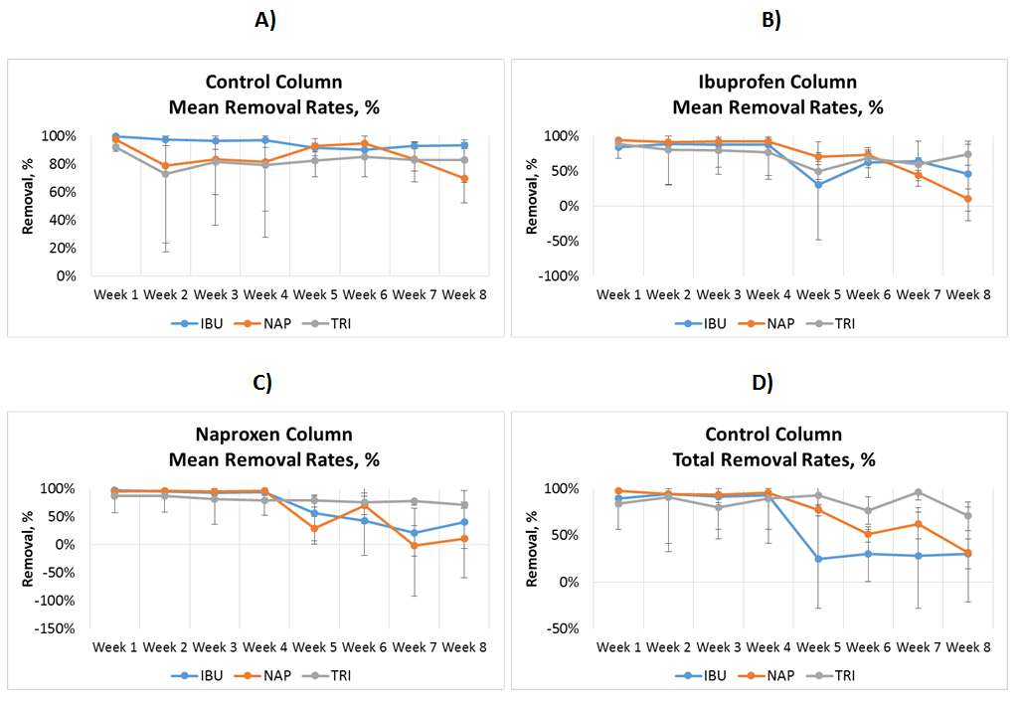
Figure 39. Total averaged removal rates from 8 weeks of treatment within each of the columns

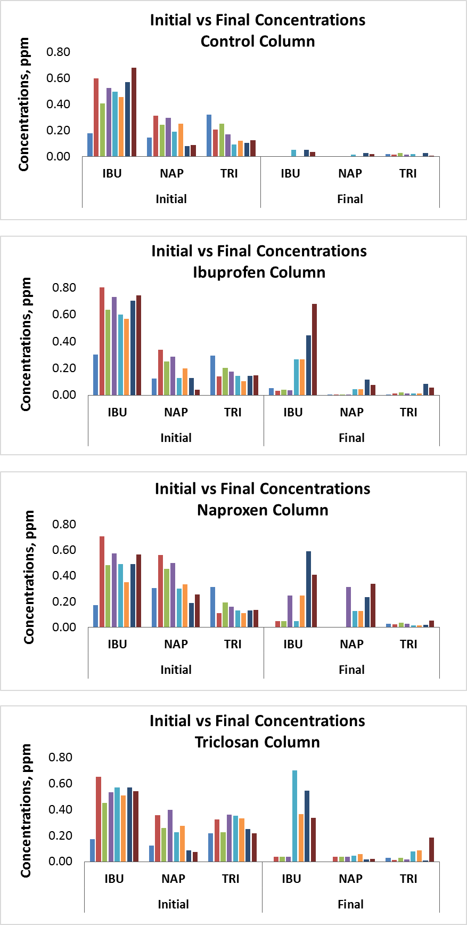
Figure 40. Ending concentrations from column effluent from all 8 weeks of treatment. Initial represents concentrations after spike, and final represents released PPCPs at the end of the week.
Two-way ANOVA analysis showed that over the course of the study, the control column saw no significant differences between the weeks (P=0.14, alpha=0.05), however there were significantly different removal rates between the columns (P>0.01, alpha=0.05). In contrast, both the IBU and NAP columns saw significant removal rate differences over the weeks (P>0.01, alpha=0.05) and no difference of removal between the compounds. This difference by week can graphically be seen in the previous figures when the negative removal rates occurred. Likewise, the TRI columns saw significantly difference removal rates over the weeks (P=0.02, alpha=0.05), however there were also significant differences in removal between the compounds as well (P=0.04, alpha=0.05).
However, when you separate the weeks where the change in removal seemed to have occurred (Week 5), much different removals are seen: 95% (Weeks 1-4) and 21% (Weeks 5-8) of IBU, 97% (Weeks 1-4) and 19% (Weeks 5-8), and 89% (Weeks 1-4) and 78% (Weeks 5-8) of TRI. TRI, once again, was the trace organic that remained the most unaffected from the changes. A graphical representation of these changes can be seen in figure 41. Two-way ANOVA showed that there were significant differences of PPCP removal over the weeks of the study (P=0.009, alpha=0.05). After separating Weeks 1-4 and Weeks 5-8, it is also clear to see to see differences in standard deviations; Weeks 1-4 has a mean difference of 3% while Weeks 5-8 had a mean difference of 18%.
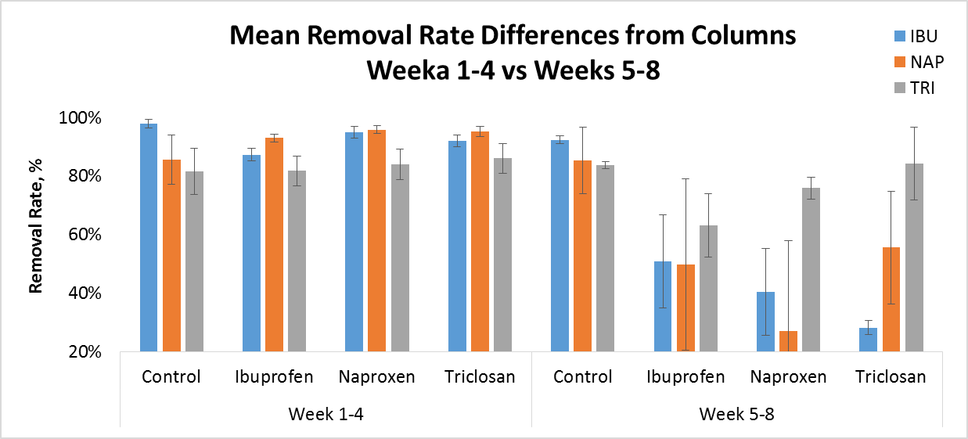
Figure 41. Differences in means of total removal for all of the columns between Weeks 1-4 and Weeks 5-8, n=4 weeks.

PPCP Adsorption to Biofilm
Media samples from each of the columns were collected from different depths (top, middle, ad bottom layer) for analysis on the biofilm present. Initially, simple loss on ignitions (LOI) tests were performed to determine the amount of organics present between each of the layers. Two-way ANOVA means comparison confirmed that there were statistical differences between the organics present within the layers (P>0.01, alpha=0.05) and no significant differences between columns (P=0.68, alpha=0.05). LOI measurements showed that the highest percentage of organics were consistently present in the top layers (3.4-3.8%) of the columns, with minimal shown in the middle and bottom (0.45-0.83%). Results like these are expected from RMFs, because the biofilm typically forms within the first 6” of media. Therefore, it can be stated that most of the biological treatment within the system was occurring within the uppermost layers of the column.
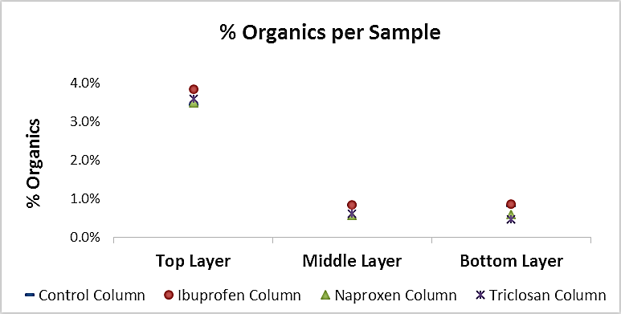
Figure 42. Percentage of organics present within each of the layers of each columns; n = 3. SD of columns are: 0.2% control, 0.5% ibuprofen, 0.07% naproxen, and 0.06% triclosan.

The reconstitution of the biofilm into a clean water sample so that SPE could be performed was the next test. This reconstitution was necessary to separate the PPCPs from the biofilm and into a liquid matrix for analysis. Two separate SPE procedures were performed on the media; triplicates was not possible because of the limited amount of media that was available for testing.
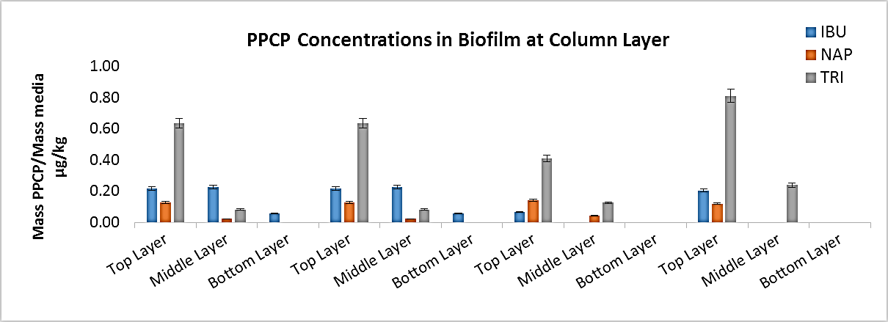
Figure 43. Mean trace organic concentrations per gram of media for each of the columns at varying locations (top, middle, bottom layers); n = 2.

Two-way ANOVA analysis showed significant differences of the amount of PPCP adsorbed in each of the layer (P=0.04, alpha=0.05), however, there were no significant differences between columns (P=0.89, alpha=0.05). Most of the adsorbed trace organics are shown to be within the top layer of the columns, which correlated to the LOI data presented earlier. However, there was an adequate amount of PPCPs detected within the middle layer as well. Comparing the mass of organics found to be adsorbed onto the biofilm to the mass or organics that were originally introduced into the system, it was found that 0.61% of IBU, 0.60% of NAP, and 4.92% of TRI of the total organics were removed through sorption after 8 weeks of treatment.

PPCP Microbial Degradation
Degradation rates of the targeted trace organics can be determined through the law of conservation. With degradation left as the unknown, it was calculated that after 8 weeks of treatment 84.9% of IBU, 87.8% of NAP, 86.8% of TRI was removed through microbial degradation. From these numbers, it can be assumed that if nitrifying bacteria played a key role in the degradation of these PPCPs, there would be more present within the experimental columns than control, which did not receive additional PPCP addition.

Final Calculated Removal
Total mean removals were then calculated using eq. 8 and substituting

  - Table 13. Mean removals (released, adsorbed, or degraded) of trace organics within each column; n = 8 weeks.
 | Released, %
Compound | Control  Column | Ibuprofen Column | Naproxen Column | Triclosan Column
Ibuprofen | 2.7% | 17.7% | 16.5% | 21.8%
Naproxen | 7.2% | 9.6% | 18.3% | 9.8%
Triclosan | 9.3% | 13.4% | 9.8% | 9.5%
 | Adsorbed, %
Compound | Control  Column | Ibuprofen Column | Naproxen Column | Triclosan Column
Ibuprofen | 0.5% | 0.3% | 0.2% | 0.2%
Naproxen | 0.7% | 0.2% | 0.0% | 0.5%
Triclosan | 4.3% | 0.7% | 0.0% | 5.1%
 | Biodegraded, %
Compound | Control  Column | Ibuprofen Column | Naproxen Column | Triclosan Column
Ibuprofen | 96.8% | 82.0% | 83.4% | 78.0%
Naproxen | 92.0% | 90.2% | 81.7% | 89.6%
Triclosan | 86.4% | 85.9% | 90.2% | 85.4%

Biofilm qPCR Analysis

Quantification of amoA genes
The relative abundance of the targeted genes were calculated from the ratio of detected N. oligotropha-like amoA copies to the mean number of all bacteria present within the samples, which was found to be 1.87x10⁹ 16S rDNA copies/L. Therefore, the relative abundance of the amoA copies/L ranged from 0.01-0.012%. The number of cells per gram of N. oligotropha-like amoA from the biofilm samples were calculated from copies/L using several assumptions with gene copies per cell, as performed by Harms et al. (2003). The assumptions were that the averaged 16S rRNA gene copies per genome in bacterial cells were 3.6 copies based on the average 16S rRNA gene copies found in cultured bacteria, and that one cell of N. oligotropha was assumed to contain 2 copies of amoA. Using these calculations, the total amount of cells/L was determined (figure 44).
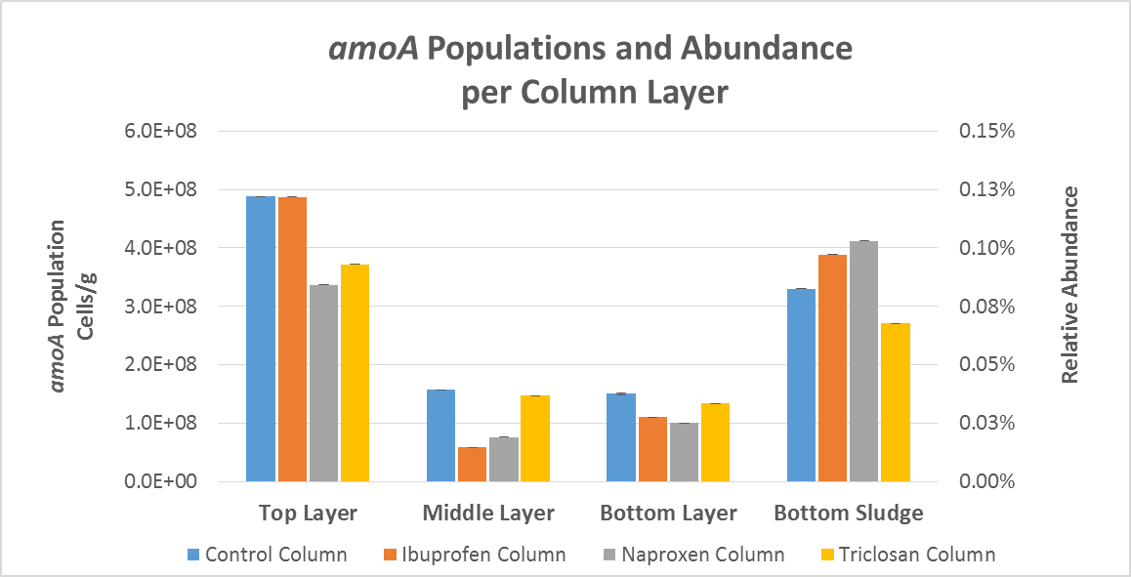
Figure 44. Normalized amoA populations (cells/g) of columns, separated by location (top, middle, bottom layers)

The averaged bacteria counts show that the highest AOB populations are present within the top layer and the sludge that was collected at the very bottom of the column. This was confirmed through two-way ANOVA analysis, showing that there were statistical differences of population counts between column layers (P>0.01, alpha=0.05) and also that there were no statistical differences between columns (P=0.76, alpha=0.05). It should be noted that these counts represent only the presence of AOB genes, and does not distinguish a difference between active and inactive bacteria. Interestingly enough, there were no significant population differences between columns. Therefore, the counts were averaged together to represent a total expected count of an RMF by layer. From the entire system, the top layer consisted of a mean 4.3x10⁸ cells/g of N. oligotropha-like amoA, followed by 1.1x10⁸, 1.2x10⁸, and 3.6x10⁸ for the middle & bottom layers, and collected sludge, respectively.

Quantification of nirS genes
In addition to the quantification of the nitrifying bacteria, denitrifying bacteria were measured to determine the potential for denitrification within the columns as well. The relative abundance was determined from the ratio of the nirS copies/L to the 16S rDNA copies/L, just as what was done with the amoA genes. The relative abundance of the nirS copies/L ranged from >0.01-0.04%. The number of cells per gram of nirS genes were calculated from assumptions with gene copies per cell, as performed by Ward et al. (2007). The assumptions were that nirS genes contained one copy per cell. Using these calculations, and after normalizing the data to represent the bacterial cells per gram of media within each of the layers, figure 45 was created.
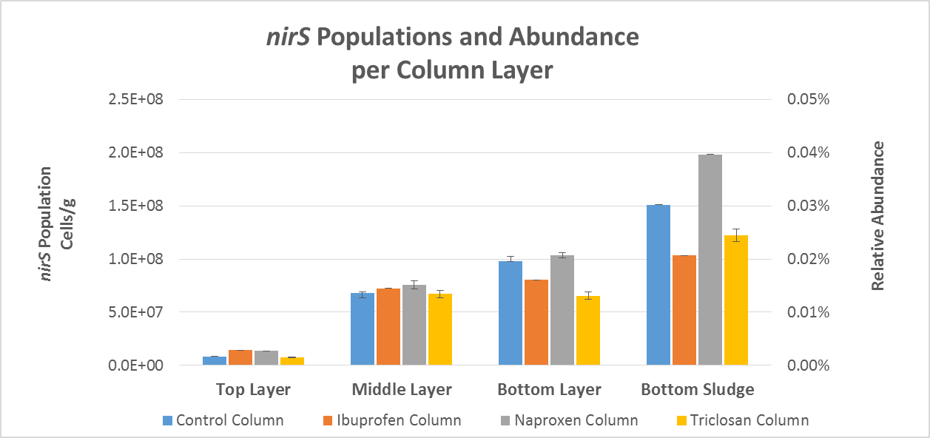
Figure 45. Normalized nirS populations (cells/g) of columns, separated by location (top, middle, bottom layers)

Two-way ANOVA showed a significant difference of population counts between layers (P>0.01, alpha=0.05) and no statistical differences between columns (P=0.17, alpha=0.05). The averaged bacteria counts show that the highest nirS gene populations are present within the bottom layer and the collected sludge. Unlike with the amoA genes, there were significant differences of populations between columns as well (P>0.01, alpha=0.01). The counts were then grouped together to represent a total expected count of an RMF by layer. From the entire system, the top layer consisted of an average 1.0x10⁷ cells/g of nirS genes, followed by 6.5x10⁷, 8.2x10⁷, and 1.26x10⁸ for the middle & bottom layers, and collected sludge, respectively.
Figure 46 shows how the populations of the targeted amoA and nirS genes change throughout the layers of the averaged columns. The data shows that there is a larger amount of ammonia oxidizing bacteria than denitrifying bacteria. Excluding the top layer, which was predominantly amoA genes, there was on averaged twice as many AOBs within the middle, bottom, and sludge samples than denitrifying bacteria.
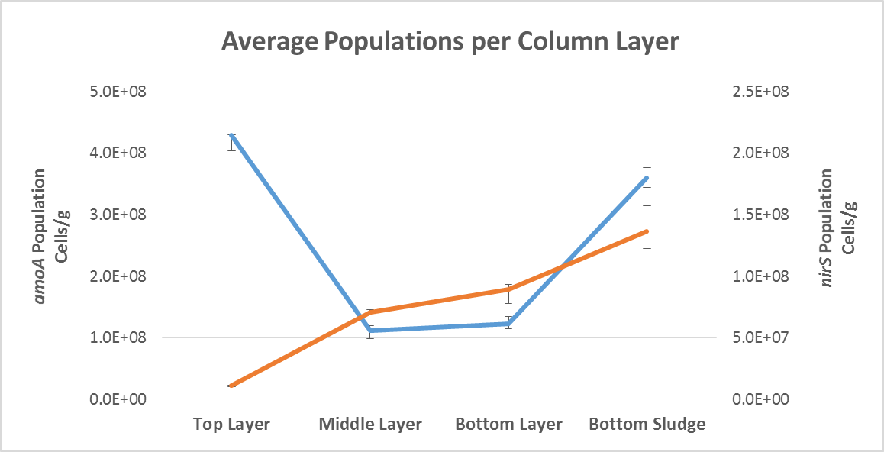
Figure 46. Mean column comparisons of population counts (cells/gram of media) between the targeted amoA and nirS genes, n=4 columns.

CHAPTER V: Discussion

RMF Effluent Quality
According to Metcalf et al. (2003) the averaged values documented for COD and TOC from the untreated wastewater for this study is considered a high-strength, when comparing to typical organic concentrations found. Taking this into consideration, the reduction values seen for organics, paired with the shown pH neutralization, has proven that the designed RMF is working commendably and producing a very high-quality effluent. Through the project, the average effluent levels were 7.03 pH, 54.8 mg/L COD, and 10.17 mg/L TOC.
Likewise, the overall reduction of nitrogen level within the effluent showed that nitrification and denitrification was occurring, dropping from 33.9 mg/L to an average of 14.4 mg/L. The drop in nitrogen was much less consistent than the drop in COD and TOC levels, but this is expected within a RMF (typically values are 30-80% reduction). Unfortunately, the TN data cannot be fully compared to the previous sets because total nitrogen values were only collected for the final four weeks of experimentation. Despite this, it can be said with confidence that if TN values were collected through the entirety of the project, similar values would have been collected.
Total nitrogen, as the name suggests, is the total concentration of all nitrogen including organic N, total ammonia N, and nitrate/nitrite N. Fixed-film treatment systems have shown to be quite good at removing total nitrogen, especially in regards to ammonia removal. Nitrification is especially known to occur within the top layer because it remains anaerobic and there is an abundance of microbial life. While the upper layer of the RMF remains aerobic, the lower half tends to be anoxic, and although denitrification is occurring, the treated water is re-introduced into aerobic conditions shortly after from exposure to oxygen when the lower valve is opened. It is from this back-forth cycling of aerobic to anaerobic conditions that lower TN reductions levels are expected, typically with a 40-80% reduction.

PPCP Removal

Total Reductions
Taking the entire project as a whole into consideration, the designed RMF was able to remove a high percentage of trace organics from the collected domestic wastewater, whether it be through sorption or degradation. The system was able to remove over 70% of the initial IBU and NAP from the system, and over 80% of the TRI. Most of the removal was calculated to be through compound breakdown rather than sorption.
The main area of discussion for this research is not about the overall removal rates of the system, but more so the drastic change in the experimental columns that occurred half way through. Both IBU and NAP experienced a >70% difference in removal starting the fifth week of treatment. This change remained the same for the remainder of the study. TRI experienced a similar drop, however, it was not nearly as significant, only a 11% change. The big questions to ask are: what prompted this change and why was TRI not nearly as affected?
The control column did not show any signs of change, and provided similar removal rates throughout the entirety of the study. Therefore, the questioned change can only be attributed to the standard addition to the experimental supply tanks. IBU and NAP are both acidic pharmaceuticals, and have been documented to be readily degradable, unlike TRI. TRI has been documented to more likely sorb onto another material than break down. After biofilm analysis to determine PPCP concentration, it was found that there was 6x more TRI (2.4% of total removal) sorbed onto the biofilm than IBU or NAP (0.4% of total removal). Because of the anti-bacteria properties of TRI, it is probable of a change on a bacterial level; more PPCP degrading bacteria were present during the beginning of the project and over time diminished from the continual sorption of TRI.
That being said, there was still a significant amount of removal from breakdown, an average of 71.4%, 78.5%, and 79.9% degradation of IBU, NAP, and TRI, respectively.

Negative Mass Balances
Within the last four week of experimentation, negative mass balances were calculated in all experimental columns. For the first half of the study, high removal rates were seen in all columns, for all compounds (>80% removal). However, an increase in IBU and NAP concentrations within the effluent began to show after the fourth week. This potentially was attributed to desorption occurring within the columns, and all compounds that were initially adsorbed onto the biofilm were being released or no longer removed from the influent.
This has become a frequent issue with many experimental studies, and reasons for this negative removal has been: improperly addressing the fluid dynamics of the system, compounds previously not detected in the influent are becoming retransformed into the original due to biological processed, desorption, and the potential release of PPCPs from fecal particles as the feces is broken down by microorganisms (Blair et al. 2015). While the release of PPCPs from enclosed fecal particles raised an interesting point, other reasons were not agreed upon, such as the retransformation back into the parent compound. While retransformation such as this is entirely possible, it does not seem likely that the energy for such a large flux of retransformation, along with all other biological processes that were occurring, was available.

Biofilm qPCR Analysis
The highest populations of AOBs in all four units were in the top layer, and decreased as the depth increased. This showed that aerobic conditions (possible nitrification) were more present in the top layer, and anaerobic conditions (possible denitrification) were present as the depth increased. In addition, the sludge collected at the bottom was found to have higher concentrations of AOB present than the sludge-free media samples in the middle and bottom layer. There are a few speculations as to why this occurred, first being that the last inch of the columns was filled with larger media (#55 crushed limestone) than what was used for the upper layers of the columns. The larger media infers that there were larger volumes of pocketed oxygen captured, allowing the growth and continuation of ammonia oxidizing bacteria. Likewise, it also cannot be stated that the lowest areas of the columns remained completly anaerobic because of the periods where effluent samples were collected and required time to refill. While the effluent jars were empty, the bottom gravel was exposed to the atmosphere through the three way valve and stainless steel tubing. This, coupled with the large volumes of pocketed air, would allow the continuation and possible re-growth of ammonia oxidizing bacteria under anoxic conditions.
In addition, denitrifying bacteria were also quantified through qPCR analysis from the biofilm samples. The results showed a rapid increase in nirS genes from the top layer to the very bottom of the columns. Unlike with the amoA genes, there was not a significant change in population counts between the bottom layer and collected sludge. Besides the top layer, which was predominantly ammonia oxidizing bacteria, there was a mean of twice as many targeted nitrifying bacteria found within the middle & bottom layers and collected sludge than targeted denitrifying bacteria. However, noticeable population for both genes show that nitrification and denitrification were likely occurring at the same time within the lower regions of the columns.
Simultaneous nitrification-denitrification within wastewater treatment systems is a phenomena that has been, and still is, an important area of research because of its potential for simplifying treatment processes and reduction of energy consumptions. However, this process has also been reported to emit a significant amount of N₂O, which is considered a critical green-house gas (Jia et al. 2013). Studies focusing on media filters have documented that because the factors affecting simultaneous nitrification and denitrification can change depending on media depth, media filters are quite capable of achieving this process (Nakhla and Farooq 2003).
Despite this, the results of this study show that although amoA and nirS genes are significant in most of the lower layers of the columns, there are more ammonia oxidizing bacteria present than denitrifying bacteria. It was questioned early in the project whether ammonia oxidizing bacteria could be attributed to playing a role in the degradation of the PPCPs. Unfortunately, the data collected cannot show if this is true because AOBs are able to co-metabolize, therefore growth cannot be attributed to degradation because they do not rely on the trace organics as a food source. If there were significant changes between the control column and experimental columns, perhaps a hypothesis could have been formed. All that can be states is that both ammonia oxidizing and denitrifying bacteria are present within the systems, and are allowing the possibility of PPCP degradation, but so are other forms of bacteria, such as heterotrophs.

CHAPTER VI: Conclusions

Conclusions
Although much research has been performed on the fate and transfer of PPCPs before and after wastewater treatment, there are still many challenges that remain, whether it be for small or large scale systems. There has not been enough questions answered that will allow a proper risk management procedure for the disposal or degradation of these trace organic compounds. It is unfortunately apparent that much more research is needed to determine a solution for all.
This research was not able to conclude whether AOBs were the main source of degradation for the three target PPCPs, as was questioned. Future work in this research, coupled with a continuous weekly monitoring of RMFs microbial community analysis, could provide an insight on what bacteria is flourishing or degrading while in the presence of TRI, which this study can conclude does have an impact on the effectiveness of a biological treatment system. In addition, it would also be important to identify and quantify the concentrations of the main metabolite of TRI, methyl-TRI, because of its known toxicity and more aggressive bioaccumulation in the environment than its parent compound.
The designed system was able to provide a superb high-quality effluent that meets EPA standards for environmental discharge, and also comparable PPCP removal rate to that seen from large scale treatment facilities. This project was able to simultaneously detect two different types of trace organic compounds (acidic and phenolic PPCPs) using one common method. It would be beneficial for future work to determine other methods that will provide the simultaneous detection of even more compounds.

LIST OF REFERENCES

Angkadjaja, S. 2007. What makes antibacterial soap antibacterial? University of South Carolina - Illumin Journal: 9(1): 17-20.

Buchanan, J.R. 2011. Recirculating packed-bed media filters. University of Tennessee – Department of Biosystems Engineering and Soil Science. Available at: http://www.txowa.org/pdf/19thAnnual/packedbed%20media%20filters%20Texas%202011.pdf. Accessed on: October 20 2015.

Burke, V., U. Duiennbier, G. Massman. 2013. The effect of aeration on the removal of wastewater-derived pharmaceutical residues from groundwater – a laboratory study. Water Science Technology 67(3): 658-665

Buser, H.R., T. Poiger, M. Muller. 1999. Occurrence and environmental behavior of the chiral pharmaceutical drug ibuprofen in surface waters and in wastewater. Environmental Science and Technology 33(15): 2529-2535.

CDC. 2013 Therapeutic drug use. National Center for Health Statistics. Available at: http://www.cdc.gov/nchs/fastats/drugs.htm. Accessed: July 03 2013.

Curiosity Aroused. 2015. What is the difference between ibuprofen and naproxen? Available at: http://www.curiosityaroused.com/health/what-is-the-difference-between-naproxen-vs-ibuprofen/. Accessed: June 11 2015.

Danielson, N.D, P.A. Gallagher. 2000. Chemical reagents and derivatization procedures in drug analysis. Encyclopedia of Analytical Chemistry: 7042–7076

Daughton, C G., Jones-Lepp, T.L. 2001. Pharmaceuticals and Personal Care Products in the Environment: Scientific and Regulatory Issues. Available at: http://www.pollutionissues.com/Co-Ea/Consumer-Pollution.html. Accessed: June 10 2015.
Davies, Neal M. 1998. Clinical pharmacokinetics of ibuprofen. Clinical Pharmokinetics: 34(2): 101-154

Davies, Neal M., Anderson, K.E. 1997. Clinical pharmacokinetics of naproxen. Clinical Pharmokinetics: 34(4): 268-293

Dobbs, R.A., L. Wang, R. Govind. 1989. Sorption of toxic organic compounds on wastewater solids: Correlation with fundamental properties. Journal of Environmental Science and Technology 23: 1092-1097.

Dubber, D., Gray, N.F. 2009. Replacement of chemical oxygen demand (COD) with total organic carbon (TOC) for monitoring wastewater treatment performance to minimize disposal of toxic analytical waste. Journal of Environmental Science and Health, Part A. 45(2010): 1595-1600

Fang, J.L., R.L Stingley, F.A. Beland, W. Harrouk, D.L. Lumpkins, P. Howard. 2010. Occurrence, efficacy, metabolism, and toxicity of triclosan. Journal of Environmental Science and Health 28(3): 147-171.

FDA – Food Drug Administration. 2013. Triclosan: what consumers should know. Available at: http://www.fda.gov/ForConsumers/ConsumerUpdates/ucm205999.htm. Accessed: June 11 2015.

Flower, Rod J. 2003. The development of COX-2 inhibitors. Nature Reviews Drug Discovery. 2(3):179–191

Gerlich, Ryan. OSSF: Onsite Wastewater Treatment Systems. Texas A&M Agriculture Extension. Available at: http://ossf.tamu.edu/onsite-wastewater-treatment-systems-owts/. Accessed: October 23 2013.

Gomez, M.J., A. Aguera, M. Mezcua, J. Hurtado, F. Mocholi, A.R. Fernandez-Alba. 2007. Simultaneous analysis of neutral and acidic pharmaceuticals as well as related compound’s by gas chromatography-tandem mass spectrometry in wastewater. Talanta 73(2007): 314-320

Grenni, P., L. Patrolecco, N. Ademollo, A. Tolomei, A.B. Cararriolo. 2013. Degradation of gemfibrozil and naproxen in a river water ecosystem. Microchemical Journal 107(2013): 158-164

Halecky, M., P. Karlova, J. Paca, et al. 2013. Biodegradation of a mixture of mononitrophenols in a packed-bed aerobic reactor. Journal of Environmental Science and Technology, Part A 48: 989-999

Halford, B. 2008. Side Effects. Chemical & Engineering News 86(8): 13-17.

Hantzch, G. 2007. Recirculating media filter technology assessment and design guidance. Iowa Department of Natural Resources. Available at: file:///C:/Users/bperez/Downloads/dg_recirc_mf_manual.pdf. Accessed: June 11 2015.

Harms, G., A.C. Layton, H.M. Dionisi, I.R. Gregory, V.M. Garrett, S.A. Hawkins, K.G. Robinson, G.S. Sayler. 2003. Real-time PCR quantification of nitrifying bacteria in a municipal wastewater treatment plant. Journal of Environmental Science & Technology. 37(2): 343-351.

Hernandez, L.L. 2010. Removal of micropollutants from grey water: combining biological and physical/chemical processes. Sub-department of Environmental Technology. Available at: http://edepot.wur.nl/146492. Accessed: October 11 2015.

Hess-Fischl, A. 2015. Endocrine disrupting compounds (EDCs): key points from the endocrine society and IPEN institute. Available at: http://www.endocrineweb.com/professional/other-endocrine-disorders/endocrine-disrupting-chemicals-edcs-key-points-endocrine-soci. Accessed: June 1 2015.

Jia, W., S. Liang, J. Zhang, H.H. Ngo, W. Guo, Y. Yan, Y. Zou. 2013. Nitrous oxide emission in low-oxygen simultaneous nitrification and denitrification process: sources and mechanisms. Journal of Bioresearch and Technology 136(2013): 444-451.

Juretschko, S., Timmermann, G., Schmid, M., Schliefer, K., Pommerening-Roser, A., Koops, H, Wagner, M. 1998. Combined molecular and conventional analysis of nitrifying bacterium in activated sludge: Nitrococcus mobilis and Nitrospira-like bacteria as dominant populations. Application of Environmental Microbiology. 64(1998):3042-3051

Karnjanapiboonwong, A., Suski, J.G., Shah, A.A.,Cai, Q, Morse, A.N., Anderson, T.A. 2010. Occurrence of PPCPs at a wastewater treatment plant and in soil and groundwater at a land application site. Journal of Water, Air, and Soil Pollution. 216(2011): 257-273.

Krkosek-Payne S.J., G.A. Gagnon. 2014. Removal of acidic pharmaceuticals within a nitrifying recirculating biofilter. Journal of Hazardous Materials 273: 85-93.

Kummerer, K. 2008. Pharmaceuticas in the environment: sources, fate, effects, and risks.

Kummerer, K. 2009. The presence of pharmaceuticals in the environment due to human use – present knowledge and future challenges. Journal of Environmental Management 90(2009): 2354-2366

Langenhoff, A.; N. Inderfurth; T. Veuskens; G. Schraa; M. Blokland; K. Kujawa-Roeleveld; H. Rijnaarts. 2012. Microbial removal of the pharmaceutical compounds ibuprofen and diclofenac from wastewater. Hindawi Publishing Corportation 2013: 1-9.

Larsson, E., S. Al-Hamimi, J.A. Jonsson. 2014. Behavior of nonsteroidal anti-inflammatory drugs and eight of their metabolites during wastewater treatment studied by hollow fibre liquid phase microextraction and liquid chromatography mass spectrometry. Science of the Total Environment 458-486(2014): 300-308

Lee, C.O., Howe, K.Y., Thompson, B.M. 2009. State of knowledge of pharmaceutical, personal care product, and endocrine disrupting compound removal during municipal wastewater treatment. New Mexico Environmental Department. Available at: http://www.unm.edu/~howe/UNM%20Howe%20PPCP%20Final%20Report.pdf. Accessed on: April 20 2015.

Lesikar, B., C. O’Neil, D. Smith. 2014. Onsite Wastewater Treatment Systems. AgriLife Extension: Texas A&M System. Available at: http://texashelp.tamu.edu/005-agriculture/onsite-waste-water-treatment-systems.php. Accessed on: December 13 2014.

Lubliner, B., M. Redding, D. Ragsdale. 2010. Pharmaceuticals and personal care products in municipal wastewater and their removal by nutrient treatment techniques. Washington State Department of Ecology. Olympia, WA. Publication Number 10-30-004

Malik, O. 2014. Primary vs secondary: types of treatment processes. Environmental protection Index – Yale University. Available at: http://epi.yale.edu/case-study/primary-vs-secondary-types-wastewater-treatment. Accessed: June 1 2015.

Matamoros, V., C. Arias, H. Brix, J.M. Bayona. 2007. Removal of pharmaceuticals and personal care products (PPCPs) from urban wastewater in a pilot vertical flow constructed wetland and a sand filter. Environmental Science Technology 41: 8171-8177

Meige, C., J.M. Choubert, L. Ribeiro, M. Eusebe, M. Coquery. 2008. Removal efficiency of pharmaceuticals and personal care products with varying wastewater treatment processes and operating conditions – conception of a database and first results. Water Science and Technology 57(1): 49-56

Metcalf & Eddy., Tchobanoglous, G., Burton, F. L. 1., & Stensel, H. D. 2003. Wastewater engineering: treatment and reuse (4th ed.). Boston: McGraw-Hill.

Mohaptara, D.P., S.K. Brar, R.D. Tyagi, et al. 2011. Occurrence of bisphenol A in wastewater and wastewater sludge of CUQ treatment plant. Journal of Xenobiotics 1(2013): e3

Nakhla G. and S. Faroog. 2003. Simultaneous nitrification-denitrification in slow sand filters. Journal of Hazardous Materials 96(2-3): 291-303.

NIH – National Institute of Environmental Health Sciences. 2015. Endocrine disruptor research. Available at: http://www.niehs.nih.gov/health/topics/agents/endocrine/. Accessed: June 11 2015.

OrthoInfo. 2009. What are NSAIDs? American Academy of Orthopedic Surgeons. Available at: http://orthoinfo.aaos.org/topic.cfm?topic=a00284. Accessed: May 23 2015.

Pasquini, L., J.F. Munoz, M.N. Pons, J. Yvon, X. Dauchy, X. France, N.D. Le, C. France-Lanord, T. Gorner. 2014. Occurrence of eight household micropollutants in urban wastewater and their fate in a wastewater treatment plant. Science of the Total Environment 481(2014): 459-468.

Ricart, M., Guasch, H., Alberch, M., Barcelo, D., Bonnineau, C., Geiszinger, A., Farre, M., Ferrer, J., Ricciardi, F., Romani, A., Morin, S., Proia, L., Sala, L. 2010. Triclosan persistence through wastewater treatment plants and its potential toxic effects on river biofilms. Journal of Aquatic Toxicity: 100(4): 346-353.

Sabourin, L.; A. Beck; P.W. Duenk; S. Kleywegt; D.R. Lapen; H. Li; C.D. Metcalfe; M. Payne; E. Topp. 2009. Runoff of pharmaceuticals and personal care products following application of dewatered municipal biosolids to an agriculture field. Science of the Total Environment 407(2009): 4596-4604.

Samaras, V.G., N.S. Thomaidis, A.S. Stasinakis, T.D. Lekkas. 2010. An analytical method for the simultaneous trace determination of acidic pharmaceuticals and phenolic endocrine disruoting chemicals in wastewater and sewage sludge by gas chromatography-mass spectrophotometry. Analytical and Bioanalytical Chemistry 399: 2549-2561.

Sanchez-Prado, L, M Llompart, M Lores, et al. 2006. Monitoring the photochemical degradation of triclosan in wastewater by UV light and sunlight using solid-phase microextraction. Chemosphere 65: 1338-1347

Shi, J., S. Fujisawa, Nakai, S., Hosomi, S. 2004. Biodegradation of natural and synthetic estrogens by nitrifying activated sludge and ammonia-oxidizing bacterium Nitrosomonas europaea. Water Res. 38:2323-2330

Smith, J.A., P.J. Witkowski, T.V. Fusillo. 1988. Manmade organic compounds in the surface waters of the United States- a review of current understanding. U.S. Geological Survey Circular 1007: 92.

Snyder, S., P. Westerhoff, Y. Yoon, D. Sedlak. 2003. Pharmaceuticals, personal care products, and endocrine disruptors in water: implications for the water industry. Environmental Engineering Science 20(5): 449-469.

Solomon, C., P. Casey, C. Mackne, A. Lake. 1998. Recirculating sand filters. Available at: http://www.nesc.wvu.edu/pdf/ww/publications/eti/rsf_tech.pdf. Accessed: October 6 2014.

Throbäck, I.N., K. Ewall, A. Jarvis, S. Hallin. 2004. Reassessing PCR primers targeting nirS, nirK, and nosZ genes for community surveys of denitrifying bacteria with DDGE. FEMS Microbiology Ecology 49(2004): 401-417.

University of Exeter. 2014. Drugs in the environment affect plant growth. Available at: http://www.exeter.ac.uk/news/featurednews/title_425231_en.html. Accessed: June 11 2015.

Vajda, A.M., L.B. Barber, J.L. Gray, E.M. Lopez, J.D. Woodling, D.O. Norris. 2008. Reproductive disruption in fish downstream from an estrogenic wastewater effluent. Journal of Environmental Science and Technology 42(9): 3407-3414.

Walker, C.W., J.E. Watson. 2010. Adsorption of estrogens on laboratory materials and filters during sample preparation. Journal of Environmental Quality 39: 744-748.

Ward, B.B., D. Eveillard, J.D. Kirshtein, J.D. Nelson, M.A. Voytek, G.A. Jackson. 2007. Ammonia-oxidizing bacterial community composition in estuarine and oceanic environments assessed using a functional gene microarray. Journal of Environmental Microbiology 9(10): 2522-2538.

Wayland III, R.H., E.T. Opellet. 2002. Onsite wastewater treatment systems manual. Office of Research and Development. EPA/625/R-00/008.

World Bank Group. 2015. The introduction to wastewater treatment processes. Available at: http://water.worldbank.org/shw-resource-guide/infrastructure/menu-technical-options/wastewater-treatment. Accessed: June 12 2015.

Xia, K., A. Bhandari, K. Das, G. Pillar. 2005. Occurrence and fate of pharmaceuticals and personal care products (PPCPs) in biosolids. Journal of Environmental Quality 34: 91-104

Yu, T.H., Lin, A. Y.C., Panchangam, S.C., Hong, P.K., Yang, P.Y., Lin, C.F. 2011. Biodegradation and bio-sorption of antibiotics and non-steroidal anti-inflammatory drugs using immobilized cell process. Chemosphere – Science for Environmental Technology. 84(9): 1167-1300

Zimmerman, M., G. Heufelder. 2006. Effectiveness of selected onsite wastewater-treatment systems in removing pharmaceuticals and personal-care products. Massachusetts Department of Environmental Protection. Available at: http://www.neiwpcc.org/ppcpconference/ppcp-docs/MarcZimmerman.pdf. Accessed on: October 20 2015.

Zhou, L., Mancl, K. 2007. Calculating load rates for the design of small flow onsite wastewater treatment systems – hydraulic vs organic loading. Ohio State University Extension Fact Sheet. AEX-756: 1-2

APPENDIX

VITA
Brittani Nikole Perez is originally from Baltimore, Maryland. She attended Towson Catholic High School and completed her coursework in 2008. Following this, she moved to Dandridge, Tennessee to attend the University of Tennessee in Knoxville. She received her Bachelor of Science with a major in Biosystems Engineering in May 2013. During her years as an undergraduate she worked under Dr. John Buchanan in the wastewater lab of the Biosystems Engineering & Soil Science Department. After graduation, she was accepted into graduate school to achieve her Master’s of Science in Biosystems Engineering & Soil Science along with a Watershed minor. As a graduate student, she was both a Research Assistant and a Teaching Assistant for Drs. John Buchanan and William Hart. She will be graduating in December 2015.

