Rare Earth Production and Characterization Studies

A Dissertation Presented for the

Doctor of Philosophy

Degree

The University of Tennessee, Knoxville

Jake Anson Stewart

August 2015

Copyright © 2015 by Jake Anson Stewart

ACKNOWLEDGEMENTS

I would like to acknowledge colleagues that have collaborated with me on these projects: Kyler Thomas, John Cadotte, Mark Hipshire, Josh Alfrey, Jordan Hellman, Casey Dominguez, Alex Williams, Kristin Forsberg, Dr. Dustin Collier, and Matt Dembo for their input and positive outlook on the projects were highly appreciated no matter how strange or difficult to figure out. I would also like to thank my advisor Dr. George Schweitzer for his patience, guidance, and support. Several other group members I would like to acknowledge helped mentor me in areas that I had minimal expertise were: Dr. Deborah Penchoff, Dr. Andrew Mabe, Dr John Auxier II, Elissa Lapoint, Amanda Jones, and Brittany Miner. I also would like to thank Siemens for their financial support and introduction to industry.

ABSTRACT

The rare earths include elements Sc, Y, and La through Lu are important in many modern technologies. With the exception of Sc and Ce the rare earths are all have similar chemical behaviors with the preferred oxidation state in aqueous solution being +3. Currently, industrial purification of the rare earths is completed by counter current solvent extraction (CCSX). In most CCSX separations, Y extracts with Ho making their separation difficult. However, in a few systems Y exhibits an itinerant behavior. Carboxylic acids of varying sizes and substitutions were investigated in a study of Y itinerant behavior. It was found when carboxylic acids have only one branch that was an alkyl group Y extracted with the early rare earths. As branches are added to the carboxylic acid Y extracted with the heavier rare earths.

This series of studies also investigated the rare earths with mechanochemical reactions. Lutetium oxyorthosilicate (LSO) was synthesized by mechanochemical methods using a planetary ball mill which is usually completed at high temperatures. It may be possible to reduce the rare earths using mechanochemical methods at room temperature with no solvents. Mechanochemistry may offer a new method of synthesizing rare earth compounds.

The final study involved lowering the operational costs of the production of LSO. Iridium is used as the crucible for melting LSO. It is a platinum group metal with a high value. However, during the synthesis of LSO iridium is lost to the insulating material by a vapor deposition process. A method to recover this lost iridium was developed using a gravity concentration method.

TABLE OF CONTENTS

Introduction 1
Chapter 1 Investigation of Itinerant Yttrium by Solvent Extraction Using Carboxylic Acids 4
Abstract 5
Introduction 5
Itinerant Yttrium 7
Experimental 9
Materials and Reagents 9
Equipment and Instrumentation 9
Preparations of Aqueous Phase 10
Preparations of Organic phase 10
Solvent Extraction 10
Analysis of the Extraction 10
Method of Slope Analysis 12
Mass Spectroscopy 13
Results 13
Data Analysis 13
Solvent Extractions 14
Stoichiometry by Slope Analysis 15
Mass Spectroscopy 28
Conclusion 34
References 37
Appendix 38
Chapter 2 Recovery of Ir Plated on ZrO₂ 48
Abstract 49
Introduction 49
Recovery of Iridium 50
Experimental 51
Materials and Reagents 52
Dissolution of Iridium and Iridium Oxides 52
Production of Iridium Metal from Solution 52
Physical Separations of Iridium and Zirconia 52
Results 54
Chemical Methods 54
Production of Iridium Metal from Solution 57
Physical Separations of Iridium and Zirconia 60
References 71
Chapter 3 Investigations of the Mechanochemistry of the Rare earths 72
Abstract 73
Introduction 73
References 88
Conclusion 89
Itinerant Yttrium 89
Iridium 90
Mechanochemistry 91
Vita 93

LIST OF TABLES

Table 1. Materials and Reagents 10
Table 2: Position of Yttrium Using Different Carboxylic acids and Solvents 17
Table 3 Chemicals Used in Separation Process Development 53
Table 4: Chemicals used for mechanochemical investigations 78

LIST OF FIGURES

Figure 1: Design of CCSX operation 7
Figure 2: (Top) Rare earth extractions using phenylacetic acid in toluene. (Bottom) Rare earth extractions using phenylacetic acid in 2-MeTHF. 16
Figure 3: Basic Carboxylic Acid Structure 18
Figure 4: (Top) Rare earth extraction with hydrocinnamic acid in 2-MeTHF. (Bottom) Rare earth extraction with trimethyl acetic acid in 2-MeTHF. 19
Figure 5: Yttrium extraction with 0.2M phenylacetic acid in toluene. 21
Figure 6: La extraction with 0.2M and 0.5M 2-phenylbutyric acid. 22
Figure 7: Lu extraction with 0.2M and 0.1M 2-phenylbutyric acid. 23
Figure 8: Yttrium extraction with 2-phenylbutyric acid in toluene. 24
Figure 9: Determination of the degree of polymerization with the extraction of yttrium using 2-phenylbutyric acid in toluene. 26
Figure 10: Determination of the number of ligands attached to yttrium in the extraction with 2-phenylbutyric acid in toluene. 27
Figure 11: Predicted isotope distribution for Lu extracted with DEHPA. 30
Figure 12: DART-MS spectrum of Lu extracted with DEHPA 31
Figure 13: DART analysis of La extracted by DEHPA. 32
Figure 14: 2-Phenylbutryic acid analyzed by Qstar-MS 33
Figure 15: Rare earth extraction with triphenylaceitc acid in 2-MeTHF 38
Figure 16: Rare earth extraction with octanoic acid in 2-MeTHF 39
Figure 17: Rare earth extraction with diphenylbutyric acid in 2-MeTHF 40
Figure 18: Rare earth extraction with diphenylaceitc acid in 2-MeTHF 41
Figure 19: Rare earth extraction with dimethylbutyric acid in 2-MeTHF 42
Figure 20: Rare earth extraction with anthranillic acid in 2-MeTHF 43
Figure 21: Rare earth extraction with 4-phenylbutyric acid in toluene 44
Figure 22: Rare earth extraction with 2-phenylbutyric acid in Toluene 45
Figure 23: Rare earth extraction with 2-phenylbutyric acid in 2-MeTHF 46
Figure 24: Rare earth extraction with 1-methylcyclohexane in 2-MeTHF 47
Figure 25: Flotation Column 64
Figure 26: Tubing Separation Design 67
Figure 27: Operation of a Planetary Ball Mill 75
Figure 28: PXRD Patterns for Starting Materials from top to bottom 1. CeO₂ 2. Lu₂O₃ 3. SiO₂ 4. LSO 80
Figure 29: PXRD patterns from LSO experiments. (From top to bottom), 1) LSO reference 2) 8 hour milled with 1000˚C annealing 3) 4 hour milled sample 4) 8 hour milled 82

Introduction

The improvement of the production of LSO is of great importance to our research. LSO is the gamma detector used in positron emission tomography (PET) in current Siemens systems. It is synthesized using the Czochralski process, where equal molar amounts of silicon dioxide (SiO₂) and lutetium oxide (Lu₂O₃) with doping of cerium oxide (CeO₂) up to 5% are melted. The components are melted in an iridium crucible at 2150˚C. An iridium crucible is needed because it can withstand the high temperatures and is resistant to corrosion by the melting process. With this process large single crystals can be produced and processed to produce a PET scanner.
While the current method for the production of LSO has been used for a long time there is room for improvement, which could lower the cost of the production. The production of LSO is dependent on a supply of high purity Lu₂O₃, a rare earth element. The rare earth elements are Sc, Y, and La-Lu. Most of the rare earth elements are most stable in an oxidation state of +3 and have very similar properties other than Ce, which is most stable in a +4 oxidation state. To produce high purity rare earths, counter current solvent extraction is primarily used. Over a hundred stages of solvent extraction are required to produce 99.999% pure Lutetium oxide.
The rare earths are usually separated into two main groups, the light rare earths and the heavy rare earths. Light rare earths are generally considered La-Gd, and the heavy rare earths are Gd-Lu. Yttrium is not in the lanthanide series but in most separation processes it separates with holmium, which is a heavy rare earth. However, there are several cases where yttirum has itinerant behavior is known to separate with the light rare earths. The reason for yttrium behavior is unknown. If it can be determined what conditions are needed to separate yttrium as a light rare earth it may then be possible to tailor better extraction agents to achieve this. Determining the conditions needed to make Y itinerant is one goal of the following research.
Iridium crucibles are needed for the production of LSO. Iridium is the most corrosion resistant material but at high temperatures in the presence of oxygen it will oxidize and losses of iridium will occur. Iridium is a platinum group metal that is roughly valued at a third of the cost of platinum. At this value it would be beneficial to recover any lost iridium if possible. As the iridium is oxidized it will become volatile (IrO₃) and will then be deposited on the insulation of the furnaces used to melt LSO. This insulation is zirconia (ZrO₂), which like iridium is also very resistant to chemical attack.
Zirconia has a melting point of 2715˚C and a density of 5.68 g/cm³. Zirconia is a white-yellow refractory material and is resistant to chemical reaction. It can be attacked by concentrated sulfuric acid (H₂SO₄) and hydrofluoric acid (HF), but these reactions occur at slow rates. Ir has a melting point of 2446˚C, density of 22.56g/cm³, and color can vary from a metallic to black material. Ir demonstrates no reaction with acids. It has been reported that certain fusions can dissolve iridium. Experimentation should be done using these fusions to determine if they will dissolve zirconia. A process to separate zirconia from iridium is another goal of the following research.
Finally, synthesis of rare earth compounds using mechanochemistry will be a focus of the following research. Mechanochemistry, a method of inducing chemical reactions via mechanical forces, will be explored for the synthesis of LSO. Using mechanochemistry it is possible to simulate high temperature reactions at room temperature. In most laboratories a high energy planetary ball mill is used to produce the mechanical energy for mechanochemistry research.
There are two goals for mechanochemical research with the rare earths. First is to produce LSO, and second is to reduce rare earths from the +3 oxidation state to the +2 oxidation state.

Chapter 1
Investigation of Itinerant Yttrium by Solvent Extraction Using Carboxylic Acids

Abstract

The rare earth elements include elements Sc, Y, and La through Lu and are important in modern technologies. With the exception of Sc and Ce the rare earth elements all have similar chemical behaviors with the preferred oxidation state in aqueous solution being +3. Currently, industrial purification of the rare earths is completed by counter current solvent extraction (CCSX). In most CCSX separations yttrium extracts with Ho making their separation difficult. However in a few systems Y has an “Itinerant behavior”, in that yttrium does not separate with Ho but with lighter rare earths. Using carboxylic acids of varying sizes and substitutions completed the investigation of Y itinerant behavior. In this study it was found that when carboxylic acids that only have one branch that is an alkyl group yttrium extracts with the early rare earths. As branches are added to the carboxylic acid Y extracts with the heavier rare earths. Attempts to determine stoichiometry were made with the conclusion that extracted species are more complex than the simple treatments that have been used in previous studies.

Introduction

The rare-earth (RE) elements Sc, Y, and La-through-Lu, bear atomic numbers of 21, 39, and 57-through-71, respectively in the periodic table. The elements are similar, with Sc differing most from the others, and the other sixteen resembling each other very closely. With many chemical and physical properties of La through Lu, there is a somewhat rough trend with atomic number, with the inter-elemental change intervals being quite small. All show a stable oxidation number of (III), with Ce also exhibiting one of (IV), and Eu exhibiting one of (II). Most others may be put into oxidation numbers greater or less than (III) under extreme conditions. Those among these latter elements which require the least extreme conditions are Pr(IV), Yb(II), and Sm(II). The outer electron configurations of the elements are 4s²3d¹, 5s²4d¹, and 6s²5d⁰⁻¹4f⁰⁻¹⁴, respectively for Sc, Y, and La-through-Lu. In many cases, Y resembles Ho, but only under special conditions, it most closely resembles other elements of the La-through-Lu series.
The aqueous chemistry of the rare earths is dominated by the Ln⁺³ species, but Ce(IV) and Eu(II) persist in aqueous solution under special conditions. The trivalent ions result from the loss of the ns2 electrons and one electron from the (n-1)d or (n-2)f level. Apart from the Sc, Ce(IV), and Eu(II) behaviors, the separation and purification of the Ln⁺³ species is exceptionally difficult because of their close resemblance.
Almost all separation procedures for kilogram quantities of highly-pure rare earths involve numerous repetitions in two-phase distribution systems. The older techniques (fractional crystallization, precipitation, volatilization, decomposition) usually require over one thousand repetitions.¹ The modern processes (continuous countercurrent solvent extraction CCSX, ion exchange) operate with about one hundred repetitions (solvent extraction) or about one hundred effective stages (ion exchange).² Industrially, the solvent extraction method is the most widely employed because it can be continuously operated.
In the solvent-extraction process, an aqueous phase containing the rare-earth ions or soluble complexes is contacted with a hydrophobic organic phase containing an extracting agent. This process takes the rare-earth ions out of the aqueous phase by the formation of a neutral complex. The better extracting agents are organophosphorus based and higher-molecular-weight carboxylic acids. A chain of about one-hundred mixing/contacting/phase-separating units is employed in the continuous counter-current mode. The slightly different stabilities of the extracted neutral complexes account for the separations. Figure 1 is a conceptual diagram of a CCSX system. ³
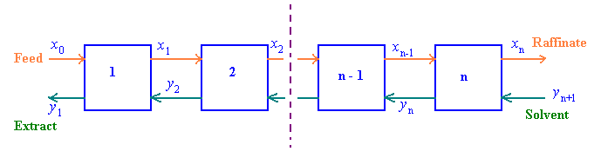
Figure 1: Design of CCSX operation

Itinerant Yttrium
As previously indicated, in most rare-earth separations that have been explored, Y⁺³ comes out in the extraction array with Ho⁺³ which resembles the placing of Y⁺³ with Ho⁺³ in the Ln⁺³ crystal-radius series from La⁺³-through-Lu⁺³. In some special separation systems, including some CCSX systems, Y⁺³ comes out with some other rare earths. ^{4, 5} Two outstanding examples are fractional crystallization of rare-earth double hexacyanoironates(II)⁶ and the solvent extraction of rare-earth thiocyanates. In both systems, the Y⁺³ accompanies Ce⁺³. Other examples include fractional precipitation of glycolates (Y⁺³ comes out with Ce⁺³),⁷ ion exchange with phthalates (Y⁺³ comes out with Ce⁺³), fractional precipitation of carbonates at 0° C (Y⁺³ comes out after Lu⁺³),⁸ sorption on freshly prepared flocculent hydroxides such as Fe(OH)₃ (Y⁺³ comes out between La⁺³ and Ce⁺³), and Al(OH)₃ (Y⁺³ comes out with Eu⁺³).⁹
This itinerant behavior of Y⁺³ confers a great advantage on the removal of Y⁺³ from all the other rare earths. Two main classes of minerals of the rare earths are known, the cerium class consists largely of the lighter rare earths (La-through-Eu) and the yttrium class consists largely of the heavier rare earths (Gd-through-Lu, including Y). The yttrium class usually contains on the order of 50% Y or greater. If the yttrium class is subjected to a process in which Y⁺³ comes out with the lighter rare earths, the separation process for Y⁺³ will exhibit a large separation factor for Y⁺³. This means that only one or a few stages of separation will remove the Y⁺³ from all the other heavy rare earths. The quantity of heavy rare earths remaining will be markedly reduced facilitating separation of lesser amounts.
Several studies have investigated the movement of Y⁺³ in solvent extractions with carboxylic acids. Du Preez and Preston in 1992 linked the position of Y⁺³ to the steric bulk of the carboxylic acid. ¹⁰ Singh, who confirmed the previous observation with several other carboxylic acids, extended this work in 2006. ¹¹ Both studies made some incomplete attempts at ascertaining the stoichiometries of the extracted species, but no pattern was observed.
The determination of the stoichiometries for yttrium and the other rare earth complexes during solvent extraction using carboxylic acids is of interest for the following study. If a correlation between the position of yttrium and its stoichiometry could be determined, this might form an explanation of yttrium’s itinerant behavior. The carboxylic acids that were used varied by length and steric bulk of different substituents on the beta carbon.

Experimental
The first goal of the study was to find extraction agents that move yttrium to different positions in relation to the other rare earths. Solvent extractions (SX) were performed using different carboxylic acids with differing lengths and ligands on the beta carbon to achieve this. Second, modifying/changing the organic solvent was also attempted to move yttrium. Once a series of carboxylic acids was found that moved yttrium to a desired position, slope analyses were performed to determine the stoichiometry of the extracted species. Finally, experimentation to ascertain stoichiometries of extracted species by mass spectroscopy was carried out.

Materials and Reagents
Carboxylic acids, rare earth oxides, solvents, and acids and bases were procured to complete the study. The reagents that were used in this study are found in Table 1.

Equipment and Instrumentation
All solvent extractions were performed using 20-mL scintillation vials. The
pH was measured using an Accument Basic pH meter. Concentrations of the rare earths before and after extractions were determined by ICP-OES analysis using a Perkin Elmer Optima 2100 DV ICP-OES.

Preparations of Aqueous Phase
Rare-earth solution stocks were prepared by dissolving the rare earth oxides in concentrated nitric acid. These stocks were employed to achieve desired concentrations of the rare earths in single samples and in mixtures.

Preparations of Organic phase
Organic phases were prepared by dissolving the carboxylic acid in the organic solvent. Concentrations were such that there was a tenfold excess of carboxylic acid over that which would be required to completely extract all the rare earths from the aqueous phase.

Solvent Extraction
In 20-mL scintillation vials the pH of the aqueous phase stocks was adjusted by addition of ammonium hydroxide. To keep volumes consistent after the base addition, water was added to achieve the desired volume of 10-mL. Once modifications to the aqueous phase were complete 10-mL of the organic phase was added. The solvent extraction samples were stirred for 24 hours at room temperature prior to analysis.

Analysis of the Extraction
After 24 hours of stirring, the organic and aqueous phases were separated. An aliquot of the organic phase was then placed in another
Table 1. Materials and Reagents
Material | Supplier
Trace Metal Grade Nitric Acid < 1 ppb | Fisher Scientific
Toluene ≥99.5% | Fisher Scientific
Water (LC/MS) Grade [impurities at ppb] | Fisher Scientific
Octane ≥95 % | Fisher Scientific
2-Methyl Tetrahydrofuran 99+% | Fisher Scientific
2,2-dimethylbutyric acid 97% | Alfa Aesar
1-methylcyclohexane-carboxylic acid 99% | Alfa Aesar
Anthranilic acid ≥98% | Sigma Aldrich
p-Toluic acid 98% | Fisher Scientific
Phenylacetic acid 99% | Sigma-Aldrich
Butyric acid >99% | Fisher Scientific
Trimethyl acetic acid 98% | Acros Organics
Hydrocinnamic acid 99% | Sigma-Aldrich
2,7-Di-tert-butylfluorene-9-carboxylic acid 98% | Sigma-Aldrich
Benzoic acid 98% | Fisher Scientific
2-phenylbutyric acid 98% | Sigma-Aldrich
2,2-diphenylbutyric acid 98% | City Chemical
Triphenylacetic acid 99% | Acros Organics
Octanoic acid 99% | Fisher Scientific
Diphenylacetic acid 99+% | Acros Organics

scintillation vial. Using a Bunsen burner, the organic phase was combusted at high temperatures in the vial until only a white residue remained. It was assumed the residue was a rare earth oxide that was converted from the rare earths extracted into the organic phase. This protocol was also carried out with the aqueous phases. The residues were then dissolved in nitric acid and the concentrations of the rare earths were determined by ICP-OES spectroscopy.

Method of Slope Analysis
To determine the stoichiometry of the extracting rare earth species, slope analyses on extractions while varying concentrations of both the rare earth and the extractant were completed. Following is a brief description of the fashion in which these slope analyses were carried out.
Solvent extraction of the rare earths by carboxylic acids can often be written as
$j{Ln}^{+3}+\overline{xjH_{2}A_{2}}⇌\overline{(LnA_{3}∙(HA)_{\left(2x-3\right)})_{j}}+3jH^{+}$, (1)

where the bars denote species that are in the organic phase. There are two unknown coefficients in the equations x and j. The number of carboxylic acid dimers involved is x, and j is the degree of polymerization of the extracted complex. The equilibrium constant for the reaction is shown in Equation 2, where D is the ratio of the major metal containing species between the organic and aqueous phases.
$K=\frac{\overline{\left[{\left(LnA_{3}∙{\left(HA\right)}_{\left(2x-3\right)}\right)}_{j}\right]}{\left[H^{+}\right]}^{3j}}{{\left[{Ln}^{+3}\right]}^{j}\overline{{\left[H_{2}A_{2}\right]}^{xj}}}=\frac{D{\left[H^{+}\right]}^{3j}}{j{\left[{Ln}^{+3}\right]}^{j-1} {\overline{\left(\left[H_{2}A_{2}\right)\right]}}^{xj}}$ (2)
Taking logarithms, and reorganizing the equations, equations 3-6 can be obtained:
$logD=3jpH+xjlog\left[H_{2}A_{2}\right]+\left(j-1\right)log{[Ln}^{+3}]+logK+logj$ (3)

$logD-xjlog\left[H_{2}A_{2}\right]=3jpH+\left[\left(j-1\right)log{[Ln}^{+3}]+logK\right]+logj$ (4)

$logD-3jpH=xjlog\left[H_{2}A_{2}\right]+\left[\left(j-1\right)log{[Ln}^{+3}]+logK\right]+logj$ (5)
$log\overline{\left[{\left(LnA_{3}∙{\left(HA\right)}_{\left(2x-3\right)}\right)}_{j}\right]}=j \left[log[{Ln}^{+3}]+3pH\right]+xjlog\overline{\left[H_{2}A_{2}\right]}+LogK$ (6)

These forms of the equations will be used to attempt to determine the stoichiometry of the extracted species.

Mass Spectroscopy
After solvent extraction had been completed, the organic phase was removed for analysis by mass spectroscopy. Two mass spectrometers were used, Jeol AccuTOF DART, and Qstar Elite HPCL QTOF ESI. In the Qstar Elite mass spectrometric measurements, methanol was used to dilute the organic phase.

Results

Data Analysis
Measurements by ICP-OES constituted the basic data of this project. Such analyses yield the best results when the liquid sample matrix is simple and when interfering elements are at a minimum. Two sets of measurements were employed: those involving a single rare earth element, and those involving mixtures of eight rare earth elements. In addition to ICP-OES errors, the systems were subject to numerous other errors, such as those in pH measurements, in sample preparation, in sample losses, in mutual solubilities of the phases, and other experimental variables.
Extractions on single-element systems were conducted in triplicate at each of four different pH values. Each system contained 20ppm of the rare earths. The maximum standard deviation that was seen was ± 0.1ppm.
Twenty-five extractions on eight-element systems were then carried out. Each of the systems contained 20.0 ppm of each element. After equilibrium was established, the concentrations of the eight elements in the two phases were measured. The sums of the two-phase values were added, and their deviations from the known value of 20.0 ppm were calculated. The 200 measurements yielded maximum standard deviation values of ± 0.4 for all eight of the elements (Y, La, Nd, Sm , Eu, Gd, Dy, Lu). Based on this repeatability, error bars on all graphs have been placed at ±1.2ppm so as not to underestimate the total error.

Solvent Extractions
The first goal of the project was to find systems that place yttrium in different positions in the rare earth series. The first experiments were completed using toluene as the solvent for the organic phase. After using toluene for extractions, it was determined that the solubility of some of the carboxylic acids was limited causing solid formation at the interface. A second solvent was found. Toluene was then replaced by 2-methyltetrahydrofuran (2-MeTHF). Figure 2 shows a comparison of the solvent extractions of the rare earths using phenylacetic acid in the two solvents. Between the different solvents there is a different shape of the extraction curve and the position of yttrium is different.
The shapes of the extraction curves are directly related to separation factors of the extraction system. Separation factors, when solvent extraction has been performed, are the ratio of the distribution ratio of the elements’ concentration across the two phases. These separation factors are particularly important to the rare earths in that the greater a separation factor the less solvent extraction stages that are required to reach a desired purity level.
The results from the solvent extraction experiments are shown in Table 2, Figure 3 displays the basic carboxylic acid structure used with labeling, and the graphs for each solvent extraction system are in Appendix A. The table shows the organic solvent used for each acid and the Y position. The position is listed as light (L), medium (M), and heavy (H). Light is considered elements La through Pm, medium is Sm-Tb, and heavy Dy-Lu. Figure 4 shows two representative extraction curves in which yttrium is extracting in one as a light rare earth and the other as a heavy rare earth.

Stoichiometry by Slope Analysis
After several systems that moved yttrium were identified, investigations to determine the stoichiometry of the extracted species began. The first system that was investigated was phenylacetic acid in toluene. The first experiment
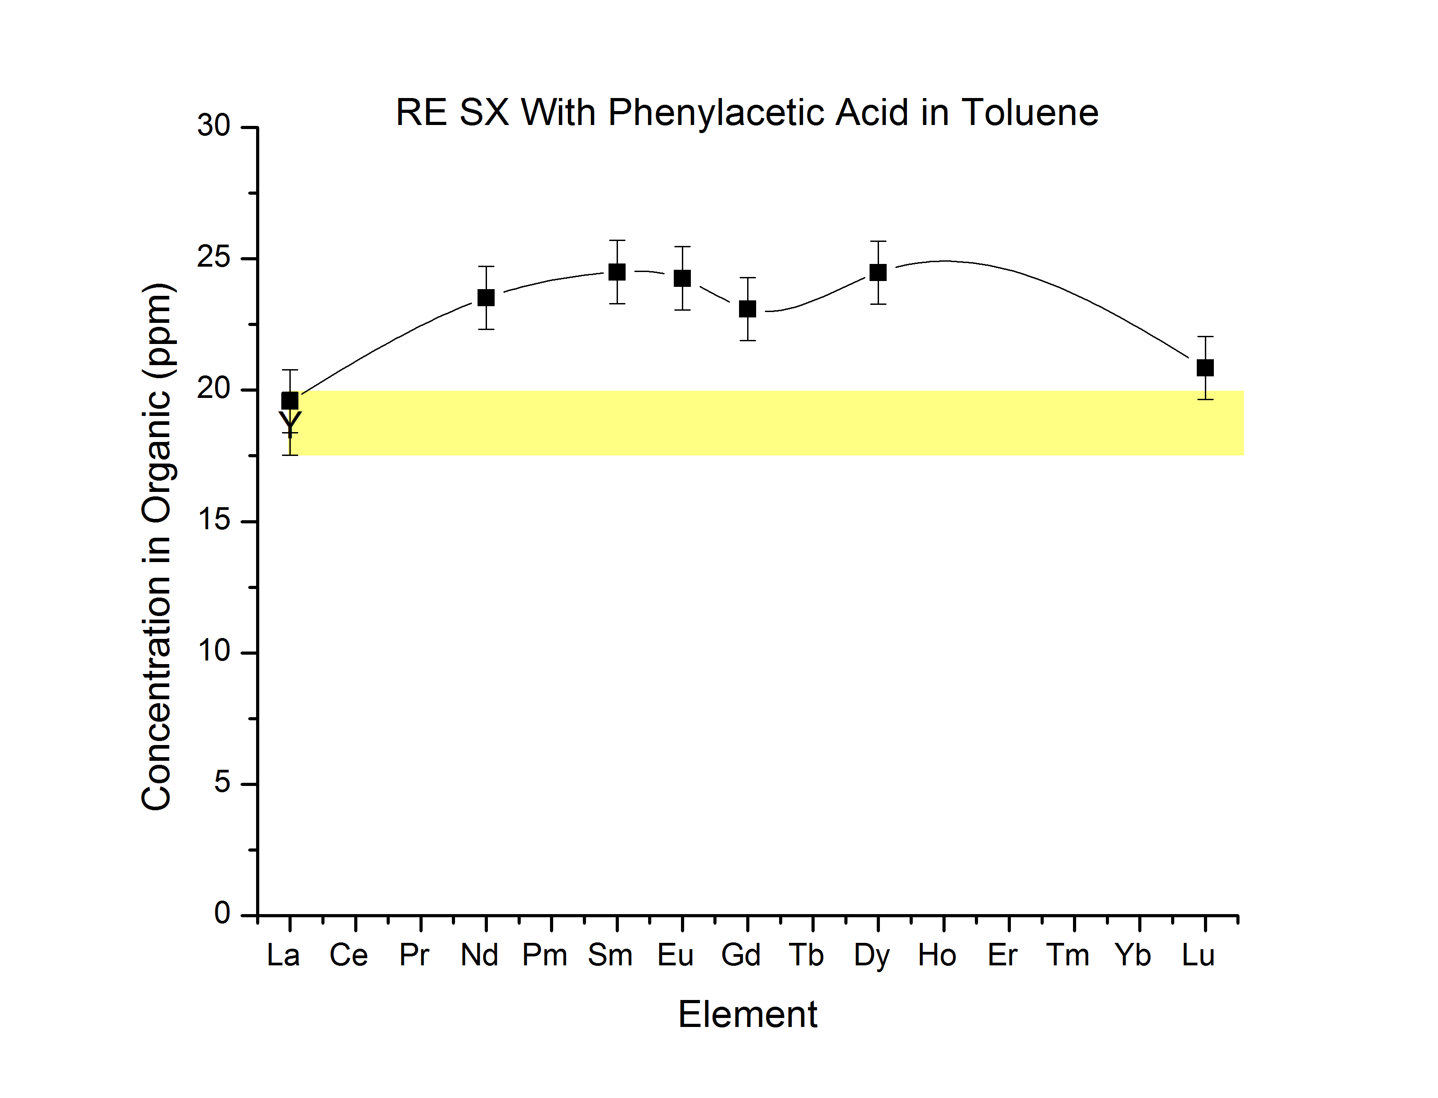
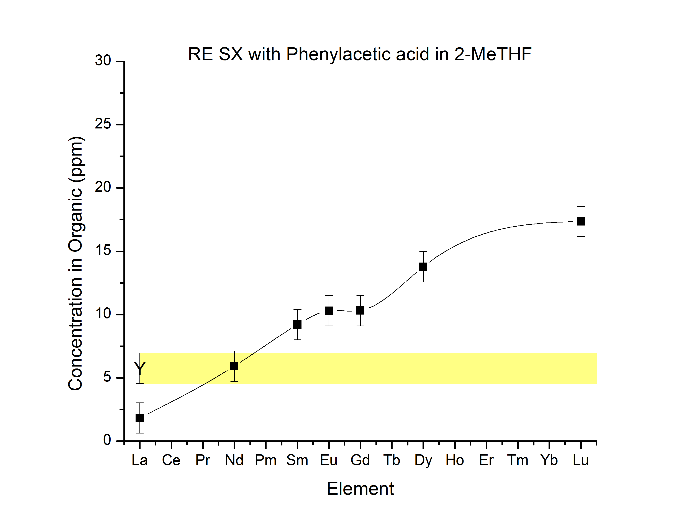
Figure 2: (Top) Rare earth extractions using phenylacetic acid in toluene. (Bottom) Rare earth extractions using phenylacetic acid in 2-MeTHF.
Table 2: Position of Yttrium Using Different Carboxylic acids and Solvents
Acid | Position | Solvent | R1 | R2 | R3
Octanoic acid | L | Toluene | Hexyl | H | H
Octanoic acid | L | 2-meTHF | Hexyl | H | H
4-Phenylbutyric acid | L | Toluene | Ph-CH2-CH2- | H | H
Hydrocinnamic acid | L | 2-MeTHF | Ph-CH2- | H | H
Phenylacetic acid | L | Toluene | Phenyl | H | H
2-phenylbutyric acid | L | Toluene | Phenyl | Ethyl | H
Phenylacetic acid | M | 2-meTHF | Phenyl | H | H
Anthranilic acid | M | Toluene | 2-Aminobenzyl | H | H
p-Toluic acid | M | Toluene | 4-Methylbenzyl | H | H
p-Toluic acid | M | 2-meTHF | 4-  Methylbenzyl | H | H
2-phenylbutyric acid | M | 2-  meTHF | Phenyl | Ethyl | H
Diphenylacetic acid | M-H | 2-meTHF | Phenyl | Phenyl | H
1-methylcyclohexane-carboxylic acid | M-H | 2-meTHF | Methyl | Cyclohexyl | H
2,2-dimethylbutyric acid | M | Toluene | Methyl | Methyl | Ethyl
Anthranilic acid | H | 2-meTHF | 2-Aminobenzyl | H | H
1-methylcyclohexane-carboxylic acid | M-H | Toluene | Methyl | Cyclohexyl | H
2,2-dimethylbutyric acid | H | 2-meTHF | Methyl | Methyl | Ethyl
Trimethyl acetic acid | H | 2-meTHF | Methyl | Methyl | Methyl
2,2-diphenylbutyric acid | L-M-H | 2-meTHF | Phenyl | Phenyl | Ethyl
Triphenylacetic acid | L-M-H | 2-meTHF | Phenyl | Phenyl | Phenyl

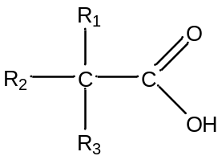
Figure 3: Basic Carboxylic Acid Structure
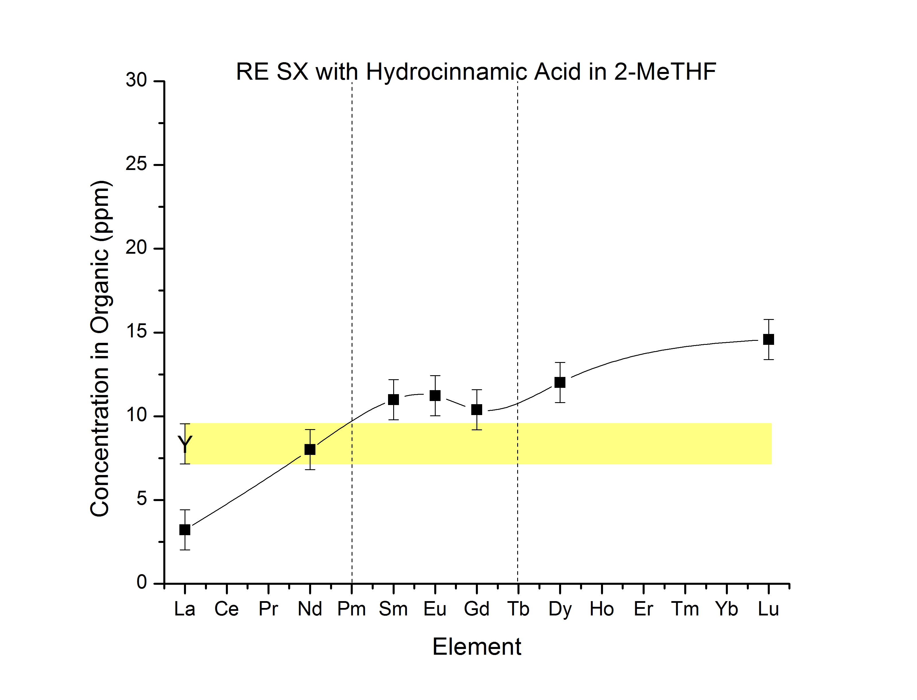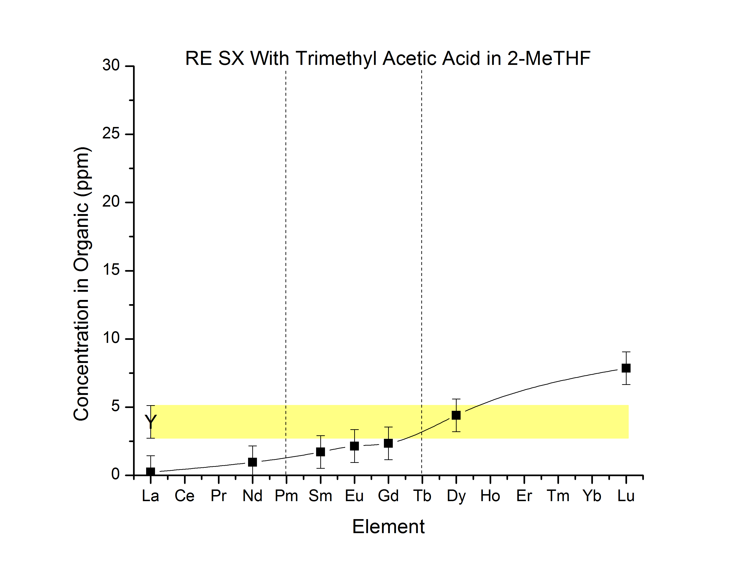
Figure 4: (Top) Rare earth extraction with hydrocinnamic acid in 2-MeTHF. (Bottom) Rare earth extraction with trimethyl acetic acid in 2-MeTHF.

completed with this system was to extract yttrium at several different pH values and to plot the ratio of the concentration in the organic phase to the aqueous phase vs the pH (LogD vs pH). The line that is generated should have a slope with multiples of 3 if equation 3 applies, as equation 3.
In this study, however, a slope with multiples of 3 was never achieved for the solvent extraction of yttrium by phenylacetic acid in toluene, Figure 5. This experiment was repeated using lanthanum at two different concentrations of 2-phenylbutyric acid, 0.2M and 0.5M, in the organic phase, Figure 6. At a concentration of 0.5 M, the slope was 4.3 ± 1.2 meaning that the number of HA₂⁻ is between 3 and 4. A slope of 1.4 ± 0.2 was obtained when the concentration of 2-phenylbutyric acid 0.2M indicates that only one carboxylic acid is involved in the extraction species. The change in the number of carboxylic acids attached appears to be dependent on the concentration of 2-phenylbutyric acid used. Since we are interested chiefly in species involving at least three HA₂⁻, no further work was done.
Some of the published work of others used xylene as the solvent for solvent extraction studies where they determined stiochiometries. This was attempted next using 2-phenylbutyric acid at different concentrations with p-xylene as the solvent (Figure 7).
Using 2-phenylbutyric acid in toluene at different concentrations, extractions of yttrium were performed. Figure 8 are plots of the pH vs. log D
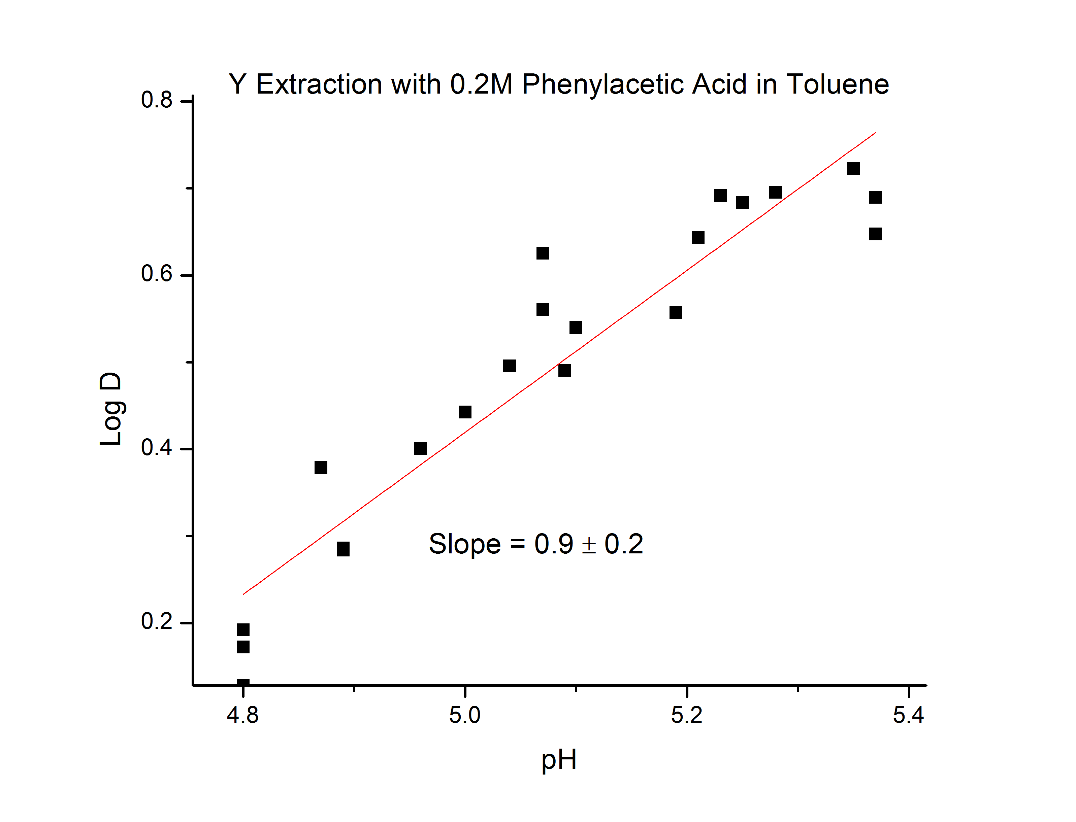
Figure 5: Yttrium extraction with 0.2M phenylacetic acid in toluene.
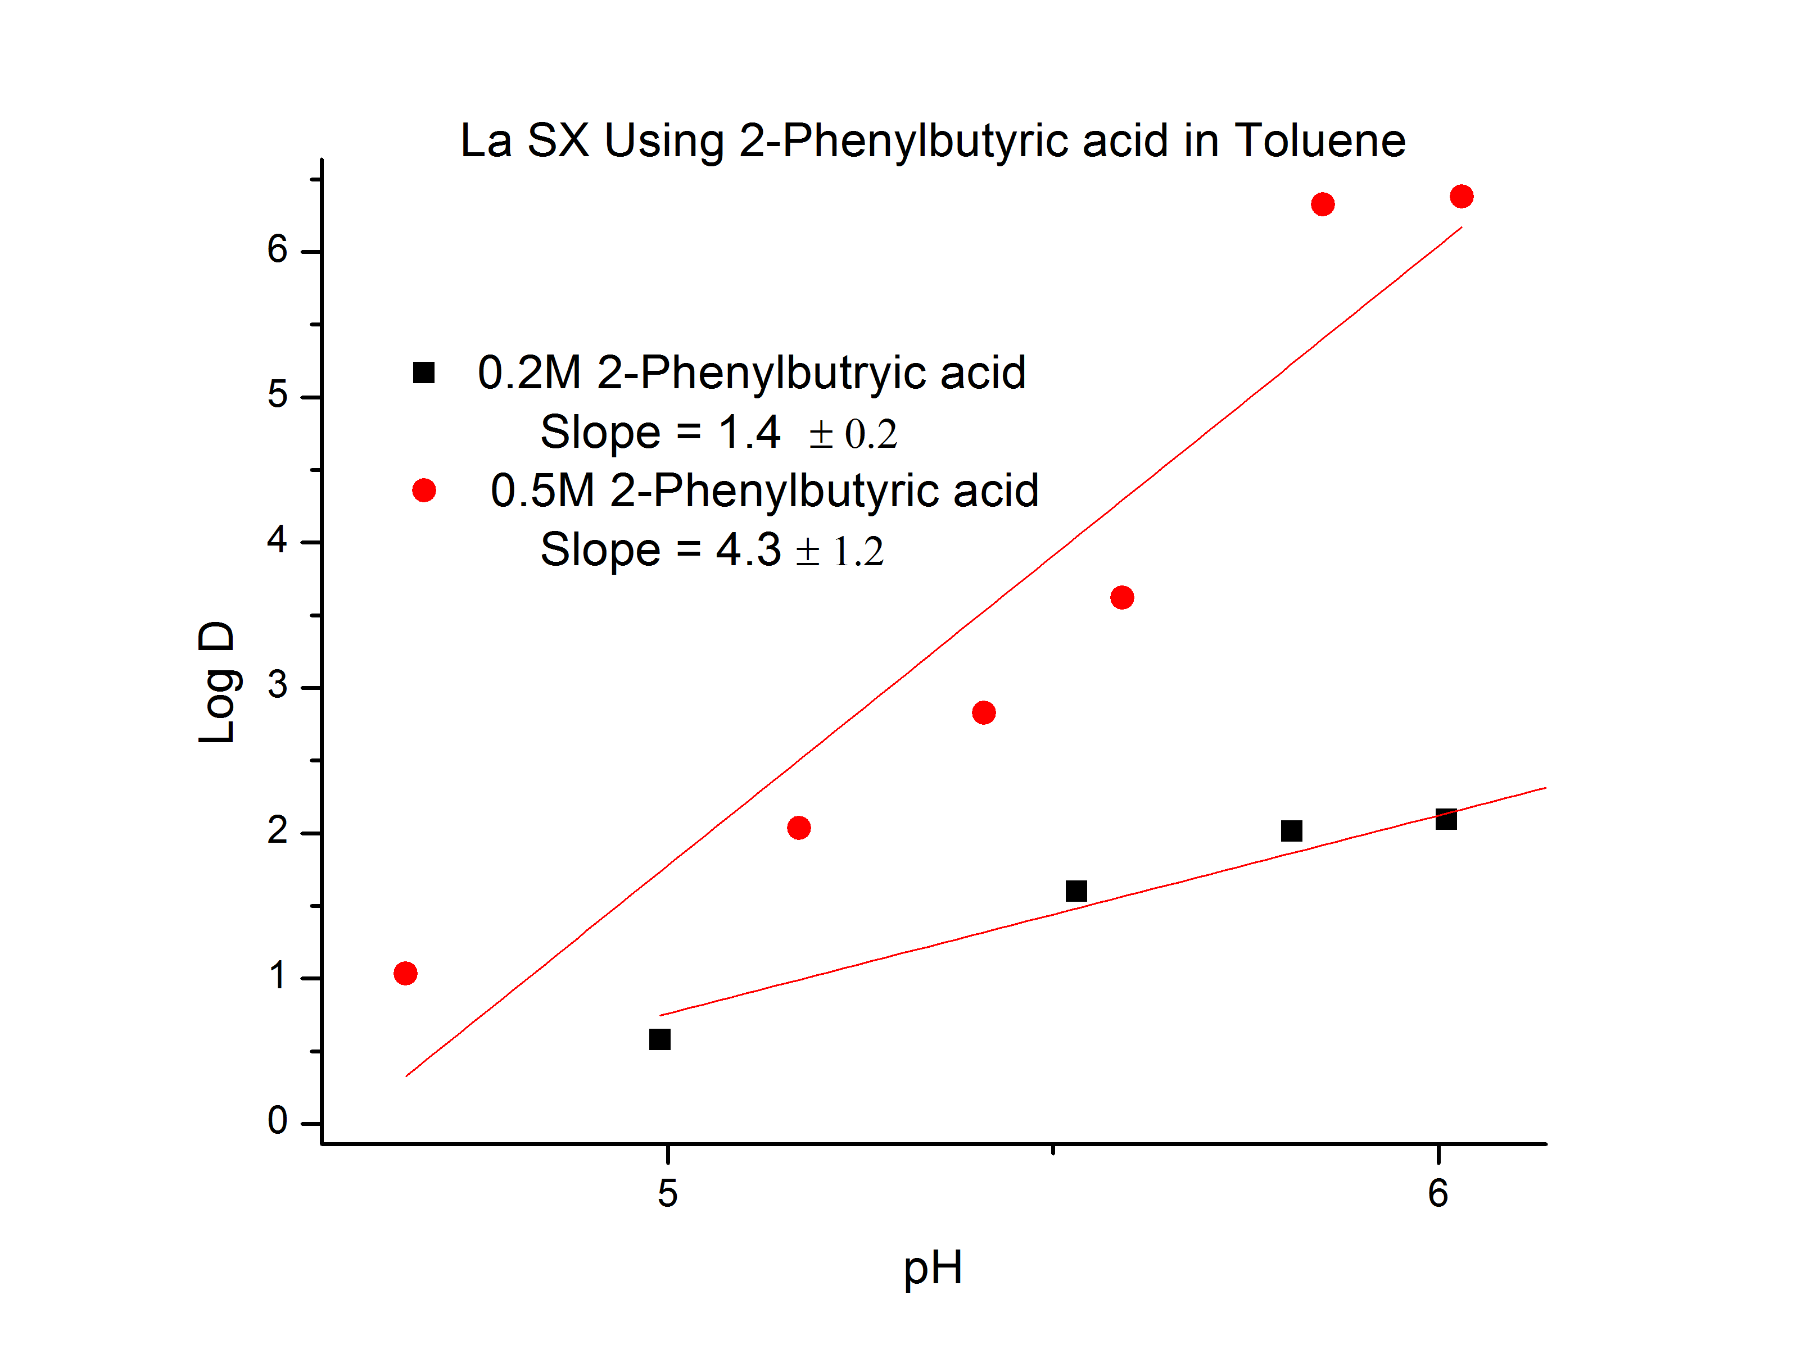
Figure 6: La extraction with 0.2M and 0.5M 2-phenylbutyric acid.

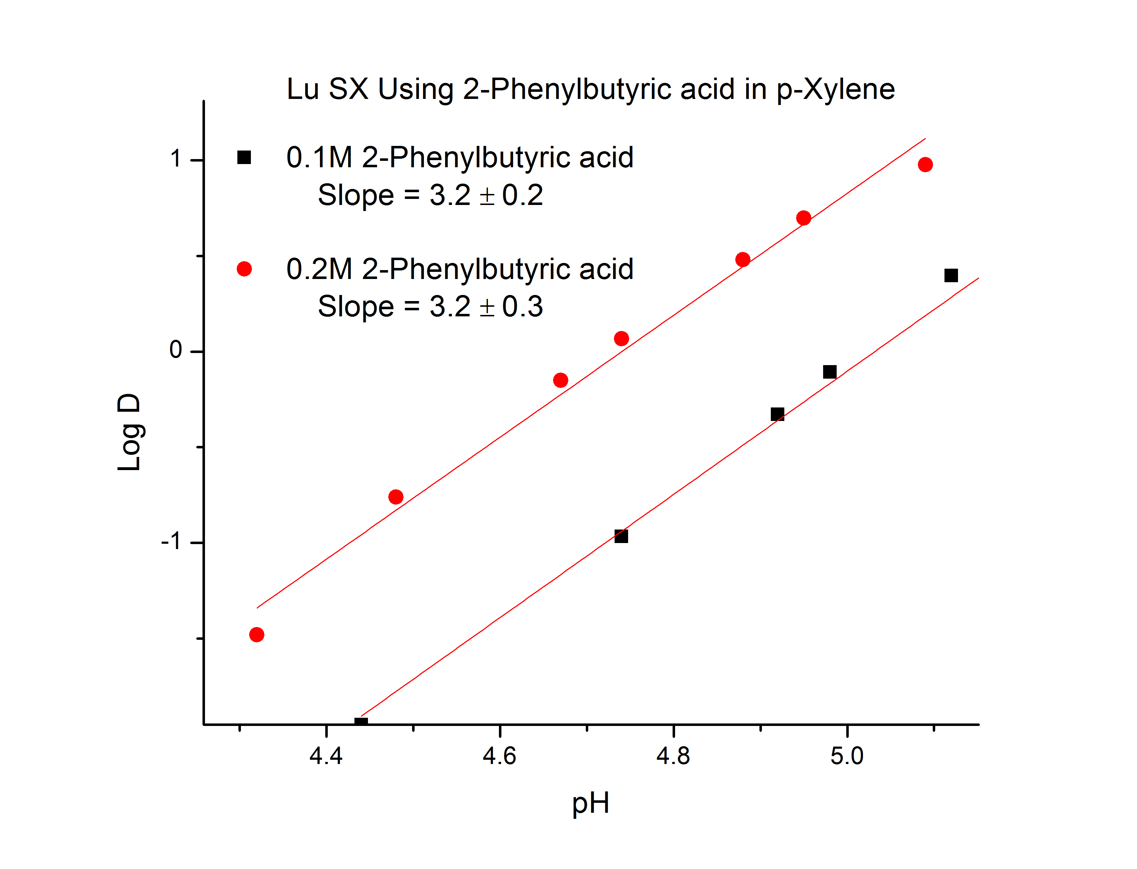
Figure 7: Lu extraction with 0.2M and 0.1M 2-phenylbutyric acid.
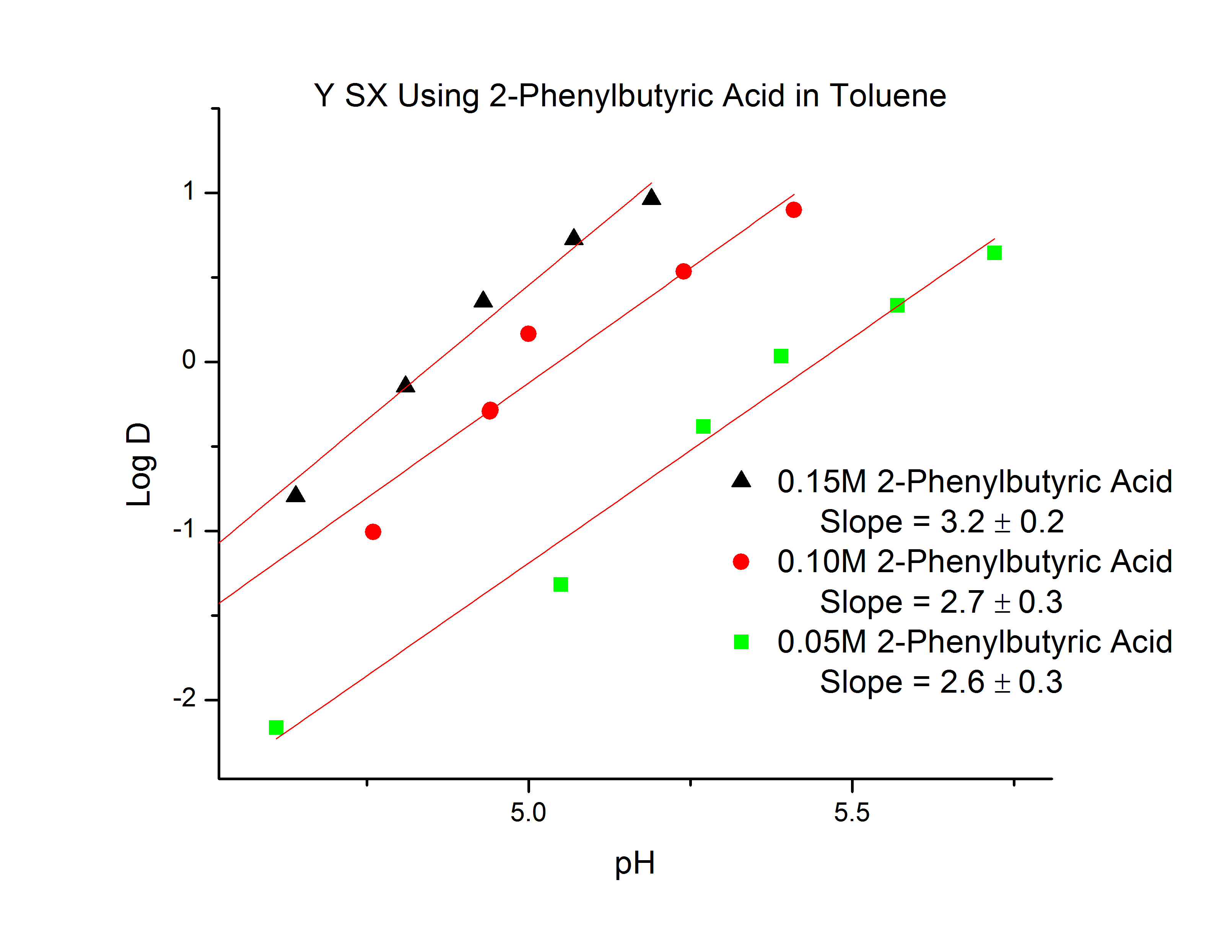
Figure 8: Yttrium extraction with 2-phenylbutyric acid in toluene.

where all the tested concentrations had a slope of approximately 3. With the agreement with equation 3 used to determine the stoichiometry, further analysis of the data could be completed. Next, using equation 6 the log of the concentration of yttrium in the aqueous phase vs the log of the concentration of yttrium in the organic phase added to 3pH was plotted (Figure 9). From this plot the slope will produce the j value, degree of polymerization, which is 1 for Y with the 2-phenylbutyric acid in toluene system. After the degree of polymerization was determined the number of ligands attached to Y could be determined. Assuming the degree of polymerization to be 1, the number of ligands can be determined by using equation 5 and plotting the log of the concentration of the 2-phenylbutryric acid vs. (Log D – 3pH) the slope will equal to the number of ligands (Figure 10). In Figure 10, slope is equal to 3, using this information the coordination number of Y in this extraction system is determined to be 9.
In most cases, except shown, the equations that were used to determine stoichiometry did not work. The failure of the equations to produce expected results does not appear to be due to error from analytical methods. The complexity of the extraction system might be the reason for the discrepancies. The equations used to determine stoichiometry assume that the extraction proceeds to one product, however, this may not be the case. Several different extraction species may exist altering the calculated stoichiometry. It also may be possible that the counter ion present in the aqueous phase NO₃⁻¹ extracts into
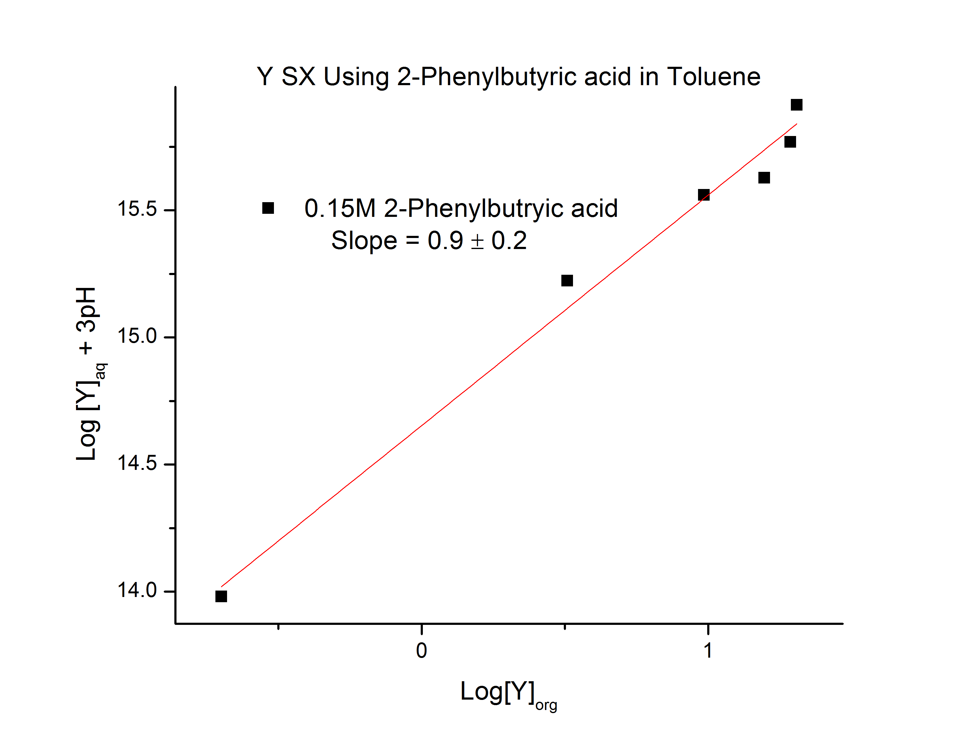
Figure 9: Determination of the degree of polymerization with the extraction of yttrium using 2-phenylbutyric acid in toluene.

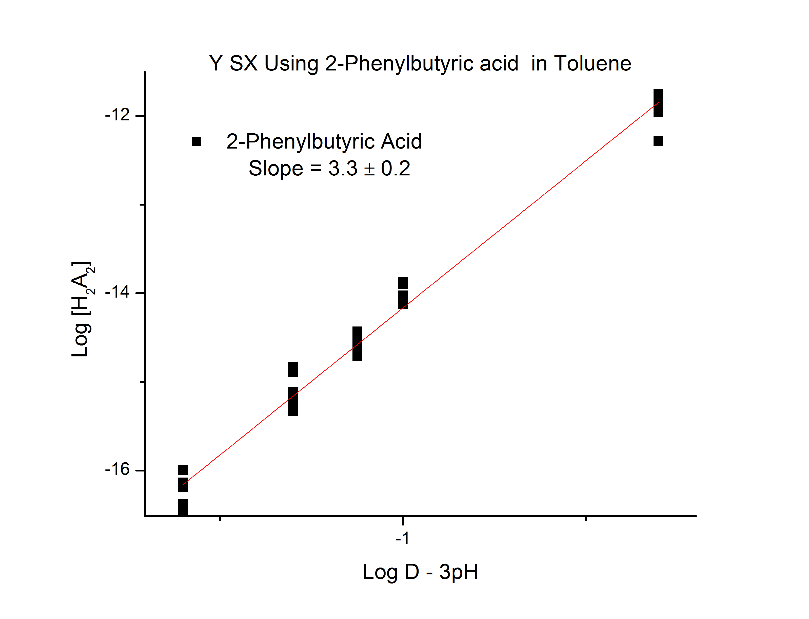
Figure 10: Determination of the number of ligands attached to yttrium in the extraction with 2-phenylbutyric acid in toluene.

the organic phase by replacing one or more of the carboxylic acids that are assumed to be bonded.

Mass Spectroscopy
There have been a few papers that involve using an electrospray ionization mass spectrometer to try to determine the m/z of extracted species. One study that was of particular interest was focused on the TALSPEAK process, which used DEHPA, diethylhexylphosphoric acid, to separate the actinides from the rare earths. Lactic acid is also involved in the TALSPEAK process as a buffer of the aqueous phase. The study uses mass spectroscopy to determine how the lactic acid is involved in the extraction of the rare earths.
The first experiments to investigate the m/z of extracted species were to simplify the published material on the TALSPEAK process without using lactic acid. Solvent extraction of lutetium using DEHPA, di-(2-ethylhexyl)phosphoric acid in kerosene, was carried out. After solvent extraction, the organic phase was separated and prepared for mass spectroscopy. Two mass spectrometers were available for experimentation: the first was JEOL USA AccuTOF DART. The DART, direct analysis in real time, is a soft ionization mass spectroscopic instrument and requires little sample preparation, however, it does not offer any quantitative concentration information. The second mass spectrometer that was used was the Applied Biosystems/QStar Elite, using an ESI soft ionization source.
There was no need for sample preparation prior to analysis by the DART mass spectrometer. Analysis was completed by determination of the largest species found in the organic phase, identified by m/z. Isotope distribution predicted for the assumed extracted species are found in Figure 11, and the experimental spectrum is found in Figure 12. The m/z found in Figure 12 agreed with the mass value expected for the Lu DEHPA extracted species. With the detection of the assumed Lu extracted species by DART-MS the experiment was repeated using La. No signal above the noise was found at the expected m/z Figure 13.
With the DART-MS unable to detect the La extracted species a different mass spectrometer was used. The Qstar Elite was then used to analyze the extracted species. The preparation of the samples for the analysis by the Qstar was different for the DART-MS. The samples needed to be diluted prior to analyses with the solvents of choice being acetonitrile and methanol. For this experiment methanol was used as the diluent, dilution was 1:200. Analysis of the two DEHPA experiments was completed several times altering several settings on the instrument. However, no signals were found in the spectra that corresponded to the expected m/z values for either La or Lu.
Next, the Qstar was used for the analysis of a lutetium extraction using 2-phenylbutyric acid in toluene with similar results as the DEHPA analysis. Figure 14 displays the mass spectrum obtained for the 2-phenylbutryic acid extraction. The mass value for LuA₃ where A is deprotonated 2-phenylbutyric acid, is 666, a
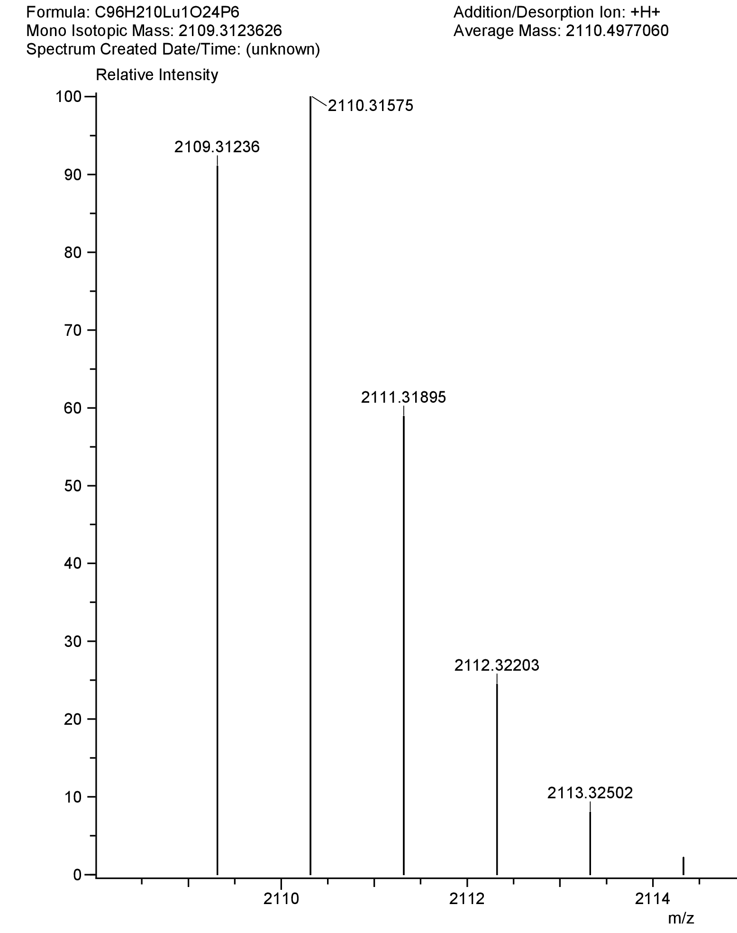
Figure 11: Predicted isotope distribution for Lu extracted with DEHPA.

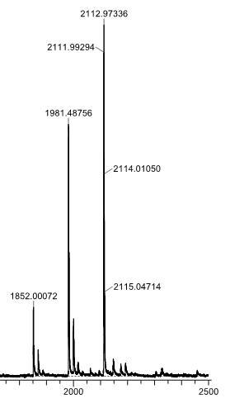
Figure 12: DART-MS spectrum of Lu extracted with DEHPA

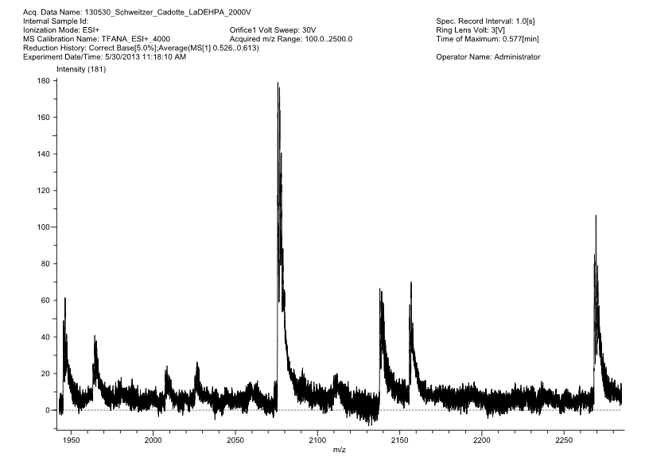
Figure 13: DART analysis of La extracted by DEHPA.
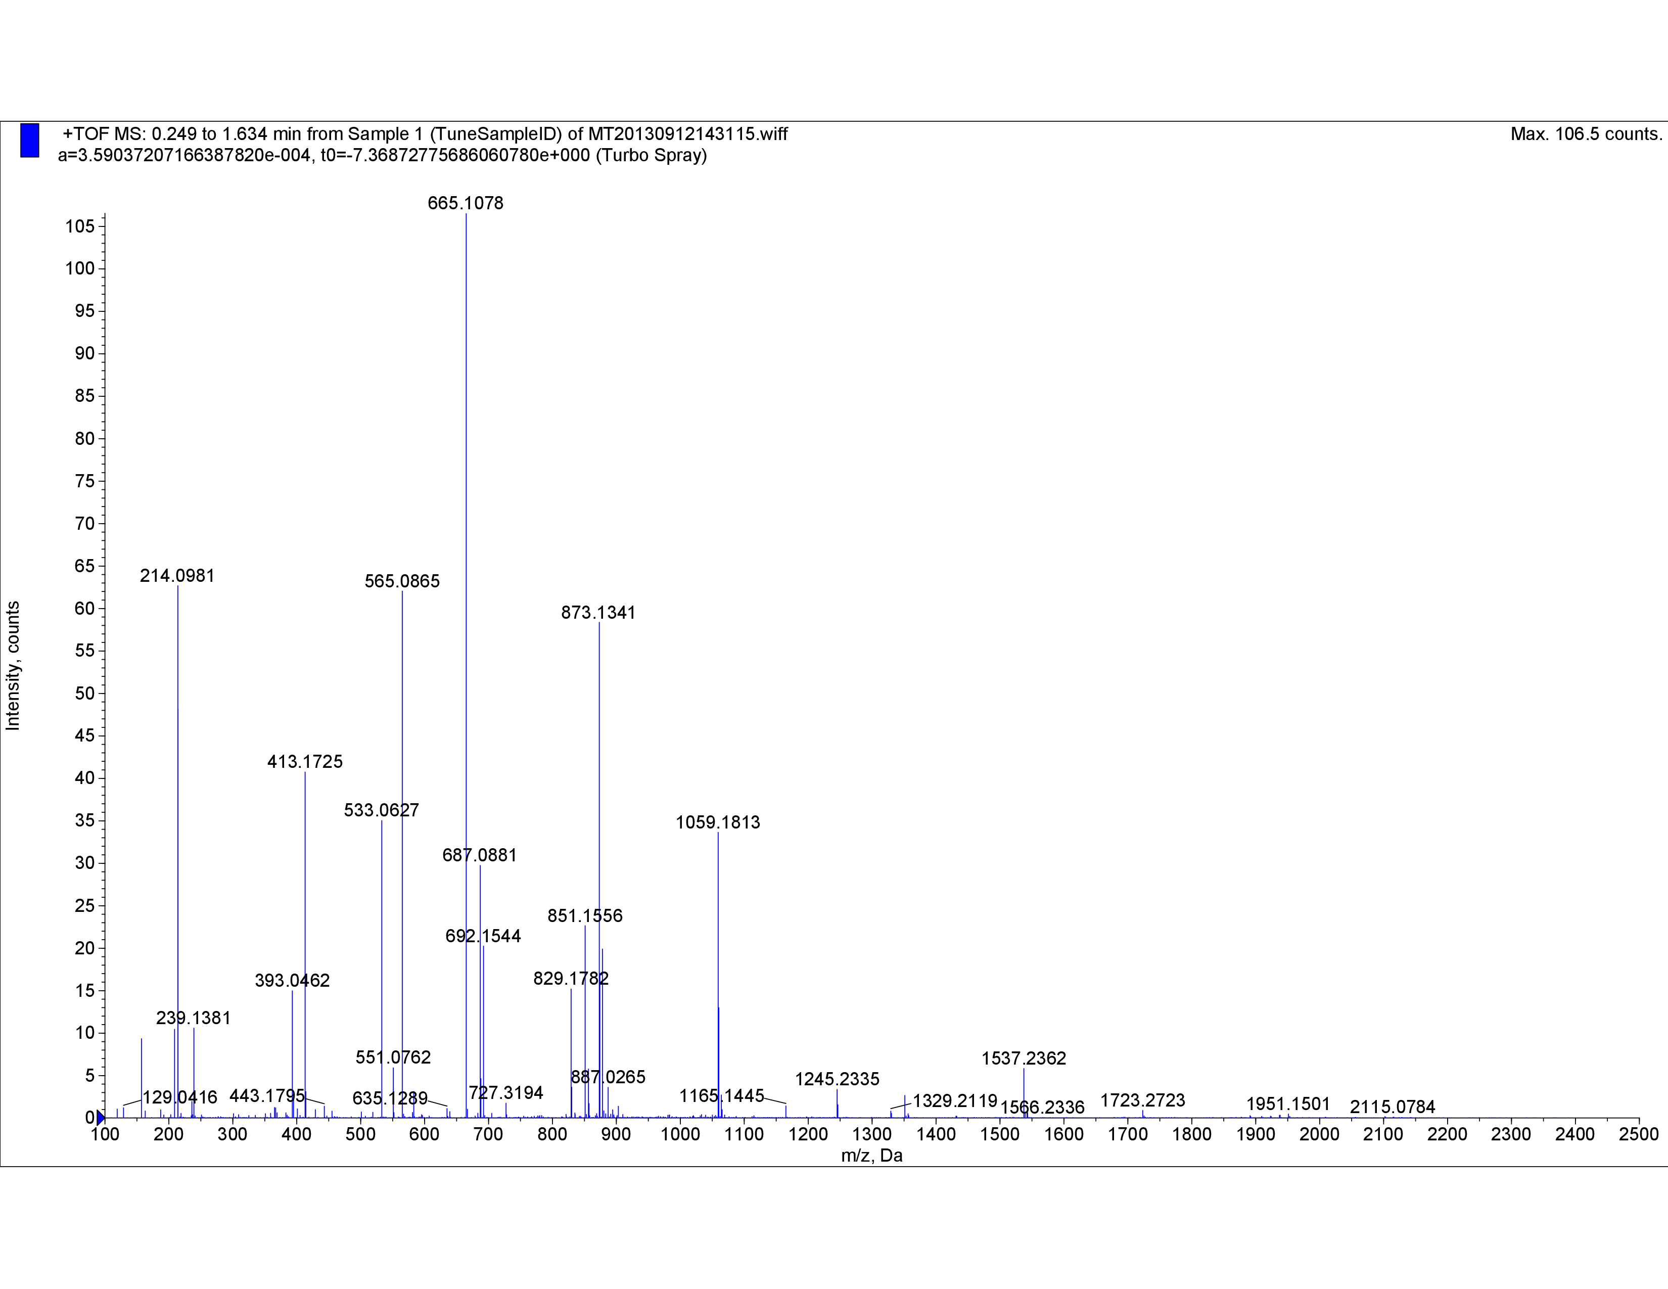
Figure 14: 2-Phenylbutryic acid analyzed by Qstar-MS

mass value of 665 was detected which corresponds to the species. However, no mass value corresponded to any species with HA bonded to LuA₃ (LuA₃•HA or LuA₃•2HA). Further experimentation using the Qstar with different carboxylic acids was attempted. Y extracted by trimethyl acetic acid in methyl isobutyl ketone, and also in cyclohexane were analyzed using the Qstar. In these systems all that could be determined from the spectra were polymers of the carboxylic acid. There were no m/z peaks that corresponded to expected Y containing species. Finally, Y extraction using octanoic acid in toluene was performed and analyzed using the Qstar. As with 2-phenylbutyric acid the only determinable signals corresponded to the YR₃ species.
With the experiments not producing results that give insight to the extracted species of rare earths the experiments were terminated.

Conclusion
The position of yttrium along the rare earth series could be manipulated by altering the carboxylic acid used for solvent extraction. The manipulation from light rare earths to heavy rare earths depends on the substituents attached to the beta carbon. Referencing Table 2, a trend of Y’s position with respect to the other rare earths is related to R1, R2, and R3 groups on the carboxylic acid. The general trend when functional groups occupy R1 with H at R2 and R3 is that Y extracts with the light rare earths. When R1 and R2 are occupied by functional groups with H at R3 then Y extracts with the medium rare earths. When all positions are occupied by functional groups Y extracts with the heavy rare earths.
However, there were deviations to this general trend, which were observed when the functional groups were branched ring structures (2-aminobenzyl and 4-methylbenzyl). The more steric bulk that the functional group has the more resemblance that yttrium has for the heavy rare earths.
In this study the identification of the stoichiometry of the extracted rare earth species was hindered by experimental error. As the slopes of the curves generated increased so did the error bars. If this trend continued it is possible that when a species became a dimer the equations would show the possibility of two different stoichiometries. The slope analysis also assumed that the extraction reaction only included one extraction species. While it is unknown in this study if this was the case, it has been noticed in other extractions such as extraction with DEHPA under high concentrations of hydrochloric acid for the rare earth to extract as the LnCl₃•DEHPA₂. The extraction of the rare earths with carboxylic acids should be further studied with consideration of the other stoichiometries.
Finally, identification of the extracted species by mass spectroscopy showed mixed results. Using DART-MS for the detection of the DEHPA extracted species m/z appeared successful for Lu but not for La. The detection of the same extracted species using ESI mass spectroscopy was unsuccessful.
The lack of results may have been due to the sample preparation for ESI. The preparation may have interfered with the dominant species and produced other species that were not expected. Also, with both mass spectrometers the concentration of the extracted species may have been overwhelmed by the concentration of unused carboxylic acid in the organic phase. The degree of extraction is another condition that may have altered the dominant species in both techniques. Changes were not made in the concentration of the extraction agent with the mass spectroscopy experimentation because it would not mirror the conditions used in the extraction experiments. Although, the results were not similar to the previously published experiments, the analysis of extractions by mass spectroscopy is intriguing. Further development of the analysis method would be required for this method to be used more often in solvent extraction studies. With current literature searches this was the first attempt to analyze solvent extraction systems using DART-MS.
While the main goal of determining if the stoichiometry of the extracted yttrium species is a deciding factor in its position in extractions was not achieved, a general trend was observed that agrees with other published work. Error bars are shown in the multi element extraction curves, which have not frequently been published in other studies. By including these error bars we believe that a more realistic extraction system is shown. Further studies are needed to determine the cause of the itinerant behavior of yttrium.

References

- James, C. J. Am. Chem. Soc. 1911, 33, 1332–1344.
- McGill, I. Rare Earth Elements; Wiley‐VCH Verlag GmbH & Co. KGaA: Weinheim, Germany, 2000.
- Solvent Extraction - Mass Transfer Solved Problems - msubbu http://www.msubbu.in/sp/mt/Extraction-Oil.htm (accessed Jul 9, 2015).
- Xie, F.; Zhang, T. A.; Dreisinger, D.; Doyle, F. Minerals Engineering 2014.
- Lu, D.; Horng, J. S.; Hoh, Y. C. Journal of the Less Common Metals 1989.
- Prandtl, W. Zeitschrift für anorganische und allgemeine Chemie 1938, 238, 321–334.
- Jantsch, G. Salts of Rare Earths with Hydroxycarboxylic Acids (I) Glycollates of Rare Earths - Google Scholar; Z. anorg. Chem, 1913; Vol. 79.
- 1955, 282, 63–79.
- Quinn, K. A.; Byrne, R. H.; Schijf, J. Aquatic Geochemistry 10, 59–80.
- Preez, A. D.; S Preston, J. Solvent extraction and ion exchange 1992, 10, 207–230.
- Singh, D. K.; Singh, H.; Mathur, J. N. Hydrometallurgy 2006, 81, 174–181.

Appendix
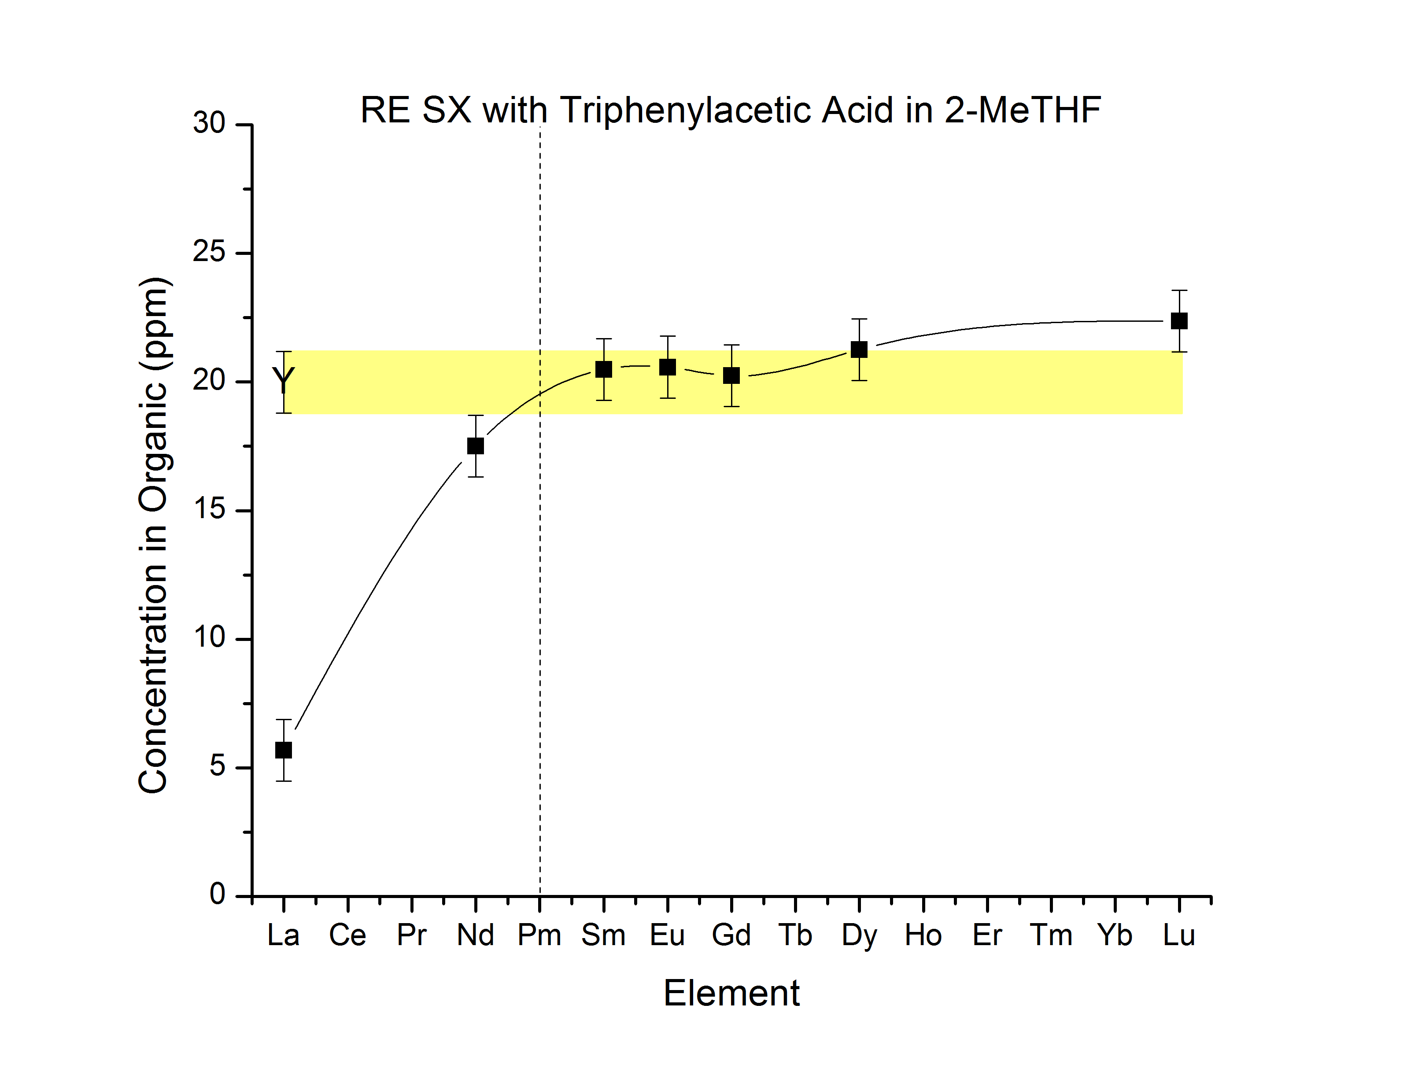
Figure 15: Rare earth extraction with triphenylaceitc acid in 2-MeTHF
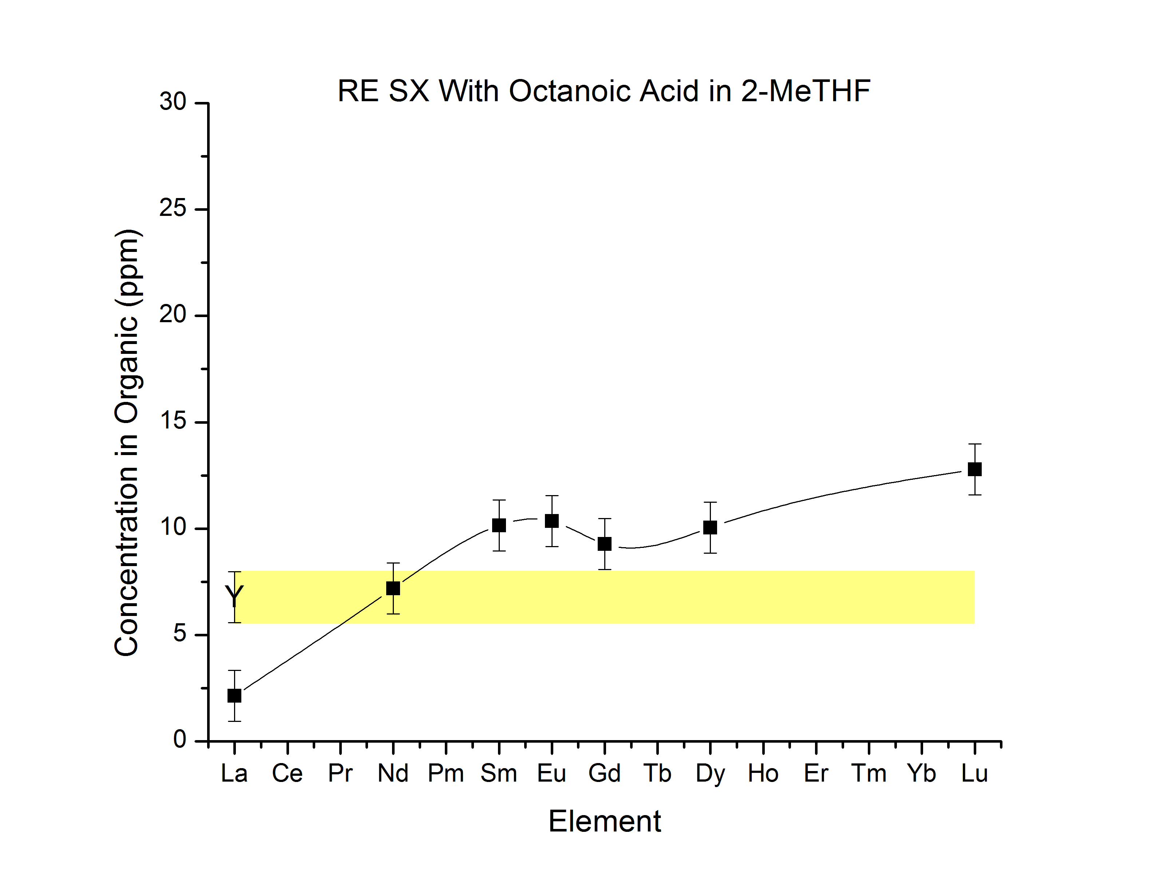
Figure 16: Rare earth extraction with octanoic acid in 2-MeTHF
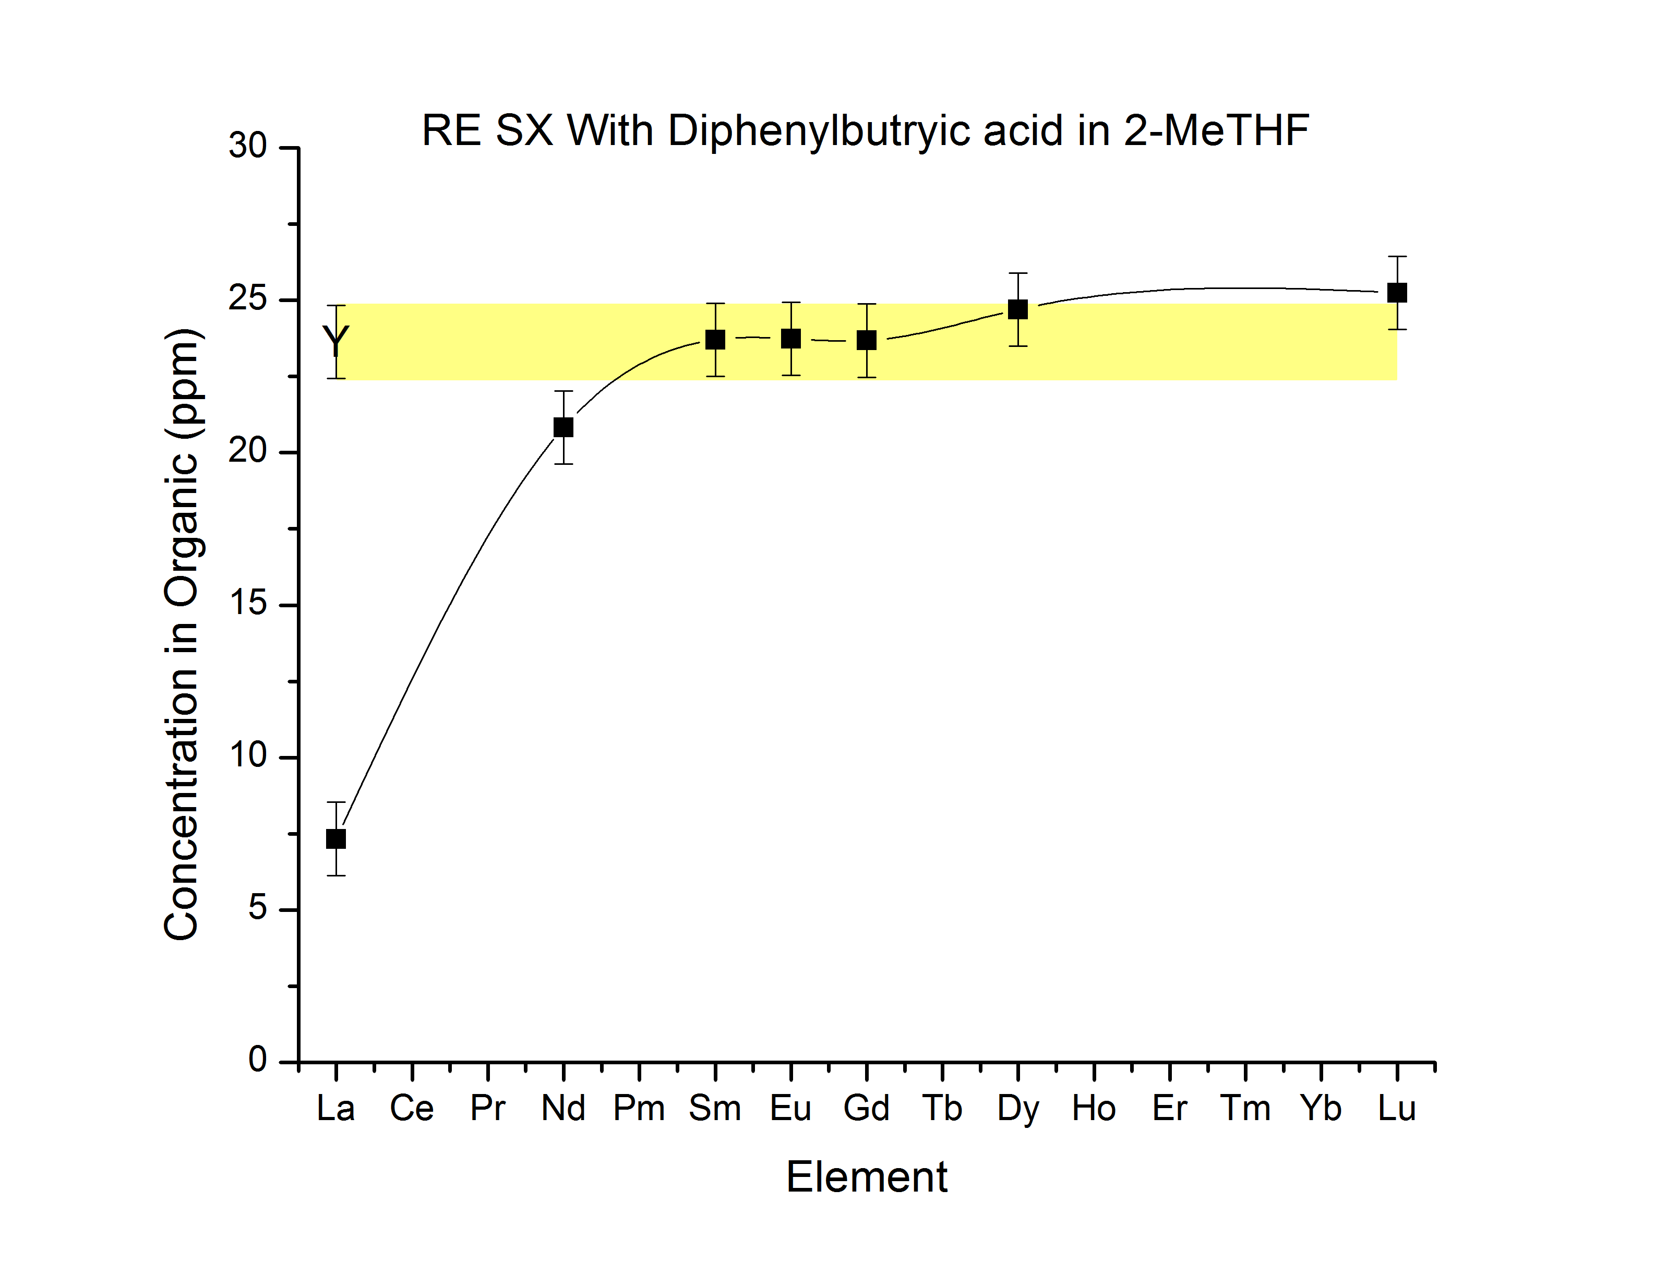
Figure 17: Rare earth extraction with diphenylbutyric acid in 2-MeTHF
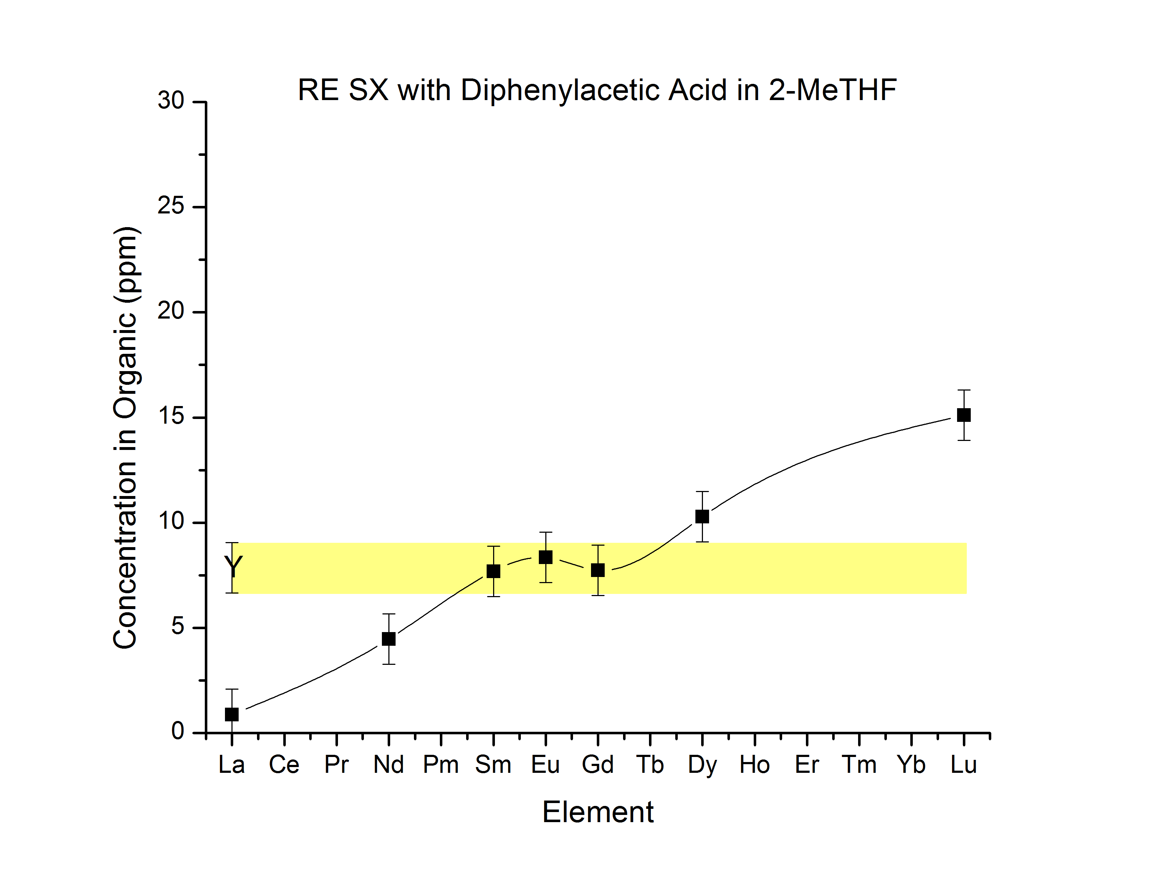
Figure 18: Rare earth extraction with diphenylaceitc acid in 2-MeTHF
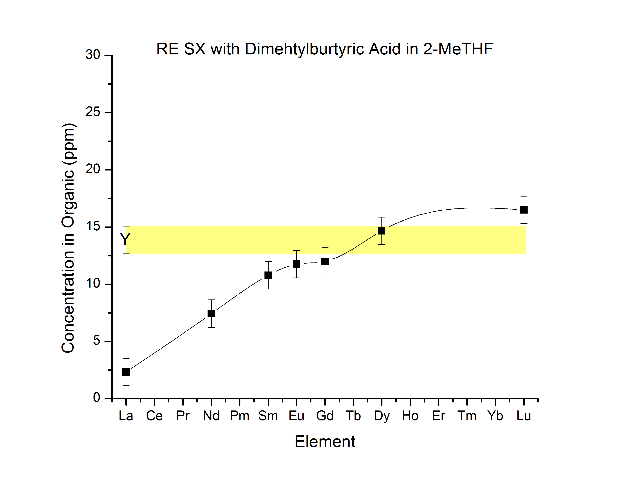
Figure 19: Rare earth extraction with dimethylbutyric acid in 2-MeTHF
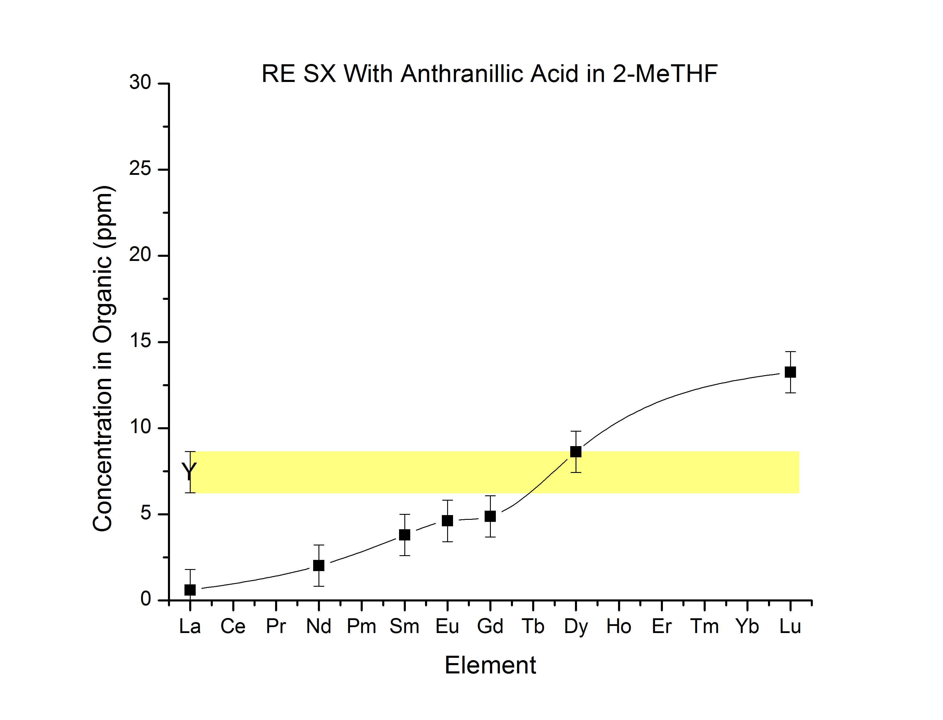
Figure 20: Rare earth extraction with anthranillic acid in 2-MeTHF
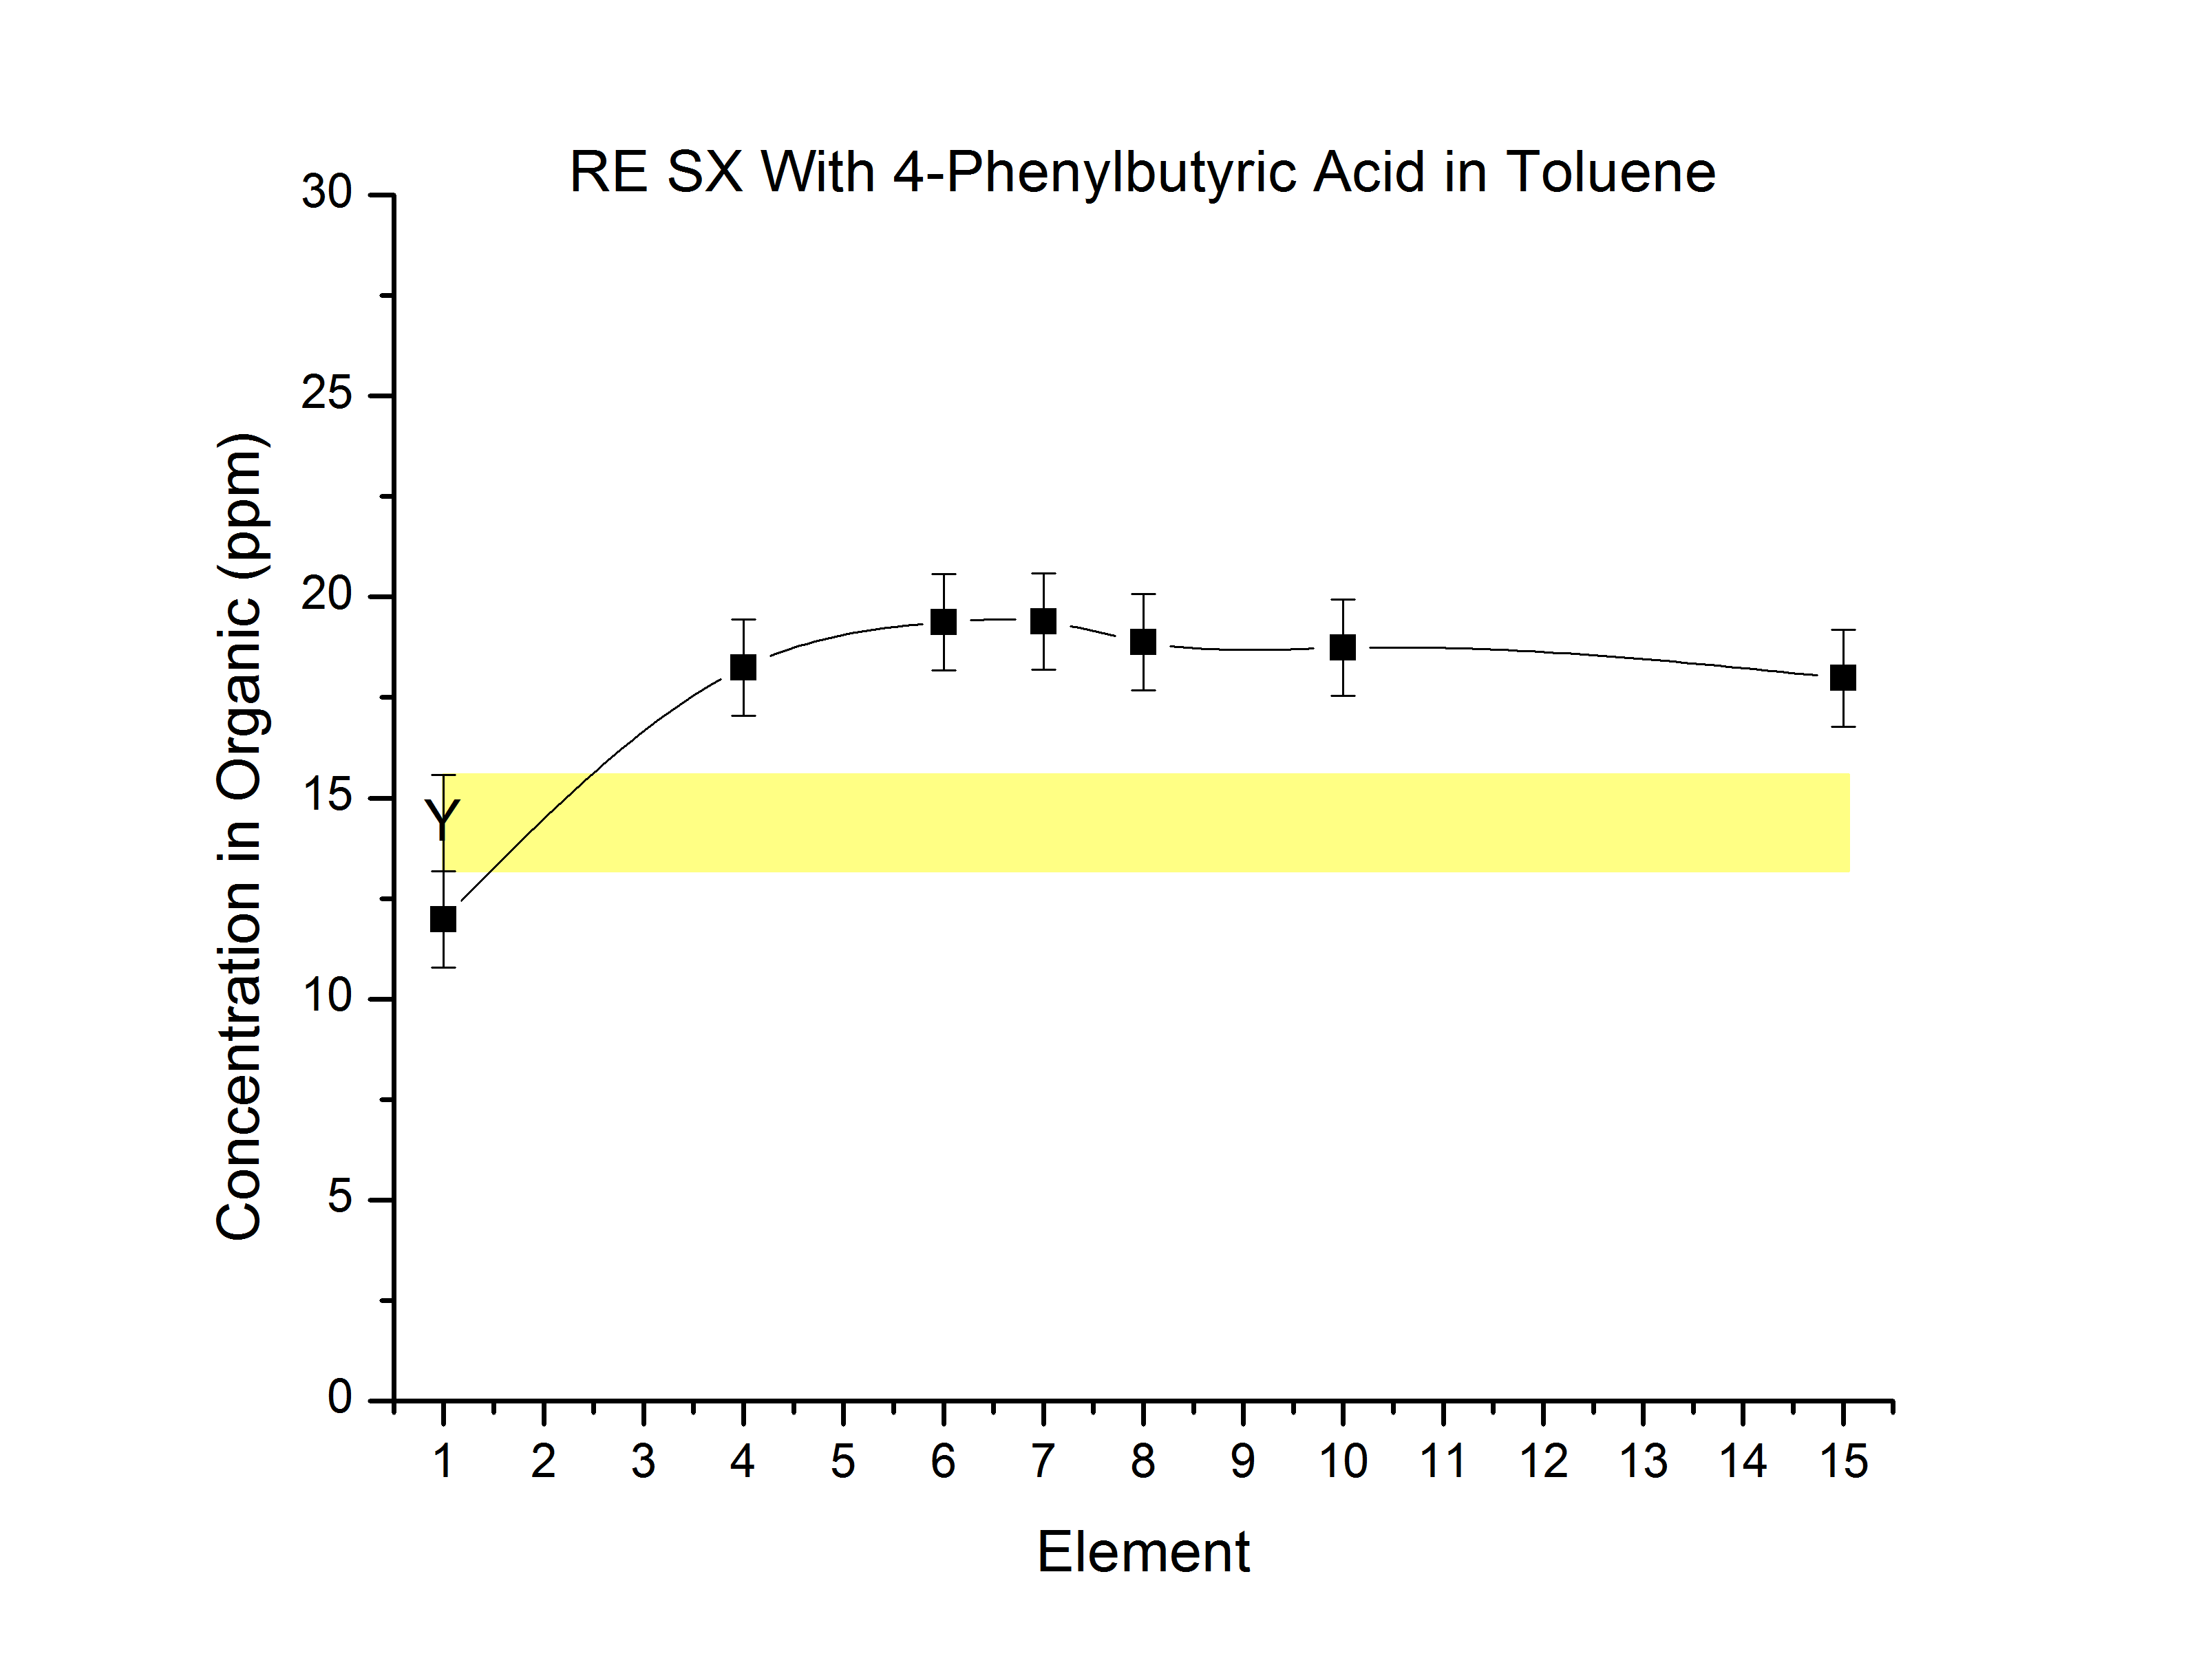
Figure 21: Rare earth extraction with 4-phenylbutyric acid in toluene
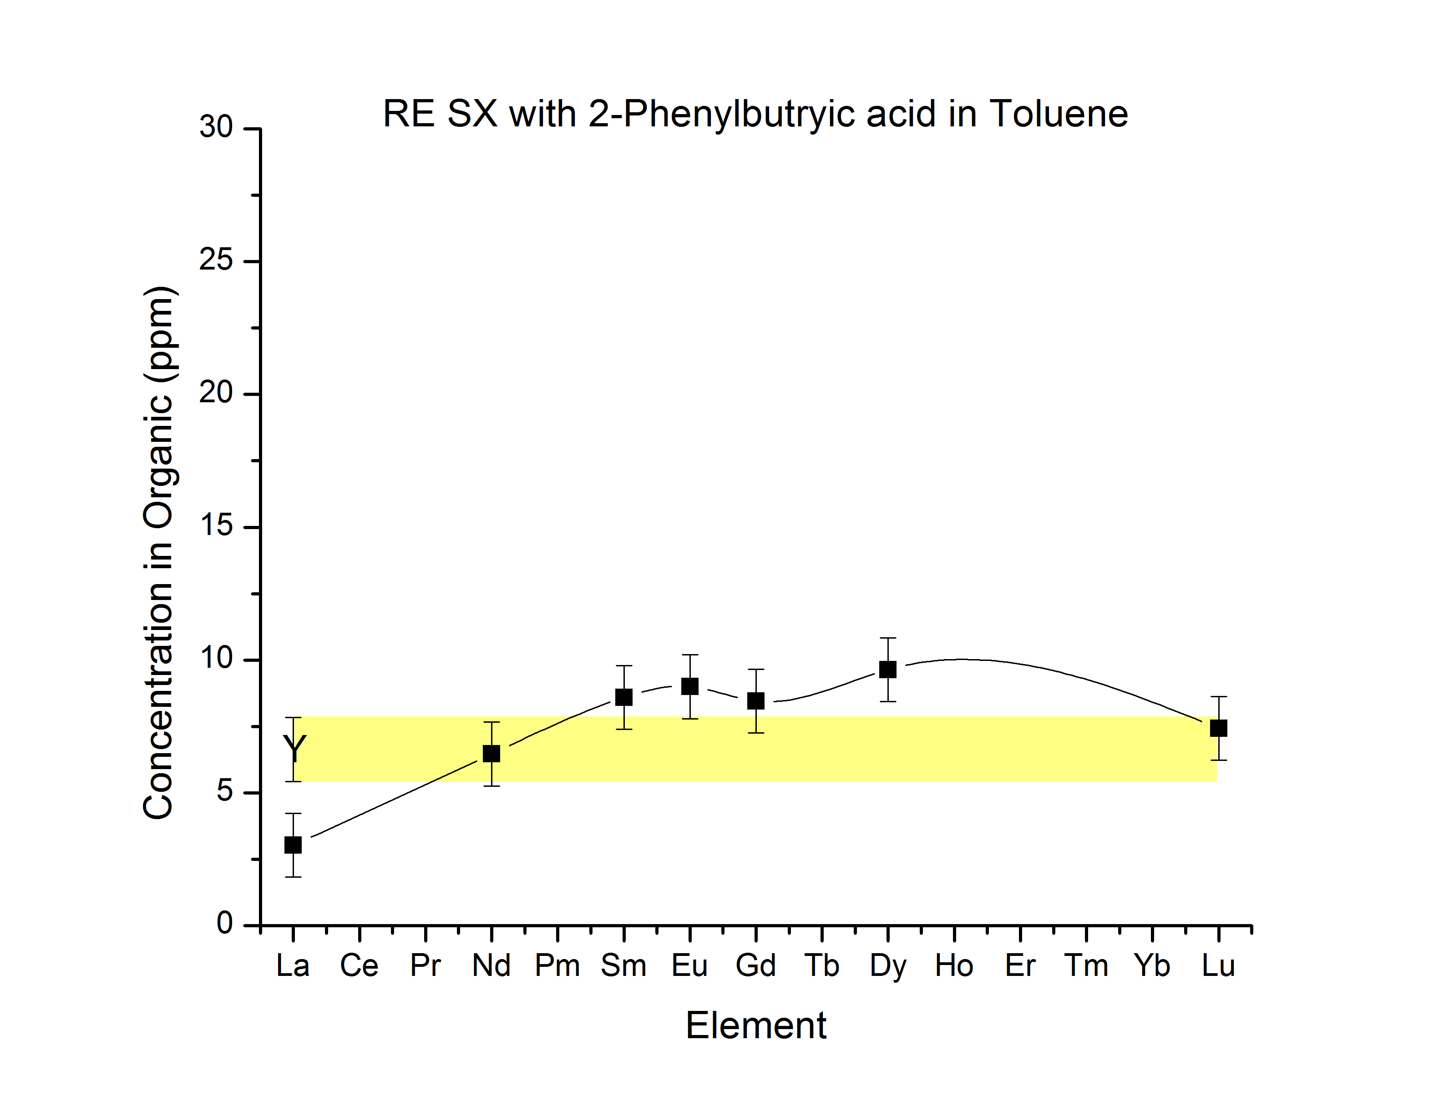
Figure 22: Rare earth extraction with 2-phenylbutyric acid in Toluene
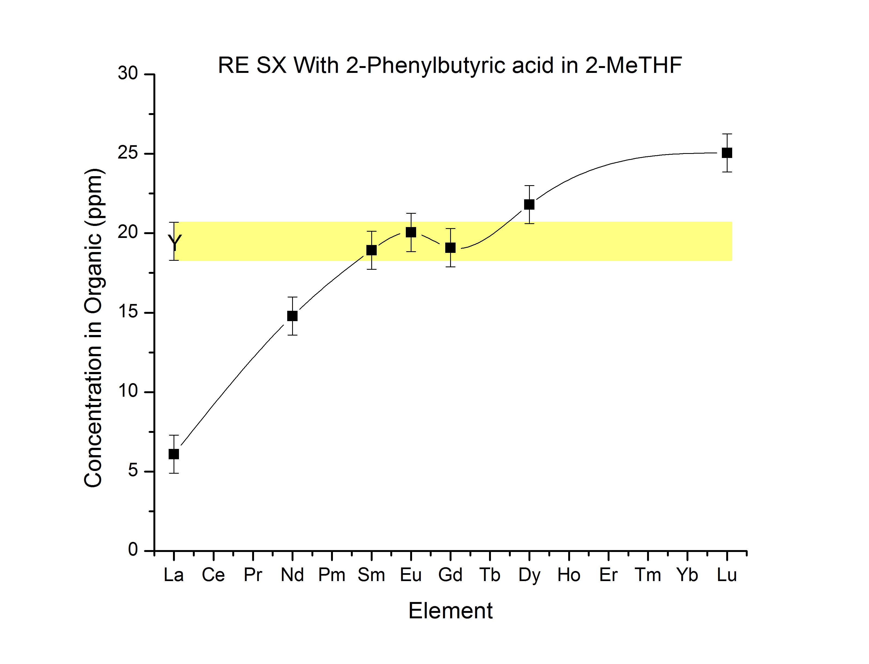
Figure 23: Rare earth extraction with 2-phenylbutyric acid in 2-MeTHF
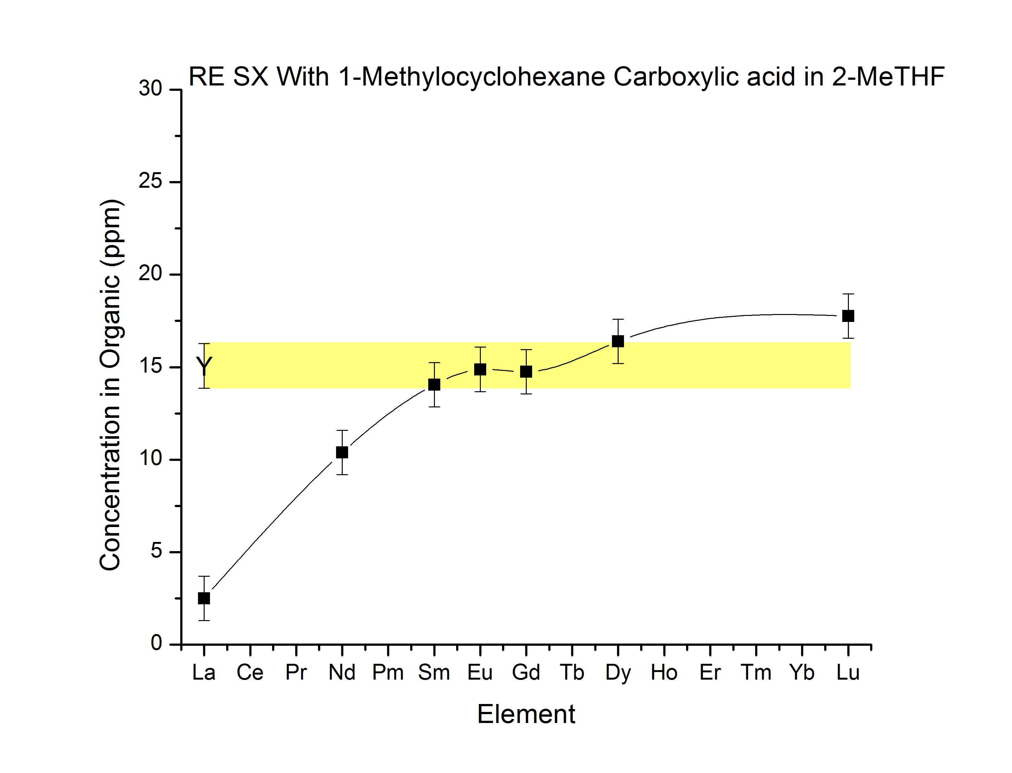
Figure 24: Rare earth extraction with 1-methylcyclohexane in 2-MeTHF

Chapter 2
Recovery of Ir Plated on ZrO₂

Abstract

This study involved lowering the operational costs of the production of LSO. Iridium is used as the crucible for melting LSO, for it high melting point and resistance to corrosion. It is a platinum group metal with a high value, however during the synthesis of LSO at temperatures approaching the melting point of iridium, iridium is lost to the insulating material, zirconia, by a vapor deposition/oxidation process. Two methods were developed to recover and separate the iridium from zirconia involving chemical and physical separations. Using chemical methods it was found that a fusion using potassium nitrate, potassium chloride, potassium nitrate would dissolve iridium leaving the zirconia untouched. A physical separation based on the difference of the densities of the materials was also developed.

Introduction
Production of LSO (lutetium oxyorthosilicate) detectors for PET (positron emission tomography) is completed by growing large single crystals by the Czochralski method. This growth process is lengthy and requires sustained high temperatures ~2150°C. Iridium (a platinum group metal, Ir), is the only suitable crucible material at these temperatures, which increases production costs. In 2012, iridium reached its highest value of $1085 per troy ounce and its current value (May 2015) is $580 per troy ounce. ¹ Therefore, the importance of maintaining a supply of iridium is imperative as the value fluctuates.
Iridium (Ir) is used as the crucible material for the growth of LSO due to its high melting temperature of 2446˚C. In addition, iridium is considered to be the most corrosion resistant metal. During the crystal growth process, iridium does not incorporate into the crystal structure.
The iridium crucible is insulated with zirconium dioxide, zirconia. During the growth period, an inert atmosphere is needed to prevent iridium from being oxidized to iridium dioxide. ² However, trace oxygen is required for the successful growth of LSO. ³ Some oxidation of the iridium occurs as a result and vapor deposits on the zirconia insulation lining the furnace. This depositing can result in significant losses of valuable iridium overtime.

Recovery of Iridium
The development of a recovery process is imperative to decrease Ir losses. Iridium is deposited at varying sites on the insulation. Zirconia is present at a greater ratio than iridium. Methods of concentrating the Ir from the zirconia are needed to successfully and economically recover it from the insulation.
Zirconia has a melting point of 2715˚C and density of 5.68 g/cm³. Zirconia is a white-yellow refractory material and is resistant to chemical reaction. It can be attacked by concentrated sulfuric acid (H₂SO₄) and hydrofluoric acid (HF), but these reactions occur at slow rates. ⁴
Ir deposited on the zirconia may be present as different compounds: the metal, iridium dioxide (IrO₂), and iridium sesquioxide (Ir₂O₃). It is speculated that the deposited material is the metal because at 1100˚C IrO₂ and Ir₂O₃ decompose to the metal.
Ir has a melting point of 2446˚C, density of 22.56g/cm³, and color can vary from a metallic to black material. Ir demonstrates no reaction with acids. It has been reported that Ir can be attacked by the following major routes: ^{5, 6}
- By gaseous elements at red heat (F₂, Cl₂, O₂).
- Aqueous dissolution in hydrochloric acid (HCl) plus an oxidizing agent in sealed containers at 250 ºC. Oxidizing agents include Cl₂ and NaClO₃.
- Fusion reactions are usually above 600 ºC.
  - Useful fusion agents are Na₂O₂, Na₂O₂ plus NaOH, BaO₂, BaO₂ plus Ba(NO₃)₂, KOH plus KNO₃, K₂S₂O₈, and NaCN plus KCN.

Experimental
Several criteria must be met to successfully develop a process for the recovery of iridium. First, a method must be developed for the concentration of the iridium from the large amount of zirconia present. Second, if a complete separation is not achieved from the latter process, the ability to chemically attack and purify the iridium from the remaining zirconia will be developed. Finally the process developed must be economically and industrially applicable.
The majority of the developmental process analysis will be visually based. Zirconia and Ir are the two main components present and differ notably in color. Zirconia compounds produced are usually colorless to white in color and Ir compounds vary in dark vivid colors.

Materials and Reagents
Several chemicals were obtained for the development of a separation process. The chemicals used for experimentation are listed in Table 3. Small Ir slugs were obtained from Siemens for pure samples of Ir metal. Siemens also provided the iridium-plated zirconia.

Dissolution of Iridium and Iridium Oxides
Several different methods were tested to dissolve Ir. Methods that were used are: dissolution using acids, thermal oxidation, chemical fusions, and oxidation using halides.

Production of Iridium Metal from Solution
Precipitation of the metal will be needed once the Ir is dissolved in solution. The utilization of a reducing agent such as formic acid (CH₂O₂), hydrazine (N₂H₂), or a reducing metal could be possible methods for the production of the metal. If a troy ounce can be produced, final processing of the Ir to an ingot will be done.

Physical Separations of Iridium and Zirconia
Physical separations were developed in accordance with the physical properties of the materials present. Initially, density was the distinguishing property investigated for the separation of the materials. The densities of Ir and zirconia are 22.5 g/cm³ and 5.68 g/cm³, respectively. Second, Iridium and zirconia have different chemical compositions. Zirconia has oxygen atoms present in its structure. Assuming the majority of the Ir is deposited as the metal, Ir metal does not have this oxygen present. This differing chemical structure may
Table 3 Chemicals Used in Separation Process Development
Material | Supplier
Nitric acid ACS Grade | Fisher Scientific
Hydrochloric acid ACS Grade | Fisher Scientific
Sodium Hypochlorite | Fisher Scientific
Calcium Hypochlorite | Fisher Scientific
Iridium ICP Standard 1000ppm | Fisher Scientific
MagicAcid:Fluorosulfuric acid-antimony pentafluoride 1:1 | Sigma-Aldrich
a-Terpineol, Mixture of Isomers 98% | Fisher Scientific
Oliec acid | Fisher Scientific
Potassium Hydroxide | Fisher Scientific
Potassium Nitrate | Fisher Scientific
Potassium Hydroxide | Fisher Scientific
Lauric Axid

make it possible to separate the compounds by flotation of either material. ⁷

Results

Chemical Methods
Iridium dioxide, IrO₂, has been reported to be soluble in aqua regia. ⁸ The compound has a brown color and can be produced by heating iridium in an oxygen environment. A polished iridium slug was heated in a furnace open to atmosphere at 1000˚C to determine whether this is a method of chemical attack. After heating, the slug appeared to have tarnished and was placed in aqua regia. The aqua regia solution containing the slug was heated for several hours at 60˚C. The tarnish on the iridium was not removed after heat application. The conclusion determined from experimentation was that presence of the oxidized iridium was a superficial layer on the slug. An iridium-coated piece of zirconia was subjected to the same conditions as the Ir slug with similar results.
Chlorine gas is known to attack iridium at high temperatures. ⁸ This would be impractical at a large scale. A solution of sodium hypochlorite (NaClO) was purchased with 12-15% available chlorine. A polished Ir slug was covered with sodium hypochlorite in a sealed bottle and heated to ~90˚C for 24 hours. After removal from the bottle, the slug did not exhibit any signs of corrosion. The solution was removed and heated to 110˚C. A white solid was formed with no black or dark color residue resulting from the heating process. The presence of the residue would have indicated Ir. After this experiment, approximately 100g of the iridium coated zirconia was placed in a 1-L Nalgene bottle and filled with the sodium hypochlorite solution. This solution was left standing for three months with mixing performed every workday. After three months, the solution was evaluated via ICP-OES and no iridium was detected upon analysis.
The above chlorine source was determined to be too weak to attack the Ir. Calcium hypochlorite Ca(ClO)₂ was obtained as a different chlorine source. One scoop of calcium hypochlorite ~0.5g, 1-ml of water, and a polished Ir slug were added to the bottle. The mixture was heated at 95˚C for 24 hours. The solution was removed to examine the Ir slug. The slug went from polished to a tarnished black-brown color. The slug was placed in aqua regia overnight with no change in the appearance of the slug.
Another method that is used to react with Ir is molten sodium or potassium cyanide. This method was attempted on a very small scale due to the toxicity of these compounds. A weighed Ir slug was placed in a test tube along with a few mL of a sodium cyanide solution. The solution was heated at 100˚C for 3 days. Afterwards the slug was removed and weighed again with no detectable loss in weight. This resulted in the discontinuation of the method.
Eller et al. reported that magic acid, ⁹ fluorosulfuric acid (HSO₃F) and antimony pentafluoride (SbF₅) in a 1:1 molar ratio, can corrode iridium. Magic acid was obtained from Sigma Aldrich and two 5-mL PTFE bottles. A weighed iridium slug and iridium coated zirconia piece was placed in each PTFE bottle, respectively. Several drops of magic acid were placed into the bottles, capped, and heated to 80˚C for several hours. Afterwards, the acid was neutralized in each bottle. The iridium slug was weighed with no detectable change in weight. The iridium-plated zirconia was checked to determine if any iridium had loosened from the surface of the zirconia. There was no change in the sample.
A fusion of potassium hydroxide and potassium nitrate is one of the oldest methods reported to attack Ir. ¹⁰ A 30-mL crucible was filled with 10g of KOH and 10g of KNO₃ plus the addition of an Ir slug. The crucible was heated for 30 minutes on a Bunsen burner. After fusion, the crucible was allowed to cool resulting in the formation of a blue-black solid. The contents were reacted with copious amounts of 6M HCl. As the acid reacted with the melt, it was apparent that the melt reacted with the crucible by the formation of silica gel. The resultant solution was blue in color and tested positive for iridium using ICP-OES. After dissolving the melt, the slug was no longer present.
This fusion process caused the ceramic crucible to dissolve in addition to the Ir slug. Zirconia crucibles were used for future fusion attempts, due to their increased resistance to attack by KOH. The fusion was repeated with the Ir plated zirconia producing similar results to the slug. The fusion was washed in 6M HCl and mirrored the fusion of the slug. A large portion of material remained, which was indicative of the zirconia. The zirconia was washed and subjected to a second fusion with no coloration noticeable in the melt.
The next attempt was to improve the process after a successful method had been found for dissolving iridium. The likely iridium compound produced by dissolving the melt in HCl is K₂IrCl₆. If a source of chloride was present in the initial fusion, the iridium may go into solution more readily. This hypothesis was tested by adding KCl to the fusion mixture of KNO₃ and KOH at a 1:1:1 ratio by weight. An iridium slug, 10g of KNO₃, 10g of KCl, and 10g of KOH were placed in the zirconia crucible. The crucible was heated in a muffle furnace at 800˚C and temperature was maintained for 30 minutes. The melt was dissolved in 6M HCl. Less HCl was required to dissolve all the material. Thus, this indicated that the melt went into solution more readily. This experiment was repeated at 900˚C and 700˚C. At 900˚C, loss of Ir by deposition of black material on the lining of the furnace was observed. At 700˚C, the temperature was too low due to the observation of a noticeable reduction in coloration of the melt.
The fusion using KNO₃, KOH, and KCl at 800˚C was the most effective process to dissolve the iridium. Attention could now be placed on a process to reduce the iridium to its metal.

Production of Iridium Metal from Solution
Iridium ICP stock solutions were used as the starting solution of iridium for the development of a process to produce the metal. A 1000ppm Ir standard was received from Alfa Asear and subjected to several reducing agents. Magnesium and zinc powder were first used as reducing agents. When put in contact with the iridium solution, the metals were coated with a black material assumed to be iridium. This test assisted in determining that these metals could reduce the iridium successfully.
The fusion method was determined to be the appropriate method for further experiments. The process of dissolving iridium using a melt of KCl, KNO₃, and KOH followed by HCl produced a blue, Ir containing solution. Mg and Zn powders were added to a small portion of this solution causing a violent reaction. The acid concentration was obviously too high. The experiment was repeated after raising the pH of the solution to 1 using sodium hydroxide. The Zn reacted less violently then the Mg. Production of the Ir metal was more visible in the zinc reaction. Hydrazine was tested as a reducing agent for iridium with no change in the color of the solution and no solids production. Sodium sulfite was attempted for use as a reducing agent. When sodium sulfite was added to the solution, the color changed from a blue to red-brown and, finally a yellow color. The color changes are not believed to be due to an oxidation state change but a change in the major complex.
Further tests were performed on Zn, since the metal has been the most appropriate reducing agent. Powdered Zn was added to the Ir solution at pH 1. The reaction was allowed to proceed until no bubbling was noticeable on the surface of the Zn. The color of the solution changed from blue to yellow. The resulting yellow solution was suspected to contain iridium that was not reduced to the metal. Approximately 100 ppm of Ir was measured via ICP-OES. This solution was then separated from the Zn. No further Ir was removed with additional Zn.
With incomplete reduction of Ir, a new method to produce the metal was required. The blue solution containing Ir was heated at 100˚C to remove all water. The temperature was increased to 200˚C for two hours in an attempt to produce the iridium oxide, After heating, water was added to dissolve any potassium salts present. When water was added to the solid, the solution produced was colorless containing a black solid. The black solid was washed three times and analyzed using powder x-ray diffraction (PXRD). The pattern did not match the predicted Ir metal pattern. Therefor, the solid was speculated to be an iridium oxide.
The iridium oxide produced was heated in a tube furnace under argon at 1200˚C in an attempt to decompose the oxide to the metal. The resulting black powder was analyzed using the PXRD and produced a pattern that matched the predicted pattern for Ir metal.
An alternative process was attempted in lieu of high temperature decomposition. Iridium oxide was produced by the previous method. After washing and drying the solid was placed in a round bottom flask. A constant stream of hydrogen was purged over the sample. While purging the flask was heated to 500˚C using a hot plate for one hour, then the flask was removed from the hot plate. After the round bottom cooled the powder was analyzed using PXRD and the resulting spectrum matched the predicted pattern for Ir.

Physical Separations of Iridium and Zirconia
To reduce the amount of material processed, development of a method to recover iridium from zirconia will require a pre-separation. The first property of the materials, as previously stated, that could be a premise for the separation of the two materials is density. The iridium-plated zirconia powder was placed in a test tube with water added and shaken and the material was allowed to settle. The test tube was visually inspected and a concentration of black material was observed at the bottom of the test tube. This initial experiment supportive results to the idea that the two materials could be separated by density.
An acrylic rod was milled to create a cylinder that had a conical bottom with a 10˚ slope. It was believed that the sloped bottom would collect the Ir containing zirconia more efficiently than the test tube. An overhead mixer was lowered into the cylinder and the powder was added along with water. The mixer was turned on and allowed to mix for one minute and then shut off. The settling of the material again concentrated the iridium containing zirconia at the bottom with a mixture of zirconia and iridium above it.
It was then determined that a better separation may occur if the iridium could be physically separated from the zirconia. The iridium-plated zirconia was ground using a mortar and pestle. Using a microscope, it was observed that the grinding fractured the iridium from the zirconia. Approximately 500g of the material was processed using this method. The ground material was then processed using the acrylic rod cylinder. The settling appeared to separate the two materials more effectively. An attempt to remove the zirconia on top of the material was done. It was found that it was hard to remove the zirconia over a large surface area without removing the iridium and after it was attempted it was found that the concentrate still contained visually 50% zirconia.
Separation of material by density has been done before in gold mining. Gold panners would initially separate gold from the dirt using a sluice box to separate the more dense gold from dirt. A sluice box is a long channel that water flows down. There are channels that are perpendicular to the flow that heavier material is supposed to deposit and the lighter material will be washed away. A small sluice box was ordered, the Micro Sluice Junior. Initial usage of the sluice box to separate the powdered material was difficult, flow rates of the water were varied and the collection of material in the channels were observed. This material did not appear to be concentrated. The use of the micro sluice box was discontinued. After the sluice box experiments the grinded material was exhausted and it was requested to Siemens that more material be acquired and come pre-milled. Siemens provided several kg of milled material.
The main issue with the acrylic cylinder was that the material was not distributed in an easy to remove position. A 1000mL separatory funnel was filled with water and 100g of the milled powder. Once shaken the material was allowed to settle. With this method the concentrated material could be flushed from the stopcock. This provided a better separation but improvements were attempted. The separatory funnel was emptied and refilled with water. The powder was poured in the top of the funnel and allowed to settle. This method provided an improvement of the separation process allowing all the material to start settling from one location.
The powder then was classified using sieves. The powder was separated into several sizes, <75µm, 75µm – 100µm, 100µm-150, and >150µm. The 100-150µm sample was used in the gravity feed separatory funnel separation. Considerably better separation was achieved with the classified material. A 1inch i.d. X 1 ft column was attached to the separatory funnel to increase the time that the powder would fall. This extra distance appeared to improve the separation. Finally a 6ft column was added to the separatory funnel, which produced the best results. Using this method a sizable amount of iridium was separated from the zirconia. It is to be noted that the separation was not complete. Visually approximately 10% of the material was zirconia, which would likely be due to the inability to control the stopcock to remove only iridium.
With the majority of the iridium separated from zirconia other methods to refine this process were explored. Methods in mining to remove small portions of mineral contaminants were researched. Flotation methods were found to be one of the simplest methods we could explore. The materials if mainly iridium metal and zirconia would have different chemical bonding. Zirconia is bonded to oxygen while iridium is metal-metal bonded. Certain surfactants could possibly attach to the zirconia and float the material to the surface leaving the iridium at the bottom of a flotation cell.
To test flotation methods a large fritted Buchner funnel was ordered and air was pumped through the bottom of the funnel to provide aspiration. Using one drop of oleic acid to 1L of water the Buchner funnel was filled with this solution. The concentrated iridium sample previously prepared was placed in the Buchner funnel and air was passed through the funnel. Bubbling instantly began and samples of the bubbles were removed to look for iridium or zirconia. In the samples of bubbles it was found that both the iridium and zirconia were present. After further investigation the addition of pine oil could reduce the bubbles produced which may limit the iridium that is carried on the bubble. One drop of terpine oil was added to the mixture and all bubbles were eliminated.
While the bubbling of the Buchner funnel was active it was noticed that some of the iridium remained on the bottom of the funnel where as most of the zirconia was lifted. With this observation it was thought if a large bubbling column was manufactured the distance that the iridium and zirconia were lifted would be different and could be controlled by the amount of bubbling. Materials were ordered to produce the large bubbling column.
The bubbling column was produced at 4 feet in height and 3 sampling ports were added to the side of the column (figure 25). Powdered material was placed in the column and it was filled with water. Bubbling was started and the sampling ports were sampled. At the top port only zirconia was found. The
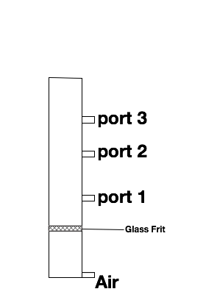
Figure 25: Flotation Column

middle port sample it was observed that mainly zirconia was found but small amounts of iridium were contaminating the sample. The bottom port was mainly iridium. This distribution of material was thought to be due to the small differences in size and a clean separation could not be made. After several attempts at varying pressure similar results were found. It was noticed after an experiment the middle port line was not shut off and iridium was collecting in the bend of the tube that was connected to the port. This iridium containing material appeared to not have any contamination of zirconia. The collection vessel however did contain a mixture of zirconia and iridium. With this observation the separation of iridium would be explored using tubing.
While using the bubbling column the top and bottom ports were closed and 4 feet of ¼ inch i.d tygon tubing was attached to the middle port. The flotation column was turned on and powdered material added. The volume of the water in the column decreased as it passed out the middle port. To keep the water level constant water was added periodically as it dropped. The tubing was laid horizontal across the lab bench and iridium and zirconia powder entered the tubing slowly as it was picked up by the bubbling action of the column. As the experiment proceeded there appeared to be a separation of the zirconia from the iridium. The iridium would pass slower thorough the tubing then the zirconia. After an hour most of the added material had passed through the tubing. In the tubing, a band of black iridium material spanned ~6 inches from the entrance, whereas most of the zirconia had exited the tubing. This experiment led to the belief that the tubing was acting like density gradiant and the bubbling column just served to dilute the zirconia mixture.
The next set of experiments focused on expanding the chromatography action of the zirconia and iridium through a tube. A 3.5 gallon tank was ordered such that a large amount of the powdered material could be mixed. 10 feet of tubing was attached to the drain of the tank. A peristaltic pump was used to pump the fluid from the tank through the tubing. Approximately 250-ml of powder was added to the tank and mixed with 3 gallons of water, the peristaltic pump was turned on at a flow rate of ~100mL per min. An example of the setup is shown in Figure 26. As with the column, water needed to be added to the tank as it was pumped out. This experiment was repeated several times altering the way the tubing was oriented. The orientations of the tubing were as such: horizontal, incline of 20˚, incline of 45˚, vertical sections, several vertical loops, and several dips. The best separations were achieved when the tubing was horizontal or when it had dips. Horizontal orientation allowed for the iridium and zirconia to separate by spreading out through the tube with the zirconia traveling farther then the iridium with each rotation of the pump. With dips the iridium would collect in the dips and the zirconia would pass though the dips. The pulsation of the pump also seemed to help with the separation by disturbing the material which would cause the iridium to sink in the material and allowing the zirconia to be flushed out by the water. Once the material had been cleared of the mixing tank the pump would be allowed to run until the zirconia had left the tubing. Then
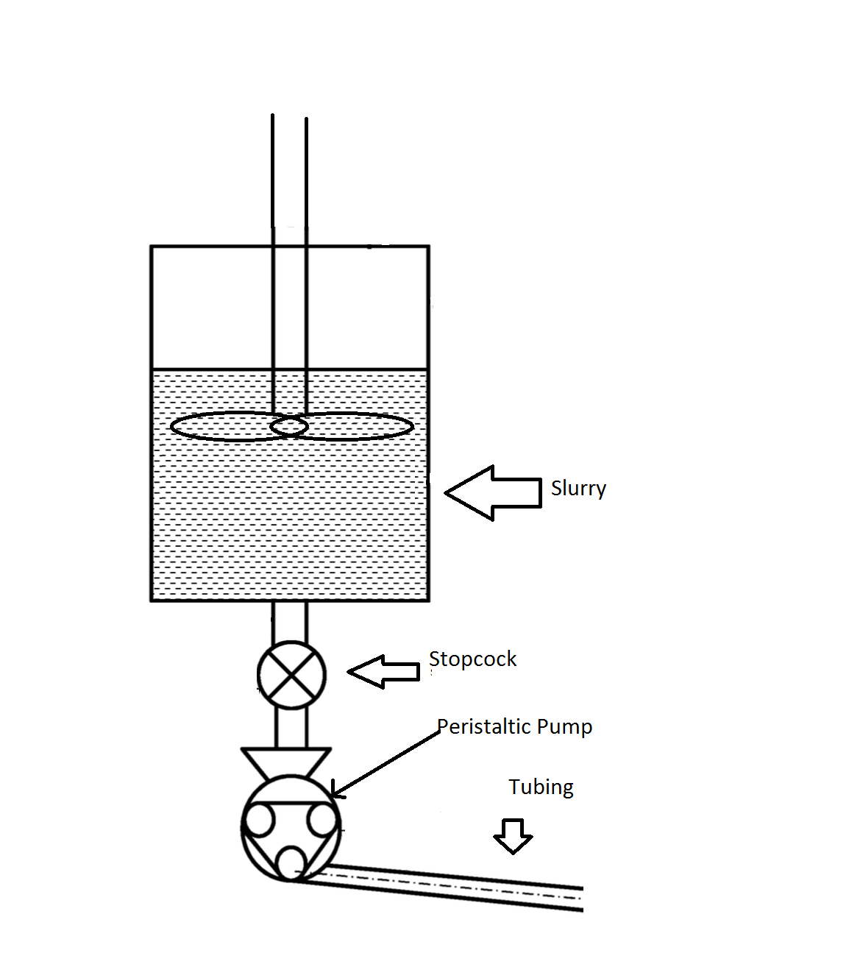
Figure 26: Tubing Separation Design

the pump speed would be increased to max speed, which would flush out the iridium. The iridium would be collected in a separate container. It was determined that all detectable iridium was removed from the zirconia by attempting to dissolve any iridium using the fusion dissolution method previously developed. Using the ICP-OES no detectable iridium was found.
The final separation procedure that was developed for iridium separation was a scale up of the previous experiment. It was decided that to increase separation of this “chromatography” experiment increasing the length would help. Also, increasing the number of dips would also help in the separation. Tubing that had dips manufactured were investigated. It was found that polyethylene corrugated tubing 0.5 inch i.d. could offer several small dips to the length of the tubing and would also be transparent so the separation could be monitored as it was in the tygon tubing. 50 feet of the tubing was obtained for the separation process. It was also requested at this time for a troy ounce, 31.1g, of Ir be produced for Siemens, so that an ingot could be made from it.
To obtain this amount ~1 gallon of powdered material would need to be passed though the tubing. The powder was initially passed though the tubing at the same rate as previous experiments, but it was quickly found that that rate was not sufficient to separate the material though the corrugated tubing. The flow rate was increased to 400-mL per min, which provided excellent flow. As the iridium was separated it was allowed to run for several hours with the iridium only traveling 6 feet though the tubing, when all the zirconia had visually left the tubing. The iridium was removed from the tubing by passing water at a rate of ~5L per min though the tubing. This experiment was repeated several times to obtain the needed 31.1 grams. With the corrugated method an efficient batch process was developed for the separation of zirconia from iridium.
Conclusions
All the goals were met for the recovery of iridium that is plated on zirconia. A chemical process was developed do dissolve iridium, a means of iridium metal production from solution, and a means of concentrating the Iridium from zirconia were all developed during this project.
To chemically dissolve iridium a fusion of KNO_{3,} KOH, and KCl at 800˚C is needed. This fusion can then be dissolved in HCl to produce the K₂IrCl₆ which is soluble. Once in solution impurities, such as zirconia or silica, can be removed. The iridium solution can then be heated to dryness and decompose the K₂IrCl₆ to iridium oxide. Finally, the iridium oxide can be heated in a hydrogen atmosphere at 500˚C to produce iridium metal.
However, the best method found for the purification of iridium was to fracture the iridium from the zirconia and preform a density separation. The density separation preformed best by pumping a slurry of the zirconia and fractured iridium through a corrugated tube with a peristaltic pump. This will perform a separation based on density by passing the zirconia at a faster rate though the tube leaving the iridium behind. When the separated iridium was melted to an ingot it was found that it met the purity specifications required to produce iridium crucibles.
The developed processes could be industrially applicable. First, the chemical means for dissolution of iridium do not use expensive reagents and are operated at easily obtainable temperatures. However, to produce the metal from solution requires drying the iridium from a solution, which if large volumes are used could be the most costly portion of the recovery process. In producing the metal from the produced oxides hydrogen would lower the temperature needed for conversion to the metal but heating to 1200˚C in an inert atmosphere also produces the metal, which would be the safest option in an industrial environment. Finally the separation of zirconia from iridium by physical means is the cheapest option with the materials needed being a pump and tubing. This process is currently a batch process but it may be possible to scale up size to processes large batches at a given time. The initial cost of a mill that can fracture the iridium without introducing impurities would be the largest cost of the operation.

References

(1). http://www.infomine.com/investment/metal-prices/iridium/5-year/ (accessed July 1, 2015)
(2) Wimber, R. T.; Kraus, H. G. MT 1974, 5, 1565–1571.
(3) Melcher, C. L.; Schweitzer, J. S. Nuclear Science, IEEE Transactions on 1992, 39, 502–505.
(4) Prajapati, R. R.; Srinivasan, T. G. … and Water Treatment 2014.
(5) Renner, H.; Schlamp, G.; Kleinwächter, I.; Drost, E.; Lüschow, H. M.; Tews, P.; Panster, P.; Diehl, M.; Lang, J.; Kreuzer, T.; Knödler, A.; Starz, K. A.; Dermann, K.; Rothaut, J.; Drieselmann, R.; Peter, C.; Schiele, R. Platinum Group Metals and Compounds; Wiley‐VCH Verlag GmbH & Co. KGaA: Weinheim, Germany, 2000.
(6) Federer, J. I. Purification of iridium by an oxidation-dissolution process; 1974.
(7) Ityokumbul, M. T.; Bulani, W.; Kosaric, N. Water Science & Technology 1987.
(8) Federer, J. I. 1974.
(9) Eller, P. G.; Kissane, R. J.; Abney, K. D.; Avens, L. R.; Kinkead, S. A.; Hanrahan, R. J. Journal of Alloys and Compounds 2004, 365, 134–137.
(10) Fellenberg, M. philosophical magazine series 1838, 12.

Chapter 3
Investigations of the Mechanochemistry of the Rare earths

Abstract
This study investigated the rare earths with mechanochemical reactions. It was found that lutetium oxyorthosilicate (LSO) could be synthesized by mechanochemical methods using a planetary ball mill. Its synthesis is completed at high temperatures. It was also found that it might be possible to reduce ytterbium oxide, europium oxide, and samarium sesquioxides oxide to monoxides using mechanochemical methods at room temperature with no solvents. Evidence of these reactions was based on the vivid color changes when undergoing milling with calcium.

Introduction

Mechanochemistry has recently seen an increase in interest. Mechanochemistry evaluates chemical reactions and physical changes by input of mechanical energy. The reactions typically studied occur between solids with little or no solvent. This field has the ability to make several chemical processes “Green” in reducing solvents required for a chemical reaction and the possibility of increasing yields¹. An added benefit of mechanochemistry is that most reactions occur quickly.
The energy input source in mechanochemistry is commonly from a ball mill. Ball mills achieve milling by rotating ball bearings in a cup or tumbler. Particle size and energy input are dependent on the ball’s size, density, and speed of rotation. In laboratory settings a planetary ball mill is used for high-energy ball milling in several cases. There are similarities and differences between a planetary ball mill and a ball mill. A planetary ball mill contains one or more grinding cups that rotate on a primary axis. As rotation occurs, the grinding cups rotate on their own axis in the opposite direction of the primary axis (Figure 27). The result is the possibility of production of nanoparticles from this mill.
Some of the chemical reactions that have been completed using a ball mill are the reduction of certain metal oxides. For example, iron oxide (Fe₂O₃) milled in the presence of aluminum will reduce to Fe and oxidize Al to Al₂O₃. This reaction is performed with excess aluminum metal and some of the produced iron forms an alloy with excess Al. ² A second example, is the reaction of copper oxide (CuO) with Al. This reduction produces Al₂O₃ and Cu₂O. ^{3, 2} These solid state reactions make it possible, with the right reducing agents, to reduce metal oxides to a desired oxidation state.
Mechanochemical reactions can also simulate high temperature reactions at room temperature. For example the classical method to produce calcium silicate (CaSiO₃) is to heat calcium oxide (CaO) or calcium carbonate (CaCO3) with quartz (SiO₂) to 1150˚C – 1200˚C for several hours. Other methods utilizing chemical routes such as sol-gel, combustion, and precipitation followed by heat will produce CaSiO₃. ⁴ When a planetary ball mill was used to produce CaSiO₃, stoichiometric amounts of CaCO₃ and dehydrated silica gel were milled for varying times. ⁵ The RPMs of the mill was set to 300. The lapse time from the conversion of the starting materials to product was three to six hours. This
CaSiO₃ was identified using powder x-ray diffraction (PXRD). The production of
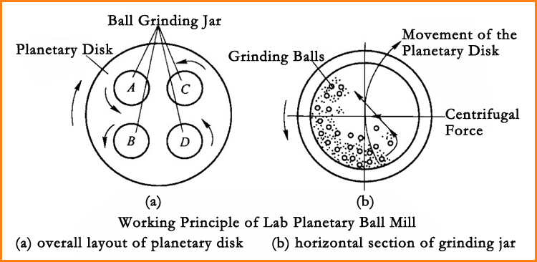
Figure 27: Operation of a Planetary Ball Mill

CaSiO₃ by this method produces nanoparticles with an average size of 21nm.
Rare Earth Problems
One of the major issues with production of high purity Lutetium (Lu) is the separation of Lu from Ytterbium (Yb). Lutetium is the heaviest rare earth in the series, and has a major oxidation state of +3. This is the most stable aqueous oxidation state of the rare earths with the exception of cerium. A few exceptions of the rare earths capable of a +2 oxidation state in the aqueous phase are Yb, Sm, and Eu. When producing of high purity Lu, over a hundred stages of solvent extraction may be needed. However, if ytterbium can be reduced from Yb⁺³ to Yb⁺² it might be possible to precipitate YbSO₄. The product is insoluble and can be filtered off. Some of the best reduction methods for ytterbium involves using amalgams. ^{6, 7} Mercury use is regulated due to its consideration as an environmental hazard. Therefore, mechanochemical methods may be a more practical method and able to eliminate the use of the mercury.
Lutetium is used in the production of lutetium oxyorthosilicate (LSO). LSO is the scintillator used in positron emission tomography (PET) scanners manufactured by Siemens. LSO exhibits one of the highest light output and one of the fastest scintillators for gamma detection. ⁸ The Czochralski process is utilized to produce LSO in the form of single crystals. LSO (Lu₂SiO₄) is made by melting equal molar quantities of Lu₂O₃ and SiO₂ with a small quantity of cerium oxide (CeO₂). The melting temperature of this mixture is 2150˚C. ⁹ The cost of LSO production could be lowered with the development of a mechanochemical method that operates at a lower temperature.
The purpose of this study was to explore the possibility of the reduction of rare earths to the +2 state to simplify separation of the rare earths in addition, LSO production was investigated to develop a mechanochemical method.
Experimental
The two goals of this study were: 1) to produce LSO using a planetary ball mill, and 2) reduce Yb to the +2 oxidation state using a planetary ball mill. The ball mill experiments were performed with a Fritsch Planetary Micro Mill Pulverisette 7 premium line. This mill rotates at 100-1100 RPM on the main disk. The grinding bowls rotation is at a 2:1 ratio of the main disk. The grinding bowls and balls are made of silicon, which is a hard material that resists abrasion. Any silicon nitride introduced to the milled material is considered inert and not affecting the product. The grinding bowls have a volume of 45-mL, and the grinding balls have a diameter of 10-mm. In each experiment seven balls were used in each grinding bowl. Table 4 shows the chemicals used during experimentation.
Instrumentation
Powder x-ray diffraction analysis (PXRD) was performed using an Olympus BTX II Benchtop XRD. Annealing of some samples was done using a MTI tube furnace at 1000˚C to improve PXRD analysis.
Synthesis of LSO by Ball Milling
Table 4: Chemicals used for mechanochemical investigations
Chemical | Supplier
Lutetium Oxide | Siemens
Silicon Dioxide (Quartz) | Siemens
Cerium Dioxide | Siemens
Silica Gel | Sigma
Europium Oxide | Alfa
Ytterbium Oxide | Alfa
Erbium Oxide | ProChem
Samarium Oxide | ProChem
Calcium | Fisher Scientific
Magnesium | Fisher Scientific
Aluminum | Fisher Scientific
Copper Oxide | Fisher Scientific
Zinc | Fisher Scientific
Zinc Oxide | Fisher Scientific
Ytterbium Chloride Hexahydrate | Alfa
Ytterbium Sulfate | In Lab
Sulfuric acid | Fisher Scientific

Initial experiment focused on determining how milling changes the starting material. PXRD analyses of the starting materials were completed in one hour intervals for eight hours total. This information assisted in the product analysis by providing information of the material composition. The same experiment was done with powdered LSO.
Reduction of Rare Earths
Rare earth reduction experiments focused on reduction of the oxides using reducing metals such as Zn, Mg, Al, and Ca. Chlorides and other anions were tested after completing the reduction experiments. Analysis of the products was completed PXRD analysis. Qualitative analysis of rare earth reductions was color as differing oxidations states of the rare earths exhibit different colors.
Results
Synthesis of LSO
Initial experiments for the synthesis of LSO were obtaining PXRD patterns for the starting materials: SiO₂, Lu₂O₃, and CeO₂ (Figure 28). A pattern was also obtained for LSO. After measuring the patterns for the starting materials, they were milled using the planetary ball mill for one hour followed by obtaining new patterns.
Synthesis of LSO was performed upon completing the analysis of the starting material patterns. In the first experiment, CeO₂ was not added to the mixture of Lu₂O₃ and SiO₂. Five grams of the mixture were milled and sampled every hour for 8 hours. Analysis of the patterns revealed after four hours of
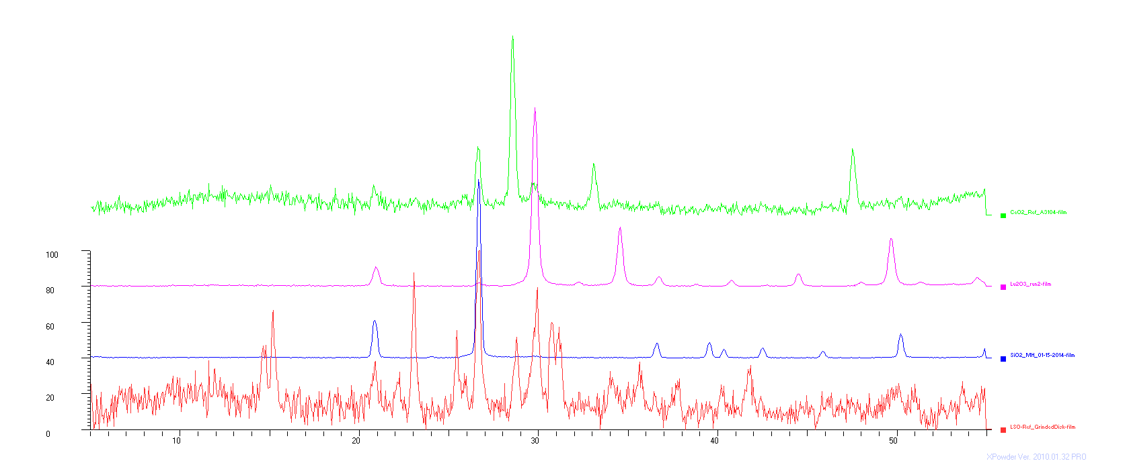
Figure 28: PXRD Patterns for Starting Materials from top to bottom 1. CeO₂ 2. Lu₂O₃ 3. SiO₂ 4. LSO
milling the produced pattern closely resembled the powdered LSO sample. The final sample collected after 8 hours appeared to have become mainly amorphous due to the decrease in signal intensity and line broadening.
The 8-hr milled amorphous sample was annealed at 1000˚C for 4 hours using a tube furnace. The annealed sample was analyzed by PXRD (Figure 29). The resulting pattern matched the powdered LSO crystal sample pattern.
A new set of samples was prepared with 5% by weight cerium dioxide. The samples were milled for 4-hr, PXRD was used to analyze the samples and the pattern matched the expected pattern. Scintillation experiments were performed on the samples in Dr. Melcher’s lab. The process entailed placing the powder samples on a PMT and positioning a gamma source (Cs-137 10µCi) above the sample. No scintillation was detected from the powder samples. When placed under a UV light, the samples did not exhibit luminescence. If luminescence had occurred, a blue light would have emitted from the sample. The samples were annealed at 1000˚C and subjected to the same series of tests. No scintillation was detected, but luminescence was observed under UV light.
Reduction of Rare Earths
Preliminary experimentation of rare earth reductions was to repeat previously reported reduction experiments with transition elements. The first experiment was to reduce CuO with Zn metal. A 1:1 molar ratio of the two materials totaling 5g was placed in a bowl with 7 balls and milled for 4 hours at 850 RPM. After milling, the contents were removed reveling a red solid known to

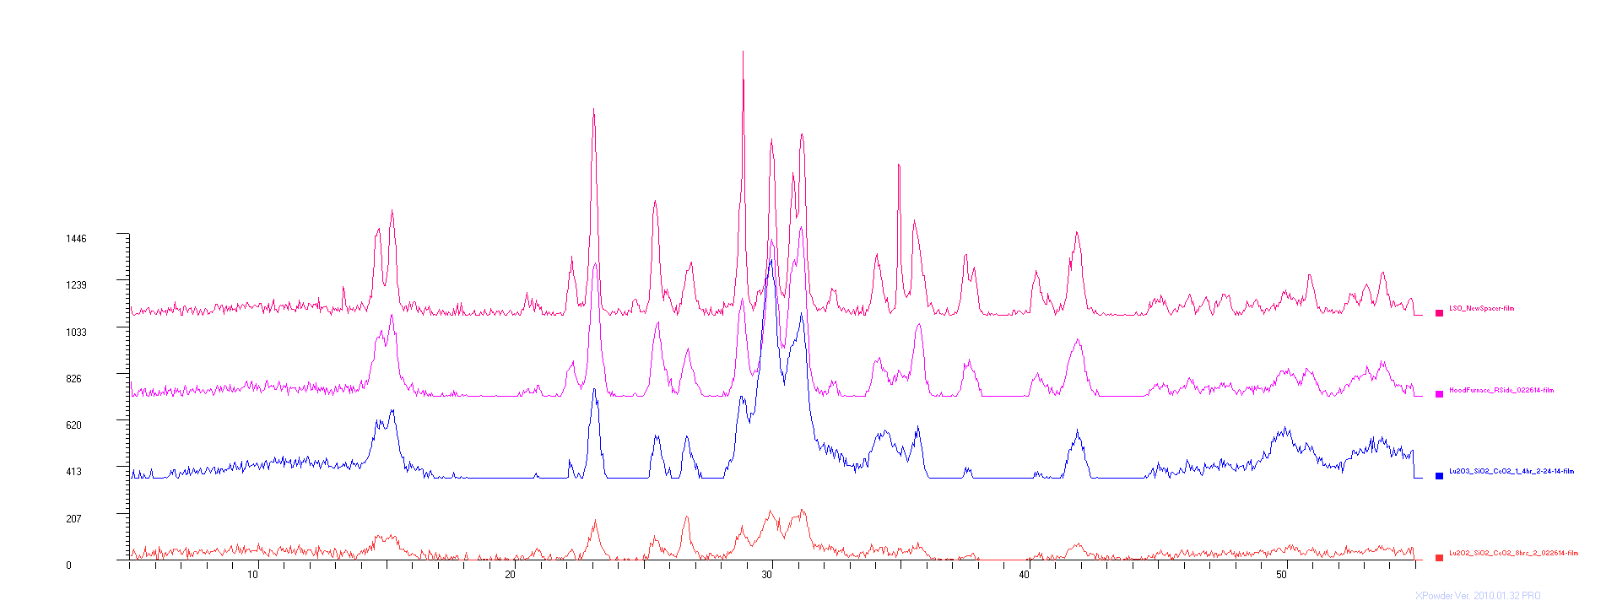
Figure 29: PXRD patterns from LSO experiments. (From top to bottom), 1) LSO reference 2) 8 hour milled with 1000˚C annealing 3) 4 hour milled sample 4) 8 hour milled

be copper(I) oxide. This experiment demonstrated that a reduction can occur, and in a unexpected result copper(II) was reduced to copper(I) instead of the metal.
Another experiment was completed milling zinc oxide with magnesium metal. If the reaction occurs, Zinc Oxide will reduce to Zn and produce MgO. The two reactants were milled under the previously specified conditions to produce a gray metallic solid. The solid was scraped with a microspatula onto weigh paper. Sparks were produced as the microspatula was running across the ground mass. Sufficient scraping resulted in igniting the solids explosively. This explosion was probably due to pyrophoric magnesium and zinc metal produced by the milling process. The explosion caused 2nd degree burns on myself, and several particles bypassed the safety glasses into my eye. The protocol for future experiments examining potential pyrophoric material will be to open in a glove bag with an argon atmosphere. In addition, full cover safety goggles will be required in the handling process.
Ytterbium
In all following experiments, prior to any milling the starting materials were analyzed by PXRD. Ytterbium in the +3 oxidation state has similar chemistry to all the other +3 rare earths, being most similar to Lu and Er. In aqueous chemistry ytterbium can be reduced to the +2 state, and exhibits different properties similar to the alkali earth elements. Possible reducing agents for Yb⁺³ are Mg, Al, and Ca.
milling in the planetary ball mill. A reduction of Yb to the +2 oxidation state occurred due to the observation of a faint green coloration. Further experimentation could be continued after finding Ca was a suitable reducing agent.
Several cases from a literature search cited that an excess amount of reducing agent was required for a reaction to occur. This was possibly due to the reducing agent clumping or adhering to the walls of the grinding vessel. A sizable amount of material was caked to the grinding vessel walls in all the reducing experiments confirming this conclusion.
The reduction of Yb₂O₃ was continued using 5% stoichiometric excess of Ca as the chosen reducing agent. For 5g of Yb₂O_{3,} 0.52g Ca were used and the mixture was milled for 4 hours. The resulting mixture had a dark green color expected of +2 ytterbium solids. The green solid was removed from the bowls and analyzed via PXRD. The results displayed patterns for Yb₂O₃ and CaO. No pattern was produced that matched the YbO pattern.
Longer milling times were speculated as a method to improve the production of YbO. Milling times were increased to 8-hr. The green solid produced by the milling demonstrated a minor change in color from the previous experiment. Next, the amount of Ca was increased to 10% stoichiometric excess at a total of 0.55g Ca. The mixture produced was a darker green. Analysis using PXRD was performed to determine if the color change was due to more Ca and not YbO. The results produced no pattern for YbO.
If YbO was not detected on PXRD, then the material may have become amorphous. The green powder mixture was placed in the tube furnace with an argon purge and annealed at 1000˚C for 4-hr. After 4-hr, the sample was removed from the furnace. The color of the sample had changed from green to white. PXRD analysis of these solids displayed patterns for Yb₂O₃ and CaO. Several attempts were made to maintain a green solid by adjusting the ramp time and argon purge, however, none were successful.
The starting material for the reduction was changed to YbCl₃•6H₂O for two reasons: 1) a PXRD pattern matching YbO could not be achieved and 2) inability to maintain a green solid after annealing. YbCl₂ is known to exist as a green compound unstable in aqueous conditions. Five grams of Ytterbium (III) chloride were milled with 0.55g Ca for 4-hr. A wet white solid remained following the milling process. The wet solid was possibly a mixture of hydrated ytterbium (III) chloride and calcium oxide. The water on the hydrated ytterbium chloride may have reacted with Ca. thus, ytterbium would be unable to reduce to the +2 oxidation state.
Samarium
Samarium is a rare earth that is capable of existing in aqueous condition in the +2 oxidation state. Five grams of Sm₂O₃ were milled with 0.55g Ca powder for 4-hr. after 4-hr of milling a yellow orange solid was present upon examination of the mixture. PXRD analysis revealed no patterns for SmO. After annealing, no color remained to signal a +2 oxidation state.
Europium
Europium in the +2 oxidation state is the most readily produced +2 rare earth in aqueous conditions. Five grams of Eu₂O₃ were milled with 0.55g Ca for 4-hr. The solid produced was a deep violet color. This coloration was unexpected due to the europium typically presenting as white or colorless in aqueous conditions. The coloration upon annealing was eliminated leaving a white reside, which was similar to previous experiments.
Erbium, Holmium, Lutetium, and Lanthanum
Er, Ho, Lu, and La oxides were each milled with 0.55g Ca for 4-hr. The expected results were a mixture of solids with no observation of a reaction. However, the colors that were produced from milling for Er, Ho, Lu and La oxides were black, dark gray, light gray, and light gray, respectively. The color differences may be due to the initial coloration of the solids or the production of an unknown compound. After these experiments, no further work was done for the reduction of rare earths by mechanochemical methods.
Conclusions
Mechanochemical synthesis of LSO was completed successfully with few experiments. The crystal structure of synthesized LSO was confirmed using PXRD analysis to compare the standard sample of LSO crystal. However, addition research of this method is needed to produce usable LSO. When tested for scintillation, the LSO powder reveals non-detectable results. NO scintillation detected is speculated to be due to particle size and packing. Further experimentation could be done to produce a LSO ceramic by pressing the powder using hot isostatic pressing. The produced LSO powder could be used as the starting material for the Czochralski process. Mechanochemical synthesis of LSO may lead to the synthesis of other scintillating materials. The usefulness of this method will be determined by the development of a post powder processing method to achieve data on scintillation.
Reducing rare earth compounds using mechanochemical reactions as previously stated, was remarkably simple. SmO, YbO, and EuO were all possibly synthesized by color change evidence that follows known changes. No identification by crystallography methods was possible due to the sensitivity of the produced compounds to oxidation, or thermal decomposition. Preparation of these compounds has not been completed before under these conditions. Further work must be done either in producing other more stable +2 compounds or in separation of the reduced rare earths from the reactant. Sodium metal could be more beneficial as a reducing agent. Its reactivity may prove to be dangerous.

References

(1) James, S. L.; Adams, C. J.; Bolm, C.; Braga, D.; Collier, P.; Friščić, T.; Grepioni, F.; Harris, K. D. M.; Hyett, G.; Jones, W.; Krebs, A.; Mack, J.; Maini, L.; Orpen, A. G.; Parkin, I. P.; Shearouse, W. C.; Steed, J. W.; Waddell, D. C. Chemical Society Reviews 2012, 41, 413–447.
(2) Matteazzi, P.; Caër, G. L. Journal of the American Ceramic … 1992.
(3) Grigoryeva, T. F.; Petrova, S. A.; Vorsina, I. A. … Properties of Metals 2007.
(4) Saito, F. Solid State Ionics 1997, 101-103, 37–43.
(5) 2011, 01, 49.
(6) Marsh, J. K. Journal of the Chemical Society (Resumed) 1943.
(7) Moeller, T.; Kremers, H. E. Ind. Eng. Chem. Anal. Ed. 1945, 17, 798–800.
(8) Melcher, C. L.; Schweitzer, J. S. Nuclear Science, IEEE Transactions on 1992, 39, 502–505.
(9) Lu, Q.; Liu, Q.; Wei, Q.; Liu, G.; Zhuang, J. Ceramics International 2013, 39, 8159–8164.

Conclusion

Itinerant Yttrium
Prior to this work, several attempts have been made to determine why among the rare earth elements yttrium displays itinerant behavior under special conditions. This study varied carboxylic acids in solvent extractions of the rare earth elements to determine how the elements extract with respect to the series. After experimentation it was found that branched carboxylic acids with straight chain alkyl groups yttrium extracts with the lighter rare earth elements. As the branched carboxylic acid used in the extraction increases in steric bulk to a phenyl group Y acts as a rare earth in the middle of the series. When there are two branches on the carboxylic acid Y behaves as the middle rare earth elements. Finally when there are three branches to the carboxylic acid Y behaves as a heavy rare earth, Ho. If the carboxylic acid branch functional group is very bulky such as two rings Y is more likely to behave as a heavy rare earth.
When analyzing the rare earth extractions close attention to error was given. These error bars are usually not shown in other publications, which we believe is noteworthy. Commonly, when stoichiometries of the extracted rare earth elements are determined it is done by assuming that the extracted species will always have a certain composition. Extractions are done at various pH values and concentrations of rare earth elements and extractants. It was deemed that the slight uncertainty of the concentrations of the extracted species might have contributed to the inability to produce expected results in the determination of stiochiometries.
Mass spectroscopy has not been used for the determination of stiochiometries of extracted rare earth elements often in previous studies. This study attempted to use this technique with varying results. If more experimentation could be preformed it may prove to be a beneficial way to examine extracted species in solvent extraction studies.

Iridium
Iridium is a crucial material for the production of LSO. Iridium is used as the crucible material for the production of LSO, but over time iridium is lost by an oxidation process that deposits it onto the insulation, zirconia, in the furnaces used. Currently no study has been found that addresses the recovery of the deposited iridium, as it is a vital and expensive material. This study developed two methods to recover the lost iridium, one chemical and the other physical.
The chemical method is a modification of one of the oldest methods to dissolve iridium. Equal amounts of potassium hydroxide, potassium nitrate, and potassium chloride melted at 800˚C with the iridium zirconia mixture in a zirconia crucible dissolve the iridium and not the zirconia. Once the melt reacts with the iridium and cools the melt can be dissolved in hydrochloric acid. The iridium solution can then be separated from the unreacted zirconia by filtration. Once separated the solution can then be heated to dryness to produce insoluble iridium again. After washing with water the insoluble iridium heated to 500˚C under hydrogen will produce the metal. Recovery of Ir was >99%.
The developed physical method involved crushing the zirconia iridium mixture to a particle size <150µm. Once crushed the powdered material would be mixed in water and slowly pumped through a corrugated tube using a peristaltic pump. As the material was pumped the more dense iridium material settled in the tube as the zirconia was washed away. Once all the zirconia had left the tube the iridium could be flushed out with water. The iridium left over was metallic and further processing to an ingot could be done.

Mechanochemistry
Mechanochemical investigations of the rare earth elements were completed and the results have not been previously published. The first goal involving the mechanochemistry of the rare earth elements was to synthesize LSO using a planetary ball mill. This was completed by milling stoichiometric amounts of SiO₂ and Lu₂O₃ with 5% CeO₂ for 4-hr. The powdered LSO was confirmed using PXRD analysis. However, the powder does not scintillate after milling. Once annealed at 1000˚C the powder does luminesce when exposed to uv light. As with most powder it does produce detectable scintillation in it current form and a process to compress the powders should be investigated to determine it this process could lead to scintillating ceramics.
The second goal was to reduce possible rare earths to the +2 state. When 5% stoichiometric excess of Ca is milled in the presence of either Yb₂O₃, Sm₂O₃, or Eu₂O₃ a color change in the material is observed. The ytterbium compound produced becomes green, the samarium becomes orange, and the europium compound becomes violet. The produced compound is believed to be the rare earth monoxides. However, verification of this product could not be achieved using PXRD. In previous studies these monoxides could only be produced by melts, or under high pressures.

Vita

Jake Anson Stewart was born July 16, 1986 in Fort Benning, Georgia. He spent his child hood living in Madisonville, Tennessee with his parents. After graduating from Sequoyah High School in 2004, Jake began his undergraduate career at the University of Tennessee Knoxville. Initially Jake planed on becoming a chemical engineer but after one semester he realized he would prefer to become a R&D chemist and switched to a chemistry major. In Spring 2008 Jake graduated with his B.S. in Chemistry from the University of Tennessee.
During his time at the University of Tennessee Knoxville, Jake had the opportunity to do undergraduate research under Dr. George K Schweitzer from 2006 until his graduation. Dr. Schweitzer’s group introduced him to rare earth chemistry and industrial chemistry. When approaching graduation Jake decided he would like to continue to graduate school and continue research in rare earth chemistry. After being accepted to the University of Tennessee Knoxville chemistry graduate program in the Fall of 2008 he promptly decided to continue his work with Dr. Schweitzer.

