Investigating genetic differences between strains of Janthinobacterium lividum on salamanders and in their environment

Rhiannon Black
EEB 407 Honors Thesis
Dr. Benjamin Fitzpatrick
May 5, 2015

Investigating genetic differences between strains of Janthinobacterium lividum on salamanders and in their environment
Rhiannon Black
EEB undergraduate program, University of Tennessee, Knoxville
Abstract:
Janthinobacterium lividum is a species of bacteria that has been recognized for its anti-fungal properties. It has also been found regularly on the skin of healthy amphibians, suggesting the potential to combat the chytrid fungus in amphibians. In this paper, we explore the possibility of speciation between strains of J. lividum occurring on salamanders and in their environment. DNA analyses were performed to explore possible genetic differences between strains. No significant genetic differences were found between the salamander and environmental samples, suggesting that speciation is not occurring between these groups. This suggests that specialization between amphibians and certain strains of J. lividum would not be a barrier to its use as a treatment for chytridiomycosis. However, further investigation will be necessary to confirm a true lack of specialization of J. lividum on amphibians.
Introduction:
Bacteria have many beneficial properties and perform pivotal roles in natural systems (McFall-Ngai et al. 2013). Some of these beneficial properties can potentially be harnessed as natural solutions for conservation issues. The genus Janthinobacterium is one probable candidate for this emerging practice. Janthinobacterium is a group of gram-negative bacteria that occur in soil and water as well as on the skin of certain amphibian species (Wiggins, et al. 2011). Bacteria in this genus produce the compound violacein, which gives them a distinct purple color and anti-fungal properties (Pantanella et al. 2006). Interest in Janthinobacterium lividum has increased recently because of its potential to prevent infection by the chytrid fungus that has been devastating amphibian populations.
Chytridiomycosis is a disease caused by the chytrid fungus (Batrachochytrium dendrobatidis) that affects amphibians. B. dendrobatidis colonizes keratinized cells in the skin and can disrupt membrane function, which is especially problematic for amphibians that use their skin to transport water and nutrients (Bataille, et al. 2015; Zumbado-Ulate, et al. 2014; Voyles, et al. 2009). The chytrid fungus is a virulent pathogen that occurs in both soil and water (Berger, et al. 1998; Voyles, et al. 2009). It has been implicated in the decline or extinction of around 200 frog species (Skerratt, et al. 2007). The recent overall decline in amphibian species has also been linked to chytridiomycosis (Berger, et al. 1998; Skerratt, et al. 2007). However, not all populations experience its negative effects to the same degree and some species have been able to persist through the spread of the fungus. Some of this difference in survival rates is thought to result from a mutualism between amphibians and antifungal bacteria, such as J. lividum (Brucker, et al. 2008).
J. lividum has been experimentally shown multiple times to inhibit the chytrid fungus. Becker, et al. (2009) found that red-backed salamanders (Plethodon cinereus) were significantly more likely to survive exposure to B. dendrobatidis if they were also exposed to J. lividum. This resistance exists because J. lividum produces anti-fungal metabolites at concentrations lethal to B. dendrobatidis (Brucker et al. 2008). In addition, Muletz et al. (2012) successfully introduced J. lividum into soil and achieved environmental transmission to Plethodon cinereus. Because of its proven utility in combating the chytrid fungus in amphibians, the association between amphibians and J. lividum warrants further investigation.
All animals are hosts to symbiotic microbiota and in some cases have mutualistic relationships with them (Walke, et al. 2014; Becker, et al. 2015). In the case of amphibians and Janthinobacterium, the bacteria receive a place to live, while the amphibian obtains anti-fungal benefits. Mutualisms frequently lead to tightly connected, species specific relationships. Often, these relationships lead to the two parties separating into different species at the same time, a process known as cospeciation. These relationships have been a driving force in bacterial evolution and may be driving speciation between strains of J. lividum (Margulis and Fester 1991).
Speciation involves two groups accumulating differing characteristics until they are sufficiently different to be classified as two separate species. J. lividum strains living on amphibians and in the environment could be in the process of speciation if they are genetically distinct. If these two groups have significant genetic differences, it would suggest a system in the early stages of speciation.
If strains found on the skin of amphibians are genetically different from other strains, this would have implications for conservation. Conservationists would need be sure to use the correct strain to treat amphibians. The strain that has adapted to amphibian skin would likely be more effective at combating chytridiomycosis. Becker et al. (2011) were unable to successfully treat Panamanian Golden Frogs (Atelopus zeteki) with J. lividum and concluded that bacteria more compatible with Atelopus skin was needed for successful treatment. If J. lividum is going to be a viable natural treatment for the chytrid fungus, it is necessary to investigate its relationship with amphibians in order to use it to its fullest potential.
Materials and Methods:
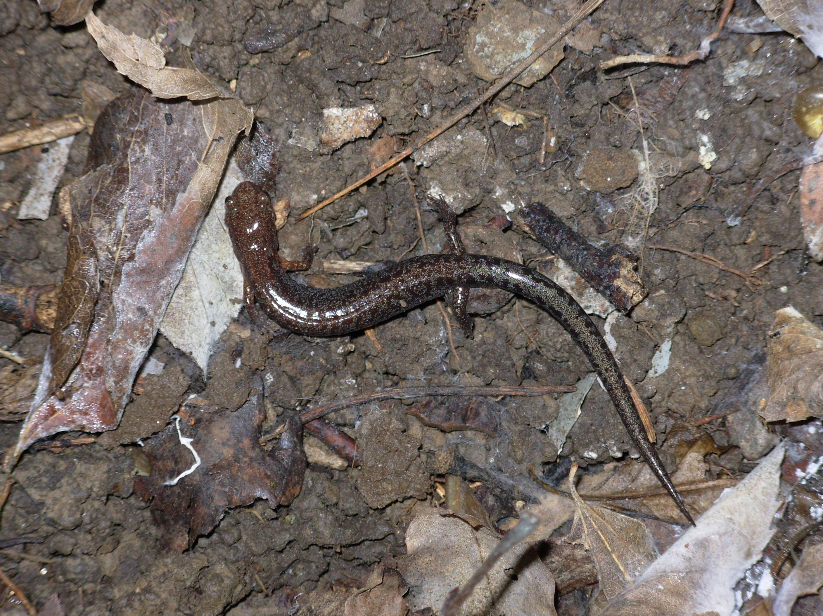
Figure 1: Plethodon ventralis
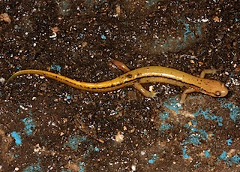
Figure 2: Eurycea cirrigera
Subjects:
20 zigzag salamanders (Plethodon ventralis) (Figure 1) and one two lined salamander (Eurycea cirrigera) (Figure 2) were captured at Second Creek in Knoxville, Tennessee. Subjects were transported to the University of Tennessee, Knoxville in 50 mL plastic tubes. They remained in tubes until the time of sampling and were returned to them after sampling. All subjects were released in the Second Creek area after bacterial sampling was completed.
Sampling:
Bacterial samples were collected from wood and rock substrate as well as cutaneous bacterial samples from salamanders. Environmental samples were collected by rubbing sterile swabs against the substrate for 10 seconds and placing them in 50mL tubes immediately afterwards. Swabs were plated on soil agar shortly after collection.
Salamanders were rinsed with deionized water for 10 seconds prior to swabbing to remove environmental contaminants. A sterile swab was run along the back of the salamander for 10 seconds to sample their cutaneous bacteria. Salamander swabs were plated immediately after collection. Samples were streaked on soil agar plates made with soil from Second Creek and incubated at 24ºC for one week. 10 wood substrate samples, 10 rock substrate samples, and 21 salamander samples were plated, resulting in a total of 41 samples. One soil agar plate was left empty to serve as a negative control.
Replica Plating:
Replica plates were made on soil agar, peptone glycerol agar (PGA), and Reasoner’s 2 agar (R2A) for each sample, for a total of three replica plates per sample. To create the replica plates, Whatman 44 ashless filter paper was moistened slightly with sterile water and pressed to the original plate. It was then gently removed and pressed to a second plate to replicate the bacterial culture. All replica plates were incubated at 24ºC for one week.
Replica plates were examined for overall growth to compare efficiencies of the agars and for any purple growth. To further isolate J. lividum colonies, all plates containing purple colonies were sampled using inoculating loops and streaked on PGA plates. PGA was chosen because it produced the highest amount of purple growth in the first set of replica plates. These plates were incubated at 24ºC for one week and then refrigerated at 4ºC.
The largest, most isolated purple colony from each of these replica plates was removed using an inoculation loop and placed in a 1.5mL tube for DNA analysis. Isolated colonies were chosen to increase the purity of the Janthinobacterium samples. Colonies were isolated from eight salamander plates, seven log plates, and two rock plates (PGA and R2A replicas of a single sample), as well as running a negative control to check for errors.
DNA analyses:
Purification was performed using a Wizard SV Genomics DNA purification kit. Samples were heated to 90ºC for five minutes to and vortexed in addition to lysating to ensure the complete breakdown of cells. PCR was performed using 50mL samples with GE Illustra Hot Start Mastermix Primer and specialized J. lividum primers that amplify approximately 500bp of a gene associated with production of the purple violacein pigment (Wiggins et al. 2011). PCR products were purified with QiaQuick PCR purification kits and sequenced using both PCR primers at the University of Tennessee Molecular Biology Resource Facility on an ABI 3730 Genetic Analyzer.
DNA sequences were examined using Sequencher DNA analysis software. S18, S19, L04, and S04 were selected as representatives of the four different alleles found in the sequences. These four sequences, along with the top nine matches from GenBank, were transferred into a NEXUS file to assess genetic similarity. A phylogenetic tree was constructed from these sequences using the program Phylogeny.fr (Dereeper et al. 2008, 2010).
Results:
A total of 41 plates were examined for overall growth to compare agar efficiencies. Bacterial growth varied among plates, with most PGA and R2A plates having significant growth and soil agar plates having little to none. All replica plates were ranked on a scale from 1-3, with one being little or no growth and 3 being high growth. Averages and medians of these rankings were calculated to provide a rough comparison of agar growth rates (Table 1). An ANOVA test was run on the means and a significant difference was found (p=5.64E-10, df=2, f-value=3.077). T-tests were then performed on all pairs of agars to determine where the significant difference occurred and significant differences were found in all pairs (Table 2).
agar type | PGA | R2A | soil agar
average growth | 2.65 | 2.8649 | 1.5854
median growth | 2.65 | 3 | 2
Table 1: Average and median of growth across the three agar types. Differences exist between all three agars with R2A having the highest average and median and soil agar having the lowest.

group | difference of means | df | t stat | p value | p<0.05
PGA vs. R2A | 0.21486 | 36 | 3.1514 | 0.00326 | yes
R2A vs. soil | 1.2795 | 36 | 4.2212 | 0.00157 | yes
PGA vs. soil | 1.06464 | 39 | -7.3427 | 7.29E-09 | yes
Table 2: T-test results comparing pairs of agars. All p values are significant, showing significant differences in amount of growth between media.
Although they did not show the highest overall growth, PGA plates contained the highest amount of purple colonies, with some almost completely covered in purple growth. All purple colonies used for DNA analysis were isolated from PGA plates except for one which was originally grown on an R2A plate. Eight colonies were isolated from salamander samples, seven from log samples, and two from a single rock sample (PGA and R2A replicas of a single sample), as well as one negative control. Neither the PGA nor R2A replica of the rock sample yielded a PCR product in two independent PCR attempts, suggesting that this sample was not Janthinobacterium, but some other purple pigment producer.
To test the hypothesis that J. lividum prevalence varied among sample types, a contingency table test was conducted. Because the sample sizes were relatively small, a randomization test was used to obtain an unbiased p-value (10,000 replicates). The null hypothesis of no difference was clearly rejected (Table 3, p = 0.0063), with the highest prevalence on logs, and lowest on rocks (zero confirmed observations on ten rocks).
 | Salamanders | Logs | Rocks
Present | 8 | 7 | 0
Absent | 13 | 3 | 10
Table 3. Contingency table of presence vs. absence of Janthinobacterium lividum in samples from salamanders and cover objects. χ² = 10. 6, df =2, randomization p-value =0.0063.
Genetic sequencing was successful for 12 of 13 PCR products. All of the fragments were sequenced with 80% or higher accuracy, except for sample L04, which had accuracies of 34% and 21% for its two strands. Because of its low accuracy, L04 was excluded from further analyses. After trimming ambiguous bases from the ends of each contig, 429 base pairs were resolved from each sample. The 12 sequences grouped into four unique alleles.
All four representative alleles were found to be >99% similar to J. lividum sequences obtained from GenBank, confirming that J. lividum was the bacteria isolated. There was no consistent pattern of association between J. lividum alleles and source (Table 4), indicating that there is not significant genetic difference between the samples from salamanders and logs.

Allele | Sequences
1. | L03, S15, S06, L05, S05, S18, S13
2.  3.  4. | L01, L02, L04  S04  S19
Table 4: Sequences containing each of the four representative alleles
The maximum likelihood phylogenetic tree created with Phylogeny.fr (Dereeper et al. 2008) shows that the S18 and S19 sequences are closely related to each other and three of the J. lividum reference sequences from GenBank (Figure 5). However, they are not on the same branch as S04 and the S04 sequence shares its branch with the L04 sequence. The phylogenetic tree shows that the salamander sequences as a group are not more closely related to each other than they are to the other sequences. 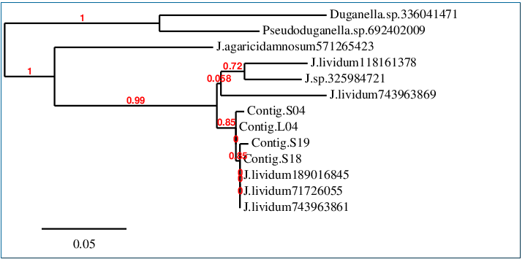
Figure 5: Phylogenetic tree of representative samples and reference sequences. Tips labeled “Contig” are new sequences from this study. The other tips are homologous sequences from GenBank (with gi numbers). Numbers in red are similarities between sequences on a given branch.
Conclusion:
The above data do not provide evidence of genetic differences between the salamander- associated and environmental samples. Differences between the reference sequences do not seem to fall into the groups of salamander and environment as hypothesized. There is no pattern of allele differentiation between the salamander and environment categories (Table 4). The phylogeny shows that the salamander samples are not more closely related to each other than they are to the other samples, so there is no evidence to support the beginning of speciation between J. lividum found on salamanders and the other groups.
However, some significant findings did result from this study. Strong differences were found in the media that grew J. lividum, with peptone glycerol agar being much more successful than either of the other two media. This finding has conservation implications because if mass amounts of J. lividum need to be grown for conservation use, it would be most efficient to use peptone glycerol agar. This agar produced the highest amount and the purest colonies of J. lividum, so it would be the best choice for cultivation. It was also found that J. lividum was not cultured from the majority of salamander swabs and was more prevalent (but not ubiquitous) on logs (Table 3). This provides further evidence that the bacterium is not more specialized to either of these environments.
Although there was no significant difference in the numbers of salamander and log samples showing J. lividum, there was a significant difference between the log and rock samples. Finding J. lividum in many of the log samples points to an important role of logs in forest environments. Salamanders could acquire the bacteria by spending time in logs, thereby reducing their chances of contracting chytridiomycosis. The removal of dead wood could be harmful to amphibians if it decreases their chances of coming into contact with helpful bacteria. J. lividum was not found in any of the rock samples, which suggests that rocks would not be a successful substitute for logs if they were removed. However, further studies examining this issue specifically would be needed to fully understand the relationship between contact with logs and transmission of Janthinobacterium.
If the genetic results are credible, it would suggest that the same strain is present on salamanders and in the environment. Alternatively, if two strains exist, they could lack significant genetic differences at the locus examined. However, a lack of difference at this particular locus does not exclude the possibility of genetic difference at another locus that could affect how well the bacteria work with amphibians. If an overall lack of genetic difference between J. lividum on salamanders and in their environment does exist, it would mean that bacteria from either source could be cultivated for use in curing amphibians. This would simplify the process of using it as a cure or preventative measure for chytridiomycosis, making J. lividum an even more likely tool for conservation use in the future.
Acknowledgements:
I would like to thank my adviser, Dr. Ben Fitzpatrick, for his guidance and assistance during the planning and conducting of this experiment as well as the writing of this paper. This project truly would not have been possible without his participation. I would also like to thank Dr. Heather Jackson for her helpful comments and support as a member of my review committee.

References:
McFall-Ngai M, Hadfield, MG, Bosch TCG, Carey HV, Domazet-Loso T, Douglas AE, Dubilier N, Eberl G, Fukami T, Gilbert SF, Hentschel U, King N, Kjelleberg S, Knoll AH, Kremer N, Mazmanian SK, Metfalf JL, Nealson K, Pierce NE, Rawls JF, Reid A, Ruby EG, Rumpho M, Sanders J, Tautz D, Wernegreen JJ 2013. Animals in a bacterial world: a new imperative for the life sciences. Proceedings of the National Academy of Sciences USA 110, 3229-36
Wiggins, P J, Smith, JM, Harris, RN, and Minbiole, PC 2011. Gut of red-backed salamanders (Plethodon cinereus) may serve as a reservoir for an antifungal cutaneous bacterium. Journal of Herpetology 45, 329-332.
Pantanella, F, Berlutti, F, Passariello, C, Sarli, S, Morea, C, Schippa, S 2006. Violacein and biofilm production in Janthinobacterium lividum. Journal of Applied Microbiology 102, 992-999.
Bataille, A, Cashins, SD, Grogan, L, Skerratt, LF, Hunter, D, McFadden, M, Scheele, B, Brannelly, LA, Macris, A, Harlow, PS, Bell, S, Berger, L, Waldman, B 2015. Susceptibility of amphibians to chytridiomycosis is associated with MHC class II conformation. Proceedings of the Royal Society B 282 20143127; DOI: 10.1098/rspb.2014.3127. Published 25 March 2015.
Zumbado-Ulate, H, Bolaños, F, Gutiérrez-Espeleta, G, Puschendorf, R 2014. Extremely low prevalence of Batrachochytrium dendrobatidis in frog populations from neotropical dry forest of Costa Rica supports the existence of a climactic refuge from the disease. Ecohealth 11, 593-602.
Voyles, J, Young, S, Berger, L, Campbell, C, Voyles, WF, Dinudom, A, Cook, D, Webb, R, Alford, RA, Skerratt, LF, Speare, R 2009. Pathogenesis of chytridiomycosis, a cause of catastrophic amphibian declines. Science 326, 582-585.
Skerratt, LF, Berger, L, Speare, R., Cashins, S, McDonald, KR, Phillott, AD, Hines, HB, Kenyon, N 2007. Spread of chytridiomycosis has caused the rapid global extinction of frogs. EcoHealth 4, 125-134.
Berger, L, Speare, R, Daszak, P, Green, DE, Cunningham, AA, Goggin, CL, Slocombe, R, Ragan, MA, Hyatt, AD, McDonald, KR, Hines, HB, Lips, KR, Marantelli, G, Parkes, H 1998. Chytridiomycosis causes amphibian mortality associated with population declines in the rain forest of Australia and Central America. Proceedings of the National Academy of Sciences USA 95, 9031-9036.
Brucker, RM, Harris RN, Schwantes, CR, Gallaher, TN, Flaherty, CR, Lam, BA, and Minbiole, KPC 2008. Amphibian chemical defense: antifungal metabolites of the microsymbiont Janthinobacterium lividum on the salamander Plethodon cinerus. Journal of Chemical Ecology 34, 1422-1429.
Becker, MH, Brucker, RM, Schwantes, CR, Harris, RN, Minbiole, KPC 2009. The bacterially produced metabolite violacein is associated with the survival of amphibians infected with a lethal fungus. Applied and Environmental Microbiology 75, 6635-6638.
Muletz, CR, Myers, JM, Domangue, RJ, Herrick, JB, and Harris, RN 2012. Soil bioaugmentation with amphibian cutaneous bacteria protects amphibian hosts from infection by Batrachochytrium dendrobatidis. Biological Conservation 152, 112-126.
Walke, JB, Becker, MH, Loftus, SC, House, LL, Cormier, G, Jensen, RV, and Belden, LK 2014. Amphibian skin may select for rare environmental microbes. The ISME Journal 8, 2207-2217.
Becker, MH, Walke, JB, Cikanek, S, Savage, AE, Mattheus, N, Santiago, CN, Minbiole, KPC, Harriss, RN, Belden, LK, Gratwicke, B 2015. Composition of symbiotic bacteria predicts survival in Panamanian golden frogs infected with a lethal fungus Proceedings of the Royal Society B 282 20142881; DOI: 10.1098/rspb.2014.2881. Published 18 March 2015.
Margulis, L. and Fester, R. 1991. Symbiosis as a Source of Evolutionary Innovation: Speciation and Morphogenesis. Massachusetts Institute of Technology: MIT Press. 74.
Becker, MH, Harris, RN, Minbiole, KPC, Schwantes, CR, Rollins- Smith, LA, Reinert, LK, Brucker, RM, Domangue, RJ, and Gratwicke, B 2011. Towards a better understating of the use of probiotics for preventing chytridiomycosis in Panamanian golden frogs. Ecohealth 8, 501-506.
Dereeper A, Guignon V, Blanc G, Audic S, Buffet S, Chevent F, Dufayard J F, Guindon S, LeFort V, Lescot M, Claverie J M, Gascuel O. 2008. Phylogeny.fr: robust phylogenetic analysis for the non-specialist. Nucleic Acids Research 36:W65-W69
Dereeper A, Audic S, Claverie JM, Blanc G 2010. BLAST-EXPLORER helps you building datasets for phylogenetic analysis. BMC Evol Biol. 2010 Jan 12;10:8.

