Testing Claims of Efficacy and Mechanism of Action for Emotion Focused Couples Therapy: A Dyadic Case Study Using Time-Series Design

A Dissertation
Presented for the
Doctor of Philosophy
Degree
The University of Tennessee, Knoxville

Albert Jun-Wei Wong
December 2014

Copyright © 2013 by Albert Jun-Wei Wong
All rights reserved.
Acknowledgements

I owe a debt, first and foremost, to Dr. Michael R. Nash for inviting me to join his band of merry rabble rousers, for guiding me surefootedly through this project, and for always seeing the best part of me. Thanks are also due to the generous and supportive members of my dissertation committee, Dr. Jake Levy, Dr. John Lounsbury, and Dr. David Patterson, who provided many thoughtful comments and insights on this project throughout its development. I am also indebted to Dr. Kristi Gordon who introduced me to Emotion Focused Couples Therapy and who provided supervision on the case described herein. This dissertation, of course, would not have been possible without the participation of the couple that is the subject of this single-case design, the pseudonymously named “Beth” and “George,” and I am grateful for their gracious willingness to be a part of this study.
I must also acknowledge the many people who have believed in me over these years: the Usual Suspects, John Soper, the Los Angeles Gestalt Study Group, John Heider, Chris Price, Eric Erikson, Bev Gibbons, Perviz Sawoski, my graduate student colleagues at the University of Tennessee, and many unmentioned others who have touched me and my life.
This dissertation is dedicated to my family and their sacrifices on my behalf: my mother, my father, my maternal and paternal grandparents, my sisters and brother-in-laws, my niece and nephew, my aunts, uncles, and cousins. All of them. Even, and perhaps especially, for the ones I do not know.
Abstract
The overall purpose of this study was to test claims regarding both the efficacy and mechanism of change for Emotion Focused Couple Therapy (EFT). Although a number of treatment outcome studies have been conducted on EFT, the vast majority of these studies emanate from the research laboratories associated with the two founders of EFT. Additionally, most EFT research has examined treatment outcome rather than mechanisms of change. This study used a time-series single-case experimental design approach to examine both the efficacy and the mechanisms of change in EFT for couple distress. I systematically tracked the symptoms of couple distress across the span of an EFT treatment and explored how symptom severity varied over time within the dyad across several measures. Simulation modeling analysis (SMA) for time-series data was used to evaluate the level change across baseline, treatment, and follow-up phases. Further, crosslag correlational analyses were used to clarify the mechanism of change in EFT. Experimental results from the time-series design provided moderate support for the EFT efficacy claim. Partial support was also found for the underlying EFT mechanism of action claim linking attachment insecurity and marital distress. Two of the EFT mechanism of action claims and an interpersonal mindfulness exploratory hypothesis, however, were unsupported by the experimental data. Implications for future research are discussed.
Keywords: Emotion Focused Therapy, EFT, couples therapy, time-series, Simulation Modeling Analysis, interpersonal mindfulness

Table of Contents

Chapter 1: Introduction 1
Chapter 2: Emotion Focused Couple Therapy: The Theory 3
A Brief Description of Emotion Focused Couple Therapy 3
EFT: Historical Roots and Theoretical Underpinnings 3
EFT Theory of Marital Discord and Repair 4
EFT Proposed Mechanism of Action 6
Chapter 3: Emotion Focused Couple Therapy: The Evidence 12
Research findings on the efficacy of Emotion Focused Therapy 12
Summary of treatment efficacy findings for Emotion Focused Therapy 18
Research on EFT mechanisms of action 19
Summary of current efficacy and mechanism research in Emotion Focused Therapy 23
Chapter 4: Applying Case-Based Time-Series Research Designs to Test EFT Claims 27
Case-Based Time-Series Research Designs 27
Efficacy of treatment: Time-series research design 28
Efficacy of treatment: Simulation Modeling Analysis phase-effect analysis 30
Mechanism of Change: Time-series research design 32
Mechanism of action: Simulation Modeling Analysis multivariate analysis 33
Claims made by EFT Theory relevant to this study 35
Chapter 5: Methods 37
Purpose 37
Measures 37
Subject Selection 41
Selection Criteria 41
Inclusion Criteria 42
Exclusion Criteria 42
Timeline for the Time-Series EFT Treatment Study 42
Recruitment and Selection 43
Baseline Phase 44
Treatment Phase 45
Post-Treatment 45
Chapter 6: Claims and Hypothesis Tested 46
Claim of efficacy 46
Claims regarding mechanism of action 47
Hypothesis influenced by case study 50
Chapter 7: Case Presentation 52
Overview 52
Presenting Complaints 52
History 54
Baseline Measures 59
Chapter 8: Case Conceptualization 64
Comorbid conditions 64
Negative cycles of behavior 65
Risk factors 65
Chapter 9: Course of Treatment and Assessment of Progress 68
Treatment Measures 68
Idiographic Time-Series Questions 68
Marital Satisfaction Inventory, Revised and the Dyadic Adjustment Scale 69
Treatment Sessions 69
Treatment Process: Early Phase 70
Treatment Process: The Middle Phase 72
Treatment Process: Final Phase 74
Follow-Up 76
Assessment of EFT claim of efficacy 77
Assessment of EFT claims regarding mechanism of action 80
Chapter 10: Discussion 84
Complicating Factors 84
Treatment Implications of the Case 85
Limitations 88
Future research 90
References 91
Appendix 101
Vita 116

List of Tables
1. Descriptive Statistics for Time-Series Symptom Measures across Phases. 102
2. Pre-Treatment and Post-Treatment Results 103
3. Phase Effect Results 104

List of Figures
1. Proposed mechanisms of action in processes underlying couple distress and the alleviation of couple distress according to Emotion Focused Therapy. 105
2. Overall timeline for the time-series case study 106
3. The change in Beth’s GDS and DAS from pre-treament to post-treatment. 107
4. Deviant response from George in reply to Target Complaint item regarding the distress that he experienced as a consequence of his ruminative thoughts towards Lexi. 108
5. Time-series ratings of marital distress using Target Complaints measure during baseline, treatment, and follow-up phases 109
6. Time-series ratings of marital satisfaction on the DAS-4 during baseline, treatment, and follow-up phases 110
7. Time-series ratings of communication difficulties on the Target Complaints scale during baseline, treatment, and follow-up phases. 111
8. Time-series ratings of overall marital distress using the Target Complaints scale across baseline, treatment, and follow-up phases. 112
9. Cross-correlational analyses showing direction of temporal relationship of change in level of attachment insecurity in Beth with change in her level of marital distress during EFT 113
10. Cross-correlational analyses showing direction of temporal relationship of change in level of hard emotions directed at George with his attachment insecurity 114
11. Cross-correlational analyses showing direction of temporal relationship of change in level of soft emotions directed at George (CERF-Soft) with his attachment insecurity (ECR-RS) during EFT couples therapy 115

Chapter 1: Introduction
Researchers and clinicians have made strides in advancing our understanding of how to treat distressed couples (Gurman & Fraenkel, 2002; Lebow, Chambers, Christensen, & Johnson, 2012; Snyder & Halford, 2012; Sperry, 2012). There is empirical support for the efficacy of couple therapy in reducing distress in relationships and in increasing overall relationship stability and satisfaction (Cordova et al., 2005; Johnson, Furrow, & Bradley, 2011; Lebow et al., 2012). Couple therapy interventions have also been used not only as a treatment for general relational issues, but as an intervention for a variety of conditions such as comorbid depression, bulimia, and PTSD (Greenman & Johnson, 2012; Johnson et al., 2011). Emotionally focused couple therapy (EFT), which emphasizes changing maladaptive interpersonal interaction cycles by exploring unexpressed emotions and unmet attachment needs, has, in particular, been reported to be effective in the treatment of relational distress (Greenberg & Goldman, 2008; Johnson, Hunsley, Greenberg, & Schindler, 1999).
Despite the claimed success of EFT as a treatment for couple distress, the vast majority of EFT treatment outcome studies have emanated from the research laboratories of its two founders (Johnson & Greenberg, 1985). This is problematic especially in light of the findings which suggest that researcher allegiance may dramatically influence treatment effect sizes (Luborsky, Singer, & Luborsky, 1975; Luborsky et al, 1999). Additionally, the mechanisms of change within EFT remain unclear (Snyder & Halford, 2012). The overall purpose of this study is to test the claims of EFT couples researchers regarding both the effectiveness of EFT and the mechanisms of change whereby EFT operates. Does EFT, in fact, work? And if so, how?
I divide this dissertation into ten chapters. In Chapter 1, I describe the purpose of this research study and outline the structure of the dissertation. In Chapter 2, I present a brief description of the EFT treatment model and its theoretical underpinnings. In Chapter 3, I provide a comprehensive review of the evidence regarding EFT efficacy and mechanism to date. In Chapter 4, I describe, in general, how a case-based time-series research design can be used to test claims regarding treatment efficacy and mechanism. In Chapter 5, I describe the specific implementation of the time-series methodology that I use in this study to test claims regarding the efficacy and mechanism of EFT. In Chapter 6, I list the EFT claims that are tested in this study and describe the statistical analytic methodology this study utilizes to test these claims. In Chapter 7, I describe the initial case presentation of the time-series couple that was selected for this study. In Chapter 8, I describe the case conceptualization of the time-series couple that helped to guide the EFT treatment. In Chapter 9, I describe the overall course of treatment for this couple and examine the validity of the various EFT claims of efficacy and mechanism of action in light of the case study results. In Chapter 10, I discuss these results and provide direction for future research.

Chapter 2: Emotion Focused Couple Therapy: The Theory

A Brief Description of Emotion Focused Couple Therapy
EFT (Greenberg & Goldman, 2008; Johnson et al., 1999) is an affectively-centered approach to couples therapy that attempts to change distressed couples’ maladaptive, emotionally constricted patterns of interaction in order to help them develop secure and mutually validating attachment bonds (Greenberg & Goldman, 2008; Halchuk, Makinen, & Johnson, 2010; Johnson et al., 1999). It is a brief therapy, typically comprised of eight to twenty sessions, that targets (1) dyadically disruptive affective states, such as anger and fear, as well as (2) negative self-reinforcing systemic interaction patterns, such as critical pursuit by one partner followed by defensive withdrawal of the other. EFT attempts to “soften” rupture-inducing affect and change negative interaction patterns into new cycles of interaction that enhance couple bonding. It integrates psychodynamic theory, attachment theory and systems theory into a three-stage, nine-step model of couple therapy change. In this section, I review the historical roots of EFT, its theory of marital discord and repair, its proposed mechanism of action, and the hypothesized steps and stages involved in EFT as practiced. I also highlight important claims and assumptions that are made by EFT theory.

EFT: Historical Roots and Theoretical Underpinnings
The theoretical underpinnings of EFT are rooted in gestalt/experiential therapy (Perls, 1973), systemic family therapy (Minuchin & Fishman, 1981; Sluzki, 1978), and attachment theory (Bowlby, 1969). EFT is an integrative approach that draws from each of these traditions.
The gestalt/experiential tradition emphasizes the way in which maladaptive affective responses contribute to both intrapsychic and interpersonal distress (Perls, 1973). By focusing on affect in the here-and-now, gestalt therapy is thought to help patients remove patterns of unresolved intra- and interpersonal conflict. EFT derives its present-centered emphasis on affect from the gestalt tradition.
Systemic family therapy highlights the role of maladaptive, habitual interactional patterns in the maintenance of systemic negative communication cycles (Sluzki, 1978; Minuchin & Fishman, 1981). Similarly, EFT also identifies rigid characteristic patterns of interaction within a couple and helps interrupt cycles of maladaptive communication and improve intimacy in the relationship bond (Johnson et al., 1999).
Attachment theory focuses on the strong affiliative needs that a child has for secure bonding with their primary caregivers in early childhood (Bowlby, 1969). From the EFT perspective, this need for secure attachment persists to some extent throughout the course of an individual’s lifespan (Greenberg & Goldman, 2008; Johnson et al., 1999). One of the primary functions of a healthy relationship, according to EFT, then is to provide a secure affiliative bond that can help each member of the dyad regulate their relational distress (Johnson et al., 2011).

EFT Theory of Marital Discord and Repair
These three therapeutic traditions combine in EFT to create an integrative theoretical model of marital discord and repair. According to EFT, adult intimacy is an attachment process (Johnson et al., 1999). Marital discord, then, is best understood as a form of separation distress that occurs in a relationship in which partners feel insecurely attached to one another. This insecure bond catalyzes the expression of negative, rupture-inducing affect or withdrawal that in turn fuels maladaptive, cyclical, self-reinforcing negative interactions between partners (Johnson et al., 1999). According to EFT, when an insecurely attached individual sufficiently fears losing their partner, they will exhibit a fight or flight response with respect to their partner. Maladaptive interaction cycles will then be enacted and marital discord will ensue (Johnson et al., 1999). A wife may, for example, feel insecurely attached to her husband and consequently may critically pursue him. However, her pursuit may, in turn, generate anxiety within her husband and he may consequently avoid her – thereby further triggering her attachment anxiety and need to critically pursue.
In order to alleviate marital discord, according to EFT, it is necessary, then, to help the couple create a secure bond. A secure interpersonal attachment to a significant other, from the EFT perspective, provides a safe haven and secure base into which one may retreat in the face of potential danger (Bowlby, 1988; Johnson et al., 1999). The attachment emphasis of EFT focuses EFT treatment goals around articulating unexpressed attachment needs in the relationship so that positive bonding interactions – and secure interpersonal attachment -- may occur.
Key claims of EFT theory of marital discord and repair. The discussion above highlights two key assumptions on which EFT theory is based. First, adult intimacy is an attachment process. Consequently, having an insecure attachment will result in relational distress, whereas having secure bonding with one’s partner will alleviate it. Second, negative emotions and negative dyadic patterns of interaction reciprocally reinforce one another and prevent the formation of secure attachment. I highlight these claims here, as they will become important focal points of this study.
Claim 1: Insecure attachment causes couple distress; secure attachment alleviates it.
Claim 2: Negative emotions and negative interaction cycles preclude the formation of secure attachment.
These two important claims will be revisited below.

EFT Proposed Mechanism of Action
I next examine the proposed mechanism of action within EFT. Within the EFT theoretical framework of treatment, therapeutic change is thought to occur when the emotional responses that underlie rigid, maladaptive patterns of couple interaction are experienced so that the couple’s fixed cycles of interaction can be transformed into more adaptive modes of relating (Greenberg & Johnson, 1988). By experiencing underlying primary emotional responses, it is thought that the couple will begin to change maladaptive interactional patterns into new ways of relating that promote interpersonal responsiveness and emotional availability.
EFT posits that under conditions of attachment distress, individuals tend to interrupt their expression of adaptive emotions. This blocking of adaptive emotions, in turn, is thought to subvert an individual’s capacity to securely attach to their partner. Emotion focused therapy for couples consequently emphasizes the interpersonal experience, expression, and processing of emotion within a relational dyad (Greenberg & Johnson, 1988; Johnson et al., 1999). EFT focuses on adequately processing each dyadic member’s blocked interpersonal emotions, whether sadness from attachment loss, anger at boundary violation, etc. In so doing, EFT posits that maladaptive emotions and dysfunctional interactional patterns will be transformed into positive cycles of behavior and emotional expression that promote intimacy and mutual respect. Encouraging the expression of primary (rather than maladaptive secondary) emotions in therapy helps each member of a couple dyad feel ownership over their own emotional experience and identify their own needs and concerns rather than becoming caught in maladaptive cycles of blame and victimization.
Primary versus secondary emotions. According to the EFT model, when a couple experiences distress, each member of the dyad often conceals their primary emotions, such as fear, vulnerability, and the need for attachment and, instead, replaces these feelings with secondary emotions such as anger, blame, and withdrawal. These secondary emotions, then, lead to negative interactional cycles, such as demand-withdraw (Johnson et al., 2011). These fixed cycles of interpersonal communication impede the integration of primary emotions into the interactional system and limit the dyadic unit’s capacity to engage in positive modes of relating, such as sharing and mutual support. Without access to primary emotions, according to the EFT model, it becomes more difficult for the dyadic unit to remain securely attached. Consequently, the overall sense of security, connection, and intimacy in the relationship deteriorates leading to increased couple distress.
Key claims of EFT proposed mechanism of change. Although there are many facets to the EFT model of change, one of the central assumptions that underlies EFT’s proposed mechanism of change is that the expression of certain kinds of emotions can either diminish or enhance secure attachment. Namely, when “hard” secondary emotions such as anger or blame or “flat” secondary emotions such as withdrawal or disinterest are expressed, secure attachment is inhibited, whereas, when “soft” primary emotions such as fear, vulnerability, and the need for attachment are expressed, secure attachment is enhanced (Johnson et al., 2011; Sanford 2012). The first part of this assumption may actually be seen as a clarification of what has been previously mentioned in Claim 2. It provides a further specification of what is constituted by the “negative emotions” that preclude secure attachment. I revise the original Claim 2 and list it below with the relevant modifier added in parentheses. The second part of the above assumption, i.e., the part regarding “soft” emotions, is listed as Claim 3 below. As before, these claims are important as they will serve as the focal point of our study.
Claim 2: Negative (“hard”/“flat”) emotions and negative interaction cycles preclude the formation of secure attachment.
Claim 3: The expression of “soft” primary emotions promotes secure attachment.
Theorized Stages of EFT as Practiced
In accordance with the aforementioned conceptualization of the mechanism of change involved in alleviating couple distress, EFT researchers have theorized that there are three distinct stages in the clinical practice of EFT. The three stages in the EFT framework are cycle de-escalation, restructuring the interaction, and consolidation and integration (Greenberg & Goldman, 2008). These three principal stages have in turn been hypothesized to be separable into nine distinct steps. The full nine steps are listed below:
Cycle De-escalation
Step 1. Identify the conflict. In this step, the therapist identifies the core conflict in the relationship from an attachment perspective.
Step 2. Identify the cycle where the conflict is expressed. The therapist identifies the problematic, fixed interaction pattern that generates this conflict. The therapist also identifies how this problematic cycle of interaction creates attachment insecurity and couple distress.
Step 3. Identify unacknowledged emotions and needs. The therapist identifies each partner’s underlying attachment needs and unarticulated primary emotions within the relationship.
Step 4. Reframe the problem. The therapist reframes the presenting problem as being the negative cycle of interaction that has overtaken the relationship rather than the particular faults and foibles of either of the partners within the relationship (Johnson et al., 1999). The couple is then encouraged to work together against the negative pattern of interaction rather blaming each other for the conflict. Instead of viewing themselves as victims of their negative interaction cycle, they are guided to become allies against it.
Restructuring the Interaction
Step 5. Promote the identification and expression of disowned emotions and needs. In this step, the therapist helps the couple to identify and express, for themselves, their own previously disavowed emotions and attachment needs.
Step 6. Promote partner acceptance. The therapist works to help each partner become attuned to and accepting of their partner’s previously unarticulated emotions and needs.
Step 7. Shape the expression of needs and wants into adaptive cycles of interaction. The therapist assists each partner in learning how to effectively express attachment needs and wants. These new expressions are then integrated into the couple’s pattern of interaction and utilized to transform the negative cycles of interaction into novel, adaptive ways of relating to one another.
Consolidation and Integration.
Step 8. Discover new solutions. The therapist helps the couple learn to use their novel pattern of interaction to create new adaptive solutions to old, previously intractable interpersonal problems.
Step 9. Review and consolidate therapeutic gains. Finally, the therapist assists the couple in articulating the difference between their old and new interaction cycles in order to help them avoid reverting to their old pattern of interaction. The therapist also assists the couple in creating a new narrative account of their relationship journey that includes the emergence of these recent changes (Greenberg & Goldman, 2008).
Despite the apparent linearity implied by a nine-step, three-stage model of change, practitioners of EFT are quick to note that EFT should not be thought of in a completely linear fashion. It is theorized that individuals may cycle through these various steps and stages repeatedly throughout the course of an EFT treatment in a kind of “spiral” manner (Greenberg & Goldman, 2008; Johnson et al., 1999). The sequence of breach of attachment → conflict → de-escalation of conflict → restructuring of interactions → re-attachment may arise multiple times throughout the course of therapy (Greenberg & Johnson, 1988). In fact, it is through this process of repeated "breach" of attachment and subsequent reconciliation that each individual may become securely attached to the other and eventually become, to borrow a phrase, a "good enough" partner (Winnicott, 1953).
Key assumption of EFT as practiced. In reviewing the steps and stages of EFT as listed, it is important to note that the first EFT stage deals with the de-escalation of conflict, whereas the second two stages (restructuring the interaction and consolidation / integration) center around the creation of a secure attachment bond between the two partners. The differentiation between these two parts of treatment reflects an underlying assumption that has previously been mentioned regarding the order in which change is theorized to occur in an EFT treatment. Namely, one of the key assumptions underlying this stage model of EFT is that de-escalation of conflict is a prerequisite to secure attachment. That is, only when conflict has been successfully de-escalated can the attachment between partners be effectively enhanced. This primary assumption mirrors that of Claim (2) listed above, namely that the level of conflict in the relationship must decrease before the level of secure attachment increases.
To summarize, EFT theory makes three important claims regarding the mechanisms of action that are alleged to underlie EFT:
Claim 1: Insecure attachment causes couple distress; secure attachment alleviates it.
Claim 2: Negative (“hard”/“flat”) emotions and negative interaction cycles preclude the formation of secure attachment.
Claim 3: The expression of “soft” primary emotions promotes secure attachment.
The claimed mechanisms of action underlying the couple distress and the alleviation of couple distress in EFT are encapsulated in Figure 1. The top part of the diagram in Figure 1 indicates the hypothesized pathway that leads to couple distress. That is, the theory of EFT claims that negative emotions and negative cycles of interaction reciprocally reinforce one another, thereby creating insecure attachment which, in turn, causes couple distress. The bottom part of the diagram indicates the EFT hypothesized pathway that leads to the alleviation of couple distress: Positive “soft” emotions and positive cycles of interaction are claimed to reciprocally reinforce one another, thereby creating couple bonding, which in turn alleviates couple distress.

Chapter 3: Emotion Focused Couple Therapy: The Evidence
In this section, I review the current research findings on the efficacy of EFT and its mechanism of action. Additionally, I describe the gaps in current EFT research and the need for further research in these domains.

Research findings on the efficacy of Emotion Focused Therapy
To date, five different randomized controlled trials (RCTs) have been published that assess the impact of EFT on couple distress (Denton, Burleson, Clark, Rodriguez, & Hobbs, 2000; Goldman & Greenberg, 1992; James, 1991; Johnson & Greenberg, 1985; Walker, Johnson, Manion, & Cloutier, 1996). Almost all of these RCTs emanate from the research laboratories of the two founders of EFT (Johnson & Greenberg, 1985). Each of them follows, roughly, the same format, with slight variations. Each of these trials operationalizes couple distress through the Dyadic Adjustment Scale (DAS; Spanier, 1976), a 32-item self-report measure that is widely considered to be the “gold standard” measure for couple distress. The Target Complaints measure (TC; Battle et al., 1966) has also frequently been used in these studies as a secondary ideographic measure of couple distress in accordance with the treatment outcome research recommendations of Waskow and Parloff (1975).
Subjects. In these RCT studies, subjects were typically recruited via a general newspaper advertisement that offered counseling for distressed couples, although one study drew volunteers from parents of chronically ill children in a pediatric hospital setting (Walker et al., 1996). Subjects were usually required to have been cohabiting for at least one year, though some of the studies required prior cohabitation of at least eighteen months or two years (Goldman & Greenberg, 1992). All studies required subjects to have no plans for immediate separation and have no problems with substance abuse or interpersonal violence. One study excluded couples in which one or more of the partners had comorbid clinical depression (Goldman & Greenberg, 1992). All studies required couples to meet criteria for couple distress on the DAS as a screening measure. That is, at least one member of the dyad was required to score below 100 on the DAS, although in the case of Walker et al. (1996) the distress cutoff screening score was set at 110, in keeping with criteria stipulated by Jacobson and Truax (1991) due to different clinical norms on the DAS for couples with children. Two studies excluded couples where the level of distress (as indicated by the DAS) was rated as severe (James, 1991; Walker et al., 1996).
Assignment. In each RCT study, subjects were randomly assigned, once selected, to either an EFT treatment category, an alternate couple therapy treatment category, or a waitlist control category. The alternate couple therapy treatments against which EFT was compared include problem-solving therapy (Johnson and Greenberg, 1985a), Integrative Systemic Therapy (Goldman & Greenberg, 1992), and EFT plus a communication skills module (James, 1991). The number of couples assigned to a particular couple therapy treatment or waitlist control condition typically ranged from 14 to 16 couples per group, although one study (Denton et al., 2000) assigned 22 couples to the EFT treatment group and 14 to the waitlist control.
Therapists. In each study, from six to eight therapists were nested within each active treatment. In some studies, the therapists were randomly assigned to their treatment protocol (James, 1991) whereas in others, the therapists were selected to administer a treatment protocol based on their expertise and experience with that protocol (Goldman & Greenberg, 1992; Johnson & Greenberg, 1985). Therapists ranged from novice clinicians with no prior experience in marital therapy (Denton et al., 2000) to more experienced clinicians with five or more years of clinical experience in the couple therapy framework they were administering (Goldman & Greenberg, 1992). Therapists were typically comprised of graduate students in either a clinical or counseling psychology program, although some studies admitted graduate students from different professions, e.g., social work or psychiatry (Denton et al., 2000).
Treatment fidelity. Every study utilized some form of fidelity check for treatment, although the nature and rigor of the fidelity check varied. In most instances, an implementation checklist was used along with excerpted videotape review by independent observers in order to insure treatment fidelity (Johnson & Greenberg, 1985). In these studies, therapist statements were coded as being adherent to treatment protocol or non-adherent and, when specified by the study, a cutoff of 80% adherence was required in order to qualify the treatment as being faithful to protocol (Walker et al., 1996). In one instance where an explicit coding system was not utilized, sessions were viewed live through a one-way mirror, and the EFT-trained supervisor subjectively assessed that the treatment appeared faithful to protocol (Denton et al., 2000).
Treatment. In each study, treatment typically consisted of couple therapy sessions held weekly, although one study allowed couples to meet their therapist every two weeks, if that was their preference (Walker et al., 1996). The number of sessions offered ranged from eight to twelve sessions, and the length of each couple therapy session was typically one hour, although one study utilized 50-minute sessions (Denton et al., 2000) and another utilized 90-minute sessions (Walker et al., 1996).
Attrition. Attrition in these studies was generally reported to be quite low with no dropouts in three of the studies (Goldman & Greenberg, 1992; James, 1991; Johnson & Greenberg, 1985) and a single dropout in another study (Walker et al., 1996). However, in one of the studies a sizable nine out of 22 couples in the original EFT treatment group dropped out of treatment (Denton et al., 2000). Notably, this appears to be the one EFT treatment outcome study that did not originate from the research laboratories of the two founders of EFT.
Measures. As previously mentioned, the DAS (Spanier, 1976) was utilized in every randomized control trial study on EFT as the “gold standard” measure of couple distress. The majority of studies averaged the DAS of each partner into an overall DAS score (Goldman & Greenberg, 1992; Johnson & Greenberg, 1985). However, one study utilized the level of couple distress from the lower scoring spouse on the DAS as the treatment outcome measure (Walker et al., 1996), citing research that indicated that the lower-scoring partner’s score may be a better measure of marital functioning (Baucom & Kaplan Mehlman, 1984). A majority of the RCT studies also utilized the Target Complaint measure (TC; Battle et al., 1966) as a secondary measure of couple distress that could be individually tailored to the presenting complaints of the couple. Aside from these two primary scales (the DAS and the TC) that were designed to measure couple distress, a cumulative total of 18 other outcome measures were utilized in these five studies to measure a variety of other treatment outcome variables including intimacy, communication skills, emotional styles, and level of positive affect in the relationship. Each study used approximately three study-specific outcome measures in addition to the DAS and the TC.
Assessment and follow-up. Prior to the commencement of couple therapy, each couple completed the pretest measures for the particular research study in which they were participants (Johnson & Greenberg, 1985). The couple also completed these same measures at the conclusion of treatment. The assessment battery would, as mentioned earlier, typically, include the DAS and the TC as measures of couple distress, as well as scales designed to clarify other variables of particular interest to the research study in question. Follow-up measures were given in four of the five RCT studies. These measures were administered, depending on the study, from two months to five months after the conclusion of treatment (Goldman & Greenberg, 1992; Johnson & Greenberg, 1985; Walker et al., 1996). Some attrition during follow-up was reported (Walker et al., 1996).
Analysis. As previously mentioned, each of these five RCTs sought to compare EFT to either an alternate psychological treatment or a waiting list control group. These studies typically utilized a multivariate analysis of variance (MANOVA) in order to compare treatment outcomes for the different treatment groups versus waitlist control. Additionally, four of the five RCT studies also used the cutoff criteria as suggested by Jacobson and Truax (1991) to categorize “recovery” and “clinically significant improvement” in treatment outcomes.
Results. I describe the primary EFT randomized control trial research findings here. First, in the research study in which EFT was first introduced, Johnson and Greenberg (1985a) found that EFT was more effective than a cognitive-behavioral problem-solving couple therapy approach and that this effect appeared to be maintained at two-month follow-up. James (1991) studied the impact of adding a communications skills module to an EFT treatment and found that there was no discernible impact on the efficacy of EFT when a communication skills module was added. Nevertheless, this study appeared to confirm the treatment effect due to EFT that had previously been claimed by Johnson and Greenberg (1985a) with a high yield of “significantly improved” (86%) and “recovered” (79%) couples at the end of treatment per criteria as specified by Jacobson and Truax (1991). Notably, however, at four-month follow-up a large percentage (37%) of the couples who had previously been thought to have been “recovered” at the conclusion of EFT treatment in this study had regressed back into a state of marital distress. Goldman and Greenberg (1992) compared EFT to Integrative Systemic Therapy (IST) and found that they were both superior to a waitlist control, but that there was no statistically significant discernible difference in treatment effect between these two approaches. Additionally, they found that participants in IST appeared to maintain gains in marital satisfaction and goal attainment to a slightly greater extent than EFT at 4-month follow up. Walker et al. (1996) applied a slightly modified version of EFT to relationally distressed parents of chronically ill children and found that EFT appeared to be effective in diminishing their marital distress and that these effects appeared to be maintained at 5-month follow up. Denton et al. (2000) attempted to replicate these aforementioned RCT findings in a training clinic that did not have any pre-existing association with either of the two cofounders. The results of this study may best be described as mixed. While the reported effect size of EFT on patients who remained in treatment is large (d = 0.99), the attrition in the EFT treatment group was anomalously high (41%) and it seems possible that the reported effect size is inflated due to attrition bias. Since this study is the only RCT replication that appears to be genuinely separate from the research programs of the two founders of EFT, the mixed results are of particular interest and concern (Denton et al., 2000).
Non-RCT treatment outcome study. In addition to these above RCT treatment outcome studies, at least one non-RCT treatment outcome study has utilized a within-subjects design in which couples served as their own controls (Johnson and Greenberg, 1985b). This EFT research design compared couples’ progress while in treatment against their own progress (or lack thereof) while waiting for treatment to commence. In this study, fourteen couples presenting with couple distress were assessed at four different points in time: at the time of first contact between the research study and the couple, at the conclusion of an eight-week waiting period, after the completion of an eight week EFT treatment, and at eight weeks following the conclusion of treatment. Marital distress was measured at each assessment point by both the DAS and the TC scale. Seven masters level therapists with limited marital and family therapy experience administered the EFT treatment. Treatment fidelity was overseen through weekly EFT group supervision and use of a comprehensive EFT treatment manual. Couples’ progress (or lack thereof) during the waitlist time period was compared against their progress during treatment. Although no significant change in marital distress was found for the couples during the waitlist timeframe, the couples did report significant changes in marital distress after receiving EFT treatment, suggesting, once again, that EFT might be an effective treatment for marital distress. Treatment gains appeared to be maintained at 8 weeks follow-up, as measured by the TC (Johnson & Greenberg, 1985b).

Summary of treatment efficacy findings for Emotion Focused Therapy
In sum, there appears to be some evidence in support of claims that EFT is an effective treatment for marital distress. Indeed, a meta-analysis of EFT efficacy based on four research trials has suggested an overall effect size of 1.3 with clinically significant improvement in 86% of couples and recovery in 70-73% of couples (Johnson et al., 1999). However, it is possible that these claims of treatment efficacy may be overstated. Although there appears to be some evidence in support of EFT as a treatment for couple distress, nearly all of the treatment outcome studies in support of EFT have emanated from the research laboratories of the two founders of EFT (Johnson & Greenberg, 1985). Luborsky et al (1975) cautions us against experimenter allegiance bias as a potential confound of treatment outcome studies. Moreover, an attempted RCT replication study of EFT treatment outcome by an independent research laboratory (Denton et al., 2000) appears to raise more questions regarding EFT efficacy than it resolves. Although the replication study did report a large effect size (d = 0.99) for EFT efficacy, there was an anomalously high amount of attrition in the study. Indeed, it appears striking that in the four combined EFT randomized control trials prior to the replication study, a combined overall attrition rate of less than 2% was reported (Goldman & Greenberg, 1992; James, 1991; Johnson & Greenberg, 1985; Walker et al., 1996), whereas in the replication study of Denton et al. (2000), a whopping 41% of the couples initially assigned to the EFT treatment dropped out prior to completion. Although a certain amount of attrition is to be expected in treatment outcome studies, this degree of attrition appears to be anomalously high especially when compared to the reported attrition in all other EFT randomized control trial studies. Additionally, attrition bias is likely to have inflated the claimed effect size (d = 0.99), thereby calling into question whether or not the replication study may, in fact, have replicated prior treatment efficacy findings. Further treatment outcome research on the efficacy of EFT in the treatment of couple distress is needed.

Research on EFT mechanisms of action
The theory of EFT makes a number of claims regarding the mechanisms of action involved in the alleviation of couple distress. I will review these claims, describe the status of current research on EFT mechanisms of action, and review evidence in support of each of these claims, in turn.
The primary claims that the theory of EFT makes regarding the mechanism of action for EFT are as follows:
Claim 1: Insecure attachment causes couple distress; secure attachment alleviates it.
Claim 2: Negative (“hard”/“flat”) emotions and negative interaction cycles preclude the formation of secure attachment.
Claim 3: The expression of “soft” primary emotions promotes secure attachment.
Although a limited amount of process research has been conducted in EFT, the majority of it has been correlational in nature (Greenberg, Ford, Alden, & Johnson, 1993; Johnson & Greenberg, 1988; Makinen & Johnson, 2006). The few studies that have not strictly been correlational have focused on developing conceptual models for particular EFT events that occur during actual couple therapy sessions, e.g., “softening” (Bradley & Furrow, 2004) or attachment injury repair (Zuccarini, Johnson, Dalgleish, & Makinen, 2012). Numerous qualitative case studies have also been reported (Furrow, Johnson, & Bradley, 2011). Although somewhat suggestive, neither the correlational studies, the model development studies (dubbed “task analysis” (Greenberg, 2007)), nor the qualitative case studies provide genuine empirical evidence in support of the aforementioned claims regarding the hypothesized mechanism of action of EFT. Correlational studies, studies that merely focus on conceptual model-development, and qualitative case studies cannot answer questions of mechanism or cause. They cannot address questions regarding the order or sequence of events as they unfold in therapy. Nevertheless, their primary findings are worth reviewing.
Correlational process research. Most of the process research in EFT has been correlational (Greenberg, Ford, Alden, & Johnson, 1993; Johnson & Greenberg, 1988; Makinen & Johnson, 2006). These studies have, by and large, attempted to ascertain what features of interpersonal process during actual couple therapy sessions are more highly correlated with positive treatment outcome. Although there has been some variation in the structure of these correlational studies, they have largely followed a similar research design. Each study compares the behavioral content of couples from “successful” and “unsuccessful” EFT videotaped sessions where the criteria separating “successful” versus “unsuccessful” sessions varies from study to study. In the original Johnson and Greenberg (1988) process-outcome study, a comparison was made between videotaped sessions from those of couples that experienced the greatest improvement in marital distress and those that experienced the least improvement. In Study 2 of Greenberg et al. (1993), the couples and therapists consensually nominated for comparison the two therapy sessions that they considered to be most effective and meaningful over the course of treatment (“peak session”) and the session that they considered to be their least effective and meaningful (“poor session”). In Makinen and Johnson (2006), sessions from those individuals who had resolved their attachment injury were compared against those individuals who had not. In Study 1 of Greenberg et al. (1993), the interpersonal behavior of couples during the early sessions of an EFT treatment were compared against couple behavior towards the end of an EFT treatment. In each instance, videotaped sessions were coded by independent observers for levels of emotional experiencing as measured by the Experiencing Scale (ES; Klein et al., 1969) as well as affiliative behavior as measured by the Structural Analysis of Social Behavior scale (SASB; Benjamin, 1974). The findings consistently indicated that the interpersonal behavior of couples during sessions from successfully completed treatments was significantly higher in emotional experiencing and affiliative behavior when compared to unsuccessful or incomplete treatments. These results are consistent with the previously listed theoretical mechanism of change for EFT (see Figure 1). Affiliative behavior with high emotional experiencing suggests that the chain of events associated with “soft emotions” and couple bonding in the lower part of Figure 1 may be operative. However, as these findings are merely correlational, they do not provide specific evidentiary support regarding the causal chain of events.
Task analysis. The other main branch of process research in EFT has focused on constructing conceptual models of specific psychotherapy events, such as “softening” or attachment repair, that are theorized to take place during an EFT treatment. The methodology utilized to develop these models is called task analysis (Greenberg, 2007) and involves a process of rational model building followed by a recursive revision of that model in light of actual couple therapy session data. Bradley and Furrow (2004) utilized an exploratory task analysis to develop a conceptual model for the “softening” process in couple therapy. Their model, which appeared supported by thematic analysis and session coding, emphasized the importance of the therapist’s ability to help the blaming partner become aware of their own fears and unmet attachment needs. Makinen and Johnson (2006) utilized task analysis to help develop their model of attachment injury and repair in couple therapy. After developing and refining their model, which included in-session apology and the acceptance of apology, they found that deeper levels of emotional experiencing were associated with increased expression of partner support, diminished partner blaming, and the successful resolution of attachment injury. However, as before, these results were either strictly in the domain of conceptual model building or merely correlational in nature.
Qualitative case studies. Numerous qualitative case studies provide anecdotal evidence for the efficacy of EFT (Furrow et al., 2011). One preliminary qualitative case study highlights the role that interpersonal mindfulness, i.e., mutual present-centered awareness and acceptance, may play in the course of an EFT treatment (Beckerman & Sarracco, 2011). Indeed, mindfulness appears to be a positive contributor to a variety of couple therapy interventions (Carson, Carson, Gil, & Baucom, 2004; Gambrel & Keeling, 2010; Wachs & Cordova, 2007). Especially given the roots of EFT in the experiential gestalt tradition, wherein it is believed that “awareness in and of itself is curative” (Perls, 1969, p. 17), it seems possible that interpersonal mindfulness may play a role in the mechanism of change in EFT. That is, it is possible interpersonal mindfulness may help contribute to -- or even emerge out of -- a successful EFT treatment (Cohen & Miller, 2009). This conjecture will be revisited later in the hypotheses section below. Although some quantitative research has been conducted that has studied the impact of mindfulness on couples distress from a non-EFT perspective, these have all been snapshot or pre-post treatment studies (Carson et al., 2004; Cohen & Miller, 2009). Indeed, the research connecting mindfulness and couple distress in general and mindfulness and EFT in particular is extremely limited and little is known about the extent to which interpersonal mindfulness may (or may not) play a role in the dynamic process of change in EFT.
Though correlational findings, model development via task analysis, and qualitative case studies are useful tools in helping to clarify the process of conducting EFT therapy, none of these research studies provides rigorous empirical evidence regarding the underlying causal mechanism of change in EFT. Though the theory underlying EFT makes clear conjectures regarding its mechanism of change, no studies have been conducted that validate this theorized mechanism. There has been a recent call for researchers to better articulate how change occurs in couples therapy (Carlson, Ross, & Stark, 2012; Pinsof et al., 2009). A research study that provides evidence for – or against – the hypothesized change mechanisms of EFT is needed.

Summary of current efficacy and mechanism research in Emotion Focused Therapy
In this section I summarize the current research in EFT efficacy and mechanism of action. I also briefly summarize the preliminary research relating mindfulness and EFT. I describe the gap in the research for each of these domains and the way in which a single-subject time-series case study may fill this gap.
Efficacy. There appears to be some support for the efficacy of EFT. Indeed, five RCTs have been conducted that support claims that EFT is effective (Denton et al., 2000; Goldman & Greenberg, 1992; James, 1991; Johnson & Greenberg, 1985; Walker et al., 1996). However, almost of all of these studies have emanated from the research laboratories of the two founders of EFT (Johnson & Greenberg, 1985). The single RCT study (Denton et al., 2000) that was conducted from a research laboratory without affiliation with either of the two founders suffers from an anomalously high attrition rate in original EFT couple participants (41%), especially when this rate of attrition is compared to the reported cumulative attrition rate in all previous EFT randomized control trials (2%). Importantly, the highly level of attrition in the replication study (Denton et al., 2000) may have also created attrition bias and artificially inflated the reported effect size (d = 0.99) of this replication study. This calls into question whether the replication study did in fact replicate prior EFT efficacy results and whether or not the previously found results regarding EFT efficacy (Johnson & Greenberg, 1985; Johnson et al., 1999) are generalizable to research training programs that are not associated with either of the two founders. The claims of EFT efficacy need to be replicated in research laboratory settings not associated with either of the two founders of EFT.
Mechanism. Additionally, although the theory of EFT makes clear assumptions regarding the alleged mechanism of action underlying EFT, no studies to date have been conducted that rigorously validate these assumptions. Correlational research has been conducted that suggests that emotional experiencing and affiliative behavior during therapy sessions is correlated with positive treatment outcome (Greenberg et al., 1993; Johnson & Greenberg, 1988; Makinen & Johnson, 2006). Task analysis has helped to create more specific conceptual models for certain process events that are thought to occur in EFT therapy, such as “softening” or attachment injury resolution (Bradley & Furrow, 2004; Zuccarini et al., 2012). However, correlation is not causation and developing more refined conceptual models is different from empirically validating a claimed mechanism of action. Although each of the previously listed Claims (1-3) regarding the mechanism of change of EFT appears to be facially plausible, no empirical study has yet been conducted to support these causal claims. There is a need for a study that directly bears on the claims regarding the underlying mechanism of EFT.
Mindfulness. Qualitative case studies have suggested that interpersonal mindfulness may assist in – or even emerge out of – an effective EFT couple therapy treatment (Beckerman & Sarracco, 2011). Especially given the roots of EFT in gestalt-experiential therapy (Perls, 1973; Perls, 1969), it seems reasonable to theorize that mindfulness may have a causal role in EFT’s mechanism of action. Although the recent research relating interpersonal mindfulness to EFT couples therapy has been highly suggestive, it has been predominantly qualitative in nature (Beckerman & Sarracco, 2011). Moreover, though some quantitative research has been conducted that has studied the impact of mindfulness on couples distress from a non-EFT perspective, these have all been snapshot or pre-post treatment studies (Carson et al., 2004; Cohen & Miller, 2009). None of these studies have rigorously tracked the relationship between couple mindfulness and couple distress over the course of a couples therapy treatment (Gambrel & Keeling, 2010). As such, it is very difficult to ascertain the causal role of interpersonal mindfulness in an EFT couple therapy treatment. There is a need for a study that helps clarify the role of interpersonal mindfulness in the mechanism of action for EFT.
Time-series. The key questions regarding EFT efficacy and mechanism remain the same: Does EFT in fact work? And if so, how? EFT claims to be an effective treatment and although there is some evidence in support of that claim, a treatment efficacy study emanating from a research laboratory that is not affiliated with one of the two cofounders is needed. As Luborsky et al (1975) saliently points out, the therapeutic allegiance of the experimenter can significantly bias treatment outcome studies. Additionally, despite facial plausibility as well as some supportive correlational research, the claims regarding the underlying mechanism of change in EFT remain unvalidated (see Claims (1-3) listed above). Ultimately, snapshot correlations cannot provide information regarding causal mechanism. Finally, while qualitative case studies suggest that mindfulness may play an adjunctive or even an integral role in an EFT treatment, the research in this domain is extremely limited. Further clarification on the role of interpersonal mindfulness in an EFT treatment is warranted.
One relatively underutilized research methodology that can address both questions of treatment efficacy and mechanism is the single-subject time-series case study (Borckardt et al., 2008). Given sufficient baseline pre-treatment data, a single-subject time-series case study can determine if an individual’s symptomatology significantly changes over the course of a treatment. That is, it can help ascertain if a treatment was effective. Also, when multiple process variables are periodically measured over time, a single-subject time-series study can determine what variables temporally lead and impact others. That is, it can help determine a treatment’s mechanism of change. Indeed, questions about mechanisms of change in treatment are well-suited to a continuous time-series analysis and multiple authors have called for more methodologically rigorous single-case study designs in order to highlight precisely how therapist and client behaviors create therapeutic change (Blow et al., 2009; Carlson et al., 2012; Karam & Sprenkle, 2009). Despite these calls for time-series designs in the literature, I could find no published account of a time-series EFT couple therapy case study that tracked couple symptom status over time. This research study is designed to fill this gap.

Chapter 4: Applying Case-Based Time-Series Research Designs to Test EFT Claims
In this section I describe the case-based time-series research design and clarify how it may be utilized to test claims of treatment efficacy as well as mechanisms of action. I also introduce the specific statistical analytic procedure called Simulation Modeling Analysis (SMA; Borckardt et al., 2008) that I use to test these claims. I then revisit the specific EFT efficacy and mechanism of action claims that I will test in this study.

Case-Based Time-Series Research Designs
Despite recent calls for an increase in the use of single-case time-series research design (Borckardt et al., 2008; Laurenceau & Bolger, 2005; Laurenceau, Hayes, & Feldman, 2007), this methodology is, currently, a relatively underutilized methodology in psychotherapy treatment research. A thorough review of these various methodologies can be found in Barlow and Hersen (1984). In this study, I focus on only one of these methodologies: a simple A-B time-series research design consisting of two phases – a pre-treatment phase (Phase A) followed by a treatment phase (Phase B). This treatment design, in which patient symptoms are tracked over time, has been fruitfully, albeit sparingly, utilized in recent years to help elucidate the efficacy and the dynamic mechanisms of change in various therapeutic modalities. Cognitive-behavioral therapies (Elkins & Moore, 2011), therapeutic assessment (Smith, Handler, & Nash, 2010), psychodynamic approaches (Frankel & Macfie, 2010), and other therapeutic modalities have been clarified through this single-case study time-series approach.
In this research design, the subject (in our case, the couple) is assessed at regular periodic intervals during both Phase A and Phase B, i.e., during pre-treatment and treatment phases of the study. The time-series data that is accumulated from this regular assessment generates a semi-continuous set of data points that characterizes the dynamic process of change (or non-change) of the couple over the course of treatment (or pre-treatment). This cumulative, sequential time-series data is referred to as a data stream.
Improvement and Efficacy. By comparing the behavior of the time-series data stream between phases, i.e., during pre-treatment (Phase A) and treatment (Phase B), we can typically ascertain whether the onset of treatment had a statistically noticeable effect on the data stream. We can begin to address the questions regarding improvement: Was this treatment effective? That is, did the treatment significantly impact the data stream?
Mechanism of Change. Additionally, when two or more different variables are repeatedly assessed at each periodic interval, we will have multiple data streams. In this case, we can then ask questions regarding the interaction of the data streams: How do the different variables we are measuring influence and impact one another? That is, what leads what? When we compare how multiple data streams interact with one another over time, we can gain insight into underlying mechanisms of change.

Efficacy of treatment: Time-series research design
I return to our original question: Does EFT, in fact, work? From a research design perspective, this question can be rephrased as follows: Does the onset of treatment generate significant improvement in couple distress? Does couple distress during Phase B look significantly better than couple distress during Phase A? The important comparison in this instance is the couple distress data stream prior to the onset of treatment versus the couple distress data stream over the course of treatment.
In order to generate the data streams for Phase A and Phase B, a research design typically asks the subject (in our case a couple) to first complete daily self-report measures of symptoms over the course of a pretreatment phase, typically lasting seven to fourteen days. These self-report measures usually consist of a Likert-scale measured item referring to overall general distress (or, in our instance, overall couple distress) in addition to two or three “target complaint” behavioral items that are indicators of symptom severity. In the case of a couple therapy treatment, these behavioral items might consist of items such as “How many arguments did we have today?” The intake therapist typically works with the couple at the time of intake to create ideographically appropriate meaningful and measurable items for the daily self-report measure. Once treatment commences, the subject (i.e., the couple) continues to complete this measure on a daily basis throughout the course of treatment. The cumulative observations that are derived from this repeated self-report measurement during pretreatment constitute the Phase A data stream, and cumulative self-report data from the treatment phase constitute the Phase B data stream.
Since the overall level of distress for a couple, we presume, is somewhat lag-1 autocorrelated, that is, since couple distress presumably has some tendency, ceteris paribus, to stay, roughly, the same over time, we can predict, based on this general inertial tendency towards recursive sameness, whether or not any difference in overall treatment outcome at the conclusion of the Phase B data stream is likely to be due to random drift or instead represents a change in the level of couple distress that is unlikely to be merely due to a random effect. If the change in the level of couple distress at the conclusion of the Phase B data stream is unlikely to be due to randomness, it is probable that the treatment has had a statistically significant effect. Because this type of analysis focuses on the difference between the data streams from two phases, it is called phase-effect analysis. (For a more in-depth discussion of phase-effect analysis, see Borckardt et al., (2008).)
One challenge in the phase-effect analysis for case-base time-series research designs is the fact that the data stream that typically arises as a result of such a design will be relatively short. For example, a six-week treatment with a two-week pre-treatment baseline will generate a data stream consisting of ( 2 weeks pretreatment + 6 weeks treatment ) x 7 self-report assessments per week = 56 distinct self-report measurements of patient symptoms. Traditional methods for analyzing short streams of time-series data, such as clinical time-series therapy data streams, do not typically provide sufficient power or enough Type I error control when considering the highly autocorrelated nature of clinical symptoms over time (Robey, Schultz, Crawford, & Sinner, 1999). A novel approach to handling short, autocorrelated data streams called Simulation Modeling Analysis (SMA; Borckardt et al., 2008) has been developed to directly assist with the statistical analysis of these data streams. I describe the use of SMA for phase-effect analysis in the statistical analytic section below.

Efficacy of treatment: Simulation Modeling Analysis phase-effect analysis
The SMA approach is a bootstrap statistical methodology that has been designed to provide adequate power and good Type I error control for short data streams in order to ascertain if and when significant phase effects and cross-variable time-lagged correlations may occur (Borckardt et al., 2008). I briefly review this methodology here. Extensive exposition regarding this methodology, however, lies beyond the scope of this paper. For detailed discussion regarding this method, including multiple real-life and hypothetical examples, see Borckardt et al. (2008).
When we are asking whether or not a treatment is effective, we are, in essence, asking if there is a significant phase effect. Has there been a significant change in a treatment outcome variable – in our instance, couple distress – when comparing Phase A (pre-treatment) to Phase B (treatment)? To implement the SMA methodology, the couple distress data stream is divided into two phases: pre-treatment and treatment phases. The stage of treatment (i.e., the phase) is considered to be the independent variable and is represented by a binary phase vector, v, in which the pre-treatment (baseline) phase is represented by v = 0 and the treatment phase is represented by v = 1. The dependent variable (DV), in this example, is overall couple distress. If our data stream (shortened for the purposes of illustration) consists of daily measurements of couple distress taken over 5 baseline, pre-treatment days and 7 days of treatment, the hypothetical couple distress data stream might look something like this:
18, 18, 19, 17, 18, 16, 15, 16, 13, 14, 12, 11
The independent variable (IV; phase vector, v) data stream would look like this:
0, 0, 0, 0, 0, 1, 1, 1, 1, 1, 1, 1
Using these two data streams, the SMA phase effect analysis proceeds as follows:
Step 1. The correlation between DV (overall couple distress) and IV (treatment phase) is calculated.
Step 2. The autocorrelation (AR) for the DV is calculated. (Typically, a Lag 1 autocorrelation is used, as a Lag 1 autocorrelation most closely represents the natural tendency of clinical process variables to remain constant over time.)
Step 3. Presuming an initial DV starting value identical to the actual initial DV starting value (in this instance DV₀= 18), a large number of randomly generated data streams are generated using the autocorrelation (AR) value for the data stream found in Step 2. After each data stream is generated, the correlation between the data stream (DV) and the phase vector (IV) is calculated. When the absolute magnitude of the correlation of the randomly generated data stream with the phase vector exceeds that of the actual correlation calculated in Step 1, the data stream is considered a “hit.” Otherwise, the data stream is considered a “miss.”
Step 4. From this repeated generation of “hits” and “misses,” a p-value is determined using the equation:
p-value = [ hits / (hits + misses) ]
This p-value, in conjunction with the designated critical alpha value, reveals whether or not the treatment effect is statistically significant.

Mechanism of Change: Time-series research design
The second question that is the subject of this study is the following: If EFT does, in fact, work, how does it work? That is, what is the underlying mechanism of change? Questions of mechanism of action are different from questions of efficacy and consequently require a different research design and analysis.
For questions of efficacy, we compare two phases of one data stream. We take the pretreatment phase (Phase A) of an outcome variable, like couple distress, and compare it against the treatment phase (Phase B) of that same outcome variable. If there is a significant difference between Phase A and Phase B of that data stream, as determined by the SMA phase-effect analysis described above, then it is likely that the treatment had an effect.
In order to study questions regarding the mechanism of change, however, we compare two separate data streams, each of which tracks a different process variable. By comparing these two data streams with one another over time, we can determine how these data streams impact one another. Which data stream leads the other? How much do changes in one data stream affect another? Through this comparison, we gain insight into mechanisms of action.
In our study, for example, we might track two variables that are thought to be integral to the mechanism of EFT: “soft” emotions and partner attachment. (Recall from Claim (3) above that one of EFT’s hypothesized mechanisms of action is that the expression of “soft” emotions creates increased partner bonding and attachment.) These process variables may be measured, as before, through regular, periodic self-report. Though it is ideal to measure these process variables on a daily basis, the length of the measures that assess “soft” emotions or partner attachment may make it more practical to measure these variables at a less frequent time interval, e.g., every other day. Regardless, this periodic assessment of these process variables will result in two data streams.
Because two (or more) processes are simultaneously tracked, the analysis is called multivariate as it must be sensitive to how multiple variables change in relation to one another over time. These data streams can be compared with one another using an analytic procedure called cross-lagged correlational analysis, which I describe below. The results of the cross-lagged correlational analysis can help us determine if the hypothesized mechanism of action appears to be valid.

Mechanism of action: Simulation Modeling Analysis multivariate analysis
A slight variation of the SMA statistical methodology that has previously been described for phase-effect analysis can be also utilized in a multivariate cross-lag correlational analysis. This kind of cross-lagged analysis can address issues related to how different process variables impact one another. For example, this analysis allows us to address the question: Does the expression of “soft” emotions, as theorized, appear to create secure bonding and attachment? I use this question for purposes of illustration and will presume that we begin with two data streams: one for “soft” emotions and one for secure attachment.
Step 1. The cross-correlation between the first data stream (SE; “soft” emotions) and the second data stream (SA; secure attachment) is calculated across a series of lags. In this instance, I expect that the primary effect between these two variables will occur within 5 days, and so I will calculate the cross-correlation between SE and SA data streams across a series of lags from -5 to +5.
Step 2. The autocorrelation for each of these data streams (“soft” emotions and secure attachment) is calculated (AR_{se}; AR_{sa}).
Step 3. A large number of pairs of data streams are randomly generated where the generation of each data stream pair is based on the respective autocorrelation values AR_{se} and AR_{sa} for “soft” emotions and secure attachment as determined in Step 2. After each pair of data streams is generated, the cross-correlation between these data streams is calculated. When the absolute magnitude of the cross-correlation of the randomly generated data streams exceeds that of the actual cross-correlation calculated in Step 1, the data stream pair is considered a “hit.” Otherwise, the data stream pair is considered a “miss.” This procedure continues across the entire series of lags, in this instance, from -5 to +5.
Step 4. From this repeated generation of “hits” and “misses,” a p-value is determined using the following equation:
p-value = [ hits / (hits + misses) ]
Step 5. The critical alpha is adjusted due to the presence of multiple comparisons. In this instance, there are 11 comparisons, as cross-correlations have been calculated from lag -5 to +5. With the Bonferroni adjustment, the critical alpha is divided by 11.
Step 6. Using the modified critical alpha and the p-values from Step 4, a determination can be made regarding whether or not the various cross-lag correlations between “soft” emotions and secure attachment are statistically significant.
Fortunately, a computer program has been developed by Borckardt et al. (2008) that streamlines the SMA analytic process, both for phase effect and cross-correlational analyses. This program may be freely downloaded at http://clinicalresearcher.org.

Claims made by EFT Theory relevant to this study
Now that the overall research design and statistical analytic methodology for treatment efficacy and mechanism of action have been delineated, I recapitulate the underlying claims of EFT theory relevant to this study. I also add a tentative hypothesis regarding the role of mindfulness as a mechanism of action for EFT.
The preeminent claim that EFT theory makes is, of course, that it works. That is, EFT claims to be an effective treatment for couple distress. Because this claim is the one on which all others appear to rest, I list it here as Claim 0.
Claim 0: EFT is an effective treatment for couple distress.
Aside from EFT’s primary claim regarding treatment efficacy, the theory underlying EFT makes three salient claims regarding its mechanism of action. I have listed these before, but reiterate them here:
Claim 1: Insecure attachment causes couple distress; secure attachment alleviates it.
Claim 2: Negative (“hard”/“flat”) emotions and negative interaction cycles preclude the formation of secure attachment.
Claim 3: The expression of “soft” primary emotions promotes secure attachment.
In addition to these claims made by EFT theory regarding efficacy and mechanism, there is preliminary case study research suggesting that mindfulness may play a role in EFT treatment outcome. I consequently list a final hypothesis regarding the role of interpersonal mindfulness, i.e., awareness and acceptance of one’s partner, as a mechanism of action for EFT.
Hypothesis: Interpersonal mindfulness alleviates couple distress.

Chapter 5: Methods

Purpose
One type of research design that is well-suited to testing the above claims is the single-subject time-series research design. This design can test claims of treatment efficacy as well as mechanism of change. In this section, I describe the precise construction of the research design for this study including measures used, subject selection, study timeline, claims/hypotheses, and statistical analytic methodology.

Measures
There are two primary types of measures that were used in this study: pre-treatment/post-treatment measures and measures that were administered every other day over the course of treatment. The pre-treatment/post-treatment measures were administered once prior to treatment and once at the conclusion of treatment. The other measures were administered every other day and were called “alternating daily measures.” The use of an alternating every-other-day self-report strategy was designed to limit the test burden on the subjects of the study, while at the same time gathering the necessary data from multiple measures for use in a complex multivariate analysis.
Conflict Tactics Scale — Revised. The Conflict Tactics Scale – Revised (CTS–2; Straus, Hamby, Boney-McCoy, & Sugarman, 1996) is a 78-item self-report measure with high reliability and adequate validity. It is designed to gauge verbal, sexual, and physical aggression that an individual has inflicted upon or received from their partner. This measure is utilized in this study as a screening measure in order to disqualify couples that appear to be at risk for domestic violence in this study. Any couple that meets criteria for moderate to severe domestic violence will be excluded from this study (Jacobson & Gottman, 1998).
Couple Emotion Rating Form. The Couple Emotion Rating Form (CERF; Sanford 2007) is a 24-item self-report measure that is designed to assess different types of emotion that may be present in a relationship, especially during times of conflict. The categories of emotions used in the CERF are as follows: hard emotions (angry, aggravated, annoyed, irritated), soft emotions (disappointed, sad, hurt, concerned), and flat emotions (disengaged, bored, uninterested, indifferent). This measure has been validated and shows good reliability (Sanford, 2007). This measure will be administered every other day during the course of the study and will be used to help track the type of emotions that are present within the couple relationship over time.
Dyadic Adjustment Scale. The Dyadic Adjustment Scale (DAS; Spanier, 1976) is a widely used self-report measure of relationship satisfaction with high reliability and validity. In this study, both the 32-item full scale (Spanier, 1976) as well as the 4-item abbreviated scale (Sabourin, Valois, & Lussier, 2005) are used. (Reported alpha for the 32-item scale ranges from .84 to .96 and reported alpha for the 4-item scale ranged from .81 to .92.) The full-scale DAS is scored from 0 to 151 with higher scores indicating greater relationship satisfaction. Scores below the cutoff point of 97 indicate couple distress. In this study, the DAS-32 will be used to assess the level of couple distress, both pre- and post-treatment, and the DAS-4 will be completed by the couple every other day in order to track the level of couple distress over the entire course of treatment. All items on the DAS utilize a Likert response format.
Marital Satisfaction Inventory—Revised. The Marital Satisfaction Inventory – Revised (MSI–R; Snyder, 1997) is a frequently used 150-item self-report questionnaire designed to measure various dimensions of couple satisfaction. It is comprised of 13 separate scales with mean Cronbach’s alpha of .82. The Global Distress Scale (GDS) within the MSI-R is, like the DAS, a commonly used measure of overall couple distress. In this study, the GDS scale of the MSI-R will be used as a filter for couple selection as well as an outcome measure. In order to qualify for selection, at least one partner within the couple must be measured above the standard couple distress cutoff on the GDS (T score > 59). At the conclusion of treatment, the MSI-R will be administered to the couple again in order to gauge symptom improvement.
Mindful Attention Awareness Scale. The Mindful Attention Awareness Scale (Brown & Ryan, 2003) is one of the most commonly utilized measures of mindfulness. The 5-item state version will be used in this study. The state MAAS is designed to measure an individual’s short-term expression of present-centered awareness. The state MAAS has been shown to have excellent psychometric properties with Cronbach’s alpha =.92. For this study, the state MAAS is tailored to account for the context of the couple relationship. The MAAS will be completed by the couple every other day as a measure of interpersonal mindfulness.
Target Complaints. The Target Complaints Questionnaire (TC; Battle et al, 1966) is a measure composed of three items as determined by the therapist in consultation with the couple at intake. Each of these items names one specific presenting complaint within the relationship that the couple would like to target over the course of their treatment. This measure is based on a 9-point Likert scale and will be filled out by each partner every other day throughout the course of treatment. There is supporting evidence for both the validity and the reliability of this measure (Battle et al., 1966). Test-retest reliability of this questionnaire has been measured at .68. This measure has been used in the majority of EFT randomized control trials (Goldman & Greenberg, 1992; James, 1991; Johnson & Greenberg, 1985).
Therapeutic Presence Inventory. The Therapeutic Presence Inventory (TPI; Geller, Greenberg, & Watson, 2010) is a recently developed measure of interpersonal mindfulness, i.e., the level of mindful presence that one individual has for another. Though the TPI has primarily been utilized across the interpersonal dyad of the therapist-client relationship, it is slightly modified for this study to incorporate other interpersonal relationships including couples. We use the 3-item client version of the TPI in order to track the level of interpersonal mindfulness throughout the course of treatment. This measure represents the perceived level of one’s partner’s mindfulness towards oneself. The couple will complete the TPI every other day. This measure has been shown to have good validity and reliability with Cronbach’s alpha of 0.75.
Experiences in Close Relationships – Relationship Structures questionnaire. The Experiences in Close Relationships – Relationship Structures questionnaire (ECR-RS; Fraley, Heffernan, Vicary, & Brumbaugh, 2011) is a 36-item self-report measure that is designed to assess attachment patterns in various interpersonal relationships, e.g., mother, father, best friend, and romantic partner. For this study, we use the 9-item sub-scale of the ECR-RS that is designed to assess the attachment style in romantic relationships. The couple will complete this questionnaire every other day over the course of treatment. The test-retest reliability of the romantic relationships sub-scale of the ECR-RS is .65. The ECR has previously been utilized in EFT research studies focusing on attachment (Makinen & Johnson, 2006).
Minnesota Multiphasic Personality Inventory – 2. The Minnesota Multiphasic Personality Inventory – 2 (MMPI-2; Butcher, Dahlstrom, Graham, Tellegen, & Kaemmer, 1989) is a 567-item self-report measure designed to aid clinicians in evaluating psychopathology, diagnosing mental disorders and providing information related to an individual’s personality profile. The MMPI-2 assesses a wide range of clinical pathology and is widely agreed to satisfy reasonable criteria for reliability, validity and internal consistency (Butcher et al., 1989).
NEO Five-Factor Inventory-3. The NEO-Five-Factor Inventory - 3 (NEO-FFI-3; McCrae, Costa, & Martin, 2005) is a 60-item personality inventory that rates participants’ neuroticism, openness to new experiences, conscientiousness, agreeableness, and extraversion. It is an abbreviated version of the Revised NEO Personality Inventory that has been shown to have high reliability and validity (McRae & Costa, 2010).

Subject Selection
Couples were recruited for the study through the University of Tennessee Psychological Clinic, a university-affiliated outpatient clinic that serves the Knoxville community and surrounding area. All adult couples (ages 18-65) seeking couple therapy were considered for the study. The couple therapy intake clinicians referred all available and appropriate clients to the primary investigator so that a determination regarding whether or not the case met the necessary selection criteria could be made (see below). Due to the possibility of the premature termination of a couple prior to the completion of the full course of treatment, up to three couples were to potentially be selected concurrently for the study. Recruitment was agreed to end when either three couples were found that met the selection criteria or when one selected couple successfully completed the full EFT treatment and time-series protocol. Because the first couple selected did in fact complete the full EFT treatment and time-series protocol, recruitment ended after their protocol was finished.

Selection Criteria
In accordance with the standard couple intake protocol at the University of Tennessee Psychological Clinic, all potential clients completed the Minnesota Multiphasic Personality Inventory-2 (MMPI-2; Butcher, Dahlstrom, Graham, Tellegen, & Kaemmer, 1989), the NEO Five-Factor Inventory-3 (NEO-FFI-3; McCrae, Costa, & Martin, 2005), the Marriage Satisfaction Inventory-Revised (MSI-R; Snyder, 1997), and the Conflict Tactics Scale-2 (CTS-2; Straus, Hamby, Boney-McCoy, & Sugarman, 1996). They also underwent an hour-long clinical interview with an intake clinician. The selection criteria for the time-series consisted of both inclusion and exclusion criteria. These criteria were as follows:

Inclusion Criteria
In order to be selected for this study, all of the following inclusion criteria had to be satisfied:
- At least one partner presenting with an elevation on the Global Distress Scale (GDS) of the MSI-R above a common screening cutoff for relational distress (T-Score > 59).
- Meeting DSM-IV-TR criteria for Partner Relational Problem.
- Both partners having an interest in participating in couple therapy.
- At least one partner with a DAS-32 score of less than 100, the typical cutoff point for relational distress.
- Both partners being willing to complete paperwork related to the study.
- Both partners being willing to wait for 2 weeks during baseline data collection phase prior to commencing couple therapy

Exclusion Criteria
In order to be selected for this study, none of the following exclusion criteria could be met.
- Either partner presenting with co-morbid schizophrenia and other psychotic disorder.
- Either partner presenting with moderate to severe levels of domestic violence as measured on the CTS-2.

Timeline for the Time-Series EFT Treatment Study
The timeline for the study adhered to the following rubric. This is diagrammatically outlined in Figure 2.

Recruitment and Selection
- Couples therapy subjects were recruited through the University of Tennessee Psychological Clinic, a university-affiliated clinic that serves the Knoxville area and surrounding community. All adult couples seeking couples therapy were considered for this study. Prospective participants were screened for the study during their initial intake appointment at the UT Psychological Clinic. This initial couple therapy intake was conducted in accordance with standard UT Clinic procedures and protocol.
- All available couples who satisfied the initial Inclusion Criteria items 1 through 3 (see above) were scheduled for an additional meeting with the study’s clinician in order to determine if they also met Inclusion Criteria 4 through 6.
- During this pre-treatment meeting, the selected couple was asked to complete the DAS-32 as a baseline measure of couple distress symptoms.
- The clinician worked with the couple to identify three specific presenting complaints that the couple wanted to target over the course of treatment. These target complaints were incorporated into the TC questionnaire.
- The study clinician provided the couple with information about the study and ascertained if the couple met Inclusion Criteria 4 through 6. Additionally, the clinician determined if the couple met any of the Exclusion Criteria 1 through 3, as listed above, that would disqualify them from selection.
- During this meeting, no EFT specific treatment interventions were utilized.
- The first couple that satisfied all of the Inclusion Criteria and none of the Exclusion Criteria was selected as a couple dyad for this EFT time-series case study.
- The couple was provided with a minor financial incentive of reduced-cost treatment in exchange for participating in this study.

Baseline Phase
- At the conclusion of the pre-treatment meeting, selected couple was given a packet of measures to be completed over the course of pre-treatment and treatment phases.
- These measures were separated into two bundles of measures.
- Bundle A consisted of measures of couple distress (DAS-4), target complaints (TC), interpersonal mindfulness (TPI and MAAS), and attachment (ECR-RS).
- Bundle B consisted of one measure that gauges the quality and kind of emotions in the relationship (CERF). This measure occupied its own bundle due to its relative length as compared to the other measures.
- Each member of the dyad was instructed to complete these two bundles of measures on alternating days. That is, Bundle A was to be completed on every odd day of the study and Bundle B was to be completed on every even day of the study. The division of these measures into bundles to be completed on alternating days was designed to limit subject test burden while still providing a sufficient number of data points for a multivariate analysis.
- In order to minimize demand characteristics and to preserve the independent integrity of the EFT treatment, all time-series measures were collected on a weekly basis by the clinic secretary and were not viewed by the treating clinician until after the time-series case study experiment had been completed, i.e., at the conclusion of the full treatment and follow-up time period.

Treatment Phase
- After the two weeks of baseline data had been collected, the EFT treatment commenced.
- Treatment adherence was established through supervision by an experienced couple therapy clinician who was familiar with the EFT methodology (K.G.).
- The clinician administering the treatment was myself. I am an advanced graduate student with prior training in EFT-related methodologies.
- Each member of the dyad was instructed to bring the completed measurements to each couple therapy session. The completion of the measures was a precondition of treatment.

Post-Treatment
- At the conclusion of the final treatment session, patients were scheduled for a follow-up session two weeks after the final treatment session. They were asked to continue to complete the daily symptom measures for another two weeks during the follow-up phase.
- At the follow-up session, the couple was asked to complete the MSI-R and the DAS as post-treatment outcome measures.

Chapter 6: Claims and Hypothesis Tested
The experimental methodology described above is designed to test the following: (1) the claim that EFT is an effective treatment, (2) the claims made by EFT theory that EFT proceeds by particular mechanisms of action, and (3) a hypothesis regarding the role of mindfulness in the mechanism of action for EFT. I list these claims and the hypothesis below. I also explicitly describe the measures used to test each claim/hypothesis, the expected finding, and the specific analytic methodology that will be utilized to evaluate each claim.

Claim of efficacy
The first and preeminent claim regarding EFT is that it is in fact an effective treatment.
Claim 0: EFT is an effective treatment for couple distress.
Measures used. The relevant outcome variable for this claim is couple distress. Couple distress will be measured by the DAS-32, DAS-4, MSI-R, and TC. The DAS-4 and the TC will be used as continuous measures of couple distress. That is, each of these measures will be completed every other day over the course of the study in order to generate a pre-treatment data stream (Phase A) and treatment data stream (Phase B). These data streams will then be compared. The DAS-32 and the MSI-R will be used as pre-post outcome measures of couple distress. That is, these measures will each be administered both at the beginning of treatment and at the end of it and the results will be compared. These comparisons (pre-post and A-B) will be used to determine efficacy.
Expected finding. For this study, I expect to find that the administration of an EFT treatment to a distressed couple will result in a treatment outcome that satisfies criteria for clinically significant change in couple distress. That is, I expect that there will be a phase effect due to treatment.
Analytic methodology. This claim will be tested in two ways: (1) time-series analysis and (2) pre-post treatment outcome measures. For the time-series analysis, the pre-treatment and treatment phases of the DAS-4 and TC compared against one another. A phase effect between baseline and intervention phases of treatment is hypothesized for each of these measures. Simulation Modeling Analysis (SMA; Borckardt et al., 2008) will be utilized to compare the baseline phase with the intervention phase in order to ascertain if this hypothesized phase effect does in fact occur. Critical alpha for these analyses will be designated to be .05.
Additionally, two standard couple distress outcome measures will be given both pre- and post-treatment: the DAS and the Global Distress Scale (GDS) scale of the Marriage Satisfaction Inventory-Revised (MSI-R; Snyder, 1997). The couple’s reported distress symptoms are expected to exhibit clinically significant change including (1) scores that no longer meet the cutoff criteria for couple distress on both the DAS and the GDS and (2) change in pre-post measure scores that satisfy the criteria for reliable change (Jacobson & Truax, 1991; Carlson et al., 2012).

Claims regarding mechanism of action
There are three claims made by EFT theory regarding its proposed mechanism of action that will be examined in this study. I have listed each of these claims before and review each of these now, in greater detail, in turn.
Claim 1: Insecure attachment causes couple distress.
Measures used. Attachment will be measured by the ECR-RS romantic partner subscale. Couple distress will be measured by the DAS-4 and TC. Each of these measures will be completed every other day over the course of the study and the cumulative sequential data will generate three continuous data streams: one for attachment (ECR-RS) and two for couple distress (DAS-4 and TC).
Expected finding. For this study, I expect to find that couple distress will increase after attachment security decreases. That is, I expect that attachment security and couple distress will be inversely related. Additionally, I expect changes in couple distress to follow changes in attachment security.
Analytic methodology. I will compare the ECR-RS data stream against each couple distress data stream (DAS-4 and TC) using a multivariate cross-lagged correlation as described earlier in this paper as well as in Borckardt et al. (2008). The range of lags that will be utilized will be +5 to -5. Because of multiple comparisons from the range of lags, the critical alpha criterion will be adjusted. As there are a total of 11 comparisons in the range of lags from +5 to -5, the critical alpha criteria will be designated to be .05 / 11 in accordance with standard Bonferroni adjustments for the testing of multiple hypotheses (Borckardt et al., 2008).
Claim 2: Negative (“hard”/“flat”) emotions preclude the formation of secure attachment.
Measures used. Hard and flat emotions will be measured by the hard and flat emotions subscales of the CERF. Attachment will be measured by the ECR-RS romantic partner subscale. Each of these measures will be completed every other day over the course of the study and the cumulative sequential data will generate three continuous data streams: one for attachment (ECR-RS), one for hard emotions (hard emotions subscale of the CERF), and one for flat emotions (flat emotions subscale of the CERF).
Expected finding. For this study, I expect to find that attachment security will decrease after either hard or flat emotions increase. That is, I expect attachment security and hard/flat emotions to be inversely related. Additionally, I expect changes in attachment security to follow changes in hard or flat emotions.
Analytic methodology. I will compare the ESR-RS data stream against hard and flat emotions data streams (the hard and flat emotions subscales of the CERF) using a multivariate cross-lagged correlation. The range of lags that will be utilized will be +5 to -5. Because of multiple comparisons from the range of lags, the critical alpha criterion will be adjusted. As there are a total of 11 comparisons in the range of lags from +5 to -5, the critical alpha criterion will be designated to be .05 / 11 in accordance with standard Bonferroni adjustments for the testing of multiple hypotheses (Borckardt et al., 2008).
Claim 3: The expression of “soft” primary emotions promotes secure attachment.
Measures used. Soft emotions will be measured by the soft emotions subscale of the CERF. Attachment will be measured by the ECR-RS romantic partner subscale. Each of these measures will be completed every other day over the course of the study and the cumulative sequential data will generate a two continuous data streams: one for attachment (ECR-RS) and one for soft emotions (soft emotions subscale of the CERF).
Expected finding. For this study, I expect to find that attachment security will increase after soft emotions increase. That is, I expect that attachment security and soft emotions to be positively related. Additionally, I expect changes in attachment security to follow changes in soft emotions.
Analytic methodology. I will compare the ESR-RS data stream against soft emotions data streams (the soft emotions subscale of the CERF) using a multivariate cross-lagged correlation. The range of lags that will be utilized will be +5 to -5. Because of multiple comparisons from the range of lags, the critical alpha criterion will be adjusted. As there are a total of 11 comparisons in the range of lags from +5 to -5, the critical alpha criteria will be designated to be .05 / 11 in accordance with standard Bonferroni adjustments for the testing of multiple hypotheses (Borckardt et al., 2008).

Hypothesis influenced by case study
There is one tentative hypothesis that is examined in this study that is motivated by suggestive EFT research linking mindfulness with treatment outcome (Beckerman & Sarracco, 2011). This hypothesis explores the possible role that mindfulness may have in the mechanism of action of EFT.
Hypothesis: Interpersonal mindfulness alleviates couple distress.
Measures used. Interpersonal mindfulness will be measured by the TPI and the state MAAS. Couple distress will be measured by the DAS-4 and TC. Each of these measures will be completed every other day over the course of the study and the cumulative sequential data will generate a four continuous data streams: two for interpersonal mindfulness (TPI and MAAS) and two for couple distress (DAS-4 and TC).
Expected finding. For this study, I expect to find that couple distress will decrease after interpersonal mindfulness increases. That is, I expect that couple distress and soft emotions to be inversely related. Additionally, I expect changes in couple distress to follow changes in interpersonal mindfulness.
Analytic methodology. I will compare each of the mindfulness data streams (TPI and MAAS) against each of the couple distress data streams (DAS-4 and TC) using a multivariate cross-lagged correlation. The range of lags that will be utilized will be +5 to -5. Because of multiple comparisons from the range of lags, the critical alpha criterion will be adjusted. As there are a total of 11 comparisons in the range of lags from +5 to -5, the critical alpha criterion will be designated to be .05 / 11 in accordance with standard Bonferroni adjustments for the testing of multiple hypotheses (Borckardt et al., 2008).

Chapter 7: Case Presentation

Overview
George and Beth are a married Caucasian couple, aged 65 and 55 respectively, who were referred to the UT Psychological Clinic’s Couples Group by Beth’s individual therapist, S.M. S.M. had noted Beth’s persistent avowal of marital dissatisfaction within the context of Beth’s individual sessions and believed that she could benefit from marital therapy. Beth’s reported level of marital distress had become so unbearable for her, according to S.M., that Beth had begun to consider staking out a life on her own. However, despite her marital difficulties, Beth retained some hope regarding her relationship and elected to attempt couples therapy to determine if her marriage could be salvaged. Importantly, at the time of intake, her husband appeared uncognizant of Beth’s level of marital distress.

Presenting Complaints
At the time of intake, Beth reported numerous elements of marital distress, including poor communication, feeling “unaccepted” by her partner George, and her partner’s ruminative obsession with another woman (one of his former co-workers named “Lexi”). She also privately stated that she felt deeply fearful of her husband -- indeed, so scared that she was worried about even openly disclosing her fear to him.
Her husband George, a night shift factory worker on the verge of retirement, contrary to Beth, denied having any significant complaints related to the marriage at the time of intake. (“Sure, we sometimes have disagreements, but I don’t see what the big deal is,” he irritably stated.) George did, however, vocally endorse feeling plagued by ruminative thoughts about his attractive former co-worker, Lexi – in particular, how betrayed he had felt by Lexi’s rejection of his “friendship.” Although he did not appear to view his obsession with Lexi as any indication of a relational deficit with his wife, he nevertheless reported wanting relief from these pervasive ego dystonic ruminations with which he felt beset. Despite his initial reluctance to participate in couples therapy, he eventually became amenable to participating in the work. “I’m doing this as a labor of love for my wife,” he stated.
During the initial assessment, Beth appeared cognitively fixated, fearful of self-assertion, generally anxious, and emotionally avoidant. Her pattern of speech was rapid and occasionally challenging to follow -- like a fast-moving hummingbird that was difficult to catch. She appeared concerned about and supplicative regarding George’s emotional state, especially his prominent irritability, throughout the entire initial assessment: The pile of paperwork associated with the initial assessment had surprised and infuriated George. Notably, as an apparent nod to assuaging George’s feelings of being “euchred” into couples therapy, she deferred my early question (“Would you prefer to be called Beth or Elizabeth?”) to her spouse, as if giving him the choice to determine how she should be addressed might diminish his foul mood. George, for his part, stated that he had no opinion regarding how Beth should be addressed by me during the course of treatment and Beth’s act of apparent deference to George did little to lessen his initial ill-content.
During these initial assessment sessions, George presented as emotionally labile, with a limited capacity to regulate his emotions, and prominent irritability. As mentioned previously, he reported feeling “euchred” into coming to couples therapy and expressed strong initial resistance to participating. He spread his legs out wide over the chair, with one leg over the armrest, and appeared to have difficulty remaining still. He appeared to be highly self-preoccupied and only minimally concerned with his wife’s feelings throughout the initial intake. The majority of his disclosure regarding his own discontent revolved around his ego dystonic ruminative attraction to his former co-worker and his feelings of having been emotionally abandoned by her. In attempting to ascertain how he might rid himself of these persistent ruminations, he stated, rather matter-of-factly, to his wife that “it would help if you lost some weight.” In the end, he stated, however, that he would like to feel more accepted by his wife and that perhaps, after all, their communication could improve.

History
Beth. Beth was born and grew up in a major city in the Southeast as an only child. Her father was a laboratory technician who, according to Beth, disliked his job severely; his ambition to be a park ranger had been thwarted due to a lack of available jobs. Her mother was trained as a registered nurse but quit her job when Beth was born in order to stay home with her. (She would later be forced to return to her nursing career when Beth was 11 years old due to Beth’s father’s work conflicts and job instability.) Beth stated that her childhood was marked by frequent conflict and fighting between her parents and that her father, in particular, was a “rage-a-holic.” She recalls dinner plates being thrown regularly on the floor and “lots of yelling all the time.” She learned to roll her fingers around in her ears in order to drown out the sound of his rage at a very young age. She reported that when she was still in pre-school, she wrote her mother a note begging her to leave Beth’s father. However, she quickly retracted the note when she discovered how distraught her mother became upon reading it. (Years later at age 12, Beth would confront her mother and ask her why she did not leave Beth’s father even though he was so emotionally abusive and volatile. Beth’s mother replied that she could not leave him because “he needs me.”)
Beth reported being unusually precocious as an artist and that she had even won a regional painting contest when she was 12. She stated that she had considered pursuing a career as a fine artist and had even been offered commissions for her work. However, as a sophomore in college, Beth had become been scared out of pursuing a career in art by a domineering art teacher who had yelled at her for a minor flaw in her work. She would not revisit her love of art for decades.
George. George was an only child who was born on the outskirts of the same major city in the southeast as Beth, though ten years earlier than she. He stated that he had a “fine” childhood with no particular distress or trauma. He did, however, recall feeling like he could never meet his mother’s expectations as a child and seemed to still carry some resentment towards her regarding this to this day. George’s rather nonchalant description of his childhood contrasted markedly with Beth’s account of George’s upbringing. Beth disclosed contrary to George’s relatively benign portrayal of his childhood that George had, in fact, been whipped frequently by his mother for the most unpredictable of offenses, including innocent accidents or spills, and that his mother had threatened to leave him if he did not behave. Additionally, Beth reported that George had once been spanked by his father with a belt simply due to laughing exuberantly. During this spanking – which was designed to stop George from laughing -- George’s father commanded George repeatedly to laugh-or-be-belted – a double-bind ordeal which lasted for approximately a half-hour. When confronted about these incidents, George brushed them off, saying “I didn’t get anything I didn’t have coming to me” and stated that he was a difficult child to manage: “I was a rowdy kid.”
He reported being an average student without a clear sense of direction. After graduating from high school, his parents sent him to a computer trade school in a different state, which George reported being pleased about as it provided him with an opportunity to leave home. (“I was young, dumb, and full of cum,” he stated reflecting back on the time.) After discovering that the computer school was in fact a scam, he found employment through a series of entry level jobs and “drank a lot of scotch whiskey.” At age 19, he was drafted into the Army for what he called his “Asian vacation” – a gallows humor term for his two year tour of duty near the front line of combat in Vietnam. He appeared reluctant to describe his experience during war times, but stated that he coped with the trauma of war by “partying it out” for three years when he returned stateside. His work at a local drug store upon his return gave him easy access to prescription medication and, via barter, what was available on the street. He reported that he was a heavy user and that he used “everything but blow [cocaine].” In 1971, however, he was fired from his job at the drug store due to missing inventory and “anger management issues.”
Shortly after he was fired, he had a negative drug experience (“some brown acid turned on me”) and thereafter became increasingly involved in an evangelical Christian movement. In June 1972, he had what he called a “genuine salvation experience.” One night while sitting in the basement of his parents’ home, he began to review his time in Vietnam, and he became filled with wonder and gratitude to have come home in one piece. “I allowed God to take me over… and found a general peacefulness that I had never before known.” Religion would, thereafter, form a central part of George’s life and he began to immerse himself in Bible study.
Beth and George. When Beth was 18 and George was 28, they met in a Bible study class; they both were regular attendees at the same church. Though he was ten years her senior, Beth reported being attracted to him because he appeared very knowledgeable about the Bible. She also reported being drawn to him due to the fact that he seemed to be a loner and needed attention. They reported that they spent their courtship frequently together in silence and that they took pride in being able to be with each other for hours without saying anything. As Beth got to know George, however, she recalls that she began to observe that he occasionally lost his temper. When witnessing his short fuse, she reported that she became anxious that he might turn out to be a “rage-a-holic” like her father. Despite her misgivings, however, Beth and George were married at ages 20 and 30.
Within five years of getting married, Beth had given birth to two sons. Several years after the birth of their sons, George began to drink heavily, use marijuana, and “have fits” wherein he would damage property or engage in spasms of self-harm. George indicates that some of his episodes were due to his frustration over a furniture-making business that he had bought and his inability to financially turn a profit. During these bouts of self-harm, George would most frequently simply hit himself in the head or the thighs, though, on occasion, Beth reported that George would use tools that left significant bruises on George’s body and/or face. Notably, Beth stated that George never physically attacked Beth or the children, but only himself. However, Beth did report that on one occasion, when she was attempting to restrain George in order to prevent another act of self-harm, he flung his arms wildly, hit Beth’s arm, and she fell to the ground.
By the time their sons were ages 10 and 12, Beth had nearly sent her children to live in a group home on two separate occasions due to George’s inability to control his alcoholism and his fits of self-harm. Beth reported that she did not want her children to be exposed to their father’s acts of self-inflicted violence. Several short-lived attempts at counseling at the time were not helpful. During one of these dark times, George had even purchased a .357 with the intention and plan of committing suicide. However, George reports that “God came and stopped me.” During this time, George also learned of a close friend’s son who killed himself and realized the impact that this suicide had on his friend’s entire family. Thereafter, he came to believe that suicide was the “most supreme chickenshit thing a person can do.” With the help of various psychotropic medications and his rededication to his faith, George’s depression became more manageable and his self-harm diminished. George eventually quit his furniture-making business and took on an inglorious job as a factory night shift worker – a job with less responsibility, but greater stability than his furniture-making business.
Even though George’s outward symptomatology had somewhat improved, by the time they had elected to commence couples therapy, George’s depression, alcoholism, and bouts with self-harm had left Beth terrified and shell-shocked. She continued to harbor longstanding resentment towards George for putting her through such difficult times. Even though George had not engaged in self-harm in years, she reported that she had shut down emotionally to him and was continually fearful that another fit of self-harm would occur. Additionally, she reported feeling deeply injured by him when she had recommenced her long-interrupted interest in art and he had stated after an art showing: “It must be really nice to have people admire your work.” She seemed to take his statement to imply that he thought she only created art in order to be admired for it – a perspective to which she took tremendous offense. His inability to understand the intrinsic meaningfulness of her work as an artist so infuriated her that she quit art for a sustained period of time thereafter. The long periods of silence which she had previously considered to be indicators of an intimate bond now became an indication of a lack of common ground between the two of them. “He doesn’t really know me,” Beth lamented. “We have nothing in common.” With this in mind and faced with her own lack of job security, Beth returned to school to pursue an arts education degree. Her advanced degree would, after completion, likely enable her, if she so chose, to stake out a life of her own.
For their 35th wedding anniversary, she gave him no physical gift. In lieu of any material item, she had told him this: “My gift to you for this anniversary is to stay married to you.” George was rather clueless as to the hidden meaning behind the “gift” and thought it was a bit of a joke. However, for Beth, it was a completely serious statement -- and a failed attempt to put George on notice regarding the precariousness of their marriage. Beth, in her own indirect manner, was trying to communicate her dissatisfaction with the marriage to George and help him understand what it was like for her to remain married to a man in whose presence she lived in continual (if generally subconscious) fear.

Baseline Measures
Several measures were administered to George and Beth prior to the onset of treatment in order to obtain an accurate baseline of their symptomatology and a complete diagnostic picture. These measures were the Minnesota Multiphasic Personality Inventory-2 (MMPI-2), the NEO Five-Factor Inventory-3 (NEO-FFI-3), the Dyadic Adjustment Scale (DAS), the Marital Satisfaction Inventory, Revised (MSI-R), and the Conflict Tactics Scale (CTS-2). Additionally, George and Beth completed an initial intake assessment wherein they specified their major symptoms of marital distress and agreed to track these symptoms over the course of the couples therapy. They completed approximately 20 days of symptom tracking before their first therapy session, and this time period served as the baseline/pretreatment phase of data collection.
The MMPI-2 (Butcher, Dahlstrom, Graham, Tellegen, & Kaemmer, 1989) is a 567-item self-report measure designed to aid clinicians in evaluating psychopathology and providing information related to an individual’s personality profile. The MMPI-2 assesses a wide range of clinical pathology and is widely agreed to satisfy reasonable criteria for reliability, validity and internal consistency (Butcher et al., 1989). George and Beth’s responses on the validity scales of the MMPI were predominantly within a normative range. However, one of George’s subscale validity scores was elevated (Fb, T-score = 83). This subscale score measured infrequent responses in the second half of the MMPI and suggested that he may have become impatient with the test and begun to respond somewhat haphazardly during the latter part of the MMPI. This interpretation was consistent with his attentionally depleted presentation when first arriving for his intake assessment. Additionally, one of Beth’s validity subscale scores (VRIN, T-score =86) was elevated, which suggested that Beth may have responded to items in a somewhat inconsistent way. If her results are valid, this subscore result suggested that confusion, uncertainty, and indecisiveness were significant aspects of her personality structure – a hypothesis that also appeared consistent with Beth’s actual clinical presentation. Nevertheless, because of these validity scale elevations, the MMPI-2 results should be interpreted with caution.
Beth’s clinical scale responses on the MMPI-2 indicated significant elevations (≥65) on five of the scales: depression (D, T-score = 70), psychopathic deviate (Pd, T-score = 76), paranoia (Pa, T-score = 74), psychasthenia (Pt, T-score = 72), and schizophrenia (Sc, T-score = 72). This constellation of test elevations suggested, consistent with her clinical history and presentation, that Beth had a chronic, severe emotional disorder which included likely symptoms of being hypersensitive, suspicious, angry, blameful, critical, passive-aggressive, and evasive. Her self-report responses were consistent with individuals who ruminate angrily about the real and imagined injustices to which they have been subjected and who tend to read malevolent intention into benign circumstance. Additionally, further examination of the Harris-Lingoes Subscales and the Supplementary Scales indicated that Beth suffered from (unsurprisingly) marital distress (MDS, T-score = 68) as well as depression (DEP, T-score = 68) with significant passive suicidal ideation (DEP₄, T-score = 93). Further, her responses on the MMPI indicated that she was likely to be resistant to treatment (TRT, T-score = 67) due to low motivation (TRT_{1,} T-score = 81). Beth’s responses on the MMPI appeared congruent with a co-morbid diagnosis of marital distress and depression.
George’s responses on the MMPI-2 were elevated (≥65) on two of the clinical scales: paranoia (Pa, T-score = 72) and psychasthenia (Pt, T-score = 77). These clinical elevations on the MMPI are typical of individuals who are anxious, hypersensitive to the expectations of others, preoccupied with failure, prone to brooding resentment and who have frequent feelings of inferiority. Further examination of the Harris-Lingoes Subscales and the Supplementary Scales suggested that George suffered from obsessiveness (OBS, T-score = 66), anxiety, dysphoria, and worry (A, T-score = 67), high negative emotionality (NEN, T-score = 66) and residual traumatic stress (PK, T-score = 67). This presentation appeared congruent with George’s obsessive, ruminative thoughts of feeling rejected by Lexi, his history as a Vietnam veteran, his diagnosis of depression, his counterphobic nonchalance, and his wife’s reports that he frequently appeared “overwhelmed by life.”
The NEO-FFI-3 personality inventory is a 60-item survey that rates participants’ neuroticism, openness to new experiences, conscientiousness, agreeableness, and extraversion (McRae & Costa, 2010). It is an abbreviated version of the Revised NEO Personality Inventory that has been shown to have high reliability and validity. While George’s responses on this measure were within normative ranges, Beth responded in a manner that suggested high neuroticism (T-score = 66), high openness to experience (T-score = 72), and low conscientiousness (T-score = 23). This pattern of scores appeared consistent with her overall anxiety and depression (neuroticism), her strong interest in the arts (openness to experience), and her reported tendency to procrastinate on anxiety-inducing tasks (lack of conscientiousness).
The Dyadic Adjustment Scale (DAS) is a 32-item measure that is commonly used as an indicator of marital distress. Individuals who score less than 100 on the DAS are typically construed as experiencing relational distress. Not surprisingly, on this measure, Beth reported experiencing significant marital distress (DAS = 92), whereas her husband, George did not (DAS = 112.5). Standard protocol for determining the presence or absence of marital distress for a relational dyad is the presence of at least one partner with a DAS-32 score of less than 100 (Greenberg et al, 1993). Consequently, marital distress is considered to be present in the relational dyad, even though only Beth is currently overtly reporting distress. The couple therefore is seen as satisfying Inclusion Criteria 4 from our Methodology section above.
The Marital Satisfaction Inventory, Revised (MSI-R) is a 150-item standardized self-report questionnaire that measures multiple dimensions of couple satisfaction. As with the DAS, the MSI-R indicated the presence of relational distress within George and Beth’s marriage, though, again, Beth was the only member of the dyad that was overtly symptomatic. Beth’s level of global distress in the marriage (GDS, T-score = 66), her discontent regarding their problem-solving communication (PSC, T-score = 67), and her concerns regarding financial disagreement within the marriage (FIN, T-score = 68) were clinically significant. Additionally, her concerns regarding aggression were elevated (AGG, T-score = 61) as consistent with her reported fear of her partner’s potential for explosiveness. Not surprisingly, given his overall presentation of compensatory nonchalance regarding the relationship, George did not indicate relational distress on any dimension of the MSI-R. Based on past research (Baucom & Kaplan Mehlman, 1984) and precedent (Walker et al., 1996) that indicates that the lower partner’s score may be the better measure of marital functioning, Beth’s DAS and GDS (MSI-R) scores were used as the pre-post treatment outcome measures.
The Conflict Tactics Scale (CTS-2) is a 78-item self-report questionnaire that measures verbal, sexual, and physical aggression that an individual has inflicted upon or received from their partner. It is typically used as a screening tool to determine if there is domestic violence present within a couple and consequently if couples therapy is therefore contraindicated. Both George and Beth denied the presence of any physical assault, injury, or sexual coercion within the context of the relationship. The lack of historic interpersonal physical assault, injury, or sexual coercion in the relationship suggested that couples therapy could, indeed, be ethically conducted without risk of exposure of one party to undue physical threat from domestic violence. It is worth noting, however, that whereas George reported minimal psychological aggression within the relationship, Beth reported high levels of psychological aggression on the part of her partner (Partner’s Psychological Aggression Raw Score = 62, Mean = 17, SD = 21). For example, she reported over 20 times in the past year in which George “insulted or swore at me” whereas George reported no times in the past year in which he had, in fact, done so. The discrepancy between Beth’s and George’s experiences of their relationship is consistent with their discrepant responses on the CTS. It indicates a significant chasm between the internal realities of the two members of the relational dyad.

Chapter 8: Case Conceptualization
At the time of intake, Beth and George appeared to be an asymmetrically distressed couple, with Beth reporting significant marital distress across multiple dimensions and George reporting minimal marital distress, both in clinical interview and on self-report measures. Beth’s primary complaints centered around difficulty communicating with George in solving problems together, feeling unaccepted by George, feeling distressed due to George’s preoccupation with Lexi, disagreements about financial matters, and overall fear of voicing her true opinions in the relationship. George’s primary complaint regarding his current functioning was his ruminative obsessive thinking in relation to an attractive female former co-worker by whom he had felt snubbed (Lexi). Importantly, he did not appear to consider his attraction to Lexi to be particularly problematic for his marriage, only himself. He also begrudgingly stated that he felt that he would like to feel more accepted by Beth and that he did believe that they could improve their communication.

Comorbid conditions
In addition to the asymmetrical distress pattern within their marriage, George and Beth had each been diagnosed by their primary care physician as having significant Axis I mental health issues. (George had been diagnosed with major depressive disorder and Beth had been diagnosed with generalized anxiety disorder for which they had each been variously prescribed Celexa and/or Wellbutrin.) George was also a frequent cannabis user (once per week) and a former alcoholic although his alcohol dependence had been in sustained remission for approximately fifteen months. George’s drug and alcohol use, per clinical interview, appeared to serve a (maladaptive) emotion regulating function. He had begun heavy use in response to his trauma from the Vietnam War and though his use had diminished over the years, it still appeared to serve in the same functional capacity as prior, i.e., as a protective buffer against overwhelming affect.

Negative cycles of behavior
Importantly, Beth exhibited a heightened sensitivity to being attacked and George exhibited a particular sensitivity to being abandoned. Given each of their dispositional vulnerabilities, an unhealthy pattern of interaction emerged between them that might best be described as: attack-withdraw (Greenberg & Goldman, 2008). In brief, George’s historic self-mutilation and his occasional tantrums of rage were experienced by Beth as severely traumatic attacks upon her psyche. She consequently withdrew from George and remained frozen in retreat, an anxiety-driven defense against perceived attack. In response to Beth’s withdrawal, it seems that George began to pursue emotional connection through alternate relationships, including, most recently, an emotional affair with a co-worker, Lexi. This affair likely was further experienced as an attack upon Beth’s sense of self and well-being, leading to her eventual plan to return to school and prepare, if necessary, for a life on her own.

Risk factors
The couple’s primary risk factors were their lack of communication, the recent intrusion of a third party in the relationship, and Beth’s overall ambivalence regarding marriage. Each of these elements contributed in unique and important ways to their marital dysfunction.
Lack of communication. While George thought that the communication between him and Beth was “fine,” the actual state of affairs seemed radically different. The high level of Beth’s privately reported distress was not registering on George’s radar. Some of this appeared to be due to Beth’s highly anxious presentation. Due to Beth’s extreme anxiety (and George’s propensity to emotional outburst) her range of emotional expression was severely constricted and she was extremely challenged in her capacity to communicate in a direct, affectively congruent manner. Her attempts to communicate her distress consequently were difficult, therefore, for George to grasp. Additionally, George may have been unable to acknowledge his wife’s veiled threats of abandonment. The prospect of aloneness to George might have been so destabilizing that he might have simply been unable to acknowledge its possibility.
Presence of a third party. One of the principal risk factors for the marriage was George’s recent emotional affair and ruminative preoccupation with an attractive former co-worker, Lexi. Positive outcomes in couples therapy are markedly reduced when one of the individuals in the relationship continues to participate in an extramarital affair, whether emotional, physical, or otherwise (Baucom et al., 2006). While George reported the affair had ended, the cessation of the affair appeared to have been involuntary and circumstantial rather than volitional. (His former co-worker had snubbed him after leaving the workplace, thereby causing the emotional affair to unceremoniously end. Had she reciprocated George’s affection, it seemed likely that George would have welcomed her continued interest, all too willingly.) Though George was no longer formally engaged in emotional infidelity, he remained primed for it and behaved via his obsessive rumination regarding Lexi, much like a jilted lover.
Ambivalent feelings towards marriage. Beth appeared highly ambivalent about remaining married. Her ambivalence extended to the point where she did not appear to exhibit any overt negative feelings regarding George’s emotional affair, and in fact stated that she had secretly hoped that he might, in fact, engage in an actual physical affair, so that she would have a just and incontrovertible cause for divorce. On the other hand, while George verbally stated that he was committed to his wife and that he hoped to “grow old” with her, his actions belied his statements. He did not appear to have behaved, in his interactions with Lexi, like a married man. His recent emotional affair seemed very incongruous with a man who was deeply committed to his wife. George’s interest in having an emotionally intimate relationship with another woman and Beth’s facial equanimity in the face of this threat was construed as a symptom of insecure attachment within the marriage.
Each of these elements contributed to George and Beth’s vulnerability to marital distress. The EFT treatment protocol would focus on helping George and Beth, (1) de-escalate conflict within their marriage -- in particular, conflict due to George’s historic acts of self-harm and his recent emotional affair, (2) restructure their interaction from one of “attack-withdraw” to one of mutual acceptance and understanding, and (3) repair the various forms of attachment injury that Beth had experienced throughout the course of the marriage so that she could once again become securely attached to her husband.

Chapter 9: Course of Treatment and Assessment of Progress

Treatment Measures
As previously described, the time-series case study was formulated as an A-B outcome design study with two separate phases: a pretreatment phase (Phase A) and a treatment phase (Phase B). During each of these phases, Beth and George’s marital distress was measured every other day using the DAS-4, an abbreviated form of the “gold standard” DAS, as well as the Target Complaints survey (TC). By performing a time-series analysis of marital distress using the DAS-4 and TC during pretreatment versus treatment, i.e., Phase A versus Phase B, I tracked the course of improvement and tested whether the change realized was statistically significant. In addition to tracking marital distress through continuous time-series questions, Beth and George’s symptoms of marital distress were examined through pre-post measures on the MSI-R and the DAS.

Idiographic Time-Series Questions
In order to monitor the patient’s individualized symptomatology, George and Beth completed an intake assessment wherein they each specified the symptoms they would track over the course of the therapy. They completed approximately one month of symptom tracking during the baseline/pretreatment phase of data collection (Phase A). The treatment phase (Phase B) consisted of 8 weeks of once weekly couples therapy (60 minute sessions). Over the course of treatment, they completed the time-series measures without interruption, excepting one day for each of them in which they forgot to fill out the time series forms.
The Target Complaints that Beth tracked continuously (every other day) in order to help her monitor her symptoms were: (1) distress due to George’s thoughts and feelings towards Lexi, (2) difficulty communicating with George, (3) feeling unaccepted by George, and (4) feeling afraid of my partner. The Target Complaints that George tracked on alternating days in order to help him track his symptoms were (1) distressing thoughts and feelings towards Lexi, (2) difficulty communicating with Beth, and (3) feeling unaccepted by Beth.
These questions were rated on a 7-point Likert scale, with higher numbers indicating more problematic symptomatology. For each of the symptoms, the possible scale responses ranged from 1 = none/not at all bothered by this problem to 7 = extreme/extremely bothered by this problem.

Marital Satisfaction Inventory, Revised and the Dyadic Adjustment Scale
At intake, Beth and George were administered the MSI-R and the DAS as a baseline measures of overall marital distress. These measures were given to them during the assessment (pre-treatment) phase as well as at the conclusion of treatment. This protocol is in keeping with the procedures mentioned previously in the Methods section.

Treatment Sessions
George and Beth participated in two pretreatment assessment sessions and eight treatment sessions for a total of 10 sessions. No EFT-specific treatment techniques were utilized during the assessment sessions. Notably, there was an approximately four week break between assessment and treatment due to scheduling logistics, which afforded the opportunity to collect an extended symptom baseline of data. Once treatment began, the treatment sessions were administered once weekly at a regularly scheduled time. Treatment was conducted utilizing an EFT therapeutic framework. I was the clinician who administered the EFT treatment. Supervision was conducted by a senior licensed clinical psychologist (K.G.) who is well-versed in the EFT methodology. The interventions that were made over the course of therapy were drawn from the EFT treatment protocol as outlined in Emotion Focused Therapy for Couples by Greenberg and Johnson (1988).

Treatment Process: Early Phase
The early phase of the EFT treatment consisted simply of creating a sense of containment and soothing for George so that he might, in fact, be willing to participate in couples therapy. As previously mentioned, he was highly resistant to participating, at first, and it seemed that he might, in fact, decline to engage. Eventually, however, after coming to believe that couples therapy might help him with his own ego dystonic ruminations regarding, Lexi, and realizing that he would not be shamed or attacked within the context of the therapy, he affirmed his willingness to participate throughout the full eight week course.
After, finally, gaining some measure of basic trust and rapport with George, we turned to the first step within the EFT model – identifying the primary conflict within the relationship from an attachment perspective (Step 1). In order to fully identify the attachment-based origins of their current conflict, extensive histories of Beth and George were conducted in order to better understand their attachment styles. Beth’s childhood history of being persistently traumatized by excessive fighting within her home environment appeared to have created an insecure avoidant attachment style, wherein she had learned to cope with distress by extreme withdrawal. As an adult, she maladaptively coped with any emotionally evocative circumstance by hiding from it. On the other hand, George’s highly traumatic childhood upbringing, including inconsistent and occasionally sadistic treatment on the part of his caregivers, had left him with what appeared to be an insecure disorganized attachment style. He seemed insecure-preoccupied in relation to Lexi, but insecure-dismissive/avoidant in relation to his own wife. Although he desperately needed and longed for a nurturing attachment figure to help him soothe himself when distressed, he did not receive this kind of care as a child. Instead, he was frequently beaten, sometimes sadistically, at exactly those junctures when he needed to be soothed. As an adult, he now consequently appeared unable to accept positive nurturance and soothing from others. His primary (maladaptive) self-regulatory mechanism when experiencing emotional distress was aggressive sadism against himself and others. By becoming the originator of the sadistic impulse, he found himself able to gain some modicum of control over his otherwise unmanageable distress.
After coming to understand the attachment styles of Beth and George, we worked in couples therapy, as per the second step in EFT, to help them identify the cycle wherein the conflict was expressed (Step 2). As briefly mentioned earlier, the cycle in which they engaged appeared to be one of attack-withdraw. When George would become distressed, he would frequently attack himself or another, thereby causing Beth to withdraw, frequently dramatically. Beth’s withdrawal would feed into George’s underlying feelings of historic abandonment by inconsistent attachment figures, thereby creating greater attachment anxiety and heightening his distress. George’s consequent inability to self-soothe would cause him to further act out his aggression upon himself or others, thereby causing Beth to withdraw even more.
Helping Beth and George identify their unarticulated emotions was the next step within the EFT protocol (Step 3). The primary unarticulated emotion on the part of Beth was the emotion of fear. She became terrified when George entered into his states of self-harm and his tantrums of rage. Her primary need, from an attachment perspective, was to be contained and held during these times of extreme distress and fear. Similarly, beneath his gruff self-sufficient exterior, George’s primary unacknowledged need was to be provided with consistent positive nurturance when under distress. Underneath his layers of anger and rage, George too appeared to be deeply afraid, ashamed, and in pain.
The fourth step within the EFT model is to reframe the problem as one in which the couple might join together against their cycle rather than blame the other party (Step 4). George and Beth appeared to agree, albeit tepidly, regarding their cycle of interaction. Beth seemed fearful, at first, of even acknowledging her fear. George seemed somewhat in denial, at first, regarding the presence of any issues or concerns. Helping Beth and George identify and recognize their cycles was quite challenging, but eventually they seemed able to do so. Eventually, Beth became brave enough to acknowledge her fearfulness and George reported that he was willing to try to help her with those fears. They, eventually, “joined together” against this cycle as per Johnson et al. (1999).

Treatment Process: The Middle Phase
The next phase of therapy, Stage II, concerned helping George and Beth restructure their pattern of interaction so that they might positively reattach to one another. This primarily involved helping Beth identify and express her disowned needs (Step 5) and having George acknowledge and accept those needs (Step 6), and vice versa. Although Beth could acknowledge, verbally, that she was afraid (“When you hit yourself, it is really, really scary for me”), she was only able to do so, consistent with her overcontrolled, anxious presentation, from a somewhat experience-distant position. Nevertheless, it was a big step for Beth to even acknowledge her distress from a somewhat removed, detached perspective. Immediately after telling George that she was afraid of him, during the fourth therapy session, she began to dread what she imagined would be the catastrophic aftermath of her disclosure. She was concerned that he would begin to act out in self-harm or begin to attack her. However, his response was very different from her expectation. He did not fly into a rage, nor a fit of despair. Rather, he appeared quite surprised and shocked that she had been so deeply traumatized by his acts of self-harm. Given Beth’s blank, affect neutral description of feeling fearful, it makes sense, in hindsight, that he – or anyone -- might have a hard time reading her emotional interior. He seemed to only be able to understand her degree of traumatization by inference, rather than direct empathic experience. It was only the fact that she had been on the brink of leaving him that he finally began to understand the extent and depth of her distress. Once Beth’s concerns had been communicated to George, however, he did his part in attempting to be attentive and compassionately responsive regarding her stated fears. In a surprisingly mature fashion, he apologized for causing her distress and affirmed a sincere intent to modify his behavior. The interaction between Beth and George was beginning to be reshaped (Step 7).
Beth’s excitement regarding this new territory of positive communication was palpable and difficult for her to contain. Though the new patterns of behavior began within the context of therapy, they appeared to continue outside of therapy. In a slight breach of established boundaries of communication, she emailed the therapist stating:
I know that emailing you at your private address is somewhat irregular, but I am too excited not to let you know this! … I had been considering a more comprehensive answer to "what I'd tell George" if I weren't afraid. Briefly, this morning at the breakfast table I calmly told him quite a bit! About keeping quiet because it seemed safer for me even though detrimental to our relationship in the long run, etc. and that I didn't want to be afraid of him (yelling, self-punishing, etc.) Then he shared his feelings for a while about Lexi and his shame and embarrassment. We both agreed that it was a "cool" (good) talk and that we could do more of it. We had a “Hindenberg” moment -- a moment of psychosimultaneity -- after that!

Despite their positive progress, there was a significant impasse that Beth faced, as well. Though George seemed to listen attentively to her voiced fears regarding his acts of self-harm, she seemed incomplete and unfinished, ultimately, with respect to this. Under Beth’s view, she could not get full closure regarding her past attachment injuries unless George himself empathically understood, to some extent, the pain and suffering that she had endured. But she felt inhibited from sharing with George the actual depths of her own suffering because she was afraid that by sharing the impact of his actions upon her, she would hurt him deeply. Beth was able, eventually, with much guidance, to at least name the bind that she was in: I want you to understand me. You cannot understand me unless I share my feelings with you. I don’t want to share my feelings with you because I’m afraid I will hurt you. This knotted trifecta of beliefs kept Beth somewhat at a standstill in deepening further in the work. Had there been more time available in which to continue on in therapy, this would have been a bind that would have been more deeply explored and hopefully untangled. However, within the 8-week treatment context, this impasse was only named and not fully resolved.

Treatment Process: Final Phase
The third and final stage of the EFT treatment, i.e., consolidation and integration, was a particularly challenging stage for Beth and George. Although it appears that they had successfully discovered some new solutions to their interpersonal conflict (Step 8), Beth, in particular, seemed hard pressed to review and consolidate her gains (Step 9). The impending termination of therapy and the loss of the secure space within couples therapy appeared to flood Beth with fear that was difficult for her to manage. As the conclusion of the 8-week treatment grew near, she appeared beset with termination anxiety regarding her loss of therapeutic space. In the last two sessions, her fear of impending abandonment began to loom large. A number of therapeutic interventions were made to help Beth in the transition out of couples therapy, including normalizing her fears, attempting to help her use her partner as an anxiety-reducing attachment figure, and providing a safety net in the form of a promise that in the event that Beth and George did, truly, need to return to couples therapy after termination that this could be arranged. Nevertheless, she remained markedly discomfited by the transition.
During the last two weeks of treatment, she began to have increasingly vocal disagreements with George. Attempts to consolidate gains and help Beth integrate her newfound capacities to communicate with her partner, as per EFT standard protocol, were difficult to enact. Becoming better as a couple, for Beth, appeared to be synonymous with being abandoned by her couples therapist. During the final ten minutes of the very last couples therapy session, Beth, who was typically quite reserved, overcontrolled, and passive, exhibited a degree of emotional expression that she had not heretofore exhibited throughout the course of therapy. She reported having had a (verbal) fight with George over the past week – the first occasion during the entire course of couples therapy wherein Beth had reported that a full fight had actually occurred. Moreover, as a consequence of the fight, Beth reported that she had felt suicidal – the first occasion, again, over the entire course of treatment, when any overt ideation had emerged. Any suicidal ideation of course deserves to be treated with seriousness, and requisite measures were taken, in session, to insure that Beth’s overall risk was low (no plan or intent). Nevertheless, the timing of her crisis – broached in the final five minutes of treatment -- seemed to primarily be a response to termination anxiety. Beth seemed very concerned that in the absence of ongoing couples therapy that things would revert back to the intolerable state that they had prior to the beginning of therapy and she needed to know that support might still be available should she need it. Because of the pre-established designated 8-week EFT protocol frame, termination proceeded as planned, with a follow-up check-in phone call scheduled two weeks post-termination. A promise was made to revisit the question of whether or not Beth and George would require further couples therapy at that time. The fact that Beth was in concurrent individual therapy at the time made the decision (after consultation with the case supervisor) to continue with the EFT couples therapy termination, as planned, even in the face of her incipient suicidal ideation, ethically and therapeutically appropriate and reasonable.

Follow-Up
As per the protocol established in the Methods section, for the duration of the two weeks after the EFT couples therapy treatment was completed, Beth and George continued to track their symptoms using the already established time-series measures. At the end of this two week time period, I had a brief check-in session with Beth and George via phone in order to ascertain their status during follow-up and to determine if further treatment was needed. During this phone conversation, it was revealed that the intervening two weeks without couples therapy had been difficult for Beth (though less so for George) and that her anxiety had spiked during this time period over a conflict with George regarding his marijuana use. (Basically, Beth had discovered that George was planning to grow marijuana in their closet -- a plan that Beth vehemently opposed.) During this conflict, she reported that she had at first engaged in her habitual pattern of withdrawal. She had said nothing directly to George, but was making plans simply to move out of the house, possibly for good. However, eventually she shared her feelings and concerns with George, who, though not entirely pleased with her emphatic stance against his plan of action, was willing to listen and eventually find a workable solution whereby the marijuana was removed. Beth and George’s old cycles of attack-withdraw appeared to have been, at least in this instance, replaced by more positive cycles of interaction. By the time I contacted them for the follow-up session, they had already successfully resolved the conflict. At the conclusion of the follow-up session, Beth and George expressed appreciation to me for the work that we had done and stated that they did not feel that they needed a referral for further couples therapy at this time.

Assessment of EFT claim of efficacy
Claim 0: EFT is an effective treatment for couple distress. The primary claim that was tested regarding EFT efficacy has been listed previously as Claim 0. This claim was tested through both pre-post measure analysis as well as phase change analysis. Overall, the results were generally supportive of this claim, though far from definitive.
Pre-post measure analysis. Pre-post tests of marital distress using the Global Distress Scale (GDS) of the MSI-R as well as the full 32-item DAS were conducted for both Beth and George (Table 1). During the pre-treatment application of these measures, Beth was found to be highly distressed according to the GDS (T-score = 66) and moderately distressed according to the DAS (T-score = 63). After treatment, her levels of marital distress dropped to moderately distressed according to the GDS (T-score = 63) and only possibly distressed on the DAS (T-score = 57). Figure 3 graphically highlights Beth’s pre-post changes in marital distress. Beth’s pre-post change in marital distress on the DAS satisfied the reliable change cutoff criteria (Reliable Change Index: RC = 1.99 > 1.96) as described in Jacobson and Truax (1991), as well as the commonly accepted cutoff between distressed and non-distressed couples (DAS cutoff = 98; T-score = 60). Though the GDS indicated that Beth’s marital distress also diminished from pre-treatment to post-treatment, the pre-post change on this measure did not qualify as reliable (RC = 0.80 < 1.96). For his part, George did not report marital distress on either the GDS or DAS either before or after treatment. None of George’s pre-post changes in marital distress on either of these measures satisfied criteria of reliable change or category change regarding marital distress (Table 1). George’s measures are, however, of less import than Beth’s. As Baucom and Kaplan-Mehlman (1984) indicate, the lower scoring member of the marital dyad is the preferred measure of overall marital distress. Reliable change criteria for both Beth and George over the course of treatment are summarized in Table 2.
Level change analysis. Simulation modeling analysis (SMA; Borckardt et al., 2008) implements a bootstrapping approach to assess time-series level changes. SMA was applied in this instance to analyze the time-series data to determine if the treatment effect size due to the EFT intervention was, in fact, significant. SMA accounts for the autocorrelation of sequential observations that is inherent in real-world, temporally continuous data streams. In the SMA level-change / phase-effect analysis, the mean scores of pre-treatment and treatment phases are compared and an actual effect size from pre- to post-treatment (Pearson’s r) is calculated. The SMA level-change analysis calculates the probability that this effect size would in fact be obtained without treatment, given the length of the data stream and its level of autocorrelation. Significant effect sizes suggest that the reported symptom has decreased in severity due to the treatment intervention. Because SMA is a bootstrap procedure, it generates exact probabilities.
As previously mentioned, continuous data streams of marital distress were gathered for both George and Beth using the TC and DAS-4 measures. These measures were administered on alternate days over the course of pretreatment (Phase A), treatment (Phase B), and follow-up (Phase C) in order to track the impact of treatment on Beth and George’s marital distress symptoms. The TC measure was itself comprised of four substreams of data for Beth: (1) her difficulty communicating with George, (2) her fear of George, (3) her feelings of being unaccepted by him, (4) her distress due to George’s obsession with Lexi. The data streams that comprised George’s Target Complaints measure were (1) his difficulty communicating with Beth, (2) his distress due to his thoughts and feelings towards Lexi, and (3) his feelings of being unaccepted by his partner. However, because of George’s consistently deviant responses on Item (2), whereby he “answered” the question regarding the distress he felt due to Lexi by blackening out her name (see Figure 4), George’s TC measure was instead comprised only of Items (1) and (3).
Beth and George completed these measures consistently, although, as previously mentioned, each of them independently forgot to complete these measures on one occasion over the course of the experiment. As there was only one missing data point for each data stream, the missing observations were estimated utilizing the Expectation Maximization approximation method, as described by Smith, Borckhardt, and Nash (2012). This method has been found to preserve inferential precision for SMA analyses of time-series data for data streams with lag-1 autocorrelation under 0.80 and therefore is a preferred manner of handling missing data for these data streams.
Using SMA, level-change analyses between pretreatment and treatment phases were conducted for Beth and George using the TC and DAS-4 measures of marital distress. A significant decrease in marital distress from baseline to treatment was found for George on both the TC (r = -0.598, p = 0.035) as well as the DAS-4 (r = -0.431, p = 0.042). Beth registered a significant decrease in marital distress according to the TC measure (r = -0.366, p = 0.037) though not on the DAS-4 (r = -0.013, p = 0.9574). These results are summarized in Table 3 and are graphically represented in Figures 5 and 6.
These cumulative results provide preliminary, tentative support for the efficacy of Emotion Focused Therapy in treating marital distress. Both of Beth’s pre-post indicators of marital distress indicated change in the correct direction. Additionally, Beth’s Targets Complaints measure of marital distress indicated statistically significant change. A topological graph of George and Beth’s dyadically represented symptom trajectory (Wood and Crawford, 2012) illustrates the dynamic, relational process of change over the course of therapy. As Figures 7 and 8 demonstrate, several of George and Beth’s marital distress symptoms exhibited path trajectories in the baseline, treatment, and follow-up phases with a trend towards symptom improvement.
However, though auspicious, the results were not unanimously, nor emphatically clear. As previously mentioned, Beth’s DAS-4 did not indicate a phase change between baseline and treatment (Figure 6), and the pre-post change in the GDS was not large enough to be deemed reliable (Table 2). Further replication tests to determine the actual efficacy of EFT are therefore warranted.

Assessment of EFT claims regarding mechanism of action
A significant advantage of the time series methodology is its capacity to examine actual therapeutic processes of change. There were three specific mechanisms of action claims and one exploratory hypothesis that were tested in this single case study design. Each of these claims will be examined in turn through an SMA cross-lag correlational analysis.
Claim 1: Insecure attachment causes couple distress. One of the intriguing claims of Emotion Focused Therapy is that marital distress is caused, in part, by attachment insecurity (Claim 1). This claim can be readily tested utilizing cross-correlation lag analyses in Simulation Modeling Analysis (SMA). In this study, cross-lagged correlations were utilized to determine whether the EFT proposed sequence of change between attachment insecurity, as measured by the ECR-RS, and marital distress as measured by TC and DAS-4, did in fact occur during treatment. A range of lags from -5 to +5 was employed, and a Bonferroni correction was used to adjust for multiple comparisons based on the number of lags of interest (i.e., -5 to +5 and 1 correlation at lag 0, total of 11 comparisons). As Figure 9 indicates, significant cross-correlations were obtained at the 0 and +5 lags between Beth’s attachment insecurity (ECR-RS) and her marital distress (TC and DAS-4) respectively, suggesting that, for Beth, that increases in attachment security lead to both an immediate decrease in expressed marital distress (lag 0) and a delayed decrease in marital distress 10 days hence (lag +5). In brief, it appeared that secure attachment led to decreases in marital distress – consistent with the EFT hypothesized relationship between attachment and marital distress.
However, it should be noted that cross-lag correlations for George did not indicate any correlation – time-delayed or otherwise – between his level of attachment security and his own experience of marital distress. It is possible that the proposed EFT relationship between attachment security and marital distress may only be valid for individuals who are experiencing moderate to high levels of marital distress, unlike George who denied any experience of significant marital distress.
Claim 2: Negative (“hard”/“flat”) emotions preclude the formation of secure attachment. A similar analytic methodology was applied to test the next significant EFT claim, i.e., that a person’s expression of “hard/flat” emotions caused attachment insecurity in their partner (Claim 2). Once again the cross-lag correlational method was utilized with a similar Bonferroni correction. The results for Beth were null: No crosslag correlation was discernible whereby her experience of “hard” or “flat” emotions predicted consequent attachment insecurity in Beth.
Notably, however, for George, a very interesting result occurred when attempting to determine the time-lag correlations between his experience of “hard” emotions and his own attachment insecurity. As before, a range of lags from -5 to +5 was employed, and a Bonferroni correction was used to adjust for multiple comparisons. While standard EFT theory would predict that “hard” emotions, when directed at and experienced by George, would produce consequent attachment insecurity within George, results from the SMA analysis suggested that the opposite temporal relationship in fact occurred (Figure 10). That is, George’s attachment insecurity was positively correlated with and temporally preceded Beth’s expressions of anger. The time lag occurred at a cross-lag of -4 (r = 0.52, p = 0.001) or approximately eight days. This curious result will be further examined in the discussion section below.
Claim 3: The expression of “soft” primary emotions promotes secure attachment. The third claim of EFT that was tested was the claim that a person’s expression of “soft” emotions helps to generate secure attachment in their partner (Claim 3). Once again, a cross-lag correlational analysis was conducted for both Beth and George, using appropriate Bonferroni corrections. Although no significant cross-lag correlations were found for Beth, the cross-lag analysis suggested that there was in fact a time lag relationship between George’s attachment security and Beth’s expression of “soft” emotions towards him (Figure 11). However, while EFT predicted that George’s attachment security would increase following Beth’s expression of soft emotions towards him, the temporal order of the sequence was actually reversed. Decreases in George’s attachment security preceded Beth’s expression of soft emotions at a cross-lag of -1 (r = 0.71, p < 0.001), i.e., by approximately two days (Figure 11). This result, like the one previously found regarding Claim 2, calls into question the validity of the underlying causal model for EFT. The finding here is unexpected and potentially disconfirms EFT’s hypothesized Claim 3, as the trend was found in the opposite direction as originally hypothesized.
Hypothesis: Interpersonal mindfulness alleviates couple distress. The last proposed EFT mechanism of action that was tested was the exploratory hypothesis that interpersonal mindfulness might in fact help alleviate marital distress. As before, cross-lag correlational analyses were conducted in order to ascertain the validity of this hypothesis. The TPI and a modified version of the MAAS-4 were used as measures of interpersonal mindfulness and the TC and DAS-4 were used as measures of marital distress. No significant cross-lag correlation was found between interpersonal mindfulness and marital distress. No support was therefore found for this hypothesis from this single case study. This result will be discussed further below.

Chapter 10: Discussion

Complicating Factors
There were a number of complicating factors in this case. Beth and George presented with comorbid depression. Additionally, Beth struggled with crippling anxiety. George also suffered from ongoing substance abuse. Prior RCT studies have required that all participants have no comorbid substance abuse issues and some of the challenges of applying an EFT protocol in this instance may have been related to George’s maladaptive avoidance of affect through cannabis use. Another complicating factor in the process of therapy was the fact that George was planning on retiring from his place of work shortly after the conclusion of the eight-week EFT treatment – a major life change that may have created superordinate strain upon the relationship.
Additionally, because this single case study design was intended to mimic the treatment protocol of past EFT randomized control trials, it was limited to eight weeks only whereas it seemed that the couple might have benefited from continued couples therapy. Having to complete treatment after a predetermined fixed time was a necessary, but artificial aspect of this study required to maintain protocol consistency. Because of this constraint, however, Beth’s separation anxiety at the termination of treatment made it difficult for her to consolidate gains during the last two weeks of couples therapy and follow-up, thereby “undoing” some of the progress that had occurred.
Some of the distress within this marriage was due to the ruminative preoccupation of George with an attractive former co-worker. While George ended his emotional affair, there were a few occasions over the course of treatment in which George, by chance, ran into Lexi. While George maintained his distance in each of these instances, these incidents stirred him against himself and appeared also to impact Beth greatly. The occasional intrusion of the third party into the lives of Beth and George was, therefore, another significant complicating factor. Additionally, it was particularly difficult to track this symptom cluster for George due to his deviant responses on this Target Complaint item (Figure 4). Although he faithfully responded to other items on his TC measure, his inability (or unwillingness) to respond to this item in a quantifiably usable manner may have skewed our results as well.
Another possibly complicating factor in this study is the fact that Beth was engaged in individual therapy with the referring clinician concurrent with her couples therapy treatment. While concurrent treatment is a frequent occurrence in real-life clinical settings, it is possible that some of the effects that were seen in the EFT couples therapy treatment may in fact have been due to Beth’s work in individual therapy. Parsing out what changes in marital distress are specifically due to a person’s work in individual therapy and what may be due to their work in couples therapy is a worthy study, but one which is beyond the scope of this dissertation. Nevertheless, the extended baseline pretreatment, treatment, and follow-up phases of this study provide some safeguard against the possibility of these external factors skewing statistical results.

Treatment Implications of the Case
At the conclusion of EFT treatment intervention, George and Beth’s symptoms of marital distress has abated, somewhat. Beth was found to have diminished marital distress on several measures, though the gains were modest and not completely uniform. Two of the four measures indicated gains that were in fact statistically significant. Importantly, the gold standard measure of marital distress (DAS) suggested that her change in marital distress was not just statistically significant, but meaningful as well. According to the DAS, at the conclusion of treatment, Beth was no longer considered to be experiencing marital distress, whereas prior to treatment she was considered to be experiencing moderate distress. On the pre-post measures of the DAS, she exhibited both “clinically significant improvement” as well as “recovery” from her initial state of marital distress. While George was not the primary complainant regarding marital distress over the course of therapy, several measures indicated that his marital satisfaction had in fact also improved over the course of therapy, as well. Though not conclusive, these results provide tentative support for the efficacy of EFT as a couples therapy treatment for marital distress.
Regarding the fundamental EFT claim that marital distress is caused by attachment insecurity (Claim 1), the experimental results from this single case time-series design supported this claim, tentatively, as well. For Beth, the member of the dyad who was in fact experiencing marital distress, it was found that consistent with this EFT hypothesis, that she in fact tended to experience heightened marital distress after having experienced increased attachment insecurity (lag-4 cross-correlation). However, it should be noted that this was not a clear cut result, as the cross-lag correlations also indicated that marital distress and attachment insecurity tracked alongside each other (with a lag-0 correlation) in addition to the statistically significant week prior (lag-4) cross correlation. It is possible that there is both a relatively instantaneous as well as a delayed impact of attachment insecurity on marital distress. Nevertheless, the time-series results are auspicious and lend credence to the underlying primary claim of EFT.
Less support, however, was found for some of the secondary and tertiary claims of EFT, i.e., that the expression of “hard/flat” emotions generates attachment insecurity (Claim 2) and that the expression of “soft” emotions increases attachment security (Claim 3). No statistically significant cross-correlations were found for either George or Beth that suggested that “hard,” “flat,” or “soft” emotions led changes in attachment security. In fact, the only statistically significant cross-correlations were found in the reverse temporal direction. The cross-lag correlations indicated that Beth tended to express “soft” emotions and “hard” emotions after George began to experience attachment insecurity – not before. George’s attachment insecurity appeared, somehow, to give rise to the expression of “soft” emotions on the part of Beth approximately two days afterwards (cross-lag 1) and then eventually “hard” emotions on the part of Beth (cross-lag 4). That is, George’s attachment insecurity led Beth’s expression of “hard” and “soft” emotions, rather than vice versa. The EFT hypothesized temporal relationship between “hard”/”soft” emotions and attachment insecurity therefore bears further significant scrutiny, especially in light of the statistically significant contrary results found in this case study.
Finally, the exploratory hypothesis regarding the temporal relationship of interpersonal mindfulness and marital distress was not supported. No statistically significant cross-lag correlations were found between the interpersonal mindfulness of Beth or George and their reported level of marital distress. The null result for this exploratory hypothesis would tend to suggest that interpersonal mindfulness may have less to do with marital distress than some have suggested. There may be occasions when being more mindfully aware of one’s partner may, for example, contribute to one’s own distress. There may be times when, as the saying goes, ignorance in fact is bliss. For instance, as George became more aware of his partner during the course of the couples therapy treatment, he had to come to terms with new information and knowledge that he had heretofore been able to ignore. Prior to treatment, he had blithely construed his wife to be as content with the marriage as was he. However, as couples therapy progressed and he became more and more appraised of her significant discontent, his own distress at times increased. He was more interpersonally mindful and aware of his wife’s inner experience, but consequently also more aware also of challenges in the relationship that he had not previously seen.

Limitations
It is important to highlight the limitations of the current study. This treatment was artificially time-limited to eight weeks in order to best mirror the existing randomized control EFT treatment studies. However, in ideal clinical settings, treatment termination is determined through collective dialogue on the part of the couple and the treating clinician with termination only occurring after treatment goals have been fully achieved. It is possible that further significant gains using an EFT treatment model may have been realized had the time-limited constraints of this particular couples therapy experimental protocol been removed.
An additional limitation of the study was the fact that the continuous time-series measures were administered at only alternating daily intervals. This was done in order to minimize test burden for the participants in the study. A more ideal circumstance, however, would be one in which all measures involved were answered every single day. Nevertheless, sufficient data points were collected over the course of the baseline, treatment, and follow-up phases to provide interesting, useful, and statistically significant results.
Upon further examination of the GDS of the MSI-R, it seems that the use of the GDS as a pre-post measure of marital distress may not be ideal. There are a number of items on the GDS which are historic, rather than contemporaneous, and which are therefore unlikely to change over any course of couples therapy. Additionally, one item on the GDS that is an indicator of distress is the item “I have often considered asking my partner to go with me for relationship counseling.” In virtue of the fact that in the post-treatment phase, the couple has just completed couples therapy, invariably this item will be answered positively by the therapy initiating member of the dyad, even if, consequent to the treatment, their actual level of marital distress has diminished to nil.
Because this is a single case experimental design study, it must be understood as only part of the larger body of research in the field of EFT couples therapy. Nevertheless, the statistically rigorous results that emerge as a result of the SMA phase and cross-lag analyses point to important strengths and weaknesses within the current EFT model. Importantly, the overall efficacy claim of the EFT couples therapy model appears to be, at least tentatively, supported. Additionally, the cross-lag correlational results from the single case study design provided some support for one of the primary mechanism of action claims in EFT, i.e., that attachment insecurity generates marital distress. However, two other fundamental claims of EFT couples therapy were unsupported, and evidence was found to suggest that EFT might in fact be misled regarding the causal chain of events relating attachment security and emotional expression. Whereas EFT typically posits that the expression of hard emotions towards a partner will cause them to become more insecurely attached, it was actually found that insecure attachment in a partner temporally preceded the expression of hard emotions against them. Additionally, the EFT conventional wisdom suggests that the expression of soft emotions towards a partner helps to make them feel more securely attached. It was actually found that when a partner feels insecurely attached, they are more likely to consequently be the recipient of soft emotions from their partner. The theme in both of these results is this: Changes in an individual’s level of attachment security temporally preceded changes in their partner’s emotional expression, rather than vice versa. Because these results are both statistically significant and somewhat contrary to current thinking within EFT, they are particularly important to attend to.

Future research
Although some prior efficacy studies on EFT couples therapy have been conducted, they have predominantly emanated from the research laboratories of the two co-founders of the EFT methodology. This paper has provided partial remedy for the relative lack of corroborating efficacy evidence for EFT couples therapy as a treatment for marital distress. However, additional efficacy studies of EFT are warranted from laboratories that do not have a specific affiliation with EFT, especially in light of research findings on allegiance bias (Luborsky et al., 1999).
Additionally, relatively little research has been done on the underlying mechanism of action within EFT couples therapy. This time-series single case experimental design study is a first step to more deeply understanding the actual process of change in EFT couples therapy. The results from this study provides partial support for the standard EFT model of couples therapy change, but also raise important questions regarding the causal relationship between emotional expression and attachment in EFT. Emotion-focused therapy does, true to its name, emphasize the expression of adaptive, “soft” emotions in the hopes that these “soft” emotions will promote secure attachment in a relationship. The findings of this study suggest that changes attachment security might, in fact, be temporally and causally prior to changes in partner’s emotional expression. That is, an individual’s level of attachment security may, in fact, precede their partner’s emotional expressivity within the relationship rather than follow it. Further research should be conducted to clarify this preliminary finding and shed further light on the mechanism of change within EFT couples therapy.

References

Barlow, D. H., & Hersen, M. (1984). Single Case Experimental Designs, Strategies for Studying Behavior Change, Second Edition (Second ed.). New York: Pergamon.
Beckerman, N. L., & Sarracco, M. (2011). Enhancing Emotionally Focused Couple Therapy Through the Practice of Mindfulness: A Case Analysis. Journal of Family Psychotherapy, 22(1), 1–15. doi:10.1080/08975353.2011.551082
Blow, A. J., Morrison, N. C., Tamaren, K., Wright, K., Schaafsma, M., & Nadaud, A. (2009). Change Processes in Couple Therapy: An Intensive Case Analysis of One Couple Using a Common Factors Lens. Journal of Marital and Family Therapy, 35(3), 350–368. doi:10.1111/j.1752-0606.2009.00122.x
Borckardt, J. J., Nash, M. R., Murphy, M. D., Moore, M., Shaw, D., & O’Neil, P. (2008). Clinical practice as natural laboratory for psychotherapy research: A guide to case-based time-series analysis. American Psychologist, 63(2), 77–95. doi:10.1037/0003-066X.63.2.77
Bowlby, J. (1969). Attachment, Vol. 1 of Attachment and loss. Pimlico, London. Reprint of Hogarth, New York.
Bradley, B., & Furrow, J. L. (2004). Toward a mini-theory of the blamer softening event: tracking the moment-by-moment process. Journal of Marital and Family Therapy, 30(2), 233–246.
Brown, K. W., & Ryan, R. M. (2003). The benefits of being present: mindfulness and its role in psychological well-being. Journal of personality and social psychology, 84(4), 822.
Butcher, J. N., Dahlstrom, W. G., Graham, J. R., Tellegen, A., & Kaemmer, B. (1989). Manual for the restandardized Minnesota Multiphasic Personality Inventory: MMPI-2. Manual for the restandardized Minnesota Multiphasic Personality Inventory: MMPI-2.
Carlson, C. I., Ross, S. G., & Stark, K. H. (2012). Bridging systemic research and practice: Evidence-based case study methods in couple and family psychology. Couple and Family Psychology: Research and Practice, 1(1), 48.
Carson, J. W., Carson, K. M., Gil, K. M., & Baucom, D. H. (2004). Mindfulness-based relationship enhancement. Behavior Therapy, 35(3), 471–494.
Cohen, J., & Miller, L. (2009). Interpersonal mindfulness training for well-being: A pilot study with psychology graduate students. The Teachers College Record, 111(12), 2760–2774.
Cordova, J. V., Scott, R. L., Dorian, M., Mirgain, S., Yaeger, D., & Groot, A. (2005). The marriage checkup: An indicated preventive intervention for treatment-avoidant couples at risk for marital deterioration. Behavior therapy, 36(4), 301–309.
Dandeneau, M., & Johnson, S. (1994). Facilitating intimacy: interventions and effect. J Marital Fam Ther, 20, 17–33.
Denton, W. H., Burleson, B. R., Clark, T. E., Rodriguez, C. P., & Hobbs, B. V. (2000). A randomized trial of emotion-focused therapy for couples in a training clinic. Journal of Marital and Family Therapy, 26(1), 65–78.
Derogatis, L. R., Lipman, R. S., Rickels, K., Uhlenhuth, E. H., & Covi, L. (1974). The Hopkins Symptom Checklist (HSCL): A self‐report symptom inventory. Behavioral Science, 19(1), 1–15. doi:10.1002/bs.3830190102
DiClemente, C.C., Prochaska, J.O., Fairhurst, S.K., Velicer, W.F., Velasquez, M.M. and Rossi, J.S. (1991) The process of smoking cessation: an analysis of precontemplation, contemplation and preparation stages of change. Journal of Consulting and Clinical Psychology, 59, 295–304.
Elkins, S. R., & Moore, T. M. (2011). A Time-Series Study of the Treatment of Panic Disorder. Clinical Case Studies, 10(1), 3–22. doi:10.1177/1534650110391901
Fraley, R. C., Heffernan, M. E., Vicary, A. M., & Brumbaugh, C. C. (2011). The Experiences in Close Relationships-Relationship Structures questionnaire: a method for assessing attachment orientations across relationships. Psychological assessment, 23(3), 615–625. doi:10.1037/a0022898
Frankel, M. R., & Macfie, J. (2010). Psychodynamic Psychotherapy With Adjunctive Hypnosis for Social and Performance Anxiety in Emerging Adulthood. Clinical Case Studies, 9(4), 294 –308. doi:10.1177/1534650110378161
Furrow, J. L., Johnson, S. M., & Bradley, B. A. (Eds.). (2011). The Emotionally Focused Casebook: New Directions in Treating Couples (1st ed.). New York: Routledge.
Gambrel, L. E., & Keeling, M. L. (2010). Relational Aspects of Mindfulness: Implications for the Practice of Marriage and Family Therapy. Contemporary Family Therapy, 32(4), 412–426. doi:10.1007/s10591-010-9129-z
Geller, S. M., Greenberg, L. S., & Watson, J. C. (2010). Therapist and client perceptions of therapeutic presence: The development of a measure. Psychotherapy Research, 20(5), 599–610. doi:10.1080/10503307.2010.495957
Goldman, A., & Greenberg, L. (1992). Comparison of integrated systemic and emotionally focused approaches to couples therapy. Journal of Consulting and Clinical Psychology, 60(6), 962.
Greenberg, L., & Goldman, R. N. (2008). Emotion-Focused Couples Therapy: The Dynamics of Emotion, Love, and Power (1st ed.). American Psychological Association (APA).
Greenberg, L. S., Ford, C. L., Alden, L. S., & Johnson, S. M. (1993). In-session change in emotionally focused therapy. Journal of Consulting and Clinical Psychology, 61(1), 78.
Greenberg, Leslie S. (2007). A guide to conducting a task analysis of psychotherapeutic change. Psychotherapy Research, 17(1), 15–30. doi:10.1080/10503300600720390
Greenberg, Leslie S., & Johnson, S. M. (1988). Emotionally Focused Therapy for Couples. Guilford Press.
Greenman, P. S., & Johnson, S. M. (2012). United We Stand: Emotionally Focused Therapy for Couples in the Treatment of Posttraumatic Stress Disorder. Journal of Clinical Psychology, 68(5), 561–569. doi:10.1002/jclp.21853
Gurman, A. S., & Fraenkel, P. (2002). The history of couple therapy: A millennial review. Family Process, 41(2), 199–260.
Halchuk, R. E., Makinen, J. A., & Johnson, S. M. (2010). Resolving Attachment Injuries in Couples Using Emotionally Focused Therapy: A Three-Year Follow-Up. Journal of Couple & Relationship Therapy, 9(1), 31–47. doi:10.1080/15332690903473069
James, P. S. (1991). Effects of a communication training component added to an emotionally focused couples therapy. Journal of Marital and Family Therapy, 17(3), 263–275.
Johnson, S., & Greenberg, L. S. (1985). Differential effects of experiential and problem-solving interventions in resolving marital conflict. Journal of Consulting and Clinical Psychology, 53(2), 175–184. doi:10.1037/0022-006X.53.2.175
Johnson, S. M, Hunsley, J., Greenberg, L., & Schindler, D. (1999). Emotionally focused couples therapy: Status and challenges. Clinical Psychology: Science and Practice, 6(1), 67–79.
Johnson, S. M., & Greenberg, L. S. (1985). Emotionally focused couples therapy: An outcome study. Journal of Marital and Family Therapy, 11(3), 313–317.
Johnson, S. M., & Greenberg, L. S. (1988). Relating process to outcome in marital therapy. Journal of Marital and Family Therapy, 14(2), 175–183.
Johnson, Susan M., Furrow, J. L., & Bradley, B. A. (2011). The EFT Casebook. (Susan M. Johnson, J. L. Furrow, & B. A. Bradley, Eds.) (1st ed.). Routledge.
Karam, E. A., & Sprenkle, D. H. (2009). The Research-Informed Clinician: A Guide to Training the Next-Generation MFT. Journal of Marital and Family Therapy. doi:10.1111/j.1752-0606.2009.00141.x
Laurenceau, J.-P., & Bolger, N. (2005). Using Diary Methods to Study Marital and Family Processes. Journal of Family Psychology, 19(1), 86–97. doi:10.1037/0893-3200.19.1.86
Laurenceau, J.-P., Hayes, A. M., & Feldman, G. C. (2007). Some methodological and statistical issues in the study of change processes in psychotherapy. Clinical Psychology Review, 27(6), 682–695. doi:10.1016/j.cpr.2007.01.007
Lebow, J. L., Chambers, A. L., Christensen, A., & Johnson, S. M. (2012). Research on the Treatment of Couple Distress. Journal of Marital and Family Therapy, 38(1), 145–168. doi:10.1111/j.1752-0606.2011.00249.x
Luborsky, L., Diguer, L., Seligman, D. A., Rosenthal, R., Krause, E. D., Johnson, S., Halperin, G., Bishop, M., Berman, J. S. and Schweizer, E. (1999), The Researcher's Own Therapy Allegiances: A “Wild Card” in Comparisons of Treatment Efficacy. Clinical Psychology: Science and Practice, 6: 95–106.
Luborsky, L., Singer, B., & Luborsky, L. (1975). Comparative studies of psychotherapies. Is it true that “everyone has won and all must have prizes”? Archives of General Psychiatry, 32, 995–1008.
Makinen, J. A., & Johnson, S. M. (2006). Resolving attachment injuries in couples using emotionally focused therapy: Steps toward forgiveness and reconciliation. Journal of Consulting and Clinical Psychology, 74(6), 1055–1064. doi:10.1037/0022-006X.74.6.1055
Perls, F. (1973). The Gestalt approach & eye witness to therapy (Vol. xv). Oxford, England: Science & Behavior Books.
Perls, F. S. (1969). Gestalt Therapy Verbatim (Revised.). The Gestalt Journal Press.
Pinsof, W. M., Zinbarg, R. E., Lebow, J. L., Knobloch-Fedders, L. M., Durbin, E., Chambers, A., Latta, T., et al. (2009). Laying the foundation for progress research in family, couple, and individual therapy: The development and psychometric features of the initial systemic therapy inventory of change. Psychotherapy Research, 19(2), 143–156. doi:10.1080/10503300802669973
Robey, R. R., Schultz, M. C., Crawford, A. B., & Sinner, C. A. (1999). Review: Single-subject clinical-outcome research: designs, data, effect sizes, and analyses. Aphasiology, 13(6), 445–473. doi:10.1080/026870399402028
Sabourin, S., Valois, P., & Lussier, Y. (2005). Development and validation of a brief version of the dyadic adjustment scale with a nonparametric item analysis model. Psychological assessment, 17(1), 15–27. doi:10.1037/1040-3590.17.1.15
Sanford, K. (2007). The Couples Emotion Rating Form: Psychometric properties and theoretical associations. Psychological Assessment, 19(4), 411–421. doi:10.1037/1040-3590.19.4.411
Sluzki, C. E. (1978). Marital therapy from a systems theory perspective. In T. J. Paolino B. S. McCrady (Ed.), Marriage and marital therapy: Psychoanalytic, behavioral and systems theory perspectives (pp. 366–394). Oxford, England: Brunner/Mazel.
Smith, J. D., Borckardt, J. J., & Nash, M. R. (2012). Inferential Precision in Single-Case Time-Series Data Streams: How Well Does the EM Procedure Perform When Missing Observations Occur in Autocorrelated Data?. Behavior therapy, 43(3), 679-685.
Smith, J. D., Handler, L., & Nash, M. R. (2010). Therapeutic assessment for preadolescent boys with oppositional defiant disorder: A replicated single-case time-series design. Psychological Assessment, 22(3), 593–602. doi:10.1037/a0019697
Snyder, D. K. (1997). Marital Satisfaction Inventory, Revised (MSI-R). Western Psychological Services. Retrieved from http://www.v-psyche.com/doc/PERSONALITY/Marital%20Satisfactin%20Inventory,Revised%20(MSIR).doc
Snyder, Douglas K., & Halford, W. K. (2012). Evidence-based couple therapy: current status and future directions. Journal of Family Therapy, 34(3), 229–249. doi:10.1111/j.1467-6427.2012.00599.x
Spanier, G. B. (1976). Measuring dyadic adjustment: New scales for assessing the quality of marriage and similar dyads. Journal of Marriage and the Family, 15–28.
Sperry, L. (2012). Family Assessment: Contemporary and Cutting-edge Strategies. Routledge.
Straus, M. A., Hamby, S. L., BONEY-McCOY, S. U. E., & Sugarman, D. B. (1996). The Revised Conflict Tactics Scales (CTS2) Development and Preliminary Psychometric Data. Journal of Family Issues, 17(3), 283–316. doi:10.1177/019251396017003001
Wachs, K., & Cordova, J. V. (2007). Mindful relating: Exploring mindfulness and emotion repertoires in intimate relationships. Journal of Marital and Family Therapy, 33(4), 464–481.
Walker, J. G., Johnson, S., Manion, I., & Cloutier, P. (1996). Emotionally focused marital intervention for couples with chronically ill children. Journal of Consulting and Clinical Psychology, 64(5), 1029.
Wood, N. D., & Crawford, C. B. (2012). A Visual Method for Couple Assessment, Therapy Progress, and Identifying Clinically Significant Change. Journal of Couple & Relationship Therapy, 11(2), 165-180.
Winnicott, D. W. (1953). Transitional Objects and Transitional Phenomena—A Study of the First Not-Me Possession. International Journal of Psycho-Analysis, 34, 89–97.
Zuccarini, D., Johnson, S. M., Dalgleish, T. L., & Makinen, J. A. (2012). Forgiveness and Reconciliation in Emotionally Focused Therapy for Couples: The Client Change Process and Therapist Interventions. Journal of Marital and Family Therapy, no–no. doi:10.1111/j.1752-0606.2012.00287.x

Appendix

Table 1.
Descriptive Statistics for Time-Series Symptom Measures across Phases
 |  | Baseline  (Nª=21; N^{b}=10) |  |  |  |  | Treatment  (N = 25) |  |  |  | Follow-up  (N = 7)
Time-Series Measures |  | M | SD |  | pAR(lag1) |  | M | SD | pAR(lag1) |  | M | SD | pAR(lag1)
Beth
Communication Difficultiesª |  | 3.10 | 0.89 |  | 0.13 |  | 2.01 | 0.58 | 0.17 |  | 2.28 | 0.95 | -0.20
Fear of Partner^{b} |  | 2.30 | 0.67 |  | -0.10 |  | 1.68 | 0.63 | -0.07 |  | 1.00 | 0.00 | -
Feeling Unaccepted by Partner^{b} |  | 1.90 | 0.74 |  | -0.25 |  | 1.55 | 0.71 | 0.09 |  | 1.57 | 1.13 | -0.31
Distress due to Third Partyª |  | 2.38 | 1.47 |  | -0.01 |  | 2.61 | 1.58 | 0.58 |  | 1.71 | 1.11 | 0.28
TC (Marital Distress)^{b} |  | 10.0 | 2.71 |  | -0.31 |  | 7.84 | 2.49 | 0.39 |  | 6.57 | 1.81 | -0.32
DAS-4 (Marital Satisfaction)ª |  | 11.3 | 1.80 |  | 0.08 |  | 11.4 | 1.15 | 0.12 |  | 10.7 | 2.14 | -0.47
George
Communication Difficultiesª |  | 2.84 | 0.89 |  | -0.05 |  | 2.00 | 0.00 | - |  | 1.29 | 0.49 | 0.51
Feeling Unaccepted by Partner^{b} |  | 1.45 | 0.50 |  | 0.59 |  | 1.24 | 0.44 | 0.45 |  | 1.29 | 0.49 | 0.45
Distress due to Third Partyª |  | 5.00 | - |  | - |  | - | - | - |  | - | - | -
TC (Marital Distress)^{b} |  | 4.32 | 1.07 |  | 0.62 |  | 3.24 | 0.44 | 0.45 |  | 2.57 | 0.98 | 0.52
DAS-4 (Marital Satisfaction)ª |  | 15.7 | 1.79 |  | 0.07 |  | 16.9 | 0.76 | 0.52 |  | 16.7 | 0.76 | 0.22
Note: pAR (lag1) = autocorrelation at lag 1.

Table 2.
Pre-Treatment and Post-Treatment Results
 | Pre-Treatment |  |  |  |  | Post-Treatment |  |  |  |  |  | Pre-Post Change
Pre-Post Measures |  | Raw Score |  | T-score |  |  | Raw Score | T-score |  |  |  | Δ T-score | RC
Beth
GDS (MSI-R) |  | 17 |  | 66.0 |  |  | 14 | 63.0 |  |  |  | -3.0 | 0.80
DAS** |  | 92 |  | 62.8 |  |  | 102 | 57.1 |  |  |  | -5.7 | 1.99*
George
GDS (MSI-R) |  | 1 |  | 46.0 |  |  | 3 | 53.0 |  |  |  | +7.0 | 1.87
DAS |  | 112 |  | 51.2 |  |  | 103 | 56.6 |  |  |  | +5.4 | 1.79

Note: A single asterisk (*) indicates that the pre-post change in marital distress satisfies criteria of reliable change (RC > 1.96). A double asterisk (**) indicates that the pre-post change in marital distress satisfies criteria of recovery (DAS_{pre} > 60 ; DAS_{post} < 60 ; RC > 1.96).
Table 3.
Phase Effect Results
 | Baseline to Treatment |  |  |  |  | Treatment to Follow-up |  |  |  |  |  | Baseline to Follow-up
Time-Series Measures |  | r |  | p |  |  | r |  | p |  |  |  | r | p
Beth
Communication Difficulties |  | -0.599 |  | 0.0001* |  |  | 0.172 | 0.3220 |  |  |  |  | -0.373 | 0.0432*
Fear of Partner |  | -0.411 |  | 0.0076* |  |  | -0.460 | 0.0001* |  |  |  |  | -0.793 | 0.0001*
Feeling Unaccepted by Partner |  | -0.224 |  | 0.1552 |  |  | 0.013 | 0.9500 |  |  |  |  | -0.185 | 0.3734
Distress due to Third Party |  | 0.077 |  | 0.7500 |  |  | -0.249 | 0.3138 |  |  |  |  | -0.210 | 0.3870
TC (Marital Distress) |  | -0.366 |  | 0.0372* |  |  | -0.222 | 0.2240 |  |  |  |  | -0.601 | 0.0016*
DAS-4 (Marital Satisfaction) |  | 0.013 |  | 0.9574 |  |  | -0.196 | 0.1856 |  |  |  |  | -0.146 | 0.3542
George
Communication Difficulties |  | -0.580 |  | 0.0001* |  |  | -0.813 | 0.0001* |  |  |  |  | -0.650 | 0.0122*
Feeling Unaccepted by Partner |  | -0.213 |  | 0.5146 |  |  | 0.044 | 0.8880 |  |  |  |  | -0.175 | 0.7162
Distress due to Third Party |  | - |  | - |  |  | - | - |  |  |  |  | - | -
TC (Marital Distress) |  | -0.598 |  | 0.0346* |  |  | -0.438 | 0.1182 |  |  |  |  | -0.662 | 0.0882
DAS-4 (Marital Satisfaction) |  | 0.431 |  | 0.0422* |  |  | -0.115 | 0.6474 |  |  |  |  | 0.279 | 0.2238
Note: r = Pearson’s R for the Level Change between pretreatment (baseline), treatment, and follow-up phases;
p = p-value with statistically significant improvement (p < 0.05) marked by the (*).

Insecure Attachment
Negative Cycles of Interaction
"Hard"/
”Flat”
Emotions

Couple Distress
Positive Cycles of Interaction
"Soft"
Emotions
Couple Bonding
Alleviated Distress
Figure 1. Proposed mechanisms of action in processes underlying couple distress (top diagram) and the alleviation of couple distress (bottom diagram) according to Emotion Focused Therapy.

Baseline Phase | Intervention Phase |  |  | Follow-up Phase
No Intervention | De-Escalation  of Conflict | Restructuring  Interactions | Consolidation and Integration | No Intervention
Alternating  Daily Measures | Alternating  Daily Measures |  |  | Alternating  Daily Measures
Bundle A  DAS-4  TC  MAAS  TPI  ECR-RS | Bundle A  DAS-4  TC  MAAS  TPI  ECR-RS |  |  | Bundle A  DAS-4  TC  MAAS  TPI  ECR-RS
Bundle B  CERF | Bundle B  CERF |  |  | Bundle B  CERF
Pre-Post Measures |  |  |  | Pre-Post Measures
MSI-R |  |  |  | MSI-R
DAS |  |  |  | DAS
2 Weeks | 8 Weeks |  |  | 2 Weeks

Figure 2. Overall timeline for the time-series case study

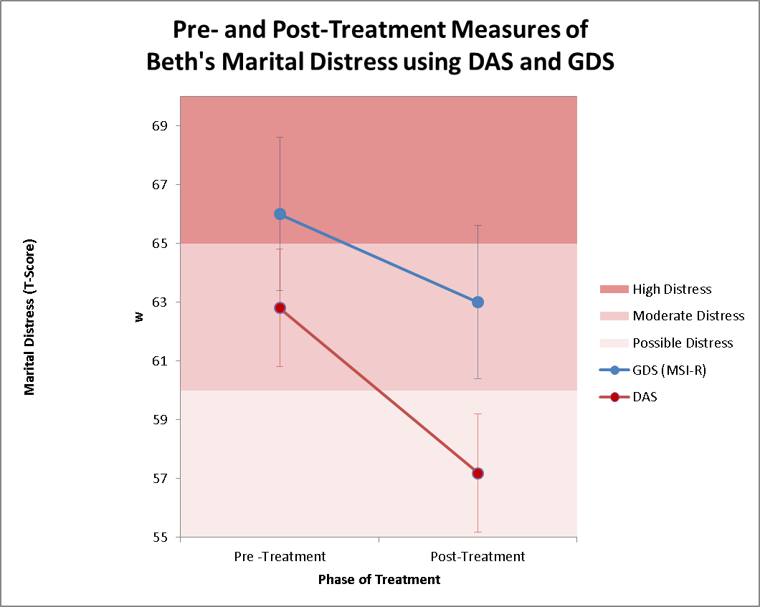

Figure 3. The change in Beth’s GDS and DAS from pre-treatment to post-treatment.
Note: Error bars as drawn in the figure are the Standard Error of Measurement for the GDS (SEM = 2.65) and the DAS (SEM = 2.00).

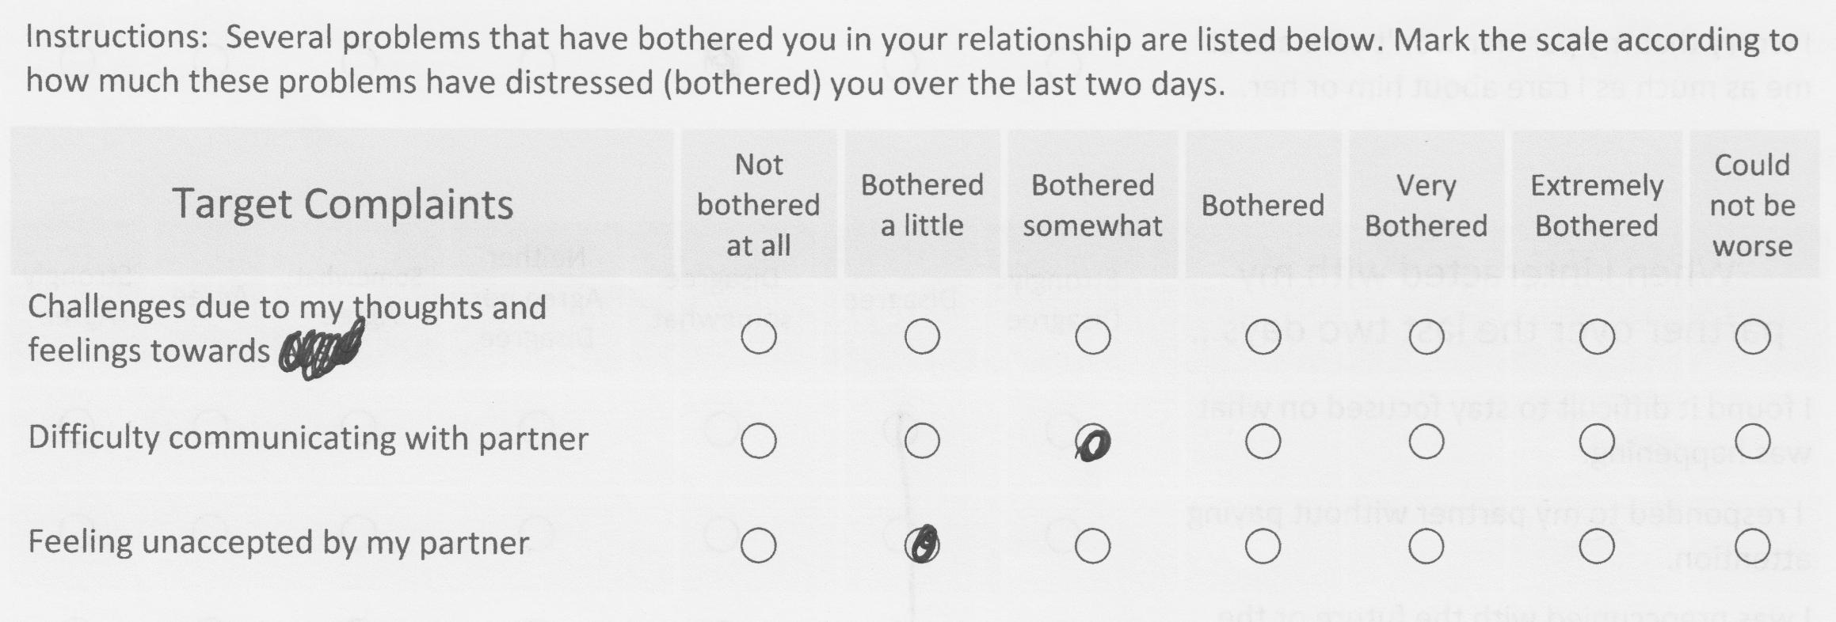
Figure 4. Deviant response from George in reply to Target Complaint item regarding the distress that he experienced as a consequence of his ruminative thoughts towards Lexi.

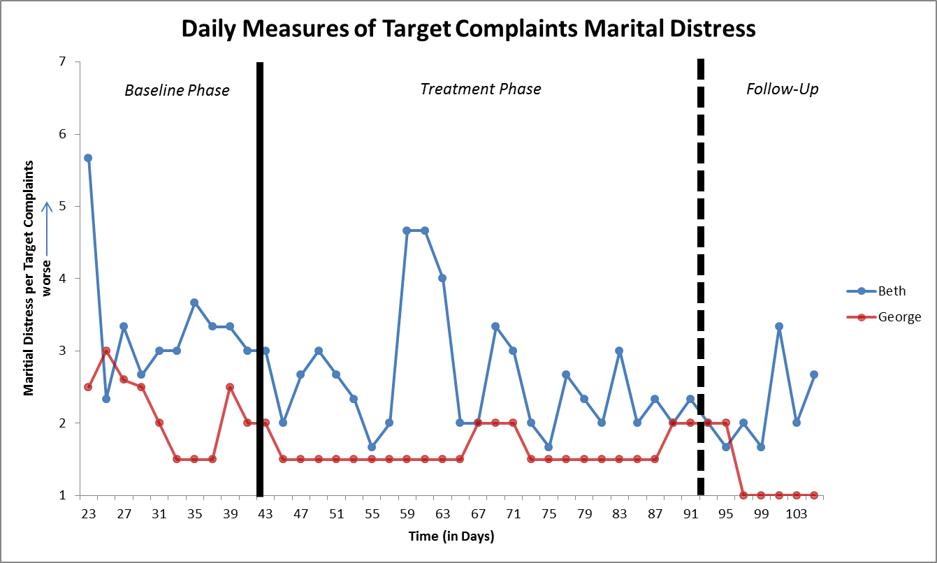

Figure 5. Time-series ratings of marital distress using Target Complaints measure during baseline, treatment, and follow-up phases. Note: Higher rating indicates more distress (1 = none/not at all distressed and 7 = extreme/extremely distressed); — = Phase marker between baseline and treatment at day 42; — — = Phase marker between treatment and follow-up at day 92.

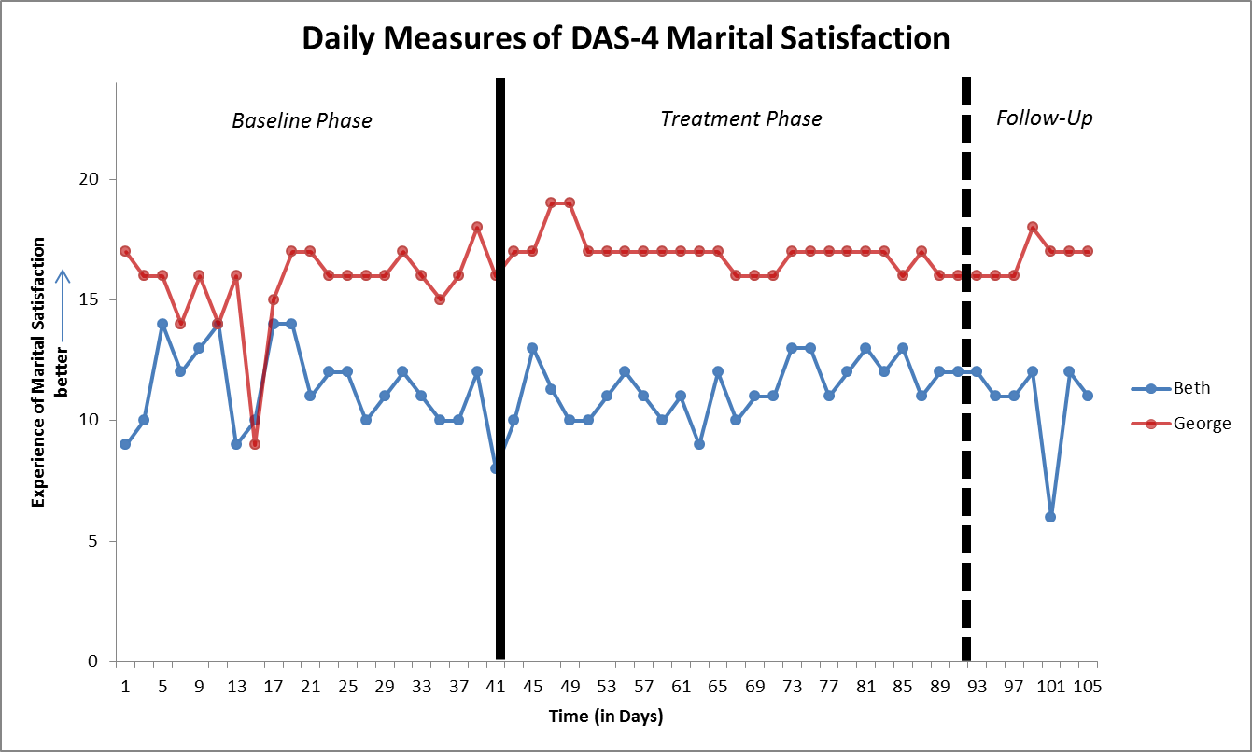

Figure 6. Time-series ratings of marital satisfaction on the DAS-4 during baseline, treatment, and follow-up phases. Note: Higher rating indicates more satisfaction (4 = extremely low marital satisfaction and 28 = extremely high satisfaction); — = Phase marker between baseline and treatment at day 42; — — = Phase marker between treatment and follow-up at day 92.
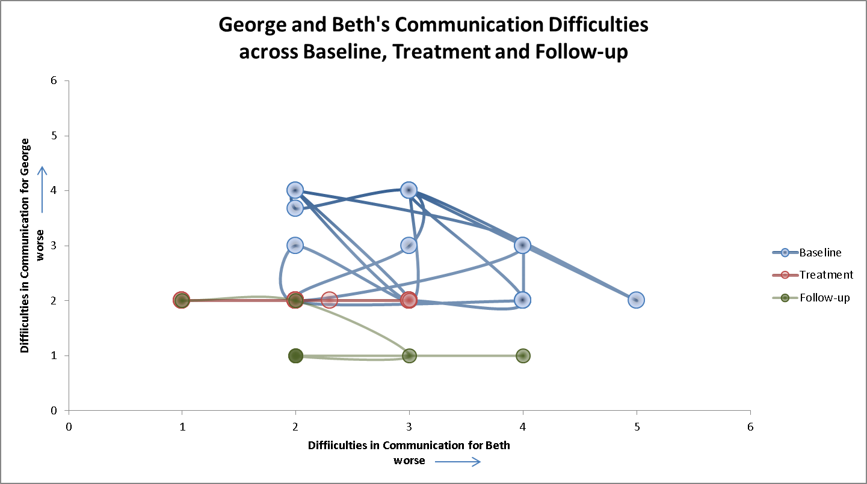
Figure 7. Time-series ratings of communication difficulties on the Target Complaints scale during baseline, treatment, and follow-up phases.
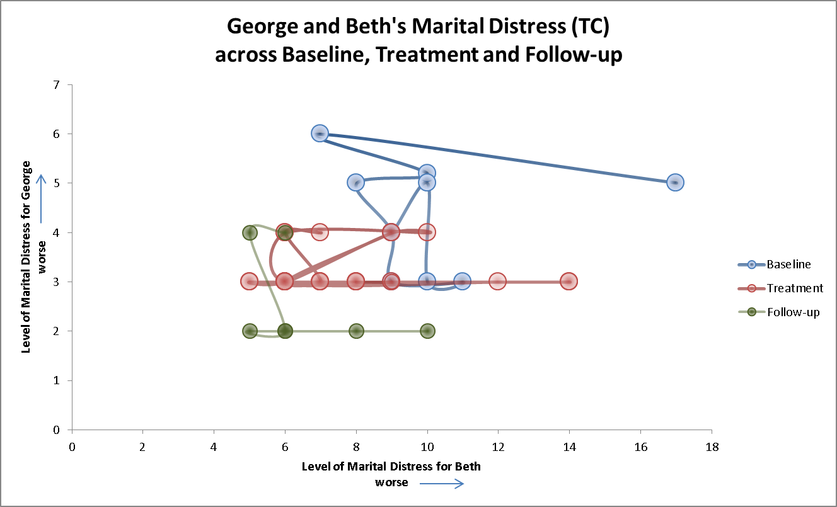
Figure 8. Time-series ratings of overall marital distress using the Target Complaints scale across baseline, treatment, and follow-up phases.

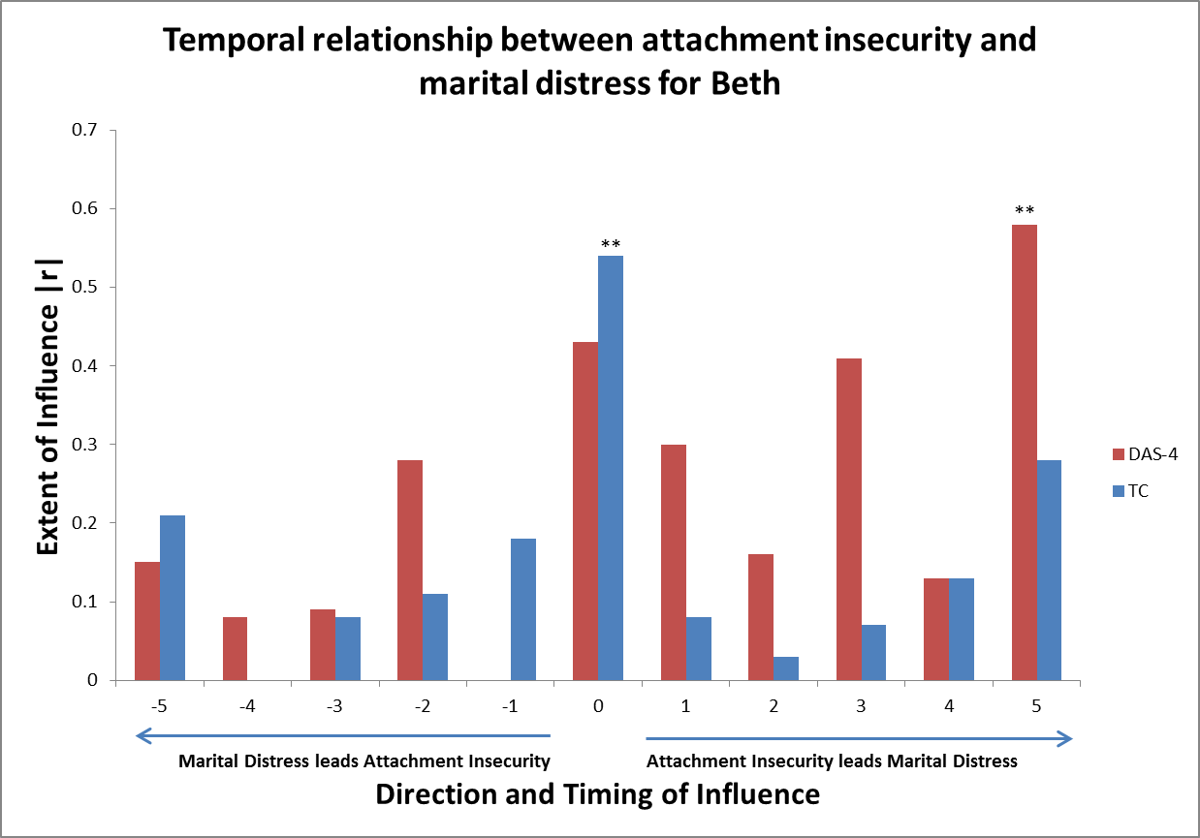
Figure 9. Cross-correlational analyses showing direction of temporal relationship of change in level of attachment insecurity in Beth (ECR-RS) with change in her level of marital distress (DAS-4 and TC) during EFT couples therapy; **p ≤ 0.005.

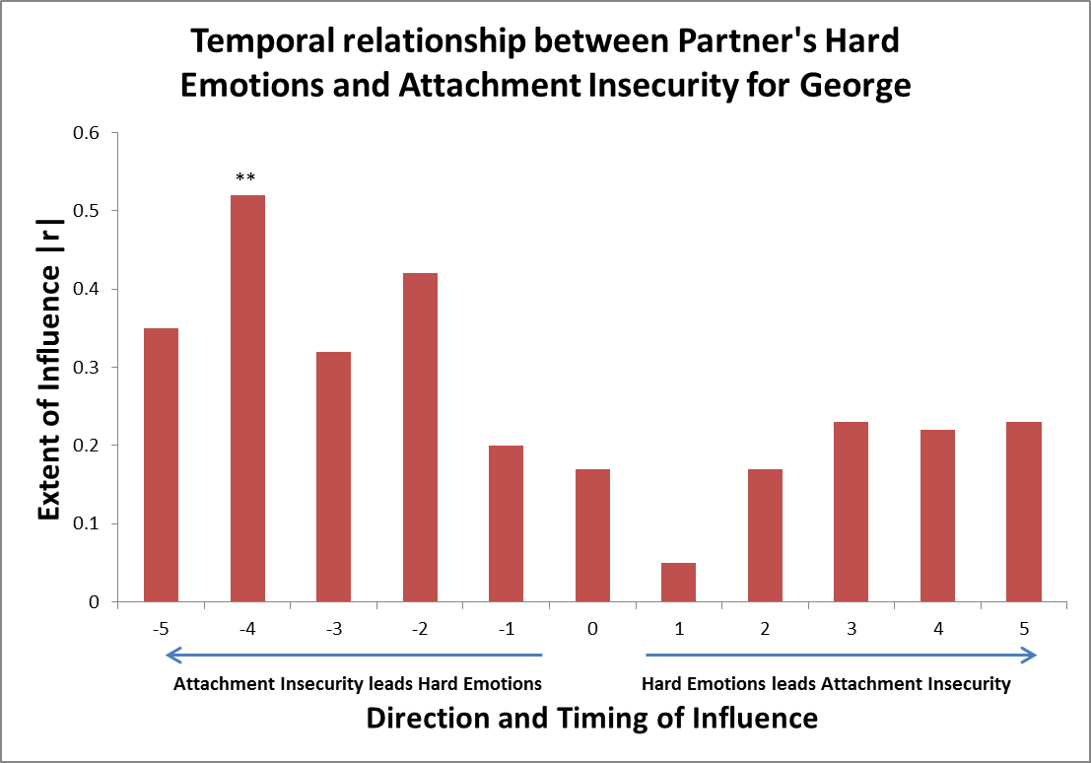
Figure 10. Cross-correlational analyses showing direction of temporal relationship of change in level of hard emotions directed at George (CERF-Hard) with his attachment insecurity (ECR-RS) during EFT couples therapy; **p ≤ 0.001.

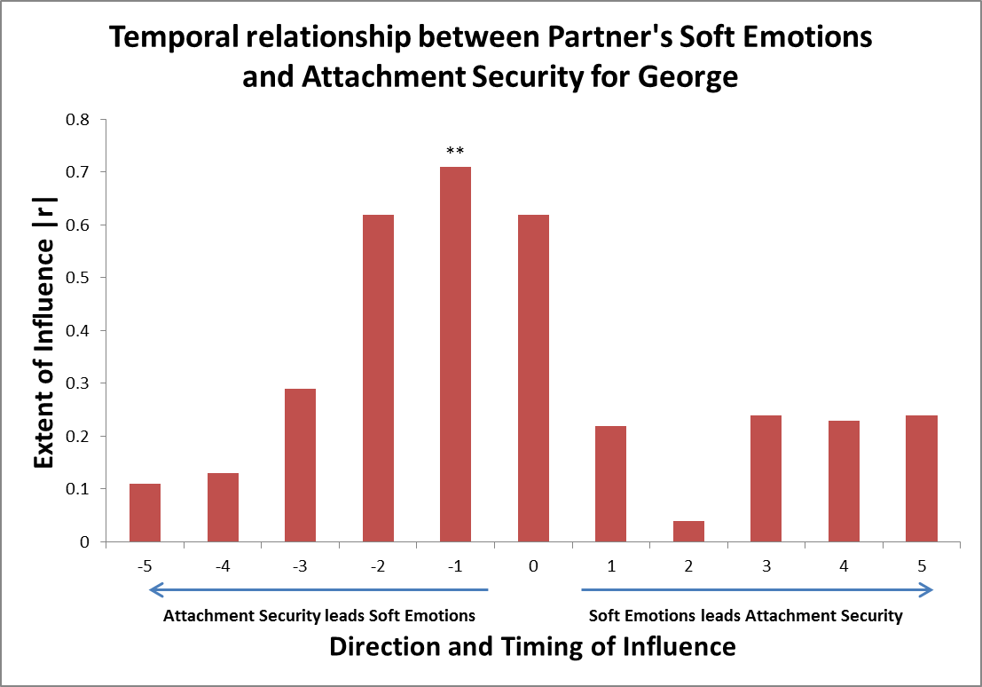

Figure 11. Cross-correlational analyses showing direction of temporal relationship of change in level of soft emotions directed at George (CERF-Soft) with his attachment insecurity (ECR-RS) during EFT couples therapy; **p ≤ 0.001.

Vita
Albert Wong graduated from Princeton University with a degree in physics and later attended Oxford University and the University of Michigan where he studied philosophy. He has served as faculty at Duke University, Santa Monica College, and Ryokan College. He is a proud member of the Cardinals Puff.

