Evaluation of Recycled Carbon Fiber Reinforced Concrete

A Thesis Presented for the

Master of Science

Degree

The University of Tennessee, Knoxville

Andrew Patchen

May 2023

Copyright © 2023 by Andrew Patchen
All rights reserved.

ACKNOWLEDGMENTS

Thank you to all the generous contributions from numerous people that made this work possible. I could not have competed this thesis without the assistance of my family, friends, colleagues, advisors, mentors, and support staff. I thank my parents and family for continued encouragement and support while I developed this thesis and laying the foundation of education and curiosity that allowed me to have the opportunity to pursue a higher education. Thank you to my friends for continued encouragement.

Thank you to my committee led by Dr. Penumadu for support, advice and always pushing for a higher standard of work. Thank you to Dr. Penumadu for encouraging me to pursue a higher education and providing me the opportunity to do so. I will be forever grateful for the opportunity and future opportunities your help has provided. Dr. Truster and Dr. Denavit thank you for being part of my committee and thank you for teaching some of the classes that I found most interesting. Dr. Truster thank you for an excellent mechanics class that set a strong foundation for all of my future work. Dr. Denavit thank you for your steel design and loads class both of which I found incredibly helpful.

Thank you to my colleagues within Dr. Penumadu’s group that made me feel welcome from day one. Thank you to Dr. Young for countless hours of discussion, testing help, paper edits, advice, and countless other tasks. This thesis would not have been competed without your help. Thank you to Dr. Puplampu for technical assistance. Thank you to the graduate students in Dr. Penumadu’s group that provided encouragement and feedback and advice on my work. Thank you to the numerous undergrad students that help me perform the countless of work. With a particular mention to Lily Parker, Jenna Brown, Hira Malik, and Natalie Holt that all helped with mixing concrete, testing samples and processing data and Logan Goodbred, Hunter Wood, Jacob Fowler, Noah Compton and Maxwell Coggin for additional technical support. Thank you to Colby Gilbert whose undergraduate research help to lay the foundation that this thesis was built on.

Thank you to the support staff at the University of Tennessee for continued support and use of invaluable resources. Thank you to Dr. Mobley who took time to train me on equipment, allowed me to use her lab space, and provided invaluable mentorship and advice. Thank you to the machine shop staff, Andy Baker, Larry Roberts and Ken Thomas for their expertise, help, and advice. Thank you to the office staff that help with paperwork, material ordering, and anything else that I might need. Lastly, thank you to all the other support staff on campus whose work and effort keeps the university working smoothly.

ABSTRACT

Concrete is the most widely used building material in the world and has many different applications and uses, all requiring specific properties and mix designs. While concrete is an incredibly valuable and versatile material for construction, it has a major drawback in the form of low tensile strength compared to its compressive strength. One solution for this is Fiber-Reinforced Concrete (FRC), where short fibers are randomly dispersed into the concrete during mixing to carry the tensile loads in the concrete. Many fibers have been used, with steel being one of the most common; however, carbon fiber shows particular promise due to its superior mechanical properties. Recycled carbon fiber is of particular interest due to its comparable mechanical properties to virgin carbon fiber but at a potentially much lower cost and additional sustainability benefits, potentially making this a novel form of reinforcement for FRC.

In this study, ultra-high-performance concrete reinforced with recycled carbon fiber was evaluated for its mechanical performance and compared with two commercially available carbon fiber types and steel fibers using the same concrete mix. Additionally, high-resolution micro X-ray computed tomography was performed on the concrete samples to investigate microstructure features of interest spatially including defects such as pore size distribution which can compromise the structural integrity of the concrete. Scanning electron microscopy were performed to investigate failure mechanism of the tensile concrete samples. Important properties including thermal stability of the carbon fibers and fiber density are reported.

The study further investigated the mechanical performance and effectiveness of recycled carbon fiber when mixed into high strength, structural lightweight and ultra lightweight concrete. The mechanical performance of the recycled carbon fiber reinforce concrete was compared to steel fibers. This study showed that recycled carbon fiber can significantly improve the tensile and flexural strength of neat concrete serving as a potential replacement for steel fiber reinforced concrete in certain applications. This study will help provide critical information for the development of process-structure relationships for recycled carbon fiber reinforced concrete for structural applications.

TABLE OF CONTENTS

INTRODUCTION 1
References 4
CHAPTER I An investigation of Mechanical properties of recycled carbon fiber reinforced ultra-high performance concrete 11
Abstract 12
Introduction 12
Materials and Methods 15
Concrete 15
Fiber properties 15
Carbon fiber density measurements 19
Scanning electron microscopy (SEM) and energy X-ray dispersive spectroscopy (EDS) of carbon fibers 19
Concrete mixing 19
Casting samples 20
Mechanical testing procedure 20
Micro-X-ray computed tomography of fiber-reinforced concrete designs 23
Results 23
Surface morphology and elemental analysis of fibers 23
Thermogravimetric analysis of fibers 24
Mechanical properties of fiber-reinforced concrete mixes 24
X-ray computed tomography results 29
SEM failure images 32
Discussion 32
Conclusions 39
Acknowledgments 40
References 41
CHAPTER II An evaluation of mechanical properties of recycled carbon fiber reinforced high strength, structural lightweight, and ultra-lightweight concrete. 48
Abstract 49
Introduction 49
Materials and Methods 51
Fiber properties 51
Concrete mix design 51
Concrete mixing procedure 55
Casting samples 55
Mechanical testing of cast samples 55
Results 58
Mechanical properties 58
Results Discussion 59
Conclusions 61
Acknowledgments 61
References 62
CONCLUSIONS 67
APPENDIX 1: DIC TRIALS 68
VITA 69

LIST OF TABLES

Table 1: UHPC mix design for steel and carbon fibers in units of kg of material per cubic meter of concrete. 16
Table 2: Physical and mechanical properties of fibers used in UHPC mix designs. 17
Table 3: Thermogravimetric isothermal properties of carbon fibers under nitrogen atmosphere. 28
Table 4: Mechanical properties of different concrete mixes. The value in parenthesis represents the standard deviation of each sample set, and the n is the number of samples. 30
Table 5: Void volume fraction of concrete mix designs 35
Table 6: Physical properties of fibers. Note: ± values are standard deviation. 52
Table 7: Summary of concrete mix designs. Note: all values are in the units of kg of material per m³ of total concrete mix. 53
Table 8: Mechanical properties, flow, and density values of the concrete mixes. The values in parenthesis are the standard deviation, and * represents the flow test not being valid due to the concrete crumbling during the test. 60

LIST OF FIGURES

Figure 1: Different fiber types mixed into concrete. A: steel fibers; B: Hexcel carbon fiber; C: Zoltek carbon fiber; D: recycled carbon fiber. 18
Figure 2: Different sample types used for mechanical testing. A: compression cube; B: tension briquettes; C: flexural beam. 21
Figure 3: The three different test methods being performed. A: compression cube; B: tensile test; C: flexural test with 229 mm major span and a 76 mm minor span. 22
Figure 4: Scanning electron micrographs of (a) Zoltek; (b) Hexcel; (c) steel; and (d–f) recycled carbon fibers. 25
Figure 5: Energy dispersive X-ray spectra of the steel, Hexcel, Zoltek, and recycled carbon fibers showing the chemical composition of each fiber type. (a) full energy spectrum form 0 keV to 15 keV; (b) inset of energy dispersive X-ray spectra energy range from 0 to 3 keV of each fiber type. The Au peaks correspond to the Au sputtering of samples. 26
Figure 6: Thermogravimetric analysis curves of Zoltek, Hexcel, and recycled carbon fiber heated in air to 900°C showing the oxidation degradation of the fibers. 27
Figure 7: Example force displacement curves for A: compression test, B: tension tests and, C: flexural test for each type of concrete. Note that for C the flexural curves for Zoltek and recycled fiber the samples were tested on a different load frame with a different overall compliance. 31
Figure 8: The left image is a 2D slice of the concrete. The right plot shows the gray values of the line as it runs from point A to D. B and C both show where the pores are and their corresponding gray values. 33
Figure 9: XCT results. A: neat concrete; B: steel fiber concrete; C: Hexcel carbon fiber concrete; D: Zoltek carbon fiber concrete; and E: recycled carbon fiber concrete. 1: 2D reconstructed cross-section; 2: full 3D reconstructed void volume; 3: expanded 3D void view. 34
Figure 10: Pore volume distribution with respect to percent of total void volume. 36
Figure 11: Scanning electron microscopy of mechanically failed (a) neat concrete sample; (b) steel fiber; (c) Hexcel fiber; (d) Zoltek fiber; and (e) rCF reinforced tensile briquettes samples. 37
Figure 12: Experimental apparatus for density measurements of aggregates lighter than water by submerging aggregates in water. 54
Figure 13: Samples used for mechanical testing. A: compression cube; B: tension briquettes; C: flexural beam. 56
Figure 14: Mechanical testing experimental setup for A: compression cube; B: tensile test; and C: flexural test with 229 mm major span and a 76 mm minor span. 57

INTRODUCTION

Concrete is the most widely used building material in the world, with over 4.4 billion metric tons of cement being produced worldwide annually [1, 2]. Concrete is used in many different applications from aesthetic architectural details to high strength structural elements [3, 4]. The concrete industry is critical both economically and for the world’s infrastructure.

Due to concrete’s many applications, there are many different desirable properties. However, concrete has a major drawback of having a low tensile strength compared to its compressive strength. Therefore, for most concrete applications, steel rebar is placed into the concrete to carry the tensile loads on the concrete [5]. The use of rebar and other continuous reinforcement methods for concrete does have several drawbacks, the first being the cost of materials and labor associated with rebar, which can make up about 18% of the total cost of concrete construction [6]. Additionally, steel rebar is vulnerable to corrosion, which can reduce the rebar’s cross-sectional area and strength, and the expanding rust can lead to rust jacking, which can damage the surrounding concrete [7–9].

A potential solution for the problems associated with rebar is fiber-reinforced concrete (FRC). FRC utilizes short fibers randomly mixed into concrete, where the short fibers carry the tensile stresses in the concrete [10–17]. FRC has been used in many different applications including 3D printing, architectural details, increasing blast protection, structural elements, and many others [18–22]. Steel fibers are among the most common fibers used in FRC due to their cost and performance [10, 23, 24]. Steel fibers have been shown to improve tensile, compressive, and flexural strength along with increasing energy absorption and toughness of concrete [25–29]. Many fibers including polypropylene, glass, basalt, and natural fibers have been utilized in FRC to increase its mechanical properties, and these have been extensively investigated [10, 30–33]. Additionally, carbon fiber is of particular interest as a reinforcement for FRC and has been studied many times due to its excellent physical properties [22, 34–39].

Carbon fiber can provide a higher modulus than steel, allowing it to develop higher tensile stress in concrete than steel before the concrete matrix fails [40]. Additionally, carbon fiber is chemically inert, preventing the corrosion issues present with steel fibers such as degeneration of strength of the fibers and rust affecting the aesthetics of the concrete [35, 41, 42]. Carbon fiber has a lower density then steel fiber, which can be beneficial in some lightweight concrete applications [40]. In FRC concrete, the fibers can make up a significant amount of the cost of the final concrete mix, which can put carbon fiber at a disadvantage due to it being more expensive than steel fiber [35, 41–45]. One potential novel solution for the cost issue with carbon fiber is to utilize recycled Carbon Fiber (rCF), which can potentially significantly reduce the cost compared to virgin carbon fiber [46–48].

rCF comes from the recycling of Carbon Fiber-Reinforced Polymers (CFRP) from numerous sources but primarily from the automotive and aerospace industry and can be recycled in three primary processes: mechanical, chemical, and thermal [49]. CFRP waste can be environmentally hazardous and is difficult to recycle due to its chemical and physical stability, requiring sustainable recycling methods [50, 51]. Additionally, the recycling process can damage the fibers leading to strength reduction, fiber length variation, fiber diameter change, and contamination [47, 49, 52–65]. Several studies have been completed on rCF, with Ogi et al. using crushed CFRP pieces and looking at the compressive, flexural, and fracture behavior [66]. Mastali et al. used recycled CFRP in self compacting concrete and saw improvements to flexural and compressive strength and impact resistance [67, 68].

FRC can be utilized and tailored for many different applications and can make use of rCF. One of the main uses of FRC is in Ultra-High Performance Concrete (UHPC) or concrete with a compressive strength greater than 124 MPa [69, 70]. Due to UHPC’s strength and durability, it is an ideal material for bridges, railroads, and construction [25, 26, 71–75]. High-strength concrete or concrete with a compressive strength greater than 50 MPa can also utilize FRC and can commonly be used for structural elements in bridges and building [76–86]. High-strength concrete is generally not as strong as UHPC but is generally more economical. Additional applications for high-strength concrete include bridge and building decking, where structural lightweight concrete is used that provides a balance between strength and performance, which can help to reduce the mass of the overall structure [87, 88]. For architectural features and aesthetic concrete, strength is less important, so ultra-lightweight concrete can be utilized to reduce unnecessary weight on the structure [89, 90].

The specific mix design and properties of a concrete mixture primarily affect the concrete’s strength; however, there are many other factors that can affect concrete’s strength even with the same mix design. One of the major factors that affects the strength of concrete is the porosity and pore distribution within the hardened concrete [75]. An effective technique to spatially observe and quantify the pore microstructure non-destructively within concrete is micro-X-ray computed tomography (μ-XCT). μ-XCT enables the evaluation of micro-cracks, fiber orientation, fiber bonding, and porosity of concrete in 3D [91–97]. Furthermore, μ-XCT aids the development of the structure–property relationship relating to microstructural features of interest within the concrete and the mechanical performance of rCF concrete.

In this study, rCF-reinforced UHPC was evaluated for structure–property relationships and compared to commercially available aerospace-grade carbon fiber and low-cost immediate modulus carbon fiber. An experimental program of mix design parameters, pore size distribution, 3D spatial volume visualization, and mechanical performance was performed. Thermal characterization was performed to compare the sizing of rCF to the two aforementioned. Additionally, the surface morphology and elemental chemical composition of the carbon fibers were evaluated to investigate the microconstituents of the fibers. The study investigated mixed rCF fibers and two other types of commercially available carbon fiber along with steel fiber and neat concrete to see how rCF compared to other types of carbon fiber and the industry standard steel fiber. In addition, to investigate the compressive, tensile, and flexural strength of the UHPC, μ-XCT scans were taken to examine the microstructure. The μ-XCT scans allowed the authors to fully understand how the rCF fibers interacted with the UHPC concrete and how the microstructure affected the strength of the concrete.

The second phase of the study was to investigate how rCF worked in high-strength, structural lightweight, and ultra-lightweight concrete. The study also utilized steel fibers and neat concrete mixes to compare to the rCF-reinforced concrete. The study investigated how different mix designs affect the concrete workability and strength. The main interest of the study was the compressive, tensile, and flexural strength of the concrete along with the workability and density of the concrete. This study shows that rCF can effectively reinforce many different types of concrete.

References

1. Naik, T. R., Sustainability of concrete construction. Practice Periodical on Structural Design and Construction 2008, 13, (2), 98-103.
2. Mineral Commodity Summaries 2022; Reston, VA, 2022; p. 202.
3. Naganna, S. R.; Ibrahim, H. A.; Yap, S. P.; Tan, C. G.; Mo, K. H.; El-Shafie, A., Insights into the multifaceted applications of architectural concrete: A state-of-the-art review. Arabian Journal for Science and Engineering 2021, 46, (5), 4213-4223.
4. Institute, A. C., ACI CODE-318-19: Building Code Requirements for Structural Concrete and Commentary. 318, A. C., Ed. 2019.
5. Institute, A. C., ACI CODE-318-14: Building Code Requirements for Structural Concrete and Commentary. American Concrete Institute, 2014.
6. Lab, R. H., Think formwork – reduce costs. Structure, 2007.
7. Bertolini, L.; Elsener, B.; Pedeferri, P.; Redaelli, E.; Polder, R. B., Corrosion of Steel in Concrete: Prevention, Diagnosis, Repair. John Wiley & Sons, 2013.
8. Samples, L. M.; Ramirez, J. A., Methods of Corrosion Protection and Durability of Concrete Bridge Decks Reinforced with Epoxy-coated Bars: Phase I. 1999.
9. Shi, X.; Xie, N.; Fortune, K.; Gong, J., Durability of steel reinforced concrete in chloride environments: An overview. Construction and Building Materials 2012, 30, 125-138.
10. Afroughsabet, V.; Biolzi, L.; Ozbakkaloglu, T., High-performance fiber-reinforced concrete: A review. Journal of Materials Science 2016, 51, (14), 6517-6551.
11. Kuder, K. G.; Shah, S. P., Processing of high-performance fiber-reinforced cement-based composites. Construction and Building Materials 2010, 24, (2), 181-186.
12. Lau, A.; Anson, M., Effect of high temperatures on high performance steel fibre reinforced concrete. Cement and Concrete Research 2006, 36, (9), 1698-1707.
13. Balaguru, P. N.; Shah, S. P., Fiber-reinforced Cement Composites. 1992.
14. Wang, Y.; Li, V. C.; Backer, S., Tensile failure mechanisms in synthetic fibre-reinforced mortar. Journal of Materials Science 1991, 26, (24), 6565-6575.
15. Jr Savastano, H.; Turner, A.; Mercer, C.; Soboyejo, W. O., Mechanical behavior of cement-based materials reinforced with sisal fibers. Journal of Materials Science 2006, 41, (21), 6938-6948.
16. Sudin, R.; Swamy, N., Bamboo and wood fibre cement composites for sustainable infrastructure regeneration. Journal of Materials Science 2006, 41, (21), 6917-6924.
17. Khayat, K. H.; Roussel, Y., Testing and performance of fiber-reinforced, self-consolidating concrete. Materials and Structures 2000, 33, (6), 391-397.
18. Ma, G.; Li, Z.; Wang, L.; Wang, F.; Sanjayan, J., Mechanical anisotropy of aligned fiber reinforced composite for extrusion-based 3D printing. Construction and Building Materials 2019, 202, 770-783.
19. Blazy, J.; Blazy, R., Polypropylene fiber reinforced concrete and its application in creating architectural forms of public spaces. Case Studies in Construction Materials 2021, 14, e00549.
20. Batoz, J.-F.; Behloul, M., UHPFRC development on the last two decades: An overview. Resplendino J. Proceedings of UHPFRC 2009, 1-13.
21. Foglar, M.; Kovar, M., Conclusions from experimental testing of blast resistance of FRC and RC bridge decks. International Journal of Impact Engineering 2013, 59, 18-28.
22. Brandt, A. M., Fibre reinforced cement-based (FRC) composites after over 40 years of development in building and civil engineering. Composite Structures 2008, 86, (1), 3-9.
23. Dvorkin, L.; Dvorkin, O., Basics of concrete science. St-Petersburg: Stroi-Beton 2006, 200.
24. Barros, J. A.; Sena-Cruz, J., Fracture energy of steel fiber-reinforced concrete. 2001.
25. Rui, Y.; Kangning, L.; Tianyi, Y.; Liwen, T.; Mengxi, D.; Zhonghe, S., Comparative study on the effect of steel and polyoxymethylene fibers on the characteristics of Ultra-High Performance Concrete (UHPC). Cement and Concrete Composites 2022, 127, 104418.
26. Yu, R.; Spiesz, P.; Brouwers, H. J. H., Energy absorption capacity of a sustainable Ultra-High Performance Fibre Reinforced Concrete (UHPFRC) in quasi-static mode and under high velocity projectile impact. Cement and Concrete Composites 2016, 68, 109-122.
27. Dingqiang, F.; Yu, R.; Kangning, L.; Junhui, T.; Zhonghe, S.; Chunfeng, W.; Shuo, W.; Zhenfeng, G.; Zhengdong, H.; Qiqi, S., Optimized design of steel fibres reinforced ultra-high performance concrete (UHPC) composites: Towards dense structure and efficient fibre application. Construction and Building Materials 2021, 273, 121698.
28. Fan, D. Q.; Yu, R.; Shui, Z. H.; Wu, C. F.; Song, Q. L.; Liu, Z. J.; Sun, Y.; Gao, X.; He, Y. J., A new design approach of steel fibre reinforced ultra-high performance concrete composites: Experiments and modeling. Cement and Concrete Composites 2020, 110, 103597.
29. Meng, W.; Khayat, K. H., Experimental and numerical studies on flexural behavior of ultrahigh-performance concrete panels reinforced with embedded glass fiber-reinforced polymer grids. Transportation Research Record 2016, 2592, (1), 38-44.
30. Mehta, P. K.; Monteiro, P. J., Concrete: Microstructure, Properties, and Materials. McGraw-Hill Education, 2014.
31. Biolzi, L.; Cattaneo, S.; Guerrini, G. L., Fracture of plain and fiber-reinforced high strength mortar slabs with EA and ESPI monitoring. Applied Composite Materials 2000, 7, (1), 1-12.
32. Kosmatka, S. H.; Panarese, W. C.; Kerkhoff, B., Design and Control of Concrete Mixtures. Portland Cement Association Skokie, IL, 2002; Vol. 5420.
33. Zhou, H.; Jia, B.; Huang, H.; Mou, Y., Experimental study on basic mechanical properties of basalt fiber reinforced concrete. Materials 2020, 13.
34. Park, S. B.; Lee, B. I.; Lim, Y. S., Experimental study on the engineering properties of carbon fiber reinforced cement composites. Cement and Concrete Research 1991, 21, (4), 589-600.
35. Ohama, Y., Carbon-cement composites. Carbon 1989, 27, (5), 729-737.
36. Zollo, R. F., Fiber-reinforced concrete: An overview after 30 years of development. Cement and Concrete Composites 1997, 19, (2), 107-122.
37. Chung, D. D. L., Cement reinforced with short carbon fibers: A multifunctional material. Composites Part B: Engineering 2000, 31, (6), 511-526.
38. Park, S.-J.; Seo, M.-K.; Shim, H.-B.; Rhee, K.-Y., Effect of different cross-section types on mechanical properties of carbon fiber-reinforced cement composites. Materials Science and Engineering 2004, 366, (2), 348-355.
39. Yao, W.; Li, J.; Wu, K., Mechanical properties of hybrid fiber-reinforced concrete at low fiber volume fraction. Cement and Concrete Research 2003, 33, (1), 27-30.
40. Daniel, I. M.; Ishai, O.; Daniel, I. M.; Daniel, I., Engineering Mechanics of Composite Materials. Oxford University Press New York: 2006; Vol. 1994.
41. Kosa, K.; Naaman, A. E., Corrosion of steel fiber reinforced concrete. ACI Materials Journal 87, (1).
42. Frazão, C.; Camões, A.; Barros, J.; Gonçalves, D., Durability of steel fiber reinforced self-compacting concrete. Construction and Building Materials 2015, 80, 155-166.
43. Isa, M. N.; Pilakoutas, K.; Guadagnini, M.; Angelakopoulos, H., Mechanical performance of affordable and eco-efficient ultra-high performance concrete (UHPC) containing recycled tyre steel fibres. Construction and Building Materials 2020, 255, 119272.
44. Zhong, R.; Wille, K.; Viegas, R., Material efficiency in the design of UHPC paste from a life cycle point of view. Construction and Building Materials 2018, 160, 505-513.
45. Das, S., Life cycle assessment of carbon fiber-reinforced polymer composites. The International Journal of Life Cycle Assessment 2011, 16, (3), 268-282.
46. van de Werken, N.; Reese, M. S.; Taha, M. R.; Tehrani, M., Investigating the effects of fiber surface treatment and alignment on mechanical properties of recycled carbon fiber composites. Composites Part A: Applied Science and Manufacturing 2019, 119, 38-47.
47. Pimenta, S.; Pinho, S. T., Recycling carbon fibre reinforced polymers for structural applications: Technology review and market outlook. Waste Management 2011, 31, (2), 378-392.
48. Carberry, W., Airplane Recycling Efforts benefit boeing operators. Boeing Aero Magazine QRT 2008, 4, (08), 6-13.
49. Butenegro, J. A.; Bahrami, M.; Abenojar, J.; Martínez, M. Á., Recent progress in carbon fiber reinforced polymers recycling: A review of recycling methods and reuse of carbon fibers. Materials 2021, 14, (21).
50. Akbar, A.; Kodur, V. K. R.; Liew, K. M., Microstructural changes and mechanical performance of cement composites reinforced with recycled carbon fibers. Cement and Concrete Composites 2021, 121, 104069.
51. Howarth, J.; Mareddy, S. S. R.; Mativenga, P. T., Energy intensity and environmental analysis of mechanical recycling of carbon fibre composite. Journal of Cleaner Production 2014, 81, 46-50.
52. Karuppannan Gopalraj, S.; Kärki, T., A review on the recycling of waste carbon fibre/glass fibre-reinforced composites: Fibre recovery, properties and life-cycle analysis. SN Applied Sciences 2020, 2, (3), 433.
53. Abdallah, R.; Juaidi, A.; Savaş, M. A.; Çamur, H.; Albatayneh, A.; Abdala, S.; Manzano-Agugliaro, F., A critical review on recycling composite waste using pyrolysis for sustainable development. Energies 2021, 14, (18).
54. Pickering, S.; Turner, T.; Meng, F.; Morris, C.; Heil, J.; Wong, K.; Melendi-Espina, S. In Developments in the Fluidised Bed Process for Fibre Recovery from Thermoset Composites, 2nd Annual Composites and Advanced Materials Expo, CAMX 2015; Dallas Convention CenterDallas; United States, 2015; pp 2384-2394.
55. Pimenta, S.; Pinho, S. T.; Robinson, P.; Wong, K. H.; Pickering, S. J., Mechanical analysis and toughening mechanisms of a multiphase recycled CFRP. Composites Science and Technology 2010, 70, (12), 1713-1725.
56. Zhu, J.-H.; Chen, P.-y.; Su, M.-n.; Pei, C.; Xing, F., Recycling of carbon fibre reinforced plastics by electrically driven heterogeneous catalytic degradation of epoxy resin. Green Chemistry 2019, 21, (7), 1635-1647.
57. Kumar, S.; Krishnan, S., Recycling of carbon fiber with epoxy composites by chemical recycling for future perspective: A review. Chemical Papers 2020, 74, (11), 3785-3807.
58. Verma, S.; Balasubramaniam, B.; Gupta, R. K., Recycling, reclamation and re-manufacturing of carbon fibres. Current Opinion in Green and Sustainable Chemistry 2018, 13, 86-90.
59. Bledzki, A. K.; Seidlitz, H.; Krenz, J.; Goracy, K.; Urbaniak, M.; Rösch, J. J., Recycling of carbon fiber reinforced composite polymers: Review—Part 2: Recovery and application of recycled carbon fibers. Polymers 2020, 12, (12).
60. Ma, C.; Sánchez-Rodríguez, D.; Kamo, T., Influence of thermal treatment on the properties of carbon fiber reinforced plastics under various conditions. Polymer Degradation and Stability 2020, 178, 109199.
61. Karuppannan Gopalraj, S.; Kärki, T., A study to investigate the mechanical properties of recycled carbon fibre/glass fibre-reinforced epoxy composites using a novel thermal recycling process. Processes 2020, 8, (8).
62. Sun, H.; Guo, G.; Memon, S. A.; Xu, W.; Zhang, Q.; Zhu, J.-H.; Xing, F., Recycling of carbon fibers from carbon fiber reinforced polymer using electrochemical method. Composites Part A: Applied Science and Manufacturing 2015, 78, 10-17.
63. Nahil, M. A.; Williams, P. T., Recycling of carbon fibre reinforced polymeric waste for the production of activated carbon fibres. Journal of Analytical and Applied Pyrolysis 2011, 91, (1), 67-75.
64. Das, M.; Chacko, R.; Varughese, S., An efficient method of recycling of CFRP waste using peracetic acid. ACS Sustainable Chemistry & Engineering 2018, 6, (2), 1564-1571.
65. Ma, Y.; Nutt, S., Chemical treatment for recycling of amine/epoxy composites at atmospheric pressure. Polymer Degradation and Stability 2018, 153, 307-317.
66. Ogi, K.; Shinoda, T.; Mizui, M., Strength in concrete reinforced with recycled CFRP pieces. Composites Part A: Applied Science and Manufacturing 2005, 36, (7), 893-902.
67. Mastali, M.; Dalvand, A., The impact resistance and mechanical properties of self-compacting concrete reinforced with recycled CFRP pieces. Composites Part B: Engineering 2016, 92, 360-376.
68. Mastali, M.; Dalvand, A.; Sattarifard, A., The impact resistance and mechanical properties of the reinforced self-compacting concrete incorporating recycled CFRP fiber with different lengths and dosages. Composites Part B: Engineering 2017, 112, 74-92.
69. Sharma, R.; Jang, J. G.; Bansal, P. P., A comprehensive review on effects of mineral admixtures and fibers on engineering properties of ultra-high-performance concrete. Journal of Building Engineering 2022, 45, 103314.
70. Adminstration, F. H. Ultra-High Performance Concrete. https://highways.dot.gov/research/structures/ultra-high-performance-concrete/ultra-high-performance-concrete (7/26/2022),
71. Ghafari, E.; Costa, H.; Júlio, E., Statistical mixture design approach for eco-efficient UHPC. Cement and Concrete Composites 2015, 55, 17-25.
72. Wang, X.; Yu, R.; Shui, Z.; Song, Q.; Zhang, Z., Mix design and characteristics evaluation of an eco-friendly ultra-high performance concrete incorporating recycled coral based materials. Journal of Cleaner Production 2017, 165, 70-80.
73. Jiang, W.; Huang, Y.; Sha, A., A review of eco-friendly functional road materials. Construction and Building Materials 2018, 191, 1082-1092.
74. Zhou, M.; Lu, W.; Song, J.; Lee, G. C., Application of ultra-high performance concrete in bridge engineering. Construction and Building Materials 2018, 186, 1256-1267.
75. Shi, C.; Wu, Z.; Xiao, J.; Wang, D.; Huang, Z.; Fang, Z., A review on ultra high performance concrete: Part I. Raw materials and mixture design. Construction and Building Materials 2015, 101, 741-751.
76. Mendis, P., Design of high-strength concrete members: State-of-the-art. Progress in Structural Engineering and Materials 2003, 5, (1), 1-15.
77. Shah, S. P.; Ahmad, S. H., High Performance Concrete. Properties and Applications. 1994.
78. Malier, Y., High Performance Concrete: From Material to Structure. CRC Press: 1992.
79. Gjørv, O., High-strength concrete. In Developments in the Formulation and Reinforcement of Concrete, Elsevier: 2008; pp 153-170.
80. Mendis, P.; Pendyala, R. In High-strength/High-performance Concrete in Australia: Design and Applications, Proceedings of the 4th World Conference on Utilization of High-strength/High-performance Concrete, Paris, 1996; pp 1581-1590.
81. Chang, P.-K.; Hwang, C.-L.; Peng, Y.-N., Application of high-performance concrete to high-rise building in Taiwan. Advances in Structural Engineering 2001, 4, (2), 65-73.
82. French, C.; Mokhtarzadeh, A.; Ahlborn, T.; Leon, R., High-strength concrete applications to prestressed bridge girders. Construction and Building Materials 1998, 12, (2-3), 105-113.
83. Persson, B. S.; Johansson, A. G.; Johansson, P. S., Prefabrication with HSC. Concrete International 1999, 21, (9), 58-62.
84. Charles H. Thornton, H. M. U. H. L. M. J.; Hashimah, H., The Petronas twin towers and high-performance concrete. ACI Symposium Publication 172.
85. M. K. Tadros, X. H. Z. M.; Baishya, M., Structural Design of high-performance concrete bridges. ACI Symposium Publication 189.
86. Breitenbucher, R., Developments and applications of high-performance concrete. Materials and Structures 1998, 31, (207), 209-215.
87. Clarke, J. L., Structural Lightweight Aggregate Concrete. CRC Press: 1993.
88. Lawson, R., Fire resistance of ribbed concrete and composite slabs. Concrete (London) 1987, 21, (5), 18-20.
89. Thienel, C.; Peck, M., Die Renaissance leichter Betone in der Architektur. Detail 2007, 522-534.
90. Thienel, K.-C.; Haller, T.; Beuntner, N., Lightweight concrete: From basics to innovations. Materials 2020, 13.
91. Ponikiewski, T.; Katzer, J.; Bugdol, M.; Rudzki, M., Determination of 3D porosity in steel fibre reinforced SCC beams using X-ray computed tomography. Construction and Building Materials 2014, 68, 333-340.
92. Qsymah, A.; Sharma, R.; Yang, Z.; Margetts, L.; Mummery, P., Micro X-ray computed tomography image-based two-scale homogenisation of ultra high performance fibre reinforced concrete. Construction and Building Materials 2017, 130, 230-240.
93. Kaczmarczyk, G. P.; Kinasz, R.; Bilozir, V.; Bidenko, I., Application of X-ray computed tomography to verify bond failures mechanism of fiber-reinforced fine-grain concrete. Materials 2022, 15, (6).
94. Zhang, H.; Pan, Q.; Zheng, K.; Jin, C.; Pan, L., Mesoscale study on splitting tensile damage characteristics of concrete based on X-ray computed tomography and digital image correlation technology. Materials 2022, 15, (13).
95. Darma, I. S.; Sugiyama, T.; Promentilla, M. A. B., Application of X-Ray CT to study diffusivity in cracked concrete through the observation of tracer transport. Journal of Advanced Concrete Technology 2013, 11, (10), 266-281.
96. Ríos, J. D.; Leiva, C.; Ariza, M. P.; Seitl, S.; Cifuentes, H., Analysis of the tensile fracture properties of ultra-high-strength fiber-reinforced concrete with different types of steel fibers by X-ray tomography. Materials & Design 2019, 165, 107582.
97. Vicente, M. A.; Mínguez, J.; González, D. C., Computed tomography scanning of the internal microstructure, crack mechanisms, and structural behavior of fiber-reinforced concrete under static and cyclic bending tests. International Journal of Fatigue 2019, 121, 9-19.

CHAPTER I
An investigation of Mechanical properties of recycled carbon fiber reinforced ultra-high performance concrete
A version of this chapter in is preparation for publication by Andrew Patchen, Stephen Young, and Dayakar Penumadu:

Andrew Patchen: investigation, methodology, conceptualization, writing—original draft, data processing and analysis. Stephen Young: investigation, writing—original draft and review. Dayakar Penumadu: supervision, project administration, funding acquisition, writing—review and editing.

Abstract

Carbon fiber-reinforced concrete is attractive for civil infrastructure due to carbon fiber having a higher tensile strength and lower density than steel fiber, as well as a resistance to corrosion. Ultra-High Performance Concrete (UHPC), possessing excellent mechanical properties, utilizes randomly oriented short fibers increasing the concrete’s strength and durability, where fibers carry the tensile stress within the concrete similar to traditional rebar reinforcement. However, carbon fiber remains a market entry barrier for the high-volume production of fiber-reinforced concrete mix designs. Recycled carbon fibers are a promising solution to mitigate cost and increase sustainability while retaining attractive mechanical properties as a reinforcement for concrete. Thus, a comprehensive study of process structure–properties relationships is critical for the use of recycled carbon fibers in ultra-high performance concrete, due to factors such as pore formation and poor fiber distribution that can significantly affect its mechanical properties. In this study, a mix design consisting of recycled carbon fiber and ultra-high performance concrete is evaluated for mechanical properties and compared to an aerospace-grade and low-cost commercial carbon fiber with same mix design. Additionally, the concrete mix designs were elevated non-destructively using high-resolution micro-X-ray computed tomography to obtain 3D quantitative spatial pore size distribution information. Scanning electron microscopy was also performed to evaluate the surface morphology of the carbon fibers and failure modes of the concrete mix designs. Energy X-ray dispersive spectroscopy was performed to obtain the chemical composition of the fibers including fiber sizing.

Introduction

Concrete is the most widely used building material in the world and plays a critical role in the world’s infrastructure [1]. Traditionally, concrete is reinforced with continuous bars for both crack control and tensile load carrying [2]. The cost of the continuous reinforced bars and the labor to place them make up a significant part of the cost for concrete construction [3]. One potential solution for this is Fiber-Reinforced Concrete (FRC), where short, chopped fibers are mixed into the concrete to serve and reinforcement [4]. FRC is ideal for use in many applications such as 3D printing, architectural design, blast protection, and many others [5–9].

Various fiber types including steel fiber, glass fiber, basalt fiber, and synthetic fibers have been used as reinforcements in concrete [4, 9]. Steel fiber is one of the most common fibers used in concrete applications [9] and has been demonstrated to increase tensile, compressive, and flexural strength as well as energy absorption and toughness for FRC [10–14]. Additionally, steel fiber exhibits uniform dispersion and suitable workability controlled up to 3% volume fraction [15]. Furthermore, many studies have been performed using carbon fiber (CF) as a reinforcement in concrete [9, 16–21]. CF could prove to be superior to steel fiber for use in concrete applications due to its better mechanical properties and high corrosion resistance or chemical inertness [16].

CF has a higher modulus then steel, which allows it to develop higher stresses before the concrete fails at relatively low tensile strains [22]. Likewise, CF is chemically inert and does not have the same corrosion issues that steel fibers are susceptible to. This is particularly important in concrete applications due to concrete being highly alkaline and potentially used in harsh environments [17]. CF’s physical properties should make an ideal replacement for steel fiber in concrete. However, the price of the fibers plays a significant role in the final cost of the concrete mix [23, 24]. This can potentially place CF at a significant disadvantage compared to steel [25]. One potential new solution for this issue is to use recycled carbon fiber (rCF), which can have a lower cost than virgin fibers [26–28].

rCF is a promising viable option due to the fact that carbon waste from the automotive and aerospace industries can be utilized [29]. CF can be recycled through three processes, namely mechanical, chemical, and thermal [29]. Despite CF’s uses in cement- and concrete-based studies, carbon fiber-reinforced polymers (CFRP) are difficult to recycle and when burned can sometimes produce toxic fumes. This is due to the thermal and chemical stability of CFRP. Thus, it is critical to develop a recycling method to mitigate environmentally harmful CFRP waste. Furthermore, recycling CFRP is potentially sustainable reducing the accumulation of CFRP in landfills [30, 31]. The process of recycling rCF presents challenges including fiber damage, fiber length variation, fiber diameter change, fiber contamination, and loss of strength [27, 29, 32–45].

Numerous studies have been performed looking at rCF-reinforced concrete. Ogi et al. used recycled and crushed CFRP pieces to reinforce concrete, investigating compressive and flexural strength and fracture behavior [46]. Additionally, the adhesion strength of the interface between CFRP and cement were evaluated by performing pull-out and peel tests [46]. Mastali et al. investigated utilizing recycled CFRP for self-compacting concrete for its impact resistance and mechanical properties [47, 48]. The study revealed compressive strength, flexural strength, and impact resistance were improved for plain self-compacting concrete reinforced using recycled CFRP [47]. However, although increased fiber length and fiber volume fraction enhanced the impact resistance and mechanical properties, workability of the reinforced mix compositions was reduced [48]. CF have been reported for use in smart concrete such as self-sensing and self-healing concrete due to CF’s electrical conductivity properties [49, 50]. Faneca et al. used polyacrylonitrile (PAN)-based rCF for the development of multifunctional conductive cementitious materials for the civil engineering industry [51]. This study looks at not just the mechanical properties of rCF concrete but also the microstructure of the concrete and how the fibers affect it, using micro-X-ray computed tomography.

One of the major applications for FRC is in ultra-high performance concrete (UHPC) [52]. UHPC is defined as having a minimum compressive strength of 124 MPa [53]. It exhibits excellent strength and durability properties and is, therefore, an attractive material for civil engineering applications including bridges, railway engineering, and construction [10, 11, 54–58]. UHPC affords excellent rheological properties and workability. However, the mix composition, curing condition, and the incorporation of fibers can significantly affect the mechanical properties of UHPC. It has been reported that the inclusion of fibers can increase the mechanical properties of UHPC [59, 60]. However, UHPC has an initial high cost barrier that is increased by expensive fiber reinforcement, which can affect the practicality of the material [23, 24, 61].

Both CF and steel fibers have been studied for used in UHPC as reinforcement [62]. Similar to steel fiber, the presence of CF can bridge microcracks in UHPC, allowing the material to continue to carry load after cracking due to the high bond strength between the CF and the cementitious-based material [63, 64]. Factors including fiber aspect ratio, length, and geometric shape affect the mechanical integrity of the resulting fiber-reinforced UHPC [10]. Furthermore, the pore structure and porosity distribution can significantly influence the strength of the cement-based material [58].

One method for evaluating the pore structure of UHPC is to utilize micro-X-ray computed tomography (μ-XCT). μ-XCT is an invaluable non-destructive evaluation method to evaluate composite materials with increasingly complex geometry. There is a growing interest in examining the microstructure of fiber-reinforced concrete materials. The key benefit of μ-XCT is the ability to evaluate in 3D spatially critical parameters including cracks, fiber orientation, the bond between fiber and matrix, and porosity, which can affect the mechanical performance of the FR concrete [65–71]. Gao et al. utilized X-ray tomography to identify carbon fiber distribution morphology for cement-based composites [72, 73]. Additionally, there is a critical need for a comprehensive structure–property relationship for rCF-reinforced concrete.

In this study, the authors developed an experimental program to evaluate rCF-reinforced UHPC (rCF-UHPC) compared to two commercially available CF and steel fibers for mechanical properties including compression and flexural and tensile strength. The CFs investigated included an aerospace-grade CF made by Hexcel and an industrial-grade CF made by Zoltek along with the rCF provided by Carbon Fiber Recycling LLC. Additional pore structure and pore size of the UHPC mixes was evaluated using μ-XCT. The microstructure properties were compared with the mechanical properties and evaluated to show how the pore structure of the different mixes affect the strength of the UHPC mixes. Additionally, physical and thermal properties were determined for the rCF and other fibers, and the microstructure of the fibers was examined using scanning electron microscopy. This study provides a novel investigation into how rCF can be used in UHPC and how μ-XCT can be utilized to show how the microstructure affects the final UHPC mix performance.

Materials and Methods

Concrete
Table 1 summarizes the mix design used in the study, where a pre-mix (Ductal’s dark gray UHPC JS1000 premix, Chicago, IL, USA) is combined with a High-Range Water Reducer (HRWR) agent (CHRYSO®Fluid Premia 150, Royse City, TX, USA), water, and steel fibers (Ductal steel fibers for Ultra-High Performance Concrete (UHPC), Chicago, IL, USA) in accordance with ASTM A820 [74]. The units in the table are in kilograms of the given material needed for producing one cubic meter of concrete and can be rescaled for any required volume of concrete. According to Ductal, the mix has high compressive strength ranging from 100 to 200 MPa depending on the mix design and has excellent durability and resistance [75]. These properties make it an ideal material for bridges, seismic columns, connections, wind turbine towers, architectural details, and many other uses [75, 76]. The premix consisted of cement, sand, ground quartz, and silica flume [77]. The CHRYSO®Fluid Premia 150 is particularly useful for UHPC due to its high flowability characteristics, according to CHRYSO [78, 79]. The volumes of carbon fiber and steel fiber were kept the same, and the mass used was adjusted based in the fiber’s density. It must be noted that carbon fibers were not used the neat concrete mix.

Fiber properties
The properties and corresponding image of the fiber types used in this study are summarized in Table 2 and Figure 1, respectively. Firstly, commercially available 6.35 mm chopped aerospace-grade carbon fiber (HexTow® AS/1925 Type 2, West Valley City, UT, USA), representing the high-end of the carbon fiber market, was used for concrete mix design, where the fibers are sized 3–7% by weight with a 1925 sizing system [77, 80, 81]. As can be seen in figure 1B the sizing of the Hexcel carbon fiber adheres the fibers into clumps that need to be broken apart during mixing. Secondly, a commercially available unsized intermediate modulus low-cost continuous carbon fiber 50K tow (Zoltek PX35, Bridgeton, MO, USA), representing the mid-range of the carbon market, was used [64]. The fibers were sized with a proprietary ammoniated dispersion sizing method (Michem Prime 4983-40R, Cincinnati, OH, USA), with a targeted sizing of 2% wt, at Izumi International in Greenville, South Carolina, USA [64]. The fibers were then chopped to a nominal fiber length of 12.7 mm using a fiber-chopping module (Cygnet Texkimp Chopping Module, Wincham, Cheshire, England). It must be noted that the tensile modulus and tensile strength for the rCF were not measured due to significant

Table 1: UHPC mix design for steel and carbon fibers in units of kg of material per cubic meter of concrete.
Materials | Steel Fiber | Carbon Fiber
Materials | kg/m³ | kg/m³
Ductal® dark gray premix | 2243 | 2243
Water | 111 | 111
CHRYSO®Premia 150 high-range water reducer | 31 | 31
Fibers | 156 | 36

Table 2: Physical and mechanical properties of fibers used in UHPC mix designs.
Fiber | Notes | Specific Gravity | Tensile Strength (MPa) | Tensile Modulus (GPa) | Fiber  Length  (mm) | Diameter (um) | Aspect ratio
Steel fiber | ASTM A820 Type 1[74] | 7.8 | 345 | 200 | 13 | 200 | 65
Hexcel carbon  fiber [81] | Mix of AS and IM | 1.80 | 4447-6826 | 231-313 | 6.4 | 4.4-7.1 | 901-1454
Zoltek carbon  fiber [64] | Sized | 1.82 | 4137 | 242 | 12.7 | 7.2 | 1764
Recycled carbon fiber | - | 1.81 | - | - | 1.5±1.2 | 6.7±0.8 | 224
Note: ± values are standard deviation.

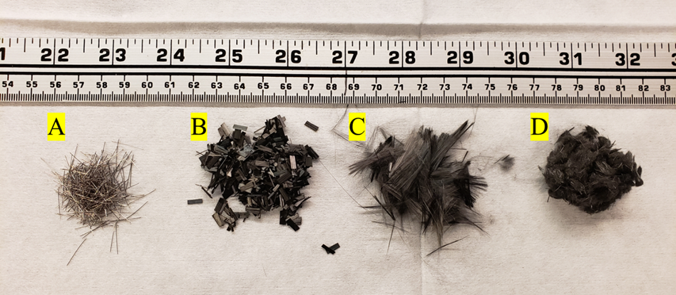
Figure 1: Different fiber types mixed into concrete. A: steel fibers; B: Hexcel carbon fiber; C: Zoltek carbon fiber; D: recycled carbon fiber.

variation of fiber lengths and small gage length. However, the length and diameter of the rCF were imaged using a digital microscope (Keyence VHX-7000, Itasca, IL, USA). Seventy rCF fibers were measured for length, and the diameter of the fibers were measured 38 times using the captured optical images and image processing software (ImageJ, https://imagej.nih.gov/ij/index.html).

Carbon fiber density measurements
The densities (Table 2) of the three carbon fiber types were measured using a gas pycnometer (Micromeritics, AccuPyc II 1340, Norcross, Georgia, USA) where ten samples for each fiber type were measured in a 3.5 cm³ volume in a helium gas atmosphere. Five cycles were repeated per sample for accuracy and to obtain statistical density values.

Thermogravimetric analysis (TGA) of carbon fibers
Thermogravimetric Analysis (TGA) was performed for the carbon fiber types to observe degradation behavior and thermal stability of the fibers using a TA Instruments TGA (Q-50, New Castle, Delaware, USA). Samples for each fiber type with approximate mass of 8.76 to 16.6 mg were placed in a 100-microliter aluminum pan and heated from room temperature to 900ºC at a heating rate of 10ºC/minute under air atmosphere. Additionally, to calculate the fiber sizing content, isothermal TGA was performed for the carbon fiber types where samples with an approximate mass of 10.82 to 22.2 mg were heated from room temperature to 400ºC at 10ºC/minute and held at 400ºC for 30 minutes.

Scanning electron microscopy (SEM) and energy X-ray dispersive spectroscopy (EDS) of carbon fibers
The surface topography and morphology of the carbon fiber types was observed using a dual beam Scanning Electron Microscope (SEM) and Focus Ion Beam (FIB) using a Zeiss Auriga SEM/FIB instrument. The fiber samples were Au sputter-coated for 40 seconds using an Au sputter coater. Additionally, Energy X-ray Dispersive Spectroscopy (EDS) was performed on Au sputter-coated fiber samples using a ThermoFisher Scientific Apreo S with an accelerating voltage of 20 kV to observe the chemical composition of the fibers. The surface topologies of the mechanically failed tensile briquettes samples were imaged using an environmental scanning electron microscope (Zeiss SEM EVO MA15) with an accelerating voltage of 5 kV and a secondary electron detector.

Concrete mixing
The concrete was mixed using a recommended procedure provided by Ductal [82]. A 7.6l Hobert tabletop paddle mixer on medium speed was used to mix the concrete. Firstly, the dry premix constituent was mixed for two minutes. The water and HRWR were added and were mixed for approximately eight to ten minutes. The mixture initially looks dry and typically does not begin to liquify until after about seven minutes of mixing, once the HRWR and water have been thoroughly mixed together with the premix. By the end of the ten minutes, the mix is fluid and self-consolidating. The fibers were then gradually added to the mix in small handfuls into the paddle mixer to ensure consistent mixing of constituents. Once all of the fibers were added to the concrete, the mix design was mixed for a further five minutes. Note that the carbon fibers tend to clump more than the steel fibers, which can lead to issues during mixing. The final mix should be self-consolidating and fluid. To check the mix, a flow test in accordance with ASTM C1437-20 is used to evaluate the rheology of the concrete. The concrete is then ready to be molded into compression cubes, beams, and tension briquettes.

Casting samples
To properly cast the tension briquettes and the compression cubes, two layers of concrete were applied in the steel and brass molds. After each layer, the concrete was tamped 20 times with a 10 mm by 25 mm wooden tamper that compacts and consolidates the concrete. After each layer, the concrete molds were tapped on each side of the mold with a rubber mallet to help release any remaining air pockets. The beam samples were prepared in a similar way, with the exception that instead of being tamped 20 times, the samples were instead tamped such that the entire surface of the sample was tamped at least once. Care was taken for each sample to ensure that the final surface was smooth by using a straight edge to screen off any excess concrete. All samples were cured for 24 hours in the molds. The molds were then removed, and the samples were transferred to an 80–90% humidity concrete cure room where the samples were cured for an additional six days for a total curing time of seven days. Figure 2 shows example resulting tension briquettes, compression cube, and flexural beam after molding and curing.

Mechanical testing procedure
The casted samples were evaluated for their tensile, compression, and flexural strength properties. The compression cubes were tested in accordance with ASTM C109, and the experimental setup is shown in Figure 3a. The samples were monotonically loaded using a 600 kN Instron load frame to mechanical failure. Based on the ASTM C109 standard, the samples should be loaded at a crosshead rate of 900–1800 N/s; however, due to the load frame possessing insufficient force control, it was determined using a displacement control at a rate 0.1 mm/min, providing consistent results in line with the required force rate [83]. As shown in Figure 3b, the tensile test was performed in accordance with ASTM C307. The tension briquettes samples were mounted into custom-made grips using ASTM specifications and loaded monotonically at a crosshead rate of 2 mm/min on a 44 kN MTS servo hydraulic load frame until mechanical failure [84]. The flexural samples were tested in accordance with ASTM C947 on a 44 kN MTS servohydraulic testing load frame using a custom-made fixture that complied with the standard as shown in Figure 3c. The samples were loaded monotonically at a crosshead rate of 1.27 mm/min to mechanical failure [85]. It must be noted that a deviation from the ASTM C947 standard was that 25 x 25 x 305 mm samples were cast as previously described instead of being cut from a sheet of concrete. The force and displacement rate for all cast samples were collected at 5 Hz [85].

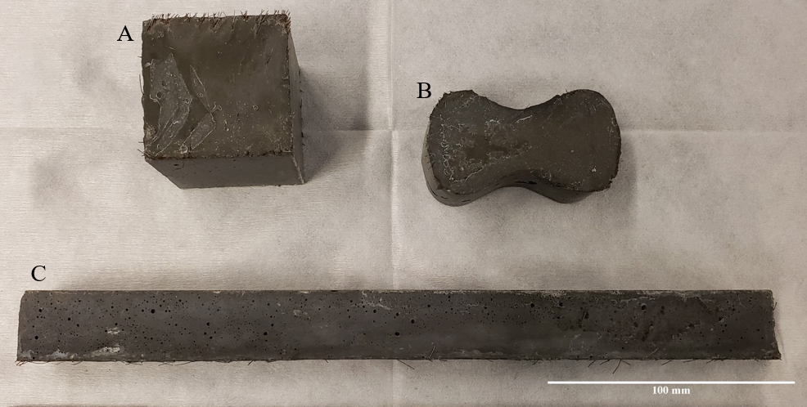
Figure 2: Different sample types used for mechanical testing. A: compression cube; B: tension briquettes; C: flexural beam.

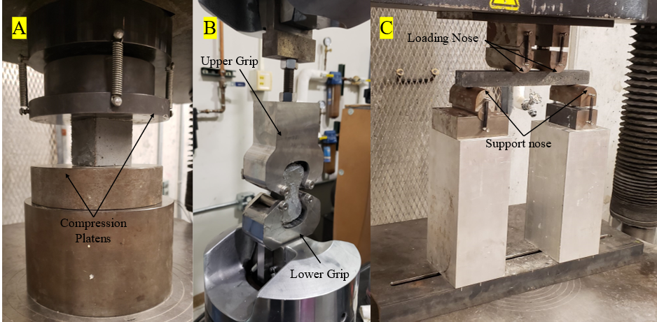
Figure 3: The three different test methods being performed. A: compression cube; B: tensile test; C: flexural test with 229 mm major span and a 76 mm minor span.

Micro-X-ray computed tomography of fiber-reinforced concrete designs

Five samples, approximately 18 mm in diameter x 25 mm in length, cored from tensile briquette samples, were scanned using a custom-developed micro-X-ray computed tomography (μ-XCT) machine. The samples were mounted onto a four-axis (x, y, z, q) rotary stage, where the samples were scanned using a voltage of 150 kV and an amperage of 137 mA (Hamamatsu L8121-03). The 3001 2D projections (12-bit, 2316 x 2316 pixels at 1x binning) were collected over an angular range of 360 degrees at approximately 0.12 degree per step at a voxel resolution of 13.89 μm. The 2D projections were normalized, and corresponding sinograms from the projections were used to obtain 2D reconstructed slices using reconstruction algorithm software (Octopus 8.9.3, Ghent University). Additionally, correction methods to reduce artificial defects such as beam hardening and ring artifacts were applied to the collected projections using the above-mentioned reconstruction software. The 2D reconstructed slices were visualized as a 3D volume and post data analysis was carried out on these slices using 3D visualization software (ScanIP, Simpleware T-2022.03-SP1). The grayscale values for each 2D reconstructed slice consisted of values between a minimum value of 0 (black pixel value), corresponding the least dense regions such as air, to a maximum pixel value of 65,535 (white pixel), corresponding to the most dense regions [71]. A cropped volume of 15.93 mm diameter x 15.81 mm length was used to characterize FR concrete samples for porosity. The voxel resolution of the volume was resampled to 0.03 mm to reduce image processing computation time, and any defect less than 12 voxels was removed as pixel noise from the reconstructed volume. As a first step to detect the geometry of the constituents within the reconstructed 3D volume, an upper and lower threshold grayscale value were manually image segmented to create a mask for each of the concrete, pore, and fiber phases. Flood-fill algorithms were then applied to further enhance the building of the voids and concrete geometries. Boolean operations were then applied to subtract overlapping masks to clearly identify the pores and concrete phases [86]. Finally, each 2D reconstructed slice was manually checked for any overlapping of masks or phases. It must be noted, with the exception of the steel fiber-reinforced concrete sample, that the segmentation of the fiber phase within the carbon fiber-reinforced samples were not 3D visualized in this study due to similar neighboring grayscale values to the concrete. However, example 2D slices of the carbon fiber bundles were detected and are reported in a subsequent section of this study. Thus, the primary objective was to investigate the 3D spatial distribution of air voids in the concrete mix designs and to evaluate the microstructure of the concrete samples.

Results

Surface morphology and elemental analysis of fibers
Figure 4 shows the fiber surface morphology for the three carbon fiber types and steel fiber. The Zoltek fiber (Figure 4a) surface exhibited a rougher surface with agglomerations of sizing compared to a smoother surface exhibited by the Hexcel carbon (Figure 4b). The rCF exhibited a mixture of fibers with rougher and smoother surfaces as expected, due to the varying sources of the carbon fiber material (Figure 4d–f). The resulting surface roughness speaks to the precursor fiber spinning process and subsequent treatment during the conversion process. Further trace amounts of residue visible on the rCF surface suggest fiber sizing played a minimal role during the concrete mixing process. Figure 5 shows the energy dispersive X-ray spectra of the steel, Hexcel, Zoltek, and recycled carbon fibers. Strong C and O peaks are, unsurprisingly, observed for all three carbon fiber types. The O peaks correspond to the oxidation of precursor fiber complex chemical reactions during the conversion process of precursor fiber to carbon fiber [87]. Additionally, trace elements of Si, traditionally used in finished oil to protect the precursor fiber, was detected for all carbon fiber types [88]. The detection of O and Si suggests that fibers were exposed to similar chemical elements during the manufacturing process including precursor, stabilization, and carbonization stages. A sulfur peak was detected for the Hexcel fiber. Fe and Al were detected in the rCF fiber, suggesting contaminants are present during the thermal treatment process. The steel fiber possessed a Fe, O, Cu, C, and Si chemical composition. However, it must be noted that the resulting final chemical composition of the carbon fiber and steel fiber are largely dependent on the manufacturer, treatment, and supplier or handling of fibers.

Thermogravimetric analysis of fibers
Figure 6 shows a comparison of the thermal stability for the three carbon fiber types under air atmosphere. Two onsets (346ºC and 609ºC) of thermal degradation were observed for the Hexcel fibers compared to onset for both the Zoltek carbon fiber and rCF. The rCF and Zoltek TGA curves were comparable with the rcF (634ºC) having slightly lower (5%) onset that the Zoltek carbon fiber (667ºC). Table 3 summarizes the thermogravimetric isothermal properties of the carbon fibers under nitrogen atmosphere to evaluate the approximate fiber sizing content for each fiber type. The Hexcel carbon fiber sizing content was 5.91% and is in the sizing range specified by the manufacturer [81]. Furthermore, the Hexcel carbon fiber sizing content was approximately 143% greater compared to the rCF sizing content (fiber sizing content = 1%). The Zoltek carbon fiber sizing content was varied and was approximately 27% (0.75% fiber sizing) to 88% (2.54% fiber sizing) greater than the rCF sizing content.

Mechanical properties of fiber-reinforced concrete mixes
The neat concrete and steel fiber-based concrete were used as a baseline to compare the three CF-based concrete mixtures to. Table 4 lists the different mechanical properties along with their rheology and density. The flow of each mix was reported with the neat having the highest at 133%, the steel having the second best at 74%, then the Hexcel CF with 44%, the rCF with 36%, and finally the Zoltek CF with 27%. The compressive strength of the rCF mix design (135.3 MPa) was about 42.5% higher than the neat mix design (87.9 MPa), about 17.9% higher than the steel mix design (113.1 MPa), about 0.6% higher than the Hexcel carbon fiber mix design (134.5 MPa), and about 23.2% higher than the Zoltek carbon fiber mix design (107.2 MPa). The tensile strength of the rCF mix design (6.89 MPa) was about 27.8% higher than the neat mix design (5.21 MPa), about 4.6% higher than the steel mix design (6.58 MPa), about 26.3% higher than
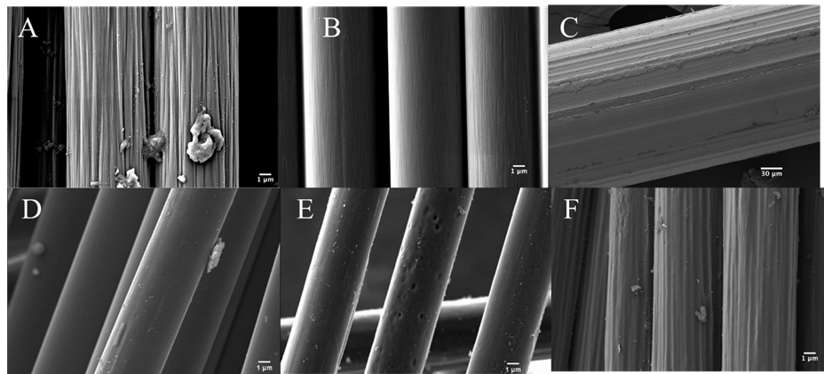
Figure 4: Scanning electron micrographs of (a) Zoltek; (b) Hexcel; (c) steel; and (d–f) recycled carbon fibers.

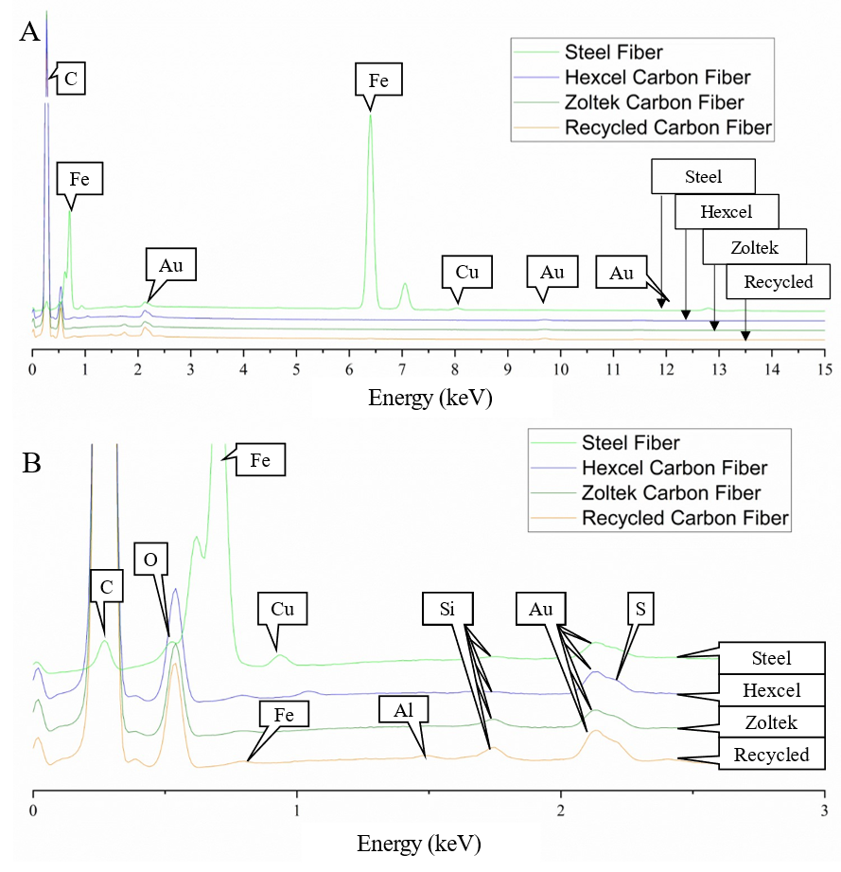
Figure 5: Energy dispersive X-ray spectra of the steel, Hexcel, Zoltek, and recycled carbon fibers showing the chemical composition of each fiber type. (a) full energy spectrum form 0 keV to 15 keV; (b) inset of energy dispersive X-ray spectra energy range from 0 to 3 keV of each fiber type. The Au peaks correspond to the Au sputtering of samples.

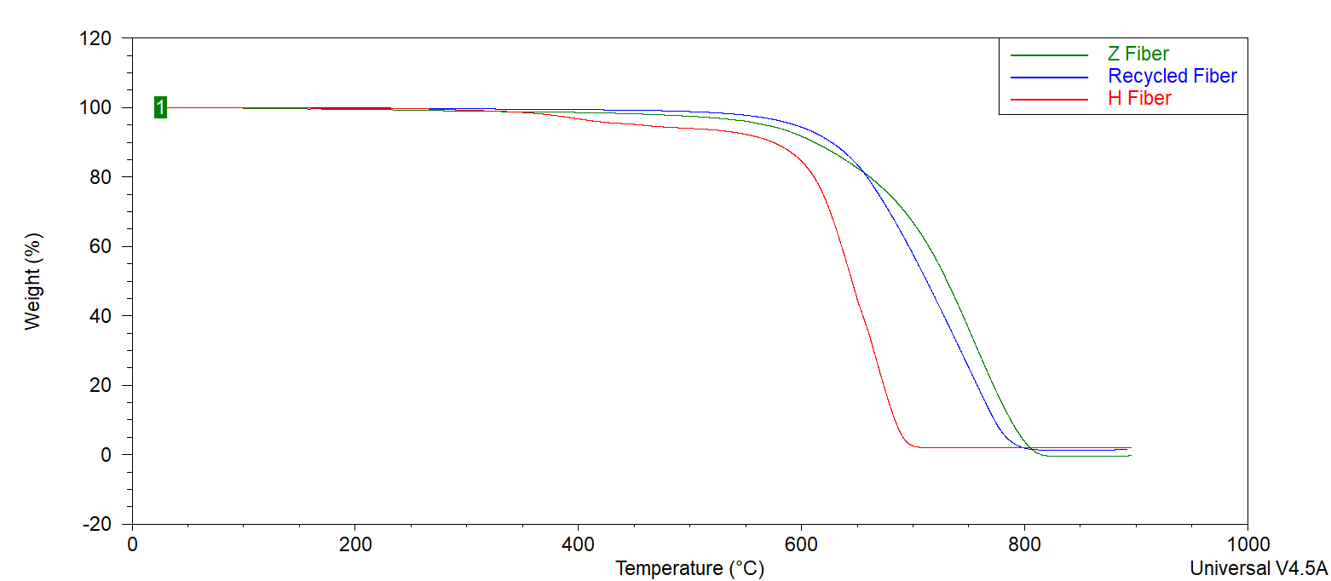
Figure 6: Thermogravimetric analysis curves of Zoltek, Hexcel, and recycled carbon fiber heated in air to 900°C showing the oxidation degradation of the fibers.

Table 3: Thermogravimetric isothermal properties of carbon fibers under nitrogen atmosphere.
Fiber Type | Total Degradation of Sizing Content (%)
Hexcel carbon fiber | 5.91
Zoltek carbon fiber | 0.75–2.54
Recycled carbon fiber | 0.99

the Hexcel carbon fiber mix design (5.29 MPa), and about 26.4% lower than the Zoltek carbon fiber mix design (8.99 MPa). The flexural strength of the rCF mix design (10.7 MPa) was about 8.9% lower than the neat mix design (11.7 MPa), about 18.6% lower than the steel fiber mix design (12.9 MPa), about 0.9% lower than the Hexcel carbon fiber mix design (10.8 MPa), and about 8.5% higher than the Zoltek carbon fiber mix design (9.83 MPa). A basic specific gravity of the samples was taken by measuring the sample size with calipers, calculating a volume, and using a scale to measure the mass of the sample. The density of the of the rCF mix design (2.30 g/cm³) was about 7.9% less than the neat mix design (2.49 g/cm³), about 5.1% lower than the steel fiber mix design (2.42 g/cm³), about 5.8% higher than the Hexcel carbon fiber mix design (2.17 g/cm³), and about 3.1% higher than the Zoltek carbon fiber (2.23 g/cm³). Figure 7 shows example force verses displacement curves for the different sample types and concrete mixes. It should be noted that the curves are based off of the load frame displacement measurement and are not exactly what the sample feels due to compliance in the system. However, the curves allow the different failure methods between the samples to be discussed. Figure 7a shows example compression curves and it can be seen that all of the samples fail catastrophically. Figure 7b shows example tension curves and it can be seen that the steel fiber provides some strength after cracking. Similarly figure 7c shows example flexural curves and it can be seen that the steel fiber provides strength post cracking. It should be noted for figure 7c that the Zoltek and recycled carbon fiber test were performed on a different load frame with a different compliance than the other concrete types and therefore has a slightly different shaped displacement curves.

X-ray computed tomography results
Figure 8 shows an example 2D reconstructed slice of neat concrete sample, where the concrete and pore phase can be clearly observed. The least dense regions, corresponding to the pores, approaches zero grayscale intensity values, and the concrete had a gray value around 12,000. This demonstrates the effectiveness of μ-XCT to segment pore phase from the concrete for post-processing of scanned samples to quantify pore size distribution. Figure 9 shows example 2D reconstructed slices and 3D reconstructed volume of segmented pores of the cored concrete samples used in this work. The first column in Figure 9 (A1–E1) shows where voids are clearly visible. Additionally, in the steel fiber samples (B1), the steel fibers are clearly visible due to attenuation contrast between the concrete and the steel fiber. Due to significant overlapping of grayscale values between carbon fiber and concrete, the fibers phase did not exhibit stark contrast between the phases. However, clumped fiber bundles for the Hexcel CF sample are clearly visible. The 2D reconstructed cross-sections for Zoltek (D1) and rCF fiber (E1) suggest that the fibers were more uniformly distributed compared to the Hexcel fiber concrete sample, where fiber bundles are shown with long gray strips. Unfortunately, the gray values of the fibers overlap significantly with the concrete gray values, making them very difficult to extract. The second column and third column in figure 9 show the 3D segmented volume and sub-volume of void phases for each concrete sample. Table 5 summarizes the void volume fraction, calculated in Simpleware. The void volume fraction of the steel and neat mix designs were the lowest, at 2.55% and 3.46%,
Table 4: Mechanical properties of different concrete mixes. The value in parenthesis represents the standard deviation of each sample set, and the n is the number of samples.
Mix | Flow  (%) | Compression Cubes (MPa)  n = 3 | Tension  (MPa)  n = 3 | Flexural  (MPa) | Mass (g/cm³)  n = 2
Neat | 133 | 87.9 (10) | 5.21 (0.30) | 11.7 (2.27) n = 2 | 2.49 (0.23)
Steel | 74 | 113.1 (5.7) | 6.58 (0.64) | 12.9 (2.79) n = 3 | 2.42 (0.05)
Hexcel carbon fiber | 44 | 134.5 (3.6) | 5.29 (0.33) | 10.8 (1.17) n = 2 | 2.17 (0.02)
Zoltek carbon fiber | 27 | 107.2 (4.5) | 8.99 (0.72) | 9.83 (0.96) n = 4 | 2.23 (0.01)
Recycled carbon fiber | 36 | 135.3 (8.4) | 6.89 (0.70) | 10.7 (1.04) n = 4 | 2.30 (0.04)

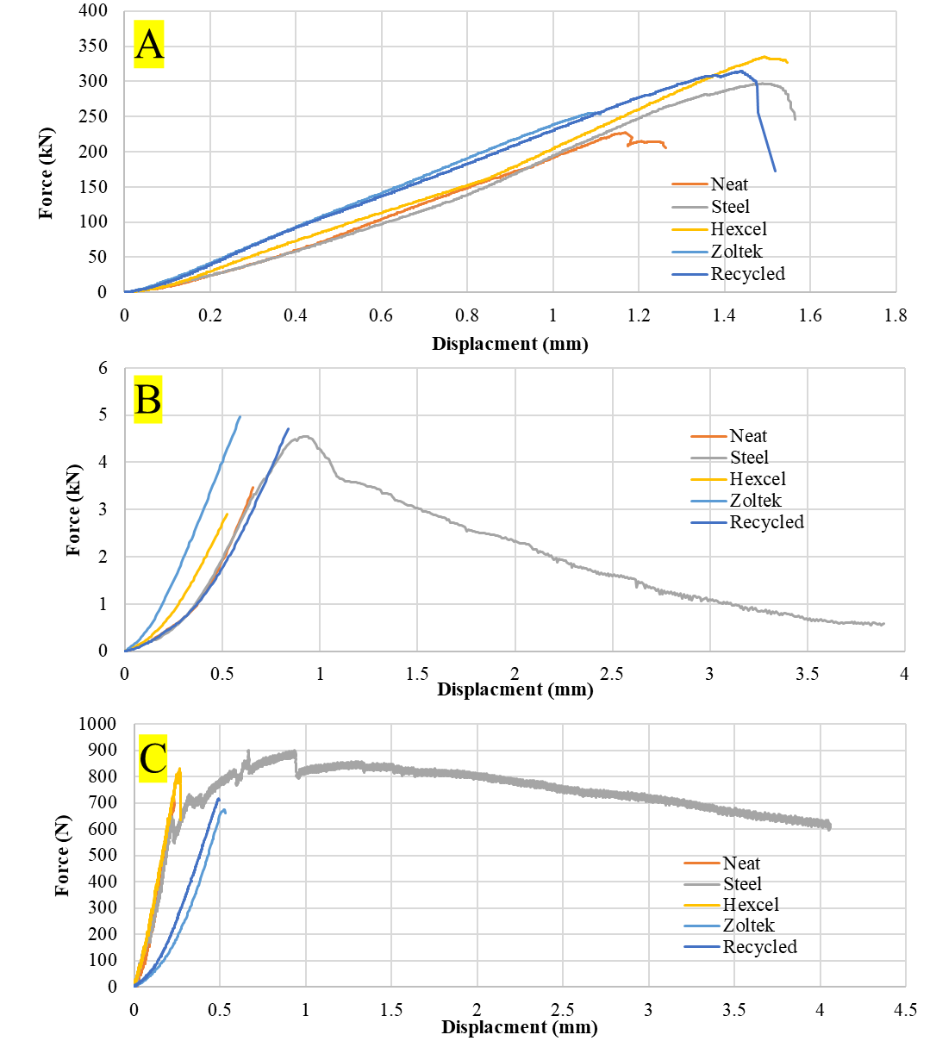
Figure 7: Example force displacement curves for A: compression test, B: tension tests and, C: flexural test for each type of concrete. Note that for C the flexural curves for Zoltek and recycled fiber the samples were tested on a different load frame with a different overall compliance.

respectively. The rCF mix design had the lowest void volume of the carbon fiber mixes, followed by Hexcel then the Zoltek carbon fiber, with values of 3.98%, 4.02%, and 4.38%, respectively. The sub-volume in the third column shows the shape and density of the voids. The voids for the neat, steel, Zoltek, and rCF concrete mix designs exhibited the most spherical geometry, while the Hexcel appears to have non-spherical geometry. This could be due to the fiber clumping and poor workability of the Hexcel carbon fiber mix design compared to the other mix designs. The void content was evaluated by taking the total volume of voids for a sample using Simpleware and dividing it by the volume of the evaluated region of interest. Figure 10 shows the void distribution, ranging from 0.01 to 1 mm³. The steel fiber and neat concrete have a relatively even distribution of voids compared to the carbon fiber samples, with a peak at voids with a volume of 0.01–0.05 mm³. Additionally, there is a significant peak for voids greater than 1 mm³ in volume. The carbon fiber samples have a higher peak in voids with a volume below 0.05 mm³. They also have a significant peak of voids above 1 mm³ in volume, with the exception of the Zoltek mix, which had no voids larger than 0.075 mm³ in volume. The rCF mix has a relatively higher volume of small voids compared to the other carbon fiber types but less large voids.

SEM failure images
Images were taken of the tensile samples after mechanical failure. It can be seen in Figure 11b that the steel fiber did not rupture; instead the fiber deboned from the concrete. Additionally, it can be seen in Figure 11b that there was minimal concrete bonded to the fiber. In Figure 11c, the Hexcel carbon fiber did rupture; however, the fibers did significantly pull out of the concrete. Compared to the other carbon fibers, it is clear that the Hexcel fibers are longer, indicating that the critical length is longer and, therefore, showing worse bonding and stress development in the fiber than the other types of carbon fiber. In Figure 11d, the Zoltek carbon fiber shows relatively short fibers sticking out. This shows that while the fibers rupture, there are still significant debonding and pull-out issues. However, compared to the Hexcel carbon fiber, the Zoltek fibers show less clumping. Figure 11e shows the rCF mix and, similarly to the Zoltek carbon fiber, pull-out and rupture can be observed. Additionally, the holes for the fiber pull-out from the opposite break face can be seen, showing how while the fibers are breaking there is still significant debonding occurring and the fibers are not developing their full strength.

Discussion
It was expected that the carbon fiber-based concrete would perform considerably better than the steel fiber or neat concrete due to carbon fiber having considerably better mechanical properties than the steel fibers. However, it was observed that the steel fibers and carbon fibers performed about equivalently in mechanical testing. It was therefore theorized that the reason for the lower than expected mechanical properties was due to the carbon fibers reducing the flow of the concrete leading to increased air voids and poor fiber dispersion. This can clearly be seen in the flow results of the concrete, with the carbon fiber-based mixes having considerably lower flow than the steel or neat concrete. The reduction in flow and poor fiber dispersion could be caused by several factors. The

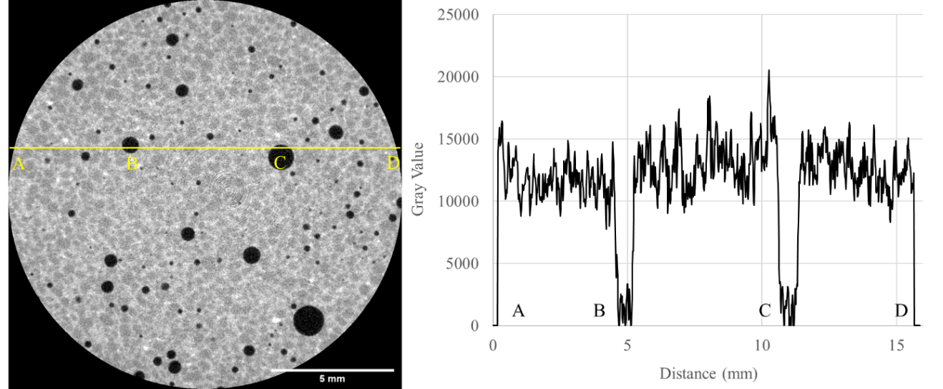
Figure 8: The left image is a 2D slice of the concrete. The right plot shows the gray values of the line as it runs from point A to D. B and C both show where the pores are and their corresponding gray values.

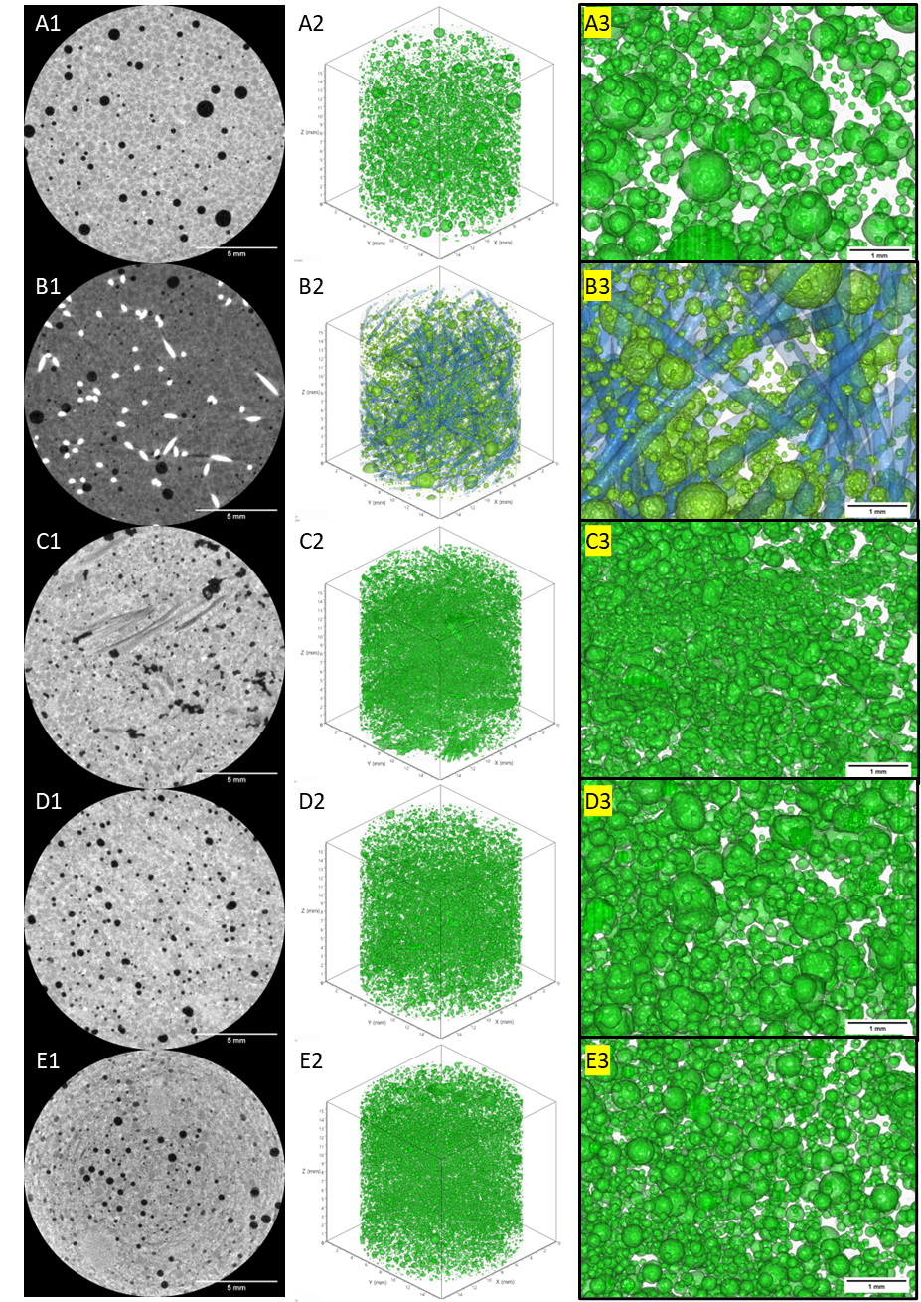
Figure 9: XCT results. A: neat concrete; B: steel fiber concrete; C: Hexcel carbon fiber concrete; D: Zoltek carbon fiber concrete; and E: recycled carbon fiber concrete. 1: 2D reconstructed cross-section; 2: full 3D reconstructed void volume; 3: expanded 3D void view.

Table 5: Void volume fraction of concrete mix designs
Sample Type | Void Volume Fraction (%)
Neat | 3.46
Steel | 2.55
Hexcel | 4.02
Zoltek | 4.38
rCF | 3.98

Figure 10: Pore volume distribution with respect to percent of total void volume.

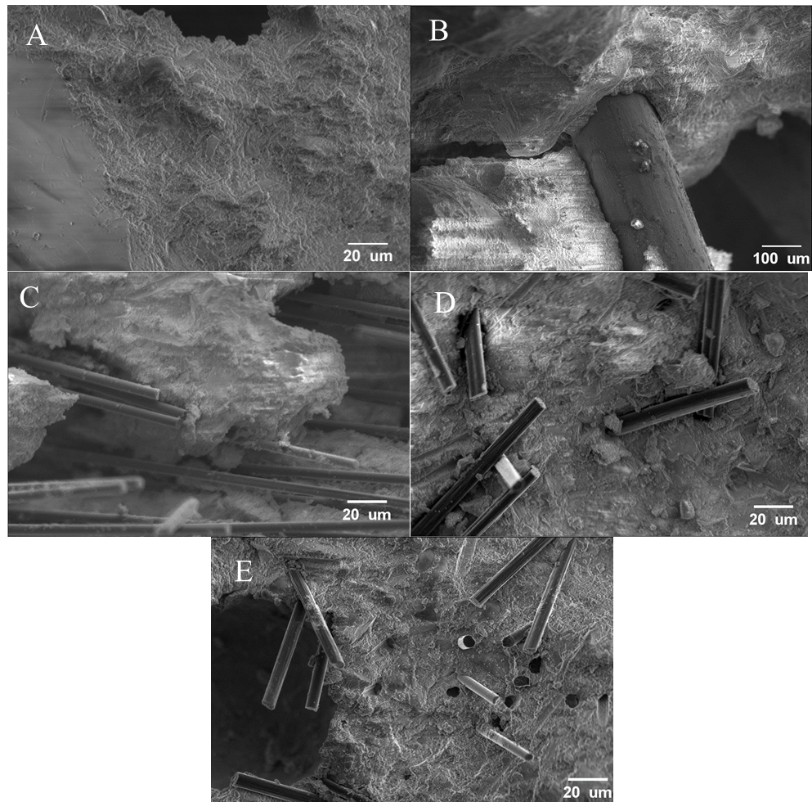
Figure 11: Scanning electron microscopy of mechanically failed (a) neat concrete sample; (b) steel fiber; (c) Hexcel fiber; (d) Zoltek fiber; and (e) rCF reinforced tensile briquettes samples.

first for the Hexcel carbon fiber is the sizing on the fibers not being chemically compatible with the concrete leading to the fibers clumping together instead of dispersing. The second issue shown with the Zoltek fibers is that the length of the fibers can cause the fibers to tangle with themselves more easily. Shorter fibers are able to be more easily mixed and dispersed throughout the concrete. Lastly, for all of the carbon fiber types the fibers had a much smaller diameter then the steel fibers meaning there are many more individual fibers to disperse and much more surface area that needs to be wetted by the concrete. These factors affect how the concrete flows and therefore will affect how well the concrete compacts into the mold leading to increased porosity, void size and poor dispersion of fibers in the concrete. The second indicator of this is the density of the concrete. The carbon fiber-based concrete mixes all have much lower density than the steel and neat concrete. This indicates that air voids have been trapped in the concrete, since the addition of the lighter density carbon fiber would not change the density as much as observed in the final mix. Another indicator that the change in density is caused primarily by air voids and not the fibers themselves is that the density of the steel and neat concrete are very similar. It was therefore concluded that the lower than expected mechanical results were due to increased air voids and poor microstructure that significantly impacted the mechanical test results, negating the potential benefits of the carbon fiber.
Furthermore, based of tensile sample’s force verses displacement plots it is shown that the steel fibers provide significant post peak strength as the steel fibers were pulled out of the concrete. The carbon fibers on the other hand all performed similarly to the neat concrete mix with no strength after initial cracking. Indicating that the steel fibers provide significantly increased durability compared to the carbon fiber.

The μ-XCT results correlated well with the density and flow results, with the neat and steel fiber-based concrete having a lower void content than the carbon fiber samples. Utilizing μ-XCT allowed the confirmation that the density differences shown were not due to the mass of the fibers used but were instead the result of increased air voids caused by the low flow of the carbon fiber-based concrete mixes. Additionally, μ-XCT allowed for the analysis of size of the different voids. This showed a clear trend where the majority of the void volume was taken up in voids less than 0.1 mm3, with another distinct peak of voids greater than 1 mm3. Looking at these amounts and distributions and comparing with the mechanical results, some interesting results can be seen. The first is that while the Zoltek carbon fiber had the highest void content, it had no voids greater than 1 mm3 and had the highest tensile strength, whereas the Hexcel carbon fiber had the highest void content over 1 mm3 and the lowest tensile strength. This shows that the tensile strength of the concrete is not just affected by the strength of the fiber used but also the void content, particularly large voids. The rCF and steel fiber mixes follow this same trend, with the steel fibers having slightly more large voids and a slightly lower tensile strength then the rCF mix. It should be noted that while the neat mix has a low large void content there are also no fibers to transfer the tensile loads, leading to a significant reduction in tensile strength. These results clearly show that while fibers can increase the tensile strength of concrete, if the addition of the fibersm decreases the workability significantly, this can negate all of their benefits due to how the reduction in flow and consolidation affect the microstructure of the concrete. Additionally, it can be seen that the rCF mix performed on par with the steel fiber-based mix, showing that it has promise as a potential replacement for steel fiber in concrete.

The effect of the voids on the concrete strength can be further illustrated through other studies that have looked at how void content and void distribution affect the strength of concrete. In a paper by li et. al. the authors developed a model for how voids affected the tensile and compressive strength of concrete. In their study they looked at samples with different void content and void sizes ranging from 0.01 mm to 1.6 mm and found that increasing the total void volume and increasing the size of the voids at the same total volume decreased the tensile and compression strength [88]. Additionally, Knab et. al. found that increasing the void content decreased the flexural and compressive strength of concrete [90]. These results correlate well with this studies test results where it was found with the Hexcel carbon fiber samples that had both a high void content and large voids and performed poorly in tension compared to the other mixes. However, this is an area of research that still require future study looking specifically at how void content and distribution affect the strength and μ-XCT would be an incredibly useful tool for that research.

Furthermore, the SEM images of the failed sample can help to explain the differences in the mechanical results. It was observed for all of the fiber types, including steel fiber, that the fiber deboned from the concrete instead of having clean breaks. This indicates that the fibers were not able to develop their full strength before they were pulled out of the concrete. Additionally, it was observed that there was very little concrete adhered to the fibers. Fibers pulling out and the lack of concrete adhered to the fibers indicates that the fibers did not bond well to the concrete. It is critical in future work to take a more in-depth look at fiber–concrete adhesion. Increasing the bond could both help to increase the load carried by the fiber and reduce the fiber length needed.

Conclusions
Using carbon fiber as a replacement for steel fiber has been shown to be able to provide comparable or better mechanical performance, with rCF being of particular interest due to it being potential more economically feasible compared to other types of carbon fiber. It has been shown that one of the major issues with using carbon fiber in concrete is the decrease in workability, which leads to increased void content that can be seen with both simple density measurements and μ-XCT scans. The total void volume and void size both negatively affect the strength of the concrete and, in some cases, can completely negate the benefits of the carbon fiber. Additionally, it was seen that the fibers pulled out of the concrete without developing their full strength, showing that there is poor bonding between the fibers and concrete, thus further reducing the benefit of the fiber. The effects of fiber bonding are shown to significantly improve the tensile strength of concrete with the sized Zoltek fibers showing particular promise in tension. Unfortunately, the Zoltek fibers also had poor workability due to their length. It is therefore critical moving forward that the workability and void content of carbon fiber-reinforced concrete is carefully evaluated to ensure that the fibers being used are able to achieve their full potential along with how well the fibers are bonding within the concrete.

Acknowledgments
The supply of recycled carbon fibers from Tim Spahn from Carbon Fiber Recycling, Inc. is acknowledged. Technical support of fiber sizing from Ryutaro Izumi and Shuhei Inoue from Izumi International, Inc. is acknowledged. The supply of sizing material from Jared Stonecash from Michelman is acknowledged. Technical support from Talmage Tyler and Justin Gladman from Shared Materials Instrumentation Facility at Duke University is acknowledged. Technical support from Logan Goodbred, Lilian Parker, Stephen Puplampu, Hunter Wood, Jacob Fowler, Noah Compton, Maxwell Coggin, Natalie Holt, and Colby Gilbert from the University of Tennessee is acknowledged. Technical support from John Lindahl from Oak Ridge National Laboratory is acknowledged. Technical support from Matt Nixon from Synopsys Simpleware is acknowledged.

References
1. Naik, T. R., Sustainability of concrete construction. Practice Periodical on Structural Design and Construction 2008, 13, (2), 98-103.
2. Institute, A. C., ACI CODE-318-14: Building Code Requirements for Structural Concrete and Commentary. American Concrete Institute: American Concrete Institute, 2014.
3. Lab, R. H., Think Formwork - Reduce Cost. Structure 2007.
4. Kosmatka, S. H.; Panarese, W. C.; Kerkhoff, B., Design and Control of Concrete Mixtures. Portland Cement Association Skokie, IL: 2002; Vol. 5420.
5. Ma, G.; Li, Z.; Wang, L.; Wang, F.; Sanjayan, J., Mechanical anisotropy of aligned fiber reinforced composite for extrusion-based 3D printing. Construction and Building Materials 2019, 202, 770-783.
6. Blazy, J.; Blazy, R., Polypropylene fiber reinforced concrete and its application in creating architectural forms of public spaces. Case Studies in Construction Materials 2021, 14, e00549.
7. Batoz, J.-F.; Behloul, M., UHPFRC development on the last two decades: An overview. Resplendino J. Proceedings of UHPFRC 2009, 1-13.
8. Foglar, M.; Kovar, M., Conclusions from experimental testing of blast resistance of FRC and RC bridge decks. International Journal of Impact Engineering 2013, 59, 18-28.
9. Brandt, A. M., Fibre reinforced cement-based (FRC) composites after over 40 years of development in building and civil engineering. Composite Structures 2008, 86, (1), 3-9.
10. Rui, Y.; Kangning, L.; Tianyi, Y.; Liwen, T.; Mengxi, D.; Zhonghe, S., Comparative study on the effect of steel and polyoxymethylene fibers on the characteristics of Ultra-High Performance Concrete (UHPC). Cement and Concrete Composites 2022, 127, 104418.
11. Yu, R.; Spiesz, P.; Brouwers, H. J. H., Energy absorption capacity of a sustainable Ultra-High Performance Fibre Reinforced Concrete (UHPFRC) in quasi-static mode and under high velocity projectile impact. Cement and Concrete Composites 2016, 68, 109-122.
12. Dingqiang, F.; Yu, R.; Kangning, L.; Junhui, T.; Zhonghe, S.; Chunfeng, W.; Shuo, W.; Zhenfeng, G.; Zhengdong, H.; Qiqi, S., Optimized design of steel fibres reinforced ultra-high performance concrete (UHPC) composites: Towards dense structure and efficient fibre application. Construction and Building Materials 2021, 273, 121698.
13. Fan, D. Q.; Yu, R.; Shui, Z. H.; Wu, C. F.; Song, Q. L.; Liu, Z. J.; Sun, Y.; Gao, X.; He, Y. J., A new design approach of steel fibre reinforced ultra-high performance concrete composites: Experiments and modeling. Cement and Concrete Composites 2020, 110, 103597.
14. Meng, W.; Khayat, K. H., Experimental and numerical studies on flexural behavior of ultrahigh-performance concrete panels reinforced with embedded glass fiber-reinforced polymer grids. Transportation Research Record 2016, 2592, (1), 38-44.
15. Gong, J.; Ma, Y.; Fu, J.; Hu, J.; Ouyang, X.; Zhang, Z.; Wang, H., Utilization of fibers in ultra-high performance concrete: A review. Composites Part B: Engineering 2022, 241, 109995.
16. Park, S. B.; Lee, B. I.; Lim, Y. S., Experimental study on the engineering properties of carbon fiber reinforced cement composites. Cement and Concrete Research 1991, 21, (4), 589-600.
17. Ohama, Y., Carbon-cement composites. Carbon 1989, 27, (5), 729-737.
18. Zollo, R. F., Fiber-reinforced concrete: an overview after 30 years of development. Cement and Concrete Composites 1997, 19, (2), 107-122.
19. Chung, D. D. L., Cement reinforced with short carbon fibers: A multifunctional material. Composites Part B: Engineering 2000, 31, (6), 511-526.
20. Park, S.-J.; Seo, M.-K.; Shim, H.-B.; Rhee, K.-Y., Effect of different cross-section types on mechanical properties of carbon fibers-reinforced cement composites. Materials Science and Engineering 2004, 366, (2), 348-355.
21. Yao, W.; Li, J.; Wu, K., Mechanical properties of hybrid fiber-reinforced concrete at low fiber volume fraction. Cement and Concrete Research 2003, 33, (1), 27-30.
22. Daniel, I. M.; Ishai, O.; Daniel, I. M.; Daniel, I., Engineering Mechanics of Composite Materials. Oxford University Press New York: 2006; Vol. 1994.
23. Isa, M. N.; Pilakoutas, K.; Guadagnini, M.; Angelakopoulos, H., Mechanical performance of affordable and eco-efficient ultra-high performance concrete (UHPC) containing recycled tyre steel fibres. Construction and Building Materials 2020, 255, 119272.
24. Zhong, R.; Wille, K.; Viegas, R., Material efficiency in the design of UHPC paste from a life cycle point of view. Construction and Building Materials 2018, 160, 505-513.
25. Das, S., Life cycle assessment of carbon fiber-reinforced polymer composites. The International Journal of Life Cycle Assessment 2011, 16, (3), 268-282.
26. van de Werken, N.; Reese, M. S.; Taha, M. R.; Tehrani, M., Investigating the effects of fiber surface treatment and alignment on mechanical properties of recycled carbon fiber composites. Composites Part A: Applied Science and Manufacturing 2019, 119, 38-47.
27. Pimenta, S.; Pinho, S. T., Recycling carbon fibre reinforced polymers for structural applications: Technology review and market outlook. Waste Management 2011, 31, (2), 378-392.
28. Carberry, W., Airplane recycling efforts benefit Boeing operators. Boeing Aero Magazine QRT 2008, 4, (08), 6-13.
29. Butenegro, J. A.; Bahrami, M.; Abenojar, J.; Martínez, M. Á., Recent progress in carbon fiber reinforced polymers recycling: A review of recycling methods and reuse of carbon fibers. Materials 2021, 14, (21).
30. Akbar, A.; Kodur, V. K. R.; Liew, K. M., Microstructural changes and mechanical performance of cement composites reinforced with recycled carbon fibers. Cement and Concrete Composites 2021, 121, 104069.
31. Howarth, J.; Mareddy, S. S. R.; Mativenga, P. T., Energy intensity and environmental analysis of mechanical recycling of carbon fibre composite. Journal of Cleaner Production 2014, 81, 46-50.
32. Karuppannan Gopalraj, S.; Kärki, T., A review on the recycling of waste carbon fibre/glass fibre-reinforced composites: fibre recovery, properties and life-cycle analysis. SN Applied Sciences 2020, 2, (3), 433.
33. Abdallah, R.; Juaidi, A.; Savaş, M. A.; Çamur, H.; Albatayneh, A.; Abdala, S.; Manzano-Agugliaro, F., A critical review on recycling composite waste using pyrolysis for sustainable development. Energies 2021, 14, (18).
34. Pickering, S.; Turner, T.; Meng, F.; Morris, C.; Heil, J.; Wong, K.; Melendi-Espina, S. In Developments in the Fluidised Bed Process for Fibre Recovery from Thermoset Composites, 2nd Annual Composites and Advanced Materials Expo, CAMX 2015; Dallas Convention CenterDallas; United States, 2015; pp 2384-2394.
35. Pimenta, S.; Pinho, S. T.; Robinson, P.; Wong, K. H.; Pickering, S. J., Mechanical analysis and toughening mechanisms of a multiphase recycled CFRP. Composites Science and Technology 2010, 70, (12), 1713-1725.
36. Zhu, J.-H.; Chen, P.-y.; Su, M.-n.; Pei, C.; Xing, F., Recycling of carbon fibre reinforced plastics by electrically driven heterogeneous catalytic degradation of epoxy resin. Green Chemistry 2019, 21, (7), 1635-1647.
37. Kumar, S.; Krishnan, S., Recycling of carbon fiber with epoxy composites by chemical recycling for future perspective: A review. Chemical Papers 2020, 74, (11), 3785-3807.
38. Verma, S.; Balasubramaniam, B.; Gupta, R. K., Recycling, reclamation and re-manufacturing of carbon fibres. Current Opinion in Green and Sustainable Chemistry 2018, 13, 86-90.
39. Bledzki, A. K.; Seidlitz, H.; Krenz, J.; Goracy, K.; Urbaniak, M.; Rösch, J. J., Recycling of carbon fiber reinforced composite polymers: Review—Part 2: Recovery and application of recycled carbon fibers. Polymers 2020, 12, (12).
40. Ma, C.; Sánchez-Rodríguez, D.; Kamo, T., Influence of thermal treatment on the properties of carbon fiber reinforced plastics under various conditions. Polymer Degradation and Stability 2020, 178, 109199.
41. Karuppannan Gopalraj, S.; Kärki, T., A study to investigate the mechanical properties of recycled carbon fibre/glass fibre-reinforced epoxy composites using a novel thermal recycling process. Processes 2020, 8, (8).
42. Sun, H.; Guo, G.; Memon, S. A.; Xu, W.; Zhang, Q.; Zhu, J.-H.; Xing, F., Recycling of carbon fibers from carbon fiber reinforced polymer using electrochemical method. Composites Part A: Applied Science and Manufacturing 2015, 78, 10-17.
43. Nahil, M. A.; Williams, P. T., Recycling of carbon fibre reinforced polymeric waste for the production of activated carbon fibres. Journal of Analytical and Applied Pyrolysis 2011, 91, (1), 67-75.
44. Das, M.; Chacko, R.; Varughese, S., An efficient method of recycling of CFRP waste using peracetic acid. ACS Sustainable Chemistry & Engineering 2018, 6, (2), 1564-1571.
45. Ma, Y.; Nutt, S., Chemical treatment for recycling of amine/epoxy composites at atmospheric pressure. Polymer Degradation and Stability 2018, 153, 307-317.
46. Ogi, K.; Shinoda, T.; Mizui, M., Strength in concrete reinforced with recycled CFRP pieces. Composites Part A: Applied Science and Manufacturing 2005, 36, (7), 893-902.
47. Mastali, M.; Dalvand, A., The impact resistance and mechanical properties of self-compacting concrete reinforced with recycled CFRP pieces. Composites Part B: Engineering 2016, 92, 360-376.
48. Mastali, M.; Dalvand, A.; Sattarifard, A., The impact resistance and mechanical properties of the reinforced self-compacting concrete incorporating recycled CFRP fiber with different lengths and dosages. Composites Part B: Engineering 2017, 112, 74-92.
49. Nuaklong, P.; Wongsa, A.; Boonserm, K.; Ngohpok, C.; Jongvivatsakul, P.; Sata, V.; Sukontasukkul, P.; Chindaprasirt, P., Enhancement of mechanical properties of fly ash geopolymer containing fine recycled concrete aggregate with micro carbon fiber. Journal of Building Engineering 2021, 41, 102403.
50. Han, B.; Ding, S.; Yu, X., Intrinsic self-sensing concrete and structures: A review. Measurement 2015, 59, 110-128.
51. Faneca, G.; Segura, I.; Torrents, J. M.; Aguado, A., Development of conductive cementitious materials using recycled carbon fibres. Cement and Concrete Composites 2018, 92, 135-144.
52. Sharma, R.; Jang, J. G.; Bansal, P. P., A comprehensive review on effects of mineral admixtures and fibers on engineering properties of ultra-high-performance concrete. Journal of Building Engineering 2022, 45, 103314.
53. Adminstration, F. H. Ultra-High Performance Concrete. https://highways.dot.gov/research/structures/ultra-high-performance-concrete/ultra-high-performance-concrete (7/26/2022),
54. Ghafari, E.; Costa, H.; Júlio, E., Statistical mixture design approach for eco-efficient UHPC. Cement and Concrete Composites 2015, 55, 17-25.
55. Wang, X.; Yu, R.; Shui, Z.; Song, Q.; Zhang, Z., Mix design and characteristics evaluation of an eco-friendly Ultra-High Performance Concrete incorporating recycled coral based materials. Journal of Cleaner Production 2017, 165, 70-80.
56. Jiang, W.; Huang, Y.; Sha, A., A review of eco-friendly functional road materials. Construction and Building Materials 2018, 191, 1082-1092.
57. Zhou, M.; Lu, W.; Song, J.; Lee, G. C., Application of ultra-high performance concrete in bridge engineering. Construction and Building Materials 2018, 186, 1256-1267.
58. Shi, C.; Wu, Z.; Xiao, J.; Wang, D.; Huang, Z.; Fang, Z., A review on ultra high performance concrete: Part I. Raw materials and mixture design. Construction and Building Materials 2015, 101, 741-751.
59. Chen, Y.; Liu, P.; Sha, F.; Yin, J.; He, S.; Li, Q.; Yu, Z.; Chen, H., Study on the mechanical and rheological properties of ultra-high performance concrete. Journal of Materials Research and Technology 2022, 17, 111-124.
60. Wang, D.; Shi, C.; Wu, Z.; Xiao, J.; Huang, Z.; Fang, Z., A review on ultra high performance concrete: Part II. Hydration, microstructure and properties. Construction and Building Materials 2015, 96, 368-377.
61. Correal, J. F.; Carrillo, J.; Reyes, J. C.; Renjifo, A. E.; Herrán, C. A., Cyclic tests of full-scale fiber-reinforced concrete (FRC) walls with steel and hybrid fibers for low-rise buildings. Engineering Structures 2022, 256, 113952.
62. Ravichandran, D.; Prem, P. R.; Kaliyavaradhan, S. K.; Ambily, P. S., Influence of fibers on fresh and hardened properties of ultra high performance concrete (UHPC): A review. Journal of Building Engineering 2022, 57, 104922.
63. Reda, M. M.; Shrive, N. G.; Gillott, J. E., Microstructural investigation of innovative UHPC. Cement and Concrete Research 1999, 29, (3), 323-329.
64. Zoltek Zoltek PX35. https://zoltek.com/products/px35/
65. Ponikiewski, T.; Katzer, J.; Bugdol, M.; Rudzki, M., Determination of 3D porosity in steel fibre reinforced SCC beams using X-ray computed tomography. Construction and Building Materials 2014, 68, 333-340.
66. Qsymah, A.; Sharma, R.; Yang, Z.; Margetts, L.; Mummery, P., Micro X-ray computed tomography image-based two-scale homogenisation of ultra high performance fibre reinforced concrete. Construction and Building Materials 2017, 130, 230-240.
67. Kaczmarczyk, G. P.; Kinasz, R.; Bilozir, V.; Bidenko, I., Application of X-ray computed tomography to verify bond failures mechanism of fiber-reinforced fine-grain concrete. Materials 2022, 15, (6).
68. Zhang, H.; Pan, Q.; Zheng, K.; Jin, C.; Pan, L., Mesoscale study on splitting tensile damage characteristics of concrete based on X-ray computed tomography and digital image correlation technology. Materials 2022, 15, (13).
69. Darma, I. S.; Sugiyama, T.; Promentilla, M. A. B., Application of X-Ray CT to study diffusivity in cracked concrete through the observation of tracer transport. Journal of Advanced Concrete Technology 2013, 11, (10), 266-281.
70. Ríos, J. D.; Leiva, C.; Ariza, M. P.; Seitl, S.; Cifuentes, H., Analysis of the tensile fracture properties of ultra-high-strength fiber-reinforced concrete with different types of steel fibers by X-ray tomography. Materials & Design 2019, 165, 107582.
71. Vicente, M. A.; Mínguez, J.; González, D. C., Computed tomography scanning of the internal microstructure, crack mechanisms, and structural behavior of fiber-reinforced concrete under static and cyclic bending tests. International Journal of Fatigue 2019, 121, 9-19.
72. Gao, J.; Sha, A.; Wang, Z.; Hu, L.; Yun, D.; Liu, Z.; Huang, Y., Characterization of carbon fiber distribution in cement-based composites by computed tomography. Construction and Building Materials 2018, 177, 134-147.
73. Gao, J.; Wang, Z.; Zhang, T.; Zhou, L., Dispersion of carbon fibers in cement-based composites with different mixing methods. Construction and Building Materials 2017, 134, 220-227.
74. ASTM, ASTM A820/A820M-22 Standard Specification for Steel Fibers for Fiber-Reinforced Concrete. ASTM Compass: 2022.
75. Ductal Ductal Break the mold a technology by Holcim: About. https://www.ductal.com/en/about
76. Akhnoukh, A. K.; Buckhalter, C., Ultra-high-performance concrete: Constituents, mechanical properties, applications and current challenges. Case Studies in Construction Materials 2021, 15, e00559.
77. Ductal JS1000. https://www.ductal.com/sites/ductal/files/atoms/files/2_ductal_js1000.pdf (7/11/2022),
78. INC, C., Chryso Fluid Premia 150. www.chrysoinc.com.
79. Sbia, L. A.; Peyvandi, A.; Lu, J.; Abideen, S.; Weerasiri, R. R.; Balachandra, A. M.; Soroushian, P., Production methods for reliable construction of ultra-high-performance concrete (UHPC) structures. Materials and Structures 2016, 50, (1), 7.
80. Hexcel Carbon Fiber. https://www.hexcel.com/Products/Carbon-Fiber/
81. Hexcel HexTow Chopped Fiber. https://www.hexcel.com/Products/Resources/1661/hextow-chopped-fiber#:~:text=Chopped%20Fiber%20is%20used%20in,high%20strength%20and%20stiffness%20characteristics.&text=*%20Other%20fiber%20lengths%20available%20on%20request.
82. Nault, G., Personal Communication. 2021.
83. ASTM, C109-21 Standard Test Method for Compressive Strength of Hydraulic Cement Mortars (Using 2-in. or [50 mm] Cube Specimens). ASTM: ASTM Compass, 2021.
84. ASTM, C307-18 Standard Test Method for Tensile Strength of Chemical-Resistant Mortar, Grouts, and Monolithic Surfacings. ASTM: ASTM Compass, 2018.
85. ASTM, C947-03 Standard Test Method for Flexural Properties of Thin-Section Glass-Fiber-Reinforced Concrete (Using Simple Beam With Third-Point Loading). ASTM: ASTM Compass, 2016.
86. Cotton, R. T.; Pearce, C. W.; Young, P. G.; Kota, N.; Leung, A. C.; Bagchi, A.; Qidwai, S. M., Development of a geometrically accurate and adaptable finite element head model for impact simulation: the Naval Research Laboratory–Simpleware Head Model. Computer Methods in Biomechanics and Biomedical Engineering 2016, 19, (1), 101-113.
87. Rahaman, M. S. A.; Ismail, A. F.; Mustafa, A., A review of heat treatment on polyacrylonitrile fiber. Polymer Degradation and Stability 2007, 92, (8), 1421-1432.
88. Newcomb, B. A., Processing, structure, and properties of carbon fibers. Composites Part A: Applied Science and Manufacturing 2016, 91, 262-282.
89. Li, D.; Li, Z.; Lv, C.; Zhang, G.; Yin, Y., A predictive model of the effective tensile and compressive strengths of concrete considering porosity and pore size. Construction and Building Materials 2018, 170, 520-526.
90. Knab, L. I.; Clifton, J. R.; Ings, J. B., Effects of maximum void size and aggregate characteristics on the strength of mortar. Cement and Concrete Research 1983, 13, (3), 383-390.

CHAPTER II
An evaluation of mechanical properties of recycled carbon fiber reinforced high strength, structural lightweight, and ultra-lightweight concrete.

Abstract
Concrete is a highly versatile material with hundreds of different uses and applications. However, concrete has a distinct disadvantage of having a low tensile strength compared to its compressive strength. Typically, to overcome this, some form of continuous reinforcement must be used to carry the tensile stresses. However, the installation process of this reinforcement tends to be time consuming and cumbersome. An alternative technology that has started to become widely used is fiber-reinforced concrete, where short fibers are mixed randomly into the concrete that can carry the tensile loads similarly to the continuous reinforcement. This allows for much more rapid construction and fewer design limitations. While steel fibers have been widely used in industry, carbon fibers show promise, with recycled carbon fiber showing particular promise due to lower cost and increased sustainability. In this study, recycled carbon fiber is evaluated for mechanical properties using three types of concrete, namely high-strength concrete, structural lightweight concrete, and ultra-lightweight concrete. Overall, it was found that recycled carbon fiber increased the tensile and flexural strength of the neat concrete and significantly reduced the density of the concrete when compared to the steel fibers. The recycled carbon fiber shows promise as a novel replacement for steel fiber in numerous concrete applications and is particularly beneficial in lightweight applications.

Introduction
Concrete is a versatile material utilized in civil infrastructure for applications ranging from simple architectural features to critical structural elements in bridges and buildings [1, 2]. Furthermore, concrete is an economically viable material; the concrete industry has produced 4.4 billion metric tons of cement worldwide and has been steadily increasing year on year [3]. Due to the fact that concrete mix designs must be tailored to meet the structural specifications of various civil infrastructure applications, a comprehensive understanding of workability and the rheological and mechanical properties is essential to the mix design [4]. Different concrete applications require different mix designs and properties. For architectural details and aesthetic pieces, the strength of the concrete is not critical but having light concrete can make installation easier and reduce the load on the structure [5, 6]. For structural elements in bridges, buildings, and other applications, the strength of the concrete is one of the most important factors so that structural elements can be made smaller and more economical while increasing strength and stiffness. Typically, high-strength concrete is used in these applications, which has a strength greater than 50 MPa [7–17]. Another commonly used structural application for concrete is in decking for bridges and floors in buildings, were concrete that is both strong and light is utilized in the form of structural lightweight concrete that can reduce the overall weight of the structure while still providing adequate strength [18, 19].

However, all concrete generally has one major drawback in that it has very low tensile strength compared to its compressive strength. Typically, the tensile strength of concrete is not considered when designing concrete structures. Therefore, it is required for the concrete to have some other structural means of carrying the tensile loads in the concrete. Traditionally, this issue has been addressed by embedding steel rebar into the concrete to carry the tensile load in a concrete structure [2]. However, rebar is both expensive and time consuming to install, making up about 18% of the cost of concrete construction [20]. Additionally, rebar can corrode, leading to reduced strength and rust jacking, damaging the surrounding concrete [21–23].

One potential solution to address these significant issues with rebar is Fiber-Reinforced Concrete (FRC). In FRC, randomly oriented short fibers are mixed into the concrete. The fibers adhere to the concrete and have a much higher tensile strength, affording the ability to carry the tensile loads in the concrete and, thus, increase the tensile strength, ductility, and toughness of the concrete [24–31]. Multiple fiber reinforcements including polypropylene, glass, basalt, and natural fibers have been used in concrete structural applications [4, 24, 32–34]. Although many different fibers can be utilized in FRC, steel fibers are most commonly used due to their high performance and low cost [24, 35, 36]. Carbon fiber is a promising fiber type for utilization in FRC due to it potentially being able to outperform steel fibers due to carbon fiber’s higher strength and modulus, allowing it to carry higher tensile loads [37–39].

Additionally, carbon fiber is chemically inert, so the fibers do not have the same corrosion issues as steel fibers, which can degrade the steel fibers’ strength and affect the aesthetics [37, 40, 41]. Carbon fiber could be an ideal replacement for steel fiber in concrete; however, carbon fibers can have a higher cost then steel fibers, potentially making them much less economically viable [42–44]. One possible way to reduce the cost of carbon fiber is to utilize recycled Carbon Fiber (rCF) [45–47].

Waste Carbon Fiber-Reinforced Polymers (CFRP) from the automotive and aerospace industries can be recycled for use in concrete, helping to prevent the accumulation of CFRP in landfill [47–49]. However, the recycling process of carbon fiber is difficult and can lead to fiber damage, fiber length variation, fiber diameter change, contamination, and loss of strength along with potentially producing toxic fumes [46, 47, 50–63]. Studies have been carried out on the use of recycled CFRP in concrete, with Ogi et al. investigating the flexural and compressive strength and fracture behavior of concrete reinforced with recycled CFRP pieces [64]. Additionally, Mastali et al. showed that recycled CFRP improved the compressive and flexural strength and impact resistance of self-compacting concrete [65, 66].

In this study, the effects of adding rCF to three concrete mix designs were evaluated, namely a high-strength structural mix, a structural lightweight mix, and an ultra-lightweight mix. Three mix designs for each mix type consisted of rCF, steel fibers, and neat in order to compare how the rCF compares to unreinforced and the industry standard of steel fibers. An experimental mechanical testing program consisted of evaluating the mix designs for compressive, tensile, and flexural strength. Additionally, an experimental study of physical properties such as rheological characteristics and density was performed.

Materials and Methods

Fiber properties
The rCF used for this study was supplied by Carbon Fiber Recycling LLC and used as received. The steel fibers were manufactured in accordance with ASTM A820 and were 13 mm long [67].The physical properties including density, length, and diameter of the fibers are summarized in Table 6. The fiber length and diameter were measured using a high-resolution digital microscope (Keyence, VHX 7000, Itasca, IL). It must be noted that the tensile modulus and tensile strength for rCF were not measured due to significant variation of fiber lengths and small gage length. A sample size of 70 fibers were measured for length, and 38 measurements were taken for diameter and processed using image processing software (ImageJ, https://imagej.nih.gov/ij/index.html). The density of 10 rCF samples was measured using a gas pycnometer (Micromeritics, AccuPyc II 1340, Norcross, Georgia, USA). Each of the samples was measured in a 3.5 cm³ volume of helium gas, and each sample was measured five times to ensure accuracy.

Concrete mix design
To compare the effects of rCF to steel fiber and neat concrete, nine concrete mix designs consisting of a high-strength, structural lightweight, and ultra-lightweight mix were evaluated for mechanical properties. Table 7 shows each of the different mix designs. Each mix utilized type I Portland cement and silica fume (MasterLife SF 100) as the cementitious materials and had a 0.3 water to cementitious materials ratio. For the Structural light and ultra-light mix, additional water was added to account for the water absorbed in aggregates for each mix. Portland cement and silica fume made up 90% and 10% by volume of the cementitious materials in the mixes, respectively. The mixes all utilized a High-Range Water Reducer (HRWR) (MasterGlenium 7920) at 756 ml/kg of cement. For the mixes that included fibers, the fiber volume fraction was set to 2% to strike a good balance between workability and tensile strength based on S. B. Park’s paper [68]. For both the high-strength and ultra-light mix, cementitious materials made up 30% of the volume of the mix, and for the structural lightweight mix, cementitious volume was set to 20%. The aggregates used in the mix were changed for each mix and were the primary item affecting the mass of the concrete. For the structural mix, sand was used with a measured density value of 2.71 g/cm³ based on ASTM C128 [69]. For the lightweight mix, stalite (stalite washed MS16 fines) with a density of 1.69 g/cm³ was used [39]. For the ultra-light mix, perlite (Vigoro organic perlite soil amendment) was used, and the measured density of the perlite was 0.37 g/cm³ using a modified procedure of ASTM C128 [69]. Due to the perlite aggregates having a lower density than water, in order to accurately measure the density, the aggregates were sieved using a number 20 sieve to discard any material passing through the sieve. Figure 12 shows the apparatus created to measure the density of lighter-than-water aggregates. The aggregates were then placed in a glass vial covered with a number 30 mesh screen guard. The mesh was weighted down with a small piece of scrap metal over the top such that air could escape from the vial but the aggregate could not. A clear, approximately 10 mm diameter tube
Table 6: Physical properties of fibers. Note: ± values are standard deviation.
Fiber | Standard | Specific Gravity | Fiber Length (mm) | Diameter ( μm) | Aspect ratio
Steel fiber | ASTM A820 Type 1 [67] | 7.8 | 13 | 200 | 65
Recycled carbon fiber (± SD) | - | - | 1.5±1.2 | 6.7±0.8 | 224

Table 7: Summary of concrete mix designs. Note: all values are in the units of kg of material per m³ of total concrete mix.
Mix | Fiber Type | Manufactured Sand (kg/m³) | Type I Portland Cement (kg/m3) | Silica Fume (kg/m3) | Water (kg/m3) | HRWR (kg/m3) | Fibers (kg/m3)
High-Strength | rCF | 1077 | 851 | 67 | 275 | 6.9 | 36
High-Strength | Steel | 1077 | 851 | 67 | 275 | 6.9 | 156
High-Strength | None | 1131 | 851 | 67 | 275 | 6.9 | 0
 | Fiber Type | Stalite (kg/m3) | Type I Portland Cement (kg/m3) | Silica Fume (kg/m3) | Water (kg/m3) | HRWR (kg/m3) | Fibers (kg/m3)
Structural Light | rCF | 901 | 567 | 44 | 242 | 4.6 | 36
Structural Light | Steel | 901 | 567 | 44 | 242 | 4.6 | 156
Structural Light | None | 931 | 567 | 44 | 244 | 4.6 | 0
 | Fiber Type | Perlite (kg/m3) | Type I Portland Cement (kg/m3) | Silica Fume (kg/m3) | Water (kg/m3) | HRWR (kg/m3) | Fibers (kg/m3)
Ultra-Light | rCF | 119 | 851 | 67 | 350 | 6.9 | 36
Ultra-Light | Steel | 119 | 851 | 67 | 350 | 6.9 | 156
Ultra-Light | None | 125 | 851 | 67 | 353 | 6.9 | 0

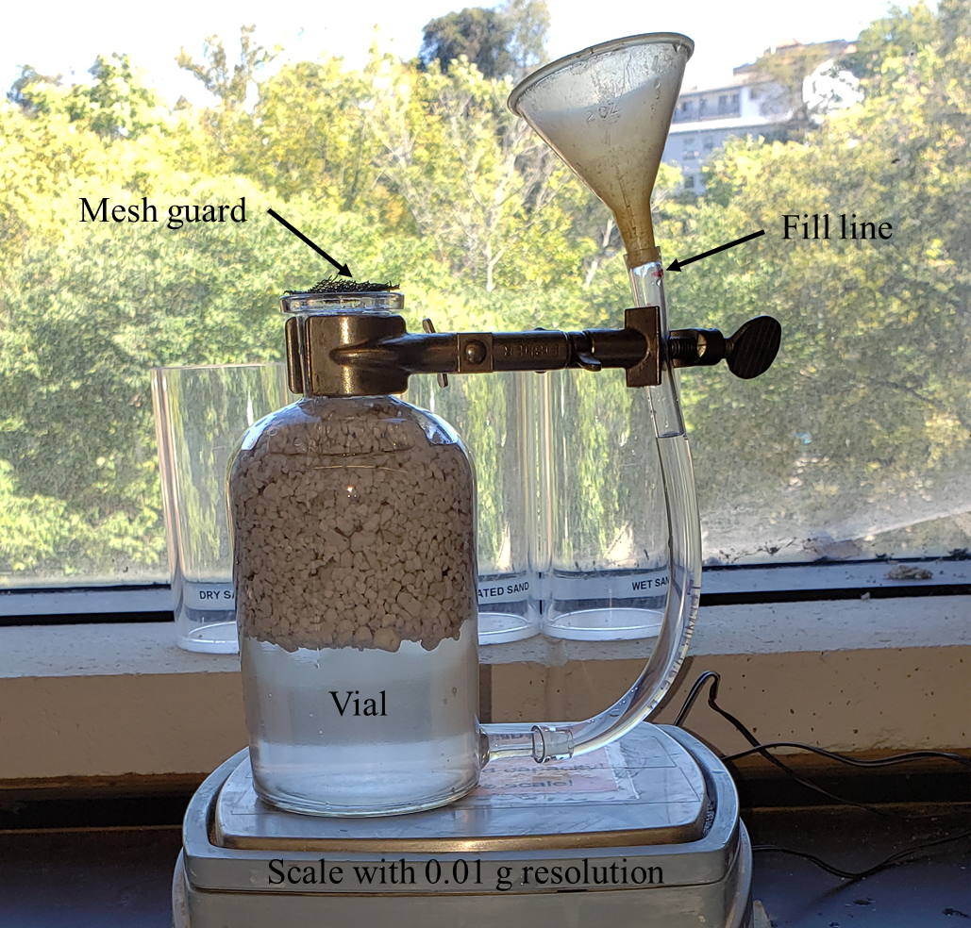
Figure 12: Experimental apparatus for density measurements of aggregates lighter than water by submerging aggregates in water.

was attached to the bottom of the vial and was carefully marked with a datum reference to ensure a repeatable volume of water used for each measurement. The vial was then filled with water to the datum reference fill line and weighed with and without the aggregates in the vial.

Concrete mixing procedure
Both the high-strength and structural lightweight concrete mixtures were mixed using the same method. Firstly, the silica fume and Portland cement were mixed together in a 7.6 l Hobert tabletop mixer for one minute. Secondly, water and HRWR were added to the mixture slowly as the mixer was operating and mixed for two minutes to promote optimal fluidity of the mix. Thirdly, the aggregates were added to the mixture and mixed for an additional three minutes. For the mix designs requiring fibers, the fiber was added and mixed for a further five minutes. For neat concrete mix designs, the mixture was mixed for five minutes to ensure each batch received the same mixing time.

The ultra-light mix was prepared similarly to dry cement mixing with the added water steps remaining the same as the high-strength and structural lightweight mixes. However, instead of adding the aggregate, the fibers were added first and mixed for five minutes, and the neat mixture was mixed for five minutes for consistency for all batches. The aggregates were then added last to the mix and mixed for three minutes. This change was made to reduce potential damage to the relatively fragile aggregates from overmixing. Following mixing of the concrete mix designs, a flow test in accordance with ASTM C1437-20 was performed to evaluate and compare the rheology of each of the concrete batches.

Casting samples
Three types of samples—tension briquettes, compression cubes, and flexural beams—were cast for mechanical characterization, as shown in Figure 13. All of the samples were cast in a similar manner. The steel or brass molds were first filled halfway with concrete and were then tamped down using a 10 mm by 25 mm wooden tamper. Care was taken to ensure that the entire surface of the concrete was tamped. The molds were then filled all the way and tamped again. The sides of the molds were tapped with a rubber mallet to help release air pockets. The surface of the samples was then smoothed and flattened with a straight edge. Care was taken with the neat samples and steel samples due to the high flow of the mix causing the aggregates and steel fibers to separate. It was, therefore, important to mix the concrete as it was being scooped out of the mixing bowl to ensure each sample was representative of the total mix.

Mechanical testing of cast samples
The concrete samples were evaluated for compression, tensile, and flexural strength. The compression strength was evaluated in accordance with ASTM C109, and the experimental setup is shown in Figure 14a. The samples were monotonically loaded on a 600 kN Instron load frame to failure. Based on the ASTM C109 standard, the samples
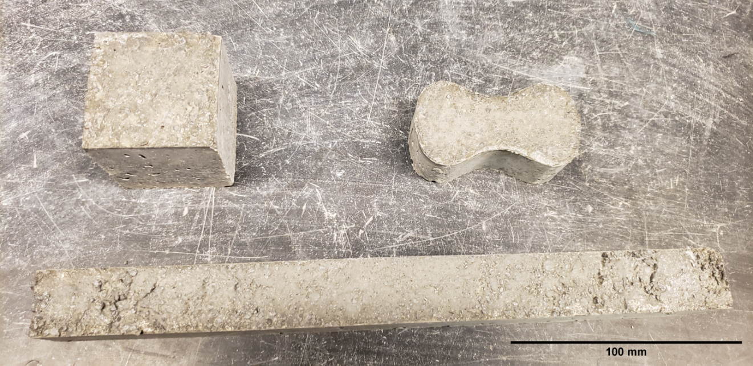
Figure 13: Samples used for mechanical testing. A: compression cube; B: tension briquettes; C: flexural beam.

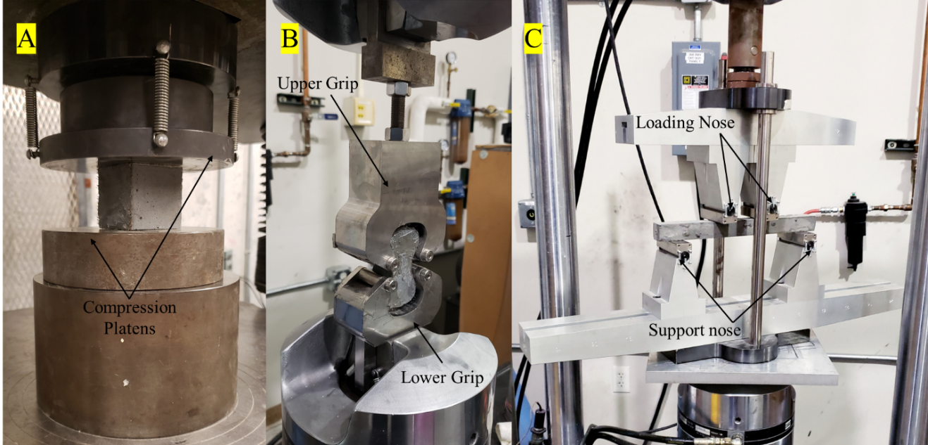
Figure 14: Mechanical testing experimental setup for A: compression cube; B: tensile test; and C: flexural test with 229 mm major span and a 76 mm minor span.

should be loaded at a crosshead rate of 900–1800 N/s; however, due to the load frame having insufficient force control, this was determined using a displacement control at a rate of 0.1 mm/min to provide consistent results in line with the required force rate [70]. The tensile test was performed in accordance with ASTM C307, and the test setup is shown in Figure 14b. The tension briquettes samples were mounted into custom-made grips using ASTM specifications and loaded monotonically at a crosshead rate of 2 mm/min on a 100 kN MTS servo hydraulic load frame until mechanical failure [71]. The flexural samples were tested in accordance with ASTM C947, and Figure 14c shows the experimental setup. The samples were loaded monotonically at a crosshead rate of 1.27 mm/min to mechanical failure on a 100 kN MTS load frame [72]. It must be noted that a deviation from the ASTM C947 standard was that 25 x 25 x 305 mm samples were cast as previously described instead of being cut from a sheet of concrete [72]. The force and displacement values for all cast samples were collected at a rate of 5 Hz.

Results

Mechanical properties
Table 8 summarizes the comparison of mechanical and rheological properties, and density of the concrete mixes. The steel fibers and neat concrete mix design were used as a baseline measurement as a comparison to the rCF reinforced mix designs. For the high-strength concrete, the compressive strength of the rCF mix design (77.0 MPa) was approximately 16.3% lower than the neat mix design (90.7 MPa) and approximately 13.4% lower than the steel fiber mix design (88.1 MPa). The tensile strength of the rCF mix design (4.55 MPa) was about 0.7% higher than the neat mix design (4.52 MPa) and about 34.2% lower than the steel fiber mix design (6.43 MPa). The flexural strength of the rCF mix design (9.40 MPa) was approximately 21.0% higher than the neat mix design (7.61 MPa) and approximately 88.4% lower than the steel mix design (24.28 MPa). The flow of both the steel and neat mix was 150+%, with rCf having a flow of 25%. The density of the rCF mix design (2.23 g/cm³) was approximately 4.8% lower than the neat mix design (2.37 g/cm³) and approximately 6.1% lower than the steel mix design (2.37 g/cm³). For the structural lightweight concrete, the compressive strength of the rCf mix design (28.4 MPa) was approximately 73.2% lower than the neat mix design (61.2 MPa) and approximately 20.8% lower than the steel mix design (35.0 MPa). The tensile strength of the rCF mix design (2.90 MPa) was about 14.8% higher than the neat mix design (2.50 MPa) and approximately 48.8% lower than the steel mix design (4.77 MPa). The flexural strength of the rCf mix design (2.57 MPa) was approximately 82.8% lower than the neat mix design (6.20 MPa) and approximately 118.3% lower than the steel mix design (10.02 MPa). The neat mix had the highest flow at 84.4%, followed by the steel fiber mix with a flow of 20.3%. Unfortunately, due to low workability and poor cohesion in the concrete mix, the rCF mix design crumbled during the test leading to an invalid test or effectively 0% flow. The density of the rCF mix design (1.53 g/cm³) was approximately 10.5% lower than the neat mix design (1.70 g/cm³) and approximately 15.7% lower than the steel mix design (1.79 g/cm³). For the ultra-lightweight concrete, the compressive strength of the rCF mix design (21.7 MPa) was approximately 13.7% lower than the neat mix design (24.9 MPa) and approximately 62.4% lower that the steel fiber mix design (41.4 MPa). The tensile strength of the rCF mix design (3.21 MPa) was approximately 72.6% higher than the neat mix design (1.50 MPa) and approximately 58.6% lower than the steel fiber mix design (5.87 MPa). The flexural strength of the rCF mix design (5.62 MPa) was approximately 48.7% higher than the neat mix design (3.42 MPa) and approximately 97.5% lower than the steel fiber mix design (16.32 MPa). The flow of both the neat and the steel fiber was 150+%, with rCF having a flow of 1.6%. The density of the rCF mix design (1.48 g/cm³) was approximately 2.0% lower than the neat mix design (1.51 g/cm³) and approximately 12.7% lighter than the steel fiber mix design (1.68 g/cm³). In addition to the results presented a trial of Digital Image Correlation (DIC) was performed to track strain in the different samples. Unfortunately, the strain results from DIC proved to be inconsistent and are further discussed in detail in appendix 1 at the end of this document.

Results Discussion
It can be observed that both tension and flexural strength values for the rCF mix design were lower than steel but higher than neat concrete, with the one exception being the structural lightweight flexural strength. The authors suspect that the reason for the poor results for the structural lightweight mix were due to the low flow, which leads to samples with more voids and less consistent samples due to the concrete not being able to adequately consolidate into the molds. The low flow could be attributed to the lower cement content of 20% by volume compared to the 30% by volume of the other mix designs. Increasing the cement content would have increased the density but would have increased the strength and flow of the mix. Similarly, the cement content of the ultra-light mix could have been reduced slightly to decrease the density of the mix. However, the fiber content could also be reduced to maintain adequate flow. Based on how the structural lightweight mix and ultra-light mix behaved, it can be observed that the cement content plays a critical role in the flow of the mix and that the fiber loading should be adjusted based on the cement volume as opposed to the total mix volume.

Additionally, it can be observed that for every mix the rCF mix was the least dense followed by neat then steel. This follows the expected trend, with steel being much heavier than rCF and the aggregates that it is replacing, thus increasing the overall density of the mix. This is particularly apparent with the ultra-light mix, showing that rCF reinforcement is ideal if the density of the concrete is critical. It should be noted that while the rCF-reinforced structural lightweight mix has a much lower density than the others, this is mostly due to the poor flow trapping air and creating air voids.

Looking at the compressive strength, the neat concrete performs better for both the high-strength mixes and the structural light mixes. The likely reason that the steel mix performed the best in compression for the ultra-light mixes is that the steel mix had both excellent flow and good dispersion of aggregates. For the neat ultra-light mix, it was observed that the combination of high flow and low density of the aggregates caused the aggregates to float to the top of the samples, whereas the steel fibers helped to both
Table 8: Mechanical properties, flow, and density values of the concrete mixes. The values in parenthesis are the standard deviation, and * represents the flow test not being valid due to the concrete crumbling during the test.
Material | Fiber Type | Compression (MPa)  n = 3 | Tension  (MPa)  n = 3 | Flexural  (MPa)  n = 4 | Flow | Density  (g/cm³)  n = 2
High-Strength | rCF | 77.0 (1.2) | 4.55 (0.31) | 9.40 (0.82) | 25.00% | 2.23 (0.012)
High-Strength | steel | 88.1 (0.8) | 6.43 (0.58) | 24.28 (1.06) | 150+% | 2.37 (0.016)
High-Strength | neat | 90.7 (8.3) | 4.52 (0.39) | 7.61 (1.11) | 150+% | 2.34 (0.010)
Structural  Light | rCF | 28.4 (0.1) | 2.90 (0.14) | 2.57 (0.60) | N/A* | 1.53 (0.022)
Structural  Light | steel | 35.0 (9.6) | 4.77 (0.45) | 10.02 (1.46) | 20.3% | 1.79 (0.016)
Structural  Light | neat | 61.2 (2.9) | 2.50 (0.24) | 6.20 (0.88) | 84.4% | 1.70 (0.058)
Ultra-Light | rCF | 21.7 (0.6) | 3.21 (0.17) | 5.62 (1.10) | 1.60% | 1.48 (0.015)
Ultra-Light | steel | 41.4 (0.7) | 5.87 (1.31) | 16.32 (2.62) | 150+% | 1.68 (0.154)
Ultra-Light | neat | 24.9 (5.3) | 1.50 (0.13) | 3.42 (0.84) | 150+% | 1.51 (0.014)

reduce flow and constrain the aggregates, allowing for a much more uniform distribution. For the high-strength mixes, it is observed that both the steel fibers and rCF lead to a reduction in compressive strength that relatively low compared to the increase in tensile and flexural strength. For the structural lightweight mix, the reduction in compressive strength is significant at about half the strength of the neat mix for both the steel and rCF mixes. This further illustrates the importance of adequate flow and adjusting the fiber loading based on the cement content to maintain flow.

Conclusions

It can be observed across the different mix designs that the rCF improves the tensile and flexural strength of the concrete while not significantly decreasing the compression strength in most cases. It was observed that the steel fibers did perform better in compression, tensile, and flexural strength across the board, but they did have a higher density than the rCF and neat mixes. Additionally, rCF can provide benefits such as chemical inertness and smaller fiber size, which could be beneficial in small cross-sections. Furthermore, it was observed that the flow was significantly reduced with the additional of rCF, and the effects on flow were significantly magnified when the cement content was reduced. This shows that the fiber content in the mixes should be based on the cementitious material content as opposed to the total mix volume. The authors suspect that this is due to the fibers only being able to mix into the volume taken up by the cement and not the aggregates. Overall, rCF is a viable reinforcement for fiber-reinforced concrete and is particularly good for lightweight applications. There is a need for further research, particularly involving fiber chemical sizing to help with flow and bonding. Additionally, more testing could be performed to find the ideal fiber content for a given cement volume, but that will be dependent on different fiber types.

Acknowledgments
The supply of recycled carbon fibers from Tim Spahn from Carbon Fiber Recycling, Inc. is acknowledged. The supply of stalite aggregate from Stalite Lightweight Aggregate is acknowledged. Technical support from Jenna Brown from the University of Tennessee is acknowledged.

References
1. Naganna, S. R.; Ibrahim, H. A.; Yap, S. P.; Tan, C. G.; Mo, K. H.; El-Shafie, A., Insights into the Multifaceted Applications of Architectural Concrete: A State-of-the-Art Review. Arabian Journal for Science and Engineering 2021, 46, (5), 4213-4223.
2. Institute, A. C., ACI CODE-318-19: Building Code Requirements for Structural Concrete and Commentary. 318, A. C., Ed. 2019.
3. Mineral commodity summaries 2022; 2022; Reston, VA, 2022; p 202.
4. Kosmatka, S. H.; Panarese, W. C.; Kerkhoff, B., Design and control of concrete mixtures. Portland Cement Association Skokie, IL: 2002; Vol. 5420.
5. Thienel, C.; Peck, M., Die Renaissance leichter Betone in der Architektur. Detail 2007, 522 – 534.
6. Thienel, K.-C.; Haller, T.; Beuntner, N., Lightweight Concrete—From Basics to Innovations. In Materials, 2020; Vol. 13.
7. Mendis, P., Design of high-strength concrete members: state-of-the-art. Progress in Structural Engineering and Materials 2003, 5, (1), 1-15.
8. Shah, S. P.; Ahmad, S. H., High performance concrete. Properties and applications. 1994.
9. Malier, Y., High performance concrete: from material to structure. CRC Press: 1992.
10. Gjørv, O., High-strength concrete. In Developments in the Formulation and Reinforcement of Concrete, Elsevier: 2008; pp 153-170.
11. Mendis, P.; Pendyala, R. In High-strength/High-performance Concrete in Australia-Design and Applications, Proceedings of the 4th World Conference on Utilization of High-strength/High-performance Concrete, Paris, 1996; pp 1581-1590.
12. Chang, P.-K.; Hwang, C.-L.; Peng, Y.-N., Application of High-Performance Concrete to High-Rise Building in Taiwan. Advances in Structural Engineering 2001, 4, (2), 65-73.
13. French, C.; Mokhtarzadeh, A.; Ahlborn, T.; Leon, R., High-strength concrete applications to prestressed bridge girders. CONSTRUCTION AND BUILDING MATERIALS 1998, 12, (2-3), 105-113.
14. Persson, B. S.; Johansson, A. G.; Johansson, P. S., Prefabrication with HSC. Concrete International 1999, 21, (9), 58-62.
15. Charles H. Thornton, H. M. U. H. L. M. J.; Hashimah, H., The Petronas Twin Towers and High-Performance Concrete. ACI Symposium Publication 172.
16. M. K. Tadros, X. H. Z. M.; Baishya, M., Structural Design of High-Performance Concrete Bridges. ACI Symposium Publication 189.
17. Breitenbucher, R., Developments and applications of high-performance concrete. MATERIALS AND STRUCTURES 1998, 31, (207), 209-215.
18. Clarke, J. L., Structural lightweight aggregate concrete. CRC Press: 1993.
19. Lawson, R., Fire resistance of ribbed concrete and composite slabs. Concrete (London) 1987, 21, (5), 18-20.
20. Lab, R. H., Think Formwork – Reduce Costs. Structure 2007.
21. Bertolini, L.; Elsener, B.; Pedeferri, P.; Redaelli, E.; Polder, R. B., Corrosion of steel in concrete: prevention, diagnosis, repair. John Wiley & Sons: 2013.
22. Samples, L. M.; Ramirez, J. A., Methods of Corrosion Protection and Durability of Concrete Bridge Decks Reinforced with Epoxy-coated Bars-Phase I. 1999.
23. Shi, X.; Xie, N.; Fortune, K.; Gong, J., Durability of steel reinforced concrete in chloride environments: An overview. Construction and Building Materials 2012, 30, 125-138.
24. Afroughsabet, V.; Biolzi, L.; Ozbakkaloglu, T., High-performance fiber-reinforced concrete: a review. Journal of Materials Science 2016, 51, (14), 6517-6551.
25. Kuder, K. G.; Shah, S. P., Processing of high-performance fiber-reinforced cement-based composites. Construction and Building Materials 2010, 24, (2), 181-186.
26. Lau, A.; Anson, M., Effect of high temperatures on high performance steel fibre reinforced concrete. Cement and Concrete Research 2006, 36, (9), 1698-1707.
27. Balaguru, P. N.; Shah, S. P., Fiber-reinforced cement composites. 1992.
28. Wang, Y.; Li, V. C.; Backer, S., Tensile failure mechanisms in synthetic fibre-reinforced mortar. Journal of Materials Science 1991, 26, (24), 6565-6575.
29. Jr Savastano, H.; Turner, A.; Mercer, C.; Soboyejo, W. O., Mechanical behavior of cement-based materials reinforced with sisal fibers. Journal of Materials Science 2006, 41, (21), 6938-6948.
30. Sudin, R.; Swamy, N., Bamboo and wood fibre cement composites for sustainable infrastructure regeneration. Journal of Materials Science 2006, 41, (21), 6917-6924.
31. Khayat, K. H.; Roussel, Y., Testing and performance of fiber-reinforced, self-consolidating concrete. Materials and Structures 2000, 33, (6), 391-397.
32. Mehta, P. K.; Monteiro, P. J., Concrete: microstructure, properties, and materials. McGraw-Hill Education: 2014.
33. Biolzi, L.; Cattaneo, S.; Guerrini, G. L., Fracture of Plain and Fiber-Reinforced High Strength Mortar Slabs with EA and ESPI Monitoring. Applied Composite Materials 2000, 7, (1), 1-12.
34. Zhou, H.; Jia, B.; Huang, H.; Mou, Y., Experimental Study on Basic Mechanical Properties of Basalt Fiber Reinforced Concrete. In Materials, 2020; Vol. 13.
35. Dvorkin, L.; Dvorkin, O., Basics of concrete science. St-Petersburg: Stroi-Beton 2006, 200.
36. Barros, J. A.; Sena-Cruz, J., Fracture energy of steel fiber-reinforced concrete. 2001.
37. Ohama, Y., Carbon-cement composites. Carbon 1989, 27, (5), 729-737.
38. Ali, M. A.; Majumdar, A. J.; Rayment, D. L., Carbon fibre reinforcement of cement. Cement and Concrete Research 1972, 2, (2), 201-212.
39. Aggerate, S. L. Properties & Gradations. https://www.stalite.com/material-gradations (10/27/2022),
40. Kosa, K.; Naaman, A. E., Corrosion of Steel Fiber Reinforced Concrete. ACI Materials Journal 87, (1).
41. Frazão, C.; Camões, A.; Barros, J.; Gonçalves, D., Durability of steel fiber reinforced self-compacting concrete. Construction and Building Materials 2015, 80, 155-166.
42. Isa, M. N.; Pilakoutas, K.; Guadagnini, M.; Angelakopoulos, H., Mechanical performance of affordable and eco-efficient ultra-high performance concrete (UHPC) containing recycled tyre steel fibres. Construction and Building Materials 2020, 255, 119272.
43. Zhong, R.; Wille, K.; Viegas, R., Material efficiency in the design of UHPC paste from a life cycle point of view. Construction and Building Materials 2018, 160, 505-513.
44. Das, S., Life cycle assessment of carbon fiber-reinforced polymer composites. The International Journal of Life Cycle Assessment 2011, 16, (3), 268-282.
45. van de Werken, N.; Reese, M. S.; Taha, M. R.; Tehrani, M., Investigating the effects of fiber surface treatment and alignment on mechanical properties of recycled carbon fiber composites. Composites Part A: Applied Science and Manufacturing 2019, 119, 38-47.
46. Pimenta, S.; Pinho, S. T., Recycling carbon fibre reinforced polymers for structural applications: Technology review and market outlook. Waste Management 2011, 31, (2), 378-392.
47. Butenegro, J. A.; Bahrami, M.; Abenojar, J.; Martínez, M. Á., Recent Progress in Carbon Fiber Reinforced Polymers Recycling: A Review of Recycling Methods and Reuse of Carbon Fibers. In Materials, 2021; Vol. 14.
48. Akbar, A.; Kodur, V. K. R.; Liew, K. M., Microstructural changes and mechanical performance of cement composites reinforced with recycled carbon fibers. Cement and Concrete Composites 2021, 121, 104069.
49. Howarth, J.; Mareddy, S. S. R.; Mativenga, P. T., Energy intensity and environmental analysis of mechanical recycling of carbon fibre composite. Journal of Cleaner Production 2014, 81, 46-50.
50. Karuppannan Gopalraj, S.; Kärki, T., A review on the recycling of waste carbon fibre/glass fibre-reinforced composites: fibre recovery, properties and life-cycle analysis. SN Applied Sciences 2020, 2, (3), 433.
51. Abdallah, R.; Juaidi, A.; Savaş, M. A.; Çamur, H.; Albatayneh, A.; Abdala, S.; Manzano-Agugliaro, F., A Critical Review on Recycling Composite Waste Using Pyrolysis for Sustainable Development. In Energies, 2021; Vol. 14.
52. Pickering, S.; Turner, T.; Meng, F.; Morris, C.; Heil, J.; Wong, K.; Melendi-Espina, S. In Developments in the fluidised bed process for fibre recovery from thermoset composites, 2nd Annual Composites and Advanced Materials Expo, CAMX 2015; Dallas Convention CenterDallas; United States, 2015; pp 2384-2394.
53. Pimenta, S.; Pinho, S. T.; Robinson, P.; Wong, K. H.; Pickering, S. J., Mechanical analysis and toughening mechanisms of a multiphase recycled CFRP. Composites Science and Technology 2010, 70, (12), 1713-1725.
54. Zhu, J.-H.; Chen, P.-y.; Su, M.-n.; Pei, C.; Xing, F., Recycling of carbon fibre reinforced plastics by electrically driven heterogeneous catalytic degradation of epoxy resin. Green Chemistry 2019, 21, (7), 1635-1647.
55. Kumar, S.; Krishnan, S., Recycling of carbon fiber with epoxy composites by chemical recycling for future perspective: a review. Chemical Papers 2020, 74, (11), 3785-3807.
56. Verma, S.; Balasubramaniam, B.; Gupta, R. K., Recycling, reclamation and re-manufacturing of carbon fibres. Current Opinion in Green and Sustainable Chemistry 2018, 13, 86-90.
57. Bledzki, A. K.; Seidlitz, H.; Krenz, J.; Goracy, K.; Urbaniak, M.; Rösch, J. J., Recycling of Carbon Fiber Reinforced Composite Polymers—Review—Part 2: Recovery and Application of Recycled Carbon Fibers. In Polymers, 2020; Vol. 12.
58. Ma, C.; Sánchez-Rodríguez, D.; Kamo, T., Influence of thermal treatment on the properties of carbon fiber reinforced plastics under various conditions. Polymer Degradation and Stability 2020, 178, 109199.
59. Karuppannan Gopalraj, S.; Kärki, T., A Study to Investigate the Mechanical Properties of Recycled Carbon Fibre/Glass Fibre-Reinforced Epoxy Composites Using a Novel Thermal Recycling Process. In Processes, 2020; Vol. 8.
60. Sun, H.; Guo, G.; Memon, S. A.; Xu, W.; Zhang, Q.; Zhu, J.-H.; Xing, F., Recycling of carbon fibers from carbon fiber reinforced polymer using electrochemical method. Composites Part A: Applied Science and Manufacturing 2015, 78, 10-17.
61. Nahil, M. A.; Williams, P. T., Recycling of carbon fibre reinforced polymeric waste for the production of activated carbon fibres. Journal of Analytical and Applied Pyrolysis 2011, 91, (1), 67-75.
62. Das, M.; Chacko, R.; Varughese, S., An Efficient Method of Recycling of CFRP Waste Using Peracetic Acid. ACS Sustainable Chemistry & Engineering 2018, 6, (2), 1564-1571.
63. Ma, Y.; Nutt, S., Chemical treatment for recycling of amine/epoxy composites at atmospheric pressure. Polymer Degradation and Stability 2018, 153, 307-317.
64. Ogi, K.; Shinoda, T.; Mizui, M., Strength in concrete reinforced with recycled CFRP pieces. Composites Part A: Applied Science and Manufacturing 2005, 36, (7), 893-902.
65. Mastali, M.; Dalvand, A., The impact resistance and mechanical properties of self-compacting concrete reinforced with recycled CFRP pieces. Composites Part B: Engineering 2016, 92, 360-376.
66. Mastali, M.; Dalvand, A.; Sattarifard, A., The impact resistance and mechanical properties of the reinforced self-compacting concrete incorporating recycled CFRP fiber with different lengths and dosages. Composites Part B: Engineering 2017, 112, 74-92.
67. ASTM, ASTM A820/A820M-22 Standard Specification for Steel Fibers for Fiber-Reinforced Concrete. ASTM Compass: 2022.
68. Park, S. B.; Lee, B. I.; Lim, Y. S., Experimental study on the engineering properties of carbon fiber reinforced cement composites. Cement and Concrete Research 1991, 21, (4), 589-600.
69. ASTM, ASTM C128-15 Standard Test Method for Relative Density (Specific Gravity) and Absorption of Fine Aggregate. 12/27/2016 ed.; ASTM: ASTM Compass, 2016.
70. ASTM, C109-21 Standard Test Method for Compressive Strength of Hydraulic Cement Mortars (Using 2-in. or [50 mm] Cube Specimens). ASTM: ASTM Compass, 2021.
71. ASTM, C307-18 Standard Test Method for Tensile Strength of Chemical-Resistant Mortar, Grouts, and Monolithic Surfacings. ASTM: ASTM Compass, 2018.
72. ASTM, C947-03 Standard Test Method for Flexural Properties of Thin-Section Glass-Fiber-Reinforced Concrete (Using Simple Beam With Third-Point Loading). ASTM: ASTM Compass, 2016.

CONCLUSIONS

It was seen that reinforcing UHPC with rCF is comparable to the other commercially available carbon fiber types. It was observed that the inclusion of carbon fiber in UHPC increased the porosity and pore size of the concrete. This increased porosity decreased the strength of the concrete and potentially negates the benefits that the carbon fiber provided. It was observed that the Zoltek fibers performed well, indicating that the concrete strength is more reliant on how the fibers bond with the concrete and how they mix into the concrete than the overall strength of the fibers themselves.

The high-strength, structural lightweight, and ultra-light mixes showed that the inclusion of rCF generally increased the tensile and flexural strength of the concrete. It was observed that the cementitious material content of the concrete mix dramatically affected the workability of the concrete mix when fibers are included. It is therefore recommended to base the fiber volume not on the total mix volume but on the volume of cementitious materials in order to maintain more consistent workability. Furthermore, while the steel fibers performed well, they significantly increased the density of the mix when compared to rCF. This may not matter in some applications, but for ultra-light or even structural lightweight concrete the increase in density could be unwanted.

Overall, rCF shows promise as a means of reinforcing concrete. However, there is significant need for further research. The first aspect would be to look into fiber size, which could help with both the workability and bonding between the cement and fibers. Similarly, an in-depth look at the bonding between the fibers and cement could be beneficial. Understanding the fiber-bonding behavior could help to determine optimal fiber length and increase the strength of the overall mix. Additionally, further investigation into how to reduce the porosity and increase the workability of the mix could prove beneficial, since currently that is severely reducing the strength of the rCF- reinforced concrete. Furthermore, investigation is needed into how the relatively small size of rCF compared to steel fibers interact with the surrounding cement and if there are any methods for decreasing the cement particle size to better bond with the fibers. Lastly, better mixing methods could be investigated to better disperse the fibers without clumping and to be practical on a commercial scale.

APPENDIX 1: DIC TRIALS

DIC was performed on compression, tension, and flexural tests for a number of fiber reinforced concrete including one reinforced with Hexcel carbon fiber. Unfortunately, it was found that the strain results from the test were inconsistent due a number of issues. The first for tension and flexural test were the low failure strains of the concrete being too low for the strain resolution of the VIC-3D digital image correlation software that was used. This led to high noise in the results that could not be used for accurate trend lines to be calculated. The second issues with the tension and flexural tests were that due to the samples being painted with spray paint to establish the required speckle pattern it was impossible to tell if an area that was registering high strain was true or micro cracks under the paint appearing as strain. Similarly due to the resolution of the cameras themselves very small cracks were impossible to see even if they went through the surface of the paint. Both of these factors could lead to higher strains being reported then was the concrete truly felt. For all sample types DIC only is able to monitor the surface of the sample. This was easiest to observe with the compression samples due to the strain being measured being high enough to be clearly detected. However, it was seen with some samples that very low strain was detected due to the observed surface spalling off and not carrying any load. This made it difficult to measure samples true maximum strain and clearly shows that what the surface of the sample is doing is not necessarily true for the full thickness of the sample. Overall DIC could provide detailed strain data for concrete however car needs to be taken to ensure that there is enough resolution for the strain level and for the cameras and that it is understood that it is just a surface measurement and not necessarily representative of the through thickness behavior.

VITA

Andrew Patchen attended the University of Tennessee Knoxville for his undergraduate and earned a Bachelor of Science in civil engineering with concentrations in structural and geotechnical engineering. During his time as an undergraduate he worked as a research assistant in Dr. Penumadu’s research group with a focus on mechanical testing of composite materials used in the automotive and wind industry. Additionally, during his time as an undergraduate student, he was technical lead of the university’s concrete canoe team.

Once graduated Andrew began working on his Master of Science in civil engineering under Dr. Penumadu’s advisement at the University of Tennessee. His graduate work primarily focused on the development of fiber reinforced concrete mix designs using recycled carbon fiber. Additionally, during his time in graduate school he worked on a glass fiber reinforced polymer composite bridge project, and he worked on testing various composite materials for the American Chemical Council (ACC). Lastly, he served as a technical advisor to the concrete canoe team. Andrew plans to transition to industry with a focus on structural engineering.

