Promotion Focus, Prevention Focus, and the Expression of Positive Emotions When Things Turn Out Well
Kamilya Gosmanova
University of Tennessee Knoxville

Abstract
The type and intensity of emotion people feel depends on if they have a prevention or promotion focus going in to a situation according to the regulatory focus theory by Higgins (1997). An individual might approach a good outcome as being a gain, where they win, or non-loss, where they avoid losing. In a promotion focus, achieving a good outcome—a gain—will induce feelings of cheerfulness, while in a prevention focus, avoiding a failure—a non-loss—will induce feelings of quiescence. People can be placed in situations framed as with a promotion or prevention focus. In our study, 103 participants played computerized games where they experienced four outcomes framed as either promotion (gain, non-gain) or prevention focus (non-loss, loss). Their reactions to each game was videotaped, and four judges coded their facial expressions as cheerful, quiescent, or other. We predicted that participants in a promotion focus experiencing a gain would elicit more cheerfulness than the other outcomes, as indicated by the judges, and that participants in the prevention focus experiencing a non-loss would elicit more quiescence. Our results indicated that participants experienced neither more cheerfulness nor quiescence in good outcomes (gain, non-loss) compared to bad outcomes (non-gain, loss). Similarly, a gain outcome did not elicit more cheerfulness compared to a non-loss, and a non-loss did not elicit more quiescence than a gain. We speculated that our findings did not match previous ones because our methods included videotaping positive emotions that might be harder to tease apart compared to negative emotions. Moreover, previous studies showing support for the regulatory focus theory used personal questionnaires with leading questions that might have inadvertently influenced participants’ answers.

Promotion Focus, Prevention Focus, and the Expression of Positive Emotions When Things Turn Out Well
Imagine if you score a 95 on your next exam, you will receive an A in the class overall. After studying hard, you do end up receiving that 95 and getting that great final grade. How do you feel? Now imagine that you had to score a 95 on the exam to not fail the class. In this instance, you also receive a 95 on the exam and pass the class. Do you feel as you did in the first scenario? In both cases, you might expect to feel happy, but some researchers might argue that the happiness you feel differs depending on if you had something to gain or something to lose. Regulatory focus theory proposes that we have two foci to approach different types of desired end states (Higgins, 1997). In the first focus, a person seeks positive outcomes, and this is kind of goal attainment deals with a promotion focus. This would be like making the 95 and succeeding in the class overall. In the second focus, a person has a prevention focus when concerned with avoiding negative outcomes. This would be like being motivated to make that 95 to prevent failing the class. Higgins' regulatory focus theory provides the backbone of this paper – how people approach situations, what kind of outcome they expect, and the kind of emotion they might feel from their particular situation (1997). Essentially, Higgins explores what motivates people and what the consequences are of this motivation. When examining what kind of different positive emotions one might feel from getting a good grade on the exam, the theory predicts that when one is in a promotion focus and succeeds his goal, he feels cheerful. On the other hand, the theory predicts that when one is in the prevention focus and avoids a bad outcome, such as failing the class, he feels calm or relaxed. In particular, we refer to this emotional state as quiescence based on Higgins’ emotion predictions. Now if someone in a promotion focus did not succeed in attaining the positive outcome (e.g. he did not make a 95 to get the great final grade, then he would feel disappointed or dejected). Similarly, if he were in a prevention focus and failed to avoid the negative outcome, e.g. he did not make a 95 and thus failed the class, then he would feel agitated or uneasy.
While Higgins (1997) postulates various needs and self-ideals that might motivate individuals, researchers can place people in experimental conditions framed as either promotion or prevention focus. A promotion focus frame would make the situation a gain, with something to be attained, if the event turns out well. The prevention focus frame would make the situation that turns out well a non-loss, as the individual is more sensitive to bad outcomes and will avoid them. When those sensitive to positive outcomes do not attain them, they are then in a non-gain situation, while when those more sensitive to bad outcomes are unable to avoid them, they are in a loss situation. If this particular frame were applied to playing games or hypothetical situations, people in a promotion focus game where there is the ability to gain will feel cheerful if they succeed. However, those in a prevention focus game where one has the potential to experience a loss will feel quiescent if they succeed in not failing—a non-loss. Idson, Liberman, and Higgins found that gains elicit more pleasure than a non-loss, as predicted by the regulatory focus theory (2000). After filling out a self-questionnaire, participants completed an anagram task and were randomly assigned to receiving positive or negative feedback depending on their performance compared to other students on the anagrams. They would receive $9 if they performed better than 70 percent of other students or $8 if they scored less than the 70 percent. In the positive outcome condition, participants were told they solved the anagrams at the 79th percentile, while in the negative outcome condition, they were told they solved them at the 61st percentile. Participants were asked to rate how happy, relaxed, discouraged, and tense they felt after the task. The results showed that participants with a strong promotion focus, which was determined by the self-questionnaire prior to the task, indicated that they felt happier when they received positive feedback after their successful anagram task than participants with a strong prevention focus. This was in line with the regulatory focus theory that predicted that those with a promotion focus feel more cheerfulness when experiencing a good outcome during a success.
Higgins, Shah, and Friedman (1997) assigned their participants a task to complete and placed them in a promotion or prevention-framing condition based on how they wanted the task to be completed. They awarded $5 to participants who completed the task, regardless of succeeding or failing. However, in the promotion focus frame, they could win an additional $1 if they correctly performed the task. Those in the prevention-framing condition were told that they would receive $6 if they succeeded in performing the task but would lose money if they failed. Based on a personal questionnaire, Higgins et al. found that those in a promotion focus experienced greater cheerfulness or dejection based on outcome (gain or non-gain), while those in a prevention focus experienced greater quiescence during a non-loss or agitation during a loss. As in Higgins et al.’s study, here participants are given the promotion or prevention focus frame while playing computerized games. A success is framed as a gain or non-loss and are thus labeled as good outcomes. Losing the game is framed as a non-gain or loss and labeled as bad outcomes.
Facial expressions of emotion
Discrete facial expressions have provided evidence for six universal emotions using facial expressions, and many studies linking facial expressions with emotions use self-reports to find the connection between the two (Ekman & Friesen, 1971; Izard, 1977). They concluded that many cultures can recognize anger, contempt, disgust, fear, sadness, and surprise on the face. While such studies provide evidence for these six discrete emotions, others depict emotions as being on a dimensional scale and varying from each other in different dimensions (Davidson et al., 2002). Those arguing for discrete emotions reference the evolutionary settings that required such distinct emotions to have evolved. Recent research provides further evidence for discrete emotions using categorical judgment studies, neuropsychological evidence, and autonomic physiology (Davidson et al., 2002). However, the dimensional view of emotions has been found useful in situations where emotions are being tracked over time or within one category of emotion (Ekman, 1992; Ekman et al., 1982). Researchers have begun to incorporate other aspects of the upper body, such as the head position, posture, and gaze, for evidence of other types of discrete emotions.
The current research
Like Idson et al. and Higgins et al.’s methods, the current study presented participants with promotion and prevention-focus framing conditions. Participants played computerized games. In the promotion-focus games, participants could score points or score nothing (gain or non-gain). In the prevention-focus games, participants could obtain zero over losing points or lose points (non-loss or loss). Based on the existing theory, we predict that gaining will induce feelings of cheerfulness, while not losing will induce feelings of quiescence. We hope to see these emotions on the face to rate their intensity. Judges blind to the framing conditions or tasks labelled the emotions they saw on participants’ faces during the games.

Method

Participants
One-hundred and three University of Tennessee undergraduate students (34 men and 69 women) participated for course credit.

Task
Subjects were told that the experiment involved a series of games where they would win or lose points. There were 8 games, and subjects were presented with a roulette of two alternating numbers. In the presentation of the games, the roulette would appear only as grey circle for one second, then the numbers would pop up as seen in Figure 1 for five seconds, and then a yellow circle would go around the roulette in a random fashion until the participant stopped it. After the yellow circle was stopped, another five seconds would pass before proceeding to the next game. Half the games involved possible wins in order to place participants in the promotion focus: gaining +12 (or +24) or receiving zero points, considered as gain or non-gain prospects respectively (Figure 2). The other half involved possible losses in order to place participants in a prevention focus: receiving zero points or losing points (-12 or -24), also considered as non-loss or loss prospects respectively. The outcomes of the games could be good based on the prospects (winning or not losing points), or the outcome could be bad (receiving zero points or losing points). All trials were pre-programmed, however, and the grand total shown to every participant was 0 at the end. Participants were filmed from when the roulette appeared through the last five seconds after stopping the yellow circle.

Judges
Four coders analyzed the same video sets of participants and selected the emotion they perceived the participant to be expressing. The coders watched the last five seconds of a trial that followed the participant stopping the yellow circle at least 5 times. There were eight videos of each participant split into the four types of outcomes: gains, non-losses, non-gains, and losses. Judges viewed all eight videos from each participant before proceeding to the next participant. Before watching the first video from each participant, they saw two montages of eight videos that they had to watch at least twice. The first montage was a mix from the neutral setting (the five seconds before the yellow circle appeared) interspersed with the participant reactions after some games to allow the judge to witness the participant at baseline. The second was of videos from the actual outcomes. After the montages, judges proceeded to watch the participant’s videos and have a still of the participant in the neutral setting in the corner as reference. Underneath each video, the judges had the option to choose which positive emotion they thought characterized the participant best. Table 1 shows the options presented to the judges. Quiescence was represented as calm, relaxed, and/or at ease as in option 2 in Table 1; cheerfulness was represented as happy, satisfied, and/or glad as seen in option 3. The other emotions included pride, amusement, and relief, but they will be further discussed in another paper. The modified differential emotions scale (mDES) explains why cheerfulness and quiescence were coded by a trio of adjectives synonymous to one emotion, allowing a coder to rate the emotion more accurately (Fredrickson, 2013). It was created to expand the positive emotions that would be associated with one another and is a more-encompassing descendant of Izard's Differential Emotions Scale (Fredrickson, 2013; Izard, 1977).

Results
We examined whether winning elicits higher cheerfulness than quiescence and whether a non-loss elicits higher quiescence than cheerfulness by submitting ratings from each emotion to a 2 (outcome: good, bad) X 2 (prospect: possible win, possible loss) X 2 (magnitude: 12 or 24) mixed-model analysis of variance (ANOVA). How likely judges could detect cheerfulness or quiescence for gain and non-loss situations was the dependent variable (Figure 3).

Cheerfulness
We predicted a main effect of outcome such that participants would express more cheerfulness after good outcomes than after bad outcomes. In addition, the main effect of outcome would be moderated by an interaction with the focus, such that people would be especially likely to express cheerfulness after gains. However, there was no main effect of outcome, F (1, 101) = .09, p = .76. There was also no interaction between outcome and focus, F (1,101) = 0.016, p = .90. Thus, good outcomes did not elicit more cheerfulness, as shown in Figure 3. Within good outcomes, we had also predicted to see more cheerfulness in response to gains compared to non-losses, but the levels of cheerfulness after gains and non-losses were not significantly different, F (1, 101) = 1.382, p =.24 (Figure 3).

Quiescence
We also predicted a main effect of outcome such that people would express more quiescence after good outcomes than after bad one. Once more, the main effect of outcome would be moderated by an interaction with the focus, such that people would be especially likely to express quiescence after non-losses. As with cheerfulness, there was no main effect of outcome on quiescence, F (1,101) = 1.98, p = .16. Unlike with cheerfulness, there was an interaction between outcome and focus, F (1,101) = 4.74, p = .03. There was a clear difference between losses and non-gains (F (1, 101) = 4.82, p = .03), with non-gains eliciting stronger quiescence than losses, as seen in Figure 3. We had also predicted that non-losses would elicit more quiescence than gains, but the ANOVA revealed that there was no significant difference in quiescence between them, F (1, 101) = 1.00, p = .32 (Figure 3).

Discussion
The results show that participants expressed no difference in either cheerfulness or quiescence between the good and bad outcomes. Participants also did not express more cheerfulness after gains compared to non-loss. We also observed no difference in quiescence in non-losses compared to gains. These findings do not support our predictions, based on regulatory focus theory, that a gain would elicit more cheerful feelings, while a non-loss would elicit quiescent feelings. There are few reasons why this might have not been seen in this study.
On the one hand, our predictions might have been wrong about what emotions are elicited depending on the framed condition. Higgins et al. (1997) and Idson et al. (2000) used questionnaires to rate how they might feel rather than observe for emotions on the face. Using self-reports to gauge participants’ emotions can be a reactive measure with unintended consequences that might steer participants to unintentionally elicit them (Larsen & McGraw, 2011). Our study avoided this potential limitation by not asking any questions about how cheerful or quiescent participants felt to not possibly compel them to feel cheerful or quiescent about their outcome. Furthermore, participants expressed more quiescence in non-gains than in losses, which was not as we predicted (Figure 3). Quiescence was theorized to be experienced after non-losses, yet it makes sense too that participants would appear to be calmer in non-gains than in losses, where they were predicted to be more agitated. In addition to this unusual finding, perhaps regulatory focus theory could misrepresent people’s motivations and perceptions of fleeting events. Maybe the human mind interprets similar events in a more complicated manner than the theory expected.
On the other hand, our predictions might have been right, but we were not using the appropriate tools to differentiate between or elicit strong enough cheerfulness or quiescence visible on the face. Some studies have found that negative emotions are more strongly elicited than positive emotions and could be harder to distinguish (Ekman, 1992), and this might explain why the mean levels of the positive emotions were so low to start (Figure 3). Moreover, discerning significant facial distinctions between positive emotions elicited by gains or non-losses may be difficult if they are very similar. Higgins (1997) had also proposed that the stronger the promotion or prevention focus, the stronger the intensity of the emotion with the gain or non-loss. Maybe our study did not use strong enough consequences for winning the computerized games, so if there was a monetary incentive, as in Higgins et al. study (1997), then maybe participants would have appeared to elicit stronger emotions for having the chance to gain money.

References
Davidson, R J., Scherer, K.R., & Goldsmith, H.H. (2002). Handbook of affective sciences. New York, NY: Oxford University Press, Inc.
Ekman, P. (1982). Emotion in the human face (2nd ed.). Cambridge, UK: Cambridge University Press.
Ekman, P. (1992). An argument for basic emotions. Cognition and Emotion, 6, 169–200.
Ekman, P., & Friesen, W.V. (1971). Constants across cultures in the face and emotion. Journal of Personality and Social Psychology, 17(2), 124-129.
Fredrickson, B. L. (2013). Positive Emotions Broaden and Build. In P. Devine & A. Plant (Eds.), Advances in Experimental Social Psychology (1-53). Burlington: Academic Press.
Higgins, E.T. (1997). Beyond pleasure and pain. American Psychologist, 52(12), 1280-1300.
Higgins, E.T., Shah, J., & Friedman, R. (1997). Emotional responses to goal attainment: Strength of regulatory focus as moderator. Journal of Personality and Social Psychology, 72(3), 515-525.
Idson, L.C., Liberman, N., & Higgins, E.T. (2000). Distinguising gains from nonlosses and losses from nongains: A regulatory focus perspective on hedonic intensity. Journal of Experimental Social Psychology, 36, 252-274.
Izard, C. E. (1977). Human emotions. New York, NY: Plenum Press.
Larsen, J.T. & McGraw, A.P. (2011). Further evidence for mixed emotions. Journal of Personality and Social Psychology, 100(6), 1095–1110.
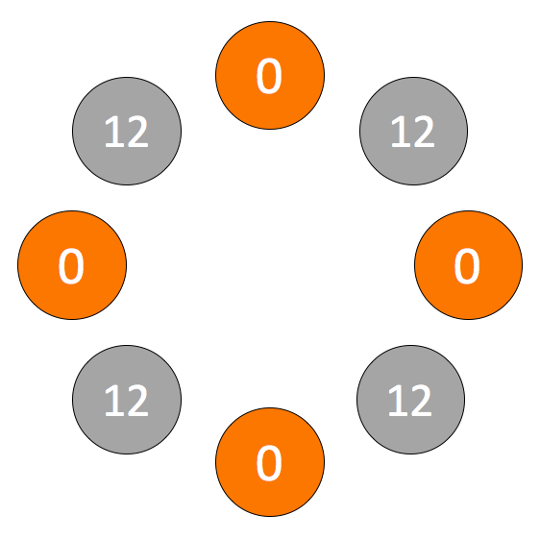 | 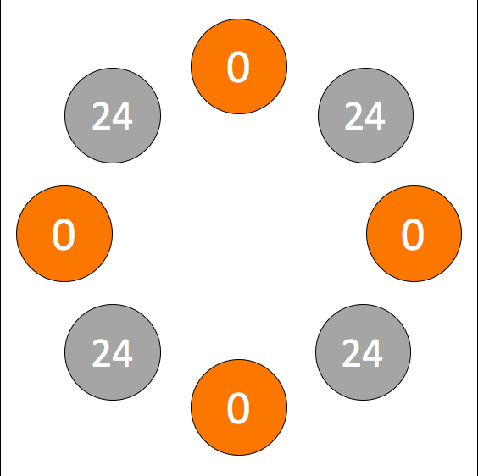 | 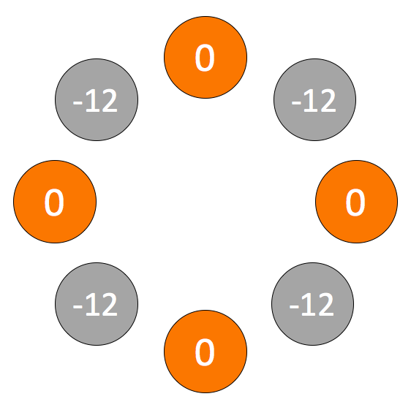 | 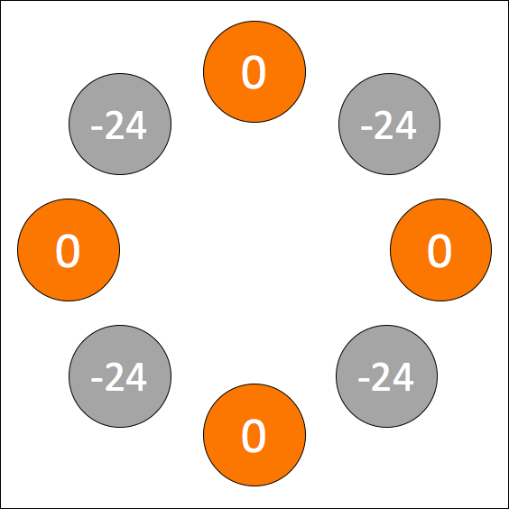
12 or 0 possible | 24 and 0 possible | -12 or 0 possible | -24 and 0 possible

Figure 1: Roulette with all possible values to obtain for participants

 | Possible Win – Promotion Focus | Possible Loss – Prevention Focus
Good Outcome | Gain  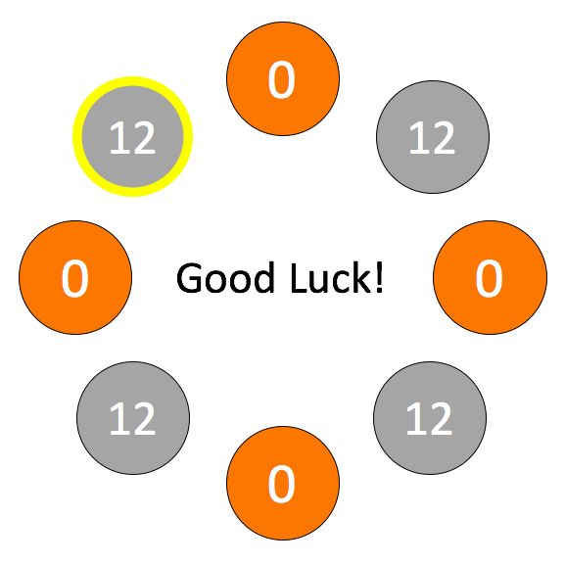 | Non-loss  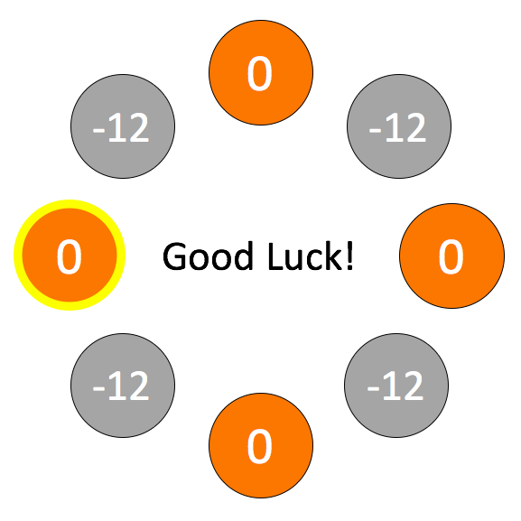
Bad Outcome | Non-gain  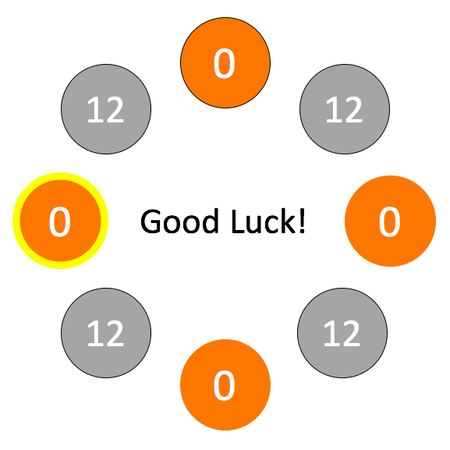 | Loss  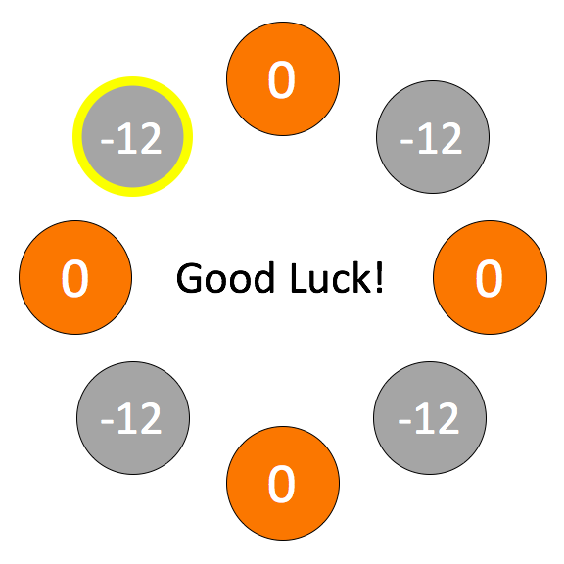

Figure 2: A yellow circle began traveling around roulette, and the player controlled when but not where it stopped. Depicted here are the four possible outcomes with two different backgrounds (12 or 0 possible; -12 or 0 possible). Participants were in a promotion focus when in the gain or loss situation and in a prevention focus when in a non-loss or non-gin situation.

Non-loss
Possible Loss Trial
Possible Win Trial
Loss
Loss
Non-gain
Non-gain
Gain
Non-loss
Gain

Figure 3: Intensity ratings of cheerfulness and quiescence in all four situations. There was a significant difference in quiescence intensities between non-gain and loss situations.

- Their face was not visible
- They did not appear to be experiencing any positive affect
- They appeared to be calm, relaxed, and/or at ease about how the trial turned out
- They appeared to be happy, satisfied, and/or glad about how the trial turned out
- They appeared to be proud, confident, and/or self-assured
- They appeared to be amused
- They appeared to be relieved
- They appeared to be experiencing some positive affect but not one of those listed above

Table 1: The various options presented to judges during their viewing of each participant clip

