Confirming Resistance to Prodiamine and
Glyphosate in a Single Annual Bluegrass
(Poa annua L.) Biotype from Tennessee

A Thesis Presented for the
Master of Science
Degree
The University of Tennessee, Knoxville

Shane Matthew Breeden
December 2015

Copyright © 2015 by Shane Breeden
All rights reserved.

DEDICATION

I dedicate this thesis to my friends and family, this would not have been possible without them. Their love and support have encouraged me to accomplish many things, this thesis being among them.

ACKNOWLEDGEMENTS

I would like to thank my graduate committee, Dr. Jim Brosnan, Dr. Scott Senseman, Dr. Tom Mueller, and Dr. Brandon Horvath. Their knowledge and encouragement has given me the skills to continue my career as a plant scientist knowing that I am prepared. Dr. Brosnan, especially has cultivated me as a scientist. I must also thank all of the graduate students in the Plant Sciences Department. At times when I have asked for help, the graduate students have stopped doing what they were doing and helped me progress beyond whatever difficulty I was being faced with. I must especially thank Eric Reasor, Jessi Benelli, Kyley Dickson, David Shell, Whitney Crow, and Matthew Elmore for their help in my career as a graduate student. I would also like to thank all of the undergraduate students that provided support through the duration of my project. Tyler Cambell, Kelly Arnholt, Jimmy Greenway, and Dennis Edralin provided much support. Gregory Breeden and Daniel Farnsworth also provided their knowledge and support to help with this project. J.D. Murr, the superintendent at Lambert Acres Golf Course, allowed me to conduct this project at Lambert Acres Golf Course and provided much assistance. At this time, I would like to thank those that have supported me in any way through my master’s candidacy.
ABSTRACT

Annual bluegrass (Poa annua L.; POAAN) is a cool-season weed that commonly infests warm-season turfgrasses during winter dormancy. In spring 2012, poor POAAN control (<50%) was reported on golf course roughs in Alcoa, TN (35.75 °N, -83.88 °W) following treatment with a tank mixture of prodiamine (1120 g ha⁻¹[hectare]) and glyphosate (840 g ae ha⁻¹) during bermudagrass dormancy. The objective of this research was to determine if this POAAN biotype was resistant to prodiamine and glyphosate.
Using mature plants from the field, 81 of the 100 selections were not controlled by glyphosate and prodiamine; 96 of the 100 selections were not controlled by glyphosate, while 84 were unaffected by prodiamine. Only a single plant sampled was susceptible to both herbicides.
Seed was harvested from surviving plants and used to confirm resistance in progeny. Percent control of the resistant and susceptible biotypes varied in response to increasing rates of prodiamine and glyphosate (P < 0.0001). Approximately 8.5 times more glyphosate (1940 g ha⁻¹) was required to reduce dry biomass of the resistant population by 50% compared to a known glyphosate susceptible population (228.9 g ha⁻¹). Moreover, glyphosate susceptible plants accumulated 50% more shikimic acid (898 mg kg⁻¹[kilogram]) 6 days after treatment than those resistant to glyphosate (394 mg kg⁻¹).
Results of this research indicate that the POAAN biotype at Lambert Acres Golf Course has evolved resistance to both prodiamine and glyphosate. This marks the second occurrence of POAAN evolving multiple-resistance in managed turf and the first instance of a POAAN population evolving resistance to both PRE and POST herbicides.

TABLE OF CONTENTS

CHAPTER 1 INTRODUCTION AND GENERAL INFORMATION 1
Annual Bluegrass as a Weed 1
Instances of POAAN Evolving Resistance 1
ALS-Inhibiting Herbicide Resistance 2
Weeds Developing Resistance to Photosystem II (PSII) Inhibiting Herbicides 4
Cases of POAAN Developing Resistance to PRE Herbicides in Managed
Turfgrass Systems 4
Methodology for Evaluating Resistance to Mitotic-Inhibiting Herbicides 5
Multiple-Resistance in Turfgrass Weeds 8
CHAPTER 2 MATERIALS AND METHODS 9
Plant Collection 9
Determining the Percentage of Plants with Putative Resistance to
Prodiamine and Glyphosate 10
Confirming Resistance in the Glasshouse 12
Statistical Analyses of Greenhouse and Laboratory Experiments 16
Confirming Resistance in the Field 18
CHAPTER 3 RESULTS AND DISCUSSION 20
Determining the Percentage of Plants with Putative Resistance to
Prodiamine and Glyphosate 20
Confirming Resistance in the Glasshouse 20
Confirming Resistance in the Field 22
CHAPTER 4 CONCLUSION 24
LITERATURE CITED 26
APPENDIX 31
VITA 44

LIST OF TABLES

Table 1. Response of annual bluegrass (Poa annua L.) biotypes harvested from Lambert Acres Golf Club (Alcoa, TN) to applications of glyphosate at 840 g ha⁻¹ and exposure to prodiamine at 0.04 mM in hydroponic culture during April 2014 in a glasshouse at the University of Tennessee (Knoxville, TN). 30

Table 2. Non-linear regression equations modeling changes in annual bluegrass (Poa annua L.) control with increasing rates of prodiamine applied to resistant and susceptible biotypes in a glasshouse at the University of Tennessee (Knoxville, TN) in 2015. Prodiamine was applied at 0, 105, 210, 420, 840, 1680, 3360, and 6720 g ha⁻¹. 32

Table 3. Non-linear regression equations modeling changes in annual bluegrass (Poa annua L.) dry biomass with increasing rates of prodiamine applied to resistant and susceptible biotypes in a glasshouse at the University of Tennessee (Knoxville, TN) in 2015. Prodiamine was applied at 0, 105, 210, 420, 840, 1680, 3360, and 6720 g ha⁻¹. 34

Table 4. Non-linear regression equations modeling changes in annual bluegrass (Poa annua L.) control with increasing rates of glyphosate applied to resistant and susceptible biotypes in a glasshouse at the University of Tennessee (Knoxville, TN) in 2015. Glyphosate was applied at 0, 105, 210, 420, 840, 1680, 3360, and 6720 g ha⁻¹. 36

Table 5. Non-linear regression equations modeling changes in annual bluegrass (Poa annua L.) dry biomass with increasing rates of glyphosate applied to resistant and susceptible biotypes in a glasshouse at the University of Tennessee (Knoxville, TN) in 2015. Glyphosate was applied at 0, 105, 210, 420, 840, 1680, 3360, and 6720 g ha⁻¹. 38

Table 6. Non-linear regression equations modeling changes in glyphosate resistant and susceptible annual bluegrass (Poa annua L.) shikimic acid accumulation following treatment with glyphosate at 420 g ha⁻¹ in glasshouse at the University of Tennessee (Knoxville, TN) in 2015. 40

Table 7. Effect of prodiamine, glyphosate, and glyphosate + prodiamine applications on annual bluegrass (Poa annua L., POAAN) survival during 30 March 2015 to 13 April 2015 at Lambert Acres Golf Club (Alcoa, TN). All prodiamine treatments were applied on 19 August 2014 and all glyphosate treatments were applied on 4 February 2015. 41

LIST OF FIGURES

Figure 1. Effect of prodiamine treatment on control of prodiamine resistant and susceptible annual bluegrass (Poa annua L.) 35 days after treatment (DAT) with prodiamine at 0, 105, 210, 420, 840, 1680, 3360, and 6720 g ha⁻¹ during spring 2015 in a glasshouse at the University of Tennessee (Knoxville, TN). Prodiamine rates resulting in 50% annual bluegrass control for the resistant and susceptible biotypes were 4117 and 132 g ha⁻¹, respectively. Error bars represent standard error of the mean. 31

Figure 2. Effect of prodiamine treatment on dry biomass of prodiamine resistant and susceptible annual bluegrass (Poa annua L.) 35 days after treatment (DAT) with prodiamine at 0, 105, 210, 420, 840, 1680, 3360, and 6720 g ha⁻¹ during spring 2015 in a glasshouse at the University of Tennessee (Knoxville, TN). Prodiamine rates resulting in 50% annual bluegrass dry biomass reduction for the resistant and susceptible biotypes were 1006 and 45 g ha⁻¹, respectively. Error bars represent standard error of the mean. 33

Figure 3. Effect of glyphosate treatment on control of glyphosate resistant and susceptible annual bluegrass (Poa annua L.) 35 days after treatment (DAT) with glyphosate at 0, 105, 210, 420, 840, 1680, 3360, and 6720 g ha⁻¹ during spring 2015 in a glasshouse at the University of Tennessee (Knoxville, TN). Glyphosate rates resulting in 50% annual bluegrass control for the resistant and susceptible biotypes were 3908 and 393 g ha⁻¹, respectively. Error bars represent standard error of the mean. 35

Figure 4. Effect of glyphosate treatment on dry biomass of glyphosate resistant and susceptible annual bluegrass (Poa annua L.) 35 days after treatment (DAT) with glyphosate at 0, 105, 210, 420, 840, 1680, 3360, and 6720 g ha⁻¹ during spring 2015 in a glasshouse at the University of Tennessee (Knoxville, TN). Glyphosate rates resulting in 50% annual bluegrass dry biomass reduction for the resistant and susceptible biotypes were 1940 and 229 g ha⁻¹, respectively. Error bars represent standard error of the mean. 37

Figure 5. Shikimate concentrations (mg kg⁻¹) in glyphosate resistant and susceptible annual bluegrass (Poa annua L.) following treatment with glyphosate at 420 g ha⁻¹. Error bars represent standard error of the mean for each biotype at each timing. Shikimate concentrations in non-treated GR and SS plants were < 200 mg kg⁻¹. Shikimate concentrations plateaued at 393.4 mg kg⁻¹ and 898.4 mg kg⁻¹ for resistant and susceptible POAAN biotypes respectively. 39

CHAPTER 1

INTRODUCTION AND GENERAL INFORMATION

Annual Bluegrass as a Weed
Annual bluegrass (Poa annua L.; POAAN) is a cool-season weed that commonly infests warm-season turfgrasses during winter dormancy. Differences in color, growth habit, and seed production render POAAN a problematic weed that can reduce turfgrass aesthetics, functionality, and surface uniformity (Beard et al. 1978). POAAN can persist under a range of mowing heights and produce seed heads at heights as low as 6 mm (Beard et al. 1978). Moreover, individual POAAN plants can produce up to 2,577 viable seeds m⁻² in the top 2.5 cm of soil (Watschke et al. 1979). This characteristic may be a factor in annual bluegrass becoming the most common weed in which herbicide resistance has been reported in managed turf (Heap 2015). The ability of a weed to produce large quantities of viable seed annually is common among species that are prone to developing resistance to herbicides (Gressel and Levy 2006).

Instances of POAAN Evolving Resistance
POAAN evolving resistance to POST herbicides has been reported throughout the transition zone southward. POAAN resistance to glyphosate has been confirmed following applications of glyphosate for winter annual weed control during dormancy on golf courses (Binkholder et al. 2011; Brosnan et al. 2012). In Missouri, applications of glyphosate at 6.28 kg ha⁻¹ only reduced the biomass of a glyphosate-resistant (GR) POAAN biotype 60% compared to the >95% reductions observed following glyphosate applications at 0.78 kg ha⁻¹ to a glyphosate-susceptible (GS) population (Binkholder et al. 2011). Similarly, a GR POAAN population in Tennessee was only controlled 76% with glyphosate at 6,720 g ha⁻¹; comparatively, applications of glyphosate at 420 g ha⁻¹ controlled a GS POAAN population >95% (Brosnan et al. 2012). The researchers also observed greater shikimate accumulation in the GS biotype compared to the GR population following glyphosate treatment at 420 g ha⁻¹. Recently, a GR POAAN population in South Carolina required 810 g ae ha⁻¹ to reduce dry biomass by 50%, compared to 180 g ae ha⁻¹ for a GS population (Cross et al. 2015). Furthermore, the GS population accumulated more shikimic acid than the GR population following glyphosate treatment. Additionally, researchers confirmed that a Pro₁₀₆ to Ala substitution was the target site mechanism conferring glyphosate resistance in this POAAN population (Cross et al. 2015).

ALS-Inhibiting Herbicide Resistance
ALS-inhibiting herbicides reduce weed populations by causing plant starvation of the branched-chain amino acids isoleucine, valine, and leucine (Shaner 1991; Tranel and Wright 2002). ALS-inhibitors are commonly used for POAAN control in warm-season turf as these herbicides offer low use rates, low mammalian toxicity, and a high level of efficacy (Saari et al. 1994). Toler et al. (2007) reported >95% POAAN control in common bermudagrass [Cynodon dactylon (L.) Pers.] with four ALS-inhibiting herbicides applied in February: rimsulfuron, trifloxysulfuron, flazasulfuron, and foramsulfuron. Heavy reliance on ALS-inhibiting herbicides has rapidly led to the evolution of many ALS-resistant weed species (Tranel and Wright 2002). There are 156 total documented cases of weed species developing resistance to ALS-inhibitors worldwide, including ALS-resistant POAAN (Heap 2015). Cross et al. (2013) identified two POAAN biotypes highly resistant to ALS-inhibiting herbicides in South Carolina and Georgia. In vivo assays revealed that ALS-resistant POAAN required 3650, 3290, and 13 times more trifloxysulfuron, foramsulfuron, and bispyribac-sodium than a susceptible population to reduce ALS activity 50%. McElroy et al. (2013) documented POAAN resistance to several families of ALS inhibiting herbicides including sulfonylureas, primidinyl benzoates, and imidazolinones. Foramsulfuron (25 and 50 g ai ha⁻¹), trifloxysulfuron (16 and 32 g ai ha⁻¹), imazaquin (490 and 980 g ai ha⁻¹), and bispyribac-sodium (0.15 and 0.30 g ai ha⁻¹) reduced aboveground biomass of susceptible POAAN by >90% compared to < 30% for the resistant biotype (McElroy et al. 2013). Genetic characterization of this biotype suggested that resistance was due to a tryptophan-to-leucine substitution at position 574 on the ALS enzyme, a common mutation conferring resistance to several herbicide families targeting ALS in weeds (McElroy et al. 2013, Duggleby et al. 2008; Tranel and Wright 2002).

Weeds Developing Resistance to Photosystem II (PSII) Inhibiting Herbicides
Weeds developing resistance to photosystem II (PSII) inhibiting herbicides is also common, with 73 cases of PSII-resistance documented globally, including several reports in POAAN populations of turf (Heap 2015). Kelly et al. (1999) documented that a simazine-resistant POAAN biotype required >1000 times more simazine than a susceptible biotype to reduce fresh weight by 50%. Resistance was the result of a serine-to-glycine mutation that alters the ability of triazine herbicides (such as simazine) to bind at the QB-binding site on the DI protein in photosystem II (Kelly et al. 1999). Perry et al. (2012) confirmed that this mutation also conferred resistance to a triazolinone inhibitor of PSII, amicarbazone, in POAAN. Applications of amicarbazone (0.26 kg ha⁻¹), atrazine (1.7 kg ha⁻¹), and simazine (1.7 kg ha⁻¹) controlled the triazine-susceptible biotypes of POAAN 94% 2 WAT compared to 0% for the resistant population (Perry et al. 2012).

Cases of POAAN Developing Resistance to PRE Herbicides in Managed

Turfgrass Systems
Cases of POAAN developing resistance to PRE herbicides in managed turfgrass systems have also been reported throughout the southeastern United States. Isgrigg et al. (2002) documented a biotype of POAAN with resistance to dinitroaniline herbicides in North Carolina. The researchers observed < 40% POAAN control on two golf course fairways with prodiamine applied at 1.1 kg ai ha⁻¹ (Isgrigg et al. 2002). Dose–response studies determined that this resistant POAAN population required 105x more prodiamine than a susceptible population to reduce shoot growth by 80%. Similar responses were observed with prodiamine-resistant POAAN populations in Tennessee as well (Brosnan et al. 2014).

Methodology for Evaluating Resistance to Mitotic-Inhibiting Herbicides
Cutulle et al. (2009) evaluated four bioassays for confirming resistance to mitotic-inhibiting herbicides in POAAN. Two populations were used in this study: a population with no known herbicide resistance and a population with putative resistance to mitotic inhibiting herbicides harvested from Eagle’s Bluff Golf Course (Chattanooga, TN). The bioassay methods evaluated included Murashige and Skoog (MS) media, filter-paper, soil, and hydroponic culture.
MS Media Bioassay. MS media (pH 5.8) was placed into square petri dishes (10-cm x 10-cm, 1.5-cm depth; Thermo Fisher Scientific, Waltham, MA) and incorporated with pendimethalin, dithiopyr, and prodiamine at 0, 0.01, 0.1, 1.0, and 10.0 mM. Six seeds were planted within each petri dish. After seeding each petri dish was sealed with paraffin wrap and aligned upright on a frame. After a two-week incubation period at 26˚C, 24-h photoperiod, and a photon flux density of 21-μmol m^{–2} s⁻¹, root length was measured.
Filter-Paper Bioassay. Petri dishes (10-cm diameter, 1.5-cm depth; Thermo Fisher Scientific, Waltham, MA) were filled with two pieces of filter paper (9-cm diameter, 520 mg; Whatman Filter papers, Whatman International Ltd., Maidstone, England). Six annual bluegrass seeds were placed between two filter-paper sheets in each petri dish. Dithiopyr, prodiamine, and pendimethalin were added at previously described concentrations to completely saturate each petri dish. After a two-week incubation period at 26˚C, 24-h photoperiod, and a photon flux density of 21-μmol m⁻² s⁻¹, root length was measured.
Soil-Based Bioassay. Ten seeds of each POAAN biotype were planted in 10-cm-diameter greenhouse pots containing Sequatchie loam soil (fine-loamy siliceous, semi-active, thermic Humic Hapludults) with 2.1% organic matter and pH 5.8. After seeding, pots were treated with dithiopyr (0.00, 0.14, 0.28, 0.56, or 1.12 kg ha⁻¹) pendimethalin (0.00, 0.28, 0.56, 1.12, or 2.24 kg ha⁻¹), or prodiamine (0.00, 0.28, 0.56, 1.12, or 2.24 kg ha⁻¹) using a CO₂ pressurized sprayer calibrated to deliver 280 L ha⁻¹. Pots were placed in a glasshouse with overhead irrigation and after three weeks the percentage of germination was recorded for each for each biotype.
Hydroponics Bioassay. Ten tillers of each POAAN biotype were added to a 950-mL-volume plastic tub (Takealongs, Rubbermaid, Fairlawn, OH) filled with 25% strength Hoagland solution (Hoagland and Arnon, 1950) and pendimethalin, prodiamine, or dithiopyr at 0, 0.01, 0.1, 1.0, or 10.0 mM. One-centimeter-diameter holes were drilled into the lids of each container and POAAN tillers were placed in each hole and held in place using foam plugs (Identi-Plug, Fisher Scientific, Pittsburgh, PA). All tillers were trimmed to a uniform root length of 3 cm prior to being placed in the container. The nutrient-herbicide solution in each container was aerated and agitated using air stones (Aqua culture, Wal-Mart Stores, Inc., Bentonsville, AR) and air pumps (230- liter Whisper Air Pump, Tetra, Blacksburg, VA). Containers were maintained under growth lights and after 10 days within this environment, root length was measured on each tiller.
Cutulle et al. (2009) reported greater herbicide concentrations were required to reduce root length of the resistant population by 50% (GR₅₀) and 90% (GR₉₀) using the hydroponic bioassay compared to the other methods tested. In hydroponics, resistant POAAN required 2, 30, and 26 times more pendimethalin, dithiopyr, and prodiamine respectively to reduce root length 50% compared to a susceptible control. MS media GR₅₀ values were 9, 2, and 80 times more pendimethalin, dithiopyr, and prodiamine respectively compared to a susceptible control. Filter paper GR₅₀ values were 3, 2, and 42 times more pendimethalin, dithiopyr, and prodiamine respectively compared to a susceptible control. Soil based method GR₅₀ values were not significantly different compared to a susceptible control. The researchers concluded that when viable seeds are not available a hydroponics bioassay is best for screening POAAN populations for resistance to mitotic inhibiting herbicides in that it provides an assessment similar to the MS media, filter paper, and soil based bioassays within 10 days. Brosnan et al. (2014) used similar hydroponic methodology to confirm prodiamine resistance in another POAAN biotype from Tennessee.

Multiple-Resistance in Turfgrass Weeds
To date, the only documented instance of a turfgrass weed developing multiple-resistance occurred on a golf course in Tennessee (Brosnan et al. 2015). POAAN at this location developed resistance to simazine and trifloxysulfuron concomitant with years of consecutive use of each herbicide in the field. In a glasshouse, applications of trifloxysulfuron (3.5 to 223 g ha⁻¹) and simazine (140 to 9000 g ha⁻¹) controlled this resistant POAAN biotype ≤ 40% and ≤ 20%, respectively (Brosnan et al. 2015). However, applications of indaziflam (35 to 70 g ha⁻¹) and oxadiazon (2240 to 4500 g ha⁻¹) effectively controlled this resistant POAAN biotype PRE (Brosnan et al. 2015).
In spring 2012, poor POAAN control (<50%) was reported on golf course roughs in Alcoa, TN (35.75 °N, -83.88 °W) following treatment with a tank mixture of prodiamine (1120 g ha⁻¹) and glyphosate (840 g ae ha⁻¹) during bermudagrass dormancy. This application had been made at this location for over ten consecutive years without rotation (J.D. Murr, personal communication). We hypothesized that this POAAN population had evolved multiple-resistance to both glyphosate and prodiamine. This would mark only the second instance of a weed with multiple-resistance in managed turf (Heap 2015). Moreover, it would also represent the first case of a POAAN population developing resistance to both PRE and POST herbicides. Thus, the objective of this research was to determine the sensitivity of a putatively resistant POAAN biotype to applications of prodiamine and glyphosate.

CHAPTER 2

Materials and Methods

Plant Collection
Three plant collection areas were identified within a single golf course rough at Lambert Acres Golf Course (Alcoa, TN; 35.75 °N, -83.88 °W) in February 2014. Previous research had reported that POAAN at this location was highly resistant to prodiamine (Brosnan et al. 2014). To investigate the potential for resistance to glyphosate, plots (1.5 x 10 m) were treated with glyphosate (Roundup Promax, Monsanto Company, St. Louis MO) at 840 g ae ha⁻¹ using a CO₂-pressurized boom sprayer calibrated to deliver 281 L ha⁻¹ via 8002 flat-fan nozzles on 18 February 2014. Each treated plot had a corresponding plot of similar size that was left non-treated. Visual assessments of annual bluegrass control 28 days after treatment (DAT) revealed no differences between treated and non-treated plots suggesting that this POAAN population may be glyphosate resistant (GR).
One hundred POAAN plugs were harvested from the non-treated plots using a Hound Dog weeder (Weed Hound, Hound Dog®, The Ames Companies Inc., Camp Hill, PA) on 18 March 2014 and transplanted in a glasshouse in Knoxville, TN (35° 57' N Lat.). Considering that POAAN is a self-pollinated species (Ellis 1973), harvested plants were given a unique identifier and clonally propagated into a minimum of four single tiller samples per plug. Tillers were established in 164-cm³ cone-tainers (SC10 Super Cell Conetainer. Steuwe & Sons. Tangent, OR) filled with peat moss growing medium (Growing Mix #2. Conrad Fafard, Inc., Agawam, MA). The unique identifier allowed for experiments to be conducted using tillers directly associated with a specific plant harvested from the field site. This resulted in a total of 890 individual tillers from 100 whole plants. After transplanting, all plants remained in a glasshouse with maximum/minimum peak light intensity of 4.29/0.03 mmol m⁻² s⁻¹ with a daily average of 1.20 mmol m⁻² s⁻¹. Day/night temperatures in the glasshouse averaged 29/19 °C. Plants received irrigation thrice daily from an overhead misting system, for 5 minutes per irrigation cycle, and were maintained at an approximate height of 4 cm using scissors. Nutrients were supplied at a rate of 24.4 kg nitrogen (N) ha⁻¹ biweekly using a complete fertilizer (20-20-20 Soluble Fertilizer with Minor Elements, Southern Agricultural Insecticides Inc., Hendersonville, NC).

Determining the Percentage of Plants with Putative Resistance to Prodiamine and Glyphosate
Research was conducted in a glasshouse at the University of Tennessee (Knoxville, TN; 35.56°N, -83.56°W) during 2014 to determine the relative percentages of POAAN plants in the sampled population with multiple resistance to both prodiamine and glyphosate, either herbicide individually, or neither active ingredient.
Glyphosate Resistance. Clonal tillers of all 100 plants harvested from the field site were treated with glyphosate at 840 g ha⁻¹ using a single flat-fan nozzle (Teejet 8004EVS flat-fan spray nozzle, Spraying Systems Co.) in an enclosed spray chamber (Generation III Research Sprayer, DeVries Manufacturing, Hollandale, MN) calibrated to deliver 215 L ha⁻¹ on 29 April 2014. Plants were at least a single tiller in size when treatments were applied and maintained under previously described glasshouse conditions. POAAN control was visually assessed on a 0 (i.e., no control) to 100% (i.e., complete control) scale relative to a non-treated check at 3 weeks after treatment (WAT). Plants controlled ≤ 30% were deemed resistant to glyphosate while those controlled ≥ 70% were deemed susceptible.
Prodiamine Resistance. Tillers of all 100 plants harvested from the field site were screened for prodiamine resistance using hydroponic methods similar to Brosnan et al. (2014) in a glasshouse at the University of Tennessee. Tillers were transplanted into polyethylene containers (Rubbermaid Roughneck, Rubbermaid Commercial Products LLC, Winchester, VA) filled with 10 L of a full strength Hoagland solution (Hoagland and Arnon 1950) aerated with a blower (Model VB-007S, Sweetwater, Ft. Collins, CO), air stones (HAGEN Elite 1" Cube Air Stone, Rolf C. Hagen Corp., Mansfield, MA), and Tygon tubing (Saint-Gobain Performance Plastics Akron, OH). Ten holes (0.4-cm diameter) were drilled into the lid of each container at a 5.3-cm spacing. One hundred individual POAAN tillers were transplanted into these holes on 29 April 2014. Root length of all tillers was trimmed to 5 cm at the beginning of the trial and all 100 tillers were placed into containers with roots submerged into the nutrient solution containing 0.04 mM prodiamine. In a previous study, the concentration of prodiamine required to reduce rooting of POAAN from this field location by 50% measured 0.04 mM compared to 2.8 x 10⁻⁶ mM for a known susceptible population of POAAN (Brosnan et al. 2014). Therefore, all 100 plants in this experiment were exposed to 0.04 mM prodiamine in hydroponic culture to identify prodiamine resistant and susceptible individuals within the population sampled from our field site. At 10 DAT, all tillers were harvested and root length was measured. Root growth beyond the 5 cm benchmark constituted a resistant plant while root length at or below 5 cm identified plants with susceptibility to prodiamine. Maximum and minimum air temperature conditions in the glasshouse during experiment averaged 31/26 °C, with maximum and minimum daily light intensity measuring 4.13/0.15 mmol m⁻² s⁻¹ with a daily average of 1.17 mmol m⁻² s⁻¹.

Confirming Resistance in the Glasshouse
Research was conducted in a glasshouse at the University of Tennessee (Knoxville, TN; 35.56°N, -83.56°W) during 2015 to determine the sensitivity of POAAN plants to prodiamine and glyphosate from seed to confirm that these traits are inheritable and measure the level of resistance.
Prodiamine Resistance. Seeds from plants exhibiting resistance to prodiamine in previously described glasshouse studies were collected and stored in Nalgene containers at -20 °C during spring 2014. After a 4-month vernalization period, greenhouse pots containing 1049 cm³ of Sequatchie silt loam soil (fine-loamy, siliceous, semiactive, thermic Humic Hapludult) were surface seeded with prodiamine-resistant germplasm on 5 February 2015. Companion pots were surface seeded with prodiamine-susceptible germplasm on the same date. Immediately after seeding, pots were treated with prodiamine at 0, 105, 210, 420, 840, 1680, 3360, and 6720 g ha⁻¹ using a previously described spray chamber. This experiment was repeated again on 13 March 2015.
In each experimental run, irrigation was supplied via an overhead misting system thrice a day. Nutrients were supplied at a rate of 24.4 kg N ha⁻¹ biweekly using a complete fertilizer (20-20-20 Soluble Fertilizer with Minor Elements, Southern Agricultural Insecticides Inc., Hendersonville, NC) once non-treated plants reached 2.5 cm in height. Maximum and minimum air temperature conditions in the glasshouse during each experimental run averaged 30/20 °C. During experimental run 1, maximum and minimum peak light intensity averaged 5.08/0.40 mmol m⁻² s⁻¹ with a daily average of 1.46 mmol m⁻² s⁻¹. The experiment was replicated a second time with maximum/minimum peak daily light intensity averaging 7.37/0.50 mmol m⁻² s⁻¹ with a daily average of 1.87 mmol m⁻² s⁻¹. POAAN control was visually assessed on a 0 (i.e., no control) to 100% (i.e., complete control) scale relative to a non-treated check 5 WAT. At the conclusion of each experimental run, aboveground biomass was measured by harvesting all tissue above the soil line and placing it in a forced air oven at 35 °C for 5 days.
Glyphosate Resistance. Seeds from plants exhibiting resistance to glyphosate in glasshouse studies were collected and stored as previously described for prodiamine. Containers (SC10 Super Cell Conetainer. Steuwe & Sons. Tangent, OR) filled with peat moss growing medium (Growing Mix #2. Conrad Fafard, Inc., Agawam, MA) were seeded with glyphosate resistant germplasm on 30 October 2014. A POAAN biotype known to be susceptible to glyphosate was seeded in a similar manner on the same date. Plants were irrigated thrice daily and maintained at approximately 4-cm height of cut using scissors. Cone-tainers were cultured under these conditions until developing a minimum of three tillers. Nutrients were applied at a rate of 24.4 kg N ha⁻¹ weekly using a complete fertilizer (20-20-20 Soluble Fertilizer with Minor Elements, Southern Agricultural Insecticides Inc., Hendersonville, NC). Maximum and minimum peak light intensity in the glasshouse averaged 7.37/0.50 mmol m⁻² s⁻¹, respectively with a daily average of 1.97 mmol m⁻² s⁻¹. Day/night temperatures averaged 30/20 °C, respectively. Chlorantraniliprole (Acelepryn® Turf Insecticide, Syngenta Professional Products. Greensboro, NC) was applied at 0.23 kg ha⁻¹ on an as needed basis to control insect pests.
Resistant and susceptible plants were treated with glyphosate (Roundup ProMax, Monsanto Company, St. Louis, MO) at 0, 105, 210, 420, 840, 1680, 3360, and 6720 g ha⁻¹ on 19 February 2015 using a previously described enclosed spray chamber calibrated to deliver 215 L ha⁻¹. This study was repeated in time with applications for the second experimental run made on 13 March 2015. POAAN control was visually assessed on a 0 (i.e., no control) to 100% (i.e., complete control) scale relative to a non-treated check 3 WAT. At the conclusion of each experimental run, aboveground biomass was measured by harvesting all tissue above the soil line and placing it in a forced air oven at 35 °C for 5 days. Data were expressed as a percentage of the non-treated control.
In a separate experiment, shikimate accumulation was quantified after exposing resistant and susceptible tillers to glyphosate similar to Mueller et al. (2003). Plants were treated with glyphosate at 420 g ha⁻¹ using a previously described enclosed spray chamber calibrated to deliver 215 L ha⁻¹. POAAN aboveground tissue was harvested using scissors from each cone-tainer at 0, 1, 2, 3, and 6 DAT using methods similar to Mueller et al. (2003). Twenty treated replicates of each resistant and susceptible POAAN were combined to provide sufficient biomass for shikimate analysis; therefore, twenty replicates were composited into four replicates of each biotype on each harvest date. Aboveground plant tissue harvested 0, 1, 2, 3, and 6 DAT was stored in an upright freezer (-20 °C) within an hour of harvest and remained there until shikimic acid was extracted from harvested tissue and analyzed. All samples were extracted and analyzed within 34 days of harvest. Shikimate accumulation studies were initiated on 10 February 2015 and repeated on 3 March 2015. Maximum and minimum air temperature conditions in the glasshouse during the time in which data were collected averaged 30/19 °C. Maximum and minimum peak light intensity in the glasshouse for run 1 averaged 4.24 and 0.03 mmol m⁻² s⁻¹, respectively with a daily average of 1.14 mmol m⁻² s⁻¹. During the second experimental run, maximum and minimum peak light intensity averaged 5.08 and 0.04 mmol m⁻² s⁻¹, respectively, with a daily average of 1.46 mmol m⁻² s⁻¹.
POAAN tissue was ground with a mortar and pestle in liquid nitrogen and then weighed in 50-mL screw-cap polypropylene centrifuge tubes. Following this 1 M HCl (Fisher Scientific, 1 Liberty Lane, Hampton, NH 03842) was added at a ratio of 5 mL of HCl solution per 1 g of tissue. Centrifuge tubes were then placed on a reciprocating shaker (Fisher Scientific, 1 Liberty Lane, Hampton, NH 03842) at 80 rpm for 16 h. HCl extractions were filtered through a 0.45-mm syringe filter into a 4-ml vial for liquid chromatography analysis. All samples were analyzed 1 d after extraction using a liquid chromatograph (Mueller et al. 2011) equipped with a UV detector (215 nm wavelength). Shikimate accumulation in plant tissue (mg shikimate per kg POAAN fresh weight) was quantified and plotted over harvest intervals (DAT) with error bars representing standard error of the mean for each biotype at each harvest interval.
Statistical Analyses of Greenhouse and Laboratory Experiments. For all experiments, analysis of variance was performed using SAS to determine if data from both experimental runs could be combined. No significant interactions with experimental run were detected allowing data from each run to be combined and subjected to non-linear regression analysis in Prism (Prism 6.0 for Mac OS X, GraphPad Software, 2236 Avenida de la Playa, La Jolla, CA 92037). Responses for resistant and susceptible POAAN compared using a global sums-of-squares F-test at α = 0.05.
Control data were analyzed using the following non-linear regression equation:

Y=Bottom + (Top – Bottom)/(1 + 10^{((Rate50 – X) *K)}) [1]

In this equation, Rate50 represents the herbicide rate (X) at which 50% control was reached (IC₅₀ value). Bottom and Top represent asymptotes that were constrained to 0 and 100%, respectively, as control could only range from 0 to 100%. K represents the slope of the best-fit line to model the response of resistant and susceptible biotypes to increasing rates of herbicide. Best-fit parameters for modeled responses were compared using a global sums-of-squares F-test at α = 0.05.
All biomass data were analyzed using the following exponential decay non-linear regression equation:

Y=(Y0 - Plateau)*exp(-K*X) + Plateau [2]

In this equation, Y0 and Plateau were constrained to 100 and 0, respectively, as dry biomass only ranged from 0 to 100% of the non-treated control regardless of herbicide rate. K represented the slope of the best-fit line to model the response of each biotype to increasing rates of herbicide (X). The herbicide rate required to reduce resistant and susceptible biotype dry biomass to 50% of the non-treated (GR₅₀ value) is expressed in the rate units of the X-axis and is calculated through ln(2)/K in Prism. Best-fit parameters for modeled responses were compared using a global sums-of-squares F-test at α = 0.05.
Shikimate accumulation data were analyzed using the following one-phase exponential association non-linear regression equation:

Y=Y0 + (Plateau-Y0)*(1-exp(-K*x)) [3]

Parameters are similar to equation 2 except that Y0 and Plateau were not constrained, and X represented days after glyphosate treatment at 420 g ha⁻¹. This allowed the maximum shikimate concentration accumulated in each biotype to be calculated (i.e., Plateau). Best-fit parameters for these equations were also compared using a global sums-of-squares F-test at α = 0.05.

Confirming Resistance in the Field
Experiments were conducted at Lambert Acres Golf Course evaluating the response of POAAN to applications of prodiamine and glyphosate in the field. Trials were conducted on a hybrid bermudagrass (C. dactylon x C. transvaalensis Burtt-Davey) golf course rough established upon a Dewey silty clay loam (fine, kaolinitic, thermic typic Paleudults). Irrigation was supplied only via rainfall and no supplemental nutrition was applied during the trial. Herbicide treatments included prodiamine (Barricade 65 WG. Syngenta Professional Products. Greensboro, NC) at 1120 g ha⁻¹ and glyphosate (Roundup Promax, Monsanto Company, St. Louis, MO) at 840 g ha⁻¹, and the combination of those two herbicides at those rates. A non-treated check was included for comparison and used as a reference for the quantity of POAAN plants that would theoretically be present if no herbicide treatments were applied. All treatments were applied to 1.2 x 3.0-m plots with a CO₂-pressurized boom sprayer calibrated to deliver 281 L ha⁻¹ using 8002 flat-fan nozzles (Teejet flat-fan spray nozzles, Wheaton, IL). All plots receiving prodiamine (i.e., prodiamine alone or prodiamine + glyphosate) were treated on 19 August 2014. The site received 2.5 cm of rainfall within 72 hours of prodiamine treatment. Glyphosate applications were made to plots receiving glyphosate alone or prodiamine + glyphosate on 4 February 2015.
The experiment was arranged in a randomized complete block design with four replications. All POAAN plants within each 1.2 x 3.0-m plot were counted. A 1-m² grid with one hundred 100-cm² square sections were used to assist in counting. Count data were collected from 30 March 2015 to 13 April 2015.

CHAPTER 3

Results and Discussion

Determining the Percentage of Plants with Putative Resistance to

Prodiamine and Glyphosate
Eighty-one of the 100 POAAN plants harvested from the field site were deemed resistant to both glyphosate and prodiamine, and only a single plant was susceptible to both herbicides (Table 1). A total of 96 of the 100 POAAN plants sampled were classified as glyphosate resistant, 15 of which were prodiamine susceptible. Conversely, 84 of the 100 plants sampled were prodiamine resistant, three of which were glyphosate susceptible. These responses suggest that the sampled POAAN population was resistant to both prodiamine and glyphosate; however, resistance must be confirmed from seed in progeny.

Confirming Resistance in the Glasshouse

Prodiamine Resistance. Control of the resistant and susceptible biotypes varied in response to increasing rates of prodiamine (Figure 1; Table 2). Non-linear regression curves fit control data collected on the resistant and susceptible biotypes and were significantly different from one another (P < 0.0001). Concentrations of prodiamine to control the resistant and susceptible biotypes 50% were 4117 and 132 g ha⁻¹, respectively. This response indicates that progeny of the resistant biotype harvested from our field site were approximately 31 times less sensitive to prodiamine than a known susceptible population. These results are similar to research conducted by Cutulle et al. (2009) who identified a biotype of POAAN 26 times less sensitive to prodiamine than a known susceptible. Previous dose-response studies conducted by Brosnan et al. (2014) with the POAAN population studied herein also support the conclusion that POAAN from our field site is resistant to prodiamine.
Dry biomass data were similar to control assessments in that exponential decay non-linear regression curves modeling reductions in biomass for the resistant and susceptible biotypes were significantly different from one another (P < 0.0001) (Figure 2; Table 3). Concentrations of prodiamine necessary to reduce dry biomass for the resistant and susceptible biotypes by 50% (GR₅₀ values) were 1006 and 45 g ha⁻¹, respectively (Figure 2).

Glyphosate Resistance. Significant differences in POAAN control were observed 21 days after treating progeny of resistant and susceptible biotypes to increasing rates of glyphosate (Figure 3, Table 4). Non-linear regression curves fit control data collected on the resistant and susceptible biotypes and were significantly different from one another (P < 0.0001). Concentrations of glyphosate to control the resistant and susceptible biotypes 50% were 3908 and 393 g ha⁻¹, respectively. This response indicates that progeny of the resistant biotype harvested from our field site were approximately 10 times less sensitive to glyphosate than a known susceptible population. Brosnan et al. (2012) reported similar findings (12x resistance) with a different glyphosate resistant POAAN biotype in Humboldt, TN (Brosnan et al. 2012). Binkholder et al. (2011) and Cross et al. (2015) reported lower levels of (4.4 to 5.2x) resistant POAAN biotypes.
Dry biomass data supported assessments of control as approximately 8.5 times more glyphosate (1940 g ha⁻¹) was required to reduce dry biomass of the resistant population by 50% compared to a known glyphosate susceptible population (229 g ha⁻¹; Figure 4, Table 5). These results are similar to reports by Binkholder et al. (2011), Brosnan et al. (2012), and Cross et al. (2015).
Shikimic acid accumulation studies also suggest a high level of resistance in this POAAN biotype. Glyphosate susceptible plants accumulated 50% more shikimic acid 6 DAT than those resistant to glyphosate (Figure 5, Table 6). Glyphosate-resistant POAAN accumulated a maximum of 394 mg kg⁻¹ shikimic acid at 6 DAT compared to 898 mg kg⁻¹ for those susceptible glyphosate. Similarly, Brosnan et al. (2012) and Cross et al. (2015) reported shikimate concentrations to be 50% lower in a glyphosate resistant POAAN biotype from Humboldt, TN at 3 and 6 DAT.

Confirming Resistance in the Field
No significant differences were detected in annual bluegrass counts among plots treated with prodiamine, glyphosate, prodiamine + glyphosate, or left non-treated (Table 7). Non-treated plots averaged 515 plants per m² compared to 559 to 611 plants per m² for those treated with prodiamine, glyphosate, or prodiamine + glyphosate.

CHAPTER 4

Conclusion

Results of our research indicate that the POAAN biotype at Lambert Acres Golf Course has evolved resistance to both prodiamine and glyphosate. This marks the second occurrence of POAAN evolving multiple-resistance in managed turf and the first instance of a POAAN population evolving resistance to both a PRE and POST herbicide.
One limitation of this research effort is that we did not identify the mechanisms conferring resistance to glyphosate or prodiamine in our POAAN population. Glyphosate resistance can be conferred through target site mutations, amplified expression of 5-enolpyruvylshikimate-3-phosphate synthase (EPSPS), altered translocation, sequestration into the vacuole, reduced absorption, mutations reducing EPSPS enzyme sensitivity to glyphosate, and the introduction of genes into plants that confer enhanced glyphosate metabolism (Baerson et al. 2002, Pline-Srnic 2006, Mohseni-Moghadam et al. 2013, Sammons and Gaines 2014). Recently, Cross et al. (2015) confirmed glyphosate resistance in a POAAN biotype was associated with a Pro₁₀₆ to Ala substitution on EPSPS. Glyphosate resistance has also been documented to be conferred through substitutions at Gly₁₀₁ and Thr₁₀₂; however, substitutions at these locations, while they confer resistance, the substitutions also decrease the functionality of EPSP synthase causing a decrease in efficiency of the shikimate pathway in plants with these substitutions (Eschenburg et al. 2002; Funke et al. 2009; Powles and Yu 2010).
Resistance to prodiamine is typically the result of target site mutations on α-tubulin. Several researchers have confirmed that a Thr-to-Ile substitution at amino acid residue 239 of α-tubulin can confer resistance to dinitroaniline herbicides such as prodiamine (Darmency et al. 2011, Morrissette et al. 2004, Anthony et al.1998). Dinitroaniline herbicide resistance has also been conferred in a Chlamydomonas reinhardtii mutant through a tyrosine to histidine substitution at position 24 on α-tubulin (Anthony et al. 1999). Genetic characterization of POAAN from Lambert Acres Golf Course should be conducted to determine if resistance to glyphosate and prodiamine is the result of target site mutations on EPSPS or α-tubulin. Future research should explore the mechanisms conferring resistance to glyphosate and prodiamine in POAAN collected from Lambert Acres Golf Course.

Literature Cited

Anonymous (2012) Barricade 4FL Herbicide Label. Syngenta Professional Products. Greensboro, NC. pp.1-32

Anthony RG, Waldin TR, Ray JA, Bright SWJ, and Hussey PJ (1998) Herbicide resistance caused by spontaneous mutation of the cytoskeletal protein tubulin. Nature 393(6682):260–263

Anthony RG, and Hussey PJ (1999) Double mutation in Eleusine indica α-tubulin increases the resistance of transgenic maize calli to dinitroaniline and phosphorothioamidate herbicides. Plant J. 18:669-674

Baerson SR, Rodriquez DJ, Tran M, Feng Y, Biest NA, and Dill GM (2002) Glyphosate-resistant goosegrass. Identification of a mutation in the target enzyme 5-enolpyruvylshikimate-3-phosphate synthase. Plant Physiol. 129:1265–1275

Beard JB, Rieke PE, Turgeon AJ, and Vargas JM (1978) Annual bluegrass (Poa annua L.) description, adaptation, culture and control. Res. Rep. 352. Michigan

Binkholder KM, Fresenburg BS, Teuton TC, Xi Xiong, and Smeda RJ (2011) Selection of Glyphosate-Resistant Annual Bluegrass (Poa annua) on a Golf Course. Weed Sci. 59:286-289

Brosnan JT, Breeden GK, Vargas JJ, and Grier L (2015) A Biotype of Annual Bluegrass (Poa annua L.) in Tennessee is Resistant to Inhibitors of ALS and Photosystem II. Weed Sci. 63:321-328

Brosnan JT, Breeden GK, and Mueller TC (2012) A Glyphosate-Resistant Biotype of Annual Bluegrass in Tennessee. Weed Sci. 60:97–100

Brosnan JT, Breeden GK, McCullough PE, Henry GM (2012) PRE and POST control of annual bluegrass (Poa annua) with indaziflam. Weed Tech. 26:48–53

Brosnan JT, Reasor EH, Vargas JJ, Breeden GK, Kopsell DA, Cutulle MA, Mueller TC (2014) A putative prodiamine-resistant annual bluegrass (Poa annua) population is controlled by indaziflam. Weed Sci. 62:138-144

Cross RB, McCarty LB, Tharayil N, Whitwell T, Bridges Jr WC (2013) Detecting annual bluegrass resistance to ALS-inhibiting herbicides using a rapid diagnostic assay. Weed Sci. 61:384-389

Cutulle MA, McElroy JS, Millwood RW, Sorochan JC, and Stewart CN Jr (2009). Selection of bioassay method influences detection of annual bluegrass resistance to mitotic-inhibiting herbicides. Crop Sci. 49:1088-1095

Darmency H, Picard JC, Wang T (2011) Fitness costs linked to dinitroaniline resistance mutation in Setaria. Heredity 107:80–86

Eschenburg S, Healy ML, Priestman MA, Lushington GH, Schönbrunn E (2002) How the mutation glycine96 to alanine confers glyphosate insensitivity to 5-enolpyruvylshikimate-3-phosphate synthase from Escherichia coli. Planta 216:129–135

Ellis, W. M. 1973. The breeding system and variation in populations of Poa annua L. Evolution. 27:656-662

Funke T, Yang Y, Han H, Healy-Fried M, Olesen S, Becker A, Schönbrunn E (2009) Structural basis of glyphosate resistance resulting from the double mutation Thr197 → Ile and Pro101 → Ser in 5-enolpyruvylshikimate-3-phosphate synthase from Escherichia coli. J Biol Chem 284:9854–9860

Gressel J, Levy A (2006) Agriculture: the selector of improbable mutations. Proc. Natl. Acad. Sci. 103:12215–12216

Heap I (2015) International survey of herbicide resistant weeds. http://www.weedscience.org. Accessed: 30 July 2015

Hoagland DR, and Arnon DI (1950) The water culture method for growing plants without soil. Circ. 347. California Agric. Exp. Stn., Berkeley, CA

Isgrigg J III, Yelverton FH, Brownie C, and Warren LS Jr. (2002) Dinitroaniline resistant annual bluegrass in North Carolina. Weed Sci. 50:86-90

Kelly ST, Coats GE, Luthe DS (1999) Mode of resistance of triazine-resistant annual bluegrass (Poa annua). Weed Tech. 13:747-752

Mannlerof M, Tuvesson S, Steen P, and Tenning P (1997) Transgenic Sugar beet tolerant to glyphosate. Euphytica 94:83-91

McElroy JS, Flessner ML, Wang ZY, Dane F, Walker RH, Wehtje GR (2013) A Trp₅₇₄ to leu amino acid substitution in the ALS gene of annual bluegrass (Poa annua) is associated with resistance to ALS-inhibiting herbicides. Weed Sci. 61:21-25

Mohseni-Moghadam M, Schroeder J, and Ashigh J (2013) Mechanism of Resistance and Inheritance in Glyphosate Resistant Palmer amaranth (Amaranthus palmeri) Populations from New Mexico, USA. Weed Sci. 61:517–525

Morrissette NS, Mitra A, Sept D, Sibley LD (2004) Dinitroanilines bind α-tubulin to disrupt microtubules. Mol Biol Cell 15(4):1960–1968

Mueller TC, Barnett KA, Brosnan JT, and Steckel LE (2011) Glyphosate-Resistant Goosegrass (Eleusine indica) Confirmed in Tennessee. Weed Sci. 59(4):562-566

Mueller TC, Ellis AT, Beeler JE, Sharma SD, and Singh M (2008) Shikimate accumulation in nine weedy species following glyphosate application. Weed Res. 48:455–460

Mueller TC, Massey JH, Hayes RM, Main CL & Stewart CN (2003) Shikimate accumulates in both glyphosate-sensitive and glyphosate-resistant horseweed (Conyza canadensis L Cronq.). J. Agric. Food Chem. 51:680–684

Perry DH, McElroy JS, Dane F, van Santen E, and Walker RH (2012) Triazine-Resistant Annual Bluegrass (Poa annua) Populations with Ser264 Mutation Are Resistant to Amicarbazone. Weed Sci. 60:355-359

Pline-Srnic W (2006) Physiological Mechanisms of Glyphosate Resistance. Weed Technol. 20:290-300

Powles SB, Yu Q (2010) Evolution in action: plants resistant to herbicides. Annu Rev Plant Biol 61:317-347

Saari LL, Cotterman JC, Thill DC (1994) Resistance to acetolactate synthase inhibiting herbicides. Pages 83–139 In S. B. Powles and J.A.M. Holtum, eds. Herbicide Resistance in Plants: Biology and Biochemistry. Ann Arbor, MI: Lewis

Sammons DR, Gaines TA (2014) Glyphosate resistance: state of knowledge. Pest Manag Sci 70:1367–1377

Shaner, DL (1991) Physiological effects of the imidazolinone herbicides. Pages 129–138 in D. L. Shaner and S. L. O’Connor, eds. The Imidazolinone Herbicides. Ann Arbor, MI: Lewis

Toler JE, Willis TG, Estes AG, and McCarty LB (2007) Postemergent Annual Bluegrass Control in Dormant Nonoverseeded Bermudagrass Turf. Hort. Sci. 42:670–672

Tranel PJ, Wright TR (2002) Resistance of weeds to ALS-inhibiting herbicides: what have we learned? Weed Sci. 50:700–712

Watschke TL, Long FW, Duich JM (1979) Control of Poa annua by suppression of seedheads with growth regulators. Weed Sci. 27:224-231

APPENDIX

Table 1. Response of annual bluegrass (Poa annua L.) biotypes harvested from Lambert Acres Golf Club (Alcoa, TN) to applications of glyphosate at 840 g ha⁻¹ and exposure to prodiamine at 0.04 mM in hydroponic culture during April 2014 in a glasshouse at the University of Tennessee (Knoxville, TN).
 | Prodiamine Resistant† | Prodiamine Susceptible | Total
Glyphosate Resistant‡ | 81 | 15 | 96
Glyphosate Susceptible | 3 | 1 | 4
Total | 84 | 16 | 100
† Prodiamine resistance screen: plants with root growth > 5 cm in length were deemed resistant to prodiamine, while those with root growth ≤ 5 cm in length were deemed susceptible.
‡ Glyphosate resistance screen: plants controlled ≤ 30% at 3 weeks after treatment were deemed glyphosate resistant, while those controlled ≥ 70% were deemed susceptible to glyphosate.

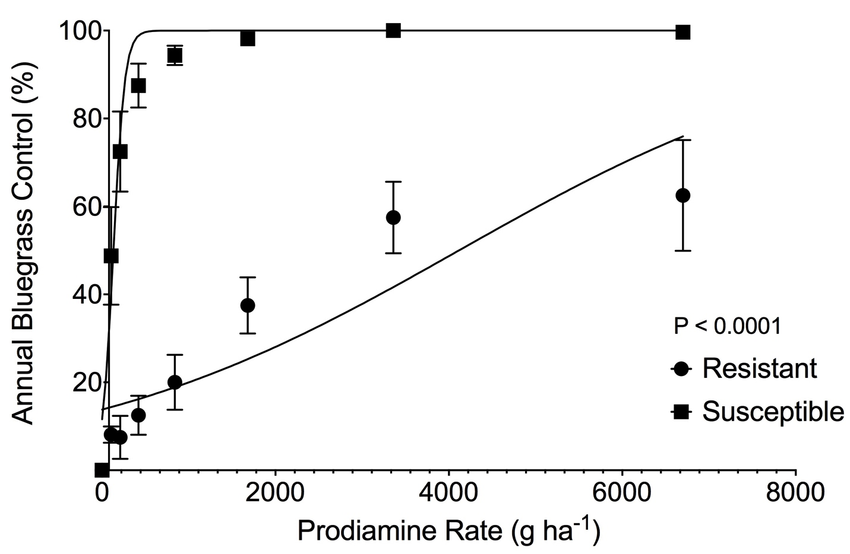Figure 1. Effect of prodiamine treatment on control of prodiamine resistant and susceptible annual bluegrass (Poa annua L.) 35 days after treatment (DAT) with prodiamine at 0, 105, 210, 420, 840, 1680, 3360, and 6720 g ha⁻¹ during spring 2015 in a glasshouse at the University of Tennessee (Knoxville, TN). Prodiamine rates resulting in 50% annual bluegrass control for the resistant and susceptible biotypes were 4117 and 132 g ha⁻¹, respectively. Error bars represent standard error of the mean.

Table 2. Non-linear regression equations modeling changes in annual bluegrass (Poa annua L.) control with increasing rates of prodiamine applied to resistant and susceptible biotypes in a glasshouse at the University of Tennessee (Knoxville, TN) in 2015. Prodiamine was applied at 0, 105, 210, 420, 840, 1680, 3360, and 6720 g ha⁻¹.

Biotype | Regression Equation | P-value
Resistant | Y = 0 + (100 – 0)/(1 + 10^{((4117 – X) * 0.0001933)}) | P<0.0001
Susceptible | Y = 0 + (100 – 0)/(1 + 10^{((131.6 – X) * 0.006701)}) | P<0.0001

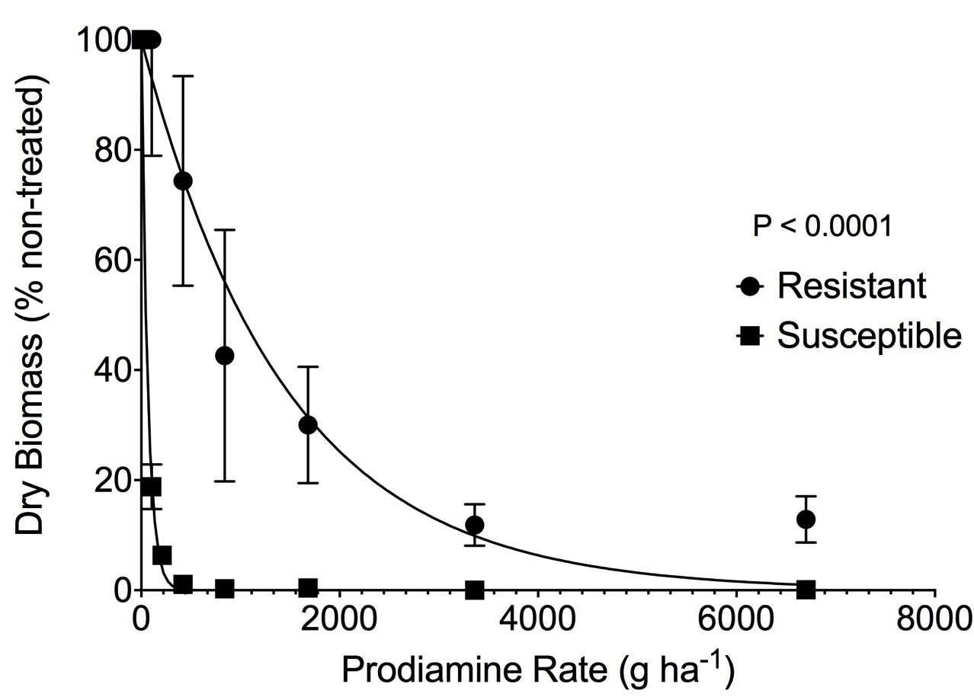

Figure 2. Effect of prodiamine treatment on dry biomass of prodiamine resistant and susceptible annual bluegrass (Poa annua L.) 35 days after treatment (DAT) with prodiamine at 0, 105, 210, 420, 840, 1680, 3360, and 6720 g ha⁻¹ during spring 2015 in a glasshouse at the University of Tennessee (Knoxville, TN). Prodiamine rates resulting in 50% annual bluegrass dry biomass reduction for the resistant and susceptible biotypes were 1006 and 45 g ha⁻¹, respectively. Error bars represent standard error of the mean.

Table 3. Non-linear regression equations modeling changes in annual bluegrass (Poa annua L.) dry biomass with increasing rates of prodiamine applied to resistant and susceptible biotypes in a glasshouse at the University of Tennessee (Knoxville, TN) in 2015. Prodiamine was applied at 0, 105, 210, 420, 840, 1680, 3360, and 6720 g ha⁻¹.

Biotype | Regression Equation | P-value
Resistant | Y = (100 – 0)*exp(–0.0006890*X) + 0 | P<0.0001
Susceptible | Y = (100 – 0)*exp(–0.0154300*X) + 0 | P<0.0001

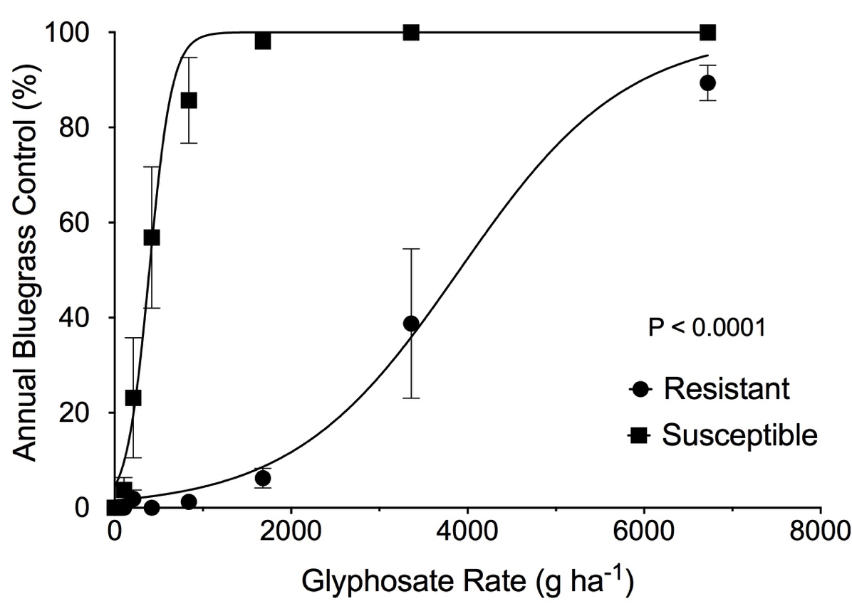

Figure 3. Effect of glyphosate treatment on control of glyphosate resistant and susceptible annual bluegrass (Poa annua L.) 35 days after treatment (DAT) with glyphosate at 0, 105, 210, 420, 840, 1680, 3360, and 6720 g ha⁻¹ during spring 2015 in a glasshouse at the University of Tennessee (Knoxville, TN). Glyphosate rates resulting in 50% annual bluegrass control for the resistant and susceptible biotypes were 3908 and 393 g ha⁻¹, respectively. Error bars represent standard error of the mean.

Table 4. Non-linear regression equations modeling changes in annual bluegrass (Poa annua L.) control with increasing rates of glyphosate applied to resistant and susceptible biotypes in a glasshouse at the University of Tennessee (Knoxville, TN) in 2015. Glyphosate was applied at 0, 105, 210, 420, 840, 1680, 3360, and 6720 g ha⁻¹.

Biotype | Regression Equation | P-value
Resistant | Y = 0 + (100 – 0)/(1 + 10^{((3908 – X) * 0.0004599)}) | P<0.0001
Susceptible | Y = 0 + (100 – 0)/(1 + 10^{((393.2 – X) * 0.0033730)}) | P<0.0001

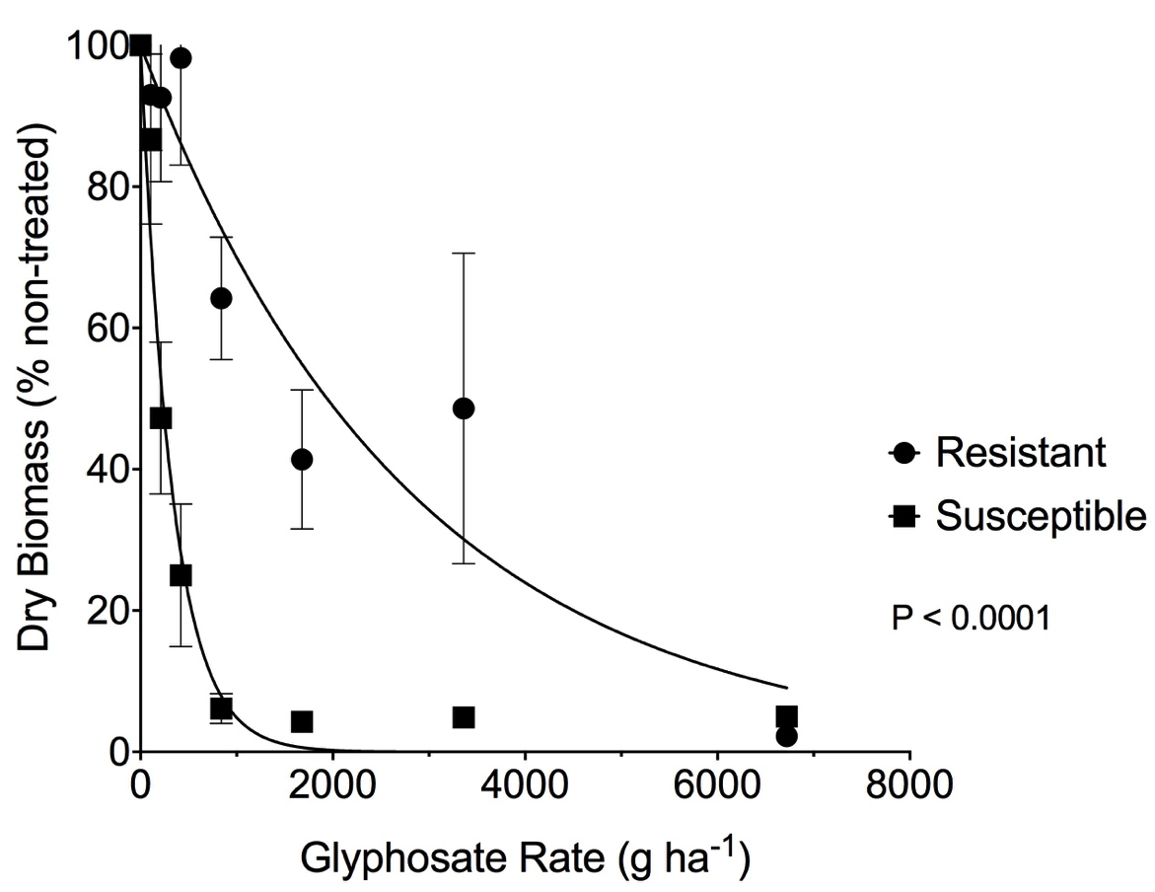

Figure 4. Effect of glyphosate treatment on dry biomass of glyphosate resistant and susceptible annual bluegrass (Poa annua L.) 35 days after treatment (DAT) with glyphosate at 0, 105, 210, 420, 840, 1680, 3360, and 6720 g ha⁻¹ during spring 2015 in a glasshouse at the University of Tennessee (Knoxville, TN). Glyphosate rates resulting in 50% annual bluegrass dry biomass reduction for the resistant and susceptible biotypes were 1940 and 229 g ha⁻¹, respectively. Error bars represent standard error of the mean.

Table 5. Non-linear regression equations modeling changes in annual bluegrass (Poa annua L.) dry biomass with increasing rates of glyphosate applied to resistant and susceptible biotypes in a glasshouse at the University of Tennessee (Knoxville, TN) in 2015. Glyphosate was applied at 0, 105, 210, 420, 840, 1680, 3360, and 6720 g ha⁻¹.

Biotype | Regression Equation | P-value
Resistant | Y = (100 – 0) * exp(–0.0003573 * X) + 0 | P<0.0001
Susceptible | Y = (100 – 0) * exp(–0.003028 * X) + 0 | P<0.0001

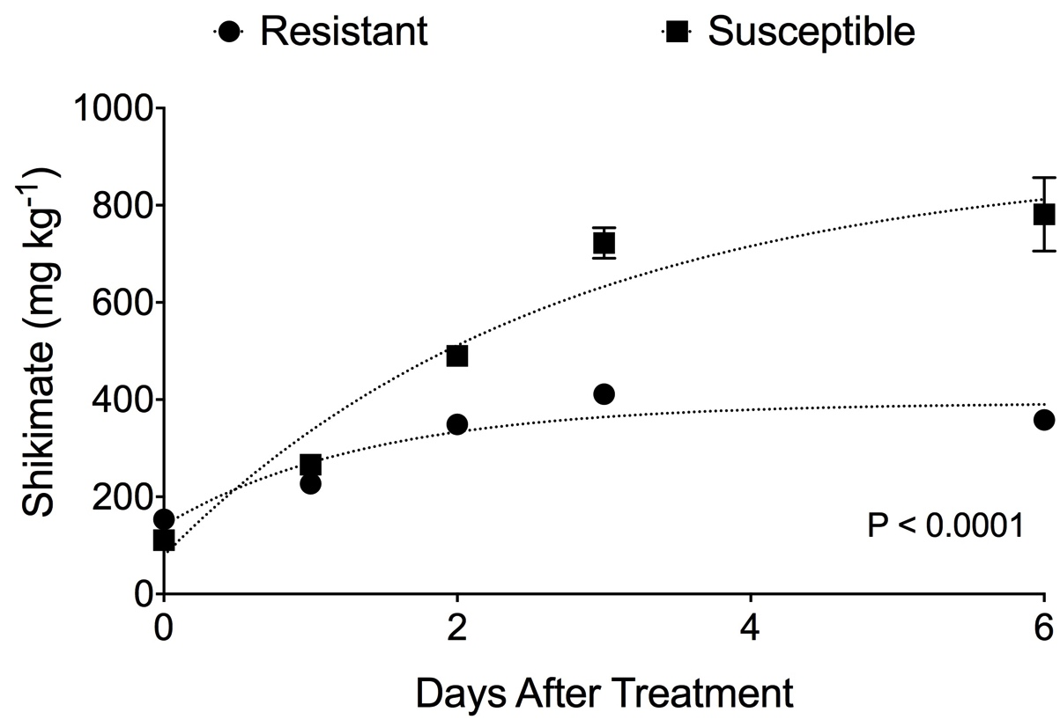

Figure 5. Shikimate concentrations (mg kg⁻¹) in glyphosate resistant and susceptible annual bluegrass (Poa annua L.) following treatment with glyphosate at 420 g ha⁻¹. Error bars represent standard error of the mean for each biotype at each timing. Shikimate concentrations in non-treated GR and SS plants were < 200 mg kg-1. Shikimate concentrations plateaued at 393.4 mg kg⁻¹ and 898.4 mg kg⁻¹ for resistant and susceptible POAAN biotypes respectively.

Table 6. Non-linear regression equations modeling changes in glyphosate resistant and susceptible annual bluegrass (Poa annua L.) shikimic acid accumulation following treatment with glyphosate at 420 g ha⁻¹ in glasshouse at the University of Tennessee (Knoxville, TN) in 2015.

Biotype | Regression Equation | P-value
Resistant | Y = 141.1 + (393.4 – 141.1) * (1 – exp(–0.7189 * x)) | P<0.0001
Susceptible | Y = 78.96 + (898.4 – 78.96) * (1 – exp(–0.3754 * x)) | P<0.0001

Table 7. Effect of prodiamine, glyphosate, and glyphosate + prodiamine applications on annual bluegrass (Poa annua L., POAAN) survival during 30 March 2015 to 13 April 2015 at Lambert Acres Golf Club (Alcoa, TN). All prodiamine treatments were applied on 19 August 2014 and all glyphosate treatments were applied on 4 February 2015.

ªAbreviations: POAAN, annual bluegrass.
^{b}Means sharing the same letter are not significantly different from one another according to Fisher’s protected LSD at the P < 0.05 level.

Treatment | N | POAANª Plants m⁻²
Non-treated | 8 | 515 a^{b}
Prodiamine | 8 | 611 a
Glyphosate | 8 | 590 a
Prodiamine + Glyphosate | 8 | 559 a

VITA

Shane Matthew Breeden was born on June 13, 1990 in Vonore, TN to Bobby and Deborah Breeden. Raised in Monroe County, TN, he attended Sequoyah High School and graduated in 2009. He went on to pursue a degree in Biology at Maryville College, graduating in 2013 with a Bachelor of Arts degree. He began pursuing his Master of Science degree in 2013 at the University of Tennessee.

