Creating and Implementing Strategies for NRHP Eligibility Assessment at the Fort Polk Military Reservation

A Thesis Presented for the
Master of Arts
Degree
The University of Tennessee, Knoxville

Matthew T. Hoover
May 2023

ACKNOWLEDGEMENTS

Thank you to: Drs. David G. Anderson, Kandace D. Hollenbach, and Anneke Janzen for their willingness to serve on my committee and for their guidance, as well as to Dr. Thaddeus Bissett, Bradley Laffitte, Thadra Stanton, and Javier Vasquez for their assistance in accessing vital material and data. I also thank the undergraduates at the University of Tennessee, Knoxville, who scanned and uploaded countless site reports to Dropbox. Thanks also go out to various friends and colleagues in the Department of Anthropology at the University of Tennessee, Knoxville, for their help and support. Finally, thank you to my fiancée Sadie, whose support and advice I cannot begin to express how thankful I am for.

ABSTRACT

Large U.S. military installations, such as the Fort Polk military reservation in west-central Louisiana, have for decades been the sites of cultural resource management (CRM) investigations, primarily due to the corpus of federal legislation developed to protect archaeological resources. These projects have yielded massive amounts of material and geospatial data and allowed researchers to develop sophisticated methodologies for analyzing site distribution, lithic tool manufacture, and many other avenues of inquiry. However, the cultural chronology represented on Fort Polk is still not well understood, and as a result assignation of National Register of Historic Places (NRHP) significance to sites on Fort Polk has to date hinged on the presence of identifiable cultural features or the presence of dense diagnostic-laden deposits. Spatially extensive sites do not necessarily yield higher artifact densities at Fort Polk; artifact diversity, however, is closely linked to assemblage size. One cannot extrapolate a site's true artifact density or diversity from a small sample size without fully testing the site. This is not only time consuming and expensive, but also detrimental to the preservationist ethic of CRM.
My thesis addresses these issues by manipulating extant databases containing information about artifacts recovered from Fort Polk. By compiling data from all test units opened at sites on Fort Polk that yielded two or more diagnostic artifacts, I created a spreadsheet that allows for an installation-wide statistical analysis of the frequencies of a given diagnostic artifact’s relative stratigraphy in relation to one or more other diagnostics. This allows for the assessment of meaningful spatial and stratigraphic relationships between diagnostic types across the installation, allowing for a more precise understanding of the cultural chronology of Fort Polk. With refined temporal control, the character of differing cultural group’s exploitation of the Fort Polk area can be better understood. Such an understanding allows for more accurate and efficient interpretations of a site and subsequent assignation of NRHP significance.

PREFACE

During the writing of this thesis, the Naming Commission, established by Congress in the 2021 National Defense Authorization Act, placed Fort Polk on a list of United States military installations named for Confederate military leaders that should be renamed. Fort Polk was originally named for Leonidas Polk, an enslaver, Episcopal bishop, and ranking officer of the Confederate States Army. In late 2022 the Commission recommended Fort Polk be renamed Fort Johnson in honor of Black Purple Heart, Distinguished Service Cross, and Medal of Honor recipient Army Sergeant William Henry Johnson, who performed acts of heroism as a member of the first African American unit of the United States Army in World War I. ‘Fort Polk’ is used throughout this thesis, as the majority of the writing was completed prior to the name change being announced, and since it is not yet officially adopted (something that will likely happen in 2023 or 2024); however, I felt it necessary to acknowledge this impending name change and state my support of it.

TABLE OF CONTENTS
1
1
3
5
7
9
11

17
17
21

26
31
33

40
40
41
50
53
57
57

61
61
62
64
82
89

92
96
97

106
106
108
109

116

118
CHAPTER ONE: INTRODUCTION………………………..........................................................
Main Goals and Chapter Contents.......................................................................................
Early NRHP Assessment at Fort Polk ................................................................................
The Nature of the Archaeological Assemblage(s) at Fort Polk...........................................
Improving NRHP Eligibility Assessment............................................................................
Comparative Analyses and Cultural Chronology................................................................
Previous Regression Analyses...........................................................................................
CHAPTER TWO: HISTORY OF ARCHAEOLOGICAL INVESTIGATION AND
CULTURAL BACKGROUND OF FORT POLK........................................................................
General Background..........................................................................................................
Early Survey and Predictive Modeling Project Investigations (1972-1988) ....................
Later Investigations and the Development of Historic Preservation Plans/Integrated Cultural Resource Management Plans (1989-present)......................................................
Temporal Conventions in Use on Fort Polk......................................................................
Archaeological Manifestations on Fort Polk.....................................................................
CHAPTER THREE: LITERATURE REVIEW/THEORETICAL GROUNDINGS AND PREVIOUS NRHP ASSESSMENT METHODS.........................................................................
Introduction.......................................................................................................................
Evaluation Standards: National Register of Historic Places Eligibility Criteria...............
The Development of NRHP Eligibility Guidelines on Fort Polk......................................
Specific NRHP Evaluation Criteria to be Employed on Fort Polk...................................
The State of Louisiana 2018 Comprehensive Archaeological Plan..................................
NRHP Evaluation Criteria from the 2019 ICRMP............................................................
CHAPTER FOUR: CREATING AND IMPLEMENTING A RELATIVE DIAGNOSTIC STRATIGRAPHY AND STRATIGRAPHIC INDICES…………………………………………………………………………………...........
Introduction.......................................................................................................................
Surovell et al. (2022) ........................................................................................................
Stratigraphic Analyses.......................................................................................................
Ceramics and the Age-In Effect........................................................................................
Potentials for New Methodologies of Determining Site Significance..............................
Regression Analyses
Number of Components vs Diagnostic Density....................................................
Volume of Fill vs Diagnostic Density...................................................................
Inconsistencies in Applications of HPP Recommendations.............................................
CHAPTER FIVE: CONCLUSIONS AND AVENUES OF FUTURE RESEARCH…………………………………............................................................................
Mapping Identifiable Cultural Components....................................................................
Social Boundaries............................................................................................................
Fort Polk as Boundary Object.........................................................................................
Potentialities of Chaînes Opératoires and Landscape Archaeology Approaches on Fort Polk..................................................................................................................................
Concluding Remarks: Operationalizing the New Methodology and Directions for Future Research...........................................................................................................................
BIBLIOGRAPHY……………………………………………………………………………..
123
149
VITA…………………………………………………………………………………………..

LIST OF TABLES

Table 3.1. Area and Volume of Fill Examined at the Five Large-Scale Data Recovery Project Sites).……………………………………………………………………………….....................45

Table 3.2. Themes from the State of Louisiana 2018 Comprehensive Archaeological Plan................................................................................................................................................57

Table 4.1. Lithic Diagnostic Occurrence and Stratification Indices in the Intensive Test Units (n=766 sites)...............................................................................................................................................65

Table 4.2. Ceramic Diagnostic Occurrence and Stratification Indices in the Intensive Test Units (n=766 sites).........................................................................................................................66

Table 4.3. Lithic and Ceramic Diagnostic Occurrence and Stratification Indices Combined in the Intensive Test Units (n=766 sites).......................................................................................67

Table 4.4. Lithic and Ceramic Diagnostic Occurrence and Stratification Indices in the 16VN18, Bayou Zourie site data recovery excavation..................................................................68

Table 4.5. Lithic and Ceramic Diagnostic Occurrence and Stratification Indices o in the 16VN24 (Big Brushy) site data recovery excavation....................................................................69

Table 4.6. Lithic and Ceramic Diagnostic Occurrence and Stratification Indices in the 16SA50 (Eagle Hill II) site data recovery excavation...................................................................70

Table 4.7. Lithic and Ceramic Diagnostic Occurrence and Stratification Indices in the 16VN791 (Beechwood) site data recovery excavation..................................................................71

Table 4.8. Lithic and Ceramic Diagnostic Occurrence and Stratification Indices in the 16VN794 site data recovery excavation........................................................................................72

Table 4.9. Lithic Diagnostics Occurrence and Stratification for lithics from sample of intensively tested sites (n = 766) with % With column separated out...........................................73
Table 4.10. Ceramics Diagnostics Occurrence and Stratification Indices for the sample of intensively tested sites (n = 766) with % With column separated out...........................................74
Table 4.11. Occurrence and Stratification Indices for all diagnostics in sample of intensively tested sites (n =766) with % With column separated out..............................................................75

Table 4.12. Diagnostics that appear out of place in the current cultural sequence for Fort Polk..80

Table 4.13. The Updated 2007 Fort Polk Cultural Sequence (Morehead et al. 2007b:30-31). Yellow highlighted types seem in place, pink highlighted types appear out of place...................85

LIST OF FIGURES
6

14

15

16

18

19

46

64

92

92

93

93

98

Figure 1.1. Locations of likely sources of lithic raw material exploited at Fort Polk.....................

Figure 1.2. Assemblage size by volume of fill excavated on Fort Polk in the intensive
site-testing assemblages, with assemblages denoted by NRHP eligibility status (n = 301). Derived from Figure 5.23 in Anderson and Smith 2003:320........................................................

Figure 1.3. Figure 1.5 – Graph showing artifact total by area and volume excavated for sample of intensively tested sites that were deemed NRHP eligible............................................

Figure 1.4. Graph showing artifact total by area and volume excavated for sample of intensively tested sites that were deemed NRHP ineligible...........................................................

Figure 2.1. Watersheds within Louisiana .....................................................................................

Figure 2.2. Archaeological site locations on Fort Polk (N=4128) in relation to the various
creeks, rivers, and watersheds of the area (Image courtesy Thaddeus G. Bissett 2022) ..............

Figure 3.1. The 2007 Cultural Sequence for Fort Polk (Source: Morehead et al. 2007b:30–31) ........................................................................................................................................................
Figure 4.1. How above, with, and below relationships and indices between diagnostics were created, using data from Test Pit N990 E1011, Site 16VN3717, found during PTA’s FP-61
series of intensive site testing excavations (Morehead et al. 2015) ..............................................

Figure 4.2. Diagnostic density’s relationship to number of components for NRHP eligible
sites in the intensively tested sites sample (n = 99 sites) ..............................................................

Figure 4.3. Diagnostic density’s relationship to number of components for NRHP ineligible
sites in the intensively tested sites sample (n =154 sites) .............................................................

Figure 4.4. Diagnostic density’s relationship to volume excavated for NRHP eligible sites in the intensively tested sites sample. (n = 99 sites) .........................................................................

Figure 4.5. Diagnostic density’s relationship to volume excavated for NRHP ineligible sites in the intensively tested sites sample (n = 154) ............................................................................

Figure 4.6. Diagnostic density’s relationship to fill volume excavated for NRHP eligible sites in the intensively tested sites sample with five outlier sites removed (n=94 sites) ......................
Figure 4.7. Diagnostic density and number of components’ relationship to volume excavated for NRHP ineligible sites in the intensively tested sites sample with four outlier sites removed (n = 150 sites) ...............................................................................................................
98

106

Figure 5.1. Map showing the location of every site with 0 identifiable cultural components (Image courtesy Thaddeus G. Bissett 2022) ...............................................................................

Figure 5.2. Flowchart depicting the operationalization of the RDS table and stratification indices methodologies..................................................................................................................119

ATTACHMENTS

Appendices A through I (appendicesforMTHThesisrevisions1-17-23.pdf) – These are referenced in the text of the manuscript and can be accessed by emailing the author. They provide supplementary information for the various tables and figures in the text of this thesis manuscript.

CHAPTER ONE
INTRODUCTION
Main Goals and Chapter Contents

The Joint Readiness Training Center (JRTC) and Fort Polk military installation (shortened hereafter to Fort Polk), located in Vernon, Sabine, and Natchitoches Parishes, south-central Louisiana, has seen several decades worth of Cultural Resource Management (CRM) based archaeological investigation, yielding an immense amount of site and artifactual data. However, this enormous repository of information has to date not been assessed to its fullest extent in efforts to refine the local cultural sequence or to assess National Register of Historic Places (NRHP) eligibility of sites on the installation. Up to this point, only comparatively small site and artifact samples have been used in conducting such efforts (Anderson and Smith 2003). This thesis demonstrates a new methodology for refining the local cultural sequence and rendering more efficient the assessment of NRHP eligibility, using the entire installation cultural resource inventory. This approach should be of great value, not only for assessing sites on Fort Polk, but also on other state or federal installations with similarly large databases. This methodology uses a much larger sample of sites and artifacts than has previously been implemented and incorporates inter-site and inter- and intra-assemblage comparison strategies to demonstrate both how pre-existing site and artifactual data can be re-analyzed as well as how NRHP eligibility assessment can be improved. This work was conducted as part of new synthesis of Fort Polk archaeology, and the analyses and reporting conducted here are a fundamental part of that effort (Anderson et al., eds. 2022; Hoover et al. 2022a, 2022b).
This thesis consists of five chapters, a set of data appendices containing the information used in the analyses herein, and a bibliography. Chapter One explores the need for a more refined understanding of the cultural chronology for Fort Polk so as to better make determinations of NRHP eligibility. In this chapter I also outline my strategy for addressing cultural chronology, which consists primarily of analyzing installation-wide assemblage area and diagnostic artifact incidence data (compiled over the summer and fall of 2021), and then developing a table listing stratigraphic relationships among the diagnostics recovered from individual excavation units. I also describe an analysis conducted on the assumed correlation between large, dense sites and NRHP eligibility, showing that this assumption is not always warranted, and that consideration of additional eligibility criteria are needed.
Chapter Two provides background information on the precontact and historic periods of the Fort Polk area, as well as about the previous archaeological work done on Fort Polk and the impetus for this work. There has been substantial research done on the precontact and historic periods of the area to date, which informs my thesis by providing contextual and corroborative information. Chapter Three elaborates on how previous archaeological researchers have gone about assigning NRHP eligibility, with an emphasis on what can be improved with their approaches, namely the use of stratigraphic data from tested sites to obtain a finer-grained understanding of the cultural chronology present, and the extent of disturbance to it.
Chapter Four is primarily concerned with methodology and discusses how and why the relative diagnostic stratigraphy table and stratigraphic indices were created. This chapter also shows how to improve NRHP eligibility determinations for sites located on Fort Polk, as well as the utility of using relative diagnostic stratigraphy analyses on other installations that have large databases of archaeological material. I demonstrate how this approach could reduce the volume needed to be excavated in order to ascertain the cultural chronology of a given site. Given large artifact assemblages are needed to accurately determine the artifact diversity at a given site on Fort Polk, the proposed method could provide another means of deriving assemblage diversity values. Chapter Five concludes this thesis, reiterating how the method of relative diagnostic stratigraphy tabulation and spatial analyses could be used to achieve a more fine-grained understanding of the cultural chronology present on the Fort Polk military reservation, and assist with the justification of NRHP eligibility determinations.
Early NRHP Assessment at Fort Polk
In brief, the earliest cultural resource management (CRM) projects undertaken at Fort Polk premised much of their assessment of NRHP eligibility of sites on the presence or absence of intact cultural components and “culture-diagnostic descriptive morphological types” (Servello 1983:109). In the context of pre-contact North American archaeology, many sites associated with Native peoples are considered eligible for the NRHP under Criterion D of 36 CFR 60, which states that sites which may contribute to better understanding of life in the past are NRHP eligible (U.S. Department of the Interior 1997:25). Prior to the issuing of Executive Order 11593 by President Richard M. Nixon, very little archaeological work of any kind had been done on Fort Polk due to a lack of monumental architecture and the area’s reputation as being generally inhospitable. However, the issuing of that Executive Order, which mandated the complete inventory survey of all federal lands for cultural resources as an extension of the National Historic Preservation Act of 1966, sparked an explosion of federal and state funded CRM projects on the installation. Due to the paucity of previous investigations, much of the early work was oriented towards establishing the cultural chronology of the area and identifying those sites that could yield more data upon further investigation in order to satisfy Criterion D of the NRHP. Thus, excavated sites that yielded discrete, intact cultural deposits with diagnostic material were often assessed as NRHP eligible. This approach was entirely valid given the lack of previous research in the area. However, in time it would prove to be problematic, as more and more intensive site testing and large-scale data recovery occurred, showing that the Fort Polk area was primarily a target of brief resource extraction visitations by many different precontact groups, with little evidence found for sustained habitation (Anderson and Smith 2003:13-14; Gunn 1982a, 1984).
To accommodate the multiple insights and perspectives on the archaeology of Fort Polk developed over the past decades, the criteria for determination of NRHP eligibility were listed in the 2019 Integrated Cultural Resource Management Plan (ICRMP), authored by base archaeologists Bradley Laffitte and Craig Dengel (2019) and adopted from the 1999 Historic Preservation Plan (HPP) for the installation outlined in the JRTC and Fort Polk Historic Preservation Plan: Cultural Resources Action Plan/Planning Manual (Anderson and Smith 1999:46-55, Appendix A herein). These documents instruct archaeologists working on Fort Polk to adhere to the four published criteria found in 36 CFR Part 60: A) association with a significant historic event; B) association with a historic individual of significance; C) exemplary of rare, unique, or distinctive methods of construction, craft, or artistic style; and D) a potential source of future research. Eligibility also is indicated if identifiable cultural features, one or more discrete stratigraphic deposits with multiple components each containing three or more diagnostic artifacts, and an overall density of 100 artifacts per cubic meter are found (Laffitte and Dengel 2019:78-80).
Calculation of artifact density utilizing the method developed in early HPP work (Anderson and Smith 1999:51, 2003:101-104) remains a prominent tool of assessment, as does the recognition of a site’s potential to contribute to future research. Kubiak and colleagues state that:
“[b]oth NSA [New South Associates] (Vasquez et al. 2018:25-32) and PTA [Prentice Thomas and Associates] (Morehead et al. 2016) organize research goals with respect to Pre-Contact and Post-Contact sites as well as by broad theme or hypothesis. These patterns are likely a reflection of the organization provided by Anderson and Smith (2003), previous versions of the Louisiana Archaeological Preservation Plan (Girard et al. 2018) and Fort Polk preservation plans” (Kubiak et al. 2021:29).
It is important to note that examining how artifact density is calculated and then used to assess a site has been conducted by other researchers, namely Gregory and Vasquez (2017:51). Gregory and Vasquez (2017:51) argued that it is better to use only the thickness of a given unit’s cultural deposit when calculating artifact density instead of total depth below surface the entire unit was taken. Using the 1999 HPP’s procedures arguably underrepresents the densities of discrete components, which may only occur in a few centimeters of a deep unit. For the purposes of this thesis, I have used Anderson and Smith’s (1999:51) method of calculating density, as I am interested in analyzing total volume excavated and ways to potentially reduce that volume.
The Nature of the Archaeological Assemblage(s) at Fort Polk
The main resource being exploited during pre-contact times at Fort Polk was lithic material, primarily chert. Chert gravels occur widely on Fort Polk, eroding out of the local Catahoula and Fleming geological formations and that may have also been alluvially transported from deposits in East Texas, Oklahoma, Arkansas, and Missouri (Figure 1.1). These were deposited as surficial gravels, and then sought out and utilized by myriad pre-contact Native groups (Heinrich 1983, 1984:175). In a regional analysis of stone sources, Banks (1990:165) has asserted that the Gulf Coastal Plain west of the Mississippi River is largely devoid of lithic
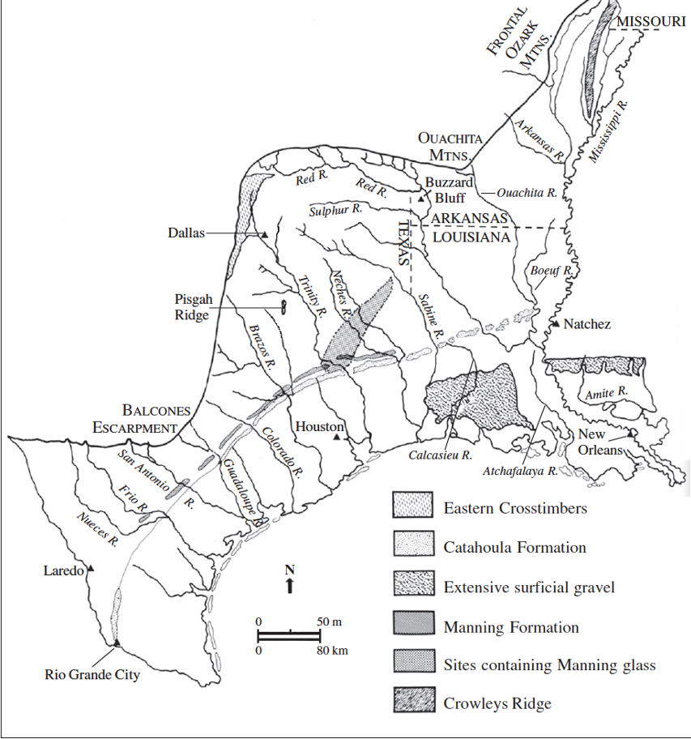
Figure 1.1 – Locations of likely sources of lithic raw material exploited on Fort Polk (from Banks 1990:48).

material suitable for knapping. Consequently, sites encountered at Fort Polk represent palimpsests of numerous distinct cultural groups visiting the area for brief periods of time, with little beyond typically small numbers of diagnostic lithic and ceramic artifacts to differentiate them (Anderson and Smith 2003: 47, 132; Cantley et al. 1997: 877-921; Gunn 1982d: 326-343). Indeed, Campbell and Weed (1986: 4-2) cite Jolly’s (1983:1) assessment of west-central Louisiana as a sort of cultural crossroads where different pre-contact populations interacted. Projects like the 1983-1984 Commonwealth Associates Site-Testing Program (Cantley and Kern 1984), New World Research’s 1986-1987 survey and testing projects (Campbell and Weed 1986; Campbell et al. 1987), and the 1995-1996 New South Associates, Inc., large-scale survey (Cantley et al. 1997) deployed intrasite (or intercomponent), intersite, and interassemblage comparative strategies in an attempt to answer questions about variability and change in resource procurement, technological productions strategies, mobility strategies, and site location probability. More recently, Morehead and Laffitte (2014) performed comparative analyses examining the distribution of all varieties of San Patrice dart points on the installation and their associated assemblages. The last major synthesis of archaeological investigation prior to the current effort underway, by Anderson and Smith (2003), also incorporates comparative analyses that examine area and volume excavated at all sites up to the time of that publication’s writing; these analyses are updated herein, as discussed below.
Improving NRHP Eligibility Assessment
In this thesis I build upon the insights gained and methods used by previous investigators at Fort Polk to (1) refine the cultural sequence and chronology for the installation, and (2) update criteria by which NRHP eligibility is determined for installation properties. Given that chronology greatly informs NRHP eligibility by allowing for the dating and cultural identification of individual assemblages, elucidating both the strengths and weaknesses inherent in assigning NRHP eligibility is important. Here, how much a site can contribute (or does not contribute) to understanding the area’s cultural chronology is examined by looking at the stratification evident among diagnostics and, from that, the likely amount of disturbance present. I argue that by first creating a database listing the probability with which certain diagnostic artifacts occur relative to other diagnostic artifacts stratigraphically across the installation is a means by which the extent to which a site adds to the pre-existing knowledge can be done more efficiently. Such an analysis is conducted here, using the hundreds of tested site assemblages obtained to date on Fort Polk.
The archaeological assemblage on Fort Polk is a palimpsest, created by countless visits of short duration by numerous precontact groups spanning millennia who left behind little evidence of their presence beyond lithic scatters and the occasional potsherd. Dividing up the cultural sequence into phases or periods of use or occupation can thus sometimes be problematic, given that the peoples and time periods represented by the material culture encountered on Fort Polk overlapped both geographically and temporally. The research presented in this thesis project aids in ameliorating this problem by examining the spatial and stratigraphic relationships of diagnostic artifacts derived from individual test units taken collectively across the entire installation. These data are then compared with similar analyses conducted at five sites within Fort Polk where large-scale data recovery excavations have occurred. Such analyses have not previously been performed on Fort Polk or any other similarly intensively examined installation in the United States. Adopting such a methodology has helped to evaluate and refine the extant cultural chronology of Fort Polk to such a degree as to improve determinations of the cultural chronology represented at any given site, and how useful that site assemblage could be to refining that sequence and chronology, which in turn expedites NRHP eligibility assignment.
This thesis can in many ways be considered Morehead and Laffitte’s (2014) analysis of San Patrice assemblages writ large, at least as far as evaluating the cultural sequence is concerned. These authors examined the manifestation of all varieties of San Patrice dart points on Fort Polk by compiling data concerning the geospatial distribution and depth of recovery of this Late Paleoindian/Early Archaic lithic series, ultimately solidifying the chronology of the varieties of San Patrice that occur on Fort Polk in addition to identifying large-scale patterning of where San Patrice points tend to be found on the installation (Morehead and Laffitte 2014:23-24, 33-34, 43-44, 59-62). The analysis presented here goes one step further by demonstrating how data from sites bearing diagnostic material can be collated in a living database that displays in the aggregate how reliably certain diagnostics occur above, in the same level as, or below another diagnostic. Being able to compare an individual site’s assemblage to such a database would provide a means of quantitatively assessing the degree to which a site’s assemblage could contribute to improved understanding of the archaeology of Fort Polk and satisfy Criterion D of the NRHP.
Comparative Analyses and Cultural Chronology
All the above being said, the cultural chronology of indigenous occupations in the Fort Polk area, while advanced and updated on numerous occasions over the past 50 years, remains incomplete, which adds an element of uncertainty to every determination of significance. The intensity with which an area as relatively small as Fort Polk has been archaeologically investigated has made the installation a unique laboratory for assessing how NRHP eligibility has been and is currently being determined by both academic and private CRM archaeological organizations both locally and over the region. The extremely high resolution made possible by the excavation of large amounts of archaeological material in a relatively small area has in turn allowed archaeologists to develop sophisticated methods for determining changes in lithic reduction strategies, number of site components, inter- and intra-site artifact density, and purpose or type of a given archaeological site (the history of such research was summarized in Anderson and Smith 2003:24-169, and most recently in Anderson 2022a, 2022b (see also Chapter 2 herein). As has been stated, such methodologies are in keeping with the recommendations of the 1999 HPP (Anderson and Smith 1999: iv-v, 46-55).
However, the 1999 HPP and 2003 synthesis call for comparative analyses to support any and all determinations of NRHP eligibility, and while this has been done to some extent, an installation-wide comparative analysis of the relative stratigraphy of lithic and ceramic diagnostics like that conducted here had yet to be undertaken. As Cantley et al. (1997) and Anderson and Smith (2003:133) have noted, systematic survey-level investigation will not provide the level of resolution needed to refine the cultural chronology. While large block excavations or close-interval shovel testing of single component sites could potentially aid in this endeavor, the level of disturbance, not to mention the cost, of excavations are high, and make consideration of alternative approaches like those taken here worth considering. While five major data recovery excavations have been undertaken to date on Fort Polk, the area examined is only a tiny fraction of that excavated in the intensive site testing program undertaken over the last 40 years.
By compiling stratigraphic data from both the five large data collection projects (16VN18, 16VN24, 16SA50, 16VN791, and 16VN794) as well from test units (50 by 50 cm, 1 by 1 m, or any other irregular dimension) from a sample of 766 intensively tested sites that yielded two or more diagnostic artifacts, and then describing each artifact in a standardized format that lists every other diagnostic artifact that occurs above, below, or within the same 10 centimeter level, I compiled a searchable table or spreadsheet that allows for an installation-wide analysis of the frequencies of a given diagnostic artifact’s ‘relative stratigraphy’ in relation to one or more other diagnostics. This relative diagnostic stratigraphy (RDS) table was in turn used to create stratification indices for all the diagnostics encountered in the sample of tested sites (i.e., the frequency with which a given diagnostic type occurs above, with, or below another diagnostic type in this sample).
Myriad spatial and stratigraphic relationships between many of the more ubiquitous diagnostic types were demonstrated by the RDS table and stratification indices generated in this thesis, which facilitated the interrogation of the cultural chronology currently in use on Fort Polk. A more precise understanding of the cultural chronology of Fort Polk has been elucidated, and the potential for better understanding the volume, repetitiousness (or lack thereof), and intensity of a given cultural group’s exploitation of the Fort Polk area has also been demonstrated. These indices are also a test of disturbance, or how mixed a site’s deposits might be, that is, if a site assemblage has indices that deviate significantly from those found over the installation, there is a high likelihood that the site is disturbed.
Previous Regression Analyses
An alternate procedure already in use on Fort Polk that the relative stratigraphy approach advanced in this thesis supplements are regression analyses examining site artifact density and diversity by area and volume excavated (Figures 1.2, 1.3, and 1.4). These regression analyses use excavation area, excavation volume, and assemblage incidence as units of analysis, instead of the spatial and stratigraphic relationships indicated by the stratification indices. Figures 1.3 and 1.4 constitute an update of the 2003 regression shown in Figure 1.2, using a much larger sample size of 638 tested sites as opposed to the 301 sites used in the 2003 analysis (see Appendix B for the data used in this updated regression calculation). Figure 1.2 compares the volume (in cubic meters, or m³) excavated at intensively tested sites to the number of total artifacts recovered; the low r and R² values generated demonstrate a weak correlation between the two independent variables (volume and total artifacts), and thus the variation of the dependent variable (NRHP eligibility status) is not meaningfully impacted by independent variables.
Figures 1.3 and 1.4 show that for both NRHP eligible and ineligible sites, area excavated, and number of artifacts recovered are weakly correlated. Thus, a heavily tested site will potentially yield higher artifact densities on Fort Polk. However, what this updated regression analysis shows is that one cannot reliably extrapolate a site’s overall artifact density from a small sample size. However, as larger, denser sites tend to be deemed eligible, while smaller, less dense sites tend to be deemed ineligible, conference of NRHP eligibility might come to depend on extensive excavation and lead to partial or complete destruction of sites if artifact density alone continues to be an important measure of eligibility, as it is at present.
The results of this thesis project also demonstrate that while there is a high degree of variability in the likelihood of certain diagnostics occurring above, with, or below other diagnostics, clear stratigraphic relationships have been observed that will aid in more efficient interpretations of a site’s temporal and cultural context(s). Linking a temporally well-identified cultural group to specific mobility patterns, resource exploitation strategies, and other research questions is important to understanding the past, and to assessing a site’s significance to address such questions. In the next chapter, I elaborate on how National Register of Historic Places eligibility has previously been assessed on Fort Polk as well as specific methods for improving assessment.

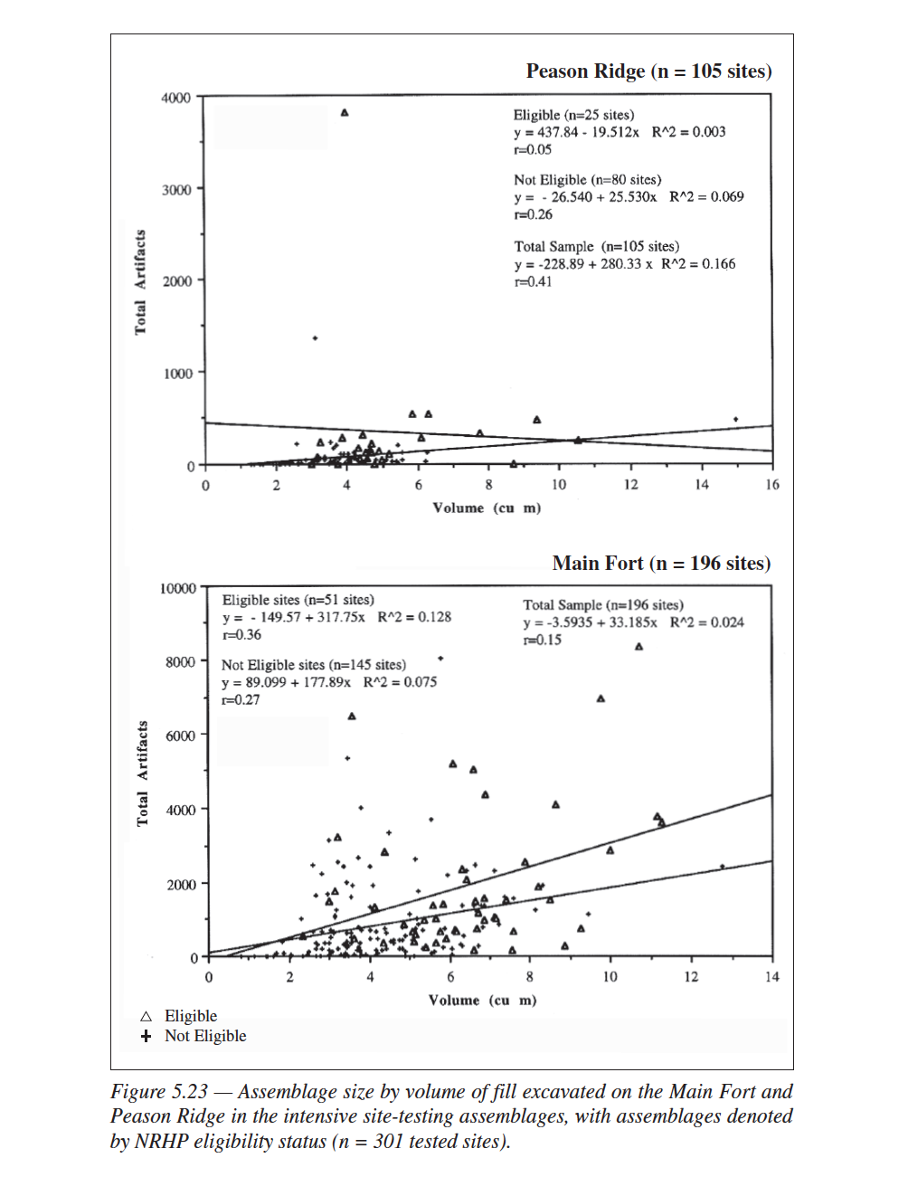
Figure 1.2 – Assemblage size by volume of fill excavated on Fort Polk in the intensive site-testing assemblages, with assemblages denoted by NRHP eligibility status (n = 301). Derived from Figure 5.23 in Anderson and Smith 2003:320.

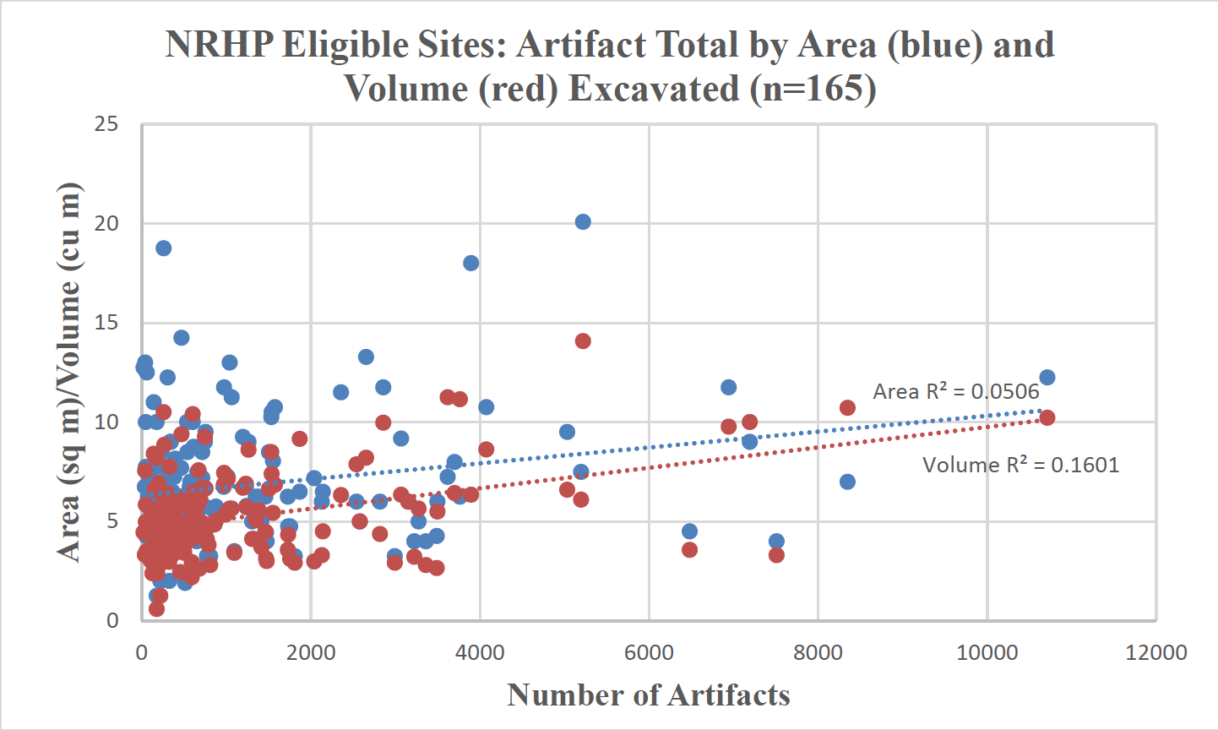
Figure 1.3 – Graph showing artifact total by area and volume excavated for the 2022 sample of 165 intensively tested sites that were deemed NRHP eligible. (Source: Hoover et al. 2022b:295)

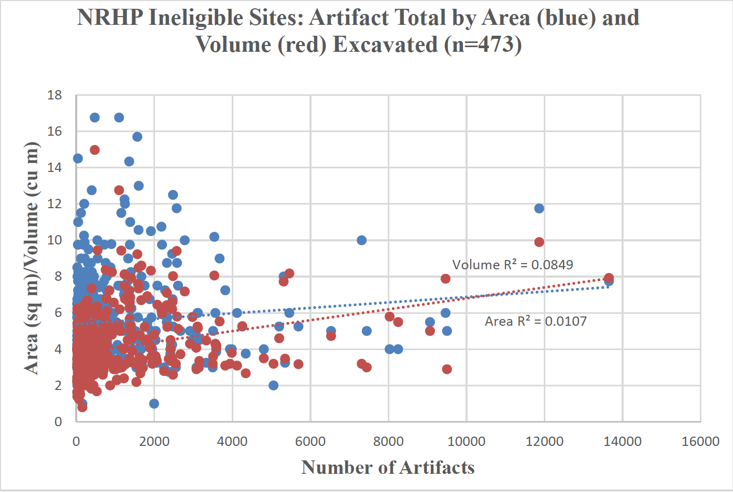
Figure 1.4 – Graph showing artifact total by area and volume excavated for the 2022 sample of 473 intensively tested sites that were deemed NRHP ineligible. (Source: Hoover et al. 2022b:295)

CHAPTER TWO
HISTORY OF ARCHAEOLOGICAL INVESTIGATION & CULTURAL BACKGROUND OF FORT POLK

General Background
To further contextualize the Fort Polk installation’s archaeological assemblage(s), this chapter provides extensive background information on both the history of archaeological investigation on Fort Polk as well as a summary of the cultural chronology and history of local pre-contact peoples. The United States Army’s Fort Polk military reservation, located in Vernon, Sabine, and Natchitoches parishes in south-central Louisiana, is adjacent to the town of Leesville and approximately 30 miles east of the Sabine River, the geographic and administrative boundary between Louisiana and Texas. Although in proximity to the confluence of several large drainage basins (Figure 2.1), the Fort Polk military reservation is located primarily within or adjacent to numerous smaller watersheds (Figure 2.2). A large proportion of sites on Fort Polk are located along water courses, facilitating the movement of both peoples to and raw materials from the environs of Fort Polk.
The Fort Polk military reservation has been in operation since 1941 and was constructed in response to the escalating conflicts in Europe and the Pacific (Kane and Keaton 2004). The installation presently conducts training maneuvers on approximately 240,786 acres, or 0.72% of the estimated 33.52 million acres that comprise the entire state of Louisiana. A large number of archaeological investigations conducted by both academic and cultural resource management (CRM) practitioners have occurred on the property owned or utilized by the installation relative to the rest of the state over the past several decades. A synthesis of this work has been developed, by David G. Anderson, Thaddeus G. Bissett, and myself (Anderson et al., eds., 2022), and this
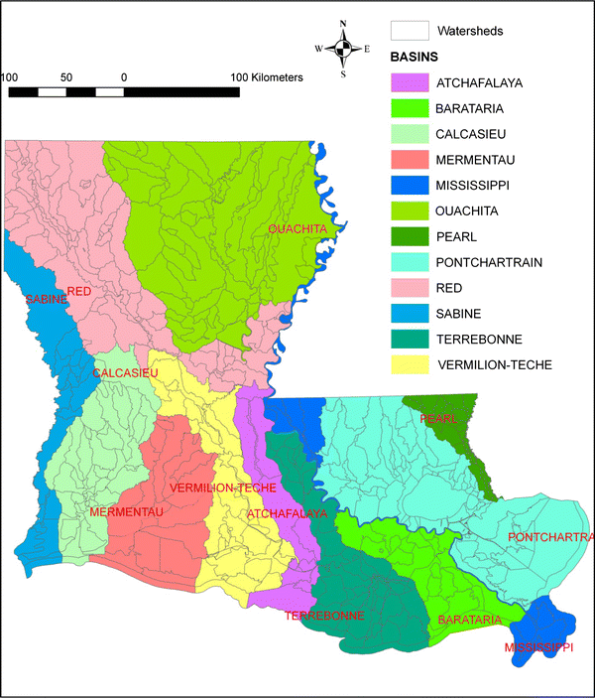
Figure 2.1 – Watersheds within Louisiana (from Zhong and Xu 2009)

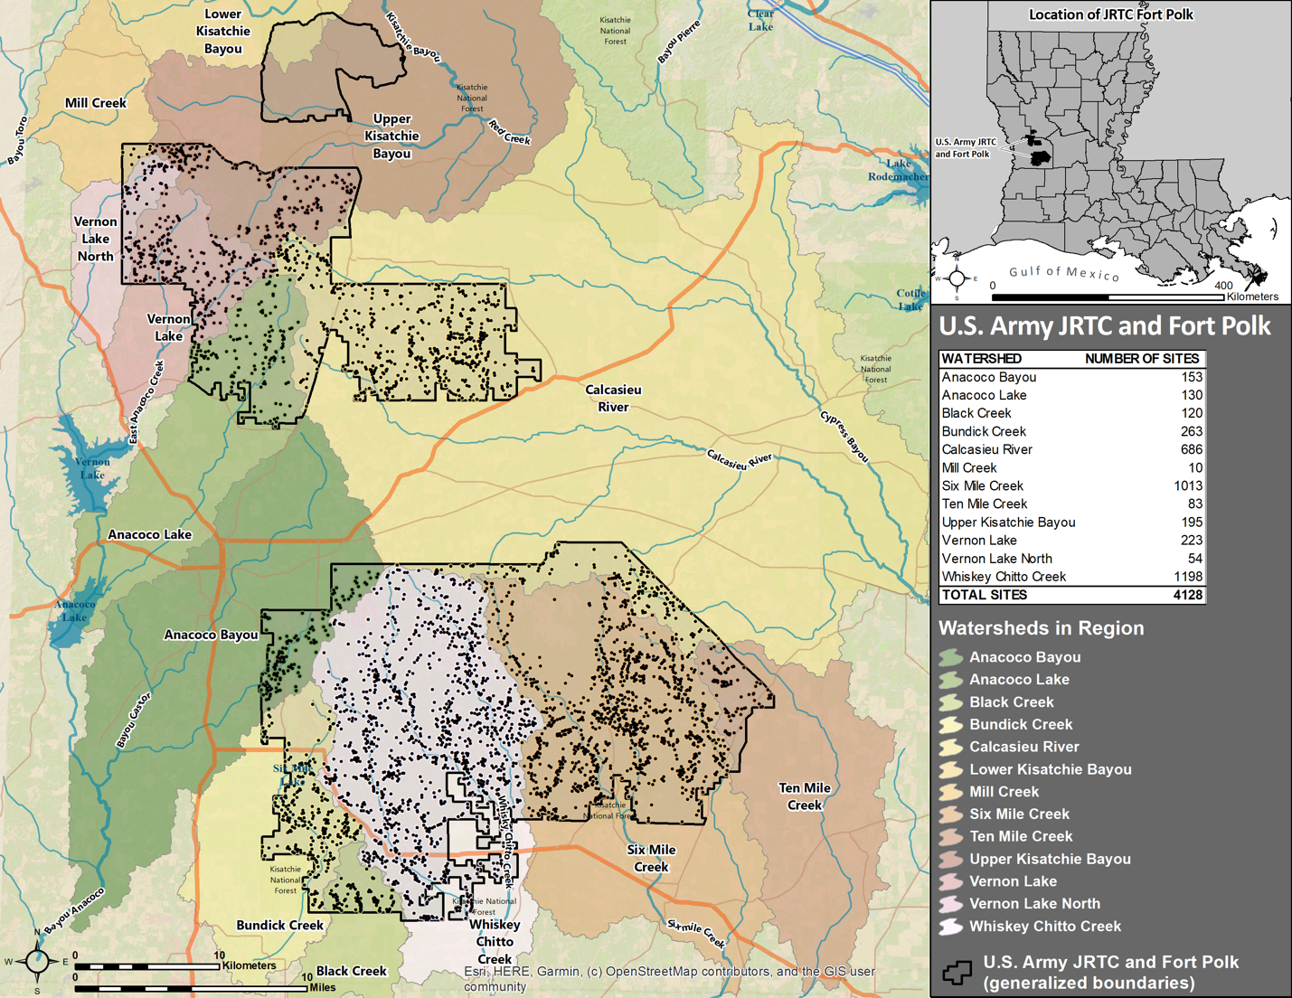

Figure 2.2 – Archaeological site locations on Fort Polk (N=4128) in relation to the various creeks, rivers, and watersheds of the area (Image courtesy Thaddeus G. Bissett 2022).
thesis is a part of and was supported by that effort (namely, my work focusing on the stratification analyses reported herein, and the analyses supporting the updated NRHP eligibility criteria) (Hoover 2022a, 2022b). Anderson and Smith (2003:24) pointed out that multiple factors have contributed to the large number of archaeological investigations at Fort Polk, including the installation’s status as an active United States Army facility and thus being subject to the mandates of federal environmental protection legislation, including the National Historic Preservation and Archeological Resources Protection Acts (NHPA and ARPA, respectively). Additionally, an ongoing land expansion plan proposed by the installation in 2008 and initiated in 2012 has necessitated even more CRM survey and mitigation. Consequently, a massive amount of precontact artifact assemblage data has been amassed from Fort Polk’s environs, representing numerous Native groups. I postulate that such an enormous and well-studied locality could serve as an ideal laboratory to interrogate the multiple methods deployed in the assignment of National Register of Historic Places (NRHP) eligibility status to archaeological sites, and aid in developing a strategy to identify more efficient methods.
As of January 2022, 4,128 archaeological sites and 2,010 isolated finds and small artifact scatters have been documented on Fort Polk, the result of hundreds of individual Phase I, II, and III cultural resource management projects that have been undertaken on Fort Polk over the past 50 years (Anderson 2022b:26-91, and Anderson and Smith 2003:24-113) provide comprehensive histories of these numerous archaeological investigations, along with detailed discussions of the importance of each investigation to the overall understanding of the archaeological character of the installation. Anderson (2022b:28-32) also provides a detailed listing all the cultural resource-related projects (more than 250) that have taken place on the installation from 1972 to the present, providing each project’s associated State Historic Preservation Office report number, the year it was conducted, and what type of project it was. Presented here is a brief chronological overview of the history of archaeological investigation on Fort Polk utilizing the sub-periods and organizational scheme from Anderson et al., eds. (2022) and Hoover et al. (2022a, 2022b).
Early Survey and Predictive Modeling Project Investigations (1972-1988)
As was stated in Chapter 1, the earliest CRM projects undertaken at Fort Polk, which began in the 1970s, were oriented towards compliance with Section 106 and Section 110 of the National Historic Preservation Act. Consequently, efforts were directed towards understanding landscape use, site location, and which cultural groups were represented by the archaeological assemblage of the installation. As a result, investigators during this time premised much of their assessment of NRHP eligibility of sites on the presence or absence of intact cultural components and the presence or absence of “culture-diagnostic descriptive morphological types” (Servello 1983:109). Sites that yielded discrete, intact cultural deposits with diagnostic material were privileged. Anderson (2022b:34) also notes that the development of predictive models for locating sites was also prioritized, as the installation even at that time was enormous and had not yet seen much systematic survey.
The 1972 Diamond Ore Test Area Survey, led by Hiram F. Gregory and H.K. Curry of the United States Forest Service (USFS), was the first CRM project undertaken on Fort Polk. It was a walkover survey performed in the Peason Ridge area, with no subsurface disturbance performed (Anderson and Smith 2003:27; Anderson 2022b:36). The 1976-1979 Fort Polk Archaeological Survey (FPAS), led by Frank A. Servello of the University of Southwestern Louisiana (USL), examined 10,600 acres, or about 5% of the installation at the time, and was the first of a series of large-scale archeological surveys on Fort Polk. The FPAS was instrumental in the development and systematic implementation of predictive modeling of site location. Importantly, it was also the first project to recognize the Eagle Hill locality in the Peason Ridge sector as a site of intensive use and reoccupation, especially during the Paleoindian and Archaic periods (Anderson and Smith 2003:29; Anderson 2022b:36; Servello and Bianchi 1983:390-403).
Numerous other survey and site-testing projects occurred from the 1970s through the late 1980s. The 1980 Bayou Zourie Terrain Analysis and Settlement Pattern Survey was undertaken by Environmental Cultural Services, Inc., who performed survey and predictive modeling analysis of ca. 800 acres along the Bayou Zourie drainage (Jolly and Gunn 1981). Additionally, investigators developed a “colluvial/clay interface” predictive model for site locations, which predicted that sites on Fort Polk would be located at the interface of sand/colluvial surface deposits and underlying Miocene clays due to the presence of natural springs and seeps located along said interface (Anderson and Smith 2003:41; Gunn 1982c; Guy and Gunn 1983; Jolly and Gunn 1981). The 1981 New World Research Sample Survey, a Phase I survey of ca. 8,096 acres on the Main Fort and Peason Ridge components of the installation, was the first systematic effort to evaluate whether deeply buried archaeological sites occur within the environs of Fort Polk (Anderson and Smith 2003:47; also see Lenzer 1982:4-49). Various predictive models for probable site locations were also evaluated, and the investigators proposed that site size and type was correlated with distance to knappable stone (Anderson and Smith 2003:47-48; Thomas et al. 1982).
The 1982-1983 Eagle Hill Locality Site-Testing Program, performed by the Center for Archaeological Research at the University of Texas, San Antonio, intensively tested 56 sites and isolated finds in the area immediately around Eagle Hill on Peason Ridge (Gunn and Kerr 1984). These sites and isolated finds had been previously identified by other investigations and were explored via a combination of shovel testing and limited test unit excavation (Anderson and Smith 2003:49-50). The investigators examined precontact land use in the vicinity of Eagle Hill, finding that sites on ridgetops such as Eagle Hill may have been “lookouts . . . or landmarks” for staging resource acquisition elsewhere in the area, as they contained very dense cultural components in an otherwise sparsely inhabited landscape (Anderson and Smith 2003:49-51; Gunn and Kerr 1984:171; Kerr 1984:127).
The 1983-1984 Commonwealth Associates Site-Testing Program was performed from October 1983 through January 1984 and was led by Charles E. Cantley (Cantley and Kern 1984). In addition to assessing the hypothesis that a shift from foraging to collecting strategies occurred during the Late Archaic on Fort Polk, this testing program also undertook one of the first large-scale comparative analyses of cultural material from Fort Polk. The investigators examined all pre-contact ceramics recovered up to that point, after which they asserted that Fort Polk had been visited by numerous groups from all across the surrounding region (Anderson 1984; Anderson and Smith 2003:51-53; Cantley and Kern 1984).
The Kisatchie Regional Environmental Management Group conducted numerous small-scale surveys from 1984 to 1986, led Frank Servello and other archaeologists (Servello 1984a, 1984b, 1985a, 1985b, 1985c, 1985d, 1985e, 1986), locating several sites, including several rediscovered by the 1985 Multipurpose Range Complex (MPRC) Survey (Campbell and Weed 1986; Anderson and Smith 2003:63). The 1985 MPRC Survey assessed 17,275 acres surveyed via Phase I pedestrian walkover and systematic shovel testing methods, with larger test units opened in certain places as well. This project produced a detailed cultural sequence for the installation and its environs and provided strong evidence in support of the argument that there was only limited use, and probably no permanent settlement/habitation on Fort Polk during the Woodland and Caddoan/Mississippian periods. Further, the 1985 MPRC survey provided evidence of an orientation towards floodplains along the smaller streams that characterized the area, that were typically ranked 5 or 6 within Strahler’s (1957) stream classification system (i.e., are four to five tributaries removed from a river whose mouth empties into a sea or ocean). These investigations also indicated that there were differences in site location between the Archaic, Woodland, and later periods, suggesting changes in land use were occurring (Anderson and Smith 2003:54-59; Campbell and Weed 1986).
The 1986 Multipurpose Range Complex (MPRC) Intensive Testing Project used Phase II methodology (i.e., dispersed 1 m or larger test pits) to investigate 20 sites tested along or near Birds Creek (Campbell et al. 1987). Two of these sites, 16VN791 and 16VN794, later were the subject of the last two of the five large-scale data recovery excavations undertaken to date on Fort Polk. Investigators also found evidence for a high degree of reworking of lithic tools and the creation of numerous expedient tools. Additionally, the results of this project further corroborated the assumption that ceramics are largely absent from Fort Polk and not just under-represented due to poor preservation, and when they are encountered, they tend to be utilitarian wares (Anderson and Smith 2003:59-63; Campbell et al. 1987:20, 91, 104).
The R. Christopher Goodwin and Associates Family Housing Area Survey in 1987 examined 1,125 acres using Phase I methodology of systematic shovel testing along transects. Results of this project aided in demonstrating the necessity of using a uniform shovel testing grid in survey projects instead of cruciform, radial, or variable-interval methods, as well as that traditional lithic-reduction models advocating procurement and use locally were inadequate to fully explain site use and lithic resource exploitation on the installation (Anderson and Smith 2003:64; Poplin 1987). The Interagency Archaeological Services National Park Service small-scale projects in 1987 and 1988 located and tested a largely intact multicomponent site, 16VN990 (Husted and Ehrenhard 1988). The investigators utilized the presence of these multiple intact cultural deposits as justification for the site being assessed as eligible for inclusion on the NRHP.
Three of the five large-scale data recovery projects occurred during this initial period of CRM investigation, prior to the 1990s. The 16VN18 (Bayou Zourie) data recovery project, performed from December 1976 through March 1977, was led by Frank A. Servello and Glen G. Fredlund of USL. Undertaken within the context of the FPAS, it consisted of dispersed test pitting followed by the excavation of two block units and contributed greatly to better understanding pre-contact use of the installation’s environs (Anderson and Smith 2003:31; Fredlund 1983). Similarly, the 16VN24 (Big Brushy) excavation, performed from December 1976 through January 1977 and led by Frank A. Servello, Thomas Bianchi, James R. Morehead, and Thomas H. Guderjan of USL, was also undertaken within the context of the FPAS. The excavations at 16VN24 improved upon the findings at 16VN18, particularly the understanding of the general sequence of projectile points on the installation (Anderson and Smith 2003:37-41; Guderjan and Morehead 1983).
The (16SA50) Eagle Hill II data recovery project was performed in 1980 and 1981 by archaeologists from the Center for Archaeological Research at the University of Texas at San Antonio (Gunn and Brown 1982). The site had been previously investigated by Servello and Bianchi (subsequently reported in 1983), who recovered a complete Clovis point and five distinct occupational deposits (Anderson and Smith 2003:42-47). The 16SA50 project, in addition to opening a 30 square meter excavation block, also utilized X-ray diffraction, X-ray fluorescence, and neutron activation analyses to determine if ceramics recovered at the site were made locally; none of the sherds tested appeared to be made from local clays, a finding which undergirds current understandings of the installation as a place of frequent but brief logistically-oriented visits during pre-contact times (Anderson and Smith 2003:44-45; Brown 1982:166, 173).
Later Investigations and the Development of Historic Preservation Plans/Integrated Cultural Resource Management Plans (1989-present)
After 15 years of near-constant archaeological investigation, Fort Polk’s environmental and cultural resources management personnel, along with the SHPO of Louisiana, deemed it necessary that a document be produced synthesizing all past work on the installation and providing standard operating procedures for future work (Anderson 2022b:46-47). The 1988 Historic Preservation Plan (HPP) was subsequently created by a team from Garrow and Associates, Inc. (Anderson and Smith 2003:65-66; Anderson and Wilson 1988; Anderson et al. 1989; Cobb 1989). The 1988 HPP served as a synthesis of cultural resource investigations, methodologies and procedures used, and discussion of future research avenues, and it also presented a series of site location probability zones to guide the intensity of future survey effort, compiled by Anderson and Macek (1987).
Large swathes of Fort Polk continued to be surveyed from the late 1980s through the early 2000s, when the work was completed. However, an expansion of the military training area in 2012 led to a major new program of survey and testing running up to the present and is itself now largely completed (work summarized in Anderson 2022b). The Earth Search Intensive Surveys from 1989 to 1992, led by Herschel A. Franks, consisted of 17 small projects that in total surveyed 4,685 acres, documented numerous sites and isolated finds, and contributed to a better understanding of chert quarry sites on Fort Polk, among other things (Anderson and Smith 2003:66-68; Franks and Yakubik 1990:85-89). Earth Search also conducted a 2,745-acre survey in the summer and fall of 1993 (Anderson and Smith 2003:68; McMakin et al. 1994). The R. Christopher Goodwin and Associates Intensive Surveys Project from 1992 to 1995 was composed of 19 separate small-scall Phase I surveys and was led primarily by Floyd B. Largent and Luis M. Williams. These series of surveys assessed 12,159 acres and demonstrated lower site incidence on Peason Ridge versus the Main Fort. The investigators also provided very thorough descriptive information about cultural material encountered (Anderson and Smith 2003:69-73; Largent et al. 1992).
The Prentice Thomas and Associates Intensive Site-Testing Program, conducted from 1991 to the present, is a standardized series of intensive site testing projects that have to date tested 691 sites, excavating more than 4100 square meters and more than 2700 cubic meters of fill (Anderson and Smith 2003:84-89; Anderson 2022b:68-71). Smaller numbers of sites have been tested in a similar manner by other organizations, including 55 sites by New South Associates, 19 by Paleowest, 7 by Panamerican Associates, and 1 by Cultural Resource Analysts, for a total of 773 sites. The consistency in excavation unit size and number, reporting methodology and artifact categories used in this program greatly facilitates a wide variety of comparative analyses (Anderson 2022b:68), including those discussed in later sections of this thesis.
The South Carolina Institute of Archaeology and Anthropology Survey (SCIAA) of 8,027 acres, conducted from November 1993 to March 1994 and led by Mark Groover, Cynthia Abrams, and Ramona Grunden, found 154 sites, and recovered 15,297 artifacts, including 87 projectile points, 327 formal tools, and 95 ceramic sherds (Clement et al. 1995). Investigators also found that formal tools were more common on the Main Fort versus Peason Ridge, probably because the former area had larger drainages and less heavily dissected terrain, and suggested that overall, Fort Polk was exploited with the most intensity during the Middle and Late Archaic (Anderson and Smith 2003:89-91; Clement et al. 1995:426-428).
The Gulf South Research Corporation Intensive Surveys from November 1994 to July 1996 consisted of seven small-scale Phase I surveys. Led by Malcolm Shuman and Dennis Jones, these surveys covered 5,180 acres and found that site density was greater on the Main Fort than on Peason Ridge, again, as the SCIAA team had found, something they attributed as likely due to topographic differences between the two areas (Anderson and Smith 2003:91-93; Jones et al. 1996a, 1996b, 1997). New South Associates surveyed 14,622 acres on the Main Fort section of Fort Polk from 1995 to 1996 (Cantley et al. 1997). Directed by Charles E. Cantley, these projects demonstrated that low density artifact scatters occur almost continuously along margins of most drainages on the installation; Cantley was the first to posit, and provide analytical documentation in the form of artifact density/distribution maps, that many large sites on the installation are in fact palimpsests of numerous smaller sites (Anderson and Smith 2003:93-97; Cantley et al. 1997:806-808, 853). A second major SCIAA survey of 12,538 acres on the Main Fort in 1996 and 1997, directed by Christopher Clement and Ramona Grunden, located 308 sites, and presented an analysis of variability in quarrying behavior (Anderson and Smith 2003:97; Clement et al. 1998). The TRC Garrow Associates survey of 6,047 acres on Peason Ridge in 1998, directed by H. Blaine Ensor, incorporated systematic artifact density calculations for each site located and recovered a possible Plainview-like lanceolate point (Anderson and Smith 2003:97-100; Ensor et al., eds. 1999). The Southeast Archaeological Center, National Park Service survey projects in 1999 continued the use of systematic artifact density calculations and demonstrated that even smaller sites had the potential to yield novel data on Fort Polk (Anderson and Smith 2003:100; Heide 1999a, 1999b).
The massive amount of intensive archaeological survey and testing that occurred in the 1990s prompted the creation of the 1999 Historic Preservation Plan, an updated version of the 1988 HPP. The 1999 HPP presented updated syntheses of previous investigations, cultural material encountered, site location predictive models, and a revised step-by-step guide for evaluating NRHP eligibility of cultural resources, included here as Appendix A (Anderson and Smith 1999; Anderson and Smith 2003:101-104). Importantly, the 1999 HPP also incorporated language adapted from the Native American Graves Protection and Repatriation Act of 1990 and the 1991 Louisiana Unmarked Burial Sites Preservation Act
Other work during this time includes the University of Memphis survey of 4,579 acres on the Main Fort from 1999 to 2000, the first large-scale survey of any of the Limited Use Areas (LUAs) by non-USFS archaeologists. The LUAs are areas within the Kisatchie National Forest and adjacent to Fort Polk that were formerly under joint military and USFS control but are currently managed solely by the USFS (Anderson and Smith 2003:104-105). Additionally, the Panamerican Consultants survey of 6,535 acres on the Main Fort from 1999 to 2000, the Panamerican Consultants survey of 4,212 acres on the Main Fort and in the Limited Use Area in 2000, and the Panamerican Consultants survey of 4,862 acres in the Limited Use Area in 2000 and 2001 also took place (Buchner 2000, 2001, 2002; Buchner and Saatkamp 2000, 2001; Bundy 2002a, 2002b; Bundy and Buchner 2002; Gray 2001; Gray and Buchner 2000; Kern 1984; Saatkamp et al. 2000, 2001). These projects, like so many others before, located numerous new sites and recovered hundreds of diagnostic and non-diagnostic artifacts. These projects also further refined understanding of site density on the installation and found that site density decreased the closer one came to the Peason Ridge area (Anderson and Smith 2003:105-107; Buchner and Saatkamp 2000; Bundy 2002). An intensive analysis of variability in worked stone was also conducted during one of these Panamerican Consultants surveys (Anderson and Smith 2003:106-107; Gray 2001:72-76).
Survey and intensive testing work has continued right up to the present on Fort Polk. As was mentioned earlier, the vast majority of this site testing work was performed by personnel from Prentice Thomas and Associates, Inc. To date, this company has produced over 70 reports detailing Phase II investigations of previously identified sites, a large-scale data recovery excavation at 16VN791, and several large intensive survey projects. As such, their project team, which has remained largely unchanged through the years, have provided a high degree of continuity in the analysis of installation assemblages, including diagnostic projectile points and ceramics.
A massive expansion of training areas at Fort Polk occurred in 2012, when 42,652 acres in what are called the New Lands were added for training just south of Peason Ridge (Laffitte and Dengel 2019:29). This necessitated a vast new program of archaeological survey and intensive testing, as described in the most recent synthesis (Anderson 2022b). Since 2011, the entire New Lands area has been systematically surveyed, and some 200 sites within it have been intensively tested. All this data was used in the preparation of this thesis.
Two more large scale excavations have occurred, in 1989 and 1991, although none in the years since, as site preservation, rather than mitigation has come to dominate resource management activity on the installation. The 16VN791 (the Beechwood Site) Data Recovery Project, conducted by New World Research in 1989, constituted the fourth of the five large-scale data recovery projects on Fort Polk (Campbell et al. 1990). Investigators encountered stratified deposits spanning the Paleoindian to the Caddoan/Mississippian periods, and the results of the project proved instrumental in constructing the first comprehensive projectile point sequence for Fort Polk. 87,160 artifacts, including 232 whole or fragmented projectile points and 145 ceramic sherds were recovered by the investigators and subsequently used to develop cluster nomenclature for groups of point types (e.g., Birds Creek, Dooley Branch) in an effort to simplify the local projectile point sequence (Anderson and Smith 2003:73-76; Campbell et al. 1990).
The 16VN794 Data Recovery Project, conducted by New South Associates in 1991, was the fifth of the five large-scale data recovery projects, also yielding deep, stratified deposits that aided in further refining the cultural sequence (Cantley et al. eds., 1993). Investigators found evidence for a hiatus in site use during the Middle Archaic at 16VN794 and demonstrated the general stability of site-bearing landforms on Fort Polk via trenching and auguring. 34,526 artifacts, including 218 whole or fragmented projectile points and 382 ceramic sherds were recovered, supporting the cultural sequence found at 16VN791. Additionally, results from this project also corroborated the findings from the 16VN791 work, and that at the previous three large scale excavations, that feature incidence is low to nonexistent on Fort Polk.
Temporal Conventions in Use on Fort Polk

The cultural material encountered by archaeological investigations on Fort Polk reflects a wide array of pre- and post-contact Indigenous groups spanning the time periods from the Paleoindian all the way through Caddoan occupation and use of the area (Anderson and Smith 2003:330-399; Hoover et al. 2022a:250-251; Dorland and Gregory 2020:11; Mountjoy et al. 2020:24; Rees 2010a:1-2). The generalized Paleoindian-Archaic-Woodland-Mississippian temporal framework developed for eastern North America in the mid-twentieth century (Griffin 1946, 1967; Phillips, Ford, and Griffin 1951; Phillips 1970) is preferred by investigators on Fort Polk, as is the division of each period into Early/Initial, Middle, and Late/Terminal subperiods. Various additional subdivisions of this framework into cultures, phases, and foci have also occurred that borrow heavily from McKern’s (1939) Midwestern taxonomic system. For example, the manifestation of San Patrice dart points on Fort Polk has been divided into three phases that span the Late Paleoindian and Early Archaic subperiods: Anacoco I, Anacoco II, and Anacoco III (Anderson and Smith 2003:334, 357-360; McGimsey and van der Koogh 2001; Mathews et al. 1995, 1997; Morehead and Laffitte 2014:18-19; Rees 2010b:56).
These various groups inhabited and continue to inhabit what is now Louisiana, eastern Texas, western Mississippi and Tennessee, southern Arkansas, and southeastern Oklahoma. The Tribal Historic Preservation Offices of many federally recognized tribes are routinely consulted during CRM work on Fort Polk, including that for the current syntheses and ICRMPs. Archaeological cultures represented on Fort Polk include primarily Clovis (Early to Middle Paleoindian), San Patrice (Late Paleoindian to Early Archaic), Tchefuncte (Early Woodland), Marksville (Middle Woodland), Fourche Maline (Late Woodland), Troyville (initial Late Woodland), Baytown (initial Late Woodland), Coles Creek (middle to terminal Late Woodland), and Plaquemine (Mississippian). Phases or foci of the Caddo peoples, namely the Ancestral Caddo, Bossier, and Belcher manifestations, are also represented on the installation (Anderson, Bissett, Stanton, and Laffitte 2022:99-183; Anderson and Smith 2003:330-399; Brown 1984; Gibson 2005:93-118; Girard 2010:195-210; Hays and Weinstein 2010:97-119; Jeter and Williams 1989a, 1989b; Lee 2010:135-156; McGimsey 2010:120-134; Neuman 1984; Perttula 1992; Perttula and Bruseth, eds. 1998; Rees 2010:172-194; Roe and Schilling 2010:157-171; Schambach 1998, 2002; Smith et al. 1983). There is also some indication that groups emanating from or associated with the monumental Watson Brake and Poverty Point sites came to what is now Fort Polk during the Middle and Late Archaic Periods (Anderson and Smith 2003:369-382; Saunders 2010:63-76).
Archaeological Manifestations on Fort Polk
Dorland and Gregory (2020:11-18) provide a succinct overview of how the four primary pre-contact temporal periods and their subperiods manifest on Fort Polk. The Early and Middle Paleoindian subperiods of Fort Polk are contemporary with the pre-Clovis and Clovis stone tool technological cultures, respectively, although no pre-Clovis artifacts have to date been found on Fort Polk (also see Gagliano and Gregory 1965; Hillman 1984; Marckese 1993). During the Late Paleoindian subperiod, Clovis technology was replaced by a variety of unfluted dart points, including Midland, Coastview, Pelican, myriad varieties of San Patrice, Angostura, and Scottsbluff (also see Anderson and Smith 2003:348-365). A shift away from exotic raw material use and simpler core-flake and blade technology towards local raw material use and more intensive use of bifacial and unifacial formal tools also characterizes the transition from the Middle to Late Paleoindian subperiod (also see Anderson and Smith 2003:348; Rees 2010b:54-57). During this time, people were thought to be very mobile foragers and to target a wide variety of plant and animal resources; no paleoethnobotanical remains have been recovered from Fort Polk, but the abundance and diversity of Late Paleoindian lithic technology points to intensive use of the installation’s environs (Morehead and Laffitte 2014). Further, Paleoindian peoples favored the edges of floodplains created by streams, a type of landscape found on Fort Polk at that time (Anderson and Smith 2003:351).
The Early Archaic subperiod of Fort Polk is characterized primarily by a significant increase in the presence of San Patrice notched dart points, especially those of the Dixon, Keithville, and Leaf River varieties. Palmer and Kirk corner-notched dart points also occur with limited frequency. Although generalist foraging was still the predominant subsistence strategy at this time, the range in which people practiced it was shrinking as population in the area increased. It is during this time that seasonal movement by small bands was punctuated by larger meetings of multiple bands for the purpose of material and informational exchange, and Fort Polk may well have been one of these loci of aggregation (Anderson 1996b; Anderson and Smith 2003:365; Cable 1982, 1996; Daniel 1998; Meltzer 1984, 1988; Meltzer and Smith 1986; Morse 1973, 1975, 1997).
The Middle Archaic subperiod of Fort Polk is characterized primarily by Sinner and Evans dart points, the latter of which is associated with the Watson Brake mound group in eastern Louisiana (Dorland and Gregory 2020:15-16; also see Anderson and Smith 2003:333, 370-372; Saunders et al. 1997). The Middle Archaic is not well represented or understood at Fort Polk, likely due to the reduced biotic productivity and disappearance of ephemeral water sources during the hot and dry climatic conditions of the Hypsithermal that characterized Eastern North America during this time. This may have been the beginning of Fort Polk’s marginalization, as subsistence strategies during this time were logistically-oriented collector strategies and the optimization of resource gathering activity (Anderson and Smith 2003:369-370; Brown 1985:219-221; Brown and Vierra 1983:167-168; Knox 1983:32-34; Sassaman 1995:182; Schuldenrein 1996:9-10, 26-27; Webb et al. 1993:454; Wright 1992). The Late Archaic subperiod on Fort Polk saw an enormous increase in diversity of diagnostic lithic types, including the Birds Creek, Delhi, Elam, Ensor, Epps, Kent, Maçon, Matamoros, Motley, Pontchartrain, Summerfield, Trinity, Woden, and Yarbrough types (Anderson and Smith 2003:243-245). Baked clay objects and limited evidence of lapidary extraction are also associated with the Late Archaic on Fort Polk, which in turn are suggestive of a linkage between the installation’s environs and the Poverty Point mound complex (Dorland and Gregory 2020:16; also see Anderson and Smith 2003:333, 377-379). While the shifting of the climatic conditions of Eastern North America to milder and wetter conditions likely increased the environmental productivity of Fort Polk and encouraged increased exploitation of the area, the near-absence of artifacts like manos, metates, and carbonized plant remains suggests that plant food procurement (and by extension prolonged habitation) was not occurring with much intensity at Fort Polk during this time (Anderson 1996a; Anderson and Smith 2003:377; Morehead et al. 1995:123-127; Thomas et al. 1994:67-73; Webb et al. 1993).
The Early Woodland subperiod of Fort Polk is associated with the first appearance of pottery on the installation, primarily Tchefuncte temperless pottery with a laminated paste (Dorland and Gregory 2020:16). The Tchefuncte peoples are thought to have inhabited much of the Lower Mississippi River Valley and Gulf Coast regions during the Early Woodland period of eastern North America and are believed to be the first makers of pottery in what is now Louisiana (Hays and Weinstein 2010:97-99). No lithics are thought to be exclusively diagnostic of the Early Woodland subperiod of Fort Polk; the Dooley Branch dart point type, while found in association with Tchefuncte ceramic wares on Fort Polk, also have been found in deposits dating to later in the Woodland period on the installation (Anderson and Smith 2003:383). During this time, the climate of Eastern North America shifted to a colder and more volatile regime, but it is unclear whether this shift impacted patterns of visitation and exploitation of the Fort Polk area (Anderson 2001; Anderson and Smith 2003:382; Fiedel 2001; O’Brien et al. 1995; Story 1990:244-246).
The early Middle Woodland subperiod of Fort Polk is closely associated with the Marksville pottery tradition, which is characterized by a distinct abstract decorative motif but a wide variety of temper types. Marksville peoples inhabited the Lower Mississippi, Yazoo, and Tensas River Valleys and portions of the Gulf Coast between present-day Mobile, AL, and Beaumont, TX. Some scholars suggest that the presence of Marksville pottery on Fort Polk is indicative of linkages between it and the Hopewell Interaction Sphere due to the finding of Marksville pottery at various Middle Woodland Hopewellian mound sites elsewhere in Louisiana (Dorland and Gregory 2020:17; also see Anderson and Smith 2003:386, 389; Girard 2000; MacClurkan et al. 1966; Story et al. 1990:1; Webb et al. 1984). The Troyville and Baytown pottery traditions are associated with the later Middle Woodland subperiod of Fort Polk; these contemporaneous groups inhabited the southern and northern portions of the Lower Mississippi River Valley, respectively. The Late Woodland subperiod is associated with the appearance of arrow point types on Fort Polk, as well as the decline of Troyville culture/tradition by Coles Creek and Ancestral Caddo peoples and material. The ceramic forms associated with Coles Creek and Ancestral Caddo peoples consisted primarily of grog-tempered and grog-and-sand-tempered types. By this time, human presence and activity on Fort Polk was likely only associated with raw lithic material acquisition by people coming from more sedentary horticultural or agricultural societies based elsewhere. No evidence for intensive maize agriculture has been found in western Louisiana to date, but there is evidence for the persistence of hunter-gatherer lifeways in some parts of the Eastern Woodlands. Coles Creek people living far from the center of Coles Creek culture in the Lower Mississippi River Valley seem to have lived this way, and they may also have been visiting Fort Polk for lithic resources (Anderson and Smith 2003:389; Fritz and Kidder 1993; Kidder 1990, 1992, 2002).
The Mississippian period in the Fort Polk area is associated primarily with the flourishing of the Plaquemine and Ancestral Caddoan peoples (Dorland and Gregory 2020:18). Plaquemine culture is thought to have been a Middle and Lower Mississippi River Valley manifestation of the pervasive Mississippian culture that emanated out from the Central Mississippi Valley in approximately 1000 B.P. and established a form of cultural hegemony over much of eastern North America (Dorland and Gregory 2020:18; also see Perttula 1992; Perttula and Bruseth, eds. 1998; Brown 1984; Jeter and Williams 1989a, 1989b; Neuman 1984; Phillips 1970; Smith et al. 1983). The majority of Plaquemine pottery is undecorated and grog-tempered; the more infrequent decorated forms display brushed surface treatments with occasional engraving or incising, suggestive of continuity with the preceding Coles Creek pottery tradition (Rees 2010c:174). Caddoan pottery is characterized by polished and engraved surfaces and a wide variety of decorative motifs and temper types. There remains disagreement about the degree to which the Caddoan culture should be thought of as distinct from Mississippian culture, as well as about the origins of the people that would become the Caddo. This is because the frontiers of the Mississippian and Caddoan worlds overlapped considerably within the Trans-Mississippi South during the Mississippian period; Ancestral Caddo culture was centered in what is today northwestern Louisiana and immediately adjoining portions of Arkansas, Texas, and Louisiana, but dominated an area of influence that extended both south and east into the rest of Louisiana as well as north and west into adjacent states. There is evidence of interaction between (and possible continuity with) the Ancestral Caddo and various cultures of the Lower Mississippi River Valley such as Coles Creek during the Early Mississippian subperiod; however, other lines of evidence suggest a link between Ancestral Caddo and the preceding Fourche Maline culture of the Late Woodland of the Trans-Mississippi South (Anderson and Smith 2003:392; Girard 2010:195-200).
Initial European contact with Indigenous peoples in Louisiana occurred in 1542 between members of de Soto’s expedition and Caddo people in northwestern Louisiana (Dorland and Gregory 2020:18). During this time, which researchers refer to as the Late Prehistoric/Early Historic, Belcher Ridged pottery seems to have predominated at Fort Polk. This ceramic type, considered to be a local manifestation of Caddoan culture, is characterized by a grog-and-clay matrix and decorated with vertical parallel ridges. Bassett arrow points are most common during this period, and Cuney, Friley, and Perdiz arrow points are thought to be diagnostic. The high incidence of arrow points relative to ceramic sherds in deposits dated to this period suggest that at this time Fort Polk was primarily a hunting ground utilized by logistically organized task groups. Quarrying activity in the area may have declined in part due to increased hostilities arising between Caddoan and Mississippian groups, causing Fort Polk to serve as a buffer zone in which Native peoples limited how much time they spent (Anderson and Smith 2003:301, 393-395, 398). However, Native peoples of west-central Louisiana such as the Avoyel were known by early European traders as being heavily involved in a robust chert trade network linking Native groups in Arkansas with Gulf Coast Native groups. It is possible that the Avoyel and other Louisiana Native groups acquired at least some of this chert from the Fort Polk area; were this so, it would further underscore how deeply engrained the general Fort Polk area as a place of lithic acquisition was to Native peoples in the larger region (Anderson and Smith 2003:396-397; Swanton 1946:543).
Over the proceeding centuries, Native groups such as the Caddoan Adai, Doustini, Natchitoches, Ouachita, Yatasi, Bidai, Opelousa, Avoyel, and Atakapa came to reside in what is now northwest and west-central Louisiana. Tragically, these groups would experience tremendous catastrophe brought on by the diseases, slave trade, and warfare associated with European colonization (Anderson and Smith 2003:396; Kniffen et al. 1987:44-47; Swanton 1911, 1946). These groups would be replaced by the Alabama, Apalachee, Biloxi, Tunica-Biloxi, Chatot/Chatoh, Choctaw, Indé/Nde, and Koasati peoples, who often arrived in the area as immigrants or refugees fleeing violence elsewhere. Many Native people belonging to these tribes still reside in the vicinity of Fort Polk (Anderson and Smith 2003:396; Kniffen et al. 1987:299-311). The extensive program of archaeology undertaken over the past 50 years on Fort Polk, revealing the diverse peoples who came to this area in the past, allowed and informed the analyses reported in the subsequent chapters.

CHAPTER THREE
LITERATURE REVIEW/THEORETICAL GROUNDINGS AND PREVIOUS NRHP ASSESSMENT METHODS

Introduction

In this chapter I elaborate on how previous archaeological projects at Fort Polk have gone about assigning National Register of Historic Places eligibility to certain sites and what is missing from these approaches; namely, I assert that a fine-grained understanding of the cultural chronology of the area is what is missing. I then explicate how such a refined cultural chronology relates to assemblage incidence, density, diversity, and stratigraphic integrity. As will be discussed later, whereas previous constructions of the cultural chronology of Fort Polk were premised upon large-scale excavations at a handful of sites, or syntheses based on a few or few tens of sites (e.g., Prentice Thomas and Associates, Inc.’s syntheses in every 10th testing project report), this thesis examines precontact diagnostic material from a much larger sample of intensively tested sites (n = 766), all five data recoveries that have taken place on the installation, and the entire assemblage of diagnostic ceramics and projectile points found to date.
While previous researchers on Fort Polk have indicated that different parts of Fort Polk saw greater or lesser intensity in use by various cultural groups at different times, the origin points of these various groups are often under-analyzed. Referring to the archaeological material on Fort Polk as a singular assemblage privileges presence on Fort Polk but (I argue) wrongly de-emphasizes the heterogeneity and variability inherent in assemblages, and also ignores work elsewhere in the region, such as on adjoining national forest lands, private property, or other landholdings. The purpose of this brief discussion of the definition of ‘assemblage’ is to elucidate the methodological approach taken in this thesis. This expands our gaze so as to better comprehend the ‘assemblage of assemblages’ that constitute the archaeological record of the precontact occupation and exploitation of the Fort Polk area. If, as DeLanda asserts, "all assemblages should be considered unique historical entities”, then it is appropriate to treat the landscape of Fort Polk as an “ensemble” of both large and small assemblages that work in concert (DeLanda 2016: 3, 6).
Evaluation Standards: National Register of Historic Places Eligibility Criteria
36 Code of Federal Regulations 60, the component of the 1966 NHPA legislation that created the NRHP, explicates how significance in American history, architecture, archaeology, and culture is potentially inherent in districts, sites, buildings, structures, and objects that possess integrity of location, design, setting, materials, workmanship, feeling, and association, and:
(a) that are associated with events that have made a significant contribution to the broad pattern of our history; or
(b) are associated with the lives of persons significant in our past; or
(c) that embody the distinctive characteristics of a type, period, or method of construction, or that represent the work of a master, or that possess high artistic values, or that represent a significant and distinguishable entity whose components may lack individual distinction; or
(d) that have yielded, or may be likely to yield, information important in prehistory or history.
Typically, archaeological site eligibility is considered under criterion D: the potential to yield information important to prehistory and history. Determining this information can only be accomplished through arguments that demonstrate why analysis of a particular site or sites can yield data pertinent to questions and issues within archaeological or historical inquiry (Anderson and Smith 1999:55; Butler 1987:821). These arguments, or “significance justifications” (Anderson and Smith 1999:55), have come to constitute boiler-plate components of technical CRM reports prepared for JRTC and Fort Polk, often without further elaboration. However, the potential of all identified cultural resources to yield (or not yield) important contributions to research must be explicitly stated and supported, using arguments developed from the theoretical and substantive knowledge of the relevant fields of archaeology and history (Anderson and Smith 1999:55; Butler 1987). The ways in which cultural material encountered at a given site on Fort Polk contributes to the broader understanding of the utilization of the environs of Fort Polk must be clearly articulated so as to aid JRTC and Fort Polk land managers in making responsible land-use management decisions regarding archaeological resources. CRM reports, accordingly, must include explanations of relevant scientific findings and the importance of identified cultural resources (in terms of criterion D). That is, these reports must provide "clearly supportable statements and recommendations about National Register of Historic Places significance" (Butler 1987:827). To do this, it is necessary to understand the status of current archaeological research in general, and in Louisiana in particular, to evaluate this potential (Hoover et al. 2022b). Exactly how a given site has the potential to yield this information must be explained, all supporting arguments must be explicit, and all other relevant archaeological or historical sources must be referenced if they are conducive to significance justification. Adhering to these guidelines will ensure that cultural resource reports produced for the Fort Polk Environmental and Natural Resource Management Division contain sufficient information to justify recommendations about significance, project effects, and future actions that are suggested.
The first attempts to present a cultural sequence for the Fort Polk area date to the 1970s, with the major survey, testing, and excavations associated with the FPAS, or Fort Polk Archaeological Survey, conducted by Dr. A. Frank Servello of the University of Southwestern Louisiana from 1976 to 1979 (Anderson and Smith 2003:27; Servello 1983:161–168). By the mid-1980s the basic framework had been advanced by researchers from New World Research, Inc. (later becoming Prentice Thomas and Associates, Inc.) whose personnel have refined it right up to the present (Campbell and Weed 1986; Campbell et al. 1987; Morehead et al. 2007b; as summarized in Anderson 2022b). Servello’s sequence was soon followed by other investigators working on the installation in the late 1970s and early 1980s (e.g., Servello 1983:161–168; Thomas et al. 1982; Gunn and Kerr 1984b; Cantley 1984:256–262). Most of these sequences were general and abbreviated due to the fact that the local archaeological record was still being resolved, and only known in broad outline. Occupations dating to many periods or associated with particular archaeological cultures were identified, if at all, by only one or a few pottery or projectile point types. For earlier periods like the Archaic the basic sequence and dating of many of the hafted biface forms, even when recognizable, was essentially unknown. The need for inter-assemblage comparison was articulated during these early excavations as well; Guderjan and Morehead (1983), in their introduction to Appendix X of the University of Southwestern Louisiana FPAS and Cultural Resources Management Program management document, asserted that:
Of necessity for a cultural resource management plan to be a long-term decision-making tool is that it must include a comparative methodology. The situation of limited prior knowledge has been aggravated by several factors: the lack of high-density archaeological deposits containing culturally diagnostic artifacts; the sedimentological processes of the region which makes stratigraphy recognition difficult [Appendix II]; large scale clear cutting that has caused erosion of largely unknown nature [Appendix II and V]; and the notable absence of previous investigations [Appendix V] [Guderjan and Morehead 1983: 861].
Although the comparative methodology Guderjan and Morehead (1983) were referring to was concerned with comparing lithic debitage from 16VN24 (Big Brushy) with that of 16VN18, elsewhere in their discussion the authors noted that the archaeological assemblage at Big Brushy, like numerous other sites on the military reservation, was composed primarily of lithic artifacts (Guderjan and Morehead 1983: 861). The small sample of diagnostic artifacts and the paucity of readily recognizable cultural features, such as pits and hearths, at these sites has contributed to the perception that their potential for archaeological research is negligible. Guderjan and Morehead (1983: 861) further argued that rather than a lack of data potential, the actual problem has been the inability of archaeologists to develop methods and techniques suitable for the investigation of such sites. Large sites such as Big Brushy are stratified and represent “segments of several prehistoric settlement systems”. The identification and analysis of these systems, some of which may not include very large sites, could be accomplished through the investigation of low visibility sites. Additionally, some precontact groups which did live in agglomerated communities carried out many activities outside of the village area. Sites such as 16VN24, even when they cannot be related directly to a specific precontact settlement pattern, do yield valuable data on the use of particular sites by various precontact groups. 16VN24 has, in fact, yielded data conducive to comparison with the technologies and the activities of four distinct precontact culture groups identified in the site deposits. Such data, retrieved from a number of sites, may aid in identifying the specific activities carried out in various environmental contexts by various archaeological culture groups. This would facilitate understanding of the man/land relationships of various settlement systems as articulated in the military reservation (Guderjan and Morehead 1983: 861-862).
Four more large-scale data recovery excavations occurred around the same time or after the one at 16VN24, namely at 16VN18 (in the Bayou Zourie survey area), 16SA50 (or Eagle Hill II), 16VN791 (or the Beechwood site), and at 16VN794 (Table 3.1). However, not until this writing have the results of all four of these excavations been brought together and quantitatively compared to one another and to the rest of Fort Polk’s pre-contact assemblages. By the early 2000s, due in large part to the work done at these five excavations, the cultural sequence of Fort Polk was near its current form (Figure 3.1), although minor updates have continued to occur, with periodic refinements offered, primarily by Morehead and his colleagues at Prentice Thomas and Associates, Inc. (the sequence is summarized in detail in Anderson, Bissett, Stanton, and Laffite 2022; Anderson and Smith 2003:330–399; Hoover et al. 2022a; Morehead et al. 2002a:17–62, 2007b:19–72). Again, this cultural sequence was premised on stratigraphic findings from only a handful of large excavations, a number of smaller tested site assemblages, and surface data from several thousand sites, albeit not taken collectively or through quantitative analyses, but impressionistically compiled. The entire suite of material culture encountered on the installation has, in fact, only rarely been considered when advancing discussion of the local cultural sequence. Anderson and Smith (2003:330-399), using diagnostic artifacts from across the installation, made such an attempt, but based on raw numbers of diagnostics rather than measures of association between them, as conducted herein.
Understanding the age and relationships among the archaeological materials encountered on the installation has also drawn in part on observations from elsewhere in the region, where for several decades research has been underway to document the lifeways of America’s Native

Table 3.1. Area and Volume of Fill Examined at the Five Large-Scale Data Recovery Project Sites
Site Name | Site Number | Area Excavated (m2) | Volume Excavated (m3) | Location on Post | Reference | LA DOA Report #
Bayou Zourie | 16VN18 | 97 | 189 | Main Fort | Fredlund 1983, Servello 1983 | 22-0947
Big Brushy | 16VN24 | 70 | 42* | Main Fort | Guderjan and Morehead 1983, Servello 1983 | 22-0947
Eagle Hill II | 16SA50 | 20 | 31 | Peason Ridge | Gunn and Brown 1982 | 22-0696
Beechwood | 16VN791 | 62 | 93* | Main Fort | Campbell et al. 1990 | 22-1459
 | 16VN794 | 105 | 149 | Main Fort | Cantley et al. 1993 | 22-1641
Grand Totals |  | 354 | 495
* Estimate (closing depths not available for all units)

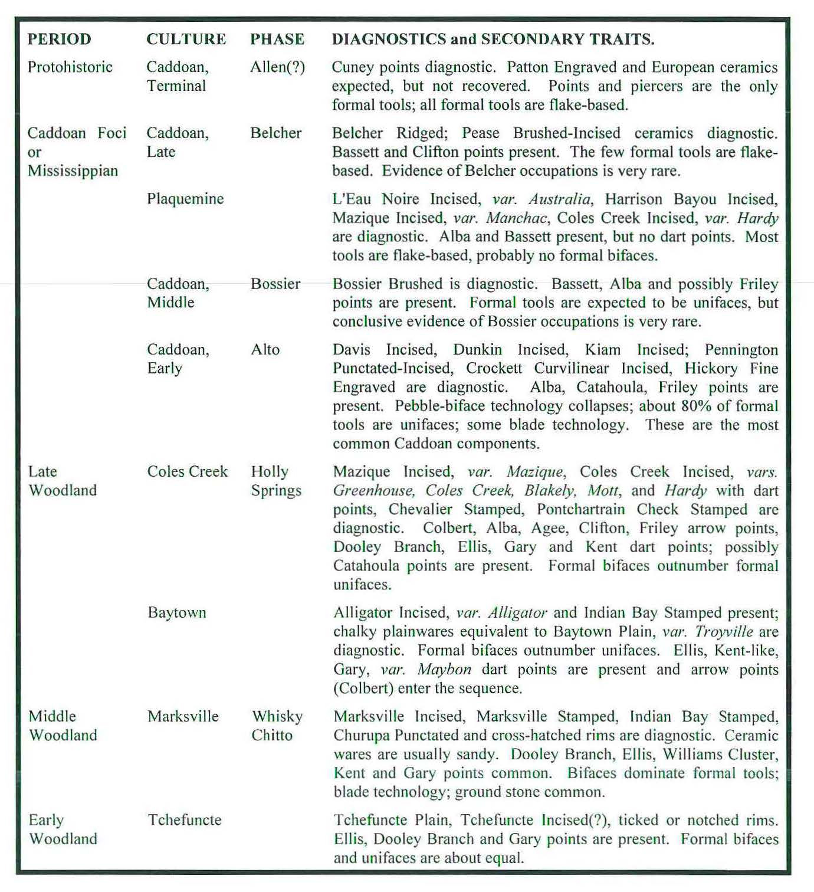
Figure 3.1 - The 2007 Cultural Sequence for Fort Polk (Source: Morehead et al. 2007b:30–31).
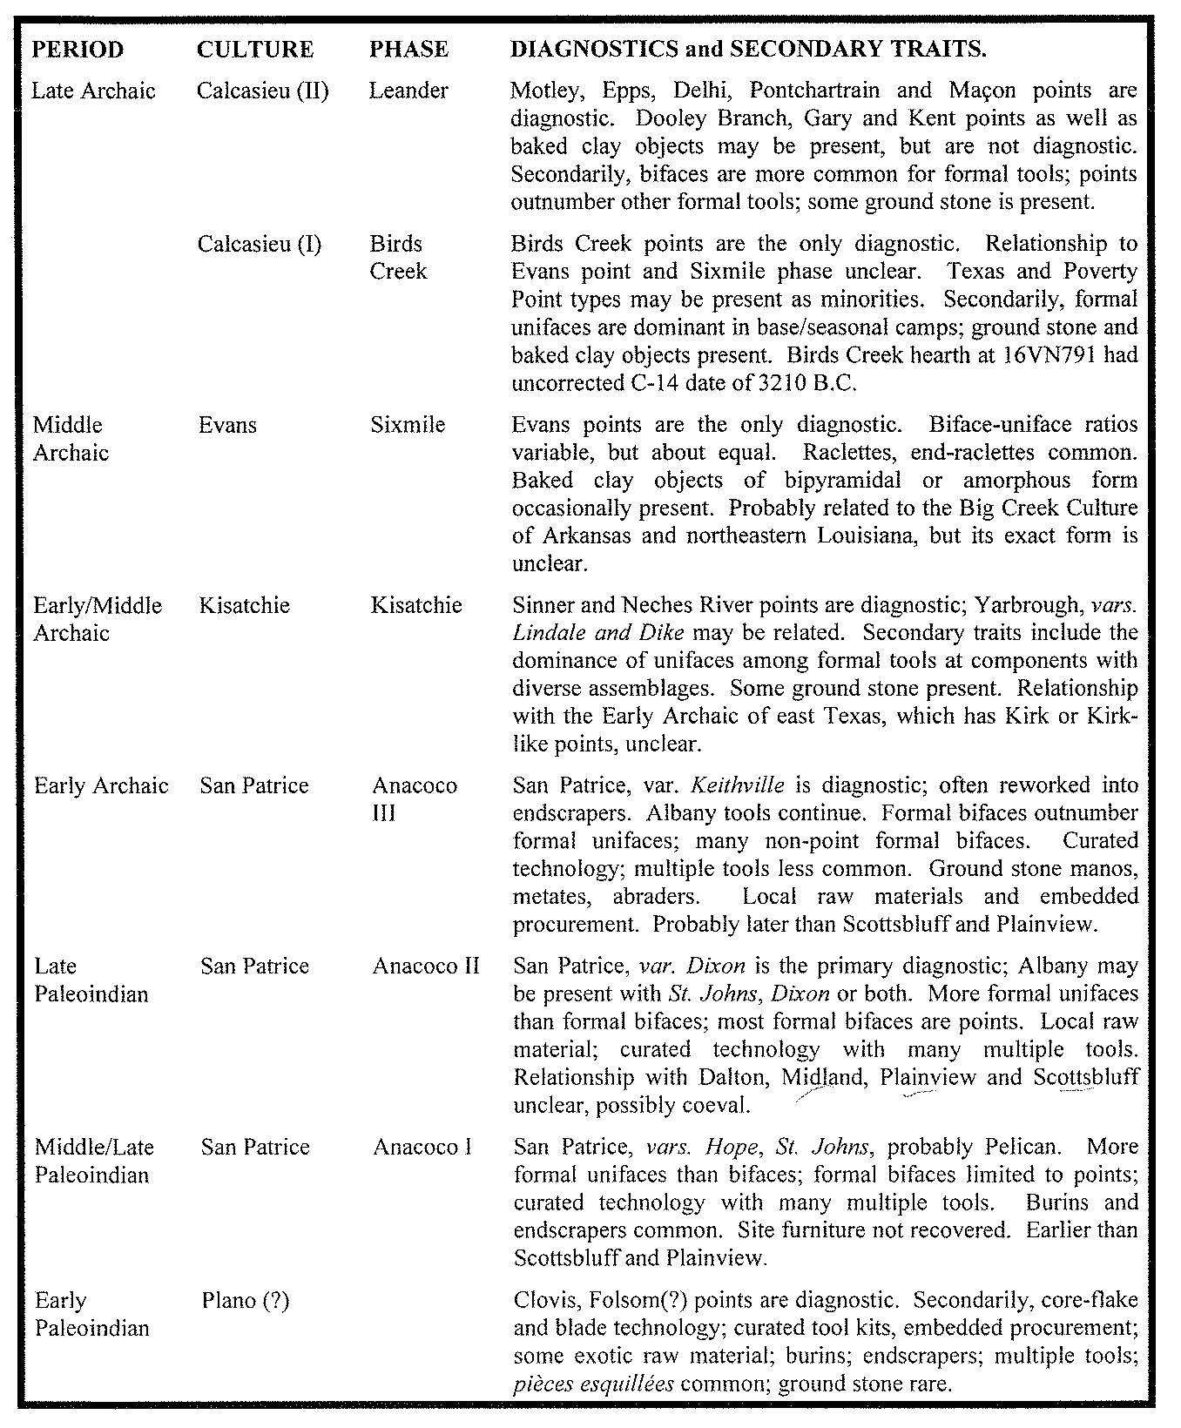Figure 3.1 (continued) - The 2007 Cultural Sequence for Fort Polk (Source: Morehead et al. 2007b:30–31).

peoples. Particular attention in such comparative analyses is given to identifying and recognizing diagnostic artifacts, site types, and features that can help us begin to date past occupations, what people were doing locally, and their relationships with peoples elsewhere in the region (Anderson et al., eds. 2022). Hoover et al. (2022a:250) and Anderson and Smith (2003:31-34) noted that the myriad cultural sequences proposed for precontact Louisiana over the preceding few decades (e.g., Gregory and Curry 1978; Rees 2010; Webb 1981, 2000), as well as those developed for the various adjoining states around Louisiana, have been very useful in interpreting what has been found on Fort Polk. Cultural material found to date on Fort Polk has been representative of a large swathe of several sub-regions of the precontact Southeastern United States: the Sabine River Basin in eastern Texas (e.g., Aten 1983; Gibson 1978a; Pertulla 2004; Story 1990), northwestern Louisiana, southern Arkansas and eastern Oklahoma (e.g., McMakin et al. 2021, Schambach 1982; Schambach and Early 1982), and the Central and Lower Mississippi Valley and the various sub-basins therein (e.g., Ford 1936; Morse and Morse 1983; Phillips 1970; Phillips et al. 1951). While certainly valuable, there is also a need for a level of analysis in between the single excavation level and interregional analyses.
The Fort Polk cultural sequence that has been developed makes use of the Paleoindian–Archaic–Woodland–Mississippian period terminology familiar to most archaeologists of the Southeastern United States (Anderson and Sassaman 2012; Griffin 1946, 1967; Willey and Phillips 1958). While there is a consensus among archaeologists working in North America that there is a great deal of cultural variability and complex patterns of continuity and discontinuity within and between each of these periods, the cultural chronology of archaeological assemblages across Louisiana, including on Fort Polk, are still described using period designations. Early, Middle, and Late period subdivisions are used to internally divide the major periods (i.e., Late Archaic, Early Woodland, etc.), as are culture or phase designations, such as Poverty Point, Tchefuncte, Marksville, Baytown, Coles Creek, and many expressions of Caddoan/Mississippian, as discussed in Chapter 2 (Hoover et al. 2022a; Anderson and Smith 2003:34; Neuman 1984; Phillips 1970; Rees 2010; Smith et al. 1983). Calendar ages are used in this thesis to temporally place these period and cultural groupings, with the caveat that they are for the most part arbitrary. Many of the past cultures represented on Fort Polk and the materials associated with them are not well known and dated, thus boundaries and transitions between cultures are usually not easily delineated (Hoover et al. 2022a).
The cultural sequence discussed above has been instrumental in the assignation of National Register of Historic Places eligibility on Fort Polk. A review of the National Register Eligibility Criteria thus follows, followed by a history of earlier work developing eligibility guidelines for Fort Polk, including consideration of the research themes developed in technical reports, HPPs, ICRMPs, and in the 1983 and 2018 Louisiana's Comprehensive Archaeological Plans (Hoover et al. 2022b; Girard et al. 2018; Smith et al. 1983). As part of this, analyses document how diagnostic component incidence, and assemblage incidence and diversity, have been tied to NRHP site eligibility determinations in the past. The results are then used to evaluate how these criteria can be best used moving forward to assess NRHP eligibility.
The Development of NRHP Eligibility Guidelines on Fort Polk

As I noted in Chapters 1 and 2, the earliest CRM projects undertaken at Fort Polk premised much of their assessment of NRHP eligibility of sites on the presence of intact cultural components, the presence of identifiable morphological types, and artifact diversity where “[w]ith respect to tool assemblages, 'diverse' is arbitrarily defined as having five or more formal chipped stone classes (points, end-scrapers, sidescrapers, perforators, burins, pièces esquillées, denticulated pieces, and notches) or four and site furniture like a mano, metate, or pitted stone" (Morehead and Laffitte 2014:14-18; Servello 1983:109). As was also noted in Chapter 2, several previous investigations have incorporated some intersite assemblage comparisons to answer questions about variability of and changes in resource procurement, technological productions strategies, mobility strategies, and site location probability. This research could be made even more meaningful if it could be coupled with a more precise understanding of the cultural chronology.
The guidelines for assessment of NRHP eligibility of cultural resources on Fort Polk have, in addition to the corpus of federal legislation familiar to all professional archaeologists, been developed and influenced by numerous documents and integrative efforts, beginning in 1983 with the State of Louisiana's Comprehensive Archaeological Plan written by Steven D. Smith, Philip G. Rivet, Kathleen M. Byrd, and Nancy W. Hawkins for the State of Louisiana's Department of Culture, Recreation, and Tourism's Division of Archaeology (Smith et al. 1983, Anderson and Smith 1999:55). This document, in addition to providing what was at the time an up-to-date and thorough summation of Louisiana’s pre-contact and post-contact environmental and archaeological histories, also outlined numerous research themes deemed by the authors important to better understanding Louisiana’s pre- and post-contact history. A total of 24 of these themes were identified as important within the portion of Louisiana encompassing Fort Polk by Anderson and Smith (1999:47-49) as relevant to archaeology done on Fort Polk. These themes are listed in Figure 2.1, together with the general criteria employed linking specific site occupations to specific themes. In brief, the presence of cultural resources of specific periods automatically made the themes relevant to that period applicable.
When cultural resources are evaluated on the installation, researchers were to use the relevant thematic discussions in the 1983 Louisiana Comprehensive Archaeological Plan (LaCAP) and apply the research approaches suggested under these discussions to the site or sites in question. Some of the LaCAP themes have greater applicability than others or prove more amenable to productive research depending on the circumstances. Every site on the installation, just by the fact of its presence, can potentially contribute information to Theme 23 "Culture History". Collections from sites that are destroyed, and hence no longer of concern to land use planners, may still prove useful to ongoing research, even if the location itself is no longer eligible for inclusion on the NRHP (Anderson 1999:47).
The 1988 and subsequent 1999 HPP were created, in part, due to a recognition of the need for standardization of field methods used by archaeological projects on the installation, as well as of Fort Polk’s unique place within the broader context of Louisiana archaeology due to the large amount of survey and excavation performed there relative to both the installation’s small size as well as the size of the entire state of Louisiana. The 1999 revision functions as:
an update of a plan that was originally developed for Fort Polk in 1988, and that has successfully guided cultural resource management on the installation since that time. Army regulation AR 420-40 and its successor AR 200-4 mandates the periodic revision and updating of HPPs/ICRMPs, to ensure compliance with current legislative and legal mandates, and to ensure that changes in mission, knowledge, and resource management strategies are accommodated. Fort Polk is an active installation that has undergone a significant mission change since 1988. Additionally, an extensive amount of CRM work has been conducted in recent years, resulting in a dramatic increase in information . . . Since 1988 a number of new federal and state laws and regulations have appeared, or old laws have been amended or had new or revised enabling regulations issued. Important areas of concern include (but are not limited to) recent amendments to the National Historic Preservation Act, the Native American Graves Protection and Repatriation Act, the 1991 Louisiana Unmarked Human Burial Sites Preservation Act, the Archaeological Resources Protection Act, recent regulations regarding curation standards and procedures, specifically 36 CFR 79, and the Louisiana Division of Archaeology’s Standards and Guidelines for Curation of Archaeological Collections (1995 Revision) [Anderson and Smith 1999:4-6].
The 1999 HPPs “established a process for cultural resources review of installation activities, advanced the archaeological survey on Fort Polk from 25 percent to 90 percent completion, provided for curation of archaeological collections, and established a process for initiation of government-to-government consultation with Native American tribes” (Lafitte and Dengel 2019:73). Specifically, the 1999 HPP outline explicit criteria for characteristics of NRHP eligible sites (Anderson and Smith 1999: 50-56). These criteria are presented in Appendix A.
Specific NRHP Evaluation Criteria to be Employed on Fort Polk
As a result of the extensive history of CRM work at Fort Polk, specific criteria under which sites on Fort Polk can be considered Eligible, Potentially Eligible, and Not Eligible for inclusion on the NRHP have been developed. Detailed discussion and justification of these criteria are provided in the 1999 HPP Technical Synthesis/Overview volume. These are criteria that must be adopted by all investigators working on Fort Polk (see Appendix A). These documents also developed the method by which a cultural resource could be deemed Potentially Eligible. Anderson and Smith (1999:53) state that if a determination cannot be made after intensive survey work has occurred, it is acceptable to label a site Potentially Eligible and to recommend more extensive testing for the purpose of determining NRHP eligibility in the future. However, in using the Potentially Eligible classification, the contractor must specify what information is needed to make an Eligible or Not Eligible evaluation, what methods will be necessary to collect that information, and why the initial field survey methods were judged inadequate to provide this data.
Various CRM projects have since incorporated analyses of the HPP method specifically to check whether the HPP’s method of calculating artifact density values were adequate, and some modifications have been suggested. Calculating artifact density had for a time been used as a standard barometer of a site’s likely NRHP eligibility due to the assumption that an artifact-dense site would contain a diverse enough array of artifact types conducive to understanding a site’s type and function. However, a series of reports authored by New South Associates, Inc., beginning with Gregory et al. (2014), critiqued the HPP method, arguing that many of the recorded sites had artifact densities were so low that calculations were not necessary. They state that sites with one or two artifacts per shovel test are well below the density thresholds set by Anderson et al. (1999:481–482) as the markers of an eligible site (100 artifacts/cubic meter prehistoric, 250 artifacts/cubic meter historic). To meet those marks, artifact densities would need to be significantly higher. They proposed calculating artifact densities for using cultural deposit depth instead of excavation depth. Depth was calculated as the thickness of the cultural deposit, not the distance from the surface to the base of excavated shovel tests (Gregory et al. 2014:47). Anderson et al. (1988) determined artifact density based on the total number of artifacts and the total volume excavated at each site.
Gregory and Vasquez (2016:38-39) expounded on NSA’s approach to artifact density, asserting that artifact densities were calculated using only artifacts recovered from subsurface contexts. For test units, Gregory and Vasquez (2016) calculated cultural deposit depth by level, excluding any levels that did not contain artifacts. Densities were calculated using both Anderson et al.’s (1988) method and the New South method. Though the New South method does not produce densities that can be reliably compared with densities calculated using Anderson et al.’s (1988) method, I acknowledge that the NSA approach would render a more accurate measure of artifact density for a given component, since it only calculates density within the cultural deposit, whereas Anderson et al.’s (1988) approach using total would lessen the density on sites that are more deeply buried.
The NSA approach, while not radically different from that outlined in the 1988 HPP and its 1999 revision, somewhat obfuscates the full volume excavated at a given site (although total volume excavated at a site is reported elsewhere in NSA reports). However, this method certainly makes intrasite and intercomponent comparisons easier, as it treats each cultural deposit within a site as a discrete entity, assuming they can be recognized as such in the testing. Employing this method would necessitate contextualizing each density calculation with the deposit’s depth below surface in order to provide a complete picture of that deposit’s place within the larger assemblage of a site; however, the assumption that discrete cultural deposits or components can be identified in the first place within the scope of limited testing projects is often problematic, as the stratification analyses in this thesis demonstrate. For this reason, the regression analyses employed in this thesis make use of the original area and volume data from each site, reflecting totals, and not estimates of each component’s extent and volume.
An important facet of the criteria advanced in the 1988 HPP and its 1999 revision is that data from individual sites should be compared with all other archaeological data collected from the installation to better contextualize and give better resolution to individual sites. However, many reports completed since 1999 have ignored this part of the 1999 HPP guidelines, and only used the data from their own project. The 1999 HPP states that:
All recommendations for NRHP eligibility status should proceed, in part, through the use of comparative analyses making use of the results of past work on JRTC and Fort Polk. These analyses should be quantitatively based and should refer to the entire site and isolated find assemblage found during the specific project in question, as well as to materials found during earlier investigations on the installation. Since assemblage data is provided in electronic and hard copy in the HPP Inventory [and now in the installation Cultural Resource Database], this should not be a difficult or time-consuming process. To illustrate, if for example a site yields Tchefuncte pottery or Ensor projectile points in undisturbed context, as part of the analysis and significance justification an effort should be made to document how many other sites on the installation yielded similar materials. This would help document the relative uniqueness and hence importance/significance of the assemblage in question [Anderson and Smith 1999:53].
The above is why a numerical and comparative approach is needed as part of the process of determining eligibility (i.e., calculate artifact and component density and diversity, compare it with other sites; look at diagnostics, compare with other sites with the same diagnostics; look at stratification; check what other sites have stratified deposits with these materials, etc.). A more robust comparative approach making use of quantitative data from Fort Polk’s entire
archaeological assemblage would enable improved temporal and cultural contextualization of a single site. It is proposed herein that this numerical and comparative approach be incorporated into future guidelines for NRHP assessment on Fort Polk, and these recommendations have been adopted in the conclusions to the 2022 synthesis (Hoover et al. 2022b).
The State of Louisiana 2018 Comprehensive Archaeological Plan
In 2018, Jeff Girard, Chip McGimsey, and Dennis Jones authored a revision of Smith et al.’s (1983) Comprehensive Archaeological Plan. As in the 1983 edition, Girard et al. (2018) identified numerous research themes that were recognized as being of particular importance to Louisiana archaeology and for understanding the state’s 15,000-year history and that provide a framework for identifying sites worthy of protection and preservation (Girard et al. 2018:54). A series of 9 research themes were presented (Table 3.2), developed from the past 30 years of archaeological research across Louisiana, regional and national perspectives, and ongoing discussions of broader archaeological and anthropological goals (also see Kintigh et al. 2014).
NRHP Evaluation Criteria from the 2019 ICRMP
In 2019 base archaeologists Bradley Lafitte and Craig Dengel authored the Integrated Cultural Resources Management Plan (ICRMP), which outlines the standard operating procedures for accidental or intentional encounters with cultural resources or human remains by base personnel or contractors, as well as mitigation strategies to address disturbances of sensitive archaeological resources. The 2019 ICRMP recommends assessing NRHP eligibility of cultural resources on the installation via the adoption of a cultural landscape and ecosystem-based planning approach, which recognizes the complexity of human cultural interaction with the natural environment (Lafitte and Dengel 2019: iv). This statement reflects a larger on-going trend within cultural resource management (and North American archaeology more broadly) of

Table 3.2 – Themes from the State of Louisiana 2018 Comprehensive Archaeological Plan

Theme 1: Paleoenvironments
This theme examines how changing natural landscapes and climates over the last 15,000 years affected human settlement and adaption. It also applies to documenting landscape changes over that time and how these changes have affected the visibility and distribution of sites in the modern landscape.
Theme 2: Settlement Patterns and Cultural Landscapes
This theme has as a general goal understanding how past human groups organized themselves at a regional scale across the landscape in relation to natural features, other settlements, and cultural principles. In addition, examine how subsequent environmental processes have altered past landscapes and impacted analyses of settlement patterns.
Theme 3: Architecture and Site Configuration
This theme has as a general goal understanding how communities organized themselves at the point or site scale across the landscape in relation to the physical landscape, social, religious, and political forces, and cultural beliefs and traditions. This goal also includes how people physically modified the landscape to accommodate these factors, including specific construction methods and techniques.
Theme 4: Subsistence Economy
This theme has as a general goal understanding past subsistence practices with regard to food acquisition, means of production, preparation, and consumption
Theme 5: Material Technology
This theme has as a general goal understanding past manufacturing technologies including raw material procurement, manufacturing methods and strategies, and the organization of production.
Theme 6: World View/Cosmology
This theme has as a general goal understanding how ideology, religion, iconography, ritual, and world views shaped human settlement, political economy, and organization.
Theme 7: Social Identity/Status
This theme has as a general goal understanding how to identify how material culture reflects social identity and status, and the significance of this variation for understanding past social, economic, and political systems.
Theme 8: Group Interaction, Conflict, and Mobility
This theme has as a general goal exploring how past peoples moved across the landscape and interacted in social, political, and economic terms.
Theme 9: Physical Condition, Health, and Leisure
This theme has as a general goal examining the health, demography and activities of past populations.

taking into consideration an individual site’s place within the larger site assemblage of a given region. This approach is especially valuable on Fort Polk given that the locale has been found to most likely be a resource extraction zone as opposed to an area where pre-contact peoples permanently settled, thus necessitating a regional approach (Anderson and Smith 2003:136-138; Campbell and Weed 1986: 4-1). Indeed, Campbell and Weed (1986:4-2) cited Jolly’s (1983:1) assessment of west-central Louisiana as a sort of cultural crossroads where different pre-contact populations interacted.
As discussed earlier, to accommodate the multiple insights and perspectives developed over the past decades, the criteria for determination of NRHP eligibility listed by the 2019 ICRMP (Appendix A) privileges the presence of identifiable ‘cultural features’ or one or more discrete stratigraphic deposits containing three or more diagnostic artifacts and an overall density of 100 Native American artifacts per cubic meter (with exceptions). These criteria allow for the implementation of multiple different survey and site testing strategies. The aforementioned calculation of artifact density utilizing the method developed by Anderson and Smith (1999) remains a prominent tool of assessment, as does the recognition of a site’s potential to contribute to future research. However, the full extent of the cultural chronology of Fort Polk remains an open question, which appends an element of uncertainty to every determination of significance. Nash et al. (2021) stated that:
Given the episodic use of Fort Polk by groups from adjacent culture regions, there is a substantial repository of comparative data on shared diagnostics with which to refine the Fort Polk sequence . . . the culture sequence developed for Fort Polk provides a good framework for interpretations of chronology and cultural affiliation. Thanks to the academic strides of many archaeologists working at Fort Polk, refinement has been an ongoing and collaborative effort, but certain periods are better understood than others, so the effort continues [Nash et al. 2021:55].

The following chapter will demonstrate how the creation of a relative diagnostic stratigraphy (RDS) and various stratification indices can be implemented to address the various problems and concerns still plaguing National Register of Historic Places eligibility on Fort Polk. Specifically, it will be shown how these tools can aid in facilitating inter- and intra-site and inter- and intra-component analyses that in turn can offer more fine-grained understanding of which groups were present on Fort Polk and when, which could serve to situate Fort Polk within the various regional syntheses that have been and continue to be produced by other researchers.

CHAPTER 4
CREATING AND IMPLEMENTING A RELATIVE DIAGNOSTIC STRATIGRAPHY AND STRATIFICATION INDICES
Introduction

This chapter is primarily concerned with methodology and discusses how and why both the relative diagnostic stratigraphy (RDS) tables and the stratification indices were created (see Appendices C-H) and then explicates how they were utilized as analytical tools to better understand diagnostic relationships. As discussed in the previous chapter, incorporating a more comparative, quantitatively based approach to the analysis of the cultural sequence of the Fort Polk military installation is important to improving how National Register of Historic Places eligibility is assessed and assigned there. While some investigators have made use of the artifact density thresholds developed by Anderson and Smith (1999), as discussed in the previous chapter this threshold’s utility has been found to be limited.
What is assessed in this chapter is an alternative form of analysis that examines the relationship that one diagnostic type has to every other diagnostic type that occurs within the sample of consistently intensively tested sites on the installation (n=766 of 915 total tested sites). Due to the fact that some diagnostic types occur with much greater or lesser frequency than other types, comparing the frequency with which a given diagnostic type occurred above, with, or below all other diagnostic types needed to be determined. Analyzing patterns of diagnostic distribution on Fort Polk in this manner also better facilitated an interrogation of the pre-existing cultural sequence put forth by other investigators discussed in Chapters 2 and 3 (see Figure 3.1). It should be noted that I used the diagnostic typologies utilized by the investigators of the sites in my sample; I did not perform any re-identification of lithic or ceramic artifacts prior to the execution of the analyses conducted in this thesis. Most of the sites examined here, however, were intensively tested by one organization, Prentice Thomas and Associates, Inc., and the identification of diagnostics were conducted by one individual, James R. Morehead, who started working on Fort Polk in the 1970s. There is thus a level of consistency in the artifacts classification that is rarely seen on installations where decades of fieldwork have occurred (Anderson et al. 2022b [Chapter 4 in the technical synthesis]). Further, I focused only lithic and ceramic diagnostics instead of looking at all artifact types because there are literally tens of millions of nondiagnostic artifacts, mostly lithic reduction debris, that have been recovered from Fort Polk, and many have not been counted, much less analyzed in detail. For the same reason I did not look at ratios of diagnostics to non-diagnostics for sites in my sample; although this type of analysis would be an interesting way to examine site density and diversity, when such data can be compiled.
Surovell et al. (2022)
Surovell et al. (2022) performed a similar analysis to the one described in this thesis in their examination of the degree of vertical disturbance at a number of well-known archaeological sites. They examined patterns in the stratigraphic integrity of early North American archaeological sites by first modeling sedimentation rate, occupational history, depositional history, and degree of disturbance, assuming the first three variables to be constant year to year and the fourth to be random year to year (Surovell et al. 2022:1). A total of 500 artifacts were placed on the ground surface of the simulated site at the beginning of each simulation, and each year every artifact was randomly moved up or down to simulate disturbance. The authors modeled ten different sedimentation rates ten times per rate for a total of 100 simulations, finding that increases in sedimentation rate significantly reduced stratigraphic integrity over time (Surovell et al. 2022:2). The authors then developed a statistic they called the ‘Apparent Stratigraphic Integrity Index’ (or ASI) that assessed the degree of change in artifact density between adjacent levels in their 100 simulated sites. These simulations and the ASI statistics provided the authors with points of comparison against which the vertical artifact distributions of extant early North American and Beringian sites could be compared to assess extant sites’ stratigraphic integrity (Surovell et al. 2022:3-7). While this analysis resembles the methodology proposed in this thesis, there are several key differences. The authors assumed that artifact deposition did not occur throughout an occupation, only at the beginning of it. This was not the case at Fort Polk, however; the assemblages at Fort Polk represent the repeated comings and goings of Native groups throughout a given occupational period or periods that created a palimpsest of material culture. Additionally, sedimentation rate at Fort Polk cannot assumed to be constant, as numerous waterways of varying size occur in the area, rainfall itself varies seasonally, and these factors result in more sediments being deposited during periods of heavy rain, and greater colluviation in hilly terrain.
Surovell et al. (2022) also used artifact density as a metric for assessing changes in artifacts’ vertical distribution. While this metric certainly speaks to degree of disturbance and intensity of site use at early North American and Beringian sites, at Fort Polk artifact density correlates poorly with volume excavated. As a central goal of the method proposed in this thesis is rendering NRHP assessment more efficient, volume of fill excavated is something I seek to limit as much as possible. However, Surovell et al. (2022) successfully demonstrate the utility of the basic premise that undergirds both their and my methodology: amassing and comparing pre-existing stratigraphic data at large scales is an effective means of clarifying unresolved issues of temporality and cultural chronology in the archaeological record.

Stratigraphic Analyses
As part of the current analyses, stratigraphic relationships were recorded for the diagnostic lithic and ceramic artifacts found during the intensive testing investigations within both the 766 Fort Polk intensively tested sites and the 5 large-scale data recovery excavations (Appendices C-H). First, every test unit or shovel test pit excavated during one of the intensive site testing projects that yielded two or more diagnostic pre-contact artifacts (lithic or ceramic) was tabulated in an Excel spreadsheet along with the project name and site trinomial, and each diagnostic artifact was listed in descending stratigraphic order (Figure 4.1; Appendix C). A column listing each diagnostic artifact’s position relative to every other diagnostic artifact in the same test unit or shovel pit was then created, using ABOVE, WITH, and BELOW to describe these relationships (Figure 4.1; Appendix C). As a result, the number of relationships a given diagnostic type has with every other diagnostic type in the unit sample was tabulated in addition to the frequency of occurrence of a given diagnostic type (Tables 4.1 to 4.3). As can be seen in Appendices C-I, artifacts did not need to be in directly adjacent levels to be categorized as above or below one another. Additionally, I decided to combine ABOVE and WITH when calculating the frequency of occurrence for each diagnostic type in both the intensively tested sites sample and for the 5 data recovery projects. This was done to account for the Age-In Effect, which is the tendency of smaller, lighter artifacts to move downwards in a site’s stratigraphy due to bioturbation (Bruseth and Perttula 1981:57; Cantley et al. 1993:46). To illustrate these points, stratification indices with the % With column separated out were created for the sample of intensively tested sites and the five data recovery projects and will be discussed elsewhere in this chapter (Tables 4.9 to 4.11; Appendix J).

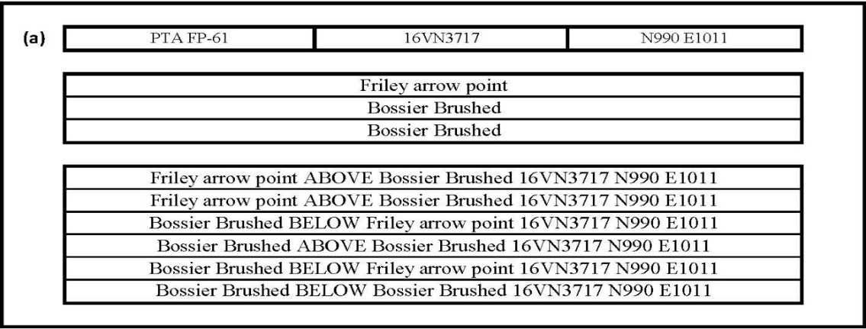

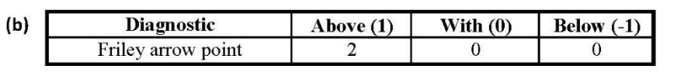

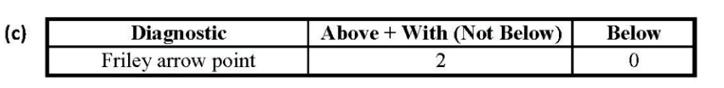

Figure 4.1. How above, with, and below relationships and indices between diagnostics were created, using data from Test Pit N990 E1011, Site 16VN3717, found during PTA’s FP-61 series of intensive site testing excavations (Morehead et al. 2015). (a) Diagnostics occurring together are listed in the same row, while stratification is depicted by the number and placement of rows. In this example, three diagnostics were found: a Friley point in an upper level above two Bossier Brushed sherds in two lower levels. Following this format, the entire relative diagnostic stratigraphy table for all units runs to several thousand lines. (b,c) How the Friley point is recorded in terms of stratigraphic relationships within this unit. (d) Indices calculated based on the combined values for above, with, and below for each diagnostic type. The Percentage Above Index equals the proportion of relationships where the diagnostic occurs ‘Above + With’ all other diagnostics, divided by the total number of relationships for that diagnostic, expressed as a percentage. The Percentage Below index is that number subtracted from 100% to give the proportion of relationships where the diagnostic occurs below all other diagnostics over the entire sample. It is also equal to the number of relationships ‘Below’ divided by the total number of relationships for that diagnostic, expressed as a percentage.

Table 4.1. Lithic diagnostic occurrence and stratification indices in the intensive test units (n=766) sites).

Table 4.2. Ceramic diagnostic occurrence and stratification indices in the intensive test units (n=766 sites).
‘Percentage Above’ should be ‘Above + With’ in the next to last column.

Table 4.4. Lithic and ceramic diagnostic occurrence and stratification indices in the 16VN18 (Bayou Zourie) site data recovery excavation.
Table 4.5. Lithic and ceramic diagnostic occurrence and stratification indices in the 16VN24 (Big Brushy) site data recovery excavation.

Table 4.6. Lithic and ceramic diagnostic occurrence and stratification indices in the 16SA50 (Eagle Hill II) site data recovery excavation.

Table 4.7. Lithic and ceramic diagnostic occurrence and stratification indices in the 16VN791 (Beechwood) site data recovery excavation.

Table 4.8. Lithic and ceramic diagnostic occurrence and stratification indices in the 16VN794 site data recovery excavation.

Table 4.9. Lithic diagnostics occurrence and stratification indices for lithics from sample of intensively tested sites (n = 766) with % With column separated out.
Table 4.10. Ceramics diagnostics occurrence and stratification indices for the sample of intensively tested sites (n = 766) with % With column separated out.
Table 4.11. Occurrence and stratification indices for all diagnostics in sample of intensively tested sites (n =766) with % With column separated out.

Because cultural stratigraphy has been found to vary substantially over the differing soils, terrain, and sites and even, in some cases, between differing units on individual sites, using
averages of artifact depth below surface would not work, as deposit depth varied widely. Instead, for every test pit that yielded two or more temporal diagnostics, whether each diagnostic was above, with, or below every other diagnostic in that unit was recorded in an RDS table, regardless of whether it was another of the same type or a different type. The occurrences were summed by type over all the test units, and indices were calculated showing what percentage of times a diagnostic occurred either above and with or below another diagnostic. These data were compiled for lithic and ceramic diagnostics, and the two categories combined (Tables 4.1 through 4.3), showing lithic and ceramic diagnostics’ relationship to all other diagnostic types, respectively. The total numbers of sites, test units, area excavated, and volume excavated, for the test units from the intensive testing program used in this analysis is given in Appendix C, and the same data from the five sites where data recovery occurred, that were used as a control, is given in Appendices D through H. Subsequent tables give the indices calculated from the data recovery projects from site 16VN18, Bayou Zourie; 16VN24, Big Brushy; 16SA50, Eagle Hill II, 16VN791, Beechwood; and 16VN794 (Tables 4.4 to 4.8); the primary data giving stratigraphic relationships for each diagnostic from every site and excavation unit in the sample is provided in Appendices C through H as well. The reason discrete tables were created for each of the five data recovery projects was because each excavation encountered different stratigraphic conditions, assemblages, and diagnostic artifacts. These data recovery excavations were instrumental in the construction of the Fort Polk cultural sequence, and the stratigraphic relationships they documented are widely referenced. The sample of intensively tested sites, in contrast, has seen little use in this fashion, save for noting the associations between small numbers of artifacts in most reports or, rarely examining all the sites of a given period, as in the case of the overview of San Patrice sites on Fort Polk (Morehead and Laffitte 2014). Incorporating both data sets into a single analysis of the cultural sequence of Fort Polk and using these results in turn to evaluate how NRHP eligibility has been and should be assessed, thus constituted a novel mode of inquiry.
As discussed below and in Chapter 2 of this thesis, comparative analyses suggest that premising a site’s NRHP eligibility solely on artifact density or diversity is not a very reliable method of assessment, since a strong correlation exists between artifact diversity and area or volume excavated, and a lesser relationship between area and volume and density (Anderson and
Smith 2003:319–322). A substantial amount of excavation is sometimes needed to recover differing diagnostic types, and for single component assemblages no amount of excavation will do much to increase diagnostic diversity. Indeed, quantitative analyses documenting artifact incidence and diversity should always be in relation to area and volume examined, to avoid subjective or intuitive ad hoc determinations. Further, the stratigraphic data from the intensive testing project reports demonstrates that some of the diagnostic artifacts found on Fort Polk do not exhibit much stratigraphic patterning. Consequently, while their presence on the installation is of interest, unless they can be found in isolated stratigraphic content, they may not be very consequential in the context of assessing NRHP eligibility.
The RDS tables (Appendices C through I) were created by examining the contractor reports written for the sample of 766 intensively tested sites examined since 1990 on Fort Polk in a consistent fashion, by Prentice Thomas and Associates, New South Associates, and Paleowest, Inc., as well as from the five data recovery excavations, for which detailed and consistent information on artifact positioning in the units was available. In the event a report did not list the stratigraphic locations of diagnostic artifacts that were encountered from a provenience, that unit was omitted from the analysis. The sample was also directed to data from intensively tested sites and excluded sites examined during survey projects for two reasons. First, few test units had been opened during survey fieldwork, and these were typically small if present at all, usually 50x50 cm in size. Second, since the early 1990s, final NRHP eligibility assessments on Fort Polk have come almost exclusively from intensive testing projects. Accordingly, an analysis of these tested sites was deemed essential to reassess both the criteria used to select areas to intensively test as well as how results from that testing led to eligibility determinations. The most important aspect of this analysis of relative diagnostic stratigraphy examines whether and how reasonably intact stratigraphy/logical artifact stratification on a site, and numbers of diagnostic types present, are related to NRHP significance determinations, or eligibility. The results of this analysis are somewhat counterintuitive: while intact stratigraphy resulting in assemblages separable from one another is important, the separation can occur spatially as well as stratigraphically, within discrete areas of a large scatter. Accordingly, high incidence or diversity of diagnostics is less important than whether individual periods of site use can be resolved (Hoover et al. 2022a).
The current cultural sequence in use on Fort Polk is presented in Figure 3.1 in the preceding chapter and includes a list specific diagnostic for each archaeological culture on the installation. Comparing the occurrence of types in this sequence chart with their stratigraphic indices for “Above + With” and “Below” from the intensive testing units (Tables 4.1 to 4.3), and from the data recovery projects (Tables 4.4 to 4.8), gives their relative stratigraphic position over the entire installation. These data are discussed in detail below, since it is clear that while many diagnostic types in the testing program fall in an appropriate position in the sequence, in a fair number of cases they do not, warranting explanation. In some cases, low sample size may be a factor, meaning there are too few artifacts of a given category to effectively determine their stratigraphic position in relation to many other types, since they simply do not occur together. In other cases, it may be that our assumptions about where these types occur stratigraphically and culturally may need revision. In still other cases, our classifications would appear to need refinement, particularly of forms that resemble one another in form, surface finish, and so on. Finally, there is some indication that ceramic fragments tend to be vertically displaced more than lithic diagnostics in the soils across the installation as whole (Hoover et al. 2022a).
Diagnostics with a low sample size seem to have resulted in a skewed placement in the sequence in the intensively tested site sample; this group appears to include just about every point and ceramic type yielding under five examples. These include Edgewood, Scallorn, Trinity, Palmillas, Ensor, Lange, Morhiss, and San Patrice var. Leaf River points and Alligator Incised ceramics (Tables 4.1-4.3) (Hoover et al. 2022a, 2022b). Types whose assumed stratigraphic and cultural associations need revision include Sinner and Evans points, most of the varieties of San Patrice points, and Baytown Plain, Baked Clay Objects, and Belcher Ridged ceramics (Table 4.12). For example, Belcher Ridged ceramics are assumed to be associated with the Late Caddoan/Mississippian Period, which is very late in the cultural chronology of Fort Polk and the surrounding area. However, Belcher Ridged ceramics occur above or with all other diagnostic types 60% of the time; this percentage should be higher, as there are significantly more ceramic and lithic types that supposedly pre-date Belcher Ridged ceramics. There are other examples, but these are the most egregious examples that appear out of place.
It should be noted that the indices refer to diagnostic types in the aggregate. A given diagnostic type’s relationship to all other diagnostics is likewise given in the aggregate, as
Table 4.12. Diagnostics that appear out of place in the current cultural sequence for Fort Polk.
opposed to single incidences of a diagnostic type. Thus, early point types like Evans or the varieties of San Patrice tend to occur below many other types, and the indices may not accurately show their relationship to closely related forms unless they are found together, which did not often happen (Hoover et al. 2022a). For some of these diagnostic types, our classification schemes would also appear to need some refinement, particularly for stemmed Archaic/Woodland and notched Late Paleoindian/Early Archaic dart points (Hoover et al. 2022a, 2022b).
Ceramics and the Age-In Effect
Finally, there is no doubt that ceramics at some excavated sites are found at greater depth than expected, evidenced by their occurrence in or below strata containing other diagnostics of much older age. This has been observed in all of the data recovery excavation reports, including Eagle Hill II, 16VN18, 16VN24/Big Brushy, 16VN790, and 16VN794 (Tables 4.4 to 4.8; Campbell et al. 1990:85, 93, 104–108; Cantley et al. 1993:225–249; Gunn and Brown 1982:221–222, 273; Servello 1983:810, 921, 924), and while at each the majority of the ceramics were appropriately located in the upper levels, at least some had been displaced downward, through bioturbation and other disturbance process. Similar disturbance processes and displacements for lithic diagnostics were also observed, but apparently not to the extent observed for the ceramics. Why this is the case is unknown, since presumably uniform processes would be operating. In previous reports the effects of bioturbation have been noted; however, bioturbation of Fort Polk assemblages are moderated by a process known in the general region as the Age-In Effect, which states that the vertical integrity of the components of an archaeological deposit usually remain intact due to the difference in the time in which each component enters the archeological record and is subjected to the processes of bioturbation (Bruseth and Perttula 1981:57; Cantley et al. 1993:46).
This phenomenon is illustrated in Tables 4.9 to 4.11, which depict how the % Above and % Below values for both lithic and ceramic diagnostics in the RDS sample change when % With is treated as a separate value (tables with the % With column were also created for the five data recovery projects and are provided in Appendix J). These changes are not drastic, nor do they seem to improve the resolution of the cultural chronology represented in my sample; dart points, arrow points, and ceramics still generally cluster together as discrete groups in these tables. However, there are a few differences that need to be addressed. Certain dart point types that are associated with multiple temporal periods, such as Dooley Branch dart points and Williams dart point types, are above some arrow point and ceramic types, but as these dart point types are known to reliably occur well into the Woodland period, this is not unusual. The San Patrice var. Hope dart point type also shifts to being above numerous younger diagnostic types, but this can be explained by the small sample size of this type within the overall sample of sites. In the index of stratigraphy that combines Above and With, San Patrice var. Hope (as well as the other San Patrice dart point varieties) appear lower down in the overall cultural chronology and closer to the other Early Archaic and Late Paleoindian diagnostic types. Baked clay objects (BCOs) shift to having a much lower % Above value, which given their association with the fluorescence of Poverty Point culture in the Late Archaic, is also not unusual. There is also evidence for the persistence of the use of BCOs into the Woodland period of the region, so BCOs having a high % Above + % With value in Table 4.3 is also understandable (Anderson and Smith 2003:380-381). Finally, in Table 4.11 several ceramic types have much lower % Above values than do the diagnostic types that pre-date ceramics, which can be attributed to the Age-In Effect. Ceramics fall into their expected general place in the cultural sequence of Fort Polk when their ABOVE and WITH values are added together and then divided by the total number of relationships a given type has with all other diagnostics (see Figure 3.1).
If ceramics are affected differentially in their stratigraphic placement, it may be because of a combination of factors, most likely related to the nature of the deposits or artifact size. Small, flat, or slightly curved surfaces might be displaced further downward than larger artifacts due to their smaller mass; many of the sherds found on Fort Polk are tiny, much smaller than dart points in size. Similar processes would also have been operating on lithic artifacts, but greater understanding of local biostratigraphic/bioturbation processes would appear to be needed (Cantley et al. 1993:45–47). Table 4.13 presents the current cultural sequence created by Morehead et al. (2007b:30–31) in its entirety, with the calculated percentage a diagnostic type occurs above and/or with other types listed in the far-right column. The average of the percentages for each diagnostic type assumed to co-occur in the same cultural phase is provided in the third column. Comparison of the indices for individual artifact type and the average of all the artifacts for a phase as a whole give some idea of the agreement between Morehead et al.’s (2007b) cultural sequence and the calculation of percentage of above or with. The diagnostic types highlighted in yellow are types whose placement within Morehead et al.’s (2007b) sequence is corroborated by the stratification indices for my sample of sites. Types highlighted in pink and lack an associated percentage value are types that were not represented in my sample. Types highlighted in pink and have an associated percentage value are types whose placement in Morehead et al.’s (2007b) sequence are not corroborated by the stratification indices and may need revision. There is some agreement, but for some periods, notably for the last few centuries prior to Native contact with Europeans, the fact that these assemblages are high in the idealized stratigraphic column is about all that can be realized.
However, this variability is mitigated by a broad patterning of stratigraphic relationships of various pre-contact diagnostic artifacts to one another on the installation. As will be discussed later, a subset of diagnostic types does re-occur on Fort Polk in a specific order, although these ordered re-occurring types are sometimes interspersed with other types in a much more random way. While this reaffirms the assumption that the pre-contact archaeological record of Fort Polk has undergone a significant amount of mixing, it is also known that myriad temporally contemporaneous groups utilized the environs of Fort Polk, that certain diagnostic types found on Fort Polk persist through time and crosscut the appearance or disappearance of other diagnostic types, and that the archaeological record at Fort Polk is characterized by a high incidence of some diagnostic types but a generally low frequency of occurrence of many types across the installation (Anderson and Smith 2003:39, 76-77, 298; Anderson et al., eds., 2022). These stratigraphic relationships have already been observed and analyzed somewhat as part of the reporting of the aforementioned large-scale data recovery projects: the 16VN18 (Bayou Zourie) excavations in1977-1976, the 16VN24 (Big Brushy) excavations in 1976-1977, the 16SA50 (Eagle Hill II) excavations in 1980-1981, the 16VN791 (Beechwood) data-recovery project in 1989, and the 16VN794 data recovery project in 1991 (Anderson and Smith 2003:29-47, 73-84; Campbell et al. 1990; Cantley et al. 1993; Fredlund 1983; Guderjan and Morehead 1983; Gunn 1982; Gunn and Brown 1983; Gunn and Kerr 1984; Jolly and Gunn 1984; Servello 1983). Data from these five projects have been used to construct a generalized cultural sequence for Fort Polk (Anderson and Smith 2003:35, 40-41, 74-75, 77; Morehead et al. 2007b). However, the post-excavation analyses associated with each of these five data recovery projects were self-contained and did not incorporate much inter-site comparison and thus may not be as representative of the overall character of the pre-contact archaeological record of Fort Polk than previously thought.
Further, while certain aspects of this cultural sequence have been corroborated to varying degrees by subsequent survey and site testing projects (namely the superposition of arrow points and ceramics over dart points, Gary dart points occurring shallower than Ellis dart points, a generalized sequence of Archaic period dart points, and the replacement of expanding-stem projectile points by contracting-stem points and ultimately the co-occurrence of ceramics and contracting-stem points), the pre-contact assemblage on Fort Polk is so large and diverse and characterized by such a high number of unique projectile point and ceramic types, that there a significant amount of refinement remains to be accomplished. These issues of refinement include the nature of the relationship amongst various co-occurring expanding-stemmed projectile point types, the exact nature of the transition from expanding-stemmed to contracting-stemmed projectile points, the increase and decrease in exploitation of various locales within Fort Polk, the unusual geospatial distribution of Gary dart points, and the exact timing of the first appearance of grog-tempered pottery. Discrepancies in percentage of above-ness and below-ness (i.e., stratification indices) between the five data-recovery projects and the RDS sample, while in some instances potentially the result of differences in sample size, also suggest that the sequences of diagnostics inferred from the five data-recovery projects are not as representative of the intensive site testing assemblages as previously assumed. For instance, the index created for the RDS sample reports that Gary dart points occur above all other diagnostic types almost 60% of the time, and Ellis dart points appear above all other diagnostic types a little more than 65% of the time (the ‘above’ metric does not indicate that the diagnostic occurred in the shallowest level
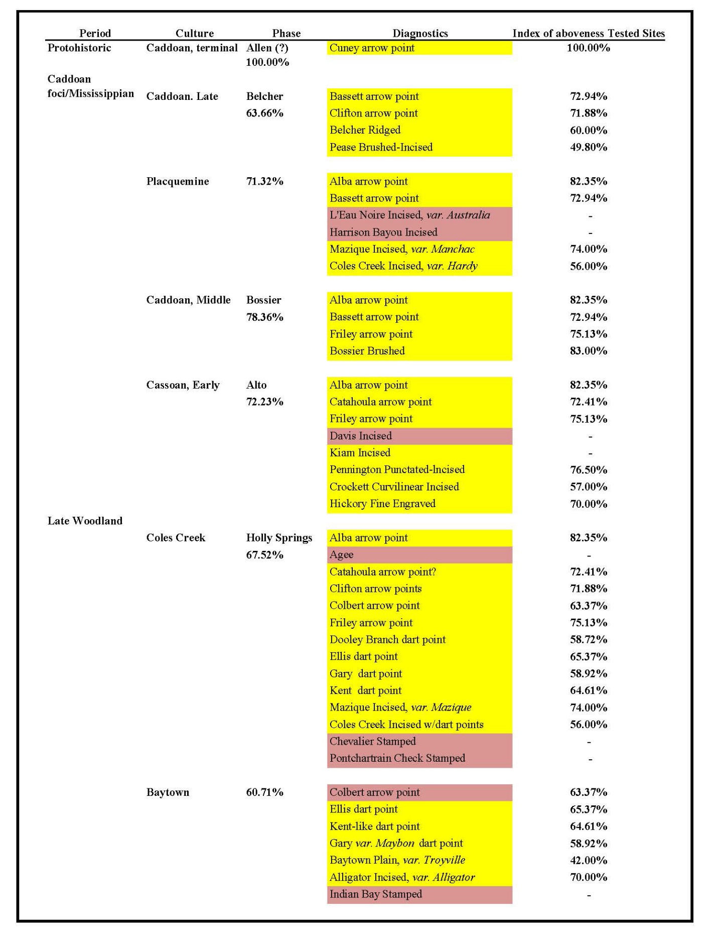
Table 4.13. The Updated 2007 Fort Polk Cultural Sequence (Morehead et al. 2007b:30-31). Yellow highlighted types seem in place, pink highlighted types appear out of place.
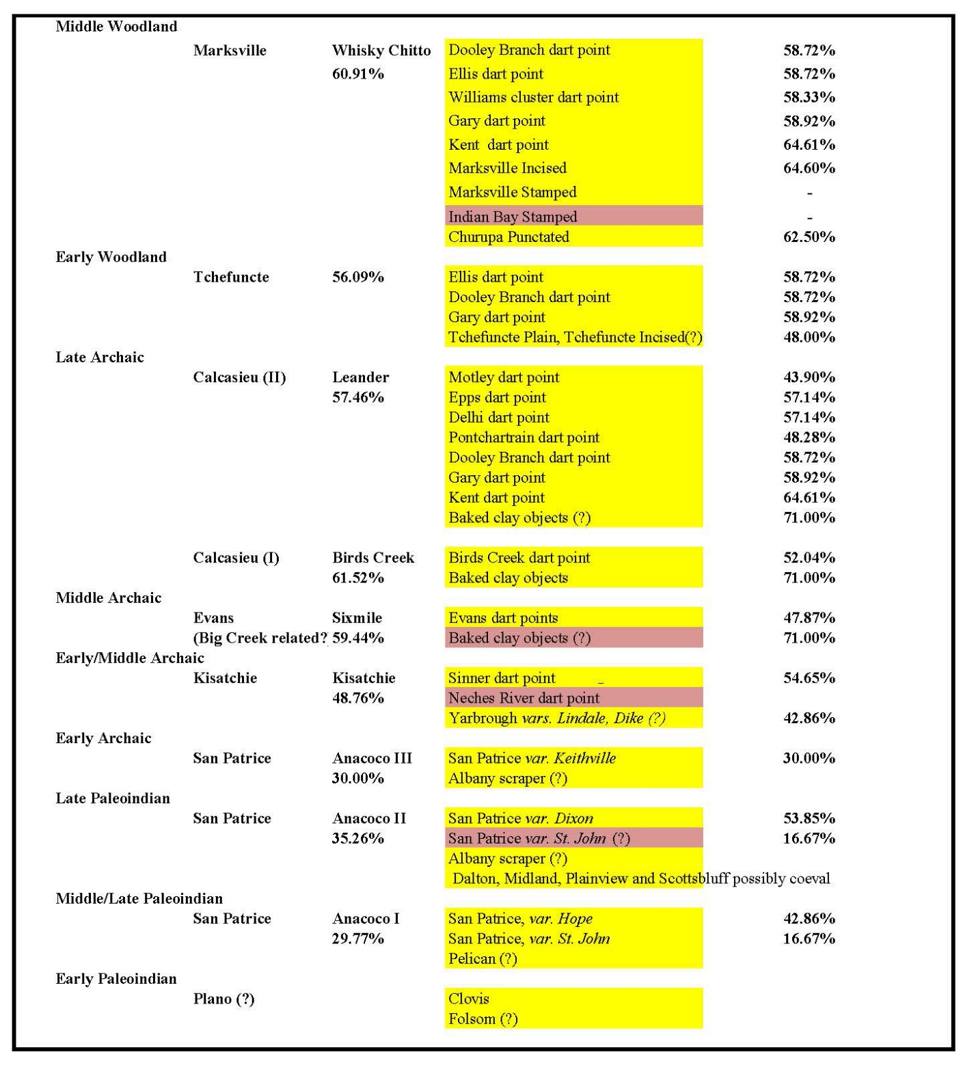
Table 4.13 (continued). The Updated Fort Polk Cultural Sequence (Morehead et al. 2007b:30-31). Yellow highlighted types seem in place, pink highlighted types appear out of place.

of a given unit, only that the diagnostic was above 65% of other diagnostic types across the sample). These values run counter to the inference of Gary dart points occurring later than Ellis dart points derived from the Bayou Zourie excavations but fall more in line with the sequence derived from 16VN794. While the superposition of Gary dart points over Ellis dart points may define the assemblage at Bayou Zourie, the RDS index reiterates the existence of inherent discrepancies between the five data-recovery projects and the larger assemblage generated by intensive site testing work.
Additionally, whereas the cultural sequence derived from 16VN794 indicates a deep time depth for the average age of Marcos dart points recovered there, the RDS index reports that Marcos dart points occurred above or with all other diagnostic types 60% of the time at intensively tested sites. While this discrepancy could be attributed to the small sample size of Marcos points in the RDS sample or the substantial amount of temporal overlap various Archaic dart point types have on Fort Polk, discrepancies warranting further examination are made apparent by inter-assemblage comparison of these indices. Comparisons such as these would provide finer resolution to an already robust set of analyses and inferences, which in turn will hopefully aid future archaeological work done on Fort Polk.
Potentials for New Methodologies of Determining Site Significance
Although occupying only a small proportion of Louisiana’s total acreage, Fort Polk has seen an outsized amount of archaeological investigation. Despite this, the 1999 HPP’s call for installation-wide comparative analyses to support any and all determinations of NRHP eligibility has yet to be undertaken to any great extent (Anderson and Smith 1999:53). Given that past assessments of the NRHP eligibility of archaeological sites on Fort Polk have been premised at least in part on an intuitive reckoning of the proportion of the overall Fort Polk cultural sequence a site’s assemblage represents (i.e., component incidence), it is of paramount importance that both the portion of the sequence represented, as well as the component incidence itself, be quantitatively compared against the entire installation’s pre-contact archaeological assemblage as well. By compiling data in the tables that describe diagnostic artifacts’ stratigraphic relationships, a more precise understanding of the local cultural chronology, as well as the nature and intensity of a given cultural group’s exploitation of the Fort Polk area, could be obtained. Further, given that every other military installation in the United States maintains databases like Fort Polk’s, the methodology proposed in this thesis could also be applied to these other installations.
It bears repeating that the regression analyses in Figure 1.4 (or Figure 5.23 from Anderson and Smith 2003:320-323) and the updated iteration of this analysis shown in Figures 1.5 and 1.6 show that: a) intensively excavated sites on Fort Polk (i.e., sites at which volume excavated was large) will not necessarily yield higher artifact densities; b) artifact diversity, however, is closely linked to assemblage size, and so a sites actual artifact density and particularly diversity cannot be reliably extrapolated from a small sample size; c) for both NRHP eligible and ineligible sites, area excavated, and number of artifacts recovered are weakly correlated; and d) a fairly strong correlation exists between volume excavated and number of artifacts recovered. When taken together these three figures demonstrate that a heavily tested site will potentially yield higher artifact densities on Fort Polk, with the caveat that small sample sizes are likely to give an inaccurate estimate of artifact density. This unreliability is problematic as it is these two site characteristics (along with number of intact cultural components) that are often invoked to assign or not assign NRHP eligibility, following the guidelines proposed in the 1999 HPP (Anderson and Smith 1999). A site would thus need to be extensively tested to ascertain assemblage density and diversity information accurately and obtaining accurate density values may not be possible no matter how much testing was done, short of complete site excavation.
To further demonstrate the aforementioned issues inherent in using artifact density, artifact diversity, or number of cultural components as the only measures of NRHP eligibility, the relationships between pre-contact diagnostic density, volume excavated, and number of components encountered for both NRHP eligible and ineligible sites in the intensively tested sites sample were examined (see Figures 4.2 to 4.5). Diagnostic density was calculated by dividing the number of pre-contact diagnostics recovered at a site by the total cubic meters excavated at the same site. Calculating diagnostic density in this manner generated a unitless value (the diagnostic density value, or DDV) that expresses how dense a site is in terms of how many pre-contact diagnostics were encountered relative to the cubic meters of fill excavated. Certain artifacts not able to be identified to type (i.e., unidentifiable ceramic sherds, dart points, and arrow points) were still included in these diagnostic density calculations, as their approximate temporal and cultural affiliations were in most cases able to be discerned due to their relative stratigraphy, their general form (i.e., dart versus arrow point or fragment), and/or their method of manufacture.
Whereas the stratification indices only look at those diagnostics that were able to be typed, the DDV calculations included artifacts whose exact temporal and cultural affiliations were not understood with as much granularity. This decision is justifiable as many of the trends recognized in the current cultural sequence of Fort Polk, as noted previously, are also premised upon the inclusion of such artifacts. Such ‘nondiagnostic’ diagnostics (i.e., like plain pottery, or broken or irregularly shaped dart points) were considered in the aggregate (i.e., by count) instead of differentiating them into specific types. Further, while artifact diversity is not being directly examined in this specific analysis, it has already been demonstrated by Anderson and Smith (2003:320-321) and in the analyses summarized here that an extensively excavated site will not necessarily yield higher artifact densities, at least not on Fort Polk. Artifact diversity, however, is closely linked to assemblage size. Thus, a high volume excavated, as well as a high density of diagnostics encountered, can together be reasonably understood as proxies for a site’s assemblage likely exhibiting high diversity as well.
Two sets of two graphs apiece were made during this analysis: one set looked at the relationship between DDV and number of components for both NRHP eligible and ineligible sites in the sample (Figures 4.2 and 4.3). The other set looked at volume excavated versus diagnostic density at both NRHP eligible and ineligible sites in the sample (Figure 4.4 and 4.5). The sites included in these analyses were derived from the sample of intensively tested sites that had at least one unit or pit with two or more diagnostics recovered in them, and that were assessed by the contracting firm doing the testing as either NRHP eligible or ineligible.
Number of Components versus Diagnostic Density
The first set of graphs (Figures 4.2 and 4.3) show the relationship between diagnostic density and number of components for sites in my sample of intensively tested sites. This analysis was done to assess whether diagnostic density increased with the number of discrete pre-contact components encountered at a site; each point on the graph represents one site. A general trend was immediately evident for both the eligible and ineligible graphs: as the diagnostic density value increased (i.e., as the number of diagnostics per cubic meter of fill increased), the number of components encountered at a site reduced in frequency. While there were a few outliers (i.e., NRHP-eligible sites with a very high diagnostic density value), this pattern predominated.
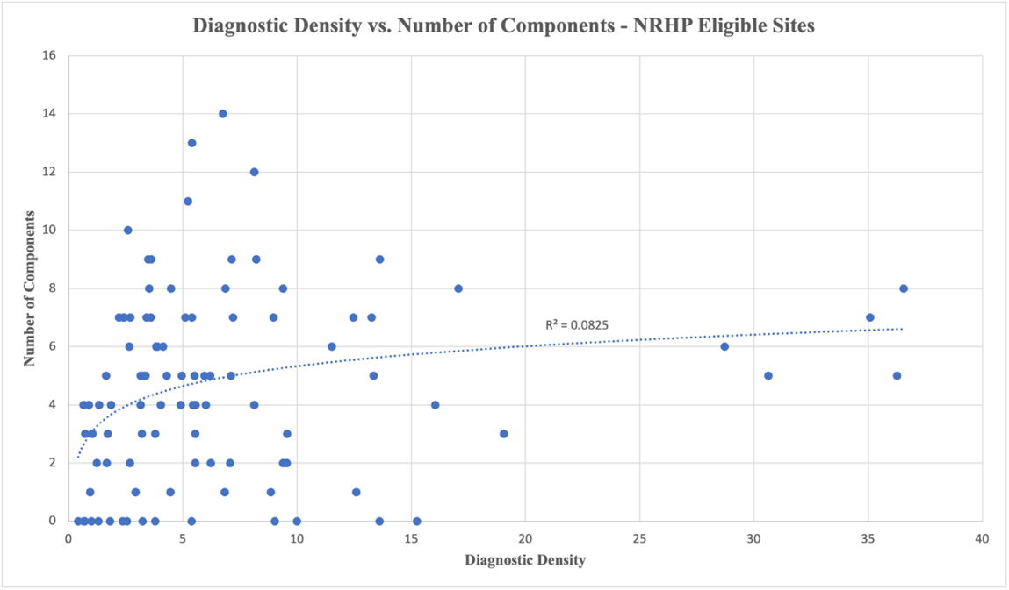
Figure 4.2. Diagnostic density’s relationship to number of components for NRHP eligible sites in the intensively tested sites sample (n=99 sites). Logarithmic trendline used due to the data’s high rate of change of data and asymptotic nature.

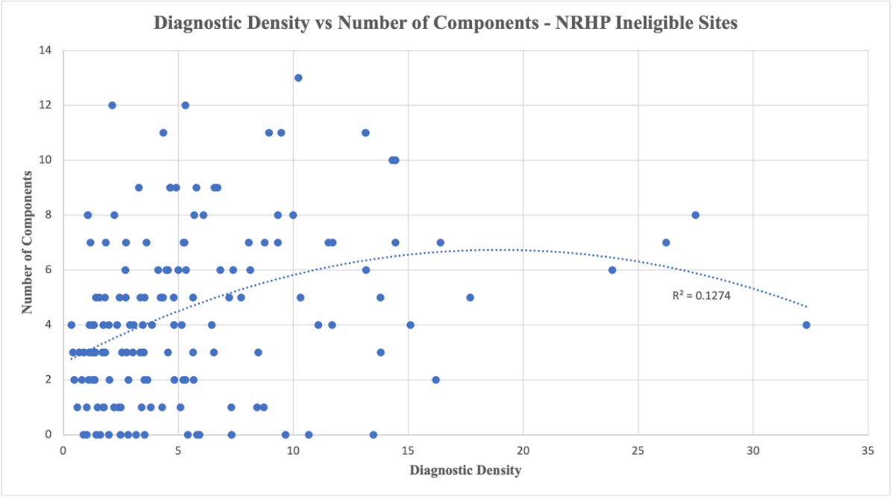
Figure 4.3. Diagnostic density’s relationship to number of components for NRHP ineligible sites in the intensively tested sites sample (n = 154 sites). Polynomial trendline used due to data in graph breaking from a linear trend.
Figure 4.4. Diagnostic density’s relationship to fill volume excavated for NRHP eligible sites in the intensively tested sites sample. (n=99 sites). Blue dots correspond to diagnostic density and orange dots correspond to number of components. A polynomial trendline is used due to data not conforming to a linear trendline.

Figure 4.5. Diagnostic density and number of components’ relationship to volume excavated for NRHP ineligible sites in the intensively tested sites sample (n = 154 sites). Blue dots correspond to diagnostic density and orange dots correspond to number of components. A polynomial trendline is used due to data not conforming to a linear trend.
Additionally, for NRHP-eligible sites, Figure 4.2 denotes a steep decline in the number of discrete cultural components as the density of diagnostic artifacts increases; in other words, as the diagnostic density value increased, the number of components decreased as well. The R-squared value (0.0825), however, indicates that there is a weak relationship between number of components and diagnostic density for the NRHP-eligible graphs in this sample. NRHP-eligible sites found to have multiple discrete cultural components are thus not reliably dense with diagnostics from a statistical standpoint, and vice versa (‘dense’ sites will not reliably have multiple components). This lack of correlation between number of discrete cultural components and diagnostic density is significant because it suggests that a dense site may not actually yield much in the way of useful information about cultural chronology; numerous diagnostic artifacts may be present, but if there is little typological diversity or granularity, the interpretive potential of the site in question is severely limited. While some investigators have noted the problems involved in treating diagnostic density as a proxy for the presence of multiple intact components, the analysis presented here demonstrates said problem with reference to a large comparative dataset.
For NRHP-ineligible sites (Figure 4.3), there is a slight but far less dramatic decrease in numbers of components as the DDV increases. The R-squared value of 0.1274, however, still indicates a very weak relationship between these variables. This weak relationship in turn suggests that sites with high diagnostic density values were often assessed as NRHP eligible. In other words, it can be reasonably inferred that a site being perceived as having a high diagnostic density either explicitly or implicitly informed NRHP eligibility assessment for this sample of sites. However, this analysis shows that after differences in site scale are accounted for, it becomes clear that diagnostic density is a somewhat ambiguous and subjective assessment tool whose implementation is biased by the size of a site.
Volume Excavated versus Diagnostic Density
I also examined the relationship of volume excavated at a site to both the number of components and DDV of the same site, which is shown in Figures 4.4 and 4.5. Cubic meters excavated functions as the independent variable, and diagnostic density and discrete numbers of cultural components each function as dependent variables. For both NRHP-eligible and NRHP-ineligible sites, low R-squared values indicate weak relationships between both number of components and diagnostic density and volume of fill excavated. This analysis further underscores that the amount of area excavated does not correlate reliably with finding sufficient archaeological material to accurately assess NRHP status. Given that Fort Polk has come to be understood as a huge palimpsest of archaeological sites and material, if one digs long enough it is highly likely that they will encounter enough diagnostic material to claim that an NRHP eligible site has been found; all that would be left to do is decide where to delineate the site boundaries.
There is significant overlap between NRHP-eligible and NRHP-ineligible sites in terms of volume excavated in this sample. While perhaps partially explainable by the higher frequency of ineligible sites in the sample, as NRHP eligibility is not an inherent quality of a site but rather one ascribed to it, the patterns described herein point to biases within the methodology employed to assess NRHP eligibility. There also does not appear to be much of an increase in diagnostic density as volume excavated increases, which agrees with the conclusions drawn by Anderson and Smith (2003) concerning the relationships between volume excavated, artifact density, and artifact diversity previously discussed. Their observations coupled with the analyses shown here suggest that a site would need to be extensively tested or completely excavated to ascertain this information, with degree of certainty increasing with excavation volume.
However, as larger, denser sites tend to be assessed as eligible, while smaller, less dense sites tend to be assessed as ineligible, conference of NRHP eligibility will depend on extensive excavation and partial or complete destruction of sites if artifact density and/or diversity continue to be considered major or the sole criteria undergirding NRHP eligibility assessments. However, a familiarity with the stratification indices calculations for both the intensively tested sites sample, as well as the calculations done for the five large data recovery projects, would allow investigators to assess the character of the stratigraphy of a site more quickly without having to excavate it to its fullest extent. Gauging how similar or dissimilar a site’s diagnostic stratigraphy is to the prevailing stratification indices for the entire Fort Polk installation would aid future investigators’ assessment of a site’s uniqueness.
Several of the outlier data points from Figures 4.4 and 4.5 were removed to see if doing so would affect their r-squared values in a significant way. For Figure 4.4, the data points corresponding to 16VN2725 (Morehead et al. 2002b), 16VN2836 (Thomas et al. 2003), 16VN878 (Morehead et al. 2007b), 16VN3999 (Mountjoy et al. 2020), and 16VN3001 (Morehead et al. 2007a) were removed. These five sites all had a low volume excavated but high numbers of diagnostics recovered from them, giving them high DDVs. Removing them did not generate r-squared values that were significant, indicating that these five outlier sites were not significantly skewing the regression calculation done on this dataset. These sites’ NRHP Eligible statuses were premised primarily on criteria other than diagnostic density and/or diversity, namely the presence of intact components representative of cultures that at the time were rare on Fort Polk.
For Figure 4.5, the data points corresponding to 16VN2961 (Morehead et al. 2007b), 16VN3029 (Morehead et al. 2005), 16VN1832 (Parrish et al. 1998), and 16SA99 (Parrish et al. 1997) were removed. These four sites each also had a low volume excavated but a high number of diagnostics recovered from them, giving them high DDVs. Removing them also did not generate r-squared values that were significant, indicating that these four outlier sites were not significantly skewing the regression calculation done on this dataset. The disturbance cited for 16VN1832 were an old tramway and an unpaved road bisecting the site. However, the NRHP Ineligible statuses of two of these sites, 16VN2961 and 16VN3029, were premised on the assertion that these sites were disturbed and lacked stratigraphic integrity (Morehead et al. 2007b:270-271; Morehead et al. 2005b:223-224). However, these evaluations of disturbance were not premised on any quantitatively-based comparative stratigraphic assessment. Rather, subjective assessment of diagnostics not being where they were expected to be was cited as the reason for calling these sites disturbed. A revisit of these sites is, I argue, appropriate so as to better determine whether they are disturbed. Site 16SA99 was declared NRHP Ineligible because although there were a large number of identifiable ceramics and lithic material, their stratigraphy did not conform to the general cultural sequence outlined by the FPAS projects. This also should be re-visited and quantitatively assessed.
Inconsistencies in Application of HPP NRHP Eligibility Determination Recommendations
During the accumulation and analysis of the data used in the relative diagnostic stratigraphy table for intensively tested sites (Appendices B and C), and its use in the calculation of stratification indices and diagnostic density graphs, numerous examples were observed of a general lack of consistency in the assessment of NRHP eligibility through the use of assemblage density, diversity, numbers of diagnostics, and the presence or absence of discrete/intact cultural
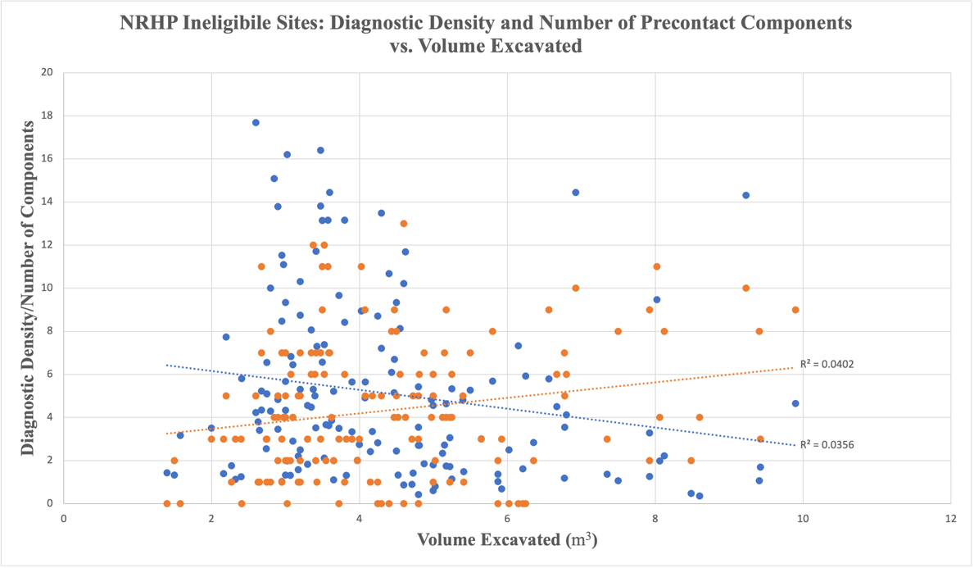
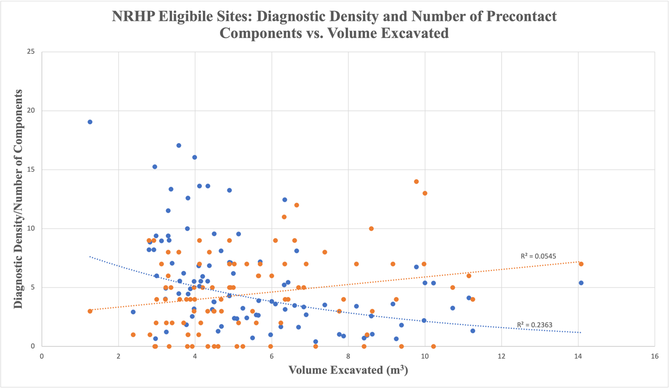
Figure 4.7. Diagnostic density and number of components’ relationship to volume excavated for NRHP ineligible sites in the intensively tested sites sample with four outlier sites removed (n = 150 sites). Blue dots correspond to diagnostic density and orange dots correspond to number of components. A polynomial trendline is used due to data not conforming to a linear trend.
Figure 4.6. Diagnostic density’s relationship to fill volume excavated for NRHP eligible sites in the intensively tested sites sample with five outlier sites removed (n=94 sites). Blue dots correspond to diagnostic density and orange dots correspond to number of components. A polynomial trendline is used due to data not conforming to a linear trendline.
components present. The frequency with which investigators deviated from using artifact density, artifact diversity, or number of cultural components (intact or otherwise) present in assessing NRHP eligibility indicates the ineffectiveness of these measures when used in isolation. Installation-wide totals of diagnostic artifacts have been available since the 1988 HPP, and their use in NRHP eligibility determinations was recommended in the 1999 HPP, which also provided updated totals, as did the 2003 synthesis. Only rarely have these data been used, however. Instead, impressionistically based NRHP eligibility determinations are fairly common, which is why this thesis has argued for the use of quantitative comparative analyses. Examples include site 16VN1022, which was reported as having eight components but was deemed ineligible because the investigators determined that the type of site 16VN1022 represented (a short-term hunting camp frequently re-visited during the Leander phase of the Calcasieu culture, during the Late Archaic) was reported to be so common on Fort Polk that the site did not meet the criteria for NRHP eligibility (Morehead et al. 2005b). However, the authors did not provide specific counts of these types of sites, or how many others on Fort Polk had eight or more components; the 2022 synthesis, in contrast, documents only 47 of 4128 sites on the installation have 8 or more components, making them exceedingly uncommon (Anderson et al. 2022: Table 5.2).
Site 16VN2898 was reported as having diagnostic artifacts and substantial artifact diversity but lacking identifiable individual occupation episodes within the deposit as a whole. The lithic tools and ceramics recovered at the site were also not considered by the investigators to be indicative of anything particularly unique (Morehead et al. 2005a: 235). How common the artifact types actually were on the installation was not specified, even though the data was available in earlier syntheses; stratification indices could have been used to see how mixed the site actually was, instead of intuitively based statements that it was mixed. In another example, site 16VN2900 represents a locus of Lower Mississippi River Valley activity from the Leander phase on. This site lacks any evidence of Mississippian activity and was described as a combination of the three type sites that are related to lithic procurement at Fort Polk – quarries, workshops/camps, and base camps (Campbell et al. 2003:321). However, the authors reported that over 90% of the cultural remains could not be identified or associated with any culture. Here again, this was a conclusion lacking quantitative analytical support (Campbell et al. 2003:322).
Site16VN296 was reported as having an intact Tchefuncte component, which at the time of writing were reported as somewhat rare at Fort Polk (Thomas et al. 2003:156). The authors used the presence of a single Tchefuncte sherd to support an NRHP Eligible assessment yet did not compare the single sherd with the incidence of Tchefuncte artifacts on other sites elsewhere on the installation. However, in the 2003 synthesis 26 Tchefuncte sherds were reported on 11 sites, and as of 2022, 47 Tchefuncte sherds have been found on 27 sites on Fort Polk (Anderson and Smith 2003:302; Anderson, Bissett, Stanton, and Laffitte 2022: Table 4.3). This highlights the need to constantly make use of available comparative assemblage data, as with each survey or site testing project this data changes. Had the investigators made use of available Fort Polk assemblage data, they may not have assessed 16VN296 as NRHP Eligible.
Site 16VN297 was reported as having a rich deposit of pre-contact artifacts, but the relative position of the diagnostics (except for the Holly Springs phase component) indicates disturbance. The profiles do not depict such disturbances, but the investigators state that there appears to be no other explanation (Thomas et al. 2003:187). In this case the authors do provide quantitative evidence for mixing (Thomas et al. 2003: 181-182) in the form of tables giving the test unit and depth of recovery of each diagnostic. For example, Late Mississippian Plaquemine lithic diagnostics appear to co-occur with Late Paleoindian, Archaic, and Early Woodland lithic diagnostics but below supposedly Woodland-period plain ceramics. However, as was shown in Figure 3.2, the current cultural sequence, lithic diagnostics on Fort Polk demonstrate considerable overlap from one temporal period to the next. Further, plain surface-finish treatment of ceramics on Fort Polk is not limited to the Woodland Period but occur widely in many site deposits. Calculation of stratification indices offers an alternative means of assessing extent of mixing at sites like this, as these indices offer a more qualitatively-based means to determine whether what initially appears to be a disturbed site is actually laden with diagnostics that have a significant amount of temporal overlap.
In another example, site 16VN1263 was determined to not have any intact cultural components but was assessed as eligible for inclusion on the NRHP. The authors state that at this site, Tchefuncte sherds occurred with what appeared to be Williams Plain-like sherds. This suggested a high research potential for the site, since at time of writing, Williams Plain sherds had not been encountered in the Fort Polk area (Thomas et al. 1994b:95). Williams Plain ceramics continue to have a very low incidence on Fort Polk (Anderson, Bissett, Stanton, and Laffitte 2022: Table 4.3), and as such were not included in the stratification indices described earlier. They were observed on two sites in the RDS testing sample, at one with two sherds above a Bassett arrow point, and at another by themselves with no other diagnostics (Appendix C). However, if more Williams Plain sherds are found on Fort Polk in the future, tabulating the percentage with which they occur above, below, or with other diagnostic types would aid in establishing the character of Williams Plain ceramics’ occurrence on Fort Polk.
At site 16VN1068, very few diagnostics were recovered (n = 3), but stratigraphy at this site was described as intact albeit without formal analyses. The authors state that “peaks in artifact frequency” allowed them to infer Middle Archaic and initial Late Archaic dates, which they then corroborated by linking each peak with the diagnostic found within the same deposit (an unidentified ceramic sherd, an Epps point, and an Evans point) (Thomas et al. 1993b:66). The artifact frequencies the authors are referring to include non-diagnostic formal and generalized bifacial and unifacial tools; retouched flakes; primary, secondary, and tertiary debitage; and tested cores. These various artifact categories were inferred to exhibit general trends with regards to their association with specific time periods on Fort Polk, namely an equal ratio of unifacial and bifacial tools in Middle Archaic components and an increased frequency of unifacial tools in initial Late Archaic components; these assumptions, however, need to be tested with larger samples from across the installation. Finally, site 16VN3785 was declared ineligible specifically because of low diagnostic and non-diagnostic artifact frequency, which the authors argue made the site’s assemblage unsuitable for answering further research questions (Gregory and Dorland 2020:45). However, this site did yield two lithic diagnostics from the same test unit, an Evans point above a San Patrice var. Keithville (see Appendix C), which, per the methodology proposed in this thesis, is in logical stratigraphic order and would be one line of evidence that the site had significant information to contribute.
As these examples demonstrate, instead of advancing impressionistic NRHP determinations based on what was found at a single site, all NRHP determinations for sites found on JRTC and Fort Polk must be based on explicit criteria supported with comparative analyses making use of the entire installation data set, with specific references to the unique characteristics of the site in question. They must also demonstrate how additional investigations at the site in question would add significant knowledge to what is already known about the culture or components that are represented. That is, what specific research approaches are relevant to understanding these past cultures, and how would investigation of the site serve to provide new information? Would investigation of the site serve to address some or all these problems? The text must demonstrate a familiarity with the archaeology and history of Louisiana and surrounding area and be able to assess the site’s ability to address legitimate research problems, questions, and topics. The investigator must state precisely why the information is of value or why it is unique and, importantly, how that kind of information can be obtained through reference to specific data recovery methods. Evaluations must also include justifications for statements that sites are not significant (“Not Eligible”) for listing in the NRHP. Unsupported statements that other sites have similar deposits or diagnostics (without providing specific quantitative or qualitative evidence in support of this claim), or that sites ‘seem” to lack significance, or that refer only to site integrity in an impressionistic framework, without supporting data, are not sufficient or acceptable. Likewise, the statement that a site is not significant because it is small and lacks deep, intact subsurface deposits may or may not be true, unless this has been demonstrated.
To conclude, moving forward, all recommendations for NRHP eligibility status should proceed, in part, using comparative analyses making use of the results of past work on JRTC and Fort Polk. These analyses should be quantitatively based and should refer to the entire site assemblage found during the specific project in question, as well as to sites and materials found during earlier investigations on the installation. Assemblage data specifically about temporally diagnostic artifacts is available electronic and hard copy in installation GIS, in the appendices to this thesis, and in the database developed for the 2023 synthesis. If, for example a site yields Tchefuncte pottery or San Patrice var. Hope projectile points, as part of the analysis and NRHP significance justification an effort should be made to document how many other sites on the installation yielded similar materials, and whether or not the materials are in appropriate stratigraphic context and are not obviously mixed with diagnostics of other periods. This would help document the relative uniqueness and hence importance/significance of the assemblage in question (Hoover et al. 2022b). Such an understanding would also improve NRHP assessment and ranking of sites from all proceeding CRM projects on Fort Polk. The relative diagnostic stratigraphy table and stratification indices described here demonstrate how pre-existing assemblage data from Fort Polk can be organized to this end. Since larger, denser (i.e., multi-component sites) sites tend to be deemed eligible, while smaller, less dense sites tend to be deemed ineligible, conference of NRHP eligibility will otherwise depend primarily on having extensive survey and test excavation data, if artifact density alone is the barometer of eligibility. Incorporating the calculation and evaluation of stratification indices for a site’s diagnostic assemblage into assessments of NRHP eligibility, which can also be thought of as evaluating how stratified or mixed the deposits of a given site are, would greatly improve NRHP assessment, while circumventing the issues that arise when artifact density, artifact diversity, or number of intact cultural components are used as the primary or sole barometer of a site’s NRHP eligibility.

CHAPTER FIVE
CONCLUSIONS AND AVENUES OF FUTURE RESEARCH

This thesis explored how the production of relative diagnostic stratigraphy tables and indices of stratigraphy can be used to both achieve a more fine-grained understanding of the cultural chronology present on the Fort Polk military reservation and in turn improve assessment of National Register of Historic Places eligibility. The wider view of the archaeological assemblage on Fort Polk taken in this analysis echoes Dan Hicks and Laura McAtackney’s observation that "a focus on landscape in its broadest sense - the heterogenous, constantly shifting networks of places, people, institutions, and objects - reveals how archaeology is a relational process" (2007:22). This analysis also reaffirms Barbara Bender’s admonition that archaeologists must learn to appreciate “mess, complexity, and contradiction, as well as disorder and untidiness” in the archaeological record, as archaeological assemblages and cultural landscapes refuse to be disciplined (2006:304, 310). In this concluding chapter I discuss some of the broader implications of the methodology developed in the preceding chapters, then move to suggesting future avenues of research that could make use of or improve upon my methodology. I conclude by provide a flowchart depicting how the methodology described in this thesis can be operationalized.
Mapping Identifiable Cultural Components

In collaboration with Thad Bissett, a series of maps were made showing the locations of sites by number of identifiable cultural components; zero, one, two, three to five, six to nine, and ten or more identifiable cultural components were used as discrete categories (See Figure 5.1 for an example; see Appendix I for all these maps). These maps display the locations of all tested sites on Fort Polk, not just the ones used in the sampling of intensively tested sites. Several useful inferences can be made from them. As can be seen in Figure 5.1, sites with zero
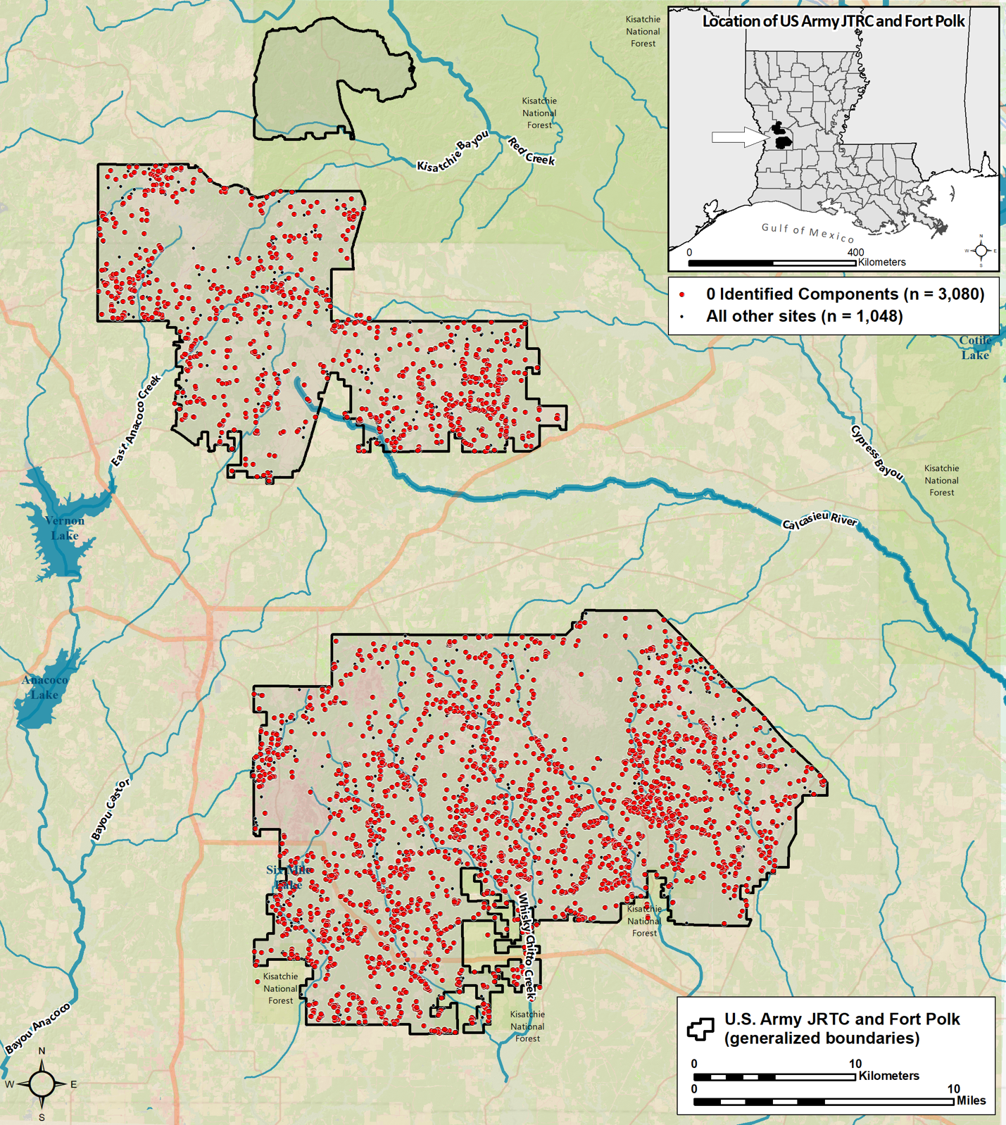
Figure 5.1. Map showing the location of every site with 0 identifiable cultural components (Image courtesy Thaddeus G. Bissett 2022).
components (n = 3080) are distributed throughout the environs of Fort Polk with no obvious patterning beyond slight clustering around water sources. As was indicated in Figures 4.3 and 4.4, sites with zero cultural components tended to also have very low diagnostic densities, regardless of NRHP eligibility. As the number of components increases, sites tend to cluster around water sources with increasing frequency, which is unsurprising. Also, as indicated by Figures 4.3 and 4.4, number of components and diagnostic density are very weakly related, with sites of higher diagnostic density clustering at or below the five-component mark. Taken together, these observations speak to a fairly even patten of pre-contact land-use; no stretch of creek or bayou seems to be more heavily visited than others. The raw lithic material available on Fort Polk was likely distributed in unpredictable, highly variable ways across an otherwise homogenous landscape, which could have helped shape these site distributions.
Social Boundaries
Miriam Stark (1998:1) asserts that of paramount important in studying formal variation across space is the identification of social groups, whose boundaries are marked by distinctive patterns in the archaeological record. Although the activities of Native peoples in what are today the environs of Fort Polk created a somewhat idiosyncratic archaeological footprint, patterns of area use and revisitation by Native peoples have still been able to be discerned. The relative diagnostic stratigraphy table and stratification indices have the potential to become important components of this analysis, as they hone in on patterns of stratigraphy exhibited by diagnostic materials. Digression from the average probability of a certain diagnostic being above, with, or below another diagnostic can be interpreted as a measure of disturbance, as well as interruptions or resumptions of area use by various groups.
The potentials of the methods proposed in this thesis also dovetail with myriad other
bodies of archaeological theory. Techniques et culture, which originated in France and resembles the anthropology of technology developed in the United States, focuses on relationships among technical choices, social boundaries, and material culture patterning (Stark 1998:1-2). This approach argues for rethinking questions concerning how we study material culture patterning (Stark 1998:2). Creating indices like those generated here for Fort Polk could aid in this endeavor. It has been almost 25 years since Stark wrote this, and nowadays questions about social boundaries across space have come to the fore in archaeology. I am here suggesting that the methods described earlier in this document be taken up by the profession as tools to use in service of an already-extant research agenda. Indeed, Themes 2, 5, 7, 8, and 10 of the 2018 State of Louisiana Comprehensive Archaeological Plan would all be addressed, in keeping with the recommendations put forward by the 1999 HPP (Anderson and Smith 1999:47-49). Namely, these themes are: Settlement Patterns and Cultural Landscapes; Material Technology; Social Identity/Status; Group Interaction, Conflict, and Mobility; and Architecture and Site Configuration (see Table 2.1). Improved analyses of the patterns of interruption and resumption in site use could improve our ability to link behaviors to broader understandings of landscape and resource use, site formation, and possible interpersonal interaction on Fort Polk by various Native groups.
Fort Polk as Boundary Object
Stark's perspective also dovetails with Sassaman's (2016) boundary object framework. Originally devised by Etienne Wenger (1998), Sassaman (2016) developed a modification of the boundary object framework (especially the utilization by Native peoples of a particular medium or mode of exchange to facilitate the perseverance, endurance, or persistence of socialities across both temporal and spatial distances, thereby creating constellations of practice) and then applied it to archaeological inquiry. These constellations of practice are further defined as “interventions against alternative futures”, or strategies to mitigate perceived existential threats (Sassaman 2016:279). Using this framework, Fort Polk could be thought of not just as a neutral zone or communal/shared territory but also as a site of interaction that was intentionally conceptualized as a place of ritualized interaction (or peaceful procurement), akin to the aggregation model developed by Conkey (1980) and others.
Further, a crucial component of Wenger’s (1998) original conception of boundary objects and constellations of practice and Sassaman’s (2016) modification of them involve rethinking what community is and means. Indeed, Sassaman (2016) states that “[r]egistered in the archives of human history are moments when connections among people with independent histories coalesced into broader institutions and structures of practice . . . Boundary objects, for instance, serve to coordinate the perspectives of diverse communities for common purpose” (Sassaman 2016:271-273). While Sassaman was here referring to singular large sites like Poverty Point, I argue that Fort Polk could also be seen as a space of experience, a place where experience was temporalized (Sassaman 2016:274, sensu Koselleck 2004). While connections between various geographically and temporally dispersed groups that came to what is now Fort Polk have long been assumed, the nature of these connections continues to be not well understood. As was previously discussed, there has been a very low incidence of ceramic sherds recovered from Fort Polk, leading archaeologists to believe that activities there involving ceramics were limited and that ceramics are uncommon for much of west-central Louisiana in general (Anderson and Smith 2003:303-304, 311). Such a profound dearth of ceramic wares in this area implies that the use of ceramics was not very important locally, which by extension precludes the possibility of extended settlement (Anderson and Smith 2003:303-304). Consequently, the Fort Polk area has come to be thought of as an area of resource extraction, a place where various indigenous peoples came to primarily collect lithic raw material, as extrusive chert gravels and pebbles borne by the various riverine systems that pass through or near the area would have been abundant; people may have also hunted in the area, but did not linger for more than a few days (Anderson and Smith 2003:141-145, 373, 379, 386, 391; Morehead et al. 1996:170-171; Morehead et al. 2002:41-51; Thomas et al. 1997:21). In short, on the surface Fort Polk has been traditionally viewed as remarkably unremarkable. As I shall demonstrate, that perspective is likely the opposite of the way the area was viewed by Native peoples.
Knowledge of the Fort Polk area as a source of lithic raw material certainly united these various groups in an abstract sense, but was this knowledge acquired independently again and again by various groups, or, in the period of demographic change and migration that occurred during the Archaic, was it passed and shared from band to band? Was Fort Polk a potential place of aggregation, sensu Anderson and Sassaman (1996), Anderson and Sassaman (2012:51), Anderson et al. (2015), and Miller (2016)? Or, during the Woodland and Mississippian periods was Fort Polk a place that reified a constellation of practice and in turn facilitated a two-way exchange of knowledge and experience amongst Native visitors to Fort Polk. This exchange would have ramified out across a large area and served to integrate numerous groups into a spatial framework that referenced time and change and aided in planning for the future (Sassaman 2016:280). In other words, was Fort Polk a place (sensu Lefebvre 1974, Relph 1976, and Yi-Fu Tuan 1977 and 1991) wherein repeated journeys to it and activities within it caused it to become an important and cosmologically significant point of reference in various groups’ broader understanding of their world? This appears likely and are the kinds of questions that can be better examined by taking up Sassaman’s (2016) boundary objects framework to the assemblage at Fort Polk.
Given the above, many of the larger trends that defined the Paleoindian, Archaic, Woodland, and Mississippian periods are harder to detect archaeologically at Fort Polk due to the absence of features (such as hearths, structures, etc.) and a robust ceramic assemblage. However, this is one of the main reasons I see the Fort Polk area itself as a potential boundary object and a profoundly meaningful place on the landscape: although not a locus of habitation, the area was still potentially important for numerous groups’ maintenance of political and socio-cultural boundaries over a long period of time. While Fort Polk was absolutely a place of utilitarian resource acquisition, the area may well have factored into the larger historical backdrop (sensu Pauketat 2007) of the Archaic, Woodland, and early Mississippian periods in ways not previously considered. The lack of well-defined boundaries also tells us something about the Fort Polk area of Louisiana. This lack of well-defined boundaries is evidenced by the palimpsest-like nature of the archaeological material. It is also a strong argument against the use of local phases (sensu Phillips et al. 1951), if by phase we mean periods of permanent occupation in the general area delineated by certain styles of lithic and ceramics objects. Other than during the San Patrice era and possibly during the Late Archaic period, there is no evidence for extended occupation, rendering assignment of phase names implying their existence a somewhat questionable exercise.
Michelle Hegmon (1998:265) argues that "style is not just a passive byproduct of cultural norms or mental templates. Style DOES something [author’s emphasis]". As will be discussed below, the styles of various lithic and ceramic diagnostics could have been active arbiters of cultural interaction and transmission within the confines of Fort Polk. Olivier P. Gosselain's work (1998:1992b) notes that of the many aspects of pottery technology, only some (forming techniques) seem to relate to ethnic differences; only forming techniques are taught by hands-on instruction. Perhaps the various ceramic styles found on Fort Polk speak as much, if not more so, to the portability and transmissibility of social identity. Additionally, logistical forays into Fort Polk to source lithic raw material could have become imbued with deeper significance, as such trips would have been a common practice for many groups living in the vicinity and potentially a means of both linking otherwise dispersed groups as well as facilitating exchange. Exchange may have needed to occur under some sort of ritualized process, one of continuing recognition of the importance and special nature of the area, to avoid conflict and ensure peaceful interaction when groups hypothetically encountered one another.
Despite not being a place of habitation, Fort Polk was, I argue, a dynamic agent that influenced the decision-making of various indigenous groups as much as any other climatic or environmental process. Sassaman (2016) states that
Drawing on Ingold (1995:126), Harris (2000) takes a dwelling perspective to account for the “resonance” between the movements of humans and the rhythmic fluctuations of environment. In this sense, dwelling is the flow of activity, the relational nature of being and time. Persons gain perception of these flows by engaging their full senses in monitoring their surroundings and its changes, mutually constituting seasonality through embodied periodicity of activity, movement, and social interaction [Sassaman 2016:276].
The climate was variable in the Fort Polk area during pre-contact times; it cycled between cool/wet and warm/unstable several times, with cooler and wetter conditions arguably better for intensive use of the area (Anderson and Smith 2003:14; Gunn 1982:182-183; Gunn 1984:150-154; Guy and Gunn 1983; Jolly 1984:4-5). At the end of the Hypsithermal (~ 5800 cal yr BP, and the beginning of the Late Archaic) the climate was cooler and wetter, which may have encouraged an increase in intensity of the area’s use; this persisted into the Early Woodland. Given that the Fort Polk area was subject to flooding and cyclical wet/dry periods at various points in time, both limitational and social knowledge may have been integral to the successful exploitation of the area. These are defined by Sassaman (2016:276) as knowledge of long-term environmental variation (limits) and the cultural coding of that knowledge in forms amenable to remembrance and transmission, respectively. This knowledge may have been exchanged along with material objects within the bounds of Fort Polk by groups who, while perhaps not intentionally seeking out such encounters, were aware of the likelihood of encounters occurring. Objects exchanged in this context could have also acted as boundary objects, becoming repositories of, or mnemonics for, the limitational knowledge concerning Fort Polk’s resources and the most opportune times to exploit the area, doing the work of coding limitational knowledge into social knowledge. Dietler and Herbich (1998:233) argue that to understand social boundaries, a more nuanced understanding of the dynamic nature of social and cultural identities and negotiation of boundaries of various kinds requires a theoretical understanding of the myriad social processes that might have produced them. The relative diagnostic stratigraphy tables and stratification indices developed here could aid in this as well. Corroborating evidence in the form of non-local diagnostic types being found at sites associated with one or more groups who exploited Fort Polk would be needed to test this hypothesis, however. Fort Polk, rather than being in the middle of nowhere, could instead be seen as being in the middle of everywhere.
Applying this perspective necessitates a shift in how the Fort Polk area is conceptualized, moving away from seeing the locale merely as a zone of extraction towards a view of it as an active constituent of various indigenous groups’ ontologies and cosmologies. Indeed, Stark argued that undecorated and/or utilitarian objects’ roles as agentive makers of cultural identity become more visible when we view objects of material culture as the end result of a sequence of technical choices made during the manufacturing process (Stark 1998:6). Thinking about broader processes or forces that may have been at work in the Fort Polk area during pre-contact times is not new in the literature. What is new here is what these processes or forces meant to the people involved. Anderson and Smith (2003:146), for example, make mention of Sassaman and Green’s (1993:214-224) cultural quarry idea that posits the reuse of worked chert by Woodland and Mississippian groups at scavenged sites, or places of substantial lithic reduction during the Archaic period encountered during subsequent periods by groups doing other tasks. As the use of raw material on Fort Polk during earlier periods placed less emphasis on conservation in favor of maximizing the potential of individual pebbles, a large amount of already-reduced lithic material may have been widely distributed on the ground surface (Anderson and Smith 2003:146). Such a functionalist view may well be correct but is only part of the larger picture.
Similarly, use of upland ridges as routes for population movement through the environs of Fort Polk has been postulated (Guy and Gunn 1983). These ridges are part of the Kisatchie Wold, a swath of high, open, uncultivated land underlain by a (formerly) continuous ridge/escarpment running from the Mississippi River floodplain, through central Louisiana, and then southwest into southern Texas. Roughly paralleling the Gulf Coast, the Kisatchie Wold cuts through central Louisiana and encompasses the Fort Polk area. When it was still intact, could it have served as an overland route linking what is now southern Mississippi, central Louisiana, and Texas’ Gulf Coast, linking the Lower Mississippi River Valley with the Fort Polk area and the Sabine River, Red River, and East Texas? Natural features like the Kisatchie Wold could have facilitated past interconnections, by serving as highways that did not require active maintenance.
Potentialities of Chaînes Opératoires and Landscape Archaeology Approaches on Fort Polk
In addition to reconceptualizing Fort Polk as a boundary object writ large, one can also conceptualize the environs of Fort Polk as nested within the chaînes opératoires (operational chains) of the entire lithic acquisition and reduction process. A chaîne opératoire seeks to reconstruct the succession of mental and physical tasks involved in the cultural transformations that raw material must go through. These processes also proceed at different rates within different cultural or societal groups (Sellet 1993:106, Perlès 1987:23). The environs of Fort Polk mediated how the various assemblages therein were created; the repeated deposition of diagnostics may reflect a medium of communication and serve to emphasize the manipulation of material symbols in strategies of group boundary maintenance, ideological representation of social relations, or cultural categorization (Dietler and Herbich 1998:245).
It is impossible for archaeologists to understand or perceive landscapes in the exact same way as Native peoples; however, it may be possible to understand (at least on federal installations with large assemblage datasets) cultural chronology in ways that do not rely on or allow the intrusion of Western assumptions about landscape and that privilege and facilitate Indigenous perspectives. Indeed, Hicks and McAtackney (2007:13) assert that archaeologists listen to landscapes, and echo Araoz’ (2004) assertion that less-visible sites whose thematic values are reinforced by being linked together in cultural landscapes, heritage areas, and cultural corridors should be considered when talking about overall landscape use and landscape archaeology (2007:13). Bradley Laffitte, Fort Polk’s base archaeologist, has also argued that we should not just dismiss the smaller sites, as sometimes a string of smaller sites along a waterway might be parts of a larger interconnected complex or locus of activity (personal communication, 2022). An understanding of space as both socially constructed and co-constitutive of social relationships instead of a static backdrop for human action should inform studies of landscape, as should phenomenological studies that seek to grasp the experiential dimensions of a space/place (Hicks and McAtackney 2007:13; Ingold 1993, 1995, 2000, and 2005:122; Robin and Rothschild 2002:161). Incorporating these considerations would make multivocality a priority, and therefore undergird, rather than preclude or contest, Native perspectives on landscapes like Fort Polk.
Despite the constellation of approaches to landscape archaeology/landscape studies, Hicks and McAtackney (2007:14) argue that there already exist many commonalities between them: prioritizing non-intrusive methodologies, incorporating multi-scalar analyses, and expanding perspective beyond arbitrarily bounded entities like sites. Understanding how people, “differently engaged and differentially empowered”, lay claim to and contest their landscapes is also a common theme within this subdiscipline (Bender 1993a:1715; Hicks and McAtackney 2007:15). Hicks and McAtackney (2007:16-17, 21) also make mention of Tim Ingold's (2005:157) discussion of the temporality of landscape: temporality, as opposed to history or chronology, arises as a result of humans’ dwelling in and on the landscape. Dwelling in this context refers to human activity patterned in a strategic way across myriad taskscapes so as to make use of accumulated prior knowledge to aid in mitigation against or prepare for future anticipated happenings (Ingold 2005:157). Archaeological practice, for Ingold (1993), also happens within taskscapes, or zones in which the temporal and emergent nature of this human dwelling unfolds in the landscape. Archaeology, including the work done on Fort Polk, is thus in turn another form of dwelling because it "tells - or rather IS - a story . . . it is the hybridity of archaeological conceptions of landscape that emphasize the material as well as the ideational” (Ingold 1993:152). Ingold (1993, 2005) argues that by viewing landscapes as fluid, emergent, and embodied entities, the manner in which they link together past, present, and future and how they are continually made and unmade, both within the minds of Native peoples and contemporary archaeologists.
Concluding Remarks: Operationalizing the New Methodology and Directions for Future Research
Julian Thomas suggests that rigidly empiricist approaches in landscape archaeology (and archaeology more generally) have developed accounts that often seem very removed from the human lives that were lived in these places (2001:165, quoted in Hicks and McAtackney 2007:22). Instead, landscapes like Fort Polk actually take an active role in social life and have material biographies in which people, places, and things are entangled (Hicks and McAtackney 2007:22; Salmond 1982; Sherratt 1996). Relative diagnostic stratigraphy tabulation and the creation of indices of stratigraphy, in addition to improving how cultural chronology and NRHP eligibility are assessed on Fort Polk, could also play a role in facilitating a more reflexive archaeological investigation on the installation. A heightened appreciation for the material diversity of the landscape and the myriad ways in which the landscape is conceptualized would also aid in this reflexivity (Hicks and McAtackney 2007:23; Schmidt and Patterson 1995:23-24).
The primary goal of this thesis was to help refine NRHP assessment and demonstrate how the methodology described in the preceding chapters can be used moving forward. I also argue that there is a need to re-assess some earlier evaluated sites and rank them in importance or priority for reassessment and certain kinds of research. For example, NRHP Ineligible sites like 16VN1022 exhibiting high numbers of discrete components but low incidence of diagnostic artifacts would potentially benefit from being re-visited and having the methodology of this thesis applied to it (also see Chapter 4 of this thesis). Generating an RDS table and indices of stratigraphy for these types of sites would provide a clearer picture of their stratigraphy and enable more thorough comparative analyses. Moving forward, future determinations of NRHP eligibility at intensively tested sites on Fort Polk should include Relative Diagnostic Stratigraphy (RDS) analyses to generate stratigraphic indices (using the methods presented in Chapter 4 and summarized below in Table 5.1). These indices provide measures of the extent to which a site is disturbed, whether individual components can be resolved and examined, and if they are in proper stratigraphic order in comparison with other components and diagnostics. These measures are meant to complement and, as needed, replace the use of artifact density and diversity metrics previously employed in NRHP assessment, as listed in the 1999 HPP and provided in Appendix A. Site discovery and boundary definition using uniform shovel test grids is still recommended to determine a site’s full possible extent, however, as is placing larger test units at artifact hot spots or areas of likely stratigraphic separation of components, or possible feature areas. Coupled with this, the occurrence of all diagnostic lithic or ceramic artifacts must be noted, and their incidence expressed in relation to the total numbers of artifacts of each type that have been found on Fort Polk, and the number of sites where that type has been found. This data will provide measures of the relative uniqueness of these site assemblages, another factor important to NRHP eligibility considerations.
Incorporating these methods will result in the development of an expanding compilation of RDS data, and stratigraphic indices for sites on Fort Polk that can be used for both qualitative and quantitative analyses to use during CRM projects to assist in assessing NRHP eligibility on all future projects. Also employed, of course, would be the ability of the site assemblage to
Figure 5.2. Flowchart depicting the operationalization of the RDS table and stratification indices methodologies.
answer questions and provide important new information about the past use of the area, as detailed to the State of Louisiana’s Comprehensive Archaeological Plans (Smith et al. 1983; Girard et al. 2018), as well as in various reports and syntheses produced on and near Fort Polk. Thus, the presence of other archaeological material, such as site furniture or features, should also be included in the assessment of a site’s NRHP eligibility, complementing the measures advanced here to assess a site’s uniqueness and the extent to which it appears to have been disturbed. These approaches are not meant to replace other modes or methods of inquiry, but rather to complement and add quantitative rigor to them. RDS data and stratigraphic indices undergird assessments of the character of a site’s stratigraphy and inform how and why the data collected from that site can contribute to better understanding the archaeological assemblage(s) at Fort Polk. The flowchart presented in Figure 5.1 depicts the two most straightforward ways in which the RDS and Indices of Stratigraphy can be used to assess NRHP eligibility assessment.
The various avenues of analysis employed in this thesis, as well as their implications, certainly require further development and corroboration at a region-wide scale. However, I argue that they and other analyses like them could push archaeological inquiry into new and exciting realms. Sustained efforts have already been aimed towards integrating various state and federal agency archaeological databases, which in turn could facilitate these creative analyses; generating relative diagnostic stratigraphy tables and indices of stratigraphy like those explicated in this thesis could be added to these synthetic endeavors. Additionally, determining which diagnostic types re-occur consistently in the same stratigraphic level as other specific diagnostic types would further refine understandings of the cultural chronology. Mapping these re-occurring combinations of diagnostics would in turn add a geospatial component to the analyses described in this thesis. This sort of geospatial data could further assist investigators at Fort Polk quantitatively determine the uniqueness of a site in terms of how rare or ubiquitous a given combination of diagnostics is in each section of the installation. Building upon previous investigations and the insights gained from them should always be the goal of archaeological inquiry.

Bibliography

Abrams, Cynthia L., Steven D. Smith, Mark D. Groover, Ramona M. Grunden, Jill S. Quattlebaum, and Christopher Ohm Clement (editors)
1995 Exploring Fort Polk: Results of an 8,027-Acre Survey in the Main Fort and Peason Ridge Portions of the Fort Polk Military Reservation, Vernon and Natchitoches Parishes, Louisiana. South Carolina Institute of Archaeology and Anthropology, Cultural Resources Div., University of South Carolina, Columbia.

Anderson, David G.
1984 The Ceramic Analysis. In Cultural Resources Evaluation, Fort Polk, Louisiana, edited by Charles E. Cantley and John R. Kern, pp. 243-252. Report R-2639, Gilbert/Commonwealth, Jackson, Michigan.

1996a Modeling Regional Settlement in the Archaic Period Southeast. In The Archaeology of the Mid-Holocene Southeast, edited by Kenneth E. Sassaman and David G. Anderson, pp. 157-176. University Press of Florida, Gainesville.

1996b Models of Paleoindian and early Archaic Settlement in the Southeastern United States. In The Paleoindian and Early Archaic Southeast, edited by David G. Anderson and Kenneth E. Sassaman, pp. 29-57. University of Alabama Press, Tuscaloosa.

1999 JRTC and Fort Polk Historic Preservation Plan Cultural Resources Inventory Primary Data: Management Summary (Site Master List and National Register of Historic Places Determinations). The National Park Service Technical Assistance and Partnerships Division, Southeast Archeological Center, Tallahassee, Florida.

2001 Climate and Culture Change in Prehistoric and Early Historic Eastern North America. Archaeology of Eastern North America 29:143-186.

2022a Introduction. In Fifty Years of Archaeology in West-central Louisiana: Cultural Resource Management Investigations on Fort Polk, 1972-2022, edited by David G. Anderson, Thaddeus G. Bissett, and Matthew T. Hoover, pp. 16-25. Manuscript in review, Department of Anthropology, University of Tennessee, Knoxville, Tennessee.

2022b Fifty Years of Cultural Resource Investigations on Fort Polk 1971-2021. In Fifty Years of Archaeology in West-central Louisiana: Cultural Resource Management Investigations on Fort Polk, 1972-2022, edited by David G. Anderson, Thaddeus G. Bissett, and Matthew T. Hoover, pp. 26-91. Manuscript in review, Department of Anthropology, University of Tennessee, Knoxville, Tennessee.

Anderson, David G., Thaddeus G. Bissett, and Matthew T. Hoover (editors)
2022 Fifty Years of Archaeology in West-central Louisiana: Cultural Resource Management Investigations on Fort Polk, 1972-2022. Manuscript in review, Department of Anthropology, University of Tennessee, Knoxville, Tennessee.

Anderson, David G., Thaddeus G. Bissett, and Matthew T. Hoover
2022 Native American Land Use in the Vicinity of Fort Polk. In Fifty Years of Archaeology in West-central Louisiana: Cultural Resource Management Investigations on Fort Polk, 1972-2022, edited by David G. Anderson, Thaddeus G. Bissett, and Matthew T. Hoover, pp. 184-249. Manuscript in review, Department of Anthropology, University of Tennessee, Knoxville, Tennessee.

Anderson, David G., Thaddeus G. Bissett, Thadra Stanton, and Bradley Laffitte
2022 Diagnostic Native American Artifacts on Fort Polk. In Fifty Years of Archaeology in West-central Louisiana: Cultural Resource Management Investigations on Fort Polk, 1972-2022, edited by David G. Anderson, Thaddeus G. Bissett, and Matthew T. Hoover, pp. 99-183. Manuscript in review, Department of Anthropology, University of Tennessee, Knoxville, Tennessee

Anderson, David G., L. Janice Campbell, James E. Cobb, John E. Ehrenhard, and Prentice M. Thomas, Jr.
1989 Historic Preservation Planning on Military Bases: An Example from Fort Polk, Louisiana. Interaction Special Publication No. 3, Interagency Archeological Services Division, National Parks Service, Atlanta.

Anderson, David G., and Matthew T. Hoover
2022 Conclusions: The Place of Fort Polk in the Regional Landscape. In Fifty Years of Archaeology in West-central Louisiana: Cultural Resource Management Investigations on Fort Polk, 1972-2022, edited by David G. Anderson, Thaddeus G. Bissett, and Matthew T. Hoover, pp. 302-308. Manuscript in review, Department of Anthropology, University of Tennessee, Knoxville, Tennessee.

Anderson, David G., J. W. Joseph, and Mary Beth Reed
1988 Fort Polk Historic Preservation Plan Technical Synthesis of Cultural Resource Investigations, Fort Polk, Louisiana. Garrow and Assoc., Atlanta.

Anderson, David G., and Vince Macek
1987 Fort Polk Historic Preservation Plan Inventory Map Volume: Site Location Maps, Cultural Resource Probability Zones, and Areas Surveyed to Date on Fort Polk. Garrow and Associates, Atlanta.

Anderson, David G., and Kenneth E. Sassaman
1996 Modeling Paleoindian and Early Archaic Settlement in the Southeast: A Historical Perspective. In The Paleoindian and Early Archaic Southeast, edited by David G. Anderson and Kenneth E. Sassaman, pp. 16–28. The University of Alabama Press, Tuscaloosa.

2012 Recent Advances in Southeastern Archaeology: From Colonization to Complexity. Society for American Archaeology Press, Washington, D.C.

Anderson, David G., Ashley M. Smallwood, and D. Shane Miller
2015 Pleistocene Human Settlement in the Southeastern United States: Current Evidence and Future Directions. Paleoamerica 1(1): 7–51.

Anderson, David G., and Steven D. Smith
1999 JRTC and Fort Polk Historic Preservation Plan Cultural Resources Action Plan/Planning Manual. The National Park Service Technical Assistance and Partnerships Division, Southeast Archeological Center, Tallahassee, Florida 32310

2003 Archaeology, History, and Predictive Modeling: Research at Fort Polk, 1972-2002. University of Alabama Press, Tuscaloosa, Alabama.

Anderson, David G., and James R. Wilson (assemblers)
1988 Fort Polk Historic Preservation Plan. Vol. 1, Technical Synthesis of Cultural Resource Investigation, Fort Polk, Louisiana (David G. Anderson, J.W. Joseph, and Mary Beth Reed); Vol. 2, Cultural Resources Planning Manual (James R. Wilson, David G. Anderson, and J.W. Joseph); Vol. 3, Comprehensive Cultural Resources Inventory (David G. Anderson); Vol. 4, Inventory Map Volume (David G. Anderson and Vince Macek). Contract CX5000-7-0007 final report prepared by Garrow and Assoc., for Interagency Archeological Services Division, National Parks Service, Atlanta.

Aten, Lawrence E.
1967 Excavations at the Jamison Site (41LB2), Liberty County, Texas. Report No. 1, Houston Archaeological Society.

1983 Indians of the Upper Texas Coast. Academic Press, New York, New York.

Aten, Lawrence E., and Charles N. Bollich
1969 A Preliminary Report on the Development of a Ceramic Chronology for the Sabine Lake Area of Texas and Louisiana. Bulletin of the Texas Archaeological Society 40:241-258.

Bender, Barbara
1993 Landscape – Meaning and Action. In Landscape: Politics and Perspectives, edited by Barbara Bender, pp. 1-17. Berg Publishers, Oxford.

2006 Place and Landscape. In Handbook of Material Culture, edited by C. Tilley, W. Keane, S. Küchler, M. Rowlands, and P. Spyer, pp. 303-314.

Bissett, Thaddeus G.
2022 The Fort Polk Cultural Resource Database. In Fifty Years of Archaeology in West-central Louisiana: Cultural Resource Management Investigations on Fort Polk, 1972-2022, edited by David G. Anderson, Thaddeus G. Bissett, and Matthew T. Hoover, pp. 92-98. Manuscript in review, Department of Anthropology, University of Tennessee, Knoxville, Tennessee.

Brown, David O.
1982 Chemical Analysis of Ceramics and Lithics from the Eagle Hill II Site. In Eagle Hill: A Late Quaternary Upland Site in Western Louisiana, edited by Joel D. Gunn and David O. Brown, pp. 163-180. Special Report 12, Center for Archaeological Research, San Antonio.

Brown, Ian W.
1984 Late Prehistory in Coastal Louisiana: The Cols Creek Period. In Perspectives on Gulf Coast Prehistory, edited by Dave D. Davis, pp. 94-124. University of Florida Press, Gainesville.

Brown, James A.
1985 Long Term Trends to Sedentism and the Emergence of Complexity in the American Midwest. In Prehistoric Hunter-Gatherers, the Emergence of Cultural Complexity, edited by T. Douglas Price and James A. Brown, pp. 201-231. Academic Press, Orlando.

Brown, James A., and Robert K. Vierra
1983 What Happened in the Middle Archaic? Introduction to an Ecological Approach to Koster Site Archaeology. In Archaic Hunters and Gatherers in the American Midwest, edited by James Phillips and James A. Brown, pp. 165-195. Academic Press, New York.

Buchner, C. Andrew
2000 Literature and Records Search Results. In An Intensive Phase I Cultural Resources Survey of 6,535 Acres within Portions of Training Areas Sixmile Creek 1, 2, & 3, and Slagle 7, 8, 9, 10 & 11 on Fort Polk Military Reservation, Vernon Parish, Louisiana, edited by Andrew Saatkamp, C. Andrew Buchner, and Jay Gray, pp. 47-54. Panamerican Consultants, Memphis.

2001 Literature and Records Search Results. In A Cultural Resources Survey of 4,212 Acres on Fort Polk Military Reservation and the Limited Use Area, Vernon Parish, Louisiana, by Andrew Saatkamp, C. Andrew Buchner, and Jay Gray, pp. 51-70. Panamerican Consultants, Memphis.

2002 Literature and Records Search Results. In A Cultural Resources Survey of 4,862 Acres in the Limited Use Area/Kisatchie National Forest, Vernon Parish, Louisiana, edited by Paul Bundy and C. Andrew Buchner, and Jay Gray, pp. 61-73. Panamerican Consultants, Memphis.

Buchner, C. Andrew, and Andrew Saatkamp
2000 Summary and Discussion. In An Intensive Phase I Cultural Survey of 6,535 Acres within Portions of Training Areas Sixmile Creek 1, 2, & 3, and Slagle 7, 8, 9, 10, & 11 on Fort Polk Military Reservation, Vernon Parish, Louisiana, edited by Andrew Saatkamp, C. Andrew Buchner, and Jay Gray, pp. 195-205. Panamerican Consultants, Memphis.

2001 Summary and Discussion. In A Cultural Resources Survey of 4,212 Acres on Fort Polk Military Reservation and the Limited Use Area, Vernon Parish, Louisiana, by Andrew Saatkamp, C. Andrew Buchner, and Jay Gray, pp. 287-298. Panamerican Consultants, Memphis.

Bundy, Paul D.
2002a Laboratory Analysis. In A Cultural Resources Survey of 4,862 Acres in the Limited Use Area/Kisatchie National Forest, Vernon Parish, Louisiana, edited by Paul D. Bundy and C. Andrew Buchner, pp. 75-129. Panamerican Consultants, Memphis.

2002b Summary and Discussion. In A Cultural Resources Survey of 4,862 Acres in the Limited Use Area/Kisatchie National Forest, Vernon Parish, Louisiana, edited by Paul D. Bundy and C. Andrew Buchner, pp. 649-665. Panamerican Consultants, Memphis.

Bundy, Paul D., and C. Andrew Buchner (editors)
2002 A Cultural Resources Survey of 4,862 Acres in the Limited Use Area/Kisatchie National Forest, Vernon Parish, Louisiana. Panamerican Consultants, Memphis.

Butler, William B.
1987 Significance and Other Frustrations in the CRM Process. American Antiquity 52:820-829.

Cable, John S.
1982a Differences in Lithic Assemblages of Forager and Collector Strategies. In Archaeological Survey and Reconnaissance within the Ten-Year Floodpool, Harry S. Truman Dam and Reservoir, by Richard L. Taylor, John S. Cable, Andrea L. Novick, and James M. O’Hara, pp. 148-150. Commonwealth Associates, Report R-2324, Jackson, Michigan.

1982b Organizational Variability in piedmont Hunter-Gatherer Lithic Assemblages. In The Haw River Sites: Archaeological Investigation at Two Stratified Sites in the North Carolina Piedmont, assembled by Stephen R. Claggett and John S. Cable, pp. 637-688. Commonwealth Associates, Report No. 2386, prepared for U.S. Army Corps of Engineers, Wilmington District, Jackson, Michigan.

1996 Haw River Revisited: Implications for Modeling Late Glacial and Early Holocene Hunter-Gatherer Settlement Systems in the Southeast. In The Paleoindian and Early Archaic Southeast, edited by David G. Anderson and Kenneth E. Sassaman, pp. 107-148. University of Alabama Press, Tuscaloosa.

Campbell, L. Janice, and Carol S. Weed
1986 Cultural Resources Investigation in the Proposed Multipurpose Range Complex Area, Fort Polk, Vernon Parish, Louisiana. New World Research, Report of Investigations 85-6, Pollock, Louisiana. Contract No. CX500-5-0015 to Archaeological Services Branch, National Park Service, Southeast Regional Office, Atlanta.

Campbell, L. Janice, Christopher Hays, Prentice M. Thomas, Jr., and James H. Mathews
1987 Archaeological Testing in the Birds Creek Drainage, Fort Polk Military Reservation, Vernon Parish, Louisiana. New World Research, Report of Investigations 154, Fort Walton Beach, Florida.

Campbell, L. Janice, James H. Mathews, James R. Morehead, Carrie A. Williams, and Prentice M. Thomas, Jr.
2003 Fort Polk 55: The Results of the Fifty-Fifth Program of Site Testing at Ten Sites, Fort Polk Military Reservation, Vernon Parish, Louisiana. Prentice Thomas and Assoc., Report of Investigations No. 681, Fort Walton Beach, Florida.

Campbell, L. Janice, M. T. Swanson, John L. Lenzer, and Prentice M. Thomas, Jr.
1980 A Cultural Resources Survey of the Kisatchie Ranger District, Kisatchie National Forest, Louisiana. New World Research, Report of Investigations 34, Pollock, Louisiana.

Cantley, Charles E., and John R. Kern (editors)
1984 Cultural Resources Evaluations, Fort Polk, Louisiana. Report R-2639, Gilbert/Commonwealth, Jackson, Michigan.

Cantley, Charles E., L. Danielsson-Murphy, T. Murphy, U. McEnvoy, Leslie E. Raymer, John Cable, R. Yallop, Cindy Rhodes, Mary Beth Reed, and L.A. Abbott
1997 Fort Polk, Louisiana: A Phase I Archaeological Survey of 14,622 Acres in Vernon Parish. New South Associates, Technical Report 427, Stone Mountain, Georgia.

Cantley, Charles E., Leslie E. Raymer, John S. Foss, C. Stiles, Linda Scott Cummings, J.W. Joseph, and J. Raymer (editors)
1993 Data Recovery at Site 16VN794: Investigations into Site Formation Processes and the Cultural Sequence of West Central Louisiana. New South Associates, Technical Report 119, Stone Mountain, Georgia.

Clement, Christopher Ohm, Ramona M. Grunden, John K. Peterson, Jill S. Quattlebaum, and Steven D. Smith (editors)
1998 Archaeological Survey of 12,538 Acres, Fort Polk, Vernon Parish, Louisiana. South Carolina Institute of Archaeology and Anthropology, University of South Carolina, Columbia.

Clement, Christopher Ohm, Ramona M. Grunden, and Steven D. Smith
1995 Interpretations. In Exploring Fort Polk: Results of an 8,027-Acre Survey in the Main Fort and Peason Ridge Portions of the Fort Polk Military Reservation, Vernon and Natchitoches Parishes, Louisiana, edited by Cynthia L. Abrams, Steven D. Smith, Mark D. Groover, Ramona M. Grunden, Jill S. Quattlebaum, and Christopher O. Clement, pp. 405-444. South Carolina Institute of Archaeology and Anthropology, Cultural Resources Div., University of South Carolina, Columbia.

Cobb, James E.
1989 Historic Preservation Planning at Fort Polk. In Historic Preservation Planning on Military Bases: An Example from Fort Polk, Louisiana, by David G. Anderson, L. Janice Campbell, James E. Cobb, John E. Ehrenhard, and Prentice M. Thomas, Jr., pp. 1-8. Interaction Special Publication No. 3, Interagency Archeological Services Division, National Parks Service, Atlanta.

Conkey, Margaret W.
1980 The Identification of Prehistoric Hunter-Gatherer Aggregation Sites: The Case of Altamira. Current Anthropology 21(5):609-630.

Daniel, I. Randolph
1998 Hardaway Revisited: Early Archaic Settlement in the Southeast. University of Alabama Press, Tuscaloosa.

Davis, E. Mott
1961 Proceedings of the Fifth Conference on Caddoan Archaeology. Bulletin of the Texas Archaeological Society. 31:77-143.

DeLanda, Manuel
2016 Assemblage Theory. Edinburgh University Press, Edinburgh, UK.

Deleuze, Gilles
1994 Difference and Repetition. Columbia University Press, New York.

Dietler, Michael, and Ingrid Herbich
1998 Habitus, Techniques, Style: An Integrated Approach to the Social Understanding of Material Culture and Boundaries. In The Archaeology of Social Boundaries, edited by Miriam T. Stark, pp. 232-263. Smithsonian Institute Press, Washington, D.C.

Dorland, Anne, and Danny Gregory
2020 Task Order 2: Phase 2 NRHP Evaluations of Eight Archaeological Sites at Fort Polk. New South Associates, Technical Report 2930, Stone Mountain, Georgia.

Dunnell, Robert C.
2008 Archaeological Things: Languages of Observation. In Time’s River: Archaeological Syntheses from the Lower Mississippi River Valley, edited by Janet Rafferty and Evan Peacock, pp. 45-68. The University of Alabama Press, Tuscaloosa.

Ensor, H. Blaine, Robert Patton, Raymond Ezell, Jeffrey L. Holland, and Lynn Marie Piatak (editors)
1999 Archaeological Survey of 6,407 Acres at Peason Ridge, Fort Polk, Vernon, Sabine, and Natchitoches Parishes, Louisiana. TRC Garrow Associates, Atlanta.

Fiedel, Stuart J.
2001 What Happened in the Early Woodland? Archaeology of Eastern North America 29:101-142.

Ford, James A.
1951 Greenhouse: A Troyville-Coles Creek Period Site in Avoyelles Parish, Louisiana. Anthropological Papers of the American Museum of Natural History 44, part 1.

Ford, James A., and G.I. Quimby
1945 The Tchefuncte Culture, an Early Occupation of the Lower Mississippi Valley. Memoirs of the Society for American Archaeology No. 2, Menasha, Wisconsin.

Ford, James A., and Clarence H. Webb
1956 Poverty Point, A Late Archaic Site in Louisiana. American Museum of Natural History Anthropological Papers 46(1), New York, New York.

Ford, James A., and Gordon Willey
1940 Crooks Site, a Marksville Period Burial Ground in LaSalle Parish, Louisiana. Department of Conservation, Louisiana Geological Survey Anthropological Study 3, Baton Rouge, Louisiana.

1941 An Interpretation of the Prehistory of the Eastern United States. American Anthropologist 43(3): 325-363.

Ford, James A., Phillip Phillips, and William G. Haag
1955 The Jaketown Site in West-Central Mississippi. American Museum of Natural History Anthropological Papers 45. New York, New York.

Franks, Herschel A., and Jill-Karen Yakubik
1990 Archaeological Survey of 316 Acres on the Main Fort (Vernon Parish) and Peason Ridge (Natchitoches Parish), Fort Polk, Louisiana. Earth Search, Fort Polk Report ES-8, New Orleans.

Fredlund, Glen G.
1983 Occupational Variability at 16VN18: A Multiple Component Site in the Bayou Zourie Area. In U.S.L. Fort Polk Archaeological Survey and Cultural Resources Management Program, 2 vols., edited by A. Frank Servello, pp. 771-858. University of Southwestern Louisiana, Lafayette.

Fritz, Gayle J., and Tristram Kidder
1993 Recent Investigations into Prehistoric Agriculture in the Lower Mississippi Valley. Southeastern Archaeology 12:1-14.

Gagliano, Sherwood M., and H. F. Gregory
1965 A Preliminary Survey of Paleo-Indian Points from Louisiana. Louisiana Studies
4(1):63–77.

Gibson, Jon L.
1978 An Archaeological Reconnaissance of the Lower Sabine River Valley, Toledo Bend Dam to Gulf Intercoastal Waterway, Louisiana, and Texas. Report No. 4, Center for Archaeological Survey, University of Southwestern Louisiana, Lafayette, Louisiana.

1994 Lower Mississippi Valley Exchange at 1100 B.C. In Exchange in the Lower Mississippi Valley and Contiguous Areas in 1100 B.C., edited by Jon L. Gibson and Robert W. Neuman, pp. 1-11. Louisiana Archaeology: Bulletin of the Louisiana Archaeological Society, No. 17. University of Southwestern Louisiana Press, Lafayette.

2005 Bossier Tribes, Caddo in North Louisiana’s Pineywoods. Caddoan Archaeology 14:93-118.

Girard, Jeffrey S.
2000 Excavations at the Fredericks Site (16NA2), Natchitoches, Parish, Louisiana.
Louisiana Archaeology 24.

2010 Caddo Communities of Northwest Louisiana. In Archaeology of Louisiana, edited by Mark A. Rees, pp. 195-210. Louisiana State University Press, Baton Rouge.

2012 Settlement Patterns and Variation in Caddo Pottery Decoration: A Case Study of the Willow Chute Bayou Locality. In The Archaeology of the Caddo, edited by Timothy K. Perttula and Chester P. Walker, pp. 239-287. University of Nebraska Press, Lincoln.

Girard, Jeffrey S., Chip McGimsey, and Dennis Jones
2018 Louisiana Comprehensive Archaeological Plan. https://www.crt.state.la.us/Assets/OCD/archaeology/Section106/Louisiana%E2%80%99s%20Comprehensive%20Archaeological%20Plan%202018.pdf, accessed June 1, 2019.

Girard, Jeffrey S., Timothy K. Perttula, and Mary Beth Trubitt
2014 Caddo Connections: Cultural Interactions Within and Beyond the Caddo World. Rowman and Littlefield, Lanham, MD.

Gray, Jay
2001 Laboratory Analysis. In A Cultural Resources Survey of 4,212 Acres on Fort Polk Military Reservation and the Limited Use Area, Vernon Parish, Louisiana, edited by Andrew Saatkamp, C. Andrew Buchner, and Jay Gray, pp. 71-101. Panamerican Consultants, Memphis.

Gray, Jay, and C. Andrew Buchner
2000 Laboratory Analysis. In An Intensive Phase I Cultural Resources Survey of 6,535 Acres within Portions of Training Areas Sixmile Creek 1, 2, & 3, and Slagle 7, 8, 9, 10 & 11 on Fort Polk Military Reservation, Vernon Parish, Louisiana, edited by Andrew Saatkamp, C. Andrew Buchner, and Jay Gray, pp. 55-79. Panamerican Consultants, Memphis.

Gregory, Danny, and J. Javi Vasquez
2017 Archaeological Testing of 10 Sites at Fort Polk. Contract P13PC00444, Task Order #2. New South Associates, Inc, Technical Report 2631, Stone Mountain, Georgia. Louisiana Cultural Resources Management Bibliography Report No. 22-5414

Gregory, Hiram F.
1995 Regional Variation in Evans Points. Paper presented at the Annual Meeting of the Louisiana Archaeological Society, Natchitoches, Louisiana.

Gregory, Hiram F., and H.K. Curry
1972 An Archaeological Survey of the Diamond Ore Test Area, Peason Ridge, Vernon Parish, Louisiana. Manuscript on file, Fort Polk Military Museum, Fort Polk, Louisiana. Louisiana Cultural Resources Management Bibliography Report No. 22-0296.

1978 Natchitoches Parish Cultural and Historical Resources, Prehistory. Natchitoches Planning Commission, Natchitoches, Louisiana.

Griffin, James B.
1946 Cultural Change and Continuity in Eastern United States Archaeology. In Man in Northeastern North America, edited by Frederick Johnson, pp. 37-95. Papers of the Robert S. Peabody Foundation for Archaeology 3, Andover, Massachusetts.

1967 Eastern North American Archaeology: A Summary. Science 156:175-191.

Guderjan, Thomas H., and James R. Morehead
1983 16VN24: A Stratified Multiple Component Site on Big Brushy Creek. In U.S.L. Fort Polk Archaeological Survey and Cultural Resources Management Program, 2 vols., edited by A. Frank Servello, pp. 859-936. University of Southwestern Louisiana, Lafayette.

Gunn, Joel D.
1982a Eagle Hill Environment, Lithics, and Dynamic Utilization Analysis. In Eagle Hill: A Late Quaternary Upland Site in Western Louisiana, edited by Joel D. Gunn and David O. Brown, pp. 181-261. Special Report 12, Center for Archaeological Research, University of Texas at San Antonio.

1982b Interpretation of Occupation Plane Patterns. In Eagle Hill: A Late Quaternary Upland Site in Western Louisiana, edited by Joel D. Gunn and David O. Brown, pp. 318-343. Special Report 12, Center for Archaeological Research, University of Texas at San Antonio.

1982c Conclusions. In Eagle Hill: A Late Quaternary Upland Site in Western Louisiana, edited by Joel D. Gunn and David O. Brown, pp. 344-347. Special Report 12, Center for Archaeological Research, University of Texas at San Antonio.

1984 Settlement Pattern Model and Analyses. In Occupation and Settlement in the Uplands of Western Louisiana, edited by Joel D. Gunn Anne C. Kerr, pp. 150-174. Special Report 17, Center for Archaeological Research, University of Texas at San Antonio.

Gunn, Joel D., and Anne C. Kerr
1984 Conclusions. In Occupation and Settlement in the Uplands of Western Louisiana, edited by Joel D. Gunn and Anne C. Kerr, pp. 171-174. Special Report 17, Center for Archaeological Research, University of Texas at San Antonio.

Guy, John, and Joel D. Gunn
1983 Settlement Patterns in the Fort Polk Region. Louisiana Studies 4(4):279-323.

Hays, Christopher T., and Richard A. Weinstein
2010 Tchefuncte and Early Woodland. In Archaeology of Louisiana, edited by Mark A. Rees, pp. 97-119. Louisiana State University Press, Baton Rouge.

Hegmon, Michelle
1998 Technology, Style, and Social Practices: Archaeological Approaches. In The Archaeology of Social Boundaries, edited by Miriam T. Stark, pp. 264-279. Smithsonian Institution Press, Washington, D.C.

Heide, Greg
1999a An Archaeological Survey of 28 Miles of the Enduro Multiple-Use Trail in the Fort Polk Limited Use Area, Kisatchie National Forest, Vernon Parish, Louisiana. Southeast Archaeological Center, National Parks Service, Tallahassee.

1999b National Cemetery Land Transfer Archaeological Survey of 84 Acres, Fort Polk, Vernon Parish, Louisiana. Southeast Archaeological Center, National Parks Service, Tallahassee.

Hicks, Dan, and Laura McAtackney
2007 Introduction: Landscapes as Standpoints. In Envisioning Landscape: Situations and Standpoints in Archaeology and Heritage, edited by Dan Hicks, Laura McAtackney, and Graham Fairclough, pp. 13-29. Routledge, New York.

Hillman, Mitchell M.
1984 Paleoindian Settlement on the Maçon Ridge, Northeastern Louisiana. Louisiana
Archaeology 12:203–215.

Hodder, Ian
1991 Reading the Past: Current Approaches to Interpretation in Archaeology. Reprinted. Cambridge University Press, Cambridge. Originally published 1986.

Hoover, Matthew T., David G. Anderson, and Thaddeus G. Bissett
2022a The Native American Cultural Sequence in the Vicinity of Fort Polk. In Fifty Years of Archaeology in West-central Louisiana: Cultural Resource Management Investigations on Fort Polk, 1972-2022, edited by David G. Anderson, Thaddeus G. Bissett, and Matthew T. Hoover, pp. 250-274. Manuscript in review, Department of Anthropology, University of Tennessee, Knoxville, Tennessee.

2022b Updated NRHP Eligibility Criteria for Fort Polk. In Fifty Years of Archaeology in West-central Louisiana: Cultural Resource Management Investigations on Fort Polk, 1972-2022, edited by David G. Anderson, Thaddeus G. Bissett, and Matthew T. Hoover, pp. 275-301. Manuscript in review, Department of Anthropology, University of Tennessee, Knoxville, Tennessee.

Husted, Wilfred M., and John E. Ehrenhard
1988 Archaeological Survey and Evaluation of the Mill Creek Road Relocation Project, Fort Polk, Vernon Parish, Louisiana. Interagency Archeological Services Division, National Parks Service, Atlanta.

Ingold, Tim
1993 The Temporality of Landscape. World Archaeology 25(2):152-174.

1995 Building, Dwelling, Living: How Animals and People Make Themselves at Home in the World. In Shifting Contexts. Marilyn Strathern, ed. Pp. 57–80. London: Routledge.

2000 To Journey Along the Way: Maps, Wayfinding and Navigation. In The Perception of the Environment: Essays in Livelihood, Dwelling and Skill. Tim Ingold, ed. Pp. 219–242. London: Routledge.

2005 Comments on Christopher Tilley ‘The Materiality of Stone: Explorations in Landscape Phenomenology’ (with Reply to Comment by Chris Tilley). Norwegian Archaeological Review 38(2):122-129.

Jeter, Marvin D., and G. Ishmael Williams, Jr.
1989a Lithic Horizons and the Early Cultures. In Archaeology and Bioarcheology of the Lower Mississippi Valley and Trans-Mississippi South in Arkansas and Louisiana, edited by Marvin D. Jeter, Jerome C. Rose, G. Ishmael Williams, Jr., and Anna M. Harmon, pp. 77-110. Research Series No. 37, Arkansas Archaeological Survey, Fayetteville.

1989b Ceramic-Using Culture, 600 B.C.-A.D. 700. In Archaeology and Bioarcheology of the Lower Mississippi Valley and Trans-Mississippi South in Arkansas and Louisiana, edited by Marvin D. Jeter, Jerome C. Rose, G. Ishmael Williams, Jr., and Anna M. Harmon, pp. 111-170. Research Series No. 37, Arkansas Archaeological Survey, Fayetteville.

Jolly, Kevin
1982 Lithics. In Eagle Hill: A Late Quaternary Upland Site in Western Louisiana, edited by Joel D. Gunn and David O. Brown, pp. 290-301. Special Report 12, Center for Archaeological Research, University of Texas at San Antonio.

1984 Introduction. In Occupation and Settlement in the Uplands of Western Louisiana, edited by Joel D. Gunn and Anne C. Kerr, pp. 1-6. Special Report 17, Center for Archaeological Research, University of Texas at San Antonio.

Jolly, Kevin, and Joel Gunn
1981 Terrain Analysis and Settlement Pattern Survey: Upper Bayou Zourie, Fort Polk, Louisiana. Survey Report 1, Environmental and Cultural Services, San Antonio, Texas.

Jones, Dennis, Malcolm Shuman, Melissa Weidenfeld, and John Lindemuth
1996a Fort Polk Delivery Order 5: A Cultural Resources Survey of 824 Acres in Peason Ridge Training Area (Vernon Parish), Fort Polk, Louisiana. Gulf South Research Corporation, Baton Rouge, Louisiana.

1996b Fort Polk Delivery Order 6: A Cultural Resources Survey of 470 Acres in Peason Ridge Training Area (Vernon Parish), Fort Polk, Louisiana. Gulf South Research Corporation, Baton Rouge, Louisiana.

1997 Fort Polk Delivery Order 7: A Cultural Resources Survey of 370 Acres in the Main Fort (Vernon Parish), Fort Polk, Louisiana. Gulf South Research Corporation, Baton Rouge, Louisiana.

Kane, Sharyn, and Richard Keeton
2004 A Soldier’s Place in History: Fort Polk, Louisiana. Southeast Archaeological Center, National Park Service, Tallahassee, Florida.

Kelley, David B. (editor)
1997 Two Caddoan Farmsteads in the Red River Valley: The Archaeology of the McLelland and Joe Clark Sites. Arkansas Archaeological Survey Research Series No. 51. Arkansas Archaeological Survey, Fayetteville.

Kern, John R.
1984 Historical Background. In Cultural Resources Evaluations, Fort Polk, Louisiana, edited by Charles E. Cantley and John R. Kern, pp. 41-70. Report R-2639, Gilbert/Commonwealth, Jackson, Michigan.

Kerr, Anne C.
1984 Spatial Distribution of Lithic Debris Frequencies. In Occupation and Settlement in the Uplands of Western Louisiana, edited by Joel D. Gunn and Anne C. Kerr, pp. 114-127. Special Report 17, Center for Archaeological Research, University of Texas at San Antonio.

Kidder, Tristram R.
1990 Ceramic Chronology and Culture History of the Southern Ouachita River Basin: Coles Creek to the Early Historic Period. Midcontinental Journal of Archaeology 15:51-99.

1992 Coles Creek Period Social Organization and Evolution in Northeast Louisiana. In Lords of the Southeast: Social Inequality and the Native Elites of Southeastern North America, edited by Alex Barker and Timothy Pauketat, pp. 145-162. Archaeological Papers of the American Anthropological Association, No. 3, Arlington, Virginia.

2002 Woodland Period Archaeology of the Lower Mississippi Valley. In The Woodland Southeast, edited by David G. Anderson and Robert C. Mainfort, Jr., pp. 66-90. University of Alabama Press, Tuscaloosa.

2006 Climate Change and the Archaic to Woodland Transition (3000–2600 cal B.P.) in the Mississippi River Basin. American Antiquity 71:195–231.

Kintigh, Keith W., Jeffrey A. Altschul, Mary C. Beaudry, Robert D. Drennan, Ann P. Kinzig, Timothy A. Kohler, W. Frederick Limp, et al.
2014 Grand challenges for archaeology. Proceedings of the National Academy of Sciences 111(3):879-880.

Kniffen, Fred B., Hiram F. Gregory, and George A. Stokes
1987 The Historic Indian Tribes of Louisiana: From 1542 to the Present. Louisiana State University, Baton Rouge.

Knox, J.C.
1983 Responses of River Systems to Holocene Climate. In Late Quaternary Environments of the United States, volume 2, The Holocene, edited by H.E. Wright, Jr., pp. 26-41. University of Minnesota Press, Minneapolis.

Kosseleck, Reinhart
2004 Futures Past: On the Semantics of Historical Time. Columbia University Press, New York.

Kubiak, Cara, Sunshine Thomas, Heather Young, and Julie Duggins
2021 Archaeological Phase II Testing of Ten Sites Within the Johnsonville 1 and Simpson 3 Training Areas, Fort Polk, Vernon Parish, Louisiana. Technical Report No. 21-41, PaleoWest, Tallahassee, Florida.

Lafitte, Bradley, and Craig Dengel
2019 Integrated Cultural Resource Management Plan: Joint Readiness Plan Center and Fort Polk, Louisiana. Edited by Conservation Branch Staff within the Fort Polk Directorate of Public Works Environmental and Natural Resources Management Division, January 2019.

Largent, Floyd B., Jr., Paul V. Heinrich, Ralph Draughon, Jr., Jennifer Cohen, and William P. Athens
1992 A Cultural Resources Survey of 80 Acres at Fort Polk, Vernon Parish, Louisiana. R. Christopher Goodwin and Associates, Delivery Order Report RCG-1, New Orleans.

Lee, Aubra L.
2010 Troyville and the Baytown Period. In Archaeology of Louisiana, edited by Mark A. Rees, pp. 135-156. Louisiana State University Press, Baton Rouge.

Lefebvre, Henri
1992 The Production of Space. Translated by Donald Nicholson-Smith. Wiley-Blackwell Publishing, Hoboken, NJ.

Lenzer, John P.
1982 Geomorphology of the Fort Polk Military Reservation. In Cultural Resources Investigations at the Fort Polk Military Reservation, Vernon, Sabine, and Natchitoches Parishes, Louisiana, by Prentice M. Thomas, Jr., Steven Shelley, L. Janice Campbell, Mark T. Swanson, Carol S. Weed, and John P. Lenzer, pp. 4-1 to 4-49. New World Research, Report of Investigations 69.

Lippert, Dorothy
2010 Building a Bridge to Cross a Thousand Years. In Indigenous Archaeologies: A Reader on Decolonization, edited by Margaret Bruchac, Siobahn Hart, H. Martin Wobst, pp. 193-195. Routledge, New York.

MacClurkan, Burney B., Sharon A. Burton, William T. Field, Thomas W. MacKern, and J. Ned
Woodall
1966 Excavations in Toledo Bend Reservoir, 1964-65. Texas Memorial Museum, the
University of Texas, Austin, Texas.

Marckese, Thomas A.
1993 A Clovis Point Fond at Cote Blanche Island. Louisiana Archaeology 20:165–167.

Mathews, James H., Joseph Meyer, James R. Morehead, L. Janice Campbell, and Prentice M. Thomas, Jr.
1997 Fort Polk-27: The Results of a Twenty-Seventh Program of Site Testing at Ten Sites, Fort Polk Military Reservation, Vernon Parish, Louisiana. Prentice Thomas and Assoc., Report of Investigations No. 336, Fort Walton Beach, Florida.

Mathews, James H., L. Janice Campbell, Prentice M. Thomas, Jr., James R. Morehead, and Joseph Meyer
1995 Fort Polk-19: The Results of a Twenty-Seventh Program of Site Testing at Ten Sites, Fort Polk Military Reservation, Natchitoches and Vernon Parishes, Louisiana. Prentice Thomas and Assoc., Report of Investigations No. 273, Fort Walton Beach, Florida.

McMakin, Todd, Maria Tavvaszi, and Kenneth R. Jones
1994 Archaeological Survey of 2,745 Acres on the Main Fort (Vernon Parish), Fort Polk, Louisiana. Earth Search, New Orleans.

McGimsey, Charles R.
2010 Marksville and Middle Woodland. In Archaeology of Louisiana, edited by Mark A. Rees, pp. 120-134. Louisiana State University Press, Baton Rouge.

McGimsey, Charles R., and Josette van der Koogh
2001 Louisiana’s Archaeological Radiometric Database. Special Publication No. 3, Louisiana Archaeological Society, Baton Rouge.

McKern, W.C.
1939 The Midwestern Taxonomic Method as an Aid to Archaeological Culture Study. American Antiquity 4:301-313.

McKinnon, Duncan P.
2021 Ceramic Variation as an Indicator of Interregional Interaction and Community. In Ancestral Caddo Ceramic Traditions, edited by Duncan P. McKinnon, Jeffrey S. Girard, and Timothy K. Perttula, pp. 173 – 192. Louisiana State University Press, Baton Rouge.

Meltzer, David J.
1984 Late Pleistocene Human Adaptations in Eastern North America. Ph.D. dissertation, Department of Anthropology, University of Washington, Seattle.

1988 Late Pleistocene Human Adaptations in Eastern North America. Journal of World Prehistory 2:1-53.

Meltzer, David J., and Bruce D. Smith
1986 Paleo-Indian and Early Archaic Subsistence Strategies in Eastern North America. In Foraging, Collecting, and Harvesting: Archaic Period Subsistence and Settlement in the Eastern Woodlands, edited by Sarah Neusius, pp. 1-30. Center for Archaeological Investigations, Southern Illinois University, Carbondale.

Miller, D. Shane
2016 Modeling Clovis Landscape Use and Recovery Bias in the Southeastern United States Using the Paleoindian Database of the Americas. American Antiquity 81(4):697–716.

Milner, George R.
2004 The Moundbuilders: Ancient Peoples of Eastern North America. Thames and Hudson, London.

Morehead, James R., and Bradley Laffitte
2010 The San Patrice Culture at Fort Polk, Louisiana: The Anacoco Phase and the Distribution of Related Paleoindian and Early Archaic Cultural Components. Louisiana Archaeology 37:9-65.

Morehead, James. R., Prentice M. Thomas, Jr., L. Janice Campbell, James H. Mathews, and Joseph Meyer
1995 Fort Polk 12: The Results of a Twelfth Program of Site Testing at Ten Sites, Fort Polk Military Reservation, Vernon Parish, Louisiana. Prentice Thomas and Associates, Report of Investigations No. 249, Fort Walton Beach, Florida.

Morehead, James R., L. Janice Campbell, James H. Mathews, Joseph Meyer, and Prentice M. Thomas, Jr.
1996 Fort Polk 21: The Results of a Twenty-First Program of Site Testing at Ten Sites, Fort Polk Military Reservation, Vernon Parish, Louisiana. Prentice Thomas and Assoc., Report of Investigations No. 301, Fort Walton Beach, Florida.

Morehead, James R., L. Janice Campbell, James H. Mathews, Philip D. Bourgeois, Jr., Carrie Williams, and Prentice M. Thomas, Jr.
2002a Fort Polk 50: The Results of a Fiftieth Program of Site Testing at Ten Sites, Fort Polk Military Reservation, Vernon Parish, Louisiana. Prentice Thomas and Assoc., Report of Investigations No. 630, Fort Walton Beach, Florida.

2002b Fort Polk 51: The Results of the Fifty-First Program of Site Testing at Ten Sites, Fort Polk Military Reservation, Vernon Parish, Louisiana. Prentice Thomas and Assoc., Report of Investigations No. 631, Fort Walton Beach, Florida.

Morehead, James R., James H. Mathews, L. Janice Campbell, A. Frank Servello, and Prentice M. Thomas, Jr.
2005 Fort Polk-58: The Results of the Fifty-Eighth Program of Site Testing at Ten Sites, Fort Polk Military Reservation, Vernon Parish, Louisiana. Prentice Thomas and Assoc., Report of Investigations No. 776, Fort Walton Beach, Florida.

Morehead, James R., James H. Mathews, L. Janice Campbell, Carrie A. Williams, Phillip Bourgeois, and Prentice M. Thomas, Jr.
2005 Fort Polk-56: The Results of the Fifty-Sixth Program of Site Testing at Ten Sites, Fort Polk Military Reservation, Vernon Parish, Louisiana. Prentice Thomas and Assoc., Report of Investigations No. 774, Fort Walton Beach, Florida.

Morehead, James R., L. Janice Campbell, James H. Mathews, A. Frank Servello, and Prentice M. Thomas, Jr.
2007a Fort Polk-59: The Results of the Fifty-Ninth Program of Site Testing at Ten Sites, Fort Polk Military Reservation, Vernon Parish, Louisiana. Prentice Thomas and Assoc., Report of Investigations No. 777, Fort Walton Beach, Florida. Louisiana Cultural Resources Management Bibliography Report No. 22-2910.

2007b Fort Polk-60: The Results of the Sixtieth Program of Site Testing at Ten Sites, Fort Polk Military Reservation, Vernon Parish, Louisiana. Prentice Thomas and Assoc., Report of Investigations No. 1060, Fort Walton Beach, Florida. Louisiana Cultural Resources Management Bibliography Report No. 22-2910.

Morehead, James R., L. Janice Campbell, Prentice M. Thomas, and Nathan Mountjoy
2015 Fort Polk 61: Phase II Test and Evaluation of Ten Sites (16VN2870, 16VN2915, 16VN3627, 16VN3697, 16VN3708, 16VN3717, 16VN3719, 16VN3720, 16VN3723, and 16VN3725), Joint Readiness Training Center and Fort Polk, Vernon Parish, Louisiana. Prentice Thomas and Assoc., Report of Investigations No. 1392, Fort Walton Beach, Florida.

Morehead, James R., Aemie Nash, Nathan Mountjoy, and L. Janice Campbell
2016 Phase I Archaeological Survey of Priority Area 40: 4,563 Acres in the Proposed Expansion of the Joint Readiness Training Center and Fort Polk, Vernon Parish, Louisiana. Report of Investigations No. 1582, Prentice Thomas and Associates, Inc., Mary Esther, Florida.

Morse, Dan F.
1973 Dalton Culture in Northeast Arkansas. Florida Anthropologist 26:23-38.

1975 Paleo-Indian in the Land of Opportunity: Preliminary Report on the Excavations at the Sloan Site (3GE94). In The Cache River Archaeological Project: An Experiment in Contract Archaeology, edited by Michael B. Schiffer and John M. House, pp. 93-113. Research Series No. 8, Arkansas Archaeological Survey, Fayetteville.

1997 An Overview of the Dalton Period in Northeastern Arkansas and in the Southeastern United States. In Sloan: A Paleoindian Dalton Cemetery in Arkansas, edited by Dan F. Morse, pp. 123-139. Smithsonian Institute Press, Washington, D.C.

Morse, Dan F., and Phyllis A. Morse
1983 Archaeology of the Central Mississippi Valley. Academic Press, New York, New York.

Mountjoy, Nathan, Aemie Nash, L. Janice Campbell, and Prentice M. Thomas
2020 Fort Polk-68 TO-11: Phase II Test and Evaluation of Ten Sites (16VN3885, 16VN3886, 16VN3889, 16VN3999, 16VN4074, 16VN4139, 16VN4140, 16VN4142, 16VN4195, and 16VN4297), Joint Readiness Training Center and Fort Polk, Vernon Parish, Louisiana. Prentice Thomas and Assoc., Report of Investigations No. 1526, Fort Walton Beach, Florida.

Neuman, Robert W.
1984 An Introduction to Louisiana Archaeology. Louisiana State University Press, Baton Rouge.

O’Brien, S.M., P.A. Mayewski, L.D. Meeker, D.A. Meese, M.S. Twickler, and S.I. Whitlow
1995 Complexity of Holocene Climate as Reconstructed from a Greenland Ice Core. Science 270:1962-1964.

Parrish, Chris, Paul LaHaye, James R. Morehead, Prentice M. Thomas, Jr., L. Janice Campbell, and James H. Mathews
1998 Fort Polk-33: The Results of a Thirty-Third Program of Site Testing at Ten Sites, Fort Polk Military Reservation, Vernon Parish, Louisiana. Prentice Thomas and Assoc., Report of Investigations No. 364, Fort Walton Beach, Florida.

Parrish, Chris, James R. Morehead, Paul LaHaye, L. Janice Campbell, James H. Mathews, and Prentice M. Thomas
1997 Fort Polk-29: The Results of a Twenty-Ninth Program of Site Testing at Ten Sites, Fort Polk Military Reservation, Sabine and Vernon Parishes, Louisiana. Prentice Thomas and Assoc., Report of Investigations No. 345, Fort Walton Beach, Florida.

Pauketat, Timothy R.
2007 Chiefdoms and Other Archaeological Delusions. AltaMira Press, Lanham, MD.

Perlès, Catherine
1987 Les Industries Lithiques Taillées de Franchthi, Argolide: Présentation Générale et Industries Paléolithiques. Indiana University Press, Terre Haute.

Perttula, Timothy K.
1992 “The Caddo Nation”: Archaeological and Ethnohistorical Perspectives. University of Texas Press, Austin.

2004 The Prehistoric and Caddoan Archaeology of the Northwest Texas Pineywoods. In The Prehistory of Texas, edited by Timothy K. Perttula, pp. 370-407. Texas A&M University Anthropology Series 9, College Station, Texas.

2021 East Texas Caddo Ceramic Traditions. In Ancestral Caddo Ceramic Traditions, edited by Duncan P. McKinnon, Jeffrey S. Girard, and Timothy K. Perttula, pp. 116 – 142. Louisiana State University Press, Baton Rouge.

Perttula, Timothy K., and James E. Bruseth
1994 Trade and Exchange in Eastern Texas, 1100 B.C – A.D. 800. In Exchange in the Lower Mississippi Valley and Contiguous Areas in 1100 B.C., edited by Jon L. Gibson and Robert W. Neuman, pp. 93-121. Louisiana Archaeology: Bulletin of the Louisiana Archaeological Society, No. 17. University of Southwestern Louisiana Press, Lafayette.

Perttula, Timothy K., and James E. Bruseth (editors)
1998 Material Culture. In Archaeological Survey of 12,538 Acres, Fort Polk, Vernon Parish, Louisiana, edited by Christopher Ohm Clement, Ramona M. Grunden, John K. Peterson, Jill S. Quattlebaum, and Steven D. Smith, pp. 377-410. South Carolina Institute of Archaeology and Anthropology, University of South Carolina, Columbia.

Phillips, Phillip
1970 Archaeological Survey in the Lower Yazoo Basin, Mississippi, 1947-1955. 2 volumes. Papers of the Peabody Museum of Archaeology and Ethnology 60, Cambridge, Massachusetts.

Phillips, Phillip, James Ford, and James B. Griffin
1951 Archaeological Survey in the Lower Mississippi Alluvial Valley, 1940-1947. Papers of the Peabody Museum of Archaeology and Ethnology 25, Cambridge, Massachusetts.

Poplin, Eric
1987 Cultural Resource Survey of the North Fort Polk Family Housing Area, Fort Polk, Vernon Parish, Louisiana. Submitted to Headquarters, 5th Infantry Division, and Fort Polk. Report on file with the Division of Archaeology, Baton Rouge.

Rees, Mark A.
2010a Introduction. In Archaeology of Louisiana, edited by Mark A. Rees, pp. 1-18. Louisiana State University Press, Baton Rouge.

2010b Paleoindian and Early Archaic. In Archaeology of Louisiana, edited by Mark A. Rees, pp. 34-62. Louisiana State University Press, Baton Rouge.

2010c Plaquemine and Mississippian. In Archaeology of Louisiana, edited by Mark A. Rees, pp. 172-194. Louisiana State University Press, Baton Rouge.

Relph, Edward
1976 Place and Placelessness. University of Toronto Press, Toronto, Ontario, Canada.

Robin, C., and N.A. Rothschild
2002 Archaeological Ethnographies: Social Dynamics of Outdoor Space. Journal of Social Archaeology 2(2):159-172.

Roe, Lori M., and Timothy M. Schilling
2010 Coles Creek. In Archaeology of Louisiana, edited by Mark A. Rees, pp. 157-171. Louisiana State University Press, Baton Rouge.

Saatkamp, Andrew, C. Andrew Buchner, and Jay Gray
2000 An Intensive Phase I Cultural Resources Survey of 6,535 Acres within Portions of Training Areas Sixmile Creek 1,2, & 3, and Slagle 7, 8, 9, 10 & 11 on Fort Polk Military Reservation, Vernon Parish, Louisiana. Panamerican Consultants, Memphis.

2001 A Cultural Resources Survey of 4,212 Acres on Fort Polk Military Reservation and the Limited Use Area, Vernon Parish, Louisiana. Panamerican Consultants, Memphis.

Sassaman, Kenneth E.
1993 Early Pottery in the Southeast: Tradition and Innovation in Cooking Technology. University of Alabama Press, Tuscaloosa.

1995 The Cultural Diversity of Interactions among Mid-Holocene Societies of the American Southeast. In Native American Interactions: Multiscalar Analyses and Interpretations in the Eastern Woodlands, edited by Michael Nassaney and Kenneth E. Sassaman, pp. 174-204. University of Tennessee Press, Knoxville.

2016 A Constellation of Practice in the Experience of Sea-Level Rise. In Knowledge in Motion: Constellations of Learning across Time and Place, edited by Andrew P. Roddick and Ann B. Stahl, pp. 271–298. University of Arizona Press, Tucson.

Sassaman, Kenneth E., and William Green
1993 Lithic Artifact Analysis. In Early Woodland Settlement in the Aiken Plateau: Archaeological Investigations at 38AK157, Savannah River Site, Aiken County, South Carolina, edited by Kenneth E. Sassaman, pp. 155-235. Savannah River Archaeological Research Papers 3, Savannah River Archaeological Research Program, South Carolina Institute of Archaeology and Anthropology, University of South Carolina, Columbia.

Saunders, Joe W.
2010 Middle Archaic and Watson Brake. In Archaeology of Louisiana, edited by Mark A. Rees, pp. 63-76. Louisiana State University Press, Baton Rouge.

Saunders, Joe W., Mandel Rolfe, Roger T. Saucier, E. Thurman Allen, C.T. Hallmark, Jay K.
Johnson, Edwin H. Jackson, Charles M. Allen, Gary L. Stringer, Douglas Frink, James K.
Feathers, Stephan Williams, Kristen J. Gremillion, Malcom F Vidrine, and Reca Jones
1997 A Mounds Complex in Louisiana at 5,400-5,000 Years Before Present.
Science (277):370.

Schambach, Frank B.
1982 An Outline of Fourche Maline Culture in Southwest Arkansas. In Arkansas Archaeology in Review, edited by Neal L. Trubowitz and Marvin D. Jeter, pp. 132-197. Research Series No. 15, Arkansas Archaeological Survey, Fayetteville, Arkansas.

1998 Pre-Caddoan Cultures in the Trans-Mississippi South. Research Series No. 53, Arkansas Archaeological Survey, Fayetteville.

2002 Fourche Maline: A Woodland Period Culture of the Trans-Mississippi South. In The Woodland Southeast, edited by David G. Anderson and Robert Mainfort, Jr., pp. 91-112. University of Alabama Press, Tuscaloosa.

Schambach, Frank B. (editor)
1990 Coles Creek and Mississippi Period Foragers in the Felsenthal Region of the Lower Mississippi Valley. Arkansas Archaeological Survey Research Series No. 39. Arkansas Archaeological Survey, Fayetteville.

Schambach, Frank B., and Ann M. Early
1982 Southwest Arkansas. In A State Plan for the Conservation of Archaeological Resources in Arkansas, edited by Hester A. Davis, pp. SW 1-149. Research Series No. 21, Arkansas Archaeological Survey, Fayetteville, Arkansas.

Schmidt, P.R., and T.C. Patterson
1995 Introduction: From Constructing to Making Alternative Histories. In Making Alternative Histories: The Practice of Archaeology and History in Non-Western Settings, edited by P.R. Schmidt and T.C. Patterson, pp. 1-24. School of American Research Press, Santa Fe, New Mexico.

Schuldenrein, Joseph
1996 Geoarchaeology and Mid-Holocene Landscape History. In Archaeology of the Mid-Holocene Southeast, edited by Kenneth E. Sassaman and David G. Anderson, pp. 3-27. University Press of Florida, Gainesville.

Sellet, Frédéric
1993 Chaîne Opératoires: The Concept and Its Application. Lithic Technology 18(1/2):106-112.

Servello, A. Frank (editor)
1983 U.S.L. Fort Polk Archaeological Survey and Cultural Resources Management Program. 2 vols. University of Southwestern Louisiana, Lafayette.

1984a Cultural Resources Investigations in the Proposed Multi-Purpose Range Complex – Option 2A Area: The Level I Phase I and 2 Sampling Survey Results. Fort Polk CRMP Report No. 7. Kisatchie Regional Environmental Management Group, Anacoco, Louisiana.

1984b CRMP Level Ia Cultural Resources Investigations in the Proposed Multi-Purpose Range Complex – Option 2 and Option 3 Areas, Fort Polk Military Reservation. Fort Polk CRMP Report No. 8. Kisatchie Regional Environmental Management Group, Anacoco, Louisiana.

1985a CRMP Level I Cultural Resources Investigations in the Proposed United Gas Transmission Line Corridor at Fort Polk. Fort Polk CRMP Report No. 10. Kisatchie Regional Environmental Management Group, Anacoco, Louisiana.

1985b CRMP Level I Intensive Survey of Two Proposed Firing Positions in the Six Mile Creek 5 Training Area, Fort Polk. Fort Polk CRMP Report No. 11. Kisatchie Regional Environmental Management Group, Anacoco, Louisiana.

1985c CRMP Level I Investigations at the ARF Range Proposed for 15 Alpha in the Northeastern Portion of Zion Hills 3, Fort Polk. Fort Polk CRMP Report No. 12. Kisatchie Regional Environmental Management Group, Anacoco, Louisiana.

1985d CRMP Level I Investigations of Proposed Artillery Firing Points and Facility in Slagle 4 Training Area, Fort Polk. Fort Polk CRMP Report No. 13. Kisatchie Regional Environmental Management Group, Anacoco, Louisiana.

1985e CRMP Level I Investigations at the FP-4 Area of Slagle 5, Fort Polk Military Reservation. Fort Polk CRMP Report No. 15. Kisatchie Regional Environmental Management Group, Anacoco, Louisiana.

1986 CRMP Level I Investigations at the FP-5 Area of Slagle 6, Fort Polk Military Reservation. Fort Polk CRMP Report No. 16. Kisatchie Regional Environmental Management Group, Anacoco, Louisiana.

Servello, A. Frank, and Thomas Bianchi
1983 Geomorphology and Cultural Stratigraphy of the Eagle Hill Area of Peason Ridge. In U.S.L. Fort Polk Archaeological Survey and Cultural Resources Management Program, 2 vols., edited by A. Frank Servello, pp. 377-566. University of Southwestern Louisiana, Lafayette.

Sherratt, Andrew G.
1996 ‘Settlement Patterns’ or ‘Landscape Studies’? Reconciling Reason and Romance. Archaeological Dialogues 3:140-159.

Smith, Steven D., Philip G. Rivet, Kathleen Byrd, and Nancy Hawkins
1983 Louisiana’s Comprehensive Archaeological Plan. Department of Culture, Recreation, and Tourism, Division of Cultural Development, Division of Archaeology, Baton Rouge.

Stark, Miriam T.
1998 Technical Choices and Social Boundaries in Material Culture Patterning: An Introduction. In The Archaeology of Social Boundaries, edited by Miriam T. Stark, pp. 1-11. Smithsonian Institute Press, Washington, D.C.

Story, Dee Ann
1990 Cultural History of the Native Americans. In The Archeology and Bioarcheology of the Gulf Coastal Plain, Vol. 1, edited by Dee Ann Story, Janice A. Guy, Barbara A. Burnett, Martha Doty Freeman, Jerome C. Rose, D. Gentry Steele, Ben W. Olive, and Karl J. Reinhard, pp. 163-366. Research Series No. 38, Arkansas Archaeological Survey, Fayetteville.

Story, Dee Ann, Janice A. Guy, Barbara A. Burnett, Martha D. Freeman, Jerome C. Rose, D.
Gentry Steele, Ben W. Olive, and Karl J. Reinhard
1990 The Archeology and Bioarcheology of the Gulf Coastal Plain, Vol. 1. The
Arkansas Archaeological Survey, Fayetteville, Arkansas.

Strahler, Arthur N.
1957 Quantitative Analysis of Watershed Geomorphology. Eos 38 (6): 913-920.

Surovell, Todd A., Sarah A. Allaun, Barbara A. Crass, Joseph A.M. Gingerich, Kelly E. Graf, Charles E Holmes, Robert L. Kelly, Marcel Kornfeld, Kathryn E. Krasinski, Mary Lou Larson, Spencer R. Pelton, and Brian T. Wygal
2022 Late Date of Human Arrival to North America: Continental Scale Differences in Stratigraphic Integrity of Pre-13,000 BP Archaeological Sites. PLoS ONE 17(4): e0264092. https://doi.org/10.1371/journal.pone.0264092.

Swanton, John R.
1911 Indian Tribes of the Lower Mississippi Valley and Adjacent Coast of the Gulf of Mexico. Bulletin 43, Bureau of American Ethnology, Washington, D.C.

1946 The Indians of the Southeastern United States. Bulletin 137, Bureau of American Ethnology, Washington, D.C.

Thomas, Prentice M., L. Janice Campbell, James R. Morehead, James H. Mathews, and Joseph Meyer
1993 Fort Polk 5: The Results of a Fourth Program of Site Testing at Ten Sites, Fort Polk Military Installation, Vernon Parish, Louisiana. Prentice Thomas and Assoc., Report of Investigations No. 225, Fort Walton Beach, Florida.

Thomas, Prentice M., Jr., L. Janice Campbell, James R. Morehead, James H. Mathews, and Joseph Meyer
1994 Fort Polk 10: The Results of a Tenth Program of Site Testing, Fort Polk Military Reservation, Vernon Parish, Louisiana. Prentice Thomas and Associates, Report of Investigations No. 224, Fort Walton Beach, Florida.

Thomas, Prentice M., Jr., James R. Morehead, Joseph Meyer, James H. Mathews, and L. Janice Campbell.
1997 Fort Polk 28: The Results of a Twenty-Eighth Program of Site Testing at Ten Sites, Fort Polk Military Installation, Natchitoches and Vernon Parishes, Louisiana. Prentice Thomas and Assoc., Report of Investigations No. 340, Fort Walton Beach, Florida.

Thomas, Prentice M., L. Janice Campbell, James R. Morehead, James H. Mathews, and Carrie A. Williams
2003 Fort Polk 54: The Results of the Fifty-Fourth of Site Testing at Ten Sites, Fort Polk Military Reservation, Vernon Parish, Louisiana. Prentice Thomas and Assoc., Report of Investigations No. 680, Fort Walton Beach, Florida.

Thomas, Prentice M., Jr., Steven Shelley, L. Janice Campbell, Mark T. Swanson, Carol S. Weed, and John P. Lenzer
1982 Cultural Resources Investigation at the Fort Polk Military Reservation, Vernon, Sabine, and Natchitoches Parishes, Louisiana. New World Research, Report of Investigations 69, Pollock, Louisiana.

Tuan, Yi-Fu
1977 Space and Place: The Perspective of Experience. University of Minnesota Press, Minneapolis.

1991 Language and the Making of Place: A Narrative-Descriptive Approach. Annals of the Association of American Geographers 81(4):684-696.

United States Department of the Interior
1997 National Register Bulletin for Technical Information on the National Register of Historic Places: Survey, Evaluation, Registration, and Preservation of Cultural Resources. United States Government Printing Office.

Webb, Clarence H.
1981 Stone Points and Tools of Northwest Louisiana. Special Publication of the Louisiana Archaeological Society, No. 1. Lafayette, Louisiana.

2000 Stone Points and Tools of Northwest Louisiana. Special Publication of the Louisiana Archaeological Society, No. 1, 2nd edition. Lafayette, Louisiana.

Webb, David S., Jerald T. Milanich, Roger Alexon, and James S. Dunbar
1984 A Bison Antiquus Kill Site, Wacissa River, Jefferson County, Florida. American
Antiquity 49:384–392.

Webb, Thompson III, Patrick J. Bartlein, Sandy P. Harrison, and Katherine H. Anderson
1993 Vegetation, Lake Levels, and Climate in Eastern North America for the Past 18,000 Years. In Global Climate since the Last Glacial Maximum, edited by H.E. Wright, Jr., J.E. Kutzbach, T. Webb III, W.F. Ruddiman, F.A. Street-Perrott, and P.J. Bartlein, pp. 415-467. University of Minnesota Press, Minneapolis.

Wenger, Etienne
1998 Communities of Practice: Learning, Meaning, and Identity. Cambridge University Press, Cambridge.

Willey, Gordon, and Phillip Phillips
1958 Method and Theory in American Archaeology. University of Chicago Press, Chicago.

Wright, H.E., Jr.
1992 Patterns of Holocene Climatic Change in the Midwestern United States. Quaternary Research 38:129-134.

Vasquez, J. Javi, Danny Gregory, and Jenna Pirtle
2018 Archaeological Testing of 10 Sites at Fort Polk, Vernon Parish, Louisiana. National Park Service, Southeastern Archaeological Center, Stone Mountain, Georgia.

Zhong, Biao and Y. Jun Xu
2009 Topographic Effects on Soil Organic Carbon in Louisiana Watersheds. Environmental Management 43: 662–672.

VITA

Matthew Hoover was born in Indianapolis, Indiana, and grew up in Memphis, TN. He earned his BA in Anthropology from the University of Tennessee, Knoxville, in 2014. After working for five years in the cultural resource management (CRM) industry, he applied to and was accepted by the University of Tennessee, Knoxville, Anthropology Department graduate program in 2019 under the advisership of Dr. David G. Anderson. While enrolled, he volunteered with the McClung Student Advisory Board at the McClung Museum and worked closely with his colleague Tatianna Griffin in support of her master’s research at a historic black cemetery in East Knoxville. Mr. Hoover also assisted his adviser in the updating of a large synthesis of the archaeology of the Fort Polk military installation, which in turn supported the writing of this thesis. His research interests, as evidenced by this thesis, include the lifeways of and landscape use by the First Peoples of the Southeastern United States, how landscape is approached in archaeology more generally, and cultural resource management method and practice. Upon completion of this thesis Mr. Hoover intends on re-entering the world of CRM for either a governmental or private entity. He currently resides in the South Knoxville neighborhood with his fiancée and constant supporter Sadie and their two dogs and two cats.

Native (intentionally capitalized) is used in this thesis to refer to the Indigenous peoples of North America in lieu of Indigenous or First Peoples
This analysis is discussed in detail in Chapter 4. Only sites with at least one STP or TU bearing two or more diagnostics among the 766 that have been consistently examined on Fort Polk over the past several decades were included.
This term is what the peoples known historically as the Apache call themselves. “Apache” is a Zuni word that means “enemy” and was adopted by the Spanish as a pejorative term.
These density thresholds can also be found in the 1999 HPP revision in Appendix A

