Factors Influencing Kinetics of Electrode Processes in Vanadium Redox Flow Batteries

Undergraduate Thesis

Emma Hollmann

13 APril 2015
University of Tennessee, Knoxville
Department of Chemical and Biomolecular engineering
haslam scholars program
advisor: Dr. Thomas Zawodzinski
Table of Contents
1. Abstract | 3
2. Introduction | 3
2.1 Need for Renewable Energy | 3-4
2.1.1 Current Technologies | 4-5
2.2 What are vanadium redox flow batteries (VRBs)? | 5-6
2.2.1 Basic Construction | 6-7
2.3 State of the Field | 8-9
3. Motivation | 9-10
3.1 Vanadium chemistry in solution | 10-14
3.2 Vanadium interactions with electrode materials | 14-17
3.2.1 Side reactions at electrodes | 18
4.Technical Introduction | 19
4.1 Electrochemistry | 19
4.1.1 Kinetics | 19
4.1.2 Tafel Kinetics | 19-20
4.1.3 Exchange Current Density | 20
4.1.4 Bulter-Volmer Kinetics | 21
4.1.5 Tafel Plots | 22
4.2 Spectroscopy | 22-23
4.2.1 Raman Spectroscopy | 23-24
4.2.2 Infrared (IR) Spectroscopy | 24
4.2.3 Comparison of Raman and IR Spectroscopy | 24-25
5. Kinetics Measurements | 25
5.1 Materials | 25
5.2 Experimental Setup | 25
5.2.1 Pure-Sulfuric Acid Electrolyte Setup | 25-26
5.2.2 Mixed Electrolyte Setup | 26-27
5.3 Data | 27
5.3.1 Pure-sulfuric acid electrolyte | 27-32
5.3.2 Mixed sulfuric acid-hydrochloric acid electrolyte | 33-37
5.4 Discussion | 37-40
5.5 Conclusion | 40
6. Spectroscopy | 40
6.1 Materials | 40
6.2 Experimental Setup | 40-41
6.2.1 Raman Experimental Setup | 41
6.2.2 FTIR Experimental Setup | 41-42
6.3 Data | 42-49
6.4 Discussion | 49-50
6.5 Conclusion | 50
7. Conclusion and Future Work | 50-51
8. Acknowledgements | 51
9. References | 52-53

- Abstract
The pressing need to integrate renewable energy sources onto the United States electrical grid necessitates the development and optimization of grid-scale electrical energy storage devices. The vanadium redox flow battery (VRB) is one of the most promising technologies for this application. In this thesis, I explore the factors contributing to the kinetic performance of operating VRBs by conducting both a kinetics study and a spectroscopy study. In the kinetics study, I determine limiting electrode performance at a range of states of charge and determine the role of the mixed-valence cation complex V₂O₃³⁺ on battery performance. I also explore the effect of chloride ions on kinetic performance by operating a VRB using mixed sulfuric acid-hydrochloric acid electrolyte. In the spectroscopy portion, I monitor vanadium species’ formation as a function of state of charge using micro-Raman spectroscopy and Fourier transform infrared spectroscopy (FTIR) in both mid-infrared (MIR) and far-infrared (FIR) ranges. The negative electrode is found to limit performance at all states of charge, and performance is enhanced on both sides of the battery using mixed acid electrolyte as compared to pure sulfuric acid electrolyte. V₂O₃³⁺ is found to have no appreciable effect on kinetic performance, indicating that kinetic performance is likely a strong function of coordination sphere structure for each of the vanadium species. The micro-Raman and FTIR studies provide insight into changes in complexation as a function of state of charge but do not provide definitive species’ structures and identification. The spectroscopy findings will be resolved in further work by conducting such measurements in an operating VRB.
2. Introduction
2.1 Need for Renewable Energy
Society faces an uncertain energy future. The global demand for energy continues to increase while the availability of fossil fuels continues to dwindle. The need for efficient and affordable alternative energy sources is ever present and growing in its urgency. Alternative energy sources are inherently variable as they are based on environmental conditions. The United States electrical grid cannot tolerate instability as fluctuations in the power supply can lead to grid failure. Substantial future integration of alternative energy technologies into the U.S. power supply is dependent upon the availability of commercially viable electrical energy storage (EES) devices.
2.1.1 Current Technologies
EES devices, particularly batteries, may be categorized by how they store energy. Traditional lead-acid cells store energy in electrodes, and fuel cells store energy in their reactants¹ Traditional batteries have the advantage of continued reliability under extreme work conditions and long life span but remain unfeasible for grid-scale installations as their development has focused on small-scale applications.^{1,2}
Redox flow batteries (RFBs) use externally stored electrolytes containing redox active species to store chemical energy and an electrochemical cell to convert that chemical energy into electrochemical energy.¹ A schematic of a general redox flow battery system is shown in Figure 1. Spatial separation of energetic materials from reaction sites improves safety for a battery of the size to be used on the grid. The advantages of redox flow cells over other energy storage technologies include their moderate cost, modularity, transportability, and flexible operation.¹ Unlike traditional batteries, the energy capacity, which is a function of reactant concentration and storage tank size, and system power, which is determined by the number of cells in a stack and electrode area, of flow batteries may be optimized independently.³ Many different chemistries are currently employed in redox flow batteries, including iron/chromium, bromine/polysulfide, and all-vanadium systems.² The focus of this thesis is understanding and improving cell performance using the all-vanadium chemistry.
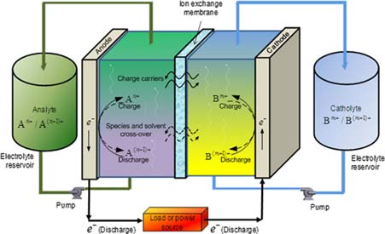
Figure 1: General Redox Flow Battery System²
2.2 What are vanadium redox flow batteries (VRBs)?

The all-vanadium redox flow battery (VRB) was first proposed in 1984 by Skyllas-Kazacos at the University of New South Wales in Australia.^{3,4} Two redox couples, utilizing four different vanadium oxidation states, are separated into two-half cells, each containing one of the redox couples. The V⁴⁺/V⁵⁺ couple, which exists as VO²⁺/VO₂⁺, is present at the positive electrode while the V²⁺/V³⁺ couple resides at the negative electrode.² V⁴⁺is oxidized to V⁵⁺ during charging, while V³⁺ is reduced to V²⁺. During discharge, V⁵⁺ reduces to V⁴⁺, and V²⁺ oxidizes to V³⁺. V²⁺ is sensitive to atmospheric oxygen, requiring this couple to be kept in an inert atmosphere. Equations 1 and 2 contain the net chemistry of the system.^{2–5}
 | $$VO^{2+}+H_{2}O↔VO_{2}^{+}+2H^{+}+e^{-}$$ | (1)
 | $$V^{3+}+e^{-}↔V^{2+}$$ | (2)
Color changes accompany the system as the battery charges and discharges. As the positive side charges from V⁴⁺ to V⁵⁺, the electrolyte color changes from blue to yellow or orange, depending on the concentration of the electrolyte. As the negative side charges from V³⁺ to V²⁺, the electrolyte color changes from green to lilac.⁵
2.2.1 Basic Construction
At its base, flow battery hardware consists of flow field plates sandwiching two electrodes separated by an ion exchange membrane. Current standard practice is to use a zero-gap architecture cell to minimize contact resistant in the cell, thereby improving system performance.⁶ Figure 2 shows an expanded view of the components used in this zero-gap design.
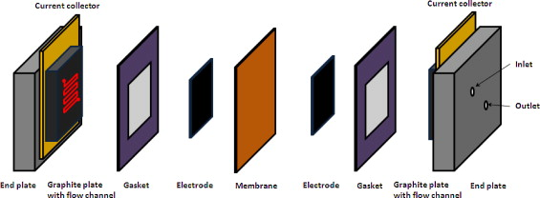
Figure 2: Components of VRB Cell⁶
Figure 3 provides a more vivid representation of the three-dimensional carbon electrode structure. Immediately noticeable is the large amount of surface area that will be exposed to flowing electrolyte. This large surface area provides room for many reactions to take place, but the small channels available for flow may cause mass transport limitations in the system if care is not taken with operating conditions.

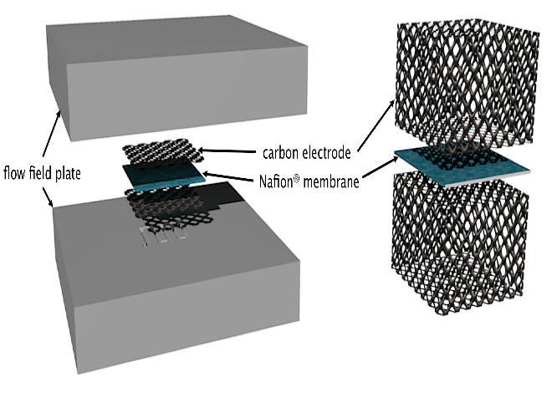
Figure 3: Alternate View of Near-Electrode Construction
The lab-scale operation used in this study is shown in Figure 4 with an explanation of labeled pieces.
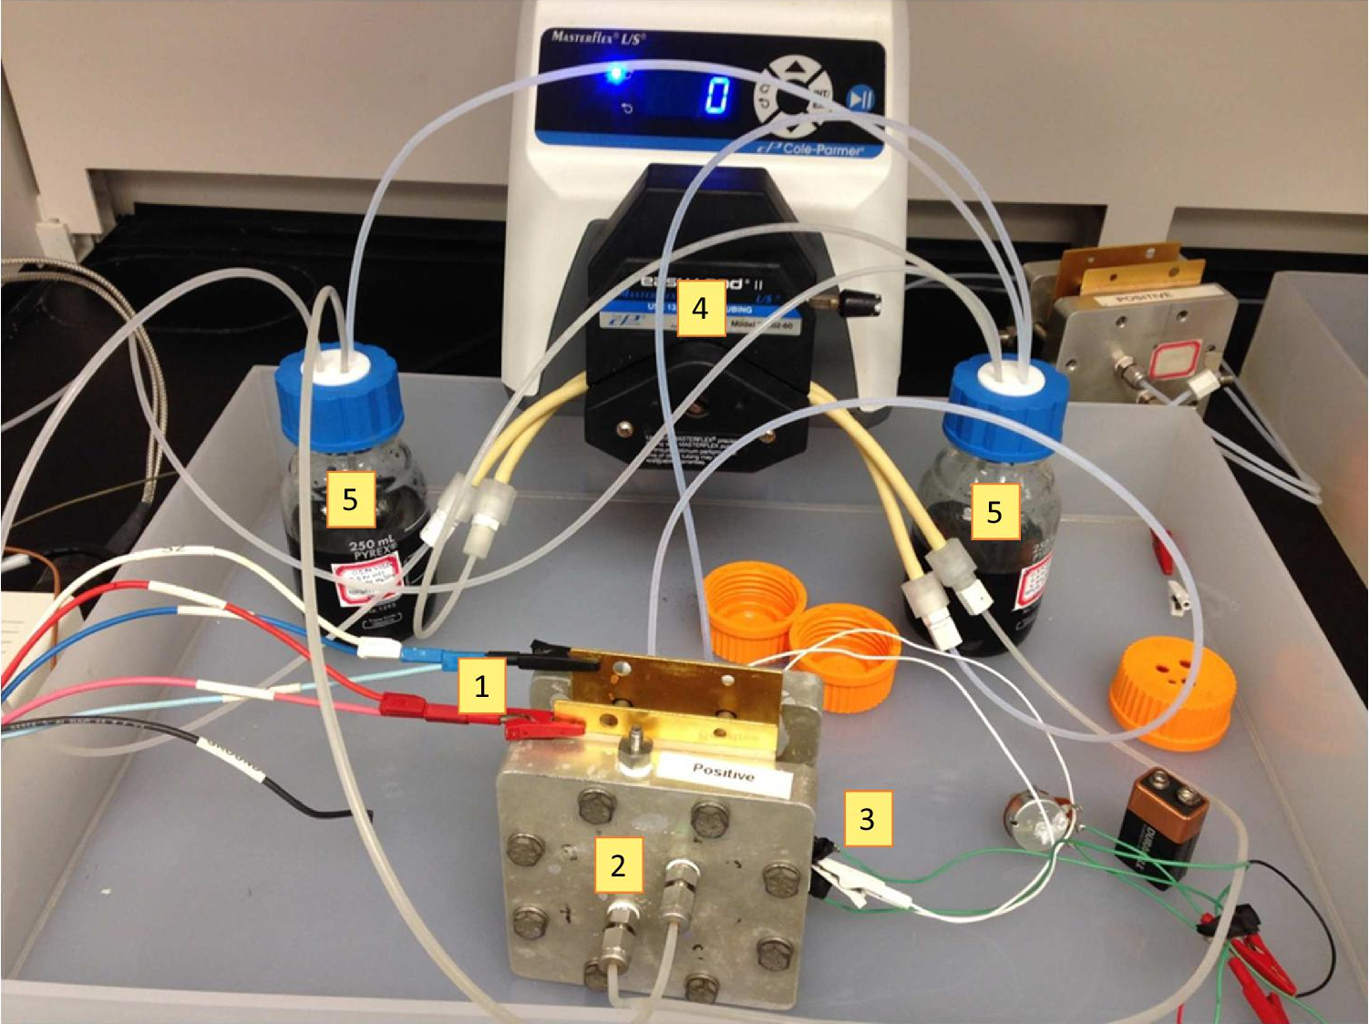
Figure 4: Laboratory Setup. (1) Potentiostat leads (2) Battery hardware (3) DHE leads (4) Peristaltic pump (5) Electrolyte resovoirs
2.3 State of the Field
Fully charged VRBs have an open circuit potential of approximately 1.6 volts. The specific energy density of the traditional pure sulfate electrolyte system is 25-35 Wh kg⁻¹, which is limited by the solubility of vanadium.^{1,7} The system has a successful temperature operating window of 10°C to 40°C.³ Peak power densities of 767 mW cm⁻² have been achieved in zero-gap architecture cells with serpentine flow fields and optimized carbon paper electrode and membrane selection.⁸ For further significant improvement, the limiting processes within the battery must be identified in order to systematically alleviate the issues.
Polarization curve analysis is common in the assessment of fuel cell performance but was not used as a flow battery performance analysis tool until recently. The primary losses in VRBs were identified as kinetic activation polarization, iR (ohmic) losses, and mass transport limitations. Contact resistance between cell components was determined to be the primary component of iR losses, and these losses could be decreased by increasing the compression of the cell to ensure good contact between components. Increasing the flow rate of electrolyte shifted mass transport control to successively lower cell voltages.⁹ Thus, the final loss to be assigned was the source of the kinetic loss in the system.
Individual electrode limitations cannot be assessed without the inclusion of a reference electrode in the system. However, the no gap architecture of VRB cells inhibits the inclusion of traditional reference electrodes. A dynamic hydrogen electrode (DHE), composed of two platinum wires attached to a membrane or sandwiched between two membranes, was connected to a 9V battery to form an in-situ reference electrode.¹⁰ The final result of this work is the determination that the negative electrode was the limiting process in the battery at approximately fifty-percent state of charge, contrary to previous ex-situ results found in the literature.^{5,10–12}
Significant research attention has been placed on improving the kinetic performance of VRBs. The progress of the field is divided into two approaches: modification of electrode characteristics and modification of electrolyte composition.^{7,8,13–15} Electrode characteristics are modified by both acid and heat treatment to increase the concentration of surface oxides on the carbon electrodes which are known to positively influence kinetic performance.^{8,13,14} Researchers at Pacific Northwest National Laboratory (PNNL) propose a mixed hydrochloric acid-sulfuric acid system, citing that the system enjoys significantly improved vanadium solubility and wider temperature operating window. They further claim that the mixed-acid electrolyte demonstrates kinetic improvement without significant chlorine side reactions.⁷
To fully optimize VRBs, one must combine electrode and electrolyte approaches with an eye towards understanding fundamental interactions within the system. Therefore, the driving purpose of this study is to optimize VRB performance by combining both approaches while understanding what is fundamentally occurring at each electrode in the battery.
3. Motivation
Previous in-situ kinetics work by our group found the negative electrode of an operating VRB to be the limiting electrode in the system at fifty-percent state of charge, accounting for ninety-four percent of the cell overpotential.¹⁰ This result is surprising as previous ex-situ work done by the flow battery community established the kinetic superiority of the V³⁺/V²⁺ couple. ^{5,10–12} A primary motivation of this work was to determine if the performance of the negative couple limits the kinetic performance of the battery at all states of charge, and if so, to what extent. State of charge (SoC) for each side of the battery is defined in Equations 3 and 4.¹⁶ The extent to which the battery was limited was gauged by the exchange current density at each electrode at all measured states of charge. From the results of this work, I further seek to identify vanadium species present in both positive and negative electrolytes as a function of state of charge.
 | $${SoC}_{anode}\frac{[V^{2+}]}{\left[V^{2+}\right]+[V^{3+}]}$$ | (3)
 | $${SoC}_{cathode}=\frac{[{VO}_{2}^{+}]}{\left[{VO}^{2+}\right]+[{VO}_{2}^{+}]}$$ | (4)
A second motivation of this study is to assess the influence of the mixed valence cation:cation complex V₂O₃³⁺ formed by a 1:1 stoichiometry between VO²⁺ and VO₂⁺.¹⁶ Coupling the measured performance of the battery with knowledge of species present in electrolyte ultimately results in the ability to better design electrodes. The surface chemistry of electrodes is known to significantly affect kinetic performance in batteries, and this surface chemistry could be tailored to interact with the vanadium species present in such a way to produce optimal performance. To this end, the kinetic performance of the battery will be measure in-situ and evaluated via appropriate kinetic models. The species composition of the electrolyte will be determined through a combination of Fourier transform infrared spectroscopy (FTIR) and micro-Raman spectroscopy. Finally, I will seek to draw conclusions about the effect of the mixed-valence cation:cation complex on the kinetic performance of the battery.
3.1 Vanadium Chemistry in Solution
Operating VRBs use four different vanadium oxidation states: V²⁺, V³⁺, V⁴⁺, and V⁵⁺. Additionally, V⁴⁺ and V⁵⁺ form a mixed-valence cation-cation complex of 1:1 stoichiometry.^{16–18,11} These oxidation states exist in complexed form with water and sulfate. Important to this chemistry is the concept of inner and outer hydration shells. Inner hydrations shells are comprised of ligands that interact directly with the metal cation. V²⁺ and V³⁺ are generally thought to have an octahedral inner hydration shell of six water molecules, though V³⁺ is known to exchange one of the water molecules for a sulfate group.^{19–21} V⁴⁺ has one axial double-bonded oxygen, one axial water molecule, and four planar water molecules.^{17–20,22} V⁴⁺ may then form an outer sphere complex with either a sulfate group or a water molecule which may react to form an equilibrium with a V⁴⁺ with a sulfate group in its inner hydration sphere, expelling one free water molecule. The sulfate group in the inner sphere may then dimerize the structure using sulfate groups as bridges under certain solution conditions.¹⁸ V⁵⁺ has two known relatively stable structures. One structure has two double-bonded oxygen atoms bonded to the vanadium center with four water molecules completing the inner hydration shell. The second structure has two double-bonded oxygen atoms with three water molecules completing the inner hydration shell and one water molecule known to be in a second hydration shell. The second structure is more stable and thus more prevalent in solution.¹⁹ These hydration shells may influence electron transfer mechanisms in redox reactions and species’ interactions with surface functional groups on carbon electrodes, making knowledge of their structure of utmost importance to this study.
Of particular interest to my study is the V₂O₃³⁺ mixed valence cation-cation complex formed by V⁴⁺ and V⁵⁺. The following reaction is proposed for its formation:
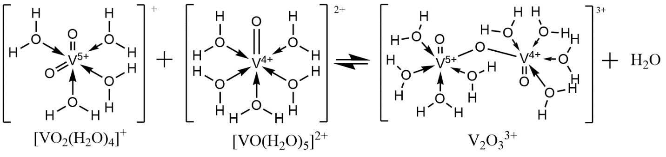
Figure 5: Formation of V₂O₃³⁺
The V₂O₃³⁺ complex will form whenever both V⁴⁺ and V⁵⁺ are present on the positive side of the battery. Thus, the complex will be present at all states of charge except 0% and 100%. For practical purposes, the complex is always present in an operating VRB with its concentration dictated by state of charge. To our knowledge, no study has elucidated the complex’s role in the kinetic performance of an operating VRB. A major focus of this study is to elucidate the complex’s effect on kinetic performance of a VRB.

Table 1: Known Vanadium Species in Solution
Vanadium Species | Structure | Reference
V²⁺ | 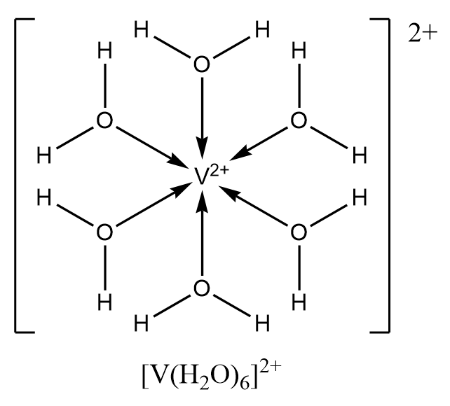 | ¹⁹
V³⁺ | 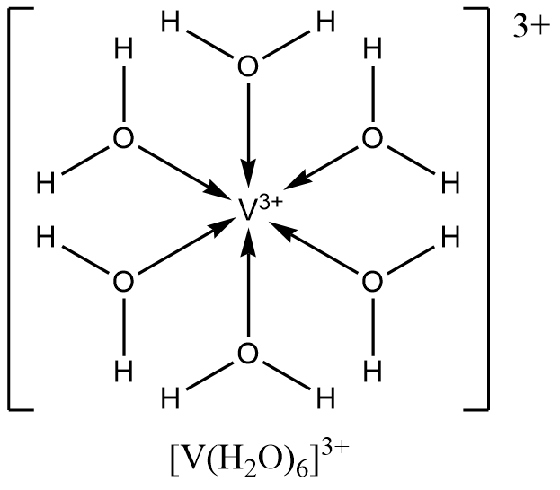  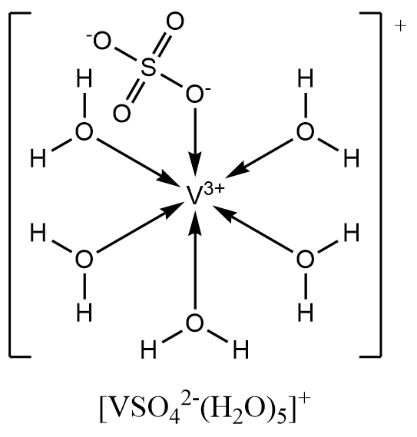 | ^{19–21}
V⁴⁺ (VO²⁺) | 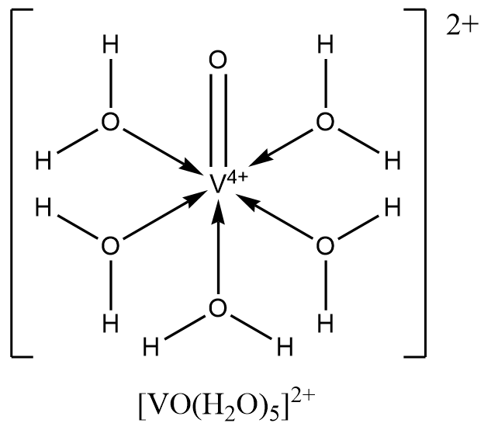 | ^{17–20,22,11}
V₂O₃³⁺ | 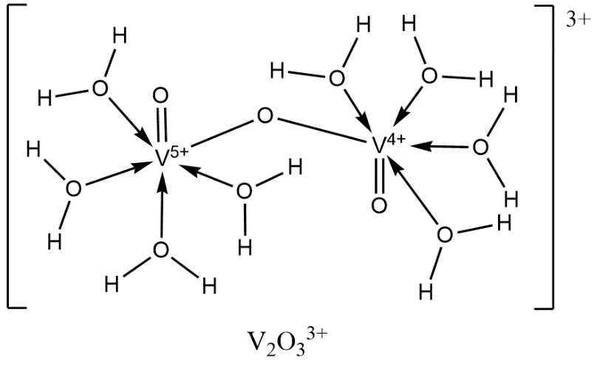 | ¹⁷
V⁵⁺ (VO₂⁺) | 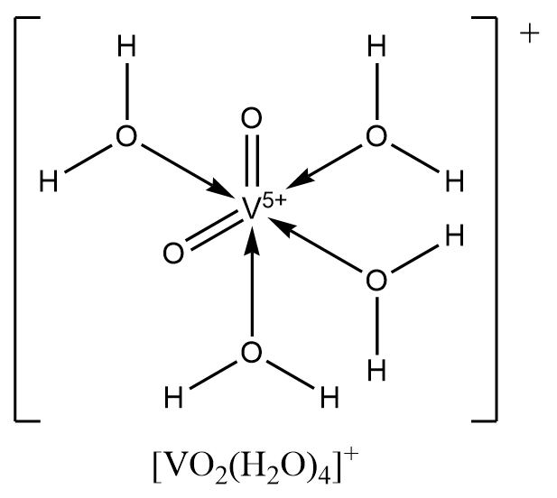  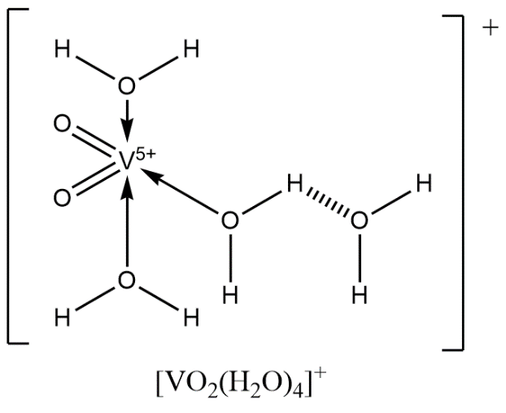 | ^{17,19,20,23,11}

3.2 Vanadium Interactions with Electrode Materials
Well-designed electrodes for VRBs accomplish two goals: maximizing kinetic performance of both V⁴⁺/V⁵⁺ and V³⁺/V²⁺ redox couples and minimizing harmful side reactions at the electrodes. The highly oxidizing nature of V⁵⁺ makes electrode material choice particularly difficult for VRBs. Despite its thermodynamic instability, carbon and graphite are suitable electrode materials due to the slow kinetics of its thermodynamic degradation and ability to reasonably withstand the oxidizing environment.^{3,24} Many materials choices exist within the realm of carbon electrode materials, differing in their surface functionality and specific surface area. In particular, electrode materials with significant carboxylic acid and hydroxyl group content enhance kinetic performance.^{2,3,13–15} Such surface oxides likely provide adsorption sites for polar compounds such as the oxo-vanadium species present in VRB operation, in turn catalyzing the redox reactions.^{13,14} Researchers turn to three main methods to increase the surface oxide content of electrode materials: heat treatment, acid treatment, and addition of graphite/graphene nanoparticles.^{13–15} Sun, et. al. proposed two three-step mechanisms to explain the reaction mechanism of V⁴⁺/V⁵⁺ on surface hydroxyl groups (Figure 6).¹³ Though this mechanism was developed based on traditional graphite materials, the mechanism still applies to graphene oxide nanoparticles as the number, but not type, of surface functional group changes.¹⁵ Notable is the absence of V₂O₃³⁺ from the reaction mechanism, indicating that, at best, the mechanism assumes a rapid equilibrium of the complex with V⁴⁺ and V⁵⁺, allowing it to be excluded from the mechanism. At worst, the rapid equilibrium assumption is inappropriate, and the mechanism is faulty.

Step 1 | 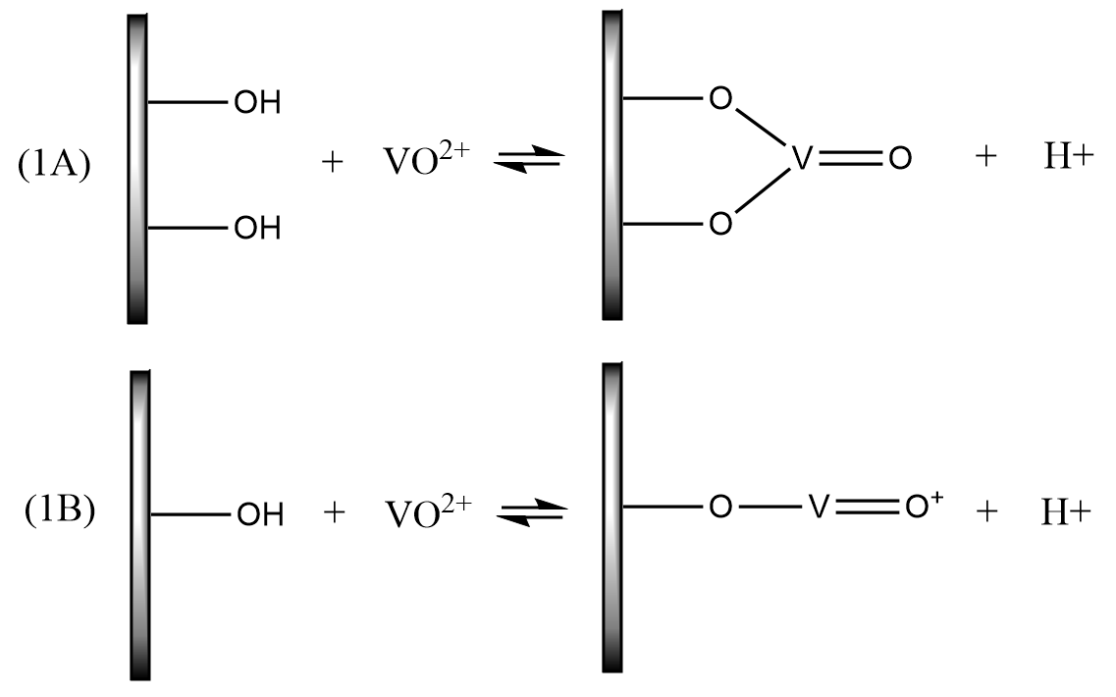
Step 2 | 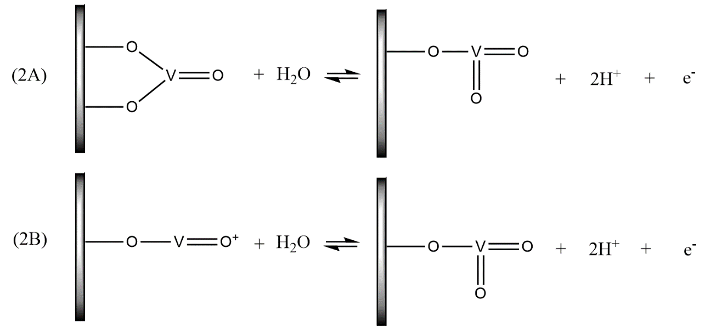
Step 3 | 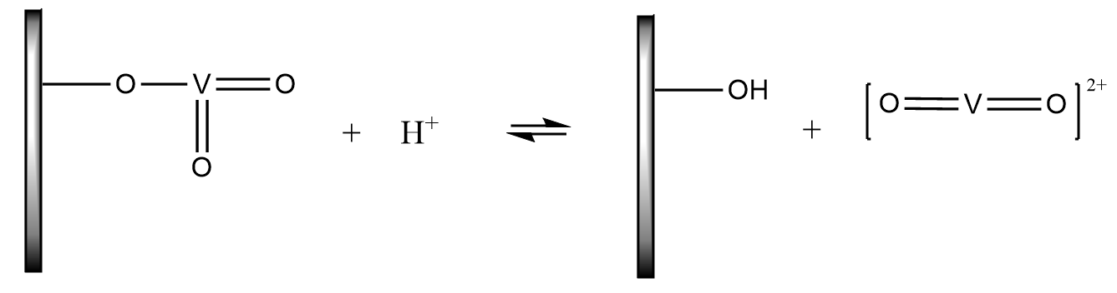
Figure 6. Mechanism A utilizes two hydroxyl groups to create a bridged oxo-vanadium species. Mechanism B uses only one hydroxyl group in its first step. For both mechanisms, the product of the first step reacts with water to form a dioxo-vanadium species. Step 3 is the same for both mechanisms with the final product of V⁵⁺.
A second mechanism was proposed for the V³⁺/V²⁺ couple on the same carbon material (Figure 7).¹⁴ Most operating VRBs employ the same electrode material in each half-cell, validating the basis of the mechanism. UV-vis experiments verify that no complex is formed between V³⁺ and V²⁺, avoiding the possible issues present in the above V⁴⁺/V⁵⁺ mechanism.¹⁶ The mechanism for this couple involves no oxygen transfer as in seen for the V⁴⁺/V⁵⁺ couple. Intuitively, one may assume that the simpler mechanism leads to faster kinetics. Indeed, ex-situ experiments find that the V³⁺/V²⁺ has superior kinetics to the V⁴⁺/V⁵⁺ couple..^{2,11,12} This thesis disproves these ex-situ results with in-situ measurements, calling into question the true reaction mechanism for the positive couple.
Step 1 | 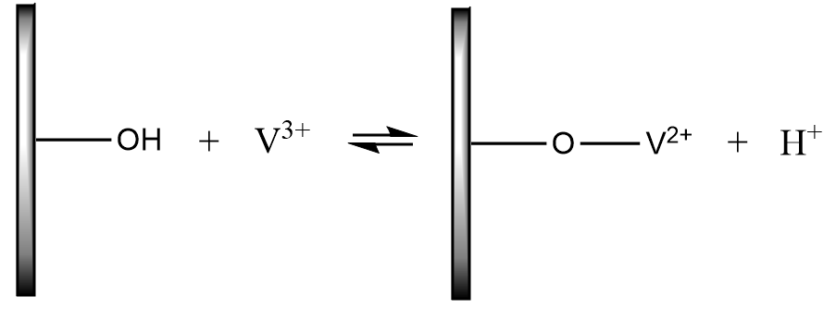
Step 2 | 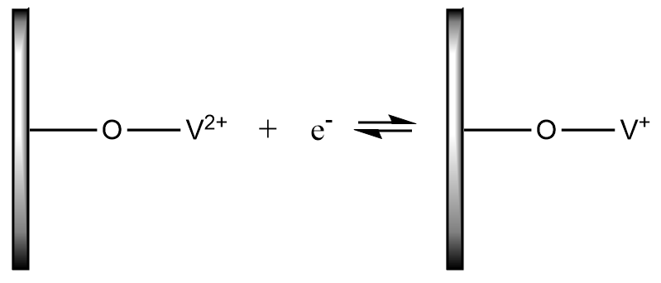
Step 3 | 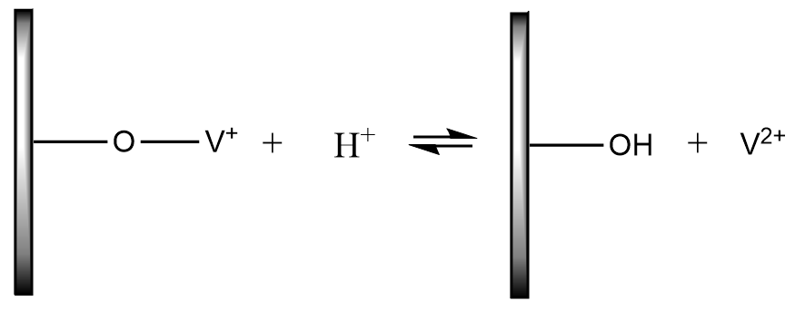
Figure 7. V³⁺ is proposed to undergo a three-step mechanism in its transformation to V²⁺. The mechanism has two chemical steps and one electron-transfer step.
Surface area also plays a crucial role in the kinetic performance of electrode materials. The ideal electrode material has maximized surface area available for chemical reactions, leading many researchers to incorporate graphite and graphene nanoparticles. These nanoparticles have significantly higher specific surface area than traditional materials, leading many researchers to incorporate them into their synthesized electrode materials. Graphene oxide nanoplatelets have four to five times the BET specific surface area (m²/g) than tradition graphite, thirteen times more C-OH groups, forty-four times more C=O groups, and 3.75 times more COOH groups. Interestingly, V²⁺/V³⁺ shows stronger performance dependence on oxygen-containing groups than did VO²⁺/VO₂⁺.¹⁵
3.2.1. Side reactions at electrodes
Unfortunately, the desired redox reactions in VRBs are not the only reactions taking place at the electrodes during battery operation. The reduction potential of V³⁺ to V²⁺ is -350 mV vs. NHE, allowing simultaneous vanadium reduction and hydrogen evolution. As the state of charge increases and the electrode is polarized more negatively, the driving force for hydrogen evolution increases.²⁵ Gas evolution at electrodes impacts battery performance by partially occluding the flow of electrolyte in the flow field, reducing the electrode surface area available for reaction, and reducing the charge and mass transport coefficients.^{24,26} Side reactions further degrade the graphite plates, leading to failure of the battery by electrolyte leakage and decreased energy efficiency as a portion of the potential applied to the battery is consumed by the side reactions.²⁴ Finally, side reactions lead to state of charge imbalance between the two half-cells, necessitating periodic rebalancing of the electrolyte and eventual failure of the electrolyte. The side reactions of greatest significance during VRB operation are hydrogen, oxygen, carbon dioxide, and carbon monoxide evolution.^{24–27}
Hydrogen evolution occurs spontaneously in V²⁺/V³⁺ in sulfuric acid electrolyte with no applied potential needed. The specific rate of hydrogen evolution is determined by the electrochemical surface area (ECSA), which is the surface area available for the reactions. This area takes into account the unavailability of some surface to chemical reactions under ambient operating conditions, making it a more useful measure than BET surface area.²⁵ At the positive electrode, oxygen, carbon dioxide, and carbon monoxide evolution pose issues. Carbon dioxide evolution has an onset potential of 1.60 V, but this potential decreases with increased polarization time.^{24,27} Oxygen evolution requires a potential of 1.80 V and poses less of a practical operational issue.²⁷ Unfortunately, the same –COOH and –C=O groups that improve redox performance also autocatalytically promote these side reactons.²⁴ Therefore, care must be taken when charging the battery to 100% state of charge, or the operational state of charge window of the battery must be limited.
4.0 Technical Introduction
Electrochemical kinetics measurements, infrared spectroscopy, and Raman spectroscopy are used to investigate the chemical and electrochemical properties of operating VRBs as a function of state of charge. This chapter provides an overview of the basis of these techniques and their relevance to this study.
4.1 Electrochemistry
4.1.1 Kinetics
Electrode reactions at equilibrium are described by the Nernst equation (Equation 5).
 | $$E= E^{0^{'}}+\frac{RT}{nF}ln⁡(\frac{C_{O}^{*}}{C_{R}^{*}})$$ | (5)
where C_{O}* and C_{R}* are the bulk concentrations of the oxidized and reduced species, respectively, E^{0’} the formal potential at which the reaction becomes spontaneous, and n the number of electrons transferred between the species.²⁸ The Nernst equation holds when the system is mass transport controlled at the surface of the electrode, meaning the rate of reaction is fully controlled by the rate at which reactants are replenished on the electrode surface.²⁸ All successful kinetic models must predict outcomes in accordance with the results of the Nernst equation at the limit of fast kinetics. Two models of importance to the one-electron transfer process in VRBs are the Tafel equation and the Butler-Volmer model of electrode kinetics.
4.1.2. Tafel Kinetics
The Tafel equation is a historical, empirical finding that links the exponential relationship between current and overpotential, the potential difference between the potential at which the redox reaction is conducted and the thermodynamic potential of the redox couple and standard state (Equation 6).
 | $$η=a+b\log{i}$$ | (6)
Successful kinetic models may be used to explain the frequent validity of the Tafel equation.²⁸
4.1.3 Exchange Current Density
At steady state, no net current flows within an electrochemical system, and the potential of the electrodes is dictated by the Nernst Equation.²⁸ Anodic and cathodic current flows at equal magnitudes, and the magnitude of this current is known as the exchange current, i₀ (Equation 7). At a fundamental level, the exchange current of a system is a measure of the kinetic speed of a system.
 | $$i_{0}=FAk^{0}C_{O}^{*}e^{-αfη}$$ | (7)
where F is Faraday’s constant, A is the electrode area, k⁰ the standard rate constant, α the transfer coefficient, and η the overptoential applied to the electrode. Equation (7) may further be reduced to the form of Equation (9) by substitution of Equation (8) into Equation (7).
 | $$e^{-αfη}={(\frac{C_{O}^{*}}{C_{R}^{*}})}^{-α}$$ | (8)

 | $$i_{0}=FAk^{0}C_{O}^{*(1-α)}C_{R}^{*α}$$ | (9)
The utility of Equation (9) is its ability to allow one to substitute i₀ for k⁰ in many kinetic models²⁸. k⁰ is a measure of the ease with which the redox couple reacts. A large k⁰ value indicates fast kinetics as the equilibrium state of the system will be quickly reached while a small value of k⁰ indicates that equilibrium takes a longer time to reach. Thus, the kinetics are sluggish.²⁸ As i₀ is the more accessible parameter of the two parameters, it often provides the most direct insight into kinetic models from which k⁰ and other parameters of interest may then be extracted. In order to compare i₀ between systems, i₀ is often normalized to the geometric area of the electrode to yield exchange current density j₀.
4.1.4 Butler-Volmer Kinetics
The Butler-Volmer Equation for kinetics derives from the current-overpotential equation (Equation 10)
 | $$i=i_{0}\left[\frac{C_{O}\left(0,t\right)}{C_{O}^{*}}\exp\left(-αfη\right)-\frac{C_{R}\left(0,t\right)}{C_{R}^{*}}\exp\left(\left(1-α\right)fη\right)\right]$$ | (10)
where C_{O}(0,t) and C_{R}(0,t) are the surface concentrations of oxidized and reduced species, respectively, i₀ is exchange current density, α is the transfer coefficient, and η is the overpotential applied to the system.²⁸ The transfer coefficient represents the symmetry of the energy barrier between the forward and reverse reactions in the system. A perfectly symmetric system has an α value of 0.5, but the value may range from zero to unity. In practice, α describes the fraction of an overpotential change that is associated with the energetics of electron transfer in one direction. While α may vary as a function of potential, it is often considered relatively constant over the small potential range over which kinetic data is collected.²⁸
When no mass transfer effects are present, often enforced by maintaining a high volumetric flow rate of electrolyte within the system, Equation (10) reduces to the Butler-Volmer Equation (Equation 11).
 | $$i= i_{0}[e^{-αfη}-e^{\left(1-α\right)fη}]$$ | (11)
At characteristically small overpotentials, Equation (11) reduces to the linear form in Equation (12).
 | $$i= -i_{0}fη$$ | (12)

From a simple plot of i versus η, i₀ may be easily extracted from the slope of a linear regression fit of the data.

4.1.5 Tafel Plots
The Tafel equation holds when the magnitude of the overpotential applied to the system is approximately 100 mV or greater. One may then examine each branch of the Butler-Volmer kinetics individually as, in this case, one may assume you have roughly two orders of magnitude difference between the forward and reverse rates of reaction. A semi-logarithmic plot of the logarithm of current versus overpotential η is used to evaluate kinetic parameters in these situations. In such a plot, the slopes of the cathodic and anodic branches for a one electron transfer system are given by Equations (13) and (14), respectively. Such analysis derives from Tafel behavior in the Butler-Volmer kinetics model, discussed in section 4.1.5.²⁸
Cathodic Branch: | $$slope= \frac{-αF}{2.3RT}$$ | (13)
Anodic Branch: | $$slope= \frac{(1-α)F}{2.3RT}$$ | (14)
Evident from (13) and (14) is the ease of determining α for the reaction The linear segment of each branch may then be extrapolated back to its intercept, allowing for extraction of the logarithm of the exchange current density of the system.²⁸
4.2 Spectroscopy
Vibrational spectroscopy is a useful technique in determining molecular structure. In this study, infrared (IR) spectroscopy and Raman spectroscopy are used to probe the species present in 1.0 M vanadium in 5.0 M sulfuric acid VRB electrolyte as a function of state of charge. Table 2 contains descriptions and diagrams of basic molecular vibrations, namely stretches and bends, detected by IR and/or Raman spectroscopy.

Table 2. Molecular Vibrations.²⁹ Species A and B are representative atoms in the below structures.
Bend/Stretch | Description | Diagram
Symmetrical Stretch | Atoms move in and out simultaneously. | 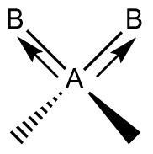
Asymmetrical Stretch | One atom moves in while the other moves out. | 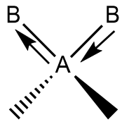
In-plane Bending | Atoms remain in same plane and move towards/away from one another. | 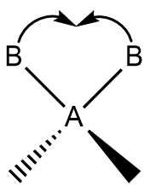
In-plane Rocking | Atoms remain in same plane and move concurrently in same direction. | 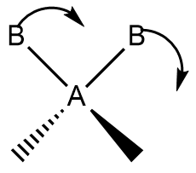
Out-of-plane Wagging | Both atoms swing up or down out of plane in unison. | 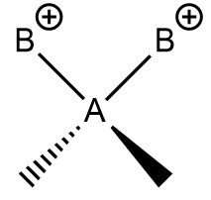
Out-of-plane Twisting Deformation | One atom swings up and the other down relative to the plane. | 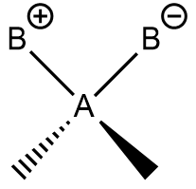

4.2.1. Raman Spectroscopy
In Raman spectroscopy, molecular vibrations are excited and measured through two-photon light scattering events.³⁰ Photons collide with molecules in non-elastic collisions, scattering the photons which may then be detected and measured.³¹ For Raman bands to be present in the recorded spectra, molecular vibration must cause a change in the polarizability of the molecule, which is the degree to which the molecule’s electron cloud is deformed by an external electric field.³⁰ Recorded Raman signals are a function of sample concentration and excitation wavelength.³⁰ Peak assignments are made via quantum mechanical calculations.
4.2.2. Infrared (IR) Spectroscopy
In infrared spectroscopy, photons from a light source collide with molecules, and if a change in dipole moment is induced, transfer energy to the molecules via adsorption.³⁰ These interactions are then recorded as intensity as a function of wavenumber. IR spectra are divided into three regions based on the wavenumbers of the source photons: near (14,000 – 4,000 cm⁻¹), mid (4,000 – 400 cm⁻¹), and far (400 – 10 cm⁻¹). The Beer-Lambert Law governs the relationship between the incident light and light transmitted through a given sample (Equation 15)
 | $$A=εlc$$ | (15)
where A is the measured absorbance of the sample, ε the absorptivity of the sample, l the path length, and c the concentration of the sample.^{30,32} The major disadvantages of this technique is its inability to detect some molecules (i.e. homodiatomic molecules), the complexity of solution spectra, and the ability of water peaks to mask less broad and intense peaks.³² IR spectra are interpreted using group theory or identifying empirical characteristic frequencies.³⁰
4.2.3. Comparison of Raman and IR Spectroscopy
IR spectroscopy and Raman spectroscopy are complementary techniques often used in concert to fully determine molecular structure as either technique is rarely able to independently fully elucidate complex structures. Raman spectra are based on photon emissions while IR spectra are based on photon absorption.³¹ IR spectroscopy is best at measuring the asymmetric vibrations of polar molecules. Raman spectroscopy is best suited to detecting the symmetric vibrations of nonpolar molecules. Symmetry in this context can be planes, axes, or centers of symmetry. Molecules containing a center of symmetry cannot have vibrations that are both IR and Raman active³⁰
- Kinetics Measurements
5.1 Materials
Modified cell hardware from Fuel Cell Technologies, consisting of aluminum end plates, gold-plated current collectors, and graphite plates with serpentine flow field, was used as flow battery hardware. Untreated SGL 10AA carbon paper with 5 cm² geometric area was used as electrodes on both sides of the battery. To prepare the pure-sulfuric acid electrolyte, vanadium(IV) sulfate oxide hydrate (Alfa Aesar, 99.9%, metals basis) was dissolved in 98% sulfuric acid (Fisher Scientific) to a final concentration of 0.75M vanadium in 5.0M sulfuric acid. To prepare sulfuric-hydrochloric mixed acid electrolyte, vanadium(IV) sulfate oxide hydrate was dissolved in 98 wt% sulfuric acid and 12.1N hydrochloric acid (Fisher Scientific) to a final concentration of 1.0M vanadium in 2.5M sulfuric acid and 2.5M hydrochloric acid.
5.2 Experimental Setup
5.2.1 Pure-Sulfuric Acid Electrolyte Setup
Electrolyte was circulated at a flow rate of 25 milliliters per minute. The cell was operated at room temperature. Areal specific resistance in the cell was measured to be 0.5-0.6 W-cm². A single layer of Nafion 117 served as the ion exchange membrane. 0.1 mm Premion® platinum wire (Alfa Aesar, 99.997% metals basis) was used in the construction of a dynamic hydrogen electrode (DHE), used to conduct in-situ kinetics measurements constructed as described by Li and Pickup and used by Aaron et al (Figure 8).^{10,33} A one membrane configuration with one platinum wire on either side of the single layer of Nafion 117 was used rather than the sandwich approach previously described in the literature.
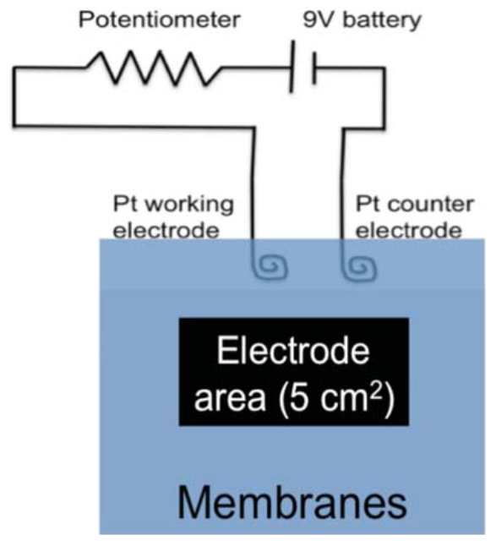
Figure 8: DHE Construction¹⁰
A BioLogic SP-200 potentiostat was used to perform all measurements. Equal volumes of electrolyte were placed on either side of the battery, and the system was purged with nitrogen for fifteen minutes. The electrolyte was then fully electrolyzed to vanadium(III) and vanadium(V) on the negative and positive sides of the battery, respectively. The positive electrolyte was replaced with vanadium(IV) electrolyte of equal concentration and volume. The battery was thus at a fully discharged state (0% state of charge). The exchange current density was measured by applying increasing amounts of overpotential to the battery and measuring the current response. Because equal amounts of positive and negative overpotentials were applied through the course of the measurement, state of charge was assumed to be unaffected. The battery was charged and exchange current measured at states of charge between 0% to 100%. All data was iR corrected before processing. All values shown are averaged results of three experimental runs.
5.2.2 Mixed Electrolyte Setup
The setup for the pure-sulfuric acid setup is conserved in the mixed sulfuric acid-hydrochloric acid setup with the exception of the reference electrode. Rather than a DHE, a mercury/mercurous sulfate (Hg/Hg₂SO₄) reference electrode was used. Two Nafion 117 membranes protruded from the top of the graphite plates, creating a trough on top of the graphite plates. The tip of the reference electrode was placed in this trough, and a droplet of 0.5M sulfuric acid placed the tip of the reference electrode in ionic contact with the membranes. This droplet was replaced with a new droplet of 0.5M sulfuric acid between each state of charge at which measurements were conducted. The reference electrode was held in place by a clamp to ensure it did not move throughout the measurements. This reference setup was chosen over the DHE setup used previously as it proved more stable than the highly unstable DHE potential readings initially obtained for this electrolyte.
5.3 Data
5.3.1 Pure-Sulfuric Acid Electrolyte
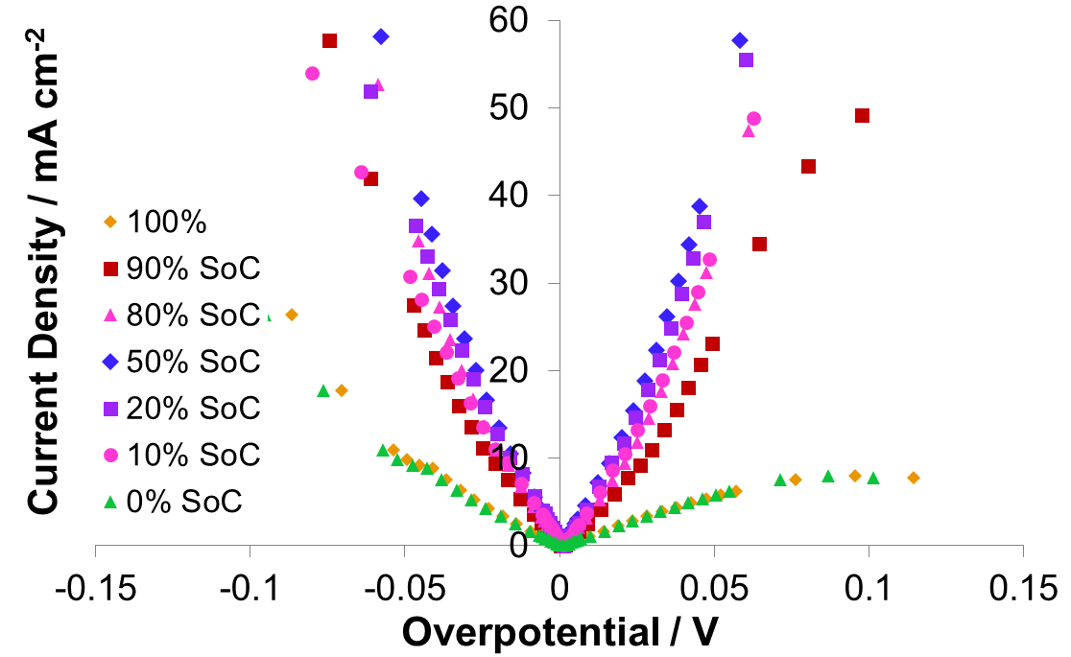
Figure 9: VO₂⁺/VO²⁺ Current Density vs. Overpotential

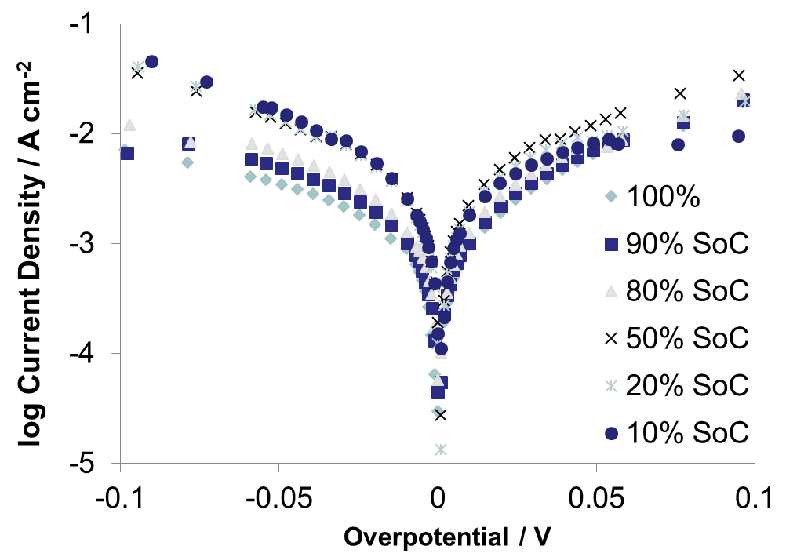
Figure 10: V³⁺/V²⁺ Current Density vs. Overpotential
Figures (9) and (10), showing logarithmic current density response to applied overpotentials on the positive and negative sides of the battery, respectively, immediately indicates starkly different kinetics behavior on each side. The VO₂⁺/VO²⁺ couple shows a stronger absolute response to applied overpotential and distinctly non-Tafel kinetic behavior. The maximum current response is seen at 50% state of charge. In contrast, the V³⁺/V²⁺ couple exhibits classical Tafel kinetic behavior. Maximum current response is again achieved at 50% state of charge as also occurs for the positive couple. An approximately parabolic current response as a function of state of charge is evident from cursory analysis.
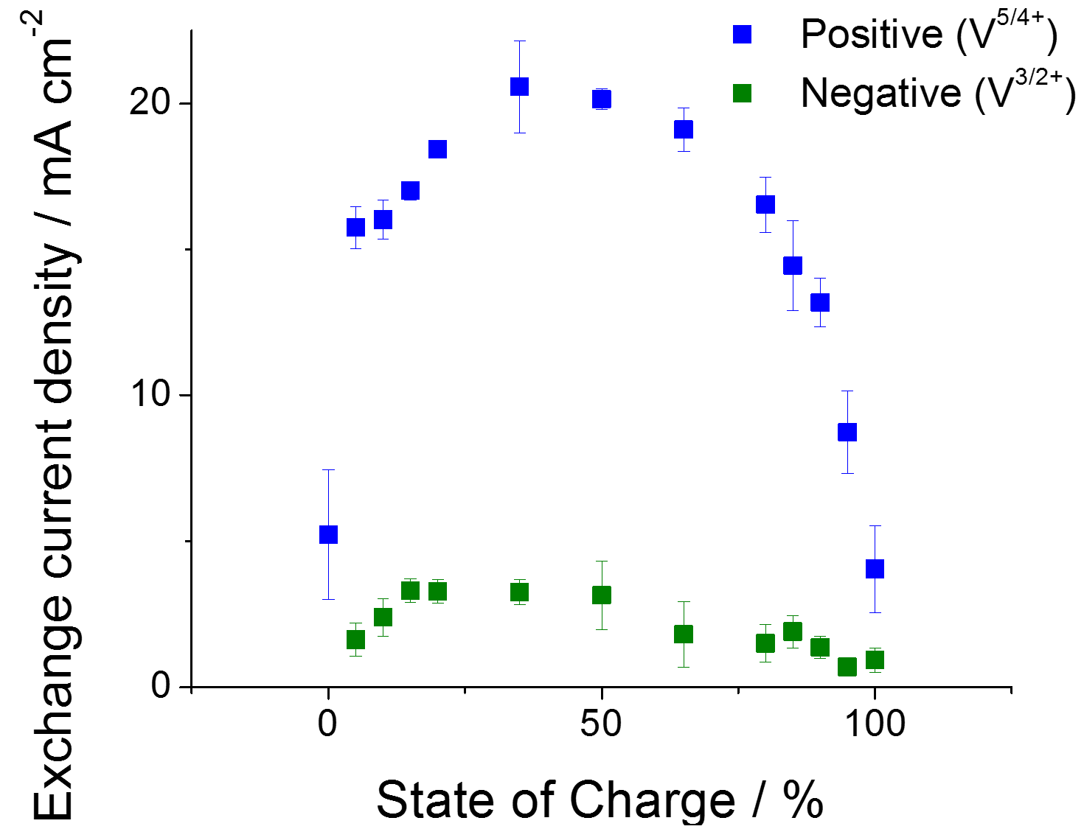

Figure 11: Exchange Current Density vs. State of Charge
Figure (11) supports the initial observation of the parabolic behavior exchange current density as a function of state of charge for both the positive and negative sides of the battery. The positive couple shows stronger absolute current density response as a function of state of charge, indicating that the kinetics of the positive couple are approximately five times faster than those of the negative couple.
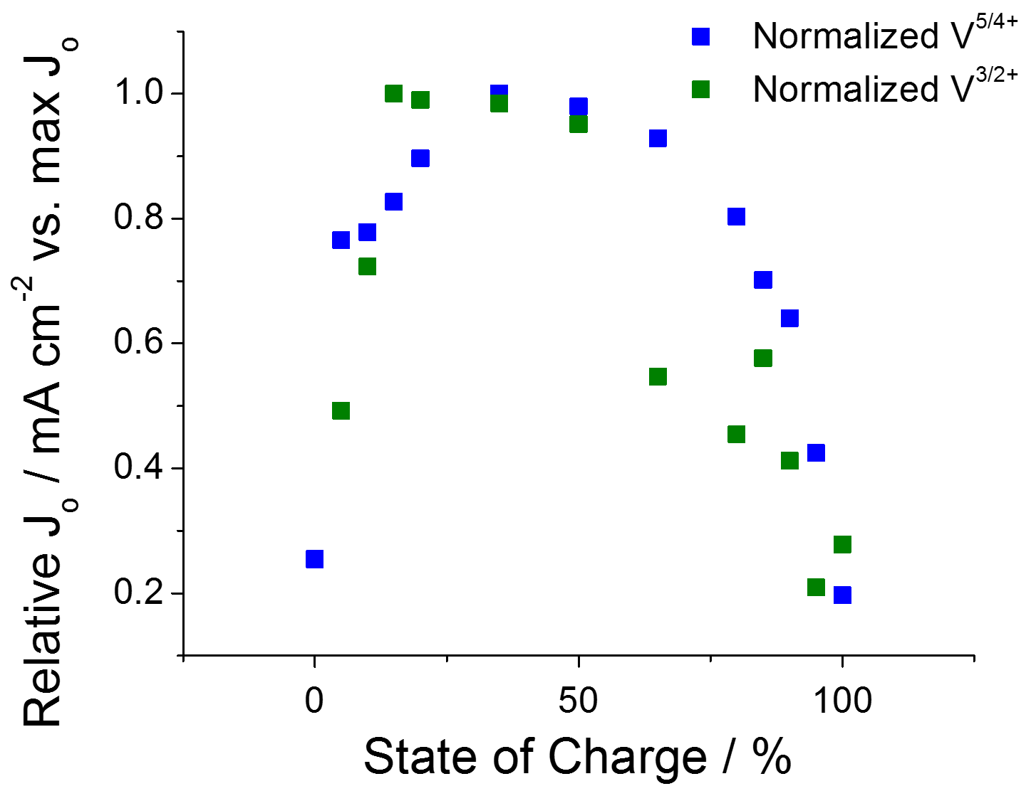

Figure 12: Normalized Exchange Current Density vs. State of Charge
To remove magnitude bias from the results, exchange current density for each side of the battery at each state of charge was normalized against the maximum exchange current density in the series (Figure 12). The V⁵⁺/V⁴⁺ couple’s exchange current density, though having a stronger absolute response to state of charge, has the same relative response to state of charge as does the V³⁺/V²⁺ couple.
Using Equation (16), this data was further analyzed by correcting the observed J₀ for the concentrations of the reagents, yielding the results in Figure (13).
 | $$J_{0}=nFk^{0}(C_{ox})^{(1-α)}(C_{red})^{α}$$ | (16)
α was assumed to be 0.5, and k⁰ has the units of centimeters per second.

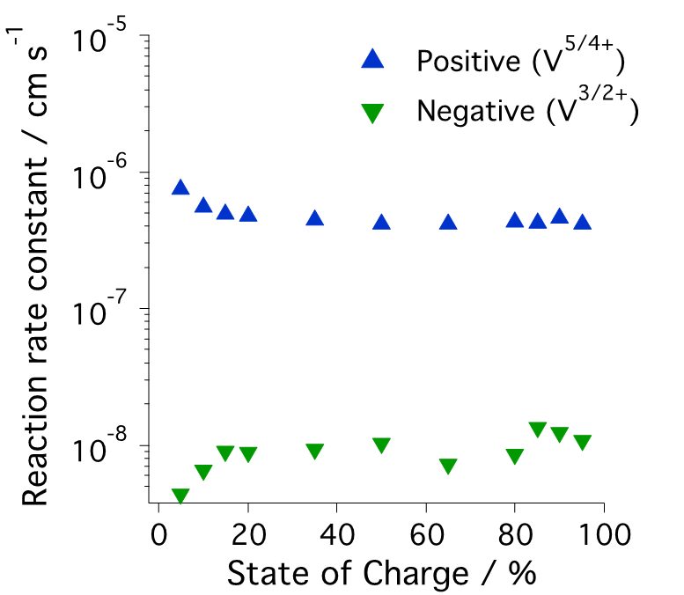

Figure 13: Reaction Rate Constant vs. State of Charge
The reaction rate constant for each side of the battery remains approximately constant as a function of state of charge (Figure 13). The reaction rate constant for the V⁵⁺/V⁴⁺ couple is approximately 1.5 orders of magnitude greater than the reaction rate constant of the V³⁺/V²⁺ couple. The constant nature of the reaction rate constant for the V⁵⁺/V⁴⁺ couple indicates that V₂O₃³⁺ plays no significant role enhancing the kinetic performance of this couple. The independence of the reaction rate constants from state of charge indicate that the kinetics of the both sides of the battery are dependent only upon the relative concentrations of vanadium species in the system.

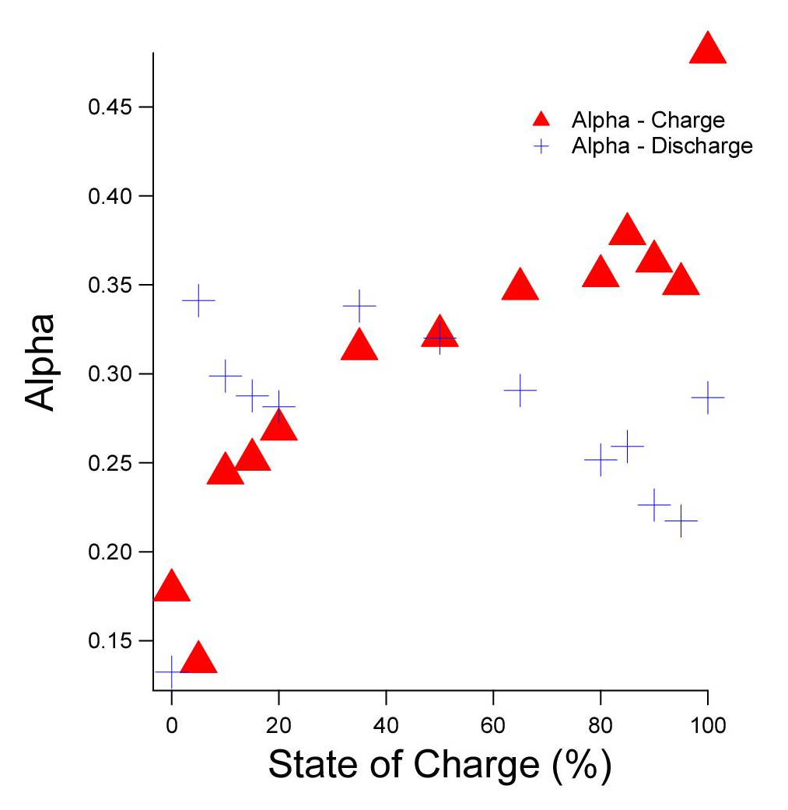
Figure 14: Calculated Alpha Values vs. State of Charge for V³⁺/V²⁺ Couple
The alpha term in Tafel kinetics indicates the symmetry of a reaction, with a value of 0.5 representing a perfectly symmetric reaction. As seen in Figure 14, the V³⁺/V²⁺ couple is decidedly asymmetric. While this result is surprising, models of the system support the evidence of non-0.5 alpha values for the system.³⁴

5.3.2 Mixed Sulfuric Acid-Hydrochloric Acid Electrolyte Data
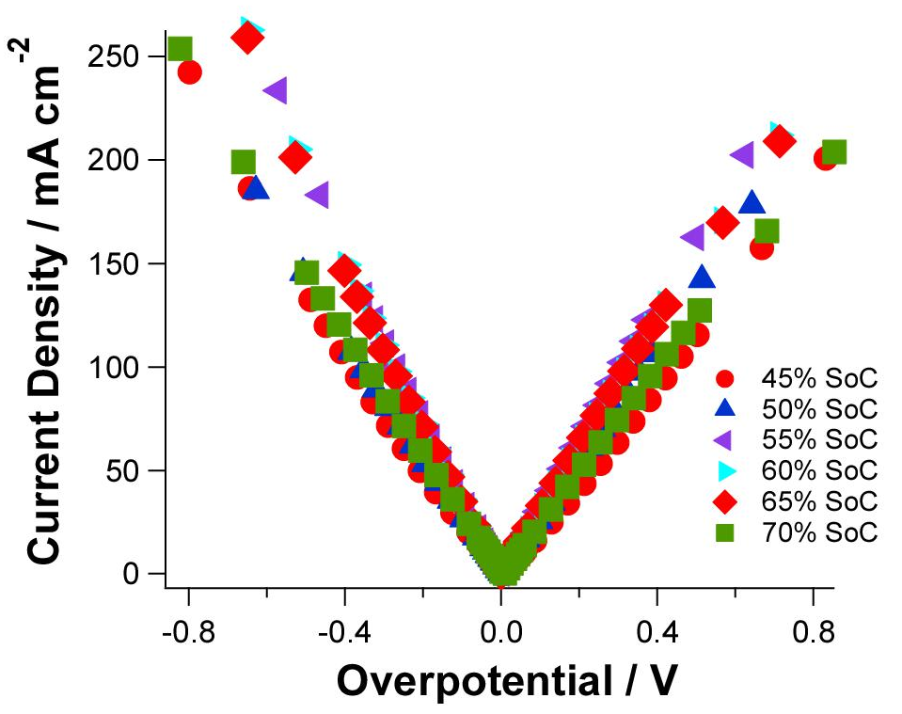
Figure 15: VO²⁺/VO₂⁺ Current Density vs Overpotential

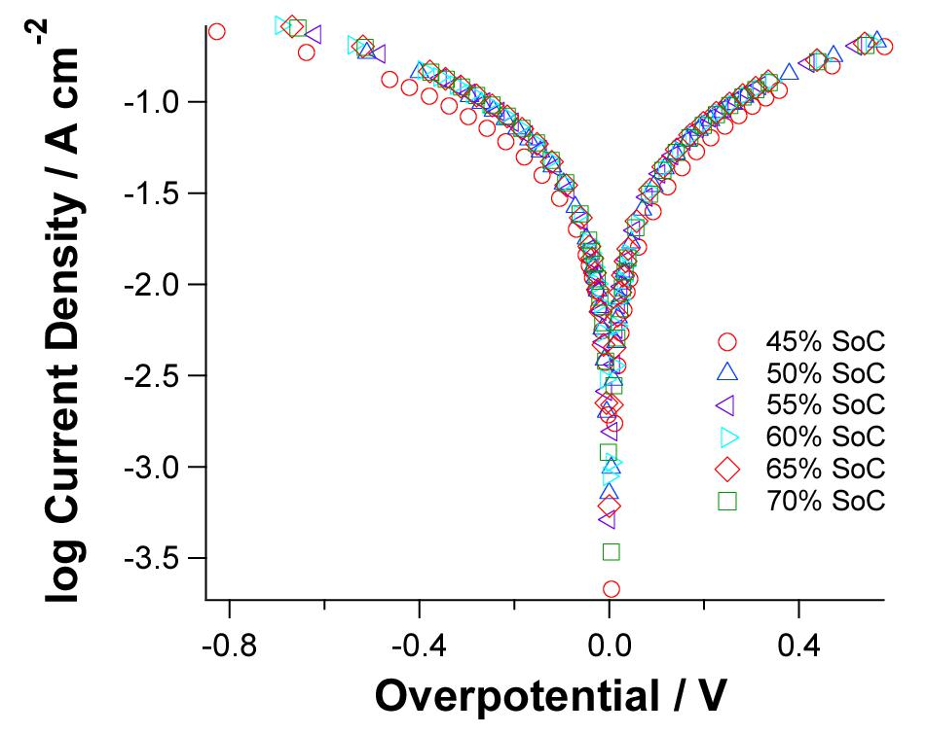
Figure 16: V³⁺/V²⁺ log Current Density vs. Overpotential
The same current density versus overpotential trends observed in the pure-sulfuric acid electrolyte system are observed in the mixed acid electrolyte system. The VO²⁺/VO₂⁺ reaches high current density at low overpotential, necessitating the use of the linearized Butler-Volmer equation in its analysis (Figure 15). The V³⁺/V²⁺ couple again demonstrates classical Tafel behavior but reaches much higher current density for its various overpotentials than was noted in the pure-sulfuric acid electrolyte system (Figure 16).

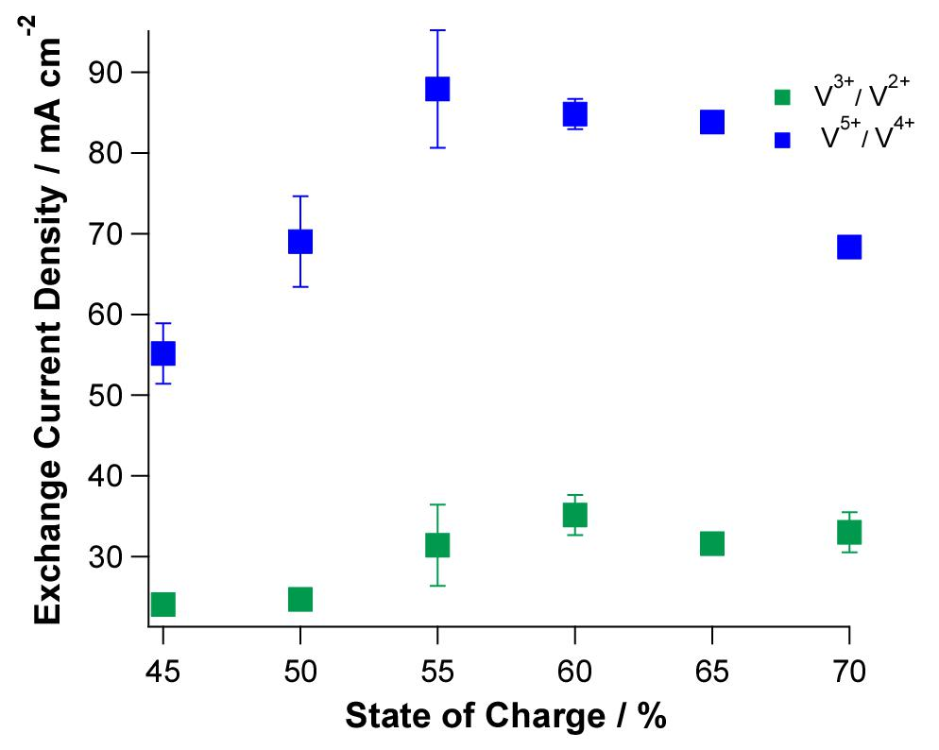
Figure 17: Exchange Current Density vs. State of Charge
The exchange current density of the V⁵⁺/V⁴⁺ couple is again larger than that of the V³⁺/V²⁺ couple and follows the same general parabolic relationship with state of charge, centered at approximately fifty-five percent state of charge, as was seen in the previous system.
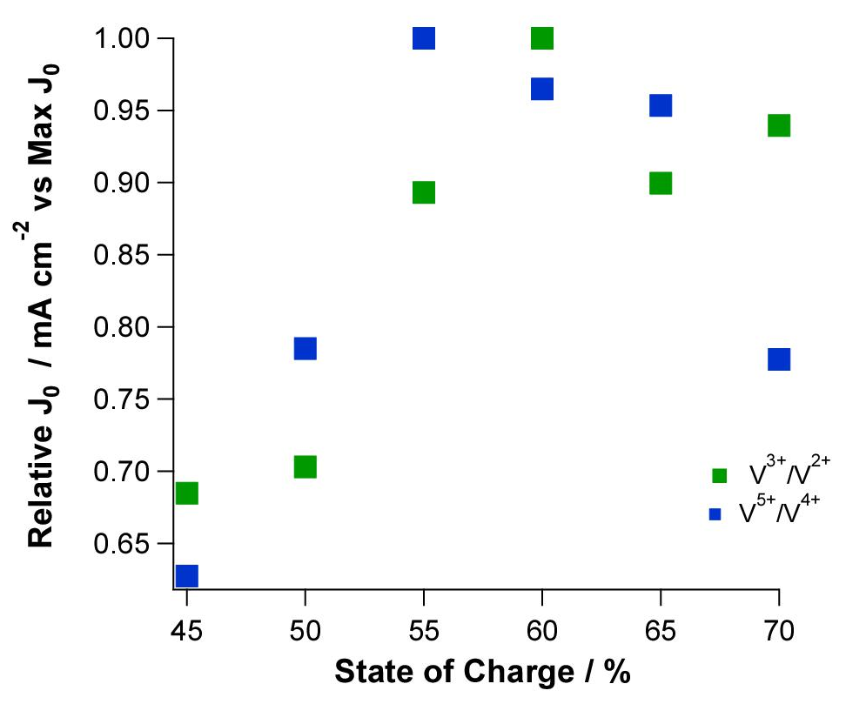
Figure 18: Normalized Exchange Current Density vs. State of Charge
The same relative dependence on state of charge as was seen in the pure-sulfuric acid system is again observed in the mixed-acid electrolyte system. The data was again analyzed by correcting the observed J₀ for the concentrations of reagents in the system.

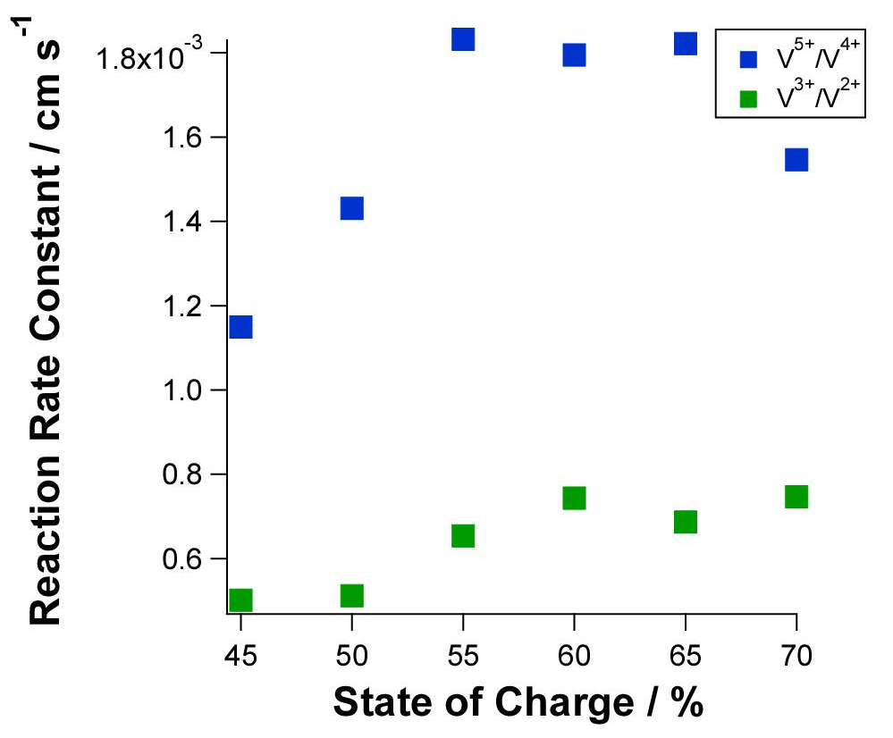
Figure 19: Standard Rate Constant vs. State of Charge
The standard rate constants for both redox couples in mixed acid electrolyte are several orders of magnitudes greater than the standard rate constants for the redox couples in pure-sulfuric acid electrolyte. The increase in the standard rate constant for the V³⁺/V²⁺ couple is greater than the increase in the standard rate constant for the VO₂⁺/VO²⁺ couple. The standard rate constants for the redox couples do not appear as constant as a function of state of charge in the mixed acid electrolyte as was observed in the pure-sulfuric acid electrolyte.
5.4 Discussion
For both electrolyte systems, the VO₂⁺/VO²⁺ couple on the positive side of the battery produced high current response at low overpotentials. Therefore, its kinetic behavior was analyzed via the linearized Butler-Volmer Equation (Equation 12). The V³⁺/V²⁺ couple exhibits classical behavior easily analyzed via Tafel Plots as described in Section 4.2.1. The end result of analyses for both sides of the battery was determination of the exchange current density for both redox couples. Additionally, k⁰ was determined for both couples as well as α for the V³⁺/V²⁺ couple in the pure-sulfuric acid system.
The significantly faster kinetics of the VO₂⁺/VO²⁺ couple in both systems compared to the kinetics of the V³⁺/V²⁺ is a relatively surprising find as ex-situ experiments have traditionally shown the VO₂⁺/VO²⁺ couple to have slower kinetics than the V³⁺/V²⁺ couple. The in-situ results of this experiment are supported by emerging data reported both by our lab and elsewhere in the literature.^{10,34} However, the reasons for these differences, both between the in-situ and ex-situ results and the differences between the two redox couples’ kinetics in-situ, remains elusive. The VO₂⁺/VO²⁺ couple is known to produce a multivalent cation with 1:1 stoichiometry of VO₂⁺ to VO²⁺ with a peak concentration of this cation at approximately fifty-percent state of charge.⁵ Therefore, one might surmise that the presence of this complex enhances the rate of electron transfer for the couple. However, the constant value of k⁰ as a function of state of charge in both electrolyte systems discredits this idea, leading one to presume that differences in complexation of the vanadium species at either side of the battery may strongly influence performance. The definitive reason for this enhanced kinetic performance will be an area of future work.
Another thought to consider is that the kinetics of VO₂⁺/VO²⁺ are possibly not so significantly inherently faster than the V³⁺/V²⁺ couple but rather that the V³⁺/V²⁺ couple is subject to more performance-degrading side reactions. The reduction potential for the negative potential is near the potential for the hydrogen evolution reaction (HER), and hydrogen is known to be spontaneously generated on carbon electrodes in electrolyte similar to the electrolyte used in this study.^{25,34} Agar et al. proposes that the reduction potential for the negative couple is close to the potential for hydrogen evolution, causing hydrogen bubbles to form on the surface of the electrode and limit the area available for reaction.³⁴ This limiting of area would cause an apparent reduction in kinetic performance. While it seems improbable that hydrogen evolution is the only reason for decreased kinetic performance, particularly as one would expect to see some state of charge dependence were hydrogen evolution the only limiting factor in the system, hydrogen evolution is certainly a small contributing factor to the dismal kinetic performance. However, its effect is virtually negligible as it is not reflected in the calculated kinetic parameters. Though the charge transfer coefficient has traditionally been taken to be 0.5 in mathematical modeling, the highly asymmetric values of α found for the negative couple are supported by experimental values reported in the newer literature.³⁴
Finally, the kinetic performance of the VRB is significantly improved by the use of the mixed-acid electrolyte as opposed to the pure-sulfuric acid electrolyte. Both systems produce the same relative kinetic response to state of charge, but the absolute exchange current density in the mixed-acid system is approximately 4.5 times greater for the VO₂⁺/VO²⁺ and approximately 7 times greater for the V³⁺/V²⁺ as compared to the pure-sulfuric acid electrolyte. In the pure-sulfuric acid electrolyte, the exchange current density for the VO₂⁺/VO²⁺ is approximately 4 times greater than that of the V³⁺/V²⁺ couple. In the mixed-acid electrolyte, the exchange current density for the VO₂⁺/VO²⁺ is approximately 3 times greater than that of the V³⁺/V²⁺ couple. Thus, kinetic performance is improved for both couples in the mixed-acid electrolyte, and the V³⁺/V²⁺ appears to benefit most strongly from the change in electrolyte composition. This finding is particularly promising as the kinetic performance of the negative couple is most in need of improvement.
A final item of note concerns the realistic state of charge operating window for each system. The pure-sulfuric acid electrolyte system can safely be cycled between 10% and 90% state of charge without threat of harmful side reactions or significant loss of efficiency. The mixed-acid electrolyte system must operate under a more constrictive window of approximately 30% to 70% state of charge to avoid chlorine evolution which poses a hazard to both human health and equipment integrity. Additionally, the electrochemical stability of the system is empirically much more fragile than that of the pure-acid electrolyte. Therefore, while the kinetic gains of the mixed-acid electrolyte system are initially very promising, the risk of side reactions and reduced operating window may make these gains virtually unimportant in a commercial sense. Further studies are needed to fully assess these limitations.
5.5 Conclusion
The kinetic performance of the VO₂⁺/VO²⁺ redox couple in an operating vanadium redox flow battery with pure-sulfuric acid electrolyte was found to be superior to that of the V³⁺/V²⁺ redox couple in the same operating battery. While the positive couple showed a stronger absolute current response to state of charge, both couples exhibited the same normalized exchange current density dependence on state of charge. The standard reaction rate constant was found to be constant and independent of state of charge for both couples with the VO₂⁺/VO²⁺ redox couple having a constant of 1.5 orders of magnitude higher rate. The initial findings of Aaron et al. of the negative electrode being the limiting process in the vanadium redox flow battery was supported at all states of charge.¹⁰ V₂O₃³⁺ was found to have no significant role in the superior performance of the positive side of battery. The kinetic performance of both couples was improved in the mixed-acid electrolyte system, with the V³⁺/V²⁺ couple benefitting more strongly than the VO₂⁺/VO²⁺ redox couple. However, the limited operating window and risk of harmful side reactions may preclude this mixed-acid system from replacing the traditional pure-sulfuric acid system despite large kinetic gains.
6. Spectroscopy
6.1 Materials
Electrolyte was prepared by first preparing 5.0M sulfuric acid from concentrated sulfuric acid (96 wt% H₂SO₄, Sigma-Aldrich). VOSO₄·xH₂O (Alfa Aesar) was then dissolved in the above solution to a concentration of 1.0M VOSO₄. All reagents were used as received.
6.2 Experimental Setup
The electrolyte was separated into two compartments of an H-cell separated by a Nafion 117 membrane. The volume of the electrolyte on the positive side of the battery was twice that of the electrolyte on the negative side of the battery. The electrolyte was charged and discharged to desired states of charge. Both electrolytes were continuously bubble with nitrogen to prevent oxidation of vanadium species by atmospheric oxygen.
6.2.1 Raman Experimental Setup
Micro-Raman spectra were collected using a house-made instrument consisting of the following:
- A double Czerny-Turner monochromator at a focal distance of 400 millimeters and a grating of 1,800 lines per millimeter blazed at 5,000 Angstrom
- A Spectra-Physics Stabilite 2017 argon laser with excitation line at 514.15 nanometers as the light source
- An Olympus BX-41 confocal microscope equipped with a 50x objective lens
- A Jobin-Yvon Symphony charge-coupled device (CCD) detector system, cooled with liquid nitrogen
Samples were measured at room temperature. At desired states of charge, aliquots of electrolyte were removed from each side of the vessel and transferred to a vial without expose to the atmosphere. The contents of the vial were then transferred to a quartz cylinder, again without exposure to oxygen. The quartz cylinder was sealed and stored in a dry box until the cylinders were placed under the micro-Raman laser for spectrum collection.
6.2.2 FTIR Experimental Setup
A Nicolet Nexus spectrometer was used to acquire FT-MIR and FT-FIR spectra in the wavenumber range between 4,000 and 50 cm⁻¹. The spectra were obtained by averaging 1000 measurements. The initial V⁴⁺ electrolyte solution was applied to a single-reflection accessory and covered with a lid designed to prevent sample evaporation during the course of measurements. Samples were measured at room temperature. For all other electrolyte compositions, electrolyte was removed from the setup at desired states of charge and sealed in a vial as described in 6.2.1. The single-reflection accessory was then moved to the dry box where it was loaded with the contents of the vial. The accessory was sealed to ensure no atmospheric contamination and removed from the dry box to collect FT-MIR and FT-FIR spectra.
6.3 Data
Table 3: V⁵⁺/V⁴⁺ Theoretical Raman Band Assignments. Quantum mechanical calculations were used to predict the Raman spectrum of the VO₂⁺/VO²⁺ redox couple in sulfuric acid electrolyte. The peak assignments were further verified in the literature.
 | Position (cm⁻¹) | Description | Reference
1 | 335-381 | $VO{\left(H_{2}O\right)}_{5}^{2+}$ V=O deformations | ³⁵
2 | 438-456 | $SO_{4}^{2-}$(450 cm⁻¹)and $HSO_{4}^{-}$(424 cm⁻¹) | ^{36,37}
3 | 490-493 | $$VO{\left(H_{2}O\right)}_{5}^{2+}$$ | ³⁸
4 | 593-606 | $SO_{4}^{2-}$(592 cm⁻¹)and $HSO_{4}^{-}$(613 cm⁻¹) | ³⁶
5 | 796-817 | V-O-V depolarized asymmetrical stretch in vanadium dimer | ³⁸
6 | 890-919* | $VO_{2}{\left(H_{2}O\right)}_{4}^{+}$ (917 cm⁻¹)antisymmetrical stretching and $HSO_{4}^{-}$symmetrical stretch of S-OH (902 cm⁻¹) | ³⁹
 | 924-941* | $VO{\left(H_{2}O\right)}_{4}^{+}$ symmetrical stretching | ³⁹
7 | 987-994 | V=O terminal $VO{\left(H_{2}O\right)}_{5}^{2+}$ polarized stretch (988 cm⁻¹), $VO{\left(H_{2}O\right)}_{4}^{+}$ (990 cm⁻¹) | ³⁹
8 | 1044-1051 | $HSO_{4}^{-}$(SO₃ symmetrical stretch) | ^{36,38,39}
9 | 1197-1236 | $H_{3}O^{+}$deformation, $HSO_{4}^{-}$ (1204 cm⁻¹ weak) | ^{36,38}

Table 4: V³⁺/V²⁺ Theoretical Raman Band Assignments. Quantum mechanical calculations were used to predict the Raman spectrum of the V³⁺/V²⁺ redox couple in sulfuric acid electrolyte. The peak assignments were further verified in the literature.
 | Position (cm⁻¹) | Description | Reference
1 | 283-305 | $$VO{\left(OH_{2}\right)}_{5}^{2+} and VO{\left(H_{2}O\right)}_{4}SO_{4}$$ | ³⁷
 | 355-390 | $VO_{2}{\left(H_{2}O\right)}_{4}^{+}$ V=O deformations | ³⁵
2 | 430-444 | $SO_{4}^{2-}$ (451 cm⁻¹) $HSO_{4}^{-}$ (424 cm⁻¹), V(III)-OH₂ and symmetric V (III)-O-V(III) dimer | ^{36,37}
4 | 597-602 | $SO_{4}^{2-}$(592 cm⁻¹)and $HSO_{4}^{-}$(613 cm⁻¹) | ^{36,39}
6 | 899-908 | $HSO_{4}^{-}$symmetrical stretch of S-OH (902 cm⁻¹) and $VO_{2}{\left(H_{2}O\right)}_{4}^{+}$ antisymmetrical stretching (917 cm⁻¹) | ³⁹
7 | 985-993 | V=O (terminal) | ³⁸
8 | 1044-1047 | $HSO_{4}^{-}$(SO₃ symmetrical stretch) | ^{36,38}
9 | 1174-1218 | $H_{3}O^{+}$deformation, $HSO_{4}^{-}$ (1204 cm⁻¹ weak) | ^{36,38}

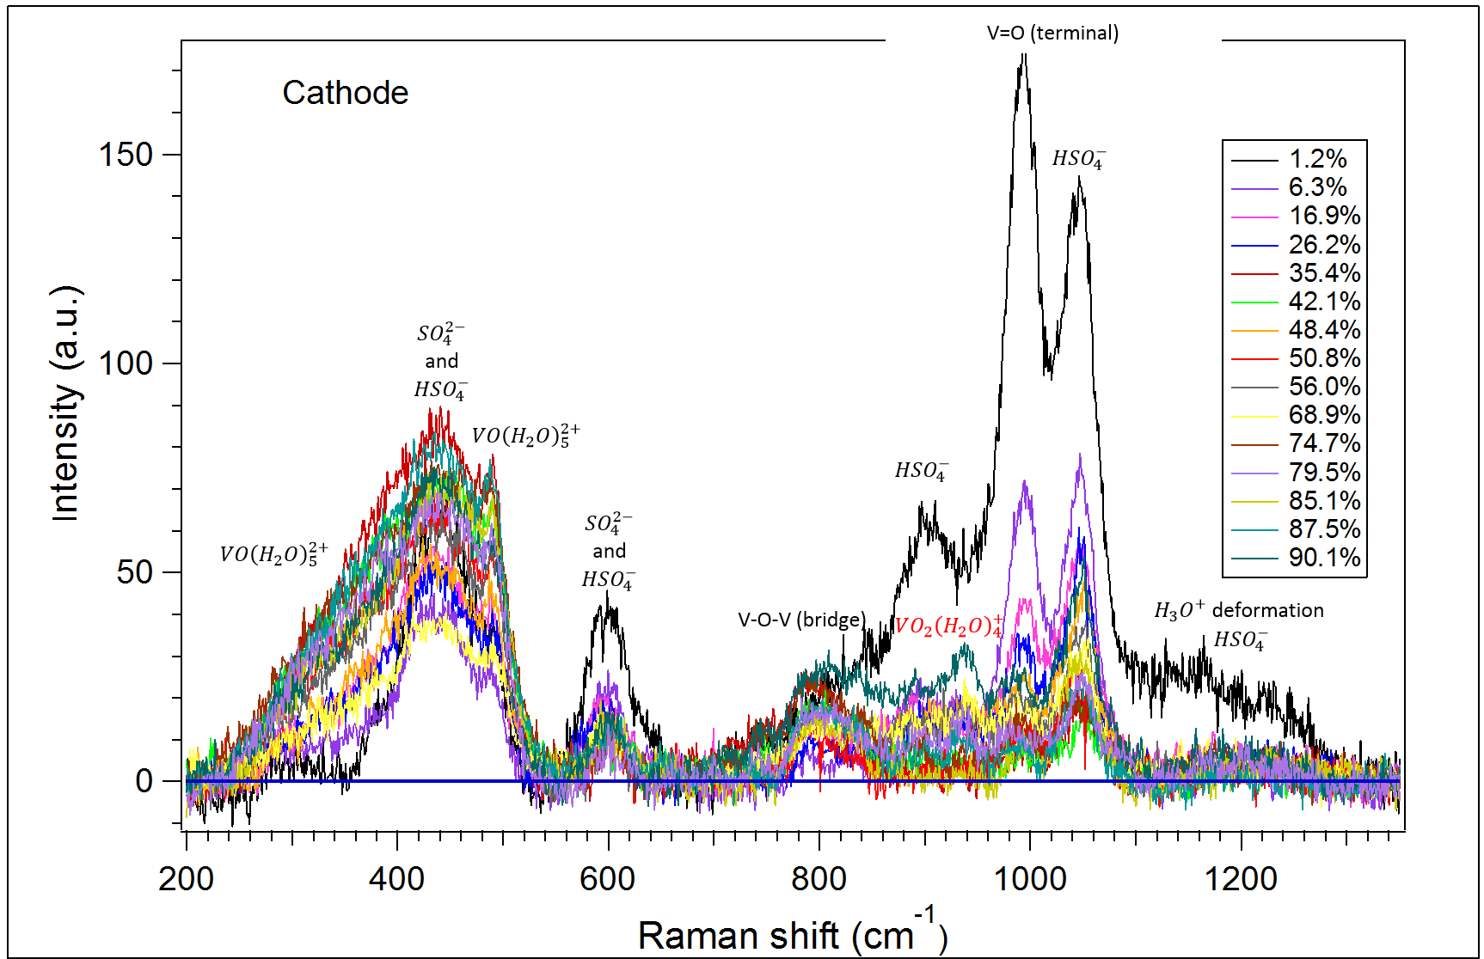
Figure 20: Raman spectrum for the VO₂⁺/VO²⁺ redox couple in sulfuric acid electrolyte as a function of state of charge. Prominent peak changes occur at approximately 440 cm⁻¹ and 600 cm⁻¹, both involving sulfate and bisulfate anions. This peak difference indicates that sulfate and bisulfate complexation with the oxo-vanadium species in solution changes as a function of state of charge.
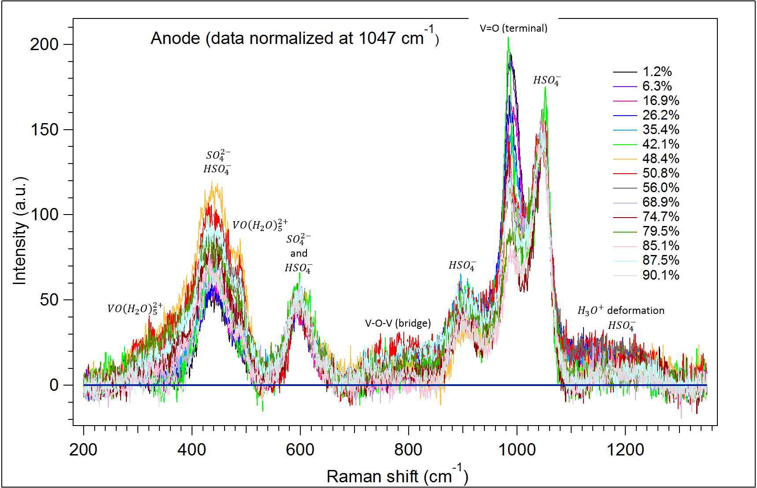
Figure 21: Raman Spectrum for the V³⁺/V²⁺ redox couple. As observed at the cathode, the most prominent peak changes occur at 440 cm⁻¹, 600 cm⁻¹, 1,000 cm⁻¹, and 1045 cm⁻¹. All of these peaks except for the peak at 1,000 cm⁻¹ correspond to sulfate and bisulfate anion species, indicating that a change in complexation structure is occurring as was observed at the cathode. The peak occurring at 1,000 cm⁻¹ corresponds to V=O terminal stretching. The decrease in this peak as state of charge increases corresponds to the disappearance of VO²⁺ and the formation of V³⁺ and V²⁺.

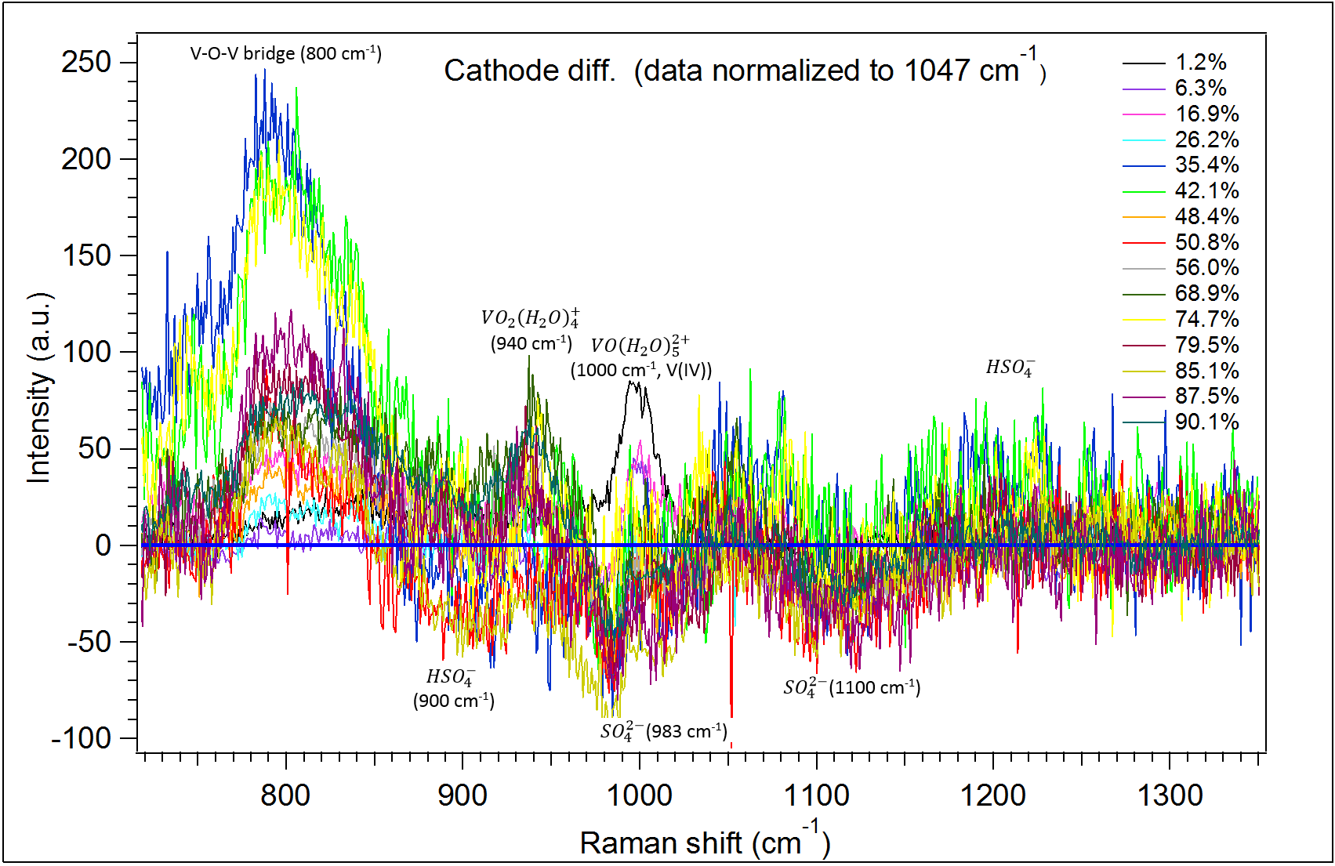
Figure 22: Cathode difference Raman spectrum. The most notable difference between the different cathode spectra is the change in intensity of the 800 cm⁻¹ peak. The change in this peak may correspond to changes in the concentration of V₂O₃³⁺ or VO²⁺ and VO₂⁺ dimers. The VO₂⁺ peak at 940 cm⁻¹ has a maximum intensity at 90.1% state of charge, and the VO(H₂O)₅²⁺ peak at 1,000 cm⁻¹ has a maximum intensity at 1.2% state of charge. Both of these results correspond to expected results at these states of charge.

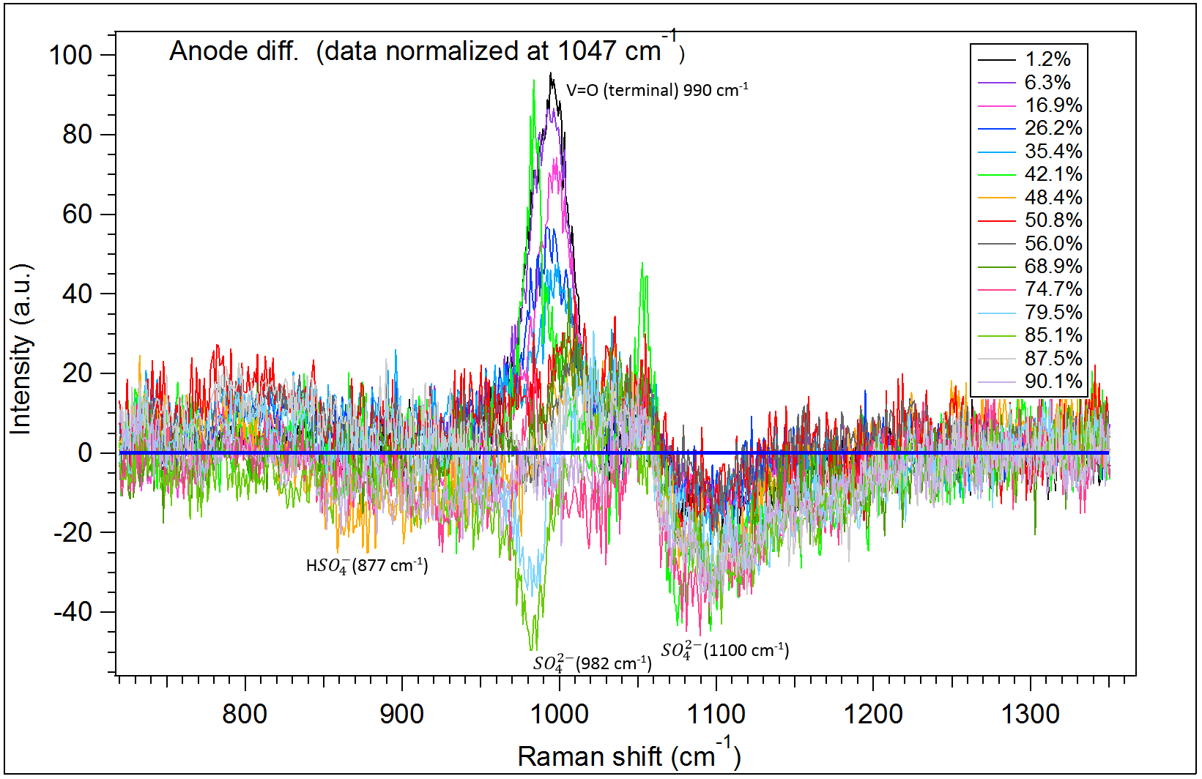
Figure 23: Anode difference Raman spectrum. The most prominent peak change occurs at 990 cm⁻¹, which corresponds to the expected decrease in VO²⁺ as state of charge decreases. The sulfate peak at 1100 cm⁻¹ roughly decreases with an increase in state of charge, indicating that V²⁺ and V³⁺ do not complex as strongly with sulfate and bisulphate species as do V⁴⁺ and V⁵⁺.

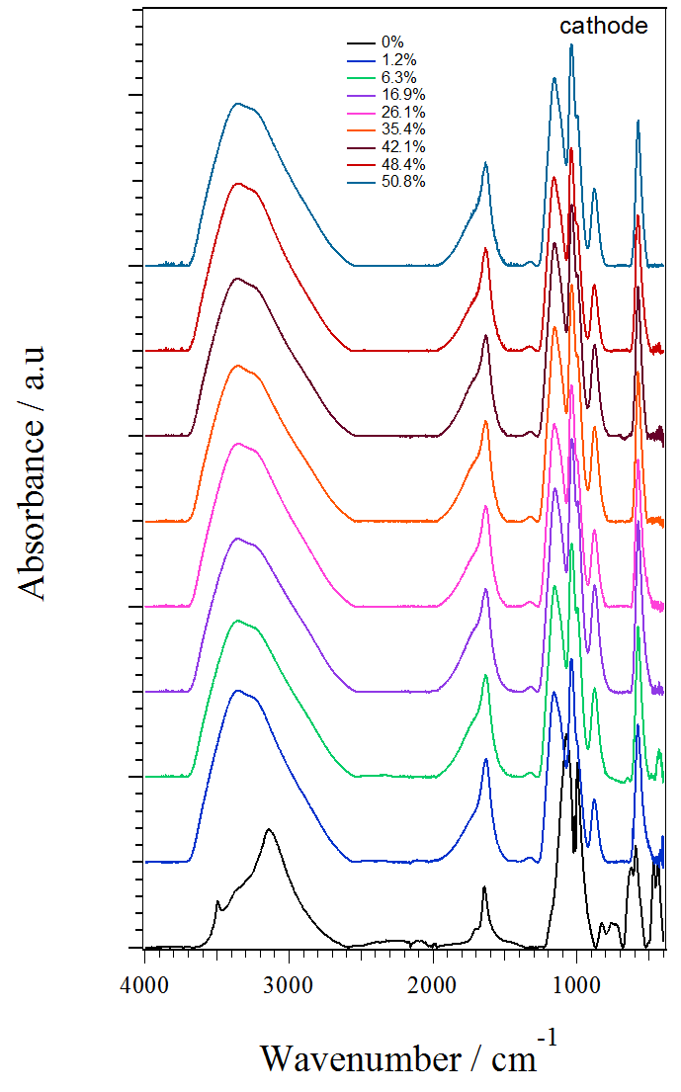 | 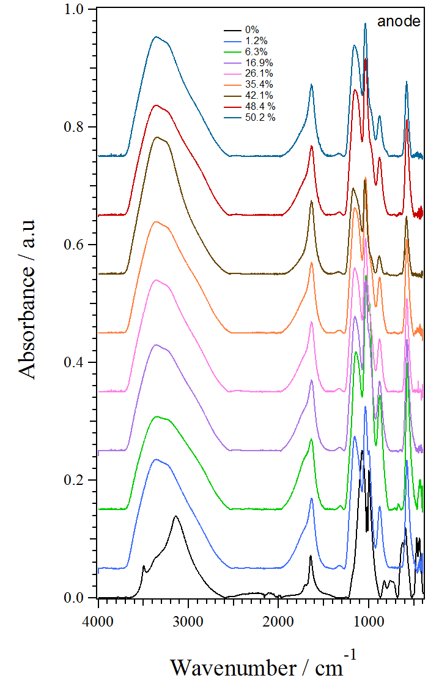
Figure 24-A | Figure 24-B
Figure 24: Cathode and anode mid-IR results, Figure 24-A and Figure 24-B, respectively. Little qualitative difference is noted between the two spectra. This lack of difference indicates that the IR spectra are most likely products of uncomplexed water and sulfate species rather than the changing vanadium species.
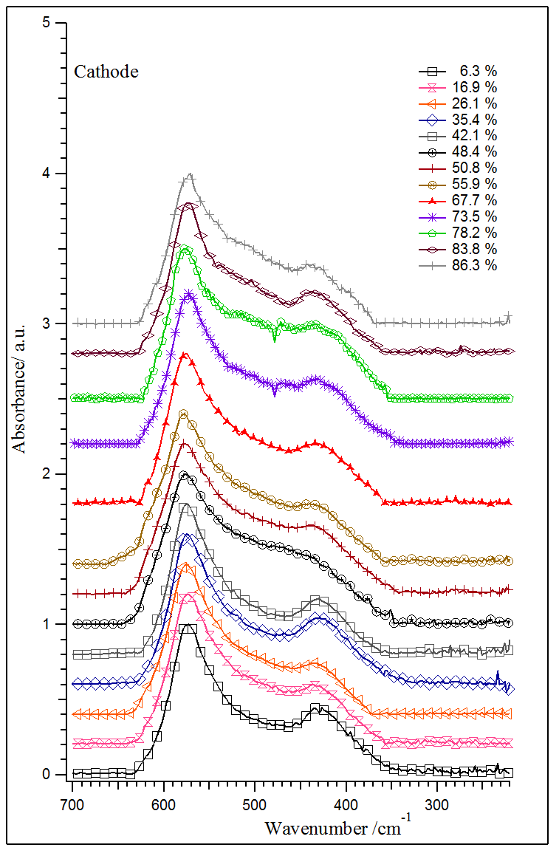 | 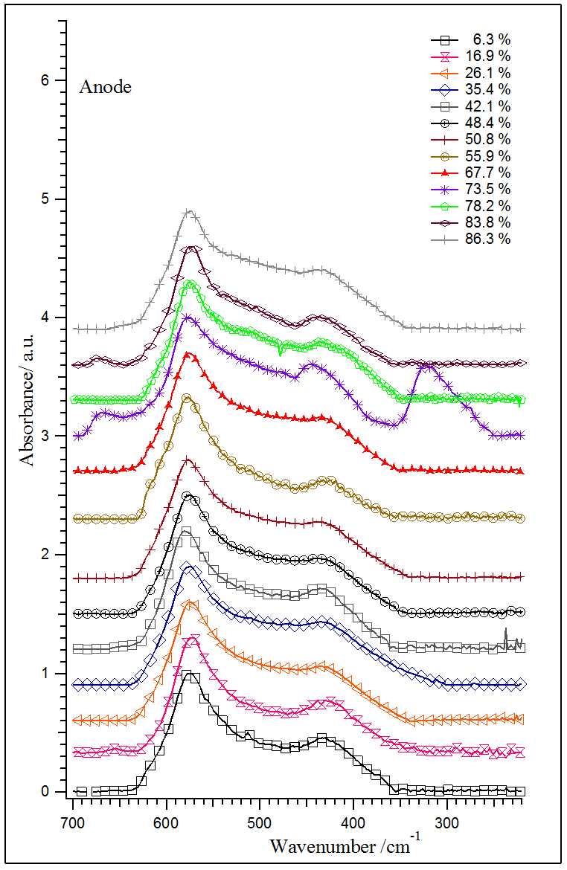
Figure 25-A | Figure 25-B
Figure 25: Cathode and anode far-IR results, Figure 25-A and Figure 25-B, respectively. Little qualitative difference is noted between the two spectra. This lack of difference indicates that the IR spectra are most likely products of uncomplexed water and sulfate species rather than the changing vanadium species.
6.4 Discussion
Raman spectra were recorded for both VO²⁺/VO₂⁺ and V³⁺/V²⁺ redox couples as a function of state of charge. Mid-IR and far-IR spectra for both redox couples were also recorded as functions of state of charge. Raman spectra proved most useful in identifying the movement of species as state of charge changes. Changes in complexation involving the VO²⁺/VO₂⁺ with sulfate and bisulfate species is the most drastic change noted in the Raman spectra. V³⁺/V²⁺ exhibit little change as a function of state of charge, which is expected based on their known structures.
Vanadium redox reactions are assumed to be outer shell reactions, making knowledge of the hydration shell vital.⁴⁰ Sulfate and bisulfate species in the electrolyte likely contribute to the second coordination sphere, most probably to the pyramidal faces of the different octahedral vanadyl species.²² Therefore, the changes in sulfate Raman bands found in this study are further supported to be caused by changes in sulfate and bisulfate complexation as vanadium species change with state of charge. The changes in sulfate species’ arrangement may affect proton and water exchange mechanisms.²² If so, the apparent complexation observed in the recorded Raman spectra for the positive electrolyte may explain the superior kinetic performance of the positive electrode as compared to the negative electrode. Further studies are needed to support this hypothesis. If supported, considerable focus should be given to understanding outer sphere interactions with carbon electrode surfaces in order to optimize kinetic performance via surface chemistry modification.
6.5 Conclusion
Initial Raman and infrared spectroscopy studies provide a valuable first step towards determining all species’ structures in operating VRB electrolyte as a function of state of charge. The most apparent change in structures appears to be related to complexation with sulfate species. Further work is needed to elucidate the structure of the second coordination sphere of each vanadium species and what effect, if any, the structure of this sphere has on electron transfer kinetics.
7.0 Conclusion and Future Work
In this study, I show that the kinetic performance of an operating VRB is limited by the V³⁺/V²⁺ couple at all states of charge in both pure-sulfuric and mixed-acid electrolytes. The kinetic performance of the battery is significantly enhanced by the inclusion of hydrochloric acid in the electrolyte. The Raman and IR spectra of the pure-sulfuric acid electrolyte were recorded as functions of states of charge. The most significant change in the spectra are changes in sulfate species’ complexation with vanadium ions. Therefore, the superior performance of the positive electrode may be linked to changes in the structure of its outer coordination sphere. The presence of the V₂O₃³⁺ mixed valence cation-cation complex formed in the positive electrolyte was shown to have no impact on kinetic performance.
In future work, in-situ Raman measurements during electrochemical experiments (e.g., cyclic voltammetry) will be used to monitor species’ formation under controlled reaction conditions. This work will provide valuable formation on the reasons for the performance discrepancies between the electrodes and will hopefully result in a clear reaction mechanism for each redox couple that includes outer sphere species. These reaction mechanisms can then be used to design carbon electrodes with optimal surface chemistry that are durable and economically feasible, further increasing the ease with which VRBs will reach widespread commercialization.
8. Acknowledgements
Many thanks to Dr. Zawodzinski for his guidance and willingness to discuss my results. All spectra results were collected by Professor Vito Di Noto’s group at the University of Padua in Padua, Italy. My sanity was kept intact largely thanks to Dr. Douglas Aaron teaching me to take setbacks in stride. Thank you to the Haslam Scholars Program for their monetary support of the Italian portion of this thesis.

9. References
(1) Ponce de León, C.; Frías-Ferrer, A.; González-García, J.; Szánto, D. A.; Walsh, F. C. Journal of Power Sources 2006, 160 (1), 716–732.
(2) Weber, A.; Mench, M.; Meyers, J.; Ross, P.; Gostick, J.; Liu, Q. Journal of Applied Electrochemistry 2011, 41 (10), 1137–1164.
(3) Skyllas-Kazacos, M.; Chakrabarti, M. H.; Hajimolana, S. A.; Mjalli, F. S.; Saleem, M. Journal of The Electrochemical Society 2011, 158 (8), R55–R79.
(4) Skyllas-Kazacos, M.; Rychcik, M.; Robins, R. G.; Fane, A. G. Journal of the Electrochemical Society 1986, 133 (5), 1057–1058.
(5) Fabjan, C.; Garche, J.; Harrer, B.; Jörissen, L.; Kolbeck, C.; Philippi, F.; Tomazic, G.; Wagner, F. Electrochimica Acta 2001, 47 (5), 825–831.
(6) Aaron, D. S.; Liu, Q.; Tang, Z.; Grim, G. M.; Papandrew, A. B.; Turhan, A.; Zawodzinski, T. A.; Mench, M. M. Journal of Power Sources 2012, 206 (0), 450–453.
(7) Li, L.; Kim, S.; Wang, W.; Vijayakumar, M.; Nie, Z.; Chen, B.; Zhang, J.; Xia, G.; Hu, J.; Graff, G.; Liu, J.; Yang, Z. Adv. Energy Mater. 2011, 1 (3), 394–400.
(8) Liu, Q. H.; Grim, G. M.; Papandrew, A. B.; Turhan, A.; Zawodzinski, T. A.; Mench, M. M. Journal of The Electrochemical Society 2012, 159 (8), A1246–A1252.
(9) Aaron, D.; Tang, Z.; Papandrew, A.; Zawodzinski, T. Journal of Applied Electrochemistry 2011, 41 (10), 1175–1182.
(10) Aaron, D. S.; Tang, Z.; Lawton, J. S.; Papandrew, A. P.; Zawodzinski, T. A. ECS Transactions 2012, 41 (23), 43–51.
(11) Gattrell, M.; Park, J.; MacDougall, B.; Apte, J.; McCarthy, S.; Wu, C. W. Journal of The Electrochemical Society 2004, 151 (1), A123–A130.
(12) Kaneko, H.; Nozaki, K.; Wada, Y.; Aoki, T.; Negishi, A.; Kamimoto, M. Electrochimica Acta 1991, 36 (7), 1191–1196.
(13) Sun, B.; Skyllas-Kazacos, M. Electrochimica Acta 1992, 37 (7), 1253–1260.
(14) Sun, B.; Skyllas-Kazacos, M. Electrochimica Acta 1992, 37 (13), 2459–2465.
(15) Han, P.; Wang, H.; Liu, Z.; Chen, X.; Ma, W.; Yao, J.; Zhu, Y.; Cui, G. Carbon 2011, 49 (2), 693–700.
(16) Tang, Z.; Aaron, D. S.; Papandrew, A. B.; Zawodzinski, T. A. ECS Transactions 2012, 41 (23), 1–9.
(17) Blanc, P.; Madic, C.; Launay, J. P. Inorg. Chem. 1982, 21 (8), 2923–2928.
(18) Wu, X.; Wang, J.; Liu, S.; Wu, X.; Li, S. Electrochimica Acta 2011, 56 (27), 10197–10203.
(19) Sepehr, F.; Paddison, S. J. Chemical Physics Letters 2013, 585 (0), 53–58.
(20) Krakowiak, J.; Lundberg, D.; Persson, I. Inorg. Chem. 2012, 51 (18), 9598–9609.
(21) Vijayakumar, M.; Li, L.; Nie, Z.; Yang, Z.; Hu, J. Phys. Chem. Chem. Phys. 2012, 14 (29), 10233–10242.
(22) Vijayakumar, M.; Burton, S. D.; Huang, C.; Li, L.; Yang, Z.; Graff, G. L.; Liu, J.; Hu, J.; Skyllas-Kazacos, M. Journal of Power Sources 2010, 195 (22), 7709–7717.
(23) Vijayakumar, M.; Li, L.; Graff, G.; Liu, J.; Zhang, H.; Yang, Z.; Hu, J. Z. J. Power Sources 2011, 196 (7), 3669–3672.
(24) Liu, H.; Xu, Q.; Yan, C.; Qiao, Y. Electrochimica Acta 2011, 56 (24), 8783–8790.
(25) Sun, C.-N.; Delnick, F. M.; Baggetto, L.; Veith, G. M.; Zawodzinski Jr., T. A. Journal of Power Sources 2014, 248 (0), 560–564.
(26) Shah, A. A.; Al-Fetlawi, H.; Walsh, F. C. Electrochimica Acta 2010, 55 (3), 1125–1139.
(27) Liu, H.; Xu, Q.; Yan, C. Electrochemistry Communications 2013, 28 (0), 58–62.
(28) Bard, A. J.; Faulkner, L. R. Electrochemical Methods: Fundamentals and Applications, Second.; John Wiley & Sons, Inc., 2001.
(29) Jag Mohan. Organic spectroscopy : principles and applications; CRC Press, 2000.
(30) Larkin, P. Infrared and Raman Spectroscopy; Principles and Spectral Interpretation; An Elsevier Title: Saint Louis, MO, USA, 2011.
(31) Schwedt, G. The Essential Guide to Analytical Chemistry, Second.; John Wiley & Sons, Inc., 1997.
(32) Smith, B. C. Fundamentals of Fouriertransform Infared Spectroscopy (2nd Edition); CRC Press: Boca Raton, FL, USA, 2011.
(33) Li, G.; Pickup, P. G. Electrochimica Acta 2004, 49 (24), 4119–4126.
(34) Agar, E.; Dennison, C. R.; Knehr, K. W.; Kumbur, E. C. Journal of Power Sources 2013, 225 (0), 89–94.
(35) Griffith, W. P.; Lesniak, P. J. B. J. Chem. Soc. A 1969, No. 0, 1066–1071.
(36) Irish, D. E.; Chen, H. J. Phys. Chem. 1970, 74 (21), 3796–3801.
(37) Evans, J. C. Inorganic Chemistry 1963, 2, 372–375.
(38) Kausar, N.; Howe, R.; Skyllas-Kazacos, M. Journal of Applied Electrochemistry 2001, 31 (12), 1327–1332.
(39) Madic, C.; Begun, G. M.; Hahn, R. L.; Launay, J. P.; Thiessen, W. E. Inorg. Chem. 1984, 23 (4), 469–476.
(40) Lee, J. W.; Hong, J. K.; Kjeang, E. Electrochimica Acta 2012, 83 (0), 430–438.

