Kinetics and phase stability of nano-scale precipitates in Fe-based binary alloys during ion irradiations

A Dissertation Presented for the
Doctor of Philosophy
Degree
The University of Tennessee, Knoxville

Yajie Zhao
February 2023

Acknowledgments
I would like to express my sincere gratitude to all who have contributed to and supported my career as a graduate student. Their guidance and kind help made this dissertation possible.
First and foremost, I am extremely grateful for the continuous support, invaluable advice and patience from my advisor, Dr. Steve Zinkle. His plentiful experience and immense knowledge have encouraged me in all the time of my academic research and daily life. I would also like to thank my co-advisor Dr. Arunodaya Bhattacharya for his insightful comments and encouragement. I am grateful for the invaluable suggestions provided by the thesis committee, Drs. Brian D. Wirth, William J. Weber, Yanwen Zhang and Philip D Edmondson. My research involves the assistance and contributions from the faculties and staff in multiple facilities. I deeply appreciate all the support and guidance on APT data acquisition and analysis from Dr. Cristelle Pareige from the University of Rouen, Drs. Jonathan Poplawsky, Caleb Massey, Philip D Edmondson and Mr. James Burns from Oak Ridge National Laboratory (ORNL). I would like to thank Drs. Zhijie Jiao and Ovidiu Toader in Michigan Ion Beam Laboratory for their help in irradiation experiments. Acknowledgments are also due to the past group members of Dr. Zinkle’s research group including Drs. Tengfei Yang, Ling Wang, Congyi Li, and Peter Doyle for their valuable suggestions. The help from our present group members Samara Levine, Pengcheng Zhu, Yao Li and other colleagues is greatly appreciated.
Most importantly, I would like to express my gratitude to my parents, my uncle, and my boyfriend Xuesong Fan, who has been with me for over 9 years. Without their tremendous understanding and encouragement in the past few years, it would be impossible for me to complete my study.
Financial support was provided by the U.S. Department of Energy, the University of Tennessee and the Tennessee Higher Education Commission. Specimens used in this work were provided by Dr. Jean Henry from CEA, France, and were fabricated within the EUROfusion Consortium framework. APT characterization was conducted in ORNL's Center for Nanophase Materials Sciences (CNMS).
Abstract
Due to the high void-swelling resistance and good mechanical, thermal and chemical properties, FeCr based ferritic-martensitic steels are promising candidates for structural materials in future fission and fusion reactors. However, they are known to suffer from radiation-induced severe hardening and embrittlement due to formation of Cr-rich alpha prime phase (α’) precipitates at temperatures below ~450 °C and doses above ~0.1 displacements per atom (dpa). Despite the extensive observation of α’ after neutron irradiations, α’ phase separation was seldom reported after high dose rate ion irradiations. Additionally, α’ formation was historically attributed to a radiation enhanced precipitation mechanism, which is not consistent with the absence of α’ after ion irradiations.
In this study, high purity FeCr alloys with a wide range of Cr concentrations of 5-18% were irradiated by 8 MeV Fe ions at -123 °C to 450 °C, 10⁻⁵ – 10⁻³ dpa/s to mid-range doses of 0.37-3.7 dpa, and by 800 keV protons at 250 – 450 °C, 2×10⁻⁵ dpa/s to 2 dpa. Solute distribution and formation of solute clusters were characterized mainly by using the atom probe tomography (APT) technique.
After heavy ion irradiations at the high temperature range (300 °C – 450 °C), Cr precipitates were observed in Fe-(12-18)Cr alloys in a large portion of irradiation conditions. These precipitates feature much lower Cr concentrations compared to the thermal equilibrium values, which can be attributed to the modifications introduced by displacement damage cascades. Furthermore, both the near-surface and implanted ion regions were observed to suppress α’ precipitation.
Proton irradiations at 350 to 450 °C resulted in the formation of homogeneously distributed α’, which have similar compositions as those formed from thermal aging, and can be attributed to a radiation enhanced precipitation mechanism. At 250 °C, highly concentrated Cr clusters with near-equilibrium concentration were detected in all specimens, and their positional association with dislocation loops was revealed in Fe-(5-8)Cr alloys. Based on the lack of homogeneous α’ precipitation in the matrix, these agglomerated clusters are attributed to radiation-induced precipitation due to the preferential coupling of Cr atoms with interstitials that flow to dislocation loops.
Irradiations at cryogenic- to room- temperature using heavy ions were conducted to further quantify the radiation-induced dissolution rate. Both FeCr and FeCu alloys with pre-existing solute clusters were simultaneously irradiated up to 0.6 dpa. Gradual dilution of Cu precipitates was observed after irradiations. However, Cr precipitates show relatively high resistance to the dissolution induced by displacement cascades, in contrast to the behavior observed at 300– 450 °C. This low temperature behavior is inconsistent with the radiation enhanced diffusion/ballistic dissolution theory. Further investigations are required to elucidate these puzzling observations.

Table of Contents

Chapter One Introduction and motivation 1
Chapter Two Literature Review 5
2.1 Radiation damage in FeCr alloys 5
2.1.1 The history of using FeCr alloys as nuclear materials 5
2.1.2 Effect of irradiation on dimensional stability 8
2.1.3 Effect of irradiation on mechanical properties 9
2.1.3.1 Tensile properties 9
2.1.3.2 Impact properties and fracture toughness 10
2.1.3.3 Irradiation creep 12
2.2 Diffusion and precipitation in FeCr alloys 12
2.2.1 FeCr phase diagram and α’ precipitates 13
2.2.2 Other precipitates in FeCr-based alloy system. 16
2.2.3 Diffusivity of point defects and their clusters 18
2.2.3 Diffusivity of point defects and their clusters 19
2.3 The stability of α’ precipitates under irradiation 21
2.3.1 Theoretical background 21
2.3.1.1 Radiation enhanced diffusion 21
2.3.1.2 Ion mixing 24
2.3.1.3 Precipitation mechanism under irradiation 26
2.3.1.4 Models accounting for the stability of precipitates under irradiation 27
2.3.2 Experimental background 30
2.3.2.1 α’ formation after electron irradiation 30
2.3.2.2 α’ formation after neutron irradiation 31
2.3.2.3 α’ formation after ion irradiation 33
2.4 Surface and injected ions effect on ion irradiation induced microstructure evolution 34
2.4.1 Surface effect 34
2.4.1 Injected ions effect 35
2.5 Cu precipitates in FeCu binary alloys 38
2.4.1 Cu precipitates formed from thermal aging. 38
2.4.2 Cu precipitates formed after irradiations. 38
Chapter Three Materials and Methods 43
3.1 FeCr and FeCu Specimens 43
3.2 Thermal aging 45
3.3 Ion irradiations 45
3.2.1 Sample preparation 45
3.2.2 Ion irradiation conditions 45
3.2.2.1 High temperature heavy ion irradiations 47
3.2.2.2 Cryogenic to room temperature heavy ion irradiations 50
3.2.2.3 Proton irradiations 50
3.4 Characterizing α’ precipitates with APT 55
3.4.1 Principles of APT 55
3.4.2 Artifacts of APT 57
3.4.2.1 Preferential evaporation 57
3.4.2.2 Local magnification 57
3.4.2.3 Isotopes overlap 59
3.4.3 APT sample preparation and data acquisition 61
3.4.4 Reconstruction 61
3.4.5 Measuring solute clustering statistically 62
3.4.6 Identifying clusters with self-developed Python codes. 66
3.4.7 Calculating Cr concentration with proxigrams 69
3.5. Studying the correlation of solute atoms with dislocations using STEM-EDS 71
Chapter Four Results 72
4.1 Effect of dose rate and temperature on α’ formation in Fe-18Cr 72
4.1.1 α’ precipitates after irradiation to 0.37 dpa 72
4.1.2 Cr-rich α’ precipitation after irradiation to 3.7 dpa 78
4.1.3 Ballistic dissolution of α’ precipitates by irradiation in aged Fe-18Cr 81
4.2 Effect of surface and injected ions on α’ formation 87
4.2.1 α’ precipitates denuded zone in the near-surface region 87
4.2.2 Suppression of α’ precipitation at and beyond the peak damage region 87
4.3 Effect of bulk Cr concentration on α’ formation in FeCr alloys 91
4.3.1 α’ precipitation in Fe-14Cr after ion irradiations 91
4.3.2 α’ precipitation in Fe-12Cr 93
4.3.3 α’ precipitation in Fe-10Cr 96
4.4 Using proton irradiation and thermal aging to determine the phase boundary 96
4.4.1 α’ formation after proton irradiations 96
4.4.2 α’ formation and hardness change after thermal aging 100
4.5 Ballistic dissolution of Cr and Cu precipitates by ion irradiations 106
4.5.1 Precipitate formation after thermal aging 106
4.5.2 Dilution of Cu precipitate after ion irradiations 106
4.5.3 Evolution of Cr precipitate after ion irradiations 111
Chapter Five Discussion 118
5.1 Comparison with previous experimental and simulation results 118
5.1.1 Proton irradiations at 250-450 °C 118
5.1.2 300-450 °C heavy ion irradiation 125
5.1.3 Cryogenic and room temperature heavy ion irradiation 129
5.2 Effect of irradiation temperature and dose rate 131
5.2.1 Temperature effect 131
5.2.2 Dose rate effect 136
5.2.3 Mathematical modeling of the irradiation results at 300-450 °C by Fe ions 139
5.3 Effect of implanted particle types 153
5.4 Effect of surface and injected ions 157
5.4.1 Implication of α’ precipitates denuded zone 157
5.4.2 Accuracy of the depths measured by APT 158
5.4.3 Possible reasons for the precipitate suppression effect at peak-implant depths 160
5.5 Effect of bulk Cr concentrations 166
5.6 Mechanisms of α’ precipitate formation 168
5.6.1 Precipitate Cr concentrations and APT artifacts 168
5.6.2 Radiation-enhanced α’ precipitation 171
5.6.3 Radiation-induced α’ precipitation 172
5.6.4 Radiation-modified α’ precipitation 172
Chapter Six Conclusion 175
6.1 300-450 °C heavy ion irradiation 175
6.2 250-450 °C proton irradiation and 450-500 °C thermal aging 178
6.3 -123 °C to R.T. heavy ion irradiation 179
6.4 Recommendations for future work 180
List of References 182

LIST OF TABLES
Table 2.1 Major precipitation in high-chromium steels after normalized-and-tempered, aged, creep-rupture tested and irradiated. Reproduced from Ref. [1]. 17
Table 2.2 Results of Cu precipitates radii measured after irradiations in literature. 41
Table 3.1 Chemical compositions and grain sizes for the FeCr alloys. 44
Table 3.2 Aging conditions for FeCr and FeCu alloys conducted in this work. 46
Table 3.3 The matrix for high temperature heavy ion irradiation conditions. All materials were irradiated in a single sample holder for each condition. 0, 3, 5, 8, 10, 12, 14, and 18 stand for FeCr alloys with the corresponding weight percent of Cr content. H1, H3 and H9 represent the Fe-18Cr aged at 500 °C for 100, 300 and 900 hours. 49
Table 3.4 The details of cryogenic to room temperature heavy ion irradiation conditions. All materials were irradiated in a single sample holder for each condition. Preirradiation heat treatment conditions are listed in the Materials column. 51
Table 3.5 Temperatures and specimens used in the 3 proton irradiations. The specimens before irradiations were in a solid solution state if not specified. 54
Table 4.1 The characteristics of α’ precipitates in Fe-18Cr irradiated at 10⁻⁴ dpa/s, 350 and 450 °C to 0.37 or 3.7 dpa. Data for the sample aged at 500 °C for 900 hours, as obtained from APT data analysis, is also presented. 79
Table 4.2 The characteristics of α’ precipitates in Fe-14Cr irradiated at 10⁻⁵-10⁻³ dpa/s, 300-450 °C to 0.37 or 3.7 dpa. 92
Table 4.3 The characteristics of α’ precipitates in Fe-12Cr irradiated at 10⁻⁵⁴10⁻³ dpa/s, 300 and 350 °C to 0.37 or 3.7 dpa. 95
Table 4.4 The characteristics of α’ precipitates in Fe-18Cr aged at 450-500 °C for 100-8760 hours. 105
Table 5.1 Characteristics of α’ precipitates in Fe-18Cr irradiated by different particles. Fe and proton irradiation results are from this work. Neutron irradiation results are from [6]. 155
Table 5.2 Typical recoil energies and dose rates during irradiations by different particles. 155

LIST OF FIGURES
Figure 1.1 (a) Decrease of impact strength for Fe18Cr after thermal aging at intermediate temperatures. (b) The change of yield stress (YS), ultimate tensile stress (UTS) and elongation as a function of aging time. (c) Atom map of Fe19Cr after thermal aging at 500 °C for 2008 hours shows the formation of α’ precipitates. Imaged volume is 10×10×50 nm³. Reproduced from [2-4] respectively. 2
Figure 2.1 The dose and temperature requirements for the in-core structural materials operating in fusion and fission reactors. Reproduced from Ref. [11]. 6
Figure 2.2 The effect of Cr content on the DBTT shift in reduced-activation FM steels after neutron irradiations at 365-410 °C, reproduced from Ref. [49]. 11
Figure 2.3 Phase boundaries between α and α+α’ two-phase region predicted by (a) CALPHAD (legend is Andersson 1987) [58], modified by Bonny et al [65] and proposed by Xiong et al [62]. 14
Figure 2.4 The diffusivity of single SIA in pure Fe and Fe-(0.2-15%)Cr as a function of temperature calculated from molecular dynamic simulation. Reproduced from Ref. [90]. 22
Figure 2.5 Diffusion coefficients for a nickel-based alloy under thermal and irradiation conditions. D_{rad} is the radiation enhanced diffusion coefficient calculated from rate theory equations. D_{th} and D_{m} are diffusion coefficients from radiation mixing and thermal activations, respectively. p is sink annihilation probabilities. Reproduced from Ref. [93]. 22
Figure 2.6 The evolution of cluster size within the characteristic time to approach the equilibrium value. Reproduced from Ref. [103]. 29
Figure 2.7 The presence/absence of α’ precipitates in FeCr alloys after neutron irradiation at different temperatures. The orange-colored symbols (ending with N in the legend) refer to the absence of precipitates while the green ones (ending with Y in the legend) refer to the observation of precipitates [5, 6, 33, 83, 84, 98, 108-123]. The phase boundary proposed by Bonny et al (dashed line) is included for comparison [61]. 32
Figure 2.8 The evolution of point defect concentration, irradiation damage rate and injected ions concentration with depth in nickel after irradiation with 14 MeV nickel ions. Reproduced from Ref. [128]. 36
Figure 2.9 (a) the radii of Cu precipitates in Fe-(0.4-1.4)%Cu alloys after thermal aging for different time lengths. (b) The same radii datapoints are plotted as a function of aging time^{1/3}, in which they can be linearly correlated. Datapoints are from Refs [134-145] 39
Figure 3.1 The arrangement of 3 accelerators located at MIBL. Only the Wolverine was used in this study. Reproduced from Ref. [151]. 46
Figure 3.2 (a) specimens loaded on the stage for irradiations. (b) SRIM prediction of the depth-dependent displacement damage and injected ion concentration of pure Fe irradiated by 8 MeV Fe ions to 8.83x10¹⁴ ions/cm², corresponding to the low fluence irradiation. Both values are 10 times higher for the high fluence irradiation. The analysis depth is marked by the gray-shadowed area. 48
Figure 3.3 (a) specimens loaded on the stage for irradiations. (b) SRIM prediction of the depth-dependent displacement damage and injected ion concentrations of pure Fe irradiated by 8 MeV Fe ions to mid-range doses of 0.1, 0.2 and 0.6 dpa. 52
Figure 3.4 SRIM prediction of the depth-dependent displacement damage of pure Fe irradiated by 800 keV proton to mid-range doses of 2 dpa. 54
Figure 3.5 Schematic drawing for the experimental setup of APT, reproduced from [153]. 56
Figure 3.6 Influence of the temperature and electric field on the evaporation of a specimen containing atom species A and B. A proper operation condition is presented in (a) while preferential evaporation occurs in (b). Reproduced from Ref. [70]. 58
Figure 3.7 The trajectory aberrations at the cluster-matrix interface and the resulting density change inside precipitates in the case of (a) a low-field precipitate and (b) a high-field precipitate. Reproduced from Ref. [153]. 58
Figure 3.8 The mass spectrum of an APT dataset collected for the as-received Fe-18Cr specimen. The peak overlap at 27 Da is highlighted. 60
Figure 3.9 (a) an example of the detector event histogram in IVAS and (b) the spatial distribution map along the z-axis corresponding to the <110> pole region highlighted in (a). 63
Figure 3.10 The Cu atoms distribution in Al-1.7at. %Cu after (a) As-quenched, aged at 100 °C for (b) 2 hours and (c) 4 hours. (d) the corresponding frequency distribution of Cu concentration and (e) evolution of Pearson coefficient. Reproduced from Ref. [153]. 63
Figure 3.11 Comparison of the standard error (s) of the Cr atoms distribution in an experimental dataset and the standard deviation (σ) of the binomial distribution for (a) Fe18Cr in as-received state and (b) Fe18Cr after ion irradiation at 450 °C, 10⁻⁵ dpa/s to 0.37 dpa. 65
Figure 3.12 (a) the frequency distribution of Cr concentration in an as-received Fe18Cr dataset calculated with block sizes of 50-500 atoms, and (b) a zoom-in view of the right tails in (a). 68
Figure 3.13 The proxigram fitted by an empirical function to calculate the matrix and cluster core Cr concentration. 70
Figure 4.1 The clustering coefficient for Fe18Cr irradiated to 0.37 dpa at different dose rates and temperatures. 73
Figure 4.2 Cluster atom maps showing α’ precipitates in Fe-18Cr irradiated to 0.37 dpa. Sampled volume = 40×40×10 nm³. Clusters are indexed with different colors. All elements in the Cr-enriched clusters including both Fe and Cr atoms are shown. 73
Figure 4.3 The evolution of (a) radius, (b) number density and (c) volume fraction of α’ precipitates irradiated to 0.37 dpa at different temperatures and dose rates. 75
Figure 4.4 Proxigrams for Fe-18Cr irradiated at 450 °C and 3 dose rates to 0.37 dpa. The inset figure shows a zoomed-in view of the matrix side. 77
Figure 4.5 The evolution of Cr concentration in (a) matrix and (b) cluster core for Fe-18Cr irradiated to 0.37 dpa at different temperatures and dose rates. The solubility limit in (a) and the equilibrium Cr content in (b) are reproduced from [61] and [65] respectively. 77
Figure 4.6 APT reconstructions of Fe-18Cr samples irradiated at 10⁻⁴ dpa/s showing α’ precipitates. The irradiation temperature and final doses are overlaid. All elements in the Cr-enriched clusters including both Fe and Cr atoms are shown. 79
Figure 4.7 Evolution of the Cr-enriched precipitate radii distribution after irradiation at (a) 350 °C, 10⁻⁴ dpa/s, and (b) 450 °C, 10⁻⁴ dpa/s. Final doses were 0.37 and 3.7 dpa. 80
Figure 4.8 APT reconstructions showing α’ precipitation evolution in Fe-18Cr. (a) Sample aged at 500 °C for 900 hours. Samples aged at 500 °C for 900 hours followed by ion irradiation at (b) 300 °C, (c) 350 °C and (d) 450 °C. (e) Unirradiated as-received material. Samples that were ion irradiated from the as-received state at (f) 300 °C, (g) 350 °C and (h) 450 °C. The dose rates and doses were10⁻³ dpa/s and 0.37 dpa for all the irradiated specimens. 82
Figure 4.9 Size distribution of α’ precipitates (a) after aging at 500 °C for 900 hours, (b) irradiation at 350 °C, 10⁻³ dpa/s to 0.37 dpa from aged and as-received state and (c) irradiation at 450 °C, 10⁻³ dpa/s to 0.37 dpa from aged and as-received state. 84
Figure 4.10 Quantification of the α’ precipitates. Comparison of the (a) mean cluster radius, (b) number density, (c) volume fraction, (d) Cr concentration in precipitates and (e) matrix Cr concentration. The investigated samples were Fe-18Cr irradiated at 350 and 450 °C, 10⁻³ dpa/s to 0.37 dpa and Fe18Cr aged at 500 °C for 900 hours followed with irradiations at the same conditions. The shaded parts show parameters of α’ precipitates formed from thermal aging. The horizontal lines represent the average values, and the half heights of the regions stand for the standard deviation of multiple measurements. 85
Figure 4.11 Reconstructions of needles taken from the surface depth of 3 specimens. α’ denuded zones are visible in the near-surface region. Local irradiation parameters are given above each reconstruction. 88
Figure 4.12 Cross-sections showing the distribution of α’ at different depths in Fe18Cr after irradiation at 350 °C to the low fluence. Imaged volume is 40×40×10 nm³ for each cross section. The local dose rate, dose and injected ion concentration are given above each cross-section. 88
Figure 4.13 Cross-sections showing the distribution of α’ at different depths in Fe-18Cr after irradiation at 350 °C and 450 °C to the high fluences. Imaged volume is 40×40×10 nm³. 89
Figure 4.14 The evolution of (a) radius, (b) number density, (c) volume fraction, (d) Cr concentration in precipitates and (e) matrix with irradiation depth. 90
Figure 4.15 Cluster atom maps of Fe-14Cr irradiated to 0.37 dpa in sampled volumes of 40×40×10 nm³. Clusters are indexed with different colors. All elements including both Fe and Cr atoms are included. 92
Figure 4.16 APT reconstruction for Fe-14Cr irradiated at 10⁻⁴ dpa/s to 3.7 dpa. The irradiation temperatures are presented above each reconstruction. All the particles indexed by different colors are α’ precipitates. 94
Figure 4.17 APT reconstructions of Fe-12Cr alloys after irradiation at 5 conditions. The irradiation temperature, dose rate and final dose are presented above each reconstruction. All the particles indexed by different colors are α’ precipitates. 95
Figure 4.18 (a) APT reconstruction for Fe10Cr irradiated at 10⁻⁴ dpa/s and 350 °C to 3.7 dpa. No α’ particles formed after irradiation. (b) Comparison between the standard deviations of the binomial distribution and the standard error of Cr atoms distribution in experimental datasets. 97
Figure 4.19 Cr atom maps of FeCr alloys irradiation by protons at 250, 350 and 450 °C. The imaged volume for each condition is 40×40×10 nm³. 97
Figure 4.20 proxigrams of Fe18Cr alloy irradiation by protons at (a) 350 °C and (b) 450 °C to 2 dpa demonstrate the shift and change resulting from changes in threshold Cr concentration values. (c) and (d) are the zoom-in view of the matrix side in (a) and (b). Matrix Cr concentration depends on threshold values in (e) Fe18Cr and (f) Fe(5-10)Cr specimens. The dashed box in (e) and dashed circles in (f) point out the threshold Cr concentration values at which maximum numbers of clusters were detected. 99
Figure 4.21 The evolution of (a) radius, (b) number density, (c) Cr at the core of precipitates, (d) Cr concentrations in matrix and (e) volume fraction of α’ formed after proton irradiations at 250-450 °C to final doses of 2-18 dpa. Shadowed regions indicate results from Fe-18Cr specimens. Two specimens were pre-aged at 475 °C for 900 hours before proton irradiations. 101
Figure 4.22 Vickers hardness of FeCr alloys in as-received and aged states. 103
Figure 4.23 (a-c) Cr atoms distribution in Fe-18Cr alloys after thermal aging at the indicated temperatures and times. (d) Proxigrams showing the change of Cr concentration crossing 30% at.% Cr iso-concentration interfaces in the 3 aged specimens. (d) The dependence of measured matrix Cr concentrations as a function of threshold values at interface. 104
Figure 4.24 APT reconstructions showing the distribution of (a, b) Cu atoms in FeCu alloys and (c, d) Cr atoms in Fe-18Cr specimens after thermal aging at indicated temperatures and times. 107
Figure 4.25 APT reconstructions showing the distribution of Cu atoms in FeCu alloys (a-d) after aging at 500 °C for 1.5h + irradiation at -123 °C - room temperature to 0.1-0.6 dpa and (f-i) after aging at 500 °C for 10h + irradiation at the same conditions. Cu atom map in the as-received state is given in (e) for comparison. 107
Figure 4.26 The evolution of (a) number density, (b) radius, (c) volume fraction, (d) precipitate core Cu concentrations and (e) matrix Cu concentration in FeCu alloys irradiated to 0.1-0.6 dpa. 109
Figure 4.27 (a) Size distribution of Cu precipitate and (b) change of precipitate Cu concentration as a function of precipitate sizes in FeCu alloys after aged at 500 °C for 1.5 hours and aged followed by irradiations to 0.1-0.6 dpa. (c) and (d) are similar plots to (a) and (b) respectively. The specimens were aged at 500 °C for 10 hours followed by irradiation under the same conditions. 110
Figure 4.28 APT reconstructions showing the distribution of Cr atoms in Fe-18Cr alloys (a-d) after aging at 475 °C for 100h + irradiation at -123 °C to RT to 0.1-0.6 dpa. For better visualization, Cr-rich clusters filtered by our algorithms are presented below each Cr atom map in (f-j). (k-n) Cr atom distribution after aging at 475 °C for 10h + irradiation at the same conditions. Cr atom map in the as-received state is given in (e) for comparison. 112
Figure 4.29 The evolution of (a) number density, (b) radius, (c) volume fraction and (d) precipitate core Cr concentrations of α’ precipitates in Fe-18Cr alloys irradiated to 0.1-0.6 dpa. 113
Figure 4.30 (a) Size distribution of Cr precipitate and (b) change of precipitate Cr concentration as a function of precipitate sizes in Fe-18Cr alloys after aged at 475 °C for 100 hours and aged followed by irradiations to 0.1-0.6 dpa. (c) and (d) are similar plots to (a) and (b) respectively. The specimens were aged at 475 °C for 900 hours followed by irradiation at the same conditions. 115
Figure 4.31 Tenth order nearest neighbor distribution of Cr atoms in APT datasets. The specimens are Fe-18Cr aged at 475 °C for 100 or 900 hours, and Fe-18Cr aged + irradiation to 0.1-0.6 dpa. 116
Figure 5.1 A comparison of measured matrix Cr concentrations in FeCr alloys after thermal aging [4, 66], electron [67] or proton irradiations with available phase boundaries [58, 61, 62] in literature. The bulk compositions of alloys without α’ are also included. 120
Figure 5.2 Reconstructions showing the distribution of C, Fe atoms and the α’ precipitates highlighted by 25% Cr iso-concentration interface in (a) Fe-5Cr, (b) Fe-8Cr, (c) Fe-10Cr irradiation at 250 °C and (d) Fe-10Cr irradiation at 350 °C. The agglomerated precipitates are marked by dashed circles. (e) Proxigrams calculated from part of precipitates shown in (a)-(d). 122
Figure 5.3 (a) STEM bright field image of an Fe-5Cr irradiation by protons at 250 °C to 2 dpa. EDS mapping showing the distribution of Fe+Cr, Cr alone and Fe alone are given in (b-d). 124
Figure 5.4 Comparison of (a) radius, (b) number density and (c) Cr concentration of α’ precipitates in Fe(15-19)Cr after ion (10⁻⁵ to 10⁻³ dpa/s) and neutron (~3x10⁻⁷ dpa/s) irradiation up to 7 dpa. The irradiations performed at temperatures ≥ 450 °C are presented with red symbols, 320-350 °C with green, and around 300 °C with blue symbols. Open symbols denote results from literature while solid symbols are from this work. 127
Figure 5.5 Summary of (a) radius, (b) number density and (c) Cr concentration of α’ precipitates in Fe(15-19)Cr after ion, neutron, proton or electron irradiations up to 7 dpa, and thermal aging at 450-500 °C for 900-8760 hours as a function of temperature. The 4 shadowed region in each plot indicate the location of the treatments in 4 different categories as pointed out by the text. 134
Figure 5.6 Summary of (a) radius, (b) number density and (c) Cr concentration of α’ precipitates in Fe(15-19)Cr after ion, neutron, proton or electron irradiations up to 7 dpa, and thermal aging at 450-500 °C for 900-8760 hours as a function of dose rate. The 4 shadowed region in each plot indicate the location of the treatments in 4 different categories as pointed out by the text. 137
Figure 5.7 Comparison between radii measured with APT (filled symbols) and calculated with the modified NHM model (open symbols) for α’ precipitates formed in Fe-(10-18)Cr after proton or electron irradiations. The legends with EXP denote experimentally measured values from the current study and Tissot et al. [67]. The legends with MODEL denote calculated values from the modified NHM model. 143
Figure 5.8 Comparison between radii measured with APT (filled symbols) and calculated with the modified NHM model (open symbols) for α’ precipitates formed in Fe-18Cr after 8 MeV Fe irradiation at 300-450 °C. The legends with EXP denote experimentally measured values from the current study and Tissot et al. [7]. The legends with MODEL denote calculated values from the modified NHM model. 146
Figure 5.9 Comparison between radii measured with APT (filled symbols) and calculated with the modified NHM model (open symbols) for α’ precipitates formed in Fe-12Cr and Fe-14Cr after 8 MeV Fe irradiation. The legends with EXP denote experimentally measured values and the ones with MODEL denote calculated values from the modified NHM model. The shadowed region indicates the good agreements at the lower dose rates (10⁻⁵-10⁻⁴ dpa/s). 148
Figure 5.10 Comparison between the evolution of α’ precipitate radii with dose predicted with modified NHM model (curves) and the experimental measurements (isolated data points) for heavy ion irradiation at (a) 300-450 °C and (b) cryogenic to room temperature [7]. 151
Figure 5.11 Comparison between the evolution of α’ precipitate radii with dose predicted with modified NHM model (curves) and the experimental measurements (isolated data points) for (a) proton/electron and (b) neutron irradiation conditions [5, 6, 67]. 152
Figure 5.12 STEM-EDS scanning results showing the distribution of Fe and Cr atoms at indicated depths in Fe-18Cr irradiated at 450 °C, mid-range dose 3.7 dpa. 159
Figure 5.13 (a) The steady state vacancy concentrations calculated from rate theory equations and (b) the zoom-in version of (a) for sink strengths of 10¹¹-10¹⁴/m² to show the effect of additional recombination with injected ions more clearly. 163
Figure 5.14. (a-c) STEM images taken along [001] directions show the distribution of dislocation lines and loops. (d-j) Mass spectrums in the range of 5 to 24.5 Da exported from APT datasets collected for needles extracted from different depths of the 3 specimens. The depth and irradiation conditions are listed on the figure. The dashed rectangle in (f) highlights the presence of the peak at 19 Da. 165
Figure 5.15 The comparison between experimental observed α’ formation/dissolution with the phase boundaries available in the literature [58, 61] 167
Figure 5.16 Particle size dependence quantified by APT of (a) Cr concentration and (b) atomic density in the core of α’ precipitates that formed in Fe-18Cr at six conditions. Conditions are listed in the legend. 169

Introduction and motivation
High Cr Ferritic-Martensitic steels are promising structural materials for potential use as the fuel pin cladding and wrapper material in fast fission reactors and the blanket and first wall structure in fusion reactors. They have numerous attractive properties including good void swelling resistance, high creep-rupture strengths, good corrosion and oxidation resistance, high thermal conductivity, and good weldability and formability [1].
A particularly severe problem limiting their applications is the well-known ‘475 °C embrittlement’ phenomenon after neutron irradiation or long-time thermal aging at intermediate temperatures [2-4]. The degradation of mechanical properties was generally associated with a decrease in impact strength as shown in Figure 1.1(a), an increase of yield strength and ultimate tensile strength accompanied by the decrease of uniform elongation in Figure 1.1(b), and an increase of ductile to brittle transition temperature (DBTT). This phenomenon was known to be related to the formation of Cr-enriched α’ precipitates, which can be seen from the atom probe tomography (APT) results shown in Figure 1.1(c).
Although α’ precipitation has been extensively studied in previous years, several unresolved issues remain such as the discrepancy in precipitation behavior under heavy ion vs. neutron irradiations. In recent years, ion irradiations are becoming more and more popular due to the relatively low cost, short time to achieve high irradiation dose, and because the irradiation temperatures, dose rates and doses can be easily and precisely monitored and controlled. Unlike neutron irradiations or thermal aging, which usually give well-formed α’ precipitates [5, 6], large discrepancies exist regarding the α’ precipitation behavior during ion irradiations. The precipitates were observed in some studies [7-9] but not in others [10], which are attributable to a competition between radiation enhanced diffusion (which promotes the formation of α’) and radiation mixing/ballistic dissolution processes associated with energetic displacement cascades (which suppresses α’ formation). One point to note is that not all reported observations of α’ precipitates are fully developed to have the equilibrium Cr content, which makes the claim that α’ forms via a radiation enhanced precipitation mechanism questionable. The relatively shallow depth of
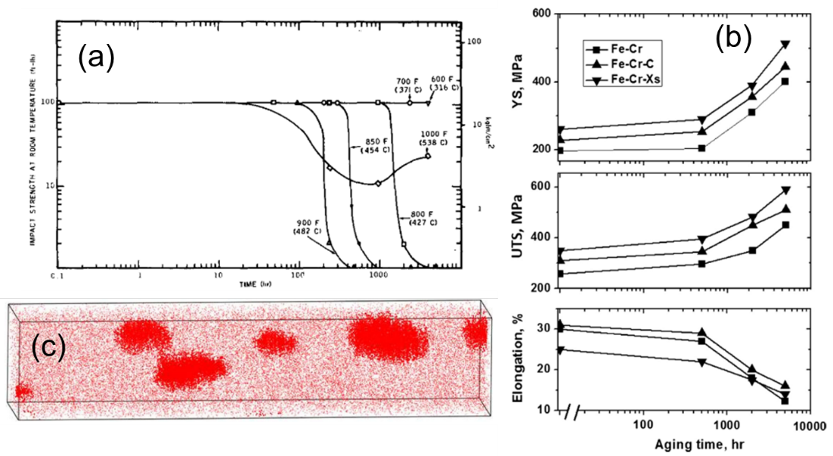
Figure 1.1 (a) Decrease of impact strength for Fe18Cr after thermal aging at intermediate temperatures. (b) The change of yield stress (YS), ultimate tensile stress (UTS) and elongation as a function of aging time. (c) Atom map of Fe19Cr after thermal aging at 500 °C for 2008 hours shows the formation of α’ precipitates. Imaged volume is 10×10×50 nm³. Reproduced from [2-4] respectively.

the damaged region and introduction of injected ions, which are characteristic of most ion irradiation studies, also generate potential artifacts that may suppress α’ formation. Besides, the Cr concentration in the investigated specimen (Cr supersaturation relative to the solvus concentration) will also influence this precipitation process by providing strong to weak/zero thermodynamic driving force for α/α’ phase separation. Currently, the association between α’ precipitates and dislocation loops is also unclear.
Although α’ precipitation has been extensively studied in previous years, several unresolved issues remain such as the discrepancy in precipitation behavior under heavy ion vs. neutron irradiations. In recent years, ion irradiations are becoming more and more popular due to the relatively low cost, short time to achieve high irradiation dose, and because the irradiation temperatures, dose rates and doses can be easily and precisely monitored and controlled. Unlike neutron irradiations or thermal aging, which usually give well-formed α’ precipitates [5, 6], large discrepancies exist regarding the α’ precipitation behavior during ion irradiations. The precipitates were observed in some studies [7-9] but not in others [10], which are attributable to a competition between radiation enhanced diffusion (which promotes the formation of α’) and radiation mixing/ballistic dissolution processes associated with energetic displacement cascades (which suppresses α’ formation). One point to note is that not all reported observations of α’ precipitates are fully developed to have the equilibrium Cr content, which makes the claim that α’ forms via a radiation enhanced precipitation mechanism questionable. The relatively shallow depth of the damaged region and introduction of injected ions, which are characteristic of most ion irradiation studies, also generate potential artifacts that may suppress α’ formation. Besides, the Cr concentration in the investigated specimen (Cr supersaturation relative to the solvus concentration) will also influence this precipitation process by providing strong to weak/zero thermodynamic driving force for α/α’ phase separation. Currently, the association between α’ precipitates and dislocation loops is also unclear.
With all these unsolved questions, in general it is currently not possible to quantify the critical condition (the lower bound of temperature and upper bound of dose rate) for α’ formation or dissolution under ion irradiations and to determine the difference between the ion irradiation-controlled steady states and the phase diagram-controlled thermal equilibrium states. Wide variances exist in the bulk Cr content, impurity atom content, temperature, injected ion type and energy, knock-on atom spectrum, dose rate and dose among different studies, which makes it difficult to directly compare the results from different researchers.
In this study, we performed a systematic study of heavy ion irradiations over a wide range of conditions (-123 to 450 °C, 10⁻⁵-10⁻³ dpa/s and 0.1-0.6 dpa) on high purity Fe-(10-18)% Cr samples. These heavy ion irradiations were supplemented by proton irradiations at 250-450 °C, 2×10⁻⁵ dpa/s and 2 dpa on the similar Fe-(5-18)Cr samples in order to investigate effects of primary knock-on energy (ballistic dissolution and mixing) on α’ stability. A limited number of complementary irradiations were also performed on Fe-0.7 at. %Cu in order to compare precipitate evolution in another well-studied Fe-base binary alloy system that forms nanoscale precipitates under thermal aging and irradiation. Solute distributions and cluster formations are identified and quantified mainly by the APT technique. The objective is to investigate 5 major phenomena:
- Effect of dose rate and temperature on α’ formation in Fe18Cr
- Effect of surface and injected ions on α’ formation in Fe18Cr
- Effect of bulk Cr concentration on α’ formation in Fe(10-18)Cr
- Using proton irradiation and thermal aging to determine the phase boundary
- Quantitative comparison of ballistic dissolution behavior of Cr and Cu precipitates for low temperature heavy ion irradiations.

Literature Review

2.1 Radiation damage in FeCr alloys
FeCr-based steels have been considered for in-reactor nuclear applications since the 1970s due to their supreme void-swelling resistance and overall favorable mechanical properties combined with extensive industrial fabrication experience. The in-reactor environment requires structural materials to maintain dimensional stability and mechanical property integrity over a long service time. Irradiation damage is caused by the displacement of lattice atoms from their equilibrium positions and the creation of impurity atoms in solid or gas states. The damages in ferritic-martensitic (FM) steels are mainly manifested as void swelling, irradiation creep, radiation hardening and embrittlement, and fracture toughness decrease, in which generally the most severe problem limiting their application is the irradiation induced/enhanced embrittlement and hardening.

2.1.1 The history of using FeCr alloys as nuclear materials
Fast fission and fusion reactors require structural materials to operate and sustain at extreme conditions including high temperatures and radiation damage to high fluences, the typical ranges of which are given in Figure 2.1 [11]. The major difference between these two types of environments is the neutron energy spectrum: neutrons are created with an average kinetic energy of about 1-2 MeV for fission and 14.1 MeV for D-T fusion. FM steels, SiC/SiC composites and vanadium alloys are the most promising structural materials for fusion energy applications [12, 13]. Compared to alternative structural materials, FM steels have high void swelling resistance, thermal stress resistance, adequate creep strength up to 600 °C, good fabricability and weldability, rich industrial experience of being used for massive structures and well existing production and fabrication technologies [1].
The development of 9-12% Cr steels originated in 1912 for the application of steam turbine blades [1, 14]. The additions of Mo, W, Nb, V, N, and the reduction of C elements
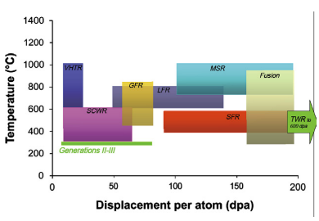
Figure 2.1 The dose and temperature requirements for the in-core structural materials operating in fusion and fission reactors. Reproduced from Ref. [11].

greatly increased the high-temperature creep-rupture strength of these steels from 35 MPa and 180 MPa [14].
The commercial Cr-Mo ferritic-martensitic steels were first considered for fast fission reactor applications in the early 1970s and for fusion reactor applications in the late 1970s. Before that, austenitic stainless steels were the primary candidates, but they suffer from a high void swelling rate, low thermal conductivity, and high thermal expansion coefficient, which results in high thermal stress. For FM steels, their coolant compatibility and elevated temperature strength limit their application for fission technologies and the possible ferromagnetic interactions may limit their fusion applications. After it was revealed that the ferromagnetic problem could be solved by reasonable reactor design and they have superior swelling resistance compared to austenitic steel, these FM steels became of great interest [15]. However, two major limitations of FM steels are that they exhibit a ductile to brittle transition at a certain temperature and the well-known 475 °C embrittlement behavior [2]. Both phenomena may limit the low temperature operating limit for FM steels.
For next-generation fission reactors, many wrought FM steels have been considered as wrapper materials, which operate at 400-560 °C [16]. In order to increase their toughness, several attempts have been conducted: ensuring a fully martensitic structure without δ-ferrite, limiting the N content to a maximum of 0.01%, and refining the grain size of prior austenite. For fusion reactors, the potential uses of FM steels are as the structural material for the first wall and tritium breeding blanket components. They are required to sustain good performance under electromagnetic and mechanical loading, thermal stress, high-energy neutron fluxes, and bombardment with the ions or atoms from the plasma.
The reduced activation FM steels (RAFM) and oxide dispersion strengthening (ODS) FM steels are two important variants of conventional FM steels. The RAFMs aimed at reducing the time for the radioactivity to decay by eliminating or minimizing Nb, Cu, Ni, Mo and N [12]. The ODS FM steels have better creep-rupture strength at temperatures >550 °C due to the introduction of oxide particles, so they could be used as cladding and work at 670-700 °C [17, 18].

2.1.2 Effect of irradiation on dimensional stability
Cavity swelling happens when the materials are irradiated at a temperature range of 0.3-0.5 T_{m} (absolute melting temperature) and to intermediate or high neutron fluences [19-21]. The materials show an increase in volume and a decrease in density due to the formation of voids and dislocation loops. Although the same amount of vacancies and interstitials are produced by irradiation, dislocations have a bias to interact more with interstitials due to their larger stain field, which leads to fewer interstitials remaining for recombination, and the resultant excess vacancies migrate and coalesce to form voids.
The general trend of volumetric swelling with dose is a negligible amount below an incubation dose, followed by a regime in which the total swelling linearly increases with dose. The austenitic steels exhibit a constant swelling rate of about 1% per dpa [22] above the incubation dose, while the steady state swelling rate of FM steels is around 0.2 % [23]. The FM steels also show a longer transient stage, which is dominated by void nucleation [23]. As for the effect of Cr content, a peak in swelling was observed at around 9% Cr in some studies [24-27]. The effect of He on swelling is not monotonic. Adding the He/dpa ratio to some extent could enhance the formation of bias-driven, large voids [28], but further increasing it could lead to the formation of a high density of small bubbles, which act as neutral sinks for vacancies and interstitials and prohibit the swelling [29-31].
The superior swelling resistance of FM steels compared to austenitic steels has been attributed to multiple possible reasons, including the special dislocation structure [32], the solute trapping effect [33], the microstructure of tempered martensite, and the lower relaxation volume [34, 35]. It has been proposed that the <100> loops have a strong bias to interstitials, while the ½<111> loops are almost neutral sinks for both types of point defects, which reduces the migration of vacancies to voids [32, 36-38]. The strong interaction of interstitials and Cr atoms retards the diffusion of interstitials to sinks and thus promotes their recombination with vacancies [33]. A large number of lath boundaries and sub-grain surfaces in martensitic steels lead to a high sink strength and reduce point defect supersaturation. The open structure and low relaxation volume of the body centered cubic (BCC) phase result in a lower dislocation bias for SIAs and higher He mobility which reduce the formation of He-stabilized bubbles [34, 35]. In general, the superior swelling resistance of FM steels is considered to be due to the multiple different microstructural aspects, with none of these mechanisms alone being solely responsible [39].

2.1.3 Effect of irradiation on mechanical properties

2.1.3.1 Tensile properties
How irradiation influences the tensile properties of steels depends on the irradiation temperature. At very low temperatures (20 to about 360 °C), a significant decrease in the work-hardening capacity or uniform elongation is observed [40], which has been attributed to the dislocation channeling deformation mechanism [41] or exhaustion or work hardening capacity [42]. At about 360 °C (0.35 T_{m}), small vacancy and interstitial loops are produced. At slightly higher temperatures (0.35-0.4 T_{m}), larger loops and network dislocation structures form from their smaller-sized precursors and irradiation-induced or -enhanced precipitation occurs. These microstructures introduce hardening effects to the system, which generally decrease as temperature increases in this range. The resulting changes in the stress-strain curve are an increase in yield and ultimate tensile stress and a decrease in the uniform and total elongation. At temperatures higher than about 0.4 T_{m}, irradiation produced defects anneal out, and thermally stable precipitates form and coarsen rapidly, so softening or little change is often observed at this temperature range [43, 44].
The low temperature irradiation induced hardening effect could start at doses below 0.1 dpa and approach saturation values at a higher dose of about 1 to 10 dpa [45].
According to Ref. [1], the effect of transmutation He on the tensile properties of FM steels at temperatures where radiation hardening occurs (< about 0.4 T_{m}) is minor. More recent studies have reported variable hardening and embrittlement associated with He co-generation, but in general the contribution of He to low temperature irradiation hardening is considered to be moderate [46]. At higher irradiation temperatures (> 0.5 T_{m}), He gas could also cause irradiation embrittlement by forming He-containing bubbles on grain boundaries, which is reflected as a decrease in tensile ductility. BCC steels with a high Cr concentration generally have a higher resistance to He embrittlement than face center cubic (FCC) steels.

2.1.3.2 Impact properties and fracture toughness
A major concern for the application of FM steels as structural materials is the irradiation induced embrittlement, which is manifested as an increase in the ductile to brittle transition temperature (DBTT), decrease in the upper shelf energy (USE), and a decrease in fracture toughness [47]. This embrittlement behavior is associated with prior grain size, irradiation-produced dislocations, and precipitate formation such as M₂₃C₆ and α’ when irradiated at T<0.4 T_{m}.
Charpy absorbed energy and fracture toughness tests are the main methods to quantify the amount of embrittlement, in which the former measures the energy to initiate and propagate a crack to produce a complete fracture, while the latter measures the critical load or energy to extend a pre-existing crack. The results obtained from fracture toughness tests are relatively limited compared to Charpy tests. The Griffith criteria (Kc), J-integral approach (Jc) and tearing modulus (T) are the quantities generally used to quantify the amount of embrittlement [1].
In Charpy tests, the DBTT shift and USE reduction generally increases rapidly at low fluence and approaches saturation at a relatively lower dose compared to that for tensile behavior. At the irradiation hardening related temperature regimes, the amount of DBTT shift generally decreases with increasing irradiation temperature [48]. At higher temperatures without any irradiation induced hardening, the shift either saturates or increases due to precipitate coarsening, which leads to lower fracture stress [44].
The effect of Cr on DBTT shift is not monotonic and the 8-9Cr steels show the least irradiation induced embrittlement as presented in Figure 2.2 [49]. The reason for the high DBTT shift for Cr content >9% is attributed to α’ formation, while that for the low Cr side is still unclear. As for the effect of alloying elements, it has been experimentally observed that Ta, Ni and Pt decrease the DBTT of Fe-based alloys while Mn and Si increase it [50]. Although He has no significant effect on the hardening, the presence of He was known to exacerbate the DBTT shift by decreasing the fracture stress and promoting intragranular fracture. The reason is that the bubbles on a precipitate/matrix interface could enhance crack nucleation and propagation or become nuclei for fracture under stress [1].

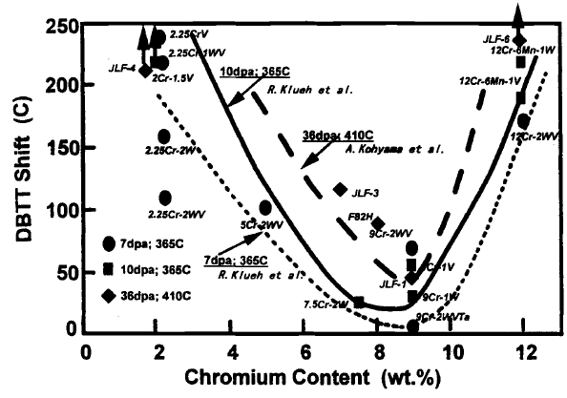
Figure 2.2 The effect of Cr content on the DBTT shift in reduced-activation FM steels after neutron irradiations at 365-410 °C, reproduced from Ref. [49].

2.1.3.3 Irradiation creep
Thermal creep, which becomes important at temperatures >0.5 T_{m}, is the mechanical behavior in which plastic deformation inside the materials accumulates with time at constant applied stress or loading. For high Cr FM steels operating at <600 °C, the processes contributing most to thermal creep are dislocation glide and climb and the resulting sub-grain formation. At the condition of simultaneous elevated temperature and irradiation, creep could happen at much lower temperatures due to the preferential absorption of self-interstitials (SIAs) by dislocations and the resulting dislocation motion, which is termed irradiation creep [51].
The Preferred Absorption Glide (PAG) creep [52] and the Stress Induced Preferential Absorption (SIPA) creep [53] were proposed to correlate the irradiation creep strain rate with stress. The strain rate was found to have a linear or quadratic dependence on stress if the SIPA or PAG mechanism is dominant, respectively [54]. It was suggested that the SIPA mechanism dominates at lower stresses while the PAG becomes more important at higher stresses [55].
Different behaviors have been observed for the temperature dependence of irradiation creep rate. At the low temperature regime, the creep rate was found to be insensitive to temperature in Ref. [56], while the creep rate was much higher than its two higher temperature variants in Ref. [57].

2.2 Diffusion and precipitation in FeCr alloys
In binary FeCr alloys, Cr-enriched α’ clusters are the main precipitate type, which is known to cause the 475 °C embrittlement phenomenon. One major problem inhibiting the study and understanding of this precipitation behavior is the lack of a precisely defined phase boundary between α and α+α’ phases. In commercial Ferritic-Martensitic steels, the introduction of other alloying elements improves the mechanical properties of materials while also increases the complexity of microstructure with additional precipitation species.

2.2.1 FeCr phase diagram and α’ precipitates
The temperature range relevant to the nuclear application of FeCr alloys is 300-700 °C, within which the materials show hardening and embrittlement after long term thermal aging (or shorter-duration neutron irradiations) due to the formation of α’ precipitates [2]. These precipitates mainly consist of Cr atoms with BCC structure and are fully coherent to the Fe-enriched matrix. α’ precipitates in dual-phase (Austenite + Ferrite) steels could also be enriched with other Ferrite forming elements such as Mo, Si and W [1].
The phase boundary between α and α+α’ phases is hard to precisely determine because of the very slow diffusion rate of Cr atoms at temperatures below 450 °C. Typical phase diagrams proposed by different authors are presented in Figure 2.3. The conventional phase boundary calculated by the CALPHAD database predicted a very low solubility of Cr atoms in the Fe-enriched matrix at low temperatures [58]. It is inconsistent with the findings that the sign of mixing entropy changes from negative to positive and the existence of short range ordering for Cr content < 10% at 427 °C [59, 60]. Based on thermal aging and neutron irradiation experimental results, Bonny et. al. suggested a new solvus line with much higher Cr solubility and a very steep solvus line at lower temperatures, and a substantial increase in the Cr solubility at higher temperatures as indicated by the blue curve in Figure 2.3(b) [61]. Their hypothesis that α’ clusters form in a radiation enhanced precipitation mechanism, and the solubility limit of Cr atoms in the Fe-enriched matrix is not modified by irradiations or the alloying elements, made the phase boundary they proposed debatable as argued by Xiong et al [62]. Xiong et al. didn’t present an exact line for the phase domain, but an area containing possible positions of this line, which is the smooth connection between the thermal aging results and the solubility predicted by ab initio calculations at 0 K as shown in Figure 2.3.
Density function theory (DFT) simulation was used to explain the experimentally observed ordering and clustering in terms of the electron band and magnetic properties of Fe and Cr [63, 64]. The ordering in dilute alloys was explained by the tendency of Cr atoms to be distributed away from each other to avoid magnetic frustration and to be isolated in the Fe matrix to lower the energy. With the higher Cr concentration, the Cr-Cr interactions could not be avoided, which leads to positive heat of mixing and Cr clustering [63, 64].
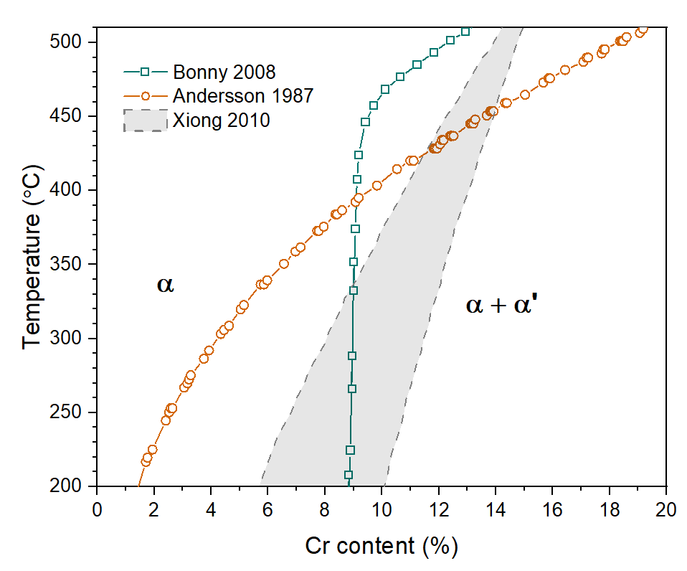
Figure 2.3 Phase boundaries between α and α+α’ two-phase region predicted by (a) CALPHAD (legend is Andersson 1987) [58], modified by Bonny et al [65] and proposed by Xiong et al [62].

The increase in solubility at higher temperatures was attributed to the increasing importance of vibrational entropy [61]. Using an advanced atom probe tomography (APT) technique to characterize the distribution of Cr atoms, recent experiments provide more precise data points related to phase boundary positions. Novy et al. found the solubility limit is about 14 at. % at 500 °C through long time thermal aging [66]. Tissot et. al. used electron irradiation to accelerate the diffusion and found the limit is about 9 at. % at 300 °C [67].
Density function theory (DFT) simulation was used to explain the experimentally observed ordering and clustering in terms of the electron band and magnetic properties of Fe and Cr [63, 64]. The ordering in dilute alloys was explained by the tendency of Cr atoms to be distributed away from each other to avoid magnetic frustration and to be isolated in the Fe matrix to lower the energy. With the higher Cr concentration, the Cr-Cr interactions could not be avoided, which leads to positive heat of mixing and Cr clustering [63, 64]. The increase in solubility at higher temperatures was attributed to the increasing importance of vibrational entropy [61]. Using an advanced atom probe tomography (APT) technique to characterize the distribution of Cr atoms, recent experiments provide more precise data points related to phase boundary positions. Novy et al. found the solubility limit is about 14 at. % at 500 °C through long time thermal aging [66]. Tissot et. al. used electron irradiation to accelerate the diffusion and found the limit is about 9 at. % at 300 °C [67].
Within the miscibility gap, there are two domains, which are separated by the phase decomposition mechanism to form the Fe-enriched α phase and Cr-enriched α’ phase: the classical nucleation and growth or the spinodal decomposition. In the first case, α’ precipitates nucleate with its equilibrium composition followed by the growth and coarsening by the addition of solute atoms from the matrix, while in the case of spinodal decomposition, domains enriched with Cr or Fe form through the solid solution and then develop both in composition and size toward their equilibrium states [68]. The spinodal decomposition activated region is located at the center of the miscibility gap while the nucleation and growth region is located at the outskirts on both sides. Microstructures formed from these two mechanisms are different: the first one is characterized by isolated and spherical clusters while domains interconnected to each other are usually observed in the latter case. However, the lower threshold Cr content for the start of spinodal decomposition is not well determined due to multiple reasons: the low atomic mobility at low temperatures, possible errors in identifying its early stage by characterization methods, and the complicated magnetic property of the FeCr alloy system [62]. The earlier work performed by Miller et al. found the specimen with 24% Cr presented isolated clusters while the one with 32% Cr exhibited a vein-like structure after prolonged age at 500 °C [69], so they were attributed to nucleation and growth mechanism, and spinodal decomposition mechanism, respectively.

2.2.2 Other precipitates in FeCr-based alloy system.
Alloying elements such as Mo, Nb, V and W have been introduced into the FeCr alloy systems for the purpose of optimizing their mechanical properties. Generally, they can be classified as Austenite stabilizing (Cu, Ni, Mn, N, C) and Ferrite stabilizing (Cr, Al, Mo, W, Nb, V, Ti, P, Si) elements, the quantities of which determine the ratio of Martensite and Ferrite after normalizing or quenching [70]. However, these elements also interact with each other to form complicated carbides, nitrides or intermetallic compounds, which have a significant influence on the toughness, high-temperature deformation and susceptibility to cracking behaviors of materials [1]. The precipitate phases that can potentially form during thermal aging at 400-750 °C or creep-rupture testing at 550-700 °C, together with their lattice structures, chemical compositions, and general distributions are listed in Table 2.1.
The most stable carbide form in this alloy system is M₂₃C₆, in which the M stands for metallic atoms including Cr, Fe, Mo and W with various ratios [21]. The M₂X precipitates forming after normalizing or tempering are gradually replaced by MX and Laves phase during high temperature creep testing or thermal aging. The Laves phase containing Mo and/or W is the main intermetallic phase in the temperature range of 450-650 °C. Its volume fraction increases with the Mo and W content. Chi phase has been observed after thermal aging up to 5000 hours, which could be considered either as a
Table 2.1 Major precipitation in high-chromium steels after normalized-and-tempered, aged, creep-rupture tested and irradiated. Reproduced from Ref. [1].
Precipitate phase | Crystal Structure and Lattice Parameter | Typical Composition | Distribution of Precipitates
M₂₃C₆ | FCC  a =1.066 nm | (Cr₆Fe₆Mo)C₆ (Cr₄Fe₁₂Mo₄Si₂WV)C₆ | Coarse particles at prior austenite grain and martensite lath boundaries and fine intra-lath particles
MX | FCC  a = 0.444-0.447 nm | NbC, NbN, VN, (CrV)N, Nb(CN), (NbV)C | Undissolved particles and fine precipitates at martensite lath boundaries
M₂X | Hexagonal  a = 0.478 nm  c = 0.444 nm | Cr₂N, Mo₂C, W₂C | Martensite lath boundaries (Cr₂N and Mo₂C); prior austenite grain boundaries (Mo₂C); intra-lath (Mo₂C and W₂C); δ-ferrite in duplex steels [Cr₂(CN) and (CrMo)₂(CN)]
Z-phase | Tetragonal  a = 0.286 nm  c = 0.739 nm | (CrVNb)N | Large plate-like particles in the matrix after creep straining at 600 °C
η-carbide | Diamond cubic  a = 1:07-1.22 nm | M₆C  (Fe₃₉Cr₆Mo₄Si₁₀) C | Prior austenite grain and martensite lath boundaries and intra-lath
Vanadium carbide | FCC.  a = 0.420 nm | V₄C₃ | Low number density in the matrix
Laves | Hexagonal  a = 0.4744 nm  c = 0.7725 nm | Fe₂Mo  Fe₂W and  Fe₂(MoW) | Prior austenite grain and martensite lath boundaries and intra-lath; δ-ferrite in duplex steels
Chi(χ) | BCC  a = 0.892 nm | M₆X, M₁₈C or  Fe₃₅Cr_{l2}Mo₁₀C | Intra-martensite lath;  δ-ferrite in duplex steels
G phase | FCC  a ~ 1.14 nm [71] | Mn₇Ni₁₆Si₁₇  with many variations. | On dislocation networks in large δ-ferrite grains
σ phase | Tetragonal  a = 0.45-0.52 nm  c = 0.88-1.02 nm  [72] | Similar to the Chi phase with more Mo | Large sheets engulfing M₂₃C₆ precipitates. Other shapes including thin ribbons, globular and rods [73].
α' | BCC  a = 0.291 nm | Mainly Cr | Homogeneously distributed within grains

carbide or an intermetallic compound. G phase and σ phase are usually observed under irradiations.

2.2.3 Diffusivity of point defects and their clusters
The configuration and motion of point defects and their clusters are often studied with DFT based simulations. According to a comprehensive review by Fu et al [74], the earlier studies before 2003 were based on empirical potentials, which predicted very similar energies for the interstitials in <111> or <110> dumbbell configurations, and interstitials diffuse very fast mainly in one dimension, associated with occasional thermally activated reorientation. However, later ab initio calculations found that the energy difference is about 0.7 eV for these two configurations and the <110> dumbbell is the most stable one in both pure Fe and dilute FeCr alloys, which put the motion mechanism accepted earlier into question [75]. Fu et al suggested the most energetically favorable interstitial motion mechanism is the nearest-neighbor translation-rotation jump, which has a migration energy of 0.34 eV and agrees well with the value of 0.3±0.03 eV obtained through experiments. Small clusters with up to 4 interstitials are found to be at the lowest energy when they are made of parallel <110> dumbbells and migrate with slightly higher energy (0.42-0.43 eV). For larger clusters, they are more energetically favorable if they are made of <111> dumbbells, and they migrate mainly through 1D gliding due to a lower activation energy.
Vacancy clusters are less stable and migrate through successive nearest-neighbor mono-vacancy jumps. The migration energy of monovacancy is ~0.65 eV [74, 76-81], and generally it increases with the number of vacancies in clusters.
Previous experiments suggested that the binding between Cr atoms and vacancies is very weak (binding energy <0.1 eV [82]), so Cr atom diffusion in Fe-Cr alloys by the the vacancy drag mechanism is very unlikely. α’ precipitates denuded zone observed in the vicinity of voids indicate the preferential exchange of Cr atoms with vacancies and thus diffusion by the inverse Kirkendall mechanism: vacancies migrate to sinks while the Cr solute atoms diffuse in the opposite direction, which leads to the local depletion of solute atoms at the sink [33]. This was further confirmed by the absence of α’ near grain boundaries reported by Borodin et al [83] and a precipitate-denuded zone with a width ≤150 nm along grain boundaries by Konobeev et al [84].

2.2.3 Diffusivity of point defects and their clusters
The configuration and motion of point defects and their clusters are often studied with DFT based simulations. According to a comprehensive review by Fu et al [74], the earlier studies before 2003 were based on empirical potentials, which predicted very similar energies for the interstitials in <111> or <110> dumbbell configurations, and interstitials diffuse very fast mainly in one dimension, associated with occasional thermally activated reorientation. However, later ab initio calculations found that the energy difference is about 0.7 eV for these two configurations and the <110> dumbbell is the most stable one in both pure Fe and dilute FeCr alloys, which put the motion mechanism accepted earlier into question [75]. Fu et al suggested the most energetically favorable interstitial motion mechanism is the nearest-neighbor translation-rotation jump, which has a migration energy of 0.34 eV and agrees well with the value of 0.3±0.03 eV obtained through experiments. Small clusters with up to 4 interstitials are found to be at the lowest energy when they are made of parallel <110> dumbbells and migrate with slightly higher energy (0.42-0.43 eV). For larger clusters, they are more energetically favorable if they are made of <111> dumbbells, and they migrate mainly through 1D gliding due to a lower activation energy.
Vacancy clusters are less stable and migrate through successive nearest-neighbor mono-vacancy jumps. The migration energy of monovacancy is ~0.65 eV [74, 76-81], and generally it increases with the number of vacancies in clusters.
Previous experiments suggested that the binding between Cr atoms and vacancies is very weak (binding energy <0.1 eV [82]), so Cr atom diffusion in Fe-Cr alloys by the the vacancy drag mechanism is very unlikely. α’ precipitates denuded zone observed in the vicinity of voids indicate the preferential exchange of Cr atoms with vacancies and thus diffusion by the inverse Kirkendall mechanism: vacancies migrate to sinks while the Cr solute atoms diffuse in the opposite direction, which leads to the local depletion of solute atoms at the sink [33]. This was further confirmed by the absence of α’ near grain boundaries reported by Borodin et al [83] and a precipitate-denuded zone with a width ≤150 nm along grain boundaries by Konobeev et al [84].
Experimentally observed radiation induced segregation (RIS) or depletion of Cr atoms at grain boundaries provide important information on the diffusion of Cr atoms in the FeCr alloy system. Existing literature reported both grain boundary Cr depletion and enrichment after irradiations [85]. Was et al found that Cr enrichment is more likely in dilute alloys (T91 with 9% Cr) at 400 °C, while Cr depletion is preferred in concentrated alloys (HCM12A and HT9 with 12% Cr) at 500 °C, which was explained by the relative exchange rate of Fe and Cr atoms with vacancies [86]. Hu et al observed the reduction of Cr enrichment at high angle grain boundaries in Fe-15Cr after ion irradiation at 350 °C, while the enrichment of Cr at grain boundaries with low misorientation angles was increased. It was attributed to the vacancy-exchange mechanism being dominant in the high sink strength situation while the interstitial-drag mechanism being dominant in the low sink strength situation [87]. In a study where Cr enrichment was observed on dislocation loops, the Cr content was ~22-35%, and it was tentatively explained by the reasoning that Cr atoms are coupled with point defects and move toward the dislocation loops, which then trap Carbon atoms and form stable C-Cr complexes [88].
Ab initio results found that Cr atoms diffuse faster than Fe atoms in both interstitial drag and vacancy exchange mechanisms, and vacancy drag is very unlikely at all temperatures of interest [89]. The depletion or enrichment of Cr at sinks is therefore determined by the relative flux of both types of point defects to sinks [89]. DFT studies by Terentyev et al found the diffusivity of SIAs in FeCr alloys depends strongly on Cr content, while long-range vacancy migration is not altered by the presence of Cr atoms [90]. The dependence of SIA diffusion on Cr concentration was explained in terms of the formation of Fe-Cr mixed dumbbells and the existence of SIA trapping configurations. The migration energy of SIAs decreases with increasing Cr content because the mixed dumbbells move faster than the dumbbells made of pure Fe. However, the pre-factor decreases significantly with increasing Cr content, which was explained by the strong attraction between SIAs and Cr atoms, and the configurational traps, the strength and concentration of which increase radically with Cr content. The combined effect is that SIAs diffuse faster in pure Fe at higher temperatures, while SIA motion is faster in more concentrated FeCr alloys at lower temperatures as presented in Figure 2.4. They also mentioned that both vacancy-exchange and SIA-drag mechanisms are active in dilute alloys, so the RIS behavior is determined by the relative strength of these two processes. However, in concentrated alloys, long range diffusion through SIA drag is very unlikely due to the unavoidable formation of Cr-Cr dumbbells, thus depletion is expected. This reasoning agrees with the results from Was et al [86].
Carbon with a concentration of a few appm can make big difference in the point defects formation and diffusion in Fe and FeCr alloys. It interacts with vacancies very strongly by forming carbon-vacancy or dicarbon-vacancy complexes, which result in an increase in the migration energy of vacancies [91]. On the other side, carbon can also form immobile carbon-SIA or carbon-di-SIAs clusters and increase the diffusion energy of SIAs [92]. Since carbon atoms widely exist in a variety of steels and carbon contamination is difficult to be totally avoided during ion irradiation experiments, carbon influence on the microstructure evolution must be considered during the interpretation of experimental results.

2.3 The stability of α’ precipitates under irradiation

2.3.1 Theoretical background

2.3.1.1 Radiation enhanced diffusion
One important effect of irradiation is enhanced diffusion by the production of supersaturated point defect concentrations. Without irradiation, the concentrations of vacancy and SIA point defects are controlled by thermal activation (point defect formation energy and temperature) alone. However, a large quantity of point defects is continuously produced during irradiation. At temperatures where point defects are mobile, they could be lost by mutual recombination, migrating to sinks or aggregating to form defect clusters of larger size. These production and annealing processes result in a steady state point defect concentration, which is much higher than the thermal equilibrium value at intermediate temperatures.
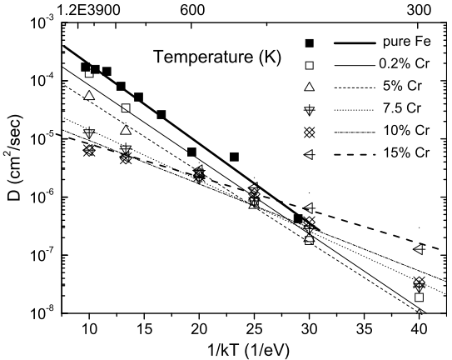
Figure 2.4 The diffusivity of single SIA in pure Fe and Fe-(0.2-15%)Cr as a function of temperature calculated from molecular dynamic simulation. Reproduced from Ref. [90].

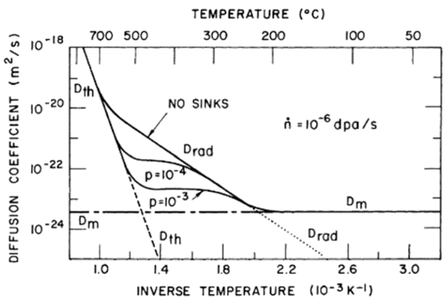
Figure 2.5 Diffusion coefficients for a nickel-based alloy under thermal and irradiation conditions. D_{rad} is the radiation enhanced diffusion coefficient calculated from rate theory equations. D_{th} and D_{m} are diffusion coefficients from radiation mixing and thermal activations, respectively. p is sink annihilation probabilities. Reproduced from Ref. [93].

The general trend of the diffusion rate with temperature under thermal or irradiation conditions is presented in Figure 2.5. At the low temperature regime, where all the defects are immobile, atomic motion is provided only by athermal ion mixing. At very high temperatures, the thermal equilibrium vacancy concentration dominates over the radiation created vacancy concentration, so the diffusion coefficient is controlled by temperature and independent of the irradiation flux.
At intermediate temperatures, the diffusion rate depends either on the dose rate or on both temperature and dose rate. The radiation enhanced diffusion rate could be considered as a linear superposition of various accessible diffusion paths, and it is generally acceptable to consider only the contributions of mono-vacancies and mono-interstitials. Thus, the radiation-controlled diffusion coefficient $D_{irr}$ could be written as:
$$D_{irr}=f_{v}C_{v}D_{v}+f_{i}C_{i}D_{i}$$
$f_{v}$ and $f_{i}$ are correlation factors, which are 1 for pure metals. $C_{v}$, $C_{i}$ are the vacancy or interstitial concentration and $D_{v}$, $D_{i}$ are their self-diffusion coefficients. The simplest rate theory model, which considers only the monomers in a homogeneous system, gives the concentration evolution by:
$$\frac{dC_{v}}{dt}=K_{0}-K_{iv}C_{i}C_{v}-K_{vs}C_{v}D_{v}$$
$$\frac{dC_{i}}{dt}=K_{0}-K_{iv}C_{i}C_{v}-K_{is}C_{i}D_{i}$$
In which $K_{0}$ is the defect production rate. $K_{iv}=\frac{4πr_{c}(D_{i}+D_{v})}{Ω}$ is the recombination coefficient, with $r_{c}$ being the spontaneous recombination radius. $K_{is}$ and $K_{vs}$ are the sink strength for interstitials and vacancies respectively. At higher temperatures, point defects have enough time to migrate to and get annihilated in sinks. If the annihilation by recombination is neglected, the steady state concentrations are:
$$C_{v}=\frac{K_{0}}{K_{vs}D_{v}}$$
$$C_{i}=\frac{K_{0}}{K_{is}D_{i}}$$
In this case, the diffusion coefficient in pure metal is linearly dependent on the dose rate:
$$D_{irr}=\frac{K_{0}}{K_{vs}}+\frac{K_{0}}{K_{is}}$$
For this sink dominant condition, the radiation enhanced diffusion coefficient is independent of temperature, which is understandable since each point defect jumps a fixed number of steps until it reaches a sink, which is independent of how fast it jumps.
At lower temperatures, point defect concentration is typically controlled mainly by direct recombination, so the corresponding recombination-dominant limit for steady state point defect concentration is:
$$C_{i}=C_{v}=\sqrt{\frac{K_{0}}{K_{iv}}}$$
$$D_{irr}=\sqrt{\frac{K_{0}Ω}{4πr_{c}}}×{(D_{i}+D_{v})}^{1/2}$$
The radiation enhanced diffusion coefficient depends on the dose rate with a square root relation and exponentially on 1/T (T is temperature). In general, point defect supersaturation behavior under irradiation depends on both recombination and sink strength (i.e., intermediate between the two limits summarized above).

2.3.1.2 Ion mixing
Irradiation with energetic particles generally leads to the displacement of target atoms away from their initial sites, which is often referred to as ion beam mixing (IM). As a particle with high energy interacts with a solid target, a cascade structure is initiated. Some of the atoms within the cascade receive energy higher than their threshold displacement energy (E_{d}) and get ejected from their original lattice sites. Recoils are produced continuously until the energy of knock-on atoms falls below E_{d} or the value to eject another atom. This process is termed recoil implantation, and it is rather well described by the modified Kinchin-Pease model considering only binary collisions:
$$ν\left(T\right)=\left\{\begin{aligned}0 T<E_{d}, \\ 1 E_{d}<T<2.5E_{d}, \\ \frac{0.8E_{D}}{2E_{d}} T>2.5E_{d},\end{aligned}\right.$$
Here $ν\left(T\right)$ is the number of produced Frenkel pairs as a function of the primary knock-on atom (PKA) energy (T) and $E_{D}$ is the damage energy. In this calculation, spontaneous recombination is implicitly considered in the threshold displacement energy. The long-range component of ion mixing is mainly caused by this mechanism.
When the recoil energies fall below a few hundred eV, the binary-collision approximation starts to break down, and the ion mixing occurs by focused replacement collision sequences (RCSs). It is characterized by multiple replacements among neighboring atoms with the production of only one vacant site and one interstitial atom. The number of atomic displacements is much larger compared to the high energy recoil implantations because the energy distribution of recoils is weighted toward low energies. This mechanism is called cascade mixing, and the resultant quantity of ion mixing is [94]:
$$D_{CM}=\frac{1}{6}aGλ^{2}$$
Where $a$ is the number of replacements per displacement and G is the dose rate in dpa/s. $λ$ is the jump distance, which could be approximated as the interatomic spacing. The RCS mainly leads to displacements of a few atomic spacings, although longer replacement chains could form in some special cases [95].
No point defects can be produced as the energy falls below a few eV, at which condition the cascade enters the thermal spike cooling phase, which is characterized by a local hot spot or melting region in the lattice. Since the energy of the initial recoil is partitioned among all atoms in the cascade, they are highly disordered and excited [96]. This phase of the ion mixing generates the most atomic disordering of the ordered phase (or the dissolution of precipitates if they exist).
With the cascade volume $V_{c}$ and the atomic density $N_{0}$, The energy density within a cascade $Θ_{D}$ in eV/atom is given by:
$$Θ_{D}=\frac{E_{D}}{V_{c}N_{0}}$$
The effective temperature can be estimated as:
$$T_{c}=\frac{Θ_{D}}{3k_{B}}$$
$k_{B}$ is the Boltzmann constant. The lifetime $τ$ of the cascade is:
$$τ=\frac{1}{4α}{(\frac{3E_{D}}{4πΘ_{D}N_{0}})}^{2/3}$$
$α$ is the thermal diffusivity and $α=k/C$, in which k is the thermal conductivity and C is the specific heat capacity.
Consideration of ion mixing in the thermal spike phase occurs when the cascade temperature is close to the melting temperature of the target material and the local hot region persists for at least a few lattice vibrations. Taking the characteristic values of $Θ_{D}≈0.3 eV/atom$ and $D={10}^{12} {nm}^{2}/s$, a 1 keV cascade has a thermal spike lifetime of about 1.5×10⁻¹² s.

2.3.1.3 Precipitation mechanism under irradiation
Three mechanisms were proposed to account for the precipitation behavior under irradiation conditions: radiation enhanced, induced, or modified precipitation [97].
Radiation enhanced precipitation is a direct result of radiation enhanced diffusion. The newly formed second phase could form during thermal annealing, but it takes a very long time. This phase separation kinetics is largely accelerated during irradiation due to the production of supersaturated point defects. The equilibrium state is not expected to be altered by the irradiation conditions and the clusters will be thermally stable if annealing at the irradiation temperature is performed following irradiation. The formation of α’ clusters after irradiation at a variety of conditions was categorized as this mechanism from previous literature [5, 61].
The radiation induced precipitation phenomenon is often closely related to the radiation induced segregation (RIS) of solute atoms to point defect sinks such as dislocations or grain boundaries, which is a non-equilibrium process. Depending on the binding energy between solute atoms and point defects if the diffusion occurs in a vacancy or interstitial drag mechanism, or the self-diffusivity of each atom species if the inverse Kirkendall mechanism is dominant, the enrichment or depletion of certain elements at sinks was often observed. In the case of enrichment, the local solute concentration could exceed the solubility limit, which provides the driving force for the excess solutes to precipitate as a second phase. This phase does not appear under thermal annealing and is expected to dissolve during post-irradiation annealing. NiSiPCr-enriched clusters observed by Kuksenko et al in neutron irradiated FeCr alloys were claimed to form via this mechanism [98].
The radiation modified precipitation mechanism is also closely related to the coupling effects between solute atoms and point defect flux. At the thermal equilibrium state, the chemical composition of the precipitates is determined by the phase diagram. During irradiations, this composition could be significantly modified due to RIS, especially in multicomponent systems. If the defect fluxes from the matrix to the second phase are maintained, the precipitates will act like sinks and be enriched with the elements carried by the fluxes. An example of modified precipitation behavior is the presence of M₂₃(C, Si)₆ phase in irradiated austenitic steels, which is simply a modified version of the commonly observed carbide M₂₃C₆ [99]. The composition of the precipitation phase will gradually revert to the thermal equilibrium value if annealing is performed after irradiation.

2.3.1.4 Models accounting for the stability of precipitates under irradiation
The stability of precipitates under irradiation is determined by the competition between the ballistic dissolution rate to destroy the precipitates and the radiation enhanced diffusion rate to recover them. Different behaviors of the precipitation phase including dissolution, conventional and inverse Ostwald ripening were reported in the literature [100-102]. Typical mathematical models proposed by Nelson et al (NHM model), Frost et al and Martin et al are summarized in this section [100, 103, 104].
In the NHM model [100], one of the cluster dissolution mechanisms is recoil dissolution. The solute atoms within clusters are ballistically recoiled into the surrounding matrix due to collisional displacements. The dissolution rate expressed in the change rate of the precipitate volume is proportional to the damage rate:
$$\frac{dV}{dt}=-\frac{4πr^{2}ϕ}{N}$$
where r is the precipitate radius, N is the atomic density and $ϕ\sim {10}^{14}G/{cm}^{2}×s$ is the flux of atoms lost by precipitates, in which G is the damage rate in dpa/s. The radiation enhanced diffusion rate $D_{irr}$ can be estimated (e.g., sink dominant condition or recombination dominant condition) depending on the specimen and irradiation conditions. If the thermal diffusion coefficient is neglected, which is generally acceptable at intermediate temperatures, by applying the boundary condition of constant solute concentration in the system $C=\frac{4}{3}πc_{p}nr^{3}+c_{m}$, in which $c_{p}$ and $c_{m}$ are the solute concentration in precipitates and matrix, and n is the number density of precipitates, the growth rate is written as:
$$\frac{dV}{dt}=3D_{irr}c_{m}r/c_{p}$$
So the net change rate of the precipitate radius is:
$$\frac{dr}{dt}=-\frac{ϕ}{N}+\frac{3D_{irr}C}{4πc_{p}r}-nD_{irr}r^{2}$$
The NHM model predicted an equilibrium cluster radius determined by irradiation conditions and the diffusivity of solute atoms. The limitations of this model are that the dissolving distance of solutes from the precipitates is unreasonably large, and neither the nucleation nor the flux of solute atoms from the matrix to clusters is included [105, 106].
A more advanced model proposed by Frost et al introduced R as the longest recoil distance beyond which there are no recoils from precipitate to the matrix, and the spacings between clusters are finite [103]. The evolution of cluster size with time is shown in Figure 2.6, in which an equilibrium cluster radius r_{m} was used as the target of each evolution. Clusters larger than r_{m} will shrink to this size (Inverse Ostwald Ripening) while the ones smaller than r_{m} will grow to this size (Conventional Ostwald Ripening), so the Frost model generally predicts the tendency for a precipitate to coarsen or shrink by comparing the irradiation dose rate with the critical dose rate ($S$) calculated with the equation:
$$S=c_{0}\frac{96D_{irr}σV_{m}}{R^{3}(R_{g}T_{irr})}$$
$c_{0}$ is the solute concentration at interface, $σ$ is the surface energy of the precipitates, $V_{m}$ is the molar volume of the precipitation phase, $R_{g}$ is the gas constant and $T_{irr}$ is the irradiation temperature. If the irradiation dose rate is higher than S, Inverse Ostwald Ripening is anticipated, while if the experimental dose rate is lower, Conventional Ostwald Ripening is expected. The limitation of this model is that it only predicts the size change
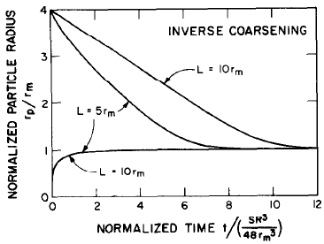
Figure 2.6 The evolution of cluster size within the characteristic time to approach the equilibrium value. Reproduced from Ref. [103].

of the precipitates without giving a critical flux at which the precipitate will be completely dissolved. This limitation was overcome by the model proposed by Martin et al [104].
The most important result of Martin’s mode is to yield an effective temperature ($T_{eff}$), which is typically higher than the irradiation temperature. The steady state reached at $T_{irr}$ is the same as the equilibrium state at $T_{eff}$. The effective temperature $T_{eff}$is calculated with:
$$T_{eff}=T_{irr}(1+\frac{D_{b}}{D_{irr}})$$
where $D_{b}$ is the ballistic diffusion coefficient caused by forced mixing and $D_{irr}$ is the radiation enhanced diffusion coefficient. D_{b} can be calculated with $D_{b}=λ^{2}aG/6$, which is the same as the equation to calculate the ion mixing in the cascade mixing phase as introduced before. In this model, if the effective temperature is inside the single phase region, irradiation will lead to the complete dissolution of precipitates.

2.3.2 Experimental background

2.3.2.1 α’ formation after electron irradiation
Electron irradiations do not produce damage cascades, so the resultant effects are mainly radiation enhanced diffusion without a significant contribution from the ballistic dissolution. α' precipitates are expected to form if the alloy composition is located at the phase separation (α+α’) region of the phase diagram. The results available for the formation of α’ phase under electron irradiation are very limited. A major contributor to the lack of experimental observations in electron irradiated samples is the nm-scale nature of these clusters and their lattice parameter being comparable to the Fe-enriched matrix, which historically made it nearly impossible to detect the α’ phase by conventional TEM characterization methods.
In 1995, Wakai et al observed the formation of α' precipitates through the Moire fringe contrast on dislocation loops in Fe-9Cr and Fe-18Cr after electron irradiation at 300 - 500 °C to 1 dpa [107]. At 300 °C, the precipitates were observed as black dots isolated from each other on the loop, while they became semi-continuous lines with Moire fringes at 500 °C. Due to the spatial correlation of the α' precipitates with dislocation loops, the radiation induced precipitation mechanism due to RIS was proposed to account for this precipitation behavior.
α' precipitates were also reported by Tissot et al in 2016 after electron irradiations of Fe-14Cr at 300 °C and 3.9×10⁻⁵ dpa/s up to 0.7 dpa [67]. The clusters were characterized by the APT technique, so more details including radius, number density, core Cr concentration and volume fraction of the α' phase were obtained. α' phase with Cr content of ~ 96 at. % were observed to be homogeneously distributed in the matrix, without any clear association with loops, so a radiation enhanced precipitation mechanism was suggested [67].

2.3.2.2 α’ formation after neutron irradiation
α’ precipitates have been extensively observed after neutron irradiations in different test reactors within a relatively wide temperature range (290-550 °C). The early post-irradiation characterizations were mainly conducted with the conventional transmission electron microscope (TEM) or small angle neutron scattering (SANS) techniques, so the available information regarding these precipitation behaviors is simply their presence or absence. In a few cases, the cluster Cr content was reported if the scanning transmission electron microscope with energy dispersive X-ray spectroscopy (STEM-EDX) technique was used. The results about the observed presence/absence of the α’ clusters are summarized in Fig. 2.6. The phase boundary suggested by Bonny et al, which was deducted mainly from the neutron irradiation results, is presented as a reference feature [61]. α’ was observed by many researchers in FeCr alloys with Cr content >9 at. % at ~300 °C and in specimens with Cr concentration >12 at. % at 400-450 °C. At the temperature range of ~350-450 °C, several conflicting results were reported near the suggested phase boundary, which may be related to the unstable temperature control during neutron irradiations, or the difficulty to identify the α’ clusters at the early stage of their formation.
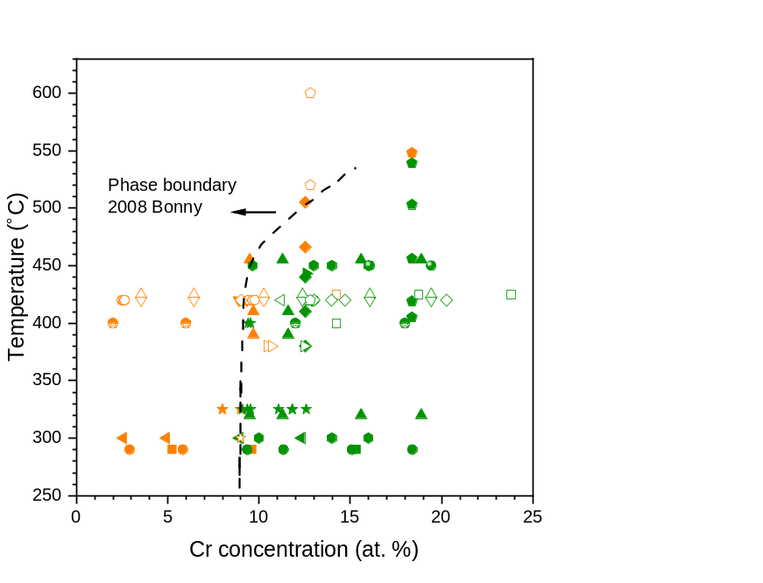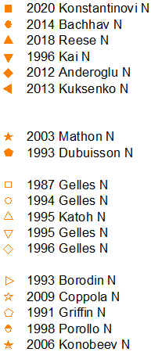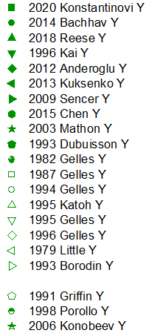
Figure 2.7 The presence/absence of α’ precipitates in FeCr alloys after neutron irradiation at different temperatures. The orange-colored symbols (ending with N in the legend) refer to the absence of precipitates while the green ones (ending with Y in the legend) refer to the observation of precipitates [5, 6, 33, 83, 84, 98, 108-123]. The phase boundary proposed by Bonny et al (dashed line) is included for comparison [61].

The results reported in recent years (after 2013) provided more detailed quantitative information by using APT to characterize the precipitates. Kuksenko et al found the formation of α’ precipitates in Fe-9Cr and Fe-12Cr alloys with 55-60 at. % Cr in clusters after neutron irradiation at 300 °C up to 0.6 dpa [98]. The precipitate radius was in the range of 1.4-2.4 nm and the number density was ~10²³/m³. Bachhav et al irradiated Fe-(3-18)%Cr alloys at 300 °C to 1.82 dpa. Clusters were observed for bulk Cr content ≥ 9.36 at. % [5]. The Cr concentration was about 85 at. % in clusters and ~ 9 at. % in the matrix regardless of the bulk Cr content. Cluster radius was in the similar range of 1.2-2.4 nm and the number density was 10²²-10²⁴/m³ depending on the global Cr concentration. The radius decreased with Cr content while the number density exhibited the opposite trend. Reese et al reported α’ precipitate formation in Fe-(9-18)%Cr after irradiation at 320-455 °C [6]. The cluster Cr concentration reached up to 96 at. %. Except for the clusters with a radius of ~7 nm in irradiated Fe-12Cr, the radius and number density in other conditions were in a similar range to the results of Refs. [5, 98].

2.3.2.3 α’ formation after ion irradiation
Although it is normal to observe α’ precipitates after neutron irradiations, they were not observed after ion irradiations for many years. In the early research works, FeCr alloys were irradiated by heavy ions at room temperature up to 500 °C, and no α’ precipitates were revealed even in the highly supersaturated Fe-18Cr alloy [124-126].
A typical research compared the precipitation behavior in Fe-9Cr and Fe-12Cr specimens after ion or neutron irradiations at 300 °C to 0.5 dpa or 0.6 dpa [10]. α’ precipitates were revealed after neutron irradiation, but not after ion irradiation. This discrepancy was attributed to the large difference in dose rates for these two irradiation conditions, which were 1.3×10⁻⁷ dpa/s for neutrons and 2.2×10⁻⁴ dpa/s for ions, respectively. It was further explained that the Cr atoms don’t have enough time to migrate together to form clusters due to the irradiation time being largely shortened at the high dose rate condition.
α’ precipitates formation after ion irradiation was first reported in 2016 by Tissot et al [7]. The Fe-15Cr alloy was irradiated by 2 MeV Fe ions at dose rates of 3-6.1×10⁻⁵ dpa/s and 300 °C up to 1 dpa. They found the Cr-enriched cluster formation was suppressed by the injected Fe ions by comparing the Cr clustering behaviors after irradiation to the same dose, but with different injected atom concentrations. They concluded that the absence of α’ precipitation in previous ion irradiation studies was due to the multi-stage irradiation method, which introduced injected ions to the whole irradiation damage area and thereby suppressed α’ formation.
Reese et al irradiated a Fe-18Cr alloy with either neutrons or heavy ions at 300 °C and 10⁻⁷-10⁻⁴ dpa/s [8]. α’ precipitates were detected in all irradiation conditions. They suggested the effect of high dose rates (typical for ion irradiations) is to increase both the point defect recombination rate and the ballistic dissolution rate.
A high purity Fe-14Cr was irradiated by He, Ne or Kr ions with different energies to create a variety of cascade sizes (PKA energies) in Ref. [9]. The irradiation temperature was 300 °C for all cases and the dose rates were 10⁻⁴ or 10⁻³ dpa/s. α’ precipitation was observed in all investigated conditions. At the same dose rate, the number density of precipitates decreased as the cascade size increased. Therefore, they claimed that cascade size (PKA energy) had a significant effect on this precipitation behavior.
The cluster Cr concentration measured by Tissot et al [7] after ion irradiation was in the range of 35-50 at. % and the maximum value measured by Reese et al. [8] was ~55 at. %, which are both much lower than the value predicted by the phase diagram [65]. Among possible reasons for the low measured Cr content in the solute clusters are the dilution effect due to the trajectory aberration in APT characterization, the effect of minor alloying elements, and enhanced ballistic dissolution effects [8, 10].

2.4 Surface and injected ions effect on ion irradiation induced microstructure evolution

2.4.1 Surface effect
Due to the relatively shallow depths (~1-2 μm) and the nonuniform damage distribution of ion irradiation, great care must be paid to interpret the results and to relate them with the local dose or dose rate levels. The main artifacts introduced by ion irradiations compared to neutron irradiations are the surface effect and injected ions effect. To avoid the complexity of these artifacts, characterization is often performed in the mid-range. However, it is necessary to understand these artifacts so that the results from a single irradiation experiment could be fully understood.
The free surfaces act as perfect sinks for both vacancies and interstitials and modify the local point defect evolution. The vacancy and interstitial concentrations at the near-surface area are calculated to approach the (much lower) thermal equilibrium values [127, 128]. One example is given in Figure 2.8, in which the profiles of point defect concentration, displacement damage, and injected ions concentrations are plotted as a function of depth. While approaching the surface, the point defect drops more significantly compared to their production rate, which is solely controlled by the damage rate or ion flux.
This phenomenon will affect microstructural evolutions relying on point defect diffusion such as void formation, precipitation, and radiation induced segregation. Void depleted zones were observed in the vicinity of grain boundaries, which is one type of surface defect [129]. In Ref. [128], a ~100 nm wide void-denuded zone was observed in high purity nickel after irradiation at 525 °C. The influence from the surface then diminished beyond a depth of ~500 nm. However, the surface effect on secondary precipitate formation is rarely reported, although it is expected due to the necessity of solute diffusion to form clusters with different chemical compositions compare to the matrix phase.

2.4.1 Injected ions effect
During ion irradiations, the bombarding ions produce displacement damage along their paths and stop at depths ranging from the peak to the end of the damaged area. At locations where the extra ions stay, the local point defect evolution is modified: an additional interstitial production term must be added to the rate theory equations for the steady state point defect concentration calculation. As summarized by Doyle et al, earlier
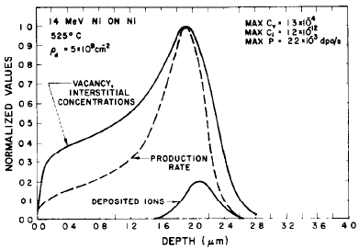
Figure 2.8 The evolution of point defect concentration, irradiation damage rate and injected ions concentration with depth in nickel after irradiation with 14 MeV nickel ions. Reproduced from Ref. [128].

rate theory calculations and experiments on materials with FCC structures suggested that the influence of injected ions on the formation of voids became significant at locations where the injected ion concentration is higher than ~10⁻⁴ atomic fraction per dpa (100 appm/dpa). A higher sensitivity in BCC materials is anticipated due to the lower bias of dislocations to absorb interstitials over vacancies. As for the precipitations under irradiation conditions, they were observed to be modified by implanted ions with a threshold concentration of 100 appm or higher [130]. Further complexity is introduced if the broadening of the implanted ion profile is considered, which is important when irradiation is performed at low dose rates to high final doses, or in a material system with high diffusivities [130].
Experimentally, injected ions were found to suppress both the void swelling and precipitation behavior. This suppression of void swelling was found to be most significant for irradiations that occur at lower temperatures, high dose rates, or for materials with a low sink strength (point defects lost mainly by recombination). A void denuded zone from the middle to peak damaged region was observed by Whitley in nickel after irradiation by 14 MeV Cu ions at 400 °C [131], which was attributed in part to the suppression effect of injected ions. Behind the peak damaged region, voids were still able to nucleate despite the high concentration of implanted ions. It was explained that the low dose rate leads to a low point defect supersaturation, so the recombination is insignificant.
Tissot et al compared the clustering that occurred at different depths along the damage profile [7]. They found that the cluster formation was suppressed at depths irradiated to the same dose but with different injected ion concentrations. The regions closer to the depth corresponding to the peak implanted ion concentration showed less precipitate formation. This discrepancy was attributed to the additional interstitials from the injected ions, which slow down the diffusion by promoting the recombination of vacancies and interstitials, and the formation of point defect sinks such as SIA clusters.

2.5 Cu precipitates in FeCu binary alloys

2.4.1 Cu precipitates formed from thermal aging.
The formation of Cu-enriched precipitates in FeCu alloys after thermal aging has been studied since several decades ago. In the early years, TEM was used to characterize the crystal structure and distribution of Cu precipitates. During thermal aging, they undergo a series of phase transformations with increasing precipitate sizes. Since most aging experiments were performed at 500 °C, the phase transformation sequence is summarized based on the precipitate size measured and aging times used at this temperature. The Cu precipitate radii measured after thermal aging for different time lengths in FeCu alloys with bulk Cu concentrations of 0.4-1.4 at. % are plotted in Figure 2.9 (a), in which both axes are in linear scales. In Figure 2.9 (b), radii datapoints are plotted against the cubic root of time, which can be well fitted using a linear equation; therefore it agrees with the conventional precipitate coarsening mechanism.
The nucleation, growth and coarsening of Cu precipitates are accompanied by a 4-step phase transformation sequence [132]. In the first several hours (<5 hours) of thermal aging, the average precipitate radii are smaller than 2nm. They have a BCC structure and are coherent with the BCC-Fe in matrix. With extended aging time for more than 10 hours, the precipitates have radii larger than 2-3 nm and they transform into a 9R structure containing multiple twins inside precipitates. When precipitates reach a typical size of ~10 nm, their crystallographic structure further transforms into a 3R structure (distorted FCC) through the detwinning of the 9R structure. Continuing thermal aging for a longer time will lead to the final phase transformation into an FCC structure [132, 133].

2.4.2 Cu precipitates formed after irradiations.
Cu-rich precipitates have been recognized as the dominant source of the irradiation embrittlement of reactor pressure vessel (RPV) steels containing high Cu concentrations. Therefore, it is crucial to study their evolution subject to irradiation environments. Unlike Cr precipitates in the FeCr alloy system, Cu precipitates have much higher stability and
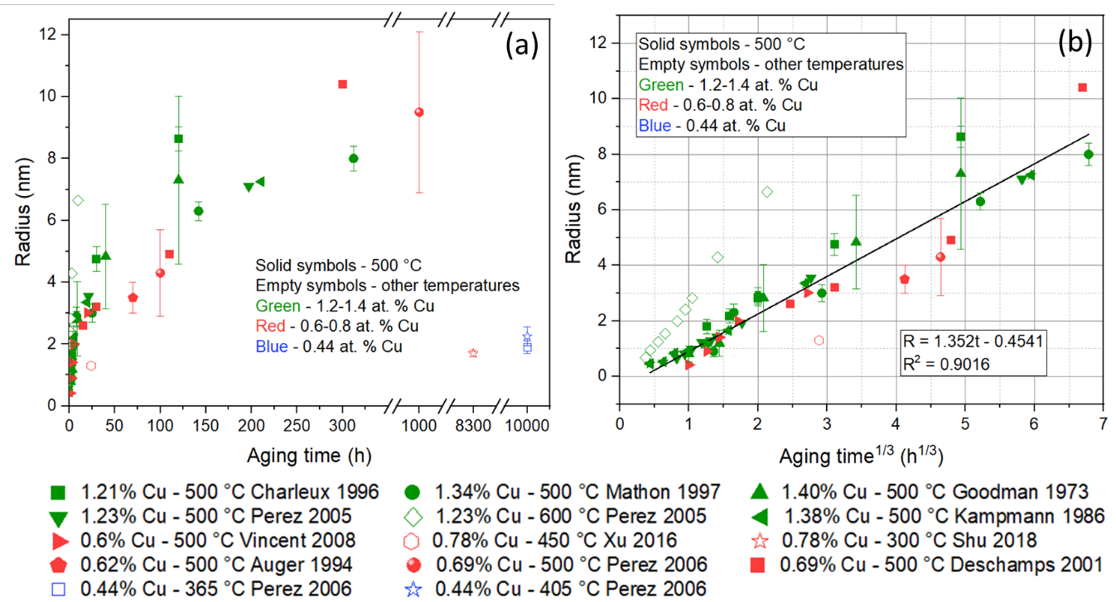
Figure 2.9 (a) the radii of Cu precipitates in Fe-(0.4-1.4)%Cu alloys after thermal aging for different time lengths. (b) The same radii datapoints are plotted as a function of aging time^{1/3}, in which they can be linearly correlated. Datapoints are from Refs [134-145]

they were extensively observed under a variety of irradiation conditions including heavy ion irradiations. Details about the irradiation conditions for each study, the size and Cu concentrations of Cu precipitates after irradiations are summarized in Table 2.2. Most precipitates are in nano-meter scale (radius <5 nm) and generally smaller than that observed after thermal aging, which might be partially attributed to the lower temperature of ~300 °C selected for irradiation experiments versus ~500 °C for thermal aging. Precipitate Cu contents show large variations among studies, and they are all well below the values predicated by the Calphad database [146]. Due to the difference in irradiation conditions, specimen compositions including Cu concentration and type of alloying elements, and the various characterization techniques, the discrepancy in Cu contents might originate from multiple factors.

Table 2.2 Results of Cu precipitates radii measured after irradiations in literature.
Cu content (at. %) | Temperature (°C) | Particle | Dose rate (dpa/s or flux) | Dose  (dpa or fluence) | Radius (nm) | Precipitate Cu content | Reference
0.78 | -20 | 5 MeV Ni | 3.6×10⁻³ | 90 | 0.6 | - | Xu, 2016 [140]
0.78 | 300 | 5 MeV Ni | 3.6×10⁻³ | 90 | 2.5 | - | Xu, 2016 [140]
0.78 | 290 | 70 MeV Fe | 3.2×10⁻⁷ | 0.03 | 1.80 | - | Shu 2018 [147]
0.78 | 290 | 70 MeV Fe | 3.2×10⁻⁶ | 0.3 | 1.78 | - | Shu 2018 [147]
0.78 | 290 | 70 MeV Fe | 1.2×10⁻⁵ | 1.1 | 1.81 | - | Shu 2018 [147]
0.78 | 290 | 70 MeV Fe | 3.2×10⁻⁵ | 3.0 | 1.76 | - | Shu 2018 [147]
0.18 | 290 | 2.4 MeV Fe | 2.5×10⁻⁴ | 1 | 0.71±0.04 | - | Watanabe 2016 [148]
0.18 | 350 | 2.4 MeV Fe | 2.5×10⁻⁴ | 1 | 0.73±0.74 | - | Watanabe 2016 [148]
0.78 | 290 | Neutron | 7.5×10¹² n/cm²×s | 0.04×10¹⁹ n/cm² | 1.6±0.06 | 55±4 | Shu 2018 [141]
0.78 | 290 | Neutron | 7.5×10¹² n/cm²×s | 0.51×10¹⁹ n/cm² | 2.2±0.02 | 64±7 | Shu 2018 [141]
0.78 | 290 | Neutron | 7.5×10¹² n/cm²×s | 1.00×10¹⁹ n/cm² | 2.7±0.07 | 66±4 | Shu 2018 [141]
0.62 | 290 | Neutron | 3×10¹³ n/cm²×s | 5.5×10¹⁹ n/cm² (0.1 dpa) | 2-3 | 15-30 | Auger 1994 [142]
1.23 | 290 | Neutron | 3×10¹³ n/cm²×s | 5.5×10¹⁹ n/cm²  (0.1 dpa) | 2-3 | 20-40 | Auger 1994 [142]
0.11 | 290 | Neutron | 2×10⁻¹⁰ | 0.058 | 1.3 | 15 | Fujii 2005 [149]
0.11 | 290 | Neutron | 8×10⁻⁹ | 0.099 | 1.1 | 11 | Fujii 2005 [149]
0.14 | 290 | Neutron | 4×10⁻⁹ | 0.054 | 1.05 | 11 | Fujii 2005 [149]
0.14 | 290 | Neutron | 8×10⁻⁹ | 0.094 | 1.05 | 9 | Fujii 2005 [149]
0.11 | 304 | Neutron | 0.78×10¹¹ n/cm²×s | 0.85×10¹⁹ n/cm² | 1.11±0.12 | ~35 | Toyama 2007 [150]
0.11 | 304 | Neutron | 0.78×10¹¹ n/cm²×s | 3.7×10¹⁹ n/cm² | 1.30±0.23 | ~38 | Toyama 2007 [150]
0.11 | 304 | Neutron | 0.78×10¹¹ n/cm²×s | 5.9×10¹⁹ n/cm² | 1.81±0.30 | ~41 | Toyama 2007 [150]
0.26 | 304 | Neutron | 0.85×10¹¹ n/cm²×s | 0.83×10¹⁹ n/cm² | 1.57±0.25 | ~36 | Toyama 2007 [150]
0.26 | 304 | Neutron | 0.85×10¹¹ n/cm²×s | 3.7×10¹⁹ n/cm² | 1.99±0.28 | ~40 | Toyama 2007 [150]
0.26 | 304 | Neutron | 0.85×10¹¹ n/cm²×s | 5.1×10¹⁹ n/cm² | 3.16±0.40 | ~45 | Toyama 2007 [150]
0.62 | 290 | Electron |  | 1.8×10⁻³ | 2.25-5.5 | 20-60 | Auger 1994 [142]
0.11 | 290 | 5 MeV Electron | 2×10⁻⁸ | 0.022 | 0.5-1 | 4 | Fujii 2005 [149]
0.14 | 290 | 5 MeV Electron | 2×10⁻⁸ | 0.022 | 0.5-1 | 5 | Fujii 2005 [149]

Materials and Methods

3.1 FeCr and FeCu Specimens
The high purity FeCr binary alloys used in this work have a wide range of Cr concentrations including 0-18 wt. % (0-19 at. %). The rod-shaped samples were provided by Dr. Jean Henry of Université Paris-Saclay, France. The fabrication of the Fe-Cr binary alloys has been carried out within the framework of the EUROfusion Consortium and has received funding from the Euratom research and training program 2019–2020 under Grant Agreement No. 633053. These specimens were manufactured through the induction melting method at Ecole des Mines de Saint Etienne, France. Cold reduction followed by heat treatment at a high temperature (750-860 °C) was performed and the resulting microstructure is in a recrystallized state with pure ferrite. Their chemical compositions measured by Glow Discharge Mass Spectrum (GDMS) method and grain sizes are listed in Table 3.1. These alloys have very high purity with the content of each impurity species less than 10 ppm. The grain sizes are relatively large for all alloys. The dislocation density was measured to be <10¹²/m² as reported in previous works [7, 88]. The rod-shaped samples were cut into disks having a diameter of 3 mm and thickness of 1 mm, or 2×5×1 mm³ rectangular-shaped specimens using the electronic discharge machining (EDM) technique before thermal aging or ion irradiations.
FeCu specimens were provided by Dr. Brian Wirth at the University of Tennessee, and originally came from the group of Dr. G. Robert Odette at the University of California, Santa Barbara. The FeCu alloy has a Cu concentration of ~0.7 at. % (detailed compositions are listed in Table 3.1). They were solution treated at 775 °C for 17 hours, followed by quenching at 450 °C in a salt bath for 3 minutes, and then cooled to room temperature in the atmosphere [141, 147].

Table 3.1 Chemical compositions and grain sizes for the FeCr alloys.
specimen |  | element concentration |  |  |  |  |  |  |  | grain size  (μm）
specimen | Cr  (wt. %) |  | Cr  (at. %) | Cu  (at. %) | C  (ppm) | S  (ppm) | O  (ppm) | N  (ppm) | P  (ppm) | grain size  (μm）
pure iron | ˂2 ppm |  |  | - | 4 | 2 | 4 | 1 | ˂5 | 183
Fe3Cr | 3.05 |  | 3.27 | - | 4 | 2 | 6 | 2 |  | 390
Fe5Cr | 5.4 |  | 5.78 | - | 4 | 3 | 6 | 2 | ˂5 | 68
Fe8Cr | 7.88 |  | 8.41 | - | 5 | 2 | 7 | 2 |  | 320
Fe10Cr | 10.1 |  | 10.77 | - | 4 | 4 | 4 | 3 | ˂5 | 82
Fe12Cr | 11.63 |  | 12.38 | - | 5 | 2 | 4 |  |  | 500
Fe14Cr | 14.25 |  | 15.15 | - | 5 | 7 | 4 | 5 | ˂10 | 141
Fe18Cr | 17.97 |  | 19.05 | - | 7 | 2 | 6 | 5 |  | 650
Fe25Cr | 24.97 |  | 26.33 | - | 4 | 1 | 3 | 3 |  | 570
FeCu | - |  | - | 6.75 | 25 | 510 | - | - | -

3.2 Thermal aging
A subset of the FeCr samples in TEM-disk shapes and FeCu samples in rectangular shapes were thermally aged to form Cr rich α’ precipitates and Cu precipitates, respectively. The oxidation layers introduced by EDM cutting were removed by grinding with sandpapers. The specimens were then sealed in quartz tubes followed by evacuated or filled with vacuum or Nitrogen gas. Both thermocouples inherent to the furnace and an external K-type thermocouple were used to monitor the temperature throughout the thermal aging experiments. A summary of the aging conditions is given in Table 3.2.

3.3 Ion irradiations

3.2.1 Sample preparation
Mechanical grinding was performed to remove the oxidation layers and reduce the thickness of the specimens to ~0.4 mm. The samples were then polished with diamond suspensions down to 0.5 μm and finished with 0.05 μm colloidal silica. The backside of samples was also grinded using sandpapers with grid sizes up to 1200 to avoid potential oxygen contamination from oxides and to get a flat surface.

3.2.2 Ion irradiation conditions
Ion irradiations were performed in the Michigan Ion beam laboratory (MIBL) using the 3 MeV Tandem particle accelerator Wolverine. A schematic plot of the accelerator’s arrangement is shown in Figure 3.1. Plasma cleaning of the sample surface for ~ 2 hours was conducted before irradiations to reduce carbon contamination. A combination of wobbling and defocused beams were used during irradiations, so the beam profiles are homogeneous, and all specimens were irradiated without pulsed/rastered beam conditions. Individual sample temperatures were continuously monitored by a 2D thermal imager for each of the irradiations, and the variance of the individual specimen to the target

Table 3.2 Aging conditions for FeCr and FeCu alloys conducted in this work.
Specimens | Temperature (°C) | Time (h)
Fe10Cr, Fe12Cr, Fe14Cr, Fe18Cr | 450 | Half year/4380, 1 year/8760
Fe18Cr, Fe25Cr | 475 | 100, 300, 900
Fe10Cr, Fe12Cr, Fe14Cr, Fe18Cr | 475 | 3100 - 4000
Fe18Cr | 500 | 100, 300, 900
FeCu | 500 | 1.5, 10, 100, 1000

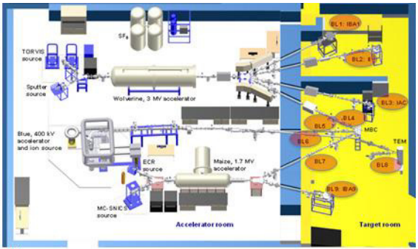
Figure 3.1 The arrangement of 3 accelerators located at MIBL. Only the Wolverine was used in this study. Reproduced from Ref. [151].

temperatures was well controlled. The target chamber pressure was maintained at 10⁻⁸ to 8×10⁻⁷ Torr through the irradiations. Since multiple sets of irradiations for different research objectives were conducted, they will be summarized by groups: high temperature heavy ion irradiations, cryogenic - room temperature heavy ion irradiations, and proton irradiations.

3.2.2.1 High temperature heavy ion irradiations
The first set of irradiations was designed for the purpose of determining the critical irradiation conditions for α’ precipitates formation/dissolution and studying the effect of bulk Cr concentrations on α’ formation at the application relevant temperatures. All samples used in these irradiations were in disk shape with a diameter of 3 mm and thickness of 0.2–0.4 mm. An example of specimens loaded on the irradiation stage is presented in Figure 3.2 (a). The disk-shaped specimens were loaded into the sandwich-structure sample holders. The top plate has holes to let the beam go through and hit the specimens. The specimens were held by two plates and extra shims to compensate for the height difference. A defocused beam of 8 MeV Fe ions was used to create a total range of ∼2 μm. The irradiations were performed between 300 and 450 °C for two ion fluences: 8.8×10¹⁴ and 8.8×10¹⁵ ions/cm². The irradiation conditions and specimens used are listed in Table 3.3, which covers a wide range of dose rates and temperatures. The variance of the individual specimen to the target temperature was less than 6 °C. The ion fluxes and irradiation times ranged between 2.5×10¹⁰ to 2.5x10¹² ions×cm⁻²s⁻¹ (midrange dose rates: 10⁻⁵ to 10⁻³ dpa/s) and 6 minutes to 9.7 hours respectively.
Figure 3.2(b) gives the depth-dependent distribution of irradiation dose and injected ion concentrations predicted using SRIM-2013 for the 0.37 dpa midrange dose condition. The calculation was performed using the full-cascade mode and damage energy method with the displacement energy of Fe set to 40 eV, as recommended in a recent comprehensive evaluation [152]. The kinetic energy absorbed by recoils from the E2RECOIL.txt file and the integrated ionization by recoil from the IONIZ.txt file was used to calculate the irradiation damage. The resulting midrange dose was 0.37 dpa at a depth of 1 μm for the low fluence and 3.7 dpa for the high fluence, which are only slightly higher
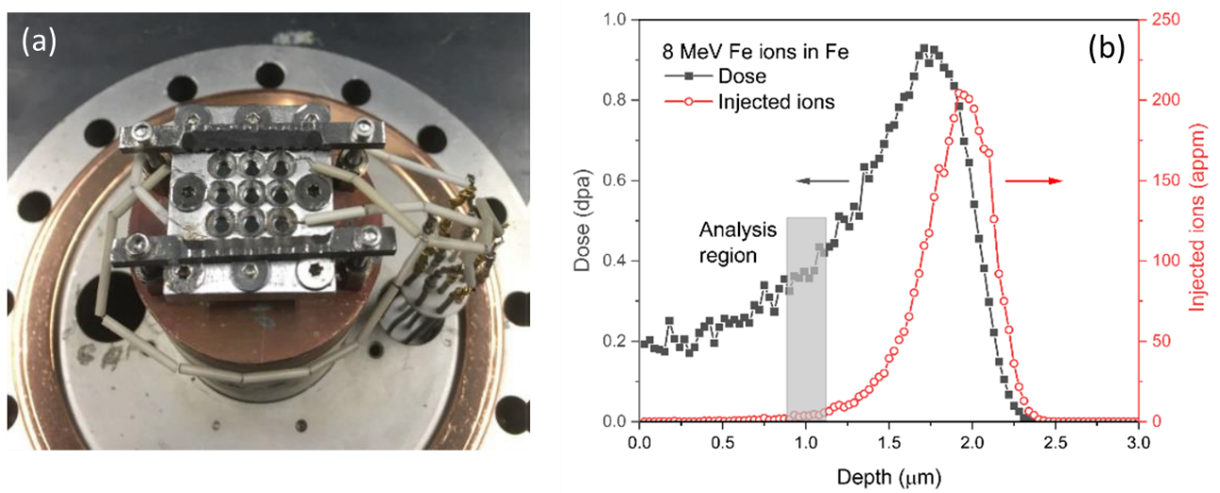
Figure 3.2 (a) specimens loaded on the stage for irradiations. (b) SRIM prediction of the depth-dependent displacement damage and injected ion concentration of pure Fe irradiated by 8 MeV Fe ions to 8.83x10¹⁴ ions/cm², corresponding to the low fluence irradiation. Both values are 10 times higher for the high fluence irradiation. The analysis depth is marked by the gray-shadowed area.

Table 3.3 The matrix for high temperature heavy ion irradiation conditions. All materials were irradiated in a single sample holder for each condition. 0, 3, 5, 8, 10, 12, 14, and 18 stand for FeCr alloys with the corresponding weight percent of Cr content. H1, H3 and H9 represent the Fe-18Cr aged at 500 °C for 100, 300 and 900 hours.
Materials | Mid-range / Peak dose  (dpa) | Fluence  (ions*  cm⁻²) | Flux/mid-range dose rate  (ions*cm⁻².s⁻¹ / dpa.s⁻¹) | Temperatures  (ºC) | Estimated time (minutes)
0, 3, 5, 8, 10, 12, 14, 18 | 0.37/0.93 | 8.83x10¹⁴ | 2.52x10¹⁰ /  10⁻⁵ | 450 | 9.6 hours
0, 3, 5, 8, 10, 12, 14, 18 | 0.37/0.93 | 8.83x10¹⁴ | 2.52x10¹¹ /  10⁻⁴ | 450 | 58 minutes
0, 3, 5, 8, 10, 12, 14, 18 | 3.7/9.3 | 8.83x10¹⁵ | 2.52x10¹¹ /  10⁻⁴ | 450 | 9.6 hours
0, 3, 5, 8, 10, 12, 14, 18 | 0.37/0.93 | 8.83x10¹⁴ | 2.52x10¹¹ /  10⁻⁴ | 350 | 58 minutes
0, 3, 5, 8, 10, 12, 14, 18 | 3.7/9.3 | 8.83x10¹⁵ | 2.52x10¹¹ /  10⁻⁴ | 350 | 9.6 hours
12, 14, 18, H1, H3, H9 | 0.37/0.93 | 8.83x10¹⁴ | 2.52x10¹¹ /  10⁻⁴ | 300 | 58 minutes
12, 14, 18, H1, H3, H9 | 0.37/0.93 | 8.83x10¹⁴ | 2.52x10¹² /  10⁻³ | 450 | 5min50s
12, 14, 18, H1, H3, H9 | 0.37/0.93 | 8.83x10¹⁴ | 2.52x10¹² /  10⁻³ | 350 | 5min50s
12, 14, 18, H1, H3, H9 | 0.37/0.93 | 8.83x10¹⁴ | 2.52x10¹² /  10⁻³ | 300 | 5min50s

than the values calculated from the VACANCY.txt file in SRIM-2013 Kinchin-Pease mode (0.35 and 3.5 dpa). The injected ion concentrations were almost identical in these two modes.

3.2.2.2 Cryogenic to room temperature heavy ion irradiations
High temperature heavy ion irradiations represent the conditions where radiation enhanced diffusion and ballistic dissolution effects are comparable or one of them is slightly stronger. In order to study the dissolution rate of pre-existing precipitates, irradiations using 8 MeV Fe ions were conducted at -123 °C (150K) to R. T. (below or near the onset temperature for vacancy migration), so the back diffusion of solute atoms can be largely suppressed. The irradiation doses were 0.1, 0.2 and 0.6 dpa, and thus the gradual dissolution of precipitates was expected to be observed. The specimens used for these irradiations were FeCu and Fe-18Cr alloys pre-aged to form Cu and Cr clusters, respectively. As a compromise to control the beam current and irradiation time more easily for the 0.1 dpa irradiation, the dose rate was set to 3×10⁻⁴ dpa/s. The same dose rate was used in the two other higher dose irradiations for consistency. Therefore, the time for each irradiation ranged between 6 to 33 minutes. The irradiation conditions and specimen status before irradiation are summarized in Table 3.4. The sample arrangements on the irradiation holders were different from the ones used during the high temperature heavy ion irradiations to avoid potential temperature control issues. For these low temperature irradiations, samples were loaded on Cu plates (dimensions are 15mm×20mm×1.5mm) using the high temperature compatible silver paste, followed by curing at ~90 °C for 2 hours to achieve stronger bonding between samples and Cu plate's surface. An example showing the arrangement of specimens after loading on the irradiation stage, and the damage and injected ions profiles calculated using SRIM-2013 are given in Figure 3.3. The analysis region was extracted from the mid-range of ~1µm.

3.2.2.3 Proton irradiations
Due to the slow diffusion of Cr atoms in the FeCr alloy system at temperatures <450 °C, the low temperature phase boundary between α and α+α’ two phase region has
Table 3.4 The details of cryogenic to room temperature heavy ion irradiation conditions. All materials were irradiated in a single sample holder for each condition. Preirradiation heat treatment conditions are listed in the Materials column.
Materials | Mid-range dose  (dpa) | Fluence  (ions*  cm⁻²) | Flux/mid-range dose rate  (ions*cm⁻².s⁻¹ / dpa.s⁻¹) | Temperatures  (ºC) | Estimated time (minutes)
Fe18Cr S.S.  Fe18Cr 475 °C 100h  Fe18Cr 475 °C 900h  FeCu S.S.  FeCu 500 °C 1.5h  FeCu 500 °C 10h  FeCu 500 °C 100h  FeCu 500 °C 1000h | 0.1 | 2.5x10¹⁴ | 7.5x10¹¹ /  3×10⁻⁴ | -123 /150K | 6
Fe18Cr 475 °C 100h  Fe18Cr 475 °C 900h  FeCu 500 °C 1.5h  FeCu 500 °C 10h  FeCu 500 °C 100h | 0.2 | 5x10¹⁴ | 7.5x10¹¹ /  3×10⁻⁴ | Room temperature  /~20 | 11
Fe18Cr 475 °C 100h  Fe18Cr 475 °C 900h  FeCu 500 °C 1.5h  FeCu 500 °C 10h  FeCu 500 °C 100h | 0.6 | 1.5x10¹⁵ | 7.5x10¹¹ /  3×10⁻⁴ | Room temperature  /~20 | 33
s.s.: as-received solid solution state
Temperatures and times in the Materials column are for the aging conditions prior to irradiations.
The FeCu 500 °C 1.5h aging followed by 0.2 dpa irradiation specimen was irradiated in repeated irradiation due to unexpected issues.

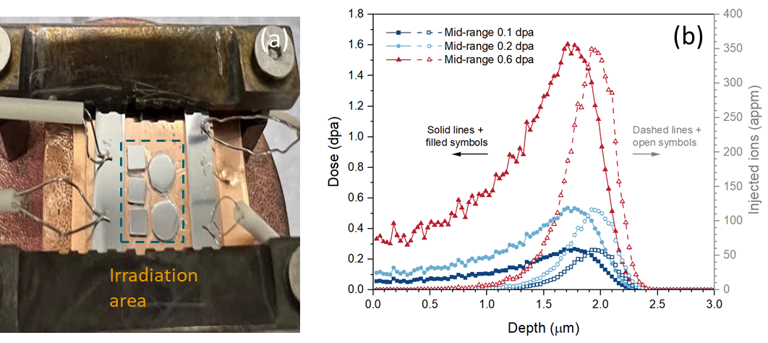
Figure 3.3 (a) specimens loaded on the stage for irradiations. (b) SRIM prediction of the depth-dependent displacement damage and injected ion concentrations of pure Fe irradiated by 8 MeV Fe ions to mid-range doses of 0.1, 0.2 and 0.6 dpa.

long been unclear. In an attempt to accelerate the phase separation kinetics and to study the precipitation evolution in the radiation enhanced diffusion dominant conditions, proton irradiations were performed at 3 selected temperatures (250, 350 and 450 °C). Since the major challenge associated with proton irradiations is a large amount of heat deposited on the sample surface, a lower beam current and lower proton energy are desired for proper temperature control. However, if the beam current is too low, it will take an unacceptably long time to achieve the target mid-range dose. Therefore, an intermediate dose rate is optimal to balance the heat dissipation and irradiation time, which was set as 2×10⁻⁵ dpa/s (at mid-range depth) for this study. For the 3 MeV Tandem accelerator, the available beam current generally decreases with lower proton energy at <1 MeV range. 800 keV turned out to be the lowest energy that the target mid-range dose rate or ion flux (1.75×10¹⁴ ions/cm²×s) can be stably maintained. Considering the acceptable irradiation time length and a dose likely to be high enough to achieve the steady state, a final dose of 2 dpa was selected, which resulted in an irradiation time of ~28 hours for each experiment. The displacement damage profile calculated by SRIM-2013 is plotted in Figure 3.4. The whole range of irradiation damage is ~6 µm, and the analysis region was taken from the mid-range of ~3 µm below the sample surface. The sample sizes and arrangements for these proton irradiations are similar to the settings used for the low temperature heavy ion irradiations, and thus are not presented here. 4 specimens were irradiated at each irradiation condition, the chemical compositions of which are listed in Table 3.5. The solubility limit of Cr in Fe can be measured from the matrix Cr concentration of specimens with α’ (Fe-18Cr with high supersaturation of Cr atoms is selected for this purpose). The matrix Cr will equal the solubility limit if the thermal equilibrium state is reached and higher than the solubility limit if the equilibrium is not reached. The accuracy of this limit can be further confirmed by the bulk Cr concentration of specimens with or without α’, so two additional specimens with a Cr content of 8-12% are selected at each temperature.

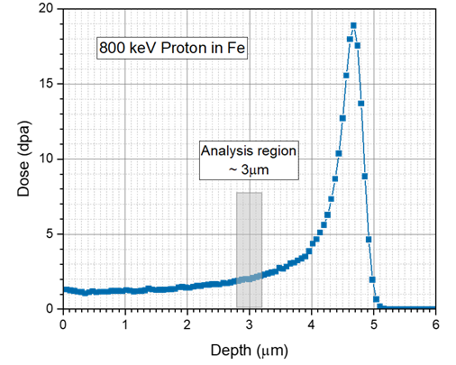
Figure 3.4 SRIM prediction of the depth-dependent displacement damage of pure Fe irradiated by 800 keV proton to mid-range doses of 2 dpa.

Table 3.5 Temperatures and specimens used in the 3 proton irradiations. The specimens before irradiations were in a solid solution state if not specified.
Temperature (°C) | Cr concentration in specimens
250 | 5, 8, 10, 18
350 | 8, 10, 18, 18 (aged 475 °C, 900 hours)
450 | 10, 12, 18, 18 (aged 475 °C, 900 hours)

3.4 Characterizing α’ precipitates with APT

3.4.1 Principles of APT
The APT technique evolved from Field Ion Microscopy (FIM), which provides an image of the sample surface with atomic resolution. During the operation of FIM, the sharp needle is positively charged and surrounded by an atmosphere of rare gas. The electric field at the vicinity of the needle tip is in the order of 10¹⁰ V/m, so the rare gas could be ionized and then accelerated by the electric field. The flying gas ions are detected and registered by the phosphor screen, which displays the ion distribution related to the electric field of the needle surface and thus corresponds to the local tomography such as crystallographic orientation.
For the APT technique, the specimens are also very sharp needles. The difference is that the analysis chamber is under ultra-high vacuum conditions below 10⁻¹⁰ Torr, and the atoms from the samples are stripped away by the combined effect of a standing electrostatic field (DC) and either a voltage or laser pulse applied on the tip surface. A schematic view of the APT setup is presented in Figure 3.5. The evaporated atoms are accelerated and detected by a position sensitive detector (PSD), which records the position and hitting time of the arrived atoms. The data recorded in the PSD, combined with the history of DC, can be used for the reconstruction of 3-D needles from 2-D histograms.
The evaporation of atoms from the tip surface can be triggered either by a high-voltage (HV) pulse or a laser pulse. In the HV pulsing mode, atoms evaporate due to the additional voltage and get accelerated by both the DC and the pulse voltage. The issue with this mode is that some atoms are not evaporated at the peak energy and don’t acquire all the energy of the pulse, which is named as energy deficit and facilitated as the long tail in the mass spectrum. The application of the HV pulse requires the specimen to be electronically conductive, and it tends to cause the fracture of brittle specimens due to the cyclic high electrostatic loading up to tens of GPa. Using a laser pulse to assist the evaporation process could enable the characterization of materials with low electric conductivity and decrease the possibility of early fracture. Although many physical processes occur during the interaction of an electromagnetic wave with the atoms located
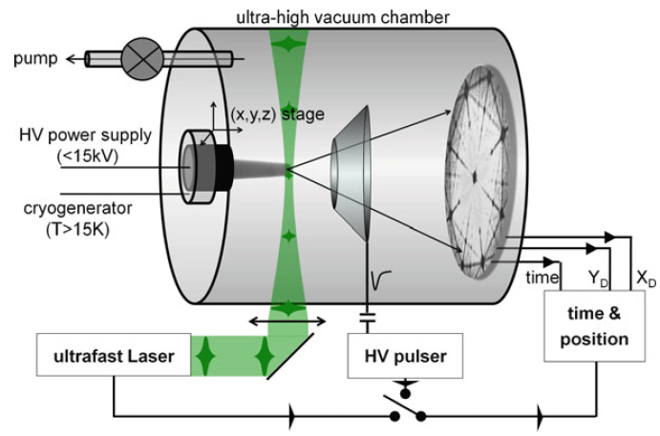
Figure 3.5 Schematic drawing for the experimental setup of APT, reproduced from [153].

at the needle apex, it is widely accepted that the evaporation of atoms is thermally activated. The energy from the laser pulse is absorbed by the specimen and increases the temperature of its surface, which causes the atoms to overcome the energy barrier and get evaporated [153].

3.4.2 Artifacts of APT

3.4.2.1 Preferential evaporation
Preferential evaporation occurs when the atom species within a single specimen have large differences in their evaporation fields. For the FeCr system studied here, the evaporation field is 33 V/nm for Fe and 29 V/nm for Cr, so the occurrence of this artifact is expected [154]. The experimental parameters must be chosen carefully to make sure that all the evaporations are triggered only by HV or laser pulses. The main parameters that can be adjusted to avoid preferential evaporation are the base temperature and pulse amplitude. The base temperature must be low enough to maintain a low probability of evaporation between pulses. As shown in Figure 3.6, in case (a), the parameters are correctly selected, so evaporation occurs only with the application of the pulse. If the base temperature is too high such as that in case (b), atom A can evaporate even without the additional heat or voltage from pulses, which introduces uncertainties in the calculation of the time of flight and locations in the mass spectrum. The preferential evaporation could also be reduced by applying a high pulse fraction and thus the DC is lowered. However, this option leads to the pollution of the sample with residual impurities and increases the amplitude of the cyclic electrostatic load, so the risk of early fracture is increased as well. In this study, a base temperature of 50 K and a pulse fraction of 20% are used to mitigate this artifact.

3.4.2.2 Local magnification
Local magnification artifact is a direct result of preferential evaporation. If the precipitates have different evaporation field from the matrix, aberrations of the ion trajectories appear in the vicinity of the matrix-precipitate interface. In FeCr alloys, the α’ precipitates are Cr enriched and thus have a lower evaporation field compared to the Fe-
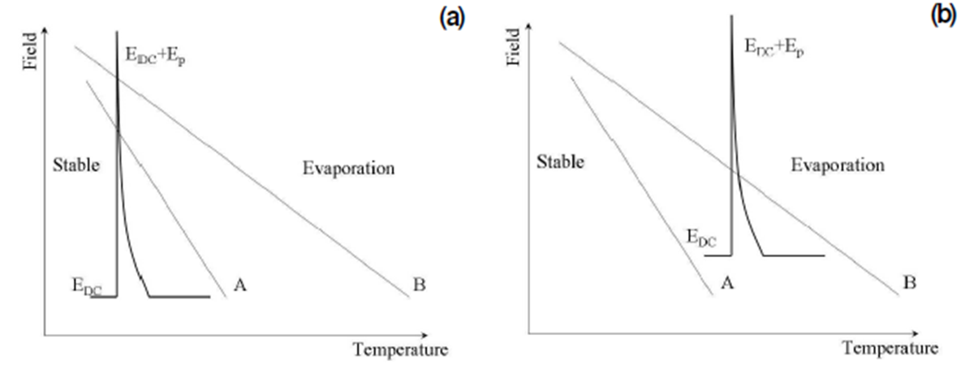
Figure 3.6 Influence of the temperature and electric field on the evaporation of a specimen containing atom species A and B. A proper operation condition is presented in (a) while preferential evaporation occurs in (b). Reproduced from Ref. [70].

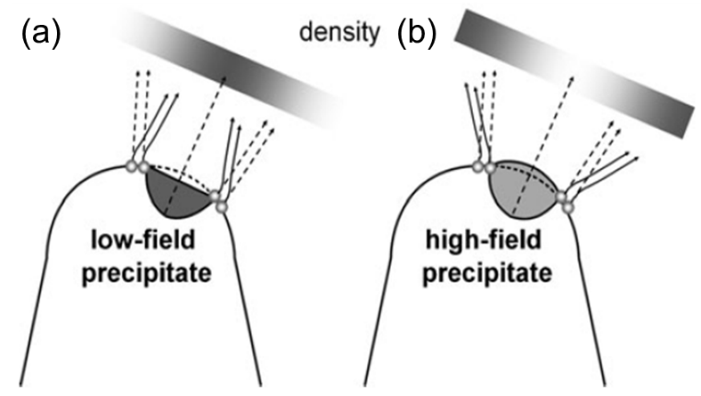
Figure 3.7 The trajectory aberrations at the cluster-matrix interface and the resulting density change inside precipitates in the case of (a) a low-field precipitate and (b) a high-field precipitate. Reproduced from Ref. [153].

enriched matrix, which corresponds to condition (a) in Figure 3.7. The precipitates evaporate faster than the matrix, which leaves a flatter surface and results in a region with a lower field that deflects the ion trajectories inwards. During reconstruction, the atoms at the interface will be treated as they evaporate from the clusters, and thus the atomic density in clusters is increased. High-field precipitates, on the other hand, will result in a lower density in precipitates because of the increase in local curvature.
The trajectory aberration of interface atoms will modify the shape of the clusters and potentially influence the measurement of cluster chemical compositions. However, it mainly blurs out the atoms at the interface, so the core composition in the cluster should not be largely changed [155]. Currently, there is no known technique for adjusting the running conditions to completely avoid the local magnification artifact.

3.4.2.3 Isotopes overlap
Isotope overlaps can cause errors in chemical composition measurement. The elemental flavor of each atom is determined by its mass to charge ratio (m/n in the unit of Da) in the mass spectrum. If two isotopes have the same m/n value, it is impossible to unambiguously determine which element this atom belongs to. In FeCr alloys, Cr atoms have isotopes with masses of 50, 52, 53 and 54 amu, while Fe atoms have masses of 54, 56, 57, and 58. Fe and Cr atoms are most likely to be detected at a charge state of 2+ when the tips are run in HV pulsing mode, so the resulting mass to charge ratios are 25, 26, 26,5 and 27 Da for Cr, and 27, 28, 28.5 and 29 Da for Fe, respectively. An overlap occurs at 27 Da as shown in Figure 3.8. For the calculation of chemical compositions, this overlap can be accommodated by introducing a correction factor based on the natural abundance of each isotope. If the peak at 27 Da was initially assigned to Fe, a correction factor for Cr concentration could be obtained by:
$$F_{Cr}=\frac{A_{Cr50}+A_{Cr52}+A_{Cr53}+A_{Cr54}}{A_{Cr50}{+A}_{Cr52}+A_{Cr53}}=1.024$$
A is the natural abundance of each isotope with the atom name and mass denoted by the subscripts. The concentrations of Cr and Fe are then calculated with:
$$C_{Cr-c}=C_{Cr-uc}×F_{Cr}$$
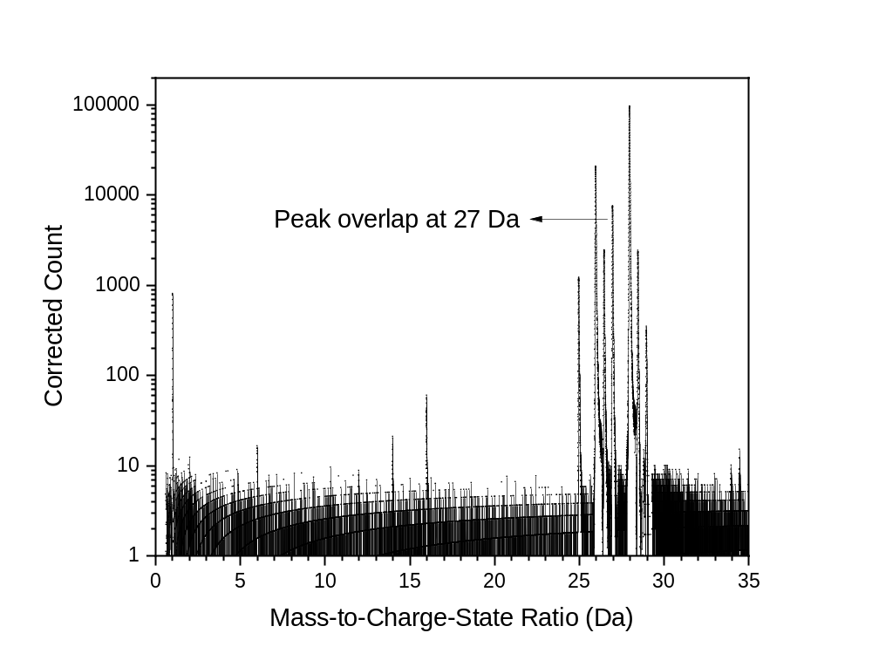
Figure 3.8 The mass spectrum of an APT dataset collected for the as-received Fe-18Cr specimen. The peak overlap at 27 Da is highlighted.

$$C_{Fe-c}={C_{Fe-uc}-C}_{Cr-uc}×{(F}_{Cr}-1)$$
In which $C_{Cr-c}$ and $C_{Cr-uc}$ are the corrected and uncorrected Cr concentrations, respectively. The same naming style is also applied to Fe.

3.4.3 APT sample preparation and data acquisition
APT specimens were lifted out and sharpened with the FEI Nova 200 Dual-Beam scanning electron microscope equipped with the focused ion beam (SEM/FIB) located at the Center for Nanophase Materials Sciences (CNMS) of the Oak Ridge National Laboratory (ORNL). A tip length of around 800 nm below the Platinum cap was removed by Ga beam sputtering in the final polishing step so that the mid-range irradiated region could be easily achieved during the APT tip evaporation. The samples were analyzed by a LEAP 4000X HR model APT with a detection efficiency of 36%. The temperature of needle-shaped samples was cooled down to 50 K to avoid the preferential evaporation of Cr atoms. The evaporation of tips was laser pulsed with a pulse energy of 50-60 pJ or voltage pulsed with a pulse fraction of 20%, and a pulse repeating rate of 200 kHz. The detection rate was set to 0.2-0.5%.

3.4.4 Reconstruction
The reconstruction of as-collected raw data was done by using the Integrated Visualization and Analysis Software (IVAS) 3.8.4 based on the point-projection model. This model simplifies the initial radial movement and subsequent straight trajectory into one straight line starting from the point sitting behind the center of the spherical cap. The compression of the field lines resulting from this approximation is reflected by an image compression factor ξ, which is taken as 1.65 for this study. The evaporation field $F_{e}$ of Fe (33 V/nm) is used here. The initial radius R was calculated by fitting the interplanar spaces along the <110> or <200> directions. The field factor k is obtained through the equation below:
$$k=\frac{V}{RF_{e}}$$
An example of the detector event histogram is given in Figure 3.9 (a), in which the <110> pole facilitated as a low hit region with a 2-fold symmetry can be easily identified. The initial radius R was carefully adjusted to make sure that the distance between neighboring peaks is 0.203 nm in the spatial distribution map along the z-axis (shown in Figure 3.9 (b)). Cr segregating to poles was observed in most datasets, which were removed before performing the analysis of α’ precipitates.
After reconstruction, the mass spectrum was exported from IVAS and analyzed by self-developed peak searching algorithm. The range for each peak was taken as the locations of the Full Width Tenth Maximum.

3.4.5 Measuring solute clustering statistically
Several methods are available to determine if there is any inhomogeneous distribution of solute atoms in an APT data set. As shown in Figure 3.10 (a-c), needle-shaped Cu clusters in AlCu alloys can be observed to become more obvious with the aging time from the Cu atom map, which provides the most direct and simple way to qualitatively determine the clustering behavior. The problem with this method is that minor clustering could be easily overlooked such as the Cu clustering in condition (a), where the atom map shows an almost homogeneous distribution of Cu atoms.
The Chi² method compensates for the disadvantage of atom maps by providing a frequency distribution of solute concentration within blocks containing a constant number of atoms, and comparing it with the random distribution (Figure 3.10 (d)). The value of Chi² for each dataset is calculated with:
$${χ_{e}}^{2}=\sum_{n=0}^{n_{b}}{\frac{{(e\left(n\right)-f_{b}(n))}^{2}}{f_{b}(n)}}$$
$n_{b}$ is the degrees of freedom and $n$is the number of solute atoms in one block (50 - 500 typically). $f_{b}\left(n\right)$ and $e\left(n\right)$ are the counts of blocks containing n solute atoms for binomial distribution and experimental dataset, respectively. The major problem with this method is that the value of ${χ_{e}}^{2}$ increases with the size of the dataset. In a larger dataset, the null hypothesis, which claims the homogeneous distribution of solute atoms, is more likely to

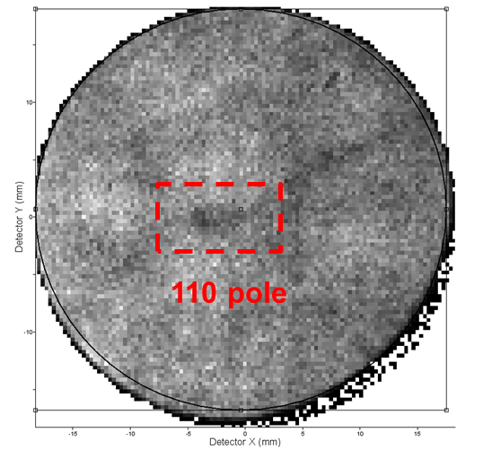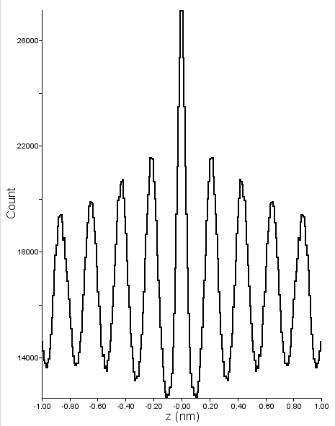
(b)
(a)
Figure 3.9 (a) an example of the detector event histogram in IVAS and (b) the spatial distribution map along the z-axis corresponding to the <110> pole region highlighted in (a).

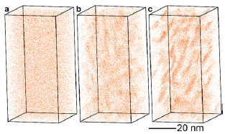
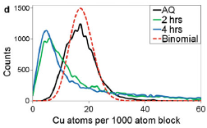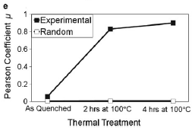
Figure 3.10 The Cu atoms distribution in Al-1.7at. %Cu after (a) As-quenched, aged at 100 °C for (b) 2 hours and (c) 4 hours. (d) the corresponding frequency distribution of Cu concentration and (e) evolution of Pearson coefficient. Reproduced from Ref. [153].

be rejected, instead, the existence of clustering is indicated. Direct comparison among differently sized datasets is also difficult.
Pearson et al came up with a method to normalize the ${χ_{e}}^{2}$ value, so the problem with datasets having too many atoms can be solved and datasets with different sizes could be directly compared [156]. Taking N as the number of blocks in one dataset, the Pearson coefficient μ could be obtained by:
$$μ=\sqrt{\frac{{χ_{e}}^{2}}{N+{χ_{e}}^{2}}}$$
It lies between 0 and 1. 1 indicates complete phase separation and 0 means random distribution. μ has a strong block size dependence, thus the same block size must be maintained for all analyses. The evolution of the Pearson coefficient in AlCu alloys with aging time is presented in Figure 3.10 (e). We found the value of $μ$ is very sensitive to how the peaks in the mass spectrum are ranged (Full Width Tenth Maximum or Full Width Half Maximum) and the presence of poles in the dataset, so it was not used in this work.
A method proposed by Thuvander et al [157] suggested comparing the standard error (s) of the experimental data with the standard deviation (σ) of the random distribution (Binomial distribution) defined with the equations below (Thuvander method):
$$S^{2}=\frac{1}{n_{b}-1}\sum_{i=1}^{n_{b}}{{(c_{i}-c_{0})}^{2}}$$
$$σ^{2}=c_{0}(1-c_{0})/N_{b}$$
For an ordered dataset, s is smaller than σ, while for a dataset with phase separation, s is larger than σ. In solid solution datasets, these two parameters are comparable.
Due to the unacceptable disadvantages of atom map, Chi² and Pearson methods, the Thuvander method is applied in this work to quantify the clustering of Cr atoms after ion irradiations. Examples are given in Figure 3.11 for Fe-18Cr in the as-received state and after ion irradiation at 450 °C, 10⁻⁵ dpa/s to 0.37 dpa. Overlap of the two curves in Figure 3.11 (a) indicates the alloy was in a solid solution state before irradiation, while splitting of them suggests phase separation occurred after it.

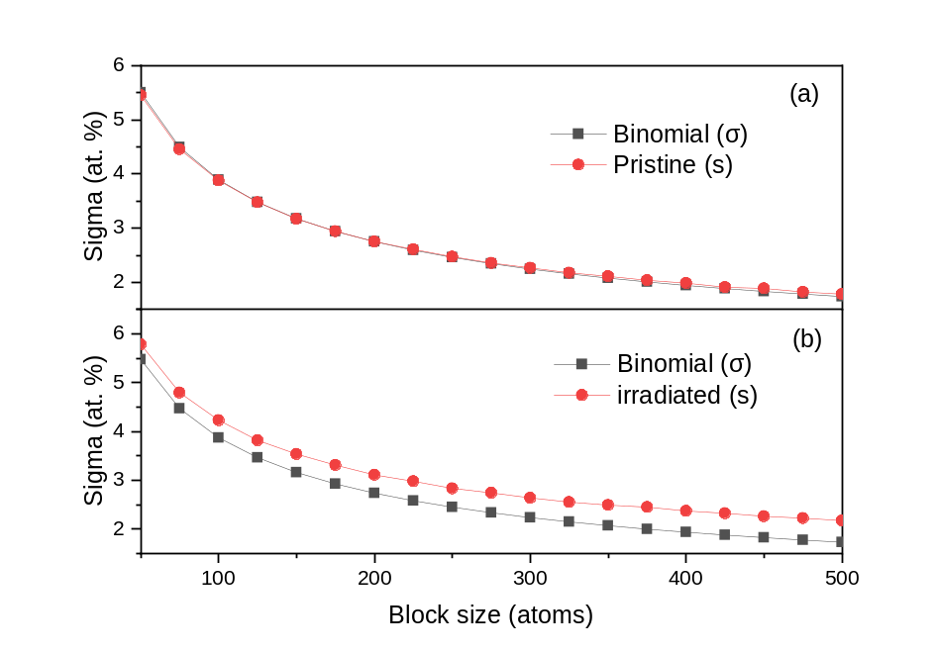
Figure 3.11 Comparison of the standard error (s) of the Cr atoms distribution in an experimental dataset and the standard deviation (σ) of the binomial distribution for (a) Fe18Cr in as-received state and (b) Fe18Cr after ion irradiation at 450 °C, 10⁻⁵ dpa/s to 0.37 dpa.

To further quantify the deviation from randomness, a quantity named clustering coefficient defined by the following equation is introduced. The range of block size from 50 to 500 was suggested by Thuvander et al [157]. A larger clustering coefficient indicates more clustering or phase separation in the dataset.
$$clustering coeficient =\sum_{Nb=50}^{500}{{(s-σ)}^{2}}$$

3.4.6 Identifying clusters with self-developed Python codes.
The cluster analysis was first conducted using the maximum separation method inherent to the Integrated Visualization and Analysis Software (IVAS) according to the D_{max} and N_{min} selection algorithm described in Ref. [5], but misleading results inconsistent with the statistical results (clustering coefficient) were obtained. Therefore, we have developed a concentration-based filtering algorithm using Python codes to identify and quantify the Cr-enriched clusters. The radius, number density and volume fraction of precipitates were calculated in this method.
This algorithm is similar to the one mentioned in Refs. [10, 155], which was found to be more effective in identifying clusters in concentrated alloys than the maximum separation method [158]. The steps to identify the clusters are listed below:
- By using the software 3Depict [159], the local Cr concentration at each atom position was calculated in a spherical volume with a radius of 0.94 nm, which corresponds to about 100 atoms. This method was applied during the analysis of Fe18Cr specimens irradiated by heavy ions at 300-450 °C. In the later analyses, the algorithm was revised and improved, so this step was successfully implemented into the Python algorithm using the BallTree module in the scikit-learn package.
- For the Fe-18Cr specimen, a threshold concentration of 30 at. % was then applied to filter the atoms. This threshold value was determined from the frequency distribution of the pristine Fe-18Cr at a block size of 200 atoms. The Cr content value at which the count goes to 0 was selected as the threshold to remove the contributions from random fluctuations. However, this value was found to decrease with the block size as shown in Figure 3.12. The block sizes of 100, 150, 200 and 400 atoms give thresholds of 39, 34.5, 30 and 26.25 at. %, respectively. By visually comparing the filtered atoms and Cr atom map, 30 at. % was found to give the best fit and thus selected as the threshold. As a result, a block size of 200 atoms was used to determine the threshold Cr content for alloys with lower bulk Cr concentrations, and the thresholds were 24%, 22% and 20.5% for Fe-14Cr, Fe-12Cr and Fe-10Cr alloys, and 4.5% for FeCu alloys respectively.
- After the filtering step, the selected atoms were judged to form clusters if their distances were shorter than 0.5 nm, and clusters with less than 16 atoms were removed. The selection of these two parameters was based on the results of maximum separation analysis performed on the same datasets using the method proposed in Ref. [5].
- Background clusters with their radius and Cr concentration fall in the region corresponding to the clusters identified in the random datasets were subtracted [160].
- For each cluster, if there are matrix atoms within 0.5 nm (envelop distance) of a cluster atom, the matrix atoms are added to the cluster. This step introduces some matrix atoms to the cluster mistakenly, which will be removed by the erosion step.
- In order to remove the Fe shell, the clusters are eroded with erosion distance d_{eros} determined by their spherical equivalent radius. d_{er} is in the range of 0.4 to 0.9 nm and a larger d_{er} is applied to larger clusters. Cluster radii are classified as 0.5-1, 1-1.5, 1.5-2, 2-2.5, 2.5-3, 3-3.5. 3.5-4 nm and >4nm size ranges. If a cluster atom is in the d_{er} of a matrix atom, the cluster atom is removed from that cluster and returned to the matrix, which is very similar to the erosion procedure in IVAS [161]. In the revised algorithm, one proximity histogram showing the change of Cr concentration crossing the precipitate interface is calculated for each cluster, and the erosion distance is taken as the difference between the current interface and the point at which solute concentration is halfway between the matrix and precipitate core values.
- Heavily connected clusters were separated as the last step [66].

After the cluster identification steps were completed, the radius (equivalent radius R) of Cr precipitates was calculated from the number of atoms N in each cluster with the

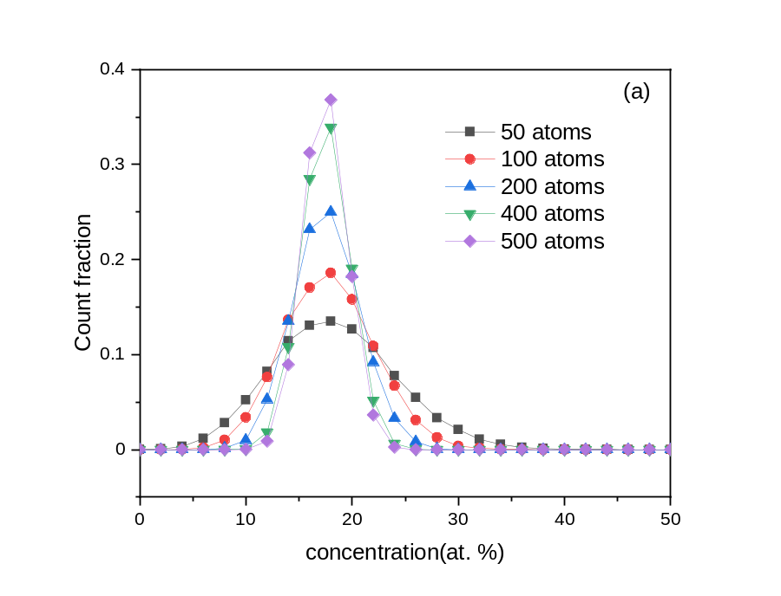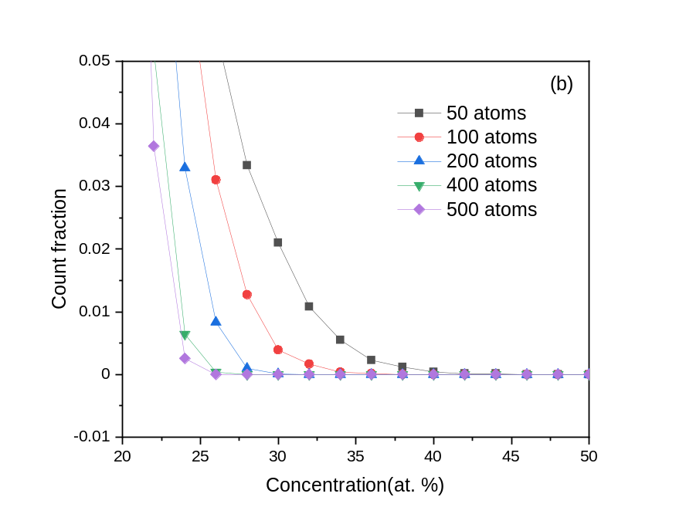
Figure 3.12 (a) the frequency distribution of Cr concentration in an as-received Fe18Cr dataset calculated with block sizes of 50-500 atoms, and (b) a zoom-in view of the right tails in (a).

equation below, in which $ρ=84.3 atoms/{nm}^{3}$ is the atomic density [5], and Q is the detection efficiency.
$$R=\sqrt[3]{\frac{3N}{4πρQ}}$$
Due to the complicated crystal structure of Cu precipitates, their atomic density is difficult to measure, so the Guinier radius was used, which was directly calculated in the Python algorithm using the equation:
$$R_{g}=\sqrt{\frac{5}{3}}×\sqrt{\frac{\sum_{1}^{N}{{((x_{n}-\overline{x})}^{2}+{(y_{n}-\overline{y})}^{2}+{(z_{n}-\overline{z})}^{2})}}{N}}$$
N is the total number of ranged atoms in a cluster. $\overline{x}$, $y$, $\overline{z}$ are the coordinates of the cluster center, and $x_{n}$, $y_{n}$, $z_{n}$ are the coordinates of nth atoms inside the cluster.
The number density is calculated from the number of clusters divided by the tip volume, and the volume fraction is the ratio of the number of atoms in clusters to the total number of atoms in the whole dataset. Only ranged atoms were used in all the calculations.

3.4.7 Calculating Cr concentration with proxigrams
The iso-concentration interface and proximity histogram or proxigram is used to obtain the Cr concentration in clusters and matrix. An iso-concentration value of 24 at. % was selected to include all clusters in Fe-18Cr. The core Cr concentration in each cluster was taken to minimize the contribution from the interface, which was obtained by fitting the proxigram with an empirical function as in Ref. [6]. An example of the fitted proxigram is shown in Figure 3.13, in which the curve gives a very good fitting to the proxigram. The matrix Cr content was taken as the lowest point in the proxigram, so that the contribution from neighboring clusters could be minimized. The peak overlap of Fe and Cr atoms at 27 Da in the mass spectrum has been corrected based on the natural abundance of each isotope (details are given on page 49) for all the concentrations recorded here. The number density could also be obtained with this method by taking the ratio of the interface number to the analyzed volume, which is less accurate due to the interconnection of multiple clusters.

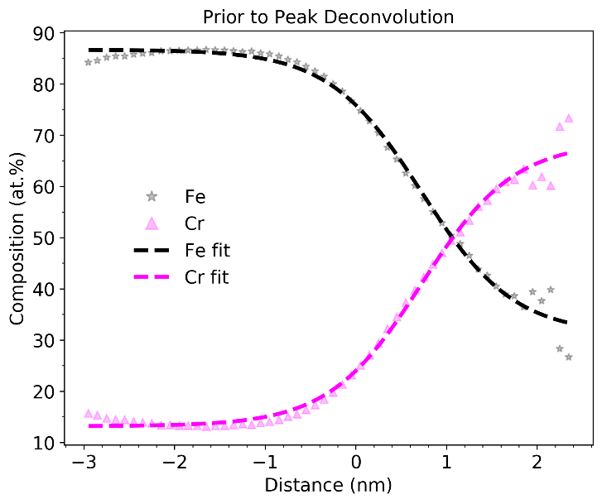
Figure 3.13 The proxigram fitted by an empirical function to calculate the matrix and cluster core Cr concentration.

3.5. Studying the correlation of solute atoms with dislocations using STEM-EDS
Due to the very small-sampled volumes, it is generally difficult to capture dislocations or dislocation loops formed from irradiations in APT tips. Therefore, scanning transmission electron microscopy - energy dispersive X-ray spectroscopy (STEM-EDS), mapping was performed to study the possible spatial correlation of Cr atoms with dislocations. EDS mapping was conducted using the FEI Talos F200X instrument located at the Low Activation Materials Development and Analysis (LAMDA) facility of ORNL. This instrument is equipped with a high-brightness Schottky-emission field-emission-gun electron source to provide electron beams with very high intensity. Its detector system includes 4 silicon-drift-detector (SDD) units, and thus has much higher X-ray spectrum imaging efficiency [162].
EDS scanning was performed on lamella specimens prepared from the FIB technique. Since electron backscatter diffraction (EBSD) mapping was obtained prior to the lift-out step, the flat surface of the thin foil specimen has an orientation very close to <001> direction, and thus minor tilts were needed after specimen loading. EDS mapping was collected after the specimen was aligned on the (001) zone axis. Therefore, both dislocations and elemental distributions are visible and can be correlated with each other. During collection, the dwell time on each pixel was ~40 µs, and ~16 frames were collected in total, which needed a total scanning time of ~30 minutes for each area of interest.
The EDS results were quantified using the Velox software available in Materials Science and Technology Division (MSTD), ORNL. Background signals were corrected by assuming a sample thickness of ~100 nm and sample density of 7.9 g/cm³ (density of pure Fe). For better contrast of images, post-filtering after quantification by averaging 7 pixels was conducted for all elemental maps.

Results

4.1 Effect of dose rate and temperature on α’ formation in Fe-18Cr

4.1.1 α’ precipitates after irradiation to 0.37 dpa
The clustering coefficient (defined in section 3.4.5) of Fe-18Cr specimens irradiated to 0.37 dpa is plotted in Figure 4.1. The unirradiated reference (horizontal dashed line) corresponds to the value measured from the as-received Fe-18Cr, which was in a solid solution state. Compared to the pristine sample, Cr clustering could be observed in most irradiation conditions. The only exception occurred at 300 °C and 10⁻³ dpa/s, at which the clustering coefficient value was very close to the solid solution line. An increase in the clustering level at higher temperatures or lower dose rates was observed, which is consistent with the increased radiation enhanced diffusion and reduced ballistic dissolution rate at these conditions.
Figure 4.2 shows the distribution of cluster atoms filtered by the Python codes for the samples irradiated to the low fluence of 0.37 dpa. A large number of Cr rich α’ precipitates were revealed for most irradiation conditions. They were homogeneously distributed without clear association with point defect sinks such as dislocations and grain boundaries. At 300 °C and 10⁻³ dpa/s, only 1 cluster was found in the presented volume. This may correspond to the critical irradiation condition for α’ formation as described in Ref. [163], in which the continuous formation and dissolution of α’ by ballistic mixing occurs and no precipitates could be stabilized. The formation of α’ precipitates under the conditions except for 300 °C, 10⁻³ dpa/s indicates that the cluster formation process from radiation enhanced diffusion was typically dominant compared to ballistic dissolution processes for the investigated irradiation conditions.
The evolution of radius, number density and volume fraction of Cr-enriched clusters with irradiation conditions are plotted in Figure 4.3. The average cluster radii were ~1-2 nm in all cases, which is consistent with the irradiated results in the literature [5, 7-10, 67, 98, 112]. Cluster sizes increased with increasing temperature or decreasing dose.
Figure 4.1 The clustering coefficient for Fe18Cr irradiated to 0.37 dpa at different dose rates and temperatures.

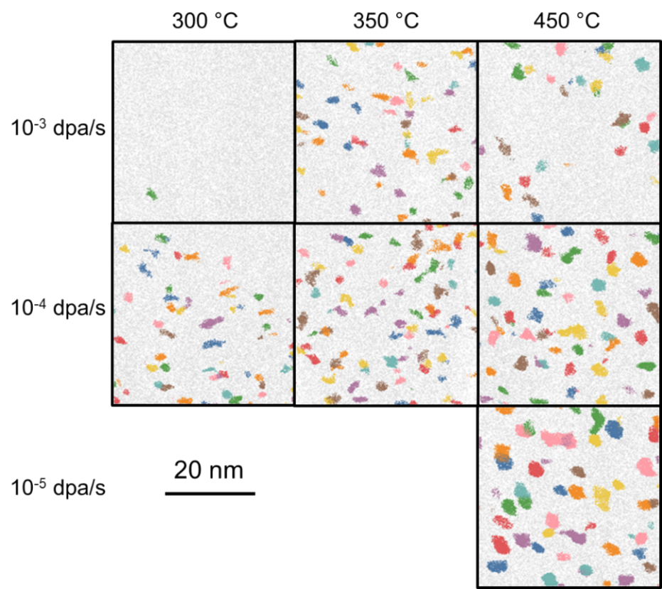
Figure 4.2 Cluster atom maps showing α’ precipitates in Fe-18Cr irradiated to 0.37 dpa. Sampled volume = 40×40×10 nm³. Clusters are indexed with different colors. All elements in the Cr-enriched clusters including both Fe and Cr atoms are shown.

The evolution of radius, number density and volume fraction of Cr-enriched clusters with irradiation conditions are plotted in Figure 4.3. The average cluster radii were ~1-2 nm in all cases, which is consistent with the irradiated results in the literature [5, 7-10, 67, 98, 112]. Cluster sizes increased with increasing temperature or decreasing dose rate. Within the range of investigated parameters, increasing the temperature from 300 to 450 °C had a much larger effect on cluster size than decreasing the dose rate from 10⁻³ to 10⁻⁵ dpa/s. As for the evolution of the cluster number density, it was maximized at 350 °C for both investigated dose rates. This trend qualitatively agreed with the number density of iso-concentration interfaces obtained using IVAS, although the latter method incorrectly provided smaller number density values for most conditions due to the presence of interconnected clusters which cannot be separated in the IVAS algorithm. The peak in Cr-rich cluster density at 350 °C is likely due to the competition between coarsening (dominant at 450 °C) and dissolution by damage cascades (dominant at 300 °C). Increasing the dose rate decreased the number density at all temperatures, which was most significant at 300 °C. It must be pointed out that for the clusters formed after irradiation at 300 °C and 10⁻³ dpa/s, their positions were closely related to low index crystallographic poles. Although the main poles along <110> or <200> directions were removed before the cluster analysis, the large regions in the vicinity of the poles were influenced by this field effect artifact and showed nonhomogeneous Cr enrichment. The same cluster search method was applied to the datasets for the as-received Fe-18Cr specimen, and similar artifacts of Cr-enriched regions were revealed around the poles. The number density and radius of these features in the as-received sample were (2.9±0.6)×10²³/m³ and 0.94±0.4 nm respectively, which are similar to the ones detected after irradiation at 300 °C and 10⁻³ dpa/s. A negligible volume fraction of α’ phase was also calculated after irradiation at 300 °C and 10⁻³ dpa/s (Figure 4.3 (c)). Based on these results, we believe these detected features originated from field effect artifacts on the poles. Therefore, the critical irradiation conditions for the α’ precipitate to dissolve or fail to nucleate as stable clusters are revealed as 300 °C and 10⁻³ dpa/s.
For all other irradiation conditions, the APT artifact features have a small influence on the cluster quantifications due to a large amount of observed cluster formation, and thus
Figure 4.3 The evolution of (a) radius, (b) number density and (c) volume fraction of α’ precipitates irradiated to 0.37 dpa at different temperatures and dose rates.

fewer Cr atoms were available for nonhomogeneous segregation. Our results highlight that great care must be taken to analyze the APT results, so that such artifacts are not erroneously identified as real precipitates. For other conditions, the trend of volume fraction change, combined with the radius and number density evolution, agreed with nucleation, growth and Ostwald ripening of precipitates, the kinetics of which decreased with lower temperatures or higher dose rates. The highest volume fraction (~ 7.6%) occurred after irradiation at 450 °C and 10⁻⁵ dpa/s (corresponding to ~10 h irradiation time), with a value close to the saturated volume fraction (~ 6.9%) for the same Fe-18Cr thermally aged at 500 °C for 2008 hours [4]. The small discrepancy might be attributed to the temperature difference of 50 °C or the more dilute clusters formed after ion irradiation.
The Cr concentration of the precipitates and matrix was calculated from the APT proxigrams. Examples of the clusters formed after irradiation at 450 °C and different dose rates to 0.37 dpa are given in Figure 4.4. The proxigrams for the three dose rates were well separated. The solute concentration was lowest in the matrix and highest in the cluster at the dose rate of 10⁻⁵ dpa/s. The distance from the interface to the center of clusters gives a rough estimation of the cluster size, which increases with decreasing dose rate. Although the distances were numerically different from the radii plotted in Figure 4.3 due to the difference in cluster definition, the trend was consistent.
The resultant matrix Cr concentration is presented in Figure 4.5 (a). The bulk Cr content was obtained from the whole sampled volume averaged over all collected datasets. The matrix Cr content was ~14 at. % after irradiation at 450 °C and 10⁻⁵ dpa/s. This was close to the concentration obtained from the same alloy after thermally aging at 500 °C for 2008 hours [4]. For all other irradiation conditions, the matrix Cr contents were much higher than the 9-14 at. % predicted by the phase diagram and other studies in the temperature range of 300-500 °C [5, 61, 66]. At all temperatures, the matrix Cr concentration was lower at lower dose rates, indicating more clustering of Cr atoms in the sample. Increasing the temperature from 300 to 350 °C largely decreased the matrix Cr content, while further increasing the temperature to 450 °C seemed to be less effective and almost negligible at 10⁻³ dpa/s. The difference between the thermal equilibrium solubility

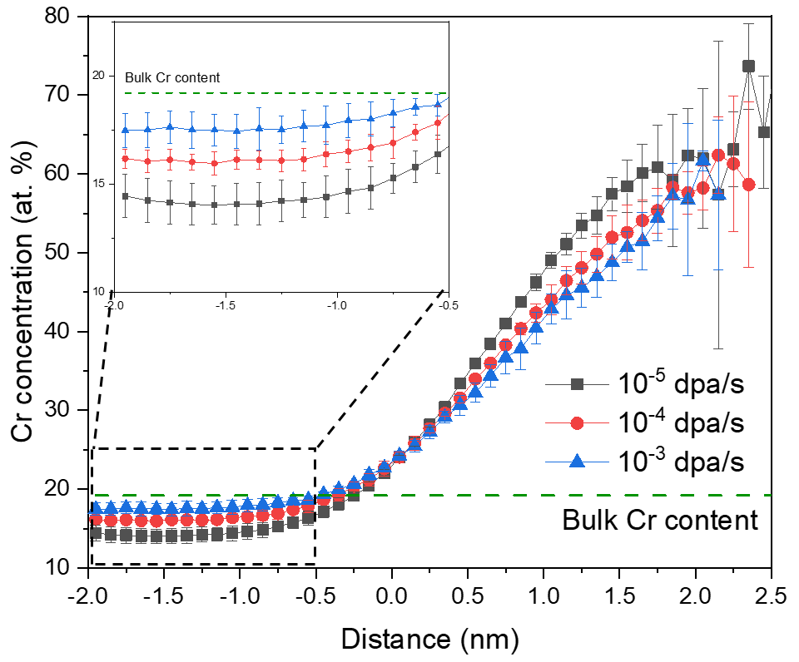
Figure 4.4 Proxigrams for Fe-18Cr irradiated at 450 °C and 3 dose rates to 0.37 dpa. The inset figure shows a zoomed-in view of the matrix side.

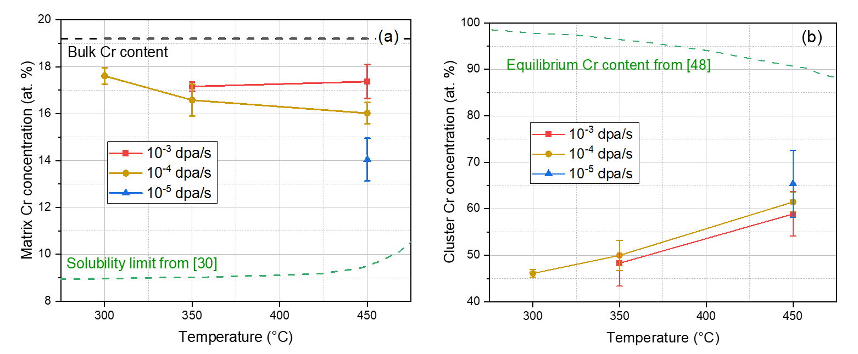
Figure 4.5 The evolution of Cr concentration in (a) matrix and (b) cluster core for Fe-18Cr irradiated to 0.37 dpa at different temperatures and dose rates. The solubility limit in (a) and the equilibrium Cr content in (b) are reproduced from [61] and [65] respectively.

limit and measured matrix Cr concentration became larger with decreasing temperature and increasing dose rate.
The Cr concentrations in the core of the clusters are plotted in Figure 4.5 (b). They were relatively widely distributed, ranging from ~45 to 65 at. % depending on the irradiation conditions. The core concentrations increased monotonically with increasing irradiation temperature. While the Cr enrichment levels in the solute clusters following ion irradiation (~45-65%) were indicative of progression toward fully formed α’ precipitates, the measured Cr contents were significantly less compared to the 80-90 % equilibrium Cr content expected for α’ precipitates as determined from thermal aging experiments [4, 66] or predicted by phase diagram [65, 164]. However, the Cr contents in the clusters after ion irradiation at 300-350 °C were similar to ~35-50 at. % Cr reported previously after irradiation by self-ions at 300 °C to ~ 1 dpa for a dose rate of 3-6.1×10⁻⁵ dpa/s [7]. Although the equilibrium Cr concentration for α’ precipitates decreases slightly with increasing temperature, the measured Cr content in clusters exhibited an opposite trend. This suggests that the Cr content in the Cr-rich clusters is mainly controlled by the kinetics of the diffusion process instead of the thermodynamic equilibrium concentration. The lower Cr content in the clusters at a higher dose rate may be an indicator of the important role of ballistic mixing over the entire range of investigated irradiation conditions.

4.1.2 Cr-rich α’ precipitation after irradiation to 3.7 dpa
Figure 4.6 compares the representative APT reconstructions for Fe-18Cr irradiated at 10⁻⁴ dpa/s for two different temperatures (350 and 450 °C) and two final doses (0.37 and 3.7 dpa). The properties of these clusters are summarized in Table 4.1. The number density of α’ precipitates showed a slight decrease (~20%) with increasing dose at 350 °C and a significant reduction (~4x) at 450 °C, which indicates the clusters grew only slightly between 0.37 and 3.7 dpa at 350 °C while a strong coarsening occurred at 450 °C as compared to 350 °C over the same doses. This observation was supported by the cluster size (radius) distributions as shown in Figure 4.7. The cluster size distributions were single-peaked for both doses at 350 °C with only a slight shift to a larger size at the higher dose,

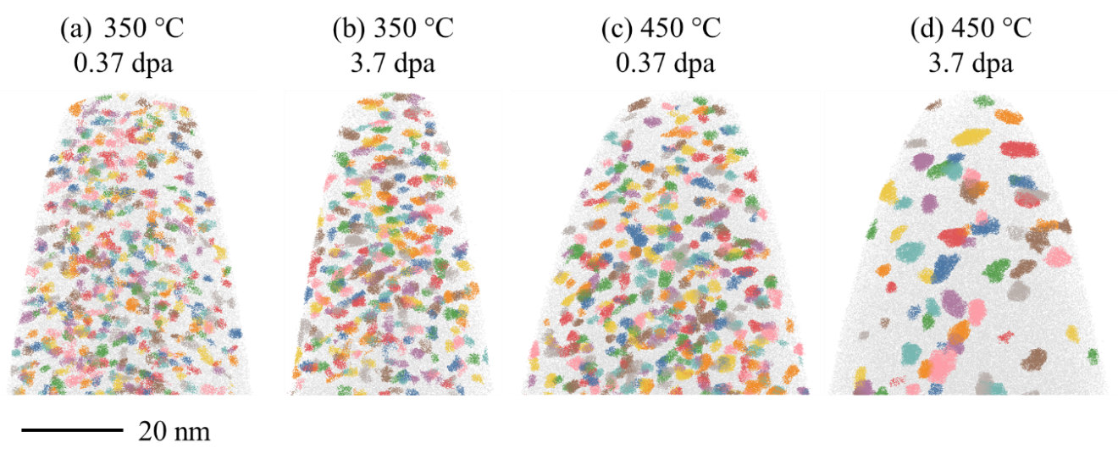
Figure 4.6 APT reconstructions of Fe-18Cr samples irradiated at 10⁻⁴ dpa/s showing α’ precipitates. The irradiation temperature and final doses are overlaid. All elements in the Cr-enriched clusters including both Fe and Cr atoms are shown.

Table 4.1 The characteristics of α’ precipitates in Fe-18Cr irradiated at 10⁻⁴ dpa/s, 350 and 450 °C to 0.37 or 3.7 dpa. Data for the sample aged at 500 °C for 900 hours, as obtained from APT data analysis, is also presented.
Aging tempera-ture  (°C) | Irradiation temperature  (°C) | Dose  (dpa) | Radius  (nm) | Number density  (10²⁴/m³) | Cluster core Cr content  (at. %) | Matrix Cr content  (at. %) | Volume fraction  (%)
- | 350 | 0.37 | 1.12 ± 0.02 | 4.8 ± 1.8 | 50.0 ± 3.2 | 16.6 ± 0.7 | 3.1 ± 1.1
- | - | 3.7 | 1.29 ± 0.01 | 4.0 ± 0.7 | 57.9 ± 7.3 | 15.4 ± 0.5 | 4.1 ± 0.8
- | 450 | 0.37 | 1.42 ± 0.03 | 3.5 ± 0.3 | 61.5 ± 2.2 | 16.0 ± 0.5 | 4.8 ± 0.6
- | - | 3.7 | 2.01 ± 0.08 | 0.94 ± 0.06 | 66.3 ± 3.5 | 16.3 ± 0.3 | 4.2 ± 0.2
500/900 h | - | - | 2.85 ± 0.34 | 0.51 ± 0.21 | 83.2 ± 5.3 | 14.4 ± 0.3 | 6.2 ± 0.6

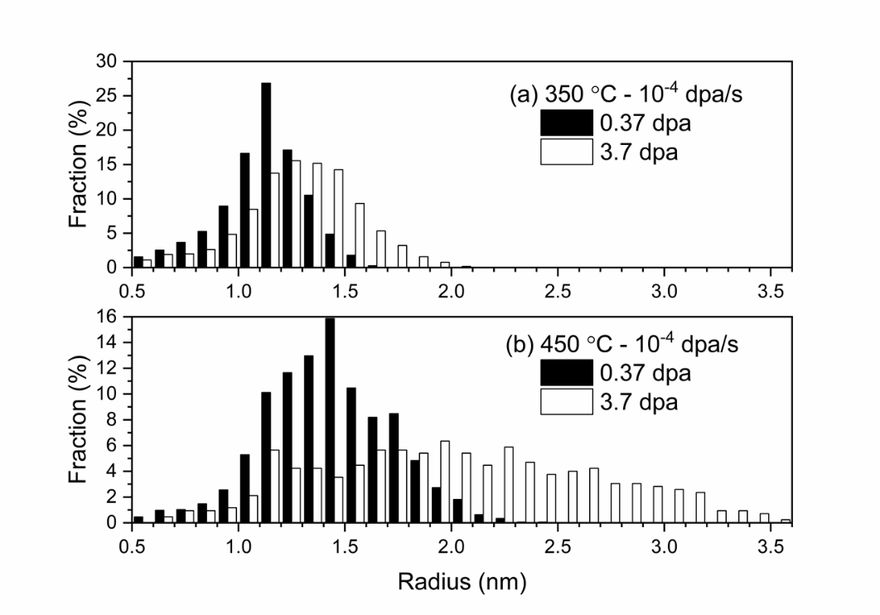
Figure 4.7 Evolution of the Cr-enriched precipitate radii distribution after irradiation at (a) 350 °C, 10⁻⁴ dpa/s, and (b) 450 °C, 10⁻⁴ dpa/s. Final doses were 0.37 and 3.7 dpa.

which may indicate that the α’ precipitates were still in the nucleation or metastable stage with little growth. However, the size distributions were very different at 450 °C: there was only one sharp peak at 0.37 dpa (Figure 4.7 (a)), while a much wider size distribution existed for irradiations up to 3.7 dpa (Figure 4.7 (b)). This difference at the two temperatures can be attributed to the much slower kinetics for phase separation at lower temperatures. The cluster Cr concentration increased only slightly after the dose increased by ten times at both temperatures. The change in matrix Cr content and the volume fraction of α’ phase was minor, which may indicate that saturation of the precipitation process with dose is largely complete already by 0.37 dpa. Since the evolution of precipitate sizes agreed with a classical Ostwald ripening mechanism, the radii measured at higher doses can be compared to the radii estimated using the LSW theory [165]. This theory predicts negligible size change (no change at 350 °C and 0.002 nm increase at 450 °C) if the thermal equilibrium vacancy concentration is used. However, a radius of ~11 nm at 350 °C and ~16 nm at 450 °C after irradiation to 3.7 dpa is anticipated if the calculated radiation enhanced diffusion rates are used, which are much larger than the precipitate size measured through APT characterization. This again indicates the presence of strong ballistic dissolution effects, which effectively slow down the precipitate coarsening rate.

4.1.3 Ballistic dissolution of α’ precipitates by irradiation in aged Fe-18Cr
A portion of Fe-18Cr samples were thermally aged in a vacuum environment at 500 °C for 900 hours to form α’ precipitates. A representative APT reconstruction showing these precipitates is given in Figure 4.8 (a). Well-formed α’ precipitates were observed with wide size distribution and an average radius of about 3 nm. The cluster core Cr content was measured to be 83.2 ± 5.3 at. %, which is very close to equilibrium values and in full agreement with the existing experimental values [4, 65, 66]. The APT reconstruction for the as-received sample is presented in Figure 4.8 (e) as a reference. Only a few potential clusters were identified by the Python codes due to the pole segregation artifact.
Both aged and as-received samples were then simultaneously irradiated at 300, 350 and 450 °C to 0.37 dpa (10⁻³ dpa/s). The reconstructions showing the evolution of α’
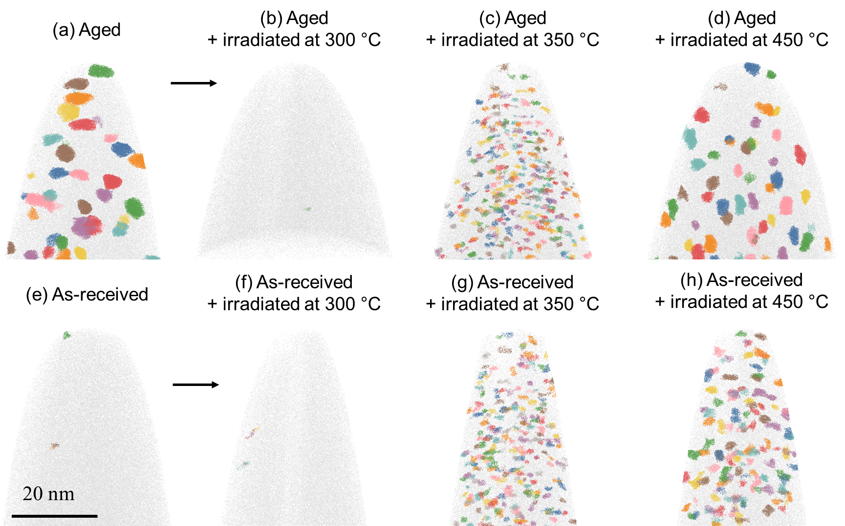
Figure 4.8 APT reconstructions showing α’ precipitation evolution in Fe-18Cr. (a) Sample aged at 500 °C for 900 hours. Samples aged at 500 °C for 900 hours followed by ion irradiation at (b) 300 °C, (c) 350 °C and (d) 450 °C. (e) Unirradiated as-received material. Samples that were ion irradiated from the as-received state at (f) 300 °C, (g) 350 °C and (h) 450 °C. The dose rates and doses were10⁻³ dpa/s and 0.37 dpa for all the irradiated specimens.

precipitation are presented in Figure 4.8. At 300 °C, irradiations completely dissolved the α’ precipitates formed due to thermal aging. Despite the drastic difference between the microstructures before irradiation, both the aged and as-received specimens showed similarly negligible Cr precipitation after irradiation at 300 °C, i.e. no formation of α’ in the solid solution alloy and complete dissolution of α’ in aged specimens. At 350 °C, the large α’ precipitates formed from thermal aging were replaced by a high density of finer precipitates, and a similar microstructure was observed in the irradiated solution alloy. At 450 °C, differences in α’ in the irradiated aged sample versus irradiated as-received sample were limited just based on the reconstructions.
Quantitative results including the radius distribution, average radius, number density, and volume fraction of α’ precipitates, and the Cr concentration in the α’ and matrix for the samples with precipitates are plotted in Figure 4.9 and Figure 4.10. After irradiation at 350 °C, the clusters in the aged specimen shrank to a size distribution comparable to the sample irradiated directly from the as-received solid solution state (Figure 4.9). The number density of clusters in the aged+irradiated sample similarly increased to a value comparable to the sample irradiated from the pristine state (Figure 4.10). Furthermore, the cluster volume fraction and Cr concentration in the matrix and cluster core following irradiation were very close for the two conditions (as-received vs. aged). These results indicate that the α’ precipitate distribution already reaches a metastable saturation condition after a dose of ~0.37 dpa at 10⁻³ dpa/s and 350 °C, irrespective of the pre-irradiation precipitate microstructure. It is remarkable that the evolution of the α’ precipitate distribution for the two markedly different starting conditions evolved to a comparable state after a dose of only 0.37 dpa at both 300 and 350 °C.
However, the cluster distributions in the aged and as-received specimens were different after irradiation at 450 °C. The average radius of α’ decreased by nearly ~0.6 nm due to the irradiation as compared to the as-aged state, but it was much larger than the clusters in the specimen irradiated from the as-received state. The radii of clusters in this specimen were more widely distributed and extended to larger values compared to the sample irradiated from a pristine state. From Figure 4.9 (c), there were no clusters with a radius >3.5 nm in the aged+irradiated specimen. The change in the number density of
Figure 4.9 Size distribution of α’ precipitates (a) after aging at 500 °C for 900 hours, (b) irradiation at 350 °C, 10⁻³ dpa/s to 0.37 dpa from aged and as-received state and (c) irradiation at 450 °C, 10⁻³ dpa/s to 0.37 dpa from aged and as-received state.

Figure 4.10 Quantification of the α’ precipitates. Comparison of the (a) mean cluster radius, (b) number density, (c) volume fraction, (d) Cr concentration in precipitates and (e) matrix Cr concentration. The investigated samples were Fe-18Cr irradiated at 350 and 450 °C, 10⁻³ dpa/s to 0.37 dpa and Fe18Cr aged at 500 °C for 900 hours followed with irradiations at the same conditions. The shaded parts show parameters of α’ precipitates formed from thermal aging. The horizontal lines represent the average values, and the half heights of the regions stand for the standard deviation of multiple measurements.

clusters was negligible, but the volume fraction was largely decreased due to their smaller sizes. It is interesting to observe that the core Cr concentration in the aged sample was not obviously changed by irradiation at 450 °C. Since the clusters forming directly from the matrix had much lower Cr concentrations, these highly concentrated precipitates were more likely to be the remnants of clusters formed during thermal aging, the sizes of which were decreased by irradiation while the core compositions were unchanged. The matrix Cr concentration of the aged sample was largely increased by the irradiation, and it is closer to the value of samples irradiated from the pristine state (see Figure 4.10 (e)). This observation is direct evidence of the ballistic dissolution effect of displacement cascades, which continuously ejects solute atoms back into the matrix. Because the core of large clusters was not significantly modified, the additional solute atoms that entered the matrix are likely to originate from the dissolution of interface or small clusters.
Judging from the differences in the α’ precipitate distribution in the samples irradiated from the aged state and as-received state, 0.37 dpa is not high enough for precipitates to evolve into a steady state at 450 °C. Since the dissolution rate is independent of the irradiation temperature, the different behavior at 450 °C compared to the two lower temperatures must be attributed to the different radiation enhanced diffusion rates. At 450 °C, the solute atoms might quickly diffuse back after they are dissolved by the displacement cascade each time, which maintains a relatively high solute concentration and large size of the precipitates. Since Cr atoms prefer to interact with themselves to form α’ precipitates in alloys with high Cr concentration, the precipitate restoration kinetics associated with the diffusion of dissolved solute atoms is also higher at 450 °C. Considering the typical size of a displacement cascade, which is ~5-10 nm in diameter, it is anticipated that precipitates with sizes larger than the cascades are less likely to be destroyed because the damage cascades happening completely inside the precipitates are ineffective in causing ion mixing between solute and solvent atoms. Therefore, the higher diffusion rate, and the resulting larger driving force for precipitate re-growth and less efficiency of damage cascades, lead to the larger resistance of α’ precipitates to ballistic dissolution at this high temperature. A higher dose rate is likely required to cause the shrinking of α’ at this temperature.

4.2 Effect of surface and injected ions on α’ formation

4.2.1 α’ precipitates denuded zone in the near-surface region
Figure 4.11 shows the reconstructions of APT needles extracted from the near-surface depth of the 3 specimens. A Ni layer with thickness of 30-60 nm was deposited on the sample surface before standard tip preparation procedures. Ni was selected because it has a similar evaporation field as Fe (The evaporation field of Ni and Fe are 35 and 33 V/nm, respectively) and thus the probability of fracture at interface is smaller. In the APT reconstruction, the original sample surfaces were marked and located just below the Ni cap. A thin layer of precipitate denuded zone can be observed near the surface region in all 3 specimens. It is around 3-4 nm after irradiation at 350 °C for both fluences and around 10 nm after irradiation at 450 °C to the high fluence.

4.2.2 Suppression of α’ precipitation at and beyond the peak damage region
Cross-sections showing the distribution of α’ in Fe-18Cr after ion irradiation at 350 °C to the low fluence, and injected ion concentration and displacement damage profiles calculated by SRIM-2013 are presented in Figure 4.12. α’ can be observed at all investigated depths, including the peak-damage region and the location with the highest injected ion concentrations. The number of α’ decreased largely in the 1.5-2 µm depths compared to their mid-range values.
Figure 4.13 shows the distribution of α’ after ion irradiation at 350 °C and 450 °C to the high fluences. At 350 °C, α’ precipitates were observed only at depths shallower than ~1.2-1.4 µm. The absence of α’ precipitation at the near peak damage region and deeper locations may indicate strong suppression effects. At 450 °C, α’ formations were detected at all investigated depths up to 1.8 µm.
The radius, number density and volume fraction of α’ precipitates are determined through a cluster searching algorithm by selecting potential cluster atoms above 30 at. % local Cr concentrations. The Cr concentration in precipitates and matrix phases was calculated using the proximity histogram method. The results are plotted in Figure 4.14. At 350 °C, there is no obvious change in the sizes of precipitates over the entire range of
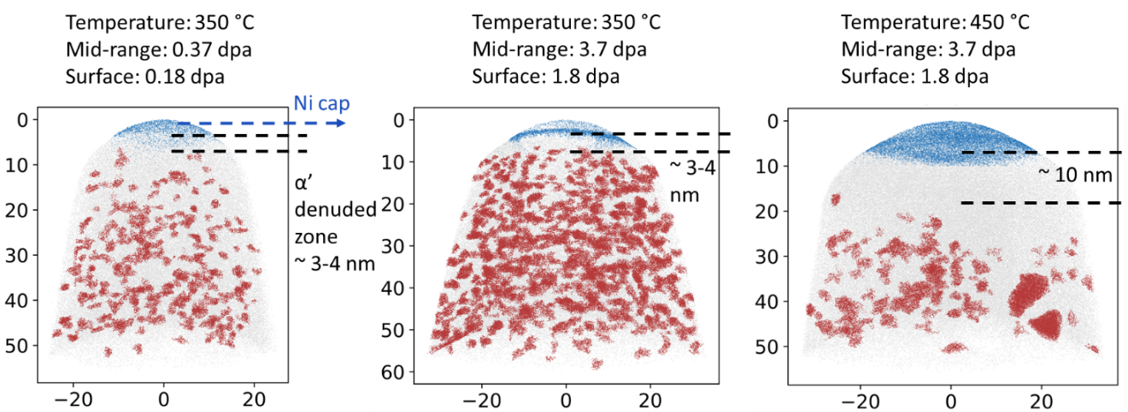
Figure 4.11 Reconstructions of needles taken from the surface depth of 3 specimens. α’ denuded zones are visible in the near-surface region. Local irradiation parameters are given above each reconstruction.

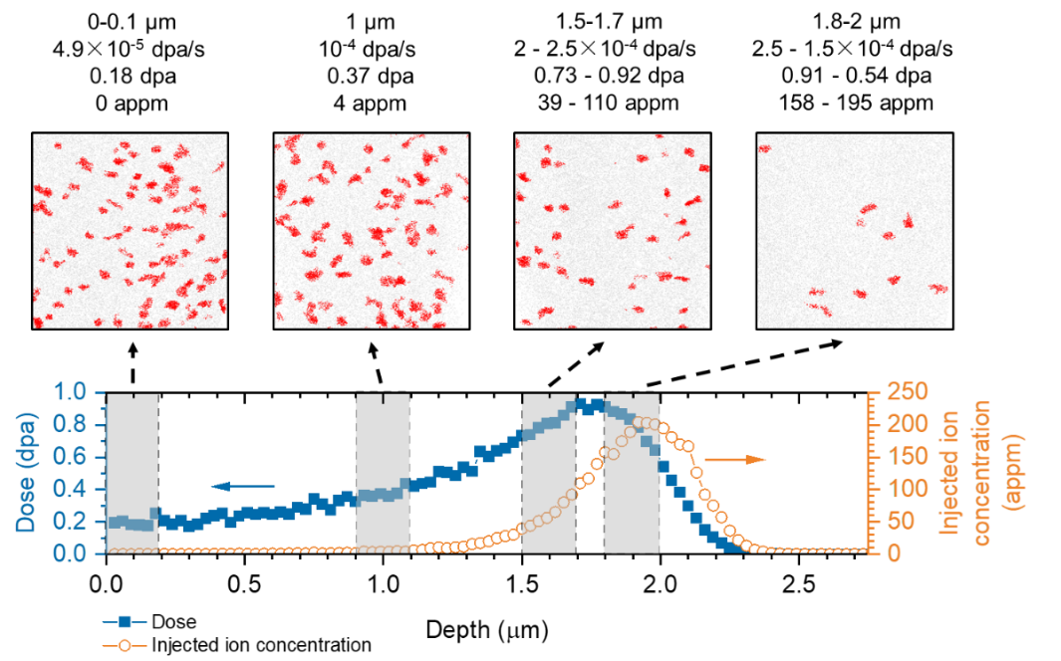
Figure 4.12 Cross-sections showing the distribution of α’ at different depths in Fe18Cr after irradiation at 350 °C to the low fluence. Imaged volume is 40×40×10 nm³ for each cross section. The local dose rate, dose and injected ion concentration are given above each cross-section.

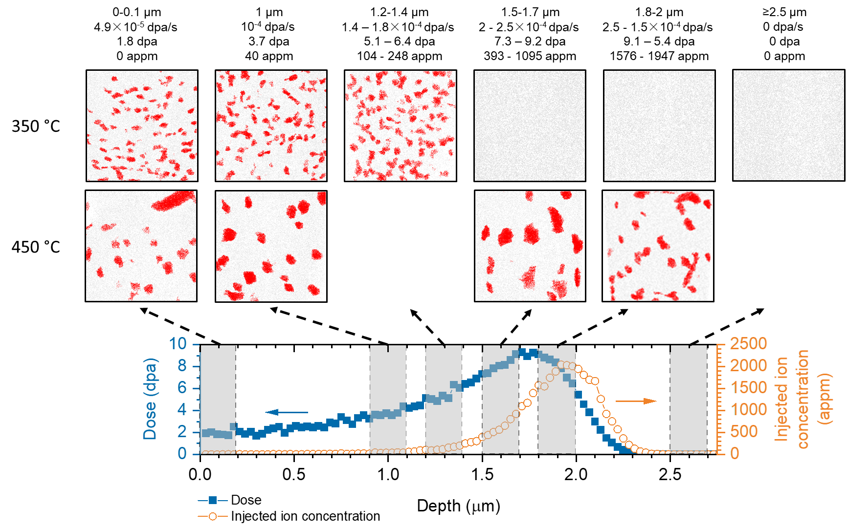
Figure 4.13 Cross-sections showing the distribution of α’ at different depths in Fe-18Cr after irradiation at 350 °C and 450 °C to the high fluences. Imaged volume is 40×40×10 nm³.
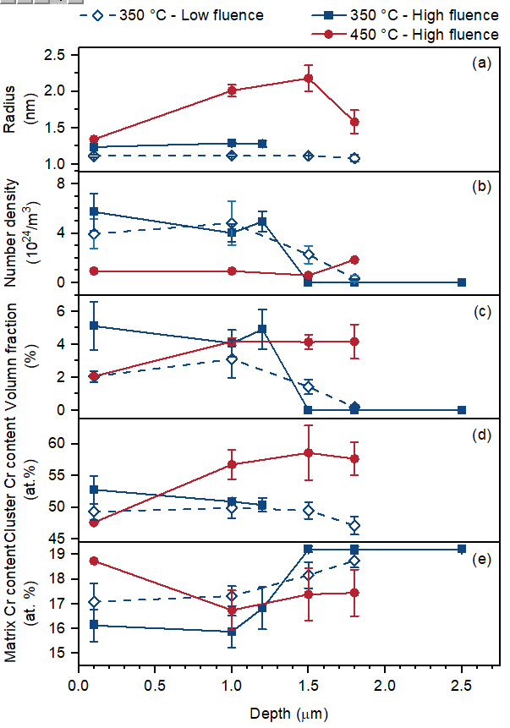
Figure 4.14 The evolution of (a) radius, (b) number density, (c) volume fraction, (d) Cr concentration in precipitates and (e) matrix with irradiation depth.

investigated depths. The number densities of α’ precipitates are nearly constant at depths shallower than 1.2 µm, above which they started to decrease for the low fluence condition and dropped below the practical APT volumetric density detection limit ~10²¹⁻²²/m³ for the high fluence condition. The volume fractions of the α’ precipitate phase showed a similar trend. The precipitate Cr contents are nearly unchanged up to 1.5 µm, and then decrease after irradiation at the 350 °C, low fluence condition. After irradiation to a high fluence, precipitate Cr concentrations are ~50% in all depths where α’ were observed, and matrix Cr contents increase at depths >1.2 µm due to the overall decreased Cr clustering. At 450 °C, both smaller-sized (radius ~1 nm) and large-sized precipitates (radius ≥1.5 nm) were present in the near-surface region (~0-200 nm depths), while precipitates with similar sizes were found in the depths of 1-1.8 µm, which resulted in a smaller average radius and a lower volume fraction of α’ in the former case. At the three deeper depths, precipitate radii initially increase with depth (irradiation dose) and then decrease at the peak damage region, while the number densities of precipitates are unchanged for depths of 0.1-1.5 µm and then increases at 1.8 µm depth. The Cr contents in precipitates also increase slightly with higher doses, and matrix Cr concentrations remain relatively constant at all investigated depths.

4.3 Effect of bulk Cr concentration on α’ formation in FeCr alloys

4.3.1 α’ precipitation in Fe-14Cr after ion irradiations
Fe-14Cr alloys were also irradiated with Fe ions at the conditions listed in Table 3.3. A similar cluster searching algorithm using a threshold Cr content of 24 at. % was applied to the APT datasets for identifying α’ clusters. The results for final doses of 0.37 dpa are presented in Figure 4.15. A large number of α’ precipitates could be observed after irradiations at dose rates of 10⁻⁵ to 10⁻⁴ dpa/s. Their properties including size, number density, volume fraction and chemical compositions in precipitate and matrix phases are given in Table 4.2. In general, the number densities of these precipitates are lower compared to that of Fe-18Cr after irradiation at the same conditions. At 10⁻³ dpa/s, Cr rich clusters were detected at 350 °C, but not at 450 °C, which is different from what was observed in Fe-18Cr. The microstructure of this specimen (Fe-14Cr, 450 °C, 10⁻³ dpa/s,
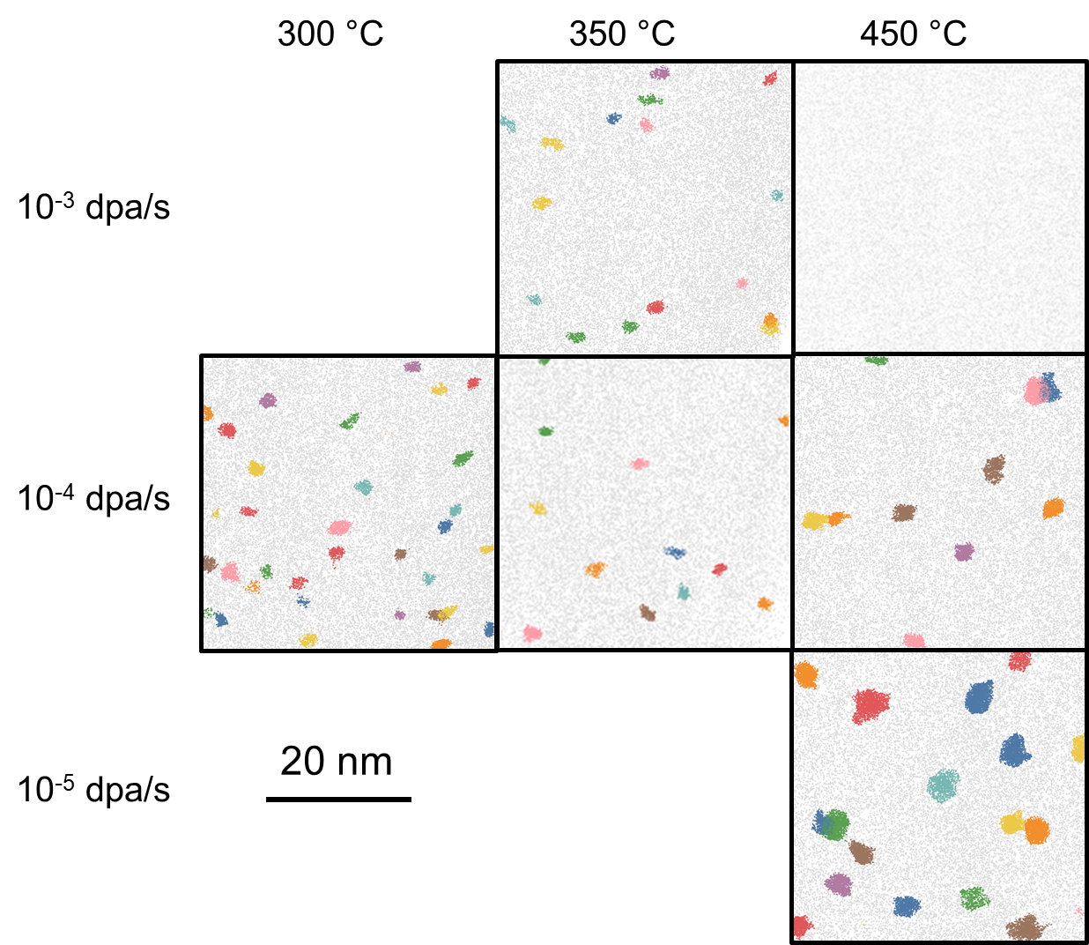
Figure 4.15 Cluster atom maps of Fe-14Cr irradiated to 0.37 dpa in sampled volumes of 40×40×10 nm³. Clusters are indexed with different colors. All elements including both Fe and Cr atoms are included.

Table 4.2 The characteristics of α’ precipitates in Fe-14Cr irradiated at 10⁻⁵-10⁻³ dpa/s, 300-450 °C to 0.37 or 3.7 dpa.
Irradiation temperature  (°C) | Dose rate (dpa/s) | Dose  (dpa) | Radius  (nm) | Number density  (10²⁴/m³) | Cluster core Cr content  (at. %) | Matrix Cr content  (at. %) | Volume fraction  (%)
300 | 10⁻⁴ | 0.37 | 1.17 ± 0.03 | 1.1 ± 0.2 | 43.5 ± 0.7 | 14.5 ± 0.7 | 0.81 ± 0.13
350 | 10⁻³ | 0.37 | 1.13 ± 0.02 | 0.61 ± 0.08 | 44.7 ± 2.5 | 14.6 ± 0.1 | 0.39 ± 0.05
350 | 10⁻⁴ | 0.37 | 1.21 ± 0.01 | 0.75 ± 0.42 | 42.7 ± 0.7 | 14.7 ± 0.3 | 0.59 ± 0.34
350 | 10⁻⁴ | 3.7 | 1.43 ± 0.02 | 1.0 ± 0.7 | 47.4 ± 1.5 | 14.9 ± 0.3 | 1.34 ± 0.95
450 | 10⁻⁴ | 0.37 | 1.56 ± 0.14 | 0.49 ± 0.12 | 50.5 ± 2.0 | 14.8 ± 0.1 | 0.93 ± 0.56
450 | 10⁻⁴ | 3.7 | 2.74 ± 0.51 | 0.06 ± 0.04 | 67.7 ± 8.5 | 14.5 ± 0.5 | 0.62 ± 0.39
450 | 10⁻⁵ | 0.37 | 1.95 ± 0.11 | 0.81 ± 0.22 | 60.7 ± 2.7 | 13.7 ± 0.5 | 2.94 ± 1.24

0.37 dpa) has been checked with TEM, which showed a clear irradiation damaged region in the ~2 µm near surface area. The absence of α’ in Fe-14Cr might be attributed to a precipitate number density that is too low to be detected by APT, or the reduced solute supersaturation level.
The distribution of clusters after ion irradiation at 10⁻⁴ dpa/s to 3.7 dpa is shown in Figure 4.16, and the numerical results are also listed in Table 4.2. At 350 °C, Number density of precipitates is pretty high and the sizes are very similar among each other. However, only a few very large precipitates are present after ion irradiation at 450 °C to 3.7 dpa. The number density was largely decreased compared to low dose results at the same temperature and dose rate, which indicates a coarsening of the α’ precipitates and the lower supersaturation of Cr solute relative to the solvus line at this higher temperature.

4.3.2 α’ precipitation in Fe-12Cr
Five ion-irradiated Fe-12Cr specimens have been selected for APT characterizations based on the results of Fe-18Cr and Fe-14Cr alloys. The APT results showing Cr-enriched clusters are presented in Figure 4.17, in which each irradiation condition is given above the corresponding APT reconstruction. α’ precipitates were observed after irradiations at 300-350 °C. At the irradiation condition of 350 °C and 10⁻³ dpa/s, Cr clusters were detected, but their radii are only ~0.8 nm (Table 4.3), which are much smaller than the precipitates formed after irradiation at 300 °C, 10⁻⁴ dpa/s, 0.37 dpa and 350 °C, 10⁻⁴ dpa/s, 3.7 dpa. These two conditions gave precipitate sizes of ~1.1 nm and 1.6 nm, respectively.
At 450 °C, only the low fluence specimens (0.37 dpa) were studied due to the very low density of precipitates detected in Fe-14Cr after irradiation to 3.7 dpa at this temperature. If no clusters could be found in Fe-12Cr after irradiation to the high fluence, it will be difficult to determine whether this absence results from the ballistic dissolution of damage cascades, or the number density of precipitates being lower than the detection limit of APT. The results presented in Figure 4.17(d) and (e) suggest no α’ formation after irradiations at 10⁻⁵-10⁻⁴ dpa/s, instead, a Cr-enriched carbide was observed. There are two
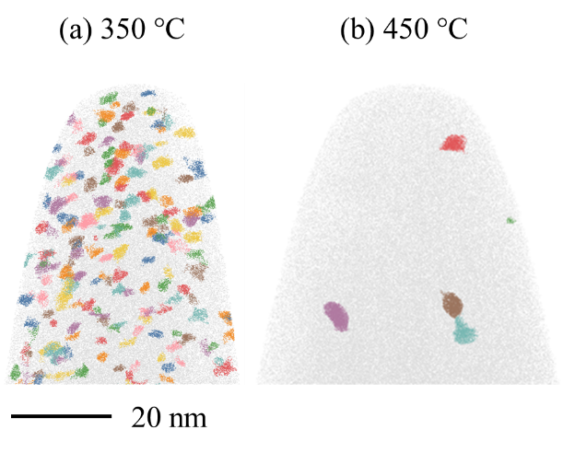
Figure 4.16 APT reconstruction for Fe-14Cr irradiated at 10⁻⁴ dpa/s to 3.7 dpa. The irradiation temperatures are presented above each reconstruction. All the particles indexed by different colors are α’ precipitates.

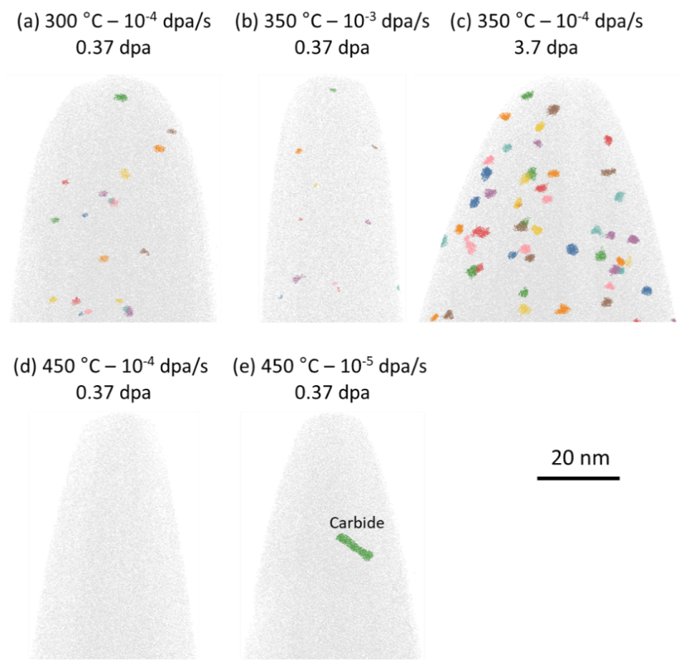
Figure 4.17 APT reconstructions of Fe-12Cr alloys after irradiation at 5 conditions. The irradiation temperature, dose rate and final dose are presented above each reconstruction. All the particles indexed by different colors are α’ precipitates.

Table 4.3 The characteristics of α’ precipitates in Fe-12Cr irradiated at 10⁻⁵⁴10⁻³ dpa/s, 300 and 350 °C to 0.37 or 3.7 dpa.
Irradiation temperature  (°C) | Dose rate (dpa/s) | Dose  (dpa) | Radius  (nm) | Number density  (10²⁴/m³) | Cluster core Cr content  (at. %) | Matrix Cr content  (at. %) | Volume fraction  (%)
300 | 10⁻⁴ | 0.37 | 1.06 ± 0.01 | 0.23 ± 0.05 | 43.9 ± 1.5 | 12.5 ± 0.1 | 0.12 ± 0.02
350 | 10⁻³ | 0.37 | 0.77 ± 0.02 | 0.17 ± 0.08 | 48.4 ± 1.2 | 11.9 ± 1.6 | 0.04 ± 0.02
350 | 10⁻⁴ | 3.7 | 1.58 ± 0.04 | 0.38 ± 0.05 | 49.9 ± 1.7 | 12.4 ± 0.1 | 0.67 ± 0.10

possible explanations for the absence of α’ at 450 °C: the Cr concentration of Fe-12Cr is too low to enter the two-phase region of the phase diagram or the Cr supersaturation is so low that the driving force for phase separation is not strong enough to balance the ballistic dissolution of displacement cascades. Our thermal treatment results, which will be presented in a later section, showed no α’ formation in Fe-12Cr after aging at 450 °C up to 1 year. It indicates this composition is in the single-phase region at 450 °C, and thus there is no thermodynamic driving force for phase separation.

4.3.3 α’ precipitation in Fe-10Cr
Only one Fe-10Cr specimen has been characterized after ion irradiation. The selected irradiation condition was 350 °C, 10⁻⁴ dpa/s and 3.7 dpa. As shown from the APT reconstruction in Figure 4.18(a), no precipitates were identified. Figure 4.18(b) gives the comparison between standard deviations of the binomial distribution and experimental results as suggested by Thuvander et al [157]. The two curves almost overlap with each other, indicating the random distribution of Cr atoms within the whole datasets, and thus consistent with our cluster analysis results.

4.4 Using proton irradiation and thermal aging to determine the phase boundary

4.4.1 α’ formation after proton irradiations
Proton irradiations of Fe-(5-18)Cr at 250-450 °C were conducted to accelerate the kinetics of phase separation to form α’, which were identified in a wide range of specimens through APT characterizations as presented in Figure 4.19. Cr rich clusters are visible in all specimens after irradiation at 250 °C, in both Fe-10Cr and Fe-18Cr specimens at 350 °C, and only in Fe-18Cr at 450 °C. The number density of precipitates is much higher in Fe-18Cr alloys at 250-350 °C than in all other conditions.
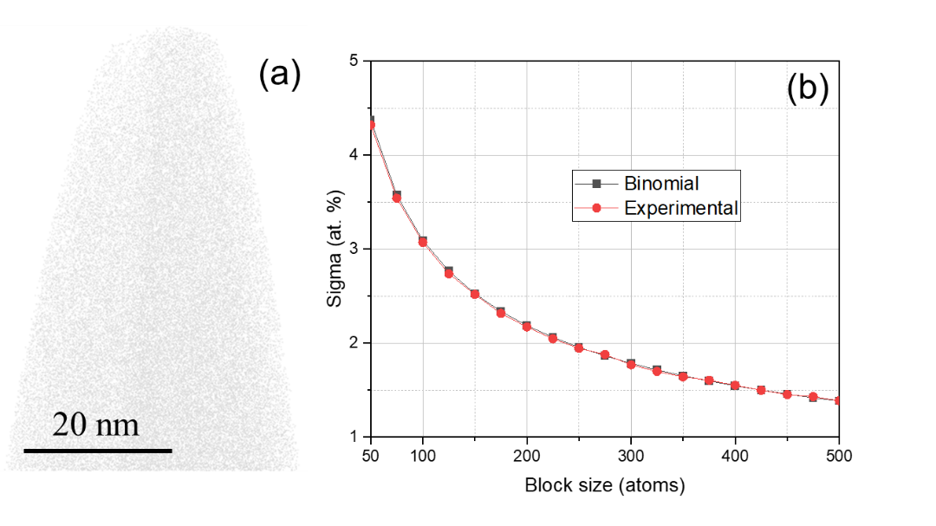
Figure 4.18 (a) APT reconstruction for Fe10Cr irradiated at 10⁻⁴ dpa/s and 350 °C to 3.7 dpa. No α’ particles formed after irradiation. (b) Comparison between the standard deviations of the binomial distribution and the standard error of Cr atoms distribution in experimental datasets.

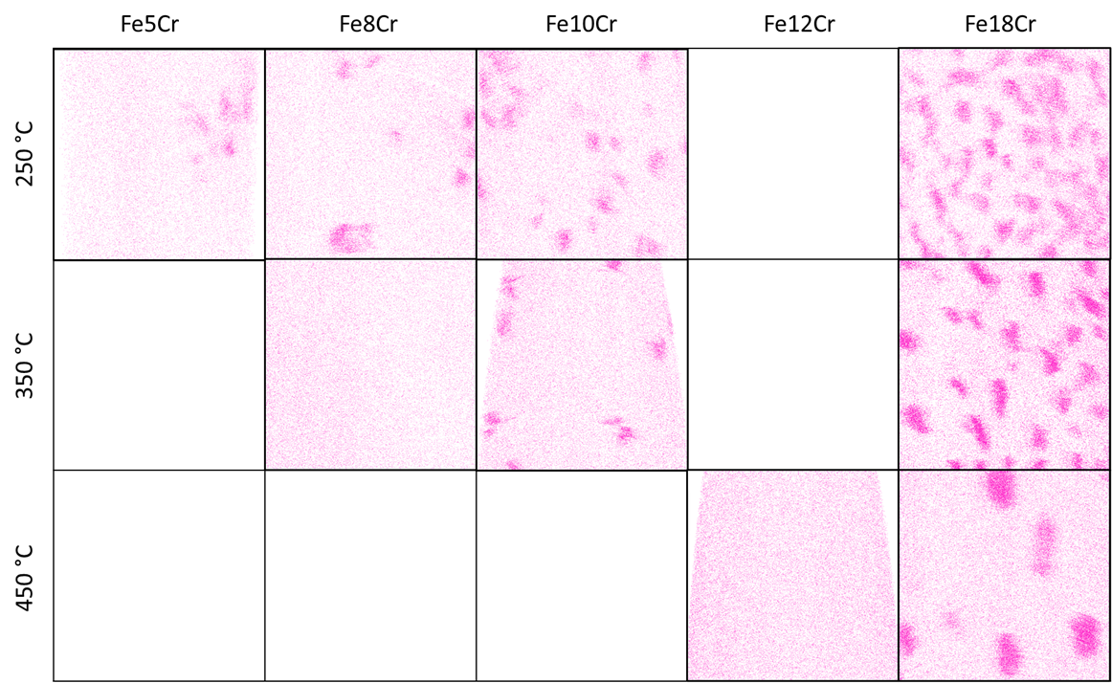
Figure 4.19 Cr atom maps of FeCr alloys irradiation by protons at 250, 350 and 450 °C. The imaged volume for each condition is 40×40×10 nm³.

Using the APT technique, not only the presence or absence of α’ can be detected, but also the matrix Cr concentrations can be measured. The matrix Cr will equal the solubility limit if the thermal equilibrium state is reached and higher than the solubility limit if the thermal equilibrium state is not reached. Bachhav et al pointed out that the measured matrix compositions would change as a function of the threshold solute values used to create interfaces [5]. Therefore, to minimize the artifact associated with selecting inappropriate threshold values and to obtain more objective results, multiple values in 20-50% were used.
Two examples showing the effect of changing threshold values on the measured proxigrams are plotted in Figure 4.20 (a) and (b). Despite the shift of the precipitate interface due to different solute concentrations used to create interfaces, the Cr concentrations at the precipitate center remain relatively constant. In Fe-18Cr specimen irradiation to 2 dpa, the Cr concentrations inside precipitates are ~85 at. % at 350 °C and 95-100 at. % at 450 °C. Since a higher α’ solute concentration is expected at lower temperatures according to the phase diagram, this reversed trend may suggest the precipitates formed at 350 °C have not reached their steady state Cr concentration values and further enrichment of Cr are very likely at higher doses.
To demonstrate the complicated effect of threshold Cr concentrations on matrix composition measurement, the matrix side of proxigrams in Figure 4.20 (a-b) are enlarged in Figure 4.20 (c) and (d), respectively. At 350 °C, increasing interface Cr concentrations leads to a change in the curvature and vertical position of curves. As the proxigram extends into the matrix side or the distance values become more negative, the Cr concentration in each bin decreases and then increases due to intersecting neighboring precipitates. Therefore, matrix solute concentrations were taken as the lowest points on the proxigram, and 5 bins were averaged to give the final result at this irradiation condition. However, the proxigram at the matrix side is almost flat and independent of the selected interface solute contents after irradiation at 450 °C.
This variance in dependence of matrix solute concentration on threshold values for creating interfaces can be further observed from the plots in Figure 4.20 (c), in which 250 °C irradiation gave the largest dependence, which then decreases at higher temperatures
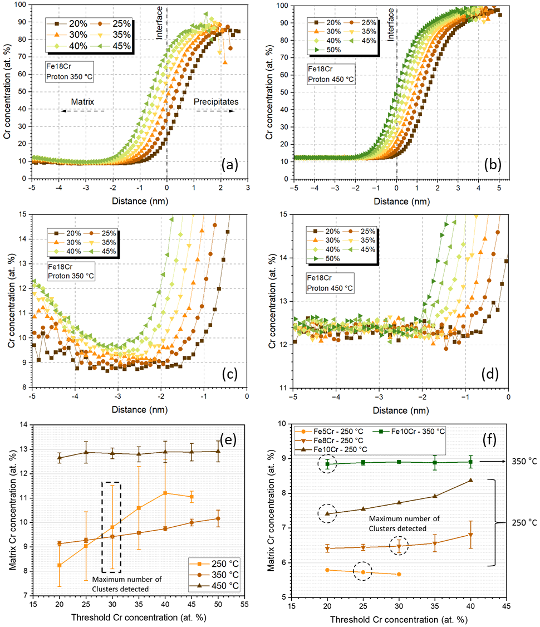
Figure 4.20 proxigrams of Fe18Cr alloy irradiation by protons at (a) 350 °C and (b) 450 °C to 2 dpa demonstrate the shift and change resulting from changes in threshold Cr concentration values. (c) and (d) are the zoom-in view of the matrix side in (a) and (b). Matrix Cr concentration depends on threshold values in (e) Fe18Cr and (f) Fe(5-10)Cr specimens. The dashed box in (e) and dashed circles in (f) point out the threshold Cr concentration values at which maximum numbers of clusters were detected.

and becomes negligible at 450 °C. The reason for this variation can be attributed to the merging or splitting of precipitates that is controlled by changing concentration values at interfaces, which is more likely to happen when the precipitate number density is very high. Results from alloys with much lower bulk solute concentrations are plotted in Figure 4.20 (f); the negligible dependence in Fe-10Cr at 350 °C and decreasing dependence in more dilute alloys at 250 °C agree with this logic. Although the matrix Cr content can be accurately measured in cases where the dependence is weak, the stronger dependences under other conditions place difficulties in the objective determination of chemical compositions. The method proposed by Bachhav et al was used here, who suggested using the threshold values giving the maximum number of iso-concentration interfaces [5].
The properties of these observed α’ precipitates were measured by APT and plotted in Figure 4.21. The 18 dpa datapoints are from the peak depth of the same specimen that has a damage level of 2 dpa at mid-range. Precipitate sizes increase with irradiation temperatures. Pre-aging at 475 °C for 900 hours slightly increased the α’ sizes, but the difference is within statistical errors. The high dose of 18 dpa had no noticeable effect on all the properties of α’ precipitates. Higher bulk Cr concentrations lead to a smaller precipitate size at 250 °C, while its effect is not very obvious at 350 °C. For the number density, it generally decreased with increasing irradiation temperatures, and again the effect of pre-aging is not significant. The values measured from the more dilute alloys are much lower compared to that from Fe-18Cr, which can be attributed to the lower solute supersaturation. Cr concentration at the core of α’ increases with irradiation temperatures. The effect of both bulk solute concentrations and pre-aging is negligible. On the other hand, matrix Cr contents also increases with temperature, and more dilute alloys have lower matrix concentration values after irradiations. The measured volume fractions of α’ phase show distinct difference among the Fe-18Cr VS the more dilute Fe-(8-10)Cr specimens. However, they both showed decreased values with increasing temperatures.

4.4.2 α’ formation and hardness change after thermal aging
FeCr alloys with Cr concentrations of ~10-18% were aged in furnaces for long times of 100 hours to 1 year (details can be found in Table 3.2). Since α’ precipitates can
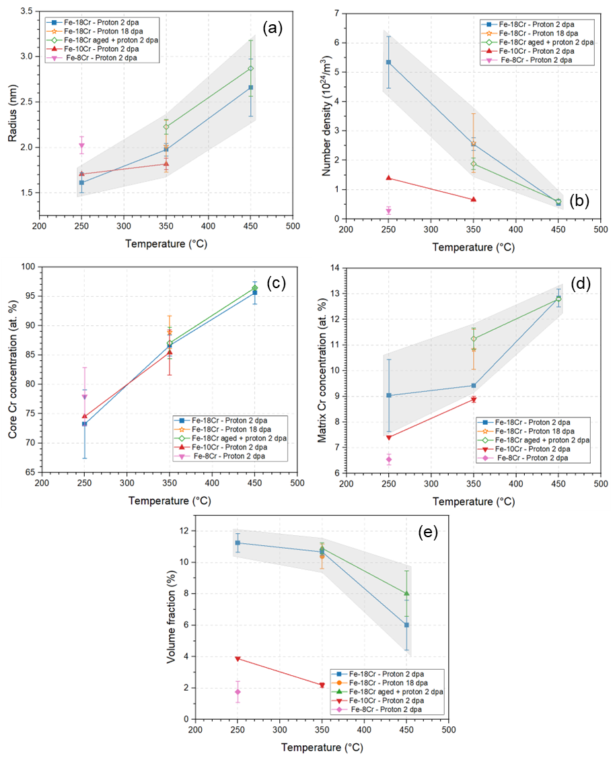
Figure 4.21 The evolution of (a) radius, (b) number density, (c) Cr at the core of precipitates, (d) Cr concentrations in matrix and (e) volume fraction of α’ formed after proton irradiations at 250-450 °C to final doses of 2-18 dpa. Shadowed regions indicate results from Fe-18Cr specimens. Two specimens were pre-aged at 475 °C for 900 hours before proton irradiations.

result in the hardening of specimens, any trace of α’ formation can be tracked through Vickers hardness tests, the results from part of specimens are plotted in Figure 4.22. At both 450 and 475 °C, an obvious hardness increase was observed in alloys with Cr concentrations >15 at. %, which implies these two alloys are located in the two-phase region of the phase diagram. On the other hand, Fe-10Cr and Fe-12Cr alloys showed no difference in hardness after thermal aging compared to their as-received (solution annealed) states, and thus their compositions appear to be below the solubility limit, in which there is no thermodynamic driving force for phase separation. These results indicate the phase boundary at 450-475 °C should be between 12.4 and 15.2 at. %, and it is consistent with the proton irradiation APT results. Therefore, α’ precipitation in Fe-18Cr alloys at 450 °C can be attributed to pronounced radiation-enhanced diffusion during proton irradiation at 2×10⁻⁵ dpa/s within ~28 hours. However, thermal aging tests at 450 °C for ~28 h will be useful to confirm the effect of thermal annealing alone on α’ formation.
Cr-enriched clusters can be observed from the APT reconstructions of the three Fe-18Cr specimens after thermal aging at 450-500 °C as presented in Figure 4.23(a-c). The increasing size of clusters at higher temperatures indicates more growth and coarsening of precipitates. In Figure 4.23(d), the matrix side of the proxigram at 500 °C is flatter compared to the concaving curves at the two lower temperatures, which is another sign of lower precipitate number density and thus less probability of crossing other precipitates. Quantitative properties of α’ precipitates formed after thermal aging are listed in Table 4.4. Results from Ref. [166] and previous thermal annealing performed at 500 °C for 100 or 300 hours are also summarized here for comparison. At 500 °C, 900 hours, Cr concentration at precipitate core reaches ~80-85 at. %, which is consistent with previous thermal aging studies characterized by the APT technique [4, 66]. However, α’ formed at 450 and 475 °C showed lower Cr concentrations of 70-80 at. %, which is also lower than the Cr enrichment level in the same alloy after proton irradiation at 450 °C. It suggests the thermal equilibrium state hasn’t been reached, and a further increase in Cr concentration will happen after aging for longer times. In Figure 4.23(e), matrix solute concentrations show strong dependences on threshold values at 450 and 475 °C. At these conditions, a maximum number of interfaces were identified using a threshold concentration of 30 at.
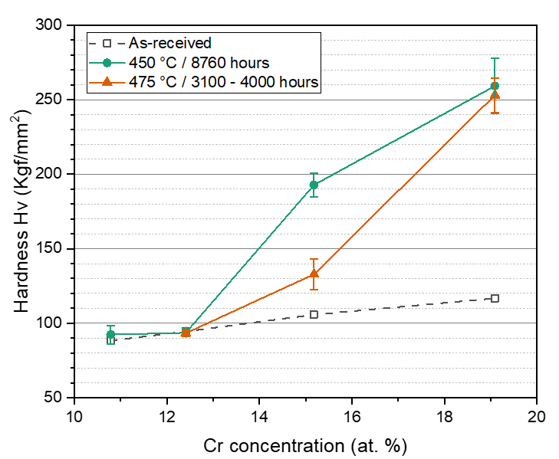
Figure 4.22 Vickers hardness of FeCr alloys in as-received and aged states.
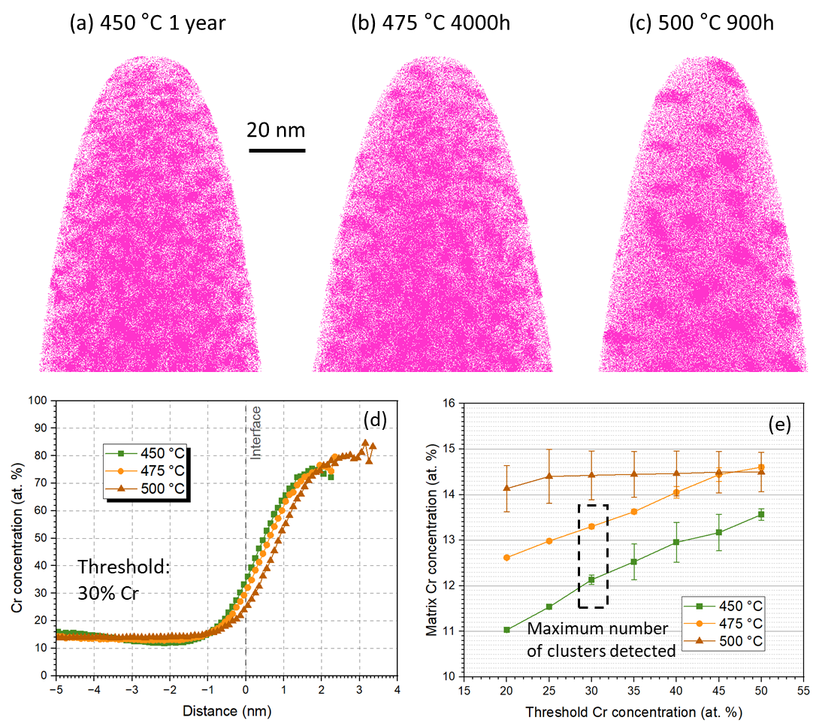
Figure 4.23 (a-c) Cr atoms distribution in Fe-18Cr alloys after thermal aging at the indicated temperatures and times. (d) Proxigrams showing the change of Cr concentration crossing 30% at.% Cr iso-concentration interfaces in the 3 aged specimens. (d) The dependence of measured matrix Cr concentrations as a function of threshold values at interface.

Table 4.4 The characteristics of α’ precipitates in Fe-18Cr aged at 450-500 °C for 100-8760 hours.
Aging temperature  (°C) | Aging time  (h) | Radius  (nm) | Number density  (10²⁴/m³) | Cluster core Cr content  (at. %) | Matrix Cr content  (at. %) | Volume fraction  (%)
450 | 8760/  1 year | 1.58 ± 0.06 | 4.23 ± 0.36 | 73.5 ± 3.0 | 12.1 ± 0.1 | 8.63 ± 0.11
475 | 100 | 1.07 ± 0.02 | 1.20 ± 0.08 | 46.8 ± 0.2 | 18.8 ± 0.1 | 0.74 ± 0.09
475 | 300 | 1.56 ± 0.01 | 3.34 ± 0.04 | 64.8 ±2.2 | 15.5 ± 0.1 | 6.01 ± 0.14
475 | 900 | 1.74 ± 0.01 | 2.41 ± 0.04 | 69.8 ± 0.3 | 13.4 ± 0.4 | 6.57 ± 0.03
475 | 4000 | 1.77 ± 0.02 | 2.71 ± 0.10 | 74.5 ± 1.5 | 13.3 ± 0.1 | 7.62 ± 0.11
500 | 100 | 1.24 ± 0.03 | 1.13 ± 0.13 | 51.4 ± 0.7 | 18.4 ± 0.1 | 1.18 ± 0.08
500 | 300 | 1.45 | 0.65 | 58.6 | 18.2 | 1.01
500 | 900 | 2.85 ± 0.34 | 0.51 ± 0.21 | 83.2 ± 5.3 | 14.4 ± 0.5 | 6.2 ± 0.6
*Errors given in this table are standard deviations calculated from multiple APT datasets. For the aging condition 500 °C, 300 hours, only one APT dataset was collected and thus error was not obtained.

%, and thus the corresponding measured values were selected as final matrix concentrations.

4.5 Ballistic dissolution of Cr and Cu precipitates by ion irradiations

4.5.1 Precipitate formation after thermal aging
The distribution of solute atoms in Fe-18Cr and FeCu alloys after thermal aging is presented in Figure 4.24. Cu clusters are clearly visible from the reconstructions at both aging conditions. After aging for 10 hours, strong coarsening of precipitates is accompanied by a decrease in number density, which agrees with the conventional Ostwald ripening mechanism. In the Fe-18Cr specimens, precipitates are unobvious in the 100h aging condition due to both the high bulk solute concentrations and low contrast of solute contents between matrix and precipitates. However, they become easily distinguishable after aging for 900 hours. In general, the number densities of precipitates in Fe-18Cr are much higher than that in FeCu specimens. Sizes of Cu and Cr precipitates will be presented later.

4.5.2 Dilution of Cu precipitate after ion irradiations
FeCu alloys containing Cu precipitates were irradiated by 8 MeV Fe ions at conditions listed in Table 3.4. The status of Cu precipitates after each irradiation was characterized by APT and the results are given in Figure 4.25. Small Cu precipitates formed from 1.5h aging became less distinct with increasing irradiation doses; only slight Cu-enriched regions can be observed at 0.6 dpa. However, the Cu atom distribution in the whole APT tip still shows some inhomogeneity compared to the uniform distribution in the as-received state. The relatively large Cu precipitates formed from aging for 10 hours stayed stable without clear change (according to the atom maps) for doses up to 0.6 dpa.
The number density, average radius and volume fraction of Cu precipitates are plotted in Figure 4.26 as a function of dose for the two pre-aged conditions. The results obtained at 0.1 dpa was plotted together with the other two doses because they all represent
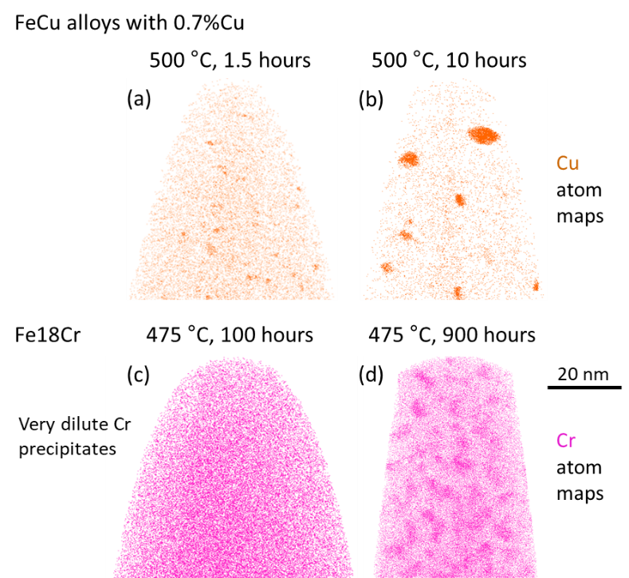
Figure 4.24 APT reconstructions showing the distribution of (a, b) Cu atoms in FeCu alloys and (c, d) Cr atoms in Fe-18Cr specimens after thermal aging at indicated temperatures and times.

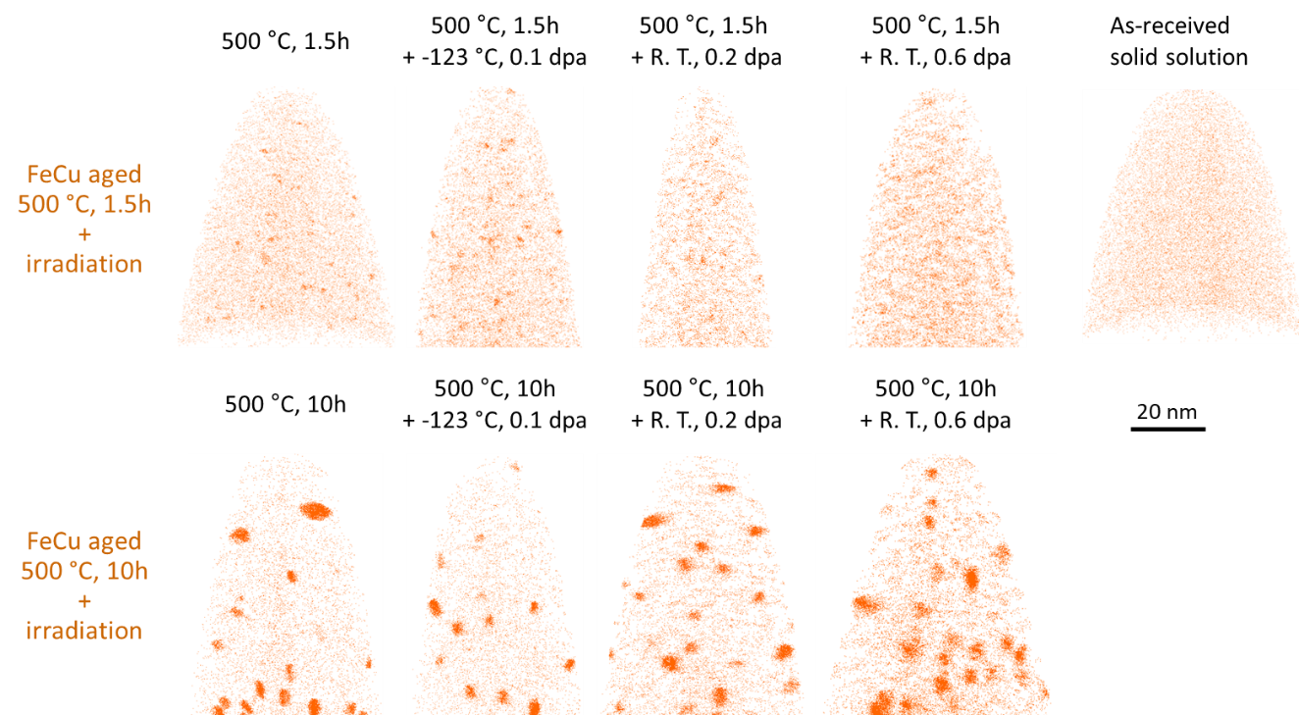
Figure 4.25 APT reconstructions showing the distribution of Cu atoms in FeCu alloys (a-d) after aging at 500 °C for 1.5h + irradiation at -123 °C - room temperature to 0.1-0.6 dpa and (f-i) after aging at 500 °C for 10h + irradiation at the same conditions. Cu atom map in the as-received state is given in (e) for comparison.

the precipitate evolutions at dissolution dominant conditions. The properties of precipitates remain relatively constant before and after irradiations. The slightly increasing volume fraction of Cu precipitates in the 10h aged specimen at 0.6 dpa is within statistical errors. Compared to the trendline for the as-aged and RT, 0.2 dpa irradiated specimens, the 150K, 0.1 dpa specimen appears to exhibit a slightly higher number density and a slightly reduced size. The 0.1 dpa irradiation temperature was -123 °C, which was much lower than the RT value used for the other irradiation doses. The most important change induced by irradiations is the large decrease in precipitate core solute concentrations from as-aged to 0.6 dpa irradiated condition (34% to 22% for the 1.5h aged specimens and 65% to 26% for the 10h aged specimens). This is strong evidence for significant ballistic mixing and cannot be attributed to APT artifact since the precipitate size and number density was nearly constant. Matrix Cu concentrations are plotted in Figure 4.26 (e). For the 1.5h aged specimens, matrix Cu concentration is slightly lower at 0.1 dpa and becomes lowest at 0.2 dpa, whereas as-aged and 0.6 dpa specimens gave similar values. The main reason for these two lower concentrations is the inhomogeneity of the FeCu alloy. Most APT measurements gave bulk Cu concentrations ~0.65 at. %, while the 0.1 dpa specimen has Cu contents of 0.59±0.08 at. %, and 0.2 dpa specimen only has 0.49±0.11% Cu (calculated from 4 APT datasets, which contain Cu concentrations of 0.47, 0.35, 0.66 and 0.48%, respectively). This inhomogeneity blurs the effect of irradiation, and thus no trend could be derived from the 1.5h aged specimen. On the other hand, 10h aged specimens show clear increase in matrix Cu content with increasing irradiation dose, which is attributed to dissolved Cu atoms from precipitates.
Detailed analysis showing the distribution of Cu precipitate sizes is plotted in Figure 4.27 (a) and (c). For the specimens starting with small Cu precipitates formed from 1.5h aging, size distributions are very close among the aged and aged + irradiated conditions. However, in the specimen aged for 10 hours, the size distribution of Cu precipitates slightly shifts to larger sizes at 0.2 dpa and shows bimodal distribution with a large number of small clusters after irradiation at 0.6 dpa, which may form from the partial dissolution of large Cu precipitates. As plotted in Figure 4.27 (b) and (d), Cu concentrations at the precipitate core decrease gradually with increasing irradiation dose, regardless of the
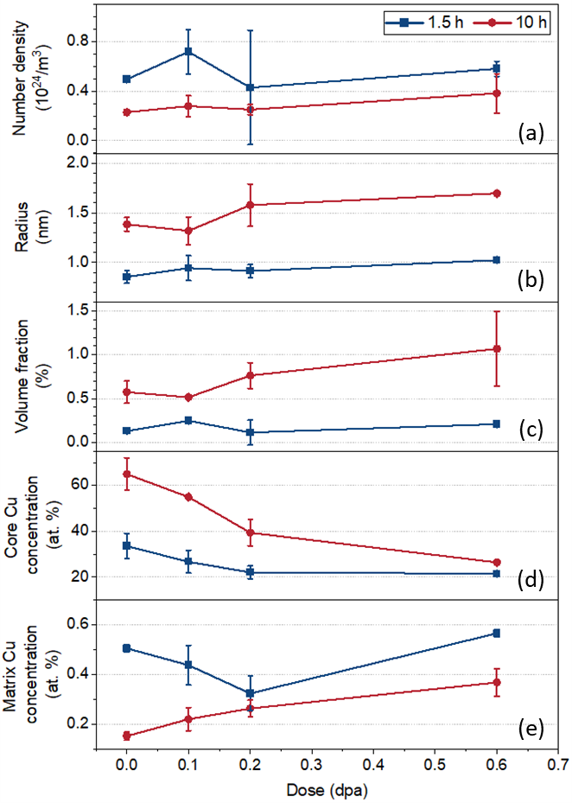
Figure 4.26 The evolution of (a) number density, (b) radius, (c) volume fraction, (d) precipitate core Cu concentrations and (e) matrix Cu concentration in FeCu alloys irradiated to 0.1-0.6 dpa.
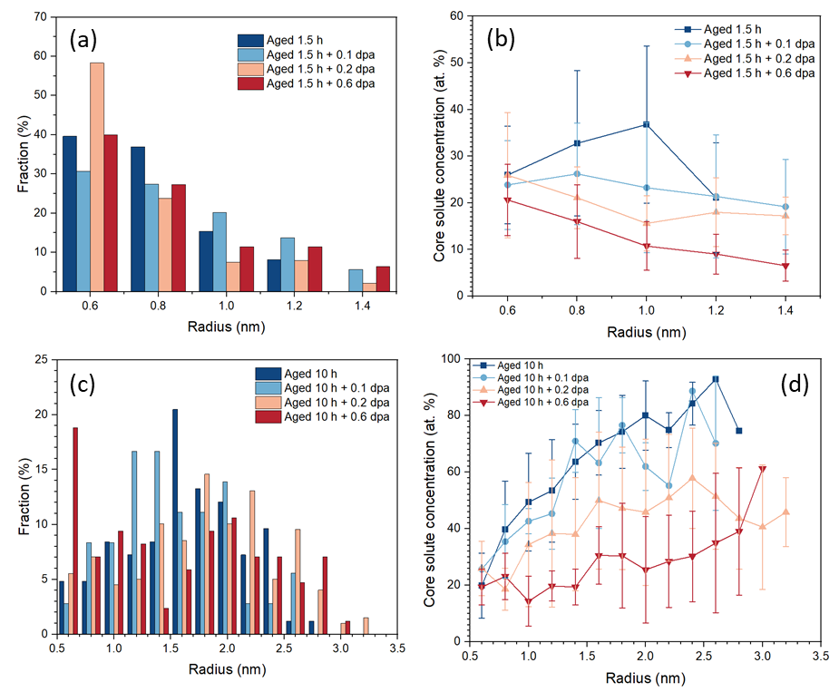
Figure 4.27 (a) Size distribution of Cu precipitate and (b) change of precipitate Cu concentration as a function of precipitate sizes in FeCu alloys after aged at 500 °C for 1.5 hours and aged followed by irradiations to 0.1-0.6 dpa. (c) and (d) are similar plots to (a) and (b) respectively. The specimens were aged at 500 °C for 10 hours followed by irradiation under the same conditions.

cluster size. In Figure 4.26 (b), Cu concentrations decrease with increasing precipitate sizes in each specimen. This might be associated with their sizes that are comparable to the sizes of background clusters. As mentioned in section 3.4.6, background clusters are removed based on their small sizes and low solute concentrations, so a smaller cluster can survive from the removing process only if it has a relatively higher solute concentration, which leads to the higher measured solute concentrations in the smaller precipitates. Precipitates are much larger in 10h aged specimens, so the effect of removing background clusters becomes less important, and Cu contents increase with precipitate sizes. This trend might be related to the blurring effect from trajectory aberration or the non-classical nucleation process [66, 141]. Further analysis is required to clarify it.

4.5.3 Evolution of Cr precipitate after ion irradiations
Fe-18Cr specimens aged at 475 °C for 100 or 900 hours to form pre-existing α’ precipitates were irradiated in the same target stage as the FeCu specimens. APT results showing the distribution of Cr atoms before and after irradiations are presented in Figure 4.28. Due to the high solute concentration of Fe-18Cr alloy and the dilute precipitates (~45% Cr) formed after the shorter aging time, the Cr precipitates are not readily visible from the atom maps, so the clusters identified using our analysis algorithms are also shown below for clarity. Surprisingly (based on the 300-450 °C results presented in section 4.1); only negligible changes can be observed from these reconstructions. Cr precipitates remain stable after RT and cryogenic irradiations up to 0.6 dpa. Similar trends can also be observed in the 900h aged specimens.
Statistical results comparing the evolution of quantitative properties of α’ precipitates before and after the irradiations are plotted in Figure 4.29. The number density, radius and volume fraction of precipitates are almost unchanged by irradiation up to 0.6 dpa. The only noticeable modification induced by the irradiations is the gradual decrease of precipitate core Cr concentrations in the Fe-18Cr specimen aged at 475 °C for 900 hours followed by irradiation at 0.1-0.6 dpa, which is similar to what was observed in the FeCu
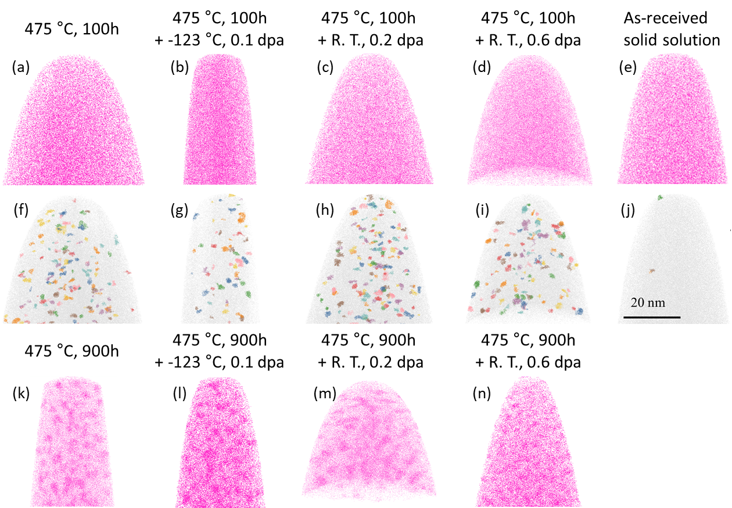
Figure 4.28 APT reconstructions showing the distribution of Cr atoms in Fe-18Cr alloys (a-d) after aging at 475 °C for 100h + irradiation at -123 °C to RT to 0.1-0.6 dpa. For better visualization, Cr-rich clusters filtered by our algorithms are presented below each Cr atom map in (f-j). (k-n) Cr atom distribution after aging at 475 °C for 10h + irradiation at the same conditions. Cr atom map in the as-received state is given in (e) for comparison.

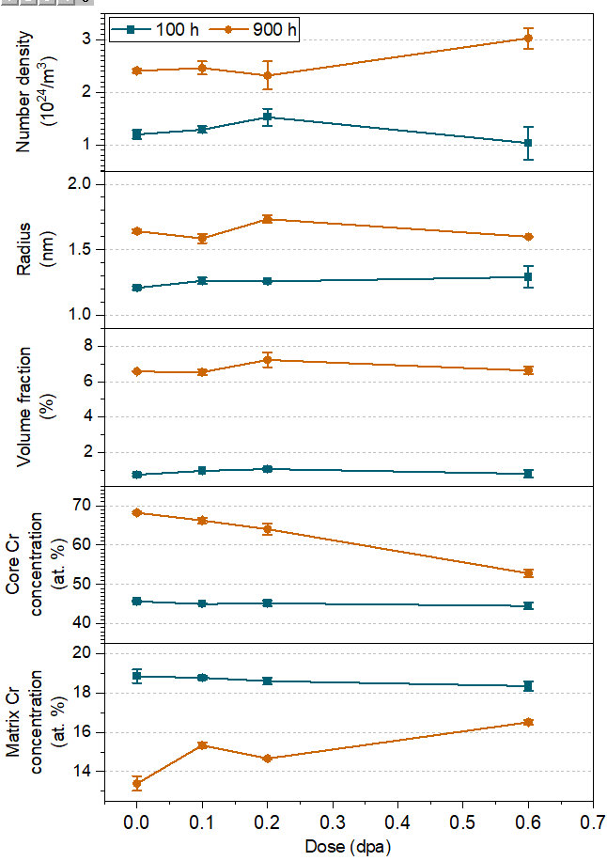
Figure 4.29 The evolution of (a) number density, (b) radius, (c) volume fraction and (d) precipitate core Cr concentrations of α’ precipitates in Fe-18Cr alloys irradiated to 0.1-0.6 dpa.

alloys. On the contrary, Cr concentrations of precipitates in Fe-18Cr samples aged for 100 hours remain unchanged (at a relatively low value of ~45%) after irradiation up to 0.6 dpa. Matrix Cr concentrations was not changed by irradiations in the 100 hour-aged specimens, while in the 900 hour-aged specimen, it was increased for ~3% after irradiation to 0.6 dpa.
The distribution of α’ sizes for the 475 °C, 100h aged Fe-18Cr specimen before and after irradiation is plotted in Figure 4.30 (a). Both the extents and peaks of all distributions are very close to each other. This is also true for the same alloy aged for the longer time (900h) followed by irradiations at the same conditions (Figure 4.30 (c)). Since the decrease of core Cu concentrations in precipitates of all sizes was observed in FeCu alloy system, it is useful to confirm whether or not a similar trend was observed in Fe-18Cr. Distinct differences can be observed from the plots in Figure 4.30 (b) and (d). In Fe-18Cr aged for 100h, the Cr concentrations of precipitates after irradiation to 0.1-0.6 dpa are almost overlapped with the ones in the as-aged state, indicating there is no change in α’ compositions. On the other hand, the larger and more concentrated precipitates formed after aging for 900h show gradual dilution of Cr concentrations inside precipitates with increasing irradiation doses, similar to what happened in the Cu precipitates.
To identify possible local changes in Cr atom distributions that can’t be detected by the cluster analysis algorithm, nearest neighbor distribution analysis was performed in all Fe-18Cr datasets. Nearest neighbor distribution analysis measures the distance between two solute atoms and plots the cumulative counts at each distance range. Order is an input parameter in this analysis, where the nth order represents the nth nearest neighbors. Most frequently used orders are in the range of 1-10, and a higher order is usually selected when the inhomogeneity of solute distribution is minor, such as in the early stage of precipitate nucleation. Due to the low contrast between the precipitate and matrix phases in Fe-18Cr, tenth order was used to generate the distributions, the results of which are plotted in Figure 4.31. Two peaks can be identified in the distribution curves if there is significant solute clustering, in which the short-distance part represents the inter-solute distances in precipitates, while the long-distance part represents that in the matrix. An example of this case can be observed in Figure 4.31 (b) at aged and aged + irradiation up to 0.2 dpa conditions. The peak at ~0.4 nm signifies that the most likely location of the 1st through
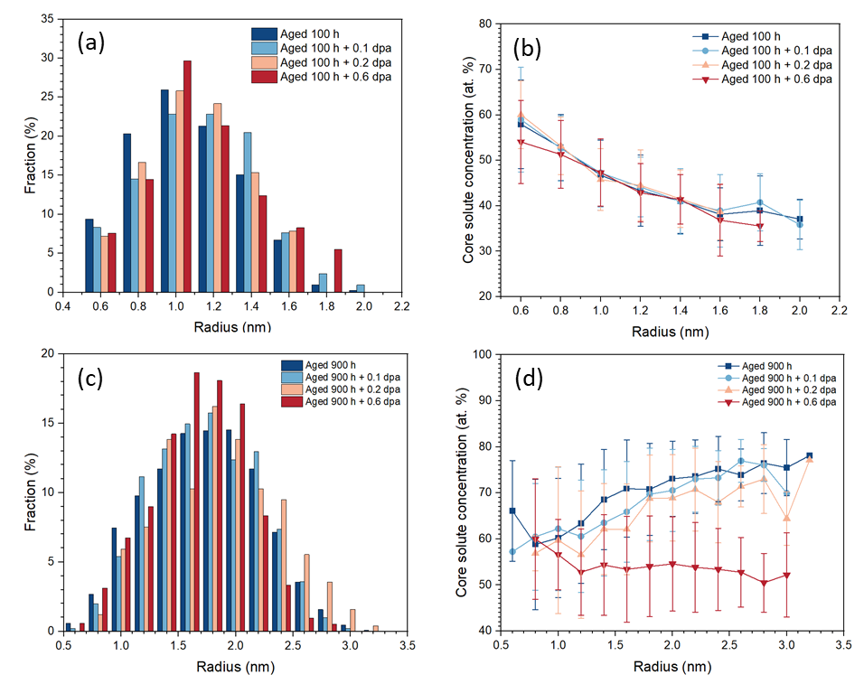
Figure 4.30 (a) Size distribution of Cr precipitate and (b) change of precipitate Cr concentration as a function of precipitate sizes in Fe-18Cr alloys after aged at 475 °C for 100 hours and aged followed by irradiations to 0.1-0.6 dpa. (c) and (d) are similar plots to (a) and (b) respectively. The specimens were aged at 475 °C for 900 hours followed by irradiation at the same conditions.

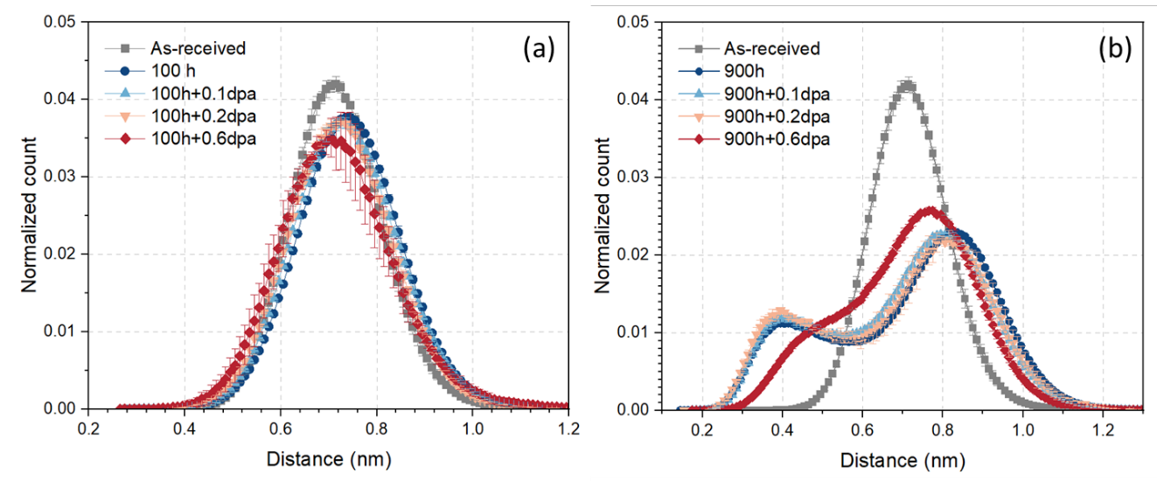
Figure 4.31 Tenth order nearest neighbor distribution of Cr atoms in APT datasets. The specimens are Fe-18Cr aged at 475 °C for 100 or 900 hours, and Fe-18Cr aged + irradiation to 0.1-0.6 dpa.

10th nearest Cr solute atoms in the solute clusters are all located within 0-0.4 nm of each other. For an ideal α’ precipitates containing only Cr atoms, the position of peak is expected to be slightly smaller than 0.4 nm. At the highest dose of 0.6 dpa, two distinct peaks become less obvious due to their shifts to central positions. However, the specimens aged for 100h didn’t give clear double-peak distributions because the Cr precipitates are less mature and contain fewer Cr atoms. There is only one peak in the distributions calculated after aging or irradiation for all of the 100h pre-aged specimens, and their peak shapes and locations are not very different compared to the as-received state.

Discussion

5.1 Comparison with previous experimental and simulation results

5.1.1 Proton irradiations at 250-450 °C
Well-developed α’ precipitates were observed in FeCr binary alloys after irradiations by protons at 250-450 °C to 2 dpa. The Cr concentrations within precipitates approached ~80% (all concentrations are in atomic percent if not specified) at 250 °C, 85-90% at 350 °C and ~95% at 450 °C. The decreasing Cr concentrations at lower temperatures are opposite to what is predicted by the equilibrium phase diagram [58, 65]. This may be due to the slower kinetics of phase separation at the lower temperatures, and thus a higher dose is required to achieve a steady state precipitate concentration.
Our results can be compared with the work by Jiao et al, who performed irradiations on HT-9 (containing 12.34% Cr) and HCM12A (containing 11.62% Cr) alloys at 400 and 500 °C up to 10 dpa using 2 MeV protons [167]. They observed Cr precipitation in HT-9 and HCM12A after irradiation at 400 °C to 7 dpa, but no α’ was observed in these two alloys at 500 °C. It indicates their bulk Cr concentrations are within the miscibility gap at 400 °C, but located at the single α phase region at 500 °C, which generally agrees with our results. However, despite the higher dose (7 dpa vs. 2 dpa), their Cr precipitates had Cr concentrations of only ~50%, which is much lower than the 85-95% we measured at similar temperatures. The specimens used in their studies are complicated alloys containing alloying elements such as Ni, Si, Mg and Cu. Therefore, multiple precipitate species such as Cu-rich precipitates and NiSiMn-rich precipitates formed during irradiations, which can act as point defect sinks and potentially slow down the phase separation process to form α’.
On the other hand, Tissot et al also found highly-enriched α’ precipitates in Fe-14Cr after electron irradiation at 300 °C to 0.7 dpa [67]. The Cr concentrations in the precipitate phase reached 96% at 0.7 dpa. Although the bulk Cr concentrations are different, both Fe-10Cr and Fe-18Cr specimens in our studies gave precipitate core concentrations of 85-90% at 350 °C and 2 dpa, which is moderately lower than their measurement. The dose rate they used was 3.9×10⁻⁵ dpa/s, and it is only slightly higher than the 2×10⁻⁵ dpa/s we used. The different Cr-enrichment levels in precipitates suggest proton irradiations have a lower efficiency to accelerate diffusion compared to electron irradiations, which might be related to the difference in PKA energy generated by 1 MeV electrons and 800 keV protons. Although they both favor the generation of low-energy knock on atoms, the mean energy of PKA generated by 800 keV protons is 300 eV, and it is ~50 eV for 1 MeV electrons, which is closer to the threshold displacement energy of Fe 40 eV.
The matrix solute concentrations of FeCr alloys measured after thermal aging and proton irradiations in this work are compared to the available phase diagrams in Figure 5.1. The bulk compositions of alloys (listed in Table 3.1) in which α’ was not observed were also overlaid (brown-filled symbols), which represent the lower limits of the phase boundary. The measured matrix concentrations are relatively widely distributed, especially at the lowest temperature of 250 °C. This can be attributed to a higher dose being required to achieve a steady state at lower temperatures, and this dose also increases with bulk solute concentrations due to the involvement of a larger amount of solute migrations. This observation is consistent with that of Bachhav et al, who found the matrix Cr contents in Fe-(15-18)Cr were higher than that in Fe(9-12)Cr specimens after neutron irradiation to the same dose [5]. Therefore, at each temperature, the lowest matrix solute concentrations, which were usually obtained from the most dilute alloys, would be closer to the thermal equilibrium solubility limit. The position of proposed solvus line at 500 °C shows a good agreement with the results by Tissot and Novy et al [4, 66]. Three versions of possible phase boundaries are included in Figure 5.1 for comparison, in which the one from Bonny et al was fitted from neutron irradiation results [61], the one from Andersson et al was calculated from CALPHAD simulation [58], and the one from Xiong et al was the smooth connection of 475 °C annealing results and solubility limits of Cr at 0 K that was obtained from ab initio calculations [62]. Among these three versions, our data points agree most closely with the prediction of Xiong et al. At 350 °C, matrix concentrations lower than their predictions were measured.

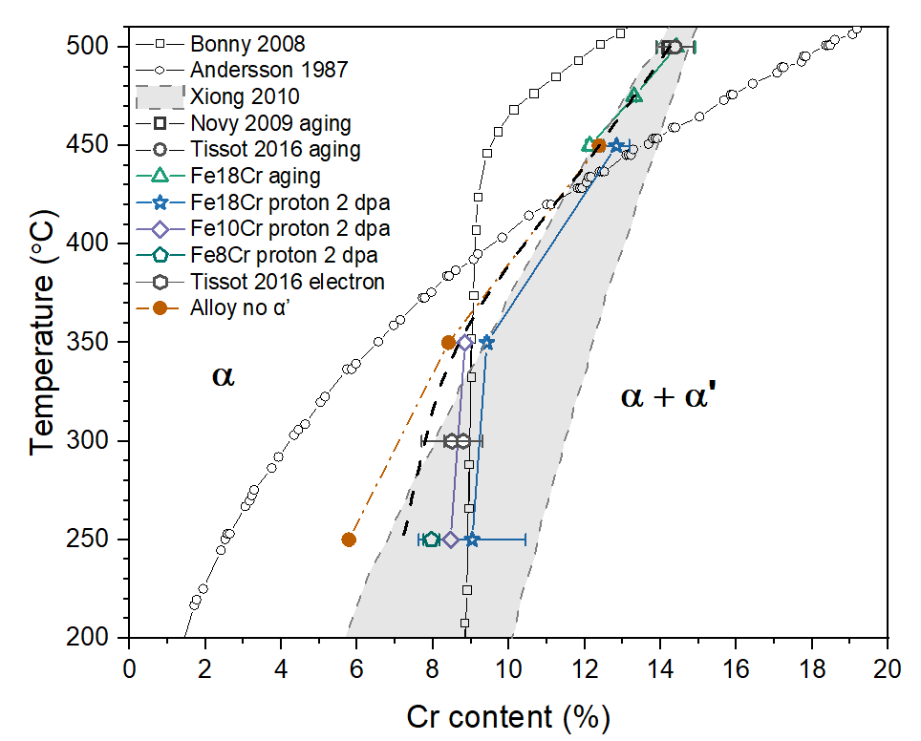
Figure 5.1 A comparison of measured matrix Cr concentrations in FeCr alloys after thermal aging [4, 66], electron [67] or proton irradiations with available phase boundaries [58, 61, 62] in literature. The bulk compositions of alloys without α’ are also included.

Generally, the precipitation process under irradiation conditions is more complicated than thermal annealing alone. The precipitate formation can be enhanced, induced or modified by particle irradiations. Historically, α’ formation under irradiation was claimed to be a radiation-enhanced precipitation phenomenon, because it was observed only in supersaturated alloys, and the precipitates were homogeneously distributed in sampled volumes [5, 7, 67]. This mechanism suggests that the measured matrix solute concentrations should be higher than or equal to the solubility limits because supersaturation is necessary for phase separation. In our previous work, we found the α’ evolution agreed more with a radiation-modified precipitation mechanism. However, the modification from thermal equilibrium states is expected to be large only under high dose rate heavy ion irradiations, which introduce displacement damage cascades to dissolve precipitates. In the case of 800 keV proton irradiations, the average energy of PKA is 289 eV, which is only a few times the displacement energy of 40 eV, so mainly point defects are created (i.e, minimal ballistic dissolution effects). Therefore, the variation from thermal equilibrium will be mainly associated with radiation enhanced diffusion, which should produce enhanced-precipitation kinetics. Radiation-induced α’ formation in Fe-(9-50)Cr alloys has been reported by Wakai et al under electron irradiations [107]. They observed the decoration of dislocation loops by precipitates, which were revealed to be α’ according to the measured interplanar spacings of 2.035 Ånsgtrom. These α’ precipitates were distributed along the edge of loops and were proposed to form from radiation-induced segregation of Cr atoms and interstitials to loops, which then form complexes of Cr-impurity interstitials and stabilize Cr-enriched clusters. If α’ formed through this path, their features would be non-homogeneous distribution and co-clustering with impurity atoms.
In fact, from atom maps in Figure 4.19 and the Cr-enriched clusters visualized by 25% Cr iso-concentration interfaces in Figure 5.2, both homogeneously distributed and inhomogeneous agglomerated precipitates can be found. α’ in Fe-18Cr alloys are predominantly homogeneously distributed at 350 and 450 °C, and thus were enhanced by irradiations. At 250 °C, Figure 4.19 shows a small portion of elongated precipitates, which might be related to spinodal decomposition occurring at the beginning of irradiation due to a high solute supersaturation. However, the distribution and morphology of precipitates in
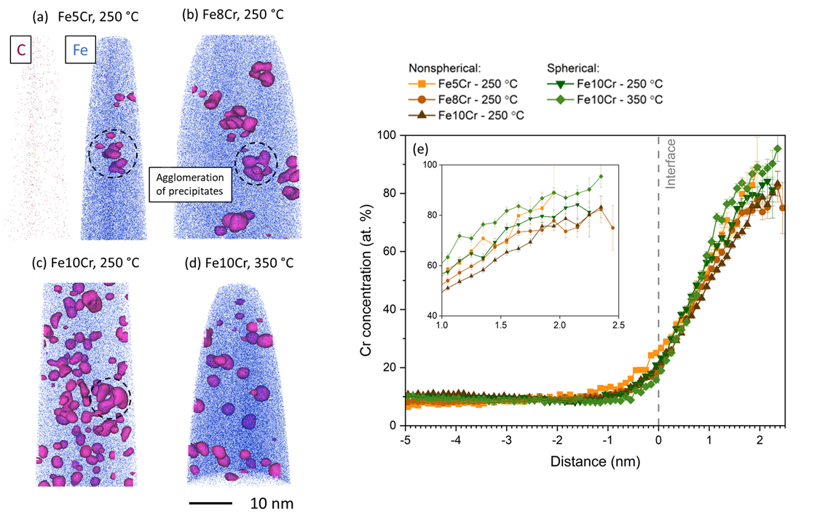
Figure 5.2 Reconstructions showing the distribution of C, Fe atoms and the α’ precipitates highlighted by 25% Cr iso-concentration interface in (a) Fe-5Cr, (b) Fe-8Cr, (c) Fe-10Cr irradiation at 250 °C and (d) Fe-10Cr irradiation at 350 °C. The agglomerated precipitates are marked by dashed circles. (e) Proxigrams calculated from part of precipitates shown in (a)-(d).

the more dilute alloys are very different. In Fe-10Cr, all the Cr clusters were homogenously distributed with near spherical shapes after irradiation at 350 °C, while both spherical and agglomerated non-spherical clusters were present at 250 °C. On the other hand, mainly agglomerated clusters with a few isolated ones can be seen in Fe-8Cr, and only agglomerated ones were present in Fe-5Cr at the same temperature. Proxigrams showing Cr concentration gradients across the interfaces are plotted in Figure 5.2 (e). Fe-10Cr irradiated at 350 °C gave the highest cluster core concentration of ~90%. Similar compositions of ~80% were measured at all other conditions, and there was no clear distinction between the agglomerated non-spherical and homogenous spherical precipitates that were both detected in Fe-10Cr at 250 °C. Therefore, whether the agglomerated precipitates are radiation-enhanced or induced products is unclear based only on the APT results. On one side, their inhomogeneous distribution would imply a radiation-induced behavior. However, the lack of association between the agglomerated precipitates with carbon atoms (Carbon distribution in Fe5Cr is presented in Figure 5.2 (a). Carbon atoms were also homogenously distributed in other proton irradiated specimens), which were observed to segregate to dislocations in our previous ion irradiation studies, and their similar chemical compositions with the spherical precipitates tends to favor a radiation enhanced precipitation mechanism.
Further characterization using STEM-EDS mapping has been conducted on an Fe-5Cr specimen irradiated by protons at 250 °C to 2 dpa to help clarify this problem. All the figures were taken at ~3 µm depth to match the location of APT results. The bright field image showing the distribution of dislocation loops is presented in Figure 5.3 (a). It was taken on the [100] zone axis orientation, so the features perpendicular to each other are aligned along <100> directions. Additionally, there are clear positional correspondences between the black dot features in Figure 5.3 (a) and Cr-rich regions in Figure 5.3 (b). According to Figure 5.3 (c) and (d), the locations where Cr is highly enriched are strongly depleted in Fe atoms, which agrees with the ~80 at. % Cr concentrations and thus very low Fe concentrations in the agglomerated clusters found in APT tips.
If agglomerated Cr precipitates form from a radiation-enhanced precipitation mechanism, the loops might act as preferential nucleation sites of α’ due to the lower
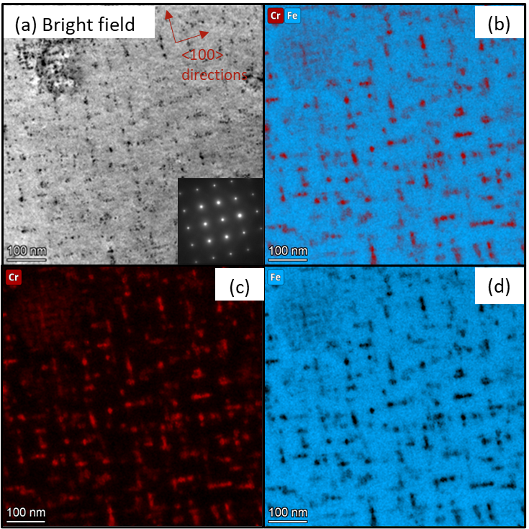
Figure 5.3 (a) STEM bright field image of an Fe-5Cr irradiation by protons at 250 °C to 2 dpa. EDS mapping showing the distribution of Fe+Cr, Cr alone and Fe alone are given in (b-d).

nucleation energy barrier, which is very high for homogeneous nucleation due to both low temperature and low solute supersaturation. However, homogenous distribution α’ is still expected if the bulk composition is within the two-phase region and there is a thermodynamic driving force, such as what was observed in Fe-10Cr (volume fraction of agglomerated precipitates V_{f} ~30%) and Fe-8Cr (agglomerated precipitates V_{f} ~85%). The fact that no homogeneous α’ were observed in Fe-5Cr after irradiation indicates the agglomerated Cr-enriched precipitates are more likely to form from a radiation-induced precipitation mechanism (i.e., radiation induced solute segregation of Cr to dislocation loops). Therefore, the data points of matrix Cr concentrations (shown in Figure 5.1) measured at 250 °C in Fe-10Cr and Fe-8Cr specimens have been corrected by the volume fraction of agglomerated precipitates.

5.1.2 300-450 °C heavy ion irradiation
Until recently, there were no definitive observations of α’ precipitation in Fe-Cr alloys with Cr concentrations up to 18% after ion irradiation at room temperature to 500 °C and dose rates of ~10⁻⁴-10⁻³ dpa/s to final doses of 1-60 dpa [10, 88, 124-126, 168]. This is due in part to difficulties with detecting α’precipitates by conventional electron microscopy techniques: similar lattice parameters of nanoscale coherent Cr-rich precipitates as Fe-rich matrix combined with precipitate sizes close to TEM resolution limits. The pronounced ballistic dissolution of precipitate nuclei by energetic displacement cascades and high dose rates as well as potential injected ion effects for heavy ion irradiations [7] could also suppress α’ formation.
In the present study, Cr-enriched clusters were not observed at the irradiation condition of 300 °C and 10⁻³ dpa/s in solution annealed Fe-18Cr, at 450 °C and 10⁻³ dpa/s in Fe-14Cr, and at 450 °C and 10⁻⁵-10⁻⁴ dpa/s in Fe-12Cr, which is qualitatively consistent with the previous work by Pareige et al. [10]. In that study, solution annealed Fe-12Cr alloys were irradiated at 300 °C with fission neutrons and Fe ions. The α' clusters were formed after neutron irradiation at 1.3×10⁻⁷ dpa/s but not after ion irradiation at 2.2×10⁻⁴ dpa/s, so the absence of α' after ion irradiation was attributed to the high dose rate, whereby the Cr atoms don’t have enough time to form precipitates in the presence of frequent ballistic dissolution by the energetic displacement cascades, and the possible suppression effect from injected interstitials [7]. In our study, α' was detected in Fe-12Cr after irradiation at 300 °C and 10⁻⁴ dpa/s, which is only slightly lower than the dose rate they used. Therefore, the discrepancy in observed α’ precipitation behavior is more likely to result from the energy of implanted ions: 8 MeV in our study and 0.5, 2 and 5 MeV in their experiments for obtaining a quasi-constant damage along the depth. Despite the large difference in bulk Cr content and spatial proximity of injected ions to the analyzed region in Ref. [10] compared to our study, the critical dose rate for the α' precipitate dissolution at 300 °C is 0.2-1x10⁻³ dpa/s in both studies.
We observed pronounced α' precipitation after ion irradiation at higher temperatures or lower dose rates, which qualitatively agrees with some recent ion irradiation results. A comparison for the various properties of α’ precipitates after ion and neutron irradiation is presented in Figure 5.4. The radii of clusters are around 1-1.5 nm after irradiation at ≤ 350 °C over a wide range of several orders of magnitude in dose rates, and all larger size clusters were observed at ≥ 450 °C, which indicates that the cluster size is more sensitive to temperature than dose rate. As for the dependence of number density on dose rate, the present study and that by Tissot et al. [7] observed a decrease in number density with increasing dose rate, while an increase of cluster density with increasing dose rate was observed in [8], and there is no clear trend when multiple works are compared together. It could be partly attributed to the effect of low energy injected ions [7], the simultaneous change of both dose rates and doses [7, 8], the difference in characterization method [9] and APT data analysis method [5, 8] that could result in a large difference in the measured precipitate number density. An extremely low number density of ~3×10²¹ m⁻³ was measured by Reese et al. in Fe-(15-18)Cr after neutron irradiation at 455 °C, which seems problematic because a constant solute concentration in the alloy couldn’t be maintained [6]. The cluster core Cr concentration monotonically decreased with increasing dose rate at all temperatures, with the highest Cr concentrations observed at the highest irradiation temperature for any given dose rate. The very high Cr concentration of ~80-90 at. % in the α' precipitates was achieved only after neutron irradiation at dose rates ~10⁻⁷-
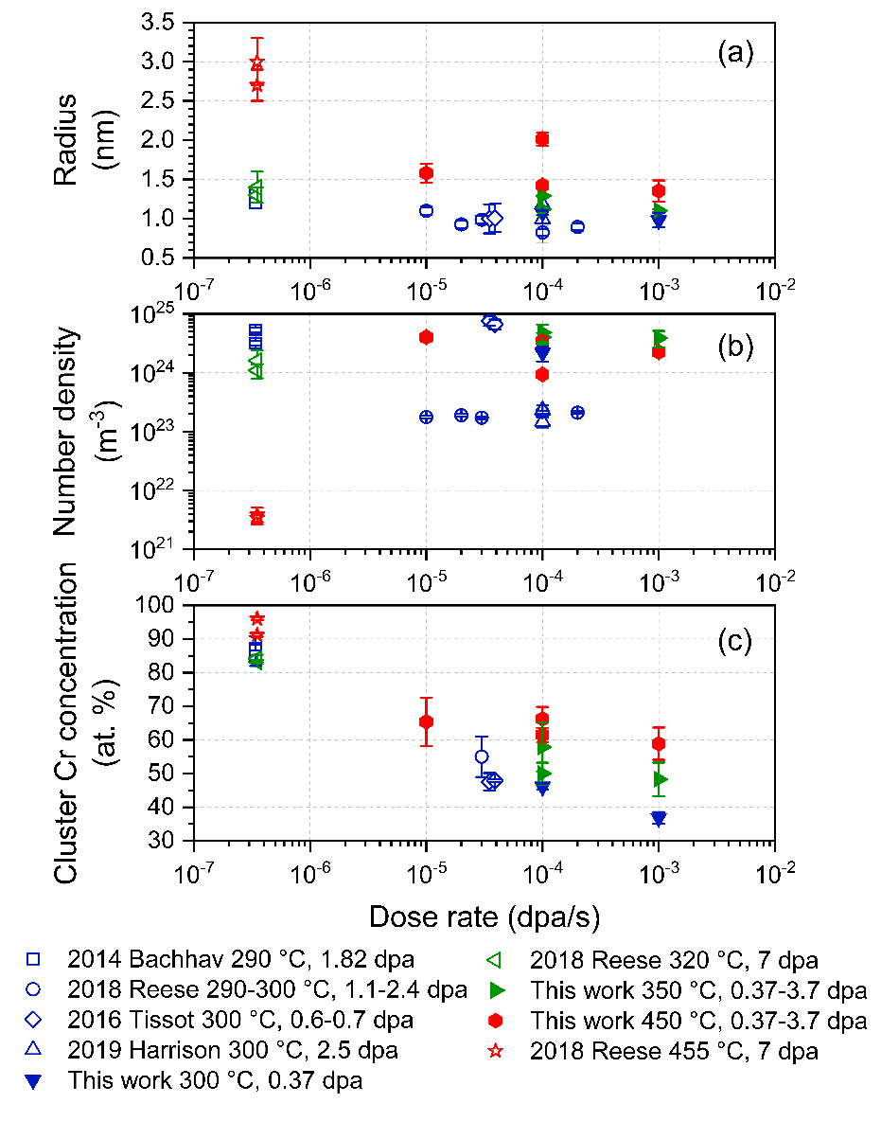
Figure 5.4 Comparison of (a) radius, (b) number density and (c) Cr concentration of α’ precipitates in Fe(15-19)Cr after ion (10⁻⁵ to 10⁻³ dpa/s) and neutron (~3x10⁻⁷ dpa/s) irradiation up to 7 dpa. The irradiations performed at temperatures ≥ 450 °C are presented with red symbols, 320-350 °C with green, and around 300 °C with blue symbols. Open symbols denote results from literature while solid symbols are from this work.

10⁻⁶ dpa/s. The Cr concentration is much lower for all the other high dose rate ion irradiation results, which will be discussed later in more detail.
Prior models of alpha prime precipitate stability have conflicting predictions. An initial Atomistic Kinetic Monte Carlo (AKMC) simulation [169] suggested that accelerated diffusion by irradiation is the only significant effect on the evolution of precipitates and that ballistic dissolution effects are negligible at 290 °C. They found the dose rate influences precipitation behavior only by controlling the point defect concentration. However, their more recent work used a combination of cluster dynamics and AKMC simulations and found ballistic dissolution effects became important for ion irradiations with dose rates >10⁻³ dpa/s [170]. The modeled precipitate dissolution was mainly caused by the high sink densities that reduce the point defect supersaturation, and thus it occurred at a relatively high dose of ~40 dpa at 300 °C. Although our observed critical dose rate of 10⁻³ dpa/s is in good agreement with the most recent model predictions [170], we observed complete dissolution of pre-existing α' precipitates already at 0.37 dpa at 300 °C, which is a much lower dose than their predictions. Ke et. al used a phase field model to study α' clusters formed after irradiation at different temperatures and dose rates [163]. The authors concluded that irradiation dose rate controls both radiation enhanced diffusion and ion mixing by causing replacements and displacements, due to which there is a threshold temperature and dose rate combination for the precipitates to form [163]. Our experimental results clearly show decreased Cr clustering at a higher dose rate, which generally agrees with [163]. But the critical dose rate of 10⁻⁵-10⁻⁴ dpa/s predicted by Ref. [163] is much lower than our observations. This discrepancy might be partly attributed to the definition of α’ precipitates between the simulations and our experimental results. A threshold Cr concentration of ~80 % was selected to define the α’ in [163], which is much higher than the 30% we used for cluster analysis, and thus inevitably predicts a more conservative critical irradiation condition. Additionally, Ke et al. also focused on Fe-15Cr, which has lower Cr supersaturation compared to Fe-18Cr used in this work and could potentially require a lower dose rate for the α’ precipitates to be stabilized.

5.1.3 Cryogenic and room temperature heavy ion irradiation
Both FeCu and Fe-18Cr specimens were pre-aged to form nm-scale solute precipitates, and then irradiated by Fe ions at -123 °C to R. T., to final doses of 0.1 - 0.6 dpa. Solute atom distributions after irradiations were studied by APT. In both alloys, the precipitate size and number density were not significantly changed by irradiations up to 0.6 dpa. The largest difference induced by irradiations is the decrease in precipitate core solute concentrations. In FeCu alloy, irradiation-induced reduction in Cu concentrations was 12% (34% to 22%) in the 1.5h aged specimen. Precipitate sizes are ~0.9 nm with number densities of 4 to 7×10²³/m³ before and after irradiation to different doses. In the 10h aged specimens, precipitate Cu concentrations decreased from ~65% to ~26%. Radii of precipitates are ~1.5 nm and number densities are ~3×10²³/m³ without clear difference with respect to irradiation dose.
This dilution process happened in all precipitates regardless of their sizes, which implies the gradual dissolution of Cu precipitates by displacement cascades. Our observations up to 0.6 dpa qualitatively agree with what was reported by Nicol et al., who found the radii of Cu precipitates to shrink by more than 1 nm after irradiation at 20 °C to 1 dpa [171]. The difference in observed precipitate Cu concentration decrease in our study versus size shrinking in their work might be partially related to different characterization techniques. In our cluster analysis algorithm, the precipitate interface is defined as the midpoint of the concentration profile. Therefore, the interface of a concentrated precipitate would have a higher solute concentration than that of a dilute precipitate. Since Cu concentrations at precipitate cores became lower after irradiations, the precipitates are viewed as larger ones by our algorithm, which might compensate for the radius decrease observed by Nicol et al. However, both sets of results suggest a strong ballistic dissolution effect, where significant dissolution was observed in ≤1 dpa in FeCu alloy system during irradiation near room temperature.
On the contrary, Cr precipitates formed in Fe-18Cr after aging for 100h showed no difference in composition (~46%) after RT irradiations up to 0.6 dpa, and solute concentrations only decreased by 16% (from 70% to 54%) in the 900h aged specimens at the highest dose. At all conditions, the sizes of precipitates are 1-2 nm and number densities are ~1 to 2 ×10²⁴/m³. These results suggest that Cr precipitates have higher stability than Cu precipitates under heavy ion irradiation conditions, which is counterintuitive. Larger and more solute-concentrated precipitates show larger irradiation induced dilution rates.
In a simplified model, the stability of precipitates under irradiation conditions is determined by the competition between radiation enhanced diffusion (promote precipitate formation) and ballistic dissolution by displacement cascades (destroy precipitates) [100]. From our thermal aging results at 500 °C, Cu precipitates grow and coarsen much faster than Cr precipitates in Fe-based binary alloys, which indicates that Cu atoms have a higher thermal diffusion rate at this temperature. However, our latest results suggest Cr precipitates are more stable, which indicated the thermal diffusion rate is not strictly relevant for irradiation conditions. Also, precipitate coarsening is not solely determined by matrix solute diffusion rate. Factors such as interface surface energy, etc. also may be important. Since the irradiation temperatures were rather low (-123 °C to R. T.) where vacancy diffusion is sluggish, it is expected that ballistic dissolution effects would be dominant. Whether the difference in their stability can be related to different dissolution efficiency of displacement cascades is unclear for now. Since the majority of FeCu and Fe-18Cr alloys are Fe atoms, and Cu and Cr both have similar atomic mass to Fe, the PKA energy and size of the displacement cascade shouldn’t be very different. The Cu and Cr precipitates formed from thermal aging have similar radii of ~1-2 nm. The major difference is that Cu precipitates might be less coherent with Fe rich matrix due to the 9R crystal structure transformation that occurs in larger precipitates, while Cr precipitates have BCC structure and are coherent with the matrix. However, clear dilution of Cu precipitates formed from 1.5h aging versus no dissolution of Cr precipitates formed from 100h aging can’t be explained by this difference, since they are both coherent with the matrix.
The strong stability of Cr precipitates at ≤ R. T. also contradicts our previous heavy ion irradiation results performed at 300-450 °C. We observed the dissolution of pre-existing α’ by irradiation to 0.37 dpa at 300 °C. Cr precipitates should be less stable at lower temperatures if their stability is simply controlled by the relative importance of radiation enhanced diffusion vs. ballistic dissolution mechanisms. The conflicting results at R. T. and 300 °C may suggest that other mechanisms are active at the low temperature regime. It might be explained by the faster diffusion rate of Cr atoms at higher temperatures (300-450 °C), so the dissolved Cr atom can quickly diffuse back and contribute to the formation of a Cr-enriched nuclei. At intermediate temperature of 300 °C, the nuclei might be too small to be detected by APT. On the other hand, the diffusion rate is so slow at ≤ R. T. that the back diffusion of solute atoms is largely suppressed. During irradiation, the whole precipitate (including core and outer region) is gradually diluted by displacement cascade. However, it remained as a solute enriched-region with the near-initial size since there is negligible diffusion to refine it. This size is above the detection limit of APT, so it is still detectable after irradiations. This reasoning might be oversimplified. Further investigations by performing additional irradiations at intermediate temperatures such as 100 and 200 °C will be helpful to generate a systematic trend, and simulation studies using molecular dynamics can also help understand the deviations between the conflicting observations at ≤ R. T. and 300-350 °C.

5.2 Effect of irradiation temperature and dose rate

5.2.1 Temperature effect
In this work, irradiations were performed in Fe-Cr alloys at a wide range of temperatures, including Fe ions irradiation at 300-450 °C (relevant to the application window of Ferritic-Martensitic steels) to mid-range doses of 0.37-3.7 dpa and -123 °C – R.T. (relevant for predominantly ballistic dissolution) to 0.1-0.6 dpa, and proton irradiations at 250-450 °C to 2 dpa (relevant for predominantly radiation enhanced diffusion).
At the higher temperature of 450 °C, α’ precipitates were observed to nucleate, grow and coarsen in solid solution Fe-18Cr specimens after irradiations by both heavy ions and protons. Additionally, further coarsening of precipitates at 3.7 dpa compared to 0.37 dpa at 10⁻⁴ dpa/s, and minor dissolution of pre-existing α’ at 10⁻³ dpa/s heavy ion irradiations both indicate radiation enhanced diffusion being dominant at this temperature. Therefore, the precipitate evolution generally agrees with the conventional Ostwald ripening mechanism. Both the kinetics of phase separation and final steady states are controlled by the irradiation dose rate.
After irradiation at the intermediate temperatures of 250-350 °C, precipitate evolution is more complicated. In the case of self-ion irradiations, ballistic dissolution becomes important, which continuously causes ion mixing between precipitates and matrix, and leads to an irradiation-controlled steady state significantly different from the thermal equilibrium state. α' precipitates observed at these conditions generally have smaller sizes and lower solute concentrations compared to the higher temperature variants. All experimentally identified α' precipitates are homogeneously distributed in the matrix, and thus agree with the enhanced precipitation by accelerated diffusion, but their compositions are simultaneously modified by displacement cascades. At 300 °C, 10⁻³ dpa/s, the rate of dissolution is too fast, which can’t be balanced by back diffusion anymore, so no α’ was observed at this condition.
However, after proton irradiations, although precipitates were spherical and homogeneously distributed in Fe-18Cr and Fe-10Cr at 350 °C, partial or complete precipitate agglomeration was observed in Fe-(5-10)Cr specimens at 250 °C. These agglomerated precipitates have spatial correlations with dislocation loops aligned along [100] directions. Since no homogenous α’ was observed in the matrix, the agglomerated ones are more likely to form from a radiation-induced precipitation mechanism, which indicates the Fe-5Cr specimens are located in the single α phase region at 250 °C. However, despite Fe-10Cr being supersaturated in Cr concentration at both 350 and 250 °C, radiation induced precipitation was observed only at 250 °C, but not at 350 °C. The volume fraction of agglomerated precipitates in all precipitates is ~30%. Radiation-induced segregation or depletion of Cr atoms at dislocations loops is determined by the relative rate of inverse Kirkendall diffusion, in which Cr diffuses in the opposite direction to vacancy flux, and interstitial drag diffusion, in which Cr diffuses to dislocations together with interstitials. Therefore, the Cr enrichment in Fe-5Cr at 250 °C suggests the dominance of the interstitial-drag mechanism at this condition. At 350 °C, no agglomerated Cr precipitates were observed. Due to the small sampled volume of APT, currently is unclear whether they formed in the specimen or not.
At very low irradiation temperatures of -123 °C – R.T., Cu precipitates were gradually dissolved by displacement damage cascades, while α’ precipitates show surprising resistance to irradiation induced dissolution. Only partial dissolution of precipitates formed from 900h aging was observed at 0.6 dpa. Cr precipitates show negligible changes at all other irradiation conditions compared to their as-aged state. This observation is in conflict with the 300-350 °C irradiation results.
Figure 5.5 summarizes the size, number density and core Cr concentration of α’ precipitates measured in this work and by other researchers after thermal aging or irradiation by different particles [5-9, 67]. In each plot, the four shadowed regions indicate the location of 4 different treatments (4 categories including thermal aging, heavy ion irradiation, proton/electron irradiation and neutron irradiation). In Figure 5.5 (a), precipitate sizes increase with irradiation or aging temperature. Ion irradiations show least temperature dependence and occupy the lower side this plot. All other three regions cover a wider range of radii from 1.5 to 3 nm. For the evolution of precipitate number density, there is no obvious trend of ion irradiation results with irradiation temperature. Especially at 300 °C, the measured number density has a large difference of ~2 orders of magnitude when multiple studies are compared together. On the other hand, the number densities decrease with increasing temperature in other 3 categories, and there is a large overlap between proton and neutron irradiation results. In Figure 5.5 (c), all 4 types of treatments show increase in Cr concentration with increasing temperature. The slope of this increasing rate is similar among 3 types of irradiations, but the results from heavy ion irradiations are located at the low concentration side of 40-70%, whereas both neutron and proton/electron irradiations give concentrated precipitates containing 70-100% Cr. Thermal aging leads to the formation of similar α’ particles, and it is located only at the higher temperature side due to slow diffusion at <450 °C.
Theoretically, irradiation temperature affects the α’ precipitation in both thermodynamic and kinetic aspects: it determines the solubility of Cr in the Fe-base matrix at thermal equilibrium and affects the radiation enhanced diffusion rate. Recent experimental results suggest solubilities of ~9% Cr at 300 °C and ~14% Cr at 500 °C [5, 66, 172]. Our proton irradiation and thermal aging experiments enabled the determination
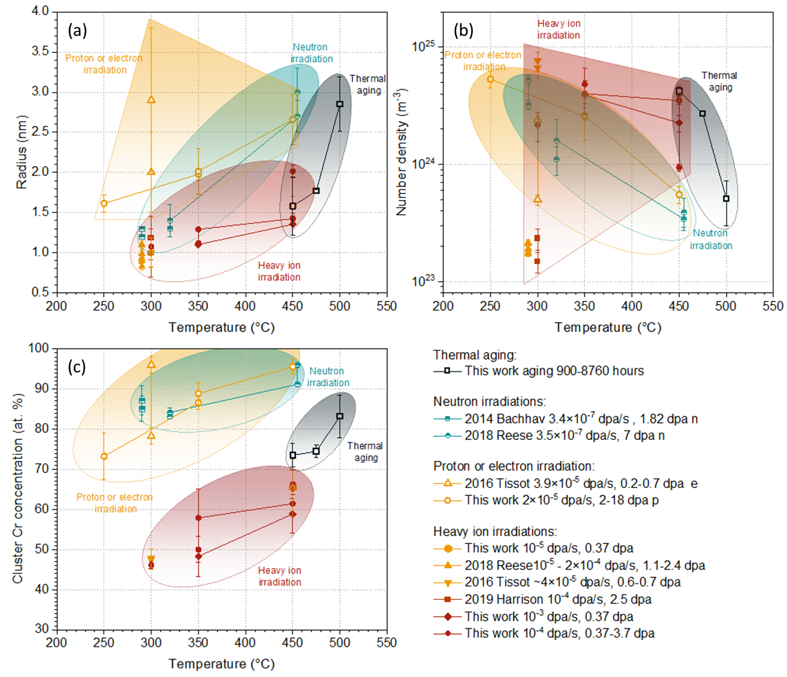
Figure 5.5 Summary of (a) radius, (b) number density and (c) Cr concentration of α’ precipitates in Fe(15-19)Cr after ion, neutron, proton or electron irradiations up to 7 dpa, and thermal aging at 450-500 °C for 900-8760 hours as a function of temperature. The 4 shadowed region in each plot indicate the location of the treatments in 4 different categories as pointed out by the text.

of a more accurate phase boundary (See Figure 5.1). For the 300-450 °C heavy ion irradiation conditions investigated in this study, the solvus line is expected to be in the range of 9-14%Cr and increase with higher temperature, which means the driving force for precipitation at higher temperatures will decrease due to the lower solute supersaturation, and the nucleation rate will be reduced according to the classical nucleation theory. On the other hand, the diffusion rate of solute atoms under irradiation conditions is also controlled by temperature. The parameter $D_{v}C_{v}$ will either increase or remain nearly constant with increasing temperature for recombination- and sink-dominant conditions, respectively.
In the Fe-18Cr specimen, we find the effect of increased diffusion rate is larger than the reduced driving force, as more Cr clustering was observed after irradiation at higher temperatures. However, the ballistic dissolution of precipitates is independent of temperature, so the dominance of diffusion over ballistic dissolution (i.e., the kinetics of phase separation) will be most notably promoted at higher temperatures.
However, in the Fe-14Cr specimen, α’ precipitates were detected after irradiation at 10⁻³ dpa/s at 350 °C, but not at 450 °C. They also formed at 450 °C and lower dose rates of 10⁻⁵-10⁻⁴ dpa/s. At the irradiation condition 450 °C and 10⁻³ dpa/s, the possible number density of precipitates is calculated to be ~3×10²³-2×10²⁴/m³, if the available Cr supersaturation level or the volume fraction of α’ phase is assumed to be ~1-2%, and the precipitate radii is 1-2 nm. This calculated number density is higher than the detection limit of APT (~10²²⁻²³/m³). However, in Fe-18Cr, it was found that the volume fraction of α’ decreased by ~2.7 times (from 7.6% to 2.8%) when the dose rate was increased from 10⁻⁵ to 10⁻³ dpa/s. In Fe-14Cr, α’ volume fraction decreased for ~3 times (from 2.9% to 0.9%) when the dose rate was increased for 10 times (10⁻⁵ to 10⁻⁴ dpa/s), which is larger than the change in Fe-18Cr alloy. It may suggest at the dose rate of 10⁻³ dpa/s, the volume fraction of precipitate phase might be too low (so either the precipitate size or number density would be below the detection limit) to be detected by APT. It indicates the decreased driving force due to reduced solute supersaturation becomes dominant over increased diffusion rate at 450 °C compared to 350 °C at a dose rate of 10⁻³ dpa/s, so they can remain stable only at lower dose rates. Generally speaking, the net influence of temperature is complicated and involves multiple factors, and it can vary greatly in different alloys.
According to the theory of radiation-enhanced diffusion and ballistic dissolution, precipitates should have lower stability at lower temperatures. However, we observed superior resistance of α’ precipitates to irradiation-induced dissolution up to 0.6 dpa at ≤ R.T., which is in conflict with the observed complete dissolution of α’ at 300 °C, 0.37 dpa. The reason for this discrepancy is still unknown. Since the dissolution effect is expected to be invariant as a function of temperature, the opposite results might be related to the activation of other diffusion paths at low temperatures, which results in a diffusion rate that is not monotonically related to temperatures. Other physical mechanisms may also be important and further investigations are needed to elucidate these puzzling observations. Nevertheless, the reduced core Cr concentration after irradiations was observed for both high temperature and low temperature irradiations, which are evidence for significant ballistic mixing.

5.2.2 Dose rate effect
To investigate the effect of dose rate, the properties of α’ precipitates measured from this work and other studies are plotted as a function of dose rate in Figure 5.6. The results from thermal aging were plotted at the dose rate of 5×10⁻⁸ dpa/s only for convenience, at which the actual dose rate is 0. Due to the narrow distribution of dose rates in the available neutron and proton/electron irradiation studies, the datapoints are spread mainly vertically. If the thermal aging studies are considered together, these 3 categories all show precipitate radii in the range of ~1-3 nm, number densities in the range of 2×10²³- 8×10²⁴/m³ and precipitate Cr concentrations in the range of 70-100%, although the dose rates are very different. On the other hand, ion irradiation conditions cover a wider range of dose rates at 10⁻⁵ to 10⁻³ dpa/s. Within the ion irradiation results, both precipitate radii and number density don’t show any clear trend with respect to dose rate, while precipitate Cr concentrations is lower at higher dose rates. The dose rates of proton/electron irradiations are similar to the lower side of ion irradiations, but the resulting α’ precipitates are very different. Although the number densities of precipitates are in the comparable range, precipitates formed after ion irradiations are smaller and more dilute. This difference
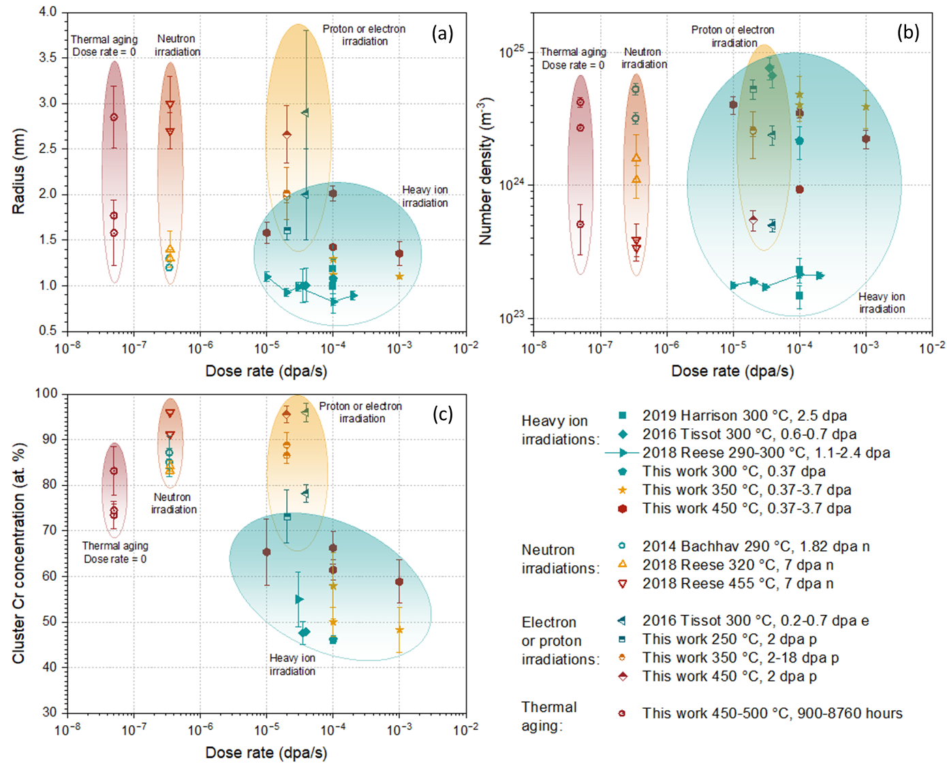
Figure 5.6 Summary of (a) radius, (b) number density and (c) Cr concentration of α’ precipitates in Fe(15-19)Cr after ion, neutron, proton or electron irradiations up to 7 dpa, and thermal aging at 450-500 °C for 900-8760 hours as a function of dose rate. The 4 shadowed region in each plot indicate the location of the treatments in 4 different categories as pointed out by the text.

can be attributed to the different cascade structures. Compared to neutron irradiations, the less mature precipitates formed after ion irradiations might be related to the large difference in dose rates.
Although the dose rate or ion flux is not related to the thermal equilibrium solubility, its contribution must be considered for studying the steady state parameters of precipitates under irradiations. It is also one of the major differences between neutron (10⁻⁷-10⁻⁶ dpa/s) and ion irradiations (10⁻⁴-10⁻² dpa/s). To explore the stability of α’ precipitates at application-relevant temperatures (300-450 °C), irradiations at a wide range of dose rates 10⁻⁵-10⁻³ dpa/s were used in our work. Precipitate stability is controlled by the competition between radiation enhanced diffusion and ballistic dissolution processes, and these rates both increase with increasing dose rates. Ballistic dissolution rate increases with the dose rate in a linear relationship. Radiation-enhanced diffusion will be proportional to $\sqrt{dose rate}$ at recombination dominant conditions, and linearly related to dose rate at sink dominant conditions. In alloys with intermediate sink strength, the dependence will be in between. However, since precipitate nucleation is a complex process, and other factors such as the availability of nearby solute atoms are also important, it is not quantitatively accurate to simply compare the ratio of these two rates. In general, the ballistic dissolution effect will be more important at high dose rate conditions, while radiation enhanced diffusion will be more important at low dose rate conditions. Therefore, precipitates are expected to be more stable at neutron irradiation conditions, which usually have lower dose rates compared to ion irradiations. Detrimental precipitates such as α’ and Cu precipitates are generally expected to be more stable at reactor-relevant dose rates when irradiated at the same temperature. On the other hand, a high density of nano-sized particles is introduced into steels to improve their mechanical property and irradiation resistance [17]. The possible coarsening of particles during prolonged low dose rate neutron irradiations could potentially be a severe problem for maintaining their functionality. In either case, the development of dispersoids or precipitates with high stability against thermal- and radiation- changes is highly desirable for reactor structural material applications.
In the low temperature heavy ion irradiations at -123 to R.T, our initial expectation was that ballistic dissolution will be dominant based on the dissolution of α’ at 300 °C, 10⁻³ dpa/s, so precipitate evolution will be purely resulted from the accumulation of dissolution from displacement cascades. If this is correct, dose rates will be less important compared to doses. Since the lowest target dose was 0.1 dpa, we considered it will be much easier for the irradiation facility to manipulate and adjust beam currents if the irradiation time is not too short. Therefore, a dose rate of 3×10⁻⁴ dpa/s was selected for this set of irradiations to 0.1-0.6 dpa, which resulted in irradiation times of 6 to 33 minutes for each irradiation. The observed high stability of Cr precipitates at ≤ R.T. compared to 300 °C might suggest that dose rate might also be important at these low temperatures.
The average PKA energy generated by 800 keV protons is less than ten times the threshold displacement energy, so radiation-enhanced diffusion is the most important process (i.e., ballistic dissolution effects are relatively minor). Changing the dose rate will mainly modify the diffusion rate and control the kinetics of precipitate nucleation and growth. The final steady state of precipitate evolution is determined mainly by dose instead of dose rate. Since achieving a target dose is most important when designing proton irradiation parameters, the dose rate 2×10⁻⁵ dpa/s was selected by considering enough time for the deposited heat to dissipate and acceptable time to reach the target dose.

5.2.3 Mathematical modeling of the irradiation results at 300-450 °C by Fe ions
Our high temperature heavy ion irradiations focused on the formation of precipitates from solid solution or the refinement of large precipitates to form finer ones. These precipitate stability cases were first evaluated in a simplified model proposed by Nelson et al. (NHM model) in 1972 [100]. In the following, we have made several important modifications to the original NHM model to quantitatively explain the presence/absence of precipitates after irradiation.
In the original NHM model, the volumetric dissolution rate ($dV/dt$) of a precipitate with radius $r$ due to the recoil dissolution mechanism is $\frac{dV}{dt}=-\frac{4πr^{2}ϕ}{N}$, where $ϕ$ is the flux of recoils from the cluster to the matrix and $N$ is the atomic density of the target. $ϕ$ was approximated as ~ $f_{m}G$, in which the multiplication factor $f_{m}\sim {10}^{14}$ atoms/cm²×dpa (proportional to the inverse of the primary knock-on atom (PKA) displacement cross section) and G is the dose rate in dpa/s. The growth rate of a precipitate was listed as $\frac{dV}{dt}=3D^{irr}cr/p$, in which the $D^{irr}$ is the radiation enhanced diffusion coefficient, $c$ and $p$ are the atomic fraction of solute in the matrix and precipitates respectively. With the boundary condition of a constant total solute concentration $C$: $C=\frac{4}{3}πr^{3}pn+c$, in which $n$ is the number of precipitates per unit volume, the steady state precipitate radius could be calculated by setting equal to zero the derivative of the sum of the recoil dissolution and regrowth coarsening terms:
$$\frac{dr}{dt}=-\frac{ϕ}{N}+\frac{3D^{irr}C}{4πpr}-D^{irr}nr^{2}=0$$
The radiation enhanced diffusion coefficient is $D^{irr}≈ {cf}_{v}C_{v}D_{v}$ with $f_{v}$ taken as the BCC correlation factor of 0.727 [173]. The vacancy concentration $C_{v}$ can be calculated using either recombination dominant or sink dominant approximations [174]. The steady state vacancy concentration in the first case is $C_{v}\sim \sqrt{\frac{GD_{i}}{RD_{v}}}$, in which $R=\frac{4πr_{c}(D_{i}+D_{v})}{Ω}$ is the point defect recombination rate. The spontaneous recombination radius $r_{c}$ is about 2.26a₀ with a₀ as the lattice parameter and $Ω$ as the atomic volume [175]. $C_{v}=\sqrt{\frac{G}{C_{s}}}$ is the vacancy concentration for sink dominant conditions, in which $C_{s}=4πrn$ is the sink strength of α’ precipitates (assumed to be the dominant point defect sink). The diffusivity of a single vacancy ($D_{v}$) and interstitial ($D_{i}$) can be calculated using the migration energy for vacancies and interstitials in Fe-Cr as 0.67 and 0.34 eV respectively [74].
Inserting the number densities measured from APT results and the equilibrium Cr content of α’ precipitates, the original NHM model predicts much larger radii of ~2-3.5 nm and extremely high volume fractions ~19% (volume fraction $V_{f}=\frac{4}{3}πr^{3}n$) of the precipitation phase no matter which approximation was used for calculating the diffusion coefficient. In other words, it predicts that all the Cr atoms would be located in the precipitates, and the size of precipitates is solely controlled by the number density, which is an input parameter. Similar overestimation also occurred when the original NHM model was used to fit the electron irradiation results of Tissot et al. [67]. Possible reasons for this overestimation may include an underestimation of the ballistic dissolution rate or an overestimation of the precipitate growth rate. It should be noted that the original NHM model implicitly assumes the precipitate volume density (n) is constant, which is approximately valid at intermediate temperatures near 350 °C but is not valid for high dose rates at 300 °C (ballistic dissolution dominant conditions) or for high temperatures (450 °C) where precipitate coarsening occurs. In addition, several of the terms used in the original NHM model appear to be incorrect.
We have made several science-based modifications to the original NHM model in an attempt to obtain more accurate estimates of the effect of particle irradiation on precipitate size. We note that the steady state vacancy concentration or the radiation enhanced diffusivity is overestimated if the dose rate is taken simply as the point defect production rate. A point defect production efficiency of $ξ_{arcdpa}$ ~ 0.33 is appropriate for a Fe ion energy of 8 MeV (average PKA recoil energy of ~18 keV) to correct for athermal in-cascade recombination of vacancies and interstitials [176]. However, to account for the additional correlated recombination that occurs at temperatures where point defects are mobile, the corresponding vacancy production efficiency should be further reduced to around 0.1 to 0.2 for a wide range of PKA energy irradiations [177, 178]. Additionally, the NHM model also overestimates the precipitate growth rate by including the entire matrix solute concentration, because only the fraction of solutes that exceed the solubility limit contribute to the formation of precipitates. We have therefore modified the matrix solute concentration to be the solute supersaturation level by subtracting the solubility limit $c_{eq}$. One further modification is that the constant of 3 used in the original NHM equation for growth rate seems to be incorrect and should be replaced by 4π according to the equations in ref. [179] cited in the original NHM publication (the derivation is given in section 6 of the Supplementary). The equation for precipitate growth rate is therefore modified into:
$$\frac{dV}{dt}=4πD^{irr}(c-c_{eq})r/p$$
As for the boundary condition of constant solute concentration, the original NHM equation is valid only for low volume fractions of precipitate. If the precipitate volume fraction might reach 5-10%, then the equation should be modified by the available matrix volume fraction, which is $1-\frac{4}{3}πr^{3}n$, so the correct equation for precipitates of nonnegligible volume fraction is:
$$p×\frac{4}{3}πr^{3}n+c×\left(1-\frac{4}{3}πr^{3}n\right)=C$$
To test the effect of the modified growth rate on precipitate evolution, the experimental settings and number densities of α’ precipitates reported after electron irradiations [67] were used, where ballistic dissolution effects are negligible. Radiation enhanced diffusion is expected to be dominant at these conditions due to the lack of displacement cascades. As shown in Figure 5.7, reasonable agreements on the steady state radii are achieved when the modifications summarized above are introduced and when the recombination dominant approximation is used, which indicates the modifications are physically correct. The large error bars came from APT measurements. The sink dominant condition, on the other hand, results in an unreasonably high dose to achieve the steady state due to the lower diffusion rates. With the modified phase boundary derived from thermal aging and proton irradiations (presented in Figure 5.1), we have also calculated the steady state radii of α’ precipitates formed in Fe-10Cr and Fe-18Cr after proton irradiations and compared them with the experimentally measured values (shown in Figure 5.7). The good agreements between the experimental and model values indicate the modified phase boundary are rather accurate.
The recoil dissolution equation in the original NHM model used a multiplication factor of $f_{m}$~1/σ_{d}~10¹⁴ for calculating the flux of recoils $ϕ$ produced by a PKA, which is about an order of magnitude smaller than typical medium-mass ion displacement cross-sections of σ_{d}~10⁻¹⁵ cm² [180]. To get a more precise estimate of this recoil dissolution parameter, the mechanism through which the precipitate is dissolved by the displacement cascade is considered at the atomic level. Two different approaches were considered: one based on in-cascade radiation mixing, and one based on the subset of longer-range ballistically ejected atoms from the center to the outer periphery of the displacement cascade. During particle irradiations that involve damage cascades, most ion mixing occurs during the thermal spike phase, when a local high temperature region can form in the core of the cascade and replacements occur between neighboring atoms [94, 96, 176]. Radiation
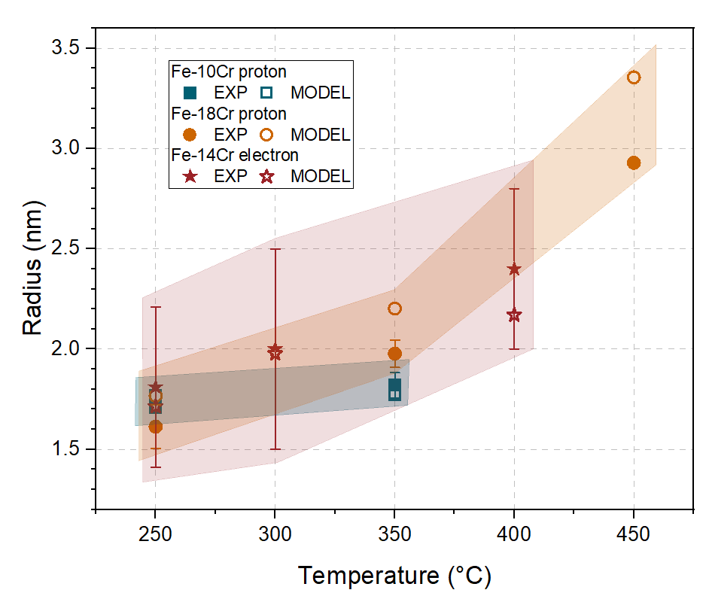
Figure 5.7 Comparison between radii measured with APT (filled symbols) and calculated with the modified NHM model (open symbols) for α’ precipitates formed in Fe-(10-18)Cr after proton or electron irradiations. The legends with EXP denote experimentally measured values from the current study and Tissot et al. [67]. The legends with MODEL denote calculated values from the modified NHM model.

mixing is important for the disordering of alloys and the dissolution of nanoscale precipitates. The degree of atomic mixing can be quantified by the replacement per atomic displacement (RPA) parameter, which could provide a basis for estimating ballistic dissolution. However, the distances that most atoms travel during the thermal spike phase are short-ranged due to intense in-cascade recombination; this phase generally persists for only a few picoseconds. The long-range displaced atoms are considered to be more important to the dissolution of precipitates as this can lead to the direct ejection of solute atoms from the precipitates and the direct injection of matrix solvent atoms into the precipitate. The dissolution rates resulting from this subset of longer-range displaced atoms as well as from overall radiation mixing are quantified in the following.
If the precipitate dissolution mainly occurs during the thermal spike phase due to radiation mixing, the dissolution parameter can be estimated using SRIM-2013 simulations and considering the concept of RPA [176, 181]. The number of recoils ($V_{NRT}$) in the unit of displacement/Å×ion produced by each injected ion was calculated by the SRIM ion collision code using the damage energy method [152]. As a further modification of the ballistic dissolution term, the RPA parameter was used to quantify in-cascade radiation mixing rather than simply using the dpa value. The replacement per displacement ratio is $ξ_{rpa}\sim 50$ for the investigated ion irradiation conditions with a mean PKA recoil energy of ~15 keV [176, 182]. Therefore, the term $f_{m}$ to quantify the number of recoils per dpa is:
$$f_{m}=\frac{N×ξ_{rpa}}{V_{NRT}} (6)$$
The ballistic dissolution factor calculated by this method in the observed midrange depth region of this study for bombardment by 8 MeV Fe ions is $f_{m}=1.17×{10}^{17}$ atoms/cm²×dpa.
To account for the dissolution caused by the long-range displaced atoms in the second method, it is important to estimate the ratio (A) of the number of atoms ejected beyond a critical distance compared to the calculated residual displacements in the displacement event calculated using SRIM, and the average distance traveled by them ($l$). This long-range displaced atom ballistic dissolution factor can be calculated with equations (14) and (16) in Ref. [183]:
$$f_{m}=\frac{1}{6}Al^{2}\left(p-c\right)N/δ$$
where $δ$ is the thickness of the interface and can be estimated to be the nearest neighbor distance. Unfortunately, no information on $A$ or $l$ is available for the FeCr system. Using a critical value of the fourth nearest neighbor distance to define the long-range displaced atoms and the molecular dynamics results reported in [184, 185], the number of these atoms is ~5.6 times what was predicted by SRIM, and they travel an average distance of ~7 angstroms in Ni and Ag-Cu system, so the resulting ballistic dissolution factor is $f_{m}=1.4×{10}^{16}$ atoms/cm²×dpa. Although the estimated ballistic dissolution factor using the subset of long-range displaced atoms is around 10 times lower than the factor calculated using the RPA value, both methods presented here suggest a much higher dissolution rate parameter compared to the original NHM model ($f_{m}={10}^{14}$ atoms/cm²×dpa).
With these modifications, the revised equation to calculate the precipitate radius at steady state is:
$$\frac{dr}{dt}=-\frac{f_{m}G}{N}+\frac{D^{irr}C}{rp}×\frac{3}{3-4πnr^{3}}-\frac{D^{irr}}{rp}×(\frac{4πr^{3}np}{3-4πr^{3}n}+C_{eq})=0$$
We observed that a $f_{m}$ value of $1.17×{10}^{17}$ atoms/cm²×dpa tends to slightly underestimate the steady state radii when compared to experimental measurements in this work and the ion irradiation result by Tissot et al [7]. On the other hand, using $f_{m}=1.4×{10}^{16}$, the steady state radii was overestimated in most ion irradiation conditions. Generally good quantitative agreements between experiment and model predictions for most irradiation conditions were achieved by assuming recombination-dominant conditions with $f_{m}=8×{10}^{16}$ atoms/cm²×dpa. The radii of α’ precipitate formed in Fe-18Cr predicted for this case are compared to the experimentally measured values in Figure 5.8. For the cluster analysis of APT datasets, the N_{min} was set to be 16 atoms, which corresponds to a cluster with a radius ~0.5 nm, so any clusters with sizes smaller than 0.5 nm are not detectable by the current APT analysis method. At the irradiation condition of 300 °C and 10⁻³ dpa/s, the predicted steady state radii are 0.58 nm assuming the number density of precipitates to be 10²³ or 10²⁴/m³, which is approaching the APT detection limit
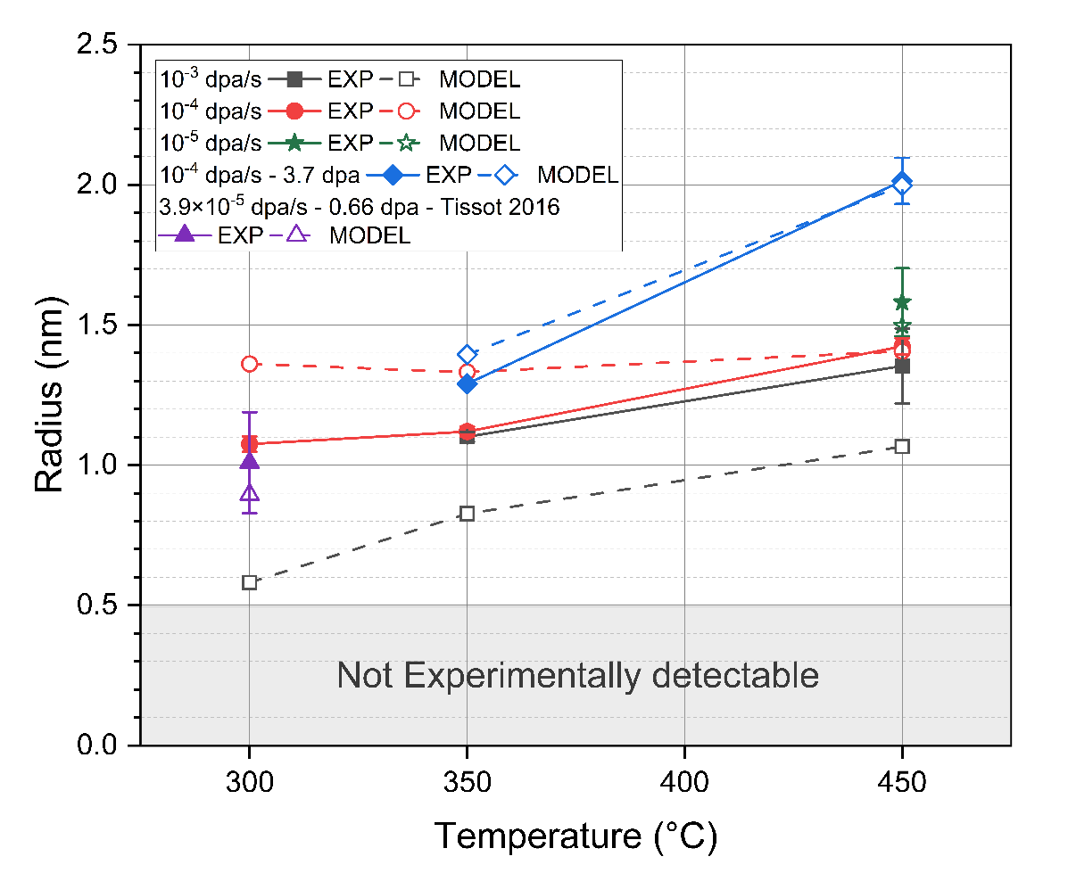
Figure 5.8 Comparison between radii measured with APT (filled symbols) and calculated with the modified NHM model (open symbols) for α’ precipitates formed in Fe-18Cr after 8 MeV Fe irradiation at 300-450 °C. The legends with EXP denote experimentally measured values from the current study and Tissot et al. [7]. The legends with MODEL denote calculated values from the modified NHM model.

and consistent with our experimental observations. The overestimation of steady state radii with $f_{m}=1.4×{10}^{16}$ implies that the exclusion of mean square displacement distances less than fourth nearest neighbor distance may not be appropriate to define the portion of displaced atoms that contribute to precipitate dissolution; atoms that are ballistically displaced shorter distances may also be important.
If sink dominant conditions are assumed (considering the potentially very large sink strength of α’ precipitates), the modified NHM model predicts complete dissolution of precipitates at all conditions no matter which of the two $f_{m}$ values are selected (i.e., there is insufficient radiation-enhanced diffusion to regrow the precipitates due to the low steady state point defect concentrations caused by high sink strength). This disagreement with our experimental observations may indicate that α’ precipitates have a weak interaction with point defects, which is reasonable because the lattice mismatch between α-Fe and α’-Cr is very small. The point defects in the vicinity of precipitates may not experience any noticeable strain field, and if they hop into the α- α’ interface they might be weakly bound and easily desorbed. Since the sink strength from other features such as network dislocations and dislocation loops was relatively low for the investigated irradiation conditions, the recombination-dominant approximation is considered to be appropriate to obtain steady state vacancy concentrations in this alloy system. This evaluation is also supported by the better fitting of electron irradiated Fe-Cr precipitate results with recombination dominant conditions [67].
The results for Fe-12Cr and Fe-14Cr conditions are given in Figure 5.9. In Fe-12Cr specimens, the steady state radii are reasonably estimated and the absence of α’ was correctly explained. However, it should be pointed out that a smaller ballistic dissolution factor must be used to achieve these agreements. In Fe-14Cr, steady state radii of α’ were correctly estimated at lower dose rates (10⁻⁵-10⁻⁴ dpa/s). Large difference between experiments and model estimations exists at 10⁻³ dpa/s or strong coarsening conditions (450 °C, 3.7 dpa), in which the modified NHM model underestimated the steady state radii in both cases. The need of a smaller dissolution factor in Fe-12Cr and the underestimations in Fe-14Cr may suggest the ballistic dissolution rate is slower when the number density of precipitates is very low.

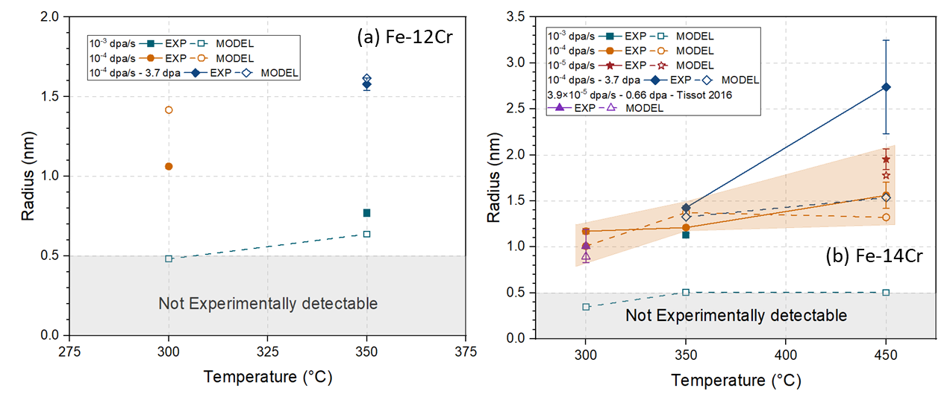
Figure 5.9 Comparison between radii measured with APT (filled symbols) and calculated with the modified NHM model (open symbols) for α’ precipitates formed in Fe-12Cr and Fe-14Cr after 8 MeV Fe irradiation. The legends with EXP denote experimentally measured values and the ones with MODEL denote calculated values from the modified NHM model. The shadowed region indicates the good agreements at the lower dose rates (10⁻⁵-10⁻⁴ dpa/s).

There are two terms in the equation to calculate steady state precipitate radii that account for the decrease of precipitate radius. The first term is associated with the dissolution effect from displacement cascades, and the second term is due to the boundary condition of constant solute concentration. According to our modified NHM model, in the Fe-18Cr system, the radius decrease due to ballistic dissolution is slightly larger than or comparable to the decrease caused by limited concentration of solutes at the irradiation conditions of both dose rates at 300 °C and for 10⁻³ dpa/s at 350 °C. The influence of the limit of solute atoms is more pronounced at other irradiation conditions. These modeling results demonstrate that it is generally not appropriate to simply compare the ballistic diffusion coefficient and radiation enhanced diffusion coefficient for determining the stability of precipitates over a wide range of irradiation conditions [102, 170]. The value of radiation enhanced diffusion coefficient is 3-4 orders of magnitude higher than the ballistic diffusion coefficient calculated with $\frac{1}{6}G{\overline{x}}^{2}$ ($\overline{x}$ is average displaced distance and treated as nearest neighbor distance here) at all investigated irradiation conditions, which doesn’t comply with the absence of precipitates observed at 300 °C and 10⁻³ dpa/s [94, 102]. This modified NHM model is applicable not only to heavy ion irradiations which involve the ballistic dissolution of precipitates, but also to electron irradiation results of Tissot et al [67]. For electron irradiation conditions the replacement per displacement (RPA) value and the point defect production efficiency (corrected for correlated recombination) should be adjusted to 2 and 0.2 respectively [176, 177].
The experimental observation that the steady state radius of α’ precipitates is controlled by irradiation dose rate and temperature irrespective of the starting size is in agreement with the predictions of the modified NHM model. If the starting size of precipitates is smaller than this equilibrium value or there are no precipitates, the supersaturation of solute atoms and enhancement of diffusivity will cause the precipitates to nucleate and grow up to the equilibrium size. If the specimen starts with very large precipitates, the ballistic dissolution will result in their shrinkage and increase the solute concentration in the matrix, and then the re-precipitation of fine solute clusters could occur. This process continues until all large precipitates are replaced by smaller ones.
Several examples comparing the evolution of precipitate sizes with irradiation dose predicted by the modified NHM model and experimental datapoints from the heavy ion irradiations in this work are presented in Figure 5.10. In Figure 5.10 (a), reasonable agreements on both dose and α’ radius are achieved for the conditions at 300 °C and 10⁻³ dpa/s from either solid solution or aged state, and ion irradiation at 450 °C and 10⁻³ dpa/s from solid solution state. At the four ion irradiations that involved lower dose rates (10⁻⁴ to 10⁻⁵), although the steady state radii were correctly reproduced by the modified NHM model, much lower doses are predicted by the model to reach the steady state. As for the sample with pre-existing α’ ion irradiated at 450 °C and 10⁻³ dpa/s, both the radius and saturation dose appear to deviate significantly from the model predictions. As noted in the results section, a possible reason for the slower dissolution rate at 450 °C is the higher radiation enhanced diffusion rates, so the precipitates can keep high solute concentration and large size, and thus increase the driving force for Cr to diffuse back and decrease the effectiveness of displacement cascade. Although the modified NHM model correctly predicts the formation of α’ precipitates under irradiation conditions used in Ref. [8, 9], the steady state radii could not be well reproduced, which might originate from the difference in characterization and data analysis methods that can introduce large differences on the measured precipitate number densities. However, as presented in Figure 5.10 (b), the modified NHM model predicted the complete dissolution of pre-existing precipitates at low doses of 0.1-0.2 dpa at cryogenic to room temperatures, which doesn’t agree with the survival of precipitates at 0.6 dpa observed after irradiations.
Figure 5.11 shows similar evolutions and comparison for proton/electron and neutron irradiation conditions. For the proton or electron irradiations, steady state radii are reasonably estimated at all conditions [67]. The dose to reach steady states were also correctly calculated for electron irradiations at 250-400 °C. However, this model underestimated the doses for ~10 times in Fe-18Cr and ~4 times in Fe-10Cr at proton irradiations conditions. Similar underestimations in required dose also happens for neutron irradiation results, although the steady state radii were reasonably fitted by the model. It must be pointed out that the APT datasets from Bachhav et al were re-analyzed by our algorithm [5]. Since we considered all precipitate atoms for radius calculation, the resulting
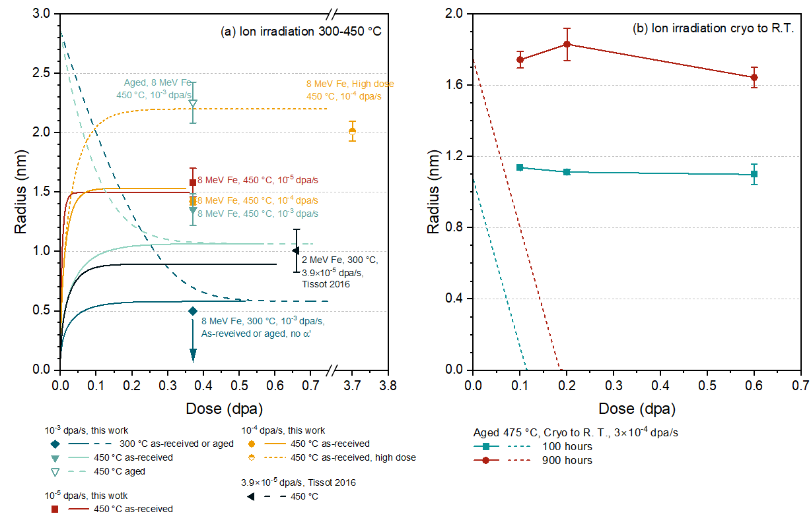
Figure 5.10 Comparison between the evolution of α’ precipitate radii with dose predicted with modified NHM model (curves) and the experimental measurements (isolated data points) for heavy ion irradiation at (a) 300-450 °C and (b) cryogenic to room temperature [7].

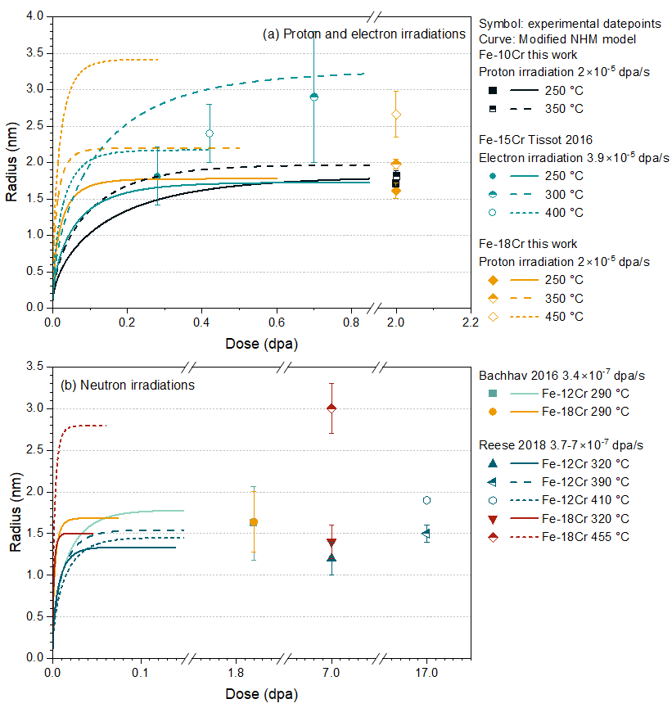
Figure 5.11 Comparison between the evolution of α’ precipitate radii with dose predicted with modified NHM model (curves) and the experimental measurements (isolated data points) for (a) proton/electron and (b) neutron irradiation conditions [5, 6, 67].

radius was larger than what was originally reported. The number densities reported by Reese et al seem too low if the decrease in matrix solute concentrations (close to the volume fraction of precipitates) were considered, so the numbers used here are corrected based on the decreased matrix composition [6].
In general, good qualitative agreement on precipitate growth and shrinkage with experimental observations is achieved by this modified NHM model (in contrast to large discrepancies with the original NHM model) due to the inclusion of more appropriate physical terms. The sizes of α’ precipitates and the doses to reach saturation during the irradiation of FeCr alloys were quantitatively accurately predicted for a large portion of irradiation conditions. However, the required dose was significantly underestimated during ion irradiation at 450 °C and 10⁻⁵-10⁻⁴ dpa/s, neutron irradiations and proton irradiations. This suggests that the net growth rate is somewhat overestimated in the model predictions, which might be related to the loss of point defect at sinks that are not considered in the analysis, the number density change or the lower nucleation rate that causes prolonged nucleation regimes at these conditions, which are not comprehensively included in this model. The disagreement between model predictions and measured precipitate radii at cryogenic to room temperatures suggests that other explanations are needed to understand the precipitate evolutions at this low temperatures. The better agreement with experimental observations by using recombination dominant approximation indicates that α’ precipitates may not be effective point defect recombination centers, despite their very high number density in Fe-18Cr after irradiation at 300-450 °C. This apparent low effective sink strength might be attributed to a small lattice mismatch at the precipitate/matrix interface, which results in a small spontaneous absorption distance and weak binding of point defects so that they are easily desorbed before experiencing recombination.

5.3 Effect of implanted particle types
In this study, irradiations were performed at similar temperatures of 250-450 °C using both heavy ions and protons, which gave very different results regarding Cr precipitate evolution and Cr atom segregation on loops.
The properties of homogeneous Cr precipitates formed after irradiation by heavy ions, protons and neutrons [6] at 320-455 °C are summarized in Table 5.1. At 350 °C, precipitates formed from proton irradiations are more mature: they have larger sizes, lower number density and higher volume fraction. The Cr concentration inside precipitates is also much higher than the value measured after Fe ion irradiations. However, their Cr contents are similar to what was measured after neutron irradiation by Reese et al [6]. At ~450 °C, both neutron and proton irradiations resulted in similar precipitate sizes, number density and high precipitate core Cr concentrations, which indicate the more coarsening of precipitates compared to Fe ion irradiations.
The datapoints presented in Table 5.1 suggest that α’ precipitate evolution is similar between neutron and proton irradiations, while Fe ion irradiations lead to the formation of smaller and more dilute precipitates. These differences can be partially understood by the difference in PKA/recoil energies and their distributions during irradiations by various particles, and the different dose rates, which are compared in Table 5.2, 1 MeV neutron irradiation gives the maximum recoil energy similar to that of 800 keV proton, but the mean recoil energy is closer to that of Fe ions. Since the spectrum of recoil energies generated by Fe and protons both favors the lower energy side, the similar mean recoil energy by Fe ions and neutron irradiation suggests the displacement damage cascade structure might be similar in these two cases. However, ion mixing caused by displacement cascades lasts for only a few picoseconds, which is followed by the relatively longer time of precipitate recovery by radiation enhanced diffusion. The much lower dose rate during neutron irradiations implies that this recovery time would be much longer, so precipitate formation is preferred. On the other hand, the mean recoil energy of 800 keV protons is only several times of the threshold displacement energy of Fe (40 eV), so mainly point defects are created and then contribute to the diffusion of solute atoms to form precipitates. Therefore, both neutron and proton irradiations would favor the formation of precipitates compared to heavy ion irradiation due to either the lower dose rate, or the lack of displacement cascade induced dissolution, respectively.
Radiation induced segregation of solute atoms at point defect sinks also results from the migration of point defects, which is similar to the physical path of precipitate formation.
Table 5.1 Characteristics of α’ precipitates in Fe-18Cr irradiated by different particles. Fe and proton irradiation results are from this work. Neutron irradiation results are from [6].
Particle type | Irradiation temperature  (°C) | Dose  (dpa) | Radius  (nm) | Number density  (10²⁴/m³) | Cluster core Cr content  (at. %) | Matrix Cr content  (at. %) | Volume fraction  (%)
8 MeV Fe | 350 | 3.7 | 1.29 ± 0.01 | 4.0 ± 0.7 | 57.9 ± 7.3 | 15.4 ± 0.5 | 4.1 ± 0.8
800 keV P* | 350 | 2 | 1.98 ± 0.07 | 2.6 ± 0.2 | 86.6 ± 1.8 | 10.9 ± 0.2 | 10.7 ± 0.2
Neutron | 320 | 7 | 1.4 ± 0.2 | 1.6 ± 0.8 | 84.2 ± 1.1 | 11.5 ± 0.4 | -
8 MeV Fe | 450 | 3.7 | 2.01 ± 0.08 | 0.94 ± 0.06 | 66.3 ± 3.5 | 16.3 ± 0.3 | 4.2 ± 0.2
800 keV P | 450 | 2 | 2.66 ± 0.32 | 0.51 ± 0.09 | 95.6 ± 1.9 | 13.2 ± 0.7 | 6.0 ± 1.6
Neutron | 455 | 7 | 3.0 ± 0.3 | 0.39 ± 0.12 | 96.0 ± 0.4 | 10.4 ± 0.2 | -
*P is short for proton

Table 5.2 Typical recoil energies and dose rates during irradiations by different particles.
Particle type | Max recoil energy | Mean recoil energy | Dose rate |  | Distribution
8 MeV Fe | 8 MeV | 17.8 keV | 10⁻⁵ – 10⁻³ dpa/s |  | Low energy recoils preferred
800 keV Proton | 55.1 keV | 289 eV | 2×10⁻⁵ dpa/s |  | Low energy strongly favored
1 MeV Neutron | 68.9 keV | 34.5 keV | 3.5×10⁻⁷ dpa/s |  | All energies equally probable

Cr enrichment has been observed at dislocation loops in FeCr alloys after irradiation by 2 MeV Fe ions at 500 °C. The Cr content at the loops was ~22-35%, which is much lower than the Cr content of α’ phase, and it was tentatively explained to be related to the stabilization of Cr clusters by impurities [88]. In our study, agglomerated precipitates formed from radiation-induced Cr enrichment at dislocation loops were observed in Fe-(5-10)Cr alloys after irradiation by protons at 250 °C. Cr concentrations in these precipitates reached 80-90%, which is comparable to the equilibrium concentration of α’ precipitates predicted by phase diagrams. Since the behavior of homogenous Cr precipitation is similar between neutron and proton irradiations, radiation-induced α’ precipitation on dislocation loops might be likely to happen also during neutron irradiations. This can be a big concern because it implies that α’ precipitation can’t be eliminated by simply decreasing the bulk Cr content. They are likely to form if both Cr solute in the matrix and dislocation loops are present. If possible, characterizing Cr atom distributions on dislocation loops in neutron irradiated FeCr alloys will be useful as a comparison.
Carbon contents of 258-1474 appm after the high temperature heavy ion irradiations were revealed in Fe-18Cr using APT. Although some introduction of carbon atoms by FIB preparations is very likely, the concentrations of carbon after ion irradiation were considerably higher than that measured in the as-received specimens, which indicated the occurrence of moderate carbon contamination during ion irradiations. Carbon atoms were present in the sampled volumes in 3 forms: segregating to dislocation loops or lines, forming Cr-containing carbides, and homogeneously distributed in matrix. Segregation of carbon on dislocation loops can potentially stabilize the enrichment of Cr at or close to the loop core, and thus decrease the Cr atoms available for precipitate formation [88]. Carbides also act as sinks to reduce the concentration of point defects. In all the collected APT datasets, carbides were observed only after ion irradiation at 450 °C, 10⁻⁵ dpa/s to 0.37 dpa. The lack of carbides at other conditions might be due to the relatively small analyzed volume using APT. Employing other techniques would be useful to verify their existence or absence at other conditions. In datasets where carbides were detected, their radius was 2.5 nm and number density was 1.4×10²²/m³, which gave a sink strength of 4.4×10¹⁴/m² and could largely decrease the local vacancy concentration near the carbide/matrix interface. Due to the strong binding of carbon with vacancies (V), the existence of carbon in a solid solution could lead to the formation of C-V complexes [186], within which C₂V (2 carbon atoms and 1 vacancy) and C₄V₂ are the most stable forms [187, 188]. The effect of C₂V can be ignored due to the lower dissolution temperature of ~240 °C [188]. However, the dissociation temperature of C₄V₂ was measured to be ~357-377 °C, and its fraction within all complexes increases with carbon content, which implies it may contribute to reducing vacancy concentrations at 300-350 °C [188, 189]. In short, the presence of carbon in all 3 forms results in the decreased Cr concentration available for clustering or decreased free vacancies for diffusion, and therefore likely slows down the Cr precipitate formation kinetics. Since the effect of impurity carbon atoms was not considered in the modified NHM model, calculating the steady state vacancy concentration using recombination dominant approximation may lead to an overestimation of radiation enhanced diffusion rates, and introduce uncertainty on the determination of $f_{m}$ value. However, because the interaction between carbon and vacancies are complicated, and the migration energy of vacancies obtained from simulation works considering carbon effects varied within 0.83-1.3 eV [170, 190], it is currently difficult to include it in the modified NHM model.

5.4 Effect of surface and injected ions

5.4.1 Implication of α’ precipitates denuded zone
The measured thicknesses of surface precipitate denuded zone are much narrower than the void denuded zones typically observed after ion irradiations at similar temperatures, which were ~100-500 nm in FeCr alloys [26]. Since the formation of voids requires a substantial net supersaturation of vacancies relative to interstitials, while only high vacancy concentrations are needed for the radiation-enhanced precipitation process, it is expected that the conditions for precipitate formation would be easier to be achieved compared to the formation of voids, and thus leads to a narrower denuded zone. The independence of the precipitate denuded zone width on irradiation dose is consistent with previous studies focusing on void denuded zones, in which no relation between the zone width with dose was also revealed [191]. The correlation of the measured denuded zone width with irradiation temperature can be understood using equation $L∝\frac{D_{v}}{4G×4πr_{0}/Ω}$, where $D_{v}=D_{v0}exp⁡(-E_{v}^{m}/kT)$ is the vacancy diffusivity, G is the dose rate in dpa/s, $r_{0}$ is the spontaneous recombination radius and $Ω$ is the atomic volume [191-193]. Therefore, $lnL$ has a linear relationship with -1/T, and the slope is $-E_{v}^{m}/k$, from which the vacancy migration energy can be extracted. This negative slope value explains the increase of denuded zone widths with rising temperatures. The estimation based on our irradiation temperatures and corresponding measured denuded zone widths suggests a vacancy migration energy of 1.63 eV. This estimation is about 40% higher than the 0.96-1.31 eV estimated for pure Fe to Fe-14Cr derived from the void denuded zone widths by Lin et al [26], and it is much higher than the predictions from previous density functional theory simulations and experimental results, which were usually in the range of 0.55-0.67 eV [74, 76, 78, 79, 81]. This discrepancy might be partially attributed to the limited datapoints measured in this work (only 2 temperatures), which leads to large statistical uncertainties. However, the reason for the experimentally measured values being consistently higher than theoretical predictions is currently unclear.

5.4.2 Accuracy of the depths measured by APT
The accuracy of depth from which APT tips are extracted has long been a concern. Since the imaged length of APT needles is limited to only a few hundred nanometers in the very good runs, which can be even shorter in voltage mode when an early fracture occurs, it is a general practice to remove the corresponding length of materials so that the target depths can be easily achieved during running. The depths are usually measured in SEM/FIB, which is inclined to the measuring direction, and a cross-section correction factor is required to get the actual depth. Furthermore, staging shifting during final milling and inaccuracy in locating the interface between the protection cap and sample surface can introduce additional uncertainties. To check the depth accuracy of the APT results, STEM-EDS mapping was performed on the specimen irradiated at 450 °C, in which the precipitate sizes are larger and solute enrichments in precipitates are higher, and thus they can be imaged more easily. The mapping results are presented in Figure 5.12. Detailed
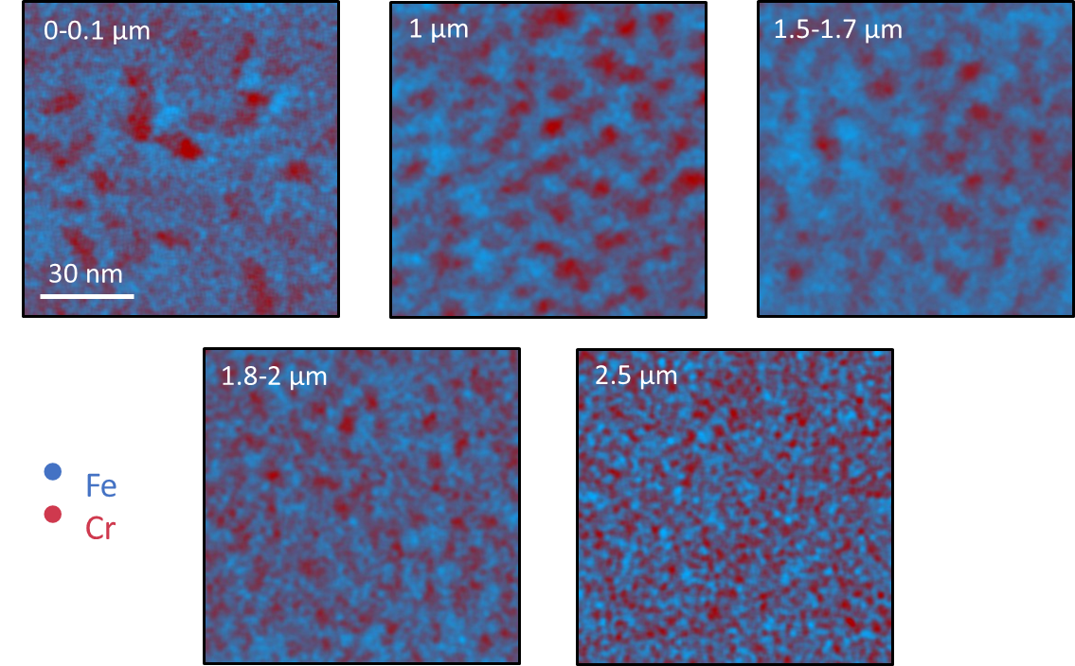
Figure 5.12 STEM-EDS scanning results showing the distribution of Fe and Cr atoms at indicated depths in Fe-18Cr irradiated at 450 °C, mid-range dose 3.7 dpa.

quantification to calculate the size and number density of Cr-rich precipitates will be conducted later. However, the following features can be observed from the maps: 1, very large precipitates in the near surface region; 2, decreased number density of α’ at 1.5-1.7 µm compared to 1 µm; 3, decreased precipitate size and increased number density at 1.8-2 µm compared to 1-1.7 µm results. These trends are consistent with the APT results from the corresponding depths (Figure 4.13), and thus confirmed the accuracy of the depth measurements during tip preparation.

5.4.3 Possible reasons for the precipitate suppression effect at peak-implant depths
At 350 °C, the sizes of precipitates were nearly constant with depth despite the change in both irradiation dose rates and doses for ~3 times in the 100-1200 nm depth range, which is consistent with the trend observed by Tissot et al [7]. At this temperature, the precipitates might still stay in the nucleation stage with little growth. Therefore, the observed trend suggested that the growth rate of precipitates is almost independent of dose rate at the range of 3×10⁻⁵ to 2×10⁻⁴ dpa/s, so the amount of precipitate radii increase is mainly determined by irradiation time. Conversely, radiation enhanced diffusion process is dominant at 450 °C, and thus increasing the dose rate from ~5×10⁻⁵ (near surface) to ~2×10⁻⁴ (near peak) resulted in the increase of solute diffusion rate, and the growth or coarsening rate of precipitates, so the precipitate size was observed to increase with irradiation dose and dose rate.
The cluster atom maps (Figure 4.13), and the evolution of quantitative properties of α’ with increasing irradiation depth Figure 4.14 suggest strong suppression of α’ precipitation at the near peak damage region after ion irradiation at 350 °C, which is most severe in the high fluence case, where no α’ was observed beyond the depth of 1.5 µm. This suppression effect is not very obvious after irradiation at 450 °C. According to our previous results, the higher dose rate in the implanted ion region alone is not sufficient to suppress α’ formation, because pronounced α’ precipitation was observed in the midrange regions of Fe-18Cr after irradiation at the same temperature and a higher dose rate of 10⁻³ dpa/s by 8 MeV Fe ions.
Similar α’ precipitation suppression behaviors near the implanted ion region have been observed by multiple researchers, and different explanations exist without reaching an agreement. Harrison et al. proposed that the high probability of cascade overlap near the end of injected ion path can effectively dissolve α’ [9]. Our experiments compared the α’ distribution after irradiation at 350 °C and the same ion flux, to final doses that are 10 times different, and the results seem to contradict this argument. The stronger suppression effect at the high fluence condition indicates that the accumulation of injected ions or displacement damage is the most important factor that leads to the disappearance of α’. Since the temperature, injected ion energy and flux were almost the same, if cascade overlap is the main reason, a similar suppression effect should be observed after irradiation to both doses.
Tissot et al. inferred the suppression of α’ formation by injected interstitials by showing the decrease in precipitate number density and volume fraction in the ion implanted region of a Fe-15Cr specimen after ion irradiation at ~2-6.1×10⁻⁵ dpa/s and 300 °C to doses of ~0.3-1 dpa, which was attributed to the decreased radiation enhanced diffusion rate due to the injected interstitials [7]. They can either recombine with vacancies, or form interstitial clusters that act as sinks and further decrease the local vacancy supersaturation level [7]. Pareige et al didn’t detect any α’ in Fe-12Cr alloy after irradiation at 2.2×10⁻⁴ dpa/s and 300 °C to 0.5 dpa using Fe ions with energies of 0.5, 2 and 5 MeV (to achieve relative flat displacement damage and injected ion profiles), which also supported this mechanism [10]. With the high concentration of injected ions from multi-stage ion irradiations, no α’ precipitates were detected in the supersaturated Fe-12Cr alloy [10]. Our observation that the most significant suppression effect occurred after irradiation at 350 °C and high ion fluences compared to its higher temperature or lower fluence variants agrees more with this reasoning. The possible reason for the smaller suppression at low fluence might be that the sink strength of interstitial type defects was not high enough to significantly reduce the local vacancy concentrations, while the radiation enhanced diffusion rate is very high at 450 °C, and potentially requires a higher sink strength to reduce it to a value that can’t compensate the ballistic dissolution rate anymore.
Using standard rate theory equations, the effect of injected ions can be treated as an additional generation term, and thus the relative contributions to reducing the local vacancy concentrations from either enhanced recombination or the increased sink strength can be understood in a more quantitative manner. The vacancy and interstitial migration energies were taken as 0.67 eV and 0.34 eV, respectively, and a spontaneous recombination radius of 2.26a₀ is used, in which a₀ is the lattice parameter [74, 175]. Inserting the irradiation parameters calculated from SRIM and a temperature of 350 °C, the calculated results are given in Figure 5.13. The maximum time to reach a steady state is ~ 15 seconds, and it occurs at the lowest sink strength of 10¹¹/m², which approaches to the sink strength of dislocations before irradiation. It must be pointed out that the contribution from the diffusion of vacancies among neighboring bins and surface are not considered here. The reasons are that the change rate of local vacancy concentration by inter-bin diffusion is several orders smaller within the typical time to reach a steady state compared to the other contributing factors, and the depth influenced by the surface sink strength seems to be narrow from our experimental observations. At the lowest sink strength condition, the steady state vacancy concentration is reduced by the injected ions by up to 60% at the 2 µm depth (Figure 5.13 (b)). As the sink strength increases, the effect of promoted recombination with injected ions decreases gradually, and the difference from whether the additional generation rate of interstitials is considered or not becomes <0.1% at sink strengths ≥10¹⁴/m². In other words, at high sink strengths, the point defect evolution is closer to a sink dominant condition, and thus the loss of vacancies to recombination with injected ions gets less important. However, increasing the sink strength from 10¹¹/m² to 10¹⁶/m² can lead to a decrease of around 2 orders of magnitude in the steady state vacancy concentrations according to the curves presented in Figure 5.13 (a). These simulation results lead to the following assumption regarding the suppression effect of injected interstitials: At low doses (low sink strength), the diffusion coefficient is reduced up to ~ 60% due to the recombination of injected ions with vacancies. The importance of this effect decreases with increasing sink strength. As the irradiation dose increases, the sink strength of interstitial type clusters also increases. The radiation enhanced diffusion coefficient can be significantly reduced compared to the low sink conditions due to the loss of vacancies
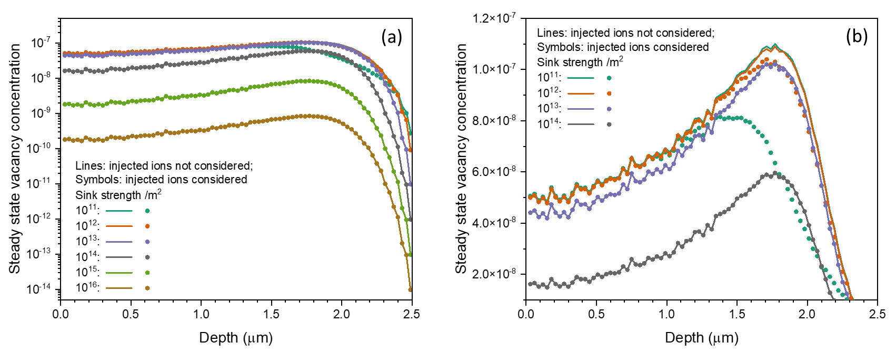
Figure 5.13 (a) The steady state vacancy concentrations calculated from rate theory equations and (b) the zoom-in version of (a) for sink strengths of 10¹¹-10¹⁴/m² to show the effect of additional recombination with injected ions more clearly.

to sinks. Careful analysis of the sinks from dislocation loops or dislocation networks in the ion irradiated specimens will be useful to verify whether this assumption is correct or not.
In addition to the mechanisms mentioned above, the additional implanted Fe ions can lead to a locally high concentration of Fe-Fe dumbbell interstitials compared to the concentration of Fe-Cr mixed dumbbells. Therefore, more Fe atoms can be dragged into the precipitate-matrix interface by the interstitial flux, and this results in an increase of Fe concentration at the interface and the dissolution of Cr-rich precipitates.
Furthermore, the observed strong suppression effect at 350 °C, high fluence condition might be associated with the mistakenly introduction of light ions during irradiation. As shown in Figure 5.14 (b), STEM image reveals a very narrow damage band, which is different from the two other irradiation conditions, and possibly was induced by light ions. The location of this band is 1.5-1.8 µm away from sample surface. Mass spectrums are plotted in Figure 5.14 (d-j), in which the peaks at 6, 12, 14, 16, 18 and 24 Da correspond to C²⁺, C⁺, N⁺, O⁺, C₃²⁺ and C₂⁺, respectively. In Figure 5.14 (f), an extra peak was detected at 19 Da, which might be attributed to Fluorine (mass is 19 and charge state is 1+). Other spectrums from different specimens or depths don’t give a peak at this location. The depth at which spectrum (f) was obtained agrees with the location of the narrow damage band, which indicates this band might be primarily induced by implanted Fluorine ions instead of Fe ions. Therefore, the disappearance of α’ precipitates at 1.5-1.7 µm at 350 °C, high fluence condition might be partly attributed to this artifact. However, at the depth of 1.8-2 µm, no α’ was observed in this specimen, whereas they were detected at the lower fluence or higher temperature conditions. All 3 mass spectrums (Figure 5.14 (h-j)) don’t show any peak at 19 Da. This comparison still suggests the stronger suppression effect from implanted ions at high fluence and low temperature conditions.
The broadening of injected ion profiles due to radiation enhanced diffusion was evaluated using the codes developed by Doyle et al [130, 194]. However, it turned out that this further broadening was minor compared to the distributions predicted by SRIM at both 350 °C and 450 °C irradiation conditions. The onset depth from which the injected ion concentrations start to increase progressively was nearly unchanged due to the relatively low doses investigated in this study.
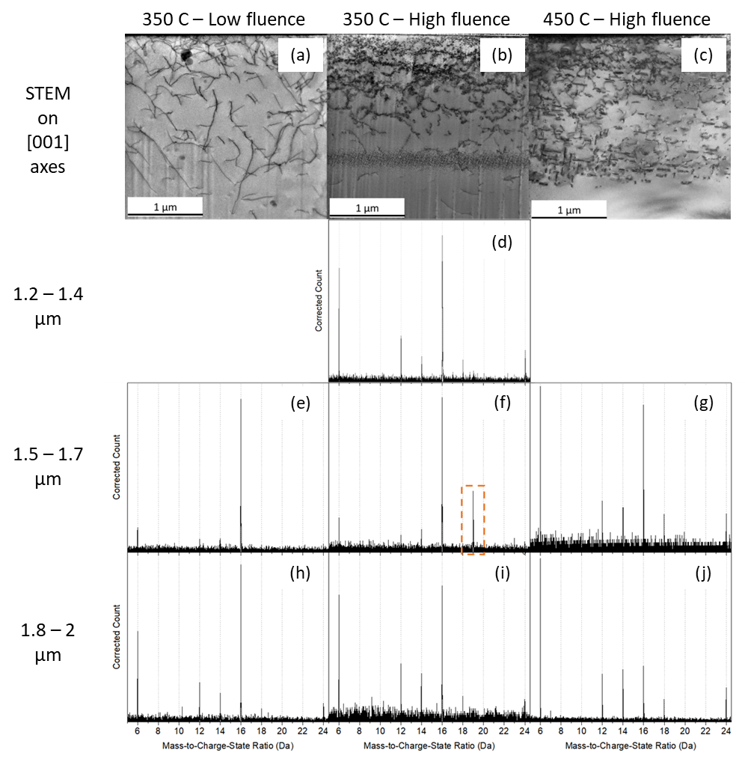
Figure 5.14. (a-c) STEM images taken along [001] directions show the distribution of dislocation lines and loops. (d-j) Mass spectrums in the range of 5 to 24.5 Da exported from APT datasets collected for needles extracted from different depths of the 3 specimens. The depth and irradiation conditions are listed on the figure. The dashed rectangle in (f) highlights the presence of the peak at 19 Da.

5.5 Effect of bulk Cr concentrations
To understand the effect of Cr concentrations on α’ evolution, Fe ion irradiation at 300-450 °C and proton irradiation at 250-450 °C were performed in Fe-(5-18)Cr alloys. For α’ precipitation, Cr concentration mainly determines the supersaturation level, and thus the driving force for phase separation.
In summary, after heavy ion irradiation, α’ precipitates didn’t form in Fe-18Cr at 300 °C and 10⁻³ dpa/s, but they are homogeneously distributed at higher temperatures and lower dose rates. The precipitates were observed in Fe-14Cr at most investigated irradiation conditions except for 450 °C, 10⁻³ dpa/s. In Fe-12Cr, α’ clusters were detected after irradiation at 300 and 350 °C, but not at 450 °C. So far, no α’ formation in Fe-10Cr was observed. The presence or absence of α’ at each irradiation dose rate and temperature are compared to the phase boundaries derived from this work and those available in the literature in Figure 5.15. The phase boundary from Bonny et al was fitted from neutron irradiation studies, which shows a large difference compared to the version calculated from the Calphad database [58, 61]. The isolated datapoints in Figure 5.15 are from experimental observations of this work and possible phase boundaries separating the absence/presence of α’ at 10⁻⁴ and 10⁻³ dpa/s are plotted with dashed lines. At 450 °C, the Calphad calculation gives a reasonable fit to the observed absence of α’ at 10⁻⁵-10⁻⁴ dpa/s in the Fe-12Cr specimen, but 10⁻³ dpa/s leads to a large deviation from both estimations (Calphad and Bonny). At the two lower temperatures, large discrepancies in experimental observations from the equilibrium phase boundary were observed at both 10⁻⁴ and 10⁻³ dpa/s dose rates. This deviation can be explained by the ballistic dissolution effect of displacement cascade, which dissolves the α’ clusters more effectively at higher dose rates or lower temperatures.
After proton irradiations, homogeneous α’ were observed in Fe-(10-18)Cr alloys at 350-450 °C, while agglomerated clusters tend to form in the more dilute Fe-(5-10)Cr alloys at 250 °C. At 250 °C, the ratio of agglomerated/homogeneous precipitate volume fraction is also higher in the more dilute alloys. Since the agglomerated α’ on dislocations are more likely to form from the coupling between interstitials and Cr atoms, this increased volume fraction may suggest the importance of diffusion through the interstitial-drag mechanism
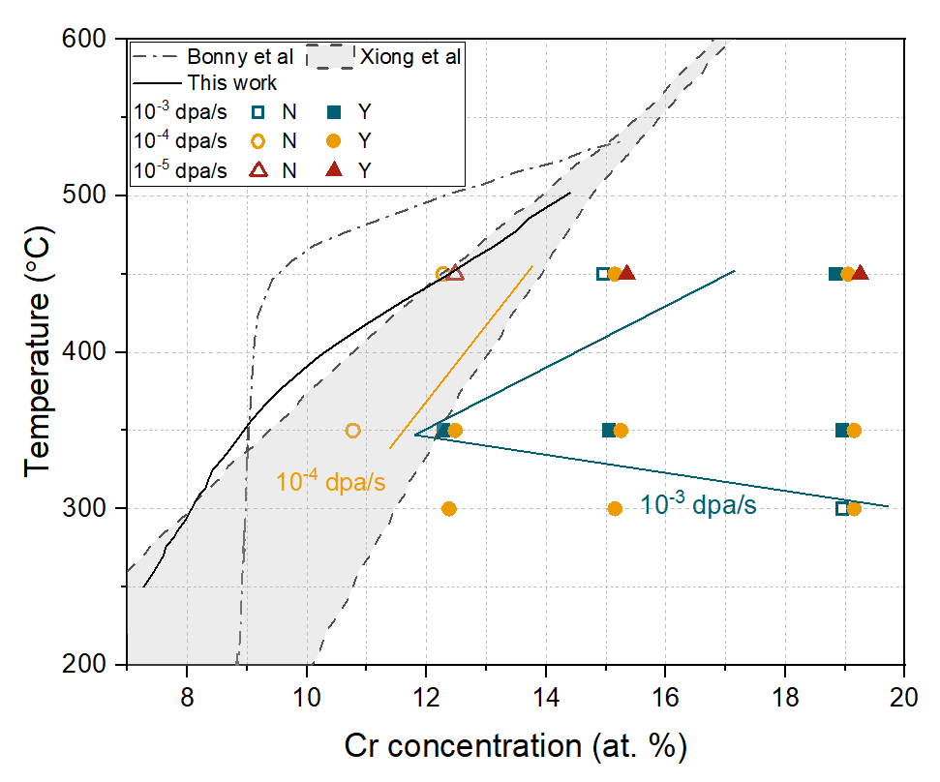
Figure 5.15 The comparison between experimental observed α’ formation/dissolution with the phase boundaries available in the literature [58, 61]

over the vacancy exchange mechanism becomes higher in more dilute alloys. This is consistent with simulation results by Terentyev et al., who found vacancy mechanism is preferred in concentrated alloys, due to the unavoidable formation of Cr-Cr dumbbells [90]. However, checking Cr atom distribution in Fe-18Cr after irradiation at 250 °C will be useful to verify this trend.
Despite the rather straightforward Cr effect on α’ formation, the effect of Cr concentration on the evolution of void swelling and dislocation types (Burgers vector a<100> and 1/2a<111>) are not monotonic. Since a lot of specimens with different Cr concentrations have been irradiated in this study, in which the irradiation conditions include a wide range of temperatures, dose rates and doses, and by either protons or heavy ions, it will be valuable to also quantify the density and size of dislocations loops formed from irradiations, so that a systematic trend will be generated.

5.6 Mechanisms of α’ precipitate formation

5.6.1 Precipitate Cr concentrations and APT artifacts
In our study, highly concentrated α’ precipitates (80-90% Cr) were obtained after both thermal aging and proton irradiations. However, all clusters formed after heavy ion irradiations from as-received states have Cr concentrations in the range of 40-75 at. %, which is much lower than the equilibrium Cr content in α’ as presented in Figure 4.5 (b). This is not the first time this phenomenon has been reported and raises questions about whether this might be an APT experimental artifact versus a true phenomenon. The characterization of α’ clusters with APT is known to suffer from the local magnification effect and ion flight trajectory aberrations due to the lower evaporation field of Cr compared to Fe [195]. For example, the increase of core Cr concentration with α’ radius after neutron irradiation at 300 and 450 °C was claimed to most likely result from the blurring of the precipitate-matrix interface [112]. Here we did a similar analysis on the change of cluster core Cr content and density as a function of their radii, and the results are plotted in Figure 5.16. Six examples including two ion irradiated specimens and two proton irradiated specimens that contain precipitates of wide size distribution and two thermally
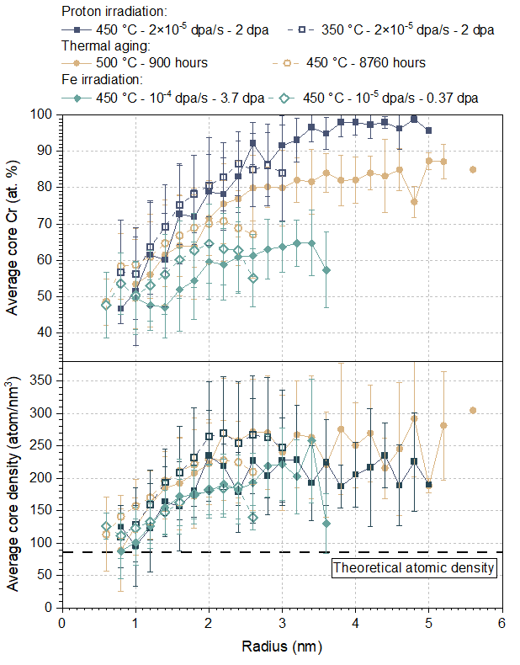
Figure 5.16 Particle size dependence quantified by APT of (a) Cr concentration and (b) atomic density in the core of α’ precipitates that formed in Fe-18Cr at six conditions. Conditions are listed in the legend.

aged specimen are presented. It seems there is no big difference in the measured Cr concentrations in smaller-sized clusters (< 2 nm) among these six conditions. Furthermore, the core density, the increase of which is an indication of trajectory aberration, is not significantly higher than the theoretical value. On the other hand, larger precipitates show distinct differences in the core Cr concentrations: >90% Cr and 80-90% Cr was measured in clusters >2.5 nm formed after proton irradiations and thermal aging, respectively, while only 60-70% Cr was measured in similar-sized clusters formed from ion irradiations. It was interesting to find that the core atomic density is not very different for these large precipitates that have different Cr concentrations, which implies the focusing of ion trajectories during evaporation doesn’t change the core solute concentration [70]. The higher atomic density in larger precipitates (having higher Cr concentrations) than smaller one suggests that the high solute concentration in the core of precipitates is responsible for the increase in local atomic density instead of vice versa. This finding agrees with a previous simulation work, which found the major effect of local magnification is to modify the precipitate shape without changing the core Cr content, and only limited underestimation of Cr content from lateral resolution error is expected for small clusters with radius ≤1nm [196]. Post-aging characterization of α’ precipitates using APT carried out by Novy et al. also excluded the possible contribution of trajectory aberration to decrease core Cr content by showing that similar sized-precipitates in specimens aged at different times exhibited different Cr concentrations [66]. Additionally, our proton irradiations resulted in the formation of α’ with high Cr concentrations of >80 at. %. Therefore, it appears the measured sub-equilibrium Cr content in the α’ precipitates is mainly controlled by kinetic/thermodynamic aspects during irradiation.
A non-classical nucleation mechanism in which the α’ phase nucleates with a solute concentration lower than the thermal equilibrium composition was previously proposed as an explanation for the appearance of low Cr content in the clusters formed from thermal aging or particle irradiation [6, 66, 197-199]. Although this mechanism might explain the formation of low Cr content for clusters in samples irradiated to low doses, it is not fully consistent with our observations. After irradiation at 450 °C and 10⁻⁴ dpa/s to 3.7 dpa, the Cr content of clusters was 66 at. %, although strong coarsening has occurred, and close to equilibrium Cr concentrations were measured in precipitates of similar size after aging at 500 °C. Combining the results on ion irradiated pre-aged samples with pre-existing α’ precipitates, it appears that the cluster Cr content is affected by the irradiation conditions studied here instead of only by the equilibrium phase diagram and the non-classical nucleation process. This conclusion is also supported by the measured matrix Cr content in the aged+irradiated samples, which is much higher than the solvus limit and can be attributed to the continuous ejection of Cr solute from precipitates into the matrix and Fe solvent from the matrix into the precipitates by ballistic dissolution.

5.6.2 Radiation-enhanced α’ precipitation
Previous studies suggest that α’ precipitates form in a radiation enhanced precipitation mechanism [5, 7, 67, 98, 172]. This is based on the observations that α’ precipitates were observed to be distributed homogeneously in the matrix without clear association with visible point defect sinks, precipitate Cr concentration was not significantly changed by irradiations using electrons and neutrons, and they were only observed in supersaturated alloys. Therefore, the precipitates formed during irradiation are similar to that under thermal aging conditions, and the only significant change induced by irradiation is the accelerated kinetics.
In our study, the same Fe-18Cr alloy was aged in a furnace for 1 year and irradiated by protons to 2 dpa at 450 °C. In both cases, homogenously distributed α’ precipitates were revealed by APT. The Cr concentrations at the core of precipitates are 96% after irradiations, which is consistent with the phase diagram prediction. On the other hand, it is ~75% after aging at the same temperature, which can be attributed to the slower kinetics, and thus a longer time is required to achieve the thermal equilibrium state. Therefore, both the positional distribution of α’ and their chemical composition agree with a radiation enhanced precipitation mechanism. Since the precipitates formed from proton irradiation at 350 °C, and part of the precipitate in Fe-10Cr at 250 °C have similar properties, they can also be classified as forming from the radiation-enhanced precipitation path.

5.6.3 Radiation-induced α’ precipitation
From the results and discussion chapters, agglomerated Cr clusters were observed in Fe-(5-10)Cr alloys after proton irradiation at 250 °C to 2 dpa. Their positional relation with dislocation loops was revealed through the STEM-EDS technique. Due to the lack of homogeneous α’ in the matrix of the Fe-5Cr specimen, all precipitates are likely to form from a radiation-induced precipitation mechanism due to the preferential coupling of interstitials with Cr atoms. In Fe-8Cr and Fe-10Cr alloy irradiation at the same conditions, only part of the precipitates were agglomerated, the volume fraction of which decreases with increasing Cr concentrations. Other parts of precipitates are homogeneously distributed and have more spherical shapes. Therefore, the precipitates observed in these specimens form in two paths: the agglomerated ones are likely to be induced by radiations, while the remaining spherical ones are enhanced by irradiations.

5.6.4 Radiation-modified α’ precipitation
This radiation-enhanced precipitation mechanism explains the accelerated cluster formation under electron irradiation, during which there was no appreciable ballistic dissolution of Cr cluster nuclei and the cluster Cr content could reach >90 at. % [67]. However, after neutron irradiation at the same temperature, the cluster solute concentration was reduced to about 85 at. % and the cluster sizes are smaller [5]. A further discrepancy in the Cr solute content and precipitate size occurs for the high dose rate heavy ion irradiation results, in which cluster absence or clusters with much lower Cr content were observed. Considering the reported results and our observations, there is strong evidence that the steady state condition for α’ precipitation under ion or neutron irradiations at 300-450 °C is controlled by the irradiation conditions regardless of the microstructural starting point, as originally suggested by Nelson et al. [100]. Based on the comparison of the precipitate evolution in annealed vs. aged Fe18Cr at 300-350 °C (Figure 4.8, Figure 4.9, Figure 4.10), quasi-equilibrium α’ precipitate distributions are achieved already at doses below 1 dpa. Due to the presence of ballistic dissolution in these energetic displacement cascade conditions, radiation enhanced precipitation, which considers only the accelerated diffusion due to irradiation, is not solely appropriate to explain the α’ precipitation behavior. Since the precipitate size, number density, and solute concentration all deviated from their thermal equilibrium values, the radiation modified precipitation processes seem to be more suitable for describing the observed evolution involving that modify the precipitate size, number density, and solute concentration are both important.
It must be pointed out that although the formation of α’ precipitates with sub-equilibrium Cr content is similar to the traditional radiation modified precipitation phenomenon, the underlying mechanisms are different. The radiation modified precipitation phenomena were first proposed in the 1980s and involved the contribution of radiation induced solute segregation (RIS) [200]. Based on our current study and related prior studies, RIS processes do not appear to be playing a dominant role in α’ precipitation during heavy ion irradiation [106, 201]. According to refs. [5-9, 98, 172, 202] and our results, α’ precipitates were observed to be distributed homogeneously in the matrix without clear association with visible point defect sinks. Although Chromium enrichment has been observed at dislocation loops in irradiated FeCr alloys [88, 107], the Cr content at the loops was ~22-35%, which is much lower than the Cr content of α’ phase, and it was tentatively explained to be related to stabilization of Cr clusters by impurities [88]. Although the chemical compositions of precipitates during irradiation can generally be changed by either RIS or ballistic mixing/dissolution processes, the lack of direct relation of α’ with defect sinks, and the consistent trends regarding Cr concentrations in precipitates and matrix with respect to irradiation temperatures and dose rates in the FeCr alloy systems indicates that the change of Cr content, quasi-equilibrium precipitate size and number density primarily results from competition between radiation enhanced diffusion and ballistic dissolution from ion mixing, instead of the preferential coupling between point defects and Cr atoms.
The radiation modified precipitation behavior of α’ precipitates generally occurs at all irradiation conditions. The extent to which the steady state precipitate parameters are modified from their thermal equilibrium state is determined by the irradiation conditions including temperature, dose rate and the type of injected particles. During irradiations performed with protons or electrons, only minor deviations from the thermal equilibrium steady state are anticipated due to the absence of displacement cascades. In other words, the precipitate evolution will be closer to a pure radiation enhanced precipitation behavior, in which accelerated kinetics is most important. During neutron or heavy ion irradiations that involves displacement cascades, we observed that higher dose rates tend to slow down the Ostwald ripening rate and lead to a final steady state with finer and less solute-concentrated precipitates. Hence, the characteristics of precipitates including radius, number density and solute concentration could all be potentially modified depending on the balance between the rates of dissolution and back diffusion. The effect of increasing dose rate becomes more pronounced at low temperatures and could result in the complete dissolution of precipitates. Although ion irradiation is a powerful tool to study radiation related effects and to test the irradiation tolerance of materials, the dose rates normally used during ion irradiations are 3-4 orders of magnitude higher than what is relevant for fission or fusion reactor conditions. Since the irradiation dose rate has a significant effect on the stability of precipitates, great care must be taken to extrapolate the results obtained from ion irradiation studies to neutron irradiation conditions.

Conclusion
Key conclusions obtained from this thesis are listed in this chapter. They are grouped by the 3 sets of irradiation experiments classified by irradiation temperatures and the type of injected ions.

6.1 300-450 °C heavy ion irradiation
Ultra-high purity Fe-(10-18)Cr specimens were irradiated with 8 MeV Fe ions at a variety of conditions including dose rates of 10⁻⁵-10⁻³ dpa/s, temperatures of 300-450 °C, and final midrange doses of 0.37 and 3.7 dpa. The Cr-rich α’ precipitates formed after most irradiations performed in this study and they were characterized with APT. Analysis of APT datasets was completed with IVAS and a solute concentration-based cluster searching algorithm developed by our group, which was found to provide improved self-consistent results of precipitate size, number density and volume fraction compared to the conventional maximum separation method. The main conclusions are summarized here:
- The critical ion irradiation condition for α’ precipitates to dissolve in Fe-18Cr is 300 °C and 10⁻³ dpa/s, which is consistent with earlier experimental results. This behavior was correctly explained by a modified NHM model concerning the competition between radiation enhanced diffusion (precipitate re-nucleation and growth) and ballistic dissolution (precipitate shrinkage). An error in the original NHM model was corrected and three important modifications for this model were introduced: using a more accurate estimation of the number of recoils per dpa, which is more than two orders of magnitude larger than assumed in the original NHM model due to an incorrect displacement cross-section for medium-mass ions and neglect of the RPA atomic mixing concept in the original NHM model, consideration of thermal equilibrium solubility effects, and the available matrix volume fractions, which result in a much better correlation to the experimental observations.
- At irradiation conditions with higher temperatures or lower dose rates compared to the critical values, the precipitates were observed to nucleate and grow. The precipitate radii generally increase with increasing temperature and decrease with increasing dose rate. The number density of α’ precipitates was highest at 350 °C and decreases with increasing dose rate at all temperatures. These trends generally agree with the classical nucleation and Ostwald ripening of precipitates (modified by ballistic dissolution and radiation enhanced diffusion effects). The decrease in precipitate number density at higher dose rates and lower temperatures is attributed to the increased ballistic dissolution rate and decreased diffusion rate to re-nucleate the precipitates, respectively. The Cr concentration in the α’ precipitates and matrix shows larger deviations compared to their thermal equilibrium values for irradiations at lower temperatures or higher dose rates, which indicates an increasing importance of the ejection of solute atoms from the precipitate phase and injection of matrix Fe into precipitates by displacement cascades at these conditions.
- Increasing the irradiation dose from 0.37 to 3.7 dpa led to only slight growth of α’ precipitates at 350 °C, while significant coarsening was observed at 450 °C, which is attributable to the slower diffusion rate at the lower temperature. The existence of well-developed α’ precipitates before irradiation has a negligible effect on the precipitate size and number density after irradiation at 300-350 °C. This indicates that quasi-equilibrium is achieved relatively quickly (by ~0.37 dpa) under the investigated 300-350 °C, 10⁻³ dpa/s irradiation conditions. This observation agrees with the behavior quantitatively predicted by the modified NHM model, i.e. the equilibrium cluster size is typically controlled by irradiation conditions irrespective of the initial starting microstructural state (annealed vs. aged), and the steady state can be achieved within 0.3-0.4 dpa. However, a convergent precipitate distribution was not achieved between the annealed and aged specimens after irradiation at 450 °C to 0.37 dpa, which deviated from the modified NHM model prediction, and was attributed to the higher recovery rate at this higher temperature. Both sets of observations suggest that ballistic dissolution processes produce quasi-equilibrium within 0.3-0.4 dpa at low to intermediate temperatures, whereas normal thermal coarsening processes dominate at high temperatures.
- All the α’ precipitates observed after ion irradiation have Cr concentrations well below the equilibrium value, and the corresponding matrix Cr contents are well above the solvus concentration limit. This can be attributed to kinetic aspects of either the non-classical nucleation mechanism or the ejection of solute atoms back into the matrix and injection of solvent Fe into precipitates by energetic displacement cascades. Radiation modified precipitation processes appear to correctly account for this behavior. The competition between radiation enhanced diffusion and ballistic dissolution provides a second path to produce a steady state different than thermal equilibrium compared to the traditional path through RIS. Both the size and solute concentration in precipitates were modified by the presence of displacement cascades. The effect of dose rate on precipitate stability is pronounced at typical ion irradiation conditions and must be considered when extrapolating high dose rate results for possible applications under lower dose rate fission or fusion reactor environments.
- Three ion-irradiated Fe-18Cr specimens were selected for detailed characterization and analysis of α’ precipitate distribution at different depths. The surface was observed to reduce α’ formation within a relatively narrow depth of ~3-4 nm at 350 °C and ~10 nm at 450 °C. It indicates that for the studies focusing on precipitation evolution under ion irradiations, the surface related artifacts are not very important and can be easily avoided. However, the implanted ions have a strong suppression effect on the precipitate formation. The number density of α’ precipitates decreased significantly at 1.5 µm after irradiation at 350 °C to the low fluence, and no α’ was observed beyond 1.2 µm after irradiation to 10× higher fluence at the same temperature. Therefore, in order to avoid the implanted ions related artifacts, the analysis region should be limited to ≤1.2 µm at 350 °C for 8 MeV Fe ions and 3.7 dpa mid-range dose. Further shrinking of this region may happen if a higher ion fluence is used. At 450 °C, the implanted ions have a much weaker suppression effect, and thus the microstructure characterization can be safely performed up to 1.5 µm from the surface based on our current results. The high dose rate and enhanced cascade overlap at the peak damage depth to the end of range are not the main reasons for this suppression behavior, which is more appropriate to be attributed to the reduced radiation enhanced diffusion rates or increased local Fe-type interstitial concentrations [7].
- The effect of Cr concentrations is studied in this work. α’ precipitates were observed in Fe-14Cr at most investigated irradiation conditions except for 450 °C, 10⁻³ dpa/s. In Fe-12Cr, α’ clusters were detected after irradiation at 300 and 350 °C, but not at 450 °C. No α’ was observed in Fe-10Cr. At 450 °C, the Calphad calculation gives a reasonable fit to the observed absence of α’ at 10⁻⁵-10⁻⁴ dpa/s in the Fe-12Cr specimen, but 10⁻³ dpa/s leads to a large deviation from both estimations (Calphad and Bonny). At the two lower temperatures, large discrepancies in experimental observations from the equilibrium phase boundary were observed at both 10⁻⁴ and 10⁻³ dpa/s dose rates. This deviation can be explained by the ballistic dissolution effect of displacement cascade, which dissolves the α’ clusters more effectively at higher dose rates or lower temperatures.

6.2 250-450 °C proton irradiation and 450-500 °C thermal aging
Proton irradiations at 250-450 °C to 2 dpa and thermal aging at 450-500 °C up to 1 year were performed to form Cr-enriched α’ precipitates in high-purity FeCr alloys, and thus determine the boundary between single/dual phases regions. APT was used to detect the presence of α’, and to measure the matrix solute concentrations after thermal aging and proton irradiations.
- α’ precipitates were not observed in Fe-12Cr at 450 °C and Fe-8Cr at 350 °C, which suggests the bulk compositions of these specimens are on the single phase α region. On the contrary, α’ formed in more concentrated alloys at these two temperatures and all studied specimens at 250 °C. The measured matrix concentrations and the bulk compositions of alloys without α’ formation suggested an α - α’ phase boundary that agreed more with the prediction of Xiong et al [62]. However, the deviation of our experimental results from their predictions exists at lower temperatures.
- From APT reconstructions, most precipitates formed in Fe-18Cr alloys at all temperatures or more dilute alloys at 350-450 °C were homogeneously distributed and were likely to be enhanced by irradiations, while the precipitates observed in Fe-5Cr at 250 °C were agglomerated, and a mixture of spherical and agglomerated precipitates were present in Fe-8Cr and Fe-10Cr at 250 °C. The positional associations of agglomerated precipitates with dislocation loops in Fe-5Cr were revealed by STEM-EDS mapping. The lack of homogeneous α’ in this specimen suggests the agglomerated ones are likely to form from a radiation induced precipitation method.
- After thermal annealing, hardness tests were conducted to measure any hardening resulting from phase separation, and APT was used to measure the matrix composition of Fe-18Cr alloys. At both 450 and 475 °C, hardness increase occurs in Fe(15-18)Cr alloys, but not in Fe(10-12)Cr alloys, which indicates a solubility limit of 12.4-15.2 at. % at this temperature range. This is consistent with APT characterization of the aged specimens and proton irradiation results at 450 °C, which implies radiation enhanced rather than radiation-induced α’ formation at this temperature.

6.3 -123 °C to R.T. heavy ion irradiation
Both FeCu and Fe-18Cr specimens were aged to form nm-scale solute precipitates. These aged specimens were then irradiated by Fe ions at -123 °C – R.T. to final doses of 0.1 - 0.6 dpa. Solute atom distributions after irradiations were studied by APT.
- In both FeCu and Fe-18Cr alloys, precipitate size and number density were not significantly changed by irradiations up to 0.6 dpa. The largest difference induced by irradiations is the decrease in precipitate core solute concentrations, which was 12% in the 1.5h aged FeCu specimen and 39% in the 10h aged FeCu specimen, respectively. This dilution process implies the gradual dissolution of Cu precipitates by displacement cascades in ≤1 dpa in FeCu alloy system.
- On the contrary, Cr precipitates formed in Fe-18Cr after aging for 100h showed no difference in composition after irradiations up to 0.6 dpa, and solute concentrations only decreased by 15% in the 900h aged specimens at the highest dose. These results suggest that Cr precipitates have higher stability than Cu precipitates under heavy ion irradiation conditions. Considering the higher diffusion of Cu atoms compared to Cr atoms in the Fe matrix, the reason for the higher stability of Cr precipitates is currently unclear.
- The strong stability of Cr precipitates at temperatures ≤ R.T. also contradicts our previous irradiation results at 300-350 °C, which may suggest the activation of different diffusion paths or other physical mechanisms.

6.4 Recommendations for future work
This project studied the evolution of Cr-rich α’ precipitates under heavy ion and proton irradiations. α’ precipitates were found to form in a radiation enhanced precipitation mechanism during proton irradiations at 350-450 °C. The chemical composition of precipitates was modified by irradiations due to ballistic dissolutions during heavy ion irradiation at 300-450 °C. Radiation-induced α’ precipitation on dislocation loops was observed after proton irradiations at 250 °C. So far, some problems are still unresolved, and the specimens irradiated in this study can potentially be useful for other purposes. The recommended works are listed below:
- α' precipitation was observed to be significantly suppressed in the peak to end range of the Fe-18Cr specimen after irradiation by 8 MeV Fe ions at 350 °C, mid-range 10⁻⁴ dpa/s to 3.7 dpa. This suppression is more severe compared to the lower dose and higher temperature variants. It will be useful to investigate the reasons for this suppression effect by counting the sink strength of dislocations. Additional rate theory calculations and irradiation experiments using Cr atoms will also be helpful.
- Cr precipitates formed after heavy ion irradiations are homogeneously distributed, while the ones formed from proton irradiations at 250 °C are agglomerated and correlated with dislocation loops, which might be associated with the different diffusion mechanisms of Cr atoms. Since conflicting results regarding the segregation or depletion of Cr atoms at point defect sinks have been reported (see section 2.2.3), it will be very useful to study the distribution of solute atoms on dislocation loops in specimens with different Cr concentrations irradiated by protons at different temperatures. Due to the lack of displacement cascade during proton irradiations, any inhomogeneity on dislocations will be much more prominent compared to ion irradiations and thus is less likely to be obscured by STEM-EDS related artifacts.
- Our cryo-room temperature irradiations suggest very high stability of Cr precipitates compared to that at high temperature conditions, which doesn’t comply with the radiation enhanced diffusion VS ballistic dissolution theory. Due to the large gap between them and the 300-450 °C temperature range, and also the lower dose rates used at low temperatures, it might be useful to perform additional irradiations at intermediate temperatures such as 100 and 200 °C, or use the same dose rate as the high temperature irradiations for comparison.

List of References
[1] R.L. Klueh, D.R. Harries, High-chromium ferritic and martensitic steels for nuclear applications, AsTM West Conshohocken, PA, 2001.
[2] P. Grobner, The 885 F (475 C) embrittlement of ferritic stainless steels, Metallurgical Transactions 4(1) (1973) 251-260.
[3] D. Chen, A. Kimura, W. Han, Correlation of Fe/Cr phase decomposition process and age-hardening in Fe–15Cr ferritic alloys, Journal of Nuclear Materials 455(1-3) (2014) 436-439.
[4] O. Tissot, C. Pareige, M.H. Mathon, M. Roussel, E. Meslin, B. Décamps, J. Henry, Comparison between SANS and APT measurements in a thermally aged Fe-19 at.%Cr alloy, Materials Characterization 151 (2019) 332-341.
[5] M. Bachhav, G. Robert Odette, E.A. Marquis, α′ precipitation in neutron-irradiated Fe–Cr alloys, Scripta Materialia 74 (2014) 48-51.
[6] E.R. Reese, M. Bachhav, P. Wells, T. Yamamoto, G. Robert Odette, E.A. Marquis, On α′ precipitate composition in thermally annealed and neutron-irradiated Fe- 9-18Cr alloys, Journal of Nuclear Materials 500 (2018) 192-198.
[7] O. Tissot, C. Pareige, E. Meslin, B. Décamps, J. Henry, Influence of injected interstitials on α′ precipitation in Fe–Cr alloys under self-ion irradiation, Materials Research Letters 5(2) (2016) 117-123.
[8] E.R. Reese, N. Almirall, T. Yamamoto, S. Tumey, G. Robert Odette, E.A. Marquis, Dose rate dependence of Cr precipitation in an ion-irradiated Fe 18Cr alloy, Scripta Materialia 146 (2018) 213-217.
[9] R.W. Harrison, A.W. Carruthers, J.A. Hinks, M.G. Burke, S.E. Donnelly, Cascade size and dose rate effects on α′ precipitation in ion-irradiated Fe14Cr alloy, Scripta Materialia 172 (2019) 33-37.
[10] C. Pareige, V. Kuksenko, P. Pareige, Behaviour of P, Si, Ni impurities and Cr in self ion irradiated Fe–Cr alloys – Comparison to neutron irradiation, Journal of Nuclear Materials 456 (2015) 471-476.
[11] S.J. Zinkle, G.S. Was, Materials challenges in nuclear energy, Acta Materialia 61(3) (2013) 735-758.
[12] E. Bloom, R. Conn, J. Davis, R. Gold, R. Little, K. Schultz, D. Smith, F. Wiffen, Low activation materials for fusion applications, Journal of Nuclear Materials 122(1-3) (1984) 17-26.
[13] E. Bloom, S. Zinkle, F. Wiffen, Materials to deliver the promise of fusion power–progress and challenges, Journal of nuclear materials 329 (2004) 12-19.
[14] R. Viswanathan, J. Nutting, Advanced heat resistant steels for power generation, IOM Communications, United Kingdom, 1999.
[15] H. Kawashima, M. Sato, K. Tsuzuki, Y. Miura, N. Isei, H. Kimura, T. Nakayama, M. Abe, D. Darrow, J.-M. group, Demonstration of ripple reduction by ferritic steel board insertion in JFT-2M, Nuclear fusion 41(3) (2001) 257.
[16] V.L. C. Brown, J. L. Seran, K. Ehrlich, R. J. C. Roger, and H. Bergmann, Fast Reactors and Related Fuel Cycles 1, Paper 7.5 (1991).
[17] G. Odette, M. Alinger, B. Wirth, Recent developments in irradiation-resistant steels, Annu. Rev. Mater. Res. 38 (2008) 471-503.
[18] S. Zinkle, J. Boutard, D. Hoelzer, A. Kimura, R. Lindau, G. Odette, M. Rieth, L. Tan, H. Tanigawa, Development of next generation tempered and ODS reduced activation ferritic/martensitic steels for fusion energy applications, Nuclear Fusion 57(9) (2017) 092005.
[19] R. Konings, R. Stoller, Comprehensive nuclear materials, Elsevier2020.
[20] S.J. Zinkle, Radiation-Induced Effects on Microstructure, in: S.R. Konings RJM (Ed.), Comprehensive Nuclear Materials, Elsevier, Oxford, 2020, pp. 91-129.
[21] S.J.Z. A. Bhattacharya, Cavity Swelling in Irradiated Materials, in: S.R. Konings RJM (Ed.), Comprehensive Nuclear Materials, Elsevier, Oxford, 2020, pp. 406-455.
[22] F. Garner, J. Bates, M. Mitchell, The strong influence of temper annealing conditions on the neutron-induced swelling of cold-worked austenitic steels, Journal of nuclear materials 189(2) (1992) 201-209.
[23] F. Garner, M. Toloczko, B. Sencer, Comparison of swelling and irradiation creep behavior of fcc-austenitic and bcc-ferritic/martensitic alloys at high neutron exposure, J. Nucl. Mater. 276(1-3) (2000) 123-142.
[24] E. Little, D. Stow, Effects of chromium additions on irradiation-induced void swelling in α-iron, Metal Science 14(3) (1980) 89-94.
[25] D.S. Gelles, N.H. Packan, R.E. Stoller, A.S. Kumar, Effects of Radiation on Materials: 14th International Symposium, Philadelphia, 1989.
[26] Y.-R. Lin, A. Bhattacharya, D. Chen, J.-J. Kai, J. Henry, S.J. Zinkle, Temperature-dependent cavity swelling in dual-ion irradiated Fe and Fe-Cr ferritic alloys, Acta Materialia 207 (2021) 116660.
[27] Y.-R. Lin, A. Bhattacharya, D. Chen, Y. Zhao, J.-J. Kai, J. Henry, S.J. Zinkle, The role of Cr concentration and temperature on cavity swelling with co-injected helium in dual-ion irradiated Fe and Fe-Cr alloys, Materials & Design 223 (2022) 111134.
[28] P. Maziasz, R. Klueh, J. Vitek, Helium effects on void formation in 9Cr-1MoVNb and 12Cr-1MoVW irradiated in HFIR, Journal of Nuclear Materials 141 (1986) 929-937.
[29] K. Farrell, Experimental effects of helium on cavity formation during irradiation—a review, Radiation Effects 53(3-4) (1980) 175-194.
[30] K. Farrell, P. Maziasz, E. Lee, L. Mansur, Modification of radiation damage microstructure by helium, Radiation effects 78(1-4) (1983) 277-295.
[31] Y.-R. Lin, A. Bhattacharya, S.J. Zinkle, The effect of helium on cavity swelling in dual-ion irradiated Fe and Fe-10Cr ferritic alloys, Journal of Nuclear Materials 569 (2022) 153907.
[32] E. Little, R. Bullough, M. Wood, On the swelling resistance of ferritic steel, Proceedings of the Royal Society of London. A. Mathematical and Physical Sciences 372(1751) (1980) 565-579.
[33] E. Little, D. Stow, Void-swelling in irons and ferritic steels: II. An experimental survey of materials irradiated in a fast reactor, Journal of Nuclear Materials 87(1) (1979) 25-39.
[34] J.J. Sniegowski, W.G. Wolfer, On the physical basis for the swelling resistance of ferritic steels, Topical Conference on Ferritic Alloys for Use in Nuclear Energy Technologies, Warrendale, PA, 1984.
[35] E. Lee, L. Mansur, Unified theoretical analysis of experimental swelling data for irradiated austenitic and ferritic/martensitic alloys, Metallurgical Transactions A 21(4) (1990) 1021-1035.
[36] R. Bullough, M.H. Wood, E.A. Little, Effects of Radiationon Materials: Tenth Conference, Philadelphia, 1981.
[37] T. Muroga, A. Yamaguchi, N. Yoshida, Effects of Radiation on Materials: 14th International Symposium, Philadelphia, 1989.
[38] D.S. Gelles, S. Ohnuki, H. Takahashi, H. Matsui, Y. Kohno, Electron irradiation experiments in support of fusion materials development, Journal of nuclear materials 191 (1992) 1336-1341.
[39] I.-S. Kim, J. Hunn, N. Hashimoto, D. Larson, P. Maziasz, K. Miyahara, E. Lee, Defect and void evolution in oxide dispersion strengthened ferritic steels under 3.2 MeV Fe+ ion irradiation with simultaneous helium injection, Journal of Nuclear Materials 280(3) (2000) 264-274.
[40] A. Rowcliffe, J. Robertson, R. Klueh, K. Shiba, D. Alexander, M. Grossbeck, S. Jitsukawa, Fracture toughness and tensile behavior of ferritic–martensitic steels irradiated at low temperatures, Journal of nuclear materials 258 (1998) 1275-1279.
[41] M.S. Wechsler, Inhomogeneity of Plastic Deformation Ohio, 1973.
[42] T. Byun, K. Farrell, Plastic instability in polycrystalline metals after low temperature irradiation, Acta materialia 52(6) (2004) 1597-1608.
[43] R. Klueh, J. Vitek, Elevated-temperature tensile properties of irradiated 9 Cr-1 MoVNb steel, Journal of Nuclear Materials 132(1) (1985) 27-31.
[44] R. Klueh, J. Vitek, Tensile behavior of irradiated 12Cr-1MoVW steel, Journal of Nuclear Materials 137(1) (1985) 44-50.
[45] I. Belianov, P. Marmy, The effect of low dose irradiation on the impact fracture energy and tensile properties of pure iron and two ferritic martensitic steels, Journal of nuclear materials 258 (1998) 1259-1263.
[46] A. Bhattacharya, S. Zinkle, J. Henry, S.M. Levine, P.D. Edmondson, M.R. Gilbert, H. Tanigawa, C.E. Kessel, Irradiation damage concurrent challenges with RAFM and ODS steels for fusion reactor first-wall/blanket: A review, Journal of Physics: Energy (2022).
[47] R.L. Klueh, D.J. Alexander, Irradiaiton effects on impact behavior of 12Cr-1MoVW and 2 1/4Cr-1Mo steels, in: R.E. Stoller, A.S. Kumar, D.S. Gelles (Eds.) Effects of Radiation on Materials: 15th International Symposium, ASTM, Philadelphia, 1992, pp. 1256-1266.
[48] C. Wassilew, K. Ehrlich, Effect of neutron irradiation on the dynamic fracture toughness behavior of the 12% Cr steel MANET-I investigated using subsize V-notch specimens, Journal of nuclear materials 191 (1992) 850-854.
[49] A. Kohyama, A. Hishinuma, D.S. Gelles, R. Klueh, W. Dietz, K. Ehrlich, Low-activation ferritic and martensitic steels for fusion application, J. Nucl. Mater. 233 (1996) 138-147.
[50] W.W. Gerberich, Y. Chen, D. Atteridge, T. Johnson, Plastic flow of Fe-binary alloys—II. Application of the description to the ductile-brittle transition, Acta Metallurgica 29(6) (1981) 1187-1201.
[51] F. Onimus, T. Jourdan, C. Xu, A. Campbell, M. Griffiths, Irradiation creep in materials, Oak Ridge National Lab.(ORNL), Oak Ridge, TN (United States), 2020.
[52] L.K. Mansur, Irradiation creep by climb-enabled glide of dislocations resulting from preferred absorption of point defects, Philosophical Magazine A 39(4) (1979) 497-506.
[53] P. Heald, M. Speight, Steady-state irradiation creep, Philosophical Magazine 29(5) (1974) 1075-1080.
[54] J. Stiegler, L. Mansur, Radiation effects in structural materials, Annual review of materials science 9(1) (1979) 405-454.
[55] M. Grossbeck, L. Gibson, S. Jitsukawa, L. Mansur, L. Turner, Irradiation creep at temperatures of 400 C and below for application to near-term fusion devices, in: K.N. Randy (Ed.) Effects of Radiation on Materials: 18th International Symposium, ASTM, 1997.
[56] B.A. Chin, Topical Conference on Ferritic Steels for Use in Nuclear Energy Technologies, The Metallurgical Society of AIME, Warrendale, 1991, p. 593.
[57] M. Grossbeck, L. Mansur, Low-temperature irradiation creep of fusion reactor structural materials, Journal of nuclear materials 179 (1991) 130-134.
[58] J.-O. Andersson, B. Sundman, Thermodynamic properties of the Cr-Fe system, Calphad 11(1) (1987) 83-92.
[59] I. Mirebeau, M. Hennion, G. Parette, First measurement of short-range-order inversion as a function of concentration in a transition alloy, Physical Review Letters 53(7) (1984) 687.
[60] M. Hennion, Chemical SRO effects in ferromagnetic Fe alloys in relation to electronic band structure, Journal of Physics F: Metal Physics 13(11) (1983) 2351.
[61] G. Bonny, D. Terentyev, L. Malerba, On the α–α′ miscibility gap of Fe–Cr alloys, Scripta Materialia 59(11) (2008) 1193-1196.
[62] W. Xiong, M. Selleby, Q. Chen, J. Odqvist, Y. Du, Phase Equilibria and Thermodynamic Properties in the Fe-Cr System, Critical Reviews in Solid State and Materials Sciences 35(2) (2010) 125-152.
[63] T. Klaver, R. Drautz, M. Finnis, Magnetism and thermodynamics of defect-free Fe-Cr alloys, Physical Review B 74(9) (2006) 094435.
[64] P. Olsson, I. Abrikosov, J. Wallenius, Electronic origin of the anomalous stability of Fe-rich bcc Fe-Cr alloys, Physical Review B 73(10) (2006) 104416.
[65] L. Malerba, A. Caro, J. Wallenius, Multiscale modelling of radiation damage and phase transformations: The challenge of FeCr alloys, Journal of Nuclear Materials 382(2-3) (2008) 112-125.
[66] S. Novy, P. Pareige, C. Pareige, Atomic scale analysis and phase separation understanding in a thermally aged Fe–20at.%Cr alloy, Journal of Nuclear Materials 384(2) (2009) 96-102.
[67] O. Tissot, C. Pareige, E. Meslin, B. Decamps, J. Henry, Kinetics of α′ precipitation in an electron-irradiated Fe15Cr alloy, Scripta Materialia 122 (2016) 31-35.
[68] F. Danoix, P. Auger, Atom probe studies of the Fe–Cr system and stainless steels aged at intermediate temperature: a review, Materials Characterization 44(1-2) (2000) 177-201.
[69] M. Miller, J. Hyde, M. Hetherington, A. Cerezo, G. Smith, C. Elliott, Spinodal decomposition in Fe-Cr alloys: Experimental study at the atomic level and comparison with computer models—I. Introduction and methodology, Acta Metallurgica et Materialia 43(9) (1995) 3385-3401.
[70] V. Kuksenko, Model oriented irradiation experiments in Fe-Cr model alloys, Université de Rouen, 2011.
[71] D. Mazey, W. Hanks, T. Williams, Microstructural studies of nitrided FV448 and FI ferritic steels ion-irradiated to 100 dpa in the Harwell VEC, Journal of Nuclear Materials 168(3) (1989) 228-242.
[72] H. Yakel, Atom distributions in sigma phases. I. Fe and Cr atom distributions in a binary sigma phase equilibrated at 1063, 1013 and 923 K, Acta Crystallographica Section B: Structural Science 39(1) (1983) 20-28.
[73] P. Maziasz, Formation and stability of radiation-induced phases in neutron-irradiated austenitic and ferritic steels, Journal of Nuclear Materials 169 (1989) 95-115.
[74] C.C. Fu, F. Willaime, First principles calculations in iron: structure and mobility of defect clusters and defect complexes for kinetic modelling, Comptes Rendus Physique 9(3-4) (2008) 335-342.
[75] P. Olsson, C. Domain, J. Wallenius, Ab initio study of Cr interactions with point defects in bcc Fe, Physical Review B 75(1) (2007) 014110.
[76] C. Domain, C. Becquart, Ab initio calculations of defects in Fe and dilute Fe-Cu alloys, Physical Review B 65(2) (2001) 024103.
[77] H. Ullmaier, P. Ehrhart, P. Jung, H. Schultz, Atomic defects in metals/Atomare Fehlstellen in Metallen, Numerical Data and Functional Relationships in Science and Technology–New Series/Condensed Matter, Springer, Berlin Heidelberg (1991).
[78] A. Vehanen, P. Hautojärvi, J. Johansson, J. Yli-Kauppila, P. Moser, Vacancies and carbon impurities in α-iron: Electron irradiation, Physical review B 25(2) (1982) 762.
[79] C.C. Fu, F. Willaime, P. Ordejon, Stability and mobility of mono- and di-interstitials in alpha-Fe, Phys Rev Lett 92(17) (2004) 175503.
[80] C.C. Fu, E. Meslin, A. Barbu, F. Willaime, V. Oison, Effect of C on vacancy migration in α-iron, Solid State Phenomena, Trans Tech Publ, 2008, pp. 157-164.
[81] P.M. Derlet, D. Nguyen-Manh, S. Dudarev, Multiscale modeling of crowdion and vacancy defects in body-centered-cubic transition metals, Physical Review B 76(5) (2007) 054107.
[82] A. Nikolaev, Specificity of stage III in electron-irradiated Fe-Cr alloys, Philosophical Magazine 87(31) (2007) 4847-4874.
[83] O. Borodin, V. Bryk, V. Voyevodin, I. Neklyudov, V. Shamardin, Investigation of microstructure of ferritic-martensitic steels containing 9 and 13% Cr irradiated with fast neutrons, Journal of nuclear materials 207 (1993) 295-302.
[84] Y.V. Konobeev, A.M. Dvoriashin, S.I. Porollo, F.A. Garner, Swelling and microstructure of pure Fe and Fe–Cr alloys after neutron irradiation to ∼26dpa at 400°C, Journal of Nuclear Materials 355(1-3) (2006) 124-130.
[85] Z. Lu, R.G. Faulkner, G. Was, B.D. Wirth, Irradiation-induced grain boundary chromium microchemistry in high alloy ferritic steels, Scripta Materialia 58(10) (2008) 878-881.
[86] G.S. Was, J.P. Wharry, B. Frisbie, B.D. Wirth, D. Morgan, J.D. Tucker, T.R. Allen, Assessment of radiation-induced segregation mechanisms in austenitic and ferritic–martensitic alloys, Journal of Nuclear Materials 411(1-3) (2011) 41-50.
[87] R. Hu, G.D.W. Smith, E.A. Marquis, Effect of grain boundary orientation on radiation-induced segregation in a Fe–15.2at.% Cr alloy, Acta Materialia 61(9) (2013) 3490-3498.
[88] A. Bhattacharya, E. Meslin, J. Henry, C. Pareige, B. Décamps, C. Genevois, D. Brimbal, A. Barbu, Chromium enrichment on the habit plane of dislocation loops in ion-irradiated high-purity Fe–Cr alloys, Acta Materialia 78 (2014) 394-403.
[89] S. Choudhury, L. Barnard, J.D. Tucker, T.R. Allen, B.D. Wirth, M. Asta, D. Morgan, Ab-initio based modeling of diffusion in dilute bcc Fe–Ni and Fe–Cr alloys and implications for radiation induced segregation, Journal of Nuclear Materials 411(1-3) (2011) 1-14.
[90] D. Terentyev, P. Olsson, T.P.C. Klaver, L. Malerba, On the migration and trapping of single self-interstitial atoms in dilute and concentrated Fe–Cr alloys: Atomistic study and comparison with resistivity recovery experiments, Computational Materials Science 43 (2008) 1183-1192.
[91] C. Barouh, T. Schuler, C.-C. Fu, M. Nastar, Interaction between vacancies and interstitial solutes (C, N, and O) inα−Fe: From electronic structure to thermodynamics, Physical Review B 90(5) (2014).
[92] T. Jourdan, C.C. Fu, L. Joly, J.L. Bocquet, M.J. Caturla, F. Willaime, Direct simulation of resistivity recovery experiments in carbon-doped α-iron, Physica Scripta T145 (2011).
[93] H. Wiedersich, in: O.A. Johnson RA (Ed.), Physics of radiation effects in crystals., Elsevier Science, New York, 1986, p. 237.
[94] R.S. Averback, Fundamental aspects of ion beam mixing, Nuclear Instruments and Methods in Physics Research Section B: Beam Interactions with Materials and Atoms 15(1-6) (1986) 675-687.
[95] M. Kirk, T. Blewitt, Atomic rearrangements in ordered fcc alloys during neutron irradiation, Metallurgical Transactions A 9(12) (1978) 1729-1737.
[96] R. Averback, Atomic displacement processes in irradiated metals, J. Nucl. Mater. 216 (1994) 49-62.
[97] E. Lee, P. Maziasz, A. Rowcliffe, Structure and composition of phases occurring in austenitic stainless steels in thermal and irradiation environments, in: J. Holland, L. Mansur, D. Potter (Eds.), Phase Stability during Irradiation, The Metallurgical Society of AIME, New York, 1981, pp. 191-218.
[98] V. Kuksenko, C. Pareige, P. Pareige, Cr precipitation in neutron irradiated industrial purity Fe–Cr model alloys, Journal of Nuclear Materials 432(1-3) (2013) 160-165.
[99] H. Brager, F. Garner, Swelling as a consequence of gamma prime (γ') and M23 (C, Si) 6 formation in neutron irradiated 316 stainless steel, J. Nucl. Mater. 73(1) (1978) 9-19.
[100] R. Nelson, J. Hudson, D. Mazey, The stability of precipitates in an irradiation environment, J. Nucl. Mater. 44(3) (1972) 318-330.
[101] T.R. Allen, J. Gan, J.I. Cole, M.K. Miller, J.T. Busby, S. Shutthanandan, S. Thevuthasan, Radiation response of a 9 chromium oxide dispersion strengthened steel to heavy ion irradiation, Journal of Nuclear Materials 375(1) (2008) 26-37.
[102] M.L. Lescoat, J. Ribis, Y. Chen, E.A. Marquis, E. Bordas, P. Trocellier, Y. Serruys, A. Gentils, O. Kaïtasov, Y. de Carlan, A. Legris, Radiation-induced Ostwald ripening in oxide dispersion strengthened ferritic steels irradiated at high ion dose, Acta Materialia 78 (2014) 328-340.
[103] H. Frost, K. Russell, Recoil resolution and particle stability under irradiation, Journal of Nuclear Materials 104 (1981) 1427-1432.
[104] G. Martin, Phase stability under irradiation: Ballistic effects, Physical Review B 30(3) (1984) 1424.
[105] P. Bellon, Precipitate and Microstructural Stability in alloys Subjected to Sustained Irradiation, Materials Science with Ion Beams, Springer2009, pp. 29-52.
[106] J. Ribis, Phase Stability in Irradiated Alloys, in: R. Konings, R. Stoller (Eds.), Comprehensive Nuclear Materials, 2nd Ed., Elsevier, Oxford, 2020, pp. 265-309.
[107] E. Wakai, A. Hishinuma, Y. Kato, H. Yano, S. Takaki, K. Abiko, Radiation-Induced α' Phase Formation on Dislocation Loops in Fe-Cr Alloys During Electron Irradiation, Le Journal de Physique IV 05(C7) (1995) C7-277-C7-286.
[108] M.J. Konstantinović, A. Ulbricht, T. Brodziansky, N. Castin, L. Malerba, Vacancy-solute clustering in Fe–Cr alloys after neutron irradiation, Journal of Nuclear Materials 540 (2020).
[109] J.J. Kai, R.L. Klueh, Microstructural analysis of neutron-irradiated martensitic steels, Journal of Nuclear Materials 230(2) (1996) 116-123.
[110] O. Anderoglu, J. Van den Bosch, P. Hosemann, E. Stergar, B.H. Sencer, D. Bhattacharyya, R. Dickerson, P. Dickerson, M. Hartl, S.A. Maloy, Phase stability of an HT-9 duct irradiated in FFTF, Journal of Nuclear Materials 430(1-3) (2012) 194-204.
[111] B.H. Sencer, J.R. Kennedy, J.I. Cole, S.A. Maloy, F.A. Garner, Microstructural analysis of an HT9 fuel assembly duct irradiated in FFTF to 155dpa at 443°C, Journal of Nuclear Materials 393(2) (2009) 235-241.
[112] W.-Y. Chen, Y. Miao, Y. Wu, C.A. Tomchik, K. Mo, J. Gan, M.A. Okuniewski, S.A. Maloy, J.F. Stubbins, Atom probe study of irradiation-enhanced α′ precipitation in neutron-irradiated Fe–Cr model alloys, Journal of Nuclear Materials 462 (2015) 242-249.
[113] M.H. Mathon, Y. de Carlan, G. Geoffroy, X. Averty, A. Alamo, C.H. de Novion, A SANS investigation of the irradiation-enhanced α–α′ phases separation in 7–12 Cr martensitic steels, Journal of Nuclear Materials 312(2-3) (2003) 236-248.
[114] P. Dubuisson, D. Gilbon, J.L. Seran, Microstructural evolution of ferritic-martensitic steels irradiated in the fast breeder reactor Phenix, Journal of Nuclear Materials 205 (1993) 178-189.
[115] D.S. Gelles, Microstructural examination of neutron-irradiated simple ferritic alloys, Journal of Nuclear Materials 108 (1982) 515-526.
[116] D.S. Gelles, Microstructural examination of several commercial alloys neutron irradiated to 100 dpa, Journal of Nuclear materials 148(2) (1987) 136-144.
[117] D.S. Gelles, Microstructural development in reduced activation ferritic alloys irradiated to 200 dpa at 420 C, Journal of nuclear materials 212 (1994) 714-719.
[118] D.S. Gelles, Void swelling in binary FeCr alloys at 200 dpa, Journal of nuclear materials 225 (1995) 163-174.
[119] Y. Katoh, A. Kohyama, D.S. Gelles, Swelling and dislocation evolution in simple ferritic alloys irradiated to high fluence in FFTF/MOTA, Journal of nuclear materials 225 (1995) 154-162.
[120] D.S. Gelles, Microstructural examination of commercial ferritic alloys at 200 dpa, Journal of nuclear materials 233 (1996) 293-298.
[121] R. Coppola, R. Lindau, R.P. May, A. Möslang, M. Valli, Investigation of microstructural evolution under neutron irradiation in Eurofer97 steel by means of small-angle neutron scattering, Journal of Nuclear Materials 386-388 (2009) 195-198.
[122] R. Griffin, D.S. Gelles, R. Dodd, G. Kulcinski, Phase stability of a manganese-stabilized low-activation martensitic steel, Journal of nuclear materials 179 (1991) 714-717.
[123] S. Porollo, A. Dvoriashin, A. Vorobyev, Y.V. Konobeev, The microstructure and tensile properties of Fe–Cr alloys after neutron irradiation at 400 C to 5.5–7.1 dpa, Journal of nuclear materials 256(2-3) (1998) 247-253.
[124] S. Xu, Z. Yao, M.L. Jenkins, TEM characterisation of heavy-ion irradiation damage in FeCr alloys, Journal of Nuclear Materials 386-388 (2009) 161-164.
[125] M.L. Jenkins, Z. Yao, M. Hernández-Mayoral, M.A. Kirk, Dynamic observations of heavy-ion damage in Fe and Fe–Cr alloys, Journal of Nuclear Materials 389(2) (2009) 197-202.
[126] E. Marquis, B. Wirth, G. Was, Characterization and Modeling of Grain Boundary Chemistry Evolution in Ferritic Steels under Irradiation, University of Michigan, Ann Arbor, MI (United States), 2016.
[127] A. Müller, V. Naundorf, M.P. Macht, Point defect sinks in self‐ion‐irradiated nickel: a self‐diffusion investigation, Journal of applied physics 64(7) (1988) 3445-3455.
[128] J. Whitley, G. Kulcinski, P. Wilkes, H. Smith Jr, The depth dependent damage profile in nickel irradiated with nickel or copper ions, Journal of Nuclear Materials 79(1) (1979) 159-169.
[129] S.J. Zinkle, K. Farrell, Void swelling and defect cluster formation in reactor-irradiated copper, Journal of Nuclear Materials 168(3) (1989) 262-267.
[130] P.J. Doyle, K.M. Benensky, S.J. Zinkle, Modeling the impact of radiation-enhanced diffusion on implanted ion profiles, Journal of Nuclear Materials 509 (2018) 168-180.
[131] J.B. Whitley, University of Wisconsin, Ph.D. Thesis, 1978.
[132] G. Han, Z.J. Xie, Z.Y. Li, B. Lei, C.J. Shang, R.D.K. Misra, Evolution of crystal structure of Cu precipitates in a low carbon steel, Materials & Design 135 (2017) 92-101.
[133] F. Soisson, A. Barbu, G. Martin, Monte Carlo simulations of copper precipitation in dilute iron-copper alloys during thermal ageing and under electron irradiation, Acta materialia 44(9) (1996) 3789-3800.
[134] M. Charleux, F. Livet, F. Bley, F. Louchet, Y. Bréchet, Thermal ageing of an Fe‒Cu alloy: Microstructural evolution and precipitation hardening, Philosophical Magazine A 73(4) (1996) 883-897.
[135] M. Mathon, A. Barbu, F. Dunstetter, F. Maury, N. Lorenzelli, C. De Novion, Experimental study and modelling of copper precipitation under electron irradiation in dilute FeCu binary alloys, Journal of nuclear materials 245(2-3) (1997) 224-237.
[136] S. Goodman, S. Brenner, J. Low, An FIM-atom probe study of the precipitation of copper from lron-1.4 at. pct copper. Part I: Field-ion microscopy, Metallurgical Transactions 4(10) (1973) 2363-2369.
[137] M. Perez, F. Perrard, V. Massardier, X. Kleber, A. Deschamps, H. De Monestrol, P. Pareige, G. Covarel, Low-temperature solubility of copper in iron: experimental study using thermoelectric power, small angle X-ray scattering and tomographic atom probe, Philosophical Magazine 85(20) (2005) 2197-2210.
[138] R. Kampmann, R. Wagner, Phase transformations in Fe-Cu-Alloys-SANS-experiments and theory, in: C. Janot, W. Petry, D. Richter, T. Springer (Eds.), Atomic transport and defects in metals by neutron scattering. Springer Proceedings in Physics, Springer, Berlin, Heidelberg, 1986, pp. 73-77.
[139] E. Vincent, C. Becquart, C. Pareige, P. Pareige, C. Domain, Precipitation of the FeCu system: A critical review of atomic kinetic Monte Carlo simulations, Journal of Nuclear Materials 373(1-3) (2008) 387-401.
[140] D. Xu, A. Certain, H.J. Lee Voigt, T. Allen, B.D. Wirth, Ballistic effects on the copper precipitation and re-dissolution kinetics in an ion irradiated and thermally annealed Fe-Cu alloy, J Chem Phys 145(10) (2016) 104704.
[141] S. Shu, B.D. Wirth, P.B. Wells, D.D. Morgan, G.R. Odette, Multi-technique characterization of the precipitates in thermally aged and neutron irradiated Fe-Cu and Fe-Cu-Mn model alloys: Atom probe tomography reconstruction implications, Acta Materialia 146 (2018) 237-252.
[142] P. Auger, P. Pareige, M. Akamatsu, J.-C. Van Duysen, Microstructural characterization of atom clusters in irradiated pressure vessel steels and model alloys, Journal of nuclear materials 211(3) (1994) 194-201.
[143] S. Lozano-Perez, M.L. Jenkins, J.M. Titchmarsh, Evidence for deformation-induced transformations of Cu-rich precipitates in an aged FeCu alloy, Philosophical Magazine Letters 86(6) (2006) 367-374.
[144] S. Lozano-Perez, G. Sha, J. Titchmarsh, M. Jenkins, S. Hirosawa, A. Cerezo, G. Smith, Comparison of the number densities of nanosized Cu-rich precipitates in ferritic alloys measured using EELS and EDX mapping, HREM and 3DAP, Journal of materials science 41(9) (2006) 2559-2565.
[145] A. Deschamps, M. Militzer, P. WJ, Precipitation kinetics and strengthening of a Fe–0.8 wt% Cu alloy, ISIJ international 41(2) (2001) 196-205.
[146] M. Hasebe, T. Nishizawa, Calculation of phase diagrams of the iron-copper and cobalt-copper systems, Calphad 4(2) (1980) 83-100.
[147] S. Shu, N. Almirall, P.B. Wells, T. Yamamoto, G.R. Odette, D.D. Morgan, Precipitation in Fe-Cu and Fe-Cu-Mn model alloys under irradiation: Dose rate effects, Acta Materialia 157 (2018) 72-82.
[148] H. Watanabe, S. Arase, T. Yamamoto, P. Wells, T. Onishi, G.R. Odette, Hardening and microstructural evolution of A533b steels irradiated with Fe ions and electrons, Journal of Nuclear Materials 471 (2016) 243-250.
[149] K. Fujii, K. Fukuya, N. Nakata, K. Hono, Y. Nagai, M. Hasegawa, Hardening and microstructural evolution in A533B steels under high-dose electron irradiation, Journal of nuclear materials 340(2-3) (2005) 247-258.
[150] T. Toyama, Y. Nagai, Z. Tang, M. Hasegawa, A. Almazouzi, E. van Walle, R. Gerard, Nanostructural evolution in surveillance test specimens of a commercial nuclear reactor pressure vessel studied by three-dimensional atom probe and positron annihilation, Acta Materialia 55(20) (2007) 6852-6860.
[151] O. Toader, F. Naab, E. Uberseder, T. Kubley, S. Taller, G. Was, Technical Aspects of Delivering Simultaneous Dual and Triple Ion Beams to a Target at the Michigan Ion Beam Laboratory, Physics Procedia 90 (2017) 385-390.
[152] S. Agarwal, Y. Lin, C. Li, R. Stoller, S. Zinkle, On the use of SRIM for calculating vacancy production: Quick calculation and full-cascade options, Nuclear Instruments and Methods in Physics Research Section B: Beam Interactions with Materials and Atoms 503 (2021) 11-29.
[153] B. Gault, M.P. Moody, J.M. Cairney, S.P. Ringer, Atom Probe Microscopy, Springer New York 2012.
[154] T. Tsong, Field ion image formation, Surface Science 70(1) (1978) 211-233.
[155] V. Kuksenko, C. Pareige, C. Genevois, F. Cuvilly, M. Roussel, P. Pareige, Effect of neutron-irradiation on the microstructure of a Fe–12at.%Cr alloy, Journal of Nuclear Materials 415(1) (2011) 61-66.
[156] K. Pearson, Drapers' Company Research Memoirs: Biometric series, Cambridge University Press1904.
[157] M. Thuvander, H.-O. Andren, K. Stiller, Q.-H. Hu, A statistical method to detect ordering and phase separation by APFIM, Ultramicroscopy 73 (1998) 7.
[158] J.M. Hyde, G. DaCosta, C. Hatzoglou, H. Weekes, B. Radiguet, P.D. Styman, F. Vurpillot, C. Pareige, A. Etienne, G. Bonny, N. Castin, L. Malerba, P. Pareige, Analysis of Radiation Damage in Light Water Reactors: Comparison of Cluster Analysis Methods for the Analysis of Atom Probe Data, Microsc Microanal 23(2) (2017) 366-375.
[159] D. Haley, 3Depict - Visualisation & Analysis for Atom Probe, http://threedepict.sourceforge.net (2010).
[160] P.D. Styman, J.M. Hyde, K. Wilford, G.D. Smith, Quantitative methods for the APT analysis of thermally aged RPV steels, Ultramicroscopy 132 (2013) 258-64.
[161] D. Vaumousse, A. Cerezo, P. Warren, A procedure for quantification of precipitate microstructures from three-dimensional atom probe data, Ultramicroscopy 95 (2003) 215-221.
[162] C.M. Parish, MT3FT-15OR0204122: Report on the acquisition and installation of FEI Talos F200X S/TEM, Oak Ridge National Laboratory (ORNL), Oak Ridge, TN (United States) http://www. osti. gov/servlets/purl/1234344 (2015).
[163] J.-H. Ke, E.R. Reese, E.A. Marquis, G.R. Odette, D. Morgan, Flux effects in precipitation under irradiation – Simulation of Fe-Cr alloys, Acta Materialia 164 (2019) 586-601.
[164] O. Senninger, E. Martínez, F. Soisson, M. Nastar, Y. Bréchet, Atomistic simulations of the decomposition kinetics in Fe–Cr alloys: Influence of magnetism, Acta Materialia 73 (2014) 97-106.
[165] A. Baldan, Review progress in Ostwald ripening theories and their applications to nickel-base superalloys Part I: Ostwald ripening theories, Journal of materials science 37(11) (2002) 2171-2202.
[166] P. Zhu, Y. Zhao, S. Agarwal, J. Henry, S.J. Zinkle, Toward accurate evaluation of bulk hardness from nanoindentation testing at low indent depths, Materials & Design 213 (2022) 110317.
[167] Z. Jiao, V. Shankar, G.S. Was, Phase stability in proton and heavy ion irradiated ferritic–martensitic alloys, Journal of Nuclear Materials 419(1-3) (2011) 52-62.
[168] A. Bhattacharya, E. Meslin, J. Henry, A. Barbu, S. Poissonnet, B. Décamps, Effect of chromium on void swelling in ion irradiated high purity Fe–Cr alloys, Acta Materialia 108 (2016) 241-251.
[169] F. Soisson, T. Jourdan, Radiation-accelerated precipitation in Fe–Cr alloys, Acta Materialia 103 (2016) 870-881.
[170] F. Soisson, E. Meslin, O. Tissot, Atomistic modeling of α’ precipitation in Fe-Cr alloys under charged particles and neutron irradiations: Effects of ballistic mixing and sink densities, Journal of Nuclear Materials 508 (2018) 583-594.
[171] A. Nicol, M. Jenkins, N. Wanderka, C. Abromeit, Dissolution of Copper Precipitates in An Fe− 1· 3Wt% Cu Alloy Under Fe+ Ion Irradiation, in: S.J. Zinkle, J. Williams, G. Lucas, R. Ewing (Eds.), MRS proceedings, Cambridge University Press, New York, USA, 1998.
[172] F. Bergner, A. Ulbricht, C. Heintze, Estimation of the solubility limit of Cr in Fe at 300°C from small-angle neutron scattering in neutron-irradiated Fe–Cr alloys, Scripta Materialia 61(11) (2009) 1060-1063.
[173] G.S. Was, Fundamentals of radiation materials science: metals and alloys, springer2016.
[174] L. Mansur, Theory and experimental background on dimensional changes in irradiated alloys, Journal of Nuclear Materials 216 (1994) 97-123.
[175] K. Nakashima, R.E. Stoller, H. Xu, Recombination radius of a Frenkel pair and capture radius of a self-interstitial atom by vacancy clusters in bcc Fe, J Phys Condens Matter 27(33) (2015) 335401.
[176] K. Nordlund, S.J. Zinkle, A.E. Sand, F. Granberg, R.S. Averback, R.E. Stoller, T. Suzudo, L. Malerba, F. Banhart, W.J. Weber, F. Willaime, S.L. Dudarev, D. Simeone, Primary radiation damage: A review of current understanding and models, Journal of Nuclear Materials 512 (2018) 450-479.
[177] S. Zinkle, B. Singh, Analysis of displacement damage and defect production under cascade damage conditions, Journal of nuclear materials 199(3) (1993) 173-191.
[178] S.J. Zinkle, R.E. Stoller, On the importance of thermally stimulated correlated defect recombination in radiation effects studies, Journal of Nuclear Materials (submitted).
[179] F.S. Ham, Theory of diffusion-limited precipitation, Journal of Physics and Chemistry of Solids 6(4) (1958) 335-351.
[180] G. Kulcinski, J. Brimhall, H. Kissinger, Production of voids in pure metals by high-energy heavy-ion bombardment, Battelle-Northwest, Richland, Wash. Pacific Northwest Lab., 1971.
[181] J.F. Ziegler, M.D. Ziegler, J.P. Biersack, SRIM–The stopping and range of ions in matter (2010), Nuclear Instruments and Methods in Physics Research Section B: Beam Interactions with Materials and Atoms 268(11-12) (2010) 1818-1823.
[182] S. Agarwal, S.J. Zinkle, Experimental Studies on Primary Damage Formation, in: R. Konings, R. Stoller (Eds.), Comprehensive Nuclear Materials, 2nd Ed., Elsevier, Oxford, 2020, pp. 74-90.
[183] A. Marwick, Solute segregation and precipitate stability in irradiated alloys, Nuclear Instruments and Methods 182 (1981) 827-843.
[184] R.A. Enrique, K. Nordlund, R.S. Averback, P. Bellon, Simulations of dynamical stabilization of Ag–Cu nanocomposites by ion-beam processing, J. Appl. Phys. 93(5) (2003) 2917-2923.
[185] R.S. Averback, T. Diaz De La Rubia, Displacement damage in irradiated metals and semiconductors, Solid state physics (New York. 1955) 51 (1997) 281-402.
[186] C. Domain, C. Becquart, J. Foct, Ab initio study of foreign interstitial atom (C, N) interactions with intrinsic point defects in α-Fe, Physical Review B 69(14) (2004) 144112.
[187] C.J. Först, J. Slycke, K.J. Van Vliet, S. Yip, Point defect concentrations in metastable Fe-C alloys, Physical review letters 96(17) (2006) 175501.
[188] M. Konstantinović, L. Malerba, Dissolution of carbon-vacancy complexes in Fe-C alloys, Physical Review Materials 1(5) (2017) 053602.
[189] B. Minov, M. Lambrecht, D. Terentyev, C. Domain, M. Konstantinović, Structure of nanoscale copper precipitates in neutron-irradiated Fe-Cu-C alloys, Physical Review B 85(2) (2012) 024202.
[190] E. Meslin, A. Barbu, L. Boulanger, B. Radiguet, P. Pareige, K. Arakawa, C. Fu, Cluster-dynamics modelling of defects in α-iron under cascade damage conditions, Journal of Nuclear Materials 382(2-3) (2008) 190-196.
[191] S. Zinkle, Dislocation loop formation in ion-irradiated polycrystalline spinel and alumina, Effects of Radiation on Materials: 15th International Symposium, ASTM International, 1992.
[192] Y. Konobeev, V. Tscherbak, V. Bykov, A. Subbotin, Determination of the vacancy diffusivity in Molybdenum and Nickel from data on the width of the grain boundary void denuded zone, physica status solidi (a) 40(2) (1977) K89-K92.
[193] Y.V. Konobeev, A. Subbotin, V. Bykov, V. Tscherbak, Grain boundary void denuded zone in irradiated metals, physica status solidi (a) 29(2) (1975) K121-K124.
[194] P.J. Doyle, K.M. Benensky, S.J. Zinkle, A set of MATLAB routines and associated files for prediction of radiation-enhanced diffusion in ion irradiated materials, Data Brief 21 (2018) 83-85.
[195] F. Vurpillot, A. Bostel, D. Blavette, Trajectory overlaps and local magnification in three-dimensional atom probe, Applied Physics Letters 76(21) (2000) 3127-3129.
[196] C. Hatzoglou, B. Radiguet, G. Da Costa, P. Pareige, M. Roussel, M. Hernandez-Mayoral, C. Pareige, Quantification of APT physical limitations on chemical composition of precipitates in Fe–Cr alloys, Journal of Nuclear Materials 522 (2019) 64-73.
[197] P. L’vov, V. Svetukhin, A. Obukhov, Thermodynamics of phase equilibrium of binary alloys containing nanprecipitates, Physics of the Solid State 53(2) (2011) 421-427.
[198] J.D. Robson, Modelling the overlap of nucleation, growth and coarsening during precipitation, Acta Materialia 52(15) (2004) 4669-4676.
[199] V. Svetukhin, P. L’vov, E. Gaganidze, M. Tikhonchev, C. Dethloff, Kinetics and thermodynamics of Cr nanocluster formation in Fe–Cr system, Journal of Nuclear Materials 415(2) (2011) 205-209.
[200] A. Rowcliffe, E.H. Lee, High temperature radiation damage phenomena in complex alloys, Journal of Nuclear Materials 108 (1982) 306-318.
[201] M. Nastar, F. Soisson, Radiation-induced segregation, in: R. Konings (Ed.), Comprehensive nuclear materials, Elsevier, Amsterdam, 2012, pp. 471-496.
[202] F. Bergner, C. Pareige, V. Kuksenko, L. Malerba, P. Pareige, A. Ulbricht, A. Wagner, Critical assessment of Cr-rich precipitates in neutron-irradiated Fe–12at%Cr: Comparison of SANS and APT, Journal of Nuclear Materials 442(1-3) (2013) 463-469.

