Speech Cue Weighting in Fricative Consonant Perception in Hearing Impaired Children
Katie Hogue
Chancellor’s Honors Program Senior Thesis
University of Tennessee

Junghwa Bahng ¹
Mark Hedrick
Deborah von Hapsburg
The University of Tennessee

¹ Now at Hallym University, Seoul, Korea
For this thesis, data had previously been collected some years ago by Drs. Junghwa Bahng, Mark Hedrick, and Deborah von Hapsburg, student faculty of The University of Tennessee. That data was collected in the Audiology and Speech Pathology Department at UT, but was never completed—that is to say it was never truly organized, analyzed, and explained. For my project, this is what I have done.
Introduction
Children and adults differ in the way in which they process speech information. There are basically two ideas of thought on how children differ from adults. One states that children give more weight to speech information that is rapidly changing in frequency (such as formant transitions) and only with sufficient experience with language will they begin to focus more on static frequency information, such as frication noise. This is termed the Developmental Weighting Shift (DWS) hypothesis (Nittrouer, 1992). The other idea is that children’s auditory systems may not be developed enough to show adult-like perception. This is termed the auditory sensitivity hypothesis (Sussman, 1993).
Children with sensorineural hearing loss (SNHL) show a reduction in both the quality and quantity of speech and language experience (Carney and Moeller, 1998). Children with hearing loss might also have a limited experience with speech perception and therefore possess weighting strategies similar to those of younger normal-hearing children (Pittman and Stelmachowicz, 2000). As a result, children with moderate to severe SNHL may use listening strategies that differ from those of children with normal hearing. For instance, Pittman and Stelmachowicz (2000) studied the perception of fricative sounds, /s, ʃ, f, ϴ/ in the /u/ vowel environment. Somewhat contrary to the DWS hypothesis, all four listening groups weighted frication for the /us/ and /uʃ/ syllables more heavily. For /uf/, listeners with normal hearing weighted the frication more than the transition, whereas the listeners with hearing loss gave low weights for both frication and transition. For the /uϴ/ syllable, children and adults with hearing loss weighted the fricative noise cue more heavily than normal-hearing children and adults.
In one study by Nittrouer and Thuente Burton (2001), mainstreamed children with hearing loss have shown results similar to those of age-matched children with normal hearing. She compared non-mainstreamed children with hearing loss to mainstreamed children and normal-hearing children. The cue weight pattern for non-mainstreamed children was different from that of the other two groups, and in line with predictions from DWS. Nittrouer and Thuente Burton noted that SNHL can result in less experience with perceiving speech and can delay development of mature speech perception and language processing abilities. These deficiencies might be overcome through appropriate early intervention (Nittrouer, 2002).
Findings from Hedrick, Bahng, von Hapsburg, and Younger (2011) did not support the DWS hypothesis. There were significant differences of cue weighting in children and adults with normal hearing. However, results showed that there was no significant difference in dynamic cue weighting between adults and children. Rather than DWS, this result is best explained by the auditory sensitivity hypothesis (Sussman, 1993), because children and adults gave more weight to the fricative noise cue, that is, to the cue with the longer duration in fricative consonant syllables. The authors also found the developmental weighting pattern of cue weighting in fricative noise cues.
In the current research, we extended our investigation to include children with SNHL who wear hearing aids. The Hedrick et al. (2011) study included children with SNHL who wore cochlear implants, children with normal hearing, and adults with normal hearing, but not children with SNHL who had less severe hearing loss and thus wore hearing aids. Our aim was to see how the children wearing hearing aids would perform in comparison to the other three groups. Would the children wearing hearing aids perform more like those in the Nittrouer and Thuente Burton study (and thus support the DWS hypothesis), or more like the children in the Stelmachowicz and Pittman study (2000) (and thus support the auditory sensitivity hypothesis)?
Methods
Participants
Two groups consisted of children with hearing impairment wearing either CIs or hearing aids. The children wearing cochlear implants (CI) had an average age of 6.7 years; the average age in the hearing aid users children’s group (HA) was 6.62 years old. Table 1 shows the average age, standard deviation (SD), and range in each group. Hearing loss etiological data was obtained from medical charts or case history forms. Table 2 presents the description of CI and HA groups and Table 3 presents the information of individual listeners with CI or HA. Hearing- impaired listeners were recruited from the Child Hearing Services (CHS) and the Audiology Clinic at the University of Tennessee. Data also was collected from students with normal hearing in the UT Department of Audiology & Speech Pathology for comparison purposes. Comparisons of these adults, CI kids, and HA kids can be seen in Plots 1-3. They plot frication by estimated marginal means at transition 1 and transition 2. For the groups plotted, 1/blue=adults, 2/green=CI kids, and 4/red=HA kids. The adult listeners with normal hearing had hearing sensitivity in both ears of 20 dB HL or better for octave frequencies from 250 to 4000 Hz (ANSI S3.6-1996) and no history of otologic pathology. All normal hearing adult listeners were recruited from undergraduate and graduate students of the Department of Audiology and Speech Pathology at the University of Tennessee. All participants were native-American English speakers. All data collection procedures were approved by the UT IRB.
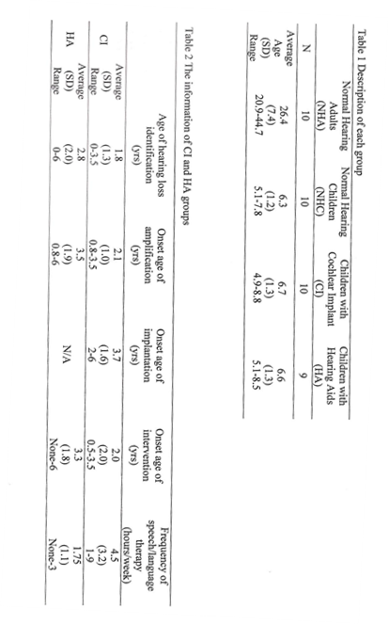
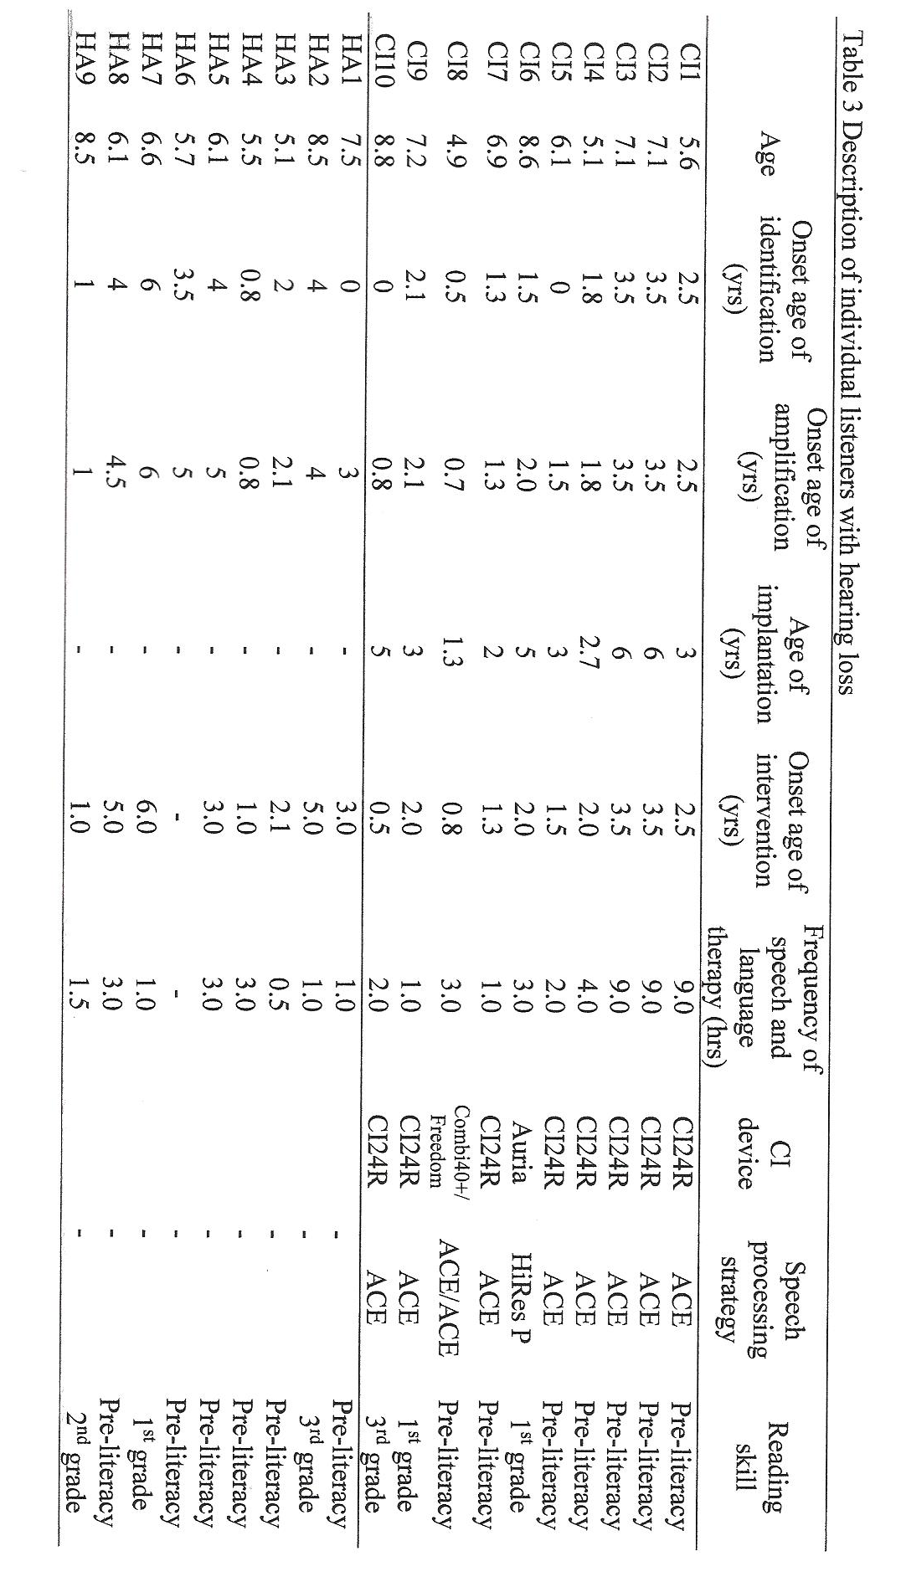
Pl1
Plot 1
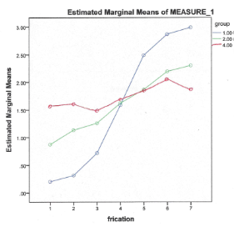
Plot 2
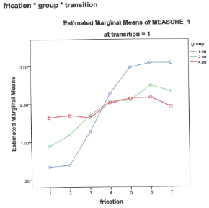

Plot 3
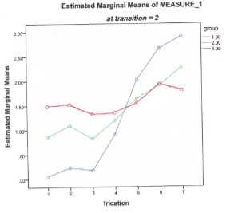
Stimuli
Synthetic CV continua representing /su/ and /ʃu/ syllables were constructed using a software cascade/parallel formant synthesizer (Klatt, 1980). The stimuli varied in terms of the frequency of the fricative spectrum and vowel onset of transition (F2 transition). The creation of the stimuli followed the trading relations design used in studies of /s/ and /ʃ/ by Nittrouer (1992, 1996) and Mayo et al. (2003).
In the current study, the poles of noise frequency spectrum were varied in 250 Hz steps from 2200 Hz to 3700 Hz (2200, 2450, 2700, 2950, 3200, 3450, and 3700 Hz). The pole frequency of 2200 Hz is most /ʃ/ like and 3700 Hz is most /s/ like. For the formant transition cue, the F2 onset frequency was either 1200 Hz or 1800 Hz. The F2 onset of 1200 Hz is most /s/ like, and the F2 onset of 1800 Hz is most /ʃ/ like. Particular effort was made to equate fricative amplitude for pairs of stimuli having the same fricative pole but different formant transition. Thus, there were two synthetic continua, each consisting of seven stimuli. Within each continuum, the spectra poles were varied. All stimuli within one continuum had F2 onset appropriate for /s/ and all stimuli in the other continuum had F2 onsets appropriate for /ʃ/.
Procedure
Practice items were presented to all listeners as they were seated in a sound booth. Two cards were used: For the stimulus /s/, a picture of a girl named “Sue” served as the prompt, and for the /ʃ/ stimulus, a picture of a shoe served as the prompt. The stimuli were presented at 70 dB SPL via a loudspeaker within the booth at 0° azimuth and 1m from the listeners. The investigator, using live voice, determined if the listener could correctly identify /su/ and /ʃu/. If this was successfully accomplished by the listener, then the examiner presented the listener with the endpoints of the continuum. The practice items were repeated until participants were right six practice times out of six (three times each for /su/ and /ʃu/ like sounds).
During the experimental phase, the 14 stimuli were randomly presented 10 times each, for a total of 140 responses. All stimuli were presented by a computer from a software program, Super lab pro 2.0.4 version. Adult participants responded by pressing a keypad; children responded by pointing to a card and the examiner recorded the responses.

Results
In tests of within-subjects effects, it was evident that many independent variables did influence one another, and that there were also many significant main effects. In all these results, the Huynh-Feldt corrections were used to guard against violations of sphericity. In regards to interactions, frication by group and transition by frication produced significant responses. The interaction for frication by group [F(7.248, 94.223)=20.991, p=<.001] indicates that frication was processed differently by the three groups (adults, CI kids, HA kids), as would be expected. Analyzing the two acoustic cues’ interaction, transition by frication [F(5.224, 135.821)=11.398, p=<.001], also indicated a significant response. This means that while the listeners listened to frication noise, they were influenced by transition information, and vice versa—both acoustic cues were used in deciding whether the signal produced was perceived as /s/ or /ʃ/. No significant effect was observed for transition by group or for transition by frication by group. Transition [F(1,26)=49.451, p=<.001]and frication [F (3.624,94.223), p<.001]were both found to be significant main effects, indicating that listeners’ responses were significantly affected by transition and frication individually.
When analyzing the tests of between subjects effect, it initially appears that there are no significant main effects between the three groups [F(2,26), p=.432]. However, the presence of the group factor in the significant frication x group interaction shows that, at least for frication processing, there is a difference between groups. It appears that there are clear differences in how greatly different each group is from other groups. This was done using plots of frication by estimated marginal means. This plot indicated that children with cochlear implants produced results closer to hearing adults than did children with hearing aids to hearing adults. This means that frication cues led CI kids to identify /s/ vs /ʃ/ in a manner more closely resembling the adults’ identification than did HA kids.
Discussion
Given the results found here, CI kids appear to do better than HA kids on measures of fricative identification. Reasons for this may be: 1) Effects of SNHL (sensorineural hearing loss) or 2) Limitations of acoustic amplification as compared to electrical hearing. It may be that hearing aid roll-off of frequencies above 2 kHz may not allow these children to fully encode high frequency frication. Limits of the study as presented here are that there was a lack of documentation regarding HA functions (such as real ear measurements). Further research as well as documentation of HA functions would be needed to further determine why CI kids seem to function better than HA kids on this task when the opposite would be expected since HA kids are believed to hear more naturally.
In regards to the DWS vs. Auditory Sensitivity hypotheses debate, the results seem to be more in line with the Auditory Sensitivity hypothesis than the DWS hypothesis. Both CI kids and HA kids performed more poorly than adults on measures of both frication and transition, but they used both cues in determining their responses. In order to support DWS, it would seem that frication would play much less of a role than it did. Further, as shown on table 2, it appears that on average, CI kids were receiving more intervention and speech therapy than their HA counterparts. This would likely result in them having more intentional hearing experience than HA kids and therefore more mature listening skills, which could be why CI kids’ results were closer to the adults’, and would thus support the Auditory Sensitivity hypothesis. More information about these groups could be helpful in better supporting the Auditory Sensitivity hypothesis, such as whether the children were mainstreamed or not, and whether one group spent more time with hearing peers than the other (especially if it was found that these CI kids were mainstreamed/had more normal-hearing peers than HA kids). Altogether, the data collected from this experiment points towards disproving of the DWS hypothesis and support of the Auditory Sensitivity Hypothesis.
References
Carney, A. E., & Moeller, M. P. (1998). Treatment efficacy: Hearing loss in children.
Journal of Speech Language and Hearing Research, 41, 61-84. Retrieved from http://www.ncbi.nlm.nih.gov/pubmed/?term=Carney+and+Moeller
Hedrick, M., Bahng, J., von Hapsburg, D., & Younger, M. (2011). Weighting of cues for fricative place of articulation perception by children wearing cochlear implants. International Journal of Audiology 50, 540-547.
Klatt, (1980). Software for a cascade/parallel formant synthesizer. Journal of the Acoustical Society of America, 67, 971-
995.
Mayo, C., Scobbie, J. M., Hewlett, N., & Waters, D. (2003). The influence of phonemic
awareness development on acoustic cue weighting strategies in children’s speech perception. Journal of Speech Language and Hearing Research, 46(5), 1184-1196. Retrieved from http://www.ncbi.nlm.nih.gov/pubmed/14575351
Nittrouer S. (1992). Age-related differences in perceptual effects of formant
transitions within syllables and across syllable boundaries. Journal of Phonetics,
20, 351 – 382.
Nittrouer, S. (1996). The relation between speech perception and phonemic awareness:
Evidence from low-SES children and children with chronic OM. Journal of Speech Language and Hearing Research, 39(5), 1059-1070. Retrieved from http://www.ncbi.nlm.nih.gov/pubmed/8898258
Nittrouer, S. & Thuente Burton, L. (2001). The role of early language experience in the
development of speech perception and language processing abilities in children with
hearing loss. Volta Rev, 103, 5-37.
Nittrouer, S. (2002). Learning to perceive speech: How fricative perception changes, and how it
stays the same. Journal of the Acoustical Society of America, 112, 711-719.
Pittman, A. L., & Stelmachowicz, P.G. (2000). Perception of voiceless fricatives by normal-
hearing and hearing-impaired children and adults. Journal of Speech Language and Hearing Research, 43(6), 1389-1401. Retrieved from http://www.ncbi.nlm.nih.gov/pubmed/11193960
Sussman, J. E. (1993). Auditory processing in children’s speech perception: results of selective
adaptation and discrimination tasks. Journal of Speech Language and Hearing Research, 36(2), 380-395. Retrieved from http://www.ncbi.nlm.nih.gov/pubmed/8487530

