Fates and Movements of Relocated Conflict Black Bears and Interactions with Interstate 40 in the Pigeon River Gorge of Tennessee and North Carolina

A Thesis Presented for the
Master of Science
Degree
The University of Tennessee, Knoxville

Kristin Jo Botzet
December 2024
Copyright © 2024 by Kristin Jo Botzet
All rights reserved.

ACKNOWLEDGEMENTS
As cliché as the phrase “teamwork makes the dreamwork” may be, it truly embodies why these projects ran smoothly and were successful. First and foremost, I would like to thank my funding partners, the National Park Service, the National Park Foundation, Foundation for the Carolinas, Tennessee Wildlife Resources Agency (TWRA), and North Carolina Wildlife Resources Commission (NCWRC) for making this project possible. I feel that I lucked out and hit the jackpot with Dr. Joe Clark as my graduate advisor. He has been an incredible mentor and is a brilliant wildlife ecologist, and I could not have asked for better guidance during my graduate research. He gave me the freedom to make this project my own but was always available when I needed advice, whether it was in the field, with analysis, or making sure my grammar was impeccable. I also thank my committee members, Bill Stiver, Dr. Mark Wilber, and Dr. Lisa Muller, each of whom provided guidance within a specific aspect of my project. I thank Terry White for making sure both Joe and I kept organized on the administrative side of things, and for the many office chats and lunch outings. And although the bear lab was small, I am incredibly thankful for my graduate peer and friend Jessica Braunstein for answering my countless questions regarding graduate school or coding in R; I could always count on her to laugh through it with me.
Wildlife fieldwork is not for the faint of heart and I am very fortunate to have had wonderful teams that were dedicated to putting in the hours to make these projects happen. I thank the wildlife crew at Great Smoky Mountains National Park, Ryan Williamson, Greg Grieco, Bill Stiver, and Joe Yarkovich, who were willing to help me whenever it was needed. Both Ryan and Greg put in many hours trapping and relocating bears and were always happy to volunteer their time to assist me with whatever needed to be done. There was never a dull moment working with these two which made my experience in the Smokies all the more enjoyable. A special thanks goes to Ryan whose organizational skills and expertise were fundamental in the project’s success and whose southern idioms never ceased to make me laugh. I am extremely grateful for the seasonal technicians and interns who did the grunt work and spent hours relocating bears, cleaning traps/transfer boxes, picking up collars, etc. – you all are what made the wheels go round! I am walking away with great memories and even better friends.
Both projects were collaborative efforts between several state and federal agencies and required cooperative effort from all our partners. Although the relocation project originally included Shenandoah National Park, they unfortunately were unable to collar any bears due to a severe sarcoptic mange outbreak. I want to formally acknowledge Rolf Gubler and David Demarest for their hard work and trying to make the most of an unfortunate situation. Additionally, I want to thank both Janelle Musser with TWRA and Mark Williams with NCWRC for putting up with my phone calls and questions past normal work hours and for helping me with private land access and recovering collars from road-killed bears. I am also thankful for Steve Goodman with the National Parks Conservation Association for taking the time to drive me around the I-40 field site prior to our field season and for providing us with game cameras to use on our traps.
I am immensely grateful for the private landowners and Pigeon River Gorge community who welcomed me with open arms and allowed us to trap on their property; our trapping effort would not have been as successful without them. A special thanks goes out to Kim and Rob Murray, Amanda Hill, Randy “Lugnut” Shults, David Collett, and Tim Lee who went above and beyond to help me out.
Needless to say, I would not be where I am today without my parents (quite literally); they fostered my love for wildlife and the outdoors at a young age. They have always encouraged me to follow my dreams and to make the most of what life hands you. I thank my sisters for their love and support all the way from Minnesota. I thank all my friends for their support even if most of them don’t quite understand what I am doing. I appreciate the number of times that Katrina Anderson drove an hour to Knoxville so that we could revel in our Midwest heritage together and bond over great food—a much welcome escape from the stress of writing this thesis. A special shoutout is reserved for Jeremy and Tonya Nicholson; I cannot properly put my gratitude into words for everything they have done for me during the past 3 years. Our late-night phone calls, tacky jokes, and picking on Jeremy helped keep my spirits high during the tougher times. I especially owe Jeremy, for he taught me everything I know about bear trapping; his love for bears is contagious and he is one hell of a bear biologist, an example I hope to follow someday.
Last, but most definitely not least, I thank my husband and best friend Logan Parr, who not only provided emotional support as I navigated the ups-and-downs of a Master’s program but worked alongside me on the I-40 project. His dedication and passion for wildlife is unmatched and was a friendly reminder for me to stop and appreciate the little things in life. I truly cannot express how appreciative I am for his patience and encouragement throughout my Master of Science program, regardless of us being together in Knoxville or over 2,000 miles apart. He’s the best cheerleader a girl could ask for.

ABSTRACT
Great Smoky Mountains National Park (GRSM) has a high-density American black bear population (Ursus americanus) and frequent human-bear conflicts. Relocation is a common tool used by wildlife managers to prevent further conflict incidents. I fitted 50 relocated conflict and 37 resident non-conflict bears with GPS-radio collars and found that the annual probability of recurrent conflict for relocated bears was as high as 0.627, depending on how conflicts were identified. Recurrent conflict increased with the level of food conditioning and decreased with release-site distance to the nearest urban area. Known-fate models indicated that the overall annual survival probability for relocated bears was 0.194 (lost signals censored) and survival of resident bears was higher than survival of relocated bears. My study suggests that previous research utilizing VHF telemetry and tag returns often resulted in many unknown fates, which can potentially result in the overestimation of the efficacy of relocation as a management tool. In addition to the effects of relocation, I evaluated movements of bears in the Pigeon River Gorge area along Interstate 40. Interstate 40 separates GRSM from Cherokee and Pisgah national forests, potentially creating a barrier to wildlife movement between these largely undeveloped tracts of contiguous forested habitat. I used a combination of hidden Markov models, step-selection models, and Omniscape analysis to identify whether relocated bears (used as a proxy for dispersers) differed in their movement patterns from resident bears. My results indicated that dispersers had longer step lengths while moving across the landscape and selected areas with lower percent slope and higher percent canopy, whereas residents selected for ridgelines and drainages in addition to gentle slopes and dense forest canopies. At the landscape level, resident bears had more defined movement patterns compared with dispersers who were more generalized in their movements; whereas at the roadway level both resident and dispersing bears had an overlap in defined locations along the interstate that could benefit from mitigation measures, such as underpasses or overpasses.

TABLE OF Contents

CHAPTER 1 : FATES AND MOVEMENTS OF RELOCATED CONFLICT AMERICAN BLACK BEARS (URSUS AMERICANUS) FROM GREAT SMOKY MOUNTAINS NATIONAL PARK TO CHEROKEE NATIONAL FOREST 19
- Abstract 20
- Introduction 21
Background 21
Justification 24
Objectives and Hypotheses 27
- Study Area 28
Great Smoky Mountains National Park 28
Cherokee National Forest 30
- Methods 31
Data Collection 31
Stable Isotope Analysis 33
GPS Data Cleaning 34
Recurrent Conflict, Survival, and Cause-specific Mortality Analysis 35
Site Fidelity and Movement Analysis 37
- Results 40
Data Collection 40
Stable Isotope Analysis 40
GPS Data 41
Recurrent Conflict 41
Survival and Cause-specific Mortality 42
Site Fidelity and Movement Analysis 46
- Discussion 48
- Management Implications 56
Literature Cited 59
Appendix 68
CHAPTER 2 : MOVEMENTS AND ROAD CROSSING SELECTION OF AMERICAN BLACK BEARS (URSUS AMERICANUS) ALONG INTERSTATE 40 IN THE PIGEON RIVER GORGE OF TENNESSEE AND NORTH CAROLINA 91
- Abstract 92
- Introduction 93
Background 93
Justification 96
Objectives and Hypotheses 100
- Study Area 100
Interstate 40 within the Pigeon River Gorge 100
Cherokee National Forest 101
Pisgah National Forest 102
- Methods 103
Data Collection 103
GPS Data Cleaning 104
Behavioral State 105
Step Selection Analysis 106
Omniscape Analysis 109
- Results 110
Data Collection 110
GPS Data 110
Behavioral State 111
Step Selection Analysis 111
Omniscape Analysis 112
- Discussion 113
- Management Implications 120
Literature Cited 121
Appendix 133
Vita 142

LIST OF TABLES
Table 1.1. Top known-fate models for the conservative and liberal recurrent conflict analyses for black bears. Liberal analyses defined recurring conflict as GPS data clusters in human developed areas and official reports to agencies whereas the conservative analyses defined conflicts by official reports to agencies only. S indicates no recurrent conflict, release site distance to urban area and distance relocated from capture site was measured in km, 2015–2024, Tennessee, USA. 72
Table 1.2. Top known-fate models for the optimistic and pessimistic survival analyses of black bears, 2015–2024, Tennessee, USA. Optimistic analyses censored bears with lost GPS signals, whereas the pessimistic analyses classified bears with lost GPS signal (unknown fate) as a mortality. S is survival, region of release is Cherokee National Forest, and distance relocated is distance moved from original capture location in km. 75
Table 1.3. Annual survival probability of black bears for the top optimistic and pessimistic models based on average distance relocated and age, 2015–2024, Tennessee, USA. Optimistic analyses censored bears with lost GPS signals, whereas the pessimistic analyses classified bears with lost GPS signal (unknown fate) as a mortality. 76
Table 1.4. Proportion of relocated and resident black bears exhibiting release-site and capture-site fidelity, respectively, for each month post-relocation; 2015–2024, North Carolina and Tennessee, USA. 80
Table 1.5. Proportion of relocated and resident black bears exhibiting release-site and capture-site fidelity, respectively, grouped by sex and age class for each month post-relocation; 2015–2024, North Carolina and Tennessee, USA. 81
Table 2.1. Top step-selection function models for disperser (relocated) and resident black bears, 2016–2024, Pigeon River Gorge in North Carolina and Tennessee, USA. 141

LIST OF FIGURES
Figure 1.1. Great Smoky Mountains National Park and Cherokee National Forest study areas and release sites, 2015–2023, Tennessee, USA. 68
Figure 1.2. Capture locations for black bears in Great Smoky Mountains National Park that were relocated outside the park boundary to Cherokee National Forest, Tennessee, USA, 2015–2023. 69
Figure 1.3. GPS location data of 50 relocated conflict black bears from Great Smoky Mountains National Park to Cherokee National Forest, Tennessee, USA, 2015–2024. 70
Figure 1.4. δ¹³C for relocated black bears, 2015–2023, Tennessee, USA. Mean δ¹³C for the data is represented by grey dashed line whereas the mean δ¹³C values for C3 and C4 plants based on Ben-David and Flaherty (2012) are depicted by purple and orange solid lines, respectively. 71
Figure 1.5. Annual probability of recurrent conflict for relocated black bears based on release-site distance to urban area for conservative and liberal definitions of conflict. The conservative model defined recurrent conflict by official reports to agencies only whereas the liberal model defined recurrent conflict by official reports to agencies and GPS clusters at human developments, 2015–2024, Tennessee, USA. 73
Figure 1.6. Annual probability of recurrent conflict for relocated black bears based on δ¹³C from relocated bears for conservative and liberal definitions of conflict. The conservative model defined recurrent conflict by official reports to agencies only whereas the liberal model defined recurrent conflict by official reports to agencies and GPS clusters at human developments, 2015–2024, Tennessee, USA 74
Figure 1.7. Annual probability of survival estimates for relocated black bears based on region of release-site and season of relocation for the average distance relocated, age, and sex for optimistic and pessimistic models, 2015–2024, Tennessee, USA. The pessimistic analyses recorded bears with lost GPS signal (unknown fate) as a mortality, whereas the optimistic analyses censored bears with lost GPS signals. 77
Figure 1.8. Annual probability of survival for female and male relocated and resident black bears in the Pigeon River Gorge of Tennessee and North Carolina, USA, 2022–2024. 78
Figure 1.9. Annual probability of return to the capture location (original home range) for adult and subadult relocated black bears based on distance relocated, 2015–2024, Tennessee, USA. 79
Figure 1.10. Log mean net squared displacement (NSD) per month post-relocation for relocated male and females black bears. Bears with points below their respective sex’s fidelity thresholds indicate fidelity to the release-site for that month. Jitter represents individual bears, 2015–2024, Tennessee, USA. 82
Figure 1.11. Probability of release-site fidelity for each month post-relocation for female and male black bears of each age class, 2015–2024, Tennessee, USA. 83
Figure 1.12. Beta estimates and their associated 95% confidence interval for the linear mixed effects model analyzing daily distance traveled (m) for resident and relocated black bears (log(daily distance traveled) ~ group*month+ (1|id)). Red estimates indicate decrease in daily distance, whereas blue indicates an increase; 2015–2024, Tennessee and North Carolina, USA. 84
Figure 1.13. Predicted daily distance traveled for relocated and resident black bears for each month, 2015–2024, North Carolina and Tennessee, USA. 85
Figure 1.14. Mean daily net squared displacement for resident (top) and relocated black bears (middle) with averages (black lines). Note the scale of the y-axis, demonstrating the distance displaced from the release site (relocated bears) or capture site (residents). Bottom figure plots both groups together and their averages (dark green and blue) on the log scale to better visualize the differences, 2015–2024, North Carolina and Tennessee, USA. 86
Figure 1.15. Total distance traveled in kilometers for relocated and resident black bears, 2015–2024, North Carolina and Tennessee, USA. 87
Figure 1.16. Movement data of a resident adult female (above) and a relocated adult female black bear (below). Note the differences in spatial scale, 2022–2023, North Carolina and Tennessee, USA. 88
Figure 1.17. Movements of a resident subadult male (above) and a relocated subadult male black bear (below). Note the differences in spatial scale, 2021–2024, North Carolina and Tennessee, USA. 89
Figure 1.18. Post-relocation movements of a relocated adult female black bear, 2022–2023, Tennessee, USA. 90
Figure 2.1. Interstate 40 corridor (51 km) in the Pigeon River Gorge of Tennessee and North Carolina, USA, 2016–2024. 133
Figure 2.2. GPS locations from 37 resident and 20 relocated black bears in the Pigeon River Gorge of North Carolina and Tennessee, USA, 2016–2024. 134
Figure 2.3. Behavioral states for a relocated (disperser) and resident subadult male black bear. State 1 represents resting, state 2 is foraging, and state 3 is exploratory (moving), 2021–2024, North Carolina and Tennessee, USA. 135
Figure 2.4. Log relative selection strength of distance to ridge for resident black bears as predicted by the top step-selection function model, 2022–2024, North Carolina and Tennessee, USA. 136
Figure 2.5. Omniscape predicted cumulative current for resident black bear movement across the Pigeon River Gorge. Interstate 40 was sectioned into 126 segments at 400 m each. Segments were buffered by 200 m and flow was classified by standard deviations from mean segment flow, 2022–2024, North Carolina and Tennessee, USA. 137
Figure 2.6. Omniscape predicted cumulative current for dispersing black bear movement across the Pigeon River Gorge. Interstate 40 was sectioned into 126 segments at 400 m each. Segments were buffered by 200 m and flow was classified by standard deviations from mean segment flow, 2016–2024, North Carolina and Tennessee, USA. 138
Figure 2.7. Locations along Interstate 40 where resident and dispersing black bears successfully and unsuccessfully (roadkilled) crossed, 2016–2024, North Carolina and Tennessee, USA. 139
Figure 2.8. Omniscape predicted elk movement flow across the Pigeon River Gorge from Hillard et al. (2022), 2018–2020, North Carolina and Tennessee, USA. 140

:
FATES AND MOVEMENTS OF RELOCATED CONFLICT AMERICAN BLACK BEARS (URSUS AMERICANUS) FROM GREAT SMOKY MOUNTAINS NATIONAL PARK TO CHEROKEE NATIONAL FOREST

Abstract
Great Smoky Mountains National Park (GRSM or Park) has a high-density American black bear population (Ursus americanus), and frequent human-bear conflicts. Although relocation is a common tool used by wildlife managers to prevent further conflict incidents, previous research in the Park based on VHF telemetry and tag returns found that the fates of these bears were largely unknown, thereby leaving questions about the efficacy of this tool largely unanswered. I fitted 50 conflict bears relocated from GRSM and 37 resident non-conflict bears at 2 release sites in the Pigeon River Gorge (PRG) with GPS-radio collars. I used those fine-scale location data to evaluate survival, recurrence of conflict activity, homing rate, and release-site fidelity for both relocated and resident bears, as appropriate. The annual probability of recurrent conflict for relocated bears was 0.422 (95% CI = 0.201, 0.643) when conflict was defined as a report to agency officials by landowners and 0.627 (95% CI = 0.412, 0.842) when GPS location clusters around homes and other human developments were also recorded as conflicts. Recurrent conflict increased with the level of food conditioning, which was determined by stable isotope analysis, and decreased with release-site distance to the nearest urban area. Known-fate models indicated that the overall annual survival probability for relocated bears was 0.152 (95% CI = 0.026, 0.278) when I classified lost radio signals as mortalities and 0.194 (95 % CI = 0.022, 0.366) when I censored lost signals. In contrast, the survival of resident bears in the PRG from 2022 to 2024 was 0.862 (95% CI = 0.704, 1.000), which differed from the survival of bears relocated to the same region during those same years (0.533; 95% CI = 0.055, 1.00). Harvest was the greatest mortality risk for both relocated and residents (H_{relocated} = 0.482, 95% CI = 0.326, 0.638; H_{relocated to PRG} = 0.750, 95% CI = 0.350, 1.000; H_{resident in PRG} = 0.136, 95% CI = 0, 0.280), and relocated bears were more at risk compared with residents. Known-fate models indicated that the annual probability of relocated bears returning to their original capture location decreased with distance relocated and averaged 0.588 (95% CI = 0.307, 0.869) for adults and 0.106 (95% CI = 0.000, 0.305) for subadults. Mixed effects logistic regression models indicated that the probability of release-site fidelity for the average months post-relocation (2.91 months) decreased with months post-relocation, with the probability being 0.00 (males 95% CI = 0.00, 0.12; females 95% CI = 0.00, 0.04) for adult males and females, 0.05 (95% CI = 0.00, 0.95) for subadult females, and 0.73 (95% CI = 0.17, 0.97) for subadult males. My results suggest that previous research utilizing VHF telemetry and tag returns typically resulted in many unknown fates, which can lead to an overly optimistic evaluation of the efficacy of relocation as a management tool. Conflict is best mitigated before food conditioning occurs in bears; therefore, public education is paramount to avoid human-bear conflicts before they begin, as relocation and other ‘bear-centered’ options may have only limited success.

Introduction

Background
Human-wildlife conflict is becoming more commonplace as the human population continues to grow and encroach on wildlands. With a population numbering >850,000 individuals across North America, the American black bear (Ursus americanus) is a quintessential example of a species prone to conflict (Garshelis et al. 2016). Their food-driven behavior, ability to remember the timing and location of specific food sources, and tenacity are essential for acquiring necessary fat stores to survive the biological stressors of hibernation. Unfortunately, these same behaviors also make bears prone to conflict when they encounter human food sources and attractants (Bacon 1973, Nelson et al. 1983, White et al. 2017). Black bears are opportunistic omnivores, which allow them to adapt to human-developed areas and take advantage of calorie-rich human food sources, whether in the form of garbage, agricultural crops, or bird feeders (Clark et al. 2002, Don Carlos et al. 2009, Scheick and McCown 2014, White 2016). Black bears usually tend to avoid humans, but once they receive a food reward and begin to positively associate humans or developed areas with a food source, they may alter their natural behaviors and be more aggressive towards humans, such as following, charging, or on rare occasions, attacking (Craighead and Craighead 1972, Hopkins and Kalinowski 2013, White et al. 2017). Such behaviors pose a concern for humans as they may result in property damage, injury, or even death. Therefore, mitigating human-bear conflicts is essential for successful bear management.
Human-bear conflict has a long history in North America. The establishment of the first National Parks exacerbated the issue by providing visitors with widespread access to wilderness, often with high bear densities, thus increasing human-bear interactions (White et al. 2017). Visitors to National Parks quickly caught on to the curious and food-driven nature of bears, resulting in bears being viewed as an attraction rather than a wild carnivore. This was especially the case for black bears, which were viewed as being tame and gentle, and whose roadside begging behavior was a favorite among visitors (Schullery 1992, White et al. 2017). Due to the bear’s popularity, several Parks created ‘feeding stations’ and ‘trash pit podiums’ to attract and congregate bears in large numbers for public viewing (Zardus and Parsons 1980). Eventually this led to substantial conflicts including thousands of dollars of property damage in which both the National Park Service and state wildlife agencies were responsible for resolving; in turn, this resulted in the formation of bear management programs in the 1970’s (Zardus and Parsons 1980, Stiver 1991, Hopkins et al. 2014). These programs began by installing bear-resistant trash cans, prohibiting the feeding of bears, increasing law enforcement, and establishing educational programs for visitors.
Although bear management programs during the last century have substantially improved methods to mitigate human-bear conflicts, there are new challenges arising as both human and bear populations are growing. Great Smoky Mountains National Park (GRSM or Park) is a prime example of this as the Park has one of the highest black bear densities in the nation with estimates of 0.90 bears/km² (1,900 bears; Humm and Clark 2020). Additionally, GRSM is within a day’s driving distance from two-thirds of the nation’s human population resulting in >13 million visitors annually (Stiver 1991, NPS 2024a). Whereas most human-bear conflicts have occurred in front-country developments (e.g., campgrounds, roadways, and picnic areas), GRSM has been experiencing an increase in backcountry (e.g., backpacking campsites/shelters and remote trail locations) conflicts (Zardus and Parsons 1980, White 2016). Historically, the backcountry functioned as a refuge for bears but, with increasing human use of these areas as well as an increasing bear population today, conflict is more likely to occur. A recent study conducted by Braunstein et al. (2020) in GRSM found that nearly all male bears and roughly half of female bears that they monitored left the Park boundary at some point and entered surrounding cities or towns in which they most likely received anthropogenic foods and engaged in conflict behavior. Bears then returned to their core home ranges within the Park boundary and continued to engage in conflict behaviors. This behavior was not limited to front-country bears, but most backcountry males were documented temporarily leaving the Park as well. This poses a challenge for managers as backcountry conflicts are extremely difficult to alleviate because the remoteness of the conflict may require a great deal of labor and time, and reporting is generally delayed, resulting in longer response times by Park personnel (Zardus and Parsons 1980, Stiver 1991).
With the increasing numbers of bears, human visitation rates, and backcountry use, proactive management plans are required to efficiently prevent conflicts from occurring in the first place, as well as effectively keeping current conflict behavior from escalating into more serious behaviors. In the 1990’s the Park began implementing more rigorous sanitation protocols, such as replacing bear-resistant trash cans with larger capacity bear-resistant dumpsters in areas of high use (e.g., picnic areas, campgrounds), increasing enforcement and monitoring of these areas, and closing picnic areas at 8 p.m. when bears were usually becoming more active (Clark et al. 2002, Braunstein et al. 2020). Park managers also developed preventative measures involving visitors, such as educational pamphlets and programs, as well as warning signs/area closures that informed visitors of bears frequenting certain areas. In addition, the Park adopted a proactive management approach which included several tools used to prevent and reduce bear conflict behavior. These tools included aversive conditioning, euthanasia of the offending animal, and relocation (DeLozier 2002).

Justification
Relocation has been used as a management tool to mitigate conflicts between humans and black bears for decades across North America (e.g., New York, Sauer et al. 1969; Tennessee, Beeman and Pelton 1976; California, Zardus and Parsons 1980; Florida, Annis et al. 2007; Colorado, Alldredge et al. 2015; Wisconsin, Bauder et al. 2021). Typically, GRSM officials will relocate a bear if it is no longer responding to aversive conditioning techniques and is demonstrating advanced conflict behaviors such as increasing activity during daylight hours, approaching humans for food, or stealing items from people in campsites or on trails (Clark et al. 2002, White 2016, Bauder et al. 2021). It is presumed that the event of relocation is a negative experience for the bear and, thus, creates a negative association with humans, which would override the learned conflict behavior (Stiver 1991, Linnell et al. 1997, Landriault et al. 2009). Furthermore, bears are generally relocated to areas with lower human presence where it is expected that they would be less likely to engage in conflict.
Although relocation is a popular management tool, 44% of agencies that practice the strategy indicated they did so because of pressure from the public and only 15% of agencies believed it was effective at managing conflict behavior (Spencer et al. 2007). This inconsistency has led to several studies evaluating the effectiveness of relocation, mostly relying on tag recovery and VHF telemetry to determine fates of the relocated animals. Although these studies gave managers a better understanding of factors that influenced relocation success (e.g., age, sex, distance relocated, and season of relocation) the fates of many individual animals were unresolved because tags often were not recovered, or the VHF radio signals were lost. For example, 2 studies in GRSM found that 65% (Stiver 1991) and 74% (White 2016) of the fates of black bears relocated outside Park boundaries from 1967–1989 and 1990–2015, respectively, were unknown. This represents a significant data gap that could represent the difference between success or failure of the relocation method. Moreover, the studies that relied on VHF telemetry lacked important details such as fine-scale post-relocation movements due to irregular and rough-scaled locations with significant spatial error (e.g., weekly triangulations), thus further contributing to data gaps (Annis et al. 2007, Hopkins and Kalinowski 2013, Alldredge et al. 2015, Bauder et al. 2021). In addition to the large gaps in information, each study defined ‘success’ and ‘failure’ differently and the environments and management strategies were vastly different (e.g., urban versus rural and proactive versus reactive) than those at GRSM.
Officials at GRSM have relocated about 10 bears to areas outside of the Park, per year, since 2010; therefore, research on the effectiveness of relocation will provide necessary information to better guide Park biologists as well as state agencies (e.g., Tennessee Wildlife Resources Agency [TWRA] and North Carolina Wildlife Resources Commission [NCWRC]) in their management decisions. Previous research has found that several factors impact the outcome of relocation including age at time of relocation, sex, distance that the bear was transported from original capture location, the season that relocation took place, and the level of food conditioning (Annis et al. 2007, Hopkins and Kalinowski 2013, Alldredge et al. 2015, Bauder et al. 2021). Such research also revealed that relocated animals undergo a period of adjustment post-relocation, during which time they exhibit large exploratory movements either to return to their original ranges or to familiarize themselves with their new surroundings (Berger-Tal and Saltz 2014, Picardi et al. 2021). These long-range movements put the animal at risk of increased mortality and can affect their overall fitness (Letty et al. 2007). There has been little research on how factors at the release-site can affect relocation outcomes and few comparisons of movements and survival between relocated and resident animals, all of which could be important predictors or contrasts of the relocation outcome (Beeman and Pelton 1976, Linnell et al. 1997). Newer technology (e.g., GPS collars) and statistical tools (e.g., improved movement models, survival and recurrent conflict rate estimation methods) will allow me to more adequately address whether relocation prevents conflict behavior and to identify which factors might be most influential on the outcome, as well as compare movements, survival, and mortality risk of bears that resided where the relocated bears were transported and released (i.e. release sites; Beeman and Pelton 1976, Stiver 1991).

Objectives and Hypotheses
Objectives
- Examine movements and identify movement patterns of bears following relocation,
- Assess homing rate and release-site fidelity,
- Assess the efficacy of relocation and how survival and conflict reoccurrence varied by age, sex, distance relocated, season, release-site attributes, and level of food conditioning, and
- Determine whether relocated bears were more prone to mortality than non-relocated (resident) bears.
Hypotheses
- Relocated bears will exhibit increased movements and more erratic movement patterns as they navigate the landscape attempting to return to their original home ranges compared with resident bears.
- Survival and conflict reoccurrence will not differ among release sites due to similar habitat types.
- (a) Juvenile bears will experience higher survival rates, lower conflict reoccurrence, and greater release-site fidelity compared with adults;
(b) female bears will experience higher survival rates, lower conflict reoccurrence, and greater release-site fidelity compared with males;
(c) the greater distance relocated, the lower the survival rate, the higher the conflict reoccurrence, and the lower the homing rate;
(d) bears relocated in spring and summer will experience higher survival rates compared with bears relocated in fall; and
(e) food-conditioned bears (high δ¹³C) will be more likely to engage in further conflict behavior.
- Relocated bears will be more prone to mortality compared with resident bears because relocated bears will be unfamiliar with their surroundings.

Study Area

Great Smoky Mountains National Park
Great Smoky Mountains National Park was established in 1934 and encompassed about 2,114 km² between eastern Tennessee and western North Carolina, USA (Figure 1.1, all figures and tables located in the Appendix). The Great Smoky Mountains are considered one of the oldest mountain ranges in the world with elevations ranging from 260 m in the lowland valleys to 2,025 m in the high mountains. This elevation range allowed for high biological diversity as different habitats and ecosystems were found along the elevational gradient, making GRSM a biological hotspot (NPS 2024a). The higher elevations were comprised of hemlock (Tsuga canadensis), red spruce-Fraser fir (Picea rubens, Abies fraseri), northern hardwood forests (sugar maple [Acer saccharum], American beech [Fagus grandifolia], yellow birch [Betula alleghaniensis]), and grassy balds. The valleys were comprised of cove-hardwood (sugar maple, yellow buckeye [Aesculus flava], American basswood [Tilia americana], rosebay rhododendron [Rhododendron maximum], mountain laurel [Kalmia latifolia], tulip poplar [Liriodendron tulipifera]), pine-oak (Pinus spp., Quercus spp.), and mixed hardwood forests (oak, hickory [Carya spp.], flowering dogwood [Cornus florida], American beech, and white ash [Fraxinus americana]; Jenkins 2007). There were 65 species of mammals, 200 species of birds, >80 species of reptiles and amphibians, 67 native fish species, and >1,600 flowering and >4,000 non-flowering plants found in GRSM (NPS 2024a). Examples of wildlife species found in the Park included the American black bear, elk (Cervus canadensis), white-tailed deer (Odocoileus virginianus), Eastern spotted skunk (Spilogale putorius), Northern flying squirrel (Glaucomys sabrinus), Eastern wild turkey (Meleagris gallopavo), Northern saw-whet owl (Aegolius acadicus), and a wide variety of salamander species (majority being in the Plethodontidae family).
Climate in GRSM varied due to the range in elevation. During summer (June – August), temperatures often reached 32ºC during the day and averaged 18ºC in the evenings at lower elevations. It was not common to see temperatures exceeding 27ºC at high elevations such as Mount Le Conte (2,010 m). Autumn (September – November) daytime temperatures averaged between 10ºC and 21ºC and precipitation was at its lowest (NPS 2024c). Most precipitation occurred as rain but, at higher elevations, snow was a possibility. The elevational change in climate was especially prominent during winter (December – February), with lower elevations having average temperatures of 10ºC and -2ºC, and higher elevations having average temperatures of 2ºC and -7ºC, during daytime and evening, respectively (NPS 2024c). Spring (March – May) was the wettest season when the weather was more unpredictable. Precipitation was highest in spring, which averaged 10.2 cm and 11.4 cm in April and May, respectively (NPS 2024c). During March, daytime high and nighttime low mean temperatures at lower elevations were 16ºC and 6ºC, respectively.
Great Smoky Mountains National Park was the most visited park in the United States, with 13.3 million visitors in 2023; it received more visitors than the next 2 most frequently visited National Parks combined (Grand Canyon NP, 4.7 million; Zion NP, 4.6 million; NPS 2024b). Several types of recreational opportunities were popular in GRSM including hiking, camping, river tubing, and fishing. The Park had an expansive trail system with 1,368 km of hiking trails, including 116 km of the 3,531-km Appalachian Trail (Hop et al. 2021). There were 10 front-country campgrounds which contained about 1,000 campsites, 11 picnic areas, and >100 backcountry campsites. Whereas GRSM allowed fishing on its 4,667 km of streams, hunting was prohibited, although it is important to note that hunting was popular just outside the boundary of the Park.

Cherokee National Forest
Cherokee National Forest (CNF) was officially designated in 1936, when the Tennessee sections of the Unaka, Cherokee and Pisgah forests were combined. Cherokee National Forest was about 2,630 km² and was situated in eastern Tennessee along the North Carolina border; it was the state’s only national forest and was located within the southern Appalachian Mountains (Figure 1.1; Woodcock 2017). Cherokee National Forest was divided into 2 zones, the Northern and Southern, which were intersected by GRSM. Elevations range from 365 m to >1,829 m and forest types and climate were similar to those at GRSM. Cherokee National Forest had 43 species of mammals, 154 fish species, 55 species of reptiles and amphibians, and >200 bird species (CNF 2023).
Cherokee National Forest was managed as multiple use, appealing to a wide variety of recreationists. With 30 established campgrounds, 30 picnic areas, >1,126 km of hiking trails, and 7 whitewater rivers, CNF provided opportunities for outdoor activities such as camping, hiking, horseback riding, mountain biking, whitewater rafting, foraging, fishing, and hunting. Bear hunting with hounds was culturally important to the area and CNF was the largest tract of public land in eastern Tennessee and, therefore, supported thousands of hunters annually. Bear hunting seasons varied slightly each year and were dependent on zone; CNF contained 3 bear hunt zones. Bear seasons followed a stop-and-go schedule from the end of September through the end of December, opening a few days or weeks at a time and closing for a few weeks in between (TWRA 2023).

Methods

Data Collection
From 2015 to 2020, NPS personnel captured and fitted conflict bears with GPS radio collars and relocated them as a pilot study for my current research. Subsequent to that, I captured and relocated bears fitted with GPS radio collars in 2021, 2022, and 2023. All bears were selected for relocation by National Park Service personnel based on the animal’s conflict history and type of conflict activity. For example, previous non-aggressive conflict behaviors such as day-time active in picnic areas or campgrounds would be cause for relocation whereas night-active bears would not. I trapped bears to be relocated from May to October with the majority occurring in June as this was when most human-bear conflicts occurred. I captured conflict bears by free-range darting or with a culvert trap. I immobilized bears with a mixture of butorphanol (27.3 mg/ml), azaperone (9.1 mg/ml) and medetomidine (10.9 mg/ml; BAM, Wildlife Pharmaceuticals Inc., Windsor, Colorado, USA) at a dose of 1 ml per ~45 kg by either Dan-inject projectile (Dan-inject LLC, Austin, Texas, USA) or a pole-mounted syringe (Wolfe et al. 2008, Williamson et al. 2018). On rare occasions, I hand-injected bears with 1 ml of ketamine (200 mg/ml; Zoetis Inc., Kalamazoo, Michigan, USA) if they were prematurely showing signs of recovery. Once the bear was immobilized, I recorded sex and mass and equipped the with animal several identification markers including an ear tag with a uniquely numbered ID, an upper inner lip tattoo of the same ID number, and a passive integrated transponder (ATP12 PIT tag, Biomark, Boise, Idaho, USA) subcutaneously inserted between the shoulders with a pre-load needle and syringe. I extracted an upper first premolar for age determination by cementum-annuli counts (Willey 1974; Matson's Laboratory, Manhattan, Montana, USA) and I pulled a sample of hair, with the roots, from the shoulder region for stable isotope analysis to determine level of food conditioning (Hopkins et al. 2012, Braunstein et al. 2020). I fitted the bears with a GPS radio collar (Vectronic Aerospace GmbH, GPS Vertex Lite Iridium, Berlin, Germany) which was programmed to acquire a location every 20 minutes for the first 2 months, and then a location every hour for the remainder of battery life. I then placed bears inside a transfer box secured in the bed of a truck and intramuscularly administered 2 reversal drugs, atipamezole (25 mg/ml; Wildlife Pharmaceuticals Inc., Windsor, Colorado) at a dose double the volume of the BAM dose (1.1 mg/kg) and naltrexone (50 mg/ml; Wildlife Pharmaceuticals Inc., Windsor, Colorado) at a dose of 0.5 ml for bears ≤91 kg and 1 ml for bears >91 kg. Once the bear was fully recovered, I transported it to the release site assigned by TWRA and hazed it with a paintball gun, combined with shouting, upon release. The animal handling protocol was approved by the National Park Service’s Institutional Animal Care and Use Committee (NPS-IACUC Protocol: TN.VA_GRSM.SHEN_Stiver_Blk Bear_2021.A3).
Additionally, I captured resident bears as a control group to compare their movements, survival rates, cause-specific mortality, and site fidelity with the relocated bears. I captured these resident bears in the Pigeon River Gorge (PRG) near the Cherry Gap and Browns Gap release sites located in the northern region of CNF (Figure 1.1). The methods for trapping, immobilization, and sampling were the same as for the relocated bears except that, instead of free-range darting, I used Aldrich foot snares or culvert traps to capture bears, and they were released on site. The animal handling protocol for the resident bears was approved by the University of Tennessee’s Institutional Animal Care and Use Committee (UTK-IACUC #: 2892-0422).

Stable Isotope Analysis
I collected full-length guard hairs with the root from black bears for stable isotope analysis to determine the prevalence of human foods in their diet. An animal’s diet can be determined via stable isotope analysis because the elemental composition of the ingested food is assimilated into their tissues (e.g., blood, bone, muscle, hair; Braunstein 2019). Some tissue types (e.g., blood) have a fast turnover rate, which represents the diet during the recent past, whereas other types (e.g., bone) have a slow turnover rate and reflect longer-term diets (Carter et al. 2019). I chose hair samples as my tissue of interest due to an intermediate turnover rate of 1 year and the ability to sample living bears (Hopkins et al. 2012, Braunstein et al. 2020). Bears typically shed their coat annually; therefore, I considered any hair sample pulled prior to July 1 to represent the previous year, and anything pulled after that date to represent the current year (Jacoby et al. 1999, Hopkins et al. 2014).
The elemental composition of plants is dependent on the type of photosynthetic pathway the plant uses to fix carbon, which can be broken down into 3 types: 1) C₃ plants fix CO₂ using the Calvin cycle and Rubisco (ribulose biphosphate carboxylase), 2) C₄ plants fix CO₂ using the Hatch-Slack cycle and PEP (phosphoenol pyruvate carboxylase), and 3) CAM plants fix CO₂ using crassulacean acid metabolism (Ben-David and Flaherty 2012). As a result, each type of photosynthetic pathway results in a different carbon isotope ratio (δ¹³C [¹³C/¹²C]), thus providing information on the type of plants the animal is eating. Anthropogenic food sources contain high amounts of corn and sugarcane, which are C₄ plants, and have higher concentrations of the heavier carbon isotope (¹³C) to the more common ¹²C. Natural bear foods are more likely comprised of C₃ which have higher concentrations of the lighter carbon isotope (¹²C) and, therefore, a lower ratio (Smith and Epstein 1971, Mizukami et al. 2005, Merkle et al. 2011). Typically, C₃ plants have a mean δ¹³C value of about –27 ‰ compared with C₄ plants, which have a mean δ¹³C value of about –14 ‰ (Ben-David and Flaherty 2012).
I individually packaged hair samples in coin envelopes according to bear ID and sent them to the Stable Isotopes Laboratory at the University of Tennessee in Knoxville, Tennessee, USA, for analysis. At the laboratory, samples were first submerged in alcohol to remove dirt and debris and allowed to air-dry on an aluminum plate. Once dry, hair was cut into 8-mm sections and placed into 5-mm x 9-mm tin capsules whereby they were folded and pressed flat into equal sizes (A. Faiia, University of Tennessee Stable Isotopes Lab Manager, personal communication). Capsules were then placed in an elemental analyzer (Costech Elemental Analyzer ECS4010, Valencia, CA, USA) for combustion and conversion to CO₂ gases. The resulting gases were separated via a packed separatory column and analyzed using an isotope ratio mass spectrometer (Thermo-Finnigan Delta+XL Mass Spectrometer, Waltham, MA, USA). Three in-house standards (UT729, acetCost, LGlu4510) were used in combination with my samples to ensure proper calibration. Peak areas of the standards and weights were used to determine the relationship between peak area and mg carbon to calculate the isotopic ratios, which were calibrated to USGS40 and USGS41 international standard materials (A. Faiia, University of Tennessee Stable Isotopes Lab Manager, personal communication). I reported isotopic results in per thousand units (‰).

GPS Data Cleaning
I sorted GPS points to reflect the most accurate positions and timelines. First, I omitted pre- and post-deployment locations based on time/date of initial capture and time/date of the known fate of animal (e.g., harvest, roadkill, collar removal), as well as any apparent erroneous data and failed fixes. Accuracy can be determined by the type of fix (3D or 2D) and the dilution of precision (DOP) value that is associated with each GPS position. All 2D fixes were omitted because 3D fixes are considered more accurate. I also omitted any 3D fixes that had a DOP value >7, as the lower the DOP value, the more precise the location (Lewis et al. 2007, Ironside et al. 2017).

Recurrent Conflict, Survival, and Cause-specific Mortality Analysis
I estimated annual survival for relocated and resident bears and the annual recurrent conflict probability for relocated bears using known-fate (KF) analysis in Program MARK (White and Burnham 1999). Simple proportions (e.g., 4 animals died of 10 monitored equals 40%) do not accurately describe survival probabilities because animals that enter the study later have a different probability of dying than individuals that enter the study earlier. Known-fate analysis accounts for the number of animals that are in a study at any one point in time and provides an unbiased estimate of survival probability (S) between sampling occasions (White and Burnham 1999). I selected a time interval of 1 week for my sampling occasions and set the maximum period for evaluating survival at 1 year, assuming fates occurring after 1 year could not be reliably attributed to the event of relocation. I started the week count in January; January 1st to 7th was always week 1 and the last week of December was always week 52. Therefore, a bear first captured during week 30 would be monitored until week 30 of the following year. Program MARK analyzes KF data using the Kaplan-Meier (Kaplan and Meier 1985) method combined with a binomial estimator which uses the maximum likelihood framework and accounts for censoring. The Kaplan-Meier method assumes that all animals entered the study at the first or same interval, so I employed the staggered entry design (Pollock et al. 1989) to account for individuals entering at different time intervals.
Known-fate analyses are typically used to estimate survival rates based on individual fates being classified as “alive” or “dead”. However, KF methods can also be used to estimate other fates, such as recurring conflict rates (e.g., conflict occurred or did not occur; Williams et al. 2002). I performed 5 different KF analyses: 1) an optimistic mortality analysis whereby missing bears (i.e., animals whose telemetry signal was permanently lost) were censored, 2) a pessimistic mortality analysis whereby missing bears suspected to be killed were counted as a mortality, 3) a relocation vs. resident analysis whereby I compared the survival rates of relocated bears released in the PRG with resident bears in the same area, 4) a conservative conflict analysis whereby recurrent conflict was determined by official conflict reports to respective agencies, and 5) a liberal conflict analysis whereby recurrent conflict was determined by GPS data clusters (i.e., >4 consecutive locations) in urban areas and residencies, as well as official conflict reports to respective agencies. This last analysis was performed because conflict bears are not always reported by the public. Because the KF models for the recurrent conflict analyses calculate the probability of not engaging in conflict post-relocation (i.e., survived), I derived the probabilities and covariate relationships of engaging in further conflict from the former. This entailed reversing the sign of the β-value and recalculating the response probability based on the logit link. Lastly, I calculated the importance of each covariate at predicting the parameter of interest in the KF analyses by summing the model weights of all models that contained the covariate of interest.
I estimated cause-specific mortality (CSM) for both relocated and resident bears using the “survival” package (Therneau 2023) in R Statistical Software (v4.3.3; R Core Team 2024). Cause-specific mortality models account for the source of mortality (otherwise known as the failure type) and estimate the associated hazard risk for each type (Heisey and Patterson 2006, Murray and Bastille-Rousseau 2020). I fit a Cox proportional hazards model (CPH; Cox 1972) using the data augmentation approach recommended by Lunn and McNeil (1995), to evaluate how my covariates of interest influenced risk factors. To acquire cumulative estimates of risk, I used a cumulative incidence function from the “mort” package (Sargeant, G., USGS, personal communication) and “cmprsk” package (Gray 2022) in R. Like the KF analyses, I used a weekly time interval and began the week count on January 1. I employed 2 variations of CSM analyses, the first estimated hazard risks for only relocated bears at all my study areas and the second compared hazard risks between relocated bears who spent time in the PRG with resident bears in the same area. Hazard proportionality is an important assumption of the CPH model; therefore, to ensure assumptions were not violated, I stratified by failure type. This stratification gives each failure type its own baseline value thus removing the requirement for proportionality (Murray and Bastille-Rousseau 2020).
I selected the best fit models for the KF and CSM analyses for my data based on Akaike’s Information Criterion scores, corrected for small sample sizes (AICc), and I only considered models that were within 2 ΔAICc of the top model (Burnham and Anderson 2002). AICc weighs the model fit (i.e., likelihood) against the complexity of the model (i.e., number of parameters) to find the most parsimonious model (Akaike 1974, Hurvich and Tsai 1989).

Site Fidelity and Movement Analysis
I was interested in 2 measures of site fidelity: 1) the fidelity exhibited by relocated bears to their original capture location (otherwise known as homing) and 2) the fidelity associated with their release location. For homing, I used the original capture location of each individual as the center for its theoretical home range. A bear was classified as ‘returned home’ if it came within one average home range diameter of their capture location. Threshold values were dependent on sex as their average home range sizes substantially differ; for males the threshold was 12 km (average home range = 116 km²) whereas for females the threshold was 4 km (average home range = 14.5 km²; Braunstein et al. 2020). Using the diameter instead of the radius allows for an appropriate buffer if the original capture location was on the periphery of its home range. Lastly, I tested whether sex, age class, distance relocated, region, and season of relocation could be used to predict whether a bear returned to their original home range by fitting KF models in Program MARK following the same methodology described for the conflict KF models, including reversing the β-value’s to describe the relationship of each covariate with the probability of homing (as opposed to not homing).
Traditionally, release-site fidelity is often determined by using the last observed location for an animal within the time interval of interest or their location at the time that an important biological event is observed (e.g., denning) relative to their release site (Jackson et al. 2016). Although this provides an overall estimate of release-site fidelity, it ignores possible variation at finer scales, such as an animal leaving the release site but later returning, thus biasing our understanding of post-relocation movements and release-site fidelity. Therefore, to better understand how release-site fidelity varied, I calculated fidelity using two methods: 1) I calculated the net squared displacement (NSD) value for the last observed location for each bear to estimate overall fidelity and 2) I calculated the mean net squared displacement by month (mNSD) to determine how site fidelity fluctuated by month post-relocation and post-release. Net squared displacement is the squared Euclidean distance between the first location (i.e., release site) and every successive location resulting in a series of displacement distances for each GPS location (Börger and Fryxell 2012). As with any hard release of wildlife, it was not expected that bears would immediately establish home ranges centered around the release locations as they often disperse upon release (Eastridge and Clark 2001, Truett et al. 2001, Sasmal et al. 2015). Therefore, I created threshold values of 36 km and 324 km surrounding the release sites for female and male bears, respectively, to assess release-site fidelity. These values were determined by using 1.5 times the average diameter of female and male bears home ranges (4 km x 1.5 = 6 km and 12 km x 1.5 = 18 km, respectively; Braunstein et al. 2020) and squaring those values to be consistent with the units of measure of NSD. I considered bears with a monthly mNSD value equal to or below their respective threshold value to be exhibiting fidelity to their release site for that month. From these values, I calculated the overall proportion of bears exhibiting site fidelity as well as the proportions by sex and age class for each month post-relocation for the relocated bears and post-capture for the resident bears to compare the two groups. Additionally, I fit mixed effects logistic regression models with a random intercept for each bear to determine the relationship between release-site fidelity for relocated bears and their sex, age class, distance relocated, season of relocation, and months since relocation. I did not use KF analysis in this instance because some bears left and later returned (switched fates) which cannot be accommodated with KF models.
To analyze post-relocation movements of relocated bears and compare their movements with the movements of resident bears, I fit a linear mixed regression model with individual bears as a random effect (i.e., random slopes) and an interaction between group and month as fixed effects. Daily distance traveled was calculated by summing the step lengths (m) acquired using the “amt” package (Signer 2023) in R. To ensure that I did not introduce biases with varying fix rates between the 2 groups (resident bears had a 20-minute fix rate whereas relocated bears had a 20-min fix rate only for the first 2 months and a 1-hour fix rate for the remainder of the monitoring period), I resampled the fix rate to 1 hour with a tolerance of 20 minutes. I used the ‘predict’ function to plot predicted values for each group and month and used least-squares means to conduct a Tukey’s post-hoc test to identify months when the 2 groups differed. I used α = 0.05 to determine statistical significance.

Results

Data Collection
From 2015 through 2020, NPS personnel captured and relocated 23 bears (11 males, 12 females) and, from 2021 through 2023, I captured and relocated 27 bears (19 males, 8 females; Figure 1.2). I relocated bears to 9 release sites; 23 bears were relocated to 4 sites in northern CNF (Browns = 6, Cherry = 9, Viking = 7, Laurel = 1) and 27 bears were relocated to 5 sites in southern CNF (Buck = 8, Iron = 6, Grassy = 11, Deep = 1, Beech = 1; Figure 1.3). I collected a premolar tooth from every bear except 1 male; ages ranged from 1 to 14 years ($\overline{x}$ = 5.1). I collected 28 hair samples, with the majority being from bears captured from 2021 to 2023 (n = 22). From 2015 through 2024, I recorded 219,017 GPS locations (Figure 1.3).
From 2022 through 2023, I captured 37 resident bears in the PRG near 2 of the northern release sites (Browns and Cherry; 22 males, 15 females) as a control group. Ages for these bears ranged from 2 to 16 years ($\overline{x}$ = 5.1). GPS locations from the control group totaled >520,918.

Stable Isotope Analysis
I submitted 28 hair samples to the Stable Isotope Laboratory at the University of Tennessee, Knoxville for stable isotope analysis. The values for δ¹³C of relocated bears ranged from -25.097 ‰ to –18.280 ‰ ($\overline{x}=$-23.61 ‰, 95% CI = -26.153, -20.569). I treated δ¹³C as a continuous variable in my analyses.

GPS Data
I had an 86.4% retention rate for the relocation data once I removed erroneous locations, 2D fixes, and 3D fixes >7 PDOP. This brought my workable location dataset to 189,290 individual locations for the relocated bears. The resident bear dataset had an 88.8% retention rate resulting in 462,665 locations.

Recurrent Conflict
For both the conservative conflict (reports only) and liberal conflict (reports and GPS clusters) analyses, I modeled several different combinations of covariates to evaluate their effect on reoccurrence of conflict behavior. The conservative conflict analysis resulted in 11 models within 2 ΔAICc and included a mixture of the following covariates: release-site distance to urban area, δ¹³C, sex, age, region, distance relocated, and season. The liberal conflict analysis resulted in 7 models within 2 ΔAICc and included the following covariates: release-site distance to urban area, δ¹³C, region of release site, and season of relocation (Table 1.1, located in the Appendix). For the conservative conflict analysis, distance to urban area had the greatest effect based on the summed AICc weights for all models including the covariate (AICc_{weight} = 0.660) followed by δ¹³C (AICc_{weight} = 0.636), region of release site (AICc_{weight} = 0.209), sex (AICc_{weight} = 0.162), season (AICc_{weight} = 0.148), distance relocated (AICc_{weight} = 0.138), and age (AICc_{weight} = 0.135). Similarly, distance to urban area had the greatest effect in the liberal conflict analysis (AICc_{weight} = 0.929) followed by δ¹³C (AICc_{weight} = 0.560) and region of release site (AICc_{weight} = 0.210) but differed from the conservative analysis in that it was followed by season of relocation (AICc_{weight} = 0.169), distance relocated (AICc_{weight} = 0.146), sex (AICc_{weight} = 0.116), and age (AICc_{weight} = 0.103).
The top models for both the conservative and liberal conflict analyses included site distance to urban area and δ¹³C (AICc_{weight} = 0.105 and 0.151, respectively). According to the top model, the annual probability estimate for recurrent conflict for the conservative analysis was 0.422 (95% CI = 0.201, 0.643) for the mean values of site distance to urban area (12.6 km) and δ¹³C (-23.361 ‰). For every 1-km increase in release-site distance to urban area, the odds of a relocated bear engaging in further conflict decreased by a factor of 0.912 (Figure 1.5), whereas for every 1 ‰ increase in δ¹³C (more food conditioned) the odds of recurrent conflict increased by a factor of 1.312 (Figure 1.6; ${\hat{β}}_{dist. to urban area }$ = -0.092, 95% CI = -0.218, 0.034; ${\hat{β}}_{δ13C}$ = 0.274, 95% CI = -0.050, 0.597). Although these 95% CIs included zero, the overlap was minimal and several models with these variables were supported. Therefore, I considered these effects to be marginal.
For the liberal conflict analysis, the annual probability estimate was 0.627 (95% CI = 0.412, 0.842) for the mean values of site distance to urban area (12.6 km) and δ¹³C (-23.361 ‰). Covariate relationships were similar to those for the conservative models. For every 1-km increase in release site distance to urban area, the odds of a relocated bear engaging in further conflict decreased by a factor of 0.879 (Figure 1.5), whereas for every 1 ‰ increase in δ¹³C (more food conditioned) the odds of recurrent conflict increased by a factor of 1.241 (Figure 1.6; ${\hat{β}}_{dist. to urban area }$ = -0.129, 95% CI = -0.237, -0.020; ${\hat{β}}_{δ13C}$ = 0.216, 95% CI = -0.064, 0.497).

Survival and Cause-specific Mortality
The optimistic survival analysis (lost GPS signals censored) for relocated bears resulted in 9 models within 2 ΔAICc, whereas the pessimistic survival analysis (lost signals recorded as deaths) resulted in 4 models (Table 1.2). The top models for both analyses included combinations of the following covariates: season of relocation, distance relocated, age, sex, and region of release site. For the optimistic survival analysis, season of relocation had the greatest effect (AICc_{weight} = 0.925), followed by age (AICc_{weight} = 0.593), sex (AICc_{weight} = 0.530), distance relocated (AICc_{weight} = 0.530), and region of release site (AICc_{weight} = 0.470). Similarly, season of relocation had the greatest effect on survival in the pessimistic analysis (AICc_{weight} = 0.863), but the order of the other top covariates differed from the optimistic model: distance relocated (AICc_{weight} = 0.590), region of release site (AICc_{weight} = 0.503), age (AICc_{weight} = 0.321), and sex (AICc_{weight} = 0.295).
The top model for the optimistic survival analysis included season, region of release site, sex, age, and distance relocated (AICc_{weight} = 0.135). According to this model, the annual probability estimates for survival of bears with an average age of 5.1 relocated to the northern and southern regions was 0.292 (95% CI = 0.000, 0.600) and 0.124 (0.000, 0.347) for relocations during the spring, 0.340 (95% CI = 0.112, 0.567) and 0.160 (95% CI = 0.002, 0.317) for relocations during summer, and 0.006 (95% CI = 0.000, 0.033) and 0.0002 (95% CI = 0.0000, 0.0017) for relocations during fall, respectively (Table 1.3). The mean overall annual survival probability estimate for relocated bears was 0.194 (95 % CI = 0.022, 0.366; Figure 1.7). There was marginal support for region of release site whereby bears relocated to the northern region had a 71.3% increased odds of survival compared with those relocated to the southern region, although the relationship was marginal (${\hat{β}}_{northern}$ = 0.538, 95% CI= -0.174, 1.250). Season had a strong relationship whereby bears relocated during spring or summer had 328% and 389% increased odds of survival compared with those relocated during fall (${\hat{β}}_{spring}$ = 1.455, 95% CI = 0.300, 2.609; ${\hat{β}}_{summer}$ = 1.587, 95% CI = 0.638, 2.537). Furthermore, male bears had a 69.2% decrease in odds of survival compared with females, although this was only marginally supported (${\hat{β}}_{male}$ = -1.179, 95% CI = -2.527, 0.171). For every 1-year increase in age and 1-km increase in distance relocated, the odds of survival decreased by a factor of 0.836 and 0.986, respectively (${\hat{β}}_{age}$ = -0.179, 95% CI = -0.341, -0.016; ${\hat{β}}_{distance}$ = -0.0138, 95% CI = -0.0271, -0.0004).
In contrast, the top model for the pessimistic analysis included the region of the release site, season of relocation, and distance relocated (AICc_{weight} = 0.183). According to this model the annual probability estimates for survival of bears of an average age of 5.1 relocated to the northern and southern regions was 0.216 (95% CI = 0.000, 0.484) and 0.095 (0.000, 0.285) for relocations during the spring, 0.259 (95% CI = 0.063, 0.454) and 0.114 (95% CI = 0.000, 0.235) for relocations during summer, and 0.005 (95% CI = 0.000, 0.028) and 0.0003 (95% CI = 0.0000, 0.0024) for relocations during fall, respectively (Table 1.3). The overall annual survival probability estimate was 0.152 (95% CI = 0.026, 0.278). There was a marginal effect for region whereby bears relocated to the northern region had a 61.9% increase in the odds of survival compared with the southern region, though the relationship was marginal (${\hat{β}}_{northern}$ = 0.482, 95% CI= -0.179, 1.143). Season of relocation had a strong relationship whereby bears relocated during spring and summer had a 262% and 292% increase in the odds of survival compared with those relocated during fall (${\hat{β}}_{spring}$ = 1.287, 95% CI = 0.148, 2.426; ${\hat{β}}_{summer}$ = 1.367, 95% CI = 0.452, 2.281). There was a significant relationship between distance and survival with the odds of survival decreasing by a factor of 0.986 for every 1-km increase in distance relocated (${\hat{β}}_{distance}$ = -0.014, 95% CI = -0.027, -0.001).
For the comparative analysis of survival of relocated and resident bears in the PRG, I modeled different combinations of the covariates, group (relocated vs. resident), sex, and age while pooling for year (i.e., 2016–2021 and 2022–2024, the former were only relocated bears whereas the latter consisted of both relocated and resident bears). The covariate with the greatest effect was group (AICc_{weight} = 0.993), followed by sex (AICc_{weight} = 0.927), and then age (AICc_{weight} = 0.926). The top model included group and an interaction between sex and age (AICc_{weight} = 0.373). According to this model, the annual survival probability estimates were 0.583 (95% CI = 0.210, 0.957), 0.533 (95% CI = 0.055, 1.00), and 0.862 (95% CI = 0.704, 1.000) for bears relocated from 2016-2021, from 2022-2024, and resident bears from 2022-2024, respectively. Relocated bears had a 76.5% decrease in the odds of survival compared with resident bears (${\hat{β}}_{relocated}$ = -1.449, 95% CI = -2.718, -0.181). Both age and males had a strong negative relationship with survival, but there was a marginally positive effect of the interaction between the two, suggesting that older male bears had higher odds of survival compared with similarly aged females, regardless of being relocated or a resident (${\hat{β}}_{males}$ = -4.104, 95% CI = -7.939, -0.269; ${\hat{β}}_{age}$ = -0.368, 95% CI = -0.638, -0.099; ${\hat{β}}_{age*sex}$ = 0.459, 95% CI = -0.122, 1.039). For example, a relocated 5-year-old male had a 96% decrease in odds of survival compared with a resident 5-year-old female bear, whereas a relocated 14-year-old male had a 51% increase in odds of survival compared with a resident 14-year-old female (Figure 1.8).
For the relocated bear dataset, the 3 types of mortality (failure types) were harvest, roadkill, and EDP (euthanasia, depredation, or poached; pooled due to small sample size of individual types). Harvest was the greatest risk of mortality for relocated bears at 0.482 (95% CI = 0.326, 0.638), followed by EDP at 0.184 (95% CI = 0.051, 0.317), and roadkill at 0.154 (95% CI = 0.000, 0.313). Distance relocated was the only variable that was related to whether a bear died of harvest or roadkill (${\hat{β}}_{dist*harvest}$ = 0.025, 95% CI = 0.008, 0.042; ${\hat{β}}_{dist*rdkll}$ = -0.046, 95% CI = -0.091 -0.001). For every 1-km increase in distance between the release site and capture location, bears had a 1.025 times higher risk of mortality due to harvest. In contrast, for every 1-km increase in distance, relocated bears had 0.955 times lower risk of mortality due to being struck by a vehicle, indicating that as distance relocated increased, the risk of mortality due to roadkill decreased.
For the relocated vs. resident CSM analysis, I only considered harvest and roadkill as the 2 failure types. I did not have any resident bears that died due to EDP and CPH models require at least 1 event per failure type and group. Harvest was the greatest risk factor for both groups at 0.750 (95% CI = 0.350, 1.000) and 0.136 (95% CI = 0.000, 0.280), whereas road-kill risk was 0.250 (95% CI = 0.000, 0.650) and 0.074 (95% CI = 0, 0.175) for relocated and resident bears, respectively. According to the fitted CPH model, relocation/resident group had a significant effect on risk of harvest (${\hat{β}}_{relocated*harvest}$ = 2.407, 95% CI = 0.422, 4.39) but not for roadkill (${\hat{β}}_{relocated*rdkll}$ = -1.655, 95% CI = -5.080, 1.770). Relocated bears had a 11.102 times higher risk of mortality due to harvest compared with resident bears.

Site Fidelity and Movement Analysis
Female and male relocated bears were considered ‘returned’ if they came within 4 km and 12 km of their original capture location, respectively (based on average home-range size estimates of 14.5 km² and 116 km² for female and males, respectively; Braunstein et al. 2020). Of the 50 bears relocated, 10 (20%) returned to their original home range. Of the bears that returned, all but 1 were classified as adults (>4 years of age) and were divided evenly between the sexes; the 1 sub-adult was a male. Nine (31%) adults returned compared with 1 (5%) subadult, and 5 (25%) relocated females returned compared with 5 (16%) relocated males. Time until return ranged from 22 to 120 days ($\overline{x}=$55.5). Of the bears that returned, 40% displayed recurrent conflict behaviors within 1 year of the relocation date. Distance relocated and age class were the only predictors in the top model and had only marginal predictive power; for every 1-km increase in distance relocated the odds of a bear returning decreased by a factor of 0.975, whereas subadults had a 87% decrease in odds of returning compared with adults (${\hat{β}}_{dist relocated}$ = -0.025, 95% CI = -0.054, 0.004; ${\hat{β}}_{subadult}$ = -2.073, 95% CI = -4.150, 0.004). According to this model, the annual probability of return for a subadult was 0.106 (95% CI = 0.000, 0.305) and for an adult was 0.588 (95% CI = 0.307, 0.869) for the average distance relocated (80.95 km; Figure 1.9).
Using the last location of each bear, the overall proportion of relocated bears that exhibited release-site fidelity was 26% (n = 13), which differed from the capture-site fidelity of resident bears at 100% (n = 36; 95% CI = -0.866, -0.614, p < 0.001). Among relocated bears, 12 (40%) males exhibited release-site fidelity compared with 1 (5%) female, and 9 (53%) subadults exhibited release-site fidelity compared with 3 (10%) adults. Release-site fidelity greatly varied by month (Tables 1.4 and 1.5). The majority of relocated bears died by the 7th month post-relocation; therefore, the increase in fidelity proportions observed as months post-relocation increased was an artifact of smaller sample sizes (Figure 1.10). According to the top mixed effects logistic regression model, age class, sex, and the months since relocation were the best predictors for monthly release-site fidelity for relocated bears. The probability of release-site fidelity for an average of 2.9 months post-relocation was 0.00 (males 95% CI = 0.00, 0.12; females 95% CI = 0.00, 0.04) for adult males and females, 0.05 (95% CI = 0.00, 0.95) for subadult females, and 0.73 (95% CI = 0.17, 0.97) for subadult males. Months post-release had a marginal relationship with release-site fidelity, for every 1-month increase post-relocation, the odds of exhibiting release-site fidelity decreased by a factor of 0.543 (${\hat{β}}_{months}$ = -0.611, 95% CI = -1.231, 0.008). Among relocated bears, age class had a strong relationship with release-site fidelity whereas sex (males) had a marginal relationship; adults had a 99.8% decrease in odds of monthly release-site fidelity compared with subadults and females had a 98.0% decrease in odds of monthly release-site fidelity compared with males. (${\hat{β}}_{subadult}$ = 6.337, 95% CI = 0.673, 12.002; ${\hat{β}}_{males}$ = 3.909, 95% CI = -0.607, 8.426; Figure 1.11).
I fit a linear mixed effects model with each bear as a random effect to determine whether relocated bears differed from resident bears in their daily distances traveled (m) per month. Overall, resident bears traveled less than relocated bears (${\hat{β}}_{resident}$ = -0.461, 95% CI = -0.773, -0.149), but that varied by month (Figure 1.12). A Tukey’s post-hoc test identified January, March, April, May, November and December as months that relocated bears had traveled greater distances per day compared with resident bears (Figure 1.13).

Discussion
I captured and relocated 50 bears that were displaying conflict behaviors, but only 12 (24%) engaged in recurrent conflict within 1 year of relocation. Based on simple proportions, my recurrent conflict rates were lower than other studies (30%, Landriault et al. 2009; 46%, Annis et al. 2007), but my study differed in that I only considered fates within 1-year post relocation; therefore, any conflicts that occurred outside of this temporal scale were not counted. However, at least 4 bears caused conflict beyond 1-year post-release and, of those, 3 returned to their original home ranges and NPS personnel responded to conflict reports at that time. Although recurrent conflict in my study was not high based on simple proportions, the annual probability of a relocated bear engaging in further conflict was 0.422 and 0.627 for the conservative (i.e., only formal reports to agencies being counted as conflict) and liberal (i.e., inclusion of GPS clusters at human residence structures being counted as conflict) conflict definitions, respectively. This demonstrates the importance of using statistical approaches that account for when individual animals enter and leave a study to estimate the probability of recurrent conflict, rather than relying on proportions that are contingent on dependable reporting and animals entering the study simultaneously. Williams et al. (2002) suggested that KF models could be used to determine the probability of processes other than survival, so I adapted that approach to predict recurrent conflict. My results also demonstrate the potential underreporting of conflicts as represented by liberal conflict probability estimates (0.627). Conflict reporting depends heavily on the parties involved, and tolerances of conflict behaviors can vary. For example, a bear getting into dog food left on someone’s porch may be considered reason enough for them to report the behavior to agency personnel, but not for others.
Conflict behaviors of bears are often rooted in 2 learning behavior pathways: food conditioning and habituation. Food conditioning in wildlife occurs when an animal has received repeated rewards in the form of human foods causing a shift in its diet and behavior in that it actively seeks out human-food sources based on learned association (e.g., human developments; McCullough 1982). Habituation differs in that it reflects ‘loss of fear’ behaviors; in the case of wildlife this is expressed as the tolerance of humans due to a lack of negative stimuli, and therefore do not exhibit the normal response of fleeing when humans are present. Habituated bears are not inherently food conditioned, but habituation can facilitate the development of food conditioning (McCullough 1982). This is an important concept for managers to consider when structuring bear management programs because it highlights the importance of proactive management approaches. This is further supported by my results, which suggested a marginal relationship between level of food conditioning and recurrent conflict. This relationship suggests that the higher the level of food conditioning, the less likely relocation will prevent recurrent conflict behaviors. The marginal nature of the relationship may have been affected by having hair samples for only 28 of the 50 bears in my study.
The distance between the release-site and the nearest urban area had a strong relationship with recurrent conflict and was additive to level of food conditioning; this relationship reflects the association between human developments and a food reward for food-conditioned bears. This emphasizes how ingrained these behaviors and associations are, regardless of being in an unfamiliar landscape. Conditioning behaviors are extremely difficult and slow to unlearn, and often require the complete removal of potential rewards. Unfortunately, this is not a feasible option and further supports a proactive management approach because it is more likely to interrupt the positive conditioning (i.e., food-conditioning) process in its early stages with the use of negative conditioning (e.g., onsite capture and release, Clark et al. 2002). Whereas these methods discourage bears from engaging in conflict behaviors, they do not remove the root cause of the issue (Barrett et al. 2023). Historically, when attempting to mitigate conflicts, managers have focused on the ‘bear’ aspect of human-bear conflicts, but in recent decades the emphasis has shifted towards addressing the ‘human’ aspect of the issue (e.g., unsecured trash or other attractants, feeding). As a result, robust education and outreach programs (e.g., BearWise®, www.bearwise.org) are generally more impactful at mitigating conflicts as they provide people with the information and resources pertaining to living and recreating responsibly in bear country. In addition, implementing trash ordinances has shown to be a more effective method at mitigating conflicts as it removes the source of reward (Johnson et al. 2018, Barrett et al. 2023).
My annual survival probability estimates (0.152 for pessimistic and 0.194 for optimistic estimates of survival depending on how lost GPS signals were classified) for relocated bears were considerably lower than those of other bear relocation studies (S_{males} = 0.75 and S_{females} = 0.80, Annis et al. 2007; S_{subadults} = 0.28 and S_{adults} = 0.50, Allredge et al. 2015; S_{males} = 0.43, S_{females} = 0.56, and S_{yearlings} = 0.38–0.40, Bauder et al. 2021). My optimistic survival estimate (0.194) is likely lower because of 2 bears that were censored in the optimistic analyses due to collar malfunction. Although I knew the time interval and cause of death (1 EDP, 1 harvest), I could not include those mortalities in my analysis because their collars were not functioning at the time of death. I only knew of the occurrence because their deaths were reported to agency personnel; including their deaths in the model would have violated the model assumptions. Similar to the recurrent conflict analyses, the temporal scale was 1-year post-relocation; therefore, any mortalities beyond this time were not considered because they could not be attributed to the treatment (relocation). I recorded 3 deaths that occurred after the 1-year threshold.
Like other studies, relocated males had lower survival rates than relocated females (Annis et al. 2007, Bauder et al. 2021), but my results differed in that relocated adult bears had lower survival rates than relocated subadults (Alldredge et al. 2015, Bauder et al. 2021). This could be attributed to the popularity of bear hunting in the southern Appalachians, whereby hunters prefer to harvest adult bears over subadults, and that harvest is the highest risk of mortality for relocated bears. My estimates of survival between relocated and residents (0.533 and 0.862, respectively) were also similar to findings in other studies whereby relocated bears had lower survival compared with resident bears (S_{relocated}: 0.43 for males and 0.56 for females, S_{non-conflict}: 0.72 for males and 0.83 for females, Bauder et al. 2021). In contrast to Bauder et al. (2021), I did not compare survival of the entire relocation dataset to the resident bears because it would bias the estimates due to different risks associated with the different regions (e.g., varied hunting pressure and high-traffic roadways) and years of sampling (e.g., mast failure years can significantly impact survival; Clark 2004). Therefore, I only compared relocated bears that spent time in the PRG from 2022 to 2024, where residents were captured and resided, to ensure the comparison was unbiased.
The relationship between distance relocated and survival for relocated bears was consistent with the findings of Annis et al. (2007) in that, as distance relocated increased, survival decreased. However, this contrasted with findings in Bauder et al. (2021). An explanation for this could be related to the landscape and proportion of human development. Like my study, the study by Annis et al. (2007) took place in the southeastern U.S. in areas that have more human developments compared with the Bauder et al. (2021) study, which took place in rural northern Wisconsin. Relocated bears often attempt to return to their original capture location and, the further a bear is taken from its original home range, the greater the likelihood that bear encounters a mortality risk during its wanderings. This is further supported by my CSM results, in which I found that distance relocated was the only strong predictor. Interestingly, the relationship was not the same for each cause of mortality; harvest risk increased as distance relocated increased, whereas road-kill risk decreased. This contrasts with Bauder et al. (2021), because relocated bears in my study had the highest risk of mortality due to harvest (0.482), which was likely because bears in my study resided in GRSM prior to relocation, where hunting is prohibited, and were likely naïve to hunting. The relationship between relocation distance and harvest risk may be because bears relocated closer to their capture location have a higher probability of returning and usually do so within 120 days ($\overline{x}=$ 55), compared with those that are relocated further and thus exposed to what might be considered a novel risk for them. The novelty of hunting for relocated bears in my study is further illustrated by the CSM comparisons between relocated and resident bears, whereby relocated bears were more at risk to harvest compared with residents. The higher harvest risk may have been further compounded because relocated bears were in an unfamiliar area. When retrieving collars from hunters, several hunters commented on how differently relocated bears responded to hunting pressure compared with resident bears, mentioning how they appeared to ‘not know where they were going’ and treed faster. The relationship between age and sex in the comparative analysis between relocated and residents was interesting because relocated males had lower survival rates than resident females up until age 14. One explanation for this is that female bears that were relocated were generally older in age whereas males were younger. The only resident males that died in my study were <5 years of age whereas the resident females that died were >8 years.
I rejected my hypothesis that road-kill risk increased with distance relocated; a possible explanation is that bears relocated closer to their original capture location had a stronger inclination to return and were more likely to risk crossing busy roadways. In addition, I did not detect a difference between the risk of roadkill for relocated and resident bears even though the risk for relocated bears was higher than that of residents (0.250 vs. 0.074), suggesting that the low number of observations combined with the timing of the observations could have impacted my results. Initially, I wanted to test whether survival varied among release sites, but because 3 of the 9 release sites only had a sample size of 1, I instead pooled the release sites based on the region of CNF where they were relocated. I had hypothesized that there would be no difference in fate between regions because of similarities in habitat composition, but my results indicated that there was a difference, although marginal, and bears relocated to the northern region had higher survival rates than the southern region. A possible explanation is that the northern region was bordered by Pisgah National Forest which contained Harmon Den Wildlife Management Area, a 57.4-km² area in North Carolina where hunting was prohibited and potentially acted as a refuge for relocated bears during hunting season (although region was not in the top CSM model). Lastly, the relationship between season of relocation and survival supported my original hypothesis that bears relocated in the fall had lower survival rates compared with bears relocated in spring and summer. This is consistent with my other findings that harvest was the greatest, and possibly a novel, risk for relocated bears.
The proportion of bears that returned to their original capture location was lower than other studies but was similar in that adults were more likely to return than subadults as well as females compared with males (Annis et al. 2007, Landriault et al. 2009, Alldredge et al. 2015, Bauder et al. 2020). As expected, relocated bears had a higher probability of return if they were relocated a short distance from the capture location, likely due to the proximity to their original home range and innate homing instinct (Beeman and Pelton 1976, Landriault et al. 2009). Whereas I did not find an effect of sex on probability of return, age class was a marginally significant predictor whereby adults had a significantly higher probability of return compared with subadults, thus supporting my original hypothesis. Subadult bears are typically thought to have poorer homing ability and navigational skills than adults (Landriault et al. 2009), but this difference could be attributed to the greater dispersal behavior exhibited by younger bears. They may have less of an inclination to return to their area of capture due to shorter times for home range establishment compared with their adult counterparts. Based on my results, I suggest managers relocate adult bears a minimum of 136 km and subadults 54 km, which will have an 80% probability of the bear not returning to their original capture location.
Overall, the proportion of relocated bears exhibiting release-site fidelity based on the last observed location was 26%, which was slightly lower than a study in Florida whereby 33% of relocated bears exhibited fidelity (Annis et al. 2007). Based on proportions, release-site fidelity was substantially higher for males than it was for females (40% and 5%, respectively), and higher for subadults than it was for adults (53% and 10%, respectively); the differences in sex were not what I predicted, whereas the differences in age class were as predicted and are supported by other studies (Alldredge et al. 2015). Several bears in my study left their release sites and travelled in the direction of their original home ranges but changed direction and headed back toward their release sites. One bear made it over halfway until he returned to his release site and established a new home range. These observations have not been well documented in other relocation studies with the exception of Annis et al. (2007) in Florida. This is not to say that relocated bears in other studies did not exhibit similar movement patterns, but instead reflects the benefits of recent advancements in GPS radio-collar technology (Figure 1.14). For this reason, I wanted to capture the variation in post-relocation site fidelity on a monthly basis. The monthly proportions illustrate the fluctuations in movement behavior between months, largely because few bears survived beyond 7 months, so the later months had smaller sample sizes. In the top mixed-effects logistic regression model, the relationship between months post-relocation, sex, and age class with monthly release-site fidelity suggested that relocated bears may have stayed in the vicinity of the release site for a few months before dispersing. This also suggests that subadults and males were much more likely to exhibit release-site fidelity by month compared with adults and females.
Extensive post-relocation movements of black bears have been well documented (Linnell et al. 1997, Laundriault et al. 2006). However, it is likely that many previous studies may have underestimated post-relocation movements because movements were based on reports of tagged bears and VHF radio telemetry. Both techniques often result in irregular location data and VHF telemetry can have high location errors, resulting in coarse-scale movement data. In contrast, I was able to acquire fine-scale GPS fixes and construct a better visualization of how bears moved post-relocation. A noteworthy observation was from an adult female (#1173) that traversed >1,609 km across 4 states within a time span of 6 months (Botzet 2023; Figure 1.16). Interestingly, she returned to within 7 km of her original capture location but continued on, eventually denning 18 km from her release site. Although she was healthy and had successfully reared young in previous years, she did not have cubs. Comley-Gericke and Vaughan (1997) reported similar observations for female bears during their first denning period post-relocation. Another relocated adult female (#1241) traveled 1,200 km through 4 states within her 9-month monitoring period but, unlike 1173, she never came close to her original capture location (Figure 1.18). Although relocated bears appeared to move substantially more than non-relocated bears, my results indicated that their daily distances traveled only differed during January, March, April, May, November and December. This contradicted my expectations, which were that movements of relocated bears would be greater than residents during the months following relocation (June – September) as they were unfamiliar with their surroundings and would likely try to navigate back to their original capture location. In contrast, it appears that they moved more than residents during the denning season, which could be attributed to unfamiliarity with desirable denning locations in the release areas. Furthermore, when considering total distance traveled between the 2 groups there is a large amount of overlap, suggesting that relocated bears do not necessarily travel greater distances (Figure 1.15) but rather covered a larger geographic space, most notably females (Figures 1.16 – 1.18).

Management Implications
Relocation is a common tool used by agencies to mitigate human-bear conflicts, but my results suggest that previous research utilizing VHF telemetry and tag returns typically results in many unknown fates, and potentially overestimates the efficacy of relocation as a management tool. My GPS data indicates that survival rates of relocated bears are much lower than resident bears, they have lower release-site fidelity, and many of these bears succumb to harvest. To complicate matters, definitions of conflict behaviors and relocation ‘success’ and ‘failure’ vary greatly among agencies, which ultimately impacts the outcomes of the practice and how those outcomes are perceived. For example, some agencies may view harvested relocated bears as a success because it created recreational opportunities and allowed a hunter to harvest the animal versus agency personnel having to euthanize the bear. Whereas this can be viewed as beneficial, it can be difficult to justify given the cost of relocating a bear. With the help of NPS and TWRA personnel, I estimated that the average cost of relocating a bear for these 2 agencies was around $1,000 per bear; this estimate is based on the average salary of personnel who respond to conflicts, materials, and the average mileage to and from the release site. Typically, multiple personnel are involved in the trapping process, work-up (if necessary), and transportation, which substantially increases the cost. This may be an underestimate of the actual cost because I did not factor in overtime pay, which is often required to successfully capture the correct bear.
With a growing human population and higher visitation rates to National Parks, conflicts are inevitable; therefore, it is a matter of what level of recurrent conflict agencies are willing to accept to deem relocation as a useful tool. Furthermore, it is important for agencies to be mindful of the restrictions of relocation. Whereas I only monitored bears that were relocated for the first time, other research has suggested that if bears returned after their first relocation event, they were more likely to return with subsequent relocations, regardless of distance relocated (Stiver 1991, Landriault et al. 2006). For these reasons, I chose not to present my results as either a ‘success’ or ‘failure’ but rather provided results for a range of definitions so that agencies can define success as they wish and use my estimates accordingly.
Braunstein et al. (2020) found that many bears engaging in conflicts within GRSM had learned those behaviors outside of the Park and nearly all male bears and about half of the female bears leave the Park. My results and those of Braunstein et al. (2020) suggest that more focus needs to be on the human aspect of human-bear conflicts. Trash ordinances and bear-resistant trash receptacles are effective at decreasing bear conflicts shortly after installation. However, these receptacles can be costly for homeowners and small businesses which can cause pushback from the public. Therefore, a cost-share program that helps those who are not financially able to cover the costs themselves could be beneficial for human-bear conflict management. Lastly, a major challenge for GRSM and the surrounding communities is the volume of short-term cabin rentals by tourists. Many visitors may not know how to be ‘bear-aware’ and often the property managers do not provide the necessary information about bears and how to recreate responsibly when in bear country. A partnership between wildlife managers and large short-term rental companies, such as Airbnb and Vrbo, could prove to be beneficial as they could incorporate a notice for properties that are within bear ranges or in areas with high bear density and conflicts.

Literature Cited
Akaike, H. 1974. A new look at statistical model identification. Institute of Electrical and Electronics Engineers Transactions on Automatic Control 19:716–723.
Alldredge, M. W., D. P. Walsh, L. L. Sweanor, R. B. Davies, and A. Trujillo. 2015. Evaluation of translocation of black bears involved in human-bear conflicts in south-central Colorado. Wildlife Society Bulletin 39:334–340.
Annis, K. M., M. E. Sunquist, and W. McCown. 2007. Determining the impact of translocation on nuisance Florida black bears. Pages 64–70 in Ryan, C., H. Spiker, and M. Ternet, editors. Proceedings of the 19th Eastern Black Bear Workshop, 9 April–12 April 2007, Shepherdstown, West Virginia, USA.
Bacon, E. S. 1973. Investigation on perception and behavior of the American black bear (Ursus americanus). Ph.D. thesis, University of Tennessee, Knoxville, Tennessee, USA.
Barrett, M. A., S. E. Barrett, D. J. Telesco, and M. A. Orlando. 2023. Human–black bear interactions and public attitudinal changes in an urban ordinance zone. Human-Wildlife Interactions 17:86–98.
Bauder, J. M., N. M. Roberts, D. Ruid, B. Kohn, and M. L. Allen. 2020. Black bear translocations in response to nuisance behaviour indicate increased effectiveness by translocation distance and landscape context. Wildlife Research 47:426–435.
Bauder, J. M., D. Ruid, N.M. Roberts, B. Kohn, and M. L. Allen. 2021. Effects of translocation on survival of nuisance bears. Animal Conservation 24:820–821.
Beeman, L. E., and M. R. Pelton. 1976. Homing of black bears in the Great Smoky Mountains National Park. International Association for Bear Research and Management 3:87–95.
Ben-David, M., and E. A. Flaherty. 2012. Stable isotopes in mammalian research: a beginner’s guide. Journal of Mammalogy 93:312–328.
Berger-Tal, O., and D. Saltz. 2014. Using the movement patterns of reintroduced animals to improve reintroduction success. Current Zoology 60:515–526.
Börger, L., and J. Fryxell. 2012. Quantifying individual differences in dispersal using net squared displacement. Pages 222–230 in J. Clobert, M. Baguette, T. G. Benton, and J. M. Bullock, editors. Dispersal ecology and evolution. Oxford University Press, Inc., Oxford, UK.
Botzet, K. J. 2023. The 1,609-km walkabout of a relocated conflict American black bear. International Bear News 32(2):20–22.
Braunstein, J. L. 2019. American black bear (Ursus americanus) movements and food-conditioning along the interface of Great Smoky Mountains National Park and private land. M.S. thesis, University of Tennessee, Knoxville, Tennessee, USA.
Braunstein, J. L., J. D. Clark, R. H. Williamson, and W. H. Stiver. 2020. Black bear movement and food conditioning in an exurban landscape. Journal of Wildlife Management 84:1038–1050.
Burnham, K. P., and D. R. Anderson. 2002. Model selection and inference: a practical information-theoretic approach. Volume 2. Springer, New York, New York, USA.
Carter, W. A., U. Bauchinger, and S. R. McWilliams. 2019. The importance of isotopic turnover for understanding key aspects of animal ecology and nutrition. Diversity 11:84–104.
Cherokee National Forest [CNF]. 2023. Welcome to Cherokee National Forest.
<https://www.fs.usda.gov/main/cherokee/home>. Accessed 12 Nov 2021.
Clark, J. D. 2004. Oak-black bear relationships in southeastern uplands. Pages 116-119 in Spetich, M. A., editor. Upland oak ecology symposium: history, current conditions, and sustainability. General Technical Report SRS-73. U.S. Department of Agriculture, Forest Service, Southern Research Station. Asheville, North Carolina USA.
Clark, J. E., F. T. van Manen, and M. R. Pelton. 2002. Correlates of success for on-site releases of nuisance black bears in Great Smoky Mountains National Park. Wildlife Society Bulletin 30:104–111.
Comly-Gericke, L. M., and M. R. Vaughan. 1997. Survival and reproduction of translocated Virginia black bears. International Association for Bear Research and Management 9:113–117.
Cox, D. R. 1972. Regression models and life tables (with discussion). Journal of the Royal Statistical Society 34:187–220.
Craighead, J. J., and F. C. J. Craighead. 1972. Grizzly bear-man relationships in Yellowstone National Park. International Association for Bear Research and Management 2:304–332.
DeLozier, K. 2002. Black bear management guideline-Great Smoky Mountains National Park. Unpublished report, Great Smoky Mountains National Park, Gatlinburg, Tennessee, USA.
Don Carlos, A. W., A. D. Bright, T. L. Teel, and J. J. Vaske. 2009. Human-black bear conflict in urban areas: an integrated approach to management response. Human Dimensions of Wildlife 14:174–184
Eastridge, R., and J. D. Clark. 2001. Evaluation of 2 soft-release techniques to reintroduce black bears. Wildlife Society Bulletin 29:1163–1174.
Garshelis, D. L., B. K. Scheick, D. L. Doan-Crider, J. J. Beecham, and M. E. Obbard. 2016. Ursus americanus. The IUCN Red List of Threatened Species 2016:e.T41687A45034604.
Gray, B. 2022. cmprsk: subdistribution analysis of competing risks. R package version 2.2-11. <https://cran.r-project.org/web/packages/cmprsk/index.html/>. Accessed 17 July 2024.
Heisey, D. M., and B. R. Patterson. 2006. A review of methods to estimate cause-specific mortality in presence of competing risks. Journal of Wildlife Management 70:1544–1555.
Hop, K., A. Strassman, S. Sattler, R. White, M. Pyne, T. Govus, and J. Dieck. 2021. National Park Service vegetation mapping inventory program: Great Smoky Mountains National Park vegetation mapping project. Natural Resource Report NPS/GRSM/NRR—2021/2285. National Park Service, Fort Collins, Colorado, USA.
Hopkins, J. B., and S. T. Kalinowski. 2013. The fate of transported American black bears in Yosemite National Park. Ursus 24:120–126.
Hopkins, J. B., P. L. Koch, J. M. Ferguson, and S. T. Kalinowski. 2014. The changing anthropogenic diets of American black bears over the past century in Yosemite National Park. Frontiers in Ecology and the Environment 12:107–114.
Hopkins, J. B., P. L. Koch, C. C. Schwartz, J. M. Ferguson, S. S. Greenleaf, and S. T. Kalinowski. 2012. Stable isotopes to detect food-conditioned bears and to evaluate human-bear management. Journal of Wildlife Management 76:703–713.
Humm, J. and J. D. Clark. 2020. Abundance and density of black bears in the southern Appalachian Highlands of Georgia, North Carolina, South Carolina, and Tennessee. Final report, Southern Appalachian Field Branch, U.S. Geological Survey, Knoxville, Tennessee, USA.
Hurvich, C. M., and C. Tsai. 1989. Regression and time series model selection in small samples. Biometrika 76:297–307.
Ironside, K. E., D. J. Mattson, T. R. Arundel, and J. R. Hansen. 2017. Is GPS telemetry location error screening beneficial? Wildlife Biology 1:1–7.
Jackson, C. L., R. Schuster, and P. Arcese. 2016. Release date influences first-year site fidelity and survival in captive-bred Vancouver Island marmots. Ecosphere 7:e01314.
Jacoby, M. E., G. V. Hilderbrand, C. Servheen, C. C. Schwartz, S. M. Arthur, T. A. Hanley, C. T. Robbins, R. Michener. 1999. Trophic relations of brown and black bears in several western North American ecosystems. Journal of Wildlife Management 63:921–929.
Jenkins, M. A. 2007. Vegetation communities of Great Smoky Mountains National Park. Southeastern Naturalist 6:35–56.
Johnson, H. E., D. L. Lewis, S. A. Lischka, and S. W. Breck. 2018. Assessing ecological and social outcomes of a bear-proofing experiment. Journal of Wildlife Management 82:1102–1114.
Kaplan, E. L., and P. Meier. 1958. Nonparametric estimation from incomplete observations. Journal of the American Statistical Association 53:457–481.
Landriault, L. J., G. S. Brown, J. Hamr, and F. F. Mallory. 2009. Age, sex and relocation distance as predictors of return for relocated nuisance black bears Ursus americanus in Ontario, Canada. Wildlife Biology 15:155–164.
Landriault, L. J., M. N. Hall, J. Hamr, and F. F. Mallory. 2006. Long–range homing by an adult female black bear, Ursus americanus. Canadian–Field Naturalist 120:57–60.
Letty, J., S. Marchandeau, and J. Aubineau. 2007. Problems encountered by individuals in animal translocations: lessons from field studies. Ecoscience 14:420–431.
Lewis, J. S., J. L. Rachlow, E. O. Garton, and L. A. Vierling. 2007. Effects of habitat on GPS collar performance: using screening to reduce location error. Journal of Applied Ecology 44:663–671.
Linnell, J. D. C., R. Aanes, J. E. Swenson, J. Odden, and M. E. Smith. 1997. Translocation of carnivores as a method for managing problem animals: a review. Biodiversity and Conservation 6:1245–1257.
Lunn, M., and D. McNeil. 1995. Applying Cox regression to competing risks. Biometrics 51:524–532.
McCullough, D. R. 1982. Behavior, bears, and humans. Wildlife Society Bulletin. 10:27–33.
Merkle, J. A., J. J. Derbridge, and P. R. Krausman. 2011. Using stable isotope analysis to quantify anthropogenic foraging in black bears. Human-Wildlife Interactions 5:159–167.
Mizukami, R. N., M. Goto, S. Izumiyama, H. Hayashi, and M. Yoh. 2005. Estimation of feeding history by measuring carbon and nitrogen stable isotope ratios in hair of Asiatic black bears. Ursus 16:93–101.
Murray, D. L., and G. Bastille-Rousseau. 2020. Estimating survival and cause-specific mortality from continuous time observations. Pages 123–155 in D. L. Murray, and B. K. Sandercock, editors. Population ecology in practice: underused, misused and abused methods. Wiley-Blackwell, Hoboken, NJ, USA.
National Park Service [NPS]. 2024a. Great Smoky Mountains National Park statistics.
<https://www.nps.gov/grsm/learn/nature/index.htm>/>. Accessed 1 March 2024.
National Park Service [NPS]. 2024b. National Park Service Visitor Use Statistics. <https://irma.nps.gov/Stats/SSRSReports/National%20Reports/Annual%
20Park%20Ranking%20Report%20(1979%20-%20Last%20Calendar%20Year)/>. Accessed 18 March 2024.
National Park Service [NPS]. 2024c. Great Smoky Mountains National Park weather. < https://www.nps.gov/grsm/planyourvisit/weather.htm >. Accessed 18 March 2024.
Nelson, R. A., G. E. Folk, E. W. Pfeiffer, J. J. Craighead, C. J. Jonkel, and D. L. Steiger. 1983. Behavior, biochemistry, and hibernation in black, grizzly, and polar bear. International Association for Bear Research and Management 5:284–290.
Picardi, S., P. Coates, J. Kolar, S. O’Neil, S. Mathews, and D. Dahlgren. 2022. Behavioural state-dependent habitat selection and implications for animal translocations. Journal of Applied Ecology 59:624–635.
Pollock, K. H., S. R. Winterstein, C. M. Bunck, and P. D. Curtis. 1989. Survival analysis in telemetry studies: the staggered entry design. Journal of Wildlife Management 53: 7–15.
R Core Team. 2024. R: A language and environment for statistical computing. R Foundation for Statistical Computing, Vienna, Austria. <https://www.R-project.org/>.
Sasmal, I., K. Honness, K. Bly, M. MacCaffery, K. Kunkel, J. A. Jenks, and M. Phillips. 2015. Release method evaluation for swift fox reintroduction at Bad River Ranches in South Dakota. Restoration Ecology 23:491–498.
Sauer, P.R., S.L. Free, and S. D. Browne. 1969. Movement of tagged bears in the Adirondacks. New York Fish and Game Journal 16:205–223.
Scheick, B. K., and W. McCown. 2014. Geographic distribution of American black bears in North America. Ursus 25:24–33.
Schullery, P. 1992. The bears of Yellowstone. High Plains Publishing Company, Worland, Wyoming, USA.
Signer, J. 2023. Package ‘amt’: animal movement tools. R package version 0.2.1.0. <https://cran.r-project.org/web/packages/amt/amt.pdf/>. Accessed 23 February 2024.
Smith, B.N., and S. Epstein. 1971. Two categories of ¹³C/¹²C ratios for higher plants. Plant Physiology 47:380–384
Spencer, R. D., R. A. Beausoleil, and D. A. Martorello. 2007. How agencies respond to human-black bear conflicts: a survey of wildlife agencies in North America. Ursus 18:217–229.
Stiver, W. H. 1991. Population dynamics and movements of problem black bears in Great Smoky Mountains National Park. M.S. thesis, University of Tennessee, Knoxville, Tennessee, USA.
Tennessee Wildlife Resources Agency [TWRA]. 2023. Tennessee bear hunting. <https://www.tn.gov/twra/hunting/big-game/bear.html/>. Accessed 10 November 2023.
Therneau, T. 2023. Survival: survival analysis. R package version 3.5-7. <https://cran.r-project.org/web/packages/survival/index.html>. Accessed 7 February 2024.
Truett, J. C., J. L. D. Dullum, M. R. Matchett, E. Owens, and D. Serry. 2001. Translocating prairie dogs: a review. Wildlife Society Bulletin 29:863–872.
White, J. P. 2016. A spatial analysis of management techniques used on nuisance black bears in Great Smoky Mountains National Park, USA (1990-2015). M.S. thesis, University of Alabama, Tuscaloosa, Alabama, USA.
White, G. C., and K. P. Burnham. 1999. Program MARK: survival estimation from populations of marked animals. Bird Study 46:S120–139.
White, P. J., K. A. Gunther, and F. T. van Manen. 2017. Yellowstone grizzly bears: ecology and conservation of an icon of wildness. Yellowstone Forever, Yellowstone National Park, Wyoming, USA.
Willey, C. H. 1974. Aging black bears from first premolar tooth sections. Journal of Wildlife Management 38:97–100.
Williams, B. K., J. D. Nichols, and M. J. Conroy, editors. 2002. Estimation of demographic parameters. Page 31 in Analysis and management of animal populations. Academic Press, San Diego, California, USA.
Williamson, R. H., L. L. Muller, and C. Blair. 2018. The use of ketamine‐xylazine or butorphanol‐azaperone‐medetomidine to immobilize American black bears (Ursus americanus). Journal of Wildlife Diseases 54:1–8.
Woodcock, J. 2017. Cherokee National Forest. Tennessee Encyclopedia. <http://tennesseeencyclopedia.net/entries/cherokee-national-forest/>. Accessed 10 November 2023.
Wolfe, L. L., C. T. Goshorn, and S. Baruch-Mordo. 2008. Immobilization of black bears (Ursus americanus) with a combination of butorphanol, azaperone, and medetomidine. Journal of Wildlife Diseases 44:748–752.
Zardus, M. J., and D. J. Parsons. 1980. Black bear management in Sequoia and Kings Canyon national parks. International Association for Bear Research and Management 4:195–200.

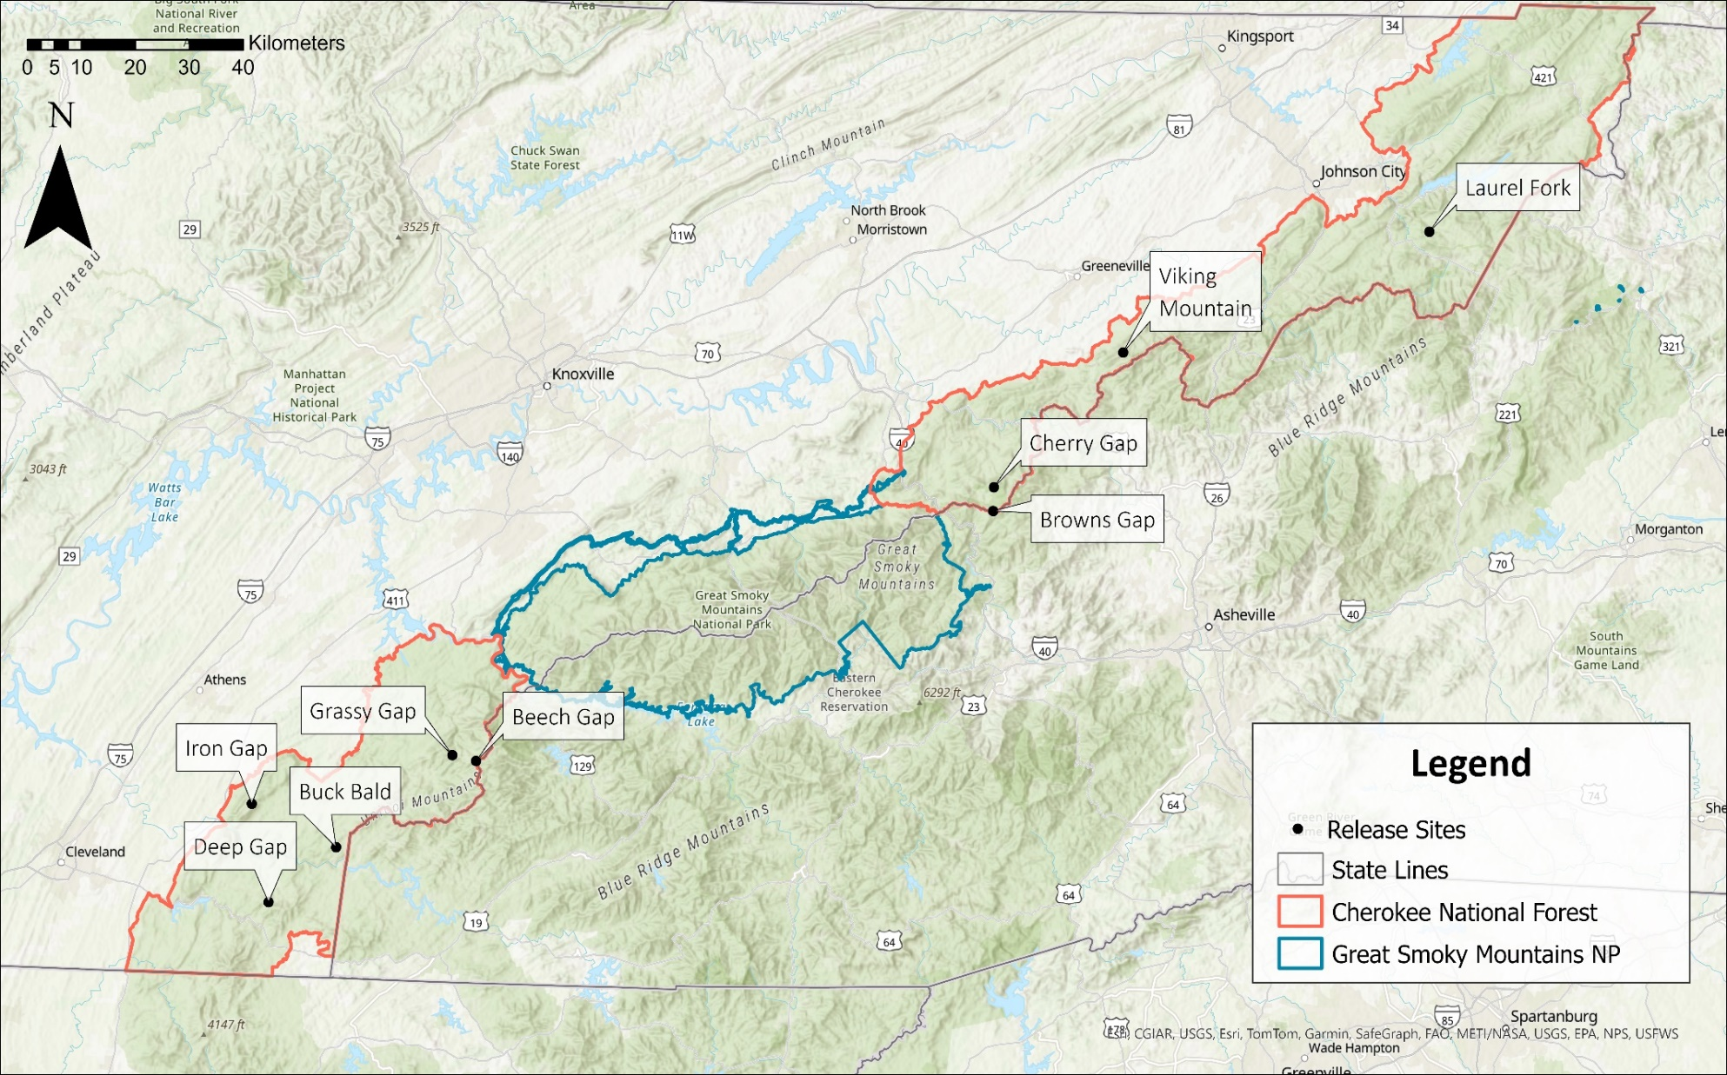
Appendix
Figure 1.1. Great Smoky Mountains National Park and Cherokee National Forest study areas and release sites, 2015–2023, Tennessee, USA.

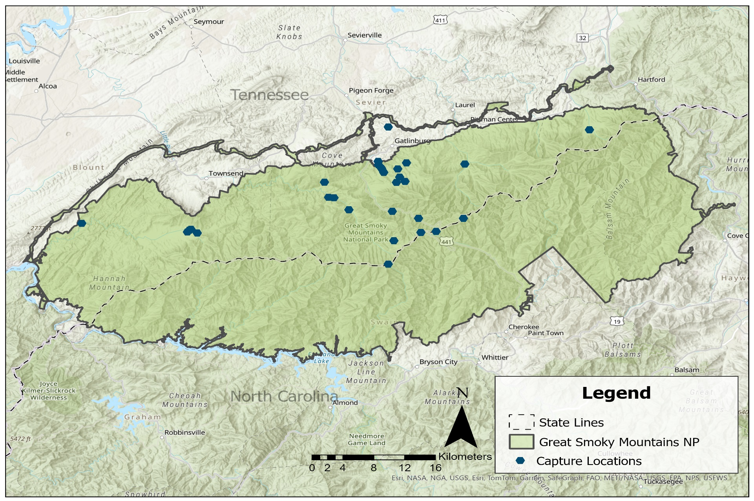
Figure 1.2. Capture locations for black bears in Great Smoky Mountains National Park that were relocated outside the park boundary to Cherokee National Forest, Tennessee, USA, 2015–2023.
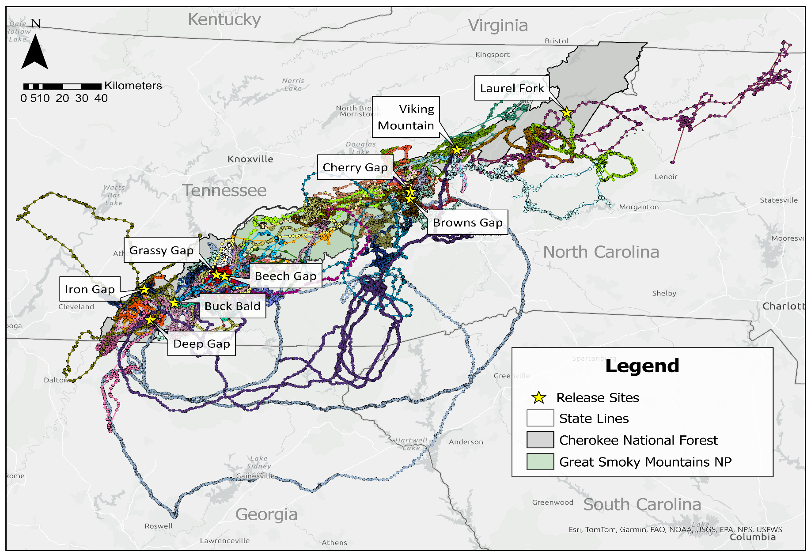
Figure 1.3. GPS location data of 50 relocated conflict black bears from Great Smoky Mountains National Park to Cherokee National Forest, Tennessee, USA, 2015–2024.
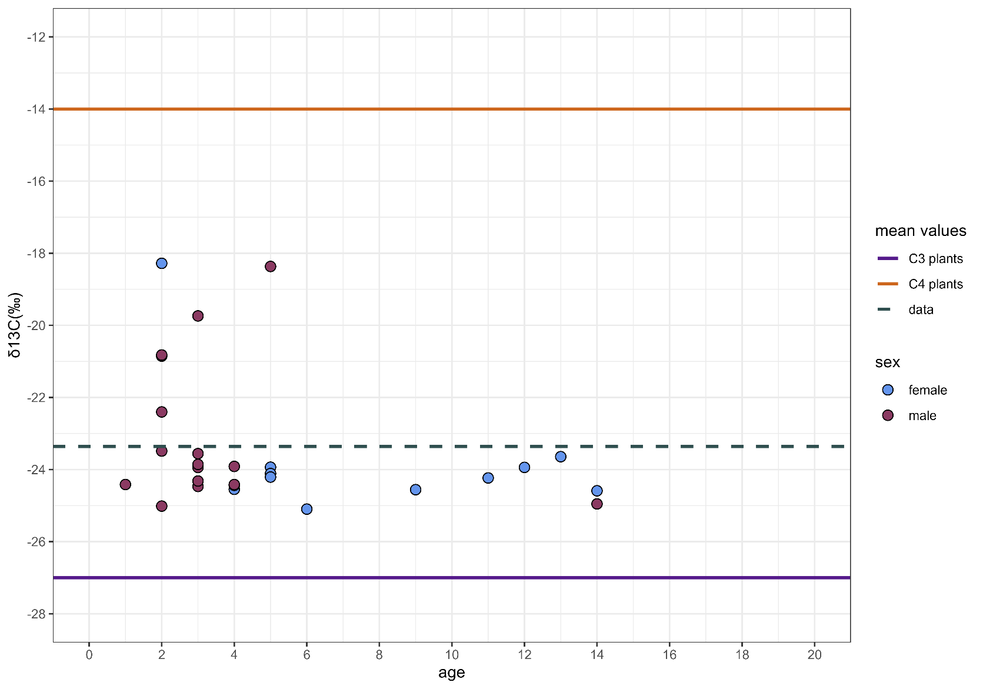
Figure 1.4. δ¹³C for relocated black bears, 2015–2023, Tennessee, USA. Mean δ¹³C for the data is represented by grey dashed line whereas the mean δ¹³C values for C3 and C4 plants based on Ben-David and Flaherty (2012) are depicted by purple and orange solid lines, respectively.

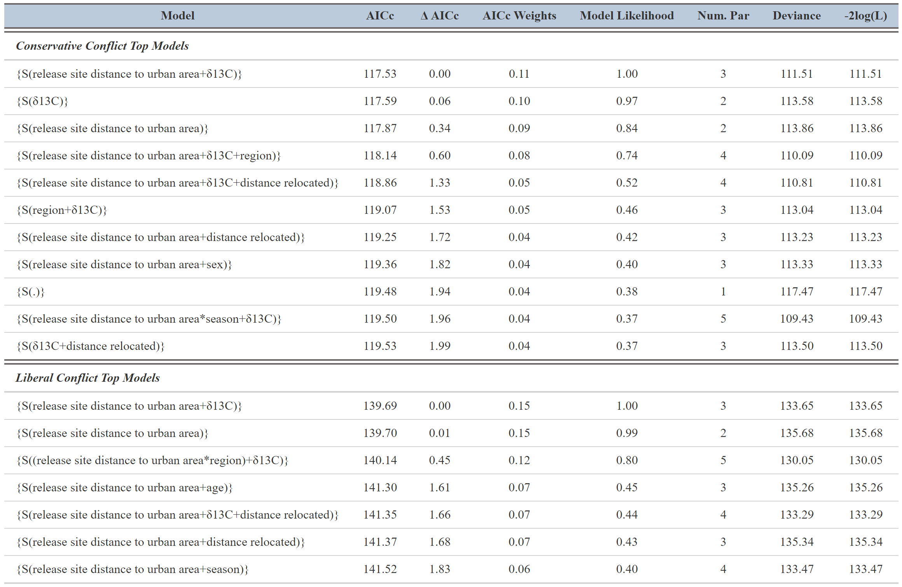
Table 1.1. Top known-fate models for the conservative and liberal recurrent conflict analyses for black bears. Liberal analyses defined recurring conflict as GPS data clusters in human developed areas and official reports to agencies whereas the conservative analyses defined conflicts by official reports to agencies only. S indicates no recurrent conflict, release site distance to urban area and distance relocated from capture site was measured in km, 2015–2024, Tennessee, USA.
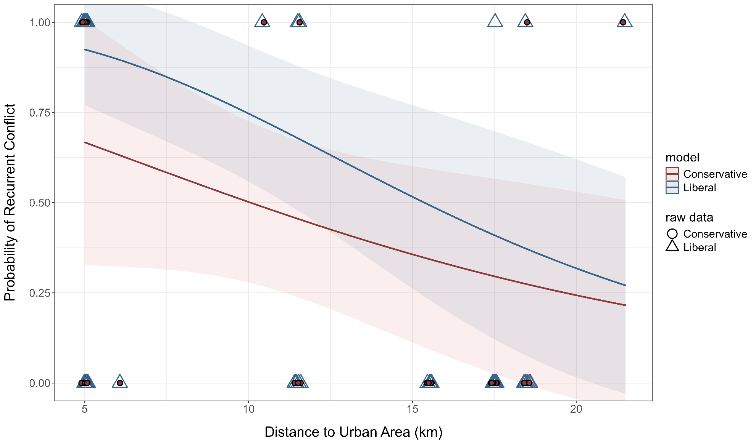
Figure 1.5. Annual probability of recurrent conflict for relocated black bears based on release-site distance to urban area for conservative and liberal definitions of conflict. The conservative model defined recurrent conflict by official reports to agencies only whereas the liberal model defined recurrent conflict by official reports to agencies and GPS clusters at human developments, 2015–2024, Tennessee, USA.
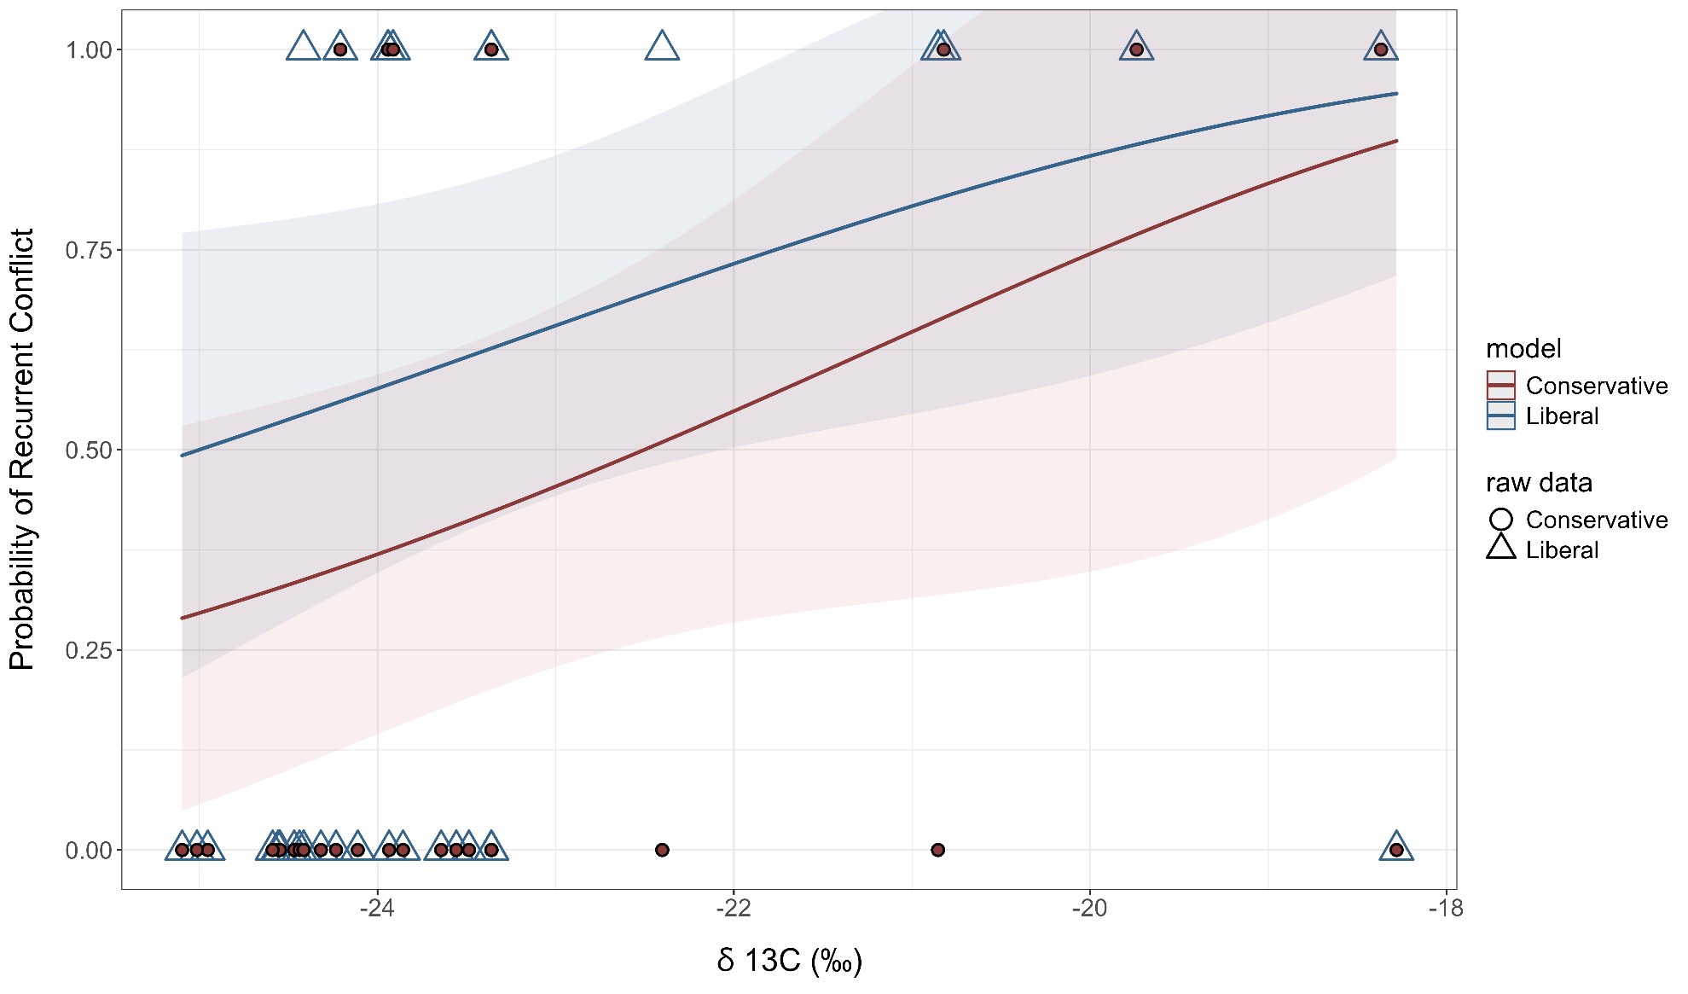
Figure 1.6. Annual probability of recurrent conflict for relocated black bears based on δ¹³C from relocated bears for conservative and liberal definitions of conflict. The conservative model defined recurrent conflict by official reports to agencies only whereas the liberal model defined recurrent conflict by official reports to agencies and GPS clusters at human developments, 2015–2024, Tennessee, USA
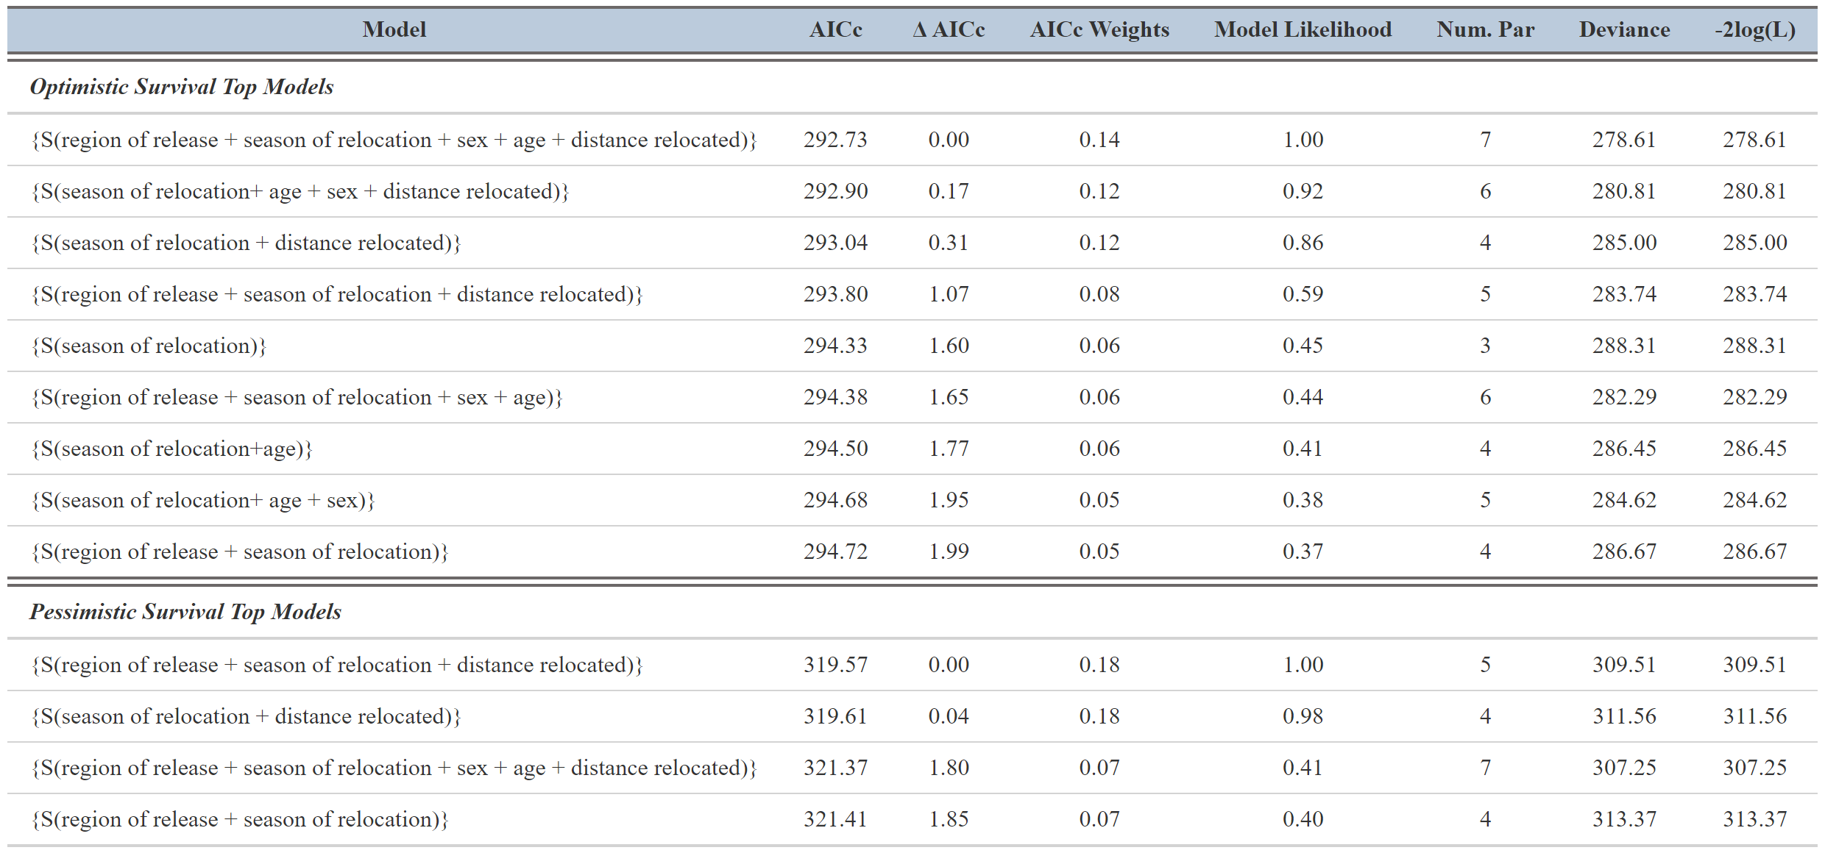
Table 1.2. Top known-fate models for the optimistic and pessimistic survival analyses of black bears, 2015–2024, Tennessee, USA. Optimistic analyses censored bears with lost GPS signals, whereas the pessimistic analyses classified bears with lost GPS signal (unknown fate) as a mortality. S is survival, region of release is Cherokee National Forest, and distance relocated is distance moved from original capture location in km.

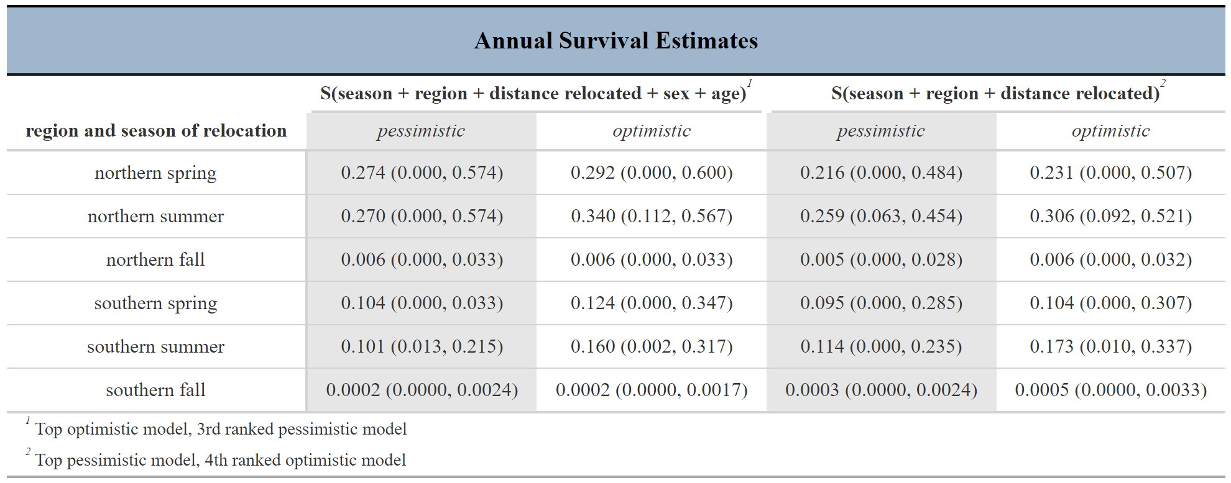
Table 1.3. Annual survival probability of black bears for the top optimistic and pessimistic models based on average distance relocated and age, 2015–2024, Tennessee, USA. Optimistic analyses censored bears with lost GPS signals, whereas the pessimistic analyses classified bears with lost GPS signal (unknown fate) as a mortality.

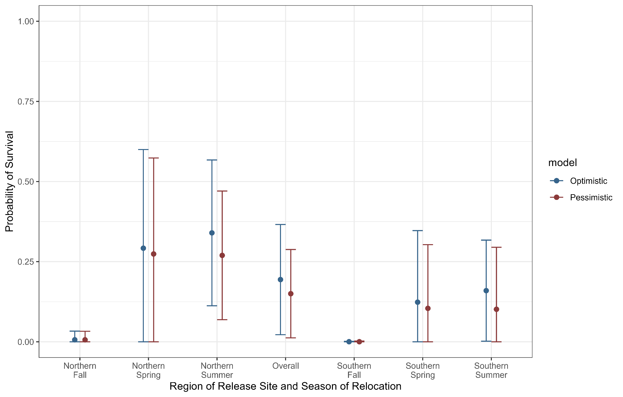
Figure 1.7. Annual probability of survival estimates for relocated black bears based on region of release-site and season of relocation for the average distance relocated, age, and sex for optimistic and pessimistic models, 2015–2024, Tennessee, USA. The pessimistic analyses recorded bears with lost GPS signal (unknown fate) as a mortality, whereas the optimistic analyses censored bears with lost GPS signals.

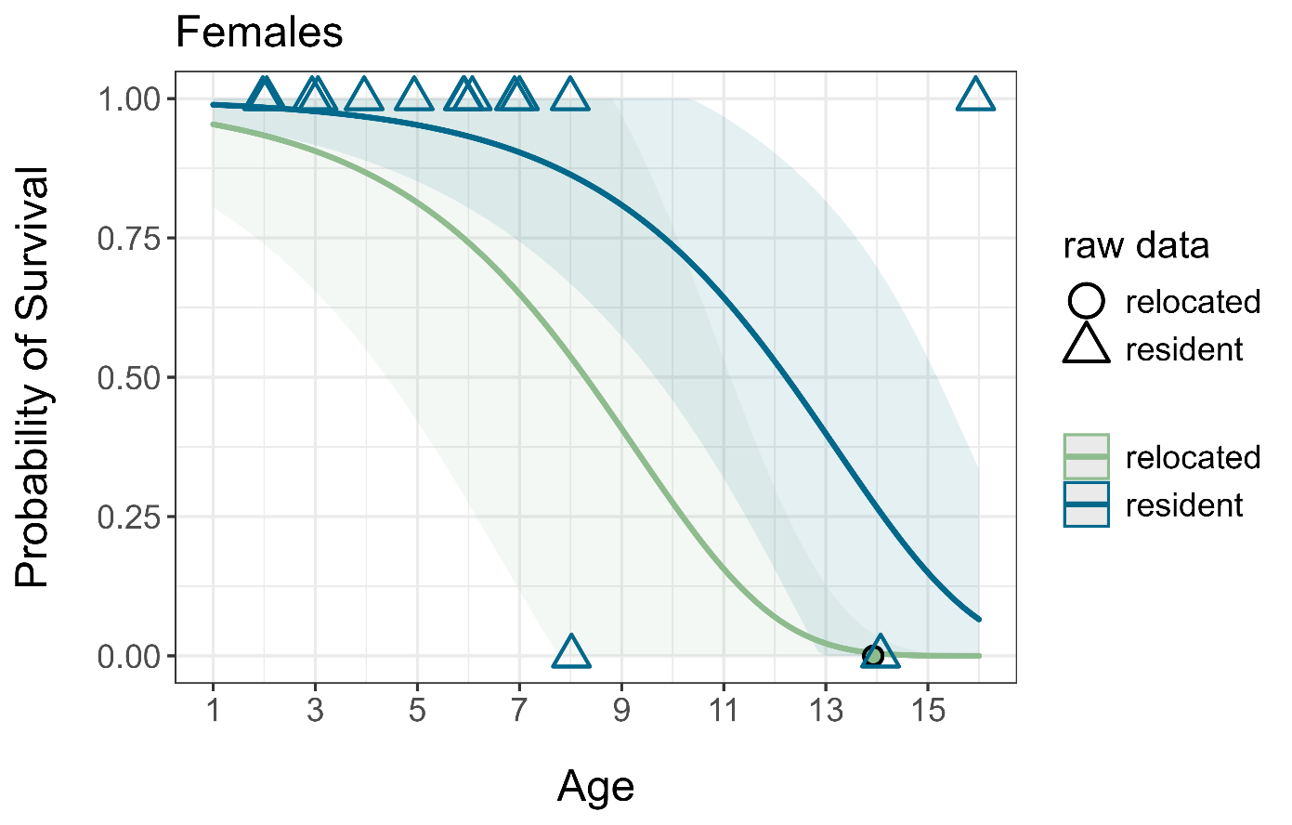
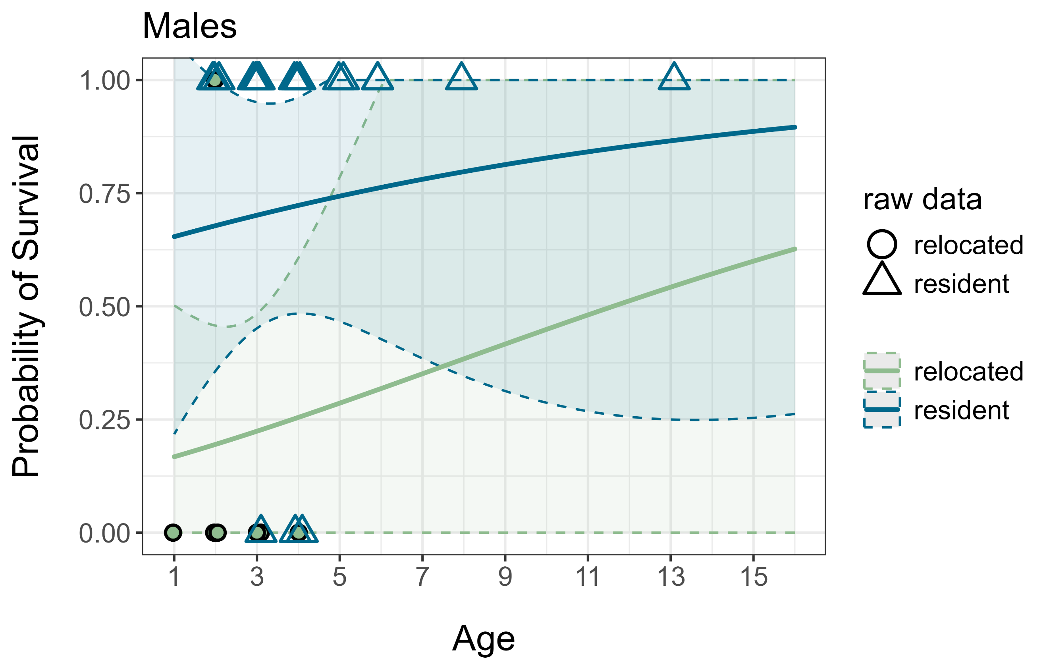
Figure 1.8. Annual probability of survival for female and male relocated and resident black bears in the Pigeon River Gorge of Tennessee and North Carolina, USA, 2022–2024.

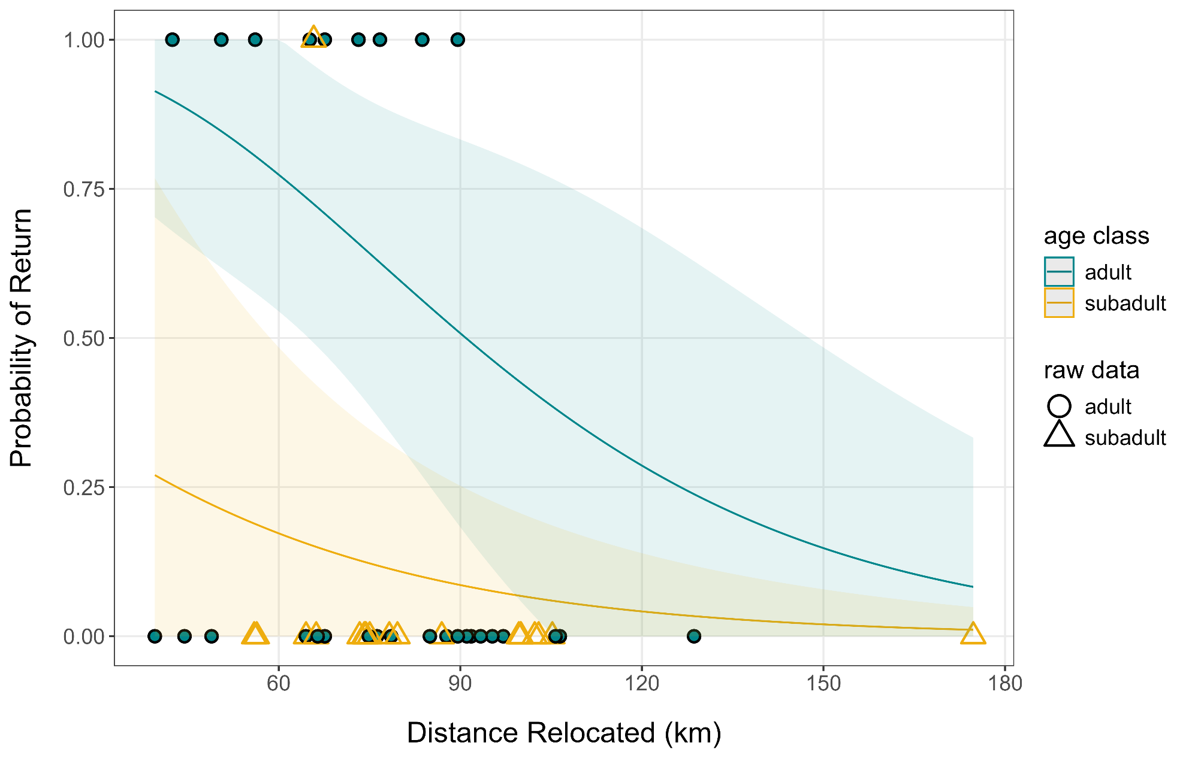
Figure 1.9. Annual probability of return to the capture location (original home range) for adult and subadult relocated black bears based on distance relocated, 2015–2024, Tennessee, USA.

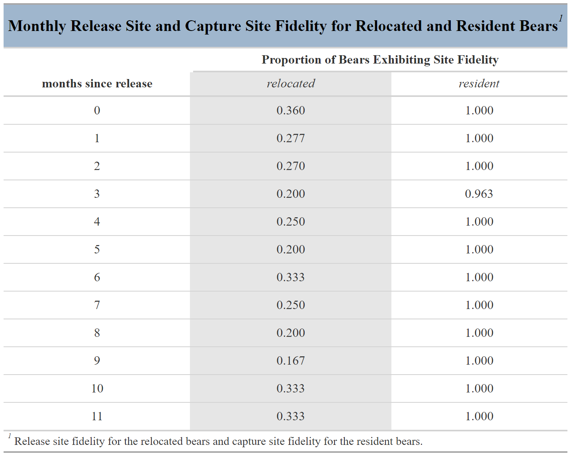
Table 1.4. Proportion of relocated and resident black bears exhibiting release-site and capture-site fidelity, respectively, for each month post-relocation; 2015–2024, North Carolina and Tennessee, USA.
Table 1.5. Proportion of relocated and resident black bears exhibiting release-site and capture-site fidelity, respectively, grouped by sex and age class for each month post-relocation; 2015–2024, North Carolina and Tennessee, USA.
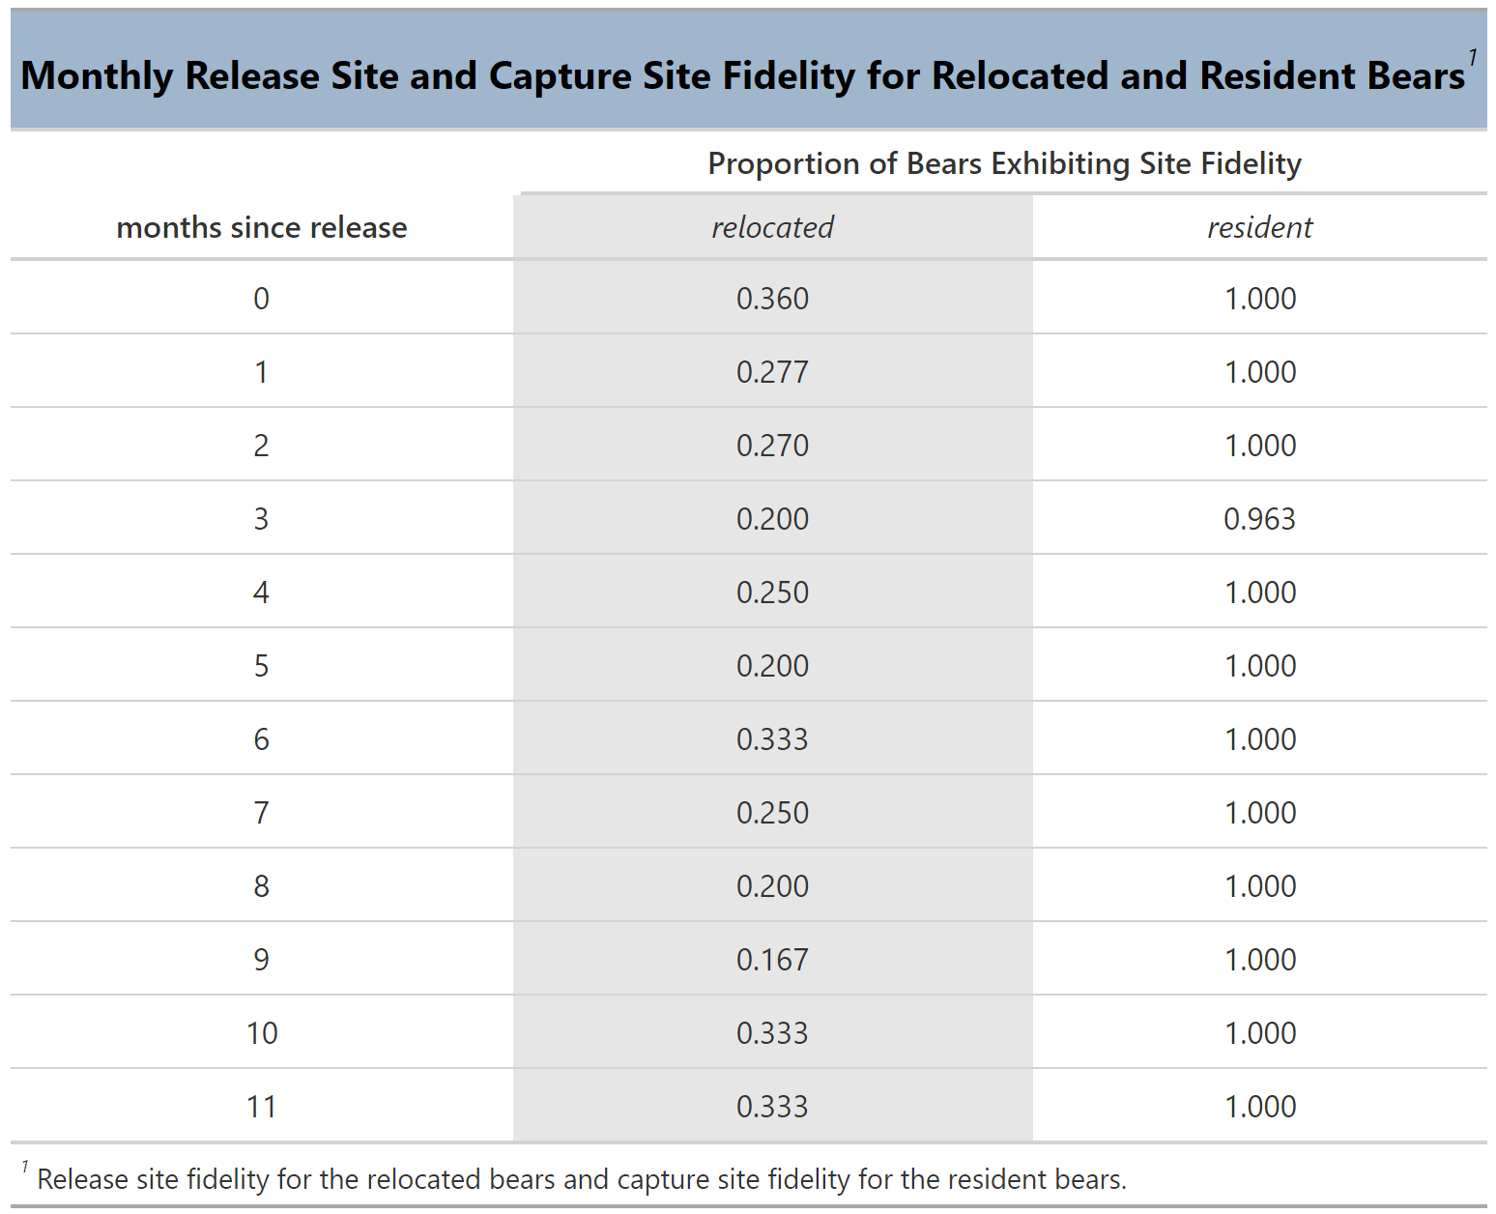
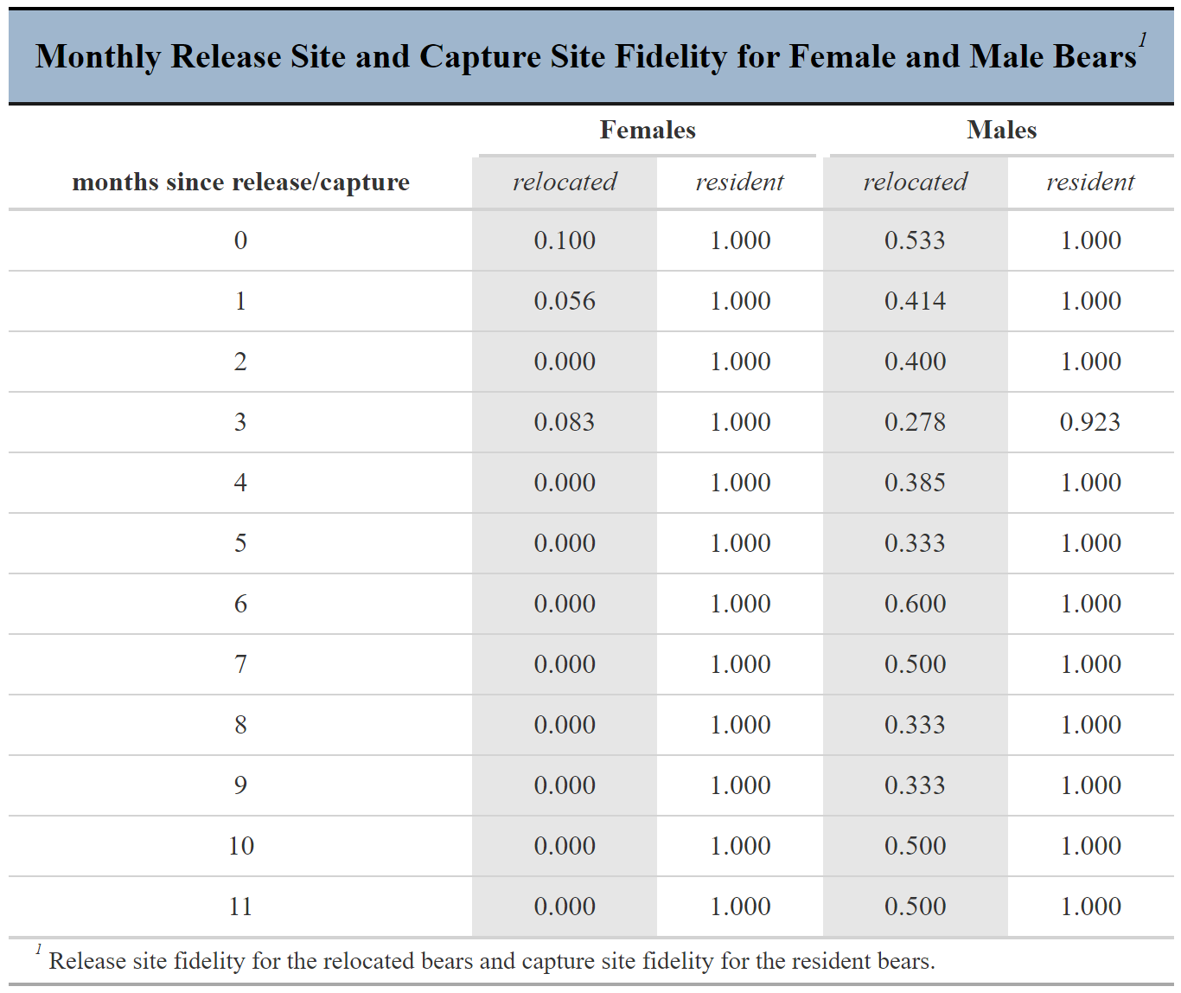
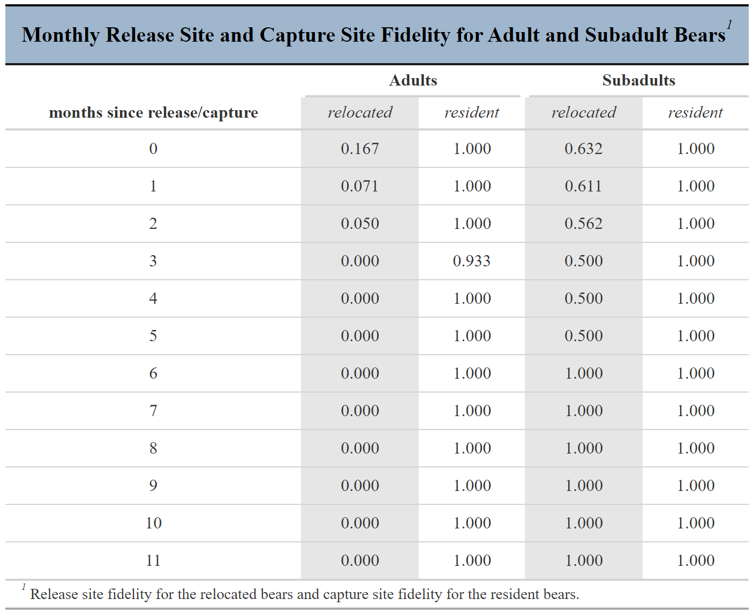
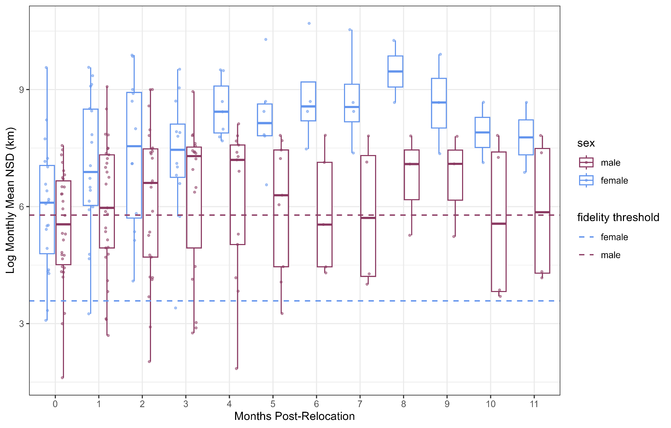
Figure 1.10. Log mean net squared displacement (NSD) per month post-relocation for relocated male and females black bears. Bears with points below their respective sex’s fidelity thresholds indicate fidelity to the release-site for that month. Jitter represents individual bears, 2015–2024, Tennessee, USA.
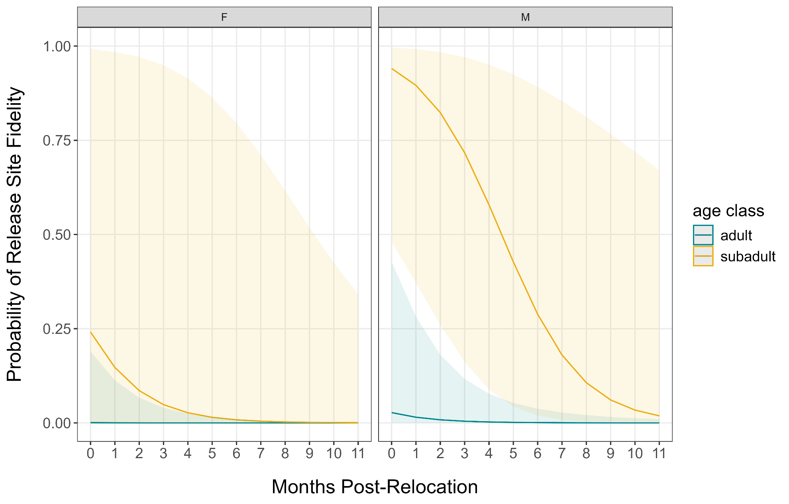
Figure 1.11. Probability of release-site fidelity for each month post-relocation for female and male black bears of each age class, 2015–2024, Tennessee, USA.
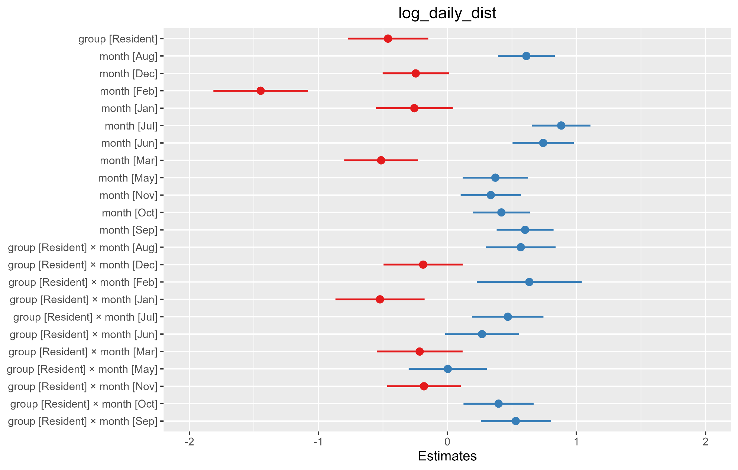
Figure 1.12. Beta estimates and their associated 95% confidence interval for the linear mixed effects model analyzing daily distance traveled (m) for resident and relocated black bears (log(daily distance traveled) ~ group*month+ (1|id)). Red estimates indicate decrease in daily distance, whereas blue indicates an increase; 2015–2024, Tennessee and North Carolina, USA.
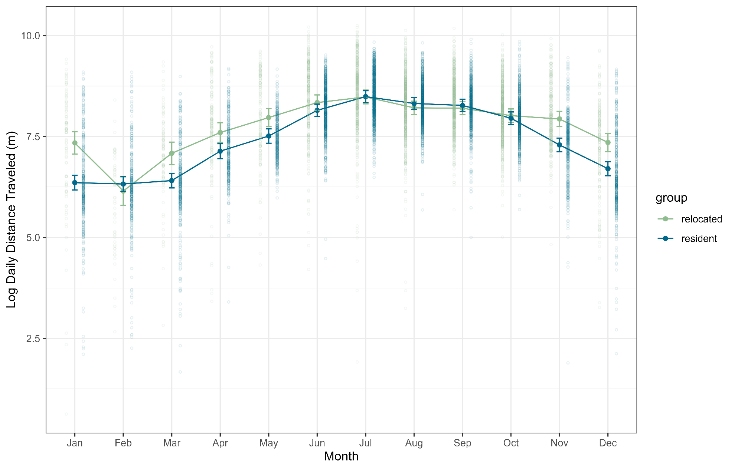
Figure 1.13. Predicted daily distance traveled for relocated and resident black bears for each month, 2015–2024, North Carolina and Tennessee, USA.

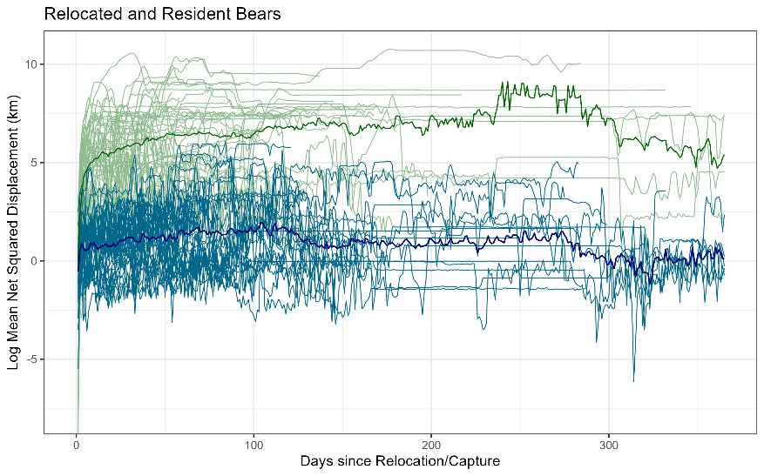
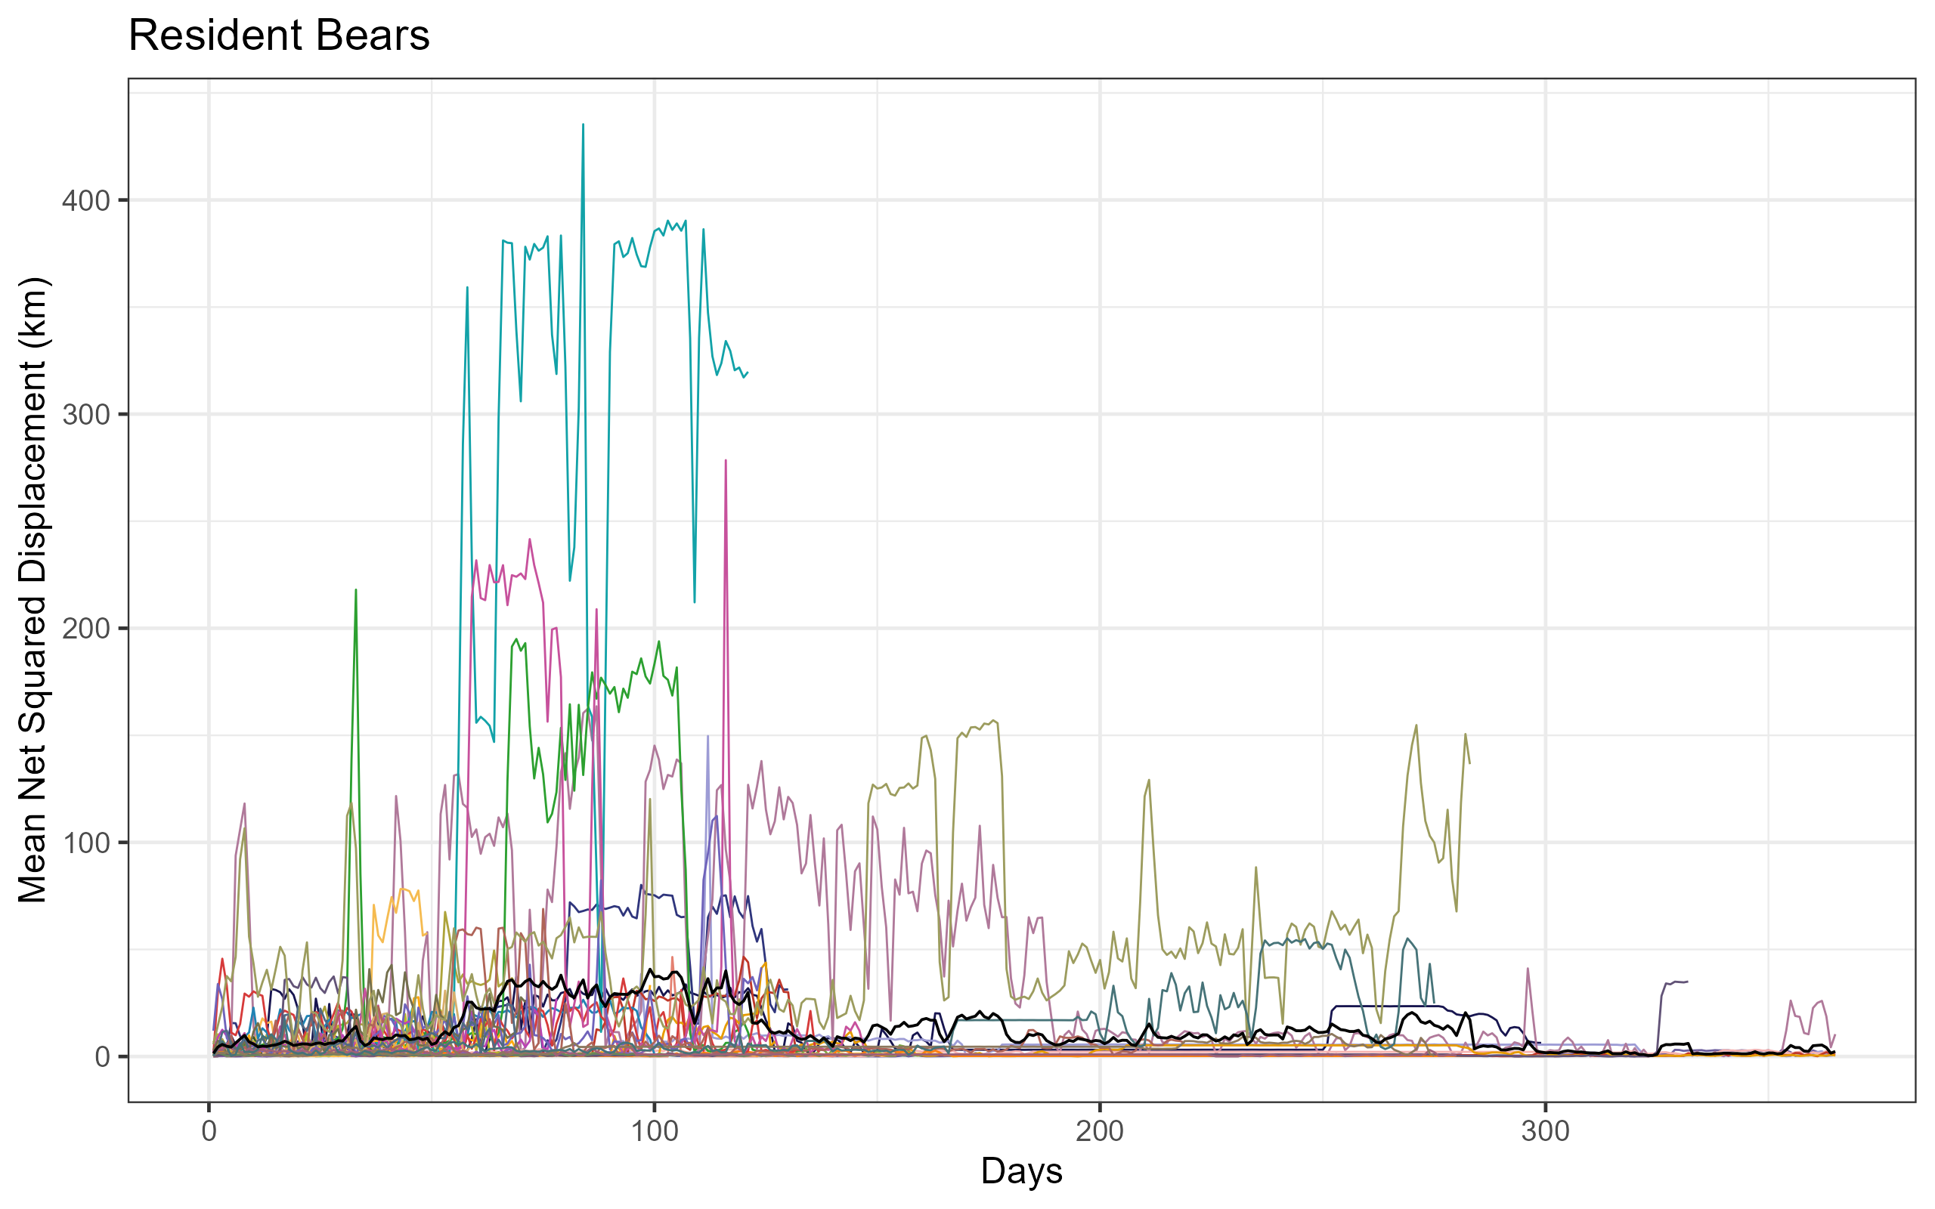
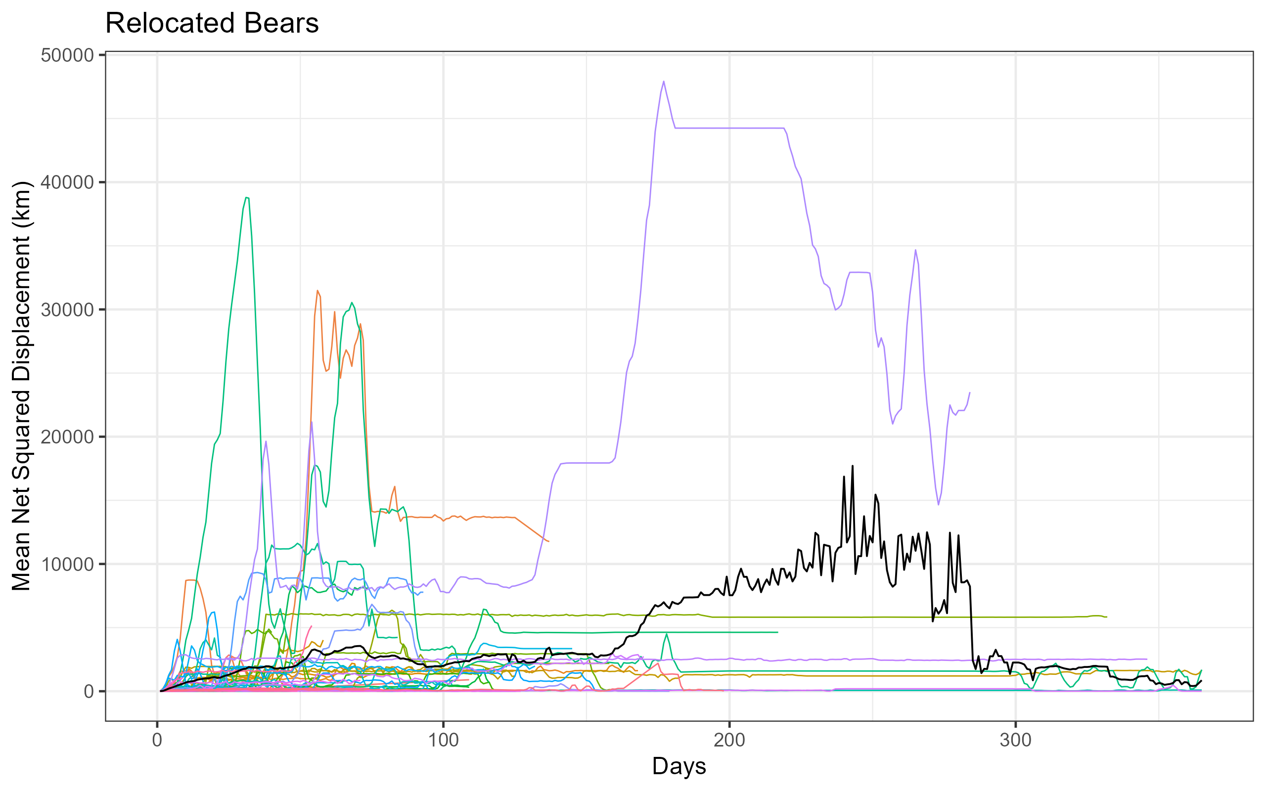
Figure 1.14. Mean daily net squared displacement for resident (top) and relocated black bears (middle) with averages (black lines). Note the scale of the y-axis, demonstrating the distance displaced from the release site (relocated bears) or capture site (residents). Bottom figure plots both groups together and their averages (dark green and blue) on the log scale to better visualize the differences, 2015–2024, North Carolina and Tennessee, USA.
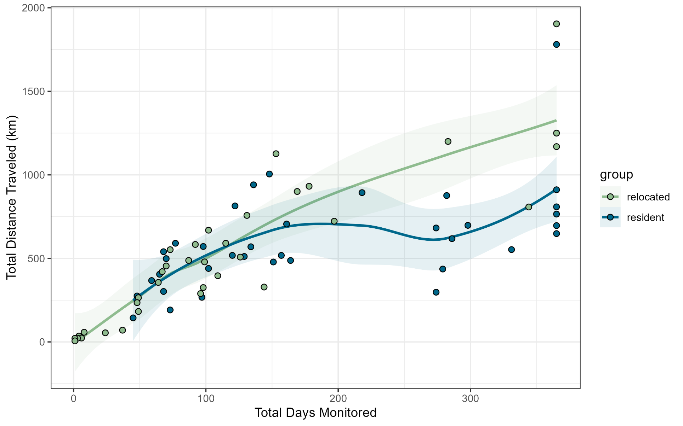
Figure 1.15. Total distance traveled in kilometers for relocated and resident black bears, 2015–2024, North Carolina and Tennessee, USA.

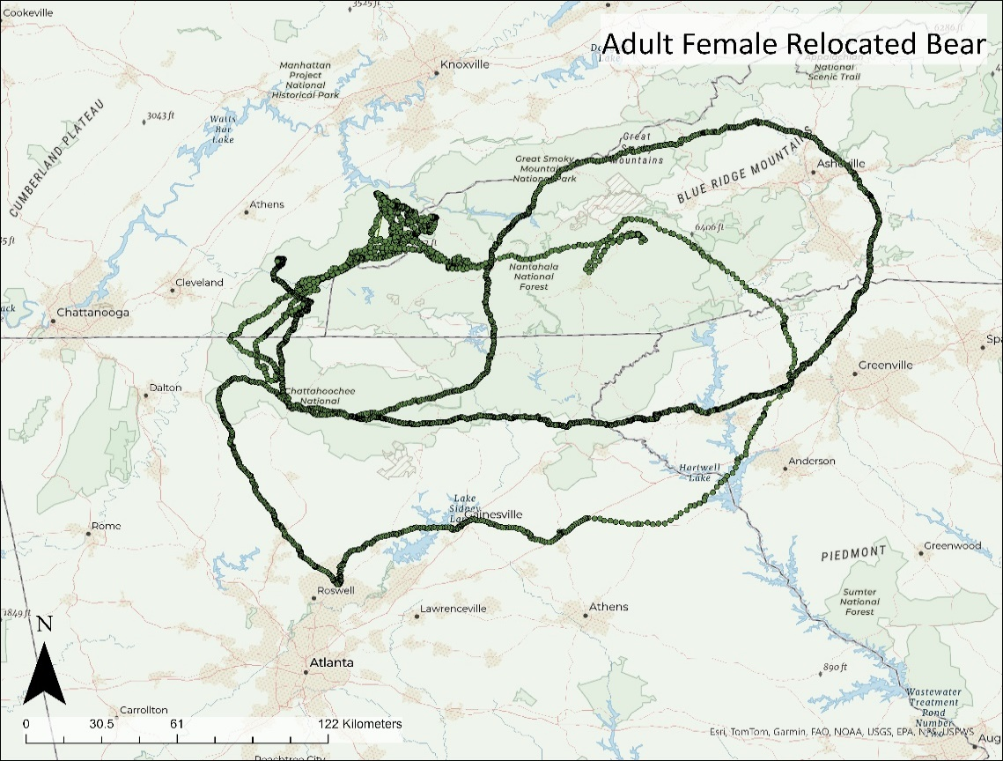
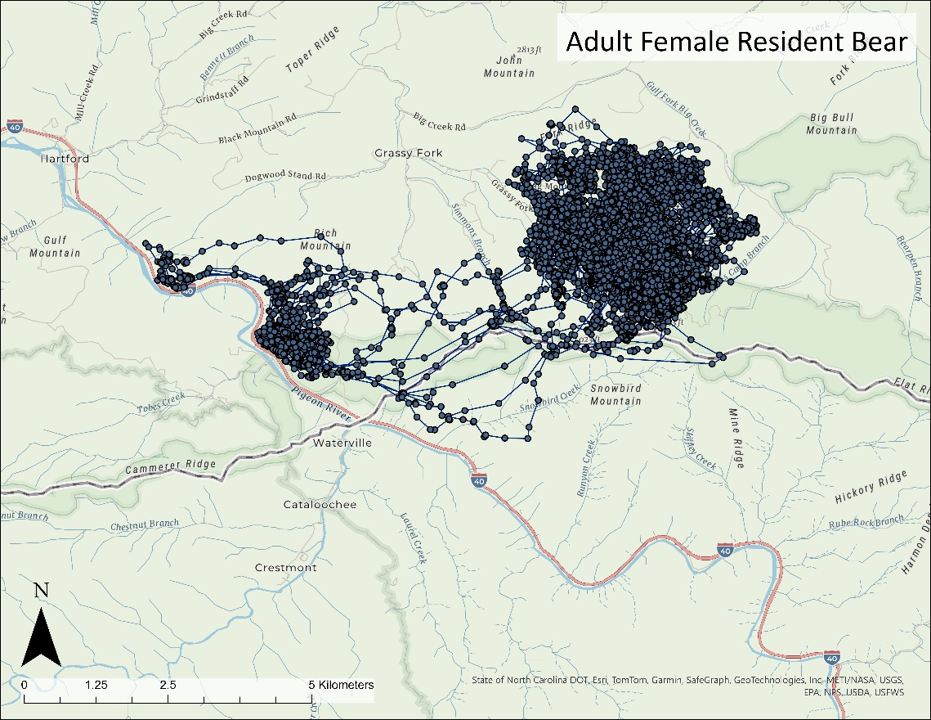
Figure 1.16. Movement data of a resident adult female (above) and a relocated adult female black bear (below). Note the differences in spatial scale, 2022–2023, North Carolina and Tennessee, USA.
Bear 1173
Bear UT08
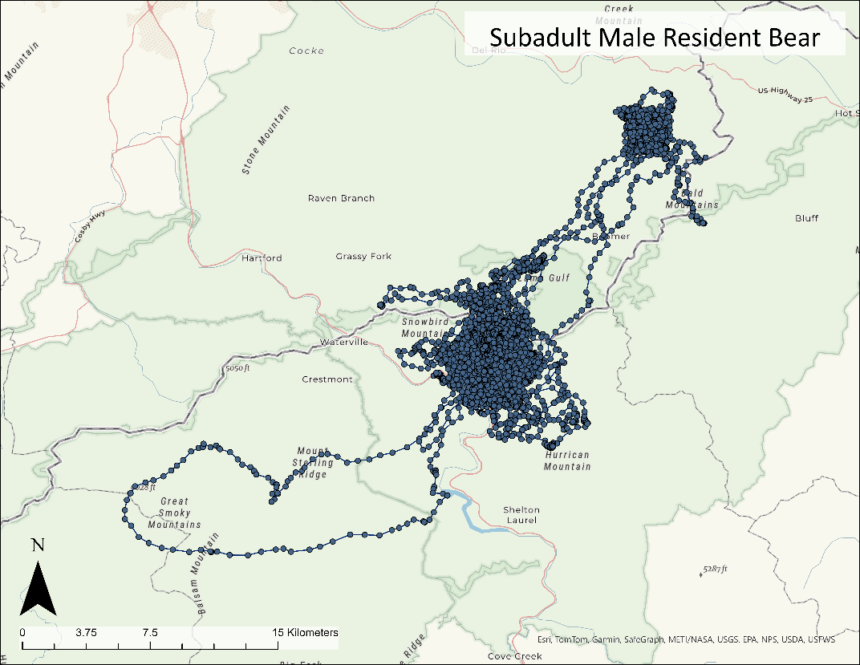
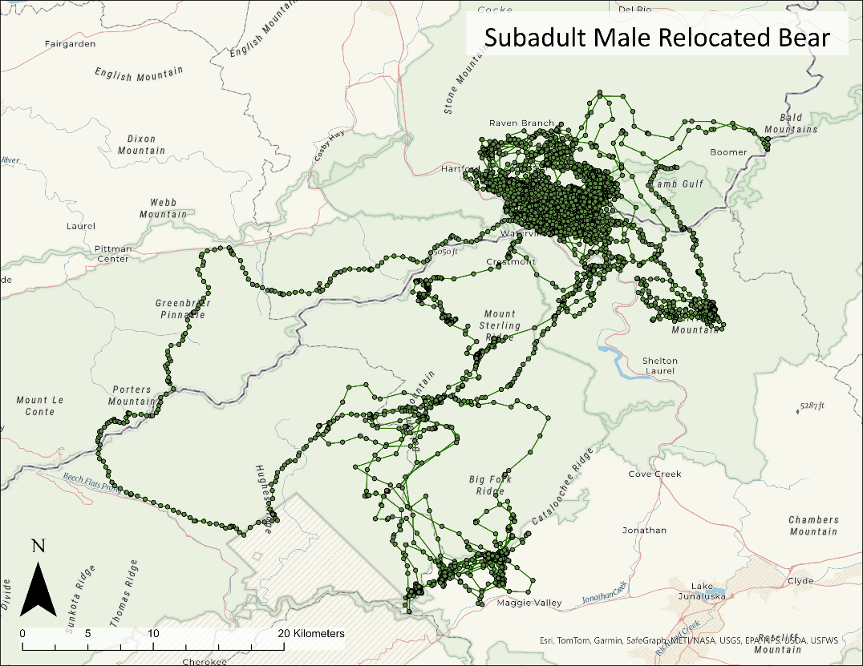
Bear 1182
Bear UT22
Figure 1.17. Movements of a resident subadult male (above) and a relocated subadult male black bear (below). Note the differences in spatial scale, 2021–2024, North Carolina and Tennessee, USA.
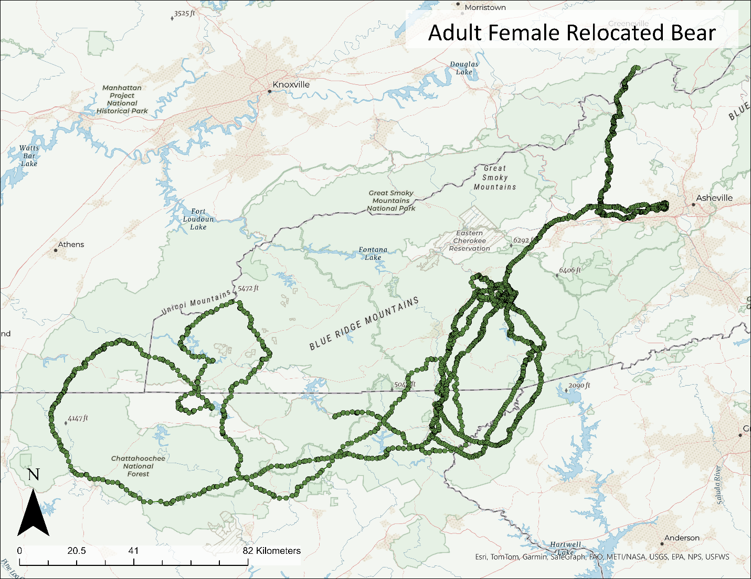
Figure 1.18. Post-relocation movements of a relocated adult female black bear, 2022–2023, Tennessee, USA.
Bear 1241

:
MOVEMENTS AND ROAD CROSSING SELECTION OF AMERICAN BLACK BEARS (URSUS AMERICANUS) ALONG INTERSTATE 40 IN THE PIGEON RIVER GORGE OF TENNESSEE AND NORTH CAROLINA

Abstract
Maintaining connectivity across the landscape is essential for ensuring that wildlife populations remain healthy. The fragmentation caused by roadways can directly impact connectivity for terrestrial species, which can isolate populations causing reduced gene flow and reduced biodiversity. In the Pigeon River Gorge (PRG) of Tennessee and North Carolina, USA, Interstate 40 separates Great Smoky Mountains National Park from Cherokee and Pisgah national forests, creating a barrier to wildlife movement between largely undeveloped tracts of contiguous forested habitat. Road-killed wildlife is common on the 51-km stretch of roadway, with the American black bear (Ursus americanus) comprising the greatest proportion. Relatively recent advancements in landscape-modeling have allowed for more robust methods to identify locations along roadways that would benefit from mitigation measures such as wildlife crossings. These methods consider wildlife movement leading up to and away from the roadways, compared with methods that only consider movement immediately adjacent to the road. The aim of my study was to apply circuit theory to black bear movement data to visualize bear movement flow across the landscape. I used a combination of hidden Markov models and step selection functions to model black bear habitat selection while moving across the landscape in the PRG. I used the resulting habitat suitability matrix as a resistance layer for the circuit-theory (i.e., Omniscape) analysis. I also wanted to determine whether movement flows for dispersers differed from residents in the area, so I used relocated bears released in the PRG as a proxy for dispersers due to unfamiliarity with their surroundings. My results indicated that dispersers had longer step lengths while moving across the landscape and selected for areas with lower percent slope and higher percent canopy, whereas residents selected for ridgelines and drainages in addition to lower percent slope and higher percent canopy. Omniscape models differed for residents versus dispersing bears at the landscape level, with dispersing bears selecting more generalized pathways. My models identified several well-defined locations along the interstate where bears might benefit from crossing structures or other mitigation measures.

Introduction

Background
Road systems not only provide convenient means for commuting and travel but have become integral to the U.S. economy because necessities, such as food, clothing, and medicine, depend on roads for transport. With the human population continuing to grow, transportation networks are expanding to meet demands in housing, agriculture, fuels, and timber (Laurance 2015, van der Ree et al. 2015b). However, roads have become a permanent and pervasive attribute of current-day landscapes and can result in fragmentation and loss of habitat for many wildlife species. It is estimated that about 80% of the earth’s terrestrial surface is fragmented into 600,000 patches, with >50% being <1 km away from a road, and 80% being <5 km away (Ibisch et al. 2017). Habitat fragmentation is considered one of the key drivers of biodiversity loss as it decreases connectivity, which is crucial for sustaining healthy wildlife populations, especially for long-ranging species (Keller and Largiadèr 2003, Epps et al. 2005, Corlatti et al. 2009). Habitats can be further impacted by roads due to increased human disturbance and related land use changes (e.g., recreation, logging, development) in areas that were previously remote and inaccessible (Beckmann and Hilty 2010, Laurance and Balmford 2013, Liu et al. 2014, Ibisch et al. 2017).
With >78,024 km of interstate highway, the U.S. has one of the most extensive highway systems in the world (TRIP 2021). Most of these roads were built before there was an in-depth understanding of wildlife movement ecology; therefore, adequate structures to enable safe wildlife crossings were not included (Forman et al. 2003, Beckmann and Hilty 2010, van der Ree 2015b). Interstate highways have the greatest environmental impact compared with any other type of road (Laurance et al. 2002, Kirby et al. 2006, Barber et al. 2014, Laurance 2015). This impact is because the adjacent landscape that extends past the road can also be affected by the physical road and activity on the road, otherwise known as the ‘road-effect zone’ (Forman and Deblinger 2000, van der Ree et al. 2015b). The size of the road-effect zone is dependent on several factors such as road width and surface type, traffic speed and volume, land cover type and topography of the landscape adjacent to the road, and the traits of the species in question (van der Ree et al. 2015b). Generally, paved roads have larger road-effect zones than unpaved roads and, as the speed and volume of traffic increases, the road-effect zone will be wider. For these reasons, interstate and state highways have the widest road-effect zones, sometimes extending several kilometers from the road itself (Forman and Deblinger 2000, Shanley and Pyare 2011, Andrasi et al. 2021). Furthermore, the surrounding landscape is often altered for driver safety (e.g., linear clearings alongside the road). This facilitates the spread of invasive species such as non-native generalist plants, causing a shift in the land cover type and increasing the ‘barrier effect’ of the road (Beckmann and Hilty 2010, van der Ree et al. 2015). The barrier effect is the degree of permeability of a road, i.e., the extent to which animal movement is inhibited (Beyer et al. 2016, Assis et al. 2019).
Barrier effects are not homogeneous across species and are dependent on species life history traits and movement patterns. For example, species with small home ranges may not interact with roads as frequently as a long-ranging species (Rytwinski and Fahrig 2015). For wildlife that must attempt to cross the road to access a specific habitat type (e.g., ungulate birthing grounds, barren-ground caribou [Rangifer tarandus]; Cameron et al. 2020) or resource (e.g., seasonal food sources, American black bears [Ursus americanus]; Ryan et al. 2007), they are faced with several potential outcomes: 1) they cross safely, 2) they are struck by a vehicle and either injured or killed, or 3) they are deterred by the traffic or degraded roadside habitat and thus remain in their original habitat patch (van der Ree et al. 2015b). Of these outcomes, wildlife-vehicle collisions (WVCs) have a substantial effect as most animals are killed either on impact or shortly thereafter (Huijser et al. 2008). In the Huijser et al. (2008) report to Congress, there was an estimated 1–2 million WVCs every year in the U.S., a number that is likely higher today, as the human population has grown by at least 10% since 2008 (U. S. Census 2023). Such collisions not only impact wildlife but impose a safety risk for humans and can also result in thousands of dollars of vehicle damage. Annually, WVCs average about 59,000 human injuries and 440 human fatalities, amounting to >$8.39 billion (2008 U.S. dollars; Huijser et al. 2008, Conover 2019). On average, a collision with a deer (Odocoileus spp.) or similar-sized animal costs $6,000 (2008 U.S. dollars) and increases as the size of the animal increases, as well as the severity of human injury and risk of death (Huijser et al. 2008).
To alleviate the safety risks and economic cost associated with WVCs as well as the ecological damage caused by roadways, biologists and transportation divisions are collaborating to identify what mitigation solutions, such as wildlife overpasses or underpasses, are most appropriate for the areas in question. Because of the high cost of such structures, it is crucial that thorough research is done prior to mitigation projects to ensure that structures are placed in locations that will maximize the usage by wildlife (van der Ree et al. 2015a). Furthermore, structures are not one-size-fits-all and are dependent on species’ preference and their habitat requirements. For example, researchers have found that species that select for more open landscapes, such as grizzly bears (Ursus arctos) and desert bighorn sheep (Ovis canadensis), prefer overpasses, whereas species that select for forested habitats, such as American black bears and cougars (Puma concolor), prefer underpasses (Clevenger and Waltho 2005, Gagnon et al. 2022). Therefore, when considering mitigation measures for a particular section of roadway, biologists should carefully consider the focal species of their research as it can impact the resulting locations of structures as well as the type of structure.
The focal species should be one that is widespread across the study area and has previously shown a strong response to the roadway in question (e.g., high volume of roadkills) or poses a substantial safety risk to humans if a collision were to occur (e.g., large-bodied animals such a moose [Alces alces]; van der Grift et al. 2013). Once structures are installed, there will be an acclimation period for wildlife but, with proper placement in established movement corridors, that timeframe can be shortened if wildlife have already demonstrated a propensity for the location (Gagnon et al. 2011, 2022). When done correctly, the retrofitting of wildlife crossing structures on roadways has been shown to dramatically decrease the number of WVCs and increase connectivity between habitat patches. Examples include a 58% decrease in WVCs on U.S. Highway 64 in North Carolina (McCollister and van Manen 2010), a 100% and 78% decrease in pronghorn (Antilocarpa americana) and mule deer (Odocoileus hemionus) WVCs, respectively, in Wyoming (Sawyer et al. 2016), and a reduction to only 0.62–1.86 WVCs per kilometer (1-3 per mile) per year in Washington (Sugiarto 2022).

Justification
Interstate 40 (I-40) is oriented in a southeast-northwest direction and passes through the Pigeon River Gorge (PRG), winding along the Pigeon River in eastern Tennessee and western North Carolina, USA. Constructed in the 1960’s, the route was carved through the mountains without much consideration of safe crossing opportunities for wildlife. Several bridges along the roadway have acted as de facto underpasses, and a highway tunnel as an overpass, allowing wildlife to move freely either below or above the roadway. However, many of these bridges were constructed over the river or other paved roadways, resulting in steep banks and little potential for movement. Furthermore, most structures along the roadway were installed for drainage purposes and consisted of corrugated metal culverts or cement box-culverts with wet bottoms. Consequently, the section of well-traveled 4-lane roadway (between 26,500 and 30,000 vehicles/day; NCDOT 2023, TDOT 2023) in the PRG was notorious for WVCs. While this section of roadway puts many species of wildlife at risk, black bears accounted for most of the roadkill at 55% (Hillard et al. 2022). On average, 28 black bears were known to be struck and killed by vehicles annually on I-40 in the PRG (S. Goodman, National Park Conservation Association, unpublished data). According to Lee et al. (2021), this number is likely higher due to roadkills that were missed because the animal moved away from the road and died out of sight. Applying a correction factor of 2.8 to account for missed carcasses (Lee et al. 2021), results in a yearly estimate closer to 78 bears killed on the 51-km stretch of roadway. This number likely fluctuates depending on resource availability, especially when bears are in hyperphagia during autumn (mid-August to December), when they move greater distances. This effect can be compounded during an acorn (Quercus spp.) mast failure when bears are more likely to increase their interactions with roadways and are more susceptible to road mortality (Ryan et al. 2007).
Previous research done by Brody and Pelton (1989) found that bears had a pronounced avoidance of I-40, making it a substantial barrier. Interstate 40 bisects important habitat for black bears as it passes through Cherokee and Pisgah national forests (CNF and PNF, respectively), separating them from Great Smoky Mountains National Park (GRSM). Not only does this limit the dispersal ability of bears in the region, but also greatly impacts other species that require connectivity between large tracts of contiguous habitat (e.g., elk [Cervus canadensis]) and isolates wildlife populations, potentially creating an island effect (Newmark 1987, Parks and Harcourt 2002, Beckmann and Hilty 2010). This island effect can be further exacerbated when the exurban interface along the Park boundary is developed due to the increased tourism. This development can have a negative impact on gene flow and dispersal ability for a variety of species, especially those that are sensitive to anthropogenic development.
Over the past several years, both state wildlife agencies (Tennessee Wildlife Resources Agency [TWRA] and North Carolina Wildlife Resources Commission [NCWRC]) and departments of transportation (Tennessee Department of Transportation [TDOT] and North Carolina Department of Transportation [NCDOT]) have expressed interest in mitigation projects in the PRG that would provide safe crossing opportunities for wildlife. Fortunately, there has been ongoing research by the Safe Passage Coalition, a group of 7 non-profit organizations working towards creating safe passage for wildlife across several major interstates throughout the nation including the PRG section of I-40 (Safe Passage, smokiessafepassage.org). The primary focus of their research has been to place cameras at the current underpasses (i.e., drainage culverts, box culverts, and bridges) and the single overpass (i.e., highway tunnel), and to conduct driving surveys to obtain road-kill counts (Hillard et al. 2022). Although this provides valuable information on the usage of current structures and identifies road-kill hotspots, it does not necessarily mean that these are the crossing locations that would be most beneficial for wildlife.
In addition to their camera surveys, Hillard et al. (2022) conducted a telemetry study whereby they fit 13 elk with GPS-collars to gain a better understanding of elk movements and interactions with I-40 using step-selection functions combined with an Omniscape analysis. Such landscape-level models are beneficial when analyzing crossing behaviors because they consider the landscape attributes leading up to the roadway (e.g., terrain, cover type, and habitat) rather than just the roadway itself (Schuster et al. 2013, Zeller et al. 2020). This method is useful for wildlife crossing analyses as it not only considers areas of high crossing frequency, but the animals’ movements approaching and avoiding the roadway as well. The elk research provided valuable information pertaining to crossing locations that elk selected for, but elk may select different habitat types than black bears and may not select for the same crossing locations.
While evaluating the effect of relocation on black bears in the PRG, I was presented with an opportunity to evaluate road-crossing behavior by bears. Interstate 40 separates several release sites used by National Park Service and TWRA for the relocation of conflict black bears from the original capture locations of the bears. Previous studies have documented that relocated bears exhibit a strong homing behavior and commonly attempt to return to their original home range, no matter the obstacles they may encounter (e.g., major roadways; Beeman and Pelton 1976, Landriault et al. 2006). Due to their homing instinct and their unfamiliarity with the area, relocated bears most likely interact with I-40 more frequently and may differ in their approach or crossing locations compared with resident bears that are familiar with the region and the highway (Stamps and Swaisgood 2007, Picardi et al. 2022). For these reasons, relocated bears may serve as proxies for dispersing animals and modelling their movements and interactions with I-40 can provide insight on how the roadway impacts dispersal ability compared with the day-to-day movement within the home ranges of resident bears. A landscape-level modeling approach is needed to better understand the movement behavior of both resident and dispersing (i.e., relocated) black bears leading up to and away from the roadway. My goal was to compare and contrast road-crossing behavior by both resident and dispersing bears and, in conjunction with the previous research completed by Safe Passage partners (Hillard et al. 2022), identify important wildlife movement corridors in the PRG where road-crossing mitigation measures could be beneficial.

Objectives and Hypotheses
Objectives
- Identify areas of high-crossing frequency ‘hotspot’ locations where bears approach the roadway, and landscape features important to bear movements,
- Evaluate whether resident bears and dispersing bears (i.e., relocated bears) vary in their crossing behavior and selection, and
- Create predictive models to generate landscape-scale movement maps to determine important movement corridors and optimal locations for roadway mitigation measures.
Hypotheses
- Bears will select for ridgelines, areas with heavy forest cover, high percent canopy cover, and areas further from human development.
- Dispersing bears will demonstrate more erratic crossing behaviors and experience a higher risk of mortality due to unfamiliarity with the area compared with resident bears, which are more predictable in their crossing behavior and demonstrate patterns in their selection of crossing points.

Study Area

Interstate 40 within the Pigeon River Gorge
The PRG section of I-40 spanned about 51 km between exit 440 (Wilton Springs, Tennessee, USA) and exit 20 (Maggie Valley, North Carolina, USA) and was located alongside the Pigeon River through CNF, PNF, and private property (Figure 2.1, located in the Appendix). There were 4 lanes of traffic with speed limits ranging from 88 kph (55 mph) to 112 kph (70 mph), with 88 kph being the most common. Opposing lanes of traffic were separated by a concrete divider that measured about 1 m in height in Tennessee and 2 m in North Carolina. There was no shoulder space between the inner lanes and the concrete barrier, and the right lane shoulder was often minimal or virtually non-existent. Elevations surrounding the interstate range from 400 m at the river to 950 m at the highest ridgeline, resulting in moderate to steep slopes oriented toward or away from the interstate (Hillard et al. 2022). Large rock cuts were made to create space when constructing the interstate due to the surrounding topography and landscape. Therefore, natural ridgelines that historically led down to the river often abruptly ended in cliffs at the interstate.

Cherokee National Forest
Cherokee National Forest was about 2,630 km² and situated in eastern Tennessee adjacent to the North Carolina border in the southern Appalachian Mountains (Figure 2.1, Woodcock 2017). Cherokee National Forest was divided into 2 zones, the northern and southern, which were separated by GRSM. The study area within the CNF was about 168 km² in size within the northern zone in the Unaka Ranger District. Elevations range from 365 m to >1,829 m and forest types included cove hardwood (sugar maple [Acer saccharum], yellow buckeye [Aesculus flava], American basswood [Tilia americana], rosebay rhododendron [Rhododendron maximum], mountain laurel [Kalmia latifolia], tulip poplar [Liriodendron tulipifera]), hemlock (Tsuga canadensis), mixed hardwood and pine, northern hardwood and oak-hickory (Quercus spp., Carya spp.). Cherokee National Forest was home to 43 species of mammals, 154 fish species, 55 species of reptiles and amphibians, and >200 bird species (CNF 2023).
The CNF was managed as multiple use, to appeal to a wide variety of recreationists. The Unaka Ranger District had >402 km of trails and CNF provided opportunities for outdoor activities such as camping, hiking, horseback riding, mountain biking, whitewater rafting, foraging, fishing, and hunting. Most notably, bear hunting with hounds was culturally important to the area and CNF was the largest tract of public land in eastern Tennessee. Bear hunting seasons slightly varied each year and differed by zone. My study area fell within bear hunt zone 1, which followed a stop-and-go schedule from the end of September through the end of December. The Tennessee hunting season was open a few days or weeks at a time and closed for a few weeks in between (TWRA 2023).

Pisgah National Forest
Officially established in 1915, PNF was the oldest of 4 National Forests in North Carolina. Pisgah National Forest was about 2,023 km² and was broken into 2 sections and 3 Ranger Districts, one situated along the western border of North Carolina and north of Asheville, and the other southwest of Asheville along the border with South Carolina. The area of focus for my research was a 286-km² area along I-40 in the PRG of the Appalachian Ranger District (Figure 2.1). Pisgah National Forest was within the southern Appalachian Mountains with elevations ranging from 232 m to 2,019 m and included portions of the Blue Ridge Mountains and Great Balsam Mountains. Pisgah National Forest was composed of similar forest types as CNF and shared the same flora and fauna (PNF 2021).
Harmon Den, a tract of land managed by NCWRC, was located within the area of focus in the PNF. Harmon Den bordered about 13 km of I-40 and was designated as a bear management area where bear hunting was prohibited. The area had 88 km of hiking trails, 22.5 km of which permitted horseback riding. The 11 km of PNF along I-40 allowed similar land use practices as CNF, including bear hunting. In contrast to Tennessee regulations, North Carolina allowed baiting using non-processed foods (e.g., corn and peanuts) during the bear hunting season. Like Tennessee hunting regulations, hounds were permitted and commonly used. The season typically started in mid-September and extended through December (NCWRC 2023).

Methods

Data Collection
I was interested in comparing road-crossing behaviors between resident bears and dispersing animals. To approximate this dispersal behavior (i.e., greater daily movements, more directed travel, unfamiliarity with the landscape), I used conflict bears from GRSM that I relocated to the study area as proxies. I trapped bears in 2022 and 2023 from mid-May to mid-September. I captured bears with baited Aldrich-spring foot snares or culvert traps. I immobilized bears with a mixture of butorphanol (27.3 mg/ml), azaperone (9.1 mg/ml), and medetomidine (10.9 mg/ml; BAM, Wildlife Pharmaceuticals Inc., Colorado, USA) at a dose of 1 ml per ~45 kg by either Dan-inject projectile (Dan-inject LLC, Austin, Texas, USA) or a pole-mounted syringe (Wolfe et al. 2008, Williamson et al. 2018). On occasion, I hand-injected bears with 1 ml of ketamine (200 mg/ml; Zoetis, Kalamazoo, Michigan, USA) if they were prematurely showing signs of recovery. Once the bear was immobilized, I recorded sex, mass, and standard body measurements. I then gave the animal several identification markers including an ear tag with a unique number ID, an upper inner lip tattoo with the same ID number, and a passive integrated transponder (ATP12 PIT tag, Biomark, Boise, Idaho, USA) subcutaneously inserted between the shoulders. I extracted an upper first premolar for age determination by counting cementum annuli (Willey 1974; Matson’s Laboratory, Manhattan, MT, USA). Lastly, I fitted bears with GPS radio-collars (Vectronic Aerospace GmbH, GPS Vertex Lite Iridium, Berlin, Germany) which were programmed to acquire a location every 20 minutes with a skip count of 2. Adding a skip count of 2 substantially prolonged the battery life of the collar by storing two thirds of the data onboard the collar. I intramuscularly administered 2 reversal drugs, atipamezole (25 mg/ml) at a dose of double the volume of the BAM dose (1.1 mg/kg; Wildlife Pharmaceuticals Inc., Colorado) and naltrexone (50 mg/ml; Wildlife Pharmaceuticals Inc., Colorado) at a dose of 0.5 ml if the bear was ≤91 kg and 1 ml if >91 kg and released onsite. The animal capture and handling protocol was approved by the University of Tennessee’s Institutional Animal Care and Use Committee (UTK-IACUC #: 2892-0422).

GPS Data Cleaning
I sorted GPS location data points to reflect the most accurate positions and timelines. First, I omitted pre- and post-deployment locations based on time/date of initial capture and time/date of the known fate of animal (e.g., harvest, roadkill, collar removal), as well as any apparent erroneous data and failed fixes. Accuracy can be determined by the type of fix (3D or 2D) and the dilution of precision (DOP) value that is associated with each GPS position. All 2D fixes were omitted because 3D fixes are considered more accurate. I also omitted any 3D fixes that had a DOP value >7, as the lower the DOP value, the more precise the location (Lewis et al. 2007, Ironside et al. 2017). To ensure all the data were on the same fix-rate scale, I filtered out data that did not have a fix rate of 20 minutes. This predominantly impacted the relocated bear dataset as only the first 2 months post-release were at a 20-minute fix rate. I deemed this acceptable because the relocated bears were used as a proxy for dispersers and most dispersal events occur during the summer months when yearlings are being weaned from their mothers (Lee and Vaughan 2003).

Behavioral State
To determine the environmental variables that bears select while traversing the landscape, I followed the methods of Hillard et al. (2022) by using a combination of hidden Markov models (HMMs) and step-selection functions (SSF). Hidden Markov models are time-series models that are comprised of an observable quantitative series (i.e., step lengths and turning angles) and an underlying hidden behavioral state sequence (e.g., encamped, foraging, exploratory; Langrock et al. 2012). These models are useful for identifying movement patterns and associated behavioral states from animal telemetry data, allowing for state-specific analyses (Michelot et al. 2016). To fit the HMMs I used the ‘moveHMM’ package (Michelot et al. 2023) in R Statistical Software (v4.3.3; R Core Team 2024) to parse the data into 3 behavioral states, encamped, foraging, and exploratory (Karelus et al. 2019, Zeller et al. 2019). I separately analyzed the resident bear and relocated bear datasets due to assumed differences in movement patterns between the 2 groups. I split individual bears’ tracks into sub-tracks to ensure that any large gaps in data/fix rates were omitted. Fitting HMMs requires initial parameters to be input into the model formula which can bias the estimates if not carefully selected. To ensure I selected values that resulted in the maximum likelihood, I ran parallelized computations that tested a variety of values for the initial parameters and provided the likelihoods associated with each set of values (Michelot and Langrock 2023). After running the HMM for each data set, I used the ‘Viterbi’ function within the ‘moveHMM’ package to assign the predicted behavioral state to each respective observation. I then subset the data to only consider observations associated with the exploratory (moving) state and omitted any animals with <50 movement relocations.

Step Selection Analysis
I selected environmental variables that have previously been shown to be important predictors for bear movement in the southern Appalachian Highlands (Braunstein et al. 2020). These variables included elevation, percent slope, aspect, distance to ridgeline, percent canopy cover, distance to forest, distance to water, distance to primary roads, distance to secondary roads, distance to open human development, and distance to human development. I used the 2021 National Land Cover Database (NLCD) USFS Tree Canopy Cover for the percent tree canopy cover layer and I extracted landcover types from the 2021 USGS NLCD layer (Dewitz 2023) using ArcGIS Pro (v3.2.2; Environmental Systems Research Institute, Redlands, California, USA). The NLCD 2021 classifies land cover into 16 types; some of which are similar enough for the purpose of my study that they could be classified as one. These included the human development and forest cover types. The NLCD has 4 classifications for human development (open, low intensity, medium intensity, and high intensity) and 3 classifications for forest (deciduous, evergreen, and mixed). I combined the low, medium, and high intensity human development classes into one, keeping the open development as its own class, and combined all the forest classes together. I used the ‘raster calculator’ tool in ArcGIS Pro to extract each cover type of interest to reclassify its own raster layer whereby the designated cover type was equal to 1 and the remaining area was 0. I used the 2023 TIGER/Lines Shapefiles data for my primary and secondary roads layers (USCB 2024). I used 8 USGS Digital Elevation Models (DEM; USGS 2023) for the topographic layers, which I merged into a single raster surface. I used the ‘slope’ tool to calculate the percent slope and the ‘aspect’ tool to derive the aspect from the DEM raster surface using ArcGIS Pro. I delineated ridgelines by using ‘hydrology’ tools to extract the streamlines from the DEM raster and reversing the fill using the ‘raster calculator’ tool. To create the ‘distance to’ raster layers, I used the ‘distance accumulation’ tool in ArcGIS Pro. I ensured all rasters had the same pixel resolution of 30 m and that the cells aligned by using the ‘resample’ function in the ‘raster’ package in R. Furthermore, I used the ‘raster’ package to scale the ‘distance to’ variables by subtracting the mean and dividing by the standard deviation to facilitate model convergence. I anticipated that some variables may not have a linear relationship with movement selection; therefore, I created squared raster layers to test for quadratic effects. Lastly, before inputting the variables into SSF models, I ran a pairwise Spearman’s rank correlation test on all variables to identify highly correlated pairs (r > |0.7|) and selected 1 variable from these pairs to use in further analyses.
I used a step-selection function (SSF) to determine what landscape attributes bears select while in an exploratory state by using step lengths (i.e., straight-line segments between successive locations) associated with movement. Step selection functions are a type of conditional resource selection analysis that creates a randomly sampled set of available steps for each used step of the animal from the empirical or statistical distribution of the used steps. The method then uses a matched case-control logistic regression approach to simultaneously estimate movement and habitat selection (Fortin et al. 2005, Thurfjell et al. 2014, Avgar et al. 2016). For the SSFs, I used the ‘amt’ package in R (Signer et al. 2019) with the resulting dataset from my HMM that only included the movement steps (state 3). I did this to ensure I was capturing environmental variables that were important for bear movement. Because I only used movement steps, I had large gaps in my data; therefore, I used the ‘steps by burst’ function in ‘amt’ to create separate bursts of locations for each animal. I excluded any bursts that had <3 locations. From the resulting dataset I fit the step lengths and turning angles to a gamma and von Mises distribution, respectively (Avgar et al. 2016, Signer et al. 2019). I randomly sampled from these distributions to create 9 random steps and associated turning angles for each used step (Braunstein et al. 2020). I extracted the values of each covariate at the end of every step from the environmental rasters using the ‘extract covariates’ function in the ‘amt’ package in R. Using values at the end of a step, rather than along the step, alleviated any assumptions relating to straight lines-of-travel.
To determine which covariates were important predictors of bear movement across the landscape, I followed the model building strategy outlined in Zhang (2016) and first fit univariable models. Any covariates with a p-value >0.25 were omitted from further analysis. The remaining variables were fit into a multivariable model and individually removed based on their p-values and the model’s Akaike’s Information Criterion scores (AIC; Akaike 1974). For the SSF models I used conditional logistic regression with the ‘glmmTMB’ package in R (Brooks et al. 2017) and ran generalized linear mixed-effects models with individual bears as random effects (i.e., random intercepts and slopes for each animal) to account for the non-independence and inter-variation of the location data for each animal (Muff et al. 2020). After determining the best-fit model, I used k-fold cross validation to test the predictive power of the top model (Boyce et al. 2002). I selected the maximum number of bins (or folds) that each data set could be evenly split into, clustering by bear, and reserved a portion of the data to be the testing set whereas the remaining was the training set (e.g., 10-fold works well with 30 bears, each fold had 3 bears withheld for testing and the remaining 28 for training). I then calculated the concordance correlation coefficient (CCC) to determine how well the observed values aligned with expected values. A CCC value >0.8 is indicative of excellent strength of agreement. I created a habitat suitability layer by multiplying the β-coefficients from the top model by the variable’s respective raster layer and then summed the layers. I scaled the resulting habitat suitability raster to range from 0 (low suitability) to 1 (highest suitability) and created the resistance raster layers by using a negative exponential transformation ($100-99*(\frac{1-\exp\left(-c*h\right)}{1-\exp\left(-c\right)})$) on the habitat suitability layers, where c was 8 as suggested by Keeley et al. (2016) and h was the habitat suitability value (Zeller et al. 2018). The resulting resistance layers ranged from 1 (high suitability, low resistance) to 100 (low suitability, high resistance; de Rivera et al. 2022).

Omniscape Analysis
I used the resistance layers generated from the SSF to calculate movement flow for black bears across the landscape using Omniscape.jl in Program Julia (v1.10.3; Julia Programming Team). Omniscape is based on the Circuitscape algorithm (Anantharaman et al. 2020) which applies electric circuit theory and random-walk theory to ecological analyses by applying resistance values to raster grids (McRae et al. 2008, 2016; Landau et al. 2021). Omniscape offers more flexibility than Circuitscape because it does not require user-defined habitat cores and instead computes omni-directional connectivity across the landscape by implementing circuit theory via a moving window (Landau et al. 2021). Much like an electrical grid, resistance refers to areas of the landscape that decrease the flow of movement (e.g., a busy roadway). Therefore, grid cells with high resistance values translate to areas of low movement, whereas grid cells with low resistance values translate to areas of high movement. Furthermore, the model includes other electrical terms, such as conductance, current, and voltage which signify the likelihood of moving through certain cells, prediction of net movement probabilities through corresponding graph nodes, and whether a bear will be successful in reaching its desired destination (i.e., across the roadway) or unsuccessful (i.e., death or return to original side of roadway), respectively (McRae et al. 2008). These function together to create a comprehensive connectivity map that considers all possible movement routes between nodes, thus highlighting areas of connectivity importance (McRae et al. 2008, Walpole et al. 2012).
The Omniscape package requires the input of a resistance layer and the radius for the moving window. I tested a variety of moving window sizes in an exploratory analysis, including average bear home range sizes for both sexes combined and average male home range. Home ranges were based on results reported in Braunstein et al. (2020) which averaged 65 km² for males and females combined and 116 km² for males, resulting in moving window radii of 5 km and 6 km, respectively. To predict locations along I-40 that could benefit from mitigation measures, I segmented the roadway into 400-m long segments and created a 200-m buffer using editing and buffering tools in ArcGIS Pro. I then calculated the average cumulative current (movement flow) per segment and classified segments based on standard deviations from the mean cumulative current (Hillard et al. 2022).

Results

Data Collection
I captured 37 resident bears in the PRG from 2022 to 2023 (22 males, 15 females). Ages for these bears ranged from 2 to 16 years ($\overline{x}$ = 5.1). I also captured 20 bears (13 males, 8 females) in GRSM and released them in or near the PRG next to I-40. Ages for these bears ranged from 2 to 14 years ($\overline{x}$ = 5.1). Overall, I collected >635,296 GPS locations (Figure 2.2).

GPS Data
Once I removed erroneous locations, 2D fixes, and 3D fixes >7 PDOP, 88.1% of the data were retained. This brought my workable location dataset to 559,611 individual locations. After filtering the datasets to only include bears that had 20-minute fix rate data, I had 14 relocated and 36 resident bears to use in my analyses with 514,000 locations.

Behavioral State
I identified 3 behavioral states using HMMs including resting, foraging, and exploration (Figure 2.3). For the resident bears, the mean step length for the resting state was 18.6 m (SD = 13.5 m) with a turning angle of -3.100 radians (concentration of 0.652). The short step lengths and low concentration of sharp turning angles were indicative of undirected movement which coincided with resting behavior. The mean step length for the foraging state was 86.9 m (SD = 65.2 m) with a turning angle of 0.0004 radians (concentration of 0.3200); these intermediate step lengths with a low concentration of turning angles close to 0 are indicative of intermediate movement or foraging behavior. The mean step length for the exploratory state was 299.4 m (SD = 158.4 m) with a turning angle of 0.013 radians (concentration of 1.433); these longer step lengths and high concentration of turning angles close to 0 are indicative of persistent, directed movement associated with exploratory behaviors. For the relocated bears, the mean step lengths and associated turning angles were 20.6 m (SD = 15.5 m) and 3.127 radians (concentration of 0.616) for the resting state, 135.0 m (SD = 104.9 m) and 0.009 radians (concentration of 0.460) for the foraging state, and 465.6 m (SD = 185.5 m) and 0.009 radians (concentration of 2.709) for the exploratory state. Because all bears had >50 records for the exploratory state, my sample sizes for the resident and disperser (relocated) models were 36 and 14 bears, respectively.

Step Selection Analysis
Percent canopy and distance to forest had high correlation (r > |0.7|), as well as distance to development and distance to open development; therefore, I only used percent canopy and distance to development for my analyses. Using the data for exploratory state for resident bears, the top SSF movement model included percent slope, percent canopy, distance to ridges (scaled), and a quadratic effect of distance to ridges (scaled; Table 2.1, located in the Appendix). The k-fold (9-fold) cross validation resulted in a mean CCC value of 0.992 indicating that the model had excellent predictive performance. According to this model, for every 1% increase in canopy cover, the odds of a resident bear selecting that patch while moving increased by a factor of 1.006, whereas for every 1% increase in slope the odds decreased by a factor 0.995 (${\hat{β}}_{canopy}$ = 0.006, 95% CI = 0.005, 0.007; ${\hat{β}}_{slope}$ = -0.0051, 95% CI = -0.0051, -0.0004). The quadratic effect of the distance to ridges (scaled) covariate suggested that for every 1-m increase in distance from a ridgeline, the odds of a resident bear selecting for that patch while moving decreased by a factor of 0.936 until roughly 600 meters away from the ridgeline where selection then increased by a factor of 1.025 as distance increased (${\hat{β}}_{dist. to ridge (scaled)}$ = -0.068, 95% CI = -0.090, -0.043; ${\hat{β}}_{{dist. to ridge (scaled)}^{2}}$ = 0.025, 95% CI = 0.010, 0.043; Figure 2.4).
In contrast, the top SSF movement model for relocated bears only included percent canopy and slope (Table 2.1) and the k-fold (8-fold) cross validation resulted in a mean CCC value of 0.970 indicating that the model had substantial predictive performance. The relationships were similar to those of residents. For every 1% increase in canopy cover, the odds of a bear selecting that patch while moving increased by a factor of 1.005, whereas for every 1% increase in slope the odds decreased by a factor of 0.997 (${\hat{β}}_{canopy}$ = 0.005, 95% CI = 0.003, 0.007; ${\hat{β}}_{slope}$ = -0.003, 95% CI = -0.005, -0.001).

Omniscape Analysis
For the resident Omniscape model, I identified 10 segments that had high bear flow (1.5 to 2.5 SD); these included 2 segments near mile-markers 13 and 19, and single segments at Groundhog Creek (between mile-marker 4 and 5), immediately before exit 7, just past Haywood rest area (mile-marker 10), and around mile-markers 441, 442, and 443 (Figure 2.5). Additionally, I identified 31 segments that had above average bear flow (0.5 to 1.5 SD), which included 7 segments between the Double Tunnel (near mile-marker 4) and Harmon Den (exit 7), 5 segments between mile-markers 8 and 9, 4 segments between mile-markers 17 and 18, 2 segments just past Harmon Den, and around mile-markers 13, 440, and 442, and single segments just before Hartford (exit 447), past Haywood rest area and Fines Creek (exit 15), and around mile-markers 444, 448, 449 and 19 (Figure 2.5).
For the disperser Omniscape model, I identified 1 segment as very high bear flow (> 2.5 SD) around mile-marker 12. I identified 7 segments of high bear flow which included 2 segments at Groundhog Creek and Wilkins Creek area (between mile-markers 12 and 13), and single segments immediately before and after exit 7 and just past Haywood rest area. Additionally, I identified 33 segments as above average bear flow, including 19 segments between the Double Tunnel and Haywood rest area, 3 segments between mile-markers 17 and 18 as well as between mile-markers 19 and 20, 2 segments between mile-marker 11 and 13 and near mile-marker 442, and single segments just before Hartford, immediately after Waterville, and near mile-markers 443 and 449 (Figure 2.6).

Discussion
GPS locations along the I-40 corridor clearly illustrated a barrier effect (Figure 2.2). Nine of the 38 (24%) resident bears interacted with I-40; 7 (78%) were successful at crossing the interstate at 3 locations, whereas 2 (22%) were unsuccessful (i.e., struck and killed; Figure 2.7). The majority of successful crossings occurred at the Double Tunnel (near mile-marker 4), which was supported by the Safe Passage Coalition and NCWRC game camera surveys whereby ear-tagged and radio-collared bears were using the overpass as well. Furthermore, successful crossings occurred 0.8 km (0.5 mi) before and past Hartford (exit 447) and at Groundhog Creek, which is between mile-markers 4 and 5. The 2 unsuccessful crossings occurred at the Single Tunnel, which is near mile-marker 8, and just before Harmon Den (exit 7). In contrast to the resident bears, 13 of 20 (65%) dispersing (relocated) bears interacted with I-40; 10 (77%) were successful at crossing whereas 3 (+ 1 cub; 23%) were not (Figure 2.7). Several bears crossed multiple times at a minimum of 12 different locations, which included the Double Tunnel, Groundhog Creek area, Bluffton Curve area (mile-marker 444 – 445), Waterville area (exit 451), and around mile-markers 450, 1, 7.5, 11, 13, and 20. The locations where the 3 relocated bears were road-killed were around mile-marker 442 and Groundhog Creek, although it is important to note that 1 of these bears survived nearly 2 years post-relocation and crossed I-40 successfully on numerous occasions before being hit. I considered his death to be beyond the ‘disperser’ stage because, by this time, he was considered a ‘resident’ to the area as he had established a home range.
The GPS data also suggested some tolerance for I-40 by bears. Although residents did not frequently cross the roadway, their GPS locations were often directly adjacent to the interstate, suggesting that the road-effect zone for bears in the Pigeon River Gorge was minimal. This was likely due to the contiguous high canopy cover along the roadway, which is an important landscape attribute for black bears as supported by my SSF models and other studies (Braunstein et al. 2020, Zeller et al. 2020). Several of my study bears denned adjacent to I-40 (e.g., <50 m), indicating that females were tolerant of the disturbance from the roadway. Females have been known to den near predictable sources of disturbance (Linnell et al. 2000), possibly because these areas offer protections from potential predators (e.g., adult male bears) that avoid the disturbance.
Several of these observations coincided with areas of high crossing structure use by bears identified by Hillard et al. (2022), including the Double Tunnel, Groundhog Creek, the Single Tunnel, and the box culvert around mile-marker 11. Although I documented successful crossings at the Single Tunnel and Groundhog Creek where crossing structures were present, 3 roadkills were also associated with these locations suggesting that bears do not always choose to use structures even if they are provided, especially if fencing is lacking, as was the case here. This may be attributed to the type of structure as well as the behavioral characteristics of individual bears (e.g., bold vs. shy). For example, the roadway at the Single Tunnel splits into east-bound and west-bound highways, with a forested patch between the two. The east-bound lanes at this split were routed through a tunnel, preserving the historic ridgeline and creating an overpass for wildlife, whereas the west-bound lanes were open which caused the overpass to abruptly end at the roadway. Wildlife were able to safely cross the east-bound side of the roadway but were at risk of being struck when crossing the west-bound lanes. Furthermore, the right shoulder of the west-bound lane was a steep (>45 degrees) rock-cut, forcing wildlife to either walk along the roadway to be able to access the landscape west of the interstate or attempt to climb the rock-cut; these features, combined with the partial overpass, created a trap for wildlife. Hillard et al. (2022) found that 79% of WVCs were within 100 m of an opening in a rock cut, suggesting that rock cuts altered animal movement due to the disruption of historical landscape features, such as ridgelines or gentler sloped areas on the landscape, and instead funneled animals to these openings. This highlights the importance of using a landscape-level approach to modeling movement flow across I-40, because it allows for the identification of such historical landscape features.
Interestingly, the Groundhog Creek area was not far from the Double Tunnel overpass structure and the location had 3 drainage culverts that could be used as crossing structures, yet a high number of bear roadkills were documented at this location (S. Goodman, National Parks Conservation Association, personal communication). This is supported by research conducted by the Safe Passage Coalition whereby they found that WVC hotspots occurred within close proximity to potential crossing structures (i.e., bridges and culverts; Hillard et al. 2022). A possible explanation for this could be individual behavioral characteristics and preferences, as some individuals were bolder in their behaviors and were indifferent to using human-made structures, whereas a shy individual may have been more reluctant. This illustrates the importance of considering inter- and intra-species variation when planning structure design to ensure optimal use (Clevenger 2005, Kintsch et al. 2015). Furthermore, other research has suggested that wildlife prefer dry-bottomed underpasses over wet-bottomed ones (Grilo et al. 2015). Most of the structures along I-40 were corrugated metal drainage culverts, which could deter wary individuals; therefore, modifications that give a more natural appearance could improve use. Along with modifications to existing structures, the addition of fencing along the roadway can act as a funnel to facilitate movement towards existing structures and prevent wildlife from crossing at the road level. In Virginia, the installation of fencing around existing box-culverts resulted in a 96.5% decrease in deer-vehicle collisions and a 410% increase in use of the structures (Donaldson and Elliott 2021). The installation of fencing around existing structures is substantially more cost effective compared with the construction of new structures; therefore, this could be a feasible solution to increase use of some of the existing structures along I-40.
The differences between the resident and disperser step lengths for each behavioral state were as I expected. Overall, dispersers had longer step lengths; differences between dispersers and residents were subtle for the resting and foraging states but were more prominent for the exploratory state. Residents and disperses exhibited similar selection strengths for percent canopy cover and slope while moving across the landscape, whereas distance to ridges was only important for residents. The quadratic relationship between distance to ridges and the relative log selection strength suggests that resident bears actively select for ridgelines and drainages while moving across the landscape, with the former being slightly preferred over the latter (Figure 2.4). This is consistent with the relationship of slope and selection strength because ridgelines and drainages typically have lower percent slope compared with surrounding areas.
The Omniscape predicted movement flow across the PRG was noticeably different between residents and dispersers, with dispersers exhibiting more homogenous movement probability flow across the landscape compared with residents. The movements by dispersing animals across the landscape were more generalized, likely due to their unfamiliarity with their surroundings, whereas residents’ movements in the area were likely informed by their past experiences. Although the two models had noticeable differences in their movement flow at the landscape level, they had considerable overlap at the roadway level with 30 segments identified as having shared greater than average flow (>0.50 SD) between residents and dispersers. Moreover, an additional 7 segments with greater than average flow were directly adjacent when comparing the 2 models. Although the disperser model had a single very high flow segment, whereas the resident model did not have any, both models shared 4 segments of high bear flow at Groundhog Creek, just before Harmon Den and Haywood rest area, and near mile-marker 12. Additionally, dispersers and residents shared 19 above average flow segments just before Hartford, between Groundhog Creek and Haywood rest area, and near mile-markers 442, 449, 19, 17 and 12.
Several above-average and high-flow segments identified in the two models were successfully crossed by residents and dispersers, and both resident and dispersers were road-killed in those segments as well. Between the 2 models there were 7 segments with greater than average bear movement flow that were also locations of observed successful crossings; these included the Groundhog creek area (both residents and dispersers), the Double Tunnel (both residents and dispersers), immediately before Hartford (resident), just past the Harmond Den exit (disperser) and Haywood rest area (disperser), the Single Tunnel (disperser), and near mile-marker 19 (disperser). In addition to this, there were 4 segments that had successful crossings that were directly adjacent to segments of predicted above-average flow near mile-marker 443 (disperser), just past Waterville (disperser) and Hartford (resident), and in the Wilkins Creek area (near mile-marker 13; disperser). At least 4 segments of predicted greater than average flow had unsuccessful crossing observations; these occurred near mile-marker 442 (disperser), the Groundhog Creek area (disperser), immediately before Harmon Den (resident), and at the Single Tunnel (resident). Lastly, there were 5 observed successful crossings (dispersers) that did not occur at segments that had greater than average flow for either model. This suggests that observed crossings or roadkills do not always occur along an animal’s ideal movement corridor due to disruptions in the natural landscape features caused by the roadway which, in turn, could be forcing wildlife to cross the roadway in less-desirable locations (Jackson et al. 2011, de Rivera et al. 2022). This may be particularly true for animals such as the dispersers that were unfamiliar with the area. At least 2 segments that were identified as high movement flow for both models had crossing structures, both of which were dry-bottom cement box-culverts that were large enough that vehicles could drive through them. Although bears have been documented using these structures, camera surveys have also documented bears standing at the entrance but choosing to instead cross at the road level (S. Goodman, National Park Conservation Association, personal communication); therefore, modifications such as fencing and the addition of vegetation around the entrances could facilitate higher use of these structures.
Overall, bear movement flow in the PRG was much higher than elk movement flow (Figure 2.8). I expected this given that the PRG was a predominantly forested landscape with high percent canopy cover. It may also explain why bears account for the greatest proportion of roadkills on I-40. Elk in the region preferred areas of herbaceous cover further from forested areas, higher elevations, and greater distances from major roads (i.e., interstates; Hillard et al. 2022). Due to these differences in landscape preferences between bear and elk, there were relatively few segments along I-40 with higher-than-average flow for both species. Exceptions were high flow for both species at the Haywood rest area (mile-marker 10) and above average flow immediately before Hartford (exit 447), just past Hartford, Haywood rest area and Fines Creek (exit 15), around mile-markers 444, and 13, and between mile-markers 8 and 9 (Figures 2.5 and 2.8). This demonstrates the challenges associated with selecting optimal locations and structure designs that would benefit a variety of species. Although bears accounted for most of the roadkills in the region, elk are larger in size and pose a greater safety risk for drivers. Furthermore, it is estimated that the bear population on the southern side of the interstate (GRSM) is comprised of 1,900 individuals (Humm and Clark 2021), whereas the elk population is estimated at 240 individuals (Braunstein 2023). The elk population is expected to increase and expand to areas north of I-40; therefore, there may be economic and ecological incentives to prioritize mitigation at locations that promote elk movement flow, as identified by Hillard et al. (2022), over the bear crossing locations identified in my study. Additionally, due to the overall high bear movement flow across the entirety of the PRG, bears would probably be more likely to use structures at optimal elk locations than elk would be at optimal bear locations.

Management Implications
I-40 isolates Cherokee and Pisgah national forests from GRSM, creating a major barrier for wildlife and inhibiting movement flow between these large tracts of contiguous forest habitat. The PRG section of I-40 passes through Cocke (Tennessee) and Haywood (North Carolina) counties which are expected to have a 2% and 7% increase in their human populations by 2030, respectively (TNSDC 2024, NCOSBM 2024). These increases will result in a greater number of vehicles using the 51-km stretch of I-40 for their daily commute and, combined with the growing wildlife populations in the area (e.g., bear and elk), WVCs are expected to increase. For this reason, it is important that wildlife managers and departments of transportation collaborate to improve the roadway for both humans and wildlife. My results combined with Hillard et al. (2022) identified locations that could be prioritized for mitigation projects in the PRG to ensure movement flow is optimized. In addition to location, structure designs that incorporate habitat characteristics may be more appealing to multiple species. For example, a structure constructed primarily for elk would be designed to mimic the landscape attributes that they prefer but should also have features that are appealing to black bears. Designing multi-species structures can be challenging but may be more effective in facilitating wildlife movement flow across the landscape.

Literature Cited
Akaike, H. 1974. A new look at statistical model identification. Institute of Electrical and Electronics Engineers Transactions on Automatic Control 19:716–723.
Anantharaman, R., K. Hall, V. B. Shah, and A. Edelman. 2020. Circuitscape in Julia: high performance connectivity modelling to support conservation decisions. Pages 1–6 in Proceedings from JuliaCon, 22 July–26 July 2019, Baltimore, Maryland, USA.
Andrasi, B., J. A. G Jaeger, S. Heinicke, K. Metcalfe, and K. J. Hockings. 2021. Quantifying the road-effect zone for a critically endangered primate. Conservation Letters 14:e12839.
Assis, J. C., H. C. Giacomini, and M. C. Ribeiro. 2019. Road permeability index: evaluating the heterogeneous permeability of roads for wildlife crossing. Ecological Indicators 99:365–374.
Avgar, T., J. R. Potts, M. A. Lewis, and M. S. Boyce. 2016. Integrated step selection analysis: bridging the gap between resource selection and animal movement. Methods in Ecology and Evolution 7:619–630.
Barber, C. P., M. A. Cochrane, C. M. Souza Jr, W. F. Laurance. 2014. Roads, deforestation, and the mitigating effect of protected areas in the Amazon. Biological Conservation 177:203–209.
Beckmann, J. P., and J. A. Hilty. 2010. Connecting wildlife populations in fractured landscapes. Pages 3–16 in J. P. Beckmann, A. P. Clevenger, M. P. Huijser, and J. A. Hilty, editors. Safe passages: highways, wildlife, and habitat connectivity. Island Press, Washington, DC, USA.
Beeman, L. E., and M. R. Pelton. 1976. Homing of black bears in the Great Smoky Mountains National Park. International Association for Bear Research and Management 3:87–95.
Beyer, H. L., E. Gurarie, L. Börger, M. Panzacchi, M. Basille, I. Herfindal, B. van Moorter, S. R. Lele, and J. Matthiopoulous. 2016. ‘You shall not pass!’: quantifying barrier permeability and proximity avoidance by animals. Journal of Animal Ecology 85:45–53.
Boyce, M. S., P. R. Vernier, S. E. Nielsen, and F. K. A. Schmiegelow. 2002. Evaluating resource selection functions. Ecological Modelling 157:281–300.
Braunstein, J. L. 2023. Population abundance and growth of elk (Cervus canadensis) in western North Carolina. PhD Dissertation, University of Tennessee, Knoxville, Tennessee, USA.
Braunstein, J. L., J. D. Clark, R. H. Williamson, and W. H. Stiver. 2020. Black bear movement and food conditioning in an exurban landscape. Journal of Wildlife Management 84:1038–1050.
Brooks, M. E., K. Kristensen, J. J. van Benthem, A. Magnusson, C. W. Berg, A. Nielsen, H. J. Skaug, M. Machler, and B. M. Bolker. 2017. glmmTMB balances speed and flexibility among packages for zero-inflated generalized linear mixed modeling. R Journal 9:378–400.
Cameron, M. D., K. Joly, G. A. Breed, C. P. H. Mulder, and K. Kielland. 2020. Pronounced fidelity and selection for average conditions of calving area suggestive of spatial memory in a highly migratory ungulate. Frontiers in Ecology and Evolution 8:564–567.
Corlatti, L., K. Hackländer, and F. Frey-Roos. 2009. Ability of wildlife overpasses to provide connectivity and prevent genetic isolation. Conservation Biology 23:548–556.
United States Census Bureau [USCB]. 2023. Historical population change data (1910-2020). <https://www.census.gov/data/tables/time-series/dec/popchange-data-text.html/>. Accessed 10 November 2023
Cherokee National Forest [CNF]. 2021. Welcome to Cherokee National Forest.
<https://www.fs.usda.gov/main/cherokee/home>. Accessed 12 Nov 2023.
Clevenger, A. P. 2005. Conservation value of wildlife crossings: measures of performance and research directions. GAIA-Ecological Perspectives for Science and Society 14:124–129.
Clevenger, A. P., and N. Waltho. 2005. Performance indices to identify attributes of highway crossing structures facilitating movement of large mammals. Biological Conservation 121:453–464.
Conover, M. R. 2019. Numbers of human fatalities, injuries, and illnesses in the United States due to wildlife. Human-Wildlife Interactions 13:264–276.
de Rivera, C. E., L. L. Bliss-Ketchum, M. D. Lafrenz, A. V. Hanson, L. E. McKinney-Wise, A. H. Rodriguez, J. Schultz, A. L. Simmons, D. T. Rodriguez, A. H. Temple, R. E. Wheat. 2022. Visualizing connectivity for wildlife in a world without roads. Frontiers in Environmental Science 10:757954.
Dewitz, J. 2023. National Land Cover Database (NLCD) 2021. U.S. Geological Survey data release. <https://doi.org/10.5066/P9JZ7AO3>.
Donaldson, B. M., and K. E. M. Elliott. 2021. Enhancing existing isolated underpasses with fencing reduces wildlife crashes and connects habitat. Human–Wildlife Interactions 15:148–161.
Epps, C. W., P. J. Palsbøll, J. D. Wehausen, G. K. Roderick, R. R. Ramey, and D. R. McCullough. 2005. Highways block gene flow and cause rapid decline in genetic diversity of desert bighorn sheep. Ecology Letters 8:1029–1038.
Forman, R. T. T., and R. D. Deblinger. 2000. The ecological road-effect zone of Massachusetts (U.S.A.) suburban highway. Conservation Biology 14:36–46.
Forman, R. T. T., D. Sperling, J. Bissonette, A. Clevenger, C. Cutshall, V. Dale, L. Fahrig, R. France, C. Goldman, K. Heanue, J. Jones, F. Swanson, T. Turrentine, and T. Winter. 2003. Road ecology: science and solutions. Island Press, Washington, DC, USA.
Fortin, D., H. L. Beyer, M. S. Boyce, D. W. Smith, T. Duchesne, and J. S. Mao. 2005. Wolves influence elk movements: behavior shapes a trophic cascade in Yellowstone National Park. Ecology 86:1320–1330.
Gagnon, J. W., N. L. Dodd, K. S. Ogren, and R. E. Schweinsburg. 2011. Factors associated with use of wildlife underpasses and importance of long-term monitoring. Journal of Wildlife Management 75:1477–1487.
Gagnon, J. W., C. D. Loberger, K. S. Ogren, S. C. Sprague, S. R. Boe, and R. E. Schweinsburg. 2022. Mitigating bighorn sheep-vehicle collisions and habitat fragmentation with overpasses and adaptive mitigation. Human-Wildlife Interactions 16:353–372.
Grilo, C., D. J. Smith, and N. Klar. 2015. Carnivores: struggling for survival in roaded landscapes. Pages 300–312 in R. van der Ree, D. J. Smith, and C. Grilo, editor. Handbook of road ecology. John Wiley & Sons, Chichester, West Sussex, United Kingdom.
Hillard, E. M., S. Goodman, R. Sutherland, and J. Hunter. 2022. Research results and mitigation strategies to improve wildlife connectivity and human safety along I-40 in the Pigeon River Gorge. Wildlands Network, National Parks Conservation Association, Asheville, North Carolina, USA.
Humm, J. and J. D. Clark. 2020. Abundance and density of black bears in the southern Appalachian Highlands of Georgia, North Carolina, South Carolina, and Tennessee. Final report, Southern Appalachian Field Branch, U.S. Geological Survey, Knoxville, Tennessee, USA.
Huijser, M. P., P. McGowan, A. Hardy, A. Kociolek, A. P. Clevenger, D. Smith, and R. Ament. 2008. Wildlife-vehicle collision reduction study: report to Congress. U.S. Department of Transportation, Federal Highway Administration, McLean, Virginia, USA.
Ibisch, P. L., M. T. Hoffmann, S. Kreft, G. Pe’er, V. Kati, L. Biber-Freudenberger, D. A. DellaSala, M. M. Vale, P. R. Hobson, and N. Selva. 2017. A global map of roadless areas and their conservation status. Science 354:1423–1427.
Ironside, K. E., D. J. Mattson, T. R. Arundel, and J. R. Hansen. 2017. Is GPS telemetry location error screening beneficial? Wildlife Biology 1:1–7
Jackson, D., S. C. Gregory, G. A., Bjornstrom, and A. N. Larkins. 2011. Highway mortality of mule deer in central Oregon. Oregon Department of Fish and Wildllife, Salem, Oregon, USA.
Karelus, D. L., J. W. McCown, B. K. Scheick, M. van de Kerk, B. M. Bolker, and M. K. Oli. 2019. Incorporating movement patterns to discern habitat selection: black bears as a case study. Wildlife Research 46:76–88.
Keeley, A. T. H., P. Beier, and J. W. Gagnon. 2016. Estimating landscape resistance from habitat suitability: effects of data source and nonlinearities. Landscape Ecology 31:2151–2162.
Keller, I., and C. R. Largiadèr. 2003. Recent habitat fragmentation caused by major roads leads to reduction of gene flow and loss of genetic variability in ground beetles. Royal Society 270: 417–423.
Kirby, K. R., W. F. Laurance, A. K. Albernaz, G. Schroth, P. M. Fearnside, S. Bergen, E. M. Venticinque, and C. da Costa. 2006. The future of deforestation in the Brazilian Amazon. Futures 38:432–453.
Kintsch, J., S. Jacobson, and P. Cramer. 2015. The wildlife crossing guilds decision framework: a behavior-based approach to designing effective wildlife crossing structures. Proceedings of the 2015 International Conference on Ecology and Transportation. Raleigh, North Carolina, USA
Landau, V. A., V. B. Shah, R. Anantharaman, and K. R. Hall. 2021. Omniscape.jl: software to compute omnidirectional landscape connectivity. Journal of Open Source Software 6:12829.
Landriault, L. J., M. N. Hall, J. Hamr, and F. F. Mallory. 2006. Long-range homing by an adult female black bear, Ursus americanus. Canadian Field-Naturalist 120:57–60.
Langrock, R., R. King, J. Matthiopoulos, L. Thomas, D. Fortin, and J. M. Morales. 2012. Flexible and practical modeling of animal telemetry data: hidden Markov models and extensions. Ecology 93:2336–2342.
Laurance, W. F. 2015. Bad roads, good roads. Pages 10–15 in R. van der Ree, D. J. Smith, and C. Grilo, editors. Handbook of road ecology. John Wiley & Sons, Chichester, West Sussex, UK.
Laurance, W. F., A. K. M. Albernaz, G. Schroth, P. M. Fearnside, E. Venticinque, and C. da Costa. 2002. Predictors of deforestation in the Brazilian Amazon. Journal of Biogeography 29:737–748.
Laurance, W. F., and A. Balmford. 2013. A global map for road building. Nature 495:308–309.
Lee, D. J., and M. R. Vaughan. 2003. Dispersal movements by subadult American black bears in Virginia. Ursus 14:162–170.
Lee, T. S., K. Rondeau, R. Schaufele, A. P. Clevenger, and D. Ducke. 2021. Developing a correction factor to apply to animal-vehicle collision data for improved road mitigation measures. Wildlife Research 48:501–510.
Lewis, J. S., J. L. Rachlow, E. O. Garton, and L. A. Vierling. 2007. Effects of habitat on GPS collar performance: using screening to reduce location error. Journal of Applied Ecology 44:663–671.
Linnell, J. D. C., J. E. Swenson, R. Andersen, and B. Barnes. 2000. How vulnerable are denning bears to disturbance? Wildlife Society Bulletin 28:400–413.
Liu, S., Y. Dong, L. Deng, Q. Liu, H. Zhao, and S. Dong. 2014. Forest fragmentation and landscape connectivity change associated with road network extension and city expansion: a case study in the Lancang River Valley. Ecological Indicators 36:160–168.
McCollister, M. F., F. T. van Manen. 2010. Effectiveness of wildlife underpasses and fencing to reduce wildlife-vehicle collisions. Journal of Wildlife Management 74:1722–1731.
McRae, B. H., B. G. Dickson, T. H. Keitt, and V. B. Shah. 2008. Using circuit theory to model connectivity in ecology, evolution, and conservation. Ecology 89:2712–2724.
McRae, B. H., K. Popper, A. Jones, M. Schindel, S. Buttrick, K. Hall, R. S. Unnasch, and J. Platt. 2016. Conserving nature’s stage: mapping omnidirectional connectivity for resilient terrestrial landscapes in the Pacific Northwest. The Nature Conservancy, Portland, Oregon, USA.
Michelot, T., and R. Langrock. 2023. A short guide to choosing initial parameter values for the estimation in moveHMM. <https://cran.r-project.org/web/packages/
moveHMM/vignettes/moveHMM-starting-values.pdf>. Accessed 5 April 2024.

Michelot, T., R. Langrock, and T. Patterson. 2023. moveHMM: an R package for the analysis of animal movement. <https://cran.r-project.org/web/packages/moveHMM/
vignettes/moveHMM-guide.pdf>. Accessed 5 April 2024.
Muff, S., J. Signer, and J. Fieberg. 2020. Accounting for individual-specific variation in habitat-selection studies: efficient estimation of mixed-effects models using Bayesian or frequentist computation. Journal of Animal Ecology 89:80–92.
North Carolina Department of Transportation [NCDOT]. 2023. NCDOT Annual Average Daily Traffic (AADT) Mapping Application. <https://ncdot.maps.arcgis.com/apps/
webappviewer/index.html?id=964881960f0549de8c3583bf46ef5ed4/>. Accessed 10 November 2023.
North Carolina Office of State Budget and Management [NCOSBM]. 2024. County population growth 2020-2030. < https://www.osbm.nc.gov/facts-figures/population-demographics/state-demographer/countystate-population-projections/population-growth-2020-2030>. Accessed 29 July 2024.
North Carolina Wildlife Resources Commission [NCWRC]. 2023. 2023-24 North Carolina inland fishing, hunting, & trapping regulations digest. <https://www.ncwildlife.org/licensing/regulations/>. Accessed 10 November 2023.
Newmark, W. D. 1987. A land-bridge island perspective on mammalian extinctions in western North American parks. Nature 325:430–431.
Parks, S. A., and A. H. Harcourt. 2002. Reserve size, local human density, and mammalian extinctions in U.S. protected areas. Conservation Biology 16:800–808.
Picardi, S., P. Coates, J. Kolar, S. O’Neil, S. Mathews, and D. Dahlgren. 2022. Behavioural state-dependent habitat selection and implications for animal translocations. Journal of Applied Ecology 59:624–635.
Pisgah National Forest [PNG]. 2021. Pisgah National Forest. <https://www.fs.usda.gov/recarea/nfsnc/recarea/?recid=48114/>. Accessed 10 November 2023.
R Core Team. 2024. R: A language and environment for statistical computing. R Foundation for Statistical Computing, Vienna, Austria. <https://www.R-project.org/>.
Ryan, C. W., J. C. Pack, W. K. Igo, and A. Billings. 2007. Influence of mast production on black bear non-hunting mortalities in West Virginia. Ursus 18:46–53.
Rytwinski, T., and L. Fahrig. 2015. The impacts of roads and traffic on terrestrial animal populations. Pages 237–246 in R. van der Ree, D. J. Smith, and C. Grilo, editors. Handbook of road ecology. John Wiley & Sons, Chichester, West Sussex, UK.
Sawyer, H., P. A. Rodgers, and T. Hart. 2016. Pronghorn and mule deer use of underpasses and overpasses along U.S. Highway 191. Wildlife Society Bulletin 40:211–216.
Schuster, R., H. Römer, and R. R. Germain. 2013. Using multi-scale distribution and movement effects along a montane highway to identify optimal crossing locations for a large-bodied mammal community. PeerJ 1:e189.
Shanley, C. S., and S. Pyare. 2011. Evaluating the road-effect zone on wildlife distribution in a rural landscape. Ecosphere 2:1–16.
Signer, J., J. Fieberg, and T. Avgar. 2019. Animal movement tools (amt): R package for managing tracking data and conducting habitat selection analyses. Ecology and Evolution 9:880–890.
Stamps, J. A., and R. R. Swaisgood. 2007. Someplace like home: experience, habitat selection and conservation biology. Applied Animal Behaviour Science 102:392–409.
Sugiarto, W. 2023. Impact of wildlife crossing structures on wildlife-vehicle collisions. Transportation Research Record 2677:670–685.
Tennessee Department of Transportation [TDOT]. 2023. Annual average daily traffic (AADT) maps. <https://www.tn.gov/tdot/driver-how-do-i/look-at-or-order-state-maps/maps/annual-average-daily-traffic-maps.html/>. Accessed 10 November 2023.
Tennessee State Data Center [TSDC]. 2024. 2020 to 2070 Tennessee population projections. <https://experience.arcgis.com/experience/511cc776d42545afb2d3684ff90c2e8e>. Accessed 27 July 2024.
Tennessee Wildlife Resources Agency [TWRA]. 2023. Tennessee bear hunting. <https://www.tn.gov/twra/hunting/big-game/bear.html/>. Accessed 10 November 2023.
Thurfjell, H., S. Ciuti, and M. S. Boyce. 2014. Applications of step-selection functions in ecology and conservation. Movement Ecology 2:4.
TRIP A National Transportation Research Nonprofit. 2021. America’s interstate highway system at 65: meeting America’s transportation needs with reliable, safe & well-maintained national highway network. <https://tripnet.org/wp-content/uploads/2021/06/TRIP_Interstate_Report_June_2021.pdf>. Accessed 10 November 2023.
United States Census Bureau [USCB]. 2024. TIGER/Line Shapefiles. <https://www.census.gov/geographies/mapping-files/time-series/geo/tiger-line-file.html/>. Accessed 5 April 2024.
U.S. Geological Survey [USGS]. 2023. Digital Elevation Models. < https://apps.nationalmap.gov/downloader/>. Accessed 14 April 2024.
van der Grift, E. A., R. van der Ree, L. Fahrig, S. Findlay, J. Houlahan, J. A. G. Jaeger, N. Klar, L. F. Madriñan, and L. Olson. 2013. Evaluating the effectiveness of road mitigation measures. Biodiversity Conservation 22:425–448.
van der Ree, R., J. A. G. Jaeger, T. Rytwinski, and E. A. van der Grift. 2015a. Good science and experimentation are needed in road ecology. Pages 71–81 in R. van der Ree, D. J. Smith, and C. Grilo, editors. Handbook of road ecology. John Wiley & Sons, Chichester, West Sussex, UK.
van der Ree, R., D. J. Smith, and C. Grilo. 2015b. The ecological effects of linear infrastructure and traffic: challenges and opportunities of rapid global growth. Pages 1–9 in R. van der Ree, D. J. Smith, and C. Grilo, editors. John Wiley & Sons, Chichester, West Sussex, UK..
Walpole, A. A., J. Bowman, D. L. Murray, and P. J. Wilson. 2012. Functional connectivity of lynx at their southern range periphery in Ontario, Canada. Landscape Ecology 27:761–773.
Willey, C. H. 1974. Aging black bears from first premolar tooth sections. Journal of Wildlife Management 38:97–100.
Williamson, R. H., L. L. Muller, and C. Blair. 2018. The use of ketamine‐xylazine or butorphanol‐azaperone‐medetomidine to immobilize American black bears (Ursus americanus). Journal of Wildlife Diseases 54:1–8.
Woodcock, J. 2017. Cherokee National Forest. Tennessee Encyclopedia. < http://tennesseeencyclopedia.net/entries/cherokee-national-forest/>. Accessed 10 November 2023.
Wolfe, L. L., C. T. Goshorn, and S. Baruch-Mordo. 2008. Immobilization of black bears (Ursus americanus) with a combination of butorphanol, azaperone, and medetomidine. Journal of Wildlife Diseases 44:748–752.
Zeller, K. A., M. K. Jennings, T. W. Vickers, H. B. Ernest, S. A. Cushman, and W. M. Boyce. 2018. Are all data types and connectivity models created equal? Validating common connectivity approaches with dispersal data. Diversity and Distributions 24:868–879.
Zeller, K. A., D. W. Wattles, L. Conlee, and S. DeStefano. 2019. Black bears alter movements in response to anthropogenic features with time of day and season. Movement Ecology 7:19.
Zeller, K. A., D. W. Wattles, and S. Destefano. 2020. Evaluating methods for identifying large mammal road crossing locations: black bears as a case study. Landscape Ecology 35:1799–1808.
Zhang, Z. 2016. Model building strategy for logistic regression: purposeful selection. Annals of Translational Medicine 4:111.

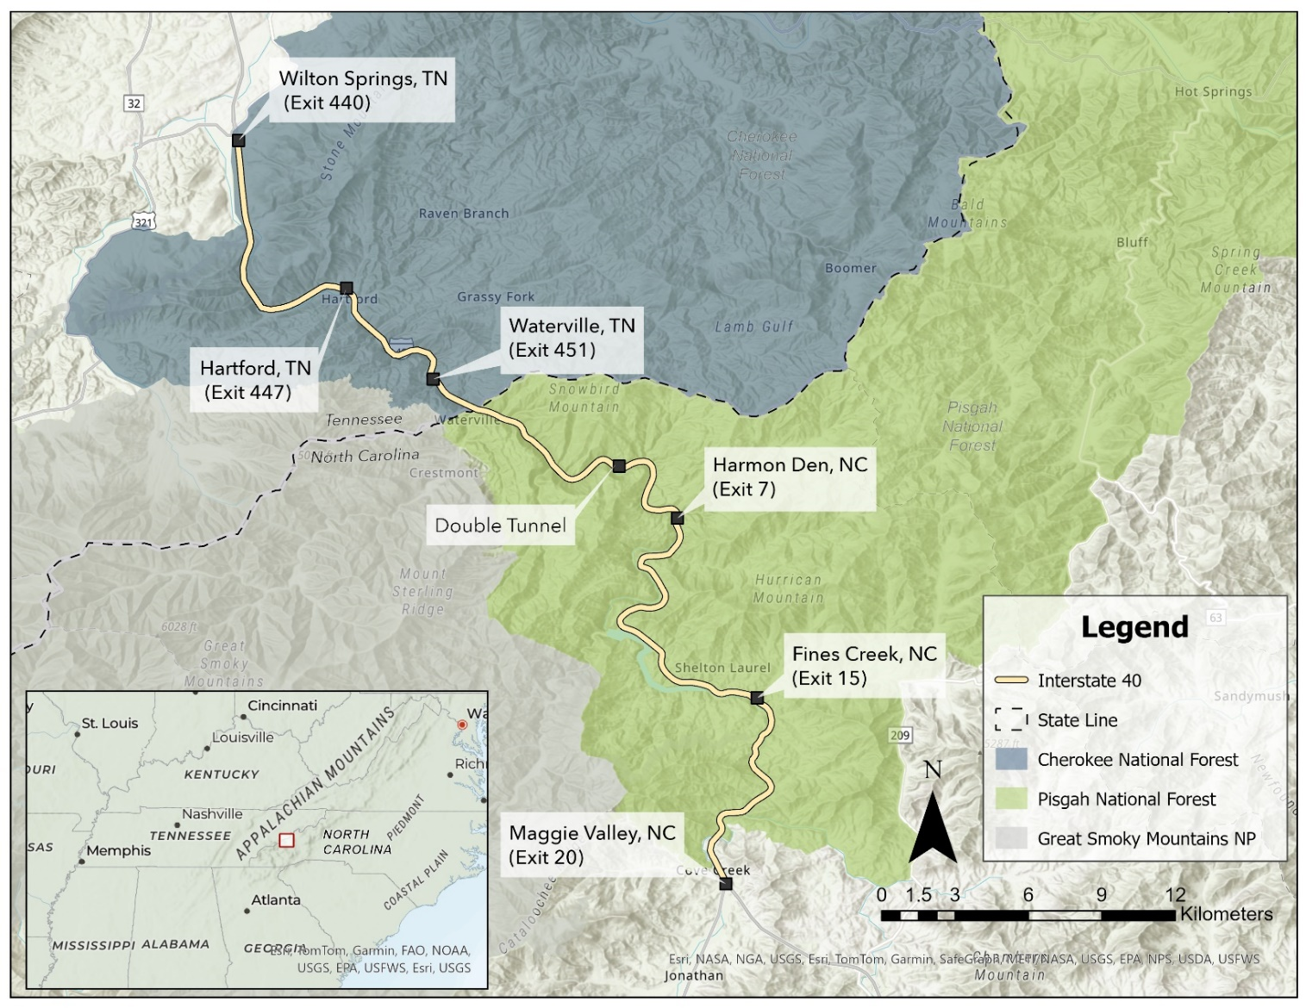
Appendix
Figure 2.1. Interstate 40 corridor (51 km) in the Pigeon River Gorge of Tennessee and North Carolina, USA, 2016–2024.

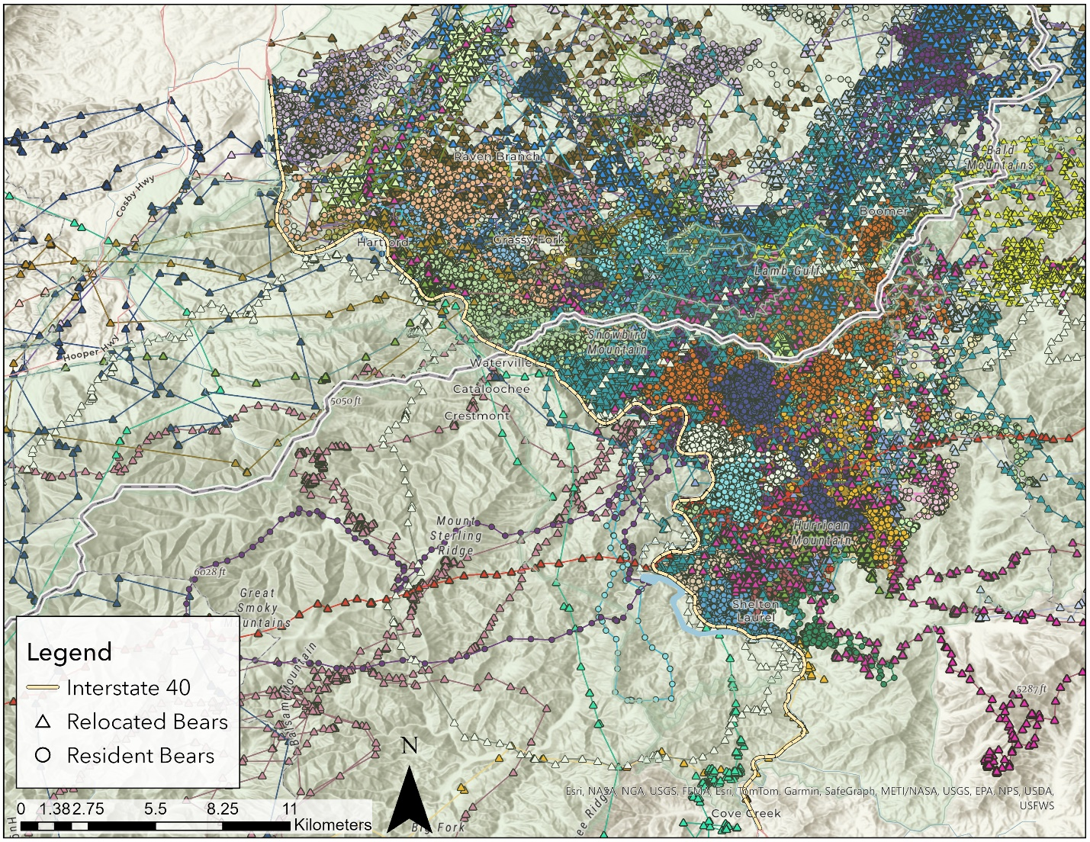
Figure 2.2. GPS locations from 37 resident and 20 relocated black bears in the Pigeon River Gorge of North Carolina and Tennessee, USA, 2016–2024.
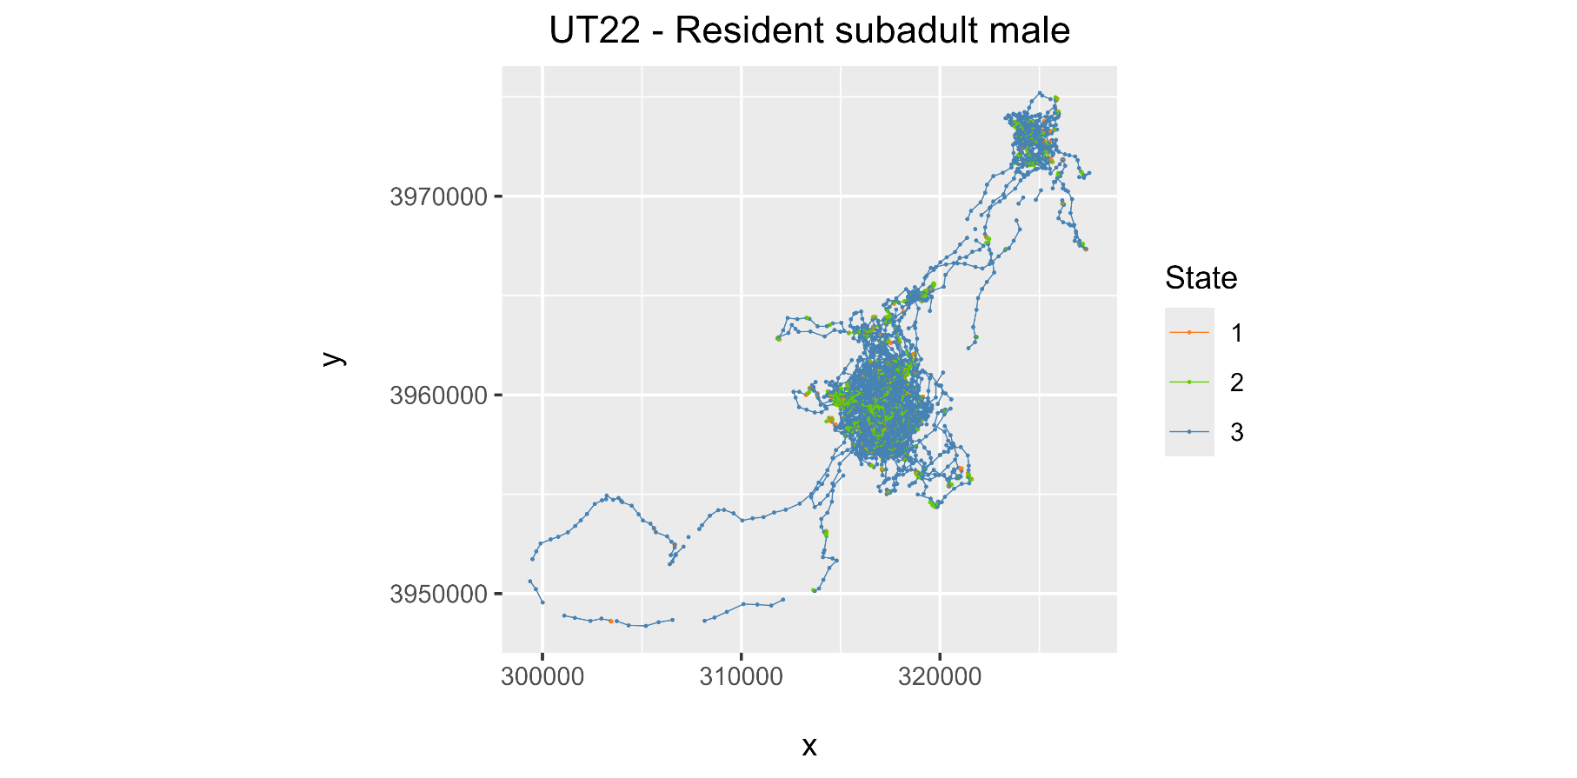
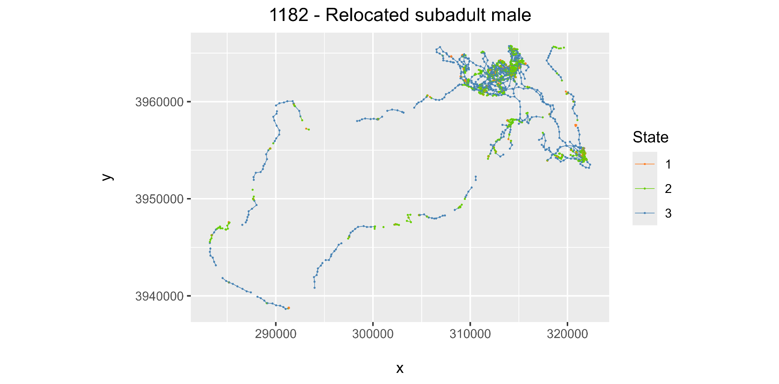
Figure 2.3. Behavioral states for a relocated (disperser) and resident subadult male black bear. State 1 represents resting, state 2 is foraging, and state 3 is exploratory (moving), 2021–2024, North Carolina and Tennessee, USA.

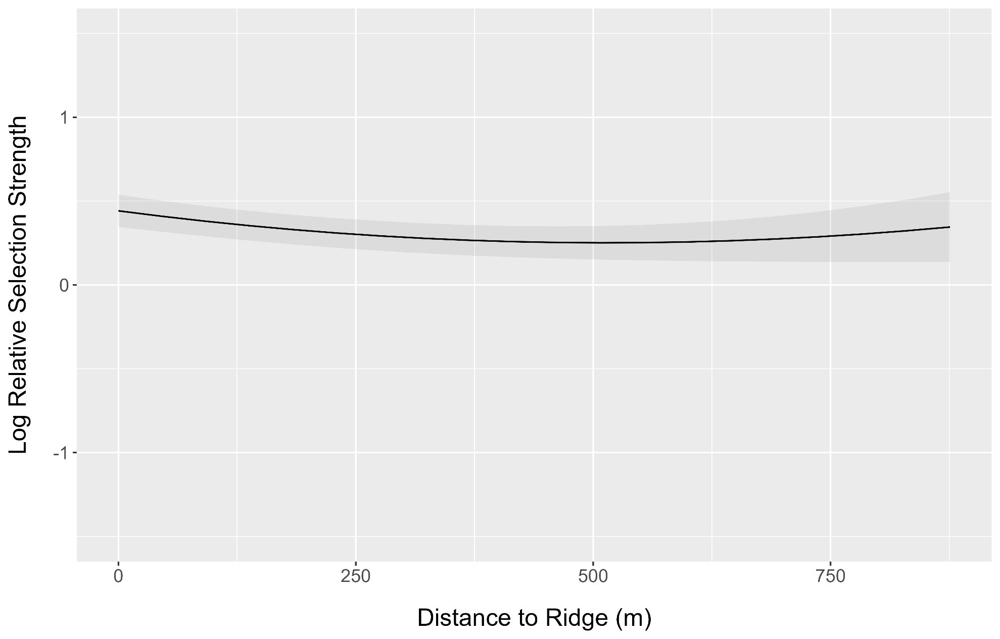
Figure 2.4. Log relative selection strength of distance to ridge for resident black bears as predicted by the top step-selection function model, 2022–2024, North Carolina and Tennessee, USA.
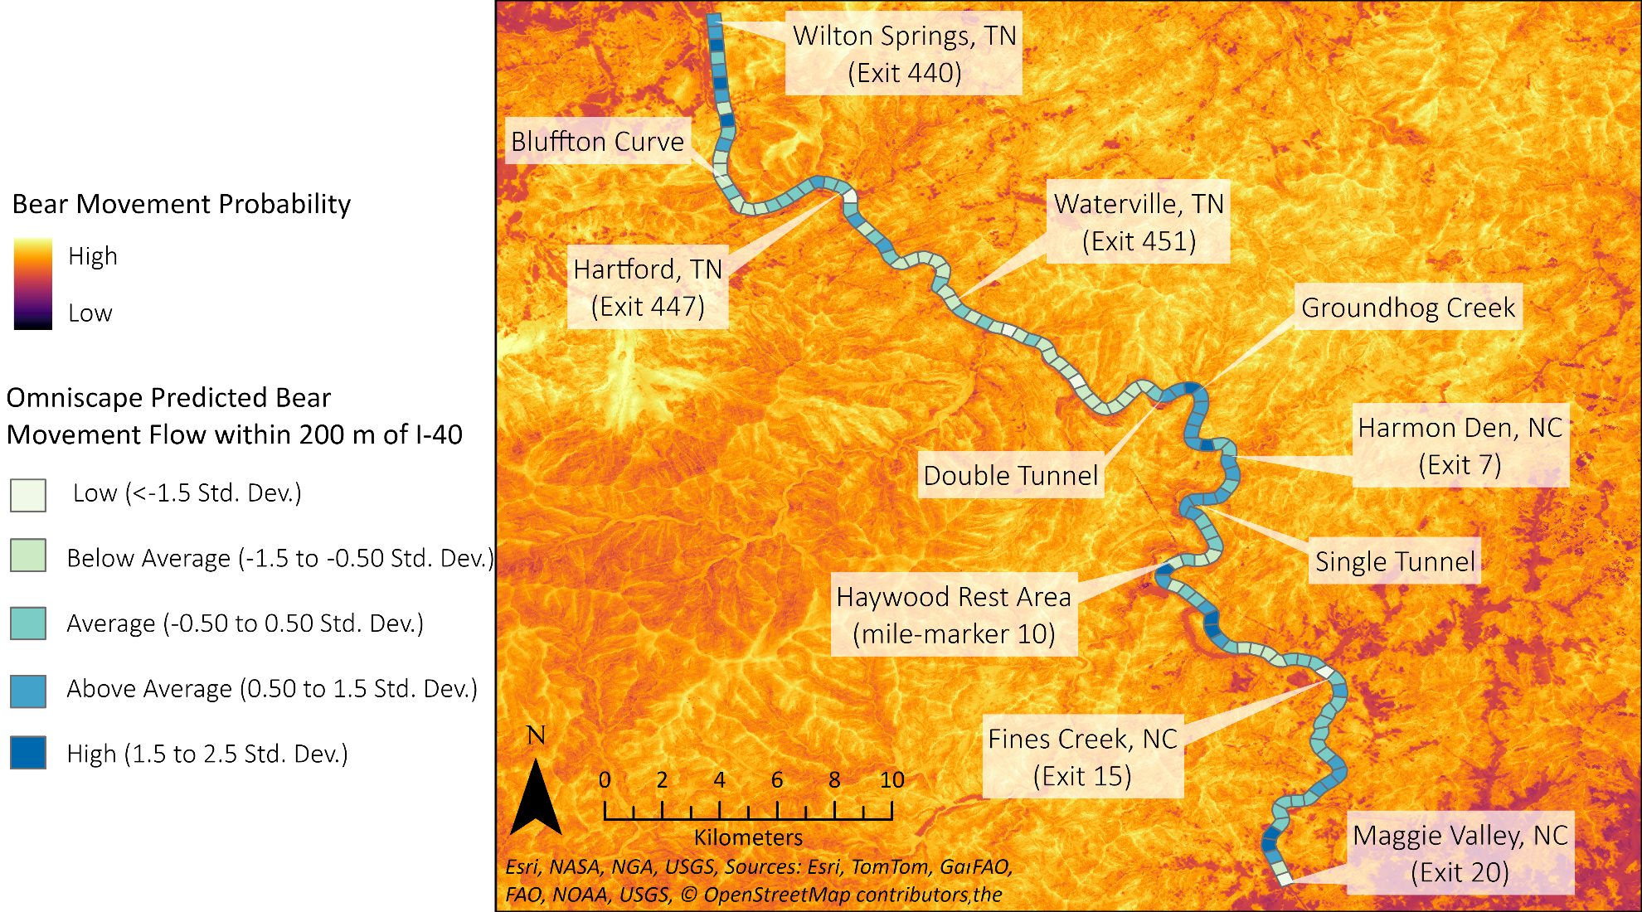
Figure 2.5. Omniscape predicted cumulative current for resident black bear movement across the Pigeon River Gorge. Interstate 40 was sectioned into 126 segments at 400 m each. Segments were buffered by 200 m and flow was classified by standard deviations from mean segment flow, 2022–2024, North Carolina and Tennessee, USA.
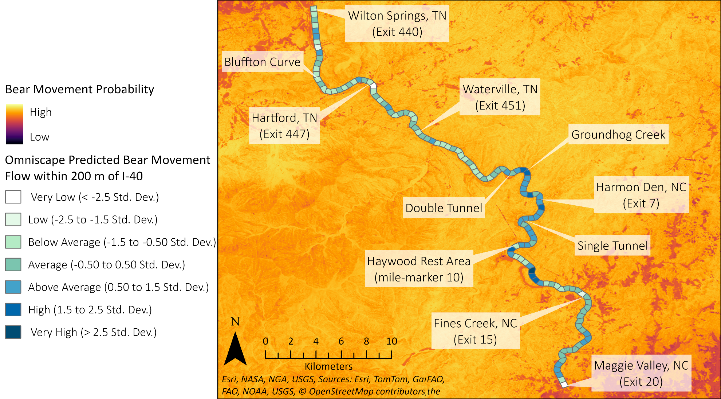
Figure 2.6. Omniscape predicted cumulative current for dispersing black bear movement across the Pigeon River Gorge. Interstate 40 was sectioned into 126 segments at 400 m each. Segments were buffered by 200 m and flow was classified by standard deviations from mean segment flow, 2016–2024, North Carolina and Tennessee, USA.
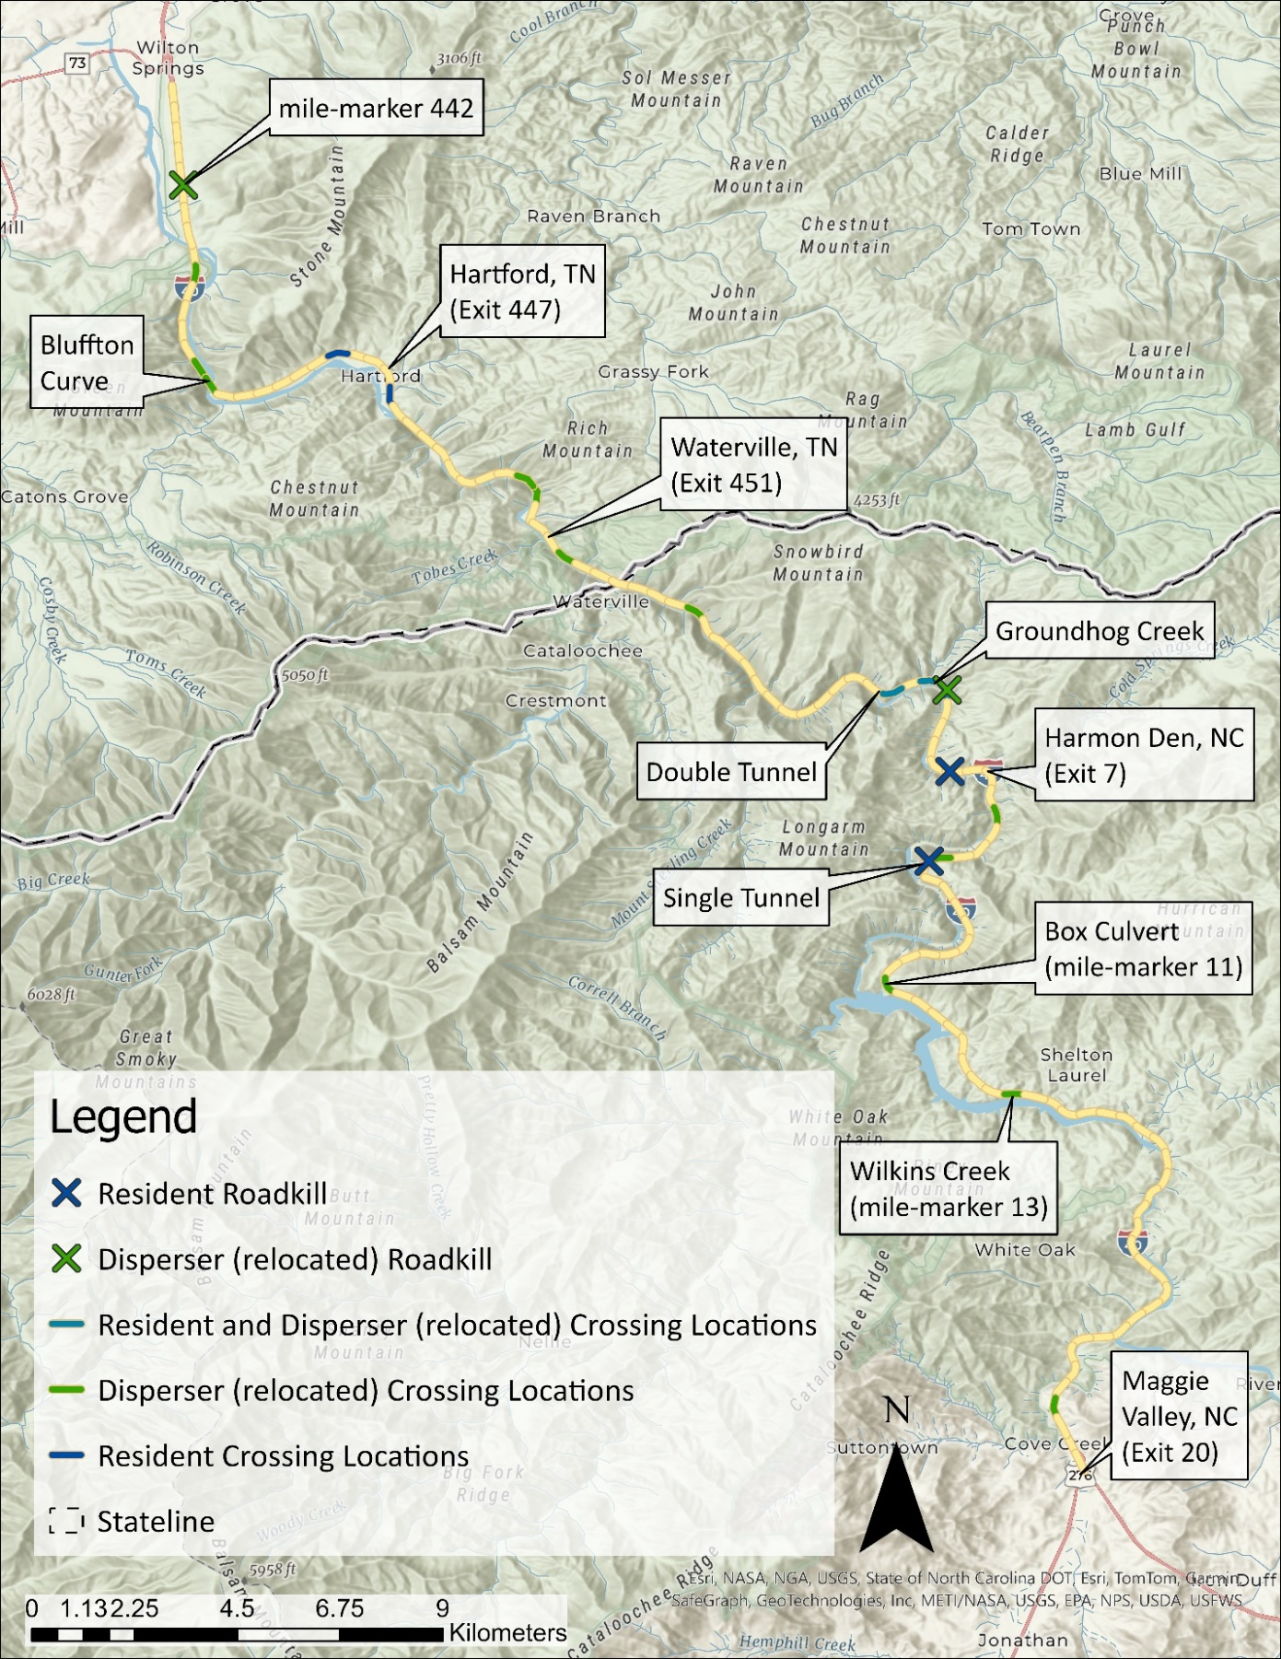
Figure 2.7. Locations along Interstate 40 where resident and dispersing black bears successfully and unsuccessfully (roadkilled) crossed, 2016–2024, North Carolina and Tennessee, USA.

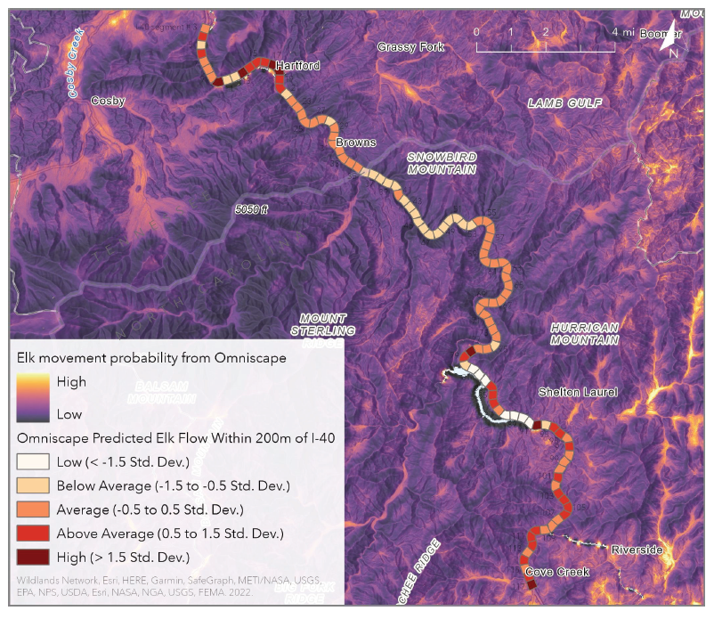
Figure 2.8. Omniscape predicted elk movement flow across the Pigeon River Gorge from Hillard et al. (2022), 2018–2020, North Carolina and Tennessee, USA.

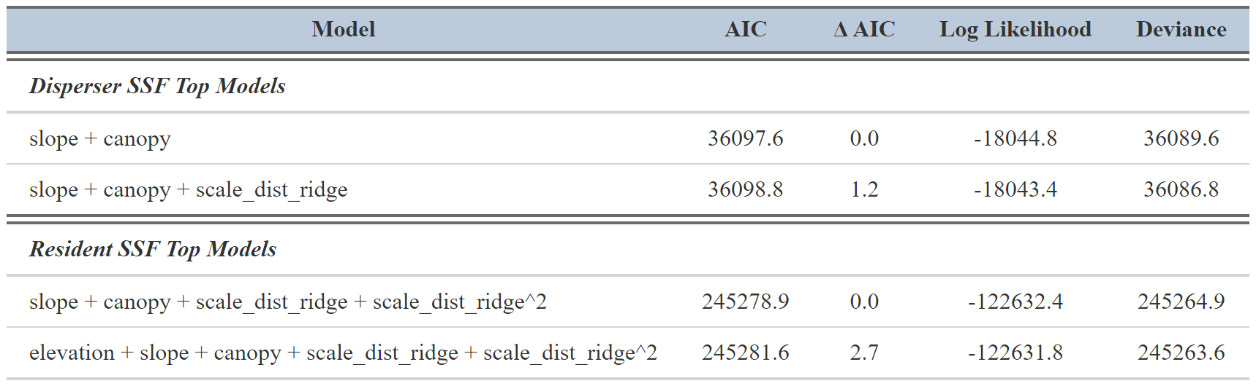
Table 2.1. Top step-selection function models for disperser (relocated) and resident black bears, 2016–2024, Pigeon River Gorge in North Carolina and Tennessee, USA.

Vita
Kristin J. Botzet was born in Duluth, Minnesota on December 7th, 1994. Her family moved to St. Louis Park, Minnesota in 1996 where she lived until she graduated from St. Louis Park Senior High School in 2013. She is fluent in Spanish as she attended a Spanish immersion elementary school from grades K – 6 and continued Spanish language studies at an advanced level until 10th grade. In 2013 she moved to Fort Collins, Colorado where she attended Colorado State University (CSU) to pursue a Bachelor’s in Science in Fish, Wildlife, and Conservation Biology with a concentration in Wildlife Biology. During her time at CSU she worked in Dr. Kate Huyvaert’s disease ecology lab where she assisted on several graduate research projects including a chytrid fungus water sampling study, feral hog detection study, and Waved Albatross ectoparasite identification and behavioral cataloging. In 2015 and 2016 she studied in Mexico in Todos Santos, Baja California Sur where she completed an independent research project on hummingbird occupancy near a well-used beach road. She completed her program a year early in 2016 and began her first wildlife field position relocating black-tailed prairie dogs in Fort Collins shortly after. For the next 5 years she worked seasonal research technician jobs with over 14 species in 10 states across the nation, including but not limited to, fishers in the Sierra Nevada’s of California and the Adirondacks of New York, grizzly bears in the Greater Yellowstone Ecosystem of Idaho, mountain lions in the Rocky Mountains of Colorado, beavers in the wetlands of southern Illinois, and Eastern spotted skunks in the southern Appalachians of North Carolina. In July of 2021 she moved to Tennessee to begin her Master of Science in Fisheries and Wildlife Science from the University of Tennessee in Knoxville. She came full circle to her beginnings of wildlife field work as her graduate research focused on determining the fates and movements of relocated conflict American black bears from Great Smoky Mountains National Park to Cherokee National Forest. In 2022, she added a second component to her project so that she could compare survival and movements of relocated bears to a resident population, as well as analyze how the two differ in their movements across the landscape and interact with a well-traveled section of Interstate 40 in Tennessee and North Carolina. After defending her thesis, she moved back to Washington where she continues to work on her research for publication.

