To the Graduate Council:

I am submitting herewith a dissertation written by Mat Mustafa Tamimi entitled "Development of a Forward / Adjoint Surface-based Monte Carlo Absorbed Dose Calculation using Fictitious Scattering in Voxelized Cartesian Coordinates for Use in Radiation Therapy". I have examined the final paper / electronic copy of this thesis for form and content and recommend that it be accepted in partial fulfillment of the requirements for the degree of Doctor of Philosophy, with a major in Nuclear Engineering.

____________________________
Ronald E. Pevey, Major Professor

We have read this dissertation and recommend its acceptance:

______________________________
Laurence F. Miller

______________________________
Lawrence W. Townsend

______________________________
Aly Fathy

Accepted for the Council:

_______________________________________
Vice Chancellor and Dean of Graduate Studies

Development of Forward / Adjoint Surface - based Monte Carlo Absorbed Dose Calculation using Fictitious Scattering in Voxelized Cartesian Coordinates for Use in Radiation Therapy

A Dissertation Presented for
the Doctor of Philosophy
Degree
The University of Tennessee, Knoxville
Department of Nuclear Engineering

Mat Mustafa Al-Tamimi
September, 2014

DEDICATION

This dissertation is dedicated to
The two people that brought me to this life, my parents;
The anchors of my being, my brothers and sisters;
The love of my life, my wife;
The light in my life, my girls;
and the hope for my future, grandchildren (my boys).

ACKNOWLEDGEMENT

I would like to thank Dr. Ronald Pevey, my faculty advisor, for guiding me through this project and being extremely patient with my progress. I would like to thank my committee members, Dr. Laurence F. Miller, Dr. Lawrence Townsend, for taking the time to review my paper and attend my presentation and Dr. Aly Fathy for his encouragement and continual support. And I would like to thank the rest of the Department of Nuclear Engineering at the University of Tennessee for allowing me the opportunity to complete my project. I would like also to thank my colleagues and long term friends, Mark Wyatt, Robert Drinnon, Ibrahim Attieh and Robbie Hakeem for all valuable discussions and support throughout the project. Finally, I would like to thank my parents, brothers and sisters, wife and the girls for their patience, encouragement and support throughout this endeavor.

ABSTRACT
A successful radiation therapy treatment aims at conforming (i.e., concentrating) radiation dose to the entire tumor volume (i.e., diseased area) while completely avoid surrounding normal tissue (i.e., healthy non diseased area). This objective achieved clinically by finding a set of radiation beam parameters that successfully deliver the desired dose distribution.
In this project we aim at building a Monte Carlo based absorbed dose computation engine for a radiation therapy external beam treatment planning system to predict the absorbed dose produced by a medical linear accelerator. This absorbed dose calculation engine should be:
- Efficient. This is achieved using several Monte Carlo techniques used in the Nuclear Engineering field for deep penetration and reactor analysis problem.
- Flexible. This is achieved by using Cartesian grid and pixelated material map. Further this algorithm allows for a different source position.
Currently most of the absorbed dose calculation algorithms in radiotherapy are 3-D based predictive models. Using such algorithms has the following disadvantages:
- Treatment plans quality will dependent tremendously on the user experience and knowledge base.
- Inaccuracy when predicting absorbed dose due to the assumptions and simplifications used in these algorithms.
- As a result, predicted absorbed dose might under or over predict the delivered dose.
As an alternative forward and adjoint Monte Carlo absorbed dose computation methods has been used and validated by several authors (Difilippo, 1998; Goldstein & Regev, 1999; Jeraj & Keall, 1999). The adjoint Monte Carlo methods are preferred since it produce viable beam parameters (particle type, location, direction and energy) while forward Monte Carlo is considered time consuming because considerable amount of time can be wasted tracking particle that do not contribute to the final dose of the planning target volume (PTV) or organ at risk (OAR). As a result a “well-defined source in a known voxel element the dosimetric response of the voxel can be easily calculated using either forward or adjoint Monte Carlo.”
TABLE OF CONTENT
Chapter 1 - Radiation therapy literature review 17
1. History of Radiation therapy 17
2. Radiobiology background 19
3. Radiation therapy treatment techniques 20
3.1. Evolution of treatment techniques 20
3.2. 3DCRT process 22
3.3. IMRT process 23
4. 3DCRT process verses IMRT process 26
5. Evolution of absorbed dose calculations techniques 26
6. Disadvantages of the predictive methods 28
7. Alternative dose calculation methods 28
Chapter 2 - Monte Carlo methods background 30
1. Monte Carlo history 30
2. Monte Carlo as a radiation transport tool and absorbed dose calculator 30
3. Modes of Monte Carlo radiation transport 31
3.1. Forward Monte Carlo radiation transport 31
3.2. Use of Forward Monte Carlo for medical physics problems 31
3.3. Adjoint Monte Carlo radiation transport 32
3.4. Application of adjoint Monte Carlo in medical physics problems 33
4. Why Monte Carlo is an accurate absorbed dose calculator 33
5. Aim of using Monte Carlo in radiation therapy 34
6. General Monte Carlo codes in Medical physics 35
7. Fictitious scattering (Woodcock hole tracking) concept 36
7.1. Mathematical proof of fictitious scattering 36
7.2. Monte Carlo algorithms use of fictitious scattering tracking methods 37
Chapter 3 - Boltzmann transport equation for non-multiplying mediums 39
1. Continuous form of the time dependent Boltzmann transport equation 39
2. Multigroup form of the transport equation 42
3. Solution of the forward transport equation 44
4. Neumann representation of the transport equation solutions 45
5. Scoring tallies 47
5.1. Average number of collisions and reaction rates 47
5.2. Other tallies 48
6. Monte Carlo Methods solution of the Boltzman equation 48
6.1. Derivation of solution 48
6.2. Monte Carlo Simulation of the solution 49
7. Applying fictitious scattering to the Boltzman transport equation 51
7.1. Derivation of Boltzman transport equation with fictitious scattering 51
7.2. Use of fictitious scattering in Monte Carlo algorithms 55
8. The Adjoint formalism of the transport equation 56
8.1. The Forward operator 56
8.2. Derivation of the adjoint operator 57
8.3. Application of the adjoint identity 60
8.3.1. External Source problems 60
8.3.2. External surface sources problem 61
8.4. Monte Carlo Methods with adjoint transport 62
8.4.1. Adjoint transport with non-absorption weighting 63
8.4.2. Adjoint transport with non-absorption weighting and fictitious scattering 63
Chapter 4 - Project objective 65
1. Voxel8 / Pixel8 project objective 65
2. How to accomplish project objective 66
3. Outline and flowcharts of project codes: 70
3.1. Outline of the forward Monte Carlo code (Voxel8) steps 70
3.2. Flow chart of the forward Monte Carlo code (Voxel8) 72
3.3. Outline of the Adjoint Monte Carlo code (Pixel8) steps 73
3.4. Flow chart of the Adjoint Monte Carlo code (Pixel8) 75
3.5. Steps for the folder code 76
Chapter 5 - Voxel8 and Pixel8 Code Mechanics 77
1. Mathematical basis for Monte Carlo methods 77
1.1. Random variables 77
1.2. Evaluating integrals using Monte Carlo method - “Law of large numbers” 80
1.3. Central limit theorem 81
1.4. Random number properties 81
2. Sampling Methods 82
2.1. Selection from a uniform distribution 82
2.2. Distribution inversion method 83
2.3. Rejection methods 85
3. Radiation transport by Monte Carlo methods 87
4. The random walk / history for a linear accelerator particles 88
4.1. Selection of initial particle parameters 89
4.1.1. Initial Direction 89
4.1.2. Initial energy 90
4.2. Sampling the distance to interaction / collision site Sampling , 92
4.3. New particle position 95
4.4. Sampling interaction / collision type 96
4.5. Sampling the scattering event energy then direction 100
5. Statistical Analysis of the results 101
Chapter 6 - Sample problems description 102
APPENDIXES 123
Appendix - A - Problem parameter then Cross section and Transport data generation 124
1. Data needed for Monte Carlo transport 124
2. General flow of problem parameter specification 125
2.1. Material Map Generator 126
2.2. Energy group structure generator 127
2.3. Source spectrum energy structure adjuster 128
3. Microscopic Cross section data generation using “NJOY99” code system 128
4. Generation of transport data 129
4.1. Total macroscopic cross section 130
4.2. Total heat macroscopic cross section 133
5. Scattering cross sections and its probability 137
5.1. Forward scattering probability 140
5.2. Adjoint scattering probability 141
5.3. Group to group scattering probability 142
5.3.1. Forward group to group scattering probability 142
5.3.2. Adjoint group to group scattering probability 142
5.4. Group to group cosine of scattering angle 143
Appendix - B - Code Input deck description 144
1. Type of cross sections generated and used 144
2. General description of input files 144
3. Forward Monte Carlo with / without Fictitious scattering input deck 145
4. Adjoint Monte Carlo with Fictitious scattering input deck 157
Appendix - C - Forward continuous and multigroup MCNP5 Input deck 164
1. Case 1: Published 6 MeV linear accelerator spectrum - continuous 164
2. Case 2: Pixel8 group structure - continuous 167
3. Case 3: MCNP5-MGXSNP group structure - continuous 170
4. Case 4: MCNP5-MGXSNP group structure – multi group 173
5. Case 5: Regions of interest absorbed dose with MGXSNP multigroup cross section 176
Appendix - D - Adjoint MCNP5 surface cell fluxes input Decks 179
6. Case 1: A box source 179
7. Case 2: Tumor source (Sphere) 182
8. Case 3: Right eye (Sphere) 185
9. Case 4: Left eye (Sphere) 188
10. Case 5: A brain (made out of three boxes) 191

LIST OF TABLES
Table 5-1 Absorbed dose calculations method that uses CT data 27
Table 6-1 Varian 6 MeV published spectra 105
Table 6-2 Varian 6 MeV spectra adjusted to Pixel8 structure 106
Table 6-3 Varian 6 MeV spectra adjusted to MCNP5-MGXSNP structure 108
Table 6-4 Varian 6 MeV response function (published structure) 111
Table 6-5 Varian 6 MeV response function (adjusted Pixel8 structure) 112
Table 6-6 Varian 6 MeV photon Response function (MCNP5-MGXSNP) 113
Table 6-7 Summary of the brain components pixel location 117
Table 6-8 Summary of the brain components actual location 117
Table C-1 Tumor, right and left eye actual location 176
Table C-2 Brain components actual location 176

LIST OF FIGURES
Figure 1-1 Time line for radiation therapy advancements 18
Figure 1-2 Therapeutic ration concept from cell response curve 19
Figure 1-3 Evolution of radiotherapy techniques (Bentel, Nelson, & Noell, 1982) 21
Figure 1-4 Medical linear accelerator equipped with MLC and OBI 22
Figure 1-5 IMRT solution for tumor dose 24
Figure 1-6 IMRT Physical compensator delivery solution 25
Figure 1-7 IMRT MLC delivery solution 25
Figure 2-1 Time line for General Monte Carlo codes in Medical physics 35
Figure 3-1 Particle transport parameters 44
Figure 4-1 Flow chart of forward Monte Carlo code (Voxel8) 72
Figure 4-2 Flow chart of adjoint Monte Carlo code (Pixel8) 75
Figure 5-1 Using CDF to sample random variable (x)value 78
Figure 5-2 Distribution of Random Numbers 82
Figure 5-3 Selecting a random variable value from uniform distribution 83
Figure 5-4 Selecting a random variable value using distribution inversion 84
Figure 5-5 Selecting a random variable value using rejection method 87
Figure 5-6 Particle interactions as it traverses medium 87
Figure 5-7 Random walk / history steps 88
Figure 5-8 High energy spectrum (15-25 MV) from Medical Linear Accelerator 91
Figure 5-9 Low energy spectrum (4-10 MV) from Medical Linear Accelerator 91
Figure 5-10 Distance to collision site sampling 92
Figure 5-11 Survival weighting (non-absorption weighting) 97
Figure 5-12 Comparison between basic sampling and survival weighting 98
Figure 5-13Illustration of Russian roulette 99
Figure 5-14 Sampling the energy &direction change (scatter direction) 101
Figure 6-1 coplanar beam arrangement 103
Figure 6-2 Source position around phantom 103
Figure 6-3 Problem coordinate convention 104
Figure 6-4 Varian 6 MeV published spectra 105
Figure 6-5 Varian 6 MeV spectra adjusted to Pixel8 structure 106
Figure 6-6 Varian 6 MeV spectra adjusted to MCNP5-MGXSNP structure 108
Figure 6-7 adjoint algorithm verification phantom 115
Figure 6-8 the phantom used for an actual adjoint problem 118
Figure A-1 General data generation flow 126
Figure A-2 Material map generator 127
Figure A-3 Energy group structure generator 127
Figure A-4 Source spectrum energy structure adjuster 128
Figure A-5 "NJOY" interface that generate elemental group microscopic cross section 129
Figure A-6 Transport data generation 130
Figure B-1 Input file view of section 1 146
Figure B-2 Input file view of section 2 data 146
Figure B-3 Input file view of photon spectrum search array 147
Figure B-4 Input file view of section 3 data 149
Figure B-5 Input file view of section4 149
Figure B-6 Input file view of section 4 MLC leaf data 150
Figure B-7 Input file view of section 4 MLC/blocked field data 151
Figure B-8 Input file view of section 5 data 152
Figure B-9 Input file view of section 6 data 153
Figure B-10 Input file view of section 7 data 154
Figure B-11 Input file view of section 8 data of type I 155
Figure B-12 Input file view of section 8 data of type II 156
Figure B-13 Adjoint Input file view of section 4 (ROI) indices 158
Figure B-14 Adjoint Input file view of section 6 material cross sections and transport data 158
Figure B-15 Input file view of section 7 data 159
Figure B-16 Input file view of section 8 data of type I 161
Figure B-17 Input file view of section 8 data of type II 162

LIST OF ABBREVIATIONS
MC | Monte Carlo.
PTV | Planning Target Volume.
OAR | Organs at risk.
CAT Scan | Computed axial tomography.
MRI | Magnetic resonance imaging.
PET | Positron emission tomography.
Linac | Medical linear accelerator.
Gy | Gray – SI unit for absorbed dose = 1 joule / kg
3DCRT | Three dimensional conformal radiation therapy.
MLC | Multi-leaf collimator.
IMRT | Intensity – Modulated radiation therapy.
IGRT | Image-guided radiation therapy.
DVH | Dose Volume Histogram.
TPS | Treatment Planning System.
OBI | On board imaging.
NTCP | Normal tissue complications probability.
TCP | Tumor control probability.
TAR | Tissue air ratio.
rTAR | Ratio of tissue air ratio.
eTAR | Equivalent tissue air ratio.
FFT | Fast Fourier transform.
DSAR | Differential scatter air ratio.
EGS | Electron Gamma Shower
MCNP | Monte Carlo N-Particle.
VMC & VMC++ | Voxel Monte Carlo.
ITS | Integrated tiger series.
NIST | National institute of standards and technology.
MMC | Macro Monte Carlo.
DPM | Dose Planning method.
ENDF | Evaluated nuclear data formats.

LIST OF SYMBOLS

- -
Radiation therapy literature review

History of Radiation therapy
The therapeutic use of radiation was realized upon the discovery of X-rays in 1895 (Dowsett, Kenny, & Johnston, 1998). Clinicians started to use x-rays to treat cancers while researchers investigated different x-ray production and delivery methods. Soon after consequences of radiation misuse were observed and users realized the need to control treatments outcome. As a result the “Radiation Therapy” field was born. Radiation therapy is the branch of medicine that deals with the use of radiation as method to treat cancer. Due to the huge amount of radiation and radiobiology research a lot of accomplishments in radiation therapy were realized. Figure 1-1 summarizes in a pictorial format these historical accomplishments chronologically. These accomplishments starts when x-rays were discovered by Wilhelm Conrad Roentgen in 1895 and continues to the most recent advancement in computer systems that led to better medical linear accelerator design and imaging methods. The field is continually advancing and evolving due to the continual need to have better control on the treatment out comes (Hall, 1988).
Radiotherapy is the treatment of cancer by means of ionizing radiation. The purpose of radiotherapy is to eradicate the tumor and spare the surrounding normal tissues as much as possible (Colvett, 2006). To achieve this objective clinician need to have several tools such as x-ray delivery systems (e.g. medical linear accelerator (Linac)) and absorbed dose prediction system (e.g. treatment planning systems (TPS)). The Linac should be able to produce several type of radiation (e.g. x-ray or charged particle beams (electrons)) and several deliver method (e.g. static verses dynamic methods). At the mean time the TPS should have the ability to account for the patient anatomy to produce predict delivered dose with high accuracy (Metcalfe, Kron, & Hoban, 1997).

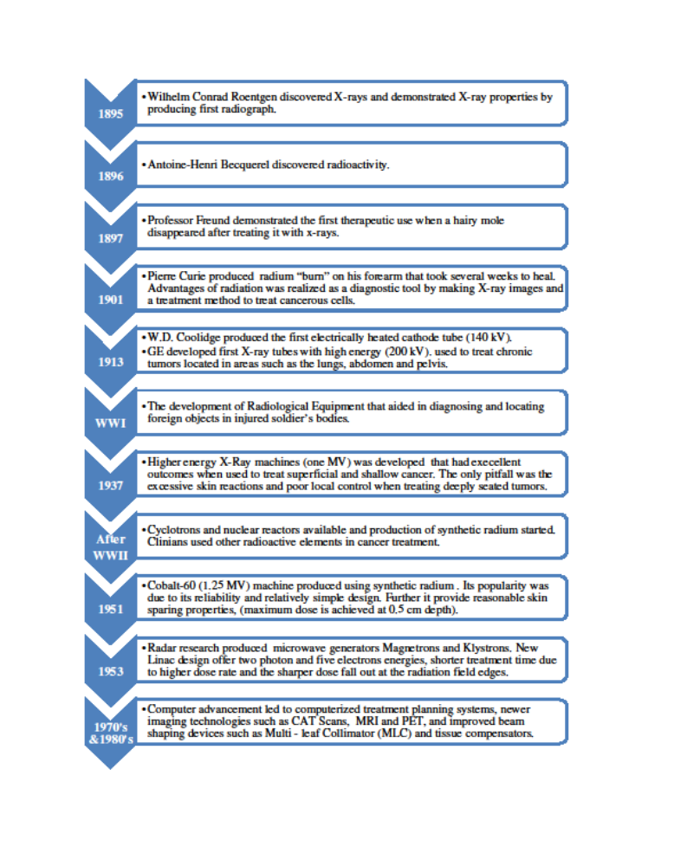
Figure 1-1 Time line for radiation therapy advancements

Radiobiology background
The purpose of radiotherapy is to eradicate the tumor and spare the surrounding normal tissues as much as possible. The dose required to achieve a particular level of cell killing is extremely variable because cells have different radiosensitivites (Williams & Thwaites, 2000). Radiation killing of individual cells is statistical in nature, because it depends on the occurrence of individual ionizing events. However, when the effect of radiation on a large collection of cell is considered, whether it is a tumor mass or an organ, the effect is largely deterministic, i.e. there is a dose threshold below which no clinical effect will be observed and a dose above which the effect will be observed in every individual.
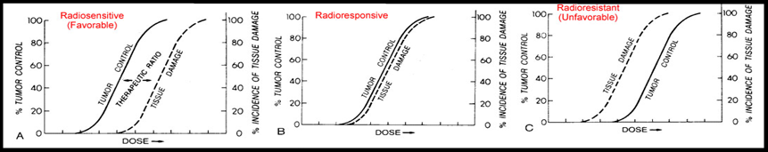
The biological response of a cell to the amount of dose received can be illustrated in dose-response curves. Using the dose response curves we can show that as delivered dose increases, more cells are destroyed. As illustrated in the Figure 1-2 below a sigmoidal relationship exists between radiation dose and the probability of achieving tumor control. This principle also applies to normal tissue and cells. As a result the probability of normal tissue complications (NTCP) and tumor control (TCP) are similar. The relationship between the NTCP and the TCP is known as the therapeutic ratio as illustrated in the figure 1 – 2 below:

Figure 1-2 Therapeutic ration concept from cell response curve
The probability for a favorable outcome is good when the TCP curve is to the left of the NTCP one. An increase in delivery and computation accuracy is required when the TCP and NTCP curves are very close to each other. As a results requiring very accurate delivery methods. When the TCP curve is to the right of the NTCP curve combined modality approaches is needed (e.g. chemo-radiation or interstitial/intracavitary implants). The tumors treated successfully by radiotherapy are those in which the tumor curve lies to the left of the curve for the limiting normal tissue. For those types of tumor the dose required to achieve a high probability of complete regression of the tumor is lower than the dose that produces a significant number of complications in normal tissue. As a result; treatment techniques that spares normal tissue will be used. In this treatment plans the high dose region conforms to the shape of the target volume as much as possible by applying beams with conformal shapes from several directions (Williams & Thwaites, 2000).
In the next two paragraphs I will review the evolution of radiation therapy techniques and absorbed dose prediction methods because of our interest in developing an absorbed dose algorithm based on Monte Carlo methods.

Radiation therapy treatment techniques

Evolution of treatment techniques
Accurate knowledge of delivered absorbed dose is critical for predicting the clinical outcomes of the prescribed radiation treatments. This goal dictates dose assessment tools that are able to predict delivered dose with high precision. The control of delivered absorbed dose is also achieved using different radiation therapy techniques. Figure 1-3 summarizes these techniques as they evolved with time.
Initial treatment techniques were simple and easy to deliver due limitation in first generation medical linear accelerators. With the advancements in computer technology designs and features of the medical linear accelerators improved leading to developments of newer treatment techniques (Thwaites & Tuohy, 2006).

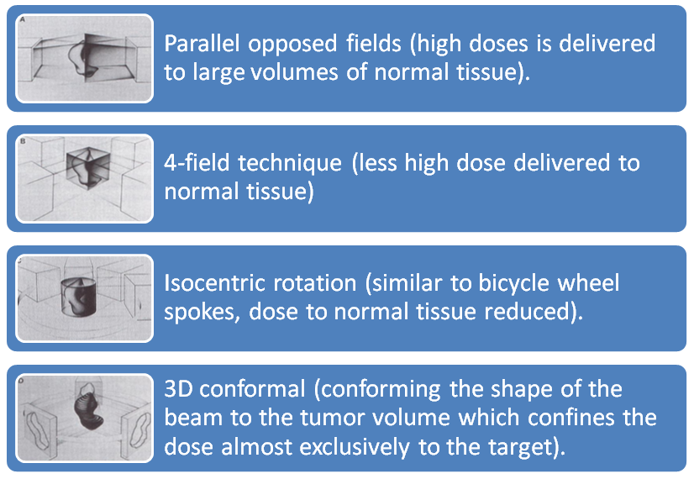
Figure 1-3 Evolution of radiotherapy techniques (Bentel, Nelson, & Noell, 1982)

The three-dimensional conformal radiotherapy (3DCRT) was introduced in the early 1980’s (Colvett, 2006). Initially this treatment method used shielding blocks made manually from low melting metal (Cerrobend). Due to the most recent advancement in computers Linac manufactures were able to develop mechanical blocking systems referred to as multi leaf collimator (MLC). This device replaced the need to fabricate shielding blocks and gave the user the ability to vary beam intensity across a radiation field giving birth to the latest treatment technique Intensity modulated radiation therapy (IMRT). Furthermore, recent development of digital imaging receptors introduced the image guided radiation therapy (IGRT) technique by adding on board imaging (OBI) systems to the accelerators (see Figure 1-4). Using this technique clinicians were able localize tumor position with more precision by imaging the patient before the initiation of treatment and monitoring the treatment progress by imaging during the treatment (Colvett, 2006; Thwaites & Tuohy, 2006).

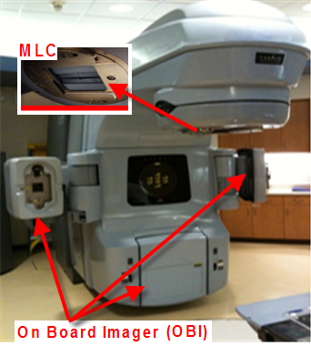

Figure 1-4 Medical linear accelerator equipped with MLC and OBI

3DCRT process
The process of creating an IMRT and 3DCRT treatment plans are quite similar but the bases of a plan design are significantly different. The conventional 3DCRT treatment planning is forward based and optimization is done manually. The process starts when the treatment planner chooses initial beam parameters, such as the number of beams, beam directions, shapes, weights, etc., and the computer calculates the resulting dose distribution. Then, the resulting dose distribution is computed and evaluated. The planner then choses to accept or reject the plan based on physicians defined criteria’s. If the distribution is not satisfactory a newer plan is designed intuitively by iterating through the various beam parameters. The resultant dose distribution is computed and evaluated at the end of each iteration and the process is repeated till the user arrives at a satisfactory absorbed dose distribution. Therefore in conventional 3DCRT treatment planning the user arrives at the optimized dose distribution as a result of the optimal conventional 3DCRT plans (i.e. beam energy, weighting, direction, and beam modifying devices such as blocks and wedges) without having to explicitly define the optimum or desired dose distribution first. Researchers have attempted to improve this tedious trial and error nature of the 3DCRT process by automating it using computer-driven parameters optimization such as:
- Beam direction. In one method the “beam's eye view was used for accurate delineation of treatment volumes to avoid real or dosimetric geographic misses. This was especially useful for oblique fields because it facilitate the design of accurate customized blocking and avoiding inadvertent blocking of the tumor or unnecessary irradiation of normal tissues” (Vijayakumar et al., 1991). Another method proposed by Soderstrom and Brahme used “Two different measures for the selection of advantageous beam directions” “lowest entropy” & “low frequency part of the Fourier transform” of the optimal beam profiles. (Soderstrom & Brahme, 1992).
- Weighting. Langer and Leong described a method for “formulating and solving this optimization problem as a combinatorial linear program.” (Langer & Leong, 1987).
Another method utilized the “simulated annealing to the optimize radiation treatment plans, in which a set of beam weights are iteratively adjusted so as to minimize a cost function, have been motivated by its potential for finding the global or near‐global minimum among multiple minima. This method was found to be slow, requiring several tens of thousands of iterations to optimize 50 to 100 variables.” (Mageras & Mohan, 1993), these methods met limited clinical success.

IMRT process
Treatment plan goals are best achieved using IMRT. The IMRT process is made of three integral parts an inverse treatment planning process, plan delivery (static or dynamic delivery), and quality assurance of produced plans. In the inverse planning step the optimizer aims at finding the two radiation beam parameters that will produce the desired absorbed dose distribution, beam angle choice (direction), optimal fluence map (beam intensity) as shown in Figure 1-5. The IMRT optimizer accomplishes this task by searching iteratively for a given beam parameter for an optimal fluence that will deliver the desired dose distribution. The optimizer evaluates and stops the optimization when the optimized plan produces dose distribution that meets criteria’s defined at the starts of optimization. Then the accepted optimal dose distribution (now it is an optimal fluence) is converted to a machine deliverable treatment plan (third element of a plan) by producing a multi leaf collimator (MLC) motion sequence that will produce this dose distribution. Then last step in the IMRT planning process is to verify that the produced leaf motion sequence will produce the optimal calculated dose distribution in the patient.
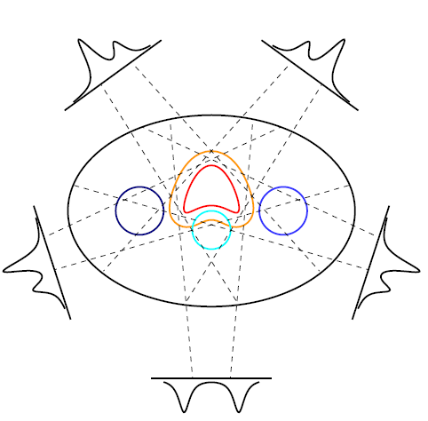

Figure 1-5 IMRT solution for tumor dose
During the IMRT optimization process the user defines the desired absorbed dose distribution by defining desired doses for the following structure volumes as described in ICRU reports 29, 50 & 71 (Morgan-Fletcher, 2001; Units & Measurements, 1978):
- CTV (clinical target volume). This normally is the gross tumor volume and subclinical extensions.
- PTV (planning target volume). This is the CTV and added margins to account for variations in tissue positions, sizes, and shapes, as well as for variations in patient position and beam geometries, both intrafractionally (i.e. during the treatment) and interfractionally (from one treatment to another).
- Radiosensitive normal tissues (critical structures or organs at risk (OAR) whose radiation sensitivity may significantly effects treatment planning and/or prescribed dose such as spinal cord, heart, parotids, etc.). This is made by means of dose-volume (DVH) constraints by having the planner defining:
  - Minimum and maximum desirable doses for those structures.
  - A set of penalty weights to indicate the relative importance for all plan structures.
Once an IMRT plan is designed, it can be delivered via several methods:
- Physical compensators can be used (Purdy, 1997) shown in Figure 1-7. These are used to modify the dose distribution to conform to irregular target shapes due to missing tissue or irregular patient contours. The fabrication is time consuming and their use is cumbersome. A picture of an actual compensator is on the right.
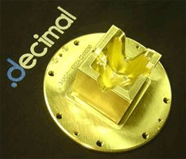

Figure 1-6 IMRT Physical compensator delivery solution

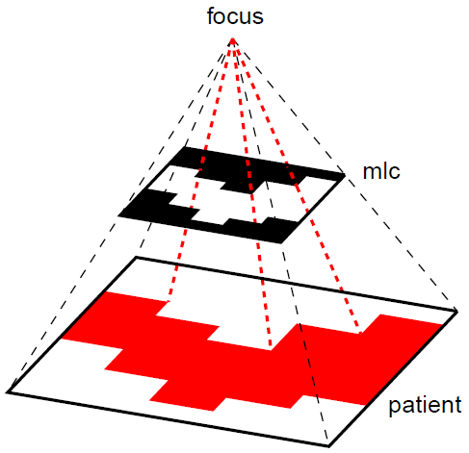
- Computer-controlled slit and multileaf collimators (MLCs) (Carol, 1994) sequences as shown in Figure 1-8. These have made the delivery of intensity-modulated fields more practical. Using these devices we can deliver the IMRT plan using either a multiple static fields or one dynamic field using dynamic multileaf collimator (DMLC) as described by(Spirou & Chui, 1994). The static method is commonly referred to as “Step-and-Shoot” method while the dynamic method “Sliding window”.

Figure 1-7 IMRT MLC delivery solution
Each delivery method has its advantages and limitations. In the literature there exist some studies comparing delivery methods (Chui, Chan, Yorke, Spirou, & Ling, 2001), but there are really no available data that permit a true “head to head” comparison between the currently available various IMRT delivery techniques.

3DCRT process verses IMRT process
Using the 3DCRT planning methods requires computing a dose distribution and then the user continually evaluating the resultant volumetric dose using a Dose Volume Histogram (DVH) (Armstrong et al., 1993) to see if the treatment objectives are achieved. On the other hand IMRT uses a computerized algorithm that searches for the solution and evaluates the results then terminates if a suitable solution is found.
The optimization parameters and structures penalty weights are the primary variables used to control the IMRT search for optimal dose distribution as opposed to the beam weights or shapes optimization in the 3DCRT treatment planning search. Specification of the optimization parameters and beam placement requires detailed knowledge of the dose calculation algorithms and anatomical features of the patient such as the proximity of the normal tissues to the target.
As a result, the combination of beams, optimization parameters, and structures needed to achieve the best plan are planning system and patient specific. Planners must develop an intuition as to how these factors affect distributions, so the plan can be optimized.

Evolution of absorbed dose calculations techniques
In the early algorithms absorbed dose in the patient was estimated using simplifications such as assuming that the patient was totally composed of water, ignoring all the patient internal organs and only using the external patient contour (Nikos Papanikolaou et al., 2004). These simplifications are not accurate and introduced inaccuracy when computing the final absorbed dose distribution. That was due to the fact that absorbed dose distributions are highly dependent on the material densities and atomic compositions and the human body is composed of tissues with different densities and atomic composition.
Advances in the imaging field led to the development of CT based dose corrections methods. Using data generated by CT’s an electron density map that acts as a full map of the patient’s internal anatomy (Nath et al., 1994). This electron density map helps predict dose distribution for the internal anatomy that is close to actual dose distribution, which were generated through a conversion process (Sontag & Cunningham, 1978). Table 1-1 summaries the CT - based absorbed dose calculation methods. The initial calculation methods employing CTs were one dimensional correction methods (1D) while the most recent methods are three dimensional and aim at achieving better absorbed dose prediction accuracy (Nikos Papanikolaou et al., 2004).

Table 1-1 Absorbed dose calculations method that uses CT data
Absorbed dose calculation methods that uses CT data
1-D | - Ratio of tissue Air Ratio factors (rTAR)
2-D | - Equivalent Tissue Air Ratio factors (eTAR).  - Fast Fourier Transform method (FFT).
3-D | - Differential scatter air ratio (DSAR).  - Delta volume.  - Dose spread array.  - Differential pencil beam.

As a result these advances led to the development of the convolution superposition techniques. The convolution superposition techniques are predictive models that simulate particle transport and energy deposition in human tissues. The models then uses a database of deposition kernels calculated using Monte Carlo techniques and mathematical expression to predict the absorbed dose distribution. Some the most common algorithms that use the superposition convolution techniques are Point Kernel model (Pencil Beam algorithm), direct summation method and the collapse cone method. The difference between these models is the way it deals with the changes in the primary fluence and changes in the spread on deposited energy when computing absorbed dose distribution in the broad. Interested reader is referred to the medical physics literature for more detailed description of these algorithms. In general treatment planning systems algorithms are divided into two major types:
- Look up based algorithms. These algorithms provide point doses estimates in patient based on conversion factors of the doses derived from a look-up table.
- Model based algorithms. The collected clinical data is fitted into mathematical physical models. These models are used to predict dose distribution in the entire volume in question based on superposition convolution dose algorithm.

Disadvantages of the predictive methods
Existing clinical practices favors model base algorithms because of the fast computation speed they offer. In general, there are two methods to calculate absorbed dose, simplified and detailed. The simplified method is called the analytical (deterministic) method that calculates absorbed dose based on several assumptions (e.g. ignoring patient internal anatomy and assuming the patient as homogenous medium). The detailed methods are Monte Carlo simulations of the actual physical phenomenon and the computed absorbed dose is based on actual particles transported in a phantom or patient (Metcalfe et al., 1997).
When computing absorbed dose using a predictive model primary photons are explicitly used and a lot of simplification is applied to compute dose deposited by scatter radiation (e.g. tissue heterogeneities). This approach is not desirable because it will lead to under or over estimating the predicted absorbed dose. To be able to use these algorithms clinically we need to increase their accuracy. Currently; to increase accuracy an extensive set of beam data of every possible beam combinations is collected. As a result, an accurate beam model is created and used in the treatment planning system to compute absorbed dose (Nikos Papanikolaou & Klein, 2008). The mean pitfall of this approach is the amount of time and data needed to collect, enter data then validating the result.

Alternative dose calculation methods
Since accurate knowledge of the delivered absorbed dose is crucial in predicting the clinical outcomes of the prescribed treatments. And because of the disadvantages mentioned above clinicians and researcher continue looking at dose assessment tools that improve the calculation accuracy and speed. The Monte Carlo simulation methods are very accurate and are considered to be the gold standard for dose calculation (Rogers, 2006) in medical physics. Currently, any deterministic method developed is bench marked against Monte Carlo simulations.

- -
Monte Carlo methods background

Monte Carlo history
Monte Carlo (MC) methods are in use more in radiation therapy due to the large gains in computers power per unit cost and the availability of many powerful software tools. The Monte Carlo methods use statistical sampling for performing numerical integrations. It was introduced as early as 1777 by Buffon when he discussed a method based on random sampling. The MC technique in its form today was first developed and named at the end of the Second World War. The main motivation behind using MC techniques was radiation transport for nuclear weapons. It was Stanislaw Ulam and John von Neumann that saw an opportunity to develop new statistical sampling application (MC technique) during the development of ENIAC, the first electronic computer(Chetty et al., 2007).
The developments of MC techniques and computers have been closely linked ever since the exponential increase of the application of MC simulations when the digital computers became widely available in the 1950s and 1960s(Chetty et al., 2007). Hence, the attention in the medical physics field was directed at Monte Carlo (MC) methods as the need for better and accurate dose calculation algorithms increased.

Monte Carlo as a radiation transport tool and absorbed dose calculator
“When Monte Carlo techniques are used to simulate the transport of electrons and photons through bulk media, expert knowledge of the probability distributions governing the individual interactions of electrons and photons in materials are used to simulate the random trajectories of individual particles. The user keeps track of physical quantities of interest for a large number of histories to provide the required information about the average quantities and to reduce the uncertainty in the solution.” (Rogers, 2006)
Monte Carlo methods simulate radiation particle random walk. The particle is followed from its inception till its death and decisions of each step is made based on basic physics laws to mimic actual radiation interactions in mediums. This technique for calculating dose in patients is favored due to the simplicity of the underlying physical basis when compared to the analytic (deterministic) algorithms. In addition, this method only requires the knowledge of the relative probability and outcomes of various physical interactions that are known and understood for over half a decade. Even though the interactions may be complex to simulate in detail, the basic ideas of each interaction are well understood. Hence, the overall process is easy to comprehend and implement in a computer code. Furthermore, dose computation is straight forward and can be performed during the simulation without complex approximations or models of dose deposition. This manner of computing doses from first principle makes it different from the conventional dose calculation algorithms.

Modes of Monte Carlo radiation transport
Using Monte Carlo methods we can simulate radiation particles random walk from an actual source to all points of interest in a region then compute the desired response at those points. This mode of calculation is referred to as forward mode. Similarly, we can think of radiation particles starting at points of interest in a region and traveling towards a source. This mode of transport is referred to as Adjoint Monte Carlo transport. The following is a brief description of both:

Forward Monte Carlo radiation transport
In the forward Monte Carlo radiation transport, photons interactions with matter are described by the Boltzmann transport equation (Bell & Glasstone, 1970). The transport process starts with photons at a certain position, with certain direction and energy heading towards a detector. The photons undergo interactions, such as photoelectric effect, Compton scattering and pair production, in the medium. Using this method we can estimates fluxes at the detector. Other quantities is then computed using conversion factor (e.g. for absorbed dose estimate the photon flux at the location is multiplied with a flux-to dose response function (ANSI/ANS-6.1.1, 1977)).

Use of Forward Monte Carlo for medical physics problems
In the field of Medical physics forward Monte Carlo radiation transport computes the response in all the voxels for a given set of source parameters. This response is usually the dose delivered per unit source weight. In the forward Monte Carlo radiation transport, photons interactions with matter are described by the Boltzmann transport equation (Bell & Glasstone, 1970). The transport process starts with photons at the head of an accelerator from a certain position, with certain direction and energy heading toward the patient. The photons undergo interactions, such as photoelectric effect, Compton scattering and pair production, in the patient releasing energy at each interaction site (therefore, losing energy). This energy is absorbed by the patient tissue. The total absorbed dose at the each location is determined by multiplying the photon flux at the location with a flux-to-dose response function (ANSI/ANS-6.1.1, 1977) and integrating over all independent variables (position, direction, energy).
It is often stated in the medical physics literature that the forward Monte Carlo dose calculations are time consuming, therefore, any practical Monte Carlo-based Treatment Planning System should be efficient when computing the 3D absorbed distribution. Most of the forward Monte Carlo calculation time spent following photons through all regions in the phase space. Unfortunately, some of these locations do not contribute to the PTV or OARs final dose.

Adjoint Monte Carlo radiation transport
The “Monte Carlo Adjoint Shield” code system “MASH” designed at oak ridge national lab is a discrete ordinates code that “determines the fluence on a coupling surface surrounding the shielding geometry due to an external neutron/gamma-ray source. The Monte Carlo calculation determines the effectiveness of the fluence at that surface in causing a response in a detector within the shielding geometry, i.e., the “dose importance” of the coupling surface fluence. A coupling “code” folds the fluence together with the dose importance, giving the desired dose response. The coupling “code” can determine the dose response as a function of the shielding geometry orientation relative to the source, distance from the source, and energy response of the detector” (Johnson, Emmett, Rhoades, & Childs, 1992).
The adjoint Monte Carlo transport methods starts from a certain location (detector) and compute the surface response (adjoint function) for all possible impinging source parameter by particle type, location, direction and energy. Hence, the adjoint Monte Carlo radiation transport methods produce calculated function describes the most important source parameters that will produce (deliver) the desired response detector response. The result adjoint Monte Carlo method calculations are often referred to as surface maps or sensitivities if they are collected at the geometry surface. The surface solution is related to the response of detector at depth.

Application of adjoint Monte Carlo in medical physics problems
The adjoint Monte Carlo transport methods compute the surface response (adjoint function) for all possible impinging beams by particle type, location, direction and energy. Hence, the adjoint Monte Carlo radiation transport methods produce calculated functions that identify the most important source parameters that will produce (deliver) the desired response to the voxel/group of voxels. Therefore, adjoint Monte Carlo radiation transport methods can be an excellent tool for optimization problems.
The adjoint transport equation (Bell & Glasstone, 1970) describes the transport of adjoint photons (i.e. adjoint source) emerging from a given position in the phantom (region of interest - ROI) traveling in a selected direction for a given source energy that was determined from the response (flux-to-dose) function.
The adjoint Monte Carlo calculations are based on sampling and tracking photons that contribute to the doses at specific location (i.e. PTV or OARs). Therefore, it is stated in the literature that the adjoint methods is more efficient than the forward simulation method. In this method adjoint photons are transported in a fashion similar to the forward photon transport except that they are moving “backwards” in space and time and actually gain energy instead of losing it after scattering collisions. The calculated adjoint flux at a point in phase space can be interpreted as the expected contribution of an emerging photon from the same point in the phase space to the dose at the ROI. As a result, the total dose to the ROI can be calculated rapidly by multiplying the source function, characterized by the phase space spectrum from a linear accelerator head, with the precalculated adjoint flux and integrating over all independent variables (convolution of the external source function with the adjoint flux).

Why Monte Carlo is an accurate absorbed dose calculator
The MC method propagates individual particles (photons, electrons, etc.) through the treatment machine, and then through the patient tracking each particle history to determine where energy is deposited along the particle tracks. With Monte Carlo methods an explicit simulation of absorbed energy in a medium of any density or atomic composition, complex geometry such as patient anatomy is easily handle with high accuracy. The Monte Carlo methods are extremely useful in radiation therapy because we can apply it to all anatomic geometries, all modalities and all shaping devices. The result is an accurate absorbed dose estimate without the need for any approximation. Consequently, we achieve an increased confidence in the accuracy of dose distributions for inhomogeneities, (particularly for lung and bony anatomy), tissue interfaces (lung interfaces, the airway, sinuses), and very small fields (including those used in IMRT treatments) that also exhibit lateral electron disequilibrium effects.

Aim of using Monte Carlo in radiation therapy
Radiation therapy is the treatment of cancerous tumor “target volumes” using several radiation beams from an external radiation source. The aim of this treatment is to deliver a lethal radiation dose to the target volume while minimizing delivered dose to surrounding tissues. In order to achieve this goal with acceptable accuracy, a radiation therapist utilizes computerized treatment planning that uses actual geometry (e.g. patient anatomy obtained from CT or x-rays), irradiating beam actual measurements (obtained during treatment planning system (TPS) commissioning) and irradiating beam configurations and weights. This process becomes very difficult especially because patient heterogeneity and irregular geometry (the patient anatomy is made of several materials and not flat skin surface).
Although often time consuming, the MC method is the closest calculation algorithm model representation to the actual physics of the energy deposition process. As a result Monte Carlo calculation methods are considered to be superior method when calculating absorbed dose in patient to conventional methods. Using Monte Carlo method we can also accurately estimation of quantities difficult or impossible to measure such as dose perturbations from small inhomogeneities in vivo leading to improved clinical outcome of radiotherapy treatment (Mohan 1997, Nahum 1997). Some researchers showed that Monte Carlo methods are faster than convolution–superposition algorithms because they are independent of how many different beams are involved while the convolution–superposition algorithms CPU time is proportional to the number of beams involved.
Using Monte Carlo methods will eliminate the need to develop new and more complex absorbed dose calculation models, laborious trial and errors parameterizing model - based calculation algorithms. Further, these methods will reduce the amount of measured dosimetric data required for beam commissioning and characterization and allow direct calculation of monitor units which in turn reduces the probability of human mistakes.
It is the hope of the medical physics community that Monte Carlo treatment planning can overcome the difficulties outlined above.

General Monte Carlo codes in Medical physics
The evolution of medical physics Monte Carlo codes is best described by the pictorial time line shown in Figure 2-1.

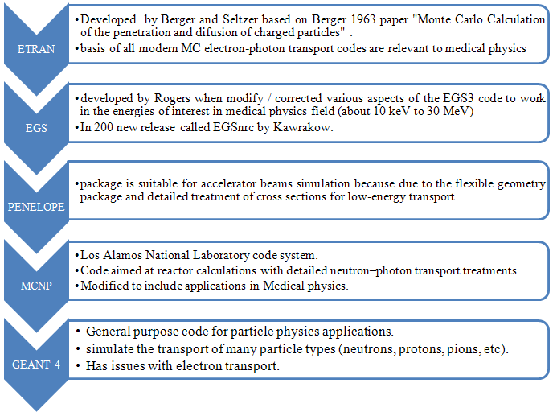
Figure 2-1 Time line for General Monte Carlo codes in Medical physics

Fictitious scattering (Woodcock hole tracking) concept
The computational performance of Monte Carlo simulations is poor for heterogeneous voxelized phantoms because of the use of general particle tracking algorithms. Because of the medium heterogeneity particle mean free path varies between regions causing the particle tracking algorithm to spend time tracking regions boundaries. One method to reduce the time spent on particle tracking for photons in a voxelized phantom are fictitious interaction tracking (also known as Woodcock tracking). Fictitious interaction tracking is a sampling technique useful when the transported particles have a relatively large mean free path length in comparison to the dimensions of the problem geometry (Brown & Martin, 2003). This technique is also called Woodcock tracking (Carter, Cashwell, & Taylor, 1972; Cramer, 1977; Kawrakow & Fippel, 2000; Woodcock, Murphy, Hemmings, & Longworth, 1965) or delta scattering (Ljungberg, Larsson, & Johansson, 2005; Tenney, Bowsher, & Jaszczak, 2004). This sampling technique would be extremely useful in external beam treatment planning to transport photon through a voxelized phantom since the therapy photon particles have mean free path length is larger than the voxel dimension.

Mathematical proof of fictitious scattering
The fictitious scattering tracking method assumes that the mean free path is constant within a multi material region; therefore, boundary tracking is not necessary. Because the mean free path between materials is not constant in a heterogeneous medium an artificial extra linear attenuation cross section is added to the actual total linear attenuation cross section to make the mean free path constant for all materials in a region. One way to implement the fictitious scattering tracking method is to make the entire problem total linear attenuation cross section equal to the problem largest total linear attenuation cross section $Σ_{Tmax}$. Mathematically for a problem with several materials
$Σ_{Tmax}=Max\left(Σ_{T1},Σ_{T2},Σ_{T3},⋯,Σ_{Tn}\right)$or
$$Σ_{Tmax}=Σ_{T1}+Σ_{T1`}=Σ_{T2}+{Σ_{T2`}=Σ}_{T3}+Σ_{T3`}=⋯=Σ_{Tn}+Σ_{Tn`}$$
Where $Σ_{T1`},Σ_{T2`},Σ_{T3`},⋯,Σ_{Tn`}$ are artificial cross-sections that we must add to achieve constant linear attenuation vale.
The fictitious scattering tracking methods increases the total attenuation cross-sections by introducing additional artificial total attenuation cross-sections. As a result it produces additional artificial collisions. These artificial collisions must clearly not disturb the passage of the particle, so that the distribution of real particle collisions is not disturbed in any way. We can show that although the total number of collisions is increased due to the artificial total attenuation cross section, the distribution of real collisions remains unchanged, therefore; the process is unbiased. In the following paragraph we will prove that the fictitious scattering tracking method theory will not bias the transport process.
Define $I(x)$as the intensity of particles at a point $x$ along an axis, and $Σ_{Ti}$ is the total attenuation cross section of region. The amount of particles removed due to collisions in $dx$ from the beam is:
$amount of particles removeddue to collisions= I\left(x\right)\left\{Σ_{Ti}dx\right\}$.
The particles intensity after traversing $dx$ along the axis is:
$$I\left(x+dx\right)=I\left(x\right)- I\left(x\right)\left\{Σ_{Ti}dx\right\}= I\left(x\right)\left(1- Σ_{Ti}dx\right)$$
Using the maximum total attenuation cross section of the problem at the same location the amount of particles fictitiously removed is:
$$amount of particles removeddue to fictitious collisions= I\left(x\right)\left\{\left({Σ_{Tmax}-Σ}_{Ti}\right)dx\right\}$$
Then the accurate particles intensity after traversing $dx$ along the axis is using the maximum total attenuation cross section of the problem is:
$$I\left(x+dx\right)=I\left(x\right)- I\left(x\right)\left\{Σ_{Tmax}dx\right\}+I\left(x\right)\left\{\left({Σ_{Tmax}-Σ}_{Ti}\right)dx\right\}$$
This equation can be derived from the above equation above. Therefore, both equations are equivalent and hence the distribution of real collisions is conserved.

Monte Carlo algorithms use of fictitious scattering tracking methods
The following are the steps of a general algorithm that uses fictitious scattering method to track particles within a medium using $Σ_{Tmax}$.:
- Compute minimum mean free path to collision site using the $Σ_{Tmax}$
$$mfp=\frac{1}{Σ_{Tmax}}$$
- Identify material at collision site $i$;
- Look up material total attenuation cross section $Σ_{Ti}$.
- Compute the ratio between the collision site total attenuation cross section to the fictitious cross section $\frac{Σ_{Ti}}{Σ_{Tmax}}$
- Ratio $\frac{Σ_{Ti}}{Σ_{Tmax}}$ interpretation:
  - If $\frac{Σ_{Ti}}{Σ_{Tmax}} = 1$ then the present material has the largest linear attenuation cross section and a normal (real) collision occurs.
  - Otherwise another material is present and the type of collision is determined as follow:
    - Real collision with probability less than or equal to $\left(\frac{Σ_{Ti}}{Σ_{Tmax}}\right)$.
    - Fictitious collision with probability greater than $\left(\frac{Σ_{Ti}}{Σ_{Tmax}}\right)$.

A problem specific application of this tracking method will be given when we describe our implementation of this method in our code.

- -
Boltzmann transport equation for non-multiplying mediums

As radiation particles traverse a medium it interacts via different mechanisms with the medium. As a result and depending on the particle energy the particles releases some of its energy causing it to either continue on the same flight path or changes its direction. The amount of energy in joules that a kilogram of the medium absorbs from the released energy at interaction sites is defined as absorbed dose. Absorbed dose can be computed from estimate of radiation fluxes at the interactions sites and a flux to dose conversion factor. Therefore, estimation of fluxes at different points or volumes in space will enable us to predict absorbed dose at those location.
The Boltzmann transport equation provides the mathematical relationship between radiation particle and the medium they are interacting with. The transport equation describes the balance of particles entering and leaving small volume in space. As a result, it relates mathematically medium radiological properties to radiation particle interactions mechanisms. Our research is focused on “photon systems where no fissionable isotopes are present” hence non multiplying mediums (Lewis & Miller, 1984). In this chapter we will give the continuous forward and the equation method of characteristic solution without derivation. Derivation of this equation and its solution can be found elsewhere. Then the forward transport equation and its solution multi-group format will be introduced. Introduce the concept of fictitious scattering to the forward multigroup equation and derive appropriate transport equations. These equations will be used to design a forward Monte Carlo algorithm to compute the forward flux. Proceed to show how we get the multi-group adjoint operator from forward equation. Once we arrive at the adjoint operator we will show how the adjoint identity is used obtain a detector response for external source problems and surface source problem. Finally describe how we utilize the forward Monte Carlo algorithm that uses the fictitious scattering method would be used to find the adjoint flux.

Continuous form of the time dependent Boltzmann transport equation
The continuous time dependent form of the transport equation is:
$$\frac{1}{ν} \frac{∂φ\left(\vec{r},\hat{Ω},E,t\right)}{dt} + \hat{Ω}∙\overline{∇}φ\left(\vec{r}\right) + Σ_{Total}^{medium}\left(\vec{r},E\right) φ\left(\vec{r},\hat{Ω},E,t\right) = S\left(\vec{r},\hat{Ω},E,t\right)$$ | (3-1)
The term $S\left(\vec{r},\hat{Ω},E,t\right)$ is the source term and it accounts for all particle sources in the medium. $S\left(\vec{r},\hat{Ω},E,t\right)$ is the sum of all particle sources such as sources embedded in the medium (external sources), scattering events and fission reactions within the system. Mathematically this is written as:
$$S\left(\vec{r},\hat{Ω},E,t\right) = S_{}^{Ext}\left(\vec{r},\hat{Ω},E,t\right)$$
$$+ \int_{0}^{∞}{dE^{'}}\int_{4π}{d{\hat{Ω}}^{'}}Σ_{Scatt}^{medium}\left(\vec{r},{\hat{Ω}}^{'}→\hat{Ω},E^{'}→E\right)φ\left(\vec{r},{\hat{Ω}}^{'},E^{'},t\right)$$
$$+ χ\left(E\right) \int_{0}^{∞}{{dE}^{'}}\int_{4π}{d{\hat{Ω}}^{'}}υ Σ_{fission}\left(\vec{r},E^{'}\right) φ\left(\vec{r},E^{'},t\right)$$
The term $\hat{Ω}∙\overline{∇}φ\left(\vec{r}\right)$ is the streaming operator defined by:
$$\hat{Ω}∙\overline{∇}φ\left(\vec{r}\right) ≡ \hat{Ω}∙\hat{i}\frac{∂φ\left(\vec{r}\right)}{∂x}+\hat{Ω}∙\hat{j}\frac{∂φ\left(\vec{r}\right)}{∂y}+\hat{Ω}∙\hat{k}\frac{∂φ\left(\vec{r}\right)}{∂z}$$
The following is what each term in equation (4-1) means:
$$ν =$$ | Particle velocity.
$$\vec{r }=$$ | Particle position vector.
$$φ\left(\vec{r},\hat{Ω},E,t\right) =$$ | Particle angular flux.
$$dt =$$ | Differential time.
$$\hat{Ω} =$$ | Direction of particle.
$$\overline{∇ }=$$ | Del operator.
$$Σ_{Total}^{medium}\left(\vec{r},E\right) =$$ | Medium total cross section (attenuation coefficient).
$$S\left(\vec{r},\hat{Ω},E,t\right) =$$ | The combined source term.
$$S_{}^{Ext}\left(\vec{r},\hat{Ω},E,t\right) =$$ | External fixed source term at the boundary.
$$Σ_{Scatt}^{medium}\left(\vec{r},{\hat{Ω}}^{'}→\hat{Ω},E^{'}→E\right) =$$ | Scattering cross section.
$$χ\left(E\right) =$$ | Fission neutrons energy spectrum.
$$υ =$$ | Average number of neutrons released per fission.
$$Σ_{fission}\left(\vec{r},E^{'}\right) =$$ | Fission cross section.
Our research medium is a nonmultiplying medium without any embedded sources. Our particle source produces photons only emitted from a point a distance away from the system surface (external to the system). A nonmultiplying (not fissionable) system will not produce delayed radiation. These two facts will enable us to remove time dependent term from equation (3-1) giving us the steady state transport equation (i.e. No time dependence) and also remove the neutron contributions term from the source expression. As a result the source term $S\left(\vec{r},\hat{Ω},E,t\right)$ become $S\left(\vec{r},\hat{Ω},E\right)$ accounting for external sources and scattered particles only as follow:
$$S\left(\vec{r},\hat{Ω},E\right) = S_{}^{Ext}\left(\vec{r},\hat{Ω},E\right) +\int_{0}^{∞}{dE^{'}}\int_{4π}{d{\hat{Ω}}^{'}}Σ_{Scatt}^{medium}\left(\vec{r},{\hat{Ω}}^{'}→\hat{Ω},E^{'}→E\right)φ\left(\vec{r},{\hat{Ω}}^{'},E^{'}\right)$$
The time independent and internal particle scatter source only transport equation is:
$$\hat{Ω}∙\overline{∇}φ\left(\vec{r}\right) + Σ_{Total}^{medium}\left(\vec{r},E\right) φ\left(\vec{r},\hat{Ω},E\right) = S\left(\vec{r},\hat{Ω},E,t\right)$$
Or in expanded form:
$$\hat{Ω}∙\overline{∇}φ\left(\vec{r}\right) + Σ_{Total}^{medium}\left(\vec{r},E\right) φ\left(\vec{r},\hat{Ω},E\right) = S_{}^{Ext}\left(\vec{r},\hat{Ω},E\right) +$$  $$= \int_{0}^{∞}{dE^{'}}\int_{4π}{d{\hat{Ω}}^{'}}Σ_{Scatt}^{medium}\left(\vec{r},{\hat{Ω}}^{'}→\hat{Ω},E^{'}→E\right)φ\left(\vec{r},{\hat{Ω}}^{'},E^{'}\right)$$ | (3-2)
To solve this equation we need to specify a boundary condition. For our research the not particle allowed to enter the problem therefore, boundary flux is zero. If we define the boundary surface normal as $\hat{n}$ and pointing outward then the boundary condition is written mathematically as:
$$φ\left({\vec{r}}_{surface},\hat{Ω},E\right)=0 for \hat{n}∙\hat{Ω} < 0$$ | (3-3)
The $\hat{n}∙\hat{Ω} < 0$ condition indicates that the source particles are incoming with respect to the boundary surface normal $\hat{n}$ . This translates to an angle of ${90}^{°} <θ< {180}^{°}$with surface normal.

Multigroup form of the transport equation
An exact solution of the time-independent energy dependent transport equation (4-2) can be obtained by adapting the multigroup approximation (Duderstadt, 1976; Lewis & Miller, 1984). In this approximation the particle energy is divided into $G$ finite number of intervals, $∆E_{g}$ called groups. Where, $E_{G} = 0$and $E_{0}$is sufficiently large that the number of particles at higher energies are negligible. The particles in group $g$ are taken to be just the particles with energies between $E_{g}$ and $E_{g-1}$. Normally the group number increases as the energy decreases. It can be assumed that the cross section in each group is constant. The cross section is averaged over the energy span resulting in a cross section that is only dependent on position and independent of energy within each group.
The group angular flux is defined as:
$$φ\left(\vec{r}, \hat{Ω}\right) = \int_{E_{g}}^{E_{g-1}}{dEφ\left(\vec{r}, \hat{Ω},E\right) }= \int_{g}{dEφ\left(\vec{r}, \hat{Ω},E\right) }$$
We proceed by dividing the nonmultiplying and time-independent transport equation (4-2) for into contribution from each group:
$$\int_{0}^{∞}{dE^{'}} = \sum_{g^{'}=1}^{G}{\int_{g^{'}}{dE^{'}}}$$
Then integrating between $E_{g}$ and $E_{g-1}$ to get $g$ group transport equation:
$$\hat{Ω}∙\vec{∇}\int_{g}{dEφ\left(\vec{r}, \hat{Ω},E\right)} + \int_{g}{dE}Σ_{Total}^{medium}\left(\vec{r},E\right)φ\left(\vec{r}, \hat{Ω},E\right) =\int_{g}{{dES}_{}^{Ext}\left(\vec{r},\hat{Ω},E\right)}$$
$$+ \sum_{g^{'}=1}^{G}{\int_{g}{dE}\int_{g^{'}}{dE^{'}}\int_{4π}{dΩ^{'}}Σ_{Scatt}^{medium}\left(\vec{r},E^{'}→E,{\hat{Ω}}^{'}∙\hat{Ω}\right)φ\left(\vec{r}, {\hat{Ω}}^{'},E^{'}\right)}$$
To express this equation in terms of the group fluxes we need to assume that angular flux is separable in energy. We start by assuming that the angular flux can be approximated as the product of known function of energy $f\left(E\right)$ and group flux $φ_{g}\left(\vec{r}, \hat{Ω},E\right)$ as follow:
$$φ\left(\vec{r}, \hat{Ω},E\right) = f\left(E\right) φ_{g}\left(\vec{r}, \hat{Ω}\right), for E_{g} < E ≤ E_{g-1}$$
Substitute this equation in the above equation we get:
$$\hat{Ω}∙\vec{∇}\left(\int_{g}{dE f\left(E\right) }\right)φ_{g}\left(\vec{r}, \hat{Ω}\right) + \int_{g}{dE}Σ_{Total}^{medium}\left(\vec{r},E\right)f\left(E\right) φ_{g}\left(\vec{r}, \hat{Ω}\right) = \int_{g}{dES_{}^{Ext}\left(\vec{r},\hat{Ω},E\right)}$$
$$+\sum_{g^{'}=1}^{G}{\int_{g}{dE}\int_{g^{'}}{dE^{'}}\int_{4π}{dΩ^{'}}Σ_{Scatt}^{medium}\left(\vec{r},E^{'}→E,{\hat{Ω}}^{'}∙\hat{Ω}\right)f\left(E^{'}\right) φ_{g^{'}}\left(\vec{r}, {\hat{Ω}}^{'}\right)}$$
utilizing the fact that the energy dependent weighting function $f\left(E\right)$ is normalized by the definition of the group flux as follow:
$$\int_{g}{dEf\left(E\right) = 1 }$$
The above formula simplifies to:
$$\hat{Ω}∙\vec{∇} φ_{g}\left(\vec{r}, \hat{Ω}\right) + \int_{g}{dE}Σ_{Total}^{medium}\left(\vec{r},E\right)f\left(E\right) φ_{g}\left(\vec{r}, \hat{Ω}\right) = \int_{g}{{dES}_{}^{Ext}\left(\vec{r},\hat{Ω},E\right)}$$
$$+ \sum_{g^{'}=1}^{G}{\int_{g}{dE}\int{dE^{'}}\int_{4π}{dΩ^{'}}Σ_{Scatt}^{medium}\left(\vec{r},E^{'}→E,{\hat{Ω}}^{'}∙\hat{Ω}\right)f\left(E^{'}\right) φ_{g^{'}}\left(\vec{r}, {\hat{Ω}}^{'}\right)}$$
If we define the group total cross sections as:
$$Σ_{Total, g}^{medium}\left(\vec{r}\right) = \int_{g}{dEΣ_{Total}^{medium}\left(\vec{r},E\right)f\left(E\right) }$$ | (3-4)
And the $g$ group from all other groups $g^{'}$ scattering cross sections as:
$$Σ_{Scatt gg^{'}}^{medium}\left(\vec{r},{\hat{Ω}}^{'}∙\hat{Ω}\right) = \int_{g}{dE}\int_{g^{'}}{dE^{'}}\int_{4π}{dΩ^{'}Σ_{Scatt }^{medium}\left(\vec{r},E^{'}→E,{\hat{Ω}}^{'}∙\hat{Ω}\right)f\left(E^{'}\right)}$$ | (3-5)
And the $g$ group external source as:
$$S_{g}^{Ext}\left(\vec{r},\hat{Ω}\right) = \int_{g}{{dES}_{}^{Ext}\left(\vec{r},\hat{Ω},E\right)}$$ | (3-6)
Then the nonmultiplying and time-independent multigroup transport equation is:
$$\left[\hat{Ω}∙\vec{∇} + Σ_{Total, g}^{medium}\left(\vec{r}\right) \right] φ_{g}\left(\vec{r}, \hat{Ω}\right) =S_{g}^{Ext}\left(\vec{r},\hat{Ω}\right)+\sum_{g^{'}=1}^{G}{\int_{4π}{dΩ^{'}Σ_{Scatt gg^{'}}^{medium}}\left(\vec{r},{\hat{Ω}}^{'}∙\hat{Ω}\right)φ_{g^{'}}\left(\vec{r}, {\hat{Ω}}^{'}\right)}$$ | (3-7)

Solution of the forward transport equation
Using the method of characteristic an expression of the flux can be derived at the point $r$, in the direction $Ω$.
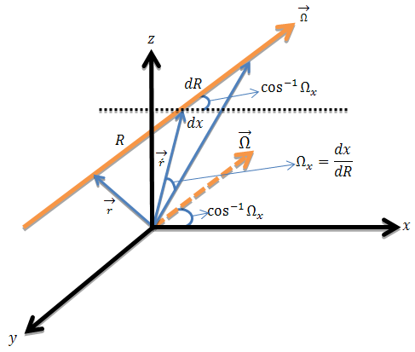

Figure 3-1 Particle transport parameters
The group angular particle fluence is:
$$φ_{g}\left(\vec{r},\hat{Ω}\right)=\int_{0}^{∞}{e^{-\int_{0}^{s}{\sum_{Total,g}^{medium}{\left(\vec{r}- s^{'} \hat{Ω}\right) ds^{'}}}}× S_{g}\left(\vec{r}- s \hat{Ω},\hat{Ω}\right) ds}$$ | (3-8)
Where $S_{g}\left(\vec{r}- s \hat{Ω},\hat{Ω}\right)$ is the total rate of particles appearing at $r and \hat{Ω}$ as a result of scattering collisions and other medium sources. This term is:
$$S_{g}\left(\vec{r}- s \hat{Ω},\hat{Ω}\right) = S_{g}^{Ext}\left(\vec{r}- s \hat{Ω},\hat{Ω}\right)$$
$$+ \sum_{g^{'}=1}^{G}{\int_{4π}{d{\hat{Ω}}^{'}}Σ_{Scatt gg^{'}}^{medium}\left(\vec{r}- s {\hat{Ω}}^{'}, {\hat{Ω}}^{'}∙\hat{Ω}\right)φ_{g^{'}}\left(\vec{r}- s {\hat{Ω}}^{'}, {\hat{Ω}}^{'}\right) }$$
Where $S_{g}^{Ext}\left(\vec{r}- s \hat{Ω},\hat{Ω}\right)$ are external sources and $Σ_{Scatt gg^{'}}^{medium}\left(\vec{r}- s {\hat{Ω}}^{'}, {\hat{Ω}}^{'}∙\hat{Ω}\right)$ is the group scattering cross section as defined in equation (3-5). The angular flux is
$$φ\left(\vec{r}, \hat{Ω},E\right) = f\left(E\right) φ_{g}\left(\vec{r}, \hat{Ω}\right), for E_{g} < E ≤ E_{g-1}$$

Neumann representation of the transport equation solutions
Starting with equation (3-8), the attenuated photon source $S_{g}^{Ext}$ is:
$$S_{g}^{Ext}\left(\vec{r}- s \hat{Ω},\hat{Ω}\right)= \int_{0}^{∞}{e^{-\int_{0}^{s}{\sum_{Total,g}^{medium}{\left(r- s^{'} \hat{Ω}\right) ds^{'}}}}} S_{g}^{LExt}\left(\vec{r}- s \hat{Ω},\hat{Ω}\right)ds$$
The integral operator for group $g$ as $L_{g}$:
$$L_{g} =\int_{0}^{∞}{e^{-\int_{0}^{s}{\sum_{Total,g}^{medium}{\left(r- s^{'} \hat{Ω}\right) ds^{'}}}}× \sum_{g^{'}=1}^{G}{\int_{4π}{dΩ^{'}}Σ_{Scatt gg^{'}}^{medium}\left(\vec{r},{\hat{Ω}}^{'}∙\hat{Ω}\right)} }$$
Then, we can write the transport equation solution in operator notation as:
$$φ=\sum_{g = 0}^{G}{\left(L_{g}φ_{g} + S_{g}^{Linac'}\right)}$$
Solution of this equation is obtained by defining:
$$φ_{}^{0}= \sum_{g=0}^{G}{S_{g}^{Linac'}}$$
$$φ_{}^{1}=\sum_{g=0}^{G}{{L_{g}φ}_{}^{0}}$$
$$φ_{}^{2}=\sum_{g=0}^{G}{L_{g}}φ_{}^{1}$$
$⋮$
$$φ_{}^{n}=\sum_{g=0}^{G}{L_{g}}φ_{}^{n-1}$$
$$φ_{}^{n+1}=\sum_{g=0}^{G}{L_{g}}φ_{}^{n}$$
If the series converges, then a solution to the equation is
$$φ= \sum_{n=0}^{∞}{φ_{}^{n}}$$
“This solution is called the Neumann series. The $φ_{}^{0}$ is the group angular flux from the source that arrives at the point in question without undergoing collisions, $φ_{}^{1}$, is the group angular flux arriving that has undergone exactly one collision, and so on. The Monte Carlo tracking of source particles that have not undergone a collision provides an estimate of $φ_{}^{0}$, the continuous tracking of particles that have undergone one collision provides an estimate of $φ_{}^{1}$, etc. The tracking process therefore estimates the Neumann series solution to the integral formulation of the transport equation” (Dupree & Fraley, 2004).

Scoring tallies

Average number of collisions and reaction rates
The average number of collision particles in group $g^{'}$ will undergo in a volume $\tilde{V}$ with total cross section $Σ_{x,g^{'}}\left(r,E\right)$ and average scalar flux ${\overline{φ}}_{g^{'}}$ is given by(Lewis & Miller, 1984):
$$\overline{c}= \tilde{V}Σ_{x,g^{'}}\left(r,E\right){\overline{φ}}_{g^{'}}\left(r,E\right)$$
Therefore during a Monte Carlo simulation we may write:
$${\overline{φ}}_{g^{'}}= \frac{\overline{c}}{\tilde{V} Σ_{x,g^{'}}}$$
In this context the $\overline{c}$ “is the mean number of collisions, normalized to one source particle. The random variable whose mean we want to calculate is $\overline{c}$ , the mean number of collisions per particle history in volume $\tilde{V}$. When we normalize the calculation to a source strength of one particle the sample estimate $\hat{c}$ is:
$$\hat{c}= \frac{1}{N} \sum_{n}{c_{n}}$$
Where $c_{n}$ is the number of collisions made in volume $\tilde{V}$ during the $n^{th}$ history. Therefore our sample estimate of scalar flux $\hat{φ}$ is
$${\hat{φ}}_{g^{'}}= \frac{1}{\tilde{V} Σ_{x,g^{'}}}\frac{1}{N} \sum_{n}{c_{n}}$$
In this estimates only the particles in group $g^{'}$ that have a collision of type $x$ in $\tilde{V}$ will contribute to this collision estimator of the group scalar flux ${\hat{φ}}_{g^{'}}$ ” (Lewis & Miller, 1984) (Roesch & Attix, 1968).
The reaction rates give the number of reactions of type a particle of group $g^{'}$will suffer per second, in 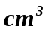(in unit volume). Reaction rates are the product of the particle flux and the macroscopic cross section for the desired reaction type.

Other tallies
The response (i.e. absorbed dose $D$) can be computed from the computed flux using a response function $R_{g}\left(\vec{r},\hat{Ω} \right)$. This is expressed mathematically as:
$$D = \int_{V}{dV}\sum_{g=0}^{G}{\int_{4π}{d\hat{Ω} φ_{g}\left(\vec{r},\hat{Ω} \right) R_{g}\left(\vec{r},\hat{Ω} \right)}}$$

Monte Carlo Methods solution of the Boltzman equation

Derivation of solution
To find a solution using Monte Carlo method we start by defining group $g$ “collision density”- the density of particles in group $g$ entering collision at $\vec{r}$ - (Irving, 1971) as:
$$ψ_{g}^{}\left(\vec{r}, \hat{Ω}\right) {={ Σ}_{Total, g}^{medium}\left(\vec{r}\right) φ}_{g}\left(\vec{r}, \hat{Ω}\right)$$ | (3-9)
Multiplying equation (3-8) by ${ Σ}_{Total, g}^{medium}\left(\vec{r}\right)$ and use equation (3-9) give us:
$$ψ_{g}^{}\left(\vec{r}, \hat{Ω}\right) = \int_{0}^{∞}{{{ds Σ}_{Total, g}^{medium}\left(\vec{r}\right) e}^{-\int_{0}^{s}{\sum_{Total,g}^{medium}{\left(\vec{r}- s^{'} \hat{Ω}\right) ds^{'}}}} }$$  $$×\left[S_{g}^{Ext}\left(\vec{r}- s \hat{Ω},\hat{Ω}\right)+\sum_{g^{'}=1}^{G}{\int_{4π}{d{\hat{Ω}}^{'}}\frac{Σ_{Scatt gg^{'}}^{medium}\left(\vec{r}- s {\hat{Ω}}^{'}, {\hat{Ω}}^{'}∙\hat{Ω}\right)}{{ Σ}_{Total, g^{'}}^{medium}\left(\vec{r}- s {\hat{Ω}}^{'}\right)}ψ_{g^{'}}^{}\left(\vec{r}- s {\hat{Ω}}^{'}, {\hat{Ω}}^{'}\right) }\right]$$ | (3-10)
And the group $g$ “emerging density”- the density of particles in group $g$ leaving a real collision or a source at $\vec{r}$ - (Irving, 1971) as:
$$χ_{g}^{}\left(\vec{r}, \hat{Ω}\right)= S_{g}^{Ext}\left(\vec{r}, \hat{Ω}\right)+ \sum_{g^{'}=1}^{G}{\int_{4π}{dΩ^{'}Σ_{Scatt gg^{'}}^{medium}}\left(\vec{r},{\hat{Ω}}^{'}∙\hat{Ω}\right)φ_{g^{'}}\left(\vec{r}, {\hat{Ω}}^{'}\right) }$$ | (3-11)
Similarly, separate $Σ_{Scatt gg^{'}}^{medium}$, then substitute equation (3-8) in (3-11) give us:
$$χ_{g}^{}\left(\vec{r}, \hat{Ω}\right)= S_{g}^{Ext}\left(\vec{r}, \hat{Ω}\right)+ \sum_{g^{'}=1}^{G}{\int_{4π}{d{\hat{Ω}}^{'}\frac{Σ_{Scatt gg^{'}}^{medium}\left(\vec{r}\right)}{{ Σ}_{Total, g^{'}}^{medium}\left(\vec{r}\right)} }f\left({\hat{Ω}}^{'}∙\hat{Ω}\right) }$$  $$×\int_{0}^{∞}{{{ds Σ}_{Total, g^{'}}^{medium}\left(\vec{r}\right) e}^{-\int_{0}^{s}{\sum_{Total,g^{'}}^{medium}{\left(\vec{r}- s^{'} {\hat{Ω}}^{'}\right) ds^{'}}}} χ_{g^{'}}^{}\left(\vec{r}, {\hat{Ω}}^{'}\right) }$$ | (3-12)
Using the definition of the delta function we can write
$$ψ_{g}^{}\left(\vec{r}, \hat{Ω}\right) = \int_{0}^{∞}{{{ds\int_{4π}{d{\hat{Ω}}^{'}}Σ}_{Total, g}^{medium}\left(\vec{r}\right) e}^{-\int_{0}^{s}{\sum_{Total,g}^{medium}{\left(\vec{r}- s^{'}{\hat{Ω} }^{'}\right) ds^{'}}}} }$$  $${× χ}_{g}^{}\left(\vec{r}- s{\hat{Ω} }^{'}, {\hat{Ω} }^{'}\right)δ\left(\vec{r}\right)$$ | (3-13)
Then we can define transport kernel as
$${{T_{g}\left(\vec{r}- s\hat{Ω},\vec{r}\right) =\int_{4π}{d{\hat{Ω}}^{'}}Σ}_{Total, g}^{medium}\left(\vec{r}\right) e}^{-\int_{0}^{s}{\sum_{Total,g}^{medium}{\left(\vec{r}- s^{'}{\hat{Ω} }^{'}\right) ds^{'}}}} ×δ\left(\vec{r}\right)$$ | (3-14)
And collision kernel as:
$$C_{\vec{r}}\left(g^{'},g\right)= \frac{Σ_{Scatt gg^{'}}^{medium}\left(\vec{r}\right)}{{ Σ}_{Total, g^{'}}^{medium}\left(\vec{r}\right)}$$ | (3-15)
Therefore the collision density:
$$ψ_{g}^{}\left(\vec{r}, \hat{Ω}\right) = \int_{0}^{∞}{ds T_{g}\left(\vec{r}- s\hat{Ω},\vec{r}\right) \left\{S_{g}^{Linac}\left(\vec{r}- s \hat{Ω},\hat{Ω}\right)\right.}$$  $$\left.+\sum_{g^{'}=1}^{G}{\int_{4π}{d{\hat{Ω}}^{'}C_{\vec{r}}\left(g^{'},g\right) }ψ_{g^{'}}^{}\left(\vec{r}- s {\hat{Ω}}^{'}, {\hat{Ω}}^{'}\right)} \right\}$$ | (3-16)
And leaving density:
$$χ_{g}^{}\left(\vec{r}, \hat{Ω}\right)= S_{g}^{Ext}\left(\vec{r}, \hat{Ω}\right)+$$  $$\sum_{g^{'}=1}^{G}{\int_{0}^{∞}{\int_{4π}{ds d{\hat{Ω}}^{'}{ C}_{\vec{r}}\left(g^{'},g\right) T_{g}\left(\vec{r}- s\hat{Ω},\vec{r}\right)}}χ_{g^{'}}^{}\left(\vec{r}-s{\hat{Ω}}^{'}, {\hat{Ω}}^{'}\right)}$$ | (3-17)

Monte Carlo Simulation of the solution
The following is a simplified outline of the followed to complete a Monte Carlo history (Irving, 1971)
The source distribution is given as:
$$S\left(\vec{r},g\right) = \frac{S\left(\vec{r},g\right)}{\sum_{g'=1}^{G}{\int_{0}^{∞}{dsS_{g}\left(\vec{s},g\right)}}}$$
      - Starting with the given source distribution select initial position $\vec{r}'$ and initial group $g'$ and set initial weight
$$Weight =\int_{0}^{\vec{r}'}{dsS_{g}\left(\vec{s},g'\right)}$$
      - Choose distance to next interaction site $R$ from
$${Σ_{Total, g^{'}}^{medium}\left(\vec{r}'+R{\hat{Ω}}^{'}\right) e}^{-\int_{0}^{R}{\sum_{Total,g^{'}}^{medium}{\left({\vec{r}}^{'}- R^{'} {\hat{Ω}}^{'}\right) dR^{'}}}}$$
Set $\vec{r} = \vec{r}'+R{\hat{Ω}}^{'}$
If $\vec{r}$ is outside the system, particle escapes and history terminated go to step 1.
      - Adjust the particle site at collision site for non-absorption weighting
$$Weight = \left(\begin{aligned}Previous \\ Weight\end{aligned}\right) \frac{\sum_{Scatt,g^{'}}^{medium}{\left(\vec{r}\right)}}{\sum_{Total,g^{'}}^{medium}{\left(\vec{r}\right)}}$$
and contribute to your tallies.
      - Decide on new energy group and new direction
        - Choose new group $g$ from group to group scattering ratios
        - Choose new direction from tabulated $μ$ value for the selected new group.
      - If new weight below cutoff weight terminate history, otherwise
        - set $\vec{r}' = \vec{r}$
        - Set $g' = g$
        - Go to step 2.

Applying fictitious scattering to the Boltzman transport equation

Derivation of Boltzman transport equation with fictitious scattering
The fictitious scattering (Woodcock Tracking) general model is developed by assuming that the entire system is homogenous with one total cross section $Σ_{Total, g}^{System}$ per group for all the system materials at all spatial points. It is “implemented by requiring $Σ_{Total, g}^{System}$ to be spatially independent and when practical, to be greater than or equal to the largest cross section in the system” $Σ_{Maximum}$ (Cramer, 1977). We start with the conventional nonmultiplying and time-independent multigroup transport equation time dependent transport equation (3-7) we add the fictitious collision term $Σ_{Total, g}^{System}\left(\vec{r}\right) φ_{g}\left(\vec{r}, \hat{Ω}\right)$ to both side of the equation:
$$\hat{Ω}∙\vec{∇} φ_{g}\left(\vec{r}, \hat{Ω}\right) {+ Σ}_{Total, g}^{medium}\left(\vec{r}\right)φ_{g}\left(\vec{r}, \hat{Ω}\right)+ Σ_{Total, g}^{System}\left(\vec{r}\right) φ_{g}\left(\vec{r}, \hat{Ω}\right) = S_{g}^{Ext}\left(\vec{r},\hat{Ω}\right)$$
$$Σ_{Total, g}^{System}\left(\vec{r}\right) φ_{g}\left(\vec{r}, \hat{Ω}\right)+\sum_{g^{'}=1}^{G}{\int_{4π}{dΩ^{'}Σ_{Scatt gg^{'}}^{medium}}\left(\vec{r},{\hat{Ω}}^{'}∙\hat{Ω}\right)φ_{g^{'}}\left(\vec{r}, {\hat{Ω}}^{'}\right) }$$
Move the term $Σ_{Total, g}^{medium}\left(\vec{r}\right)φ_{g}\left(\vec{r}, \hat{Ω}\right)$to the right side and collect terms:
$$\hat{Ω}∙\vec{∇} φ_{g}\left(\vec{r}, \hat{Ω}\right) + Σ_{Total, g}^{System}\left(\vec{r}\right) φ_{g}\left(\vec{r}, \hat{Ω}\right) = S_{g}^{Ext}\left(\vec{r},\hat{Ω}\right)$$  $$+\left\{Σ_{Total, g}^{System}\left(\vec{r}\right)-Σ_{Total, g}^{medium}\left(\vec{r}\right)\right\}φ_{g}\left(\vec{r}, \hat{Ω}\right)$$  $$+\sum_{g^{'}=1}^{G}{\int_{4π}{d{\hat{Ω}}^{'}Σ_{Scatt gg^{'}}^{medium}}\left(\vec{r},{\hat{Ω}}^{'}∙\hat{Ω}\right)φ_{g^{'}}\left(\vec{r}, {\hat{Ω}}^{'}\right) }$$ | (3-18)
Rewrite the term
$$\left\{Σ_{Total, g}^{System}\left(\vec{r}\right)-Σ_{Total, g}^{medium}\left(\vec{r}\right)\right\}φ_{g}\left(\vec{r}, \hat{Ω}\right) =Σ_{Total, g}^{System}\left(\vec{r}\right)φ_{g}\left(\vec{r}, \hat{Ω}\right)\left\{1 - \frac{Σ_{Total, g}^{medium}\left(\vec{r}\right)}{Σ_{Total, g}^{System}\left(\vec{r}\right)}\right\}$$
Using the definition of the delta function we can write for group $g:$
$$\sum_{g^{'}=1}^{G}{\int_{4π}{d{\hat{Ω} }^{'}\left[Σ_{Total, g^{'}}^{System}\left(\vec{r}\right)\left\{1 - \frac{Σ_{Total, g^{'}}^{medium}\left(\vec{r}\right)}{Σ_{Total, g^{'}}^{System}\left(\vec{r}\right)}\right\} δ\left({\hat{Ω} }^{'}→\hat{Ω}\right)\right]φ_{g^{'}}\left(\vec{r}, {\hat{Ω} }^{'}\right)}}$$
And for the scattering cross section we can rewrite as:
$$Σ_{Scatt gg^{'}}^{medium}\left(\vec{r},{\hat{Ω}}^{'}∙\hat{Ω}\right) = Σ_{Scatt gg^{'}}^{medium}\left(\vec{r}\right) f\left({\hat{Ω}}^{'}∙\hat{Ω}\right)$$
Substitute back in equation (3-18) and collect the terms
$$\hat{Ω}∙\vec{∇} φ_{g}\left(\vec{r}, \hat{Ω}\right) + Σ_{Total, g}^{System}\left(\vec{r}\right) φ_{g}\left(\vec{r}, \hat{Ω}\right) = S_{g}^{Ext}\left(\vec{r},\hat{Ω}\right)$$  $$+ \sum_{g^{'}=1}^{G}{\int_{4π}{dΩ^{'}\left[Σ_{Scatt, gg^{'}}^{medium}\left(\vec{r}\right) f\left({\hat{Ω}}^{'}∙\hat{Ω}\right)\right.} }$$  $$\left.{ + Σ}_{Total, g^{'}}^{System}\left(\vec{r}\right)\left\{1 - \frac{Σ_{Total, g^{'}}^{medium}\left(\vec{r}\right)}{Σ_{Total, g^{'}}^{System}\left(\vec{r}\right)}\right\} δ\left({\hat{Ω} }^{'}→\hat{Ω}\right)\right] φ_{g^{'}}\left(\vec{r}, {\hat{Ω}}^{'}\right)$$ | (3-19)
Factor out the $Σ_{Total, g}^{System}\left(\vec{r}\right)$ term from the square bracket to the right of equation (3-19) will result in the following:
$$\hat{Ω}∙\vec{∇} φ_{g}\left(\vec{r}, \hat{Ω}\right) + Σ_{Total, g}^{System}\left(\vec{r}\right) φ_{g}\left(\vec{r}, \hat{Ω}\right)={ S}_{g}^{Ext}\left(\vec{r},\hat{Ω}\right)$$  $$+\sum_{g^{'}=1}^{G}{\int_{4π}{dΩ^{'}\left[\frac{Σ_{Scatt, gg^{'}}^{medium}\left(\vec{r}\right)}{Σ_{Total, g^{'}}^{System}\left(\vec{r}\right)} f\left({\hat{Ω}}^{'}∙\hat{Ω}\right)\right.}}$$  $$\left.+ \left\{1 - \frac{Σ_{Total, g^{'}}^{medium}\left(\vec{r}\right)}{Σ_{Total, g^{'}}^{System}\left(\vec{r}\right)}\right\} δ\left({\hat{Ω} }^{'}→\hat{Ω}\right)\right]{Σ_{Total, g^{'}}^{System}\left(\vec{r}\right)φ}_{g^{'}}\left(\vec{r}, {\hat{Ω}}^{'}\right)$$ | (3-20)
Rewrite the term $\frac{Σ_{Scatt, gg^{'}}^{medium}\left(\vec{r}\right)}{Σ_{Total, g}^{System}\left(\vec{r}\right)}$ as follow:
$$\frac{Σ_{Scatt, gg^{'}}^{medium}\left(\vec{r}\right)}{Σ_{Total, g^{'}}^{System}\left(\vec{r}\right)} = \frac{Σ_{Total, g^{'}}^{medium}\left(\vec{r}\right)}{Σ_{Total, g^{'}}^{System}\left(\vec{r}\right)} ×\frac{Σ_{Scatt, gg^{'}}^{medium}\left(\vec{r}\right)}{Σ_{Total, g^{'}}^{medium}\left(\vec{r}\right)}$$ | (3-21)
And define the fictitious collision density term $ψ_{g^{'}}^{System}\left(\vec{r}, {\hat{Ω}}^{'}\right)$ as:
$${ψ_{g^{'}}^{System}\left(\vec{r}, {\hat{Ω}}^{'}\right) =Σ_{Total, g^{'}}^{System}\left(\vec{r}\right)φ}_{g^{'}}\left(\vec{r}, {\hat{Ω}}^{'}\right)$$ | (3-22)
Similar to equation (3-22), the real collision density term $ψ_{ g^{'}}^{Real}\left(\vec{r}, {\hat{Ω}}^{'}\right)$ is:
$$ψ_{ g^{'}}^{Real}\left(\vec{r}, {\hat{Ω}}^{'}\right) {={ Σ}_{Total, g^{'}}^{medium}\left(\vec{r}\right)φ}_{g^{'}}\left(\vec{r}, {\hat{Ω}}^{'}\right)$$ | (3-23)
Then the ratio of real collision to the fictitious collision term is:
$$\frac{ψ_{ g^{'}}^{Real}\left(\vec{r}, {\hat{Ω}}^{'}\right)}{ψ_{ g^{'}}^{System}\left(\vec{r}, {\hat{Ω}}^{'}\right)} = \frac{Σ_{Total, g^{'}}^{medium}\left(\vec{r}\right)}{{ Σ}_{Total, g^{'}}^{System}\left(\vec{r}\right)}$$ | (3-24)
The real collision in terms of the fictitious collision term is:
$$ψ_{ g^{'}}^{Real}\left(\vec{r}, {\hat{Ω}}^{'}\right) = \frac{Σ_{Total, g^{'}}^{medium}\left(\vec{r}\right)}{{ Σ}_{Total, g^{'}}^{System}\left(\vec{r}\right)} ψ_{ g^{'}}^{System}\left(\vec{r}, {\hat{Ω}}^{'}\right)$$ | (3-25)
Substitute equation (3-21) and (3-22) back in equation (3-20) we get:
$$\hat{Ω}∙\vec{∇} φ_{g}\left(\vec{r}, \hat{Ω}\right) + Σ_{Total, g}^{System}\left(\vec{r}\right) φ_{g}\left(\vec{r}, \hat{Ω}\right)= { S}_{g}^{Ext}\left(\vec{r},\hat{Ω}\right)$$  $$+ \sum_{g^{'}=1}^{G}{\int_{4π}{dΩ^{'}\left[\frac{Σ_{Total, g^{'}}^{medium}\left(\vec{r}\right)}{Σ_{Total, g^{'}}^{System}\left(\vec{r}\right)} ×\frac{Σ_{Scatt, gg^{'}}^{medium}\left(\vec{r}\right)}{Σ_{Total, g^{'}}^{medium}\left(\vec{r}\right)} f\left({\hat{Ω}}^{'}∙\hat{Ω}\right)\right.} }$$  $$\left.+ \left\{1 - \frac{Σ_{Total, g^{'}}^{medium}\left(\vec{r}\right)}{Σ_{Total, g^{'}}^{System}\left(\vec{r}\right)}\right\}δ\left({\hat{Ω} }^{'}→\hat{Ω}\right)\right]ψ_{ g^{'}}^{System}\left(\vec{r}, {\hat{Ω}}^{'}\right)$$ | (3-26)
Multiply $ψ_{ g^{'}}^{System}\left(\vec{r}, {\hat{Ω}}^{'}\right)$ into right hand bracket and use equation (3-25). Equation (3-27) becomes:
$$\hat{Ω}∙\vec{∇} φ_{g}\left(\vec{r}, \hat{Ω}\right) + Σ_{Total, g}^{System}\left(\vec{r}\right) φ_{g}\left(\vec{r}, \hat{Ω}\right)= { S}_{g}^{Ext}\left(\vec{r},\hat{Ω}\right)$$  $$+ \sum_{g^{'}=1}^{G}{\int_{4π}{dΩ^{'}\left[\frac{Σ_{Scatt, gg^{'}}^{medium}\left(\vec{r}\right)}{Σ_{Total, g^{'}}^{medium}\left(\vec{r}\right)} × ψ_{ g^{'}}^{Real}\left(\vec{r}, {\hat{Ω}}^{'}\right) × f\left({\hat{Ω}}^{'}∙\hat{Ω}\right)\right.} }$$  $$\left.+ \left\{1 - \frac{Σ_{Total, g^{'}}^{medium}\left(\vec{r}\right)}{Σ_{Total, g^{'}}^{System}\left(\vec{r}\right)}\right\}δ\left({\hat{Ω} }^{'}→\hat{Ω}\right)ψ_{ g^{'}}^{System}\left(\vec{r}, {\hat{Ω}}^{'}\right)\right]$$ | (3-27)
the right hand side of equation (3-27) at ${\hat{Ω} }^{'}→\hat{Ω}$ is the emergent particle density for all events (source real collisions, and fictitious collisions) designated as $q_{g}^{System}$
$$q_{g}^{System}\left(\vec{r}, {\hat{Ω}}^{'}\right) = \sum_{g^{'} = 1}^{G}{\left[\frac{Σ_{Scatt, gg^{'}}^{medium}\left(\vec{r}\right)}{Σ_{Total, g^{'}}^{medium}\left(\vec{r}\right)}\right.} × ψ_{ g^{'}}^{Real}\left(\vec{r}, {\hat{Ω}}^{'}\right)$$  $$+ \left\{1 - \frac{Σ_{Total, g^{'}}^{medium}\left(\vec{r}\right)}{Σ_{Total, g^{'}}^{System}\left(\vec{r}\right)}\right\}\left. ψ_{ g^{'}}^{System}\left(\vec{r}, {\hat{Ω}}^{'}\right)\right]$$ | (3-28)
Since, the emergent particle density for source real collisions is $q_{g}^{}$ :
$$q_{g}^{}\left(\vec{r}, {\hat{Ω}}^{'}\right) =\sum_{g^{'}=1}^{G}{\frac{Σ_{Scatt, gg^{'}}^{medium}\left(\vec{r}\right)}{Σ_{Total, g^{'}}^{medium}\left(\vec{r}\right)}} ψ_{ g^{'}}^{Real}\left(\vec{r}, {\hat{Ω}}^{'}\right)$$ | (3-29)
Or as shown in equation (3-20) it is also equal to:
$$q_{g}^{}\left(\vec{r}, {\hat{Ω}}^{'}\right) =\sum_{g^{'}=1}^{G}{\frac{Σ_{Scatt, gg^{'}}^{medium}\left(\vec{r}\right)}{Σ_{Total, g^{'}}^{System}\left(\vec{r}\right)}} ψ_{ g^{'}}^{System}\left(\vec{r}, {\hat{Ω}}^{'}\right)$$ | (3-30)
Substitute equation (3-29) in equation (3-28) to get
$$q_{g}^{System}\left(\vec{r}, {\hat{Ω}}^{'}\right) = q_{g}^{}\left(\vec{r}, {\hat{Ω}}^{'}\right) +\sum_{g^{'}=1}^{G}{\left\{1 - \frac{Σ_{Total, g^{'}}^{medium}\left(\vec{r}\right)}{Σ_{Total, g^{'}}^{System}\left(\vec{r}\right)}\right\}} ψ_{ g^{'}}^{System}\left(\vec{r}, {\hat{Ω}}^{'}\right)$$ | (3-31)
The angular flux is computed from equations (3-22) and (3-23):
$$φ_{g}\left(\vec{r}, {\hat{Ω}}^{'}\right) = \sum_{g^{'}=1}^{G}{\frac{ψ_{ g^{'}}^{System}\left(\vec{r}, {\hat{Ω}}^{'}\right)}{Σ_{Total, g^{'}}^{System}\left(\vec{r}\right)}} = \sum_{g^{'}=1}^{G}{\frac{ψ_{ g^{'}}^{Real}\left(\vec{r}, {\hat{Ω}}^{'}\right)}{{ Σ}_{Total, g^{'}}^{medium}\left(\vec{r}\right)}}$$ | (3-32)
All the above equations are valid when non absorption weighting Monte Carlo method is used to find a solution. Further for this type of transport (non-absorption weighting – all scatter) real emergent density $q_{g}^{}\left(\vec{r}, {\hat{Ω}}^{'}\right)$ is given by:
$$q_{g}^{}\left(\vec{r}, {\hat{Ω}}^{'}\right) =\sum_{g^{'}=1}^{G}{\frac{Σ_{Scatt, gg^{'}}^{medium}\left(\vec{r}\right)}{Σ_{Total, g^{'}}^{medium}\left(\vec{r}\right)}} ψ_{ g^{'}}^{Real}\left(\vec{r}, {\hat{Ω}}^{'}\right)$$  $$=\sum_{g^{'}=1}^{G}{\frac{Σ_{Scatt, gg^{'}}^{medium}\left(\vec{r}\right)}{Σ_{Total, g^{'}}^{System}\left(\vec{r}\right)}} ψ_{ g^{'}}^{System}\left(\vec{r}, {\hat{Ω}}^{'}\right)$$ | (3-33)
And the fictitious emergent density is:
$$q_{g}^{System}\left(\vec{r}, {\hat{Ω}}^{'}\right) = \sum_{g^{'}=1}^{G}{\left[\frac{Σ_{Scatt, gg^{'}}^{medium}\left(\vec{r}\right)}{Σ_{Total, g^{'}}^{System}\left(\vec{r}\right)} +\left\{1 - \frac{Σ_{Total, g^{'}}^{medium}\left(\vec{r}\right)}{Σ_{Total, g^{'}}^{System}\left(\vec{r}\right)}\right\}\right]}ψ_{ g^{'}}^{System}\left(\vec{r}, {\hat{Ω}}^{'}\right)$$ | (3-34)
And using equation (3-33) and (3-34) the flux is:
$$φ_{g}\left(\vec{r}, {\hat{Ω}}^{'}\right) =\sum_{g^{'}=1}^{G}{\frac{q_{g^{'}}^{}\left(\vec{r}, {\hat{Ω}}^{'}\right)}{Σ_{Scatt, gg^{'}}^{medium}\left(\vec{r}\right)}}$$  $$= \frac{q_{g}^{System}\left(\vec{r}, {\hat{Ω}}^{'}\right)}{\sum_{g^{'}=1}^{G}{\left[Σ_{Scatt, gg^{'}}^{medium}\left(\vec{r}\right) +Σ_{Total, g^{'}}^{System}\left(\vec{r}\right)\left\{1 - \frac{Σ_{Total, g^{'}}^{medium}\left(\vec{r}\right)}{Σ_{Total, g^{'}}^{System}\left(\vec{r}\right)}\right\}\right]}}$$ | (3-35)

Use of fictitious scattering in Monte Carlo algorithms
When implementing the fictitious scattering method the distance to interaction site is computed using fictitious cross section $Σ_{Total, g}^{System}\left(\vec{r}\right)$. Once at the interaction site is within the problem boundaries we determine if the interaction is real or fictitious based on the ratio between the true site attenuation coefficient and the fictitious cross section. A true scattering interaction occur with probability of less or equal to $\frac{\sum_{Total, g}^{medium}{\left(\vec{r}\right) }}{Σ_{Total, g}^{System}\left(\vec{r}\right)}$, then real scattering event take place with non-absorption weighting. Otherwise, with probability greater than $\left\{ 1-\frac{\sum_{Total, g}^{medium}{\left(\vec{r}\right) }}{Σ_{Total, g}^{System}\left(\vec{r}\right)}\right\}$ a fictitious interaction occurred particle continues on the same path without the change of direction, energy and weight.
The fictitious scattering method is implemented using random number to determine if collision is real or fictitious (random number RN are in interval $0 ≤ RN ≤ 1$ ).
  - Choose a fictitious cross-section $Σ_{Total, g}^{System}\left(\vec{r}\right)$. Normally chosen to be the largest expected cross section value during any particle flight.
  - Sample trial flight distance using $Σ_{Total, g}^{System}\left(\vec{r}\right)$ ,
  - Move particle that distance and find $\sum_{Total, g}^{medium}{\left(\vec{r}\right) }$ at location.
  - Compute $P= \frac{\sum_{Total, g}^{medium}{\left(\vec{r}\right) }}{Σ_{Total, g}^{System}\left(\vec{r}\right)}$.
  - Draw a random number $RN$
  - Draw a random number and test type of collision:
    - Real collision occur $RN ≤ P=\frac{\sum_{Total, g}^{medium}{\left(\vec{r}\right) }}{Σ_{Total, g}^{System}\left(\vec{r}\right)}$ and ordinary collision mechanisms used to determine post collision parameters:
      - Photon Energy;
      - Scattering direction.
    - Fictitious collision occur $RN > \frac{\sum_{Total, g}^{medium}{\left(\vec{r}\right) }}{Σ_{Total, g}^{System}\left(\vec{r}\right)}$ a new flight path is selected at $\vec{r}$ using the $Σ_{Total, g}^{System}\left(\vec{r}\right)$ and the particle is transported to the next tentative collision site along the same direction; Keep:
      - Weight;
      - Photon Energy;
      - Travel direction.
The fictitious scattering tracking becomes inefficient if $Σ_{Total, g}^{System}\left(\vec{r}\right)$ is much larger than the typical cross-section otherwise it is a very powerful Monte Carlo technique.

The Adjoint formalism of the transport equation

The Forward operator
Starting with equation (3-7) we can derive the operator format of the transport equation by defining the following::
- $L_{1} = \hat{Ω}∙\overline{∇} \{Streaming term\}$
- $L_{2} = Σ_{Total, g}^{medium}\left(\vec{r}\right) \left\{interaction term\right\}$
- $L_{3} = Σ_{Scatt,gg^{'}}^{medium}\left(\vec{r},{\hat{Ω}}^{'}→\hat{Ω}\right) \left\{Scattering term\right\}$
Define the cumulative operator $L$ as:
$$L_{g} = L_{1}+ L_{2} - {\sum_{g^{'}=1}^{G}{\int_{4π}{d{\hat{Ω}}^{'}}}L}_{3}$$
Substitute back each operator in the $L$ operator equation gives us:
$$L_{g} = \left[\hat{Ω}∙\overline{∇} + Σ_{Total,g}^{medium}\left(\vec{r}\right)\right]-\sum_{g^{'}=1}^{G}{\int_{4π}{d{\hat{Ω}}^{'}Σ_{Scatt,gg^{'}}^{medium}\left(\vec{r},{\hat{Ω}}^{'}→\hat{Ω}\right)}}$$ | (3-36)
Finally, the left hand side of the transport equation in operator notation is:
$$L_{g} φ_{g}\left(\vec{r},\hat{Ω}\right) =\left[\hat{Ω}∙\overline{∇} + Σ_{Total,.g}^{medium}\left(\vec{r}\right)\right] φ_{g}\left(\vec{r},\hat{Ω}\right)$$  $$-\sum_{g^{'}=1}^{G}{\int_{4π}{d{\hat{Ω}}^{'}Σ_{Scatt,gg^{'}}^{medium}\left(\vec{r},{\hat{Ω}}^{'}→\hat{Ω}\right)φ_{g^{'}}\left(\vec{r},{\hat{Ω}}^{'}\right)}}$$ | (3-37)

Derivation of the adjoint operator
Starting from the time-independent nonmultiplying transport equation given in equation (3-7), the transport operator is given by equation (3-37). The spatial domain $V$ (i.e. volume of interest) of the problem is bounded by a surface where its outward normal is $\hat{n}$ . Further, we assume that the flux is continuous along the direction of travel for $\hat{Ω}∙\overline{∇}φ_{g}\left(\vec{r},\hat{Ω}\right)$to be finite and no particles enter (i.e. vacuum boundary condition) (Lewis & Miller, 1984). This is given as:
$$φ_{g}\left({\vec{r}}_{surface},\hat{Ω}\right)=0 for \hat{n}∙\hat{Ω} < 0 where \vec{r} ∈ Surface$$ | (3-38)
If we define integration over the independent variable as:
$$〈〉 = \int_{V}{dV}\sum_{g=1}^{G}{\int_{4π}{d\hat{Ω}}}$$ | (3-39)
If we multiply equation (3-37) by $φ_{g}^{*}$ and insert it in equation (3-38) we get (Note: I am going to drop $\left(\vec{r},\hat{Ω}\right)$ from the bracket side):
$$〈φ_{g}^{*}L_{g} φ_{g}〉 = \int_{V}{dV}\sum_{g=1}^{G}{\int_{4π}{d\hat{Ω} φ_{g}^{*}\left(\vec{r},\hat{Ω}\right) ×\left\{\hat{Ω}∙\overline{∇} φ_{g}\left(\vec{r},\hat{Ω}\right)\right. }}$$  $$+ Σ_{Total, g}^{medium}\left(\vec{r}\right)φ_{g}\left(\vec{r},\hat{Ω}\right)\left. -\sum_{g^{'}=1}^{G}{\int_{4π}{d{\hat{Ω}}^{'}Σ_{Scatt,g^{'}g}^{medium}\left(\vec{r},{\hat{Ω}}^{'}→\hat{Ω}\right)φ_{g^{'}}\left(\vec{r},{\hat{Ω}}^{'}\right)}}\right\}$$ | (3-40)
For the streaming term $\hat{Ω}∙\overline{∇}$ we can use the fact that:
$$\hat{Ω} ∙ \overline{∇} = \overline{∇} ∙\hat{Ω}$$ | (3-41)
And the identity that:
$$\overline{∇} ∙\left(\hat{Ω} φ_{g}^{*} φ_{g}\right) = φ_{g}^{*} \hat{Ω}∙ \overline{∇}φ_{g} + φ_{g} \hat{Ω}∙ \overline{∇}φ_{g}^{*}$$ | (3-42)
Integrating equation (3-42) over volume $V$ to get:
$$\int_{V}{dV}\overline{∇} ∙\left(\hat{Ω} φ_{g}^{*} φ_{g}\right) =\int_{V}{dV}φ_{g}^{*} \hat{Ω}∙ \overline{∇}φ_{g} + \int_{V}{dV}φ_{g} \hat{Ω}∙ \overline{∇}φ_{g}^{*}$$ | (3-43)
The divergence theorem converts a volume integral to a surface integral as follow:
$$\int_{V}{dV \hat{Ω}}∙\overline{∇} f\left(\vec{r},\hat{Ω}\right) =\int_{S}{dS}\hat{n} ∙ \hat{Ω} f\left(\vec{r},\hat{Ω}\right)$$ | (3-44)
Applying equation (3-44) to equation (3-43) we get:
$$\int_{S}{dS}\hat{n}∙\left(\hat{Ω} φ_{g}^{*} φ_{g}\right) =\int_{V}{dV}φ_{g}^{*} \hat{Ω}∙ \overline{∇}φ_{g} + \int_{V}{dV}φ_{g} \hat{Ω}∙ \overline{∇}φ_{g}^{*}$$ | (3-45)
We can make the surface integral - equation (3-45) - vanish (equal to zero) if we specify the correct boundary conditions. The first boundary condition given in equation (3-38) will make the forward flux part vanishes for all $\hat{n}∙\hat{Ω} < 0$, hence, we need a boundary condition that will make the adjoint flux vanishes. Therefore; this is achieved by specify that the outward $\hat{n}∙\hat{Ω} > 0$ surface flux is zero. This is written as:
$$φ_{g^{'}}^{*}\left({\vec{r}}_{surface},\hat{Ω}\right) =0 for \hat{n}∙\hat{Ω} ≥ 0 where \vec{r} ∈ Surface$$ | (3-46)
Using the two boundary conditions equation (3-38) and equation (3-46) the surface integral:
$$\int_{S}{dS}\hat{n} ∙\left(\hat{Ω} φ_{g}^{*} φ_{g}\right) =0$$ | (3-47)
Using this result in equation (3-45) we can conclude that:
$$\int_{V}{dV}φ_{g}^{*} \hat{Ω}∙ \overline{∇}φ_{g} = - \int_{V}{dV}φ_{g} \hat{Ω}∙ \overline{∇}φ_{g}^{*}= \int_{V}{dV}φ_{g} \left(-\hat{Ω}∙ \overline{∇}φ_{g}^{*}\right)$$ | (3-48)
Going back to equation (3-40), the collision term becomes:
$$φ_{g}^{*}\left(\vec{r},\hat{Ω}\right) Σ_{Total,.g}^{medium}\left(\vec{r}\right) φ_{g}\left(\vec{r},\hat{Ω}\right) = {φ_{g}\left(\vec{r},\hat{Ω}\right) Σ}_{Total,.g}^{medium}\left(\vec{r}\right){ φ}_{g}^{*}\left(\vec{r},\hat{Ω}\right)$$ | (3-49)
And the scattering term, interchanging the dummy variables
$$\int_{4π}{d\hat{Ω} }\sum_{g=1}^{G}{φ_{g}^{*}\left(\vec{r},\hat{Ω}\right)×\left\{\int_{4π}{d{\hat{Ω}}^{'}}\sum_{g^{'}=1}^{G}{Σ_{Scatt,g^{'}g}^{medium}\left(\vec{r},{\hat{Ω}}^{'}→\hat{Ω}\right)φ_{g^{'}}\left(\vec{r},{\hat{Ω}}^{'}\right)}\right\}}$$  $$=\int_{4π}{d\hat{Ω} }\sum_{g=1}^{G}{φ_{g}^{}\left(\vec{r},\hat{Ω}\right)×\left\{\int_{4π}{d{\hat{Ω}}^{'}}\sum_{g^{'}=1}^{G}{Σ_{Scatt,gg^{'}}^{medium}\left(\vec{r},{\hat{Ω}}^{'}→\hat{Ω}\right)φ_{g^{'}}^{*}\left(\vec{r},{\hat{Ω}}^{'}\right)}\right\}}$$ | (3-50)
Substituting equations (3-48), (3-49) and (3-50) in equation (3-40) we get:
$$〈φ_{g}^{*}L_{g} φ_{g}〉 = \int_{V}{dV \int_{4π}{d\hat{Ω} }}\sum_{g=1}^{G}{φ_{g}\left(\vec{r},\hat{Ω}\right)×\left\{-\hat{Ω}∙\overline{∇} φ_{g}^{*}\left(\vec{r},\hat{Ω}\right) \right.}$$  $$+ Σ_{Total, g}^{medium}\left(\vec{r}\right)φ_{g}^{*}\left(\vec{r},\hat{Ω}\right)\left. -\sum_{g^{'}=1}^{G}{\int_{4π}{d{\hat{Ω}}^{'}Σ_{Scatt,gg^{'}}^{medium}\left(\vec{r},{\hat{Ω}}^{'}→\hat{Ω}\right)φ_{g}^{*}\left(\vec{r},{\hat{Ω}}^{'}\right)}}\right\}$$ | (3-51)
Define the adjoint operator as:
$${ L}_{g}^{*} φ_{g}^{*} = \left\{-\hat{Ω}∙\overline{∇} φ_{g}^{*}\left(\vec{r},\hat{Ω}\right)+ Σ_{Total, g}^{medium}\left(\vec{r}\right)\right\} φ_{g}^{*}\left(\vec{r},\hat{Ω}\right)$$  $$-\sum_{g^{'}=1}^{G}{\int_{4π}{d{\hat{Ω}}^{'}Σ_{Scatt,gg^{'}}^{medium}\left(\vec{r},{\hat{Ω}}^{'}→\hat{Ω}\right)φ_{g}^{*}\left(\vec{r},{\hat{Ω}}^{'}\right)}}$$ | (3-52)
To satisfy the condition:
$$〈φ_{g}^{*} L_{g} φ_{g}〉 = 〈φ_{g} L_{g}^{*} φ_{g}^{*}〉$$  Or  $$〈φ_{g}^{*} L_{g} φ_{g}〉 - 〈φ_{g} L_{g}^{*} φ_{g}^{*}〉 = 0$$ | (3-53)
Where as defined in equation (3-39) signifies integration over all the independent variables. It is worth noting that if $L_{g} = L_{g}^{*}$ the operator is called a self-adjoint, and non-self-adjoint otherwise.

Application of the adjoint identity
The adjoint flux at the problem surface is commonly computed using Monte Carlo calculation. Then the adjoint identity is used to find detector response. The answer found using this method can be verified using forward Monte Carlo calculation. The following is a description of how the adjoint identity is commonly applied in Monte Carlo calculation (Lewis & Miller, 1984).

External Source problems
The transport problem will have an external source distribution given by $S_{g}^{Ext}$. The corresponding transport equation in operator notation will be:
$$L_{g} φ_{g} = S_{g}^{Ext}$$ | (3-54)
Where $φ_{g}$ meet the boundary condition given in equation (3-38). If the problem objective is to find the response of a small detector that has a total cross section $Σ_{g}^{Detector}$and volume $V_{}^{Detector}$ at a point $\vec{r}$ in space. This response is computed from the reaction rate $\dot{R}$ at the detector as follow:
$$\dot{R} =V_{}^{Detector}\int_{4π}{d\hat{Ω}} \sum_{g=1}^{G}{Σ_{g}^{Detector}}\left(\vec{r}\right)φ_{g}\left(\vec{r },\hat{Ω}\right)$$ | (3-55)
The corresponding adjoint problem is:
$$L_{g}^{*} φ_{g}^{*} =V_{}^{Detector}Σ_{g}^{Detector}\left(\vec{r}\right)δ\left(\vec{r }-{\vec{r }}_{Detector}\right)$$ | (3-56)
Where adjoint flux $φ_{g}^{*}$ is required to satisfy the boundary condition specified by equation (3-46). Now multiply (3-54) by the adjoint flux $φ_{g}^{*}$ and integrate over the independent variables we get:
$$〈φ_{g}^{*} L_{g} φ_{g}〉 = 〈φ_{g}^{*} S_{g}^{Ext}〉$$ | (3-57)
Similarly, if we multiply equation (3-56) by the forward flux and integrate over the independent variables we get:
$$〈φ_{g} L_{g}^{*} φ_{g}^{*}〉 = 〈φ_{g} V_{}^{Detector}Σ_{g}^{Detector}\left(\vec{r}\right) δ\left(\vec{r }-{\vec{r }}_{Detector}\right) 〉 = \dot{R}$$ | (3-58)
If we subtract equation (3-57) from equation (3-58) we get:
$$〈φ_{g}^{*} L_{g} φ_{g}〉 -〈φ_{g} L_{g}^{*} φ_{g}^{*}〉 = 〈φ_{g}^{*} S_{g}^{Ext}〉 - \dot{R}$$ | (3-59)
Note that the left hand side of equation (3-59) is vanishes as shown in equation (3-53). As a result we get:
$$\dot{R} = 〈φ_{g}^{*} S_{g}^{Ext}〉$$ | (3-60)
From this result we can state that “the detector response is given by the volume integral of the adjoint weighted source distribution.” Therefore, the special case when the source particles are one energy group $g$ emitted from a certain point ${\vec{r}}_{0}$ and direction ${\hat{Ω}}_{0}$ $\left(group g, {\vec{r}}_{0}, {\hat{Ω}}_{0}\right)$ the source term will be:
$$S_{g}^{Ext} = δ\left(\vec{r }-{\vec{r }}_{0}\right)δ\left(\hat{Ω}-{\hat{Ω}}_{0}\right)$$ | (3-61)
And the response we obtain is:
$$\dot{R} =φ_{g}^{*}\left({\vec{r}}_{0}, {\hat{Ω}}_{0}\right)$$ | (3-62)

External surface sources problem
In this problem type we do not have any embedded sources within the problem volume $V$. The particles enter the volume across its surface. The transport problem operator notation is:
$$L_{g} φ_{g} = 0$$ | (3-63)
The boundary condition will be:
$$φ_{g}\left({\vec{r}}_{surface},\hat{Ω}\right)=S_{g}^{Surf}\left({\vec{r}}_{surface},\hat{Ω}\right)$$  $$for \hat{n}∙\hat{Ω} < 0 where \vec{r} ∈ Surface$$ | (3-64)
$S_{g}^{Surf}\left({\vec{r}}_{surface},\hat{Ω}\right)$ is a known distribution of incoming particles. Now our adjoint equation is given by equation (3-56) and its boundary (3-46). Carrying out the same procedure as above we get to (3-59), but with $S_{g}^{Ext}=0$ we get:
$$〈φ_{g}^{*} L_{g} φ_{g}〉 -〈φ_{g} L_{g}^{*} φ_{g}^{*}〉 = - \dot{R}$$ | (3-65)
The boundary condition specified in equation (3-64) adds a complication and the answer is not straight forward. Examining equations (3-45) & (3-51) we can conclude that the left hand side of equation (3-65) is:
$$〈φ_{g}^{*} L_{g} φ_{g}〉 -〈φ_{g} L_{g}^{*} φ_{g}^{*}〉 =$$  $$\int_{S}{dS\sum_{g=1}^{G}{\int_{\hat{n}∙\hat{Ω}<0}{d\hat{Ω}}}}\left(\hat{n}∙\hat{Ω}\right)\left\{φ_{g}^{*}\left(\vec{r},\hat{Ω}\right) S_{g}^{Surf}\left({\vec{r}}_{surface},\hat{Ω}\right) \right\}$$ | (3-66)
And the desired detector response is:
$$\dot{R}= \int_{S}{dS\sum_{g=1}^{G}{\int_{\hat{n}∙\hat{Ω}<0}{d\hat{Ω}}}}\left|\hat{n}∙\hat{Ω}\right|\left\{φ_{g}^{*}\left(\vec{r},\hat{Ω}\right) S_{g}^{Surf}\left({\vec{r}}_{surface},\hat{Ω}\right) \right\}$$ | (3-67)
This is the method that we will use in our project.

Monte Carlo Methods with adjoint transport
Monte Carlo calculation using the adjoint transport equation is similar to the forward calculation with few adjustments. In adjoint transport mode the detector become the source and the motion of particles is backward traveling toward the boundary. During this process instead of the particle losing energy as travels in the medium it gains energy. That is why in order to perform adjoint transport the group to group scattering needed to be manipulated. Description of how we manipulate the scattering cross section can be found in Appendix A “Scattering cross sections and its probability” section. Further scoring for the adjoint is normally done at the surface.

Adjoint transport with non-absorption weighting
The steps are similar to what was outlined in section 6.2 of this chapter with minor adjustments. The adjoint particles starts at the detector site and travel isotropically toward the surface with initial weight of one. The distance to collision sites is sampled from the forward total cross section. The particle is moved to the new location and we test to see if the site is still in the problem geometry. If the site is within the problem geometry normal transport process are applied otherwise current history terminates and new history starts. Normal transport process involves adjusting the particle weight by its scattering probability, finding an up - scatter group and new direction. Then the loop back to the distance to collision site step and repeat the process till either particle exit geometry or dies as a result of Russian roulette game.

Adjoint transport with non-absorption weighting and fictitious scattering
Similarly adjoint transport using the fictitious scattering is similar to what is described in section 7.2 of this chapter with the few adjustments mention in the previous section (8.4.1). The adjoint particles starts at the detector site and travel isotropically toward the surface with initial weight of one. Sampling the distance to collision is done using the maximum total cross section in the system. The particle is moved to the new location and we test to see if the site is still in the problem geometry. If the site is outside the geometry the history is terminated and new history starts. If the particle is within the problem geometry we will need to determine if the collision is real or fictitious as described in section 7.2 of this chapter. If the collision is fictitious we keep particle energy (energy group), direction and loop back to get a new distance to interaction site and repeat the process. If collision is real normal transport process are applied where we adjust the particle weight by its scattering probability, find an up - scatter group and new direction. Then we loop back to the distance to collision site step and repeat the process till either particle exit geometry or dies as a result of Russian roulette game.

- -
Project objective

Voxel8 / Pixel8 project objective
Due to the increased use of Monte Carlo methods in medical physics as an absorbed dose evaluator in medical physics this research will aim at building software to aid in the design of cancer patient treatments. The software will use the readily available evaluated nuclear data format “ENDF” file to generate photon cross section and transport data.
Because Monte Carlo method has a few disadvantages that make it unsuitable for clinical use such as the amount of time it takes to calculate results, the associated statistical uncertainties and the amount of computer storage required. Our research will prove that the adjoint and forward Monte Carlo method are a viable clinical choice for faster absorbed dose computation, IMRT optimization with low statistical uncertainties. At this time and age the amount of computer storage needed is not as critical as much as the calculation accuracy (resolution of statistical uncertainty) and speed.
We will build a forward and adjoint Monte Carlo based code that will aid in the design of optimized patient treatment plans. The codes will demonstrate that the “forward” and “adjoint” voxel to voxel approach would yield the same results within statistical error. Further, the new code will at being more efficient and flexible than currently used methods. We will accomplish this objective by implementing several Monte Carlo techniques that have been shown useful in deep penetration and reactor analysis, but have not been applied to radiation therapy. These techniques are:
- Replacing the conventional ray tracing method used to track adjoint particles with the “Fictitious Scattering” (commonly known as “Woodcock Tracking”) method on a dedicated regular Cartesian grid. This should be efficient to implement on a regular grid. The literature indicates that researchers have used CT images when describing the patient anatomy when performing forward and adjoint Monte Carlo calculation (i.e. Cartesian grid to describe problem geometry).
- Interfacing the external conical beam source with a calculated adjoint surface sensitivity through an integration procedure to predict absorbed dose in specified internal structures. The adjoint method, commonly used in the reactor physics, will be used as an optimization engine for radiation therapy patient treatment plans. In order to harvest the usefulness of the adjoint method for a specific geometry (patient) we will:
    - To maximize dose to the target, starting from the tumor volume an adjoint flux $φ_{Tumor}^{*}\left(r,Ω,E\right)$is calculated on an external surface (i.e. patient body or a box) as a function of position, direction and energy.
    - To minimize dose to each organ at risk (OAR or vital organs), a similar adjoint flux $φ_{OAR}^{*}\left(r,Ω,E\right)$is calculated on an external surface (i.e. patient body or a box) as a function of position, direction and energy.
    - Fold the computed adjoint fluxes $φ_{Tumor}^{*}\left(r,Ω,E\right)$ and $φ_{OAR}^{*}\left(r,Ω,E\right)$ with the linac source to certain source position to compute an estimate of the delivered absorbed dose on the fly.
    - The two adjoint fluxes $φ_{Tumor}^{*}\left(r,Ω,E\right)$ and $φ_{OAR}^{*}\left(r,Ω,E\right)$ are compared for the selection of the best set of beam parameters to achieve the treatment goal (dose is a lethal to the tumor and a minimal to the normal tissues and vital organs).

How to accomplish project objective
Using Monte Carlo methods to solve the transport equation in “forward” modes the solution is one source and many detectors scenario. Therefore, the user can deduce conclusions about the presence of a source. The resultant particle flux distribution can be used to compute dose everywhere in the phantom and construct a “DOSE MAP”. On the other hand solving the “adjoint” transport equation is a solution for one detectors and many source scenario. Therefore, the user can deduce conclusions about the presence of a DETECTOR. The resultant adjoint flux distribution can be translated to “DETECTOR SENSITIVITY MAP” at the phantom surface giving us a map of what source locations a detector can see.
Solving the transport equation requires boundary conditions. This condition is the flux at the surface of volume of interest. It is common to assume vacuum boundaries (incoming forward flux and outgoing adjoint flux is set to zero). Another possible scenario with a solution is when we have a surface forward flux. This is the scenario we are solving for in our project.
We will use these facts to accomplish our goal. We will use Monte Carlo method to solve the multi group Boltzman transport equation in forward and adjoint modes. We will start by finding the traditional “forward” solution the transport equation by developing a computer code that will solve:
$$L_{g} φ_{g}\left(\vec{r},\hat{Ω}\right) = S_{g}\left(\vec{r},\hat{Ω}\right)$$
The equation solution is found for zero inward boundary flux. Mathematically:
$$φ_{g}\left({\vec{r}}_{surface},\hat{Ω}\right) =0 for \hat{n}∙\hat{Ω}< 0 for all \vec{r} ∈ Surface$$
Or we can specify a surface source at the boundary:
$$φ_{g}\left({\vec{r}}_{surface},\hat{Ω}\right) =S_{Surface}^{Ext} for \hat{n}∙\hat{Ω}< 0 for all \vec{r} ∈ Surface$$
The code will produce an estimate of fluence at all locations in the phantom. Once we have an estimate of $φ_{g}\left(\vec{r},\hat{Ω}\right)$ we then fold it into the detector response function $R_{g}\left(\vec{r},\hat{Ω}\right)$, to get desired response in the volume (i.e. Absorbed Dose $D$ ) as follow:
$$D = \int_{V}{dV}\sum_{g=0}^{G}{\int_{4π}{d\hat{Ω} φ_{g}\left(\vec{r},\hat{Ω} \right) R_{g}\left(\vec{r},\hat{Ω} \right) = 〈φ_{g}, R_{g}〉}}$$
Where the angular flux $φ\left(\vec{r}, \hat{Ω},E\right)$ is found from the group flux:
$$φ\left(\vec{r}, \hat{Ω},E\right) = f\left(E\right) φ_{g}\left(\vec{r}, \hat{Ω}\right), for E_{g} < E ≤ E_{g-1}$$

Secondly, we will find the “adjoint” solution for the transport equation by developing a computer code that will solve:
$$L_{g}^{*} φ_{g}^{*}\left(\vec{r}, \hat{Ω}\right) = R_{g}\left(\vec{r},\hat{Ω}\right)$$
To solution is found by assuming no particles are allowed to exit the system boundary. This zero outward flux is given mathematically as:
$$φ_{g}^{*}\left({\vec{r}}_{surface},\hat{Ω}\right) =0 for \hat{n}∙\hat{Ω} ≥ 0 for all \vec{r} ∈ Surface$$
The code will estimate particle crossing at the surface of the phantom (exiting particle fluence sorted into different direction and energy bins). Then the computed estimate $φ_{g}^{*}\left(\vec{r}, \hat{Ω}\right)$ is then folded into the source distribution $S_{g}\left(\vec{r},\hat{Ω} \right)$, to get desired response in the volume at depth (i.e. Absorbed Dose $D$ ) as follow:
$$D = \int_{V}{dV}\sum_{g=0}^{G}{\int_{4π}{d\hat{Ω}φ_{g}^{*}\left(\vec{r},\hat{Ω} \right) S_{g}\left(\vec{r},\hat{Ω} \right) = 〈φ_{g}^{*}, S_{g}〉}}$$
Since the correct answer for the adjoint equation is:
$$〈φ_{g}^{*}, L_{g} φ_{g}〉 = 〈φ_{g}, L_{g}^{*}φ_{g}^{*}〉 +\int_{V}{dV}\sum_{g=0}^{G}{\int_{4π}{d\hat{Ω} \hat{Ω}∙\overline{∇} \left\{{φ_{g}\left(\vec{r},\hat{Ω} \right)φ}_{g}^{*}\left(\vec{r},\hat{Ω} \right)\right\} }}$$ | (4-1)
And because we do not have an embedded internal sources in our problem, therefore the term $〈φ_{g}^{*}, L_{g} φ_{g}〉$ vanishes, $〈φ_{g}^{*}, L_{g} φ_{g}〉 = 0$. Equation (4-1) simplifies to:
$$〈φ_{g}, L_{g}^{*}φ_{g}^{*}〉 = -\int_{V}{dV}\sum_{g=0}^{G}{\int_{4π}{d\hat{Ω} \hat{Ω}∙\overline{∇} \left\{{φ_{g}\left(\vec{r},\hat{Ω} \right)φ}_{g}^{*}\left(\vec{r},\hat{Ω} \right)\right\} }}$$ | (4-2)
This can be quantified using the divergence theorem. The divergence theorem transforms a volume integral into a surface integral as follow:
$$\int_{V}{dV\hat{Ω}∙\overline{∇}f_{g}\left(\vec{r},\hat{Ω}\right)} = \int_{S}{dS \hat{n}∙\hat{Ω}f_{g}\left(\vec{r},\hat{Ω}\right)}$$ | (4-3)
Using the divergence theorem the right hand side of equation (4-2) can be write as a surface integral as follow:
$$\int_{V}{dV}\sum_{g=0}^{G}{\int_{4π}{d\hat{Ω} \hat{Ω}∙\overline{∇} \left\{{φ_{g}\left(\vec{r},\hat{Ω} \right)φ}_{g}^{*}\left(\vec{r},\hat{Ω} \right)\right\}}}=\int_{S}{dS}\sum_{g=0}^{G}{\int_{4π}{d\hat{Ω} \hat{n}∙\hat{Ω} \left\{{φ_{g}\left(\vec{r},\hat{Ω} \right)φ}_{g}^{*}\left(\vec{r},\hat{Ω} \right)\right\}}}$$ | (4-4)
Therefore:
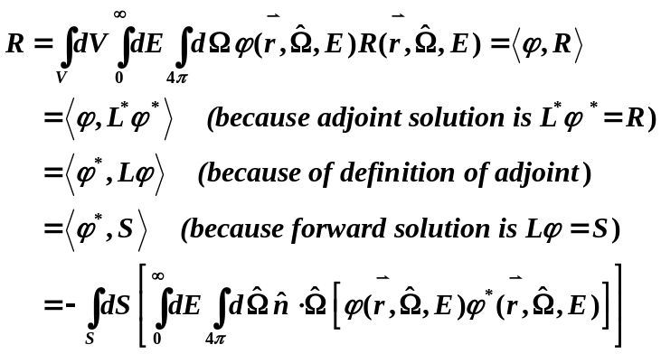
and the minus sign is ignored (adjoint is performed with 180° error in particle direction, so the dot product is calculated as the negative of what the equation assumes).

Outline and flowcharts of project codes:

Outline of the forward Monte Carlo code (Voxel8) steps
For $n=1 to desired number of histories (NPS)$.
- Starting from initial source position pick initial particle direction $Ω_{0}$ within the primary collimator specified cone apex angle – for set initialweight .
- Compute intersection point $\left(x_{intersect} , y_{intersect} ,z_{intersect}\right)$ between the picked particle direction & plane defining adjustable field size.
- Test if $\left(x_{intersect} , y_{intersect} ,z_{intersect} \right)$ within open field or not
- No, discard this direction and start new history (GOTO bullet 1).
- Yes, continue the random walk (GOTO bullet 4).
- Sample source Energy group.
- Sample (Pick) distance to collision site using the maximum total cross section.
- Compute collision site location $\left(x,y,z\right)$.
- Test if the collision site is within the problem geometry:
- No, terminate this history and start new history (GOTO bullet 1).
- Yes, continue the random walk (GOTO bullet 8).
- Score quantities based on current energy and weight.
- Compute Fictitious scattering probability
- Determine type of collision
- Fictitious, keep particle group, direction and weight then go back to selecting new distance to collision pint (GOTO bullet 5).
- Real, Normal scattering process (GOTO bullet 11).
- Lookup the material at this collision site
- Lookup the following for the location site material and particle energy group:
- Scattering probability.
- Group to group CDF.
- Group to group cosine scattering angle data.
- Compute:
- New particle weight based on scattering probability.
- New scatter down to group.
- New direction of travel for this scatter to group.
- Set the new particle parameter values found in step 13
- Repeat the steps for this particle till it exit geometry or die due to Russian roulette (GOTO bullet 5).
End

Perform statistical analysis, and then output the results

Flow chart of the forward Monte Carlo code (Voxel8)
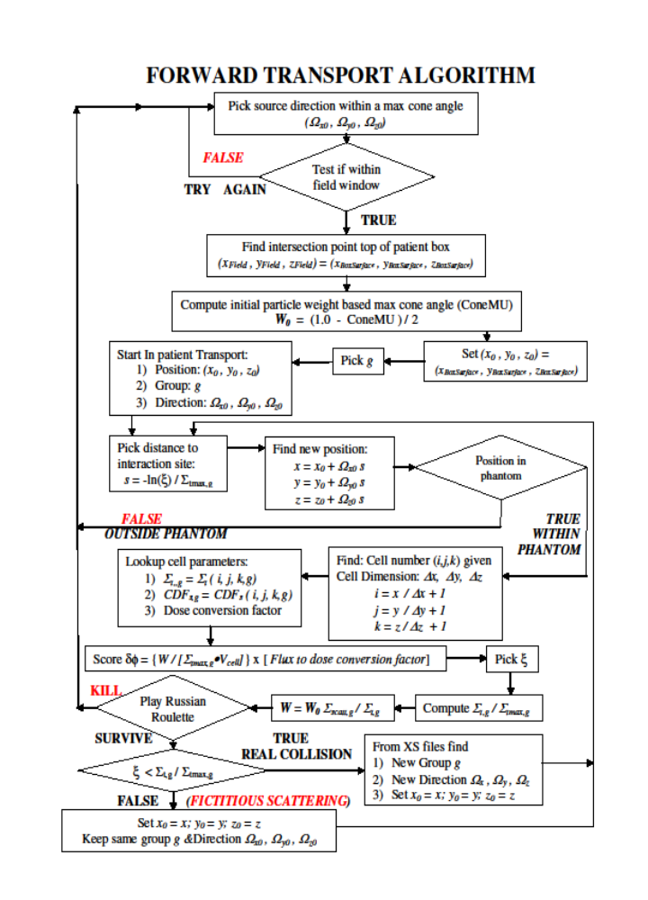

Figure 4-1 Flow chart of forward Monte Carlo code (Voxel8)

Outline of the Adjoint Monte Carlo code (Pixel8) steps
For $n=1 to desired number of histories (NPS)$.
- Set particle initial weight to one.
- Sample voxel from region of interest (ROI).
- Sample initial position within the voxel $\left(x_{0} , y_{0} ,z_{0}\right)$.
- Sample direction isotropically $\left({\hat{Ω}}_{x0} , {\hat{Ω}}_{y0} ,{\hat{Ω}}_{xz0}\right)$.
- Sample source energy group from dose response function.
- Sample distance to collision site from maximum total cross section.
- Compute the new location $\left(x_{new} , { y}_{new},{ z}_{new}\right)$.
- Test if collision site $\left(x_{new} , y_{new},z_{new}\right)$ within the problem geometry:
- No, terminate history (GOTO bullet 1).
- Yes, continue the random walk (GOTO bullet 9).
- For collision site voxel look up:
- Material.
- Total cross section (given material and energy group).
- Compute fictitious scattering probability
- Determine type of collision
- Fictitious, keep particle group, direction and weight then go back to selecting new distance to collision pint (GOTO bullet 6).
- Real, Normal scattering process (GOTO bullet 12).
- Lookup the following for the location site material and particle energy group:
- Scattering probability.
- Group to group CDF.
- Group to group cosine scattering angle data.
- Compute:
- New particle weight based on scattering probability.
- New scatter down to group.
- New direction of travel for this scatter to group.
- Set the new particle parameter values found in step 13
- Repeat the steps for this particle till it exit geometry or die due to Russian roulette (GOTO bullet 6).
- Figure out
  - What surface of geometry particle exited
  - Compute pixel location and index.
  - Bin particle direction.
  - At the pixel score $\left(\frac{Weight}{Cosθ}\right)$.
  - GOTO bullet 1
End

Perform statistical analysis, and then output the results

Flow chart of the Adjoint Monte Carlo code (Pixel8)
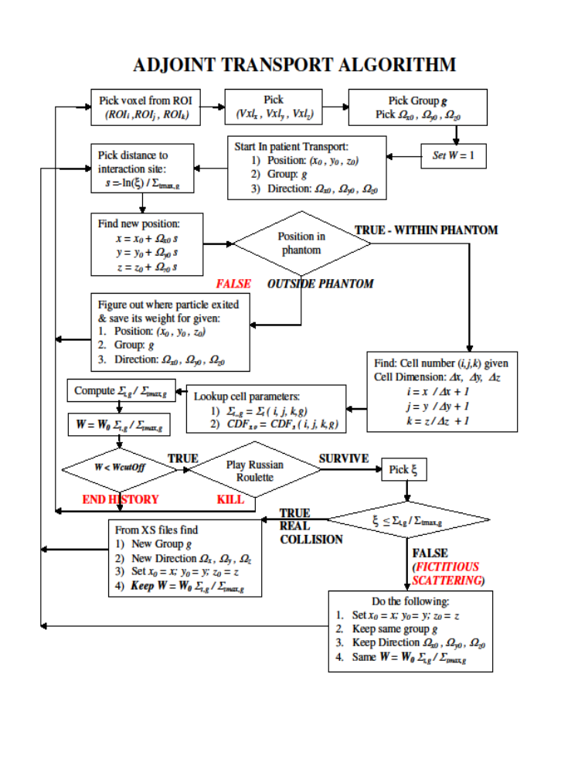
Figure 4-2 Flow chart of adjoint Monte Carlo code (Pixel8)

Steps for the folder code

Read the Adjoint Monte Carlo code Results (Adjoint flux).
For $n=1 to desired number of histories (NPS)$.
- Starting from initial source position pick initial particle direction $Ω_{0}$ within the primary collimator specified cone apex angle –set initial weight.
- Sample source particle energy group from its CDF.
- Find intersection point $\left(x_{intersect} , y_{intersect} ,z_{intersect}\right)$ between the picked particle direction & adjoint flux plane.
- Locate appropriate igloo bin and retrieve data
- Compute response from the following equation:
$$\dot{R}= \int_{S}{dS\sum_{g=1}^{G}{\int_{\hat{n}∙\hat{Ω}<0}{d\hat{Ω}}}}\left|\hat{n}∙\hat{Ω}\right|\left\{φ_{g}^{*}\left(\vec{r},\hat{Ω}\right) S_{g}^{Surf}\left({\vec{r}}_{surface},\hat{Ω}\right) \right\}$$
End

Perform statistical analysis, and then output the results

-
Voxel8 and Pixel8 Code Mechanics

Mathematical basis for Monte Carlo methods

Random variables
A random variable is a variable that can take finite number of values each with associated probability, or infinite number of values whose probabilities are summarized by a density function. One way to get a good estimate of a random variable is by designing an experiment that well generate countable set of the random variable as an elementary event then repeating this experiment several times (Kalos & Whitlock, 2008).
When the experiment is performed it well produce a countable set of $n$ random outcomes,$E_{1}$ , $E_{2}$, $⋯$ , $E_{n}$ each occurring with probability $p_{1}$ , $p_{2}$, $⋯$ , $p_{n}$, respectively and $p_{1} + p_{2} + ⋯ + p_{n} = 1$. A random number $ξ$ picked form the interval $0 ≤ ξ < 1$, will define the probability of event $E_{i}$ occurance. This is represented mathematically as:
$$p_{1} + p_{2} + ⋯ + p_{i-1} ≤ ξ < p_{1} + p_{2} + ⋯ + p_{i}$$
As a result; we can use the same logic to estimate the value of a random variable $x$ as a function of the random number $\left(ξ\right)$. This process is illustrated in Figure 5-1 and explained as follow. Since random numbers has a values between zero and one $0 ≤ ξ < 1$ and because a random number $ξ$ is uniformly distributed on the unit interval, its corresponding random variable $x$ will fall in the interval $i-1 ≤ x < i$ with probability $p_{i}$ determining the event $E_{i}$ (Mathematically the random variable $x$ falls with probability $p\left(t\right)dt$ in the interval $\left(x,x+dx\right)$). Because
$$P\left(x\right)= \sum_{i=1}^{n}{p_{i}} = 1$$
$P\left(x\right)$ is interpreted to mean the cumulative probability of the inequality $\grave{x} ≤ x$ for $x = i$ and $i = 1,2, ⋯ , n$. As a result, the random number $ξ$ is defined to be:
$$ξ = P\left(x\right)= \int_{0}^{x}{p\left(t\right)dt }$$
Using this equation, Figure 5-1 illustrates how a user can select the random variable $x$ uniquely as a function of $ξ$ (Carter et al., 1972).

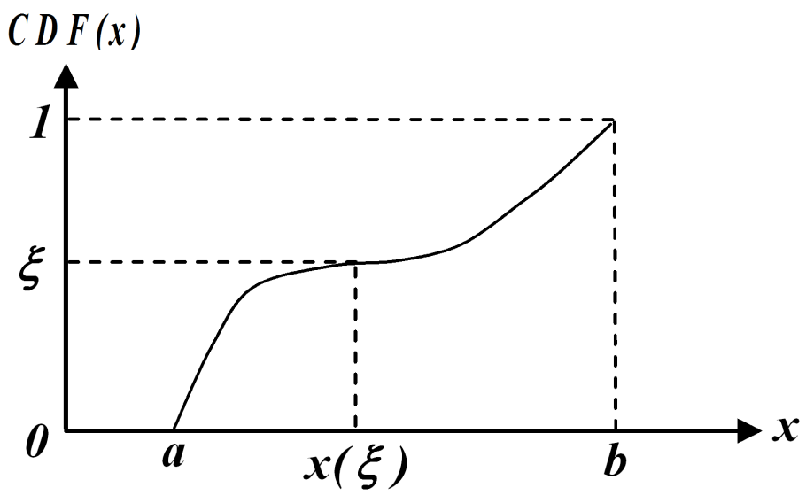

Figure 5-1 Using CDF to sample random variable (x)value

Further, the expectation of the random variable $x$ (also called the stochastic mean) from values $x_{i}$ occurring with discrete probability $p_{i}$ is defined as:
$$E\left(x\right) = 〈x〉 = \sum_{i}{p_{i}}x_{i}$$
If we use $μ$ symbol to denote the expected value or the mean then the above equation becomes:
$$E\left(x\right) = 〈x〉 = \sum_{i}{p_{i}}x_{i }= μ$$
The n^{th} moment of $x$ is defined as the expectation values of the $n^{th}$ power of $x$ is given by:
$$〈x^{n}〉 = \sum_{i}{p_{i}}x_{i}^{n}$$
where the second moment is given by
$$〈x^{2}〉 = \sum_{i}{p_{i}x_{i}^{2}}$$
The central moments of $x$ are given by
$$〈{\left(x-μ\right)}^{n}〉 = \sum_{i}{p_{i}}{\left(x_{i}-〈x〉\right)}^{n}$$
The second central moment is given by:
$$〈{\left(x-μ\right)}^{2}〉 =〈{\left(x-〈x〉\right)}^{2}〉= \sum_{i}{p_{i}}{\left(x_{i}-〈x〉\right)}^{2} = \sum_{i}{p_{i}}{\left(x_{i}-μ\right)}^{2}$$
$$=\sum_{i}{p_{i}}{\left({x_{i}^{2}-2x}_{i}μ+μ^{2}\right)}^{2}=\left(\sum_{i}{p_{i}x_{i}^{2}}\right)-2μ\left(\sum_{i}{p_{i}}x_{i}\right)+μ^{2}\left(\sum_{i}{p_{i}}\right)$$
Using the fact that
$$〈x〉 = \sum_{i}{p_{i}}x_{i}$$
$$〈x^{2}〉 = \sum_{i}{p_{i}x_{i}^{2}}$$
And
$$\sum_{i}{p_{i}} =1$$
Then we can simplify the last equation to:
$$〈{\left(x-μ\right)}^{2}〉 =〈x^{2}〉 -2μμ + μ^{2}= 〈x^{2}〉 - μ^{2}= 〈x^{2}〉 -{〈x〉}^{2}$$
This is called the variance of $x \left[var \left\{x\right\}\right]$. The square root of the variance is a measure of the random variable spread and it is called the standard deviation or standard error. (Kalos & Whitlock, 2008)

Evaluating integrals using Monte Carlo method - “Law of large numbers”
For an independent random variables $x_{1} , x_{2} , ⋯ ,x_{N}$ that are drawn from a distribution, so that the expectation of each $x$ is $μ$. Then, as the sample size $N$ become very large $\left(approches infinity ∞ \right)$ , the average value of the $x's$
$${\overline{x}}_{N }= \frac{1}{N} \sum_{i=1}^{N}{x_{i}}$$
Will almost surely Converges to $μ$ almost surely as sample size $N$ becomes large. This implies that the mean of $n$ sampled variables converges (in probability) to its expected value. So for an estimator $G$, its mean $〈G〉$ , and variance $var\left\{G\right\}$ all exist. The Chebychev inequality is
$$P\left\{\left|G - 〈G〉\right| ≥ \sqrt{\frac{var\left\{G\right\}}{δ}}\right\} ≤ δ$$
Or
$$P\left\{{\left(G - 〈G〉\right)}^{2} ≥ \frac{var\left\{G\right\}}{δ}\right\} ≤ δ$$
and $δ$ is a positive number. This inequality gives an estimation of the chance of generating a large deviation in a Monte Carlo calculation. For the case when we have a large number $N$ of identical estimates of $G$ the variance $var\left\{G\right\} = var\left\{g\right\}$ the above inequality becomes:
$$P\left\{{\left(G - 〈G〉\right)}^{2} ≥ \frac{var\left\{g\right\}}{Nδ}\right\} ≤ δ$$
So when $N$ is large enough, the variance of $G$ becomes as small as one likes, and the probability of getting a large deviation relative to $δ$ between the estimate of the integral and actual value becomes very small.

Heart of Monte Carlo method for evaluating integrals:
For large sample size ($N$), the range of values of $G$ that will be observed with some fixed probability will be contained in a region of decreasing size near it expected value $〈g〉$. The result of a Monte Carlo experiment to estimate a random variable will produce a consistent estimate of the random variable value. Further, this and its value will converge to the expected value as the sample size becomes very large.

Central limit theorem
The sum of large number of independent random variables is always normally distributed (i.e. has a Gaussian distribution), no matter how the individual random variables are distributed, provided they have finite expectations and variance and the number of samples is “large enough”.
In summary for any fixed sample size $\left(N\right)$, there is a PDF that describes the value of $G$ that occurs in a Monte Carlo calculation. Further, as the sample size $N$ become large $\left(aproaches infinity ∞ \right)$ the observed values of $G$ well follow normal distribution.

Random number properties
The random number generator produces a uniformly distributed sequence of numbers $ξ_{0}, ξ_{1},ξ_{2},⋯,ξ_{N}$ between $0$ and $1$. Each random number has the same probability of occurrence in that interval and we essentially consider it to be 1. The uniformity of the produced random number can be illustrated by generating a pair of random (x, y) values and plot then as shown as shown in Figure 5-2.

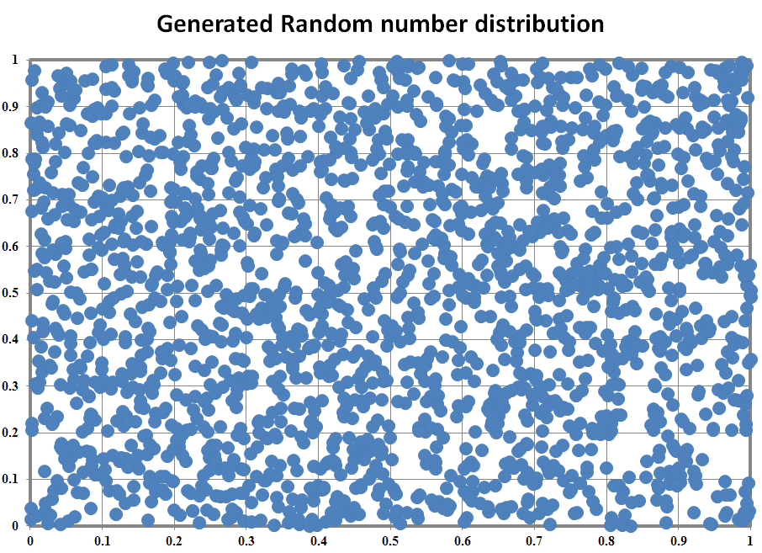
Figure 5-2 Distribution of Random Numbers

Since the value of a random number is between $0$ to $1$ we can think of it as a probability value. Therefore, for a random variable with a known cumulative distribution function selecting a random number is essentially the same as picking the random variable with that CDF value.

Sampling Methods
The following are the selection methods I will be use when selecting random variables values in my code:

Selection from a uniform distribution
For a random variable $x$ that occurs uniformly in the interval $\left[a,b\right]$ Figure 5-3 illustrates a simple method to pick a value for $x$ in that interval. We start by converting the random variable occurrence probability to cumulative probability distribution. Then we pick a random number $ξ$ and find the random variable $x$ value $x\left(ξ\right)$ that corresponds to that $ξ$.
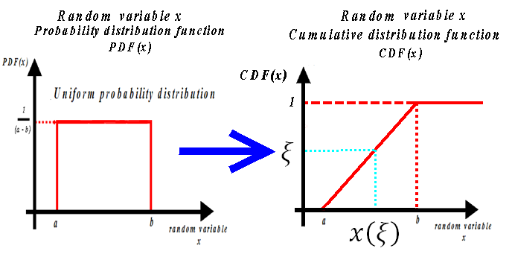

Figure 5-3 Selecting a random variable value from uniform distribution

For a uniform probability function over interval $\left[a,b\right]$ the step are:
- Pick a random number $ξ$ ; this a value between $0.0$ - $1.0$ that is uniformly distributed over that interval $\left[0.0, 1.0\right]$.
- Compute the random variable $x$ using:
$$x = a + (b-a) × ξ$$
I use this selection method to pick a uniformly distributed random variable such initial azimuthal angles and scatter azimuthal angle.

Distribution inversion method
Similarly for a random variable $x$ with occurrence probability not uniformly distributed in the interval $\left[a,b\right]$ Figure 5-4 illustrates a simple method to pick an $x$ value in that interval using distribution inversion method. Each time we select a random number $ξ$, we convert its value to a particular random variable value with the same probability ${CDF}_{R.V.}\left(x\right)\sim x_{ξ}$ . Mathematically, from fundamental principles:
$$Cumulative probability distribution of x represenetd as {CDF}_{R.V.}\left(x\right)$$
$$probability of pick value of x in intercval dx = {CDF}_{R.V.}\left(x\right) dx$$
Similarly for random number $ξ$ we can write:
$$each random number has a probability {CDF}_{R.N.} (v)= 1$$
$$probability of picking ξ in intercval dv ={CDF}_{R.N.} (v)dv =dv$$

Therefore:
$${CDF}_{R.V.}\left(x\right) dx ={CDF}_{R.N.}\left(v\right)dv$$
Integrating we get
$$\int_{0}^{x_{ξ}}{{CDF}_{R.V.}\left(x\right) dx}=\int_{0}^{ξ}{{CDF}_{R.N.}\left(v\right)dv} =\int_{0}^{ξ}{1 dv}$$
$${CDF}_{R.V.}\left(x_{ξ}\right)=ξ$$
$$x_{ξ}={{CDF}_{R.V.}}^{-1}\left(ξ\right)$$
where ${CDF}_{R.V.}\left(x_{ξ}\right)$ is the random variable cumulative probability distribution. This equation is normally used for easily invertible cumulative probability distribution.

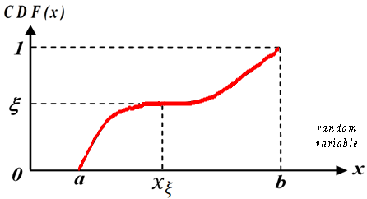

Figure 5-4 Selecting a random variable value using distribution inversion
I use this selection method in my code to select the initial particle energy from its CDF and also its search array, select the down scatter and up scatter groups and cosine of the scattering angle.

Rejection methods
This method is an alternative sampling method to the distribution inverse sampling method. This method is used to ensure that our decision obey specified condition (such as emission of a particle in certain direction). The sample value is accepted if it results in a decision that meets our specified condition and rejected and new sampled is when our decision does not meet the specified condition. As a result of this method, more samples of random numbers will use because we will discard several of these values during the process. Further, forcing or restricting random variables selection may alter their natural probability (should have probability) and will bias our decisions. Consequently, we will need to apply an adjusting factor (new weight) to counter this biasing. The best example to illustrate this method is the selection of initial particle direction to conform to a certain direction and field size (maximum opening of the primary collimator ~ half of cone apex angle and the adjustable field size window at the exiting window).
Figure 5-5 show selection cone. Particles are emitted isotropically and the particle direction vector is specified in spherical coordinates using its starting point, a polar angle and an azimuthal angle. For isotropic emission direction is symmetric as a result the angle along emission direction will take values from 0° to 180° (cosine value between [-1.0, +1.0]) while the azimuthal angle can take values from 0° to 360°. Sampling method that will force particles to travel down the z-axis (polar axis) within the specified cone angle is given below. At the end of the step the picked direction is accepted if it passes through the adjustable field size window and rejected otherwise:
- Pick a random number $ξ_{1}$ then compute a cosine polar angle $μ$ as follow:
$$μ = 1 - \left\{\left(1 - Cos\left(θ\right)\right) × ξ_{1} \right\}$$
- Pick a random number $ξ_{2}$ the select an azimuthal angle as follow:
$$ϕ = 2π × ξ_{2}$$
- Make the particle direction vector.
- Compute the intersection of the vector with field size limiting plane $\left(x_{intersect} , y_{intersect} ,z_{intersect}\right)$.
- Accept this direction if intersection point is within adjustable field size area;
- Reject this direction if intersection point is outside adjustable field size area.
Restricting the emission of particles to an angle theta $θ$ (half of the apex angle of the cone defining the open area of a linac primary collimator) and the ones passing through the adjustable field size window at the exit window will result in restricting particle emission to angles with collimator axis from $0 to θ$. These angle values are mapped to cosine values that range from $Cos\left(θ\right)$ to 1 (this is would have probability). Since the natural cosine range is $\left[-1.0, +1.0\right] = 2$ (should have probability) the adjusting factor that will restore probability is simply the ratio between the “would have” probability to the “should have” probability, which is:
$$adjusting factor = \frac{\left(1 - Cos\left(θ\right)\right)}{2}$$
For Monte Carlo transport this is the weight adjusting factor.
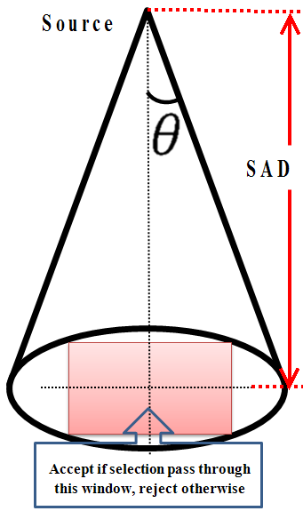

Figure 5-5 Selecting a random variable value using rejection method

Radiation transport by Monte Carlo methods

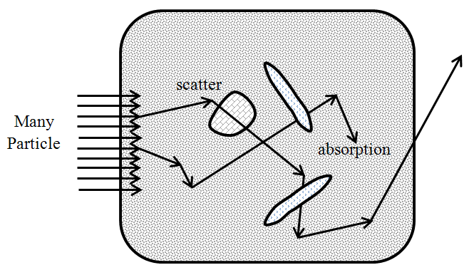

Figure 5-6 Particle interactions as it traverses medium
A particle beam is made of large number of particles (photons or electrons). Therefore, with a sample of these particles we can simulate particle transport and energy deposition as particles traverses the irregular, heterogeneous medium (human body) as shown in Figure 5-6. The particle “histories” can be tallied (“scored”) to generate distribution of internal dose or the exiting particles. The results will have uncertainties due to the mathematical model errors and statistical errors. In general, particle history is dependent on the transported particle (Lux & Koblinger, 1991; Spanier & Gelbard, 1969) type (photons or electrons) and particle incident energy.
Particle interactions are statistical in nature and are considered as random events that occur according to probability distributions. Consequently, the decisions during the particle random walk through a material are made by sampling from those probability distribution using random numbers. The general idea is to convert a sampled random number into a particle random walk variable such as distance to collision, type of collision, scatter angle and new particle energy to estimate integral quantities of interest. Then according to the “law of large numbers” if we repeat this process large number of times the estimate of the quantity of interest should converge to its expected value with calculable variance and standard deviation. Further, for such large number of sample size this estimate will be normally distributed (i.e. has a Gaussian distribution), no matter how the individual random variables are distributed, according to the “central limit theorem”. This is the bases of Monte Carlo estimate of any integral random variable.

The random walk / history for a linear accelerator particles

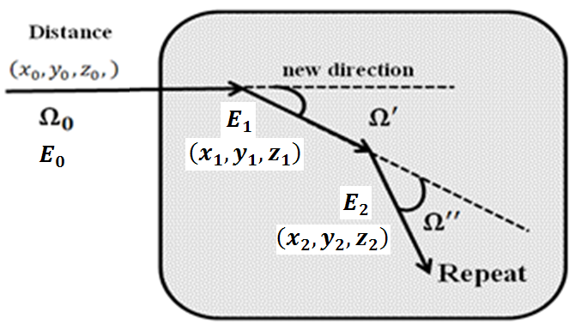

Figure 5-7 Random walk / history steps
Figure 5-7 illustrates the events occurring during particle random walk in a medium (E. D. Cashwell & Everett, 1959) and are the bases of Monte Carlo simulation of radiation transport in a medium. For the purpose of our project, this random walk is essentially the same in forward and adjoint Monte Carlo mode except at the start of the random walk and the outcome of a scattering event.

Selection of initial particle parameters

Initial Direction
In forward mode, we start our transport by selecting initial particle direction as describe in the rejection method section above. The result is an initial direction choice within the adjustable field size window. The passing particle will have an initial weight of:
$${Wght}_{0}= \frac{\left(1 - Cos\left(θ\right)\right)}{2}$$
In adjoint mode, we start from a region of interest voxel (i.e. selecting a voxel index) where all voxel have the same probability. Then I select a starting point $\left(x, y, z\right)$ inside voxels as follow:
- $Select random number ξ_{x} then compute$
$x_{i} = x_{min} + dx × ξ_{x}$.
- $Select random number ξ_{y} then compute$
$y_{i} = y_{min} + dy × ξ_{y}$.
- $Select random number ξ_{z} then compute$
$z_{i} = z_{min} + dz × ξ_{z}$.
Then an initial direction is selected by selecting a cosine of a polar angle and azimuthal angle. Then these two values are converted to Cartesian coordinate. The steps are as follow:
- $Select random number ξ_{μ} then compute$
$$Ω_{z} = μ = -1.0 + 2.0 × ξ_{μ}$$
- $Select random number ξ_{ϕ} then compute$
$$ϕ = 2.0 × π ×ξ_{ϕ}$$
$$Then compute:$$
$$\sqrt{1-μ^{2}}$$
$$x \& y direction component:$$
$$Ω_{x} = \sqrt{1-μ^{2}} Cos\left(ϕ\right)$$
$$Ω_{y} = \sqrt{1-μ^{2}} Sin\left(ϕ\right)$$

Initial energy
Our research interest is the poly energetic photon spectrum generated by a medical linear accelerator. Description of spectrum can be found papers published by Mohan, Chui, and Lidofsky in 1985 and the paper by Sheikh-Bagheri and Roger in 2002 (Mohan, Chui, & Lidofsky, 1985; Sheikh-Bagheri & Rogers, 2002). The latest paper by Sheikh Bagheri & Rogers (Mohan et al., 1985; Sheikh-Bagheri & Rogers, 2002) calculated and tabulate the photon spectrum using Monte Carlo simulation for nine beams from three major manufacturers of commercial medical linear accelerators with energies ranging from 4-25 MV at the source location. The data is separated into two categories according to the linear accelerator maximum energy as high energy (energy between 15-25 MV) and low energy (4-10 MV). Figure 5-8 is a plot of the computed photon spectrum for a high energy linac while Below is a plot Figure 5-9 is a plot of the computed photon spectrum for a low energy linac.
In forward transport mode, the desired photon spectrum is selected. The probability distribution function $PDF$ and the cumulative probability distribution $CDF$ are calculated a search array is built. The initial particle energy is selected from the CDF using the distribution inversion method described earlier.
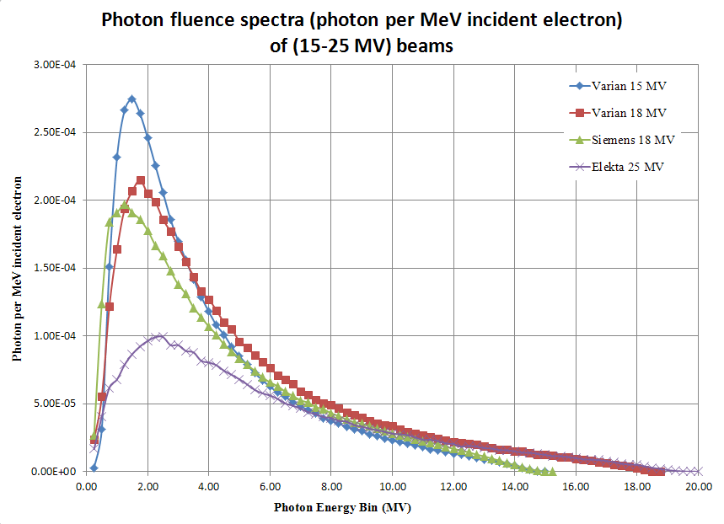

Figure 5-8 High energy spectrum (15-25 MV) from Medical Linear Accelerator

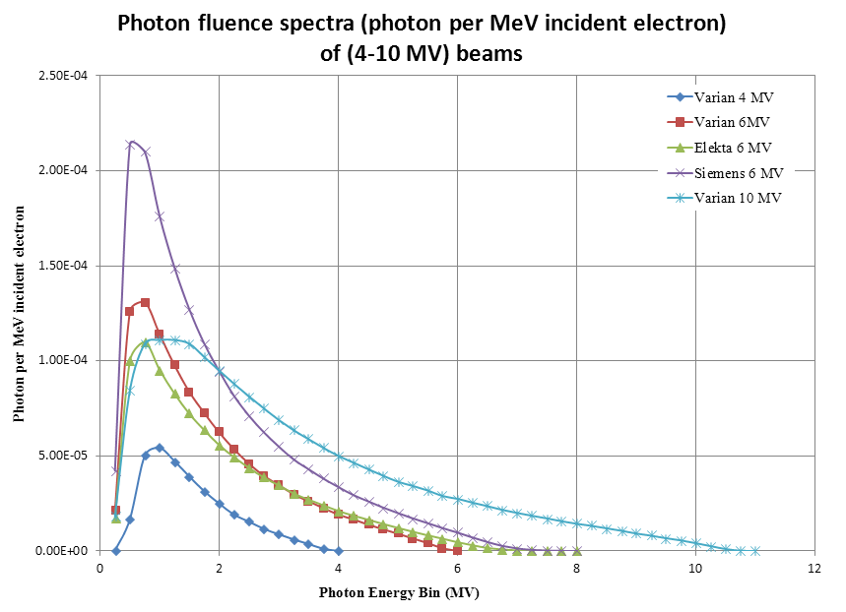

Figure 5-9 Low energy spectrum (4-10 MV) from Medical Linear Accelerator
To speed up the initial energy selection process I build a search array that bins the photon spectrum $CDF$ into a known number of bins. The number of search array bins reflects the desired search precision. In my implementation I use a search array size of a 1000. Therefore, the search array bins index will reflect the photon group $CDF$ values multiplied by a 1000. The array itself will hold the corresponding energy group. Once a group is selected it is verified against the actual photon $CDF$ and adjusted accordingly. Using the search array will eliminate the need to loop through the entire photon spectrum $CDF$ every time we start a new history.
Similarly in adjoint transport mode, the best guess about the adjoint source probability distribution is built from the response function before the start of transport. The probability distribution function $PDF$ and the cumulative probability distribution $CDF$ are calculated and a search array is built. During transport the initial adjoint particle energy is sampled from the search array then verified with CDF using the distribution inversion method described earlier.

Sampling the distance to interaction / collision site Sampling ,
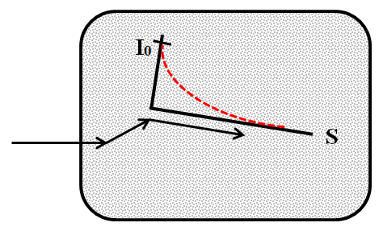

Figure 5-10 Distance to collision site sampling

Both the forward and adjoint transport uses the same process to sample distance to collision site. This process is illustrated in Figure 5-10 and the mathematics behind it is given below.
Let the optical depth $β\left(x\right)$traversed by a particle traveling a distance $x$ through a homogenous medium with arbitrarily specified macroscopic cross-section $Σ\left(x\right)$ (Carter & Cashwell, 1975; Carter et al., 1972; E. Cashwell, Neergaard, Taylor, & Turner, 1972; E. D. Cashwell & Everett, 1959) defined and shown in Figure 5-10 as:
$$β\left(x\right)= \int_{0}^{x}{Σ\left(x^{'}\right)}dx^{'}$$
Assuming that $Σ\left(x\right)$is finite and $Σ\left(x\right) ≥0$. The probability of traversing a distance $x$ in a medium without collision event when $x$ is $0 ≤x < ∞$ is:
$$probability of traversing a distance x = e^{-β\left(x\right)}$$
The independent interaction probability per distance traveled event is:
$$\frac{dβ}{dx}= Σ\left(x\right)$$
Which lead to $≤\frac{dβ}{dx} < ∞$.
The probability density function (PDF) for a collision occurring after a particle traveling a distance $x$ through a medium is given by the product of the above two equation:
$$PDF\left(x\right)=\frac{dβ}{dx} ∙ e^{-β\left(x\right)}$$
Normalizing the result by integrating the equation yield the normalization constant $G$ :
$$G= \int_{0}^{∞}{\frac{dβ}{dx} ∙ e^{-β\left(x\right)} dx}=1-e^{-β\left(∞\right)}$$
To allow for particles that have no collisions during it history we define “no collision probability” $P_{NC}$ (probability a particle travels a finite distance without any collision) as:
$$P_{NC}=e^{-β\left(∞\right)}$$
The normalization constant $G$ becomes:
$$G= \int_{0}^{∞}{\frac{dβ}{dx} ∙ e^{-β\left(x\right)} dx}=1-e^{-β\left(∞\right)}=1- P_{NC}$$
The probability density function $\left(PDF\right)$ for a collision occurring after a particle traveled a distance $x$ through a medium is now can be expressed as the sum of the two mutually exclusive events probability (probability of no interactions and interaction) given by
$$PDF\left(x\right)= P_{NC}∙δ\left(x= ∞\right)+ \frac{dβ}{dx} ∙ e^{-β\left(x\right)}$$
If we use the fact that
$$1= \frac{\left(1-P_{NC}\right)}{\left(1-P_{NC}\right)} = \left(1-P_{NC}\right) ∙ \frac{1}{\left(1-P_{NC}\right)}=\left(1-P_{NC}\right) ∙ \frac{1}{G}$$
Our probability density function (PDF) for a collision occurring after a particle traveled a distance $x$ through a medium is:
$$PDF\left(x\right)= P_{NC}∙δ\left(x= ∞\right)+\left(1-P_{NC}\right) ∙ \frac{1}{G} ∙ \frac{dβ}{dx} ∙ e^{-β\left(x\right)}$$
Note that the PDF equation allows for the possibility of traveling an infinite distance without colliding. These are cases that occur when $Σ\left(x\right) →0$ as $x → ∞$ (most often occurring when the solution volume is limited to a finite region and void assumed outside of this volume)
Random sampling the Monte Carlo flight path requires solving the following equation for $s$, the flight path:
$ξ= \int_{0}^{s}{PDF\left(x\right)} dx$ or $ξ=CDF\left(s\right)$
where $ξ$ is a uniform random number in $\left[0\right.,\left.1\right)$, $pdf\left(x\right)$ by the equations above and the $CDF\left(x\right)$ is given by:
$$CDF\left(x\right)= \int_{0}^{s}{CDF\left(x^{'}\right)} dx^{'}= P_{NC} ∙H\left(x,∞\right)+ \left(1-P_{NC}\right) ∙ \frac{1-e^{-β\left(x\right)}}{1-e^{-β\left(∞\right)}}$$
With $H\left(x,∞\right)$ the Heaviside step function. Frequently we write $S$ as:
$$S={CDF}^{-1}\left(ξ\right)$$
For the infinite homogenous medium case when the cross section is a constant and independent of $x$ the optical distance equation simplifies to:
$β\left(x\right)= Σx$, $\frac{dβ}{dx}= Σ$, $P_{NC}=0$, $G=1$, $CDF\left(x\right)=Σe^{-Σx}$
And the solution for
$ξ= \int_{0}^{s}{CDF\left(x\right)} dx$ or $ξ=CDF\left(S\right)$
is
$$S= - \frac{ln\left(1-ξ\right)}{Σ}$$
Since $ξ$ and $\left(1-ξ\right)$ has equivalent uniform distribution, the above equation is commonly implemented as
$$S= - \frac{ln\left(ξ\right)}{Σ}$$
As particle traveling the medium it enters region with different total cross section $Σ\left(x\right)$. Therefore, the sampled distance to the next collision $S$ will vary. When the value of $S$ are larger than region dimensions we need to adjust $S$ appropriately. This will result in a lot of computation time spent trying to figure out distances to boundaries. We can avoid this situation by utilizing the concept of factitious scattering method. When using fictitious scattering method the material actual total cross section is replaced with a fictitious total cross section. Then the transport performed using this fictitious total cross section. Using the fictitious total cross section eliminates the need to check and compute distance to current region boundaries every time we need compute distance to next collision, therefore; it results in a computational time saving. The details of how we applied this method described previously.

New particle position
The particle’s new and old Cartesian position is related by:
$$x_{new}= x_{old}+S Ω_{x_{new}}$$
$$y_{new}= y_{old}+S Ω_{y_{new}}$$
$$z_{new}= z_{old}+S Ω_{z_{new}}$$
The computed location is tested against the geometry boundaries to determine if the particle is still in the geometry. If the particle is still in the geometry the transport continues otherwise the history terminates and a new history is started. Both forward and adjoint method uses the same formulas to compute the particle new position.

Sampling interaction / collision type
Our research will only deal only with scattering $\left(μ_{s}\left(\frac{1}{cm}\right)\right)$ and absorption $\left(μ_{a}\left(\frac{1}{cm}\right)\right)$ interactions.
In the forward mode, the “down scattering probability” $α_{down}$ is defined as the fraction of interactions / collisions that are down scatters, hence:
$$α_{down}= \frac{μ_{scatt-down}}{μ_{scatt-down}+μ_{a}} = \frac{μ_{scatt-down}}{μ_{T}}$$
In the forward mode, this ratio is always less than one because the down scattering cross section is always less that the total cross section.
In the adjoint mode, the “up scattering cross section” is computed first as described in Appendix A section five, then the “up scattering probability” $α_{up}$ is defined as the fraction of interactions / collisions that are up scatters, hence:
$$α_{Up}= \frac{μ_{scatt-Up}}{μ_{scatt-Up}+μ_{a}} = \frac{μ_{scatt-Up}}{μ_{T}}$$
In the adjoint mode, this ratio would be greater than one in some instances because the up scattering cross section will be greater than total cross section in some instances.
Using basic sampling we determine Interaction / collision type as follow:
- Sample $ξ$ ; pick a value in the interval $\left[0 , 1\right]$ then we decide if interaction is scatter or absorption as follows:
  - Scatter interaction if $ξ < α$
  - Absorption interaction if $ξ > α$
This method is rarely used in practice due to its inefficiency because when an absorption interaction occur the particles “dies” terminating the simulation and the medium is not sampled any further. Survival weighting (non-absorption weighting) is a way around this inefficiency and I implement this method in my code. The method is based on keeping all particles alive by not allowing absorption to occur $\left(making μ_{a}\left(\frac{1}{cm}\right)=0\right)$. As a result the, the computed estimates are biased. This error corrected for by reducing the particle “weight” after each true collision. The following is how I implement this method:
- Particle weight at the start of history $w=1$ or any initial value.
- When interaction occur the weight $w$ is reduce by a factor of $α$ after each interaction.
The following is proof of why this method works:
Survival weighting reduces the variance in scored quantities because it scores particle weights and not particle numbers. This concept is illustrated in Figure 5-11.

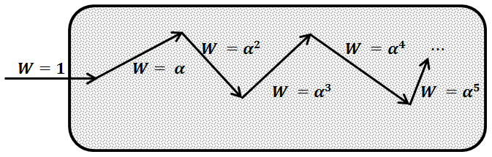
Figure 5-11 Survival weighting (non-absorption weighting)

We can prove how survival weighting reduces variance in scored quantities using a simulation of a single particle incident on a slab and scoring transmittance, , $\left(known to be 50\%\right)$ . When using:
- Basic Sampling – produces estimate of either $T=0$ or $=1$ , hence large variance.
- Survival weighting – produces estimate in the interval $\left(0,1\right)$ of $T= α^{i}$ , with $i=\# collisions.$
It is worth noting that survival weighting reduces variances in scored quantities but not the mean as illustrated in Figure 5-12:

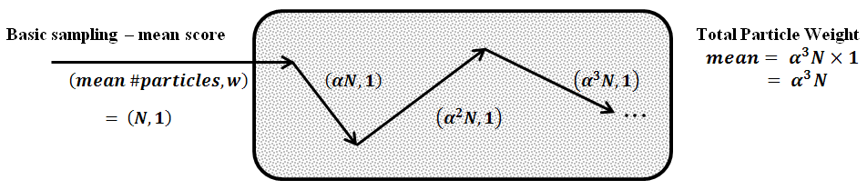

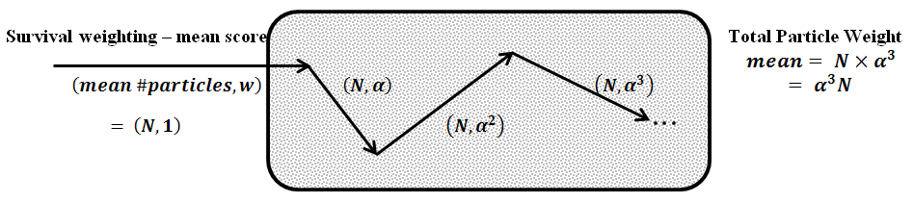
Figure 5-12 Comparison between basic sampling and survival weighting

When we use survival weighting we spend a lot of time tracking low weight particles endlessly long after their weights become very small. Approximately 50% of CPU time is consumed to track secondary and higher order photons and the electrons they set in motion. “Russian roulette” is a variance reduction technique designed to avoid tracking particles with low weights using biased sampling methods. Particles whose weight fall below a preset weight threshold, $W_{min}$, is forced to play one game of Russian roulette.
The user define a particle kill probability $P_{kill}$ . When a particle weight falls below $W_{min}$, we draw a random number , a value between $\left[0, 1\right].$ Then if
          - $< P_{kill}$ particle is killed $→$ $W_{new}=0$
          - Else; particle lives with $→$ $W_{new}=W_{min} ∙ \frac{1}{\left({1-P}_{kill}\right)}$
Application of Russian roulette to scattered photons reduces the CPU time but introduces an additional source of variance (because of varying weights). It is therefore not a priori clear whether this technique increases the efficiency. Russian roulette is biased sampling, but fair. If a large number of particles, , of weight, $W$, get rouletted, the statistical expectation for the total surviving weight is
$$〈E〉=N ∙ \left(1-P_{kill}\right) ∙ \frac{W}{\left(1-P_{kill}\right)}=NW$$
Which is the same as without Russian roulette. Therefore, the sampling is biased but the results are not. The process is illustrated in Figure 5-13:
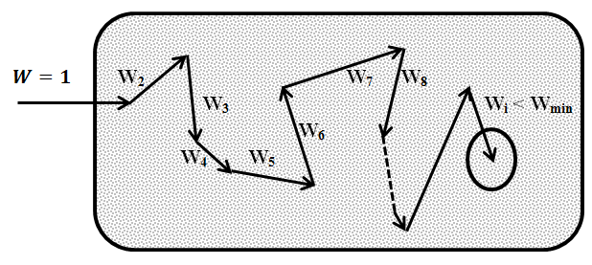

Figure 5-13Illustration of Russian roulette

Sampling the scattering event energy then direction
For the current particle energy a cumulative probability values (CDF) are tabulated for all possible scattered to groups during transport data preparation step for both transport modes. These cumulative probability values represent the maximum random number value for the listed scatter to group. Once a scatter to group is determined a cosine of scattering angle is picked from a tabulated cumulative probability values for all possible cosine scattering angles computed. These values were also computed during transport data preparation step and they represent the maximum random number value to scatter in that particular direction. The distribution inversion method is used to determine the next particle energy and scattering direction. Figure 5-14 gives a pectoral illustration of the sampling of after scatter particle energy and direction. Further, the new direction $Ω_{new}$ is computed using the relationship with the old direction $Ω_{old}$ through the new scattering polar angle $θ$ and azimuthal angle $φ$ and the old direction of cosine described by Carter and Cashwell (Carter & Cashwell, 1975) and given by spherical coordinate equations below:
$$Ω_{old}= \left(Ω_{x_{old}},Ω_{y_{old}},Ω_{z_{old}}\right)$$
$$Ω_{x_{new}}= Ω_{x_{old}}Cosθ+ \frac{Sinθ}{\sqrt{1-Ω_{z_{old}}^{2}}} \left(Ω_{x_{old}}Ω_{z_{old}}Cosφ - Ω_{y_{old}}Sinφ \right)$$
$$Ω_{y_{new}}= Ω_{y_{old}}Cosθ+ \frac{Sinθ}{\sqrt{1-Ω_{z_{old}}^{2}}} \left(Ω_{y_{old}}Ω_{z_{old}}Cosφ + Ω_{x_{old}}Sinφ \right)$$
$$Ω_{z_{new}}= Ω_{z_{old}}Cosθ+ \frac{Sinθ}{\sqrt{1-Ω_{z_{old}}^{2}}} \left(-\left[1-Ω_{z_{old}}^{2}\right]Cosφ \right)$$
In Cartesian coordinates, the new direction is found using simple vector rotation. The first rotation is around the positive y-axis then followed by a rotation around the z- axis.
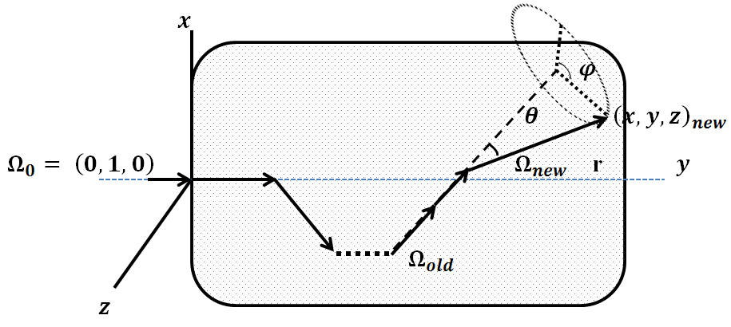

Figure 5-14 Sampling the energy &direction change (scatter direction)

Statistical Analysis of the results
In a Monte Carlo Method simulation to estimate an independent random variables $x$ by drawing $x_{1}$ , $x_{2}$ , $⋯$ , $x_{n}$ from a distribution, the expectation value of $x$ is calculated using the following equation:
$${\overline{x}}_{N}= \frac{1}{N} \sum_{i=1}^{N}{x_{i}}$$
The variance of this estimate when a large sample is drawn is calculated using the following equation:
$$σ^{2} = \left(\frac{N}{N-1}\right) \left\{\frac{1}{N} \sum_{n=1}^{N}{x_{n}^{2}} -{\left(\frac{1}{N} \sum_{n-1}^{N}{x_{n}}\right)}^{2}\right\}$$
If a sample size $N$ is used in the simulation the sample variance is calculated using the following equation:
$$σ_{Sample}^{2} = \left(\frac{1}{N-1}\right) \left\{\frac{1}{N} \sum_{n=1}^{N}{x_{n}^{2}} -{\left(\frac{1}{N} \sum_{n-1}^{N}{x_{n}}\right)}^{2}\right\}$$

- -
Sample problems description
To run the code we will need the following:
- Phantom / Patient:
This is a collection of two dimensional maps that describe the material composition of the medium in question. We can get this map either from CT data sets or built it from simple geometric shapes. For the purpose of the project we built a 50.0 cm x 50.0 cm x 50.0 cm water filled box. The box is divided into voxels of 0.5 cm x 0.5 cm x 0.5 cm. The following is the used direction convention:
- X-axis runs along the box width.
- Y-axis runs along the box depth.
- Z-axis runs along the box length.
The top of the box is the most negative y plane. The furthest top left corner is the minimum box point and the furthest bottom right corner is the maximum box point. Using this configuration the origin (0.0, 0.0, 0.0) is at the center of the top layer.
- Radiation Source:
The source is a photon only poly energetic source produced by a medical linear accelerator. The source distribution has a very well defined spectrum published by several authors. The source energy is designated as 6 MeV or 18 MeV. Source strength is defined at 100.00 cm away from source at a reference depth and field size (for a linear accelerator that is calibrated using source to phantom surface distance (SSD) method - a common calibration method - is 1.0 cGy / monitor unit at the selected energy maximum depth and 10.0 cm x 10 cm field size).
- Irradiation geometry:
The source can be at any position around the phantom / patient via simple source rotation. The radiation field boundary (field size) is defined at 100.0 cm away from the source by either a set of jaws and / or by multi leaf collimator. The outer radiation field shape can be squares or rectangles by adjusting the jaws from 1.0 cm x 1.0 cm up to 40.0 cm x 40.0 cm. The inner field shape can is modified using multi leaf collimator to further collimate the shape of the radiation field to conform to desired targets.
For a coplanar (same - one – plane normally designated XY) beam arrangement we will have one plane (X-Y). For each beam we will always have one central axis (CAX) and iso-center (machine physical center and treatment center). This illustrated in the figure below:
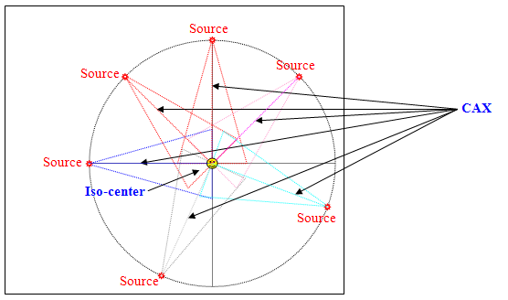

Figure 6-1 coplanar beam arrangement
The following is an illustration of source position around the phantom:
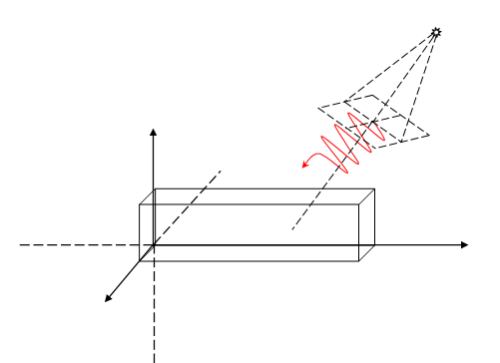
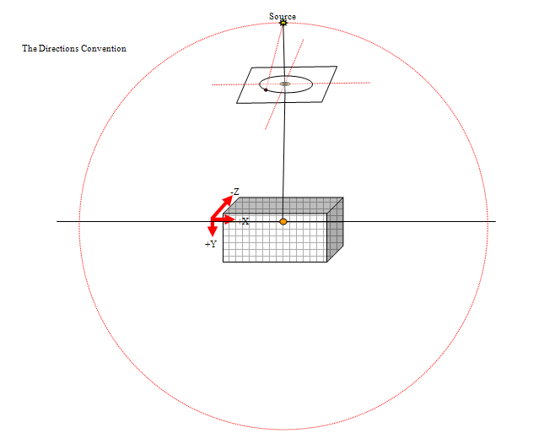

Figure 6-2 Source position around phantom
The following is illustration of the coordinate convention used throughout the code.
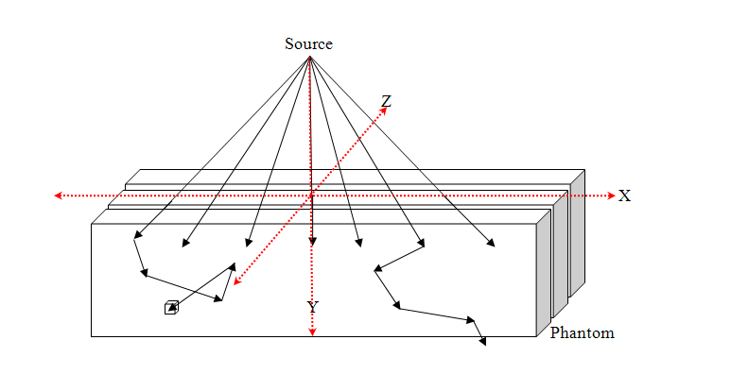
Figure 6-3 Problem coordinate convention

It is worth noting that this coordinate convention is used to describe medical images. For a set of 3-D medical images (e.g. computed tomography data) with the patient in the supine position (rested on his back) the following is the direction convention:
- The x-axis runs from right to left when examining one slice of data (transverse direction) with the negative direction at patient right side and positive direction at patient left side.
- The y-axis runs from top to bottom when examining one slice of data (axial direction) with the negative direction at patient bottom side (posterior position) and positive direction at patient top side (anterior position).
- The z-axis follow the patient mid line with the positive direction is at the patient superior end (head) and the negative direction is at the patient inferior end (feet).

The following describes the sample problems used to verify Voxel8 / Pixel8 code.
- Conventional and fictitious forward codes verification:
- Phantom:
50.0 cm x 50.0 cm x 50.0 cm water filled box with voxel dimension of 0.5 cm x 0.5 cm x 0.5 cm.
- Radiation Source:
Varian 6 MeV medical linear accelerator photon spectrum as published by (Sheikh-Bagheri & Rogers, 2002). The following are a plot and listing for the spectrum distribution of the Varian 6 MeV photon beam:
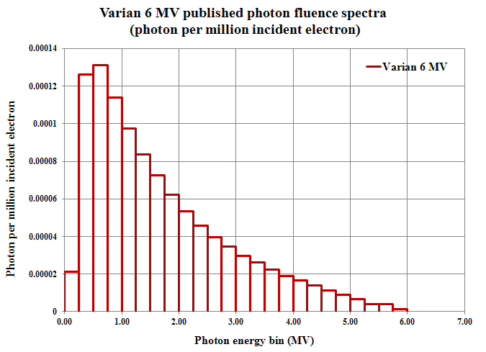
Figure 6-4 Varian 6 MeV published spectra

Table 6-1 Varian 6 MeV published spectra
Gamma Group # | Energy Bin Upper Bound (MeV) | Photons per MeV incident electrons | PDF
1 | 0.25 | 2.14E-05 | 0.020530
2 | 0.50 | 1.26E-04 | 0.120877
3 | 0.75 | 1.31E-04 | 0.125674
4 | 1.00 | 1.14E-04 | 0.109365
5 | 1.25 | 9.76E-05 | 0.093632
6 | 1.50 | 8.36E-05 | 0.080201
7 | 1.75 | 7.25E-05 | 0.069552
8 | 2.00 | 6.23E-05 | 0.059767
9 | 2.25 | 5.35E-05 | 0.051325
10 | 2.50 | 4.59E-05 | 0.044034
11 | 2.75 | 3.95E-05 | 0.037894
12 | 3.00 | 3.47E-05 | 0.033289
13 | 3.25 | 2.98E-05 | 0.028588
14 | 3.50 | 2.61E-05 | 0.025039
15 | 3.75 | 2.25E-05 | 0.021585
16 | 4.00 | 1.91E-05 | 0.018323
17 | 4.25 | 1.66E-05 | 0.015925
18 | 4.50 | 1.38E-05 | 0.013239
19 | 4.75 | 1.14E-05 | 0.010937
20 | 5.00 | 9.04E-06 | 0.008672
21 | 5.25 | 6.55E-06 | 0.006284
22 | 5.50 | 4.09E-06 | 0.003924
23 | 5.75 | 1.40E-06 | 0.001343
24 | 6.00 | 4.34E-08 | 0.000042

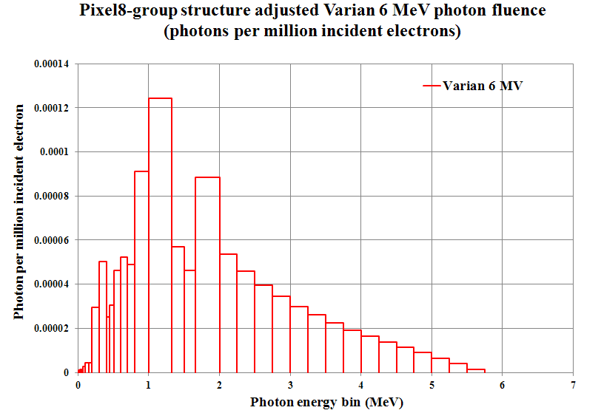
Figure 6-5 Varian 6 MeV spectra adjusted to Pixel8 structure

Table 6-2 Varian 6 MeV spectra adjusted to Pixel8 structure
Gamma Group # | Energy Bin Upper Bound (MeV) | Photons per MeV incident electrons | PDF
1 | 0.010 | 0.00000000 | 0.000000
2 | 0.020 | 8.9167E-07 | 0.000855
3 | 0.030 | 8.9167E-07 | 0.000855
4 | 0.045 | 1.3375E-06 | 0.001283
5 | 0.060 | 1.3375E-06 | 0.001283
6 | 0.070 | 8.9167E-07 | 0.000855
7 | 0.100 | 2.6750E-06 | 0.002566
8 | 0.150 | 4.4583E-06 | 0.004277
9 | 0.200 | 4.4583E-06 | 0.004277
10 | 0.300 | 2.9658E-05 | 0.028451
11 | 0.400 | 5.0400E-05 | 0.048349
12 | 0.450 | 2.5200E-05 | 0.024174
13 | 0.510 | 3.0440E-05 | 0.029201
14 | 0.512 | 1.0480E-06 | 0.001005
15 | 0.600 | 4.6112E-05 | 0.044235
16 | 0.700 | 5.2400E-05 | 0.050268
17 | 0.800 | 4.9000E-05 | 0.047006
18 | 1.000 | 9.1200E-05 | 0.087489
19 | 1.330 | 1.2435E-04 | 0.119290
20 | 1.500 | 5.6848E-05 | 0.054535
21 | 1.660 | 4.6400E-05 | 0.044512
22 | 2.000 | 8.8400E-05 | 0.084803
23 | 2.250 | 5.3500E-05 | 0.051323
24 | 2.500 | 4.5900E-05 | 0.044032
25 | 2.750 | 3.9500E-05 | 0.037893
26 | 3.000 | 3.4700E-05 | 0.033288
27 | 3.250 | 2.9800E-05 | 0.028587
28 | 3.500 | 2.6100E-05 | 0.025038
29 | 3.750 | 2.2500E-05 | 0.021584
30 | 4.000 | 1.9100E-05 | 0.018323
31 | 4.250 | 1.6600E-05 | 0.015924
32 | 4.500 | 1.3800E-05 | 0.013238
33 | 4.750 | 1.1400E-05 | 0.010936
34 | 5.000 | 9.0400E-06 | 0.008672
35 | 5.250 | 6.5500E-06 | 0.006283
36 | 5.500 | 4.0900E-06 | 0.003924
37 | 5.750 | 1.4000E-06 | 0.001343
38 | 6.000 | 4.3400E-08 | 0.000042

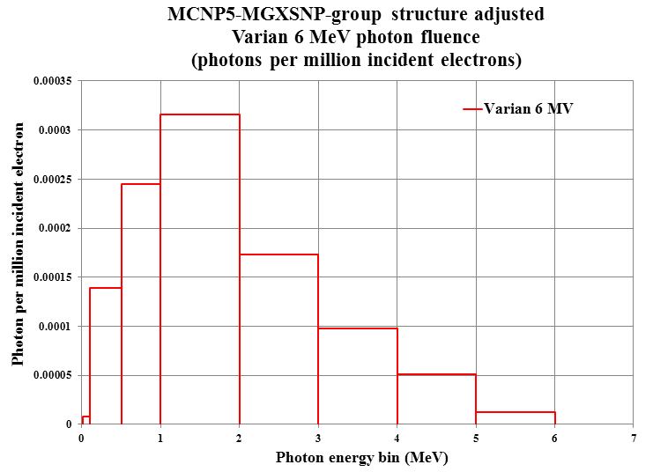
Figure 6-6 Varian 6 MeV spectra adjusted to MCNP5-MGXSNP structure

Table 6-3 Varian 6 MeV spectra adjusted to MCNP5-MGXSNP structure
Gamma Group # | Energy Bin Upper Bound (MeV) | Photons per MeV incident electrons | PDF
1 | 0.010 | 0.000000 | 0.000000
2 | 0.100 | 8.025E-06 | 0.007698
3 | 0.500 | 1.394E-04 | 0.133707
4 | 1.000 | 2.450E-04 | 0.235028
5 | 2.000 | 3.160E-04 | 0.303138
6 | 3.000 | 1.736E-04 | 0.166534
7 | 4.000 | 9.750E-05 | 0.093532
8 | 5.000 | 5.084E-05 | 0.048771
9 | 6.000 | 1.208E-05 | 0.011591

Note: The photons are produced as a result of slowing down electrons in a tungsten target (bremsstrahlung spectrum). The produced bremsstrahlung spectrum is forwardly peaked and is collimated to produce a maximum square field of 40.0 cm x 40.0 cm at 100.0 cm downstream from the target. The energy upper bound is in MeV and the PDF will be used to model the source distribution in MCNP5.
- Geometry:
  - Location:
The source is positioned at 100.00 cm directly above the water box center. The particles travel straight down and limited to ~ 11.30993 cone from the source. The following is the MCNP source definition:
- Published 6 MeV photon spectrum:

c
c **********************************************************
c ************ Energy Distribution 2100-6MV ******************
c ************ Group structure - Published ********************
c **********************************************************
c
SI1 H 0.010 0.250 0.500 0.750 1.000 1.250 1.500 1.750 2.000 2.250
2.500 2.750 3.000 3.250 3.500 3.750 4.000 4.250 4.500 4.750
5.000 5.250 5.500 5.750 6.000
SP1 D 0.000000 0.020529 0.120872 0.125669 0.109361 0.093628
0.080198 0.069549 0.059765 0.051323 0.044032 0.037892
0.033288 0.028587 0.025038 0.021584 0.018323 0.015924
0.013238 0.010936 0.008672 0.006283 0.003924 0.001343
0.000042
c
c **********************************************************
c Picking in a 11.30993 cone (Bias = 1/ 0.009707)
c **********************************************************
c
SI2 -1 0.980581 1. $ Histogram for cosine bin limits
SP2 0.0 0.99029 0.009707 $ frac. solid angle for each bin
SB2 0. 0. 1. $ source bias for each bin
c

- Pixel8 group structure adjusted 6 MeV photon spectrum:

c
c **********************************************************
c ************ Energy Distribution 2100-6MV ******************
c ************ Group structure - Pixel8 **********************
c **********************************************************
c
SI1 H 0.010 0.020 0.030 0.045 0.060 0.070 0.100 0.150 0.200
0.300 0.400 0.450 0.510 0.512 0.600 0.700 0.800 1.000
1.330 1.500 1.660 2.000 2.250 2.500 2.750 3.000 3.250
3.500 3.750 4.000 4.250 4.500 4.750 5.000 5.250 5.500
5.750 6.000
SP1 D 0.000000 0.000855 0.000855 0.001283 0.001283 0.000855
0.002566 0.004277 0.004277 0.028451 0.048349 0.024174
0.029201 0.001005 0.044235 0.050268 0.047006 0.087489
0.119290 0.054535 0.044512 0.084803 0.051323 0.044032
0.037893 0.033288 0.028587 0.025038 0.021584 0.018323
0.015924 0.013238 0.010936 0.008672 0.006283 0.003924
0.001343 0.000042
c
c **********************************************************
c Picking in a 11.30993 cone (Bias = 1/ 0.009707)
c **********************************************************
c
SI2 -1 0.980581 1. $ Histogram for cosine bin limits
SP2 0.0 0.99029 0.009707 $ frac. solid angle for each bin
SB2 0. 0. 1. $ source bias for each bin
c

- MCNP5-MGXSNP adjusted 6 MeV photon:

c
c***********************************************************
c ************ Energy Distribution 2100-6MV ******************
c ************ Group structure MCNP-MGXSNP ***************
c **********************************************************
c
SI1 H 0.010 0.100 0.500 1.000 2.000 3.000 4.000 5.000 6.000
SP1 D 0.000000 0.007698 0.133707 0.235028 0.303138 0.166534
0.093532 0.048771 0.011591
c
c **********************************************************
c Picking in a 11.30993 cone (Bias = 1/ 0.009707)
c **********************************************************
c
SI2 -1 0.980581 1. $ Histogram for cosine bin limits
SP2 0.0 0.99029 0.009707 $ frac. solid angle for each bin
SB2 0. 0. 1. $ source bias for each bin
c

  - Field size:
The source was placed at 100.0 cm directly above the center of the water box. The Linear accelerator jaws are set to have a 10.0 cm x 10.0 cm square field projected on the top of the water box. This is model in MCNP5 by creating two 0.001 cm thick void cells covering the entire water box surface.
The result is a very thin 10.0 cm x 10.0 cm void window centered above the water box. The photon particle importance is set to 1 inside the window and 0 outside the window. The following are the MCNP5 decks that will accomplish this:

c *************************************************************
c Cells
c *************************************************************
1 1 -1 -1 imp:p=1 $ 50.0x50.0x50.0 Water box
2 0 -2 3 imp:p=0 $ thin layer surrounding window
3 0 -3 imp:p=1 $ 10 x 10 window
4 0 #1 #2 #3 -100 imp:p=1 $ outside water box inside universe
5 0 +100 imp:p=0 $ Outside universe -void

c *************************************************************
c Surfaces
c *************************************************************
100 so 200.0 $ Universe bound
1 RPP -25.0 25.0 0.0 50.0 -25.0 25.0 $ Water box 50.0x50.0x50.0
2 RPP -25.0 25.0 -0.001 0.0 -25.0 25.0 $ thin Field Plate
3 RPP -5.0 5.0 -0.001 0.0 -5.0 5.0 $ Field size 10.0 x 10.0

- The computed photon flux is converted to central axis depth dose using the response function shown below then compared to:
  - Clinical depth dose measurements.
  - MCNP FMESH4 tally placed at a z=0 plane in using the continuous and multigroup MCNP mode.
Table 6-4 Varian 6 MeV response function (published structure)
Gamma Group # | Energy bin upper bound (MeV) | Response Function  (cGy-cm²)
1 | 0.25 | 5.23780E-10
2 | 0.50 | 1.50459E-09
3 | 0.75 | 2.60158E-09
4 | 1.00 | 3.54905E-09
5 | 1.25 | 4.37346E-09
6 | 1.50 | 5.11610E-09
7 | 1.75 | 5.79888E-09
8 | 2.00 | 6.44136E-09
9 | 2.25 | 7.01251E-09
10 | 2.50 | 7.59904E-09
11 | 2.75 | 8.09581E-09
12 | 3.00 | 8.58734E-09
13 | 3.25 | 9.10125E-09
14 | 3.50 | 9.55186E-09
15 | 3.75 | 9.99510E-09
16 | 4.00 | 1.04792E-08
17 | 4.25 | 1.09187E-08
18 | 4.50 | 1.13250E-08
19 | 4.75 | 1.18073E-08
20 | 5.00 | 1.22876E-08
21 | 5.25 | 1.27357E-08
22 | 5.50 | 1.31545E-08
23 | 5.75 | 1.35449E-08
24 | 6.00 | 1.39088E-08

Table 6-5 Varian 6 MeV response function (adjusted Pixel8 structure)
Gamma Group # | Energy bin upper bound (MeV) | Response Function  (cGy-cm²)
1 | 0.010 | 2.55258E-09
2 | 0.020 | 8.66601E-10
3 | 0.030 | 3.94856E-10
4 | 0.045 | 2.62531E-10
5 | 0.060 | 2.45678E-10
6 | 0.070 | 2.87271E-10
7 | 0.100 | 4.20037E-10
8 | 0.150 | 6.42006E-10
9 | 0.200 | 9.80897E-10
10 | 0.300 | 1.44793E-09
11 | 0.400 | 1.80022E-09
12 | 0.450 | 2.03092E-09
13 | 0.510 | 2.16457E-09
14 | 0.512 | 2.35184E-09
15 | 0.600 | 2.72503E-09
16 | 0.700 | 3.11679E-09
17 | 0.800 | 3.64004E-09
18 | 1.000 | 4.48348E-09
19 | 1.330 | 5.23123E-09
20 | 1.500 | 5.67619E-09
21 | 1.660 | 6.32465E-09
22 | 2.000 | 7.01281E-09
23 | 2.250 | 7.59976E-09
24 | 2.500 | 8.09697E-09
25 | 2.750 | 8.58888E-09
26 | 3.000 | 9.10313E-09
27 | 3.250 | 9.55404E-09
28 | 3.500 | 9.99759E-09
29 | 3.750 | 1.04819E-08
30 | 4.000 | 1.09217E-08
31 | 4.250 | 1.13283E-08
32 | 4.500 | 1.18107E-08
33 | 4.750 | 1.22912E-08
34 | 5.000 | 1.27396E-08
35 | 5.250 | 1.31586E-08
36 | 5.500 | 1.35491E-08
37 | 5.750 | 1.39131E-08
38 | 6.000 | 1.43375E-08

Table 6-6 Varian 6 MeV photon Response function (MCNP5-MGXSNP)
Gamma Group # | Energy bin upper bound (MeV) | Response Function  (cGy-cm²)
1 | 0.010 | 3.12689E-10
2 | 0.100 | 9.90001E-10
3 | 0.500 | 3.00098E-09
4 | 1.000 | 5.29621E-09
5 | 2.000 | 7.76637E-09
6 | 3.000 | 9.74813E-09
7 | 4.000 | 1.15586E-08
8 | 5.000 | 1.33190E-08
9 | 6.000 | 1.49516E-08

- Adjoint code verification:
- Phantom:
A 50.0 cm x 50.0 cm x 50.0 cm box filled with water.
- Adjoint Source (adjunctons):
The adjoint source resides in a cell made of a collection of voxels. For the sample problems the cell is a box structure, collection of boxes structure (brain tissue) and spherical structure (tumor, right eye and left eye). The adjoint source starts from a point within the defined cell boundaries. The adjoint source has a distribution that follows the response function of a 6 MeV medical linear accelerator photon spectrum listed above.
- Geometry:
    - The adjunctons starts from a 1.5 cm x 1.5 cm x 1.5 cm box.
    - Box axis range:
      - X-range & Z-range = [-0.50, 1.0].
      - Y-range = [5.0, 6.5].
      - Box center (0.25, 5.75, 0.25).
The pixel8 code will produce surface crossings at each box surface. These surface crossings are collected and binned into an igloo bins specified in the problem input file. The result will be compared to Adjoint MCNP surface flux using the FMESH4 tally and surface crossings collected using the SSW card. The produced SSW file will be processed into bins identical to the bins produced by the pixel8 code.


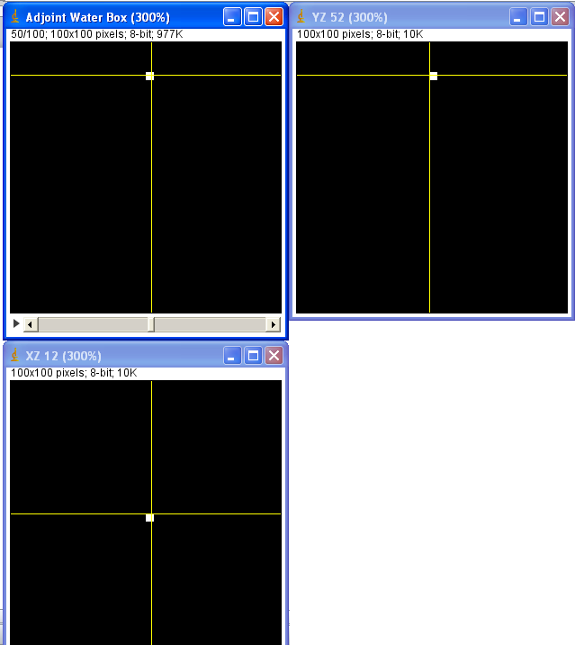

Figure 6-7 adjoint algorithm verification phantom

- Real Problem:
- Phantom:
50.0 cm x 50.0 cm x 50.0 cm water filled box with four structures outlined (Tumor, Right eye, Left eyes and Brain). The following is the geometric description of each structure:
  - Tumor:
    - Shape: Sphere.
    - Size: Sphere radius = 3 pixels (1.5 cm).
    - Location: The sphere starts on slice 55 and end at slice 60. The sphere center is at the end of slice 57 and at the end of 59th x-pixel and 30th y-pixel placing the structure geometric center at (4.5, 15.0, 3.0) cm.
  - Right Eye:
    - Shape: Sphere.
    - Size: Sphere radius = 7 pixels (3.5 cm).
    - Location: The sphere starts on slice 44 and end at slice 57. The sphere center is at the end of slice 50 and at the end of the 36th x-pixel and 8th y-pixel placing the structure geometric center at (-7.0, 4.0, 0.0) cm.
  - Left Eye:
    - Shape: Sphere.
    - Size: Sphere radius = 7 pixels (3.5 cm).
    - Location: The sphere starts on slice 44 and end at slice 57. The sphere center is at the end of slice 50 and at the end of the 64th x-pixel and 8th y-pixel placing the structure geometric center at (7.0, 4.0, 0.0) cm.
  - Brain:
    - Shape: Three rectangular boxes combine to make the final structure.
    - Size:
      - Box one: width = 40 pixels (20.0 cm) and height = 25 pixels (12.5 cm) and length = 20 pixels (10.0 cm).
      - Box two: width = 40 pixels (20.0 cm) and height = 15 pixels (7.5 cm) and length = 14 pixels (7.0 cm).
      - Box three: width = 40 pixels (20.0 cm) and height = 55 pixels (27.5 cm) and length = 13 pixels (6.5 cm).
    - Location:
      - Box one: Starts at end of slice 32 (z = -9.0 cm) and ends at the end of slice 52 (z =1.0 cm), the box top x & y pixel 30 (x = -10.0 cm) & 34 (y = 17.0 cm) and the box lower x & y pixel 70 (x = 10.0 cm) & 59 (y = 29.5 cm).
      - Box two: Starts at the end of slice 52 (z = 1.0 cm) and ends at slice 66 (z = 8.0 cm), the box top x & y pixel 30 (x=-10.0cm) & 42 (y = 21.0 cm) and the box lower x & y pixel 70 (x = 10.0 cm) & 57 (y = 28.5 cm).
      - Box three: Starts at the end of slice 66 (z = 8.0 cm) and ends at slice 80 (z = 15.0 cm), the box top x & y pixel 30 (x = -10.0 cm) & 7 (y = 3.5 cm) and the box lower x & y pixel 70 (x = 10.0 cm) & 62 (y = 31.0 cm).

Table 6-7 Summary of the brain components pixel location
 | $X_{min}$ Pixel | $$X_{max}$$  Pixel | $Y_{min}$ Pixel | $$Y_{max}$$  Pixel | $Z_{min}$ Pixel | $$Z_{max}$$  Pixel
Box one | 30 | 70 | 34 | 59 | 32 | 52
Box two | 30 | 70 | 42 | 57 | 52 | 66
Box three | 30 | 70 | 7 | 62 | 66 | 80

Table 6-8 Summary of the brain components actual location
 | $$X_{min}$$  cm | $X_{max}$ cm | $Y_{min}$ cm | $Y_{max}$ cm | $Z_{min}$ cm | $Z_{max}$ cm
Box one | -10.0 | 10.0 | 17.0 | 29.5 | -9.0 | 1.0
Box two | -10.0 | 10.0 | 21.0 | 28.5 | 1.0 | 8.0
Box three | -10.0 | 10.0 | 3.5 | 31.0 | 8.0 | 15.0

- Adjoint Source (adjunctons):
6 MeV medical linear accelerator photon response function (listed above) starting from the three structures (Tumor, Right eye, Left eyes and Brain). [I do not understand why you have a response function that depends on what source is used. Is there a reason for this dependence?]
- Dose computed using the adjoint code is folding into source distribution using the folding code to get the response at a region of interest and can be verified using the forward code for a photon source positioned at predetermine location above the water box. In practice the photon spectrum distribution cannot be adjusted the full photon will be used photon will be

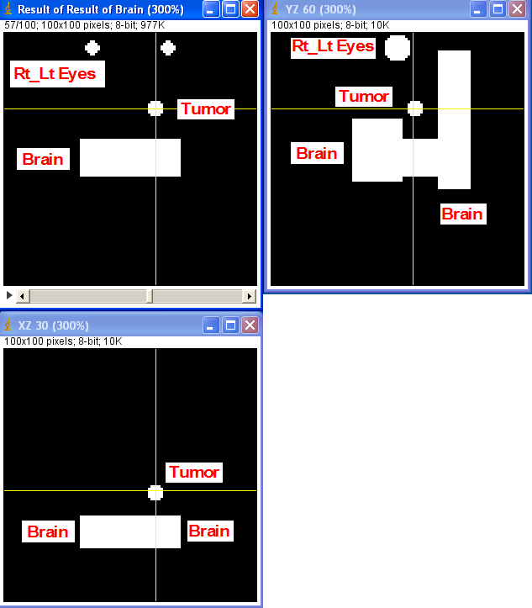
Figure 6-8 the phantom used for an actual adjoint problem

Results Chapter

References

- ANSI/ANS-6.1.1. (1977). "Neutrons and gamma-ray flux-to-dose-rate factors". (ANS-6.1.1).
- Armstrong, J. G., Burman, C., Leibel, S., Fontenla, D., Kutcher, G., Zelefsky, M., & Fuks, Z. (1993). Three-dimensional conformal radiation therapy may improve the therapeutic ratio of high dose radiation therapy for lung cancer. Int J Radiat Oncol Biol Phys, 26(4), 685-689.
- Bell, G. I., & Glasstone, S. (1970). Nuclear Reactor Theory. New York: Van Nostrand Reinhold.
- Bentel, G. C., Nelson, C. E., & Noell, K. T. (1982). Treatment planning and dose calculation in radiation oncology (3rd ed.). New York: Pergamon.
- Brown, F. B., & Martin, W. R. (2003, April 6-11). “Direct Sampling of Monte Carlo Flight Paths in Media with Continuously Varying Cross-sections". Paper presented at the ANS Mathematics and Computation Topical Meeting, Gatlinburg, TN.
- Carol, M. (1994, March 20–24). "Integrated 3-D Conformal Multivane Intensity Modulation Delivery System for Radiotherapy". Paper presented at the XIth International Conference on the Use of Computers in Radiation Therapy, Manchester, UK.
- Carter, L., & Cashwell, E. (1975). Particle Tranport Simulation with the Monte Carlo method.
- Carter, L., Cashwell, E., & Taylor, W. (1972). Monte Carlo sampling with continuously varying cross sections along flight paths. Nucl. Sci. Eng, 48, 403-411.
- Cashwell, E., Neergaard, J., Taylor, W., & Turner, G. (1972). MCN: A Neutron Monte Carlo Code: Los Alamos Scientific Lab., N. Mex.(USA).
- Cashwell, E. D., & Everett, C. J. (1959). A practical manual on the Monte Carlo method for random walk problems (Vol. 37): Pergamon Press New York.
- Chetty, I. J., Curran, B., Cygler, J. E., DeMarco, J. J., Ezzell, G., Faddegon, B. A., . . . Ma, C.-M. C. (2007). Report of the AAPM Task Group No. 105: Issues associated with clinical implementation of Monte Carlo-based photon and electron external beam treatment planning. Med Phys, 34(12), 4818-4853.
- Chui, C.-S., Chan, M. F., Yorke, E., Spirou, S., & Ling, C. C. (2001). Delivery of intensity-modulated radiation therapy with a conventional multileaf collimator: comparison of dynamic and segmental methods. Med Phys, 28(12), 2441-2449.
- Colvett, K. (2006). The history of radiation oncology. South Med J, 99(10), 1155-1156.
- Cramer, S. N. (1977). Application of the Fictitious Scattering Radiation Transport Model for Deep-Penetration Monte Carlo Calculations. Oak Ridge National Laboratory: Oak Ridge National Laboratory.
- Difilippo, F. C. (1998). Forward and adjoint methods for radiotherapy planning. Med Phys, 25(9), 1702-1710.
- Dowsett, D. J., Kenny, P. A., & Johnston, R. E. (1998). The physics of diagnostic imaging (1st ed.). London ; New York: Chapman & Hall Medical.
- Duderstadt, J. J. (1976). Nuclear reactor analysis.
- Dupree, S. A., & Fraley, S. K. (2004). A Monte Carlo Primer: Springer.
- Goldstein, M., & Regev, D. (1999). Igo - A Monte Carlo Code For Radiotherapy Planning [219-223].
- Hall, E. J. (1988). Radiobiology for the radiologist (3rd ed.). Philadelphia: Lippincott.
- Irving, D. (1971). The adjoint Boltzmann equation and its simulation by Monte Carlo. Nuclear Engineering and Design, 15, 273-293.
- Jeraj, R., & Keall, P. (1999). Monte Carlo-based inverse treatment planning. Phys Med Biol, 44(8), 1885.
- Johnson, J., Emmett, M., Rhoades, W., & Childs, R. (1992). A User's Manual for MASH 1.0-A Monte Carlo Adjoint Shielding Code System: DTIC Document.
- Kalos, M. H., & Whitlock, P. A. (2008). Monte carlo methods: John Wiley & Sons.
- Kawrakow, I., & Fippel, M. (2000). Investigation of variance reduction techniques for Monte Carlo photon dose calculation using XVMC. Phys Med Biol, 45(8), 2163.
- Langer, M., & Leong, J. (1987). Optimization of beam weights under dose-volume restrictions. International Journal of Radiation Oncology* Biology* Physics, 13(8), 1255-1260.
- Lewis, E. E., & Miller, W. F. (1984). Computational methods of neutron transport.
- Ljungberg, M., Larsson, A., & Johansson, L. (2005). A new collimator simulation in SIMIND based on the delta-scattering technique. Nuclear Science, IEEE Transactions on, 52(5), 1370-1375.
- Lux, I., & Koblinger, L. (1991). Monte Carlo particle transport methods: neutron and photon calculations (Vol. 102): CRC press Boca Raton.
- Mageras, G., & Mohan, R. (1993). Application of fast simulated annealing to optimization of conformal radiation treatments. Med Phys, 20(3), 639-647.
- Metcalfe, P., Kron, T., & Hoban, P. (1997). The physics of radiotherapy X-rays from linear accelerators. Madison, Wis.: Medical Physics Pub.
- Mohan, R., Chui, C., & Lidofsky, L. (1985). Energy and angular distributions of photons from medical linear accelerators. Med Phys, 12(5), 592-597.
- Morgan-Fletcher, S. (2001). Prescribing, Recording and Reporting Photon Beam Therapy (Supplement to ICRU Report 50), ICRU Report 62. ICRU, pp. ix+ 52, 1999 (ICRU Bethesda, MD) $65.00 ISBN 0-913394-61-0. The British Journal of Radiology, 74(879), 294-294.
- Nath, R., Biggs, P. J., Bova, F. J., Ling, C. C., Purdy, J. A., van de Geijn, J., & Weinhous, M. S. (1994). AAPM code of practice for radiotherapy accelerators: report of AAPM Radiation Therapy Task Group No. 45. Med Phys, 21(7), 1093-1121.
- Papanikolaou, N., Battista, J. J., Boyer, A. L., Kappas, C., Klein, E., Mackie, R. T., . . . Van Dyk, J. (2004). TISSUE INHOMOGENEITY CORRECTIONS FOR MEGAVOLTAGE PHOTON BEAMS.
- Papanikolaou, N., & Klein, E. E. (2008). 1.7. Heterogeneity corrections should be used in treatment planning for lung cancer. Colin G. Orton and William R. Hendee, 32.
- Purdy, J. A. (1997). "The Development of Intensity Modulated Radiation Therapy" in 1st NOMOS IMRT Workshop. In W. Advanced Medical Publishing ( Madison (Ed.). Durango, Colorado.
- Roesch, W. C., & Attix, F. H. (1968). Basic concepts of dosimetry. Radiation dosimetry, 1, 1-41.
- Rogers, D. (2006). Fifty years of Monte Carlo simulations for medical physics. Phys Med Biol, 51(13), R287.
- Sheikh-Bagheri, D., & Rogers, D. (2002). Monte Carlo calculation of nine megavoltage photon beam spectra using the BEAM code. Med Phys, 29(3), 391-402.
- Soderstrom, S., & Brahme, A. (1992). Selection of suitable beam orientations in radiation therapy using entropy and Fourier transform measures. Phys Med Biol, 37(4), 911.
- Sontag, M. R., & Cunningham, J. (1978). Clinical application of a CT based treatment planning system. Computerized tomography, 2(2), 117-130.
- Spanier, J., & Gelbard, E. M. (1969). Monte Carlo principles and neutron transport problems. Reading, Mass., USA.
- Spirou, S. V., & Chui, C. S. (1994). Generation of arbitrary intensity profiles by dynamic jaws or multileaf collimators. Med Phys, 21(7), 1031-1041.
- Tenney, C., Bowsher, J., & Jaszczak, R. (2004). A delta-scatter Monte Carlo model of a rotating parallel-hole collimator for/sup 131/I brain tumor imaging. Paper presented at the Nuclear Science Symposium Conference Record, 2004 IEEE.
- Thwaites, D. I., & Tuohy, J. B. (2006). Back to the future: the history and development of the clinical linear accelerator. Phys Med Biol, 51(13), R343-362. doi: 10.1088/0031-9155/51/13/R20
- Units, I. C. o. R., & Measurements. (1978). Dose Specification for Reporting External Beam Therapy with Photons and Electrons: International Commission on Radiation Units and Measurements.
- Vijayakumar, S., Myrianthopoulos, L. C., Rosenberg, I., Halpern, H. J., Low, N., & Chen, G. T. (1991). Optimization of radical radiotherapy with beam's eye view techniques for non-small cell lung cancer. Int J Radiat Oncol Biol Phys, 21(3), 779-788.
- Williams, J. R., & Thwaites, D. I. (2000). Radiotherapy physics--in practice (2nd ed.). Oxford New York: Oxford University Press.
- Woodcock, E. R., Murphy, T., Hemmings, P. J., & Longworth, T. C. (1965). Techniques Used in the GEM Code for Monte Carlo Neutronics Calculations in Reactors and Other Systems of Complex Geometry. Paper presented at the Proc. Conf. Applications of Computing Methods to Reactor Problems, Argonne National Laboratory.

APPENDIXES

- -
Problem parameter then Cross section and Transport data generation

Data needed for Monte Carlo transport
When transporting a particle in a medium several important basic parameters about the particle state are needed to chart the particle random walk through the medium correctly. Examples of such particle state parameters are:
- Particle initial position, direction and energy,
- Type of interactions occurring during the random walk to determine the scattered particle energy and new direction.
As a result accurate knowledge of the particle physics and ability to model it probabilistically is essential to make accurate decision during the particle random walk. It is common to use an input data file to provide all necessary particle data to chart the random walk accurately.
On the first hand, our research interested is beams of photon particles used in radiotherapy, hence particles that are in the mega electron volt energy range, we will concentrate only on the most dominant photon interactions in that energy range. The photon interactions in this energy are mainly scattering events (such as Compton, Rayleigh scattering and pair production). Secondly, our research interested is focused on finding the adjoint solution for the Boltzmann transport equation. Solving such equation requires the use of multi-group cross section data. “NJOY99” code system is a software package that can generate multi-group cross sections from an ENDF file. “NJOY99” is a system of codes that was developed at “Los Alamos national lab” and is provided by “Radiation Information Safety Center” (RISC) group at Oakridge, Tennessee. “NJOY99” code system can produce multi-group cross section data needed to transport particles in the forward and adjoint mode for each energy group in the problem materials. The photon interaction cross sections generated by “NJOY99” is:
- Scattering cross sections (e.g. Coherent, Incoherent and Pair production).
- Scattering heat cross sections (used to predict Kerma / Absorbed dose for all the scattering interaction mentioned above).
- Total cross section.
- Total heat cross section (used to predict Kerma / Absorbed dose).
- Group to group scattering cross sections for all interactions mention above.
- Distribution of Group to group cosine of scattering angle for all interactions above.

The cross sections produced by “NJOY99” code system for any element in question (provided that initial input parameters are given) are microscopic and need to be post processed. I a code was developed that will process the “NJOY99” output data file and produce data in a format useful for particle transport.

General flow of problem parameter specification
To prepare a problem specific input deck with cross sections and transport data useful for transport problems three basic parameters needs to be specified. These parameters are the problem elemental components, involved particle energy group structure and the particles energy distribution (photon source energy spectrum). Once these parameters are specified cross sections and transport data can be generated. The final component of this data is dependent on the problem mode. In the forward mode we need to specify several forward source (beam) parameters while in the adjoint mode we need to specify adjoint source parameters.
This general process flow is illustrated in Figure A-1. We start the process by creating problem material map. The result of this step is a list of elemental components present in the problem. We then need to specify the energy group structure of the problem particles. This energy group structure can be either user define structure or selected from “NJOY99” built-in group structure. Then we specify the problem particles energy distribution (photon source energy spectrum).
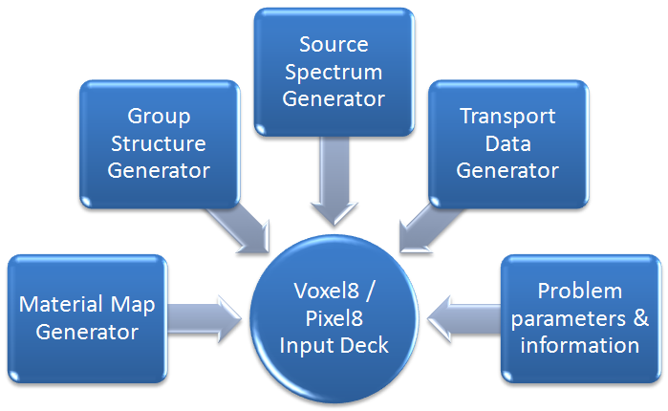
Figure A-1 General data generation flow
These parameters are feed into the cross section and transport data generator. The result is an “ASII” file that contains the problem specific cross sections and transport data for both modes (i.e. forward and adjoint). The following is a brief description of each component.

Material Map Generator
The main interface allows the user to either go to a patient database or physics data mode. Selecting the patient database invokes the “Material map generator” module. The “Material map generator” module enables the user to either import CT axial images or create a phantom data set as illustrated in Figure A-2. The result of the “Material map generator” is a set of data files in matrix (table) format. Each file represents a Z coordinate level. The file data points are integers that represent material that resides in that voxel. The matrix row represents X coordinate level and matrix column represents Y coordinate level. A summary of the data files CT numbers tally is also produced to be used when generating cross section data.

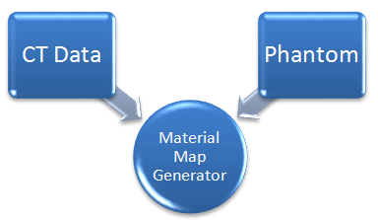
Figure A-2 Material map generator

Energy group structure generator
Specification of source particles energy structure is needed and used in the following modules:
- Cross section and transport data generation.
- Source photon spectrum generation.
- Forward and adjoint Monte Carlo transport.

Energy structure can be either designed or read from an existing list of files. The existing structure files are NJOY internal energy structures. The result of this module is an “ASCII” file that lists the energy structure boundaries. This file is used in the NJOY interface to produce a batch file that run “NJOY99”. Figure A-3 is illustrates this process.

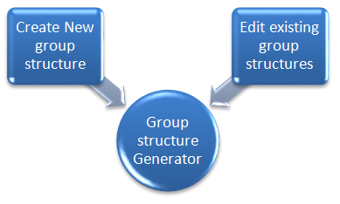
Figure A-3 Energy group structure generator

Source spectrum energy structure adjuster
Once the group structure is defined the photon source energy spectrum can be selected. The user selects a photon spectrum from published data. This is illustrated in Figure A-4. Then the code adjusts the spectrum energy bins to match the selected group structure energy bins. As a result an “ASCII” file that will contain information about our:
- Choice of photon spectrum,
- Number of photon spectrum energy bins after adjustment
- CDF for each energy bin after adjustment.

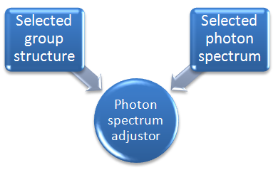
Figure A-4 Source spectrum energy structure adjuster

Once all these initial problem parameters are specified the cross section and transport data generation steps starts by initiating the “NJOY99” interface.

Microscopic Cross section data generation using “NJOY99” code system
To generate the microscopic group cross sections for problem materials we need to run “NJOY99” code system. To run “NJOY99” we need to specify an energy group structure and provide the code system an evaluated nuclear data file “ENDF”. The energy group structure can be user specified energy structure or code system built-in energy structure. A user interface was developed to aid in viewing built-in, and design new energy group structure. The “ENDF” file used is the “ENDF/B-VI” for photo-atomic interactions. This file is available in public domain from the “International Atomic Energy Agency” nuclear data services branch. A user interface was designed to assist in running the “NJOY99” code system. Figure A-5 describes the rest of the parameters needed to generate the microscopic group cross section by the “NJOY99” code system. The result of running this interface is an “ASCII” file that contains all available microscopic photon cross sections for the specified elements.
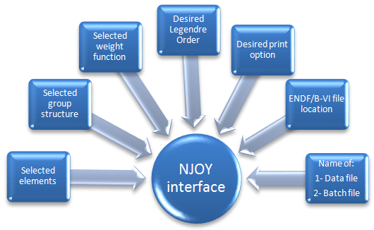
Figure A-5 "NJOY" interface that generate elemental group microscopic cross section

Generation of transport data
Once “NJOY99” output file is generated we can generation of transport data. A special interface was built to facilitate this task. In this interface the user makes the following choices:
- “NJOY99” output file to use.
- Select problem material as:
  - Element
  - Tissue
The result of is the needed data to perform forward and adjoint Monte Carlo transport. The process is illustrated in Figure A-6.
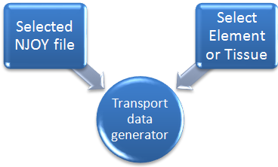
Figure A-6 Transport data generation

Total macroscopic cross section
“NJOY99” generates different interaction reactions cross section data in units of $\left(\frac{barn}{atom}\right)$. The following is a procedure to convert the generated data to appropriate units of $\left(\frac{1}{cm}\right)$:
- A single isotope atomic density $ρ_{{N_{A}}_{isotope}}$ is the number of atoms in a unit volume of the isotope and is computed from:
$${ρ_{{N_{A}}_{isotope}}}_{ }= \frac{ρ_{isotope}\left(\frac{g}{{cm}^{3}}\right)}{A_{isotope} \left(\frac{g}{mole}\right)} × N_{A}\left(\frac{atoms}{mole}\right) =\frac{ρ_{isotope}× N_{A}}{A_{isotope}} \left(\frac{atoms}{{cm}^{3}}\right)$$
- For a material made of several isotopes $\left(i=1, ⋯, N\right)$ the $i^{th}$ isotope atomic density ${\left(ρ_{{N_{A}}_{isotope}}\right)}_{i}$ with density contribution ${\left(ρ_{isotope}\right)}_{i}\left(\frac{g}{{cm}^{3}}\right)$ to the material density $ρ_{material}\left(\frac{g}{{cm}^{3}}\right)$ is:
$${\left(ρ_{N_{isotope}}\right)}_{i} = \frac{{\left(ρ_{isotope}\right)}_{i}\left(\frac{g}{{cm}^{3}}\right)}{{\left(A_{isotope}\right)}_{i} \left(\frac{g}{mole}\right)} × N_{A}\left(\frac{atoms}{mole}\right) \\ {\left(ρ_{N_{isotope}}\right)}_{i} ={\left(\frac{ρ_{isotope}}{A_{isotope}}\right)}_{i} × N_{A}\left(\frac{atoms}{{cm}^{3}}\right)$$For a material with known isotope weight fraction contribution ${\left(f_{isotope}\right)}_{i}$the isotope $i$ density ${\left(ρ_{isotope}\right)}_{i}$ in the material is computed from ${\left(ρ_{isotope} = f_{isotope}× ρ_{material}\right)}_{i}$ isotope $i$ atomic density is computed by substituting ${\left(f_{isotope}× ρ_{material}\right)}_{i}$ for isotope $i$ density $ρ_{isotope}$ in the above equation:
$${\left(ρ_{{N_{A}}_{isotope}}\right)}_{i}= {\left(\frac{f_{isotope}}{A_{isotope}}\right)}_{i}× ρ_{material} × N_{A}\left(\frac{atoms}{{cm}^{3}}\right)$$
- For a certain reaction type a single isotope macroscopic cross section $Σ_{Rxn Type}^{isotope}$ in units of $\left(\frac{1}{cm}\right)$ from the same microscopic cross section $σ_{Rxn Type}^{isotope}$ in units of $\left(\frac{barn}{atom}\right)$ is computed as follow:
$$Σ_{Rxn Type}^{isotope} = ρ_{{N_{A}}_{isotope}} \left(\frac{atoms}{{cm}^{3}}\right) × σ_{Rxn Type}^{isotope}\left(\frac{barn}{atom}\right)×{10}^{-24} \left(\frac{{cm}^{2}}{barn}\right) \\ Σ_{Rxn Type}^{isotope} = \frac{ρ_{isotope}× N_{A}}{A_{isotope}} \left(\frac{atoms}{{cm}^{3}}\right) × σ_{Rxn Type}^{isotope}\left(\frac{barn}{atom}\right)×{10}^{-24} \left(\frac{{cm}^{2}}{barn}\right) \\ Σ_{Rxn Type}^{isotope} = \left(\frac{σ_{Rxn Type}^{isotope} × N_{A}{ × ρ}_{isotope}× {10}^{-24} }{A_{isotope} }\right) \\ Σ_{Rxn Type}^{isotope} = σ_{Rxn Type}^{isotope}×\left(\frac{{ ρ}_{isotope} }{A_{isotope} }\right) × \left(N_{A}× {10}^{-24}\right)\left(\frac{1}{cm}\right)$$
It is customary to compute the macroscopic cross section in a unit of $\left(\frac{{cm}^{2}}{g}\right)$ to eliminate the density effect (mass cross section). The above equation becomes:
$$\frac{Σ_{Rxn Type}^{isotope}}{{ ρ}_{isotope}} = \left(\frac{σ_{Rxn Type}^{isotope}}{A_{isotope} }\right) × \left(N_{A}× {10}^{-24}\right) \left(\frac{{cm}^{2}}{g}\right)$$
- For a material composed of several isotopes $\left(i=1, ⋯, N\right)$ and ${\left(f_{isotope}\right)}_{i}$ is the weight fraction contribution of isotope $i$ to the material density, the density independent macroscopic cross section is:
$$\frac{Σ_{Rxn Type}^{material}}{{ ρ}_{material}} = \sum_{i=1}^{N}{{\left(f_{isotope}\right)}_{i}×{\left(\frac{Σ_{Rxn Type}^{isotope}}{{ ρ}_{isotope}}\right)}_{i} \left(\frac{{cm}^{2}}{g}\right)} \\ \frac{Σ_{Rxn Type}^{material}}{{ ρ}_{material}} = \sum_{i=1}^{N}{{\left(f_{isotope}\right)}_{i} ×{\left(\frac{σ_{Rxn Type}^{isotope}}{A_{isotope} }\right)}_{i}×\left(N_{A}×{10}^{-24}\right)} \left(\frac{{cm}^{2}}{g}\right)$$Multiply by ${ ρ}_{material}$:
$$Σ_{Rxn Type}^{material} = \left(N_{A}×{10}^{-24}\right)×\sum_{i=1}^{N}{\left({\left(f_{isotope}\right)}_{i} {× ρ}_{material}\right)×{\left(\frac{σ_{Rxn Type}^{isotope}}{A_{isotope} }\right)}_{i}} \left(\frac{1}{cm}\right)$$
Since ${\left(ρ_{isotope}\right)}_{i} = {\left(f_{isotope}\right)}_{i} {× ρ}_{material}$ in the material then:
$$Σ_{Rxn Type}^{material} = \left(N_{A}×{10}^{-24}\right)×\sum_{i=1}^{N}{{\left(\frac{{ρ_{isotope}×σ}_{Rxn Type}^{isotope}}{A_{isotope} }\right)}_{i}\left(\frac{1}{cm}\right)}$$

In summary:
- The mass macroscopic cross section (per unit density):
  - Isotope $i$:
$${\left(\frac{Σ_{Rxn Type}^{isotope}}{{ ρ}_{isotope}}\right)}_{i} ={\left(\frac{σ_{Rxn Type}^{isotope}}{A_{isotope} }\right)}_{i}×\left(N_{A}×{10}^{-24}\right)\left(\frac{{cm}^{2}}{g}\right)$$ | (ANSI/ANS-6.1.1)
  - Material with ${\left(f_{isotope}\right)}_{i}$ weight fraction for isotope $i$ :
$$\frac{Σ_{Rxn Type}^{material}}{{ ρ}_{material}} = \sum_{i=1}^{N}{{\left(f_{isotope}\right)}_{i} ×{\left(\frac{Σ_{Rxn Type}^{isotope}}{{ ρ}_{isotope}}\right)}_{i}} \left(\frac{{cm}^{2}}{g}\right)$$ | (2)
- The macroscopic cross section (per cm):
  - Isotope $i$ :
$${\left(Σ_{Rxn Type}^{isotope}\right)}_{i}={\left(σ_{Rxn Type}^{isotope}×\frac{ρ_{isotope}}{A_{isotope}}\right)}_{i}×\left(N_{A}×{10}^{-24}\right)\left(\frac{1}{cm}\right)$$
  - Material with $f_{i}$ weight fraction of isotope $i$ :
$$Σ_{Rxn Type}^{material} = \sum_{i=1}^{N}{{\left(f_{isotope}\right)}_{i}×ρ_{material} ×{\left(\frac{Σ_{Rxn Type}^{isotope}}{{ ρ}_{isotope}}\right)}_{i}} \left(\frac{1}{cm}\right)$$
$$Σ_{Rxn Type}^{material} =\left(ρ_{material}×N_{A}×{10}^{-24}\right)×\sum_{i=1}^{N}{{\left(σ_{Rxn Type}^{isotope}×\frac{f_{isotope}}{A_{isotope} }\right)}_{i}} \left(\frac{1}{cm}\right)$$ | (3)

Total heat macroscopic cross section
“NJOY99” generates different heat reactions cross section data in units of $\left(eV-barn\right)$. According to the NJOY manual the heat cross section is the product of the particular microscopic cross section and the average energy released as a result of the interaction. Therefore the above unit is thought of as $\left(\frac{eV - barn}{Collision-atom}\right)$ The following is a procedure to convert this generated data to appropriate units of $\left(\frac{MeV-{cm}^{2}}{g}\right) and \left(cGy-{cm}^{2}\right)$:
- For a certain reaction type we can compute a heat macroscopic cross section for a single isotope $Σ_{x-Heat }^{isotope}$ in units of $\left(\frac{eV}{cm}\right)$ from the same microscopic cross section $σ_{x-Heat}^{isotope}$ in units of $\left(eV-barn\right)$ is computed as follow:
$$Σ_{x-Heat}^{isotope}= ρ_{{N_{A}}_{isotope}}\left(\frac{atoms}{{cm}^{3}}\right) × σ_{x-Heat}^{isotope}\left(\frac{eV-barn}{atom}\right)×{10}^{-24} \left(\frac{{cm}^{2}}{barn}\right) \\ Σ_{x-Heat}^{isotope}= \frac{ρ_{isotope}× N_{A}}{A_{isotope}} \left(\frac{atoms}{{cm}^{3}}\right) × σ_{x-Heat}^{isotope}\left(\frac{eV-barn}{atom}\right)×{10}^{-24} \left(\frac{{cm}^{2}}{barn}\right) \\ Σ_{x-Heat}^{isotope}= \left(\frac{σ_{x-Heat}^{isotope} × N_{A}{ × ρ}_{isotope}× {10}^{-24} }{A_{isotope} }\right) \\ Σ_{x-Heat}^{isotope}= \left(\frac{{ ρ}_{isotope}×N_{A}× {10}^{-24} }{A_{isotope} }\right) × σ_{x-Heat}^{isotope}\left(\frac{eV}{cm}\right)$$Converting the units to $\left(\frac{MeV}{cm}\right)$ by multiplying by $\left(\frac{1×{10}^{-6}MeV}{eV}\right)$ we get:
$$Σ_{x-Heat}^{isotope} = \left(\frac{{ ρ}_{isotope}×N_{A}× {10}^{-30} }{A_{isotope} }\right) × σ_{x-Heat}^{isotope}\left(\frac{MeV}{cm}\right)$$it is customary to report the heat macroscopic cross section in a unit of $\left(\frac{{MeV-cm}^{2}}{g}\right)$ to eliminate the density effect (mass cross section). This is done by dividing above equation by the density:
$$\frac{Σ_{x-Heat}^{isotope}}{{ ρ}_{isotope}} =\left(\frac{N_{A}× {10}^{-30}}{A_{isotope} }\right)× σ_{x-Heat}^{isotope}\left(\frac{MeV-{cm}^{2}}{g}\right)$$
- For a material composed of several isotopes $\left(i=1, ⋯, N\right)$ and ${\left(f_{isotope}\right)}_{i}$ is isotope $i$ weight fraction contribution to the material density, therefore; the density independent macroscopic cross section is:
$$\frac{Σ_{x-Heat}^{material}}{{ ρ}_{material}}= \sum_{i=1}^{N}{{\left(f_{isotope}\right)}_{i}×{\left(\frac{Σ_{x-Heat}^{isotope}}{{ ρ}_{isotope}}\right)}_{i} \left(\frac{{MeV-cm}^{2}}{g}\right)}$$Substitute the isotope mass heat cross section in this equation we get:
$$\frac{Σ_{x-Heat}^{material}}{{ ρ}_{material}}= \sum_{i=1}^{N}{{\left(f_{isotope}\right)}_{i}×{\left(\frac{σ_{x-Heat}^{isotope}}{A_{isotope} }\right)}_{i}×\left(N_{A}× {10}^{-30}\right)\left(\frac{{MeV-cm}^{2}}{g}\right)} \\ \frac{Σ_{x-Heat}^{material}}{{ ρ}_{material}}= \left(N_{A}× {10}^{-30}\right)\sum_{i=1}^{N}{{\left(\frac{f_{isotope}{×σ}_{x-Heat}^{isotope}}{A_{isotope} }\right)}_{i}\left(\frac{{MeV-cm}^{2}}{g}\right)}$$
- To convert $\left(\frac{MeV-{cm}^{2}}{g}\right)$ to $\left(\frac{MeV}{cm}\right)$ we multiply the equation by ${ ρ}_{material}$ to get:
$$Σ_{x-Heat}^{material}= \left(N_{A}× {10}^{-30}\right)×\sum_{i=1}^{N}{{\left(f_{isotope}\right)}_{i}×{{ ρ}_{material}×\left(\frac{σ_{x-Heat}^{isotope}}{A_{isotope} }\right)}_{i}\left(\frac{MeV}{cm}\right)}$$Since ${\left(ρ_{isotope}\right)}_{i} = {\left(f_{isotope}\right)}_{i} {× ρ}_{material}$ then:
$$Σ_{x-Heat}^{material} = \left(N_{A}× {10}^{-30}\right)×\sum_{i=1}^{N}{{\left(\frac{{ρ_{isotope}×σ}_{x-Heat}^{isotope}}{A_{isotope} }\right)}_{i}\left(\frac{MeV}{cm}\right)}$$
- Assuming that the energy released in an interaction is deposited in a voxel with weight ${Wght}_{voxel}$ .The energy released in a voxel is:
$${Energy Released}_{voxel} = \frac{Σ_{x-Heat}^{material}}{{Wght}_{voxel}}\left(\frac{MeV}{g-cm}\right)$$for a voxel with volume $V_{voxel}$ and density $ρ_{voxel}$ the voxel weight is:
$${Wght}_{voxel} = {ρ_{voxel}×V}_{voxel}$$the energy released in a voxel per interaction become:
$${Energy Released}_{voxel} = \frac{Σ_{x-Heat}^{material}}{{ρ_{voxel}×V}_{voxel}}\left(\frac{MeV}{g-cm}\right)$$substitute the last equation in the step above in we get:
$${Energy Released}_{voxel} = \frac{N_{A}× {10}^{-30}}{{ρ_{voxel}×V}_{voxel}}×\sum_{i=1}^{N}{{\left(\frac{{ρ_{isotope}×σ}_{x-Heat}^{isotope}}{A_{isotope} }\right)}_{i}\left(\frac{MeV}{g-cm}\right)}$$
- To convert $\left(\frac{MeV}{g-cm}\right)$ to $\left(\frac{cGy}{cm}\right)$ we compute the $\left(\frac{cGy}{{MeV}/g}\right)$ factor:
$$\frac{1000 g}{kg} × \frac{1.602×{10}^{-13}joule}{MeV} × \frac{Gy}{{joule}/{kg}} × \frac{100 cGy}{Gy} = 1.602×{10}^{-8} \frac{cGy}{{MeV}/g}$$
The absorbed dose in a voxel $D_{voxel}$ for each interaction:
$$\frac{D_{voxel}}{interaction}= \frac{N_{A}× 1.602×{10}^{-38}}{{ρ_{voxel}×V}_{voxel}}×\sum_{i=1}^{N}{{\left(\frac{f_{isotope}{×σ}_{x-Heat}^{isotope}}{A_{isotope} }\right)}_{i}\left(\frac{cGy}{cm}\right)}$$
- For photon fluence of a $ϕ\left(\frac{particles}{{cm}^{2}}\right)$ the reaction rate $\dot{R}$ for any type of interaction in a volume (number of interaction) is:
$$\dot{R} = Σϕ$$therefore, absorbed dose in a voxel from all particle interaction:
$$D_{voxel} = \frac{D_{voxel}}{interaction} \left(\frac{cGy}{cm}\right)× ϕ\left(\frac{particles}{{cm}^{2}}\right) \\ D_{voxel} = \frac{N_{A}× ϕ× 1.602×{10}^{-38}}{{ρ_{voxel}×V}_{voxel}}×\sum_{i=1}^{N}{{\left(\frac{f_{isotope}{×σ}_{x-Heat}^{isotope}}{A_{isotope} }\right)}_{i}\left(cGy\right)}$$The absorbed dose per photon fluence is:
$$\frac{D_{voxel} }{ϕ}= \frac{N_{A}×1.602×{10}^{-38}}{{ρ_{voxel}×V}_{voxel}}×\sum_{i=1}^{N}{{\left(\frac{f_{isotope}{×σ}_{x-Heat}^{isotope}}{A_{isotope} }\right)}_{i}\left(cGy-{cm}^{2}\right)}$$

In summary:
- The mass macroscopic heat cross section (per unit density):
  - Isotope $i$:
$${\left(\frac{Σ_{x-Heat}^{isotope}}{{ ρ}_{isotope}}\right)}_{i} \left(\frac{MeV-{cm}^{2}}{g}\right) = {\left(\frac{σ_{x-Heat}^{isotope}}{A_{isotope} }\right)}_{i}× \left(N_{A}× {10}^{-30}\right) \left(\frac{MeV-{cm}^{2}}{g}\right)$$
  - Material with ${\left(f_{isotope}\right)}_{i}$ weight fraction for isotope $i$ :
$$\frac{Σ_{x-Heat}^{material}}{{ ρ}_{material}} \left(\frac{MeV-{cm}^{2}}{g}\right) = \sum_{i=1}^{N}{{\left(f_{isotope}\right)}_{i}×{\left(\frac{Σ_{x-Heat}^{isotope}}{{ ρ}_{isotope}}\right)}_{i}\left(\frac{{MeV-cm}^{2}}{g}\right)}$$
- The macroscopic heat cross section $\left(\frac{MeV}{cm}\right)$:
  - Isotope $i$ :
$${\left(Σ_{x-Heat}^{isotope}\left(\frac{MeV}{cm}\right)\right)}_{i} = {\left(σ_{x-Heat}^{isotope}×\frac{{ ρ}_{isotope} }{A_{isotope} }\right)}_{i} × \left(N_{A}× {10}^{-30}\right) \left(\frac{MeV}{cm}\right)$$
  - Material with $f_{i}$ weight fraction of isotope $i$ :
$$Σ_{x-Heat}^{material}\left(\frac{MeV}{cm}\right) = \sum_{i=1}^{N}{{\left(f_{isotope}\right)}_{i}×{ρ_{material}×\left(\frac{Σ_{x-Heat}^{isotope}}{ρ_{isotope} }\right)}_{i}\left(\frac{MeV}{cm}\right)} \\ Σ_{x-Heat}^{material}\left(\frac{MeV}{cm}\right)=\left(ρ_{material}{×N}_{A}× {10}^{-30}\right)×\sum_{i=1}^{N}{{\left(\frac{{σ_{x-Heat}^{isotope}×f}_{isotope}}{A_{isotope} }\right)}_{i}}\left(\frac{MeV}{cm}\right)$$
  - Absorbed dose in a voxel from photon fluence of a $ϕ\left(\frac{particles}{{cm}^{2}}\right)$ :
$$\frac{D_{voxel} }{ϕ}= \frac{N_{A}×1.602×{10}^{-38}}{{ρ_{voxel}×V}_{voxel}}×\sum_{i=1}^{N}{{\left(\frac{f_{isotope}{×σ}_{x-Heat}^{isotope}}{A_{isotope} }\right)}_{i}\left(cGy-{cm}^{2}\right)}$$

Scattering cross sections and its probability
The scattering cross sections are defined using the following two independent variables (hence double differential):
  - ENERGY – The Energy group of the Incident photon to the scattered photon.
  - ANGULAR - The scattering angle for the scattered photon (the result is angular distribution).
“NJOY99” generates three microscopic scattering cross sections:
  - Coherent Scattering – Raleigh Scattering:
There is no energy loss occur during this interaction. The incident photon emerges with the same energy but traveling in a different direction. The differential scattering cross section at location $\vec{r}$ is denoted by $σ_{Coherent}\left(\vec{r},Ω^{'}∙Ω, E→E\right)$
  - Incoherent Scattering – Compton Scattering:
The incident photon emerges from the reaction in a different direction. The photon loses some energy in the interaction. The differential cross section at location r is denoted by $σ_{Incoherent}\left(\vec{r},Ω^{'}∙Ω, E→E\right)$
  - Pair Production is considered a scattering interaction:
Therefore, in general (for all energy and scattering angles) the overall scattering cross section is defined to be:
$$σ_{Scattering} = σ_{Coherent} + σ_{Incoherent} + σ_{Pair Production}$$
Therefore, the individual contribution from each reaction to the overall scattering cross section:
$$Coherent = \frac{σ_{Coherent}}{σ_{Scattering}}$$
$$Incoherent = \frac{σ_{Incoherent}}{σ_{Scattering}}$$
$$Pair Production = \frac{σ_{Pair Production}}{σ_{Scattering}}$$
We can convert this cross section to macroscopic cross section using the same method used describe to generate macroscopic total cross section from microscopic cross section. This scattering cross section:
$Σ_{Scattering}\left(r,E\right) =$ describe the probability of scattering per unit path length $\left[\frac{1}{cm}\right]$
In a scattering event, the incident photon will change both direction of motion and energy. The quantity that will describe the state of the scattered photon is called the differential cross section. The energy distribution of photon emerging from a scattering reaction is given by a macroscopic differential scattering cross section $Σ_{Scattering}\left(E^{'}→E\right)$, where

$Σ_{Scattering}\left(E^{'}→E\right)dE$characterizes the probability that a photon with an
initial energy $\grave{E}$will scatter into $dE$ around$E$.

The macroscopic scattering cross section is related to the probability that a photon with initial energy $E$ will suffer a collision regardless of final energy $\grave{E}$, then the integral of the macroscopic differential scattering cross section, $σ_{Scattering}\left(E^{'}→E\right)$over all final energies $\grave{E}$ is the total scattering cross section:
$Σ_{Scattering}\left(E^{'}\right) = \int_{0}^{∞}{Σ_{Scattering}\left(E^{'}→E\right)dE}$
the dimension of this differential cross section is $\left[\frac{{cm}^{2}}{nucleus} MeV\right]$. We define the probability that a photon with initial energy $\grave{E}$will scatter into $dE$ around$E$ is given by:
$p\left(E^{'}→E\right)dE = \frac{Σ_{Scattering}\left(E^{'}→E\right)}{Σ_{Scattering}\left(E^{'}\right)}dE$
this is the probability density function in $\left[\frac{1}{MeV}\right]$. The microscopic differential scattering cross section is defined as:
$$Σ_{Scattering}\left(E^{'}→E\right) = Σ_{Scattering}\left(E^{'}\right) × p\left(E^{'}→E\right)$$
The angular distribution for photon emerging from a scattering reaction is given by a microscopic differential cross section, $Σ_{Scattering}\left({\hat{Ω}}^{'}→\hat{Ω}\right)$, where
$Σ_{Scattering}\left({\hat{Ω}}^{'}→\hat{Ω}\right)$ Characterizes the probability that a photon with an initial angle ${\hat{Ω}}^{`}$ will scatter into $d\hat{Ω}$ around $\hat{Ω}$.

The integral of the microscopic differential scattering cross section, $Σ_{Scattering}\left({\hat{Ω}}^{'}→\hat{Ω}\right)$, over all final directions $\grave{Ω}$ is the scattering cross section:
$Σ_{Scattering}\left(E\right)=\int_{0}^{∞}{Σ_{Scattering}\left(E,{\hat{Ω}}^{'}→\hat{Ω}\right)d\hat{Ω}}$
the dimension of this differential cross section is $\left[\frac{{cm}^{2}}{nucleus} Seteradian\right].$ We define the probability that a photon with initial directions $Ω$ will scatter into $d\grave{Ω}$ around $\grave{Ω}$ is given by:
$p\left({\hat{Ω}}^{'}→\hat{Ω}\right)d\hat{Ω} = \frac{Σ_{Scattering}\left({\hat{Ω}}^{'}→\hat{Ω}\right)}{Σ_{Scattering}\left(E\right)}d\hat{Ω}$
this is the probability density function in [steradian -1]. The macroscopic differential scattering cross section is defined as:
$$Σ_{Scattering}\left({E,\hat{Ω}}^{'}→\hat{Ω}\right) = Σ_{Scattering}\left(E\right) p\left({\hat{Ω}}^{'}→\hat{Ω}\right)$$
Since the macroscopic differential cross section can depend on:
    - Photon Energy
    - Target nuclide
    - The initial direction $Ω$
    - The final direction $Ω^{'}$
Note that the dependence on the initial and final direction is rare, but the dependence is stronger on the angle $θ$ between the initial and final direction, hence the$Ω∙\grave{Ω}$. Since that the direction vector is a unit vector therefore if we define:
$$μ_{0} = {\hat{Ω}}^{'}∙\hat{Ω} = cosθ$$
Hence
$${Σ_{Scattering}\left({E,\hat{Ω}}^{'}→\hat{Ω}\right)=Σ}_{Scattering}\left({E,\hat{Ω}}^{'}∙\hat{Ω}\right) = Σ_{Scattering}\left(E,μ_{0}\right)$$
We can define
$$dΩ = sinθ dθ dϕ = -d\left(cosθ\right)dϕ = -dμ_{0}dϕ$$
therefore
$$Σ_{Scattering}\left(E\right) =\int_{0}^{2π}{dϕ\int_{0}^{π}{Σ_{Scattering}\left({E,\hat{Ω}}^{'}→\hat{Ω}\right)d\hat{Ω}}}$$
$$Σ_{Scattering}\left(E\right) =\int_{0}^{2π}{dϕ\int_{0}^{π}{Σ_{Scattering}\left({E,\hat{Ω}}^{'}∙\hat{Ω}\right)sinθdθ}}$$
$$Σ_{Scattering}\left(E\right) =\int_{0}^{2π}{dϕ\int_{-1.0}^{+1.0}{Σ_{Scattering}\left(E,μ_{0}\right)dμ_{0}}}$$
$$Σ_{Scattering}\left(E\right) =2π\int_{-1.0}^{+1.0}{Σ_{Scattering}\left(E,μ_{0}\right)dμ_{0}}$$
For the purpose of our code we need to generate the total group scattering cross section. This value is generated using the following equation:
$$Σ_{Scattering}\left(E\right) = Σ_{Coherent}\left(E\right) + Σ_{Incoherent}\left(E\right) + Σ_{Pair Production}\left(E\right)$$
Further, the group to group macroscopic scattering cross section is computed from the microscopic cross section data generated by “NJOY99” using the same method describe to generate total macroscopic cross section. For the purpose of our problem we used the zero order of the Legendre polynomial to be our cross section.

Forward scattering probability
The forward scattering probability is derived from the total cross and forward scattering cross section. Total cross section is the sum of absorption and scattering cross section. The forward probability of scattering for a group is the result of dividing the forward scattering cross section by the total cross section as shown:
$${Scattering Probability}_{forward,g} = \frac{Σ_{Scatt-forward,g}}{Σ_{Total,g}}$$
The result is a number between 0 and 1. When a random number is drawn and the value is between 0 and the scattering probability the type of interaction occurring is downward scattering interaction. If the random number drawn is above the scattering probability the occurring interaction is absorption

Adjoint scattering probability
For the adjoint formalism, the group to group scattering cross section data need to be arranged. The data for the same final group is collected and arranged then a new adjoint group to group cross is computed. This cross section is simply for the same final group is the sum of all individual group to group scattering cross section as shown:
$$Σ_{Scatt-adjoint,g^{'} } = \sum_{g^{'} = 1}^{G}{\sum_{g=1}^{G}{Σ_{Scatt , g→g^{'}}}}$$
The adjoint scattering probability is derived from the total cross and adjoint scattering cross section. Total cross section is the sum of absorption and scattering cross section. The adjoint probability of scattering for a group is the result of dividing the adjoint scattering cross section by the total cross section as shown:
$${Scattering Probability}_{adjoint,g^{'}} = \frac{Σ_{Scatt-adjoint,g^{'}}}{Σ_{Total,g^{'}}}$$
For this ratio the result might not be a number between 0 and 1. When a random number is drawn and the value is between 0 and the adjoint scattering probability the type of interaction occurring is upward scattering interaction. If the random number drawn is above the scattering probability the occurring interaction is absorption

Group to group scattering probability
The group to group scattering probability is generated from the:
- The group total scattering cross section;
- The group to group scattering cross section.

Forward group to group scattering probability
The forward group to group scattering probability is computed by dividing the group to group scattering cross section by the group total scattering cross section as shown below:
$${Group to group scattering Probability}_{Forward,g^{'}} = \frac{Σ_{Scatt,g→g^{'}}}{Σ_{Scatt-forward,g}}$$
The ratios produce is then used to create a CDF. For the forward input file the first entry of the CDF data point is for the lowest down to energy group and the last data point is for the current energy group.

Adjoint group to group scattering probability
Then adjoint group to group scattering probability is computed by dividing the group to group scattering cross section by the newly computed above adjoint group to group scattering cross section as shown:
$${Group to group scattering Probability}_{Adjoint,g} = \frac{Σ_{Scatt, g→g^{'}}}{Σ_{Scatt-adjoint,g^{'} }}$$
The ratios produce is then used to create a CDF. For the adjoint input file the first entry of the CDF data point is for the current energy group and the last data point is for the energy highest up scatter group.

Group to group cosine of scattering angle
“NJOY99” produce group to group cosine scattering angle cross sections. This data is presented by “NJOY99” as a Legendre polynomial coefficient. The maximum order of the polynomial coefficient is specified by the user as part of “NJOY99” code system needed input parameters. The resultant data need to be processed to be used in particle transport. It is well known in the literature that presentation of cross section as Legendre polynomial coefficient can cause the cross section to be negative for polynomials with coefficient order higher than 1. The negative cross section does not make any physical sense and can cause the computed probabilities to be negative.
For cross sections presented by Legendre polynomial with polynomial order one or higher codes such as “MORSE” and “KENO” eliminates the negative cross section problem by computing the average cosine of the scattering angle using the zero and first Legendre polynomial coefficient as follow:
$$\overline{μ}\left(g→g^{'}\right)= \frac{Σ_{Scatt-P1}^{g→g^{'}}}{Σ_{Scatt-P0}^{g→g^{'}}}$$
This value gets tabulated for each $g→g^{'}$ interaction.
“Morse-SGC NUREG-CR-200” document describe the method we used to generate scattering cosine scattering angles and their corresponding probability. Using this method for all the possible group to group scattering five possible cosine of scattering angles and their corresponding probability was generated and tabulated.
For our problem I used both methods. The final code version uses the “Morse-SGC NUREG-CR-200” tabulated values.

- -
Code Input deck description

Type of cross sections generated and used
In this thesis the interaction types are reduced to absorption and scattering cross sections only. The absorption cross section is the physical absorption interaction while the scattering cross section is the sum of the physical coherent, incoherent and pair production interactions. The generated transport cross section data is arranged by groups. For each group we generate a probability of absorption and of scatter, heat cross section for each interaction as well as total cross section and heat cross section.
The designed code has two main programs that represent two problem mode:
- Forward Monte Carlo method transport
- Adjoint Monte Carlo transport.
The “transport data” file used is dependent on the problem mode. The input data deck name for each mode is:
- Forward mode: “ForwardFicMC.in”
- Adjoint mode: “AdjointFicMC.in”

General description of input files
The “transport data” file follows a general format. In general the file consists of eight major sections. These sections have the following general description:
- Section 1: Problem information and needed Monte Carlo parameters.
- Section 2: Source spectrum description.
- Section 3: Phantom-Patient Information.
- Section 4: Source location and emission methods.
- Section 5: Problem material information.
- Section 6: Cross sections and transport data for each energy group & material.
- Section 7: Group to group scattering probabilities for each problem material.
- Section 8: Group to group scattering angles for each problem material.

Forward Monte Carlo with / without Fictitious scattering input deck
The forward Monte Carlo input deck contains the following problem specific information:
- Section 1: This section has general problem information and needed Monte Carlo parameters. Image of this data is shown in Figure B-1. The data read from this section is used to setup proper problem directories and turn proper program flags. The following is description of each item:
  - Problem Type. The available are:
    - Forward where it can be:
      - Spectrum Percent Depth Dose.
      - Group Percent Depth Dose.
      - Beam Simulation / Computation.
  - Number particles to run – number of histories.
  - Particle tracks:
    - Flag.
    - Number of tracks per track file.
    - Number of tracks used to plot.
  - Particle history:
    - Flag.
    - At what run to start writing particle history.
    - At what run to stop writing particle history.
  - CAX percent depth dose compare flag.
  - Source phantom entrance plot:
    - Flag.
    - Number of points to plot.
  - When to annunciate on the screen the random walk being process. This serves as a Monte Carlo progress indicator.
  - Write trouble shooting file flag.
  - Russian Roulette parameters:
    - Particle weight cut-off.
    - Particle Survival Probability
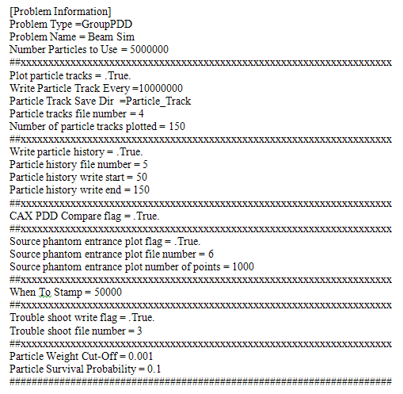
Figure B-1 Input file view of section 1
- Section 2: Source information as shown in Figure B-2.
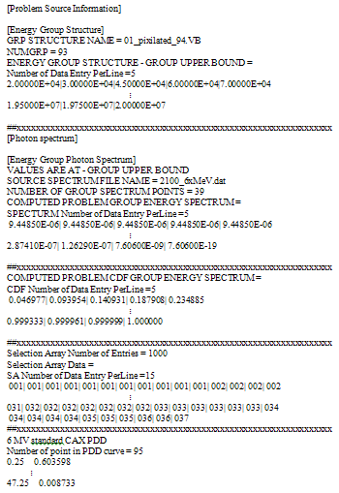
Figure B-2 Input file view of section 2 data
The information is:
  - Energy group structure:
    - Name
    - Number of groups
    - Energy bins upper limit (tabulated in rows with a given number of entries per row).
  - Source photon spectrum:
    - File name.
    - Number of source spectrum points.
    - Source spectrums bin frequencies (tabulated in rows with a given number of entries per row).
    - Source spectrums bin CDF (tabulated in rows with a given number of entries per row).
    - Source spectrums selection array information and it values as shown in Figure B-3:
      - Number of entries.
      - Number of entries per each line of search array data.
      - Search array data in rows.

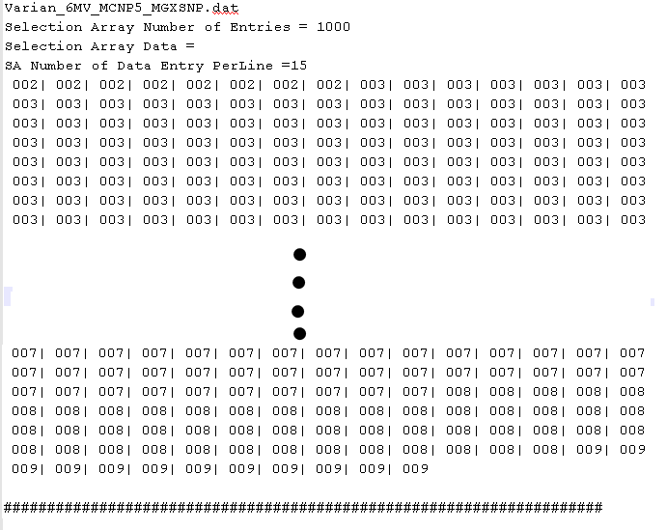
Figure B-3 Input file view of photon spectrum search array
  - The standard reference beam data information:
    - Name of standard beam.
    - Number of points in the standard reference beam data.
    - Standard reference beam data in rows.

As a result of processing this section the following data is read to assist in the particle random walk decisions:
- Then number of spectrum groups.
- The number of search array points (normally multiple of 1000).
- The photon spectrum CDF as one dimensional array.
- The photon spectrum search array values as one dimensional array.
The search array is used to speed up the search for the particle initial group. In doing this we eliminate the need to look through the entire array every time we start a new history. The following is description of how the search array is used during particle random walk:
- A random number is drawn.
- The random number is converted to an integer by multiplying it with search array number of points to produce a search array index (e.g. between 1and 1000 for array of 1000 dimension).
- The computed index is converted to spectrum group number (saved array value).
- The selected spectrum group is tested against its actual CDF and adjusted accordingly if it fails the test.

- Section 3: Phantom-Patient Information as shown in Figure B-4:
  - Material map box dimension (e.g. X-Length, Y-Length and Z-Length.)
  - Length ranges (e.g. Low and high value for each dimension.)
  - Voxel dimension.
  - First voxel corner coordinate.
  - Material Map type:
    - Homogenous.
    - Nonhomogeneous.

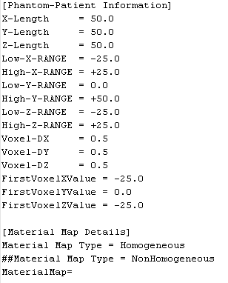
Figure B-4 Input file view of section 3 data

- Section 4: Source position and beam blocking (Linac-Specifications and Field Parameters) parameters as illustrated in Figure B-5.

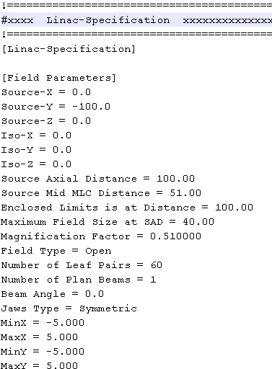
Figure B-5 Input file view of section4
This information is:
  - Source coordinates.
  - Isocenter coordinates.
  - Source Axial Distance.
  - Source Middle MLC Distance.
  - Enclosed Limits is at Distance.
  - Maximum field size at source axial distance (used to compute maximum angle of the primary collimator opening. This will affect particle initial weight.
  - Magnification Factor
  - Field Type as shown in Figure B-6:

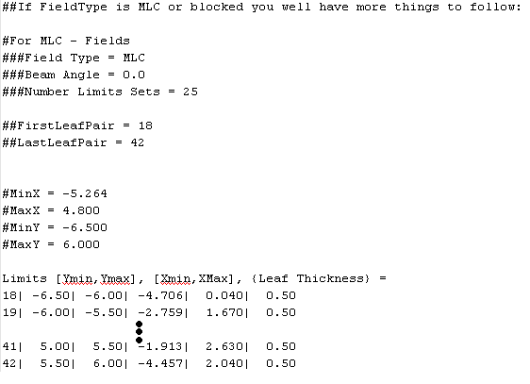
Figure B-6 Input file view of section 4 MLC leaf data

The field can be either:
    - Open.
    - Blocked (MLC or Block). If the field blocked we can read the following:
      - If MLC’s you will have MLC data information (e.g. number of limit points, first and last leaf pair followed by listing of the leaf number, minimum, maximum of X and Y jaws and leaf thickness given in rows of data.
      - If block you will have Block data information (e.g. number of polygon data points followed by listing of $(x,y)$ coordiantes)
  - Number of Leaf Pairs.
  - Number of Plan Beams.
  - Beam Angle
  - Jaws Type:
    - Symmetric.
    - Asymmetric.
  - Jaw limits (list the maximum and minimum for the X and Y jaws.)

This is illustrated in Figure B-7 below:

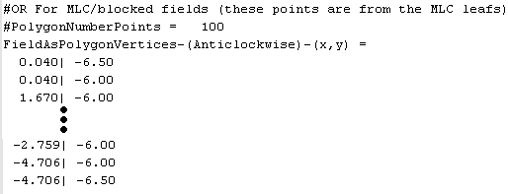
Figure B-7 Input file view of section 4 MLC/blocked field data

- Section 5: This section contains needed information regarding the materials present in the problem. Figure B-8 illustrate the organization of this section. This information is:
  - Number of materials in the problem.
  - Listing of materials in problem.
  - Problem material information including:
    - Elemental composition of each material followed by:
      - Density.
      - Z number.
      - Atomic weight.
      - Weight fraction

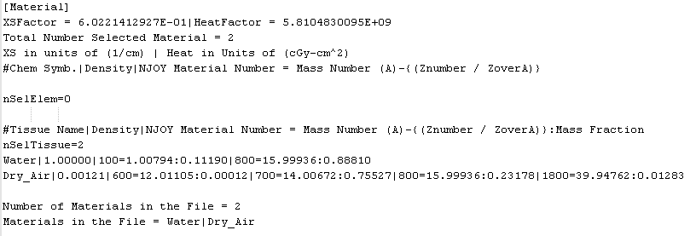
Figure B-8 Input file view of section 5 data

- Section 6: For each problem present material the cross sections are listed in rows with several columns. The rows represent groups as shown in Figure B-9 and each column is:
  - Column 1: Group number.
  - Column 2: Middle group structure energy bin.
  - Column 3: Absorption probability,
  - Column 4: Absorption heat cross section.
  - Column 5: Down scattering probability.
  - Column 6: Scattering heat cross section
  - Column 7: Total cross section.
  - Column 8: Total heat cross section.
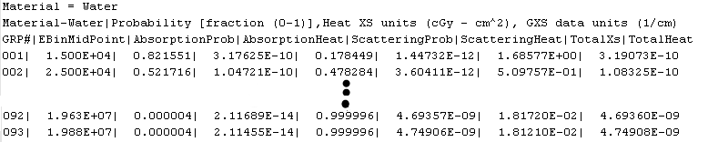
Figure B-9 Input file view of section 6 data

The following is how read data read from this section is used:
- The first two columns indicate current group number and the mid bin value and primarily used for plotting purposes.
- The absorption or scattering probability is used to decide whether the interaction is absorption or scattering. The absorption probability is not being used currently.
- The absorption heat is being used for the simulation. The dose contributed to that problem is the value of the absorption heat cross section, if the type of interaction is an absorption reaction. If it was a scattering section, the scattering heat cross section would be contributed to dose.
- The total cross section is used to determine the distance to the interaction site.
- The total heat cross section not used in the current program.

- Section 7: Tabulation of group to group scattering probabilities for each material in the problem as shown in Figure B-10. Each group data is in one row. The number of data rows in this table is given. The following is the sequence of data in the each group row:
  - Initial group.
  - Final group (down scatter group).
  - Number of probability points following in this data line.
  - The current group CDF table entries. The first value represents the maximum probability for scattering to the lowest energy group while the last two entries is the range of probabilities for scattering to the current group.

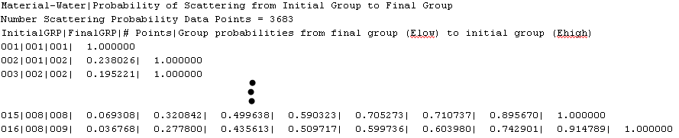
Figure B-10 Input file view of section 7 data

The data in this section is arranged as initial group and the lowest final group. After that the probability is given from the lowest final group to the initial group. The number of probability values varies from 1 all the way to the maximum number based on the lowest final group. When this data is read into the program four two dimensional arrays are created indicating the material number and group number. The following is what data arrays are created:
- The first array stores the lowest down group.
- The second array stores the index of the group probability starting point.
- The third array stores the index of the group probability ending point.
- The fourth array has a second dimension that is equal to the maximum scatter data records. This array stores the down scatter group to group probability.
- Section 8: Tabulation of the group to group scattering angles for each material in the problem. Each group data is in one row. The input deck contains two types of cosine scattering data. The following is a description of both types:
  - Type I: Average of cosine scattering angle as described in the Mores code shown in Figure B-11. The number of data rows in this table is given. The following is the sequence of data in the each group row. :
    - Initial group.
    - Final group (scatter down to group.)
    - Zero Order Legendre coefficient.
    - First order Legendre coefficient.
    - The computed average cosine scattering angle.

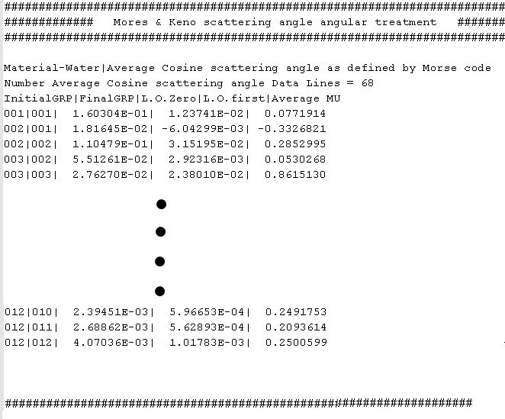
Figure B-11 Input file view of section 8 data of type I

  - Type II: Tabulates the angular probability distribution function of cosine scattering angle shown in Figure B-12. Further; the number of group to group data lines in the table, the number of cosine of scattering angle values and its corresponding probability per data line is also listed. The following is the sequence of data in the each group row:
  - Initial group.
  - Final group (scatter down to group.)
  - A sequence of cosine of scattering angle values followed by the same number of the probability distribution value of these cosines scattering angle.

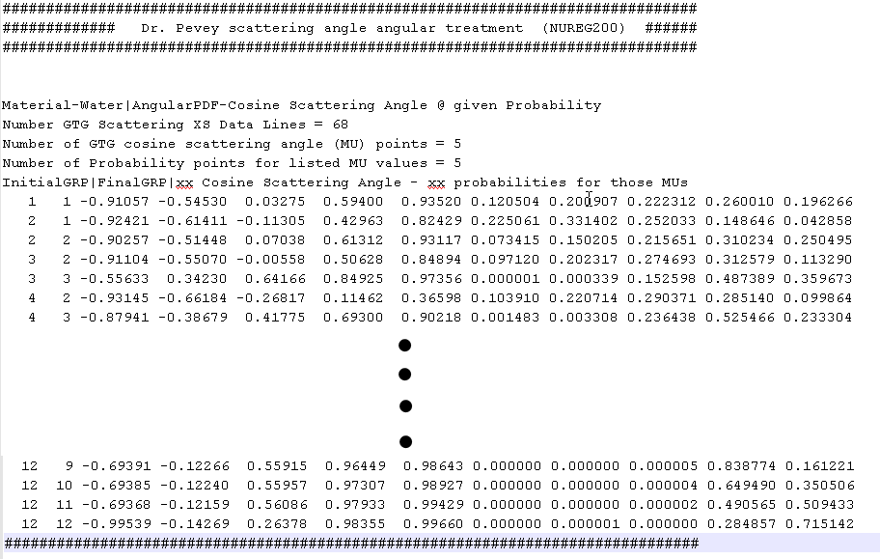
Figure B-12 Input file view of section 8 data of type II

The (μ) value and its corresponding probability are tabulated in each line. To store this data in a compact way it is read for each problem material into the program using the following arrays:
- Two dimensional array that stores the starting group for the specified group to group scattering. Index one represents the material number and second index represents the particular group to group scattering (data line).
- Two dimensional array that stores the final down group for the specified group to group scattering. Index one represents the material number and second index represents the particular group to group scattering (data line).
- Three dimensional array that store the specified (μ) values. Index one represents the material number and second index represents the particular group to group scattering (data line) and index three represent the listed (μ) value.
- Three dimensional array that store the specified probability for the given (μ) values. Index one represents the material number and second index represents the particular group to group scattering (data line) and index three represent the listed probability value for the listed (μ) value.

Adjoint Monte Carlo with Fictitious scattering input deck
The adjoint input deck sections 1, 2, 3 and 5 are identical to the forward input deck. The rest of the sections are similar to the forward input deck with modifications that is suitable for adjoint transport. Method of data generation was described in the previous appendix. Here we will describe data organization only.
- Section 4: Adjoint source location. As illustrated in Figure B-13 the user specify:
  - Region of interest name (ROI).
  - Number of region of interest indices.
  - List of all voxel indices for the region of interest (i, j, k). These indices will be converted to (x, y, z) values using voxel dimension.

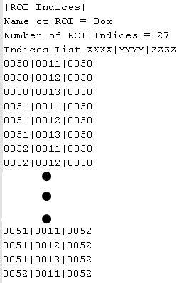
Figure B-13 Adjoint Input file view of section 4 (ROI) indices
- Section 6: For each problem material cross sections and transport data for each energy group are listed as shown in Figure B-14. The rows represent groups (figure B - 9) and each column is:
  - Column 1: Group number.
  - Column 2: Middle group structure energy bin.
  - Column 3: Absorption probability,
  - Column 4: Absorption heat cross section.
  - Column 5: Up scattering probability.
  - Column 6: up scattering heat cross section
  - Column 7: Total cross section.
  - Column 8: Total heat cross section.

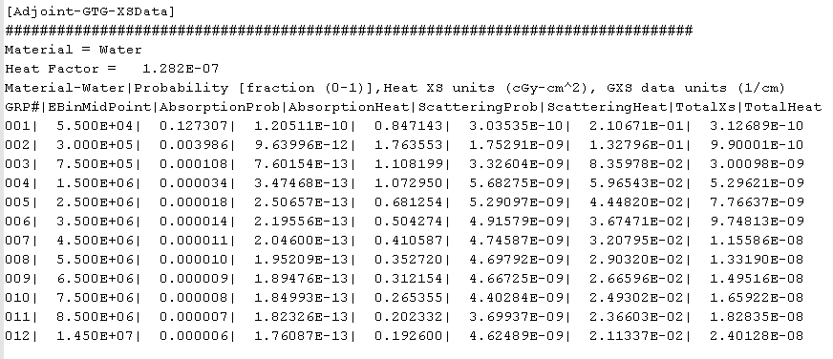
Figure B-14 Adjoint Input file view of section 6 material cross sections and transport data

In this section the total & absorption cross section is identical to the forward cross sections. The scattering cross section and scattering probability is different than the forward input file data. These values are generated using the method described in the previous section.
- Section 7: Tabulation of group to group scattering probabilities for each problem material as shown in Figure B-15. Each group data is in one row. The number of data rows in this table is given. The following is the sequence of data in the each group row:
  - Initial group.
  - Final group (up scatter group).
  - Number of probability points following in this data line.
  - The current group CDF table entries. The first value represents the maximum probability for scattering to the current energy group while the last two entries is the range of probabilities for scattering to the highest energy group.

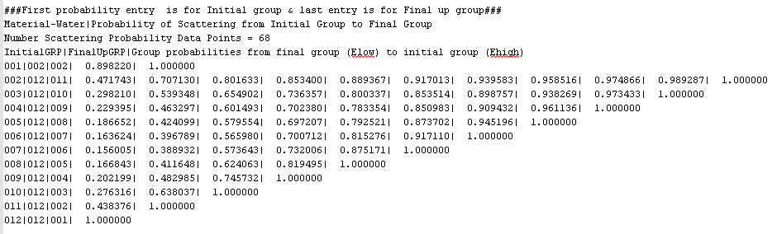
Figure B-15 Input file view of section 7 data

The data in this section is arranged as initial group and the highest final group. After that the probability is given from the current group to the highest final group. The number of probability values varies from 1 all the way to the maximum number based on the highest final group. When this data is read into the program four two dimensional arrays are created indicating the material number and group number. The following is what data arrays are created:
- The first array stores the current group.
- The second array stores the index of the group probability starting point.
- The third array stores the index of the group probability ending point.
- The fourth array has a second dimension that is equal to the maximum scatter data records. This array stores the up scatter group to group probability.

- Section 8: Tabulation of group to group scattering angles for each material. Each group data is in one row. The input deck contains two types of cosine scattering data. The following is a description of both types:

- Type I: Average of cosine scattering angle as described in the Mores code shown in Figure B-16. The number of data rows in this table is given. The following is the sequence of data in the each group row. :
    - Initial group.
    - Final group (up scatter group.)
    - Zero Order Legendre coefficient.
    - First order Legendre coefficient.
    - The computed average cosine scattering angle.

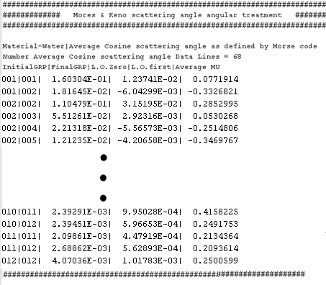

Figure B-16 Input file view of section 8 data of type I

- Type II: Tabulates the angular probability distribution function of cosine scattering angle shown in Figure B-17. Further; the number of group to group data lines in the table, the number of cosine of scattering angle values and its corresponding probability per data line is also listed. The following is the sequence of data in the each group row:
    - Initial group.
    - Final group (up scatter group.)
    - A sequence of cosine of scattering angle values followed by the same number of the probability distribution value of these cosines scattering angle.

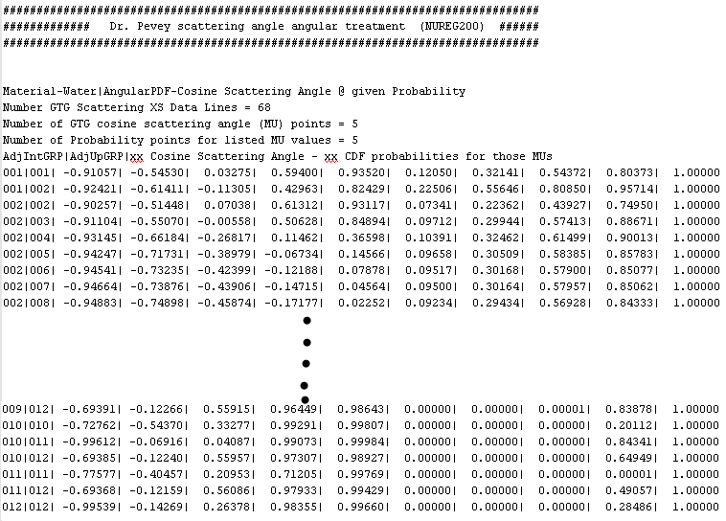

Figure B-17 Input file view of section 8 data of type II

The (μ) value and its corresponding probability are tabulated in each line. To store this data in a compact way it is read for each problem material into the program using the following arrays:
- Two dimensional array that stores the starting group for the specified group to group scattering. Index one represents the material number and second index represents the particular group to group scattering (data line).
- Two dimensional array that stores the final up group for the specified group to group scattering. Index one represents the material number and second index represents the particular group to group scattering (data line).
- Three dimensional array that store the specified (μ) values. Index one represents the material number and second index represents the particular group to group scattering (data line) and index three represent the listed (μ) value.
- Three dimensional array that store the specified probability for the given (μ) values. Index one represents the material number and second index represents the particular group to group scattering (data line) and index three represent the listed probability value for the listed (μ) value.

-
Forward continuous and multigroup MCNP5 Input deck

The following are different MCNP5 input decks that I will use to estimate cell (Voxel) fluxes using MCNP5 FMESH4 tally. The particles are the 6 MeV photons produced by Medical Linear Accelerator. These particles start from a point that is 100 cm from the phantom surface and limited by a 10 x 10 cm² window (field size). This setup is referred to as reference geometry. The reference geometry is used to calibrate the Linear Accelerator absolute output (define a point in phantom that have a defined absolute dose value).

Case 1: Published 6 MeV linear accelerator spectrum - continuous
Forward continuous energy input deck. This case models track length estimate of a cell flux (FMESH4 MCNP tally) for 6 MeV Linear accelerator source (using the published group structure) located at 100.0 cm above a 50.0 cm x 50.0 cm x 50.0 cm water box for a reference field size (10.0 cm x 10.0 cm) in detectors located 0.5 cm apart starting from phantom surface on beam central axis using MCNP mesh feature. The following is MCNP input deck:

Forward MC CAX PDD Simulation - Published Varian 6 MV Spectrum
c *******************************************************************
c Cells - 50.0 x 50.0 x 50.0 Water Box
c *******************************************************************
1 1 -1 -1 imp:p=1 $ 50.0x50.0x50.0 Water box
2 0 -2 3 imp:p=0 $ thin layer surrounding window
3 0 -3 imp:p=1 $ 10 x 10 window
4 0 #1 #2 #3 -100 imp:p=1 $ outside water box inside universe
5 0 +100 imp:p=0 $ Outside universe -void

c *******************************************************************
c Surfaces
c *******************************************************************
100 so 200.0 $ Universe bound
1 RPP -25.0 25.0 0.0 50.0 -25.0 25.0 $ Water box 50.0x50.0x50.0
2 RPP -25.0 25.0 -0.001 0.0 -25.0 25.0 $ thin Field Plate
3 RPP -5.0 5.0 -0.001 0.0 -5.0 5.0 $ Field size 10.0 x 10.0

c *******************************************************************
c Data Cards
c *******************************************************************
c
c Photon point source positioned at (0.0,-100.0,0.0) all particles
c travelling in direction <0.0,-1.0,0.0>. Source energy distribution
c is according to the published 2100-6MV spectrum. Direction is
c limited to a 40.0 cm diameter circle at 100.0 cm from the source.
c max angle is Acos(100/101.98=0.980581) = 11.30993-
c mu from 1.0 --> 0.980581. to normalize to the particles in the cone
c use WGT=1/fsa2 (fsa2= fraction solid angle of the cone)
c This is a 40.0 cm circle run
SDEF POS 0.0 -100.0 0.0 VEC 0.0 1.0 0.0
ERG d1 DIR d2 PAR 2 WGT 1.03018e2
c
c *******************************************************************
c ************ Energy Distribution 2100-6MV ***********************
c ************ Group structure - Published ***********************
c *******************************************************************
c
SI1 H 0.010 0.250 0.500 0.750 1.000 1.250 1.500 1.750 2.000 2.250
2.500 2.750 3.000 3.250 3.500 3.750 4.000 4.250 4.500 4.750
5.000 5.250 5.500 5.750 6.000
SP1 D 0.000000 0.020529 0.120872 0.125669 0.109361 0.093628
0.080198 0.069549 0.059765 0.051323 0.044032 0.037892
0.033288 0.028587 0.025038 0.021584 0.018323 0.015924
0.013238 0.010936 0.008672 0.006283 0.003924 0.001343
0.000042
c
c *******************************************************************
c Picking in a 11.30993 cone (Bias = 1/ 0.009707)
c *******************************************************************
c
SI2 -1 0.980581 1. $ Histogram for cosine bin limits
SP2 0.0 0.99029 0.009707 $ frac. solid angle for each bin
SB2 0. 0. 1. $ source bias for each bin
c
c *************** Materials *****************************************
c *******************************************************************
c WATER for gamma-ray transport (by mass fraction)
c *******************************************************************
c
M1 1000 -0.11190 $ elemental H mass fraction
8000 -0.88810 $ elemental O mass fraction
c
c *******************************************************************
c ******************** Problem FMESH4 Tally *************************
c *******************************************************************
c
FC4 Continuous Published Varian 6 MV Spectrum
FMESH4:P GEOM=xyz
ORIGIN=-25 0 0
IMESH=25. IINTS=100
JMESH=50. JINTS=100
KMESH=.5 KINTS=1
OUT=ij
EMESH = 6.000
c
c *******************************************************************
c **************** NJOY Dose Conversion factors ****************
c **************** For Published group structure ****************
c *******************************************************************
c
E0 0.010 0.250 0.500 0.750 1.000 1.250 1.500 1.750 2.000
2.250 2.500 2.750 3.000 3.250 3.500 3.750 4.000 4.250
4.500 4.750 5.000 5.250 5.500 5.750 6.000
EM0 5.23780E-10 1.50459E-09 1.50459E-09 2.60158E-09 3.54905E-09
4.37346E-09 5.11610E-09 5.79888E-09 6.44136E-09 7.01251E-09
7.59904E-09 8.09581E-09 8.58734E-09 9.10125E-09 9.55186E-09
9.99510E-09 1.04792E-08 1.09187E-08 1.13250E-08 1.18073E-08
1.22876E-08 1.27357E-08 1.31545E-08 1.35449E-08 1.39088E-08
c
c *******************************************************************
c PHYS:P EMCPF IDES NOCOH ISPN NODOP
c EMCPF = Upper energy limit for detailed photon physics treatment,
c in MeV.
c To turn off electron production and the bremsstrahlung photons
c use IDES=1 default =0 --> thick target bremsstrahlung. To turn
c off coherent scattering NOCOH=1; photo nuclear collision ISPN=0
c Doppler energy broadening NODOP=1
c *******************************************************************
c
CUT:P J 0.01
MODE P
PHYS:P 6.000 1
c PRINT 100 40 110 150 160 161 162
NPS 250000000
PRINT

Case 2: Pixel8 group structure - continuous
Forward continuous energy input deck. This case models track length estimate of a cell flux (FMESH4 MCNP tally) for 6 MeV Linear accelerator source (using the pixel8 group structure) located at 100.0 cm above a 50.0 cm x 50.0 cm x 50.0 cm water box for a reference field size (10.0 cm x 10.0 cm) in detectors located 0.5 cm apart starting from phantom surface on beam central axis using MCNP mesh feature. The following is MCNP input deck:

Forward MC CAX PDD Sim - Varian 6 MV Spectrum-Pixel8 Group Structure
c *******************************************************************
c Cells - 50.0 x 50.0 x 50.0 Water Box
c *******************************************************************
1 1 -1 -1 imp:p=1 $ 50.0x50.0x50.0 Water box
2 0 -2 3 imp:p=0 $ thin layer surrounding window
3 0 -3 imp:p=1 $ 10 x 10 window
4 0 #1 #2 #3 -100 imp:p=1 $ outside water box inside universe
5 0 +100 imp:p=0 $ Outside universe -void

c *******************************************************************
c Surfaces
c *******************************************************************
100 so 200.0 $ Universe bound
1 RPP -25.0 25.0 0.0 50.0 -25.0 25.0 $ Water box 50.0x50.0x50.0
2 RPP -25.0 25.0 -0.001 0.0 -25.0 25.0 $ thin Field Plate
3 RPP -5.0 5.0 -0.001 0.0 -5.0 5.0 $ Field size 10.0 x 10.0

c *******************************************************************
c Data Cards
c *******************************************************************
c
c Photon point source positioned at (0.0,-100.0,0.0) all particles
c travelling in direction <0.0,-1.0,0.0>. Source energy distribution
c is according to the published 2100-6MV spectrum. Direction is
c limited to a 40.0 cm diameter circle at 100.0 cm from the source.
c max angle is Acos(100/101.98=0.980581) = 11.30993-
c mu from 1.0 --> 0.980581. to normalize to the particles in the cone
c use WGT=1/fsa2 (fsa2= fraction solid angle of the cone)
c This is a 40.0 cm circle run
SDEF POS 0.0 -100.0 0.0 VEC 0.0 1.0 0.0
ERG d1 DIR d2 PAR 2 WGT 1.03018e2
c
c *******************************************************************
c ************ Energy Distribution 2100-6MV ***********************
c ************ Group structure - Pixel8 ***********************
c *******************************************************************
c
SI1 H 0.010 0.020 0.030 0.045 0.060 0.070 0.100 0.150 0.200
0.300 0.400 0.450 0.510 0.512 0.600 0.700 0.800 1.000
1.330 1.500 1.660 2.000 2.250 2.500 2.750 3.000 3.250
3.500 3.750 4.000 4.250 4.500 4.750 5.000 5.250 5.500
5.750 6.000
SP1 D 0.000000 0.000855 0.000855 0.001283 0.001283 0.000855
0.002566 0.004277 0.004277 0.028451 0.048349 0.024174
0.029201 0.001005 0.044235 0.050268 0.047006 0.087489
0.119290 0.054535 0.044512 0.084803 0.051323 0.044032
0.037893 0.033288 0.028587 0.025038 0.021584 0.018323
0.015924 0.013238 0.010936 0.008672 0.006283 0.003924
0.001343 0.000042
c
c *******************************************************************
c Picking in a 11.30993 cone (Bias = 1/ 0.009707)
c *******************************************************************
c
SI2 -1 0.980581 1. $ Histogram for cosine bin limits
SP2 0.0 0.99029 0.009707 $ frac. solid angle for each bin
SB2 0. 0. 1. $ source bias for each bin
c
c *************** Materials *****************************************
c *******************************************************************
c WATER for gamma-ray transport (by mass fraction)
c *******************************************************************
c
M1 1000 -0.11190 $ elemental H mass fraction
8000 -0.88810 $ elemental O mass fraction
c
c *******************************************************************
c ******************** Problem FMESH4 Tally *************************
c *******************************************************************
c
FC4 Continuous Varian 6 MV Spectrum-Pixel8 Group Structure
FMESH4:P GEOM=xyz
ORIGIN=-25 0 0
IMESH=25. IINTS=100
JMESH=50. JINTS=100
KMESH=.5 KINTS=1
OUT=ij
EMESH = 6.000
c
c *******************************************************************
c **************** NJOY Dose Conversion factors ****************
c **************** For Pixe8 group structure ****************
c *******************************************************************
c
E0 0.010 0.020 0.030 0.045 0.060 0.070 0.100 0.150 0.200
0.300 0.400 0.450 0.510 0.512 0.600 0.700 0.800 1.000
1.330 1.500 1.660 2.000 2.250 2.500 2.750 3.000 3.250
3.500 3.750 4.000 4.250 4.500 4.750 5.000 5.250 5.500
5.750 6.000
EM0 2.55258E-09 8.66601E-10 3.94856E-10 2.62531E-10 2.45678E-10
2.87271E-10 4.20037E-10 6.42006E-10 9.80897E-10 1.44793E-09
1.80022E-09 2.03092E-09 2.16457E-09 2.35184E-09 2.72503E-09
3.11679E-09 3.64004E-09 4.48348E-09 5.23123E-09 5.67619E-09
6.32465E-09 7.01281E-09 7.59976E-09 8.09697E-09 8.58888E-09
9.10313E-09 9.55404E-09 9.99759E-09 1.04819E-08 1.09217E-08
1.13283E-08 1.18107E-08 1.22912E-08 1.27396E-08 1.31586E-08
1.35491E-08 1.39131E-08 1.43375E-08
c
c *******************************************************************
c PHYS:P EMCPF IDES NOCOH ISPN NODOP
c EMCPF = Upper energy limit for detailed photon physics treatment,
c in MeV.
c To turn off electron production and the bremsstrahlung photons
c use IDES=1 default =0 --> thick target bremsstrahlung. To turn
c off coherent scattering NOCOH=1; photo nuclear collision ISPN=0
c Doppler energy broadening NODOP=1
c *******************************************************************
c
CUT:P J 0.01
MODE P
PHYS:P 6.000 1
c PRINT 100 40 110 150 160 161 162
NPS 250000000
PRINT

Case 3: MCNP5-MGXSNP group structure - continuous
Forward continuous energy input deck. This case models track length estimate of a cell flux (FMESH4 MCNP tally) for 6 MeV Linear accelerator source (using the mcnp5-mgxsnp group structure) located at 100.0 cm above a 50.0 cm x 50.0 cm x 50.0 cm water box for a reference field size (10.0 cm x 10.0 cm) in detectors located 0.5 cm apart starting from phantom surface on beam central axis using MCNP mesh feature. The following is MCNP input deck:

Forward MC CAX PDD Sim - Varian 6 MV Spectrum-MCNP-MGXSNP Grp Strctre
c *******************************************************************
c Cells - 50.0 x 50.0 x 50.0 Water Box
c *******************************************************************
1 1 -1 -1 imp:p=1 $ 50.0x50.0x50.0 Water box
2 0 -2 3 imp:p=0 $ thin layer surrounding window
3 0 -3 imp:p=1 $ 10 x 10 window
4 0 #1 #2 #3 -100 imp:p=1 $ outside water box inside universe
5 0 +100 imp:p=0 $ Outside universe -void

c *******************************************************************
c Surfaces
c *******************************************************************
100 so 200.0 $ Universe bound
1 RPP -25.0 25.0 0.0 50.0 -25.0 25.0 $ Water box 50.0x50.0x50.0
2 RPP -25.0 25.0 -0.001 0.0 -25.0 25.0 $ thin Field Plate
3 RPP -5.0 5.0 -0.001 0.0 -5.0 5.0 $ Field size 10.0 x 10.0

c *******************************************************************
c Data Cards
c *******************************************************************
c
c Photon point source positioned at (0.0,-100.0,0.0) all particles
c travelling in direction <0.0,-1.0,0.0>. Source energy distribution
c is according to the published 2100-6MV spectrum. Direction is
c limited to a 40.0 cm diameter circle at 100.0 cm from the source.
c max angle is Acos(100/101.98=0.980581) = 11.30993-
c mu from 1.0 --> 0.980581. to normalize to the particles in the cone
c use WGT=1/fsa2 (fsa2= fraction solid angle of the cone)
c This is a 40.0 cm circle run
SDEF POS 0.0 -100.0 0.0 VEC 0.0 1.0 0.0
ERG d1 DIR d2 PAR 2 WGT 1.03018e2
c
c *******************************************************************
c ************ Energy Distribution 2100-6MV ***********************
c ************ Group structure MCNP-MGXSNP ***********************
c *******************************************************************
c
SI1 H 0.010 0.100 0.500 1.000 2.000 3.000 4.000 5.000 6.000
SP1 D 0.000000 0.007698 0.133707 0.235028 0.303138 0.166534
0.093532 0.048771 0.011591
c
c *******************************************************************
c Picking in a 11.30993 cone (Bias = 1/ 0.009707)
c *******************************************************************
c
SI2 -1 0.980581 1. $ Histogram for cosine bin limits
SP2 0.0 0.99029 0.009707 $ frac. solid angle for each bin
SB2 0. 0. 1. $ source bias for each bin
c
c *************** Materials *****************************************
c *******************************************************************
c WATER for gamma-ray transport (by mass fraction)
c *******************************************************************
c
M1 1000 -0.11190 $ elemental H mass fraction
8000 -0.88810 $ elemental O mass fraction
c
c *******************************************************************
c ******************** Problem FMESH4 Tally *************************
c *******************************************************************
c
FC4 Continuous Varian 6 MV Spectrum-MCNP-MGXSNP Grp Strctre
FMESH4:P GEOM=xyz
ORIGIN=-25 0 0
IMESH=25. IINTS=100
JMESH=50. JINTS=100
KMESH=.5 KINTS=1
OUT=ij
EMESH = 6.000
c
c *******************************************************************
c **************** NJOY Dose Conversion factors ****************
c **************** For MCNP-MGXSNP group structure ****************
c *******************************************************************
c
E0 0.010 0.100 0.500 1.000 2.000 3.000 4.000 5.000 6.000
EM0 3.12689E-10 9.90001E-10 3.00098E-09 5.29621E-09 7.76637E-09
9.74813E-09 1.15586E-08 1.33190E-08 1.49516E-08
c
c *******************************************************************
c PHYS:P EMCPF IDES NOCOH ISPN NODOP
c EMCPF = Upper energy limit for detailed photon physics treatment,
c in MeV.
c To turn off electron production and the bremsstrahlung photons
c use IDES=1 default =0 --> thick target bremsstrahlung. To turn
c off coherent scattering NOCOH=1; photo nuclear collision ISPN=0
c Doppler energy broadening NODOP=1
c *******************************************************************
c
CUT:P J 0.01
MODE P
PHYS:P 6.000 1
c PRINT 100 40 110 150 160 161 162
NPS 250000000
PRINT

Case 4: MCNP5-MGXSNP group structure – multi group
Forward multigroup input deck. This case models track length estimate of a cell flux (FMESH4 MCNP tally) for 6 MeV Linear accelerator source (using the mcnp5-mgxsnp group structure) located at 100.0 cm above a 50.0 cm x 50.0 cm x 50.0 cm water box for a reference field size (10.0 cm x 10.0 cm) in detectors located 0.5 cm apart starting from phantom surface on beam central axis using MCNP mesh feature. The following is MCNP input deck:

Forward MC CAX PDD Sim - Varian 6 MV Spectrum-MCNP-MGXSNP Grp Strctre
c *******************************************************************
c Cells - 50.0 x 50.0 x 50.0 Water Box
c *******************************************************************
1 1 -1 -1 imp:p=1 $ 50.0x50.0x50.0 Water box
2 0 -2 3 imp:p=0 $ thin layer surrounding window
3 0 -3 imp:p=1 $ 10 x 10 window
4 0 #1 #2 #3 -100 imp:p=1 $ outside water box inside universe
5 0 +100 imp:p=0 $ Outside universe -void

c *******************************************************************
c Surfaces
c *******************************************************************
100 so 200.0 $ Universe bound
1 RPP -25.0 25.0 0.0 50.0 -25.0 25.0 $ Water box 50.0x50.0x50.0
2 RPP -25.0 25.0 -0.001 0.0 -25.0 25.0 $ thin Field Plate
3 RPP -5.0 5.0 -0.001 0.0 -5.0 5.0 $ Field size 10.0 x 10.0

c *******************************************************************
c Data Cards
c *******************************************************************
c
c Photon point source positioned at (0.0,-100.0,0.0) all particles
c travelling in direction <0.0,-1.0,0.0>. Source energy distribution
c is according to the published 2100-6MV spectrum. Direction is
c limited to a 40.0 cm diameter circle at 100.0 cm from the source.
c max angle is Acos(100/101.98=0.980581) = 11.30993-
c mu from 1.0 --> 0.980581. to normalize to the particles in the cone
c use WGT=1/fsa2 (fsa2= fraction solid angle of the cone)
c This is a 40.0 cm circle run
SDEF POS 0.0 -100.0 0.0 VEC 0.0 1.0 0.0
ERG d1 DIR d2 PAR 2 WGT 1.03018e2
c
c *******************************************************************
c ************ Energy Distribution 2100-6MV ***********************
c ************ Group structure MCNP-MGXSNP ***********************
c *******************************************************************
c
SI1 H 0.010 0.100 0.500 1.000 2.000 3.000 4.000 5.000 6.000
SP1 D 0.000000 0.007698 0.133707 0.235028 0.303138 0.166534
0.093532 0.048771 0.011591
c
c *******************************************************************
c Picking in a 11.30993 cone (Bias = 1/ 0.009707)
c *******************************************************************
c
SI2 -1 0.980581 1. $ Histogram for cosine bin limits
SP2 0.0 0.99029 0.009707 $ frac. solid angle for each bin
SB2 0. 0. 1. $ source bias for each bin
c
c *************** Materials *****************************************
c *******************************************************************
c WATER for gamma-ray transport (by mass fraction)
c *******************************************************************
c
M1 1000 -0.11190 $ elemental H mass fraction
8000 -0.88810 $ elemental O mass fraction
c
c *******************************************************************
c ******************** Problem FMESH4 Tally *************************
c *******************************************************************
c
FC4 Multi-group Varian 6 MV Spectrum-MCNP-MGXSNP Grp Strctre
FMESH4:P GEOM=xyz
ORIGIN=-25 0 0
IMESH=25. IINTS=100
JMESH=50. JINTS=100
KMESH=.5 KINTS=1
OUT=ij
EMESH = 6.000
c
c *******************************************************************
c **************** NJOY Dose Conversion factors ****************
c **************** For MCNP-MGXSNP group structure ****************
c *******************************************************************
c
E0 0.010 0.100 0.500 1.000 2.000 3.000 4.000 5.000 6.000
EM0 3.12689E-10 9.90001E-10 3.00098E-09 5.29621E-09 7.76637E-09
9.74813E-09 1.15586E-08 1.33190E-08 1.49516E-08
c
c *******************************************************************
c PHYS:P EMCPF IDES NOCOH ISPN NODOP
c EMCPF = Upper energy limit for detailed photon physics treatment,
c in MeV.
c To turn off electron production and the bremsstrahlung photons
c use IDES=1 default =0 --> thick target bremsstrahlung. To turn
c off coherent scattering NOCOH=1; photo nuclear collision ISPN=0
c Doppler energy broadening NODOP=1
c *******************************************************************
c
CUT:P J 0.01
MODE P
PHYS:P 6.000 1
MGOPT F 12
c PRINT 100 40 110 150 160 161 162
NPS 250000000
PRINT

Case 5: Regions of interest absorbed dose with MGXSNP multigroup cross section
Forward multi-group energy input deck using MGXSNP cross section. This case computes the absorbed dose in a tumor, left eye, right eye and brain tissue using (f4 MCNP tally) and appropriate dose response for a 6 MeV Linear accelerator source located at 100.0 cm above a 50.0 cm x 50.0 cm x 50.0 cm water box for a reference field size (10.0 cm x 10.0 cm). The structures are positioned in the phantom are:
- Tumor, right eye and left eye:

Table C-1 Tumor, right and left eye actual location
 | $$X_{Cntr}$$  cm | $Y_{Cntr}$ cm | $Z_{Cntr}$ cm | $Raduis$ cm
Tumor | 4.5 | 15.0 | 3.0 | 1.5
Right Eye | -7.0 | 4.0 | 0.0 | 3.5
Left Eye | 7.0 | 4.0 | 0.0 | 3.5

- Brain:

Table C-2 Brain components actual location
 | $$X_{min}$$  cm | $X_{max}$ cm | $Y_{min}$ cm | $Y_{max}$ cm | $Z_{min}$ cm | $Z_{max}$ cm
Box one | -10.0 | 10.0 | 17.0 | 29.5 | -9.0 | 1.0
Box two | -10.0 | 10.0 | 21.0 | 28.5 | 1.0 | 8.0
Box three | -10.0 | 10.0 | 3.5 | 31.0 | 8.0 | 15.0

Forward Eyes Tumor Brain - Varian 6MV Spectrum-MCNP-MGXSNP Grp Strctr
c *******************************************************************
c Cells - 50.0 x 50.0 x 50.0 Water Box with 3 structures
c *******************************************************************
1 1 -1.0 -1 imp:p=1 $ Tumor
2 1 -1.0 -2 imp:p=1 $ Right eye
3 1 -1.0 -3 imp:p=1 $ Left eye
4 1 -1.0 -4:-5:-6 imp:p=1 $ Brain
5 1 -1.0 -7 #1 #2 #3 #4 imp:p=1 $ 50.0x50.0x50.0 Water box
6 0 -8 9 imp:p=0 $ thin layer above box
7 0 -9 imp:p=1 $ 20 x 20 window
8 0 #1 #5 #6 #7 -100 imp:p=1 $ outside water box in universe
9 0 +100 imp:p=0 $ Outside universe - void
c *******************************************************************
c Surfaces
c *******************************************************************
1 S 4.5 15.0 3.0 1.5 $ Tumor
2 S -7.0 4.0 0.0 3.5 $ Right Eye
3 S 7.0 4.0 0.0 3.5 $ Left Eye
4 RPP -10.0 10.0 17.0 29.5 -9.0 1.0 $ Brain - Box 1
5 RPP -10.0 10.0 21.0 28.5 1.0 8.0 $ Brain - Box 2
6 RPP -10.0 10.0 3.5 31.0 8.0 15.0 $ Brain - Box 3
7 RPP -25.0 25.0 0.0 50.0 -25.0 25.0 $ Water box 50.0x50.0x50.
8 RPP -25.0 25.0 -0.001 0.0 -25.0 25.0 $ thin Field Plate
9 RPP -5.0 5.0 -0.001 0.0 -5.0 5.0 $ Field size 10.0 x 10.0
100 so 200.0 $ Universe bound

c *******************************************************************
c Data Cards
c *******************************************************************
c
c Photon point source positioned at (0.0,-100.0,0.0) all particles
c travelling in direction <0.0,-1.0,0.0>. Source energy distribution
c is according to the published 2100-6MV spectrum. Direction is
c limited to a 40.0 cm diameter circle at 100.0 cm from the source.
c max angle is Acos(100/101.98=0.980581) = 11.30993-
c mu from 1.0 --> 0.980581. to normalize to the particles in the cone
c use WGT=1/fsa2 (fsa2= fraction solid angle of the cone)
c This is a 40.0 cm circle run
SDEF POS 0.0 -100.0 0.0 VEC 0.0 1.0 0.0
ERG d1 DIR d2 PAR 2 WGT 1.03018e2
c
c *******************************************************************
c ************ Energy Distribution 2100-6MV ***********************
c ************ Group structure MCNP-MGXSNP ***********************
c *******************************************************************
c
SI1 H 0.010 0.100 0.500 1.000 2.000 3.000 4.000 5.000 6.000
SP1 D 0.000000 0.007698 0.133707 0.235028 0.303138 0.166534
0.093532 0.048771 0.011591
c
c *******************************************************************
c Picking in a 11.30993 cone (Bias = 1/ 0.009707)
c *******************************************************************
c
SI2 -1 0.980581 1. $ Histogram for cosine bin limits
SP2 0.0 0.99029 0.009707 $ frac. solid angle for each bin
SB2 0. 0. 1. $ source bias for each bin
c
c *************** Materials *****************************************
c *******************************************************************
c WATER for gamma-ray transport (by mass fraction)
c *******************************************************************
c
M1 1000 -0.11190 $ elemental H mass fraction
8000 -0.88810 $ elemental O mass fraction
c
c *******************************************************************
c ******************** Problem FMESH4 Tally *************************
c *******************************************************************
c
FC4 Tumor Absorbed dose (cGy)
F4:P 1
FC14 Right Eye Absorbed dose (cGy)
F14:P 2
FC24 Left Eye Absorbed dose (cGy)
F24:P 3
FC34 Brain Absorbed dose (cGy)
F34:P 4
c
c *******************************************************************
c **************** NJOY Dose Conversion factors ****************
c **************** For MCNP-MGXSNP group structure ****************
c *******************************************************************
c
E0 0.010 0.100 0.500 1.000 2.000 3.000 4.000 5.000 6.000
EM0 3.12689E-10 9.90001E-10 3.00098E-09 5.29621E-09 7.76637E-09
9.74813E-09 1.15586E-08 1.33190E-08 1.49516E-08
c
c *******************************************************************
c PHYS:P EMCPF IDES NOCOH ISPN NODOP
c EMCPF = Upper energy limit for detailed photon physics treatment,
c in MeV.
c To turn off electron production and the bremsstrahlung photons
c use IDES=1 default =0 --> thick target bremsstrahlung. To turn
c off coherent scattering NOCOH=1; photo nuclear collision ISPN=0
c Doppler energy broadening NODOP=1
c *******************************************************************
c
CUT:P J 0.001
MODE P
PHYS:P 6.000 1
MGOPT F 12
c PRINT 100 40 110 150 160 161 162
NPS 100000000
PRINT
- -
Adjoint MCNP5 surface cell fluxes input Decks

The following are the MCNP5 input decks used to run MCNP5 in adjoint mode to compute cell fluxes using FMESH4 tally. The calculation was repeated for multiple region of interest (adjoint sources). The adjoint source distribution was derived from the region of interest response function.

Case 1: A box source
Multigroup adjoint MCNP input deck. This case compute top surface cell fluxes (using FMESH4 MCNP tally - track length estimate) and top surface crossing’s (using SSW card) for a 1.5 cm x 1.5 cm x 1.5 cm box adjoint source embedded in a 50.0 cm x 50.0 cm x 50.0 cm water box. The adjoint source is placed between x-range [-0.5, 1.5], y-range [5.0, 6.5] and z-range [-0.5, 1.5] within the water box and its distribution follow a 6 MeV Linear accelerator source response function.

Adjoint with MCNP-MGXSNP - Adjoint Source as a box (1.50x1.50x1.50)
c *******************************************************************
c Cells - 50.0 x 50.0 x 50.0 Water Box
c *******************************************************************
1 1 -1.0 -1 imp:p=1 $ Adjoint source box
2 1 -1.0 -2 #1 imp:p=1 $ 50.0x50.0x50.0 Water box
3 0 #2 -100 imp:p=0 $ outside water box inside universe
4 0 +100 imp:p=0 $ Outside universe -void

c *******************************************************************
c Surfaces
c *******************************************************************
c
1 RPP -0.5 1.0 5.0 6.5 -0.5 1.0 $ Adjoint Source
2 RPP -25.0 25.0 0.0 50.0 -25.0 25.0 $ Water box 50.0x50.0x50.0
3 PY 0 $ Crossing plane
100 so 200.0 $ Universe bound

c *******************************************************************
c Data Cards
c *******************************************************************
c Adjoint source is in cell number 1. The cell is made out of
c parallelepiped with given dimensions. Points are chosen uniformly
c within the parallelepiped.
c
SDEF PAR=2 ERG=d1 X=d2 Y=d3 Z=d4 CEL=1
c
c *******************************************************************
c ************ Energy Distribution 2100-6MV ***********************
c ************ Group structure MCNP-MGXSNP ***********************
c *******************************************************************
c
SI1 H 0.000 0.010 0.100 0.500 1.000 2.000 3.000 4.000 5.000
6.000
SP1 D 0.000000000 3.12689E-10 9.90001E-10 3.00098E-09 5.29621E-09
7.76637E-09 9.74813E-09 1.15586E-08 1.33190E-08 1.49516E-08
c
c *******************************************************************
c *************** Where to pick starting points *********************
c *******************************************************************
SI2 -0.5 1.0 $ X-range for Adjoint source
SP2 0.0 1.0 $ uniform probability over the X-range
SI3 5.0 6.5 $ Y-range for Adjoint source
SP3 0.0 1.0 $ uniform probability over the Y-range
SI4 -0.5 1.0 $ Z-range for Adjoint source
SP4 0.0 1.0 $ uniform probability over the Z-range
c
c *******************************************************************
c *************** Materials *****************************************
c *******************************************************************
c WATER for gamma-ray transport (by mass fraction)
c *******************************************************************
c
M1 1000 -0.11190 $ elemental H mass fraction
8000 -0.88810 $ elemental O mass fraction
c
c *******************************************************************
c ******************** Problem FMESH4 Tally ***********************
c ******************** Need to have EMESH ***********************
c ******************** to run Adjoint problem ***********************
c *******************************************************************
c
FMESH4:P GEOM=xyz
ORIGIN=-25 0 -25
IMESH=25. IINTS=100
JMESH=.5 JINTS=1
KMESH=25. KINTS=100
OUT=ik
EMESH = 6.000
c
c *******************************************************************
c **************** NJOY Dose Conversion factors ****************
c **************** For MCNP-MGXSNP group structure ****************
c *******************************************************************
c
E0 0.010 0.100 0.500 1.000 2.000 3.000 4.000 5.000 6.000
EM0 0.000000 0.007698 0.133707 0.235028 0.303138 0.166534
0.093532 0.048771 0.011591
c
c *******************************************************************
c PHYS:P EMCPF IDES NOCOH ISPN NODOP
c To turn off electron production and the bremsstrahlung photons
c use IDES=1 default =0 --> thick target bremsstrahlung. To turn
c off coherent scattering NOCOH=1; photo nuclear collision ISPN=0
c Doppler energy broadening NODOP=1
c *******************************************************************
c
CUT:P J 6.000
MODE P
c
c *******************************************************************
c Surface Source Write card or PTRAC
c *******************************************************************
c
SSW -3
c PTRAC FILE=ASC WRITE=ALL EVENT=SUR,TER TYPE=P SURFACE=3
c PTRAC FILE=ASC FILTER=-100.0,50.0,Y 0.0,6.0,ERG -3,JSU
c EVENT=TER TYPE=P SURFACE=3
c
c *******************************************************************
c
MGOPT A 12
c PRINT 100 40 110 150 160 161 162
NPS 1000000
PRINT

Case 2: Tumor source (Sphere)
Multigroup adjoint MCNP input deck. This case compute top surface cell fluxes (using FMESH4 MCNP tally - track length estimate) and top surface crossing’s (using SSW card) for a spherical Tumor {centered at (4.5, 15.0, 3.0) and radius = 1.5 cm} as an adjoint source embedded in a 50.0 cm x 50.0 cm x 50.0 cm water. The adjoint source is placed between x-range [2.5, 6.5], y-range [13.0, 17.0] and z-range [1.0, 1.0] within the water box and its distribution follow a 6 MeV Linear accelerator source response function.

Adjoint-MCNP-MGXSNP - Adjoint Source Tumor(4.5,15.0,3.0) R=1.5 cm
c *******************************************************************
c Cells - 50.0 x 50.0 x 50.0 Water Box
c *******************************************************************
1 1 -1.0 -1 -2 imp:p=1 $ Adjoint source Tumor
2 1 -1.0 -2 #1 imp:p=1 $ 50.0x50.0x50.0 Water box
3 0 #2 -100 imp:p=0 $ outside water box inside universe
4 0 +100 imp:p=0 $ Outside universe -void

c *******************************************************************
c Surfaces
c *******************************************************************
c
1 S 4.5 15.0 3.0 1.5 $ Adjoint Source Tumor
2 RPP -25.0 25.0 0.0 50.0 -25.0 25.0 $ Water box 50.0x50.0x50.0
3 PY 0 $ Crossing plane
100 so 200.0 $ Universe bound

c *******************************************************************
c Data Cards
c *******************************************************************
c Adjoint source is in cell number 1. The cell is made out of
c parallelepiped with given dimensions. Points are chosen uniformly
c within the parallelepiped.
c
SDEF PAR=2 ERG=d1 X=d2 Y=d3 Z=d4 CEL=1
c
c *******************************************************************
c ************ Energy Distribution 2100-6MV ***********************
c ************ Group structure MCNP-MGXSNP ***********************
c *******************************************************************
c
SI1 H 0.000 0.010 0.100 0.500 1.000 2.000 3.000 4.000 5.000
6.000
SP1 D 0.000000000 3.12689E-10 9.90001E-10 3.00098E-09 5.29621E-09
7.76637E-09 9.74813E-09 1.15586E-08 1.33190E-08 1.49516E-08
c
c *******************************************************************
c *************** Where to pick starting points *********************
c *******************************************************************
SI2 2.5 6.5 $ X-range for Adjoint source
SP2 0.0 1.0 $ uniform probability over the X-range
SI3 13.0 17.0 $ Y-range for Adjoint source
SP3 0.0 1.0 $ uniform probability over the Y-range
SI4 1.0 5.0 $ Z-range for Adjoint source
SP4 0.0 1.0 $ uniform probability over the Z-range
c
c *******************************************************************
c *************** Materials *****************************************
c *******************************************************************
c WATER for gamma-ray transport (by mass fraction)
c *******************************************************************
c
M1 1000 -0.11190 $ elemental H mass fraction
8000 -0.88810 $ elemental O mass fraction
c
c *******************************************************************
c ******************** Problem FMESH4 Tally ***********************
c ******************** Need to have EMESH ***********************
c ******************** to run Adjoint problem ***********************
c *******************************************************************
c
FMESH4:P GEOM=xyz
ORIGIN=-25 0 -25
IMESH=25. IINTS=100
JMESH=.5 JINTS=1
KMESH=25. KINTS=100
OUT=ik
EMESH = 6.000
c
c *******************************************************************
c **************** NJOY Dose Conversion factors ****************
c **************** For MCNP-MGXSNP group structure ****************
c *******************************************************************
c
E0 0.010 0.100 0.500 1.000 2.000 3.000 4.000 5.000 6.000
EM0 0.000000 0.007698 0.133707 0.235028 0.303138 0.166534
0.093532 0.048771 0.011591
c
c *******************************************************************
c PHYS:P EMCPF IDES NOCOH ISPN NODOP
c To turn off electron production and the bremsstrahlung photons
c use IDES=1 default =0 --> thick target bremsstrahlung. To turn
c off coherent scattering NOCOH=1; photo nuclear collision ISPN=0
c Doppler energy broadening NODOP=1
c *******************************************************************
c
CUT:P J 6.000
MODE P
c
c *******************************************************************
c Surface Source Write card or PTRAC
c *******************************************************************
c
SSW -3
c PTRAC FILE=ASC WRITE=ALL EVENT=SUR,TER TYPE=P SURFACE=3
c PTRAC FILE=ASC FILTER=-100.0,50.0,Y 0.0,6.0,ERG -3,JSU
c EVENT=TER TYPE=P SURFACE=3
c
c *******************************************************************
c
MGOPT A 12
c PRINT 100 40 110 150 160 161 162
NPS 1000000
PRINT

Case 3: Right eye (Sphere)
Multigroup adjoint MCNP input deck. This case compute top surface cell fluxes (using FMESH4 MCNP tally - track length estimate) and top surface crossing’s (using SSW card) for a spherical right eye {centered at (-8.0, 3.0, 0.0) and radius = 3.5 cm} as an adjoint source embedded in a 50.0 cm x 50.0 cm x 50.0 cm water. The adjoint source is placed between x-range [-10.0, -6.0], y-range [1.0, 5.0] and z-range [-2.0, 2.0] within the water box and its distribution follow a 6 MeV Linear accelerator source response function.

Adjoint-MCNP-MGXSNP - Adjoint Source RtEye(-8.0,3.0,0.0) R=3.5 cm
c *******************************************************************
c Cells - 50.0 x 50.0 x 50.0 Water Box
c *******************************************************************
1 1 -1.0 -1 -2 imp:p=1 $ Adjoint source Rt Eye
2 1 -1.0 -2 #1 imp:p=1 $ 50.0x50.0x50.0 Water box
3 0 #2 -100 imp:p=0 $ outside water box inside universe
4 0 +100 imp:p=0 $ Outside universe -void

c *******************************************************************
c Surfaces
c *******************************************************************
c
1 S -8.0 3.0 0.0 3.5 $ Adjoint Source Rt Eye
2 RPP -25.0 25.0 0.0 50.0 -25.0 25.0 $ Water box 50.0x50.0x50.0
3 PY 0 $ Crossing plane
100 so 200.0 $ Universe bound

c *******************************************************************
c Data Cards
c *******************************************************************
c Adjoint source is in cell number 1. The cell is made out of
c parallelepiped with given dimensions. Points are chosen uniformly
c within the parallelepiped.
c
SDEF PAR=2 ERG=d1 X=d2 Y=d3 Z=d4 CEL=1
c
c *******************************************************************
c ************ Energy Distribution 2100-6MV ***********************
c ************ Group structure MCNP-MGXSNP ***********************
c *******************************************************************
c
SI1 H 0.000 0.010 0.100 0.500 1.000 2.000 3.000 4.000 5.000
6.000
SP1 D 0.000000000 3.12689E-10 9.90001E-10 3.00098E-09 5.29621E-09
7.76637E-09 9.74813E-09 1.15586E-08 1.33190E-08 1.49516E-08
c
c *******************************************************************
c *************** Where to pick starting points *********************
c *******************************************************************
SI2 -10.0 -6.0 $ X-range for Adjoint source
SP2 0.0 1.0 $ uniform probability over the X-range
SI3 1.0 5.0 $ Y-range for Adjoint source
SP3 0.0 1.0 $ uniform probability over the Y-range
SI4 -2.0 2.0 $ Z-range for Adjoint source
SP4 0.0 1.0 $ uniform probability over the Z-range
c
c *******************************************************************
c *************** Materials *****************************************
c *******************************************************************
c WATER for gamma-ray transport (by mass fraction)
c *******************************************************************
c
M1 1000 -0.11190 $ elemental H mass fraction
8000 -0.88810 $ elemental O mass fraction
c
c *******************************************************************
c ******************** Problem FMESH4 Tally ***********************
c ******************** Need to have EMESH ***********************
c ******************** to run Adjoint problem ***********************
c *******************************************************************
c
FMESH4:P GEOM=xyz
ORIGIN=-25 0 -25
IMESH=25. IINTS=100
JMESH=.5 JINTS=1
KMESH=25. KINTS=100
OUT=ik
EMESH = 6.000
c
c *******************************************************************
c **************** NJOY Dose Conversion factors ****************
c **************** For MCNP-MGXSNP group structure ****************
c *******************************************************************
c
E0 0.010 0.100 0.500 1.000 2.000 3.000 4.000 5.000 6.000
EM0 0.000000 0.007698 0.133707 0.235028 0.303138 0.166534
0.093532 0.048771 0.011591
c
c *******************************************************************
c PHYS:P EMCPF IDES NOCOH ISPN NODOP
c To turn off electron production and the bremsstrahlung photons
c use IDES=1 default =0 --> thick target bremsstrahlung. To turn
c off coherent scattering NOCOH=1; photo nuclear collision ISPN=0
c Doppler energy broadening NODOP=1
c *******************************************************************
c
CUT:P J 6.000
MODE P
c
c *******************************************************************
c Surface Source Write card or PTRAC
c *******************************************************************
c
SSW -3
c PTRAC FILE=ASC WRITE=ALL EVENT=SUR,TER TYPE=P SURFACE=3
c PTRAC FILE=ASC FILTER=-100.0,50.0,Y 0.0,6.0,ERG -3,JSU
c EVENT=TER TYPE=P SURFACE=3
c
c *******************************************************************
c
MGOPT A 12
c PRINT 100 40 110 150 160 161 162
NPS 1000000
PRINT

Case 4: Left eye (Sphere)
Multigroup adjoint MCNP input deck. This case compute top surface cell fluxes (using FMESH4 MCNP tally - track length estimate) and top surface crossing’s (using SSW card) for a spherical left eye {centered at (7.0, 3.0, 0.0) and radius = 3.5 cm} as an adjoint source embedded in a 50.0 cm x 50.0 cm x 50.0 cm water. The adjoint source is placed between x-range [5.0, 9.0], y-range [1.0, 5.0] and z-range [-2.0, 2.0] within the water box and its distribution follow a 6 MeV Linear accelerator source response function.

Adjoint-MCNP-MGXSNP - Adjoint Source LtEye(7.0,3.0,0.0) R=3.5 cm
c *******************************************************************
c Cells - 50.0 x 50.0 x 50.0 Water Box
c *******************************************************************
1 1 -1.0 -1 -2 imp:p=1 $ Adjoint source Lt Eye
2 1 -1.0 -2 #1 imp:p=1 $ 50.0x50.0x50.0 Water box
3 0 #2 -100 imp:p=0 $ outside water box inside universe
4 0 +100 imp:p=0 $ Outside universe -void

c *******************************************************************
c Surfaces
c *******************************************************************
c
1 S 7.0 3.0 0.0 3.5 $ Adjoint Source Lt Eye
2 RPP -25.0 25.0 0.0 50.0 -25.0 25.0 $ Water box 50.0x50.0x50.0
3 PY 0 $ Crossing plane
100 so 200.0 $ Universe bound

c *******************************************************************
c Data Cards
c *******************************************************************
c Adjoint source is in cell number 1. The cell is made out of
c parallelepiped with given dimensions. Points are chosen uniformly
c within the parallelepiped.
c
SDEF PAR=2 ERG=d1 X=d2 Y=d3 Z=d4 CEL=1
c
c *******************************************************************
c ************ Energy Distribution 2100-6MV ***********************
c ************ Group structure MCNP-MGXSNP ***********************
c *******************************************************************
c
SI1 H 0.000 0.010 0.100 0.500 1.000 2.000 3.000 4.000 5.000
6.000
SP1 D 0.000000000 3.12689E-10 9.90001E-10 3.00098E-09 5.29621E-09
7.76637E-09 9.74813E-09 1.15586E-08 1.33190E-08 1.49516E-08
c
c *******************************************************************
c *************** Where to pick starting points *********************
c *******************************************************************
SI2 5.0 9.0 $ X-range for Adjoint source
SP2 0.0 1.0 $ uniform probability over the X-range
SI3 1.0 5.0 $ Y-range for Adjoint source
SP3 0.0 1.0 $ uniform probability over the Y-range
SI4 -2.0 2.0 $ Z-range for Adjoint source
SP4 0.0 1.0 $ uniform probability over the Z-range
c
c *******************************************************************
c *************** Materials *****************************************
c *******************************************************************
c WATER for gamma-ray transport (by mass fraction)
c *******************************************************************
c
M1 1000 -0.11190 $ elemental H mass fraction
8000 -0.88810 $ elemental O mass fraction
c
c *******************************************************************
c ******************** Problem FMESH4 Tally ***********************
c ******************** Need to have EMESH ***********************
c ******************** to run Adjoint problem ***********************
c *******************************************************************
c
FMESH4:P GEOM=xyz
ORIGIN=-25 0 -25
IMESH=25. IINTS=100
JMESH=.5 JINTS=1
KMESH=25. KINTS=100
OUT=ik
EMESH = 6.000
c
c *******************************************************************
c **************** NJOY Dose Conversion factors ****************
c **************** For MCNP-MGXSNP group structure ****************
c *******************************************************************
c
E0 0.010 0.100 0.500 1.000 2.000 3.000 4.000 5.000 6.000
EM0 0.000000 0.007698 0.133707 0.235028 0.303138 0.166534
0.093532 0.048771 0.011591
c
c *******************************************************************
c PHYS:P EMCPF IDES NOCOH ISPN NODOP
c To turn off electron production and the bremsstrahlung photons
c use IDES=1 default =0 --> thick target bremsstrahlung. To turn
c off coherent scattering NOCOH=1; photo nuclear collision ISPN=0
c Doppler energy broadening NODOP=1
c *******************************************************************
c
CUT:P J 6.000
MODE P
c
c *******************************************************************
c Surface Source Write card or PTRAC
c *******************************************************************
c
SSW -3
c PTRAC FILE=ASC WRITE=ALL EVENT=SUR,TER TYPE=P SURFACE=3
c PTRAC FILE=ASC FILTER=-100.0,50.0,Y 0.0,6.0,ERG -3,JSU
c EVENT=TER TYPE=P SURFACE=3
c
c *******************************************************************
c
MGOPT A 12
c PRINT 100 40 110 150 160 161 162
NPS 1000000
PRINT

Case 5: A brain (made out of three boxes)
Multigroup adjoint MCNP input deck. This case compute top surface cell fluxes (using FMESH4 MCNP tally - track length estimate) and top surface crossing’s (using SSW card) for the brain (made out of three boxes) as an adjoint source embedded in a 50.0 cm x 50.0 cm x 50.0 cm water box. The adjoint source is placed between x-range [-10.0, 10.0], y-range [17.0, 31.0] and z-range [-9.0, 15.0] within the water box and its distribution follow a 6 MeV Linear accelerator source response function.

Adjoint-MCNP-MGXSNP - Adjoint Source Brain - made of three boxes
c *******************************************************************
c Cells - 50.0 x 50.0 x 50.0 Water Box
c *******************************************************************
1 1 -1.0 (-1:-4:-5) -2 imp:p=1 $ Adjoint source Lt Eye
2 1 -1.0 -2 #1 imp:p=1 $ 50.0x50.0x50.0 Water box
3 0 #2 -100 imp:p=0 $ outside box inside universe
4 0 +100 imp:p=0 $ Outside universe -void

c *******************************************************************
c Surfaces
c *******************************************************************
c
1 RPP -10.0 10.0 17.0 29.5 -9.0 1.0 $ Adjoint Source - Box 1
2 RPP -25.0 25.0 0.0 50.0 -25.0 25.0 $ Water box 50.0x50.0x50.0
3 PY 0 $ Crossing plane
4 RPP -10.0 10.0 21.0 28.5 1.0 8.0 $ Adjoint Source - Box 2
5 RPP -10.0 10.0 3.5 31.0 8.0 15.0 $ Adjoint Source - Box 3
100 so 200.0 $ Universe bound

c *******************************************************************
c Data Cards
c *******************************************************************
c Adjoint source is in cell number 1. The cell is made out of
c parallelepiped with given dimensions. Points are chosen uniformly
c within the parallelepiped.
c
SDEF PAR=2 ERG=d1 X=d2 Y=d3 Z=d4 CEL=1
c
c *******************************************************************
c ************ Energy Distribution 2100-6MV ***************************
c ************ Group structure MCNP-MGXSNP ************************
c *******************************************************************
c
SI1 H 0.000 0.010 0.100 0.500 1.000 2.000 3.000 4.000 5.000
6.000
SP1 D 0.000000000 3.12689E-10 9.90001E-10 3.00098E-09 5.29621E-09
7.76637E-09 9.74813E-09 1.15586E-08 1.33190E-08 1.49516E-08
c
c *******************************************************************
c *************** Where to pick starting points **************************
c *******************************************************************
SI2 -10.0 10.0 $ X-range for Adjoint source
SP2 0.0 1.0 $ uniform probability over the X-range
SI3 17.0 31.0 $ Y-range for Adjoint source
SP3 0.0 1.0 $ uniform probability over the Y-range
SI4 -9.0 15.0 $ Z-range for Adjoint source
SP4 0.0 1.0 $ uniform probability over the Z-range
c
c *******************************************************************
c *************** Materials *******************************************
c *******************************************************************
c WATER for gamma-ray transport (by mass fraction)
c *******************************************************************
c
M1 1000 -0.11190 $ elemental H mass fraction
8000 -0.88810 $ elemental O mass fraction
c
c *******************************************************************
c ******************** Problem FMESH4 Tally *************************
c ******************** Need to have EMESH *************************
c ******************** to run Adjoint problem ***************************
c *******************************************************************
c
FMESH4:P GEOM=xyz
ORIGIN=-25 0 -25
IMESH=25. IINTS=100
JMESH=.5 JINTS=1
KMESH=25. KINTS=100
OUT=ik
EMESH = 6.000
c
c *******************************************************************
c **************** NJOY Dose Conversion factors *********************
c **************** For MCNP-MGXSNP group structure ******************
c *******************************************************************
c
E0 0.010 0.100 0.500 1.000 2.000 3.000 4.000 5.000 6.000
EM0 0.000000 0.007698 0.133707 0.235028 0.303138 0.166534
0.093532 0.048771 0.011591
c
c *******************************************************************
c PHYS:P EMCPF IDES NOCOH ISPN NODOP
c To turn off electron production and the bremsstrahlung photons
c use IDES=1 default =0 --> thick target bremsstrahlung. To turn
c off coherent scattering NOCOH=1; photo nuclear collision ISPN=0
c Doppler energy broadening NODOP=1
c *******************************************************************
c
CUT:P J 6.000
MODE P
c
c *******************************************************************
c Surface Source Write card or PTRAC
c *******************************************************************
c
SSW -3
c PTRAC FILE=ASC WRITE=ALL EVENT=SUR,TER TYPE=P SURFACE=3
c PTRAC FILE=ASC FILTER=-100.0,50.0,Y 0.0,6.0,ERG -3,JSU
c EVENT=TER TYPE=P SURFACE=3
c
c *******************************************************************
c
MGOPT A 12
c PRINT 100 40 110 150 160 161 162
NPS 1000000
PRINT

VITA
Mat Mustafa Al-Tamimi was born in Kuwait city, Kuwait to the parents of Abdel Jawad and Samira Al-Tamimi. He is the second of six siblings: Aminah, Imad, Rula, Mobin and Tasneem. He attended Jareer Middle school in Kuwait and continued to Abdula Al-Saleem High school in the same city. Came to the united stated to purse higher education. He attended Hillsborough community college for two year as pre engineering major. After completing all the needed pre engineering credits he attended the University of South Florida in Tampa for one semester. He transferred to New Jersey Institute of Technology in Newark New Jersey and completed a Bachelor degree in Electrical Engineering with concentration in communication in 1991. He returned to school 1997 to complete graduate studies in Nuclear Engineering. During his studies he worked as a graduate assistant at the University of Tennessee Radiological Safety Office. He earned his Master of Science in Nuclear Engineering with concentration in Radiological Engineering from the University of Tennessee at the end of 1999. He then pursued another graduate degree in the field of Medical Physics at the University of Kentucky at Lexington. He served as a physics tutor in the physics at the University Of Kentucky Department for two semesters. He also completed a medical physics internship at the Marshfield Clinic in Marshfield Wisconsin. He completed his Medical Physics graduate studies and earned a Master of Science in Radiological Medical Physics from the University of Kentucky in 2001. In 2001 he began to work as a medical physicist working for RadPhys Medical Physics consultant serving primarily Baptist Hospital in Knoxville. He enrolled back at the University of Tennessee Nuclear Engineering to pursue a Doctorate degree in 2001. In 2004 he passed his preliminary exam and was admitted to candidacy.

