STUDY OF SECONDARY PARTICLES PRODUCED FROM HEAVY-ION INTERACTIONS

A Dissertation Presented for the
Doctor of Philosophy
Degree
The University of Tennessee, Knoxville

Pi-En Tsai
July 2015

Copyright © 2015 by Pi-En Tsai
All rights reserved.

ACKNOWLEDGEMENTS

Thank you all for your help. However, this page is optional.
ABSTRACT

The study of secondary particles produced from heavy-ion interactions is important in several fields, including radiotherapy using ion beams, space radiation protection, accelerator facilities for scientific researches, etc.. Among all the secondary particles, neutrons are of special concern because they are highly penetrating particles with large dose conversion factors. Hence, this dissertation focuses on the study of secondary neutron production.

The dissertation includes two major topics: one of them is the measurement of secondary neutrons created from helium ions bombarding various stopping targets, and the other one is benchmarking the existing neutron production cross section data with three Monte Carlo simulations codes – PHITS, FLUKA, and MCNP. The results of both experimental study and model calculations will provide critical information for validation and verification of the current radiation transport codes used for simulating heavy-ion interactions and further help lead to improvements in the physics models.

TABLE OF CONTENTS

CHAPTER I 1
Introduction 1
I.1 Application in hadron therapy 1
I. 2 Application in space radiation 3
I.3 Validation and verification of radiation transport codes 4
CHAPTER II 6
secondary neutrons produced from helium ions bombarding stopping targets 6
II.1 Experiment target design 6
II.1.a PHITS simulations 6
II.1.b Simulation results for varying target depth 9
II.1.c Simulation results for varying target cross sectional area 12
II.1.d Summaries 15
II.2 Experimental setup 15
II.2.a Beam and target characteristics 17
II.2.b Measurement methods 19
II.2.c Electronics and data acquisition 23
II.3 Data analysis 25
II.3.a Energy Calibration and Time Calibration 26
II.3.b Spectra Analysis 27
II.3.c Background Subtraction and Application of Corrections 31
II.4 Benchmark calculations 33
II.4.a Physics models 33
II.4.b Geometry setup 34
II.5 Measurement and simulation results 34
II.6 Summaries and conclusions 34
CHAPTER III 35
Benchmark of secondary neutron production cross sections from heavy ion interactions 35
Heading 2 35
Heading 3 35
Heading 3 35
Heading 2 35
Heading 3 35
Heading 3 35
Heading 2 35
CHAPTER IV 38
Conclusions and Recommendations 38
LIST OF REFERENCES 39
APPENDIX 43
Vita 45

LIST OF TABLES

Table 1. Existing measurements of ⁴He-induced secondary neutron thick target yields (stopping or thick targets). 5
Table 2. Existing measurements of ⁴He-induced secondary neutron production cross section (thin targets). 5
Table 3. The various beam-target simulation cases. The reference systems that are highlighted in yellow are used for comparison of angular distributions in the same beam-target material combination. 7
Table 4. Details of the stopping targets. 19

LIST OF FIGURES

Figure 1. The energy spectra of the hadronic galactic cosmic rays. 3
Figure 2. Schematic diagram of the simulation geometry. 8
Figure 3. Normalized neutron angular distributions of different beam-target combinations with target depth as a variable. 9
Figure 4. Normalized proton angular distributions of different beam-target combinations with target depth as a variable. 10
Figure 5. Normalized neutron angular distributions of different beam-target combinations with target cross sectional area (A_{cs}) as a variable. 11
Figure 6. Normalized proton angular distributions of different beam-target combinations with target cross sectional area (A_{cs}) as a variable. 13
Figure 7. Geometries of the iron targets for 100-MeV/nucleon ⁴He projectiles and the water targets for 230-MeV/nucleon ⁴He projectiles. 14
Figure 8. The experimental setup of the HIMAC measurement. 16
Figure 9. A picture of the experimental setup at HIMAC. 16
Figure 10. A closer look of the trigger plastic and the target setup. 17
Figure 11. Two pictures showing the measurement with shadow bars. 22
Figure 12. The block diagram of measurement circuits 24
Figure 13. An E vs. ΔE plot measured at 0⁰ when 100-MeV/nucleon He stopped in the PMMA target. 28
Figure 14. A ToF vs. E plot measured at 0⁰ under the system with 100-MeV/nucleon He incident on the PMMA target. 29
Figure 15. The pulse shape discrimination performed for the 0⁰- neutron detector in the system with 100-MeV/nucleon He projectiles and a thick PMMA target. 30
Figure 16. Time-of-flight spectra measured at (a) 0⁰ with 230-MeV/nucleon ⁴He incident on water, and (b) 15⁰ with 230-MeV/nucleon ⁴He incident on iron. 32

CHAPTER I

Introduction

                - Knowledge of high-energy heavy-ion induced nuclear reactions is critical in diverse fields including heavy ion radiotherapy, space exploration, and accelerator facilities for scientific research. In each application of heavy ions, not only the primary ions but also the secondary particles must be considered. Among all secondary particles, secondary neutrons are of special concern, since neutrons are highly-penetrating neutral particles with large dose conversion factors. Hence, this study is focused on the production of secondary neutrons derived from heavy-ion induced nuclear reactions.
                - In CHAPTER I, the general information regarding the importance of this secondary neutron study in hadron therapy and in space radiation protection are briefly described. CHAPTER II focuses on the measurement of secondary neutrons produced by ⁴He ions stopping in various target materials, including the experiment target design, experimental setup, and measurement results along with the benchmarking calculations by PHITS, FLUKA and MCNP. In CHAPTER III, the inter-comparison of three Monte Carlo simulation codes – PHITS, FLUKA and MCNP with the existing secondary neutron production cross section data are presented. The simulation cases cover the projectiles from ¹²C ions to ¹³²Xe ions over the energy range from 135 MeV/nucleon to 600 MeV/nuclon, and the target materials include ^{nat}Li, ^{nat}C, ^{nat}Al, ^{nat}Cu, and ^{nat}Pb.

I.1 Application in hadron therapy

                - Radiotherapy using ion beams has gained momentum in radiation oncology. While the number of proton therapy facilities under construction or in operation in the United States and worldwide is rapidly growing, clinical facilities using heavy-ion (whose atomic number Z is greater than one) beam for treatment are concentrated in Asia and Europe, especially in Japan and Germany. Though the Lawrence Berkeley National Laboratory was the pioneer in heavy ion therapy conducting the first helium ion treatment in 1957 [1], the United States has lost its leadership position in hadron therapy. However, the interests in heavy ion radiotherapy has been revitalized in the United States, as reflected in a recent grant award supported by the National Institute of Health (NIH) to establish heavy ion research centers.
                - Protons and heavy ions are all capable of delivering Bragg peaks and exhibit a small lateral and range scattering in tissue, yet the detailed physical dose distribution is different for different ions. With the increasing atomic mass, both lateral scattering and range straggling decrease such that therapeutic dose can be more precisely delivered. At the same time, however, the probability and number of nuclear reaction channels increase, producing energetic secondary fragments with certain ranges that leads to unwanted doses to health tissue. As a result, an optimum in overall dose distribution lies between helium and oxygen. In addition to carbon ions, which are more commonly used in clinical studies, helium ions also have advantages of significant peak-to-entrance dose ratios and limited dose contributions from secondary neutrons charged fragments [2]. Considering the risk of late sequelae and radiation-induced tumors, reduction of the dose in healthy tissues contributed by secondary particles produced from nuclear interaction of primary ion beams with human tissue is important for children and adolescents. Therefore, the U.S. hadron therapy community has also expressed interest in using helium ions for radiation treatment. To use helium ions for radiotherapy in the future, it is of critical interest to well characterize the secondary particles produced by primary ion interactions with beam-delivery devices and human tissue.

I. 2 Application in space radiation

                - Helium ions also play an important role in the space environment. The ionizing radiation in space radiation consists of galactic cosmic ray (GCR) and solar energetic particle (SEP). SEP includes about 80-90% protons, 10-20% helium and about 1% heavy ions. About 98% of the GCR comprises protons and heavy ions, and electrons are the remaining 2%. Among the hadronic GCR, the ion species include 87% protons, 12% helium, and 1% heavy ions with energies ranges from tens of MeV/nucleon to several TeV/nucleon and these hadronic GCR have a broad fluence peak between 200 to 600 MeV/nucleon, as shown in Figure 1 [3].
                - 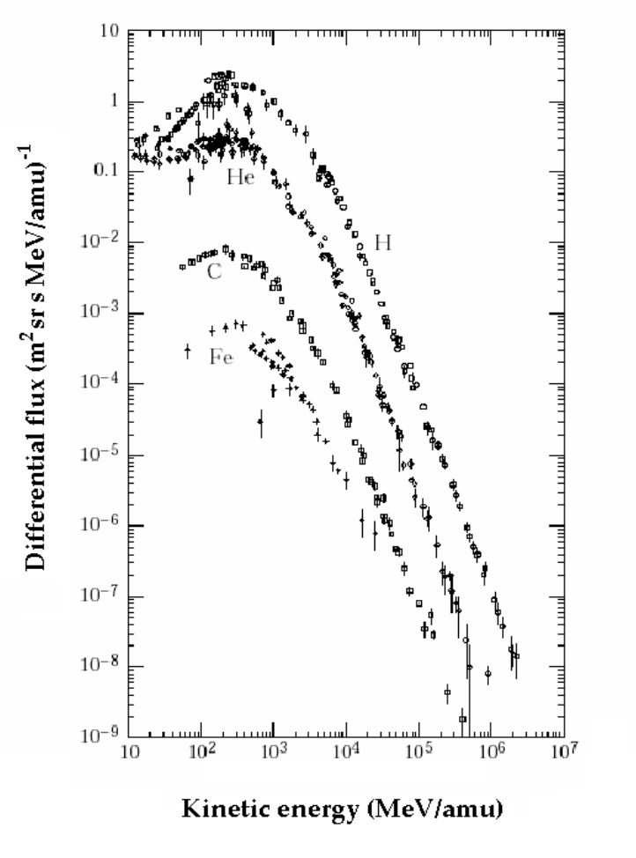
Figure 1. The energy spectra of the hadronic galactic cosmic rays.
                - Neutrons, as one of the major concerns for space radiation shielding, are created by GCR and SEP interacting with shielding materials or astronauts' bodies in space. Even though helium ions make up only 12% of the hadronic GCR fluence, they can contribute approximately 30% of the secondary neutron fluence, depending on the shielding material and thickness [4]. Hence, the secondary neutrons created by helium ions have to be taken into consideration, especially for future long-term and deep-space missions.

I.3 Validation and verification of radiation transport codes

                - As such, characterizing the radiation field created by helium ion is relevant for medical and space applications. Existing Monte Carlo transport codes such as PHITS [5], FLUKA [6], MCNP [7] and GEANT4 [8] are capable of calculateing secondary neutron and charged particle yields. These transport codes rely on accurate cross section and thick target data to build reliable physics models, and experiment data are also needed for validating the physics models; however, the benchmark measurements of helium ions are still limited up to now. The thick target measurements and cross section measurement with respect to helium ions that have been done are respectively listed in Table 1 and Table 2 [9].
                - Therefore the measurement of double differential spectra of secondary neutrons derived from 100- and 230 MeV/nucleon helium ions bombarding various thick targets were proposed. The energies of the helium projectiles were selected not only to cover the therapeutic demand in hadron therapy but also represent the low-energy end of the fluence peak of the GCR helium. The stopping targets were chosen to be water, polymethyl methacrylate (PMMA), and iron for the following reasons. Water is the major and essential compound in the human body and is used as a surrogate for a tissue-equivalent material. PMMA is also a surrogate tissue material and is commonly used in radiotherapy QC/QA. Iron is chosen to represent certain beam line and spacecraft components; iron is one of the compositions of the Martian soil and the albedo dose created by GCR and SEP has to be taken into consideration for exploration activities on Mars.
                - To further help lead to improvements in the default physics models employed in PHITS, FLUKA and MCNP, the experiment results were compared with the model calculations done by these three codes. An inter-comparison of the model calculations done by these three codes with the existing neutron production cross section data was also performed.

Table 1. Existing measurements of ⁴He-induced secondary neutron thick target yields (stopping or thick targets).

⁴He energy (MeV/nucleon) | Target materials | Angles of measurement
100 | C, Al, Cu, Pb | 0, 7.5, 15, 30, 60, 90
155 | Al | 10, 30, 45, 90, 120, 150
160 | Pb | 0, 45, 90, 120, 150
177.5 | C, water, Steel, Pb | 0, 6, 15, 30, 45, 60, 90, 120, 135, 150
180 | C, Al, Cu, Pb | 0, 7.5, 15, 30, 60, 90

Table 2. Existing measurements of ⁴He-induced secondary neutron production cross section (thin targets).

⁴He energy (MeV/nucleon) | Target materials | Angles of measurement
135 | C, Al, Cu, Pb | 0, 15, 30, 50, 80, 110
230 | Al, Cu | 5, 10, 20, 30, 40, 60, 80

CHAPTER II

secondary neutrons produced from helium ions bombarding stopping targets

                - This chapter covers the experiment target design by using PHITS calculations, the experimental setup, data analysis, and the measurement results along with the PHITS, FLUKA and MCNP simulations in each section.

II.1 Experiment target design

                - During the literature survey of stopping target measurements either for helium ions incident on various targets [10 - 13] or therapeutic carbon ions bombarding targets as tissue surrogates [14 - 15], it was found that the ratio of the ion beam range (R) to the target depth (i.e. the length along the beam direction) (d) varies from 0.5 to 0.98. The difference in the values of ratio R/d makes the comparison of experimental data complex and requires accurate corrections. Hence, in order to determine the target size used in our experiment as well as to seek a general trend resulting from change of target geometries, the quantitative influence on secondary particle angular distribution by changing the stopping target geometries was investigated by PHITS. There were two variables of a cuboid target that were studied; one is the target depth (d) and the other one is the target cross sectional area (A). All of the beam-target simulation combinations can be found in Table 3.

II.1.a PHITS simulations
                - The experiment target design was performed by the Monte Carlo code PHITS 2.64 (Particle and Heavy Ion Transport code System). The physical processes in PHITS include collisions with nuclei and transport between collisions. With continuous-slowing-down approximation, stopping powers were calculated by SPAR [16] for nuclei, protons, pions, and muons, and by NMTC for
Table 3. The various beam-target simulation cases. The reference systems that are highlighted in yellow are used for comparison of angular distributions in the same beam-target material combination.

⁴He energy (MeV/nucleon) | Target | Target cross sectional area (A)  (cm x cm) | Target depth (d)  (cm) | Ratio of  range/depth
100 | water | 5 x 5 | 8, 9, 11, 13 | 0.97, 0.86, 0.71, 0.60
100 | water | 10 x 10  20 x 20 | 9 | 0.86
100 | iron | 2 x 2 | 1.5, 1.6, 2.0, 2.4 | 0.97, 0.91, 0.73, 0.61
100 | iron | 3 x 3 | 1.6, 2.0 | 0.91, 0.73
100 | iron | 10 x 10 | 1.6 | 0.91
230 | water | 5 x 5 | 34, 37, 45, 55 | 0.97, 0.90, 0.74, 0.60
230 | water | 10 x 10  20 x 20 | 37 | 0.90
230 | iron | 2 x 2 | 6.2, 6.6, 10.0 | 0.98, 0.92, 0.61
230 | iron | 3 x 3  10 x 10 | 6.6 | 0.92

                - the others. For collisions with nuclei, the nuclear data library (JENDL-4.0) was used for neutron energies up to 20 MeV, and intra-nuclear cascade model INCL4.6 [17] was used as the default model to simulate triton-, ³He-, ⁴He-, and nucleon-induced nuclear reactions. The transport cut-off energy was set to 1 keV/nucleon for charged particles and 0.01 eV for neutrons. Gamma emission was also included.
                - The simulation geometry is illustrated in Figure 2. A uniform ⁴He beam with 1.0 cm diameter started at 10 cm upstream of the target and was incident perpendicularly to the front face of the target. Seven scoring regions were set up respectively at 0°, 10°, 20°, 30°, 60° and 120°, referenced to the target center. In order to improve statistics and shorten computational time, the scoring regions were designed as ring-shaped cylinders with 10 cm width (the outer radius minus the inner radius) and 10 cm thick. Thus the angular ranges of each scoring region are 0°-1.15°, 9.09°-10.20°, 19.80°-20.81°, 29.90°-30.96°, 59.53°-60.26°, 89.14°-90.86°, and 119.74°-120.96°.
                - Experimentally, secondary particles are measured by a ΔE-E telescope at each angle. The ΔE-E telescope consists of a thin NE102 plastic scintillator and a thick EJ301 liquid scintillation detector. However, since the aim of this study is to investigate the influence of target depth and cross sectional area upon the angular distributions of the fragments, the scoring region was assumed to be void instead of realistic detector materials to avoid any interactions and attenuation within the detectors, and the rest of the space was assumed to be air, except for the target.
                - 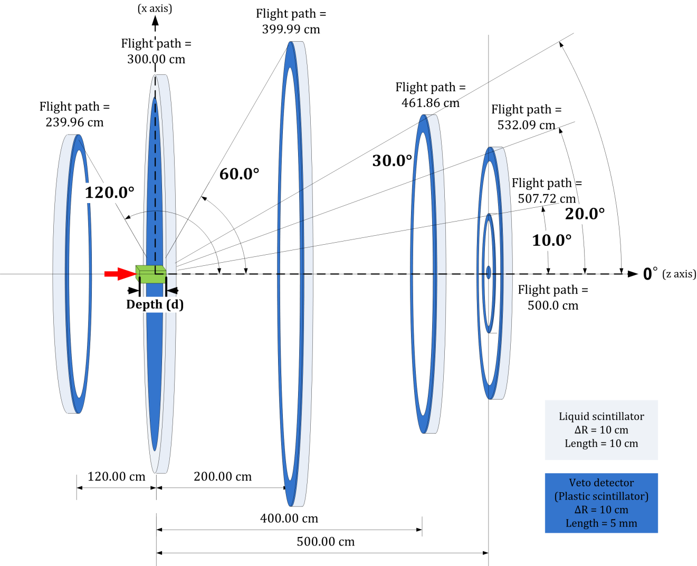
Figure 2. Schematic diagram of the simulation geometry.

II.1.b Simulation results for varying target depth
                - The influence of target depth upon the angular distributions of secondary particles is a point of interest. To quantify that influence, the relative fluence at each scoring angle was obtained by normalizing the fluence in the systems with various target depths to the fluence at the corresponding angle in the reference system, whose target R/d value equals to 0.97 or 0.98 as yellow-highlighted in Table 3. For example, the 230-MeV/nucleon ⁴He induced neutron fluences at 10° from water targets with different depths were all divided by the neutron fluence at 10° from 34-cm deep water target. Such relative neutron and proton fluences are shown in Figure 3 and Figure 4.
                - 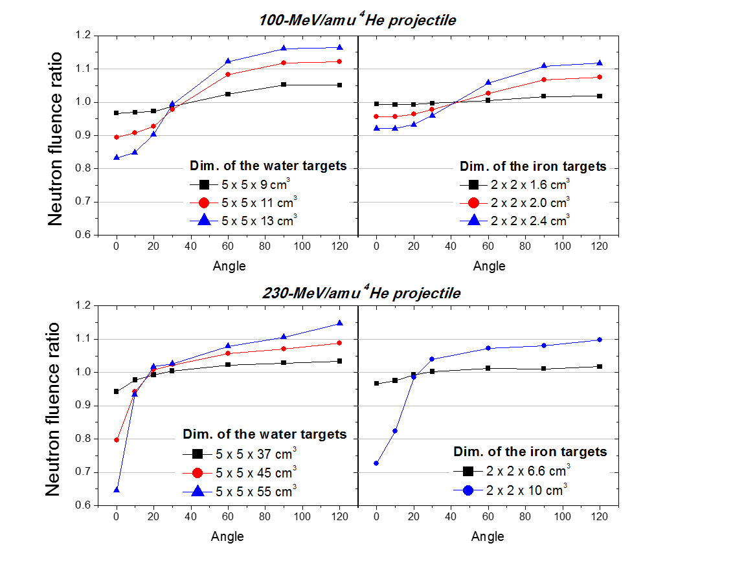
Figure 3. Normalized neutron angular distributions of different beam-target combinations with target depth as a variable.
                - 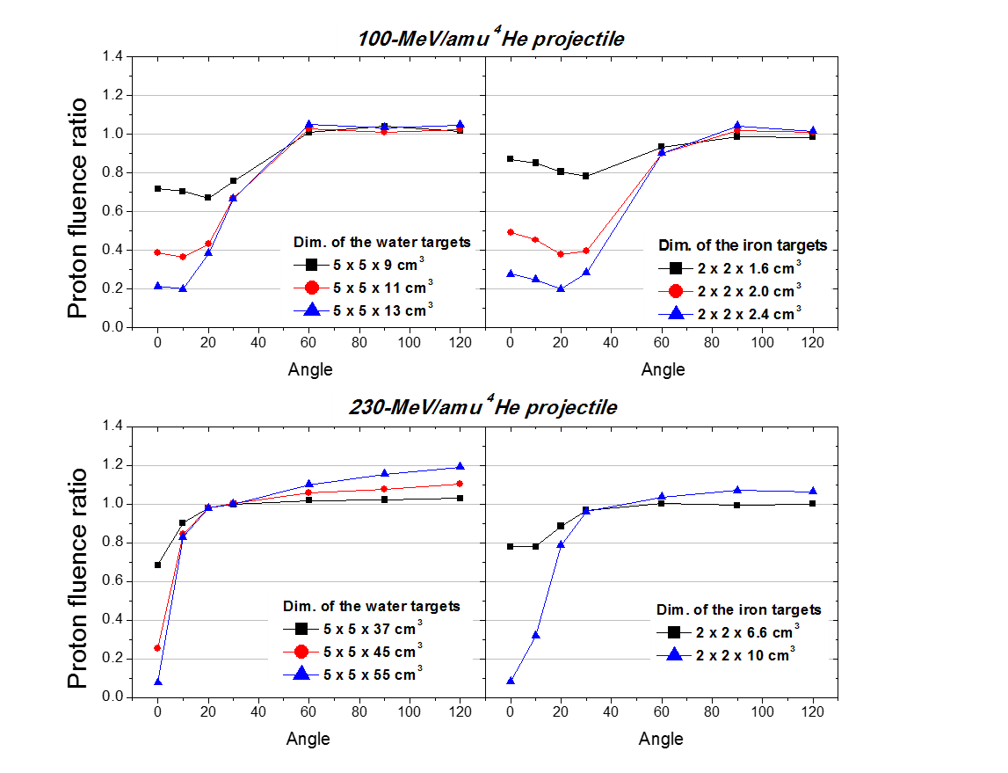
Figure 4. Normalized proton angular distributions of different beam-target combinations with target depth as a variable.
                - Most of the neutrons in high-energy and forward regions are dominated by the breakup of the projectile and direct knock-on process due to the high velocity of incident projectiles. As the target depth increases, these high-energy and forward-focused neutrons have to go through more material, such that the neutron fluence are attenuated at forward angles, as shown in Figure 3. With the decreasing R/d ratio, the attenuation is more significant for lighter target mass and for higher-energy projectiles. The 230-MeV/nucleon ⁴He-induced neutron intensity at 0° decreases to 64.5% of the 34-cm water target fluence when the depth is increased from 34 cm to 55 cm (R/d from 0.97 to 0.60), whereas the
neutron intensity retains 92.1% of the 1.5-cm fluence when the iron target is bombarded by 100-MeV/nucleon ⁴He ions and the depth is also increased from R/d = 0.97 to 0.61 (d = 1.5 cm to 2.4 cm).
                - At energies below 20 MeV, the spectra are dominated by target breakup that emits neutrons nearly isotropically, so these target-like neutrons can be seen at all angles. Since deeper targets have more materials behind the primary ion range, more nuclear interactions may occur between the secondary particles and the target nuclei. As a result, the angular distribution outside the stopping targets becomes less forward peaked, and the secondary neutron fluences produced from thicker targets exceed the neutron fluences produced from the thinnest target at angles greater than 30°-40°, which can be seen in Figure 3. This neutron buildup effect is more evident for lighter target mass and for lower-energy projectiles. The 100- MeV/nucleon ⁴He- induced neutron fluence at 120° with a 13-cm deep water target (R/d=0.60) is 116.4% of the value with the reference water target, while the increase of the fluence for an iron target with R/d=0.60 (d = 10 cm) bombarded by 230 MeV/nucleon ⁴He is 9.8%.
                - Regarding the secondary charged particles, most of the heavier charged fragments whose atomic number is only slightly less than the target element are easily attenuated and trapped within the target. Light secondary charged particles, such as protons, deuteron, tritons, ³He and etc., are attenuated to a higher degree than neutral particles but have a higher probability to escape from the target compared to high-Z fragments since the range of particles at the same velocity is proportional to A/Z². Even so, a slight increase in target thickness can decrease the proton intensity at forward angles by an appreciable amount. Looking at secondary protons, for example (as shown in Figure 4), the relative proton fluence at 0° decreases by 13.0% when the depth of iron target increases by 0.1 cm (R/d=0.97 to 0.91) with 100-MeV/nucleon ⁴He bombardment. At backward angles, such as 120°, the relative proton fluence in the 230-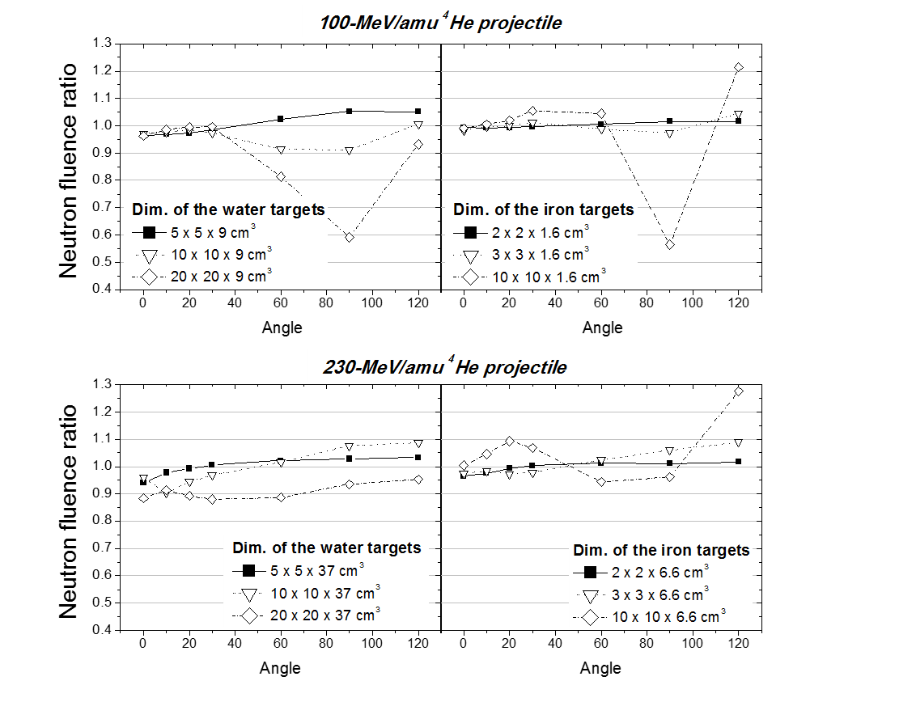 Figure 5. Normalized neutron angular distributions of different beam-target combinations with target cross sectional area (A_{cs}) as a variable.
                - MeV/nucleon projectile system can increase by 19.1% if the water depth increases from 34 cm to 55 cm (R/d=0.97 to R/d=60).

II.1.c Simulation results for varying target cross sectional area
                - The changes in angular distributions caused by varying the target cross sectional area (A_{cs}) are shown in Figure 5 for secondary neutrons and Figure 6 for secondary protons. While considering the various target A_{cs}, it is necessary to consider the average traveling distances for secondary particles from locations being created within the stopping targets to the scoring regions at each angle. In
                - 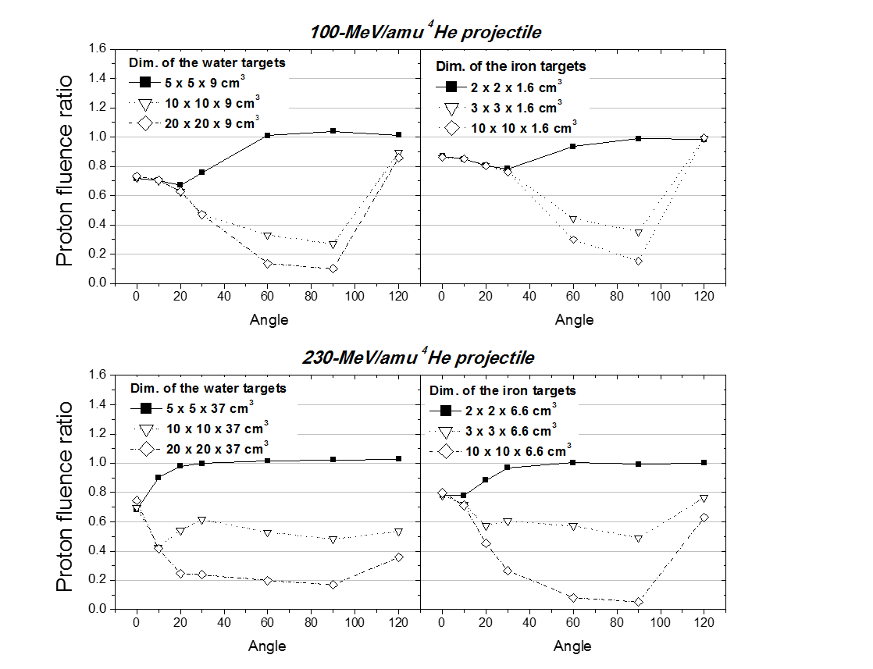
                - Figure 6. Normalized proton angular distributions of different beam-target combinations with target cross sectional area (A_{cs}) as a variable.
                - addition, it is reminded that the minimum target depth required to stop the primary ions are dependent on not only the beam species and beam energy but also the target material. Figure 7 shows two zooming in pictures of the thick iron targets for 100-MeV/nucleon ⁴He projectiles and the thick water targets for 230-MeV/nucleon ⁴He projectiles, which have the thinnest and the thickest targets among our four studied systems. Assuming a nuclear reaction occurs at the target center, from Figure 7, it is very clear that the traveling distances for secondary particles are almost identical for emitting angles smaller than 51° and 8° respectively for the thinnest iron targets and the thickest water targets if A_{cs} is increased.
                - As a result, it is both seen in Figure 5 and Figure 6 that with the increasing A_{cs}, the angular distributions of neutrons and protons remain alike or slightly higher at angles < 30° in the 100-MeV/nucleon ⁴He projectile systems. This is as expected since the path length of the secondary particles going through is identical, with a slight contribution from the target side. As the angle increases, the attenuation of the secondary particles becomes more severe until angles > 90° where the contribution of the target breakup from the larger target becomes significant.
                - However, the influence of the target cross sectional area in the 230-MeV/nucleon ⁴He projectile systems is unique for each case and no general trend is found, which is be not only because the attenuation capability and the secondary fragments production cross section are dependent on target material but also due to the requirement of the thick target geometry are dependent on various factors including the beam species, beam energy, and target materials. Hence, it is recommend that attention should be paid to the cross sectional area of the target when comparing different measurements from the same systems.
                - 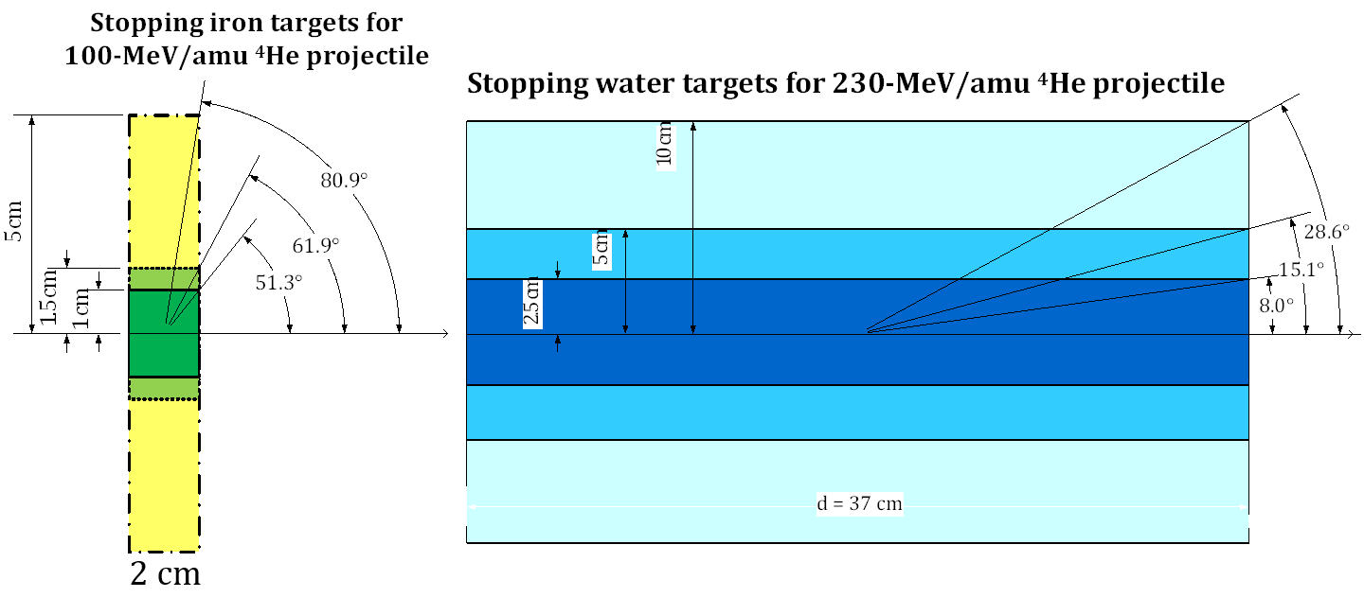
                - Figure 7. Geometries of the iron targets for 100-MeV/nucleon ⁴He projectiles and the water targets for 230-MeV/nucleon ⁴He projectiles.

II.1.d Summaries
                - The influence of the depth and the cross sectional area of stopping water and iron targets on the fluences and angular distributions of secondary particles induced by 100- and 230-MeV/nucleon ⁴He ions was studied using the Monte Carlo simulation code PHITS. The secondary charged particles and secondary neutrons which come from the breakup of projectiles are highly forward-focused, whereas the secondary particles produced by target breakup are nearly isotropic. As the energy of ⁴He ions increases from 100 MeV/nucleon to 230 MeV/nucleon, the normalized intensities of charged particles decrease less rapidly with increasing angles. When the target depth increases, the impact on the attenuation of secondary particles is more significant for lighter target mass and higher-energy projectiles at forward angles. Also, with deeper targets, more interactions occur between the secondary particles and the target elements, which results in a buildup of the fluence from more target-like fragments at large and backward angles. With respect to the cross sectional area of the stopping targets, the forward angular distributions are similar regardless of cross sectional area. The fluences of secondary charged particles are highly reduced at large angles; however, no general rule was found for secondary neutrons at large and backward angles. If one wants to compare the angular distributions from the systems with identical projectiles and target materials but with different target geometry, there is no simply analytical solution to correct the angular differences caused by different target geometries. It is therefore suggested to utilize a radiation transport code to correct the influence from the target geometry in stopping target measurements.

II.2 Experimental setup
                - The experiment of measuring angular distributions of secondary neutrons produced by 100- and 230-MeV/nucleon ⁴He ions bombarding stopping water,
                - 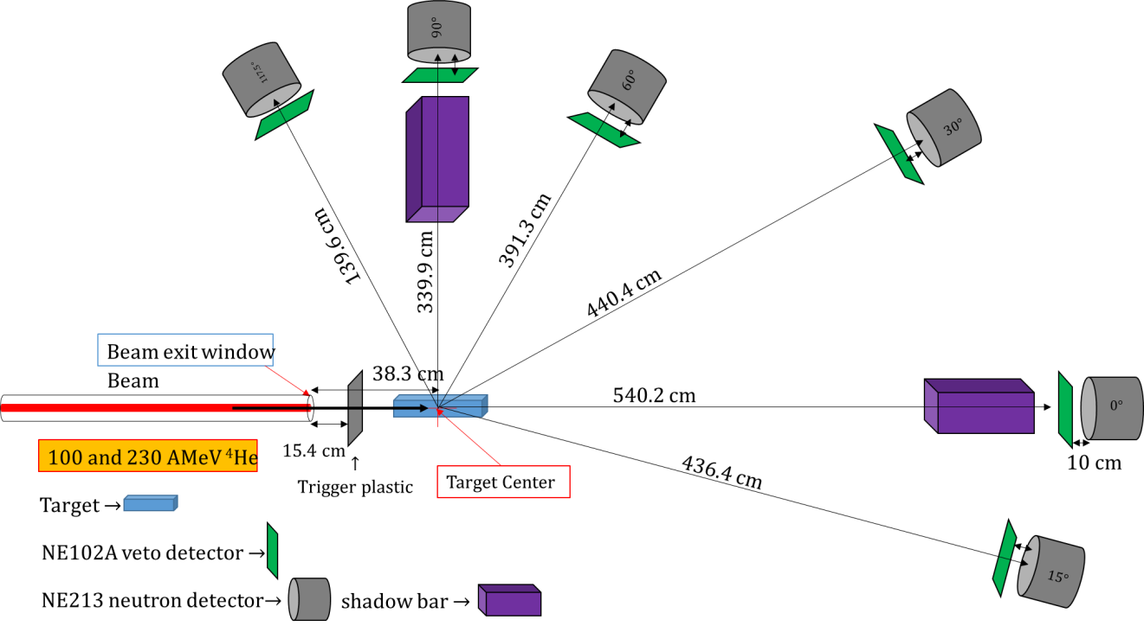
X
Z
Y
Figure 8. The experimental setup of the HIMAC measurement.

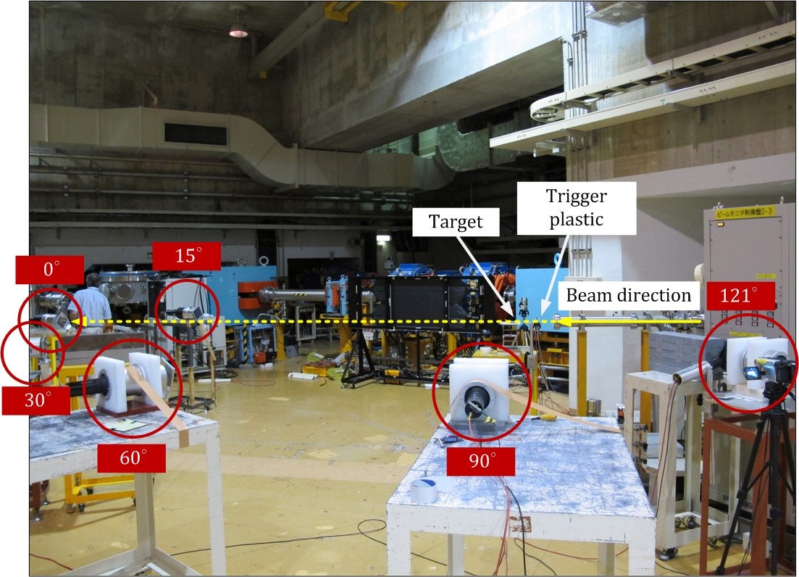
Figure 9. A picture of the experimental setup at HIMAC.
                - PMMA and iron targets was conducted in June 2014 at the Heavy Ion Medical Accelerator in Chiba (HIMAC) of the National Institute of Radiological Sciences (NIRS) in Japan. A sketch of the experimental setup is shown in Figure 8, and Figure 9 is a picture showing the actual setup at HIMAC.

II.2.a Beam and target characteristics
                - Helium ion beams were delivered from the PH2 beam line at HIMAC. The output profiles of the ion beam were approximately Gaussian distributions horizontally and vertically. The standard deviations of the beam profiles were between 2.08 to 2.52 mm, of which were measured just upstream of the beam checking phosphor at the target position. The beam was delivered to the target about 18 spills every minute, and the duration of each spill lasted between 0.5 and 1 second depending on the beam type. The beam intensities varied roughly from 8x10⁴ to 2x10⁵ particles per spill.
                - 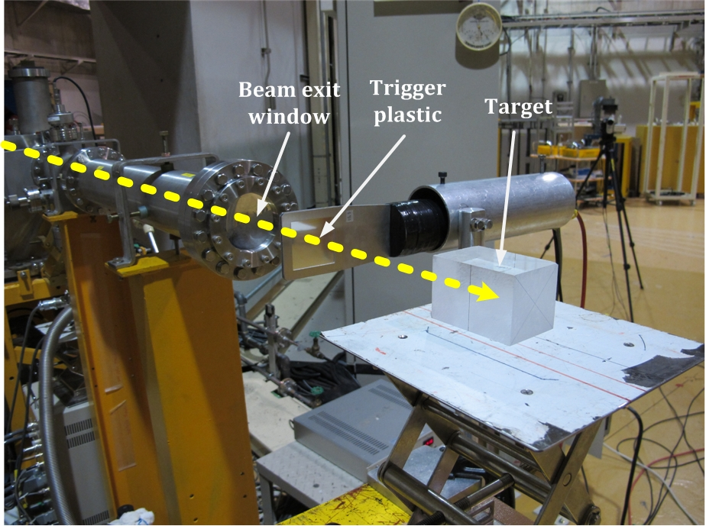
Figure 10. A closer look of the trigger plastic and the target setup.
                - Figure 10 shows the setup for the trigger plastic and the targets. After exiting the aluminized Mylar window with a 10 mils thickness, the ⁴He ions were detected by a trigger plastic scintillator (TP), which is made of NE102 and is 0.5 mm thick with an area of 5 cm by 5 cm. The counts in the TP provided the number of incoming beam particles and can be used for normalizing different runs.
                - All of the targets were thick enough to fully stop the primary ions. The ranges of ⁴He ions in target medium were calculated by SRIM 2013 [18] (for water targets) and retrieved from the range table for helium ions provided by NIST [19] (for PMMA and iron). The information for ion ranges, target dimensions, and the ratio of ion range to target thickness is listed in Table 5. The water containers are made with 3.175-mm thick PMMA walls at each side (the outer dimensions are listed in Table 4), and the containers were filled with pure water. Polymethyl methacralate (PMMA) is also called acrylic, lucite, or plexiglass. Its molecular formula is (C₅O₂H₈)_{n}, and its density is 1.19 g/cm³.
Table 4. Details of the stopping targets.

Target | Range for ⁴He (R) | Target dimensions  (width x height x thickness) | R/t ratio
100-MeV/nucleon ⁴He beam
Water container  - Wall  - Water | 7.590 cm | Wall thickness: 3.175 mm  Outer dimensions:  5.035 cm x 5.385 cm x 8.900 cm
PMMA | 6.697 cm | 5.08 cm x 5.08 cm x 7.62 cm | 0.879
Iron with 99.5% purity | 1.452 cm | 2.10 cm x 2.10 cm x 1.71 cm | 0.849
230-MeV/nucleon ⁴He beam
Water container  - Wall  - Water | 32.600 cm | Wall thickness: 3.175 mm  Outer dimensions:  4.690 cm x 5.260 cm x 37.200 cm
PMMA | 28.580 cm | 5.08 cm x 5.08 cm x 31.75 cm | 0.900
Iron with 99.5% purity | 6.053 cm | 2.10 cm x 2.10 cm x 6.60 cm | 0.917

                - The target center was defined as the origin of the beam-target Cartesian coordinate system: the +Z axis was along the beam incident direction, as illustrated in Figure 11. The center of the beam exit window was at Z = -38.3 cm, and the front surface of the trigger plastic scintillator was at Z = -22.9 cm. The height from the floor to the target center was 125 cm.

II.2.b Measurement methods
                - The secondary particles created inside the stopping targets include both neutral particles (neutrons and photons) and light charged ions, such as protons, deuterons, tritons, ³He, etc., which might have enough energy to travel through the target medium and air and be detected. These secondary particles were detected by six sets of ΔE-E telescopes at 0⁰, 15⁰, 30⁰, 60⁰, 90⁰, and 117.5⁰ (for 100-MeV/nucleon ⁴He beam configuration) and 121.2⁰ (for 230-MeV/nucleon ⁴He beam configuration) with respect to the beam direction (on the Y-Z plane). Each ΔE-E telescope used in this study consisted of a thin NE102A organic plastic scintillation detector (ΔE detector) and an NE213 organic liquid scintillation detector (E detector).
                - The NE102A scintillator is commercial equivalent to BC400 and EJ212, with the same density of 1.023 g/cm³ and the same composition (C₁₀H₁₁). Two NE102A detectors and four BC400 plastic scintillation detectors were used in the experiment. Their area size is the same, 12.7 cm by 12.7 cm, but the NE102A detectors have a thickness of 6.35 mm (0.25 in) and the BC400 detectors have a thickness of 5 mm. The NE213 scintillator is commercial equivalent to EJ301 and BC501A. Three NE213 and three EJ301 detectors were used in this experiment. The NE213 scintillator has great pulse shape discrimination (PSD) properties and is widely used for fast neutron spectroscopy in a gamma-neutron mixed field [20]. The composition of NE213 includes xylene, activators, the organic compound POPOP (as a wavelength shifter), and naphthalene (assed to improve light emission). Its chemical formula is C₆H₄(CH₃)₂, and its density is 0.874 g/cm³. All of the NE213 and EJ301 liquid scintillators used in this study are filled in a 12.7-cm diameter and 12.7-cm high cylindrical chamber with an aluminum housing. The thickness of front aluminum face is 1.524 mm (0.06 in) and 1.5 mm respectively for the EJ301 and the BC501A detectors.
                - Since the plastic scintillator is very thin and consists of only hydrogen and carbon atoms, photons and neutrons have a very small probability of interacting within the detector while passing through it, while charged particles will lose energy in the plastic scintillator with practically 100% efficiency, and then deposit rest of their energy in the liquid scintillator. By combining the coincidence signals from the NE102A (ΔE) detector and the NE213 (E) detector, the species of charged particles can be identified from two-dimensional ΔE-E plots because the specific energy loss is unique to ions with different atomic number (Z) and mass number (A) at a certain energy. The plastic scintillators in ΔE-E telescopes are also called veto detectors as they are used to discriminate neutral particles from charged particles. After applying the charged particle discrimination by veto detectors, neutrons and photons can be separated by using the PSD of NE213 detectors.
                - The kinetic energy of the secondary particles, including neutrons and charged particles will be determined by their time of flight. The distances shown in Figure 11 are defined from the origin (0, 0, 0), i.e. the target center, to the front surfaces of each liquid scintillation detector; they are 501.9 cm, 398.1 cm, 402.1 cm, 353.0 cm, 301.6 cm, and 101.3 cm (in the 100-AMeV ⁴He system) or 261.1 cm (in the 230-AMeV ⁴He system), respectively for 0⁰, 15⁰, 30⁰, 60⁰, 90⁰, and 117.5⁰ (for 100-AMeV ⁴He beam configuration) or 121.2⁰ (for 230-AMeV ⁴He beam configuration). The start and stop signals were obtained from the EJ301 detector and the trigger plastic scintillator (TP), respectively. Once the flight time is determined, and the flight path is a known parameter, the particle energy can be acquired by using the relativistic relations:
                - 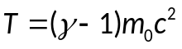, and 1
                - 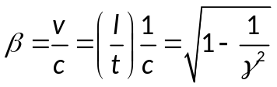. 2
                - Then the kinetic energy as a function of the tof is given by
                - 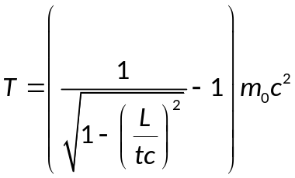, 3
                - where T is the particle kinetic energy, L is the flight path, defined from the target center to the front surface center of the EJ301 liquid scintillator, t is the time of flight, m_{o}c² is the particle’s rest mass.
                - The relative energy resolution (is also dependent on the time resolution (dt) of the tof spectra, given by the Gaussian error propagation. The relationship can be expressed by the following equation.
                - 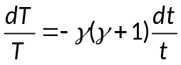, 4
                - where the time resolution dt is usually taken from the observed FWHM of the prompt gamma ray peak in the tof spectra, or 2.354 times of the standard error (σ) of the photon peak if the peak is fitted by a Gaussian distribution.
                - Experimentally the time of flight measured by the TDC (denoted to t_{TDC}) starts at the trigger plastic signal and stops at the liquid scintillator signal. In other words, t_{TDC} is the sum of the time for a primary ion passing through the trigger plastic to the target location where a nuclear interaction occurs (t_{p}) and the time
                - 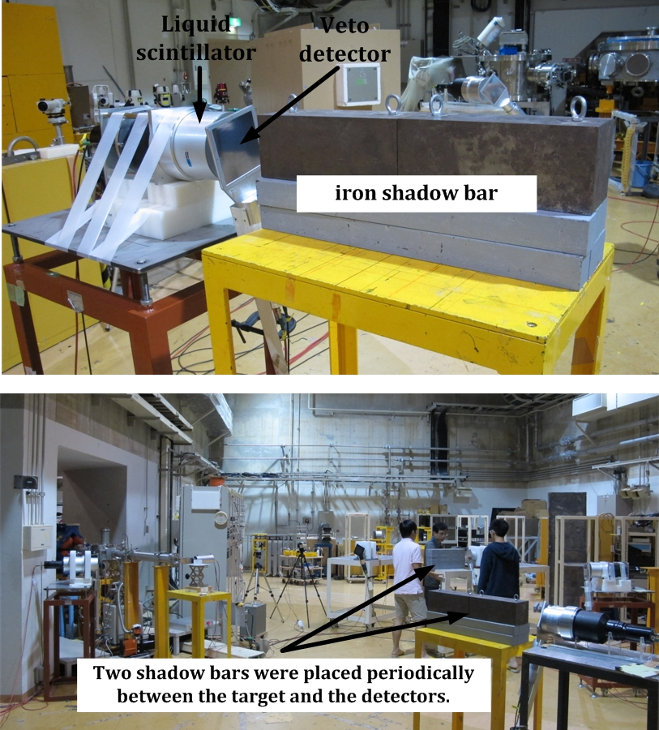
Figure 11. Two pictures showing the measurement with shadow bars.
                - of the measured particles from the reaction point to the liquid scintillator (t) (t_{TDC} = t_{p} + t). For the time-to-energy conversion the simplifying assumption was made that the nuclear fragmentation reaction take places at the target center, i.e.
                - t_{TDC} = t_{TP -> 1/2 target} + t _{½ target -> NE213}.
                - To obtain an accurate experiment result, background is also an important factor that has to be taken into consideration. Thus for each beam-target configuration, measurements were carried out with and without an iron shadow bar in front of the ΔE-E detector set. A 60-cm long iron shadow bar was placed periodically between the target and the detectors in order to block secondary nuclear fragments coming directly from the target, allowing only room scattered background particles to enter the detector. Figure 11 shows two pictures of the measurement with shadow bars.

II.2.c Electronics and data acquisition
                - The block diagram of the measurement circuit is plotted as Figure 12. The anode signals of each liquid scintillation detector were split twice. Two of the split signals were applied with different delay time and fed into a charge-to-digital converter (QDC, LeCroy 2249W, CAMAC), where the signals were integrated over a 400-ns gate for PSD; the other split signal was fed into a constant-fraction discriminator (Quad CFD, CANBERRA 454, NIM), and then was jointed with five logic signals from the other five liquid scintillation detectors into an “OR” logic coincidence module. The TP signal was split once; one signal was fed into a QDC to obtain the spectrum of primary ⁴He ions, and the other one was fed into a CFD to generate logic signals, one of which was served as the STOP signal of a time-to-digital converter (TDC, LeCroy 2228A, CAMAC) for the time-of-

                - flight measurement, and one of which was jointed into an “AND” coincidence module with the “OR” signal of six EJ301 detectors. As such, if any one of the EJ301 detectors' signals arrived in coincidence with the signal from the TP, an event was triggered. For investigation of which detectors fired the trigger, the logic signals from the six EJ301 detectors were also delayed 200 ns and fed into a TDC for self timing.
                - The output of the “AND” coincidence counted the total number of events; these events were further put into another “AND” coincidence with “COMPUTER NOT BUSY” signal to obtain the live events (“live” here means an event which was processed by the data acquisition system). The output from the second “AND” coincidence also served as the START signal of the TDC for time-of-flight measurement. It is noted that, logically the clock of time-of-flight starts at the TP
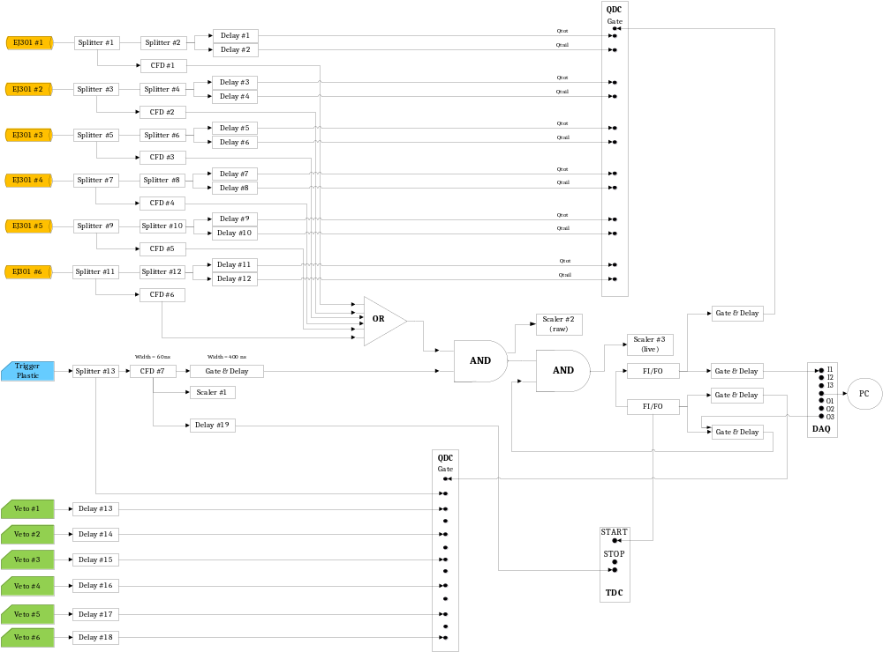
Figure 12. The block diagram of measurement circuits
                - signal and then stops at the coincident EJ301 signal. However, in our experimental setup, the clock was inversed and started by the second "AND" coincidence signal in order to insure that for every start signal there was a corresponding stop signal and thus to reduce the counting dead time. The veto detectors were delayed for a certain amount of time such that the signals were within the charge integration gate for the EJ301 signals, and then fed into a QDC to obtain their spectra. The veto detectors were not set in coincidence with the liquid scintillation detectors. The charged particle discrimination mentioned above can be offline using analysis software afterwards. All the data were recorded event-by-event by using the CAMAC data acquisition system.

II.3 Data analysis

                - The experimental data were recorded in an event-by-event mode with binary data format. To obtain the final experiment results, i.e. the double-differential spectra of secondary particles, the raw data have to be converted into a readable data format for analysis software, and the wanted events have to be filtered out to perform the analysis tasks. Two analysis programs were used in this study. One is SpecTcl, which is developed by the National Superconducting Cyclotron Laboratory at the Michigan State University; the other data analysis tool is ROOT, which is developed by CERN and is commonly used in particle physics experiments.
                - Although interactions of energetic ⁴He ions and target atoms generate several species of secondary particles, the analysis work in my dissertation will focus on the neutron production based on the following reasons. Neutrons are the most penetrating secondary particles created during the nuclear interaction, and as such dictate the radiation protection and shielding requirements. Also, neutrons are responsible for a significant portion of the activation and radiation damage to the materials and components of accelerator facilities and spacecrafts.
                - The analysis tasks included 1) pulse height calibration of neutron detectors and time calibration of TDCs, 2) neutron, gamma, and charged particle discrimination, 3) time-of-flight spectra analysis, 4) energy differential spectral determination, and 5) the application of corrections for detector efficiencies, acquisition dead time, and other experimental effects. Each of the analysis tasks is briefly described below.

II.3.a Energy Calibration and Time Calibration
                - The measurement of neutron energy with organic scintillators requires a precise calibration of the pulse height response to recoil proton energy. Because the standard neutron sources or proton sources are less accessible than gamma-ray sources, experimentally the calibration is done most often by using gamma-ray sources to identify certain locations in the pulse height spectrum corresponding to particular Compton electron energies, and then converting the electron equivalent energy (units in keVee or MeVee) to the recoil proton energy (units in keV or MeV) based on their pulse shape characteristics.
                - Generally the peak or the half-height of the Compton spectra is selected, and the energy corresponding to those locations is obtained by multiplying the maximum Compton electron energy by a fixed constant. However, that constant can vary for detectors with different scintillators, geometries, as well as photomultiplier tube and electronics. The relationship of certain locations in the pulse height spectrum versus the corresponding electron equivalent energy has been studied for organic scintillation detectors smaller than 3” in length or in diameter according to the literature, but the study for 5” detector used in our measurement was not found. Therefore we have developed a two-dimensional broad-mapping technique to perform the energy calibration by gamma-ray sources. The energy was calibrated from 0.1 MeVee to 1.1 MeVee. By using the time-of-flight (tof) spectrum measured in this experiment done at HIMAC, the electron equivalent energy can be converted to the recoil proton energy based on the flight time of the neutrons. Once the secondary neutrons are identified in the tof spectrum, the neutron velocity can be obtained by dividing the flight path by the time of flight and as a result the neutron energy is obtained.
                - As for the TDCs used for the tof measurement, the time calibration can be done by using a time calibrator generating periodic signals.

II.3.b Spectra Analysis
                - Trigger plastic
                - The total count of the trigger plastic in a single run represents the number of primary ions incident on the target and can be used for normalizing the total number of primary ions among different runs. There are a certain probabilities that more than one particle hit the trigger plastic within a tiny time window such that the detector is not able resolve these particles causing a pile-up event. Because it is not able to distinguish which ions results in the later coincidence event, these pile-up events have to be removed from the data analysis.
                - Sorting the self-time for each neutron detector
                - In the logic setting for this measurement, as long as any one of the six EJ301 detectors is in coincidence with the trigger plastic, the coincidence module fires a trigger. Sorting out which neutron detector fire the event trigger relies on the self-time of each detector.
                - E vs. ΔE and tof vs. E
                - After sorting out which EJ301 detector is in coincidence with the trigger plastic, the next step is to distinguish what species of the secondary particle fired the trigger. In order to do this, two types of plots are utilized. One is the energy deposition in the EJ301 detector (E) versus the energy deposition in the NE102 veto detector (ΔE), and the other is the energy deposition in the EJ301 detector (E) versus the time of flight of each particle (tof). Figure 13 shows a measurement example of the E vs. ΔE plot. In such plots, neutral particles including neutrons and photons deposit no energy when they passing through the thin veto detector, and as a result these particles lie on the very bottom of the plot, as indicated by the arrow (these events have non-zero values in the veto detector because they register their “pedestal” values that correspond to the ambient electronic noise that is processed during the event). As to the charged particles, since the stopping power is specific to the ion species with certain velocity, different species of charged particles can be separated by combining the information of linear energy transfer to the veto detector and the remaining energy deposited in the liquid scintillator.
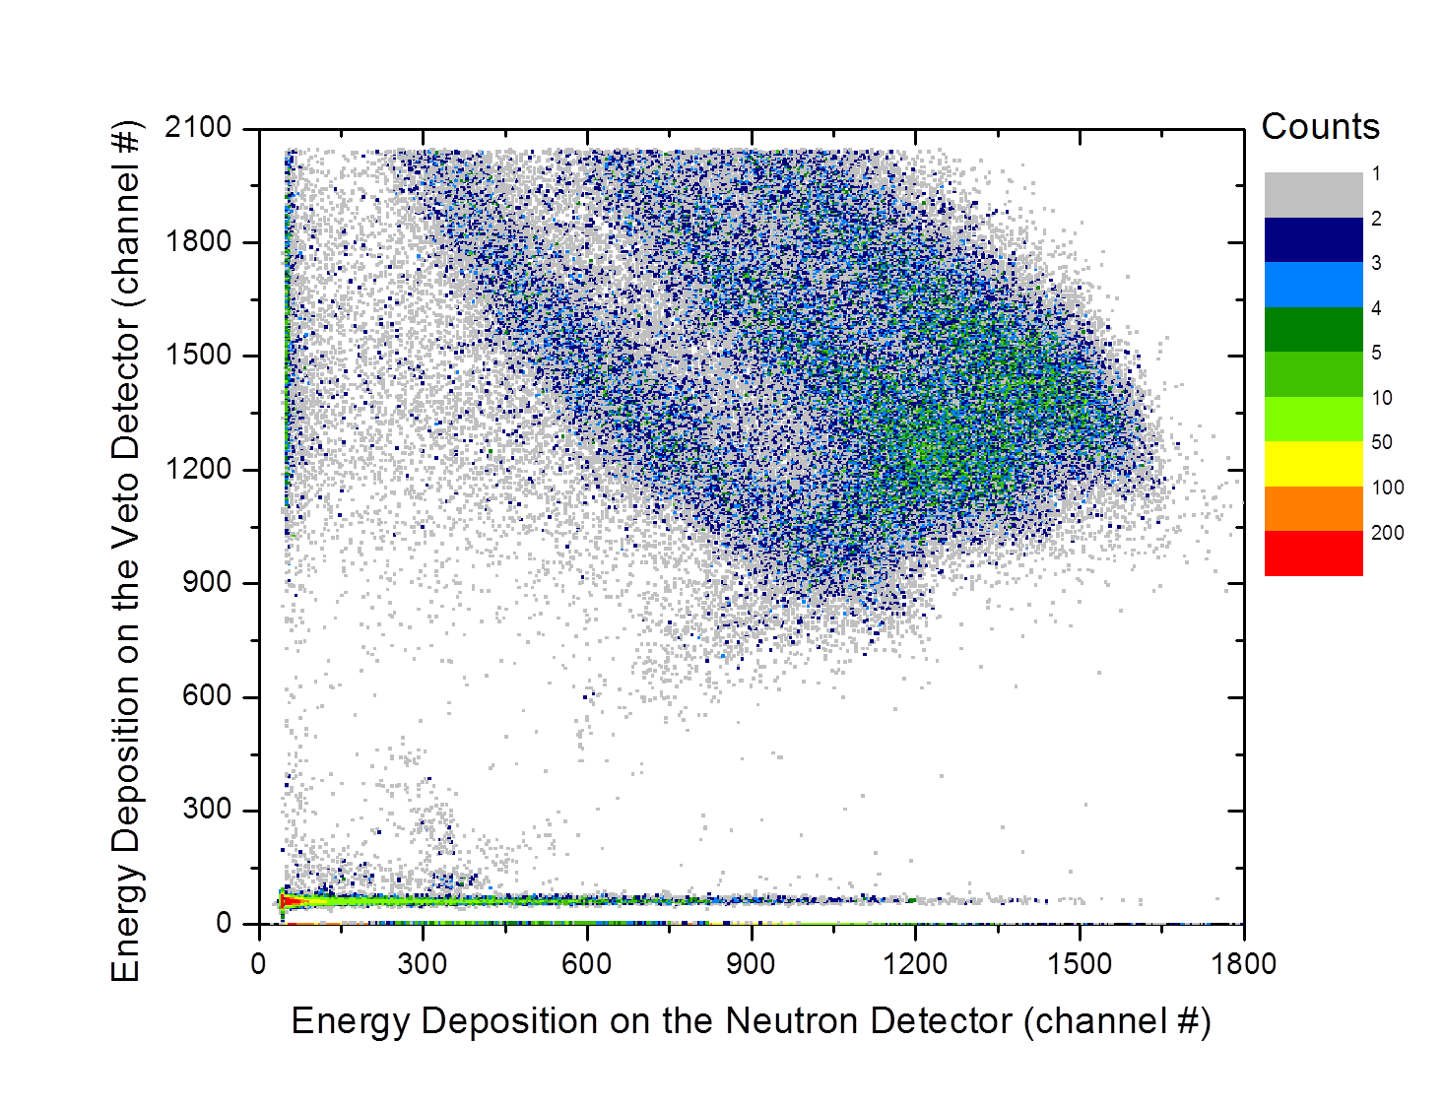
T
D
P

Neutrons & Gammas

                - Figure 13. An E vs. ΔE plot measured at 0⁰ when 100-MeV/nucleon He stopped in the PMMA target.

                - Figure 14 is an example of the ToF versus E plot from the experiment of which 100-MeV/nucleon ⁴He ions stopping in the PMMA target. Prompt gamma rays are produced during the nuclear interactions occurring between primary ions and target nucleus; thus the signals created by prompt gamma rays can be used as a time reference showing the ToF for light to travel such a flight path. Considering the rest of the events in the ToF versus E plot, even if different types of particles carry the same kinetic energy, they have different velocity, and thus different flight time to arrive the liquid scintillator, due to their different masses. The resulting separation seen in the ToF versus E plots is how these particles are distinguished. It should be noted that the reversed time-of-flight measurement technique was used in the experiment, i.e. the clock starts at the trigger plastic signal and stops at the particle generating a signal in the liquid scintillator.
                - 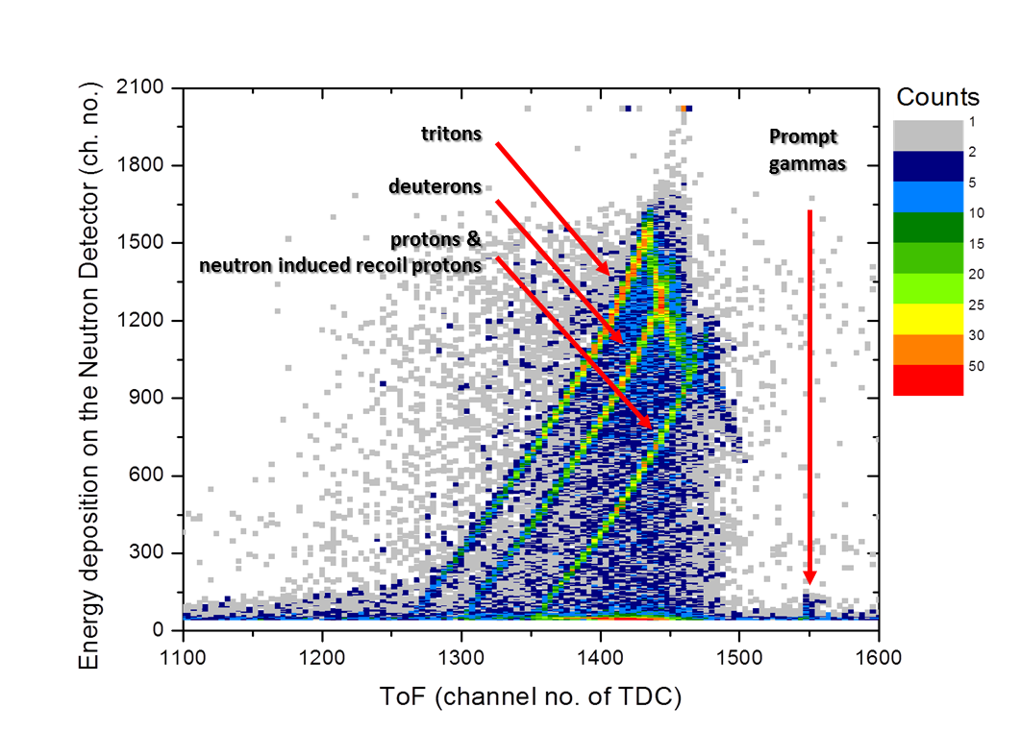
                - Figure 14. A ToF vs. E plot measured at 0⁰ under the system with 100-MeV/nucleon He incident on the PMMA target.
                - Neutron/gamma discrimination
After separating neutral particles from charged particles, neutrons and gamma rays must be discriminated. The EJ301 detector used in this experiment is well-known for its good capability of neutron/gamma discrimination based on their different pulse shapes. The fraction of the scintillation light that appears in the slow component depends on the species if the exciting particles. Scintillation light created by neutrons (recoil protons) or other heavier charged particles have more fraction in the slow component than light created by gamma rays (Compton electrons). Hence, by plotting the Qtot (the pulse charge is totally integrated) versus Qtail (only the slow component of the pulse charge is integrated), neutrons and gamma rays can be separated by pulse shape discrimination, as shown in Figure 15.
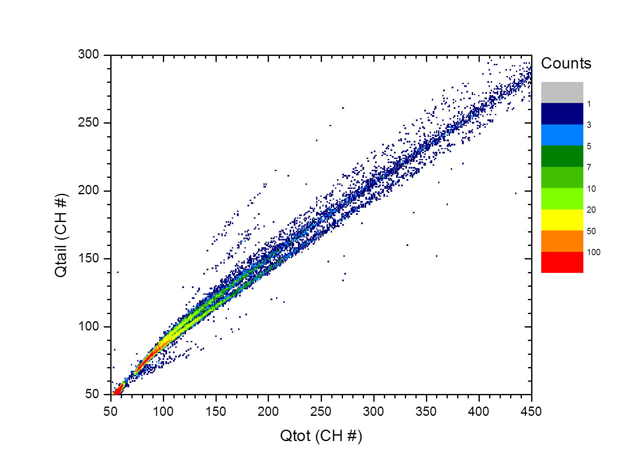
neutrons

photons
                - Figure 15. The pulse shape discrimination performed for the 0⁰- neutron detector in the system with 100-MeV/nucleon He projectiles and a thick PMMA target.
                - Time-of-flight and energy spectra
                - The time-of flight spectra are also composed of various particles, as two examples from the experiment data shown in Figure 16 (a) and (b). The particle species can be sorted out by the techniques described above. Once the particle species is selected, the total ToF spectrum can be filtered to a corresponding spectrum. Then the energy information can be obtained by Equation 1-4 listed in the section II.2.b.

II.3.c Background Subtraction and Application of Corrections
                - For each beam-target configuration, measurements were carried out with and without an iron shadow bar in front of the ΔE-E detector set. The measurements with shadow bars were to measure room scattered background particles for the background subtraction, which is especially important for secondary neutrons since neutrons have higher probability to have large-angle scattering than charged particles. After the background subtraction, the statistic error can be obtained by the error propagation from measurement with and without shadow bar.
                - The corrections required to apply to the measurement data include the detector efficiency of the EJ301 detectors and the particle attenuation in the air. The detector efficiency is the necessary information for obtaining the angular yields of the secondary neutrons. The neutron detection efficiency of an EJ301 detector can be calculated by SCINFUL-QMD, a Monte Carlo based computer code that can calculate response function and detection efficiency of a liquid organic scintillator for neutron energies from 0.1 MeV up to 3 GeV. This code simulates the scintillator response not only to neutron induced recoil protons and carbons but also to nuclear fragments created by incident neutrons within the detector volume.
                - 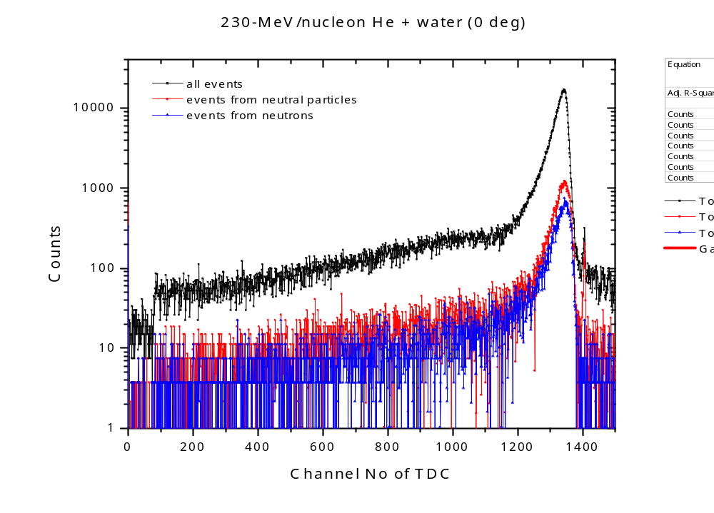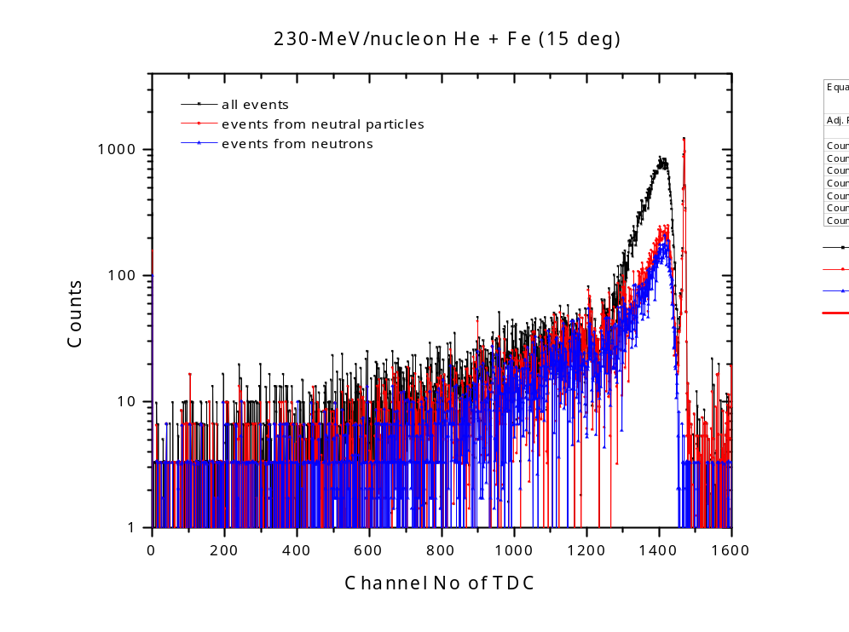
(a)

(b)
                - Figure 16. Time-of-flight spectra measured at (a) 0⁰ with 230-MeV/nucleon ⁴He incident on water, and (b) 15⁰ with 230-MeV/nucleon ⁴He incident on iron.
                - For benchmark comparison of double-differential spectra of secondary particles, there are two common scenarios seen in the literature. One is to compare the raw measurement results, and the other is to compare the corrected measurement result. In the former scenario, the experimental setup, including the environment, detector geometry, the room scattered background etc., is considered in a Monte Carlo simulation, and the Monte Carlo code simply simulate the measurement. Thus there is no need to determine the detector efficiency and to correct the attenuation in air for the measurement results. Though this type of comparison can avoid some errors introduced by these correction, the experimental data are not universal if the experiment is performed at a different facility or using a different experimental setup. In contrast, in the later scenario, the data for such a beam-target configuration is compared; such data will not and should not be changed even if the facilities and the measurement methods are different, but the disadvantage would be the introduced error for the experiment data correction. Hence the corrected measurement data were selected to be compared with the Monte Carlo simulations.

II.4 Benchmark calculations

                - The comparison of the experiment data with the benchmark model calculations was done as described in the section II.3.c. Three Monte Carlo simulation codes including PHITS, FLUKA, and MCNP were selected for benchmarking. The physics models employed in each code as well as the geometry setup are described below.

II.4.a Physics models
                - PHITS
                - The PHITS version 2.73 which was the latest version at the time when calculations performed was utilized for model calculations. The cut-off energies of particle transport were 0.01 MeV for protons, 0.1 MeV for neutrons, electrons, positrons and photons, and 0.1 MeV/nucleon for nucleus equal or heavier than deuterons.
                - FLUKA

                - MCNP

II.4.b Geometry setup

II.5 Measurement and simulation results

II.6 Summaries and conclusions

CHAPTER III

Benchmark of secondary neutron production cross sections from heavy ion interactions

Heading 2

Heading 3
Don’t forget to refer to all tables/figures by number within the text. Once you have mentioned a table/figure, you must place it on the same or next page. For instance, if you mention Figure 1 on page 33, the actual figure should be placed on page 33 (if it is small), or by itself on page 34 (if it will take up more than half of the page).

Heading 3
Blah blah blah.

Heading 2

Heading 3
Things and stuff, stuff and things.

Heading 3
More things and stuff and words and information.

Heading 2

Keep writing. You’re almost there!

Blah blah blah. Blah blah blah. Blah blah blah. Blah blah blah. Blah blah blah. Blah blah blah. Blah blah blah. Blah blah blah. Blah blah blah. Blah blah blah. Blah blah blah. Blah blah blah. Blah blah blah. Blah blah blah. Blah blah blah. Blah blah blah. Blah blah blah. Blah blah blah. Blah blah blah. Blah blah blah.
Blah blah blah. Blah blah blah. Blah blah blah. Blah blah blah. Blah blah blah. Blah blah blah. Blah blah blah. Blah blah blah. Blah blah blah. Blah blah blah.

CHAPTER IV

Conclusions and Recommendations

LIST OF REFERENCES

                - [1] J. R. Castro et al., “15 years experience with helium ion radiotherapy for uveal melanoma,” Int. J. Radiat. Oncol. Biol. Phys., 39, 989 (1997).
                - [2] I. Pshenichnov, I. Mishustin and W. Greiner, "Comparative Study on Depth-Dose Distributions for Beams of Light and Heavy Nuclei in Tissue-like Media," Nuclear Instruments and Methods in Physics Research Section B, vol. 266, p. 1094, 2008.
                - [3] Reference for the GCR spc
                - [4] L. Heilbronn, L. Townsend, C. Burnham, H. Green, P.-E. Tsai, T. Borak and R. McBeth, "Neutron fluences and doses behind shielded environments in space," in 2014 IEEE Aerospace Conference, Big Sky, MT, USA, 2014.
                - [5] T. Sato et al., “Particle and Heavy Ion Transport Code System PHITS, Version 2.52,” J. Nucl. Sci. Technol., 50, 913 (2013).
                - [6] T. Böhlen et al., “The FLUKA Code: Developments and Challenges for High Energy and Medical Applications,” Nucl. Data Sheets 120, 211 (2014).
                - [7] D. B. Pelowitz Ed., “MCNPX User’s Manual Version 2.7.0,” LA-CP-11-00438, Los Alamos National Laboratory report (2011).
                - [8] J. Allison et al., “Geant4 Developments and Applications,” IEEE T. Nucl. Sci., 53, 270 (2006).
                - [9] T. Nakamura and L. Heilbronn, Handbook on Secondary Particle Production and Transport by High-Energy Heavy Ions, World Scientific Publishing Co. Pte. Ltd., 2006.
                - [10] T. Kurosawa, T. Nakamura, N. Nakao, T. Shibata, Y. Uwamino and A. Fukumura, "A Spectral Measurements of Neutrons, Protons, Deuterons and Tritons Produced by 100 MeV/nucleon He bombardment," Nuclear Instruments and Methods in Physics Research Section A: Accelerators, Spectrometers, Detectors and Associated Equipment, vol. 430, no. 2-3, pp. 400-422, 1999.
                - [11] T. Kurosawa, N. Nakao, T. Nakamura, Y. Uwamino, T. Shibata, N. Nakanishi, A. Fukumura and K. Murakami, "Neutrons Produced from Thick Targets Bombarded by High-Energy Helium and Carbon Ions," Nuclear Science and Engineering, vol. 132, no. 1, pp. 30-57, 1999.
                - [12] L. Heilbronn, R. Carry, M. Cronqvist, M. Deak, K. Frankel, A. Galonsky, K. Holabird, A. Horvath, A. Kiss, J. Kruse, R. Ronningen, H. Schelin, Z. Seres, C. Stronach, J. Wang, P. Zecher and C. Zeitlin, "Neutron Yields from 155 MeV/nucleon Carbon and Helium Stopping in Aluminum," Nuc.l Sci. Eng., vol. 132, no. 1, pp. 1-15, 1999.
                - [13] R. A. Cecil, B. D. Anderson, A. R. Baldwin, R. Madey, A. Galonsky, P. Miller, L. Young and F. M. Waterman, "Neutron Angular and Energy Distribution from 710-MeV Alphas Stopping in Water, Carbon, Steel, and Lead, and 640-MeV alphas Stopping on Lead," Physical Review C, vol. 21, no. 6, pp. 2471-2484, 1980.
                - [14] B. Braunn, M. Labalme, G. Ban, M. Chevallier, J. Colin, D. Cussol, D. Dauvergne and J. M. Fontbonne, "Nuclear reaction measurements of 95 MeV/u 12C interactions on PMMA for hadrontherapy," Nuclear Instruments and Methods in Physics Research Section B: Beam Interactions with Materials and Atoms, vol. 269, no. 22, pp. 2676-2684, 2011.
                - [15] K. Gunzert-Marx, H. Iwase, D. Schardt and R. S. Simon, "Secondary Beam Fragments Produced by 200 MeV/u 12C Ions in Water and Their Dose Contributions in Carbon Ion Radiotherapy," New Journal of Physics, vol. 10, no. 075003, pp. 21, 2008.
                - [16] T. Armstrong et al., “SPAR, a FORTRAN Program for Computing Stopping Powers and Ranges for Muons, charged Pions, Protons and Heavy ions,” ORNL-4869, Oak Ridge National Laboratory (1973).
                - [17] A. Boudard et al., "New Potentialities of the Liege Intranuclear Cascade Model for Reactions Induced by Nucleons and Light Charged Particles,” Phys. Rev. C, 87, 014606 (2013).
                - [18] J. F. Ziegler, M. D. Ziegler and J. P. Biersack, "SRIM – The stopping and range of ions in matter (2010)," Nuclear Instruments and Methods in Physics Research Section B: Beam Interactions with Materials and Atoms, vol. 268, no. 11-12, p. 1818–1823, 2010.
                - [19] M. J. Berger, J. S. Coursey, M. A. Zucker and J. Chang, "ESTAR, PSTAR, and ASTAR: Computer Programs for Calculating Stopping-Power and Range Tables for Electrons, Protons, and Helium Ions (version 1.2.3)," National Institute of Standards and Technology, Gaithersburg, MD, 2005.
                - [20] J. H. Heltsley, L. Brandon, A. Galonsky, L. H. Heilbronn, B. A. Remington, S. Langer, A. Vander Molen, J. Yurkon and J. Kasagi, "Particle identification via pulse-shape discrimination with a charge-integrating ADC," Nuclear Instruments and Methods in Physics Research Section A: Accelerators, Spectrometers, Detectors and Associated Equipment, vol. 263, no. 2-3, pp. 441-445, 1988.

APPENDIX
[Remove this note, but DO NOT REMOVE THIS PAGE, AND/OR DO NOT PUT APPENDIX MATERIAL ON THIS PAGE – you can change “Appendix” to “Appendices” if you would like, but this is the ONLY text that should be on this page. The actual appendix material should start at the top of the NEXT page.]
You’ll put appendix material here. This section is optional. You can place tables and figures in the appendix if you like. If you choose this option, you should indicate that tables and figures are in the appendix after the first mention in the text. You can place some tables/figures in the text and others in the appendix.
Vita

                - Pi-En Tsai received her M.S. degree in nuclear engineering in 2009 from National Tsing Hua University, Taiwan, and has been at the University of Tennessee since 2010. She conducts research on the measurement and Monte Carlo simulation of secondary neutrons from heavy ion interactions relevant to both shielding in space and heavy ion radiotherapy. She is also conducting research on methods for the calibration of liquid scintillator neutron detectors over a broad range of pulse heights.

