Explaining the Rise of Far-Right Political Parties in Europe
Lori Eller
Honors in Political Science
Chancellor’s Honors Program
The University of Tennessee

I. Introduction
In this study, I will discuss the rise of far-right political parties throughout Europe, and the possible reasons for their increased support. Far-right parties have grown in popularity and in number in recent decades, and many scholars have responded with research analyzing both what characterizes a far-right party and why they are gaining traction in European elections.
My research question is: Why has there been a rise in far-right parties in Europe over the past 30 years? To answer this question, I will evaluate five far-right European political parties to determine factors that could explain why they have experienced a rise in support in recent decades. I will start by defining terms such as “far-right political party” and what I mean by “rise” in far-right parties. I will demonstrate that these parties have seen an increase in support by looking at their electoral success in European Parliament elections and in national parliamentary elections, and explain the data that I have collected to achieve that goal. I will then review the relevant literature on this topic to ascertain some possible factors to explain why they may be gaining support. After reviewing the literature, my method of collecting data will be discussed. I will utilize a case study method to explain why these far-right parties have been on the rise, and will summarize my findings. Finally, I will discuss future research implications based on my results.
The Far-Right Political Parties
To answer my research question, I had to first decide which far-right political parties to choose for my case studies. I ultimately chose Golden Dawn in Greece, the United Kingdom Independence Party in the United Kingdom of Great Britain and Northern Ireland, the National Front in France, the Sweden Democrats in Sweden, and Jobbik in Hungary. As my focus was on Europe, I looked at political parties that are widely considered to be far right, and that fit the criteria for such parties that was established in the literature. I wanted to choose parties that were in different regions of Europe as to get a broad picture the issue. I also only chose countries that are members of the European Union. Greece is located in southeastern Europe and Hungary is central Europe, both of which are sometimes classified as Eastern Europe. The United Kingdom Independence Party (UKIP) is off of mainland Western Europe as is France, which are both classified as Western European countries. Finally, Sweden is one of the Nordic or Scandinavian countries in Northern Europe. These parties all seemed to be fairly prominent in their native countries, which was an important factor as I wanted to assess why there has been a rise in these far-right parties; if I had chosen parties that were not gaining support then I would not be able to evaluate why these parties are on the rise.
II. Background
Definition of Terms:
In this analysis, I will be utilizing the term far-right political party frequently, as it is the overarching term for the political parties I will be assessing in my case studies. As such, I need to define what I mean by far-right political party. There is not an agreed upon definition for the term far-right political party, but there are certain characteristics that many scholars have agreed are indicative of far-right parties. Developing a classification for these types of parties is crucial, as many parties do not outright identify themselves as far-right parties because this term has some negative connotations. Whether or not a party possesses these characteristics is an easy way to determine whether or not it can be classified as a far-right political party.
Far-right political parties are those that have an ideology of nativism, authoritarianism, and populism (Mudde, 2007) (Mudde, 2014). The signature factor of far-right political parties today is their focus on nativism. Nativism is a combination of nationalism and xenophobia, and is apparent when far-right political parties emphasize the importance of having a culturally homogeneous nation (not necessarily ethnically homogenous, although that often is an underlying assumption as well) with a shared language or religion (Golder, 2016). Nativism is an underlying basis of many policy proposals of far-right parties, especially the notion that states need to curtail immigration so that the state will be comprised mainly of members of the native group and not of non-native cultures that could threaten to erode the monocultural nation-state (Mudde, 2007) (Golder, 2016). These non-native elements are typically defined in terms of cultures, religions, or ethnicities that are different than that of the native ethnic group (Golder, 2016). As nativism encompasses nationalism, far-right parties are known for promoting nationalist and patriotic attitudes. The elevation of these attitudes is indicative of populism, which is another distinguishing characteristic of far-right political parties.
Through the lens of populism, society is viewed as two distinct groups: “the corrupt elite” and “the pure people,” which are antagonistic by nature (Mudde, 2004) (Golder, 2016, p. 479). Populism believes that politics should reflect the will of the people, which often means the will of the majority (Mudde, 2004). Populism in this sense did not originate from the left, as it has traditionally, but from the far-right side of the political spectrum that was able to vilify the elite who they claimed were ruining the country by accepting immigrants (Yilmaz, 2012). Scholars have argued that this is a trend occurring all over Europe despite the cultural differences of various countries (Yilmaz, 2012). Populism distinguishes between the general will of the public and the will of the elite, and can easily tap into voters’ frustration with the economy or what they see as political corruption within their country. Far-right parties tap into these energies and utilize them for their own electoral advantage. Increased cynicism and protest votes are often cited as reasons that far-right parties have been receiving more support, as people tire of the status quo and want change. Far-right parties promise frustrated voters the change that they desire, claiming that they do not support the current establishment and will bring change to the political arena.
Further, a specific type of populism is exhibited throughout Europe and is associated with right-wing parties: exclusionary populism (Golder, 2016). This type of populism excludes particular groups of people and attempts to limit their access to benefits and rights of the primary group (Golder, 2016). The justifications for this exclusion are typically cultural, religious, or ethnic (Golder, 2016). For far-right parties, citizenship is typically based on cultural and ethnic affinity, which can be acquired later by cultural assimilation if not at birth (Akkerman, 2012).
The final factor that defines far-right political parties is authoritarianism. Authoritarianism denotes a strong belief in law and order-based policies and rigid enforcement within society (Mudde, 2014). Far-right political parties link these “law and order” preferences to their anti-immigration stances by shifting blame for economic concerns or perceived cultural issues onto immigrants, often invoking national security concerns as well (Akkerman, 2012). Parties that have an authoritarian outlook take a hard viewpoint on all things such as crime and border control, which require increased state control to achieve. Overall, far-right parties tend to be more restrictive than left-wing parties, and value cultural assimilation and loyalty to the nation (Akkerman, 2012). Examples of things that far-right parties support include language tests, civic integration courses, and other hurdles that are required for naturalization (Akkerman, 2012). These three factors are the attributes shared by all far-right political parties.
Rise in Far-Right Party Support
The rise of far-right political parties is defined in this study as the increase in support these parties have received in various political elections in the past 30 years. I am assessing this by collecting voter turnout rates for both European Parliament elections and national elections, and comparing them from the early 1990s up until the most current elections that data is readily available. Research has indicated that in recent decades support for far-right parties has increased and shows no signs of decreasing, growing by 10 percent in most national elections, with highs of almost 30 percent in countries like Austria and Switzerland (Akkerman, 2012).
Data Selection Demonstrating Increase in Support for Far-Right Political Parties
I have collected the share of the vote that these far-right parties received for two types of elections to demonstrate that support for far-right political parties has increased in recent years. First, I compiled data for European Parliament elections. I found these election results listed on the European Parliament website for 2009 and 2014, but I had to find other sources for European Parliament elections for the 1994, 1999, and 2004 elections. The results I was looking for had to be separated by political party, as I needed to know what percent of the vote those parties obtained relative to the other national parties that ran in each particular country. Some of the far-right political parties did not have data available for all of the years I collected election data. I could not find data for some election years because if a party received less than one percent of the vote, it was placed into the “other” category with all other parties that received less than one percent of the vote. Thus, specific rates were not readily available for those election years. For the Sweden Democrats and UKIP, the election of 1999 was the first European Parliament election they participated in, or in which they received more than one percent of the vote. Jobbik was a special case, as 2009 was the first European Parliament election it participated in, which is much later than the other far-right political parties studied. As a result, I only have data for Jobbik for the 2009 and 2014 European Parliament elections.
Second, I compiled data for each country’s national parliamentary elections. I compiled this data on national parliamentary elections for Greece, the United Kingdom, France, Sweden, and Hungary to assess whether or not support for these far-right political parties has increased. The earliest data I found was from 1993, and I tried to find data for as close to the middle of the 1990s as I could with what was available. The Sweden Democrats did not meet the minimum vote threshold for the 2006 elections, and thus no data is available for their national parliamentary elections prior to 2010. Jobbik first participated in Hungary’s national parliamentary elections in 2006; therefore, that is the first election for which I could obtain data. I did not collect data from presidential elections in these countries, because not every country has a presidential election as they have different electoral systems. Additionally, while far-right parties have been gaining a substantial supporter base, it is more difficult for their leaders to get elected in presidential elections than it is for party leaders to obtain seats in national parliamentary elections. The only nation that might be able to break this trend and elect their party leader as leader of the country is the National Front in France in the current 2017 presidential election.
III. The Rise in Support for Far-Right Parties
Figure 1 demonstrates the increased electoral success in European Parliament elections of the far-right political parties I have chosen to conduct case studies on. The results are below:
Figure 1: Success of Far-Right Parties in European Parliament Elections from 1994-2014 (European Parliament, 1999) (European Parliament, 2004) (European Parliament, 2014)
Figure 1 shows the upward trend of support for far-right parties in European Parliament elections in the five countries under study. The vertical axis shows the percent of the vote won by each far-right party in comparison to other political parties within each country. The horizontal axis shows the dates of the European Parliament elections from 1994 to the most recent election in 2014. The horizontal lines on the chart show the uptick in party support for each European Parliament election between the years shown. The different colored lines correspond to the five far-right political parties studied: Golden Dawn in Greece, the United Kingdom Independence Party in the United Kingdom, the National Front in France, the Sweden Democrats in Sweden, and Jobbik in Hungary.
While the percent of the vote won by far-right parties fluctuated in some years, in general one can see that there has been an upward trend in support for each of these parties. The rates at which these percentages have gone up are varied, but each far-right party (excluding Jobbik) more than doubled its percent of the vote between 1999 and 2014.
Tables 2-6 demonstrate the increased electoral support of far-right parties within their national parliamentary elections. All of the elections featured in Tables 2-6 below are the same type of election (a national parliamentary election), but the titles on the tables differ, depending on how the countries refer to those elections.
Table 2: National Parliamentary Elections in Greece
Results for Golden Dawn

Date of Election | Percent of Vote | Votes | Seats
1996 | .07 | 4,487 | 0
2009 | .29 | 19,624 | 0
May 2012 | 6.97 | 440,985 | 21
June 2012  January 2015  September 2015 | 6.92  6.28  6.99 | 426,025  388,447  379,581 | 18  17  18
Figure 2: National Parliamentary Elections in Greece, showing results for Golden Dawn (Hellenic, 2015)
Table 2 shows that Golden Dawn has rapidly increased its vote share in elections for Greece’s Hellenic Parliament. There are two 2012 elections listed because after the first election on May 6, 2012, the newly elected Greek political parties failed to establish a new government. As a result, Greece held another election on June 17, 2012. A similar situation occurred with the 2015 elections. The Greek prime minister resigned and the country called a snap election on September 2015. The largest increase is from the 2009 election to the May 2012 election, when Golden Dawn went from holding 0 seats in the Hellenic Parliament to holding 21. While there was a decrease from the June 2012 election to the January 2015 election, that did not last very long as Golden Dawn obtained 6.99% of the vote in the September 2015 election, which was more than all previous elections.
Table 3: General Elections in the United Kingdom
Results for the United Kingdom Independence Party

Date of Election | Percent of Vote | Votes | Seats
1997 | .03 | 105,722 | 0
2001 | 1.5 | 390,575 | 0
2005 | 2.2 | 605,973 | 0
2010  2015 | 3.1  12.6 | 919,546  3,881,099 | 0  1
Figure 3: General Elections in the United Kingdom, results for UKIP (BBC, 2001) (BBC News, 2005) (BBC News, 2010) (BBC News, 2015) (UK Parliament, 1997)
Table 3 shows that the United Kingdom Independence Party experienced a drastic increase in its vote share between the 2010 general election and the 2015 general election. While they gained a large percent of the vote in the most recent (2015) general election, they only received one seat in the UK Parliament. However, UKIP has a large number of seats in the European Parliament as compared to other British political parties.
Table 4: Legislative Elections in France
Results for the National Front

Date of Election | Percent of Vote | Votes | Seats
1993 | 12.69 | 3,155,702 | 0
1997 | 14.94 | 3,791,063 | 1
2002 | 11.12 | 2,873,390 | 0
2007  2012 | 4.29  3.66 | 1,116,136  842,695 | 0  2
Figure 4: Legislative Elections in France, results for the National Front (France, 2007) (IPU, 2007) (Ministère, 2017)
Table 4 demonstrates a couple of things. France seems to be an anomaly in relation to the other countries chosen for this study. The National Front has been a well-established political party in France for some time now, and has managed to maintain its support over the years. The percent of the vote they have received from 1993 to 2012 would suggest that they have seen a decrease in support rather than an increase. However, after the 2012 general election they gained two seats in the French National Assembly, which is an increase from holding no seats the previous year. The recent success of their party leader, Marine Le Pen, in the 2017 presidential election also demonstrates that the National Front still maintains a wide base of support. I will later analyze factors that could have caused this decline in support for the National Front, especially as all other far-right parties studies have seen an increase in support.

Table 5: General Elections in Sweden
Results for the Sweden Democrats

Date of Election | Percent of Vote | Votes | Seats
2010  2014 | 5.7  12.86 | 339,610  801,178 | 20  49
Figure 5: General Elections in Sweden, results for the Sweden Democrats (Sweden, 2014)
Table 5 shows that the Sweden Democrats have seen a swell of support in recent years. As previously discussed, there is a limited amount of data on the Sweden Democrats in Sweden’s general elections, and as such it is difficult to draw inferences. However, the data does show that the Sweden Democrats more than doubled their vote share between 2010 and 2016. Additionally, they hold a decent amount of seats in the Riksdag (Sweden’s parliament).
Table 6: National Parliamentary Elections in Hungary
Results for Jobbik

Date of Election | Percent of Vote | Votes | Seats
2006 | 1.38 | 119,238 | 0
2010  2014 | 12.18  20.22 | 996,851  1,020,476 | 47  23
Figure 6: National Parliamentary Elections in Hungary, results for Jobbik (National Election Commission, 2010) National Election Office, 2004)
Table 6 reveals that between the 2006 election and the 2010 election, Jobbik vastly increased its vote share in Hungary’s national parliamentary elections. While the data I collected is not over a substantial time period, it still demonstrates the increased rate at which voters in Hungary are choosing to support the far-right political party Jobbik.
Now that I have demonstrated the rise in support for far-right political parties, I will move on to give a review of relevant literature assessing why far-right parties have been on the rise in the last 30 years.
IV. Literature Review: The Rise of Far-Right Parties
A plentiful amount of research has been conducted on far-right parties since the 1980s, as they have gained popularity throughout Europe. This research assesses some of the reasons for these parties’ success and appeal to European citizens. Among the issues far-right parties adopt that are hypothesized to draw support from the public are concerns of economic problems, promises of change from a corrupt political elite, and particularly increased concerns of cultural change or loss due to increased immigration.
Ivarsflaten (2008) claims to have settled the debate about what makes populist right parties similar, as the data shows that Europe’s ongoing immigration influx is to blame. Some of the findings in this study suggest that populist right parties that experienced success in the preceding elections, including the National Front in France, were those that “most successfully mobilized grievances over immigration” (Ivarsflaten, 2008, p. 14). Ivarsflaten (2008) addresses the economic grievance argument, which is an explanation for far-right party success positing that far-right parties gain support from voters who find that these parties serve as an outlet for unhappiness with the current economic situation. Far-right parties often represent opposition to the status quo and object to the current political and economic state of their country (Ivarsflaten, 2008). This dissatisfaction with a country’s economic state is a seemingly convincing factor in the surge of support for far-right parties, and it is a factor many other studies identify. Ivarsflaten (2008) finds that while this likely is a factor for populist right party success, a much bigger factor is immigration.
In a comparative study by Lucassen and Lubbers (2012), find that perceived cultural threats predict support for a far-right political party. They found also that economic factors have an impact on far-right preference, and they looked at levels of GDP in a country to come to that result, finding that higher levels of GDP resulted in higher far-right support (Lucassen and Lubbers, 2012). They also addressed other potential factors that could lead to the rise in far-right party support. One such possible factor was a perceived ethnic threat by an increased Muslim population. One hypothesis of this study was “the larger the Muslim community, the more strongly the perceived cultural ethnic threats would affect far-right wing preference, as compared to economic ethnic threats” (Lucassen and Lubbers, 2012, p. 566). Per the data they collected, they determined that “the effect of proportion of Muslims on far-right preference is nonsignificant,” and that other predictors include “political dissatisfaction, authoritarianism, and nationalism” (Mudde, 2007) (Lucassen and Lubbers, 2012, p. 548).
After these other options were addressed, the study focused on its main goal, which was to find out whether economic predictors or perceived cultural threats are more likely to result in far-right voting behaviors (Lucassen and Lubbers, 2012). Another interesting finding of this study was that far-right political parties use their anti-immigrant or anti-immigration standpoint as a selling point; this unfavorable attitude toward immigrants is then a reliable indicator of explaining the attitudes of their support base (Lucassen and Lubbers, 2012). The study found that “perceived threats to cultural identity are more likely to evoke exclusionary reactions than those to economic well-being,” (Lucassen and Lubbers, 2012 p. 548). A reason that cultural threats have more of an impact than economic concerns is highlighted in an argument by Koopmans, Statham, Giugni, and Passy (2005), who argue that “globalization processes and the expansion of the European Union fuel feelings of loss of national identity, even though these processes might be economically beneficial for a country” (Lucassen and Lubbers, 2012, p. 551). This illustrates a choice being made of perceived cultural threats over what may be best economically. Far-right parties have owned the issue of national identity, and have capitalized on this issue rather than issues already championed by established, mainstream parties (Norris, 2005).
In research conducted by Yilmaz (2012), the perceived cultural threats in relation to immigration is again related to far-right political parties, as they have successfully made immigration an important issue in mainstream politics. Immigration is presented as a cultural threat to European nations, as permitting large numbers of immigrants into a country with different cultures than of the host country—particularly Muslim immigrants—threatens a nation’s “common achievements,” (Yilmaz, 2012, p. 368). This study looks at the ways that right-wing parties have pushed the immigration issue to the forefront of European politics, and how other center-right parties have attempted to adjust their policies accordingly.
Yilmaz (2012) states that these far-right parties began intervening in public discourse in the mid-1980s by capitalizing on voters’ discontent with the political establishment, and providing an outlet for those fears with xenophobic policies and rhetoric. This often rested on rhetoric promising to return a particular country to what it once was, implying that the current political establishment allowed their nation to become overrun with other cultures that somehow have taken away from that nation’s identity. The definition of the type of immigrant that was threatening European society has transformed into a specific type of immigrant: Muslim immigrants (Yilmaz, 2012). However, Yilmaz (2012) finds it problematic that other studies of this nature assume that increased Muslim immigration numbers naturally would lead to increased tensions in the host countries, and instead found that support for far-right parties is often strongest in areas with relatively low numbers of Muslim immigrants, which has been cited by a few other studies as well. Additionally, the study also found that previous economic and social divides within Europe have been replaced with cultural divides between “native” populations of European countries (Yilmaz, 2012).
V. Data and Methods
The literature suggests that divisions over native populations and immigrants entering European countries are the most apparent factors in the rise of far-right political party support. Therefore, I have chosen to collect data on attitudes toward immigrants for five European countries, as well as asylum seekers in these countries. I utilized data from the Pew Research Center that included information gleaned from their Spring 2016 Global Attitudes Survey. I found data on the number of asylum seekers in all European countries, and wanted a more in depth look at the five countries that I chose to analyze in this study, so I located this data and made my own chart which I labeled Figure 2. For some years and countries, data was not available and thus there are a few years without data for certain countries. I also conducted research on the foreign population within the five countries in my study to determine if there was an increase in the foreign population within those countries. I gathered this data from the Organization for Economic Co-operation and Development (OECD), which retrieves data from the International Migration Database. The methods of my analysis therefore are both quantitative (that is, I examine the percentages of asylum seekers and the foreign populations for each country), and qualitative (that is, I examine attitudes toward refugees that were acquired from the Spring 2016 global attitudes survey). I chose to focus on data from the middle of the 1990s until the present. Many other researchers have chosen this time period, as it is when many of these far-right political parties began to become prominent in their home countries and in the international sphere.
IV. Results
Figure 7: Asylum Applications in Europe from 1995-2015 (Connor, 2016)
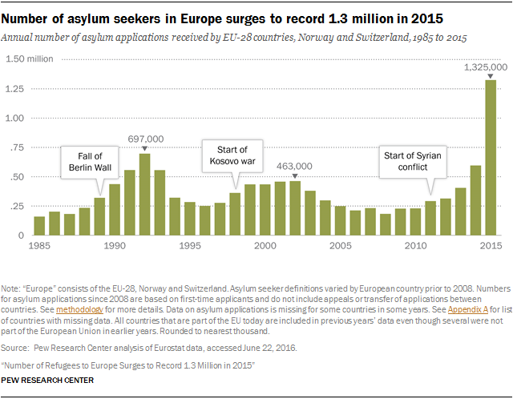
First, I looked at the number of asylum seekers in Europe, to see if any increases corresponded with the rise of far-right political party support in my countries of study. There is little question about the increased number of asylum seekers in Europe in recent years. As Figure 2 pictured above demonstrates, the number of asylum seekers in Europe has fluctuated since 1985. Since 2010, we see an increase in the number of asylum seekers, presumably due to the Syrian conflict. This number rose drastically from 2014 to 2015, and nearly doubled in 2015 compared to the highest number of asylum seekers Europe experienced over this entire time span (which was 697,000 in 1992). This chart includes data from all five of the countries featured in this study, and shows that there has been a rise in asylum seekers across Europe. Many scholars have postulated that this influx in refugees is correlated with the rise in support for far-right parties, as the main policy point of those parties is typically immigration concerns. For Figure 2, the data was divided into the five countries featured in my study to better picture the number of refugees seeking asylum in each separate country. This data is featured above.
Figure 2 displays mixed findings. Hungary and Sweden have seen a varied number of asylum applicants from 1995 to 2010, and then a sharp increase from then up until 2015. As previously demonstrated, the Sweden Democrats received 12.86 percent of the vote in the 2014 general election in Sweden, which was more than double the 5.7 percent they had received in the 2010 elections (Sweden, 2014). One could infer that the number of asylum seekers could have had an impact on the ability of the Sweden Democrats to advocate their view that increased immigration is a problem for Sweden. The Sweden Democrats state that they are not opposed to immigration, but believe that it must be minimal, as mass immigration has negative economic and social connotations, and is a threat to Sweden’s national identity and to their security (Sweden Democrats). Increased immigration can enhance their argument, especially if it correlates with a poor economy, seemingly increased security threats (such as the widely publicized terrorist attacks in Europe of late), or simply a perceived cultural threat. Whether or not citizens in Sweden will allow these outside concerns to affect their voting behaviors remains to be seen, and will be discussed later in this section. Hungary also experienced a drastic increase in asylum applicants from 2013 to 2015. There was not data available from 2008 to 2012, so the increase in Jobbik’s support from the 1.38 percent of the vote they received in the 2006 national Hungarian parliamentary election to the 12.18 percent they received in the 2010 election cannot be explained by this data. The increase from 12.18 percent in 2010 to 20.22 percent in the 2014 election does correlate with an increase in asylum applicants, as evidenced by Figure 2. While I am wary of drawing any definite conclusions from this correlation, it is something to be aware of considering how strong of an emphasis Jobbik places on immigration.
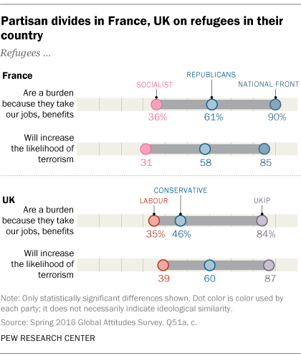
The United Kingdom has seen a reduction in the number of asylum applications they have received since the early 2000s, which is a very different trend than the increase that the other countries studied, and European countries in general, are experiencing. However, from 2010 to 2015 we do see a steady increase in the number of asylum applicants, even though it is at a relatively low rate. France also saw an increase in the early 2000s, but there was also a greater increase in asylum applications from 2009 to 2015. This follows the established pattern of increased asylum seekers in the past 5-10 years in most European countries. The country that does not seem to adhere to this pattern is Greece. Greece has received a very low number of asylum applications compared to the other countries in this study. They did see an increase in applications from 2005 to 2007, and possibly after that date, as data was not available from 2007 to 2010. From 2011 to 2015 they have still gotten a marginal amount of asylum applications that has remained at a steady rate between those years. I therefore do not see much of a correlation with this data and the rise of far-right parties in the case of Golden Dawn in Greece, but there is somewhat of a correlation with the other far-right political parties.
Further data was located on attitudes within France and the United Kingdom of refugees in their country. In this figure, we can see that in France, there is a clear partisan divide, as 90 percent of National Front supporters believe that refugees are a burden as they take jobs and benefits from those native to the UK. Additionally, 85 percent of National Front supporters surveyed believe that refugees will increase the likelihood of terrorism within their country. These are both economic concerns and security concerns that likely are reasons those surveyed support the National Front, a far-right political party. The same seems to be true for the United Kingdom, as 84 percent UKIP supporters believe refugees will harm their country economically and 87 percent believe they will also cause security concerns as they will increase the likelihood of terrorism. It is also worth noting that at least a third of supporters of political parties in the center right and the left on the political spectrum also believe these statements about refugees causing economic and security issues, which could be indicative of a general trend in attitudes toward incoming refugees.
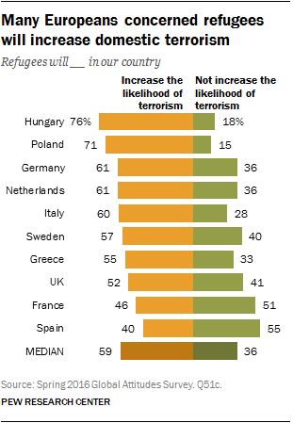
The perception that refugees will lead to increased security threats is a possible explanation for why there has been a rise in support for far-right parties over the last 30 years. Most Europeans surveyed believe that refugees will increase the likelihood of terrorism in their country. Among the highest countries that hold this belief are the five countries in this case study, Hungary being the country surveyed with the highest percentage of these attitudes. Far-right parties often connect refugees with the threat of terrorism, and emphasize their goal of curtailing immigration to save the people of these countries from these threats. As far-right political parties are characteristically authoritarian, they have strong ‘law and order’ preferences calling for limits on immigration and tough stances on crime.
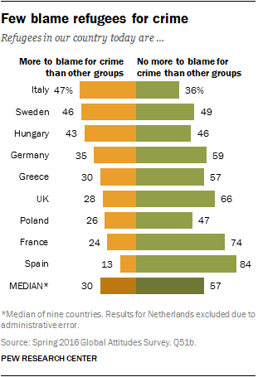
Oddly enough, this next chart shows that few European citizens actually blame refugees for crime. I thought it was interesting that Europeans believe refugees will increase domestic terrorism, but do not blame than for crime in general. This finding suggests that the security issue championed by far-right parties is only persuasive when terrorism is involved. One possible explanation for this finding is that the type of immigrant matters for these perceptions. Other studies have looked into attitudes toward Muslim immigrants, who make up a large portion of the immigrants that have comprised the recent spike in refugees throughout Europe, particularly due to the Syrian refugee crisis. These scholars have witnessed increased hostility toward Muslim immigrants, and have suggested that Muslim immigrants in particular are being vilified by far-right parties for economic issues and for perceived cultural threats (Yilmaz, 2012). To evaluate this claim, I looked for data to see if there was a large amount of support for these views in European countries in general, and particular the five in this case study. As such, I located data on attitudes toward Muslim populations within European countries, which shows that in eastern and southern Europe, negative views of Muslims are more prominent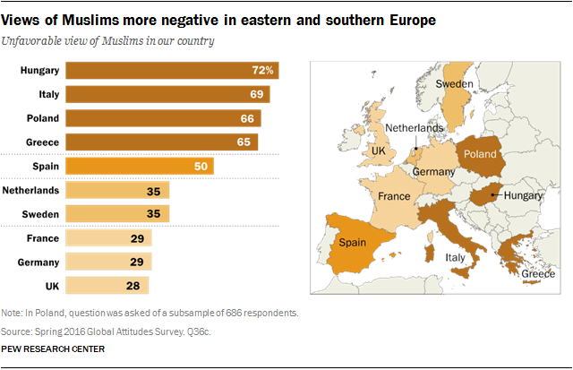
than in central and Western European countries such as France, Sweden, and the United Kingdom. Hungary again leads the group with the highest percentage of people surveyed that have an unfavorable view of Muslims. Greece also hosts a high percentage of those surveyed that held this view, while the United Kingdom, France, and Sweden have a smaller, yet still substantial, percent of citizens who had a negative view of Muslims in their respective countries. These attitudes have also been shown to correlate with what political party one supports, with supporters of far-right parties believing these claims at a much higher rate than supporters of other right-wing, center, and left-wing political parties.
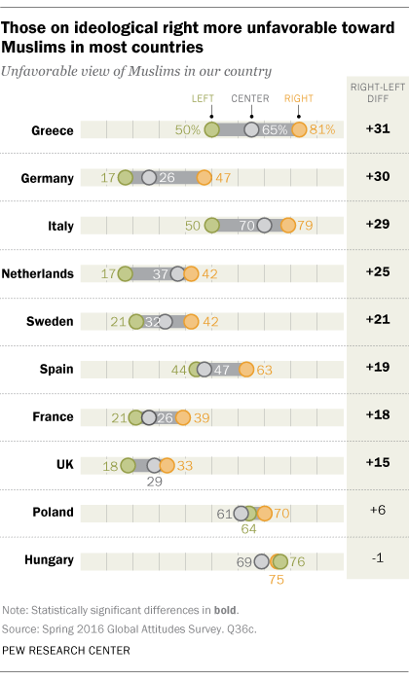
As one can see from the chart, there is a left-right difference among attitudes toward Muslims in European countries. In countries where there is less of a difference such as Hungary, it is seemingly because the majority of citizens hold these unfavorable views, and there is little distinction based on party affiliation. In Greece we see the highest right-left distinction, with 81% of right-wing political party supporters holding an unfavorable view of Muslims. This ties into earlier suggestions that increased negative views toward Muslims, who compose a large percentage of the influx of immigration in Europe, are a factor in the rise of far-right political party support throughout Europe.
Finally, I collected data on the foreign populations present within Greece, the UK, France, Sweden, and Hungary. I did this to see if there was any substantial influx of foreigners that could substantiate the rising negative attitudes toward immigrants throughout Europe. While there is in fact an increase displayed by the data, it is not as drastic as one would expect, given the sharp rise in support for many far-right parties researched in this study. The total populations of Greece, the United Kingdom, France, and

Figure 3: Total percent of the foreign population in the countries studied. (OECD, 2013)
Sweden are all comprised of about 6 percent of foreign individuals. The OECD describes this measure as, “consist[ing] of people who still have the nationality of their home country, [which] may include people born in the host country” (OECD, 2013). This shows that for most of the time period under study, there has been a steady increase in each country’s foreign population. The most recent data available was for 2013, and based on the other data concerning immigration throughout Europe, I would expect the numbers for 2014 and 2015 to continue this upward trend, perhaps even at a high rate of increase.
V. Conclusion
Overall, the data suggests a strong correlation between the rise of immigration in European countries and the rise in support of far-right political parties in those countries. This is evidenced by the sharp increase in the electoral success of far-right political parties, which is correlated with a sharp increase in asylum seekers around the same time span. Moreover, the research demonstrates that negative attitudes concerning refugees (Muslim refugees in particular) are strong in the countries in this study that have successful far-right parties. This is consistent with previous literature, which shows that one of the biggest factors that influences far-right political party success is a perceived cultural threat from increased immigration. Therefore, this increase in immigration and the negative attitudes European citizens are developing toward this immigration seems to be one reason why these far-right political parties are experiencing increased success in Europe over the last 30 years. More research will need to be conducted on this topic to establish how strong this correlation is. Future research implications resulting from this study are looking at why only certain countries have far-right political parties experiencing increased electoral success, which is outside of the scope of this research. I would also suggest that future studies attempt to analyze all far-right political parties within Europe, or Western Europe so that they can get a bigger picture of their success, and find trends that could fit to all far-right political parties.

Bibliography
Akkerman, T. (2012). Comparing Radical Right Parties in Government: Immigration and
Integration Policies in Nine Countries (1996-2010). West European Politics, 35(3),
511-529. doi:10.1080/01402382.2012.665738
BBC. (2001). VOTE 2001 | RESULTS & CONSTITUENCIES. Retrieved from
http://news.bbc.co.uk/hi/english/static/vote2001/results_constituencies/uk_brea
kdown/uk_full.stm
BBC News. (2005, September 08). UK | UK Politics | Results. Retrieved from
http://news.bbc.co.uk/2/hi/uk_news/politics/vote_2005/constituencies/default.st
m
BBC News. (2010). Election 2010 | Results | United Kingdom - National Results. Retrieved
from http://news.bbc.co.uk/2/shared/election2010/results/
BBC News. (2015). Election 2010 | Results | United Kingdom - National Results. Retrieved
from http://news.bbc.co.uk/2/shared/election2010/results/
Connor, P. (2016, August 2). Number of Refugees to Europe Surges to Record 1.3 Million in
2015. Retrieved from http://www.pewglobal.org/2016/08/02/appendix-a-asylum-
applications-1985-through-2015/
Connor, P. (2016, August 2). Number of Refugees to Europe Surges to Record 1.3 Million in
2015. Retrieved from http://www.pewglobal.org/2016/08/02/number-of-
refugees-to-europe-surges-to-record-1-3-million-in-2015/
European Parliament. (1999). European Parliament 1999 Results (Europe, European
Parliament).
European Parliament. (2004). European Elections 10-13 June (Europe, European
Parliament).
European Parliament. (2014). Results of the 2009 European elections (Europe, European
Parliament).
European Parliament. (2014). Results of the 2014 European elections (Europe, European
Parliament).
France, European Election Database. (2007). Dataset: France: Parliamentary Election 1993-
2007.
Golder, M. (2016). Far Right Parties in Europe. Annual Review of Political Science, 19(1),
477-497. doi:10.1146/annurev-polisci-042814-012441
Hellenic Parliament. (2015). Election Results (Greece, Hellenic Parliament).
IPU, I. (2007). HISTORICAL ARCHIVE OF PARLIAMENTARY ELECTION RESULTS (France,
Inter-Parliamentary Union).
Ivarsflaten, E. (2008). What Unites Right-Wing Populists in Western Europe? Re-Examining
Grievance Mobilization Models in Seven Successful Cases. Comparative Political
Studies, 41(1), 3-23. doi:10.1177/0010414006294168
Koopmans, R., Statham, P., Giugni, M., & Passy, F. (2005). Contested citizenship:
Immigration and cultural diversity in Europe. Minneapolis: University of Minnesota
Press.
Lucassen, G., & Lubbers, M. (2012). Who Fears What? Explaining Far-Right-Wing
Preference in Europe by Distinguishing Perceived Cultural and Economic Ethnic
Threats. Comparative Political Studies, 45(5), 547-574. doi:10.1177/0010414011427851
Ministère de l'Intérieur. (2017). Election Presidentielle (France, Ministère de l'Intérieur).
Mudde C. (2004). The populist zeitgeist. Gov. Opposition 39:541–63
Mudde C (2007). Populist Radical Right Parties in Europe. Cambridge: Cambridge
University Press.
Mudde, C. (2014). Fighting the system? Populist radical right parties and party system
change. Party Politics, 1(10), 1-10. doi:10.1177/1354068813519968
National Election Commission. (2010, February 11). Elections to the European Parliament
2004. Retrieved from http://www.valasztas.hu/en/nvb/198/198_0.html
National Election Office. (2004). THE ELECTION OF THE MEMBERS OF THE
EUROPEAN PARLIAMENT 13 June 2004 (Hungary, National Election Office).
Norris, P. (2005). Radical right: Voters and parties in the electoral market. Cambridge,
UK: Cambridge University Press.
OECD. (2013). Foreign Population (% of population 2013). Retrieved from
https://data.oecd.org/migration/foreign-population.htm#indicator-chart.
Sweden Democrats. (n.d.). Invandringspolitik. Retrieved from https://sd.se/var-
politik/invandringspolitik/
Sweden, Statistics Sweden. (2014). Election to the Riksdag - seats won by region and party.
Year of election 1973 - 2014. Retrieved from
http://www.statistikdatabasen.scb.se/pxweb/en/ssd/START__ME__ME0104__ME0
104C/Riksdagsmandat/?rxid=af10a208-b937-4895-8760-56605533f674
UK Parliament. (1997, May 1). No. 68 General Election Results, 1 May 1997. Retrieved from
http://www.parliament.uk/documents/commons-information-office/m15.pdf
Wikie, R., Stokes, B., & Simmons, K. (2016, July 11). Europeans Fear Wave of Refugees Will
Mean More Terrorism, Fewer Jobs. Retrieved from
http://www.pewglobal.org/2016/07/11/europeans-fear-wave-of-refugees-will-
mean-more-terrorism-fewer-jobs/#
Yilmaz, F. (2012). Right-wing hegemony and immigration: How the populist far-right
achieved hegemony through the immigration debate in Europe. Current Sociology, 60(3), 368-381. doi:10.1177/0011392111426192

