Hemiparasitic Castilleja promotes plant diversity in an alpine meadow ecosystem

By Johannah Reed
Mentor: Dr. Nate Sanders

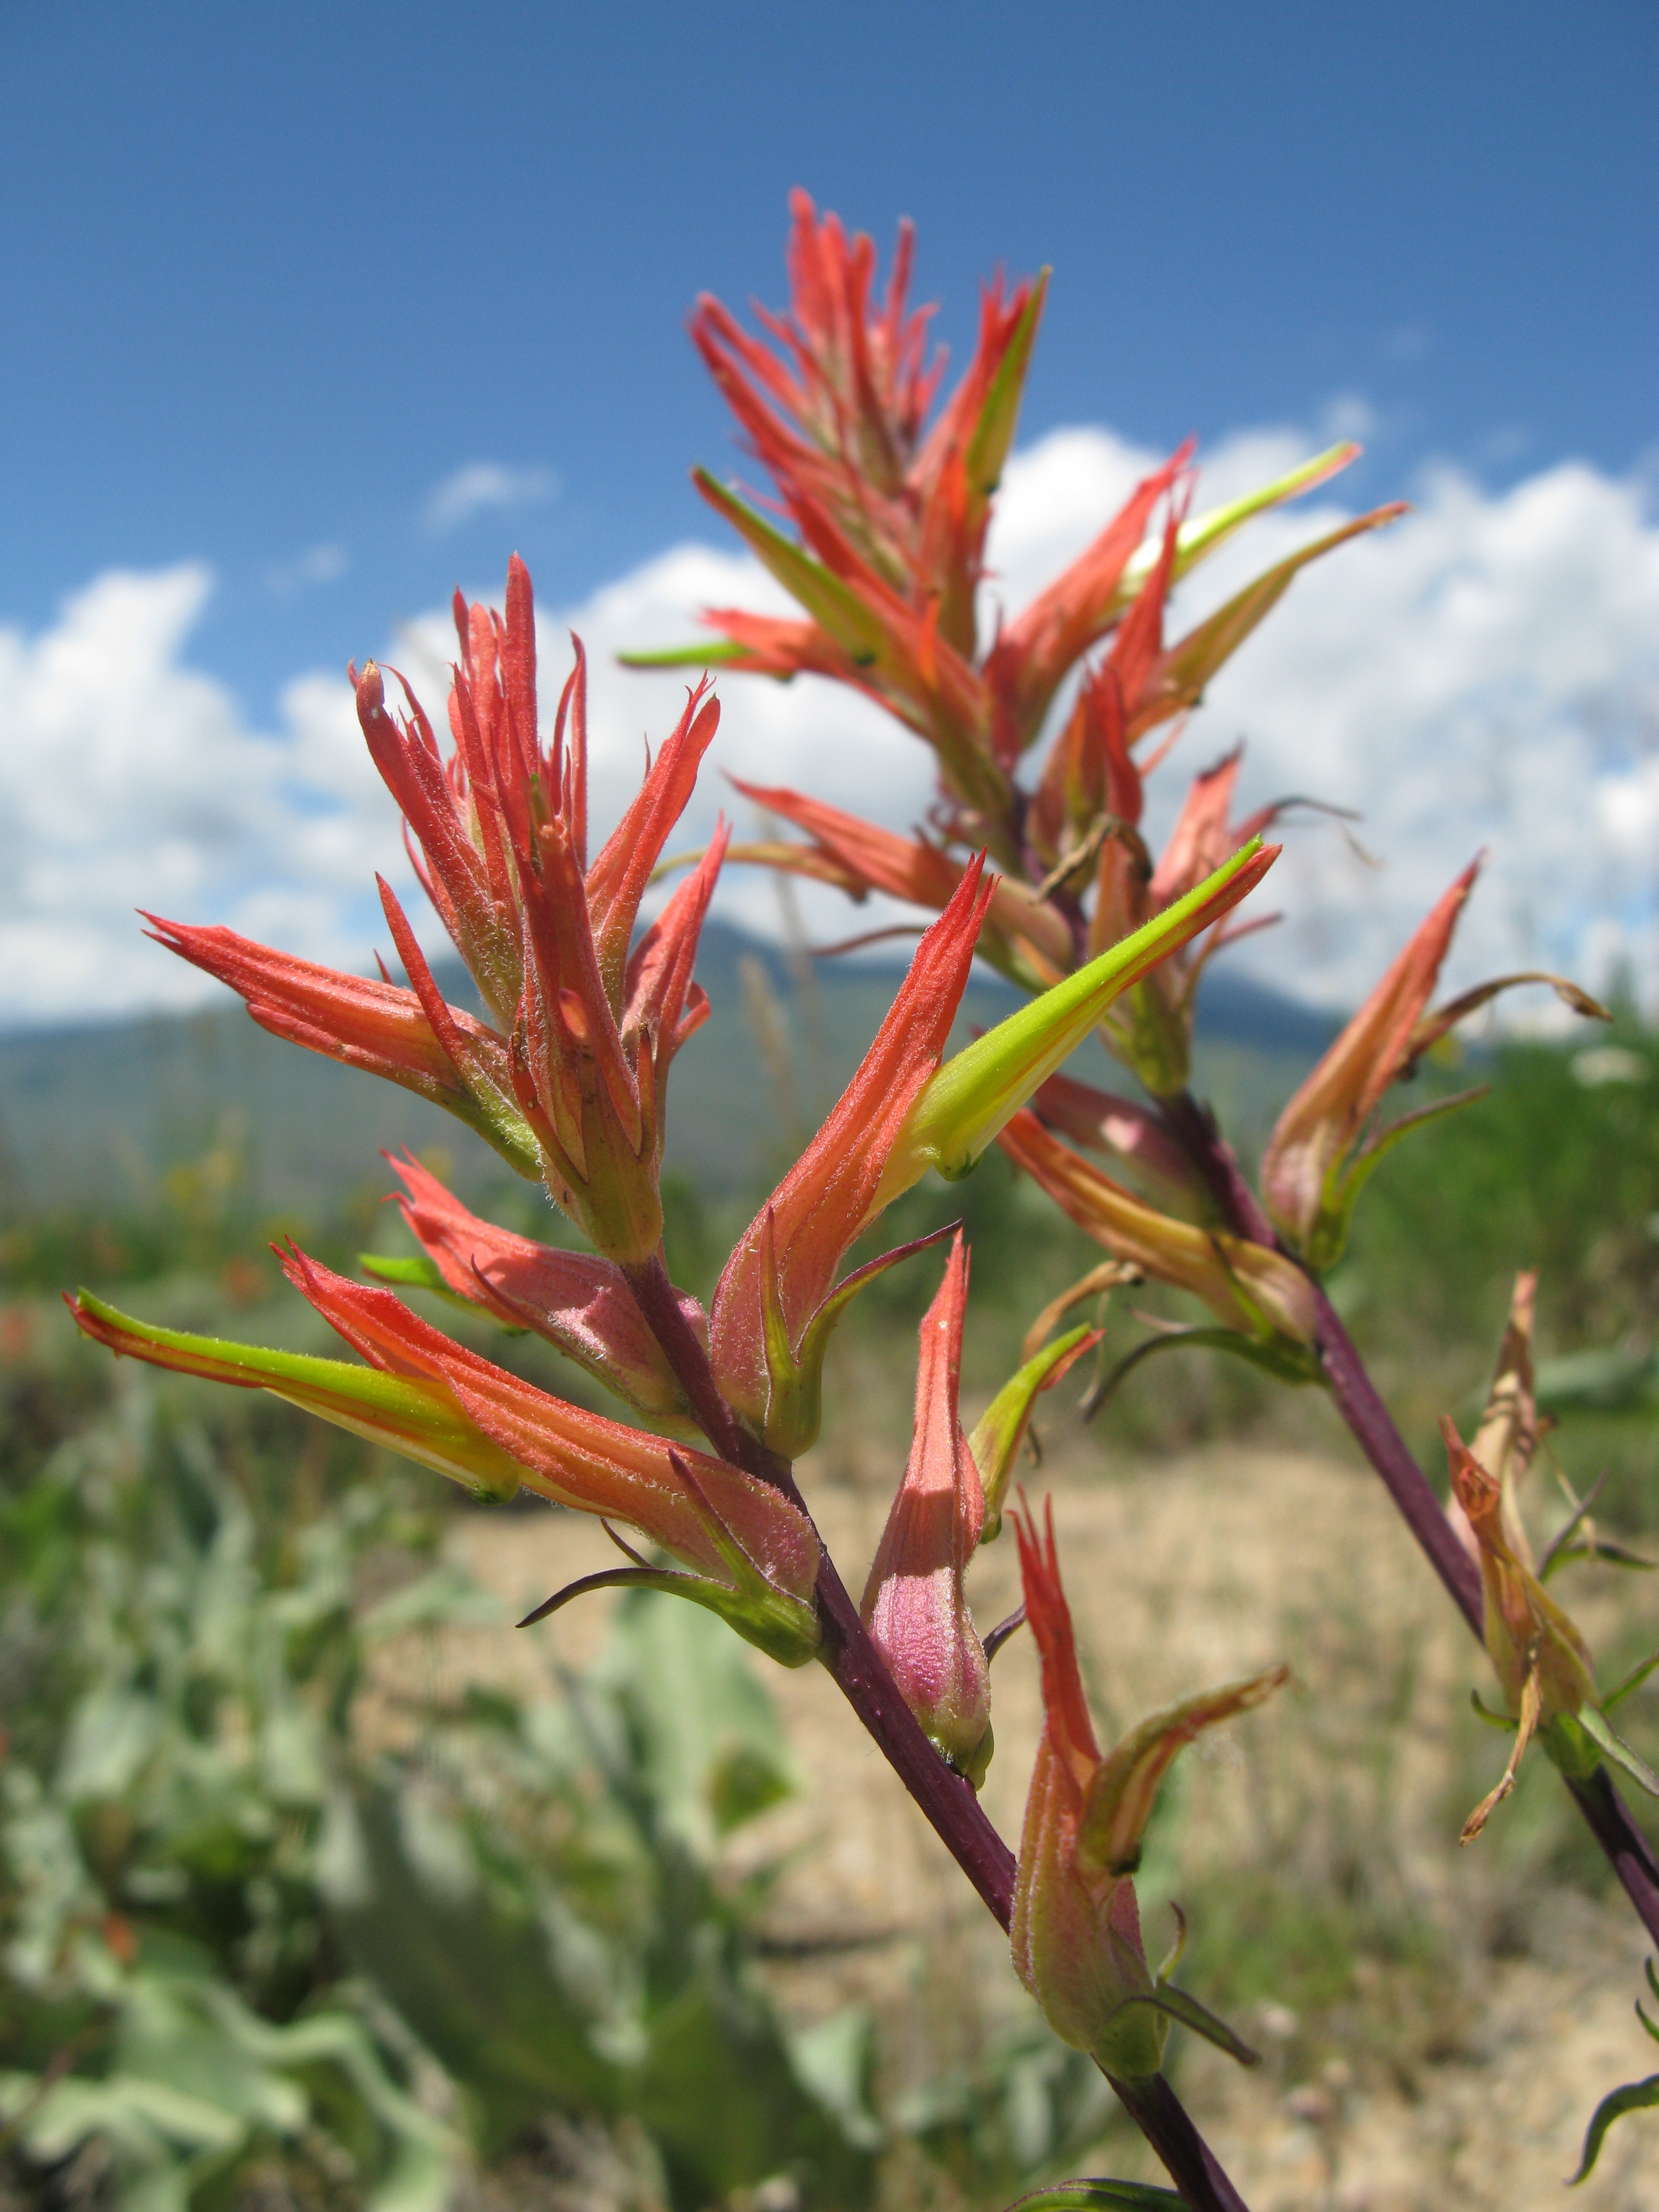
Abstract
There is a long history in ecology of examining how biotic interactions such as competition, predation, and mutualism influence the structure and dynamics of natural communities. However, few studies to date have experimentally assessed the role of hemiparasitic plants, which are commonly found in a variety of ecosystems, as a structuring force of plant communities. Hemiparasitic plants have the potential to shape plant communities because of their ability to photosynthesize and parasitize host plants and because of their abundance in a variety of natural and managed ecosystems. I conducted a study that focused on the impacts of hemiparasitic species in the genus Castilleja, which are ubiquitous in montane meadows in the Rocky Mountain West. This study employed a manipulative field experiment in which Castilleja was removed from intact plant communities to examine the relationship between the presence of Castilleja and a suite of community-level properties. The experiment showed that evenness was 32 % lower, diversity was 29% lower, and Shannon entropy was 32% lower in plots from which Castilleja was removed relative to plots in which Castilleja was present. This suggests that the presence of Castilleja promotes diversity in a montane plant community. This research demonstrates that hemiparasites have the potential to shape plant communities in alpine ecosystems, but more research should be done to determine the extent of their effects on community structure and ecosystem function in natural and manipulated systems.
Introduction
Plant community ecologists have examined the effects of competition and herbivory on plant community structure for at least decades, but they have generally ignored the impact parasitic or hemiparasitic plants might have on community composition (Spasojevic and Suding 2010; Bardgett et al. 2006). Parasitic plants are comprised of two main groups, holoparasites (plants that are completely parasitic and contain virtually no chlorophyll) and hemiparasites (plants that are both parasitic and photosynthetic), and each group has the potential to play a major role in shaping plant community structure (Press and Phoenix 2005). Globally there are over 3000 parasitic flowering plant species, and most plant assemblages contain one or more parasitic plant species (Marvier 1996; Bardgett et al. 2006; Quested 2008). Parasitic plants are also represented in every major ecosystem (Adler 2002). Given their ubiquity and diversity, it is surprising that so few studies have examined whether they impact plant community composition.
Hemiparasitic plants may exert strong indirect effects on plant community structure by directly altering the performance of their hosts. Though few studies have examined community-level impacts of hemiparasitic plants (see Bardgett et al. 2006; Phoenix and Press 2005), several experiments on parasite-host interactions have found that hemiparasites can have detrimental effects on their hosts and that hosts have varying positive effects on their parasite (Adler 2003; Pennings and Simpson 2008). Hemiparasitic plants obtain some resources, including water, fixed carbon compounds, nitrogen, etc., from their host plants, but they also compete with their hosts for light, water and soil nutrients (Pennings and Callaway 2002; Press and Phoenix 2005; Marvier 1996; Borowicz and Armstrong 2011). Hemiparasitic plants have the potential to determine the structure and productivity of the plant communities in which they are present, as their parasitism can decrease the growth of host species, which might indirectly affect other plants by altering the competitive balance between hosts and non-hosts species in a community (Press and Phoenix 2005; Quested, et al. 2002). Put another way, when hemiparasites have detrimental effects on their hosts, this can allow non-host plants to gain a competitive advantage and become more abundant in the community (Bardgett et al. 2006; Marvier 1998). Finally, the effects of hemiparasitic plants on community biomass or diversity depends on whether their host is a dominant or subordinate species in the community. If a host is a dominant species, then hemiparasitic species might promote diversity and decrease ANPP when compared to when it parasitizes a subordinate host (Bardgett et al. 2006).
Soil nutrient availability, the density of parasitic plants within the community, and the parasitic plants’ host preference can all drive changes in plant community composition (Spasojevic and Suding 2010; Quested 2008). Most parasitic plants are thought to be generalists, meaning that they parasitize and exploit resources from many different plant species, and Castilleja spp. are even thought to parasitize over 100 different hosts (Press 1998). This could drive changes in competitive interactions among hosts or create other indirect effects (Marvier 1998). It is common, however, for parasitic plants to behave more as specialists because they show various levels of host preference (Press and Phoenix 2005).
Castilleja species are facultative hemiparasites of plant roots, from which they obtain a portion of their required nutrients, including water, nitrogen, carbon compounds, and minerals from their host (Bardgett et al. 2006; Press and Phoenix 2005; Cameron et al. 2009; Quested 2008; Marvier 1996). Hemiparasitic plants such as Castilleja species can “forage” by selectively growing in a specific direction (towards or away from host plants) or by selectively penetrating a host’s roots upon contact (Pennings and Callaway 2002). It is difficult to determine the host for most Castilleja individuals, but Castilleja species can parasitize a wide range of plant species in montane and alpine communities (Spasojevic and Suding 2010), including deeply rooted sagebrush, fast growing grasses, lupines, and other plants (Darrow 2006). Adler (2003) found that Castilleja indivisa benefits more from parasitizing lupines, which are nitrogen fixers, suggesting that some hosts have stronger positive effects on the hemiparasite’s productivity than others (Adler 2003; Pennings and Simpson 2008).
Although Castilleja species are common in alpine systems in Colorado and the Rocky Mountains (Appendix 1), their community-level effects have not been widely studied. One exception is the work of Spasojevic and Suding (2010), who conducted an experiment in the Front Range of the Colorado Rocky Mountains focusing on the effects of Castilleja occidentalis on nutrient dynamics and diversity-productivity relationships. They found that long-lived hemiparasitic plants may increase the availability of nitrogen in nutrient poor systems through their nutrient rich litter. This positive nutrient effect could significantly increase productivity and slightly increase diversity. To my knowledge, this is the only study that shows the effects of hemiparasitism on community structure and driving ecosystem processes in Rocky Mountain ecosystems.
In my study, I employed a manipulative experiment to examine the relationship between the presence of Castilleja spp. and a suite of community-level variables. In particular, I asked: (1) Do Castilleja spp. affect the structure of plant communities by altering species richness, evenness, and diversity? (2) How do Castilleja spp. affect the structure of plant communities? I predicted that if Castilleja species have an effect on plant communities, Castilleja presence would promote species richness, evenness, and diversity. Overall, with this research I aim to better understand the roles of parasitic plants in shaping community structure in alpine systems.

Methods
My work was conducted near the Rocky Mountain Biological Laboratory (RMBL) (latitude 38° 96′ N, longitude 106 ° 98′ W). The experimental site was located at approximately 3000 meters in elevation in a dry montane meadow approximately 1-km east of Gothic, CO. The dominant vegetation at the site consisted of herbaceous perennials, aspen trees, and a mixture of grasses. There were about fifty plant species represented across the study site; common plant species at the site included Populus tremuloides, Achillea millefolium, Potentilla hippiana, Mahonia repens, Lomatium dissectum, Ipomopsis aggregata, Phleum praetense (Appendix 1).
In July 2011, I established 18 1-m² plots with a 0.5 × 0.5 m buffer zone to determine if Castilleja influences the structure and diversity of plant communities. Each plot was at least 1-2 m from the nearest adjacent plots, but the exact distance was not measured, as it depended on the topography and vegetation of the area, as well as the abundance of Castilleja. I implemented three treatments: a control plot in which nothing was manipulated; a Castilleja-removal plot, in which Castilleja was removed by clipping to ground level in each plot (including the 0.5 × 0.5 m buffer zone) each week during the growing season (primarily July 2011); and a random-biomass removal plot, in which a comparable amount of biomass (compared to the Castilleja-removal plots) was removed. I included a random-biomass removal plot in each block to account for the removal of Castilleja biomass and the impacts that removing biomass in general could have on plant community structure (Symstad and Tilman 2001). Biomass removed from the Castilleja-removal plots and random-biomass removal plots was collected in paper bags and then dried for approximately 72 hours at 70°C in a static air oven. Collected biomass was weighed to the nearest 0.01 gram.
To determine if all plots were similar in their abiotic pressures and properties, soil moisture was measured for all plots periodically using a soil moisture probe with all measurements taken on clear days between 11 am and 1 pm. Two measurements were taken in each plot on each measurement occasion throughout the peak growing time for Castilleja.
To determine the effects of Castilleja on plant community structure, I measured the richness, evenness, and diversity of the existing plant community on three occasions (June 28th, July 14th and July 28th) during the 2011 growing season in each of the 18 1-m² plots; however, I used only the data from the last observation at the end of the growing season to measure the effects of Castilleja on the community-level variables. Richness was measured in all plots on each date by identifying and recording each plant species present in the plots (Darrow 2006). Evenness was measured by estimating the relative abundance of each species based on percent foliar cover at five percent intervals and using the Inverse Simpson’s Index
( where p_{i} is the proportion of each species and S is the total number of species). Shannon’s Diversity and Shannon’s Entropy were also calculated. Note that in all cases the response variable did not include Castilleja presence or abundance; instead, the focus of these calculations was on the diversity of the rest of the plant community.
For each response variable, I used a separate one-way Analysis of Variance model with treatment being “removal” at three levels: (1) Castilleja removal, (2) random biomass removal, and (3) control. I also used Tukey-Kramer HSD to determine whether treatments differed from each other for each of the response variables at α = 0.05. All data met the assumptions of normality prior to analysis.

Results
Prior to plant removals in 2011, no diversity measures differed among treatments (P > 0.667 in all cases), and plots did not differ in soil moisture (P = 0.971; F = 0.030). After plant removals, richness still did not differ among treatments (Table 1; Figure 1A), but evenness (Inverse Simpson’s Index) and diversity (Shannon’s Diversity and Shannon’s Entropy) did significantly differ (Table 1). In particular, evenness was 32% lower in Castilleja removal plots than in control plots (Figure 1B; F = 18.56; P < 0.0001; Table 1), and diversity was 29% lower in Castilleja removal plots than in control plots (Figure 1C; F = 8.14; P < 0.004; Table 1). Shannon’s Entropy was marginally significant (P = 0.070, F = 3.18), showing that Castilleja removal plots had 32% lower Shannon’s entropy than control plots (Figure 1D). Finally, Shannon’s diversity and entropy did not differ between Castilleja removal and random biomass removal plots; random biomass removal plots did not differ from control plots either in terms of evenness, Shannon’s diversity, and Shannon’s entropy (Table 1; Figure 1C, D).

Source | Sum of Squares | Mean Square | F | P
Richness | 10.78 | 5.39 | 0.79 | 0.471
Simpson’s Evenness | 0.07 | 0.04 | 18.56 | <0.0001*
Shannon’s Diversity | 0.34 | 0.17 | 8.41 | 0.004*
Shannon’s Entropy | 35.99 | 18.00 | 3.18 | 0.070*

Table 1. ANOVA results testing for the effects of Castilleja removal on Simpson’s evenness, Shannon’s diversity, and Shannon’s entropy after a growing season of experimental treatments. Significant (P < 0.05) and marginally significant variables (P < 0.07) are in bold.

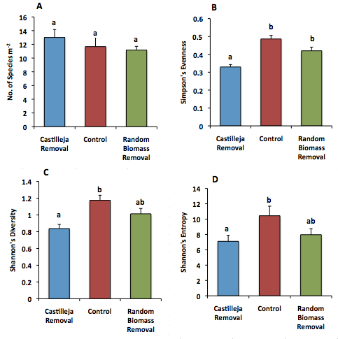
Figure 1. Mean (± SE) values for plant community diversity measures as they are affected by the presence of Castilleja spp. Richness or number of species in plots (A), Inverse Simpson’s Evenness Index (B), Shannon’s Diversity Index (C), and Shannon’s Entropy (D) for Castilleja removal plots, control plots, and random biomass removal plots. Values with different letters are significantly different at the P <0.05 level, except for D, in which P<0.07 is considered marginally significant.

Discussion
The most salient result of this study was that the presence of the hemiparasite Castilleja altered alpine plant community structure over the course of a single growing season. More specifically, when Castilleja was present, plant community evenness, diversity, and entropy were all higher than when Castilleja species were experimentally removed (Figure 1B, 1C, 1D). Species richness was not affected by the presence of Castilleja in the experiment (Figure 1A). Taken together, the results of this study suggest that the presence of the hemiparasite Castilleja promotes shifts in community structure and overall higher diversity in this alpine system.
Hemiparasitism by Castilleja promoted evenness and diversity while leaving species richness unchanged. It is not surprising that richness did not differ among treatments because a difference in richness would require that new species appear or become extinct in removal plots over the course of a short growing season. In other words, removal treatments are likely to alter species richness over longer periods of time than in the time frame of a growing season. The effects of hemiparasitism by Castilleja on evenness, diversity and entropy suggest that the effects of this species alter the relative abundance of species in local communities, perhaps by altering competitive interactions among plants. So it seems possible that the presence of Castilleja promotes diversity and evenness, in much the same way that parasites, pathogens and predators in other systems promote diversity and evenness (e.g. Dobson and Crawley 1994).
The effects of hemiparasitism may depend on how selective Castilleja is for its host and how virulent it is in montane meadows and alpine ecosystems in general (Pennings and Callaway 2002). If Castilleja is largely a generalist, then it would parasitize multiple plant species and have little effect on specific plant species and plant community structure. For example, removing it should lead to a shift in the abundance of all its host species equally. However, if Castilleja is primarily a specialist, then it would have a greater effect on the abundance of only one or a few species. So removing it would release those host species from parasitism, thereby increasing their competitive ability, and in turn causing a shift in the evenness, diversity, and entropy. In general, plots that had Castilleja present had higher species diversity measures except richness, so this study suggests that Castilleja may be more of a specialist hemiparasite than a generalist in alpine ecosystems. This makes logical sense, as many hemiparasites can selectively “forage” and “choose” which plants to parasitize. But what is surprising is that I did not detect any significant and consistent changes in the relative abundances of particular plant species resulting from Castilleja removal. Instead, what is likely happening is that within each plot, Castilleja specializes on a single or small number of species, but the identity and/or abundance of that species varied among plots.
The defining characteristic of hemiparasitic plants is that they have the ability both to make their own photosynthate and to parasitize their hosts (Press and Phoenix 2005). This means that they compete with other plants for light, water and nutrients and directly affect them through parasitism, so removing hemiparasites not only reduces their effect on other plants through parasitism, but it also reduces their competitive effect on their hosts. I tested for this competitive effect, however, using the random biomass removal treatment. If effects seen by the removal of hemiparasites were purely due to the reduction of competition with other plants, then the random biomass removal plots would react in the same ways as the Castilleja removal plots. Evenness, however, saw the most definitive changes due to the removal of Castilleja because the control and random biomass removal treatments were statistically the same, while Castilleja removal was significantly lower (Figure 1B). This confirms that the presence of Castilleja has effects on the rest of the plant community because of its hemiparasitic nature.
Parasitic and hemiparasitic plants are ubiquitous but have been largely excluded from community-level studies. Hemiparasites have the potential to influence community structure and composition, so it is important that plant community ecologists consider their roles in various ecosystems in order to obtain a better understanding of their potential impacts. Through several studies, it is understood that hemiparasites have varying effects on their plant communities depending on factors such as abundance or density of the hemiparasite, host preference, and soil fertility of the system. According to this study, the presence of Castilleja species generally increased the evenness, diversity, and entropy of the rest of the plant community. This is similar to the finding that Rhinanthus minor, also a hemiparasite, promoted plant diversity in a temperate grassland ecosystem (Bardgett et al. 2006). R. minor is a facultative root hemiparasite that, like Castilleja, affects plant community structure by promoting evenness (Bardgett et al. 2006). They found that plots with R. minor had 26% greater evenness (calculated using the inverse Simpson’s index) than those without the hemiparasite (Bardgett et al. 2006), and our study found that plots with Castilleja were 32% higher in evenness (calculated using the inverse Simpson’s index). The Bardgett study, however, was conducted in low-to-moderately productive grassland, so it is interesting to see how similar effects of hemiparasites can extend across different ecosystems. On the contrary, Spasojevic and Suding (2010) found that there was no significant difference in richness, evenness, and Simpson’s diversity index between plots with and without the hemiparasite Castilleja occidentalis in a dry meadow tundra.
The results of my study indicate that the hemiparasite Castilleja significantly increases evenness, diversity, and entropy in alpine ecosystems, enforcing the idea that hemiparasites can have detectable effects on plant community structure. Hemiparasites have largely been excluded from community-level studies, yet several studies show their importance in shaping and changing communities (Bardgett et al. 2006; Press and Phoenix 2005; Spasojevic and Suding 2010). The influence of hemiparasites on their hosts may become more intense as global changes such as warming in these montane ecosystems increase, and understanding how hemiparasites regulate plant community composition may become increasingly important for making predictions on how ecosystems will function in the future.
Acknowledgements
This research was conducted as part of an undergraduate thesis project for Johannah Reed under the direction of Nathan Sanders at the University of Tennessee, Knoxville. I thank Nate Sanders for his constant guidance and expertise and for encouraging me to pursue ecology and become a part of his lab family. I also thank Aimee Classen and Lara Souza for making suggestions that greatly improved this research and paper. I extend my sincerest appreciation to Jennie Reithel, Tess Leuthner, Ross Brenan, and other students and faculty at the Rocky Mountain Biological Laboratory for their help with plant identification. I thank the Rocky Mountain Biological Laboratory for granting permission to stay and work at the lab. This research was funded by the Rocky Mountain Biological Laboratory, University of Tennessee Office of Research, Sanders Lab at the University of Tennessee, and the Chancellor’s Honors Program at the University of Tennessee.
Literature Cited
Adler, L. S. 2002. Host Effects on Herbivory and Pollination in a Hemiparasitic Plant. Ecology 83: 2700-2710.
Adler, L. S. 2003. Host Species Affects Herbivory, Pollination, and Reproduction in experiments with Parasitic Castilleja. Ecology 84: 2083-2091.
Bardgett, R. D., R. S. Smith, R. S. Shiel, S. Peacock, J. M. Simkin, H. Quirk, and P. J. Hobbs. 2006. Parasitic plants indirectly regulate below-ground properties in grassland ecosystems. Nature 439.
Borowicz, V. A., J. E. Armstrong. 2011. Resource limitaton and the role of hemiparasite on a restored prairie. Oecologia. DOI: 10.1007/s00442-011-2222-7
Callaway, R. M., R.W. Brooker, P. Choler, Z. Kikvidze, C. J. Lortle, R. Michalet, L. Paolini, F. I. Pugnaire, B. Newingham, E. T. Aschehoug, C. Armas, D. Kikodze, and B. J. Cook. 2002. Positive interactions among alpine plants increase with stress. Nature 417.
Cameron, D. D., A. White and J. Antonovics. 2009. Parasite-grass-forb interactions and rock-paper-scissor dynamics: predicting the effects of the parasitic plant Rhinanthus minor on host plant communities. Ecology 97: 1311-1319.
Cross , M. S. and J. Harte. 2007. Compensatory responses to loss of warming-sensitive plant species. Ecology 88: 740-748.
Darrow, K. 2006. Wild About Wildflowers: Extreme Botanizing in Crested Butte, Wildflower Capital of Colorado. 2nd Ed. Heel and Toe Publisher, Fort Collins, CO.
Dobson, A. and M. Crawley. 1994. Pathogens and the structures of plant communities. Trends in Ecology and Evolution 9: 393-398.
Hellstrom, K., J.M. Bullock and R. F. Pywell. 2011. Testing the generality of hemiparasitic plant effects on mesotropic grasslands: a multi-site experiment. Basic and Applied Ecology 12: 235-243.
Marvier, M. A. 1996. Parasitic plant-host interactions: plant performance and indirect effects on parasite feeding herbivores. Ecology 77: 1398-1409.
Marvier, M. A. 1998. Parasite impacts on host communities: plant parasitism in a California coastal prairie. Ecology 79: 2616-2623.
Pennings, S. C. and J. C. Simpson. 2008. Like herbivores, parasitic plants are limited by host nitrogen. Plant Ecology 196: 245-250.
Pennings, S. C. and R. M. Callaway. 2002. Parasitic plants: parallels and contrasts with herbivores. Oceologia 131: 479-489.
Phoenix, G.K. and M.C. Press. 2005. Linking physiological traits to impacts on community structure and functon: the role of root hemiparasitic Orobanchaceae (ex-Scrophulariaceae). Journal of Ecology 93: 67-78.
Press, M. C. 1998. Dracula or Robin Hood? A functional role for root
hemiparasites in nutrient poor ecosystems. Oikos 82: 609–611.
Press, M. C. and G. K. Phoenix. 2005. Impacts of parasitic plants on natural communities. New Phytologist 166: 737-751.
Quested, H. M. 2008. Parasitic plants- impacts on nutrient cycling. Plant Soil 311:269-272.
Quested, H. M., M. C. Press, T. V. Callaghan, and J. H. C. Cornelissen. 2002. The hemiparasitic angiosperm Bartsia alpina has the potential to accelerate decomposition in sub-arctic communities. Oecologia 130: 88-95.
Spasojevic, M. J. and K. N. Suding. 2010. Contrasting effects of hemiparasites on ecosystemprocesses: can positive litter effects offset the negative effects of parasitism? Oecologia 165: 193-200.
Symstad, A.J. and D. Tilman. 2001. Diversity loss, recruitment limitation, and ecosystem functioning: lessons learned from a removal experiment. Oikos 92: 424-435.
Appendix 1. Abundance of all plant species in the plots based on data from the last observation at the end of the growing season. Percent (%) of plant species represented across all plots and for each treatment (Castilleja Removal, Control, Random Biomass Removal).
 | Species | All | Castilleja Removal | Control | Random Biomass Removal
1 | Poaceae | 20.28 | 6.11 | 5.56 | 8.61
2 | Paxistima myrsinites | 11.67 | 5.28 | 2.50 | 3.89
3 | Populus tremuloides | 10.28 | 3.61 | 2.78 | 3.89
4 | Castilleja miniata | 9.50 | 0.00 | 5.56 | 3.94
5 | Heterotheca villosa | 6.28 | 2.28 | 3.39 | 0.61
6 | Erigeron Speciosus | 4.33 | 1.44 | 0.67 | 2.22
7 | Potentilla hippiana | 3.94 | 1.22 | 2.06 | 0.67
8 | Helianthella quinqueneruis | 3.94 | 1.17 | 2.78 | 0.00
9 | Arenaria congesta | 3.06 | 1.72 | 0.44 | 0.89
10 | Mahonia repens | 2.78 | 1.39 | 0.56 | 0.83
11 | Lomatium dissectum | 2.61 | 1.17 | 0.83 | 0.61
12 | Vaccinium myrtillus | 2.50 | 2.50 | 0.00 | 0.00
13 | Vicia americana | 2.28 | 0.89 | 0.83 | 0.56
14 | Viola praemorsa | 2.00 | 0.67 | 0.72 | 0.61
15 | Phacelia hastata | 1.78 | 0.11 | 1.11 | 0.56
16 | Artemisia tripartita | 1.78 | 0.06 | 1.72 | 0.00
17 | Senecio canus | 1.39 | 0.17 | 0.83 | 0.39
18 | Achillea millefolium | 1.28 | 0.28 | 0.28 | 0.72
19 | Lathyrus lanszwertii | 1.11 | 0.11 | 0.56 | 0.44
20 | Poa partensis | 0.78 | 0.50 | 0.11 | 0.17
21 | Galium Boreale | 0.78 | 0.06 | 0.33 | 0.39
22 | Draba aurea | 0.61 | 0.56 | 0.00 | 0.06
23 | Phleum pratense | 0.56 | 0.11 | 0.33 | 0.11
24 | Gentiana parryi | 0.56 | 0.28 | 0.00 | 0.28
25 | Cymopterus lemmonii | 0.56 | 0.28 | 0.28 | 0.00
26 | Potentilla gracilis | 0.44 | 0.00 | 0.06 | 0.39
27 | Unknown Grass | 0.33 | 0.06 | 0.28 | 0.00
28 | Rosa woodsii | 0.33 | 0.06 | 0.00 | 0.28
29 | Unknown Herbaceous Plant #2 | 0.28 | 0.06 | 0.17 | 0.06
30 | Taraxacum officianale | 0.28 | 0.00 | 0.00 | 0.28
31 | Ipomopsis aggregata | 0.28 | 0.11 | 0.00 | 0.17
32 | Unknown Herbaceous Plant #1 | 0.22 | 0.11 | 0.11 | 0.00
33 | Sedum lanceolatum | 0.17 | 0.11 | 0.06 | 0.00
34 | Hydrophyllum capitatum | 0.17 | 0.06 | 0.00 | 0.11
35 | Triteleia grandiflora | 0.06 | 0.06 | 0.00 | 0.00
36 | Stipa richardsonii | 0.06 | 0.00 | 0.06 | 0.00
37 | Frageria virginiana | 0.06 | 0.00 | 0.06 | 0.00
38 | Arnica cordifolia | 0.06 | 0.00 | 0.06 | 0.00

