To the Graduate Council:

I am submitting herewith a thesis written by Prasanna Rao Venkateswara Rao entitled “Increasing Accuracy of Simulation Modeling via a Dynamic Modeling Approach”. I have examined the final electronic copy of this thesis for form and content and recommend that it be accepted in partial fulfillment of the requirements for the degree of Master of Science, with a major in Industrial Engineering.

Dr. Rapinder Sawhney
Major Professor

We have read this thesis and recommend its acceptance:

Dr. Xueping Li

Dr. Xiaoyan Zhu

Accepted for the Council:

Carolyn R. Hodges,
Vice Provost and Dean of
the Graduate School

(Original signatures are on file with official student records.)

Increasing Accuracy of Simulation Modeling via a Dynamic Modeling Approach

A Thesis Presented for
the Master of Science
Degree
The University of Tennessee, Knoxville

Prasanna Rao Venkateswara Rao
May 2011

Copyright © 2011 by Prasanna Rao Venkateswara Rao
All rights reserved.

ACKNOWLEDGEMENTS

I would like to first and foremost thank Dr Rapinder Sawhney for being my committee chairman as well as my advisor and mentor throughout my graduate work. He has been inspirational in motivating me without which I could not have accomplished my graduate study. I would also wish to thank my committee members Dr Xueping Li and Dr Xiaoyan Zhu who offered valuable advice and guidance.

I would like to thank all IIE department faculty and especially my lab mates Tachapon, Bharadwaj, Gagan, Amoldeep, Sashi, Karthik, Ernest, Kaveri, Lavanya, Eric, Anna, Enrique, Rajeev, Caiciao who have waded through several drafts of manuscript and provided excellent feedback.

Last but not least, I would like to thank my family; Revathi, Venkateswara Rao, and Prajwal. Without their support, inspiration, and sacrifices this thesis would not have been completed.

ABSTRACT

Simulating processes is a valuable tool which provides in-depth knowledge about overall performance of a system and caters valuable insight on improving processes. Current simulation models are developed and run based on the existing business and operations conditions at the time during which the simulation model is developed. Therefore a simulation run over one year will be based on operational and business conditions defined at the beginning of the run. The results of the simulation therefore are unrealistic, as the actual process will be going through dynamic changes during that given year. In essence the simulation model does not have the intelligence to modify itself based on the events occurring within the model.
The paper presents a dynamic simulation modeling methodology which will reduce the variation between the simulation model results and actual system performance. The methodology will be based on developing a list of critical events in the simulation model that requires a decision. An expert system is created that allows a decision to be made for the critical event and then changes the simulation parameters. A dynamic simulation model is presented that updates itself based on the dynamics of the actual system to reflect correctly the impact of organization restructuring to overall organizational performance.
TABLE OF CONTENTS

Chapter Page

CHAPTER I 1
1. Introduction and General Information 1
1.1 Background 1
1.2 Problem Statement 1
1.3 Methodology 3
1.4 Anticipated Results 4
1.5 Thesis Road Map 5
CHAPTER II 6
2. Literature Review 6
2.1 Factors Affecting Accuracy of Simulation 6
2.1.1 Invalid Input data 6
2.1.2 Unrealistic System Representation 7
2.1.3 Short Term Constraints and Data for Analyzing Long Run Operations 7
2.2 Overcoming Inaccurate Simulation Models 8
CHAPTER III 12
3. Methodology 12
3.1 Dynamic Simulation Modeling Methodology 12
3.1.1 Step 1: Formulate the problem 14
3.1.2 Step 2: Specify independent and dependant variables 14
3.1.3 Step 3: Develop and validate conceptual model 15
3.1.4 Step 4: Data collection 15
3.1.5 Step 5: Identify critical performance metrics 16
3.1.6 Step 6: Develop and verify computer based model 16
3.1.7 Step 7: Validate the model 17
3.1.8 Step 8: Perform simulations 17
3.1.9 Step 9: Analyze results 17
CHAPTER IV 22
4. Case Study 22
4.1 Transportation Project 22
4.2 Base Simulation Model 25
4.2.1 Data Collection 27
4.2.2 System Observation 30
4.2.3 Initial Data Analysis 31
4.2.4 ARENA to Model Express Route 32
4.2.5 Understanding the Current Scenario 32
4.2.6 Base Model Development 33
4.2.7 Conclusions from base simulation model 37
4.3 Dynamic Simulation Modeling 38
4.3.4 Assumptions 41
4.4 Dynamic Simulation Model Layout 42
4.4.1 The Clock Model 42
4.4.2 Dynamic Assignment of Buses 43
4.4.3 Dynamic Travel Times 43
4.4.4 Event and Route Decisions 44
CHAPTER V 45
5. Results and Discussion 45
5.1 Analysis of Result 47
5.2 Comparing Performance Metrics of Traditional and Dynamic Simulation Models 50
CHAPTER VI 53
6. CONCLUSIONS AND RECOMMENDATIONS 54
6.1 Summary of Research 54
6.2 Limitations of the Model 55
6.3 Recommendations 55
LIST OF REFERENCES 57
Vita 62

LIST OF TABLES

Table Page
Table 1: Ag Express Fall/Spring bus schedule 29
Table 2: Average number of passengers per day 31
Table 3:Result from the Base Simulation Model 37
Table 4: Savings from the Base Simulation Model 38
Table 5: Critical Performance Metrics in Transportation Model 39
Table 6: Results of dynamic simulation model 47
Table 7: Time of Entry and Exit of Buses 47
Table 8: Cost of Operation Calculation for Dynamic Model 48
Table 9: Comparison between Real, Traditional and Dynamic Model 49

LIST OF FIGURES

Figure Page

Figure 1: Difference between actual system and simulation model 3
Figure 2: Methodology to implement dynamic simulation 19
Figure 3: Express route map 26
Figure 4: Annual ridership data 27
Figure 5: Ag Express ridership history 28
Figure 6: Passengers entering the system 34
Figure 7: Passengers exiting system 35
Figure 8: Base simulation model 36
Figure 9: Clock model 42
Figure 10: Ag Express ridership data over the years 50
Figure 11: Comparison between traditional and dynamic simulation models 52
Figure 12: Comparison of cost saving 53

CHAPTER I
- Introduction and General Information

1.1 Background
Simulation is the act replicating an actual system or process over a period of time using logical tools and software. The amenity of using simulation is its ability to conduct ‘what if’ analysis for the simulated model under various conceptual scenarios. There are a multitude of areas where process simulation can be used to conduct experiments. Recent developments have advanced simulation to the level of a decision making tool and it is being widely used in areas ranging from manufacturing, finance, healthcare and many more (Robinson, 2004). Simulation was introduced in the 1950s, the science evolved rapidly and is currently a widely used Operations Research (OR) tool (Hollocks, 2006). In fact Simulation has been widely accepted as a mathematical OR alternative. There are two basic types of simulation namely Logical or Mathematical Models and Computer Simulation. Mathematical models can be explained as describing a system using mathematical reasoning. Computer simulations are a part of mathematical modeling and can be classified as static, dynamic, continuous, discrete, deterministic and stochastic. Discrete event simulation is popular due to its ability to mimic dynamics of real system as a chronological sequence of events (Ingalls, 2001).

1.2 Problem Statement
The accuracy of results from a simulation model depends on how close the precision which the simulation model is developed with respect to the actual system. There are many factors which influence how well the simulation model duplicates the real system. A list of such factors is namely invalid input data, unrealistic system representation, improper analysis, inapt situation analysis and short term constraints, and data for analyzing large time frames of operations as shown in Figure 1. More often than not, simulation involves analyzing large time frames of operations. The focus of this research is to improve the quality of output from simulation realigning the simulation process to incorporate unforeseen or abrupt changes in the regular cycle.
The input data for a simulation model is based on distributions and constraints which are collected, observed and analyzed. Simulation models that have a long time period refine the model parameters by themselves if their actions reflect the actual system. In any actual system, there are numerous changes that can happen and those are not accounted for in the simulation model. The traditional simulation methodology does not provide a template to duplicate the actual system, while in real time the actual system has numerous changes which will not be accounted for in the simulation model. The undocumented change is termed as critical events in this research. This thesis discusses the importance of confronting this problem with a plausible solution which is to make changes in the simulation methodology.
Actual System
Simulation Model

1. Invalid input data
2. Unrealistic system representation
3. Improper analysis
4. Short term constraints
and data for analyzing large time frame of operation

Figure 1: Difference between actual system and simulation model

1.3 Methodology
The initial focus of this research involves developing a methodology to allow the simulation model to adapt and refine itself based on ‘critical events’. This new methodology will provide the means to achieve accurate results from simulation. The critical events arise in a unscheduled manner over a long period of running the system. In the actual system, the critical events are addressed on the run and go undocumented. In order to develop an accurate simulation model, the logical solution path to each critical event is assigned. Incorporating solution logic to counter critical events in a simulation model makes it dynamic in nature. Whenever these critical events arise during a long run, the newly developed system should be capable of adjusting the simulation model parameters to counter the critical events and reroute the system logic to provide a solution to the scenario.
The importance of critical events in the real system is best explained by the manager of a system. In any well-organized dynamic processes, the manager or supervisor is given the task of overcoming hurdles in operations which are scenario specific. These operational disruptions are mostly undocumented, and may not appear in work protocols. Considering these critical events while simulating makes the model more precise and helps document the latter. The simulation model can also be used to understand the operating process in detail, and more-over, develop a managerial guide to control and teach the processes.
A dynamic simulation methodology is thus developed in this research, and which will help the simulation model to adapt itself through different scenarios using preset conditions. The dynamic simulation model will be sensitive to changing conditions in a system and will provide a more accurate replica of the real system than does the traditional simulation model. Brainstorming helps to identify the scenarios or critical events that might happen, and then possible solutions to overcome the events are recommended with the help of the managers of the actual system.

1.4 Anticipated Results
This thesis develops a simulation modeling methodology that will help develop simulation models that are more accurate in construction than the traditional simulation model for long runs. The result of the developed simulation model will illustrate in the form of a template, how the system should react under various conditions. In traditional simulation modeling each “what if” condition has to be run separately to check on the result. Simulation is cited as a tool that gives the user, the abilities to check system performance under various conditions and to analyze the flexibility of the model. Dynamic simulation model, with its in-built adaptability in recognizing more constraints than does ordinary simulation, would address multiple criterions with appropriate results. Results from dynamic simulation can also be used to train personnel who will be in charge of the actual process. The solution template of the dynamic simulation model helps trainees understand and analyze the range of situations they may face at the work place. Since simulation can be easily shown through animations, it will be simple for people of any educational background to learn through the simulation model.

1.5 Thesis Road Map
This thesis is organized into six chapters including the introductory chapter. Chapter 2 is a comprehensive literature review on simulation modeling with decision making capability. This chapter also details the different types of dynamic simulation modeling, their approaches and drawbacks. Chapter 3, “Methodology” provides a detailed description of the methodology to generate dynamic simulation models. This chapter also describes the general steps to construct dynamic simulation models. Chapter 4, “Case Study”, utilizes a generic simulation project and demonstrates the effectiveness of the dynamic simulation methodology. Chapter 5, “Results and Discussion” explains the results of dynamic simulation models from the case study and interprets the results. This chapter also compares the traditional and the dynamic simulation models using a critical performance metric. Chapter 6, “Conclusions and Recommendations” summarizes the major conclusion of this thesis. It discusses the major implications of such a model and scope for further research.

CHAPTER II
- Literature Review
This chapter is divided into two sections of literature review. The first section focuses on the factors affecting accuracy of simulation models. The second section is a comprehensive list of efforts done to improve the accuracy of simulation models and their drawbacks.

2.1 Factors Affecting Accuracy of Simulation
As stated in Chapter 1 there are four factors which affect the accuracy of a simulation model. This thesis focuses mainly on factors which affect the simulation model results in the long run.

2.1.1 Invalid input data

Invalid input data is one of the most common causes of faulty simulation results. This factor affects simulation results irrespective of the length of the simulation run. Considering invalid input data for simulation models is categorized as a human error. The most common reason for this factor is the lack of actual system knowledge by the simulation analyst. In order to avoid collecting invalid input data, it is recommended to involve managers of the actual system in each step of simulation modeling (Jerry Banks, 1999; Robinson, 2004; Robinson et al., 2001; Robinson, Edwards, & Yongfa, 1998). There are also cases where random inputs are considered by simulation analysts and when such stochastic inputs are provided the output will also be random (W. Kelton, Sadowski, & Swets, 2009; W. D. Kelton, 1997).

2.1.2 Unrealistic system representation

Unrealistic system representation in a simulation model is defined as improperly analyzing collected data and considering the wrong distribution. A central problem in the design of simulations is the selection of appropriate input distributions to characterize the stochastic behavior of the modeled system (Wagner & Wilson, 1995). Failure to select appropriate input distributions can result in misleading simulation output and thus poor system design decisions (Chick, 2001).

2.1.3 Short term constraints and data for analyzing long run operations

Simulation models which are developed to replicate long time frame of operations must consider all the constraints that occur over that time period in order to increase accuracy.
- The primary limitation of closed form simulation models is the deficiency in analyzing most of the complex systems that are encountered in practice. The main factors that affect accuracy of simulation results over a long run is the practice of considering visible short term constraints and data at places where the simulation model is expected to perform for a long period of time (J Banks, Nelson, & Nicol, 2009).
- Most real life operational models are dynamic in nature and their system state variables changes very often with time affecting system behavior. While simulating systems of such kind on the long run, the variation is assumed as negligible and it affects the accuracy of the simulation model (El-Haik & Al-Aomar, 2006).
- The data and constraints are collected under a small time frame and are used as inputs to the simulation model. Problems with accuracy arise when the simulation is run for long period of time. During such situations, the changes that happened in the actual system or processes over the extended period of time are not considered in the simulation model and thus the results are not accurate results and reliability of the simulation model is affected (W. Kelton, et al., 2009; Ming, Jiang, & Tsai, 1990).

2.2 Overcoming Inaccurate Simulation Models
Attempts were made to overcome limitations in simulation result accuracy in simulation modeling using expert systems, artificial intelligence, metadata, and a few mathematical tools. These models and methods enhanced the functioning of systems that are dynamic in nature and in their own way adapt to surrounding environments.
- Traditional simulation modeling explanation was given by Ford et al. The article explains ideal expert simulation system and development of a system to couple an expert system with any commercial simulation language. The article proposes a simulation writer to convert the output of Natural Language Interface into SIMAN simulation language. The research helps develop intelligent simulation modeling. However, the expert system code generated from this model has issues with bugs there, because it reduces the reliability of its output (Ford & Schroer, 1987).
- Concepts of software and knowledge engineering are adapted together into discrete, next event simulation. An expert system is proposed to achieve a software analysis technique and an actual process simulation to develop a dynamic model. Each objective has its own knowledge base in the form of a rule set and associated heuristics (Burns & Morgeson, 1988).
- The framework for the use of Artificial Intelligence (AI) in Operations Research (OR) Simulation was proposed with an aim to increase the accuracy of simulation modeling. Rule-based search algorithm is integrated with simulation, where the hierarchy of searching conditions is prioritized. The rule-based algorithm is set to keep continue searching for possible solutions, based on rule priority. This enables the development of dynamic simulation models which think like humans and can be dubbed as artificial intelligence (Doukidis & Angelides, 1994; Widman & Loparo, 1990).
- An embedded IF THEN rules-based expert system approach within a simulation model was developed. The case study used to demonstrate the developed system is to show the use of simulation in verifying the usefulness of proposed expert system controls for factory activity. The environment created facilitates creating class of expert systems that can interface with other models (Cho & Zeigler, 1997).
- Protocols and Standard Operating procedures (SOP) are provided at workplaces to working people for flawless operation. Managers are also hired at the same place to oversee proper functioning to and provide solutions to critical events. The reason is human evaluation of situations is a unique phenomenon, which changes from one person to another as does its effectiveness. Expert systems were developed using rules obtained from surveying the best managers. These expert systems are objective, specific, and have the advantage of obtaining a logic similar to human beings and corporate priorities (Doukidis & Angelides, 1994; Flitman & Hurrion, 1987; Robinson, et al., 1998; Williams, 1996). The disadvantage of these types of expert systems is the inconsistency in human decision-making from time to time and from person to person.
- Corporate Human behavioral modeling has been under the scanner to develop intelligent simulation models. Managers’ quick thinking and decision-making when they face an unforeseen critical event at any work place will affect the overall results of the operation. A scenario-specific knowledge-based improvement strategy was suggested. This strategy, when coupled with artificial intelligence (AI) and visual interactive simulation (VIS) approaches like neural networks. Expert systems could help develop a methodology to model and improve decision-making comparable to human beings (Robinson, et al., 2001).
- Formulation of a simulation concept to evaluate performance of dynamic transportation system is developed. Also proposed is a method of successive averages to determine pre- trip dynamic equilibrium of path choices in an event-based traffic simulation (Visser, Wees, & Hertzberger, 2002).
- An adaptive modeling simulation tool was developed in Moses Software specifically for product development processes using the object oriented Petri nets. It is based on a class hierarchy of generic processes which map corporate knowledge in a structured way. These processes are divided into activity, resource and data models. Activity models enable simulation of activities for which resources are taken from resource models and resulting data modifications are recorded in the data model (Krause, Kind, & Voigtsberger, 2004).
- An intelligent knowledge based simulation tool is designed to address labor and logistics uncertainties in a high mix, low volume manufacturing environment. A knowledge-based module is created in ARENA which recognizes incoming data based on fuzzy membership function and assigns an attribute set from its integrated knowledge base. This model designs realistic production systems according to the product mix and production volume (S. A. Ali & Seifoddini, 2006).
- An intelligent knowledge-based simulation environment for optimization of performance of manufacturing system is developed. This simulation is driven by an integrated database and model, a goal oriented behavior mechanism and parametric structure. The integrated database by a rule-based learning process leads to the best answer or a set of optimal solutions. The priority of rules in this intelligent simulation model changes over time thereby addressing the problem of accuracy of simulation results over time (A. Ali & Farid, 2006). But this framework is best suitable for a manufacturing scenario and lacks a generic framework applicable to all scenarios.
An exhaustive literature search has not identified models explicitly developed to enhance the accuracy of a simulation model over long runs. Most of the initial attempts were aimed at developing expert systems which will help develop intelligent simulation models. Finally an intelligent simulation modeling framework which changes its rule priority over a simulation run is identified, but this framework lacks a general approach. The literature search suggests the need for developing a simulation methodology that is generic in nature in order to increase the accuracy of simulation modeling over long runs.

CHAPTER III
- Methodology
This chapter explains in detail the methodology developed to address process simulation accuracy. The literature review detailed the scenario specific simulation models, which could not address more than one field at a time. There is a need to develop a generic simulation modeling methodology that is dynamic in nature and considers all the critical events that might happen in the actual system over long runs.

3.1 Generic Dynamic Simulation Steps
Dynamic simulation modeling methodology is a generic framework which can be adapted and modified to any system for achieving accurate simulation models. The purpose of developing this methodology is to address the influence of time based critical events in simulation model. This research proposes a dynamic simulation methodology that is generic in nature and can be adapted to any dynamic work environment. The limitation of existing simulation methodology is well known and needs to be phased out. A dynamic simulation modeling methodology is required and must develop from the traditional simulation methodology as per the concept of continuous process improvement (Manuj, Mentzer, & R.Bowers, 2009). Dynamic simulation methodology is the term used to describe the framework through which, critical events are induced in the simulation model over long runs. The generic dynamic simulation road map helps to develop an accurate simulation model with accurate results over long runs. The steps to develop a dynamic simulation road map are as follows:

Step 1: Formulate the problem
Purpose: Model objective defined
Involves actual system experts; and stakeholders in problem formulation

Step 2: Specify independent and dependent variables
Purpose: Both independent and dependent variables are defined

Step 3: Develop and validate a conceptual model
Purpose: Specify assumptions, algorithms, and model components
Perform a structured walk through experts

Step 4: Collect data
Purpose: Define data requirements
Establish sources of data collection

Step 5: Identify critical performance metrics
Purpose: Develop detailed logic flow of critical events
Involve system experts to identify critical events and decide on a solution

Step 6: Develop and verify a computer-based model
Purpose: Choose a suitable programming environment
Cross check output against manual calculation

Step 7: Validate the model
Purpose: Check that all the critical events are addressed and make note of limitations
Check for reasonableness of results
Perform result validation, and if possible, sensitivity analysis

Step 8: Perform Simulations
Purpose: Specify sample size i.e. number of independent replications
Specify run length and warm-up period

Step 9: Analyze and document results
Purpose: Establish appropriate statistical techniques

3.1.1 Step 1: Formulate the problem

The firsts step involves defining the overall objectives and the reason for designing the simulation model. Defining the problem statement helps to maintain the overall focus of the simulation logic and will help avoid the failure of the model while analyzing. The people managing the actual system have the most knowledge about the system and will mostly be the benefactors/end users of the simulation model. Their involvement plays a vital role in formulating the problem.

3.1.2 Step 2: Specify independent and dependent variables

The next step involves identifying the independent and dependent variables. These variables need to be identified because performance criteria are measured by dependent variables of the system and independent variables represent system parameters. Manipulating the independent variables significantly affects the dependent variables. Independent and dependent variables also help identify the critical events and control them over time.

3.1.3 Step 3: Develop and validate conceptual model

The conceptual model ensures that the observed constraints and criterions fall well within the problem statement. Conceptual simulation is used for system understanding, validation, and teaching. Methods for analyzing the situation through observation, oral confrontation with system experts and other techniques are illustrated for successful utilization without getting erroneous results (Jerry Banks; Robinson, 2006; Zeigler, Elzas, Klir, Oren, & Tzafestas, 1982). Data is added later on to the conceptual model to validate and fine tune the replica. Developing and validating the conceptual model is a very important step, as the frame work has to be set correctly to induce the critical paths within the simulation model over time. Failure to adequately implement the conceptual model will result in erroneous results. There is large possibility of overlooking the conceptual model as the results are not validated until later stage, and at that point fixing the model will be a time consuming and costly affair.

3.1.4 Step 4: Data collection

Data collection is a challenging process as it is time consuming and may not be easily available. Data collection can closely follow conceptual modeling under the real system manager’s supervision. If collecting data becomes challenging then efforts should be taken to conduct a survey. Most of the time, interaction with people who are handling the system will yield better results in terms of data collection. A source of data has to be documented for validation. Once the data is collected proper analysis should be conducted in terms of fitting distributions, schedules and process times. Even if data is assumed under circumstances, steps should be taken to ensure that data falls within the boundaries of the conceptual model. Surveys and onsite observations are suitable methods to collect data for assumptions.

3.1.5 Step 5: Identify critical performance metrics

Critical events are defined as events which arise when operations happen over a long period of time, and addressing them with the right solution logic is necessary for proper functioning of the model. The critical events in the actual system go undocumented and will be addressed by the supervisors of the system. Manager’s involvement in this step is crucial as they are the best in terms of overcoming the event. Once these events are identified, an appropriate solution to these events must also be decided upon and documented. The role of the programmer in this step is developing the system logic to the critical events in software.

3.1.6 Step 6: Develop and verify computer-based model

Different areas of operations have their own specialty software and the choices offered these days are unlimited. So, according to the field of the actual system, suitable software has to be selected and simulation logic has to be developed. Dynamic simulation models usually require the ability to read and write to an external metadata such as MS EXCEL. Choosing a simulation model that offers these features is preferred. There are quite a few methods elaborated to verify the simulation model. The logic of the simulation model has to be checked by personnel handling the system for verifying the system details. A variety of inputs are used to generate results and their outputs are compared to manual calculations and actual system performance (Fishman & Kiviat, 1967)

3.1.7 Step 7: Validate the model

Validating simulation models is necessary to determine if a model is an accurate replica of an actual system or not. Invalid models leads to erroneous data and it is very time consuming and costly to fix the problems at this stage. Steps need to be taken to ensure that all the different critical events are properly working. Various statistical techniques like hypothesis testing and sensitivity analysis are used to validate the results against known data.

3.1.8 Step 8: Perform simulation runs
For each configuration of interest, the number of replications, the sample size, run length, and warm up periods have to be decided. Simulation runs have to be performed to check all the critical conditions under a variety of inputs. In dynamic simulation modeling with a variety of different inputs, the system logic will re-route to address each condition. So increasing the number of replications over a wide range of input parameters will ensure that all possible combinations are tested over time. Statistical analysis of end results shows the effectiveness of the simulation model.

3.1.9 Step 9: Analyze results

Expressing the simulation output data depends much on the type of the simulation model and its objectives. Traditionally, simulation output data is analyzed in the form of confidence intervals and confidence regions in case of multivariate output. Comparing different simulation methods, using visual inspection of graphs and their metrics such as mean, lower and upper limits, standard deviation and percentiles, are preferred(W. D. Kelton, 1997). Focus should be given more to models with lots of conceptual data in simulation.

3.2 Dynamic Simulation Model for Transportation Department

The generic dynamic simulation steps for developing dynamic simulation model can be adapted to any possible working scenario. Each operation has its own unique requirements, and the dynamic simulation steps can be modified to suit all conditions. To illustrate the versatility of the dynamic simulation modeling steps, a university campus transportation route is considered to be modeled on a long run, and the dynamic simulation steps are tested on the same. Implementation of the dynamic simulation methodology of the model is explained in the next chapter “Case Study.”

Dynamic Simulation Road Map
Data Collection and onsite observation
Develop Distributions and Schedules
Process Simulation
Model Validation by Supervisors of Real System

Tracking and Identifying key Events
Logic to counter Key Events
Testing the Dynamic Simulation Model
Define the problem

Traditional Simulation Road Map
Result
1. Dynamic Assignment of buses
2. Dynamic Traffic Times
3. Dynamic Bus Stops
4. Event Recognition
5. Real time monitoring of system metrics
6. Change in schedule
Critical Events for a Bus Route
Figure 2: Methodology to implement dynamic simulation

Figure 2 illustrates the methodology to implement a dynamic simulation model in the transportation model case study. The generic dynamic simulation methodology has been carefully adapted to be used in the transportation model. The transportation department at University of Tennessee has already been modeled in the conventional way to replicate the system and find the optimal number of buses. In order to consider long run implications on the same system, it is necessary to consider various critical performance evaluation metrics. As shown in Figure 2 developing a traditional simulation roadmap is the initial step. The development of the traditional simulation road map is expedited by the developed generic steps. Defining the problem brings focus and purpose to the whole project. Onsite observation of the working system and collecting data with the help of system supervisors comprise a crucial step. From the observed data and functionality, preliminary analysis of independent and dependent variables is performed. A simulation model falling within the specifications from data and observation is drawn. In the transportation model, historical data, onsite observation of events happening and customer feedback gave a comprehensive idea of how things work in the real system. The most challenging task of the simulation process is transforming real life scenarios into system logic, which is adaptable by the computer software. The system logic of a same scenario can vary by software type, software features, computer configuration, and mainly by person. Therefore it is very important to choose the right hardware and software for the type of operations to be simulated. For a transportation scenario, ARENA 10.0 simulation software was chosen. Human variation in system logic is the main reason simulation projects have to be well documented. Simulation models are expected to analyze long time periods, but lack the capability to simulate the changes in the process which occurs over time. To address situations where simulation runs for long time periods, the dynamic simulation approach is required. The first step in achieving the dynamic simulation is short-listing the critical events that might happen over a long run, in view of improving the performance metrics. Performance metrics is a generic term used here which depends on the purpose of the project. In our case study, the number of buses in the route and average waiting time are considered to be the performance metrics, as cost evaluation for route depends entirely on these metrics. A list of critical events that can happen is listed, and with the help of the supervisors of the system, proper action is also prioritized and documented. It is now the job of the simulation analyst to incorporate the system logic in the simulation software for proper working of the model.
The simulation model thus developed has the capability to work through any change that might occur in the simulation model. The input to the system can now have a wide range of values to it, as the simulation model is now capable of realizing the scenario and routing the entities through the right path for favorable solution.

CHAPTER IV
- Case Study
The following case study is based on a highly successful optimization and process improvement project completed for the University of Tennessee- Knoxville. Traditional simulation was used to replicate the fast track route between the main university campus and the agriculture campus, which is also known as Ag-Campus. The purpose of the project was to demonstrate optimization of bus routes and the optimal number of buses in the route in order to streamline the working process and reduce any unwanted activity thereby saving operating cost. The annual cost savings of $217,266, proposed from this project, was determined to be executable by the Parking and Transit Department of UTK, and the same was presented before Chris Cimino, the Vice Chancellor for Finance and Administration, University of Tennessee-Knoxville. The simulation-based model used in this case study to demonstrate the intelligent simulation methodology is just a small part of the transportation project.

4.1 Transportation Project
As an initiative to make the UTK campus more efficient, the CPI group has taken several process improvement, lean and reliability projects under its wing. One of the several projects that were handled by the student group was the transportation project. The objective of this project was to help minimize operating costs by identifying non-value added activities in the parking and transit department using various Industrial Engineering (IE) tools. The University of Tennessee operates bus routes in and around the campus for the convenience of students, visitors, and physically challenged people and faculty. The arrangement of buses is done with contract to Knoxville Area Transit (KAT). KAT is Knoxville’s city-owned public transportation provider which has won a ten-year contract in 1993 to provide bus services to University of Tennessee campus. KAT, as a public company, receives incentives from the federal government which makes them offer services to the UTK campus at considerable expenses. The contract between KAT and UT was signed for a period of 10 years, and the contract will end in the next 2 years. On an average, around 1.2 million passengers are recorded as using the KAT – UT service per year. The campus at UT itself is undergoing various infrastructure changes and development. These changes affect the transportation routes and schedules, which imposes a never-ending task of rerouting vehicles according to the commuter’s convenience. The University of Tennessee pays around $1 Million for the transportation facility it is providing (per year). The price other private companies would charge for the same facility would be around $2.4 Million.
The transportation department at UT operates six bus routes within the parameters of campus to transport students. The routes are termed as the following
- T: East – West
The T: E-W operates weekdays only.
7 a.m. – 4 p.m. every 5-7 minutes
4 p.m. – 6 p.m. every 10 minutes
- T: North – South
The T: N-S operates every weekday only.
7 a.m. – 3 p.m. every 5 minutes
3 p.m. – 6 p.m. every 10 minutes
- T: Ag Campus
The T: Ag Express operates weekdays only.
8:45 a.m. – 3:45 p.m. every 5 minutes
- T: Late Nite
Every 10 minutes
Sunday - Thursday, 6 p.m. – 2 a.m.
Friday and Saturday, 6 p.m. – 3:30 a.m.
- T: Access
The T: Access is for persons with disabilities. Riders must register with the UT Office of Disability Services to use this service.
The T: Access operates an on-demand, point-to-point service on the UT main campus, Ag Campus or UT facilities in the Ft. Sanders area, weekdays from 7 a.m. – 6 p.m.
After 6 p.m.; disabled persons may use the T: Link service.
- T: Link
The T: Link operates nightly between 6 p.m. and 7 a.m. (no disability ID required).
The T: Link transports students traveling alone at night to the T: Late Nite or to their destination. Call from any campus Blue Phone. The Link service area includes UT's Main and Ag campuses, and Ft. Sanders to Grand Avenue (excluding the Cumberland Ave. Strip).
Out of the six operating routes that were submitted to the team for process improvement, only three routes were improved. No changes were suggested to T: Late Nite, T: Access and T: Link routes for process improvement as the moral reason for the functioning of the route was solely the safety of the students. Process efficiency measures that involve reducing the numbers of buses on special routes carry the risk of student safety late at night and also might cause inconvenience to physically challenged students.
The system used to evaluate the intelligent simulation model is the Ag Express route at University of Tennessee. This routing model was developed as part of a lean and continuous process improvement project for the university to increase the efficiency of the route by optimizing the parameters namely, time between buses and the average waiting time of passengers at the bus stop. The express route modeled is used to connect two ends of campus, transporting students attending classes and also serving the people parking cars in parking lots around the route. The software used to simulate this route is ARENA 10 which uses the SIMAN discrete event modeling technique. Mary Lynn Holloway, director of transportation department played a crucial role in helping the UT lean team to collect data, study the system, analyze constraints and provided valuable feedback at every step of the project.

4.2 Base Simulation Model
The Ag Express bus route is chosen as the base model to test the dynamic simulation methodology. The fast track simulation model is a unique route as it serves multiple purposes. The fast track route which connects the campus from one end to the other is managed by the area public transit service (KAT). The route was using four buses during any regular working days of Fall/Spring semester. The timing between each bus is set to be 5 minutes. These metrics were decided upon by the management through years of trial and error method. The rationale behind the set parameters was that the parameters would increase students’ satisfaction in terms of transferring them between classes from one end of the campus to the other. The other criterion express route is expected to perform is to transport students, faculty and visitors who park in the main parking complex to their respective building areas. This functionality of the express route plays a major role in eliminating parking lot congestions. The express route is supported by a few other routes in and around the campus which as a system helps the students travel faster and more safely around the campus to their destinations. Figure 3 illustrates the university map showing the Ag Express route. The figure visually displays in detail, the route, bus stops, the localities/buildings and parking lots covered by the route.
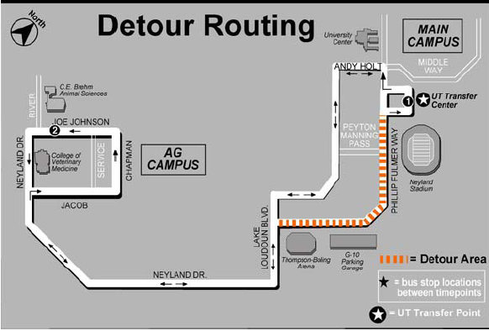
Figure 3: Express route map

4.2.1 Data collection
The initial step of simulation process is proper understanding of the actual system and valid data collection. The most eligible people to approach for process briefing and data collection regarding the route are the managers of the system. Historical and current data were collected and analyzed for the bus schedule, ridership data, driver schedule, bus timing and frequency.
University of Tennessee transportation service operates seven bus routes, providing service to hundreds of commuters every day. The ridership of students is not uniform through consecutive years and varies significantly depending upon the enrolment of students and location of parking facilities around campus. In Figure 4 the statistical data displays graphically the annual ridership data of the entire transportation department fleet over the past few years.

Figure 4: Annual ridership data

Since this case study uses the university express route system, the annual performance of this route is shown in the form of a graph comparing operation year and month of the year. The Ag Express annual ridership data from 2003 to 2007 is shown in Figure 5.

Figure 5: Ag Express ridership history

Table 1 is the actual schedule used by the transportation department for the express route during Fall/Spring semester. The table illustrates the varied functionality of the route, namely the number of buses, the time interval between the buses, bus dispatch schedule, and number of hours operated per day.

Table 1: Ag Express Fall/Spring bus schedule

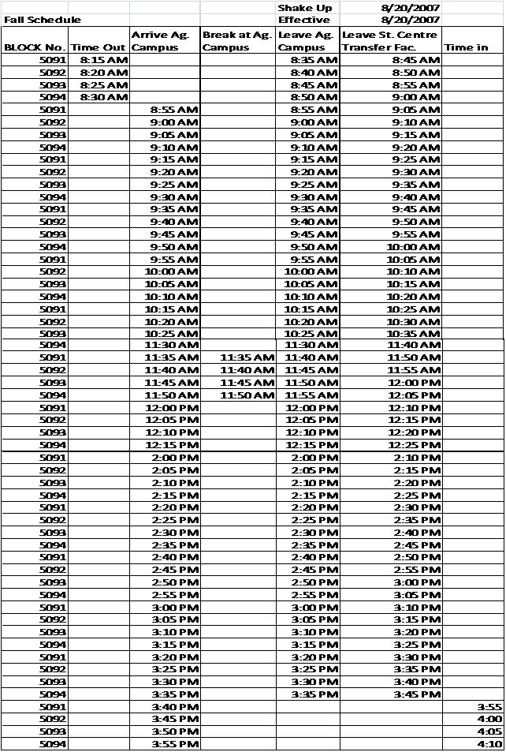

4.2.2 System observation
A number of onsite surveys were conducted to collect data relevant for developing the simulation models. The onsite observations were conducted by team members who travelled on the bus and noted the number of passengers on the bus. The second onsite observation was conducted in order to track the flow of passengers in the bus stops. The third onsite observation was conducted in order to find out the actual time interval between bus stops. All of the conducted observations were performed by the CPI team’s graduate and undergraduate students.
Upon surveying, the team concluded that there are lots more passengers in route between class hours, morning and evening. The rest of the time during any given day, the number of occupants in the bus route is minimal. Even during peak hours, the buses seldom carry enough passengers to reach buses’ seating limit. Table 2 is a summary table of the data collected with the help of transportation department. The table details the average number of riders, average working days in a month, average rider each month for a whole year. At the end the average rider per day on a whole is derived.

Table 2: Average number of passengers per day

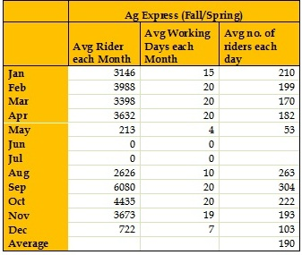

4.2.3 Initial data analysis
The collected and surveyed data is analyzed. On-site investigation of the bus route reveals that the schedule prepared for the express route is ideological i.e. the real system performance is slightly varied. A variation was identified in and around the route. This variation revealed the following
- The time interval between each bus is not maintained at 5 minutes.
- Sometimes stacking of buses near a bus stop happens. Stacking of buses can be explained as the presence of more than one bus at a bus stop within a very small time interval.
- Since the main purpose of the buses is to satisfy the students, stops were made whenever any person gestures to the driver of the bus to stop.
- Unscheduled breaks were taken by the drivers.
- The full seating capacity of the buses was rarely filled and a few instances of bus running empty were also documented.
The main purpose of the express route model is first to study and understand how the transportation network works. Ag Express operates every 5 minutes from 8:45 a.m. until 3:45 p.m. Using the provided, collected, and surveyed data, the simulation model was created in ARENA platform. As in the real route network, the base model consists of 4 buses, each starting one after the other at regular intervals from the same main station.

4.2.4 ARENA to model express route
ARENA is discrete event simulation and automation software developed by Rockwell Automation. The processor and simulation language employed by ARENA is SIMAN. According to Abu et al, ARENA can be used to simulate a wide range of systems from complex systems design evaluations, to supply chain management, to ‘What if?’ scenarios, to business process reengineering and workflows (Abu-Taieh & Sheikh, 2007).

4.2.5 Understanding the current scenario
To replicate the express route, detailed understanding of the current scenario in the route is a necessary. The constraints present in this route, which make it unique, is detailed below
- There are four buses in the route with their own starting and ending schedule.
- There are four bus stops out of which the main two bus stops, namely the Ag campus and the transit service, are the extreme points in the route.
- The other two bus stops are both in close proximity to one another in-between Thompson-Boling Arena and G-10 parking lot. The two stops are located on either side of the road.
- The route satisfies two kinds of passengers: people who are travelling from one end of campus to the other end for classes, and people who are travelling from parking lots to their office/class buildings.
- The arrival of passengers at each bus stop is recorded by personal observation.
- The theoretical time between each bus stop is 5 minutes.
- The capacity of each bus is 30 passengers.
- Each passenger boarding at any bus stop will have his or her own destination to reach.

4.2.6 Base model development
A simulation model featuring all the functionalities of the express route was created using ARENA 10.0 simulation software. Simulation is the process of replicating the real working condition of a system using computer logic. Every simulation model is unique, as the model logic depends upon the thinking process of a simulating team or of individuals.

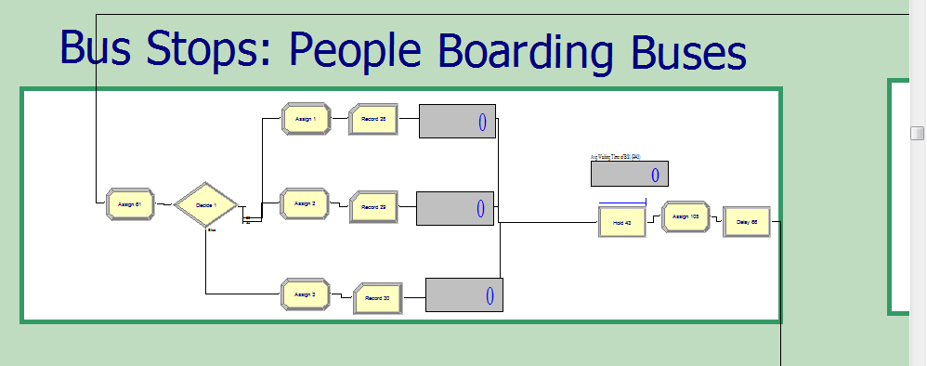
Figure 6: Passengers entering the system

This simulation model is created by considering both passengers and buses as entities. A series of combined and separate blocks are used to replicate the logic of passengers entering and exiting buses. Each passenger and bus entity is given individual attributes to identify them throughout the system. Variables are used to control metrics such as the bus’s seating capacity, the number of people entering the system, the number of people exiting the system and the number of passengers currently in the bus. Figure 6, shows the arrangement of passengers entering the system. All the passengers are identified according to their respective destination and batch module in ARENA is used to merge each bus with the arriving buses. Each bus after getting batched travels to other bus stops. At the bus stops each bus is separated and the passengers whose destination matches to the bus stop exit. Figure 7 illustrates the exiting process of the bus stop. Figure 7 also shows that, the process involves a series of divide and separate modules.

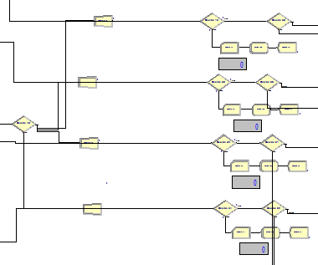
Figure 7: Passengers exiting system

After the destined entities exit the system, the remaining passenger entities along with the new passenger entities are clubbed again into the bus and the process is repeated. The capacity of each bus is 30 and the system logic does not allow more than 30 passenger entities to be batched with a single bus entity. This is achieved using a series of IF statements in the Hold modules. Figure 8, shows the actual simulation model with a few blocks being hidden in sub modules. The actual performance of any simulation model depends on its proximity to the real system performance. Therefore verifying the simulation model is as important as developing the simulation model. The best way to validate the performance of the simulation model is to let the managers and supervisors of the real system decide the precision of the replica to the actual system functioning.
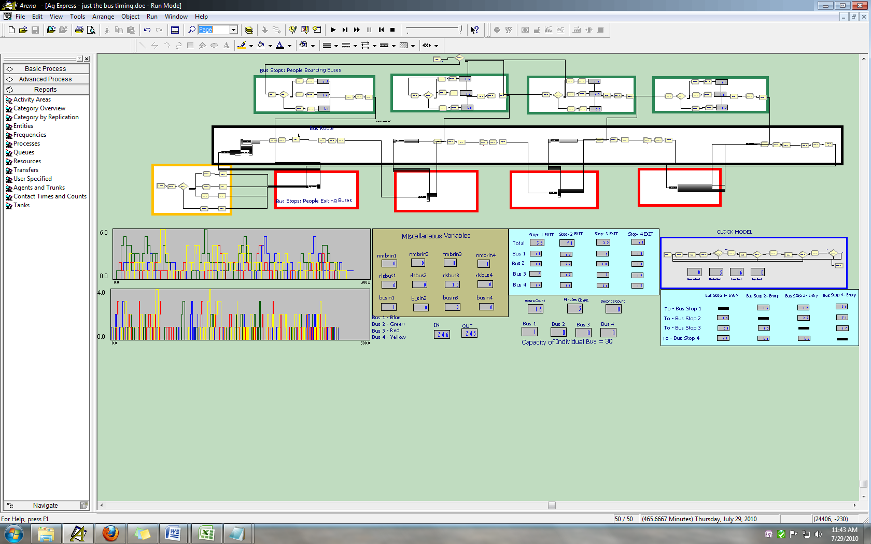
Figure 8: Base simulation model

Figure 8 shows the collective bus travelling route, the passenger boarding area, passenger exiting area, and the performance metrics are highlighted using graphs. The base simulation model is developed to simulate a day’s work in one run. Unlike manufacturing operations where unfinished parts are left in the system to be picked up when the next shift starts, the transportation system re-organizes itself to a fresh start every shift. There are no passengers left in the system at the end of the day. The transportation model is run in 3 sets with 100 replications for each set. For each set, the number of resources is reduced one at a time to estimate the average waiting time of passengers at each bus stop.
Table 3: Result from the bases simulation model
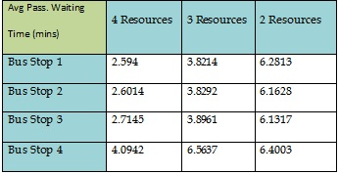

4.2.7 Conclusions from base simulation model
The following information was acquired from the results of the simulation model as shown in Table 3.
- The average waiting time of the passengers for the bus increases from around 2.59 min with four buses to 3.8 min with three buses to 6.4 min for two buses.
- But even with just two buses serving the route, the number of people in the bus is never more than 12 on an average working day.

Table 4: Savings from the base simulation model
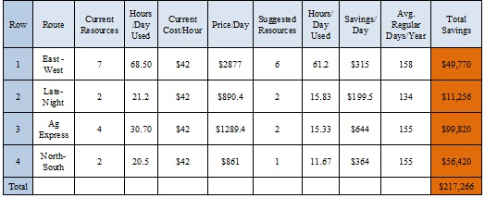

Table 4 shows the calculated cost savings projected by the transportation project. Since we are considering only the Ag Express route, per annum cost saving of $99,820 can be achieved by reducing the number of buses from four to two.

4.3 Dynamic Simulation Modeling
The developed dynamic simulation methodology is based out of the base simulation model. The purpose of the dynamic simulation model is to build a simulation model which will adapt itself to the changing conditions and which is more accurate in its construction. In a traditional simulation model, changes have to be made when critical events happen in the real system. Dynamic simulation modeling minimizes the effort needed for timely updating the simulation model as all the critical events are added at the development stage, thus also increasing the reliability of the simulation model. The dynamic simulation model construction begins with documenting the list of critical events. Involvement of the system supervisors and managers is once again needed at this stage of simulation as they have firsthand experience in handing events which falls out of the procedure book. Considering our base model which is a university transit route, the following critical events are listed in Table 5.
The Dynamic simulation methodology has to be blended with the current case study scenario. Table 5 lists the critical performance metrics in the case study model. The present case study is a demonstration to show the feasibility of dynamic simulation methodology.
Table 5: Critical performance metrics in transportation model

4.3.1 Critical metrics
The key factors are the main metrics of operation in the simulation model. The whole purpose of the transit route is to reduce the average waiting time of passengers at the bus stop and to have fewer of people waiting for the bus at any given time. In the dynamic simulation model, the end goal under any critical event or condition is to keep the average waiting time of passengers low.

4.3.2 Critical events
Developed under supervision from managers of the simulation model, the list of critical events show the areas where nontraditional changes or situations occur.
- The average number of passengers travelling in the route per day has been calculated to 190, but increases in the number of passengers are not rare. Factors such as holidays, and events just outside the campus trigger increases in number of commuters.
- Ideal route schedules shows buses arriving at the bus stops every five minutes, but onsite observation indicates otherwise. The time gap between buses varies considerably due to the driving style of each driver, number of passengers at the bus stop, traffic conditions, etc.
- As students are the main commuters for the bus route, their class schedules change every day of the week which affects the ridership numbers.
- During special events such as game day and cultural events, the number of bus stops is increased from four to six. This change in route is made so that people can park their cars in parking lots around the campus and travel to the events’ gathering locations easily. In the dynamic simulation model, the decision for special events is made by predicting the number of passengers entering the system.
- The traffic plays a key role in the travelling time of the buses. The dynamic simulation model considers the rush hour traffic according to the time of day to make the model more accurate.

4.3.3 Deliverables
The result of the simulation model is detailed as deliverables. When the dynamic simulation model adapts itself, the changes that happen in the system can be view through the following metrics.
- Increase or decrease in the number of buses in simulation model.
- Change in bus route.

4.3.4 Assumptions

The purpose of this thesis is to induce and replicate complex scenarios in simulation. The scenarios which have been kept in this model are actually replicating executive decisions in case of crisis. Even though there are multiple protocols, the scenario-specific decision that people make when facing a crisis is in a class all its own. This specificity is also the reason why managers are hired to manage systems involving workers and machines. Assumptions in the case study include:

- The number of bus stops and buses do not exceed more than six at any given time.
- Depending upon the average waiting time of passengers at each bus top, the buses are provided specifically at places where they are needed the most.
- Once the requirement of additional buses is fulfilled, the task of a bus is to deliver onboard passengers to their destinations and then to exit the system to the bus depot.
- The model is run for four varying schedule types termed in the model as high frequency schedule, low frequency schedule, medium frequency schedule and schedule with gaps in between.
- The capacity of the bus is limited to thirty.
- The boarding time of passengers is assumed to be negligible.
- Decisions on type of event on campus are decided by the overall passengers traveling on that day.
- There are two different routes for the Ag Express. The smallest one has four bus stops and longest one has six bus stops.

4.4 Dynamic Simulation Model Layout
The critical events are set in the validated base simulation model using the following logic cases.

4.4.1 The clock model
A clock is loop simulation, which is a part of the base simulation model. It has its own seconds, minutes and hour variables which are used to control the main simulation model. Figure 9 details the clock simulation model and its ARENA modules.
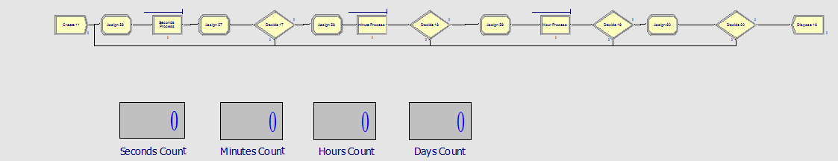
Figure 9: Clock model

4.4.2 Dynamic assignment of buses
One of the features of the dynamic simulation model is the addition of buses to the specific bus stop where the average waiting of passenger is more than normal. This addition is achieved by calculating the average number of passengers in the hold module of the bus stop and using this average number as a condition to release buses into the system. A condition-loaded divide module diverts the incoming buses to the bus stop with most need of it.
Another loop is created in order to remove buses from the system if there are fewer passengers to satisfy. This feature is also coded using the same average number of passengers waiting in the bus stop. A decide block looks for the average number of passengers waiting at the bus stop and channels it into a parallel loop where the buses are taken around other bus stops to deliver passengers to their destinations. Once the number of passengers in the bus is zero, the bus exits the system. The buses can be pulled into the system and out of the system any number of times based on the requirement.

4.4.3 Dynamic travel times
The ideal travel time between any consecutive bus stops is 5 minutes as per the parking and transit services department. But traffic density changes in and around university roads according to the time of day. In the dynamic simulation model the time variables in the clock model is used to three different travel times for buses depending on the time of day.

4.4.4 Event and route decisions
Traditionally the purpose of the express route is to connect two ends of campus and to get people from parking lots to their destinations. In any ordinary Fall/Spring or Summer semester, the number of passengers travelling and people using parking lots is small. Events like football, basketball matches and university festivals draws huge number of people to the campus. On occasions like these the number of parking lots in the university main campuses would not be sufficient. Therefore two extra University owned parking lots on the far reaches of campus are user in order to park cars and the buses are used to transport people into the main campus.
In the dynamic simulation model the switch between the routes and events happen with the expected incoming number of passengers for the day. The incoming number of passengers is read by the dynamic simulation model using a series of ‘Read and Write’ modules. For each run, the incoming number of passengers changes dynamically triggering a new event and route for each run. A series of ‘Read Write and Decide’ modules along with global variables are used in order to achieve this feat.

CHAPTER V

5. Results and Discussion
In a traditional simulation model, for each repetition random values are taken within the specified values, and the average of all the runs are used for generating results. In a dynamic simulation model for each run a controlled input data is assigned which will trigger a series of events specific to that one particular condition. The path which the model assigns itself is the result of the simulation model. In a traditional simulation model, conducting ‘What if?’ analysis is confined to a limited range of data under a specific scenario. In a dynamic simulation model, all possible conditions that occur and events that might occur together can be replicated in a simulation model. The case study provided is a brief illustration to demonstrate the feasibility of the dynamic simulation methodology.
Table 6 illustrated below, is a sample of the events that happen in a dynamic simulation model. The number of passengers entering the system for each consecutive run varies, and it is brought into the model using ‘Read Write’ modules. But the actual number of passengers entering the system is approximate and falls around the predicted number. Event and route are categorized based on the number of passengers entering the system using a global variable. Input for each run is a range of average number of people travelling on the route throughout the year. The route operating conditions changes as the incoming flow of passengers change. As the simulation model is run, the system adapts itself based on the average waiting time of passengers at the bus stop and the expected number of passengers for the run. The result of simulation model is displayed in the form of a series of decisions that the simulation model had to make in order to work through the conditions.
The actual number of passengers entering the system will be an approximation of the expected number. The number of bus stops and the route is decided by the simulation model depending upon the incoming flow of passengers. Depending upon the waiting time of passengers at the bus stops, buses are released one at a time to the exact bus stop of need. The bus number, time of release and the simulation run number are displayed in the simulation result. In a similar manner, the buses are removed from the route when the average waiting time of passengers reduces drastically. Simulation logic code ensures that when a bus is selected to depart from the system, the passengers on the bus reach their destinations. This simulation case study illustrates the possibility of using dynamic simulation methodology to develop a self-adapting simulation model which changes itself over various critical conditions. Table 6 shows the series of decisions the simulation model had to make for different passenger input rates, different runs and number of passengers entering. The template can be expanded to show details regarding individual runs, such as the average waiting time of passengers at each bus stop, the release time of individual bus into the system and the exit of individual bus from the system.

Table 6: Results of dynamic simulation model
An example of the dynamic simulation model is illustrated in Table 7 where for ‘Replication number 5’ it is shown that two buses entered the route to meet the demand and one bus exited the system in between the simulation run. Detail metrics illustrating the time of bus release and time of recall can also be traced using the set methodology.

Table 7: Time of entry and exit of buses

5.1 Analysis of Results
From the conducted case study, the practicability of achieving a dynamic simulation environment can be elucidated. The base simulation model is compared to the dynamic simulation model for its effectiveness in understanding and obtaining results. Table 9 shows the effectiveness of the base simulation model in terms of suggestions proposed. The traditional simulation model employs reducing the number of buses one at a time manually to generate results. Each result with a different number of resources is compared to decide on the optimal number of resources needed. In the dynamic simulation model, more environmental conditions and constraints are considered than they are in base simulation model, and the result is obtained with the exact number of resources needed, the hour of need, and the time frame of need.
To compare the dynamic simulation model with the traditional simulation model, a comparable situation is applied, namely the number of passengers entering system and the number of bus stops. The result of this simulation is compared to the base simulation model to calculate the effective savings.
Table 8: Cost of operation calculation for dynamic model
Table 8 shows the analysis of dynamic allocation of buses over time. The primary advantage of having a dynamic simulation model capable of taking decisions based on set constraints is the dynamic allocation of buses during hours of need. Table 8 illustrates the time and duration of need starting from minute zero. In the traditional simulation model, the number of buses was allocated manually and buses were operating in the route even when not required.
Table 9: Comparison between real, traditional and dynamic model

Table 9 is a visual comparison between the operating cost of the real model, proven traditional simulation model, and the dynamic simulation model proposed by this research. The current working model employs four active buses throughout the day irrespective of passenger usage, and the annual operating cost of this model is $199,857. The traditional simulation model is a replica of the actual system and manually reduces the number of buses using average waiting time of passengers as the key metric. The result of the traditional simulation model suggests using two buses throughout the shift bringing down the operating cost and saving $644 per day and $99820 per year. The result of the dynamic simulation model suggests using four buses for the shift with three buses returning back to the depot when not needed. The dynamic simulation model sends and removes buses from the system according to demand, bringing down the buses usage hours per day from 30.7 to 13.31. The projected annual cost savings using the dynamic simulation model is $113,235.12.

5.2 Comparing Traditional and Dynamic Simulation Models

Various factors affect the ridership of different transportation programs. In a university transportation department, the enrollment of students in a fiscal year plays the primary role in determining the ridership. The University of Tennessee has been gradually increasing enrolment over the past few years, which clearly shows in its ridership trend. Figure 10 clearly shows that the ridership numbers can sometimes double in a year, remain stable, and drastically decline. Under the current transportation department management system, unless the transportation department accurately forecasts the ridership trend, the department can actually lose money. This money loss will occur when the department’s management programs and traditional simulation ‘what if?’ analysis cannot adapt to the changing conditions. The dynamic simulation model can fill the gap in the transportation system design by optimally utilizing the available resources for any number of riders under any scenario.
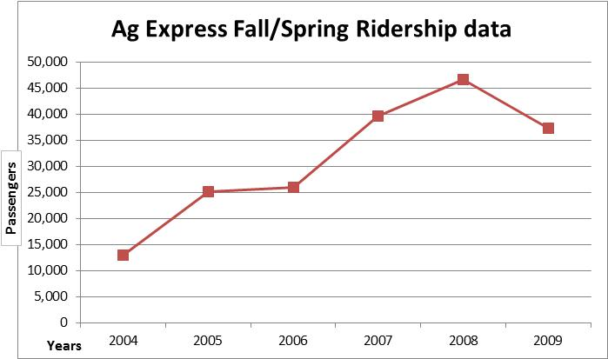
Figure 10: Ag Express ridership data over the years
In order to compare the versatile dynamic simulation model with the existing traditional simulation model, one of the critical performances metric, resource (bus) allocation, is considered for assessment. The unique feature of the dynamic simulation model is its ability to allocate adequate resources to the system when critical events such as the number of passengers, time of day, traffic conditions, and number of bus stops changes as the simulation run progresses. Figure 11 shows that in the traditional simulation model, the number of buses remains a constant four irrespective of the number of passengers using the system, passenger rate of arrivals and physical environment of the system. The same Figure 11 also illustrates the behavior of dynamic simulation model by plotting the three diverse conditions that arises based on the critical factors. The first condition plotted In Figure 11 is Summer semester when the total number of students enrolled is much smaller. Next plotted is the Fall semester when the number of students enrolled is larger, as compared to Summer. The last condition is the special event, for which the number of students increases exponentially and additional bus stops are added to the system to allow people to park their cars.
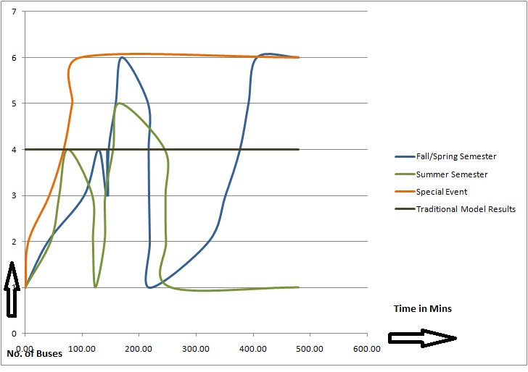
Figure 11: Comparison between traditional and dynamic simulation models

Figure 11 illustrates the dynamic allotment of resources, namely buses to one specific route when facing critical factors. In the above graph, time is assigned to the x-axis and the number of buses is assigned to the y-axis. Following these axes, the curves represent dynamic resource allocation for various conditions over time.
The capabilities of dynamic simulation model are illustrated in Figure 11 by running the dynamic model without making any changes for various scenarios. The results of the dynamic simulation model are compared to the results from a traditional simulation model. Under the set condition (that does not make any logical changes to the simulation models), the traditional simulation model can run only one scenario at a time. The traditional simulation model is set for the Fall/Spring semester and shows simulated results for Fall/Spring only. Figure 11 shows that the dynamic simulation model uses only the number of buses required at various times of day, for optimal resource utilization, irrespective of the number of passengers. Optimal utilization reduces the overall usage of buses, thereby reducing the operating cost.

Figure 12: Comparison of cost saving
Cost in USD

The overall operating cost of running the transportation department varies each year according to the ridership. Figure 12 show that the dynamic simulation model provides realistic cost savings compared to the traditional simulation model.

CHAPTER VI
- CONCLUSIONS AND RECOMMENDATIONS
The introduction section of this chapter briefs about the research work done for this thesis. It continues through details of the study limitations, recommendations, and future research possibilities.

6.1 Summary of Research
The main purpose of this research was to develop a dynamic simulation methodology for developing a simulation model capable of adjusting the simulation parameters depending on the input conditions. The model starts with building an ordinary simulation model with a specific purpose. The traditional simulation model is built by a team of experts and approved by the supervisors of the actual system. In ordinary simulation modeling, only the day to-day working and protocols of the system are considered and simulated. Collecting data for a limited period of time and analyzing it through long period of time do not provide accurate results. In any dynamic work environment, there are multiple critical events that arise and are overcome by the people handling the system with quick and undocumented solutions. These events play a key role in the performance of a system during a long run. An accurate simulation model requires considering all the events happening in a working process. These critical events are well known to the supervisors or managers of the system, and developing a dynamic simulation model involving the supervisors to identify the critical events is vital. The development of a dynamic simulation model is iterative as the model has to be valid for multiple constraints and conditions.
This thesis validated the dynamic simulation methodology through a transportation department case study. The transportation department which is a multi-criterion environment proved to be perfect scenario to test the dynamic simulation model. The behavior of the system was tracked by identifying critical events over time. The dynamic simulation model was developed that allows a decision to be made for the critical event and then changes the simulation parameters.

6.2 Limitations of the Model
The dynamic simulation modeling is an effort to create an accurate simulating method over a long run. There are some limitations in the developed model. The dynamic simulation model is limited in terms of which conditions it can work with. For example, in the case study the model dynamically allocates buses when the incoming flow of passengers is high, but it limits the number of passengers it can satisfy with the buses. The current waiting time of passengers is a trigger for the model to release bus from the depot, but it takes time for the bus to reach all the bus stops, resulting in a slight increase in average waiting time. The logic of simulating all the critical events is time consuming. Further research could be carried out to develop a more robust decision model.

6.3 Recommendations
The following recommendations are provided for further enhancement of dynamic simulation methodology
- The dynamic simulation model can be further developed by categorizing the field specific system logic in its steps.
- The case study can be further refined to provide even better optimized results.
- Models considering multiple constraints can be developed and tested.
4. The intelligent simulation methodology can be integrated with low risk physical systems that can operate themselves without human intervention, thereby developing a decision making system independent of humans.

LIST OF REFERENCES

Abu-Taieh, E. M. O., & Sheikh, A. A. R. E. (2007). Commercial Simulation Packages- a Comparitive Study. International Journal of Simulation, 8(2), 66-76.
Ali, A., & Farid, G. (2006). A Framework for Design of Intelligent Simulation Environment: Science Publications.
Ali, S. A., & Seifoddini, H. (2006). Simulation intelligence and modeling for manufacturing uncertainties. Paper presented at the Proceedings of the 38th conference on Winter simulation.
Banks, J. Handbook of Simulation - Principles, Methodology, Advances, Applications, and Practice: John Wiley & Sons.
Banks, J. (1999). Introduction to simulation. Paper presented at the Proceedings of the 31st conference on Winter simulation: Simulation---a bridge to the future - Volume 1.
Banks, J., Nelson, B., & Nicol, D. (2009). Discrete-Event System Simulation: Prentice Hall.
Burns, J. R., & Morgeson, J. D. (1988). An Object-Oriented World-View for Intelligent, Discrete, Next-Event Simulation. Management Science, 34(12), 1425-1440.
Chick, S. E. (2001). Input Distribution Selection for Simulation Experiments: Accounting for Input Uncertainty. Operations Research, 49(5), 744-758.
Cho, T. H., & Zeigler, B. P. (1997). Simulation of intelligent hierarchical flexible manufacturing: batch job routing in operation overlapping. Systems, Man and Cybernetics, Part A: Systems and Humans, IEEE Transactions on, 27(1), 116-126.
Doukidis, G. I., & Angelides, M. C. (1994). A framework for Integrating Artificial Intelligence and Simulation. Artificial Intelligence Review, 8(1), 55-85.
El-Haik, B., & Al-Aomar, R. (2006). Simulation-based lean six-sigma and design for six-sigma. from http://encompass.library.cornell.edu/cgi-bin/checkIP.cgi?access=gateway_standard%26url=http://www.books24x7.com/marc.asp?bookid=16837
Fishman, G. S., & Kiviat, P. J. (1967). The Analysis of Simulation-Generated Time Series. Management Science, 13(7), 525-557.
Flitman, A. M., & Hurrion, R. D. (1987). Linking Discrete-Event Simulation Models with Expert Systems: Palgrave Macmillan.
Ford, D. R., & Schroer, B. J. (1987). An expert manufacturing simulation system. Simulation, 48(5), 193-200.
Hollocks, B. (2006). Forty years of discrete-event simulationa personal reflection. Journal of the Operational Research Society, 57, 1383-1399.
Ingalls, R. G. (2001). Introduction to simulation. Paper presented at the Proceedings of the 33nd conference on Winter simulation.
Kelton, W., Sadowski, R., & Swets, N. (2009). Simulation with Arena: McGraw-Hill Higher Education.
Kelton, W. D. (1997). Statistical analysis of simulation output. Paper presented at the Proceedings of the 29th conference on Winter simulation.
Krause, F. L., Kind, C., & Voigtsberger, J. (2004). Adaptive Modelling and Simulation of Product Development Processes. CIRP Annals - Manufacturing Technology, 53(1), 135-138.
Manuj, I., Mentzer, J. T., & R.Bowers, M. (2009). Improving the rigor of discrete-event simulation in logistics and supply chain research. [General Review]. International Journal of Physical Distribution & Logistics Management, 39(3), 172 - 201.
Ming, R., Jiang, T. S., & Tsai, J. J. P. (1990). Integrated intelligent simulation environment. Simulation, 54(6), 291-295.
Robinson, S. (2004). Discrete-event simulation: from the pioneers to the present, what next? [Journal]. Journal of the Operations Research Society, 56(6).
Robinson, S. (2006). Issues in conceptual modelling for simulation: Setting a Research Agenda. OR Society 3rd Simulation Workshop, Ashorne, UK.
Robinson, S., Alifantis, T., Hurrion, R., Ladbrook, J., Edwards, J., & Waller, T. (2001). Modelling and improving human decision making with simulation. Paper presented at the Proceedings of the 33nd conference on Winter simulation.
Robinson, S., Edwards, J. S., & Yongfa, W. (1998). An expert systems approach to simulating the human decision maker. Paper presented at the Proceedings of the 30th conference on Winter simulation.
Visser, A., Wees, v. d. A. J., & Hertzberger, L. O. (2002). Discrete Event Modelling Methodology for Intelligent Transport Systems. [Conference Paper]. Proceedings of the World Congress on Intelligent Transport Systems.
Wagner, M. A. F., & Wilson, J. R. (1995). Graphical interactive simulation input modeling with bivariate B\&eacute;zier distributions. ACM Trans. Model. Comput. Simul., 5(3), 163-189.
Widman, L. E., & Loparo, K. A. (1990). Artificial Intelligence, Simulation, and Modeling. Interfaces, 20(2), 48-66.
Williams, T. (1996). Simulating the man-in-the-loop. [JOUR]. Operational Research Society, 9(4), 0953-5543.
Zeigler, B., Elzas, M., Klir, G., Oren, T., & Tzafestas, S. G. (1982). Methodology in Systems Modelling and Simulation. Systems, Man and Cybernetics, IEEE Transactions on, 12(1), 97-97.

Vita
Prasanna Rao is working as a quality engineer at SL Tennessee, LLC. He has an undergraduate degree in Mechanical Engineering from Anna University, Chennai, India. He currently is pursuing his Masters degree in Industrial and Information Engineering. He has been a Graduate Research and Teaching Assistant for the past two years. He is also the recipient of Outstanding Masters Student Award from the Industrial Engineering Department for the year 2010.

