An Autonomous Online I-V Tracer for PV Monitoring Applications

A Thesis Presented for the
Master of Science
Degree
The University of Tennessee, Knoxville

Cameron William Riley
December 2014
Copyright ©2014 by Cameron William Riley
All rights reserved.

DEDICATION

To be completed

ACKNOWLEDGEMENTS

To be completed.

ABSTRACT

With the unprecedented growth of photovoltaic technologies and their implementation in recent times, more precise methods of determining modules health, degradation, and performance are needed. Current monitoring efforts are helpful in determining these attributes but do not provide all of the information necessary to truly understand the health properties of the PV module in question. The current-voltage curve, or I-V curve, provides a level of insight into a PV module’s health unparalleled by most monitoring efforts. However, the tools which measure the I-V curve exist in an undesirable form—PV must be disconnected from its load and connected to the tool in order to trace the I-V curve. This is undesirable due to the fact that it requires a trained technician to perform, as well as requiring some time to disconnect and reconnect the modules.
In this thesis, an I-V tracer which operates autonomously, with no need to be disconnected from its load, will be discussed. The current state of I-V tracers commercially available will be discussed and motivation will be provided for the online autonomous I-V tracer. Design of such an I-V tracer using the single-ended primary inductance converter (SEPIC) will be discussed, and simulation results of such a converter operating as an I-V tracer will be presented.

TABLE OF CONTENTS

To be completed.

LIST OF FIGURES

To be completed.

ABSTRACT

To be completed.

CHAPTER 1
INTRODUCTION AND OVERVIEW

1.1 The I-V Curve
The current-voltage characteristics of a photovoltaic (PV) cell are often collectively referred to as the I-V curve. A PV cell is a p-n junction with traits similar to a diode. When illuminated, photons excite electrons in the PV cell, and a current is generated. This is known as the photovoltaic effect. The current density of a PV cell can be modeled by (1.1) below.
$J_{L}=J_{s}-J_{0}\left[exp\left(\frac{e_{0}V}{kT}\right)-1\right]$(1.1) [1]
$J_{L}$ is the load current density of the PV cell, while $J_{s}$ is the cell output current density and $J_{0}$ is the reverse saturation current density. The variable $e_{0}$ is the charge of one electron in coulombs, $k$ is Boltzmann’s constant, $T$ is the temperature in kelvin, and $V$ is the voltage across the cell. Using equation 1 with arbitrary values for the variables, the current-voltage characteristics of a PV cell can be plotted. This plot is known as the I-V curve and is illustrated below in Figure 1.1.
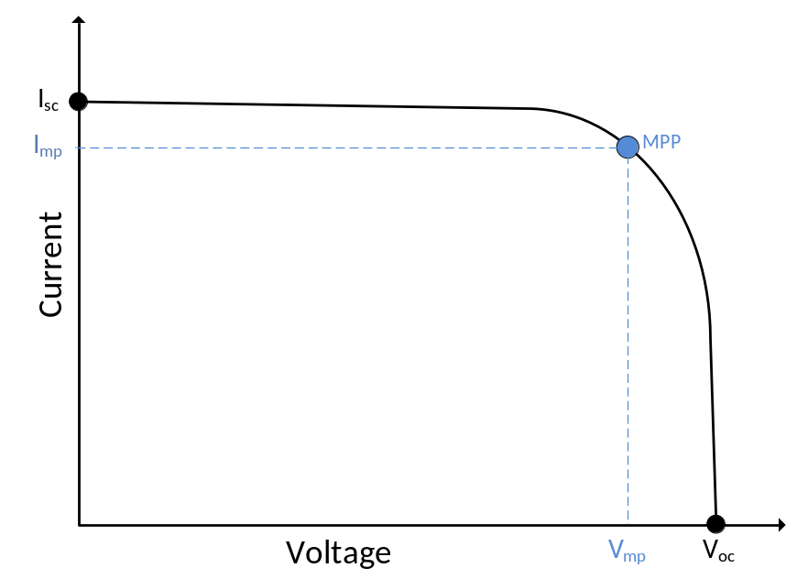
Figure 1.1: I-V Curve of Solar Cell
For the purposes of analysis, the first quadrant of the I-V curve is typically all that is considered because the first quadrant is the only quadrant where a PV cell generates power. The I-V curve starts at the short-circuit condition, I_{sc}, where the voltage is zero. The current falls slightly as the voltage is increased, until the curve nears the open-circuit condition where the current rapidly drops off. The curve ends at the open-circuit condition, V_{oc}, with the current at zero. Both the short-circuit condition and open circuit condition result in zero power being generated by the PV cell.
At some point on the I-V curve, the power of the cell is at its maximum. This point is known as the maximum power point (MPP) and solar cells are the most efficient at converting light energy into electrical energy at this point. In the case of inverters produced for solar energy applications, the inverter will have maximum-power-point tracking (MPPT) to ensure that the PV is operating at the MPP at all times. The voltage and current at these points is commonly referred to as I_{mp} and V_{mp}.
1.2 Irradiance and Temperature
The solar irradiance incident to a solar panel is the most important factor in amount of power a solar cell can generate. The amount of irradiation affects the short-circuit current drastically, while the open-circuit voltage remains relatively the same. The MPP tracks very closely with the irradiance incident to the module and can be estimated to be proportional to the irradiance.
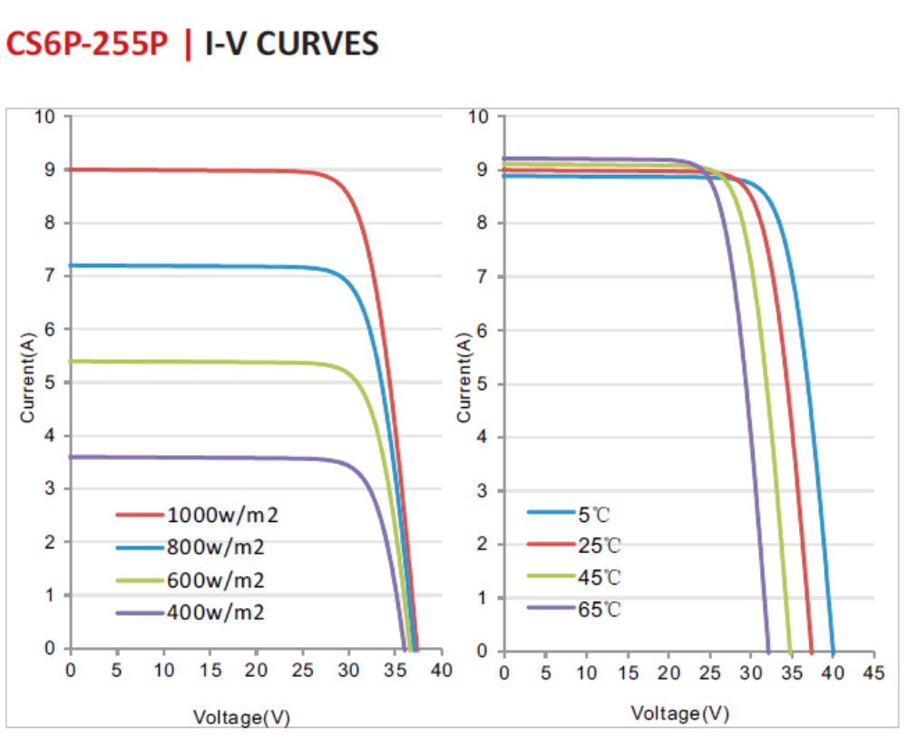
Figure 1.2: Effect of incident solar irradiation and temperature on PV’s I-V curve [2]
Figure 1.2 illustrates sample I-V curves for the CS6P-255P solar module by Canadian Solar. As Figure 1.2 shows, increasing the irradiance changes the I-V curve by increasing the short-circuit current proportionally to the increase in irradiance. The open-circuit voltage also increases slightly as the irradiance increases.
Temperature has a non-negligible effect on the I-V curve and is of particular importance because solar modules are usually placed in areas that have a high ambient temperature during times of peak sunlight. As the temperature of a cell increases, the open circuit voltage decreases, the short-circuit current is raised by a small amount. Figure 1.2 shows the effect temperature has on the CS6P-255P solar module. For this particular module, for every degree C of temperature rise the open-circuit voltage falls by 0.34%, the MPP falls by 0.43%, and the short-circuit current raises by 0.065% [2].
1.3 Combining Cells in Series and Parallel
Solar cells used for electricity generation are usually connected in combinations of series and parallel to create a solar module. In the case of PV plants operating with centralized inverters, these modules are further connected in series and parallel combinations until a certain power level is obtained. Combining PV in series has the effect of extending the I-V curve further to the right (increasing voltage), while combinations added in parallel extend the curve vertically (increasing current). This is illustrated in Figure 1.3.
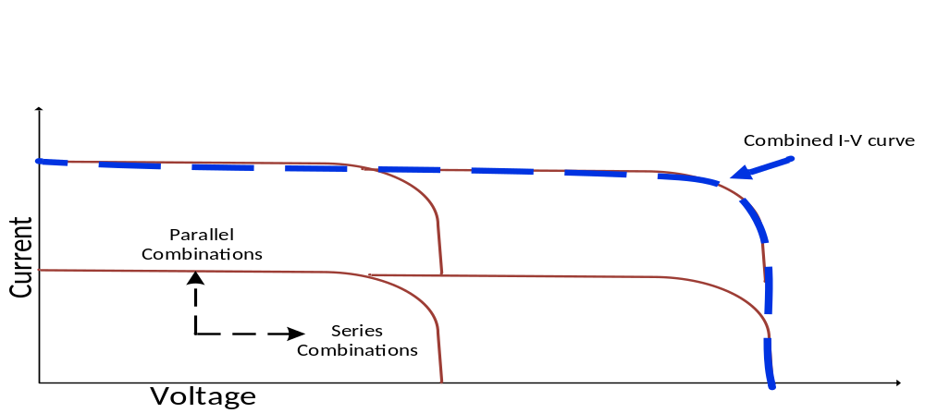
Figure 1.3: Parallel and Series combinations of PV Cells
Consider a PV module that is made up of 4 PV cells with the topology shown in Figure 1.4 below. The 4 PV cells are arranged so that two are in series with each other, and those two are paralleled with the other two. Example (A) shows the current flow when all four cells are illuminated equally. Example (B) shows the current flow when three of the four cells are illuminated, and there is no bypass diode installed. Example (C) shows the current flow when three of the four cells are illuminated, and a bypass diode is installed.
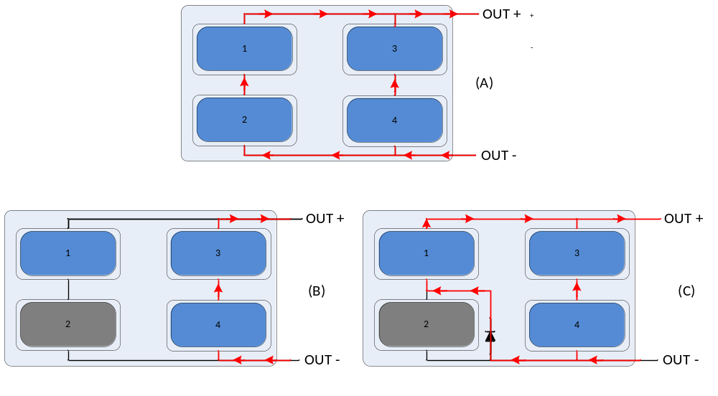
Figure 1.4: Example topology (A) with all cells illuminated (B) 3 cells illuminated (C) 3 cells illuminated with bypass diode
If cell #2 is shaded completely, then its short circuit current goes down to zero. This limits cell #1’s current to zero also, because it is in series with cell #2. This means the potential power from half the module is lost due to shading on one-quarter of the module. To remedy this, a diode can be paralleled with the cells so that the current of one cell does not limit the other. Looking at Figure 1.4, example (A) shows a scenario where all four cells are equally lit. As shown in the figure, current flows through each parallel leg and the I-V curve would combine the same way as Figure 1.3 illustrates. The bypass diode allows a path for the current to flow that doesn’t exist in example (B). The combined I-V curve can be found by adding together the I-V curves of the cells which are active. In Figure 1.4 (B) cell #1 is illuminated but not active, so the I-V curve is unable to reach the second tier of current. The combined I-V curve for this scenario can be seen in Figure 1.5 (A). The combined I-V curve is unable to reach the second tier of parallel combinations, and is the same as if two cells in series were the only ones connected. To avoid this, a bypass diode can be paralleled with the unilluminated cell so that current from cell #1 has path. This scenario is illustrated in Figure 1.4 (C). The I-V curve is affected by including the third cell because it now has a current path. This is illustrated in Figure 1.5 (B). Including the third cell, but not the fourth cell, creates a notch in the I-V curve. This notch is a common characteristic of bypass diode activity, which usually indicates a mismatch, where a module is not uniformly degrading, or has non-uniform soiling or partial shading.
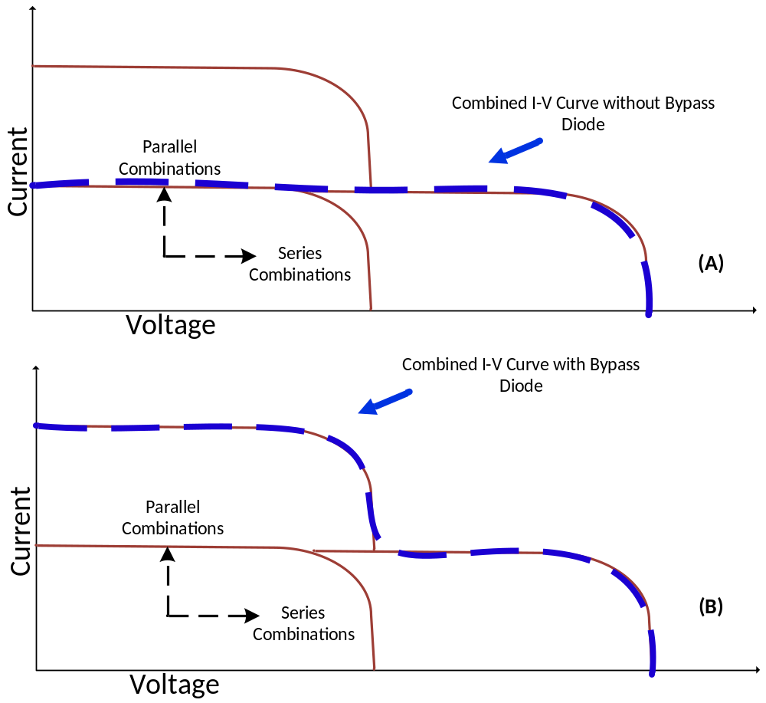
Figure 1.5: Combined I-V curve of partially shaded circuit with and without bypass diode

1.4 Metrics Available from I-V Curves
1.4.1 Slope Near Isc
Beyond notches, there is more valuable information in the shape of the I-V curve. Examining the slope of the curve near I_{sc} reveals an approximation of the shunt resistance (R_{sh}). The shunt resistance represents the availability of current paths in parallel with cell, and in an ideal case would be infinitely high. Physically damaged modules sometimes have lower-than-expected shunt resistances due to new current paths formed by the damage. This problem is sometimes self-correcting, as the current through the shunt path burns it out. Other times, a module may need to be replace. Figure 1.6 illustrates the slope used to approximate the shunt resistance.
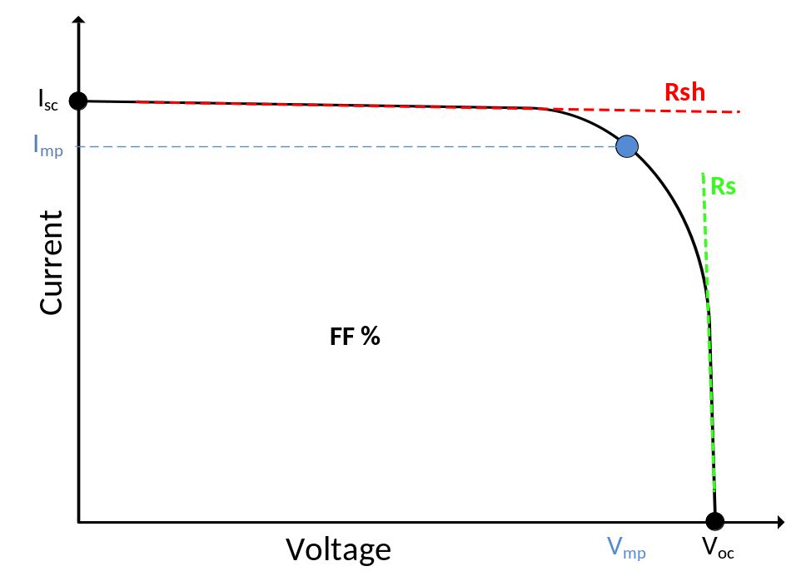
Figure 1.6: I-V curve showing approximation for Rsh and Rs

1.4.2 Slope Near Voc
Similar to the shunt resistance, the series resistance (Rs) can be approximated by examining the slope of the I-V curve near the open-circuit voltage. The series resistance is representative of the resistive losses before energy leaves the panel. In an ideal cell it would be zero.
1.4.3 Analysis of the I-V Curve
The I-V curve offers data helpful in diagnosing a PV cell’s health. Figure 1.7 below shows the metrics available from an I-V trace. Each of these metrics reveal unique information about the health of a cell and can be useful in diagnosing underperforming cells.
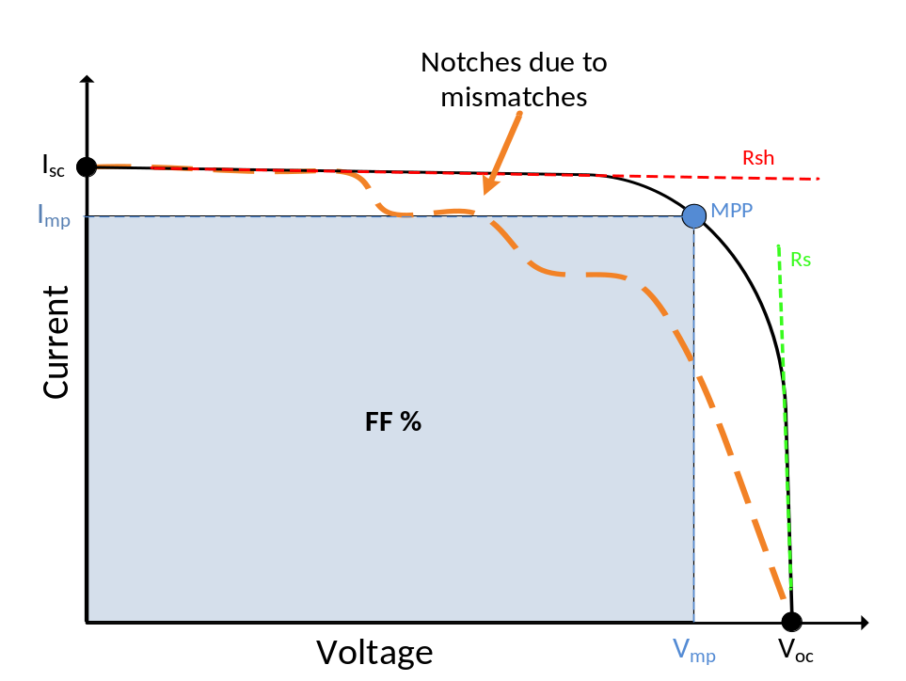
Figure 1.7: All metrics available from an I-V trace
I-V curves should be taken under controlled conditions, and should not be measured in low sunlight. Under high sunlight conditions with stable cell temperatures, each quantifiable part of the I-V curve tells its own story about PV health. Each of the metrics shown in Figure 1.7 and their usefulness in diagnosing health are explained below.
- Shunt Resistance: An R_{sh} value that is too small, approximated from the slope of the I-V curve near I_{sc} , is usually an indicator of shunt paths existing in a module. Shunt paths are paths through which electrical current flows internally to the module without leaving the module, dissipating power as heat loss. They are also commonly identified by infrared imaging, as they can cause a significant temperature rise.

- Series Resistance: An R_{s} value that is too large, approximated from the slope of the I-V curve near V_{oc}, is generally indicative of a poor connection somewhere along the line that is creating excess resistance; it could also be caused by insufficiently sized wire. This value increasing over time can also be used as a metric to quantify panel degradation. Large R_{s} values reveal higher series losses.

- Open-Circuit Voltage: Lower than expected V_{oc} can also be an indicator of failures. It can mean the module’s cell temperature is higher than expected, that a single module in the string is uniformly shaded, or indicate bypass diode activity (i.e. forward bias or short).

- Short-Circuit Current: Lower than expected I_{sc} usually indicates either uniform soiling across the PV string or uniform aging. It is a significant metric, along with the more commonly available I_{mp} and V_{mp}, to use for quantifying degradation on a string that otherwise has an ideal I-V curve.
- Maximum Power Point: Lower than expected MPP is usually the result of some other metric failing to meet expectations. A low MPP can be a result of a visibly deformed I-V curve (which may be because of notches or unwanted Rs and Rsh values). If the curve is the correct shape and the MPP is still too low, the I_{sc} or V_{oc} are likely too low also.
I-V curves can also reveal any deviations from an ideal or theoretical curve. Notches are indicative of bypass diode activity, which hints toward mismatch problems or shorted diodes. The fill factor is a parameter which, in conjunction with I_{sc} and V_{oc}, determines the maximum power from a solar cell. It is defined as the ratio of the maximum power from the solar cell to the product of I_{sc} and V_{oc} , or ${\left(V_{mp}{×I}_{mp}\right)}/{\left(V_{oc}{×I}_{sc}\right)}$. Graphically, the fill factor is a measure of the "rectangularity" of the solar cell’s I-V curve and is also the area of the largest rectangle which will fit in the I-V curve.
1.5 Case for I-V Tracing as a Common Monitoring Method
The value of data available from an I-V trace outweigh the value of data from traditional monitoring. Today, few metrics are readily available to determine solar PV plant performance degradation. PV system operators typically only track the lifecycle power and energy output of their systems, and occasionally they calculate additional metrics—such as performance relative to available sunlight (a.k.a. performance factor or performance ratio)—for plants with installed pyranometers or reference cells. Together, these metrics are moderately helpful in determining PV system health. However, they tend to be more useful in diagnosing larger failures and often overlook underperforming or failing PV modules. The extra metrics provided by I-V curve analysis offer added insight beyond that provided by typical monitoring systems gives PV plant owners a better understanding of how their PV plant is operating. The full I-V curve offers the potential to diagnose specific types of failures within the PV plant beyond general performance degradation. By quantitatively measuring PV health at a particular moment in time, string level I-V curves, for example, offer a useful snapshot of the extent to which degradation has occurred relative to the historic measurements and rate values of observed PV modules. Subsequent I-V curves, taken periodically under similar temperature and irradiance conditions, can also reveal the rate of degradation. This offers a two-fold advantage in assessing string-level performance degradation issues that:
1. Occur quickly, perhaps as the result of mechanical breaking or electrical malfunction
2. Occur more slowly as part of the natural aging process of the modules.
In the first case, where a PV system has been damaged resulting in a noticeable change in the I-V curve, regular I-V curve measurement can reveal the damage and allow for timely repair. At the most basic level of monitoring, a PV plant operator will only know the plant’s power/energy output. A misshapen I-V curve is a more conclusive indicator of damage than diminished power output.
In the case of aging modules, which experience no significant forms of damage, I-V curves can diagnose accelerated deterioration that is faster than their warranties allow. A string level I-V curve prior to implementation provides a baseline for future performance, while future I-V curves can indicate degradation rates.
A PV module warranty is typically based on the ability of the module to produce a percentage of its original power rating over a certain time period after purchase. For example, manufacturer warranties for modules are typically activated if the module performs at less than 90% of its nameplate rating before 10 years, and less than 80% before 25 years [2]. In the operation of a large PV system, a PV system operator may only have inverter-level data (per array), or perhaps string-level data at the inverter’s operating point, with little information at the module level. While an I-V trace of a string may not be able to identify a specific module that is damaged or critically underperforming, misshapen I-V curves can indicate mismatch losses which might identify existence of a damaged or underperforming module. This level of detail allows individual modules to be replaced per the warranty without waiting for the entire string to fall below the warranty’s standards.
Separately, proactive diagnosis of failing modules has an added safety benefit in that replacing the failing module earlier may prevent a catastrophic failure which damages surrounding modules. As has been seen in the past, PV plants are not immune to electrical fires, and diagnosing a failing module earlier may help prevent similar events from occurring.
1.5.1 Field I-V Tracers currently available
There are several methods available to measure the I-V curve, most of which focus on using an electronic load to trace the curve. To this end, commercial I-V tracers are currently available for both laboratory and field applications. I-V tracers used in the field are available in power ratings ranging from less than 1 kW to tens of kilowatts, allowing for all levels of monitoring except for large (>100kW) arrays.
In-field I-V tracers are usually portable with a carrying case and battery. These manual devices require a complete disconnect of the string/module to measure the I-V curve and can be an expensive proposition: They have a substantial upfront purchase price (typically several thousand dollars) and also require a trained technician to take manual I-V traces on-site. This is unideal, as many solar farms are in remote locations and the cost of sending a technician to take periodic I-V curves could become expensive and too costly for normal operations and maintenance (O&M) companies.
1.6 Case for Autonomous Tracer
For I-V tracing to become a regular part of O&M activities it must be financially viable. Currently, no known PV O&M companies use I-V traces as part of regular monitoring activities. This is likely to do the high cost associated with the ‘manual’ aspect of currently available I-V tracers. An I-V tracer could be placed between a string of modules and the inverter, with a power electronics interface that traces the string once per day. This would remove the human element and associated labor costs. If implemented at the string level, the autonomous I-V tracer provides a detailed measure of system health, and historical data shows degradation rates. This data is useful for early detection of failures as well as a general measure of health for investment or warranty renegotiation purposes.
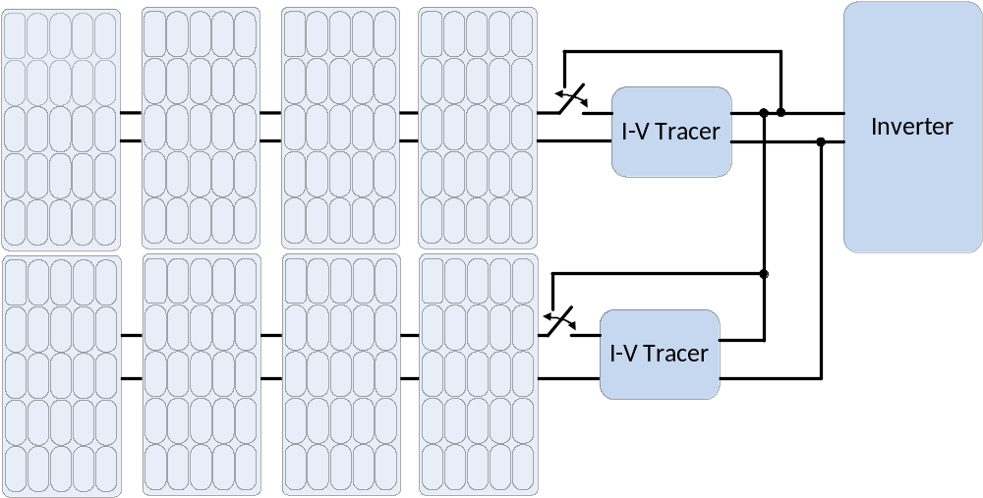
Figure 1.8: Topology of two strings with autonomous I-V tracers connected
In Figure 1.8, the I-V tracer will not be part of the PV generation circuit during normal operation. At regular intervals, and during instances of acceptable conditions (high and stable irradiance, stable module temperature), the I-V tracer will switch into the circuit. The voltage on the PV side of the I-V tracer is swept via a switching converter from open-circuit voltage to short-circuit current while the voltage on the inverter side is held constant. This means the I-V tracer, when part of the circuit, requires no external load.
1.7 Conclusion
In this thesis, a simulated model of a power electronics based converter for the purpose of obtaining PV I-V traces will be presented. This converter will be created using the SEPIC topology and will operate as interface between the PV and the inverter. In Chapter 2, the basics of photovoltaics will be discussed, as well as the current state of the market for commercial I-V tracers. Motivation will be shown for an autonomous I-V tracer to exist and the reasoning behind choosing a SEPIC topology will be revealed. Chapter 3 will focus on the modelling of the SEPIC converter and the methodology of analyzing PV I-V curves. Chapter 4 will present the overall results of the converter’s simulation. Chapter 5 will be a conclusion. (To add more as I finish chapter 3 and chapter 4.)

CHAPTER 2
LITERATURE REVIEW

2.1 Photovoltaic Cell Review
A photovoltaic cell is a p-n junction which experiences the photovoltaic effect. According to atomic theory, an atom is composed of a nucleus with protons and neutrons, with electrons in orbit. These electrons are positioned in ‘bands’ around the nucleus. Electrons fill the bands from inner to outer, so only the outermost band has the possibility of being unfilled. The outermost band of electrons is called the valence band. Insulators have relatively full valence bands, conductors have relatively empty valence bands, while semiconductors are somewhere in between. Sometimes, electrons in the valence band can become energetic enough that they jump into a different band, far from the nucleus of the atom. This band is called the conduction band. The energy it takes for an electron to move from the valence band to the conduction band is known as the band gap energy. In a PV cell, if a photon with sufficient energy strikes the cell, an electron will become dislodged from the valence band and move into the conduction band, where it can be used as electricity [solar book]. This is illustrated in Figure 2.1.
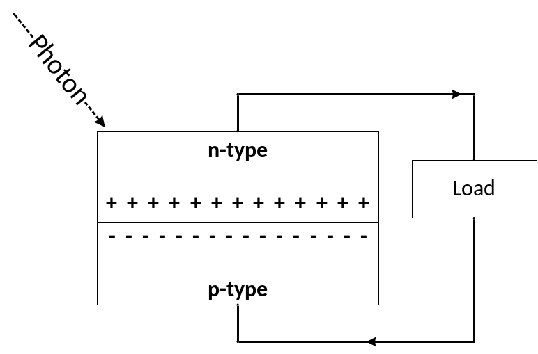
Figure 2.1: Illustration of Photovoltaic Cell

2.1.1 PV Cell Characteristics
If no photon strikes the PV cell, then the cell is simply a p-n junction which behaves like a diode. A diode is a device that conducts when a positive voltage is applied from the anode to the cathode, and blocks current when a negative voltage that is not too large is applied. A diode has 3 regions of operation:
- Forward Bias: The conducting region of the diode
- Reverse Bias: The blocking region of the diode
- Breakdown: If a reverse voltage is too large the diode cannot block and becomes conductive
The I-V curve for a diode is illustrated in Figure 2.2 (A).
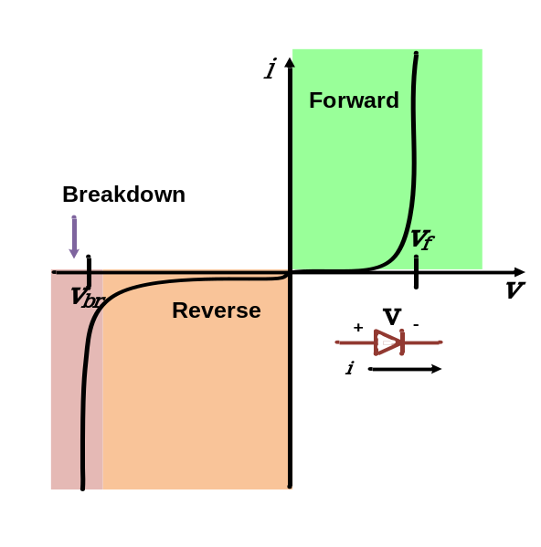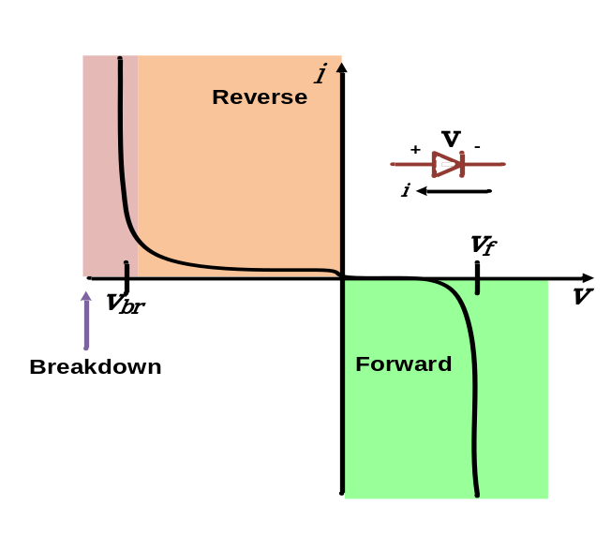
B
A
Figure 2.2: Diode I-V Curve (A) Diode I-V Curve with Reverse Current Notation (B)
In a PV cell, the current convention is opposite that of a diode. This is illustrated in Figure 2.2 (B) by flipping the curve about the x-axis and noting the current direction change. When light strikes the PV cell the I-V curve changes by shifting upward. For basic analysis the I-V curve of an illuminated cell can be assumed to be the unilluminated I-V curve shifted by the short circuit current [4]. A PV cell’s I-V curve under illumination is illustrated in Figure 2.3 with the same current notation as Figure 2.2 (B).
The power generation capabilities of a PV cell are limited by the intensity of the solar energy incident to the cell. Solar energy comes from, as one might expect, the sun. The sun is a celestial body which radiates energy. At the outer edge of the atmosphere, the flux of solar energy incident on the surface and oriented normal to the sun’s rays has a mean value of about 1350W/m² [1]. This value is attenuated due to the filtering properties of the earth’s atmosphere. By the time the energy reaches the earth’s surface, it can be assumed to be about 1000W/m², though this is dependent on a large number of factors. The actual irradiance at any time is dependent on latitude, cloud cover, atmospheric properties, and angle of the sun. Nonetheless, 1000W/m² is defined as the default irradiance to use when testing PV cells under standard test conditions (STC).

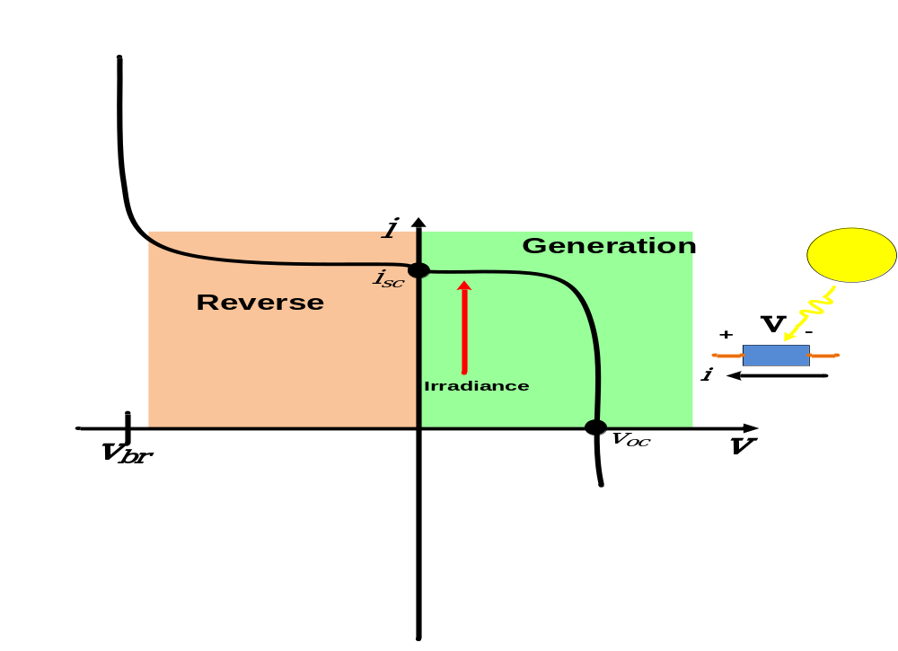
Figure 2.3: I-V curve of PV Cell
The first quadrant of the curve seen in Figure 2.3 is what is typically defined as the I-V curve for a PV cell. The other quadrants of the curve are often ignored because the PV cell is designed to operate only in the first quadrant, which is the only power generating quadrant.
The second quadrant of the I-V curve is useful for understanding some of the problems that can occur when combining PV cells in series. Recall from chapter 1 that when connected in series, the I-V curve is extended on the x (voltage) axis. This means that a current mismatch in series connected cells will limit the cells to the current of the worst cell. This is a weakest-link-in-the-chain scenario. Consider a string of cells in series with one shaded cell as illustrated in Figure 2.4.
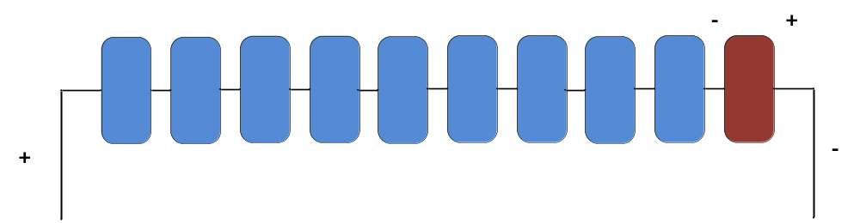
Figure 2.4: String of Series Cells with One Underperforming Cell
Under normal operation, this single shaded cell will limit the current of all the other 9 cells. If a large number of series connected ‘good’ cells reverse bias the shaded cell, the shaded cell’s operating point moves into the second quadrant of the I-V curve. This results in the single cell dissipating power instead of generating it. This dissipation of power becomes worst at the short circuit condition, when the bad cell blocks the entirety of the good cells’ voltage, dissipating a large amount of power. In the case of a normal cells, the reverse biased cell will dissipate up to 5W, resulting in localized hot spots on the module [2]. These hot spots are easily identified by IR cameras as they cause large temperature spikes on the affected cells. These hot spots can cause cell or glass cracking, faster degradation, and melting of electrical paths within the module. A bypass diode on every cell would remedy this and help avoid cells becoming reverse biased, but would be economically unfeasible. In practice, most modules are just series combined cells, meaning a 260W module with 60 cells in series would need 60 bypass diodes to have one for every cell [2]. For the CS6P module from Canadian Solar, the module instead has 3 bypass diodes, one for every twenty cells. This provides a happy medium between excessive diodes and not enough diodes, though hot spot heating can still occur.
2.2 Power Electronics
2.2.1 I-V Tracers
The current of a PV panel can be said to be a function of its voltage, that is, for each voltage point between short-circuit current and open-circuit voltage there exists one current value. Because of this, anything that can vary the voltage as well as measure the current and voltage simultaneously can be used to capture the I-V characteristics. A popular I-V tracer manufacturer, DayStar, uses a capacitive load to measure the I-V curve [5]. The DayStar I-V tracer allows the PV to charge a large capacitor, measuring the voltage and current as the capacitor is charged from zero at the short-circuit condition to the open-circuit voltage. Other I-V tracers use resistive loads to vary the PV voltage and capture the curve. Lab-grade curve tracers with high accuracy typically used in research facilities use an electronic load [6]. These methods vary in sweep time, accuracy, and price, but all of them operate on the same basic principle of varying the voltage and capturing the voltage and current at the same time.
The purpose of these I-V tracers varies from device to device. For example, the MP-180, a lab-grade I-V tracer intended for PV use from Eko Instruments is shaped in a way to be rack mounted and fit in a laboratory space. It is clear from the design in Figure 2.5 that it is not intended to be mobile, or be used in-field.
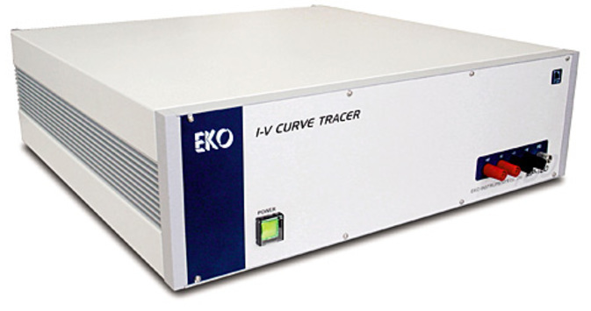
Figure 2.5: Eko Rack Mountable I-V Tracer [12]
The curve tracer pictured above in Figure 2.5 is a 100W peak input power device, meaning it is too small to measure most PV modules’ I-V curve. It can sense currents as low as 10 μA and voltages as low as 1mV, and is intended characterization of single cells [12]. Compare this to a different I-V tracer also manufactured by Eko, the MP-11 I-V checker, pictured below in Figure 2.6.
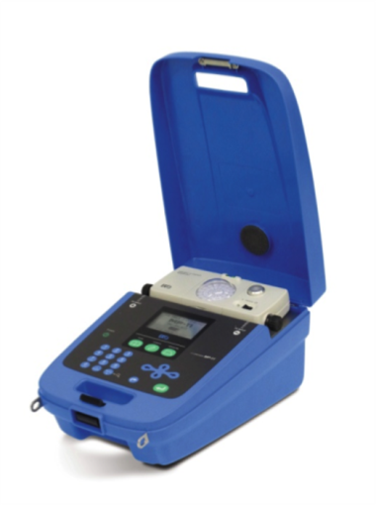
Figure 2.6: MP-11 I-V Checker [13]
The MP-11 I-V Checker shown above in Figure 6comes in a hard plastic case with a handle, a far-cry from the rack-mounted device shown in Figure 2.6. This device is intended for in-field use, and its technical specs reflect this. The MP-11 can sense current as low as 10 mA, making it much less sensitive than the 10 μA sensing MP-180. The MP-11’s power level is much higher as well, allowing for measurements of strings of PV modules up to 18 kW and 1000VDC at the open circuit condition [13]. This device is intended for monitoring of large PV plants, and is more useful as a health measurement than a device characterization tool. This can be seen in the naming convention between the two devices. The lab-grade MP-180 is referred to as an I-V tracer, while the rugged MP-11 is known as an I-V checker.
For the purposes of health measurement of large-scale PV systems, the laboratory grade I-V tracers are not suitable. They are often not made to handle high power, and are too accurate to be cost effective.
There are many I-V tracers intended for in-field use. These I-V tracers vary in method of measurement, accuracy, and power ratings. Generally the accuracy of the I-V tracers intended for field use in PV generation is around 1% and the power ratings vary from ~5kW -50kW.
The two largest environmental factors that affect the I-V curve are irradiance and temperature. Some field I-V tracers come equipped with temperature and irradiance measurement tools and use models to find the common parameters like I_{SC}, V_{OC}, and P_{MP} at standard test conditions. Recall from earlier that STC is defined as 1000W/m², AM1.5, and 25˚C cell temperature. This translation from measured to STC is helpful for comparing nameplate ratings as it is difficult to get 1000W/m² and 25˚C cell temperature in field environments.
Different commercial I-V tracers intended for field use vary slightly in price, accuracy, and portability, but remain largely the same in operation. To capture the I-V curve, the module, string, or strings of modules are connected to the I-V tracer’s positive and negative terminals. This requires disconnecting the module, string, or strings from their generation circuit. If available, irradiance and temperature sensors are attached. The I-V curve is then captured, stored to a device or local computer, and the module, string, or strings are reconnected in their generation circuit. This is repeated for all the I-V curves of other strings or modules.
This method is not ideal for a PV plant owner who is interested in automating their monitoring system. In fact, some of the best locations for PV resources are in places with a very low population density, meaning O&M technicians are likely further away and need more time to dispatch a solution. Figure 2.7 below compares a map of PV resources to population density to illustrate this. On both maps, darker red indicates higher density.
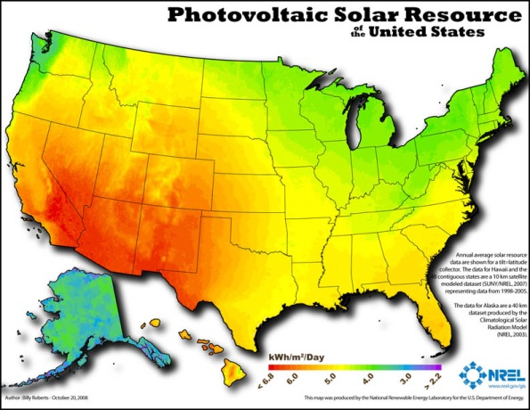(A)(B)
Figure 2.7: Population Density (A) Available Solar Resource (B) [14]

I-V tracers have an excellent future in PV monitoring, and can be extremely useful in monitoring the health and degradation effects that a PV plant is undergoing. However, the manual method of acquiring the trace limits the frequency that I-V traces can be captured and studied. I-V curves have the potential to be very useful for monitoring degradation of PV modules relative to their rating, but only if periodic I-V curves are captured. An autonomous approach is needed.
DC-DC optimizers are power electronics converters which have the ability to hold a module or string of modules at its individual MPP, regardless of the condition of surrounding PV. With the use of these at the module level, mismatch effects are greatly reduced [7]. The DC-DC optimizers operate by varying the voltage on the PV input side to find the MPP, while maintaining the DC bus voltage going to the central inverter.
This same topology could be used as an I-V tracer for monitoring purposes. The PV side of the converter would sweep and capture the I-V curve while maintaining the DC voltage on the inverter side. The converter would need to be able to buck and boost the voltage as it covered the entirety of the I-V curve.
A switching converter would be best for this application. A Duran, Galan, Sidrach-de-Cardona have investigated different topologies’ effectiveness at capturing I-V curves [10]. They found that converter topologies capable of replicating the entire I-V curve of a PV module were those that could buck or boost the voltage. These included the buck-boost converter, Zeta, Cuk, and SEPIC. These topologies are illustrated in Figure 2.8 below.
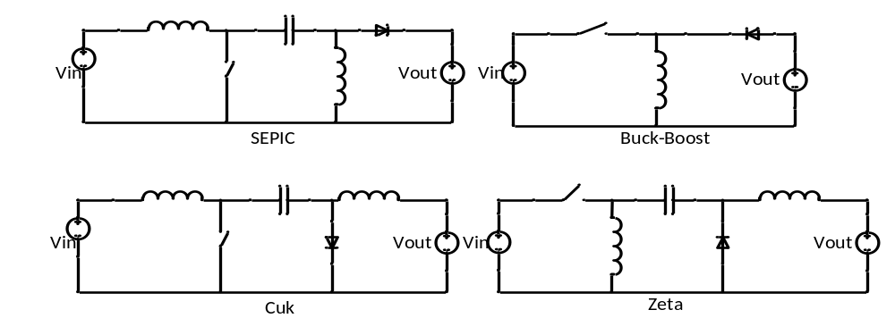
Figure 2.8: Some Common Switching Converter Technologies with Buck and Boost Capabilities
The Buck-Boost converter and Zeta converter both have the switch in series with the panel. This produces a discontinuous input current which can introduce significant noise problems when trying to capture the I-V curve. In [10], the SEPIC is offered as the best option for I-V tracing PV modules.
2.2.2 The SEPIC Converter
The single-ended primary-inductance converter (SEPIC) converter is a non-inverting DC-DC converter capable of producing an output voltage less than, greater than, or equal to its output voltage. It is advantageous for I-V tracing due to its ability to buck and boost, its non-inverting input, and its continuous input current. The authors in [10] chose a load resistor with a value that would ensure the SEPIC converter remained in continuous conduction mode (CCM) for the entirety of the trace. It is helpful to keep the converter in CCM for analysis and control purposes, as the dynamics of the converter change when it enters discontinuous conduction mode (DCM). However, keeping I-V tracer in CCM is not possible with the autonomous topology. The load side of the SEPIC converter in an autonomous I-V tracer is connected to the DC side of the inverter, and it can be assumed that near V_{OC} of the traced module the converter will enter discontinuous conduction mode (DCM). In CCM, the converter can be assumed to have two states, on and off. In the first state, on, the switch is turned on. The input voltage source charges the first inductor, and the second inductor takes energy from coupling capacitor C_{P}. The diode is not turned on. In the second state, off, the switch is turned off. The first inductor charges the coupling capacitor and provides current to the load. The second inductor also provides current to the load. In the DCM case, the current in L1 and L2 drop to a point where they fail to forward-bias the diode, and both the diode and switch are off. These three states are illustrated in Figure 9.
The first switching state, occurs when the switch is driven on, and lasts until the switch is turned off. This switching period is defined as $d_{1}T_{s}$, where $d_{1}$is the time the switch is on. The second switching state occurs when the switch is off, and the diode is on. This period is defined as $d_{2}T_{s}$, where $d_{2}$ is the time that the diode is turned on. The final switching period occurs when the diode turns off and as defined as $d_{3}T_{s}$, where $d_{3}=1-d_{2}-d_{1}$. The switching states can be seen in the inductor current in Figure 2.10.

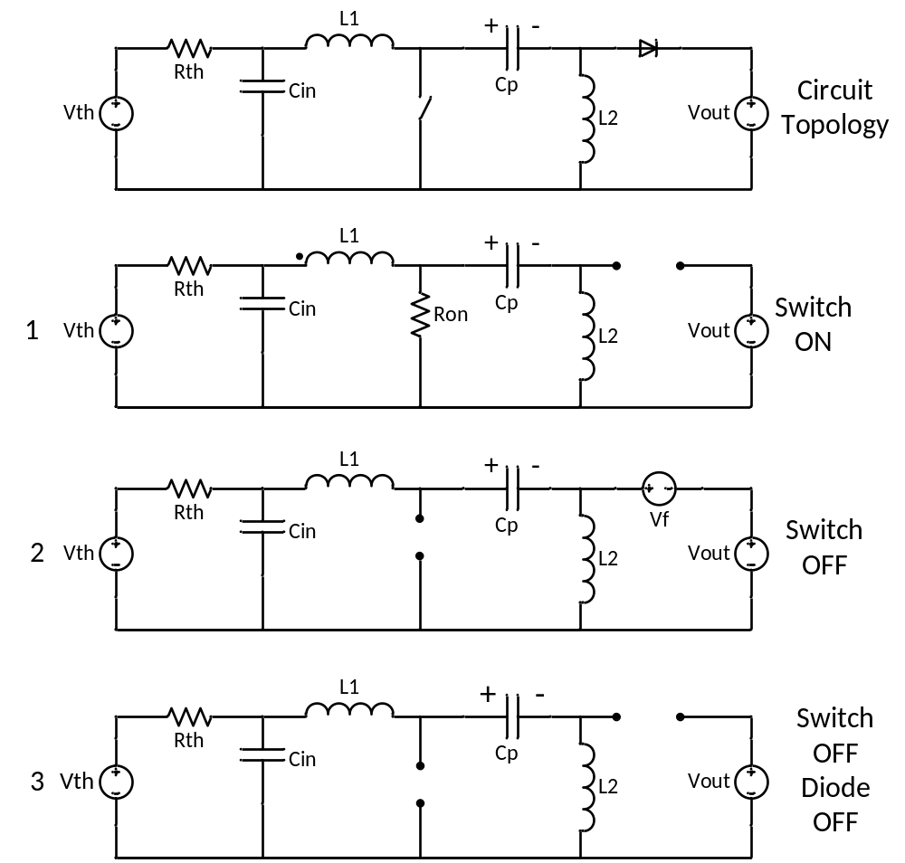
Figure 2.9: Illustration of SEPIC Topology and All 3 Switching States

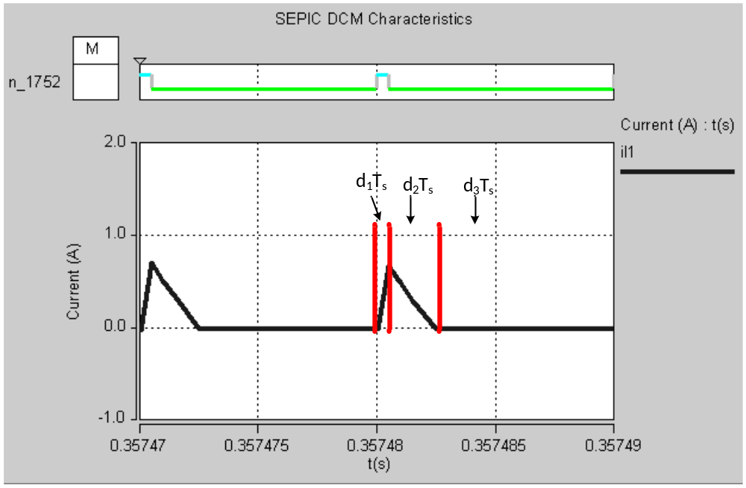Figure 2.10: Inductor Current in all 3 Switching States
2.3 State Space Representation
The state space representation is a canonical form of describing a linear system. In state-space representation, derivatives of state variables are described as linear combinations of inputs and the state variables themselves. The state variables are typically properties of energy storage components. For switching converters, this usually means the state variables are inductor voltages and capacitor currents [15]. Inductor voltages are the time-domain derivative of their currents. Similarly, capacitor currents are the time-domain derivative of their voltages. The general form of state-space represented systems is seen below in (2.1).

$$K\frac{dx(t)}{dt}=Ax(t)+Bu(t)$$
(2.1)
$$y(t)=Cx(t)+Eu(t)$$

The variable $x(t)$ is a vector which contains all the state variables. $u(t)$ is a vector of input variables, and is independent to the system. The derivative of the state vector $\frac{dx(t)}{dt}$ is simply a vector the same size as the state vector whose individual components are equal to the derivatives of the corresponding components in the state vector. In power electronics, K is a matrix of values for capacitance, inductance, and mutual inductances. Matrices A, B, C, and E, are matrices full of constants of proportionality. The vector $y(t)$ is the output vector which can be any dependent signal in the switching converter, regardless of if it is an actual output [15].
2.3.1 State Space Averaging
In a switching converter, each switching state reduces the converter to a single linear circuit. In the case of a SEPIC converter operating in DCM there are switching states. Each of these states can be represented in state-space form individually [15]. The equations for these are shown below in (2.2)-(2.4).
For Time Interval 1: ($d_{1}T_{s}$)
$\frac{dx}{dt}=A_{1}x+B_{1}u$ (2.2)
$y=C_{1}x+E_{1}u$

For Time Interval 2: ($d_{2}T_{s}$)

$\frac{dx}{dt}=A_{2}x+B_{2}u$ (2.3)
$y=C_{2}x+E_{2}u$

For Time Interval 3: ($d_{3}T_{s}$)

$\frac{dx}{dt}=A_{3}x+B_{3}u$ (2.4)
$y=C_{3}x+E_{3}u$

During each the three time intervals, the converter is connected in a different configuration. Because of this, it is likely the variables $A_{1}, B_{1},C_{1}, E_{1}$, $A_{2}, B_{2},C_{2}, E_{2}$, and $A_{3}, B_{3},C_{3}, E_{3}$, are different from each other. The state vector $x$ and the input vector $u$ remain the same across all three time intervals.
Due to volt-second balance and charge balance properties of inductors and capacitors, these state space matrices can be averaged to find the State Space Averaged Model. At equilibrium, the discontinuous conduction mode circuit can be described as:
$0=AX+BU$ (2.5)
$Y=CX+EU$ (2.6)
where the averaged matrices $A, B, C, and E,$ are the averaged values of the same variables in equation 1-A through 1-C weighted by the duty cycle values.
$A= {D_{1}A}_{1}+ {D_{2}A}_{2}+{D_{3}A}_{3}$ (2.7)
$B= {D_{1}B}_{1}+ {D_{2}B}_{2}+{D_{3}B}_{3}$ (2.8)
$C= {D_{1}C}_{1}+ {D_{2}C}_{2}+{D_{3}C}_{3}$ (2.9)
$E= {D_{1}E}_{1}+ {D_{2}E}_{2}+{D_{3}E}_{3}$ (2.10)

The small signal model can be derived from the state space averaged model by perturbing and linearizing the state space average model about the equilibrium point seen in (2.5) and (2.6). To perturb and linearized the model the vectors X, U, Y, D₁ ,D₂ , and D₃ can be represented as combinations of DC terms and high frequency perturbations as shown in (2.11) – (2.15) [15].
${〈x\left(t\right)〉}_{Ts}=X+ \tilde{x}\left(t\right)$ (2.11)
${〈u(t)〉}_{Ts}=U+ \tilde{u}(t)$ (2.12)
${〈y\left(t\right)〉}_{Ts}=Y+ \tilde{y}\left(t\right)$ (2.13)
${〈D_{1}(t)〉}_{Ts}=D_{1}+ {\tilde{d}}_{1}(t)$ (2.14)
${〈D_{2}(t)〉}_{Ts}=D_{2}+ {\tilde{d}}_{2}(t)$ (2.14)
${〈D_{3}(t)〉}_{Ts}=D_{3}- {\tilde{d}}_{1}\left(t\right)-{\tilde{d}}_{2}\left(t\right)$ (2.15)

2.4 Chapter Summary
In this chapter the basic properties of PV panels and their I-V characteristics have been discussed. The current state of PV monitoring equipment for the purposes of characterizing PV I-V curves has been described, and sufficient motivation has been shown for an I-V tracer to exist which operates autonomously in-line with the inverter. Well-known power electronics topologies have been analyzed for the purpose of tracing the I-V characteristics of a PV module and the single-ended primary inductance converter (SEPIC) has been chosen as the optimal topology for an I-V tracer. Finally, the state space averaging technique, which will be used to understand the large and small signal characteristics of the converter has been discussed.

CHAPTER 3
MODELING AND CALCULATIONS

In this chapter, the modeling of the SEPIC Converter for online PV I-V tracing is shown as well as the process of choosing and sizing components.
3.1 Modeling of the SEPIC Converter in DCM

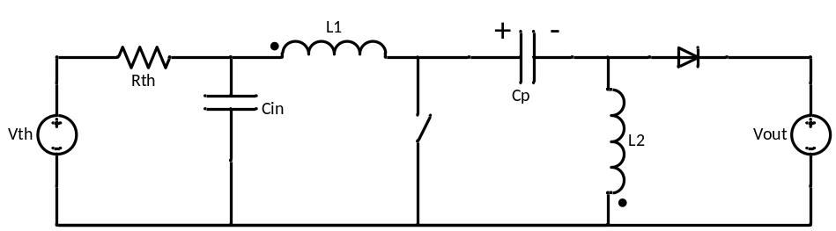

Figure 3.1: SEPIC Topology

For the topology seen in Figure 3.1, the SEPIC is noted by the components inside the dashed line. The PV module is represented by a Thevenin equivalent voltage and resistance, and the DC bus input to the inverter is modeled as an ideal voltage source [16].
As discussed in Chapter 2, it is important to model this circuit in the state-space form. Recalling from Chapter 2, the state-space representation is of the form shown in (3.1).
$K\dot{x}=Ax+Bu$ (3.1)
$y=Cx+Eu$
Also described in Chapter 2, the vector $x$ contains the state variables, $u$ contains the input variables, and $y$contains the output variables. For this particular application, there will only be one output variable, the voltage across capacitor C_{IN}. This is chosen as the output variable because the purpose of the converter is to control the PV module’s voltage and trace the entirety of the curve. The state variables in this converter are chosen to be the inductor currents and capacitor voltages. The state variable vector $X$ is defined below in (3.2).
$X= \left[\begin{matrix}\begin{matrix}I_{L1} \\ I_{L2}\end{matrix} \\ \begin{matrix}V_{Cin} \\ V_{Cp}\end{matrix}\end{matrix}\right]$ (3.2)
The input variables for this topology are chosen to be the Thevenin voltage source representing the PV module, the forward voltage drop across the diode, and the output voltage, which is the DC bus to the inverter. The input variable vector $U$ is defined below in 3.3.
$U= \left[\begin{matrix}Vth \\ Vf \\ Vout\end{matrix}\right]$ (3.3)
Matrices $K$, $C,$ and $E$ are constant for all switching states and are defined in (3.4). $K$ is a diagonal matrix containing the inductance and capacitance values for the state variables seen in (3.2). $E$ is a vector of zeros because the output has been defined as one of the state variables. $C$ is a vector of zeros except for the position which corresponds to the output variable, $V_{Cin}$.
$C= \left[\begin{matrix}\begin{matrix}0 & 0\end{matrix} & \begin{matrix}1 & 0\end{matrix}\end{matrix}\right]$, $E= \left[\begin{matrix}0 & 0 & 0\end{matrix}\right]$, $K= \left[\begin{matrix}\begin{matrix}L1 & 0 \\ 0 & L2\end{matrix} & \begin{matrix}0 & 0 \\ 0 & 0\end{matrix} \\ \begin{matrix}0 & 0 \\ 0 & 0\end{matrix} & \begin{matrix} Cin & 0 \\ 0 & Cp\end{matrix}\end{matrix}\right]$ (3.4)

3.1.1 Mode 1 Operation
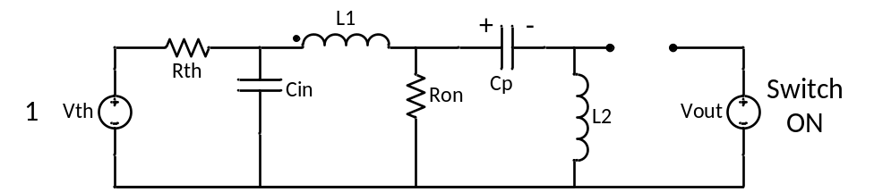
Figure 3.2: Mode 1 of Operation of DCM SEPIC
Variables $A$ and $B$ are unique to each of the three switching states seen in Figure 2.9. For mode 1 operation, when the switch is on and the diode is off (shown again in Figure 3.2), the state space form can be found by using nodal analysis to solve the equations for inductor voltages, and mesh analysis to solve the equations for capacitor currents. All of these equations are solved in terms of the state variables seen in (3.2). These equations are shown in (3.5).
$V_{L1}=L_{1}\frac{dI_{L1}}{dt}=V_{Cin}- R_{on}\left(I_{L1}+I_{L2}\right)$
$V_{L2}=L_{2}\frac{dI_{L1}}{dt}=V_{Cp}- R_{on}\left(I_{L1}+I_{L2}\right)$ (3.5)
$I_{Cin}=C_{in}\frac{dV_{Cin}}{dt}=\frac{V_{th}}{R_{th}}- \frac{V_{Cin}}{R_{th}}- I_{L1}$
$I_{Cp}=- I_{L2}$
These variables can be written in matrix form to obtain a form which resembles 3.1. The matrix form of mode 1 operation of this topology is shown in 3.6.
$\left[\begin{matrix}\begin{matrix}L1 & 0 \\ 0 & L2\end{matrix} & \begin{matrix}0 & 0 \\ 0 & 0\end{matrix} \\ \begin{matrix}0 & 0 \\ 0 & 0\end{matrix} & \begin{matrix} Cin & 0 \\ 0 & Cp\end{matrix}\end{matrix}\right]\dot{\left[\begin{matrix}\begin{matrix}I_{L1} \\ I_{L2}\end{matrix} \\ \begin{matrix}V_{Cin} \\ V_{Cp}\end{matrix}\end{matrix}\right]}=\left[\begin{matrix}\begin{matrix}-R_{on} & -R_{on} \\ -R_{on} & -R_{on}\end{matrix} & \begin{matrix}1 & 0 \\ 0 & 1\end{matrix} \\ \begin{matrix}-1 & 0 \\ 0 & -1\end{matrix} & \begin{matrix}-\frac{1}{R_{th}} & 0 \\ 0 & 0\end{matrix}\end{matrix}\right]\left[\begin{matrix}\begin{matrix}I_{L1} \\ I_{L2}\end{matrix} \\ \begin{matrix}V_{Cin} \\ V_{Cp}\end{matrix}\end{matrix}\right]+\left[\begin{matrix}\begin{matrix}0 \\ 0\end{matrix} & \begin{matrix}0 \\ 0\end{matrix} & \begin{matrix}0 \\ 0\end{matrix} \\ \begin{matrix}\frac{1}{R_{th}} \\ 0\end{matrix} & \begin{matrix}0 \\ 0\end{matrix} & \begin{matrix}0 \\ 0\end{matrix}\end{matrix}\right]\left[\begin{matrix}V_{th} \\ V_{f} \\ V_{out}\end{matrix}\right]$ (3.6)
$$V_{Cin}= \left[\begin{matrix}\begin{matrix}0 & 0\end{matrix} & \begin{matrix}1 & 0\end{matrix}\end{matrix}\right]\left[\begin{matrix}\begin{matrix}I_{L1} \\ I_{L2}\end{matrix} \\ \begin{matrix}V_{Cin} \\ V_{Cp}\end{matrix}\end{matrix}\right]$$
3.1.2 Mode 2 Operation
In mode 2 operation of the DCM SEPIC, the switch is off, the diode is on and conducting with its power loss represented as the diode’s forward voltage drop.
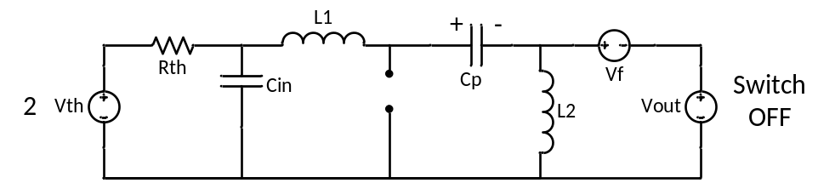
Figure 3.3: Mode 2 Operation of DCM SEPIC
The state space form for mode 2 operation is again found using nodal and mesh analysis to solve the circuit in terms of the state equations. This is shown in (3.7).
$V_{L1}=L_{1}\frac{dI_{L1}}{dt}=V_{Cin}- V_{f}-V_{out}-V_{Cp}$
$V_{L2}=L_{2}\frac{dI_{L2}}{dt}=- V_{f}-V_{out}$ (3.7)
$I_{Cin}=C_{in}\frac{dV_{Cin}}{dt}=\frac{V_{th}}{R_{th}}- \frac{V_{Cin}}{R_{th}}- I_{L1}$
$I_{Cp}= I_{L1}$
Similar to the mode 1, these equations can be represented as matrices to better resemble (3.1). The matrix form of (3.6) is shown in (3.8).
$\left[\begin{matrix}\begin{matrix}L1 & 0 \\ 0 & L2\end{matrix} & \begin{matrix}0 & 0 \\ 0 & 0\end{matrix} \\ \begin{matrix}0 & 0 \\ 0 & 0\end{matrix} & \begin{matrix} Cin & 0 \\ 0 & Cp\end{matrix}\end{matrix}\right]\dot{\left[\begin{matrix}\begin{matrix}I_{L1} \\ I_{L2}\end{matrix} \\ \begin{matrix}V_{Cin} \\ V_{Cp}\end{matrix}\end{matrix}\right]}=\left[\begin{matrix}\begin{matrix}0 & 0 \\ 0 & 0\end{matrix} & \begin{matrix}1 & -1 \\ 0 & 0\end{matrix} \\ \begin{matrix}-1 & 0 \\ 1 & 0\end{matrix} & \begin{matrix}-\frac{1}{R_{th}} & 0 \\ 0 & 0\end{matrix}\end{matrix}\right]\left[\begin{matrix}\begin{matrix}I_{L1} \\ I_{L2}\end{matrix} \\ \begin{matrix}V_{Cin} \\ V_{Cp}\end{matrix}\end{matrix}\right]+\left[\begin{matrix}\begin{matrix}0 \\ 0\end{matrix} & \begin{matrix}-1 \\ -1\end{matrix} & \begin{matrix}-1 \\ -1\end{matrix} \\ \begin{matrix}\frac{1}{R_{th}} \\ 0\end{matrix} & \begin{matrix}0 \\ 0\end{matrix} & \begin{matrix}0 \\ 0\end{matrix}\end{matrix}\right]\left[\begin{matrix}V_{th} \\ V_{f} \\ V_{out}\end{matrix}\right]$ (3.8)
$$V_{Cin}= \left[\begin{matrix}\begin{matrix}0 & 0\end{matrix} & \begin{matrix}1 & 0\end{matrix}\end{matrix}\right]\left[\begin{matrix}\begin{matrix}I_{L1} \\ I_{L2}\end{matrix} \\ \begin{matrix}V_{Cin} \\ V_{Cp}\end{matrix}\end{matrix}\right]$$
3.1.3 Mode 3 Operation
Mode 3 is where the converter enters discontinuous conduction mode, and where both the switch and diode are no longer conducting. The topology of the circuit in this state is shown below in Figure 3.4.
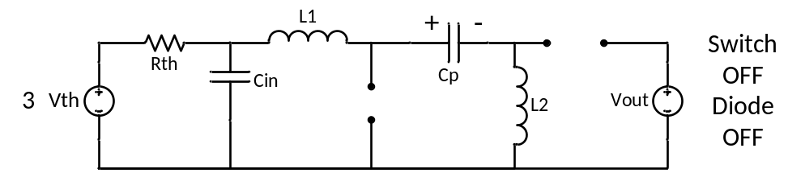
Figure 3.4: Mode 3 Operation of DCM SEPIC
Nodal and mesh analysis are again used to represent the circuit in terms of its state variables. The equations describing the circuit in this mode are shown in (3.9).

$V_{L1}=L_{1}\frac{dI_{L1}}{dt}=V_{Cin}- V_{Cp}$
$V_{L2}=L_{2}\frac{dI_{L1}}{dt}=- V_{Cin}-V_{Cp}$ (3.9)
$I_{Cin}=C_{in}\frac{dV_{Cin}}{dt}=\frac{V_{th}}{R_{th}}- \frac{V_{Cin}}{R_{th}}- I_{L1}$ (3.9)
$I_{Cp}= I_{L1}$
Similar to the other modes of operation, these four equations can be converted to matrix form to better resemble the state space form. Equation (3.9) represented in matrix form can be seen in (3.10).
$\left[\begin{matrix}\begin{matrix}L1 & 0 \\ 0 & L2\end{matrix} & \begin{matrix}0 & 0 \\ 0 & 0\end{matrix} \\ \begin{matrix}0 & 0 \\ 0 & 0\end{matrix} & \begin{matrix} Cin & 0 \\ 0 & Cp\end{matrix}\end{matrix}\right]\dot{\left[\begin{matrix}\begin{matrix}I_{L1} \\ I_{L2}\end{matrix} \\ \begin{matrix}V_{Cin} \\ V_{Cp}\end{matrix}\end{matrix}\right]}=\left[\begin{matrix}\begin{matrix}0 & 0 \\ 0 & 0\end{matrix} & \begin{matrix}1 & -1 \\ -1 & -1\end{matrix} \\ \begin{matrix}-1 & 0 \\ 1 & 0\end{matrix} & \begin{matrix}-\frac{1}{R_{th}} & 0 \\ 0 & 0\end{matrix}\end{matrix}\right]\left[\begin{matrix}\begin{matrix}I_{L1} \\ I_{L2}\end{matrix} \\ \begin{matrix}V_{Cin} \\ V_{Cp}\end{matrix}\end{matrix}\right]+\left[\begin{matrix}\begin{matrix}0 \\ 0\end{matrix} & \begin{matrix}0 \\ 0\end{matrix} & \begin{matrix}0 \\ 0\end{matrix} \\ \begin{matrix}\frac{1}{R_{th}} \\ 0\end{matrix} & \begin{matrix}0 \\ 0\end{matrix} & \begin{matrix}0 \\ 0\end{matrix}\end{matrix}\right]\left[\begin{matrix}V_{th} \\ V_{f} \\ V_{out}\end{matrix}\right]$ (3.10)
$$V_{Cin}= \left[\begin{matrix}\begin{matrix}0 & 0\end{matrix} & \begin{matrix}1 & 0\end{matrix}\end{matrix}\right]\left[\begin{matrix}\begin{matrix}I_{L1} \\ I_{L2}\end{matrix} \\ \begin{matrix}V_{Cin} \\ V_{Cp}\end{matrix}\end{matrix}\right]$$
Now that the circuit has been modeled in each of the three switching states, work can be done using the state space averaging technique discussed in 2.3.1. Equations (3.6), (3.8), and (3.10) are enough to create the three state space equations shown in (2.2)-(2.4).
For the matrices shown in (2.2)-(2.4), each state space representation has different constant matrices $A, B, C,$ and $E$. In the case of the SEPIC operating in DCM for PV I-V curve tracing, only the matrices $A$ and $B$ change during the three switching states. Dividing these three matrices through by matrix $K$ defined in (3.4) yields (3.11) and (3.12), which defines the three matrices for $A$ and $B$ each in the state space description.
$A1= \left[\begin{matrix}\begin{matrix}-\frac{R_{on}}{L1} & \frac{-R_{on}}{L1} \\ \frac{-R_{on}}{L2} & \frac{-R_{on}}{L2}\end{matrix} & \begin{matrix}\frac{1}{L1} & 0 \\ 0 & \frac{1}{L2}\end{matrix} \\ \begin{matrix}\frac{-1}{Cin} & 0 \\ 0 & \frac{-1}{Cp}\end{matrix} & \begin{matrix}-\frac{1}{{CinR}_{th}} & 0 \\ 0 & 0\end{matrix}\end{matrix}\right]$ $A2=\left[\begin{matrix}\begin{matrix}0 & 0 \\ 0 & 0\end{matrix} & \begin{matrix}\frac{1}{L1} & \frac{-1}{L1} \\ 0 & 0\end{matrix} \\ \begin{matrix}\frac{-1}{Cin} & 0 \\ \frac{1}{Cp} & 0\end{matrix} & \begin{matrix}-\frac{1}{R_{th}} & 0 \\ 0 & 0\end{matrix}\end{matrix}\right]$ $A3=\left[\begin{matrix}\begin{matrix}0 & 0 \\ 0 & 0\end{matrix} & \begin{matrix}\frac{1}{L1} & \frac{-1}{L1} \\ \frac{-1}{L2} & \frac{-1}{L2}\end{matrix} \\ \begin{matrix}\frac{-1}{Cin} & 0 \\ \frac{1}{Cp} & 0\end{matrix} & \begin{matrix}-\frac{1}{{CinR}_{th}} & 0 \\ 0 & 0\end{matrix}\end{matrix}\right]$ (3.11)
$B1=\left[\begin{matrix}\begin{matrix}0 \\ 0\end{matrix} & \begin{matrix}0 \\ 0\end{matrix} & \begin{matrix}0 \\ 0\end{matrix} \\ \begin{matrix}\frac{1}{{CinR}_{th}} \\ 0\end{matrix} & \begin{matrix}0 \\ 0\end{matrix} & \begin{matrix}0 \\ 0\end{matrix}\end{matrix}\right] B2=\left[\begin{matrix}\begin{matrix}0 \\ 0\end{matrix} & \begin{matrix}\frac{-1}{L1} \\ \frac{-1}{L2}\end{matrix} & \begin{matrix}\frac{-1}{L1} \\ \frac{-1}{L2}\end{matrix} \\ \begin{matrix}\frac{1}{{CinR}_{th}} \\ 0\end{matrix} & \begin{matrix}0 \\ 0\end{matrix} & \begin{matrix}0 \\ 0\end{matrix}\end{matrix}\right]$ $B3=\left[\begin{matrix}\begin{matrix}0 \\ 0\end{matrix} & \begin{matrix}0 \\ 0\end{matrix} & \begin{matrix}0 \\ 0\end{matrix} \\ \begin{matrix}\frac{1}{{CinR}_{th}} \\ 0\end{matrix} & \begin{matrix}0 \\ 0\end{matrix} & \begin{matrix}0 \\ 0\end{matrix}\end{matrix}\right]$ (3.12)

According to the state-space averaging technique discussed in 2.3.1, the state space description of the converter across all three switching states can be described by multiplying each of the mode of operations’ variables with the corresponding duty cycle as shown in (3.13).
$\dot{X}=\left(A1D1+A2D2+A3D3\right)X+ \left(B1D1+B2D2+B3D3\right)U$ (3.13)
The equation describing the output variable $Y$ is the same across all switching states. This is due to the fact that the output variable is one of the state variables.
3.2 Small Signal Modeling
As discussed in 2.3.1, these variables can be described as combinations of their averaged terms and small signal perturbations. Using (2.11)-(2.15), (3.13) is changed to include the small and large signal portions. This is described by (3.14).
$\dot{X}+\dot{\tilde{x}}=\left(A1\left(D1+\tilde{d}1\right)+A2\left(D2+\tilde{d}2\right)+A3\left(D3-\tilde{d}1-\tilde{d}2\right)\right)\left(X+\tilde{x}\right)+ \left(B1\left(D1+\tilde{d}1\right)+B2\left(D2+\tilde{d}2\right)+B3\left(D3-\tilde{d}1-\tilde{d}2\right)\right)\left(U+\tilde{u}\right)$ (3.14)
Expanding (3.14), and discarding the second order nonlinear terms as well as the large signal terms reveals the small signal representation of the circuit. This is described by 3.15.
s$\tilde{x}= \left(A1D1+A2D2+A3D3\right)\tilde{x}+\left(B1D1+B2D2+B3D3\right)\tilde{u}+\left(\left(A1-A3\right)X+\left(B1-B3\right)U\right)\tilde{d}1 +\left(\left(A2-A3\right)X+\left(B2-B3\right)U\right)\tilde{d}2$ (3.15)
It is important at this point to redefine $\tilde{d}2$ in terms of $\tilde{d}1$. From [17], it is known that the average inductor current in inductor L₁ can be written as described in (3.16).
$I_{L1}=\frac{1}{2}I_{L1pk}\left(D_{1}+D_{2}\right)$ (3.16)
The peak inductor 1 current $I_{L1pk}$ can be replaced with the voltage across the input capacitor multiplied by the length of time spent in mode one operation and divided by the inductance. This is shown in (3.17).
$I_{L1}=\frac{1}{2}I_{L1pk}\left(D_{1}+D_{2}\right)=\frac{D_{1}T_{s}\left(V_{Cin}\right)\left(\left(D_{1}+D_{2}\right)\right)}{2L}$ (3.17)

This allows $\tilde{d}2$ to be represented in terms of $\tilde{d}1$ and the system variables. Adding in AC perturbations and removing second order AC terms as well as DC terms, a description of $\tilde{d}2$ in terms of $\tilde{d}1$ is found. This is shown in (3.18).
$\tilde{d}2= \tilde{d}1\left(\frac{\frac{2Lf_{s}}{{D_{1}}^{2}}I_{L1}}{V_{Cin}}-1\right)$ (3.18)
Substituting (3.18) into (3.15) reveals (3.19).
s$\tilde{x}= \left(A1D1+A2D2+A3D3\right)\tilde{x}+\left(B1D1+B2D2+B3D3\right)\tilde{u}+\left(\left(A1-A3\right)X+\left(B1-B3\right)U\right)\tilde{d}1 +\left(\left(A2-A3\right)X+\left(B2-B3\right)U\right)\tilde{d}1\left(\frac{\frac{2Lf_{s}}{{D_{1}}^{2}}I_{L1}}{V_{Cin}}-1\right)$ (3.19)
Using simulation results to determine the large signal characteristics of the converter, including the state variables and three duty cycle values, MATLAB code is written to find the transfer function of the converter’s small signal duty cycle to input. The bode plot for this is shown below in Figure 3.4.
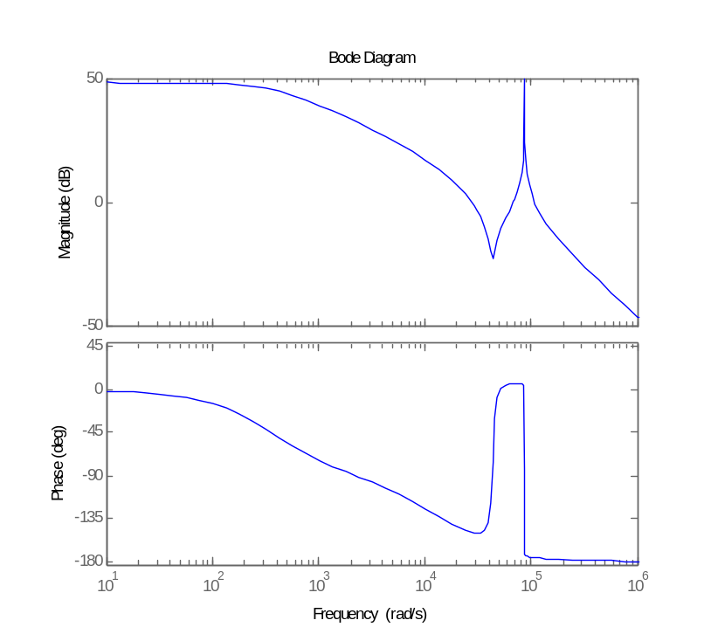
Figure 3.4: Bode plot of DCM SEPIC
Using different equilibrium conditions obtained from simulation results the converter’s dynamic characteristics can be shown in the continuous conduction mode case. This is shown below in Figure 3.5.
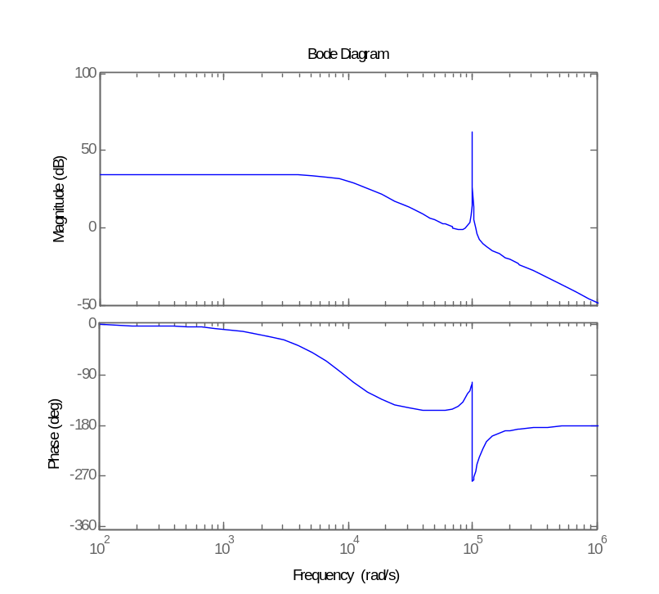
Figure 3.5: Bode plot of CCM SEPIC
3.3 Component Sizing
3.3.1 Inductor L1 sizing

LIST OF REFERENCES

[1] B. Hodge, “Alternative Energy Systems and Applications,” 2010.

[2] CS6P-255P Data sheet [Online]. Available: h http://www.canadiansolar.com/down/en/CS6P-P_en.pdf

[3] Guide to Interpreting I-V Curve Measurements of PV Arrays [Online]. Available: http://resources.solmetric.com/get/Guide%20to%20Interpreting%20I-V%20Curves.pdf Solmetric, Application Note PVA-600-1, 1 March 2011

[4] F. A. Lindholm et al., “Application of the Superposition Principle to Solar-Cell Analysis,” in IEEE Transactions on Electron Devices, ed-26, no. 3, pp. 165-171, March 1979.

[5] A.A. Willoughby et al., “A simple resistive load I-V curve tracer for monitoring photovoltaic module characteristics,” in 5th International Renewable Energy Congress (IREC), pp. 25-27, March 2014.

[6] P. Hernday, Field Applications for I-V Curve Tracers, [Online]. Available: http://resources.solmetric.com/get/SolarPro-FieldApplicationsOf-I-V-Curve-Tracers-Hernday.pdf not used in paper yet

[7] “The Learning Curve,” in Photon Magazine, issue 8 August 2012. Not used in paper yet

[8] P. Tsao et al., “Distributed Max Power Point Tracking For Photovoltaic Arrays,” in 34th IEEE Photovoltaic Specialists Conference (PVSC), pp. 2293-2298, 7-12 June 2009.

[9] E. Duran et al., “A New Application of the Buck-Boost-Derived Converters to Obtain the I-V Curve of Photovoltaic Modules,” in Power Electronics Specialists Conference, pp. 413-417, 17-21 June 2007.

[10] R. Ridley, “Analyzing the SEPIC Converter”, in Power Systems Design Europe, pp. 14-18, November 2006.

[11] V. Eng, “Modeling of a SEPIC Converter Operating in Discontinuous Conduction Mode,” in 6th International Conference on Electrical Engineering/Electronics, Computer, Telecommunications and Information Technology, vol. 1, pp. 140-143, 6-9 May 2009.

[12] MP-180 I-V Tracer, [Online] Available: http://eko-eu.com/products/photovoltaic-evaluation-systems/i-v-tracers/mp-180-i-v-tracer

[13] MP-11 I-V Checker, [Online] Available: http://eko-eu.com/products/photovoltaic-evaluation-systems/i-v-tracers/mp-11-i-v-checker

[14] Solar Maps, [Online] Available: http://www.nrel.gov/gis/solar.html

[15] R. Erickson and D. Maksimovic, “Fundamentals of Power Electronics,” 2nd Ed. 2001.

[16] A. Kashyap et al, “Input Voltage Control of SEPIC for Maximum Power Point Tracking,” in Power and Energy Conference at Illinois (PECI), pp. 30-35, 22-23 Feb. 2013

