LEVERAGING SENSITIVITY ANALYSIS TO INFORM SEPARATE EFFECTS TESTS FOR NUCLEAR REACTOR SAFETY APPLICATIONS

A Dissertation Presented for the
Doctor of Philosophy
Degree
The University of Tennessee, Knoxville

Nicholas Akira Meehan
August 2025

Copyright © 2025 by Nicholas Akira Meehan
All rights reserved.
ACKNOWLEDGEMENTS
I would like to thank Dr. Nicholas R. Brown for providing me with this incredible opportunity and for guidance and encouragement which helped me to succeed throughout graduate school. I would also like to thank Dr. Ivan Maldonado for his support and guidance throughout my many projects.
I would like to thank Dr. Trevor Howard and the OSU team for their insight in modeling TRTL and Dr. Charles Folsom for guidance in modeling TREAT and for his technical insight in critical heat flux.
I extend my thanks to all of the Irradiation Engineering Group for being welcoming and letting me run ANSYS non-stop for weeks. Thank you to Dr. Jacob Gorton for his extensive mentorship throughout the MiniFuel project and for guidance in modeling the MiniFuel subcapsules. I would also like to thank Dr. Nathan Capps for insight in modeling fuel performance in BISON.
Thank you to all my friends who helped me through the ups and downs of life and for the great memories we shared together. Finally, I would like to thank my family for their unwavering support in my ambitions.
ABSTRACT
Future commercial nuclear power is seeking enhanced performance through technologies that operate outside the current regulatory space. Accident tolerant fuels (ATFs) are a proposed method for enhancing safety in nuclear systems without sacrificing cost or performance. Prior to licensing a new fuel form for commercial use, fuel qualification must be performed. Traditionally, fuel qualification is time-consuming and costly, taking upwards of 20 years to perform and relying primarily on integral effects tests. A novel solution to accelerating the fuel qualification process is supplementing integral effects testing by leveraging an iterative process between separate effects tests and modeling and simulation to establish a database of fuel performance. Separate effects tests are cost-effective experiments which isolate specific fuel performance behaviors to provide fundamental data for developing theory and predictive models. Predictive models can then be used to inform the design of experiments to address regions of high uncertainty through the use of sensitivity analysis. The goal of my work is to identify high-impact, high-uncertainty parameters within predictive nuclear models to inform separate effects experimental design. This approach will be applied to two individual case studies.
The first study performs a knowledge gap analysis of transient critical heat flux and transient boiling heat transfer modeling within the RELAP5-3D code. I inspect discrepancies between experiments and code predictions due to rapid transient heating effects by performing experimental comparison and highlight areas of highest modeling uncertainty using sensitivity analysis. To address this region of high-uncertainty, I proposed an experimental test matrix that can provide insight for future models of transient boiling heat transfer and transient critical heat flux within this operational regime.
The second study inspects modeling nuclear fuel irradiation tests in collaboration with Oak Ridge National Laboratory (ORNL). I perform an in-depth analysis of an irradiation subcapsule design to reduce model variance in fuel temperature predictions. This analysis revealed three important design parameters which can be controlled: initial gas pressure, contact pressure, and surface roughness. Using the results of the predictive model, I have developed a set of design recommendations which can reduce fuel temperature variance in future separate effects experiments.

Table of Contents
Chapter 1: Introduction 1
Chapter 2: Literature Review 6
Fuel qualification 6
Separate Effects vs Integral Effects Experiments 8
Framework for Accelerated Qualification of Nuclear Fuels 9
Sensitivity and Uncertainty Analysis 11
Morris Sensitivity Analysis 13
Pearson Sensitivity Analysis 16
Sobol Sensitivity Analysis 17
Considerations for Sensitivity Analysis 19
Chapter 3: Case Study 1 21
Critical Heat Flux 21
Factors that Influence CHF 22
Modeling CHF 26
Project Overview 26
The TRTL Facility (OSU) 27
Background and Capabilities 27
Model Development and Verification 31
Sensitivity Analysis 43
The TREAT Facility (INL) 56
Background and Capabilities 56
The SERTTA Capsule 58
Model Specification 61
Sensitivity Analysis 61
Experimental Comparison 68
Pool Boiling Test Chamber (UNM) 71
Background and Capabilities 71
Model Development and Verification 72
Experimental Comparison 76
Conclusions and Future Work 79
Conclusions 79
Proposed Test Matrix 81
Proposed Future Work 84
Chapter 4: Case Study 2 87
Separate Effects Fuel Performance Testing 87
Halden Irradiation Tests 87
MiniFuel Irradiation Tests 89
Past MiniFuel Experimental Campaigns 94
Project Overview 97
Full Subcapsule Analysis 98
Model Framework 98
Morris Parameter Screening Methods 100
Sobol Sensitivity Analysis Methods 105
Model Verification and Validation 108
Morris Parameter Screening Results 111
Sobol Sensitivity Analysis Results 111
ANSYS Model Uncertainty 126
Influence of Gap Conductance 127
Influence of Fuel Height 128
Influence of HGR Uncertainty 129
Influence of Thermal Contact Conductance 129
Influence of ANSYS Model TCC Calculations 118
Conclusions from Full Subcapsule Analysis 119
In Depth TCC Model Analysis 121
Python Model Framework 123
Python-BISON Model Framework 128
Standalone Python Model Results 131
Coupled Python/BISON Model Results 133
Sobol Sensitivity Analysis Results 133
Performance Envelopes 135
Influence of Controllable Variables 135
Influence of Temperature Jump Distance 146
Capsule Design Recommendations 151
Applying Recommendations to ANSYS 153
Additional Considerations and Future Work 156
Conclusions of In-Depth TCC Model Analysis 158
Chapter 5: Conclusions 160
Answers to Key Questions 160
Key Questions for Case Study 1 160
Key Questions for Case Study 2 162
Unique Contributions 165
Suggested Future Work 166
List of References 168
Appendix 197
Full Subcapsule Analysis 197
In-Depth Model Analysis 200
Vita 202

LIST OF TABLES
Table 3.1. TRTL Loop Design Parameters for Operation [19, 100]. 29
Table 3.2. TRTL Low Power Transient Test Matrix Parameters [102]. 33
Table 3.3. Proposed Experimental Test Matrix Details. 43
Table 3.4. Proposed Experimental Test Matrix Details. 51
Table 3.5. CHF-SERTTA Test Matrix for TREAT. 59
Table 3.6. New Proposed Experimental Test Matrix Power Pulse Details. 84
Table 4.1. Materials used for each component within MiniFuel designs [22, 138]. 92
Table 4.2. MF01/MF02 Irradiation Test Matrix [22, 137]. 95
Table 4.3. Morris screening analysis parameter uncertainty distributions. 101
Table 4.4. MF01 time averaged fuel temperature prediction with model by Petrie et al. [22] and PIE data from Harp et al. [137] 109
Table 4.5. RB01 model-to-model comparison of time-averaged fuel temperature prediction with model by Gorton et al. [133]. 110
Table 4.6. Sobol sensitivity parameters from the Morris parameter screening 116
Table 4.7. Statistics for the Sobol sensitivity analysis of ANSYS MiniFuel models 125
Table 4.8. Parameter uncertainty distributions for Sobol analysis. 127
Table 1. Abbreviations 197
Table 2. Subcapsule geometry parameters for Morris analysis 198
Table 3. Thermal Contact Conductance Parameter Abbreviations 200
Table 4. Sensitivity Analysis Parameter Abbreviations 201
LIST OF FIGURES
Figure 2.1. Comparison Between Traditional Fuel Qualification [9] and Accelerated Fuel Qualification [10]. 10
Figure 2.2. General Approach to Iterative Improvement of Predictive Modeling Adapted from [11]. 12
Figure 3.1. TRTL Primary Loop Schematic [100]. 28
Figure 3.2. TRTL Facility (Left) Within the OSU Advanced Thermal Hydraulics Research Laboratory (Right) Instrumentation Diagram of the Primary Loop [100]. 30
Figure 3.3. Transient TRa Experimental Data with Corresponding Representative Power Pulse Overlaid. 34
Figure 3.4. Schematic of the TRTL Loop (Left) with a Corresponding RELAP5-3D Nodalization Diagram (Right). 36
Figure 3.5. Comparison Between Experimental Data, RELAP5-3D Code Predictions, and TRACE Code Predictions for Case TRa. 38
Figure 3.6. Comparison Between Experimental Data, RELAP5-3D Code Predictions, and TRACE Code Predictions for Case TRb. 39
Figure 3.7. Comparison Between RELAP5-3D Code Predictions, and TRACE Code Predictions for Case TR5. 41
Figure 3.8. Comparison Between RELAP5-3D Code Predictions, and TRACE Code Predictions for Case TR8. 42
Figure 3.9. TRTL High-Power Experimental Power Pulses as Proposed by Meehan et. al. [106]. 45
Figure 3.10. Envelope for CHF Occurrence within the TRTL Facility Test Section. 46
Figure 3.11. PPMCCs for Each Input with Respect to Peak Cladding Heat Flux 54
Figure 3.12. PPMCCs for Each Input with Respect to Peak Outer Surface Temperature 54
Figure 3.13. PPMCCs for Each Input with Respect to Time of CHF Occurrence 55
Figure 3.14. PPMCCs for Each Input with Respect to Time of Cladding Rewetting 55
Figure 3.15. CHF Multiplier vs Exponential Period Using the Empirical Model Fit By Hata et al. [66] With Inlaid Graph of Experimental Test Matrix Periods. 57
Figure 3.16. CHF-SERTTA Experimental Campaign Test Matrix Transients [45]. 60
Figure 3.17. CHF-SERTTA Capsule (Left) Nodalization Diagram (Right) Borated Heater Rod Nodalization as Designed by Folsom et. al. [45]. 62
Figure 3.18. CHF-SERTTA PPMCCs for each input with respect to peak cladding heat flux. 64
Figure 3.19. CHF-SERTTA PPMCCs for each input with respect to peak outer surface temperature. 65
Figure 3.20. CHF-SERTTA PPMCCs for each input with respect to time of CHF occurrence. 66
Figure 3.21. CHF-SERTTA PPMCCs for each input with respect to time of cladding rewetting. 67
Figure 3.22. Experimental Case SERTTA-A Transient 2 with Experimental Data From R. J. ARMSTRONG, et al. [116]. 69
Figure 3.23. Experimental Case SERTTA-B Transient 2 with Experimental Data From C. P. FOLSOM, et al. [45], R. J. ARMSTRONG, et al. [116]. 70
Figure 3.24. Representative RELAP5-3D Nodalization for the UNM Pool Boiling Facility 73
Figure 3.25. Experimental Test Matrix for Vertical Pool Boiling Experiments Using Equation 3 with Varying Values of s M. HE and M. CHEN [21]. 75
Figure 3.26. Comparison of Experimental RELAP5-3D Calculated Results for Horizontal and Vertical Test Sections Under Steady-State Conditions M. HE and M. CHEN [21], M. HE, A. F. ALI and M. CHEN [117]. 77
Figure 3.27. Comparison of Experimental RELAP5-3D Calculated Results for Horizontal and Vertical Test Sections Under Transient Conditions M. HE and M. CHEN [21], M. HE, A. F. ALI and M. CHEN [117]. 78
Figure 3.28. Proposed CHF Performance Envelopes for TRTL Power Pulses. 83
Figure 4.1. ANSYS rendering of a MiniFuel a) target, b) subcapsule, c) axisymmetric subcapsule. 91
Figure 4.2. Morris Method parameter screening methodology. 106
Figure 4.3. Morris parameter screening for high-temperature UO₂ fuel with respect to average fuel temperature. 112
Figure 4.4. Morris parameter screening for high-temperature UO₂ fuel with respect to fuel temperature gradient. 113
Figure 4.5. Morris parameter screening for low-temperature UO₂ fuel with respect to average fuel temperature. 114
Figure 4.6. Morris parameter screening for low-temperature UO₂ fuel with respect to fuel temperature gradient. 115
Figure 4.7. Total Sobol index convergence for high-temperature UO₂ fuel with respect to average fuel temperature. 118
Figure 4.8. Total Sobol indices for high-temperature UO₂ fuel with respect to each POI (including the primary subcapsule design parameters). 119
Figure 4.9. Total Sobol indices for low-temperature UO₂ fuel with respect to each POI (including the primary subcapsule design parameters). 120
Figure 4.10. Total Sobol indices for high-temperature UO₂ fuel with respect to each POI (not including the primary subcapsule design parameters). 121
Figure 4.11. Total Sobol indices for low-temperature UO₂ fuel with respect to each POI (not including the primary subcapsule design parameters). 122
Figure 4.12. Histogram of average fuel temperature for the high-temperature UO₂ fuel Sobol analysis. 123
Figure 4.13. Histogram of average fuel temperature for the low-temperature UO₂ fuel Sobol analysis. 124
Figure 4.14. Thermal contact conductance between two surfaces in mechanical contact. 117
Figure 4.15. R-Z BISON model with boundary conditions for code coupling. 129
Figure 4.16. Total Sobol indices Sobol sensitivity parameters of UO₂ MiniFuel TCC parameters at 1000°C target temperature using a standalone Python model. 132
Figure 4.17. Total Sobol indices of UO₂ MiniFuel TCC parameters at 1000°C target temperature and 80 GWd/MTU using a coupled Python-BISON model. 134
Figure 4.18. Interface temperature variations of UO₂ MiniFuel subcapsules with target temperatures of 800°C, 1000°C, and 1200°C. 136
Figure 4.19. Histograms of UO₂ MiniFuel specimens at 80 GWd/MTU with target temperatures of 800°C, 1000°C, and 1200°C. 137
Figure 4.20. FGR of UO2 MiniFuel subcapsules with target temperatures of 800°C, 1000°C, and 1200°C. 138
Figure 4.21. Performance envelopes of a 1000°C target temperature UO₂ MiniFuel subcapsule based on initial fill gas pressure. 140
Figure 4.22. Performance envelopes of a 1000°C target temperature UO₂ MiniFuel subcapsule based on contact pressure. 141
Figure 4.23. Performance envelopes of a 1000°C target temperature UO₂ MiniFuel subcapsule based on effective surface roughness. 142
Figure 4.24. Performance envelopes of a 1000°C target temperature UO₂ MiniFuel subcapsule inspecting varying SSC. 144
Figure 4.25. SSC of a 1000°C target UO₂ MiniFuel subcapsule at 80 GWd/MTU based on contact pressure and surface roughness. 145
Figure 4.26. Fuel interface temperature performance envelopes of a Target UO₂ MiniFuel subcapsule at 80 GWd/MTU based on initial fill gas pressure. 147
Figure 4.27. Influence of initial gas pressure on temperature jump distance for a He-Mo interface at 1000 °C. 149
Figure 4.28. Influence of initial gas pressure on temperature jump distance for a He-UO₂ interface at 1000 °C. 150
Figure 4.29. Influence of design recommendations on fuel and dish interface temperature gradients in ANSYS. 155
Figure 1. MiniFuel subcapsule cross section with overlaid geometric parameter numbers. 199

Introduction
Nuclear power accounts for roughly 31% of global power production [1]. One of the main challenges in utilizing nuclear energy as the primary means of energy production is that current generation gigawatt-scale reactors induce too great of a capital risk; as evident by Vogtle unit 3 & 4 in Georgia taking over 10 years and $10s of billions to begin operation. Public and private industry are working toward the development of advanced reactor designs which can leverage historical reactor concepts and aim to address these issues with improvements in safety, economics and waste [2]. Several advanced reactor designs are adopting a modular approach to standardize parts and scale down reactor units to operate at the megawatt-scale, which should drastically reduce the upfront construction cost and construction time [2]. Advanced reactor operational cycle lifetimes are extended to reduce plant outages and decrease waste, and passive safety features are being implemented to ensure the core is sufficiently cooled and that radioactive material is contained in the event of accidents [2].
Although advanced reactors seem like the most promising long-term solution to nuclear power, there is currently no established licensing basis for the majority of the proposed designs [2]. To bridge the gap between the development and licensing of advanced reactors, the near-term compromise is to improve and extend the lifetime of existing light water reactor (LWR) plants. The current commercial nuclear fleet is approaching or has exceeding the end of their original 40 year operational licenses [3]. While many plants have applied for and have been approved for license extensions [3], there is still a need to enhance performance and economic competitiveness [4]; especially in competition with other renewable energy alternatives [5]. Current avenues for improvement include front/back end fuel cycle costs, proliferation resistance, and operational performance and safety [4]. Among other global efforts, the US Department of Energy (DOE) has put forth several programs to address these challenges including, but not limited to, the accident tolerant fuels (ATF) campaign, advanced fuels campaign (AFC), and campaigns for integrated energy systems and energy storage [5-7].
The ATF program is an ongoing campaign within the AFC supporting the goal of improving the safety of fuels without sacrificing performance or economics [6, 8]. To license new fuels for the use in commercial nuclear systems, candidate materials must undergo fuel qualification [9, 10]. This is a process that involves down-selection of candidate fuel systems through comprehensive experimental testing and traditionally takes ~20 years from conception to licensing [9]. Although the approach has been successfully applied for several fuel forms across several reactor designs including, but not limited to, light-water reactors, gas cooled reactors, sodium fast reactors and research reactors; the approach as a whole remains inefficient and costly to perform [10].
In an effort to accelerate the current fuel qualification process, a new approach was proposed by Terrani et. al. leveraging advanced modeling and simulation capabilities [10]. The basis of this new approach is to supplement integral effects testing with the use an iterative feedback loop between computational modeling and separate effects experimentation. Integral effects tests are tests which encapsulate the full representative environment of a system. While these tests are necessary for fuel performance, they are expensive to perform and give little information outside of the range of its specific design [10]. Separate effects tests are cost-effective experiments that aim to isolate a specific effect which is imperative for gathering fundamental data in a highly coupled system such as a nuclear reactor environment [10]. The data from these experiments can help to develop new and improve existing predictive computational models. Predictive models can then be used to inform the design of future experiments to fill data gaps and to address areas of high uncertainty. This iterative process will be performed prior to integral testing to help streamline the down-selection process and ensure a comprehensive database is formed that can be used to inform integral tests. This iterative process is an approach that has been proposed in the past for efficient design of expensive time-consuming experiments [11], and has been endorsed by several organizations including the Nuclear Regulatory Committee (NRC) [12-14].
This goal of this work is to establish a computational framework which can identify areas of high uncertainty in predictive models and inform the design of separate effects experiments to address them. In order to demonstrate this approach, specifically for fuel qualification, I will be performing two individual case studies within two research areas of nuclear safety analysis. The first study will inspect transient critical heat flux (CHF) and transient boiling heat transfer and the second will inspect irradiation of candidate fuels. The main method I will utilize to drive this framework will be sensitivity and uncertainty analysis, a powerful data analysis tool capable of gaining insight into tightly coupled complex systems such as that of a nuclear reactor core [15-18]. The facilities that I will inspect for the first case study are the Transient Reactor Test Loop (TRTL) facility at Oregon State University (OSU), the Transient Reactor Test (TREAT) Facility at Idaho National Laboratory (INL) and a boiling chamber at the University of New Mexico (UNM) [19-21]. The second case study will inspect the MiniFuel irradiation vehicle developed at Oak Ridge National Laboratory (ORNL) for use in the High Flux Isotope Reactor (HFIR) [22].
The work presented aims to answer the following key questions associated with each case study:
Study 1: Transient Critical Heat Flux and Transient Boiling Heat Transfer
- What are high-impact high-uncertainty parameters for prediction of pre- and post- CHF transient boiling heat transfer?
- How can I improve model predictions of transient critical heat flux and transient boiling heat transfer?
Study 2: Investigation of MiniFuel Irradiation Vehicle
- What are high-impact high-uncertainty parameters for prediction of MiniFuel specimen temperatures?
- How can I improve experimental designs to reduce variance in predicted fuel temperatures?
The first question of each case study will be addressed by performing a sensitivity analysis on existing predictive modeling capabilities and the second question will be addressed by comparing model results to experimental data. The work associated with both the first case study [23, 24], and second case study [25, 26] have been published or submitted for publication and are modified to give a cohesive overview of the work.

Literature Review

Fuel qualification
Mika et. al. defines fuel qualification as “the process of ensuring that a fuel concept will perform as intended in a reactor when it is manufactured to a defined standard” and is a joint effort between regulators, private industry, institutions, and independent research efforts [27]. “Fuel qualification” itself is a sparse topic throughout the current literature and isn’t explicitly defined or used within regulations developed by the Nuclear Regulatory Commission (NRC) [28]. Efforts have been made to both define a process for qualifying fuel and the expectations of a qualified fuel form. Crawford et. al. [9] and Terrani et. al. [10]. have published summaries of the fuel qualification process which serve as the primary resources for the topic; Crawford inspecting the traditional process and Terrani outlining a framework for accelerated fuel qualification (AFQ). NUREG-2246, while not a legally binding document required to be fulfilled to acquire a license, is a publication which outlines the justifications required to demonstrate a fuel is qualified. A comprehensive overview of the joint fuel qualification efforts and the interconnection between the different independent parties involved is given in the review article by Mika et. al. [27]. In this section, I will give a brief overview of the overall fuel qualification landscape as it applies to my work.
The framework outlined by NUREG-2246 is a top-down approach that contains high level goals that are supported by smaller, more specific sub-goals. The primary goals of fuel qualification are G1: The assurance that the fuel can be manufactured within the associated specifications and G2: The assurance that margins to safety limits can be demonstrated. G2 has 3 associated subgoals for demonstrating margins to safety. These are G2.1: Margin to design limits can be demonstrated under normal operation and anticipated operational occurrences, G2.2: Margin to radionuclide release limits under accident conditions can be demonstrated, and G2.3: Ability to achieve and maintain safe shutdown is assured. To demonstrate these safety goals, the primary justification method is to provide an experimental database that defines an envelope of fuel performance. Supporting evidence can be provided using evaluation models including either computational fuel performance models or empirical correlations both validated using experimental testing.
The journal article by Crawford et. al. [9] inspects the traditional experimental process for fuel qualification. The process begins with a large selection of candidate fuels and performs a down-selection process with increasing costs and time associated with experiments. The down-selection begins with a general screening of candidate fuels and moves on to development of fuel performance envelopes using increasingly complex integral testing. Integral effects testing consists of testing the fuel form in representative reactor conditions. While integral effects tests are necessary to demonstrate performance, a primary limitation to integral effects testing is that the data acquired is only applicable to a specific set of conditions.
Altogether, the full process from conceptualization to licensing takes about 20-25 years assuming there is sufficient availability of test reactors and an eventual demonstration reactor to perform the tests [9]. As described by Crawford et. al., the “only viable assessment of fuel performance potential and limitations” is through the use of integral effects testing within a reactor [9]. However, the main drawback to this approach is that it relies too heavily on the use of costly, and time intensive integral tests to demonstrate the feasibility of new fuel forms that may not even make it to the licensing phase [10]. With new reactor designs being proposed and a rapidly evolving nuclear landscape, 20 years to develop each new fuel form is prohibitive to development of new reactor technologies.

Separate Effects vs Integral Effects Experiments
Before explaining the newly proposed AFQ process, it is important to understand the difference between integral and separate effects testing. Integral effects nuclear fuels tests are described by Terrani et. al. as “experiments in which a specific fuel concept consisting of a fissile material encapsulated inside a nonfissile plate, tube (cladding), or an integrated matrix was irradiated,” and are performed exclusively as in-pile experiments within a test reactor. This means that the fuel will experience all the effects that it would encounter within the reactor system throughout all phases of development. While this is a surefire way to demonstrate the feasibility of candidate fuel forms, the tests provide little to no information on a fundamental level [10].
Numerous coupled interactions within a reactor environment including chemical, thermal, physical, and irradiation effects make it extremely difficult to understand why a specific fuel form either works or fails [29-31]. Each new fuel form resembles a black box function where the underlying mechanisms and interactions are mostly unknown. Separate effects testing, as the name suggests, attempts to isolate one or more of these effects to determine their impact on the system. This can be done for nuclear fuels using methods such as out-of-pile testing to remove irradiation effects such as fission heating and irradiation damage, testing the fuel apart from the cladding to remove physical effects such as pellet cladding mechanical interaction and limit chemical interaction, etc. [22, 32]. In summary, through separate effects testing, we aim to more easily determine aspects of fuel performance on a fundamental level and can use this fundamental data to develop predictive modeling capabilities.

Framework for Accelerated Qualification of Nuclear Fuels
Building off the approach presented by Crawford et. al., Terrani et. al. proposed an improved methodology to accelerate the fuel qualification process [10]. A high-level comparison between the approaches described in Crawford et. al. [9] and Terrani et. al. [10] is shown in Figure 2.1. The accelerated approach aims to more effectively leverage increasing computational modeling and simulation capabilities to inform experimental design of cost-effective separate effects tests [10]. Specifically, the accelerated approach seeks to alleviate the bottleneck caused by integral effects testing by utilizing an iterative loop between separate effects testing and predictive modeling. As previously mentioned, the use of separate effects tests allows us to more easily determine the factors that are directly influencing the performance of the fuel during the experiments. This information can then be effectively used in evaluating the accuracy of models that are currently implemented into the code and streamline the process of improving them to the point of

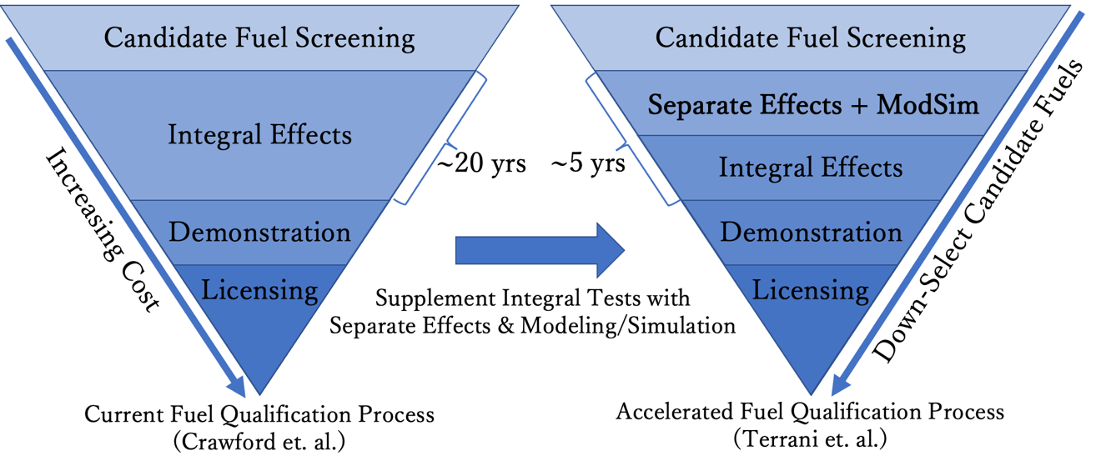
Figure 2.1. Comparison Between Traditional Fuel Qualification [9] and Accelerated Fuel Qualification [10].

being able to match reality. The process will repeat until a knowledge basis for the fuel form is established which can inform integral testing. Through integral testing, confidence of fuel performance across the full envelope can be established, and the process can proceed to full-scale demonstration for validation and eventual licensing.

Sensitivity and Uncertainty Analysis
Sensitivity analysis is an analysis method which can give insight on the influence of each model input parameter with respect to each model output [33]. The advantage of using sensitivity analysis is that it can use existing models and data to determine high impact, high uncertainty parameters in systems that resemble black box functions [11]. As mentioned in the introduction, this is crucial for ensuring that experiments are designed to provide data within the areas of highest model uncertainty within the operating space.
Although my work is specific to nuclear fuel qualification, the framework for simultaneously designing separate effects tests and improving modeling and simulation capabilities can be applied to any system through the use of sensitivity analysis. This approach has been presented before by Fraedrich et. al. as a general method for validating predictive models of expensive, highly-coupled experiments [11]. A diagram of the generalized approach is shown in Figure 2.2. The end-goal of this approach is to develop both a comprehensive database of the experiments considered with validated predictive models that match reality.
The approach has been applied across several different fields with varying applications including hydrological analysis of rivers [16], optimization of chemical plant operation
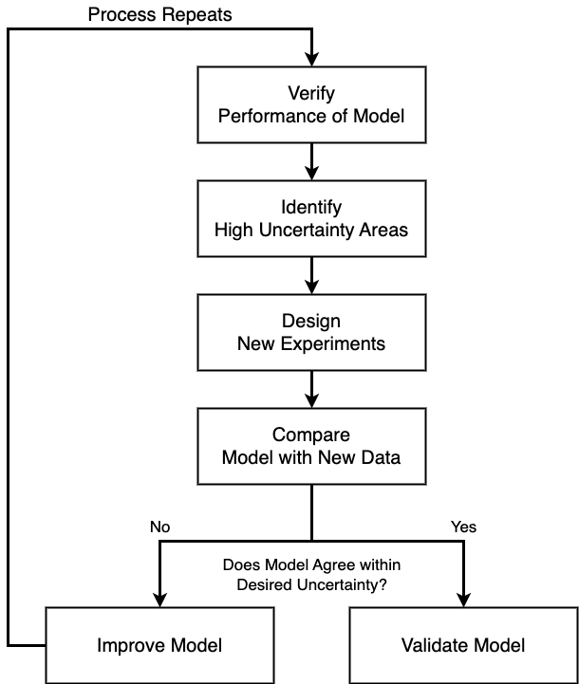
Figure 2.2. General Approach to Iterative Improvement of Predictive Modeling Adapted from [11].

[15], analyzing operational reliability [17], and safety analysis of nuclear waste disposal [34]. Sensitivity and uncertainty analysis has even been recommended across several organizations including the Environmental Protection Agency [12], National Institute for Health and Care Excellence [13], and the NRC [14] as a way to ensure best modeling practice [33]. Across each field of study, the one common factor that necessitates this approach is the cost and expense of performing experiments.
A recent review of sensitivity analysis methods describes the different types of methods and how to use them effectively [33]. Within this dissertation, several methods for global sensitivity analysis are discussed including value of information-based, density-based and variance-based analyses [33]. The three methods for sensitivity analysis that will be utilized throughout the study are the Morris method for parameter screening, and the Pearson and Sobol sensitivity analysis methods for determining importance ranking.

Morris Sensitivity Analysis
Factor fixing is a process that determines the input parameters of least importance across a given sample space [33]. By determining the inputs of least influence towards provided
outputs of interest, it provides justification for the inputs to be fixed throughout the sample space. This will be done using a screening method developed by Morris [35]. The basis behind the Morris algorithm is the development of an independent sample space of “elementary effects” for each input variable, x [35]. If we assume that an output variable, y, is a function of k input variables, such that
 | $$y=f\left(x_{j}\right) :j=(1,2,3,…,k)$$ | 1
then we can define the functional influence of some input x_{i} on the output y as the differential with respect to input i:
 | $$∂_{i}\left(x\right)=\frac{∂_{y}}{∂_{x_{i}}}{\left.​\right|}_{x}$$ | 2
This parameter can have a value of one of the following [35]:
- 0, suggesting negligible influence
- a non-zero constant, suggesting a linear and additive correlation
- f(x_{i}), suggesting a non-linear correlation
- f(x₁,x₂,x₃,…,x_{j}) such that any j ≠ i, suggesting a coupled influence with another input
The Morris approach takes the differential and evaluates it over a discretized space given by a k × P matrix where P is the number of intervals across the sample distribution of any input where P is any even number greater than 2 [35]. Using a normalized sample range from 0 to 1, a P-level sample distribution can be defined as [0, 1/(P-1), 2/(P-1), …, 1]. Morris then goes on to describe that when evaluating the differential across a subset of the distribution using the discretization given by P, we can calculate a subset of the output’s behavior with respect to the input, which is referred to as an “elementary effect” [35]. An elementary effect of the i^{th} input corresponding to any given value of x is given by the following equation:
 | $$d_{i}=\frac{\left[y\left(x_{1},x_{2},…,x_{i-1}, x_{i}+Δ,x_{i+1},…,x_{k}\right)-y\left(x\right)\right]}{Δ}$$ | 3
The idea behind the calculation of elementary effects is to gain insight of the functional behavior without needing to inspect the full sample range. With calculation of enough elementary effects, we are able to approximate the mean and standard deviation of each distribution which are used to gauge overall influence and higher order effects of each input, respectively [35, 36]. The total number of runs required for calculation of each elementary effect is 2, once for the given value of x, and one at some interval given by Δ. The total number of runs, n, assuming a set number of elementary effects, e, calculated for the total input parameters, k, is then
 | $$n=2ek$$ | 4
Optimizations to the method of Morris have been developed recently including enhanced sampling strategies that aim to maximize the efficiency of the sampled elementary effects, henceforth referred to as “trajectories” [36, 37]. Since the method of Morris traditionally requires calculates trajectories with random starting points, there is no guarantee that a sufficient representation of the sample space will be produced [35]. Campolongo et. al. developed an alternative sampling algorithm that first generates a large number of proposed trajectories to be calculated, typically ~500-1000, and then selects the 10 most optimal for use in the calculation [36]. The optimal trajectories are those with the largest cumulative distance between them within the input space calculated using a brute-force method. This guarantees a more representative coverage over the entire sample space rather than the Monte Carlo approach as suggested by Morris [35]. An additional improvement to this method was proposed by Ruano et. al. which optimizes the brute-force approach proposed by Campolongo to streamline the calculation of the optimal trajectories [37].

Pearson Sensitivity Analysis
Variance reduction is a process that aims to assess the inputs and determine which input, if we knew the true value, would reduce the most variance in the output [33]. One such method for performing global sensitivity analysis was developed by Pearson [38]. The Pearson product-moment correlation coefficient (PPMCC) is a dimensionless measurement of the covariance of 2 continuous variables that is bounded between -1 and 1 [39, 40]. Assuming we have two continuous variables X and Y, the PPMCC, most commonly denoted as r, across N samples of X and Y can be defined using the following set of equations:
 | $$\overline{X}=\frac{1}{N}\sum_{i=1}^{N}{X_{i}}$$ | 5
 | $$\overline{Y}=\frac{1}{N}\sum_{i=1}^{N}{Y_{i}}$$ | 6
 | $$r=\frac{\sum_{i=1}^{N}{\left\{\left(X_{i}-\overline{X}\right)\left(Y_{i}-\overline{Y}\right)\right\}}}{\sqrt{\sum_{i=1}^{N}{{\left(X_{i}-\overline{X}\right)}^{2}}}\sqrt{\sum_{i=1}^{N}{{\left(Y_{i}-\overline{Y}\right)}^{2}}}}$$ | 7
As the value of an input variable increases, the output will either increase, decrease, or stay constant, resulting in a PPMCC with a positive value, negative value, or a value of 0, respectfully. Values of the PPMCC are based on a relative scale of linearity between the input variable and output variable. More specifically, trends that approach a straight line will lie closer to 1 or -1, while less linear behavior, approaching random scatters surrounding the trend line, will fall closer to 0.
Although the PPMCC will allow us to determine if the trend is linear, there is no measure of magnitude of the distribution in the outputs. This can be better estimated using the value of r² which is known as the coefficient of determination although the magnitude of the Pearson coefficient is sufficient for determining sensitivity. We assume that to have at least weak linearity, the PPMCC of an input parameter must be above 0.2 or below -0.2 which is between the two bottom ranges presented in Schober et al. [39]. It is important to note that a Pearson coefficient outside the threshold for linearity does not necessarily mean that the inputs and outputs are not correlated so it is important to also plot the sampled data for additional analysis [39]. This is especially important since any trend that is periodic, exponential, discontinuous, etc. will give an unreliable PPMCC.

Sobol Sensitivity Analysis
Another method for global sensitivity analysis is the Sobol sensitivity method [41]. This is a method focused on variance reduction which assesses how much the variance of the output would decrease if we can decrease the variance of an input parameter or group of input parameters [33]. Variance reduction methods such as the Sobol method typically discretize the input space similar to the method of Morris and then approximate the variance of the output using a non-linear curve fit of the expected value of the output [33]. The curve fit, ϕ_{α}, is given by,
 | $$φ_{α}(x_{α})= E\left[Y | X_{α}=x_{α}\right]$$ | 8
where the output, Y, is evaluated with an input parameter, or group of input parameters, X_{α}, at a fixed [33]. The fit is then measured using the following,
 | $$S_{α}=\frac{V[φ_{α}\left(x_{α}\right)]}{V[Y]}$$ | 9
where S_{α}, is known as the first order index [33]. The first order index, hereafter denoted S_{1st,α}, is a measure of the model output variance by fixing the model input, X_{α,} and allowing the set of all other input parameters or parameter groups, denoted by $X_{\sim }$, to vary. The first order index represents the direct impact of an individual input or group of inputs on the output, not accounting for any interactions between other inputs, and is evaluated as:
 | $$S_{1^{st},}=\frac{V_{X_{}}[E_{X_{\sim }}[ Y|X_{} ]]}{V[ Y ]}$$ | 10
The sum of all the first and higher order effects, E.G. the fraction of variance stemming from any combination of 2 or more variable interactions, with respect to any input X_{α} is known as the total effect. The Sobol index for total effect, S_{Total,α}, represents the variance of a given input or group of inputs induced by both its interactions with the other input parameters, and its individual influence. The total effect is denoted:
 | $$S_{Total,}=\frac{E_{X_{\sim }}[V_{X_{}}[ Y|X_{} ]]}{V[ Y ]}$$ | 11
The sensitivity coefficients for the total effect of each input form a set of terms summing to a value of 1 [41]. The main benefit of this method over the previous method developed by Pearson, is that it is applicable to both linear and non-linear correlations [42].

Considerations for Sensitivity Analysis
While sensitivity analysis can be a powerful tool to gain insight on these expensive black box functions, there are several factors to consider that are imperative to the conclusions drawn. Sample ranges must be carefully considered and applied within realistic ranges. Improper selections of sample ranges can skew results and associate artificially high sensitivity to parameters. When considering the sensitivity of a model, it is often useful to consider the extremes of a sample range while uncertainty analysis usually looks at a subset of the full sampling range based on a parameter's associated uncertainty [43]. Whether the variables within the analysis are dependent or independent can drastically change the sensitivity of inputs when using methods such as the Sobol analysis [44]. Dependent parameters may have a lower calculated sensitivity than their independent counterparts, and can alter conclusions of the analysis. Finally, if models are not representative of reality, the sensitivity of each parameter may not necessarily reflect the true sensitivity. With this in mind, it is important to compare model results to experimental data to ensure that the models are capable of capturing the fundamental mechanisms behind the tests that are being inspected. Even if all these practices are followed, it is important to follow the sensitivity analysis by applying the results back to experiments to demonstrate the calculated sensitivity.

Case Study 1

Critical Heat Flux
The work associated with this case study has been published in [23, 24] and is modified to give a cohesive overview of the work. Specifically:
- N. A. MEEHAN, et al., “Sensitivity Analysis of Transient Critical Heat Flux by RIA Under High-Pressure Flow Boiling Conditions in TRTL,” Nuclear Technology, (2023); https://doi.org/10.1080/00295450.2023.2195355.
and
- N. A. MEEHAN, C. P. FOLSOM and N. R. BROWN, “A knowledge gap analysis for transient CHF prediction within RELAP5-3D,” Nuclear Engineering and Design, 422, (2024); https://doi.org/10.1016/j.nucengdes.2024.113171.
Reactivity-initiated accidents (RIAs) are a design basis accident for LWRs which are characterized by a rapid insertion of reactivity and a corresponding localized increase in fuel temperature. This rapid increase in temperature and heat flux can initiate a boiling crisis if the CHF of the cladding-liquid interface is exceeded. The boiling crisis and resulting onset of CHF causes a localized degradation in heat transfer due to the formation of a vapor layer between the cladding and the coolant. Cladding under this condition is at risk of ballooning, which can compromise the coolable geometry of the subchannel and impede coolant flow, and subsequent failure by rupture or exceeding the cladding melt temperature; both of which can release fission products into the system. To prevent these consequences, operational margins are designed to avoid reaching CHF [45].
Early studies on the fundamentals of CHF phenomena based on the hydrodynamic instability model were limited to steady-state conditions [46, 47]. However, recent studies have shown discrepancies in predicting CHF under power-transient conditions using steady-state CHF models. Some reported that the transient heating resulted in similar or higher values of CHF [48, 49], and even decreasing values of CHF under certain transient conditions [50]. Different tendencies with respect to power transients introduced challenges in explaining the fundamental mechanism beneath the occurrence of CHF [51], which has led to a substantial gap in prediction accuracy. The heterogeneous spontaneous nucleation (HSN) model was developed based on the observation of direct transition to film boiling without reaching nucleate boiling [52], and provided evidence that the mechanism of transient CHF is different from steady state CHF [50]. The HSN model elaborates that the manifestation of CHF is the result of rapid levitation of the liquid sublayer on a heated surface by explosive-like HSN in cavities on the cladding surface.

Factors that Influence CHF
The phenomenon of CHF is highly coupled to the surrounding environment with influence stemming from power distribution, coolant channel geometry, coolant conditions, irradiation dose, and energy deposition rate [53-59]. In this work, I inspect several separate effects facilities that have attempted to isolate the rapid heating enhancement of CHF by using single, unfueled, cladding samples under either pool or flow boiling conditions. To determine the parameters of greatest importance to the prediction of CHF under these simplified conditions, we need to understand the mechanisms that affect the behavior of CHF. Several extensive reviews of the literature have been performed regarding the mechanisms behind and parameters of influence to transient CHF and the factors that would influence the separate effects systems of interest are summarized below [55, 60].
The exponential period is a key factor that accounts for the transient characteristics of boiling heat transfer and CHF. The importance of power-transient features in understanding CHF was previously demonstrated when conventional interfacial heat transfer models generated erroneous results in predicting thermal responses for fast transients where the transient exponential period was smaller than the exponential period of the representative phenomena [61]. Additional research showed that the exponential period becomes more important when the heating surface has a relatively low heat capacity [62]. Su et al. [63] determined that the heat transfer coefficient is dependent on the exponential period of the heat generation rate. Recent studies introduced the exponential period into empirical correlations of CHF prediction and showed good agreement with experimental data of pool and flow boiling transient CHF [50, 60, 64-69]. Pasamehmetoglu et. al. [61] and Serizawa [70] derived a correction factor based on the exponential period term that accounts for a power transient in pool boiling and subcooled flow boiling, and Chang et al. [71] used this correction factor to validate transient CHF mechanisms against experimental data. Research done by our group at UTK [72] characterized the significant impacts of power-transient features on the peak fuel and outer cladding temperatures, as well as the time occurrence of CHF. Pervious work in our research group developed a modification of the CHF model to mechanistically account for transient effects which enhanced the capability of RELAP5-3D to predict the thermal response of fuel under an RIA-type event [73].
Thermal properties of heater materials are key parameters for estimating CHF under both steady state and transient conditions. Early studies on pool boiling experiments using various heater materials reported strong evidence that material properties effect transient CHF [74-76]. Thermal properties including density, specific heat capacity, as well as thermal conductivity are often investigated in the combination of other parameters, such as thermal effusivity, thermal diffusivity, thermal activity, and heat transfer time constant (HTTC). One previous study [77] reported a strong correlation between the thermal effusivity of heater and CHF, while another [78] described the occurrence of CHF using thermal diffusivity of heater materials. The thermal activity-based correlations could account for the pool boiling CHF for some heater materials [79-81], although it has yet to be applied for aluminum-based heat surfaces [82]. A recent study at UTK used HTTC to account for the effect of thermal properties under transient conditions and yielded the exact characterization of the contribution of HTTC on the peak fuel and outer cladding temperatures, as well as the time occurrence of CHF using sensitivity and uncertainty analysis [18].
Radiation-induced surface activation (RISA) has been known to influence the wettability of metallic heating surfaces. Following early observation of enhanced quenching performance within in-pile reactor experiments [83], several studies have reported that gamma-ray irradiation increases the wettability of metal oxides [84], and non-oxidized metallic surfaces including titanium, Zircaloy-4, stainless steel 304, and copper [57, 85-87]. Interestingly, an irradiated and oxidized Zircaloy-4 surface coated in chromium was able to achieve super-hydrophilicity due to its high surface conductivity, which demonstrated that RISA effects are dependent on surface chemistry and material properties [87]. The mechanism of RISA is assumed to be a result of water radiolysis on the surface induced by gamma-ray irradiation that produces the hydroxyl group [86, 88]. Since the wettability of the heating surface plays an important role in the manifestation of CHF, the CHF enhancement by RISA effects has been investigated using various materials. Okamoto et al. [89] conducted pool boiling experiments using oxidized SS304, which yielded a CHF enhancement up to about 20 % following surface irradiation. Georgenthum et al. [90] also noted that an irradiated heating surface allows for high heat fluxes, which lowered the maximum cladding surface temperature and delayed the occurrence of CHF. More recently, Gong et al. [91] presented large increases of the surface wettability, as well as CHF enhancement of 64 % after gamma-ray irradiation in their downward-facing pool boiling experiments. One should note that the enhancement of surface wettability was reduced once the samples were removed from the irradiation environment [57, 86, 88], and the CHF of irradiated surfaces can decrease under certain experimental conditions [92].

Modeling CHF
Traditionally, model estimates for CHF within widely used thermal hydraulic systems codes, such as the Reactor Excursion and Leak Analysis Program - Three Dimensional (RELAP5-3D) and the Trac/RELAP Advanced Computational Engine (TRACE), utilize steady-state look-up tables developed by Groenveld et al. [93-96]. However, the use of conservative models for RIA scenarios have contributed to large uncertainties in predicting the value of CHF as well as the cladding temperature [97, 98]. Nuclear Energy Agency (NEA) reports stated the need to further assess additional influential parameters to improve the prediction of transient CHF and post-CHF phenomena through both code-to-code comparison and comparison to experimental data [97, 98].

Project Overview
The overarching objective of this work is to improve the currently implemented CHF model to mechanistically account for transient, material and RISA effects, and to validate the model using a database acquired from experiments. To support this goal, I have investigated experimental results from several facilities including the Transient Reactor Test Loop (TRTL) Facility at Oregon State University (OSU), the Critical Heat Flux Static Environment Rodlet Transient Test Apparatus (CHF-SERTTA) capsule within the Transient Reactor Test (TREAT) facility at Idaho National Laboratory (INL), and a pool boiling chamber at the University of New Mexico (UNM). My work focuses specifically on the power transient effect. Included in the present work are the corresponding models of each facility within RELAP5-3D with an implemented transient CHF correlation, sensitivity analysis of the CHF prediction parameters, comparison with the available experimental results, and a proposed campaign of experiments to address discovered modelling gaps.

The TRTL Facility (OSU)

Background and Capabilities
The original design of TRTL was to perform rapid transient tests in a flow loop for the purposes of replicating experiments to be performed in an in-pile flow loop designed for use in the TREAT facility at INL [99]. These experiments would support the ATF campaign by emulating PWR RIAs, so TRTL was designed to operate at PWR pressures, temperature, and flow conditions and to support rapid transient testing. The primary loop of the TRTL facility consists of an instrumented, heated test section inserted in a flow loop with supporting infrastructure and instrumentation built-in [100]. A simple schematic and operational parameters are presented in Figure 3.1 and Table 3.1, respectively. The TRTL facility is shown as-built within the OSU Advanced Thermal Hydraulics Research Laboratory with a corresponding instrument diagram of the primary flow loop in Figure 3.2. The instrumentation map shows the locations of the instruments that will be used for the CHF analysis including fluid thermocouples, TF’s, pressure transducers, PT’s, the installed venturi meter, FT-401, and turbine flow meter, FT-402.
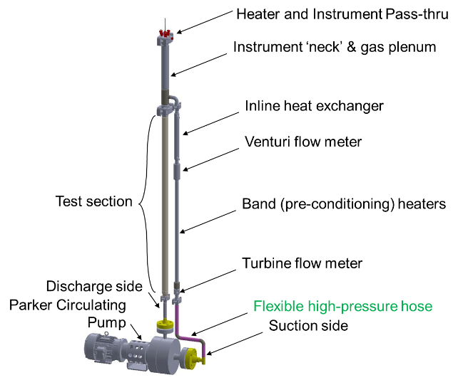
Figure 3.1. TRTL Primary Loop Schematic [100].

Table 3.1. TRTL Loop Design Parameters for Operation [19, 100].
Parameter |  | Value | Units
System Design Pressure | P | 0-20.7 | MPaG
System Fluid Temperature | T_{F} | 300-600 | K
Volumetric Flow Rate | Q | 0-10.2 | m³/hr
Power Transient Length | τ | ~10-∞ | s⁻³

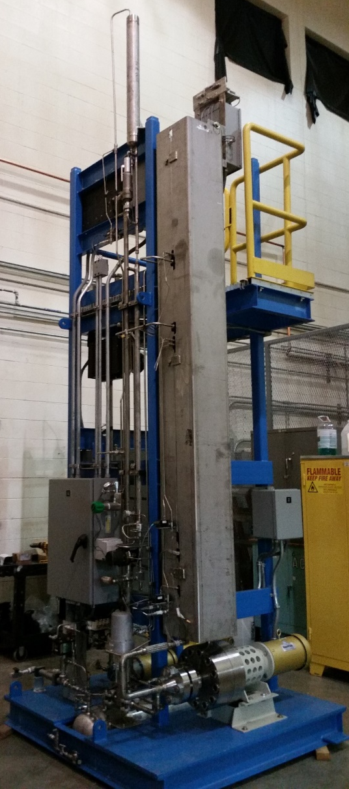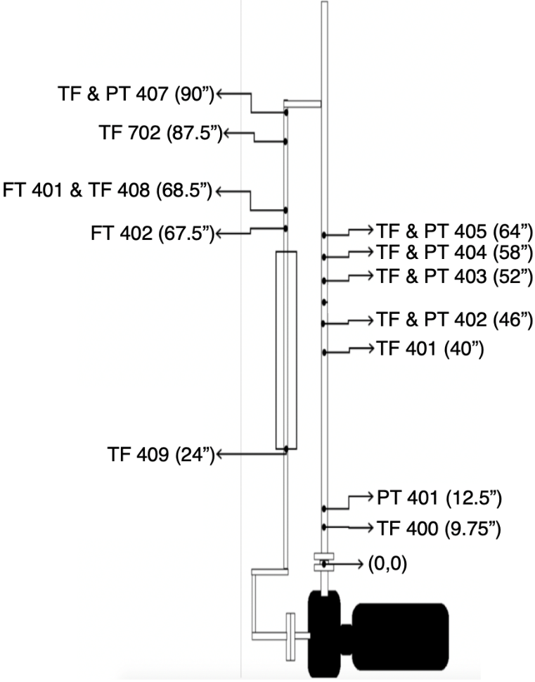
Figure 3.2. TRTL Facility (Left) Within the OSU Advanced Thermal Hydraulics Research Laboratory (Right) Instrumentation Diagram of the Primary Loop [100].

Coolant flow is circulated throughout the primary test loop by a magnetic drive centrifugal pump that is capable of providing a test section flow rate of ~ 4 m/s when operating at 95-100% capacity [19, 101]. A secondary heat removal system is used to cool the fluid following rapid transients and during longer or higher power transients. It also allows the loop to stabilize at higher temperatures and pressures. The primary loop may be heated with the heater rod present in the test section or utilize the preconditioning heaters if an initially “cold” test is desired.
The heater rod and associated measuring devices are secured inside of a stainless-steel test section, made up of an annular flow channel connected to the flowing water source. The test section consists of a Greyloc hub with three Conax ports for instrumentation and a central heater rod for conducting CHF or RIA tests. The rod is heated indirectly by three resistance heater wires running the length of the rod and back and controlled through an external power supply.

Model Development and Verification
Two sets of tests were devised for transient benchmarking tests of TRTL; those performed at lower temperatures and low pressure with use of the low-wattage transient rod, and those utilizing the high-wattage transient rod at prototypical conditions [99, 102]. Low-power tests at steady state were conducted using the same initial temperature, T₀, loop pressures, P, of 3.5, 7.0, and 10.5 MPa, and a constant linear heat rate, q’_{SS}, of 0.5 kW/m. Subsequent high-power steady-state tests were conducted using the same initial pressure conditions with initial temperatures of 523, 538, and 553 K and a constant linear heat rate of 5.0 kW/m. All steady-state simulations were run for up to 10000 seconds to ensure steady-state.
Following these initial steady state tests, low and high-power transient tests were also
proposed to evaluate the TRTL response during periods of sudden spikes in the linear heat rate representative of an RIA. Initial testing conditions for low-power transient tests, TRa-TRd, include a pressure of 6.9 MPa, a temperature of 373 K, and a flow rate of ~ 4 m/s. Four sets of transient pulses (i.e., 1.0, 2.0, 5.0, and 10.0 s) were used for low-power transient test. The transient power pulse was assumed to reach its maximum linear heat rate of 2 kW/m at the end of the pulse period before abruptly returning to its pre-transient power level. It was assumed that the power profile would return to its pre-transient power level within 1.0 µs. A table summarizing the conditions of each of the low temperature transient tests is shown in Table 3.2.
The experimentally measured fluid temperatures during a 10s low-power transient test and a corresponding transient power pulse for this case is shown in Figure 3.3. The experimental uncertainty of the thermocouple measurements is 3 degrees Kelvin. Results of the low power experimental transients have been compared to previously developed TRACE and RELAP5-3D code predictions and had seen discrepancies between the initial and transient temperature distributions [102]. I have found that the discrepancies reported [102] were due to inaccuracies in the boundary conditions of the heater rod. The TRACE model has since been updated and will be validated against the experimental data to be used for code-to-code comparison.
Table 3.2. TRTL Low Power Transient Test Matrix Parameters [102].
Parameter | Unit | TRa | TRb | TRc | TRd
T₀ | K | 373 | 373 | 373 | 373
P_{ss} | MPa | 7 | 7 | 7 | 7
q’_{ss} | kW/m | 0.5 | 0.5 | 0.5 | 0.5
q’_{max} | kW/m | 2 | 2 | 2 | 2
V_{ss} | m/s | 4 | 4 | 4 | 4
τ | s | 10 | 5 | 2 | 1

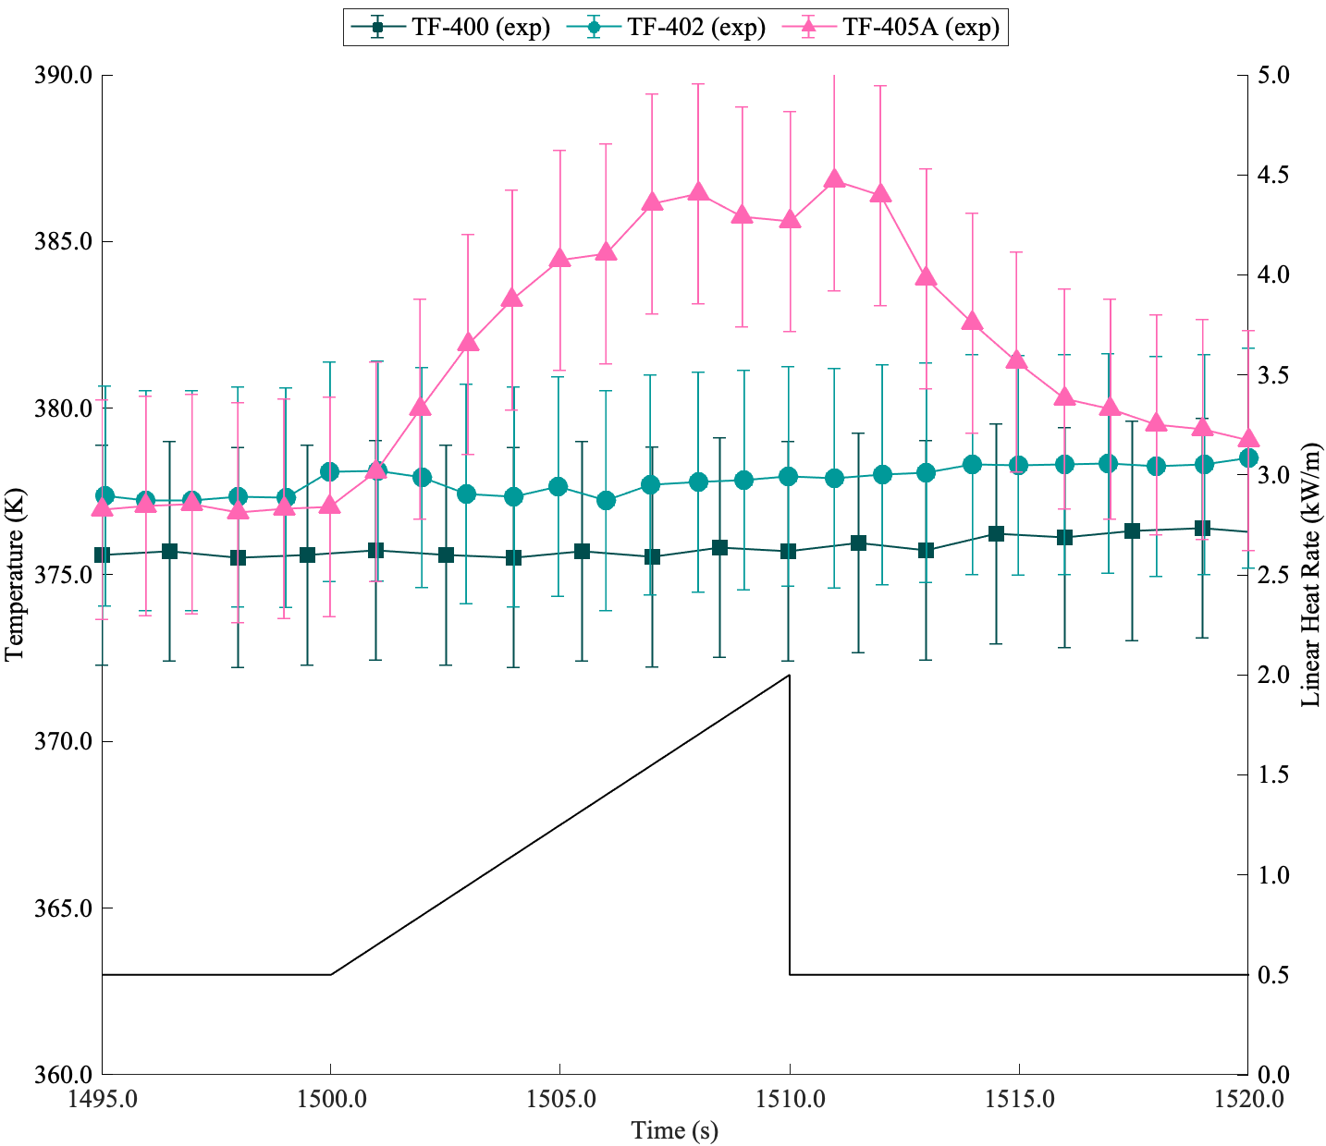
Figure 3.3. Transient TRa Experimental Data with Corresponding Representative Power Pulse Overlaid.

The high-powered transient experiments have not been fully realized for the TRTL facility. While the validity of operating the high-power heater rod was demonstrated in the laboratory setting, the prototypical condition transient tests requiring the use of the high-power heater rod had not yet completed. Instead, high-power transient test simulations using the TRACE and RELAP5-3D code were completed using the conditions close to the transition range between CHF and non-CHF behavior.
As previously mentioned within the literature review, efforts have been made to improve the prediction of CHF and post-CHF behavior within RELAP5-3D [18, 72, 73, 103, 104]. The development of the TRTL facility provides the opportunity to continue the improvement of the RELAP5-3D CHF prediction model. Since there is no legacy CHF data for the TRTL facility, I have developed a RELAP5-3D model of the TRTL facility (independent of the models previously mentioned) to define a performance envelope for a future CHF experimental campaign. The developed thermal-hydraulics model, as seen in the nodalization diagram in Figure 3.4, includes both the primary side (shown in the render) and secondary side (not shown) of the TRTL loop based on the reported operational dimensions and primary side flow conditions [99]. Since there was a lack of instrumentation on the secondary side, the conditions of the secondary side are determined such that the steady state conditions of the primary side were reached. While this may cause discrepancies between longer term response of the system, this is deemed negligible for short transients such as those experienced during RIA scenarios.

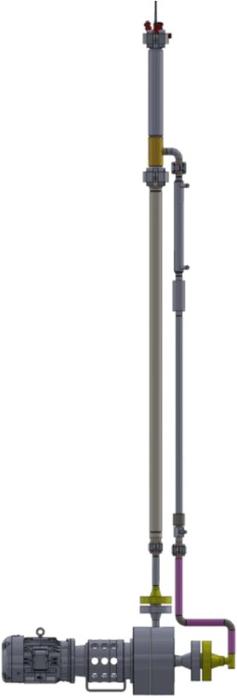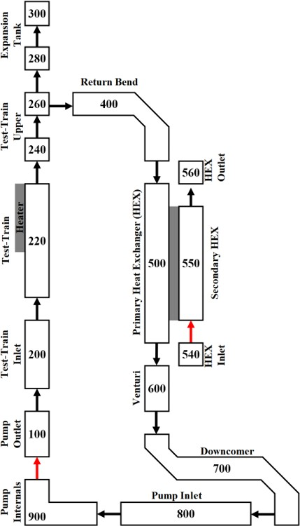
Figure 3.4. Schematic of the TRTL Loop (Left) with a Corresponding RELAP5-3D Nodalization Diagram (Right).

Our RELAP5-3D model and the updated legacy TRACE model will be validated against the low power experimental results such as those in Figure 3.3. Each test starts at a constant power until steady state is achieved, after 1500 seconds, then triggers an exponential pulse of varying exponential period and magnitude. The transient power of each pulse is of the following form
 | $$P_{Tr}=P_{SS}+G\left(e^{\frac{t-t_{s}}{τ}}-1\right)$$ | 12
where $P_{SS}$ is the steady state power, $G$ is the maximum transient power which accounts for the exponential functional form and the steady state power, t is the problem time, $t_{s}$ is the start time of the transient, and $τ$ is the exponential period of the transient.
The low-power transient tests are run at 373 K and 7 MPa which are lower than typical PWR conditions. Transient fluid temperatures measured by thermocouples 400, 402, and 405 along the test train for cases TRa and TRb are shown in Figure 3.5 and Figure 3.6, respectively. The RELAP5-3D and TRACE fluid temperature predictions fall within the measured uncertainty for most of case TRb and show slight differences between the experimental data with a maximum relative error below 2% in case TRa. The main differences between the model and experimental measurements are the initial fluid temperatures and post transient behavior which is caused by the uncertainty in the boundary conditions of the secondary side of the loop.
High-power transient tests have not yet been performed experimentally so these cases were run using the newly developed RELAP5-3D model and TRACE model for code-to-code comparison. The testing conditions of tests TR5-TR8 are summarized in Table 3.2.

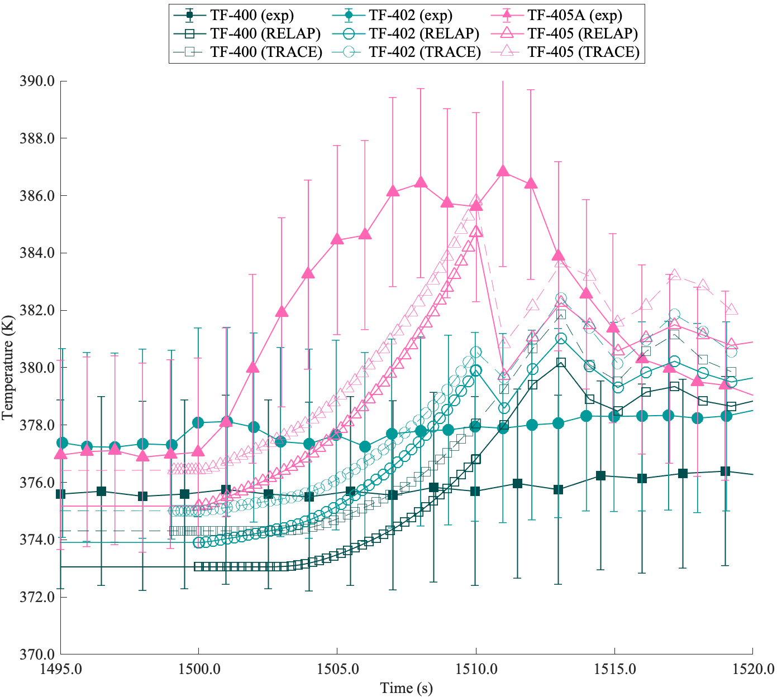
Figure 3.5. Comparison Between Experimental Data, RELAP5-3D Code Predictions, and TRACE Code Predictions for Case TRa.

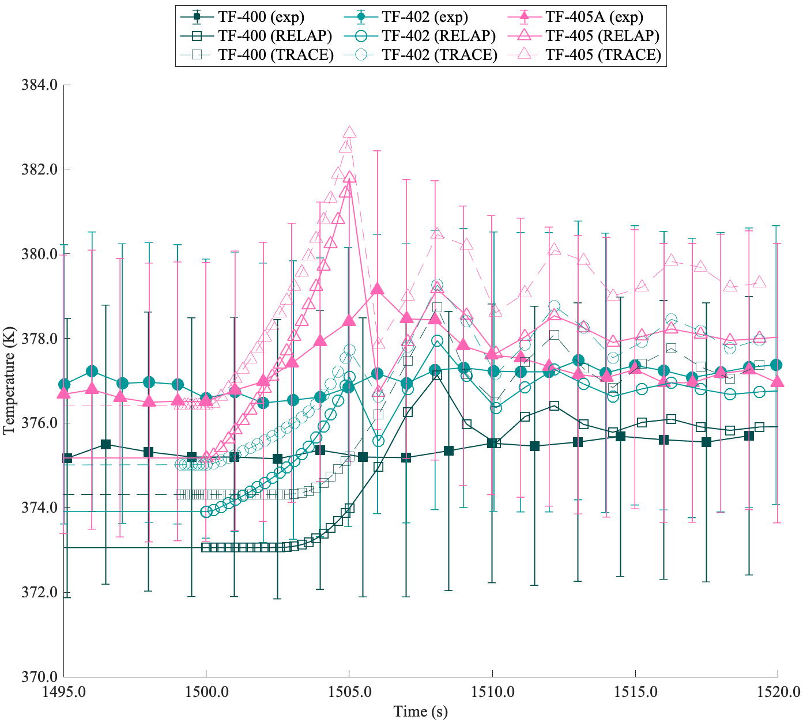
Figure 3.6. Comparison Between Experimental Data, RELAP5-3D Code Predictions, and TRACE Code Predictions for Case TRb.

The high-power test cases showed good agreement for cases, TR5-TR7. However, during case TR8, RELAP5-3D predicted CHF to occur while the TRACE model did not. A comparison of fluid temperatures at thermocouple locations 400, 402, and 405 for case TR5 and TR8 are shown in Figure 3.7 and Figure 3.8, respectively. Within case TR8, lower peak temperatures were observed during the initial energy deposition, and a distinct second temperature peak is observed at around 1 second following the first peak. This behavior is representative of CHF occurring during the first peak and rewetting following CHF during the second peak.
Although both RELAP5-3D and TRACE evaluate the CHF value using a look-up table, RELAP5-3D uses the 1986 AECL-UO CHF look-up table while TRACE uses the 1995 AECL-IPPE CHF look-up table, which is an updated version of the 1986 look-up table [96, 105]. The 1995 AECL-UO CHF look-up table [94] was developed specifically for 8mm tubes and implements a correction factor to the original methodology developed for the 1986 table [93]. This correction factor likely causes the CHF prediction in this test to be higher for the TRACE model compared to the RELAP5-3D model, preventing CHF from occurring within the TRACE simulation. Whether or not CHF occurs has a significant influence on predicting thermal hydraulic behaviors of system, so it is important to explore the sensitivity to input parameters associated with the CHF and pre-
/post- CHF models.
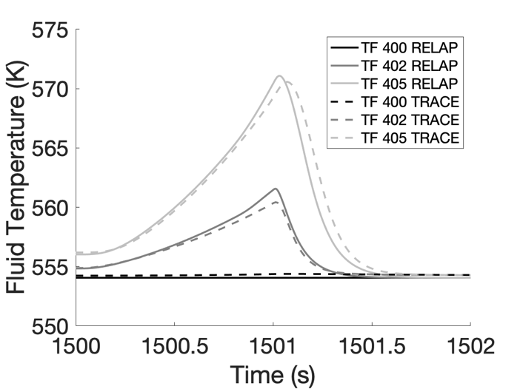
Figure 3.7. Comparison Between RELAP5-3D Code Predictions, and TRACE Code Predictions for Case TR5.

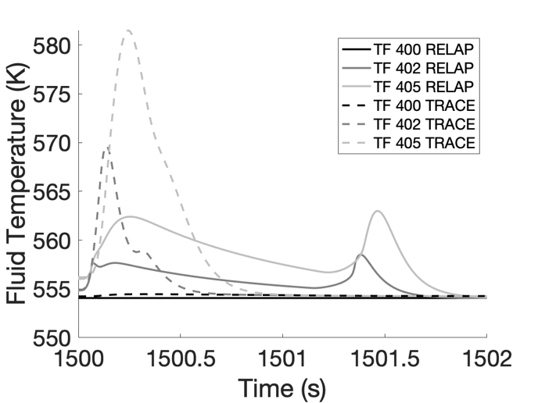
Figure 3.8. Comparison Between RELAP5-3D Code Predictions, and TRACE Code Predictions for Case TR8.

Sensitivity Analysis
To analyze CHF within the RELAP5-3D model, I developed a proposed experimental test matrix for the TRTL facility, shown in Table 3.3, to inspect the influence of the power pulse exponential period on the CHF of the system [23]. This test matrix was chosen such that all cases would reach CHF prior to the implementation of a correlation to mechanistically account for transient CHF into RELAP5-3D. Within this sensitivity analysis, I aim to determine the sensitivity of the model calculation to specific input parameters that relate to transient CHF. The figures of merit (FoMs), model outputs that I will use for the analysis with regards to reactor safety, include the peak cladding heat flux, the peak cladding temperature, the time of CHF occurrence, and the time of cladding rewetting. The inputs I will be varying are the thermal properties of the cladding, the boiling heat transfer multipliers and the CHF multiplier.
Table 3.3. Proposed Experimental Test Matrix Details.
Parameter | Unit | Case 1 | Case 2 | Case 3 | Case 4 | Case 5 | Case 6
Exponential  Period | ms | 100 | 60 | 55 | 60 | 65 | 70
Maximum Transient Linear Heat Rate | kW/m | 44.89 | 25.14 | 44.89 | 36.94 | 30.82 | 26.03
Critical Heat Flux Multiplier | n/a | 1.431 | 1.585 | 1.617 | 1.585 | 1.558 | 1.534

The experimental power pulses for each test are exponential ramps in power of the same form as the experimental validation test matrix shown in Equation 12.
The steady state power is given by $P_{SS}$. The problem time is given by t, the start time of the transient, which is the same for each transient, is given by $t_{s}$, and the exponential period of the transient is given by $τ$. The maximum transient power is given by G, which is calculated based on the desired value of $P_{Tr}$ for the given values of $P_{SS}$, $t_{s}$, and $τ$ at the time of peak power. Once the peak power is reached, the power immediately returns to
the steady state value for the remainder of the simulation. A visualization of the power pulses that will be analyzed for this sensitivity analysis can be found in Figure 3.9.
Case 1 and 2 are the maximum and minimum total energy deposition for CHF occurrence within the chosen sample range, and cases 3-6 have the same total energy deposition, but varying energy deposition rates. The full results of the parametric sweep based on the time of CHF are shown in Figure 3.10. The open circles represent cases which did not reach CHF and the closed circles represent cases that have reached CHF and are colored according to the time of CHF occurrence.
I performed the sensitivity analysis inspecting the RELAP5-3D model boiling heat transfer multipliers and the thermal properties of the cladding. The boiling heat transfer multipliers are direct multipliers on the heat transfer coefficients within the nucleate, transition, and film boiling regimes, and on the look-up table value of critical heat flux.
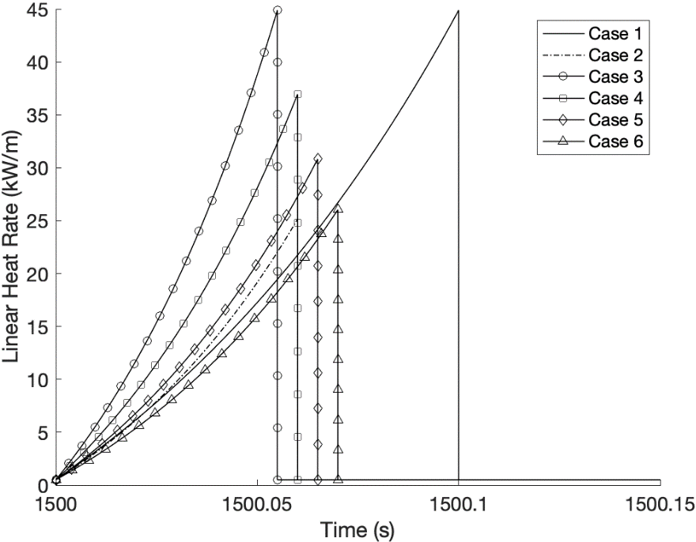
Figure 3.9. TRTL High-Power Experimental Power Pulses as Proposed by Meehan et. al. [106].

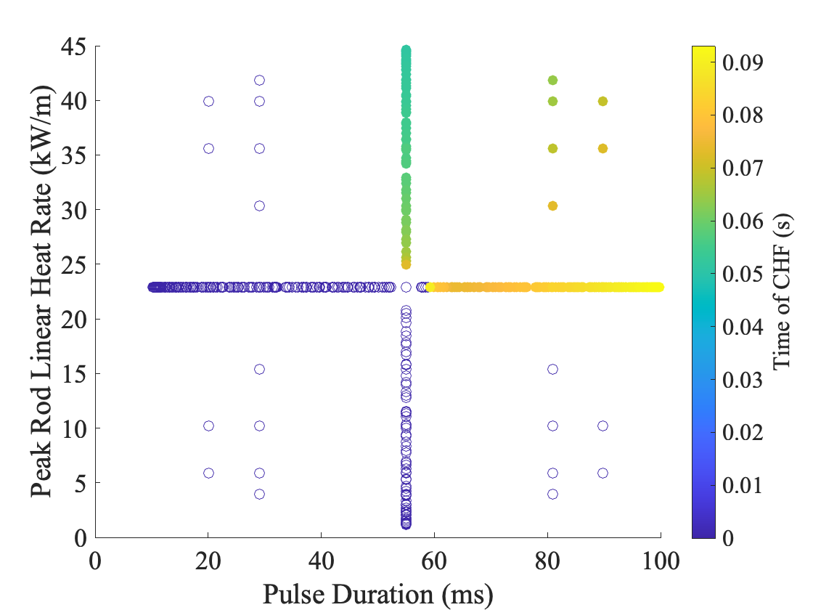
Figure 3.10. Envelope for CHF Occurrence within the TRTL Facility Test Section.

The thermal properties of the cladding have been previously shown to have a non-negligible impact in the uncertainty in peak temperature predictions during CHF, and will
provide additional context of scale for the previously determined relative importance of the boiling heat transfer correlations [18, 72]. Each of these parameters can be accessed within the RELAP5-3D input file without modification of the source code.
Within RELAP5-3D each of the boiling heat transfer mechanisms operate independently of each other and are individually activated using logic based on the water quality, wall temperature, and interfacial heat flux. Since the wall temperature is a function of the thermal properties, the amount of time spent in each heat transfer regime is directly dictated by the thermal properties of the cladding. This interaction could influence the sensitivities of each parameter and place additional influence on the thermal properties of the cladding. Ultimately, while the sensitivity of each parameter can give an idea of which parameters are most important toward the calculation of each parameter of interest, the conclusions drawn from this study must also take into account the comparison to experimental tests. The experimental comparison will give insight on the accuracy of the model and can help give merit toward the sensitivities of each parameter.
The uncertainties in the thermal properties of the cladding are taken from an experimental analysis of SS-316 by Kim et al. which provides empirically derived correlations with respect to temperature [107]. The empirical correlations for the cladding volumetric heat capacity and thermal conductivity were implemented into the RELAP5-3D model assuming a constant density at 1000K within the solid phase [107]. The influence of this assumption should be minimal in the final results as the change in density is nearly linear and varies less than 2.5% within the temperature range of the transients (~600K to 1300 K). The sampling range of both linear empirical correlations was uniform with an uncertainty of 7% of the intercept [107].
The RELAP5-3D code is able to account for mechanistic changes in the boiling heat transfer correlations by applying multipliers to the existing heat transfer correlations. For this application, the CHF multiplier is used to implement a mechanistic increase in the critical heat flux value representative of the transient effect. The boiling heat transfer multipliers are used to vary the boiling heat transfer coefficients across the reported uncertainty in their corresponding empirical correlations. The boiling heat transfer correlations within RELAP5-3D include the nucleate [108], transition [109], and film boiling [110] heat transfer regimes with reported maximum uncertainties in their heat transfer correlations of 11.6, 14.2, and 6.5 %, respectively.
The CHF multiplier within RELAP5-3D is a multiplier on the predicted steady-state CHF look-up table value calculated using the 1986 AECL-UO CHF look-up table by Groenveld et al. [93]. Within this analysis, I account for the transient effect of CHF using an empirical correlation developed by Hata et al. which was informed by experimental CHF cases of SS304 tubes [66]. Test conditions covered by these experiments include a wide range of conditions, with pressures from 718 – 1,315 kPa, inlet subcooling from 68 – 161 K, flow velocities from 4 – 13 m/s, and exponential periods from 16.8 ms – 15.5 s. The experimental results showed increasing transient CHF relative to steady-state CHF with decreasing exponential period; corresponding to increasing heating rate. To capture this behavior, a non-dimensional multiplier was developed containing the power pulse exponential period and dimensionless characteristic length shown in Equation 13. The flow constants C₁ and C₂ are 11.4 and -0.6 as per Lee et al., and $u,τ,σ,g,$ $ρ_{1}$, and $ρ_{g}$ are flow velocity (4 m/s), exponential period (varying based on the test), surface tension (measured at 15.5 MPa and 553 K), gravitational acceleration (9.81 m/s²), inlet density (measured at 15.5 MPa and 553 K), and saturated vapor density (measured at 15.5 MPa), respectively [73].
 | $$\text{Bo=}\frac{{\text{q}}_{\text{tr}}^{\text{''}}}{\text{G}{\text{h}}_{\text{fg}}}\text{=}\frac{{\text{q}}_{\text{st,sub}}^{\text{''}}}{\text{G}{\text{h}}_{\text{fg}}}\text{*}\left[\text{1+}{\text{C}}_{\text{1}}{\left\{\frac{\text{τu}}{\sqrt{\text{σ/g(}{\text{ρ}}_{\text{l}}\text{-}{\text{ρ}}_{\text{g)}}}}\right\}}^{{\text{C}}_{\text{2}}}\right]$$ | 13
This implementation method of the transient CHF correlation into RELAP5-3D using the CHF multiplier was previously demonstrated by Lee et al. and was shown to improve the post-CHF peak cladding temperature prediction by 25% [73]. Since the system pressures for the TRTL facility are much higher than that of the experimental tests used to develop this correlation, I compared predictions of transient CHF against experimental transient CHF data at PWR-relevant conditions by Bessiron [111]. For an exponential period of 30 ms, the correlation predicted a transient CHF value of 5.86 MW/m² which fell within the experimental transient CHF values ranging from 4.2 – 6.5 MW/m². While this suggests that the correlation is applicable at high pressures, it should be noted that the effects of pressure have not yet been studied and need to be investigated further. For this study, I assume that the correlation can be applied for high pressure systems.
Table 3.4 contains the sampled ranges of each of the input parameters. All distributions were considered uniform as the correlations for each of the parameters are based on empirical fits of experimental data, not experimental data itself. Since the CHF multiplier was individually calculated for each test case, Table 3.4 contains the default value of 1 with the corresponding uncertainty of 15% [66].
The Pearson product-moment correlation coefficient (PPMCC) is a dimensionless measurement of the covariance of 2 continuous variables that is bounded between -1 and1 [39, 40]. As the value of an input variable increases, the output will either increase, decrease, or stay constant, resulting in a PPMCC with a positive value, negative value, or a value of 0, respectfully. Values of the PPMCC are based on a relative scale of linearity between the input variable and output variable. More specifically, trends that approach a straight line will lie closer to 1 or -1, while less linear behavior, approaching random scatters, will fall closer to 0. If the relation between the variables is linear, the PPMCC will allow us to determine if there is significant sensitivity of the safety parameter to variation of the chosen inputs.
I assume that to have at least weak linearity, the PPMCC of an input parameter must be above 0.2 or below -0.2 which is between the two bottom ranges presented in Schober et al. [39]. It is important to note that a Pearson coefficient outside the threshold for linearity does not necessarily mean that the inputs and outputs are not correlated so it is important to also plot the sampled data for additional analysis [39]. This is especially important since any trend that is periodic, exponential, discontinuous, etc. will give an
Table 3.4. Proposed Experimental Test Matrix Details.
Parameter | Minimum | Default | Maximum
Multiplier for nucleate boiling HTC (NBM) | 0.884 | 1.0 | 1.116
Multiplier for Critical Heat Flux (CHFM) | 0.85 | 1.0* | 1.15
Multiplier for transition boiling HTC (TBM) | 0.858 | 1.0 | 1.142
Multiplier for film boiling HTC  (FBM) | 0.935 | 1.0 | 1.065
Cladding Thermal Conductivity (W/mK) | 8.601 | 9.248 | 9.895
Cladding Volumetric Heat Capacity (J/m³K) | 3.245 $\text{×}$ 10⁶ | 3.490 $\text{×}$ 10⁶ | 3.734 $\text{×}$ 10⁶
*Multiplier for CHF was evaluated from the exponential period corresponding to the power pulse used for each case.

unreliable PPMCC. For this study, I measure the sensitivity of the peak surface temperature, peak surface heat flux, and the times of CHF and rewetting to variation in the boiling heat transfer and CHF multipliers, and thermal properties of the cladding, specifically volumetric heat capacity and thermal conductivity.
To perform this analysis, I leverage the existing coupling between the RELAP5-3D code and the Risk Analysis Virtual Environment (RAVEN) framework which is developed and maintained by INL. RAVEN is an open-source data analysis framework capable of performing sensitivity and uncertainty analysis through use of both classical statistics as well as more modern artificial intelligence algorithms [112]. The coupled RAVEN/RELAP5-3D code framework to generates and runs input files with randomly sampled input parameters and extracts the corresponding output parameters for the PPMCC analysis. Using the RAVEN Monte Carlo sampler, I construct 25000 samples of each variable in order to ensure the solution is converged. This sample size is determined based on a previously conducted convergence study which ensures that the relative error between successive PPMCCs is below 1% for parameters of relevant importance [23].
As previously discussed within the literature review, the PPMCC being outside the threshold for linearity does not suggest that there is no correlation. Upon inspection of the sample data, I found that implementation of the CHF multiplier causes cases 5 and 6 to not reach CHF in all samples. This created a discontinuity in the data and these PPMCCs are deemed unreliable for the analysis. This discontinuity causes the shift from positive to negative correlations of CHFM and volumetric heat capacity with regard to time of CHF occurrence for cases 5-6. Samples where the CHFM and volumetric heat capacity increased such that the cladding no longer reached CHF use a default placeholder value of 0, so the shift occurs as an artifact of my code.
The PPMCCs within Figure 3.11-Figure 3.14 demonstrate the same behavior as the initial study, but the most significant change is the large influence from the cladding volumetric heat capacity in the prediction of peak temperature, time of CHF, and, to a lesser extent, time of rewetting [23]. The CHF multiplier directly changes the threshold heat flux value for the transition to the film boiling regime, and the amount of energy from the power pulse remaining post-CHF. Similarly, the volumetric heat capacity of the cladding determines the energy required to increase wall superheat, which directly changes the amount of energy remaining post-CHF.
For cases under more rapid energy deposition rates, the results show less correlation with the CHF multiplier, shifting more towards the volumetric heat capacity. This trend is consistent between both the peak cladding temperature and time of CHF occurrence PPMCCs, but with opposite signs since earlier occurrence of CHF causes higher peak cladding temperatures. With regard to the time of rewetting, the relative influence of the CHFM compared to the volumetric heat capacity stays fairly consistent while the FBM
becomes most important under rapid energy deposition transients due to its direct influence over film boiling heat transfer and since the majority of the transient is spent in the film boiling heat transfer regime.

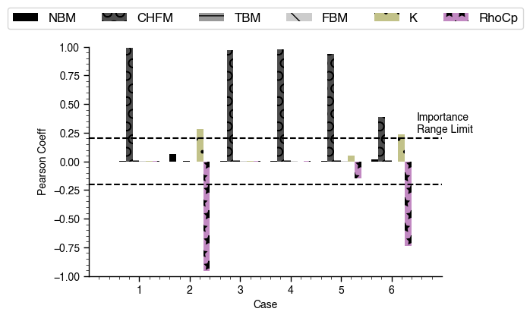
Figure 3.11. PPMCCs for Each Input with Respect to Peak Cladding Heat Flux

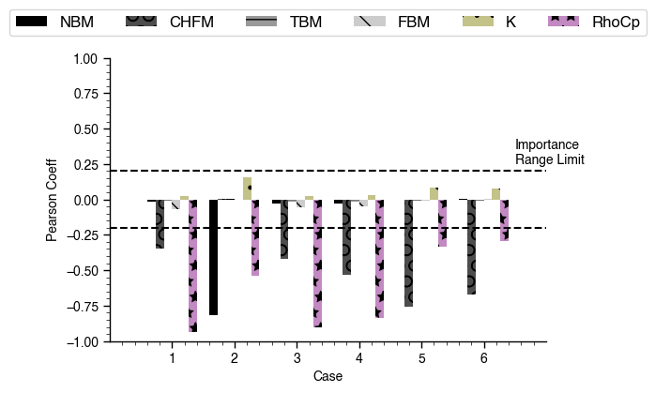
Figure 3.12. PPMCCs for Each Input with Respect to Peak Outer Surface Temperature

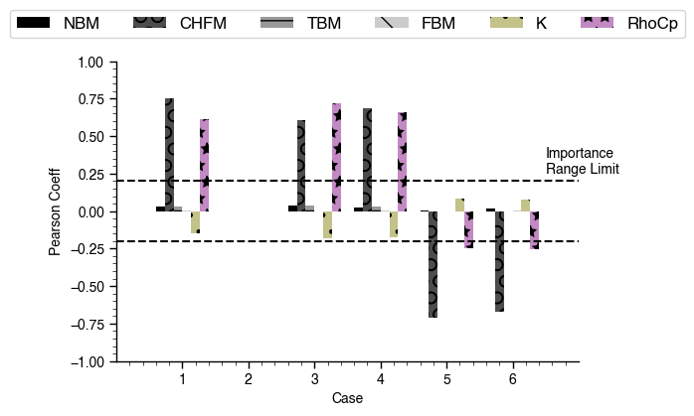
Figure 3.13. PPMCCs for Each Input with Respect to Time of CHF Occurrence

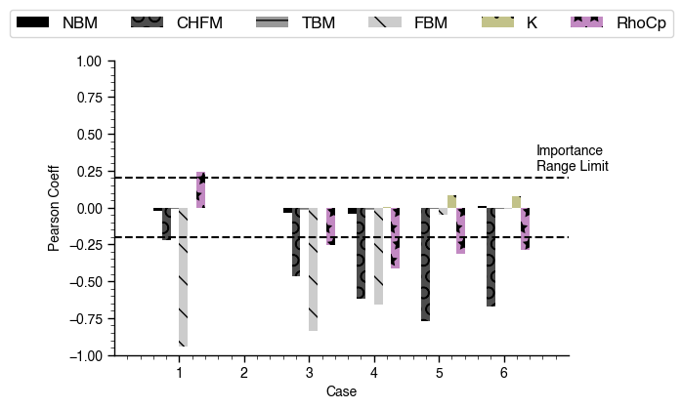
Figure 3.14. PPMCCs for Each Input with Respect to Time of Cladding Rewetting

This suggests that with increasingly fast energy deposition rates, and correspondingly smaller exponential periods, the influence of the heat capacity is greater than the transient heating effects on CHF occurrence. However, since the exponential periods of our proposed experimental tests, with a minimum timescale of 55ms, are relatively slow compared to reported RIA cases for LWRs, with a minimum full width at half maximum (FWHM) of ~25ms, the transients fall into a relatively linear portion of the implemented transient CHF multiplier prior to the exponential region which approaches the 1-10 ms timescale as shown in Figure 3.15. With larger CHFM values, the CHFM could have a higher PPMCC value, but these pulse timescales currently fall outside the performance capabilities of the current TRTL system. Overall, the parameters of highest importance from this analysis are the CHFM, FBM and volumetric heat capacity.

The TREAT Facility (INL)

Background and Capabilities
TREAT is an air-cooled, graphite moderated reactor at INL capable of fast-transient integral effects tests [113]. Treat was initially constructed in the 1950s, and operated until 1994 [113, 114]. The reactor was restarted in 2017 to help support the need for new
nuclear data for nuclear fuel development [114]. The reactor is fueled with high enriched uranium dispersed through graphite moderator blocks and encased in a zirconium alloy to prevent fission product release [114]. TREAT specializes in power pulse transients representative of a reactivity initiated accident, a design basis accident in LWRs, by leveraging fast-acting control rods and the strong thermal feedback effects of the graphite

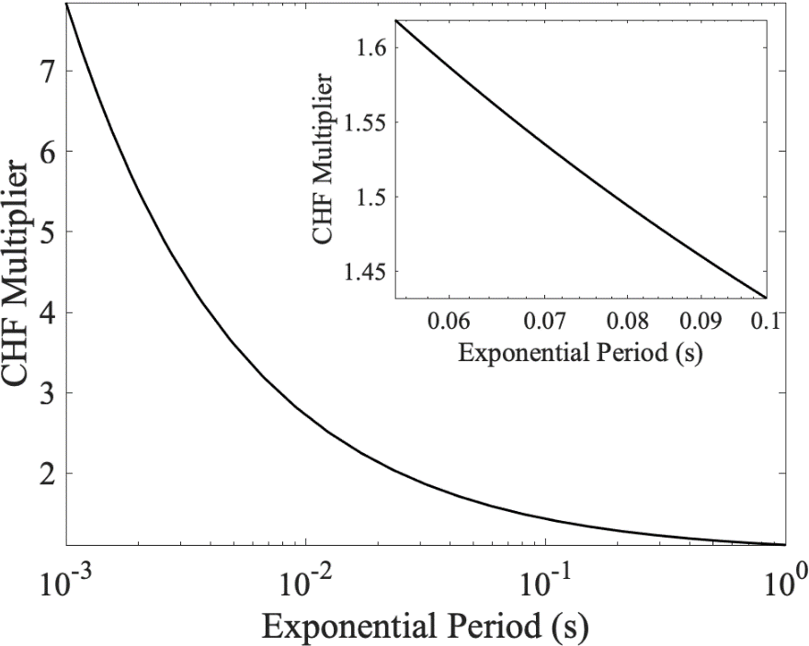
Figure 3.15. CHF Multiplier vs Exponential Period Using the Empirical Model Fit By Hata et al. [66] With Inlaid Graph of Experimental Test Matrix Periods.

moderator which drive down reactivity at high temperatures [113]. With the capability to operate under steady-state conditions of 120 kWt, and flexible operation modes, the TREAT reactor can also provide various power histories for experiments [113]. Irradiation experiments within the TREAT reactor are typically self-contained and instrumented capsules, facilitated by the lack of a coolant system pressure boundary [113, 114]. Experimental test vehicles replace several of the center fuel assemblies when inserted into the core. The standard experiment, as per the campaigns following the 2017 restart, replaces 2 fuel assemblies [114].

The SERTTA Capsule
The apparatus used within the TREAT facility for transient CHF experiments is the CHF-SERTTA capsule; an adaptation of the previously developed MARCH-SERTTA capsule [45]. The capsule is split into two regions, a lower region filled with water that contains a submerged heater rodlet and corresponding instrumentation, and an upper region that contains a cover gas used to accommodate the expansion of water and for pressurization of the capsule. The heater rodlet used in these experiments is hourglass-shaped and comprised of 2.05 wt% borated austenitic stainless steel. The (n,α) reaction within b-10 provides volumetric heating to the rod with transients controlled by reactivity insertions within the TREAT reactor. The hourglass shape ensures low power peaking near the ends of the tube and makes CHF tend to occur toward the axial midplane of the rod where the instrumentation is located [115]. The capsule is fit with several thermocouples on the outer surface of the rodlet for direct temperature measurement, pyrometers within the hollow inner region of the rodlet for indirect temperature measurements, an (n,α) thermometer within the rodlet to gauge energy deposition, and a pair of capacitance plates to determine the occurrence of CHF. A more in-depth description of the capsule can be found in the paper by Folsom et al., and Hill et al. [45, 115].
The CHF-SERTTA test matrix is comprised of 14 test transients [45]. Table 3.5 contains 5 selected tests from the full test matrix and is a similar test matrix to that of the TRTL sensitivity analysis; two tests at relatively high and low energy deposition and three tests at the same energy deposition, but with decreasing exponential period. A visualization of the test matrix is given in Figure 3.16. A MCNP/RELAP5-3D model framework was used by INL to replicate experimental tests performed for the CHF-SERTTA capsule and was determined to consistently underpredict the value of CHF, causing large overestimations in the peak temperature of the rodlet [45].

Table 3.5. CHF-SERTTA Test Matrix for TREAT.
 | CHF-SERTTA-A | CHF-SERTTA-B | CHF-SERTTA-C1 | CHF-SERTTA-C2 | CHF-SERTTA-C3
Pulse FWHM  [ms] | 156 | 109 | 136 | 111 | 93
Exponential Period [ms] | 45 | 31 | 39 | 31 | 26
Total Energy Deposition  [MJ] | 1050 | 1800 | 1400 | 1400 | 1400
Critical Heat Flux Multiplier | 1.202 | 1.261 | 1.223 | 1.264 | 1.298

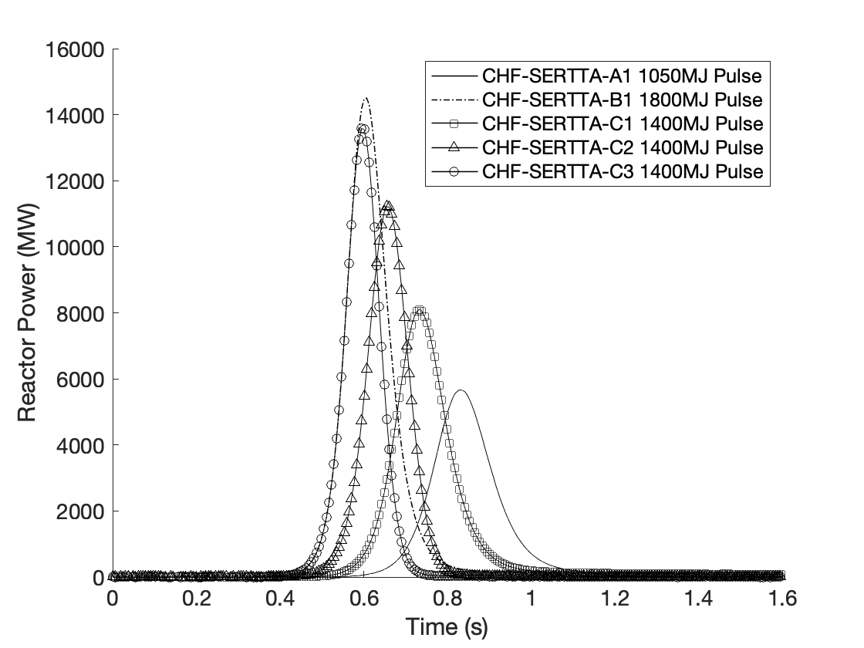
Figure 3.16. CHF-SERTTA Experimental Campaign Test Matrix Transients [45].

Model Specification
Researchers at INL developed a coupled Monte Carlo N-Particle (MCNP) and RELAP5-3D model to simulate the transient CHF experimental test matrix [45]. The MCNP model was used to generate axial and radial volumetric heating profiles that were applied to the RELAP5-3D model as the heat generation profile for the heater rodlet, then RELAP was run with a TREAT power pulse as the heater rod boundary condition to collect the transient data. A summary of both models can be found in the paper by Folsom et al. [45], and a more in-depth assessment of the MCNP model is provided by Hill et al. [115]. A simplified nodalization diagram of the CHF-SERTTA capsule, and a nodalization diagram of the hourglass shaped borated heater rod can be found in Figure 3.17.

Sensitivity Analysis
I used the model developed by INL for the CHF-SERTTA capsule to perform a sensitivity analysis using the same inputs and FOMs from the TRTL analysis. The model inputs considered include the boiling heat transfer and CHF multipliers, and the thermal properties of the cladding. The FoMs are the peak cladding heat flux, the peak cladding temperature, the time of CHF occurrence, and the time of cladding rewetting.
There is no reported uncertainty of the thermal properties of the borated stainless steel, specifically volumetric heat capacity and thermal conductivity, used for the treat CHF experiments. To estimate thermal property uncertainty, thermal properties from the initial model were replaced with that of SS304 empirically fit by Kim, using a constant density
within the solid phase [107]. The properties of SS304 and borated stainless steel are

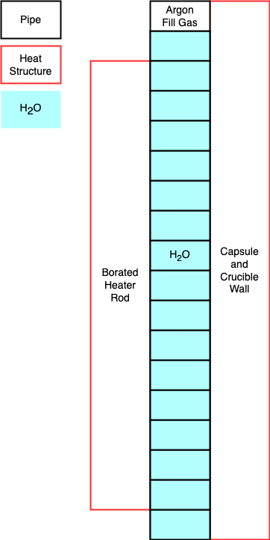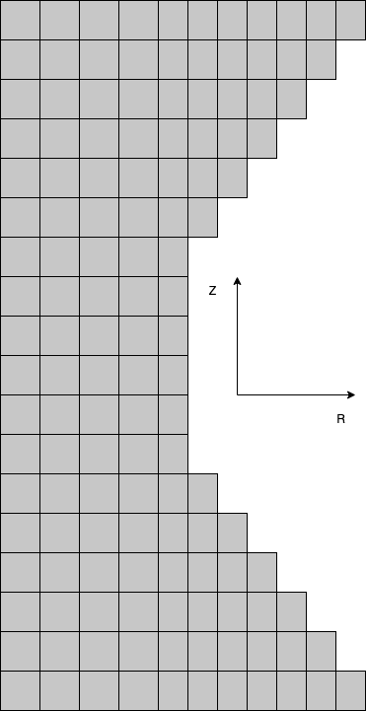
Figure 3.17. CHF-SERTTA Capsule (Left) Nodalization Diagram (Right) Borated Heater Rod Nodalization as Designed by Folsom et. al. [45].

comparable, with less than 5% relative error between the empirical data of SS304 until the maximum reported temperature of 1200K.
The uncertainty range for each of the remaining parameters is the same as previously discussed within the TRTL sensitivity analysis, but with the implementation of an empirical CHF correlation for pool boiling rather than flow boiling. The implemented correlation, given by Equation 14, was developed by Sakurai for liquid subcooling ranging from 60-80 K matching the range of subcooling for the experimental test matrix [50].
 | $$q_{tr}=q_{st}[1+2.3×{10}^{-2}{(τ}^{-0.7})]$$ | 14
Within this equation, q_{st} is the steady-state CHF value which RELAP5-3D predicts using the Groenveld CHF lookup tables, q_{tr} is the calculated transient CHF value, and τ is the exponential period of the power pulse which was calculated using an exponential fit of the experimental power pulses. Using the transient data from the sensitivity analysis, I also developed a set of performance envelopes for each test case to compare with the experimental results and the original model results.
The PPMCCs for each of the multipliers with respect to each FOM within each case is displayed in Figure 3.18 through Figure 3.21. Within this study, the results similar trends to the TRTL study, but with much less importance in the CHFM. These results also show the trend of volumetric heat capacity overtaking the CHFM in importance with regard to the time of CHF occurrence as the exponential period of the transient increases. However, the trends for this parameter show that there wasn’t a very strong correlation

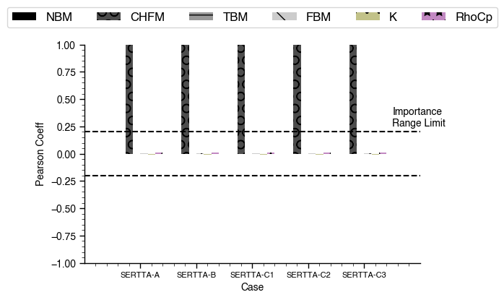
Figure 3.18. CHF-SERTTA PPMCCs for each input with respect to peak cladding heat flux.

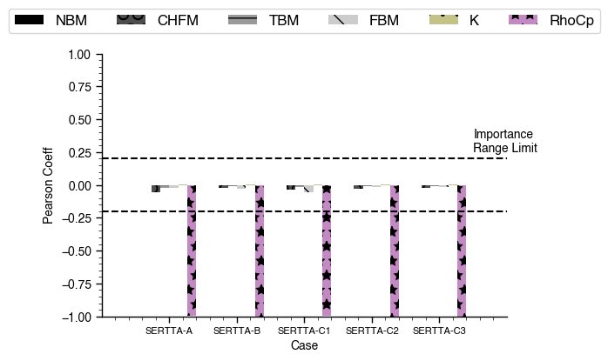
Figure 3.19. CHF-SERTTA PPMCCs for each input with respect to peak outer surface temperature.

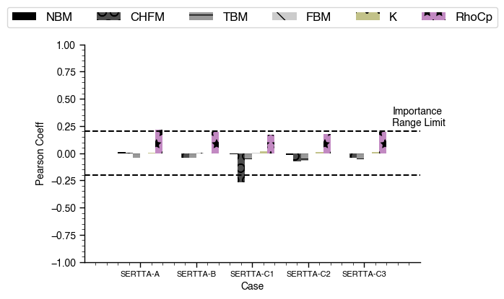
Figure 3.20. CHF-SERTTA PPMCCs for each input with respect to time of CHF occurrence.

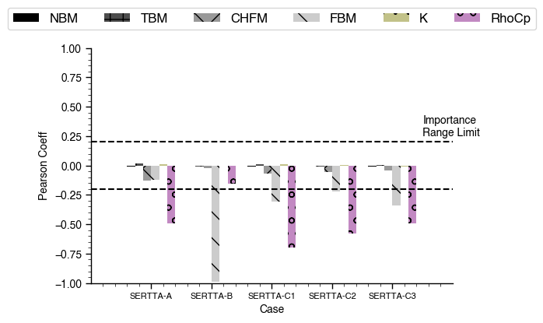
Figure 3.21. CHF-SERTTA PPMCCs for each input with respect to time of cladding rewetting.

between any of the input variables tested, with the peak PPMCC value barely exceeding the minimum importance threshold. With regard to the peak cladding heat flux, the main influence was from the CHFM, but unlike the TRTL results, there is no influence from CHFM with regard to the peak cladding temperature, with the main influence coming solely from the volumetric heat capacity. With regard to the time of clad rewetting, there is once again a large influence from the FBM, but the dependence seems to only be trending more towards the FBM than the volumetric heat capacity for larger energy deposition cases. However, the results somewhat unreliable results for this parameter since there are flashes of film boiling on the cladding past the initial CHF occurrence,causing discontinuity in the dataset. The main takeaway from these sensitivity studies is the RELAP5-3D model appears is most sensitive to the CHFM, the volumetric heat capacity of the cladding and the FBM with regard to our chosen FoMs within the given sample space.

Experimental Comparison
Comparison of experiments CHF-SERTTA-A transient 2, and CHF-SERTTA-B transient 2, selected as the most representative pulses of their series of tests, are shown in Figure 3.22 and Figure 3.23, respectively. For both cases, the RELAP5-3D model performance envelopes, developed over the sensitivity analysis sample range, are seen to consistently underpredict the experimental value of CHF and significantly overpredict surface temperature [45]. The large temperature discrepancy for CHF-SERTTA-A is discussed in the original publications and is thought to be an artifact of fin cooling from the
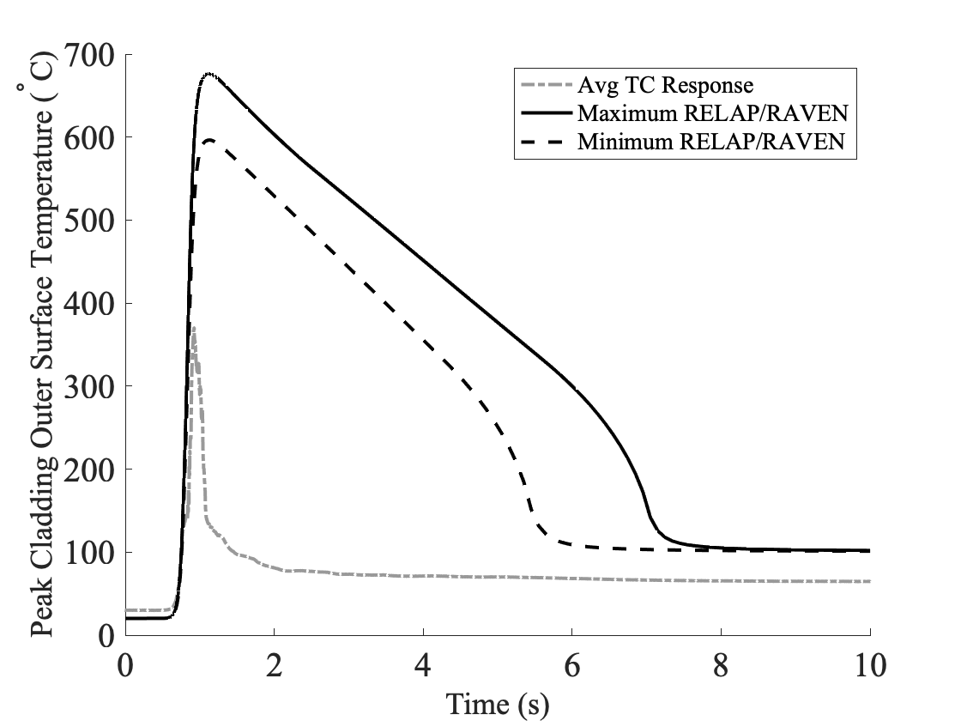
Figure 3.22. Experimental Case SERTTA-A Transient 2 with Experimental Data From R. J. ARMSTRONG, et al. [116].

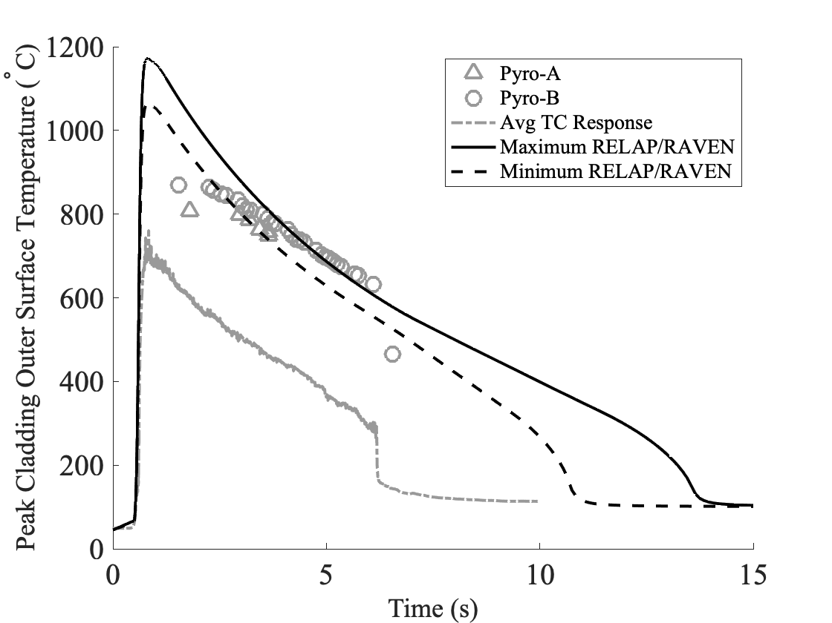
Figure 3.23. Experimental Case SERTTA-B Transient 2 with Experimental Data From C. P. FOLSOM, et al. [45], R. J. ARMSTRONG, et al. [116].

thermocouples welded to the surface of the rod [45, 116]. The developed performance envelopes seem to have a slightly better agreement with the post-CHF temperature measurements for case CHF-SERTTA-B, but our model still predicts a much larger peak temperature and a subsequently longer duration of CHF. However, the consistently large discrepancies between the model predictions and the experimental results further necessitates the investigation of transient heating for the prediction of CHF and for pre- and post-CHF boiling heat transfer. Another factor to consider, not investigated within this analysis, is the enhanced wettability of the cladding enhancing the CHF due to RISA which is thought to be the cause of more rapid rewetting in transients 2-4 of the CHF-SERTTA-B tests [116]. This could further contribute to the underprediction of CHF within the model, but would also need further investigation.

Pool Boiling Test Chamber (UNM)

Background and Capabilities
The pool boiling facility at UNM is an 18 x 15 x 23 cm³ boiling chamber made from stainless steel. The chamber is open to the surrounding environment and therefore operates at the atmospheric pressure of Albuquerque, ~84 kPa. The working fluid within the chamber is deionized water and tests are all run from the saturation point of 367 K. The chamber utilizes several heaters to preheat and maintain the temperature of the water, a condenser to recirculate water back into the chamber during transients, and a hot water feed tank to maintain a level of 5 cm above the test section. Tests were run using cylindrical test sections of varying material filled with an isothermal high-temperature cement with 4 thermocouples attached to the inner surface. Additional details regarding the facility can be found in the published experimental results [21, 117].
Two pool boiling experimental test campaigns have been conducted using this boiling facility inspecting the influence of several key factors to boiling heat transfer and CHF prediction. An initial set of tests performing steady state CHF experiments confirmed there is an influence of material thermal properties and surface roughness on CHF prediction and the nucleate boiling heat transfer coefficient [117]. The second set of tests changed the tube orientation and increased the heating rate to induce transient CHF effects. Comparing these experiments to the initial study, they confirmed there is additional influence on CHF prediction and the nucleate boiling heat transfer coefficient from both of these factors, but with significant influence specifically from transient heating effects [21].

Model Development and Verification
To further investigate the gaps in the CHF modeling capabilities of the RELAP5-3D code, I performed a comparison with pool boiling CHF experiments performed at UNM [21, 117]. To model these experiments, I constructed a corresponding model of the boiling facility using both the horizontal and the vertical test section orientation within RELAP5-3D. A nodalization diagram of the model with a vertically oriented test section is shown in Figure 3.24. This diagram is not to scale, but is meant to give a simplified layout of how the components within the model interact. Included in the diagram is the main pool with wall heaters attached to each volume.
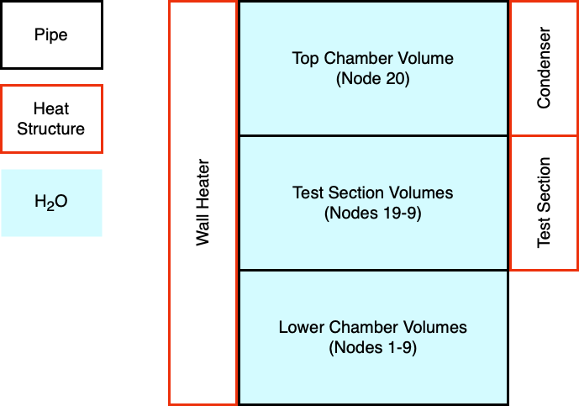
Figure 3.24. Representative RELAP5-3D Nodalization for the UNM Pool Boiling Facility

The lower section, represented by nodes 1-9, is the bulk pool surrounding the test section and the top section, represented by nodes 9-20, represent smaller axial regions that make up the test section and the spacing between the test section and the condenser. The heaters are controlled such that the water temperature is pre-heated evenly and maintains saturation throughout the transient. The condenser is active throughout the transient and works to condense the water in the top volumes of the system. The test section is modeled as FeCrAl-126Y and is filled with the high temperature cement. Not included in
the diagram is the time-dependent volume component that acts as the pressure boundary of the ambient environment and the hot water feed to maintain the tank level. This time dependent volume remains at the saturation temperature and pressure throughout the full transient.
The experimental tests that I replicated using the RELAP5-3D model are those using FeCrAl-B126Y under steady state and transient conditions. These tests were run to a heat flux of approximately 450 kW/m² and the transient tests were performed using a Fuchs-RIA power pulse boundary condition as determined by:
 | $$q(t)= \left\{\begin{aligned}\frac{q_{m}}{2s}\left[cos\left(π\frac{t-s}{s}\right)\right] t ∈ \left[0, 2s\right] \\ 0 \text{Otherwise}\end{aligned}\right.$$ | 15
q_{m} represents the peak thermal power of the rod during the transient, t is the problem time and s is a variable that adjusts the heating rate of the rod. For this specific transient, s is set to 8 to match the experimental value and q_{m} was adjusted such that the peak heat flux during the experiment was ~450 kW/m². A test matrix with constant peak power and varying energy deposition rates, by varying the value of s, is shown in Figure 3.25.
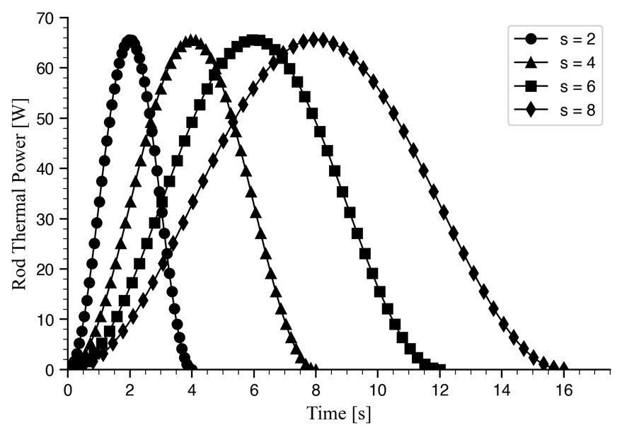
Figure 3.25. Experimental Test Matrix for Vertical Pool Boiling Experiments Using Equation 3 with Varying Values of s M. HE and M. CHEN [21].

These tests notably do not reach critical heat flux and remain within the nucleate boiling heat transfer regime.

Experimental Comparison
Several studies including the original experimental studies by UNM have shown the influence of test section orientation on the boiling heat transfer capabilities of the cladding throughout the nucleate boiling regime [21, 117, 118]. The angle of orientation of the test section with respect to the bubble motion either enhances or hinders the ability
for the bubbles to lift off of the surface. The nominal value relevant to PWRs is 90 degrees representing a vertically oriented surface. For the horizontal test sections, there is a significant degradation in heat transfer since as the contact angle approaches 180 degrees the motion of bubbles leaving the surface is impeded. This degradation in bubble departure outweighs the enhancement from the top half having an angle of 0 degrees, and causes a lower average heat transfer than with a fully vertical test section [21, 117, 118].
The comparison between the results of the experimental tests and the predictions using the RELAP5-3D model are shown in Figure 3.26 and Figure 3.27.
The results of the RELAP5-3D model are identical regardless of the orientation of the test section since the model calculation is 1-D and there is no correlation implemented for bubble departure and crowding. The RELAP5-3D model under transient heat input follows very closely to the steady-state heating results and falls between the horizontal and vertical test section orientations in terms of heat transfer coefficient and wall superheat. The experimental results under transient heating exhibit a highly enhanced
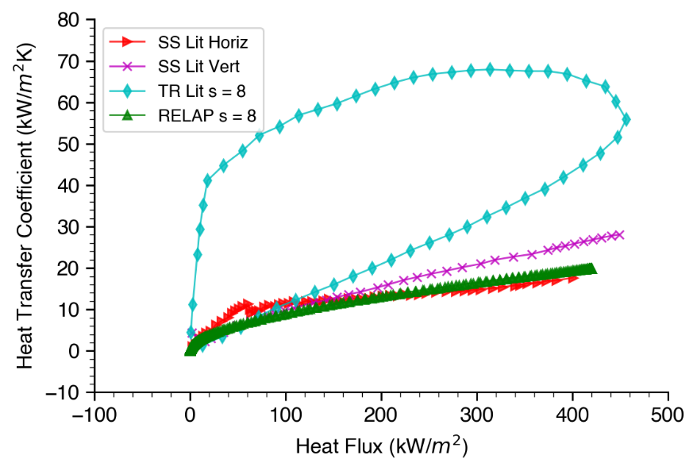
Figure 3.26. Comparison of Experimental RELAP5-3D Calculated Results for Horizontal and Vertical Test Sections Under Steady-State Conditions M. HE and M. CHEN [21], M. HE, A. F. ALI and M. CHEN [117].

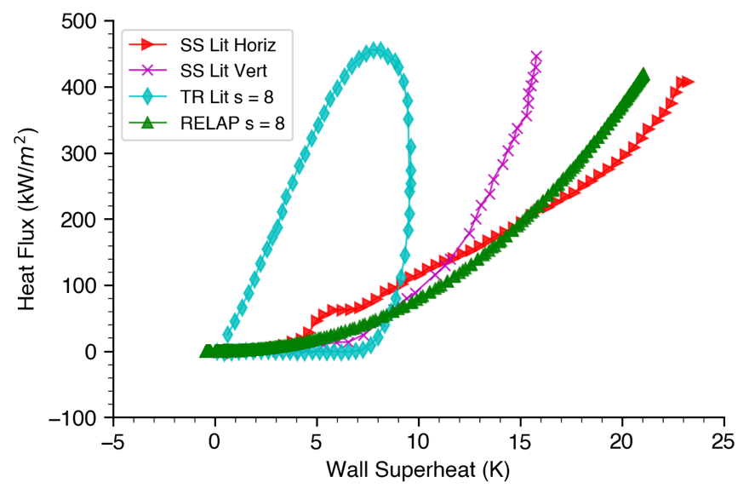
Figure 3.27. Comparison of Experimental RELAP5-3D Calculated Results for Horizontal and Vertical Test Sections Under Transient Conditions M. HE and M. CHEN [21], M. HE, A. F. ALI and M. CHEN [117].

heat transfer coefficient before reaching an asymptote as heat flux increases. Through this transient heat transfer mechanism, the cladding reaches a point where at the same heat flux, the heat transfer coefficient is significantly higher and the wall superheat is significantly lower than the corresponding steady state heating values, demonstrating that the transient heating effects have influence throughout the nucleate boiling regime. This further exaggerates the need for implementation of transient heating effects within the boiling heat transfer regimes as well as the prediction of CHF as outlined by the TREAT experimental results.

Conclusions and Future Work

Conclusions
From each of the above studies, I have determined that significant gaps in the CHF model
predictions of RELAP5-3D lie both within the transient mechanism of CHF and within the boiling heat transfer correlations. The transient effect is prevalent in both sensitivity studies and even following implementation of transient correlations, RELAP5-3D is still seen to underpredict the value of CHF as compared to experimental results. Upon further investigation, I determined that the transient effect also extends to the nucleate boiling heat transfer regime due to large model discrepancies in comparison to the pool boiling experiments of the UNM boiling chamber.
As shown by the sensitivity analyses, the discrepancies in our predictions for pre- and post-CHF behavior cannot be solved solely through implementation of a correlation for the CHFM since the boiling heat transfer coefficients and cladding thermal properties contain significant influence as well. However, I cannot definitively quantify the influence of the uncertainty in the boiling heat transfer correlations. The boiling heat transfer correlations weren’t developed with transient effects in mind [119]. The uncertainties of each correlation could very well be much larger than the ~10% reported in the literature when accounting for the transient effect and could greatly outweigh the contributions of the uncertainties in the thermal properties of the cladding. This is evident by a recent calibration study of the pre-CHF behavior of the CHF-SERTTA experimental campaign using RELAP5-3D which determines the CHFM to be about 2 times greater than the steady-state value and a 50% increase in the NBM [120]. Another calibration study performed for transient flow boiling experiments performed at UNM using RELAP5-3D revealed increases of up to 4x the steady state value of the TBM, increases of up to 1.4x the steady state value for CHF, and large variations from 0.2x to 2.8x the steady state value of the FBM [73]. Additional discrepancies in RELAP5-3D post-CHF flow boiling heat transfer have been found through inspection of a flow boiling test capsule designed for TREAT [121]. The model predicts quicker rewetting under low-flow conditions which is inconsistent with other flow boiling CHF experiments that show decreased dry-patch duration with increased mass flow [122].
I believe that after implementing correlations that account for mechanistic effects such as bubble formation and departure, power shaping, and radiation induced surface activation, and addressing the current issues with model predictions relating to mass flow rate, the sensitivities of each parameter could change drastically. As the majority of the mechanistic models occur in the pre-CHF region, I believe that the sensitivity of the nucleate and transition boiling heat transfer regimes will increase and less importance will fall on the CHF multiplier. However, this is also heavily dependent on the implementation in RELAP5-3D so care would have to be taken in setting up the analysis to draw proper conclusions. Within RELAP5-3D each of the boiling heat transfer mechanisms are independent of each other and are individually activated using logic based on the water quality, wall temperature, and interfacial heat flux. Assuming the implementation of each mechanism falls within the underlying correlations for nucleate, transition and film boiling, the inspection of additional parameters may be needed to isolate the influence from one specific mechanism, which may not be possible without code modification.

Proposed Test Matrix
Working towards addressing the current gaps within the RELAP5-3D model, with emphasis on the transient effect, I have developed a new experimental test matrix for the TRTL facility. The previous test matrix contained data points that were too close to each other in timescale with all the tests having only a range of 15 ms between them. To further exaggerate the enhancement of boiling heat transfer and CHF, and give a wider breadth of data, I propose a matrix of constant energy deposition with exponential periods over several orders of magnitude. This matrix will able to incorporate a wide variety of pulse durations that span from the tens-of-milliseconds timescale to those approaching steady-state heating.
To develop the test matrix, I sampled a broad sweep of energy depositions and power pulse timescales using the coupled RAVEN/RELAP5-3D model with the flow boiling transient CHF correlation used for the TRTL sensitivity analysis. The limits for energy deposition and timescale were based on limitations of the power supply from the initial sensitivity analysis, with the fastest achievable pulses on the order of ~10ms and ~500 kW [100]. Based on these limitations, I sampled the timescale from 10ms to 10s on a log-uniform distribution and the energy deposition from 0 to 25 kJ, accounting for a constant steady state power. This test matrix assumes the use of the initial power supply and the SS-316 heater rod from the sensitivity study rather than one of the new rod designs proposed to be installed in the loop [23]. The updated power supply will be capable of 24 kW of power which is significantly less than the previous, but the new rod and power supply combination will be able to produce higher heat fluxes at lower power and create less resistance toward heating and allow for faster power pulse timescales. The results of the parametric sweep based on the time of CHF occurrence, and peak cladding surface temperature are shown in Figure 3.28. The open-faced markers within the time of CHF graph represent samples that did not reach CHF, while the filled markers reached CHF and correspond with the color bar scale to the right. The proposed test matrix cases with their corresponding exponential period, maximum transient power and calculated CHFM are given in Table 3.6. For the new test matrix, I propose several tests with a constant energy deposition of 15 kJ and will consist of 6 tests at 10s, 1s, 0.25s, 0.1s, 0.075s, and 0.055s pulse durations. I chose an energy that would reach pulses on the order of 10s of
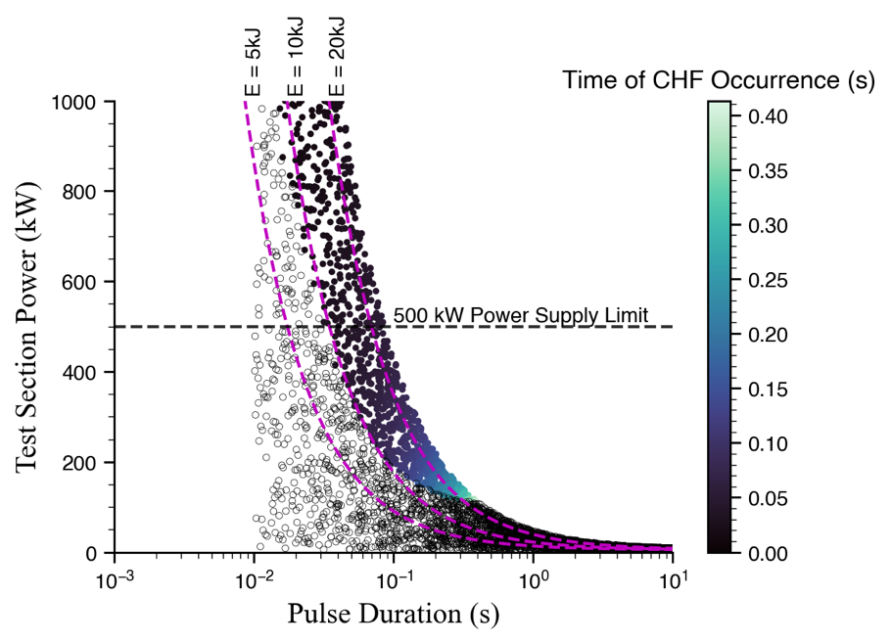
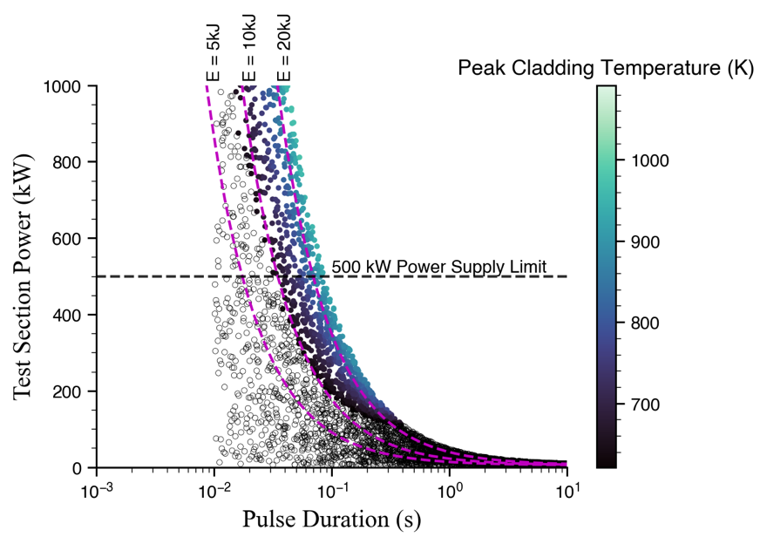
Figure 3.28. Proposed CHF Performance Envelopes for TRTL Power Pulses.

Table 3.6. New Proposed Experimental Test Matrix Power Pulse Details.
 | Case 1 | Case 2 | Case 3 | Case 4 | Case 5 | Case 6
Exponential Period [ms] | 10000 | 1000 | 250 | 100 | 75 | 55
Maximum Transient Power [kW] | 7.58 | 30.77 | 108.10 | 262.74 | 358.66 | 473.62
Critical Heat Flux Multiplier | 1.02 | 1.11 | 1.25 | 1.43 | 1.51 | 1.62

milliseconds and would also span slightly above the threshold for CHF occurrence at lower timescales since it has been shown with the TREAT experimental comparisons that the CHF correlations may still be underpredicting the value of CHF. Based on the already conservative estimate of CHF within the RELAP5-3D model, the SS-316 cladding should not exceed the melt temperature of ~1600 K within this operating space [107].

Proposed Future Work
Another step to take further down the line is to incorporate other mechanistic models for CHF to compare with both the experimental results and the currently implemented CHF correlation. Several correlations that have been investigated in detail in the literature are the bubble interference model, the hydrodynamic instability model, the microlayer dryout model, the hot/dry spot model and the interfacial liftoff model [118]. An example approach developed by Brown et al. calculates CHF based on a predictive model for dryout of the coolant interface and found good agreement to experimental values [60]. The RELAP5-3D model does not account for physical surface attributes such as nucleation site activation or physical bubble interactions such as liftoff and crowding. Methods that incorporate pre-determined predictions of CHF based on parameters such as power pulse timescale or wall temperatures should be feasible with our current calculation methods while methods that incorporate a real-time prediction of the CHF multiplier will require additional framework to redefine the heat structures within RELAP5-3D at each timestep. Following implementation of transient correlations for all boiling heat transfer regimes, a new sensitivity analysis can be performed and compared to the steady-state RELAP5-3D model. This sensitivity analysis would likely also incorporate the Sobol analysis rather than the Pearson analysis to determine if there are higher order effects and the cases would be separated by the occurrence of CHF to avoid any potential discontinuities within the data that could skew the results.
The CHF case study outlined gaps within the RELAP5-3D transient boiling heat transfer models including inconsistencies in the prediction of pre- and post- CHF transient boiling heat transfer as demonstrated in Figure 3.26 and Figure 3.23, respectively. The sensitivity analysis of the RELAP5-3D models using the considered parameters gives little to no insight on what basic parameters are most impactful towards the prediction of CHF and cladding temperature during an RIA since much of the underlying physics during fast transients are not captured. The proposed test matrix can help to address the phenomena behind the transition between steady state and transient CHF, but overall, more data will be needed on the fundamental effects within pre- and post- CHF transient boiling heat transfer. Inspection of post-CHF heat transfer can be performed in conjunction with CHF experiments, so new experimental capabilities should be established inspecting pre-CHF transient boiling heat transfer.
An avenue for future work that can address the inconsistencies within pre-CHF transient boiling heat transfer includes the development and implementation of mechanistic models for bubble crowding and departure. As per He et. al. [117], the mechanistic effects on the pool boiling heat transfer and bubble dynamics stemming from the thermal-physical properties of cladding are not well understood. Many individual empirical correlations have been developed to characterize this behavior, but are limited to a specifically defined set of experimental conditions [123]. Overall, there is a need for further fundamental tests that use as little parameters as possible to try to isolate bubble dynamics [123]. Exploration into the fundamentals of bubble dynamics can be done using the same methodology presented in Figure 2.2 using an iterative loop between predictive modeling and experiments.
Future work for further analysis of the TREAT experimental data would be to incorporate the enhancement of CHF due to RISA which was unaccounted for within this analysis. There have been several experimental studies that relate irradiation dose to an increase in wettability and a corresponding decrease in contact angle of the coolant with respect to the surface [56, 57]. Data from these studies may be used in conjunction with developed correlations that relate a receding contact angle with an enhancement in CHF [58, 59]. This would likely be added to the model as a separate factor within the calculation of the CHFM and would be accounted for separately from the transient multiplier within the sensitivity analysis.

Case Study 2

Separate Effects Fuel Performance Testing
The work associated with this case study has been published or submitted for publication [25, 26] and is modified to give a cohesive overview of the work. Specifically:
- N. A. MEEHAN, et al., “Identifying high-impact and high-uncertainty parameters in MiniFuel model predictions,” Journal of Nuclear Materials, 609, (2025); https://doi.org/10.1016/j.jnucmat.2025.155745.
and
- N. A. MEEHAN, et al., “Sensitivity Analysis of Thermal Contact Conductance Modeling to Inform MiniFuel Irradiation Capsule Designs for Minimizing Fuel Temperature Variance,” To be submitted for publication, (2025);
To support fuel qualification, experiments are performed in test reactors and independent experimental facilities at universities. Chapter 3: discussed several separate effects test facilities for fuel performance at OSU, UNM, and INL. This section will discuss separate effects testing capabilities that can support the fuel qualification process, beginning with tests performed in the Halden reactor and ultimately focusing on MiniFuel experiments within HFIR at ORNL.

Halden Irradiation Tests
The Halden reactor is a 20 MWt research reactor in Norway that accommodated irradiation tests for nuclear fuel, cladding and structural materials [124]. The reactor supported up to 30 simultaneous experiments and could inspect the performance of fuel under nominal and transient operation as well as during anticipated operational occurrences [125]. The primary research goals of Halden were to inspect the operational performance of LWR fuel, focusing primarily on UO₂ fuel and Zr alloy cladding to support licensing of new fuels and the development of fuel performance codes [125].
Several campaigns were performed inspecting effects of high burnup in UO₂ including restructuring microstructure in the rim region, degradation of thermal conductivity, and fission gas release [126-128]. As these effects are all sensitive to temperature and temperature gradients, a separate effects capability was established to provide isothermal irradiation samples with a uniform radial temperature profile. This was done by developing rodlets that change the design of the pellet stack found in traditional LWR fuel. Rather than a stack of full-sized fuel pellets, thin fuel disks were individually sandwiched between two disks of molybdenum (Mo). The thin fuel disk design minimized temperature gradients in the axial and radial direction and the Mo spacer disks acted as additional heat sinks for the fuel in the axial direction. Specific irradiation temperatures were achieved by adjusting the Mo thickness and varying the fill gas composition within the rod between pure He and pure Ar.
The Halden reactor, which served as an irradiation effects test bed for LWR fuels, ceased operation in 2018 [124, 125, 129]. As historic integral test facilities continue to shut down, there is a rising need to bolster irradiation testing capabilities [130]. A recent report has proposed using the Advanced Test Reactor to take over some of the Halden reactor’s test capability, but gaps in experimental capabilities still remain [130].

MiniFuel Irradiation Tests
HFIR is an 85 MWt flux-trap type reactor with an annular core of highly enriched uranium fuel plates surrounding a moderating center region [131, 132]. HFIR’s core is surrounded by beryllium reflectors and a set of inner and outer control plates. MiniFuel experiments are conducted in the small vertical experimental facilities (VXFs) within the permanent beryllium reflector, and in the removable beryllium (RB) reflector [133]. The RB and VXF irradiation locations have an average thermal neutron flux of ~1.3×10¹⁵ n/cm²/s and ~7×10¹⁴ n/cm²/s, respectively, and provide higher fission rates as compared to typical pressurized water reactor thermal neutron fluxes of ~1×10¹³ n/cm²/s [22].
MiniFuel is a high-throughput separate effects test platform for nuclear fuels developed at ORNL for use in HFIR to facilitate accelerated irradiation and time to data collection [22]. A detailed description of the MiniFuel design for the VXF and RB irradiation positions are given by Petrie et al. [22], and Gorton et al. [133], respectively. In summary, a set of subcapsules each contain miniature fuel specimen(s) that sit on a chemically inert dish. A heater tube is placed on top of the dish which generates the majority of the subcapsule heating via gamma interactions. The subcapsules contain a SiC thermometry rod for passive temperature measurements that are determined during PIE [134]. Grafoil insulator disks are used to ensure that the heater tube does not move. The subcapsules are filled with helium gas, and an endcap is welded to the top of the subcapsule to ensure hermiticity throughout irradiation. The subcapsules are fit within a target housing using centering thimbles and springs on each end. The target housing is filled with a gas composition which can vary from pure He to pure Ar and sealed. An ANSYS rendering of a MiniFuel target, subcapsule, and axisymmetric cross section of a subcapsule with labeled components is shown in Figure 4.1. A summary of materials commonly used for each component is given in Table 4.1.
Subcapsules are analyzed post-irradiation for fission gas release (FGR), fuel swelling, microstructure characterization, irradiation temperature, and other specific parameters as dictated by the experimental sponsor [134-137]. A detailed process for the disassembly and examination of the subcapsules is given in a report by Raftery et. al [135]. Not included in the report is the method for irradiation temperature measurements which is determined through continuous dilatometry (CD) analysis of the silicon carbide (SiC) thermometry rod within each subcapsule [134].
MiniFuel subcapsules are designed to decouple the fuel temperature from the fission rate to allow for accelerated fission rates at a constant and controllable temperature. The fuel is sized such that the main heat source within the capsule is gamma heating generated within the metallic components from prompt gammas emitted from the HFIR fuel and that temperature gradients across the specimen are minimized. This allows the surrounding material to act as a constant temperature heat sink for the fuel unlike traditional fuel rods where rod temperature is driven by heat generated through fission. Subcapsule irradiation temperatures are controlled via the gas gap between the subcapsule holder outer diameter and the target housing inner diameter and the target fill gas composition. Fuel specimen burnup rates and component heat generation rates
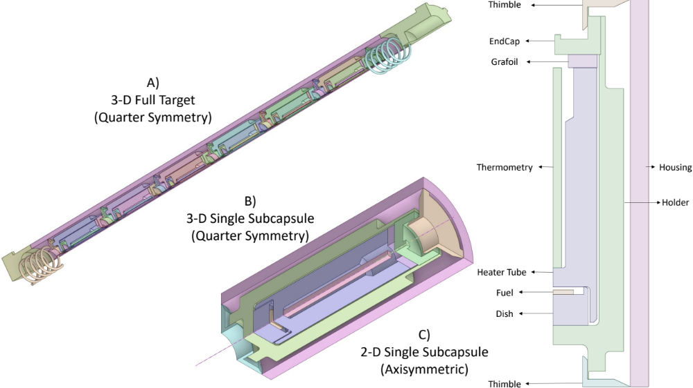
Figure 4.1. ANSYS rendering of a MiniFuel a) target, b) subcapsule, c) axisymmetric subcapsule.

Table 4.1. Materials used for each component within MiniFuel designs [22, 138].
Component | Material
Holder, Endcap, Thimbles | Ti or Mo*
Thermometry | SiC
Tube, Dish | Mo
Insulator disks | Grafoil
Fuel | Variable
Housing | 304 Stainless Steel
Fill Gas | He, Ar, or He–Ar mixture
* Ti6Al4V or Mo for VXF targets, Mo only for RB targets.

(HGRs) are dependent upon the irradiation location within the reactor (RB or VXF) and the target position within the basket.
The design of MiniFuel is similar to that of the separate effects irradiation campaigns performed within the Halden reactor [126-128]. However, MiniFuel irradiation targets offer several distinct advantages over the Halden rodlet design. The use of individual test capsules allows for greater experimental flexibility within each target. MiniFuel disks are ~1/10 the size of the Halden disks, allowing further control over irradiation temperature and burnup by limiting burnup and heat generated through fission. The fuel specimens are not sandwiched between the Mo, which minimizes mechanical interactions with the surrounding components and the use of HFIR irradiation positions allows for a greater range of potential operating conditions at more accelerated fission rates than achievable within Halden [22, 127, 139].
A high-throughput separate effects capability such as MiniFuel has the potential to support AFQ. Terrani et al. [10] proposed a methodology for AFQ that leverages rapid design iteration between separate effects experiments and computational model development for enhanced mapping of fuel irradiation performance. The goal of this iterative process is to map out regions of high uncertainty within computational models and design new experiments to reduce the model uncertainty. The framework established by the series of sensitivity analyses presented herein could easily be adapted to fit the needs of AFQ.

Past MiniFuel Experimental Campaigns
MiniFuel has been leveraged across several experimental campaigns to investigate the performance of fuels at temperatures spanning ~200°C-900°C utilizing the VXFs in HFIR’s permanent beryllium reflector region [22, 136, 140, 141]. These experimental campaigns have investigated the performance of low-enriched uranium (LEU) fuels, including UO₂, UN, UC, UMo, and U₃Si₂ in bare kernel, disc, fully ceramic microencapsulated (FCM), and tristructural isotropic (TRISO) fuel forms [137, 138, 141-146]. The MiniFuel platform has recently been extended to utilize the RB region of the core to enable higher temperature irradiations and fuel specimen fission rates roughly three times that of VXF, however PIE has yet to be performed on these experiments [131, 147].
The first MiniFuel experiments, denoted MF01 and MF02 were designed for the continued development of uranium nitride (UN) tristructural isotropic (TRISO) fuel [22, 137]. A summary of the experimental conditions for each subcapsule within the test matrix are shown in Table 4.2. This study was intended as a scoping study looking at different fuel compositions including bare uranium mononitride and monocarbide, U(C,N), varying in both carbide to nitride ratio and fuel density, kernels with integrated burnable absorber in the form of gadolinium, and several TRISO particles with varying layer composition [137]. MF01 and MF02 were placed in the HFIR VXF irradiation positions within the outer reflector of the core in June 2018 with target burnups of 1% FIMA and 6% FIMA respectfully [137]. Other notable MiniFuel experiments that have
Table 4.2. MF01/MF02 Irradiation Test Matrix [22, 137].
Subcapsule Position by RAS* | Fuel Composition | Kernel Theoretic Density (%) | ²³⁵U Enrichment  (wt. %) | Target Burnup  (% FIMA) | Target Temp  (°C) | Fillgas  (% by vol)
221/321 | UC_{.20}N_{.80}  Kernels | 94.9 | 0.22 | 1/6 | 500/600 | 40.5% He  Balance Ar
222/322 | UC_{.15}N_{.85}  Kernels | 90.6 | 0.71 | 1/6 | 500/600 | 40.5% He  Balance Ar
223/323 | U_{.89}Gd_{.11}C_{.11}N_{.89} Kernels | 92.0 | 0.71 | 1/6 | 500/600 | 40.5% He  Balance Ar
224/324 | U_{.98}Gd_{.02}C_{.15}N_{.85} Kernels | 93.6 | 0.71 | 1/6 | 500/600 | 40.5% He  Balance Ar
225/325 | UC_{.21}O_{.79}  Kernels | 90.9 | 0.22 | 1/6 | 500/600 | 40.5% He  Balance Ar
226/326 | UC_{.20}O_{.80}  TRISO | 87.2 | 0.22 | 1/6 | 500/600 | 40.5% He  Balance Ar
*(R = radial target position, A = axial target position, S = subcapsule position in target).

been designed since MF01/MF02 include GA-FOA 201 and 202, inspecting UC/UO₂ kernels, LA01 and LB02, inspecting U₃Si₂/UO₂ disks, FC01-04, inspecting UN/UCO TRISO, KP01-05, inspecting UCO/UO₂ TRISO compacts, and ALEU-1-3, inspecting UMo disks [138, 141-146]. For the work presented, I focus on the results from MF01 and comparing my models to these results as an initial validation basis.
A summary of the PIE activities for the MF01 subcapsules includes fission gas release measurement, analysis of the SiC thermometry rod, and microstructure analysis [137]. The neutronics predictions were able to accurately capture the burnup of the fuel with minor discrepancies in the mass of plutonium of low-enriched and natural uranium. The main discrepancies between the simulations and the experimental data stem from the CD analysis of the thermometry rods. Continuous dilatometry of a passive silicon carbide (SiC) thermometry rod is used during PIE to verify the experimental temperatures, and this technique has shown reasonable agreement to experiments at low temperatures for a limited number of data points [137, 143]. The simulations tended to overpredict the temperature of the thermometry by around 100 °C leading to a predicted 50 °C underprediction of the fuel temperature during irradiation. Initial speculation on the model underprediction is the calculation of the heat transfer across the gas gaps in the capsule (between both the outer surface of the subcapsule holder and inner surface of the housing and the thermometry and the heater tube), errors in the gamma heating rate calculation, or differences in predicted vs as-built fill gas mixture composition [137].

Project Overview
The MiniFuel capsule design is intended to de-couple fuel temperature from fission rate, creating a near-constant irradiation temperature [22]. Capsules are designed using predictive modeling capabilities to achieve a desired irradiation temperature [22]. Transitioning from VXF to RB will allow for higher temperatures and fission rates, but will introduce greater thermal uncertainties into our models [25]. Thermal property correlations for the subcapsule materials have higher uncertainty at higher temperatures [148, 149] and increased heat generation rates will propagate higher uncertainty into heat transfer calculations. Fuel performance is tightly coupled to the temperature of the fuel so ensuring the accuracy of fuel temperature predictions is crucial to the understanding the data collected from post irradiation examination (PIE) [22]. However, uncertainty quantification of MiniFuel presents a challenge since the system is highly coupled and is essentially a black box function. A practical method for identifying high-impact, high-uncertainty regions within a highly coupled model entails the use of sensitivity analysis.
The overarching goal of this work is to quantify the uncertainty within the MiniFuel subcapsule design and to develop an informed set of design recommendations that can reduce this uncertainty in future experiments. To support this goal, I first performed a sensitivity and uncertainty analysis of the full subcapsule design to determine high-impact high-uncertainty parameters with respect to the fuel temperature prediction. This study began with over 50 sources of uncertainty that were narrowed down to the ~10 most impactful sources of uncertainty using the method of Morris. The remaining 10 sources of uncertainty were ranked using a Sobol sensitivity analysis and the associated uncertainty was quantified. The highest-ranking sources of uncertainty from the Sobol analysis were then inspected in increasing model detail to quantify the uncertainty and inform a set of design recommendations to inform future experiments. These recommendations were applied to the original model to estimate the potential uncertainty reduction.

Full Subcapsule Analysis

Model Framework
The MiniFuel subcapsule models used in this study were developed using the same methodology as that outlined in Petrie et al. [22] and Gorton et al. [133] and each model inspects 0.33% enriched UO₂ fuel discs. The HGRs and burnup of each subcapsule were calculated using HFIRCON, a neutronics wrapper script consisting of MCNP for the transport calculation, the SCALE ORIGEN code for depletion and isotope decay calculations, and additional modules for variance reduction and geometry calculations [150-152]. The HGRs, material properties, and boundary conditions for the heat transfer calculation at each timestep are implemented into an ANSYS model using a validated Ansys Parametric Design Language (APDL) macro library developed by McDuffee [153]. To optimize the use of computational time, the model developed for this study was a single subcapsule in 2D axial symmetry, ensuring that the total volume of and contact area between components are conserved.
Verification and validation of the VXF single-subcapsule model was performed using experimental data from MF01, as reported by Petrie et al. [22] and Harp et al. [137]. RB subcapsule verification and validation is performed using model-to-model comparison from RB01, as reported by Gorton et al. [133] because PIE data does not yet exist for any RB MiniFuel experiments. To adapt the single subcapsule model to VXF and RB, boundary conditions for heat generation rates and fuel burnup were applied based on the models by Petrie et al. [22], and Gorton et al. [133], respectively. Additionally, Mo holders and thimbles were used in the high-temperature model, whereas Ti was used in the low-temperature model. Material thermal properties use the same reference library as the calculations and were applied using the developed APDL macro libraries. To accommodate reduced-order modeling comparisons for MF01, data from subcapsules 1, 2, and 5 for bare UCN kernels was utilized, and the model was adjusted such that the volume of fuel was consistent with the experiments. The models for RB01 utilize single disk geometry, so a model-to-model comparison for all 6 subcapsules was performed.
To ensure computational efficiency, the sensitivity analysis was performed in two steps. An initial screening was performed using the Morris method to give an initial calculation of the importance of each parameter, allowing for down-selection of the highest-impact, highest-uncertainty parameters. The down-selection process of parameters then enabled the use of the more computationally intensive Sobol sensitivity analysis, which has shown to be more stable in ranking convergence and uncertainty quantification than the Morris method for assessing highly non-linear models.

Morris Parameter Screening Methods
The first step in performing the sensitivity analysis is determining the input and output parameters of interest (POIs). The primary function of the MiniFuel subcapsule design is to isolate the effects of fission from irradiation temperature; this design aims to provide control over both the fuel temperature and temperature gradient across the fuel. Pre-irradiation predictions of the thermometry temperature are compared to dilatometry measurement taken during PIE and is therefore the figure of merit for verifying thermal model predictions. Therefore, the chosen output POI are the fuel temperature, temperature distribution across the fuel, and the thermometry temperature. The fuel inspected in the sensitivity analysis is UO₂.
Table 4.3 provides a list of the uncertainties in material properties, HGRs, solid-spot conductance values, and irradiation conditions considered in the screening study. A table containing the geometric parameters considered within the analysis, Table 2, and a corresponding cross section of the model are included in the appendix. Capsule geometry uncertainties are based on the machining tolerances from internal engineering drawings and were sampled on a uniform distribution as a conservative estimate of the machining accuracy of the parts. As the capsule geometry changes, the internal volume of the subcapsule is not conserved. The initial pressure remains constant regardless of the changes to the internal volume because the subcapsules are backfilled with gas following assembly. Thermal property uncertainties are based on empirical correlations developed using experimental data and were sampled on a uniform distribution, incorporating
Table 4.3. Morris screening analysis parameter uncertainty distributions.
Parameter Name | Uncertainty |  | Unit | Source
Q | ± | 9 | % | [131]
k_{Mo} | ± | 10 | % | [148]
k_{Grafoil} | ± | 13 | % | [154, 155]
k_{SS304} | ± | 5 < 900°C, 10 > 900°C | % | [148]
k_{TI6AL4V} | ± | 5 < 922°C, 15 > 922°C | % | [148]
k_{Fuel} | ± | 25 < 1000°C, 10 (1000°C - 1300°C),  5 > 1300°C | % | [149]
k_{Ar} | ± | 1 < 723°C, 5 (723°C-1723°C),  10 > 1723°C | % | [156]
k_{He} | ± | 2 < 923°C, 5 (923°C-1723°C),  10 > 1723°C | % | [156]
ε_{Mo} | ± | 25 < 500°C, 15 (500°C-1500°C),  10 > 1500°C | % | [156]
ε_{Grafoil} | ± | 20 | % | [157]
ε_{SIC} | ± | 5 | % | [158]
ε_{TI6AL4V} | ± | 3 | % | [159]
ε_{Fuel} | ± | 6.8 | % | [160]
α_{Mo} | ± | 3 < 1500°C  5 > 1500°C | % | [156]
α_{SIC} | ± | 10 | % | [161]
α_{SS304} | ± | 7 | % | [162]
α_{TI6AL4V} | ± | 6 | % | [162]
α_{Fuel} | ± | 10 | % | [160]
BU_{Fuel} | 50-60 |  | GWd/MtU | [163]
SSC_{Fuel-Dish} | [0,0.109] (VXF)  [0,0.073] (RB) |  | MW/m²-K | [153]
SSC_{Therm-Tube} | [0,1.121] (VXF)  [0,0.769] (RB) |  | MW/m²-K | [153]
SSC_{Dish-Tube} | [0,1.200] (VXF)  [0,1.017] (RB) |  | MW/m²-K | [153]
SSC_{Dish-Holder} | [0,0.266] (VXF)  [0,1.020] (RB) |  | MW/m²-K | [153]
SiC Irradiation | 0-1.25 (VXF)  0-6.12 (RB) |  | dpa | [131]
PTD | 90-100 |  | % | [22]

temperature-dependent uncertainties when applicable. The uncertainty in the HGRs of each material was assumed to be 9% based on the reported maximum acceptable in the flux tilt in HFIR, as reported by Chandler et al. [131]. This a conservative estimate of HGR uncertainty under nominal operational conditions and accounts for variations in surrounding experimental loading.
Materials with thermal properties that consider irradiation effects include Grafoil, SiC, and the fuel. The thermal conductivity of Grafoil assumes a constant post-irradiation value of 38 W/mK, similar to H451 graphite at a fluence of 8 × 10²⁵ n/m² between 500 and 1200 °C, as reported by Strydom et al. [155]. The uncertainty in the Grafoil thermal properties does not consider any change in irradiation dose. The thermal conductivity of the thermometry varies based on the irradiation swelling of SiC. The swelling in SiC is determined by an independent function to calculate dose based on the days spent in an irradiation position. The maximum dose for SiC within the allowable irradiation time is 1.25 dpa for the VXF position and 6.12 dpa for the RB position. The thermal conductivity of the fuel is determined using a function that incorporates both temperature and irradiation dose and has uncertainties associated with each [149]. For the screening analysis, the burnup will vary about the expected discharge burnup of 50–60 GWd/MtU, which is the typical discharge burnup for LWRs.
Most parameters within the analysis are independent. Dependent parameters include the thermal properties of SiC and fuel which, as previously mentioned, are functions of irradiation, and the thermal contact conductance which is a function of thermal conductivity. This could artificially increase the sensitivities of the associated independent parameters. I have ensured the values presented are reasonable through personal judgement and deliberation with several colleagues.
The ANSYS model accounts for thermal contact conductance (TCC) across material interfaces in contact [153]. The TCC is split into two parts, gap and solid spot conductance (SSC). The gap conductance was varied in the sensitivity analysis based on the uncertainties in the thermal properties of the fill gas. Since the true value of TCC during the experiments is unknown, the SSC was varied from 0—representing a majority of heat transfer through the interstitial gas—to its maximum allowable value, approaching an ideal heat transfer system. The SSC was directly varied between several key contacts, which were selected as the most important for heat transfer from the fuel and thermometry; the TCC between the fuel and the dish, the thermometry and the tube, the dish and the tube, and the dish and the holder. The minimum and maximum calculated values of the SSC for each contact considered are given in Table 4.3.
The fill gas composition and holder outer diameter are the most important design parameters used in determining the irradiation temperature of the capsules and have a large combined sample space within both the VXF and RB irradiation positions. The screening analysis was performed for two temperature regimes: the higher-temperature regime is representative of RB MiniFuel experiments, and the low-temperature regime represents VXF experiments. When using nominal parameters, the fuel temperature was ~1100 °C in the high-temperature model and ~500 °C in the low-temperature model.
For all calculations for the Morris and Sobol sensitivity analyses, the SALib Python libraries [164, 165] were used. A number of previous works suggested that 40 optimal trajectories can provide a converged Morris parameter screening [37, 166-173]. Following this approach, the parameters were screened into groups of high and low importance so that only the most important parameters were included in the Sobol analysis. To ensure that the sample space of the input parameters is better represented, sampling optimizations from Campolongo et al. [36] and Ruano et al. [37], which are both default features of the SALib Morris sampler were utilized.
The Morris screening ranks parameters based on the mean, μ, and standard deviation, σ, in the output. For this study, rather than using the mean, the absolute mean, μ*, was used, which has been shown by Campolongo et al. [36] to be more representative of the sensitivity and to account for self-cancellation of terms. Parameters that have a large μ* will show high individual sensitivity to the output, and parameters with a large σ will show high joint sensitivity to the output due to interactions with other variables [174].
While these parameters have the potential to provide insights similar to those of a more rigorous analysis method such as the Sobol method, they have been shown to be unstable for problems with high non-linearity [42, 166, 170, 173]. The instability of parameter ranking in the Morris method can be overcome with a large number of assessed trajectories, but the computational cost is impractical and obviates the advantages of using the Morris method for screening. For this reason, this approach is used solely for screening parameters.
The Morris parameter screening was performed using two lines of influence as recommended by other studies and screening by μ* [168, 170]. A vertical line at 0.1 of the maximum μ* separates the graph into regions of high and low importance. The line with a 0.1 ratio of μ* to σ separates the high importance region into regions of joint and individual influence. A sample diagram of this screening method is shown in Figure 4.2. All parameters that met the high importance threshold were used within the Sobol sensitivity analysis.

Sobol Sensitivity Analysis Methods
The parameters that were deemed of high importance within the Morris screening study were used in the Sobol sensitivity analysis. As previously mentioned, the primary design parameters currently used for determining the subcapsule irradiation temperature are the fill gas and holder outer diameter, which is why they were excluded from the Morris screening. It has also been determined that the primary design parameter for determining the temperature gradient across the fuel is the fuel height. Within the study, two different Sobol analyses were performed—the first with and second without these parameters to determine the sensitivity of the model and uncertainty of the model, respectively.
The goal of the first analysis was to confirm that the primary design parameters have the greatest influence on the output POIs. The combination of holder outer diameter and fill gas composition within this analysis was varied within the safety bounds for gap conductance within the VXF or RB irradiation positions, respectively. The allowable ranges for gap conductance are 43 to 2385 W/C*m² in the VXF and 136 to 3423 W/C*m²
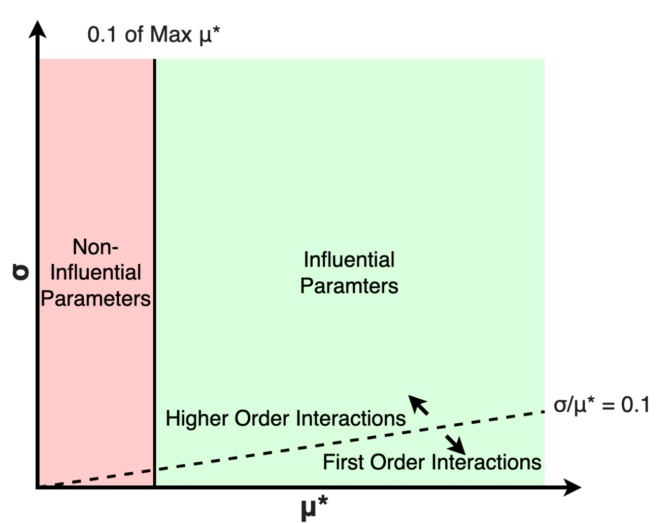
Figure 4.2. Morris Method parameter screening methodology.

in the RB positions. An additional Sobol analysis was performed that excluded the design parameters in order to quantify uncertainty in the outputs; this was done because the exact values of the holder OD and fill gas are measured to within instrument tolerance and are therefore not contributors to uncertainty. The goal of the second analysis was to quantify the uncertainty of the model based on the parameters that are not controlled during subcapsule assembly.
Unlike the Morris method, the Sobol sensitivity analysis within SALib uses a Quasi–Monte Carlo sampling scheme. Rather than running a set number of cases, the Sobol analysis for each temperature regime was run until the rank of each parameter converged. To satisfy the calculation algorithm within SALib, convergence was checked on intervals of 2^{n}(D+2), where D is the number of input parameters. Sobol indices were determined to be converged if the percent difference between subsequent intervals was less than 1%. The main benefit of this method over the previous method developed by Morris is that it is stable for both linear and highly non-linear correlations [42, 166, 170, 173]. The computational cost of this method is significantly higher than the Morris method because the samples are taken using a quasi-random Monte Carlo sampling sequence, thus requiring a large number of samples to provide converged indices. This makes it computationally favorable to perform the Morris method for a large number of input parameters and to then perform Sobol analysis using a smaller subset of the total model inputs.

Model Verification and Validation
Table 4.4 shows the comparison between the available MF01 data and our model predictions using as-built capsule data. The data reported by Petrie et al. [22] are initial model predictions of the experimental temperatures, and the data reported by Harp et al. [137] are from PIE of the subcapsules. Across all fidelities the models agree with the previously developed models within an average of 10 °C. Sources of error between the PIE data and the originally developed models for MF01 were discussed by Harp et al. [137]. The primary sources of error were hypothesized as differences in the as-built subcapsule geometry and fill gas composition, and in the HFIR loading from the time of calculation to the time of insertion, which altered the component gamma heating rates. These potential sources of uncertainty will all be inspected within the sensitivity analyses.
The results of the model-to-model comparison are given in Table 4.5. From the comparison, the results show relatively good agreement across all fidelities, but there is a consistent difference in average fuel temperature of ~28 °C even though the modeling methodologies for the development of both models and the data used for both model calculations are the same. This temperature difference is thought to be associated with axial heat transfer between the subcapsules in the full target that is not accounted for in the reduced-order single-subcapsule model. Overall, the single-subcapsule model is sufficient in capturing the behavior of the full irradiation target as the general trends in the fuel temperature match those of MF01 and RB01.
Table 4.4. MF01 time averaged fuel temperature prediction with model by Petrie et al. [22] and PIE data from Harp et al. [137]
Subcapsule  Number | Single  Subcapsule  2-D | Petrie et al. Model | Harp et al. PIE
1 | 515 °C | 502 °C | 451 °C
2 | 519 °C | 512 °C | 462 °C
5 | 497 °C | 499 °C | 446 °C

Table 4.5. RB01 model-to-model comparison of time-averaged fuel temperature prediction with model by Gorton et al. [133].
Subcapsule  Number | Single  Subcapsule  2-D | Original  RB01  Model
1 | 1077 °C | 1083 °C
2 | 1069 °C | 1096 °C
3 | 1058 °C | 1085 °C
4 | 1045 °C | 1069 °C
5 | 1036 °C | 1064 °C
6 | 1055 °C | 1076 °C

Morris Parameter Screening Results
The results of the Morris parameter screening with respect to the average fuel temperature and the temperature gradient across the fuel are shown in Figure 4.3 and Figure 4.4 for high-temperature fuel and Figure 4.5 and Figure 4.6 for low-temperature fuel. Within these figures, only the parameters within the high-influence regime of the plot at above 0.1 of the maximum μ* are labeled. The remaining parameters are unlabeled for clarity and are considered to have low influence. The results for the average thermometry temperature are not shown since the results screen the same parameters as the average fuel temperature.
The screening results suggest that the majority of the prediction uncertainty results from uncertainty in the HGRs, TCC between several components, and the thermal conductivity of several materials. The greatest influence from the geometric inputs were those that directly changed the dimensions of the fuel, with some influence stemming from dimensions of heater materials and the housing. The results show a consistently greater magnitude of uncertainty at higher-temperature irradiations.

Sobol Sensitivity Analysis Results
Table 4.6 contains the parameters that were determined to be of high importance within the Morris screening analysis. The fill gas composition and the holder outer radius of the subcapsule were only used in the first analysis to confirm that they are the most influential on design temperatures. Each case was run to ensure less than 5% difference
between consecutive calculations of the highest ranked Sobol indices. A sample

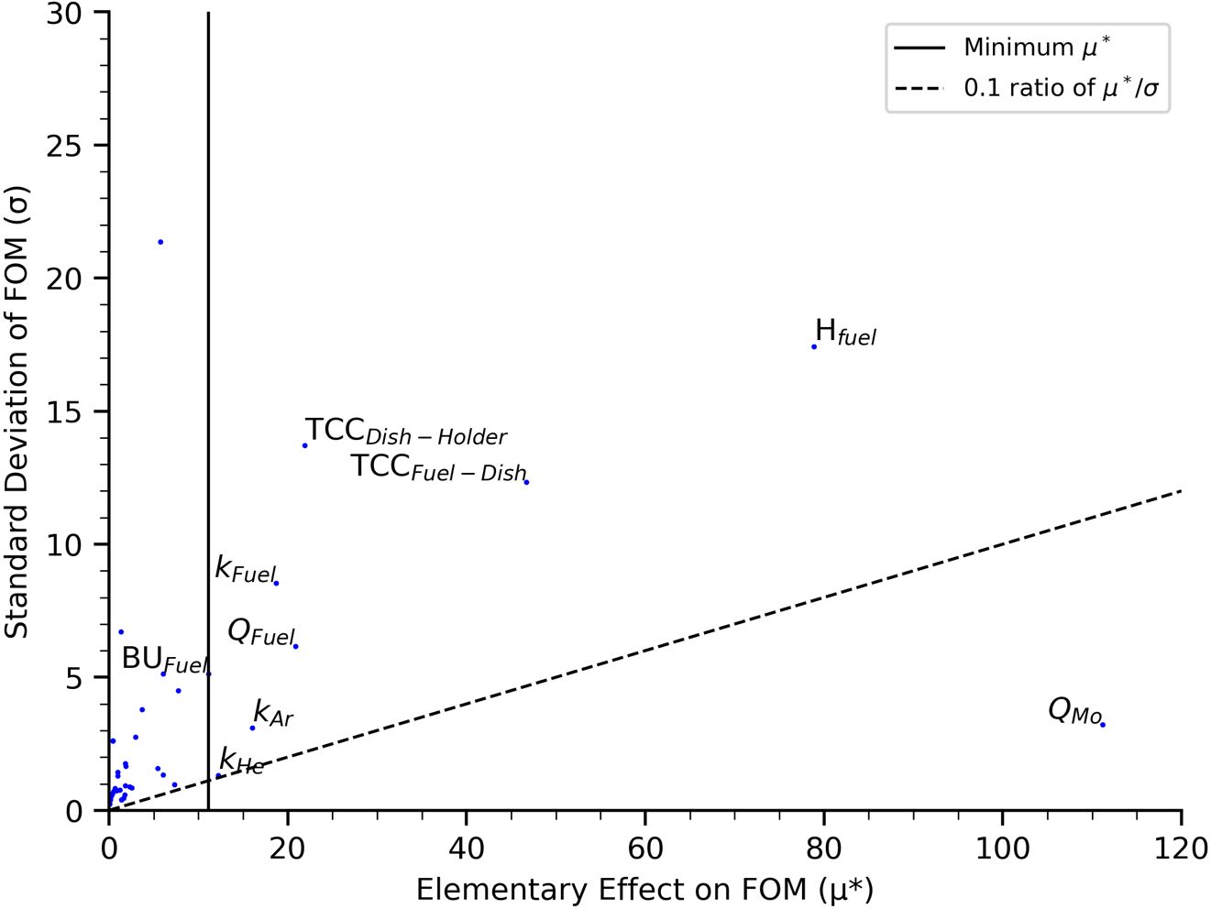
Figure 4.3. Morris parameter screening for high-temperature UO₂ fuel with respect to average fuel temperature.

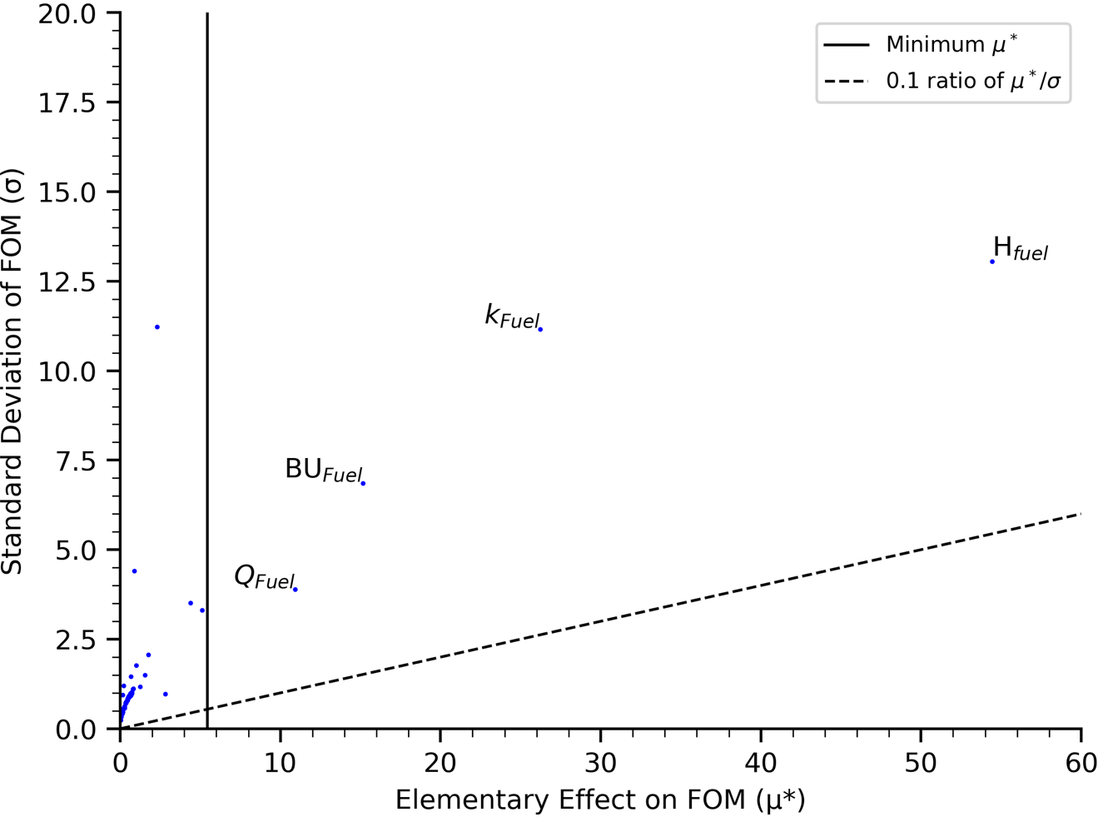
Figure 4.4. Morris parameter screening for high-temperature UO₂ fuel with respect to fuel temperature gradient.

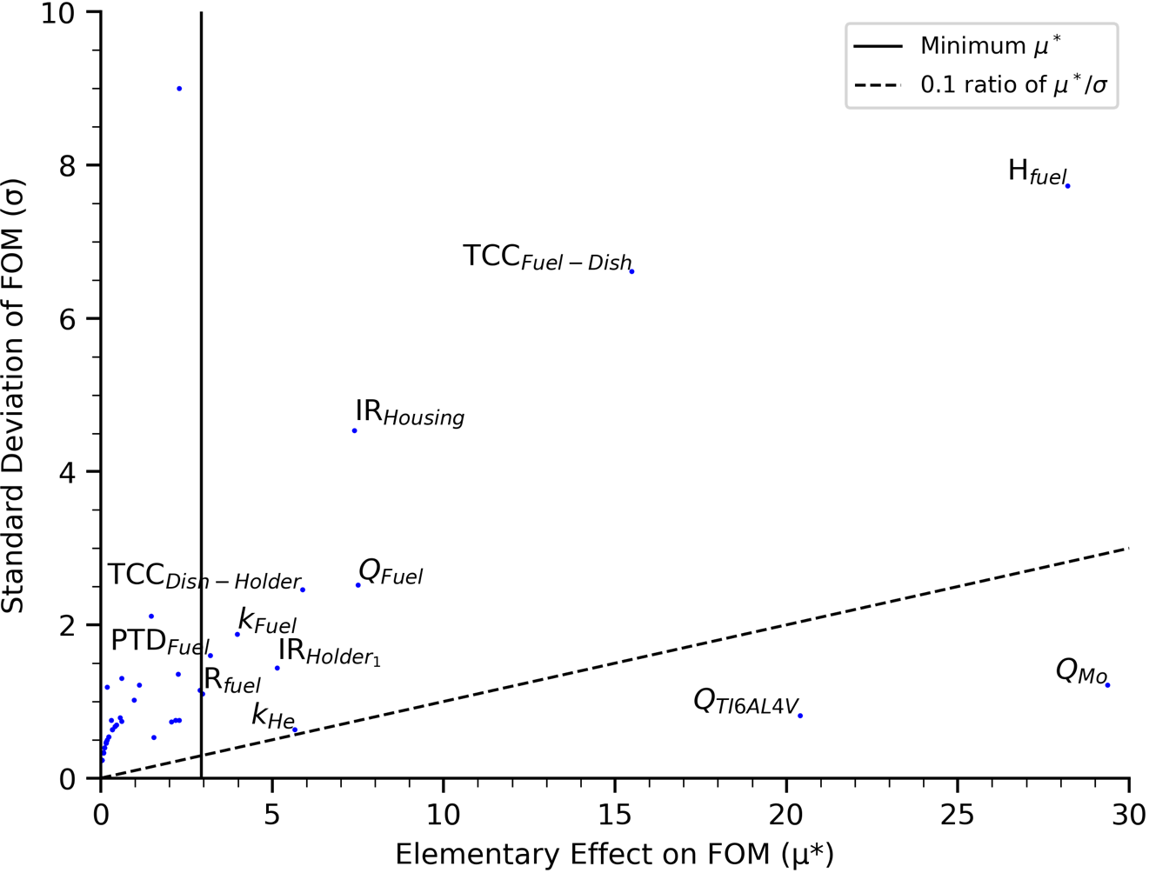
Figure 4.5. Morris parameter screening for low-temperature UO₂ fuel with respect to average fuel temperature.

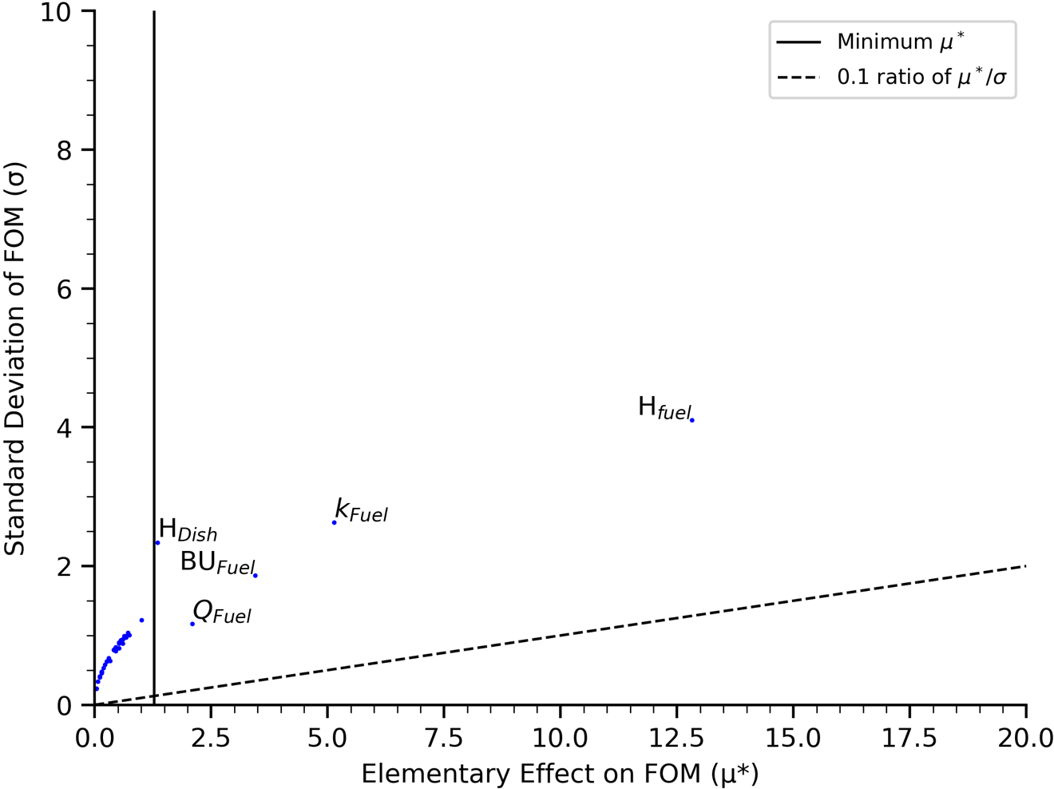
Figure 4.6. Morris parameter screening for low-temperature UO₂ fuel with respect to fuel temperature gradient.

Table 4.6. Sobol sensitivity parameters from the Morris parameter screening
Parameter | Low Temperature Morris Screening | High Temperature Morris Screening
Geometry | H_{Fuel} | H_{Fuel}
Geometry | R_{Fuel} | *OR_{Holder,1}
Geometry | H_{Dish}
Geometry | *OR_{Holder,1}
Geometry | IR_{Holder,1}
Thermal Properties | BU_{Fuel} | BU_{Fuel}
Thermal Properties | Q_{Ti6Al4V} | ε_{Mo}
Thermal Properties | Q_{Mo} | Q_{Mo}
Thermal Properties | Q_{Fuel} | Q_{Fuel}
Thermal Properties | k_{Fuel} | k_{Fuel}
Thermal Properties | k_{Ar} | k_{He}
Thermal Properties | PTD | k (Ar)
Thermal Contact Conductance | TCC_{Fuel-Dish} | TCC_{Fuel-Dish}
Thermal Contact Conductance | TCC_{Dish-Holder} | TCC_{Dish-Holder}
Other | *Gas Composition | *Gas Composition
*Used for sensitivity analysis only and excluded from uncertainty analysis

convergence plot is shown in Figure 4.7. The converged total Sobol indices for the high- and low-temperature cases are shown in Figure 4.8 and Figure 4.9, respectively. The results show that the holder OD and fill gas composition have the greatest influence on fuel temperature across the high- and low-temperature regimes, as designed.
The second analysis was performed excluding the primary design parameters. The converged Sobol indices for each case are shown in Figure 4.10 and Figure 4.11. These figures show that the primary sources of uncertainty in calculating the fuel temperatures are the heat generation boundary conditions, fuel height, and the TCC between the fuel and the dish. The uncertainty in the fuel temperature gradient stems from uncertainty in the height and thermal properties of the fuel.
Histograms of the fuel temperatures from the high- and low-temperature cases are shown in Figure 4.12 and Figure 4.13. The temperature history from the preliminary Sobol analyses demonstrate the model sensitivity, which is indicative of the full experimental envelope, 300–1400 °C for the RB and 300–1000 °C for the VXF positions. The temperature history from the secondary Sobol analyses give an indication of the model uncertainty, which is indicative of an average temperature capsule within the RB or VXF irradiation positions. The histograms demonstrate that the uncertainty in the prediction of average fuel temperatures is conservatively ±100 °C within the RB and ±50 °C in the VXF positions. Table 4.7 contains the statistics from each of the Sobol analyses. The data from the preliminary analyses, denoted D for the inclusion of the primary design
parameters, should be taken as model sensitivity, and the data from the secondary

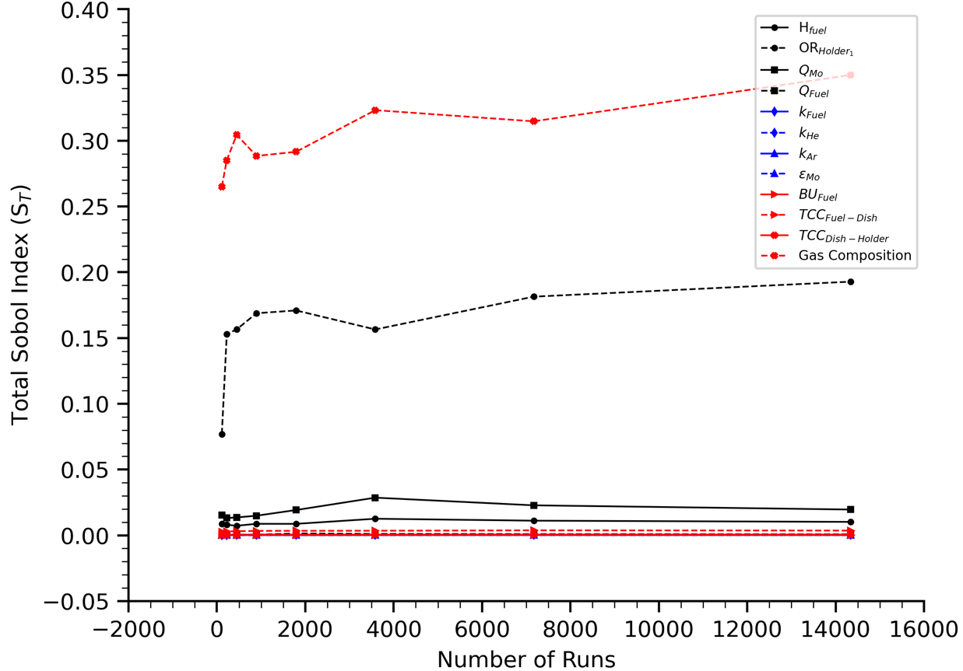
Figure 4.7. Total Sobol index convergence for high-temperature UO₂ fuel with respect to average fuel temperature.

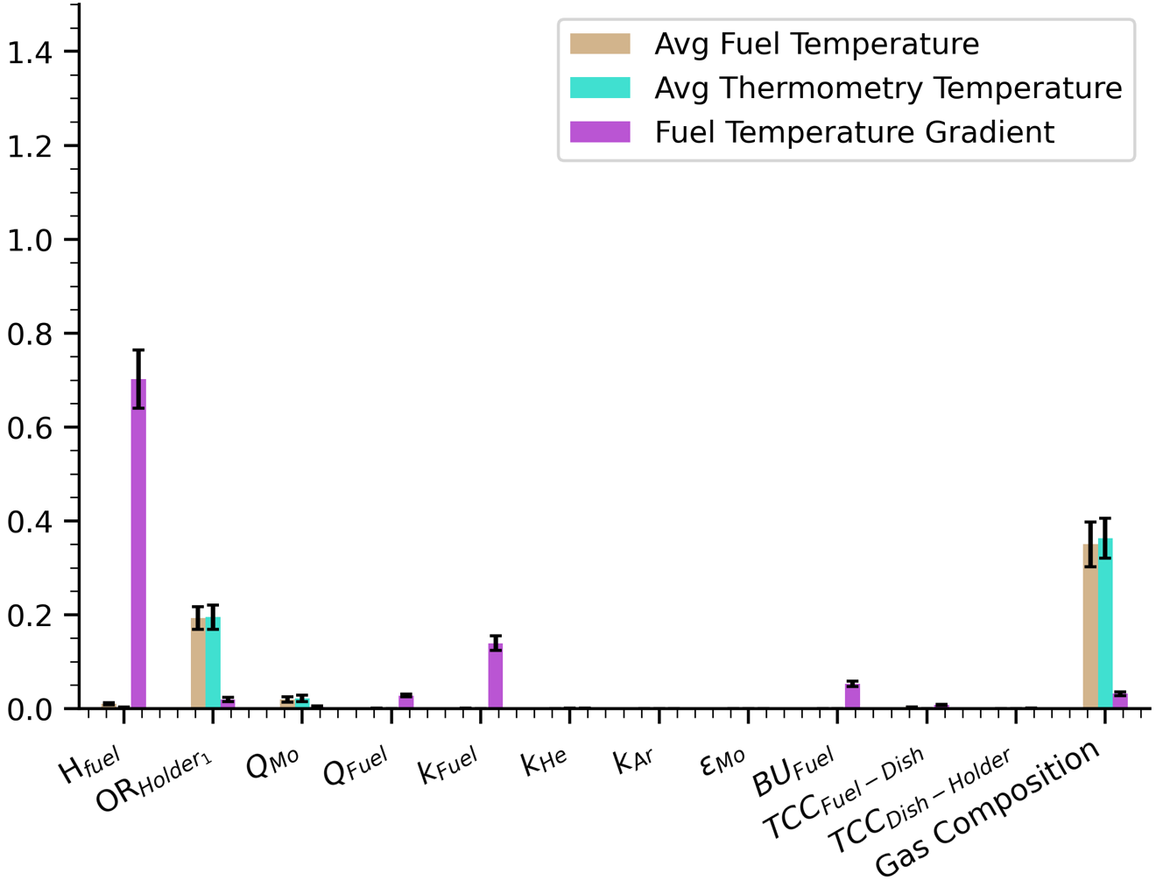
Figure 4.8. Total Sobol indices for high-temperature UO₂ fuel with respect to each POI (including the primary subcapsule design parameters).

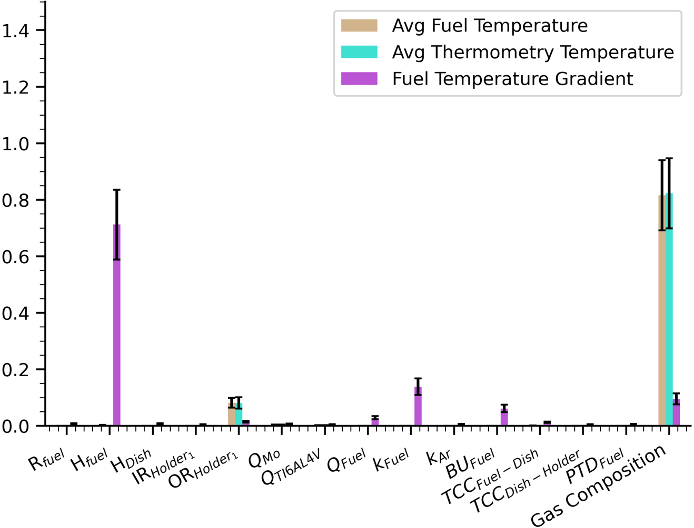
Figure 4.9. Total Sobol indices for low-temperature UO₂ fuel with respect to each POI (including the primary subcapsule design parameters).

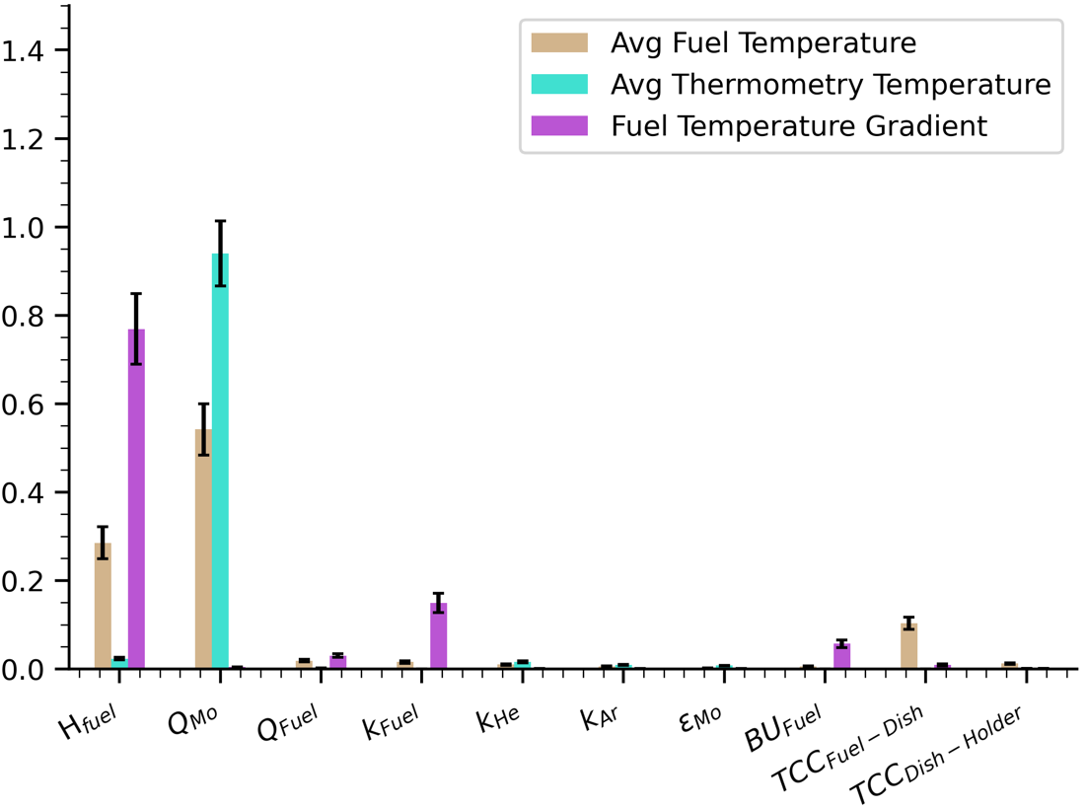
Figure 4.10. Total Sobol indices for high-temperature UO₂ fuel with respect to each POI (not including the primary subcapsule design parameters).

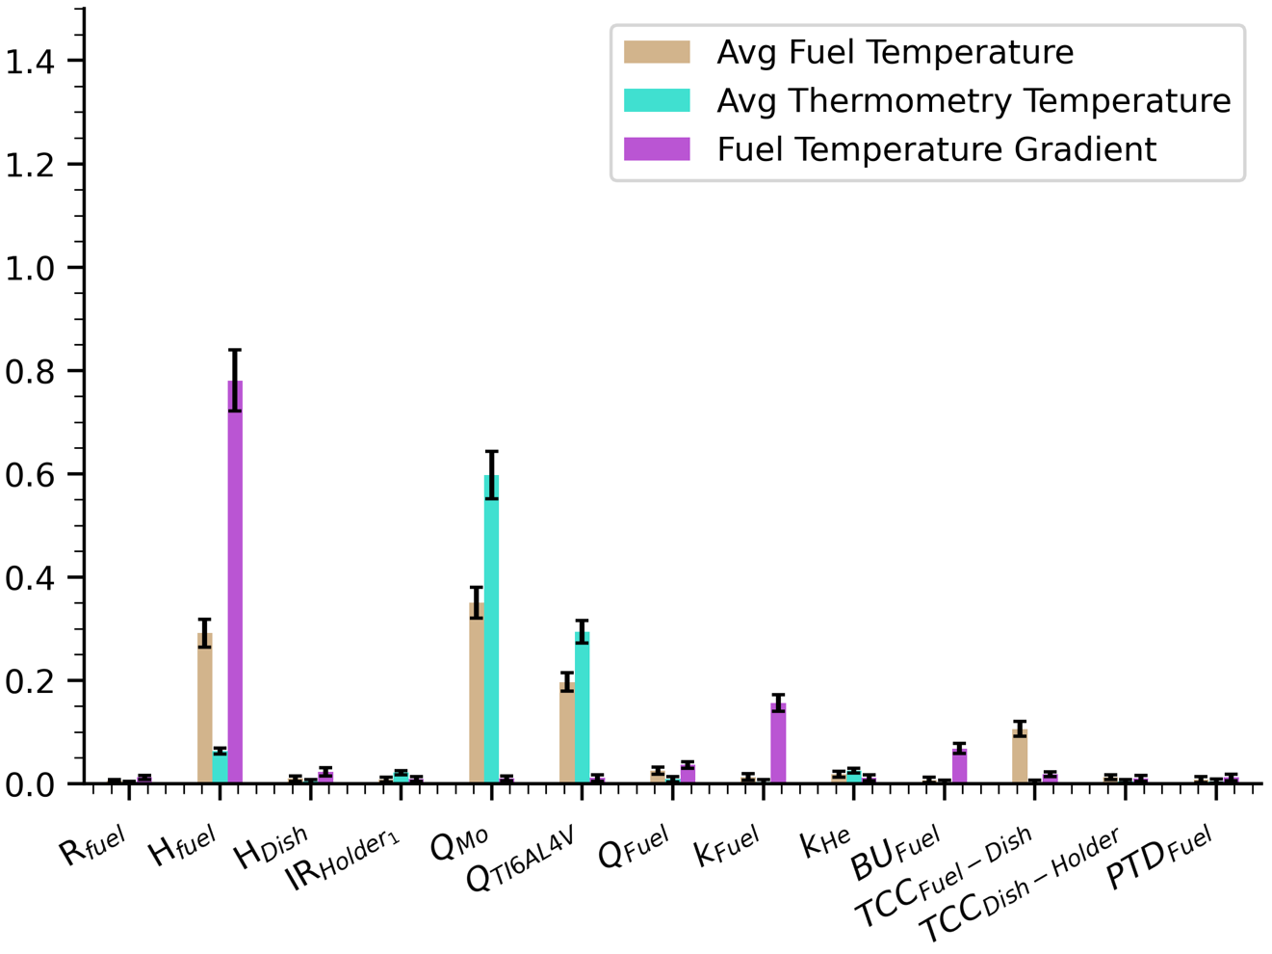
Figure 4.11. Total Sobol indices for low-temperature UO₂ fuel with respect to each POI (not including the primary subcapsule design parameters).

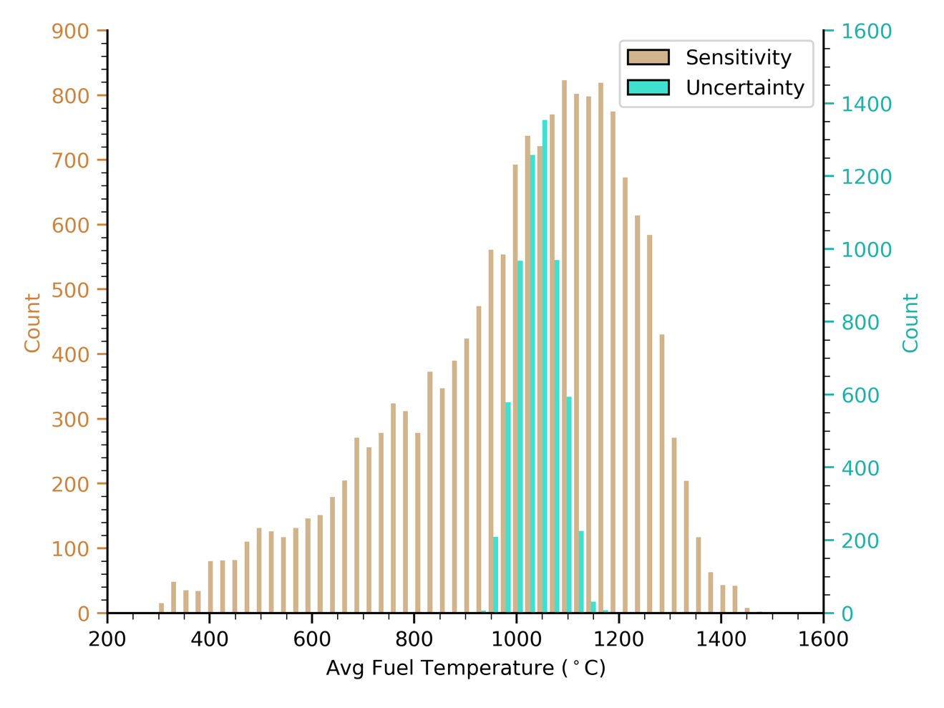
Figure 4.12. Histogram of average fuel temperature for the high-temperature UO₂ fuel Sobol analysis.

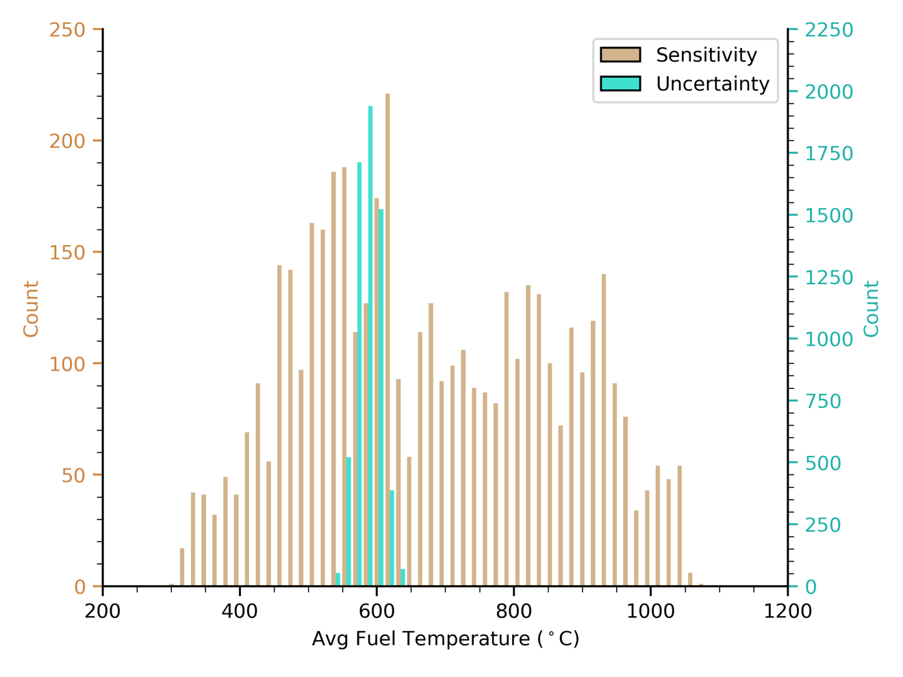
Figure 4.13. Histogram of average fuel temperature for the low-temperature UO₂ fuel Sobol analysis.

Table 4.7. Statistics for the Sobol sensitivity analysis of ANSYS MiniFuel models
POI |  | High  Temperature  Case (D) | Low  Temperature  Case (D) | High  Temperature  Case (ND) | Low  Temperature  Case (ND)
Fuel  Temperature  (°C) | Max | 1494 | 1086 | 1181 | 642
Fuel  Temperature  (°C) | Min | 301 | 297 | 933 | 542
Fuel  Temperature  (°C) | Range | 1193 | 789 | 248 | 100
Fuel  Temperature  (°C) | Mean | 1007 | 682 | 1041 | 587
Fuel  Temperature  (°C) | 2σ | 448 | 365 | 82 | 34
Thermometry  Temperature  (°C) | Max | 1358 | 1023 | 1045 | 604
Thermometry  Temperature  (°C) | Min | 324 | 295 | 916 | 533
Thermometry  Temperature  (°C) | Range | 1034 | 728 | 129 | 71
Thermometry  Temperature  (°C) | Mean | 945 | 658 | 979 | 569
Thermometry  Temperature  (°C) | 2σ | 399 | 348 | 58 | 26
Fuel  Temperature Gradient  (°C) | Max | 115 | 34 | 115 | 31
Fuel  Temperature Gradient  (°C) | Min | 14 | 4 | 22 | 5
Fuel  Temperature Gradient  (°C) | Range | 101 | 30 | 93 | 26
Fuel  Temperature Gradient  (°C) | Mean | 53 | 14 | 54 | 14
Fuel  Temperature Gradient  (°C) | 2σ | 35 | 10 | 34 | 9
*Used for sensitivity analysis only and excluded from uncertainty analysis

analyses, denoted ND for the exclusion of the primary design parameters, should be taken as model uncertainties. The table includes the maximum, minimum, range, mean, and 2 standard deviations of each POI for each case.

ANSYS Model Uncertainty
The results of the preliminary Sobol sensitivity analysis confirm that the most important parameters in determining the temperature of the fuel and the thermometry are the gap size between the subcapsule holder and housing as well as the fill gas composition. This study also confirmed that the most important parameter in determining the temperature gradient across the fuel was the fuel height. While the model is certainly sensitive to these parameters, the gap size and gas composition are all measured to within instrument
tolerance during the assembly of the subcapsules. Therefore, they do not contribute significant uncertainty to the model calculation.
The uncertainty in RB irradiation models was shown to be conservatively ±100 °C in the prediction of average fuel temperatures, ± 60 °C in the prediction of the average thermometry temperatures, and ± 40 °C in the prediction of fuel temperature gradient. Under VXF irradiation conditions, the uncertainties are conservative estimates of ±50 °C, ±30 °C, and ±10 °C, respectively. Within this uncertainty analysis, the fuel height parameter for was incorrectly varied ±0.1 mm, which encompasses the as-built design space of the capsules. In reality, the height of the fuel can be measured to within ±0.001 mm, drastically reducing the contribution to uncertainty. Removing the contribution to uncertainty from the fuel height reduces the modeling uncertainties to ~±80 °C, ~±56 °C, ~±8 °C in RB and ~±40 °C, ~±24 °C, ~±2 °C in the VXF position, respectively.
Upon reviewing the previous MF01 experimental comparison, the results of the experiment were observed to fall slightly outside the estimated model uncertainty. Similarly, the thermometry temperature predictions were about 60 °C higher than that of the experimental PIE, which is outside the ±24 °C calculated uncertainty in the thermometry temperature predictions for the VXF position. However, this may be a result of additional factors that are outside of the considered uncertainty of this report, such as differences in the HFIR loading. The results of the RB01 model-to-model comparison fall within the reported uncertainty in the fuel temperature calculations; however, the differences can still be primarily associated with the lack of an axial heat transfer boundary condition within the reduced-order model.

Influence of Gap Conductance
The gap conductance is defined within the MiniFuel model using the following equation from McDuffee [153]:
 | $$h_{gap}=\frac{1}{\frac{δ}{k_{gas}(T_{g,avg})}+\frac{g_{s1}}{k_{gas}(T_{s1})}+\frac{g_{s2}}{k_{gas}(T_{s2})}}$$ | 16
Within this equation, the g_{s1} and g_{s2} parameters are thermal jump distances and are negligible for the housing gas gap because it is larger than 0.1 mm in most cases. The primary dependence for gap conductance from the holder to the housing stems from the effective gap size, δ, dictated by the outer radius of the holder, and effective thermal conductivity of the fill gas, k_{gas}, which is determined by the gas composition. As demonstrated in the Sobol analysis, the sample space for the combination of these two parameters enables temperatures to range over several hundreds of degrees.

Influence of Fuel Height
The height of the fuel disk is the most important factor in determining the temperature gradient across the fuel, and it contributes significantly to the average fuel temperature. The fuel volume has a direct impact on the fuel temperature by changing the internal heat generation due to fission. The uncertainty in the temperature gradient can be explained using Fourier’s law [175]:
 | $$q^{''}=-k∇T$$ | 17
where q’’ is the heat flux, k is the material thermal conductivity, and ∇T is the temperature gradient across the material. As the height of the fuel increases, the heat must travel farther across the fuel prior to reaching the lower-temperature dish. Since the thermal conductivity of the fuel is very low at high temperatures compared to the Mo components, and because the internal heat generation due to fission increases with the volume of the fuel, the temperature gradient across the fuel increases significantly with increased fuel height. Direct variation of the thermal conductivity, which also degrades with burnup, has the same effect.

Influence of HGR Uncertainty
From both Sobol analyses, a non-negligible fraction of uncertainty, ~55%, in both temperature regimes stemmed from component heat generation. Due to the high throughput of the reactor and shuffling of experiments to different irradiation positions within the core, it is impractical to perform the neutronics calculations for one specific loading. To account for this, the HFIRCON model used to determine the component heat boundary conditions assumes a nominal core loading for each of the surrounding irradiation positions based on anticipated experiment types using historical loading data. Local differences in this loading can alter the flux that reaches the MiniFuel targets and can thus create discrepancies in the heat generated by the Mo or Ti-6Al-4V. The uncertainty reported by Chandler et al. [131] is the allowable safety limit of perturbation of the local power density, making the determined uncertainty conservative. While a flux tilt of 9% is not allowed in HFIR during normal operation, flux tilts of a few percent can be expected based on variation in the experimental loading, and some statistical uncertainty exists within predicted HGRs due to the use of MCNP [141]. Quantifying the uncertainty in HGRs could be addressed in future analyses but may be infeasible due to the lack of a fast-running predictive model for HFIR HGRs and because of the wide variety of potential experimental loadings that could affect neutron fluxes.

Influence of Thermal Contact Conductance
The secondary Sobol analysis demonstrates that for conditions of high surface temperature, the TCC between components becomes increasingly important in fuel temperature predictions. Components in mechanical contact transfer heat through a relatively small portion of the effective surface area, with conduction across microscopic surface contacts and the interstitial gas between them [153, 176, 177]. A diagram of this phenomenon is shown in Figure 4.14. This diagram depicts heat transferred via surface–surface contacts, Q_{s}, and via interstitial gas, Q_{g}, and a representative temperature differential across the interstitial gas, ΔT_{g}, between the contact surfaces, S₁ and S₂. The effective heat transfer between the two surfaces is based on surface characteristics such as roughness and microhardness, thermal properties of the surfaces and interstitial gas, and the contact pressure applied between the two surfaces [153, 177]. As the contact pressure between the surfaces increases, the heat being transferred by means of surface surface contacts increases relative to heat transfer across the interstitial gas, thus increasing the TCC.
The TCC between the fuel and dish is most important for the calculation of the fuel and thermometry temperature. Varying the TCC between the fuel and dish directly influences the fuel temperature, as conduction to the dish is the main heat sink for the fuel. The reason this also influences the thermometry temperature is because it dictates the radiative heat transfer between the fuel and the holder in the axial direction. The hemispherical total emissive power, E, for a gray body is given by the following equation [178]:
 | $$E=εσT^{4}$$ | 18
where ε is the emissivity of the material, σ is the Stefan–Boltzmann constant, and T is the

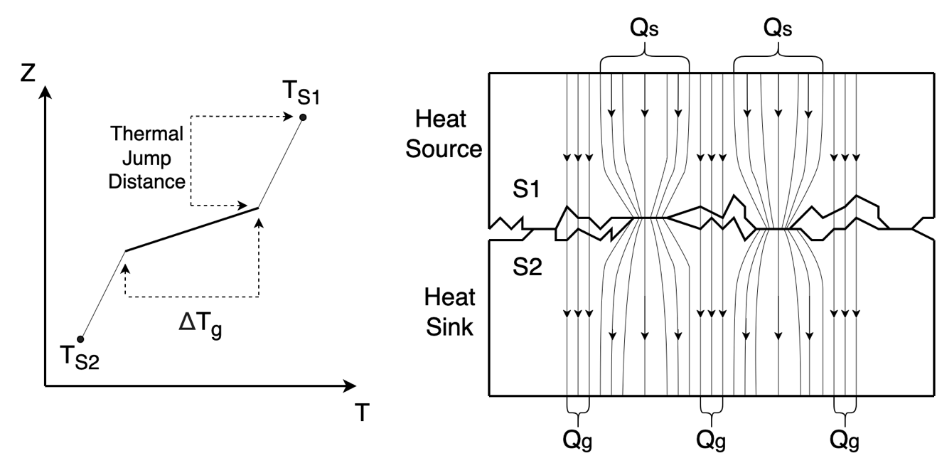
Figure 4.14. Thermal contact conductance between two surfaces in mechanical contact.

surface temperature. At higher fuel temperatures, the fuel radiates heat to the holder and indirectly heats the thermometry rod.
The TCC between the dish and the holder also indirectly influences the fuel and thermometry temperature. In this case, the TCC directly changes the temperature of the dish because the holder acts as a heat sink. The thermal conductivity of the Mo dish is negatively correlated to the temperature throughout the experimental temperature range. As the dish temperature decreases as a result of increased heat transfer to the holder, the thermal conductivity increases, allowing more heat to be transferred from the fuel to the dish via SSC. As the temperature of the fuel changes, the temperature of the thermometry changes through the previously mentioned radiative heat transfer mechanism.

Influence of ANSYS Model TCC Calculations
The implemented calculation of TCC for components within the ANSYS model is based on several experimental studies of metal–metal contact by Bahrami et al. [177] and Yüncü [179]. While the contacts in our model are primarily ceramic–metal, the metal–metal contact models have shown to be sufficient estimations of TCC regardless of surface and microstructural differences [180]. However, the experiments reported in the study by Garcia-Poulin et al. [180] were performed at very low temperatures, ambient–100°C, compared to those achievable with the RB MiniFuel capability, which are >1000 °C.
The gap conductance of the system is determined using the thermal jump distance of each surface. The thermal jump distance, a region of discontinuity in the temperature profile within heat transfer regimes of low gas pressures, is a function of temperature with a $1/\sqrt{M}$ dependence, where M is the atomic mass [181]. Toptan et al. [181] performed an analysis of the thermal jump distance for He, Ar, Kr, and Xe interstitial gasses, all present during FGR of high-burnup MiniFuel experiments, and demonstrated that the temperature jump distance is especially sensitive below pressures of 1 MPa. The gas pressure of the MiniFuel capsules begins at atmospheric pressure, 0.1 MPa, and increases to ~0.5 MPa at irradiation temperature within the RB. The uncertainties in both the change in gas pressure and gas composition under irradiation, not considered in this analysis, can lead to large discrepancies in the model predictions.
The TCC models currently implemented within ANSYS do not account for FGR into the interstitial gaps between the surface contacts. The release of fission products into the gas gap is a safety concern for high-burnup UO₂ fuel pellets within LWRs, and it negatively affects TCC at low contact pressures where gap conductance dominates [182]. Ongoing MiniFuel capsule designs within RB are investigating the impacts of FGR on fuel temperature predictions using a coupled ANSYS and BISON model [133].

Conclusions from Full Subcapsule Analysis
Traditional integral effects tests are limited by both expense and time to inspect only a fraction of the potential burnups and temperatures, impeding the development of fundamental irradiation models and the development of new candidate fuel forms. To address these challenges, ORNL developed the MiniFuel irradiation target to accommodate high-throughput separate effects fuel irradiation tests utilizing HFIR. As the capability continues to advance to accommodate higher temperature experiments and a wider variety of fuel configurations, the need to quantify the uncertainty in thermal model predictions used for experiment design became clear. A two-step sensitivity analysis was performed to determine a set of high-impact, high-uncertainty parameters that influence the model calculation.
The first analysis utilized the Morris method, a computationally efficient method for screening a large number of parameters into groups of high and low importance. The high importance parameters from the Morris analysis underwent a Sobol sensitivity analysis to rank their importance and to quantify associated uncertainties. The parameters of the highest importance, excluding those primarily used for capsule design, were found to be the component heat generation rates, the fuel height, and the TCC between the fuel, dish, and holder. As the contribution from the component heat generation rate was deemed fairly conservative and fuel height does not contribute to the model uncertainty in reality, the main source of uncertainty within the model was determined to be the TCC. The TCC is a representation of the of heat being transferred between imperfect surfaces through SSC and gap conductance. The TCC models within ANSYS are highly sensitive to the gas composition, and gap conductance has been shown to vary exponentially at low surface contact pressures. Follow-on uncertainty analyses to better quantify and potentially mitigate the TCC uncertainty are therefore recommended for future work.

In Depth TCC Model Analysis
Prior work was performed by Meehan et. al. [25] to identify high-impact, high-uncertainty parameters that contribute the most to variance in MiniFuel temperature predictions and to quantify the total model uncertainty. The model fuel temperature uncertainty associated with each irradiation position was determined to be ±40°C in VXF and ±80°C in RB. Key parameters identified to contribute the most toward model uncertainty are the heat generation rate of the molybdenum (Mo) filler material, and the thermal contact conductance (TCC) between the fuel and dish.
Component HGRs within HFIR irradiation targets are determined through analysis of a representative core loading of HFIR (Cycle 400) using Monte Carlo transport methods [131, 183]. The cycle 400 model uses a representative experimental loading of the flux trap region of the core and assumed beryllium (Be) dummy plugs in each RB position with a split between Be plugs and Pu²³⁸ production targets in VXF [183]. For MiniFuel analysis, this model is modified to include the experiments in their desired irradiation position, but does not account for surrounding experimental loading [141]. The sensitivity analysis assumed a conservative estimate of 9% uncertainty in the heat generation of each component based on the maximum allowable local power density perturbation due to surrounding experimental loading [131]. Although the HGR uncertainty within Mo was more impactful than the TCC, reducing the uncertainty in the TCC will help to address the variance in fuel interface temperature. If the TCC can be increased by informed capsule design changes, the influence of heat flux on the interface temperature gradient will be reduced.
At a microscopic level every surface has some form of waviness, roughness, etc. and will only contact under a relatively small fraction of the surface area [184]. TCC accounts for the heat transfer across two real surfaces in contact by accounting for both solid-solid heat transfer and heat transfer across gaps between the solid interfaces [184]. A representative diagram of TCC is shown in Figure 4.14 [25]. A well-defined correlation for TCC is necessary within the realm of finite-element and reduced-order modeling as model surfaces contain no inherent imperfections. The gap between a set of model surfaces could be infinitesimally small without ever establishing contact, which is non-physical. Models are able to replicate the effects of surface imperfections on heat transfer using TCC correlations [153]. Current correlations for TCC are predominantly empirical based on previous experiments primarily using data below 1000°C [184].
The current work aims to perform a thorough analysis of the TCC model to identify high-impact high-uncertainty parameters which contribute high variance toward fuel temperature predictions. As outlined in the previous work [25], the RB irradiation position has inherently greater thermal uncertainties compared to VXF. Therefore, a subcapsule with RB boundary conditions [147] is the primary focus of this variance reduction. A Sobol sensitivity analysis is performed to identify parameters that contribute to variance in fuel temperature and analysis of the associated Monte Carlo data is performed to further inspect the influence of these high-impact parameters. Conclusions from this work are used to form a set of design recommendations for future subcapsule designs to reduce fuel temperature variance.
Based on the conclusions of the previous study, the TCC between the fuel and dish is a major contributor to variance of fuel temperature predictions in both the VXF and RB positions within HFIR [25]. Since the RB positions have greater inherent thermal uncertainty, the models developed in this work are representative of the RB design by Gorton et. al. [147]. The models include the fuel-dish interface between a UO₂ fuel disk, and a molybdenum (Mo) dish and assume an initially pure helium (He) fill gas. Each model assumes a constant fuel geometry of 1.4 mm radius and 0.3 mm height based on the nominal disk characteristics from Gorton et. al. [147].

Python Model Framework
Current design analysis and calculations for irradiation subcapsules are performed within ANSYS using a validated ANSYS Parametric Design Language (APDL) macro library developed by McDuffee [153]. To perform a more computationally efficient inspection of the TCC model, a Python code is developed to replicate the TCC design analysis and calculation methods used for ANSYS. This model utilizes the following set of equations:
 | $$ΔT_{gap}=\frac{q''}{TCC}$$ | 19

 | $$TCC=h_{s}+h_{g}$$ | 20

 | $$h_{s}=C_{1}\frac{k_{gm}*tanθ}{σ}{\left(\frac{P_{c}}{H_{eff}}\right)}^{C_{2}}$$ | 21

 | $$h_{g}=\frac{1}{\frac{δ}{k_{gas}(T_{g,avg})}+\frac{g_{s1}}{k_{gas}(T_{S1})}+\frac{g_{s2}}{k_{gas}(T_{S2})}}$$ | 22

 | $$δ=1.184σ{\left[-\ln\left(3.132\frac{P_{c}}{H_{eff}}\right)\right]}^{-0.547}$$ | 23

 | $$g=\frac{k_{g}}{P_{g}}\left(\frac{2-α}{α}\right)\left(\frac{γ-1}{γ+1}\right)\sqrt{\frac{2π∙MW_{g}∙T_{g}}{R_{g}}}$$ | 24

 | $$α=F\left(T\right)\frac{MW_{g}}{6.8\frac{g}{mol}+MW_{g}}+\left[1-F\left(T\right)\right]\frac{2.4μ}{\left(1+μ^{2}\right)}$$ | 25

 | $$F(T)=exp⁡[-0.57∙(\frac{T_{s}-273K}{273K})]$$ | 26

The full details of this model are explained in McDuffee [153]. A full list of equations and nomenclature can be found in the Appendix. Parameters with subscript g refer to the fill gas and parameters with subscript s refer to the solid surfaces.

To account for the effects of FGR, a lookup table of burnup and temperature is implemented into the Python TCC model based on BISON simulation data of UO₂ MiniFuel compacts from Cheniour et. al. [185]. The table reports FGR as a function of both temperature and burnup. Within this table, the FGR is defined as the fraction of FGR versus the total fission gas generated. The model assumes the composition of FGR is a 7.5:1 ratio of Xe to Kr as reported by Tonks et. al. [186]. The total moles of fission gas are calculated based on the fission rate within the fuel and by assuming 25% of all fission products are gaseous (Xe and Kr) as per Cheniour et. al. [185]. The fission rate is conservatively estimated as the peak fission rate in the capsule throughout each cycle.
The model first performs the TCC calculation assuming the fuel and dish are initially at the same temperature and the initial gas composition is pure helium. The code then predicts an updated fuel temperature using the TCC and interfacial heat flux based on the fuel volumetric heat generation. If the difference between the initial fuel interface temperature prediction and calculated fuel interface temperature is greater than 0.01°C, the initial fuel interface temperature prediction is replaced with the calculated fuel interface temperature. This calculation process is repeated until the temperature of the fuel meets the convergence criteria. This process is repeated at each timestep, using a timestep of 2 days, as the gas composition gradually changes due to FGR at higher burnup. The dish temperature is selected such that under nominal design conditions, not accounting for parameter uncertainties, the fuel interface temperature is 1000°C. This same methodology will be used throughout the analysis to inspect several fuel interface temperatures. Fuel interface temperatures under nominal design conditions will be referred to as target temperatures.
A Sobol sensitivity analysis [187] inspecting the variance of the fuel temperature calculation within the Python model is performed by varying the HGRs and TCC model parameters associated with the fuel, dish and fill gas. The total Sobol index of each parameter is calculated using SALib [164], a set of open-source Python libraries, using a Monte Carlo sampling scheme.
The uncertainties of each parameter within this study are listed in Table 4.8. The uncertainty in volumetric heat generation is based the work of Chandler et. al. [131] which reports a maximum allowable flux tilt of 9% for a nominal HFIR loading. The material thermal property uncertainties are based on empirical models reported in the associated references and account for temperature dependent uncertainties where applicable. The surface roughness of each material is varied using a rough estimate ranging from a smooth finish (0.8 μm) to rough finish (2.0 μm). Microhardness is only considered for the Mo dish as the correlation for solid spot conductance (SSC) uses the microhardness of the softer material. The burnup of the fuel is varied from 0 to 80 GWd/MTU to determine the influence of FGR over a large irradiation envelope. Contact pressure between the fuel and dish in the current capsule design is due to gravity. The contact pressure range considered in this study are determined with H_{eff}/P_{c} values based on experimental studies of metal-metal contact by Bahrami et. al. [177], and Yüncü [179] using the method outlined by McDuffee [153].
Table 4.8. Parameter uncertainty distributions for Sobol analysis.
Parameter Name | Uncertainty |  |  | Unit | Source
Q | ± | 9 |  | % | [131]
k_{UO2} | ± | 25 | < 1000°C | % | [149]
k_{UO2} | ± | 10 | 1000°C - 1300°C | % | [149]
k_{UO2} | ± | 5 | > 1300°C | % | [149]
k_{Mo} | ± | 10 |  | % | [148]
k_{He} | ± | 2 | < 923°C | % | [156]
k_{He} | ± | 5 | 923°C-1723°C | % | [156]
k_{He} | ± | 10 | > 1723°C | % | [156]
k_{Ar} | ± | 1 | < 723°C | % | [156]
k_{Ar} | ± | 5 | 723°C-1723°C | % | [156]
k_{Ar} | ± | 10 | > 1723°C | % | [156]
k_{Xe} | ± | 13 |  | % | [154, 155]
E_{UO2} | ± | 6×10⁹ | 177°C - 1327°C
E_{UO2} | ± | F(T)* | 1327°C - 2840°C | N/m² | [160]
E_{Mo} | ± | 63×10⁹ |  | N/m² | [188]
H_{Mo} | [1.8,2.6] |  |  | GPa | [189]**
BU_{Fuel} | [0.0,80.0] |  |  | GWd/MtU | [163]
σ_{UO2} | [0.5,2.0] |  |  | μm
σ_{Mo} | [0.8,2.0] |  |  | μm
Pc | [9.2×10⁴, 5.8×10⁷] |  |  | Pa | [177, 179]
C2 | [0.6,0.94] |  |  |  | [184]
*F(T) = 6×10⁹ + ES(T-1600)/6052.6
** Upper limit of considered range based on internal measurement data

Python-BISON Model Framework
FGR and irradiation temperature have been shown to have a positive feedback loop between them [186]. Fission gas degrades the heat transfer at the interface, raising fuel temperature and as fuel temperature increases, diffusion and subsequent release of fission gas increases. To account for this potential feedback effect, the FGR lookup table is replaced by utilizing the BISON finite element fuel performance code developed by Idaho National Laboratory [190].
The BISON models developed for this work are based on those of Cheniour et. al. [185]. To reduce the computational demand of the model for the use in a sensitivity analysis, a 2D r-z model of the fuel and dish is developed. The 2D r-z BISON model is a simplified representation of the subcapsule that includes the fuel disk and a container of Mo that acts as a plenum for FGR. A diagram of the model is shown in Figure 4.15. The BISON model is responsible for calculating the fuel temperature gradient and associated FGR. The Mo container volume is representative of the free gas volume within a MiniFuel subcapsule and the container and surrounding gas do not thermally interact with the fuel. The heat transfer calculation at the fuel-dish interface is performed by coupling the BISON model to the Python TCC model.
The framework is a loose coupling that updates after each timestep of 2 days. The Python model calculates the fuel interface temperature using the method from Section 0. and the heat sink is held at a constant temperature. The fuel interface temperature is then passed into the BISON model and applied as a boundary condition on the bottom surface of the
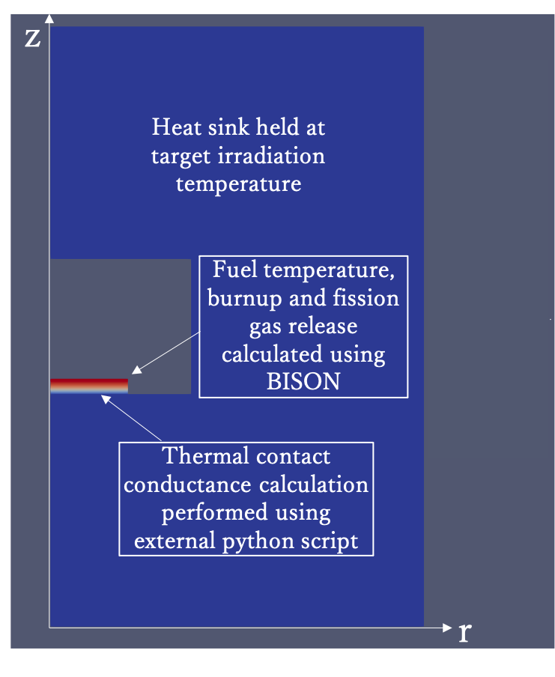
Figure 4.15. R-Z BISON model with boundary conditions for code coupling.

fuel. BISON then performs a steady state irradiation of the fuel over one time step. The calculated burnup, FGR, and gas pressure are then passed back to the Python model to update the TCC and fuel interface temperature.
The BISON model utilizes the Turnbull model for Xe diffusion [191, 192], which incorporates 3 distinct regions of FGR as described by the following set of equations:

 | $$D=D_{1}+{4D}_{2}+{4D}_{3}$$ | 27

 | $$D_{1}=7.6*{10}^{-10}\exp\left(-\frac{4.8599*{10}^{-19}}{k_{B}T}\right)$$ | 28

 | $$D_{2}=1.41*{10}^{-25}\sqrt{F}\exp\left(-\frac{1.9053*{10}^{-19}}{k_{B}T}\right)$$ | 29

 | $$D_{3}=2*{10}^{-40}F$$ | 30
where k_{B} is the Stefan-Boltzmann Constant (eV•K⁻¹), T is fuel temperature (K) and F is the fission rate in the fuel (m⁻³•s⁻¹). This model is used since it considers athermal FGR through knockout and recoil mechanisms which are most relevant under the lower range of temperature conditions of these experiments (<1000°C) [186]. Solid mechanics such as swelling are disabled both to reduce computational demand and since they are assumed negligible toward heat transfer.
The sensitivity analysis is re-run using the coupled BISON/Python model to investigate the influence of fission gas and several parameters were included in the analysis related to the FGR model. From the previous study, initial capsule fill gas pressure was identified as a parameter that can contribute high variance toward fuel temperature predictions [25]. Based on the work of Toptan et. al. [181], the ranges of 0 to 2 MPa are the most sensitive for thermal jump distances of inert gasses and are considered in the sensitivity analysis of the coupled model. An initial grain radius of 10.9 μm ± 1.3 μm is considered based on previously fabricated UO₂ MiniFuel disks [147] to inspect influence on FGR.

Standalone Python Model Results
The results of the sensitivity analysis inspecting uncertainty of parameters in the TCC model for a 1000°C target temperature RB subcapsule using the standalone Python are shown in Figure 4.16. In each Sobol analysis, the variance contribution on the TCC, fuel interface temperature and FGR are determined. For the optimization of the capsule design, the primary optimization parameter, and parameter of highest importance is the fuel interface temperature.
The primary contributors to the variance under these conditions are the contact pressure between the fuel and the dish, SSC coefficient C₂, and surface roughness, which together dictate the SSC as seen in Equation 21. The other main contributor is the burnup of the fuel which, through the lookup table, accounts for the FGR and dictates the gas gap conductance across the interface. Although contact pressure and SSC are shown to be the most impactful, this portion of the analysis did not consider how the error would
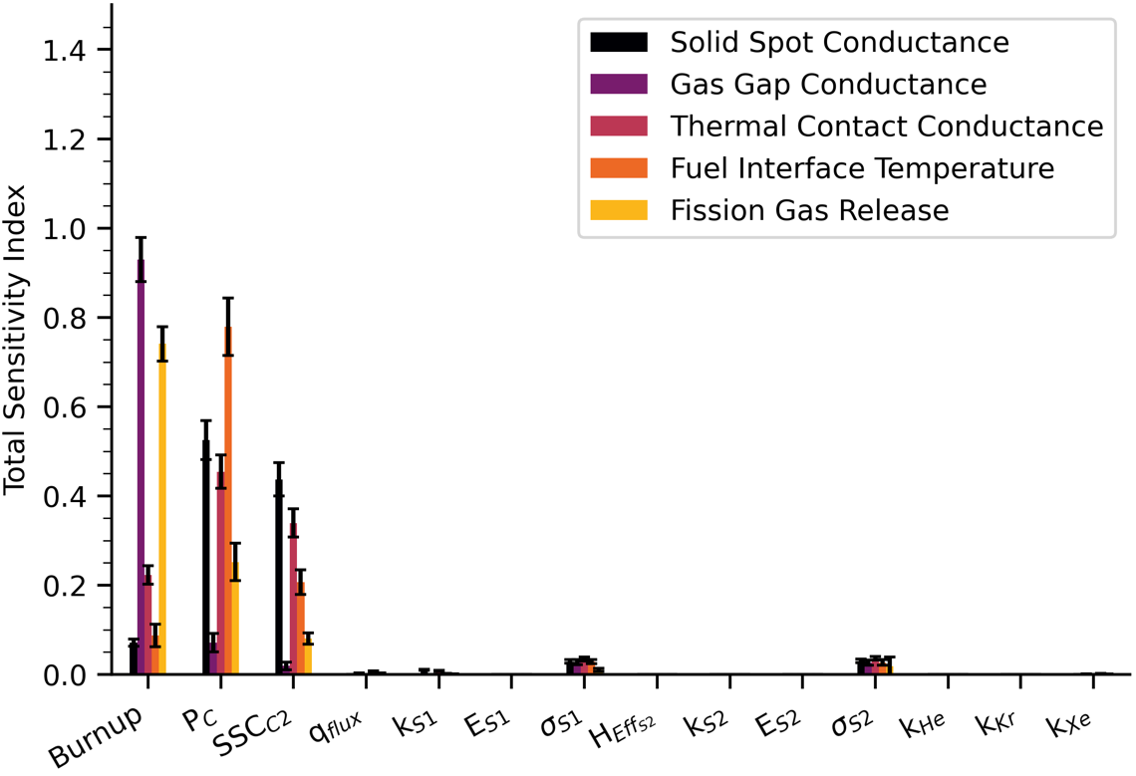
Figure 4.16. Total Sobol indices Sobol sensitivity parameters of UO₂ MiniFuel TCC parameters at 1000°C target temperature using a standalone Python model.

propagate into the FGR models.

Coupled Python/BISON Model Results
To consider the uncertainty propagation from the TCC model into the FGR model, the Sobol analysis is performed using the coupled Python-BISION code framework. This coupling accounts for the interaction between temperature and fission gas diffusion increasing FGR. The coupled analysis is performed using designs that would reach 3 different target temperatures, 800°C, 1000°C, and 1200°C. Each simulation is run until a burnup of 80 GWd/MTU is reached. As diffusion of fission gas is low at low fuel temperatures, a fuel interface temperature of 800°C ensures that FGR occurs within 80 GWd/MTU based on the work by Cheniour et. al. [185]. Fuel interface temperatures of 1000°C and 1200°C aim to inspect different variations of FGR.

Sobol Sensitivity Analysis Results
The results of the coupled Python-BISON model for a 1000°C target temperature RB subcapsule are shown in Figure 4.17. This demonstrates the impact of the initial gas pressure on the fuel temperature predictions. The primary design parameters dictating the variance in the fuel interface temperature are the contact pressure, initial gas pressure and C₂ coefficient. There is also a small contribution to the variance from uncertainty in surface roughness of both the fuel and dish.

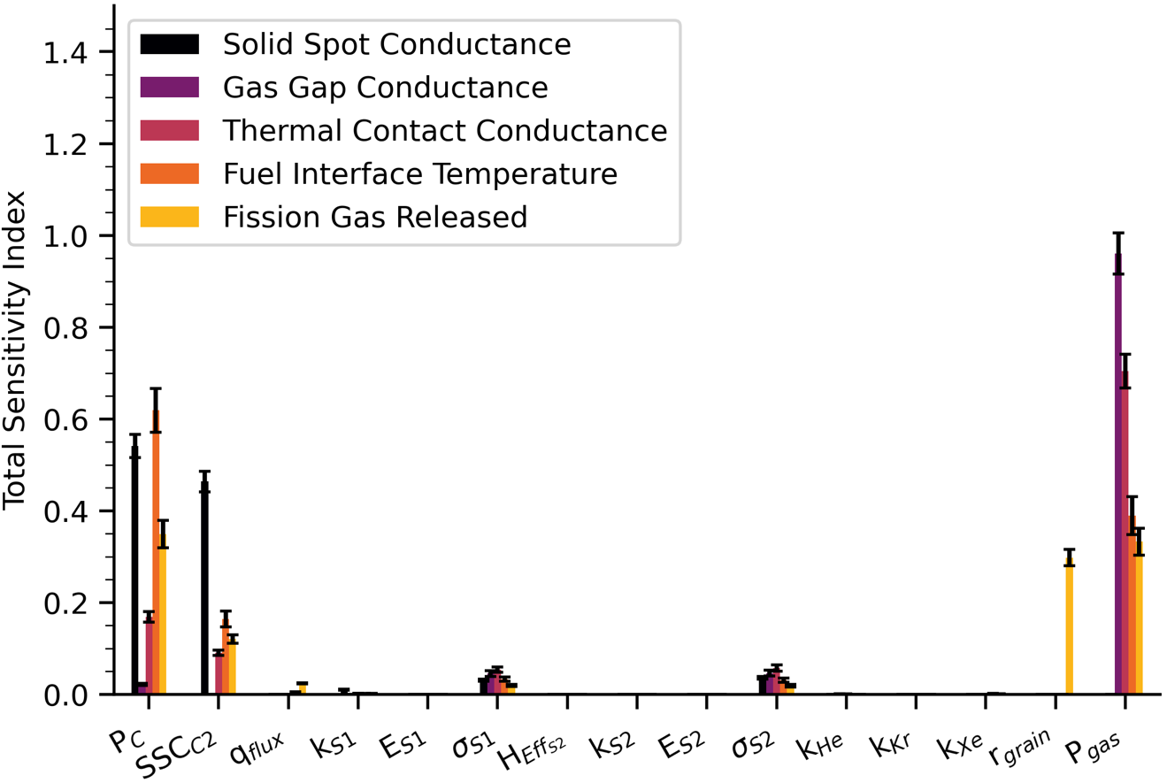
Figure 4.17. Total Sobol indices of UO₂ MiniFuel TCC parameters at 1000°C target temperature and 80 GWd/MTU using a coupled Python-BISON model.

Performance Envelopes
Using the data from each run in the Sobol sensitivity analysis, envelopes of performance are developed for each target temperature over the 80 GWd/MTU irradiation. The data within these plots are bounded by the maximum and minimum values at each interval of
5 GWd/MTU. Figure 4.18 contains the fuel interface temperature for each of the target temperatures, 800°C, 1000°C, and 1200°C, within the Sobol sensitivity analysis. The figure demonstrates a ~200°C range in interface temperature for all targets with fresh fuel, which increases to ~300°C as burnup increases. Histograms containing the distribution of interface temperature for each target temperature are shown in Figure 4.19. Higher thermal uncertainties propagate into the higher temperature calculations which shift the fuel interface temperature distributions further from the dish temperature. The cause of this shift will be inspected in the discussion section. Figure 4.20 contains the performance envelopes for FGR across each target temperature. As temperature increases, the time of initial FGR decreases. The behavior of these curves closely resembles those from the work of Cheniour et. al. [185] at each respective temperature.

Influence of Controllable Variables
This section aims to inspect the influence of each parameter of interest which can be controlled in the capsule design. The Sobol Sensitivity analysis consists of over 70,000 sample cases. Within the sample cases, each parameter was varied within the sample spaces specified in Table 4.8. The individual influence of initial gas pressure, contact pressure, and effective surface roughness on the fuel interface temperature prediction is

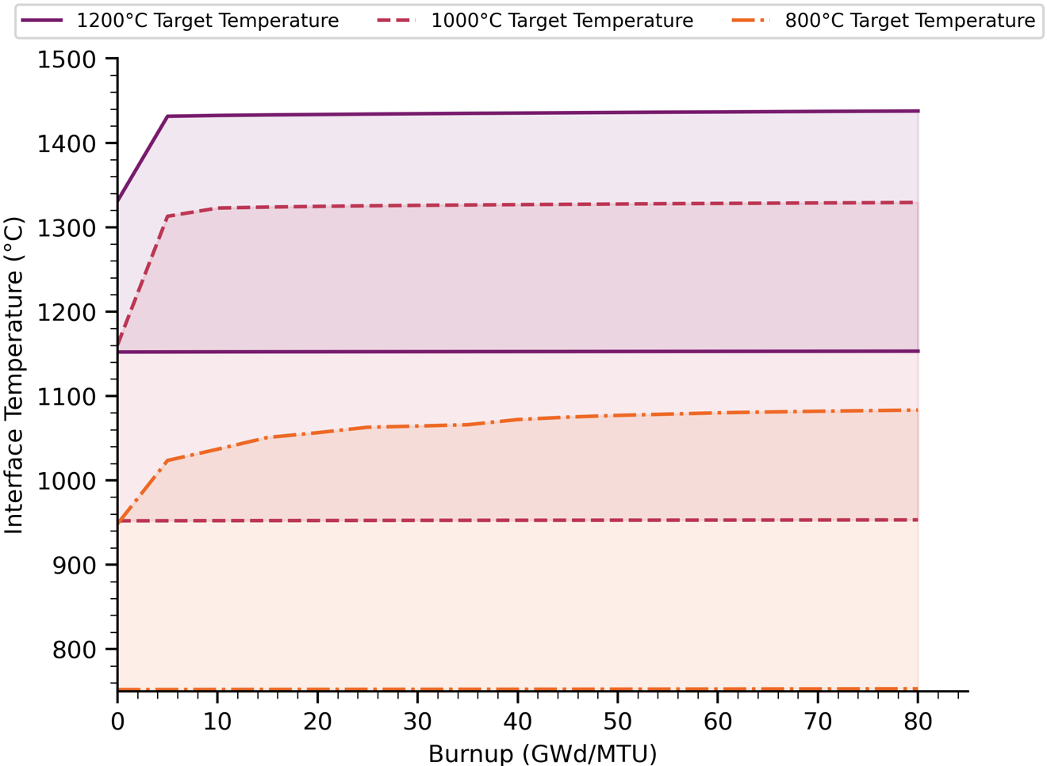
Figure 4.18. Interface temperature variations of UO₂ MiniFuel subcapsules with target temperatures of 800°C, 1000°C, and 1200°C.

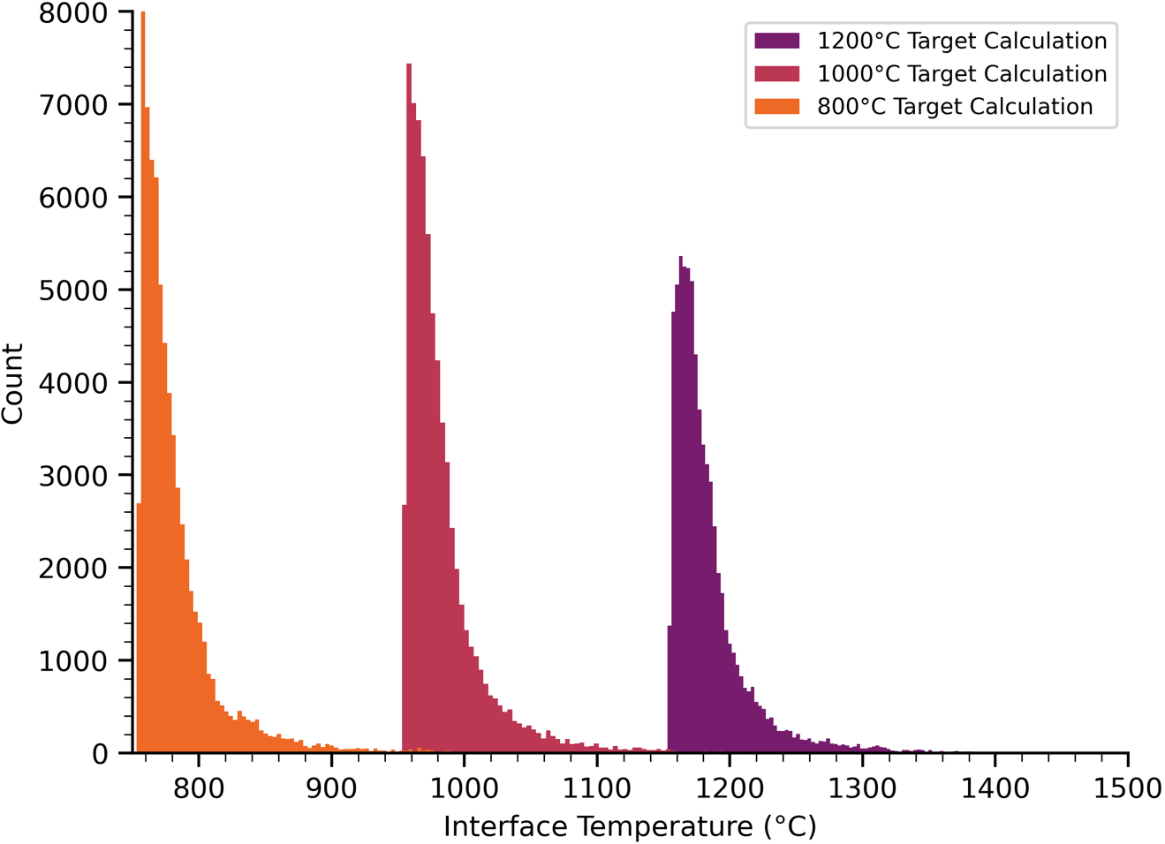
Figure 4.19. Histograms of UO₂ MiniFuel specimens at 80 GWd/MTU with target temperatures of 800°C, 1000°C, and 1200°C.

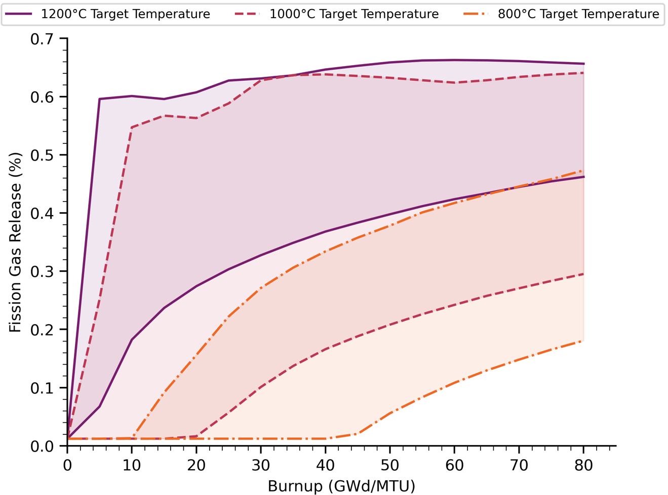
Figure 4.20. FGR of UO2 MiniFuel subcapsules with target temperatures of 800°C, 1000°C, and 1200°C.

determined by filtering the Monte Carlo data using 4 set subintervals of their respective sample space. Model temperature predictions for a 1000°C target temperature subcapsule at 80 GWd/MTU with varying initial gas pressure, contact pressure, and effective surface roughness are seen in Figure 4.21, Figure 4.22, and Figure 4.23, respectively. Figure 4.21 suggests that the current capsule design with a target temperature of 1000°C, which is backfilled with He at atmospheric pressure (~0.1 MPa) and room temperature prior to irradiation, operates within a range of ~15°C at low burnup, which increases to ~50°C at 80 GWd/MTU due to FGR and degradation of thermal conductivity due to burnup. At the maximum initial pressure range of 1-2 MPa, the range reduces to ~20°C across all considered burnups. The initial gas pressure has a two-fold effect on increasing the TCC at the interface. The temperature jump distance of He, Ar, and Xe gas decreases [181], increasing gas gap conductance, and the initial composition of He is greater, mitigating the thermal conductivity reduction from FGR into the plenum. It is important to note that the only way to achieve vacuum conditions within the subcapsule is to seal the subcapsule within a vacuum chamber since the pressure of the irradiation target is also backfilled with He at atmospheric pressure.
Figure 4.22 shows the relationship between the interface temperature and contact pressure. This relationship is more linear and consists of relatively even distributions of each envelope with increasing orders of magnitude in contact pressure. The same can be expressed for Figure 4.23 with regard to effective surface roughness between the fuel and dish interfaces. There may be additional higher order interactions between the
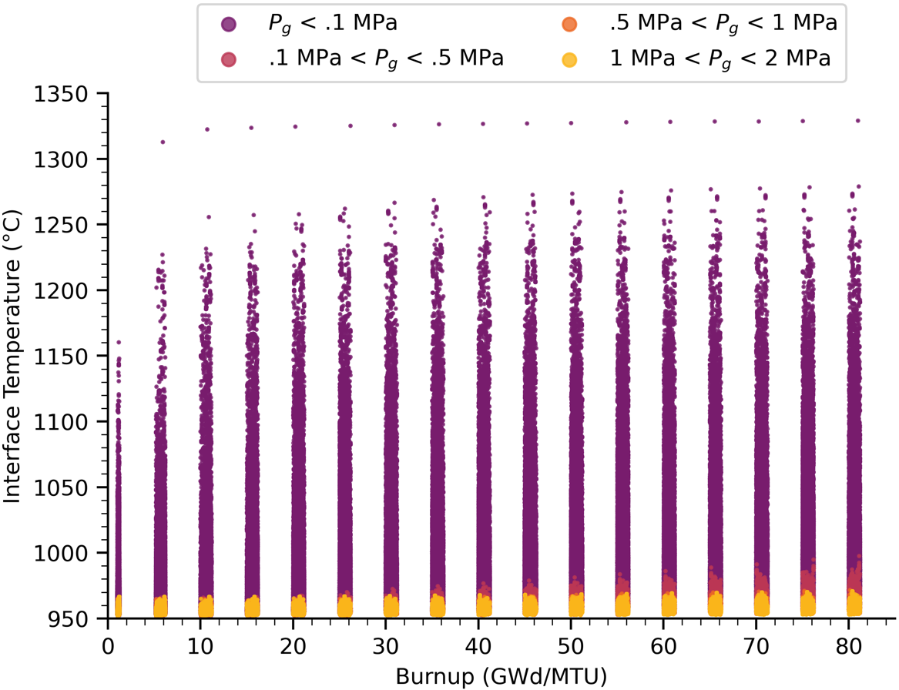

Figure 4.21. Performance envelopes of a 1000°C target temperature UO₂ MiniFuel subcapsule based on initial fill gas pressure.

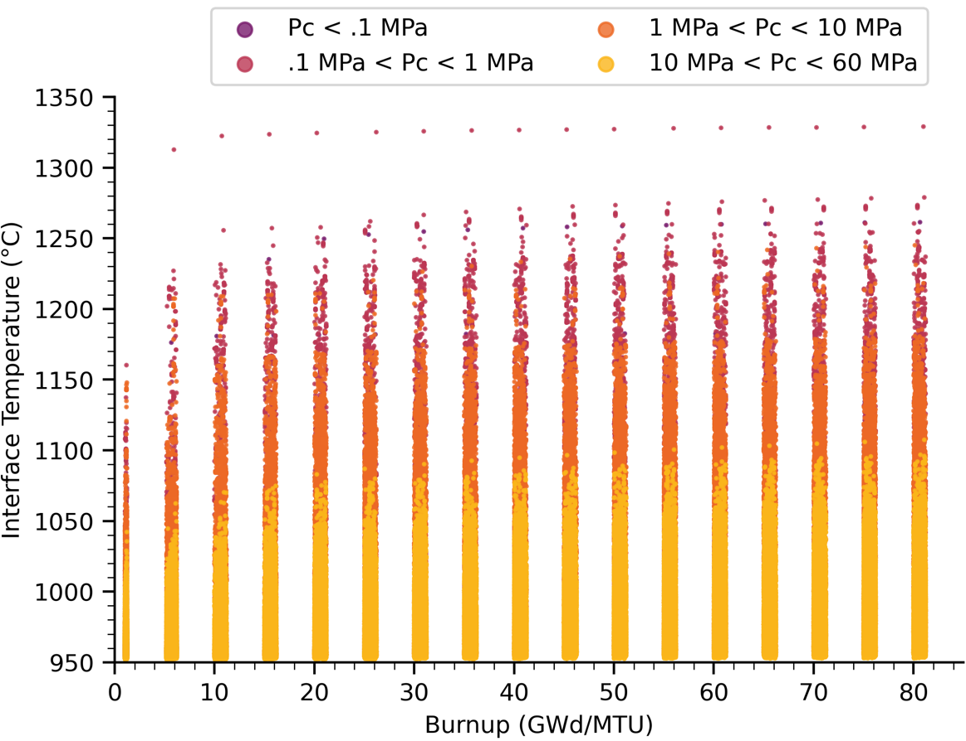

Figure 4.22. Performance envelopes of a 1000°C target temperature UO₂ MiniFuel subcapsule based on contact pressure.

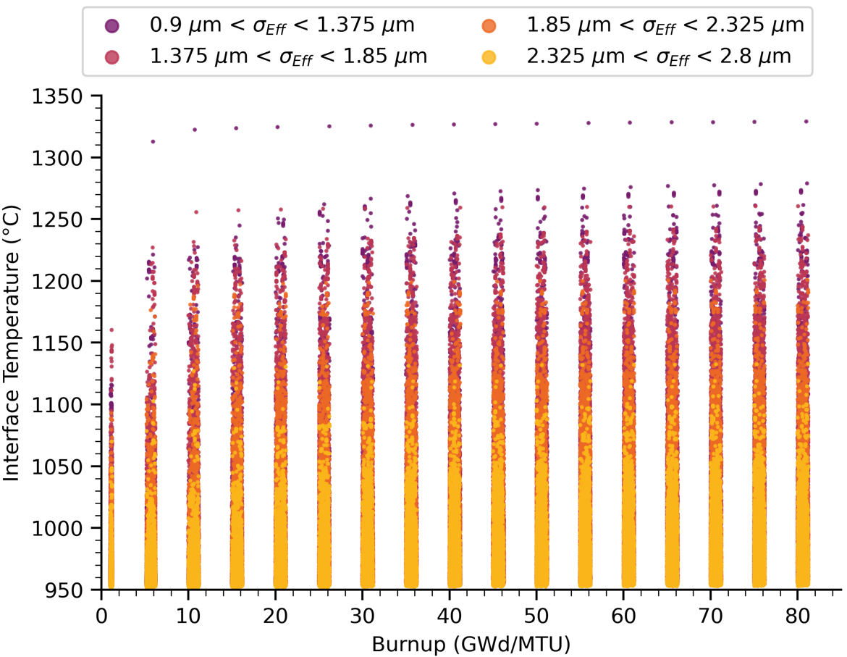

Figure 4.23. Performance envelopes of a 1000°C target temperature UO₂ MiniFuel subcapsule based on effective surface roughness.

parameter C₂ however, since C₂ is an empirical fitting correlation with a wide variation based on surface characteristics and surface materials [184], little can be done to reduce any uncertainties stemming from this interaction. With this in mind, C₂ is set to a nominal value of 0.68, a mean value for the reported range of C₂ for engineering surfaces 0.6-0.75 [153], for the remainder of the analysis. Based on the results in Figure 4.22 and Figure 4.23, the use of contact pressure or surface roughness as a primary method of variance reduction seems unreasonable within the currently considered gas and contact pressures.
To translate these results into design recommendations, a set of performance envelopes are developed using initial gas pressure as the primary design parameter and several regions of SSC as the secondary design parameter. Figure 4.24 shows each considered range of initial gas pressure with several ranges of SSC overlaid. The ranges of SSC (in W/m²-°C) are as follows:
Case 1: 1×10⁴ < h_{s} < 2×10⁴ Case 2: 2×10⁴ < h_{s} < 3×10⁴
Case 3: 3×10⁴ < h_{s} < 4×10⁴ Case 4: 4×10⁴ < h_{s} < 5×10⁴
The minimum SSC is selected to keep the interface temperature within ~50°C of the heat sink at all initial gas pressure conditions including vacuum. This corresponds to the results at 0.1 MPa initial pressure and 80 GWd/MTU from Figure 4.21. To determine an estimate for the maximum SSC, a linear least squares fit is performed on the SSC data with respect to surface roughness and contact pressure.
Figure 4.25 is a contour plot outlining the required contact pressure and effective surface roughness to reach a specific SSC according to Equation 21. The maximum SSC
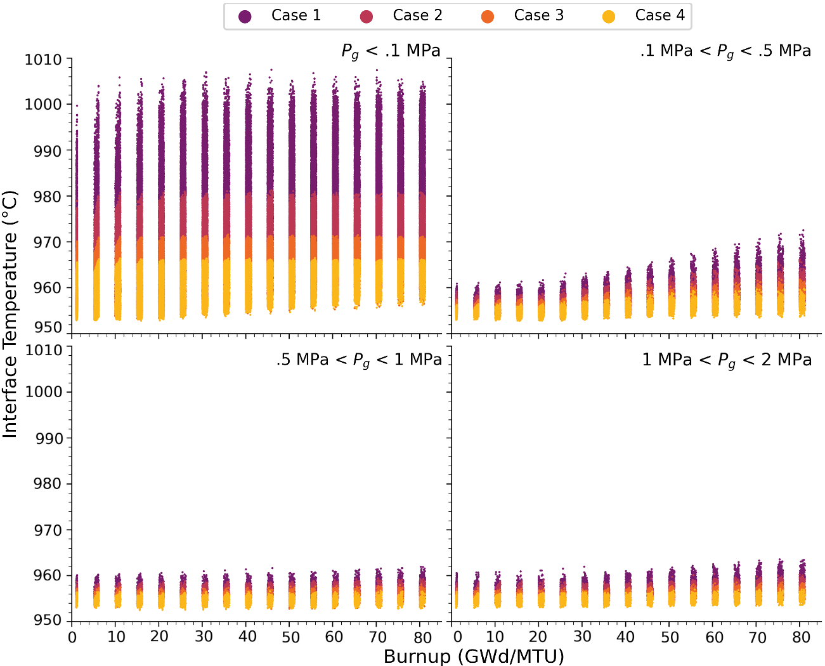
Figure 4.24. Performance envelopes of a 1000°C target temperature UO₂ MiniFuel subcapsule inspecting varying SSC.

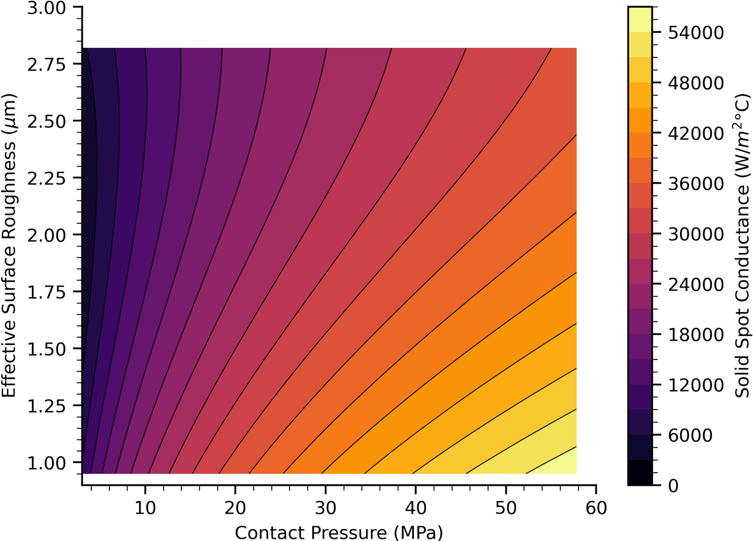
Figure 4.25. SSC of a 1000°C target UO₂ MiniFuel subcapsule at 80 GWd/MTU based on contact pressure and surface roughness.

considered in Case 4 is the peak SSC from Figure 4.25. It should be noted that the thermal conductivity between the two surfaces degrades as a function of burnup, so the peak achievable SSC would be at 0 GWd/MTU and degrade over the course of the irradiation to reach the considered ranges. From the trends in Figure 4.24 and Figure 4.25, the SSC should be maximized through increasing contact pressure and decreasing surface roughness. Based on the results in Figure 4.24, if the SSC is kept above 4x10⁴ W/m²-°C, the effects of FGR under atmospheric pressure conditions would be mitigated.

Influence of Temperature Jump Distance
Temperature jump distance is a manifestation of inefficiencies in heat transfer between individual gas particles and surface particles [184]. The jump distance of a gas in the ANSYS model, dictated by Equation 24, is based on the derivation by Kennard [193].
Equation 24 takes into account the collision efficiency of the particles using an accommodation coefficient α. The model utilizes a formulation of α by Song and Yovanovich [194], Equation 25, which is applicable to gas mixtures and applied for temperatures between 0°C and 1000°C. Heavier gas particles such as Xe and Kr have a higher accommodation coefficient and are more efficient at transferring energy to Mo or UO₂ surfaces but also have lower thermal conductivity than a less efficient particle such as He.
Equation 24 demonstrates the jump distance is inversely proportional to both pressure and molecular weight of the gas [181, 193]. Figure 4.26 demonstrates how the relationship between temperature jump distance and gas pressure translates to the fuel
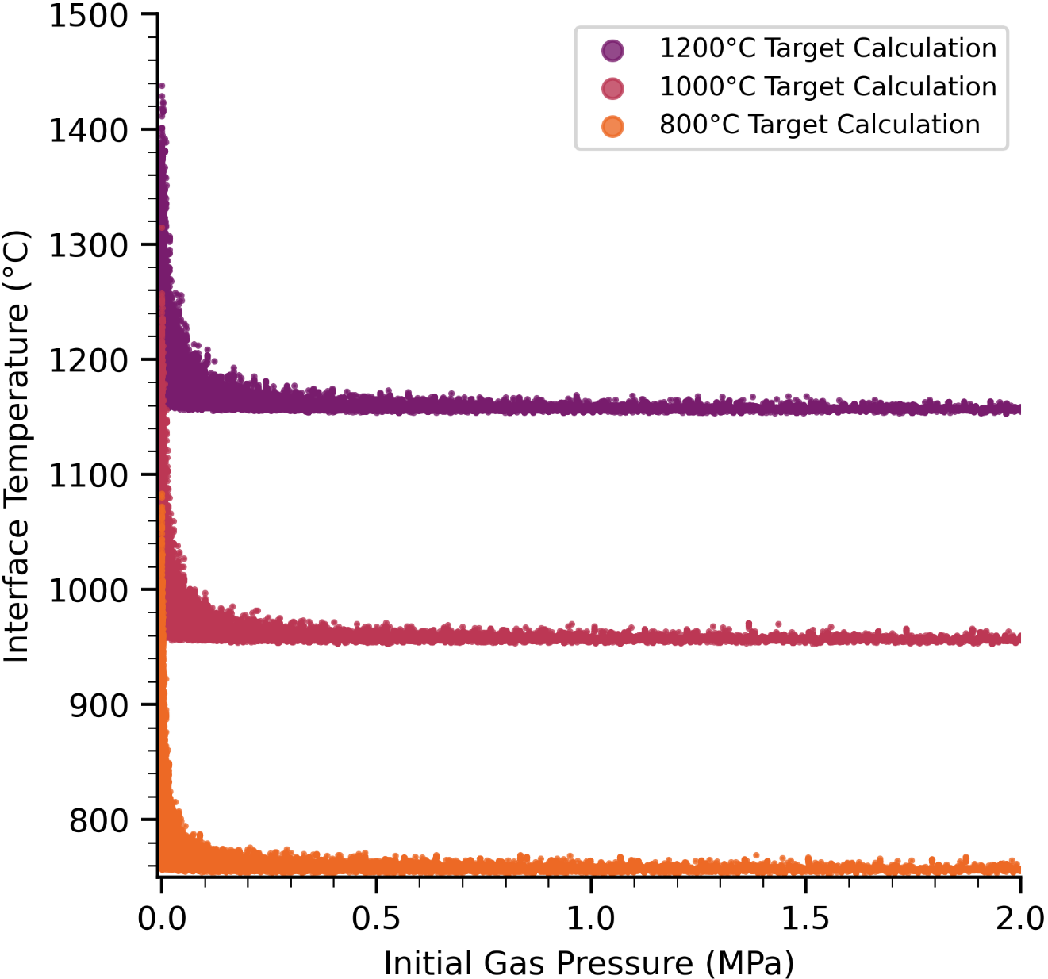
Figure 4.26. Fuel interface temperature performance envelopes of a Target UO₂ MiniFuel subcapsule at 80 GWd/MTU based on initial fill gas pressure.

interface temperature predictions and shows that the temperature jump distance of the gas can influence the fuel temperature prediction. At higher temperatures, the jump distance increases and shifts the distribution of temperatures toward higher initial gas pressures. This behavior is replicated in the histogram from Figure 4.19.
The temperature jump distance formulation based on Kennard [193] is standard in many model calculations of TCC [153, 181, 184, 195-198]. However, the accommodation coefficient, Equation 25, varies between correlations and can shift the behavior shown in Figure 4.26. Figure 4.27 and Figure 4.28 show several jump distance calculations at 1000°C between He and Mo, and He and UO₂, respectively. Data for each graph was generated using the Python model from Section 0. Each jump distance calculation used the formulation by Kennard, but varied calculations of the accommodation coefficient. Included are methodologies by Kennard [193] using a classical hard-sphere approximation, by Song and Yovanovich [194] (Currently implemented in ANSYS), and by Goodman and Wachman [199]. Based on the 1/P dependence; the jump distances will all have an asymptote at 0 and, from the results in Figure 4.27 and Figure 4.28, are most sensitive at pressures below ~0.5 MPa. Above ~0.5 MPa, the differences between jump distance methodologies start to converge. Most accommodation coefficients include a mass dependence similar to the hard-sphere approximation which causes energy transfer to become less efficient with greater difference in particle molecular weight. As such there is a higher jump distance between He gas and UO₂ surfaces than He gas and Mo surfaces at all pressures.
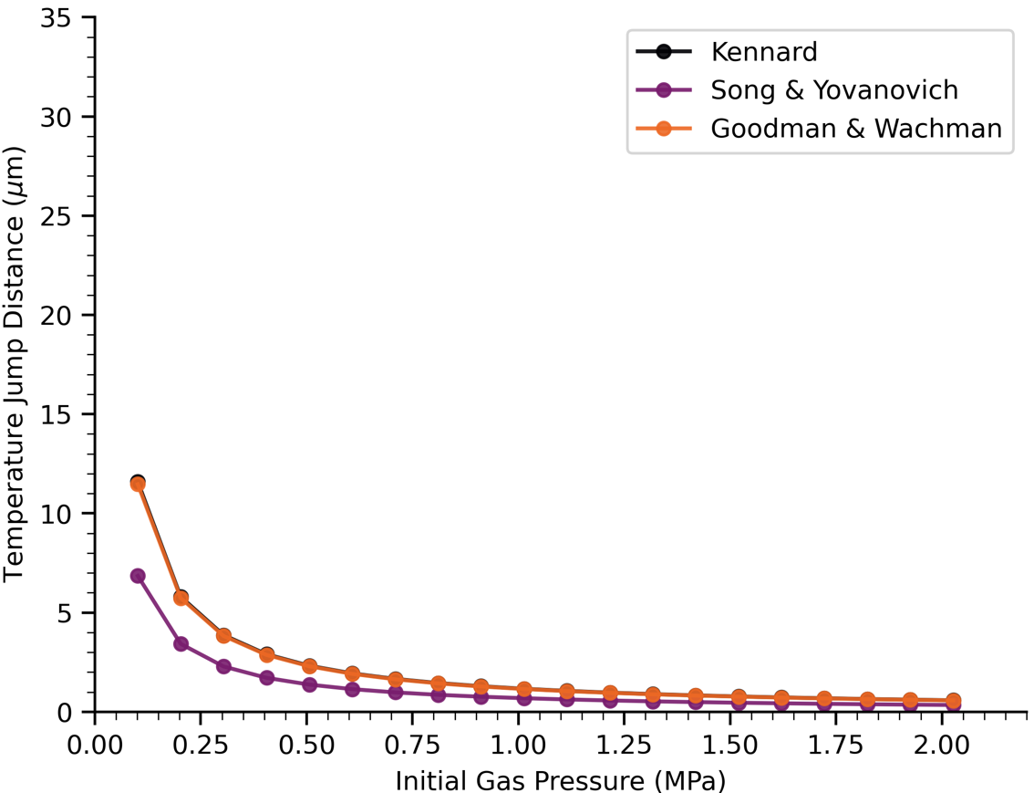
Figure 4.27. Influence of initial gas pressure on temperature jump distance for a He-Mo interface at 1000 °C.

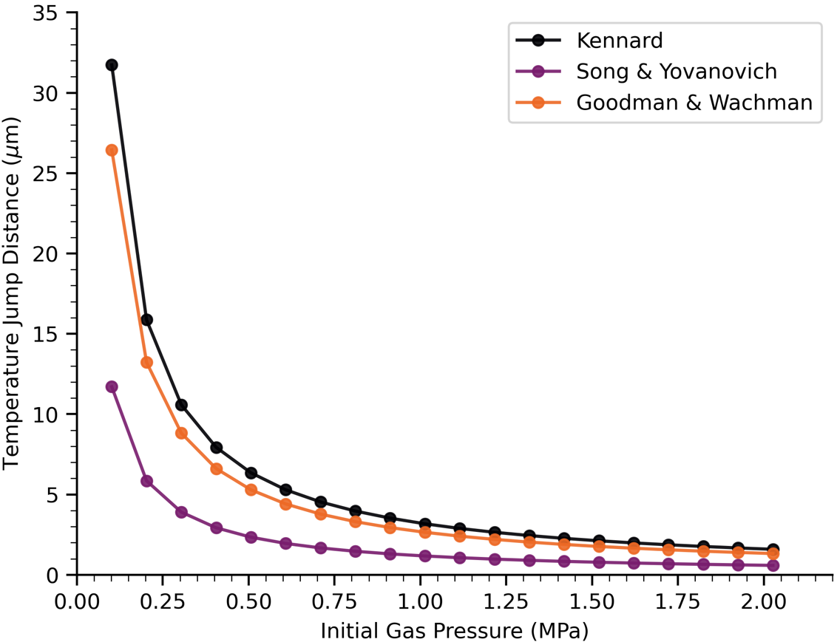
Figure 4.28. Influence of initial gas pressure on temperature jump distance for a He-UO₂ interface at 1000 °C.

Additional variance may be introduced in the at-temperature gas pressure due to simplifying assumptions of the r-z model. Since the gas is dispersed throughout the capsule, the actual gas temperature at the fuel-dish interface is unknown. The model gas temperature is assumed to be the average between the fuel and dish interface temperatures. The fuel interface temperature can potentially be much higher than the dish temperature, but the effects resulting from this variance can be mitigated with sufficiently high initial pressure.

Capsule Design Recommendations
Figure 4.17 outlines the parameters that contribute the greatest variance to the model fuel temperature predictions. The parameters are, in order of greatest to least impact, the initial gas pressure, the contact pressure between the fuel and dish, the C₂ empirical constant, and the surface roughness of the fuel and dish. The nominal values currently used for design analysis and calculations for subcapsules are 0.1 MPa initial gas pressure, 0 MPa contact pressure (i.e., the negligible weight of the specimen resting on the dish) and 2.26 μm effective surface roughness, equating 0 W/m²-°C SSC.
Using the results from the discussion, the following set of design recommendations is developed for minimizing fuel temperature variance in future experiments:
  - Increase initial gas pressure from 0.1 to ~0.5 MPa such that the thermal jump distance uncertainty is low as demonstrated in Figure 4.27 and Figure 4.28. This is the most impactful design improvement and can be implemented without changing the capsule design so long as the welds can ensure hermiticity. Increased initial gas pressure will also help to suppress the degradation of gas conductance induced by FGR.
  - Increase SSC from 0 to ~1×10⁴ W/m²-°C such that interface temperature variance is low under low gas pressure conditions. This can be established through some combination of contact pressure and effective surface roughness as outlined in Figure 4.25. Any additional SSC will work to further reduce the variance at any initial gas pressure as demonstrated by Figure 4.24.
Using the subcapsule gas pressure as a main method of variance reduction is favorable since the current subcapsule design does not have to change to accommodate the new subcapsule pressures. Additional variance reduction achieved via enhanced contact pressure would require a redesign of the MiniFuel subcapsule such that the fuel disk is contacted on both axial faces and under a mechanical load. This would provide two surfaces for heat transfer out of the specimen and would reduce the peak heat flux by ~1/2. The combination of enhanced contact pressure and a reduction in heat flux at each surface could mitigate error at the interface further.
Furthermore, if initial gas pressure is sufficiently high, it may obviate the need to include a tightly coupled FGR model for these experiments. Based on the current FGR models, the total fuel mass (assuming nominal dimensions of 1.4mm height and 0.3mm radius at all considered target interface temperatures) does not generate enough FGR over the given 80 GWd/MTU irradiation to significantly degrade the gas conductance under the recommended initial gas pressure of ~0.5 MPa. In this case, it would be possible to provide a conservative estimate of FGR using the lookup table method. However, this would need to be reevaluated with any design changes to the subcapsule which increase fuel temperature or fuel mass as FGR may increase.

Applying Recommendations to ANSYS
The goal of this section is to quantify the potential reduction in the uncertainty of average fuel temperature predictions by applying the design recommendations to ANSYS. First, the model from the previous work [25] is re-evaluated at the extremes of the associated sampling space using the RB and VXF boundary conditions. This will define a minimum and maximum temperature range within the considered uncertainties. Each model evaluation uses set fuel dimensions of 1.4 mm radius and 0.3 mm height and subcapsules are assumed to be backfilled with atmospheric pressure He. The minimum temperature case uses the minimum HGRs and burnup, maximum heat transfer parameters including SSC and thermal conductivity, and will approach ideal heat transfer. The maximum temperature case is a conservative estimate that uses the maximum HGRs and burnup, minimum heat transfer parameters including no SSC (which is nominally assumed for design analysis and calculation) and the minimum considered thermal conductivity.
Applying these conditions to the subcapsule for VXF and RB boundary conditions gives the following average fuel temperature ranges: 542°C - 641°C in VXF and 947°C - 1178°C in RB. The uncertainty range within the considered sample space is 99°C in VXF and 231°C in RB. These ranges correspond with the uncertainty extremes determined in the previous work [25]. The previous paper quantified uncertainty ranges of ±40°C in VXF and ±80°C in RB by calculating two standard deviations from the mean fuel temperatures. The larger ranges of 99°C and 231°C listed here are inclusive of the low-probability tails of the bell curves presented in the previous work. Applying the design recommendations to the ANSYS model provides the following average fuel temperature ranges: 542°C - 620°C in VXF and 947°C - 1102°C in RB. The new uncertainty ranges are 78°C in VXF and 155°C in RB, equating to a 21% and 33% reduction in the uncertainty range of the average fuel temperature for VXF and RB, respectively. Assuming that uncertainty calculated using two standard deviations would scale by the same degree, the ±2σ uncertainties for fuel specimen temperatures could reduce to approximately ±32°C and ±53°C for VXF and RB MiniFuel, respectively.
Figure 4.29 shows several cases that represent variations in the applied design recommendations. The minimum and maximum temperature cases again assumed the extremes of each parameter from the Sobol sensitivity analysis of the previous work [25]. Case 0 represents a baseline ANSYS calculation which assumes ~0.1 MPa initial fill gas pressure and 0 W/m²-°C SSC. Case 1 applies only the recommended 1E+04 W/m²-°C SSC to the baseline calculation. Case 2 applies only the recommended ~0.5 MPa initial fill gas pressure to the baseline calculation. Case 3 applies both ~0.5 MPa initial fill gas pressure and 1E+04 W/m²-°C SSC to the baseline calculation. By utilizing either design recommendation to the baseline design individually, the temperature gradient across the
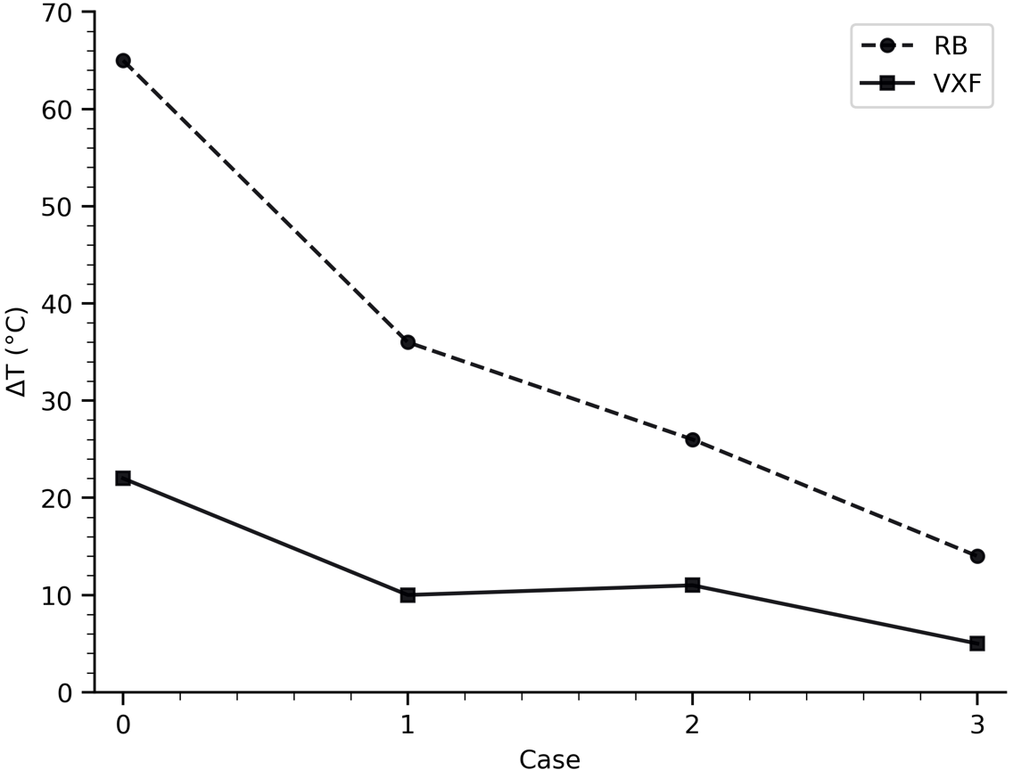
Figure 4.29. Influence of design recommendations on fuel and dish interface temperature gradients in ANSYS.

interface between the fuel and dish decreases from ~65°C to ~30°C in RB and from ~20°C to ~10°C in VXF. By utilizing both design recommendations, the gradient is further reduced to ~15°C in RB and ~5°C in VXF.

Additional Considerations and Future Work
While high initial gas pressures can provide a notable reduction in the predicted temperature range, the welds that ensure the hermiticity of the capsule need to be able to withstand this pressure. This will serve to prevent the leakage of He and ensure gas gap conductance remains high. If the welds do fail, contact pressure will be essential for mitigating temperature variation through SSC. Pressure within the subcapsule in the case of a leak would equalize to the pressure of the surrounding target which is backfilled with atmospheric pressure He prior to irradiation, replicating the nominal subcapsule design.
As contact pressure approaches zero between two real surfaces, the effective gap distance increases until the surfaces are no longer in contact. To account for this transition within a simulation environment, where surfaces do not include imperfections such as roughness, there must be a minimum contact pressure for which SSC is considered [153]. Otherwise, the gap can be infinitesimally small without being in contact. The model addresses this transitional period by using the correlation from Negus and Yovanovich [200]:
 | $$δ=1.184σ{\left[-\ln\left(3.132\frac{P_{c}}{H_{eff}}\right)\right]}^{0.547}$$ | 31
and applying Equation 31 across the minimum and maximum values of P/H_{eff} from literature [177, 179]. The considered contact pressure ranges, minimum ~.1 MPa and maximum ~60 MPa, far exceed the expected contact pressures between the fuel and dish based on gravitational force. This both increases the calculated SSC and decreases the effective gap distance which increases gas gap conductance [153]. This in turn can introduce an overestimation of gap conductance. The impact of this estimation will not be known until PIE is performed and results for irradiation temperature and fission gas release are compared to the model predictions.
An avenue for future work that can further benefit the reduction of variance in fuel temperature predictions is better defining SSC. The correlation by Mikić [201], used in this work, has been shown to be the most fundamental in nature and widely applicable [202]. Several alternate SSC correlations have been tested against UO₂ fuels in out-of-pile conditions [202-204], but these correlations following implementation in fuel performance codes have shown to have large uncertainties when compared to experimental data [204]. From the literature there are correlations specifically for UO₂ and some surface, but are fit to very specific data and may not be more widely applicable to differing temperatures, burnups, etc. There is no dataset that inspects all of these effects but there are some that exist looking at each individually [204]. There has been no comparison with the correlation by Mikic to some of these datasets since there is too little data to inform the correlation [204].
Another avenue of future work would be to better define the FGR of MiniFuel under these irradiation conditions. As PIE for RB MiniFuel irradiations begins, there is an opportunity to compare these results to existing data to either confirm that the applied models are sufficient or even to develop a new model specific to MiniFuel. These results can determine if the FGR model estimates are conservative and if there is a need for a tightly coupled FGR model for MiniFuel thermal analysis.

Conclusions of In-Depth TCC Model Analysis
Within this study, the TCC model for predicting the temperature gradient between the fuel and dish has been inspected with the intention to reduce the variance in MiniFuel specimen temperature predictions. The model was analyzed in increasing levels of complexity to determine high-impact high-uncertainty parameters while considering the influence of FGR. This work has produced Sobol sensitivity parameters associated with each parameter at 1000°C and performance envelopes of the associated subcapsule design at 800°C, 1000°C, and 1200°C. There are three high-impact sources of variance in the fuel interface temperature prediction within the subcapsule which can be reduced in future designs: the contact pressure between the fuel and dish, the effective surface roughness of the fuel-dish interface and the initial gas pressure within the subcapsule. A set of design recommendations has been made to reduce variance in fuel temperature predictions using the initial gas pressure as the primary design parameter. Applying these recommendations to the previously developed ANSYS models reduced the uncertainty range for average fuel temperature predictions from 99°C to 78°C in VXF, a 21% reduction, and from 231°C to 155°C in RB, a 33% reduction. Assuming the ±2σ uncertainties determined in the previous work decrease by the same amount, implementing the design changes suggested in this work would reduce the fuel temperature uncertainty in VXF and RB MiniFuel experiments to ±32°C and ±53°C, respectively. The maximum temperature gradient across the fuel-dish interface also decreased from ~65°C to ~15°C in RB and from ~20°C to ~5°C in VXF. This creates a lower bound for TCC and can work to address both the variance in temperature due to TCC and volumetric HGRs. Future work to further reduce variance include better definitions of contact conductance under low contact pressure irradiation conditions and experimental comparison with PIE data of FGR when it becomes available.

Conclusions
The overarching goal of this dissertation was to establish and demonstrate the feasibility of a computational framework for informing separate effects experimental design using sensitivity analysis. While this concept itself is not new, the demonstration of this method within the fuel qualification process is novel and is a necessary step to save time and money in accelerating the traditional process timeline. The process was applied to two individual case studies involving separate effects testing for fuel qualification; one case inspecting transient boiling heat transfer and critical heat flux and another case inspecting irradiation of MiniFuel.

Answers to Key Questions
Chapter 1 established several key questions associated with each case study. Within this section, I will address each question in detail with supporting evidence from the work presented.

Key Questions for Case Study 1
- What are high-impact high-uncertainty parameters for prediction of pre- and post- CHF transient boiling heat transfer?
From the Sobol sensitivity analysis in Chapter 3, the high-impact high-uncertainty parameters for the prediction of pre- and post- CHF are the CHF multiplier and film boiling multiplier. The CHF multiplier accounts for the transient CHF effect which increases CHF as the transient period decreases. The film boiling multiplier accounts for the film boiling heat transfer out of the system following the onset of CHF. These parameters collectively control the energy retained in the system following a rapid power insertion so it follows that they would have the highest impact.
- How can I improve model predictions of transient CHF and transient boiling heat transfer?
Chapter 3 demonstrated the modeling gaps for both pre- and post- CHF transient boiling heat transfer within RELAP5-3D. The experimental comparison with TREAT CHF-SERTTA capsule data demonstrated that CHF was still being underestimated without the consideration of effects such as irradiation, and the post-CHF heat transfer effects were not within the considered model uncertainties. The experimental comparison with the UNM boiling facility data demonstrated that there is enhancements to transient nucleate boiling heat transfer related to bubble crowding and departure and to the orientation of the cladding that is not being accounted for. To address the lack of experimental data for both pre- and post- CHF transient boiling heat transfer, I developed an experimental test matrix for the TRTL facility. The details of the test matrix can be found in Figure 3.28 and Table 3.6. This test matrix will inspect several timescales which will allow for the inspection of transient boiling heat transfer within the nucleate and film boiling region as well as the transition between steady-state and transient CHF. While this test matrix was specific to the TRTL facility based on its capability to accommodate representative LWR pressures and flow rates, the test matrix can be scaled and performed on another CHF experimental system.

Key Questions for Case Study 2
- What are high-impact high-uncertainty parameters for prediction of MiniFuel specimen temperatures?
Chapter 4 outlined two separate sensitivity analyses. The first is a full subcapsule analysis which considered over 50 sources of uncertainty. Following a Morris parameter screening and performing a Sobol sensitivity analysis, the heat generation rate in the Mo, and the TCC between the fuel and dish were the parameters of highest impact and uncertainty. The second sensitivity analysis was performed on the TCC model and inspected parameters within the gas and solid spot conductance correlations. The high-impact high-uncertainty parameters within the TCC model in order of greatest sensitivity to lowest sensitivity are the initial fill gas pressure, contact pressure between the fuel and dish, the C2 fitting parameter, and the effective surface roughness.
- How can I improve experimental designs to reduce variance in predicted fuel temperatures?
To address the uncertainty stemming from both the heat generation rate of the Mo, and the TCC model, I developed a set of design recommendations using the highest impact and uncertainty parameters of the TCC model. Increasing the TCC will reduce the impact of the heat generation rate uncertainty on the fuel-dish interface temperature gradient as per the following equation:
 | $$ΔT=\frac{q''}{TCC}$$ | 32
Where q’’ is the heat flux across the fuel-dish interface. The design recommendations are as follows:
- Increase initial gas pressure from 0.1 to ~0.5 MPa such that the thermal jump distance uncertainty is low as demonstrated in Figure 4.27 and Figure 4.28. This is the most impactful design improvement and can be implemented without changing the capsule design so long as the welds can ensure hermiticity. Increased initial gas pressure will also help to suppress the degradation of gas conductance induced by FGR.
- Increase SSC from 0 to ~1×10⁴ W/m²-°C such that interface temperature variance is low under low gas pressure conditions. This can be established through some combination of contact pressure and effective surface roughness as outlined in Figure 4.25. Any additional SSC will work to further reduce the variance at any initial gas pressure as demonstrated by Figure 4.24.
The primary contributor to the uncertainty of gas conductance is the initial fill gas pressure. The fill gas pressure directly increases the gas conductance via jump distance, Equation 24, and is also the primary contributor to the gas thermal conductivity. The initial fill gas pressure influences the final composition of the gas following gaseous fission product release and can mitigate the thermal conductivity degradation from the addition of Kr and Xe. Figure 4.24 demonstrates that an initial fill gas pressure of 0.5 MPa is sufficient to mitigate the effects of FGR within 80 GWd/MTU with a 1000°C target temperature. Figure 4.27 and Figure 4.28 demonstrate that an initial fill gas pressure of 0.5 MPa is also sufficient to reduce the jump distance uncertainty across several correlations for both Mo and UO₂ interfaces.
The current ANSYS calculation method assumes 0 W/m²-°C solid spot conductance, given no contact pressure between the fuel and dish, and ~0.1 MPa initial gas pressure, corresponding to 1 atm. The solid spot conductance is not 0 in reality, but since the real value of contact pressure is unknown, the uncertainty in solid spot conductance is anywhere between 0 and ideal heat transfer. By addressing the minimum value of SSC, the minimum heat transfer case can be improved. Figure 4.24 demonstrates that a minimum solid spot conductance of ~1×10⁴ W/m²-°C can keep the interface temperature within 1000°C even under vacuum conditions. This is the peak temperature demonstrated for a 1000°C target temperature RB subcapsule at 80 GWd/MTU assuming ~0.1 MPa initial fill gas pressure. Although vacuum conditions within the subcapsule can only be achieved through intentional experimental design, this offers a method to maintain the current uncertainty margins with the option of vacuum and will also work toward reducing the uncertainty of the nominal design conditions.
Applying these recommendations to the previously developed ANSYS models reduced the uncertainty range for average fuel temperature predictions from 99°C to 78°C in VXF, a 21% reduction, and from 231°C to 155°C in RB, a 33% reduction. Assuming the ±2σ uncertainties determined in the previous work decrease by the same amount, implementing the design changes suggested in this work would reduce the fuel temperature uncertainty in VXF and RB MiniFuel experiments from ±40°C and ±80°C to ±32°C and ±53°C, respectively. The maximum temperature gradient across the fuel-dish interface also decreased from ~65°C to ~15°C in RB and from ~20°C to ~5°C in VXF.

Unique Contributions
This dissertation provides an assessment of computational modeling capabilities for two reactor safety applications: transient boiling heat transfer and critical heat flux, and thermal contact conductance. The significant contributions of this work are as follows:
- Utilized sensitivity analysis to identify parameters of high model uncertainty and sensitivity to inform design of separate effects tests for reactor safety applications.
- Developed a model of the TRTL facility within RELAP5-3D which can be used for experimental comparison to flow boiling CHF tests.
- Performed an experimental comparison of the UNM pool boiling facility to a RELAP5-3D model with an implemented empirical pool boiling CHF correlation.
- Performed an experimental comparison of the TREAT CHF-SERTTA capsule to a RELAP5-3D model with an implemented empirical pool boiling CHF correlation.
- Identified that implementation of empirical correlations of CHF from the literature are not sufficient for capturing transient boiling heat transfer phenomena.
- Demonstration of modeling gaps within the transient heat transfer models within RELAP5-3D for pre- and post- CHF transient boiling heat transfer.
- Development of an experimental test matrix which can work toward addressing modeling gaps in transient boiling heat transfer models.
- Developed a standardized MiniFuel model repository for use in sensitivity analysis.
- Developed a reduced order model for MiniFuel that includes a fission gas model within BISON.
- Proposed methods for reducing temperature uncertainty in MiniFuel irradiation tests.
- Identified correlations for thermal accommodation and solid spot conductance as sources of uncertainty within gap heat transfer modeling.
- Established design recommendations that can reduce the fuel temperature prediction uncertainty in MiniFuel targets by ~21% in VXF and ~33% in RB.

Suggested Future Work
This work demonstrates a method for utilizing sensitivity analysis to inform the design of separate effects tests to accelerate the nuclear fuel qualification process. Complications with documenting the fuel qualification process included a lack of established procedures and justification. A clear next step for future work would be to thoroughly document the use of the accelerated workflow to qualify a new fuel form. This would provide a preliminary quantification of the time necessary to qualify a new form and would provide future fuel qualification ventures a process to reference. Of course, this process and timeline would be subject to change based on the technology readiness level of the fuel form, but a well-documented reference would be a great benefit as literature on fuel qualification is sparse.

List of References
[1] D. S. SIQUEIRA, et al., “Current perspectives on nuclear energy as a global climate change mitigation option,” Mitigation and Adaptation Strategies for Global Change, 24, 5, (2019); 10.1007/s11027-018-9829-5.
[2] D. A. AROSTEGUI and M. HOLT, “Advanced nuclear reactors: technology overview and current issues,” Congressional Research Service Report for Congress, Washington, DC, Report,
[3] Z. CHEN, et al., “Review of Operating License Extension of Nuclear Power Plants,” 2022 29th International Conference on Nuclear Engineering,
[4] J. P. GORTON, C. M. PETRIE and A. T. NELSON, “A review of neutronics and thermal hydraulics–based screening methods applied to accelerated nuclear fuel qualification,” Progress in Nuclear Energy, 162, (2023); https://doi.org/10.1016/j.pnucene.2023.104737.
[5] L. T. KNIGHTON, et al., “Energy Arbitrage: Comparison of Options for use with LWR Nuclear Power Plants,” (2021-09-01 2021).
[6] F. J. GOLDNER, et al., “The U.S. Accident Tolerant Fuels Program — Update on a National Initiative,” United States, 2021-10-01.
[7] K. PASAMEHMETOGLU, “Advanced Fuels Campaign Execution Plan,” (2010-10-01 2010).
[8] J. CARMACK, et al., “Overview of the U.S. DOE Accident Tolerant Fuel Development Program,” presented at Conference: Top Fuel 2013,Charlotte, NC,09/15/2013,09/19/2013, United States, 2013.
[9] D. C. CRAWFORD, et al., “An approach to fuel development and qualification,” Journal of Nuclear Materials, 371, 1, (2007); https://doi.org/10.1016/j.jnucmat.2007.05.029.
[10] K. A. TERRANI, et al., “Accelerating nuclear fuel development and qualification: Modeling and simulation integrated with separate-effects testing,” Journal of Nuclear Materials, 539, (2020); https://doi.org/10.1016/j.jnucmat.2020.152267.
[11] D. FRAEDRICH and A. GOLDBERG, “A methodological framework for the validation of predictive simulations,” European Journal of Operational Research, 124, 1, (2000); https://doi.org/10.1016/S0377-2217(99)00117-4.
[12] N. GABER, et al., “Guidance on the Development,Evaluation, and Application of Environmental Models,” EPA/100/K-09/003, (2009);
[13] NICE, “Guide to the methods of technology appraisal 2013,” PMG9, (2013);
[14] A. GILBERTSON, “An Approach for Using Probabilistic Risk Assessment in Risk-Informed Decisions on Plant-Specific Changes to The Licensing Basis,” REGULATORY GUIDE 1.174, Revision 3, (2018);
[15] I. BANERJEE and M. G. IERAPETRITOU, “Design Optimization under Parameter Uncertainty for General Black-Box Models,” Industrial & Engineering Chemistry Research, 41, 26, (2002); 10.1021/ie0202726.
[16] E. BORGONOVO, et al., “Making the most out of a hydrological model data set: Sensitivity analyses to open the model black-box,” Water Resources Research, 53, 9, (2017); https://doi.org/10.1002/2017WR020767.
[17] A. LYE, et al., “Robust optimization of a dynamic Black-box system under severe uncertainty: A distribution-free framework,” Mechanical Systems and Signal Processing, 167, (2022); https://doi.org/10.1016/j.ymssp.2021.108522.
[18] R. HERNANDEZ, et al., “Sensitivity analysis of in-pile CHF experiments in the TREAT facility: Characterization of impacts of fuel system thermal properties,” Annals of Nuclear Energy, 165, (2022); https://doi.org/10.1016/j.anucene.2021.108645.
[19] W. MARCUM, et al., “Developing Separate Effects Transient Test Experiments Using an Out-of-Pile Flowing Water Loop,” Nuclear Technology, 206, 6, (2020); 10.1080/00295450.2020.1720559.
[20] N. WOOLSTENHULME, et al., “Development of Irradiation Test Devices for Transient Testing,” Nuclear Technology, 205, 10, (2019); 10.1080/00295450.2019.1590072.
[21] M. HE and M. CHEN, “Steady-state and power transient critical heat flux experiments of FeCrAl and Zircaloy claddings under saturated pool boiling,” Nuclear Engineering and Design, 410, (2023); https://doi.org/10.1016/j.nucengdes.2023.112374.
[22] C. M. PETRIE, et al., “Separate effects irradiation testing of miniature fuel specimens,” Journal of Nuclear Materials, 526, (2019); https://doi.org/10.1016/j.jnucmat.2019.151783.
[23] N. A. MEEHAN, et al., “Sensitivity Analysis of Transient Critical Heat Flux by RIA Under High-Pressure Flow Boiling Conditions in TRTL,” Nuclear Technology, (2023); https://doi.org/10.1080/00295450.2023.2195355.
[24] N. A. MEEHAN, C. P. FOLSOM and N. R. BROWN, “A knowledge gap analysis for transient CHF prediction within RELAP5-3D,” Nuclear Engineering and Design, 422, (2024); https://doi.org/10.1016/j.nucengdes.2024.113171.
[25] N. A. MEEHAN, et al., “Identifying high-impact and high-uncertainty parameters in MiniFuel model predictions,” Journal of Nuclear Materials, 609, (2025); https://doi.org/10.1016/j.jnucmat.2025.155745.
[26] N. A. MEEHAN, et al., “Sensitivity Analysis of Thermal Contact Conductance Modeling to Inform MiniFuel Irradiation Capsule Designs for Minimizing Fuel Temperature Variance,” To be submitted for publication, (2025);
[27] M. MIKA, A. PROBERT and A. AITKALIYEVA, “Nuclear fuel qualification: History, current state, and future,” Progress in Nuclear Energy, 177, (2024); https://doi.org/10.1016/j.pnucene.2024.105460.
[28] T. DRZEWIECKI, SCHMIDT, J., VANWERT, C., CLIFFORD, P., HOELLMAN, J., “Fuel Qualification for Advanced Reactors,” Nuclear Regulatory Commission, Office of Nuclear Reactor Regulation, NUREG-2246, (2022); https://www.nrc.gov/docs/ML2206/ML22063A131.pdf.
[29] T. ALLEN, et al., “Materials challenges for nuclear systems,” Materials Today, 13, 12, (2010); https://doi.org/10.1016/S1369-7021(10)70220-0.
[30] D. OLANDER, “Nuclear fuels – Present and future,” Journal of Nuclear Materials, 389, 1, (2009); https://doi.org/10.1016/j.jnucmat.2009.01.297.
[31] C. R. F. AZEVEDO, “Selection of fuel cladding material for nuclear fission reactors,” Engineering Failure Analysis, 18, 8, (2011); https://doi.org/10.1016/j.engfailanal.2011.06.010.
[32] B. W. SPENCER, et al., “Separate-effects validation experiments for models of fracture in ceramic nuclear fuel,” Idaho National Lab.(INL), Idaho Falls, ID (United States) 2019).
[33] E. BORGONOVO and E. PLISCHKE, “Sensitivity analysis: A review of recent advances,” European Journal of Operational Research, 248, 3, (2016); https://doi.org/10.1016/j.ejor.2015.06.032.
[34] A. SALTELLI and T. HOMMA, “Sensitivity analysis for model output: performance of black box techniques on three international benchmark exercises,” Computational statistics & data analysis, 13, 1, (1992);
[35] M. D. MORRIS, “Factorial Sampling Plans for Preliminary Computational Experiments,” Technometrics, 33, 2, (1991); 10.1080/00401706.1991.10484804.
[36] F. CAMPOLONGO, J. CARIBONI and A. SALTELLI, “An effective screening design for sensitivity analysis of large models,” Environmental Modelling & Software, 22, 10, (2007); https://doi.org/10.1016/j.envsoft.2006.10.004.
[37] M. V. RUANO, et al., “An improved sampling strategy based on trajectory design for application of the Morris method to systems with many input factors,” Environmental Modelling & Software, 37, (2012); https://doi.org/10.1016/j.envsoft.2012.03.008.
[38] K. PEARSON, On further methods of determining correlation, 16, Dulau and Company, (1907).
[39] P. SCHOBER, C. BOER and L. A. SCHWARTE, “Correlation Coefficients: Appropriate Use and Interpretation,” Anesthesia & Analgesia, 126, 5, (2018); https://doi.org/10.1213/ANE.0000000000002864.
[40] M.-T. PUTH, M. NEUHÄUSER and G. D. RUXTON, “Effective use of Pearson's product–moment correlation coefficient,” Animal Behaviour, 93, (2014); https://doi.org/10.1016/j.anbehav.2014.05.003.
[41] I. M. SOBOL, “Sensitivity Estimates for Nonlinear Mathematical Models,” Mathematical Modelling and Computational Experiments, 4, 407 (1993);
[42] T. IKONEN, “Comparison of global sensitivity analysis methods – Application to fuel behavior modeling,” Nuclear Engineering and Design, 297, (2016); https://doi.org/10.1016/j.nucengdes.2015.11.025.
[43] J. P. C. KLEIJNEN, “Sensitivity analysis and related analyses: A review of some statistical techniques,” Journal of Statistical Computation and Simulation, 57, 1-4, (1997); 10.1080/00949659708811805.
[44] J. HART and P. A. GREMAUD, “An approximation theoretic perspective of Sobol'indices with dependent variables,” International Journal for Uncertainty Quantification, 8, 6, (2018);
[45] C. P. FOLSOM, et al., “Design of separate-effects In-Pile transient boiling experiments at the TREAT Facility,” Nuclear Engineering and Design, 397, (2022); https://doi.org/10.1016/j.nucengdes.2022.111919.
[46] N. ZUBER, “Hydrodynamic Aspects Of Boiling Heat Transfer,” Thesis, Univ. of California, Los Angeles, (May 1959).
[47] S. S. KUTATELADZE, “HYDROMECHANICAL MODEL OF A CRITICAL STATE IN THE HEAT TRANSMISSION IN A BOILING LIQUID, FOR THE CASE OF FREE CONVECTION,” Vol: 20, (1950); Journal Name: Zhur. Tekh. Fiz.; Journal Volume: Vol: 20; Other Information: Orig. Receipt Date: 31-DEC-51.
[48] A. INOUE, et al., “Studies on a cooling of high heat flux surface in fusion reactor by impinging planar jet flow,” Fusion Engineering and Design, 51-52, (2000); https://doi.org/10.1016/S0920-3796(00)00178-2.
[49] V. BESSIRON, T. SUGIYAMA and T. FUKETA, “Clad-to-Coolant Heat Transfer in NSRR Experiments,” Journal of Nuclear Science and Technology, 44, 5, (2007); 10.1080/18811248.2007.9711861.
[50] A. SAKURAI, “Mechanisms of transitions to film boiling at CHFs in subcooled and pressurized liquids due to steady and increasing heat inputs,” Nuclear Engineering and Design, 197, 3, (2000); https://doi.org/10.1016/S0029-5493(99)00314-3.
[51] A. KOSSOLAPOV, “Transient flow boiling CHF under exponentially escalating heat inputs,” Thesis, Massachusetts Institute of Technology, Department of Nuclear Science and Engineering (November 2018).
[52] S. SAITO, et al., “Development of In-Reactor Fuel Behavior Observation System,” Journal of Nuclear Science and Technology, 18, 6, (1981); https://doi.org/10.1080/18811248.1981.9733275.
[53] F. BERTOCCHI, I. J. V. DE KOCK and C. A. VEGA, “Predicting Critical Heat Flux in Rectangular Channels: Which Correlation to Trust?,” Nuclear Engineering and Design, 418, (2024); https://doi.org/10.1016/j.nucengdes.2024.112900.
[54] G. ZHU, Z. WANG and H. XIE, “Prediction of critical heat flux in non-uniform heated rod bundle based on modified CHF empirical correlations,” Nuclear Engineering and Design, 417, (2024); https://doi.org/10.1016/j.nucengdes.2023.112875.
[55] R. HERNANDEZ, et al., “Review of pool boiling critical heat flux (CHF) and heater rod design for CHF experiments in TREAT,” Progress in Nuclear Energy, 123, (2020); https://doi.org/10.1016/j.pnucene.2020.103303.
[56] A. SESHADRI, E. C. FORREST and K. SHIRVAN, “Why ionizing radiation enhances surface wettability,” Applied Surface Science, 514, (2020); https://doi.org/10.1016/j.apsusc.2020.145935.
[57] S. KANO, et al., “Investigation of radiation-induced surface activation effect in austenitic stainless steel under ultraviolet and γ-ray irradiations,” Journal of Nuclear Science and Technology, 56, 3, (2019); https://doi.org/10.1080/00223131.2019.1571451.
[58] S. G. KANDLIKAR, “A Theoretical Model to Predict Pool Boiling CHF Incorporating Effects of Contact Angle and Orientation,” Journal of Heat Transfer, 123, 6, (2001); 10.1115/1.1409265.
[59] H. O'HANLEY, et al., “Separate effects of surface roughness, wettability, and porosity on the boiling critical heat flux,” Applied Physics Letters, 103, 2, (2013); 10.1063/1.4813450.
[60] E. BROWN, Y. YAN and W. R. MARCUM, “A Novel Method for Predicting Power Transient CHF via the Heterogeneous Spontaneous Nucleation Trigger Mechanism,” Nuclear Technology, 206, 9, (2020); https://doi.org/10.1080/00295450.2020.1724730.
[61] K. O. PASAMEHMETOGLU and R. A. NELSON, “Investigation of the quasi-steady approach used in transient two-phase flow analysis,” presented at American Nuclear Society National Heat Transfer Conference, Houston, TX, July 24, 1988.
[62] H. UMEKAWA, et al., “Scaling parameter of CHF under oscillatory flow conditions,” Heat Transfer, 28, 6, (1999); https://doi.org/10.1002/(SICI)1523-1496(1999)28:6<541::AID-HTJ10>3.0.CO;2-E.
[63] G.-Y. SU, et al., “Transient boiling of water under exponentially escalating heat inputs. Part II: Flow boiling,” International journal of heat and mass transfer, 96, (2016); https://doi.org/10.1016/j.ijheatmasstransfer.2016.01.031.
[64] K. HATA, M. SHIOTSU and N. NODA, “Influence of Heating Rate on Subcooled Flow Boiling Critical Heat Flux in a Short Vertical Tube,” JSME International Journal Series B Fluids and Thermal Engineering, 49, 2, (2006); 10.1299/jsmeb.49.309.
[65] K. HATA and S. MASUZAKI, “Influence of heat input waveform on transient critical heat flux of subcooled water flow boiling in a short vertical tube,” Nuclear Engineering and Design, 240, 2, (2010); https://doi.org/10.1016/j.nucengdes.2008.12.001.
[66] K. HATA and N. NODA, “Transient Critical Heat Fluxes of Subcooled Water Flow Boiling in a Short Vertical Tube Caused by Exponentially Increasing Heat Inputs,” Journal of Heat Transfer, 130, 5, (2008); https://doi.org/10.1115/1.2887850.
[67] J.-D. PARK, K. FUKUDA and Q. LIU, “Transient CHF phenomena due to exponentially increasing heat inputs,” Nuclear Engineering and Technology, 41, (2009); 10.5516/NET.2009.41.9.1205.
[68] D.-H. HWANG, et al., “Transient CHF in Rod Bundle under SMR Conditions,” presented at Proceedings of the KNS 2017 Fall Meeting, Republic of Korea, 2017.
[69] M. SHIBAHARA, et al., “Boiling heat transfer and CHF for subcooled water flowing in a narrow channel due to power transients,” Experimental Heat Transfer, 33, 1, (2020); 10.1080/08916152.2019.1570984.
[70] A. SERIZAWA, “Theoretical prediction of maximum heat flux in power transients,” International journal of heat and mass transfer, 26, 6, (1983); https://doi.org/10.1016/S0017-9310(83)80116-1.
[71] S. H. CHANG, K. W. LEE and D. C. GROENEVELD, “Transient-Effects modeling of critical heat flux,” Nuclear Engineering and Design, 113, 1, (1989); https://doi.org/10.1016/0029-5493(89)90295-1.
[72] S. B. SEO, et al., “Sensitivity analysis of in-pile critical heat flux experiments in TREAT for characterization of RIA power-transient effects,” Annals of Nuclear Energy, 161, (2021); https://doi.org/10.1016/j.anucene.2021.108448.
[73] S. K. LEE and N. R. BROWN, “Flow boiling transient critical heat flux tests with stainless steel and FeCrAl: Transient correlation implementation, model calibration, and sensitivity analysis,” International journal of heat and mass transfer, 179, (2021); https://doi.org/10.1016/j.ijheatmasstransfer.2021.121730.
[74] F. TACHIBANA, M. AKIYAMA and H. KAWAMURA, “Non-Hydrodynamic Aspects of Pool Boiling Burnout,” Journal of Nuclear Science and Technology, 4, 3, (1967); https://doi.org/10.1080/18811248.1967.9732708.
[75] C. UNAL, V. DAW and R. A. NELSON, “Unifying the Controlling Mechanisms for the Critical Heat Flux and Quenching: The Ability of Liquid to Contact the Hot Surface,” Journal of Heat Transfer, 114, 4, (1992); https://doi.org/10.1115/1.2911909.
[76] I. GOLOBIČ and A. E. BERGLES, “Effects of heater-side factors on the saturated pool boiling critical heat flux,” Experimental Thermal and Fluid Science, 15, 1, (1997); https://doi.org/10.1016/S0894-1777(96)00170-7.
[77] P. A. RAGHUPATHI and S. G. KANDLIKAR, “Effect of Thermophysical Properties of the Heater Substrate on Critical Heat Flux in Pool Boiling,” Journal of Heat Transfer, 139, 11, (2017); https://doi.org/10.1115/1.4036653.
[78] C. STASZEL and A. L. YARIN, “Exponential vaporization fronts and critical heat flux in pool boiling,” International Communications in Heat and Mass Transfer, 98, (2018); https://doi.org/10.1016/j.icheatmasstransfer.2018.08.019.
[79] J. R. SAYLOR, “An experimental study of the size effect in pool boiling critical heat flux on square surfaces,” Thesis, University of Minnesota, (n/a 1989).
[80] M. ARIK and A. BAR-COHEN, “Effusivity-based correlation of surface property effects in pool boiling CHF of dielectric liquids,” International journal of heat and mass transfer, 46, 20, (2003); https://doi.org/10.1016/S0017-9310(03)00215-1.
[81] M. H. LEE, H. HEO and I. C. BANG, “Effect of thermal activity on critical heat flux enhancement in downward-hemispherical surface using graphene oxide coating,” International journal of heat and mass transfer, 127, (2018); https://doi.org/10.1016/j.ijheatmasstransfer.2018.07.151.
[82] J. Y. HO, K. K. WONG and K. C. LEONG, “Saturated pool boiling of FC-72 from enhanced surfaces produced by Selective Laser Melting,” International journal of heat and mass transfer, 99, (2016); https://doi.org/10.1016/j.ijheatmasstransfer.2016.03.073.
[83] K. SVANHOLM, et al., “Halden reactors IFA-511.2 and IFA-54x: Experimental series under adverse core cooling conditions,” Experimental Thermal and Fluid Science, 11, 1, (1995); https://doi.org/10.1016/0894-1777(94)00138-X.
[84] Y. IMAI, et al., “Radiation Induced Surface Activity Phenomenon: 1st Report — Surface Wettability on Metal Oxides,” presented at 10th International Conference on Nuclear Engineering, March 4, 2009.
[85] T. KOGA, et al., “Radiation Induced Surface Activity Phenomenon: 2nd Report — Radiation Induced Boiling Enhancement,” presented at 10th International Conference on Nuclear Engineering, March 4, 2009.
[86] T. TAKAMASA, et al., “Radiation induced surface activation on Leidenfrost and quenching phenomena,” Experimental Thermal and Fluid Science, 29, 3, (2005); https://doi.org/10.1016/j.expthermflusci.2004.05.014.
[87] A. SESHADRI, B. PHILLIPS and K. SHIRVAN, “Towards understanding the effects of irradiation on quenching heat transfer,” International journal of heat and mass transfer, 127, (2018); https://doi.org/10.1016/j.ijheatmasstransfer.2018.07.144.
[88] T. OTSUKA, et al., “On the wettability change of oxidized and gamma irradiated Zircaloy,” presented at Proc. LWR Fuel Performance Meeting, Kyoto, Japan, 2005.
[89] K. OKAMOTO, et al., “Experimental Study on Radiation Induced Boiling Enhancement for Stainless Steel Plate,” presented at ICONE-10, Arlington, Virginia, April 14-18, 2002.
[90] V. GEORGENTHUM, N. TREGOURES and Y. UDAGAWA, “Synthesis and interpretation of fuel cladding temperature evolution under reactivity initiated accident in NSRR reactor,” presented at Proceedings of 2014 water reactor fuel performance meeting (WRFPM 2014), Sendai, Miyagi, Japan, Sept 14-17, 2014.
[91] H. GONG, et al., “Critical heat flux enhancement in downward-facing pool boiling with radiation induced surface activation effect,” International journal of heat and mass transfer, 109, (2017); https://doi.org/10.1016/j.ijheatmasstransfer.2017.01.112.
[92] L. WANG, et al., “Influence of surface wettability increase induced by Gamma-ray irradiation on critical heat flux in downward-facing flow boiling,” Annals of Nuclear Energy, 142, (2020); https://doi.org/10.1016/j.anucene.2020.107420.
[93] D. C. GROENEVELD, S. C. CHENG and T. DOAN, “1986 AECL-UO Critical Heat Flux Lookup Table,” Heat Transfer Engineering, 7, 1-2, (1986); https://doi.org/10.1080/01457638608939644.
[94] D. C. GROENEVELD, et al., “The 1995 look-up table for critical heat flux in tubes,” Nuclear Engineering and Design, 163, 1, (1996); https://doi.org/10.1016/0029-5493(95)01154-4.
[95] INL, RELAP5-3D Code Manual, INL/MIS-15-36723 Revision 4.4, Idaho National Laboratory, Idaho Falls, Idaho (2018).
[96] USNRC, TRACE V5.1220 THEORY MANUAL, Office of Nuclear Regulatory Research, Washington, DC (2018).
[97] NEA, RIA Fuel Codes Benchmark, 1, 15, OECD Publishing, Paris (2013).
[98] NEA, Reactivity-initiated Accident Fuel-rod-code Benchmark Phase II: Uncertainty and Sensitivity Analyses, 2, 11, OECD Publishing, Paris (2017).
[99] D. LABRIER, A. WEISS and W. MARCUM, “Task 2.2 Summary for IRP-15-8761,” Oregon State University (December 2018).
[100] W. MARCUM, “OSU-TRTL-991000-TECH-003,” (2018);
[101] D. LABRIER, “On the Performance of the Transient Reactor Test Loop (TRTL),” Trans. Am. Nucl. Soc, 118, (2018);
[102] W. MARCUM, et al., “Benchmark Comparison of Experimental Data with Thermal-Hydraulic Codes RELAP5-3D and TRACE for a RIA Transient Scenario,” Nuclear Technology, 206, (2020); 10.1080/00295450.2020.1713673.
[103] J. P. GORTON, et al., “Comparison of experimental and simulated critical heat flux tests with various cladding alloys: Sensitivity of iron-chromium-aluminum (FeCrAl) to heat transfer coefficients and material properties,” Nuclear Engineering and Design, 353, (2019); https://doi.org/10.1016/j.nucengdes.2019.110295.
[104] S. K. LEE, et al., “Comparison of steady and transient flow boiling critical heat flux for FeCrAl accident tolerant fuel cladding alloy, Zircaloy, and Inconel,” International journal of heat and mass transfer, 132, (2019); https://doi.org/10.1016/j.ijheatmasstransfer.2018.11.141.
[105] Idaho National Laboratory, RELAP5-3D Code Manuals, Volumes I, II, III, IV, V, Appendix A, Revision 4.3, 98, Idaho National Laboratory, Idaho Falls, ID, 2015 INEEL-EXT.,
[106] N. MEEHAN and N. R. BROWN, “Sensitivity Analysis of Transient Critical Heat Flux Phenomena Within RELAP5-3D in the Transient Reactor Test Loop,” presented at NURETH 20, Washington, D.C., August 20-25, 2023.
[107] C. S. KIM, Thermophysical properties of stainless steels, 1-22, Argonne National Laboratory Chemical Engineering Division, United States (1975).
[108] J. C. CHEN, “Correlation for Boiling Heat Transfer to Saturated Fluids in Convective Flow,” Industrial & Engineering Chemistry Process Design and Development, 5, 3, (1966); https://doi.org/10.1021/i260019a023.
[109] J. C. CHEN, R. K. SUNDARAM and F. T. OZKAYNAK, A phenomenological correlation for post-CHF heat transfer, 1-138, U.S. Nuclear Regulatory Commission, Bethlehem, Pennsylvania (1977).
[110] L. A. BROMLEY, Heat Transfer in Stable Film Boiling (UCRL-122), 6-78, USDOE, Berkeley, California (1949).
[111] V. BESSIRON, “Modelling of Clad-to-Coolant Heat Transfer for RIA Applications,” Journal of Nuclear Science and Technology, 44, 2, (2007); https://doi.org/10.1080/18811248.2007.9711275.
[112] C. RABITI, et al., RAVEN User Manual, 2-586, Idaho National Laboratory, Idaho Falls, Idaho (2019).
[113] J. D. BESS, et al., “Nuclear characterization of a general-purpose instrumentation and materials testing location in TREAT,” Annals of Nuclear Energy, 124, (2019); https://doi.org/10.1016/j.anucene.2018.10.011.
[114] C. L. POPE, et al., “Transient Reactor Test (TREAT) Facility Design and Experiment Capability,” Nuclear Technology, 205, 10, (2019); 10.1080/00295450.2019.1599615.
[115] C. M. HILL, et al., “A non-fueled nuclear-heated rod for in-pile transient boiling studies,” Nuclear Engineering and Design, 414, (2023); https://doi.org/10.1016/j.nucengdes.2023.112508.
[116] R. J. ARMSTRONG, et al., “Results of the CHF-SERTTA In-Pile Transient Boiling Experiments at TREAT,” presented at TopFuel 2021, Santander, Spain, 10/24/2021 - 10/28/2021, 2021.
[117] M. HE, A. F. ALI and M. CHEN, “Steady-state pool boiling heat transfer experimental studies of horizontally-placed tubes,” International journal of heat and mass transfer, 196, (2022); https://doi.org/10.1016/j.ijheatmasstransfer.2022.123270.
[118] G. LIANG and I. MUDAWAR, “Pool boiling critical heat flux (CHF) – Part 1: Review of mechanisms, models, and correlations,” International journal of heat and mass transfer, 117, (2018); https://doi.org/10.1016/j.ijheatmasstransfer.2017.09.134.
[119] R. VISENTINI, C. COLIN and P. RUYER, “Experimental investigation of heat transfer in transient boiling,” Experimental Thermal and Fluid Science, 55, (2014); https://doi.org/10.1016/j.expthermflusci.2014.02.026.
[120] R. ARMSTRONG, et al., “Calculation of Critical Heat Flux Using an Inverse Heat Transfer Method to Support TREAT Experiment Analysis,” presented at ICONE28-POWER2020, August 2-6, 2020.
[121] C. P. FOLSOM, et al., “Thermal-hydraulic and Fuel Performance Scoping Studies of a Flowing Water Capsule in TREAT,” presented at Conference: TopFuel 2022, Raleigh, NC, 10/09/2022 - 10/13/2022, United States, 2022.
[122] M. CHOI, et al., “Direct observation of rewetting failure mechanism at CHF under different subcooled flows,” International journal of heat and mass transfer, 163, (2020); https://doi.org/10.1016/j.ijheatmasstransfer.2020.120465.
[123] A. D. STOJANOVIĆ, et al., “Nucleate pool boiling heat transfer: Review of models and bubble dynamics parameters,” Thermal Science, 26, 1, (2022); https://doi.org/10.2298/TSCI200111069S.
[124] S. HOLCOMBE, et al., “Nuclear Fuel and Materials Research, Experimental Capabilities, and Continuation of the Halden Reactor Project After the Permanent Shutdown of the Halden Reactor,” (Sept 2018).
[125] M. A. MCGRATH and B. VOLKOV, “Role of Halden Reactor Project for world-wide nuclear energy development,” (2011-07-01 2011).
[126] C. VITANZA, “Irradiation and measurement techniques at the Halden reactor project and their application to high burn-up fuel performance studies,” Thermal Performance of High Burn-Up LWR Fuel, (1998);
[127] A. SCOLARO, et al., “Investigation on the effect of eccentricity for fuel disc irradiation tests,” Nuclear Engineering and Technology, 53, 5, (2021); https://doi.org/10.1016/j.net.2020.11.003.
[128] J. NOIROT, et al., “Fission gas release behaviour of a 103GWd/tHM fuel disc during a 1200°C annealing test,” Journal of Nuclear Materials, 446, 1, (2014); https://doi.org/10.1016/j.jnucmat.2013.12.002.
[129] R. V. NIEUWENHOVE and S. SOLSTAD, “In-core fuel performance and material characterization in the Halden reactor,” 2009 1st International Conference on Advancements in Nuclear Instrumentation, Measurement Methods and their Applications, 7-10 June 2009.
[130] N. E. WOOLSTENHULME, et al., “Pellet Cladding Interaction In-Reactor Ramp Testing in a World without the Halden Boiling Water Reactor,” United States, 2022-10-12.
[131] D. CHANDLER, et al., “Modeling and simulation of a High Flux Isotope Reactor representative core model for updated performance and safety basis assessments,” Nuclear Engineering and Design, 366, (2020); https://doi.org/10.1016/j.nucengdes.2020.110752.
[132] ORNL, “High Flux Isotope Reactor (HFIR) USER GUIDE,” Oak Ridge National Laboratory (November 2015).
[133] J. GORTON, et al., “Separate effects irradiation testing targeting fission gas release from Cr-doped UO2,” Nuclear Engineering and Design, In Review, (2024);
[134] K. G. FIELD, et al., “Evaluation of the continuous dilatometer method of silicon carbide thermometry for passive irradiation temperature determination,” Nuclear Instruments and Methods in Physics Research Section B: Beam Interactions with Materials and Atoms, 445, (2019); https://doi.org/10.1016/j.nimb.2019.02.022.
[135] A. M. RAFTERY, et al., “Development of a characterization methodology for post-irradiation examination of miniature fuel specimens,” (2018-08-01 2018).
[136] B. A. WILSON, et al., “Nuclear fuel irradiation testbed for nuclear security applications,” Frontiers in Nuclear Engineering, 2, (2023); 10.3389/fnuen.2023.1123134.
[137] J. M. HARP, et al., “Postirradiation examination from separate effects irradiation testing of uranium nitride kernels and coated particles,” Journal of Nuclear Materials, 544, (2021); https://doi.org/10.1016/j.jnucmat.2020.152696.
[138] A. LE COQ, et al., “MiniFuel Experimental Capability at Oak Ridge National Laboratory,” Oak Ridge National Lab.(ORNL), Oak Ridge, TN (United States) 2022).
[139] M. D. DEHART, “Capabilities of the Halden Reactor and ATR Modifications to Partially Support Halden’s Former Capabilities,” Idaho National Lab.(INL), Idaho Falls, ID (United States) 2021).
[140] P. DOYLE, et al., “Accelerated fission rate irradiation design, pre-irradiation characterization, and adaptation of conventional PIE methods for U-10Mo and U-17Mo,” Frontiers in Nuclear Engineering, Volume 1 - 2022, (2023); 10.3389/fnuen.2022.1054288.
[141] J. P. GORTON, et al., “Simulation of a TRISO MiniFuel irradiation experiment with data-informed uncertainty quantification,” Nuclear Engineering and Design, 404, (2023); https://doi.org/10.1016/j.nucengdes.2023.112177.
[142] C. M. PETRIE, et al., “Monolithic ATF MiniFuel Sample Capsules Ready for HFIR Insertion,” (2020-01-17 2020).
[143] A. LE COQ, et al., “Irradiation Testing of Fully Ceramic Microencapsulated (FCM) Fuel Compacts in the High Flux Isotope Reactor,” Oak Ridge National Laboratory (ORNL), Oak Ridge, TN (United States) 2023).
[144] B. COLLIN, et al., “TRISO Fuel Performance Pre-test Predictions of HFIR MiniFuel High Power Irradiation,” Oak Ridge National Lab.(ORNL), Oak Ridge, TN (United States) 2022).
[145] A. LE COQ, et al., “UCO TRISO Minifuel FY23 NSUF-Kairos Power Post-Irradiation Examination Status Report,” Oak Ridge National Laboratory (ORNL), Oak Ridge, TN (United States) 2023).
[146] A. LE COQ, et al., “Assembly of MiniFuel Targets for Irradiation of U-Mo Fuel Specimens in the High Flux Isotope Reactor,” Oak Ridge National Lab.(ORNL), Oak Ridge, TN (United States) 2021).
[147] J. P. GORTON, et al., “Modeling and design of a separate effects irradiation test targeting fission gas release from Cr-doped UO2,” Nuclear Engineering and Design, 429, (2024); https://doi.org/10.1016/j.nucengdes.2024.113571.
[148] Y. S. TOULOUKIAN, et al., “Thermophysical properties of matter - the TPRC data series. Volume 2. Thermal conductivity - nonmetallic solids. (Reannouncement). Data book,” (1971-01-01 1971).
[149] C. E. BEYER and D. D. LANNING, “Review of fuel thermal conductivity data and models,” NEA, 1999-12-31.
[150] C. DAILY, et al., “HFIRCON Version 1.0.5 User Guide,” (2020-10-01 2020).
[151] D. CHANDLER and C. DAILY, “Deployment of the HFIRCON Transport and Depletion Tool for Plutonium-238 Production Studies,” Oak Ridge National Lab.(ORNL), Oak Ridge, TN (United States) 2022).
[152] D. CHANDLER, et al., “Fuel cycle depletion validation and code-to-code verification studies for High Flux Isotope Reactor highly and low-enriched uranium fuel designs,” Annals of Nuclear Energy, 190, (2023); https://doi.org/10.1016/j.anucene.2023.109895.
[153] J. L. MCDUFFEE, “Heat Transfer Through Small Moveable Gas Gaps in a Multi-Body System Using the ANSYS Finite Element Software,” presented at ASME 2013 Heat Transfer Summer Conference, 2013.
[154] SGLCARBON, “Flexible graphite foils and sheets for high temperature applications,” (March 2022).
[155] G. STRYDOM, “IAEA Coordinated Research Project on HTGR Physics, Thermal-Hydraulics, and Depletion Uncertainty Analysis Prismatic HTGR Benchmark Specification: Phase II,” (2018-04-01 2018).
[156] CINDAS, “global benchmark for critically evaluated materials properties
data,” (2016); http://cindasdata.com.
[157] “Grafoil Engineering Manual,” second ed., (2002); http://www.graftech.com/wp-content/uploads/2014/12/GRAFOIL-Engineering-Manual-2nd-Ed.pdf.
[158] G. NEUER and G. JAROMA-WEILAND, “Spectral and Total Emissivity of High-Temperature Materials,” International Journal of Thermophysics, 19, 3, (1998); 10.1023/A:1022607426413.
[159] Y. S. TOULOUKIAN and D. P. DEWITT, “Thermophysical properties of matter - the TPRC data series. Volume 7. Thermal radiative properties - metallic elements and alloys. (Reannouncement). Data book,” (1970-01-01 1970).
[160] D. T. HAGRMAN, C. M. ALLISON and G. A. BERNA, “SCDAP/RELAP5/MOD 3.1 code manual: MATPRO, A library of materials properties for Light-Water-Reactor accident analysis. Volume 4,” (1995-06-01 1995).
[161] L. L. SNEAD, et al., “Handbook of SiC properties for fuel performance modeling,” Journal of Nuclear Materials, 371, 1, (2007); https://doi.org/10.1016/j.jnucmat.2007.05.016.
[162] Y. S. TOULOUKIAN, et al., “Thermophysical properties of matter - the TPRC data series. Volume 12. Thermal expansion metallic elements and alloys. (Reannouncement). Data book,” (1975-01-01 1975).
[163] D. LANNING, C. BEYER and K. GEELHOOD, Frapcon-3 updates, including mixed-oxide fuel properties, NUREG/CR-6534, Vol. 4, U.S. Nuclear Regulatory Commission, (1997).
[164] JON HERMAN and W. USHER, “SALib: An open-source Python library for sensitivity analysis. Journal of Open Source Software,” The Journal of Open Source Software, 2, (2017); https://doi.org/10.21105/joss.00097.
[165] TAKUYA IWANAGA, WILLIAM USHER and J. HERMAN, “Toward SALib 2.0: Advancing the accessibility and interpretability of global sensitivity analyses,” Socio-Environmental Systems Modelling, 4, (2022); https://doi.org/10.18174/sesmo.18155.
[166] J. YANG, “Convergence and uncertainty analyses in Monte-Carlo based sensitivity analysis,” Environmental Modelling & Software, 26, 4, (2011); https://doi.org/10.1016/j.envsoft.2010.10.007.
[167] E. VANUYTRECHT, D. RAES and P. WILLEMS, “Global sensitivity analysis of yield output from the water productivity model,” Environmental Modelling & Software, 51, (2014); https://doi.org/10.1016/j.envsoft.2013.10.017.
[168] P. A. VANROLLEGHEM, et al., “Global sensitivity analysis for urban water quality modelling: Terminology, convergence and comparison of different methods,” Journal of Hydrology, 522, (2015); https://doi.org/10.1016/j.jhydrol.2014.12.056.
[169] F. SARRAZIN, F. PIANOSI and T. WAGENER, “Global Sensitivity Analysis of environmental models: Convergence and validation,” Environmental Modelling & Software, 79, (2016); https://doi.org/10.1016/j.envsoft.2016.02.005.
[170] K. MENBERG, Y. HEO and R. CHOUDHARY, “Sensitivity analysis methods for building energy models: Comparing computational costs and extractable information,” Energy and Buildings, 133, (2016); https://doi.org/10.1016/j.enbuild.2016.10.005.
[171] J. LI, et al., “Assessing parameter importance of the Common Land Model based on qualitative and quantitative sensitivity analysis,” Hydrol. Earth Syst. Sci., 17, 8, (2013); 10.5194/hess-17-3279-2013.
[172] X. YI, R. ZOU and H. GUO, “Global sensitivity analysis of a three-dimensional nutrients-algae dynamic model for a large shallow lake,” Ecological Modelling, 327, (2016); https://doi.org/10.1016/j.ecolmodel.2016.01.005.
[173] C. CIRIC, P. CIFFROY and S. CHARLES, “Use of sensitivity analysis to identify influential and non-influential parameters within an aquatic ecosystem model,” Ecological Modelling, 246, (2012); https://doi.org/10.1016/j.ecolmodel.2012.06.024.
[174] R. J. L. RUTJENS, et al., “Elementary effects for models with dimensional inputs of arbitrary type and range: Scaling and trajectory generation,” PLOS ONE, 18, 10, (2023); 10.1371/journal.pone.0293344.
[175] T. L. BERGMAN, Fundamentals of heat and mass transfer, John Wiley & Sons, (2011).
[176] S. M. S. WAHID and C. V. MADHUSUDANA, “Gap conductance in contact heat transfer,” International journal of heat and mass transfer, 43, 24, (2000); https://doi.org/10.1016/S0017-9310(00)00071-5.
[177] M. BAHRAMI, R. CULHAM and M. YOVANOVICH, “Thermal resistances of gaseous gap for conforming rough contacts,” 42nd AIAA Aerospace Sciences Meeting and Exhibit, 2004.
[178] T. R. STEINER, “High temperature steady-state experiment for computational radiative heat transfer validation using COMSOL and ANSYS,” Results in Engineering, 13, (2022); https://doi.org/10.1016/j.rineng.2022.100354.
[179] H. YÜNCÜ, “Thermal contact conductance of nominaly flat surfaces,” Heat and Mass Transfer, 43, 1, (2006); 10.1007/s00231-006-0087-9.
[180] M. GARCIA-POULIN and M. BAHRAMI, “Thermal Contact Resistance at Rough Ceramic–Metallic Joints,” Journal of Thermophysics and Heat Transfer, 33, 4, (2019); 10.2514/1.T5684.
[181] A. TOPTAN, D. J. KROPACZEK and M. N. AVRAMOVA, “Gap conductance modeling I: Theoretical considerations for single- and multi-component gases in curvilinear coordinates,” Nuclear Engineering and Design, 353, (2019); https://doi.org/10.1016/j.nucengdes.2019.110283.
[182] J. REST, et al., “Fission gas release from UO2 nuclear fuel: A review,” Journal of Nuclear Materials, 513, (2019); https://doi.org/10.1016/j.jnucmat.2018.08.019.
[183] D. CHANDLER, et al., “Modeling and Depletion Simulations for a High Flux Isotope Reactor Cycle with a Representative Experiment Loading,” (01 2016).
[184] C. V. MADHUSUDANA, Thermal Contact Conductance, Springer Cham, Springer International Publishing Switzerland (2014).
[185] A. CHENIOUR, et al., “Application of BISON to UO2 MiniFuel fission gas release analysis,” Journal of Nuclear Materials, 565, (2022); https://doi.org/10.1016/j.jnucmat.2022.153686.
[186] M. TONKS, et al., “Unit mechanisms of fission gas release: Current understanding and future needs,” Journal of Nuclear Materials, 504, (2018); https://doi.org/10.1016/j.jnucmat.2018.03.016.
[187] I. M. SOBOL′, “Global sensitivity indices for nonlinear mathematical models and their Monte Carlo estimates,” Mathematics and Computers in Simulation, 55, 1, (2001); https://doi.org/10.1016/S0378-4754(00)00270-6.
[188] R. FARRARO and R. B. MCLELLAN, “Temperature dependence of the Young’s modulus and shear modulus of pure nickel, platinum, and molybdenum,” Metallurgical Transactions A, 8, 10, (1977); 10.1007/BF02644859.
[189] M. BHOWMIK, R. DADHICH and I. SINGH, “The effect of annealing on micro-hardness of molybdenum single crystals,” Physica Scripta, 99, 7, (2024); 10.1088/1402-4896/ad5796.
[190] R. L. WILLIAMSON, et al., “Multidimensional multiphysics simulation of nuclear fuel behavior,” Journal of Nuclear Materials, 423, 1, (2012); https://doi.org/10.1016/j.jnucmat.2012.01.012.
[191] J. TURNBULL, R. WHITE and C. WISE, “The diffusion coefficient for fission gas atoms in uranium dioxide,” presented at Technical committee on water reactor fuel element computer modelling in steady state, transient and accident conditions., Preston, UK, September 1988, 1989.
[192] J. A. TURNBULL, et al., “The diffusion coefficients of gaseous and volatile species during the irradiation of uranium dioxide,” Journal of Nuclear Materials, 107, 2, (1982); https://doi.org/10.1016/0022-3115(82)90419-6.
[193] E. H. KENNARD, Kinetic theory of gases, 483, McGraw-hill New York, (1938).
[194] S. SONG and M. YOVANOVICH, “Correlation of thermal accommodation coefficient for engineering surfaces,” -1, (1987);
[195] D. C. BARROS, L. LARCHEVÊQUE and P. DUPONT, “A model of heat transfer from a cylinder in high-speed slip flow and determination of temperature jump coefficients using hot-wires,” International Journal of Heat and Fluid Flow, 110, (2024); https://doi.org/10.1016/j.ijheatfluidflow.2024.109623.
[196] R. O. A. HALL and D. G. MARTIN, “The evaluation of temperature jump distances and thermal accommodation coefficients from measurements of the thermal conductivity of UO2 packed sphere beds,” Nuclear Engineering and Design, 101, 3, (1987); https://doi.org/10.1016/0029-5493(87)90053-7.
[197] D. LANNING and C. HANN, “Review of methods applicable to the calculation of gap conductance in Zircaloy-clad UO2 fuel rods,” Battelle Pacific Northwest Labs., Richland, WA (United States), No. BNWL-1894, (1975);
[198] S. VANAPALLI, et al., “A Passive, Adaptive and Autonomous Gas Gap heat Switch,” Physics Procedia, 67, (2015); https://doi.org/10.1016/j.phpro.2015.06.191.
[199] F. O. GOODMAN and H. Y. WACHMAN, “Formula for thermal accommodation coefficients,” Journal of Chemical Physics, 46, 6, (1967);
[200] K. NEGUS and M. YOVANOVICH, “Correlation of the gap conductancg integral for conforming rough surf aces,” Journal of Thermophysics and Heat Transfer, 2, 3, (1988);
[201] B. B. MIKIĆ, “Thermal contact conductance; theoretical considerations,” International journal of heat and mass transfer, 17, 2, (1974); https://doi.org/10.1016/0017-9310(74)90082-9.
[202] G. JACOBS and N. TODREAS, “Thermal Contact Conductance in Reactor Fuel Elements,” Nuclear Science and Engineering, 50, 3, (1973); 10.13182/NSE73-A28981.
[203] A. TOPTAN, D. J. KROPACZEK and M. N. AVRAMOVA, “Gap conductance modeling II: Optimized model for UO2-Zircaloy interfaces,” Nuclear Engineering and Design, 355, (2019); https://doi.org/10.1016/j.nucengdes.2019.110289.
[204] L. E. HERRANZ and A. TIGERAS, “Solid-solid conductance in nuclear fuel: An assessment of it in-code models performance,” Progress in Nuclear Energy, 52, 4, (2010); https://doi.org/10.1016/j.pnucene.2009.09.018.

Appendix

Full Subcapsule Analysis
Table 1. Abbreviations
Category | Name | Symbol
Geometry | Radius | R
Geometry | Height | H
Geometry | Inner | I
Geometry | Outer | O
Material Properties | Thermal Conductivity | k
Material Properties | Emissivity | ε
Material Properties | Internal Heat Generation Rate | Q
Material Properties | Burnup | BU
Material Properties | Percent Theoretical Density | PTD
Material Properties | Thermal Contact Conductance | TCC

Table 2. Subcapsule geometry parameters for Morris analysis
# | Parameter Name | Base | Uncertainty |  | Unit
1 | Fuel R | 1.435 | ± | 0.05 | mm
2 | Fuel H | 0.3 | ± | 0.1 | mm
3 | Dish IR | 2.0 | ± | 0.04 | mm
4 | Dish OR | 2.35 | - | 0.05 | mm
5 | Dish H | 0.5 | + | 0.05 | mm
6 | Thermometry R | 0.564 | ± | 0.01 | mm
7 | Tube IR 1 | 0.8 | ± | 0.04 | mm
8 | Tube IR 2 | 1.36 | ± | 0.1 | mm
9 | Tube IR 3 | 2.4 | + | 0.05 | mm
10 | Tube OR | 2.85 | - | 0.05 | mm
11 | Grafoil H | 0.85 | - | 0.2 | mm
12 | Grafoil IR | 1.0 | ± | 0.04 | mm
13 | Grafoil OR | 2.875 | ± | 0.04 | mm
14 | EndCap IR 1 | 0.125 | ± | 0.03 | mm
15 | EndCap IR 2 | 2.25 | ± | 0.1 | mm
16 | EndCap OR | 3.075 | ± | 0.01 | mm
17 | EndCap Tab OR | 2.417 | ± | 0.04 | mm
18 | Holder IR 1 | 3.0 | ± | 0.03 | mm
19 | Holder IR 2 | 3.1 | ± | 0.01 | mm
20 | Holder IR 3 | 2.25 | ± | 0.05 | mm
21 | Holder OR 2 | 3.44 | ± | 0.04 | mm
22 | Holder OR 3 | 3.44 | ± | 0.04 | mm
23 | Holder OR 4 | 2.427 | ± | 0.04 | mm
24 | Top Thimble IR | 1.925 | ± | 0.04 | mm
25 | Top Thimble Contact OR | 2.24 | ± | 0.04 | mm
26 | Top Thimble Tab OR | 5.0 | ± | 0.03 | mm
27 | Bottom Thimble Contact IR | 1.925 | ± | 0.04 | mm
28 | Bottom Thimble Contact OR | 2.24 | ± | 0.04 | mm
29 | Bottom Thimble Tab OR | 5.0 | ± | 0.03 | mm
30 | Housing IR | 5.04 | ± | 0.01 | mm
31 | Housing OR | 6.22 | ± | 0.01 | mm
*All uncertainty values are machining tolerance uncertainties on internal engineering drawings

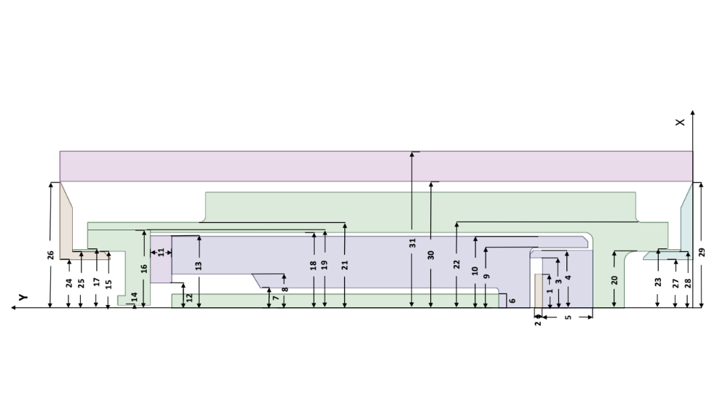
Figure 1. MiniFuel subcapsule cross section with overlaid geometric parameter numbers.

In-Depth Model Analysis
Table 3. Thermal Contact Conductance Parameter Abbreviations
Name | Symbol | Unit
Temperature | T | K
Heat Flux | q'’ | W/m²
Thermal Contact Conductance | TCC | W/m²K
Solid Spot Conductance | h_{s} | W/m²K
Gas Gap Conductance | h_{g} | W/m²K
Thermal Conductivity | k | W/m²K
Mean Harmonic Thermal Conductivity  k_{m} = $\sqrt{k_{1}^{2}+k_{2}^{2}}$ | k_{m} | W/m²K
Effective Slope of Asperities  tanθ = $\sqrt{tanθ_{1}^{2}+tanθ_{2}^{2}}$ | tanθ
Surface Roughness | σ | m
Contact Pressure | P_{c} | Pa
Effective Microhardness  (softer of H_{S1} and H_{S2}) | H_{eff} | N/m²
Gap Distance | δ | m
Temperature Jump Distance | g | m
Gas Pressure | P_{g} | Pa
Accommodation Coefficient | α
Ratio of specific heats  γ = C_{p}/C_{v} | γ
Molecular weight | MW | kg/kmol
Ideal Gas Constant  R_{g} = R/MW | R_{g} | J/kmol⋅K
Temperature Fitting | F(T)
Ratio of Molecular weights  μ = MW_{g}/MW_{s} | μ
Empirical Constants | C1, C2
Side 1 | s1
Side 2 | s2
Average | avg

Table 4. Sensitivity Analysis Parameter Abbreviations
Name | Symbol
Volumetric Heat Generation | Q
Thermal Conductivity | k
Youngs Modulus | E
Microhardness | H
Burnup | BU
Surface Roughness | σ
Contact Pressure | P_{c}

Vita
Nicholas A. Meehan graduated from North Carolina State University with a Bachelor of Science Degree in Nuclear Engineering in May of 2020. In the summer of 2020, he began research at the University of Tennessee, Knoxville. He graduated with a Master of Science Degree in Nuclear Engineering in May 2022. Nicholas has since begun work on this project and has presented this work at the American Nuclear Society Annual Meeting in 2023, the International RELAP User Group Meeting in 2023, at NURETH 20 in 2023, and the MOOSE International Workshop in 2025. He intends to graduate with a Doctor of Philosophy Degree in Nuclear Engineering in August 2025.

