The Effects of Class XI Myosins on Arabidopsis thaliana Root Hair Growth and Fertility using amiRNAs

Lauren Swientoniewski
BCMB 457 Honors Thesis
Dr. Andreas Nebenführ
4/28/14
ABSTRACT
Myosins are ATP-dependent motor proteins that cell organelles use for motility along actin filaments. In Arabidopsis thaliana, plant-specific class XI myosins are required for expansion of cells and organs of the plant. Root hair and pollen tube growth are both affected in single and double myosin mutants, resulting in shortened root hairs and reduced fertility, respectively. Two artificial mircroRNA constructs were designed to simultaneously reduce the expression of multiple class XI myosins. It was predicted that plants expressing the artificial microRNA would have drastically shortened root hairs and significantly decreased plant fertility due to reduced pollen tube growth compared to the single and double myosin mutants. It was found that the artificial microRNAs designed did not result in shorter root hairs or a drastic decrease in fertility. In conclusion, either the artificial microRNAs were not expressed at a high enough level or they did not effectively target the class XI myosins.
INTRODUCTION
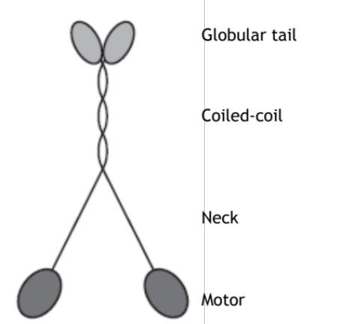
Arabidopsis thaliana is a flowering plant used frequently as a model in laboratories studying various aspects of plant biology. In Dr. Nebenführ’s laboratory, research is done on myosin XI, ATP-dependent motor proteins that are utilized by cell organelles for motility along actin filaments in plants. Structurally, myosin XI contains three domains, the head, neck, and tail, each with characteristic function (Figure 1). The head is the most genetically conserved structure of the myosin; its primary function is to bind to actin filaments and act as a catalyst for ATP hydrolysis to induce movement. The neck serves as an alpha-helix linker between the head and the tail and also binds calmodulin and/or light chain myosin. Within the tail there is a coiled-coil domain used for dimerization and the globular tail that binds to the cargo. The tail being the least conserved structure most likely creates isoform specificity for motility. Arabidopsis is a model plant here because it encodes thirteen myosin XI genes in which knockout mutants are available and easy to transform (Nebenführ, 2012).
Figure 1: Diagram of a Class XI Myosin (Li, 2008)
Class XI myosins are found specifically in plants with the functions of organelle motility, intracellular transport, plant growth, and root hair elongation (Madison, 2013). The goal of this study is to examine the role of myosins in tip growth, specifically in root hairs and pollen tubes. Root hairs provide an efficient mean of monitoring plant growth. They grow perpendicular to the root and take up nutrients and water from the soil to deliver to the rest of the plant for survival (Prokhnevsky, 2008). It has been shown that myosin xik and mya2 mutants have shorter root hairs (Park, 2013; Peremysov, 2008; Ojangu, 2007). The mya2 xib double mutant displayed even shorter root hairs than mya2, suggesting XIB is also involved in root hair growth (Prokhnevsky, 2008). Not only do myosins influence root hair growth, but they affect pollen tube growth as well. A plant’s production of pollen is key to reproduction; without it, the plant becomes sterile and cannot form seeds contained in siliques located on the stem. Pollen develops in the anther located on the stamen. Pollen tube growth is essential to the plant’s fertility because it is the structure that brings the sperm to the ovule. This growth is controlled by actin filaments, which create the path on which myosins travel. Polymerization of new actin filaments provides tracks for cytoplasmic streaming at the apex of the tube, which results in growth (Vidali, 2001). Six class XI myosins are expressed in pollen: XIA, XIB, XIC, XID, XIE, and XIJ (Peremyslov, 2011). Single myosin mutants are found to have little to no defect in plant structure or growth, but higher order mutants have more drastic defects, suggesting that the myosin genes of Arabidopsis thaliana act redundantly (Peremyslov, 2008; Prokhnevsky, 2008). Because of this, artificial microRNA becomes an ideal candidate as a method to knockdown multiple class XI myosins at once. (Schwab, 2006)
microRNA is a class of regulatory RNA that can negatively affect gene expression. miRNA is a 19-24 nucleotide sequence that is noncoding. miRNAs are synthesized as a part of a longer sequence that leaves the nucleus and forms a hairpin precursor. This binds to the enzyme Dicer, which cleaves the precursor sequence into the mature miRNA sequence. The mature sequence then binds to RISC, the RNA induced Silencing Complex, which uses the miRNA to bind to the complementary mRNA to negatively affect expression of the gene (Lu, 2005). In plants, miRNA negatively regulates gene expression through cleavage followed by degradation of the target mRNA. Also in plants, the miRNA sequence is similar but not identical to the target mRNA. As a result, plant miRNA can target several closely related mRNAs. Artificial microRNA, amiRNA, can be produced and inserted into the genome to silence specific genes (Ossowski, 2008). In plants the amiRNAs can be used to study the effect of reducing the expression level of several related genes. amiRNAs can also be used with an inducible system in order to study lethal mutations (Corrado, 2009).
An inducible system is one in which the addition of an activator allows transcription to proceed. In the case of amiRNA under such a system, when the activator is present, the amiRNA is transcribed and can negatively affect its target’s gene expression. A dexamethasone-inducible system has been used for amiRNA expression in plants. This system contains two components: a construct containing the amiRNA and a GUS reporter gene separated by six lac operators and a 35Spro:LhGR construct. When dexamethasone is present, LhGR is no longer trapped in the cytoplasm. LhGR enters the nucleus, binds to the lac operators, and activates transcription both towards the amiRNA and the GUS reporter gene. Therefore, a positive GUS staining result is usually a strong indication that the amiRNA is also being expressed (Wielopolska, 2005). When dexamethasone is not present, LhGR binds to HSP90, which prevents LhGR from entering the nucleus and activating transcription (Figure 2).
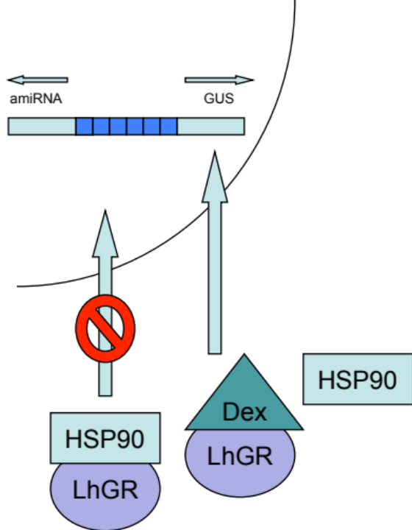
Using amiRNAs to reduce the expression of myosin genes in root hairs and pollen tubes will provide an insight on the functions of class XI myosins. It was predicted that seedlings expressing an amiRNA designed to target multiple class XI myosins would have shorter root hairs than the control since some myosin XI mutants have been shown to have shorter root hairs than wild-type plants. Furthermore, it was predicted that expressing the amiRNA in pollen would reduce pollen tube growth resulting in a decrease in fertility.
Figure 2: Schematic diagram of the dexamethasone-inducible system
MATERIALS AND METHODS
Dexamethasone-Inducible amiRNA:
Root hair tip growth was analyzed using a dexamethasone-inducible system. Lines R1 (amiRNA1) + LhGR in WT and xik and R2 (amiRNA2) + LhGR in WT, mya1, xik, and mya1 xik were tested on dexamethasone concentrations of 0, 10, and 200 μM on vertical plates with 1/4xMS, 1% sucrose, and 0.5% phytagel at a pH of 5.7. When they were five days old, the plate was imaged so that root hair length could be studied. The root hairs were measured using ImageJ. The seedlings were eventually removed from the plates and GUS staining was performed. The staining buffer consisted of 0.05 M sodium phosphate buffer, 0.2% Triton X-100, 0.2 mM potassium ferrocyanide, 0.2 mM potassium ferricyanide, and 1 mM X-Gluc. Each seedling was transferred to a well with 250 μL of staining solution. This was wrapped in parafilm and placed at 37 °C overnight. Then, each seedling was washed two times with 70% ethanol. The wells were filled with 95% ethanol and imaged.
Pollen Specific amiRNA:
The goal of this cloning procedure was to move XIJpro and SYP22pro in front of amiRNA1 (R1) and amiRNA2 (R2) to drive their expression in pollen. The first step was the miniprep of the relevant plasmids, which were pAN777, pAN778, pAN713, pAN664, and pPZP221. 1.5 mL of over night culture was added to a microfuge tube and centrifuged for one minute at 13.2 rpm. The supernatant was removed, and the pellet was resuspended in 600 μL of water. 100 μL of 7X Lysis Buffer was added; the tube was inverted six times to mix. 350 μL of cold neutralization buffer was quickly added and mixed. The tube was centrifuged for three minutes at 13.2 rpm. 900 μL of the supernatant was transferred to the column in a collection tube and centrifuged for thirty seconds. The flow-through was discarded. 200 μL of the Endo-Wash Buffer was added, and the tube was centrifuged for thirty seconds. Then, 400 μL of the Zippy Wash Buffer was added; the tube was centrifuged for thirty seconds once again. The column was transferred to a new centrifuge tube. 60 μL of dH₂O was added to the column. The tube was centrifuged for thirty seconds. This isolated the plasmid from E.coli. Then, a digest was performed for one hour to cut insert and vector with the same enzymes. The digest consisted of 10.5 μL of deionized water, 5 μL of plasmid, 2 μL of BSA (10X), 2 μL of NEB #4, and 0.5 μL of SacI-HF and NotI-HF. To separate the DNA pieces, a 1% agarose gel was run at 100 V for one hour and bands were cut and cleaned to isolate the DNA from the gel. After this, the vector underwent a phosphatase treatment to clip off phosphatase so that the vector could not close on itself. The concentration of DNA was measured for the vector and the insert. A ligation reaction was set up for three and a half hours so that the insert and the vector could be spliced together. Then, the ligation product was transformed into E.coli. A PCR was performed on the colonies to check for the insert (Table 1). Finally, the digest was performed followed by another gel to determine if the intended plasmid was obtained.
The four constructs were transformed into Argrobacterium tumefaciens strain GV3101, then the wild-type Arabidopsis was transformed with the constructs in Table 1 using the floral dip method (Weigel, 2002). The T1 seeds from the floral-dipped plants were collected, and they
Table 1: Forward and reverse primers for each construct used to test for the desired plasmid constructs
Construct | Forward Primer | Reverse Primer
SYP22 pro: amiRNA1 | SYP22 pro-F3 | A12
SYP22 pro: amiRNA2 | SYP22 pro-F3 | A22
XIJ pro: amiRNA1 | M11.J pro-F1 | A12
XIJ pro: amiRNA2 | M11.J pro-F1 | A22

were grown on MS plates with Gentamicin to select which plants were transformed with the constructs. From the T1 plants, genomic DNA, gDNA, was extracted from the leaves of each plant. The leaves were placed in a labeled centrifuge tube along with a sterilized BB at -80 °C. An extraction buffer was made consisting of 200mM Tris-C1, 250 mM NaCl, 25 mM EDTA, and 0.5% SDS. When the tubes were removed from the freezer, the BB was released from the end of the tube, and the tube was tapped on a hard surface upside down to break apart the leaves. The BB was removed and 200 μL of extraction buffer was added and mixed. Each tube was vortexed for five seconds, incubated for ten minutes at room temperature, and centrifuged at maximum speed for ten minutes. 175 μL of the supernatant was pipetted into a corresponding labeled centrifuge tube along with 175 μL of isopropanol. The contents were mixed by inversion, and the sample was incubated for fifteen minutes at room temperature then centrifuged for ten minutes. The supernatant was discarded, and the pellet was washed twice with 200 μL of 75% ethanol. The ethanol was removed carefully with pipetting twice out, and the pellets were left to air dry for five minutes at room temperature under the hood. 50 μL of deionized water was added. The samples were incubated for ten minutes, vortexed for one minute, centrifuged for three minutes, and placed at -20 °C. A PCR and a gel electrophoresis was performed on each gDNA. The forward and reverse primers are listed in Tables 1 and 2. DT6-RP and DT6-LP primers were used as the control.
Table 2: List of sequences for each primer
Primer Name | Primer Sequence
DT6-RP | CTTTTCCGGTGGATTCTCTTC
DT6-LP | ATACCATCAAGAAGGTTCGGG
SYP22 pro-F3 | CGAGAATTCATCAACCACTATCTGTCGTCC
M11.J pro-F1 | ACGTCCGGAGGTCTGCTGAACTAGAGACT
A12 | GACTCGACGAAGCTTGCATGTTATCAAAGAGAATCAATGA
A22 | GACAGCACTTTAATCAGCATGTATCAAAGAGAATCAATGA

T2 seeds were collected from confirmed T1 plants. These were then grown on Gentamicin, and segregation ratios were determined to determine the number of resistant plants. Those lines that did not have the expected 3:1 ratio were thrown out, but those that showed a more sensitive ratio such as 6:50 or 2:1 were kept for further investigation. It was predicted that a 3:1 ratio of resistant:non resistant plants would exist if only one insertion was present. Selected lines were then planted and grown. It was noted whether a phenotype other than wild-type existed.
The T2 seeds were grown up again without selection to analyze those eight lines with a phenotype. Images were taken of these T2 plants of the flower and the entire plant of SYP22 pro:amiRNA1-6D, XIJ pro:amiRNA1-7D, and XIJ pro: amiRNA2-5A. gDNA was extracted for all T2, and the presence of the amiRNA construct was detected by PCR (Tables 1 and 2). Both genotyping and phenotype analysis was performed. Samples of the T2 plants were frozen in liquid nitrogen including rosette leaves and inflorescence tops, flowers, and siliques (no leaves). Table 3 shows the lines collected from for freezing to perform RNA extractions.
Table 3: Sample lines for RNA extraction
Line | Plant | Sample Taken*
SYP22 pro:amiRNA1-6D | 8A, 8B, 8C, 8D | I and R (for each plant)
XIJ pro:amiRNA1-7D | 12A, 12B, 13A, 13B, 14A, 14B | I and R (for each plant)
XIJ pro:amiRNA2-5A | 12A, 12B, 12C, 13A, 14A, 14D | I
XIJ pro:amiRNA2-5A | 12B, 13A | R
*I = inflorescence, R = Rosette Leaves
Since XIJ pro:amiRNA2-5A showed the strongest phenotype apart from wild-type, those samples along with wild-type I and R were used in the RNA extraction. Each sample was ground as much as possible. 500 μL of TRIzol was added to each centrifuge tube, then the samples were allowed to thaw. 500 μL of TRIzol was added again, the sample was ground further, and left to sit. To each sample, 200 μL of cloroform was added, they were vortexed for fifteen seconds, and they were centrifuged for ten minutes at 11,000 rmp in a 4 °C room. The top aqueous layer of approximately 600 μL was transferred to a new centrifuge tube. 600 μL of isopropanol was added and mixed by inversion. Each sample sat for ten minutes and centrifuged for another ten minutes at 11,000 rpm in a 4 °C room. The supernatant was removed and 1 mL of 75% ethanol in DEPC water was added to each tube. Each sample was centrifuged for five minutes at 8,500 rpm in a 4 °C room, the supernatant was removed, and the sample was allowed to air dry. Finally, 50 μL of DEPC water was added to each tube.
RESULTS
amiRNA1 | amiRNA1
MYA2 | MYA1
XIA | MYA2
XIB | XIB
XIC | XID
XID | XIF
XIE | XIJ
XIG
XIH
XI-I
Root Hair Length:
Table 4: amiRNA Targets
The effectiveness of two amiRNAs that target multiple class XI myosins was tested using a dexamethasone-inducible system, which allows expression in targeted areas of the plant. Eunsook Park, a previous graduate student, used the Web MicroRNA Designer to determine the desired sequence for a miRNA that would target the thirteen genes in class XI myosin (Schwab, 2006). These genes were targeted in the motor head region of the myosin due to the conserved nucleotide sequences. The sequence Park found was inserted into an endogenous miRNA precursor. Plants were transformed with amiRNA1 (TAACATGCAAGCTTCGTCGAG) and amiRNA2 (TACATGCTGATTAAAGTGCTG), whose targets are shown in Table 4.
The seedlings expressing the inducible amiRNA grown on vertical plates were imaged using ImageJ after four days. These were then removed, and GUS staining was performed. Shorter roots hairs were expected to be seen in the test lines because single mutants of myosins targeted by the amiRNA have been shown to reduce the root hair length. Seedlings with the same GUS staining results (Figure 3), genotype, and dexamethasone concentration were averaged. The twelve graphs in Figure 4 show the averages of root hair lengths for each genotype on the three different dexamethasone concentrations, 0, 10, and 200 μM. The pink bars display the control for each genotype. The teal bar displays the control for GUS staining used in every comparison to confirm that expression of the GUS reporter gene is not responsible for any shortening of the root hairs. The yellow bar displays the test. R1 is amiRNA1, and R2 is amiRNA2. The missing bar in one of the graphs is due to no seedlings being grown for that construct under that condition. For GUS staining results, the controls (WT, xik, mya1xik, mya1) never stained positive for GUS, and the 35Spro:GUS seedlings always positively stained for GUS. Finally, none of the test lines in 0 μM dexamethasone positively stained for GUS, but the test lines in 10 or 200 μM dexamethasone stained positive for GUS. None of the test lines showed shorter root hairs compared to the appropriate control.
Figure 3: A) Negative GUS staining B) Positive GUS staining
Figure 4: These graphs show the root hair measurement data (n= 18 to 210) from ImageJ. C is WT background, M is mya1 mutant, D is double mya 1 xik mutant, and K is xik mutant
Pollen Tube Growth:
Pollen tube growth, and thus fertility of the plant, can be genetically manipulated and analyzed using amiRNAs by exchanging the 35S promoter already in place for the XIJ and SYP22 promoters, since the 35S promoter does not function in pollen. After Arabidopsis was transformed with the four constructs, lines of the plant were counted and selected based on the presence of partial or full sterility (Table 5). Sterility was noted as the absence of siliques on the plant.
Table 5: Independent Lines Obtained for Each Construct
Construct | # of Independent Lines | # of Lines Screened Further | # of Lines with Fertility Defect
SYP22 pro:amiRNA1 | 27 | 14 | 1
SYP22 pro:amiRNA2 | 11 | 7 | 0
XIJ pro:amiRNA1 | 24 | 12 | 1
XIJ pro:amiRNA2 | 17 | 8 | 6
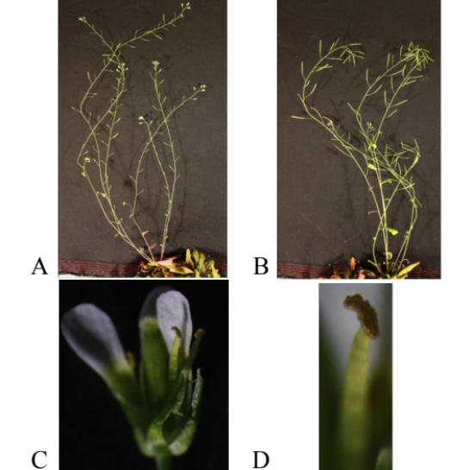
The expression of the sterile phenotype was variable for all lines. However, for XIJ pro: amiRNA2, the strongest phenotype was visible in line 5A, but all of the lines displayed this distinctive phenotype to some degree. The phenotype was the following: no siliques formed on the plant, the plants had brown anthers, and there was no pollen on the affected branches (Figure 5). The plants did display morphologically normal flowers besides the brown anthers. Even though some of the plants had the phenotype, not every plant for each line displayed it. Also, some plants had the phenotype on all the branches whereas some plants had the phenotype on a few of their branches of the XIJ pro:amiRNA2-5A line. The other five lines did not have sterile plants. The presence of the transgene was confirmed by PCR. 47 of 53 plants had the transgene, but only 14 plants had the sterile phenotype.
Figure 5: A) shows an XIJ pro:amiRNA2 plant with the phenotype B) shows an XIJ pro:amiRNA2 without the phenotype C) shows a flower of XIJ pro:amiRNA2 D) gives an example of the brown anther in the phenotype
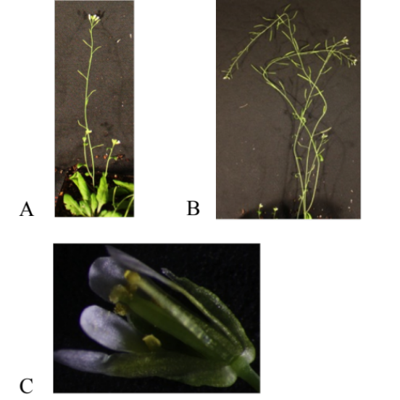
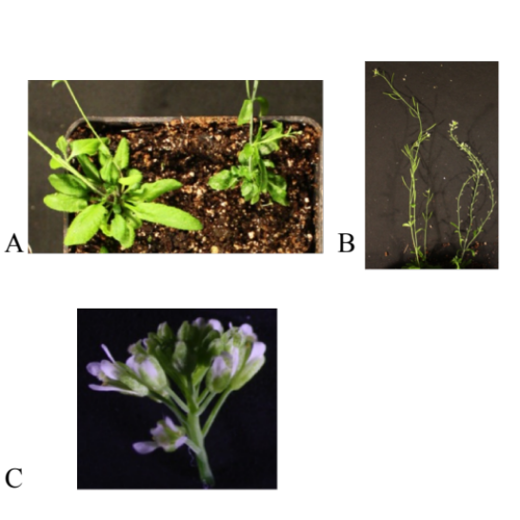
For XIJ pro: amiRNA1, line 7D showed a clear phenotype. The phenotype was the following: no siliques, skinny/point rosette leaves, abnormally small flowers, short filament growth, normal yellow anthers, and very little pollen was produced (Figure 6). Overall, all 60 plants had the transgene, but only 16 of them had the sterile phenotype.
Figure 7: A) shows a SYP22 pro:amiRNA1 plant with the phenotype B) shows a SYP22 pro:amiRNA1 without the phenotype C) shows the flower on a SYP22 pro:amiRNA1 plant
Figure 6: A) shows a plant without and with a phenotype left to right in XIJ pro:amiRNA1 B) shows the same as panel A but at a different angle C) shows the cluster of small flowers in the phenotype
For SYP22 pro: amiRNA1, the line that showed the phenotype was 6D. The phenotype was very similar to the one displayed by XIJ pro: amiRNA2, except that SYP22 pro: amiRNA1 had yellow anthers and pollen (Figure 7). Overall, 26 of 47 plants had the transgene, and 10 had the sterile phenotype.
Stephanie Madison crossed the sterile T2 plants for XIJ pro:amiRNA1 to WT and XIJ pro:amiRNA2 to WT and a fertile sibling, and the resulting F1 plants were grown up and scored for the sterile phenotypes (Table 6). If the sterile phenotypes were due to the construct inserting within a gene that when knocked out results in sterility, there would be all nonsterile F1 plants resulting from a cross to WT. In this case, the sibling cross would result in a 1:1 ratio which is shown as well. The cDNA was not tested further because the results from Table 6 showed that the phenotypes were likely due to an insertion in another gene.
Table 6: Crosses
Male | Female | Sterile F1 | Nonsterile F1
WT | XIJ pro:amiRNA2-5A-3A | 1 | 41
XIJ pro: amiRNA2-5A-1D | XIJ pro:amiRNA2-5A-1B | 18 | 13
WT | XIJ pro: amiRNA1-7D-2A | 0 | 27

DISCUSSION

Previously in this laboratory, mya2 and xib mutants were shown to have shorter root hairs than wild-type plants, so it was predicted that Arabidopsis expressing amiRNA1 or amiRNA2 grown on dexamethasone would have shorter root hairs than a control. However, this was not shown in the results. Taking into account the standard deviations, the test line was not statistically shorter than its corresponding control (xik, WT, mya1, or mya1xik). A possible explanation for these results could be that the amiRNA was not being expressed in the presence of dexamethasone. Only 0.1 μM of dexamethasone was found to be enough to induce GUS activity; also, it was studied that plants developed normally exposed to up to 30 μM of dexamethasone (Samalova, 2005). Another explanation is that the system could be expressing the GUS reporter gene more strongly than the amiRNA. This is quite possible since the pOp6 promoter is bidirectional. Even though the GUS reporter gene was expressed, either the amiRNAs were not expressed, or they did not successfully target the myosin mRNAs involved in root hair growth since there was a lack of shorter root hairs. Even though root hair length results were not as predicted, the GUS staining results were. The control never stained for GUS, the 35Spro always stained for GUS, and for the test, no staining was observed for 0 μM of dexamethasone, and staining was observed for 10 and 200 μM Dexamethasone at similar levels (data not shown). Overall, testing the amiRNA in root hairs using a dexamethasone-inducible system did not work. However, since the 35Spro amiRNA plants did have shorter root hairs (data not shown), we tried constitutive expression in pollen. It was concluded that R1 and R2 probably target myosins, and the expression issues were the fault with the inducible system.
To test amiRNA in pollen versus previous root hairs, the 35S promoter, which does not function in pollen, was exchanged for promoters SYP22 and XIJ. The results were analyzed based on the prediction that if a single insertion was made, a 3:1 ratio would exist of resistant to non resistant plants. Because for XIJ pro:amiRNA2 47 out of 53 plants had the transgene, this ratio is higher than 3:1, meaning that multiple insertions occurred. The phenotype could be due to one of the two phenomena: either the amiRNA was silenced in some of the plants, or the phenotype was caused by the insertion that was only homozygous in 14 out of 53. The second was actually shown to be true when the F1 plants of a cross with a fertile sibling were examined.
T2 plants carrying XIJ pro:amiRNA1 had 60 out of 60 plants containing the transgene, which indicates multiple insertions as well. For this construct, it is more likely that the phenotype was due to an insertion. 16 of the 60 plants, which is close to one-fourth, had the phenotype, so this line is probably homozygous for an insertion in an important gene. This was confirmed with the F1 plants resulting from a cross to WT; all of the plants displayed a normal phenotype identical to wild-type.
Finally, SYP22 pro:amiRNA1 had 26 of 47 plants containing the transgene. Since this ratio does not show three-fourths having the transgene, but it also does not show a number larger than three-fourths, it is possible that a single insertions did occur. However, not all the plants that had the sterile phenotype had the transgene. It is possible that some plants tested negative for the transgene even though they really had it. The reason for this unexpected result is not known.
Overall, both the inducible and non-inducible system did not show shorter root hairs or a drastic reduction in fertility respectively due to amiRNA. For the inducible system, either the amiRNA was not targeting the myosins, the amiRNA was not being expressed at a high enough level, or the amiRNA was not expressed at all. For the non-inducible system, even though drastic defects in fertility were not seen, slight defects in pollen tube growth could exist. These results suggest that the amiRNAs tested here are probably not very efficient in suppressing myosin gene expression. In the future, the lines containing the 35S promoter will be tested for myosin expression levels. However, it would be wisest to create new amiRNA sequences.
REFERENCES
Corrado, G. 7 Karali, M. (2009). Inducible gene expression systems and plant biotechnology. ScienceDirect. 27 (6), 733-743).

Li, J.-F., and Nebenführ, A. (2008). The tail that wags the dog: The globular tail domain defines the function of myosin V/XI. Traffic 9, 290-298.

Lu, J., Getz, G., Miska, E., Alvarez-Saavedra, E., Lamb, J., Peck, D., Sweet-Cordero, A.,… Golub, T., (2005). MicroRNA expression profiles classify human cancers. Nature. 435 834-838.

Madison, S. L., & Nebenführ, A. (2013). Understanding myosin functions in plants: are we there yet?. Current Opinion in Plant Biology, 16(6), 710-717.

Nebenführ, A. (2012). Research. The Nebenführ Lab: Molecular Cell Biology of Plants. Retrieved December 5, 2012 from http://www. bio.utk.edu/cellbiol/res/default.htm

Ojangu, E., Järve, K., Paves, H., & Truve, E. (2007). Arabidopsis thaliana myosin XIK is involved in root hair as well as trichome morphogenesis on stems and leaves. Protoplasma, 230(3-4), 193-202.

Ossowski, S., Schwab, R., & Weigel, D. (2008). Gene silencing in plants using artificial microRNAs and other small RNAs. The Plant Journal, 53(4), 674-690.

Park, E., Nebenführ, A. (2013). Myosin XIK of Arabidopsis thaliana Accumulates at the Root Hair Tip and Is Required for Fast Root Hair Growth. PLoS ONE, 8(10), e76745.

Peremyslov, V. V., Prokhnevsky, A. I., Avisar, D., & Dolja, V. V. (2008). Two Class XI Myosins Function in Organelle Trafficking and Root Hair Development in Arabidopsis. Plant Physiology, 146(3), 1109-1116.

Peremyslov, V. V., Prokhnevsky, A. I., & Dolja, V. V. (2010). Class XI Myosins Are Required for Development, Cell Expansion, and F-Actin Organization in Arabidopsis. The Plant Cell Online, 22(6), 1883-1897.

Peremyslov, V. V., Mockler, T. C., Filichkin, S. A., Fox, S. E., Jaiswal, P., Makarova, K. S., et al. (2011). Expression, Splicing, and Evolution of the Myosin Gene Family in Plants. Plant Physiology, 155(3), 1191-1204.
Prokhnevsky, A. I., Peremyslov, V. V., & Dolja, V. V. (2008). Overlapping functions of the four class XI myosins in Arabidopsis growth, root hair elongation, and organelle motility. Proceedings of the National Academy of Sciences, 105(50), 19744-19749.

Samalova, M., Brzobohaty, B., & Moore, I. (2005). pOp6/LhGR: a stringently regulated and highly responsive dexamethasone-inducible gene expression system for tobacco. The Plant Journal, 41(6), 919-935.

Schwab, R. (2006). Highly Specific Gene Silencing by Artificial MicroRNAs in Arabidopsis. The Plant Cell Online, 18(5), 1121-1133.

Vidali, L., Mckenna, S. T., & Hepler, P. K. (2001). Actin Polymerization Is Essential for Pollen Tube Growth. Molecular Biology of the Cell, 12(8), 2534-2545.

Wielopolska, A., Townley, H., Moore, I., Waterhouse, P., & Helliwell, C. (2005). A high-throughput inducible RNAi vector for plants. Plant Biotechnology Journal, 3(6), 583-590.

