Characterization of a Digital Holography Diagnostic for In Situ Erosion Measurement of Plasma-Facing Components in Fusion Devices

A Dissertation Presented for the

Doctor of Philosophy

Degree

The University of Tennessee, Knoxville

Cary Dean Smith

December 2020

Copyright © 2020 by Cary Dean Smith
All rights reserved.

For Annie

ACKNOWLEDGEMENTS
I would like to extend gratitude to the following people for their involvement in the preparation of this dissertation:
Theodore Biewer, Principle Investigator, and Tommy Thomas, designer and lead operator of the digital holography diagnostic; their expertise and guidance were instrumental in the success of this work.
Trey Gebhart and Elizabeth Lindquist, for their knowledge and assistance with operation of the electrothermal arc source.
John Echols, for his help with obtaining measurements on the scanning electron microscope.
Xi Ren and Alex Greenhalgh, for their participation in conducting holographic measurement experiments.
Special thanks is given to my advisor Zhili Zhang for his mentorship throughout my time as both an undergraduate and graduate student.
Additionally, I would like to thank dissertation committee members David Donovan and John Schmisseur for their support.

ABSTRACT
Fusion energy devices, particularly tokamaks, face the challenge of interior surface damage occurring over time from the heat flux of the high-energy plasma they generate. The ability to monitor the rate of surface modification is therefore imperative, but to date no proven technique exists for real-time erosion measurement of planar regions of interest on plasma-facing components in fusion devices. In order to fill this diagnostic gap, a digital holography system has been established at ORNL [Oak Ridge National Laboratory] for the purpose of measuring the erosion effects of plasma-material interaction in situ.
The diagnostic has been designed with the goals of measuring both steady-state and off-normal erosion events. It is capable of operating with either one laser for measuring displacements up to 4.5 microns, or two lasers in tandem to extend the measurement range to an upper limit near 2 millimeters.
The performance of the digital holography system is characterized in this dissertation. Discussion of the impetus and background of this project is provided in Chapter I, along with a description of the components and technique. Chapter II covers initial characterization of the measurement fidelity regarding surface roughness of stainless steel surfaces, surface displacements in various sizes, and image noise reduction via multi-frame averaging. A threshold roughness average of 300 nanometers was defined for satisfactory correlation between holographic and validation measurements, and dual-laser measurements were accurate for displacements exceeding 100 microns. In Chapter III, improvements for dual-laser resolution, increased image signal, and noise reduction are described. Chapter IV presents an extensive characterization of ex situ erosion measurement on target plates exposed to an electrothermal arc, with a measured average erosion of 150 nanometers per exposure which indicated that erosion would be distinguishable from noise in situ; the holographic results are compared to profilometry and scanning electron microscopy for validation. In Chapter V, measurements of dynamic surface translations simulating material modification are analyzed, and displacement detection is shown to be accurate. A project summary is given in Chapter VI, and initial results are shown of a successful in situ proof-of-concept demonstration of holographic measurement of erosion from the electrothermal arc.

PREFACE
The dream of providing abundant clean energy for the world that has driven fusion research is a high ambition, and today it motivates one of the grandest examples of international cooperation for peaceful scientific purposes that has ever been conceived. I consider myself fortunate to have had the opportunity to participate in the global pursuit of fusion energy, and offer this work as a contribution to that cause.
The development process of digital holography for surface erosion measurement has induced both excitement and consternation, as one might expect in any research engineering project. The insights gleaned from experimentation have proven instructive to our research group’s performance expectations for the holography system and illuminative to myself during my graduate studentship. It is my hope that this document may serve as a useful reference for future advancement and application of this diagnostic and others like it.

TABLE OF CONTENTS
CHAPTER I Introduction 1
Background 1
A Brief History of Fusion Energy 1
Plasma Material Interaction Research 2
PMI Diagnostics 4
Digital Holography and its Applications 5
ORNL Digital Holography 10
Digital Holography System Description 14
Digital Holography Technique 19
Flatfield Correction 25
Dual-Laser Operation 26
CHAPTER II Recent Developments in Dual-Laser Digital Holography for Plasma Facing Surface Characterization 29
Abstract 30
Introduction 31
Digital Holography Technique 32
Experiment 33
Digital Holography System Description 33
Surface Roughness Characterization Targets 34
Dual-Laser Characterization Targets 35
ET Arc-Exposed Target 35
Results and Discussion 35
Surface Roughness Characterization 35
Dual-Laser Characterization 38
ET Arc-Exposed Target Analysis 46
Conclusion 48
Future Work 48
Acknowledgements 49
CHAPTER III Improvements and Performance Parameters for the ORNL Digital Holography PFC Surface Erosion Diagnostic 50
Abstract 51
Introduction 51
Dual-Laser Flatfield Correction 52
Signal Improvement 53
System Noise Levels 55
Current Status and Future Work 59
Acknowledgements 59
CHAPTER IV Digital Holography Measurement Characterization of Plasma-Exposed Surface Erosion from an Electrothermal Arc Source 60
Abstract 61
Introduction 61
Technique 62
Experimental Setup 63
Digital Holography 63
Electrothermal Arc Source 64
Results 67
Erosion Measurement 67
Surface Roughness Average 73
Surface Features 75
Conclusion 84
Acknowledgements 86
CHAPTER V Measurements of Dynamic Surface Changes by Digital Holography for In Situ Plasma Erosion Applications 87
Abstract 88
Introduction 88
Technique 89
Experimental Setup 90
Digital Holography 90
Electrothermal Arc Source 91
Translation Stage 91
Results and Discussion 93
Ex Situ Erosion Measurement 93
Single-Laser Holographic Motion Detection 93
Dual-Laser Holographic Motion Detection 101
Conclusion and Future Work 110
Acknowledgements 111
CHAPTER VI Conclusion 112
Summary 112
In Situ Demonstration and Future Work 118
Digital Holography System Modifications 118
Electrothermal Arc Integration 124
Noise Measurements 124
In Situ Demonstration Preliminary Results 128
Further Development and Applications 134
REFERENCES 135
VITA 148

LIST OF TABLES
Table 4.1. Measured Surface Depth vs. Plasma Exposure Level 72
Table 4.2. Ra Values from Profilometry and Digital Holography 74
Table 5.1. Single-Laser DH Detected Motion 96
Table 5.2. Dual-Laser DH Detected Motion 108

LIST OF FIGURES
Figure 1.1. Diagram of the ORNL DH system components. Component dimensions and positions are accurate to the true setup. The optical table bolt holes’ vertical and horizontal spacing is 25.4 mm. 15
Figure 1.2. Photograph of the ORNL DH system. 16
Figure 1.3. A raw holographic image (top) and the real domain visualization of its spatial Fourier transform (bottom). 20
Figure 1.4. Selected sideband identified in the original spatial Fourier transform of the hologram (top left) and shifted to the center by equivalent shifting of the image in real space (top right). The von Hann filter with a radius of 32 pixels is applied to the shifted sideband (bottom). 23
Figure 1.5. Amplitude (top left) and phase (top right) reconstructions of the hologram. The rendered topographical map of the phase image after cropping and horizontal correction have been performed is shown (bottom). 24
Figure 1.6. Section of stacked stainless steel shims imaged by holography; steps were each 0.381 mm thick (top left). Raw hologram of the stack (top right). Phase images from single-laser holography for wavelengths of 9.25 µm (middle left) and 9.27 µm (middle right). Phase image from dual-laser holography (bottom left) and rendered topographical map of the dual-laser phase image (bottom right). 27
Figure 2.1. Surface sample results. (a) Polished surface sample, (b) original shim surface sample, and (c) wet bead-blasted sample. 37
Figure 2.2. Differences of holography-measured roughness averages from profilometer roughness average measurements. 39
Figure 2.3. Dual-laser holography-measured step target surfaces with mean values of step areas. (a) Target 1: 25.4 µm steps, (b) Target 2: 76.2 µm steps, (c) Target 3: 127 µm steps, (d) Target 4: 381 µm steps, (e) Target 5: 787 µm step. 40
Figure 2.4. Selected pixels of measured step surfaces with mean values subtracted. (a) Target 1: 25.4 µm steps, (b) Target 2: 76.2 µm steps, (c) Target 3: 127 µm steps, (d) Target 4: 381 µm steps, (e) Target 5: 787 µm step. 42
Figure 2.5. Selected pixels of measured step surfaces with mean values ± standard deviation subtracted. (a) Target 1: 25.4 µm steps, (b) Target 2: 76.2 µm steps, (c) Target 3: 127 µm steps, (d) Target 4: 381 µm steps, (e) Target 5: 787 µm step. 44
Figure 2.6. Actual and holography-measured step sizes (left), differences of measured and actual step sizes (center), and %errors of measured from actual step sizes (right). 45
Figure 2.7. Single-laser holographic surface measurements with correction options. (a) Single-frame, raw measurement with no correction, (b) single frame with flatfield correction, and (c) average of 500 sequential frames with flatfield correction. 47
Figure 3.1. Differential hologram of a stairstep target comparison of (a) standard vs. (b) flatfield-corrected results. 54
Figure 3.2. Comparison of signal exposure time effects on holographic phase noise. 56
Figure 3.3. Vibrational modes of the DH system optical table. 58
Figure 4.1. (a) ET-arc target with plasma strike zone center and shadowed region indicated. (b) Pre- and post-plasma exposed target. (c) Post-exposure target undergoing DH imaging, with the approximate ROI indicated by the red box and the center of the object beam by the red HeNe laser dot. The ROI encompassed the area under the (removed) cover plate as well as the plasma strike zone at the imaging location shown. 66
Figure 4.2. 3-D renderings of surface erosion for Target 1. 68
Figure 4.3. 3-D renderings of surface erosion for Target 2. 70
Figure 4.4. Measured surface erosion for (a) Target 1 and (b) Target 2. 71
Figure 4.5. Roughness averages and % differences. 76
Figure 4.6. Histograms of phase images with plasma strike zone ROI. 77
Figure 4.7. (a) SEM image of Target 1 plasma strike zone after three ET-arc exposures. Note that the cover plate shielded zone is visible after the white line to the right of the image. (b) Phase image of the plasma strike zone on the same target The phase image was flipped horizontally to align with the SEM image. 79
Figure 4.8. Selected particles imaged at (a) 0° and (b) 40° tilt for z-axis size estimation of surface features. 80
Figure 4.9. (a) SEM image of deposition in the plasma strike zone after 9 ET-arc exposures. (b) The associated phase image, flipped horizontally. 81
Figure 4.10. Surface height measurements of selected features for both targets after every level of plasma exposure. 83
Figure 5.1. (a) ET-arc target pre-plasma exposure. Plasma impact on the target occurred at an angle of incidence 45° above the cover the target to provide a small unaffected area adjacent to the plasma strike zone. (b) ET-arc target post-exposure. 92
Figure 5.2. (a) Measured surface profiles of ET Arc target 1. (b) 3-D phase images of surface ROI for each level of total plasma exposure observed. 94
Figure 5.3. Single-laser DH detected motion vs. programmed translation. 97
Figure 5.4. (a) ~1 µm detected motion from a 50 Hz recording. (b) ~1 µm detected motion from a 500 Hz recording. Both results show 18 count movements, with higher measured surface height fidelity frame-to-frame in the 500 Hz recording vs. capability of capturing multiple events in the longer 50 Hz recording. 99
Figure 5.5. Motion detection of minimum programmable translation (1 count) from (a) 50 Hz and (b) 500 Hz recordings. The displacement was undiscernible from noise when recorded at 50 Hz, but could be clearly identified at 500 Hz. 100
Figure 5.6. Anomalous holographic surface warping observed during ~1 µm translation recorded at 50 Hz. 102
Figure 5.7. Anomalous holographic surface warping observed during ~1 µm translation recorded at 500 Hz. 103
Figure 5.8. (a) Detected motion of 880 counts translation from a 50 Hz dual-laser recording. The translation event occurred from t = ~2.5 s to 6 s and is shaded in gray; high noise and moment arm effects on the moving target during the translation event caused the detected motion during this time to appear to be hundreds of µm in the opposite direction of programmed translation, and therefore unreliable. However, the detected mean surface height after motion was ceased was stable around 47 µm (t = 6 s to 10 s). This value was within 10 µm of the expected displacement. (b) The 3-D phase image for t = 10 s. 106
Figure 5.9. (a) Detected mean surface height from a 50 Hz dual-laser recording of 4,000 counts translation. (b) 3-D phase image of t = 14 s from the recording. 107
Figure 5.10. Dual-laser DH detected motion vs. programmed translation. 109
Figure 6.1. Modified DH layout for off-table imaging. The target location is 1.524 m from the object beam lens, or ~0.96 m from the edge of the DH optical table. The reference beam components were adjusted to match the extended object beam path length. 119
Figure 6.2. The object beam reflected from a USAF resolution target imaged in the in situ DH configuration. The prominent lines are from group 0 element 2, which have a line width of 445.45 µm. 121
Figure 6.3. The hologram (a), phase image (b), and 3-D rendering (c) of a USAF resolution target imaged in the in situ DH configuration. The phase image ROI (indicated by the red square) contains a visible square element approximately 2 mm on each side. The rendering of the ROI indicated a detected depth of ~770 nm for the square feature, and the ROI’s surface warp noise was over 1 µm. 122
Figure 6.4. The object beam image of a stainless steel target plate that had received 6 total plasma exposures from the ET-arc, demonstrating that an acceptably visible object beam signal could still be achieved even with higher diffusivity at the ET-arc target configuration. The camera exposure time was 253 µs. The maximum intensity count was 7,300, which falls within the typical preferred range for object beam intensity. 123
Figure 6.5. Custom ET-arc chamber for in situ holography. The DH object beam enters on the perpendicular axis to the target, and the plasma source (indicated by the ground housing component) produces a spark which strikes the plate at a 35° angle of incidence. Image provided by Trey Gebhart, ORNL. 125
Figure 6.6. Block diagram of electronic components for DH integration with the ET-arc. 126
Figure 6.7. (a) Accelerometer noise measurement of the ET-arc target-holder flange under quiescent conditions. (b) Holographic noise measurement of the ET-arc target under quiescent conditions. (c) Accelerometer motion measurement of the ET-arc target-holder flange during a plasma event. 127
Figure 6.8. (a) Polished target for in situ measurement demonstration with pristine finish. (b) Target after 10 plasma exposures, with approximate CO₂ beam area indicated by the red ellipse. (c) Cropped ROI and dimensions shown by the red rectangle on an example phase image. 129
Figure 6.9. Selected 500 Hz hologram frames recorded during the first plasma exposure on the target; (a) t = 0.001 s, (b) t = 0.638 s, and (c) t = 1 s. 131
Figure 6.10. (a) 3-D rendered phase images for 10 total plasma exposures from the ET-arc on the target. (b) The y-axis line profiles with z-axis surface heights; profile heights were averaged along the x-axis. 133

CHAPTER I
Introduction

Background
A crucial challenge to the development of sustained, reliable fusion energy is the considerable damage to machine surfaces from plasma-material interaction. A nonintrusive measurement technique would allow surface material in a fusion device to be monitored over its expected lifetime to ensure that the machine remains in acceptable operational shape. Digital holography has been proposed as a solution for achieving this capability, and research and development on a holographic diagnostic system specifically for fusion-related in situ erosion measurement of plasma-facing surfaces has been performed at Oak Ridge National Laboratory (ORNL).

A Brief History of Fusion Energy
The discovery of nuclear fusion emerged in the first half of the twentieth century from advances in atomic physics. Mark Oliphant, Paul Harteck, and Ernest Rutherford researched the potential for massive energy release from the fusion of heavy hydrogen isotopes deuterium and tritium into helium [1], and fusion as the energy mechanism of stars was explained in the works of Arthur Eddington [2] and Hans Bethe [3]. Though the first successful artificial fusion devices were thermonuclear weapons, researchers dreamed of achieving controlled fusion for the purpose of meeting global energy needs.
A thermonuclear reactor concept based on magnetic plasma confinement was proposed by Igor Tamm and Andrei Sakharov in the 1950s, leading to the establishment of the first tokamaks [4]. The tokamak is characterized by a toroidal chamber in which hot plasma is shaped and contained by a magnetic field generated by surrounding coils. Several institutions around the world have since constructed their own tokamaks for fusion research, and the tokamak is now widely considered to be the leading candidate for establishing a viable fusion power plant.
In 1985, the leaders of the United States and the Soviet Union proposed an international collaboration to realize “controlled thermonuclear fusion for peaceful purposes” [5] laying the foundation of the ITER Project which is currently established as a partnership of China, the European Union, India, Japan, Russia, South Korea, and the United States. Situated in France, ITER will be the largest-scale tokamak in the world when completed. The primary targeted deliverable of ITER will be demonstration of 500 MW output with a fusion energy gain factor Q ≥ 10, that is a tenfold increase of output power over input power [6].
Lessons learned from ITER will be incorporated into the design of the future Demonstration Power Station (DEMO), a conceptualized prototype fusion power plant intended to be operational by the 2050s.
The ITER tokamak has a double-walled stainless steel vacuum vessel with a major radius of just over 6 m and a minor radius of 2 m, surrounded by 18 Nb₃Sn magnetic field coils. The first wall of the vessel is lined with a breeder blanket designed to produce tritium and the lower region is equipped with a tungsten divertor, a channel specific to tokamaks which is designed to allow removal of waste products during plasma discharge. The fusion reaction is expected to generate a neutron load of 14 MeV per reaction on the interior surfaces, which will be exhausted to a coolant surrounding the vessel.

Plasma Material Interaction Research
Plasma-material interaction (PMI) has been identified as a crucial research area for the success of fusion energy. The effects on first wall and divertor surfaces from transient thermal loads, impurities, and erosion have been identified as primary PMI concerns for ITER and the planned DEMO reactor [7, 8]. Interior walls in fusion tokamaks must be capable of sustaining high energy plasma impacts and dissipating the heat load while permitting neutron flux with minimal retention of tritium; aside from steady state plasma effects, surfaces will contend with off-normal transient events such as disruptions, edge localized modes (ELMs), and runaway electrons [9]. Disruptions are rapid plasma stoppages which deposit energy loads onto the tokamak’s interior surface, ELMs are periodic events which emit particles and thermal energy along magnetic field lines onto the surface, and highly accelerated runaway electrons due to low collision frequency in the ionized plasma can impact the surface carrying high energy; these events can cause melting, ablation, and re-deposition of released surface material, degrading the lifetime of the tokamak interior and jeopardizing the sustained operation of the tokamak.
Linear plasma devices (LPDs) dedicated to PMI research have been developed which can test the ability of target materials to withstand ITER-relevant conditions including temperatures of ~1,000 K and combined electron temperatures and ion energies of ~20 eV [10]. Linear plasma devices are characterized as plasma sources within vacuum chambers surrounded by magnetic field coils (i.e. solenoids) in which columns of plasma contact target surfaces. Example LPDs for fusion PMI research include the Plasma Interaction with Surface Component Experiment (PISCES) at the University of California at San Diego [11], Magnum-PSI at the Dutch Institute for Fundamental Energy Research [12] and PSI-2 at Forschungszentrum Jülich in Germany [13], the Magnetized Plasma Interaction Experiment (MAGPIE) at the Australian National University [14], the Simulator for Tokamak Edge Plasma (STEP) at Beihang University of Beijing [15], and the Prototype Material Plasma Exposure Experiment (Proto-MPEX) at Oak Ridge National Laboratory.
Oak Ridge National Laboratory established Proto-MPEX to research and develop a novel electrodeless linear plasma generation concept which includes electron and ion heating capabilities for deployment as a PMI test platform with ITER-like plasma conditions of 4 to 6 $×$ 10¹⁹ m⁻³ electron densities and up to 25 eV electron temperatures [16-18]. The plasma was produced by a 13.56 MHz helicon antenna at power levels up to 130 kW with electron microwave heating at 28 GHz and ion cyclotron heating at 8.5-12 MHz. The plasma impacted a target plate typically positioned ~2.5 m downstream at an angle of 45 degrees. A viewing window was present at the target location. Typical heat fluxes for high density plasma discharges were ~1 MW/m² with an energy of ~1.5 kJ to the target; the maximum electron density achieved by these discharges was 1 $×$ 10²⁰ m⁻³. The maximum recorded electron temperature was 20 eV achieved at a density of 1.5 $×$ 10¹⁹ m⁻³; although increasing the electron density at which such temperatures can be attained is a goal, the 20 eV plasma is the highest ever recorded in a linear PMI research device [17]. The Proto-MPEX device has demonstrated the capabilities required for ITER-like plasma conditions and is being retired to make way for the successor MPEX device. MPEX requirements to achieve conditions equivalent to ITER include a power flux on an inclined target of 10 MW/m², electron density at the target of 10²¹ m⁻³, and electron and ion temperatures of 15 and 20 eV [18]. Drawing on the design and physics lessons learned from the prototype, the MPEX device will be utilized for PMI research including erosion measurements.

PMI Diagnostics
Various diagnostics for ex situ characterization of material sample targets exposed in LPDs are well-established; they include profilometry, scanning electron microscopy, ion beam analysis, and spectroscopy [10]. However, there are few available techniques for in situ measurements which can be utilized during plasma events. Spectroscopic methods including laser-induced desorption spectroscopy (LIDS), laser-induced ablation spectroscopy (LIAS), and laser-induced breakdown spectroscopy (LIBS) as well as an amplitude-modulated laser-based In-Vessel Viewing System (IVVS) have been proposed for monitoring ablated material composition and surface erosion during or after plasma discharges in ITER [19, 20]. While these diagnostics provide important data on the degree of material liberated from the surface by plasma interaction, there are no available techniques for measuring surface depth over a selected target region in a single shot in situ that have yet been demonstrated for fusion PMI. The steady-state as well as off-normal erosion of the plasma-facing surfaces will affect the maintenance schedule and operational health of a tokamak, therefore finding a solution for real-time nonintrusive erosion measurement is a significant concern for demonstrating reliable output from fusion energy devices.
Three laser diagnostics have been proposed to fill this measurement gap, with target performance parameters based on the requirements for ITER. The first, frequency-modulated laser radar [21], is a point measurement that requires a high signal-to-noise ratio for quality results; it has seen little development for use as an independent in situ diagnostic and has since been incorporated into the IVVS [22]. The other proposed options are dual-wavelength speckle interferometry [23] and dual-wavelength digital holography [24, 25]. The two are fundamentally similar methods of obtaining the topography of a surface from the interference of light reflected from the surface with a reference wavefront; the measurable range can be extended by the use of two or more laser wavelengths. Both techniques would be challenged by vibration of the diagnostic components and target surfaces during plasma discharges. While speckle interferometry is a viable tool, it requires four exposures to resolve a surface height map from one laser wavelength and eight for two wavelengths which would necessitate time-displaced exposures or multiple cameras, whereas digital holography can achieve a topographical measurement from just one exposure per wavelength. In order to research the practicality of digital holography for fusion PMI in situ erosion measurement, ORNL has developed a digital holography system in a laboratory setting with the goal of a proof-of-concept demonstration on a plasma device and eventual integration into the MPEX diagnostics package.

Digital Holography and its Applications
The principle of holography was first proposed in 1948 by Dennis Gabor [26, 27] as a method of improving the resolution of electron microscopes. A target object was illuminated by a diverging electron beam so that the part of the beam emitted by the object interfered with the rest of the beam which passed unimpeded to form a hologram image on a photographic plate; the photograph could then be illuminated to reconstruct only the phase and amplitude information corresponding to the target object, effectively creating a three-dimensional image. The advent of the laser allowed significant advancement of the holographic process in the work of Emmett Leith and Juris Upatnieks [28, 29]. Use of a laser provided the necessary coherent and monochromatic beam at high intensity which was passed through both the target object position as well as a prism to generate two beams, one corresponding to the object with the unimpeded beam for reference, forming a hologram. The reconstructed image was of high quality and objects with dark backgrounds could be imaged, which represented a step beyond the capability of a conventional hologram up to that point in time. By the 1990s advances in digital imaging sensors had enabled digital holographic (DH) imaging to be performed using charge-coupled device (CCD) chips rather than photographic plates for the image capturing media [30]. Though digital holograms were of limited quality due to the low resolution of early CCD chips, continued improvement of CCD detectors helped the development of digital holography, and the invention of optical direct-to-digital holography (DDH) at ORNL made possible the recording of true digital holograms with amplitude and phase information from the original target wave for every pixel [31]. Widespread adoption of digital cameras has since made digital holography the dominant mechanism of holographic image capture.
A variety of applications of holography have been reported. Digital holographic microscopy (DHM) has been implemented for applications in biological sciences, materials sciences, and microelectronics [32-35]. Holographic interferometry, which involves the superimposing of two sequential holograms of a target object and measuring interference patterns that appear if any dynamic change in the target has occurred [36], has seen extensive use in aerospace research for flow visualization [37, 38], strain measurement [39, 40], and wavefront sensing [41, 42]. Laser Doppler Imaging (LDI) has been performed using the combination of holographic interferometry with Doppler-based analysis of amplitude and phase shifting for in vivo blood flow measurements [43-46]. Holography has also been applied to the characterization of microparticles, liquid spray structures, and dusty plasmas [47-51].
Of particular interest is the use of holography for measuring the topography of material surfaces. The reflection of an object wavefront from a surface which includes displaced features generates distortions in the fringe pattern of the hologram; the distortions directly correspond to the optical path length of the object beam and therefore the reconstructed phase information provides the topography of the surface [52]. Direct generation of simultaneous amplitude reconstructions and phase contrast images with quantitative surface measurement has been demonstrated with digital holography [53]. Digital holographic methods for 3-D surface measurement have become pervasive in non-destructive testing. A recent example of holographic topography generation utilizing DHM in an off-axis reflection-mode configuration achieved high quality results [54]. DHM images of a mirror, USAF 1951 test pattern, and microelectronic component sections were taken with 633 nm laser illumination and rendered topographical maps had a sensitivity of λ/100.
Holographic topographical measurements can be limited by an inherent ambiguity wherein phase differences exceeding 2π appear as wraparound anomalies referred to as “phase jumps” in the phase reconstruction. Phase unwrapping methods can be used to correct these errors, such as in two reported applications of digital holography in which the curvature and thermal response of optical surfaces were measured [55, 56]; the reliable shape exhibited by the highly polished surface allowed discontinuities to be clearly identified and eliminated. However, phase unwrapping is considerably difficult to perform on holograms of rough surfaces and phase jumps with an unknown degree of wrapping. A method of performing topography and tomography via depth-from-focus holography has been shown to be capable of reconstructing objects with large features based on algorithmic correlation of the intensity of reflected light to depth [57]. The technique’s resolution is based on the size of the target object as well as the complexity of the computation parameters; a recent application of it reported 100 µm as the best resolution yet achieved [58].
Another technique for increasing the measurable range of holography is the use of two or more illumination wavelengths. Multiple-wavelength holography was originally demonstrated as a method of performing 3-D reconstructions of complex objects by superimposing fringe patterns on the objects themselves [59, 60]. It was shown that holographic interferometry conducted with two illumination sources of different wavelengths resulted in an interferogram equal to that which would have been obtained with a longer wavelength illumination source than either of the actual sources [61]; this phenomenon is based on the formation of a “synthetic wavelength” by the phase difference resulting from the division of the two holograms, which acts as a multiplier on the phase ambiguity and expands the equivalent measurable path length bounds [62, 63]. Multi-wavelength holography has been frequently used for topographical imaging. One example is the simultaneous use of 532 nm and 633 nm laser sources to form a synthetic wavelength of 3.3 µm for digital holographic microscopy of a ~1 µm stepped surface resulting in a phase measurement with comparable quality to phase unwrapping [64]. Dual-wavelength DHM using those same laser wavelengths has been demonstrated on measurements of cells with nm resolution [65, 66]. Selection of appropriate wavelengths can allow imaging of much larger objects; 3-D holographic profiling of a ~12 mm tall cylindrical pedestal [67] was accomplished via frequency-scanning laser diode digital holography with wavelength tuning over 1.5 nm in the near-infrared range and light reflected from the pedestal at multiple angles to correct for optical shadowing. The measurement, which took 7 minutes to complete, was significantly faster than a companion validation measurement with a coordinate-measurement machine, and the accuracy was computed to be 7.6 µm. Multi-wavelength holography is typically limited in resolution by the availability of stable continuous wave (CW) laser wavelengths; an application in which five wavelengths were generated by a laser linked to an optical frequency comb (OFC) was able to obtain resolution on the order of tens of nm, although multiple sequential phase images were required causing the OFC-based technique to be as yet unsuitable for real-time or near-instantaneous measurements [68].
To date, there are few reports of applications of digital holography to fusion-related surface measurement. Besides ORNL, the University of Stuttgart has reported the development of a digital holography diagnostic for fusion sciences. Researchers at the Institute of Applied Optics reported in 2018 their design of a dual-wavelength digital holography system for monitoring plasma-induced surface erosion inside the ITER tokamak [25, 69]. To date, they have performed a feasibility study on the potential future installation of a digital holography diagnostic for regular detection of erosion on a representative plasma-contacting interior wall in the divertor region inside the ITER tokamak and have demonstrated a measurement resolution of 10 µm at a distance of 23 m from the opto-electronic instruments. The diagnostic would have to be placed 40 m from the target in the real tokamak and would have to contend with predicted vibration at 150 Hz inside the device, which can severely affect the quality of the hologram. The system design for the feasibility study included two 600 mW lasers with holograms recorded at wavelengths in the range of ~778 to ~780 nm. Holograms were successfully measured with acceptable quality with pulse lengths as short as 100 µs, and the authors stated that the utilization of higher power lasers in future work could allow shorter pulse lengths and therefore better mitigation of vibrational noise. Though the purpose of this system is similar to that of the ORNL DH diagnostic, the ORNL system is not designed for implementation on the ITER tokamak but rather a US-domestic PMI research platform, therefore the developmental path and design choices are not equivalent. The digital holography diagnostic at ORNL utilizes both single- and dual-wavelength imaging capabilities for detecting surface erosion on PFCs, and a history of the development of this system and its operating principles will be presented in the next sections of this work.

ORNL Digital Holography
The digital holography system at Oak Ridge National Laboratory was originally proposed in 2014 as an in situ diagnostic for measuring PFC surface deformation on linear plasma-materials test facilities or toroidal fusion devices [24]. Though not intended as an ITER diagnostic, the system would be designed based on the predicted erosion parameters of ITER as they are the general guidelines for current PMI research, e.g. an erosion rate of ~0.01 mm/h under typical operation and up to 0.5 mm of erosion in off-normal events [70]. A dual-wavelength configuration using CO₂ lasers (design wavelength of 10.6 µm) was proposed to achieve the capability of measuring the off-normal ITER erosion levels while retaining the ability to operate with a single wavelength to measure the standard erosion rate. The system would be based on a single-wavelength CO₂ laser digital holography diagnostic previously demonstrated on capturing the evolution of supersonic gas jets at Princeton Plasma Physics Laboratory (PPPL) with µs resolution [71]. Accuracy of the proposed configuration was expected to be ~100 nm longitudinally and on the order of the wavelength multiplied by the imaging system’s f/# transversely (i.e. ~100 µm for an f/10 system). The design image resolution and frame speeds were ~82,000 points for a 320x256 pixel window recorded at 420 frames per second or 20,000 points for 160x128 pixels at 1,300 frames per second; these options represented a level of detail which had not been demonstrated previously in capturing time-resolved PFC surface evolution. The dual-wavelength capability would be achieved by two CO₂ lasers tuned to slightly different wavelengths, e.g. ~10 µm with a difference of ~10 nm between the two which would provide an increase of the measurement upper limit by a factor of ~1,000. Image capture of both lasers’ holograms on a single frame was proposed by multiplexing, that is the arrangement of the object and reference beams such that one hologram would have vertical fringes while the other would have horizontal fringes; the phase reconstructions for the individual lasers could then be extracted from the Fourier transform of the frame and the differential phase image could be formed. Potential concerns were the reflectivity of the potentially diffuse PFC surfaces as well as vibrational noise. Since the PFC materials (i.e. tungsten) are known to be highly reflective of infrared light and good holograms could be formed by object beam intensities as low as ~10% of the reference beam, the system was expected to be successful in terms of signal acquisition. Quiescent vibrational levels of the surroundings were measured to be ~1 µm and vibrations of the target device were expected to be much higher, which would likely affect measurements taken with the single-wavelength configuration but were not expected to present a problem for dual-wavelength operation.
The project was moved forward under the auspices of ORNL Laboratory Directed Research and Development with the goal of development towards integration with the Proto-MPEX and proposed MPEX devices [72]. A high-speed cryo-cooled IR camera was selected which could image holograms at a rate of ~1.5 kHz for a window size of 128x128 pixels. CO₂ lasers capable of tuning to wavelengths of ~9.2 µm were selected since they have a lifetime of several years between isotopic fills and the quantum efficiency of the IR camera was optimized at this wavelength. Vibration limited measurements with longitudinal resolution of 20-30 nm had been demonstrated in the previous work with CO₂ laser holography at PPPL and dust particles were not observed to be significant contributors of noise, as they are in visible wavelength systems [71]. The lasers were designed for CW operation, therefore the system was equipped with acousto-optic modulators (AOMs) to facilitate pulsing on-and-off at a rate fast enough to mitigate vibration during hologram exposures. The plan of multiplexing both holograms on a single dual-wavelength exposure was abandoned, since it was determined that the optics necessary to achieve single-frame dual-wavelength holograms would be severely complicated. Instead, the layout was designed so that the beam paths for both CO₂ lasers would overlap and alternating exposures controlled by the AOMs would allow one laser’s hologram to be followed by the hologram of the second laser. An off-axis parabolic (OAP) mirror pair was installed to expand the beam diameter to slightly greater than ~1.2 cm at the camera. OAPs were chosen rather than refractive optics and the camera was turned to an angle of 8 degrees from the incoming object beam to prevent second-surface reflections from the optics and the camera’s cold tunnel, which introduce errors into holographic images. Because of this layout, the camera window experienced image clipping at a size of 256x256 pixels as the incoming beam passed through the cold tunnel; use of a room-temperature camera could allow the full sensor to be usable since it would not have the problem of clipping on a cold tunnel, but the maximum imaging speed would be reduced to 30 Hz.
The DH system was tested on targets of known geometry, including mirror surfaces, a lithographic etched USAF 1951 test pattern, and “stair step” stacks of metal shims [70]. The etched target was stated to have feature depths of ~1 µm by the manufacturer, and holographic measurements performed in single-laser mode indicated measured features of ~800 nm in depth demonstrating rough agreement with the manufacturer’s specifications. Likewise, the dual-wavelength configuration successfully imaged a stack of shims in which each shim had a thickness of 381 µm and produced an overall accurate measurement. Another test was performed on a plate removed from Proto-MPEX after exposure, in which discoloration on the plate had been identified as erosion associated with the Trivelpiece-Gould helicon mode. This plate was measured in the single-wavelength configuration, and a trough-shaped formation was observed.
Due to concerns regarding the system vibration, availability of diagnostic space, and operation scheduling for Proto-MPEX, an electrothermal (ET) arc source has been identified as another potential option for a proof-of-concept in situ DH measurement. The ORNL ET-arc was designed as an ELM simulation module intended for integration with Proto-MPEX [73]. It delivers stored energy in a high voltage capacitor through a spark gap switch to produce a plasma load on a target plate inside a pressure chamber. Power delivered is ~1.0 MW over a 2 ms plasma pulse or up to ~4.5 MW over 1 ms. Calculated heat fluxes are 1.2 GW/m² for the 1 ms pulse and 250 MW/m² for the 2 ms pulse, corresponding to the delivered plasma energy. The plasma load impacts the target plate at a 45-degree angle of incidence. The ET-arc has not yet been installed on Proto-MPEX, therefore it was readily available for coupling with the DH system and an exploration of the likelihood of a successful demonstration was commenced. A study of considerations including vibration and motion, thermal growth, and levels of erosion and deposition found that the ET-arc performance would be likely to permit a satisfactory DH in situ demonstration [74]. Vibration measurements were performed with accelerometer measurements of the DH system’s optical table to gauge background vibration levels as well as measurements of the ET-arc during a plasma pulse. Additionally, a vibration measurement was made from analysis of frame-to-frame variations in a holographic sequence of a benchtop mirror target. Low frequency vibrations were found to be the most significant contributors of noise amplitudes, but high-speed holographic imaging would be able to avoid significant noise accumulation. Measurements of the DH table indicated ~10-100 nm vibrational amplitudes at frequencies below 50 Hz. A ~250 nm peak amplitude at 1.4 kHz was observed during the ET-arc pulse, although the dominant amplitudes remained in the low frequency range. The 250 nm peak was noted as a potential DH resolution limit although it could be mitigated in an in situ demonstration if the target plate was more tightly secured. A demonstration of dynamic motion tracking of a target via holography was performed by imaging a sequence of frames capturing the longitudinal movement of a mirror mounted on a precision translation stage. The average surface height of the holographic frames compared to the initial frame of the sequence represented the linear motion; translations of 1.5 µm were holographically imaged with good correlation to the programmed motion, and noise fluctuations of ~100 nm were exhibited during increments in which the target was static. The same holographic analysis was performed on a recorded sequence observing thermal contraction. A simplified experimental simulation of the thermal effects of a plasma load was performed by contact heating of a stainless steel shim by a soldering iron and recording a holographic sequence as the shim cooled immediately after removal of the heat source; this simulation was intended to model the thermal effects of the ET-arc’s plasma load on a target since the estimated thermal growths produced by the soldering iron and ET-arc roughly matched. The rate of thermal growth and therefore contraction of the shim after contact heating was predicted to be ~46 nm/s, and the holographic analysis agreed with a measured contraction rate of ~40 nm/s. Erosion measurements of ET-arc exposed targets indicated an average net erosion of ~150 nm per plasma pulse. Comparison of each of these aspects was made with expected effects of a Proto-MPEX plasma pulse, but the overall results indicated that the ET-arc would be the most likely candidate plasma device of the two for conducting a successful in situ holography erosion measurement. Current DH development has therefore been performed with the goal of measuring surface features of a target before, during, and after an ET-arc plasma pulse due to the ET-arc’s ready accessibility and simplicity of coupling with DH compared to Proto-MPEX.

Digital Holography System Description
A diagram of the ORNL DH system and photograph of the optical table with the full setup are shown in Figures 1.1 and 1.2. The configuration is similar to that of a Michelson interferometer. The coherent sources for holographic image formation are twin Access Laser Co. model AL30G CO₂ lasers. The lasers have CW output with a design maximum power of 30 W and are tunable in the LWIR range. Based on wavelength peaks available within the AL30G tuning range, Laser 1 has been tuned to 9.25 µm and Laser 2 to 9.27 µm, from which a suitable synthetic wavelength for the design phase measurement range can be formed from the tuning difference of 20 nm. Wavelength tuning was performed using a CO₂ Laser Spectrum Analyzer manufactured by Macken Instruments, Inc. (model 16A). The output CW beams have a diameter of 2.4 mm. Each laser is paired with an acousto-optic modulator model AGM-404PC24-6 manufactured by IntraAction Corporation; the AOMs are used as secondary shutters to convert the CW output into controlled pulses. The timing for both AOMs is controlled by a Berkeley Nucleonics BNC 565 delay generator, with alternating pulses so that either Laser 1 or 2 will be open and its counterpart closed during each pulse. The output from
Figure 1.1. Diagram of the ORNL DH system components. Component dimensions and positions are accurate to the true setup. The optical table bolt holes’ vertical and horizontal spacing is 25.4 mm.

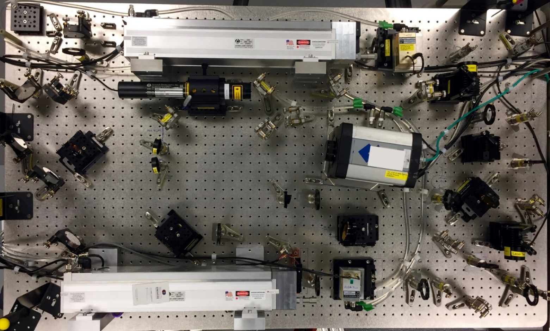
Figure 1.2. Photograph of the ORNL DH system.

each AOM consists of a main beam and a pickoff directed into an associated optical power meter. The typical measured intensities for Laser 1 and 2 are respectively ~7 W and ~5 W; these measured power levels generally increase by 1 to 2 W over a few hours of operation. The main CO₂ beams are joined by visible alignment beams split from the output of a HeNe laser (633 nm wavelength) and the combined CO₂/HeNe beams are directed along separate paths with equivalent optical path lengths. The two beam paths are joined at the first CO₂ beam combiner. From there, the joined beams are expanded by a 30-degree off-axis parabolic (OAP) mirror pair with a diameter of 25.4 mm (1”) and an effective focal length (EFL) of 54.45 mm for the first OAP and a diameter and EFL of 50.8 mm (2”) and 108.89 mm respectively for the second OAP. The expanded beam diameter is approximately 1 cm. The joined beams pass through a second CO₂ beam combiner, which terminates the initial HeNe alignment beams but adds a single new alignment beam. The joined beams next reach the CO₂ beam splitter which separates them into object and reference paths. The object path is directed to the target location where it is reflected back to the beam splitter and reflected again through the first ZnSe lens, and the reference path is directed through a four-mirror group through the second ZnSe lens. Both lenses have a focal length of 254 mm (10”). The object and reference beam paths have equivalent optical paths lengths and are directed through the lenses to overlap on the camera chip, forming a digital hologram. The object and reference beams have generally been aligned to be decentered at the lenses; it was observed that anomalies from second-surface reflections would become apparent in the hologram if centered alignment was attempted, but decentering mitigated the reflections. The complete set of optics in the DH system consists of the two HeNe beam splitters, two CO₂ beam combiners, CO₂ beam splitter, OAP pair, four reference beam mirrors, and two lenses, as well as fifteen mirrors with diameters of 12.5 mm, 25.4 mm, and 50.8 mm which form the optical paths and provide alignment control. Apertures are located throughout the optical paths for use during alignment, which is performed via UV-illuminated plates manufactured by Macken Instruments, Inc. that visibly indicate incident IR light. The optics and apertures are mounted on pedestal posts, and the CO₂ beam combiners and beam splitter are mounted on three-axis adjustable platforms. The AOMs, HeNe laser, power sensors, and beam dump are secured to the table with conventional mount components, and the CO₂ lasers are fastened to custom mount blocks. Mounting components were chosen with the goal of minimizing vibration to reduce holographic image noise.
The detector is a Gigabit Ethernet (GigE) controlled FLIR Systems, Inc. model SC4000 IR camera. It is equipped with a quantum well infrared photodetector (QWIP) and has a maximum imaging window size of 320x256 pixels at 30 µm/pixel. The dynamic range is 14 bits. The camera is triggered by the delay generator which also controls the exposure time. The settings for holographic imaging are square window sizes with pixel dimensions in multiples of 4, and the software-defined camera integration time at least 2 µs longer than the delay generator exposure time setting to account for timing uncertainty and thus prevent exposure time cutoff errors. Typical settings provide frame rates of 500 Hz at 256x256 pixels or 1.4 kHz at 128x128 pixels, with a standard exposure time setting of 13 µs (integration time set in software to 16 µs). Recorded data is exported to the control computer as 16-bit TIFF images.
The lasers, AOMs, and camera are water-cooled via individual chillers at a temperature setting of 28 °C; this temperature setting was selected to mitigate potential condensation buildup on the AOM windows. Additionally, the camera is equipped with a cold plate, cooling fans, and a focal plane array (FPA) cooler. The fans are left inactive by default for the purpose of removing vibrational noise in the recorded data, and the FPA cooler is also deactivated via software script for further noise reduction during hologram acquisition. The FPA cooler can only be inactive for ~14 seconds (therefore limiting the maximum duration of consecutive frame recording), since the internal temperature will rise from its required constant of ~64 K after which the camera will automatically shut off its photodetector.
The recorded holographic image is modulated by a fringe pattern caused by the interference of the reference and object wave fronts. The spacing between fringes can be physically controlled by fine altering of the degree of overlap via adjustment of the reference or object beam path optics. In practice, the target object is placed on an optical mount, and the horizontal and vertical adjustment knobs are used to produce an integer number of pixels per fringe in the digital hologram; the use of an integer pixel/fringe value eliminates Moiré beat frequency anomalies. The ORNL system is optimized for generating holograms with 64 vertical fringes at 4 pixels/fringe.

Digital Holography Technique
Consider a 2-D hologram. Fringe spatial frequencies are based on the optical path length of the object wavefront, therefore topographical features of the target surface result in distortions of the primary fringe spatial frequency. The holographic image is represented by a spatial function $f\left(x,y\right)$. The 2-D spatial Fourier transform and inverse Fourier transform of the image are:
$F\left(u,v\right)=\iint_{-∞}^{∞}{f\left(x,y\right)e^{-i2π\left(ux+vy\right)}dxdy}$ (1.1)
$f\left(x,y\right)=\iint_{-∞}^{∞}{F\left(u,v\right)}e^{i2π\left(ux+vy\right)}dudv$ (1.2)
In the above equations, $u$ and $v$ are spatial frequencies and $F\left(u,v\right)$ is the 2-D spectrum of the image. Figure 1.3 shows an example 256x256 hologram of an etched line pattern from a USAF 1951 Test Target and the associated spatial Fourier transform (visualized in the real domain by displaying the log of the transform’s absolute value).
The 2-D spectral component $F\left(u,v\right)$ can be represented as a complex combination of real and imaginary components:
$F\left(u,v\right)=F_{r}\left(u,v\right)+iF_{i}\left(u,v\right)$ (1.3)
In polar coordinate form, the amplitude and phase components can thus be represented as:
$A=\left|F\left(u,v\right)\right|=\sqrt{{F_{r}\left(u,v\right)}^{2}+{F_{i}\left(u,v\right)}^{2}}$ (1.4)
$φ=\tan^{-1}{\frac{F_{i}\left(u,v\right)}{F_{r}\left(u,v\right)}}$ (1.5)

$$f\left(x,y\right)\underset{⇔}{} F\left(u,v\right)$$
Figure 1.3. A raw holographic image (top) and the real domain visualization of its spatial Fourier transform (bottom).

The complex representation of $F\left(u,v\right)$ is thus rewritten in polar representation:
$F\left(u,v\right)=A\cos{φ}+i\sin{φ}$ (1.6)
By Euler’s formula, $F\left(u,v\right)$ becomes:
$F\left(u,v\right)=Ae^{iφ}$ (1.7)
The exponential component of the inverse transform’s integral is itself expandable by Euler’s formula:
$e^{i2π\left(ux+vy\right)}=\cos{2π\left(ux+vy\right)}+i\sin{2π\left(ux+vy\right)}$ (1.8)
The quantity $\left(ux+vy\right)$ can be considered a dot product of the spatial frequency and spatial direction vectors ($\overset{⃑}{u}=u\hat{i}+v\hat{j}$ and $\overset{⃑}{x}=x\hat{i}+y\hat{j}$ respectively). Normalization of $\overset{⃑}{u}$ allows the quantity to be represented as a projection of $\overset{⃑}{x}$ along the unit vector $\hat{u}$ of $\left(u,v\right)$:
$ux+vy= f\overset{⃑}{x}∙\hat{u}$ (1.9)
In which the frequency $f$ is the magnitude of the spatial frequency vector, which is equivalent to the inverse of the wavelength:
$f=\sqrt{u^{2}+v^{2}}=λ^{-1}$ (1.10)
Therefore, the exponential component represents a sinusoidal pattern in the spatial plane:
$\cos\left(\left(\frac{2π}{λ}\right)\overset{⃑}{x}∙\hat{u}\right)+i\sin\left(\left(\frac{2π}{λ}\right)\overset{⃑}{x}∙\hat{u}\right)=e^{i\left({2π}/λ\right)\overset{⃑}{x}∙\hat{u}}$ (1.11)
Noting that the wavenumber $k=\frac{2 π}{λ}$ and letting path $l=\overset{⃑}{x}∙\hat{u}$, the exponential component represents phase expressed as a function of $k$ and path $l$ by:
$ϕ=kl=\left(\frac{2π}{λ}\right)\overset{⃑}{x}∙\hat{u}$ (1.12)
The image function $f\left(x,y\right)$ is therefore a sum of sinusoidal patterns containing a primary phase component $φ$ and additional phase components given by $ϕ$:
$f\left(x,y\right)=\iint_{-∞}^{∞}{A}e^{i\left(φ+ϕ\right)}dudv$ (1.13)
Applying Fourier transformation results in a complex image in which the sinusoidal components representing the fringes appear as prominent points (sidebands).
A bandpass filter $H$is used to isolate one of the sidebands and remove the primary phase component $φ$, and the remaining phase $ϕ$ corresponding to the selected sideband is shifted to the center of the domain. The filter used in this work is a von Hann window (commonly called a Hanning window) with length $L$, given by the following equation for digital sampling in which $N=L-1$:
$w\left(n\right)=\frac{1}{2}\left(1-\cos{2π\frac{n}{N}}\right), 0≤n≤N$ (1.14)
The sideband is moved to the center by first performing a Fourier transformation on the hologram for identification of the desired sideband’s displacement from the center in the Fourier domain, and then shifting the original image in the spatial domain by the same displacement before performing the Fourier transformation again for application of the filter. This has the effect of extracting the information represented by the spatial frequency of the fringes and removing the fringe pattern from the reconstruction. The process of shifting and filtering the sideband is depicted in Figure 1.4.
The remaining filtered complex representation of the hologram is thus:
$I=Ae^{iϕ}$ (1.15)
The components can be separated into separate amplitude ($A$) and phase ($ϕ$) image reconstructions. Recalling that the phase component is a function of path, the phase image’s intensity is thus convertible to a topographical map of path differences:
$l=\frac{λϕ}{2π}$ (1.16)
Figure 1.5 shows the resulting amplitude and phase reconstructions of the original hologram with a 3-D rendering of the phase image converted to a topographical map.
The phase component is bounded by $0≤ϕ≤2π$, meaning that the upper limit of the measurable path is the wavelength of the system. Phase displacements which exceed this range appear in the reconstructed image as “phase jumps,” in which the excess phase differences are modularly summed. Various phase unwrapping algorithms are available, however in this work phase unwrapping is not applicable due to the generally unknown degree to which phase jumping has
Sideband
Sideband (shifted)
Figure 1.4. Selected sideband identified in the original spatial Fourier transform of the hologram (top left) and shifted to the center by equivalent shifting of the image in real space (top right). The von Hann filter with a radius of 32 pixels is applied to the shifted sideband (bottom).

Figure 1.5. Amplitude (top left) and phase (top right) reconstructions of the hologram. The rendered topographical map of the phase image after cropping and horizontal correction have been performed is shown (bottom).

occurred in the image reconstructions. Therefore, the presence of phase jumps renders the topography of a phase image deceptive unless the topographical features are known quantities beforehand.
The phase measurement is affected by the traversal of the object beam to and from the target object by reflection, in effect seeing the object “twice.” Because of this, the measured phase displacements are doubled from the actual path length differences. Dividing the phase by 2 gives the correct topographical measurement and establishes that the upper limit of the measurable path length is equivalent to $λ/2$.

Flatfield Correction
Flatfield correction is the process of subtracting a baseline hologram from another hologram to reduce background information to zero while preserving path differences in the phase image reconstruction of the second hologram. Flatfield correction is performed by division of the holograms in complex space:
$\frac{I_{1}}{I_{2}}=\frac{A_{1}e^{iϕ_{1}}}{A_{2}e^{iϕ_{2}}}=\left(\frac{A_{1}}{A_{2}}\right)e^{ϕ_{1}-ϕ_{2}}$ (1.17)
Thus, the flatfield corrected amplitude component and phase component are then able to produce reconstructed images:
$∆A=\frac{A_{1}}{A_{2}}$ (1.18)
$∆ϕ=ϕ_{1}-ϕ_{2}=k\left(l_{1}-l_{2}\right)$ (1.19)
Flatfield correction is useful for background subtraction, detection of time-resolved phase difference caused by noise accumulation between sequential holographic frames, and reduction of noise by subtraction of a hologram from a flat surface. It also enables dynamic displacement of a surface to be observed by subtracting a reference frame from a sequence of time-resolved consecutive holograms, with the caveat that doing so eliminates all static surface topography from the reconstructed images and preserves only the dynamic phase changes.

Dual-Laser Operation
The ORNL digital holography diagnostic is capable of producing dual-laser holograms via differential holography. Differential holography allows the equivalent spatial path bounded by the $\left[0,2π\right]$ phase range to be greatly expanded. The process of performing a differential hologram is similar to flatfield correction using two holograms of the same target object in which the second hologram has been obtained by a wavefront tuned to a different wavelength than that of the first hologram. Thus, the dual wavelength phase image is based on a difference of wavelength rather than path:
$∆ϕ=\left(k_{1}-k_{2}\right)l=2πl\left(\frac{1}{λ_{1}}-\frac{1}{λ_{2}}\right)$ (1.20)
The wavelength component is rewritten to the form known as the “synthetic wavelength” using the least common multiple of the denominators:
$\left(\frac{1}{λ_{1}}-\frac{1}{λ_{2}}\right)=\left(\frac{λ_{2}-λ_{1}}{λ_{1}λ_{2}}\right)=\frac{1}{λ_{synth}}$ (1.21)
Note that $λ_{1}λ_{2}≫λ_{2}-λ_{1}$ and therefore $λ_{synth}$ far exceeds either of the single wavelengths, which causes the measured path $l$ to be significantly larger for the dual wavelength phase image reconstruction compared to the reconstructions for either of the individual wavelengths:
$l_{dual}=\frac{λ_{synth}∆ϕ}{2π}≫l_{single}=\frac{λ_{single}ϕ}{2π}$ (1.22)
Figure 1.6 illustrates the dual-laser measurement expansion capability. The synthetic wavelength acts as a multiplier to the measured phase difference. The drawback of differential holography is that this multiplier affects phase differences produced by noise as well, therefore any noise accumulated in the holograms’ acquisitions may severely degrade the measurement precision of the differential phase image reconstruction. Measurements in the reconstruction of topographical displacements which are smaller than typical differential noise levels may therefore be suspect.

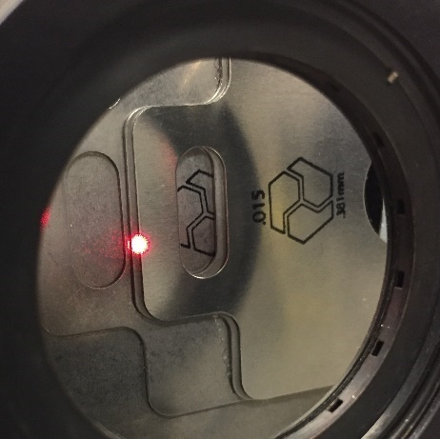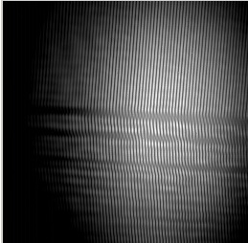
Figure 1.6. Section of stacked stainless steel shims imaged by holography; steps were each 0.381 mm thick (top left). Raw hologram of the stack (top right). Phase images from single-laser holography for wavelengths of 9.25 µm (middle left) and 9.27 µm (middle right). Phase image from dual-laser holography (bottom left) and rendered topographical map of the dual-laser phase image (bottom right).

Flatfield correction can be performed on the individual holograms of a dual wavelength hologram. Consider the generalized representations of flatfield correction of single-wavelength hologram $i$ by a counterpart hologram $j$ and differential holography of holograms with wavelengths $m$ and $n$:
$∆ϕ_{ij}=ϕ_{i}-ϕ_{j}=\frac{2π\left(l_{i}-l_{j}\right)}{λ_{m}}$ (1.23)
$∆ϕ_{mn}=ϕ_{m}-ϕ_{n}=2πl_{i}\left(\frac{λ_{n}-λ_{m}}{{λ_{m}λ}_{n}}\right)$ (1.24)
Applying Equation 1.20, a differential phase reconstruction of two flatfield-corrected phase terms is formed:
$∆{ϕ_{ij}}_{mn}={\left(ϕ_{i}-ϕ_{j}\right)}_{m}-{\left(ϕ_{i}-ϕ_{j}\right)}_{n}=2π\left(l_{i}-l_{j}\right)\left(\frac{λ_{n}-λ_{m}}{{λ_{m}λ}_{n}}\right)$ (1.25)
Therefore, the flatfield-corrected path measurement from this “dual differential” method is obtained:
$∆l_{ij}=l_{i}-l_{j}=\frac{∆{ϕ_{ij}}_{mn}{λ_{m}λ}_{n}}{2π\left(λ_{n}-λ_{m}\right)}$ (1.26)
As with single-wavelength holography, dual differential flatfield correction can reduce phase image noise, and the technique is particularly effective when detecting time-resolved noise buildup in a hologram sequence or measuring dynamic displacements.

CHAPTER II
Recent Developments in Dual-Laser Digital Holography for Plasma Facing Surface Characterization
A version of this chapter was originally published by Cary D. Smith1, Theodore M. Biewer^{1,}, Xi Ren, C. E. Thomas, Jr., Trey Gebhart², and Zhili Zhang¹:
C. D. Smith, T. M. Biewer, X. Ren, C. E. Thomas, T. Gebhart and Z. Zhang, "Recent Developments in Dual-Laser Digital Holography for Plasma-Facing Surface Characterization." IEEE Transactions on Plasma Science, Vol. 48, No. 6, pp. 1655-1660, 2020, DOI: 10.1109/TPS.2019.2943739
The work in this chapter was presented at the 28th IEEE Symposium on Fusion Engineering (SOFE), June 2-6, 2019 in Ponte Vedra Beach, Florida.

Abstract
A digital holography device is currently undergoing development at Oak Ridge National Laboratory for the purpose of measuring surface topography, with the goal of deployment as a real-time plasma facing component diagnostic for the study of materials that could be utilized in a fusion device. The holography system utilizes one or two lasers depending on the scale of surface features under measurement. Measurements of surface roughness were performed in single-laser mode and compared to data from profilometry, with a linear correlation of increased holographic measurement fidelity as surfaces became smoother. Characterization of the dual-laser operating mode has been performed via surface measurement of stainless steel targets with “stair step” features in various sizes. Results demonstrated that surface features with known sizes as small as 25.4 µm could be resolved. Measurements were within ~55 µm or less deviation from the actual sizes, and measurement accuracy was improved as feature size was increased, corresponding to the effect of noise becoming less pronounced. A target exposed to plasma generated by an electrothermal arc source was analyzed with flatfield correction and averaging of sequential image frames to demonstrate improved measurement quality in preparation for future use of holography on electrothermal arc-exposed targets.

Introduction
The ongoing development of engineering materials for fusion devices is faced with the challenges of plasma-material interactions (PMI) on plasma facing components (PFCs). Fusion devices experience PFC modifications such as erosion, redeposition, and implantation from plasma effects, and abnormal events such as edge localized modes (ELMs) are particularly responsible for significant PFC modifications [7]. Various techniques exist for measuring PFC surface deformation ex situ, but the ability to monitor surface deformation from PMI in situ is needed. A digital holography (DH) device has been established at Oak Ridge National Laboratory (ORNL) in cooperation with Third Dimension Technologies (TDT) for development as a diagnostic of PFC modifications with a project goal of deployment on a plasma device such as ORNL’s Prototype Material Plasma Exposure eXperiment (Proto-MPEX) [24, 72] or electrothermal (ET) arc source.
The ORNL DH device uses two lasers which can be operated individually or in tandem, effectively allowing measurements of small features (nm to µm in displacement) in single-laser mode or large features (µm to mm) in dual-laser mode. Progress in the initial development of the DH device and proof-of-principle data have been reported previously [70]. The aim of this work was to determine the effects of material surface roughness on DH measurements, produce a detailed characterization of the dual-laser mode of operation, and evaluate the results of image correction techniques on a plasma-exposed surface measurement in preparation for future work involving the ET arc source. The points of interest were accuracy of measurement corresponding to surface feature size and systematic noise.

Digital Holography Technique
Digital holography is the process of performing holographic imaging to detect phase and amplitude information regarding a target object; as digital cameras have now become ubiquitous, the word “digital” is a legacy term once used to differentiate the technique from earlier holographic methods. Holography is achieved by recording a reference wave front (i.e. a reference laser beam) with known amplitude and phase simultaneously with a wave front carrying information about the target under examination (i.e. an object laser beam reflected from a target). The interference of the two beams produces fringe patterns, which are imaged by a detector. The resulting holographic image is transformed into the Fourier domain, wherein information corresponding to the holographic fringe patterns can be selected and used to reconstruct the phase and amplitude information of the target in image form. Changes in the target surface can be detected by conversion of the phase image to path length information. An inherent limitation of holography is that the phase image’s range of detectable path length displacement (without uncertainty) is bounded by 0 and 2π, which is equivalent to half the wavelength of light used in the reference and object beams for a reflected image; therefore displacements that exceed half the wavelength produce “phase jumps” in the phase images which make the measurements more challenging to interpret.
Differential digital holography allows a change in phase displacement over the time increment between two holograms to be measured. The technique involves the division of the complex representation of one hologram by another. The formula for a differential hologram is given by Equation 2.1:
$\frac{I_{1}}{I_{2}}= \frac{A_{1}e^{iϕ_{1}}}{A_{2}e^{iϕ_{2}}}=\left(\frac{A_{1}}{A_{2}}\right)e^{(ϕ_{1}-ϕ_{2})}$ (2.1)
The amplitude component is given by ${A_{1}}/{A_{2}}$and the measured phase by
$(ϕ_{1}-ϕ_{2})$.
Differential holography can also be used to expand the path length equivalence of the 2π phase range when the division is performed on a hologram recorded at a certain laser wavelength by another hologram recorded at a different wavelength. This is accomplished by the formation of a synthetic wavelength, which is relatively large compared to the wavelength of a single-laser hologram and therefore allows the measurable range to be much higher. The measured phase component of a single hologram is a function of wavelength () and path length ($l$):
$ϕ= \frac{2π}{}l$ (2.2)
Modifying Equation 2.1 with Equation 2.2 results in the formula for differential holography with expanded measurable range:
${\left(\frac{A_{1}}{A_{2}}\right)e}^{(ϕ_{1}-ϕ_{2})}={\left(\frac{A_{1}}{A_{2}}\right)e}^{\left(\left(\frac{{}_{2}-{}_{1}}{{}_{1}{}_{2}}\right)2l\right)}$ (2.3)
The synthetic wavelength is equal to $\left(\frac{{}_{1}{}_{2}}{{}_{2}-{}_{1}}\right)$.

Experiment

Digital Holography System Description
The digital holography system uses two tunable water-cooled CO₂ infrared lasers manufactured by Access Laser Company (model AL30G). The lasers are nominally rated at 30 W peak power and can be tuned to wavelengths of 9.2 to 10.8 µm. In the standard configuration, Laser 1 is tuned to a wavelength of 9.250 µm and Laser 2 is tuned to 9.271 µm, with both lasers typically operating at ~5-7 W. A HeNe laser is present to provide a visible beam for aiding alignment. The lasers are controlled by twin infrared acousto-optic modulators (AOMs) manufactured by IntraAction Corporation (model AGM-404PC24-6). The AOMs convert the continuous light output from the lasers into variable time-width pulses, effectively acting as secondary shutters. The laser pulse width is controlled by changing the width in time of the AOM pulse. The AOMs are typically set to 13 µs with 2 µs delay after the camera trigger in standard operation. An alignment HeNe beam is combined with each laser after its respective AOM.
The laser beams are directed by respective series of mirrors to a beam combiner, from which they exit on the same path and are expanded by two off-axis parabolic mirrors. The two combined beams pass through a beam splitter, and are separated into reference beams and object beams for both lasers. The object beams are reflected from the target back into the beam splitter and directed through a focusing lens into the camera aperture, while the reference beams are directed to bypass the beam splitter and pass through a second focusing lens into the camera aperture. The two laser beams and their respective reference and object beams are configured to travel over equal optical paths.
The camera used in the system is an externally triggered high-speed infrared camera manufactured by FLIR Systems, Inc. (model SC4000). It is capable of imaging up to 320x256 pixels, with typical holograms produced with a window setting of 256x256 pixels at a rate of 500 Hz and with exposure times of 13 µs. The camera is controlled using ExaminIR software produced by FLIR Systems. Holograms are obtained by pulsing one laser at a time with the other laser’s AOM inactive. Raw holograms are imaged and exported from ExaminIR, and then processed using Matlab to generate phase and amplitude images. The measured areas are cropped from the original 256x256 phase images to remove pixels outside the field-of-view of the laser beam.
The digital holography device can operate in single- or dual-laser modes. In single-laser mode, holograms are produced using either Laser 1 or Laser 2 only, and can detect surface features up to ~4.5 µm in displacement. In dual-laser mode, image acquisition alternates between the two lasers so that consecutive frames switch between Laser 1 and Laser 2. Division of a Laser 1 frame with a Laser 2 frame allows the detectable surface displacement to reach ~2 mm.

Surface Roughness Characterization Targets
The first experiment in this work was intended to determine the levels of target roughness that could produce usable holographic images. Targets used for characterizing the effects of surface roughness on DH measurement were 304 stainless steel shims, produced by Maudlin Products. Shims were modified to produce three degrees of surface roughness: polished to a mirror finish, “wet” bead-blasted, and “dry” bead-blasted. Additionally, a shim with the original surface finish as delivered by Maudlin Products was considered. The shims were imaged with the DH system running in single-laser mode.

Dual-Laser Characterization Targets
The second part of this work was to determine dual-laser measurement accuracy for a range of predefined surface displacements. Targets were constructed out of shims arranged in “stair step” configurations and secured to a vertical flat optical mounting plate. Shim thicknesses of 25.4 µm, 76.2 µm, 381 µm, and 787 µm were used to build individual step targets over a range of step heights; additionally, a target with step heights of 127 µm was constructed with 3 sets consisting of single 76.2 µm shims with two 25.4 µm shims stacked together. The shims were stated to have very high precision in thickness, and shim thicknesses were confirmed to match the product specifications using a Mitutoyo caliper. The targets were imaged with the DH system running in dual-laser mode.

ET Arc-Exposed Target
The last experiment was to compare holographic image correction techniques applied to data of a plasma exposed target. A 304 stainless steel target was used in the ET arc at ORNL and imaged with the DH system. The ET arc produces plasma exposures of ~2.2 kJ with a peak power flux of 1.8 to 2 GW/m² over a period of approximately 2 ms [73]. The target was initially polished to a mirror finish and received 6 total exposures from the ET arc, causing visible surface deformation and heavy soot deposits. The target was imaged by the DH system in single-laser mode.

Results and Discussion

Surface Roughness Characterization
The shims were first measured using a Mahr GD25 profilometer, which had an x-y resolution of 2 µm and provided roughness average (Ra) information for the z-axis. The Ra values for the shim surfaces were 13 nm (polished), 205 nm (original), 593 nm (wet bead-blasted), and 1720 nm (dry bead-blasted). The DH results were then compared to the shims. Figure 2.1 shows the 3-D rendered surfaces produced from the holographic phase images of the targets with flatfield correction performed using a hologram of a flat mirror. Signal loss from the dry bead-blasted target was high, and therefore no usable data was produced for that target. The remaining three targets have a saddle shaped curvature in their measured surfaces which was believed to be likely due to systematic noise, as similar curvature appeared in phase images of the mirror used for flatfield correction. Since the mirror was known to be flat, the curvature (~700 nm) could be identified as being due to unmatched phase fronts of the reference and object beam. The holographic surface renderings of Figure 2.1 show a clear visual difference in roughness from the polished finish to the original finish, but the wet bead-blasted surface rendering appears to be similar to the original surface in topography and scale despite the difference in Ra values of ~400 nm as measured by the profilometer.
Line profiles of the holographic renderings were taken across the x-axis of the measured surfaces at y-axis locations of 1.8 mm, 3.6 mm, and 5.4 mm. To obtain holographic Ra measurements, a best-fit curve was subtracted from each line profile and the absolute value of the difference was taken. The Ra value for each surface was obtained by averaging the mean values of the three absolute differences. Notably, the DH-measured Ra value is increased by a factor of ~10 moving from the polished surface (Ra ~9 nm) to the original surface (Ra ~95 nm), but the measured Ra exhibits a decrease moving to the wet bead-blasted shim (Ra ~60 nm), again contradicting the increase in Ra expected from profilometry measurements. This discrepancy and the visual similarity of the wet-bead blasted rendered surface to the original rendered surface indicate that the wet bead-blasted surface roughness was not well-resolved by the DH system. An explanation for the DH error is that since the profilometer’s x-y resolution (2 µm)
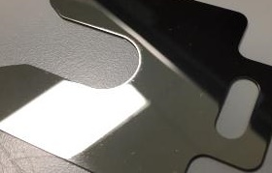
a.
b.
c.

Figure 2.1. Surface sample results. (a) Polished surface sample, (b) original shim surface sample, and (c) wet bead-blasted sample.

was superior to the DH system’s x-y resolution (~120 µm), the profilometer measurement appears to have been able to resolve fine details which the DH system cannot measure.
The plots of the differences and %differences of the holographic Ra measurements and profilometer Ra values, shown in Figure 2.2, reveal a highly linear trend in the difference between the two types of Ra measurements as surface roughness was increased. This finding may be used to determine a correction factor for bringing holographic surface measurements more closely in line with macro-level characteristics of the surface obtained by other means, such as profilometry Ra. Note that %difference was used here rather than %error, as Ra is a simplified indicator of surface quality; furthermore the profilometer measurement represents an average across a single line rather than a full area and therefore possesses its own uncertainties. Finally, the plot shows that surface roughness can be up to ~300 nm in Ra with the %difference between the DH-measured Ra and the profilometer Ra staying below 100%; this may be useful as a simplified cutoff for preferred surface roughness of targets to be measured by the DH system.

Dual-Laser Characterization
The measured phase displacements of each target are shown as 3-D renderings in Figure 2.3, with mean values of the measured surface in overlay for each step. “Spikes” are apparent in the renderings from pixels where signal loss occurred. Another anomaly that occurred in some cases was a slope apparent in the z-axis surface displacement measurements. Slopes appearing in these cases can be considered false and products of systematic noise, since the target geometries were well-defined prior to measurement via the DH system.
In Figure 2.3.a, the target was constructed out of four 25.4 µm shims stacked together on a substrate shim. The steps are generally visible, though ripples in the surface cause some of the step edges to appear to blend together. Figure 2.3.b shows the target built out of four 76.2 µm shims arranged on a
Figure 2.2. Differences of holography-measured roughness averages from profilometer roughness average measurements.

a.
b.

c.
d.
e.
Figure 2.3. Dual-laser holography-measured step target surfaces with mean values of step areas. (a) Target 1: 25.4 µm steps, (b) Target 2: 76.2 µm steps, (c) Target 3: 127 µm steps, (d) Target 4: 381 µm steps, (e) Target 5: 787 µm step.
substrate. The slope anomaly can be seen clearly, and the error also includes a slight twisting effect about the x-axis. However, the four individual steps can each be clearly identified. The third target, shown in Figure 2.3.c, was constructed to produce three steps of 127 µm displacement each. The quality of the steps in the measured surface is visibly improved over the previous targets.
The improvement in surface fidelity continued in the results for the next target, built out of three 381 µm shims on a substrate, as shown in Figure 2.3.d. The steps appear much smoother, with surface ripples and roughness having less significance in the z-axis scale than the step height displacements. The steps are rendered more sharply than those of the previous targets. Finally, the largest measured displacement was of a target built with one 787 µm shim placed on a substrate. The result, shown in Figure 2.3.e, is affected by anomalous sloping in the z-axis. Therefore, though the z-axis scale does not have any extremes produced by signal loss, it still represents a range of just over 1.2 mm total, which is nearly twice the expected total displacement in the measurement. However, the difference in z-axis values in the middles of the upper and lower surfaces align more closely with the expected surface displacement, and the surfaces are rendered more smoothly than the other targets.
Figures 2.4.a-e show the selected pixels of each step with their associated mean z-axis (measured surface) values subtracted for each target; these pixels correspond to the areas with mean values in overlay shown in Figure 2.3, thus the flatness of each step is measured in these results. Targets 1 and 3, shown in Figures 2.4.a and 2.4.c, exhibited the closest overall similarity to their step surface mean values, with their z-axis ranges staying within ~100 µm of the means. Targets 2, 4, and 5 (Figures 2.4.b, 2.4.d, and 2.4.e) had differences up to ~250 µm away from the step mean values. These targets also show evidence of the slope anomaly seen in the 3-D renderings; pixels with values below the mean values appear fully on one side while pixels with values above the means appear on the other. By contrast, Targets 1 and 3 have pixel values rising above and below the means located on both sides of the steps.
a. b.
c. d.
e.
Figure 2.4. Selected pixels of measured step surfaces with mean values subtracted. (a) Target 1: 25.4 µm steps, (b) Target 2: 76.2 µm steps, (c) Target 3: 127 µm steps, (d) Target 4: 381 µm steps, (e) Target 5: 787 µm step.

Figures 2.5.a-e show the selected pixels with their associated mean ±1 standard deviation in the z-axis subtracted; one standard deviation above or below the mean is used as an error threshold in these results and parts of the measured surfaces which exceed the error threshold in magnitude are therefore shown in these results. Generally, pixels remaining above or below the threshold are mostly concentrated toward the left and right edges of the measured area, indicating that the center pixels of the measured surface areas around 1.8 mm on the x-axis are not far from the mean values. Corresponding to the results in Figure 2.4, Figures 2.5.a and 2.5.c (Targets 1 and 3) had the smallest values exceeding the error threshold, and the other targets had a maximum excess value of ~150 µm above or below the threshold. This maximum value is related to the slope anomaly, and removal of the anomaly would bring the excess closer to the error threshold in the affected cases.
The actual and measured displacements for each step target are shown in the left plot of Figure 2.6. The differences of adjacent mean values were averaged for each target so that a single mean measured step size could be produced for each size of shim employed in this data set. The error bars for the mean measured step sizes were produced from averages of the standard deviations for each case. The plot demonstrates that the measured step size was above the actual step height in all cases, but tracked linearly with increasing step size. The actual step size fell within the error bars for all but the 127 µm step, in which the actual step size appears just outside of the lower error bar. As noted in the discussion of the 76.2 µm and 787 µm target results, the presence of the slope anomaly caused the standard deviation from the mean step size to be large, therefore the error bars for these step sizes appear to encompass an abnormally large range. The differences of the measured step size from the actual step size are shown in the center plot. Despite the linearly increasing trend of the measured step size, the differences between measured and actual values appear to be random, ranging from ~10 to ~55 µm. The %errors of the differences between measured and actual values,
a. b.
c. d.
e.
Figure 2.5. Selected pixels of measured step surfaces with mean values ± standard deviation subtracted. (a) Target 1: 25.4 µm steps, (b) Target 2: 76.2 µm steps, (c) Target 3: 127 µm steps, (d) Target 4: 381 µm steps, (e) Target 5: 787 µm step.
Figure 2.6. Actual and holography-measured step sizes (left), differences of measured and actual step sizes (center), and %errors of measured from actual step sizes (right).

shown in the plot on the right side of the figure, reveal that the measured values were generally closer in precision as step size was increased, which can serve to demonstrate that noise in the DH device has a greater impact on the measurement of small features. Furthermore, the data shows that noise does not cause a scalar multiplication of all surface displacement, but rather introduces uncertainty up to ~150 µm as seen by the typical excess in magnitude of the measured surfaces in comparison to their mean values ±1 standard deviation. This uncertainty correlates to known typical noise values around 100 µm for dual-laser mode under the current configuration of the DH system.
The complications introduced by these uncertainties can be seen in the difficulty of discerning some of the step edges in the 25.4 µm target and in the increased %error of measured surface difference from the actual value for that target. Despite the presence of uncertainties, the surface features could still be observed visually even for the 25.4 µm target, indicating that the DH system is capable of producing believable results for surface features in the range of tens of µm in z-axis displacement, with the caveat that such small features with relatively small displacements may produce measurement errors due to the effects of noise on the measured surface. Larger surface features, that is those which exceed ~100 µm, are less affected by noise and other uncertainties since any small features surrounding them which may experience measurement errors will not be comparably noticeable. Sharp edged features tend to introduce noise from signal loss.

ET Arc-Exposed Target Analysis
The results shown in Figure 2.7 represent a test of correction techniques for improving the surface measurement of the exposed target. In the first image, the rendered surface from a single phase image taken in single-laser mode with no flatfield correction is shown. Note the appearance of twisting in the surface, causing the z-axis range to reach almost 1 µm. The application of flatfield correction to the phase image using a mirror hologram is intended to reduce
a.
b.
c.
Figure 2.7. Single-laser holographic surface measurements with correction options. (a) Single-frame, raw measurement with no correction, (b) single frame with flatfield correction, and (c) average of 500 sequential frames with flatfield correction.
systematic noise. This caused the twist to be removed from the surface and reduced the z-axis range from ~1 µm to ~450 nm at maximum as seen in the second image. Mounds and pits in the surface have been made more visible. Finally, the third image is the result of applying an averaging scheme, in which 500 frames of the target location were acquired consecutively at 500 Hz. Flatfield correction was performed using an average of a set of mirror holograms acquired in the same way, and then the average phase image was obtained by averaging the 500 individual flatfield corrected target images. The method appears to have produced a slight improvement in the rendered surface by slightly reducing the z-axis range further, i.e. eliminating discrepancies that exist in individual phase images resulting from frame-to-frame random or vibrational noise. These results demonstrate that flatfield correction with pre-exposure holograms is crucial for producing reliable in situ measurements, and measurements may benefit from the averaging method to mitigate any false measurements produced by interframe noise.

Conclusion
Single-laser digital holography has been shown to be useful for measuring surfaces with feature displacements up to ~4.5 µm, and dual-laser digital holography allows measurable surface displacement up to ~2 mm. Single-laser holographic measurements of surfaces with Ra values up to ~300 nm could be achieved within less than 100% difference from profilometer surface measurements. Dual-laser measurements of features that exceeded ~100 µm in displacement were significantly distinguishable from noise. Finally, a method of averaging multi-frame holographic measurements of static targets showed the ability to reduce noise.

Future Work
An extensive campaign to characterize DH by measurement and analysis of ET arc-exposed 304 stainless steel plates in single- and dual-laser modes is ongoing, moving towards an in situ demonstration by determining suitability of the DH system for use with the ET arc source. Further efforts to reduce dual-laser noise and change the system configuration to allow longer camera exposures of substantially eroded targets will be undertaken.

Acknowledgements
This manuscript has been authored by UT-Battelle, LLC under Contract No. DEAC05-00OR22725 with the U.S. Department of Energy.

CHAPTER III
Improvements and Performance Parameters for the ORNL Digital Holography PFC Surface Erosion Diagnostic

Portions of this chapter are intended to be incorporated into other manuscripts for future publications.

Abstract
A digital holography diagnostic for in situ measurement of plasma-exposed surface erosion has been assembled at Oak Ridge National Laboratory. The diagnostic is capable of operating in single- or dual-laser modes depending on whether the target’s topographical features of interest have displacements on the order of nm or µm. System improvements and current performance in terms of image noise levels are presented herein: a flatfield correction method for dual-laser holograms which can reduce image noise, elevation of the maximum exposure time by the addition of a holographic wire grid polarizer to reduce reference beam intensity, and efforts taken to mitigate image noise from vibration and other sources with current noise levels briefly discussed. Future work, particularly regarding an upcoming planned demonstration of the system in an in situ experiment with a plasma device, is also described.

Introduction
A digital holography (DH) diagnostic is in development at Oak Ridge National Laboratory (ORNL) for 3-D in situ measurement of plasma-facing component (PFC) surface deformation in support of fusion plasma-material interaction (PMI) research [24, 70, 72, 74, 75]. The DH system utilizes two CO₂ lasers tuned to wavelengths of 9.25 µm and 9.27 µm to enable measurement of features up to ~4.5 µm with nm resolution in single-laser mode, or up to ~2 mm with µm resolution in dual-laser mode via formation of a “synthetic” wavelength. The lasers are controlled by acousto-optic modulators (AOMs) with individual timing settings through separate delay generator channels allowing either one laser to run for consecutive exposures or both lasers to alternate. Each laser is aligned to the same path through a beam splitter which separates them into reference and object beams, which return through 10” focal length lenses to form holographic images on the detector chip of a FLIR Systems SC4000 infrared camera.
This article details image processing and system improvements that have been performed in the course of the diagnostic’s development. First, a flatfield correction method for dual-laser holograms has been developed and shown to reduce image noise significantly. Secondly, the exposure time upper limit has been elevated by use of a wire grid polarizer to reduce reference beam intensity while enabling signal improvement through longer exposure on the target object. Finally, efforts to mitigate noise from vibration and other sources are described and the current system noise levels are discussed.

Dual-Laser Flatfield Correction
Flatfield correction of dual-laser differential holograms has been demonstrated. Consider a recording of consecutive holograms which alternates frame-to-frame between Laser 1 and Laser 2; hologram A is therefore produced from Laser 1 exposure and hologram B from Laser 2. Additionally, let holograms C and D be frames for flatfield correction of Laser 1 and Laser 2 frames respectively. A flatfield-corrected “dual differential” holographic phase image is then produced by performing the operation (A – C) – (B – D).
Typical flatfield correction of single-laser holograms is performed by the division of complex images. This results in a phase change term in which only path length displacement differences from the changes in the object beams are retained:
$∆ϕ_{ij}=ϕ_{i}-ϕ_{j}=\frac{2π\left(l_{i}-l_{j}\right)}{λ}$ (3.1)
The dual-laser technique is itself similar flatfield correction in which the phase change is a result of the difference in wavelength rather than path length, given by the following formula [24]:
$∆ϕ_{mn}=ϕ_{m}-ϕ_{n}=2πl\left(\frac{λ_{n}-λ_{m}}{{λ_{m}λ}_{n}}\right)$ (3.2)
The corrected phase term $∆ϕ$ can therefore represent a single-laser hologram with flatfield correction by another holographic frame, or a dual-laser hologram formed by the subtraction of a hologram generated with Laser 2 from a hologram of Laser 1. It is therefore possible to perform flatfield correction on the two lasers’ individual holograms before forming the differential hologram by a modification of Equation 3.2 by Equation 3.1:
$∆{ϕ_{ij}}_{mn}={\left(ϕ_{i}-ϕ_{j}\right)}_{m}-{\left(ϕ_{i}-ϕ_{j}\right)}_{n}=2π\left(l_{i}-l_{j}\right)\left(\frac{λ_{n}-λ_{m}}{{λ_{m}λ}_{n}}\right)$ (3.3)
An example of this capability is shown in Figure 3.1. A standard differential hologram without flatfield correction of an artificial “stairstep” target of the type from [75] is shown; the steps were each 381 µm in height. The surface is slanted on the horizontal axis, which is likely due to errors in detecting the carrier frequency due to a nonlinear carrier or phase image noise typically manifested as an ostensibly bowl-shaped depression in targets which are known to be flat. A line profile (red line taken across the phase image from left to right) exhibits this z-axis slant and provides an estimated noise level of over 700 µm. However, dual differential flatfield correction of the dual-laser hologram with holograms of a flat mirror target reduced the slant substantially and reduced the estimated noise level to 124 µm.

Signal Improvement
Camera signal intensity is based on the exposure time of the lasers’ AOMs. Under the standard setting of 13 µs exposure, the typical maximum intensity of holograms of a flat mirror target is ~7,000 counts on the readout of the SC4000’s software. Increasing the exposure time allows the hologram intensity to be raised up to a safe maximum intensity limit of 13,000 counts under regular operating parameters. However, the AOM exposure time setting affects both the object and reference laser beams; while increasing the exposure time can improve a weak object beam reflection from a rough target, the maximum allowable exposure time is effectively limited to ~25 µs by the intensity of the reference beam.
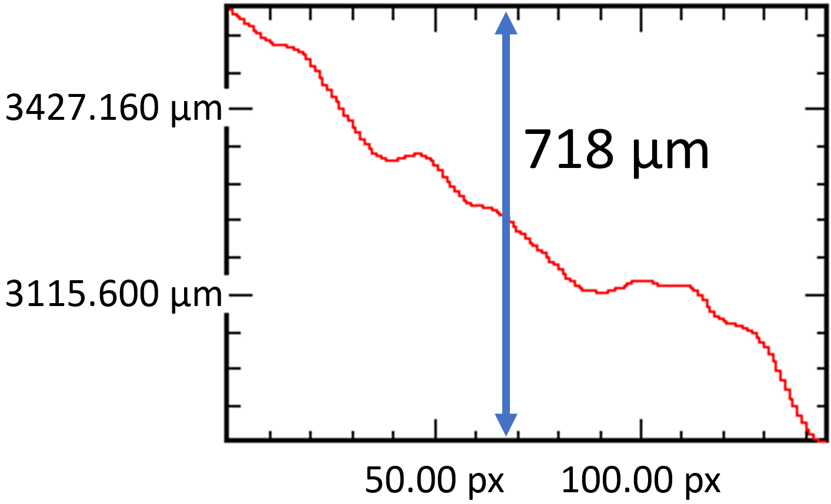

a.

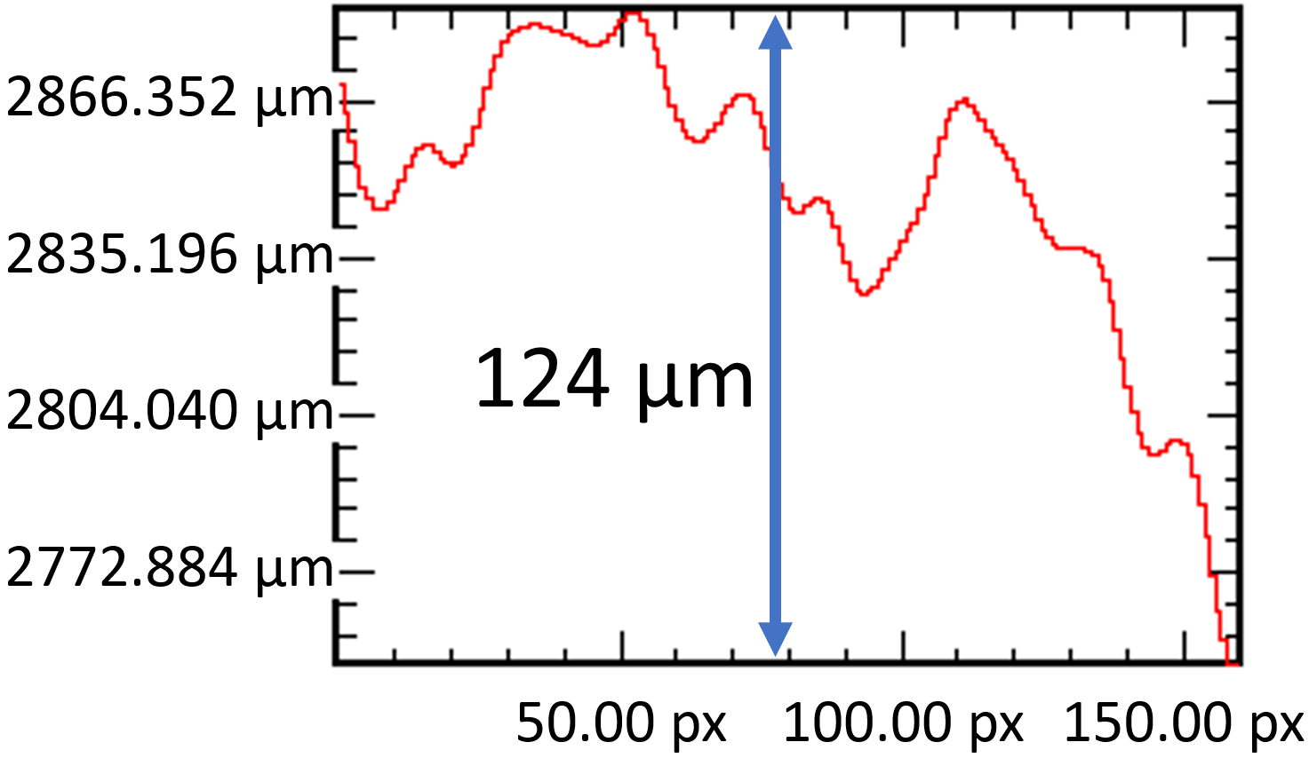

b.
Figure 3.1. Differential hologram of a stairstep target comparison of (a) standard vs. (b) flatfield-corrected results.

A holographic wire grid polarizer has been added to the DH system to facilitate longer exposure times. The polarizer is placed in the path of the reference beam only and is used for tuning the reference beam intensity to lower levels as the laser exposure time is raised, with the reference beam signal maximized at a tuning of 90° and minimized when tuned to 0°. This allows the exposure time to be hundreds of µs long, and up to 240 µs exposures have been experimentally performed on plasma-exposed targets with severe surface deformation. The theoretical maximum exposure time limit is now ~500–1,000 µs; vibrational amplitudes would become excessive at very high exposure times and induce image washout. Leakage of the reference beam signal through the polarizer at 0° tuning could also eventually saturate the image at very high exposure times, but it is likely that the vibrational washout would occur before reaching the saturation intensity.
Figure 3.2 demonstrates the signal improvement capability allowed by the polarizer. The holograms were generated from a bead-blasted stainless steel surface with a roughness average (Ra) of 1.72 µm. The roughness and grit of the surface produced very low reflectivity. Under the standard exposure time setting of 13 µs the object beam reflection was too weak to produce an effective hologram and the resulting phase image is too noisy to be useful. However, tuning of the polarizer to 30° enabled the exposure time to be raised to 50 µs, which significantly improved the object beam reflection and allowed a better hologram to be generated. The noise in the resulting phase image is greatly reduced and there are clear areas of the image where the surface can be measured without interference from “phase jumps” (sharp-edged areas representing displacements which have exceeded the 2π phase limit).

System Noise Levels
Holographic noise errors arise from many sources. Chief among them is the total amount of vibration from all components in the DH system and target object.
Figure 3.2. Comparison of signal exposure time effects on holographic phase noise.
Additionally, noise can appear from vibration of the camera cooling system, systematic phase front errors interacting with vibrations, solid body phase offset between temporally displaced holograms, beat frequencies from mismatched RF driver frequencies, mismatched gate widths between the camera and AOMs, and Moiré beats between holographic fringes and camera pixels. Noise errors are compounded in dual-laser mode since the synthetic wavelength expansion of the 2π phase limit applies to all path length displacements including anomalous ones from noise.
Efforts to mitigate the noise in the DH system have been taken. The optical table legs and vibrating components (e.g. chiller hoses) have been placed on up to 1.5” thick noise-dampening Sorbothane® pads manufactured by Sorbothane, Inc. of Kent, OH. The camera is placed on a cold plate and the camera fans are turned off in normal operation, and during data acquisition the camera’s Stirling engine cryo-cooler is deactivated to further reduce vibration (limiting the acquisition time to ~14 seconds before automatic shut-off from temperature increase). Phase fronts are matched as closely as possible by precision movement of the optics to optimized positions. The lasers’ RF feeds are connected to the same quartz oscillator to eliminate beat frequencies and the camera integration time is set to a few µs longer than the AOMs’ exposure time to prevent timing mismatch. An integer value of pixels/fringe is used to eliminate Moiré beats. Frame-to-frame dual-laser noise can be significantly reduced by using the dual differential flatfield correction method on a set of consecutive dual-laser holograms corrected by an initial hologram within the set, with the caveat that the displacement of interest must be a dynamic change since the dual differential application causes the corrected holograms to erase all static displacement features on a surface.
An accelerometer measurement of horizontal vibrations on the DH optical table is given in Figure 3.3; the highest vibrational amplitudes occur at low frequencies and typically manifest as ~10-100 nm errors in single-laser holograms. These appear in practice as frame-to-frame variations as low as ~5 µm in dual-
Figure 3.3. Vibrational modes of the DH system optical table.

laser mode and only a few nm in single-laser mode when recording frames at 500 Hz; lower data acquisition frequencies lead to higher frame-to-frame errors although they enable longer recording durations. These noise levels are associated with a benchtop target, but for an off-table target in a true in situ experimental environment higher vibrations and noise from sources such as plasma-induced thermal growth must be contended with [74].

Current Status and Future Work
The DH diagnostic is slated to be demonstrated in situ for measurement of erosion on stainless steel plates exposed to plasma from an electrothermal arc source. The system is being reconfigured for the experiment with new lenses of 15” focal lengths to transport the target focus ~48” off the DH optical table, which will accommodate imaging the plates inside the electrothermal arc chamber with 3X magnification. Vibration measurements of the electrothermal arc components and preliminary ex situ erosion measurements of exposed plates have indicated that dynamic erosion should be within the DH system’s single-laser measurable range. Upon completion of an in situ demonstration, future work will include experiments in conjunction with the electrothermal arc on measurements of fusion-relevant materials, as well as potential integration with other plasma devices.

Acknowledgements
Co-authors of this chapter were Theodore Biewer and C. E. Thomas.

CHAPTER IV
Digital Holography Measurement Characterization of Plasma-Exposed Surface Erosion from an Electrothermal Arc Source

A version of this chapter has been planned for submission to Review of Scientific Instruments, and the work in this chapter was presented at the 62nd Annual Meeting of the APS Division of Plasma Physics (DPP), November 9–13, 2020 (online).

Abstract
Digital holography has been proposed to fulfill a need for an imaging diagnostic capable of in situ monitoring of surface erosion caused by plasma-material interaction in fusion devices. A digital holography diagnostic for 3-D surface erosion measurement has been developed at Oak Ridge National Laboratory with the goal of deployment on a plasma device. A proof-of-concept in situ demonstration has been planned which will involve measurement of plasma erosion on targets exposed to an electrothermal arc source. This work presents the results of an ex situ characterization of the capability and limitations of holographic imaging of targets exposed to the arc source. Targets were designed to provide a fiducial for comparison of deformed and unaffected areas. The results indicated that the average erosion was ~150 nm per plasma exposure, which is expected to be within the diagnostic’s measurement capacity. Surface roughness averages determined by holographic image analysis showed good agreement with measurements taken with a profilometer. The limit of the holography diagnostic’s x-y spatial resolution was characterized by comparison to scanning electron microscope imaging.

Introduction
Plasma-material interaction (PMI) is a major area of ongoing research in fusion science and engineering in support of the ITER project and beyond. Plasma facing components (PFCs) are subject to damage from continuous gradual erosion and transient off-normal events such as instabilities associated with edge localized modes (ELMs). ITER is expected to produce up to 10 µm/h of deposition/erosion in baseline operation, with potentially much higher erosion resulting from off-normal plasma fluxes [76, 77]. Digital holography (DH) has been proposed as a potential solution for in situ 3-D PFC surface erosion monitoring. A DH system has been established at Oak Ridge National Laboratory (ORNL) for development toward implementation as an in situ diagnostic on an ITER-relevant fusion material research platform, e.g. Proto-MPEX [24, 72]. The ORNL DH system is capable of measuring surface topographical features with displacements of nm up to ~2 mm via its configuration options which allow both single- and dual-laser operation. The device has been demonstrated on artificial and plasma-exposed targets and benchmark characterization of its imaging quality has been performed [70, 75].
A proof-of-concept in situ demonstration of the DH system to observe surface erosion on targets exposed to plasma in an electrothermal arc (ET-arc) source has been planned based on a predicted suitability of the ET-arc as a plasma device in terms of its potential to produce observable erosion as well as its vibrational and thermal noise levels [74]. Coupling of the DH system to the ET-arc will require a substantial effort and it is crucial to have an understanding of the likelihood of a successful in situ demonstration before undertaking the necessary modifications to the DH system and ET-arc. Therefore, the purpose of this work was to characterize the DH system’s capability to measure surface deformation of targets exposed to the ET-arc through ex situ measurements. Two stainless steel targets were fabricated to a design specification that would shield part of their surfaces from plasma exposure to act as a reference point, and polished for suitable flatness and reflectivity to guarantee an initially strong signal that would remain reliable after a number of ET-arc exposures had been performed. The targets were imaged by DH in their original state and after several repeated plasma exposures to observe deformation effects, and validation data was provided via profilometry and scanning electron microscopy.

Technique
The digital holography technique has been described previously [24]. The interference of a reference laser beam and an object beam reflected from a target surface forms a fringe pattern that is recorded by a detector as a 2-D image. The image is then spatially Fourier transformed, and from there information corresponding to phase and amplitude can be selected and returned to the spatial domain as respective phase and amplitude images. Phase information is formulated as a function of path length and wavelength, and therefore the phase image can be converted into a 3-D topographical representation of target surface height. The phase range is bounded by 0 and 2π, i.e. it has a maximum of half the laser wavelength, and surface features with displacements that exceed this limit will be rendered as “phase jumps” of wraparound anomalies signifying modular combinations of excess displacement. These errors can be corrected with phase unwrapping schemes, but they are often prohibitively difficult to perform when the surface topography possesses uncertainties. Flatfield correction can reduce the effects of phase image noise through the division of one hologram by another hologram, ideally of the same surface. For instance, a hologram of a target prior to the appearance of erosion may be used to flatfield correct a hologram taken after erosive effects have appeared on the surface. Division can also be performed using holograms of the same target surface taken with two different lasers tuned to different wavelengths to expand the equivalent path length limit of the phase bounds; this unique dual-laser capability allows the ORNL DH system to image surface displacements hundreds of times larger than those allowed by the single-laser configuration. The dual-laser mode was not utilized in this work, but fuller description and characterization of it can be found in prior publications [24, 70, 75].

Experimental Setup

Digital Holography
The ORNL DH system separates a CO₂ laser with a HeNe alignment laser into reference and object beams which are ultimately recombined at the detector. Two CO₂ lasers are aligned to the same reference and object beam paths to facilitate the dual-laser imaging mode, but for the purposes of this work only Laser 1 was used. The laser is tuned to a wavelength of 9.25 µm, providing an effective upper limit of ~4.5 µm for measurable surface height in single-laser mode with a z-axis resolution of ~100 nm for holograms of static targets. Noise in the z-axis can be improved by averaging of consecutive phase frames to generate a single phase image. In this work each target region of interest (ROI) was imaged with a 500 frame sequence; the resulting phase images were then averaged to reduce frame-to-frame noise. The CO₂ laser is directed through an acousto-optic modulator (AOM) which acts as a secondary shutter synced to the detector frame rate. The typical laser exposure time, controlled by the AOM, was 13 µs; since this exposure time affected both the reference and object beams, a wire grid polarizer was used to reduce reference beam intensity and avoid detector saturation when longer exposure times were used to increase object beam reflectivity on particularly rough target surfaces. The object beam images a circular area ~8 mm in diameter on the target with a spatial resolution of ~120 µm and is reflected with the reference beam through respective ZnSe lenses of 10 in (25.4 cm) focal length. The detector is a FLIR Systems SC4000 infrared (IR) camera, and the window size and frame rates used in this work were 256x256 pixels and 400-500 Hz respectively. Holographic phase images were typically cropped from 256x256 to smaller regions of interest to remove areas with high noise pixels or no signal. The target object placement location for ex situ imaging was on the same optical table as the DH system components. More detailed descriptions of the DH system are available in other work [72].

Electrothermal Arc Source
The ET-arc system at ORNL simulates transient plasma events in fusion devices [73]. It forms a directed plasma jet from current passed from a discharged capacitor through a spark gap switch and an ablative liner which impacts a square target plate at a 45° angle of incidence inside a pressurized chamber. Typical plasma pulses transmit ~1 GW/m² heat flux to the target over a 2 ms period with source energy of ~1.2 kJ. The targets used in this work were 304 stainless steel plates with a “step” configuration. They consisted of a 7.46 x 7.46 x 0.64 cm base plate with a removable cover plate 1.5 mm thick. The cover plate was designed to provide a “shadowed” region on the base plate ~1 mm wide and adjacent to the plasma strike centerpoint, similar to target designs used in previous material studies involving the ET-arc [78]; the incoming plasma would partially impact the target on the corner of the cover plate with the 45° angle of incidence and the remaining plasma would continue onto the point of impact on the base plate, with the area of the base plate next to the cover plate edge obscured from the plasma. The shadowed region was intended to act as a fiducial for measuring surface deformation since it was presumed that it would have little to no difference between plasma exposure levels when imaged by DH. Two targets were fabricated at ORNL; Target 1 was machine-polished in house while the polishing of Target 2 was performed by Surface Finishes in Addison, IL (information about the company is available at surfacefinishes.com). The pristine targets were initially imaged with the DH system at several points separated by 2 mm increments along the base plate axis perpendicular to cover plate’s long edge and up to 2 cm away from the plasma strike zone center, including the area under the cover plate when it was removed. The targets were then exposed to two consecutive plasma exposures each, after which they were removed and imaged by DH at the same locations as before. Hydrocarbon deposits were not removed from the targets post-plasma exposure to better simulate the surface that would be imaged in an in situ experiment. This process was repeated for several more plasma exposures on both targets to provide a range of up to 9 total plasma exposure levels to be imaged. The range of DH images captured for a particular plasma exposure level was eventually narrowed to only the region near the strike zone center, shadowed region, and under the cover plate when it was decided that only that range of images demonstrated significant observable change. Figure 4.1.a depicts an ET-arc target with the approximate location of the plasma strike zone center and shadowed region indicated. Figure 4.1.b shows a target surface before and after plasma exposure, and Figure 4.1.c shows a post-exposure target being imaged by DH with the approximate ROI indicated.

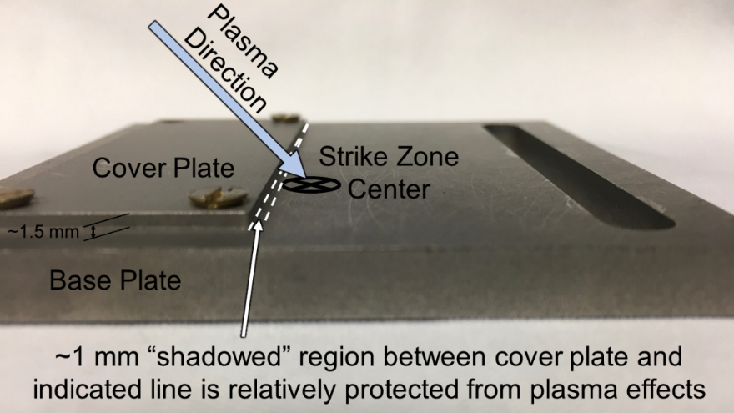

a.

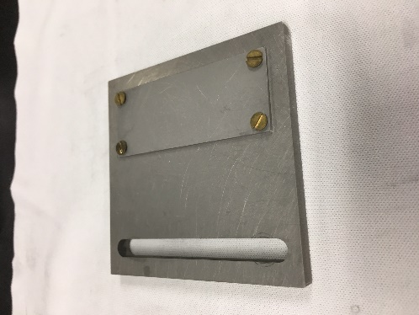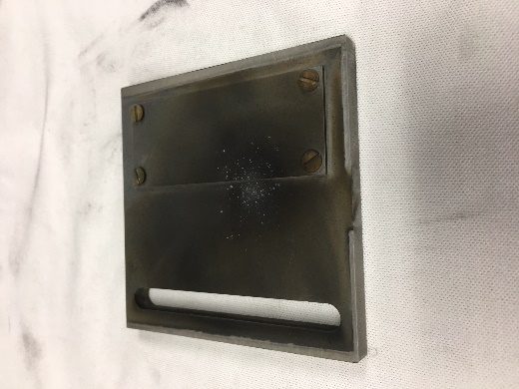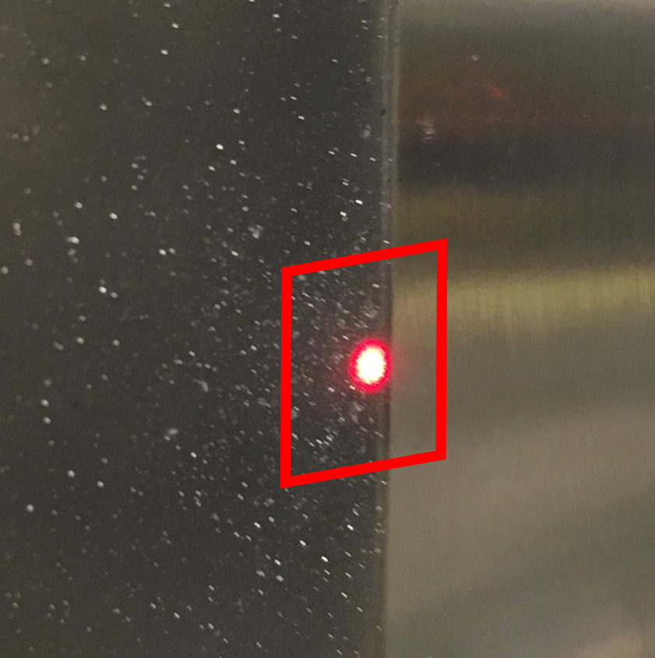

b. c.
Figure 4.1. (a) ET-arc target with plasma strike zone center and shadowed region indicated. (b) Pre- and post-plasma exposed target. (c) Post-exposure target undergoing DH imaging, with the approximate ROI indicated by the red box and the center of the object beam by the red HeNe laser dot. The ROI encompassed the area under the (removed) cover plate as well as the plasma strike zone at the imaging location shown.

Holograms taken of the target surface were flatfield corrected with holograms of a flat mirror target to reduce noise, as it was found that use of the pre-exposure surface for the correction hologram was ineffective since the necessity of removing the target from the DH table to perform plasma exposures as well as moving the target mount to change the DH ROI prevented maintaining the exact same target alignment for every subsequent hologram. The targets were also measured by a profilometer and scanning electron microscope (SEM) in the plasma strike zone prior to initial exposure. The roughness average (Ra) for Target 1 was 885 nm calculated as the mean of two Ra line measurements taken on the base plate at the central ROI separated perpendicularly by ~1 mm. The Ra for Target 2 was 600 nm ±100 nm (measurement provided by Surface Finishes). The original surface machine and polishing marks on the surface were visualized by the SEM images for comparison to the initial DH images. Profilometry and SEM imaging were performed in the same manner on both targets after each ET-arc exposure event.

Results

Erosion Measurement
The 3-D surface renderings from the phase images for Target 1 after each level of exposure are shown in Figure 4.2. The ROI for these images was centered on the edge of the cover plate adjacent to the plasma strike epicenter, and the cover plate was removed for each of the images shown. The area under the cover plate extended from x = 0 to ~1.7 mm in this ROI. The covered area therefore remained unaffected by the plasma exposure, and was used as a reference level for normalization of the surface images to each other by taking the mean surface height in this region of the pre-exposed phase image as the point to which the mean surface heights in the covered area for the other targets were aligned. The images show a progressively deepened trench formed between x = 1.5 mm and 3 mm as the total number of plasma exposures was increased. Non-uniform surface
Figure 4.2. 3-D renderings of surface erosion for Target 1.

erosion has been observed on similar step-configuration targets exposed to the ET-arc source [78]; the trench formation shown here is considered to be resultant from turbulent effects as the plasma passed over the cover plate edge and impacted the base plate surface. The surface renderings for Target 2 are shown in Figure 4.3. The cover plate was removed in these images also, and the protected area under the plate extended from x = 0 to ~1.6 mm. The same method of normalization was used, but an additional correction was performed to remove a z-axis slant in the phase image for 0 exposures. The other phase images did not possess the same slant and were similar to each other in the covered area, therefore the slope observed in the pre-exposure phase image was judged to be anomalous and removed by subtracting the second-order best-fit polynomial of the surface profile averaged along the y-axis for the covered region from the entire image. The same trench formation as seen in Target 1 was repeated as total plasma exposure increased on Target 2; the trench appeared at x = ~2.3 mm in the surfaces shown. Due to the lower number of total plasma exposures performed on Target 2, the trench did not reach the same depth as that of Target 1.
Line profiles of the z-axis height for the 3-D surfaces are shown in Figure 4.4 for both targets after each level of plasma exposure. The line profiles extend across the x-axis and are averaged along the y-axis to gage typical erosion levels for the entire ROI. The minimum z-axis values were selected for the exposed regions to quantify the erosion corresponding to the degree of plasma exposure. It is apparent, particularly for Target 2, that the exposed area beyond the heavily eroded zone did not exhibit progressive erosion; instances of higher total plasma exposure did not necessarily result in further erosion but rather seemingly regained surface height. This effect is attributed to deposition of material ablated from the ET-arc source’s liner as well as re-deposition of particles removed from the target surface. The surface minima are tabulated in Table 4.1 with the calculated mean values of measured depth. The mean measured erosion depths per plasma exposure were -162.3 nm for Target 1 and -141.2 nm for Target 2, and
Figure 4.3. 3-D renderings of surface erosion for Target 2.

a. b.

Figure 4.4. Measured surface erosion for (a) Target 1 and (b) Target 2.

Table 4.1. Measured Surface Depth vs. Plasma Exposure Level
Measurement | Total Plasma Exposure Level
Measurement | Pre-Exposure | 2x | 3x | 4x | 6x | 9x | 1x (Mean)
Target 1 Measured Depth (nm) | -12 (baseline) | -410 | -569 | -682 | N/A | -1573 | -162.3
Target 2 Measured Depth (nm) | +27 (baseline) | -145 | -392 | N/A | -664 | N/A | -141.2

therefore the average plasma erosion observed in these results can be taken to be ~150 nm per exposure. This value is believed to be above the lower measurement limit of the DH diagnostic based on considerations of potential noise error [74], and indicates that an in situ study of plasma erosion from the ET-arc could be successfully carried out.

Surface Roughness Average
Profilometer measurements were taken of the targets’ pre-exposed surfaces and after each of the subsequent plasma exposures. For each instance, the mean Ra value was used of two profiles taken at the epicenter of the plasma strike zone and separated from each other in the perpendicular direction by ~1 mm. DH-measured Ra values were obtained using a method developed previously [75]. Three line profiles of surface height were obtained and the absolute value of each profile was taken after its associated second order best-fit polynomial was subtracted; the mean value of the average heights of the lines provided the holographic Ra measurement, which was lastly corrected by normalization of the mean of holographic Ra values to the mean of profilometer values. The DH x-y resolution is much lower than that of the profilometer and the phase image typically exhibits a noise-induced bowl-shaped slope. The holographic Ra measurement is therefore an indirect comparison, but can be considered useful with situational corrections applied and understanding of limiting factors (i.e. a more disparate result compared to profilometry as Ra is increased and holographically unresolvable surface grain fineness is also increased). The Ra values are given in Table 4.2.
Most of the normalized DH Ra measurements were within a few hundred nm of their profilometer counterparts, but the result for Target 2 after two total plasma exposures was larger by ~1 µm. The profilometer Ra measurement was also abnormally large in comparison to Target 1 after the same number of plasma exposures, while measurements for three and six total exposures of Target 2 were in line with the overall trend. The Ra values steadily increased, which can be correlated with the increasing overall erosion observed in Figure 4.4 as well as the
Table 4.2. Ra Values from Profilometry and Digital Holography
Measurement | Total Plasma Exposure Level
Measurement | Pre-Exposure | 2x | 3x | 4x | 6x | 9x
Target 1 Profilometer Ra (µm) | 0.885 | 1.188 | 1.219 | 1.385 | N/A | 2.326
Target 1 DH Ra, Normalized (µm) | 0.740 | 1.380 | 1.076 | 1.738 | N/A | 2.295
Target 2 Profilometer Ra (µm) | 0.600 | 2.833 | 1.413 | N/A | 1.686 | N/A
Target 2 DH Ra, Normalized (µm) | 0.773 | 3.737 | 1.114 | N/A | 1.766 | N/A

deposition of material onto the surface in the plasma strike zone. The Ra values for Target 2 with two plasma exposures in this instance can thus be considered outliers. The Ra measurements are plotted for both targets in Figure 4.5. The best-fit lines for profilometry and holography were remarkably similar for both targets. The %differences between the two measurements did not exceed ~25% with the best similarity for both targets occurring after the highest total number of plasma exposures; %difference was used rather than %error in consideration of the inherently simplified surface quality indication provided by Ra and the aforementioned differences between profilometry and holography.
It should be noted that although the degree of similarity between holography and profilometry shown here is high, factors such as initial surface roughness and atypical peaks or valleys from prominent features may introduce error in both diagnostics. These results show that choosing a surface ROI with distinctively progressive erosion or deformation will provide holography Ra measurements which correlate well enough to profilometry for a comprehensive normalization factor to be applied.

Surface Features
Histograms for the phase images with the plasma strike zone as the ROI are shown together in Figure 4.6. The DC offset was removed from each phase image prior to generating the histograms in order to place their mean surface heights at zero. The ROIs partially excluded the eroded trench formation so that primarily the area with generalized roughness would be observed. The histograms for both targets show that after the initial two plasma exposures were performed the spread of surface height values was greatly increased. This is due to the significant change in surface topography from the pristine pre-exposure surfaces; soot, pitting, and particle buildup were visually observed in the plasma strike zone. However, the spreads decreased for both targets after the third plasma exposure was applied, although they still exceeded the pre-exposure values. From there, continued exposures produced an increasing trend in the spreads. This suggests
a. Target 1 b. Target 2
Figure 4.5. Roughness averages and % differences.

Figure 4.6. Histograms of phase images with plasma strike zone ROI.
that after the initial exposures inflicted relatively severe damage to the surfaces, continued exposures may have filled in and sheared away some existing pits and peaks with their own fresh erosion and deposition effects, so that the phase images captured a “new” surface in each instance rather than a progressive deformation trend. Since progressive erosion was clearly observed in the area just adjacent to the cover plate edge, this finding has informed plans for future targets to be used in DH measurement of ET-arc plasma effects; it indicates that the step configuration would provide an observable change in overall depth in the ROI encompassing the shadowed region whereas a completely flat surface or ROI that excludes the step-shadow would provide a different topography, but not necessarily observable overall erosion, after an exposure in the ET-arc source.
Holographic phase images were compared to images from a scanning electron microscope (SEM). The SEM is capable of observing fine surface features which are much smaller than the DH system’s x-y resolution of ~120 µm. An example SEM image of Target 1 after three total plasma exposures and the associated phase image of the same ROI are shown in Figure 4.7. The difference in image quality is starkly apparent: the SEM’s far-superior spatial resolution allowed numerous small features to be observed which could not be captured by DH. Machine marks on the surface visible in the SEM image as a pattern of diagonal lines can vaguely be seen in the phase image, but they appear to have merged into one another in the form of relatively large ridges. Selected objects were SEM imaged perpendicularly and also at an angle of 40° from the z-axis to allow the height of the objects to be calculated trigonometrically, as shown in Figure 4.8. The calculated heights of these objects exceed the 2π phase limit of the DH system’s single-laser mode, however no apparent phase jumps appeared in the phase image of Figure 4.7.b which suggests that the fine surface features were not individually resolvable or were imaged as amalgamated formations similarly to the machine marks. A SEM image of the plasma strike zone of Target 1 after nine ET-arc exposures (Figure 4.9.a) displays an even higher level of
a.
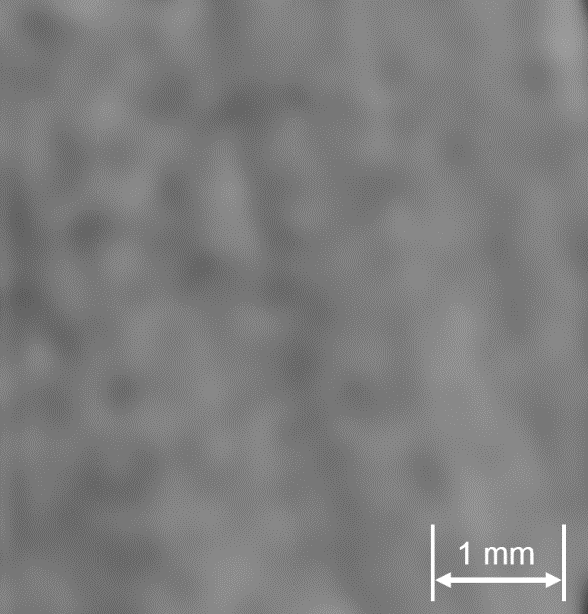
b.
Figure 4.7. (a) SEM image of Target 1 plasma strike zone after three ET-arc exposures. Note that the cover plate shielded zone is visible after the white line to the right of the image. (b) Phase image of the plasma strike zone on the same target The phase image was flipped horizontally to align with the SEM image.
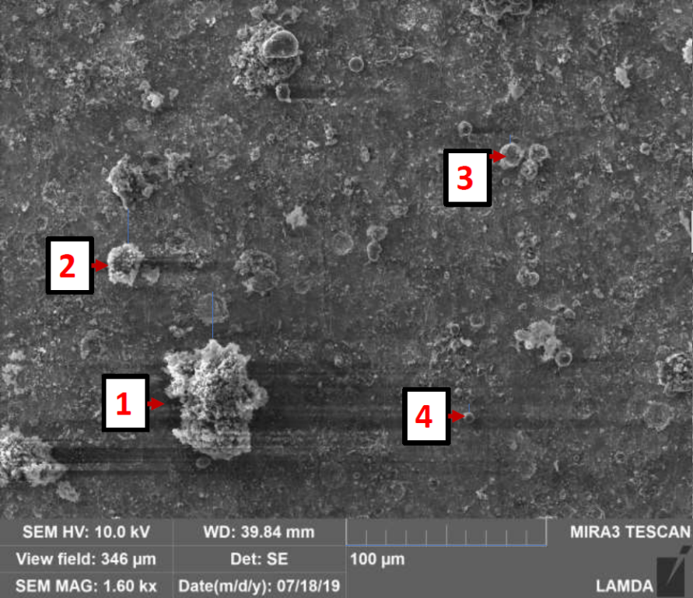
a.
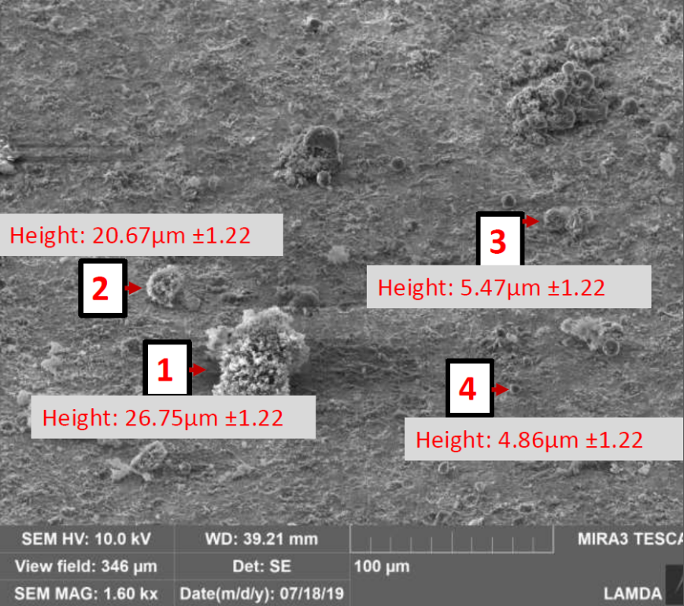
b.
Figure 4.8. Selected particles imaged at (a) 0° and (b) 40° tilt for z-axis size estimation of surface features.

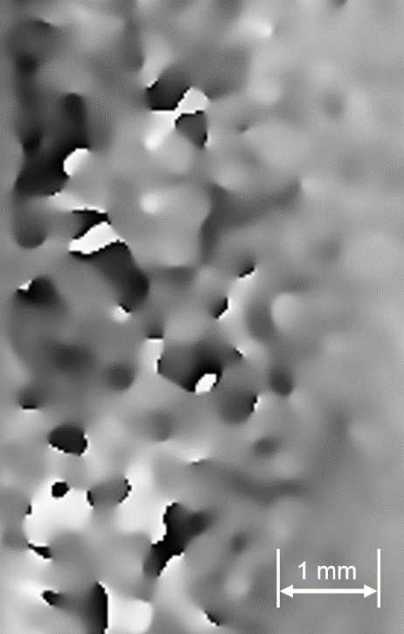
a. b.
Figure 4.9. (a) SEM image of deposition in the plasma strike zone after 9 ET-arc exposures. (b) The associated phase image, flipped horizontally.

surface objects, including strands and flakes that suggest deposition of metallic and polymeric material as well as globular particles indicating molten material. In this instance, the associated phase image (Figure 4.9.b) suffered from phase jumps. The phase jumps may be due to the more numerous objects with heights that exceed the phase limit merging into larger features as seen by DH, and also to signal loss from the higher degree of surface grit caused by the deposition.
Despite the discrepancies between the SEM and DH images, individual phase image features may be identified and measured in the z-axis to provide some indication of potential concentrated surface deformation effects. Selected surface feature height measurements are shown in Figure 4.10. The phase images are the same as those used for generating the histograms in Figure 4.6 (i.e. the mean surface heights were normalized to zero).
The pre-exposure surfaces of Target 1 (Figure 4.10.a) and Target 2 (Figure 4.10.f) had peaks and pits that measured ~250 to 600 nm above or below the mean level. After two exposures in the ET-arc source, both targets became rough enough that their phase images suffered from phase jumps due to signal loss or exceedingly large deformations, especially Target 2 (Figure 4.10.b and g). Most of the features observed in Figure 4.10.b are on the µm level, including one with a recorded depth of over 2 µm below the mean which has the hallmark of signal loss, and in Figure 4.10.g the phase jumps were so prevalent that only a feature measuring ~1.26 µm in height above the mean might be considered reliable. After the third plasma exposure took place, identified features returned to height measurements near or below 1 µm differences from the mean, with those of Target 1 (Figure 4.10.c) in the range of ~-440 to 380 nm and ~-1.18 to 1.36 µm for Target 2 (Figure 4.10.h). Target 1’s features remained below a µm difference from the mean after the fourth plasma exposure (Figure 4.10.d). The final target surfaces after five more exposures for Target 1 (Figure 4.10.e) and three more for Target 2 (Figure 4.10.i) were once again deformed enough to engender phase jumps. The potentially reliable feature measurements for Figure 4.10.e were ~1 to 2 µm
a. Target 1, 0 Exp. b. Target 1, 2x Exp. c. Target 1, 3x Exp.
d. Target 1, 4x Exp. e. Target 1, 9x Exp. f. Target 2, 0 Exp.
g. Target 2, 2x Exp. h. Target 2, 3x Exp. i. Target 2, 6x Exp.

Figure 4.10. Surface height measurements of selected features for both targets after every level of plasma exposure.
different from the mean, and several phase jumped features exhibited both peaks and pits on the extremes of the range for the entire image. Figure 4.10.i has more features which have no obvious phase jumps and are therefore more believable, all of which are peaks with heights ~1 to 1.6 µm above the mean. The phase jumps that appeared as dark ovals appear to be definitively the result of features’ z-axis measurements exceeding the 2π range rather than signal loss since they are all surrounded by areas of peak intensity. Therefore, the feature measurement showing a depth of almost 2.9 µm below the mean is likely to be a peak object rather than a pit in actuality; a robust phase unwrapping scheme could be applied to phase images such as this one to provide improved feature measurement.
It is important to state that the application of DH for individual feature measurements must be approached with an understanding that there is a significant degree of uncertainty, as evidenced by the object heights determined by SEM measurement to be on the order of several µm. These images therefore highlight the inherent limits of the DH diagnostic for resolving individual fine surface features to a high level of certainty. If a rigorous material study requiring highly detailed imaging is being performed on plasma-exposed surfaces, an ex situ measurement tool such as microscopy and 3-D profilometry will produce much greater spatial resolution. However, the DH system’s intended purpose of achieving in situ erosion measurement is the advantage that ex situ diagnostics cannot provide.

Conclusion
An ex situ characterization of digital holographic 3-D surface imaging was performed on plasma-eroded targets exposed to an electrothermal arc source. A distinguishable trench formation was created in the targets after numerous plasma exposures, and its rate of erosion of ~150 nm/exposure was determined to be within the holography system’s expected performance capability for in situ operation. Roughness average of the target surface was determined from holographic image analysis and validated with profilometer measurements, and was found to increase linearly with repeated plasma exposure while showing good agreement with the profilometer at ~25% or lower difference. Histograms of images taken of the plasma strike zone showed an initial jump in the spread of z-axis displacement values above or below the mean surface level after the first two plasma exposures were applied, before condensing after the next exposure and gradually increasing again after subsequent exposures; this result suggested that deposition of material in the plasma strike zone after new exposures could have the effect of reducing any previous deposition or erosion from a prior exposure. The x-y resolution limit of ~120 µm was characterized by comparison to scanning electron microscope imaging and various surface objects were found to be too small to be resolved clearly by the holographic phase images, instead being captured as merged features of relatively large spatial size. The z-axis displacements of selected individual surface features seen in the phase images were determined, with the most reliable results on the order of hundreds of nm to over 1 µm different from the mean surface levels while other results exemplified signal loss and phase jumps.
Future work will involve reconfiguration of the digital holography system to couple with the electrothermal arc source for the planned in situ demonstration. The crucial result from this work of an apparent measurable erosion rate has informed the design choices for targets to be used in the planned demonstration. The holography system will be configured to relay the object beam’s focal point off the optical table to be able to capture an area of a target inside the arc source chamber. Hologram sequences will be recorded in which plasma exposure will occur during the recording duration, and the frames will be analyzed to observe the dynamic surface change. Beyond the in situ demonstration, an extensive scientific study of plasma erosion effects on surfaces with fusion-relevant materials and geometries could be performed via in situ holographic measurement in tandem with quantitative validation diagnostics for measurement of deposition composition (e.g. laser-induced breakdown spectroscopy).

Acknowledgements
Co-authors of this chapter were Theodore Biewer, Trey Gebhart, John Echols, and C. E. Thomas.

CHAPTER V
Measurements of Dynamic Surface Changes by Digital Holography for In Situ Plasma Erosion Applications

The work in this chapter was prepared for an invited talk at the 23rd Topical Conference on High Temperature Plasma Diagnostics (HTPD), December 14–17, 2020 (online), and the manuscript will be submitted for publication in a special issue of Review of Scientific Instruments.

Abstract
There are currently few viable diagnostic techniques for in situ measurement of plasma facing component erosion. Digital holography is intended to fill this gap. Progress on the development of single- and dual-CO₂ laser digital holography diagnostics for in situ plasma facing component erosion is discussed. The dual-laser mode’s synthetic wavelength allows the measurable range to be expanded by a factor of ~400 compared to single-laser digital holography. This allows the diagnostic to measure surface height changes of up to 4.5 µm in single-laser mode and up to 2 mm in dual-laser mode. Results include ex situ measurements of plasma eroded targets and also dynamic measurements of nm and µm scale motion of a target mounted on a precision translation stage. Dynamic measurements have successfully been made with the system operating in both single- and dual-laser modes, from ~50 nm to ~4 µm in single-laser mode, and up to ~400 µm in dual-laser mode (limited only by the stage speed and camera acquisition duration). These results demonstrate the feasibility of using digital holography to characterize plasma facing component erosion dynamically, i.e. during plasma exposure. Planned in situ digital holography diagnostic measurements of targets exposed to an electrothermal arc plasma source will be presented. Surface evolution, instrumentation artifacts, and vibrational effects will also be discussed.

Introduction
Plasma facing components (PFCs) in fusion devices are subject to surface-deforming plasma effects, especially during highly transient events. These effects may include erosion of the surface, redeposition of eroded material, and implantation into the surface. Plasma-material interaction (PMI) is therefore an important area of research interest for large scale fusion projects such as ITER [7]. While various plasma diagnostics and ex situ material measurement techniques have been applied to PMI studies [10], there is not currently a method to monitor 3-D surface deformation in situ; Digital Holography (DH) has been proposed as a solution to this problem. A DH system has been established and characterized at the Oak Ridge National Laboratory (ORNL) for measurements of plasma-exposed surfaces [24, 70, 72, 74, 75]. The system includes a unique capability of producing dual-laser holograms which allows the system to measure surface features on the nm to mm levels. Measurements have been successfully performed on targets with artificial surface height gradients as well as plasma-exposed targets. The project goal is to couple the DH system with an electrothermal (ET) arc source to carry out a proof-of-principle demonstration of in situ measurement of a plasma-exposed surface. In this work, DH characterization efforts toward this end are reported, including ex situ measurement of erosion on targets exposed to the ET-arc and temporally resolved surface displacement measurements of a moving mirror target in simulation of whole-surface average height changes occurring during an erosion event.

Technique
Digital holography (DH) produces topographical information from a holographic image of a target surface. A reference laser beam interferes with an object laser beam reflected from the target to produce fringe patterns which form the holographic image. Phase information is then extracted from the spatial Fourier transform of the hologram and converted to path length information, which provides the z-axis surface height at every point in the x-y image plane. The phase information is bounded by 0 and 2π, which limits the maximum measurable surface height; since the image is reflected, the effective upper limit is half of the laser wavelength in single-laser DH. Surface features that exceed this limit appear as “jumps” and are difficult to interpret. The ORNL DH system’s upper limit in single-laser mode is ~4.5 µm. Dual-laser DH allows the maximum measurable surface height to be greatly increased via formation of a “synthetic” wavelength. This factor arises by tuning laser 2 to a slightly larger wavelength than laser 1. Division of a laser 1 hologram by a laser 2 hologram (similar to flatfield correction) produces differential phase information given by the following:
$ϕ_{1}-ϕ_{2}=2πl\left(\frac{λ_{2}-λ_{1}}{{λ_{1}λ}_{2}}\right)=\frac{2πl}{λ_{synth}}$ (5.1)
In this equation, the synthetic wavelength λ_{synth} is much larger than either of the single lasers’ wavelengths alone and therefore enlarges the equivalent maximum path length afforded by the phase range. The ORNL DH system’s lasers are tuned to wavelengths of 9.25 µm and 9.27 µm, and therefore it has a λ_{synth} of ~440 which raises the upper limit of surface height measurement to ~2 mm in dual-laser mode. Detailed description of the technique has been given in a prior publication [24].

Experimental Setup

Digital Holography
The ORNL DH system has been described in detail previously [72]. In brief, it utilizes two CO₂ lasers with acousto-optic modulators (AOMs) acting as secondary shutters aligned to the same reference and object beam paths so that the same target region of interest (ROI) can be imaged using either or both of the lasers depending on whether single- or dual-laser mode is used. The beams image a target area ~8 mm in diameter at magnification M = 1 with 10” (25.4 cm) focal length ZnSe lenses. The detector is a FLIR SC4000 infrared (IR) camera with a typical window size setting of 256x256 pixels for 500 Hz imaging. In single-laser mode, holographic frames utilizing one laser are therefore captured at a time increment of 2 ms while in dual-laser mode the AOMs alternately open and close such that the holographic frames switch between Laser 1 and 2 at the 2 ms time increment. The laser exposure time is typically 13 µs and can be raised for targets with low reflectivity. The standard configuration for ex situ imaging allows the target object to be mounted on the same optical table as the DH system.

Electrothermal Arc Source
The ORNL ET-arc system simulates transient fusion plasma events [73]. It produces plasma exposure with ~1.2 kJ source energy and ~1 GW/m² heat flux over a period of ~2 ms. Stainless steel “step” targets were designed to facilitate DH measurement of ET-arc plasma effects on surfaces. These targets were 7.46 cm x 7.46 cm x 0.64 cm plates polished to a typical roughness average of ~600– 800 nm with a removable cover plate ~1.5 mm thick (Figure 5.1). They were aligned in the ET-arc chamber such that the incoming plasma would strike the target at an angle of incidence of 45° above the target at the edge of the cover plate; this design was intended to produce a relatively undamaged “shadowed” region adjacent to the plasma strike zone on the base plate which would act as a fiducial for DH measurements. The cover plate was removed during DH imaging to further allow surface height normalization by comparison of the untouched covered region for each level of plasma exposure. Soot deposits were not cleaned from the targets after plasma exposure to allow the ex situ DH characterization to simulate in situ imaging as much as possible.

Translation Stage
DH motion detection characterization was performed to demonstrate the system’s capability of capturing frame-by-frame changes in surface height in simulation of an erosion event. A flat mirror was mounted on a New Focus linear translation stage (Model No. 9063-B with model 8310 actuator) to provide a moving target capable of performing translations on the order of tens of nm. The target was translated along the laser axis so that forward motion of the target mirror was detected by the DH system as an increase in surface height and backward motion as a decrease. The actuator was operated in closed-loop mode in which it has an optical encoder resolution of 63.5 nm. Its bi-directional and uni-directional repeatability are ±1 µm and ±100 nm respectively.

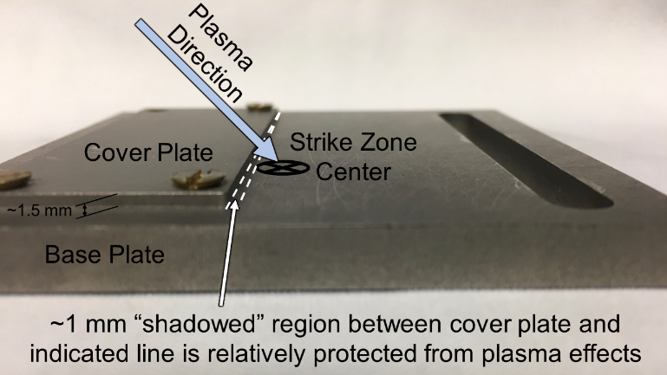
a.
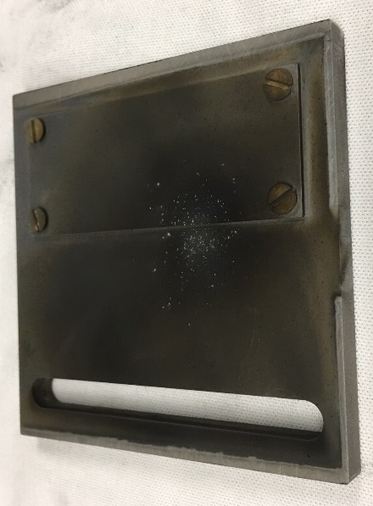
b.
Figure 5.1. (a) ET-arc target pre-plasma exposure. Plasma impact on the target occurred at an angle of incidence 45° above the cover the target to provide a small unaffected area adjacent to the plasma strike zone. (b) ET-arc target post-exposure.

Results and Discussion

Ex Situ Erosion Measurement
Ex situ DH imaging of stainless steel surfaces exposed to ET-arc plasma was carried out to characterize the DH system’s potential applicability for in situ coupling with the ET-arc. Two step-targets were imaged with the DH system pre- and post-plasma exposure with up to 9 total exposures repeated on the same target. Analysis of the images was performed by averaging the surface height per image column (i.e. y-axis) to generate a mean surface height profile along the x-axis. Measured erosion was based on the minima of the profiles. Figure 5.2 shows the surface profiles of one of the targets as well as 3-D phase images for each level of total plasma exposure. The unexposed region under the removable cover plate extended from x = 0 to ~1.7 mm. The most significant deformation occurred ~0.5 mm outside the unexposed region around x = 2.4 mm, where plasma turbulence was present. The plasma carved a trench in this region as the number of exposures was increased. The area extending from x = 3 mm and beyond retained similar surface height but exhibited varying surface features, which appeared to indicate redeposition of material after each new plasma exposure. The key finding from this study was that average measured plasma erosion on the step targets was ~150 nm per shot, which is believed to be potentially measurable in situ based on the performance characteristics of the DH system and ET-arc (including vibrational noise effects and thermal growth of the plasma-exposed target) [74].

Single-Laser Holographic Motion Detection
Translation events for displacements up to 1 µm were holographically recorded at 50 Hz and 500 Hz. The resulting holographic “movies” displayed the z-axis phase change of the x-y planar surface resulting from the change in object beam path length caused by the translation of the target mirror. Ergo, a holographic surface with a starting position (i.e. mean z-axis value for the x-y surface) defined
a. b.
Figure 5.2. (a) Measured surface profiles of ET Arc target 1. (b) 3-D phase images of surface ROI for each level of total plasma exposure observed.
at 0 would exhibit a clearly discernible phase displacement over time corresponding to the movement of the target mirror forward or backward along the laser axis. A total of 500 sequential holographic frames were recorded for each movie, resulting in 10 s of recorded mirror motion per 50 Hz movie, and 1 s of recorded motion for the 500 Hz movies. The holographic frames of each movie were processed by flatfield correction with the first frame of the set, so that the processed phase images showed the relative surface change of each frame compared to the initial position.
Analysis of the surface change was performed by plotting the mean phase value ±1 standard deviation for each frame. The translations therefore appeared in step form on the plots. When possible, multiple translation events showing movement from and return to the initial position were recorded (the 10 s window for 50 Hz recordings easily enabled this but only single movement/return events could be recorded within the 1 s window at 500 Hz). The first movement/return displacements were tabulated for each programmed translation (see Table 5.1).
Note that in some cases two displacements were not able to be captured due to recording time limitation and holographic phase noise. Plotting the displacements with their corresponding programmed translation values (Figure 5.3) reveals an expected linearity and demonstrated the viability of this method of motion analysis. Generally, the displacements showed high repeatability in that the movement and return motions per recording were close in value to each other. Note also that the assumed translation path shown is calculated from a motion increment of 51 nm/count; this value is below the actuator’s minimum incremental motion (i.e. optical encoder resolution), however repeated DH measurements with the same number of counts showed variations corresponding to measured incremental motions ranging from ~43 to ~63 nm. The actuator’s bi-directional repeatability of ±1 µm as well as measurement error from phase image noise (to be described in detail in the following paragraphs) may account for the apparent discrepancy.
Table 5.1. Single-Laser DH Detected Motion
Translation (Counts) | 50 Hz Detected Surface Height (nm), Displacement and Return | 500 Hz Detected Surface Height (nm), Displacement and Return | Assumed Translated Height (nm), 51 nm Per Count
1 | Undiscernible from noise | 76, 67 | 51
3 | 128, 117 | 114, 115 | 153
5 | 159, 158 | 175, 176 | 256
10 | 301, 389 | 384, 390 | 511
15 | 595, 632 | 687 (return motion not recorded) | 767
18 | 998, 885 | 972 (return motion not recorded) | 920

Figure 5.3. Single-laser DH detected motion vs. programmed translation.

Phase noise interfered with the results of this analysis; noise levels of ~100 nm for 50 Hz holography affecting the phase values of a single holographic image as well as the phase difference between temporally displaced frames from an initial image are known characteristics of the DH system [74]. Noise effects worsen over time due to the increase in prominence of low frequency vibration, accumulation of systematic noise throughout recordings, and increase in camera temperature after shutoff of its cryo-cooler. Additionally, frame-to-frame noise is on the order of tens of nm for 50 Hz holography. A 10 s movie recorded at 50 Hz therefore accumulates noise more and more severely over its duration. If a 1 s recording is performed at 500 Hz, noise is significantly reduced at the cost of available recording time. At that rate, typical frame-to-frame noise is only a few nm, and the short recording time does not allow low frequency noise and systematic effects to build up. The motion analysis therefore exhibited the effects of noise in the improved linearity of the displacements detected at 500 Hz versus those detected at 50 Hz; this can be interpreted as the 500 Hz movies’ higher fidelity of the mean holographic surface phase value to the actual target’s translated displacement since noise is lower. Conversely, the 50 Hz recordings were more prone to producing mean surface phase values with higher variance. Figure 5.4 compares 50 Hz and 500 Hz recordings of the same programmed target translation of 18 counts. The 50 Hz result demonstrates that multiple displacement/return movements were detectable over the movie duration but with a loss of fidelity, e.g. the detected movement of 998 nm that was more than 100 nm different from its corresponding return motion of 885 nm. The 500 Hz result appears much more precise but only captured a single displacement motion.
The clearest demonstration of noise improvement in 500 Hz recordings vs. 50 Hz recordings came from the fact that the minimum programmable target translation could be successfully identified only in the 500 Hz recordings, as seen in Figure 5.5. The 1 count motion was expected to be near 63.5 nm based on the stage motor’s optical encoder resolution; this motion is well below the DH system’s
a.
b.
Figure 5.4. (a) ~1 µm detected motion from a 50 Hz recording. (b) ~1 µm detected motion from a 500 Hz recording. Both results show 18 count movements, with higher measured surface height fidelity frame-to-frame in the 500 Hz recording vs. capability of capturing multiple events in the longer 50 Hz recording.

a.
b.
Figure 5.5. Motion detection of minimum programmable translation (1 count) from (a) 50 Hz and (b) 500 Hz recordings. The displacement was undiscernible from noise when recorded at 50 Hz, but could be clearly identified at 500 Hz.
noise limit for 50 Hz holography. As such, the minimum target motion could not be discerned from the overall noise of 50 Hz recordings. However, the 500 Hz recording allowed the displacement to be clearly observed, and the mean surface phase results were within ~15 nm of the expected motion. This finding shows that the DH system should be able to detect the temporal phase change caused by <100 nm of average surface erosion during a 500 Hz recording. This is a key result indicating the possibility of successful erosion detection of targets exposed to ET-arc plasma, though it should be noted that it is based on the assumption that temperature and vibrational effects would not significantly contribute to the frame-to-frame noise limit during a 1 ms shot.
A 3-D surface “warping” effect was observed in both 50 Hz and 500 Hz recordings (Figures 5.6 and 5.7), which was another source of dynamic holographic noise. The holographic frames recording during translation events exhibited a distortion in flatness which changed frame-to-frame and was clearly not a true representation of the actual object’s surface; that is, the holograms depicted dynamic surface warping as the surface displacement changed from its original position, but the actual object only experienced a change in displacement as the surface was static. This effect was apparent throughout the translation frames, but its severity seemed to be dependent on the instantaneous displacement away from the initial position. After completion of the translation event, the dynamic deformation ceased, but the displaced surface retained a high degree of anomalous warping in some cases. In recordings where the surface was returned from the displaced position to its initial position, the anomalous warping also disappeared. This behavior indicates that rapid displacement changes to a surface under observation, e.g. erosion of the full ROI, may introduce noise in the holograms occurring after the displacement change.

Dual-Laser Holographic Motion Detection
Recordings of displacements from ~20 µm to ~400 µm were obtained via the DH system’s dual-laser mode. These translations were captured at a frame
(a) t = 2.10 s (b) t = 2.16 s (c) t = 2.22 s
(d) t = 2.28 s (e) t = 2.34 s
Figure 5.6. Anomalous holographic surface warping observed during ~1 µm translation recorded at 50 Hz.

(a) t = 0.536 s (b) t = 0.576 s (c) t = 0.616 s
(d) t = 0.656 s (e) t = 0.696 s
Figure 5.7. Anomalous holographic surface warping observed during ~1 µm translation recorded at 500 Hz.

rate of 50 Hz only, because the translation stage’s maximum speed could not produce the large displacements within the timeframe required for 500 Hz movies. The number of frames per recording was raised to 700 for some cases in order to allow the largest programmed translations to be performed within the duration of a single movie. This resulted in movies with a total elapsed time of up to 14 s. Additionally, since a dual-laser hologram is produced by subtraction of a single-laser hologram from another single-laser hologram, the analyzed dual-laser frames numbered 350 in total and separated by 4 ms rather than 2 ms to account for the subtraction of adjacent frames.
Similar to the single-laser movies, noise from various sources affected dual-laser recordings. The synthetic wavelength factor of ~440 not only measures true surface variations observed in a hologram to the expanded 2π range but also multiplies noise in the hologram by the same degree. This effectively means that a dual-laser holographic phase image has a lower limit of discernable surface variation in the z-axis of ~100 µm [75].
The movie technique demonstrated in this work allows this limit to be lowered dramatically if the surface variation of interest can be dynamically recorded. While a dual-laser phase image generated by two single-laser holograms captured out of sequence (i.e. with several seconds or minutes of elapsed time between them) cannot be resolved in the z-axis below ~100 µm, frame-to-frame noise in a flatfield corrected 50 Hz dual-laser movie is typically ~5 µm. The drawback is that any static surface features that were present before the movie began are not captured since subtraction of the initial frame from all subsequent frames leaves a “flat” hologram throughout. However, a surface variation dynamically appearing within the duration of the movie can be captured and discerned by comparing the surface heights before and after the event, with a projected z-axis resolution limit of ~20 µm.
The dual-laser movies include an anomaly that was not observed in the single-laser movies. Large displacements with significant frame-to-frame variation were exhibited during translation events; these displacements were on the order of hundreds of µm, much larger than the actual programmed motion of the translation stage, and in some cases were in the opposite direction of the actual motion. These anomalous displacements likely stemmed from vibrational noise and potential moment arm effects during the stage motion which were amplified by the synthetic wavelength multiplier. The detected surface heights during the translation events of these dual-laser movies are therefore unreliable, but the detected surface heights before and after the translation events were reproducible and relatively accurate, as shown by Figure 5.8.a.
The 3-D surface warping effect observed in the single-laser results was also present in the dual-laser recordings. The phase image of Figure 5.8.b shows ~150 µm of flatness distortion after a programmed translation equivalent to 56 µm. The warping effect could potentially complicate detailed analyses such as depth of individual surface features apparent after erosion. The warping effect was generally less pronounced when the programmed translation was larger as exemplified by Figure 5.9. The detected mean surface height after translation was 256 µm (Figure 5.9.a), but the phase image flatness distortion was ~100 µm (Figure 5.9.b). This phase image noise was therefore not observed to increase as the size of the surface displacement was increased, which followed typical dual-laser surface noise behavior.
The detected final surface heights post-translation are tabulated in Table 5.2. Despite the noise from the target motion and the 3-D phase image warp, The results are remarkably close to the expected final target positions based on an assumed translation increment of 63.5 nm per count (note that the manufacturer’s quoted resolution is used in the calculation of the assumed translated height since the displacements far exceeded the actuator’s bi-directional repeatability of ±1 µm). The results were repeated at each programmed translation size to demonstrate reproducibility. Figure 5.10 provides plots of the expected and detected surface heights, and the high linearity of the detected results is seen in the R² values of 0.99 for both data groups.
a. b.
Figure 5.8. (a) Detected motion of 880 counts translation from a 50 Hz dual-laser recording. The translation event occurred from t = ~2.5 s to 6 s and is shaded in gray; high noise and moment arm effects on the moving target during the translation event caused the detected motion during this time to appear to be hundreds of µm in the opposite direction of programmed translation, and therefore unreliable. However, the detected mean surface height after motion was ceased was stable around 47 µm (t = 6 s to 10 s). This value was within 10 µm of the expected displacement. (b) The 3-D phase image for t = 10 s.

a. b.
Figure 5.9. (a) Detected mean surface height from a 50 Hz dual-laser recording of 4,000 counts translation. (b) 3-D phase image of t = 14 s from the recording.

Table 5.2. Dual-Laser DH Detected Motion
Translation (Counts) | 50 Hz Detected Surface Height, Group 1 (µm) | 50 Hz Detected Surface Height, Group 2 (µm) | Assumed Translated Height (µm), 63.5 nm Per Count
440 | 43 | 47 | 28
880 | 50 | 47 | 56
1,320 | 82 | 83 | 84
1,760 | 121 | 84 | 112
2,000 | 135 | 132 | 127
3,000 | 202 | 197 | 191
4,000 | 268 | 256 | 254
5,000 | 304 | 313 | 318
6,000 | 391 | 374 | 381

Figure 5.10. Dual-laser DH detected motion vs. programmed translation.

Conclusion and Future Work
The ORNL digital holography diagnostic for measuring 3-D surface deformation has been demonstrated ex situ on targets exposed to plasma from an electrothermal arc, and measurements of ~150 nm of erosion per plasma shot were obtained. The diagnostic has typical noise levels of ~100 nm in single-laser mode and ~100 µm in dual-laser mode; noise levels are greatly reduced when “movies” of temporally resolved sequential frames are recorded. Recordings of a moving mirror target mounted on a precision electronic translation stage were made at 50 Hz and 500 Hz in single-laser mode, and 50 Hz in dual-laser mode. These recordings showed the ability of the holography system to measure dynamic displacements of the overall ROI with good accuracy and reduced frame-to-frame noise on the order of tens of nm in single-laser mode and tens of µm in dual-laser mode. These findings along with the successful ex situ erosion measurements indicate that the diagnostic may be coupled with the electrothermal arc for an in situ demonstration.
The in situ demonstration of the digital holography diagnostic on the ET-arc is planned for the near future. The DH system has been reconfigured with 15” focal length lenses to allow the object beam focal point to extend off the diagnostic’s optical table to the target location inside the ET-arc chamber. Stainless steel targets with removable cover plates in a similar form factor to the ex situ targets described in this work have been procured, with the plasma exposure area polished to a roughness average of 10 nm for high initial reflectivity. The ET-arc is undergoing modifications to facilitate deployment of the diagnostic; a new pressure chamber with a ZnSe window has been fabricated with a secured target holder to minimize vibration. The chamber is mounted on an elevated stand which is also designed for minimal vibration. A software trigger linked to a system of delay generators has been designed for the IR camera to begin recording holograms half a second prior to firing of the ET-arc for a movie with a duration of a full second, so that ~250 holographic frames will be captured before and after the plasma event. Analysis of the recordings will allow the 3-D surfaces to be imaged before and after the plasma exposure and the dynamic erosion of the surface to be observed.

Acknowledgements
Co-authors of this chapter were Theodore Biewer, Trey Gebhart, Elizabeth Lindquist, and C. E. Thomas.

CHAPTER VI
Conclusion
The development progress of the Oak Ridge National Laboratory digital holography system has shown its capability to successfully generate holograms using either single- or dual-wavelength operational modes, and the work described in this dissertation has provided benchmark data for the characteristic results that might be expected from in situ operation with the specific target configurations and plasma source utilized in this work. Based on this work, an in situ demonstration under conditions which are similar to those used herein was considered to have a likelihood of success; that is, a probability of showing that the holography diagnostic could detect a change in a surface under interrogation by recording frames before, during, and after a plasma event. This chapter presents a summarization of the holography system’s development work reported in this dissertation in the context of previous and surrounding publications, as well as a description and initial results of the in situ demonstration and potential future applications of the system.

Summary
The development of the digital holography system for in situ measurement of erosive fusion plasma effects began at ORNL in 2014 as a potential diagnostic for the Proto-MPEX linear plasma device [24, 72]. The system has been designed to produce holograms of initially flat target surfaces from which the resulting phase data can be converted to elevation maps, allowing any displaced features to be observed. Its operational options provide measurable elevation (z-axis) displacement limits of ~4.5 µm using a single laser or ~2 mm using two lasers with different wavelengths. The maximum region of interest is defined by the laser spot size at the target of ~1 cm, and the x- and y-axis spatial resolution is over 100 µm with a relatively superior z-axis resolution.
Both single- and dual-laser holography have been demonstrated initially on artificial targets with defined displacement [70]. Further experiments have shown the capability of the holography system to observe plasma-induced damage on surfaces exposed to Proto-MPEX as well as an electrothermal arc source. A consideration of several aspects of potential holographic recording during a live plasma event, particularly vibrational noise levels [74], indicated that the electrothermal arc source would present a less challenging environment and therefore a higher chance of a successful proof-of-concept demonstration of in situ plasma erosion measurement. This planned demonstration in conjunction with the ET-arc has therefore been the guidepost for the characterization work reported in this dissertation. The reader will note that the conclusion sections of the previous chapters alluded to this plan, which at the time of the chapters’ writing was being developed based on lessons learned from the progress of this work.
Initial characterization results have been shown in Chapter II. A selection of stainless steel shims were machine-treated to produce various degrees of surface roughness, which were quantified by profilometry. Holographic measurements of the surface roughness showed a linearly increasing deviation from the profilometer results as roughness was increased; a surface roughness average of up to ~300 nm could be measured by holography with less than 100% difference from the profilometer. It must be taken into account that the holograms could not fully resolve the fineness of the surface features on these targets and that therefore caution should be used if the results of this characterization are broadly extrapolated. However, potential future experiments could benefit from the use of the %difference between holography and profilometry as a simplified cutoff for estimating the maximum measureable surface roughness on a target which was machine-treated in a similar way to the ones reported in this work. Additionally, the dual-laser measureable range was explored via holograms of various “stair step” targets composed of stacked shims with different thicknesses. The effect of noise was less pronounced for the larger thicknesses, with the errors between the measured and actual thickness not exceeding 10% for the largest displacement. The lower limit of the dual-laser range was established as ~100 µm after which the noise prevented effective measurement. The noise therefore was shown to hold at a practically static level regardless of the size of the total displacement in the holographic measurement, indicating that features larger than 100 µm could be measured with confidence in the accuracy of the holography system. Finally, a prototype target for measurement of plasma erosion from the electrothermal arc exhibited identifiable features produced by the plasma exposure; it was shown that averaging several consecutively recorded holograms took out small noise-produced variations and provided an image with slightly improved accuracy compared to a single frame hologram.
Chapter III described improvements made to the holography system stemming from weaknesses that were identified as the development progressed. A method for performing flatfield correction on dual-laser holograms was demonstrated; flatfield correction can reduce noise in single-laser holograms and therefore the application to dual-laser holography also mitigates noise effects. Since dual-laser holography involves subtraction of holograms in a similar fashion to single-laser flatfield correction, the dual-laser flatfield correction method required correction to be performed on the two lasers’ holograms individually after which one of the corrected holograms was subtracted from the other corrected hologram, essentially adding two additional holographic subtractions to the original subtraction. An experimental comparison of a flatfield corrected dual-laser hologram to the same hologram without correction showed that the former had noise-induced anomalous displacement across the ROI reduced by ~600 µm. The holographic system’s signal was improved by the addition of a wire grid polarizer to the reference beam path. The polarizer allowed the reference beam intensity to be independently controlled prior to arriving at the detector, which in turn allowed the lasers’ pulse width to be increased so that longer exposures could be performed on targets with low reflectivity. In the original configuration, increasing the pulse width was limited by the fact that the reference beam intensity would be increased at the same rate as the object beam, so that the exposure time limit was effectively ~25 µs (only about twice as long as the exposure time used in typical operations). The polarizer introduced the ability to tune the reference beam as the exposure time was increased so that it could be held constant while the object beam signal was boosted; this enabled the exposure time to be raised to a theoretical limit of 0.5–1 ms with the new limiting factor being image washout from vibrational noise. Holograms with exposures as long as 240 µs have been recorded, and a comparison of a 50 µs hologram of a rough surface to a 13 µs hologram of the same surface showed that the longer exposure eliminated errors caused by phase ambiguity. Other improvements have been made for noise cancellation. These include the introduction of vibrational frequency absorbing pads underneath the optical table legs and components, enabling the camera’s cooling system to briefly shut down for vibration reduction during holographic recording, maintaining optical position as precisely as possible to match phase fronts, preventing RF interference, and using an integer number of pixels per holographic fringe to eliminate Moiré beats. Measurements of noise levels indicated that the highest interference occurred at low frequencies, and typical noise levels for single-shot holograms were identified to be 10-100 nm (in single-laser operation). Consecutive holographic recordings can greatly reduce noise, with frame-to-frame levels on the order of only a few nm for single-laser recordings or a few µm for dual-laser recordings.
In Chapter IV, a campaign to extensively characterize the holography system’s ability to measure ET-arc plasma-induced erosion was detailed. The experimental campaign involved acquisition of holographic data alongside validation measurements with profilometry and scanning electron microscopy on the target surfaces before and after plasma exposures. Stainless steel targets were designed with smaller removable cover plates located adjacent to the anticipated strike zone of the plasma, so that incoming plasma at an angle of incidence of 45° would strike the main lower surface of the target plate with a protected “shadowed” region just beside the cover plate. The shadowed region as well as the area underneath the removable plate provided a fiducial for comparing the erosion zone before and after a plasma strike. The holographic measured erosion per plasma exposure was ~150 nm on average, which was determined to be within the projected in situ measureable capability of the holography system considering the expected noise level. The highest erosion occurred in the form of a trench adjacent to the fiducial region which steadily increased in depth after each plasma exposure. Further onto the exposed surface, the plasma effects did not consistently erode the surface but instead produced varying degrees of material deposition as well, indicating that a typical plasma exposure essentially created a “new” surface with original features established while initial features were worn down in the area away from the edge of the fiducial region. Profilometer results compared favorably to the normalized roughness average obtained from holography with ~25% or lower difference and a linearly increasing trend. The scanning electron microscope images showed the difference in detail that could be expected from in situ holography compared to standard ex situ imaging; the SEM spatial resolution is far higher than that of the holography system, therefore fine particles and objects which were visible in the SEM images were not resolvable with holography, and the comparison suggested that such small features might be perceived by the holography system to be merged into larger amalgamations.
The characterization experiments concerning measurement of dynamic surface changes are reported in Chapter V. A flat mirror was mounted on a precision motorized linear translation stage and holographically recorded as it was moved through a series of programmed displacements along the laser beam axis. Consecutively recorded holograms were analyzed by subtracting the average of the initial phase image (i.e. the average measured height) from the other phase images; in this way, the resultant images displayed the phase difference from the initial frame which was converted to displaced height. The height measurements corresponded to displaced position over time, with increasing height representing the target moving toward the detector. Recordings were made with single-laser mode at rates of 50 Hz and 500 Hz, and dual-laser mode at a rate of 50 Hz. Results showed that the higher recording speed resulted in lower noise with the requirement that the total recording time was shortened by a factor of 10, while the lower speed allowed longer recordings but resulted in higher noise accumulation. Consecutive holography greatly reduced noise at either frame speed however, allowing 500 Hz single-laser holography to observe dynamic displacements of ~50 nm, representing the smallest possible motion allowed by the translation stage controller, and the dual-laser recordings were capable of capturing motion with a lower resolution limit of ~20 µm, well below the typical ~100 µm limit for static dual-laser holograms. The 3-D surface images exhibited anomalous “warping” which appeared to change severity depending on the total spatial and temporal displacement from the starting position, and the dual-laser recordings in particular showed extreme variances from the expected position in holograms recorded during the translation event; these effects were attributed to noise buildup and the amplifying nature of dual wavelength holography, but the comparison of expected position to recorded position after translation showed good agreement in all cases.
The overall conclusion of this work is that a potential in situ holographic recording of stainless steel target plates with a defined surface roughness exposed to plasma in the ET-arc would likely result in measured dynamic erosion, thus providing a successful proof-of-concept demonstration. The ability of holography to capture images showing the difference between images before, during, and after a plasma event represents the most crucial goal for an in situ demonstration. Though the holography system’s image quality is not as high as typical ex situ material analysis instruments, the system’s raison d’être is its capability of detecting overall surface changes in a plasma device as they happen, fulfilling a measurement need which currently has no established solution. Secondarily, this work has provided characterization of the measurement limits and image noise levels that might be expected from in situ recordings. The key challenge the holography system would have to contend with in the demonstration experiment is vibrational interference from the ET-arc components and surroundings, however measured noise levels reported in [74] and planned improvements to the ET-arc system suggested that the noise would be manageable enough to allow erosion measurement to take place.

In Situ Demonstration and Future Work
Plans for the in situ demonstration on the ET-arc have been developed and experiments were in progress as of the time of writing of this dissertation. The demonstration involves coupling the holography system with the ET-arc via the same timing control so that consecutive hologram recordings begin at a set moment prior to the plasma discharge and end after the discharge has been completed. The recorded results are analyzed to detect the overall difference between the pre- and post-exposure surface of the target, quantify the amount of erosion that has been measured, and determine the accuracy of the holographic topography in comparison to validation measurements. Upon completion of the proof-of-concept demonstration, the holography system may begin to be utilized for fusion material scientific applications.

Digital Holography System Modifications
The layout of the DH optical components required modification in order to relay the target position off the optical table. A new configuration (Figure 6.1) was designed which facilitated locating the target inside the ET-arc chamber and only required changing the two lenses and the mounting locations of the four reference beam mirrors. The optimal lens focal length for achieving off-table focusing, providing satisfactory image ROI, and minimizing component positional changes was calculated to be 381 mm (15”). Accounting for the doubling of the object beam path length stemming from the light traveling to and reflecting from the target, the ET-arc chamber was placed on a second table adjacent to the DH table with a total distance to the target location of 1.524 m (60”) from the object beam lens, or ~0.96 m (38”) from the edge of the DH optical table. This configuration produces an approximate magnification factor of 3 for the object and reference beams when they reach the camera. The magnification incurs a loss of spatial resolution compared to the benchtop target configuration used in the characterization work, but this loss is considered acceptable when weighed against the significant
Figure 6.1. Modified DH layout for off-table imaging. The target location is 1.524 m from the object beam lens, or ~0.96 m from the edge of the DH optical table. The reference beam components were adjusted to match the extended object beam path length.

difficulty of achieving lower magnification without a complete and costly overhaul of the existing system layout. The z-axis resolution remains unchanged.
Modification of the beam paths to the new layout has been completed. Figure 6.2 shows a standalone image of the object beam (i.e. without the reference beam present) reflected from a USAF resolution target located off the DH table at the ET-arc target position. The pixel resolution has been calculated from the resolution target elements seen in the image to be ~89 µm/pixel, which is virtually equivalent to the theoretical pixel size with 3X magnification of 90 µm/pixel. The beam size at the target has been calculated from the number of pixels to be approximately 8 mm x 14 mm; the calculated size is reasonably similar to an estimated ~12 mm diameter based on a visual judgement of the CO₂ laser spot on a Macken plate at the target location. The beam size is thus expanded in the new configuration compared to the ~1 cm diameter from the previous work. A test hologram was taken of the resolution target at the ET-arc position, shown in Figure 6.3; the hologram was not flatfield corrected. The decrease in spatial resolution caused by the magnification under the new optical configuration is apparent in the phase image, in which the only discernable feature is a large square element (approximately 2.2 mm on each side). The phase image exhibited noise in the form of surface warping of over 1 µm.
There was a concern that increased diffusivity of the expanded beam size would significantly inhibit the object beam signal after only a few plasma exposures, however a test of a plasma-exposed target from the work in Chapter IV resulted in a visible object beam as seen in Figure 6.4. The target had been exposed a total of 6 times and was able to be imaged with an intensity levels in the preferred range for standard holographic imaging. The camera exposure time was 253 µs, which indicated that a target could be exposed up to 9 times over and still generate some degree of usable object beam signal (if the reference beam intensity causes the maximum camera exposure time to be limited to ~250 µs) based on a rough estimate of the increase in signal loss per plasma exposure that occurred in the characterization work.
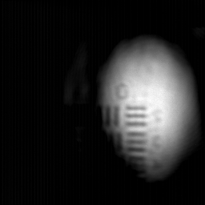
Figure 6.2. The object beam reflected from a USAF resolution target imaged in the in situ DH configuration. The prominent lines are from group 0 element 2, which have a line width of 445.45 µm.
a. b.
c.
Figure 6.3. The hologram (a), phase image (b), and 3-D rendering (c) of a USAF resolution target imaged in the in situ DH configuration. The phase image ROI (indicated by the red square) contains a visible square element approximately 2 mm on each side. The rendering of the ROI indicated a detected depth of ~770 nm for the square feature, and the ROI’s surface warp noise was over 1 µm.
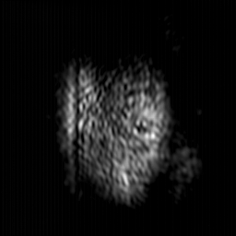
Figure 6.4. The object beam image of a stainless steel target plate that had received 6 total plasma exposures from the ET-arc, demonstrating that an acceptably visible object beam signal could still be achieved even with higher diffusivity at the ET-arc target configuration. The camera exposure time was 253 µs. The maximum intensity count was 7,300, which falls within the typical preferred range for object beam intensity.

Electrothermal Arc Integration
The electrothermal arc source has been equipped with a new vacuum chamber designed to accommodate the DH system. The chamber allows the target to be securely mounted perpendicularly to the DH object beam to ensure direct reflection along the same axis as the incoming beam. The chamber has a 50.8 mm diameter ZnSe window mounted in a 5° flange. The plasma angle of incidence is reduced to 35° in the new chamber compared to 45° in the original configuration. Figure 6.5 shows a section view of the chamber model.
The DH pulse generator is connected to the trigger mechanism of the ET-arc to provide a time-controlled signal to the DH lasers, camera, and ET-arc. The spare output channel of the DH system’s BNC 565 delay generator is connected to a second delay generator (Berkeley Nucleonics BNC 500B) which addresses the need to have independent control of the ET-arc signal to achieve the desired timing sequence, as the same output signal of the BNC 565 will trigger the computer to shut off the camera’s cryo-cooler via a USB-connected LabJack Corp. DAQ. The BNC 500B delay generator signals a third delay generator (Berkeley Nucleonics BNC 7010) which is part of the ET-arc control suite and provides the signal to discharge the capacitor. The complicated nature of this setup is designed for overall signal timing that ensures that the hologram recording begins first at a rate of 500 Hz for a total duration of 1 second, and the plasma discharge occurs ~0.6 s after the hologram recording has started. The block diagram of the components is shown in Figure 6.6. The power connections are designed to mitigate ground loops.

Noise Measurements
Accelerometer and holographic noise measurements have been taken of the ET-arc target in quiescent conditions, shown in Figure 6.7.a–b. The accelerometer was placed on the exterior flat surface of the ET-arc’s target-holder flange and data was recorded for 1 second periods to match the duration of the holographic recording sequence. The accelerometer measurement shown in
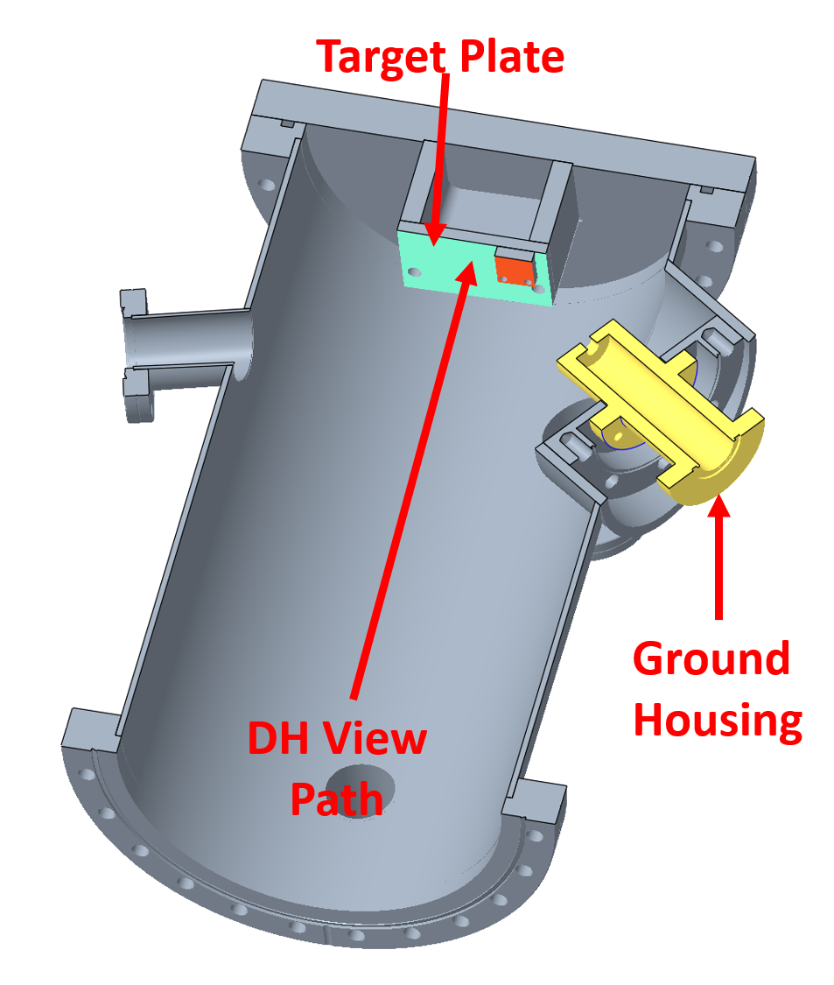
Figure 6.5. Custom ET-arc chamber for in situ holography. The DH object beam enters on the perpendicular axis to the target, and the plasma source (indicated by the ground housing component) produces a spark which strikes the plate at a 35° angle of incidence. Image provided by Trey Gebhart, ORNL.

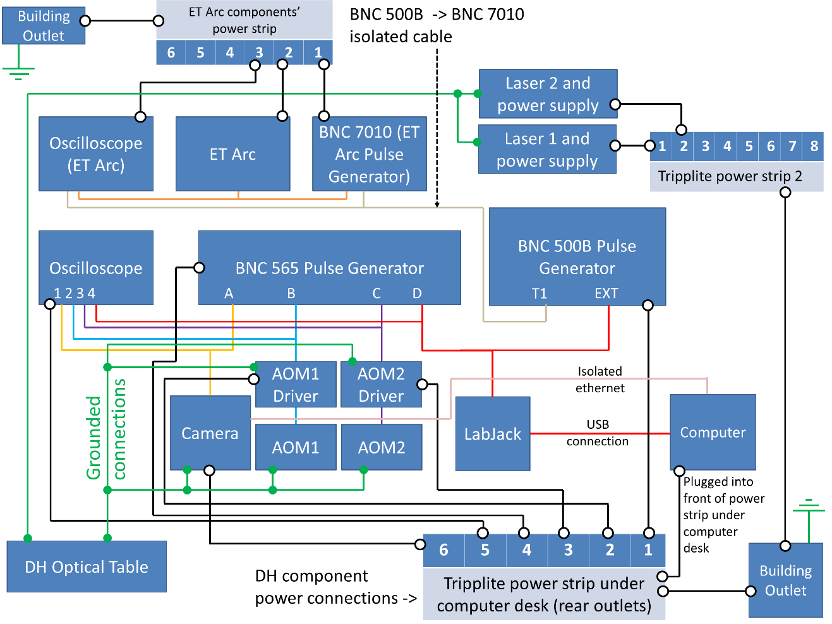
Figure 6.6. Block diagram of electronic components for DH integration with the ET-arc.

a.
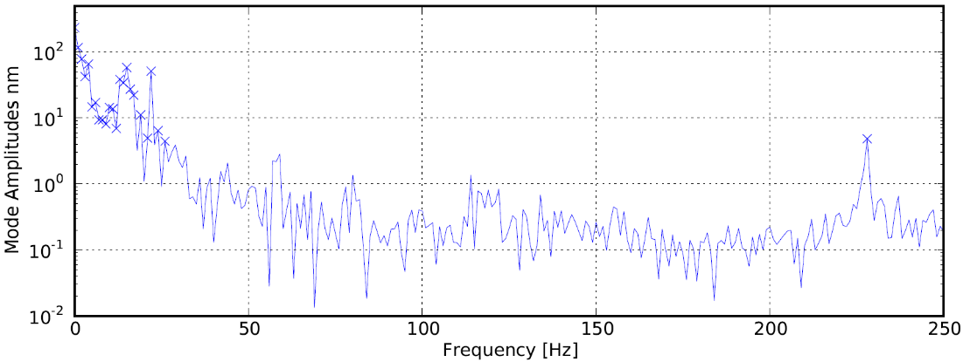
b.
c.
Figure 6.7. (a) Accelerometer noise measurement of the ET-arc target-holder flange under quiescent conditions. (b) Holographic noise measurement of the ET-arc target under quiescent conditions. (c) Accelerometer motion measurement of the ET-arc target-holder flange during a plasma event.

Figure 6.7.a is of the channel with the largest vibrational amplitudes, which was aligned to the vertical axis (perpendicular to the optical table surface). Note that the peak at 90 Hz in Figure 6.7.a is apparently anomalous, as it does not appear in the correlated holographic image noise measurement of Figure 6.7.b. The accelerometer showed vibrational motion reaching up to ~10 nm for frequencies of ~25 Hz or more, and exhibited increasing vibration as frequencies approached 0, reaching the order of µm at the lowest frequencies. However, low frequency noise is mitigated by the 500 Hz frame rate of holographic recordings, and as such the measured image noise only reached up to a few hundred nm.
Accelerometer measurements have been taken during an ET-arc plasma event, with the resulting measurement of the vertical channel shown in Figure 6.7.c. Holographic image noise measurements were not possible for the plasma event since the resulting surface deformation would corrupt the result. The signal was recorded for 100 ms in order to resolve the plasma event with high precision. As a result, the vibrational measurement is extended to 2.5 kHz. Motion was significantly higher during the arc firing, with measured amplitudes reaching several nm throughout and tens of µm at the lowest frequencies. Although the target-holder flange was securely fastened to the ET-arc, this measurement appeared to show that plasma thrust would be a significant contributor to surface motion in holographic measurement of the plasma event.

In Situ Demonstration Preliminary Results
In an effort to reproduce results as similar as possible to the ex situ work, the in situ experiment was designed to follow a similar plan with the characterization data serving as benchmarks, insofar as the results could be expected to match the previous work considering the fundamental differences between ex situ and in situ measurement. Stainless steel target plates were procured from Surface Finishes, Inc. with the plasma facing sides polished to a roughness average of 10 nm and both sides machined to a flatness of 10 µm, providing a virtual mirror finish (as seen in Figure 6.8.a); smaller accessory cover plates designed to produce a shadowed fiducial region similar to those described
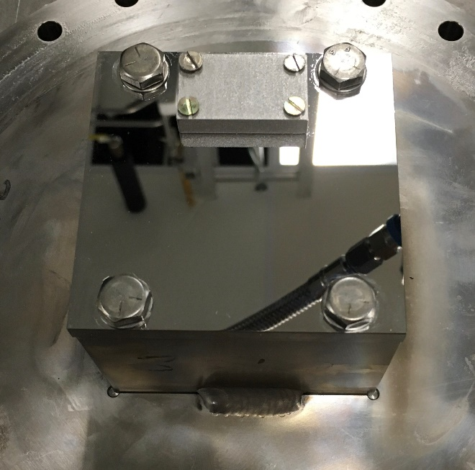
a.
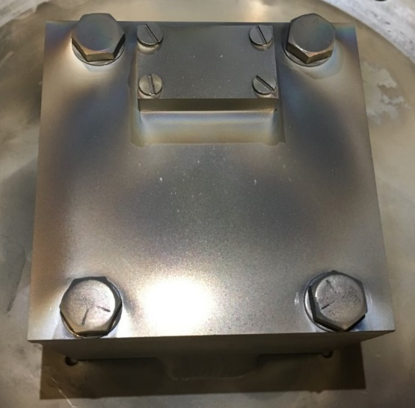
b. c.
Figure 6.8. (a) Polished target for in situ measurement demonstration with pristine finish. (b) Target after 10 plasma exposures, with approximate CO₂ beam area indicated by the red ellipse. (c) Cropped ROI and dimensions shown by the red rectangle on an example phase image.

in Chapter IV are included. The cover plate provides ~0.25” of protected length away from its edge along the base plate surface. Profilometry data was provided by the manufacturer. The target was securely placed in the ET-arc chamber and initially aligned using the HeNe laser while fringe adjustment is performed via the reference beam mirrors. After completing alignment, single-shot holograms were captured to establish benchmark pre-plasma exposure holographic data.
Initial in situ experiments have been conducted as of the time of writing of this document. A target plate received a total of 10 plasma exposures from the ET-arc. In these instances the ET-arc was configured to provide a ~1 ms pulse with a source energy of ~2 kJ. The final roughness average measured by the profilometer after the 10 plasma exposures was 739 nm.
Each exposure event was recorded at 500 Hz, and additional single-shot holograms were taken before and after each exposure. The holographic ROI was situated such that the shadowed region was almost entirely out of frame while the center of the plasma strike zone was encompassed; Figure 6.8.b–c shows the approximate position of the CO₂ beam on the target and the cropped ROI of an example phase image.
Due to jitter in the ET-arc’s firing trigger, the moment of the plasma event varied by tens of milliseconds from the programmed firing time, but always occurred approximately 0.6 seconds after the hologram sequence recording was started. The recordings were flatfield corrected with their frames which occurred ~4 ms before the moment of ET-arc firing (this time is based on selection of the second-to-last frame before the plasma event).
Example recorded results of the first plasma exposure on the pristine target are shown in Figure 6.9. In this sequence, flatfield correction was performed using the 608 ms frame, and the plasma event occurred at the frame corresponding to 610 ms. The changes in the surface appear subtle, but differences between the pre-exposure original finish at t = 0.001 s (Figure 6.9.a) and the post-exposure surface at t = 1 s (Figure 6.9.c) can be seen. As anticipated from the accelerometer
a.
b.
c.
Figure 6.9. Selected 500 Hz hologram frames recorded during the first plasma exposure on the target; (a) t = 0.001 s, (b) t = 0.638 s, and (c) t = 1 s.

vibration measurement, the surface showed motion over 3 µm for several milliseconds after the plasma event occurred. A frame taken soon after the plasma event during this period (Figure 6.9.b) captured a particle moving across the ROI, which can be seen in the rendered phase image as a brightly-colored object at x = ~1 mm and y = ~9 mm. The mean surface height remained elevated from the general level prior to the plasma event and exhibited relatively small periodic motions for the remainder of the recording; this observed behavior may be consistent with rapid post-plasma thermal expansion and subsequent cooling. Future in situ measurements are anticipated to elucidate the nature of the surface motion.
The single-shot holograms taken after each plasma exposure were flatfield corrected with a hologram of the original surface, and the resulting phase images are shown in Figure 6.10.a. The image orientation was changed so that the y-axis is most prominent in order to provide a better viewing angle for the surface features. The surfaces became increasingly roughened after each plasma exposure took place, and a depression was seen forming in the center of the ROI. The edge of the image near y = 14.4 mm represents the cusp of the shadowed region which was just out of the frame; at this location, a trench formation was observed to begin forming with the fifth plasma exposure and beyond, resembling the trench formation believed to be due to plasma turbulence in the results of Chapter IV. Figure 6.10.b shows the y-axis surface height profiles averaged along the x-axis, which have been normalized to a feature near y = ~13 mm. The increasing depth of the trench formation with each plasma exposure can be seen when y > 13 mm, and the prominence of the larger depression after multiple exposures is also observable. In contrast to the results from Chapter IV, the trench formation deepened at roughly 30 nm/exposure and the overall surface feature displacement did not exceed a range of up to ~400 nm, but the difference in experimental configurations, holographic spatial resolution, and noise factors all may contribute to the discrepancies.

a.
b.
Figure 6.10. (a) 3-D rendered phase images for 10 total plasma exposures from the ET-arc on the target. (b) The y-axis line profiles with z-axis surface heights; profile heights were averaged along the x-axis.
Further in situ experiments are anticipated to be completed and presented in the future, including the capture of 500 Hz holographic recorded sequences of plasma events with the ROI changed to include the shadowed region.

Further Development and Applications
New PMI data for fusion-relevant materials such as tungsten can be obtained by exposing targets made from those materials to the ET-arc in extensive experimental campaigns, potentially contributing to the wider literature on material processes under plasma contact. Target configurations simulating MPEX and ITER target geometries with relevant materials may also be studied by holography coupled with the ET-arc. Finally, the eventual plan for the ORNL DH system is to integrate it with the MPEX diagnostic suite.
Analysis techniques may be developed for the removal of planar tilt in a hologram, and unwrapping of phase jumps in single-wavelength holograms to achieve high resolution measurements with expanded elevation ranges may be possible by using corresponding dual wavelength holograms as references. Looking ahead to the ultimate goal of deploying digital holography as an in situ surface erosion monitoring diagnostic, custom software for streamlined automation of hologram capture will be developed so that true real-time continuous measurements can be made. Standard user-aligned optical mounts may be replaced with electronically adjustable mounts to allow remote alignment maintenance and corrections to be performed without requiring shutdown of the plasma device or disconnection of the diagnostic. As with any diagnostic system in development, the feasibility of using digital holography for measuring erosion of surfaces in a particular plasma device and its requirements in turn for successful operation will come from continuous experimental trials.

REFERENCES
[1] Oliphant, M. L. E., Harteck, P., and Rutherford, E. "Transmutation Effects Observed with Heavy Hydrogen," Proceedings of the Royal Society of London A Vol. 144, No. 853, 1934, pp. 692-703.
doi: http://doi.org/10.1098/rspa.1934.0077
[2] Eddington, A. S. "The Internal Constitution of the Stars," Science Vol. 52, No. 1341, 1920, p. 233.
doi: http://doi.org/10.1126/science.52.1341.233
[3] Bethe, H. A. "Energy Production in Stars," Physical Review Vol. 55, No. 1, 1939, pp. 103-103.
doi: http://doi.org/10.1103/PhysRev.55.103
[4] Smirnov, V. P. "Tokamak Foundation in USSR/Russia 1950–1990," Nuclear Fusion Vol. 50, No. 1, 2009, p. 014003.
doi: http://doi.org/10.1088/0029-5515/50/1/014003
[5] "Union of Soviet Socialist Republics - United States: Documents from the Geneva Summit," International Legal Materials Vol. 25, No. 1, 1986, pp. 102-122.
doi: http://doi.org/10.1017/S0020782900024682
[6] Aymar, R. "ITER Status, Design and Material Objectives," Journal of Nuclear Materials Vol. 307-311, 2002, pp. 1-9.
doi: http://doi.org/10.1016/S0022-3115(02)00937-6
[7] Federici, G., Andrew, P., Barabaschi, P., Brooks, J., Doerner, R., Geier, A., Herrmann, A., Janeschitz, G., Krieger, K., Kukushkin, A., Loarte, A., Neu, R., Saibene, G., Shimada, M., Strohmayer, G., and Sugihara, M. "Key ITER Plasma Edge and Plasma–Material Interaction Issues," Journal of Nuclear Materials Vol. 313-316, 2003, pp. 11-22.
doi: http://doi.org/10.1016/S0022-3115(02)01327-2
[8] Stork, D., Agostini, P., Boutard, J. L., Buckthorpe, D., Diegele, E., Dudarev, S. L., English, C., Federici, G., Gilbert, M. R., Gonzalez, S., Ibarra, A., Linsmeier, C., Li Puma, A., Marbach, G., Morris, P. F., Packer, L. W., Raj, B., Rieth, M., Tran, M. Q., Ward, D. J., and Zinkle, S. J. "Developing Structural, High-heat Flux and Plasma Facing Materials for a Near-term DEMO Fusion Power Plant: The EU Assessment," Journal of Nuclear Materials Vol. 455, No. 1, 2014, pp. 277-291.
doi: http://doi.org/10.1016/j.jnucmat.2014.06.014
[9] Naujoks, D. Plasma-Material Interaction in Controlled Fusion. Berlin, Heidelberg: Springer, 2006.
doi: http://doi.org/10.1007/3-540-32149-7
[10] Kreter, A. "Reactor-Relevant Plasma-Material Interaction Studies in Linear Plasma Devices," Fusion Science and Technology Vol. 59, No. 1T, 2011, pp. 51-56.
doi: http://doi.org/10.13182/FST59-1T-51
[11] Baldwin, M. J., Doerner, R. P., Nishijima, D., Patino, M., Simmonds, M. J., Tynan, G., Yu, J. H., and Založnik, A. "Plasma-Material-Interaction Research Using PISCES Linear Plasma Devices," Fusion Science and Technology Vol. 75, No. 7, 2019, pp. 664-673.
doi: http://doi.org/10.1080/15361055.2019.1646608
[12] Rapp, J., Koppers, W. R., van Eck, H. J. N., van Rooij, G. J., Goedheer, W. J., de Groot, B., Al, R., Graswinckel, M. F., van den Berg, M. A., Kruyt, O., Smeets, P., van der Meiden, H. J., Vijvers, W., Scholten, J., van de Pol, M., Brons, S., Melissen, W., van der Grift, T., Koch, R., Schweer, B., Samm, U., Philipps, V., Engeln, R. A. H., Schram, D. C., Lopes Cardozo, N. J., and Kleyn, A. W. "Construction of the Plasma-Wall Experiment Magnum-PSI," Fusion Engineering and Design Vol. 85, No. 7, 2010, pp. 1455-1459.
doi: http://doi.org/10.1016/j.fusengdes.2010.04.009
[13] Kreter, A., Brandt, C., Huber, A., Kraus, S., Möller, S., Reinhart, M., Schweer, B., Sergienko, G., and Unterberg, B. "Linear Plasma Device PSI-2 for Plasma-Material Interaction Studies," Fusion Science and Technology Vol. 68, No. 1, 2015, pp. 8-14.
doi: http://doi.org/10.13182/FST14-906
[14] Blackwell, B. D., Caneses, J. F., Samuell, C. M., Wach, J., Howard, J., and Corr, C. "Design and Characterization of the Magnetized Plasma Interaction Experiment (MAGPIE): a New Source for Plasma–Material Interaction Studies," Plasma Sources Science and Technology Vol. 21, No. 5, 2012, p. 055033.
doi: http://doi.org/10.1088/0963-0252/21/5/055033
[15] Lu, G.-H., Cheng, L., Arshad, K., Yuan, Y., Wang, J., Qin, S., Zhang, Y., Zhu, K., Luo, G.-N., Zhou, H., Li, B., Wu, J., and Wang, B. "Development and Optimization of STEP—A Linear Plasma Device for Plasma-Material Interaction Studies," Fusion Science and Technology Vol. 71, No. 2, 2017, pp. 177-186.
doi: http://doi.org/10.13182/FST16-115
[16] Caughman, J. B. O., Goulding, R. H., Biewer, T. M., Bigelow, T. S., Campbell, I. H., Caneses, J., Diem, S. J., Fadnek, A., Fehling, D. T., Isler, R. C., Martin, E. H., Parish, C. M., Rapp, J., Wang, K., Beers, C. J., Donovan, D., Kafle, N., Ray, H. B., Shaw, G. C., and Showers, M. A. "Plasma Source Development for Fusion-relevant Material Testing," Journal of Vacuum Science & Technology A Vol. 35, No. 3, 2017, p. 03E114.
doi: http://doi.org/10.1116/1.4982664
[17] Rapp, J., Beers, C., Biewer, T., Bigelow, T., Caneses, J., Caughman, J., Diem, S., Goulding, R., Isler, R., Kafle, N., Owen, L., and Showers, M. "Operational Domain of Proto-MPEX," Fusion Engineering and Design Vol. 136, 2018, pp. 712-716.
doi: http://doi.org/10.1016/j.fusengdes.2018.03.064
[18] Rapp, J., Lau, C., Lumsdaine, A., Beers, C. J., Bigelow, T. S., Biewer, T. M., Boyd, T., Caneses, J. F., Caughman, J. B. O., Duckworth, R., Goulding, R. H., Hicks, W. R., Kafle, N., Piotrowicz, P. A., and West, D. "The Materials Plasma Exposure eXperiment: Status of the Physics Basis Together with the Conceptual Design and Plans Forward," IEEE Transactions on Plasma Science Vol. 48, No. 6, 2020, pp. 1439-1445.
doi: http://doi.org/10.1109/TPS.2020.2970398
[19] Philipps, V., Malaquias, A., Hakola, A., Karhunen, J., Maddaluno, G., Almaviva, S., Caneve, L., Colao, F., Fortuna, E., Gasior, P., Kubkowska, M., Czarnecka, A., Laan, M., Lissovski, A., Paris, P., van der Meiden, H. J., Petersson, P., Rubel, M., Huber, A., Zlobinski, M., Schweer, B., Gierse, N., Xiao, Q., and Sergienko, G. "Development of Laser-based Techniques for In Situ Characterization of the First Wall in ITER and Future Fusion Devices," Nuclear Fusion Vol. 53, No. 9, 2013, p. 093002.
doi: http://doi.org/10.1088/0029-5515/53/9/093002
[20] Reichle, R., Andrew, P., Bates, P., Bede, O., Casal, N., Choi, C. H., Barnsley, R., Damiani, C., Bertalot, L., Dubus, G., Ferreol, J., Jagannathan, G., Kocan, M., Leipold, F., Lisgo, S. W., Martin, V., Palmer, J., Pearce, R., Philipps, V., Pitts, R. A., Pampin, R., Passedat, G., Puiu, A., Suarez, A., Shigin, P., Shu, W., Vayakis, G., Veshchev, E., and Walsh, M. "Review of the ITER Diagnostics Suite for Erosion, Deposition, Dust, and Tritium Measurements," Journal of Nuclear Materials Vol. 463, 2015, pp. 180-184.
doi: http://doi.org/10.1016/j.jnucmat.2015.01.039
[21] Itami, K., Sugie, T., Vayakis, G., and Walker, C. "Study of an Erosion Monitor for the ITER Divertor Target Plates," 32nd EPS Conference on Plasma Physics and Controlled Fusion, 27 June - 1 July 2005.
[22] Siegel, T., Kolokotronis, E., Cifuentes, A., Matia-Hernando, P., Sansa, A., Symeonidou, P., Bates, P., Damiani, C., Dubus, G., Puiu, A., and Reichle, R. "In-vessel Viewing System Prototype Performance Measurements and Simulation of Measurement Quality Across the ITER In-vessel Components," Fusion Engineering and Design Vol. 146, 2019, pp. 2348-2352.
doi: http://doi.org/10.1016/j.fusengdes.2019.03.187
[23] Gauthier, E., Colledani, G., Jourd'heuil, L., and Patterlini, J. C. "Divertor Erosion Monitoring in ITER Using Speckle Interferometry," 25th IEEE Symposium on Fusion Engineering (SOFE), 10-14 June 2013.
doi: http://doi.org/10.1109/SOFE.2013.6635444
[24] Thomas, C. E., Granstedt, E. M., Biewer, T. M., Baylor, L. R., Combs, S. K., Meitner, S. J., Hillis, D. L., Majeski, R., and Kaita, R. "Digital Holography for In Situ Real-time Measurement of Plasma-Facing-Component Erosion," Review of Scientific Instruments Vol. 85, No. 11, 2014, p. 11D810.
doi: http://doi.org/10.1063/1.4886435
[25] Pedrini, G., Alekseenko, I., Osten, W., Jagannathan, G., Kempenaars, M., and Vayakis, G. "Multi-wavelength Digital Holography for Erosion Measurements Inside the ITER Tokamak," OSA Digital Holography and Three-Dimensional Imaging Topical Meeting, 25-28 June 2018.
doi: http://doi.org/10.1364/DH.2018.DW3F.1
[26] Gabor, D. "A New Microscopic Principle," Nature Vol. 161, No. 4098, 1948, pp. 777-778.
doi: http://doi.org/10.1038/161777a0
[27] Gabor, D., and Bragg, W. L. "Microscopy by Reconstructed Wave-fronts," Proceedings of the Royal Society of London. Series A. Mathematical and Physical Sciences Vol. 197, No. 1051, 1949, pp. 454-487.
doi: http://doi.org/10.1098/rspa.1949.0075
[28] Leith, E. N., and Upatnieks, J. "Reconstructed Wavefronts and Communication Theory*," Journal of the Optical Society of America Vol. 52, No. 10, 1962, pp. 1123-1130.
doi: http://doi.org/10.1364/JOSA.52.001123
[29] Leith, E. N., and Upatnieks, J. "Wavefront Reconstruction with Continuous-Tone Objects*," Journal of the Optical Society of America Vol. 53, No. 12, 1963, pp. 1377-1381.
doi: http://doi.org/10.1364/JOSA.53.001377
[30] Schnars, U., and Jüptner, W. "Direct Recording of Holograms by a CCD Target and Numerical Reconstruction," Applied Optics Vol. 33, No. 2, 1994, pp. 179-181.
doi: http://doi.org/10.1364/AO.33.000179
[31] Thomas, C. E., Baylor, L. R., Hanson, G. R., Rasmussen, D. A., Voelkl, E., Castracane, J., Simkulet, M., and Clow, L. "Direct-to-digital Holography and Holovision," Lockheed Martin Energy Research Corp. (Oak Ridge, TN), United States of America, Patent No. 6078392, 2000.
[32] Xu, W., Jericho, M. H., Meinertzhagen, I. A., and Kreuzer, H. J. "Digital In-line Holography for Biological Applications," Proceedings of the National Academy of Sciences of the United States of America Vol. 98, No. 20, 2001, pp. 11301-11305.
doi: http://doi.org/10.1073/pnas.191361398
[33] Marquet, P., Rappaz, B., Magistretti, P. J., Cuche, E., Emery, Y., Colomb, T., and Depeursinge, C. "Digital Holographic Microscopy: a Noninvasive Contrast Imaging Technique Allowing Quantitative Visualization of Living Cells with Subwavelength Axial Accuracy," Optics Letters Vol. 30, No. 5, 2005, pp. 468-470.
doi: http://doi.org/10.1364/OL.30.000468
[34] Nicola, S. D., Ferraro, P., Finizio, A., Grilli, S., Coppola, G., Iodice, M., Natale, P. D., and Chiarini, M. "Surface Topography of Microstructures in Lithium Niobate by Digital Holographic Microscopy," Measurement Science and Technology Vol. 15, No. 5, 2004, pp. 961-968.
doi: http://doi.org/10.1088/0957-0233/15/5/026
[35] Coppola, G., Ferraro, P., Iodice, M., Nicola, S. D., Finizio, A., and Grilli, S. "A Digital Holographic Microscope for Complete Characterization of Microelectromechanical Systems," Measurement Science and Technology Vol. 15, No. 3, 2004, pp. 529-539.
doi: http://doi.org/10.1088/0957-0233/15/3/005
[36] Powell, R. L., and Stetson, K. A. "Interferometric Vibration Analysis by Wavefront Reconstruction," Journal of the Optical Society of America Vol. 55, No. 12, 1965, pp. 1593-1598.
doi: http://doi.org/10.1364/JOSA.55.001593
[37] Bachalo, W. D. "Flow-field Measurements on an Airfoil with an Oscillating Trailing-edge Using Holographic Interferometry," NASA-CR-166604,
NASA Ames Research Center, 1984, https://ntrs.nasa.gov/search.jsp?R=19840026359.
[38] Hicks, Y., Schock, H., Craig, J., Umstatter, H., and Lee, D. "Visualization of Flows in a Motored Rotary Combustion Engine Using Holographic Interferometry," 22nd AIAA Joint Propulsion Conference, 16-18 June 1986.
doi: http://doi.org/10.2514/6.1986-1557
[39] Sciammarella, C. A. "Electro Optical System to Measure Strains at High Temperature," NASA-CR-190450, NASA Ames Research Center, 1991, https://ntrs.nasa.gov/search.jsp?R=19920024452.
[40] Decker, A. J. "Damage Detection Using Holography and Interferometry," NASA/TM-2003-212078, NASA Glenn Research Center, 2003, https://ntrs.nasa.gov/search.jsp?R=20030014823.
[41] Spencer, M. F., Raynor, R. A., Banet, M. T., and Marker, D. K. "Deep-turbulence Wavefront Sensing Using Digital-Holographic Detection in the Off-axis Image Plane Recording Geometry," Optical Engineering Vol. 56, No. 3, 2017, p. 031213.
doi: http://doi.org/10.1117/1.OE.56.3.031213
[42] Wilcox, C. C., Radosevich, C. J., Keith, P. H., Tuffli, A. L., Agena, B. D., Spencer, M. F., and Wittich, D. J. "Digital Holography Wavefront Sensing with a Supersonic Wind Tunnel," Proceedings of SPIE Vol. 11030, Holography: Advances and Modern Trends VI, 2019.
doi: http://doi.org/10.1117/12.2521337
[43] Atlan, M., Gross, M., Forget, B. C., Vitalis, T., Rancillac, A., and Dunn, A. K. "Frequency-domain, Wide-field Laser Doppler In Vivo Imaging," Optics Letters Vol. 31, No. 18, 2006, pp. 2762-2764.
doi: http://doi.org/10.1364/OL.31.002762
[44] Magnain, C., Castel, A., Boucneau, T., Simonutti, M., Ferezou, I., Rancillac, A., Vitalis, T., Sahel, J. A., Paques, M., and Atlan, M. "Holographic Laser Doppler Imaging of Microvascular Blood Flow," Journal of the Optical Society of America A Vol. 31, No. 12, 2014, p. 2723.
doi: http://doi.org/10.1364/JOSAA.31.002723
[45] Bencteux, J., Pagnoux, P., Kostas, T., Bayat, S., and Atlan, M. "Holographic Laser Doppler Imaging of Pulsatile Blood Flow," Journal of Biomedical Optics Vol. 20, No. 6, 2015, p. 066006.
doi: http://doi.org/10.1117/1.JBO.20.6.066006
[46] Puyo, L., Paques, M., Fink, M., Sahel, J. A., and Atlan, M. "In Vivo Laser Doppler Holography of the Human Retina," Biomedical Optics Express Vol. 9, No. 9, 2018, p. 4113.
doi: http://doi.org/10.1364/BOE.9.004113
[47] Darakis, E., Khanam, T., Rajendran, A., Kariwala, V., Naughton, T. J., and Asundi, A. K. "Microparticle Characterization Using Digital Holography," Chemical Engineering Science Vol. 65, No. 2, 2010, pp. 1037-1044.
doi: http://doi.org/10.1016/j.ces.2009.09.057
[48] Khanam, T., Nurur Rahman, M., Rajendran, A., Kariwala, V., and Asundi, A. K. "Accurate Size Measurement of Needle-shaped Particles Using Digital Holography," Chemical Engineering Science Vol. 66, No. 12, 2011, pp. 2699-2706.
doi: http://doi.org/10.1016/j.ces.2011.03.026
[49] Santangelo, P. J., and Sojka, P. E. "Focused-image Holography as a Dense-spray Diagnostic," Applied Optics Vol. 33, No. 19, 1994, p. 4132.
doi: http://doi.org/10.1364/AO.33.004132
[50] Burke, J., Hess, C. F., and Kebbel, V. "Digital Holography for Instantaneous Spray Diagnostics on a Plane," Particle & Particle Systems Characterization Vol. 20, No. 3, 2003, pp. 183-192.
doi: http://doi.org/10.1002/ppsc.200390024
[51] Kroll, M., Muhlfeld, L., and Block, D. "Stereoscopic Digital Holography," IEEE Transactions on Plasma Science Vol. 38, No. 4, 2010, pp. 897-900.
doi: http://doi.org/10.1109/TPS.2009.2032548
[52] Osakabe, N. "Application of Electron Holography to Surface Topography Observation," Surface Science Vol. 298, No. 2-3, 1993, pp. 345-350.
doi: http://doi.org/10.1016/0039-6028(93)90047-N
[53] Cuche, E., Bevilacqua, F., and Depeursinge, C. "Digital Holography for Quantitative Phase-Contrast Imaging," Optics Letters Vol. 24, No. 5, 1999, p. 291.
doi: http://doi.org/10.1364/OL.24.000291
[54] Castañeda, R., and Garcia-Sucerquia, J. "Single-shot 3D Topography of Reflective Samples with Digital Holographic Microscopy," Applied Optics Vol. 57, No. 1, 2018, pp. A12-A18.
doi: http://doi.org/10.1364/AO.57.000A12
[55] Wang, F., Xiao, W., Pan, F., Liu, S., Cong, L., Li, R., Rong, L., and He, A. "Curvature Measurement of Optical Surface Using Digital Holography," Optics and Lasers in Engineering Vol. 49, No. 7, 2011, pp. 903-906.
doi: http://doi.org/10.1016/j.optlaseng.2011.02.012
[56] Georges, M. P., Vandenrijt, J.-F., Thizy, C., Stockman, Y., Queeckers, P., Dubois, F., and Doyle, D. "Digital Holographic Interferometry with CO2 Lasers and Diffuse Illumination Applied to Large Space Reflector Metrology [Invited]," Applied Optics Vol. 52, No. 1, 2013, p. A102.
doi: http://doi.org/10.1364/AO.52.00A102
[57] Ma, L., Wang, H., Li, Y., and Jin, H. "Numerical Reconstruction of Digital Holograms for Three-dimensional Shape Measurement," Journal of Optics A: Pure and Applied Optics Vol. 6, No. 4, 2004, pp. 396-400.
doi: http://doi.org/10.1088/1464-4258/6/4/016
[58] van Rooij, J., and Kalkman, J. "Sub-millimeter Depth-resolved Digital Holography," Applied Optics Vol. 56, No. 25, 2017, pp. 7286-7293.
doi: http://doi.org/10.1364/AO.56.007286
[59] Hildebrand, B. P., and Haines, K. A. "Multiple-wavelength and Multiple-source Holography Applied to Contour Generation*," Journal of the Optical Society of America Vol. 57, No. 2, 1967, pp. 155-162.
doi: http://doi.org/10.1364/JOSA.57.000155
[60] Friesem, A. A., and Levy, U. "Fringe Formation in Two-wavelength Contour Holography," Applied Optics Vol. 15, No. 12, 1976, pp. 3009-3020.
doi: http://doi.org/10.1364/AO.15.003009
[61] Wyant, J. C. "Testing Aspherics Using Two-wavelength Holography," Applied Optics Vol. 10, No. 9, 1971, pp. 2113-2118.
doi: http://doi.org/10.1364/AO.10.002113
[62] Skudayski, U., and Jueptner, W. "Synthetic Wavelength Interferometry for the Extension of the Dynamic Range," Proceedings of SPIE Vol. 1508, Industrial Applications of Holographic and Speckle Measuring Techniques, 1991.
doi: http://doi.org/10.1117/12.47090
[63] Gass, J., Dakoff, A., and Kim, M. K. "Phase Imaging without 2π Ambiguity by Multiwavelength Digital Holography," Optics Letters Vol. 28, No. 13, 2003, pp. 1141-1143.
doi: http://doi.org/10.1364/OL.28.001141
[64] Hu, L., Shui, Y., Dai, Y., Wu, H., Zhu, G., and Yang, Y. "Study on Quantitative Phase Imaging by Dual-wavelength Digital Holography Microscopy," International Journal of Optics Vol. 2018, 2018.
doi: http://doi.org/10.1155/2018/2312137
[65] Khmaladze, A., Kim, M., and Lo, C.-M. "Phase Imaging of Cells by Simultaneous Dual-wavelength Reflection Digital Holography," Optics Express Vol. 16, No. 15, 2008, p. 10900.
doi: http://doi.org/10.1364/OE.16.010900
[66] Di, J., Song, Y., Xi, T., Zhang, J., Li, Y., Ma, C., Wang, K., and Zhao, J. "Dual-wavelength Common-path Digital Holographic Microscopy for Quantitative Phase Imaging of Biological Cells," Optical Engineering Vol. 56, No. 11, 2017, p. 111712.
doi: http://doi.org/10.1117/1.OE.56.11.111712
[67] Lédl, V., Psota, P., Kaván, F., Matoušek, O., and Mokrý, P. "Surface Topography Measurement by Frequency Sweeping Digital Holography," Applied Optics Vol. 56, No. 28, 2017, pp. 7808-7814.
doi: http://doi.org/10.1364/AO.56.007808
[68] Yamagiwa, M., Minamikawa, T., Trovato, C., Ogawa, T., Ibrahim, D. G. A., Kawahito, Y., Oe, R., Shibuya, K., Mizuno, T., Abraham, E., Mizutani, Y., Iwata, T., Yamamoto, H., Minoshima, K., and Yasui, T. "Multicascade-linked Synthetic Wavelength Digital Holography Using an Optical-comb-referenced Frequency Synthesizer," Optics Express Vol. 26, No. 20, 2018, pp. 26292-26306.
doi: http://doi.org/10.1364/OE.26.026292
[69] Pedrini, G., Alekseenko, I., Jagannathan, G., Kempenaars, M., Vayakis, G., and Osten, W. "Feasibility Study of Digital Holography for Erosion Measurements Under Extreme Environmental Conditions Inside the International Thermonuclear Experimental Reactor Tokamak [Invited]," Applied Optics Vol. 58, No. 5, 2019, p. A147.
doi: http://doi.org/10.1364/AO.58.00A147
[70] Biewer, T. M., Sawyer, J. C., Smith, C. D., and Thomas, C. E. "Dual Laser Holography for In Situ Measurement of Plasma Facing Component Erosion (Invited)," Review of Scientific Instruments Vol. 89, No. 10, 2018, p. 10J123.
doi: http://doi.org/10.1063/1.5039628
[71] Granstedt, E. M., Thomas, C. E., Kaita, R., Majeski, R., Baylor, L. R., Meitner, S. J., and Combs, S. K. "High-speed Digital Holography for Neutral Gas and Electron Density Imaging," Review of Scientific Instruments Vol. 87, No. 5, 2016, p. 053507.
doi: http://doi.org/10.1063/1.4949505
[72] Thomas, C. E., Biewer, T. M., Baylor, L. R., Combs, S. K., Meitner, S. J., Rapp, J., Hillis, D. L., Granstedt, E. M., Majeski, R., and Kaita, R. "Design of a Digital Holography System for PFC Erosion Measurements on Proto-MPEX," Review of Scientific Instruments Vol. 87, No. 11, 2016, p. 11D624.
doi: http://doi.org/10.1063/1.4960488
[73] Gebhart, T. E., Baylor, L. R., Rapp, J., and Winfrey, A. L. "Characterization of an Electrothermal Plasma Source for Fusion Transient Simulations," Journal of Applied Physics Vol. 123, No. 3, 2018, p. 033301.
doi: http://doi.org/10.1063/1.4998593
[74] Biewer, T. M., Smith, C. D., Gebhart, T. E., Greenhalgh, A., Ren, X., and Thomas, C. E. "Considerations for In Situ, Real Time Measurement of Plasma-Material Interactions Using Digital Holographic Imaging," Journal of Instrumentation Vol. 15, No. 02, 2020, p. C02017.
doi: http://doi.org/10.1088/1748-0221/15/02/c02017
[75] Smith, C. D., Biewer, T. M., Ren, X., Thomas, C. E., Gebhart, T., and Zhang, Z. "Recent Developments in Dual-laser Digital Holography for Plasma-facing Surface Characterization," IEEE Transactions on Plasma Science Vol. 48, No. 6, 2020, pp. 1655-1660.
doi: http://doi.org/10.1109/TPS.2019.2943739
[76] Kaur, R., Vayakis, G., Andrew, P., Govindarajan, J., and Walsh, M. "Progress with Divertor Deposition/Erosion Monitoring Diagnostics," ITER ITPA Diagnostics Topical Group Meeting, 4-7 June 2013.
[77] Reichle, R., Andrew, P., Anthoine, D., Barnsley, R., Bertalot, L., De Temmerman, G., Jagannathan, G., Lisgo, S., Pitts, R., Shigin, P., Shu, W., Vayakis, G., Veshchev, E., and Walsh, M. "Redefinition of the ITER Requirements and Diagnostics for Erosion, Deposition, Dust, and Tritium Measurements Accounting for the Change to Tungsten Divertor," 25th IAEA Fusion Energy Conference, 13-18 October 2014.
[78] Coburn, J. D., Gebhart, T. E., Parish, C. M., Unterberg, E., Canik, J., Barsoum, M. W., and Bourham, M. "Surface Erosion of Plasma-Facing Materials Using an Electrothermal Plasma Source and Ion Beam Micro-Trenches," Fusion Science and Technology Vol. 75, No. 7, 2019, pp. 621-635.
doi: http://doi.org/10.1080/15361055.2019.1623570

VITA
Cary D. Smith received a Bachelor of Science in Aerospace Technology cum laude from Middle Tennessee State University in 2009. He received a second bachelor’s degree in Aerospace Engineering from the University of Tennessee at Knoxville in 2016, where he performed undergraduate research in the Laser Diagnostics Laboratory under the supervision of Professor Zhili Zhang. Smith remained at the University of Tennessee to continue his education in aerospace engineering as a Ph. D. student with Professor Zhang as his advisor. He took part in the Air Force Research Laboratory Scholars Program as an intern at the Directed Energy Directorate of AFRL Kirtland in Albuquerque, New Mexico in the summer of 2017, and began working as a student researcher on digital holography under subcontract at Oak Ridge National Laboratory in Oak Ridge, Tennessee in fall 2017 alongside Dr. Tommy Thomas of Third Dimension Technologies with Dr. Theodore Biewer as the principle investigator. While working at ORNL, Smith continued to perform research at the UT Laser Diagnostics Laboratory and contributed to multiple papers and a patent application. During his graduate studies he received a Tennessee Space Grant Consortium scholarship in 2017, conference travel awards from the UT Graduate Student Senate, IEEE, and NASA University Leadership Initiative in 2019, the Walter R. Lempert Student Paper Award in Diagnostics for Fluid Mechanics, Plasma Physics, and Energy Transfer from the 2019 AIAA SciTech Forum and Exposition, and in 2020 he received a MABE Department Outstanding Graduate Student Award, Chancellor’s Citation for Extraordinary Professional Promise, and his master’s degree.

The name ITER was originally an acronym for International Thermonuclear Experimental Reactor, and is now commonly invoked in a standalone sense; it is stated to be derived from the Latin word meaning “the way” on the official web site (www.iter.org).
1 University of Tennessee, Knoxville, TN 37996 USA
Oak Ridge National Laboratory, Oak Ridge, TN 37830 USA
Beloit College, Beloit, WI 53511 USA
Third Dimension Technologies, Knoxville, TN 37931 USA

