Optimization of in vitro Assays to Study the Efficacy of Anti-Leptospira Antibodies.

A Thesis Presented for the

Master of Science

Degree

The University of Tennessee, Knoxville

Avni Patel

December 2025

Copyright © 2025 by Avni Patel
All rights reserved.

ACKNOWLEDGEMENTS

I want to express my deepest gratitude to my supervisor, Dr. Sreekumari Rajeev, for her excellent mentorship and guidance. Your immense support and assistance have continuously helped me become a better student. I appreciate how patient and helpful you’ve always been. I am also grateful to my committee members, Dr. Madhu Dhar and Dr. Andrea Lear, for their guidance and constructive feedback during committee meetings.
I appreciate Dr. Liana Barbosa for guiding me and helping me learn about Leptospira and lab techniques. I am also grateful to the Leptospira lab and the bacteriology lab for their consistent support throughout my entire journey.
Lastly, I would like to thank my family for their selfless sacrifices and endless support, so that I could continue my higher education.

ABSTRACT

Leptospirosis is a reemerging global zoonotic disease caused by Leptospira. Antibody-mediated protective response is commonly evaluated using animal models. Previously demonstrated in vitro growth inhibition test lacks consistent procedures. Thus, considering the 3Rs of animal research, it is ideal to develop an in vitro assay for the initial evaluation of antibodies that can potentially protect the animals before moving to the in vivo models. The objective of this study was to optimize in vitro assays to conduct a preliminary evaluation of antibody efficacy. First, we attempted to optimize the Leptospira growth inhibition assay (LGIA) in which L. interrogans serovar Manilae culture containing 10^3 to 10^7 bacteria was treated with polyclonal antiserum developed against this strain. Cultures were examined for the presence of Leptospira growth for 28 days. We observed that 10^4 bacteria treated with a 1:10 dilution of antiserum, for a 14-day incubation, would be an optimal combination for conducting this assay, and these conditions effectively inhibit the growth of Leptospira in the presence of antiserum. Moreover, another key mechanism for preventing bacterial growth is phagocytosis. As previous studies showed inconsistent findings on the phagocytosis of virulent strains, we attempted to evaluate the parameters for detecting intracellular Leptospira within THP-1 (a human monocytic cell line), which would further aid in optimizing the macrophage-infection model for assessing antibody efficacy in the antibody-mediated bacterial phagocytosis process. Upon THP-1 cell infection with Leptospira, we noted that CFSE (Carboxyfluorescein succinimidyl ester) labeling for bacteria was more effective in detecting intracellular Leptospira, compared to FITC (Fluorescein isothiocyanate)-conjugated polyclonal anti-Leptospira antibody, as FITC-conjugated antibody exhibited excessive fluorescence and non-specific binding to THP-1 cells. Next, after treating the infected THP-1 cells with gentamicin, we observed that treatment with gentamicin did not eliminate extracellular Leptospira from the cell culture. Further evaluation of this experiment is necessary, as our observations were invalid, as it was unclear whether the bacteria resided inside or outside of the cell. We concluded that LGIA is an appropriate testing strategy for evaluating antibody efficacy and can be optimized for various Leptospira species and conditions. However, in our experience, the macrophage model can be labor-intensive and not straightforward and may not be suitable for this purpose.

TABLE OF CONTENTS
CHAPTER 1 INTRODUCTION TO LEPTOSPIRA AND LEPTOSPIROSIS 1
LEPTOSPIRA AND LEPTOSPIROSIS 2
Leptospira and Its Classification 2
Leptospira and Its Hosts 3
Human and Animal Leptospirosis 4
Diagnosis of Leptospirosis 5
Treatment and Prevention 6
Current Vaccines Immunogenicity 7
Future Directions 7
REFERENCES 9
CHAPTER 2 OPTIMIZATION OF AN IN VITRO LEPTOSPIRA GROWTH INHIBITION ASSAY TO EVALUATE THE PROTECTIVE EFFICACY OF ANTI-LEPTOSPIRA ANTIBODIES 14
ABSTRACT 15
INTRODUCTION 15
Purpose of Study and Specific Aim 19
MATERIALS AND METHODS 19
Leptospira Strain and Culture 19
Optimization of Incubation Period 19
Optimization of Bacterial Number 20
Optimization of Anti-Leptospira Antiserum Dilution 21
Assessing the Reproducibility of the Experiment 21
RESULTS 22
Bacterial Incubation Period 23
Optimization of Bacterial Number 25
Optimization of Anti-Serum Dilution 25
Assessment of the Reproducibility of the Assay 26
DISCUSSION 28
REFERENCES 31
CHAPTER 3 TO DEFINE THE PARAMETERS FOR THE DETECTION OF INTRACELLULAR LEPTOSPIRA 34
ABSTRACT 35
INTRODUCTION 35
Leptospira Interactions with Epithelial and Endothelial Cell Lines 36
Leptospira Interactions with Immune Cell 38
Purpose of The Study and Specific Aim 41
MATERIALS AND METHODS 42
Leptospira Strain and Culture 42
Cell Line and Culture 42
Detection of Intracellular LIM Using FITC-Conjugated Anti-Leptospira Polyclonal Antibody 43
Evaluation of CFSE Labeling Efficacy and LIM Motility 43
Evaluation of Lysotracker DND-99, DAPI Staining, and CFSE Labeling for THP-1 Cells 44
Detection of Intracellular LIM using CFSE Labeling 45
Evaluation of Gentamicin Effectiveness in Eliminating Extracellular LIM upon Treatment 46
RESULTS 47
Leptospira -Host Interactions 47
Detection of Intracellular LIM Using FITC-Conjugated Anti-Leptospira Polyclonal Antibody 48
Assessment of CFSE Labeling and Bacterial Motility upon Treatment 49
Evaluation of the treatment of THP-1 cells with Lysotracker DND, DAPI Staining and CFSE Labeling 49
Detection of Intracellular LIM using CFSE-Labeled LIM and Lysotracker DND stained THP-1 cells 55
Evaluation of Gentamicin Effectiveness in Eliminating Extracellular LIM upon Treatment 51
DISCUSSION 53
REFERENCES 57
APPENDIX 1 61
CHAPTER 4 CONCLUSION AND FUTURE APPLICATIONS 62
VITA 65

LIST OF TABLES
Table 1. Conversion of Leptospira per mL number to percentage count 22

LIST OF FIGURES
Figure 2.1 Method: Optimization of Bacterial Incubation Duration 20
Figure 2.2 Method: Optimization of Bacterial Number 21
Figure 2.3 Method: Optimization of Anti-serum Dilution. 22
Figure 2.4 Method: Reproducibility of the Experiment 23
Figure 2.5 Result:Optimization of Bacterial Incubation Duration in EMJH-IH 24
Figure 2.6 Result:.Optimization of Bacterial Incubation Duration in EMJH-CM 24
Figure 2.7 Result: Optimization of Bacterial Number in EMJH-IH 25
Figure 2.8.Result:Optimization of Bacterial Number in EMJH-CM 26
Figure 2.9 Result:Optimization of Anti-serum Dilution in EMJH-IH 27
Figure 2.10 Result:Reproducibility of the Experiment in EMJH -IH 27
Figure 3.1 Schematic Representation of Antibody-Mediated Phagocytpsis . 42
Figure 3.2 Method: LIM Detection with FITC-Conjugated Antibodies 44
Figure 3.3 Method: CFSE .Labeling Efficacy and LIM Molility 45
Figure 3.4 Method:LysoTracker DND, CFSE Labeling & DAPI staining for THP-1 cells 46
Figure 3.5 Method: LIM Detection with CFSE Labeling . 47
Figure 3.6 Method: Gentamicin Effectiveness Experiment 1 48
Figure 3.7 Method: Gentamicin Effectiveness Experiment 2 48
Figure 3.8 Result: LIM Detection with FITC-Conjugated Antibodies 49
Figure 3.9 Result: CFSE-Labeling Efficacy and LIM Motility 50
Figure 3.10 Result: LysoTracker DND, CFSE Labeling & DAPI staining for THP-1 cells 51
Figure 3.11 Result: LIM Detection with CFSE Labeling 52

CHAPTER 1
Introduction to LEPTOSPIRA AND Leptospirosis

LEPTOSPIRA AND LEPTOSPIROSIS

Leptospira and Its Classification
Leptospirosis, caused by the spirochete Leptospira, is a neglected zoonotic disease of global importance with significant impacts on both human and animal health(Bharti et al., 2003). There are roughly 1.03 million cases of leptospirosis annually, with an estimated 58,900 deaths worldwide (Costa et al., 2015). It is a systemic disease, subsequently named Weil’s disease in 1886 after Adolph Weil, when he described this disease as jaundice with splenomegaly, renal dysfunction, and conjunctivitis(Adler, 2015b). The first isolation of Leptospira was demonstrated by Stimson in 1907 from a patient who died of yellow fever (Stimson, 1907).
Leptospira are members of the family Leptospiraceae with long, thin, highly motile, spiral-shaped, and gram-negative morphology with a distinctive hooked end (Carleton et al., 1979). The serological classification of Leptospira relies on differences in lipopolysaccharide (LPS) composition on the outer surface (Adler, 2015a). The distinction in this classification is based on differences in LPS composition and its orientation (Adler, 2015a). Strains that have the same antigenic reactions are grouped into serovars, while broader groupings of serovars that share partial cross-reactivity are categorized into serogroups (Adler, 2015b; Wolff.J.W. & J.C, 1954). There are approximately 260 distinct pathogenic serovars of Leptospira that have been identified based on surface antigenic profiles (Adler & de la Pena Moctezuma, 2010).The rfb gene locus is a genomic region responsible for the LPS biosynthesis, and genes in this region have been described as the primary determinant of this serological classification(Adler & de la Pena Moctezuma, 2010; Ca Ferreira et al., 2024; Mitchison et al., 1997). The serovars most frequently found worldwide are Copenhageni, Grippotyphosa, Icterohaemorrhagiae, Pomona, Australis, and Ballum. (Adler, 2015a).
While serological classification is crucial for understanding disease epidemiology and guiding vaccine development, genomic classification, based on DNA sequence similarity, plays a key role in evaluating the evolutionary relationships between samples of the genus, species diversity, and virulence evolution (Vincent et al., 2019). The evolutionary insights and genetic discoveries have led to the genomic-based classification of Leptospira using DNA-DNA hybridization and, later, whole genome sequencing, which comprises 64 different species further classified into two major clades: pathogenic and saprophytic (Vincent et al., 2019). These two clades are further subdivided into pathogenic P1 and P2, and saprophytic S1 and S2, where the saprophytic strains do not cause disease and persist in the environment (Vincent et al., 2019). Species in P1 are further classified into P1+ as highly virulent and P1- as low-virulent. (Giraud-Gatineau et al., 2024). It suggested that virulence in P1+ species emerged through gene acquisition, gene loss, and immune evasion strategies, thus allowing it to be persistent in mammalian hosts (Giraud-Gatineau et al., 2024). The common species that cause most disease in humans and animals are L. interrogans, L. kirschneri, and L. borgpetersenii (Adler, 2015a). There have been a few virulence factors identified on the bacterial outer surface aiding in invasion and disease mechanisms, such as Loa22 surface lipoprotein, Lig and Len surface proteins, which bind to the host ECM, and LipL32, a highly conserved protein across the pathogenic Leptospira spp. causing adhesion and immune evasion.(Hoke et al., 2008; Ristow et al., 2007; Stevenson et al., 2007).

Leptospira and Its Hosts
Leptospira establishes a persistent kidney infection with no symptoms in maintenance hosts, which are mostly animals where they are maintained in their kidneys (Adler, 2015a). Rats are mainly quintessential maintenance hosts of Leptospira worldwide (Boey et al., 2019). (Boey et al., 2019). These hosts tend to excrete bacteria in their urine over long periods of time with no signs of illness(Bertelloni & Ebani, 2025). However, incidental hosts include both humans and animals, as they develop acute symptoms with a short duration of bacterial shedding in urine that may sometimes result in long-term complications (Bharti et al., 2003; Ellis, 2015). The serovars with a broad host range indicate that they are widely distributed across many species. For example, serovar Grippotyphosa is associated with 39 host species worldwide, followed by Icterohaemorrhagiae with 29 species (Hagedoorn et al., 2024). Some serovars are host-adapted and are detected in specific animal species, such as cattle, which mainly carry Hardjo, while Canicola is associated with dogs, and Bratislava is found in pigs (Adler & de la Pena Moctezuma, 2010; Hagedoorn et al., 2024). Cattle, pigs, and dogs can also show incidental exposure to other serovars contributing to human infection risks (Shiokawa et al., 2019). Wildlife, including bats, marsupials, and sea mammals, also contribute to the circulation of Leptospira in the environment (Adler & de la Pena Moctezuma, 2010).
Human and Animal Leptospirosis
Pathogenic Leptospira enter the body through skin abrasions, mucous membranes, or wet skin, and then spread throughout the body via the bloodstream, persistently colonizing the renal proximal tubules of carrier animals. (Adler & de la Pena Moctezuma, 2010). These animals shed bacteria in their urine, which contaminates soil and water, making it a source of infection for humans and other animals through direct contact with contaminated urine or indirect exposure to contaminated soil and water (Adler & de la Pena Moctezuma, 2010; Faine, 1999). Thus, kidney colonization and shedding in urine are fundamental to the survival and circulation of Leptospira in nature. Rodents, particularly mice and rats, serve as reservoir hosts for Leptospira. (Ellis, 2015; Faine, 1999). Pathogenic Leptospira are widespread as they are persistently present in the kidneys of wild and domestic animals (D. A. Haake & P. N. Levett, 2015). The risk factors include occupational exposure (farmers, sewer workers, veterinarians) and recreational activities (swimming, kayaking)(Adler & de la Pena Moctezuma, 2010; David A. Haake & Paul N. Levett, 2015). The transmission is widespread during flooding and heavy rainfall, when a large population comes into contact with contaminated water (David A. Haake & Paul N. Levett, 2015).
When Leptospira colonizes the kidneys, the bacteremic phase can last up to 7 days (Adler & de la Pena Moctezuma, 2010). The incubation phase of leptospirosis is between 3 and 30 days, with an average of 7-12 days (D. A. Haake & P. N. Levett, 2015). In acute infections, the bacterial level can reach up to 10⁶ / mL (D. A. Haake & P. N. Levett, 2015). Symptoms of human leptospirosis include high fever, headache, and/or abdominal pain (David A. Haake & Paul N. Levett, 2015). The severe cases may show pulmonary damage, hemorrhage, hepatocellular damage, jaundice, circulatory collapse, and platelet deficiency, which can cause death (Adler & de la Pena Moctezuma, 2010; David A. Haake & Paul N. Levett, 2015). Transmission of Leptospirosis in animals is similar to that in humans, often associated with host-adapted serovars that can cause milder infection in their preferred species, such as Canicola in dogs, Bratislava in horses and pigs, Hardjo in cattle, and Australis and Pomona in pigs (Adler & de la Pena Moctezuma, 2010; Ellis, 2015). While acute infections in animals may include fever, jaundice, and weight loss, chronic infections result in animals being asymptomatic carriers with bacterial shedding in the urine and continued transmission (Adler & de la Pena Moctezuma, 2010; Ellis, 2015). These chronic infections can lead to organ damage, such as chronic kidney disease and liver damage (Ellis, 2015). Specific serovars are associated with characteristic diseases; serovar Kennewicki or Grippotyphosa may cause equine recurrent uveitis in horses; agalactia in dairy cows is associated with serovar Hardjo (Ellis, 2015). Leptospirosis in cattle and pigs primarily affects reproduction with abortion, stillbirths, and/or reduced or absent milk production(Adler & de la Pena Moctezuma, 2010; Ellis, 2015).

Diagnosis of Leptospirosis
Clinical diagnosis of Leptospirosis is challenging given the wide range of symptoms (Adler & de la Pena Moctezuma, 2010). However, laboratory confirmation relies on serological, cultural, molecular, and antigen-detection methods(Adler & de la Pena Moctezuma, 2010; Faine, 1999; D. A. Haake & P. N. Levett, 2015). Detection of Leptospira or its components is possible in urine or tissue material (Adler & de la Pena Moctezuma, 2010). The diagnosis is heavily based on the gold standard MAT (Microscopic Agglutination Test), as it detects serovar-specific antibodies (Faine, 1999). However, MAT is not considered a reliable diagnostic technique because the antibody levels can be undetectable during the early phase of infection, and it fails to distinguish between actual infection and prior immunization (Adler & de la Pena Moctezuma, 2010; McCreight et al., 2025). Culture technique is used for the isolation of Leptospira from blood, urine, or tissue; however, it sometimes requires incubation for an extended period, and it often takes weeks to observe any bacteria, and a negative culture result does not exclude the possibility of infection (Adler & de la Pena Moctezuma, 2010). ELISA (Enzyme-linked Immunosorbent Assay) is based on the detection of antibodies in animals against the Leptospira (Ellis, 2015; D. A. Haake & P. N. Levett, 2015). However, ELISA is limited to the detection of the Leptospira genus and is unable to provide information on specific serovars that cause infection(Adler & de la Pena Moctezuma, 2010; D. A. Haake & P. N. Levett, 2015). Additionally, ELISA has sensitivity issues similar to those of MAT (Adler & de la Pena Moctezuma, 2010; D. A. Haake & P. N. Levett, 2015). Molecular methods, including PCR-based diagnostics, which are highly sensitive in detecting Leptospiral DNA, particularly during the acute phase of infection, and offer rapid diagnosis. However, unlike MAT, PCR is unable to distinguish serovar-specific infections (D. A. Haake & P. N. Levett, 2015). Immunofluorescence and Dark-Field Microscopy are considered definitive diagnostic methods. However, they are impractical for routine diagnosis because immunofluorescence is a time-consuming, multi-step process that provides mainly subjective analysis. Additionally, the nonspecific staining emits excessive fluorescence, obscuring the target. (D. A. Haake & P. N. Levett, 2015). Dark-field microscopy has limited sensitivity, which prevents it from detecting a small number of organisms.

Treatment and Prevention

Common therapeutic agents, such as penicillin, ampicillin, and doxycycline, are the agents of choice for treatment in humans, whereas penicillin, tetracycline, and tulathromycin can be used for acute cases in animals (Ellis, 2015; D. A. Haake & P. N. Levett, 2015). Currently, there are no vaccines available for humans against leptospirosis. Heat-killed Whole-cell bacterin vaccines have been used extensively for dogs, swine, and cattle for over 50 years(Adler, 2015c). This vaccine tends to increase antibody responses to serovar-specific LPS(Adler, 2015c). The polyvalent vaccines are useful for protection against a vast diversity of Leptospira serovars(Adler, 2015c; Bashiru & Bahaman, 2018). However, significant challenges include limited serovar coverage, short-term immunity, regional variability in Leptospira strains, and variations in virulence(Adler, 2015d). Due
to the short-lived immunity, revaccination of animals is necessary, making it a less cost-effective approach. The immunity produced by bacterin vaccines is typically limited to serovars with related agglutinating antigens; thus, the response is primarily antibody-mediated(Naiman et al., 2001).

Current Vaccine Immunogenicity
When cattle were immunized with commercially available Leptospira bacterin and then challenged with L. borgpetersenii serovar Hardjo, it was demonstrated that bacterial renal colonization and urinary shedding were reduced following vaccination; however, the infection could not be eliminated. Cellular immunity was observed upon IFN-γ production, in contrast with hamsters and dogs, where the humoral immunity is primarily observed upon vaccination (Wilson-Welder et al., 2021).
A recent study (Novak et al., 2023) stated that when evaluation of both humoral and cellular responses was demonstrated in dogs after revaccination with commercial tetravalent vaccines containing L. kirschneri (Grippotyphosa) and L. interrogans (Canicola, Icterohaemorrhagiae, Australis), it showed that annual tetravalent vaccination tends to stimulate IgG antibody production as well as cell-mediated responses, including CD4+ and CD8+ proliferation and cytokine secretion. CXCL-10 and IFN-γ cytokine responses were elicited, which are important for clearing the pathogens. This suggests that T-cell responses may serve as an additional long-term protection marker, offering improved protection. Additionally, cellular immunity is crucial for Leptospira, as these bacteria tend to escape phagocytosis depending on the specific serovars, thus surviving the antibody-induced immune response. This highlights the future human and animal vaccines evaluation that elicit stronger cellular immunity, not just humoral immunity, because cellular immunity is mainly based on T-cell responses and is crucial for controlling established infections and providing long-term protection.

Future Directions
Though there is an advancement in Leptospira research, the disease is still poorly acknowledged worldwide as a zoonotic infection. Significant challenges in combating leptospirosis are the insufficient studies of the pathogenesis of Leptospira. Thus, considering the current global burden of leptospirosis, it is crucial to address the remaining research gaps for a better understanding of the disease mechanism, such as prolonged Leptospira colonization in the kidney, which presents an opportunity for research on Leptospira strategies to evade the immune system and survive in hosts. Further exploration is needed to identify the essential virulence determinants to understand the molecular basis of the disease. Limited diagnostics with poor sensitivity and specificity make it challenging to control the disease, thus requiring the development of rapid and point-of-care assays for better diagnostics. As the current bacterin vaccines provide short-term immunity and are mainly serovar-restricted, it is essential to investigate and develop enduring vaccines that utilize conserved, surface-exposed antigens to trigger cross-protective responses.

REFERENCES
Adler, B. (2015b). Leptospira and Leptospirosis Current Topics in Microbiology and Immunology, 387. https://doi.org/https://doi.org/10.1007/978-3-662-45059-8_1 (Springer, Berlin, Heidelberg)
Adler, B. (2015c). Vaccines against leptospirosis. Curr Top Microbiol Immunol, 387, 251-272. https://doi.org/10.1007/978-3-662-45059-8_10
Adler, B. (2015d). Vaccines Against Leptospirosis in Leptospira and Leptospirosis, . ,CurrentTopics inMicrobiology
andImmunology. https://doi.org/10.1007/978-3-662-45059-8_1 (Springer-VerlagBerlinHeidelberg)
Adler, B., & de la Pena Moctezuma, A. (2010). Leptospira and leptospirosis. Vet Microbiol, 140(3-4), 287-296. https://doi.org/10.1016/j.vetmic.2009.03.012
Andrade, G. I., & Brown, P. D. (2012). A comparative analysis of the attachment of Leptospira interrogans and L. borgpetersenii to mammalian cells. FEMS Immunol Med Microbiol, 65(1), 105-115. https://doi.org/10.1111/j.1574-695X.2012.00953.x
Bashiru, G., & Bahaman, A. R. (2018). Advances & challenges in Leptospira l vaccine development. Indian J Med Res, 147(1), 15-22. https://doi.org/10.4103/ijmr.IJMR_1022_16
Bertelloni, F., & Ebani, V. V. (2025). Leptospirosis in Unconventional Mammal Pets. Veterinary Sciences, 12(3), 285. https://www.mdpi.com/2306-7381/12/3/285
Bharti, A. R., Nally, J. E., Ricaldi, J. N., Matthias, M. A., Diaz, M. M., Lovett, M. A., Levett, P. N., Gilman, R. H., Willig, M. R., Gotuzzo, E., Vinetz, J. M., & Peru-United States Leptospirosis, C. (2003). Leptospirosis: a zoonotic disease of global importance. Lancet Infect Dis, 3(12), 757-771. https://doi.org/10.1016/s1473-3099(03)00830-2
Boey, K., Shiokawa, K., & Rajeev, S. (2019). Leptospira infection in rats: A literature review of global prevalence and distribution. PLoS Negl Trop Dis, 13(8), e0007499. https://doi.org/10.1371/journal.pntd.0007499
Boyao Wang, James A. Sullivan, Gail W. Sullivan, A., & Mandell*, G. L. (1984). Role of Specific Antibody in Interaction of Leptospires with Human
Monocytes and Monocyte-Derived Macrophages. INFECTION AND IMMUNITY,American Society for Microbiology, 46(3), 809-813. https://doi.org/10.1128/iai.46.3.809-813.1984
Ca Ferreira, L., de Fa Ferreira Filho, L., MR, V. C., & Sakamoto, T. (2024). Genetic structure and diversity of the rfb locus of pathogenic species of the genus Leptospira . Life Sci Alliance, 7(6). https://doi.org/10.26508/lsa.202302478
Carleton, O., Charon, N. W., Allender, P., & O'Brien, S. (1979). Helix handedness of Leptospira interrogans as determined by scanning electron microscopy. Journal of Bacteriology, 137(3), 1413-1416. https://doi.org/doi:10.1128/jb.137.3.1413-1416.1979
Chideroli, R. T., Goncalves, D. D., Suphoronski, S. A., Alfieri, A. F., Alfieri, A. A., de Oliveira, A. G., de Freitas, J. C., & Pereira, U. P. (2017). Culture Strategies for Isolation of Fastidious Leptospira Serovar Hardjo and Molecular Differentiation of Genotypes Hardjobovis and Hardjoprajitno. Front Microbiol, 8, 2155. https://doi.org/10.3389/fmicb.2017.02155
Costa, F., Hagan, J. E., Calcagno, J., Kane, M., Torgerson, P., Martinez-Silveira, M. S., Stein, C., Abela-Ridder, B., & Ko, A. I. (2015). Global Morbidity and Mortality of Leptospirosis: A Systematic Review. PLoS Negl Trop Dis, 9(9), e0003898. https://doi.org/10.1371/journal.pntd.0003898
De la Peña-Moctezuma, A., Bulach, D. M., Kalambaheti, T., & Adler, B. (1999). Comparative analysis of the LPS biosynthetic loci of the genetic subtypes of serovar Hardjo: Leptospira interrogans subtype Hardjoprajitno and Leptospira borgpetersenii subtype Hardjobovis. FEMS Microbiology Letters, 177(2), 319-326. https://doi.org/10.1111/j.1574-6968.1999.tb13749.x
Ellis, W. A. (2015). Animal Leptospirosis. In B. Adler (Ed.), Leptospira and Leptospirosis (pp. 99-137). Springer Berlin Heidelberg. https://doi.org/10.1007/978-3-662-45059-8_6
Faine, S. (1999). Leptospira and leptospirosis (2nd ed.). MediSci. .
Flannagan, R. S., Jaumouillé, V., & Grinstein, S. (2012). The Cell Biology of Phagocytosis. Annual Review of Pathology: Mechanisms of Disease, 7(Volume 7, 2012), 61-98. https://doi.org/https://doi.org/10.1146/annurev-pathol-011811-132445
Genovez, M. E., Oliveira, J. C. F., Castro, V., Ferrari, C. I. d. L., Scarcelli, E., Cardoso, M. V., Paulin, L. M., & Lança Neto, P. (2004). Serological Profile of a Nelore Herd Presenting Endemic Leptospirosis and Submitted to Vaccination. Arquivos do Instituto Biológico, 71(4), 411-415. https://doi.org/10.1590/1808-1657v71p4112004
Giraud-Gatineau, A., Nieves, C., Harrison, L. B., Benaroudj, N., Veyrier, F. J., & Picardeau, M. (2024). Evolutionary insights into the emergence of virulent Leptospira spirochetes. PLoS Pathog, 20(7), e1012161. https://doi.org/10.1371/journal.ppat.1012161
Gomes-Solecki, M., Santecchia, I., & Werts, C. (2017). Animal Models of Leptospirosis: Of Mice and Hamsters. Front Immunol, 8, 58. https://doi.org/10.3389/fimmu.2017.00058
Haake, D. A., & Levett, P. N. (2015). Leptospirosis in Humans. In B. Adler (Ed.), Leptospira and Leptospirosis (pp. 65-97). Springer Berlin Heidelberg. https://doi.org/10.1007/978-3-662-45059-8_5
Haake, D. A., & Levett, P. N. (2015). Leptospirosis in HumansB. Adler (ed.), Leptospira and Leptospirosis, . Current Topics in Microbiology, 387. https://doi.org/DOI 10.1007/978-3-662-45059-8_5
Hagedoorn, N. N., Maze, M. J., Carugati, M., Cash-Goldwasser, S., Allan, K. J., Chen, K., Cossic, B., Demeter, E., Gallagher, S., German, R., Galloway, R. L., Habus, J., Rubach, M. P., Shiokawa, K., Sulikhan, N., & Crump, J. A. (2024). Global distribution of Leptospira serovar isolations and detections from animal host species: A systematic review and online database. Trop Med Int Health, 29(3), 161-172. https://doi.org/10.1111/tmi.13965
https://doi.org/https://doi.org/10.1016/0165-2427(84)90083-7
Hoke, D. E., Egan, S., Cullen, P. A., & Adler, B. (2008). LipL32 is an extracellular matrix-interacting protein of Leptospira spp. and Pseudoalteromonas tunicata. Infect Immun, 76(5), 2063-2069. https://doi.org/10.1128/IAI.01643-07
McCreight, K. A., Barbosa, L. N., Odoi, A., Reed, P., & Rajeev, S. (2025). Leptospira seroprevalence in dogs, cats, and horses in Tennessee, USA. Journal of Veterinary Diagnostic Investigation, 37(1), 119-125. https://doi.org/10.1177/10406387241299880
Mitchison, M., Bulach, D. M., Vinh, T., Rajakumar, K., Faine, S., & Adler, B. (1997). Identification and characterization of the dTDP-rhamnose biosynthesis and transfer genes of the lipopolysaccharide-related rfb locus in Leptospira interrogans serovar Copenhageni. Journal of Bacteriology, 179(4), 1262-1267. https://doi.org/doi:10.1128/jb.179.4.1262-1267.1997
Naiman, B. M., Alt, D., Bolin, C. A., Zuerner, R., & Baldwin, C. L. (2001). Protective killed Leptospira borgpetersenii vaccine induces potent Th1 immunity comprising responses by CD4 and gammadelta T lymphocytes. Infect Immun, 69(12), 7550-7558. https://doi.org/10.1128/IAI.69.12.7550-7558.2001
Novak, A., Hindriks, E., Hoek, A., Veraart, C., Broens, E. M., Ludwig, I., Rutten, V., Sloots, A., & Broere, F. (2023). Cellular and humoral immune responsiveness to inactivated Leptospira interrogans in dogs vaccinated with a tetravalent Leptospira vaccine. Vaccine, 41(1), 119-129. https://doi.org/10.1016/j.vaccine.2022.11.017
Rabinovitch, M. (1995). Professional and non-professional phagocytes: an introduction, . Trends in Cell Biology, 5(3), 85-87. https://doi.org/https://doi.org/10.1016/S0962-8924(00)88955-2.
Rana, A., Ahmed, M., Rub, A., & Akhter, Y. (2015). A tug-of-war between the host and the pathogen generates strategic hotspots for the development of novel therapeutic interventions against infectious diseases. Virulence, 6(6), 566-580. https://doi.org/10.1080/21505594.2015.1062211
Ristow, P., Bourhy, P., da Cruz McBride, F. W., Figueira, C. P., Huerre, M., Ave, P., Girons, I. S., Ko, A. I., & Picardeau, M. (2007). The OmpA-like protein Loa22 is essential for Leptospira l virulence. PLoS Pathog, 3(7), e97. https://doi.org/10.1371/journal.ppat.0030097
Shiokawa, K., Welcome, S., Kenig, M., Lim, B., & Rajeev, S. (2019). Epidemiology of Leptospira infection in livestock species in Saint Kitts. Trop Anim Health Prod, 51(6), 1645-1650. https://doi.org/10.1007/s11250-019-01859-5
Stimson, A. M. (1907). Note on an Organism Found in Yellow-Fever Tissue. Public Health Reports (1896-1970), 22(18), 541-541. https://doi.org/10.2307/4559008
Vincent, A. T., Schiettekatte, O., Goarant, C., Neela, V. K., Bernet, E., Thibeaux, R., Ismail, N., Mohd Khalid, M. K. N., Amran, F., Masuzawa, T., Nakao, R., Amara Korba, A., Bourhy, P., Veyrier, F. J., & Picardeau, M. (2019). Revisiting the taxonomy and evolution of pathogenicity of the genus Leptospira through the prism of genomics. PLoS Negl Trop Dis, 13(5), e0007270. https://doi.org/10.1371/journal.pntd.0007270
Wilson-Welder, J. H., Alt, D. P., Nally, J. E., & Olsen, S. C. (2021). Bovine Immune Response to Vaccination and Infection with Leptospira borgpetersenii Serovar Hardjo. mSphere, 6(2), 10.1128/msphere.00988-00920. https://doi.org/doi:10.1128/msphere.00988-20
Wolff.J.W., & J.C, B. (1954). The Genus Leptospira Noguchi, 1917.Problems of Classification and a Suggested System based on Antigenic Analysis. Documenta de Medicina Geographica et Tropica,, 6(1), 78-95.

CHAPTER 2
Optimization of an in vitro Leptospira growth inhibition assay to evaluate the protective efficacy of anti-Leptospira antibodies.

ABSTRACT
Evaluation of the protective antibody response is crucial for confirming vaccine efficacy and establishing protection against microbes. In the case of leptospirosis, the hamster potency test has limitations due to ethical. Although serological alternatives such as ELISA (enzyme-linked immunosorbent assay) and MAT (Microscopic agglutination test) certainly enable the detection of antibody response to vaccines, they fail to assess the protective efficacy of the antibody. Thus, considering the 3R of the animal research, it is ideal to develop an in vitro Leptospira growth inhibition assay as a preliminary screening tool for evaluating protective potential of vaccine induced antibodies before moving to in vivo models. In this study, we attempted to optimize an in vitro Leptospira growth inhibition assay (LGIA) to conduct a preliminary evaluation of antibody efficacy. Previous studies on Leptospira growth inhibition lack methodological details. Thus, we sought to optimize the combination of incubation period, bacterial numbers, and antibody concentrations that function efficiently in inhibiting bacterial growth. We incubated Leptospira interrogans serovar Manilae in a dose range from 10³ to 10⁷ per mL with anti-Leptospira polyclonal antibodies generated in rabbits against this serovar. Leptospira treated with PBS and negative rabbit serum were used as controls. Cultures were examined for the presence of Leptospira growth using dark field microscopy on days 2,4,7,14 and 28. We observed that 10⁴ was the ideal bacterial count for effective growth inhibition. Upon conducting this assay for 28 days, we found that bacterial growth was inhibited until day 14 compared to the controls. In response to bacterial treatment with various antiserum concentrations, we observed 1:10 as a highly effective antiserum concentration for preventing bacterial growth. Thus, we conclude that 10⁴ bacteria, 1:10 antibody, and up to 14-day incubation would be an optimal combination to conduct this assay for the effective growth inhibition of the bacterial strain tested. This LGIA can be used as a tool for the early assessment of antibody response in vaccinated animals before challenging them to analyze the protective response to the vaccine. However, optimization of this assay is needed when working with different Leptospira strains.

INTRODUCTION
Evaluation of the antibody response to a vaccine is critical for assessing its
efficacy and protection against the disease. Evaluation of an antibody-induced protective response is commonly evaluated using animal models. For the potency test of Leptospira l bacterin vaccines, a hamster potency test, codified in 1974 and licensed by the U.S. Department of Agriculture (USDA), is used. In this test, hamsters are immunized with potential bacterin dilutions and then challenged with vaccine-specific serogroups (Canicola, grippotyphosa, Icterohaemorrhagiae, and Pomona) two weeks post-vaccination (Ruby & Srinivas, 2013). However, there are limitations to using this hamster potency test for multivalent vaccines, as it would require an individual potency test setting for each specific serovar. Consequently, the use of large numbers of animals is necessary, and is both expensive and time-consuming, and conflicts with ethical concerns and animal welfare (Ruby & Srinivas, 2013). This test has become even more challenging to conduct under USDA regulations for hamster usage, particularly in Leptospira vaccine research, due to the Animal Welfare Act, as a large number of hamsters are used for this purpose. Additionally, the use of highly virulent strains can ultimately cause significant suffering to animals. (Walker & Srinivas, 2013). Another issue with using animal models for Leptospira studies, particularly for pathogenesis studies and vaccine development, is that animals such as hamsters and guinea pigs are highly susceptible to Leptospira infection, making it challenging to analyze the immune system’s protective response. The high level of susceptibility leads to an overwhelming immune response, thereby failing to replicate the usual complex response of the immune system. Due to the rapid disease progression, animals may die quickly, and their immune systems may not have enough time to develop effectively, thus leading to an inaccurate measurement of the immune response (Colby, 2017; Gomes-Solecki et al., 2017). At the same time, mice and rats are known to be resistant to clinical leptospirosis; thus, this limits our understanding of the immune response and disease mechanism (Gomes-Solecki et al., 2017).
Researchers have explored monoclonal antibody-based enzyme-linked immunosorbent assays (ELISAs) as a substitute for the hamster potency test for the initial quantification of Leptospiral antigens in bacterin vaccines containing Leptospira serogroups. This assay relies on a sandwich ELISA, where the detection and quantification of the antigen are achieved using two antibodies: the capture antibody, which facilitates binding of the antigen, and the detection monoclonal antibody, which is specific to a different epitope, allowing for detection and quantification of small differences in the antigen (Aydin et al., 2025). The basic format involves coating microtiter plates with serogroup-specific antisera, subsequently adding bacterin as the antigen, followed by the addition of serogroup-specific monoclonal antibodies (MAbs) for the potency testing of the antigens in the bacterins. (Ruby et al., 1992). Ruby et al. (1992) stated that the ELISA system they developed could be used as an alternative method for the reproducible detection of L.interrogans Pomona components in bacterins, with potential for in vitro vaccine efficacy testing. However, this ELISA testing primarily focuses on antigen quantification in the bacterins and does not necessarily provide much information on immune activation by the vaccines or vaccine efficacy (Novak et al., 2022). Additionally, since this ELISA is based on serogroup-specific monoclonal antibodies (MAbs), it targets a single antigen epitope at a time. Thus, it requires the development of monoclonal antibodies for each specific serovar (Novak, 2023).
Currently, a serological approach using the microscopic agglutination test (MAT) has also been explored. This test aids in detecting antibodies to specific serovars by using live Leptospira antigen to test various serum dilutions with positive serovars, thereby obtaining MAT titers (Balks et al., 2013). A previous study (Goddard et al., 1986) proposed a potency test based on the MAT response of guinea pigs to evaluate the protective properties of two commercial Leptospira Hardjo vaccines in calves, suggesting a strong dose-response correlation between the MAT titer in guinea pigs and calf protection. However, there are some limitations to using MAT for monitoring protective vaccine status, such as non-specific cross-reactivity and the potential for lower sensitivity in host-adapted Leptospira infections (Valente et al., 2024). MAT is considered inadequate for assessing the currently available vaccines against leptospirosis, as no significant increases in MAT titer were detected after vaccination for serovars Hardjo or Wolffi, thus rendering MAT an inconsistent test (Genovez et al., 2004). MAT has low sensitivity, as this test fails to distinguish between active infection and vaccine-
induced immunity (Adler & de la Pena Moctezuma, 2010).
Animal testing for vaccines has been crucial to evaluating vaccine efficacy. However, considering the ethical concerns, as well as the number of animals used per study, reflects the excessive cost of the experiment. The researchers are implementing non-animal alternatives by developing in vitro assays that are also flexible and timely, thereby saving a significant amount of time. The minimizing usage of numbers also seems cost-effective (Akkermans et al., 2020). Therefore, considering the 3Rs of animal research, replacement, reduction, and refinement of animals used in research and clinical testing, it is ideal to develop in vitro Leptospira growth inhibition assays for the initial evaluation of antibodies that can potentially protect animals, before moving to an in vivo model.
A study conducted in 1973 (Tripathy et al., 1973) utilized an in vitro Leptospira growth inhibition method to measure the potency of Leptospira vaccines in cattle and rabbits, suggesting that the in vitro growth inhibition strategy could be a tool for detecting and evaluating inhibitory and neutralizing antibodies. In this study, cattle and rabbits were vaccinated with Pomona and Hardjo bacterin at different time intervals. Serums were collected before and at weekly intervals after vaccination, to observe bacterial growth inhibition, where live Leptospira specific to its serovars in bacterin were added to inactivated serum. They demonstrated that sera collected from cattle after 8 months of primary vaccination with serovars Pomona and Hardjo bacterins showed growth inhibition, but MAT titers were negative. The results suggested that growth inhibition serum titers persisted for a longer period. A similar study was conducted using the above-mentioned growth inhibition method to evaluate the presence of inhibitory antibodies in horses after vaccination (Correia et al., 2017). In this study, mares were vaccinated with two doses of Lepto Equus vaccine, and upon performing the growth inhibition protocol, the serum’s ability to inhibit in vitro Leptospira growth was observed. Although the in vitro growth inhibition method was used previously to evaluate anti-Leptospira antibody efficacy in vaccinated animals, these studies lack optimized conditions and consistent methodologies for future applications in evaluating protection in vaccinated hosts and potential use for evaluating vaccine candidates in the early stage

of development.

Purpose of The Study and Specific Aim:
As mentioned above, an optimized method for inhibiting Leptospira growth is not currently available to aid in evaluating vaccine efficacy. This growth inhibition method is helpful for the initial evaluation of protective antibody responses in vaccinated animals. So, the development of in vitro Leptospira growth inhibition assay (LGIA) is needed.
We hypothesize that anti-Leptospira antibodies inhibit Leptospira growth in laboratory media. The specific aim of this study is to optimize a bacterial growth inhibition assay to evaluate the efficacy of antibodies in preventing Leptospira growth in in vitro cultures. In this objective, we will evaluate bacterial inoculum, incubation duration, and antibody concentrations to prevent Leptospira growth in two different growth media.

MATERIALS AND METHODS

Leptospira Strain and Culture:
A low passage (P5-P12) Leptospira interrogans serovar Manilae (LIM) strain L495 (kindly provided by Dr. Andre Grassmann, University of Connecticut) was used in this study. LIM was recovered from liquid nitrogen storage by transferring 1 mL of thawed frozen stock to 4.5 mL of liquid Ellinghausen-McCullough-Johnson-Harris (EMJH) media supplemented with Leptospira Enrichment EMJH (BD, NJ, USA) at 29◦C incubation. The Leptospira counting was performed using the Petroff-Hausser chamber under dark-field microscopy. Polyclonal antiserum generated in rabbits against the L. interrogans serovar Manilae was used in this study.

Optimization of Incubation Period:
This experiment was conducted using two different Leptospira growth media: a commercially available EMJH medium supplemented with enrichment, which lacked rabbit serum (EMJH-CM), and an in-house-prepared medium containing in-house enrichment and rabbit serum (EMJH-IH). Based on the general knowledge of the in vitro Leptospira growth inhibition test developed by Tripathy et al. (1973), we modified this assay to optimize it for future applications. 100 μL of Leptospira culture containing 1 × 10⁷ bacteria was treated with 100 μL of 1:10 anti-LIM polyclonal antiserum generated in rabbits against the Manilae serovar. A heat-inactivated aliquot was also included to evaluate the effect of complement. A negative serum, PBS, EMJH-CM, or EMJH-IH inoculated with Leptospira were kept as controls. The samples were incubated at room temperature for 2 hours. Two hundred μL of each sample was inoculated into individual 4.5 mL EMJH-CM media tubes. Another set of identical samples was inoculated into individual 4.5 mL of EMJH-IH media tubes. All culture tubes were incubated at 29℃ for 28 days. The number of Leptospira was enumerated using a Petroff-Hausser chamber under dark-field microscopy on days 2, 4, 7, 14, and 28. A schematic representation of the experiment is shown in Figure 2.1
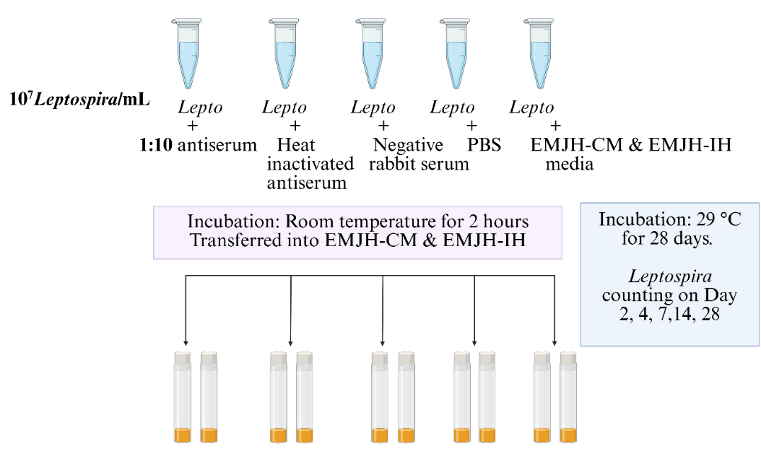
Figure 2.1: Methodological approach for Experiment 1: Optimization of Bacterial Incubation Duration.

Optimization of Bacterial Number:
One hundred μL of the Leptospira culture containing 10³ to 10⁷ bacteria/mL was treated with 100 μL of 1:10 anti-Leptospira polyclonal antiserum, negative rabbit serum, and PBS. All the samples were incubated at room temperature for 2 hours. Two hundred μL of each sample was inoculated into 4.5 mL of EMJH-CM medium and EMJH-IH medium tubes. All culture tubes were incubated at 29℃ for 14 days. Leptospira counting was performed on days 2,4,7,and 14. A schematic representation of the experiment is
shown in Figure 2.2
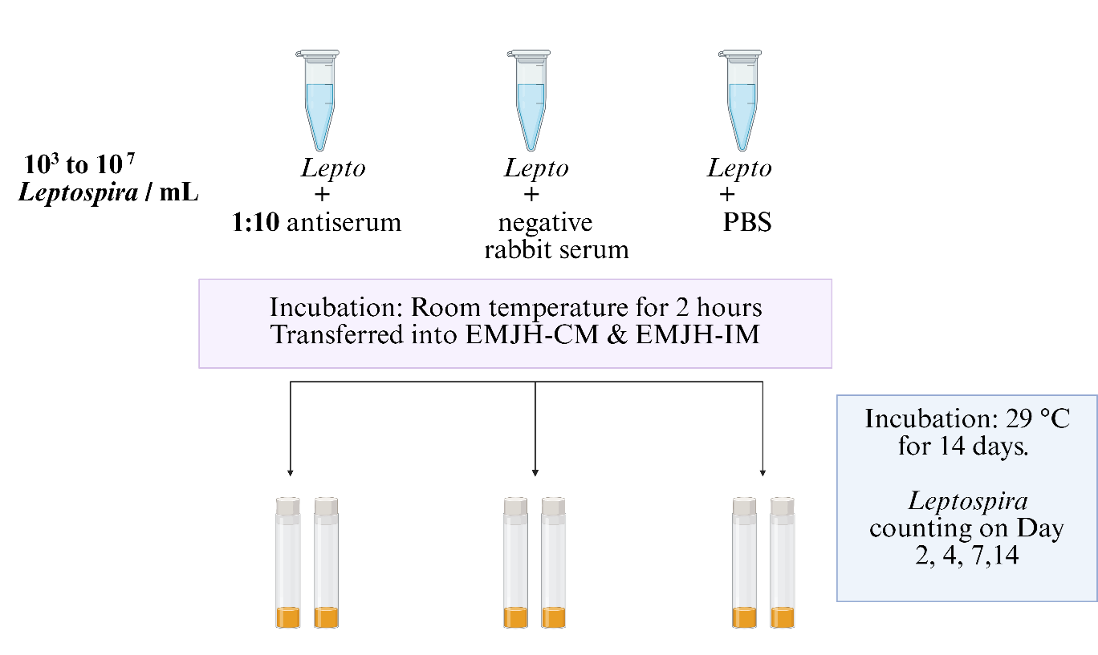
Figure 2.2: Methodological approach for experiment 2: optimization of bacterial number.

Optimization of Anti-Leptospira Antiserum Dilution:
One hundred μL of Leptospira culture containing 1 X 10⁴ bacteria was treated individually with 100 μL of five anti-Leptospira polyclonal antiserum dilutions: 1:10, 1:20, 1:40, 1:80, and 1:160. Negative serum and PBS treatment were used as controls. All the samples were incubated at room temperature for 2 hours. Two hundred μL of each sample was inoculated into 4.5 mL of EMJH-CM medium and EMJH-IH medium tubes. All culture tubes were incubated at 29°C for 14 days. Leptospira counting was performed on days 2, 4, 7, and 14. A schematic representation of the experiment is shown in Figure 2.3
Assessing the Reproducibility of the Experiment:
One hundred μL of Leptospira culture containing 1 × 10^4 bacteria was treated
with 100 μL of 1:10 polyclonal antiserum, negative rabbit serum, and PBS. All samples were prepared in five replicates and incubated at room temperature for 2 hours. Two hundred of each sample were inoculated into 4.5 mL of EMJH-CM and EMJH-IH medium in separate tubes. All culture tubes were incubated at 29℃ for 14 days. Leptospira counting was performed on days 2, 4, 7, and 14. A schematic representation of the experiment is shown in Figure 2.4.

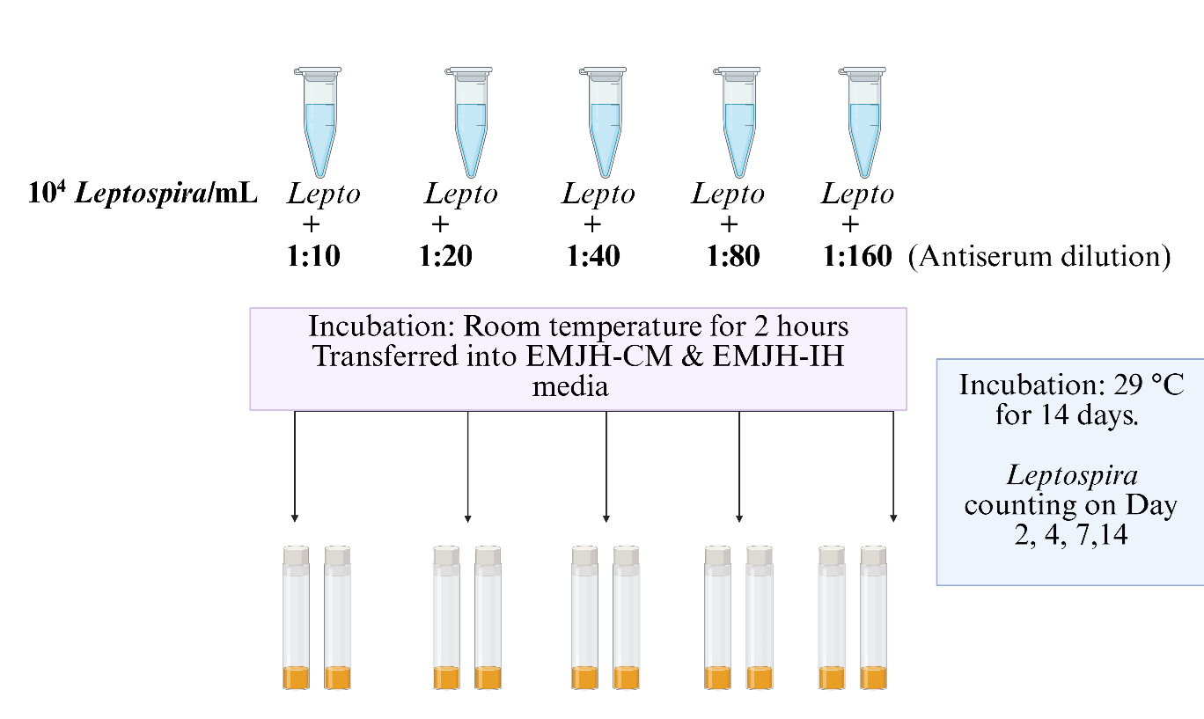

Figure 2.3: Methodological approach for experiment 3: optimization of anti-serum dilution

RESULTS

We developed a qualitative scoring method to assess the Leptospira growth inhibition, where Leptospira counts per mL were converted into a percentage (Table 1).

Table 1: Conversion of Leptospira per mL number to percentage count based on Leptospira growth observation upon its treatment with antiserum and negative controls. Here, “x” represents the Leptospira count per mL
Leptospira per mL | Leptospira count (%)
10⁴ ≤ x < 10⁵ | 25
10⁵ ≤ x < 10⁶ | 50
10⁶ ≤ x < 10⁷ | 75
10⁷ ≤ x | 100
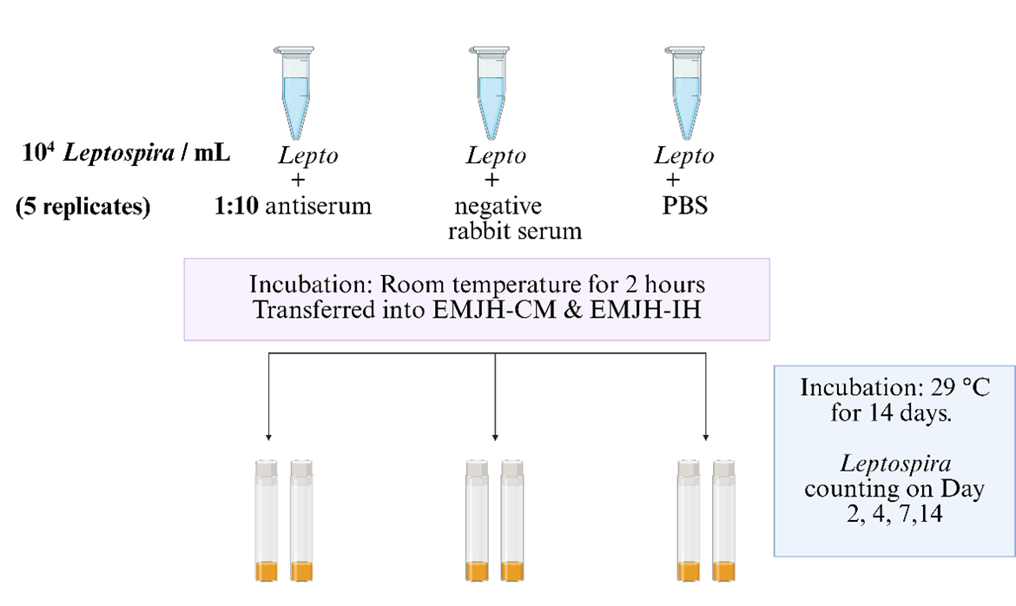Figure 2.4: Methodological approach for experiment 4: assessing the reproducibility of the experiment
Bacterial Incubation Period:

We first evaluated the incubation period to determine the optimal time frame after bacterial treatment with anti-serum. A fixed bacterial concentration of 10⁷ was used in this experiment. On days 2 and 4, in both antiserum- and heat-inactivated antiserum-treated samples, we observed no bacterial growth. On day 7, a 50% bacterial count was observed in antiserum-treated samples compared to 100% growth in the control. There was 25% growth on day 14 and 50% growth on day 21 in both antiserum- and heat-inactivated antiserum-treated samples, whereas 100% growth was observed in the control. On day 28, 100% bacterial growth was observed in the test samples and controls (Fig. 2.5).
When the bacterial incubation period was observed in EMJH-CM medium under similar conditions to those in EMJH-IH medium, no bacterial growth was observed on days 2, 4, and 7 in anti-serum-treated samples, compared to 100% growth in the control. However, a 50% bacterial count was observed in that sample on day 14, whereas the control showed 100% growth. We detected no bacterial growth in heat-inactivated antiserum-treated samples on days 2 and 4. Nevertheless, a 50% bacterial count was observed on day 7, followed by 100% growth on day 14 for that sample, compared to 100% growth in the control. The growth was 100% in antiserum and heat-inactivated antiserum on days 21 and 28. Considering the 100% growth on day 21 in both treated and control samples, we assessed that day 14 was the maximum time period we incubated cultures at which bacterial growth was inhibited by at least 75% in antiserum-treated samples in EMJH-IH media and by 50% in EMJH-CM media (Fig. 2.6)
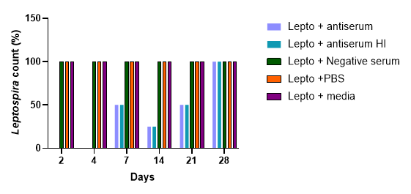 Figure 2.5: Percentage of Leptospira growth upon treatment of 10⁷ Leptospira with 1:10 antiserum compared to negative controls in EMJH-IH media.

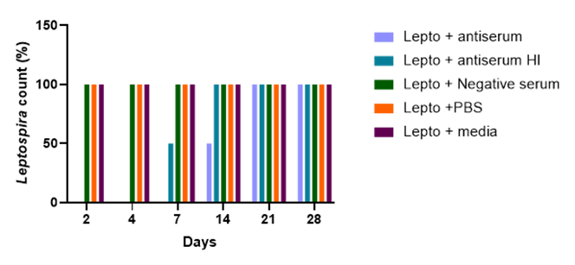
Figure 2.6. Percentage of Leptospira growth upon treatment of 10⁷ Leptospira with 1:10 antiserum compared to negative controls in EMJH-CM media
Optimization of Bacterial Numbers:
After obtaining day-14 as the optimized bacterial incubation period (Fig. 5 and 6), we attempted to evaluate a suitable bacterial number for conducting in vitro LGIA in EMJH-IH medium using culture containing 10³ to 10⁷ bacteria. We detected 25% bacteria in 10³ and 10⁴ bacterial number samples, upon anti-serum treatment on day 14 in EMJH-IH media. The bacterial count was 50% for the 10⁵, 10⁶, and 10⁷ bacterial samples treated with antiserum; 100% bacterial growth was observed in the negative control on day 14 for all samples (Fig. 2.7).
Upon optimizing the bacterial number in EMJH-CM media, the results were
identical to those in EMJH-IH media (Figs. 2.7 and 2.8). Twenty-five percent of bacteria were detected in 10³ and 10⁴ bacterial samples upon anti-serum treatment, followed by 50% in 10⁵ to 10⁷ bacterial inoculum samples on day 14. One hundred percent bacterial growth was observed in the negative control on day 14. Based on this observation, we determined that 10⁴ bacterial numbers were suitable for this assay, as only 25% of the bacterial count was observed on day 14 after antiserum treatment in both media.

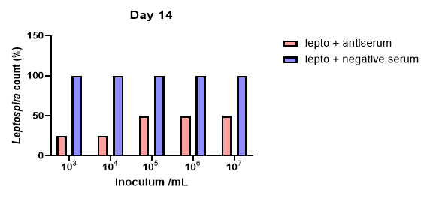
Figure 2.7. Percentage of Leptospira growth upon treatment of 10³ to 10⁷ Leptospira with 1:10 antiserum compared to negative controls for 14 days of incubation in EMJH-IH media
Optimization of Anti-Serum Dilution:
After optimizing a 14-day bacterial incubation period and bacterial concentration,
we attempted to determine the antibody dilution that effectively inhibits bacterial growth under previously optimized conditions. On day 14, we observed no growth in 1:10 and 1:20 anti-serum-treated samples compared to 100% growth in the control. However, there was a 25% bacterial count in the 1:40 dilution, followed by a 50% count in the 1:80 and 1:160 antiserum dilutions. The negative controls showed 100% growth on day 14 (Fig.2.9). Based on this observation, we determined that a 1:10 dilution of the antiserum was required to inhibit 10⁴ bacteria on day 14 for this assay.

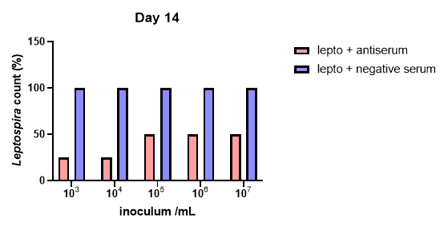
Figure 2.8. Percentage of Leptospira growth upon treatment of 10³ to 10⁷ Leptospira with antiserum compared to negative controls for 14 days of incubation in EMJH-CM media.
Assessment of the Reproducibility of the Assay:

After optimizing the bacterial incubation period, bacterial number, and antiserum dilutions to conduct the in vitro LGIA, we performed this experiment under previously optimized conditions where 10⁴ bacteria were treated with 1:10 antiserum dilution for 14 days with replicates to assess the reproducibility of our data (Fig. 2.10). We observed 25% bacterial count in antiserum treated samples on day 14 compared to 100% growth in controls indicating significant difference in Leptospira growth inhibition by antiserum compared to the negative serum on day 14 (P <0.05).
When we assessed the reproducibility of the assay using EMJH-CM media, we
observed no bacterial growth in either antibody-treated samples or controls by day 14. Based on this, when we inoculated 10⁴ to 10⁷ bacteria in EMJH-CM media for further confirmation, we observed 100% bacterial growth on day 7 in 10⁵ to 10⁷ bacterial samples and no growth in 10⁴ sample. However, 10⁴ culture sample showed 100% growth on day 14.

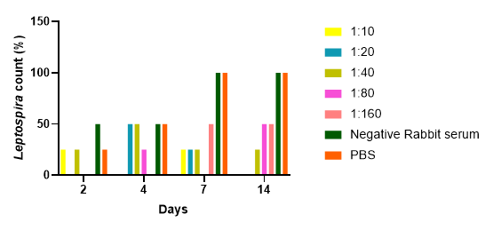

Figure 2.9. Percentage of Leptospira growth upon treatment of 10⁴ Leptospira per mL with different antiserum dilutions compared to negative controls for 14 days of incubation in EMJH-IH media.

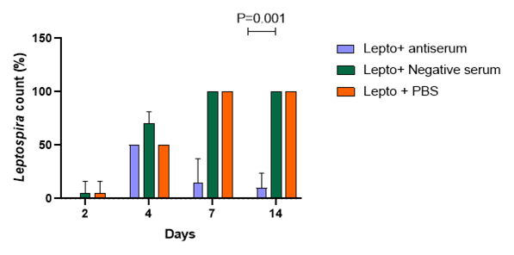
Figure 2.10. Percentage of Leptospira growth upon treatment of 10⁴ Leptospira per mL with 1:10 antiserum dilutions compared to negative controls for 14 days of incubation using five replicates in EMJH-IH media (P<0.05)

DISCUSSION
An in vitro Leptospira growth inhibition protocol, conducted by Tripathy, D.N., et al. (1973) to evaluate the bacterin's efficacy and neutralizing antibody response after vaccination with Pomona and Hardjo bacterin to cattle and rabbits, demonstrated complete or partial bacterial growth inhibition even after 8 months of primary vaccination over a two-week test incubation period. Correia et al. (2017) emphasized the importance of growth inhibition technique in evaluating vaccine-induced protective responses, demonstrating Leptospira growth inhibition using inactivated serum from vaccinated horses over a 10-day incubation period. However, these previous studies lack consistent procedures using optimal bacterial concentration, antibody dilutions, or a specific incubation period. In this study, we optimized LGIA, where the bacterial number, anti-serum dilution, and incubation period were determined to assess the bacterial growth inhibition following anti-serum treatment. We concluded that 10⁴ LIM treated with a 1:10 dilution of rabbit anti-LIM polyclonal serum for 14 days was able to inhibit 75% bacterial growth compared to the control, where 100% bacterial growth was observed.

When 10⁷ bacteria were treated with 1:10 antibody dilutions for 28 days, we observed 75% inhibition of bacterial growth on day 14. However, on day 21, the bacterial growth inhibition decreased to 50%. This suggests that after 14 days, the serum becomes less effective or inactive, and bacteria that were not inhibited start replicating, indicating an increase in bacterial growth after day 14. We concluded that day 14 would be an optimal incubation period for assessing the growth inhibition activity of the antibody-treated Leptospira culture. However, the required incubation time can vary depending on the generation time of the Leptospira species. The average generation time for pathogenic Leptospira species is 12-18 hours(Adler, 2015a). However, species such as L. borgpetersenii, which typically require additional growth factors to grow, may grow slowly due to their fastidious nature(Hornsby et al., 2020). In this case, bacterial growth in the controls may not be observed until after 14 days and requires additional time. Thus, incubation time needs to be standardized and validated for specific species.
We also tested the required number of Leptospira inoculum to achieve an efficient bacterial growth inhibition. To determine the bacterial concentration, it is necessary to understand the bacterial generation time to optimize the effective bacterial number that is inhibited by the antiserum. As mentioned above, slow-growing species may take up to several weeks to grow. If the bacterial concentration used for the optimization assay is minimal, growth detection through dark-field microscopy may be compromised. On the other hand, using high bacterial concentration may lower the assay’s sensitivity as antibodies may not be able to neutralize the higher number of bacteria effectively. Therefore, the assessments may underestimate the protective response of vaccines. Thus, optimizing bacterial concentration for specific species is required for this assay to be functional. In our case, when 10³ to 10⁷ bacteria were treated with 1:10 antiserum, we observed 75% growth inhibition at 103 and 104 bacterial concentrations, while 10⁵ to 10⁷ bacterial concentrations exhibited 50% growth inhibition on day 14. However, 10³ bacterial numbers are not sufficient to conduct this assay, as microscopic detection can be challenging with lower bacterial numbers. Thus, after optimizing the 14-day incubation period, we concluded that 10⁴ would be a likely suitable bacterial number to observe maximum growth inhibition after anti-serum treatment.
After optimizing the incubation period and bacterial number, we concluded that a 1:10 antibody dilution was effective in inhibiting bacterial growth over 14 days of incubation, as more diluted antibodies appeared to have a less inhibitory effect on bacterial growth compared to a 1:10 dilution. To apply this assay for other Leptospira species, the serum titer should be determined first, after which the appropriate titer that inhibits the maximum bacterial growth can be used.
Reproducibility experiments confirmed that 10⁴ bacterial numbers, 1:10 antibody dilution, and 14-day incubation are optimized conditions for conducting this assay using the same strain and antiserum. We also conclude that EMJH-IH is superior to EMJH-CM for this assay. When we performed this experiment using EMJH-CM media, we did not observe any growth in this medium even on day 14. Further evaluation revealed that 10⁴ bacterial samples exhibited 100% growth on day 14, suggesting that EMJH-CM media may facilitate slow bacterial growth, as it lacks serum and additional supplements.
Several techniques have been used in the serological evaluation of antibody responses in vaccinated animals, including ELISA and Microscopic Agglutination Test (MAT). However, due to their limitations, such as ELISA being a single-antigen, epitope-specific method, the development of monoclonal antibodies for each specific serovar makes it less feasible for practical approaches (Novak, 2023). Though MAT is widely recommended as a diagnostic test for leptospirosis, IgM is primarily responsible for agglutination reactions. Thus, for a specific humoral response after vaccination, MAT is inadequate in evaluating late antibody responses, and a low level of IgM may not be detectable or may only be detectable for a short period (Hartman et al., 1984)
Therefore, the present study demonstrates that an in vitro Leptospira growth inhibition assay (LGIA) can be an effective tool for detecting protective responses in vaccinated animals, providing a presumptive evaluation of vaccines. It is a cost-effective and straightforward assay that can be used for all serotypes.
While MAT is used to confirm the presence of antibodies after vaccination or animal exposure to Leptospira, it cannot determine if the antibodies confer protection. Whereas LGIA provides further confirmation of the vaccine's response in determining the efficacy of the antibody that inhibits bacterial growth, thus aiding in assessing the protective response of vaccines.
The LGIA assay described in this study provides semi-quantitative analysis because it involves the titration of the antibody that can potentially prevent infection, and it further evaluates the maximum growth-inhibitory antibody titer at which bacterial growth can be inhibited. The limitation of this assay is that it needs to be standardized for each specific species, depending on the species’ generation time. Moreover, the Leptospira counting procedure is very laborious. Thus, digital PCR can be used as an alternative to counting, as it provides absolute quantification of DNA present in the sample. Thus, it offers accuracy, faster performance, and higher sensitivity. Additionally, viability PCR is also an option, which selectively performs live cell amplification and excludes dead cells (Fittipaldi et al., 2012).

REFERENCES
Adler, B. (2015b). Leptospira and Leptospirosis Current Topics in Microbiology and Immunology, 387. https://doi.org/https://doi.org/10.1007/978-3-662-45059-8_1 (Springer, Berlin, Heidelberg)
Adler, B., & de la Pena Moctezuma, A. (2010). Leptospira and leptospirosis. Vet Microbiol, 140(3-4), 287-296. https://doi.org/10.1016/j.vetmic.2009.03.012
Akkermans, A., Chapsal, J. M., Coccia, E. M., Depraetere, H., Dierick, J. F., Duangkhae, P., Goel, S., Halder, M., Hendriksen, C., Levis, R., Pinyosukhee, K., Pullirsch, D., Sanyal, G., Shi, L., Sitrin, R., Smith, D., Stickings, P., Terao, E., Uhlrich, S.,…Webster, J. (2020). Animal testing for vaccines. Implementing replacement, reduction and refinement: challenges and priorities. Biologicals, 68, 92-107. https://doi.org/10.1016/j.biologicals.2020.07.010
Aydin, S., Emre, E., Ugur, K., Aydin, M. A., Sahin, I., Cinar, V., & Akbulut, T. (2025). An overview of ELISA: a review and update on best laboratory practices for quantifying peptides and proteins in biological fluids. J Int Med Res, 53(2), 3000605251315913. https://doi.org/10.1177/03000605251315913
Balks, E., Gyra, H., Kobe, B., Cussler, K., & Werner, E. (2013). Development and validation of a serological potency test for the release of Leptospira vaccines--requirements in the European Union. Biologicals, 41(5), 325-329. https://doi.org/10.1016/j.biologicals.2013.06.011
Colby, L. A., Quenee, L. E., & Zitzow, L. A. (2017). Considerations for Infectious Disease Research Studies Using Animals. Comparative medicine, 67(3).
Correia, L., Martins, G., & Lilenbaum, W. (2017). Detection of anti-Leptospira inhibitory antibodies in horses after vaccination. Microb Pathog, 110, 494-496. https://doi.org/10.1016/j.micpath.2017.07.038
Fittipaldi, M., Nocker, A., & Codony, F. (2012). Progress in understanding preferential detection of live cells using viability dyes in combination with DNA amplification. J Microbiol Methods, 91(2), 276-289. https://doi.org/10.1016/j.mimet.2012.08.007
Goddard, R. D., Hopkins, I. G., & Thörnton, D. H. (1986). The development of a potency test for Leptospira hardjo vaccines: a comparison of protection in calves and serology in guinea-pigs. Journal of Biological Standardization, 14(4), 337-344. https://doi.org/https://doi.org/10.1016/0092-1157(86)90021-1
Gomes-Solecki, M., Santecchia, I., & Werts, C. (2017). Animal Models of Leptospirosis: Of Mice and Hamsters. Front Immunol, 8, 58. https://doi.org/10.3389/fimmu.2017.00058
Hartman, E. G., M. van Houten, J.F. Frik, & DONK, J. A. V. D. (1984). Humoral immune response of dogs after vaccination against leptospirosis measured by an IgM- and IgG-specific ELISA. Veterinary Immunology and Immunopathology, 7(3-4), 245-254. https://doi.org/https://doi.org/10.1016/0165-2427(84)90083-7
Hornsby, R. L., Alt, D. P., & Nally, J. E. (2020). Isolation and propagation of leptospires at 37 degrees C directly from the mammalian host. Sci Rep, 10(1), 9620. https://doi.org/10.1038/s41598-020-66526-4
Novak, A. (2023). Innate and adaptive immune responsiveness to Leptospira in dogs: In vitro alternatives to animal testing in Leptospira vaccine manufacturing. Doctoral thesis 1 (Research UU / Graduation UU), Universiteit Utrecht, Utrecht, 194. https://doi.org/https://doi.org/10.33540/1682
Novak, A., Pennings, J. L. A., van der Maas, L., Meiring, H. D., Ludwig, I., Verkoeijen, S., Rutten, V., Broere, F., & Sloots, A. (2022). Transcriptome and proteome analysis of innate immune responses to inactivated Leptospira and bivalent Leptospira vaccines in canine 030-D cells. Sci Rep, 12(1), 13418. https://doi.org/10.1038/s41598-022-16457-z
Ruby, K. W., Cardella, M. A., & Knudtsont, W. U. (1992). Assay for Measuring Relative Potency of Leptospira l Bacterins Containing Serovar Pomona. Biologicals, 20, 259-266. https://doi.org/https://doi.org/10.1016/s1045-1056(05)80045-4
Ruby, K. W., & Srinivas, G. B. (2013). Development of in vitro assays for measuring the relative potency of Leptospira l bacterins containing serogroups canicola, grippotyphosa, icterohaemorrhagiae, and pomona. Biologicals, 41(5), 308-314. https://doi.org/10.1016/j.biologicals.2013.06.007
Tripathy, D. N., Hanson, L. E., & Mansfield, M. E. (1973). Growth inhibition test for measurement of immune response of animals vaccinated with Leptospira l bacterins. Proc Annu Meet U S Anim Health Assoc(77), 113-118. https://www.ncbi.nlm.nih.gov/pubmed/4534706
Valente, M., Bramugy, J., Keddie, S. H., Hopkins, H., Bassat, Q., Baerenbold, O., Bradley, J., Falconer, J., Keogh, R. H., Newton, P. N., Picardeau, M., & Crump, J. A. (2024). Diagnosis of human leptospirosis: systematic review and meta-analysis of the diagnostic accuracy of the Leptospira microscopic agglutination test, PCR targeting Lfb1, and IgM ELISA to Leptospira fainei serovar Hurstbridge. BMC Infect Dis, 24(1), 168. https://doi.org/10.1186/s12879-023-08935-0
Walker, A., & Srinivas, G. B. (2013). Opportunities and strategies to further reduce animal use for Leptospira vaccine potency testing. Biologicals, 41(5), 332-337. https://doi.org/10.1016/j.biologicals.2013.06.006

CHAPTER 3
To define the parameters for the detection of intracellular LEPTOSPIRA.

ABSTRACT
The macrophage-infection model serves as one approach to evaluate antibody efficacy in the opsonized bacterial phagocytosis process, thereby preventing bacterial growth. Previous studies on Leptospira-macrophage interactions have yielded contradictory findings regarding the Leptospira phagocytosis process. Thus, we attempted to determine the parameters for detecting intracellular Leptospira within the human monocytic cell line, laying the groundwork for a macrophage-infection model to study the protective efficacy of antibodies in antibody-driven phagocytosis, aiding in controlling bacterial growth. We noted that FITC-conjugated antibodies against Leptospira were not a suitable detection tool for intracellular Leptospira due to their excessive background fluorescence. Alternatively, we observed that CFSE staining for Leptospira was the most effective way of detecting intracellular Leptospira. We also observed Leptospira within the THP-1 cells; however, the failure of gentamicin in eliminating extracellular bacteria after infection made the bacterial location uncertain, regarding whether they were within the THP-1 cells or on the cell surface. While establishing these detection parameters, we concluded that the macrophage-infection model may not be a suitable option in evaluating antibody efficacy in preventing bacterial growth via antibody-mediated phagocytosis due to the laborious nature of the method.

INTRODUCTION
Host-pathogen interactions are highly dynamic processes that encompass the pathogen's invasion, dissemination within the host through various mechanisms, host strategies such as immune system activation, and elimination of the pathogen(Jo, 2019). Understanding the factors that play in these interactions is crucial, as it provides a deeper understanding of microbial pathogenesis, thereby aiding in the development of improved and novel therapies to prevent infectious diseases (Rana et al., 2015). Several studies have been published on Leptospira and host interactions to get a deeper understanding of its pathogenic mechanisms. Many of these studies have utilized immune cells, such as human and murine macrophages, to evaluate the phagocytosis of Leptospira and its association with intracellular compartments (Chen et al., 2017; Fabrice Merien et al., 1997; Jin et al., 2009; Liu et al., 2007). Additionally, epithelial and endothelial cell lines have been used to study Leptospira outer membrane proteins in host binding and host responses (Breiner et al., 2009; Takahashi et al., 2022). In this introduction, a summary of studies describing Leptospira’s interactions with various cell lines is provided to gain a better understanding of Leptospira-host interactions.

Leptospira Interactions with Epithelial and Endothelial Cell Lines:
In one of the earliest studies (S. A. Ballard, 1986) Leptospiral adhesion to renal tubular epithelial cells, which is related to its virulence, was explored to unravel the mechanisms involved in establishing a renal carrier state. In this study, the researchers infected primary mouse renal proximal tubular epithelial cell cultures with virulent and avirulent variants of Leptospira interrogans serovar Copenhageni, which had been previously treated with the homologous antibody, to evaluate the effect of the antibody on the adhesion of Leptospira to cells. It demonstrated persistent adhesion for 24 hours in the case of virulent strain. In contrast, no adhesion was observed in the case of the avirulent strain, suggesting that a subagglutinating concentration of homologous antibody enhanced the attachment of the virulent strain to the cells but had no effect on the attachment of the avirulent strain.
In another study (Breiner et al., 2009), the researchers demonstrated that upon infecting EA. hy926 (human endothelial) and HEp-2 (human epithelial) with virulent L. interrogans serovar Copenhageni; this serovar is bound firmly to both cell lines. When cells were pretreated with trypsin, a proteolytic enzyme, and heparinase, adhesion was significantly reduced, indicating that proteoglycans, especially with heparan sulfate chains, are key components in the binding of Leptospira to host cells. Additionally, the bacteria appear to bind to extracellular matrix (ECM) molecules, such as fibronectin and laminin, suggesting multiple receptor types for flexibility in binding to various host types. When bacteria were pretreated with exogenous soluble glycosaminoglycans (GAGs) before cell infection, they showed reduced binding, as soluble GAGs functioned as competitive inhibitors for bacterial attachment to the cells, suggesting that GAG binding may facilitate kidney colonization (Breiner et al., 2009).
A comparative analysis of the attachment of two pathogenic Leptospira serovars, L. interrogans serovar Pomona and L. borgpetersenii serovar Jules, to the mammalian HEp-2 cells and their extracellular matrix components showed that when binding to fibronectin and integrins was assessed upon cell infection, both strains exhibited significantly increased binding to both ECM components. This study suggested that Fibronectin binding may be related to the higher virulence, and integrin binding has a potential role in tissue colonization (Andrade & Brown, 2012)
It was shown that specific cell-surface receptors, such as VE-cadherin and P-cadherin, are involved in the L. interrogans binding process to EA. hy926, HMEC-1 endothelial cells, and Hep-2, HK-2 epithelial cells, and may play a crucial role in strong bacterial binding to cells (Evangelista et al., 2014). Pathogenic species enable binding more effectively than non-pathogenic L. biflexa. N-cadherin was found in all cell lines used; however, when purified VE-cadherin was blocked with an anti-VE-cadherin antibody, bacterial binding was decreased, suggesting that bacterial binding to VE cadherin is crucial for adhesion, as it leads to disrupting cell junctions and allowing efficient bacterial dissemination (Evangelista et al., 2014).
Another study reported that Leptospira can capture plasminogen (PLG) and generate plasmin (PLA) associated with its surface, suggesting a significant contribution to facilitating penetration and invasion (Vieira et al., 2009). Additionally, an interaction of L. interrogans serovar Pomona with Human umbilical vein endothelial cells (HUVECs), demonstrated that when Leptospira were coated with PLG, they penetrated and migrated faster across HUVEC monolayers, especially with PLA activation. Real-time PCR for PLG activators (uPA and tPA) showed that when PLA-coated bacteria were exposed to the HUVEC cells, it increased the transcription of these activators, suggesting the generation of more PLA for faster endothelial barrier penetration by facilitating ECM degradation. This PLA-associated Leptospira upregulates the metalloproteinases (MMPs) transcription, which is involved in breaking down the ECM, aiding in initiating a proteolytic cascade for tissue invasion (Vieira et al., 2013).
Evaluation of the responses of Human dermal microvascular (HMEC-1) and macrovascular endothelial cells (EA. hy926) to pathogenic strain, L. interrogans serovars Canicola and Copenhageni, and non-pathogenic L. biflexa serovar Patoc, showed that pathogenic Leptospira altered gene expression profiles related to cytoskeleton and adhesion regulation, suggesting disintegration of the endothelial barrier, which aids in bacterial dissemination. Trans-endothelial migration studies revealed that pathogenic strains were able to transverse the endothelial layers efficiently compared to non-pathogenic strains (Martinez-Lopez et al., 2010). However, when proteoglycan synthesis was inhibited by β-xyloside, bacterial binding to the cells decreased; yet, an endothelial layer breakage was still observed, suggesting that non-proteoglycan receptors are also crucial for bacterial adhesion and invasion (Martinez-Lopez et al., 2010).
In addition to evaluating host-specific cell receptors that are responsible for the bacterial binding, the role of L. interrogans’ major outer membrane proteins (OMPs) was also analyzed for adhesion to the various cell lines(Takahashi et al., 2022). It was observed that the virulent L. interrogans Copenhageni binds very strongly to all major cell lines, such as endothelial: EA. hy926, HMEC-1, HULEC5a; epithelial: HEK293T, MDBK; fibroblast: E. Derm, BHK-2. When blocking OMPL1 and LIPL41 proteins with their respective polyclonal antibodies, bacterial adhesion to cells decreased in EA. hy926 and HEK293T cells, suggesting that OmpL1 and LipL41 are the major proteins with a dominant binding profile to all cell lines. OmpL37, LipL21, and LipL46 bound selectively to the cell lines (Takahashi et al., 2022). This study suggests that specific interactions mediate the binding of bacterial outer membrane proteins to host cell receptors. Therefore, OmpL1 and LipL41 could be potential targets for the development of therapeutic vaccines for Leptospirosis (Takahashi et al., 2022).
In another study, evaluating the interaction of L. interrogans serovar Manilae with proximal renal tubule epithelial cells (TCMK-1) revealed that infection triggers ROS production and DNA cleavage in the cell, leading to cell death (Yamaguchi et al., 2018). However, the oxidative stress response was delayed in low-passage infected cells. When low-passage infected cells were treated with the PARP-1 enzyme inhibitor PJ34, an enzyme responsible for caspase-independent cell death, it was found that PJ34 inhibited cell death. This suggests that a virulent strain may manipulate the host's stress response, thereby avoiding cell death and enabling long-term survival (Yamaguchi et al., 2018). Leptospira Interactions with Immune Cells:
A study in 1997 (Fabrice Merien et al., 1997) aimed to investigate the immune
interactions between pathogenic L. interrogans serovar icterohaemorrhagiae and murine monocyte-macrophage-like cells (J774A.1). Double-fluorescence immunolabeling microscopy demonstrated that virulent Leptospira were found entering the macrophages. At the same time, the avirulent strain had minimal to no uptake in macrophages. The internalization of this virulent strain was significantly reduced with higher passage of the bacteria. Apoptosis in macrophages was observed only in passage 0 strain; in higher passages, no apoptosis was observed. This illustrates the correlation between host cell invasion and macrophage apoptosis. Cells pre-treated with cytochalasin D, a potential inhibitor of actin polymerization, were still involved in bacterial invasion, suggesting that actin microfilaments are not essential for bacterial entry, as it is via receptor-driven phagocytosis.
Upon examining the internalization of L.interrogans serovar Pomona in J774A.1 cell line, researchers have observed membrane-bound phagosomes containing multiple Leptospira. This study also claimed no involvement of actin-dependent polymerization, suggesting different internalization mechanisms depend on host cell type. Leptospira -containing phagosome fusion with lysosome was observed via lysosomal marker Lamp1, suggesting that it may provide a hostile environment for bacteria to survive, leading to adaptive immune responses (Liu et al., 2007). However, another study showed that when mouse bone-marrow-derived macrophages (BMMs) were infected with L. interrogans serovar Manilae, the recruitment of lysosomal proteases and acidification were slower, indicating that Leptospira-containing phagosomes avoided complete fusion with the lysosome(Toma et al., 2011). A viable count assay confirmed that the bacterial number increased within the macrophages. This study suggested that bacterial replication can occur inside a membrane-bound compartment (Toma et al., 2011).
On the other hand, another study demonstrated that, upon infection of Mouse RAW264.7 and bone marrow–derived macrophages (BMDMs), human THP-1 macrophages, with L. interrogans serovars Manilae, Copenhageni, Icterohaemorrhagiae, and saprophytic L. biflexa serovar Patoc, both pathogenic and saprophytic bacteria actively enter and exit macrophages without any intracellular replication. It was observed that the intracellular bacterial load was reduced between 3 and 6 hours post-infection, as indicated by bioluminescent monitoring. A small number of bacteria were observed within the macrophages, which survived for up to 48 hours without replicating. The exit of the live bacteria from macrophages was confirmed by observing viable Leptospira in the culture supernatants after performing a gentamicin protection assay at 6 hours post-infection, suggesting that the rapid reduction in bacterial number within macrophages is due to the bacterial exit and not because of macrophage-related microbicidal killing (Santecchia et al., 2022).
Bovine macrophages infected with L. interrogans serovar Pomona virulent low passage P1 and culture-attenuated P-19 strains showed that, in response to infection, macrophages tend to form extracellular traps (Nagel et al., 2019). Higher internalization of P1 than P19 was observed even when the phagocytosis process was inhibited with cytochalasin D. This suggests that Leptospira may use a phagocytosis-independent entry route for the P1 strain. Virulent strain P1 tends to colocalize with the acidic compartment and with the late endosome, suggesting Leptospira may survive within the endolysosomal pathway (Nagel et al., 2019). On the contrary, another study suggests that P1+, a highly virulent strain of Leptospira, tends to evade the complement system and is less adherent to, and interacts less with, human macrophages (Giraud-Gatineau et al., 2024). This study suggested that highly virulent Leptospira species may be involved in immune evasion by escaping phagocytosis, thereby facilitating their dissemination within the host (Giraud-Gatineau et al., 2024).
Upon evaluation of the apoptotic effect of L. interrogans serovar Lai in J774A.1 cell and primary mouse peritoneal macrophages showed a robust induction of cell apoptosis with these bacteria, whereas no cell death was observed with L. biflexa (Jin et al., 2009). When caspase-8 was inhibited, it blocked the activation of caspase-3 and caspase-6, which reduced the cell apoptosis, indicating that L. interrogans may trigger apoptosis in macrophages via the extrinsic pathway. Thus, the evaluation of the internalization of Leptospira can help analyze tissue-specific damage (Jin et al., 2009). On the other hand, a study reported that L. interrogans, with three pathogenic serovars — Manilae, Icterohaemorrhagiae, and Copenhageni, when interacting with murine, human, bovine, and hamster bone marrow-derived macrophages, prevents macrophage death (Bonhomme et al., 2023). No caspase 3 or 7 cleavage was observed, suggesting the absence of apoptosis. However, Leptospira induces IL-1β secretion in murine macrophages, which is associated with a form of cell death known as pyroptosis. Nevertheless, this response is mild and occurs through non-lytic caspase 8-dependent gasdermin D pore formation, thereby not causing cell death, which suggests its role in bacterial persistence within the host cells (Bonhomme et al., 2023).

Purpose of The Study and Specific Aim:
As stated in Chapter 1, one of the major goals of our laboratory is to develop in vitro assays to assess the efficacy of antibodies in preventing Leptospira infection. Macrophage-infection models are not optimized for detecting intracellular Leptospira and have shown to have inconsistent results.
Phagocytosis is a process in which immune cells, such as macrophages, neutrophils, and dendritic cells, engulf pathogens to kill them (Rabinovitch, 1995; Uribe-Querol & Rosales, 2017). Phagocytosis typically begins when immune cells recognize microbial components or pathogen-associated molecular patterns (PAMPs) through pattern recognition receptors (PRRs), which enable them to engulf the pathogen (Flannagan et al., 2012; Uribe-Querol & Rosales, 2017). However, in antibody-mediated phagocytosis, microbes are first opsonized with specific antibodies. These opsonized microbes are then detected by Fc receptors on the immune cells, which further involves the engulfment of the microbes (Flannagan et al., 2012; Uribe-Querol & Rosales, 2017) (Fig. 3.1) However, in some cases, it is uncertain if the antibody-coated Leptospira blocks the engulfment by macrophages and avoids internalization (Fig. 3.1). lo
In one of the earliest studies (Boyao Wang et al., 1984), phagocytosis of L. interrogans serovar Icterohaemorrhagiae by human monocytes and monocyte-derived macrophages was evaluated. This study reported that upon treatment of these bacteria with normal human serum collected from healthy donors, the Leptospira was not ingested and killed by the immune cells. However, when the bacteria were opsonized with immune serum containing serovar-specific antibody, this enabled the phagocytosis
process, followed by the killing of the bacteria (Boyao Wang et al., 1984).

Therefore, we aimed to define the parameters for the detection of intracellular
Leptospira for establishing a macrophage-infection model, which is essential in facilitating further evaluation of antibody efficacy in preventing bacterial growth in antibody-mediated Leptospira phagocytosis.

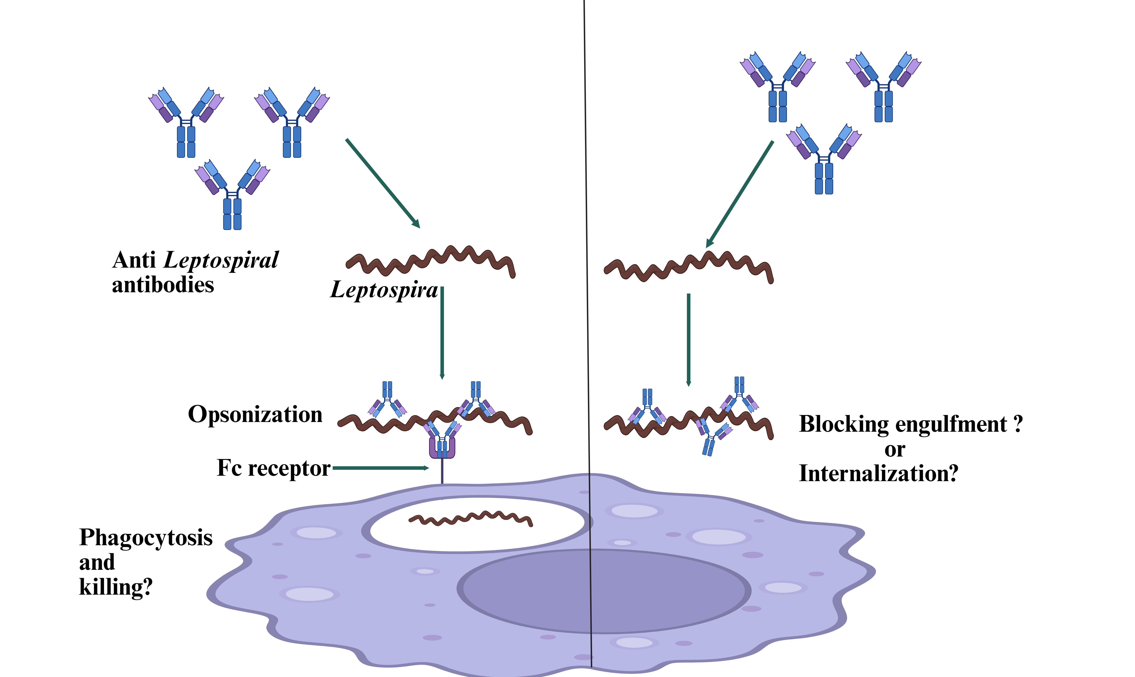

Figure 3.1: Schematic representation of the antibody-mediated phagocytosis process

MATERIALS AND METHODS

Leptospira Strain and Culture:
A low passage (P5-P12) Leptospira interrogans serovar Manile (LIM) strain L495 (kindly provided by Dr. Andre Grassmann, University of Connecticut) was used in this study. LIM was recovered from liquid nitrogen storage by transferring 1 mL of thawed frozen stock to 4.5 mL of liquid Ellinghausen-McCullough-Johnson-Harris (EMJH) media supplemented with commercially available Leptospira enrichment EMJH at 29°C incubation (BD, NJ, USA). The Leptospira counting was performed using the Petroff-Hausser chamber under dark-field microscopy.
Cell Line and Culture:
A human monocytic cell line (THP-1, ATCC TIB-202) was purchased from
ATCC and grown in RPMI 1640 liquid medium (Gibco, USA), supplemented with 10% fetal bovine serum, 10 mM HEPES, and 1 mM sodium pyruvate. Cells were maintained at 37˚C in an atmosphere of 5% CO_{2.}

Detection of Intracellular Leptospira Using FITC-Conjugated Anti-Leptospira Polyclonal Antibody:
THP-1 cells (1 × 10^5) were seeded in a 24-well plate. Cells were infected with LIM at an MOI of 100 (1 × 10^7) for 4 hours and 18 hours, followed by 1 hr of gentamicin treatment (Gibco, USA) at 100 μg/ml, following a previously described (Giraud-Gatineau et al., 2024). A sample, co-cultured with THP-1 cells and LIM, was left untreated with gentamicin. Uninfected cells were used as a negative control. After gentamicin treatment, the cells were centrifuged at 1200 RPM for 5 minutes and then resuspended in 100 μL of fresh RPMI 1640 cell media. To perform an immunofluorescence assay (IFA), IFA slides were prepared by smearing 15 μl of the cell suspension from each well. After allowing it to air dry, cells were fixed with 4% paraformaldehyde at room temperature for 30 minutes.(Chen et al., 2017). After fixation, cells were washed three times with PBS. Cells were permeabilized using 0.1% Triton X-100 in PBS for 30 minutes at room temperature.(Chen et al., 2017). Cells were washed three times with PBS. Cells were incubated with 15 μL of 1:2000 diluted FITC-conjugated rabbit polyclonal anti-Leptospira antibodies for 1 hour at room temperature. Cells were washed three times with PBS. Finally, cells were observed after adding mounting medium and a coverslip. The slides were observed using fluorescence microscopy. A schematic representation of this experiment is shown in Figure 3.2.
Evaluation of CFSE Labeling Efficacy and LIM Motility:
LIM (1 × 10^7) were incubated with 5 μM, 50 μM, 500 μM, and 1000 μM CFSE (Sigma-Aldrich) for 30 minutes at room temperature (Giraud-Gatineau et al., 2024). After 30 minutes, LIM was centrifuged at 14000 g for 5 minutes. The pellet was washed three times with PBS and then resuspended in 100 μL of fresh RPMI 1640 medium. 15 μL of this suspension was placed on a slide and observed using fluorescence microscopy after placing a coverslip. Figure 3.3 shows the schematic representation of this experiment.
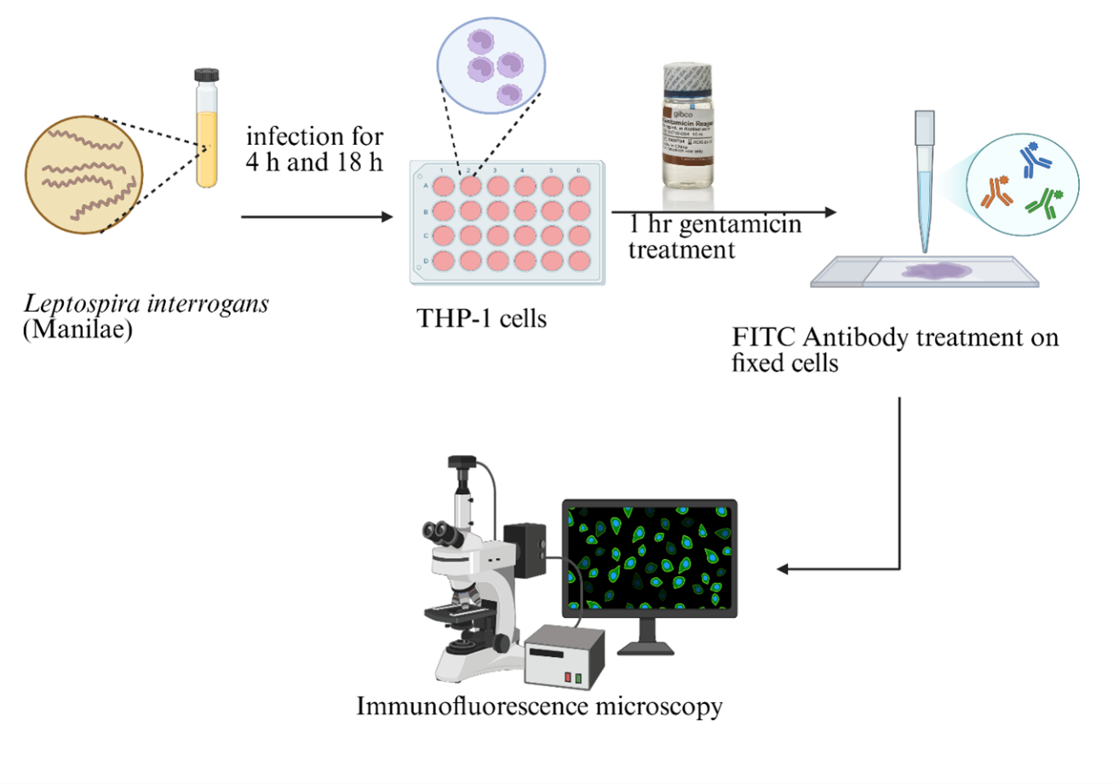
Figure 3.2 Schematic representation of the methodology for detecting intracellular Leptospira with a FITC-conjugated anti-Leptospira antibody-mediated phagocytosis process

Evaluation of LysoTracker DND-99, DAPI Staining, and CFSE Labeling for THP-1 Cells:
THP-1 cells (1 × 10^5) were resuspended in 100 μL of RPMI medium for three different sets of treatments: 100 nM LysoTracker DND-99 (Thermo Fisher), 50 μM CFSE, and 1 μg/mL DAPI (Thermo Fisher) (Giraud-Gatineau et al., 2024). The untreated cell sample was used as a negative control. The LysoTracker DND-99-treated cells were incubated for 1 hr at 37˚C, and the CFSE-treated cells were incubated at room temperature for 30 minutes. DAPI-treated cells were incubated at room temperature for 10 minutes. After treatment, all samples were washed three times with PBS. 15 μL of these samples were placed on a slide and observed using fluorescence microscopy after placing a coverslip. A schematic representation of this experiment is demonstrated in Figure 3.4.

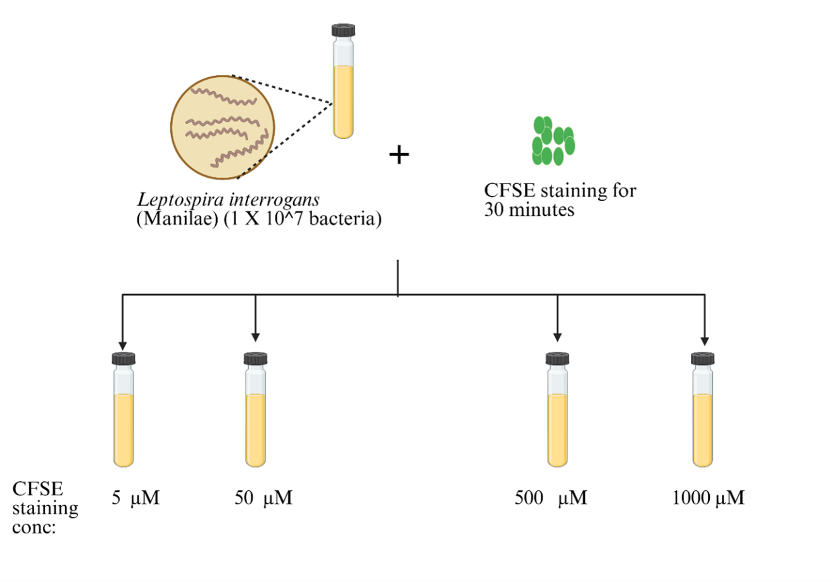
Figure 3.3: Schematic representation of the methodology for evaluation of CFSE labeling efficacy and LIM motility
Detection of Intracellular LIM Using CFSE Labeling:
THP-1 cells (1 × 10^5) were seeded in a 24-well plate. For the fluorescent CFSE labeling, 5 mL of Leptospira culture cells were centrifuged at 3250 g for 25 minutes, and the pellet was resuspended in 5 mL of PBS supplemented with 10 μM CFSE for 30 minutes at room temperature (Santecchia et al., 2022). The bacterial suspension was washed once with PBS before being used for infection. THP-1 cells were infected with CFSE-labeled LIM with an MOI of 100 (10^7 bacteria) for 4 hours. Uninfected cells and LIM-only samples were used as controls. After infection, both infected and uninfected THP cells were treated with 100 nM LysoTracker DND-99 for 1 hour at 37˚C (Giraud-Gatineau et al., 2024). After LysoTracker DND-99 treatment, the cell samples were washed three times with PBS by centrifuging at 1200 RPM for 5 minutes, followed by resuspension of the pellet in 1 mL of fresh RPMI 1640 medium. The LIM-only control was centrifuged at 14,000 RPM for 5 minutes and then resuspended in 100 μL of fresh RPMI 1640 medium. Both infected and uninfected THP-1 cells were treated with 1 μg/mL DAPI for 10 minutes. After DAPI treatment, the cells were washed three times with PBS and then resuspended in 100 μL of RPMI 1640 medium. The cells were observed under fluorescence microscopy by preparing IFA slides with 15 μL of the suspension, and after placing a coverslip on it. An experimental layout is provided in
Figure 3.5.
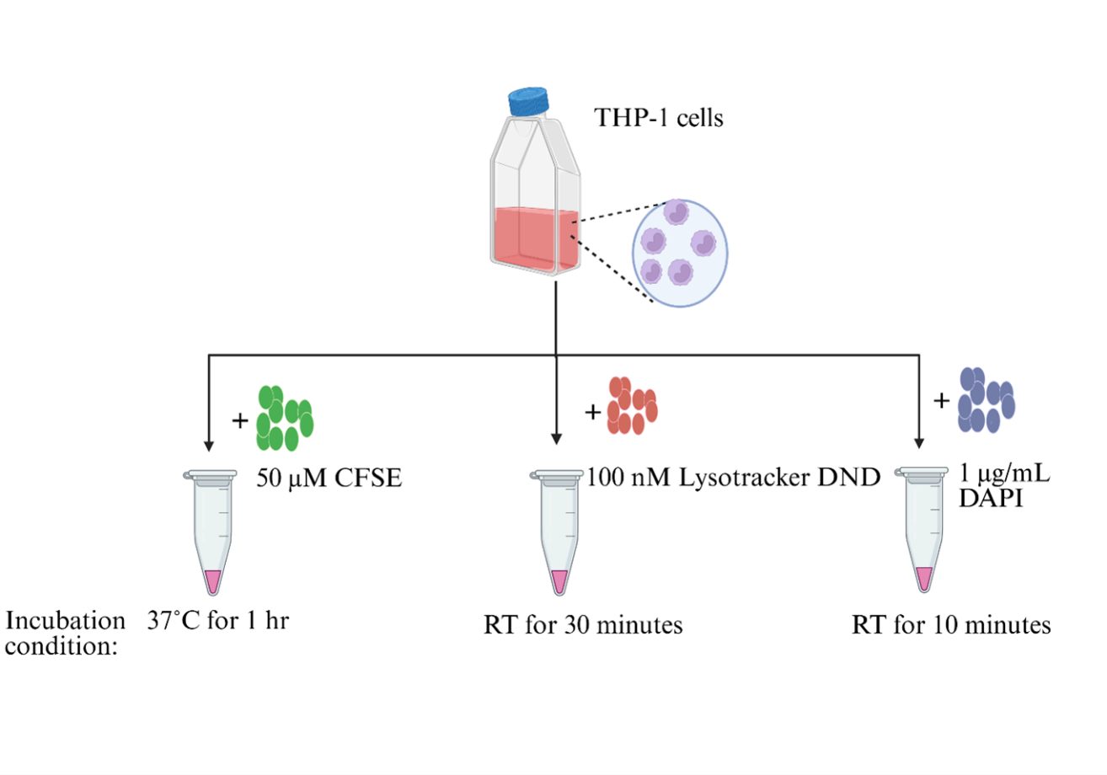
Figure 3.4: Schematic representation of the methodology for the evaluation of Lysotracker DND-99, DAPI, and CFSE staining for THP-1 cells.

Evaluation of Gentamicin Effectiveness in Eliminating Extracellular LIM Upon Treatment:
Experiment 1- LIM (1 × 10^7) was treated with 100 μg/mL and 1000 μg/mL of gentamicin (Gibco, USA) in lab-prepared EMJH-IH media for LIM and in RPMI-1640 medium. LIM without gentamicin treatment was used as a negative control. Bacterial motility was observed at 4 hours and 24 hours under dark-field microscopy. A schematic representation is illustrated in Figure 3.6.
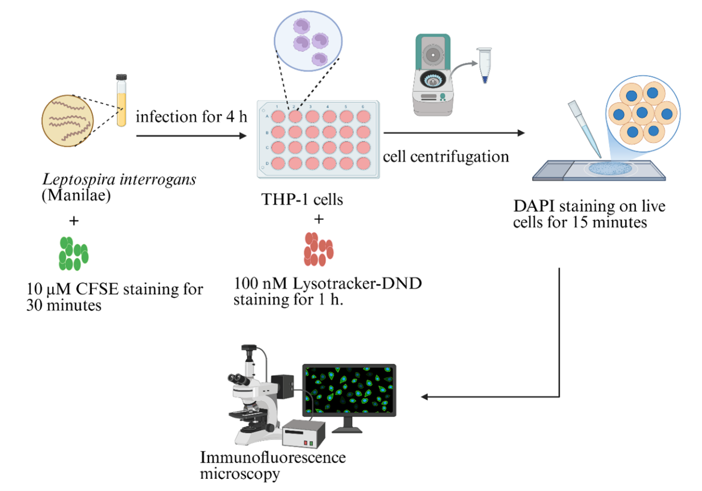
Figure 3.5: Schematic representation of the methodology for detecting intracellular Leptospira using CFSE labeling.
Experiment 2-LIM (1 × 10^7) was treated with a different gentamicin batch from Sigma-Aldrich at concentrations of 10 μg/mL, 100 μg/mL, 1000 μg/mL, and 10,000 μg/mL in lab-prepared EMJH-IH media. LIM without gentamicin treatment was used as a negative control. Bacterial motility was observed at 4 hours and 24 hours under dark-field microscopy. Figure 3.7 displays an outline of this experiment.

RESULTS

Leptospira -Host Interactions:
To optimize the macrophage-infection model, we attempted to gather previous literature related to understanding Leptospira-host interactions, as it provides the foundation for existing knowledge that helps identify the requirements for this assay. Supplementary File 1, attached to the appendix, presents previously published work on Leptospira-host interactions.
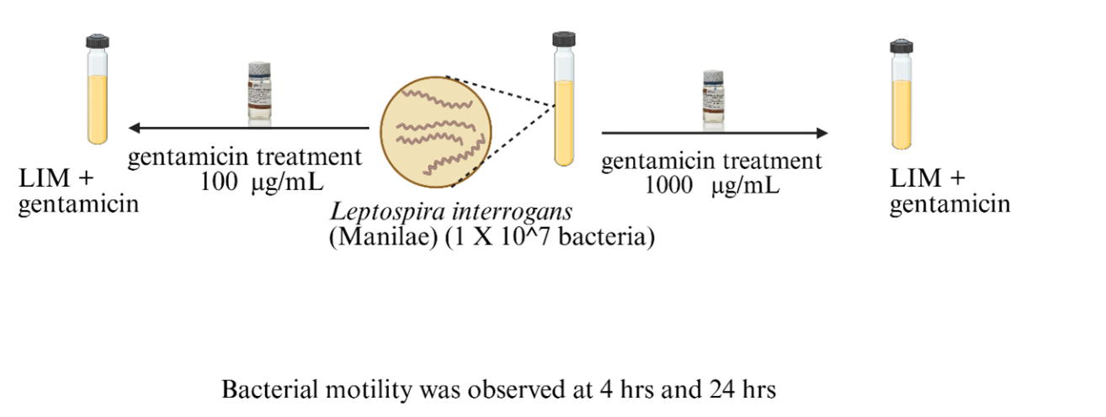
Figure 3.6: Schematic representation of evaluating gentamicin effectiveness and assessing bacterial motility using batch 1 gentamicin (Gibco, USA).
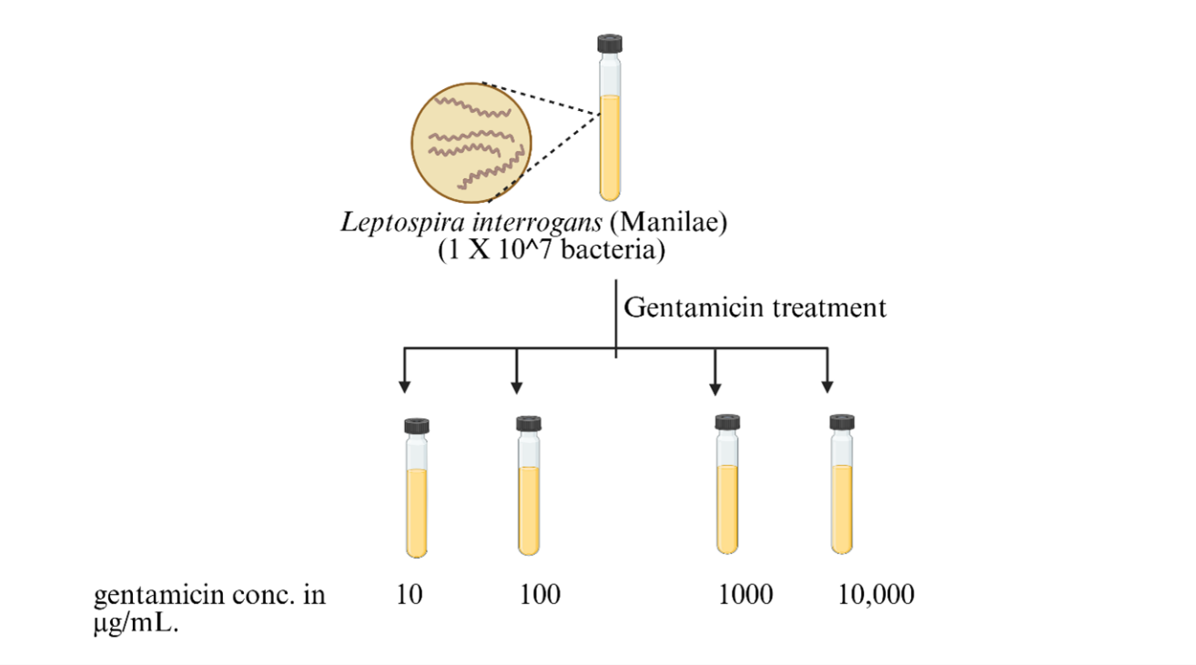
Figure 3.7. Schematic representation of the evaluation of gentamicin effectiveness and assessment of bacterial motility using batch 2 gentamicin (Sigma Aldrich, USA).

Detection of Intracellular LIM with FITC-Conjugated Rabbit Polyclonal Anti-Leptospira Antibody:
First, we attempted to detect intracellular LIM using FITC-conjugated rabbit polyclonal anti-Leptospira antibody as a primary tool for initial evaluation. The immunofluorescent microscopic examination showed that when LIM-infected THP-1 cells were treated with a 1:2000 diluted FITC-conjugated polyclonal anti-Leptospira
antibody, the FITC-conjugated antibody exhibited an extremely high fluorescence intensity in the background (Fig. 3.8). This resulted in very intense fluorescence staining of the cells rather than the bacteria. Thus, this nonspecific staining of the cells compromised the observation of Leptospira bound to the antibodies.
A B

Figure 3.8: LIM-infected THP-1 cells using FITC-conjugated antibodies at different time points: (A) After 4 hours of infection, (B) After 18 hours of infection, observed by fluorescent microscopy

Assessment of CFSE Labeling and Bacterial Motility Upon Treatment:
In the next step, we attempted to use CFSE as an alternative fluorescent labelled antibody to detect the bacteria. The immunofluorescence microscopic analysis demonstrated that upon treatment of LIM with various CFSE concentrations, 50 μM was an optimal concentration for bacterial detection, and the bacteria were highly motile. The 5 μM concentration resulted in a reduced immunofluorescence intensity, making it difficult to observe any bacteria. When we examined the bacterial samples with 500 μM and 1000 μM CFSE concentrations, we observed that the bacteria were aggregated and non-motile at these higher concentrations (Fig. 3.9).
Evaluation of the Treatment of THP-1 cells with Lysotracker DND, DAPI Staining, and CFSE Labeling:
After optimizing the CFSE concentration for LIM detection, we attempted to evaluate the detection of THP-1 cells using Lysotracker DND. This fluorescent dye labels acidic organelles in live cells (Nagel et al., 2019), and DAPI was used to stain the cell

C. 500 μM CFSE D. 1000 μM CFSE
A. 5 μM CFSE B. 50 μM CFSE

Figure 3.9: Evaluation of CFSE labeling for detection of LIM at various concentrations: 5 μM , 50 μM , 500 μM, and 1000 μM, observed by fluorescent microscopy.

nuclei. We also labeled the THP-1 cells with CFSE to assess the extent of the dye uptake by the cells, as we were using CFSE for LIM detection. The fluorescence microscopic analysis showed that cells were stained perfectly with Lystotracker DNA and DAPI (Fig.3.10). Thus, 100 nM Lystotracker DND and 1 μg/mL DAPI were optimal for detecting the cells. However, at a 50 μM CFSE concentration (optimal for LIM detection; Fig. 3.9), the fluorescence was too intense for the cells to be visible, compared with LIM staining in the previous experiment (Fig. 3.9 and 3.10). The CFSE uptake was too high, resulting in cells with intense green fluorescence, which may compromise LIM staining for further experiments. This led us to reduce the CFSE concentrations for detecting

intracellular LIM.
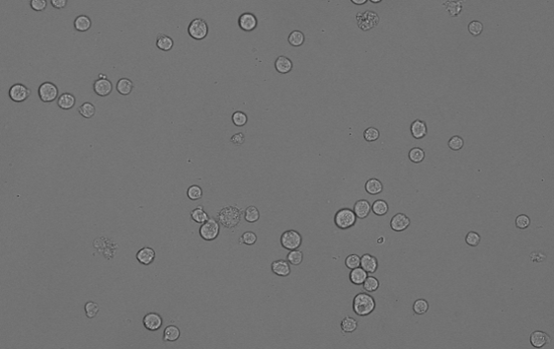
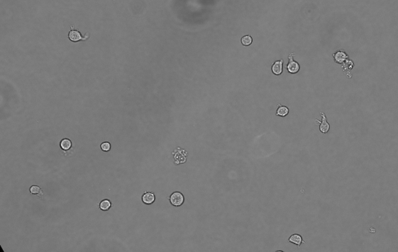
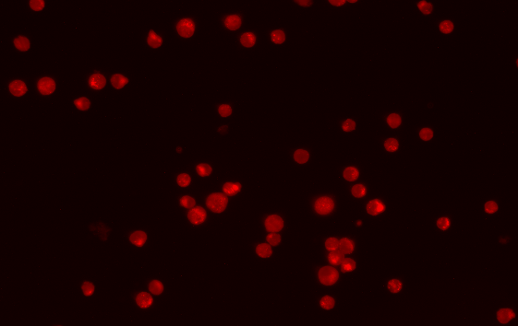

A. Brightfield 100 nM Lystotracker DND


B. Brightfield 1 μg/mL DAPI

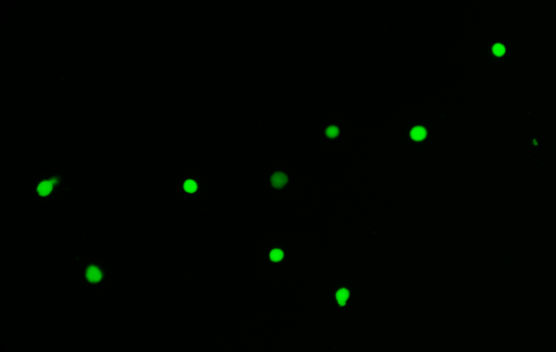

C. Brightfield 50 μM CFSE
Figure 3.10: Evaluation of Lysotracker DND, DAPI, and CFSE labeling for detection of THP-1 cells observed by fluorescent microscopy.
Detection of Intracellular LIM Using CFSE-Labeled LIM and Lysotracker DND Stained THP-1 cells:

After detecting LIM using CFSE and identifying THP-1 cells with Lysotracker DND and DAPI, we attempted to detect intracellular LIM under these conditions. However, as mentioned previously, 50 μM CFSE is intense for the THP-1 cells and may cause difficulty in LIM detection. Therefore, we performed this experiment by infecting THP-1 cells with 10 μM CFSE-labeled LIM. The fluorescent microscopic examination revealed that DAPI exhibited intense cell staining with excessive fluorescence, which obscured any LIM detection that might have been present. So, we eliminated DAPI and continued the THP-1 cell staining only with Lysotracker DND. It was observed that there were very few THP-1 cells with intracellular LIM-like morphology (Fig. 3.11).
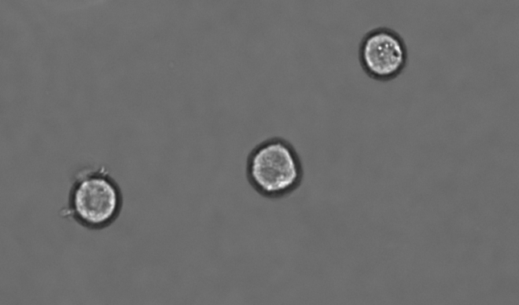
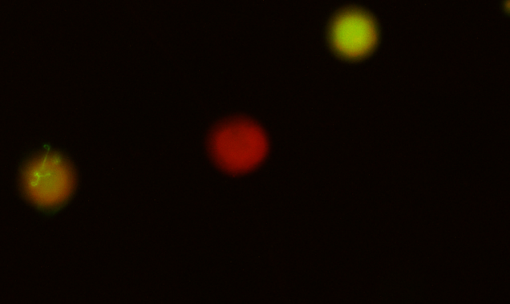
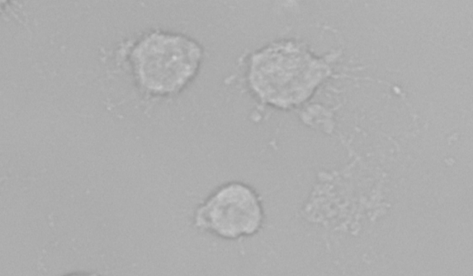
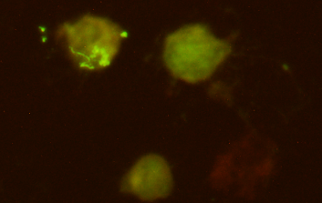

A. Bright Field (Live cells) Lysotracker-stained THP-1 cells infected
with CFSE-labeled LIM

B. Bright Field (Fixed cells) Lysotracker-stained THP-1 cells infected
with CFSE-labeled LIM

Figure 3.11: Evaluation of intracellular CFSE-labeled LIM within Lysotracker-DND-stained THP-1 cells at 4 hours, observed by fluorescent microscopy.
Effectiveness of Gentamicin in Eliminating Extracellular LIM
To analyze the intracellular LIM within THP-1 cells, the extracellular LIM needed to be eliminated. When we treated LIM-infected THP-1 cells with 100 μg/mL gentamicin for 1 hr, we observed that the LIM was highly motile, indicating the ineffectiveness of gentamicin in killing bacteria. Therefore, we decided to evaluate the effectiveness of gentamicin by treating LIM with various gentamicin concentrations (Fig. 3.6)
We observed that after 4 hours of treatment, bacteria were as motile as the control. At 24-hour treatment, no bacteria were observed in a 1000 μg/mL concentration sample. For a 100 μg/mL sample, we observed a reduced number of bacteria compared to the control; however, a higher bacterial count was detected compared to the 1000 μg/mL treated sample. Thus, based on the results of the previous experiment assessing gentamicin effectiveness, another experiment was conducted using a different gentamicin batch to evaluate its efficacy, to make sure that a different batch might yield consistent results (Fig. 3.7). We observed that bacteria remained as motile as controls even in the highest gentamicin concentration, 10,000 μg/mL, after 24 hours. When each sample was inoculated into EMJH-IH media for further verification, on day 7, we observed no bacteria in the samples treated with 10, 100, 1000, and 10,000 μg/mL gentamicin. On day 14, very few bacteria were observed in the sample treated with 10 μg/mL gentamicin only.

DISCUSSION
Overall, the evaluation of the current literature on Leptospira’s interactions in various cell culture systems resulted in contradictory findings. One study showed that the virulent Leptospira strain P1 tends to colonize in the macrophages(Nagel et al., 2019), while another study stated that highly virulent strains tend to evade the complement system, resulting in fewer interactions with macrophages (Giraud-Gatineau et al., 2024). There are also inconsistent findings on whether bacterial replication occurs within the macrophage during infection (Santecchia et al., 2022; Toma et al., 2011). An earlier study showed that Leptospira opsonized with serovar-specific antibodies were efficiently engulfed and killed by human monocytes and monocyte-derived macrophages, compared to non-opsonized Leptospira (Boyao Wang et al., 1984). Taking all this into account, we further attempted to develop a macrophage infection model to gather more clarity on the Leptospira phagocytosis process.
To do so, we first attempted to detect intracellular LIM within the THP-1 cell line using a FITC-conjugated rabbit polyclonal anti-Leptospira antibody. The result was inconclusive, as the FITC showed inconsistent and nonspecific binding to the THP-1 cells, accompanied by an extensive fluorescence background, which compromised the LIM-FITC binding. Previously, researchers have used CFSE labeling for Leptospira to study Leptospira-macrophage interactions, claiming this dye is non-toxic and maintains bacterial motility, viability, and virulence (Giraud-Gatineau et al., 2024; Liu et al., 2014; Santecchia et al., 2022). Thus, to overcome the background fluorescence of FITC-conjugated anti-Leptospira antibodies in detecting Leptospira, we used CFSE labeling as an alternative method for Leptospira detection. Although a suitable CFSE concentration of 5 μM was previously mentioned (Giraud-Gatineau et al., 2024), it failed to detect LIM at this concentration in our case. Thus, we decided to optimize the CFSE concentration by treating the LIM with various concentrations of CFSE. Our results showed that 50 μM was an optimal concentration to detect the LIM, as bacterial motility was compromised at higher concentrations and bacteria were killed.
Another challenge with CFSE was that CFSE can also bind to eukaryotic cells, as it can diffuse into the cells and become fluorescent in the presence of intracellular esterases, which activate the acetate groups of CFSE by cleaving them to exhibit the fluorescence (Liu et al., 2014). We attempted to evaluate the CFSE effect on THP-1 cells by treating them with 50 μM CFSE. Our results showed that 50 μM CFSE resulted in excessive fluorescence in THP-1 cells, which could lead to failure in LIM detection.
Based on these results, we attempted to detect intracellular LIM using 10 μM CFSE (Santecchia et al., 2022). We then stained the THP-1 cells with Lysotracker DND to exhibit distinct fluorescence, thereby differentiating between the two distinct fluorescence emissions for improved microscopic analysis of LIM. Our results showed that Leptospira-like morphology might be present within the THP-1 cells. However, a limited number of THP-1 cells with intracellular LIM-like morphology were observed.
Overall, our results showed that there was a minimal number of THP-1 cells with Leptospira-like morphology within them. However, Santecchia et al. (2022) stated that they observed internalized Leptospira in both human and murine macrophages after performing a gentamicin protection assay. In this assay, after infecting macrophages with Leptospira, the cells were treated with gentamicin to eliminate any extracellular bacteria. Then, the intracellular bacteria were evaluated.
This gentamicin protection assay is a classical method based on the principle that gentamicin effectively eliminates extracellular bacteria in gentamicin-treated infected cells without penetrating eukaryotic cells, thereby preserving intracellular bacteria for subsequent analysis.(Sharma & Puhar, 2019). In our case, when we observed Leptospira-infected THP-1 cells with gentamicin after 1 hr, the bacteria were live and motile. We considered this as gentamicin ineffectiveness in killing the bacteria. Due to the ineffectiveness of gentamicin, we were unable to achieve the intended outcome of analyzing intracellular Leptospira in the phagocytosis process. Therefore, we could not confirm whether the Leptospira were within the THP-1 cells or on the cell outer surface.
When further confirmation of gentamicin effectiveness was evaluated by inoculating gentamicin-treated samples into EMJH-IH media, a few bacteria were observed in the 10 μg/mL gentamicin-treated sample on day 14, a very minimal number compared to the control, and no bacteria were observed in the higher gentamicin concentration samples, suggesting that this drug can be bacteriostatic.
Our initial goal was to optimize a macrophage-infection model to assess the efficacy of the antibodies in preventing or aiding the macrophage-based antibody-mediated phagocytosis through bacterial opsonization. However, due to the ineffectiveness of gentamicin, we could not find a uniform way to evaluate this model. Therefore, the intended aim was not accomplished. Taking all these factors into account, we proceeded to establish the parameters for intracellular Leptospira detection, which will potentially help unravel antibody-mediated Leptospira phagocytosis.
As mentioned before, the Leptospira growth inhibition assay (LGIA) can be an effective tool for detecting protective responses in vaccinated animals, providing a preliminary analysis in vaccine development. At the same time, the macrophage-infection model can be valuable for studying host-pathogen interactions, disease mechanisms, and host responses following infection; however, it is not practical to use as an in vitro assay to evaluate the efficacy of anti-Leptospira antibodies in early-stage vaccine development because this assay is highly time-consuming, inflexible, non-feasible, lacks consistency in methodology, faces challenges in quantifying phagocytosis, and is subjective. Several challenging points are beyond our control when performing this assay, such as the phagocytosis process for Leptospira, which has remained largely unexplored, and inconsistent findings on the phagocytosis of virulent strains have been reported in previous studies. Therefore, this model is not suitable for assessing the efficacy of antibodies in preventing bacterial growth.

REFERENCES
Andrade, G. I., & Brown, P. D. (2012). A comparative analysis of the attachment of Leptospira interrogans and L. borgpetersenii to mammalian cells. FEMS Immunol Med Microbiol, 65(1), 105-115. https://doi.org/10.1111/j.1574-695X.2012.00953.x
Bonhomme, D., Hernandez-Trejo, V., Papadopoulos, S., Pigache, R., Fanton d'Andon, M., Outlioua, A., Boneca, I. G., & Werts, C. (2023). Leptospira interrogans Prevents Macrophage Cell Death and Pyroptotic IL-1beta Release through Its Atypical Lipopolysaccharide. J Immunol, 210(4), 459-474. https://doi.org/10.4049/jimmunol.2200584
Boyao Wang, James A. Sullivan, Gail W. Sullivan, A., & Mandell*, G. L. (1984). Role of Specific Antibody in Interaction of Leptospires with Human
Monocytes and Monocyte-Derived Macrophages. INFECTION AND IMMUNITY,American Society for Microbiology, 46(3), 809-813. https://doi.org/10.1128/iai.46.3.809-813.1984
Breiner, D. D., Fahey, M., Salvador, R., Novakova, J., & Coburn, J. (2009). Leptospira interrogans binds to human cell surface receptors including proteoglycans. Infect Immun, 77(12), 5528-5536. https://doi.org/10.1128/IAI.00546-09
Chen, X., Li, S. J., Ojcius, D. M., Sun, A. H., Hu, W. L., Lin, X., & Yan, J. (2017). Mononuclear-macrophages but not neutrophils act as major infiltrating anti-Leptospira l phagocytes during leptospirosis. PLoS One, 12(7), e0181014. https://doi.org/10.1371/journal.pone.0181014
Evangelista, K., Franco, R., Schwab, A., & Coburn, J. (2014). Leptospira interrogans binds to cadherins. PLoS Negl Trop Dis, 8(1), e2672. https://doi.org/10.1371/journal.pntd.0002672
Fabrice Merien, And, G. B., & Perolat, P. (1997). Invasion of Vero Cells and Induction of Apoptosisin Macrophages by Pathogenic Leptospira interrogansAre Correlated with Virulence. American Society for Microbiology, 729-738. https://doi.org/https://doi.org/10.1128/iai.65.2.729-738.1997
Flannagan, R. S., Jaumouillé, V., & Grinstein, S. (2012). The Cell Biology of Phagocytosis. Annual Review of Pathology: Mechanisms of Disease, 7(Volume 7, 2012), 61-98. https://doi.org/https://doi.org/10.1146/annurev-pathol-011811-132445
Giraud-Gatineau, A., Nieves, C., Harrison, L. B., Benaroudj, N., Veyrier, F. J., & Picardeau, M. (2024). Evolutionary insights into the emergence of virulent Leptospira spirochetes. PLoS Pathog, 20(7), e1012161. https://doi.org/10.1371/journal.ppat.1012161
Jin, D., Ojcius, D. M., Sun, D., Dong, H., Luo, Y., Mao, Y., & Yan, J. (2009). Leptospira interrogans induces apoptosis in macrophages via caspase-8- and caspase-3-dependent pathways. Infect Immun, 77(2), 799-809. https://doi.org/10.1128/IAI.00914-08
Jo, E. K. (2019). Interplay between host and pathogen: immune defense and beyond. Exp Mol Med, 51(12), 1-3. https://doi.org/10.1038/s12276-019-0281-8
Liu, B., Wang, Y., Guo, X., Zhu, W., Zhang, Y., & He, P. (2014). Carboxyfluorescein diacetate succinimidyl ester labeling method to study the interaction between Leptospira and macrophages. J Microbiol Methods, 107, 205-213. https://doi.org/10.1016/j.mimet.2014.10.005
Liu, Y., Zheng, W., Li, L., Mao, Y., & Yan, J. (2007). Pathogenesis of leptospirosis: interaction of Leptospira interrogans with in vitro cultured mammalian cells. Med Microbiol Immunol, 196(4), 233-239. https://doi.org/10.1007/s00430-007-0047-0
Martinez-Lopez, D. G., Fahey, M., & Coburn, J. (2010). Responses of human endothelial cells to pathogenic and non-pathogenic Leptospira species. PLoS Negl Trop Dis, 4(12), e918. https://doi.org/10.1371/journal.pntd.0000918
Nagel, A., Vazquez, C. L., Etulain, J., Blanco, F. C., Gravisaco, M. J., Gomez, R. M., & Caimi, K. (2019). Bovine macrophages responses to the infection with virulent and attenuated Leptospira interrogans serovar Pomona. Vet Microbiol, 233, 124-132. https://doi.org/10.1016/j.vetmic.2019.04.033
Rabinovitch, M. (1995). Professional and non-professional phagocytes: an introduction, . Trends in Cell Biology, 5(3), 85-87. https://doi.org/https://doi.org/10.1016/S0962-8924(00)88955-2.
Rana, A., Ahmed, M., Rub, A., & Akhter, Y. (2015). A tug-of-war between the host and the pathogen generates strategic hotspots for the development of novel therapeutic interventions against infectious diseases. Virulence, 6(6), 566-580. https://doi.org/10.1080/21505594.2015.1062211
S. A. Ballard, M. W., B. Adler, T. Vinh and S. Faine. (1986). Interactions of virulent and avirulent leptospires with primary cultures of renal epithelial cells. Journal of Medical Microbiology, 21(1), 58-67. https://doi.org/https://doi.org/10.1099/00222615-21-1-59
Santecchia, I., Bonhomme, D., Papadopoulos, S., Escoll, P., Giraud-Gatineau, A., Moya-Nilges, M., Vernel-Pauillac, F., Boneca, I. G., & Werts, C. (2022). Alive Pathogenic and Saprophytic Leptospires Enter and Exit Human and Mouse Macrophages With No Intracellular Replication. Front Cell Infect Microbiol, 12, 936931. https://doi.org/10.3389/fcimb.2022.936931
Sharma, A., & Puhar, A. (2019). Gentamicin Protection Assay to Determine the Number of Intracellular Bacteria during Infection of Human TC7 Intestinal Epithelial Cells by Shigella flexneri. Bio Protoc, 9(13), e3292. https://doi.org/10.21769/BioProtoc.3292
Takahashi, M. B., Teixeira, A. F., & Nascimento, A. (2022). Host Cell Binding Mediated by Leptospira interrogans Adhesins. Int J Mol Sci, 23(24). https://doi.org/10.3390/ijms232415550
Toma, C., Okura, N., Takayama, C., & Suzuki, T. (2011). Characteristic features of intracellular pathogenic Leptospira in infected murine macrophages. Cell Microbiol, 13(11), 1783-1792. https://doi.org/10.1111/j.1462-5822.2011.01660.x
Uribe-Querol, E., & Rosales, C. (2017). Control of Phagocytosis by Microbial Pathogens. Front Immunol, 8, 1368. https://doi.org/10.3389/fimmu.2017.01368
Vieira, M. L., Alvarez-Flores, M. P., Kirchgatter, K., Romero, E. C., Alves, I. J., de Morais, Z. M., Vasconcellos, S. A., Chudzinski-Tavassi, A. M., & Nascimento, A. L. (2013). Interaction of Leptospira interrogans with human proteolytic systems enhances dissemination through endothelial cells and protease levels. Infect Immun, 81(5), 1764-1774. https://doi.org/10.1128/IAI.00020-13
Vieira, M. L., Vasconcellos, S. A., Goncales, A. P., de Morais, Z. M., & Nascimento, A. L. (2009). Plasminogen acquisition and activation at the surface of Leptospira species lead to fibronectin degradation. Infect Immun, 77(9), 4092-4101. https://doi.org/10.1128/IAI.00353-09
Yamaguchi, T., Higa, N., Okura, N., Matsumoto, A., Hermawan, I., Yamashiro, T., Suzuki, T., & Toma, C. (2018). Characterizing interactions of Leptospira interrogans with proximal renal tubule epithelial cells. BMC Microbiol, 18(1), 64. https://doi.org/10.1186/s12866-018-1206-8

Appendix

Appendix 1: Below is the link for a summary of Leptospira -host interactions

CHAPTER 4
CONCLUSION AND FUTURE APPLICATIONS

This study has two main goals. Firstly, we attempted to optimize the in vitro Leptospira growth inhibition assay using L. interrogans serovar Manilae and anti-serum against this strain. The in vitro LGIA can be used as a preliminary step in assessing the presence of potentially protective antibodies in vaccinated animals and evaluating the efficacy of vaccine candidates before challenging the animals, considering the 3Rs of animal research.
For future directions, further optimization of this assay is necessary with specific strains, considering their generation time, incubation period, and assessment of the antibody titer, as the antibody titer may vary depending on the Leptospira species. For higher sensitivity and better results, Leptospira counting can be replaced by digital PCR or viability PCR. As it was observed that commercially available EMJH media contributed to the slower bacterial growth for L. interrogans serovar Manilae, it is important to perform this assay with the media that is appropriate for that strain. Thus, initial media optimization for any specific strain is also essential before conducting this assay.
Secondly, we attempted to define criteria for detecting intracellular Leptospira by using CFSE for Leptospira staining and Lysotracker DND dyes for THP-1 cell staining. These defined criteria can serve as a prerequisite for further analysis of the macrophage-infection model, which measures the antibody potency in preventing bacterial growth through macrophage-based phagocytosis. Thus, optimization of opsonization titrations can be performed to evaluate the bacterial pathogenesis mechanism. Due to a lack of consistency, the complexity of the methodology, and laboriousness, this assay may not be a suitable strategy for modeling the detection of a protective response in vaccinated animals or as a tool for preliminary antibody efficacy analysis in vaccine development. However, this assay can still aid in decoding the pathogenic Leptospira phagocytosis mechanism and virulence-associated features.
Gentamicin protection assay is a widely used method to assess the intracellular bacteria within the infected host cells upon eliminating the extracellular bacteria from the host-cell surface, and in our assay, however, in our model, we noticed gentamicin ineffectiveness in killing extracellular bacteria. Therefore, in future applications, further evaluation of gentamicin effectiveness is necessary to perform a gentamicin protection assay to assess the internalization of Leptospira.

VITA
Avni Patel, a native of Gujarat, India, holds a Bachelor of Science in Microbiology from the University of Tennessee and is currently pursuing a Master of Science degree in Comparative and Experimental Medicine at the same institution. Her research focuses on optimizing in vitro assays before transitioning to an in vivo model, considering the 3Rs of Animal research. She expects to graduate in December 2025 and gratefully acknowledges the enormous support from her graduate mentor, colleagues, friends, and family.

