Analysis of an Electrospray Thruster with a Concave Propellant Meniscus

A Thesis Presented for the
Master of Science
Degree
The University of Tennessee, Space Institute

Adam Nicholas Huller
December 2023

Copyright © by Adam Nicholas Huller
All rights reserved.

I dedicated this thesis to my father, Mark Huller,
who I modeled my life after.
The man, the husband, and the father I am today is because of you.
Acknowledgements
I would like to express my gratitude to my advisor, Dr. Trevor Moeller, who gave me the opportunity to work for him both as an intern and as a graduate research assistant. My original discussions with him during my application process about my interest in all kinds of rocket propulsion let me know that the University of Tennessee, Space Institute was where I wanted to do my graduate work. The fact that I was able to work in propulsion right away was more than I could have hoped for. Coming out of the Army and using the G. I. Bill made it trickier for me to work on the µSTAMPS project so I greatly appreciate his time and tireless efforts to make it happen.
I also want to thank my other two committee members, Dr. Lino Costa and Dr. Brian Canfield. Dr. Costa’s mentorship throughout the development of this thesis was invaluable. He also chose to stay on my committee after moving on to another position outside of UTSI. I am sure juggling two schedules is not easy, and I appreciate all the help and support. Dr. Canfield’s work in helping me refine my thesis has also been invaluable. He took the time to read through and recommend changes throughout the paper which is a tedious endeavor. His efforts have made me a better technical writer, and he has my gratitude for it. I want to thank my fellow GRA’s Joshua Howell, Tyler Sundstrom, John Allman, Caitlin Bunce, Christian Sharpe, and James Rhodes. They have been an excellent team to work with and going through graduate school with them has been a pleasure. I have no doubt this project will ultimately be successful with them working on it. I would also like to thank UTSI and all the administrators for their dedication to me and the other GRAs.
Next, I would like to thank Andre Porter, the graduate recruiter at UTSI. When I was attempting to apply to UTSI, I cold-called him to ask about the application process and, in that one phone call, he learned about my interests, concerns, and hooked me up with Dr. Moeller. He could have easily sent me to another person to work on my application but instead his assistance started my academic path.
Finally, I would like to thank my family. My mom for her love and support, for nurturing my love of math since I was seven years old, and for driving down to Joelton, TN to help with my newborn son so that my wife and I could get a little extra sleep. My siblings, Scott, Paige, and Kellie, who have always believed in me and supported me through my academic journey. My newborn son, Rowan, who was my writing partner and practice audience for my thesis defense. He always seemed to know when I needed to take a break and let me know loudly when it was time. And last but certainly not least, my wife, Lynnette, who, despite working through a rigorous doctoral program to be a nurse anesthetist, always found the time to love and support me in the things I needed to accomplish. Without her none of this would be possible.

Abstract
The low thrust, high specific impulse, and low mass of electrospray thrusters (ETs) make them ideal for maneuvering nanosatellites, especially with the new requirement to deorbit a satellite within five years of completing its mission. These innovative thrusters use electrohydrodynamic principles of electrospray (ES) to provide thrust. These principles have been subject to much research over the past decade, though much more research is needed to fully understand the underlying physics of these thrusters. The first part of this study establishes a procedure for analyzing the theoretical thrust performance of an ET, by using propellant properties and well-documented ES scaling laws to identify the ES mode and governing equations applicable to the ET of interest. Next, this procedure is demonstrated by analyzing a novel ET in development at the University of Tennessee Space Institute, which culminates in the comparison of three theoretical thrust density and specific impulse equations based on geometry, electric pressure, and Ohmic conduction. The second part of this study will focus on a numerical analysis of ES produced from a concave meniscus using ANSYS Fluent. The novel ET will use capillary action to drive propellant through its capillaries, unlike most ETs that use a pump. The capillary action will result in the propellant forming a concave meniscus at the end of the capillary. There is little research on whether a concave meniscus can produce ES because most studies assume the meniscus is initially flat or in the Taylor cone shape. This model will focus on ES on the microscale using a low-conductivity fluid flowing through a charged capillary. The numerical model used in this study is verified by comparing the jet diameter produced by the model with well-established microscale ES scaling laws for the jet diameter. The results of this numerical model show that it is possible to produce a Taylor cone and an unsteady jet from a concave meniscus. Finally, this study will make recommendations on future work for analyzing and understanding the underlying physics of ETs.

Table of Contents
Chapter 1: Introduction 1
1.1 Electrospray Thruster Overview 1
1.2 Background and Relevance 3
1.3 Micro-propulsion Overview 3
1.4 Electrospray Thruster Literature Review 6
1.5 Electrospray Numerical Analysis Review 8
1.6 Organization 10
Chapter 2: Physics Review and Governing Equations 11
2.1 Fluid Mechanics 11
2.2 Surface Tension 11
2.3 Capillary Action 12
2.4 Electrostatics 12
2.5 Electrohydrodynamics 15
2.6 Electrospray Modes 15
2.7 Space Charge 27
2.8 Pure Ion Thrust Equations 27
2.9 Characteristic Times 28
Chapter 3: Analytical Investigation of an Electrospray Thruster 30
3.1 µSTAMPS Overview 30
3.2 Ionic Liquid Overview 30
3.3 The Electrostatic Assumption 31
3.4 µSTAMPS Taylor Cone Formation 31
3.5 µSTAMPS Electrospray Mode 31
3.6 Electric Thruster Analysis Results and Discussion 33
Chapter 4: Numerical Investigation of Concave Meniscus 43
4.1 Design of Research Model 43
4.2 Verification Model 47
4.3 Concave Meniscus Model 53
Chapter 5: Conclusions and Future Work 65
5.1 Conclusions 65
5.2 Future Work 66
Appendix A: Summary of Equation Tables 67
Appendix B: Electrospray Thruster Mode Analysis Tables 69
Appendix C: Thrust Metric Analysis Tables 70

List of Figures
Figure 1: General set-up of an ES device [10]. 2
Figure 2: Micro-Propulsion Systems under 5 kg plotted by thrust, specific impulse, and mass. 5
Figure 3: Micro-Propulsion Systems plotted by thrust, specific impulse, and power. 5
Figure 4: ES Cone-jet of Ethyl-alcohol [19]. 7
Figure 5: Taylor Cone—the broken lines’ half-angle is 49.3° [1]. 7
Figure 6: Interface Between Two Fluids [43]. 14
Figure 7: Taylor Cone Stress Balance. 16
Figure 8: Flash Shadowgraph of Jet Breakup [3]. 18
Figure 9: Steady Cone-jet Configuration with Parameters Used for Scaling Laws [2]. 20
Figure 10: Close-up of ES-produced Droplet Experiencing Coulomb Fission. Mean flow direction: top to bottom [50]. 24
Figure 11: Evolution of Transient Cone-jets on Levitated Ethylene-Glycol Droplet [51]. 24
Figure 12: Plot of Electric Field, Current, and Flow Rate for Formamide Nano-ES [52]. 25
Figure 13: µSTAMPS schematic. 32
Figure 14: Target Dimensions of µSTAMPS Emitter Chip. 32
Figure 15: Effects of w Values on Taylor Cone Shape. 34
Figure 16: µSTAMPS Minimum Flow Rate Analysis. 34
Figure 17: µSTAMPS Critical Electric Field Analysis. 36
Figure 18: Schematic of Pure Ion Emission with Governing Equations for µSTAMPS 36
Figure 19: µSTAMPS IL Characteristic Time Comparison. 38
Figure 20: µSTAMPS Particle Characteristic Times. 38
Figure 21: µSTAMPS Theoretical Thrust Density Comparison. 40
Figure 22: µSTAMPS Specific Impulse Comparison. 40
Figure 23: µSTAMPS Apex Electric Field Strength vs. Surface Tension. 42
Figure 24: Verification Model Domain. 45
Figure 25: Model Transient Startup Issue Example. 50
Figure 26: Domain Axis Static Pressure Comparison. 50
Figure 27: Domain Axis Velocity Comparison. 51
Figure 28: Time for Initial Jet to Exit the Domain. 51
Figure 29: Time per Node for Initial Jet to Exit the Domain. 52
Figure 30: ES Verification Model VOF Results for Various Flow Rates. 54
Figure 31: Characteristic Length and Jet Diameter Measurement Locations. 55
Figure 32: Comparison of Simulation and Scaling Law Jet Diameters. 55
Figure 33: Concave Meniscus Model Domain. 56
Figure 34: Contact Angle Implementation Schematic. 57
Figure 35: Evolution of Concave Meniscus (21°) Subject to an Applied Voltage. 59
Figure 36: Current Density Along the Cone-Jet Axis. 61
Figure 37: Electric Field Strength Along the Cone-Jet Axis. 61
Figure 38: Applied Voltage Along the Cone-Jet Axis. 62
Figure 39: Force Along the Cone-Jet Axis. 62
Figure 40: Transient Charged Particle Introduction Issues at 0.6 ms. 64
Figure 41: Pressure Along the Cone-Jet Axis. 64

List of Tables
Table 1: Ionic Liquid Properties of Interest (@ 25° C) 32
Table 2: Model Material Properties. 48
Table 3: Model Boundary Conditions. 48
Table 4: Mesh Independence Case Properties. 52
Table 5: Summary of µSTAMPS Governing Equations. 67
Table 6: Summary of Taylor Cone Apex Domain Equations. 67
Table 7: Summary of Characteristic Time Equations. 68
Table 8: Summary of Thruster Analysis Equations. 68
Table 9: Scaling Laws and Minimum Volumetric Flow Rate Values. 69
Table 10: Critical Electric Field Strength for ILs. 69
Table 11: Characteristic Times of ILs in the $r* or ra$ Domain. 69
Table 12: Thrust Density and Specific Impulse Analysis. 70
Table 13: Space Charge Ratios for ILs of Interest. 70

Nomenclature
Note: Bold characters indicate a vector (i.e., $u_{e}$) and double overbars indicate a tensor (i.e., ${\overset{̿}{τ}}_{e}$).
Constant
$$g$$ | Gravitational Constant | $9.81$ m/s²

$$π$$ | Pi | $$3.14159$$

$$ε_{0}$$ | Vacuum Permittivity | $8.854×{10}^{-12}$ F/m

$$k_{B}$$ | Boltzmann’s Constant | $1.38×{10}^{-23}$ m²-kg/s²-K

$$h$$ | Planck’s Constant | $6.63×{10}^{-34}$ J-s

$$e$$ | Elementary Charge | $1.602×{10}^{-19}$ C

$$μ_{0}$$ | Vacuum Permeability | $4π×{10}^{-7}$ H/m

Variables
$$I_{sp}$$ | Specific Impulse | s

$$I_{t}$$ | Total Impulse | N-s

$$T$$ | Thrust | N

$$\dot{m}$$ | Mass Flow Rate | kg/s

$$u_{e}$$ | Exhaust Velocity | m/s

$$F_{g}$$ | Gravitational Force | N

$$m$$ | Mass | kg

$$m_{p}$$ | Propellant Mass | kg

$$a$$ | Acceleration | m/s²

$$m_{f}$$ | Final Rocket Mass | kg

$$m_{0}$$ | Initial Rocket Mass | kg

$$∆v$$ | Delta V | m/s

$$f_{b}$$ | Body Forces | N

$$ρ_{m}$$ | Mass Density | kg⁄m³

$$t$$ | Time | s

$$u$$ | Velocity | m/s

$$∇P$$ | Pressure Gradient | N/m²

$$\overset{̿}{τ}$$ | Viscous Stress Tensor | N/m²

$$p$$ | Pressure | N/m²

$$Φ$$ | Dissipation Function | W/m³

$$q_{h}$$ | Heat Flux | W/m²

$$β$$ | Thermal Expansion Coefficient | K⁻¹

$$c_{p}$$ | Constant Pressure Specific Heat | J/kg-K

$$R$$ | Gas Constant | J/kg-K

$$n$$ | Unit Normal Vector | --

$$γ$$ | Surface Tension | N/m

$$r_{c}$$ | Capillary Radius | m

$$Q$$ | Volumetric Flow Rate | m³/s

$$r$$ | Radius | m

$$θ$$ | Angle | radians

$$μ$$ | Viscosity | kg/m-s

$$h_{c}$$ | Capillary Height | m

$$ρ_{e}$$ | Charge Density | C/m³

$$J$$ | Current Density | A/m³

$${\overset{̿}{τ}}_{e}$$ | Maxwell Stress Tensor | N/m²

$$ε$$ | Dielectric Constant | --

$$E$$ | Electric Field | V/m

$$ϕ$$ | Voltage | V

$$κ$$ | Curvature | m⁻¹

$$L$$ | Characteristic Length | m

$$K$$ | Electrical Conductivity | S/m

$$d_{d}$$ | Droplet Diameter | m

$$R$$ | Jet Diameter | m

$$R_{a}$$ | Taylor Cone Apex Region | m

$$G\left(ε\right)$$ | Droplet Diameter Scaling | --

$${Re}_{K}$$ | Electric Reynolds Number | --

$$I$$ | Current | A

$$q_{R}$$ | Rayleigh Charge Limit | C

$$E^{*}$$ | Critical Electric Field | V/m

$$σ_{e}$$ | Surface Charge Density | C/m²

$$∆G$$ | Solvation Energy | eV

$$T$$ | Temperature | K

$$r_{a}$$ | Apex Radius | m

$$r^{*}$$ | Critical Apex Radius | m

$$I^{*}$$ | Critical Current | A

$$q/m$$ | Charge-to-Mass Ratio | C/kg

$$x_{a}$$ | Thruster Gap Distance | m

$$T/A$$ | Thrust Density | N/m²

$$t_{e}$$ | Characteristic Electric Time | s

$$t_{rl}$$ | Liquid Residence Time | s

$$t_{p}$$ | Particle Residence Time | s

$$t_{rμ}$$ | Viscous-Capillary Time | s

$$t_{in}$$ | Inertia Time | s

$$t_{em}$$ | Emission Time | s

$$t_{m}$$ | Characteristic Magnetic Time | s

$$μ_{r}$$ | Relative Permeability | --

$$B$$ | Magnetic Field | T

$$w$$ | Taylor Cone Sharpness Constant | --

$$v_{e}$$ | Ion Velocity | m/s

$$x_{0}$$ | ES Cavity Gap Distance | m

$$α$$ | Volume Fraction | --

$$CFL$$ | Courant Number | --

$$U$$ | Cell Velocity | m/s

Chapter 1: Introduction
1.1 Electrospray Thruster Overview
Electrospray thrusters (ETs) are an electrostatic satellite propulsion technology that relies on the physics of electrospray (ES) to produce thrust, typically on the order of a few tens of µN. ES is a technique that involves a combination of electrohydrodynamics (EHD) and electrostatic acceleration to produce a stream of high-velocity particles and droplets from conductive liquids and eject them from the device. To execute this technique, an electric potential is applied between a fluid surface and an extraction grid. This electric potential produces an electric field that deforms the fluid into a Taylor cone due to a balance created between the electric force and the surface tension of the fluid [1]. If the fluid is fed into the Taylor cone at a sufficient flow rate, fluid is ejected from the cone's apex as a steady jet and accelerated by the electric field [2]. Small perturbations develop along the jet length to a breakup point where monodispersed charged droplets are produced [3, 4]. The size and charge of these droplets, as well as the resulting current emitted via the jet, are dependent upon the physical properties of the fluid and the flow rate [2, 4]. Besides droplets, it is also possible for ions to be produced at the breakup point depending on the strength of the electric field and the electric conductivity of the liquid propellant [5]. Figure 1 shows a schematic for the general configuration of an ES device.
The ES phenomenon has been researched extensively over the past century for applications in various technologies. Starting in the 1950s, ES became a desired technique for spacecraft propulsion, and it has become an important technology for modern nanosatellites [6]. Besides electric propulsion, one of the first applications of ES was for inkjet printers, which were heavily developed throughout the 1960s and ’70s [6]. Also, ES was found to be useful for spraying complex surfaces, because electric field lines can terminate on surfaces not “seen” by a spray nozzle. A good example of this is using ES to distribute pesticides on vegetables like cabbage [6]. Another useful application of ES is in spray painting, as it can be used to provide a uniform, continuous spray [6, 7]. ES has been investigated for use in combustion systems as a method to inject hydrocarbons into a combustion chamber, although ES injectors are not currently a widely used technology [8]. Importantly, in the mid-1980s, interest in ES exploded after it was demonstrated that electrospray ionization could be used in the mass spectrometry of biomolecules, and this analysis technique is still used extensively today [9].
As ES technology has matured, the need to understand the physics behind the ES phenomenon has grown and numerical simulations have become an important means of studying ES. This is because numerical simulations are a powerful tool for studying physical phenomena due to their low cost, rapid iterations, and ability to change geometries and operating conditions to match real-world scenarios. It is also useful because the extremely small size and time scales of ES make it difficult to observe directly. Many attempts have been made to develop numerical simulations for ES across multiple software suites and for a range of applications over the past two decades with varying success. Establishing proper numerical methods for the study of ES will be essential in the continued development of ES devices.

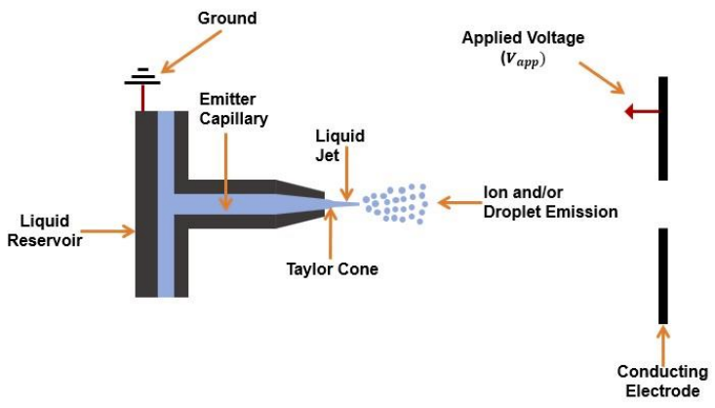
Figure 1: General set-up of an ES device [10].

1.2 Background and Relevance
Nanosatellites are an emerging space technology with a mass of $1–10$ kg. They are driving innovation in space because they provide a cost-effective method to deploy new technologies into Low Earth Orbit (LEO). As of May 2023, 2,286 nanosatellites have been launched; another 2,080 are expected to be launched over the next five years [11]. Unfortunately, only around six percent of these nanosatellites have been launched with a propulsion system [11]. Despite the many benefits of nanosatellites, space congestion is a rapidly growing concern in the space community, and without a propulsion system, the increase in nanosatellite launches will likely compound this issue. Not only are satellites without propulsion systems unable to deorbit themselves, but they are also unable to perform maneuvers to avoid collisions with other satellites. To mitigate this concern, the Federal Communications Commission (FCC) has issued a new rule requiring satellites in LEO to deorbit within five years following the completion of their mission [12]. This is a dramatic change to the previous requirement of 25 years to deorbit, and for many nanosatellites this new timeline is impossible to achieve without a device to assist in deorbit. Drag-enhancement devices could be used to assist in deorbiting a nanosatellite. However, unlike drag-enhancement devices, propulsion systems can perform precise collision avoidance maneuvers, mitigating any risk of collision during a nanosatellite mission or deorbit maneuver. A propulsion system can also provide additional capability to a nanosatellite, such as attitude control and station-keeping capabilities.
1.3 Micro-propulsion Overview
To understand the attraction of ETs for nanosatellite propulsion, an analysis of spaceflight parameters and a comparison of micro-propulsion systems is required. There are many things to be considered when determining the suitability of a propulsion system for a spacecraft mission, but common to all missions are the requirements for thrust, total impulse, specific impulse ($I_{sp}$), $Δv$, mass fraction, and power. To begin the analysis, consider the force balance for a spacecraft in a gravitational field which is given by [13]:
$m\dot{v} = \dot{m}u_{e} + F_{g}$, | (1.1)
where m is the mass of the spacecraft, $\dot{v}$ is the acceleration, $\dot{m}$ is the mass flow rate of the propellant, $u_{e}$ is the exit velocity of the propellant, and $F_{g}$ is the force from gravity. The thrust of the spacecraft is given by the first term on the right-hand side of (1.1) and can be written as [13]:
$T = \dot{m}u_{e}$, | (1.2)
where $T$ is the force from thrust. By integrating (1.2) over the timespan of the spacecraft’s mission, the total impulse required for the mission is found to be [13]:
$I_{t} = \int_{t_{0}}^{t_{f}}{T dt} = m_{p}u_{e}$, | (1.3)
where $m_{p}$ is the mass of the propellant, $t_{0}$ is the initial time of thrust, and $t_{f}$ is the final time of thrust. By dividing (1.3) by the weight of the propellant, the following equation for $I_{sp}$ is established [13]:
$I_{sp} = \frac{ m_{p}u_{e}}{m_{p}g} = \frac{ u_{e}}{g}$, | (1.4)
where $g$ is the acceleration due to gravity. Now, rewriting (1.1) in terms of $I_{sp}$ and assuming the local gravitational force is negligible results in [13]:
$m\dot{v} = \dot{m}gI_{sp}$, | (1.5)
Next, integrating (1.5), an equation for the magnitude of the velocity increment required for the mission is:
$$\int{dv} = \int_{m_{0}}^{m_{f}}{\frac{gI_{sp}}{m}}dm$$
$∆v = gI_{sp}\ln{\frac{m_{0}}{m_{f}}}$, | (1.6)
where $m_{0}$ is the initial mass of the spacecraft and $m_{f}$ is the final mass of the spacecraft. Solving for the ratio of final and initial propellant mass, otherwise known as the mass fraction, yields:
$\frac{m_{0}}{m_{f}} = exp\left(\frac{-∆v}{gI_{sp}}\right)$, | (1.7)
With the governing equations established, it becomes clear from (1.2), (1.6), and (1.7) that achieving the desired thrust and $Δv$ for a mission is ideally accomplished through high exhaust velocity values instead of high amounts of propellent mass ejection. This avoids prohibitively high mass fractions for the spacecraft [13]. It is also important to note that based on (1.6) and (1.7), achieving a large $Δv$for a mission does not require a large amount of thrust if the propulsion system has a large $I_{sp}$ and assuming there is enough time to the $Δv$. Thus, a propulsion system with high $I_{sp}$ and exit velocity is desirable for any mission, especially for small spacecraft such as nanosatellites that cannot afford a large mass fraction.
Now armed with the parameters that are important for nanosatellite propulsion, it is worth analyzing the available micro-propulsion systems that achieve these parameters. Micro-propulsion systems can be divided into Cold/Warm Gas, Chemical, and the three electric propulsion categories: Electrothermal, Electromagnetic, and Electrostatic. Figure 2 compares the thrust, $I_{sp}$, and mass of micro-propulsion systems across all five categories. Based on Figure 2, electric propulsion systems, and more specifically electromagnetic and electrostatic systems, have the high Isp desirable for high $Δv$ missions. However, the high $I_{sp}$ found in electric propulsion systems does not come without penalties, namely in the form of a large power supply which adds to the mass of the system and can cause problems for small systems like nanosatellites through electromagnetic interference (EMI). The mass of the power supply will likely scale linearly with the propulsion system's power level. Figure 3 compares $I_{sp}$, thrust, and power requirements of micro-propulsion systems. Based on Figure 3, ETs require less power than most electric propulsion systems (generally less than 30 W) which means their power supplies will be low in mass and will minimize EMI. To maintain the low cost and rapid deployment benefits of nanosatellites the propulsion system needs to be low-volume, low-mass, low-power, and have a high $I_{sp}$. From the analysis in this Section 1, it is clear why ETs are an ideal solution for nanosatellite propulsion.
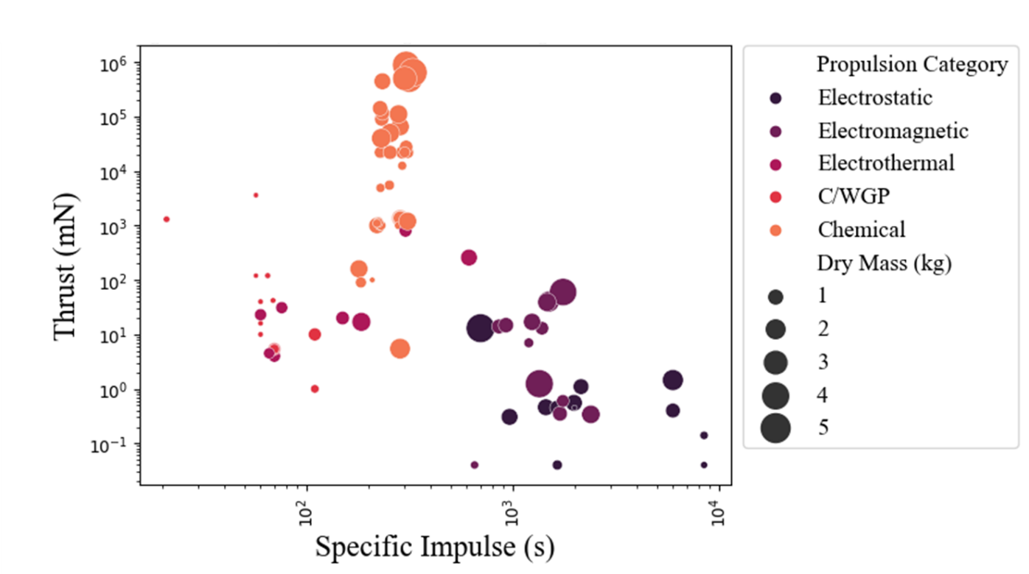
Figure 2: Micro-Propulsion Systems under 5 kg plotted by thrust, specific impulse, and mass [69-163].

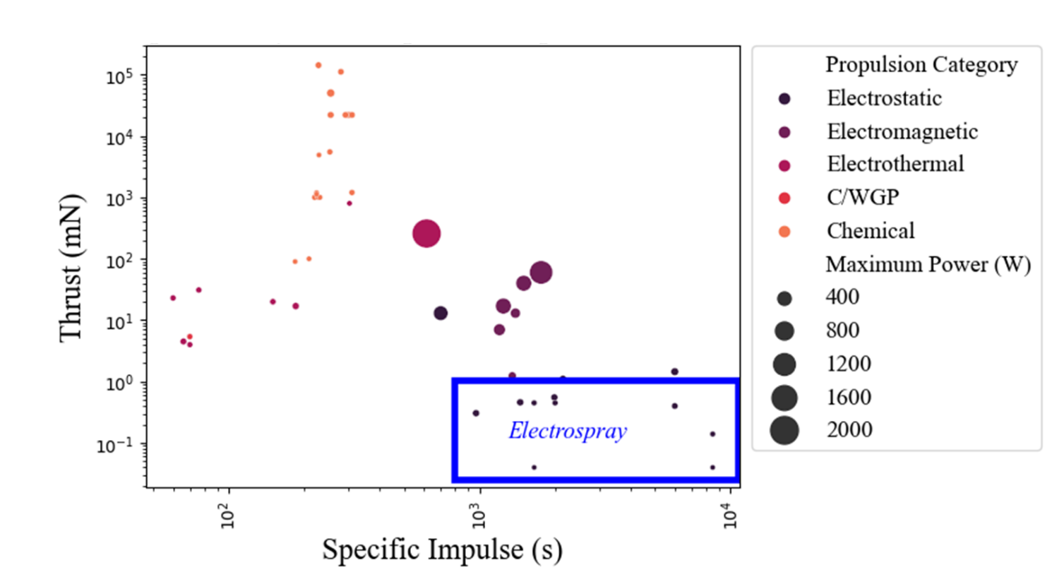
Figure 3: Micro-Propulsion Systems plotted by thrust, specific impulse, and power [69-163].
1.4 Electrospray Thruster Literature Review
The effects on liquids and gases exposed to an applied voltage have been extensively studied since the 1700s. The origins of ES for space propulsion can be traced back to F. Huaksbee who is credited with the first observance of EHD effects in 1709, recording the feeling of wind against his face when held near a charged tube [14, 16]. Isaac Newton managed to recreate his experiments and published them in Opticks in 1709 [15, 16]. The first use of ionic wind for propulsion occurred in 1750 when Benjamin Wilson harnessed the power of EHD effects to drive a rapid rotary pinwheel [16]. Decades later, EHD was effectively described qualitatively by Michael Faraday when he correctly explained that the transfer of momentum between charged and uncharged particles was caused by friction or collisions [16]. Despite the quality of the quantitative work performed up to this point, it is James Maxwell’s quantitative work in A Treatise on Electricity and Magnetism in 1873 that established the foundation of electrostatics with the well-known Maxwell Equations which are a driving force in EHD [16].
Because the electrostatic acceleration of ions showed so much promise for propulsion, a lot of research was performed on the production of ions. Some of the most important research at the time demonstrated and described the mechanisms of field emission of positive ions from metallic sources such as the work performed by Muller et al. in 1956 [17]. The use of metal propellants became ubiquitous in electric propulsion in field emission electric propulsion thrusters which are still used today. This type of research culminated in NASA's launch of the SERT 1 spacecraft in 1964. This spacecraft carried two electrostatic thrusters: a cesium contact ion thruster and a mercury electron bombardment ion thruster. The former failed to perform due to a voltage short circuit, but the latter operated for over 31 minutes and is considered the first successful electric space thruster [13]. Despite its promise, there are drawbacks with liquid metal propellants such as toxicity and the ability to only produce positively charged ions. These drawbacks have led to the pursuit of propellants other than metal for ETs.
The use of liquids other than metals for ETs finds its origins in the research performed by Lord Rayleigh in 1879, who published a relationship for the charge limit of charged liquid droplets which would become important in the study of the relationship between charged droplets and ions produced by ES [18]. From 1915–1917, the first work recording cone-jets was published by John Zeleny who performed experiments charging ethyl alcohol in a glass tube to several thousand volts, which resulted in what he described as a thread or stem of liquid emanating from the apex of the cone, as can be seen in Figure 4 [19]. The cone structure observed by Zeleny was investigated by Geoffery Taylor in 1964, who resolved the half angle of the cone to be 49.3° before a jet forms at the cone apex. His discovery led to the structure, shown in Figure 5, being named a Taylor cone [1].
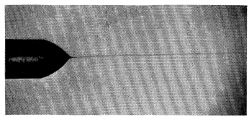
Figure 4: ES Cone-jet of Ethyl-alcohol [19].

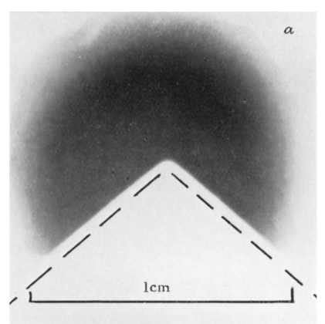
Figure 5: Taylor Cone—the broken lines’ half-angle is 49.3° [1].
Using Taylor and Zeleny’s research as a foundation, many applications of the cone-jet were created to include pesticide spraying, spray painting, and inkjet printing [6]. In 1990, Cloupeau et al. described and demonstrated through experiments using water and various organic products the different spraying modes that can be produced by applying a voltage to a liquid that could be used in these applications. These modes included dripping, micro-dripping, cone-jet, spindle, and pulsating [20]. The first three modes focused on the production of droplets and jets with diameters in the micrometer range or larger. From 1993 to 2018, the physics of ES in these modes were researched extensively by A. M. Ganan-Calvo et al., who produced scaling laws for ES that produced droplets and jets in the micrometer range. These scaling laws showed that the parameters such as current, jet and droplet radii, etc. were dependent only on the liquid flow rate through the capillary and the properties of the liquid and were independent of the voltage applied to the system [2].
Another mode discovered in ES involves cone-jets that produce droplets and jets with diameters in the nanometer range, sometimes called nano-ES. In the late 1980s, interest in nano-ES exploded as Fenn et al. demonstrated its use for mass spectrometry [9]. This renewed interest has driven research from the late 1990s to the present day on the production of droplets versus ions during ES. Two models were developed to explain the phenomenon: the charge residue mechanism (CRM) pioneered by Dole and the Ion Evaporation Model (IEM) pioneered by Iribarne et al. [21]. The CRM can be summarized as an ionization mechanism in which Coulomb fission is the only means a droplet can use to reduce its charge as it approaches the Rayleigh limit. In 1993, Gomez et al. published a paper describing Coulomb fission, which they found occurs at approximately 80% of the droplet charge limit due to the deformation of the droplet caused by the forces acting on the droplet [3].
The IEM is an ionization mechanism in which droplets eject bare solution ions, reducing the droplet charge before Coulomb fission can occur [22]. The IEM was hotly debated for a time, but research by de la Mora et al. and M. Gamero-Castano et al. has shown that not only is IEM a valid model for ion production, but also that both mechanisms can be present during ES ionization [21, 23].
Much like the scaling laws developed by Ganan et al., in 1994, de la Mora et al. developed scaling laws for nano-ES to model parameters such as spray current and jet diameter, noting that these parameters are a function of flow rate and fluid properties [21]. These scaling laws are backed up by M. Gamero-Castano et al. experiments with the ionic liquid (IL) 1-ethyl-3-methylimidazolium bis(trifluoromethylsulfonyl) imide (EMI-Im) in 2008 [26]. M. Gamero-Castano’s work on ILs has been for the purpose of using ILs as propellants for ETs because, unlike liquid metals, ILs are less toxic and can produce ions of both negative and positive charges, making them advantageous for space propulsion [4, 24]. This type of work on ETs was demonstrated with the Colloidal Micro Newton Thruster Assemblies (CMTAs) used on the LISA Pathfinder mission which launched in 2015. The CMTAs were successful in meeting the attitude-control performance requirements for drag-free control of the spacecraft [25].
1.5 Electrospray Numerical Analysis Review
A large amount of effort is being put into developing reliable numerical analysis for ETs because physical experimentation with ETs can be both time-consuming and expensive. Numerical analysis is a powerful tool that can be relatively inexpensive and rapidly iterative regarding geometry and operating conditions. Rapid iterations provide the opportunity to optimize device design before testing and increase the chance of success during costly physical experiments. Also, it can provide values for properties that cannot be practically measured through experiments. However, numerical simulations still have their limitations, which is apparent in the relationship between accuracy and computational cost. Characteristic times, which will be discussed in Section 2.9, in ES can reach values less than one picosecond, and the mesh size required to accurately resolve the movement of a liquid subject to electrostatic forces can reach values on the nanometer scale. These small scales drastically increase the computational cost to provide accurate results. Thus, it is important to understand previously achieved successes in the numerical analysis of ES and what can be done to reduce computational costs. To perform numerical analysis on ES, commercially available computational fluid dynamics (CFD) software is generally employed, and there are many types of commercial software available for this endeavor.
OpenFOAM is an open-source CFD software that has been used to solve EHD problems. In 2013 and 2023, OpenFOAM was used to simulate ES for n-heptane. Both models compared their droplet diameter results to experiments conducted by Gomez et al. [27, 28]. The 2023 results were closer to the droplet diameter values produced by their experiments, likely due to implementing a transient charge conduction equation along the jet.
Another software available for ES simulation is LAMMPS, which is an open-source code used for classical molecular dynamics modeling [29]. In 2021, LAMMPS was used to perform a molecular dynamics simulation of the IL 1-ethyl-3-methyl-imidazolium tetrafluoroborate (EMI-BF4) in a charged capillary. This study analyzed Taylor cone formation, ES currents, energy characteristics, and velocity distributions for varying operating conditions [30]. In 2022, LAMMPS was used to simulate molecular dynamics for ion emission, ion acceleration, and beam neutralization of an ET using EMI-BF4 as the propellant [31].
Gerris is free software that can solve fluid flow equations and has been used to solve EHD problems. [32]. In 2011, an extension was developed for Gerris as a charge-conservation approach to simulate two-phase flows, which build on the volume-of-fluid model [33]. This charge-conservation approach has been adapted for use in future numerical analysis with other software.
COMSOL is a multiphysics software platform that is available for ES simulation. In 2023, this software was used to simulate low- and high-conductivity liquids in an ES device. This model used an interpolation method to achieve more accurate calculations of charge and current [34]. COMSOL was also used by the University of California, Los Angeles to create an Interaction Model that simulates the plume evolution of an ES device using ethanol as the propellant [35]. COMSOL was also used in 2023 to model IL droplets of different diameters to observe Coulomb fission and ion evaporation, yielding results comparable to physical experiments. [36]
STAR-CCM+ is another multiphysics software that has been explored for use in analyzing ES systems. It was used by Jones et al. in 2020 to investigate the EHD and two-phase phenomenon of ES. This investigation was successful in optimizing the geometry of a novel electrospray thruster emitter [37].
ANSYS provides software suites that can be used to solve dynamic electrical and fluid systems. In 2006, ANSYS CFX 4.4 was used to simulate the EHD atomization process for heptane and ethanol. The model successfully modified the heat conduction equation to solve the electrostatic field equations which were used to determine the electric body forces acting on the liquid. This method was accurate for the initial development of the cone-jet, but, because the current was neglected in the model, it did not accurately predict steady-state behavior [38]. In 2012, ANSYS Fluent was used again to simulate the ES of heptane and ethanol through a charged capillary. New updates to the ANSYS software meant that mean droplet diameter results from this simulation could be compared to experimental results with good agreement [39] In 2018, Ansys Fluent was used to model nano-ES ionization in a mass spectrometer. This model assumed “fully desolvated gas-phase ions are instantaneously produced at the emitter tip” when being introduced. [40] It implemented a particle-in-cell method using a user-defined scalar (UDS) and a user-defined function (UDF) to accurately represent space-charge effects on the electric field. The model also used a corrected drag law to represent forces on sub-micron particles [40]. In 2022, ANSYS Electronics Desktop was successfully used by Howell et al. to investigate the minimum onset voltages to establish a Taylor cone using ionic liquid propellants and optimal dimensions for an ET chip. [10] The simulations in this paper use ANSYS Fluent to model and optimize the performance of the ET analyzed by Jones et al. and Howell et al. which will be introduced in Chapter 3.
1.6 Organization
Chapter 1 focused on the relevant background information for electric propulsion as it applies to space, ES, and numerical analysis of ES. Next, Chapter 2 will focus on the physics and governing equations of ES related to electric propulsion. In Chapter 3, the physics and governing equations established in Chapter 2 will be used to analyze an ET. Then, Chapter 4 will discuss numerical simulations conducted for establishing a Taylor cone on an initially concave interface. Finally, Chapter 5 will provide conclusions for the present thesis and recommendations for future work on this subject.

Chapter 2: Physics Review and Governing Equations
ES devices operate based on the effects of electric fields on conductive liquid propellants. The behavior of a liquid subjected to the effects of an electric field can be described by the governing equations of electrostatics and fluid mechanics. The electrostatic behavior is fundamentally represented by Maxwell’s equations, and the fluid mechanics are represented by the conservation equations for mass, momentum, and energy. This section will discuss these governing equations and the assumptions that will be used to simplify them to solve them analytically or numerically.
2.1 Fluid Mechanics
Fluid motion behaves based on hydrodynamics. This behavior can be modeled using the Navier-Stokes equations. The first equation is the conservation of mass equation, also called the continuity equation, which is given by [41]:
$\frac{∂ρ_{m}}{∂t}+∇∙ρ_{m} u=0$, | (2.1)
where $ρ_{m}$ is the fluid mass density. The second equation is conservation of momentum, which can be written as [41]:
$ρ_{m}\left(\frac{∂u}{∂t}+u∙∇u\right)=-∇P + ∇∙\overset{̿}{τ} + f_{b}$, | (2.2)
where P is the pressure, $\overset{̿}{τ}$ is the viscous stress tensor, and $f_{b}$ represents other body forces acting on the fluid. The third equation is the conservation of energy, given by [41]:
$ρ_{m}c_{p}\frac{DT}{Dt}=-∇∙q_{h}+βT\frac{DP}{Dt}+Φ$, | (2.3)
where $c_{p}$ is the specific heat at constant pressure, T is the temperature, $q_{h}$ is the heat of the system, $β$ is the thermal expansion coefficient, and $Φ$ is the dissipation function. To complete the above system of conservation equations an equation of state is required. The most common one is the ideal gas law, which is given by [41]:
$P=ρ_{m}RT$, | (2.4)
where$R$ is the specific gas constant.
2.2 Surface Tension
At the scale where ETs operate, the force from surface tension at the interface between two fluids is required to accurately explain fluid behavior. In 1990, a continuum method for modeling surface tension was developed by Brackbill, Kothe, and Zemach as a simplified and effective method of modeling flows driven by surface forces [42]. This publication considers surface forces at the interface of two fluids as seen in Figure 6.
The boundary condition for surface stress can be expressed as [42]
$\left(p_{1}-p_{2}+γκ\right)∙n=({\overset{̿}{τ}}_{1}-{\overset{̿}{τ}}_{2})∙n + ∇∙γ$, | (2.5)
where $p_{i}$ is the pressure in fluid i, $γ$ is the surface tension between the two fluids, $κ$ is the curvature at the interface of the fluids, and $n$ is the unit normal vector. Brackbill et al. show that if the system is at equilibrium, the terms on the right-hand side of the boundary condition balance each other. This means that the terms on the left-hand side of the equation also balance each other, such that the pressure jump across the interface is proportional to the curvature of the interface as shown in (2.6) [42]:
$p_{2}-p_{1}=γκ$, | (2.6)
This result shows that the normal surface force per unit area can be written as [42]
$F_{sa}=γκn$, | (2.7)
Brackbill et al. then show that this surface force can be transformed into a volume force via the gradient of a “color function” which describes the mixing of the two fluids in a finite transition region near the interface with height, h, as shown in Figure 6. This results in the Continuum Surface Force (CSF) equation, which is given by [42]:
$f_{st}=γκ\frac{∇\tilde{c}(x)}{[c]}$, | (2.8)
where $c$ the “color function.”
2.3 Capillary Action
Typically, the fluid dynamics of capillary action would be described with Jurin’s Law, which describes how high the fluid would rise in a capillary against the force of gravity. However, because we are focused on electric propulsion in LEO, the force from gravity is negligible. Thus, the situation is described by the Washburn equation, which can be written [43]:
$d = \sqrt{\frac{γr_{c}tcos(θ)}{2μ}}$, | (2.9)
where $d$ is the distance the fluid will travel in the capillary,$γ$ is the surface tension coefficient,$t$ is the time it takes the fluid to travel the capillary length, $r_{c}$ is the capillary radius, $μ$ is the dynamic viscosity, and $θ$ is the contact angle of the fluid. If we solve the Washburn equation for time,
$t = \frac{2d^{2}μ}{γr_{c}cos(θ)}$, | (2.10)
and find the volume of the capillary of height, $h_{c}$:
$V = h_{c}π{r_{c}}^{2}$. | (2.11)
Assuming that $d=h_{c}$, the resulting capillary volumetric flow rate, $Q_{cap}$, equation from capillary action is
$Q_{cap} = \frac{V}{t} = \frac{π{r_{c}}^{3}γcos\left(θ\right)}{2μh_{c}}$. | (2.12)
Also, based on (2.9), over a long enough period of time, the fluid will always flow to the end of the capillary in a vacuum if capillary action is the only driving force in the fluid.
2.4 Electrostatics
As seen in Figure 1, ES devices apply an electric potential, $ϕ$, between a capillary and an extraction grid to induce an electric field, $E$, which can be represented as follows [44]:
$E=-∇ϕ$. | (2.13)
The effects of this electric field on the liquid propellant are critical to the proper operation of an ES device and are governed by Maxwell’s equation for electrostatics, charge continuity, and electrostatic force. Maxwell provides two equations for electrostatics. The first is Gauss’s Law, which can be written as [44]
$∇∙E=\frac{ρ_{e}}{εε_{0}}$, | (2.14)
where $ρ_{e}$ is the charge density, $ε$ is the dielectric constant, and $ε_{0}$ is the vacuum permittivity. The second equation shows that the electric field has no curl [44].
$∇×E=0$. | (2.15)
These equations are a simplification of Maxwell’s electromagnetic equations, and they rely on the following assumptions [44]:
- The electric field goes to zero in the far field.
- The magnetic field is equal to zero.
The second assumption can be evaluated by comparing the electric relaxation time, $t_{e}$, to the magnetic relaxation time, $t_{m}$, such that $t_{e} ≫ t_{m}$ [67]. These relaxation times can be written as follows [10]:
$$t_{e} = \frac{εε_{0}}{K}$$ | (2.16)
and
$t_{m} = μ_{r}μ_{0}KL^{2}$, | (2.17)
where K is the electrical conductivity, $μ_{r}$ is the relative permeability, $μ_{0}$ is the vacuum permeability, and L is the characteristic length of the system. Both relaxation times will be explored in Chapter 3, where this assumption will be shown to be valid. The existence of (18) implies that $ϕ$ is a scalar potential and means (2.10) can be written as Poisson’s equation [44],
$∇^{2}ϕ=\frac{ρ_{e}}{εε_{0}}$. | (2.18)
Tracking the charge in an electrostatic system requires the following conservation equation [44]:
$\frac{∂ρ_{e}}{∂t}-∇∙J=0$, | (2.19)
where $J$ is the current density.
The final electrostatic equation is that of electrostatic force, $f_{e}$ which is given by [44]
$f_{e}=∇∙τ_{e}$, | (2.20)
where ${\overset{̿}{τ}}_{e}$ is the Maxwell stress tensor of the electrostatic field. This tensor can be written as:
${\overset{̿}{τ}}_{e}={εε}_{0}\left(EE-\frac{1}{2}{I\left|E\right|}^{2}\right)$, | (2.21)
where $I$ is the Identity Matrix. Inserting (2.21) into (2.20), the following equation is found:
$f_{e}= ∇∙{εε}_{0}\left(EE-\frac{1}{2}{I\left|E\right|}^{2}\right)$, | (2.22)
Using (2.14), this can be simplified to:
$f_{e}= ρ_{e}E - \frac{1}{2}ε_{0}{\left|E\right|}^{2}∇ε$, | (2.23)
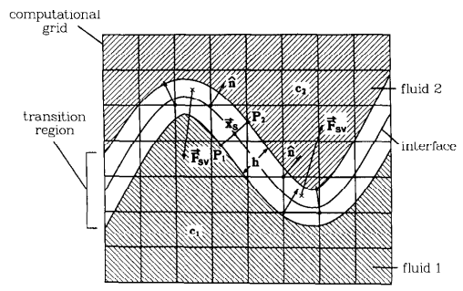
Figure 6: Interface Between Two Fluids [43].

where the first term on the right-hand side of the equation is the Coulomb force and the second term is the polarization force.
2.5 Electrohydrodynamics
The governing equations of fluid mechanics and electrostatics can be combined to model EHD by replacing the representative body force term with the electrostatic force density, the surface tension force density, and the gravitational force density, $f_{g}$
$f_{b}=f_{e}+f_{st}+f_{g}$. | (2.24)
Inserting this into the conservation of momentum equation yields
$ρ_{m}\left(\frac{∂u}{∂t}+u∙∇u\right)=-∇P + ∇∙\overset{̿}{τ} + f_{e}+f_{st}+f_{g}$. | (2.25)

2.6 Electrospray Modes
Cloupeau and Prunet-Foch identified three ES modes: dripping mode, micro-dripping mode, and cone-jet mode [20]. Two other modes have been found for ES, which are a hybrid droplet-ion beam and a pure ion beam. [23, 45] Regarding ETs, the three modes of interest are the cone-jet, hybrid droplet-ion beam, and pure ion beams, so this paper will focus only on these modes. Common to all three of these modes is the formation of the Taylor cone.
2.6.1 Taylor Cone Formation
Taylor cone formation occurs due to a pressure balance at the interface of a liquid and a dielectric, while electric stressing is present in a hydrostatic system between some liquid and air, as seen in Figure 7. To understand this phenomenon, consider the stress balance provided in (2.5) with the electric stress present [1]:
$\left(p_{v}-p_{l}+γκ\right)∙n=({\overset{̿}{τ}}_{v}-{\overset{̿}{τ}}_{l})∙n +\left({\overset{̿}{τ}}_{ve}-{\overset{̿}{τ}}_{le}\right)∙n+ ∇∙γ$, | (2.26)
where subscript v labels parameters for the vacuum and subscript l labels parameters for the liquid, . Because the system is hydrostatic all tangential stresses must be balanced. Also, it is assumed the surface tension is constant. [42] Thus, expanding and simplifying the Maxwell stress tensors results in the following:
$\left(p_{v}-p_{l}+γκ\right) = ε_{v}ε_{0}\frac{1}{2}{E_{vn}}^{2}-ε_{l}ε_{0}\frac{1}{2}{E_{ln}}^{2}$. | (2.27)
$E_{ln}$ is the electric field normal to the interface in the liquid and $E_{vn}$ is the electric field in the vacuum normal to the interface. Assuming that the liquid meniscus approaches a perfect dielectric, the electric field jump condition across the interface is $E_{ln}≈E_{vn}/ε$. Also, assuming $ε_{v}=1$ the following equation is found [21]:
$γκ-∆p=\frac{1}{2}ε_{0}{E_{vn}}^{2}\left(\frac{ε-1}{ε}\right)$. | (2.28)
Classic Taylor analysis generally neglects the hydrostatic pressure, $∆p$ [45]. The curvature, $κ$, can also be represented as $∇∙n$. Converting this to spherical coordinates, $κ$ can be represented as
$κ=∇∙n=∇∙r=\frac{1}{r^{2}}\frac{∂}{∂r}r^{2}=\frac{2}{r}$. | (2.29)
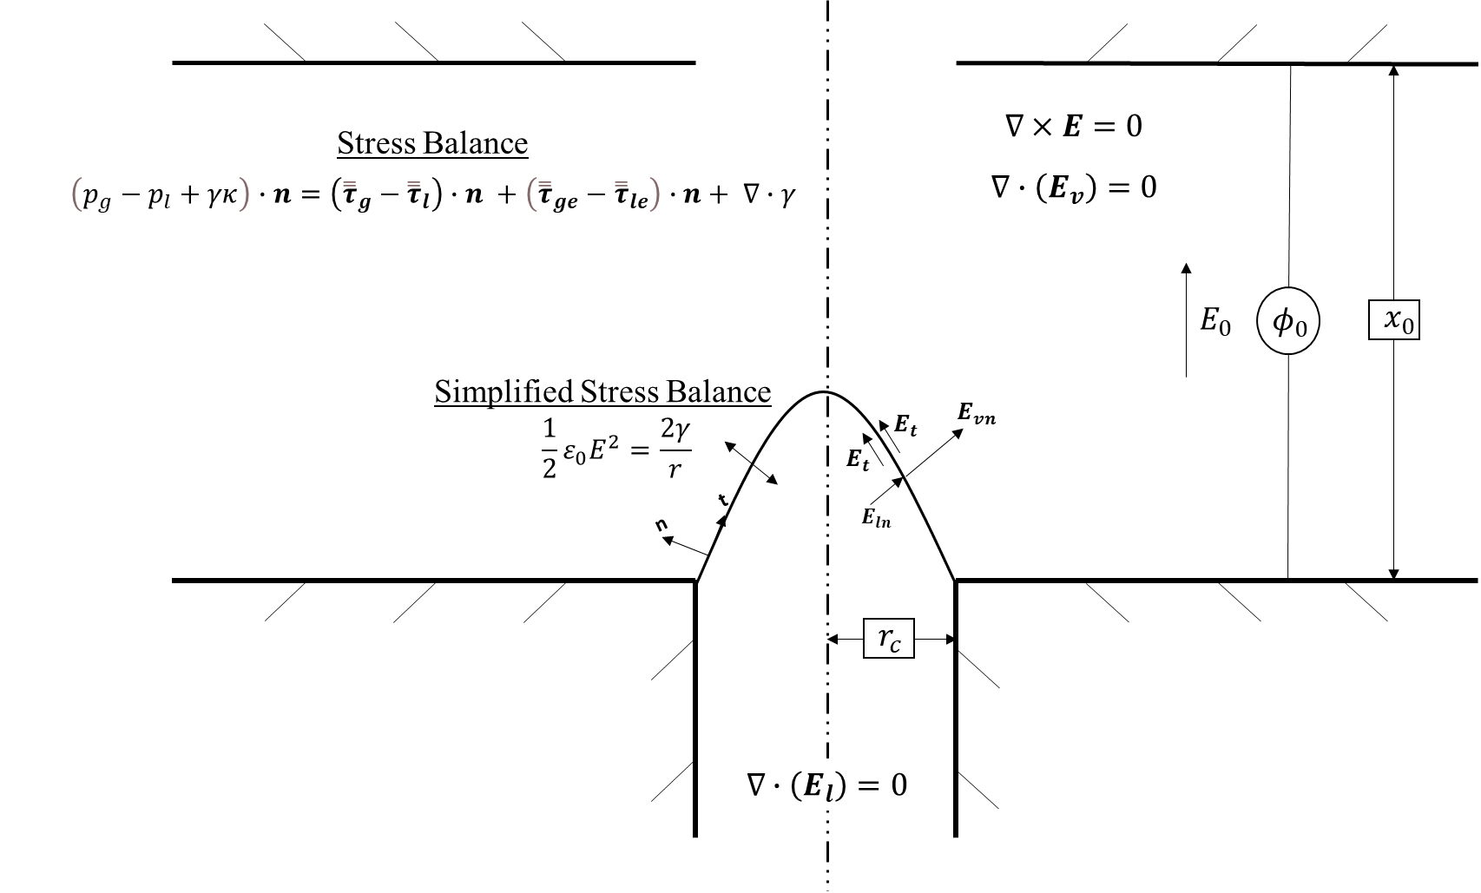
Figure 7: Taylor Cone Stress Balance.

Thus, the stress balance for a Taylor cone is found to be
$\frac{2γ}{r}=\frac{1}{2}ε_{0}{E_{vn}}^{2}\left(\frac{ε-1}{ε}\right)$. | (2.30)
If it is assumed that $ε≫1$, (2.30) can be simplified further to [1]:
$\frac{2γ}{r}=\frac{1}{2}ε_{0}{E_{vn}}^{2}$. | (2.31)
As Coulombic forces draw charge to the interface from the bulk liquid, the surface charge density is increased, which increases the electric field strength normal to the meniscus. Therefore, for the surface tension to continue to balance the electric stress, the radius must be reduced, which leads to the conical shape of the Taylor cone. Through some minor algebraic manipulations, (2.31) can be used to find the electric field on the surface of the liquid at the apex of the Taylor cone at equilibrium [1],
$E_{vn}=\sqrt{\frac{4γ}{ε_{0}r_{a}}}$, | (2.32)
where $r_{a}$ is the apex radius of the evolving Taylor cone and can be estimated with the following equation:
$r_{a}=\frac{r_{c}}{w}tan(θ_{0})$, | (2.33)
where w is a measure of the sharpness of the Taylor cone and $θ_{0}$ is the Taylor cone half-angle, assumed to be 49.29°. [10] This equation can used to find the onset voltage, $V_{0}$, required for Taylor cone formation. Using the derivation provided by Howell, the following equation is found [10]:
$V_{0}=\frac{1}{C}\sqrt{\frac{4γ}{ε_{0}r_{a}}}$, | (2.34)
where $C=\frac{E_{gn}}{V_{0}}$.
2.6.2 Cone-Jet Modes
The Taylor cone on its own is not particularly useful to ETs, but it is a precursor to some very useful phenomenon, one of which is the cone-jet. These cone-jets can be steady or transient depending on the applied electric field and the conditions of the fluid. The applied electric field causes the near immediate relaxation of mobile ionic species in this fluid, which leads to a highly charged interface [2]. Because the electric relaxation time in the fluid is generally much shorter than the liquid residence time, $t_{rl}$, the charge of the bulk fluid can be considered quasi-neutral. Using (2.14), this can be represented as
$\frac{ρ_{e}}{εε_{0}}=∇∙E_{l}=0$. | (2.35)
In a steady cone-jet, a quasi-steady cone originating at the end of a capillary emits a jet from its apex that has a diameter much smaller than the diameter of the capillary. This jet develops due to perturbations in the cone that elongates the cone tip. This reduces the cone angle and raises the intensity of the electric field at the apex according to (2.32) [2]. The electric stresses overcome the surface tension, and the electric forces accelerate the liquid out of the cone, forming the jet. As the jet lengthens, axisymmetric surface wave instabilities develop along its length, reaching a breakup point where droplets are formed in a bimodal distribution of primary and satellite droplets, as shown in Figure 8 [3]. The system reaches a steady state when the liquid flow rate into the meniscus matches the flow rate out of the meniscus via the jet [2]. The diameter of the primary droplets are approximately 1.9 times the diameter of the jet, which matches well with Rayliegh’s theory on capillary jet stability. As the electric field accelerates these droplets away from the breakup point, they become monodispersed, with the satellite droplets being forced to the edge of the spray due to their small charge-to-mass ratio [3].
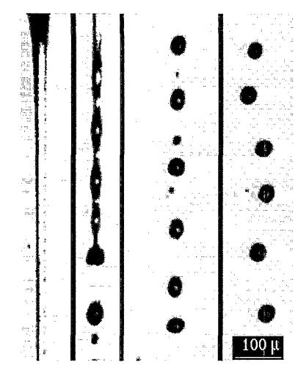
Figure 8: Flash Shadowgraph of Jet Breakup [3].

Based on numerous experiments, it has been found that the diameter of the monodispersed droplets created by steady cone-jets can be easily controllable based on the liquid properties of the meniscus and the liquid flow rate through the capillary [2, 21] One of the most important parameters for the diameter of the droplets is the electric conductivity of the liquid, because the higher the conductivity, the smaller the diameter of the droplet is that can be achieved. Liquids with low conductivity—$\left(K<{10}^{-4}\left[\frac{S}{m}\right]\right)$—are generally only capable of producing droplets on the micrometer scale, whereas moderate to high conductivity fluids—$\left(K>{10}^{-4}\left[\frac{S}{m}\right]\right)$— can produce droplets on the nanometer scale [21]. Sprays at these two separate scales are generally similar but have enough differences that they have been worth analyzing separately.
2.6.2.1 Micro-Electrospray (Steady Cone-Jet)
Cone-jet mode sprays involving droplets at the micrometer scale, which will be referred to as micro-ES in this paper, seem to have been studied the most since the discovery of ES. The scalability of the droplet diameters makes it useful for many applications, including ETs [2]. The physics of steady cone-jet mode can be broken into three regions based on the dominant charge transport mechanism. The first region is the upstream meniscus attached to the capillary where ohmic conduction dominates charge transport. This region is quasi-neutral except at the interface between the liquid and gas. The second region is the transition region where charge transport is transitioning from ohmic conduction to surface convection, and both must be taken into account. The third region is the downstream jet where surface convection is the dominant transport mechanism. The analysis of these regions has produced scaling laws that can be used to predict important ES parameters such as minimum flow rate, droplet diameter and charge, and current [2].
These scaling laws, which have been developed and succinctly summarized by Ganan et al., are a powerful tool for verifying numerical analysis of micro-ES. Figure 9 shows parameters used for the scaling laws. Ganan et al. show that the emitter droplet diameter can be sufficiently predicted via the following equation [2]:
$d_{d}=d_{d0}\sqrt{\frac{Q}{Q_{0}}}$, | (2.36)
where $Q$ is the capillary flow rate, and $d_{d0}$ and $Q_{0}$ are a characteristic droplet diameter and capillary flow rate, respectively, given by [2]:
$$d_{d0}={\left(\frac{γε_{0}^{2}}{ρK^{2}}\right)}^{\frac{1}{3}}$$ | (2.37)
and
$Q_{0}=\frac{γε_{0}}{ρK}$. | (2.38)
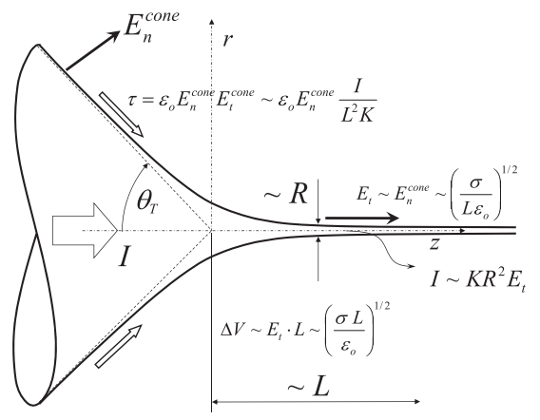
Figure 9: Steady Cone-jet Configuration with Parameters Used for Scaling Laws [2].

This scaling law was extensively compared with experimental data and shows good agreement [46]. They also show that the current, I, transported by the jet scales with the flow rate with the following equation:
$I = 2.6I_{0}\sqrt{\frac{Q}{Q_{0}}}$, | (2.39)
where $I_{0}$ is a characteristic current given by [46]:
$I_{0}=γ\sqrt{\frac{ε_{0}}{ρ}}$. | (2.40)
This scaling law has been verified through comparison of over 2000 data points from various experiments [2]. Using a balance of the convective and conductive charge transports, the characteristic length, L, of the transition region can be written [47]:
$L=d_{d0}\frac{Q}{Q_{0}}$. | (2.41)
Finally, the diameter of the jet, R, is given by [2]
$R={\left(\frac{ρε_{0}Q^{3}}{γK}\right)}^{1/6}$. | (2.42)
These scaling laws lead to an important limit for micro-ES, which is the minimum flow rate, $Q_{min}$, at which a steady cone-jet can be maintained. There are two scenarios for which $Q_{min}$ is approached: viscous forces stall jet emission, and polarization forces stall jet emission. To determine which of these forces will dominate the flow, the electric Reynolds number, ${Re}_{K}$, and the dielectric constant are compared. If viscous forces are dominant, ${Re}_{K}ε<1$ and if polarization forces are dominant, ${Re}_{K}ε>1$. In the former case, the minimum flow rate is given by [47]
$Q_{min}= \frac{Q_{o}}{{Re}_{K}}$, | (2.43)
and in the latter case, the minimum flow rate can be written:
$Q_{min}= {εQ}_{o}$, | (2.44)
where the electric Reynolds number is
${Re}_{K}={\left(\frac{γ^{2}ρϵ_{o}}{μ^{3}K}\right)}^{\frac{1}{3}}$. | (2.45)
These scaling laws show that the parameters characterizing micro-ES are $Q$, $ε$, $ρ$, $γ$, $μ$, and $K$. It is interesting to note that these scaling laws are independent of the system applied voltage, which implies that the only requirement of the applied voltage is to form and maintain a Taylor cone to create a micro-spray. It is also worth noting that the applied voltage does influence the exit velocity of the droplets, because they will be accelerated by the electric field.
2.6.2.2 Nano-Electrospray (Steady Cone-Jet)
For high electric conductivity in a liquid, the diameter of the droplets produced by ES can be reduced to the nanoscale, which in this paper will be referred to as nano-ES. The scaling laws at this scale differ from those of micro-ES by a function of the permittivity. Fernandez de la Mora and Loscertales used experimental measurements to show that a region of size $R_{a}$ and of the same order as the jet diameter at the cone apex can be expressed as [21]
$R_{a}={\left(\frac{εε_{0}Q}{K}\right)}^{\frac{1}{3}}$. | (2.46)
This expression essentially states that residence time of the fluid at the cone apex, $t_{lr}$, is of the same order as the electric relaxation time at the apex of the cone [21]. They also determined a scale for the electric current at the cone apex to be
$I_{F}\sim uR_{a}σ_{e}\sim uR_{a}ε_{0}E_{vn}\sim \sqrt{\frac{γQK}{ε}}$, | (2.47)
where $u=\frac{Q}{R_{a}^{2}}$ and $σ_{e}$ is the surface charge at the interface of the cone, which can be written as the electric field jump condition at that interface[21]:
$σ_{e}=ε_{0}(E_{vn}-εE_{ln})$. | (2.48)
In the electrostatic limit the electric field in the gas is normal to the interface and the electric field in the liquid is zero. Using this assumption in (2.48) leads to [21]
$σ_{e}=ε_{0}E_{vn}$. | (2.49)
The electric current of the system is then determined to be related to $I_{F}$ such that [21]
$I=f(ε) \sqrt{\frac{γQK}{ε}}$. | (2.50)
It is also found that the droplet diameter is related to $R_{a}$ which can be expressed as [21]
$d_{d}=G(ε) R_{a}$. | (2.51)
Chen and Pui use experimental data for eight liquids with various dielectric constants $\left(12.51≤ε≤182.4\right)$ to determine the following expressions [48]:
$$f(ε)=-449-0.21ε+157ε^{\frac{1}{6}}+336ε^{-\frac{1}{6}}$$ | (2.52)
$G(ε)=-10.9ε^{-\frac{5}{6}}+4.08ε^{-\frac{1}{3}}$. | (2.53)
It is worth noting that, despite the relatively large variation of $ε$, $f(ε)$ was found to be between 5 and 30 and increases for increasing $ε$, and $G(ε)$ was found to be between 0.5 and 2 [48]. These scaling laws are useful for the verification of numerical simulations.
2.6.2.3 Coulomb Fission (Transient Cone-Jet)
Transient cone-jets occur in situations where charge in a liquid body reaches its charge limit. Competing stresses at the interface form a Taylor cone and emit charge through a jet. However, after emitting the charge the body no longer has enough charge to maintain the Taylor cone, so both the jet and Taylor cone disappear. This form of cone-jet is typically seen in charged droplets and is called Coulomb fission [49]. This phenomenon is governed by Rayleigh’s droplet charge limit equation given by
$q_{R}=8π\sqrt{γεε_{0}r_{d}^{3}}$, | (2.54)
where ε represents the dielectric constant of the fluid that surrounds the droplet and $r_{d}$ is the radius of the droplet. Any droplet at or above this charge limit can reduce its charge below this limit by emitting smaller charged droplets, sometimes referred to as daughter droplets, of high charge-to-mass ratio via Coulomb fission. The Rayleigh charge limit is widely accepted, but experiments conducted on charged droplets have shown that Coulomb fission can occur in droplets at less than the Rayleigh charge limit [50]. This is because the Rayleigh charge limit equation assumes a perfect sphere, which is rarely, if ever, the case due to a reduction in the effective radius of the droplet. This reduction in effective radius can occur due to the reduction in mass of the droplet from evaporation or deformation of the droplet.
Deformation of a droplet can occur due to external forces. Tang and Gomez showed that as droplets travel through the atmosphere, drag elongates the droplet perpendicular to the direction of travel [50]. This causes a reduction of the droplet’s effective radius and a subsequent increase in the electric field on the surface of the droplet at the apex of that radius as seen in (2.32). The increased electric field creates a transient cone-jet on the surface of the droplet. This cone-jet emits smaller, highly charged droplets to reduce the charge of the droplet despite it being charged less than $q_{R}$. Once the charge is released the electric field on the droplet is quickly reduced and the transient cone-jet disappears. Figure 10 shows a close-up of Coulomb fission. [50]
This situation is also observed in charged droplets suspended in another fluid. In this case, the droplets are elongated along the lines of the applied electric field, reducing the radius and increasing the electric field at the apex to produce a transient spray. Duft et al. investigated this phenomenon by suspending ethylene-glycol droplets in an electro-dynamic levitator. The evolution of the transient cone-jet is shown in Figure 11. [51]
2.6.2.4 Hybrid Droplet/Ion Beam
Based on the discussion about nano-ES and (50), it can be assumed that the current produced by nano-ES decreases as flow rate decreases. However, experiments show that below a critical flow rate, the current produced by nano-ES increases. Figure 12 shows the results of nano-ES experiments performed by Castano using formamide. These results show that at higher flow rates and lower electric field strengths, the cone-jet and subsequent droplets are the primary contributors to the total current. But, below a critical flow rate, ions from the formamide contribute to a significant portion of the total current and eventually dominate the current over droplets. [52] The mechanism by which the ions are produced during ES was debated for a time with two models considered: the Charge Residue Mechanism (CRM) championed by Dole and the Ion Evaporation Model (IEM) suggested by Iribarne and Thomson [53].
The CRM is an ionization mechanism that asserts that the only way for a droplet to reduce its charge is through Coulomb fission. For ions to be produced in this method, the initial droplet would evaporate until its radius is reduced enough that the droplet reaches its charge limit based on (2.54). That droplet would emit daughter droplets to reduce its charge, and the daughter droplets would go through the same evaporation and emission process. This would occur until droplets are produced that contain a single analyte molecule [54].
The IEM is an ionization mechanism which asserts that as the radius of a charged droplet is reduced by evaporation, the electric field on the droplet surface becomes large enough to overcome the forces holding the ion to its solvent and pulls the ion into the ambient gas. This model relies on an Image Potential Model (IPM) where the polarization forces between the ion and liquid molecules describe the potential. Iribarne and Thomson’s use of the polarization force for the IPM was an important distinction in their model because the characteristic time of the polarization interaction is smaller than the electric relaxation time and the ion escape time, which is what ensures the model holds [54]. Both the CRM and the IEM are valid models because the phenomenon they describe can occur in ES, but IEM is the only model that explains the contribution and dominance of ions in the total current as seen in Figure 12 because Iribarne and Thomson showed that the ionization rate increases rapidly with the electric field when it reaches $\sim 1$ V/nm [54]. This electric field strength is achievable for liquids with an electric conductivity greater than $\sim 1$ S/m [22, 52].
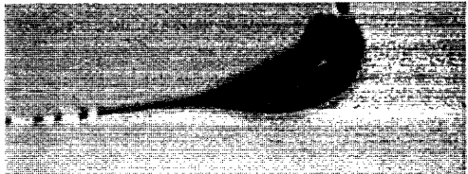
Figure 10: Close-up of ES-produced Droplet Experiencing Coulomb Fission. Mean flow direction: top to bottom [50].

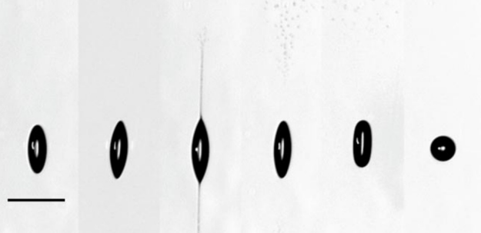
Figure 11: Evolution of Transient Cone-jets on Levitated Ethylene-Glycol Droplet [51].

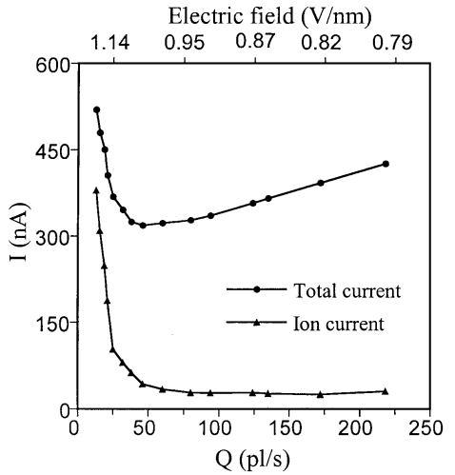
Figure 12: Plot of Electric Field, Current, and Flow Rate for Formamide Nano-ES [52].

The location of ion evaporation in nano-ES is driven by the normal component of the electric field along the cone-jet. There are two locations of local maxima for this normal component, which are the base of the jet and at the jet break-up point. Experiments by Castano using EMI-Im show that the electric field at the base of the jet is not high enough to induce ion evaporation. Thus, ion evaporation occurs at the pinched area of the jet break-up or on droplets with sufficiently small radii, resulting in a hybrid droplet/ion beam [55].
2.6.2.5 Pure Ion Beam
The final mode that will be discussed in this paper is the pure ion beam. In contrast to steady cone-jets, pure ion beams do not require the electric stresses to overcome the surface tension of the liquid. Rather, the electric field at the apex of the Taylor cone must be strong enough to evaporate ions from the liquid. Using EMI-BF4, De la Mora and Castano showed that a regime of pure ion evaporation with no droplet production can be obtained very near the Taylor cone’s stable minimum flow rate. They observed that the likely position of ion evaporation was at a fixed position in the meniscus [23]. The lack of droplet production and a very small flow rate implies that a jet is never formed at the apex of the Taylor cone when a pure ion beam is produced. Instead, the accumulation of charge at the apex increases the normal component of the electric field high enough that the ions are lifted directly from the solvent. The mechanism for this ion evaporation is described by the IEM and is given by the absolute reaction rate equation [45],
$J_{i}=σ_{e}\frac{k_{B}T}{h}exp\left(-\frac{∆G-G\left(E_{vn}\right)}{k_{B}T}\right)$, | (2.55)
where $J_{i}$ is the ion current density evaporating from the meniscus, $k_{B}$ is Boltzmann’s constant, T is the temperature, h is Planck’s constant, and $∆G$ is the solvation energy of the liquid. The term $G\left(E_{vn}\right)$ can be expressed as [45]
$G\left(E_{vn}\right)=\sqrt{\frac{e^{3}E_{vn}}{4πε_{0}}}$, | (2.56)
where e is the fundamental charge. The term in the numerator of the exponential of equation (2.55) can be considered the activation energy of this process. To better understand (2.55), consider a situation in which the liquid is not subject to an electric field such that $G\left(E_{vn}\right)=0$ and assume $T$ is room temperature. $∆G$ is much larger than $k_{B}T$ which would preclude any meaningful ion evaporation. However, when the liquid is subject to an electric field, the activation energy decreases, making ion evaporation more likely. At a high enough $E_{gn}$ where $∆G\sim G\left(E_{vn}\right)$, the activation energy is reduced enough that meaningful ion evaporation occurs, creating a pure ion beam. [45] Thus, rearranging (2.56) and substituting $∆G\sim G\left(E_{vn}\right)$ the following equation for the critical electric field, $E^{*}$, that results in ion evaporation is found [45]:
$E^{*}=\frac{4πε_{0}{\left(∆G\right)}^{2}}{e^{3}}$. | (2.57)
Using (2.32) and substituting in (2.57), the critical apex radius, $r^{*}$, associated with the critical electric field can be written [45]
$r^{*}=\frac{4γ}{ε_{0}E^{*2}}$. | (2.58)
(2.57) and (2.58) can be used to find a characteristic current and velocity in vicinity of $r^{*}$ which are given by [45]
$$I^{*}≈j^{*}A≈KE_{ln}A≈\frac{KE^{*}}{ε}2πr^{*2}=\frac{32πKγ^{2}}{ε_{0}^{2}εE^{*3}}$$ | (2.59)
and
$u^{*}=\frac{j^{*}}{ρ(q/m)}$, | (2.60)
where $j^{*}$ is a characteristic convective current density and $(q/m)$ is the charge to mass ratio.
2.7 Space Charge
Once the ions are evaporated from the surface of the meniscus, they are accelerated by the applied electric field. However, the ions in the vicinity of the apex $\left(\sim r^{*}\right)$ result in a space charge that can affect the electric field at the apex. To analyze this, a simple energy balance, assuming one-dimensional motion, can be written as [5]:
$\frac{1}{2}mv_{e}^{*2}=qΔϕ^{*}$, | (2.61)
where $m$ is the mass of the ion, $v_{e}^{*}$ is the ion velocity, and $Δϕ^{*}$ is the characteristic potential drop. Solving for ion velocity, (2.61) becomes [5]:
$v^{*}=\sqrt{2\left(\frac{q}{m}\right)∆ϕ^{*}}$. | (2.62)
The characteristic potential drop can be written [5]
$Δϕ^{*}≈E^{*}r^{*}$. | (2.63)
Now, writing (2.14) in terms of space charge gives [5]
$ε_{0}∇∙E=ρ_{sc}$. | (2.64)
This results in the relationships [5]:
$ε_{0}\frac{E_{sc}}{r^{*}}\sim ρ_{sc}\sim \frac{j^{*}}{v^{*}}$. | (2.65)
Substituting (2.60), (2.62), and (2.63) into (2.65) a ratio of the change in electric field to the critical electric field can be found [5]:
$\frac{E_{sc}}{E^{*}}\sim \frac{K}{εε_{0}}\frac{r^{*}}{\sqrt{\frac{2q}{m}E^{*}r^{*}}}$, | (2.66)

2.8 Pure Ion Thrust Equations
A new thrust equation is needed for the acceleration of ions. Returning to Poisson’s equation (2.18) and using the derivation provided by Jahn, a space charge-limited current density, $j_{CL}$, can be written [13]
$j_{CL}=\frac{4ε_{0}}{9}{\left(\frac{2q}{m}\right)}^{\frac{1}{2}}\frac{ϕ_{0}^{\frac{3}{2}}}{x_{a}^{2}}$, | (2.67)
where $ϕ_{0}$ is the applied voltage and $x_{a}$ is the distance from the ion source to the extraction grid of the ES device. (2.67) is known as Child’s law and describes a limit on the current density based on thruster geometry and applied voltage. For a steady state, this leads to a limit on the thrust density. Dividing (1.2) by area and substituting (2.67), the following is found [13]:
${\frac{T}{A}}_{CL}=\frac{8ε_{0}}{9}{\left(\frac{ϕ_{0}}{x_{a}}\right)}^{2}$. | (2.68)
Where ${\frac{T}{A}}_{CL}$is the thrust density found using Child’s Law. Jahn also shows it is possible to express the thrust density as a function of the maximum electric field in the ES cavity which can be written as [13]:
${\frac{T}{A}}_{Emax}=\frac{1}{2}ε_{0}E_{max}^{2}$. | (2.69)
(2.69) is the electric pressure at the Taylor cone apex. It is also possible to define the thrust density in terms of the current density, ion velocity, and charge-to-mass ratio [13]:
${\frac{T}{A}}_{j}=\frac{jv_{e}}{\left(q/m\right)}$, | (2.70)
where $v_{e}$ is the extraction velocity of the ET which is the velocity of the ions produced by the extraction grid. This expression can be analyzed with critical values and IL properties. A simple energy balance can be rearranged to find $v_{e}$, which can be written as follows:
$v_{e}=\sqrt{v^{*2}+2\left(\frac{q}{m}\right)\left(Δϕ\right)}$, | (2.71)
where $v^{*}$ is the velocity of the ion in the region of the Taylor cone apex found by (2.62). Assuming that the voltage decreases linearly between the top of the capillary and the extraction grid and that all of the voltage is transferred to kinetic energy, the value of $Δϕ$ will be the voltage at the Taylor cone apex. The height of the Talor cone can be found using the Taylor cone half angle, $θ_{0}=49.29°$ and the radius of the capillary, $r_{c}$, from [1]
$h=\frac{r_{c}}{tan⁡\left(θ_{0}\right)}$. | (2.72)
This height can now be used to find an approximation for the change in voltage at the Taylor cone apex, $Δϕ$, via the following equation:
$Δϕ=ϕ_{0}\left(1-\frac{h}{x_{0}}\right)$, | (2.73)
where $ϕ_{0}$ is the applied voltage and $x_{0}$ is the distance between the top of the capillary and extraction grid.
2.9 Characteristic Times
2.9.1 Electric Relaxation Time
Characteristic times are a valuable method for analyzing the physics of a system and justifying assumptions such as the electrostatic assumption mentioned in Section 2.4. Key to this assumption was the electric relaxation time, which physically represents the time scale at which charge is redistributed in a substance to make it quasi-neutral. To obtain this characteristic time, consider the charge conservation equation (2.19). Substituting in (2.14), the following equation is found:
$\frac{∂ρ_{e}}{∂t}-\frac{K}{εε_{0}}ρ_{e}-∇∙ρ_{e}u=0$, | (2.74)
where the coefficient of the second term is the inverse of the electric relaxation time [45]:
$\frac{1}{t_{e}}=\frac{K}{εε_{0}}$. | (2.75)

2.9.2 Residence Time
Besides the electric relaxation time, there are other characteristic times useful for analyzing ES systems. The first is the liquid residence time, which is typically given by the ratio of a characteristic length and a characteristic velocity [45]:
$t_{r}=\frac{L}{u}$. | (2.76)
When working with capillary systems it is typical to define $t_{r}$ in terms of volumetric flow rate where $t_{r}=t_{rl}$. Using (2.60), (2.76) becomes [45]:
$t_{rl}=\frac{rρ(q/m)}{j}$. | (2.77)
In the gas phase, which will occur in ion evaporation, the characteristic particle velocity can be represented by (2.62). Therefore, (2.76) can be written [45]:
$t_{p}=\frac{r}{\sqrt{2\left(\frac{q}{m}\right)∆ϕ}}$. | (2.78)

2.9.3 Viscous Capillary Time
Another important characteristic time is that of viscous capillary time, which physically represents the residence time of flow for fluid driven solely by surface tension forces. This means we can use (2.76) to define this time if we have a velocity. The characteristic viscous capillary speed can be defined as the ratio of surface tension to the dynamic viscosity and written as [45]
$u=\frac{γ}{μ}$. | (2.79)
This means (2.76) can be written:
$t_{rμ}=\frac{μr}{γ}$. | (2.80)

2.9.4 Inertial Time
Inertial time considers the capillary forces driving a fluid and is represented by Newton’s second law. Using $r$ again as our length scale, Newton’s second law can be written as [45]
$γr=\left(ρr^{3}\right)\left(\frac{r}{t_{in}^{2}}\right)$. | (2.81)
Solving for the characteristic inertial time, (2.81) becomes
$t_{in}=\sqrt{\frac{ρr^{3}}{γ}}$. | (2.82)

2.9.5 Emission Time
The characteristic emission time provides the characteristic time of ion evaporation caused by the ion evaporation mechanism and is established in the absolute reaction rate equation (2.55) where [45]:
$\frac{1}{t_{em}}=\frac{Tk_{B}}{h}$. | (2.83)
The physics and equations presented in this chapter provide the foundation for the analysis of any ET and will be used in subsequent Chapters to analyze an ET and verify the micro-ES model.
Chapter 3: Analytical Investigation of an Electrospray Thruster
In preparation for using CFD software to model an ET, it is important to verify assumptions and determine the mode of the ES. This can be done by analysis of relevant propellant properties, ET geometry, ES scaling laws, and Taylor cone electric fields. This analysis starts by verifying the electrostatic assumption. If verified, it should be determined if the system can form a Taylor cone. Next, the ES mode needs to be found. To do this, scaling laws should be used to determine whether a steady cone-jet can be formed, and if so, whether the jet is on the microscale or the nanoscale. Key to this step is determining and comparing the minimum required flow rate for a steady cone-jet to the flow rate into the ET capillary. Then, it should be determined if ion emission is possible for the system. Key to this step is determining the electric field strength at the Taylor cone apex. Finally, after all physics and governing equations are identified, thruster performance can be analyzed. This section will demonstrate this analysis by analyzing a novel ET known as the Micro Scalable Thrusters for Adaptive Mission Profiles in Space (µSTAMPS) along with three ILs as candidate propellants.
3.1 µSTAMPS Overview
The µSTAMPS is an ET that uses a novel thruster chip design to address known failure mechanisms of common ETs. The capillary tubes are machined into a borosilicate glass emitter chip using ultrafast laser machining techniques, and the extractor grid is a thin layer of indium tin-oxide (ITO) deposited on top of the emitter chip substrate [164]. A schematic of the µSTAMPS emitter chip is shown in Figure 13. This design meets all the requirements to create an ES but is more robust than typical designs that rely on fragile needles which protrude from the emitter chip surface, as depicted in the general ET setup shown in Figure 1. It is worth noting that the purpose of µSTAMPS is not to produce as much thrust as possible, but rather to produce enough thrust for a particular mission while minimizing the power and mass requirements of the thruster. Previous numerical investigations by Jones and Howell have determined the dimensions and minimum onset voltage to minimize the µSTAMPS’s power need and mass [10, 37]. The target dimensions of the capillaries and ES cavities can be seen in Figure 14.
The µSTAMPS uses capillary action to pull electrically conductive propellant through its array of capillaries rather than being fed through a pump. A voltage is then applied to the ITO while the propellant is grounded. This creates the necessary electric field to initiate the ES process. Once ES begins, the particles ejected out of the ES cavity provide the change in momentum that creates thrust. To neutralize the charged plume created by the ejection of particles, the µSTAMPS cycles the polarity of the applied voltage to extract both cations and anions for thrust, effectively neutralizing the plume without the need for external neutralizing apparatus.
3.2 Ionic Liquid Overview
The µSTAMPS uses ionic liquid, which is a salt that remains liquid over a wide range of temperatures, as the propellant. ILs are excellent propellants for ETs due to some of them having relatively high electrical conductivity and surface tension and negligible vapor pressure [56]. From (2.14) and (2.32), high electrical conductivity and surface tension are important for ES, but the vapor pressure becomes important in preventing solvent evaporation in vacuum environments where ETs operate [68]. Another important property for ILs is its electrochemical stability window (ESW). Because the IL is subject to an applied voltage, it is possible for it to be reduced or oxidized. Thus, understanding the ESWs of the ILs chosen as ET propellants is important for proper operation of the ET [56]. In addition, because the µSTAMPS emits both cations and anions to address spacecraft charging issues, the mass of the cations and anions becomes important in ensuring consistent thrust performance. This paper will focus on two ILs: 1-butyl-1-methyl-pyrrolidinium dicyanamide (BMP-DCA) and ethylammonium nitrate (EAN). Their parameters along with order of magnitude (OOM) values listed in Table 1. The OOM values are there to ensure OOM analysis provides reasonable results.
3.3 The Electrostatic Assumption
In Section 2.4, it is assumed that ES devices are electrostatic, which means there is no meaningful magnetic field, and the electric field has no curl. This assumption relies on the idea that the electric relaxation time, $t_{e}$, is much greater than the characteristic magnetic time, $t_{m}$. Using the property values in Table 1 and (2.16), $t_{e}$ for the ILs of interest is $\sim {10}^{-10}$ s The relative magnetic permeability of the ILs of interest is not readily available in the literature, but using the values available in Table 1 and (2.17) the value of the characteristic magnetic time is $\sim μ_{r}*{10}^{-18}$ s. Unless $μ_{r}$ reaches values greater than ${10}^{6}$, the electrostatic assumption holds.
3.4 µSTAMPS Taylor Cone Formation
As established in Section 2, fundamental to ES is the formation of a Taylor cone at the end of the capillary in the ET. Using (2.34), the properties important for Taylor cone formation are $ϕ_{0}, γ, r_{a}$, and $C$ which will account for the ET geometry. Both Jones and Howell use the simulation technique of Krpoun and Shea to determine $r_{a}$ and the optimal $ϕ_{0}$ to establish a Taylor cone using the following equation [10, 37]:
$r_{a}=\frac{r}{w}\tan\left(ϕ_{0}\right)$, | (3.1)
where $w$ is a parameter related to the sharpness of the Taylor cone. Figure 15 shows the effect of variations of $w$ on the Taylor cone shape based on numerical simulations. Jones determined that at $w\sim 11$ the Taylor cone reaches a steady state. See A Numerical Optimization Study of a Novel Electrospray Emitter Design for more information on the optimization of ET geometry and minimization of the onset voltage. Having established that a Taylor cone will be formed, the ES mode can be determined [10, 37].
3.5 µSTAMPS Electrospray Mode
3.5.1 Electric Conductivity
To properly analyze and model any ES device, it is important to identify the ES mode in which it operates. Section 2 identified four possible ES modes that are applicable to µSTAMPS: micro-ES, nano-ES, hybrid droplet/ion beam, and pure ion beam. To begin, consider the electric conductivities of the ILs listed in Table 1. All values are greater than ${10}^{-2}$ S/m, which are considered high conductivities. Thus, micro-ES can likely be eliminated as an ES mode for µSTAMPS.
3.5.2 Scaling Laws: Droplet Diameter
This can be verified using the droplet diameter scaling laws of micro-ES. Using (2.37) the characteristic diameter for each of the ILs is $\sim {10}^{-9}$ m putting the droplets in the nano-ES range. It is now important to understand if the ET is capable of maintaining a steady cone-jet.

Table 1: Ionic Liquid Properties of Interest (@ 25° C)
Ionic Liquid | $γ$(N/m) | $ρ$ (kg/m³) | $K$ (S/m) | $μ$ (kg/m-s) | $$ε$$ | $q/m$ (C/kg)
 |  |  |  |  |  | Cation | Anion
OOM | $${\sim 10}^{-2}$$ | $${\sim 10}^{3}$$ | $${\sim 10}^{0}$$ | $${\sim 10}^{-2}$$ | $$\sim {10}^{1}$$ | $$\sim {10}^{6}$$ | $$\sim {10}^{6}$$
BMP-DCA | 0.0562 [60] | 950 [59] | 0.325 [59] | 0.0352 [59] | 18.0 [58] | $0.68×{10}^{6}$ [59] | $1.43×{10}^{6}$ [59]
EAN | 0.0492 [64] | 1260 [63] | 2.03 [63] | 0.036 [63] | 26.3 [61] | $2.09×{10}^{6}$ [29] | $1.56×{10}^{6}$ [29]

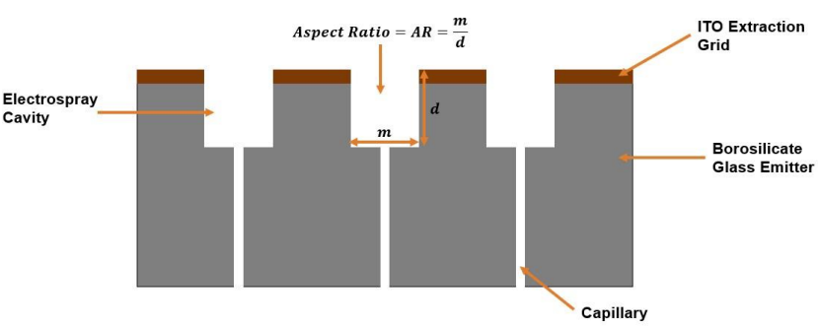
Figure 13: µSTAMPS schematic.

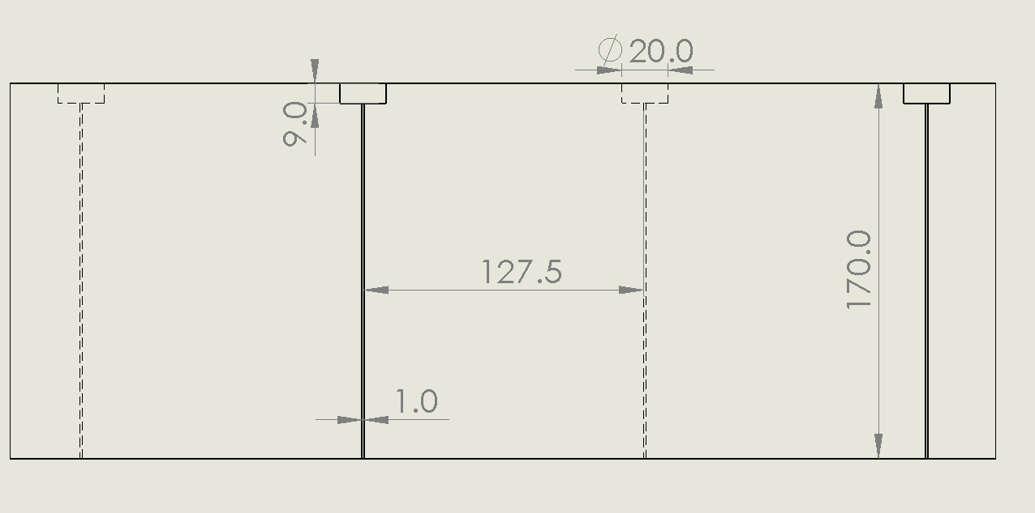
Figure 14: Target Dimensions of µSTAMPS Emitter Chip.
3.5.3 Steady Cone-Jet
The scaling laws of nano-ES must be used to determine whether or not a steady cone-jet can be maintained. Key to these scaling laws is understanding the flow rate at which fluid is fed into the Taylor cone apex. As discussed in Section 2.3 and 3.1, capillary action draws the IL all the way through the opening. However, once the fluid reaches the top of the capillary, the flow rate produced by capillary action goes to zero. Thus, the fluid inertia is being driven by the electric field in the Taylor cone apex given by [2]
$ε_{0}E_{vn}^{2}\sim ρ\left(\frac{Q}{r_{a}^{2}}\right)$. | (3.2)
Thus, the flow rate at the apex can be written as
$Q\sim \sqrt{\frac{4γ}{ρ}}r_{a}^{2}$. | (3.3)
Table 9 in Appendix C shows the OOM and actual values of IL parameters for minimum flow rate analysis based on the values in Table 1. Based on the minimum volumetric flow rate requirements discussed in Section 2.6.2.1, the product of the dielectric constant and the electric Reynolds number is less than unity. Thus, the $Q_{min}$ required to sustain a steady cone-jet is given by (2.43) and is shown in Figure 16 . From this analysis, ILs will not reach the $Q_{min}$ required for a steady cone-jet, which rules out nano-ES and hybrid droplet/ion as the mode.
3.5.4 Ion Emission
This leaves pure ion emission as the final option for the ES mode. As discussed in Section 2.6.2.4, for ion evaporation to occur the electric field strength at the Taylor cone apex must be $\sim 1$ V/nm which is possible for liquids with an electric conductivity greater than $\sim 1$ S/m. Though not measured for many ILs, the typical activation energy, $∆G$, of an IL is $1–2$ eV [5]. Using this value of $∆G$ in (2.56) returns a critical electric field, $E^{*}$, of $\sim {10}^{9}$ V/m or $\sim 1$ V/nm. Substituting this result into (2.57) gives a critical apex radius of $\sim {10}^{-8}$ m.
These OOM values can be compared to actual IL values by using apex radius values calculated by (2.32). The value for $w$ was found by Jones et al. to be $\sim 11$ for a steady-state system [10] and the capillary radius, $r_{c}$, for the µSTAMPS is $0.5$ µm. Table 10 in Appendix B shows the value of the apex radius to be approximately $50$ nm, which is the approximate value reported for ILs based on an activation energy of $1–2$ eV [5]. These apex radius values lead to electric field intensities near $1$ V/nm as shown in Figure 17. No IL from this study reaches the exact value of the critical electric field strength, but experiments conducted with the IL EMI-BF4 showed that a pure ion emission regime is possible even though the electric field strength calculated was only $0.693×{10}^{9}$V/m [45]. Thus, the ILs of interest are likely capable of providing the electric field strength required at the apex of the Taylor cone to induce ion evaporation, though experimentation will be needed to confirm. Thus, the µSTAMPS is capable of operating in the pure ion emission mode.
3.6 Electric Thruster Analysis Results and Discussion
Having established that the µSTAMPS operates in a pure ion emission mode, the physics and governing equations can be solidified. Figure 18 shows the ion emission domain based on the physics discussed in Section 2, and Table 5, Table 6, Table 7, and Table 8 in Appendix A summarize the governing equations for µSTAMPS.

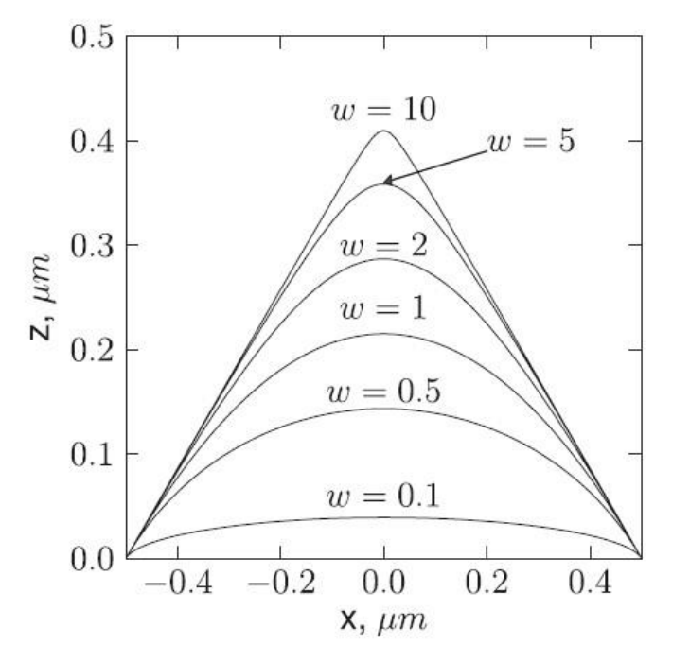
Figure 15: Effects of w Values on Taylor Cone Shape.

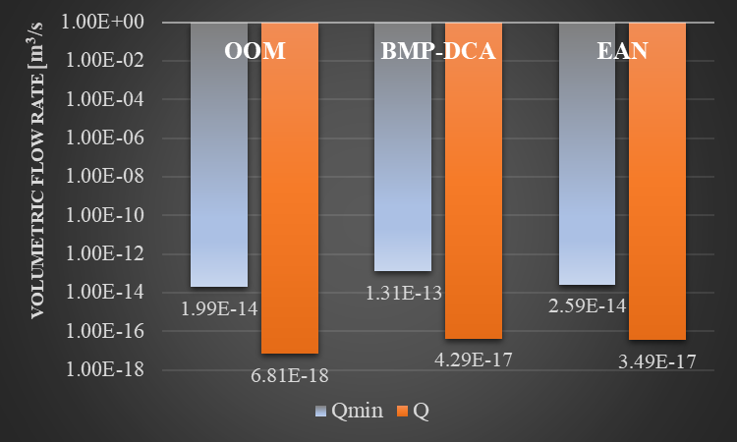
Figure 16: µSTAMPS Minimum Flow Rate Analysis.

3.6.1 Characteristic Times
Table 11 in Appendix B shows the important characteristic times in the region of the Taylor cone apex. These times give an idea of the general importance of the different forces acting on the fluid in this region. The OOM for each time has been listed, along with the values calculated using the properties of the two ILs of interest for the purpose of ensuring an OOM analysis is accurate for this system. For the electric, liquid residence, viscous-capillary, and inertial characteristic times the OOM analysis results in values that are one OOM higher than the times that result from IL properties. For the particle residence and emission characteristic time the OOM and IL property values are similar. Thus, for any thruster that uses ILs, it is beneficial to look at the characteristic times resulting from IL properties, rather than just using the OOMs to get an accurate understanding of the forces acting at the Taylor cone apex.
Also listed in Table 11 in Appendix B are the values of the characteristic times for both the cations and anions of each IL. For the purposes of this analysis, the only property that differs between the cations and anions is the charge-to-mass ratio. For the ILs of interest in this paper, the characteristic times of the cations and anions are of the same OOM and will thus exhibit similar behavior in the vicinity of the Taylor cone apex.
Inside of the liquid in the Taylor cone there are four characteristic times that are important: $t_{e }$, $t_{rl}$, $t_{rµ}$, and $t_{in}$. Shown in Figure 18, the smallest of these times is the electric characteristic time, which tells us that the charge transport is dominated by ohmic conduction versus surface convection. It is worth noting that $t_{e }$is only one OOM faster than $t_{in}$ for the ILs of interest. In other scenarios $t_{in}$ could become significant in the redistribution of charge in the cone apex and may need to be accounted for in a computational model.
Figure 20 shows the values of the electric times, the residence times of the cation and anion particles, and the emission times for the two ILs of interest. As previously mentioned, ohmic conduction dominates charge transport in the liquid until it reaches the meniscus in the Taylor cone apex. At the meniscus, the emission time is much faster than the electric time so charge transport is dominated by the ion evaporation mechanism where the electric field is strong enough to reduce the activation energy of the ions and move the ions from the liquid into the vacuum. As ions are accelerated from the vacuum side of the meniscus out of the region of the apex the emission time becomes irrelevant and, comparing the electric time to the particle residence time shows that the dominant charge transport mechanism in the vacuum is convective.
One of the most important characteristic time comparisons is between the particle residence and electric times near the Taylor cone apex. This ratio provides an understanding of space charge effects of the ions evaporated from the meniscus and will be discussed in the next section.

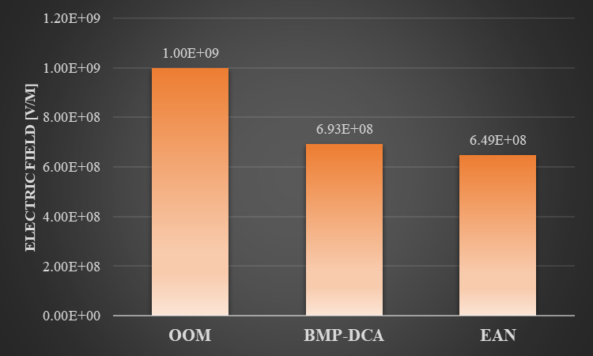
Figure 17: µSTAMPS Critical Electric Field Analysis.

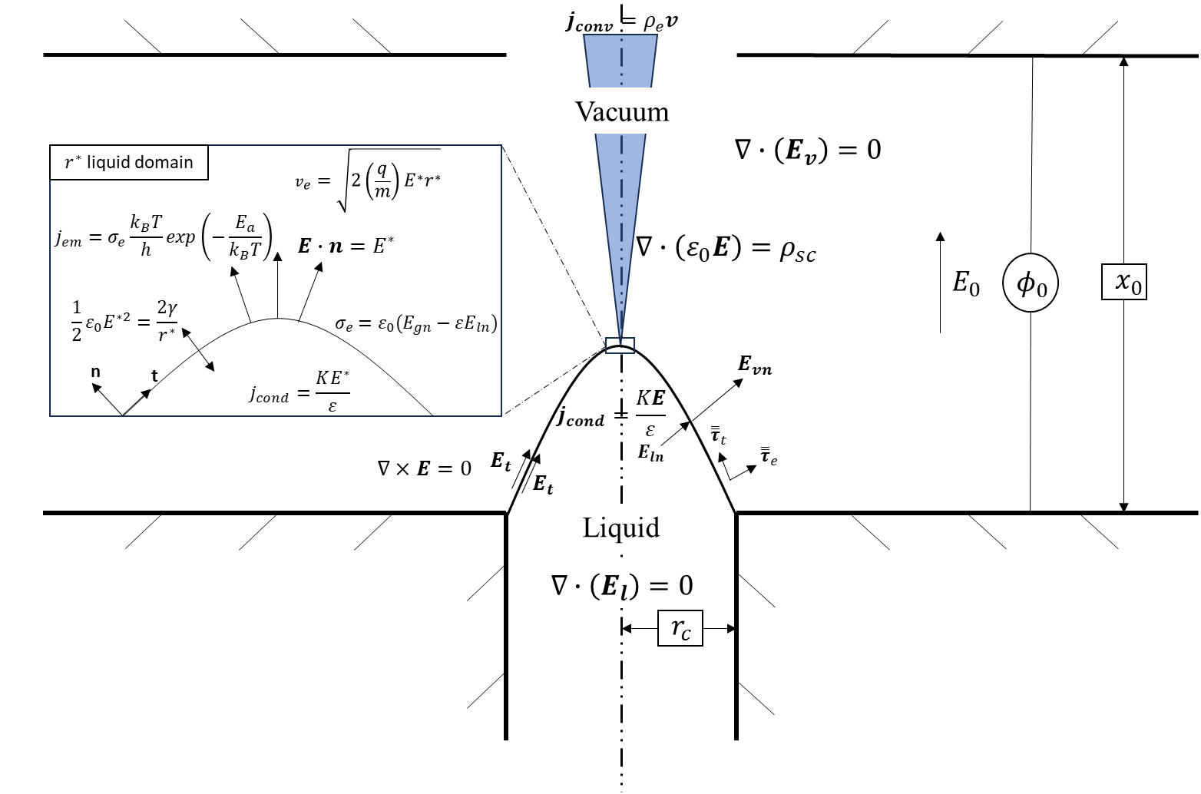
Figure 18: Schematic of Pure Ion Emission with Governing Equations for µSTAMPS

3.6.2 Thruster Performance Analysis
Thruster performance analysis in this paper will focus on the thrust density and the specific impulse of the µSTAMPS based on geometry, critical values, and IL properties. Jahn provided three equations for thrust density of ETs that electrostatically accelerate ions: (2.68), (2.69), and (2.70) [13]. (2.68) is based on Child’s Law, which provides the case for a space charge-limited acceleration field. (2.69) is based on the electric pressure from the maximum electric field in the ES cavity. And (2.70) is based on the ion extraction velocity. All values are given in Table 12 in Appendix C. The velocity calculated for Child’s Law, $v_{CL}$, is found using a modified version of (2.62) that can be written as [13]
$v_{CL}=\sqrt{2\left(\frac{q}{m}\right)ϕ_{0}}$, | (3.5)
where $ϕ_{0}$ is the applied voltage, and it is assumed that all electric potential is transferred to kinetic energy. The other velocity values are found using (2.60).
3.6.2.1 Thrust Density
From Figure 20, it can be seen that the thrust density found using the electric pressure and the ohmic conduction are similar, but despite the velocities for each category being similar, the thrust density found for Child’s Law is much smaller. This also occurs for the current densities found for Child’s Law and for the ohmic conduction. The reason for this discrepancy is that one of the assumptions of Child’s Law is that the space charge will disrupt the electric field at the Taylor cone apex. Jahn explains that when ions are emitted from the liquid with a negligible velocity, the electric field must be in the range of $0<E<\frac{ϕ_{0}}{x_{a}}$ [13]. In the absence of space charge, the electric field is at the maximum of the range. However, as current is increased with the applied voltage, the electric field approaches the minimum of that range. This leads to the space charge-limited case of Child’s Law in (2.67) and (2.68) [13]. This assumption is predicated on the fact that the space charge is strong enough to affect the electric field at the location of ion production. In contrast, the current density used in the 2nd Law is calculated using (3.2).
To analyze the strength of the space charge, (2.66) can be used. For the case of very high-conductivity liquids ($K\sim {10}^{1}$ S/m) such as liquid metals like gallium, (2.66) results in a value near unity. This means that for ETs that rely on liquid metal propellants, space charge is likely to have a significant effect on thruster performance. However, for ILs this may not be the case. To analyze IL propellants (2.66) can be re-written as the ratio of the particle residence time to the electric time [5]:
$\frac{E_{sc}}{E^{*}}\sim \frac{K}{εε_{0}}\frac{r^{*}}{\sqrt{\frac{2q}{m}E^{*}r^{*}}}=\frac{t_{p}}{t_{e}}$. | (3.6)

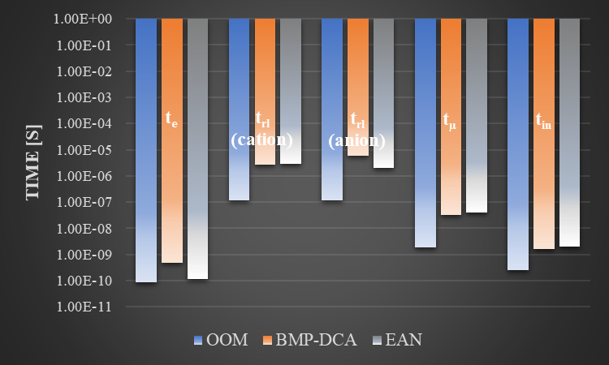
Figure 19: µSTAMPS IL Characteristic Time Comparison.

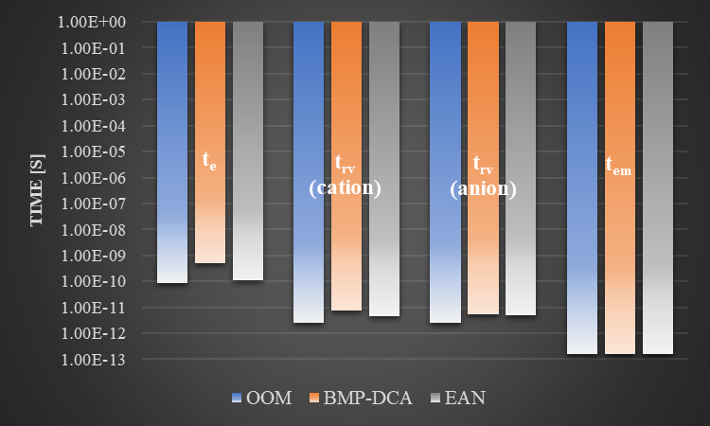
Figure 20: µSTAMPS Particle Characteristic Times.

For both ILs of interest and their respective cations and anions, the particle residence time is two orders of magnitude smaller than the electric time, which means the electric field produced by the evaporating ions is two OOMs smaller than the electric field produced at the apex of the Taylor cone. Thus, in contrast to liquid metals, ILs may avoid the limitations of space charge. Completely ignoring space charge will not provide completely accurate results, but the µSTAMPS thrust density is not minimized by the space charge-limited case given by Child’s Law.
This is further supported by the fact that Jahn assumed the maximum electric field would occur at the extraction grid, but in an ET using an IL propellant, the maximum electric field clearly occurs at the Taylor cone apex [13]. This is why the values from the electric pressure agree more with the values found using Ohmic conduction rather than with Child’s Law. It is worth noting that space charge will still have some effect on thruster performance, so although the thrust density values provided by the electric pressure and Ohmic conduction are better estimates than Child’s Law, they are likely to be overestimates of the thrust density.
Some ETs are configured to emit both cations and anions to eliminate the need for an external neutralizer on the spacecraft. One concern for this configuration is the large difference between the thrust density provided by the cation versus the anion. However, Figure 21 shows that the thrust densities of the cations and anions of the ILs of interest are similar in value. Thus, switching between the two ions should not have any major effect on the thrust performance of the ET.
3.6.2.2 Specific Impulse
Table 12 in Appendix C also shows the values of specific impulse found for cations and anions of the ILs of interest. All of the values are in the range expected of an ET. The extremely high extraction velocities of each of the ions ensures ETs that use ILs are very efficient. However, unlike the thrust density, there is a large difference between the specific impulse of the cations and anions of the ILs. For the BMP-DCA, there is a 31% difference between the cation and the anion, and for the EAN, there is a 13.5% difference between the cation and the anion. This difference could be compensated for by modulating the applied voltage to increase or decrease the extraction velocity as needed.
3.6.4 Importance of IL surface tension
In any mode of ES, surface tension plays a role in the formation of the Taylor cone, and in the steady cone-jet mode, it hinders the production of the jet. Thus, it may be tempting to want to reduce the surface tension as much as possible to increase the ease of Taylor cone and jet formation. However, in the case of pure ion emission, reducing the surface tension may reduce the electric field strength at the apex and hinder ion evaporation. (2.32) provides the strength of the electric field at the apex of the Taylor cone. The critical value for this electric field has been shown to be $\sim 1$ V/nm. The graph in Figure 23 shows that for a fixed apex radius, expected to be near $50$ nm for ILs, as the surface tension decreases from $0.1$ N/m to $0.01$ N/m, a typical range for ILs, the electric field strength decreases from the critical value needed to produce ion evaporation [5]. Also, below $0.03$ N/m, the electric field strength seems to begin decreasing rapidly. Thus, it is important to balance the need to increase the ease of Taylor cone formation with the need to produce the necessary electric field strength at the Taylor cone apex to include ion evaporation.

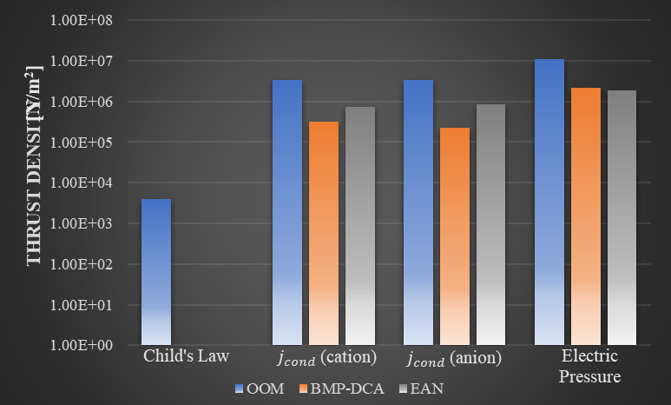
Figure 21: µSTAMPS Theoretical Thrust Density Comparison.

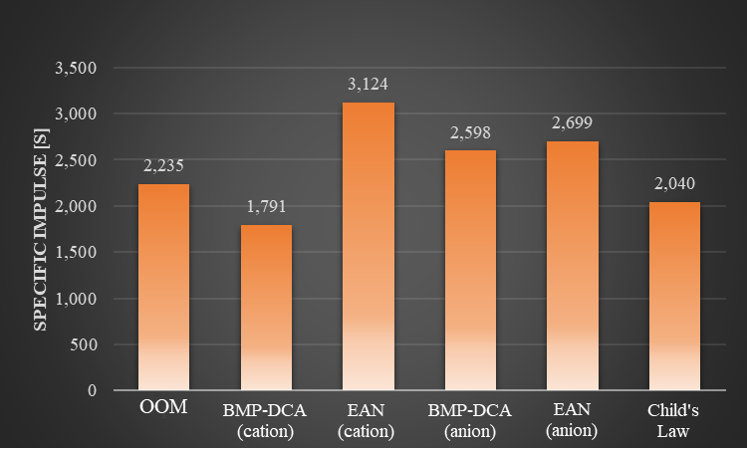
Figure 22: µSTAMPS Specific Impulse Comparison.

3.6.5 Analysis Limitations
3.6.5.1 Perfect Dielectric Assumption
To solve the charge density from the ion emission (2.48) the surface charge density on the meniscus must be found. (2.48) uses the electric field jump condition at the meniscus to find that surface charge density. However, when looking at the derivation of the stress balance that leads to formation of the Taylor cone (2.31), one of the fundamental assumptions is that the liquid approaches a perfect dielectric, such that $E_{ln}≈\frac{E_{vn}}{ε}$. If this assumption is used in (2.48), the surface charge density becomes zero. The critical values for electric field and apex radius which are fundamental in our ion emission analysis are based on (2.31). This discrepancy will likely cause inaccuracies in any solution found using the perfect dielectric assumption. Thus, it is important that in any numerical analysis conducted the full meniscus surface stress balance (2.26) be used to solve for the meniscus shape and electric field.
3.6.5.2 Characteristic Current Density
To calculate the thrust density using the extraction velocity, the conductive current density in the Taylor cone apex was used instead of the emission current density (2.55). This is because (2.55) requires a solution for the surface charge using (2.48), which is problematic for this analysis as stated in the Section 3.6.5.1. Surface charge can be found using a numerical analysis, which is outside of the scope of this paper. However, because the emission time is smaller than the electric time it can be expected that the conductive current density will be of the same OOM as the emission current density.
3.6.5.3 Concave Meniscus
Another limitation of this analysis is the µSTAMPS’s method of using capillary action to draw propellant into the ET capillary rather than pumping the propellant in at a specific flow rate. This would result in a concave meniscus at the top of the capillary with an angle that depends on the contact angle of the liquid propellant. There is little research on ES devices that initialize with a meniscus in a concave shape, and it is not certain if it is possible for a Taylor cone to form from a concave meniscus. The next Chapter will discuss the use of ANSYS Fluent to simulate a concave meniscus subject to an applied electric field and determine if a Taylor cone can be formed.

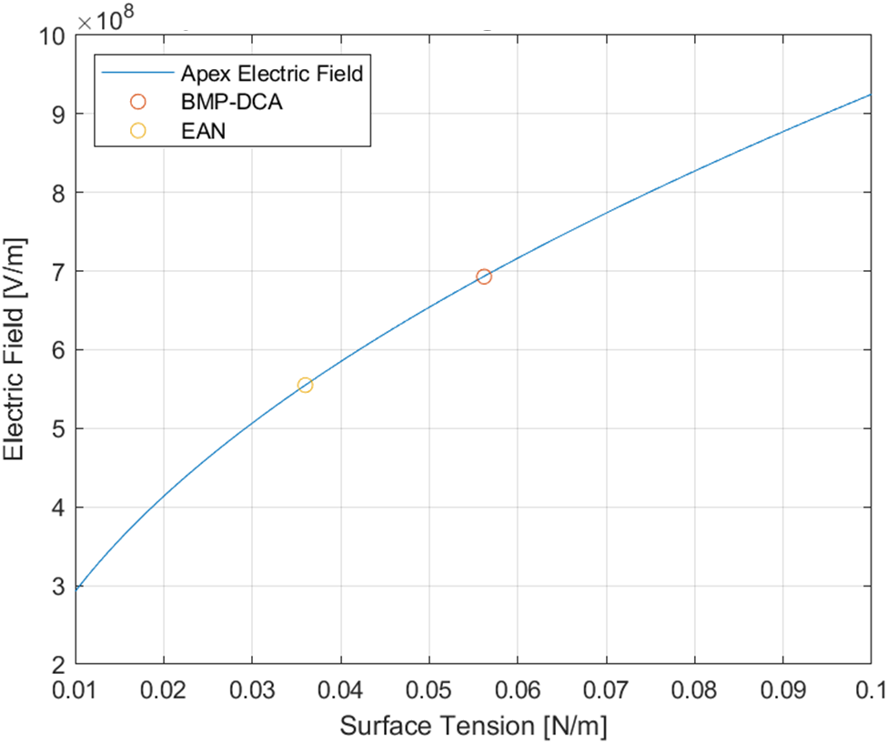
Figure 23: µSTAMPS Apex Electric Field Strength vs. Surface Tension.

Chapter 4: Numerical Investigation of Concave Meniscus
The µSTAMPS will introduce propellant into the thruster chip via capillary action. In a vacuum, the propellant will flow to the end of the capillary but will settle with a concave meniscus that depends on the contact angle of the propellant. Little research has been conducted on ES devices with an initially concave meniscus, which is why it is worthwhile to perform numerical simulations to determine if this is feasible. Ideally, these simulations would be performed on the geometry and propellant used in µSTAMPS, but because the electric relaxation time produced by ILs is so short ($\sim {10}^{-10}$ s) the computational cost of performing numerical simulations on ILs is prohibitively high with available equipment and time. However, low-conductivity fluids can have much longer electric relaxations times ($\sim {10}^{-5}$ s). Thus, it is feasible to perform numerical simulations of ES devices that use low-conductivity fluids. There is also much more published research on ES using low-conductivity fluids, which makes verification of numerical simulations simpler. This section will focus on numerical simulations conducted in ANSYS Fluent to determine if a low-conductivity fluid with an initially concave meniscus will deform into a Taylor cone and produce an ES when subject to an applied electric field.
4.1 Design of Research Model
Currently, there is no experimental research on an ES device that has an initially concave meniscus. Thus, it is necessary to create a verification model to ensure accurate results in the concave case. This verification model will use n-heptane and air in a stainless-steel capillary-fed ES device configured as shown in Figure 24. The goal of this ES device will be to create a steady-cone jet on the microscale, which can then be verified with the scaling laws discussed in Section 2.6.2.1. [2] The general set up for this verification model includes geometry that is axisymmetric, a transient time state, and gravity in the x-direction. Once the model is verified, it will be adjusted to n-heptane in an initially concave shape, with no gravity, and the mass flow rate will be adjusted to zero to reflect the operating conditions of an ET in vacuum. To model an ES device in ANSYS Fluent, three models are used simultaneously: the Magnetohydrodynamics (MHD) model, the Volume-of-Fraction (VOF) model, and the Discrete Phase Model (DPM).
4.1.1 Electrohydrodynamics Model
ANSYS Fluent has a built-in model for EHD inside of the MHD model called the Electric Potential Method. This model uses the electric potential equation (Laplace’s equation) [65]:
$∇^{2}ϕ=0$. | (4.1)
To solve the steady-state version of the conservation of charge equation (2.19) for charge density which is given by [65]:
$∇∙J=0$, | (4.2)
where $J$ is given by [65]
$J=KE$. | (4.3)
This model adds an electric force to the momentum equation which can be written [65]
$ρ_{m}\left(\frac{∂u}{∂t}+u∙∇u\right)=-∇P + ∇∙\overset{̿}{τ} + f_{e}$, | (4.4)
where the electric force is [65]
$f_{e}=ρ_{e}E$. | (4.5)
For boundary conditions, this method allows boundaries to be assigned electric potential values, potential flux values, and current values where desired. Limitations of this model regarding this research will be discussed in Section 4.3.4.
4.1.2 Volume-of-Fraction Model
The Volume-of-Fraction (VOF) Model is capable of modelling interaction between two immiscible fluids, where the interface between the two fluids is of interest. In this model, the fluids share a momentum equation, and the volume fraction of each fluid is tracked by cell. This is useful for modeling surface tension forces using the CSF method for two fluids as proposed by Brackbill et al., which is given by [65]
$f_{st}=γ_{ij}\frac{ρκ_{i}∇α_{i}}{\frac{1}{2}(ρ_{i}+ρ_{j})}$, | (4.5)
where $κ_{i}$ is the curvature of the interface and $ρ$ is the density given by [65]
$ρ=\sum{α_{q}ρ_{q}}$, | (4.6)
where $α_{q}$ is the volume fraction of the q^{th} species defined as [66]
$$\left\{\begin{aligned}α_{q}=0 for a qth fluid if none of the qth fluid is in the cell. \\ α_{q}=1 for a qth fluid if only that qth fluid is in the cell. \\ 0<α_{q}<1 for a qth fluid at the interface of the qth fluid and another fluid\end{aligned}\right\}$$ | (4.7)
The surface tension force given in (4.5) is added to the conservation of momentum equation such that (4.3) becomes [65]
$ρ_{m}\left(\frac{∂u}{∂t}+u∙∇u\right)=-∇P + ∇∙\overset{̿}{τ} + f_{e}+f_{st}$. | (4.8)
The ability to model surface tension means this model can predict jet breakup as seen in micro-ES and nano-ES. It is also important to note that this model is compatible with the built-in MHD model, whereas the more accurate Eulerian model is not. This model was chosen over the Continuum Surface Stress model because the surface tension is assumed to be constant throughout the system and there was no need to resolve solutions near sharp corners.
Accuracy at the interface between the liquid and air in the system is extremely important for this research due to the balance of forces that exist along the meniscus. As such, the Explicit Volume Fraction Formulation was chosen for this research. It is non-iterative and, because it is time-dependent, it can only be used in a transient model. This formulation provides more accurate results than the Implicit Volume Fraction Formulation, but it is limited by the Courant-based stability criterion defined by the user in the user interface [66]. The Courant-based stability criterion will be discussed further in Section 4.2.4. The Sharp interfacial modeling type was chosen for this research due to the distinct interface between the liquid and gas in the system. Using the Explicit Formulation and the Sharp interface allows for the use of geo-reconstruction approach at the interface of the two fluids. This approach, though more computationally expensive than others, is the most accurate. It assumes a linear slope between the two fluids at their interface per cell and uses that assumption to solve for the advection of the fluid through the cell [65].

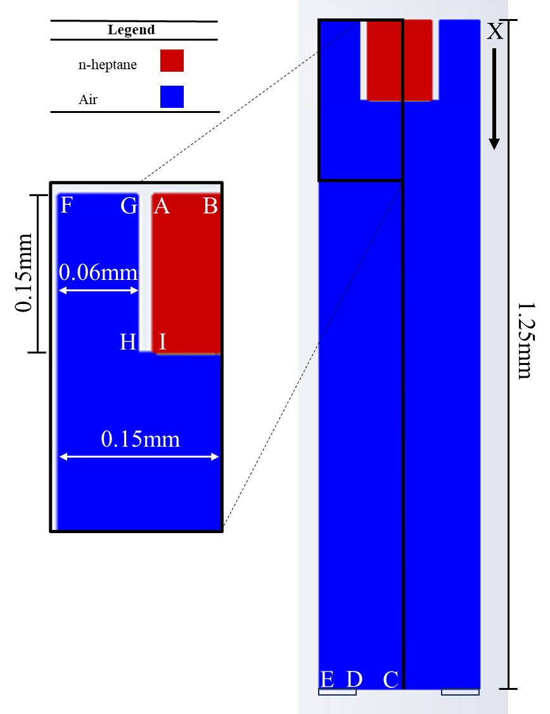
Figure 24: Verification Model Domain.

4.1.3 Discrete Phase Model
The DPM is used to introduce particles into a system. Particle trajectory is predicted using particle motion theory. This research will assume there are no particle collisions in the system. When used in conjunction with the MHD model, the particles can be given a constant charge density. These particles can be set to interact with the continuous phase of a system, which creates a two-way coupling between the particles and the continuous phase. This allows momentum to be exchanged between the particles and the fluid when solving for the fluid motion [65, 66]. For ES applications, this method can be used to introduce a charge into the liquid, which allows the liquid to interact with the applied electric field. This will provide the balance between the surface tension and the electric field that will ultimately create a steady cone-jet. Limitations of this model regarding this research will be discussed in Section 4.3.4
4.1.4 Solution Method and Control
Spatial discretization in ANSYS Fluent is accomplished by storing the value of a scalar at the center of a cell. To solve for convection terms cell face values for the scalar are required. These face values are found through interpolation using one of two upwind schemes. The first scheme is the first-order upwind scheme and is used when first-order accuracy is required. The second is the second-order upwind scheme, which uses a Taylor expansion of the cell solution to achieve second-order accuracy [65]. In this research, momentum was found using a second-order scheme and the electric potential was found using a first-order scheme. It is also possible to use High Order Term Relaxation (HOTR) to assist in solution stability [66]. During this research, if a solution lost stability, it usually occurred due to problems in the momentum equations. Thus, HOTR was implemented to assist in finding stable solutions for the momentum equations.
The models in this research are transient so, besides spatial discretization, the governing equations also require temporal discretization. The models in this research used a pressure-based solver and a constant time step. So, to accomplish temporal discretization they used the first-order implicit method, which has the advantage of being unconditionally stable for each time step [65].
Evaluations of gradients and derivatives are required for solving for the scalar face value of a cell. Because the mesh used in this research was quadrilateral with minimal skewness in the fluid flow regions, the least squares cell-based gradient method was chosen. This method is less computationally expensive than the node-based gradient methods available [65].
ANSYS Fluent has two types of solution methods: pressure-based and density-based. Micro-ES is a low-speed, incompressible flow which pressure-based methods were designed to solve. The pressure-based solvers control the way velocity and pressure are updated during calculations. Computational expense is an issue with ES models, so of the pressure-based solvers available in ANSYS Fluent, the Pressure-Implicit with Splitting of Operators (PISO) was selected because it allows transient solutions to be solved with a larger time-step and larger under-relaxation factors than other methods. This method increases the efficiency of calculations using neighbor correction. This correction moves repeated calculations required by other methods into the pressure-correction equation, which helps to decrease the number of iterations required for convergence, particularly in transient models [65].
The density relaxation was left at unity, because this system is assumed incompressible and no major density changes take place. However, the rest of the relaxation factors were reduced to 0.6. Though this reduction increases the number of iterations needed per time step, the reduction allowed the time step to be dropped one OOM while keeping the solutions stable. This greatly decreased the computational cost of the simulations without sacrificing accuracy.
4.2 Verification Model
4.2.1 Materials
The VOF model determines interactions between two fluids, particularly in terms of momentum and surface tension. For this model, those fluids are liquid n-heptane and air. The DPM will introduce charged particles of n-heptane. Also, the capillary tube and extraction grid are made of stainless steel. All material properties are listed in Table 2.
4.2.2 Boundary Conditions and Initial Conditions
One of the most important aspects of any model are the boundary conditions and initial conditions. As shown in Section 2, besides the propellant properties, the most important aspects of an ES device are the volumetric flow rate, the applied electric potential, and the electric field at the boundaries. These boundary conditions are defined in Table 3. For the initial conditions, the particle introduction and initial fluid locations must be identified. ANSYS Fluent allows cells to be filled with either of the fluids being considered. The cells internal to the capillary are filled with n-heptane to the height of the capillary and the rest of the system is filled with air, as shown in Figure 24. In the DPM, the diameter, flow rate, and velocity of the particles is defined along with the location and way the particles will be introduced. The diameter of the particles is assumed to be the same as of the droplets produced by the steady cone-jet, which is found using (2.31). The flow rate of the particles matches the flow rate of the n-heptane. The initial velocity of the particles is zero. The particles will be introduced evenly distributed at the top of the capillary along the interface of n-heptane and air.
4.2.3 Mesh Independence Study
The mesh independence study for this research was conducted using four meshes of 200k nodes, 300k nodes, 450k nodes, and 900k nodes. The mesh cases were built in Ansys Meshing using quadrilateral nodes. The model used to evaluate these mesh cases had a volumetric flow rate of $10$ cc/hr of n-heptane into the capillary and an applied voltage of $7500$ V. Quadrilateral mesh quality can be evaluated on four properties: element quality, aspect ratio, skewness, and orthogonal quality. The element quality is a dimensionless metric that denotes a perfectly regular element as 1 and a degenerated element as 0. The aspect ratio is a measure of the longest side of an element to the shortest. High-quality elements have an aspect ratio close to one. Skewness assigns a numerical value to how equilateral the quadrilateral elements are throughout the domain with a value of 1 being the worst and 0 being the best. Orthogonal quality indicates a deviation from the line that connects two cell enters. A value of 1 is the best and 0 the worst [66]. Table 4 lists the properties of each of the mesh cases and shows that for each of the cases, the average element quality is $>0.96$, the average aspect ratio is $\sim 1.1$, the average skewness is $<3×{10}^{-2}$, and the average orthogonal quality is $>0.997$ which makes it reasonable to say that the mesh in each case is of high quality. More information on the properties of each of these cases can be found in Table 4.
Before discussing each case, it is worth mentioning the issues during startup for this transient model. In the figure on the left of Figure 25 there is an example of this start-up issue, where there is buildup of n-heptane in the initial portion of the jet. By inspection, this build up is non-physical, and from the pressure graph it is clear that it causes instabilities in the solution data. This solution instability from the initial portion of the jet occurs in all mesh cases. However, once that initial portion of the jet has exited the domain, the solution becomes stable for all mesh cases.

Table 2: Model Material Properties.
Material Properties
 | Density (kg/m³) | Electric Conductivity (S/m) | Surface Tension (N/m) | Viscosity (kg/m-s)
n-heptane | $$684$$ | $$1.15×{10}^{-6}$$ | $$21×{10}^{-3}$$ | $$2.62×{10}^{-3}$$
n-heptane particles | $$684$$ | $$1.15×{10}^{-6}$$ | -- | --
stainless steel | 8030 | $$8.33×{10}^{6}$$ | -- | --

Table 3: Model Boundary Conditions.
Domain Boundary Conditions
Domain | Boundary | Fluid Dynamics |  | Electric Field
 |  | Air | n-heptane
AB | Inlet | $$Q_{x}=0$$ | $$Q_{x}=Q_{x0}$$ | $$\frac{∂ϕ}{∂x}=0$$
CD | Outlet | $$\frac{∂v}{∂x}=0$$ | $$\frac{∂v}{∂x}=0$$ | $$\frac{∂ϕ}{∂x}=0$$
DE | Electrode- | $$\frac{∂v}{∂x}=0$$ | $$\frac{∂v}{∂x}=0$$ | $$ϕ=0$$
EFG | Atmosphere | $$\frac{∂v}{∂x}=0$$ | $$\frac{∂v}{∂x}=0$$ | $$\frac{∂ϕ}{∂x}=0$$
GHIA | Electrode+ | $$v=0$$ | $$v=0$$ | $$ϕ=ϕ_{0}$$

Figure 26 and Figure 27 show the static pressure and the velocity, respectively, along the axis of the domain in each of the mesh cases. Each case exhibits similar behavior in both of these metrics with a couple discrepancies, one of which can possibly be explained by perturbations in the jet. As described in Section 2, perturbations will travel along the jet to a breakup point where droplets are produced. The small fluctuations in the static pressure along the axis near the end of the transition region in Figure 26 are likely caused by such perturbations. It is possible that these perturbations are better resolved by the two cases with the greatest nodes and those fluctuations in pressure are causing the differences in velocity near the end of the transition region in Figure 27. More investigation is needed to verify this hypothesis. The other discrepancy to note in Figure 26 is the large difference in static pressure near the Taylor cone apex. The case with the highest number of nodes has a much larger pressure than the other cases. It is unknown at this time what is causing this pressure difference.
The similar behavior across these parameters makes it difficult to choose an optimal mesh, so this study moved to looking at the time and timesteps required for the initial portion of the jet to exit the domain. Figure 28 shows the amount of time required for the initial portion of the jet to exit the domain for each case. As the number of nodes is increased, the amount of time required for the initial jet to exit also increases. However, Figure 29 shows the amount of time per node that is needed for the initial jet to exit the domain. These results show that the 200k case requires the most amount of time per node and the 450k case requires the least. Since meaningful results are not obtained until after the initial jet exits the domain and the 450k case seems to resolve the pressure fluctuation of the perturbations nearly as well as the 900k case, the 450k case was chosen as the mesh for this study.
4.2.4 Temporal Independence Study
This study will use a transient model to determine the capability of a concave meniscus to produce ES, so besides a mesh independence study, a temporal independence study must also be conducted. To establish a possible timestep the electric relaxation time and liquid residence time were required. The dielectric constant for n-heptane is 1.93, [50] so for n-heptane, using (2.75) and (2.77), $t_{e}\sim {10}^{-5}$ s and $t_{rl}\sim {10}^{-5}$ s which means the timestep will need to be at least $\sim {10}^{-5}$ s to find a stable solution. The stability criteria for each simulation were based on the Courant number, $CFL$, which is given by [66]
$CFL=\frac{U∆t}{∆x}$. | (4.9)
A stable solution required that the Courant Number remained below 250, though it was found through multiple iterations that if the Courant number reached $\sim 0.1$, it grew exponentially with each timestep that followed. A timestep value of ${10}^{-5}$ was attempted for these simulations, but the inherent instability of the transient startup in these models meant that the timestep needed to be reduced to ${10}^{-8}$ for the solution to remain stable until the initial portion of the jet exited the domain. However, further experimentation led to stable solutions using a timestep of ${10}^{-7}$ if the relaxation factors for all parameters except density were reduced to $0.2–0.3$. Even though reducing the relaxation factors can increase the number of iterations needed per timestep, the increase in timestep significantly reduced the amount of time needed to reach a stable solution.

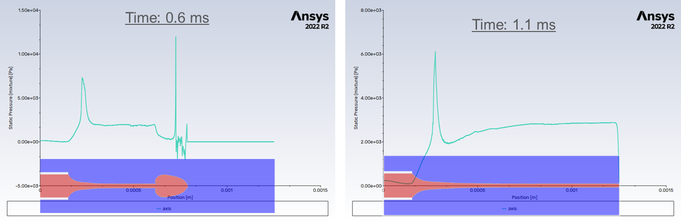
Figure 25: Model Transient Startup Issue Example.

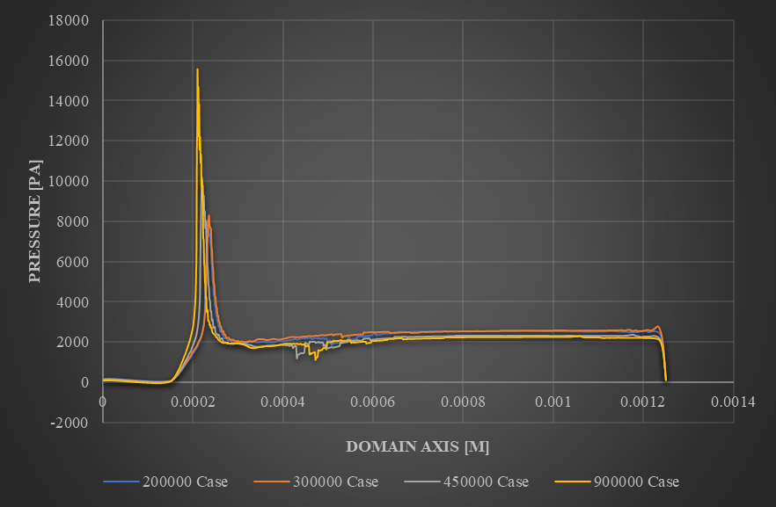
Figure 26: Domain Axis Static Pressure Comparison.

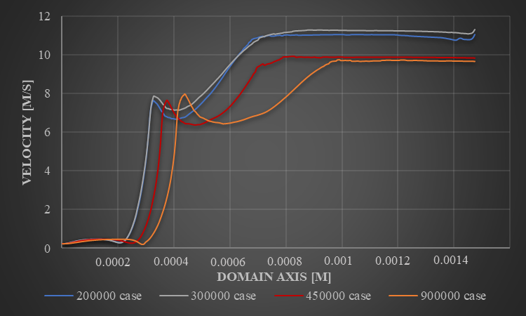
Figure 27: Domain Axis Velocity Comparison.
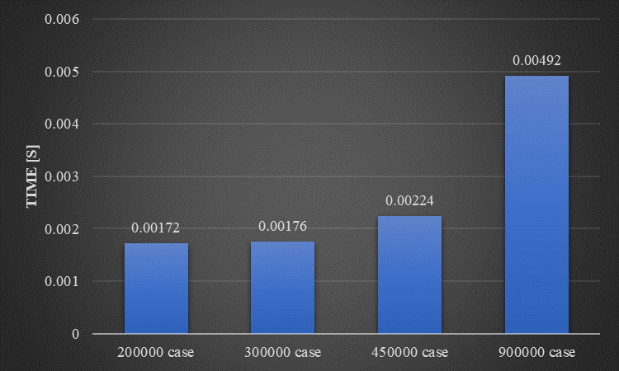
Figure 28: Time for Initial Jet to Exit the Domain.
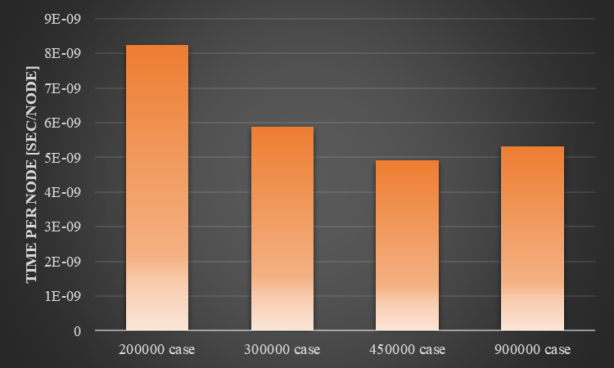
Figure 29: Time per Node for Initial Jet to Exit the Domain.
Table 4: Mesh Independence Case Properties.
Case | 200,000 | 300,000 | 450,000 | 900,000
Exact Nodes | 208,751 | 299,255 | 456,548 | 927,027
Element size | 9.00E-07 | 7.40E-07 | 6.16E-07 | 4.20E-07
Element Quality
Min | 0.3395 | 0.36065 | 0.3549 | 0.43168
Max | 0.99995 | 0.99954 | 0.9947 | 0.99948
Average | 0.97161 | 0.96337 | 0.98699 | 0.9797
Standard Dev | 2.23E-02 | 2.80E-02 | 1.83E-02 | 1.81E-02
Aspect Ratio
Min | 1 | 1 | 1 | 1
Max | 3.0523 | 2.6966 | 3.1519 | 3.0773
Average | 1.1144 | 1.1475 | 1.0916 | 1.1343
Standard Dev | 9.99E-02 | 0.12121 | 6.87E-02 | 8.38E-02
Skewness
Min | 2.75E-05 | 6.98E-06 | 6.46E-06 | 3.70E-06
Max | 0.66375 | 0.64873 | 0.74455 | 0.63794
Average | 2.35E-02 | 2.78E-02 | 9.07E-03 | 1.24E-02
Standard Dev | 2.60E-02 | 3.35E-02 | 1.78E-02 | 1.74E-02
Orthogonal Quality
Min | 0.59201 | 0.60752 | 0.57524 | 0.69011
Max | 1 | 1 | 1 | 1
Average | 0.99866 | 0.99782 | 0.99962 | 0.99955
Standard Dev | 5.50E-03 | 6.43E-03 | 5.45E-03 | 4.99E-03

A test was conducted with the ${10}^{-7}$ timestep and the ${10}^{-8}$ timestep using a volumetric flow rate of $10$ cc/hrand an electric potential of $7500$ V. Comparison of the average jet diameter in the transition region showed that there are differences in the results when using the ${10}^{-8}$ versus the ${10}^{-7}$ timestep. The average jet diameter in the former case is $41.5$ µm and in the latter case it is $35.5$ µm. The value of the scaling law jet diameter for this case is $41.9$ µm. So, the ${10}^{-8}$ timestep case is off by $1\%$ where the ${10}^{-7}$ timestep case is off by $15\%$. Because this study is focused on the feasibility of ES from a concave meniscus and not on specific values, the benefit of using the ${10}^{-7}$ timestep was deemed to be worth the sacrifice in accuracy.
4.2.5 Particle Mass
The charged particles that ANSYS Fluent introduces into a system have their own mass. It is important to determine if the total mass of the particles introduced into the system is significant enough to affect the overall solution. ANSYS Fluent provides a summary of particle statistics in the Results tab of the user interface. For the $10$ cc/hrscenario, the total particle mass in the system is $\sim {10}^{-10}$ kg, but the total mass introduced into the capillary is $\sim {10}^{-6}$ kg. The particle mass is significantly smaller than the amount that enters through the capillary, so it is assured that the particle mass has very little effect on the final solution.
4.2.6 Results and Verification
The volumetric flow rate of the n-heptane into the capillary was varied for three scenarios, 10 cc/hr, 8 cc/hr, and 6 cc/hr, using the verification model described in Section 4.2. Figure 30 shows the VOF results of all three flow rates. To confirm these results are accurate, the characteristic length of the transition region was calculated from (2.41). Next, the average jet diameter inside of the characteristic length was found by taking four measurements of the jet diameter inside of the characteristic length, as shown in Figure 31. Finally, the average was compared to the jet radius calculated using (2.42). The results of these measurements can be seen in Figure 32. The errors between the average jet diameter and the scaling law jet diameter for the 10 cc/hr, 8 cc/hr, and 6 cc/hr scenarios were 15%, 6%, and 10%, respectively. These results indicate that the simulation represents the physics of micro-ES accurately based on comparison to the scaling laws. They also indicate that for decreasing volumetric flow rates, and thus decreasing jet radii, a finer mesh may be needed than the present mesh to achieve the most accurate results. Because the purpose of this model is to determine whether or not a Taylor cone will be formed when an electric field is applied to a concave meniscus, and not to accurately determine the jet radius produced, the current mesh will be maintained for the concave meniscus case.
  - Concave Meniscus Model
4.3.1 Changes from Verification Model
The concave meniscus model will use the same mesh, settings, and parameters as the verification model with three exceptions. First, the mass flow rate is set to zero, and second, the acceleration due to gravity will be set to zero. This will ensure that the only external force affecting the concave meniscus is the electrostatic force. This will be more representative of capillaries in space environments, where the µSTAMPS will be operating. The third exception is the concave meniscus shape in the initial n-heptane in the system with a contact angle of 21°, which is shown in Figure 33.
The angle of the meniscus is achieved by patching a circle with air near the top of the capillary, as shown in Figure 34.

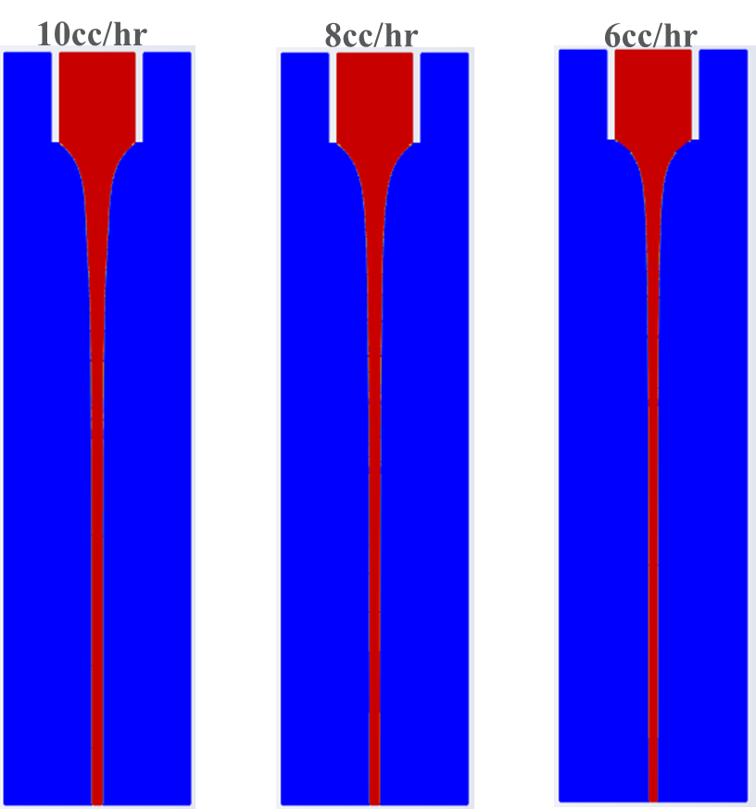
Figure 30: ES Verification Model VOF Results for Various Flow Rates.

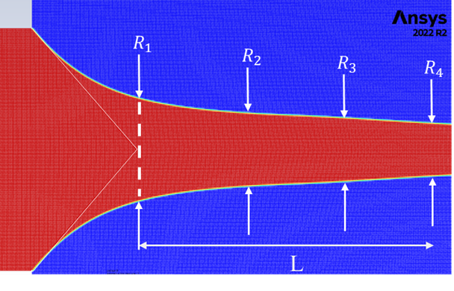
Figure 31: Characteristic Length and Jet Diameter Measurement Locations.
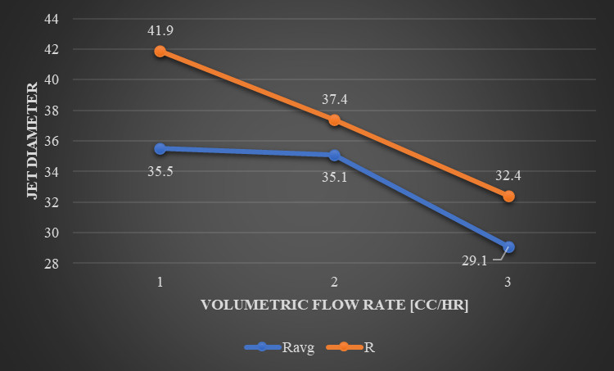
Figure 32: Comparison of Simulation and Scaling Law Jet Diameters.
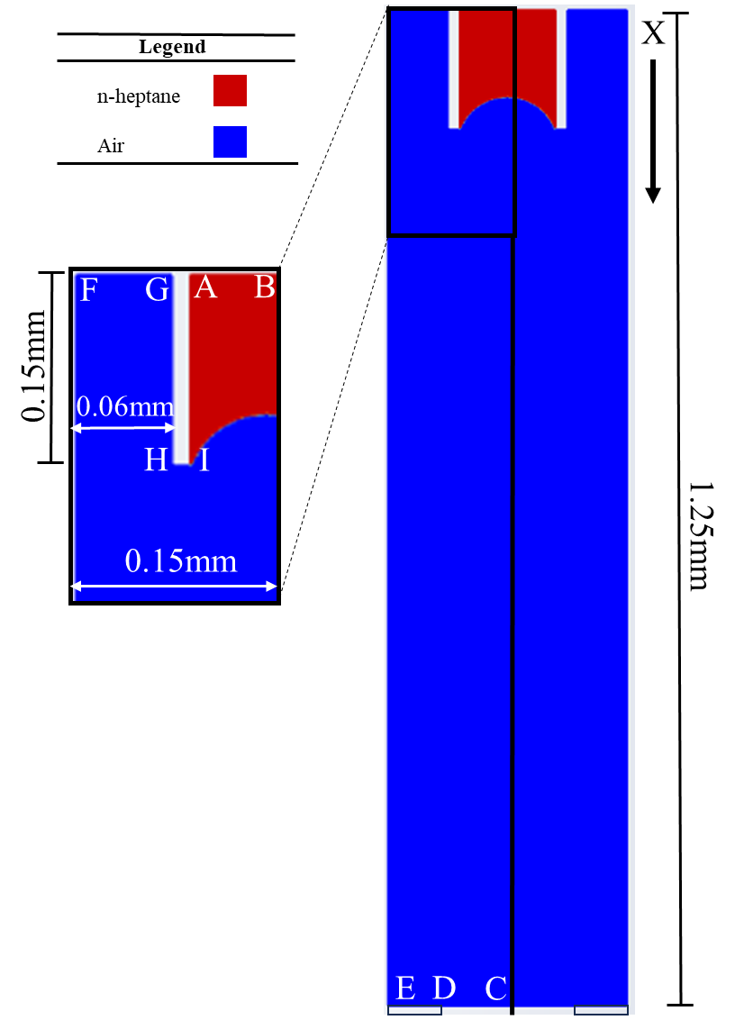
Figure 33: Concave Meniscus Model Domain.

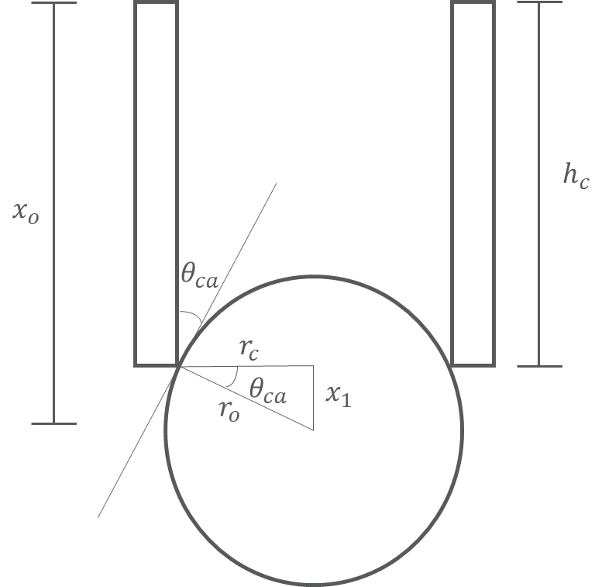
Figure 34:Contact Angle Implementation Schematic.

The radius of the circle is found using the following equation:
$r_{o}=\frac{r_{c}}{cos⁡\left(θ_{ca}\right)}$. | (4.3)
The location of the center of the circle is found from
$x_{o}=h_{c}+x_{1}$. | (4.4)
Also, the rake that introduces the charged particles is placed at the edge of the meniscus, which is found by
$x_{r}=x_{o}-r_{o}$. | (4.5)

4.3.2 Results
Referring to Figure 35, the system begins with a concave meniscus at an angle of 21° with the n-heptane in contact with the end of the capillary. After $0.03$ ms, the n-heptane recedes from the edges of the capillary, as the surface tension stresses reduce the local radius to begin forming the Taylor cone. At $0.05$ ms, the n-heptane angle at the wall becomes acute with reference to the wall and has receded further down the wall as more charge and n-heptane accumulate at the apex. At $0.15$ ms, a cone-jet has fully formed. At $0.2$ ms, perturbations form along the jet. Finally, at $0.25$ ms, the jet is broken up into droplets because the flow rate into the capillary is not enough to maintain a steady cone-jet.
4.3.3 Discussion
From Figure 35, it is clear that a Taylor cone can be formed from a concave meniscus. As expected, because there is no flow rate into the capillary, mass is pulled from the edges of the capillary toward the center to form the Tayor cone and subsequent cone-jet. Also, because there is no flow rate into the capillary, the cone-jet runs out of mass and eventually breaks up into droplets which quickly decrease in size.
Using these results, it can be theorized that, in the case of the µSTAMPS, a Taylor cone will form from the concave meniscus of the IL propellant at the top of the capillary in the same manner as if there were a flow rate into the capillary. Because the ES mode of µSTAMPS is in the pure ion regime, the lack of a flow rate into the capillary becomes less of an issue, as the loss of ions will reduce the mass inside the Taylor cone far slower than if a cone-jet were formed, allowing the cone to be maintained. Over a longer period of time the capillary will need to be refilled, but the Taylor cone and ion evaporation should not be interrupted until that refill is required. This means it is likely the µSTAMPS will provide a steady emission of ions to provide thrust for a spacecraft.
4.3.4 Limitations of the ANSYS Fluent Model
4.3.4.1 Reporting of Values
The limitations in ANSYS Fluent in conducting EHD exist in the EHD model. The equation for current density is given as [65]
$j=σ\left(E+U×B\right)$, | (4.6)
where $σ$ is the electric conductivity, $U$ is the fluid velocity field, and $B$ is the magnetic field. Because ES occurs electrostatically, this limits the current density to ohmic conduction:
$j=σE$. | (4.7)

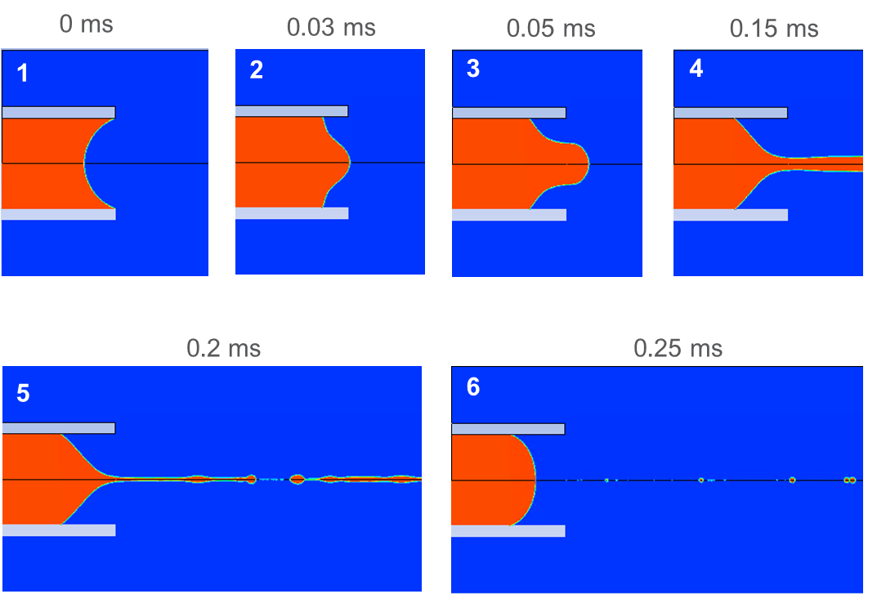
Figure 35: Evolution of Concave Meniscus (21°) Subject to an Applied Voltage.

As discussed in Section 2, ohmic conduction dominates charge transport in the Taylor cone of micro- and nanoscale ES, but as the Taylor cone transitions into a jet, charge transport transitions to surface convection, which becomes dominant in the jet itself. This causes the value of the current density to rapidly go to zero after the transition region as shown in Figure 36. A similar issue exists in the reported values of the electric field, which also goes to zero shortly after the transition region as shown in Figure 37. This is because the Poisson Equation is assumed to be as follows [65]:
$∇^{2}φ=∇∙\left(U×B\right)$, | (4.10)
where $φ$ is the applied voltage. Again, the electrostatic nature of ES changes (4.8) to
$∇^{2}φ=0$, | (4.11)
(4.11) implies that there is no free charge at the surface of the fluid, but, as explained in Section 2, at the interface between the air and the cone-jet there is free charge at the surface. Also, Figure 38 shows that the electric energy supplied by the applied voltage falls to zero inside the domain, as that energy is converted to kinetic energy. Since there is no transition from ohmic conduction to surface convection, the surface free charge is considered zero throughout the system, and the voltage falls to zero inside the domain, so the electric field strength is incorrectly reported after the transition region. Importantly, these limitations do not seem to affect the behavior of the model, but they do make it impossible to get accurate values of electric potential, electric field, and current density.
Another important limitation in reporting is the electric force, which is reported in ANSYS Fluent as the Lorentz force and is given by [65]
$F=j×B$. | (4.12)
The electrostatic assumption changes (4.12) to
$F=0$. | (4.13)
Clearly, the Lorentz force is not zero during ES, but the force is reported as zero nonetheless, as seen in Figure 39. The ANSYS Fluent Theory Guide also provides an equation for Lorentz force on a particle which is written [65]
$F_{p}=q(E+v_{p}×B)$, | (4.14)
where $q$ is the charge of the particle and $v_{p}$ is the particle velocity. As before, the magnetic field is zero, so (4.14) becomes
$F_{p}=qE$, | (4.15)
This force certainly makes sense based on how charge is introduced into the system, but there does not seem to be a way to report this force when processing results. Thus, the only force reported for the system is (4.13). Again, this limitation does seem to affect the behavior of the model, but the model does not provide an accurate report of the Lorentz force in the system.
The introduction of particles via the DPM includes another limitation. Because the charge is coupled to the particle, the charges do not move through the fluid as a physical charge. Rather, they are subjected to the drag laws that are applied to the particles and thus are slowed by the fluid. This is why the charged particles must be introduced at the meniscus rather than initially assigning charge to be evenly distributed through the n-heptane based on the charge density.

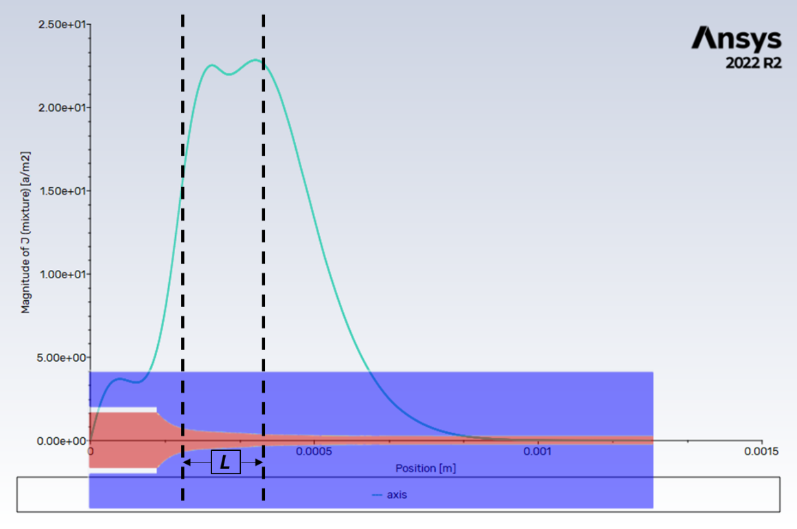
Figure 36: Current Density Along the Cone-Jet Axis.
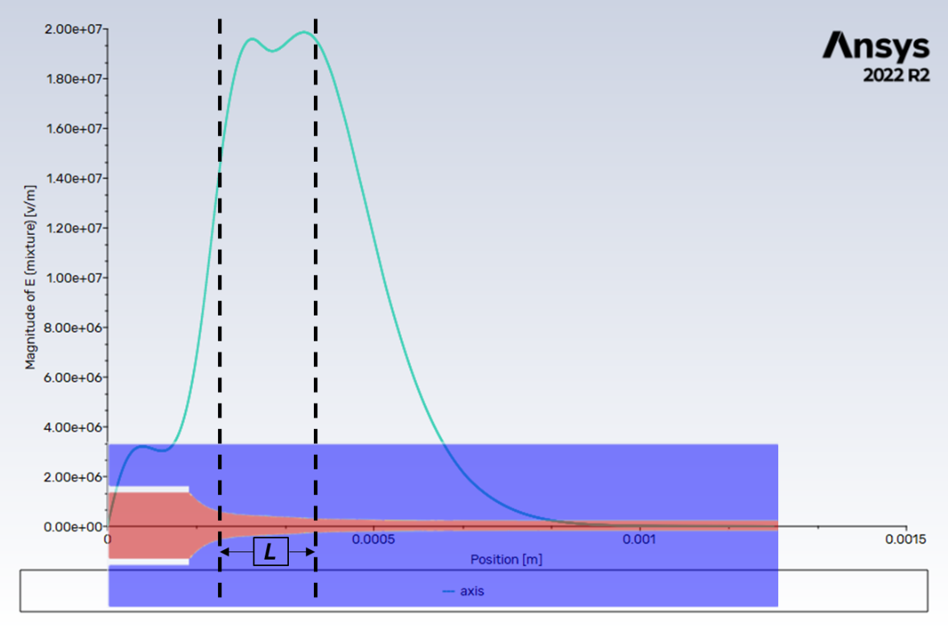
Figure 37: Electric Field Strength Along the Cone-jet Axis.
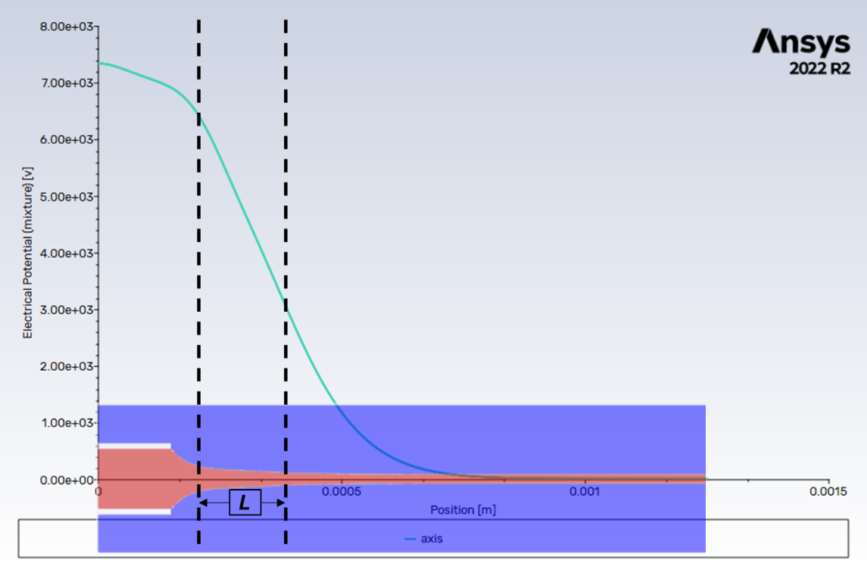
Figure 38: Applied Voltage Along the Cone-jet Axis.

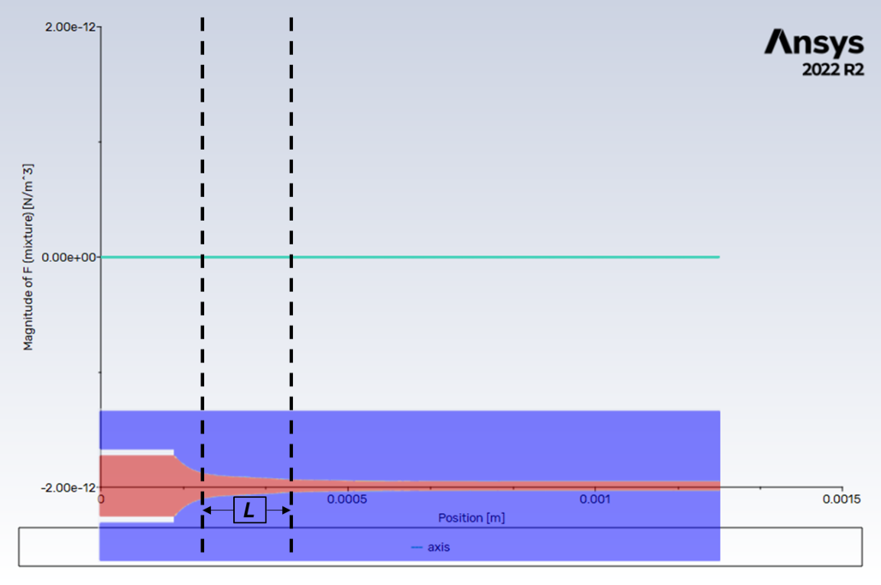
Figure 39: Force Along the Cone-jet Axis.

The introduction of charged particles in this manner caused unrealistic behavior in the initial stages of the transient simulation, as shown in Figure 40. Once the bulge of n-heptane at the head of the jet exited the domain, the solution moved towards a steady state and the behavior of the fluid moved closer to physical reality, as shown by the comparison to scaling laws in Section 4.2.6. This is shown in the pressure graphs of Figure 41. The top graph corresponds to Figure 40, and the two bottom pictures show the pressure after the bulge leaves the domain. Clearly, the pressure has stabilized after the bulge passes out of the domain. This is why the initial shape of the evolving Taylor cone shown in Figure 35 does accurately represent the expected Taylor cone shape.
As discussed in Section 4.1.2, the CSF model was chosen for this research for surface tension forces. This model is only valid for constant surface tension and performs well when there are no sharp interfaces. For the purposes of micro-ES, these limitations are reasonable, but for research in nano-ES and ion emission, even though constant surface tension is still expected, better resolution may be found at the Taylor cone apex with CSS. More research would need to be done to confirm this theory.

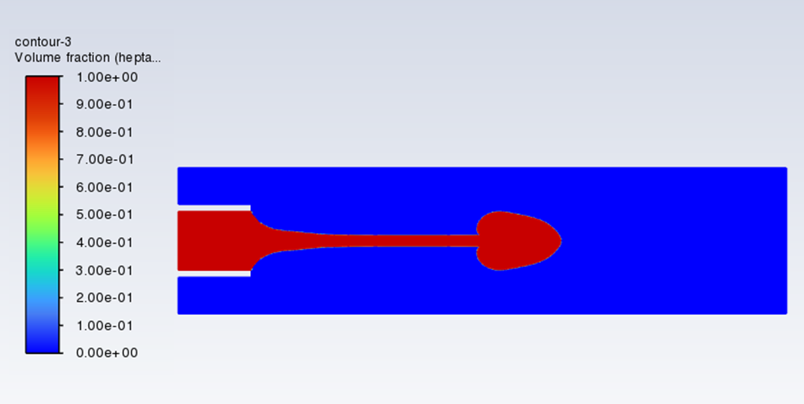
Figure 40: Transient Charged Particle Introduction Issues at 0.6 ms.
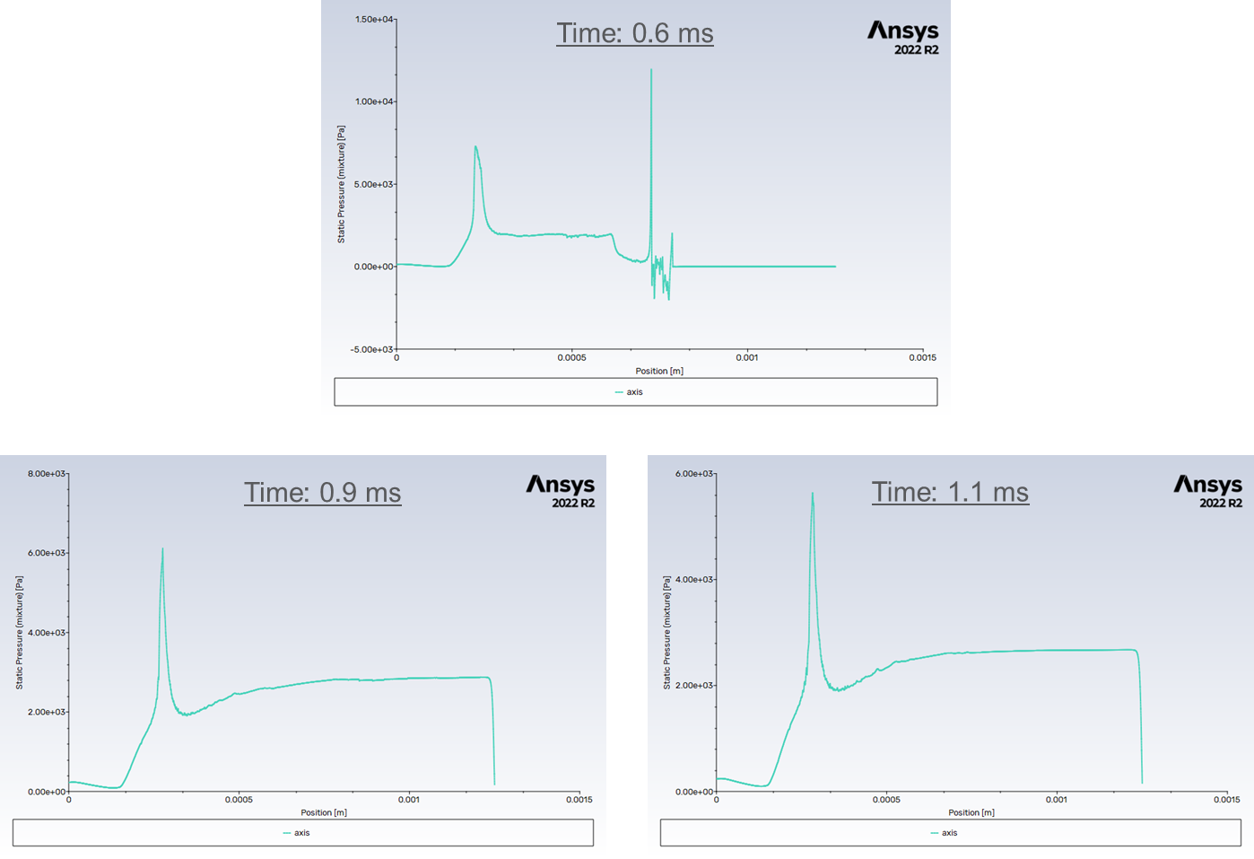
Figure 41: Pressure Along the Cone-jet Axis.

Chapter 5: Conclusions and Future Work
5.1 Conclusions
With the rise in deployment of nanosatellites and the new requirements for deorbiting a satellite, there is an increased need for propulsion devices compatible with these low-mass satellites. ETs are ideal propulsion devices for this purpose, because the electrohydrodynamic principles that govern this type of thruster can provide extremely high extraction velocities. This not only keeps the mass fraction of the thruster low, but also ensures a very high specific impulse.
ETs can operate in different ES modes, and it is imperative to properly identify the ES mode to make accurate analytical and numerical models. A successful procedure for identifying the ES mode involves the following steps:
- Verify the electrostatic solution is valid for the device.
- Determine if the device can form a Taylor cone.
- Determine if the device can establish a steady cone-jet:
  - Find the minimum flow rate required for a steady cone-jet.
  - Compare the expected flow rate of the system to the minimum flow rate.
If a steady cone-jet can be established:
  - Determine the scale of the cone-jet using electric conductivity and scaling laws.
  - Identify if ion emission will occur during the droplet breakup process.
If a steady cone-jet cannot be established:
  - Identify if ion emission will occur at the Taylor cone apex.
Once the ES mode is established, the governing equations and scaling laws can be gathered for the ET to create both an analytical model and numerical model to analyze the thruster performance.
This procedure was used to analyze the novel ET, µSTAMPS, and identified it as operating in the pure ion emission ES mode. The governing equations were then gathered for the µSTAMPS and used to create an analytical model. Initially, this model was used to compare the characteristic times at the Taylor cone apex to understand the behavior of the fluid and the ions in the smallest liquid domain of the system. The characteristic times showed that the electric time was much smaller than any of the fluid times, which says that the conductive current density will dominate charge transport in the Taylor cone. However, the emission time shows that once the charge reaches the meniscus at the Taylor cone apex, the ion evaporation mechanism will dominate charge transport and move ions from the liquid into the vacuum. Ions are then accelerated away from the apex and, from comparing the electric time and the particle residence time, the dominant charge transport mechanism becomes convective.
Next, this model compared thrust density and specific impulse values given by Child’s Law, electric pressure, and extraction velocity. This model showed that Child’s Law provided a much smaller estimate for thrust density than either the electric pressure or the extraction velocity. An analysis of the space charge effects by comparing the electric time to the particle residence time at the apex determined that the µSTAMPS is likely not limited by space charge effects, and as such, Child’s Law is not a reliable estimate for the thrust density for an ET using ILs. It is worth noting that space charge likely will have some effect on the thruster performance, so even though the thrust densities found using the ohmic and electric pressure may be better estimates than Child’s Law, they are likely to be overestimates of thruster performance.
The µSTAMPS will emit both cations and anions to create thrust while eliminating the need for an external neutralizer. Thus, the cation and anion performance for two possible IL propellants, BMP-DCA and EAN, were analyzed. The analysis showed that for both ILs, the thrust density did not vary largely between the cation and anion, but there is a large variation in the specific impulse produced by the cation and anion. This variation could be mitigated by modulating the acceleration voltage accordingly.
A unique feature of the µSTAMPS is the use of capillary action to draw the propellant to the end of the capillaries. This will result in a concave meniscus dictated by the contact angle between the fluid and the capillary. There is little published research on Taylor cone formation from a concave meniscus. So, using a numerical model developed in ANSYS Fluent of a low conductivity liquid inside a capillary and verified using the scaling laws, this study showed that it is possible to form a Taylor cone from a concave meniscus.
5.2 Future Work
The ultimate goal of this work is to develop a full numerical model of the µSTAMPS. The groundwork regarding identifying the underlying physics and governing equations for the µSTAMPS has been accomplished in [10, 37], and in this study. To continue this effort, one of the things that must be accomplished is the development of a model that can handle the short characteristic times involved in high-conductivity liquid propellants. The simulations performed in this study worked with characteristic times on the order of ${10}^{-6}$ s which required a time step of ${10}^{-7}$ s to remain stable. A simulation that works with high-conductivity propellants will need to handle characteristic times on the order of ${10}^{-13}$ s which may require a time step of ${10}^{-14}$ s and which will be computationally expensive.
The model will also need to be able to handle the ion emission physics. This will require tracking a large number of particles between the Taylor cone apex and the domain outlet, which can also be very computationally expensive. Accurate tracking of particle trajectories will provide accurate measurements of the ion beam shape, an understanding of the ion plume, and space charge effects on thruster performance.
Another topic that needs to be solved is the introduction of charge so that the initial formation of the Taylor cone is accurate. This is especially important for an ET that will emit both cations and anions. The process of switching polarity will likely cause changes in the Taylor cone shape and understanding that shape, and more importantly, the radius of the apex, will provide accurate data on ion evaporation and the transition from ohmic conduction to ion evaporation to convection.
The final topic to be mentioned in this study is the effect of temperature on the electric conductivity of the IL propellants. This study did not focus on the energy equation or temperature. However, temperature fluctuates significantly during space operations. Decreases in temperature result in the decrease of electric conductivity. If the electric conductivity gets too small, the electric field at the apex may not be strong enough to cause ion evaporation. Understanding these effects will determine if the IL propellant in the ET needs to have any kind of temperature control to make sure thruster performance is optimal and consistent.
Appendix A: Summary of Equation Tables
Table 5: Summary of µSTAMPS Governing Equations.
Equation | Equation Name
$$∇∙u=0$$ | Mass Conservation
$$ρ_{m}\left(u∙∇u\right)=-∇P + ∇∙\overset{̿}{τ} +∇∙{\overset{̿}{τ}}_{e}$$ | Momentum Conservation
$$∇∙J=0$$ | Charge Conservation
$$∇∙\left(εE\right)=ρ_{e}$$ | Maxwell-Poisson
$$∇×E=0$$ | Maxwell
$$E=-∇ϕ$$ | Scalar Potential
$$\left(p_{v}-p_{l}+γκ\right)∙n=\left({\overset{̿}{τ}}_{v}-{\overset{̿}{τ}}_{l}\right)∙n +\left({\overset{̿}{τ}}_{ve}-{\overset{̿}{τ}}_{le}\right)∙n$$ | Meniscus Normal Stress Balance
$${\overset{̿}{τ}}_{e}={εε}_{0}\left(EE-\frac{1}{2}{I\left|E\right|}^{2}\right)$$ | Maxwell Stress Tensor
$$σ_{e}=ε_{0}\left(E_{gn}-εE_{ln}\right)$$ | Surface Charge Jump Condition
$$J_{i}=σ_{e}\frac{k_{B}T}{h}exp\left(-\frac{∆G-G\left(E_{gn}\right)}{k_{B}T}\right)$$ | Current Density—Absolute Reaction Rate
$$j_{cond}=\frac{KE}{ε}$$ | Current Density—Ohmic Conduction

Table 6: Summary of Taylor Cone Apex Domain Equations.
Equation | Equation Name
$$E^{*}=\frac{4πε_{0}{\left(∆G\right)}^{2}}{e^{3}}$$ | Critical Electric Field
$$r^{*}=\frac{4γ}{ε_{0}E^{*2}}$$ | Critical Apex Radius
$$v^{*}=\sqrt{2\left(\frac{q}{m}\right)∆ϕ^{*}}$$ | Ion Velocity in $r^{*}$ Domain
$$Δϕ^{*}≈E^{*}r^{*}$$ | Potential Drop in $r^{*}$ Domain
$$j^{*}=\frac{KE^{*}}{ε}$$ | Current Density in $r^{*}$ Domain
$$u^{*}=\frac{j^{*}}{ρ(q/m)}$$ | Liquid Velocity in $r^{*}$ Domain

Table 7: Summary of Characteristic Time Equations.
Equation | Equation Name
$$t_{e}=\frac{εε_{0}}{K}$$ | Electric Time
$$t_{rl}=\frac{rρ(q/m)}{j}$$ | Liquid Residence Time
$$t_{p}=\frac{r}{\sqrt{2\left(\frac{q}{m}\right)∆ϕ}}$$ | Particle Residence Time
$$t_{rμ}=\frac{μr}{γ}$$ | Viscous-Capillary Time
$$t_{in}=\sqrt{\frac{ρr^{3}}{γ}}$$ | Inertial Time
$$t_{em}=\frac{h}{Tk_{B}}$$ | Emission Time

Table 8: Summary of Thruster Analysis Equations.
Equation | Equation Name
$$j_{CL}=\frac{4ε_{0}}{9}{\left(\frac{2q}{m}\right)}^{\frac{1}{2}}\frac{ϕ_{0}^{\frac{3}{2}}}{x_{ag}^{2}}$$ | Current Density—Child’s Law
$$v_{e}=\sqrt{v^{*2}+2\left(\frac{q}{m}\right)\left(Δϕ\right)}$$ | Extraction Velocity
$${\frac{T}{A}}_{CL}=\frac{8ε_{0}}{9}{\left(\frac{ϕ_{0}}{x_{ag}}\right)}^{2}$$ | Thrust Density—Child’s Law
$${\frac{T}{A}}_{Emax}=\frac{1}{2}ε_{0}E_{max}^{2}$$ | Thrust Density—Electric Pressure
$${\frac{T}{A}}_{j}=\frac{jv_{e}}{\left(q/m\right)}$$ | Thrust Density—Ohmic Conduction
$$I_{sp} = \frac{ v_{e}}{g}$$ | Specific Impulse

Appendix B: Electrospray Thruster Mode Analysis Tables
Table 9: Scaling Laws and Minimum Volumetric Flow Rate Values.
IL | $${Re}_{K}$$ | $${Re}_{K}ε$$ | $d_{d0}$ (m) | $I_{0}$ (A) | $Q_{0}$ (m³/s) | $Q_{min}$ (m³/s) | $Q$ (m³/s)
OOM | $${\sim 10}^{-3}$$ | $${\sim 10}^{-2}$$ | $${\sim 10}^{-10}$$ | $${\sim 10}^{-10}$$ | $${\sim 10}^{-17}$$ | $${\sim 10}^{-14}$$ | $$\sim {10}^{-19}$$
BMP-DCA | $$1.23×{10}^{-2}$$ | $$2.2×{10}^{-1}$$ | $$3.5×{10}^{-9}$$ | $$5.43×{10}^{-9}$$ | $$1.61×{10}^{-15}$$ | $$1.31×{10}^{-13}$$ | $$2.7×{10}^{-17}$$
EAN | $$6.58×{10}^{-3}$$ | $$1.7×{10}^{-1}$$ | $$9×{10}^{-10}$$ | $$4.12×{10}^{-9}$$ | $$1.7×{10}^{-16}$$ | $$2.59×{10}^{-14}$$ | $$2.65×{10}^{-17}$$

Table 10: Critical Electric Field Strength for ILs.
Ionic Liquid | $r^{*}$ (OOM) or $r_{a}$ (IL) (m) | $E^{*}$ (OOM) $E_{vn}$ (IL) (V/m)
OOM | $$\sim {10}^{-8}$$ | $$\sim {10}^{9} V/m$$
BMP-DCA | $$5.28×{10}^{-8}$$ | $$0.693×{10}^{9}$$
EAN | $$5.28×{10}^{-8}$$ | $$0.555×{10}^{9}$$

Table 11: Characteristic Times of ILs in the $r^{*} or r_{a}$ Domain.
IL | $t_{e }$(s) | $t_{rl}$ (s) | $t_{p}$ (s) | $t_{rµ}$ (s) | $t_{in}$ (s) | $t_{em}$ (s)
OOM | $$\sim {10}^{-11}$$ | $$\sim {10}^{-7}$$ | $$\sim {10}^{-12}$$ | $$\sim {10}^{-9}$$ | $$\sim {10}^{-10}$$ | $$\sim {10}^{-13}$$
Cation
BMP-DCA | $$4.9×{10}^{-10}$$ | $$2.73×{10}^{-6}$$ | $$7.49×{10}^{-12}$$ | $$3.31×{10}^{-8}$$ | $$1.58×{10}^{-9}$$ | $$1.64×{10}^{-13}$$
EAN | $$1.15×{10}^{-10}$$ | $$2.78×{10}^{-6}$$ | $$4.41×{10}^{-12}$$ | $$3.87×{10}^{-8}$$ | $$1.94×{10}^{-9}$$ | $$1.64×{10}^{-13}$$
Anion
BMP-DCA | $$4.9×{10}^{-10}$$ | $$5.73×{10}^{-6}$$ | $$5.16×{10}^{-12}$$ | $$3.31×{10}^{-8}$$ | $$1.58×{10}^{-9}$$ | $$1.64×{10}^{-13}$$
EAN | $$1.15×{10}^{-10}$$ | $$2.07×{10}^{-6}$$ | $$5.11×{10}^{-12}$$ | $$3.87×{10}^{-8}$$ | $$1.94×{10}^{-9}$$ | $$1.64×{10}^{-13}$$

Appendix C: Thrust Metric Analysis Tables
Table 12: Thrust Density and Specific Impulse Analysis.
Thrust Density from Child’s Law
IL | $v_{CL}$ (m/s) | $j_{CL}$ (A/m²) | ${T/A}_{CL}$ (N/m²) | $I_{sp}$ (s)
OOM | $$2×{10}^{4}$$ | $$1.94×{10}^{5}$$ | $$3.89×{10}^{3}$$ | 2040
Thrust Density from Electric Pressure
IL | -- | -- | ${T/A}_{Emax}$ (N/m²) | --
OOM | -- | -- | $$\sim {10}^{7}$$ | --
BMP-DCA | -- | -- | $$2.13×{10}^{6}$$ | --
EAN | -- | -- | $$1.86×{10}^{6}$$ | --
Thrust Density from the Extraction Velocity
IL | $v_{e}$ (m/s) | $j$ (A/m²) | ${T/A}_{ve}$ (N/m²) | $I_{sp}$ (s)
OOM | $$\sim {10}^{4}$$ | $$\sim {10}^{8}$$ | $$\sim {10}^{6}$$ | $$\sim {10}^{3}$$
Cation
BMP-DCA | $1.8×{10}^{4}$ | $$1.25×{10}^{7}$$ | $${3.23×10}^{5}$$ | 1790
EAN | $$3.1×{10}^{4}$$ | $$5.01×{10}^{7}$$ | $${7.34×10}^{5}$$ | 3120
Anion
BMP-DCA | $$2.5×{10}^{4}$$ | $$1.25×{10}^{7}$$ | $${2.23×10}^{5}$$ | 2600
EAN | $$2.6×{10}^{4}$$ | $$5.01×{10}^{7}$$ | $${8.5×10}^{5}$$ | 2700

Table 13: Space Charge Ratios for ILs of Interest.
IL | ${E_{sc}}/{{(E}^{*} or E)}$ cation | ${E_{sc}}/{{(E}^{*} or E)}$ anion
OOM | $$\sim {10}^{-2}$$ | $$\sim {10}^{-2}$$
BMP-DCA | $$1.53×{10}^{-2}$$ | $$1.05×{10}^{-2}$$
EAN | $$3.85×{10}^{-2}$$ | $$4.45×{10}^{-2}$$

Works Cited
[1] Taylor, G., “Disintegration of water drops in an electric field,” Proceedings of the Royal Society of London. Series A. Mathematical and Physical Sciences, vol. 280, 1964, pp. 383–397.
[2] Gañán-Calvo, A. M., López-Herrera, J. M., Herrada, M. A., Ramos, A., and Montanero, J. M., “Review on the physics of Electrospray: From electrokinetics to the operating conditions of single and coaxial Taylor Cone-jets, and AC Electrospray,” Journal of Aerosol Science, vol. 125, 2018, pp. 32–56.
[3] Gomez, A., and Tang, K., “Charge and fission of droplets in electrostatic sprays,” Physics of Fluids, vol. 6, 1994, pp. 404–414.
[4] Gamero-Castano, M., and Hruby, V., “Electrospray as a source of nanoparticles for efficient colloid thrusters,” Journal of Propulsion and Power, vol. 17, 2001, pp. 977–987.
[5] Gallud, X., and Lozano, P. C., “The emission properties, structure and stability of ionic liquid menisci undergoing electrically assisted ion evaporation,” Journal of Fluid Mechanics, vol. 933, 2022.
[6] Bailey, A. G., “Electrostatic spraying of liquids,” Physics Bulletin, vol. 35, 1984, pp. 146–148.
[7] Hines, R. L., “Electrostatic atomization and spray painting,” Journal of Applied Physics, vol. 37, 1966, pp. 2730–2736.
[8] Yule, A. J., Shrimpton, J. S., Watkins, A. P., Balachandran, W., and Hu, D., “Electrostatically atomized hydrocarbon sprays,” Fuel, vol. 74, 1995, pp. 1094–1103.
[9] Fenn JB, Mann M, Meng CK, Wong SF, Whitehouse CM. Electrospray ionization for mass spectrometry of large biomolecules. Science. 1989 Oct 6;246(4926):64-71. doi: 10.1126/science.2675315. PMID: 2675315.
[10] Howell, Joshua H., "A Numerical Optimization Study of a Novel Electrospray Emitter Design. " Master's Thesis, University of Tennessee, 2022. https://trace.tennessee.edu/utk_gradthes/6418
[11] Kulu, E., “Nanosats database,” Nanosats Database Available: https://www.nanosats.eu/.
[12] Wiquist, W. (2022) FCC ADOPTS NEW ‘5-YEAR RULE’ FOR DEORBITING SATELLITES TO ADDRESS GROWING RISK OF ORBITAL DEBRIS, IB Docket Nos. 22-271, 18-313, Washington, USA.
[13] R. G. Jahn, Physics of electric propulsion. in Dover books on physics. Mineola, N.Y: Dover Publications, Inc, 2006.
[14] Hauksbee, F., Physico-Mechanical Experiments on Various Subjects, London, 1709, 1st Edition, pp. 46-47.
[15] Newton, I. sir, Opticks, Estados Unidos: Dover Publications, 1952.
[16] Fylladitakis, E. D., Theodoridis, M. P., and Moronis, A. X., “Review on the history, research, and applications of electrohydrodynamics,” IEEE Transactions on Plasma Science, vol. 42, 2014, pp. 358–375.
[17] Müller, E. W., and Bahadur, K., “Field ionization of gases at a metal surface and the resolution of the Field Ion Microscope,” Physical Review, vol. 102, 1956, pp. 624–631.
[18] Rayleigh, Lord, “Xx. on the equilibrium of liquid conducting masses charged with electricity,” The London, Edinburgh, and Dublin Philosophical Magazine and Journal of Science, vol. 14, 1882, pp. 184–186.
[19] Zeleny, J., “Instability of electrified liquid surfaces,” Physical Review, vol. 10, 1917, pp. 1–6.
[20] Cloupeau, M., and Prunet-Foch, B., “Electrostatic spraying of liquids: Main functioning modes,” Journal of Electrostatics, vol. 25, 1990, pp. 165–184.
[21] De La Mora, J. F., and Loscertales, I. G., “The current emitted by highly conducting Taylor Cones,” Journal of Fluid Mechanics, vol. 260, 1994, pp. 155–184.
[22] Gamero-Castaño, M., and Fernández de la Mora, J., “Direct measurement of ion evaporation kinetics from electrified liquid surfaces,” The Journal of Chemical Physics, vol. 113, 2000, pp. 815–832.
[23] Romero-Sanz, I., Bocanegra, R., Fernandez de la Mora, J., and Gamero-Castaño, M., “Source of heavy molecular ions based on Taylor cones of ionic liquids operating in the pure ion evaporation regime,” Journal of Applied Physics, vol. 94, 2003, pp. 3599–3605.
[24] Gamero-Castaño, M., and Galobardes-Esteban, M., “Electrospray propulsion: Modeling of the beams of droplets and ions of highly conducting propellants,” Journal of Applied Physics, vol. 131, 2022.
[25] Ziemer, J. K., Randolph, T., Hruby, V., Spence, D., Demmons, N., Roy, T., Connolly, W., Ehrbar, E., Zwahlen, J., and Martin, R., “Colloid microthrust propulsion for the space technology 7 (ST7) and Lisa Missions,” AIP Conference Proceedings, 2006.
[26] Gamero-Castaño, M., “Characterization of the electrosprays of 1-ethyl-3-methylimidazolium bis(trifluoromethylsulfonyl) imide in vacuum,” Physics of Fluids, vol. 20, 2008.
[27] Wei, W., Gu, Z., Wang, S., Zhang, Y., Lei, K., and Kase, K., “Numerical simulation of the cone–jet formation and current generation in electrostatic spray—modeling as regards space charged droplet effect,” Journal of Micromechanics and Microengineering, vol. 23, 2012, p. 015004.
[28] Kumar, P., Kwon, C., Kwon, K., and Yoh, J. J., “On the cone-to-jet transition region and its significance in electrospray propulsion,” Acta Astronautica, vol. 205, 2023, pp. 12–22.
[29] Plimpton, S., Thompson, A., Moore, S., Kohlmeyer, A., and Berger, R., “LAMMPS molecular dynamics simulator,” LAMMPS Molecular Dynamics Simulator Available: https://www.lammps.org/#gsc.tab=0.
[30] Zhang, J., Cai, G., Liu, X., He, B., and Wang, W., “Molecular dynamics simulation of ionic liquid electrospray: Revealing the effects of interaction potential models,” Acta Astronautica, vol. 179, 2021, pp. 581–593.
[31] Asher, J. S., and Wang, J., “Three-dimensional particle-in-cell simulations of Bipolar Ionic electrospray thruster plume,” Journal of Propulsion and Power, vol. 38, 2022, pp. 573–580.
[32] “Main page,” Gerris Available: http://gerris.dalembert.upmc.fr/.
[33] López-Herrera, J. M., Popinet, S., and Herrada, M. A., “A charge-conservative approach for simulating electrohydrodynamic two-phase flows using volume-of-fluid,” Journal of Computational Physics, vol. 230, 2011, pp. 1939–1955.
[34] Suo, X., Zhang, K., Huang, X., Wang, D., Jia, H., Yang, F., Zhang, W., Li, J., Tu, L., and Song, P., “Electrospray beam currents in the cone-jet mode based on numerical simulation,” Physics of Fluids, vol. 35, 2023.
[35] Cui, C., and Wang, J., “Simulations of pure ionic electrospray thruster plume neutralization,” AIAA Propulsion and Energy 2020 Forum, 2020.
[36] Magnani, M., and Gamero-Castaño, M., “Modelling and scaling laws of the ion emission regime in Taylor Cones,” Journal of Fluid Mechanics, vol. 972, 2023.
[37] Jones, Justin Michael, "The Effects of Geometry and Material Variations on the Onset Voltage of Electrospray Emitters. " Master's Thesis, University of Tennessee, 2020. https://trace.tennessee.edu/utk_gradthes/5617
[38] Lastow, O., and Balachandran, W., “Numerical simulation of electrohydrodynamic (EHD) atomization,” Journal of Electrostatics, vol. 64, 2006, pp. 850–859.
[39] Rahmanpour, M., Reza, E., Shafiey, M., Dehpanah, P., “Numerical Simulation of Single Emitter Taylor Cone-Jet for Electrospray Thruster Applications,” Conference: International Symposium on Electrohydrodynamics, ISEHD 2012, At: Gdańsk, Poland, Volume: 1, September 2012
[40] Wang, W., Bajic, S., John, B., and Emerson, D. R., “Numerical simulation of ion transport in a nano-electrospray ion source at atmospheric pressure,” Journal of the American Society for Mass Spectrometry, vol. 29, 2018, pp. 600–612.
[41] White, F. M., Viscous Fluid Flow, New York: McGraw-Hill, 2006.
[42] Brackbill, J. U., Kothe, D. B., and Zemach, C., “A continuum method for modeling surface tension,” Journal of Computational Physics, vol. 100, 1992, pp. 335–354.
[43] Washburn. “The Dynamics of Capillary Flow.” Physical review. 17.3 (1921): 273–283. Web.
[44] Griffiths, D. J., Introduction to electrodynamics, S.l.: CAMBRIDGE UNIV PRESS, 2023.
[45] Coffman, C. S., “Electrically-assisted evaporation of charged fluids: Fundamental modeling and studies on ionic liquids,” dissertation, Massachusetts Institute of Technology, 2009.
[46] Gañán-Calvo, A. M., and Montanero, J. M., “Revision of capillary cone-jet physics: Electrospray and flow focusing,” Physical Review E, vol. 79, 2009.
[47] Gañán-Calvo, A. M., Rebollo-Muñoz, N., and Montanero, J. M., “The minimum or natural rate of flow and droplet size ejected by Taylor Cone–jets: Physical symmetries and scaling laws,” New Journal of Physics, vol. 15, 2013, p. 033035.
[48] Da-Ren Chen & David Y. H. Pui (1997) Experimental Investigation of Scaling Laws for Electrospraying: Dielectric Constant Effect, Aerosol Science and Technology, 27:3, 367-380, DOI: 10.1080/02786829708965479
[49] Rosell-Llompart, J., Grifoll, J., and Loscertales, I. G., “Electrosprays in the cone-jet mode: From Taylor Cone Formation to spray development,” Journal of Aerosol Science, vol. 125, 2018, pp. 2–31.
[50] Gomez, A., and Tang, K., “Charge and fission of droplets in electrostatic sprays,” Physics of Fluids, vol. 6, 1994, pp. 404–414.
[51] Duft, D., Achtzehn, T., Müller, R., Huber, B. A., and Leisner, T., “Rayleigh Jets from levitated microdroplets,” Nature, vol. 421, 2003, pp. 128–128.
[52] Gamero-Castaño, M., “Electric-field-induced ion evaporation from dielectric liquid,” Physical Review Letters, vol. 89, 2002.
[53] Iribarne, J. V., “On the evaporation of small ions from charged droplets,” The Journal of Chemical Physics, vol. 64, 1976, p. 2287.
[54] Loscertales I. G., “Ion emission from charged liquid surfaces,” Yale University ProQuest Dissertations Publishing, 1995.
[55] Gamero-Castaño, M., and Cisquella-Serra, A., “Electrosprays of highly conducting liquids: A study of droplet and ion emission based on retarding potential and time-of-flight spectrometry,” Physical Review Fluids, vol. 6, 2021.
[56] Howell, J., Canfield, B., Costa, L., Rhodes III, J., Terekhov, A., Moeller, T., “Analysis on the Effects of Ionic Liquid Properties on Electrospray Thruster Performance,” University of Tennessee Space Institute, Center for Laser Applications, 2023 (not yet published).
[57] Ethylammonium nitrate (EAN), 100 G - Carl roth Available: https://www.carlroth.com/com/en/ionic-liquids/ethylammonium-nitrate-%28ean%29/p/2035.2.
[58] Rudnev, A. V., Ehrenburg, M. R., Molodkina, E. B., Abdelrahman, A., Arenz, M., Broekmann, P., and Jacob, T., “Structural changes of au(111) single‐crystal electrode surface in Ionic liquids,” ChemElectroChem, vol. 7, 2020, pp. 501–508.
[59] M.-M. Huang, Y. Jiang, P. Sasisanker, G. W. Driver, and H. Weingärtner, “Static Relative Dielectric Permittivities of Ionic Liquids at 25 °C,” J. Chem. Eng. Data, vol. 56, no. 4, pp. 1494–1499, Apr. 2011, doi: 10.1021/je101184s.
[60] N. Zec, M. Bešter-Rogač, M. Vraneš, and S. Gadžurić, “Physicochemical properties of (1-butyl-1-methylpyrrolydinium dicyanamide + γ-butyrolactone) binary mixtures,” The Journal of Chemical Thermodynamics, vol. 91, pp. 327–335, Dec. 2015, doi: 10.1016/j.jct.2015.08.014.
[61] L. G. Sánchez, J. R. Espel, F. Onink, G. W. Meindersma, and A. B. de Haan, “Density, Viscosity, and Surface Tension of Synthesis Grade Imidazolium, Pyridinium, and Pyrrolidinium Based Room Temperature Ionic Liquids,” J. Chem. Eng. Data, vol. 54, no. 10, pp. 2803–2812, Oct. 2009, doi: 10.1021/je800710p.
[62] Technical Data Sheet. 1-Butyl-1-methylpyrrolidinium dicyanamide. IL-004. Ionic Liquids Technologies GmbH. Salzstrasse 184 D, 74076, Heilbronn, Germany. September 26, 2014. https://iolitec.de/sites/iolitec.de/files/2017-05/TDS%20IL-0041%20BMPyrr%20DCA.pdf.
[63] McEwen, A. B. Electrochemical Properties of Imidazolium Salt Electrolytes for Electrochemical Capacitor Applications. Journal of The Electrochemical Society 1999, 146 (5), 1687. https://doi.org/10.1149/1.1391827.
[64] Technical Data Sheet. Ethylammonium nitrate. IL-0043. Ionic Liquids Technologies GmbH. Salzstrasse 184 D, 74076, Heilbronn, Germany. February 14, 2012. https://iolitec.de/sites/iolitec.de/files/2017-05/TDS%20IL-0043%20EAN.pdf.
[65] Ansys® Fluent, Release 2022 R2, help system, Ansys® Fluent Theory Guide, Release 2022 R2
[66] Ansys® Fluent, Release 2022 R2, help system, Ansys® Fluent User Guide, Release 2023 R1
[67] Saville, D. A., “Electrohydrodynamics: The Taylor-Melcher leaky dielectric model,” Annual Review of Fluid Mechanics, vol. 29, 1997, pp. 27–64.
[68] Allman, J., Canfield, B., Terekhov, A., Moeller, T., “Liquid Immersion Laser Micromachining Using Ionic Liquids,” 42nd International Congress on Applications of Lasers & Electro-Optics, International Congress on Applications of Lasers & Electro-Optics, October 16th, 2023.
[69] SatCatalog, D. A., “2U CubeDrive,” SatCatalog Available: https://www.satcatalog.com/component/2u-cubedrive/.
[70] 10, M., “High-performance satellite propulsion,” Dawn Aerospace Available: https://www.dawnaerospace.com/products/cubedrive.
[71] “Water ion thruster - satcatalog.s3.amazonaws.com,” Pale Blue Available: https://pale-blue.co.jp/product/.
[72] SatCatalog, “Tile 3,” SatCatalog Available: https://www.satcatalog.com/component/tile-3/.
[73] VACCO Industries, “JPL Marco - Micro CubeSat Propulsion System X14102000-01,” cubesat-propulsion Available: https://www.cubesat-propulsion.com/wp-content/uploads/2015/11/X14102000-01_2019update.pdf.
[74] VACCO Industries , Argomoon propulsion system X17025000 - Vacco Industries Available: https://www.cubesat-propulsion.com/wp-content/uploads/2017/08/X17025000-data-sheet-080217.pdf.
[75] VACCO Industries, X19041000 green propulsion system data sheet 073019 - Vacco Industries Available: https://cubesat-propulsion.com/wp-content/uploads/2019/08/X19041000-Green-Propulsion-System-data-sheet-073019.pdf.
[76] VACCO Industries, “Nea Scout Propulsion System X16056000 - Vacco Industries,” VACCO Industries Available: https://www.cubesat-propulsion.com/wp-content/uploads/2017/08/X16056000-data-sheet-080217.pdf.
[77] VACCO Industries, “Cusp Propulsion System,” VACCO Industries Available: https://cubesat-propulsion.com/cusp-propulsion-system/.
[78] VACCO Industries, “Reaction control propulsion module X13003000-01,” VACCO Industries Available: https://cubesat-propulsion.com/wp-content/uploads/2022/04/X13003000-01_RCM_2016update.pdf.
[79] VACCO industries, “X14029003-0X MIPS standard - VACCO industries,” VACCO industries Available: https://www.cubesat-propulsion.com/wp-content/uploads/2015/10/standard-micro-propulsion-system.pdf.
[80] VACCO Industries, “Propulsion unit for CubeSats 11044000-01 - Vacco Industries,” VACCO Industries Available: https://cubesat-propulsion.com/wp-content/uploads/2016/03/11044000-01_PUC_2019update.pdf.
[81] Busek, “Electrospray thruster system - satcatalog.s3.amazonaws.com,” Busek Available: https://satcatalog.s3.amazonaws.com/components/1282/SatCatalog_-_Busek_-_BET-MAX_-_Datasheet.pdf.
[82] Squarespace, “BHT-100 - Squarespace,” Squarespace Available: https://static1.squarespace.com/static/60df2bfb6db9752ed1d79d44/t/6154811d7ac4036af765f736/1632928031263/BHT_100_v1.0.pdf.
[83] Busek, “BHT-200,” Busek Available: https://www.busek.com/bht200.
[84] Squarespace, “Master datasheets - Squarespace,” Squarespace Available: https://static1.squarespace.com/static/60df2bfb6db9752ed1d79d44/t/623c83ffee873f6917f8f15a/1648133121254/BHT_600_v1.1.pdf.
[85] Squarespace, “Pioneering center-mounted cathode. compact and efficient. - squarespace,” Squarespace Available: https://static1.squarespace.com/static/60df2bfb6db9752ed1d79d44/t/61292a6a6a852874bb123c23/1630087786826/bht_1500_v1.0.pdf.
[86] Squarespace, “High Power. high performance. - Squarespace,” Squarespace Available: https://static1.squarespace.com/static/60df2bfb6db9752ed1d79d44/t/610c3fb6ad8cb2543959bcc4/1628192694760/BHT_6000_v1.0.pdf.
[87] Squarespace, “Green monopropellant thruster - Squarespace,” Squarespace Available: https://static1.squarespace.com/static/60df2bfb6db9752ed1d79d44/t/61292af2a097083a87c4cbc0/1630087925107/BGT_X5_v1.0.pdf.
[88] SatCatalog, “HBT-1,” SatCatalog Available: https://www.satcatalog.com/component/hbt-1/.
[89] SatCatalog, “HBT-5,” SatCatalog Available: https://www.satcatalog.com/component/hbt-5/.
[90] SatCatalog, “BT-4,” SatCatalog Available: https://www.satcatalog.com/component/bt-4/.
[91] SatCatalog, “BT-6,” SatCatalog Available: https://www.satcatalog.com/component/bt-6/.
[92] SatCatalog, “Bipropellant Attitude Control System (ACS) thrusters,” SatCatalog Available: https://satcatalog.s3.amazonaws.com/components/1270/SatCatalog_-_Moog_-_DST-13_-_Datasheet.pdf.
[93] Aerojet-Rocketdyne, “AJ10-220 62.3 N (14.0 lbf) reaction control thruster,” Aerojet-Rocketdyne Available: https://satcatalog.s3.amazonaws.com/components/1012/SatCatalog_-_Aerojet_Rocketdyne_-_AJ10-220_62.3N_-_Datasheet.pdf?lastmod=20210918181041.
[94] SatCatalog, “PPS5000,” SatCatalog Available: https://www.satcatalog.com/component/pps5000/.
[95] SatCatalog, “PPS1350,” SatCatalog Available: https://www.satcatalog.com/component/pps1350/.
[96] Safran Group, “PPS®5000, Hall Effect Thruster,” Safran Available: https://www.safran-group.com/products-services/ppsr5000-plasma-thruster.
[97] Pale Blue, “Water ion thruster - satcatalog.s3.amazonaws.com,” SatCatalog Available: https://satcatalog.s3.amazonaws.com/components/1220/SatCatalog_-_Pale_Blue_-_Water_Ion_Thruster_-_Datasheet.pdf?lastmod=20230531084516.
[98] Benchmark Systems, “Products,” Benchmark Space Systems Available: https://www.benchmarkspacesystems.com/products#slide-2-2.
[98] Benchmark Systems, “Halcyon,” Benchmark Space Systems Available: https://www.benchmarkspacesystems.com/products#slide-2-2.
[99] Champaign-Urbana Aerospace, “Monopropellant Propulsion Unit for CUBESATS (MPUC) system low flame ...,” Champaign-Urbana Aerospace Available: https://satcatalog.s3.amazonaws.com/components/910/SatCatalog_-_Champaign-Urbana_Aerospace_-_MPUC_1.5U_-_Datasheet.pdf?lastmod=20210806035351.
[100] Champaign-Urbana Aerospace, “FPPT,” Champaign-Urbana Aerospace Available: https://satcatalog.s3.amazonaws.com/components/989/SatCatalog_-_Champaign-Urbana_Aerospace_-_FPPT_1U_-_Datasheet.pdf?lastmod=20210806035033.
[101] Champaign-Urbana Aerospace, “Monofilament vaporization propulsion (MVP) system solid inert polymer ...,” Champaign-Urbana Aerospace Available: https://satcatalog.s3.amazonaws.com/components/988/SatCatalog_-_Champaign-Urbana_Aerospace_-_MPV_-_Datasheet.pdf?lastmod=20210806034255.
[102] Champaign-Urbana Aerospace, “(chips) K ãê ùîìíõ - satcatalog.s3.amazonaws.com,” Champaign-Urbana Aerospace Available: https://satcatalog.s3.amazonaws.com/components/1104/SatCatalog_-_Champaign-Urbana_Aerospace_-_CHIPS_1U_-_Datasheet.pdf?lastmod=20210806032656.
[103] NanoAvionics, “CubeSat Propulsion System EPSS,” NanoAvionics Available: https://nanoavionics.com/cubesat-components/cubesat-propulsion-system-epss/.
[104] VACCO Industries, “XS0E10220-01 palomar MIPS - satcatalog.s3.amazonaws.com,” VACCO Industries Available: https://satcatalog.s3.amazonaws.com/components/1102/SatCatalog_-_VACCO_Industries_-_Palomar_MiPS_-_Datasheet.pdf?lastmod=20210717003111.
[105] 1VACCO Industries, “Mepsi Micro Propulsion System XV0E10889-01 - amazon web services,” VACCO Industries Available: https://satcatalog.s3.amazonaws.com/components/1101/SatCatalog_-_VACCO_Industries_-_MEPSI_MiPS_-_Datasheet.pdf?lastmod=20210717003043.
[106] SatCatalog, “End-mounted standard mips-0.25u,” SatCatalog Available: https://www.satcatalog.com/component/end-mounted-standard-mips-025u/.
[107] GOMspace, “NanoProp - Amazon Web Services,” SatCatalog Available: https://satcatalog.s3.amazonaws.com/components/1082/SatCatalog_-_GomSpace_-_NanoProp_CGP3_-_Datasheet.pdf?lastmod=20210717002152.
[108] GOMspace, “Nanoprop - satcatalog.s3.amazonaws.com,” SatCatalog Available: https://satcatalog.s3.amazonaws.com/components/1081/SatCatalog_-_GomSpace_-_NanoProp_CGP6_-_Datasheet.pdf?lastmod=20210717002121.
[109] ThrustMe, “Amazon Web Services,” SatCatalog Available: https://satcatalog.s3.amazonaws.com/components/1080/SatCatalog_-_ThrustMe_-_I2T5_-_Datasheet.pdf?lastmod=20210717002044.
[110] Moog, “Cold gas thruster triad - Amazon Web Services,” SatCatalog Available: https://satcatalog.s3.amazonaws.com/components/1027/SatCatalog_-_Moog_-_50-820_Triad_-_Datasheet.pdf?lastmod=20210714200111.
[111] Moog, “Cold gas thrusters - satcatalog.s3.amazonaws.com,” SatCatalog Available: https://satcatalog.s3.amazonaws.com/components/1026/SatCatalog_-_Moog_-_58E163A_-_Datasheet.pdf.
[112] SatCatalog, “CGT,” SatCatalog Available: https://www.satcatalog.com/component/cgt/.
[113] “Cold gas microthruster: Marotta controls,” Marotta Controls, Inc. Available: https://marotta.com/products/flow-controls/satellite-propulsion-controls/cold-gas-microthruster/.
[114] Aerojet-Rocketdyne, “In-space data sheets 4.8 - Satcatalog.s3.amazonaws.com,” Aerojet-Rocketdyne Available: https://satcatalog.s3.amazonaws.com/components/1013/SatCatalog_-_Aerojet_Rocketdyne_-_R-1E_110N_-_Datasheet.pdf.
[115] Tesseract Space, “Amazon Web Services,” Tesseract Space Available: https://satcatalog.s3.amazonaws.com/components/1011/SatCatalog_-_Tesseract_Space_-_Rigel_500_-_Datasheet.pdf?lastmod=20210710070754.
[116] Ariane Group, “Satcatalog.s3.amazonaws.com,” Ariane Group Available: https://satcatalog.s3.amazonaws.com/components/1008/SatCatalog_-_ArianeGroup_-_S400-12_Biprop_Thruster_-_Datasheet.pdf?lastmod=20210710070632.
[117] Orbion Space Technologies, “Aurora - Satcatalog.s3.amazonaws.com,” Orbion Space Technologies Available: https://satcatalog.s3.amazonaws.com/components/993/SatCatalog_-_Orbion_Space_Technology_-_Orbion_Aurora_-_Datasheet.pdf?lastmod=20210710024345.
[118] ThrustMe, “NPT30-I2 1U - Amazon Web Services,” SatCatalog Available: https://satcatalog.s3.amazonaws.com/components/992/SatCatalog_-_ThrustMe_-_NPT30-I2_1.5U_-_Datasheet.pdf?lastmod=20210710024315.
[119] Exo Terra Corp, “Halo Hall-Effect Thruster,” ExoTerra Corp Available: https://exoterracorp.com/wp-content/uploads/2021/07/ExoTerra-Data-Sheet-Thrusters-REV-0J.pdf.
[120] Exo Terra Corp, “Halo12: Hall-Effect Thruster,” Exo Terra Corp Available: https://exoterracorp.com/wp-content/uploads/2021/03/Halo12_thrusterWEB.pdf.
[121] Comat, “Inspired by space,” Comat Available: https://comat.space/en/p/small-sat-en/en-pjp-technology/.
[122] T4i, “Regulus-50-I2 Electric Propulsion System - T4I - technology for propulsion and Innovation,” T4i Available: https://www.t4innovation.com/regulus-50-electric-propulsion-system/.
[123] T4i, “Regulus-50-I2 Electric Propulsion System - T4I - technology for propulsion and Innovation,” T4i Available: https://www.t4innovation.com/regulus-150-electric-propulsion-system/.
[124] Morpheus Space, “Satcatalog.s3.amazonaws.com,” Morpheus Space Available: https://satcatalog.s3.amazonaws.com/components/981/SatCatalog_-_Morpheus_Space_-_nanoFEEP_-_Datasheet.pdf?lastmod=20210710023905.
[125] Morpheus Space, “Satcatalog.s3.amazonaws.com,” Morpheus Space Available: https://satcatalog.s3.amazonaws.com/components/981/SatCatalog_-_Morpheus_Space_-_multiFEEP_-_Datasheet.pdf?lastmod=20210710023905.
[126] Busek, “Micro Resistojet module provides Integrated Primary & ACS propulsion ...,” SatCatalog Available: https://satcatalog.s3.amazonaws.com/components/979/SatCatalog_-_Busek_-_Micro_Resistojet_-_Datasheet.pdf.
[127] SatCatalog, “GT-50,” SatCatalog Available: https://www.satcatalog.com/component/gt-50/.
[128] Phase Four, “Production,” Phase Four Available: https://phasefour.io/production/.
[129] Apollo Fusion, “Apollo fusion ace Max Propulsion System - Amazon Web Services,” SatCatalog Available: https://satcatalog.s3.amazonaws.com/components/976/SatCatalog_-_Apollo_Fusion_-_ACE_Max_-_Datasheet.pdf?lastmod=20210710023641.
[130] Aerojet-Rocketdyne, “Print-aeps sheet-single sheet-ol - satcatalog.s3.amazonaws.com,” SatCatalog Available: https://satcatalog.s3.amazonaws.com/components/974/SatCatalog_-_Aerojet_Rocketdyne_-_AEPS_-_Datasheet.pdf?lastmod=20210710023547.
[131] SatCatalog, “Next-C thruster,” SatCatalog Available: https://www.satcatalog.com/component/next-c-thruster/.
[132] Aerojet-Rocketdyne, “In-space data sheets 4.8 - Satcatalog.s3.amazonaws.com,” SatCatalog Available: https://satcatalog.s3.amazonaws.com/components/972/SatCatalog_-_Aerojet_Rocketdyne_-_NEXT_6.9_kW_Ion_System_High_Pressure_-_Datasheet.pdf.
[133] Space Electric Thruster Systems, “The SPS25 propulsion system was SPS25,” SatCatalog Available: https://satcatalog.s3.amazonaws.com/components/964/SatCatalog_-_Space_Electric_Thruster_Systems_-_SPS-25_Propulsion_System_-_Datasheet.pdf?lastmod=20210710023056.
[134] Space Electric Thruster Systems, “The SPS40 propulsion system was designed for medium SPS40SPS25,” SatCatalog Available: https://satcatalog.s3.amazonaws.com/components/963/SatCatalog_-_Space_Electric_Thruster_Systems_-_SPS-40_Propulsion_System_-_Datasheet.pdf.
[135] Ariane Group, “Arclight - Satcatalog.s3.amazonaws.com,” SatCatalog Available: https://satcatalog.s3.amazonaws.com/components/962/SatCatalog_-_ArianeGroup_-_Arclight_-_Datasheet.pdf?lastmod=20210710022954.
[136] Topaz/THORs, “Topaz/thors - amazon web services,” SatCatalog Available: https://satcatalog.s3.amazonaws.com/components/961/SatCatalog_-_Airbus_-_Topaz_-_Datasheet.pdf?lastmod=20210710022928.
[137] Enpulsion, “IFM micro thruster COTS+ - Amazon Web Services,” SatCatalog Available: https://satcatalog.s3.amazonaws.com/components/960/SatCatalog_-_Enpulsion_-_IFM_Micro_600_Thruster_-_Datasheet.pdf?lastmod=20210710022905.
[138] Enpulsion, “IFM nano thruster cots+ - satcatalog.s3.amazonaws.com,” SatCatalog Available: https://satcatalog.s3.amazonaws.com/components/956/SatCatalog_-_Enpulsion_-_IFM_Nano_Thruster_COTS_-_Datasheet.pdf?lastmod=20210710022712.
[139] Baryon Dynamics, “Amazon Web Services,” SatCatalog Available: https://satcatalog.s3.amazonaws.com/components/948/SatCatalog_-_Baryon_Dynamics_-_Small_Satellite_Electrothermal_Thruster_-_Datasheet.pdf?lastmod=20210710020523.
[140] Busek, “Amazon Web Services,” SatCatalog Available: https://satcatalog.s3.amazonaws.com/components/947/SatCatalog_-_Busek_-_BmP-220_-_Datasheet.pdf?lastmod=20210710020500.
[141] Busek, “Efficient and high-performance dual mode propulsion system designed for ...,” SatCatalog Available: https://satcatalog.s3.amazonaws.com/components/942/SatCatalog_-_Busek_-_BHT-8000_-_Datasheet.pdf?lastmod=20210710020248.
[142] SITAEL, “XR resistojet product family - amazon web services,” SatCatalog Available: https://satcatalog.s3.amazonaws.com/components/938/SatCatalog_-_SITAEL_-_XR-150_-_Datasheet.pdf?lastmod=20210710020049.
[143] SITAEL, “At 1k Arcjet - Amazon Web Services,” SatCatalog Available: https://satcatalog.s3.amazonaws.com/components/931/SatCatalog_-_SITAEL_-_AT_1k_Arcjet_-_Datasheet.pdf?lastmod=20210710015803.
[144] Exotrail, “Mobility Solutions for an agile space,” Exotrail Available: https://exotrail.com/propulsion/.
[145] Ariane Group, “ariane - Amazon Web Services,” SatCatalog Available: https://satcatalog.s3.amazonaws.com/components/916/SatCatalog_-_ArianeGroup_-_RIT_2X_-_Datasheet.pdf?lastmod=20210710015151.
[146] SteamJet Space Systems, “A new age of steam in space - amazon web services,” SatCatalog Available: https://satcatalog.s3.amazonaws.com/components/906/SatCatalog_-_SteamJet_Space_Systems_-_TunaCan_Propulsion_System_-_Datasheet.pdf?lastmod=20210710014516.
[147] Bradford Space, “Water based propulsion for small satellites - Amazon Web Services,” SatCatalog Available: https://satcatalog.s3.amazonaws.com/components/899/SatCatalog_-_Bradford_Space_-_Comet-X_-_Datasheet.pdf.
[148] Aerojet Rocketdyne, “Modular propulsion CubeSat Modular Propulsion Systems Systems,” SatCatalog Available: https://satcatalog.s3.amazonaws.com/components/896/SatCatalog_-_Aerojet_Rocketdyne_-_MPS-125-8U_-_Datasheet.pdf.
[149] Tethers Unlimited, “2019 hydros - satcatalog.s3.amazonaws.com,” SatCatalog Available: https://satcatalog.s3.amazonaws.com/components/886/SatCatalog_-_Tethers_Unlimited_-_HYDROS-M_-_Datasheet.pdf.
[150] Ariane Group, “Mono Propellant System PM25 - satcatalog.s3.amazonaws.com,” SatCatalog Available: https://satcatalog.s3.amazonaws.com/components/884/SatCatalog_-_ArianeGroup_-_PM25_-_Datasheet.pdf?lastmod=20210710013501.
[151] IHI Aerospace, “Monopropellant thrusters - Amazon Web Services,” SatCatalog Available: https://satcatalog.s3.amazonaws.com/components/880/SatCatalog_-_IHI_Aerospace_-_MT-6_-_Datasheet.pdf?lastmod=20210710011614.
[152] Moog, “Monopropellant thrusters - Amazon Web Services,” SatCatalog Available: https://satcatalog.s3.amazonaws.com/components/876/SatCatalog_-_Moog_-_MONARC-445_-_Datasheet.pdf?lastmod=20210710011427.
[153] Bradford Space, “Amazon Web Services,” SatCatalog Available: https://satcatalog.s3.amazonaws.com/components/866/SatCatalog_-_Bradford_Space_-_200N_HPGP_Long_-_Datasheet.pdf?lastmod=20210710011022.
[154] Bradford Space, “Amazon Web Services,” SatCatalog Available: https://satcatalog.s3.amazonaws.com/components/864/SatCatalog_-_Bradford_Space_-_50N_HPGP_-_Datasheet.pdf?lastmod=20210710010927.
[155] Bradford Space, “Satcatalog.s3.amazonaws.com,” SatCatalog Available: https://satcatalog.s3.amazonaws.com/components/863/SatCatalog_-_Bradford_Space_-_22N_HPGP_-_Datasheet.pdf.
[156] Bradford Space, “Amazon Web Services,” SatCatalog Available: https://satcatalog.s3.amazonaws.com/components/862/SatCatalog_-_Bradford_Space_-_5N_HPGP_-_Datasheet.pdf?lastmod=20210710010830.
[157] Bradford Space, “Amazon Web Services,” SatCatalog Available: https://satcatalog.s3.amazonaws.com/components/861/SatCatalog_-_Bradford_Space_-_1N_GP_-_Datasheet.pdf?lastmod=20210710010802.
[158] Bradford Space, “Amazon Web Services,” SatCatalog Available: https://satcatalog.s3.amazonaws.com/components/860/SatCatalog_-_Bradford_Space_-_1N_HPGP_-_Datasheet.pdf?lastmod=20210710010734.
[160] Bradford Space, “Amazon Web Services,” SatCatalog Available: https://satcatalog.s3.amazonaws.com/components/859/SatCatalog_-_Bradford_Space_-_100mN_HPGP_-_Datasheet.pdf.
[161] Aerojet-Rocketdyne, “In-space data sheets 4.8 - Satcatalog.s3.amazonaws.com,” SatCatalog Available: https://satcatalog.s3.amazonaws.com/components/854/SatCatalog_-_Aerojet_Rocketdyne_-_MRM-122_130N_-_Datasheet.pdf.
[162] Ariane Group, “ariane - Amazon Web Services,” SatCatalog Available: https://satcatalog.s3.amazonaws.com/components/837/SatCatalog_-_ArianeGroup_-_1N_Monoprop_Hydrazine_Thruster_-_Datasheet.pdf?lastmod=20210710005604.
[163] “State-of-the-art of Small Spacecraft Technology,” NASA Available: https://www.nasa.gov/smallsat-institute/sst-soa.
[164] A. Terekhov, B. K. Canfield, J. M. Jones, T. M. Moeller, and L. Costa, “Ultrafast Laser Fabrication of Capillary Electrospray Emitter Arrays.,” Lasers in Engineering (Old City Publishing), vol. 49, no. 4–6, pp. 353–359, 2021.

Vita
Adam Huller was born on February 23rd, 1991, in Baltimore, MD. He attended Rensselaer Polytechnic Institute in Troy, NY on an Army ROTC scholarship in 2009. He completed his undergraduate degree in Mechanical Engineering in 2013. Following graduation, he commissioned into the U.S. Army as an Infantry Officer and served with 1st Battalion (Airborne), 509th Infantry Regiment in Fort Polk, LA. In 2019, he transferred to Military Intelligence and worked as an Intelligence Officer for 2nd Battalion, 5th Special Forces Group (Airborne) until he transitioned from military service in 2022. In the fall of 2022, he was admitted to the University of Tennessee, Space Institute to earn a Master of Science in Aerospace Engineering and worked as a Graduate Research Assistant for Dr. Trevor Moeller, Dr. Lino Costa, and Dr. Brian Canfield on a novel electrospray thruster designed for nanosatellites. He was married to his amazing wife, Lynnette Huller, in 2021 and became father to his wonderful son, Rowan Huller, in 2023.

