Measurement and Analysis of Pressure Profile for Nozzle Based Single Screw Extrusion Systems

A Thesis Presented for the
Master of Science
Degree
The University of Tennessee, Knoxville

Jake Fielder Dvorak
December 2020

To Meredith and everyone who supports me

ACKNOWLEDGMENTS
Many persons were key in the completion of this work. Dr. Chad Duty, my research advisor, provided invaluable suggestions and methods when needed the most. His perspective was key in outlining this pursuit for me and keeping me on the right path. Dr. Young, Dr. Compton, and Dr. Kunc all provided key insight into tying this work together and ensuring its ability to move into future work.
My lab mates, Tyler Smith and Christine Ajinjeru were key in supporting experimental efforts on the BAAM and answering questions I had along the way. Eli Charles and Carson Helton, both undergraduate research assistants in Dr. Duty’s lab, made the vast experimental efforts on the Microtruder possible. Without them I am certain the results of this work would be nowhere near as comprehensive. Their willingness to learn and process data was refreshing.
Thank you to the Manufacturing Demonstration Facility at Oak Ridge National Lab, sponsored by the US Department of Energy, for providing the BAAM system for testing.
Many peoples at the Manufacturing Demonstration Facility were key in getting this work started, John Lindahl, Seokpum Kim, Christopher Hershey, and Vidya Kishore, all provided key information for properly characterizing the BAAM system and other suggestions for methods and theory. Alan Franc at Techmer PM was of extreme help in manufacturing and providing all materials for this work.
ABSTRACT

Most large-scale material-extrusion (MatEx) AM systems utilize a single screw extruder. Simulating flow rate and operating pressures of extrusion systems is notoriously difficult without resorting to full finite element analysis due to the phase change and non-Newtonian nature of relevant polymers. This study characterized two machines of interest: a Big Area Additive Manufacturing (BAAM) system and a Randcastle Microtruder. A custom nozzle adapter was fabricated to gather pressure data within the nozzle and mimic the die design of the BAAM on the Microtruder system. Several theories were tested for overall machine output and max pressure. Feed and compression zone theories were added to generate a pressure map throughout the system. The data was related to theory to observe extrusion, screw, and machine issues. Overall, this work provides and tests theory for simulating single screw extruder output and pressure throughout the system.

TABLE OF CONTENTS
Chapter 1: Introduction 1
1.1 Motivation 1
1.2 Single Screw Extrusion 1
1.3 Research Approach 4
Chapter 2: Systems and Materials 5
2.1 Machine Introduction 5
2.2 Big Area Additive Manufacturing 5
2.3 Randcastle Microtruder 7
2.4 Built-In Sensors 7
2.5 Additional Nozzle Sensors 7
2.6 Materials and Material Properties 11
2.7 Temperature Profiles 16
Chapter 3: Analytical Approach to Pressure Profile 19
3.1 Introduction 19
3.2 Modified Newtonian Model for the Metering Zone 19
3.3 The Feed Zone 22
3.4 The Compression Zone – Four Zone Model 24
3.5 Hagen-Poiseuille Pressure Flow 29
Chapter 4: Experimental Approach to Pressure Profile 31
4.1 Introduction 31
4.2 DAQ System and Melt Pressure Sensor 31
4.3 BAAM Experimental Procedure 32
4.4 Microtruder Experimental Procedure 34
4.5 BAAM Experimental Results & Discussion 36
4.6 Microtruder Experimental Results & Discussion 36
4.7 BAAM Experimental Results Compared to Analytical Model 42
4.8 Microtruder Experimental Results Compared to Analytical Model 46
Chapter 5: Summary and Conclusions 54
5.1 Summary of Research Work 54
5.2 Conclusions 54
5.3 Future Work 55
References 56
Appendix 58
A1. Material Product Information 59
A2. LCR Tabulated Test Data 60
A3. Microtruder Die Constant Plots 65
A4. Microtruder Data Plots 76
A5. Microtruder Tabulated Data 97
Vita 107

LIST OF TABLES
Table 1: BAAM and Microtruder geometrical constants. 6
Table 2: Power law parameters for all materials in this study. 15
Table 3: Material thermal properties obtained from literature (Rauwendaal 2014. 249). 16
Table 4: Melt, bulk, and solid densities for all materials. 16
Table 5: Pellet sizes for all materials and machine suggested pellet size limits. 17
Table 6: Temperature settings for all materials and both machines. 18
Table 7: Print speeds for all RPMs tested. 33
Table 8: Scope of tests completed on the Microtruder System. 35

LIST OF FIGURES
Figure 1: Diagram of a typical single screw extruder system (Campbell and Spalding 2013, 2). 2
Figure 2: Standard screw zones (Campbell and Spalding 2013, 7). 3
Figure 3: Relevant screw geometry and coordinate system (Campbell and Spalding 2013, 8). 3
Figure 4: BAAM system at the Manufacturing Demonstration Facility. Photo courtesy of Oak Ridge National Laboratory, US Dept. of Energy. 6
Figure 5: Microtruder setup and control system (left) and Microtruder sectioned view with notable features (right) (“What is a Microtruder?” 2020). 8
Figure 6: Screw pressure sensor in Microtruder circled in red. 9
Figure 7: Screw pressure sensor in BAAM end cap circled in red. 9
Figure 8: New nozzle adapter and pressure sensor attached to BAAM end cap. 10
Figure 9: New nozzle adapter without pressure sensor and die block attached to the Microtruder. 10
Figure 10: Schematic of pressure sensor mounting port (“Transducer Mounting Hole Machining Tool Kit Manual” 2020). 12
Figure 11: Sectioned view of Microtruder throat, die block, nozzle adapter, and nozzle. 12
Figure 12: Dynisco LCR 7000 used to obtain the power law parameters. 13
Figure 13: Forces on polymer in the feed zone (Campbell and Spalding 2013, 708). 23
Figure 14: Cross section of resin in compression zone from a solidification experiment (Campbell and Spalding 2013, 193). 25
Figure 15: Cross section of resin in compression zone axially down the compression zone (Campbell and Spalding 2013, 197). 25
Figure 16: Schematic of four zone melting model (Campbell and Spalding 2013, 204). 27
Figure 17: Schematic of solid bed width (top) and height (bottom) down the compression channel (Campbell and Spalding 2013, 210). 27
Figure 18: BAAM printing single beads for experiment. Photo courtesy of Oak Ridge National Laboratory, US Dept. of Energy. 33
Figure 19: Pressure data from nozzle sensor for one bead of CF-ABS at 50 RPM. 34
Figure 20: Sample data for screw pressure with CF PLA, 0.1” nozzle at 110 RPM. 35
Figure 21: Mass flow rate results for BAAM testing for CF ABS at all nozzle sizes and RPMs. 37
Figure 22: Nozzle pressure results for BAAM testing for CF ABS at all nozzle sizes and RPMs. 37
Figure 23: Screw pressure results for BAAM testing for CF ABS at all nozzle sizes and RPMs. 38
Figure 24: Mass flow rate results for Microtruder testing for all materials and nozzle sizes at 70 RPM. 39
Figure 25: Screw pressure results for LLDPE on Microtruder system at all nozzle sizes. 39
Figure 26: Screw pressure results for PLA on Microtruder system at all nozzle sizes. 40
Figure 27: Screw pressure results for CF-PLA on Microtruder system at all nozzle sizes. 40
Figure 28: Screw and nozzle pressure results for ABS on Microtruder system at all nozzle sizes. 41
Figure 29: Screw and nozzle pressure results for CF-ABS on Microtruder system at all nozzle sizes. 41
Figure 30: Die constants from BAAM 0.2 nozzle tests. 43
Figure 31: Die constants from BAAM 0.3 nozzle tests. 43
Figure 32: Die constants from BAAM 0.4 nozzle tests. 44
Figure 33: Flow rate and pressure results for BAAM 0.2 nozzle tests and code. 44
Figure 34: Flow rate and pressure results for BAAM 0.3 nozzle tests and code. 45
Figure 35: Flow rate and pressure results for BAAM 0.4 nozzle tests and code. 45
Figure 36: Pressure map results for BAAM 0.2 nozzle. 47
Figure 37: Pressure map results for BAAM 0.3 nozzle. 47
Figure 38: Pressure map results for BAAM 0.4 nozzle. 48
Figure 39: Die constants for CF-ABS Microtruder 0.1 nozzle tests. 48
Figure 40: Flow rate and pressure results for Microtruder 0.1 nozzle and CF-ABS tests and code. 49
Figure 41: Flow rate and pressure results for Microtruder 0.15 nozzle and CF-ABS tests and code. 49
Figure 42: Flow rate and pressure results for Microtruder 0.2 nozzle and CF-ABS tests and code. 50
Figure 43: Flow rate and pressure results for Microtruder 0.25 nozzle and CF-ABS tests and code. 50
Figure 44: Flow rate and pressure results for Microtruder 0.1 nozzle and ABS tests and code. 51
Figure 45: Flow rate and pressure results for Microtruder 0.1 nozzle and LLDPE tests and code. 51
Figure 46: Flow rate and pressure results for Microtruder 0.1 nozzle and CF-PLA tests and code. 52
Figure 47: Flow rate and pressure results for Microtruder 0.1 nozzle and PLA tests and code. 52

Introduction

Motivation
Extrusion systems are notoriously difficult to model and troubleshoot (Campbell and Spalding 2013; Vlachopoulos and Wagner 2001). The extrusion process includes a phase change, rotational and pressure flow, complex geometry, and Non-Newtonian flow. To simulate extrusion without resorting to costly finite element analysis, many assumptions must be made. This work explores several assumptions for the varying theories in the extrusion process and compares them to physical data from multiple machines, materials, nozzle sizes, and print settings. The BAAM was of primary interest for this study, as the ability to simulate pressures and output have large potential for future studies and supporting the large scope of research surrounding the system. The simulations provide preliminary information for testing of new materials, screw geometries, and machine settings. Ultimately, this work leads to more accurate print parameters, testing of new materials and settings computationally, and built a base simulation code for expansion from future research.

Single Screw Extrusion
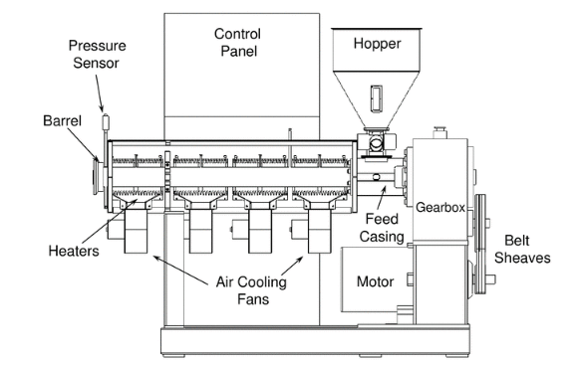
Single screw extruders have become increasingly common in industry over the past several decades (Campbell and Spalding 2013, 1). Single screw extruders share several characteristics that will be explained and studied individually: the screw, the barrel, a motor-drive system, and control systems for heaters and the motor speed (Figure 1). In the case of machines used in this study, the extruders are gravity fed pellets via the hopper into the feed section. The screw contains three characteristics zones: the feed zone where pellets are brought together but not melted, the compression zone where the solid bed is melted and compressed, and the metering zone where the melt is pressurized and pushed through any systems after the screw, typically, a die. A diagram of a standard screw is shown in Figure 2.
Figure 1: Diagram of a typical single screw extruder system (Campbell and Spalding 2013, 2).
Due to the physical complexity of a screw, its geometry is broken down further. The flight and channel of a screw is helical and is typically unwound to simplify calculations (Middleman 1977, 125). All screws utilized in this study were single flighted. There is a small clearance between the flights of the screw and the barrel that allow molten polymer to flow between flights and center the screw (Campbell and Spalding 2013, 7). Several geometrical constants are identified in Figure 3: lead length, $L$, screw diameter, $D$, barrel diameter, $D_{b}$, flight width, $e$, and channel depth, $H$. For the coordinate system, x is the direction perpendicular to the flights, y is normal to the barrel surface, and z is in the down-channel direction. Typically, the channel depth is constant in the feed zone, decreasing in the compression zone, and constant in the metering zone. Channel depth and core diameter, $D_{c}$, are related in Equation 1.
$$\begin{aligned}D_{c}=D_{b}-2H \#Eq. \left(1\right)\end{aligned}$$

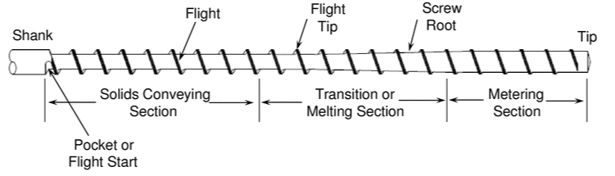

Figure 2: Standard screw zones (Campbell and Spalding 2013, 7).
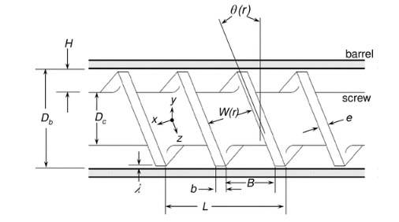
Figure 3: Relevant screw geometry and coordinate system (Campbell and Spalding 2013, 8).

The helix angle, $θ$, and channel width, $W$, are both a function of the radius of the screw. As a result, they are calculated at radii of interest at the barrel and core of the screw (Equation 2 through 5).
$$\begin{aligned}θ_{b}=\arctan\left(\frac{L}{πD_{b}}\right) \#Eq.\left(2\right)\end{aligned}$$
$$\begin{aligned}W_{b}=Lcosθ_{b}-e \#Eq.\left(3\right)\end{aligned}$$
$$\begin{aligned}θ_{c}=\arctan\left(\frac{L}{πD_{c}}\right) \#Eq.\left(4\right)\end{aligned}$$
$$\begin{aligned}W_{c}=Lcosθ_{c}-e \#Eq.\left(5\right)\end{aligned}$$

Research Approach
To properly evaluate theories and code a wide range of data had to be collected that covered the entire range of practical extrusion situations. The scope of independent variables in these experiments included, but were not limited to, nozzle size, material, and zone temperatures. The primary dependent variable was RPM in each run. It was also necessary to gather data from multiple machines to better verify the theory and code.

Systems and Materials

Machine Introduction
In this work, two machines were employed for study: the BAAM at the Manufacturing Demonstration Facility in Oak Ridge National Lab and a Randcastle Microtruder at University of Tennessee, Knoxville. In order to be able to differentiate characteristics between machines, they have been divided into subsections for comparison. This work has done the literature standard of separating the screw and the die as much as possible (Campbell and Spalding 2013; Middleman 1977; Tadmor and Gogos 2006). The screw used in each machine will be broken down and compared.

Big Area Additive Manufacturing
The BAAM (Figure 4) is an extrusion system that utilizes a single screw extruder, vacuum fed hopper, and gantry to support Fused Filament Fabrication (FFF) on a large scale. Because of this setup, the BAAM is inherently different from typical extrusion systems. Its orientation is entirely vertical, it starts and stops extrusion rapidly, and a wide variety of materials and screws for differing print requirements are utilized. The BAAM was originally developed by the MDF in collaboration with Cincinnati Inc. A standard style compression screw found in most extrusion systems was utilized for this work (Campbell and Spalding 2013, 8-10).
The BAAM also uniquely features a “back pressure screw” located in the end cap. This screw allows for simple adjustments of the pressure profile in the machine. For these tests the back pressure screw was left at approximately 25%.
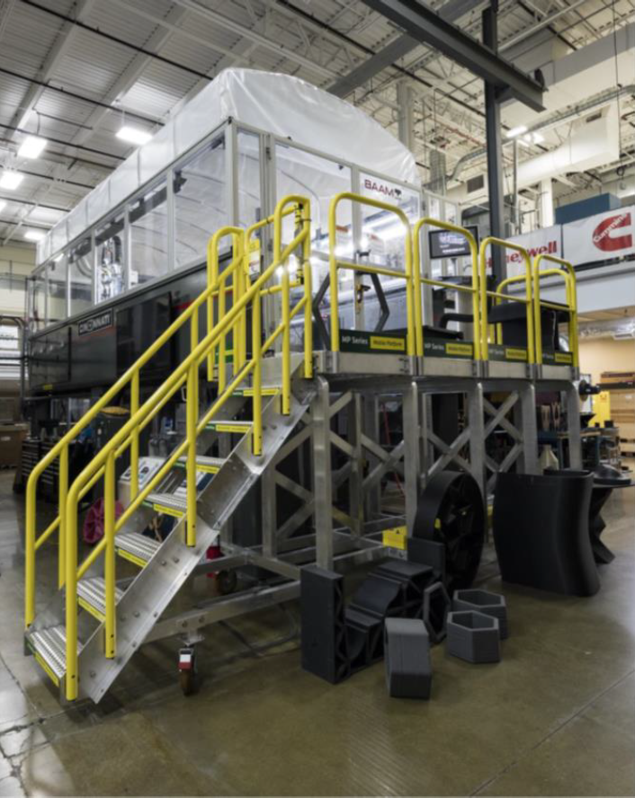
Figure 4: BAAM system at the Manufacturing Demonstration Facility. Photo courtesy of Oak Ridge National Laboratory, US Dept. of Energy.
Table 1: Microtruder geometrical constants.
Parameter | Microtruder  (in)
Feed zone depth | 0.125
Metering zone depth | 0.041
Axial length of feed zone | 4
Axial length of compression zone | 5.6
Axial length of metering zone | 4
Barrel diameter | 0.5
Screw clearance | 0.003
Lead length | 0.5
Flight width | 0.093
Throat | 0.25
Throat length | 3.68
Nozzle diameter | 0.1,0.15,0.2,0.25
Nozzle length | 0.425
Compression ratio | 3.05
Compression rate | 0.006254

Randcastle Microtruder
The Microtruder (Figure 5) is a specialty system designed and built by Randcastle Extrusion Systems aimed at being able to fit a variety of industrial needs. As suggested by its name, it is one of the smallest extrusion systems widely available in terms of screw and barrel size (“What is a Microtruder?” 2020). The relevant geometrical constants for this study are shown in Table 1, including compression rate and compression ratio. Randcastle offers a variety of dies for the system, and initially came with a slit die. The machine was retrofitted with a new die like that on the BAAM system, which is discussed in detail in the Additional Nozzle Sensors section below.

Built-In Sensors
Traditionally, extruders feature a pressure sensor towards the end of the screw for measuring discharge pressure (Campbell and Spalding 2013, 14). The Microtruder features a screw pressure sensor (Figure 6), however, the BAAM’s screw pressure sensor is located just below the screw, slightly into the end cap (Figure 7). These screw pressure ports were utilized in this work since discharge pressure is relevant in screw modeling (Campbell and Spalding 2013; Tadmor and Gogos 2006).

Additional Nozzle Sensors
To meet experimental demands and mimic the flow of the BAAM on the Randcastle, a custom nozzle adapter with a sensor port was designed and constructed for both machines as shown in Figures 8 and 9. This nozzle adapter added the ability to rapidly change nozzle tip sizes and obtain pressure in the throat as close to the nozzle tip as feasibly possible. The nozzle adapters and tips were constructed out of brass due to its easy to machine nature and superior thermal

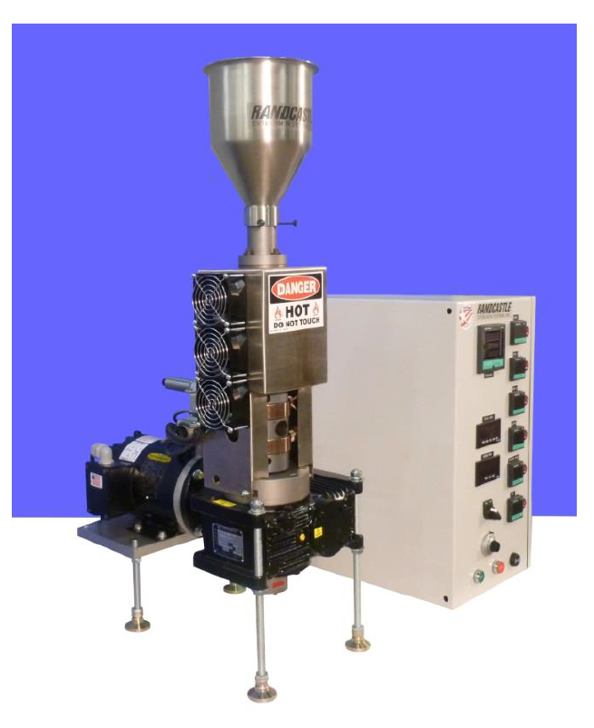
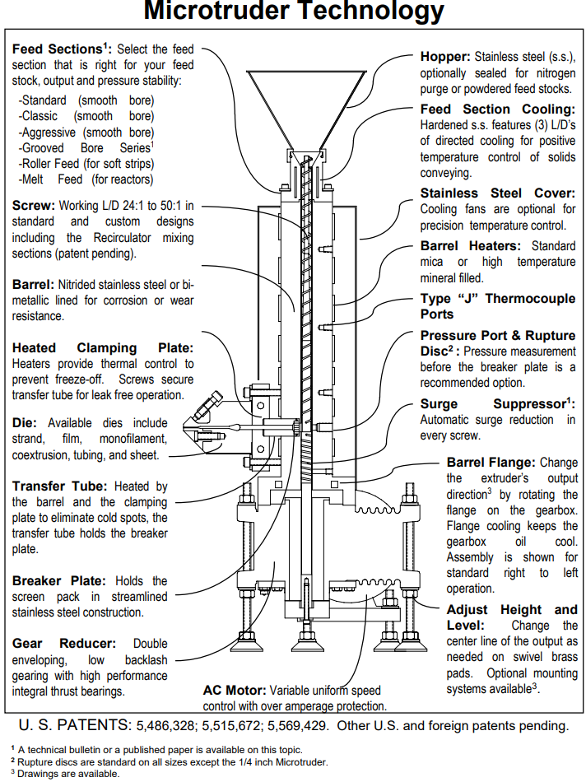
Figure 5: Microtruder setup and control system (left) and Microtruder sectioned view with notable features (right) (“What is a Microtruder?” 2020).

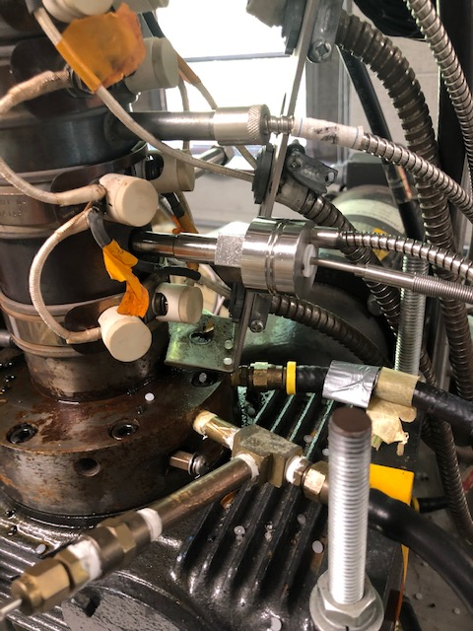
Figure 6: Screw pressure sensor in Microtruder circled in red.
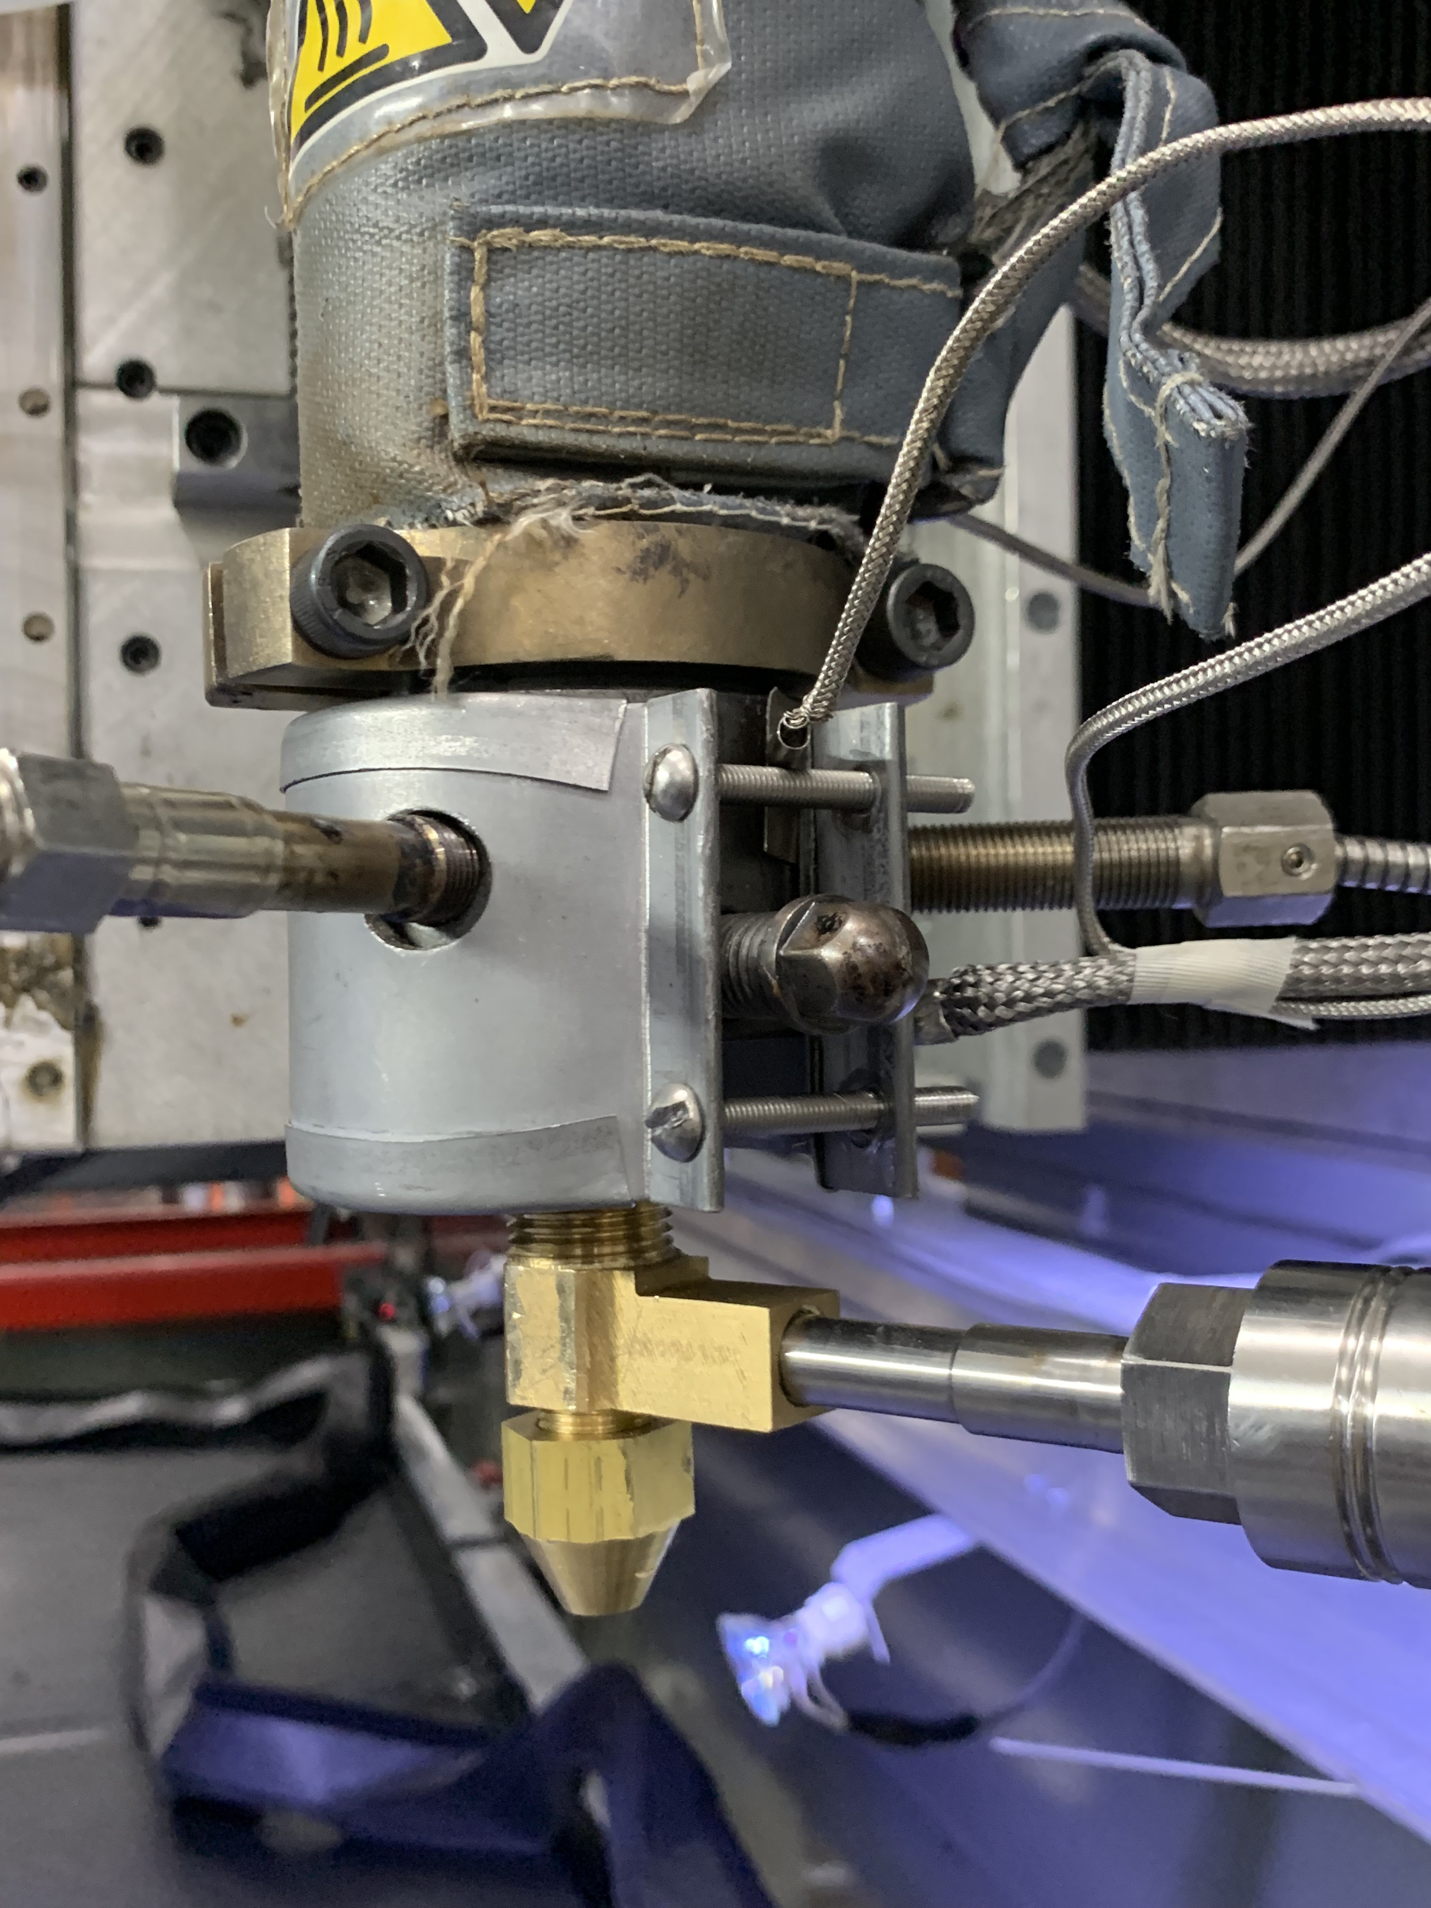
Figure 7: Screw pressure sensor in BAAM end cap circled in red.
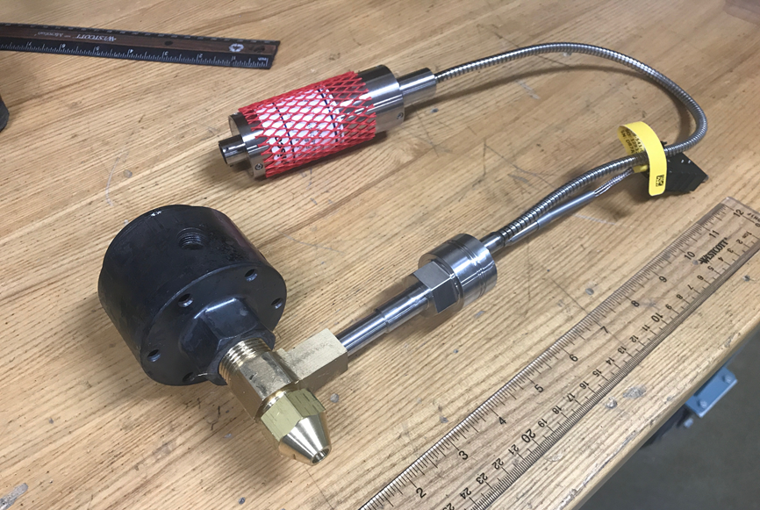
Figure 8: New nozzle adapter and pressure sensor attached to BAAM end cap.
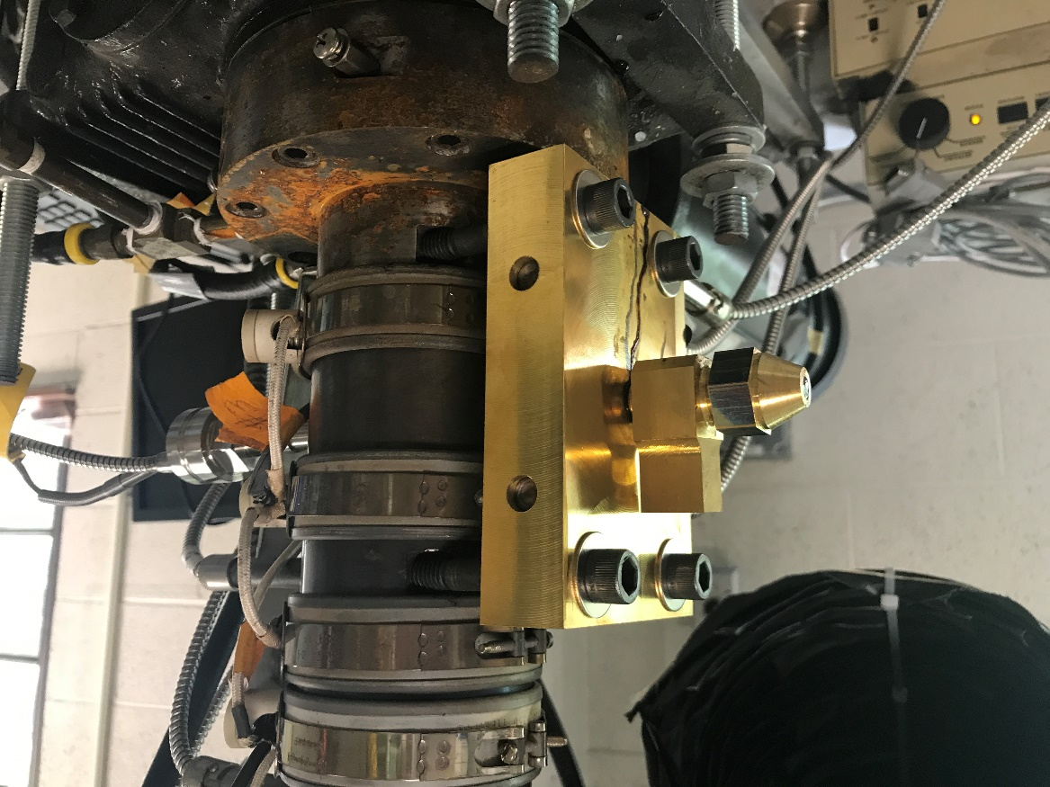
Figure 9: New nozzle adapter without pressure sensor and die block attached to the Microtruder.
conductivity. While a different adapter was made for the BAAM and the Microtruder, their designs differ only slightly. As stated previously, the Microtruder’s scale relative to the BAAM is roughly 50% in terms of its screw and flow paths. The nozzle adapter for the BAAM featured a 0.4” throat, whereas on the Microtruder the throat was 0.25”. Smaller nozzle tips were constructed for the Microtruder as needed to meet back pressure demands of the machine, resulting in 0.1”, 0.15”, 0.2”, and 0.25” nozzle tips. Both nozzle adapters featured the same pressure port design shown in Figure 10. This pressure port design is standard among Dynisco sensors (“Transducer Mounting Hole Machining Tool Kit Manual” 2020). The depth of the pressure port was adjusted during machining to minimalize flow interruption while still providing enough depth to accurately measure the melt pressure. Lastly, the BAAM’s nozzle adapter featured 7/8”-14 UNF threads to fit into the end cap, and the Microtruder’s nozzle adapter featured 1/2”-13 UNC threads to fit into the designed die block. The die block was constructed to house the die heaters, thermocouple, and provide threads to connect the nozzle adapter and throat. A sectioned view of this setup is shown in Figure 11.

Materials and Material Properties
In order to properly validate pressure models, a variety of materials were characterized and tested. On the Microtruder system neat PLA, 20% CF-PLA, neat ABS, 20% CF-ABS, and neat LLDPE were utilized. Only 20% CF-ABS was tested on the BAAM system due to availability and testing time; the broad scope of this research resulted in timely testing procedures in order to properly capture pressure at a variety of nozzle sizes, screw speeds, flow rates, and materials. The table of Techmer product numbers is provided in Appendix A1.
A variety of relevant material properties were gathered, namely, rheological properties. A Dynisco LCR7000 (Figure 12) capillary rheometer was utilized to obtain the Weissenberg-
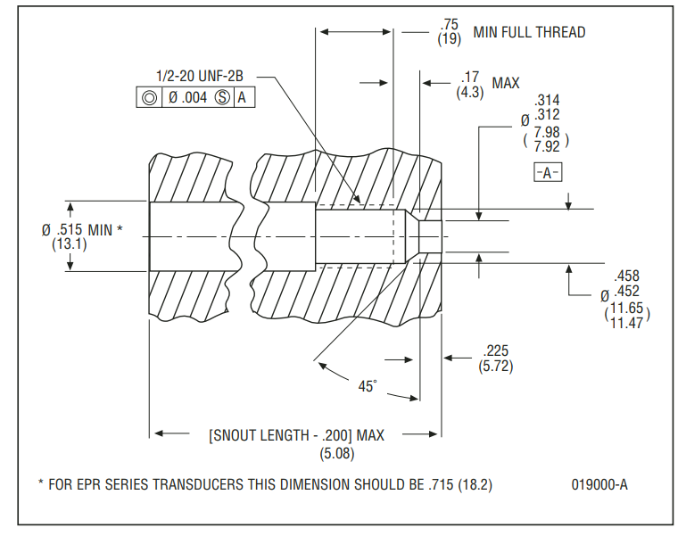
Figure 10: Schematic of pressure sensor mounting port (“Transducer Mounting Hole Machining Tool Kit Manual” 2020).
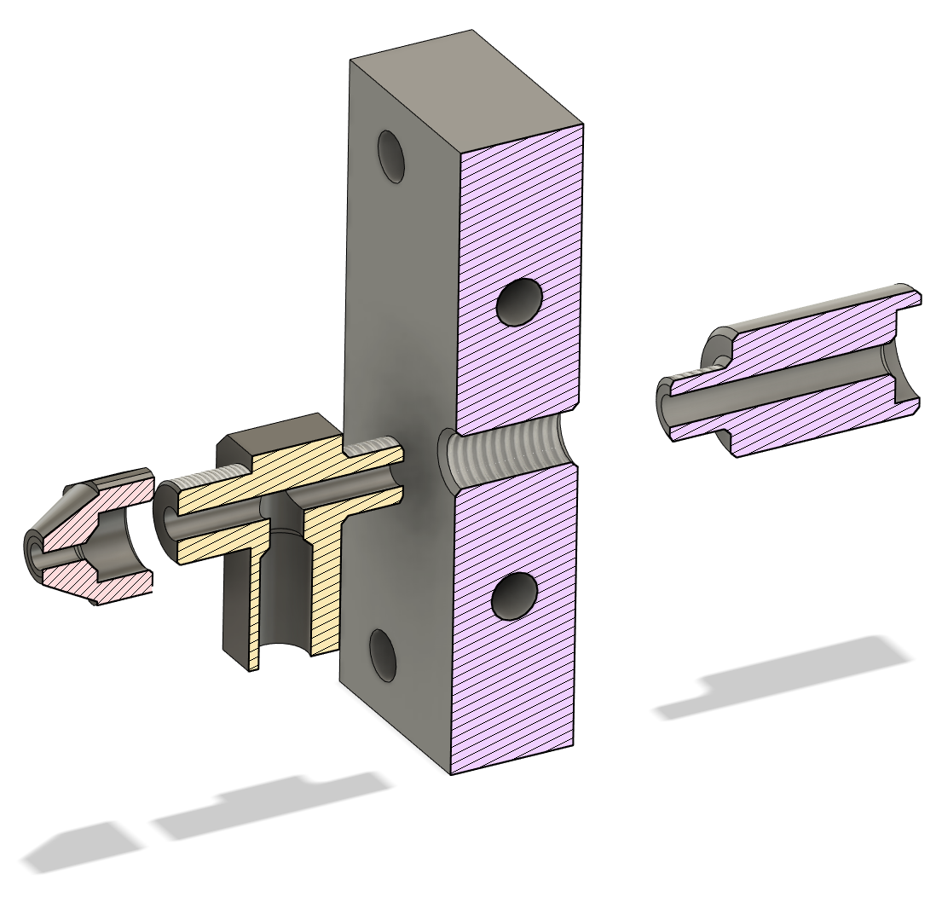
Figure 11: Sectioned view of Microtruder throat, die block, nozzle adapter, and nozzle.
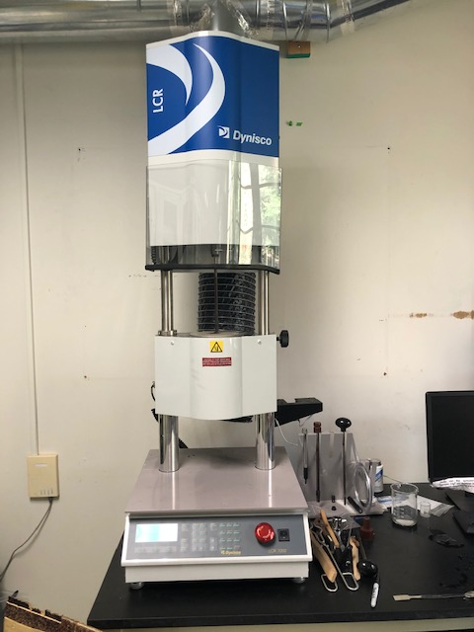
Figure 12: Dynisco LCR 7000 used to obtain the power law parameters.

Rabinowitsch corrected power law parameters for all materials in this study (Table 2). The power law parameters, consistency index, $m$, and power law index, $n$, for these materials were obtained at their respective set die temperatures on each machine. This is a common practice in theory to account for non-Newtonian nature in the most relevant sections of the machine (Campbell and Spalding 2013, 14). The power law relating shear rate, $\dot{γ}$, and viscosity, $μ$, is shown in Equation 6.
$$\begin{aligned}μ=m\dot{γ^{n}} \#Eq. \left(6\right)\end{aligned}$$
The full data containing shear rate and viscosity data from the LCR tests is found in Appendix A2.
Several thermal properties were also needed as inputs to the compression zone theory where the phase change takes place. The thermal properties consisted of thermal conductivity, $k_{m}$, heat of fusion, $λ$, and specific heat, $C_{v}$. These properties were not directly measured; they were obtained from literature and are shown in Table 3. The thermal properties will only be used in the compression zone theory.
Melt, bulk, and solid density were also gathered to support theory. For the single screw extrusion process, the material begins at bulk density as loose pellets in the hopper, packs together in the feed zone, melts in the compression zone to reach its melt density, then finally extrudes and hardens back to its solid density. Melt density, $ρ_{d}$, which is relevant for melt flow in the machine, was gathered using the LCR7000 by extruding a set amount of material through the capillary rheometer at its set die temperature and taking its mass. A detailed description of the procedure for obtaining melt density is found in page 87 of the LCR7000 manual (“7000 Series Capillary Rheometers & LabKARS Software” 2020). Melt density is most relevant to the models proposed, and is used throughout calculations in the compression zone, feed zone, and die. Bulk density, $ρ_{b}$, is the density of loose pellets in the hopper. It was measured by placing pellet feedstock in a
Table 2: Power law parameters for all materials in this study.
LCR Power Law Results
Material | m (Consistency Index) (Pa*s^n) | n (Power Law Index)
PLA (@ 190 C) | 22985 | -0.637
ABS (@ 220 C) | 21363 | -0.666
LLDPE (@ 245 C) | 6799 | -0.504
20% CF PLA (@ 210 C) | 2785 | -0.444
20% CF ABS (@ 240 C) | 29356 | -0.688
20% CF ABS (@ 250 C) | 24459 | -0.670

Table 3: Material thermal properties obtained from literature (Rauwendaal 2014. 249).
Material Thermal Properties
Material | Thermal Conductivity (J/ms°C) | Heat of Fusion (J/kg) | Specific Heat (J/kg°C)
PLA | 0.195 | 93600 | 1800
ABS | 0.25 | Amorphous | 1400
LLDPE | 0.2 | 215000 | 2300
20% CF PLA | 0.195 | 93600 | 1800
20% CF ABS | 0.25 | Amorphous | 1400

cylindrical container of known volume and taking its mass. The mass could then be divided by the known volume. Bulk density is used to calculate the weight of pellets in the hopper. Solid density, $ρ_{s}$, was measured using a Mettler Toledo XS204 analytical balance with a built-in density application using Archimedes principle. Beads from Microtruder testing were tested in the XS204 as shown in Table 4. It should be noted that due to extreme porosity in most materials, the solid density deviated wildly when testing different sections of each bead. Several measurements were taken at various sections of the beads and at differing RPMs for the result found in Table 4. Solid density is only used in the models proposed at the beginning of the compression zone, where the pellets are assumed to be compacted and near the solid density of the material.
Pellet size was also of interest, as it was discovered during testing that certain materials were above the recommended size for the Microtruder. Each material’s pellet approximate shape, longest dimension, and shortest dimension were measured using calipers. To provide a sense of scale between materials, ten measurements were taken for each the longest and shortest dimension and averaged. These results as well as the BAAM and Microtruder max pellet size are shown in Table 5. The effect of pellet size on results will be discussed in the Chapter 4 Results section.

Temperature Profiles
As is standard with extrusion, temperature profiles were adjusted as needed. Temperature profiles from the BAAM system were initially used on the Microtruder and altered to achieve proper extrusion. Temperatures were typically increased as the shorter nature of the Microtruder compared to the BAAM required more heat for the material to melt properly at the faster rate. The temperature profile for CF-ABS on the BAAM was left to their standard values. The temperature profiles are shown in Table 6.
Table 4: Melt, bulk, and solid densities for all materials.
Material Densities
Material | Melt Density (g/cc) | Bulk Density (g/cc) | Solid Density (g/cc)
PLA | 1.104 (@ 190 C) | 0.8711 | 1.242
ABS | 0.9133 (@ 220 C) | 0.7066 | 1.153
LLDPE | 0.7305 (@ 245 C) | 0.5955 | 0.792
20% CF PLA | 1.1685 (@ 210 C) | 0.6666 | 1.008
20% CF ABS | 1.015 (@ 240 C) | 0.6526 | 0.838

Material Pellet Sizes

Material | Pellet Style | Long Dimension (mm) | Short Dimension (mm)
LLDPE | Ovoid | 4.86 | 2.58
PLA | Ovoid | 4.74 | 3.53
20% CF-PLA | Cylinder | 2.88 | 2.52
ABS | Ovoid | 4.63 | 2.10
20% CF-ABS | Cylinder | 2.77 | 2.47
 | BAAM Max pellet length | Randcastle max pellet length
 | 7 mm | 3.175 mm
Table 5: Pellet sizes for all materials and machine suggested pellet size limits.

Table 6: Temperature settings for all materials and both machines.
Machine Set Temperatures In °C
Machine | Material | Temperature Zones
Machine | Material | Zone 1 | Zone 2 | Zone 3 | Die
Microtruder | PLA | 140 | 160 | 170 | 190
Microtruder | ABS | 160 | 200 | 220 | 220
Microtruder | LLDPE | 190 | 240 | 245 | 245
Microtruder | 20% CF PLA | 160 | 180 | 190 | 210
Microtruder | 20% CF ABS | 180 | 220 | 240 | 240
BAAM | 20% CF ABS | 175 | 205 | 250 | 250

Analytical Approach to Pressure Profile

Introduction
In several works, a Newtonian model for the peak pressure (discharge pressure) and machine output is derived with varying modifications (Campbell and Spalding 2013, 11-15; Middleman 1977, 123-150; Tadmor and Gogos 2006, 247-259). By comparing their results to data, the model presented in section 3.2 was chosen for its balance between simplicity and accuracy. After this result, theories for the feed, compression zones, and nozzle were added to supplement the result and create a complete pressure map down the axis of the screw.

Modified Newtonian Model for the Metering Zone
When a single screw extruder is operating properly, the metering section can be assumed to be the rate controlling section of the system (Campbell and Spalding 2013, 247). This allows for estimation of discharge pressure and machine output using solely information from the metering zone and neglecting effects from the feed and compression zone. The following model was gathered from several works (Campbell and Spalding 2013, 11-15; Tadmor and Gogos 2006, 247-258, 450-452). The following assumptions are made:
- Flow is fully developed.
- Flow channels are completely filled.
- No slip at the boundary surfaces.
- No leakage flow over the flight tips.
- All channel corners are square.
- Flows are isothermal and Newtonian.
- Channel dimensions are not changing in the metering section.
The overall flow rate, $Q$, is split into two terms, containing rotational flow, $Q_{d}$, and pressure flow, $Q_{p}$. Their relation is shown in Equation 7.
$$\begin{aligned}Q=Q_{d}-Q_{p} \#Eq. \left(7\right)\end{aligned}$$
It should be noted that the average shear rate, $\dot{γ}$, is calculated using RPMs and the width of the channel in Equation 8 and then used in Equation 6 to find the shear viscosity. This is an attempt at account for non-Newtonian flow while still deriving expressions under the Newtonian assumption.
$$\begin{aligned}\dot{γ}=\frac{πD_{c}N}{H} \#Eq. \left(8\right)\end{aligned}$$
Several velocities must first be established. As discussed in Chapter 1, there are several areas of interest along the screw radii, namely, at the screw core and barrel. Velocities in the X and Z directions are calculated at these locations as shown in Equations 9-11:
$$\begin{aligned}V_{cx}=πND_{c}sinθ_{c} \#Eq. \left(9\right)\end{aligned}$$
$$\begin{aligned}V_{cz}=-πND_{c}cosθ_{c} \#Eq. \left(10\right)\end{aligned}$$
$$\begin{aligned}V_{bz}=-πND_{b}cosθ_{b} \#Eq. \left(11\right)\end{aligned}$$
where subscript c designates the screw core and b designates the screw barrel. Shape factors $F_{d}$ and $F_{p}$ are established to account for effects from shallow or deep channels, the screw’s characteristic H/W. $F_{d}$ is calculated in Equation 12 and $F_{p}$ in Equation 13.
$$\begin{aligned}F_{d}=\frac{16W}{π^{3}H}\sum_{i=1,3,5,…}^{∞}{\frac{1}{i^{3}}\tanh\left(\frac{iπH}{2W}\right)} \#Eq. \left(12\right)\end{aligned}$$
$$\begin{aligned}F_{p}=1-\frac{192H}{π^{5}W}\sum_{i=1,3,5,…}^{∞}{\frac{1}{i^{5}}\tanh\left(\frac{iπW}{2H}\right)} \#Eq. \left(13\right)\end{aligned}$$
The shape factors are extremely important for deep channels (Tadmor and Gogos 2006, 254-255). The rotational flow can now be calculated as shown in Equation 14:
$$\begin{aligned}Q_{d}=\frac{pV_{bz}WHF_{d}}{2} \#Eq. \left(14\right)\end{aligned}$$
where $p$ is the number of flights of the screw. Similarly, the pressure flow term is calculated in Equation 15:
$$\begin{aligned}Q_{p}=\frac{pWH^{3}F_{p}}{12μ}\left(\frac{∂P}{∂z}\right) \#Eq. \left(15\right)\end{aligned}$$
where $μ$ is the shear viscosity of the molten polymer as discussed in Chapter 2, and $\frac{∂P}{∂z}$ is the pressure gradient across the metering zone. For the purposes of this work, the pressure gradient is assumed to be at maximum as shown in Equation 16:
$$\begin{aligned}\frac{∂P}{∂z}=\frac{P_{dis}sinθ_{b}}{l_{m}} \#Eq.\left(16\right)\end{aligned}$$
where $l_{m}$ is the length of the metering zone. The mass rate of the extruder can be calculated by combining Equations 7, 12, 13, 14, 15, and 16:
$$\begin{aligned}Q=\frac{pV_{bz}WHF_{d}}{2}-\frac{pWH^{3}F_{p}}{12μ}\left(\frac{P_{dis}sinθ_{b}}{l_{m}}\right) \#Eq. \left(17\right)\end{aligned}$$
What has been neglected thus far is the effect the die has on the system. Equation 16 shows the relationship between pressure and flow rate for isothermal pressure flow for an incompressible Newtonian fluid through a die:
$$\begin{aligned}Q_{D}=\frac{K}{μ}∆P_{D} \#Eq. \left(18\right)\end{aligned}$$
where $K$ is the die constant. The die constant is a term lumping together geometry of the die, for example, the die constant for a tubular die can be solved for:
$$\begin{aligned}K=\frac{πR_{D}^{4}}{8L_{D}} \#Eq. \left(19\right)\end{aligned}$$
where $L_{D}$ is the length of the die and $R_{D}$ is the radius of the die. For more complex die geometry the die constant must be solved for experimentally (Tadmor and Gogos 2006, 451). The operating point of the extruder is found by setting the flow rate through the screw and die equal and setting the pressure rise over the screw equal to the pressure drop over the die. The final flow rate and discharge pressure of the system can be calculated by setting the flow rate of the die and screw equal as shown in Equation 20 & 21:
$$\begin{aligned}Q=Q_{s}=Q_{D}=\frac{0.5πND_{b}cosθ_{b}WHF_{d}}{1+\frac{WH^{3}sin\overline{θ}F_{p}}{12LK}}\#Eq. \left(20\right)\end{aligned}$$
$$\begin{aligned}∆P=∆P_{S}=∆P_{D}=\frac{0.5μπND_{b}cosθ_{b}WHF_{d}}{K+\frac{WH^{3}sin\overline{θ}F_{p}}{12L}}\#Eq. \left(21\right)\end{aligned}$$
where $\overline{θ}$ is the average angle of the screw core and barrel. It is noteworthy that the viscosity term in Equation 20 is cancelled out. This work uses the viscosity calculated in the screw channel for all calculations allowing for the viscosity term to drop. These equations make the primary model for estimating machine output and discharge pressure.

The Feed Zone
The feed zone has historically been studied less than the metering and compression zones, as it is assumed to be operating properly. Under proper operation the metering zone is provided with adequate flow and is the rate-limiting part of the process (Campbell and Spalding 2013, 247). Air between pellets all the way up to a full melt in the compression zone is forced back through the screw and out of the hopper. When the feed zone is operating incorrectly, material can begin melting prematurely in the feed zone. This makes the metering zone no longer rate controlling, and flow rate and pressure consistency deteriorate as a result (Campbell and Spalding 2013, 131). Therefore, it is typical to have a water-cooled casing at the feed zone entry below the hopper. The casing constricts the feed zone temperature to that section of the barrel and prevents heat from rising into the hopper (Campbell and Spalding 2013, 132). It should be noted that both machines, in this case, are smooth hopper and barrel style, as opposed to grooved systems.
The model used in this research was developed by Campbell and his students at Clarkson University (Campbell and Spalding 2013, 139-141). This was the first model to introduce the idea of the screw flight pushing the polymer bed. All similar models treat the polymer as a solid incompressible plug that travels down the screw. A force balance is made containing pressure and contact forces as shown in Figure 13.

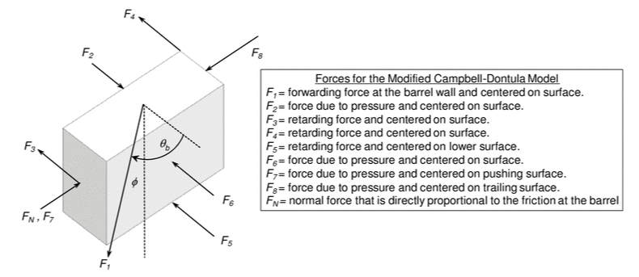
Figure 13: Forces on polymer in the feed zone (Campbell and Spalding 2013, 708).
A derivative relationship between angles is substituted in and integration is performed resulting in Equation 22:
$$\begin{aligned}sinϕ=cosθ_{b}-\left(2\left(\frac{H}{W_{b}}\right)\left(\frac{f_{H}}{f_{b}}\right)+f_{H}+\left(\frac{W_{c}}{W_{b}}\right)\left(\frac{f_{c}}{f_{b}}\right)\right)sinθ_{b}-\frac{HWsinθ}{K_{xz}W_{b}f_{b}Z}\ln\left(\frac{P_{z}}{P_{0}}\right) \#Eq. \left(22\right)\end{aligned}$$
where $ϕ$ is the solids forwarding angle, $K_{xz}$ is the lateral stress ratio in the x and y directions, $P_{0}$ is the pressure at the start of the solids conveying section, $P_{z}$ is the pressure at the end of the solids conveying section, and $f_{H}$, $f_{c}$, & $f_{b}$ are dynamic coefficients of friction at the screw flights, screw core, and barrel, respectively. The solids conveying angle is the angle between the barrel velocity and the velocity difference between the barrel and plug and is typically in the range of 2-7 degrees (Campbell and Spalding 2013, 134). Equation 23 shows that the lateral stress ratio is a simple relationship between stress in the x and z directions.
$$\begin{aligned}K_{xz}=\frac{σ_{x}}{σ_{z}} \#Eq. \left(23\right)\end{aligned}$$
Under the assumption that the hopper is sufficiently filled, the initial pressure is calculated using Equation 24 by calculating the weight of pellets on themselves:
$$\begin{aligned}P_{0}=\frac{ρ_{b}gD}{4f_{w}K_{xz}} \#Eq. \left(24\right)\end{aligned}$$
where g is gravitational constant and D is the diameter of the hopper. By relating the velocity of the plug and its geometry Equation 25 is found:
$$\begin{aligned}Q=π^{2}NHD_{b}\left(D_{b}-H\right)\left(\frac{tanϕtanθ_{b}}{tanϕ+tanθ_{b}}\right)\left(\frac{W}{W+e}\right) \#Eq. \left(25\right)\end{aligned}$$
Flow rate data or Equation 20 is used to find $ϕ$ via Equation 25 and $ϕ$ is plugged into Equation 22 to obtain pressure at the end of the feed zone.

The Compression Zone – Four Zone Model
The compression zone is increasingly difficult to characterize and simulate due to its complex nature. The material is undergoing a phase change, the channel depth is decreasing, and the melted material is flowing around the solid bed as the solid bed decreases in size. A photograph of solidified resin in a compression zone from a solidification experiment is shown in Figure 14. The melt pool gathers along the pushing flight and steadily increases in size as the solid bed melts. The cross section at multiple points along the compression zone is shown in Figure 15. It can be observed that melt films are forming and increasing all around the solid bed, leading to the four
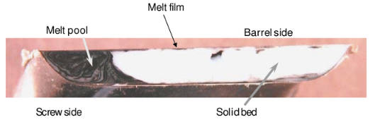
Figure 14: Cross section of resin in compression zone from a solidification experiment (Campbell and Spalding 2013, 193).
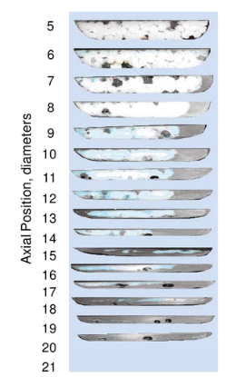
Figure 15: Cross section of resin in compression zone axially down the compression zone (Campbell and Spalding 2013, 197).

zone model proposed by Campbell and Spalding in Figure 16, where A is the solid bed, B is the film on the pushing flight, C is the film at the barrel, D is the film at the screw core, and E is the film at the trailing flight. Energy dissipation and melt pool velocities are used to iterate down the compression channel until full melt is reached. The expected profile for solid bed width, $X$, and height, $Y$, is shown in Figure 17. It should be noted that the melting is completed when $Y$ is equal to zero, as the primary melting takes place directly from barrel heat into the top of the solid bed causing its height to decrease at a faster rate than its width.
The velocity of the solid bed at the beginning of the compression zone must first be established:
$$\begin{aligned}V_{sz}=\frac{Q}{ρ_{s}WH_{f}} \#Eq. \left(26\right)\end{aligned}$$
where $H_{f}$ is the depth of the feed section. Another diameter of interest is established at the surface of the solid bed and its interface with film C, $D_{f}$. The velocity at this location is calculated through Equation 27:
$\begin{aligned}V_{sx}=πND_{f}sinθ_{f} \#Eq. \left(27\right)\end{aligned}$Equations 8-10 will now need to be calculated at each increment since the diameter of the core is decreasing. The average z velocity is calculated by Equation 28:
$$\begin{aligned}\overline{V_{fz}}=\frac{V_{cz}+V_{bz}}{2} \#Eq. \left(28\right)\end{aligned}$$
The vectorial velocity of each film, $V_{j}$, can now be calculated with Equation 29 through 32:
$$\begin{aligned}V_{j,C}=\sqrt{V_{sx}^{2}+V_{sz}^{2}} \#Eq. \left(29\right)\end{aligned}$$
$$\begin{aligned}V_{j,D}=\left|V_{cz}\right|+V_{sz} \#Eq. \left(30\right)\end{aligned}$$
$$\begin{aligned}V_{j,E}=\left|\overline{V_{fz}}\right|+V_{sz} \#Eq. \left(31\right)\end{aligned}$$
$$\begin{aligned}V_{j,B}=\left|\overline{V_{fz}}\right|+V_{sz} \#Eq. \left(32\right)\end{aligned}$$
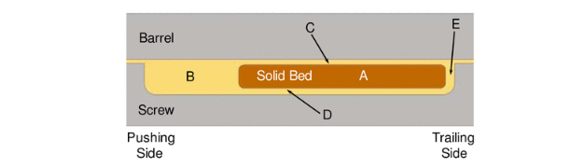
Figure 16: Schematic of four zone melting model (Campbell and Spalding 2013, 204).

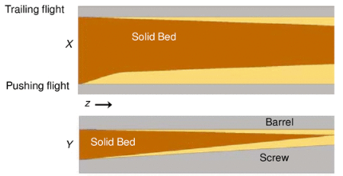
Figure 17: Schematic of solid bed width (top) and height (bottom) down the compression channel (Campbell and Spalding 2013, 210).

By completing an energy and material balance for the melting process melting velocities for the four films are established in Equations 33-36:
$$\begin{aligned}V_{sy,C}=\frac{\left[\frac{k_{m}}{δ_{C}}\left(T_{b}-T_{m}\right)+\frac{μV_{j,C}^{2}}{2δ_{C}}\right]}{ρ_{s}λ+ρ_{s}C_{v}\left(T_{m}-T_{s}\right)} \#Eq. \left(33\right)\end{aligned}$$
$$\begin{aligned}V_{sy,D}=\frac{\left[\frac{k_{m}}{δ_{D}}\left(T_{screw}-T_{m}\right)+\frac{μV_{j,D}^{2}}{2δ_{D}}\right]}{ρ_{s}λ+ρ_{s}C_{v}\left(T_{m}-T_{s}\right)} \#Eq. \left(34\right)\end{aligned}$$
$$\begin{aligned}V_{sx,B}=\frac{\left[\frac{k_{m}}{δ_{B}}\left(T_{b}-T_{m}\right)+\frac{4μV_{j,B}^{2}}{2δ_{B}}\right]}{ρ_{s}λ+ρ_{s}C_{v}\left(T_{m}-T_{s}\right)} \#Eq. \left(35\right)\end{aligned}$$
$$\begin{aligned}V_{sx,E}=\frac{\left[\frac{k_{m}}{δ_{E}}\left(T_{b}-T_{m}\right)+\frac{4μV_{j,E}^{2}}{2δ_{E}}\right]}{ρ_{s}λ+ρ_{s}C_{v}\left(T_{m}-T_{s}\right)} \#Eq. \left(36\right)\end{aligned}$$
where $δ$ is each melt film thickness, $T_{b}$ is the barrel temperature, $T_{m}$ is the resin melt temperature, $T_{screw}$ is the temperature of the screw, and $T_{s}$ is the temperature of the solid bed. The thickness of melt film C is calculated via Equation 37:
$$\begin{aligned}δ_{C}={\left[\frac{\left[2k_{m}\left(T_{b}-T_{m}\right)+μV_{j,C}^{2}\right]\left(\frac{X}{α}\right)}{V_{sx}ρ_{m}\left(C_{v}\left(T_{m}-T_{s}\right)+λ\right)}\right]}^{0.5} \#Eq. \left(37\right)\end{aligned}$$
Where $α$ is a fitting factor. Similarly, the thickness of zone E is calculated through Equation 38:
$$\begin{aligned}δ_{E}={\left[\frac{\left[3k_{m}\left(T_{b}-T_{m}\right)+6μV_{j,E}^{2}\right]Z}{{\frac{2}{9}V}_{j,E}ρ_{m}\left(C_{v}\left(T_{m}-T_{s}\right)+λ\right)}\right]}^{0.5} \#Eq. \left(38\right)\end{aligned}$$
The thicknesses of Zones B and D can be found by difference:
$$\begin{aligned}δ_{B}=W-X-δ_{E} \#Eq. \left(39\right)\end{aligned}$$
$$\begin{aligned}δ_{D}=H\left(z\right)-Y-δ_{C} \#Eq. \left(40\right)\end{aligned}$$
Where $H\left(z\right)$ is the channel depth at the current increment. The solid bed width and height are found by subtracting the reduction over a small distance, $∆z$, at each increment, $i$:
$$\begin{aligned}Y_{i+1}=Y_{i}-\left[V_{sy,C}+V_{sy,D}\right]\left(\frac{∆z}{V_{sz}}\right) \#Eq. \left(41\right)\end{aligned}$$
$$\begin{aligned}X_{i+1}=X_{i}-\left[V_{sx,B}+V_{sx,E}\right]\left(\frac{∆z}{V_{sz}}\right) \#Eq. \left(42\right)\end{aligned}$$
$$\begin{aligned}Z_{i+1}=Z_{i}+∆z \#Eq. \left(43\right)\end{aligned}$$
The volumetric flow rate of melted material is calculated at each increment:
$$\begin{aligned}Q_{melt,i}=\left(WH_{f}-Y_{i}X_{i}\right)V_{sz} \#Eq. \left(44\right)\end{aligned}$$
The pressure change at each increment based on rotational and pressure flow is calculated via Equation 45:
$$\begin{aligned}∆P_{i}=\left[\frac{{ Q}_{melt,i}-\frac{\frac{1}{2}V_{bz}\left(W-X_{i}\right)\left(H_{i}H_{i+1}\right)}{0.5\left(H_{i}+H_{i+1}\right)}}{\frac{\left(W-X_{i}\right){\left(H_{i}H_{i+1}\right)}^{2}}{6μ\left(H_{i}+H_{i+1}\right)}}\right]∆z \#Eq. \left(45\right)\end{aligned}$$
Finally, the pressure at each increment is calculated:
$$\begin{aligned}P_{i+1}=P_{i}+∆P_{i} \#Eq. \left(46\right)\end{aligned}$$

Hagen-Poiseuille Pressure Flow
To bridge the gap between exit pressure and discharge pressure, non-Newtonian tubular pressure flow was assumed via the Hagen-Poiseuille equation:
$$\begin{aligned}Q=\frac{πR_{n}^{3}}{s+3}{\left(\frac{R_{n}∆P_{n}}{2mL_{n}}\right)}^{s} \#Eq. \left(47\right)\end{aligned}$$
where $s=\frac{1}{n+1}$, and $∆P_{n}$ is the pressure drop across the nozzle tip. This enables the pressure between the end of the screw (discharge pressure) and exit to be more complex than just a linear drop.

Experimental Approach to Pressure Profile

Introduction
In order to validate the analytical model, pressure data during normal operations was conducted. Data was gathered from both machines, the BAAM and the Microtruder, over a range of RPMs, nozzle sizes, pressure locations, and materials. A sensor and DAQ setup were purchased for testing separate from each machine’s built in sensing systems. Testing procedures for each machine varied due to the nature of each system, as explained below.

DAQ System and Melt Pressure Sensor
To obtain pressure data at the new nozzle location, a DAQ and pressure sensor were purchased. The pressure sensor, a Dynisco TPT4634-5M-3/18-SIL2, featured a melt pressure sensor capable of up to 5,000 psi. The TPT4634 also came equipped with a Type J melt flow thermocouple that was used during tests done on the Microtruder. It should be noted that the TPT4634 is a transmitter and not a transducer.
A National Instruments (NI) DAQ was purchased to go alongside the TPT4634, a cDAQ-9174 chassis with a NI 9219 analog voltage input model and a NI 9207 combo voltage and current input module. The NI 9219 was utilized for the melt thermocouple, as it provides built in excitation. The NI 9207 was utilized for the pressure sensor due to its capability for mA input.

BAAM Experimental Procedure
To establish a base set of data for this study an experiment with 20% CF-ABS, the custom nozzle adapter and simple print parameters was conducted. The 20% CF-ABS was first dried at 85 °C for 4 hours. The back pressure screw was set to 25%. A single layer of linear beads measuring 30” x 0.3” x 0.15” were printed long enough for the machine to reach steady state as shown in Figure 18. A range of RPMs and print speeds were utilized in order to keep the bead’s dimensions consistent (Table 7). The BAAM slicing software automatically determined print speeds for the various RPMs to maintain the bead’s dimensions. This meant that the higher the RPM, the shorter the run time per bead. These beads were weighed, and pressure data was used to obtain the time it took to print each bead in order to calculate mass flow rate. Discharge pressure was obtained via the BAAM’s built-in pressure sensor within the end cap and logged directly to its controller PC. Nozzle pressure was gathered from the Dynisco TPT4634 sensor combined with the NI DAQ and a laptop computer at 50 Hz. Drooled material was wiped off the nozzle before each test to ensure no extra material would be added to the result. The entire range of RPMs, 50-350 in 50 RPM increments, were ran for the 0.3” and 0.4” nozzle. The 0.2” nozzle was not ran at 200, 250, 300, and 350 RPM due to potential issues with pressures above the BAAM’s capability. A sample of raw pressure data at the nozzle at 50 RPM is shown in Figure 19 with extrusion start and stop indicated. This sample demonstrates the need to remove data near the start and stop of each bead to obtain the steady state pressure that the model predicts.
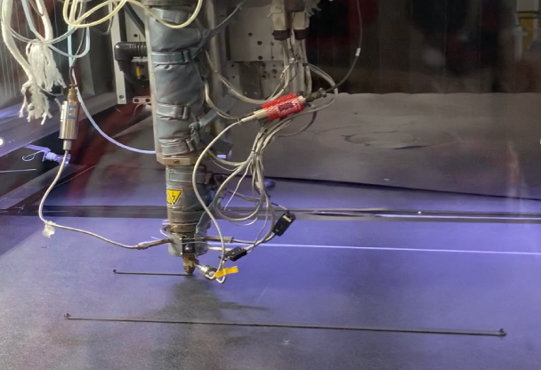
Figure 18: BAAM printing single beads for experiment. Photo courtesy of Oak Ridge National Laboratory, US Dept. of Energy.

Table 7: Print speeds for all RPMs tested.
Test RPM | Print Speed (mm/s)
50 | 39.06
100 | 78.11
150 | 117.17
200 | 156.23
250 | 195.28
300 | 234.34
350 | 278.98

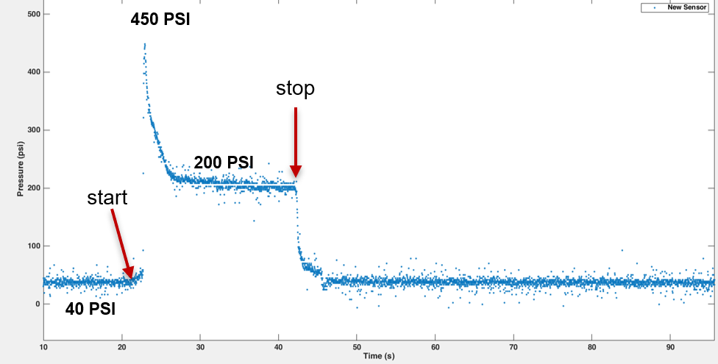
Figure 19: Pressure data from nozzle sensor for one bead of CF-ABS at 50 RPM.

Microtruder Experimental Procedure
A more extensive set of tests were conducted on the Randcastle Microtruder. A nozzle adapter was used as discussed in section 2.5. All materials covered in Chapter 2 were tested. Tests were done at 30-110 RPMs. Additionally, a wider variety of nozzle sizes were tested. The full scope of tests is shown in Table 8. Materials were dried before testing and the machine was allowed to achieve steady flow before each test was conducted by keeping the hopper full of material. As opposed to the BAAM system tests, each RPM was ran at the same amount of time of 1.5 minutes. This was more desirable as the extruder was allowed to reach steady state before tests, therefore eliminating the need to remove transient data later. A sample of screw pressure data for CF PLA at 110 RPM with a 0.1” nozzle is shown in Figure 20, that is noticeably more linear than that of Figure 19 due to reaching steady state before running each test. It should be noted that the sinusoidal nature of the screw pressure data is due to the rotation of the screw and is expected (Campbell and Spalding 2013, 546-548). Again, the time of the pressure data and
Table 8: Scope of tests completed on the Microtruder System.
Scope of Microtruder Testing
Material | Nozzle Diameter |  |  |  | Sensor Location
Material | 0.1 | 0.15 | 0.2 | 0.25 | Sensor Location
PLA |  |  |  |  | Barrel
PLA |  |  |  |  | Nozzle
20% CF PLA |  |  |  |  | Barrel
20% CF PLA |  |  |  |  | Nozzle
LLDPE |  |  |  |  | Barrel
LLDPE |  |  |  |  | Nozzle
ABS |  |  |  |  | Barrel
ABS |  |  |  |  | Nozzle
20% CF ABS |  |  |  |  | Barrel
20% CF ABS |  |  |  |  | Nozzle
 |  |  |  | Tested:
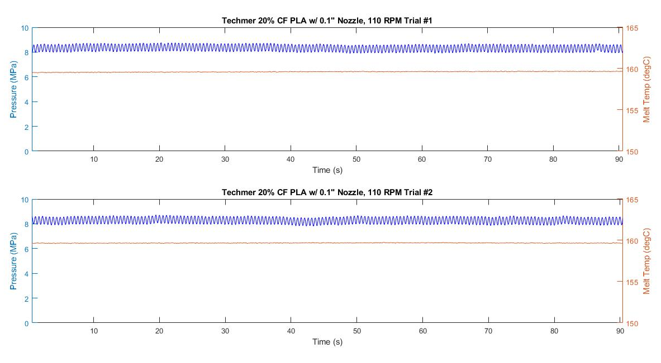
Figure 20: Sample data for screw pressure with CF PLA, 0.1” nozzle at 110 RPM.
weight of the resulting beads were used to calculate mass flow rate. The starts and stops of the bead were made by manually cutting the bead coming out of the nozzle during data start and data stop. The Dynisco TPT4634 with the NI DAQ at 25 Hz was used at two locations: the end of the screw and the nozzle tip to obtain discharge pressure and nozzle pressure, respectively. This meant that each “run” was done independently at each sensor location. This increased testing procedure resulted in nozzle pressure only gathered for ABS and CF ABS. Each run was done twice and their result average for the final results.

BAAM Experimental Results & Discussion
The results of mass flow rates from the BAAM testing are shown in Figure 21. It is clear that as nozzle size increases, flow rate increases, especially at higher RPM. Results for the nozzle pressure are shown in Figure 22, and the screw pressure in Figure 23. Interestingly, the nozzle pressure tapers off as RPM increases more so than at the screw sensor.

Microtruder Experimental Results & Discussion
Results for mass flow rates of all Microtruder tests are shown in Figure 24. Interestingly, ABS and CF-ABS seem to be the only materials where flow rate increases with nozzle size. This is likely due to several factors that will be discussed further. One of these factors is that there were extrusion issues with neat PLA due to pellet size. Table 5 tabulates the pellet size and the PLA pellets were exceeding the limit of the Microtruder recommended pellet size. This led to feed problems with the material and under extrusion. Another factor was how LLDPE, PLA, and CF-PLA all had flow surging issues. The full pressure results for all materials are shown in Figures 25 through 29. Figures 25-27 highlight some of the pressure inconsistencies visually. Figures 28

Figure 21: Mass flow rate results for BAAM testing for CF ABS at all nozzle sizes and RPMs.

Figure 22: Nozzle pressure results for BAAM testing for CF ABS at all nozzle sizes and RPMs.

Figure 23: Screw pressure results for BAAM testing for CF ABS at all nozzle sizes and RPMs.

Figure 24: Mass flow rate results for Microtruder testing for all materials and nozzle sizes at 70 RPM.

Figure 25: Screw pressure results for LLDPE on Microtruder system at all nozzle sizes.

Figure 26: Screw pressure results for PLA on Microtruder system at all nozzle sizes.

Figure 27: Screw pressure results for CF-PLA on Microtruder system at all nozzle sizes.

Figure 28: Screw and nozzle pressure results for ABS on Microtruder system at all nozzle sizes.

Figure 29: Screw and nozzle pressure results for CF-ABS on Microtruder system at all nozzle sizes.
and 29 show both the nozzle and screw pressure for neat ABS and CF-ABS. It is observed that at larger nozzle sizes of 0.2 and 0.25 inch, the pressure stays relatively constant. This was due to these nozzle sizes not providing ample back pressure proper for the machine. The 0.1 inch nozzle saw a steep increase in pressure relative to other nozzle sizes for all materials. The 0.1 inch nozzle size is close to what similar scale machines use.

BAAM Experimental Results Compared to Analytical Model
Before being able to review results of the model, the die constants had to be found. Initially, it was planned to gather data with nozzles the same sizes as the machine throat so that the die constant could be calculated analytically using Equation 19. However, issues with accuracy came from just using this result, and die constants were calculate from data as well.
The die constant calculation is the only direct interaction between data and the model. Since the die constants are a function of die geometry, it should remain constant across various pressures and materials for the same nozzle & throat. Die constants were calculated using pressure data, mass flow rate data, and Equation 18. The result for die constants of the BAAM are shown in Figures 30 through 32. These plots show die constants calculated directly from data, curves fit to the data, the Newtonian round tube assumption, the non-Newtonian tube assumption, and the die constant plugged into the model. The die constant plugged into the model was at the middle of RPMs tested using the curve fit to data. The die constants are increasing for increasing nozzle size as expected, and the die constants were found to be relatively non-constant across RPM. This was likely due to variations in data from the BAAM data testing itself.
Figures 33 through 35 show flow rate and pressure results. Interestingly, the model predicts accurately for the 0.2 and 0.3 inch nozzles, but less so on the 0.4 inch nozzle. Flow rate
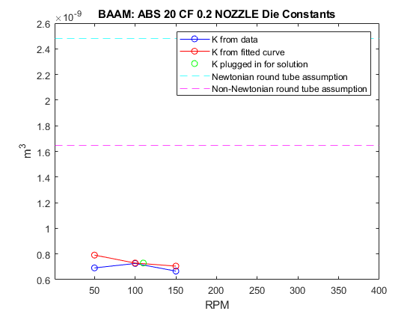
Figure 30: Die constants from BAAM 0.2 nozzle tests.
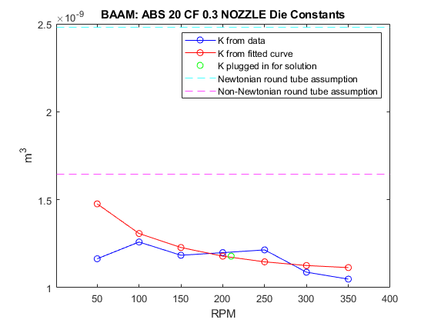
Figure 31: Die constants from BAAM 0.3 nozzle tests.
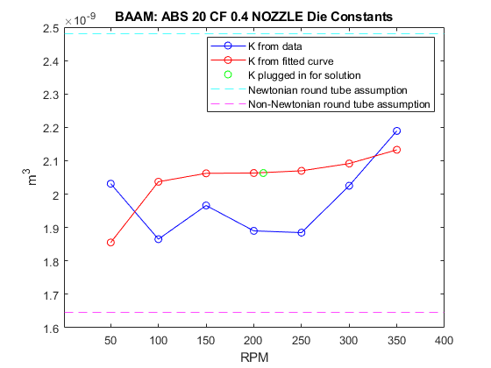
Figure 32: Die constants from BAAM 0.4 nozzle tests.
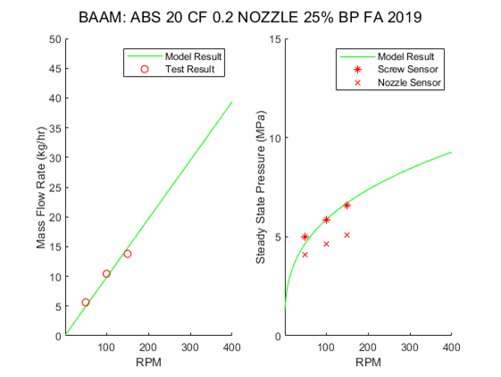
Figure 33: Flow rate and pressure results for BAAM 0.2 nozzle tests and code.
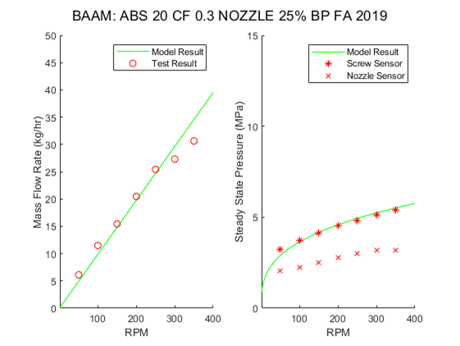
Figure 34: Flow rate and pressure results for BAAM 0.3 nozzle tests and code.
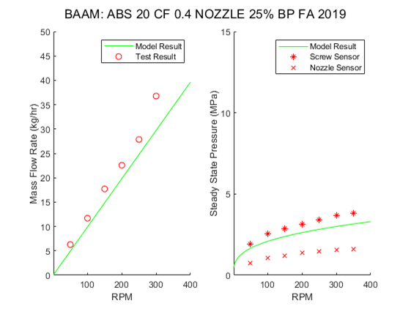
Figure 35: Flow rate and pressure results for BAAM 0.4 nozzle tests and code.
data for the 0.4 inch nozzle is trending above the analytical prediction. It is possible that this inaccuracy in only the 0.4 inch nozzle is due to it not providing proper back pressure to the machine, and the machine is over extruding as a result.
Lastly, Figures 36 through 38 show pressure map results for all the nozzle sizes. It is observed that as nozzle size increases the analytical model lines up more accurately with the nozzle data. This suggests the need for more rigorous flow theory in the nozzle than Hagen-Poiseuille.

Microtruder Experimental Results Compared to Analytical Model
The die constants for CF-ABS on the Microtruder with the 0.1 inch nozzle are shown in Figure 39. The die constants on the Microtruder were more linear than those on the BAAM. The full die constant plots are found in Appendix A3. Mass flow rate and pressure results for CF-ABS at all nozzle sizes are shown in Figures 40-43. It is observed that all analytical predictions are consistently below than the data. One explanation for the inaccurate result is the compression ratio of each screw. The Microtruder’s compression ratio is 3.05, and the recommended range for ABS single screw extrusion is 2.25-2.7 (Campbell and Spalding 2013, 196).
The mass flow rate and pressure results for all other materials with the 0.1 inch nozzle are shown in Figures 44-47. The best fit is found to be CF-PLA, whereas neat PLA came out very poor. This result was actually expected, as the neat PLA’s pellet size was much larger than Randcastle’s recommended max as shown in Table 5. The CF-PLA pellet size was much smaller than the neat PLA and extruded properly, providing an accurate analytical prediction. The neat ABS’s inaccuracy is again explained by the incorrect compression ratio for the material. The LLDPE result also came out inaccurate. This can be explained by the compression rate of the machine, as LLDPE requires a compression rate of less than 0.0055 without solid bed breakup
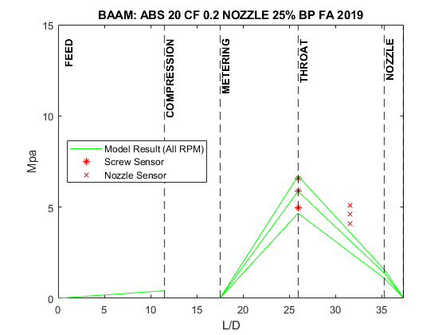
Figure 36: Pressure map results for BAAM 0.2 nozzle.
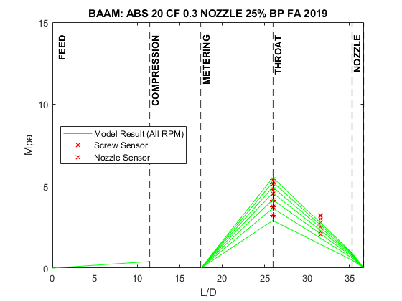
Figure 37: Pressure map results for BAAM 0.3 nozzle.
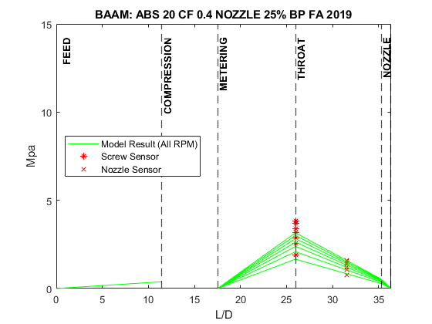
Figure 38: Pressure map results for BAAM 0.4 nozzle.
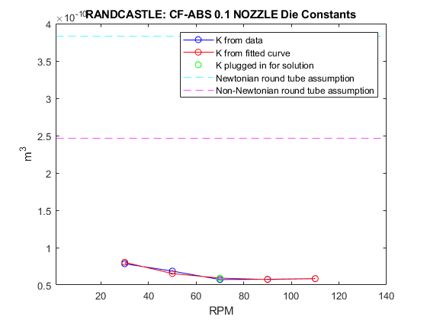
Figure 39: Die constants for CF-ABS Microtruder 0.1 nozzle tests.
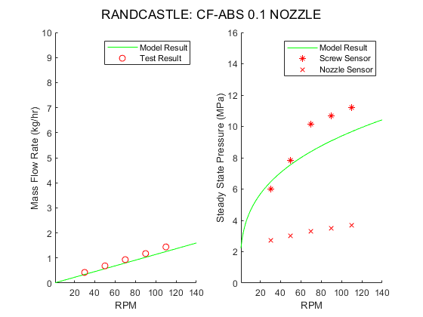
Figure 40: Flow rate and pressure results for Microtruder 0.1 nozzle and CF-ABS tests and code.
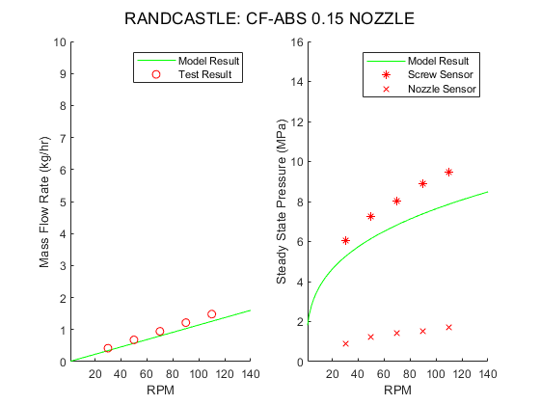
Figure 41: Flow rate and pressure results for Microtruder 0.15 nozzle and CF-ABS tests and code.
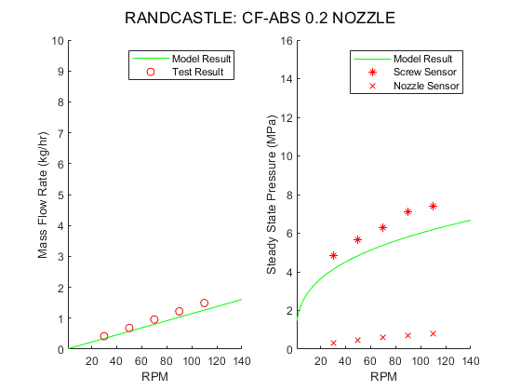
Figure 42: Flow rate and pressure results for Microtruder 0.2 nozzle and CF-ABS tests and code.
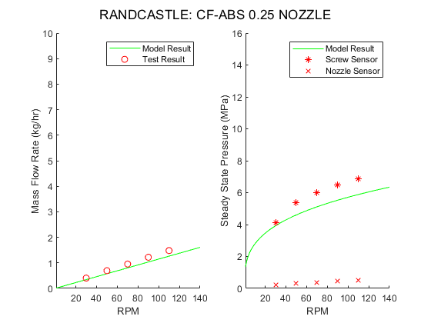
Figure 43: Flow rate and pressure results for Microtruder 0.25 nozzle and CF-ABS tests and code.
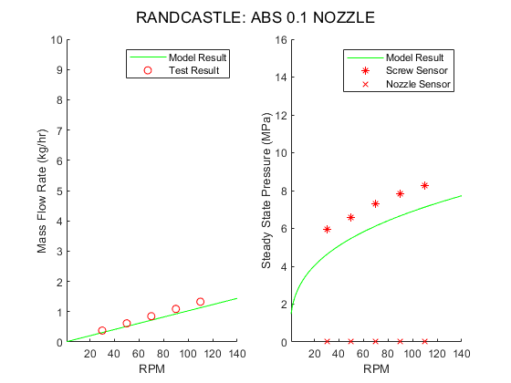
Figure 44: Flow rate and pressure results for Microtruder 0.1 nozzle and ABS tests and code.
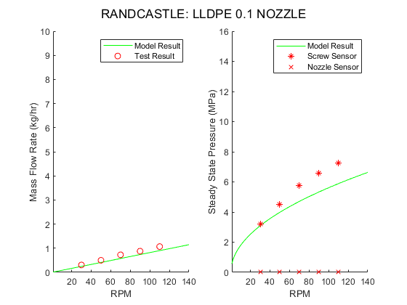
Figure 45: Flow rate and pressure results for Microtruder 0.1 nozzle and LLDPE tests and code.
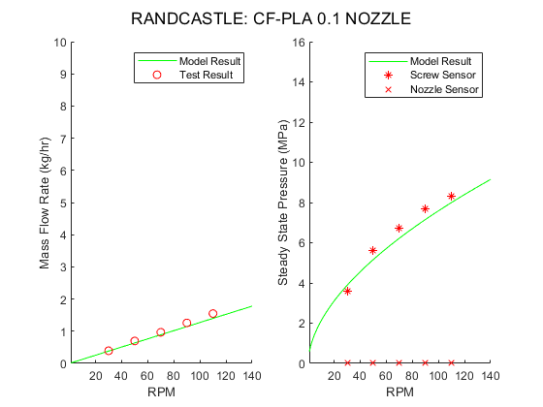
Figure 46: Flow rate and pressure results for Microtruder 0.1 nozzle and CF-PLA tests and code.
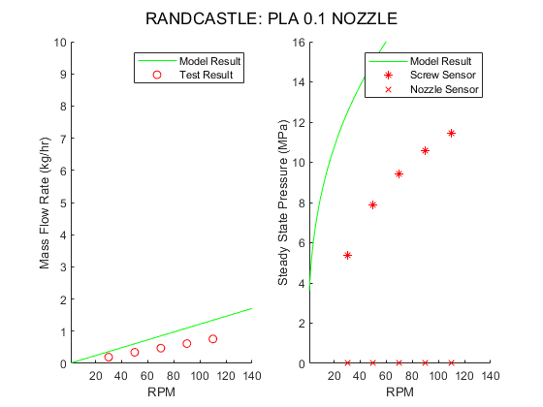
Figure 47: Flow rate and pressure results for Microtruder 0.1 nozzle and PLA tests and code.
issues (Campbell and Spalding 2013, 192), and the Microtruder has a compression rate of 0.00625. This is one example of why LLDPE is not seen in the additive extrusion field and is only used as a purge material with the BAAM. The complete set of Microtruder data plots can be found in Appendix A4, as well as tabulated data in Appendix A5.

Summary and Conclusions

Summary of Research Work
This work stemmed from the goal of improving print quality through more accurate print settings. To meet this demand, predictions and simulations of single screw extrusion had to be made and tailored to the machines at hand: the BAAM at the MDF and the Microtruder at UT. Several models, methods, and traditions were explored before settling on Newtonian theory for a rate controlling metering zone to estimate discharge pressure and machine output. In addition to the theory for the metering zone, theories for the feed zone, compression zone, and nozzle were added to complete the pressure map down throughout each system. A Matlab code was developed to house these theories and was written in such a way that new machines, materials, data, and theory can be easily added on. A wide variety of pressure and flow rate data was gathered from both machines to ensure validity of theory. The result of this work allows for testing of new machine settings and materials without performing timely physical testing.

Conclusions
Several conclusions can be made from the results of this work:
- When nozzle size is equal to throat size of the machine, extrusion issues will appear due to low back pressure in the system. The BAAM accounts for this via the adjustable back pressure screw.
- Die constants have a large impact theory accuracy. It is crucial to gather accurate data to properly encapsulate the die geometry into a die constant.
- Non-Newtonian effects must be accounted for, for the materials and systems tested. In early testing using just the Newtonian assumption, the analytical pressures diverged wildly from reality.
- Screw designs can be better tailored to material demands, namely, on the Microtruder system. Several extrusion issues arose in Microtruder testing, and the theory reinforced this idea.

Future Work
From the beginning it was known that this work should be done with future work in mind. Due to the broad scope of this research, there is a large area of potential for expansion and use. Direct use of this work includes improving print parameters through theory estimation, testing of new material grades and comparing to previous material grades, and finding machine limits for certain settings and materials.
The BAAM system is naturally of specific interest for future work. More data can be gathered, especially at more back pressure screw settings, and a full map of die constants for the system can be generated. The tests can be ran with the gantry in-air and not printing for more accurate pressure and flow rate data.
As a result of setup for this study, the Microtruder is now outfitted for quick testing in our laboratory with a die similar to that of the BAAM system. This removes the need to go through the MDF for certain data and adds a simpler direct source at UT.
Lastly, and potentially most important, the code is designed such that new models and theories can be tacked on. Certain research targets certain areas of the screw or new machine design can be united with the code resulting from this work.

References

Campbell, Gregory, and Mark Spalding. 2013. Analyzing and Troubleshooting Single-Screw Extruders. Munich: Hanser Publications.
Middleman, Stanley. 1977. Fundamentals of Polymer Processing. New York: McGraw-Hill.
Rauwendaal, Chris. 2014. Polymer Extrusion. 5th ed. Munich: Hanser Publications.
Tadmor, Zehev, and Costas Gogos. 2006. Principles of Polymer Processing. 2nd ed. Hoboken: John Wiley & Sons Incorporated.
Tadmor, Zehev, and Imrich Klein. 1970. Engineering Principles of Plasticating Extrusion. New
York: Van Nostrand Reinhold Company.
“Transducer Mounting Hole Machining Tool Kit Manual”. 2020. Dynisco. https://www.dynisco.com/userfiles/files/Mounting%20Hole%20Machining%20Tool%20Kit.pdf.
Vlachopoulos, John, and John Wagner. 2001. SPE Guide on Extrusion Technology and Troubleshooting. Brookfield: Society for Plastic Engineers.
"What is a Microtruder?". 2020. Randcastle Extrusion Systems. http://www.randcastle.com/mcrtrdr.html.
“7000 Series Capillary Rheometers & LabKARS Software”. 2020. Dynisco. https://www.dynisco.com/userfiles/files/lcr7000_series_ver_2_4.pdf

Appendix

- Material Product Information
All materials were provided by Techmer PM LLC.
Material | Product Label
LLDPE | PF-0218-F
Neat PLA | Natureworks 4043D
CF-PLA | Electrafil® PLA 2007 3DP
Neat ABS | Hifill® ABS 1512 3DP
CF-ABS | Electrafil® ABS 1501 3DP

- LCR Tabulated Test Data
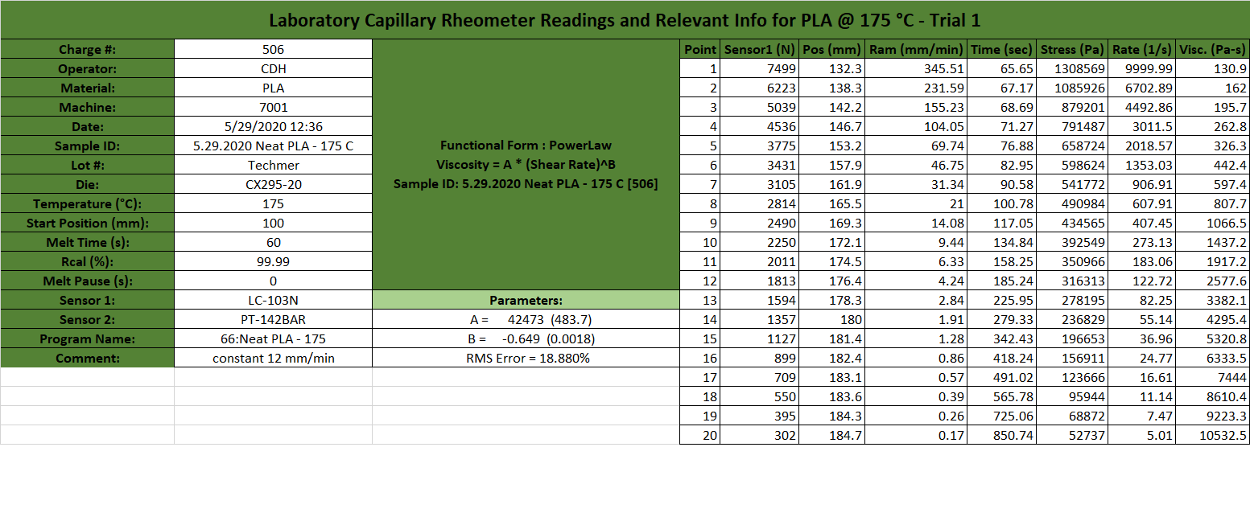
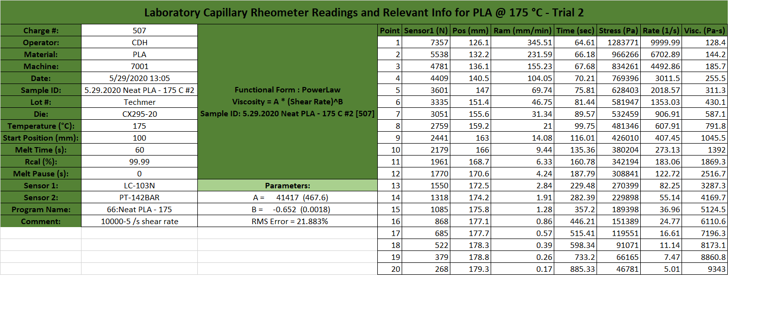
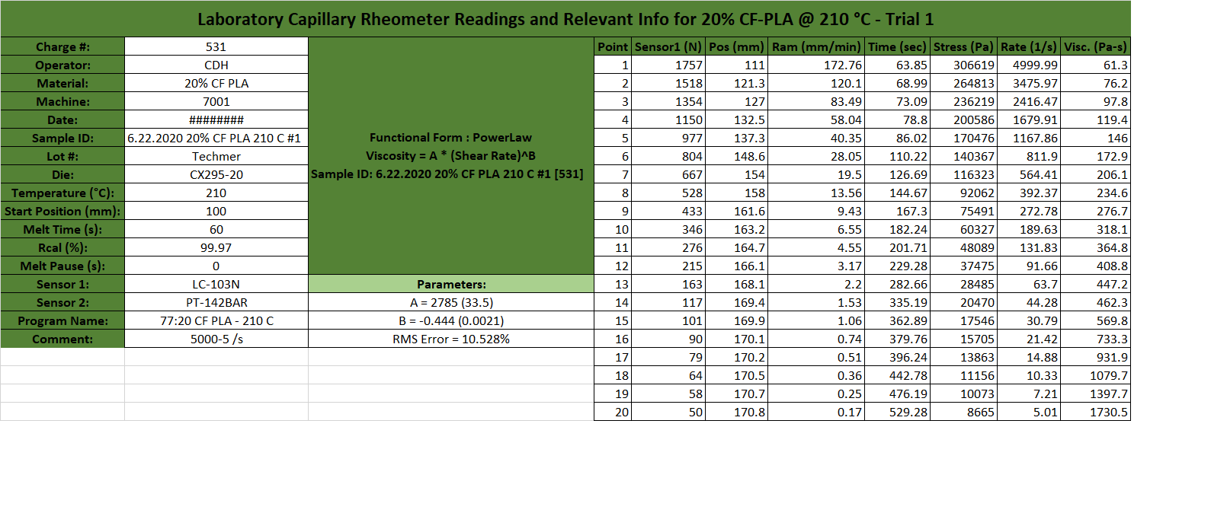
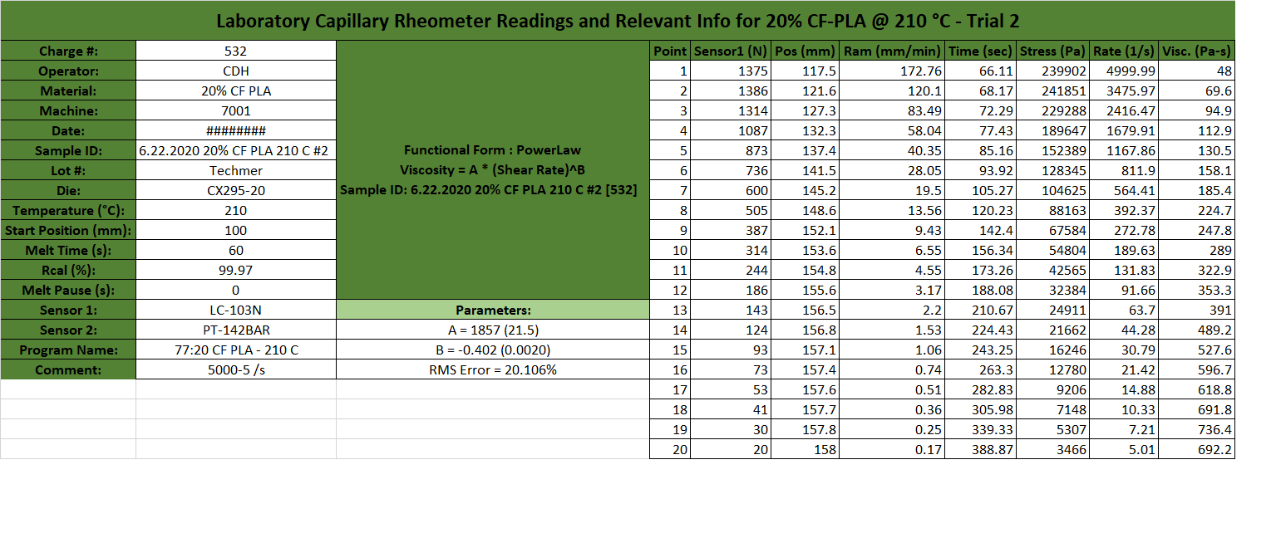
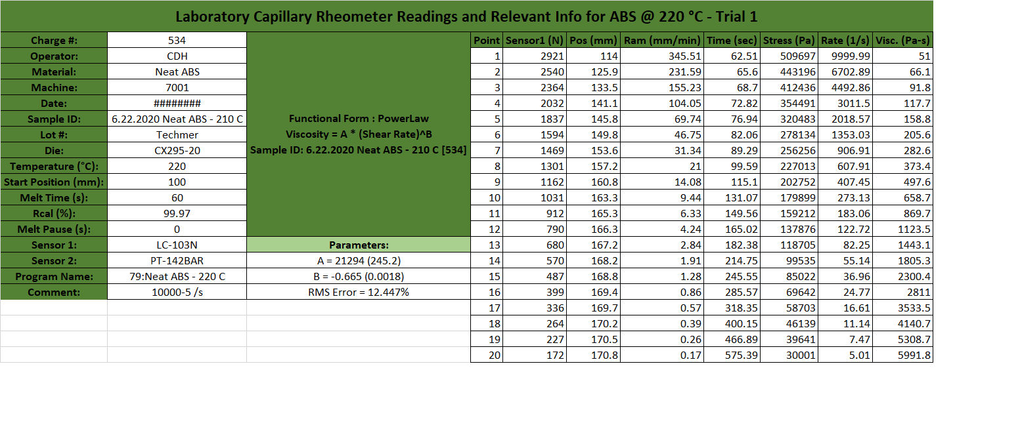
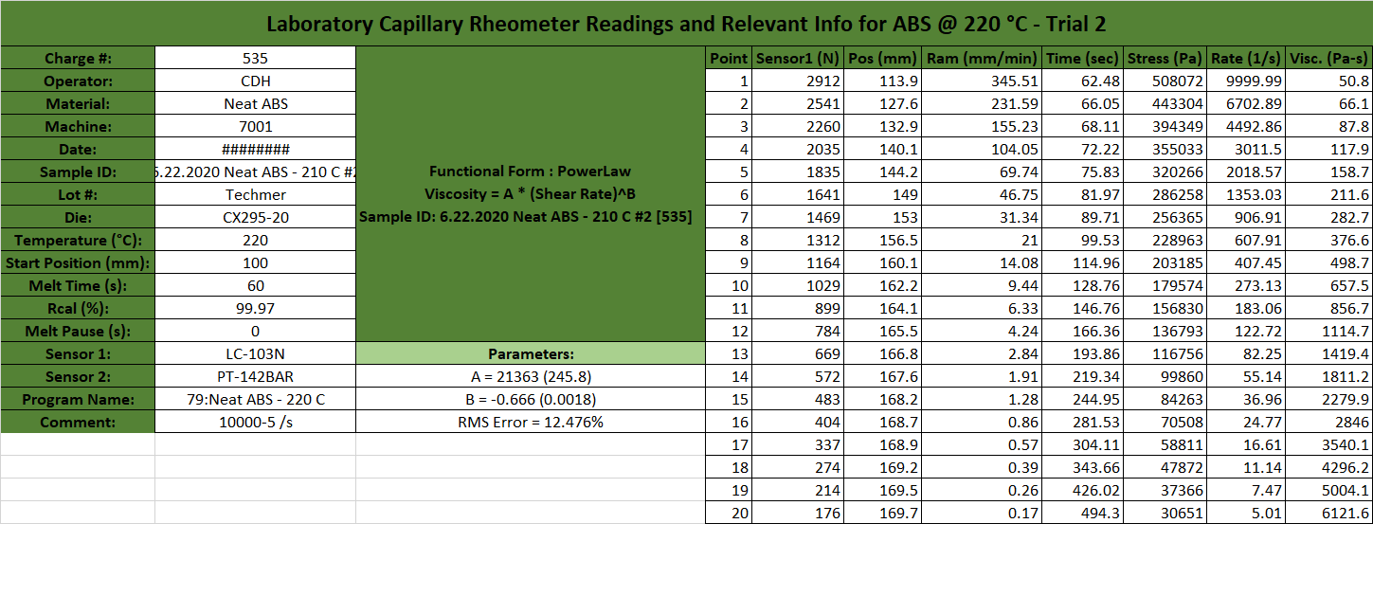
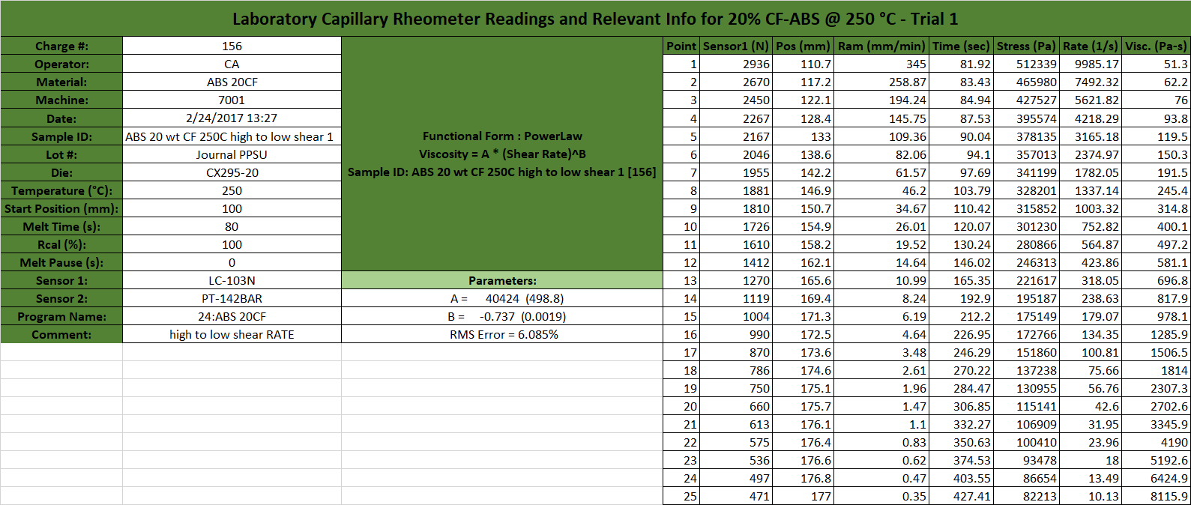
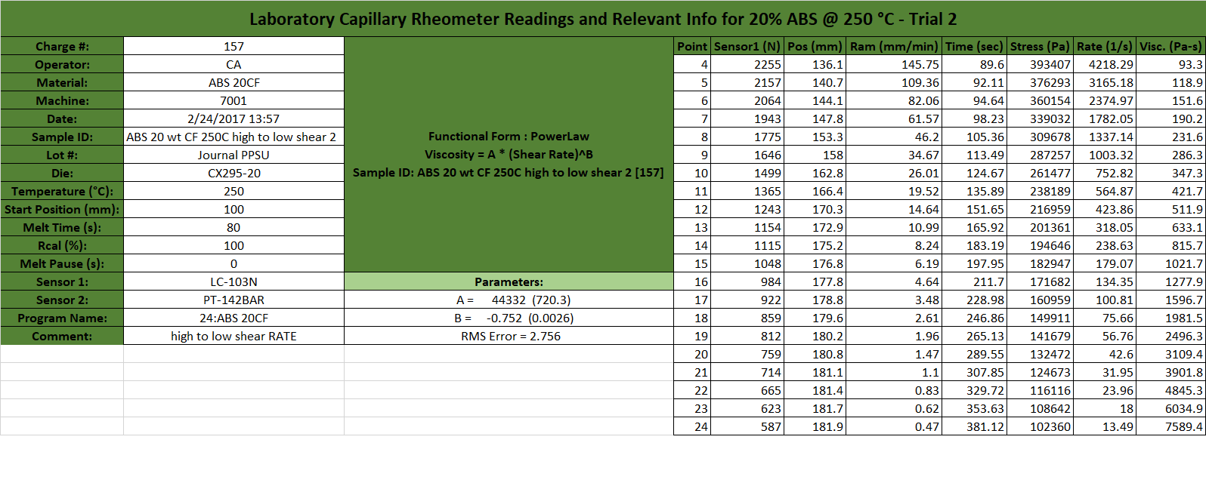

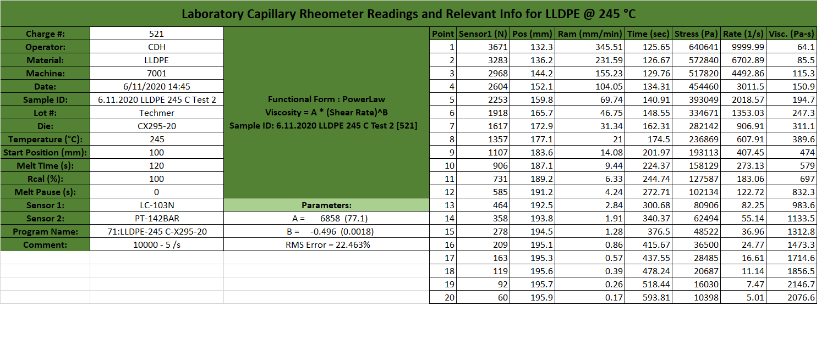

- Microtruder Die Constant Plots
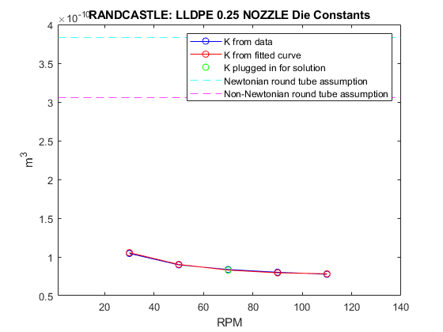
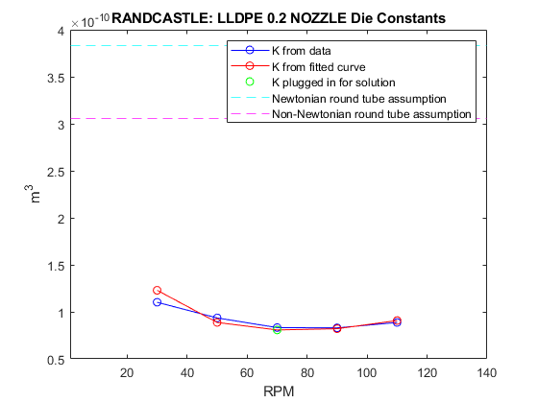
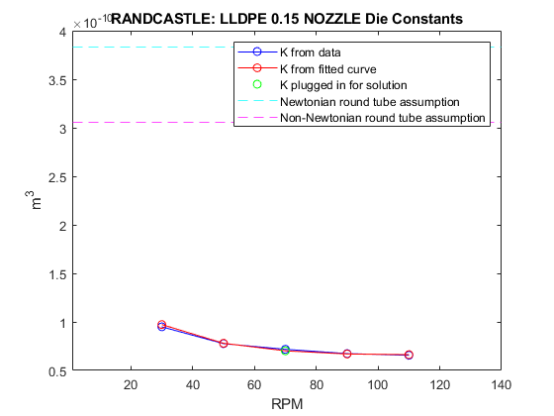
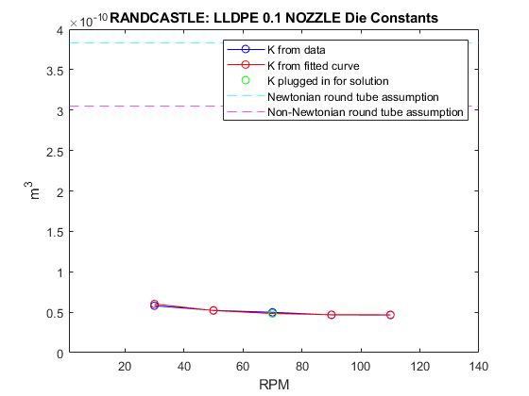
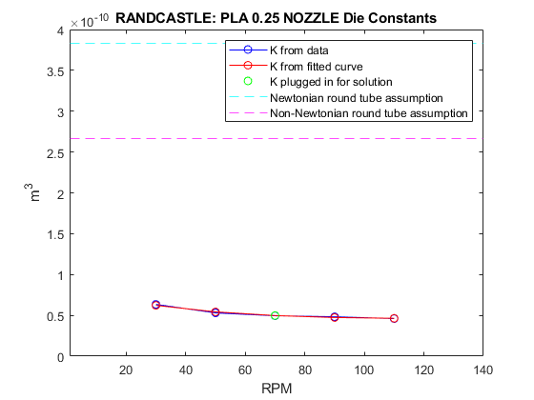
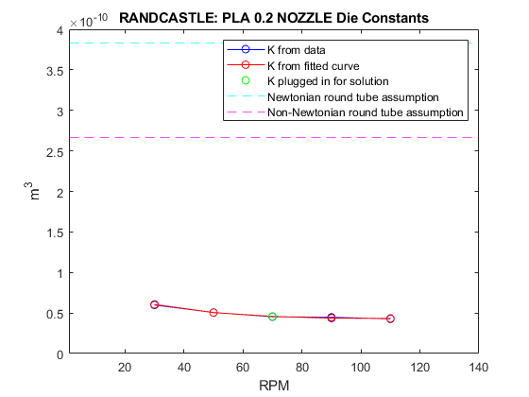
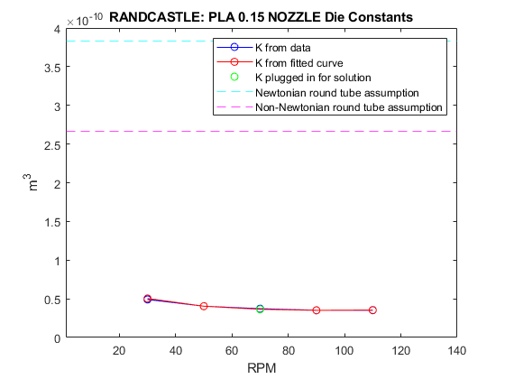
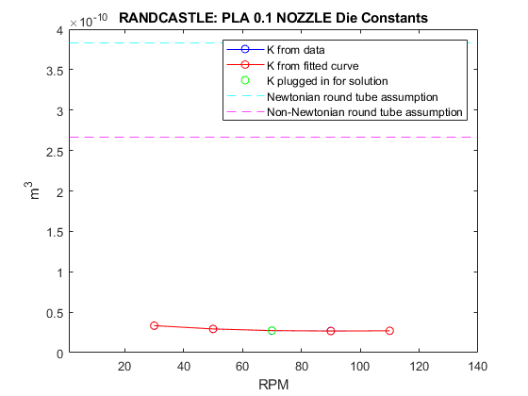
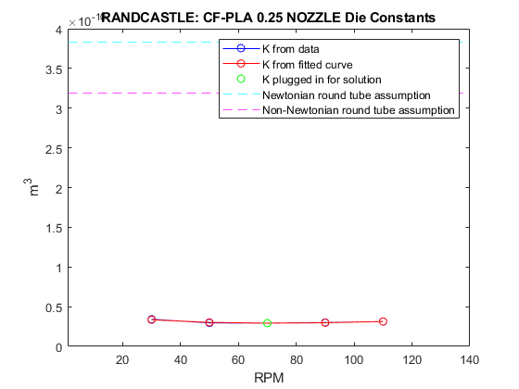
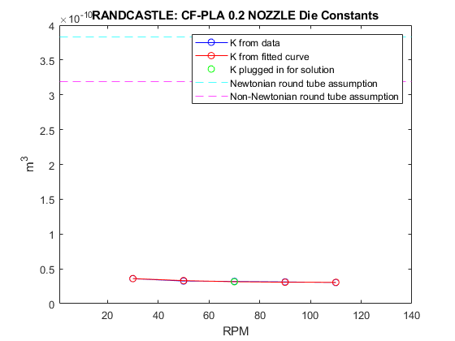
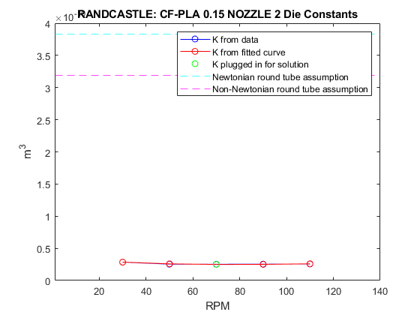
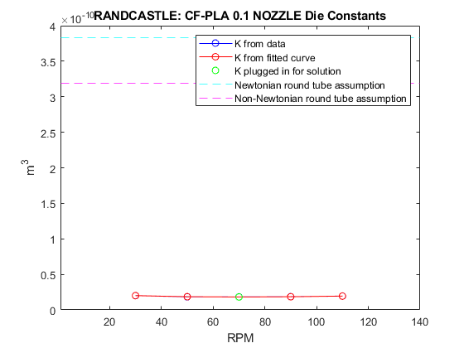
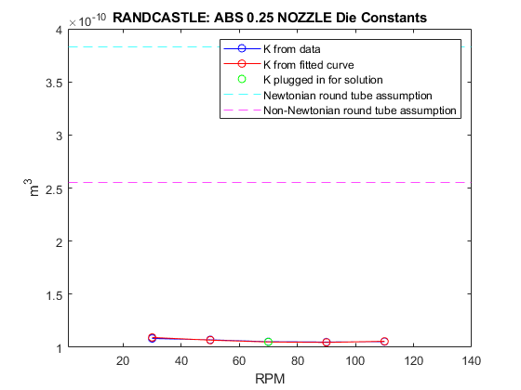
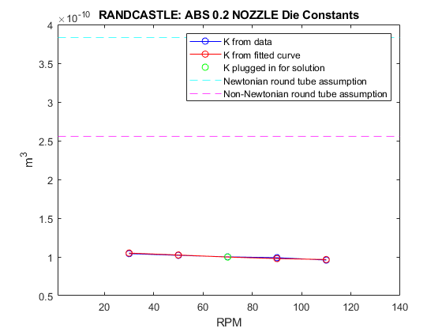
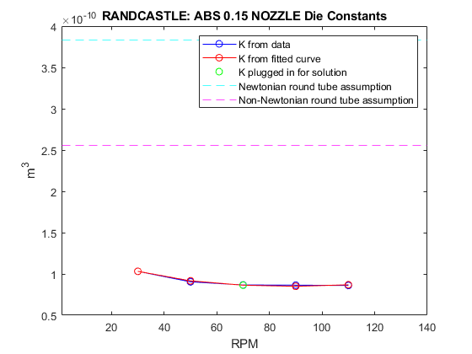
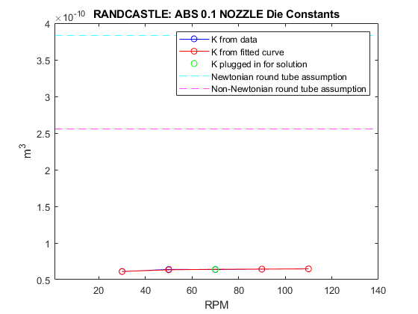
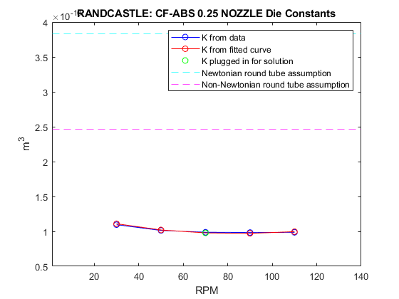
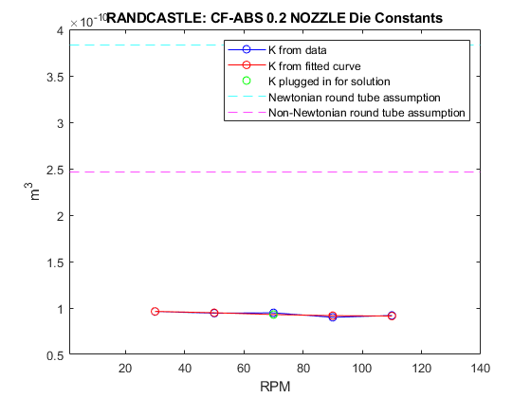
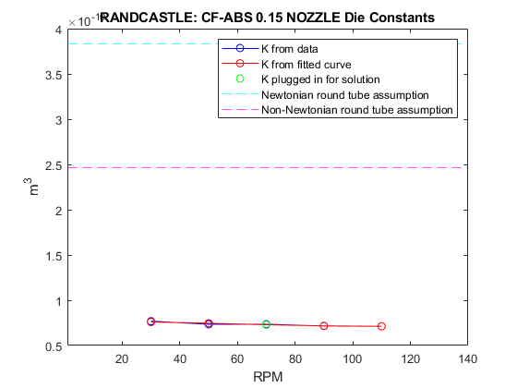

- Microtruder Data Plots
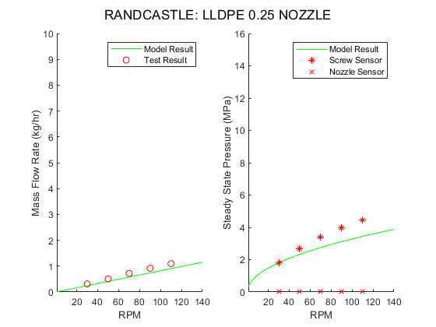
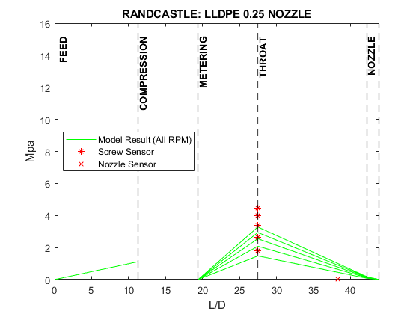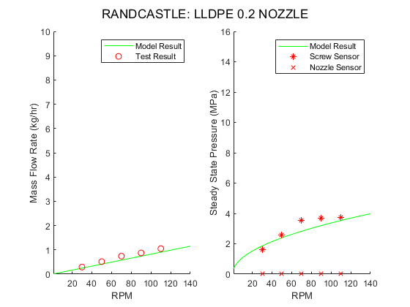
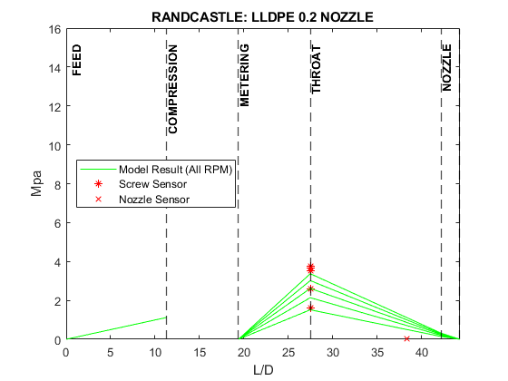
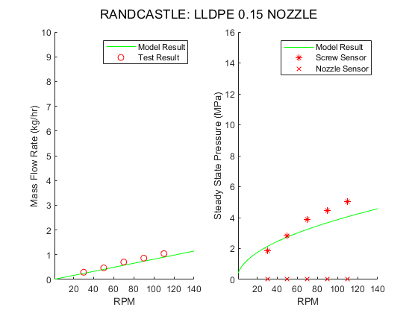
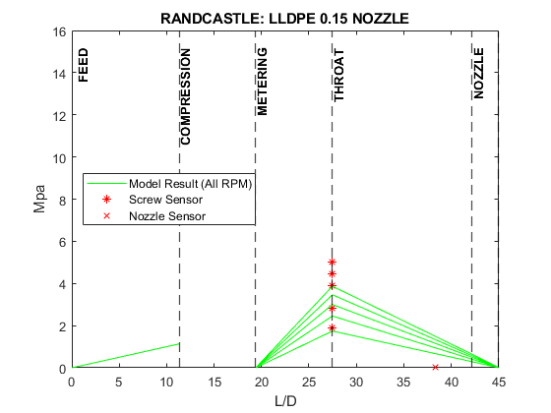
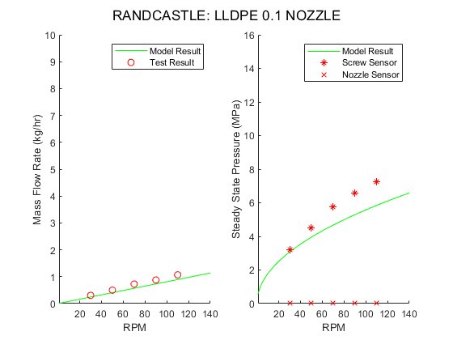
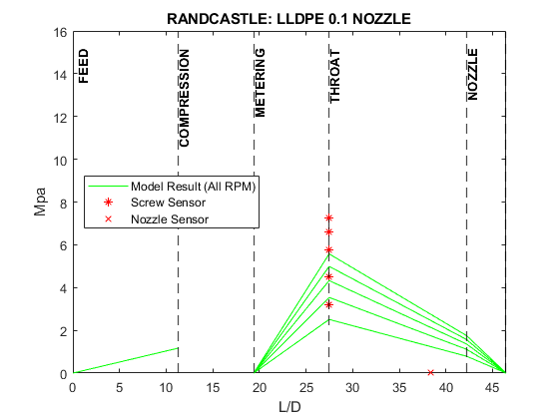
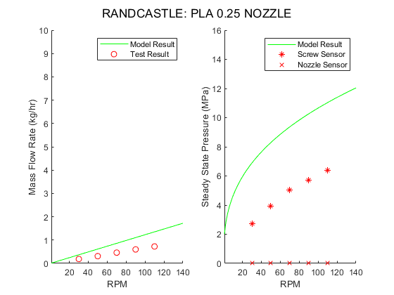
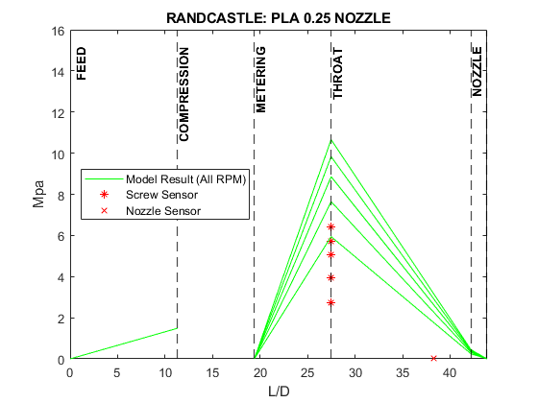
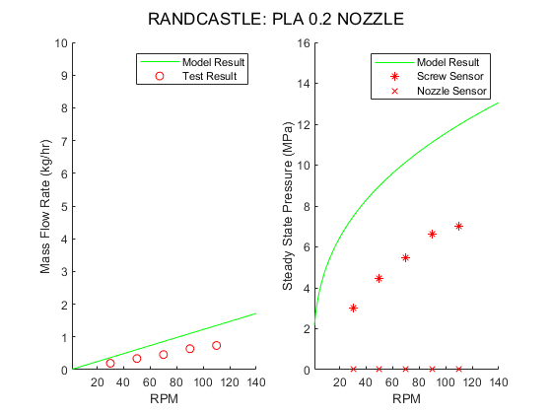
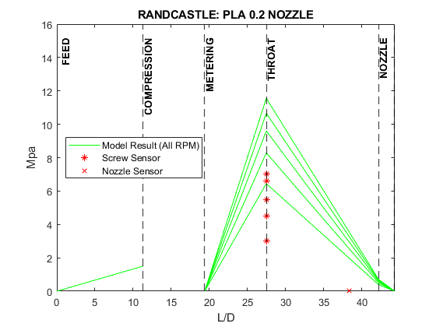
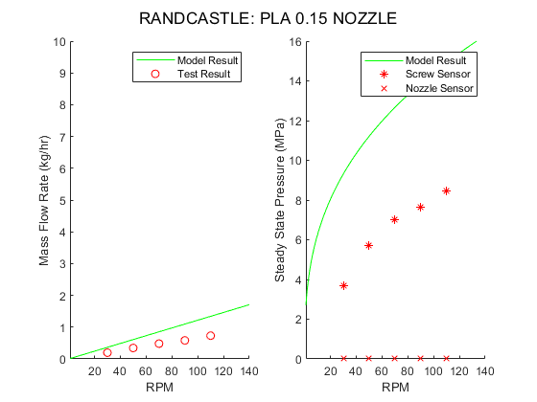
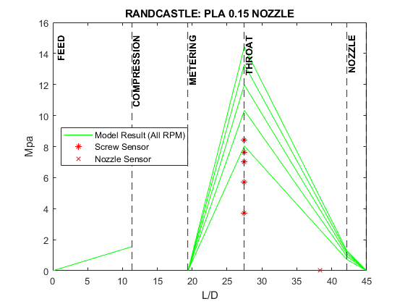
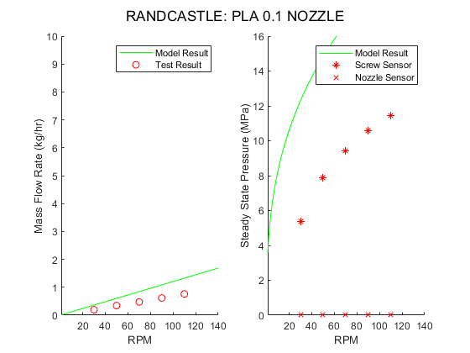
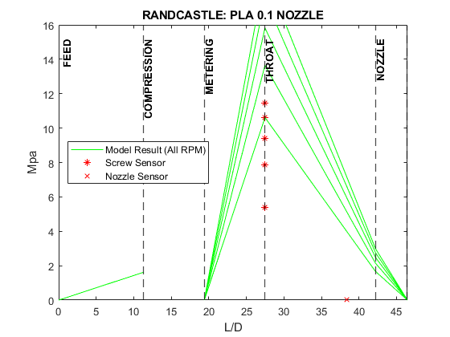
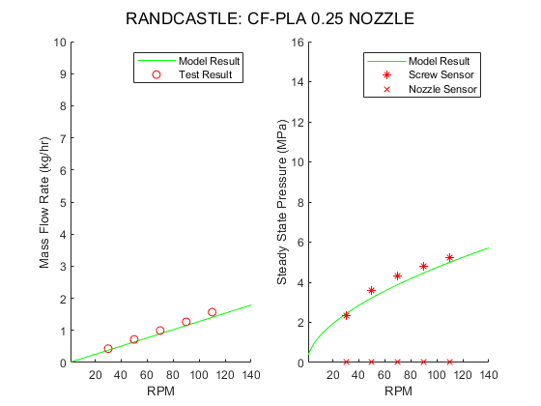
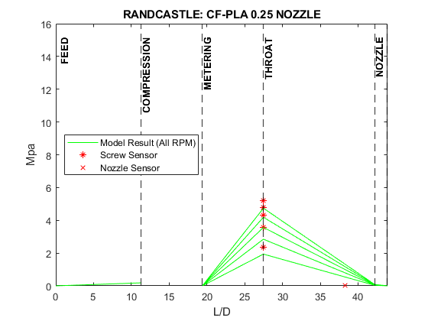
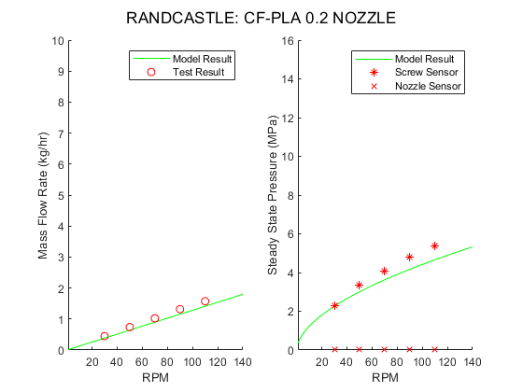
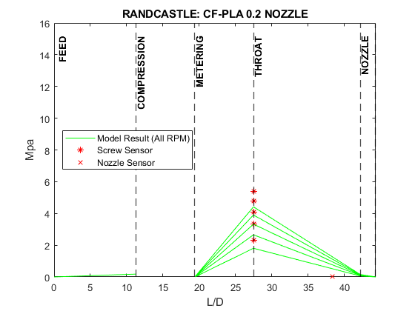
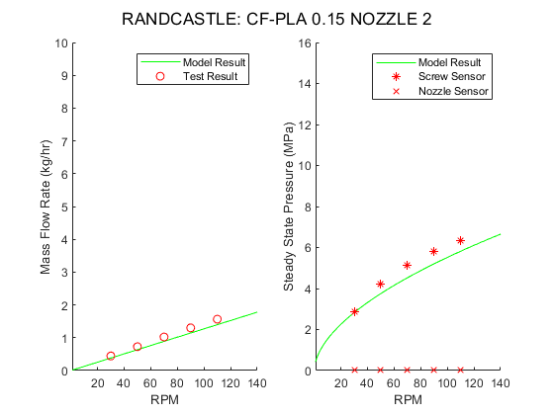
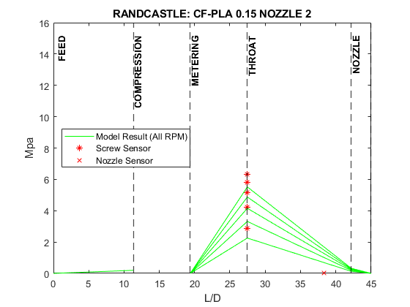
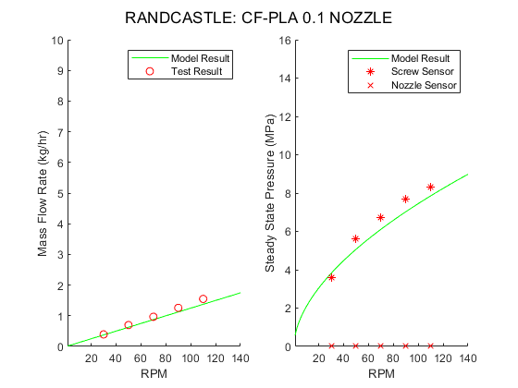
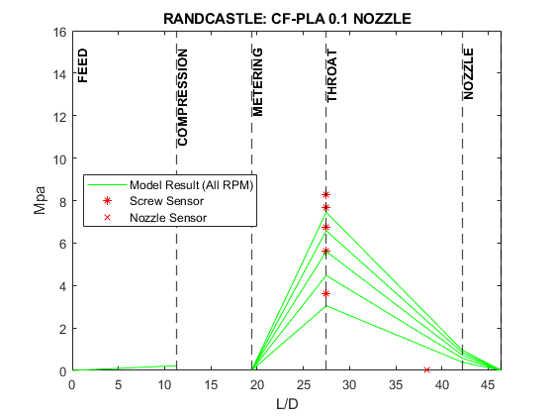
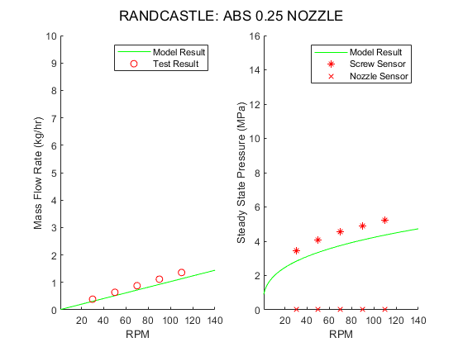
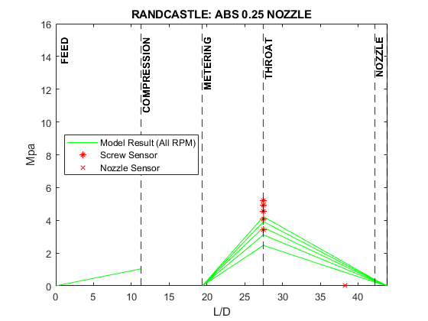
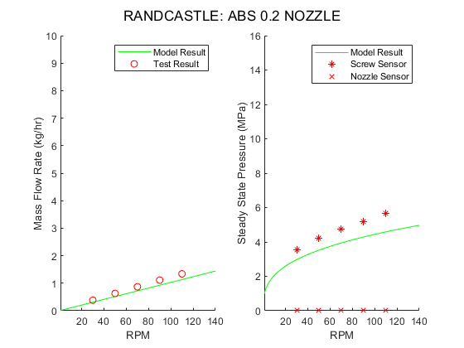
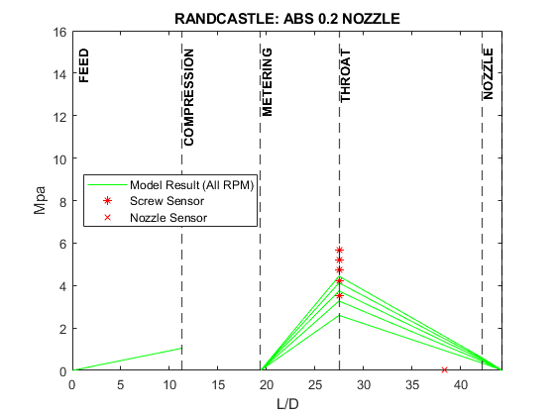
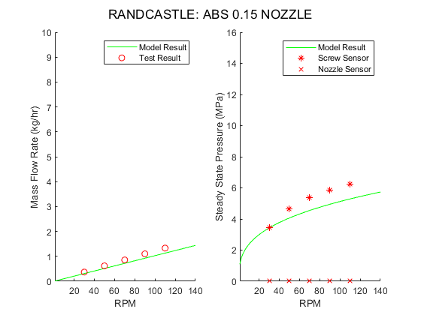
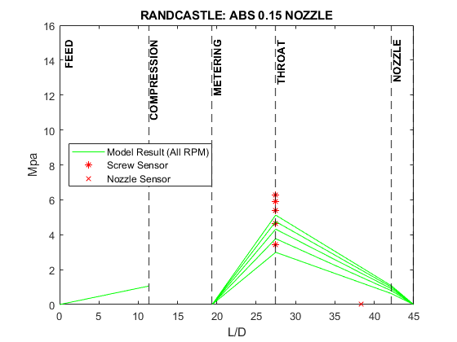
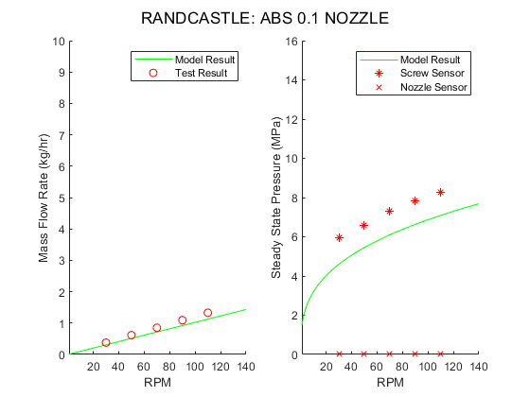
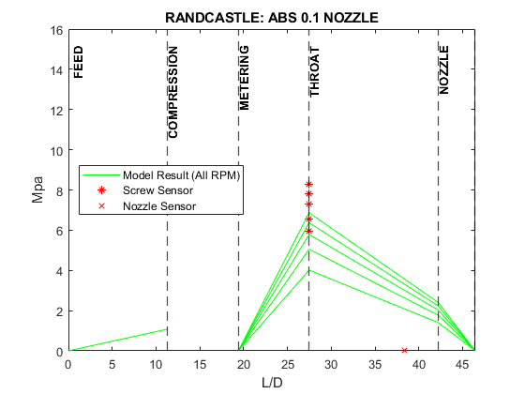
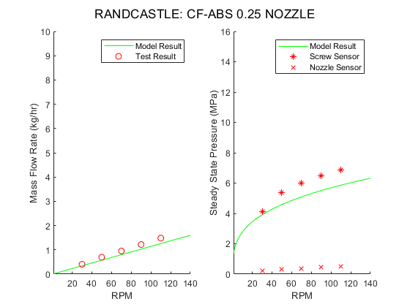
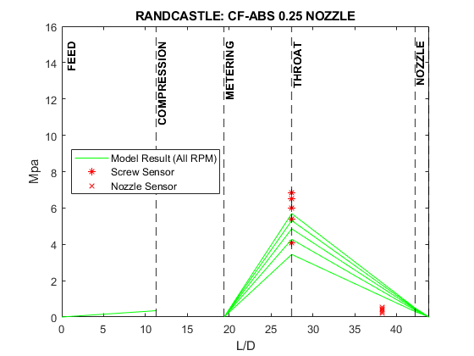
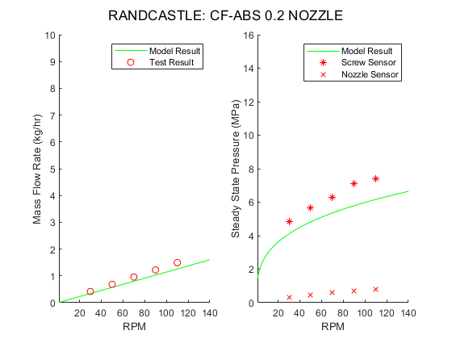
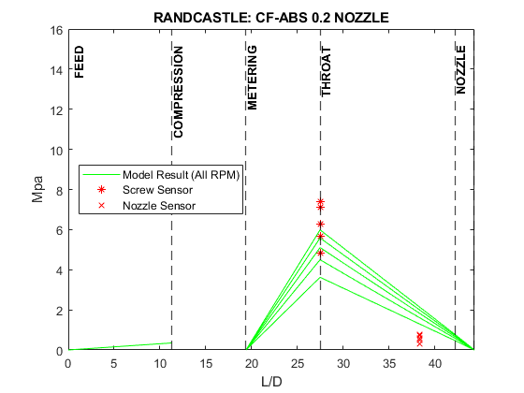
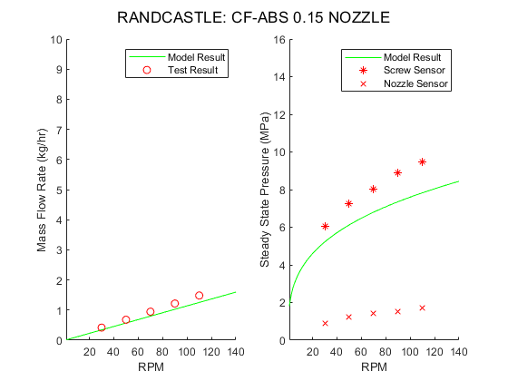
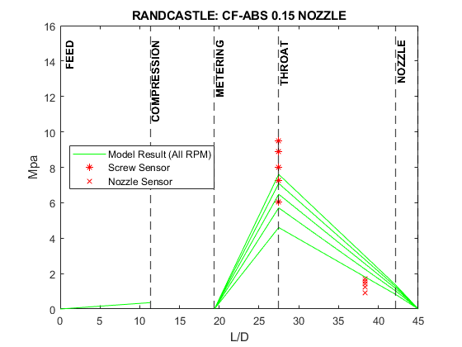
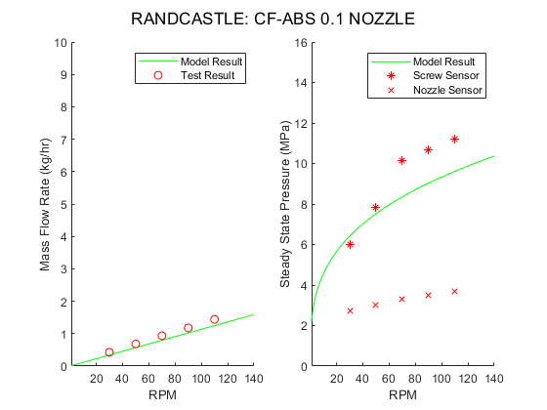
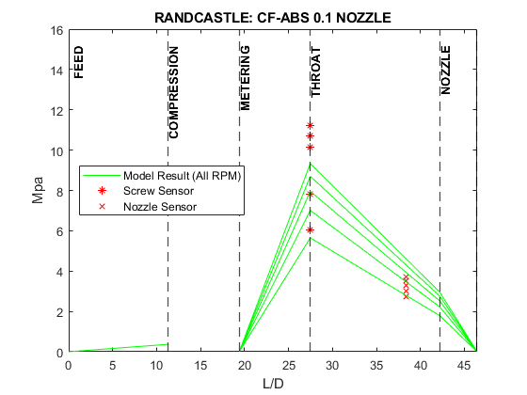

- Microtruder Tabulated Data
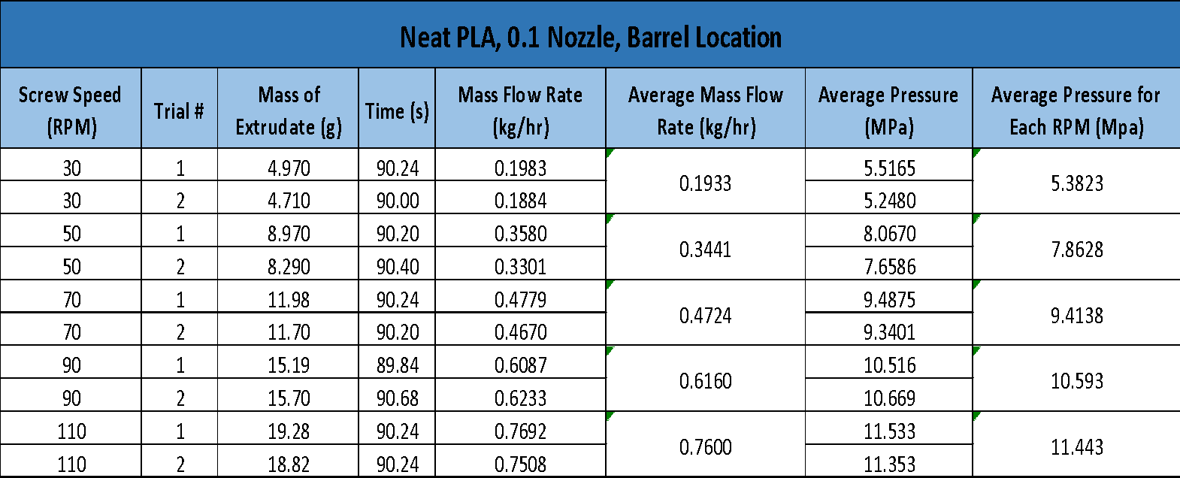
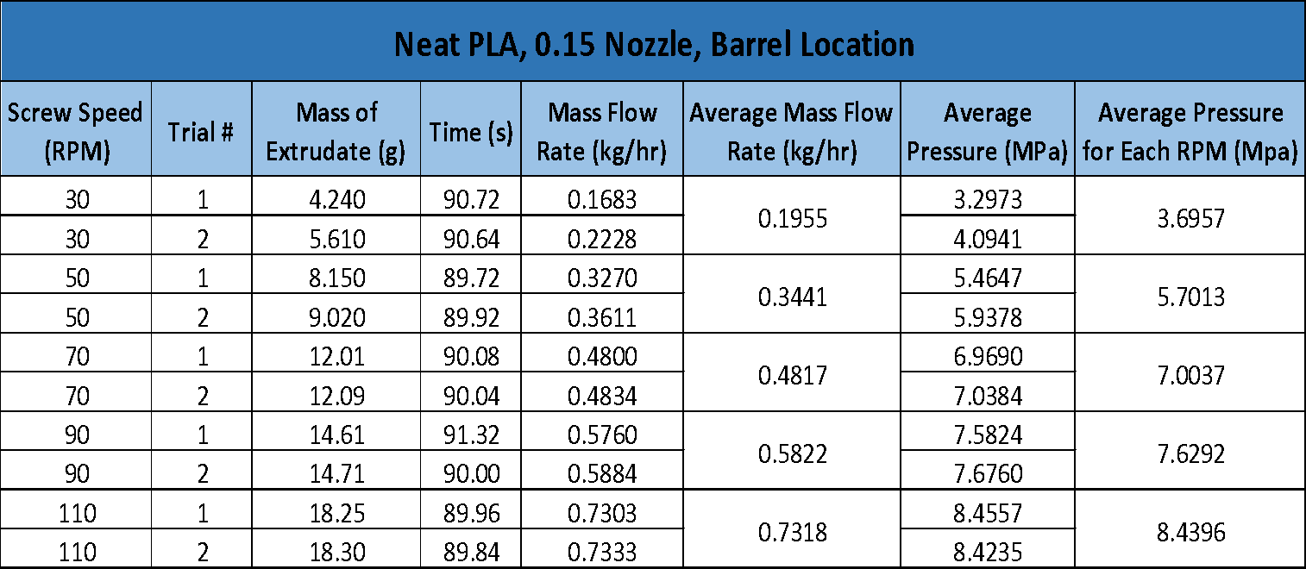
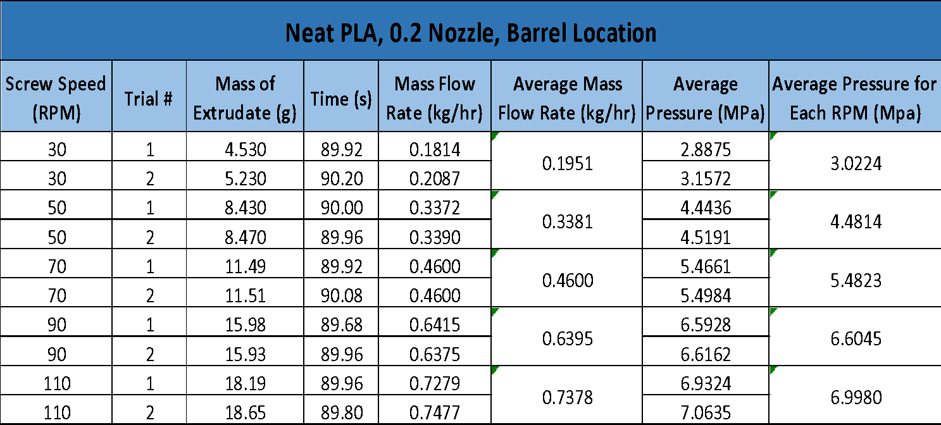
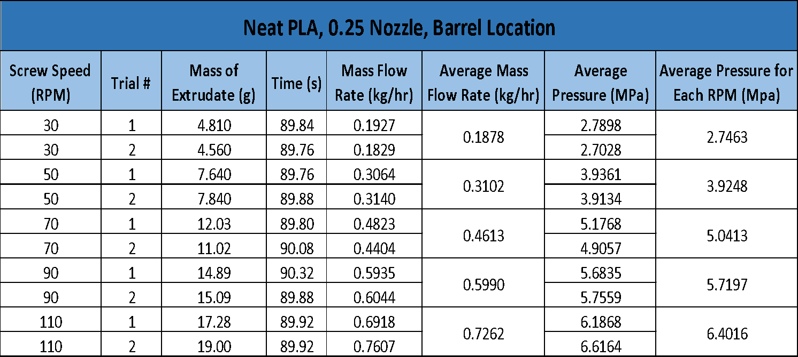
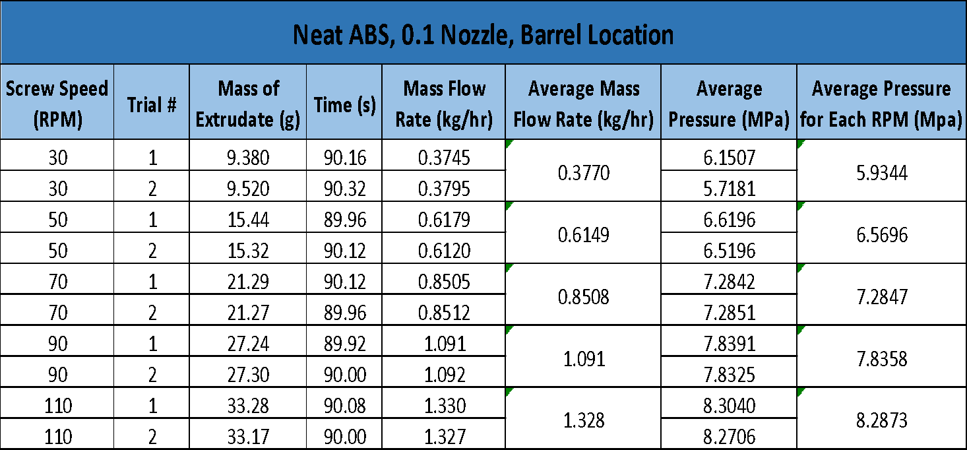
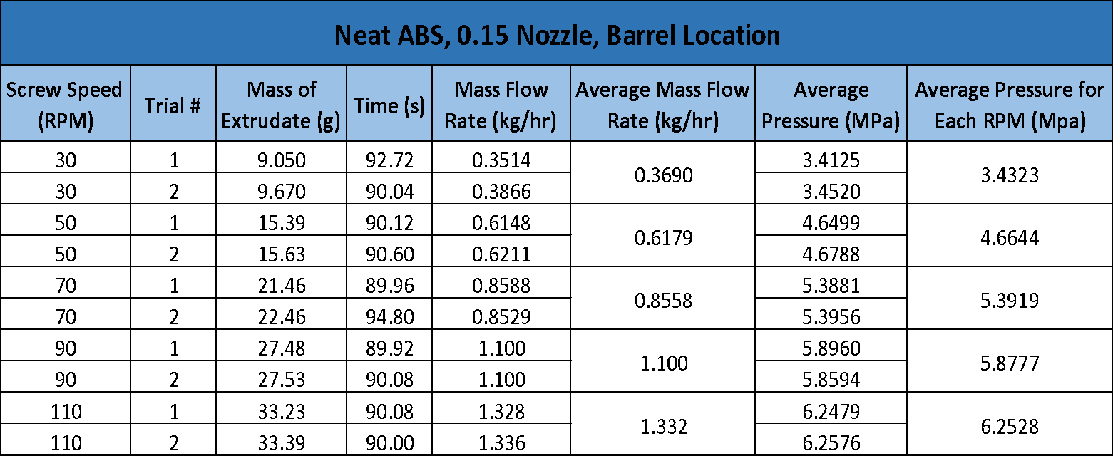
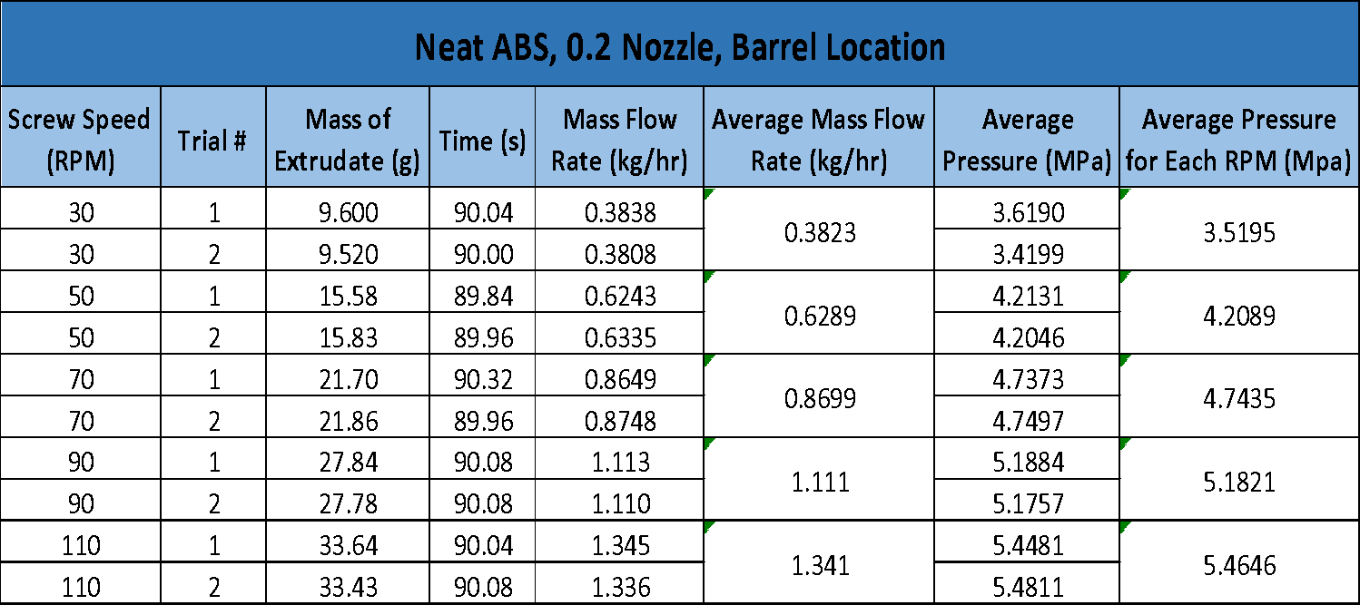
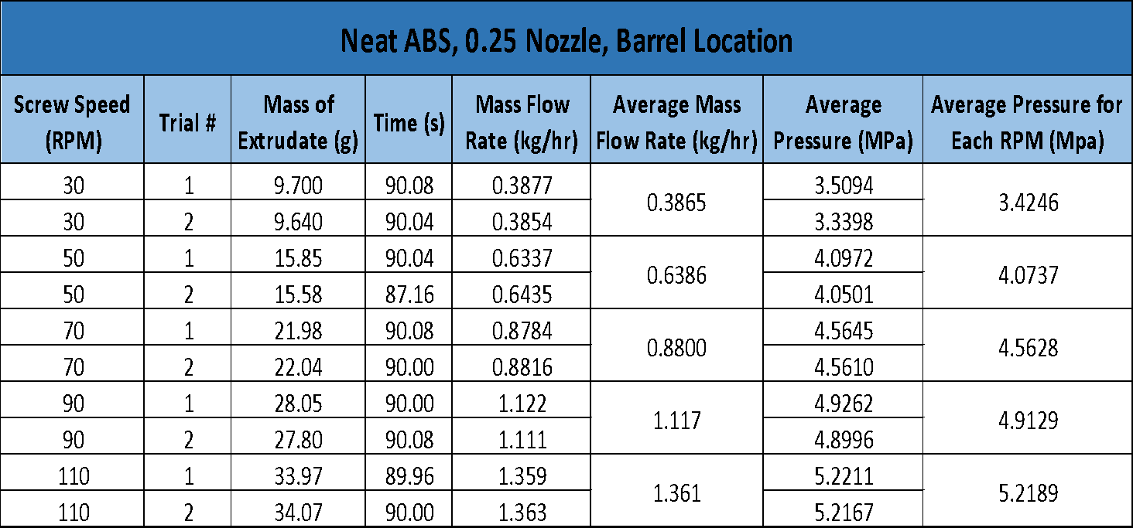
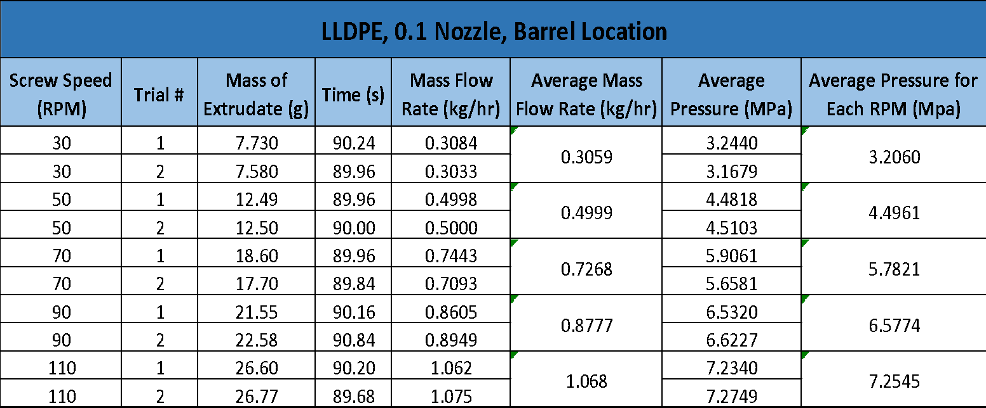
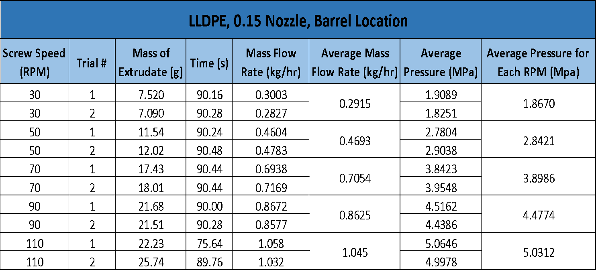
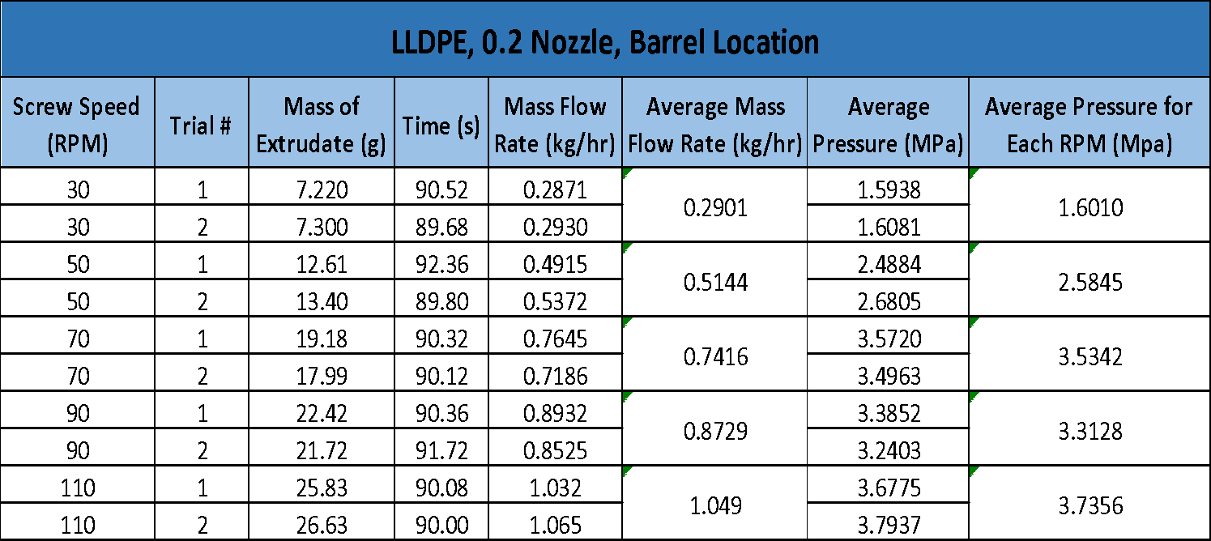
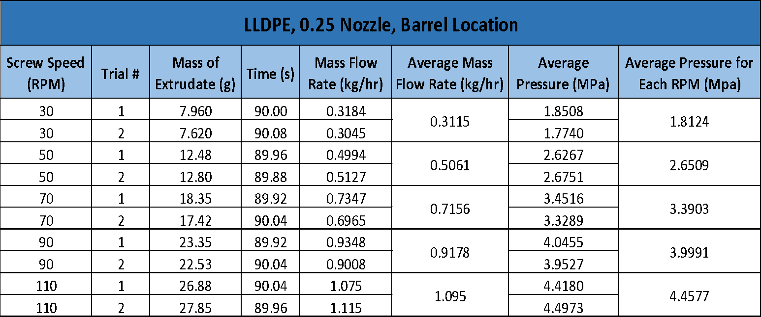
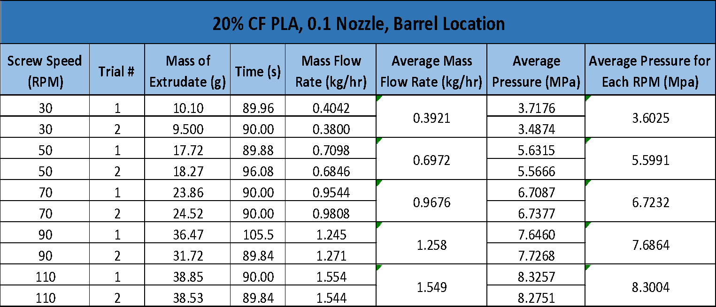
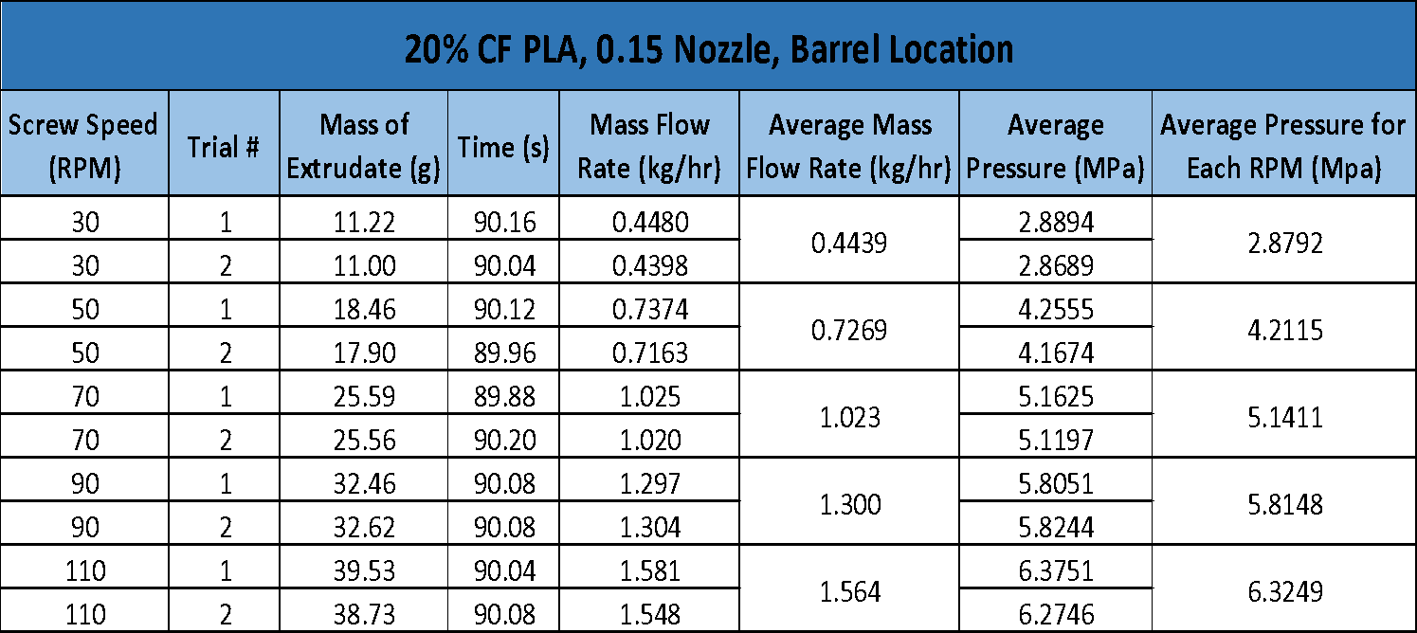
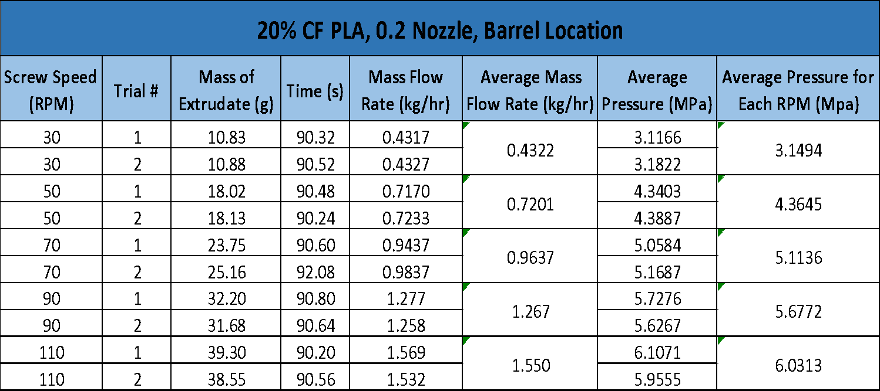
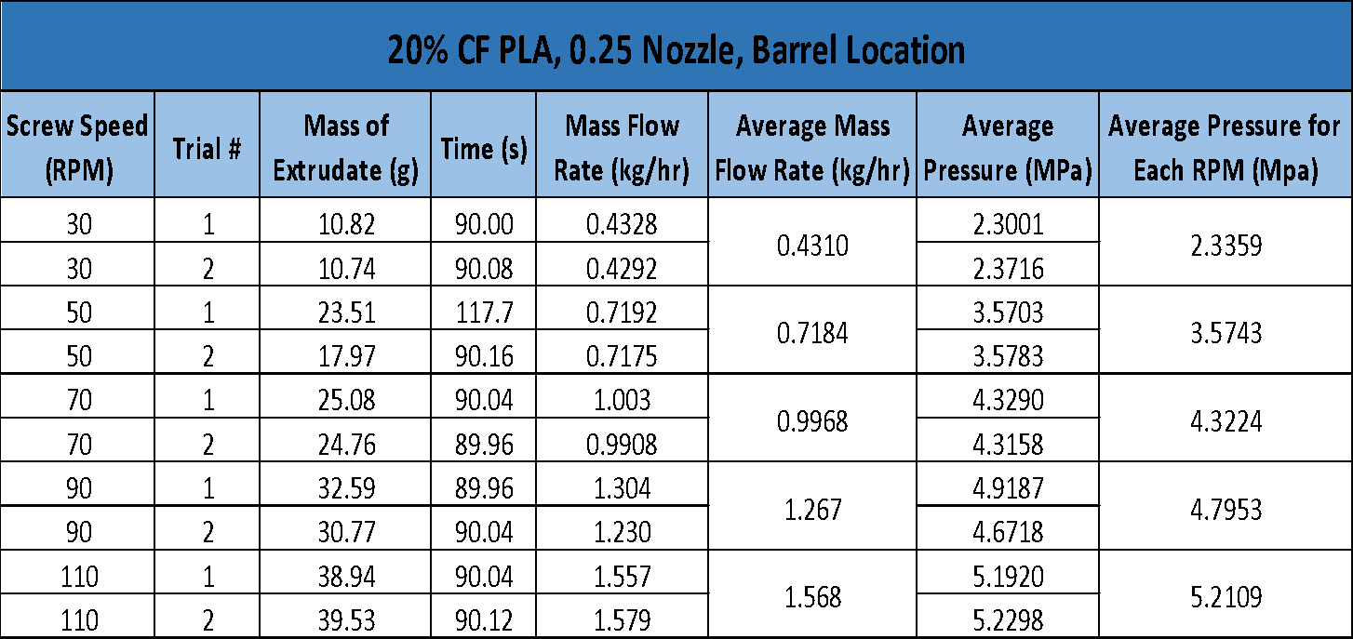
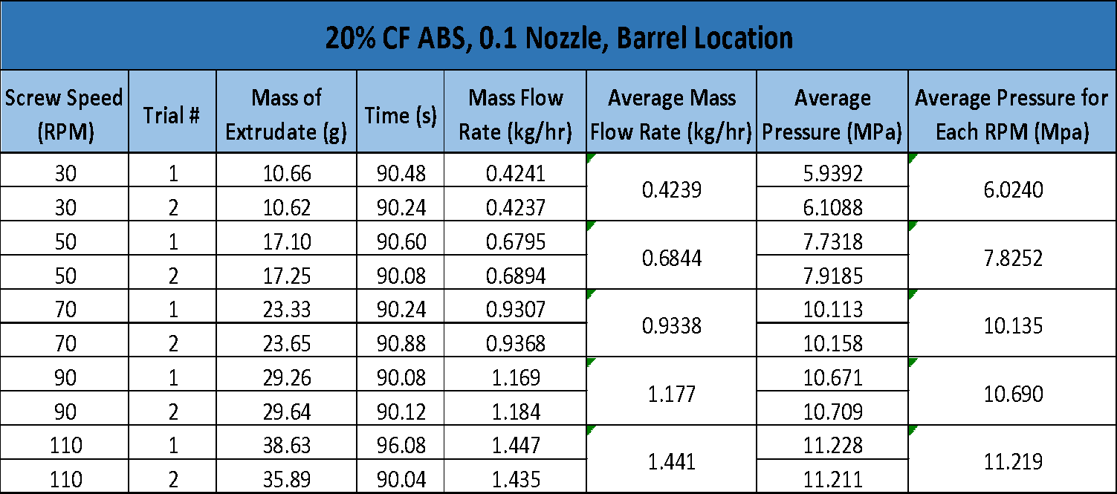
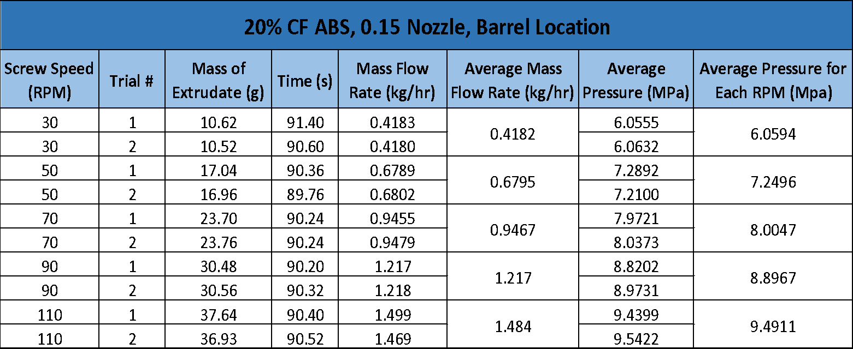
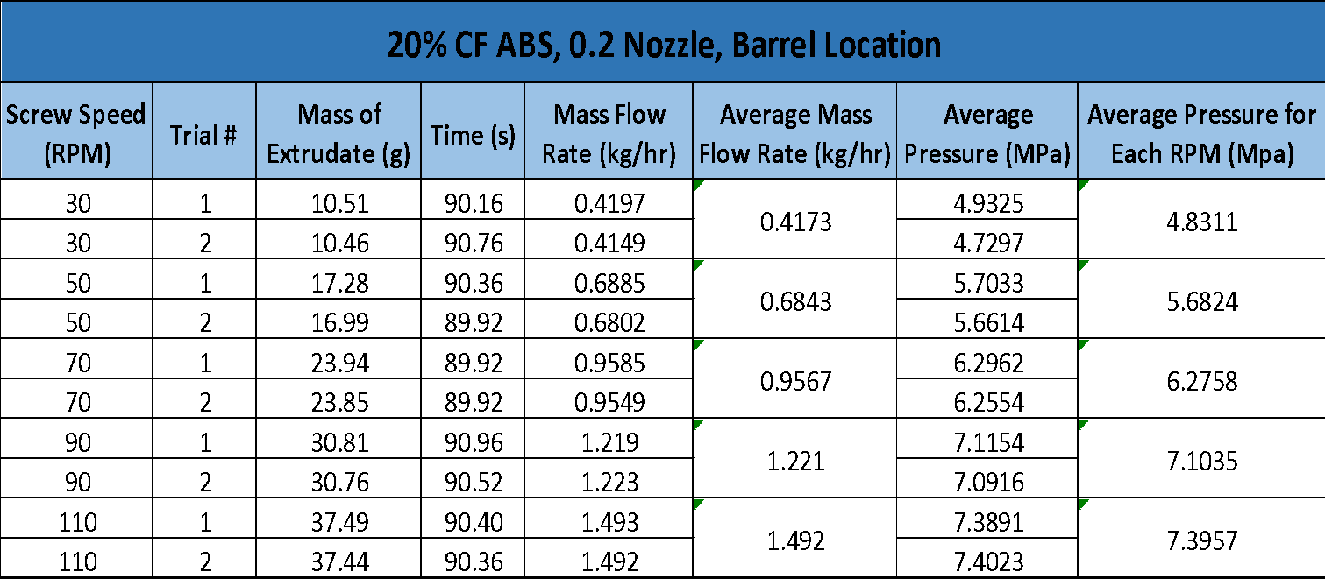
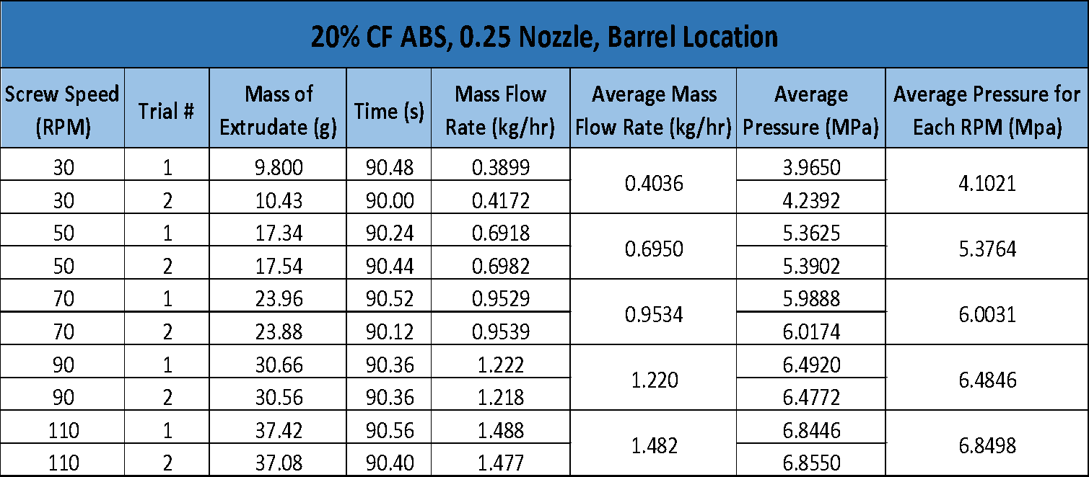
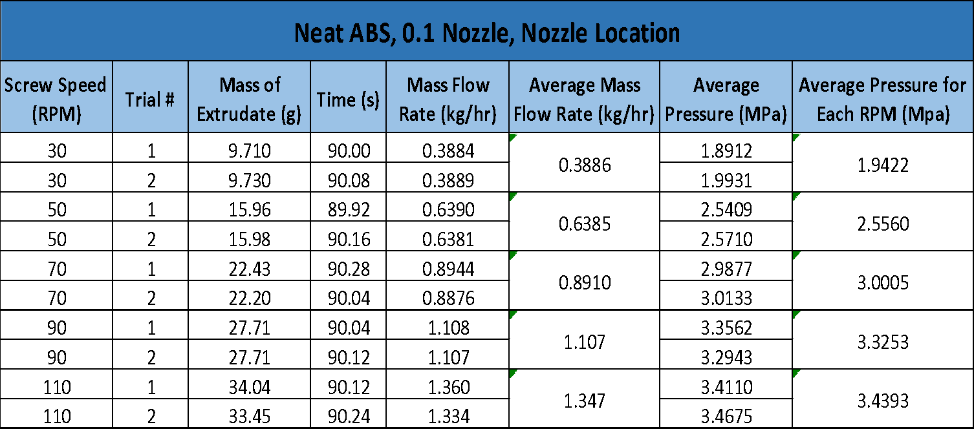
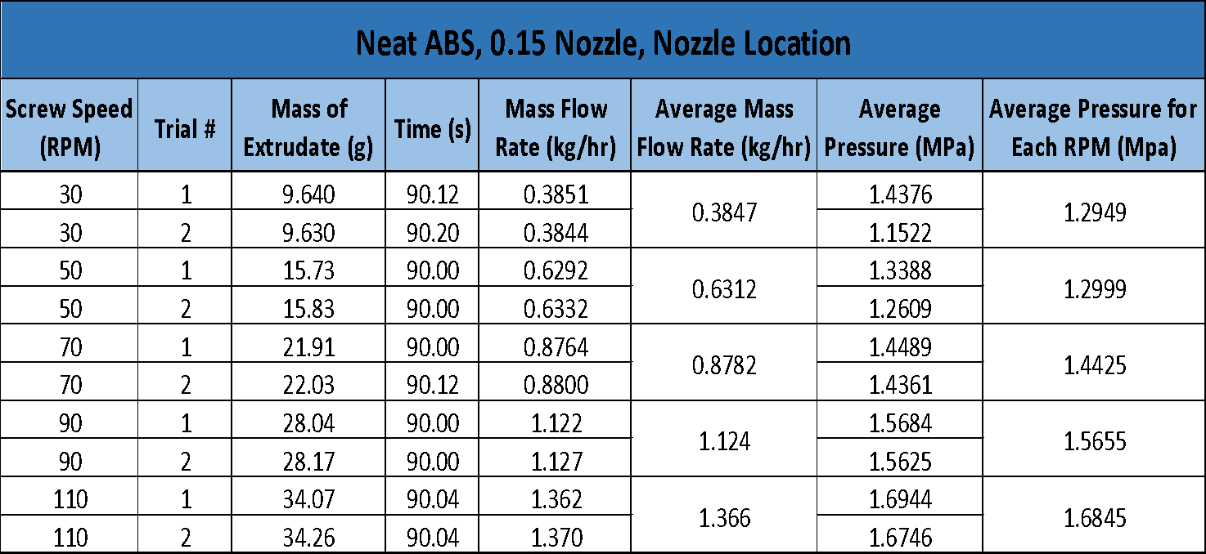
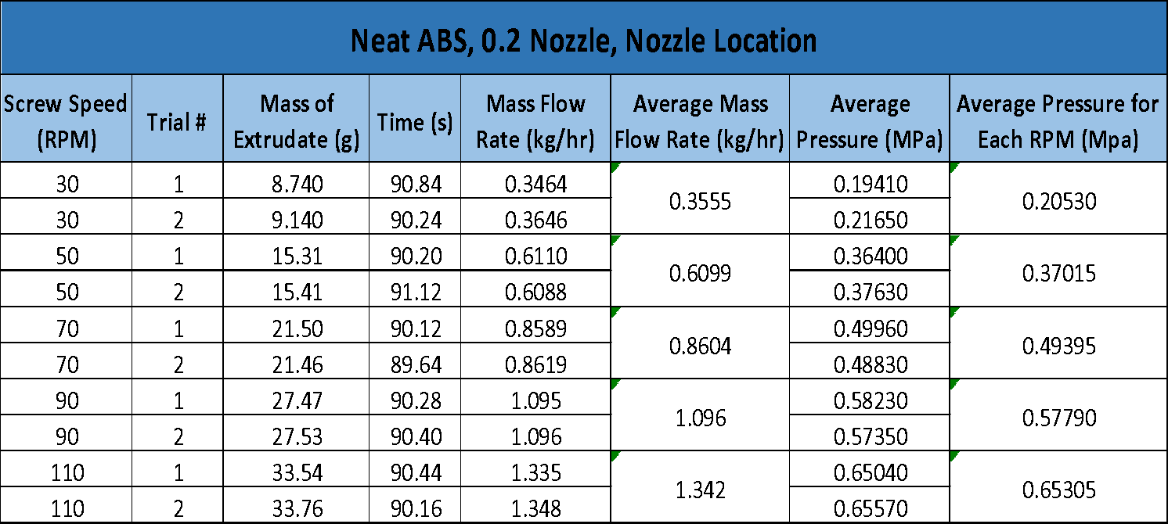
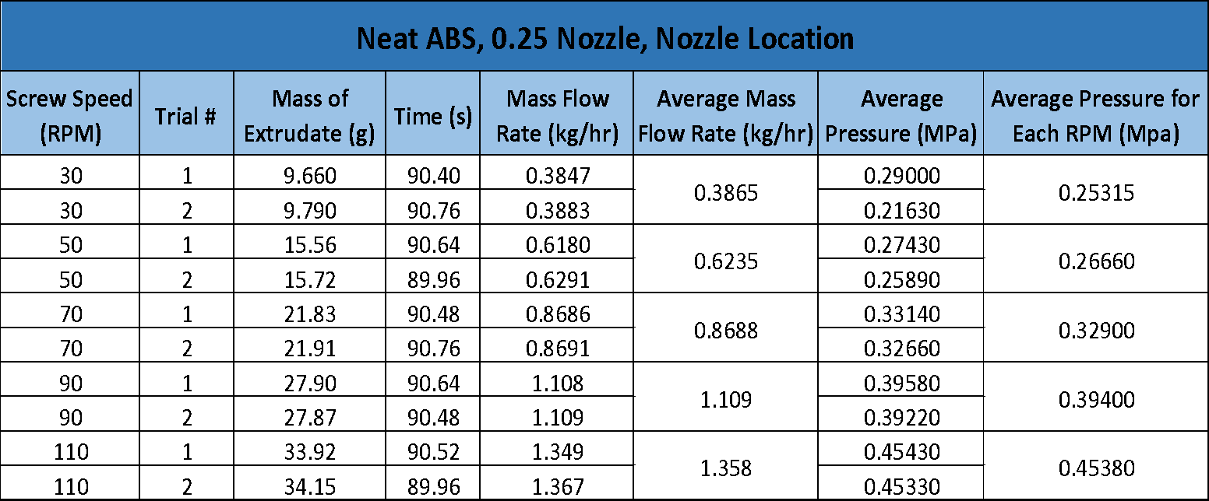
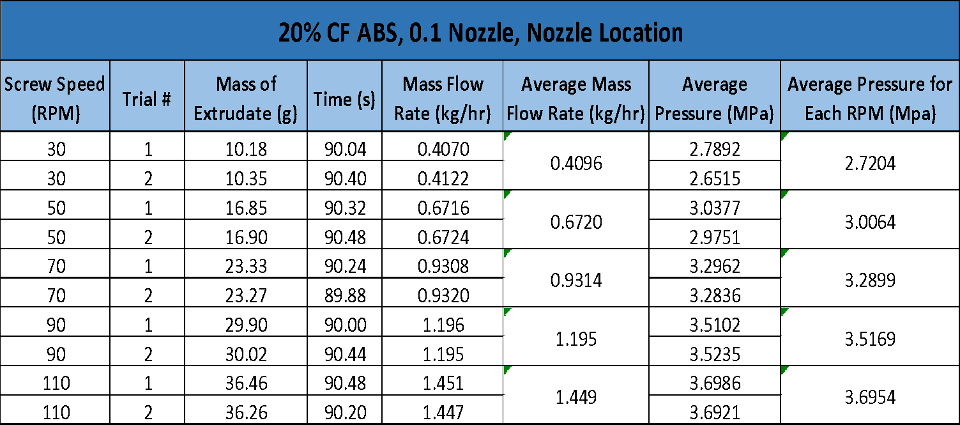
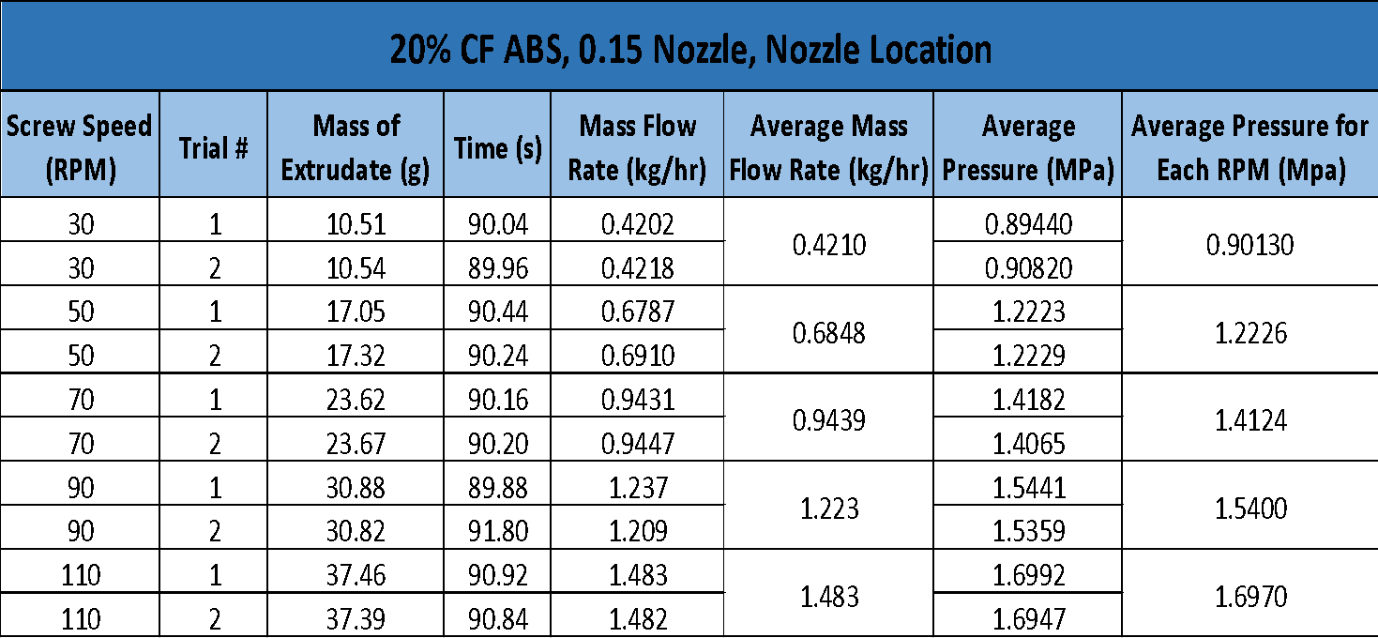
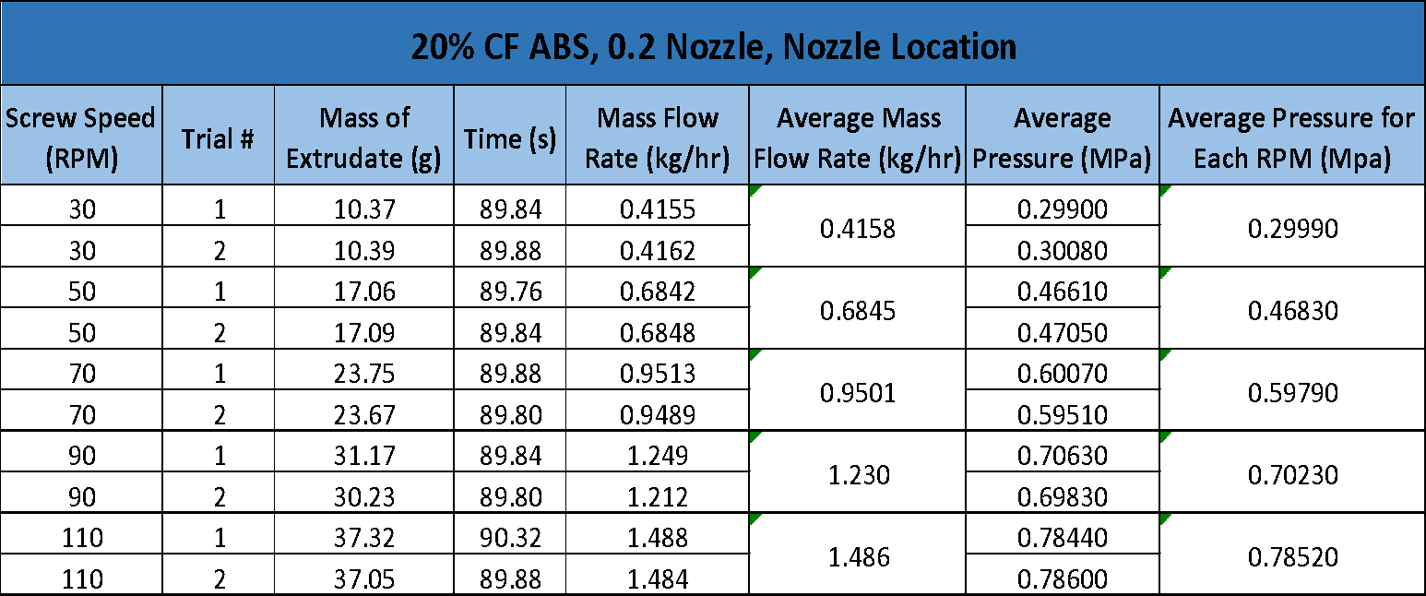
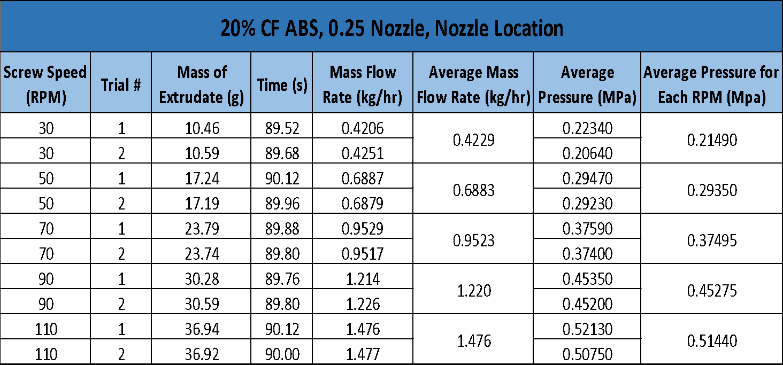

Vita
Jake Dvorak obtained his bachelor’s degree in Mechanical Engineering from the University of Tennessee in 2017. He continued to do graduate work by becoming a graduate research assistant under Dr. Chad Duty and a graduate teaching assistant under Dr. Matthew Young. While working his teaching assistantship in the MABE Maker Lab he conducted research for Dr. Duty and the Manufacturing Demonstration Facility. Jake will be continuing graduate work to obtain his PhD under Dr. Tony Schmitz doing machining research and improving the University of Tennessee’s machining capability and presence.

