Protein Studies: The Function of Constitutive Androstane Receptor (CAR) and its Associated Ligands

Jacob M. Amburn

The University of Tennessee, Knoxville

May 10, 2016

Abstract - Constitutive androstane receptor (CAR) is a nuclear receptor implicated in many physiological activities of the cell¹. Although it has the structural capability to function in the absence of a bound ligand, CAR has a wide variety of known ligands, such as CINPA-1, and the interaction with these ligands is important for possible drug treatment therapies. This study amplified the genetic construct for CAR by polymerase chain reaction (PCR), grafted it into a plasmid, and transformed Escherichia coli strains so that they acquired the plasmid. The strains were then assayed for CAR expression, and the strain with the best expression was grown for large-scale protein expression. The protein was isolated via affinity chromatography and further purified by size-exclusion chromatography. After purification the protein was concentrated and flash-frozen for long-term storage. A crystallization conditions screening was performed to determine the structure of CAR and its interaction with CINPA-1, but this screen was unsuccessful due to equipment malfunction.

Introduction

Nuclear receptors are common in signal transduction pathways. With the human genome encoding 48 different types of nuclear receptors¹, they are thought to be among the most prevalent families of transcriptional regulators in the Animal Kingdom². The term transcriptional regulator stems from the nuclear receptor’s ability to modulate transcription of an organism’s genome in various ways. They achieve this by directly interacting with the DNA at a regulatory site specific to the target gene. When activated by a specific signal, the nuclear receptor is transported through the nuclear pore into the nucleus, where it is then able to find and bind to a specific DNA sequence. This sequence is recognized by a distinct region of the nuclear receptor, termed the DNA-binding domain, or DBD² (Figure 1). This region is highly conserved between receptors and possesses a zinc-finger motif, which allows site-specific interaction with the DNA double helix². If this interaction increases transcription, the receptor is said to be an enhancer. If the opposite effect is achieved, the receptor behaves as a silencer, as the gene it acts on becomes expressed less frequently.
Another characteristic of nuclear receptors involves their activation mechanism. As implied by the name, a nuclear receptor receives some sort of environmental signal. This can be a peptide or hormone, for example, and it interacts with a specialized region of the receptor, namely the LBD, or the ligand-binding domain² (Figure 1). The LBD recognizes its ligand, and amino acids of the receptor form molecular interactions with the ligand. These interactions trigger a conformational change in the receptor that either activates or inactivates it. When activated, the nuclear receptor is able to carry out its function in the nucleus; when inactivated, the protein is unable to do so. Thus, the LBD serves an important role in regulating the activity of the entire receptor.
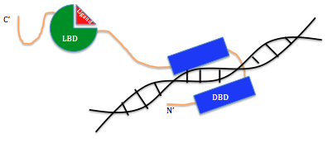
Constitutive androstane receptor (CAR) is a member of the nuclear receptor superfamily. When activated, it elicits a cellular response by modifying transcription, creating a cascade of events downstream that modifies the behavior of the cell in various ways¹. Unlike most nuclear receptors, however, CAR displays unusual activity in that it can become activated even in the absence of one of its ligands³. In this event, CAR is activated in response to a separate cellular signaling pathway. This usually occurs via phosphorylation or dephosphorylation of a threonine toward the N’ terminus³. This biochemical activity is important for the proper nuclearization of CAR, and the removal of the phosphoryl group on Thr-38 results in CAR being shuttled into the nucleus where it can properly function³.
Figure 1. General Structure of the Nuclear Receptor, CAR.
The typical nuclear receptor has two major regions of activity. The DNA-binding domain (blue) marks the site where the protein is able to interact directly with the DNA (black), which elicits a change in the transcription for a certain gene. The other conserved domain is the ligand-binding domain (green), which allows regulation of the nuclear receptor via interaction with various, specific ligands (red).
CAR usually exists in a multi-protein complex in the cytoplasm. This complex is then broken down and CAR is freed to enter the nucleus. This breakdown is regulated by both protein kinases and phosphatases, such as protein kinase A (PKA) and protein phosphatase 2A (PP2A)³. PKA and PP2A are each activated as the result of various signaling pathways. When PKA is activated, it phosphorylates CAR, which effectively sequesters it in the cytoplasm. PP2A dephosphorylates CAR, freeing it to enter the nucleus. Because of the nature of these PKA and PP2A pathways, CAR is thus activated independently of binding one of its ligands. Furthermore, the oppositional nature of these signaling pathways helps to keep CAR activity closely regulated.
In addition to this indirect method of activation, CAR can also be stimulated directly through interaction with ligands. CAR has been shown to have a variety of ligands, such as CINPA-1. These ligands can be either agonists or antagonists. Because of its constitutive nature, unbound CAR is in an active state when inside the nucleus³. This activity, however, is modulated by ligand-binding interactions; agonists serve to increase the activity while antagonists decrease its activity. Because CAR is involved in so many cellular processes, its regulation can be the key to understanding many other biochemical pathways in the cell.
One such pathway that is regulated by CAR is involved in drug efflux. The major mechanism through which CAR affects this is by transcriptional control of the gene multiple drug resistance 1 (MDR1)⁴. This gene encodes P-glycoprotein, which serves as a drug efflux pump⁵. This pump is implicated in multiple drug resistance; it is able to remove many different types of drugs from accumulating within the cell. This lack of accumulation means that medication cannot become concentrated enough to reach an effective dose, and this has become a problem for drug treatment therapies such as various chemotherapy regiments used to target cancerous cells.
For patients with a cancer diagnosis, the level of P-glycoprotein expression can be a strong predictor of their recovery outlook⁵. Typically, the more P-glycoprotein expressed, the less likely the patient will respond well to chemotherapy. Since this gene is regulated by CAR, it is possible that treating CAR with an antagonist can have the downstream effect of reducing expression of P-glycoprotein and thus increasing the susceptibility of cancer cells that previously were multi-drug resistant.

Materials and Methods

Plasmid Preparation
Site-specific mutagenesis was performed using pET15b6HisMBP-hCAR-LBD vector as the template DNA strand. Two reaction mixtures were prepared: one contained 1μM of 5x Phusion High-Fidelity buffer, 0.4μM dNTPs, 0.25μM of both the forward and reverse primers, 0.25μL of Phusion DNA polymerase, and 5ng of template DNA (PCR5), and the other contained the same concentrations of solutions with 10ng of template DNA (PCR10). The final reaction volumes were brought to 50μL by adding autoclaved deionized water. The reaction vessels were vortexed prior to the addition of Phusion, and were gently mixed before placement in the thermocycler. The initial denaturation temperature was programmed to 95°C for 3 minutes. The replication cycle was set to repeat 20 times with the following program: 95°C denaturation for 30 seconds, 55°C annealing for 30 seconds, and 72°C extension for 10 minutes. There was one final extension period of 10 minutes at 72°C after which the reaction was held at 4°C. The sample was then run on a 2.5% agarose gel to ensure proper amplification.
The PCR product was treated with 1μL of the restriction enzyme Dpn1 in 5 μL of CutSmart buffer. The reaction mixture was incubated at 37°C for one hour and was shaken at 225rpm for the first 30 minutes. This reaction was used to transform DH5α E. coli cells by heat shock. 2μL of the Dpn1 digestion reaction product was added to an eppendorf tube containing DH5α cells. The mixture was flicked gently to mix and set on ice for 20 minutes. The tube was heat shocked for 45 seconds in a 42°C water bath, and the mixture was then set in ice for 5 minutes. 450μL of 2XYT medium was added to the cells to bring the total volume up to 500μL, and the tube was placed in the 37°C shaker for 1 hour at 225rpm. This was repeated twice, once for PCR5 and once for PCR10. After incubation the samples were streaked on agar plates containing kanamycin and stored at 37°C overnight. Glycerol stocks were prepared for 5 transformant colonies from PCR5 and 2 transformant colonies from PCR10. These were stored at -80°C.
The plasmids from these stocks were isolated using Zymo Research Plasmid Miniprep-Classic kit, and concentrations were determined using a Nanodrop instrument. Three samples were submitted for sequencing using the Sanger sequencing method. Results were analyzed using ExPASy Translate Tool⁶ and NCBI Align Sequence Nucleotide BLAST⁷.

Expression Screening
The plasmids pET15b6HisMBP-hCAR PCR5-5 and pET15b6HisMBP-hCAR PCR10-1 were used to transform two strains of E. coli used for protein expression, RIPL and BL21. These transformation reactions followed the same protocol for the DH5α heat-shock transformation above, with the only exception being 4μL of plasmid added to the 100μL BL21 glycerol stocks to ensure that the cell to plasmid ratio was constant. The final volumes for the reaction were brought to 500μL by the addition of 400μL of 2XYT media to BL21 cells and 450μL of 2XYT media to RIPL cells. These reactions were placed in the 37° shaker at 225rpm for 1 hour. After incubation, the reaction tubes were centrifuged at 4000rpm for 1 minute to concentrate the cells toward the bottom of the tube, without forming a pellet. The top 400μL were disposed of, and the remaining 100μL were spread on agar plates. The plates for RIPL cells contained two antibiotics, kanamycin and chloramphenicol, while the plates for BL21 cells contained only kanamycin. Both plates were kept at 37°C overnight for growth.
5 colonies from each of the 4 plates, were transferred to 5 test tubes containing 5mL of 2XYT liquid medium and the appropriate antibiotics. These cultures were grown overnight in the 37°C shaker set at 225rpm. The next day, 30% glycerol stocks were made from the overnight cultures by mixing 700μL of the culture with 300μL of glycerol. The glycerol stocks were then kept at -80°C. An additional 50μL from each culture was used to inoculate another 5mL of 2XYT liquid medium with appropriate antibiotics. These cultures were grown in the 37°C shaker at 225rpm to an optical density (OD) of 0.7 at which point they were each induced with 2.5μL of IPTG and kept in a 20°C shaker at 225rpm for 20 hours.
The cultures were removed from the shaker after 20 hours, and 1mL of each sample was centrifuged for 5 minutes at 13000rpm. A sample of each pellet was taken and a Western blot was performed to verify correct protein expression.

Small-Scale Protein Preparation
Using the glycerol stocks prepared for each of the selected strains, a small-scale protein preparation was performed to more accurately screen for highest MBP-hCAR expression and isolation. A small sample from each glycerol stock was taken using a sterile inoculation loop, which was also used to streak agar plates containing the appropriate antibiotics. These plates were grown overnight at 37°C and then colonies were transferred to 5mL of 2XYT medium with antibiotics. These cultures were grown overnight in the 37°C shaker at 225rpm. Next, 2mL from each sample was used to inoculate 200mL of 2XYT media. These larger cultures were grown in the 37°C shaker at 225rpm for 3 hours. After growth, the OD was checked and the cultures were induced with 100μL of IPTG.
The samples were then placed in the 20°C shaker at 225rpm for 20 hours. The cells were harvested by centrifugation at 7000rpm for 7 minutes. The supernatants were decanted and the pellets were stored at -80°C.
The pellets were resuspended in lysis buffer and sonicated for 4 minutes with a 30 second pulse time followed by 1 minute of wait time. After the cells were lysed, the samples were centrifuged for 1 hour at 17000rpm. The pH of the supernatant was then tested and corrected to be 8.0 by the addition of 8M NaOH. Each supernatant was run through an affinity chromatography column with 100μL of Ni-NTA resin at the base. The supernatant flowed through the column slowly, so it was only passed through the column once. The column was washed with Tris-HCl wash buffer to remove any unbound proteins. The columns were then eluted 5 times with 100μL elution volumes. Samples were taken throughout this process (supernatant, pellet, flow-through, washed resin, elution 2-3, and end resin) and mixed with 20μL of SDS dye to run on an SDS-PAGE gel.

Large-Scale Protein Preparation
For the large-scale prep, the BL21 10-4 strain was used because it was shown to have the greatest expression of MBP-hCAR. A small sample was taken from the glycerol stock and plated on an agar plate with kanamycin. The plate was kept overnight at 37°C for colony growth. Two isolated colonies were transferred to 2 test tubes containing 5mL of 2XYT liquid medium and kanamycin. The liquid cultures were placed in the 37°C shaker at 225rpm overnight. After one night of growth, the two test tubes were combined into a flask containing 1L of 2XYT medium and kanamycin. This culture was grown to an OD of 0.7 after which it was induced with 500μL of IPTG and placed in the 20°C shaker at 225rpm for 20 hours. The cells were then harvested by centrifugation at 7000rpm for 7 min and the pellets were stored at -80°C.
For the protein isolation, the pellet was first resuspended in 15mL of Tris-HCl lysis buffer containing 1.5μL of DNAse, 30μL PMSF, and 5μL of βME. The resulting solution was passed through the French Press one time at a pressure of 1500psi to lyse the cells. The lysate was then centrifuged for 1 hour at 17000rpm. The pH of the supernatant was measured at 7.97 and the supernatant was passed through an affinity chromatography column with a 750μL bed volume of Ni-NTA resin at the bottom. The supernatant was allowed to pass through the column a total of two times to ensure that the desired protein had effectively bonded to the resin. The column was washed with 25mL of Tris-HCl wash buffer, and 5 elutions of 750μL each were taken. The concentration for each elution was measured using Bradford’s reagent (Table 3).

Protein Purification and Concentration
After MBP-hCAR was isolated via affinity chromatography, it was further purified by size-exclusion chromatography (SEC). A total of 2mL of protein from elutions 1, 2, and 3 from the Ni-NTA column were loaded onto a gel filtration machine equipped with an S200 SEC column. The column was equilibrated with gel filtration buffer containing: 20mM Tris-HCl, 100mM NaCl, .1mM EDTA, and 1mM DTT. The machine was programmed to collect 1.5mL fractions at a flow rate of 1mL/minute until the entire sample had been run through the column. To determine which peak corresponded with the desired protein, a sample from both the peak marked 69.19 (fraction 18) and that marked 79.03 (fraction 26) were taken and run on SDS-PAGE. The resulting gel showed that peak 79.03 contained MBP-hCAR and that it had been successfully purified by the size-exclusion chromatography (Figures 4 and 5). The fractions corresponding to this peak were collected and the sample was concentrated down to 10mg/mL using an Amicon concentrating unit with a filter with a size cut-off of 10kDa. The concentrated sample was flash-frozen using liquid nitrogen to ensure that the protein was not damaged during the freezing process, and the frozen protein was stored at -80°C.

Crystallization Screening
To examine the structure of MBP-hCAR, two Peg-Ion crystallization screens were prepared. The first was MBP-hCAR alone, and the second was MBP-hCAR with CINPA-1. For the second screen, 80μL of MBP-hCAR was mixed with 2μL of CINPA-1. A robot was used to nanodispense small amounts of the protein sample into a 3-well plate containing different amounts of each of the 96 Peg-Ion crystallization buffers. The screens were sealed and incubated at 25°C.
4
Results
Plasmids isolated from samples PCR5-5 and PCR10-1 showed 100% sequence identity to the MBP-hCAR sequence, but PCR10-2 failed to sequence (Table 1).
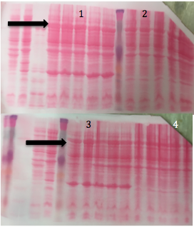

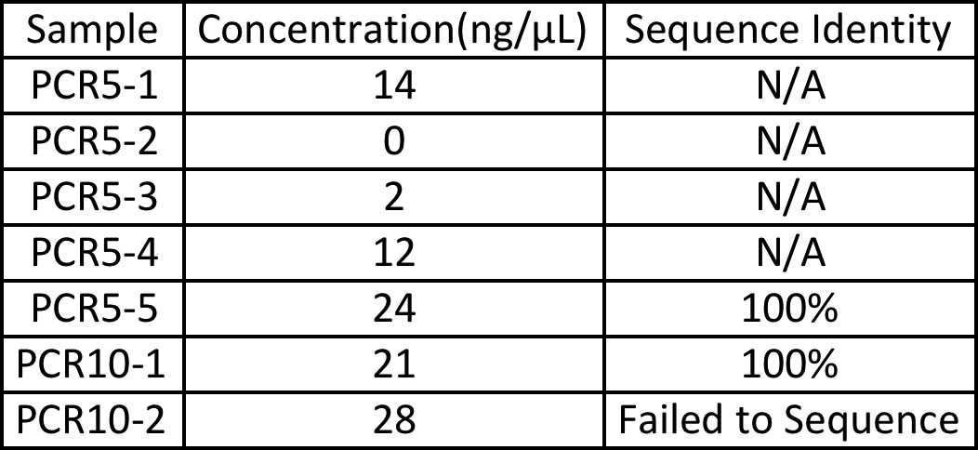

Table 1. The Results of Plasmid Preparation for pET15bMBP-hCAR.
Five samples from the original PCR5 reaction and two samples from PCR10 were chosen to isolate plasmids. Of these plasmid preparations, samples PCR5-5, PCR10-1, and PCR10-2 showed high concentrations and were selected for sequence analysis. Of these three samples, PCR5-5 and PCR10-2 matched the theoretical sequence with 100% identity. PCR10-2 failed to sequence. PCR5-1 through PCR5-4 did not show strong enough isolation and were not sequenced.

Although there were issues with the antibody binding to the Western blot (Figure 2), the band pattern of the stain shows that each culture produced MBP-hCAR. The results were compared with each other and those that were thought to have the best expression of MBP-hCAR were selected for further experimentation. The selections were made so that both combinations of cells and plasmids were represented.

Figure 2. Western Blot Expression Screening.
The left screen is for BL21 10 and RIPL 10 and the right screen is for BL21 5 and RIPL 5. The row of bands indicated by the black arrows represents MBP-hCAR at approximately 75kDa. Each sample produced the desired protein, so their respective bands were compared against each other to determine which appeared to be expressed more strongly. Those selected are RIPL 10-3 (1), BL21 10-4 (2), RIPL 5-4 (3), and BL21 5-2 (4).

The BL21 strains showed faster growth rates than the RIPL strains. Both BL21 samples reached higher optical densities than RIPL samples grown for the same amount of time (Table 2).
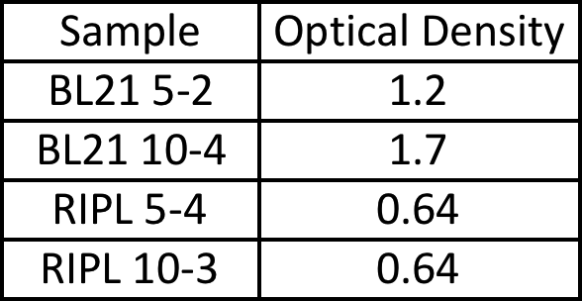

Table 2. Sample ODs for Small-Scale Preparation.
The optical density for each of the four observed-growth colonies is shown above. Despite being grown for the same time, the BL21 cultures grew to a much higher OD than RIPL.

The SDS samples taken for the small-scale protein preparations were run on an SDS-PAGE gel and the expression between each strain was compared against each other to determine that BL21 10-4, which showed the greatest concentration of MBP-hCAR, would be used for a larger prep (Figure 3).

1 2 3 4 5 6 7 8 9 10 11 12 13 14 15
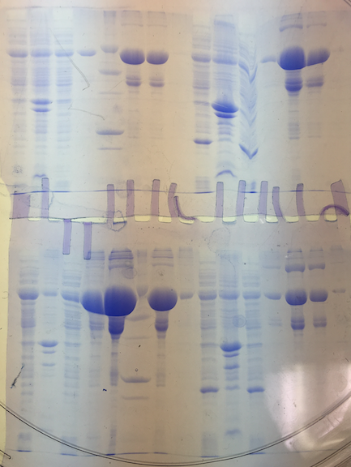

Figure 3. SDS PAGE Results for Small-Scale Protein Preparation.
The gel on top has samples BL21 5-2 and RIPL 5-4. In lane 6 and 7 are elution 2 and 3 from BL21 5-2, and in land 13 and 14 are elution 2 and 3 from RIPL 5-4, respectively. Lane 5 contains the ladder, and the arrow designates the marker for 75kDa, which corresponds to the location of MBP-hCAR. The bottom gel has samples from BL21 10-4 and RIPL 10-3. Lanes 5 and 7 contain BL21 10-4 elution 2 and 3 respectively, and lanes 13 and 14 contain elution 2 and 3 from RIPL 10-3. The large band circled in lane 5 shows the highest concentration of MBP-hCAR and thus was chosen for further experimentation.

Table 3 shows the total amount of MBP-hCAR produced by the BL21 10-4 strain. The high concentrations of elutions 2 and 3 show that this strain is highly effective for large-scale expression of MBP-hCAR. With more than 20mg of protein produced, this strain demonstrated the ability to produce very large quantities of protein.

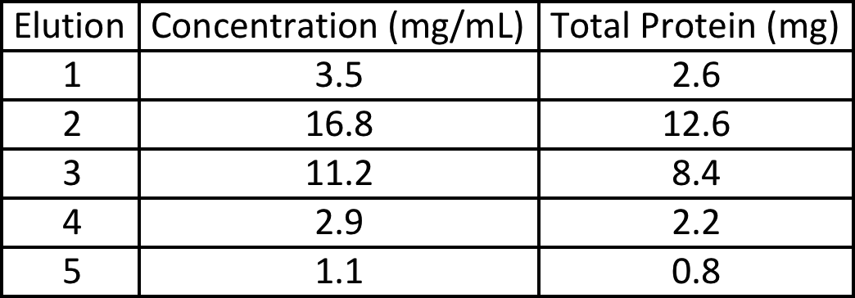

Table 3. The Concentrations and Total Amount of Protein Isolated After Affinity Chromatography.
The concentration was calculated using Bradford’s reagent. 2μL of protein was added to a mixture of 200μL of Bradford’s reagent and 798μL of deionized water, and the absorbance at 595nm was measured using a UV spectrometer. The absorbance was multiplied by a factor of 10 to yield the concentration in mg/mL. The total protein was then calculated by multiplying the concentration by the volume of each elution (750μL).

The size-exclusion chromatography machine produced the following chromatogram (Figure 4). The peak marked 79.03 is MBP-hCAR. The blue line measures absorbance at 260nm, and the sharpness of this peak signifies a large amount of protein.
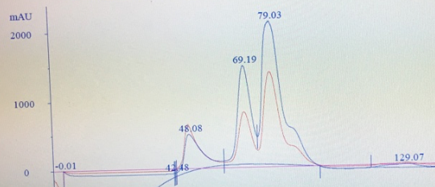

Figure 4. The Chromatogram Produced by Size-Exclusion Chromatography.
The peak marked 79.03 is MBP-hCAR. This peak was distributed over 5 fractions, which were later combined into one vessel. The peaks marked 48.08 and 69.19 were indicative of proteins larger than the ~70kDa MBP-hCAR. The blue line measures the absorbance of the sample at 280nm, the wavelength used to show absorption by protein.
The final SDS-PAGE (Figure 5) was run after SEC and Ni-NTA. Peak 2 contains isolated and purified MBP-hCAR, after SEC. MBP-hCAR is also seen in high concentration in lane 6, after Ni-NTA, but the sample is less pure.
1 2 3 4 5 6 7 8 9 10 11
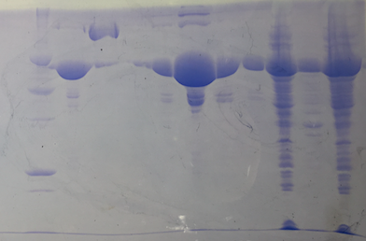

Figure 5. SDS-PAGE After Ni-NTA and SEC.
Lane 1 contains the ladder. Lane 2 contains fraction 26 from peak 79.03. Lane 3 contains fraction 18 from peak 69.19. The remaining lanes contain samples from the affinity chromatography column. Lane 2 shows that peak 79.03 corresponds to MBP-hCAR. It also shows that MBP-hCAR has been successfully purified by size-exclusion chromatography. Comparing lanes 2 and 6 show that, although the protein is now more dilute, the majority of impurities have been removed from the sample.

There are no results for the final crystallization conditions screening due to equipment malfunction.

Discussion

This experiment successfully isolated and purified MBP-hCAR, a construct that contains the human nuclear receptor CAR as well as the Maltose Binding Protein (MBP) of E. coli. MBP was chosen because it contains a genetic marker consisting of 6 consecutive histidine residues. This tag has the benefit of allowing the protein to bind to the Ni-NTA resin of the affinity column for easier isolation⁸.
Beginning with the plasmid preparation, two separate PCR reactions were carried out to test the effect of template DNA concentration on amplification. Both reactions used Phusion DNA polymerase, which has an error rate more than 50-times lower than the standard Taq polymerase used in PCR reactions⁹, and both reactions successfully amplified the target DNA sequence. These reactions were then digested using Dpn1, a restriction enzyme that cleaves between the adenine and thymine residues of a methylated GATC inverted repeat¹⁰. Cleavage by this enzyme results in blunt ends in the recognition sequence of both the target plasmid as well as the PCR product, which must then be ligated together in order to form a complete plasmid containing the gene targeted for expression. When used to transform DH5α cells, the reaction mixture that contained 5ng of template DNA was taken up more successfully by the cells. After overnight growth on agar plates, the plate inoculated with DH5α-5 had far more transformant colonies than that inoculated by DH5α-10 cells. Because of this, 5 colonies were selected from DH5α-5 and 2 colonies were selected from DH5α-10. After the plasmids were isolated and sequenced, however, it was shown that both PCR5 and PCR10 resulted in one successfully replicated plasmid, respectively.
During the expression-screening step of the experiment, 20 small cultures (5 from BL21 5, 5 from BL21 10, 5 from RIPL 5, and 5 from RIPL 10) were made. Both BL21 and RIPL E. coli strains are competent, meaning that they are able to take up DNA from their surrounding environment. RIPL is a substrain of BL21 that is designed to contain extra tRNA genes and thus additional tRNAs¹¹, which can be helpful in making protein translation more efficient. However, for this experiment, the BL21 strain showed the greatest expression. These cultures were tested for expression of MBP-hCAR by Western blot (Figure 2), an assay that utilizes antibodies that are specific to a certain antigen to determine whether that specific antigen is present¹². After the addition of antibody specific to the desired protein, there appeared to be no interaction between the antibody and protein. This typically signifies that the target protein is not present. Testing the antibody with a protein known to be isolated, however, also resulted in the same non-interaction. Thus, it was reasoned that the error in the Western blot was due to the antibody, and that the identified band was indeed MBP-hCAR.
During the small-scale protein preparation, the 4 strains showing the highest expression in the Western blot were used to inoculate 4 small liquid cultures. 2XYT was used as the growth medium of choice because it is enriched to allow faster growth and allowed the cells to be grown for longer durations¹³. For the observed growth cultures, the optimal OD range is said to be between 0.4-0.8¹⁴. Once the culture’s OD is within this range it should be induced with IPTG, which is a molecularly engineered metabolite used to induce E. coli’s Lac operon. Unlike lactose, the natural inducer of the Lac operon, IPTG is not broken down by the organism¹⁵. This is beneficial for induction purposes because it allows continuous activation without loss of the inducing agent, such that the operon will be turned on longer and more efficiently. For both of the BL21 samples the ODs surpassed the ideal range before they were induced. This overgrowth may have led to competition for resources and premature cell death, causing the induction to be less successful. Based on the results of the protein preparation, though, it appears that the sample with the highest expression of MBP-hCAR, BL21 10-4, was also grown to the highest OD (Table 2). Furthermore, when running the samples through the Ni-NTA affinity chromatography columns, the flow rate was slow in all samples except RIPL 5-4. For sample BL21 5-2, the column stopped flowing completely and the sample was quickly run through another clean column. Columns BL21 10-4 and RIPL 10-3 were dried out to accelerate the flow. Though these techniques could have skewed the data regarding which strain had the best expression, BL21 10-4 showed much greater expression despite expedited flow through.
For the large-scale protein preparation, BL21 10-4 was chosen because it has been shown to produce high quantities of MBP-hCAR under the desired growth conditions. A French Press was chosen to lyse the cells for two reasons: it allows the reaction volume to be much less than it would have been with sonication, and it provides a more complete and efficient lysis of cells¹⁶. Typically, the resuspended cells are passed through the French Press either 1 or 2 times. A single passage is enough to lyse approximately 75-percent of the cells, with a second passage lysing the remaining cells¹⁶. Because the lysate appeared to be thoroughly lysed after 1 passage through the French Press, it was decided that it would not be re-lysed to limit any potential damage caused by overexposing the protein to the high pressure produced by the French Press. After centrifuging the lysate, the supernatant was run through a Ni-NTA affinity chromatography column a total of 2 times. This ensured that MBP-hCAR, whose histidine tag is able to bind the resin, had ample opportunity to bind. A downside to this method is the possibility that proteins other than that with the histidine tag can bind the resin as well¹⁷. This means that, although the desired protein will be much more isolated than before, it might still have some impurities.
To remove these impurities, the eluted protein was passed through a size-exclusion chromatography column. This technique separates proteins based on size, with large proteins passing through more quickly than small proteins¹⁸. The S200 column chosen had a size limit of 200kDa. Since MBP-hCAR is 70kDa, it would elute off the column toward the middle of the collection period and would not elute off the column prior to or after the collection period and be lost. Size-exclusion chromatography allows for more specific separation of proteins, and thus is another method by which purified MBP-hCAR was isolated. Although there is still slight contamination by other proteins after SEC (Figure 5), it was not enough to classify the protein as impure. Since SEC elutes the protein over a few separate fractions, it is possible for fractions to overlap such that similarly sized proteins are being eluted at the same time. This phenomenon gives rise to the low level of contamination, though it could be ameliorated by being more selective in determining which SEC fractions to collect, and thus collecting fewer total fractions. After collection, the protein was concentrated down to 10mg/mL using an Amicon concentrating unit with a filter size cutoff of 10kDa. This unit uses pressurized nitrogen gas to slowly force the buffer through the filter while the protein, which is too large to pass through the filter, remains behind. This allows the protein to reach a concentration suitable for further experimentation. After concentration, the protein was flash-frozen using liquid nitrogen. This prevented the ice shards that form during the normal freezing process from damaging the protein. Storage of the protein at -80°C allowed it to be kept long-term for further experimentation.
Due to equipment malfunction, the crystallization screening experiment did not succeed. The robot did not properly dispense the Peg-Ion buffers into the appropriate wells, and the protein dispenser periodically became clogged. This resulted in inappropriate mixing between protein and buffer. Because of this, the protein was not able to crystallize, and no information regarding the mechanism of inactivation can be discerned regarding MBP-hCAR’s interaction with CINPA-1.

Conclusion

Overall, this experiment was successful in isolating and purifying MBP-hCAR. It was shown that both BL21 and RIPL strains of E. coli could be manipulated to express MBP-hCAR at high levels, though BL21 showed greater expression. Initial protein isolation was effectively performed using a Ni-NTA affinity chromatography column, and size-exclusion chromatography was successfully utilized to purify the remaining protein. Despite initial successes, this experiment was not effective in determining the structure of MBP-hCAR and its interaction with an antagonist ligand, CINPA-1.

Further Research

After isolation of MBP-hCAR, additional studies must be performed to better understand the structure and function of CAR. The primary focus of any additional experimentation should be to complete the attempted crystallization condition screens to show the structure of MBP-hCAR as well as structural changes when bound to a ligand such as CINPA-1. From there, treating MBP-hCAR with TEV protease will cleave off the Maltose-Binding Protein, allowing for sole isolation of CAR for further studies. Setting up crystal screens with CAR as well as with its associated ligands will help shed light on the binding mechanism of CAR’s LBD as well as demonstrate methods of ligand-mediated activation or inactivation of CAR, the latter of which can be used therapeutically to decrease multi-drug resistance in cancer cells.

References

- Kachaylo, E. M., Pustylnyak, V. O., Lyakhovich, V. V., Gulyaeva, L. F. (2011). Constitutive Androstane Receptor (CAR) Is a Xenosensor and Target for Therapy. Biochemistry, 76.10, 1087-1097.
- Robinson-Rechavi, M., Garcia, H. E., Laudet, V. (2003). The Nuclear Receptor Superfamily. Journal of Cell Science 116, 585-586.
- Yang, H., Wang, H. (2013). Signaling control of the constitutive androstane receptor (CAR). Protein Cell, 5.2, 113-123.
- Wang, Y., Masuyama, H., Nobumoto, E., Zhang, G., Kiramatsu, Y. (2014). The inhibition of constitutive androstane receptor-mediated pathway enhances the effects of anticancer agents in ovarian cancer cells. Biochemical Pharmacology, 90, 356-366.
- Maraldi, N. M., Zini, N., Santi, S., Scotlandi, K., Serra, M., Baldini, M. (1999). P-glycoprotein subcellular localization and cell morphotype in MDR1 gene-transfected human osteosarcoma cells. Biology of the Cell, 91, 17-28.
- Swiss Institute of Bioinformatics. (n.d.). ExPASy Translate Tool.
- U.S. National Library of Medicine. (n.d.) Align Sequences Nucleotide BLAST.
- Cabanne, C., Pezzini, J., Joucla, G., Hocquellet, A., Barbot, C., Garbay, B., Santarelli, X. (2009). Efficient purification of recombinant proteins fused to maltose-binding protein by mixed-mode chromatography. Journal of Chromatography A, 1216, 4451-4456.
- New England BioLabs Inc. (2016). Phusion High-Fidelity DNA Polymerase.
- New England BioLabs Inc. (2016). Dpn1.

- Stratagene. (n.d.). Competent Cells: How do you choose the right competent cell?
- Mahmood, T., Yang, P. (2012). Western Blot: Technique Theory, and Trouble Shooting. North American Journal of Medical Sciences, 4.9, 429-434.
- Neogen. (2010). 2xYT Medium (7281).
- New England BioLabs Inc. (2016). Protein Expression Using BL21 (DE3) (C2527).
- PubChem (n.d.). IPTG.
- Benov, L., Al-Ibraheem, J. (2002). Disrupting Escherichia coli: A Comparison of Methods. Journal of Biochemistry and Molecular Biology, 35.4, 428-431.
- Bornhorst, J. A., Falke, J. J. (2000). Purification of Proteins Using Polyhistidine Affinity Tags. Methods Enzymol, 326, 245-254.
- Bio-Rad. (2016). Introduction to Size Exclusion Chromatograghy.

