No Tunes Chime Amidst the Bones:
A Zooarchaeological Analysis of Saltpeter Cave (3NW29), an Ozarchaic Bluffshelter in Northwest Arkansas

A Thesis Presented for the
Master of Arts
Degree
The University of Tennessee, Knoxville

Nathanael G. Fosaaen
August 2022

Copyright © 2022 by Nathanael G. Fosaaen
All rights reserved.

DEDICATION

In memory of Jamie Chad Brandon
1971-2018

ACKNOWLEDGEMENTS

I have been blessed beyond belief with a community of friends, colleagues, teachers, and mentors who have imparted some of themselves into this work through their support, insight, criticism, and editorial acumen. First, I must thank my committee- Drs. Kandace Hollenbach, Anneke Janzen, and David Anderson- for their expert guidance. Kandi in particular has always had patience for my excited chatter and thinking-out-loud while firmly directing me back to the task at hand when I had wandered off into the proverbial weeds. They really don’t make better mentors.

I would like to thank Dr. Jamie Brandon, to whom this work is dedicated. This thesis would never have begun without his encouragement or infectious love for forgotten people from allegedly insignificant places. Thanks also to Dr. Tom Whyte, who has remained a mentor to me for more than a decade after I left his classroom.

Thanks are also owed to Dr. George Sabo, Dr. Jessica Kowalski, Jared Pebworth, and the Arkansas Archeological Survey in Fayetteville for allowing me the use of the Saltpeter Cave collections, upon which this research is based. Pritam Chowdhury, Dr. Stephen Collins-Elliott, and Dr. Heather Lapham were always willing to offer advice and technical support when needed.

Kilan Jacobs of the Osage Nation and Sam Mingo of the Mississippi Band of Choctaw Indians have kindly provided feedback pertaining to this research. I am very grateful for their perspectives, insights, linguistic knowledge, and encouragement in this work which relates to their cultural heritage far more than it does mine.

My friends in the University of Tennessee Anthropology Department were of course instrumental in the completion of this work: Katherine Parker, Jordan Schaefer, Catherine Herring, Elizabeth Tarulis, Aubrey Roemer, and Jen Green. The company, conversations, meals, and countless drinks have been good medicine these several years. I’d never have made it without y’all. My gratitude is also owed to Brigid Ogden and Taylor Bowden for the many consults, tea times, and readings from the soggy scripture. Each of the persons mentioned have read some percentage of the texts cited in this thesis to me aloud, and Jade Frantz typed the manuscript from my dictation, as I can neither read nor write. I would be remiss if I didn’t also thank Catherine Herring and Jordan Schaefer for making maps for me, and James Cate for letting me borrow the Battle Station for editing and formatting. I would also like to acknowledge my friends from the University of Arkansas for drinking with me during a very dark year: Amy Faust, Marc Marino, Sam Martin, Justin Dubois, Cheyenne Lewis, Carl Williford, Will Loder, and Victoria Jones. Kayden Dennis was there too sometimes.

I am bonded in blood, sweat, alcohol, and laughter with my field family. These people helped me cultivate the personal fortitude that got the job done: Coke Can, Shawny, Razor, El Que, Peppa Jack, Peaches, Cap’n Blood, D-Rock, Lt. Dan, Ski Ball, Shawn Hamm, Crawling Wolf, Texas Toast Tom, High Standards, Whitty, Dionysus, Omar, the All-American, Cypriot Boy, Sonny-D, Ballewga, the Alpha, Country Bob, and a whole host of other folks with less colorful names. Thank you not only for your support and encouragement, but also for your tireless and thankless service in protecting our nation’s irreplaceable cultural resources. I hope I will see you soon.

I am also indebted to Ken Sassaman for writing The Eastern Archaic, Historicized which is largely responsible for my devotion to the Archaic cultures of the American Southeast, and to David Anthony for The Horse, the Wheel, and Language, which reminds me to think linguistically wherever possible. I also should acknowledge Binford’s ghost and Patty Jo Watson’s spirit who remind me periodically to keep myself firmly rooted in the data.

Thanks are owed to Unreqvited, Insomnium, Seven Spires, and Æther Realm, for composing the soundtrack to the writing of this thesis.

ABSTRACT

The Southeastern Ozarks region is a karst limestone environment featuring many sheltered sites, including Saltpeter Cave in Newton County, Arkansas. Early and Middle Archaic components of this site assemblage contain abundant faunal materials that illustrate how Archaic peoples modified their subsistence strategies to accommodate significant climate change that began ~10,000 years ago. I have employed several quantitative techniques, including, density-mediated attrition analysis, diet breadth models, and bone fragmentation patterns to investigate the hunting and trapping strategies, taphonomic processes, and ultimately the faunal component of foodway practices at this southern Ozarks archaic site. To facilitate a regional perspective, I have also employed small mammal representation and correspondence analysis using datasets from Dust Cave, Modoc Rock Shelter, and Little Freeman Cave in Alabama, Illinois, and Missouri respectively to contextualize these practices in a broader landscape. While people living in other parts of the Eastern Woodlands region appear to have altered their species selection patterns to cope with these changes, the people occupying Saltpeter Cave retained a selective concentration on forested patches which they quarried for game in what must have been a diverse mosaic landscape between 10,000 and 4,000 cal BP.

Table of Contents

CHAPTER ONE: INTRODUCTION…………………………………………………….. 1
The Southern Ozarchaic………………………………………………………………... 1
Objectives and Research Questions……………………………………………………. 2
Theoretical Considerations…………………………………………………………….. 3
Notes on Style……………………………………………………………………….. 5
CHAPTER TWO: SET AND SETTING…………………………………………………. 6
Physiographic Setting………………………………………………………………….. 6
Environmental Setting…………………………………………………………………. 6
Ecological Variation in the Ozarks………………………………………………….. 9
Faunal Communities……………………………………………………………….. 10
CHAPTER THREE: BACKGROUND…………………………………………………. 20
Culture History……………………………………………………………………….. 20
The Paleoindian Period: The First Settlement of the Americas……………………. 20
The Archaic Period: Changing Environments and Adaptive Strategies in the Eastern Woodlands…………………………………………………………………………. 20
The Ozarks in the Terminal Paleoindian and Archaic Periods……………………….. 21
Early Archaic (11,500-8000 cal BP)……………………………………………….. 21
Middle Archaic (8000-5000 cal BP)……………………………………………….. 22
Archaic Period Zooarchaeology in the Southern Ozarks……………………………... 23
Sheltered Sites………………………………………………………………………… 24
CHAPTER FOUR: ARCHAEOLOGICAL SITES……………………………………... 27
Saltpeter Cave………………………………………………………………………… 27
Comparative Datasets………………………………………………………………… 31
Modoc Rock Shelter……………………………………………………………….. 35
Dust Cave…………………………………………………………………………...35
Little Freeman Cave………………………………………………………………... 36
CHAPTER FIVE: SCOPE OF RESEARCH……………………………………………. 37
Intra-Site Analysis……………………………………………………………………. 37
Taxonomic Selection and Representation………………………………………….. 37
Element Representation……………………………………………………………. 37
Bone Fragmentation………………………………………………………………... 38
Seasonality…………………………………………………………………………. 38
Inter-Site Analysis……………………………………………………………………. 39
CHAPTER SIX: METHODS…………………………………………………………… 41
Concerning Bias……………………………………………………………………… 41
Deposition Bias…………………………………………………………………….. 41
Preservation Bias…………………………………………………………………... 41
Recovery Bias……………………………………………………………………… 42
Identification Bias…………………………………………………………………. 42
Zooarchaeology………………………………………………………………………. 43
Data Collection…………………………………………………………………….. 43
Quantification……………………………………………………………………… 45
Richness, Diversity, and Evenness………………………………………………… 45
Density-Mediated Attrition………………………………………………………… 47
Diet Breadth Modeling……………………………………………………………….. 47
Correspondence Analysis…………………………………………………………….. 50
Habitat Index Analysis……………………………………………………………...51
CHAPTER SEVEN: RESULTS………………………………………………………… 55
General Data………………………………………………………………………….. 55
Taxonomic Summaries……………………………………………………………….. 55
Early Archaic………………………………………………………………………. 55
Middle Archaic 1…………………………………………………………………... 64
Middle Archaic 2………………………………………………………………….. .65
Seasonality……………………………………………………………………………. 65
Density-Mediated Attrition…………………………………………………………… 67
Medium Mammal Element Frequencies……………………………………………… 70
Bone Modification Patterns…………………………………………………………... 70
Fragmentation of Medium to Large Mammal Elements…………………………… 70
Burning Patterns, Cuts, Percussion, and Gnawing………………………………… 73
Bone Tools and Adornments………………………………………………………. 73
Bone Modification Summary……………………………………………………… 80
Richness, Diversity, and Evenness…………………………………………………… 80
Diet Breadth Modeling……………………………………………………………….. 82
Intersite Analysis……………………………………………………………………... 87
Habitat Group Index Analysis……………………………………………………... 87
Correspondence Analysis………………………………………………………….. 87
Small Mammal Selection…………………………………………………………... 91
CHAPTER EIGHT: CONCLUSIONS………………………………………………….. 95
Saltpeter Cave………………………………………………………………………… 95
Early Archaic………………………………………………………………………. 95
Middle Archaic 1…………………………………………………………………... 95
Middle Archaic 2…………………………………………………………………... 96
Summary…………………………………………………………………………… 96
The White-Tailed Deer Beyond Caloric Value……………………………………. 96
Inter-site Implications………………………………………………………………… 97
The Gray Fox in the Ozarchaic and Recent Eastern Cultures……………………... 98
CONCLUSION……………………………………………………………………… 100
LIST OF REFERENCES………………………………………………………………. 101
APPENDIX…………………………………………………………………………….. 115
Supplemental Figures……………………………………………………………... 115
Supplemental Tables……………………………………………………………… 117
VITA…………………………………………………………………………………… 119

LIST OF TABLES

Table 2.1. Taxonomic Inventory for the Ozarks and Interior Highland Region, Adapted from Echternacht and Harris(1993:83-102). 11
Table 4.1. AMS Dates from Saltpeter Cave in Order of Depth from Highest to Lowest, Expressed in Radiocarbon Years Before Present (RCYBP) and Calibrated Years Before Present (cal BP). 32
Table 4.2. Temporal Components and Date Ranges for Sites Used in the Comparative Analysis with Dates in Calibrated Years BP. 33
Table 6.1. Taxa Identified at Saltpeter Cave, Sorted by Class, Size, and Alphabetized by Common Name. 52
Table 6.2 Taxa Identified at Dust Cave, Little Freeman Cave, or Modoc Shelter That Were Not Identified at Saltpeter Cave. 53
Table 6.3. Habitat Type Categories Explained. 54
Table 7.1. Counts, Weights, and Modifications for Grouped Taxa from Saltpeter Cave, Divided by Temporal Component. 56
Table 7.2. Seasonality Indicators by Temporal Component. 66
Table 7.3. Survivorship Calculations for Density Mediated Attrition Analysis on Deer Elements. 68
Table 7.4. Rank Order of Select Taxa Based on Caloric Return Rates. 83
Table 7.5. Small Mammal (Size 0.5) Taxa Represented by Site and Component with NISP and %NISP. 93
Table A.1 Eigenvalues for the First Three Dimensions of the Correspondence Analyses in Chapter Seven….……………………………………………………………..……117
Table A.2. Counts from Histograms in Figure 7.8………………………..……………118
Table A.3. Counts from Histograms in Figure A.2……………………………………..118

LIST OF FIGURES

Figure 2.1. A map of the Ozarks physiographic regions. 7
Figure 2.2. Map of the approximate location of Saltpeter Cave based on the Township, Range, and Section recorded in the ARAS site file (ARAS 2022). 8
Figure 4.1. Entrance to the vestibule of Saltpeter Cave. Photo from the field records on file with the ARAS. 28
Figure 4.2. Cole's 1969 map of Saltpeter Cave illustrating the approximate location of Pit E. 29
Figure 4.3. West profile map of Pit E with the locations of samples used for AMS dates. Modified from Rees et al. (2017). The date ranges are provided in Table 4.1 30
Figure 4.4. Map of Saltpeter Cave, Little Freeman Cave, Modoc Rock Shelter, and Dust Cave. 34
Figure 6.1. Binford's graph of destruction with sample points illustrating low and high density-mediated attrition rates. Reproduced from Binford (1981) via Lyman (2014:90). 48
Figure 7.1. Taxonomic class composition of each temporal component by the percentage of NISP. 61
Figure 7.2 Taxonomic class composition of each time period by percentage of NISP with mammals and birds represented by size class. The indet.vertebrate category has been excluded to improve visibility. 62
Figure 7.3. NISP of terrestrial vertebrate taxa by excavation level. See Figure A.1 in the appendix for the NISP chart including fishes and mollusks. 63
Figure 7.4. Density-mediated attrition analysis for Saltpeter Cave. 69
Figure 7.5. Cervid element frequencies in each temporal group expressed as percentage of NISP. 71
Figure 7.6. Body section representation by %NISP. Head includes cranial and mandible fragments, Axial includes ribs, vertebrae, scapulae, and pelvic fragments. ULBN includes the upper limb bones: humerus and femur. LLBN includes the lower limb bones: radius, ulna, and tibia. Foot includes metapodials and phalanges. 71
Figure 7.7. Longbone fragmentation patterns for mammals sizes 1 through 3. The N value recorded on the Fracture Texture chart is the maximum total of break surfaces incorporated in the calculation. 72
Figure 7.8. Histograms illustrating bone fragmentation in millimeters. Only mammals from size class 1, 2 and/or 3 are included. An alternative iteration of this analysis which only considers limb elements is included in the appendix. The counts per bin are printed in Table A.2.. 74
Figure 7.9. Burning stage of all burned bone analyzed from Saltpeter Cave. 75
Figure 7.10. Bone tools from the Early Archaic 2 component. They include bone awls (A,B), a bone stylus (C), two indeterminate pieces of cut and polished bone (D, E) and one perforated and polished bone implement or adornment (F). 76
Figure 7.11. Modified bone from the Middle Archaic 1 component. Included are a bone awl (A), three pointed bone tools (C, D), two bone pins/needles (E, F), bone wedges (G, H), a cut and polished hook/clip (I), an antler pressure flaker (J), and a burned and worn antler tine (K). 78
Figure 7.12. Modified bone from the Middle Archaic 2 component. Included are a pointed bone fragment with a lightly worked edge (A), an antler pressure flaking tool (B), two cut antler tines (C, D), a split and incised antler beam fragment (E), a bird bone bead/toggle (F), and a perforated and polished bone wand. 79
Figure 7.13. Richness, Diversity, and Evenness values calculated based on MNI. 81
Figure 7.14. Richness, Diversity, and Evenness values calculated based on NISP. 81
Figure 7.15. MNI-based diet breadth models for Saltpeter Cave using taxa that were represented by more than 2 individuals in the total assemblage. Taxa are listed in order of return rate from highest on the left to lowest on the right. 85
Figure 7.16. NISP-based diet breadth models for Saltpeter Cave. Taxa are listed in order of return rate from highest on the left to lowest on the right. 86
Figure 7.17. Woodland/Grassland index graph with a log10 transformed scale. 88
Figure 7.18. Correspondence Analysis of Habitat Group counts. On this biplot, each site label consists of the site name initial and abbreviated temporal group. Dust-Early Archaic 1 = D-EA1, Modoc-Middle Archaic 2= M-MA2, etc. Site labels are color-coordinated. 88
Figure 7.19. Correspondence analysis of terrestrial taxonomic groups represented at the four sites incorporating Dimension 1 and Dimension 2. Labeling follows the convention described in Figure 7.18. 89
Figure 7.20. Correspondence analysis of terrestrial taxonomic groups incorporating Dimension 1 and Dimension 3. This figure complements Figure 7.19. 90
Figure 7.21. Size 0.5 Mammals represented by %NISP. The Early Archaic 1 time group chart is in the appendix. 92
Figure A.1. Assemblage density by level calculated from NISP including Mollusks and Fishes……………………...………………..……………………………..……...115
Figure A.2. Maximum length of limb bones only from mammals size 1-3. The Measurements are in 5 mm increments and the raw counts can be found in Table A.3………………………………………………………………………………...116
Figure A.3. Small Mammal frequencies from the Early Archaic 1 component of the comparative sites………………………………………………………………….117

LIST OF ATTACHMENTS

Attachment 1. Saltpeter Cave Pit E Faunal Data.
Attachment 2. Habitat Group Contingency Table for Correspondence Analysis.
Attachment 3. Taxon Group Contingency Table for Correspondence Analysis.

Introduction

The Southern Ozarchaic

This thesis is rooted in several elementary observations: that much of human experience is conditioned by our interactions with non-human animals; that fauna available in the environment represent a wealth of diverse resources, including food, clothing, companionship, shelter, tool materials, animistic symbolism, and sources of totemic identity (Reitz and Wing 2008:1); that the utilization of and interaction with animals are both culturally embedded as a set of practices, and are prone to diachronic changes. Human Behavioral Ecology (HBE) interprets these patterns as advantageous responses to environmental conditions (Hollenbach 2009:16; Kelly 2013:33-37), but more ideological and social vectors cannot be disregarded. In this study, I will investigate how faunal selection practices changed among hunter-gatherers in the Ozarks between the Late Paleoindian Period and the Late Archaic Period (hereafter designated the Ozarchaic for brevity), which represents almost 6000 years of shifting environmental and social landscapes (Anderson and Sassaman 2012:5; Sabo et al. 1990).

The southern Ozarks are a rugged mosaic landscape that will be explored in greater detail in Chapter Two. The region is famous archaeologically for its bluffshelters which were the focus of much excavation and research in the early 20th century, but very little work has been conducted on the southern Ozarchaic in recent decades outside of the Cultural Resource Management (CRM) industry. Rees and Brandon (2017) have argued that this is in part due to a projection of “hillbilly” stereotypes (isolation, conservatism, technological primitivism, etc.) into deep antiquity. The region allegedly offers little diachronic change for archaeologists to study. However, there are several indications that the southern Ozarchaic peoples were actively involved in major networks and processes during the Late Archaic, including the Poverty Point phenomenon (Kidder 2012:463) and the Eastern Agricultural Complex (Fritz 1986:141, 1997:56). This may imply some degree of connectivity to the broader Eastern Woodlands world during earlier periods. I will elaborate on these connections in Chapter Three.

This zooarchaeological analysis of the assemblage from Saltpeter Cave, Arkansas, will employ the models provided by HBE generally and Optimal Foraging Theory (OFT) specifically, to examine changes in subsistence strategies within the Southern Ozarchaic. The bluffshelters of the Ozark Mountains feature excellent preservation of faunal materials, providing a unique perspective on how human faunal utilization changed in response to shifting climatic and social environments. Faunal assemblages are often analyzed from the perspective of diet (Hollenbach and Walker 2010; Homsey et al. 2010). This is not a superficial line of inquiry. Foodways are deeply embedded with social meaning, tradition, political nuance, and individual creativity (Twiss 2019). This study examines diachronic changes in taxonomic selection practices, as well as bone element modification practices such as fragmentation for marrow extraction and element representation to examine patterns on an intra-site scale. I also employ density-mediated attrition analysis to evaluate the degree to which the assemblage I have analyzed is still representative of what was left behind at Saltpeter Cave by the Ozarchaic inhabitants.

I also incorporate datasets from contemporaneous sheltered sites from other parts of the Eastern Woodlands for a broader inter-site analysis in order to examine the local character of the Southern Ozarks foodways tradition in antiquity. These datasets will be discussed in Chapter Four. Chapter Five outlines the scope of work, Chapter Six describes the methods that I use to analyze these datasets, and Chapter Seven reports my results. Chapter Eight discusses my conclusions based on these results.

Objectives and Research Questions

Two primary objectives guide this thesis. The first is to understand how Ozarchaic peoples engaged with their landscape through the lens of faunal resource use at Saltpeter Cave. In keeping with the principles of Human Behavioral Ecology, I will be operating under the assumption that these foragers did not act as a homogenous human mass that moved across a landscape as calorie-seeking drones, but that the material remains from Saltpeter Cave reflect the activities of communities, and that those communities coordinated their efforts to accomplish multiple complementary tasks, such as hunting, trapping, gathering, tool manufacture, butchering, processing, weaving, cooking, shamanic practice, medicine, and so on. Participation in any one or set of these tasks may have been determined by gender, age, stage of reproductive life, ability or disability, or other unknown criteria.

The second objective is to contextualize these practices within a broader regional context using similar data from other sheltered sites in the Eastern Woodlands in order to identify idiosyncrasies and to understand how different communities developed these practices in response to changing local environmental conditions in antiquity.

To accomplish these objectives, my research questions can be broadly articulated as follows:

- What animal taxa did people choose to hunt or trap at Saltpeter Cave?
- How did people use or interact with these animals and what does this imply about how people used sheltered sites?
- How did these practices change over time?
- How do changing faunal selection practices reflected at Saltpeter Cave compare to those practiced by people in other regions using similar sheltered spaces?
- Are there differences in the Early and Middle Archaic assemblages from different sheltered sites that might suggest how people living in different parts of the Eastern Woodlands developed regionally distinct foodways that are not explained by resource availability or dietary value?

Theoretical Considerations

The theoretical premises underpinning this thesis belong to the Processualist branch. Human Behavioral Ecology is designed to model how behaviors are adaptive within a physical and social context. Some environments have sufficient resource diversity and abundance that make multiple adaptive strategies viable (Kelly 2013:28), but all humans and groups thereof occupy physical space and must necessarily have sets of practices that will meet their thermodynamic needs within that space (Binford 2009:48). Optimal Foraging Theory (OFT) is a major contributing framework within HBE. It is important to note that in this sense, “optimum” does not refer to a maximum acquisition of a resource within a given time frame, but rather the most efficient acquisition of a sufficient quantity of a resource to meet one’s needs. According to Winterhalder (1981:15-16) OFT is predicated on the Darwinian principle that organisms in an environment with finite resources are in competition for those resources. Those individuals that are best able to meet their resource needs while avoiding harm (often through cooperating in groups) have competitive survival and reproductive advantages. The optimal forager has a greater surplus of time and energy needed for reproductive activities than does the sub-optimal forager. Biological reproduction is generally treated as the primary form of reproduction but in rare instances behaviors may be reproduced through lateral cultural transmission (Eerkins and Lipo 2007). Actions (and inactions) are associated with a set of costs, which are most frequently reckoned in terms of calories or time.

The HBE framework has not gone without criticism in recent decades. When models use caloric value as the currency under evaluation, the model cannot account for non-caloric priorities within the diet, such as vitamins and minerals, or non-dietary needs such as tools or hides. While most non-caloric nutrients have been found to be sufficiently acquired when prioritizing caloric needs in Eastern Woodlands foraging economies (calcium being a noteworthy exception), the assumption that toolbone and hide needs will be sufficiently met by food-oriented hunting/trapping practices is not always justified (Reidhead 1981:70,107). It may well be that a community needed the hides of 30 deer in the same timeframe that they could reasonably consume 20 as food. However, Gifford-Gonzalez (2018:531) observes that the caloric value models may serve as null hypotheses which can demonstrate the violation of calorie-centric behaviors and illustrate what the foragers in question are prioritizing.

Modelling such behavior is accomplished through diet breadth models, which are graphic illustrations of the frequencies of specific resource categories within an assemblage. All else being equal, it is expected that there will be a direct relationship between the caloric value of a taxon and the frequency with which a taxon is represented in the assemblage (Winterhalder 1981:24). Individuals and groups may prioritize maximizing their nutrition income or minimizing the amount of time spent meeting their dietary needs so that they can do other things (Hollenbach 2009:16). These relationships are constrained by the properties of the environment, such that an environmental shift (from dense forest to open prairie for instance) or a demographic change (migrations or changing exchange networks) will require changes in subsistence strategies (Kelly 2013:35-37). These may manifest as changes in what resources are sought out on the landscape, but in a highly mosaic environment, changes in what patches are quarried for resources may also be a viable strategy (Winterhalder 1981:26-27).

For this reason, hunter-gatherer research is inextricable from understanding the use of landscape. Mobility frequency and rate/intensity of resource patch exploitation affect the sustainability and therefore efficacy of a subsistence strategy. Here, Binford’s (1980) Forager/Collector model is illustrative. In brief, Forager strategies employ a landscape use in which communities frequently relocate their base camps and procure resources from the area immediately surrounding the base camp, such that all hunting and gathering activities are conducted within a day’s round-trip of the base camp. Conversely, Collectors relocate their base camps less frequently, but establish logistical sites farther away from the base camps where resources are procured and sometimes processed in bulk by a smaller team to be brought back to the base camp for the group’s use. These functional categories (Forager base, Collector base, or logistical site) will condition my interpretations of the faunal assemblages at Saltpeter Cave.

Zooarchaeologically, logistical sites are expected to have a narrow range of resources that are more intensively exploited. Collector bases have a broad range of resources represented, but “scrap” (elements with low meat yield and little tool material value) may be absent, having been discarded at a logistical site. Forager base sites (also called residential camps) are then expected to feature a low density of resources due to short-term occupation, with a high diversity of activities represented, such as butchering and marrow extraction, as well as tool manufacture.

A separate theoretical concept originally developed by Sackett (1986) and espoused by Hegmon (1998:265-267) called isochrestics may provide some insight into the idiosyncrasies of an assemblage that are not satisfactorily explained by OFT. Simply put, an isochrestic is a choice made by an individual when several alternative but functionally equivalent options are available. So some, but not all choices are isochrestic in nature. Functional equivalence can be something of a moving target depending on the goals of the individual and the situation, but for the sake of illustration let’s say you have a well-furnished kitchen and want to have two eggs for breakfast. You’re not in a hurry. With a pan you might scramble them, whisk them into an omelet, or fry them over-easy, sunny side up, etc. You could use butter, olive oil, lard, or some other oil to grease your pan. You could instead reach for a small pot and hard boil, soft boil, or poach them. You might have anticipated this breakfast scenario two months ago and pickled a large quantity of them. Each of these methods and their constituent materials and processes will produce a qualitatively different result, but all of them accomplish the same functional task: to cook two eggs. For an Archaic forager looking for food, raccoons, foxes, opossums, skunks, and rabbits are similar in size and, compared to deer or field mice, represent roughly equivalent options as prey. This hunter or trapper might target any combination of these smaller mammal taxa and achieve a functionally equivalent result (again, compared to the exponentially larger deer, which is not a functionally equivalent prey option to these smaller taxa). These isochrestic choices rise to the level of “style” only when members of a community habitually make similar choices such that they express identity tantamount to what we might loosely call “ethnicity,” or at least “identity.” These choices may be a form of deliberate and self-aware identity signaling, or they might be what Sackett (1986:270) called “latent” style.

For most archaeologists, our understanding of how foraging societies employed their landscape is based on fitting generalized strategic foraging models to reconstructed environmental conditions that are regional rather than local in scope. Using four faunal assemblages introduced in Chapter 4 as proxies for habitat exploitation practices, I have narrowed my focus to investigate people’s foraging practices in the Eastern Archaic at a localized scale. I am then able to evaluate how these foragers actually chose to employ their landscape while occupying specific sheltered sites.

Notes on Style
Throughout the text and tables in this thesis, species-specific common names are capitalized in keeping with the zoological convention prescribed by Southeastern Naturalist (2021:2) because they are proper nouns (see also American Society of Ichthyologists and Herpetologists 2021). It will be it clear if I am referring to a specific species or a general group when using a common name with which the reader may or may not be familiar. For instance, White-tailed Deer (Odocoileus virginianus) and Gray Fox (Urocyon cinereoargenteus) will always be capitalized, while mud turtle (Kinosternon sp.) and tree squirrel (Sciurus sp.) will not.

Set and Setting

This chapter covers the physiography of the study region, as well as the environmental history of the area during the Paleoindian and Archaic periods. It also includes a discussion of current micro-environmental conditions and the faunal communities found in and around the Ozarks today.

Physiographic Setting

Saltpeter Cave in Newton County, Arkansas, is situated on the southern border of the Springfield Plateau near the northern border of the Boston Mountains (Figure 2.1). The latter is predominantly a Pennsylvanian shale and sandstone geology, while the former is characterized by karst topography. These regions belong to the broader the Ozark Plateau physiographic province (Sabo et al. 1990:3-4). This karstic region extends all the way to the Missouri River in central Missouri and is bordered to the south by the Ouachita Mountains. The Boston Mountains constitute the highest portion of the Ozark Plateau, with summits exceeding 2,200 ft above sea level. The local topography surrounding Saltpeter Cave exceeds 1,000 ft in some places. The site overlooks Cave Creek which is less than 1 km away (Figure 2.2). The confluence of Cave Creek with the Buffalo River is less than 3 km from the site as the crow flies. This river system is one of several waterways in the area that have incised the landscape and are overlooked by bluffs, which were the focus of early archaeological research in the region (Harrington 1960; Sabo et al. 1990:16). The area surrounding Cave Creek is typical for the region, with rolling slopes forested with a variety of hardwoods. The photography from the excavations of Saltpeter Cave shows some cleared fields across the creek, but most of the immediate surroundings are still forested. Lithic resources are abundant in northwest Arkansas. The karst Springfield Plateau is rich with high-quality Burlington, Reeds Spring, and Jefferson City cherts (Ray 2016:3).

Environmental Setting

Environmental reconstructions for the Ozarks are based on several pollen core studies, predominantly from southeast Missouri, and supplemented by isotopic analyses from Ozark speleothems (Denniston et al. 1999; Denniston et al. 2000; Jones et al. 2017; Smith 1984). The Cupola Pond record is the most complete and shows a transition around 17,000 cal BP from glacial Pinus (pine) and Picea (spruce) forest to a mixed boreal-hardwood environment for which there is no extant analog (Jones et al. 2017:174-175). This “no-analog” vegetation represents an intermediary suite of tree species as the glacial coniferous forest was gradually replaced by Quercus (oak), Fraxinus (ash), and Ostrya/Carpinus (hornbeam) taxa. After ~11,000 cal BP, the glacial taxa fully gave way to the Quercus-Carya (Oak-Hickory) hardwoods of the early Holocene. The dense canopy was short-lived. After ~10,000 cal BP increasing Poaceae pollen (grasses) and decreasing oak pollen indicate a thinning of the oak component of the canopy
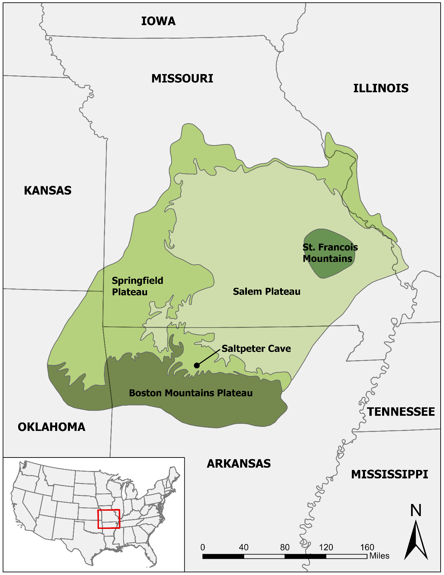
Figure 2.1. A map of the Ozarks physiographic regions.

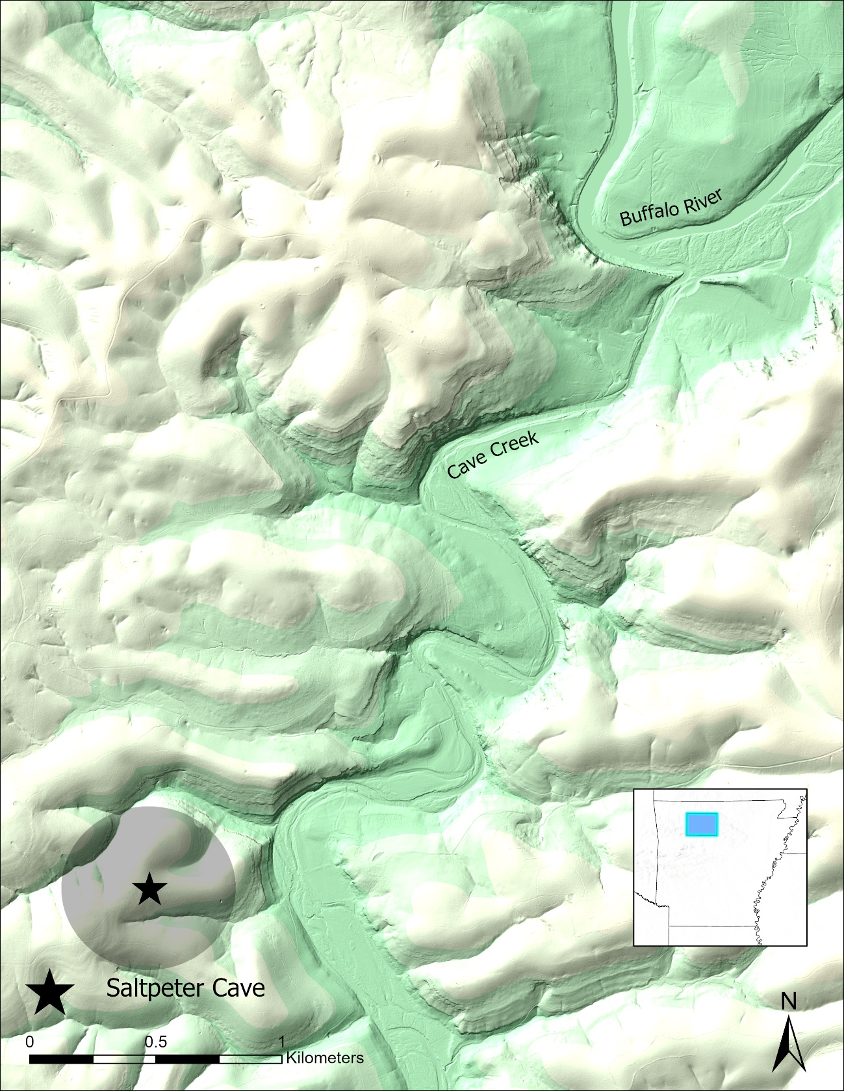
Figure 2.2. Map of the approximate location of Saltpeter Cave based on the Township, Range, and Section recorded in the ARAS site file (ARAS 2022).

in particular (Jones et al. 2017:184).

This expansion of the prairie is echoed by the aforementioned speleothem analyses from five caves spanning the Ozark region (Denniston et al. 2000:24, see also Denniston et al. 1999). Speleothem carbon isotope analysis is based on the premise that δ¹³C values in the soil and groundwater are lower during cool eras, and are higher in warm, arid periods. These studies found that across the entire Ozark region, δ¹³C values dropped abruptly in the early Holocene, suggesting a cooler climate with more trees and other C3 vegetation. This drop occurred earliest in the Eastern Ozarks both in the north and south of the region ~10,000 cal BP, slightly later in northwest Arkansas in the southwest of the region ~9,700 cal BP. This cool, wet period was short-lived and the pollen sequences from Oldfield Swamp, Missouri, also show a decrease in tree pollen and an increase in grass pollen around 9,500 cal BP, corroborating the proposed “cold snap” interpretation (Denniston et al. 2000:25). The pattern associated with forest expansion in the speleothem record persisted for about a millennium, after which the increase in δ¹³C values was most abrupt and drastic along the western edge of the region, and more gradual in the east. Conditions appear to have been more arid across the region until sometime after 5000 cal BP, with the drought severity increasing gradually in the southern Ozarks while having a more abrupt onset but consistent severity over the course of the period in the northern Ozarks.

To summarize, both pollen and isotopic analyses suggest a widespread reduction in forest canopy and expansion of grasslands across the Ozarks after ~9000 years ago. This grassland expansion reached its maximum around 8,000 cal BP and receded back to its modern condition in the Late Holocene around 4,000 cal BP (Jones et al. 2017:180). Carya (Hickory) species appear to have remained consistent during this arid Mid-Holocene period.

Ecological Variation in the Ozarks

The modern landscape in the Ozarks is a mosaic of upland and lowland deciduous forest, oak savannah, cedar glade, and prairie (Sabo et al. 1990:8-9). Oak, hickory, and Pinus schinata (shortleaf pine) predominate the upland deciduous forest of the sort that constitutes the immediate surroundings of Saltpeter Cave (Jurney and Stahle 2004:42; Woods et al. 2004). Ulmus (elm), hornbeam, and Acer (maple) taxa contribute minority species to this patch type. Salix spp. (willow), maples, Juglans nigra (black walnut), elm, and Populus (poplar) taxa are more common along the lowland drainages. Oak savannah is characterized by prairie grasses with widely dispersed trees. These are most frequent where soils are thin or clays are near the surface (Sabo et al. 1990:10). Cedar glades are associated with gravely soils along the bluffs, and feature Juniperus virginiana (eastern red cedar) and Juniperus ashei (ashe juniper). Prairie is the most open patch type, consisting mostly of tall grasses including Poa spp. (bluegrasses), Sorghastrum nutans (Indiangrass), and Panicum virgatum (switchgrass), as well as herbaceous plants suited to thin soils.

Faunal Communities

Inventories of wild fauna for the region have been compiled by Cleland (1960:17-18), Sabo et al. (1990) and Ahler et al. (2010), but the most comprehensive inventory can be found in Echternacht and Harris (1993:81-102). All of these are modern biological inventories except for Cleland’s 1960 thesis, which is based on archaeological data. After the extirpation of the Pleistocene megafauna from the Ozarks, a diverse menu remained available for exploitation, including a broad array of mammal, bird, reptile, and aquatic species. Cleland’s (1960) study found that 37 species were represented at the 58 bluffshelters he analyzed. White-Tailed Deer (Odocoileus virginianus), the Common Raccoon (Procyon lotor), Groundhog (Marmotoa monax), and American Bison (Bison bison) were among the best represented mammal taxa across the southern Ozarks. Wild Turkey (Meleagris gallopavo) was by far the best represented bird species, and turtles (Terrapene spp.) were the best represented reptiles (Cleland 1960:17). The faunal taxa represented in the Southern Ozarks is broadly similar to those found throughout the Eastern Woodlands. Table 2.1 is an inventory of the terrestrial vertebrate taxa present in or extirpated from the southern Ozarks (Echternacht and Harris 1993). While the richness of the region is very high, the number of taxa within the same taxonomic family tends to be fairly low, especially among mammals.

The Ozarks provide a broad array of flora and fauna as well as geological resources to foragers. The area immediately surrounding Saltpeter Cave is well forested and is situated near a major river network which affords the opportunity to move quickly between an array of patch types. During the Hypsithermal, arid conditions likely caused a thinning of the tree canopy which would have created an even more diverse mosaic of habitats and associated resources than that seen today.

Table 2.1. Taxonomic Inventory for the Ozarks and Interior Highland Region, Adapted from Echternacht and Harris (1993:83-102).
Taxon | Common Name
Amphibia
ANURA
Pelobatidae
Scaphiopus bombifrons | Plains Spadefoot
Scaphiopus holbrookii | Eastern Spadefoot
Microhylidae
Gastrophryne olivacea | Great Plains Narrowmouth Toad
Gastrophryne carolinensis | Eastern Narrowmouth Toad
Bufonidae
Bufo americanus | American Toad
Bufo woodhousii | Woodhouse's Toad
Hylidae
Hyla avivoca | Bird-voiced Treefrog
Hyla gratiosa | Barking Treefrog
Hyla versicolor-chrysoscelis | Gray Treefrog
Pseudacris triseriata | Chorus Frog
Pseudacris crucifer | Spring Peeper
Pseudacris brachyphona | Mountain Chorus Frog
Pseudacris streckeri | Strecker's Chorus Frog
Acris crepitans | Northern Cricket Frog
Ranidae
Lithobates clamitans | Green Frog
Lithobates catesbeianus | American Bullfrog
Lithobates pipiens | Northern Leopard Frog
Lithobates utricularia | Southern Leopard Frog
Lithobates areolata | Crawfish Frog
Lithobates palustris | Pickerel Frog
Lithobates sylvatica | Wood Frog
Caudata | Salamanders
Cryptobranchidae
Crytobranchus alleganiensis | Eastern Hellbender
Necturidae
Necturus maculosus | Muddpuppy
Necturus alabamensis | Alabama Waterdog
Salamandridae
Notophthalmus viridescens | Red-spotted Newt
Ambystomatidae
Ambystoma talpoideum | Mole Salamander
Ambystoma texanum | Smallmouth Salamander
Ambystoma barbouri | Streamside Salamander
Ambystoma annulatum | Ringed Salamander
Ambystoma tigrinum | Tiger Salamander
Ambystoma jeffersonianum | Jefferson Salamander
Ambystoma maculatum | Spotted Salamander
Ambystoma opacum | Marbled Salamander
Plethodontidae
Desmognathus fuscus | Dusky Salamander
Desmognathus brimleyorum | Ouachita Dusky Salamander
Table 2.1. continued.
Taxon | Common Name
Desmognathus welteri | Black Mountain Salamander
Aneides aeneus | Green Salamander
Gyrinophilus porphyritucus | Spring Salamander
Gyrinophilus palleuchus | Tennessee Spring Salamander
Gyrinophilus subterraneus | West Virginia Spring Salamander
Pseudotriton montanus | Eastern Mud Salamander
Pseudotriton ruber | Red Salamander
Plethodon nettingi | Cheat Mountain Salamander
Plethodon richmondi | Ravine Salamander
Plethodon wehrlei | Wehrle's Salamander
Plethodon websteri | Webster's Salamander
Plethodon albagula | Western Slimy Salamander
Plethodon glutinosus | Northern Slimy Salamander
Plethodon kiamichi | Kiamichi Slimy Slamander
Plethodon kentucki | Cumberland Plateau Salamander
Plethodon ouachitae | Rich Mountain Salamander
Plethodon caddoensis | Caddo Mountain Salamander
Plethodon fourchensis | Fourche Mountain Salamander
Hemidactylium scutatum | Four-toed Salamander
Eurycea multiplicata | Many-ribbed Slamander
Reptilia
TESTUDINES
Chelydridae
Chelydra serpentina | Snapping Turtle
Macroclemmys temminckii | Alligator Snapping Turtle
Kinosternidae
Sternotherus odoratus | Common Musk Turtle
Sternotherus carinatus | Razorback Musk Turtle
Sternotherus depressus | Flattened Musk Turtle
Kinosternon subrubrum | Eastern Yellow Mud Turtle
Emydidae
Graptemys pseudogeographica | False Map Turtle
Graptemys geographica | Common Map Turtle
Graptemys pulchra | Alabama Map Turtle
Graptemys kohnii | Mississippi Map Turtle
Deirochelys reticularia | Chicken Turtle
Chrysemys picta | Painted Turtle
Pseudemys concinna | River Cooter
Trachemys scripta | Slider
Trionychidae
Apalone mutica | Smooth Softshell
Apalone spinifera | Eastern Spiny Softshell
SOUAMATA: LACERTILIA
Crotaphytidae
Crotophytus collaris | Eastern Collared Lizard
Phrynosomatidae
Sceloporus undulatus | Fence Lizard
Scincidae
Eumeces septentrionalis | Prairie Skink
Table 2.1. continued.
Taxon | Common Name
Eumeces fasciatus | Five-lined Skink
Eumeces inexpectatus | Southeastern Five-lined Skink
Eumeces laticeps | Broadhead Skink
Eumeces obsoletus | Great Plains Skink
Eumeces anthracinus | Coal Skink
Scincella lateralis | Ground Skink
Teiidae
Cnemidophorus sexlineatus | Six-lined, Racerunner
Anguidae
Ophisaurus attenuatus | Slender Glass Lizard
Colubridae-Snakes
Viperidae-Snakes
Elapidae-Snakes
Aves
PODICIPEDIFORMES
Podicipedidae
Podilymbus podiceps | Pied-billed Grebe
CICONIFORMES
Ardeidae
Ardea herodias | Great Blue Heron
Butorides striatius | Green Heron
Bulbulcus ibis | Cattle Egret
Nycticorax nycticorax | Black-crowned Night Heron
Nycticorax violaceus | Yellow-crowned Night Heron
Ixobrychus exilis | Least Bittern
Botaurus lentiginosus | American Bittern
ANSERIFORMES
Anatidae
Aix sponsa | Wood Duck
Anas discors | Blue-winged Teal
Lophodytes cucullatus | Hooded Merganser
FALCONIFORMES
Cathartidae
Cathartes aura | Turkey Vulture
Coragyps atratus | Black Vulture
Accipitridae
Ictinia mississippiensis | Mississippi Kite
Accipter striatus | Sharp-shinned Hawk
Accipiter cooperii | Cooper's Hawk
Buteo Jamaicensis | Red-tailed Hawk
Buteo Iineatus | Red-shouldered Hawk
Buteo platypterus | Broad-winged Hawk
Haliaeetus leucocephalus | Bald Eagle
Falconidae
Falco sparverius | American Kestrel
GALLIFORMES
Tetraonidae
Bonasa umbellus | Ruffed Grouse
Phasianidae
Table 2.1. continued.
Taxon | Common Name
Colinus virginianus | Northern Bobwhite
Meleagrididae
Meleagris gallopavo | Wild Turkey
GRUIFORMES
Rallidae
Rallus elegans | King Rail
Rallus limicola | Virginia Rail
Gallinula chloropus | Common Moorhen
CHARADRIIFORMES
Chamdriidae
Charadrius vociferus | Killdeer
Scolopacidae
Bartramia longicauda | Upland Sandpiper
Scolopax minor | American Woodcock
COLUMBIFORMES
Ectopistes migratorius | Passenger Pigeon*
Zenaida macroura | Mourning Dove
PSITTACIFORMES
Psittacidae
Conuropsis carolinensis | Carolina Parakeet
CUCULIFORMES
Cuculidae
Coccyzus americanus | Yellow-billed Cuckoo
Coccyzus erythropthalmus | Black-billed Cuckoo
Geococcyx californianus | Greater Roadrunner
STRIFORMES
Tytonidae
Tyto alba | Common Barn-owl
Strigidae
Otus asio | Eastern Screech-owl
Bubo virginianus | Great Homed Owl
Strix varia | Barred Owl
CAPRIMULGIFORMES
Caprimulgidae
Caprimulgus carolinensis | Chuck-will' S-window
Caprimulgus vociferus | Whip-poor-will
Chordeiles minor | Common Nighthawk
APODIFORMES
Apodidae
Chaetura pelagica | Chimney Swift
Trochilida
Archilochus colubri | Ruby-throated Hummingbird
CORACIIFORMES
Alcedinidae
Ceryle alcyon | Belted Kingfisher
PIClFORMES
Picidae
Colaptes auratus | Northern Flicker
Melanerpes carolinus | Red-bellied Woodpecker
Table 2.1. continued.
Taxon | Common Name
Melanerpes erythrocephalus | Red-headed Woodpecker
Picoides villosus | Hairy Woodpecker
Picoides pubescens | Downy Woodpecker
Picoides borealis | Red-cockaded Woodpecker
Dryocopus pileatus | Pileated Woodpecker
PASSERIFORMES
Tyrannidae
Tyrannus tyrannus | Eastern Kingbird
Tyrannus forficatus | Scissor-tailed Flycatcher
Myiarchus crinitus | Great Crested Flycatcher
Sayornis phoebe | Eastern Phoebe
Empidonax virescens | Acadian Flycatcher
Empidonax traillii | Willow Flycatcher
Contopus virens | Eastern Wood-peewee
Alaudidae
Eremophila alpestris | Horned Lark
Hirundinidae
Tachycineta bicolor | Tree Swallow
Riparia riparia | Bank Swallow
Stelgidopteryx serripennis | Northern Rough-winged Swallow
Hirundo rustica | Barn Swallow
Hirundo pyrrhonota | Cliff Swallow
Progne subis | Purple Martin
Corvidae
Cyanocitta cristata | Blue Jay
Corvus brachyrhynchos | American Crow
Paridae
Parus atricapillus | Black-capped Chickadee
Parus carolinensis | Carolina Chickadee
Parus bicolor | Tufted Titmouse
Sittidae
Sitta carolinensis | White-breasted Nuthatch
Sitta pusilla | Brown-headed Nuthatch
Troglodytidae
Troglodytes aedon | House Wren
Thryothorus bewickii | Bewick's Wren
Thryothorus ludovicianus | Carolina Wren
Cistothorus platensis | Sedge Wren
Mimidae
Mimus polyglottus | Northern Mockingbird
Dumetella carolinensis | Gray Catbird
Toxostoma rufum | Brown Thrasher
Muscicapidae
Turdus migratorius | American Robin
Hylocichla mustelina | Wood Thrush
Sialia sialis | Eastern Bluebird
Polioptila caerulea | Blue-gray Gnatcatcher
Bombycillidae
Bombycilla cedrorum | Cedar Waxwing
Table 2.1. continued.
Taxon | Common Name
Laniidae
Lanius ludovicianus | Loggerhead Shrike
Vireonidae
Vireo griseus | White-eyed Vireo
Vireo bellii | Bell's Vireo
Vireo flavifrons | Yellow-throated Vireo
Vireo olivaceous | Red-eyed Vireo
Vireo gilvus | Warbling Vireo
Emberizidae .
Mniotilta varia | Black-and-white Warbler
Protonotaria citrea | Prothonotary Warbler
Limnothlypis sawinsonii | Sawinson 's Warbler
Helmitheros vermivorus | Worm-eating Warbler
Vermivora chrysoptera | Golden-winged Warbler
Vermivora pinus | Blue-winged Warbler
Vermivora bachmanii | Bachman's Warbler
Vermivora ruficapilla | Nashville Warbler
Panila americana | Northern Parula
Dendroica petechia | Yellow Warbler
Dendroica virens | Black-throated Green Warbler
Dendroica cerulea | Cerulean Warbler
Dendroica fusca | Blackbumian Warbler
Dendroica dominica | Yellow-throated Warbler
Dendroica pennsylvanica | Chestnut-sided Warbler
Dendroica pinus | Pine Warbler
Dendroica discolor | Prairie Warbler
Seiurus aurocapillus | Ovenbird
Seiurus motacilla | Louisiana Waterthrush
Oporomis formosus | Kentucky Warbler
Geothlypis trichas | Common Yellowthroat
Icteria virens | Yellow-breasted Chat
Wilsonia citrina | Hooded Warbler
Setophaga ruticilla | American Redstart
Cardinalis cardinalis | Northern Cardinal
Pheucticus ludovicianus | Rose-breasted Grosbeak
Guiraca caerulea | Blue Grosbeak
Passerina cyanea | Indigo Bunting
Passerina ciris | Painted Bunting
Spiza americana | Dickcissel
Pipilio erythrophthalmus | Rufus-sided Towhee
Ammodramus savannarum | Grasshopper Sparrow
Ammadramus henslowii | Henslow' S Sparrow
Pooecetes gramineus | Vesper Sparrow
Melospiza melodia | Song Sparrow
Chondestes grammacus | Lark Sparrow
Aimophila aestivalis | Bachman's Sparrow
Aimophila ruficeps | Rufous-crowned Sparrow
Spizella pusilla | Field Sparrow
Spizella passerina | Chipping Sparrow
Table 2.1. continued.
Taxon | Common Name
Stumella magna | Eastern Meadowlark
Agelaius phoeniceus | Red-winged Blackbird
Molothrus ater | Brown-headed Cowbird
Quiscalus quiscula | Common Grackle
Icterus spurius | Orchard Oriole
Icterus galbula | Northern Oriole
Piranga olivacea | Scarlet Tanager
Piranga rubra | Summer Tanager
Fringillidae
Carduelis tristic | American Goldfinch
Carpodacus purpureus | Purple Finch
Carpodacus mexicanus | House Finch
Mammalia
MARSUPALIA
Didelphidae
Didelphis virginiana | Virginia Opossum
INSECTIVORA
Soricidae
Sorex longirostris | Southeastern Shrew
Sorex fumeus | Smoky Shrew
Sorex dispar | Long-tailed Shrew
Blarina brevicauda | Short-tailed Shrew
Cryptotis parva | Least Shrew
Notiosorex crawfordi | Crawford's Desert Shrew
Talpidae
Parascalops breweri | Hairy-tailed Mole
Scalopus aquaticus | Eastern Mole
Condylura cristata | Star-nosed Mole
CHIROPTERA
Vespertilionidae
Myotis subulatus | Mall-footed Myotis
Myotis lucifugus | Little Brown Myotis
Myotis sodalis | Indiana Myotis
Myotis austroriparius | Southeastern Myotis
Myotis grisescens | Gray Myotis
Myotis keenii | Keen's Myotis
Lasionycteris noctivagans | Silver-haired Bat
Pipistrellus subfiavus | Eastern Pipistrelle
Eptesicus fascus | Big Brown Bat
Nycteris borealis | Red Bat
Nycteris seminola | Seminole Bat
Nycteris cinerea | Hoary Bat
Nycticeius humeralis | Evening Bat
Plecotus townsendii | Townsend's Big-eared Bat
Plecotus rafinesque | Rafinesque's Big-eared Bat
Molossidae
Tadarida brasiliensis | Brazilian Free-tailed Bat
EDENTATA
Dasypodidae
Table 2.1. continued.
Taxon | Common Name
Dasypus novemcinctus | Nine-banded Armadillo
LAGOMORPHA
Leporidae
Sylvilagus aquaticus | Swamp Rabbit
Sylvilagus floridanus | Eastern Cottontail
Lepus califomieus | Black-tailed Jack Rabbit
RODENTIA
Sciuridae
Tamias striatus | Eastern Chipmunk
Marmota monax | Woodchuck
Spermophilus tridecemlineatus | 13-lined Ground Squirrel
Sciurus carolinensis | Gray Squirrel
Sciurus niger | Fox Squirrel
Glaucomys volans | Southern Flying Squirrel
Geornyidae
Geomys bursarius | Plains Pocket Gopher
Castoridae
Castor canadensis | American Beaver
Muridae
Oryzomys palustris | Marsh Rice Rat
Reithrodontomys humilis | Eastern Harvest Mouse
Reithrodontomys megatons | Western Harvest Mouse
Reithrodontomys fulvescens | Fulvous Harvest Mouse
Peromyscus potionotus | Oldfield Mouse
Peromyscus maniculatus | Deer Mouse
Peromyscus leucopus | White-footed Mouse
Peromyscus gossyptnus | Cotton Mouse
Peromyscus attwateri | Attwater's Mouse
Ochrotomys nuttalli | Golden Mouse
Sigmodon hisptdus | Hispid Cotton Rat
Neotoma floridana | Eastern Wood Rat
Microtus pennsylvanicus | Meadow Vole
Microtus chrotorrhinus | Rock Vole
Microtus ochrogaster | Prairie Vole
Microtus pinetorum | Pine Vole
Ondatra zibethicus | Muskrat
Synaptomys cooperi | Southern Bog Lemming
Zapodidae
Zapus hudsonius | Meadow Jumping Mouse
Napaeozapus insignis | Woodland Jumping Mouse
Erethiozontidae
Erethizon dorsatum | Porcupine
CARNIVORA
Canidae
Canis latrans | Coyote
Canis rufus | Red Wolf
Vulpes vulpes | Red Fox
Urocyon cinereoargenteus | Gray Fox
Ursidae
Table 2.1. continued.
Taxon | Common Name
Ursus americanus | American Black Bear
Procyonidae
Bassariscus astutus | Ringtail
Procyon lotor | Common Raccoon
Mustelidae
Martes pennanti | Fisher
Mustela nivalis | Least Weasel
Mustela frenata | Long-tailed Weasel
Mustela vison | Mink
Lutra canadensis | River Otter
Mephitidae
Mephitis mephitis | Striped Skunk
Spilogale putorius | Spotted Skunk
Felidae
Felis concolor | Mountain Lion
Lynx rufus | Bobcat
Cervidae
Cervus canadensis | American Elk
Odocoileus virginianus | White-tailed Deer
Bovidae
Bison bison | American Bison

.

Background

This chapter reviews the early culture history for the Eastern Woodlands broadly, with an additional section that focuses on the specifics of the southern Ozarks region. I also review the extant zooarchaeological literature that deals with the southern Ozarchaic, and discuss of the significance of sheltered sites in the Eastern Woodlands prior to colonization.

Culture History

The Paleoindian Period: The First Settlement of the Americas

The earliest human occupations in southeastern North America are represented by the Paleoindian peoples that moved into the region after the Last Glacial Maximum (~21,000 cal BP). The Southeast at the time was home to large megafaunal populations such as Bison antiquus (Giant Bison) and Mammut americanum (American Mastodon) (Anderson and Sassaman 2012:40). Sites predating ~14,000 cal BP are represented in the interior of the continent, including Cactus Hill in Virginia (Wagner and McAvoy 2004), Meadowcroft in Pennsylvania, and Topper in South Carolina (Goodyear 2005). These early cultures are broadly assigned to the Pre-Clovis period. Although not the first peoples to inhabit the continent, the first evidence for occupation in the Ozarks is represented by the Middle Paleoindian culture known as Clovis. The earliest of these sites date shortly before 13,000 cal BP (Ahler et al. 2010; Sabo et al. 1990). Clovis hunter-gatherers are generally characterized as highly mobile big-game hunters with a highly curated toolkit that included prismatic blade technologies and a lanceolate projectile tradition. This founding population transitioned through intermediary Late Paleoindian cultural traditions and eventually into the Dalton phase around 11,900 cal BP, by which time people were required to cope with the extinction (or perhaps extirpation) of the Pleistocene megafauna (Anderson and Sassaman 2012:36). The climate in this environment fluctuated frequently but was generally colder than modern conditions.

The Archaic Period: Changing Environments and Adaptive Strategies in the Eastern Woodlands

The Dalton culture emerged during the Pleistocene-Holocene transition ~12,450-11,500 cal BP. This group continued to use lanceolate projectiles, but as the megafauna had been extirpated from the Southeast by this time, Dalton people focused their efforts on smaller game species, including White-tailed Deer and the American Bison (Walthall 1998). The Dalton phase was followed by the Early Archaic period (~11,500-8,900 cal BP) and saw the introduction of notched projectile point technology (Anderson and Sassaman 2012:71). This period appears to have been much warmer and drier than that which Dalton peoples had known. In the latter centuries of the Early Archaic period, large swaths of the Southeast were abandoned, and not re-occupied until the Middle Archaic period (~8,900-5,800 cal BP) by a people who appear to have been of distinct ethnic origin (Anderson and Sassaman 2012:73; Sassaman 2010:23). These newcomers practiced a very different set of cultural traditions, including a distinct mortuary practice, emphasis on shellfishing, hook-and-sinker angling, and a contracting-stemmed projectile tradition that was unprecedented in the Southeast (Sassaman 2010). The earliest known manifestations of monumental construction also belong to this Middle Archaic period (Anderson and Sassaman 2012:74; Claassen 2010). The Middle Archaic corresponds to the Hypsithermal, a period during which temperatures were generally warmer than those of the modern day (Anderson and Sassaman 2012:72: Denniston et al. 2000).

By the Late Archaic (~5,800-5,300 cal BP), essentially modern climatic conditions had been established (Anderson and Sassaman 2012:74). This last stage of the Archaic featured even more pronounced monumental activity and interregional interaction (Kidder 2012). During this time, wetland habitats expanded as precipitation increased, facilitating the independent development of domesticated agricultural crops by Eastern Woodlanders (Smith 1992), which extends into the Ozarks (Fritz 1986:141, 1997:56). Artisans innovated both early ceramic traditions and soapstone vessels along the Atlantic coast and in the Appalachian Mountains respectively (Sassaman 2002:400; Sassaman and Brookes 2017).

The Ozarks in the Terminal Paleoindian and Archaic Periods

The Ozarks are situated in a cultural and physiographic crossroads. They are flanked by the Great Plains to the west and prairie to the north (Sabo et al. 1990). The rivers that flow from them towards the Southeast meet with the Mississippi River. They are adjacent to the sandhills where the Sloan site, the oldest cemetery in North America associated with the Dalton culture, is located (Walthall and Koldehoff 1998). To the south lies the Delta region of Louisiana, which was the locus of North America’s earliest monumental cultures (Saunders et al. 1997) culminating in the monumentality and extensive communication networks created by groups inhabiting and otherwise affiliated with Poverty Point during the Late Archaic (Kidder 2012:465). Despite the centrality of the southern Ozarks in terms of geographic placement, a narrative of marginality and cultural stagnation has persisted (Rees and Brandon 2017).

Early Archaic (11,500-8000 cal BP)

The hafted biface sequence of the central portion of the southern Ozarks is not well reported, and the culture history of southwest Missouri is usually employed as the closest proxy. The cultural sequence for the region following the Dalton phase is organized by associated lithic typologies and begins with a continuation of unfluted lanceolate tradition, usually with beveled retouch. These include Packard and Breckenridge types (Ray et al. 2009:160-163) which cluster around 11,000 cal BP. The stemmed Scottsbluff (~10,700 cal BP), Rice (~9500-9000 cal BP), and Jakie ( ~9000-6800 cal BP) types follow the lanceolate tradition (Ray et al. 2009:165,168, 172). Early Archaic peoples also produced the Searcy lanceolate type, overlapping with the Rice and Jakie traditions (Ray et al. 2009:171). McMillan and Klippel (1981:227) indicate that during this time, the faunal assemblages from northern Ozarks sites started to include more prairie-associated taxa, including American Bison, certain game birds, badgers (Taxidea taxus), and Pronghorn (Antilocapra americana, colloquially called antelope).

Middle Archaic (8000-5000 cal BP)

The Middle Ozarchaic is associated with the warm, dry period known as the Hypsithermal (Ray et al. 2009:173). The reduction in tree cover also expanded forest edge environments favored by White-tailed Deer (Sabo et al. 1990:49-54). Wyckoff (2010:96-97) suggests that the two cultural phases that are recognized archaeologically (Tom’s Brook and Calf Creek) correspond to ameliorations of the Hypsithermal. That is to say that there are gaps in the lithic sequence during the Middle Archaic, especially for northwest Arkansas.

The knappers of this period generally abandoned the older beveled and serrated resharpening techniques in favor of a more regular bifacial resharpening of hafted bifaces. The Tom’s Brook complex is some 7000-6000 years old, and includes T-shaped drills, full-grooved axes, and groundstone tools for mast processing (Sabo et al. 1990:51; Wyckoff 1984:136-140). Heat treatment is a common feature of this lithic industry, and unlike its antecedents, modified flake tools are common. Chipped stone bifaces are characterized by types for which the knapper has ground the lateral edges of the stems. Although the Jakie tradition began at the end of the Early Archaic, it is mostly associated with the Middle Archaic period and is represented in Tom’s Brook assemblages, as is the side-notched White River type (~7500-6300 cal BP) (Ray et al. 2009:174; Wyckoff 1984:136).

Both bison (McMillan and Klippel 1981; Styles and McMillan 2009:50) and the Calf Creek foragers (6000-5700 cal BP) that hunted them appear to have occupied the uplands of northwest Arkansas during this time (Ayala 2019:xi; Chowdhury et al. 2021:374). This phase is characterized by hafted bifaces with deep, narrow basal notches that produce a square to excurvate stem with barbs on either side that are as long as the stem itself. However, While Calf Creek components have been identified in northwest Arkansas, no such component has been definitively identified at Saltpeter Cave. What is present is the Cossatot River type, which has been found to be concurrent with Calf Creek components at open-air sites in northwest Arkansas (Branam et al. 2018). Cossatot River points are basally notched with either excurvate or occasionally basally notched bases that can grade into nearly bifurcated morphologies. They are heavily re-worked to the point of exhaustion at the Spring Creek site, producing a corner-notched appearance and are similar in outline to Late Archaic corner notched types like Smith and Etley. Cossatot River points overlap in size more with Calf Creek cluster types and tend to be more thinned than the smaller and thicker Late Archaic types. Following this period hardwood pollen frequencies increased in the Late Archaic, signaling the expansion of the forests once again (Jones et al. 2017:180; Sabo et al. 1990:58-59).

Archaic Period Zooarchaeology in the Southern Ozarks

The Paleoindian and Archaic periods that constitute the early human past of the Southern Ozarks region have received remarkably sparse attention from zooarchaeologists. Only very coarse faunal analyses appear in the available literature, and none of these specifically deal with diachronic shifts in taxonomic selection. Only three Ozarchaic component analyses with noteworthy zooarchaeological evaluations have been identified for this spatiotemporal context (Cleland 1960; Dickson 1991; Wampler 2000). The first of these is Charles Cleland’s (1960) master’s thesis, which aimed to reconstruct paleoecology, diet, and technology in the Ozarks region of Arkansas. He collapsed almost 60 sites, each with its own abstruse stratigraphic matrices, into a single assemblage. This implicitly repeats the interpretive error first made by Harrington (1960), making the region appear to be timeless, homogenous, and culturally “stuck” in a primitive state compared to neighbors in the aforementioned surrounding regions. This characterization is explicitly reiterated in the text:

Contrary to Harrington’s (1960) statement that more large animals were killed during the later occupations of the bluffs of Missouri and Arkansas, in the present sample the proportion of species of all size classes, as well as the quantity of each species killed remained relatively uniform between all sites although they presumably occupied a considerable span of time.
The implications of this lack of change are that either there was little change in the selection of food animals by peoples of several cultural occupations, or that the sites were continuously or intermittently occupied by people of the same cultural complex who made similar selections throughout their history (Cleland 1960:16-19).

However, Cleland made some important observations regarding preservation and depositional biases that remove materials from a site assemblage. In fact, he believed that his homogenization of these site assemblages was a productive method to compensate for these taphonomic processes, making sure the full species diversity of the region is accounted for.
The Albertson Site was excavated largely between the summer of 1967 and 1969, and overseen by avocational archaeologist Don Dickson (1991), who wrote the report with assistance from the Arkansas Archeological Survey (ARAS) and University of Arkansas Archaeologists. Research was oriented towards three fundamental objectives: identification of temporal components represented, reconstruction of site function over time, and analysis of lithic technological practice over time, including material sourcing, reduction and maintenance sequences, and tool-kit components. Because this report is organized around functional analysis, the faunal assemblage is discussed when bones are worked into tools, but no comprehensive faunal analysis was conducted here.

The faunal assemblage at the Albertson Site furnished the data set for Marc Wampler’s (2000) master’s thesis. His analysis of White-Tailed Deer element frequencies attempted to evaluate hypothesized foraging efficiency models that predict that axial elements would be transported from butchery sites to main camps, and limb elements would be deposited at or near the kill site. The models employed are entirely focused on deer as a meat resource, ignoring the utility of bone, hide, antler, sinew, and gut as tool resources, or marrow and bone collagen as secondary food resources. In summation, the zooarchaeological literature for the southern Ozarchaic is extremely sparse and entirely obsolete both theoretically and methodologically.

Sheltered Sites

Caves and rockshelters, here collectively designated “sheltered sites,” are distinguished from each other in the archaeological convention based on the presence or absence of a “dark zone” that is never illuminated by sunlight (Simek 2004; Whyte 2007:2). These kinds of sites have been formative in the development of archaeology due in no small part to their high preservation rate of perishable materials, including bone, wood, and in some cases highly fragile materials such as plant fibers and textiles (Harrington 1960:1-3). Moreover, because they have well-defined and impermeable boundaries (rock walls), human activity is spatially concentrated. This creates a stratigraphic record that is dense with evidence of human activity and allows archaeologists to investigate how these practices changed over time at a single site.

At present, many sheltered sites have been excavated in the Eastern Woodlands, both in the Greater Appalachian region and to a lesser extent in the Ozarks. These sites are frequently presented as falling somewhere on a gradient between practical occupation sites that provide shelter from the elements (Bergsvik and Skeates 2012; Hollenbach and Walker 2010; Walthall 1998) and socially charged ritual sites (Claassen 2011; Crothers 2012; Peres et al. 2016; Walker 2010; Whyte 2007). The decades of research on these sites have illustrated a wide range of uses that people devised for these spaces in antiquity. These include permanent residences, temporary base camps, logistical refuges, mortuaries, shrines, sites of initiation rites, and menstrual retreats.

While the dark zones of many caves appear to have been regarded as sacrosanct (Crothers 2012; Peres et al. 2016; Simek et al. 2012), the vestibules and entrances of several caves, including Russell Cave (Griffin 1974), Dust Cave (Hollenbach 2005; Homsey-Messer 2015; Walker 1998a), and Dunbar Cave (Simek et al. 2012) were considered appropriate for prosaic use though they likely retained sacred associations.

Among modern indigenous communities in the Eastern Woodlands, sheltered sites are profound spaces. The Cherokees regard caves as access points to the waters of the world below, where “the spiritual and visible worlds were close, and where the living could seek spiritual strength in seclusion” (Carroll et al. 2019:520). The cave at Nanih Wiyah is sacred to the Choctaws as the place from which they emerged as did (in the Choctaw tradition) the Chickasaws, Cherokees, and Muskogees (Spring 2016). The Cherokees also speak of “Little People” who live in caves (Mooney 2006:333). These creatures are reminiscent of the fay, dwarves, or elves in Eurasian folklore. A similar troglodytic entity appears in the Osage Tradition (Duncan and Diaz-Granados 2018:58), and among the Choctaws.
Sheltered sites (including those that do not feature a dark zone) were often used as mortuary spaces in the Middle and Late Archaic periods, as were dark-zone cave vestibules (e.g. Homsey-Messer 2015:333; Peres et al. 2016). Saltpeter Cave is not exempt from this, as human burials are documented in the field notes (ARAS 2022) and during my analysis a few previously unidentified human remains were recognized and repatriated to the Osage Nation. Indigenous communities in Guatemala have used rockshelters and crevasses as hunting shrines up to the twenty-first century (Brown 2009). These shrines are places where the spirits of particular animals are cared for by their spiritual guardian. While this specific practice is far afield from the Ozarchaic, it follows the general pattern in the Americas that associates caves with spirits and otherworldly beings.

From a more prosaic standpoint, sheltered sites provide insulation. They block the wind and contain heat in the winter and offer shade and cool air in the summer. From the perspective of industry, several stages of hide tanning process require that the hide remain dry for long periods of time, so the natural shelter is conducive to processing large numbers of hides (Grayson 2016). The nature of these sites, being fixed on the landscape and conducive to high preservation rates, makes them appropriate to caching resources for later use. These caching practices have been noted at Dust Cave in the form of Canada Goose (Branta canadensis) humeri (Walker 2010:435) and at several Ozarks shelters recorded by Harrington (1960) which included bundles of split cane for textile manufacture and seed bags (also Fritz 1986:103). Homsey-Messer (2015:346) explores how the expansion of mixed hardwood forest during the Holocene increased mast availability, but also reduced its predictability due to heterogeneity of species distribution. Low predictability, she says, created a pressure for food storage, which encouraged seasonal logistical intensification at upland shelters as the storable mast resource became available.

Despite the ongoing Southeastern research on the Archaic period, the use of sheltered sites, and zooarchaeological analysis, work on the southern Ozarchaic as a specific sub-component has been allowed to languish in the last several decades with a few exceptions. Fritz’s (1986) dissertation evaluated evidence for early domestication from southern Ozarks bluffshelters, and work on lithic seriation and typology is always ongoing (e.g. Ray et al. 2009; Ray 2016). The comparative lack of work publication on the Ozarchaic in some part due to an academic legacy that has portrayed the region as stagnant and isolated from areas where developments traditionally of interest to archaeologists (monumentality, exchange, migration, conflict, sedentism, etc.), have been identified (Rees and Brandon 2017). However, Archaic peoples were in all probability seasonally mobile in most areas (Anderson and Sassaman 2012:72), and in the Ozarks the river systems provide effective avenues for mobility and interaction with other lowland groups. The bluffs themselves have been compared to an Archaic equivalent to a modern hunting lodge or fishing cabin (Rees and Brandon 2018), which is to suggest that they are not representative of life in general but were occupied seasonally or sporadically (as are all sites occupied by mobile foragers). If the inhabitants of the bluffshelters spent several months of every year down-river at lowland base camps, it is plausible that their resource base and activity set at those sites were different as well. If this description of mobility and landscape use is correct, then the imagined people of the Ozarchaic who isolated themselves in the hills must be recognized as a mirage. I think it far more likely that the flesh-and-blood humans who created the Saltpeter site and others like it spent portions of their year down river or out on the plains interacting with non-Ozark peoples.

Archaeological sites
This section covers the excavation history of Saltpeter Cave as well as some discussion of Dust Cave, Modoc Shelter, and Little Freeman Cave. I will be use the faunal assemblage data from these sites for inter-site comparative analysis in a subsequent chapter.

Saltpeter Cave

According to the ARAS site file records (ARAS 2022), the first work at Saltpeter Cave may have been conducted by the University of Arkansas Museum under Samuel Dellinger in the summer of 1931. A site known as Hale Cave (3NW4) is reported from the same general vicinity, and the site file also reports it had been used as a saltpeter mine. A local resident by the name of Jack McCutcheon indicated to ARAS station archaeologist Ken Cole that these two sites were the same. However, the Hale Cave file indicates that the dome in the back of the cave was 60 ft high, which is a much higher expanse than the 7 m (~22 ft) reported by Rees and colleagues (2017:2; ARAS 2022). Cole visited Saltpeter in 1969 after a “potting attack” by artifact collectors damaged portions of the site, prompting pre-emptive excavations (Figure 4.1).

Cole’s map from the 1969 field season illustrates the locations of excavation Pit A, Pit B, Pit C, and Pit D (Figure 4.2). Pits A and B were placed a few meters behind the drip line, avoiding pits associated with either looting activity or historic saltpeter production. Pit D is located deeper in the cave beyond these disturbances, and Pit C was placed more centrally within the chamber, about 40 meters north of the drip line. This map is the only available visual record of where units were placed at the site. The following year, Pits E, F, H, I, and J were placed in a discontinuous line starting in the vestibule and moving alphabetically towards the dripline. Unfortunately, no map of this arrangement exists. The excavation forms for the 2-m-x-2-m Pit E indicate that it was placed south of Pit D, but no measurement of the distance between the two is recorded. However, the field notes and profile map of Pit E (Figure 4.3) indicate that a looter/mining pit occupied the northwest corner of the unit. The only place within the cave that would account for these criteria is approximately 12 m north of the drip line on the western side of the vestibule as indicated in Figure 4.2. Artifact recovery was accomplished by screening with 6.4-mm (0.25-in.) mesh hardware cloth, but flotation was not conducted during either of these excavation seasons, so paleoethnobotanical analysis will not be feasible unless further excavations are conducted. As was usual for the time, excavation was conducted in 10-cm arbitrary levels, and stratigraphic transitions were not excavated separately.

Shortly after the 1970 excavation season, Cole resigned his position with the ARAS and the assemblages and site records were largely forgotten until ARAS archaeologist Jared Pebworth brought the assemblages to the attention of the Fayetteville

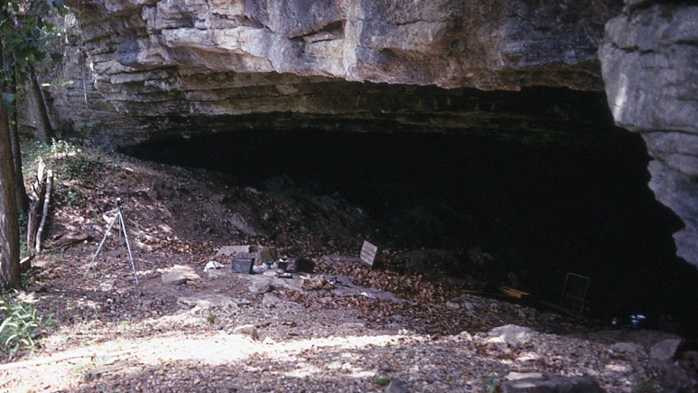
Figure 4.1. Entrance to the vestibule of Saltpeter Cave. Photo from the field records on file with the ARAS.

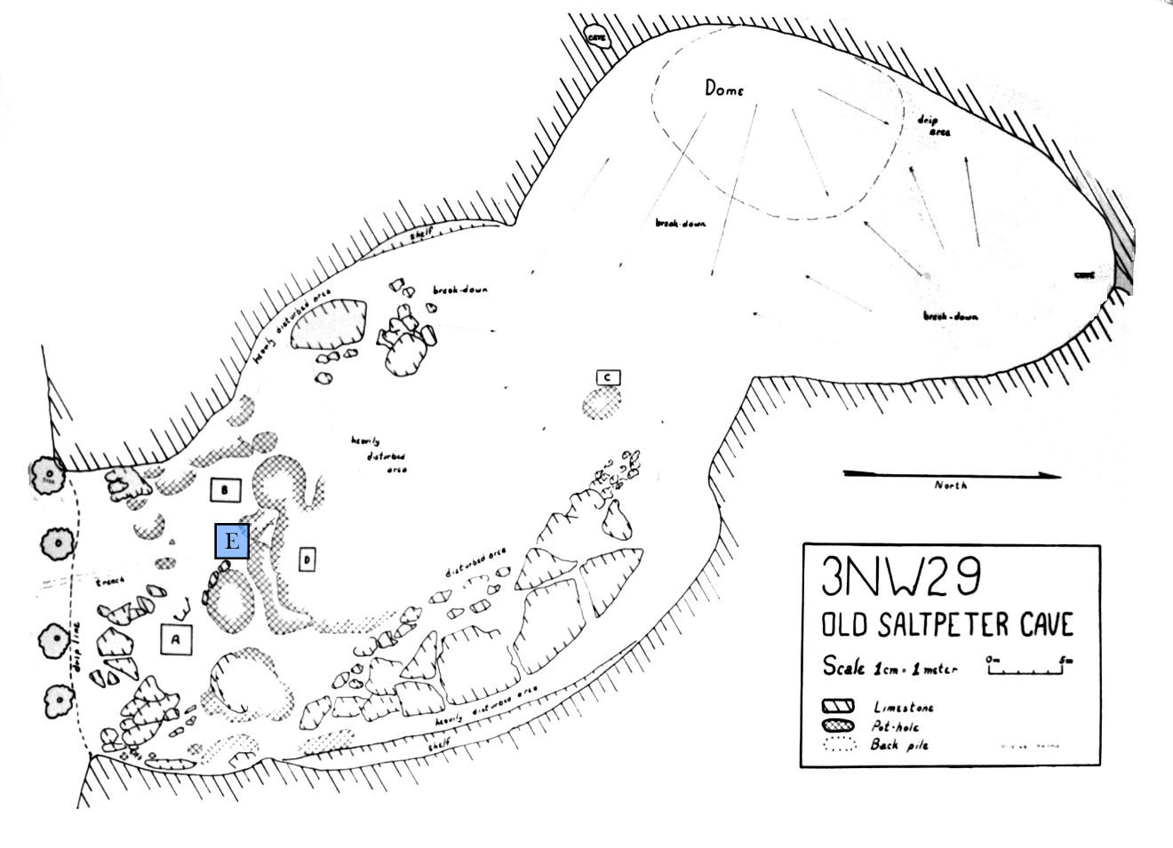
Figure 4.2. Cole's 1969 map of Saltpeter Cave illustrating the approximate location of Pit E.
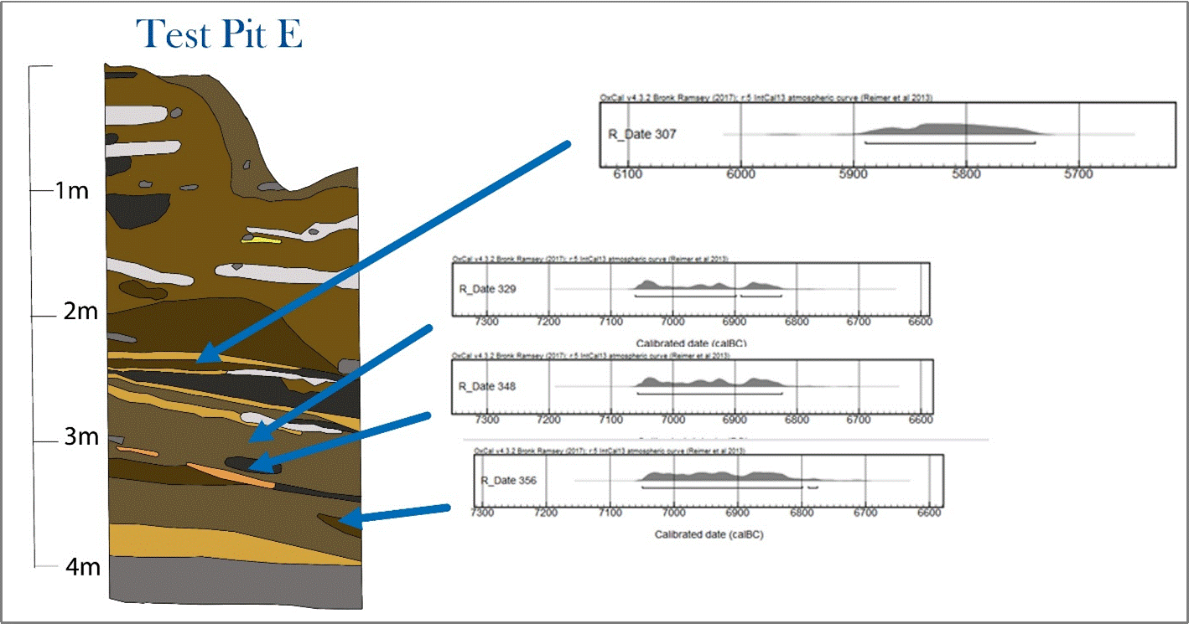
Figure 4.3. West profile map of Pit E with the locations of samples used for AMS dates. Modified from Rees et al. (2017). The date ranges are provided in Table 4.1

station archaeologist Jamie Brandon (Rees et al. 2017:5). An Arkansas Natural and Cultural Resource Council grant was awarded for the rehabilitation of the Saltpeter Cave materials. While faunal materials and other artifacts from all excavation units were rehoused for curation, Pit E has been given special attention, and it is to this unit that I have restricted my analysis.

With a depth of 4.11 m, Pit E is the deepest unit thus far excavated. The lithic sequence from Pit E was analyzed in order to evaluate the stratigraphic integrity of the site. Rees et al. (2017) report that the lithic sequence begins with a small Dalton component in the last level of the unit (4.00-4.11 m below surface), which transitioned into an Early Archaic component of Rice and Taney bifaces. Three AMS dates associated with these points show indistinguishable date ranges for the entire Early Archaic sequence, ranging from 9010-8725 cal BP (Beta- 474951, Beta- 474952, Beta- 474953) (Table 4.1). A small discontinuous zone of tightly banded, sometimes gravely deposits separated the Early Archaic strata from the Middle Archaic horizon, the latter of which is represented by Jakie and White River point types. One AMS date of 7839-7689 cal BP (Beta- 474950) is associated with the deepest White River point. The Jakie/White River component transitions gradually into a series of corner-notched projectiles consistent with the Cossatot River type below the disturbed horizons. Lenses of ash between 130 and 170 cm below datum (cmbd) indicate intact stratigraphy up to this point, and no pottery was recovered below 110 cmbd, so in lieu of further radiocarbon evidence, I will proceed under the assumption that everything below 130 cmbd is Archaic or Dalton in age (Table 4.2). I am provisionally designating levels between 130 and 170 cmbd as Middle Archaic 2 (7,000-5,000 cal BP), though they may include some transitional Late Archaic point types (5,000-3500 cal BP). The levels from 170 to 270 cmbd are designated Middle Archaic 1 (8,000-6,300) based on the latest AMS date available and the associated Jakie and White River points, as well as the presence of Cossatot River points. Everything below 270 cmbd is designated Early Archaic 2 (9,500-8000 cal BP) based on the three radiocarbon dates from below the sterile gravel layers. Early Archaic 1 is reserved for older strata from three other sheltered sites which will be incorporated into a regional inter-site analysis. Early Archaic 1 (11,500-9,500 cal BP) dates are not represented at Saltpeter Cave at this time. No vertebrate osteological material was recovered from levels below 390 cmbd.

Comparative Datasets

Three additional sites were incorporated into this study based on contemporaneity, comparability in recovery methods, and availability of data. Modoc Rockshelter, Illinois, Dust Cave, Alabama, and Little Freeman Cave, Missouri, are all Eastern Woodlands sheltered sites that were occupied during approximately the same timeframe as Saltpeter Cave (Figure 4.4). All were excavated using 6.4-mm (0.25-in.) mesh hardware cloth for artifact recovery. However, the volume of soil matrix excavated to produce each assemblage is many times greater than that analyzed from Saltpeter Cave. The raw datasets for each have been made available through the Digital

Table 4.1. AMS Dates from Saltpeter Cave in Order of Depth from Highest to Lowest, Expressed in Radiocarbon Years Before Present (RCYBP) and Calibrated Years Before Present (cal BP).
Lab Number | RCYBP | cal BP
Beta-474950 | 6940 ± 30 BP | 7839 - 7689 cal BP
Beta-474951 | 8020 ± 30 BP | 9010 - 8775 cal BP
Beta-474952 | 8010 ± 30 BP | 9007 - 8774 cal BP
Beta-474953 | 7990 ± 30 BP | 8999 - 8725 cal BP

Table 4.2. Temporal Components and Date Ranges for Sites Used in the Comparative Analysis with Dates in Calibrated Years BP.
 | Early Archaic 1 |  | Early Archaic 2 |  | Middle Archaic 1 |  | Middle Archaic 2
 | Components | Date Range | Components | Date Range | Components | Date Range | Components | Date Range
Saltpeter | No Dates Available |  | Rice + Taney | 9,000 - 8,000 | White River | 7,500 - 6,300 | No Dates Available
Modoc | EAR1 | 10,000 -9,500 | EAR2 | 9,500 - 9,000 | MAR 1 | 8,000 - 6,800 | MAR 2,  LAR1 | 6,800 - 5,500
Dust | Side-Notch,  Strat Q | 11,450 - 10,950 | Kirk Stemmed | 9,860 - 7,750 | Eva,  Morrow Mountain | 7,710 - 6,400 | Benton | 6,570 - 5,650
Little Freeman | e Early Archaic | 11,500 -9,600 | l Early Archaic | 9,600 - 9,000 | e Middle Archaic | 8,000 - 7,000 | l Middle Archaic | 7,000 - 5,400

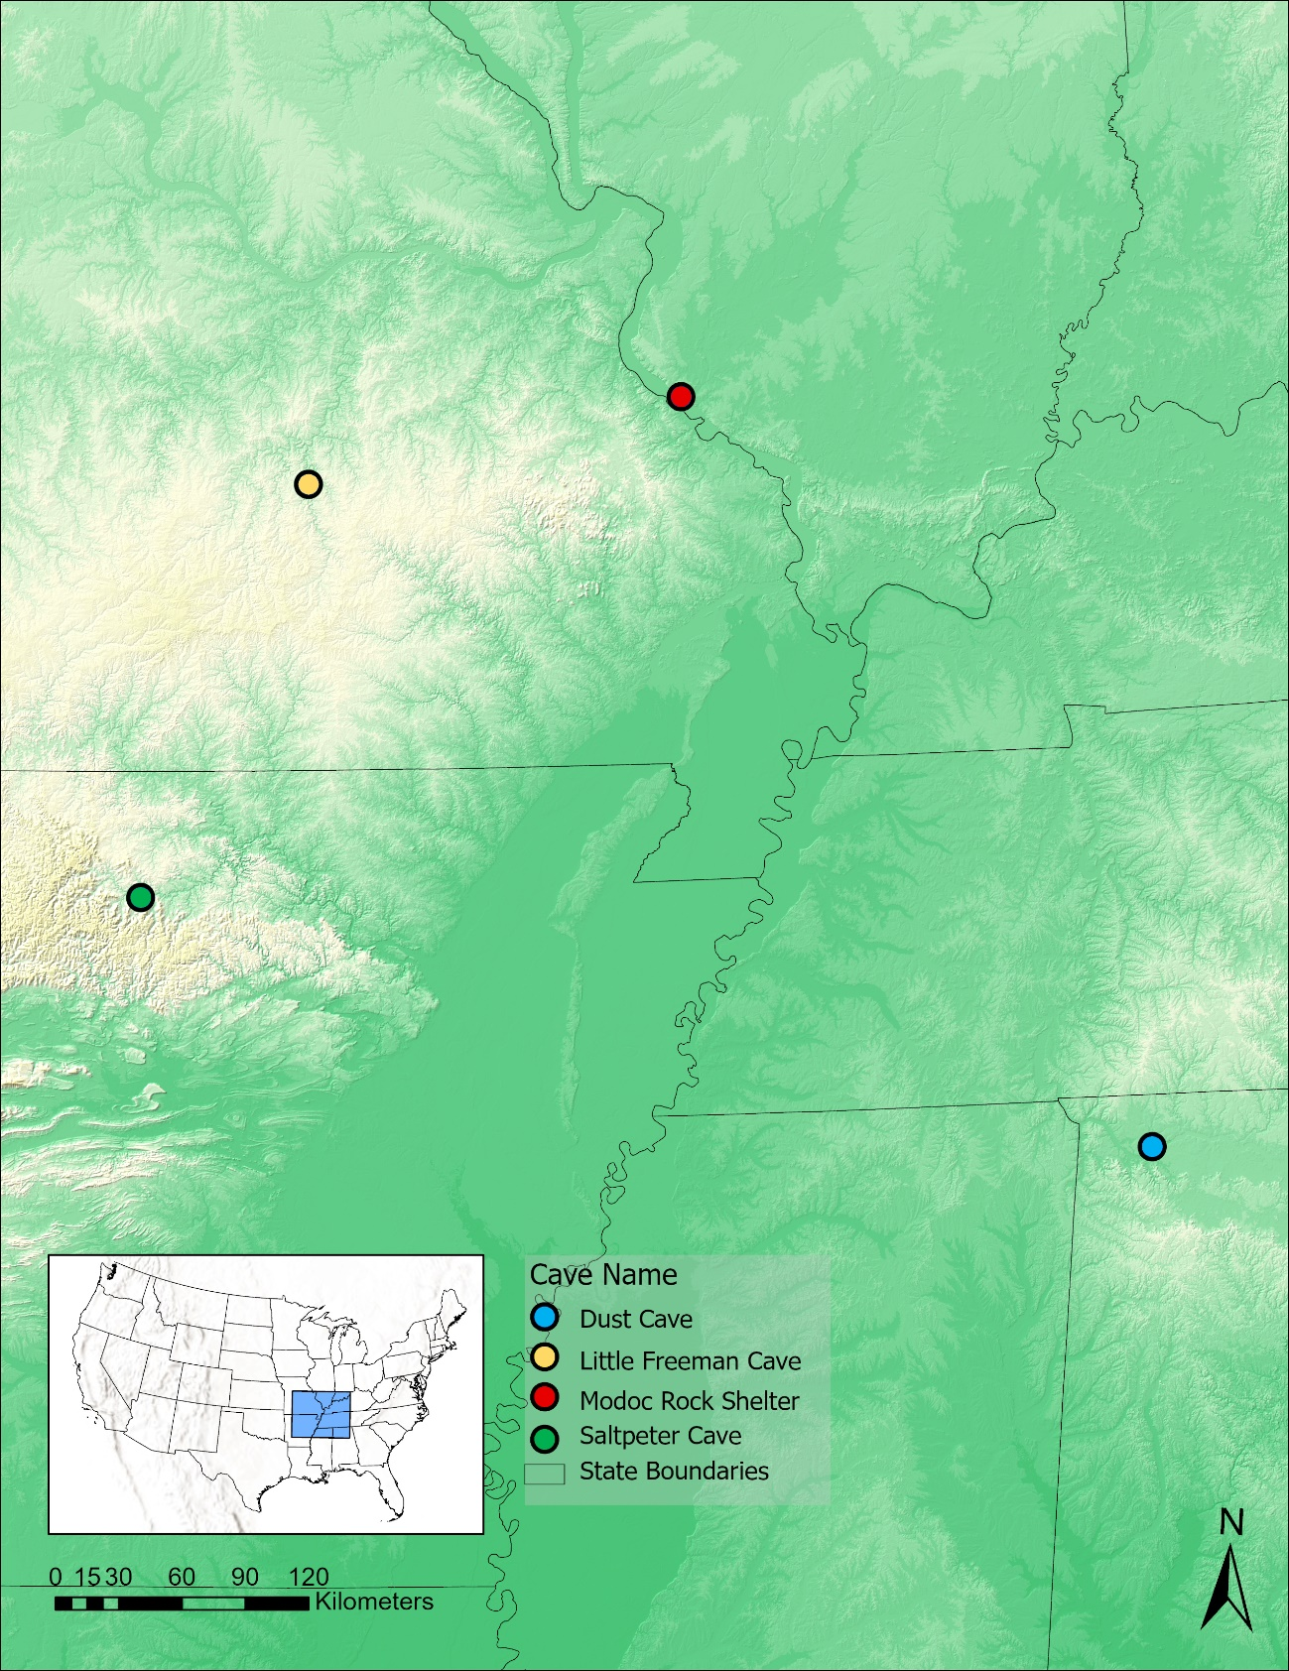
Figure 4.4. Map of Saltpeter Cave, Little Freeman Cave, Modoc Rock Shelter, and Dust Cave.

Archaeological Record (tDAR) (Colburn and Styles 1984; Colburn et al. 1980; Colburn et al. 1996; Colburn et al. 1987; Walker 1998b).

Modoc Rock Shelter

Modoc Rock Shelter is a bluffshelter overlooking the Mississippi River floodplain and formed by the erosion of limestone, leaving a sandstone “roof” (Ahler 1993:463). It is located on the Illinois side of the Mississippi River basin just beyond the eastern fringe of the Salem Plateau region of the Ozarks. Early excavations of the site were conducted
in the 1950’s, but it was revisited in 1980, 1984, and 1987 by the Illinois State Museum and the University of Wisconsin-Milwaukee (Ahler 1993:465, Styles and Colburn 2019:7-8). Only the assemblages recovered during these later investigations are included in this analysis. During the Early Archaic, prairie expansion is noted here by 9000 cal BP, which persisted until ~7500 cal BP when more mesic habitats rebounded. The closing of these forest canopies may have been detrimental to local deer populations (Styles and Colburn 2019:10). In the Middle Archaic, a much more intensive trend of warming and drying resumed the prairie expansion, and Purdue (1991) observes a concurrent decrease in deer body size. Short-term forager residential camps and multi-season base camps are both found at Modoc Shelter, with the former being associated with the Early Archaic and the initial part of the Middle Archaic, and the latter more characteristic of the later Middle Archaic (Styles and Colburn 2019:33-34). The Late Archaic components are characterized as “field camps” or logistical sites that were used only sporadically for specific tasks.

Dust Cave

Excavated between 1989 and 2002 by the University of Alabama, Dust Cave is a southeast-facing cave located within the Highland Rim of the Interior Low Plateau physiographic province of the Appalachian Highland region (Davis 1988:6; Sherwood et al. 2004:533). Its modern surroundings are a cypress swamp created by the Pickwick Reservoir of the Tennessee River, but Walker (1998a:50) indicates that the surrounding environment was highly variable during its occupation (see also Hollenbach and Walker 2010). Importantly, while the area surrounding Dust Cave experienced changes in its local environment and landscape mosaic, it did not undergo an expansion of grassland during the Hypsithermal, but instead saw the establishment of the mix of hardwoods and pine that characterizes the region now. The diversity of activity and intensive subsistence focus indicates the site was used as a residential camp for much of its use-life. A wide variety of lithic tools were identified reflecting the industry of the inhabitants (McMillan 2016), and more than 350 cultural features, including pits, prepared clay surfaces, and hearths were recorded at Dust Cave, leaving no doubt of its domestic function, especially in Middle Archaic contexts (Homsey-Messer 2015). Previous subsistence-oriented zooarchaeological and paleoethnobotanical analyses indicate that in terms of NISP, the Late Paleoindian occupants placed greater emphasis on waterfowl than did subsequent occupations, with a more general focus on available plant resources. Fish taxa take on a greater significance in the Early Archaic, with mammals only taking on a primary position at the end of the Early Archaic and onset of the Middle Archaic. Plant utilization began with a broad taxonomic diversity, which gradually narrowed to a focus on hickory mast by the onset of the Middle Archaic (Carmody 2009; Hollenbach and Walker 2010).

Little Freeman Cave

Little Freeman Cave is located in the Northern Ozark Highlands in the bluffs on the north side of the Big Piney River on Fort Leonard Wood (a United States Army installation) in central Missouri (Styles and McMillan 2009:46, 50). The immediate surroundings are described as mixed oak-hickory forest, but the presence of Bison suggests that prairie patches were also present in the vicinity during the Early-Middle Archaic transition period. Unfortunately, published information about this site is sparse, and most that exists appears to be in the form of contract reports curated by the United States Department of Defense. I have not been able to acquire access to these reports, so my interpretive scope relating to this site will be limited to the dataset itself.

scope of research
Three major lines of inquiry guide this study, and these will be discussed in the following chapter. The first line is concerned with how the use of Saltpeter Cave changed over the course of its occupation. The second line incorporates three other sheltered sites to examine how different foraging communities modified their hunting and trapping strategies to accommodate changing climates. The third line is an examination of these four datasets for local idiosyncrasies

Intra-Site Analysis

Three major lines of inquiry guide this study, and these will be explained over the course of this chapter. The first deals with how the function of Saltpeter Cave changed during its use. This consists of two basic diachronic questions: what terrestrial animal taxa were people using at the cave, and what were people doing to/with those animals once they had been sourced? Assemblage composition, anthropogenic modification patterns, and bone element frequencies from larger taxa will serve to illuminate how Saltpeter Cave was used diachronically. A thorough analysis of the bone tools from the Pit E assemblage is beyond the scope of this thesis, but a general summary of the modified bone artifacts with some discussion of macroscopic wear patterns is included in lieu of a more extensive functional analysis of tools from Saltpeter Cave.

Taxonomic Selection and Representation

In order to assess how the inhabitants of Saltpeter Cave made use of the faunal resources in the surrounding landscape, I quantify the range of taxa represented in each time period. Richness, Diversity, and Evenness indices are numerical values that can be used to assess not only how many taxa are represented within an assemblage, but the degree to which some taxa are emphasized over the rest. Richness (the number of discrete taxa identified) tends to increase with sample size, so Diversity and Evenness (index values designed to evaluate how similarly each taxon is represented and scaled for assemblage size for inter-assemblage comparability) can help to account for this. I will also evaluate Ozarchaic peoples selection practices for or against specific taxa, which is done via diet breadth modeling.

Element Representation

If bone density has not contributed to the destruction of particular elements or element portions in a biased way (Lyman 2014), then the element frequencies themselves can provide information on the habits of butchers at Saltpeter. Because of their large size and weight, it is not always feasible or even desirable to transport an entire animal back to a base camp where it may be processed for food and secondary resources (O’Connell et al. 1988:138). For instance, if upper limb elements are found to predominate, with the conspicuous absence of foot elements and head elements, it may suggest that those elements with poor meat yields were discarded elsewhere, and Saltpeter represents a Base Camp site. If the opposite is the case then it may be that this site was largely used for butchery of recently killed game, and the high value elements were transported elsewhere for further processing and consumption. This premise is of course very general, and individuals make choices based on immediate and perceived future needs, habits, and situational factors (Lupo 2006:57).

Bone Fragmentation

Deliberate fragmentation of appendicular bone elements is identifiable by the predominance of smooth and helical perimortem fracture patterns and suggests marrow extraction based on ethnographic analogy and experimentation (Gifford-Gonzalez 2018:203-221; O'Connell et al. 1988). The more extreme the degree of fragmentation, the greater the likelihood that those individuals were maximizing their resources by boiling nutrients out of the bone as a secondary resource. This is more likely to be conducted in bulk at a larger residential camp due to the high time, labor, and resource costs involved in this practice (Binford 1978:157-158). Ethnoarchaeological observation suggests that this mechanical reduction produces fragments 2-5 cm in maximum length, and occasionally slightly longer, which maximizes the bone volume that can be fit in the cooking vessel and decreases the amount of water and fuel needed for the boil (Church and Lyman 2003:1077-1078; Janzen et al. 2014). I use the degree of fragmentation in larger mammals as another proxy to suggest the likelihood that Saltpeter Cave was used as a residential site at various times in the past.

Seasonality

Seasonality of use may also be evaluated using faunal data. The presence or absence of migratory or hibernating taxa is suggestive of spring/summer or fall/winter occupation (Reitz and Wing 2008:90). White-tailed Deer tooth eruption schedules are well understood, and can be used as an indicator of seasonality (Severinghaus 1949; Whyte 2017:177-178). Moreover, male deer drop their antlers in the winter, so cranial elements that show dropped, rather than removed antlers indicate winter seasonality, while those with attached antlers suggest late fall seasonality. Perinatal elements may also suggest seasonality, as many taxa including the Gray Fox have narrow gestation periods and short juvenile states (Fritzell and Haroldson 1982).

Some writers (e.g. Wiant et al. 2009:264) have argued that the presence of mussels indicates warm-season activity because in the winter the water would be too cold to wade or dive in for mussel harvesting. I consider this argument suspect at best. Archaic hunter-gatherers necessarily were accustomed to working in the elements in all seasons and the claim that a group could not tolerate some cold water for a few minutes on any day between late November and early March projects a weakness of constitution onto them that is not justifiable. Moreover, the Southeast today enjoys mild temperatures that persist into November and the harsher months ameliorate quickly. Given that winter is a lean season for nutrient-rich plant resources and mussels are high in vitamin A, phosphorus, calcium, and iron (Reidhead 1981:55), it seems far more likely that Ozarchaic peoples would want to harvest mussels in the winter specifically.

Inter-Site Analysis

The second line of inquiry is to use the three comparative sites as well as my own faunal data from Saltpeter Cave to investigate how hunters/trappers attenuated their practices as environmental conditions changed in the Eastern Woodlands during the Early Archaic and Middle Archaic periods, and how people changed the use of their landscapes as time progressed. Both animal remains deposited by humans and those that are intrusive, such as taxa that den in caves or were the prey of those that did, suggest what habitats were nearby over time, so this investigation also has implications for what local environments were like with greater specificity than the environmental reconstructions discussed in Chapter Three can provide.

The third line of inquiry is to investigate idiosyncrasies in faunal taxonomic selection patterns that distinguish the southern Ozarks from other parts of the Eastern Woodlands region. Because the White-Tailed Deer represents the largest game mammal abundantly available in most of the study region, its ubiquity on archaeological sites is less the result of preference and more of utility. The processing of a deer is also less labor-intensive than the larger but more sparsely available elk and bison, for food as well as hide processing (Grayson 2016). It is the smaller taxa which represent minority components of most faunal assemblages that have more overlap with each other in resource value, and therefore provide those functionally equivalent alternatives from which people might develop regionally specific isochrestics over time as described by Hegmon (1998). For instance, raccoons, rabbits, foxes, and opossums are all terrestrial mammals that may be hunted or trapped and represent roughly comparable resource packages. The conspicuous concentration on (or avoidance of) any one or combination of such taxa would suggest deliberate choices tantamount to a cuisine component or preference, rather than opportunistic capture based on natural encounter rates within targeted patches within a mosaic landscape. These deliberate choices were already perceived by Paul Parmalee in his analysis of the Stanfield-Worley shelter in northwest Alabama (Dejarnette et al. 1962:112-114), because the frequencies of animal taxa recovered from the site did not reflect the expected abundance of those taxa on the landscape. OFT predicts that these taxonomic concentrations reflect search time and pursuit/processing costs with consideration for the rank order of a taxon’s resource value (Winterholder 1981:24-25). If the patterns violate this rank order, it may suggest that taxa are represented in the assemblage for reasons other than their caloric resource value.

Preliminary analysis of the Saltpeter Cave assemblage has produced patterns that may suggest a fourth line of inquiry. The Gray Fox is represented in far greater proportion at Saltpeter Cave than at any other Eastern Woodlands Archaic sheltered site identified to date. Moreover, the left side of the animal is overwhelmingly represented. The question is: why? What caused Ozarchaic people to treat this taxon’s remains so specifically? While this study may find that the presence of these foxes can be explained by HBE, the near-exclusive deposition of left limbs and mandibles cannot. A brief discussion of ethnohistoric and folkloric references to foxes among Eastern Woodland peoples will be included in Chapter Eight.

Methods
This chapter covers the methods for data collection, as well as the analytical methods to be employed. These include morphological analyses, secondary data calculations, data preparation, and statistical analysis.

Concerning Bias
As with most facets of archaeology, four major biases condition the resolution of our perspective and must be considered before forming conclusions. These biases occur chronologically from deposition bias, to preservation bias, on to recovery bias, and finally identification bias. The causes and effects of each of these will be discussed in this section.

Deposition Bias

Deposition bias is produced when some materials are left behind at a site, and others are not. Zooarchaeologically, this is constrained by the availability of particular taxa on the landscape and is the product of several processes: the manner in which people hunted/collected faunal taxa for food and other purposes, transported elements, processed their bodies, and finally discarded remains on and off site. If fauna are field-dressed and some bone elements are left behind while others are transported to another site, those choices will condition what is deposited at both the butchering site and at the site where the animal is used or consumed (Binford 1978; Wampler 2000). Small mammals and birds may be roasted and consumed whole, causing their bones to be digested and possibly excreted elsewhere. Elements may be selected to be made into tools or adornments, such as awls, fishhooks, projectiles, pins, needles, and beads, in which case they are more likely to be kept and transported off-site. Custom may dictate that elements are removed from one site and deposited at another (Brown 2009) or burned thoroughly. All of these decisions determine what was left behind in antiquity for subsequent biasing processes to distort.

Preservation Bias

Preservation bias defines what may be recovered from an archaeofaunal assemblage after the passage of time has taken its toll. The sources of taphonomic modifications are twofold. First, the environment contributes conditions of degradation such as soil acidity, temperature fluctuations, moisture fluctuations, root growth and decay, and burrowing animals (Behrensmeyer 1978; Gifford-Gonzalez 2018:226, 344-348, 360). Second, the actions of people contribute to these processes both pre- and post-depositionally. Burned bone tends to fragment easily (Gifford-Gonzalez 2018:324-325; Stiner et al. 1995:229). Breaking bones open for marrow or bone grease (Lyman 1995) increases their surface area and may contribute to faster degradation. In persistently occupied places (as sheltered sites often are), repeated human activity such as trampling or the digging of pits for storage or cooking will disturb, displace, and degrade faunal materials. Humans often keep dogs, and their digging and gnawing behaviors may also play a role in deletion or degradation of faunal remains (Jeske and Kuznar 2001; Reitz and Wing 2008:134-135), as do other scavengers like Coyotes and rodents. Bacteria and fungi also play a role in destruction of bone with highly porous portions being most susceptible (Nicholson 1996:524).

Recovery Bias

Recovery bias is also a significant determining factor in what is available for analysis (Reitz and Wing 2008:147-150). Because the Saltpeter assemblage in question was recovered in the summer of 1970, a minimum of 0.25-in. mesh was used to recover materials. This produces a filter that removes many elements of smaller taxa, such as reptiles, smaller birds, fish, and small mammals that might have been represented in the assemblage had a smaller mesh size been employed. It is common practice that artifacts including faunal materials are collected from the screen before discarding the presumed non-cultural remainder on-site. It is very likely that some bone elements were not recognized and were discarded in the field. Excavators with limited knowledge of faunal materials may misidentify elements of amphibian or fish taxa as botanical detritus, leading to their discard. This recovery failure has been shown experimentally by Whyte and Compton (2020).

Identification Bias

Two components contribute to identification bias in an assemblage once it has passed through the deposition, preservation, and recovery bias filters. The first is that using morphological criteria as the primary method of identification means that elements with more species-specific and/or element-specific features will be identified with greater confidence and regularity. For instance, in the appendicular skeleton, midshaft fragments often lack distinguishing features that would facilitate either taxonomic or elemental identification (Gifford-Gonzalez 2018:170; Marean et al. 2004). By contrast, teeth and epiphysial portions bear many taxa-specific characteristics that are particularly useful for the element and taxonomic identification of each. Deer metatarsals are much easier to identify compared to metacarpals when they are fragmentary, because of the deep groove that runs along the cranial margin of the former.

The second component is analyst experience. Whyte and Compton (2020) tested the effects of analyst experience by having minimally trained laboratory personnel sort out bone elements from mixed assemblages and had their work checked by the more experienced senior author. This exercise found that the laboratory personnel missed more than 30% of frog head elements. A study by Prendergast et al. (2018) found that even analysts with more comparable experience working on the same assemblage will produce similar, but not identical results.

Zooarchaeology

Traditional zooarchaeological analysis has been conducted as part of this study to establish a baseline of faunal resource procurement and use (Reitz and Wing 2008). This baseline established what species Southern Ozarks people selected as resources during the Early Archaic through the Middle Archaic Period. Specimens have been identified to taxon, element, portion, and side via comparison to reference collections, and both anthropogenic and environmental modifications have been identified. Because the earliest vertebrate faunal elements were recovered from 390 cmbd, two levels above the Dalton component, only Early and Middle Archaic materials are included in this analysis.

Data Collection
Each element from terrestrial vertebrates has been identified to the narrowest taxonomic level possible with reference to the Anthropology Department’s Vertebrate Osteology Comparative Collection at the University of Tennessee, Knoxville. The remains of fishes and mollusks were quantified and weighed, but not analyzed further. The Linnaean Taxonomic System is used to establish taxonomic groupings. Specimens that could not be identified to at least taxonomic class were designated “indet.” for indeterminate or “vertebrate” when possible. Each specimen was identified to element where possible, with more general categories (e.g., longbone, cranial), used when necessary. The portion (e.g. mid-shaft fragment, proximal and shaft, distal shaft fragment) of each element was also recorded for the estimation of Minimum Number of Elements (MNE) and Minimum Number of Individuals (MNI) for each taxon within each component. Bones were sided where possible (left, right, or axial). For cranial and innominate fragments, if a side could be identified it was recorded as such (e.g, an ilium or premaxilla), but if an axial element was too fragmentary to assign a side, it was simply designated “x” for axial, as were all vertebrae.
Mammals have been sorted into size classes ranging from 0 to 3, where small rodents were included in size class 0 and large mammals including American Bison and American Elk belong to size class 3. Non-mammalian taxa are organized into a size scale from very small to small, medium and large (VS, S, M, L). These do not correspond across taxonomic classes, so a medium bird will be generally larger than a medium reptile (e.g. Canada Goose vs. box turtles.) Size classes for particular taxa can be found in the table at the end of this chapter.
Burned bone is recognizable by a change in color and luster. Early burning stages produce a darkening that may be brown, black, or a dark purple which are generally grouped as the carbonized stage, while more intense heat will produce calcined bone that turns grey to white as a result of thermal restructuring of the bone’s bioapatite crystalline structure (Gifford-Gonzalez 2018:322; Shipman et al. 1984). The seven-stage burning system used by Stiner et al. (1995:226) is employed here. Stage 0 specimens are unburned, stages 1-3 are carbonized with <50%, >50%, and 100% coverage respectively, and stages 4-6 are calcined specimens likewise sorted by <50%, >50%, and 100% coverage of the bone surface.

Breakage patterns were assessed only for mammalian long bones above size class 0.5. Specimens were assessed for fragmentation using both maximum length and width, as well as the fracture angle, outline, and texture on both ends and one side of limb bones, so that each specimen could contribute a maximum of three break surfaces for analysis (Villa and Mahieu 1991). However, some specimens were only broken on one end, or their fracture surfaces were too damaged or irregular to assign categories. Angle describes the angle from the bone’s interior to the exterior and may either be right or obtuse. Outline describes the shape of the break which may be curved, transverse/longitudinal, or V-shaped. Texture describes the surface of the fracture, which was recorded as S (smooth), SR (more smooth than rough), RS (more rough than smooth), or R (rough). These categories are designed to assess if the breaks are more likely perimortem (near the time of death) or postmortem (after bone nutrients have been depleted). Perimortem fracture is characterized by more obtuse and curved or V-shaped fractures with smooth surfaces. By contrast, postmortem fractures produced by post-depositional disturbances tend to have more right-angled, transverse breaks with rough break surfaces.
An approximate percentage of the exposed medullary cavity that contained trabecular bone was recorded for limb bones. This estimate was also attributed to specimens that had enough interior space exposed to make such an estimate. Any surface modifications were also documented. Such modifications included, but were not limited to: cuts, rodent or carnivore gnawing, burning, impact marks, polishing, gastric etching, and fracture patterns. Cuts were identified based on the presence of a V-shaped cross section and location on the bone element. Clustering of cut marks, especially in parallel groups, served to strengthen the identification in some cases. Stereomicroscopes were used as needed to assess suspected cut marks. Because the assemblage came from a sheltered site, bone weathering is almost nonexistent, so weathering stage has only been explicitly recorded if the specimen exhibits flaking of the bone surface or more extensive weathering stages (Behrensmeyer 1978).
Any fragments that were determined to be unidentifiable and were under 2 cm in maximum length were not analyzed but were sorted into burning stage category and weighed in bulk. Element fragments from the same arbitrary level that could be refit were assigned the same accession number but quantified as separate pieces for number of individual specimens present (NISP) purposes unless the breaks appeared to be recent. This was done so that natural fragmentation would be reflected in NISP counts, but this scenario was rare. Data was entered in Google Sheets to safeguard against inadvertent data loss. These spreadsheets were converted to Microsoft Excel for data analysis.

Quantification

Number of individual specimens present is the most standard and straightforward method of quantification. It is a simple count of bone element specimens by taxonomic group. This quantification is heavily skewed by the biases discussed above. Deliberate bone fragmentation for extraction of nutrients will increase the NISP for those taxa processed in this way, which amplifies counts of larger taxa. These taxa are already over-represented due to preservation and recovery biases.

Minimum Number of Individuals (MNI) is calculated by the greatest number of an individual element from an identifiable taxon from a specific side recovered from a particular context. Age, size and individual variation are considered in this calculation wherever possible. For the purposes of age estimation, tooth eruption, tooth wear, and epiphyseal fusion stage were used as relative indication. If a specimen is identifiable to narrow taxonomic resolution but is significantly larger or smaller than other specimens within the stratigraphic assemblage, it has been noted as such so as not to calculate it as a possible left/right match with more normative specimens, preventing underestimation of MNI. Some individuals within the Saltpeter assemblage have morphological features that are qualitatively divergent from most specimens. For instance, one of the fox mandibles has an unusually curved coronoid process. Some elements are unusually robust or gracile compared to the others. These discrepancies are also noted to avoid inappropriate left-right matching. Ribs and general vertebral elements are not used to calculate MNI, partly because they are so fragmentary and difficult to assign to anatomical specificity, and because so few are identifiable to species. Because of the degree of fragmentation in faunal assemblages, minimum number of elements (MNE) must be calculated before an MNI may be estimated. Proximal, distal, and medial fragments are quantified, and possible re-fits are calculated based on similar criteria to those discussed for MNI, such as redundancies in element portions and noteworthy size outliers.

Richness, Diversity, and Evenness

For inter-assemblage comparison, it may be useful to quantify the amount of variation within each assemblage as secondary data calculations. The most fundamental of these is richness, which is the number of taxa represented in an assemblage (Hollenbach and Walker 2010:234).

While richness can articulate the range of taxa represented, it does not indicate how well any of those taxa are actually represented within the assemblage. It could easily be that 90% of the MNI of any given assemblage is dominated by a single taxon, while large numbers of taxa are represented by a single individual each. Diversity and Evenness are calculated to illustrate how well each taxon is represented within the assemblage. An assemblage in which 10 taxa are represented by 5 MNI each will have a high Evenness index, while an assemblage that has the same 10 taxa represented, but one taxon has an MNI of 41 and the rest have an MNI of 1 will have a low Evenness index value. The Shannon-Weaver index is used to produce a Diversity value, the equation for which is:
H’=-Σ(p_{i})(Log₁₀ p_{i})
Peres (2010:29) defines the H’ variable as the index value expressed in the desired analytical unit, such as MNI or NISP. I will incorporate each. p_{i} is the abundance p of each taxon i within a sample, and Log₁₀ p_{i} is a base 10 logarithmic transformation of the abundance value for each taxon. Evenness values (E) are calculated using the equation:
$$E=\frac{H^{'}}{\left({Log}_{e} R\right)}$$
Where the Diversity index value (H’) is divided by the natural Log of the Richness value (R) (Hollenbach and Walker 2010:234), which is to say that Evenness is the Diversity represented per taxon in the assemblage. These index values can be employed in concert with diet breadth models to assess if people were actively changing the scope of their foraging targets, or if the changes in Richness values are statistical accidents.
Calculating these indices with MNI and NISP yield differing results. For an MNI-based analysis, I am necessarily limited to those taxa for which I can calculate some MNI. While I have four specimens that can be assigned to the family “Anatidae” (waterfowl including ducks and geese) they cannot be identified with enough specificity to assign meaningful MNI estimates. However, I can confidently say that there are four waterfowl specimens from an NISP standpoint. Moreover, where squirrels are concerned the assemblage has large numbers identified to the genus Sciurus and some minority assigned to specific species. For purposes of estimating for MNI-based analysis, I enumerated the total number of squirrels possible on the genus level, but for NISP-based analysis each species is counted separately. As a rule of thumb I include NISP for family-level identifications only when no other specimens could be identified more specifically, as is the case with the waterfowl. I include MNI calculations for species-level identifications only except in those cases where taxa like squirrels contribute significant numbers to the NISP but can only rarely be identified to species. In those instances, I estimate the MNI of the genus. This is the case for squirrels, box turtles, and rabbits.

Density-Mediated Attrition

While the presence of gracile mammal and bird bones in the Early Archaic component assemblage indicates that variation in bone density has not contributed significantly to biasing the degradation (deletion) of specimens from the archaeological record, an experimental study by Nicholson (1996) suggests that bird elements may be over-represented in some assemblages due to differences in bone structure compared to mammals, especially due to the absence of trabecular bone structures in bird bones. For this reason, the presence of gracile bird bones cannot be invoked as an indication that preservation biases are minimal within an assemblage. Because of this I have incorporated a method outlined by Lyman (2014) for evaluation of density-mediated attrition using several elements from the size 2 ungulates (which is to say White-tailed Deer) in the Saltpeter assemblage as a proxy. The premise of the method is that different bone element portions have different density values (Lam et al. 1998; Lam et al. 1999). For instance, the proximal and distal ends of a deer tibia have very different densities, regardless of the method used to calculate it. If low density element portions have been removed at a higher rate than high density portions from the assemblage by soil acidity, fungal degradation, or scavengers, then the number of distal ends of deer tibia should be better represented than the proximal ends.

I have calculated for each component the minimum number of element portions (MNP) where the proximal and distal ends of each limb element, the horizontal ramus and ascending ramus portions of mandibles, and the articular and blade portions of scapulae are calculated as separate element portions. I then divided the MNP values for each pair by the number of times that element occurs in the body, which is two for all elements except the proximal and medial phalanges which occur eight times each. These are the Minimum Animal Unit (MAU) values (Binford 1984:51). Finally, I divided the MAU values by the MNI estimate produced by the specimens included in the calculation resulting in a “Survivorship” index for each element portion. I then plotted the survivorship of the low-density portion on the y-axis against that of the high-density portion on the x-axis of a biplot. High- and low-density designations have been based on Lyman’s (1984:274-279) Volume Density (VD) values, which are derived from mass in grams per cubic centimeter, as well as more precise CT scan and photon densiometry measurements reported in Lam et al. (1998) and Lam et al. (1999). If preservation biases are significantly affected by bone density for any reason, then most of the points on the biplot should appear within the Zone of Destruction (Figure 6.1) (Lyman 2014:90).

Diet Breadth Modeling

The diet breadth model is an analytical technique imported from Evolutionary Ecology into Human Behavioral Ecology. The model is predicated on the premise that human people are competent and pragmatic. They find a foraging equilibrium that the balances resource value, search time, and processing time to meet their thermodynamic
Figure 6.1. Binford's graph of destruction with sample points illustrating low and high density-mediated attrition rates. Reproduced from Binford (1981) via Lyman (2014:90).

needs efficiently, yielding time to pursue other needs or interests. In a landscape with abundant and diverse plant and/or animal resources, they will preferentially exploit those resources that yield the highest return on their investment of labor while ignoring the rest, even if viable but lower-return resources are encountered (Winterhalder 1981:24).

A rank-order is based on an established currency, which is generally calculated in terms of kilocalories per hour (kcal/hr) of processing (Weitzel 2019:199). Here, processing time includes butchering of game, shucking mussels, extracting mast from the shell, and so on, but not time searching until a resource is encountered. The rank order used is based on calculations published in Thomas (2008) and Ugan (2005) As the name implies, diet breadth models are concerned specifically with food resources, and do not consider non-nutrient resources such as hides, bone tools, soap production, sinew, or other functional resources.

A standard diet breadth model (Winterhalder 1981:24) is a line chart designed to visualize what decisions foragers made, in which resources represented in an assemblage are listed on the x-axis in order from highest to lowest rank, and the y-axis illustrates those resources by quantity (generally MNI or NISP). I employ both MNI and NISP-based models, because NISP allows for less specific but more categories compared to MNI, for reasons described in the Richness, Diversity, and Evenness section. If all resources are sufficiently abundant on the landscape such that search times do not negate the kcal/hr return rate, then we should see a regular decrease in representation the farther we get from the highest ranked resource. If the model demonstrates increased breadth such that intermediate and low-rank taxa are well represented, it suggests that those highest-ranked taxa are not sufficiently abundant to meet community needs. Increasing human populations or depletion of the higher ranked prey taxa will lower the encounter rate, increasing search time, and thereby pressuring people to focus on intermediate or lower-ranked taxa (Carmody 2009:154; Winterhalder 1981:24-25).

Irregular spikes in particular taxa may have several explanations. Those taxa may have been easily collected in bulk, congregating in groups or being suitable for trapping, thereby offsetting the processing cost by decreasing the search time needed to encounter the resource. They may have offered some resource value that was not strictly caloric, such as bone or shell for tool manufacture, excess oils for dermatological care, medicinal properties, or hides that had desirable aesthetic qualities (Claassen 2011:4). In hunting and gathering societies, children, the elderly, or the injured may have involved themselves in foraging within their range of ability by collecting low-rank faunal resources that are reliably located and easily collected, such as mussels, snails, fish, turtles, or squirrels (Hawkes 1996:262-263). The conspicuous absence of high-rank taxa may imply a taboo, that they were seasonally unavailable, or that these individuals were disposed of in such a way that precluded their recovery, such as ceremonial burning or extralocal discard (Lawson 1709:52).

Correspondence Analysis

Correspondence Analysis (CA) is a statistical technique of visualization. It is designed to evaluate the homogeneity or heterogeneity of data assemblages using counts of categorical data (Carlson 2017:279-280). The assemblages from the four sites discussed in Chapter Four are easily formatted to be suitable for CA. While a chi-squared test can provide insight on the degree of similarity between assemblages, CA visualizes which aspects of each assemblage contribute most and least to its individuality. These data are represented on a biplot on which both the assemblages and the categories are represented, with a percentage of the variance within the dataset explained associated with each axis. The higher the sum of these percentages, the greater the variance that is preserved in two dimensions. Assemblages located nearest the origin of the biplot consist of categorical ratios that are closest to the expected values if all of the assemblages were homogenous, while those farthest from the origin have the least correspondence with these expected values. Similarly, the categories appear superimposed on the plot such that those nearest the origin are the most homogeneously represented in each assemblage, while those farthest from the origin reflect the highest deviation from the expected values and indicate some idiosyncrasy within a minority of the assemblages.

Moreover, CA provides two other insights: first, those assemblages that cluster together within a quadrant near one or several categorical labels are more similar to each other because those categories are better represented in those assemblages, which also means that the categories that cluster together within a quadrant tend to co-occur. Second, there is an inverse relationship between those assemblages and categories that are plotted on opposite sides of both axes (e.g. top right and bottom left quadrants). This technique is especially well suited to evaluating pre-contact faunal assemblages of drastically different sizes that are dominated by a few taxa and have a wide diversity of minority taxa represented (Carlson 2017:279-280).

The assemblages that I am analyzing contain specimens that are affiliated with 45 taxonomic groups, and eight environmental categories. These data are converted into two contingency tables in which one has the sites and time periods represented as rows, and primary habitat as columns, and the other has the same row label configuration with the simplified taxonomic group as columns. The site-time period assemblages are plotted with a site initial(s) and temporal affiliation abbreviation.

Once the data from Saltpeter cave was generated, I combined it with data from the three comparative sites included in the study. I scrubbed the combined dataset to remove entries that could not be assigned to an Early Archaic or Middle Archaic time period. Specimen entries that could not be identified with sufficient specificity to be assigned either a primary habitat or a taxon group as seen in Table 6.1 and Table 6.2 were also removed. Excluded specimens were predominantly indeterminate mammals, birds, etc. Habitat assignments (Table 6.3) were based on the NatureServe (2021) database. Specimens that were not removed were also assigned to one of four temporal components (Table 4.1). I then constructed contingency tables of habitat counts and taxon group counts in which values were calculated from NISP, and imported these data into RStudio (2021) for analysis. Analyst notes were checked for specimens that were fragmented during or after excavation to prevent those categories from having inflated NISP values.

Habitat Index Analysis

The habitat assignments can also be used to calculate indices that summarize changes in representation over time, such as forest/prairie calculations (after Denniston et al. 1999:385). By dividing the NISP counts for specimens assigned to woodland (Forest and Edge) habitats by the counts associated with grassland (Prairie and Open) habitats, it is possible to produce line graphs that diachronically illustrate the relative significance of each habitat to the hunting and trapping practices of the various foraging communities in question. Unlike Denniston et al. (1999:385) who use a fraction-of-total index (woodland counts divided by woodland + grassland counts), I have elected to use a simpler woodland divided by grassland index value, because the overwhelming preponderance of woodland taxa renders changes in grassland representation difficult to visualize as a ratio.
Class | Common Name | Scientific Name | Taxon Group | Habitat | Size
Amphibian | American Bullfrog | Lithobates catesbeianus | Frog | Water | L
Bird | Wild Turkey | Meleagris gallopavo | Turkey | Forest | L
Bird | Greater Prairie Chicken | Tympanuchus cupido | Game Bird | Prairie | M
Bird | Sandhill Crane | Grus canadensis | Crane | Wetland | M
Bird | American Crow | Corvus brachyrhynchos | Passerine | Edge | S
Bird | Passenger Pigeon | Ectopistes migratorius | Pigeon | Forest | S
Bird | Red-tailed Hawk | Buteo jamaicensis | Hawk | Edge | S
Bird | American Kestrel | Falco sparverius | Falcon | Open | VS
Bird | Pigeon/Dove | Columbidae | Pigeon
Mammal | Eastern Chipmunk | Tiamias striatus | Rodent | Forest | 0
Mammal | Eastern Grey Squirrel | Sciurus carolinensis | Squirrel | Forest | 0
Mammal | Eastern Woodrat | Neotoma floridana | Rodent | Forest | 0
Mammal | Fox Squirrel | Sciurus niger | Squirrel | Edge | 0
Mammal | Common Raccoon | Procyon lotor | Raccoon | General | 0.5
Mammal | Eastern Cottontail | Sylvilagus floridanus | Rabbit | Open | 0.5
Mammal | Gray Fox | Urocyon cinereoargenteus | Fox | Forest | 0.5
Mammal | Muskrat | Ondatra zibethicus | Muskrat | Water | 0.5
Mammal | North American Porcupine | Erethizon dorsatum | Porcupine | Forest | 0.5
Mammal | Northern River Otter | Lontra canadensis | Otter | River | 0.5
Mammal | Opossum | Didelphis virginiana | Opossum | General | 0.5
Mammal | Rabbit | Sylvilagus sp. | Rabbit | Open | 0.5
Mammal | Red Fox | Vulpes vulpes | Fox | Edge | 0.5
Mammal | Striped Skunk | Mephitis mephitis | Skunk | General | 0.5
Mammal | Woodchuck | Marmota monax | Groundsquirrel | Edge | 0.5
Mammal | Beaver | Castor canadensis | Beaver | Wetland | 1
Mammal | Bobcat | Lynx rufus | Bobcat | Forest | 1
Mammal | Whitetail Deer | Odocoileus virginianus | Deer | Edge | 2
Reptile | Common Snapping Turtle | Chelydra serpentina | Turtle | Water | L
Reptile | Eastern Box Turtle | Terrapene carolina | Turtle | General | M
Reptile | Ornate Box Turtle | Terrapene ornata | Turtle | Open | M
Reptile | mud/musk turtles | Kinosternidae | Turtle | Water | S
Reptile | musk turtles | Sternotherus sp. | Turtle | Water | S
Reptile | softshell turtles | Apalone | Turtle | Wetland
Table 6.1. Taxa Identified at Saltpeter Cave, Sorted by Class, Size, and Alphabetized by Common Name.

Table 6.2 Taxa Identified at Dust Cave, Little Freeman Cave, or Modoc Shelter That Were Not Identified at Saltpeter Cave.
Class | Common Name | Scientific Name | Taxon Group | Habitat | Size
Amphibian | American Toad | Bufo americanus | Frog | General | S
Amphibian | Southern Toad | Anaxyrus terrestris | Frog | General | S
Bird | swan | Cygnus | Waterfowl | Water | L
Bird | American Coot | Fulica americana | Waterfowl | Lake | M
Bird | Canada Goose | Branta canadensis | Waterfowl | Water | M
Bird | Common Egret | Ardea alba | Heron | Wetland | M
Bird | Great Horned Owl | Bubo virginianus | Owl | General | M
Bird | grouse | Tetraonidae | Game Bird | Prairie | M
Bird | Pied-billed Grebe | Podilymbus podiceps | Waterfowl | Wetland | M
Bird | Ruffed Grouse | Bonasa umbellus | Game Bird | Forest | M
Bird | Snow Goose | Anser caerulescens | Waterfowl | Water | M
Bird | Wood Duck | Aix sponsa | Duck | Wetland | M
Bird | Yellow-crowned Night-Heron | Nyctsa violacea | Heron | Wetland | M
Bird | American Bittern | Botaurus lentiginosus | Bittern | Wetland | S
Bird | Barred Owl | Strix varia | Owl | Edge | S
Bird | Black-crowned Night-heron | Nycticorax nycticorax | Wetland | Wetland | S
Bird | Blue-winged Teal | Spatula discors | Duck | Wetland | S
Bird | Broad-winged Hawk | Buteo platypterus | Hawk | General | S
Bird | Common Barn Owl | Tyto alba | Owl | Open | S
Bird | Diving Ducks | Aythya | Duck | Water | S
Bird | Eastern Screech-owl | Megascops asio | Owl | General | S
Bird | King Rail | Rallus elegans | Rail | Wetland | S
Bird | Long-eared Owl | Asio otus | Owl | Forest | S
Bird | Mourning Dove | Zenaida macroura | Pigeon | Edge | S
Bird | Northern Bobwhite | Colinus virginianus | Game Bird | Edge | S
Bird | Blue Jay | Cyanocitta cristata | Passerine |  | VS
Bird | Carolina Parakeet | Conuropsis carolinensis | Passerine |  | VS
Bird | Common Grackle | Quiscalus quiscula | Passerine | Open | VS
Bird | Eastern Phoebe | Sayornis phoebe | Passerine | Open | VS
Bird | Great Crested Flycatcher | Myiarchus crinitus | Passerine | Forest | VS
Bird | Northern Flicker | Colaptes auratus | Woodpecker | Open | VS
Bird | Northern Goshawk | Accipiter gentilis | Hawk | Forest | VS
Bird | Pileated Woodpecker | Dryocopsus pileata | Woodpecker | Forest | VS
Bird | Red-bellied Woodpecker | Melanerpes carolinus | Woodpecker | Forest | VS
Bird | Sora | Porzana corolina | Rail | Wetland | VS
Bird | Virginia Rail | Rallus limicola | Rail | Wetland | VS
Mammal | Eastern Mole | Scalopus aquaticus | Mole | Open | 0
Mammal | Marsh Rice Rat | Oryzomys palustris | Rodent | Wetland | 0
Mammal | Meadow Vole | Microtus pennsylvanicus | Rodent | Open | 0
Mammal | Northern Short-tailed Shrew | Blarina brevicauda | Rodent | Forest | 0

Table 6.2. continued.
Class | Common Name | Scientific Name | Taxon Group | Habitat | Size
Mammal | Northern Short-tailed Shrew | Blarina brevicauda | Rodent | Forest | 0
Mammal | Plains Pocket Gopher | Geomys bursarius | Rodent | Prairie | 0
Mammal | Prairie Vole | Microtus ochogaster | Rodent | Prairie | 0
Mammal | S. Flying Squirrel | Glaucomys Volans | Flying Squirrel | Forest | 0
Mammal | Mink | Vison vison | Mustelidae | Water | 0.5
Mammal | Spotted Skunk | Spilogale putorius | Skunk | Forest | 0.5
Mammal | Swamp Rabbit | Sylvilagus aquaticus | Rabbit | Forest | 0.5
Mammal | Coyote | Canis latrans | Canine | Prairie | 1
Mammal | Gray Wolf | Canis Lupus | Canine | Forest | 2
Mammal | American Bison | Bison bison | Bison | Prairie | 3
Mammal | Black Bear | Ursus americanus | Bear | Forest | 3
Mammal | American Elk | Cervus elaphus | Elk | Edge | 3
Reptile | Painted Turtle | Chrysemys picta | Turtle | Wetland | L
Reptile | Mud Turtle | Kinosternon sp. | Turtle | Wetland | S

Table 6.3. Habitat Type Categories Explained.
Habitat | Description | Example
General | Broad range of terrestrial environments | raccoons, opossums
Forest | Clusters of standing trees | Grey Squirrel, Wild Turkey
Edge | Borders between forest and open environments, meadows, etc. | deer, some predatory birds
Open | Meadows, savannahs, low brush | rabbits, moles
Prairie | Expansive grasslands | prairie chickens, bison
Water | Lakes, streams, wetlands, or rivers, but doesn’t specialize | muskrats, most ducks,
Lake | Larger bodies of slow-moving water | coots, some ducks
Wetland | Swamps, marshes, ponds, etc. | beavers, cranes

Results

General Data

The Saltpeter Cave faunal assemblage from the undisturbed strata includes 3634 specimens with a total weight of 9578.25 g. Of these, 817 specimens weighing 1495.85 g were from fishes and mollusks and were not analyzed further. Of the remaining 2817 terrestrial vertebrate specimens, 2349 were identifiable to Class at least, while 177 were categorized as indeterminate vertebrates. Of the total (mollusks and fish included), 940 were of Early Archaic 2 antiquity, 1575 were Middle Archaic 1, and 742 belonged to the Middle Archaic 2. Reptiles and Amphibians contributed no more than 5% of the total NISP combined. These will not be discussed in detail, but their counts and weights can be found in Table 7.1. The initials “cf.” designates tentative identifications that are confident enough to include in MNI estimates. Wild Turkey MNIs were calculated together, they are recorded here in separate size categories. Some specimens are excluded because they do not fit neatly into analytical categories, such as “Size 1-3 Mammal”. Cut and burning counts are quantified by NISP. Mammals represented more than 70% of the terrestrial faunal assemblage in every time period, with birds contributing between 15% and 20% across three time periods (Figure 7.1, Figure 7.2). Incorporating invertebrates and fishes into these calculations only has meaningful implications for the Early Archaic assemblage, which is more than 75% mollusk by NISP, most of which are bivalves.

Despite the high preservation rate within Saltpeter Cave, the Middle Archaic levels contain much more vertebrate material than the Early Archaic (Figure 7.3), with the Middle Archaic 1 levels having the highest recovery of faunal materials. This pattern does not appear to be the product of taphonomic processes such as bioturbation, as the elements recovered from these deeper strata include a raccoon fibula, a very gracile and delicate bone element, recovered from the deepest stratum of Pit E, between 380 and 390 cmbd, and had parallel cut marks clearly visible just above the ankle joint. Fragile bird specimens were also identified in these Early Archaic strata in comparable condition to those recovered from more recent contexts.

Taxonomic Summaries

Early Archaic

The Early Archaic is the only component which includes a significant proportion of mollusks which account for over 75% of the identifiable assemblage by NISP (Table 7.1, Figure 7.2). Despite their large numbers, all of these invertebrate specimens would fit in a small basket, so their dietary contribution would still be minor from a caloric standpoint. Size 2 mammals contribute the majority of the vertebrate fauna by NISP. Only deer were identifiable beyond taxonomic class with an MNI of four based on the left mandible specimens. Size 0 mammals represent just under 5% of the identified
Table 7.1. Counts, Weights, and Modifications for Grouped Taxa from Saltpeter Cave, Divided by Temporal Component.
Early Archaic 2
Taxon | Common Name | NISP | MNI | Weight (g) | Burned | Cut
Size 0 Mammals
Sciurus sp. | tree squirrel | 34 | 4 | 15.92 | 8 | 1
Sciurus sp. cf.ª. |  | 1 |  | 0.12
rodent |  | 1 |  | 0.28
Size 0.5 Mammals
carnivore |  | 1 |  | 0.94
Didelphis virginiana cf. | Virginia Opossum | 1 | 1 | 0.60
Procyon lotor | Common Raccoon | 3 | 1 | 14.36 | 1 | 1
Sylvilagus sp. | rabbit | 2 | 1 | 1.25 | 1
Urocyon cinereoargenteus | Gray Fox | 1 | 1 | 2.20
Size 1 Mammals
Canis sp. |  | 1 | 1 | 0.98
Size 2 Mammals
Odocoileus virginianus | White-tailed Deer | 42 | 4 | 292.40 | 7
Odocoileus virginianus cf. |  | 10 |  | 44.10 | 1
Ungulate |  | 22 |  | 101.70
IndeterminateMammals
Size 0 Mammal |  | 2 |  | 0.20
Size 0.5-1 Mammal |  | 1 |  | 0.50
Size 2 Mammal |  | 29 |  | 104.80 | 5
Size 2-3 Mammal |  | 3 |  | 10.60
Very Small Birds
Passerine | perching birds | 1 | 1 | 0.14
Small Birds
Buteo jamaicensis | Red-tailed Hawk | 1 | 1 | 0.68
Ectopistes migratorius | Passenger Pigeon | 1 | 1 | 0.31 | 1
Medium and Large Birds
Meleagris gallopavo | Wild Turkey | 4 | 1 | 15.81 | 2
Meleagris gallopavo cf. |  | 1 |  | 1.97
Indeterminate Birds
Very Small Bird |  | 1 |  | 0.10
Small Bird |  | 3 |  | 0.70
Medium Bird |  | 10 |  | 8.40 | 1
Large Bird |  | 2 |  | 2.70
Gastropods
mussels |  | 484 |  | 1044.30
snails |  | 233 |  | 26.60
Fishes |  | 1 |  | 0.3

Table 7.1. continued.
Middle Archaic 1
Taxon | Common Name | NISP | MNI | Weight (g) | Burned | Cut
Amphibians
Bufo americanus cf. | Bullfrog | 1 | 1 | 0.12
Anura | frog | 6 |  | 0.70
Medium Amphibian |  | 2 |  | 0.21
Reptiles
Apalone sp. cf. | Softshell turtle | 1 | 1 | 0.78
Sternotherus sp. | musk turtle | 1 | 1 | 0.45
Sternotherus sp. cf. |  | 1 |  | 1.02
Kinosternidae |  | 2 |  | 1.43
Terrapene carolina | Three-toed Box Turtle | 2 | 1 | 88.34 |  | 1
Terrapene carolina cf. |  | 2 |  | 4.46
Terrapene ornata | Ornate Box Turtle | 9 | 4 | 11.77 | 1
Terrapene sp. | box turtle | 7 |  | 71.18 |  | 2
Small-Medium Turtle |  | 8 |  | 7.00
Medium Turtle |  | 5 |  | 4.51
Medium-Large Turtle |  | 1 |  | 0.51
Size 0 Mammals
Neotoma floridana | Eastern Woodrat | 12 | 4 | 3.97 | 1
Neotoma floridana cf. |  | 2 |  | 0.55 | 1
Sciurus sp. | tree squirrel | 106 | 10 | 80.58 | 11
Sciurus sp. cf. |  | 3 |  | 0.56 | 1
Tamius striatus cf. | Eastern Chipmunk | 2 | 2 | 0.00 | 2
rodent |  | 12 |  | 2.92 | 3
Size 0.5 Mammals
Sylvilagus sp. | rabbit | 13 | 2 | 5.90 | 1
Sylvilagus sp. cf. |  | 3 |  | 3.60
Lutra canadensis | Northern River Otter | 1 | 1 | 1.28
Marmota monax | Woodchuck | 2 | 1 | 5.74 |  | 1
Mephitis mephitis cf. | Striped Skunk | 1 | 1 | 0.50
Procyon lotor | Common Raccoon | 9 | 2 | 41.72 | 2 | 1
Procyon lotor cf. |  | 2 |  | 1.52
Urocyon cinereoargenteus | Gray Fox | 9 | 3 | 23.64 | 4
Urocyon cinereoargenteus cf. |  | 4 |  | 11.31 | 1 | 1
Canidae cf. |  | 1 |  | 0.61
Size 1 Mammals
Canis sp. |  | 1 | 1 | 3.02
Castor canadensis | American Beaver | 3 | 1 | 17.20 | 2

Table 7.1. continued.
Middle Archaic 1
Taxon | Common Name | NISP | MNI | Weight (g) | Burned | Cut
Lynx rufus | Bobcat | 1 | 1 | 7.00
Size 2 Mammals
Odocoileus virginianus | White-tailed Deer | 208 | 5 | 2049.43 | 35 | 8
Odocoileus virginianus cf. |  | 35 |  | 386.47 | 6
Ungulate |  | 49 |  | 197.27 | 2 | 2
Indeterminate Mammals
Size 0 Mammal |  | 14 |  | 2.58 | 2
Size 0-0.5 Mammal |  | 7 |  | 2.57 | 3
Size 0.5 Mammal |  | 47 |  | 32.37 | 6
Size 0.5-1 Mammal |  | 27 |  | 11.36 | 6
Size 1 Mammal |  | 12 |  | 9.94 | 1
Size 1-2 Mammal |  | 100 |  | 105.89 | 15 | 1
Size 2 Mammal |  | 346 |  | 990.97 | 64 | 7
Size 2-3 Mammal |  | 51 |  | 220.51 | 10
Size 3 Mammal |  | 6 | 1 | 7.40
Very Small Birds
Passerine | perching bird | 3 | 1 | 1.66
Small Birds
Anatidae | waterfowl | 1 | 1 | 0.27
Small Birds (continued)
Corvus brachyrhynchos cf. | Common Crow | 1 | 1 | 0.66
Ectopistes migratorius | Passenger Pigeon | 13 | 6 | 4.67
Ectopistes migratorius cf. |  | 17 |  | 3.31 | 4
Columbidae | pigeon/dove | 15 |  | 2.92
Tympanuchus cupido cf. | Prairie Chicken | 2 | 1 | 0.24
Medium Birds
Anatidae cf. | Waterfowl | 2 | 1 | 5.24
Meleagris gallopavo | Wild Turkey | 46 | 6 | 152.64 | 6
Meleagris gallopavo cf. |  | 15 |  | 23.18 | 1 | 1
Large Birds
Meleagris gallopavo | Wild Turkey | 19 | 6 | 157.86 | 5
Meleagris gallopavo cf. |  | 4 |  | 11.94
Indeterminate Birds
Very Small Bird |  | 2 |  | 0.34
Small Bird |  | 23 |  | 4.39 | 2
Small - Medium Bird |  | 5 |  | 1.62
Medium Bird |  | 51 |  | 38.92 | 5
Medium-Large Bird |  | 36 |  | 31.25 | 2
Large Birds |  | 8 |  | 5.97
Gastropods
snails |  | 62 |  | 34.7
Fishes |  | 8 |  | 2.1
Table 7.1. continued.
Middle Archaic 2
Taxon | Common Name | NISP | MNI | Weight (g) | Burned | Cut
Amphibians
Lithobates catesbeiannus | American Bullfrog | 1 | 1 | 0.11
Reptiles
Apalone sp. cf. | softshell turtle | 1 | 1 | 0.49
Chelydra sperpentina | Common Snapping Turtle | 1 | 1 | 2.87
Graptemys/Trachemys sp. | slider/map turtle | 8 | 1 | 20.37 | 2
Sternotherus sp. | musk turtle | 3 | 1 | 2.30
Kinosternidae | mud/musk turtle | 1 |  | 0.32
Terrapene carolina | Three-Toed Box Turtle | 1 | 1 | 9.42
Terrapene ornata | Ornate Box Turtle | 2 | 1 | 29.53 | 1
Terrapene ornata cf. |  | 3 | 1 | 2.79 | 1
Terrapene sp. | box turtle | 7 |  | 32.50 |  | 1
Indeterminate Turtles
Small Turtle |  | 2 |  | 1.08
Small-Medium Turtle |  | 4 |  | 2.55
Medium Turtle |  | 1 |  | 2.17
Medium-Large Turtle |  | 1 |  | 0.52
Large Turtle |  | 1 |  | 3.03
Size 0 Mammals
Neotoma floridana | Eastern Woodrat | 3 | 2 | 1.30 | 1
Neotoma floridana cf. |  | 1 |  | 0.20
Sciurus sp. | tree squirrel | 42 |  | 50.62 | 3
Sciurus sp. cf. |  | 1 |  | 1.42
Size 0.5 Mammals
Sylvilagus sp. | rabbit | 2 | 1 | 1.61 | 1
Didelphis virginiana | Virginia Opossum | 1 | 1 | 3.88 | 1
Ondatra zibethicus cf. | Muskrat | 1 | 1 | 0.60
Procyon lotor | Common Raccoon | 7 | 3 | 28.98 | 1
Procyon lotor cf. |  | 3 |  | 4.20
Urocyon cinereoargenteus | Gray Fox | 1 | 1 | 51.90
Urocyon/Vulpes sp. |  | 1 |  | 92.80
Size 1 Mammals
Canis sp.
Castor canadensis | American Beaver | 1 | 1 | 0.37
Lynx rufus | Bobcat
Table 7.1. continued.
Middle Archaic 2
Taxon | Common Name | NISP | MNI | Weight (g) | Burned | Cut
Size 2 Mammals
Odocoileus virginianus | White-tailed Deer | 158 | 4 | 1054.75 | 16 | 2
Odocoileus virginianus cf. |  | 22 |  | 170.46 | 5 | 2
Ungulate |  | 5 |  | 38.70
Indeterminate Mammals
Size 0 Mammal |  | 4 |  | 1.94 | 1
Size 0-0.5 Mammal |  | 1 |  | 0.71
Size 0.5 Mammal |  | 15 |  | 7.35 | 1
Size 0.5-1 Mammal |  | 3 |  | 0.96
Size 1 Mammal |  | 3 |  | 2.70
Size 1-2 Mammal |  | 39 |  | 60.16
Size 2 Mammal |  | 197 |  | 528.19 | 43 | 6
Size 2-3 Mammal |  | 21 |  | 80.92
Size 3 Mammal |  | 4 |  | 19.55 | 1
Very Small Birds
Falco sparverius | American Kestrel | 6 | 1 | 0.81
Passerine |  | 14 |  | 0.45
Small Birds
Ectopistes migratorius | Passenger Pigeon | 4 |  | 1.03 | 2
Ectopistes migratorius cf. |  | 2 |  | 0.27
Columbidae | pigeon/dove | 4 |  | 1.02
Galliformes cf. | ground bird | 1 | 1 | 0.31
Medium Birds
Meleagris gallopavo | Wild Turkey | 22 | 4 | 36.04 | 1
Meleagris gallopavo cf. |  | 10 |  | 15.82
Galliformes | ground bird | 2 |  | 1.29
Large Birds
Meleagris gallopavo | Wild Turkey | 4 | 4 | 25.35 | 1 | 1
Meleagris gallopavo cf. |  | 3 |  | 5.41
Indeterminate Birds
Very Small-Small Bird |  | 1 |  | 0.09 | 1
Small Bird |  | 3 |  | 0.30
Small - Medium Bird |  | 4 |  | 1.08
Medium Bird |  | 28 |  | 18.26 | 3
Medium-Large Bird |  | 14 |  | 11.56
Large Birds |  | 2 |  | 1.26
Gastropods
snail |  | 26 |  | 96
Fishes |  | 4 |  | 0.75
Not Identified |  | 350 |  | 101.63 | 20
Total |  | 3441 |  | 9129.12 | 78
Figure 7.1. Taxonomic class composition of each temporal component by the percentage of NISP.

Figure 7.2 Taxonomic class composition of each time period by percentage of NISP with mammals and birds represented by size class. The indet. vertebrate category has been excluded to improve visibility.

Figure 7.3. NISP of terrestrial vertebrate taxa by excavation level. See Figure A.1 in the appendix for the NISP chart including fishes and mollusks.

assemblage, most of which were squirrels, which also have an MNI of four. These have clear signs of being cooked, as six tibiae have been burned. Other small and medium mammals and birds are present, but do not contribute much to the Early Archaic assemblage as a whole. Overall the Early Archaic foraging strategy appears focused on a few key taxa, including deer, turkeys, and squirrels.

Middle Archaic 1

Besides a few snail shells, invertebrates are not represented in this component. Size 2 Mammals contribute nearly half of the NISP identified, most of which represent White-tailed Deer (Table 7.1, Figure 7.2). This core species is supplemented significantly by medium and large birds (mostly Wild Turkeys) as well as the smaller Passenger Pigeons. Small, medium, and large birds contribute just over 20% of the identifiable NISP for this component. Size 0 and Size 0.5 mammals contribute and additional 20% to the assemblage, and taxa such as tree squirrels, foxes, and raccoons are all well represented. Also represented here are 14 Eastern Woodrat elements which produced an MNI estimate of four. Two of the tibiae from this taxon were burned on the distal end, suggesting that they had been cooked. Two probable chipmunk tibiae were also observed, and these were also burned on the distal end.

Skunk, rabbit, raccoon, fox, otter, and groundhog elements were all identified in this context. Of the 13 fox elements, only one ulna fragment was from the right side of the body. A tibia was observed with cut marks, and five elements bore traces of minor burning. The high numbers of fox elements and the near absence of right-sided specimens is extremely unusual and suggests deliberate action on the part of the people who occupied the cave. This taxon will be discussed more extensively at the end of Chapter Eight.

Cuts were also observed on groundhog, and raccoon specimens, and burning was noted on some rabbit and raccoon specimens as well. Six skull fragments were assigned to the Size 3 mammal class. All were too fragmentary to identify beyond taxonomic class, but they were also unmistakably perinatal. These most likely belonged to a bison or elk calf.

Reptiles contribute less than 5% if the identifiable NISP. All were from turtles, including both Ornate Box Turtle and Three-toed Box Turtles. Musk turtle and soft-shelled turtle were also identified with one specimen each.

This component shows the greatest diversity of prey choice at Saltpeter Cave. Deer certainly represent the cornerstone of the meat diet, but the foragers during this time appear more inclined to hunt and trap a wider range of taxa with greater regularity than their predecessors or successors.

Middle Archaic 2

Nearly 60% of this component is represented by Size 2 mammals (Table 7.1, Figure 7.2. Turkey-sized birds continue to represent the second most significant taxon by NISP but smaller birds contribute far less to the assemblage than they did in the Middle Archaic 1 component. The Passenger Pigeon is still present, but much less abundant than before. The Size 0 and Size 0.5 mammals likewise contribute less to this component than to the Middle Archaic 1 component, but tree squirrel tibiae are still burned near the distal ends indicating that they were cooked over fire or coals. Raccoons dominate the Size 0.5 mammals. Size 3 mammals are represented by only four specimens, one of which is perinatal.

Reptiles are slightly better represented in this component than the one previous, with box turtles predominating, but snapping turtles, soft-shelled turtles, and musk turtles were represented by one specimen each.

Fewer levels contributed to the Middle Archaic 2 component than did Middle Archaic 1, but even when scaled as percentages, deer predominate the assemblage more than they did the previous two components. A wide variety of smaller mammals and birds are still present in this component, but these minority taxa are not as well represented as they were in the first portion of the Middle Archaic.

At no point in any component did fishes or amphibians contribute even 1% of the NISP. While this may be partly due to identification and recovery biases, these taxonomic groups do not appear to have been significant prey for the Saltpeter foragers. It is also noteworthy that waterfowl are extremely sparse throughout the assemblage, despite the availability of permanent water nearby.

Seasonality

The seasons during which an archaeological site is occupied may be estimated based on the presence or absence of certain taxa, as well as age indicators for taxa that are born during specific times of year (Table 7.2). During winter months, many turtle taxa enter a state of reduced metabolism called brumation which is conducted under water, rendering them generally unavailable between November and February or later, depending on the duration and severity of winter temperatures. Other turtles burrow in winter for similar reasons. White-tailed Deer are born from late May to June and their dental eruption schedules are known within a few months (Severinghaus 1949:200-201). These can be used to estimate age-at-death for young deer with erupting teeth or certain combinations of deciduous and permanent teeth, which can then be used to calculate season of death. perinatal elements can be used for similar seasonality estimations.

Middle Archaic 2 |  |  |  | J | F | M | A | M | J | J | A | S | O | N | D
Taxon | Element | Criterion | Range
Snapping Turtle | Hypoplastron | Brumation | March-November |  |  | X | X | X | X | X | X | X | X | X
Passenger Pigeon | NISP=6 | Migration | October-February | X | X |  |  |  |  |  |  |  | X | X | X
White-tailed Deer | Metapodial | Perinatal | April-June |  |  |  | X | X | X
White-tailed Deer | Mandible | 3rd molar partial erupted | May-October |  |  |  |  | X | X | X | X | X | X
Misc. turtles | NISP=36 | Brumation/Burrowing | April-October |  |  |  | X | X | X | X | X | X | X
Middle Archaic 1 |  |  |  | J | F | M | A | M | J | J | A | S | O | N | D
Taxon | Element | Criterion | Range
White-tailed Deer | Mandible | P3 not erupted | November-January | X |  |  |  |  |  |  |  |  |  | X | X
White-tailed Deer | Mandible | P2 and P3 not erupted | November-January | X |  |  |  |  |  |  |  |  |  | X | X
White-tailed Deer | Femur | near complete proximal fusion | November-January | X |  |  |  |  |  |  |  |  |  | X | X
White-tailed Deer | Mandible | dP3 with M1&M2 | November-January | X |  |  |  |  |  |  |  |  |  | X | X
Passenger Pigeon | NISP=30 | Migration | October-February | X | X |  |  |  |  |  |  |  | X | X | X
Gray Fox | Cranium | Perinatal | March-May |  |  | X | X | X
Turtles | NISP=39 | Burrowing | April-October |  |  |  | X | X | X | X | X | X | X
Mammal size 3 | NISP=6 | Perinatal | March-July |  |  | X | X | X | X | X
Early Archaic 2 |  |  |  | J | F | M | A | M | J | J | A | S | O | N | D
Taxon | Element | Criterion | Range
White-tailed Deer | Mandible | Eruption of P3 and P4 | November-January | X |  |  |  |  |  |  |  |  |  | X | X
Passenger Pigeon | Synsacrum | Migration | October-February | X | X |  |  |  |  |  |  |  | X | X | X
Table 7.2. Seasonality Indicators by Temporal Component.

The absence of turtles in the Early Archaic component points to winter occupation, which is bolstered somewhat by the presence a single burned Passenger Pigeon synsacrum. Flocks of these birds occupied the Southeast between October and February (Whyte 2017:178). Furthermore, a deer mandible fragment with partially erupted third and fourth premolars indicates an occupation between November and January.

Although not formally admissible as a seasonality indicator, the presence of mussels is of interest. Mussels provide several key nutrients such as iron, calcium, and vitamin A which are generally more abundant in plant foods than in vertebrate taxa (Reidhead 1981:55). These nutrients are especially crucial for pregnant women and growing children so these mussels may have been an important a wintertime nutritional substitute until such plant foods become available in the spring.

The first portion of the Middle Archaic includes both box turtles and Passenger Pigeons in abundance, indicating both warm and cold month occupations. The presence of an extremely juvenile fox cranium in the same level as a butchered adult suggests late-stage pregnancy rather than denning with kits between human occupations, although opportunistic predation on denning foxes by humans returning to the cave is also possible. Gray Fox breeding season begins in January and ends in March, with a gestation
period of about eight weeks (Fritzell and Haroldson 1982:2-3). This indicates a spring occupation of early March to sometime in May. The perinatal size 3 mammal skull fragments present in the Middle Archaic 1 component assemblage could only have come from elk or bison. Elk are born between May and August (DeVivo et al. 2011:158) while bison calves are born in April or May. This indicates a range from spring through summer for these specimens. Four deer mandibles with age-indicative dental eruptions all correspond to a death season between November and January.

Surprisingly, waterfowl are represented by only four specimens in the entire column of Pit E, and none were identifiable with enough specificity to contribute to season estimates. This wide seasonal use range is also reflected in the Middle Archaic 2 component via similar elements and criteria. In total it appears that occupation of Saltpeter Cave was specifically associated with late fall and winter months during the Early Archaic, but the site took on a more generalized role in the Middle Archaic at which point people stayed there frequently or for longer periods of time throughout the year.

Density-Mediated Attrition

Table 7.3 provides the calculations used for the density-mediated attrition analysis found in Figure 7.4. While a few elements appear within the Zone of Destruction, the vast majority plot outside this area. This suggests that bone density is not a significant factor contributing to preservation bias. The specific elements that appear within the Zone of Destruction are few and do not plot in that section of the chart consistently across

Table 7.3. Survivorship Calculations for Density Mediated Attrition Analysis on Deer Elements.
Element | Density | Early Archaic 2 |  |  |  | Middle Archaic 1 |  |  |  | Middle Archaic 2
 |  | NISP | MNE | MAU | Survival | NISP | MNE | MAU | Survival | NISP | MNE | MAU | Survival
Humerus D | high | 0 | 0 | 0 | 0% | 6 | 6 | 3.00 | 60% | 1 | 1 | 0.50 | 13%
Humerus P | low | 0 | 0 | 0 | 0% | 1 | 1 | 0.50 | 10% | 0 | 0 | 0.00 | 0%
Radius P | high | 1 | 1 | 0.5 | 13% | 4 | 4 | 2.00 | 40% | 3 | 2 | 1.00 | 25%
Radius D | low | 0 | 0 | 0 | 0% | 5 | 5 | 2.50 | 50% | 1 | 1 | 0.50 | 13%
Ulna P | high | 0 | 0 | 0 | 0% | 2 | 2 | 1.00 | 20% | 5 | 5 | 2.50 | 63%
Ulna D | low | 0 | 0 | 0 | 0% | 5 | 5 | 2.50 | 50% | 1 | 1 | 0.50 | 13%
Metapodial P | high | 0 | 0 | 0 | 0% | 0 | 0 | 0.00 | 0% | 1 | 1 | 0.50 | 13%
Metapodial D | low | 4 | 3 | 1.5 | 38% | 4 | 4 | 2.00 | 40% | 3 | 3 | 1.50 | 38%
Metacarpal P | high | 3 | 2 | 1 | 25% | 4 | 3 | 1.50 | 30% | 1 | 1 | 0.50 | 13%
Metacarpal D | low | 1 | 1 | 0.5 | 13% | 2 | 2 | 1.00 | 20% | 2 | 2 | 1.00 | 25%
Metatarsal P | high | 3 | 3 | 1.5 | 38% | 4 | 3 | 1.50 | 30% | 2 | 2 | 1.00 | 25%
Metatarsal D | low | 1 | 1 | 0.5 | 13% | 2 | 2 | 1.00 | 20% | 1 | 1 | 0.50 | 13%
Femur P | high | 0 | 0 | 0 | 0% | 2 | 2 | 1.00 | 20% | 2 | 2 | 1.00 | 25%
Femur D | low | 1 | 1 | 0.5 | 13% | 6 | 3 | 1.50 | 30% | 3 | 2 | 1.00 | 25%
Tibia D | high | 2 | 2 | 1 | 25% | 3 | 3 | 1.50 | 30% | 2 | 2 | 1.00 | 25%
Tibia P | low | 1 | 1 | 0.5 | 13% | 2 | 2 | 1.00 | 20% | 2 | 2 | 1.00 | 25%
Mandible A | high | 6 | 4 | 2 | 50% | 2 | 2 | 1.00 | 20% | 3 | 2 | 1.00 | 25%
Mandible H | low | 6 | 4 | 2 | 50% | 15 | 9 | 4.50 | 90% | 15 | 7 | 3.50 | 88%
Scapula N | high | 0 | 0 | 0 | 0% | 6 | 4 | 2.00 | 40% | 1 | 1 | 0.50 | 13%
Scapula B | low | 1 | 1 | 0.5 | 13% | 9 | 4 | 2.00 | 40% | 4 | 3 | 1.50 | 38%
Phalanx 1 D | high | 0 | 0 | 0 | 0% | 5 | 4 | 0.50 | 10% | 1 | 1 | 0.13 | 3%
Phalanx 1 P | low | 1 | 1 | 0.125 | 3% | 7 | 6 | 0.75 | 15% | 3 | 2 | 0.25 | 6%
Phalanx 2 D | high | 0 | 0 | 0 | 0% | 0 | 0 | 0.00 | 0% | 0 | 0 | 0.00 | 0%
Phalanx 2 P | low | 1 | 1 | 0.125 | 3% | 1 | 1 | 0.13 | 3% | 2 | 2 | 0.25 | 6%

Figure 7.4. Density-mediated attrition analysis for Saltpeter Cave.

temporal components. Taken as a whole, I would proffer that the spatially limited sample employed in the Saltpeter Cave analysis is more responsible for these patterns than preservation biases.

Medium Mammal Element Frequencies

For the purposes of this section, all elements identified as Odocoileus virginianus, Odocoileus virginianus cf., or size 2 ungulate will be presumed to be White-tailed Deer. The only comparable taxon possible is the Pronghorn (Antilocapra americana) which has been identified at Little Freeman Cave in Missouri, but no certain evidence of this taxon was identified at Saltpeter Cave. When rendered as percentages of the NISP for the deer sub-assemblage, several patterns are apparent (Figure 7.5, Figure 7.6). The most illustrative elements charted in Figure 7.5 are evenly distributed within the body, two per side. This does not include the cranium, vertebrae, tarsals, and phalanges.

Cranial elements are far better represented during the Middle Archaic 1 and 2 than they are in the Early Archaic. Conversely, the Early Archaic shows better representation of mandibles. Likewise, foot elements including metacarpals, metatarsals, and phalanges are all better represented in the Early Archaic components. The metapodial elements are generally more easily identified than upper limb elements when heavily fragmented, which should make them somewhat better represented in the analysis, but the degree of difference for the Early Archaic specimens is extreme and suggests some bias in transportation practices. Pelvic specimens also constitute a larger proportion of the Early Archaic assemblage than subsequent periods. Overall, the Middle Archaic assemblages show generally even distribution of bodily specimens other than the cranial section, which is most likely the result of the highly fragmentary state of those skull fragments.

The utility of the skull lies in the brain itself, which is useful for tanning hides. It is interesting then that cranial fragments (which are generally easily identifiable) are so sparse in the Early Archaic component. It appears that the skulls of these deer were transported elsewhere. While it is possible that the discrepancies seen in the Early Archaic are the result of differential transport or processing practices, it may also be that in the Early Archaic, people were using the front of the cave more intensively, so faunal refuse did not accumulate where Pit E is located, several meters back from the dripline.

Bone Modification Patterns

Fragmentation of Medium to Large Mammal Elements

In all temporal components, break surface texture leans heavily towards clean, smooth breaks, and outlines likewise trend towards curved and V-shaped patterns (Figure 7.7). Surprisingly, fracture angle is evenly represented between right and oblique angles.
Figure 7.5. Cervid element frequencies in each temporal group expressed as percentage of NISP.
.
Figure 7.6. Body section representation by %NISP. Head includes cranial and mandible fragments, Axial includes ribs, vertebrae, scapulae, and pelvic fragments. ULBN includes the upper limb bones: humerus and femur. LLBN includes the lower limb bones: radius, ulna, and tibia. Foot includes metapodials and phalanges.

Figure 7.7. Longbone fragmentation patterns for mammals sizes 1 through 3. The N value recorded on the Fracture Texture chart is the maximum total of break surfaces incorporated in the calculation.

This may be because, in contrast to the ends of longbone fragments, their sides tend to produce fracture angles that appear to fall within the “right” category more readily than the “oblique” category, especially when they are mechanically reduced into very small fragments. The overwhelming frequency of smooth-leaning surface textures may be partially attributed to the low frequency of weathering (Gifford-Gonzalez 2018:221).

Most mammalian specimens from size classes 1-3 fall between 2 cm and 5 cm in maximum length (Figure 7.8). When separated into their constituent temporal groups, this pattern is maintained in the Middle Archaic assemblages, but the Early Archaic shows a more even distribution. This suggests that the Middle Archaic inhabitants of Saltpeter practiced bone grease production while those in the Early Archaic either did so with less regularity, or not at all.

Burning Patterns, Cuts, Percussion, and Gnawing

Bone is rarely burned during the cooking process except for any exposed ends not covered by flesh. This only applies to “dry” cooking over heat, not boiling, stewing, or other “wet” cooking methods. At Saltpeter Cave, 85 ±1% of all specimens are unburned in every temporal group. Of the remaining ~15%, most are carbonized, with stages 1 and 3 being best represented (Figure 7.9). For very small mammals (size 0), 73% of stage 1 burning appears around the distal end of tibia elements, which is an expected pattern for roasting (Table 7.1). All in all, these burning patterns are fairly prosaic. The lack of calcined bone indicates that fire was not regularly used as a waste disposal technique. Most of the charring was likely the result of roasting or incidental exposure.

Cut marks were observed on only 52 specimens from the assemblage (Table 7.1). These were observed on box turtles, Woodchuck, Gray Fox, American Raccoon, and Wild Turkey specimens, but were most frequent on deer specimens. Direct percussion marks were observed on 54 specimens, and carnivore gnawing was observed on 93 specimens. Only 16 specimens have rodent gnawing marks.

Bone Tools and Adornments

Bone tools at Saltpeter Cave imply a range of activities during all time periods. The six modified bone specimens from the Early Archaic component include three pointed bone tools (Figure 7.10 A-C). Two of these, one mammal (Figure 7.10 A) and one bird (Figure 7.10 B), are sharpened and highly polished near the point, which is consistent with leatherworking awls, but the third (Figure 7.10 C) shows more coarse grinding along one edge of the point and does not feature the bright polish pattern of the other two. Its function is uncertain. A mid-shaft fragment of a deer’s metacarpal has been split longitudinally and the curved exterior was aggressively scraped, leaving deep striations along the surface (Figure 7.10 D). It has been shaped on the sides by
Figure 7.8. Histograms illustrating bone fragmentation in millimeters. Only mammals from size class 1, 2 and/or 3 are included. An alternative iteration of this analysis which only considers limb elements is included in the appendix. The counts per bin are printed in Table A.2.

Figure 7.9. Burning stage of all burned bone analyzed from Saltpeter Cave.

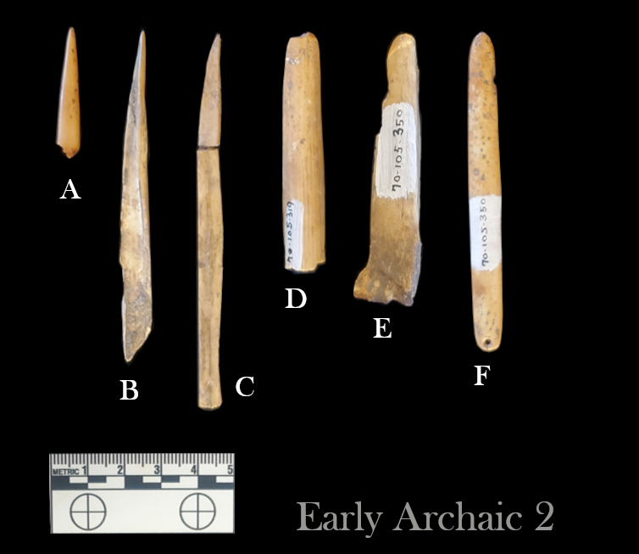
Figure 7.10. Bone tools from the Early Archaic 2 component. They include bone awls (A, B), a bone stylus (C), two indeterminate pieces of cut and polished bone (D, E) and one perforated and polished bone implement or adornment (F).

percussion, similar to knapping, and these fractures have been polished over. Another implement has been highly polished on one end, which is blunt, and has grooves in several directions on the other end (Figure 7.10 E). Although this piece is the correct size and shape for an indirect percussion billet used in knapping, it does not have the coarse end damage knapping would produce. A final tool worth noting is a spatulate piece carved from the tibiotarsus of a medium to large bird. The polish is highly consistent on the entire surface, and one end has been drilled with a very fine perforation. This may have served as a spool or other textile tool, but personal adornment is also possible.

The Middle Archaic 1 worked bone assemblage (Figure 7.11) includes several sharpened bone implements reflecting a variety of functions. One burned fragment has a highly polished sharpened tip reflecting hide working (Figure 7.11 A). Three others come to a point, but the tips are not well polished (Figure 7.11 B-D), and in one case it is the side that has the most developed polish pattern reflecting use as a sort of knife, possibly for shredding plant fibers (Figure 7.11 B). Two are very regularly made bone pin/needle fragments (Figure 7.11 E, F), one of which is most highly polished towards the middle, suggesting function as a hairpin or possibly a sort of spool. Two pieces have been ground into wedges (Figure 7.11 G-H), and both have a groove running up the center of the wedge. Two pieces of antler tine are represented here, one of which is an obvious pressure flaking tool (Figure 7.11 J). The other is missing its distal end, but it is burnt near the proximal end where the tine was removed from the beam (Figure 7.11 K). The remaining piece is a turkey tarsometatarsus that has had the distal articular surfaces cut off and has been worked into a “U” shape (Figure 7.11 I). This piece may have been used as a hook for catching small fish, but it is so gracile, and the surface so well polished, especially at the base of the “U”, that I suspect a more personal or industrial function, such as a clip or fastener.

The Middle Archaic 2 assemblage (Figure 7.12) includes no sharpened bone tools, although one piece is pointed at a more obtuse angle than is usual for awls (Figure 7.12 A). Four antler implements are represented. One tine has the grinding on the distal end characteristic of a well-used pressure flaker (Figure 7.12 B). One is the correct size and shape for a similar function but shows no use wear (Figure 7.12 C). One is a short tine fragment that has been rounded off on both the proximal and distal end, and apparent reshaping along the sides (Figure 7.12 D). The last is a beam fragment that has been split longitudinally and polished on the interior surface forming a curved and robust strip of antler (Figure 7.12 E). This has then had fine incisions cut into either side of the strip at semi-regular intervals. This may have been part of an adornment or decorative piece, but it may also have functioned as a percussion instrument or sound tool, not dissimilar in concept to the washboard. A bead (Figure 7.12 F) made of a medial fragment of a medium to large bird bone is highly polished, but also covered with coarse and irregular cut marks. This may have been a form of adornment, but it may also have been a fastening toggle for a bag, lanyard, or article of clothing. The final piece worth noting is a long flattened section of ungulate metapodial (Figure 7.12 G). It has had a coarsely on the wide end. This tapers down into narrow distal end which is broken off.
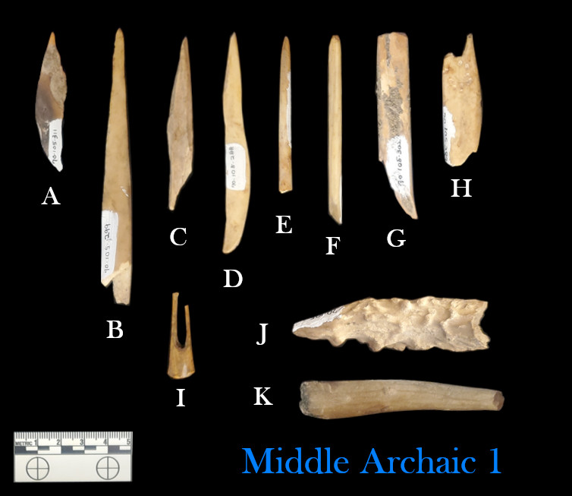
Figure 7.11. Modified bone from the Middle Archaic 1 component. Included are a bone awl (A), three pointed bone tools (C, D), two bone pins/needles (E, F), bone wedges (G, H), a cut and polished hook/clip (I), an antler pressure flaker (J), and a burned and worn antler tine (K).

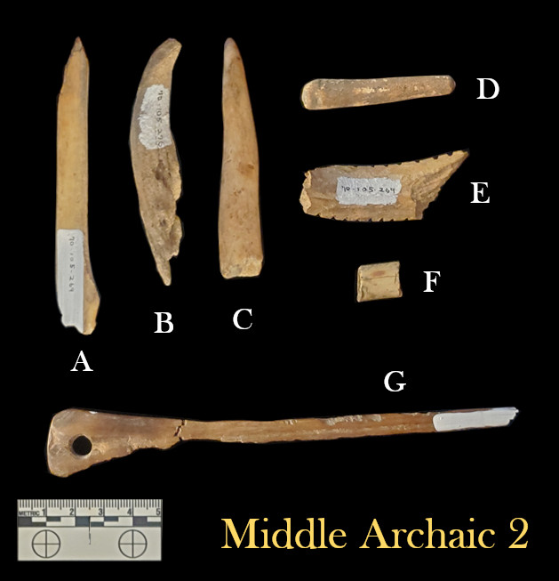
Figure 7.12. Modified bone from the Middle Archaic 2 component. Included are a pointed bone fragment with a lightly worked edge (A), an antler pressure flaking tool (B), two cut antler tines (C, D), a split and incised antler beam fragment (E), a bird bone bead/toggle (F), and a perforated and polished bone wand.

carved groove incised along its length on the exterior surface ending in a large perforation. Both sides are heavily damaged by rodent gnawing, but the remaining surface is highly polished and stained a dark brown color. Despite the high polish, grinding and cutting marks from the object’s manufacture are visible on most of the surface.

Bone Modification Summary

The modification patterns of the larger mammal bones indicate that Ozarchaic peoples practiced marrow extraction during all occupations at Saltpeter Cave, but that bone grease production was likely practiced regularly only in the Middle Archaic period. As discussed previously, this second-order resource has many possible uses, including
cooking oil, dermatological care, soap production, and lubricant for grinding and polishing stone or bone objects. Furthermore, the low frequency of burning observed on specimens suggests that either meat was generally stewed, or it was removed from the bone before being roasted. Indirect cooking methods may also produce low charring frequencies. The distribution of body parts for cervids indicates that Early Ozarchaic occupants discarded upper limb and cranial elements either elsewhere in the cave or off-site entirely, while Middle Ozarchaic occupants likely transported game back to Saltpeter Cave with minimal field dressing. The presence of highly fragmented cranial elements in the Middle Archaic components suggests that the occupants also practiced brain tanning of hides, which is further suggested by the presence of bone awls in Middle Archaic components. Awls also appear in the Early Archaic assemblage but shaving and scraping the hides often requires these tools even before the tanning stage. Knapping and textile production are indicated by several bone tools in the Middle Archaic components. Probable items of decoration such as hair pins and beads reflect conscious self-expression.

Richness, Diversity, and Evenness

The Richness, Diversity, and Evenness values for Saltpeter Cave have been calculated based on MNI estimates first (Figure 7.13), followed by NISP counts (Figure 7.14). Richness in the Early Archaic is low with nine taxa being identified with sufficient specificity to calculate an MNI. The subsequent Middle Archaic 1 component included 21 taxa, and the Middle Archaic 2 included 17. Diversity indices generally follow the same trend, but with less amplitude. The Evenness indices are nearly indistinguishable. This reflects that the tree squirrel predominates the MNI estimate in every component, and most other taxa are represented only by a few elements, and often do not have an MNI estimate greater than 1 with few exceptions. These will be explored in the Diet Breadth Model. It should be noted that MNI calculations may inflate the representation of smaller taxa, because even small fragments will include a proportionately larger percentage of the original element, making them more identifiable.
Figure 7.13. Richness, Diversity, and Evenness values calculated based on MNI.
Figure 7.14. Richness, Diversity, and Evenness values calculated based on NISP.

With regard to the NISP-based analysis, the richness values increase slightly with 11, 23, and 21 taxa represented in the three components from earliest to latest. The Diversity and Evenness values are noticeably lower for two reasons. One is that most of the taxonomic groups that were added in the NISP analysis were poorly represented, which is why they can not have an MNI estimate in the first place. More specimens means more chances for a taxon to be identified to species level with confidence. The second reason is that deer elements can be broken into many more pieces while still being identifiable, which inflates this taxon’s representation in the assemblage. The same is true of Wild Turkey elements.

This analysis illustrates that the Early Archaic foragers targeted a very specific set of taxa while the foragers in the Middle Archaic broadened their prey choice. The Middle Archaic 1 foragers incorporated a few of these additional taxa into the diet with some regularity, but in the high Richness of the Middle Archaic 2 component does not correspond to a regular inclusion of these additional taxa into the diet.

Diet Breadth Modeling

Rank order among taxa is based on return rate estimates from Newton (2011), Thomas (2008), and Ugan (2005) (Table 7.4). The diet breadth models produced for Saltpeter Cave have been calculated based on MNI estimates first (Figure 7.15), followed by NISP counts (Figure 7.16). The Early Archaic 2 component has a predominance of deer in each case, with an expected drop in representation among the smaller mammals and avian taxa. Turtles are absent, possibly due to the season of occupation, but squirrels are very well represented considering their low rank.

The breadth of the Middle Archaic 1 component is much more varied, with pigeons and turkeys being as well represented as deer based on MNI estimates. Both birds tend to live in groups, which may contribute to their larger numbers in the assemblage. Passenger Pigeons in particular migrate in enormous and dense flocks and may have been netted or hunted by groups using slings. The density of the flock reduces the accuracy necessary for a successful shot. Large numbers of low rank taxa including box turtles, squirrels, and even woodrats, are present. The rats were not an expected game animal, but some tibias are burned on the distal ends indicating that they were roasted. The rats may have inhabited the cave during hiatuses in human occupation, prompting people to systematically exterminate them upon their return to curtail their scavenging. Opossums are characteristically absent. Despite their return rate being similar to raccoons, at these four sites opossums are only well represented in the early components at Dust Cave. This may be the result of a taboo on eating them developing later.

The Middle Archaic 2 component is similar to its predecessor but somewhat more normalized, with the upper ranks of deer and raccoon being well represented, and a similar spike in the low rank taxa including turtles and squirrels in particular, but very little in between. As is the case with the Richness, Diversity, and Evenness analysis,

Table 7.4. Rank Order of Select Taxa Based on Caloric Return Rates.
Rank | Taxon | Avg. weight (kg) | Max return rate (kcal/hr) | Min return rate (kcal/hr) | Mean return rate (kcal/hr)
1 | Size 3 Mammalª |  | 54709 | 22976 | 32114.5
2 | Deer | 42 | 19895 | 12096 | 15995.5
3 | Size 2 Mammal |  | 19895 | 12096 | 15995.5
4 | Size 1 Mammal^{b}
5 | Raccoon | 6.75 | 13569 | 9408 | 11488.5
6 | Gray Fox^{c} | 5 | 10053 | 10053 | 10053
7 | Wild Turkey | 6.55 | 11200 | 7765 | 9482.5
8 | M-L Bird |  |  |  | 9482.5
9 | Opossum | 4 | 12111 | 6540 | 9325.5
10 | Size 0.5 Mammal |  | 13569 | 2042 | 8444.625
11 | Large Turtle | 10.25 | 8273 | 6547 | 7410
12 | Pigeon | 0.5 | 6375 | 6375 | 6375
13 | Rabbit | 1.2 | 3781 | 2042 | 2911.5
14 | Kinosternidae | 0.35 | 2758 | 2182 | 2470
15 | Box Turtle | 0.45 | 2758 | 2182 | 2470
16 | Squirrel | 0.5 | 1244 | 672 | 958
17 | Woodrat^{d} | 0.25 | / | / | /
18 | Size 0 Mammal^{d} |  | / | / | /
ª Size 3 Mammals is based on the average return rate for Elk and Bison after Newton (2011).
^{b} Return rates for Size 1 Mammals cannot be estimated, as return rate data for Coyotes and Bobcats are not reported. These are presumed to have return rates slightly higher than large game birds.
^{c} The Gray Fox was estimated by averaging the kcal/hr estimate per live-weight pound for raccoons and opossums. The return rate for rats is not published in Thomas (2008) or Ugan (2005) but is presumed to be comparable to that of squirrels. The ranks for minimally identified mammals and birds by size class are based on the average of the mean return rate for attested taxa within the assemblage except where noted.
^{d} Only squirrel return rates are reported for Size 0 Mammals. The others are presumed to have lower return rates due to their generally smaller size.

the use of NISP is heavily biased in favor of larger taxa, which in this case corresponds to White-tailed Deer and Wild Turkey. It could be argued that this bias produces a result that is better representative of the significance of these taxa to the subsistence base that the Saltpeter foragers depended on. In no way can ten squirrels compensate for even a single deer. The NISP method also allows for the inclusion of minimally identifiable specimens such as mammals and birds of particular size classes, but these generally appear to be redundant representations of the most populous taxa within the assemblage.
Even so, it is clear that the Size 3 Mammal class, be those individuals bison or elk, did not contribute significantly to the foraging economy practiced by these Ozarchaic people.

Writ large, it appears that the subsistence base in all time periods focused on deer and turkeys given that deer represent between 48% to 60% of the vertebrate faunal assemblage in every component, and medium to large birds (of which the Wild Turkey is the best represented taxon) never constitute less than 10% of the remaining vertebrate fauna by NISP. In the first portion of the Middle Archaic, the diet breadth expanded to include smaller taxa including raccoons, foxes and pigeons. The thinning of the tree canopy during the Middle Archaic should have improved conditions for deer, so the expansion of the diet breadth is likely a reflection of an increasing human population, a more consistent occupation of the site, or both. In the later years of the Middle Archaic, foragers at Saltpeter narrowed their diet breadth, focusing on very high ranked taxa like deer and turkeys, as well as small taxa that might be collected while foraging for other
resources. These included turtles and the ever-present tree squirrels, the latter of which is well represented in all components despite having low caloric return rates. There are two likely explanations for this.

From a practical standpoint, deer are a significant time investment. If a forager has non-food-related plans for the day, then waiting several hours for big game that may or may not materialize is an unattractive prospect if they can get two squirrels in 15 minutes and have the rest of the day free for other activities. Squirrels are ubiquitous, and can be taken with traps, slings, or blowguns. The short search and quick butchering time may have made them a meal of convenience rather than one of necessity. Speaking from my own experience spending hours per day in the woods for much of my life, squirrels are also some of the easiest game to find. They are noisy and their movements draw attention. For this reason, it may be that children were the primary predators involved in hunting squirrels. Their ubiquity and obtrusive behavior demand less patience than deer or rabbits, and because squirrels are active during the day when larger crepuscular predators are less active, it is reasonably safe for a child or small group of children armed with simple projectiles to go unsupervised on a squirrel hunt. We might also imagine a woman out foraging for mast with her children (Hawkes 1996:262-263; Hollenbach 2005:204) might point out a particularly obnoxious squirrel to her offspring and encourage one of them to go get it for dinner. In many ways, squirrels were an ideal game animal for children to develop the hunting acumen they would need as adults.
Figure 7.15. MNI-based diet breadth models for Saltpeter Cave using taxa that were represented by more than 2 individuals in the total assemblage. Taxa are listed in order of return rate from highest on the left to lowest on the right.
Figure 7.16. NISP-based diet breadth models for Saltpeter Cave. Taxa are listed in order of return rate from highest on the left to lowest on the right.

Intersite Analysis

Habitat Group Index Analysis

Following Denniston et al. (1999:385), a simple index value can be created for each site and temporal affiliation by adding together the Forest and Edge NISP counts and dividing those by the sum of the Prairie and Open counts. Higher index values represent greater representation of woodland taxa, and lower values represent increased representation of grassland taxa (Figure 7.17). When these indices were graphed, the Saltpeter index values were so high that the other sites could not be distinguished from each other, requiring a log10 transformation of the data.

Some fundamental observations may be made from this analysis: 1) that the taxa represented at Saltpeter Cave reflect a much more exclusive use of forested patches than those at any other site, 2) that Little Freeman Cave represents the greatest dependence on open canopy and prairie taxa of those evaluated, and 3) that there is a very slight increase in forest taxa across time everywhere except Modoc Shelter, which fluctuates regularly in its forestation index.

Correspondence Analysis

The Habitiat CA (Figure 7.18) reflects 67.2% of the variance in two dimensions. It illustrates that Dust Cave and Modoc Shelter have similar assemblage structures in the Early Archaic, while Modoc Shelter’s Middle Archaic assemblages are more intermediate in composition between Dust Cave and Saltpeter Cave. This pattern is best explained by the association of Dust Cave with generalized water habitat taxa (rivers, lakes, ponds, streams, etc.) while all Saltpeter assemblages are most exclusively associated with the forest and its periphery. These Saltpeter habitats are most closely associated with deer and turkeys respectively. Little Freeman Cave shows the strongest change in taxonomic representation between the Early Archaic and Middle Archaic. The Early Archaic assemblages have more significant association with wetland and lacustrine environments, and this site is the only one specifically associated with prairie and other unforested, open habitats.

A correspondence analysis of the taxonomic groups that are represented at these sites is complex and requires two plots which illustrate the first three dimensions, yielding a combined visualization of 64.1% of the variance. The first (Figure 7.19) plots Dimension 1 against Dimension 2, while the second (Figure 7.20) plots Dimension 1 against Dimension 3. This analysis shows strong association between Saltpeter Cave and turkeys, deer, and to a lesser extent, pigeons. The Middle Archaic components of Modoc Shelter have similar but less pronounced affiliations with these taxa. While the foxes appear more closely associated with Modoc Shelter, adding the third dimension shows that foxes and the Modoc assemblages are on opposite sides of the z-axis, but the Middle Archaic 1 component of the Saltpeter assemblage overlaps with the Fox plot. Dust Cave
Figure 7.17. Woodland/Grassland index graph with a log10 transformed scale.
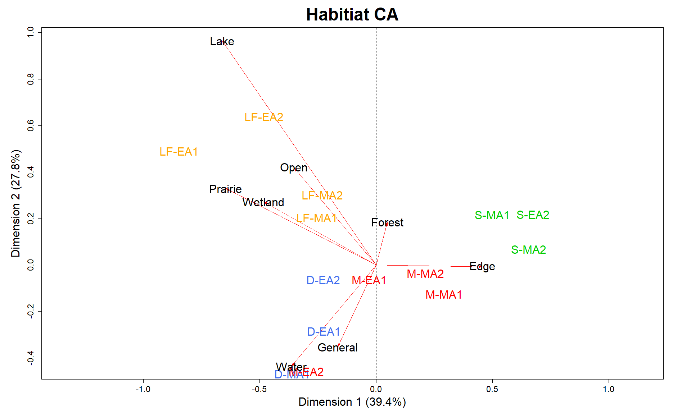
Figure 7.18. Correspondence Analysis of Habitat Group counts. On this biplot, each site label consists of the site name initial and abbreviated temporal group. Dust-Early Archaic 1 = D-EA1, Modoc-Middle Archaic 2= M-MA2, etc. Site labels are color-coordinated.
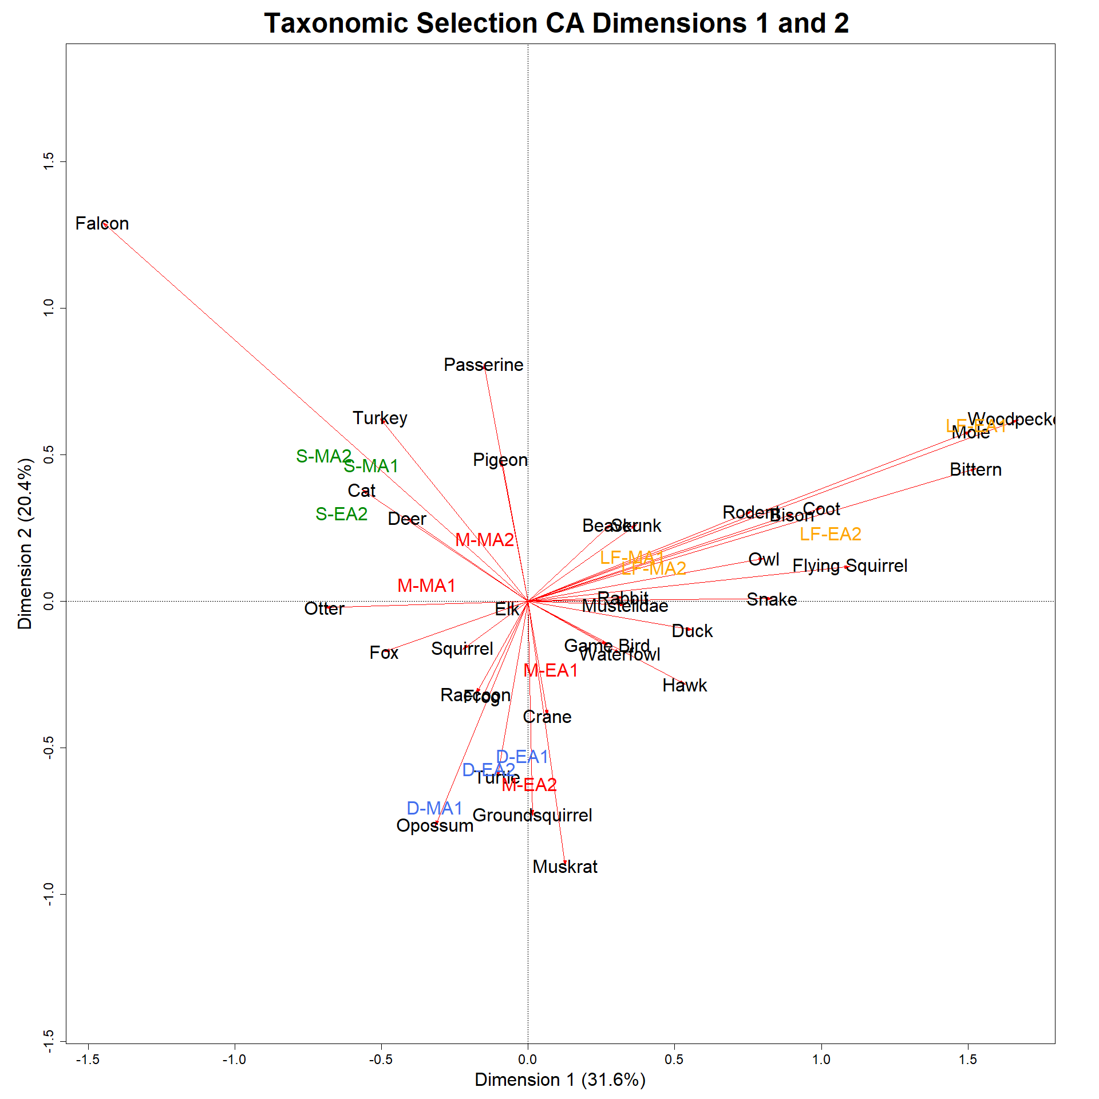
Figure 7.19. Correspondence analysis of terrestrial taxonomic groups represented at the four sites incorporating Dimension 1 and Dimension 2. Labeling follows the convention described in Figure 7.18.

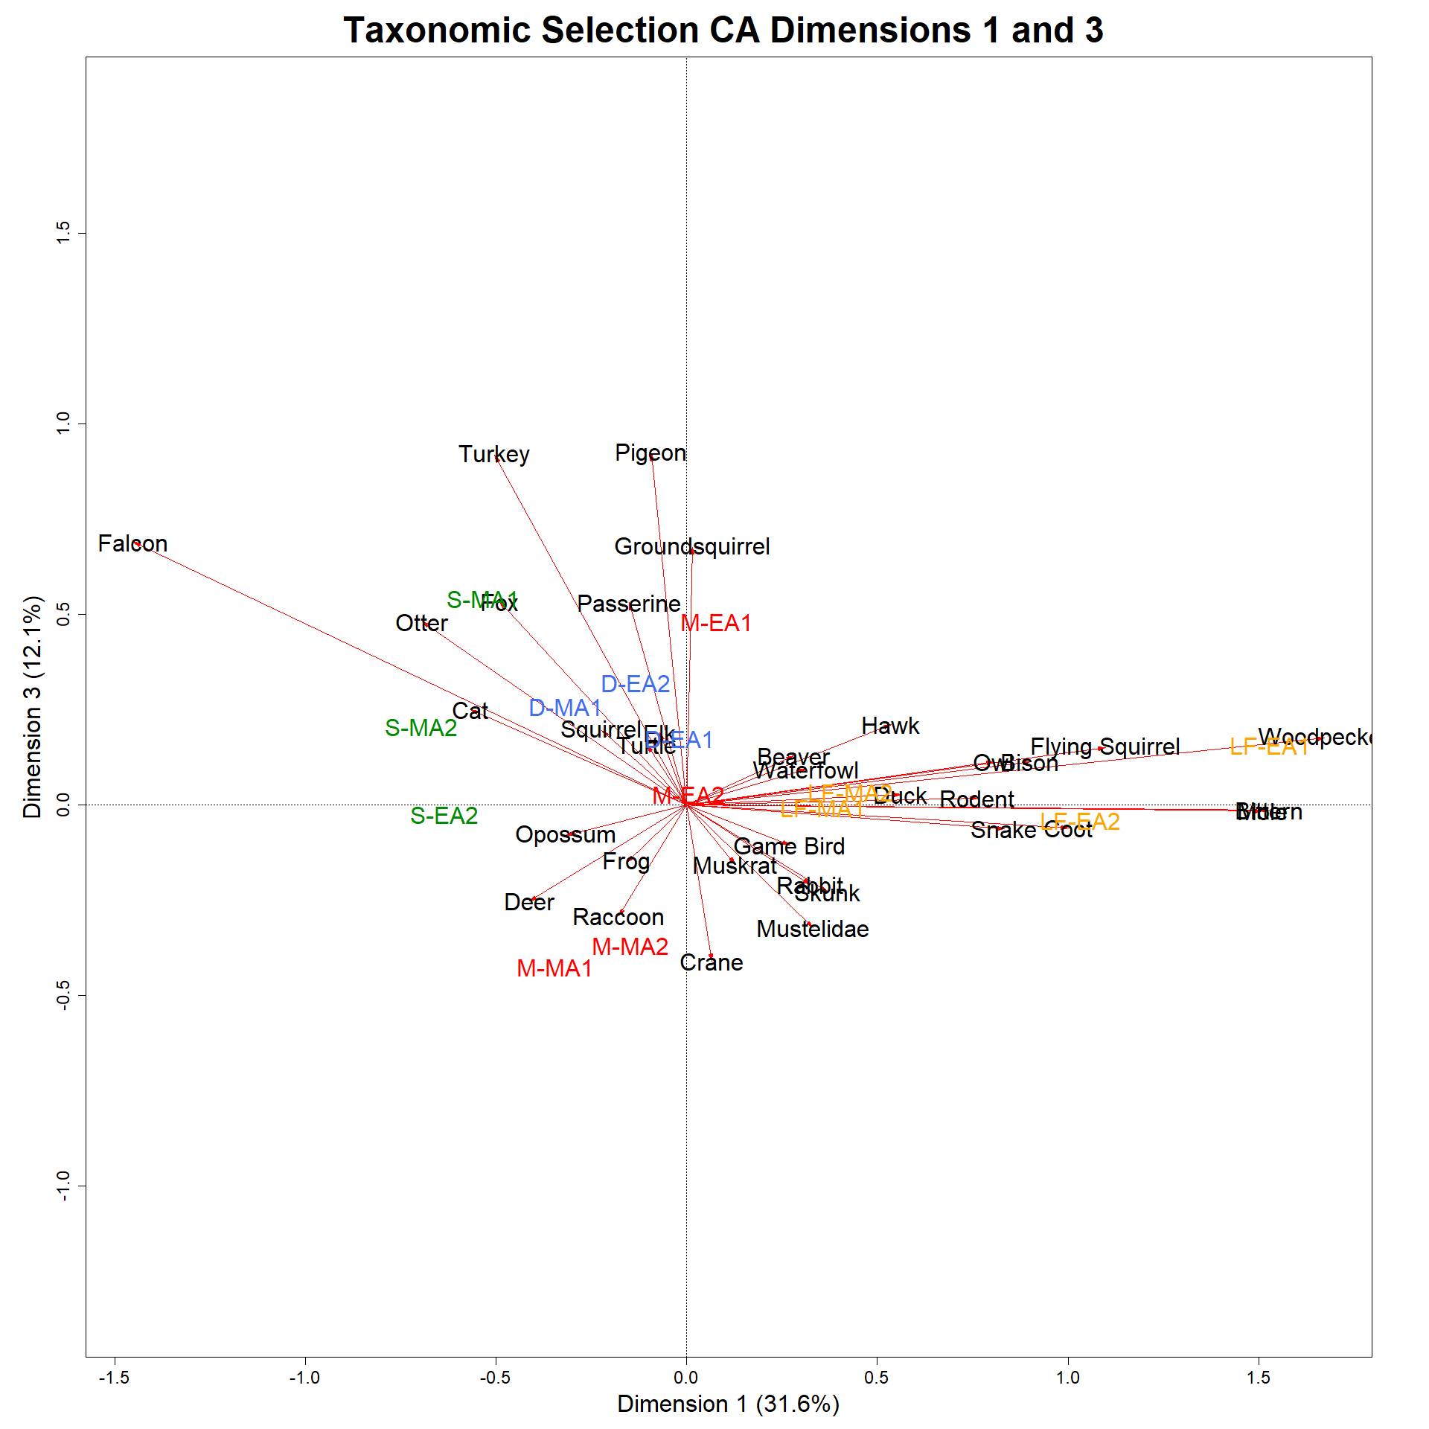
Figure 7.20. Correspondence analysis of terrestrial taxonomic groups incorporating Dimension 1 and Dimension 3. This figure complements Figure 7.19.

is more closely affiliated with Modoc’s Early Archaic components, with turtles contributing most to this association, as well as opossums and muskrats. This is all in agreement with the Habitat CA. Little Freeman Cave is by itself in all components, and clusters with a variety of otherwise unusual taxa, including woodpeckers, moles, coots, and owls. This may in part be the product of high precision by the analyst for LittleFreeman Cave, but the geographic placement farthest to the northwest within prairie territory suggests that any inter-analyst bias is not the sole variable involved. A table providing the eigenvalues and percentage of variance for each of these analyses can be found in the appendix (Table A.1).

Small Mammal Selection

The representation of mammals in the 0.5 size class may provide insights into food preferences at each site across time. These taxa are less likely to be intrusive compared to the many size 0 taxa. The major taxonomic groups included in this analysis are foxes, ground squirrels, muskrats, various members of the family Mustelidae, opossums, rabbits, raccoons, and skunks. These have had their NISP grouped by site and temporal component, and then converted into percentage of each spatial-temporal assemblage (Figure 7.21, Table 7.5). Saltpeter Cave is not represented in the Early Archaic 1 component, but the other sites will be discussed to provide antecedent context for subsequent assemblages.

In the Early Archaic 1 component, the Size 0.5 mammal assemblage at Modoc Shelter is predominantly composed of ground squirrels (52%), with opossums contributing an additional 21%. In stark contrast, raccoons and muskrats each contribute 44% of the total NISP of the Little Freeman Cave small mammal assemblage. Dust Cave has the most diversity in this size group with seven taxonomic groups represented, with rabbits (31%), Muskrats (21%), raccoons (19%), and opossums (17%) constituting the bulk of these taxa.

The Early Archaic 2 component shows some shifts in selection practices. Modoc’s small mammal assemblage is still dominated by muskrat (37%) but opossums have been supplanted by raccoons (26%) and rabbits (18%). The Little Freeman Cave assemblage is completely re-organized in this period, with rabbits going from a minority taxon to the best represented taxon with 63% of the NISP. Of the remaining taxa only the Muskrat (13%) contributes more than 10% to this assemblage. At Dust Cave, rabbits (43%), raccoons (25%), and opossums (21%) continue to constitute the majority, but muskrats have been reduced to 4% of the small mammal assemblage. The earliest assemblage at Saltpeter Cave is small (n=7) but raccoons (43%) and rabbits (29%) are the best represented taxa by NISP.

The transition to the Middle Archaic 1 component should be where we see the most pronounced changes if grassland expansion produced significant pressures to change hunting or trapping practices. Modoc Shelter’s assemblage no longer contains a
Figure 7.21. Size 0.5 Mammals represented by %NISP. The Early Archaic 1 time group chart is in the appendix.

Table 7.5. Small Mammal (Size 0.5) Taxa Represented by Site and Component with NISP and %NISP.
Early Archaic 1 | Dust |  | Little Freeman |  | Modoc |  | Saltpeter
Taxon | NISP | % | NISP | % | NISP | % | NISP | %
Fox | 2 | 5% | 0 | 0% | 0 | 0% | 0 | 0%
Ground squirrel | 1 | 2% | 0 | 0% | 22 | 52% | 0 | 0%
Muskrat | 9 | 21% | 4 | 44% | 2 | 5% | 0 | 0%
Mustelidae | 2 | 5% | 0 | 0% | 0 | 0% | 0 | 0%
Opossum | 7 | 17% | 0 | 0% | 9 | 21% | 0 | 0%
Rabbit | 13 | 31% | 1 | 11% | 4 | 10% | 0 | 0%
Raccoon | 8 | 19% | 4 | 44% | 5 | 12% | 0 | 0%
Skunk | 0 | 0% | 0 | 0% | 0 | 0% | 0 | 0%
Total | 42 | 100% | 42 | 100% | 42 | 100% | 0% | /
Early Archaic 2 | Dust |  | Little Freeman |  | Modoc |  | Saltpeter
Taxon | NISP | % | NISP | % | NISP | % | NISP | %
Fox | 0 | 0% | 0 | 0% | 16 | 5% | 1 | 14%
Ground squirrel | 0 | 0% | 0 | 0% | 17 | 6% | 0 | 0%
Muskrat | 1 | 4% | 12 | 17% | 108 | 37% | 0 | 0%
Mustelidae | 1 | 4% | 2 | 3% | 0 | 0% | 0 | 0%
Opossum | 6 | 21% | 0 | 0% | 20 | 7% | 1 | 14%
Rabbit | 12 | 43% | 46 | 64% | 53 | 18% | 2 | 29%
Raccoon | 7 | 25% | 8 | 11% | 76 | 26% | 3 | 43%
Skunk | 1 | 4% | 4 | 6% | 2 | 1% | 0 | 0%
Total | 28 | 100% | 72 | 100% | 292 | 100% | 7 | 100%
Middle Archaic 1 | Dust |  | Little Freeman |  | Modoc |  | Saltpeter
Taxon | NISP | % | NISP | % | NISP | % | NISP | %
Fox | 0 | 0% | 0 | 0% | 1 | 0% | 13 | 30%
Ground squirrel | 0 | 0% | 0 | 0% | 2 | 1% | 2 | 5%
Muskrat | 0 | 0% | 4 | 15% | 33 | 15% | 0 | 0%
Mustelidae | 0 | 0% | 1 | 4% | 3 | 1% | 0 | 0%
Opossum | 4 | 16% | 0 | 0% | 24 | 11% | 0 | 0%
Rabbit | 12 | 48% | 19 | 70% | 78 | 36% | 16 | 36%
Raccoon | 9 | 36% | 2 | 7% | 75 | 35% | 11 | 25%
Skunk | 0 | 0% | 1 | 4% | 1 | 0% | 2 | 5%
Total | 25 | 100% | 27 | 100% | 217 | 100% | 44 | 100%
Middle Archaic 2 | Dust |  | Little Freeman |  | Modoc |  | Saltpeter
Taxon | NISP | % | NISP | % | NISP | % | NISP | %
Fox | 0 | 0% | 1 | 0% | 4 | 4% | 2 | 12%
Ground Squirrel | 0 | 0% | 2 | 1% | 4 | 4% | 0 | 0%
Muskrat | 0 | 0% | 7 | 3% | 2 | 2% | 1 | 6%
Mustelidae | 0 | 0% | 3 | 1% | 2 | 2% | 0 | 0%
Opossum | 0 | 0% | 0 | 0% | 2 | 2% | 1 | 6%
Rabbit | 0 | 0% | 162 | 79% | 58 | 53% | 2 | 12%
Raccoon | 0 | 0% | 24 | 12% | 31 | 28% | 11 | 65%
Skunk | 0 | 0% | 5 | 2% | 7 | 6% | 0 | 0%
Total | 0 | / | 204 | 100% | 110 | 100% | 17 | 100%

majority Muskrat specimens (15%), and rabbits (36%) and raccoons (35%) constitute the majority of the small mammal group. Reliance on rabbits (70%) remains high at Little Freeman Cave during this time, edging out raccoons (7%) almost entirely. Dust Cave’s small mammal assemblage continues to be dominated by a mix of rabbits (48%) and raccoons (36%). Saltpeter Cave’s pattern is surprising given the expansion of prairie. In terms of NISP, rabbits (36%) constitute the largest single taxonomic group, but foxes, specifically tree-climbing Gray Foxes, contribute 30% of the small mammal assemblage, with raccoons contributing an additional 25%. This suggests that while more open, shrubby environments were available and used with some regularity for small mammal capture, as suggested by the presence of rabbits, Ozarchaic foragers still primarily relied on the forests. It is also noteworthy that no other site or time period has foxes representing more then 5% of the 0.5 size mammals. The taxonomic group is almost entirely absent at all other sites except at Modoc Shelter during the Early Archaic 2 component.

In the Middle Archaic 2 component, Dust Cave is not represented as Walker (1998a) did not analyze the Benton horizon assemblages. Modoc Shelter’s assemblage is even more heavily weighted towards rabbits (53%) with raccoons in the secondary position at 28%. Little Freeman has an even more pronounced reliance on rabbits (79%) with raccoons (12%) representing a small minority. In stark contrast, raccoons contribute 65% of Saltpeter’s 0.5 size mammal assemblage, with foxes and rabbits contributing an additional 12% each.

Overall, life at Little Freeman Cave appears to be the most extremely affected by the changing climate associated with the end of the Early Archaic, with a transition from the aquatic muskrat to an extreme concentration on rabbits as a second-line resource. Dust Cave’s inhabitants started out with the highest diversity within this size class, but progressively narrowed their focus to just rabbits, raccoons, and opossums, which were always in the majority. Modoc Shelter’s inhabitants changed their practices most drastically in almost every time group. Initially they concentrated on ground squirrels and opossums, transitioned to muskrats and raccoons at the end of the Early Archaic, re-focused on rabbits and raccoons early in the Middle Archaic, and then intensified use of rabbits late in the Middle Archaic. Saltpeter Cave always has a good representation of raccoons, with rabbits and foxes outnumbering them (by NISP) in the Middle Archaic 1 component only.

Conclusions

Saltpeter Cave

Early Archaic

The Early Archaic component at Saltpeter Cave is characterized by winter occupation with a prey choice concentration on deer supplemented by mussels and squirrels. These are supplemented by an array of intermediate-ranked taxa such as raccoons, foxes, turkeys, and rabbits as is illustrated by the diet breadth model in Chapter Seven. In contrast to subsequent components, the representation of mussels in the Early Archaic may indicate that Cave Creek was higher in elevation some 9000 years ago, and more accessible to people occupying the vestibule of Saltpeter Cave. However, this should not be taken to indicate that mollusks contributed significantly to the diet. The caloric and nutrient value of the small basket-load’s worth of shells and shell fragments from these Early Archaic levels is far less than that represented by the mammals and birds in the same assemblage. Bone modifications indicate that the occupants regularly extracted marrow from the bones, but fragment size does not reflect the degree of fragmentation expected for bone grease production. Bone tools include awls, which are a clear indicator that some hide processing was practiced by the inhabitants. However, the high representation of lower limb bones and dearth of cranial elements for deer suggest that the choicest cuts of meat and valuable brain-laden skulls were more regularly transported to another site. Given that this component represents several centuries of occupation, it appears that the function of Saltpeter was flexible at this time, with some visits being short-term hunting forays and others longer-term residential stays.

Middle Archaic 1

During the initial Middle Archaic component, people at Saltpeter Cave increased their diet breadth to intensify the use of intermediate rank resources including foxes, raccoons, turkeys and pigeons. They also more intensively processed deer for bone grease production. This generalized pattern of intensification, richer faunal representation, and larger terrestrial faunal assemblage in general is most consistent with higher population density, more regular use of the site itself, or both. The latter interpretation is bolstered by the broad range of seasonality reflected in the assemblage. This is the time when the climate-induced forest thinning should have been in full effect, which may explain the more regular and intensive use of this site and its presumed situation in patchy forest suited to the deer, turkeys, and pigeons represented in the assemblage. The bone tools in the assemblage reflect a diverse industrial range, some of which are designed for knapping, tanning, textiles, and basketry. This component is noteworthy for the abnormally high number of fox specimens, which skew strongly against right-sided elements. The intensified use of forest taxa, bone grease production, broad industrial range, and multi-season occupation all point to regular use as a base camp during the Middle Archaic 1 component. In short, it appears that this was a period of more intensive settlement of the Ozark high country.

Middle Archaic 2

The component associated with the end of the Middle Archaic has a more normalized diet breadth with deer, raccoons, turtles, turkeys, and squirrels being the best represented taxa. Bone grease production is still suggested by the fragmentation size patterns in addition to marrow extraction. The bone tool assemblage reflects a narrower industrial range. Presently, only a pressure flaking tool and a likely billet for indirect percussion can be assigned a function with any degree of confidence. People in this later Middle Archaic occupation appear to have occupied Saltpeter Cave as a Collector Base, in that stays appear to have been long-term.

Summary
Overall, it appears that in all time periods the inhabitants of Saltpeter Cave relied primarily on resources associated with forested habitats. Both Middle Archaic assemblages have greater taxonomic breadth, and fragmentation patterns point more towards intensified use of faunal bone resources including bone grease production. In the Middle Archaic 1 assemblage, Gray Foxes were well represented as were rabbits and raccoons. If the foragers at Saltpeter Cave were utilizing collector-style logistical sites there is no indication that these sites were far enough away from the cave to cross over into oak savannah or prairie habitats. Based on the suite of taxa found in the assemblage, any game that was brought back to site was collected from forested habitats similar to that which surrounded Saltpeter Cave in the first place.

The White-Tailed Deer Beyond Caloric Value

I proffer the opinion that the White-tailed Deer’s significance to Eastern Woodlands life was so profound that it is difficult for a twenty-first century Euro-American like myself to grasp on an intuitive level. Not only was it a cornerstone of the meat diet, but the antlers furnished knapping tools that were nearly requisite to produce the stone tools needed for hunting, cooking, carving, basketry, hide tanning, etc. Noel Grayson (2016) describes how the hide furnishes clothing and footwear, can be cut into strips for cordage, and can be made into bags and other carrying devices. Deer sinew is a valuable cordage resource that can be tied wet and shrinks when dry, forming a tight bond. It can serve as sewing thread or be processed into glue. He explains that in contrast to larger taxa, deer hide can be brain-tanned in a relatively short period of time. The bones of deer were also valuable tool resources. The phalanges can be ground and carved into fishhooks. The metapodials are very straight and have thick walls that are extremely dense, which lends them to needle and hairpin manufacture. While much is made of bone grease as a food resource, it can also be used for dermatological care (Harper 1999:117). Traditionally, the skull and lower limbs are assigned “low utility” values , which are justified from a caloric value and processing requirement standpoint (e.g. Binford 1978:20-21). However, even if we set aside the symbolic significance associated with various “low utility” elements, their (non-caloric) functional utility is often very high. The skull contains the brain that is needed for tanning those hides and might be expected to be prioritized for transportation to residential sites despite having low caloric value.

Inter-site Implications

Given the climate shifts described by Denniston et al. (2000, also Denniston et al. 1999) as well as those relevant to Dust Cave more specifically (Hollenbach and Walker 2010; Sherwood et al. 2004), we should expect that people living at each site should alter their hunting practices to accommodate their changing landscape. Sites located on the edge of the prairie, such as Modoc Shelter and Little Freeman Cave, should contain more prairie taxa as the grasslands expanded and the forests thinned. However, correspondence analysis indicates that environmental patch exploitation choices were more related to site location than time period, especially for people at Dust Cave and Saltpeter Cave. While the habitat use index does reflect a slight increase in the use of grassland taxa at Saltpeter Cave, the preponderance of a grassland turtle species responsible for that change is probably better explained by changes in site function and seasonality than changes in habitat exploitation. Ornate Box Turtles also venture into more forested environments at times.

This persistent use of woodland taxa suggests that at Saltpeter Cave, rather than widen the range of habitats they exploited for game to suit their changing landscape, the people of the Ozarchaic intensified their landscape use to focus on a wider range of taxa within forested areas. This may be due to the value of the trees themselves as mast producers, and the secondary resources associated with woodland fauna. Mast resources are an important and dependable source of nutrients and calories exploited throughout the Eastern Woodlands (Reidhead 1981:110).

As for the high-rank prairie taxa (especially Bison), ostensibly available and evidenced by the presence of juvenile elements of the appropriate size, the elephantine proportions of bison and elk require much more time and labor to transport and process for meat, hides, bone nutrients, and other resources. We also cannot rule out the possibility that taxa like bison and game birds were considered “plains food for plains people,” and were relegated to social interactions between different regional groups. By contrast, both the Modoc Shelter and Little Freeman Cave assemblages do show noticeable changes in patch use practices. At Modoc Shelter it appears that foragers shifted away from aquatic and grassland taxa towards forest edge associated animals. The Little Freeman Cave assemblage becomes more normative in its composition after the transition to the Middle Archaic. The close proximity of Dust Cave to the Tennessee River seems to have had a stabilizing effect on the sorts of habitats the occupants there chose to forage in, as this site is closely associated with water in all components. It would appear then that the people who lived at each of these sites not only spoke with different accents, they ate with regional accents as well.

The Gray Fox in the Ozarchaic and Recent Eastern Cultures

The significance of Gray Foxes at Saltpeter Cave remains enigmatic. While this critter was certainly available to people at the other sites, the people living there seem to have deliberately avoided hunting or trapping them. The fact that the Ozarchaic people not only sought this taxon out, but also deposited the animal’s remains with the right side of the body segregated out, particularly as seen in the Middle Archaic 1 component, suggests some special relationship with foxes that other Archaic peoples did not share. This may have involved medicine, sympathetic magic, shamanic practice, a special meal, or simply a local tradition. Whatever the case may be, the paucity of foxes at other Eastern Woodlands sites is conspicuous. This agrees with taboos observed among both northeastern and southeastern communities, who generally avoided eating certain animals, especially small carnivores like foxes and bobcats (Harper 1999:115, 323)

The Cherokee and Choctaw words for “fox” are nearly identical (tsuhla and chula respectively), while the Muskogee term from Alabama is cola (Lupardus 1982:284; Mithun 1984:265). The Cherokees have another word, ina’li which means “Black Fox,” though it is unclear if this is meant to designate a separate species or if it refers to a melanistic fox (Mooney 2006:265). The Osage term shomekasee applies both to the Gray Fox and to the Coyote (Kilan Jacobs, Osage Nation, personal communication, 2022) while “mo^{n’}-zhi tha-gthi^{n”} refers to the Gray Fox specifically (La Flesche 1932:103).

References to the fox in Eastern Woodlands folklore and belief are sparse and often take the form of personal names of humans rather than literal foxes. Alfred Wright (1823: 182-183) reports that among the Choctaws:

“It was their ancient belief, that every man had shilombish, the outside shadow, which always followed him, and shilup, the inside shadow, or ghost, which at death goes to the land of ghosts. The shilombish was supposed to remain upon the earth, and wander restless about its former habitation, and often, especially at night, by its pitiful moans, so to affrighten its surviving friends, as to make them forsake the spot, and seek another abode, it is also supposed frequently to assume the form of a fox, or owl; and, by barking like the one, and screeching like the other at night, causes great consternation, for the cry is ominous of ill. They distinguish between its note and that of the animals it imitates, in this way. When a fox barks, or an owl screeches, another fox or owl replies. But when the shilombish imitates the sound of either animal, no response is given.”

George Amos Dorsey (1997:537-539) records a story from the Pawnees in which the Red Fox scares off the Buffalo and a boy named Burnt-Belly goes to hunt Red Fox to rectify the issue. One of the foxes he kills has hair that is a “bluish color” which likely refers to the Gray Fox. This may suggest that the distinction between Urocyon and Vulpes taxa was recognized, but they were also both recognized as kinds of foxes, at least among the Pawnees. In a similar story, Red Fox steals game and a bounty is put on him (Dorsey 1997:982). Several of the stories associate foxes and larger canids (Dorsey 1997:728, 819, 965), and at least one telling of the Cherokee Tar-Wolf story associates foxes and wolves (Mooney 2006:272).

The Caddo incorporated the fox into military practice, as Spanish clergyman Isidro Felix de Espinosa observed in the 18th century:
“When they go to war, they hold general assemblies in the house of a chief and give drinks to one of those considered most valiant, until he loses or pretends to lose consciousness. After a day and a night he says that he has seen where the enemy were and whether or not they were prepared, and they predict their pretended victories accordingly. They do the same enroute when they go their journeys, and with a fox’s tail they make an astrolobe by means of which to see future events.” (Bolton and Magnaghi 1987:171)

This same source indicates that Caddo medicine men employed a device made from a foxtail in divination. The Osage reportedly used Gray Fox hides to make quivers of exceptional value (La Flesche 1932:103).

All that to say that while foxes do occasionally appear in the lore and tradition of Eastern Woodlands people in recent history, there is little consensus about the symbolic significance of the fox that might point to a more ancient belief. The only justifiable conclusion at this juncture is that the Ozarchaic people inhabiting Saltpeter Cave in the Middle Archaic period had a very different relationship to the Gray Fox than did their neighbors to the north and east, and that the unusual treatment of these remains suggests that relationship prompted a sacred practice in a space that was less than sacrosanct. Evaluating whether this practice was a regional feature will require analyses of other faunal assemblages associated with the southern Ozarchaic.

CONCLUSION

This study has provided some insights into how Eastern Archaic foragers utilized their landscapes in very concrete terms. Much is made of the high mobility of Archaic peoples, which may be true in terms of annual cycles (Binford 1980). However, the correspondence analyses in Chapter Seven indicate that the most important variable that influenced the composition of the faunal diet portion was not Hypsithermal climate change altering environmental variability. Instead, the immediate surroundings of the sites in question appear to have been the most important for hunting and trapping strategies. It may be the case that Collector-style forays were undertaken to exploit more predictable stationary resources, such as raw lithic materials, river cane, or salt, but there is little indication that foragers made long-distance hunting or trapping forays to patches with faunal resources that differed significantly from those found in the immediate vicinity of these four base camps. In Binfordian terms, these sites do not appear to reflect Collector patch utilization models from a faunal resource perspective.

New answers always prompt new questions, so further analysis is always needed. An investigation of the lithic toolkits from Saltpeter Cave would serve to expand our understanding of the range of industries that took place at the site. While most of the excavation pits from Saltpeter have more material from the Woodland and Caddoan/Mississippian cultural traditions, Pit F is known to parallel Pit E in temporal affiliation and would allow for an expansion of the extant Saltpeter Cave faunal data. Any analysis from a Human Behavioral Ecology perspective is hindered by a lack of paleoethnobotanical information, so a return to the site to excavate flotation samples would shed new light on the foraging practices of these archaic period inhabitants. To my mind, the most significant deficit of this study is the lack of AMS radiocarbon dates from above the onset of the Middle Archaic. A more robust set of radiometric dates would allow for a much more refined and confident re-analysis of the data that I have generated for this research. Of course, this is not the only sheltered site that has been excavated in the region. Zooarchaeological materials from several other Ozarchaic bluffshelters are curated at the Arkansas Archaeological Survey, and these could still be analyzed to elaborate on the hunting and trapping practices in this under-studied context. With so much field work having already been done, the opportunities to expand our understanding of Ozarchaic foraging societies are seemingly endless, and the work has only just begun.

List of References

Ahler, Steven R.
1993 Stratigraphy and Radiocarbon Chronology of Modoc Rock Shelter, Illinois. American Antiquity 58(3):462-489.

Ahler, Steven R., Paul P. Kreisa, and Richard Edging
2010 Marginality and Continuity: The Archaeology of the Northern Ozarks. Missouri Archaeological Society, Special Publications No. 9.

American Society of Ichthyologists and Herpetologists
2021 Instructions to Authors. Electronic document, https://asih.org/ichsandherps/instructions-to-authors, accessed May 5, 2021.

Anderson, David G., and Kenneth E. Sassaman
2012 Recent Advances in Southeastern Archaeology; From Colonization to Complexity. Society for American Archaeology Press, Washington, D.C.

Arkansas Archaeological Survey (ARAS)
2022 Saltpeter Cave Site File and Field Notes. Curated by the Arkansas Archeological Survey, Fayetteville Arkansas.
Ayala, Sergio J.
2019 Calf Creek Horizon Evidence at the Gault Site (41BL323). Journal of Texas Archaeology and History 5:xi-xviii.

Behrensmeyer, Anna K.
1978 Taphonomic and Ecologic Information from Bone Weathering. Paleobiology 4:150–162.

Bergsvik, Knut Andreas, and Ingebjørg Storvik
2012 Mesolithic Caves and Rockshelters in Western Norway. In Caves in Context: The Cultural Significance of Caves and Rockshelters in Europe, edited by Knut Andreas Bergsvik and Robin Skeates, pp 22-38. Oxbow Books, England.

Binford, Lewis R.
1978 Nunaimut Ethnoarchaeology. Academic Press, New York.

1980 Willow Smoke and Dogs’ Tails: Hunter-Gatherer Settlement Systems and Archaeological Site Formation. American Antiquity 45(1):4–20.

1981 Bones: Ancient Men and Modern Myths. Academic Press, New York.

1984 Faunal Remains from Klasies River Mouth. Academic Press, New York

2009 Debating Archaeology. Updated Edition. Taylor and Francis, New York.

Bolton, Herbert Eugene, and Russell M. Magnaghi
1987 The Hasinais, Southern Caddoans as Seen by the Earliest Europeans. Vol. 1st ed. The Civilization of the American Indian Series. University of Oklahoma Press, Norman.

Branam, Chris M. Eric R. Mills, Pritam Chowdhury, Jane Carmack, and Zachary Burt
2018 Phase III Archaeological Data Recovery of Sites 3BE714 (Hudson East) and 3BE906 (Hudson West) For the Springdale Highway 412 Northern Bypass, Benton County Arkansas, Volume III. Submitted to Arkansas Highway and Transportation Department Environmental Division. Prepared by Flat Earth Archaeology, LLC.

Brown, Linda A.
2009 Communal and Personal Hunting Shrines Around Lake Atitlan, Guatemala. Maya Archeology 1:36-59.

Carlson, David L.
2017 Quantitative Methods in Archaeology using R. Cambridge University Press, Cambridge UK.

Carroll, Beau Duke, Allan Cressler, Tom Belt, Julie Reed, and Jan F. Simek
2019 Talking Stones: Cherokee Syllabary in Manitou Cave, Alabama. Antiquity 93(368):519-536.

Carmody, Stephen Byrnes
2009 Hunter/Gatherer Foraging Adaptations During the Middle Archaic Period at Dust Cave, Alabama. Masters Thesis, Department of Anthropology, University of Tennessee Knoxville.

Chowdhury, Pritam, Chris Branam, and Eric Mills
2021 Calf Creek Hunter-Gatherers in the Southern Ozarks: Mid-Holocene Deposits at Hudson East (3BE714) and Hudson West (3BE906) in Northwest Arkansas. In The Calf Creek Horizon:A Mid-Holocene Hunter-Gatherer Adaptation in the Central and Southern Plains of North America, edited by Jon Lohse, Marjorie A. Duncan, and Don Wycoff. pp. 369-394. Texas A&M University Press, College Station, Texas.

Church, R. R., and R. Lee Lyman
2003 Small Fragments Make Small Differences in Efficiency When Rendering Grease from Fractured Artiodactyl Bones by Boiling. Journal of Archaeological Science 30(8):1077–1084.

Claassen, Cheryl
2010 Feasting with Shellfish in the Southern Ohio Valley Archaic: Sacred Sites and Rituals (1st ed.). University of Tennessee Press.

2011 Rock Shelters as Women’s Retreats: Understanding Newt Kash. American
Antiquity 78:628-641.
2016 Abundant Gifts of Stone and Bone. Midcontinental Journal of Archaeology 41(3):274-294.
Cleland, Charles
1960 Analysis of Animal Remains in the Prehistoric Ozark Bluff-Dwellings of Northwestern Arkansas. Master’s thesis, Department of Anthropology, University of Arkansas, Fayetteville.
Colburn, Mona, and Bonnie Styles
1984 Modoc Rock Shelter, IL (11R5)-1984 Unit D 1/4" Faunal data. (tDAR id: 398924); doi:10.6067/XCV8G44RWP.

Colburn, Mona, Bonnie Styles, and Holly Ann Carr
1980 Modoc Rock Shelter, IL (11R5)-1980 Fauna Sataset-West Shelter 1/4 inch Waterscreen. (tDAR id: 394370); doi:10.6067/XCV87M091T. accessed January 30, 2022

Colburn, Mona, Bonnie Styles, and Karli E. White
1996 Little Freeman Cave (23PU565)-Vertebrate Fauna, 1/4" screen. (tDAR id: 401048); doi:10.6067/XCV87M09H2. accessed January 30, 2022

Colburn, Mona, Bonnie Styles, and Paula Thorson
1987 Modoc Rock Shelter, IL (11R5)-1987 Fauna Dataset-East Pillar-1/4" Screen. (tDAR id: 398883); doi:10.6067/XCV8FB547Q. accessed January 30, 2022

Crothers, George M.
1987 An Archaeological Survey of Big Bone Cave, Tennessee and Diachronic Patterns
of Cave Utilization in the Eastern Woodlands. Master’s Thesis, University of
Tennessee, Knoxville.

2012 Early Woodland Ritual Use of Caves in Eastern North America. American
Antiquity 77:524-541.

Davis, Marvin. E.
1988 Stratigraphic and hydrogeologic framework of the Alabama Coastal Plain: Water-Resources Investigations Report 87-4112. United States Departement of the Interior Geological Survey.

Denniston, Rhawn F., Luis A. Gonzalez, Holmes A. Semken, Yemane Asmerom, Richard G. Baker, Heather Recelli-Snyder, Mark K. Reagan, and E. Arthur Bettis
1999 Integrating Stalagmite, Vertebrate, and Pollen Sequences to Investigate Holocene Vegetation and Climate Change in the Southern Midwestern United States. Quaternary Research 52(3):381–387.

Denniston, Rhawn F., Luis A. González, Yemane Asmerom, Mark K. Reagan, and Heather Recelli-Snyder
2000 Speleothem carbon isotopic records of Holocene environments in the Ozark Highlands, USA. Quaternary International 67(1):21–27.
DeJarnette, David L., Edward B. Kurjack, and James W. Cambron
1962 Excavations at the Stanfield-Worley Bluff Shelter. Journal of Alabama Archaeology 8:1–124.

DeVivo, Melia T., Walter O. Cottrell, Jon M. DeBerti, Joseph E. Duchamp, Lindsey M. Heffernan, Jason D. Kougher, and Jeffery L. Larkin
2011 Survival and Cause-Specific Mortality of Elk Cervus canadensis Calves in a Predator Rich Environment. Wildlife Biology 17:156-165.
Dickson, Don R.
1991 The Albertson Site: A Deeply and Clearly Stratified Ozark Bluff Shelter. Arkansas Archaeological Survey Research Series No. 41. Arkansas Archeological Survey, Fayetteville.

Dorsey, George Amos
1997 The Pawnee: Mythology (part I). Carnegie Institution of Washington, Washington DC.

Duncan, James R., and Carol Diaz-Granados
2018 Landscape, Cosmology and the Old Woman: A Strong Female Presence. In Transforming the Landscape: Rock Art and the Mississippian Cosmos, edited by Carol Diaz-Granados, Jan Simek, George Sabo III and Mark Wagner, pp. 57-74. Oxbow Books, Oxford, UK.
Echternacht, Arthur C., and Larry D. Harris
1993 The Fauna and Wildlife of the Southeastern United States. In Biodiversity of the Southeastern United States: Lowland Terrestrial Communities, edited by William H Martin, Stephen G. Boyce, and Arthur C. Echternacht. pp.81-116. John Wiley and Sons, New York

Eerkins, Jelmer W., and Carl P. Lipo
2007 Cultural Transmission Theory and the Archaeological Record: Providing Context to Understanding Variation and Temporal Changes in Material Culture. Journal of Archaeological Research 15: 239–274.
Fritz, Gayle J.
1986 Prehistoric Ozark Agriculture, the University of Arkansas Rockshelter Collections. Unpublished Ph.D. dissertation, Department of Anthropology, University of North Carolina, Chapel Hill.

1997 A Three-Thousand-Year-Old Cache of Crop Seeds from Marble Bluff, Arkansas. In People, Plants and Landscapes, edited by K.J. Gremillion, pp. 42-62. University of Alabama Press, Tuscaloosa.
Fritzell, Erik K., and Kurt J. Haroldson
1982 Urocyon cinereoargenteus. Mammalian Species 189:1-8.

Gifford-Gonzalez, Diane
2018 An Introduction to Zooarchaeology. Springer International Publishing AG, Cham, Switzerland.

Goodyear, A. C., III.
2005 “Evidence for Pre-Clovis Sites in the Eastern United States.” In Paleoamerican Origins: Beyond Clovis, edited by R. Bonnichsen, B. T. Lepper, D. Stanford, and M. R. Waters, pp. 103–112. Center for the Study of the First Americans, Texas A&M University Press, College Station.

Grayson, Noel, Cherokee Nation
2016 Making Moccasins. Cherokee Nation Cultural Enrichment Series. YouTube, March 8, 2016. https://www.youtube.com/watch?v=kA8rakZrw7M, accessed July 21, 2022.

Griffin, James W.
1974 Investigations in Russell Cave. National Park Service Publications in Archaeology, No. 13. U.S. Government Printing Office, Washington D.C.

Harper, Ross Kenneth
1999 To Render the God of the Eater Propitious: Hunting and Human-Animal Relations in the Northeast Woodlands. Unpublished Ph.D. dissertation, University of Connecticut.

Harrington, Mark R.
1960 The Ozark Bluff-Dwellers. Museum of the American Indian, Indian Notes and Monographs 12. Heye Foundation, New York.
Hawkes, Kristen
1996 Foraging Difference Between Men and Women: Behavioral Ecology of the Sexual Division of Labor. In The Archaeology of Human Ancestry: Power, Sex and Tradition, edited by James Steele and Stephen Shennan, pp. 283-305. Routledge, New York.

Hegmon, Michelle
1998 Technology, Style, and Social Practices: Archaeological Approaches. In The Archaeology of Social Boundaries, edited by Miriam T. Stark, pp. 264-279. Smithsonian Press, Washington D.C.
Hollenbach, Kandace D.
2005 Gathering in the Late Paleoindian and Early Archaic Periods in the Middle Tennessee River Valley, Northwest Alabama. PhD dissertation, Department of Anthropology, University of North Carolina, Chapel Hill.

2009 Foraging in the Tennessee River Valley, 12,500 to 8000 Years Ago. University of Alabama Press, Tuscaloosa.

Hollenbach, Kandace D., and Renee B. Walker
2010 Documenting Subsistence Change During the Pleistocene/Holocene Transition: Investigations of Paleoethnobotanical and Zooarchaeological Data from Dust Cave, Alabama. In Integrating Zooarchaeology and Paleoethnobotany: A Consideration of Issues, Methods, and Cases, edited by Amber M. VanDerwarker and Tanya M. Peres, pp. 227-244. Springer Press, New York.

Homsey, Lara K., Renee B. Walker, and Kandace D. Hollenbach
2010 What’s for Dinner? Investigating Food Processing Technologies at Dust Cave, Alabama. Southeastern Archaeology 29:182–196.

Homsey-Messer, Lara K.
2015 Revisiting the Role of Caves and Rockshelters in the Hunter-Gatherer Taskscape of the Archaic Midsouth. American Antiquity 80:332-352.

Janzen, Anneke, Rachel E. B. Reid, Anthony Vasquez, and Diane Gifford-Gonzalez
2014 Smaller Fragment Size Facilitates Energy-Efficient Bone Grease Production. Journal of Archaeological Science 49:518-523.

Jeske, Robert J., and Lawrence A. Kuznar
2001 Canine Digging Behavior and Archaeological Implications. Journal of Field Archaeology 28(3):383-394.

Jones, Rachel A., John W. Williams, and Stephen T. Jackson
2017 Vegetation History since the Last Glacial Maximum in the Ozark Highlands (USA): A New Record from Cupola Pond, Missouri. Quaternary Science Reviews 170:174–187.

Julian, Charles
2010 A History of the Iroquoian Languages. Doctoral Thesis, Department of Linguistics, University of Manitoba, Winnipeg.

Jurney, David H., and David W. Stahle
2004 Old-Growth Wooded Pasture in the Ozarks. Gen. Tech. Rep. SRS-73, pp. 42-52. U.S. Department of Agriculture, Forest Service, Southern Research Station, Asheville, North Carolina.

Kelly, Robert L.
2013 The Lifeways of Hunter–Gatherers: The Foraging Spectrum. Cambridge University Press, Cambridge, UK.
Kidder, Tristram R.
2012 Poverty Point. In The Oxford Handbook of North American Archaeology, edited by Timothy R. Pauketat, pp. 460–470. Oxford University Press, Oxford, UK.

La Flesche, Francis
1932 A Dictionary of the Osage Language. United States Government Printing Office, Washington D.C.

Lam, Y.M., Xingbin Chen, Curtis W. Marean, and Carol J. Frey
1998 Bone Density and Long Bone Representation in Archaeological Faunas: Comparing Results from CT and Photon Densitometry. Journal of Archaeological Science 25:559–570.

Lam, Y.M., Xingbin Chen, and O. M. Pearson
1999 Intertaxonomic Variability in Patterns of Bone Density and the Differential Representation of Bovid, Cervid, and Equid Elements in the Archaeological Record. American Antiquity 64(2):343-362.

Lawson, John
1709 A New Voyage to Carolina; Containing the Exact Description and Natural History of That Country: Together with the Present State Thereof. And a Journal of a Thousand Miles, Travel'd thro' Several Nations of Indians. Giving a Particular Account of their Customs, Manners, &c. Electronic document, https://go-gale-com.utk.idm.oclc.org/ps/i.do?ty=as&v=2.1&u=knox61277&it=search&p=ECCO&dblist=ECCO&qt=BIB_ID%7ET133233&lm=&sw=w, accessed July 21, 2022.

Lupardus, Karen Jacque
1982 The Language of the Alabama Indians. Unpublished Ph.D. dissertation, Department of Linguistics, University of Kansas, Lawrence.

Lupo, Karen D.
2006 What Explains the Carcass Field Processing and Transport Decisions of Contemporary Hunter-Gatherers? Measures of Economic Anatomy and Zooarchaeological Skeletal Part Representation. Journal of Archaeological Method and Theory 13(1):19-66.

Lyman, R. Lee
1984 Bone Density and Differential Survivorship of Fossil Classes. Journal of Anthropological Archaeology 3:259-299.

1995 A Study of Variation in the Prehistoric Butchery of Large Artiodactyls. In Ancient Peoples and Landscapes edited by Eileen Hohnson, pp.233-253. Museum of Texas Tech University, Lubbock.

2014 Bone Density and Bone Attrition. In Manual of Forensic Taphonomy, edited by James T. Pokines, Steve A. Symes, and Ericka N. L’Abbé, pp 79-102. CRC Press, Boca Raton.

Marean, C. W., M. Domínguez-Rodrigo, and T. R. Pickering
2004 Skeletal Element Equifinality in Zooarchaeology Begins with Method: The Evolution and Status of the “Shaft Critique.” Journal of Taphonomy 2(2):69–98.

McMillan, R. Bruce, and Walter E. Klippel
1981 Post-glacial Environmental Change and Hunting-gathering Societies of the Southern Prairie Peninsula. Journal of Archaeological Science 8:215-245.

McMillan, Katherine Elizabeth
2016 Technological Adaptations at Dust Cave, Alabama (1LU496): An Evaluation of Organizational Strategies from the Late Paleoindian to the Middle Archaic. Unpublished Ph.D. dissertation, Department of Anthropology, University of Tennessee, Knoxville.

Mithun, Marianne
1984 The Proto-Iroquoians; Cultural Reconstruction from Lexical Materials. In
Extending the Rafters: Interdisciplinary Approaches to Iroquoian Studies, edited by Michael K. Foster, Jack Campisi, and Marianne Mithun, pp. 259–81. State University of New York Press, Albany.

Mooney, James
2006 Cherokee History, Myths, and Sacred Formulas. Cherokee Publications, Cherokee, North Carolina. Originally published in 1891 and 1900.
NatureServe
2021 NatureServe Explorer. https://explorer.natureserve.org, accessed August 12, 2021.

Newton, Cody
2011 Using Euro-American Hunting Data to Assess Western Great Plains Biogeography, 1806-35. Great Plains Research 21(1):17-26.

Nicholson, Rebecca A.
1996 Bone Degradation, Burial Mediaum and Species Representation: Debunking the Myths, an Experiment-based Approach. Journal of Archaeological Science 23:513-533.

O'Connell, James F., Kristen Hawkes, and Nicholas Blurton-Jones
1988 Hadza Hunting, Butchering, and Bone Transport and Their Archaeological Implications. Journal of Anthropological Research 44(2):113–161.

Peres, Tanya M.
2010 Methodological Issues in Zooarchaeology. In Integrating Zooarchaeology and Paleoethnobotany: A Consideration of Issues, Methods, and Cases, edited by Amber M. VanDerwarker and Tanya M. Peres, pp. 15-36. Springer Press, New York.

Peres, Tanya M., Aaron Deter-Wolf, Joey Keasler, and Shannon Chappell Hodge
2016 Faunal Remains from an Archaic Period Cave in the Southeastern United States. Journal of Archaeological Science:Reports 8:187-199.

Prendergast, Mary E., Anneke Janzen, Michael Buckley, and Katherine M. Grillo
2018 Sorting the Sheep from the Goats in the Pastoral Neolithic: Morphological and Biomolecular Approaches at Luxmanda, Tanzania. Archaeological and Anthropological Sciences 11(2):3047–3062

Purdue, James R.
1991 Dynamism in the Body Size of White-Tailed Deer (Odocoileus virginianus) from Southern Illinois. In Beamers, Bobwhites, and Blue-Points: Tributes to the Career of Paul W. Parmalee, edited by James R. Purdue, Walter E. Klippel, and Bonnie W. Styles, pp, 277─283. Illinois State Museum Scientific Papers 23, and University of Tennessee Department of Anthropology Report of Investigations 52. Illinois State Museum, Springfield.

Quintero, Carolyn
2009 Osage Dictionary. University of Oklahoma Press, Norman.

Ray, Jack H.
2016 Projectile Point Types in Missouri and Portions of Adjacent States. The Missouri Archaeological Society Special Publication No. 10.,The Missouri Archaeological Society, Springfield.
Ray, Jack H., Neal H. Lopinot, and Edwin R. Hajic
2009 Archaic Prehistory of the Western Ozarks of Southwest Missouri. In Archaic Societies: Diversity and Complexity across the Midcontinent, edited by Thomas E. Emerson, Dale L McElrath and Andrew C. Fortier, pp.155-198. State University of New York Press, Albany.

Rees, Lydia, Jared Pebworth, and Jamie Brandon
2017 Saltpeter Cave and Its Potential for Better Understanding Archaic Chronology in the Ozarks. Paper presented at the 74th Annual Meeting of the Southeastern Archaeological Conference, Tulsa, Oklahoma.

Rees, Lydia I., and Jamie C. Brandon
2017 Beyond the “Bluff Dweller”: Excavating the History of an Ozark Myth. The Arkansas Historical Quarterly 76(2):125–143.

2018 “Ozark Bluff Dwellers and Native American Rock Art,” public lecture recorded by Fayetteville Public Library. Facebook, July 28, 2018. https://www.facebook.com/FayettevillePublicLibrary/videos/10157767541408902
accessed February 2, 2022.

Reidhead, Van A.
1981 A Linear Programming Model of Prehistoric Subsistence Optimization: a
Southeastern Indiana Example. Prehistory Research Series, Vol. 6(1). Indiana Historical
Society, Indianapolis.

Reitz, Elizabeth J., and Elizabeth S. Wing
2008 Zooarchaeology. 2nd ed. Cambridge University Press, New York.

RStudio Team
2021 RStudio: Integrated Development for R. RStudio, PBC, Bostonhttp://www.rstudio.com/, accessed August 19,2021.

Sabo III, George, Ann M. Early, Jerome C. Rose, Barbara A. Burnett, Louis Vogele, Jr., and James P. Harcourt
1990 Human Adaptation in the Ozark and Ouachita Mountains. Arkansas Archaeological Survey Research Series No. 27. Arkansas Archeological Survey, Fayetteville.

Sackett, James R.
1986 Isochrestism and Style: A Clarification. Journal of Anthropological Archaeology 5:266-277.

Sassaman, Kenneth E.
2002 Woodland Ceramic Beginnings. in The Woodland Southeast, edited by David G. Anderson and Robert C. Mainfort, Jr., pp. 398–420. University of Alabama Press, Tuscaloosa.

2010 The Eastern Archaic, Historicized. AltaMira Press, New York.
Sassaman, Kenneth E., and Samuel O. Brookes
2017 Situating the Claiborne Soapstone Vessel Cache in the History of Poverty Point.
American Antiquity 82(4):781–797.

Saunders, Joe W., Rolfe D. Mandel, Roger T. Saucier, E. Thurman Allen, C. T. Hallmark, Jay K. Johnson, H. Edwin Jackson, Charles M. Allen, Gary L. Stringer, Douglas S. Frink, James K. Feathers, Stephen Williams, Kristen J. Gremillion, Malcolm F. Vidrine, and Reca Jones
1997 A Mound Complex in Louisiana at 5400–5000 Years before the Present. Science 277:1796–1799.

Severinghaus, C.W.
1949 Development and Wear as Criteria of Age in White-Tailed Deer. The Journal of Wildlife Management 13(2):195-216.

Sherwood Sarah C., Boyce N. Driskell, Asa R. Randall and Scott C. Meeks
2004 Chronology and Stratigraphy at Dust Cave, Alabama. American Antiquity 69(3):533-554.

Shipman, Pat, Giraud Foster, and Margaret J. Shoeninger
1984 Burnt Bones and Teeth: An Experimental Study of Color, Morphology, Crystal Structure, and Shrinkage. Journal of Archaeological Science 11:307-325.

Simek, Jan F.
2004 Archaeology of Caves: History. in Encyclopedia of Caves and Karst Science, edited by John Gunn, pp. 80-82. Taylor and Francis Group, New York and London.

Simek, Jan F., Sarah A. Blankenship, Alan Cressler, Joseph C. Douglas, Amy Wallace, Daniel Weinand, and Heather Welborn
2012 The Prehistoric Cave Art and Archaeology of Dunbar Cave, Montgomery County, Tennessee. Journal of Cave and Karst Studies, 74(1):19–32.

Smith, Bruce D.
1992 Rivers of Change : Essays on Early Agriculture in Eastern North America. Smithsonian Institution Press, Washington, D.C.

Smith, Jr., Everett N.
1984 Late Quaternary Vegetational History at Cupola Pond, Ozark National Scenic Riverways, Southeastern Missouri. Unpublished Master’s Thesis, Department of Geology, University of Tennessee, Knoxville.

Southeastern Naturalist
2021 Southeastern Naturalist Formatting Guidelines. Electronic document, https://www.eaglehill.us/programs/journals/sena/SENA-formatting-guidelines.pdf, accessed May 5, 2021.

Spring, Ryan
2016 Civilized Tribe: History of the Choctaw. Public Lecture at Allen Public Library, Allen, Texas. YouTube, February 15, 2016. https://www.youtube.com/watch?v=R-vvu_hQwDQ&t=6s. accessed July 21, 2022.

Stiner, Mary C., Steven L. Kuhn, Stephen Weiner, and Ofer Bar-Yosef
1995 Differential Burning, Recrystallization, and Fragmentation of Archaeological Bone. Journal of Archaeological Science 22:223-237.

Styles, Bonnie W.
2016 Coding Sheet for Cultural Affiliation (Little Freeman Cave (23PU565)- Fauna dataset-1/4" screen). (tDAR id: 402188); DOI:10.6067/XCV8VX0J6B, accessed January 30, 2022.

Styles, Bonnie W., and R. Bruce McMillan
2009 Archaic Faunal Exploitation in the Prairie Peninsula and Surrounding Regions of the Midcontinent. In Archaic Societies: Diversity and Complexity across the Midcontinent, edited by Thomas E. Emerson, Dale L McElrath and Andrew C. Fortier, pp.39-80. State University of New York Press, Albany.

Styles, Bonnie W., and Mona Colburn
2019 Taphonomic, Environmental, and Cultural Influences on Archaic Faunal Assemblages at Modoc Rock Shelter, Illinois, USA. Quaternary International 530-531:124–145.

Thomas, David Hurst
2008 Native American Landscapes of St. Catherines Island, Georgia: I. The Theoretical Framework. Anthropological Papers of the American Museum of Natural History 88(1):1-341.

Twiss, Katheryn C.
2019 The Archaeology of Food: Identity, Politics, and Ideology in the Prehistoric and Historic Past. Cambridge University Press, Cambridge.

Ugan, Andrew
2005 Does Size Matter? Body Size, Mass Collecting, and Their Implications for Understanding Prehistoric Foraging Behavior. American Antiquity 70(1):75-89.

Villa, Paola, and Eric Mahieu
1991 Breakage Patterns of Human Long Bones. Journal of Human Evolution 21(1):27–48.

Wagner, Daniel P., and Joseph M. McAvoy
2004 Pedoarchaeology of Cactus Hill, a Sandy Paleoindian Site in Southeastern Virginia, U.S.A. Geoarchaeology: An International Journal 19(4):297-322.

Walker, Renee B.
1998a The Late Paleoindian through Middle Archaic Faunal Remains from Dust Cave, Alabama. Ph.D. dissertation, Department of Anthropology, University of Tennessee, Knoxville.

1998b Dust Cave, Alabama Archaic faunal dataset. (tDAR id: 394390); DOI:10.6067/XCV8W95B74, accessed January 30, 2022

2010 Paleoindian and Archaic Activities at Dust Cave, Alabama: The Secular and the Sacred. North American Archaeologist 31:427-445.

Walthall, John A.
1998 Rockshelters and Hunter-Gatherer Adaptation to the Pleistocene/Holocene Transition. American Antiquity 63:223-238.

Walthall, John. A., and Brad Koldehoff.
1998 Hunter-gatherer Interaction and Alliance Formation: Dalton and the Cult of the Long Blade. Plains Anthropologist 43:257–273.

Wampler, Marc E.
2000 White-Tailed Deer Remains from the Albertson Site (3BE174), A Northwest Arkansas Rockshelter. Unpublished Master’s thesis, Department of Anthropology, University of Arkansas, Fayetteville.

Weitzel, Elic M.
2019 Declining Foraging Efficiency in the Middle Tennessee River Valley Prior to Initial Domestication. American Antiquity 84(2):191-214.

Wiant, Michael D., Kenneth B. Farnsworth, and Edwin R. Hajic
2009 The Archaic Period in the Lower Illinois River Basin. In Archaic Societies: Diversity and Complexity across the Midcontinent, edited by Thomas E. Emerson, Dale L McElrath and Andrew C. Fortier, pp. 229-286. State University of New York Press, Albany.

Winterhalder, Bruce
1981 Optimal Foraging Strategies and Hunter-Gatherer Research in Anthropology: Theory and Models. In Hunter-Gatherer Foraging Strategies: Ethnographic and Archeological Analyses, edited by Bruce Winterhalder and Eric Alden Smith, pp. 13-35. University of Chicago Press, Chicago.

Whyte, Thomas R.
2007 Caves Versus Rockshelters: How Noimenclature Influences Interpretations of Site Function. Paper presented at the 72nd Society for American Archaeology Conference, Austin, Texas.

2017 Zooarchaeological Study of Faunal Remains from Phase III Archaeological Data Recovery within the WWTP APE at the Williams Spring Site (1MA1167), Madison County, Alabama. in Phase III Data Recovery At The Williams Spring Site (1MA1167), A Late Middle Woodland Village On Redstone Arsenal, Madison County, Alabama Volume III, edited by Lawrence S. Alexander, Orion S. Kroulek, Max Schneider, Mary F. Trudeau, and Robert H. Lafferty, III., pp.147-190. Submitted to Department of the Army Environmental Management Division, Redstone Arsenal, Alabama. Alexander Archaeological Consultants, Inc., Wildwood, Georgia.

Whyte, Thomas R., and J. Matthew Compton
2020 Explaining Toad Bones in Southern Appalachian Archaeological Deposits. American Antiquity 85(2):305-330.

Woods A.J., T.L. Foti, S.S. Chapman, J.M. Omernik, J.A. Wise, E.O.
Murray, W.L. Prior, J.B. Pagan, Jr., J.A. Comstock, and M. Radford
2004 Ecoregions of Arkansas (color poster with map, descriptive text, summary tables, and photographs, map scale 1:1,000,000). U.S. Geological Survey, Reston, Virginia.

Wright, Alfred
1828 Choctaws: Religious Opinions, Traditions, Etc. Missionary Herald 24:178-183, 214-216.

Wyckoff, Don G.
1984 The Foragers: Eastern Oklahoma. In Prehistory of Oklahoma, edited by Robert E. Bell, pp. 119–160. Academic Press, Orlando, Florida.

2010 Hunter-Gatherer Chert Use along the Soutwest Flank of the Ozarks. The Missouri Archaeologist 71:79-112.

Appendix

Supplemental Figures

Figure A.1. Assemblage density by level calculated from NISP including Mollusks and Fishes.

Figure A.2. Maximum length of limb bones only from mammals size 1-3. The Measurements are in 5 mm increments and the raw counts can be found in Table A.3.

Figure A.3. Small Mammal frequencies from the Early Archaic 1 component of the comparative sites.

Supplemental Tables
Table A.1 Eigenvalues for the First Three Dimensions of the Correspondence Analyses in Chapter Seven.
Taxonomic Selection Correspondence Analyses
Dimension | Eigenvalue | Percentage
1 | 0.229796 | 31.63%
2 | 0.14799 | 20.37%
3 | 0.088161 | 12.14%
Habitat Correspondence Analyses
Dimension | Eigenvalue | Percentage
1 | 0.133068 | 39.37%
2 | 0.09382 | 27.76%
3 | 0.057514 | 17.02%

Table A.2. Counts from Histograms in Figure 7.8.
 | ≤20 | 20-25 | 25-30 | 30-35 | 35-40 | 40-45 | 45-50 | 50-55 | 55-60 | 60-65 | 65-70 | 70-75 | 75-80 | 80-85 | 85-90 | 90-95 | 95-100 | >100
Early Archaic 2 | 1 | 6 | 11 | 11 | 8 | 7 | 11 | 13 | 5 | 10 | 7 | 5 | 2 | 2 | 1 | 0 | 2 | 3
Middle Archaic 1 | 14 | 52 | 91 | 101 | 107 | 90 | 72 | 76 | 45 | 35 | 22 | 25 | 21 | 20 | 10 | 6 | 10 | 23
Middle Archaic 2 | 9 | 22 | 50 | 63 | 50 | 50 | 35 | 36 | 26 | 29 | 17 | 9 | 8 | 11 | 7 | 7 | 1 | 23

Table A.3. Counts from Histograms in Figure A.2.
 | ≤20 | 20-25 | 25-30 | 30-35 | 35-40 | 40-45 | 45-50 | 50-55 | 55-60 | 60-65 | 65-70 | 70-75 | 75-80 | 80-85 | 85-90 | 90-95 | 95-100 | >100
Early Archaic 2 | 1 | 6 | 7 | 7 | 3 | 4 | 7 | 4 | 4 | 5 | 3 | 3 | 1 | 2 | 1 | 0 | 2 | 1
Middle Archaic 1 | 6 | 17 | 50 | 58 | 55 | 61 | 48 | 46 | 28 | 25 | 14 | 17 | 13 | 10 | 5 | 1 | 4 | 9
Middle Archaic 2 | 6 | 8 | 32 | 44 | 33 | 35 | 26 | 23 | 17 | 19 | 10 | 4 | 5 | 9 | 4 | 4 | 1 | 15

Vita
Nathanael Fosaaen was born in Easley, South Carolina and spent most of his childhood in southern Appalachia. He attended Appalachian State University and received his Bachelor of Arts in Anthropology in December of 2011. He spent the next seven years working as an archaeologist for several cultural resource management firms across the United States and also worked on three field seasons in Ireland, including the Hill of Ward excavations with University College Dublin. In 2014 he supervised excavations at the Williams Spring site in Alabama and contributed authorship and analysis to the report for that site. Other noteworthy excavations included the Rupple Road site and Hudson sites in Arkansas and the El Segundo project in New Mexico. In 2018 he briefly attended the University of Arkansas to pursue a Masters of Arts in Anthropology until the untimely death of his adviser, Jamie Brandon at the end of that year. He began attending the University of Tennessee in Knoxville in 2019 specializing in Zooarchaeology.

This return rate is typically calculated in kilocalories (kcal) yielded per hour of post-processing
Other resources like hides or furs may be different enough in quality that some of these taxa may be inherently preferable to others.
Speleothem analyses were dated using 230Th / 234 U isotope ratios. They are reported accurate between 20 and 450 calendar years, with most being accurate to ~100-200 years.
This resource is somewhat out of date, but most of the changes have been to the salamander taxa which do not feature in this analysis (Echternacht 2022, personal communication).
Extirpation is a process distinct from extinction in that a species has been extirpated when it no longer lives in a particular region that it once occupied, while a species that has gone extinct no longer exists anywhere.
I use the word “sacrosanct” here to indicate that these spaces were visited exclusively for specifically sacred practices apart from the thermodynamic functions of daily life, in order to draw distinction from the “sacred” which likely infused all aspects of life for Ozarchaic peoples.
This was revealed to me in a dream.
See Table 6.1 at the end of this chapter. the taxa that were not identified at Saltpeter Cave can be found in Table 6.2
This situation is different with plant resources, many of which are both high-rank and within the range of ability for children, the elderly, or the injured.
Turtles need not be actively hunted. Box turtles especially are encountered in the woods incidentally and can be tossed in a bag or basket for later use as an opportunistic resource. They cannot exactly run away.
In indigenous southeastern languages, this taxon is known as: Muskogee ico (Lapardus 1982:283) Cherokee ahwi (Julian 2010:31; Mithun 1984:265), Osage htáa (Quintero 2009:276).
It should be noted that both Red Foxes and Gray Foxes display a range of pelt colors, and the distinction in the story could just as easily be dealing with two foxes of the same species with different coloration as taxonomically distinct animals.

