EECS 400 Final Report
Team Ecuador
Mark Bellott
Mischa Buckler
John Cotham
Willie Flaherty
4/26/2013
Team Ecuador: TRx iPad Application

Introduction

TRx is an iPad application developed for Humanitarian Health International to assist them during medical missions to underserved areas.

Story [Author: John Cotham]

Humanitarian Health International (HHI) is a non-profit group of medical professionals that travels to underserved towns in South America. On these trips, they provide simple but life-changing surgeries (e.g., hernia, cataracts, cleft lip). With the TRx application, HHI is leveraging new technology to help provide better care on these trips. It will be an integral part of their medical operations--helping them process and communicate with patients, keep individual records, and track their trips.

Given the following cast of characters, this is an example of TRx integration into an HHI medical mission:

- Fred – volunteer surgeon
- Andrew – Nurse volunteer
- Jaime – high school senior volunteering
- Mateo – 45 y.o. laborer in Guaranda, Ecuador

It is Saturday morning, and HHI volunteers are setting up their equipment at the local clinic in Guaranda, Ecuador. Outside, a line of 50 Guarandans has already formed. There are mothers with ailing children in tow, elderly men and women blinded by cataracts, and many others who have come in hope of a simple surgery. The doctors will be at the clinic for three days and will see as many patients as they can. Mateo makes his way to the end of the line.

Mateo has had to take the past several months off work after developing a hernia. If he lived in a city with a surgeon, he would have been able to have this fixed months ago and would be fit and well by now. This three-day clinic is his chance to have a surgery that will relieve him of a lot of pain and allow him to resume his normal life and continue providing for his family.

As the clinic opens, the nurses begin triage. Mateo waits patiently while the nurses go to each patient, take their picture, and ask their names and their reason for coming. The process takes about 45 minutes, and after it’s over, the nurses tell some patients to wait around and some to come back the next day or Monday. Some patients are told they have to see a local hospital as their conditions are not treatable by this team. Mateo, towards the end of the line and towards the end in priority, is told to come back on Monday. He knows the doctors are leaving Monday night, so he is a little nervous that they will not get to him in time.

When Monday rolls around, Mateo makes his way to the clinic. A young woman greets him warmly introducing herself as Jaime. She asks Mateo his name, and she presses something a few times on the screen of her small computer. As they sit down to go through Mateo’s medical history, Mateo sees the picture of himself the nurse took when he was here the other day.

Jaime is an enthusiastic volunteer, but she doesn't have any medical training. Mateo can also tell that her Spanish is a bit rough. However, she is able to use the TRx medical records application to quickly and easily guide Mateo through the process. With the app, she takes Mateo's name, picture, and chief complaint, and they begin to go through a series of questions customized to Mateo's answers. Each question is displayed in English and Spanish so Mateo can read and understand the form and Jaime doesn't have to rely too much on her Spanish. The process takes about 10 minutes, much less than the 40-50 minutes it took without the TRx app. Doing this on paper, Jaime would have had to shuffle several forms around, fill out many questions that didn't pertain to Mateo's situation, and stumble around with translating and explaining the questions. She is able to play an important role assisting the medical professionals and freeing them up to serve people with their skills.

As Mateo answers questions, his answers are instantly available to nurse Andrew in the prep room, and Andrew is able to have the history read and the room prepped by the time Mateo finishes the questions. As Mateo continues through the process, each medical assistant will be able to verify they are working with the correct file by Mateo's picture at the top of each page. This is an important safety feature that is not included in traditional screening processes. As Andrew goes through the physical, he enters the results of his tests and questions into the TRx where they will be available for the surgeons to look over. At the end of the physical, Andrew is able to play a video that explains the procedure in detail and goes over the risks and expected outcomes. An anesthesiologist then comes in and goes over another video in the application with Mateo concerning the risks associated with anesthesia. This anesthesiologist speaks fluent Spanish and is able to reassure Mateo about some of his specific concerns. Mateo is heartened by this talk.

The data from the pre-Op and the physical exam are displayed on a summary page that the surgeons can quickly look over. Values outside normal ranges are highlighted in red. In the surgery, every medical professional with an iPad has their own copy of the patient's medical record to examine, so while minimizing the amount of paperwork that needs to be printed. During the surgery, the surgeon, Fred, is able to take dictation and save pictures of the surgery for later reference. Post surgery, Fred is able to quickly select a set of Nurse's orders to give to Andrew.

In the recovery room, Andrew reviews the nurse’s orders and checks over Mateo’s vitals. As Mateo is recovering, Andrew prints off some post-op instructions for him to take home. They watch another video together in Spanish that highlights the most important parts of what Mateo needs to do at home.

After a few days of rest at home, Mateo is on the mend. He had the last scheduled surgery for the trip. This trip, HHI was able to see everyone who needed the services they could provide. Thanks to the efficiency of the digital medical record keeping, the surgeons saw three extra patients per day and, on one day, as many as seven. They are also going to take home valuable statistics about the trip so they can help track the needs of people in Guaranda and prepare for future trips.

Motivation [Author: Mark Bellott]

A large group of ordinary people do not need this project. TRx is specifically developed for the needs of HHI--a non-profit based out of Knoxville that sends doctors and surgeons to under-developed areas to perform a limited number of much needed surgeries [Humanitarian Health International. "What We Do."]. These areas are without any sort of internet or cellular connection, and as a result all of the patient information is taken and stored on paper. This method is slow, unreliable and inconvenient. We are solving this problem by creating a locally-based Electronic Medical Records application consisting of a set of tablets communicating with a local database over a wireless network, only relying on a power source. In the future, HHI hopes to extend this software to other organization doing similar mission trips both to help these organizations be more efficient as well as collect statistics from these trips.

Primarily, though, the TRx application will be used by teams of doctors sent out by HHI. The application itself will consolidate and streamline the various stages of a patient’s time with the team: from patient intake and previous medical history gathering, through a physical exam and the surgery itself, up to the proper release of the patient. The doctors will use this application on various tablet devices to perform these tasks simply and efficiently, without relying on any sort of connection to the internet. TRx also helps ease the communication burden. Most staff members do not speak the local language of the area being served, and most trips have a very limited number of translators available. TRx offers simultaneous bilingual support and videos in the native language so that translators are needed less often and for less amounts of time.

While our immediate client is already defined, the application has serious potential to grow and to branch out into a much larger product, consisting of multiple teams taking the application to various areas and bringing valuable information back for deep and meaningful analysis about the health and needs of specific areas. Long term, TRx has the potential to be templated in such a way that different teams will be able to customize the data gathering for their specific needs.

Market Analysis [Author: Willie Flaherty]

At the moment more than 50% of doctors, nurses, and administrators around the US use some sort of mobile device in their day-to-day medical practices. [Gullo, Chris. "Half of doctor to use medical apps in 2012 | mobihealthnews."] The projected growth of mobile devices in this market is enormous and the market is quickly being flooded with new medical related start-ups. Our target market, doctors who participate in humanitarian trips abroad however, is not currently being catered to by any application developers.

Currently, these doctors resort to either using paper forms or do not take any static patient information when traveling abroad to do patient care. These paper forms can range from taking patient history to discharge orders and everything in between, however, not taking any patient information is common and very unfortunate for the people being served. They are in dire need of an electronic system that they can take with them to replace all of these forms and to allow a medical record to be created for patients for use on return trips. This system will also provide services that were not previously viable, e.g. video, audio, and pictures to aid in communication with foreign speakers.

There are several different organizations that will be able to take advantage of our system including our first customer, Humanitarian Health International. Being the first to approach this field, we hope to gain a large market share of the available groups who could benefit from our application including Doctors without Borders, The Peace Corp, Save the Children, Remote Area Medicine, and The Mercy Corp. [Mary Mosquera -- ”Plans in the Making for Peace Corps EHR healthcareitnews.com] That being said, there is still generous room for competition to develop, as there are many EMR application companies. One of these companies could quickly try to build it’s own system based around their EMR.

The growth potential of our application is very large. If we are able to take a significant share of the market, we will be able to reach several hospitals, as these groups are rarely made up of doctors from just one hospital. With our product being something that these doctors will be familiar with using abroad the opportunity arises for it to be modified to serve as a full EMR stateside, with many hospitals looking for one integrated in a standard, ubiquitous manner. [Fierce EMR , Marla Hershc -- “Hospitals seek more integrated, functional EHRs“ ]

Unfortunately, there are several barriers to our market that we are currently working past. This includes lack of technical staff going on these trips, meaning we have to have a robust and easily manageable system; government regulations for patient information (HIPAA, for example), [Hippa Compliance for EMR/EHR Systems http://www.medicalrecords.com] meaning data must be handled carefully; lack of reliable power sources and no internet access, which creates a hefty technical challenge; however, our application has very few operational costs which means it can be inexpensive for our target market.

Measurement of Similar Products [Author: Mischa Buckler]

There are several Electronic Medical Record products on the market. The key differences of our application lie in lack of reliance on the internet or cell providers, simultaneous bilingual support, and customizable patient history and physical exam questions. The following represent some of the most prevalent and relevant solutions:

Practice Fusion is a free EHR software with an iPad application in beta [Practice Fusion. "iPad EMR | Secure iPad EHR Software."]. They support electronic prescriptions, medical charting including diagnosis and medical history, patient scheduling, instant patient referrals, patient billing, laboratory integration with many labs around the United States, and a patient portal that allows access to certain records.

DrChrono is paid EHR software designed specifically for the iPad, i.e. a native application [drchrono. "iPad EHR | EMR software app for the iPad & web | drchrono."]. It supports medical charting--including diagnosis, medical history, chief complaint, physical exams, patient billing, adding and drawing on images such as xrays, medical speech to text that improves over time, electronic prescriptions, and customizable clinical form templates.

HealthFusion MediTouch EHR is a web-based solution [HealthFusion. "EMR/EHR Platform - MediTouch EHR Software by HealthFustion."]. It is not a native iPad application but is instead part of their web solution, available over the internet, with touchscreen support. It supports laboratory results, patient scheduling, pediatric growth charts, medical history, and adding and drawing on images such as xrays. It also supports a patient portal for access to certain records.

Greenway PrimeMOBILE has a whole suite of products related to EMR [Greenway Medical Technologies. "Mobile EHR Application - Greenway Medical."]. They support a native iPad application that allows for scheduling, viewing patient documents, editing certain patient documents, and billing.

PrognoCIS is a web based solution with touchscreen support that supports scheduling, billing, medical charting, laboratory integration, ePrescriptions, medical history, adding images, electronic faxing, and a patient portal for access to certain documents [bizmatics Inc. "EMR Software, Top EMR Software, EMR Electronic Medical Records Software | Bizmatics."].

CareCloud charts is a web-based paid EHR software with no real iPad support [CareCloud, . "Practice Management Software | CareCloud."]. However, it supports one of the end goals of TRx in particular--data mining in the form of clinical reporting. Overall, it supports electronic prescriptions, medical charting including history and allergies, patient summaries, laboratory results, billing, and clinical reporting.

Several of these solutions are not native iPad applications. This poses a problem as the target locations will most likely not have internet or cellular providers, and, therefore, will not be able to serve up the appropriate web pages. Even native iPad applications such as DrChrono will not work in these remote areas as the application can not synchronize any data with a server. It may be possible that DrChrono can be used by each iPad independently, but again there will be no data sharing across multiple iPads since synchronization is accomplished via the internet and data servers.

Furthermore, not a single solution offers simultaneous bilingual support. For example, a question in the medical history section can not be displayed in both English and Spanish side by side. This is very important to HHI as the patients being treated will most likely speak little to no English while many HHI staff will speak little of the native language. There will be translators on site, but the number is very limited especially in proportion to the total staff and patients. This means some of the burden of communication falls solely on TRx. In accordance with this goal, TRx also offers surgery specific surgery risk and discharge order videos in one’s native language so that the patient is as fully informed as possible. None of these solutions offers anything close to this functionality.

Lastly, all of these solutions are overly complex for HHI. These medical mission trips have no need for scheduling as patients are helped on a first-come first-served basis. Again as these are mission trips, there is also no need for billing as patients are not charged for their surgeries. Similar arguments apply to electronic prescriptions, referrals, faxing, etc. Some laboratory tests are run on these trips, but many of the above solutions focus on integration with large US labs. One of these solutions probably does integrate with on-site laboratories, but this was unclear during research. Some of the HHI staff will not be medically trained professionals but instead volunteers. This means TRx has to be very simple and straightforward so that volunteers understand what to do with minimal training. That is, all of the options available in the above solutions are appropriate for full clinics and hospitals, but are only cluttering and confusing for a non-medical volunteer.

In short, TRx supports only essential documentation performed on medical mission trips while providing it in the most distilled, robust version possible. TRx allows for bilingual surgery specific medical charting in the form of chief complaints, medical histories, allergies, physical exams etc. TRx incorporates on-site laboratory results. TRx provides a snapshot of all patient information in the form of a one-page patient summary so that doctors and anesthesiologists can see literally all relevant information all at once--no scrolling, no paging, and no fussing with multiple documents. Doctors can even edit the information presented on the summary screen while on said screen. Similarly, all pre-operative and post-operative surgeon and anesthesiologist orders can be seen and edited on one page. These orders are not only surgery-specific, they are templates that can be customized for a patient or for a surgery. TRx also allows for image management, although it does not support drawing on the images. TRx also includes audio capture, recovery vital sign information, nurse’s orders, and videos in the patient’s native language. Similar to the surgeon and anesthesiologist orders, nurse’s orders are customizable on both the surgery and patient level. Lastly, TRx can operate without internet or a cellular network as it operates on a local network instead, but, upon return to the United States, these local databases can be synchronized with a larger system. This means HHI can perform de-identified statistic reporting operations on aggregate sets of patients, and successive mission trips to a previously served location can bring with them all information for any previously seen patients. It may also be useful for reporting to such organizations as the World Health Organization (WHO) to better understand common health risks and problems in these not very well documented locations.

Table 1. System Comparison of 3 Most Important Characteristics
 | Simultaneous Bilingual Support | Not Internet or Cell Service Dependent | Customizable
TRx | Yes | Yes | Yes
Practice Fusion | No | No | Yes
DrChrono | No | No | Yes
HealthFusion MediTouch EHR | No | No | Yes
Greenway PrimeMOBILE | No | No | No
PrognoCIS | No | No | No
CareCloud | No | No | No

Measurement of Prototypes and Final Product [Author: Willie Flaherty]

One of the best opportunities that our project afforded us was that we were working with an actual client with a real need; We were able to meet with this client weekly and to get almost immediate feedback on different portions of the app we were working on. There were three major stages/prototypes within our development process. The first was a rapid iteration prototype of the UI and apps capabilities after talking with our client. To do this rapid prototype we used an online software called Proto.io[12] which allows for rapid prototyping of mobile applications, exactly what our team needed. An example of some of the prototyped screens:
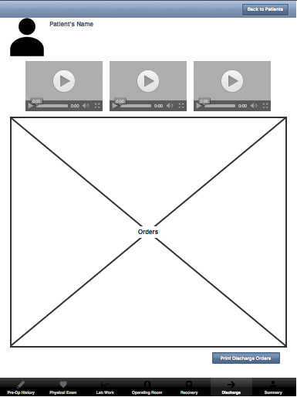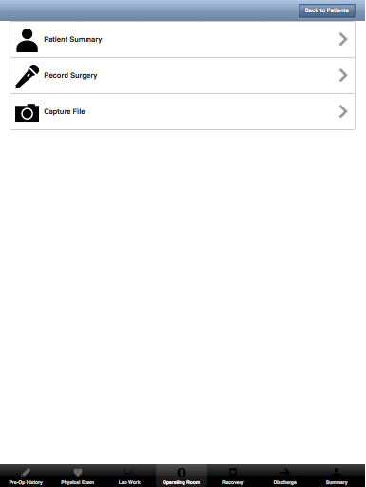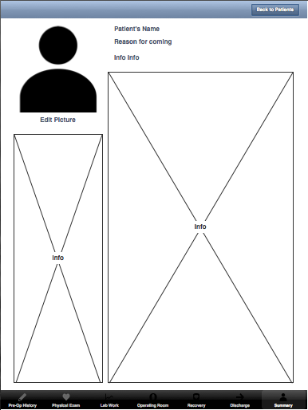
One specific measurement that we are proud of is our improvement from the beginning to the end of the project of taking a patients history. This section not only showed enormous improvement from our first prototype but also outperforms our major competitor (paper based forms). As you can, in the first prototype patient taking was just a thought, we had planned for the ability to do it and nothing else, we did not know what magic we would implement to make it work.

Following our rapid prototyping -- when we first started writing the application itself, we split up tasks using a task management software called Trello.[13] This allowed each team member to be kept accountable while working on a specific moving part and for us to come together later to attach them. (Our history taking at this point was several view controllers within the application that contained hard-coded sets of questions.) We quickly learned however that this approach was not best for our team dynamic. We were able to get a basic prototype up and running with parts of our app communicating with both our local database and our hosted local server running our second database; however, there was soon a falling out about the design of the back end of our application and after the midterm presentation we did a complete overhaul of what we had, switching to a Publisher/Subscriber model.

With this overhaul came a much smoother process for our application’s interface connecting to our back end as everything was (is) now loosely coupled. With the overhaul of the back end we decided to overhaul the history question taking and designed a new method that is much more dynamic. With the help of our client we worked out having one question per page and having the questions branch off into different series of questions depending on answers given by the patient. We also implemented mirroring so the answer to a question could be put in once and shown as both an answer to the spanish and english question. This allowed our app to save a lot of time when interviewing patients. We don’t necessarily have to wait for a translator to come translate an english question, it will be right there. Here are a few screens of the history taking in the final prototype that we completed this semester:
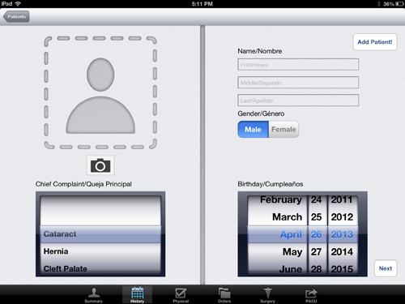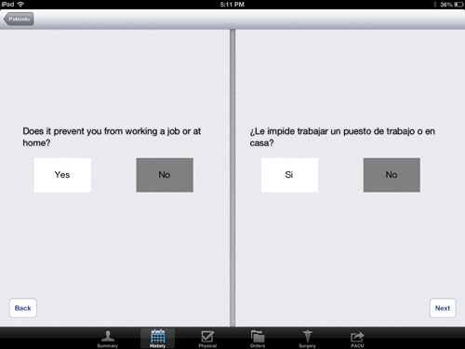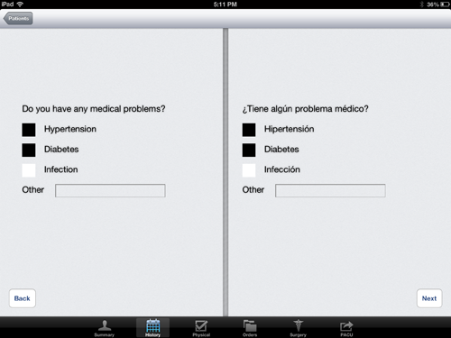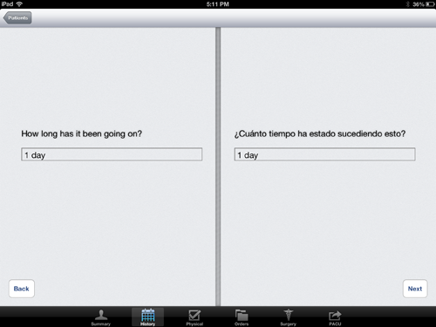
The following chart shows how our application compares compared a regular paper based system that the doctors would take down to ecuador with them. As you can see in almost all areas our application creates a time saving improvement for the doctor’s and volunteers work flow. The three areas we might not be improving in are physical exam intake, because most of that involves directly interacting with the patient and taking notes, so the amount of time to write the information on paper versus putting the information received in the app is about the same. Another of these areas is PACU -- Post Anesthesia Care Unit -- Where the amount of time to let the patient watch a discharge video and printing a discharge form is roughly equivalent to what happened before, with a person describing the post-care procedures and getting a form from a file, altering it, and giving it to a patient. The major point that we, in a way, slow down the operation is in the operating room. The surgeon/anesthesiologist take notes on paper and recording but our client specifically asked that they just be able to take the recording on the ipad and be able to take pictures of the notes that they create while in the room. So we actually add time to instead of speeding things up.
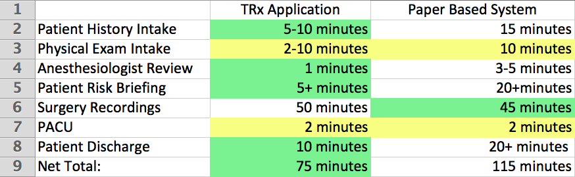
As you can see from the chart above, overall, we have made major improvements to the whole process of taking in patients and processing them, our app increases the overall number of patients doctors will be able to see in a day and makes it easier to allow volunteers to do work that normally a doctor would have to, thus freeing up the doctor to see more patients in the surgery room. To view a set of screenshots from the prototype at the time of completion of this class, follow this link.[14]

Design Decisions [Author: Mark Bellott and Mischa Buckler]

Throughout the course of the development of our project we made several design decisions that added to our workload, but in the end left us with a much more cohesive and robust system with a promising ability to grow and expand. The first of these decisions involved the questionnaire, both in gathering past medical history and in the physical exam. Originally, we planned on building the system page by page, hardcoding in the necessary values and question structures as we went. As we met with our client, however, we realized that this method would be inefficient and inflexible, both short term and long term. Short term, this method provided difficulty in allowing us to incorporate a dynamic branching structure. Our client expressed his desire for a branching question structure, where answering yes to one question might lead to one set of questions, while answering no would lead to another. Long term, this method would have conflicted with the flexibility desired by our client to have the ability to interchange different questions and question sets to fit the needs of different trips. To answer this problem, we made the decision to build a dynamic question page that loaded and built questions dynamically as the questionnaire progresses. The questions are built type by type as they are stored in the database from prebuilt, dynamic templates. The branching is handled by a helper data structure that can be easily manipulated to handle the addition or subtraction of questions. In addition to this, meeting with our client revealed a simplification in our design that could be made. Originally, we wanted to dynamically load multiple questions onto a page with the caveat of avoiding so many questions as to force a scrolling page. Instead, our client revealed to us that only displaying one question per page was more than acceptable, simplifying our design and allowing for a more elegant question structure.

The second major issue we came across was the way in which we were communicating with the server. Originally we were hacking things together, “hard coding” connections together at every step along the way. While this was working to a point, it gave us trouble in the sense that working on any one part of the project hinged on the server being up and running correctly at all times as well as the coder intimately knowning every section of the project both application and server side. Instead of leaving it like this, we decided to move to an “Observer-Listener” model (Also known as “Pub-Stub”) throughout the application and a 4-tiered application model. The four tiers were the server (MySql database with stored procedures), server database and local database communication layer (affectionately named DBTalk), a local database and application communication layer (affectionately named LocalTalk), and the application code layer itself. The combination of these two decisions essentially de-coupled all the different portions of the project, allowing for concurrent development cross-project, both database side and app side. The structure of this method is as follows: any time a portion of the app needs to communicate with the server for any reason, it publishes a notification. This notification is then picked up by a listener, which handles the necessary steps to complete the communication with the server and returns the requested information. The four layers have appropriate interfaces that abstracted away the actual communication from the app-development side. This allowed for easier development and quicker debugging.

The third major decision we made involved moving from a single database system to a double database system: the main MySql database on the local server and a SQLite database on every iPad. This proved to be no small task, but was absolutely necessary to accommodate the desires expressed by our client. To build a robust and reliable system, we wanted to make sure that the app could work on its own, without the presence of a larger database if needed. This was very important because the unstable environment means it is likely the local server will go down, at least temporarily, during a trip, but this cannot be allowed to stop the flow of patients and surgeries. The two-database system allows our app to continue to function even if the local network or server go down. The pub-sub structure works on two different instruction sets based on whether or not there is a connection to the server available. If a connection is available, communication with the database continues as normal. If however, for whatever reason there is not a connection available, the app then switches to communicate with a local database on the iPad itself. This prevents the potential detrimental circumstance of an unusable app or lost/unreachable records. In this situation, whenever a connection is made available again, the app will sync any new information store on its local database with the main database. The syncing between iPad and server functions as we hope the user expects--records are merged seamlessly if multiple users work in different parts of the same record, but if two users work on the exact same portion of a record, the last user to save their changes wins. In the future, we would like to present “conflicts” to a user if necessary, but presenting conflicts is a very low priority and so has not yet been started.

User Manual [Author: John Cotham and Mischa Buckler]

Warnings: As specified in the ToS, this application is not compliant with United States healthcare regulations, including but not limited to HIPAA. As such, this application is NOT meant to be used in the United States, and as no provisions have been made to be compliant with ANY government regulations of any countries, we do not claim compliance for any country. Be advised and familiar with your country’s healthcare regulations.

Setup:

All relevant pictures for the following sections are included in the following link: https://www.dropbox.com/sh/nzwhdvrhuza6qjx/JBBZR3kyEG

Necessary Equipment:
- iPad running iOS v6.0 or later
- router
- MAMP
- TRx app
- Database creation file (“create_database.sql”)

The TRx app runs on iPad 6.0 and later. While the app can be used without access to a server, it is designed so multiple users may simultaneously take records and have them backed up to a MySQL database on a local server.

Instructions:

1) The TRx app will be release through Apple’s Enterprise program and will be available to users through Humanitarian Health International. After getting initial instructions from HHI, download the TRx app from Apple’s app store to the iPads you want to take records with. You will need to enter your assigned passwords to activate the application.

The app will work ‘out of the box’ without connection to a server, and you will be able to access and use the whole app. However, it is designed to be used by a team who are connected to a local server.

2) To set up a local wireless network, plug in your router and follow its instructions for setting up a local network.

3) On the computer you will be using for your server:
a.) Download and install MAMP (for Macs) or LAMP (Linux).
b.) Open MAMP and click the “Start Servers” button.
c.) On the start page that loads, note the port number. The default is 8889
d.) Find the computer’s IP address
On a Mac:
-Go to System Preferences --> Network
-Under the status bar, note the IP address
Linux or Mac:
-Open a shell and input the command: /sbin/ifconfig
-In the output, locate the inet number of the form xxx.x.x.x
e.) Connect your iPads to the local network.
-connect to: http://IP:PORT

4) Configure settings for a trip. Once the server is running, open the configure_trip_settings.html file in your browser. With this web portal, you can enter information relevant to your particular trip. Update the Doctor’s list with the names of the doctors who will be going on the trip. Update the Surgery Type’s field with names for each of the surgeries you will be performing.

5) Set up the database:
a). In the MAMP start page, click on the phpMyAdmin page.
b). In the database tab, enter “TRxDatabase” in the create database box and click “create”
c). Select the newly created database from the list on the left.
d). In the tabs on the top, click the “Import” tab
e). Choose to upload the “create_database.sql” file, set char style to utf-8, make sure that format is “MySQL” and then click “Go”

6) Make sure your iPads can connect to the server. Go to Settings->Wi-Fi and choose your local network.

Using the App:

Patient List: The TRx app opens to a list of patients stored on the server’s database and locally on the user’s iPad. If you are not connected to the server, only patients stored on the iPad are displayed. Clicking a patient in the table retrieves and opens a summary of the patient’s latest record. This information may be edited by selecting text fields and typing in your changes. You can return to the patient list from any screen by clicking the “Patient” button in the upper left corner.

Adding a Patient: From the patient list, click the Add New Patient Button (plus symbol) in the top right corner of the patient list. This button takes you to the first page of Patient History. Clicking on the camera icon, you can take a picture of the patient. This picture will be displayed on all of the patient’s records for identification purposes. Then, in order to successfully add a new patient record, the user must add a unique combination of first name, last name, and birthday as well as the type of procedure the patient is seeking. After these fields are added, press the “Add Patient” button to move on to questions.

Answering Questions: Questions appear in English and are mirrored in Spanish on the right. Selecting an answer on one side simultaneously updates the mirrored side. The questions branch according to the patient’s answers to collect relevant data. To change the flow of questions, please contact the developers.

Navigation Bar: The previous pages as well as the Orders, Surgery, and PACU pages can be reached through the navigation bar located at the bottom of the screen on all but the Patient List page.

Physical Page: This page lists questions in English that pertain to the physical examination. Questions are currently listed one at a time.

Orders Page: This page lists Surgeon Pre-Op orders, Surgeon Post-Op Orders, Anesthesiologist Pre-Op Orders, and Anesthesiologist Post-Op Orders. These are templated text fields that can be edited and saved in the patient’s records. Later versions of the app will have one-touch wireless printing for these pages.

Surgery Page: The surgery page displays features for doctors to access during surgery. They can take dictations and pictures and save them with the patient’s file. Files can be accessed in a list at the bottom of the page. This page also links to videos that explain various parts of the procedures for patients in their native language.

PACU (Post-Anesthesiology Care Unit) Page: Displays templated recovery vital signs forms that can be edited. Later versions of the app will allow for easy printing of these templates. This page also liinks to discharge videos that explain the recovery process.

Conflicts: In the event of a conflict (two users simultaneously working on the same fields on the same patient’s record), the user who submits their changes last will ‘win’, overwriting the other user’s changes.

No connection: The application is designed to work with and without connection to the local server. This allows for the doctors to work in a wider variety of conditions and to have mobility with the application.

Terms and Conditions
(generated with binpress.com’s license generator and added to and edited)

- Preamble: This Agreement, signed on Apr 15, 2013 [hereinafter: Effective Date] governs the relationship between Humanitarian Health International, a duly registered company, (hereinafter: Licensee) and Team Ecuador, a Partnership under the laws of TN, United States whose principal place of business is TN, United States (Hereinafter: Licensor). This Agreement sets the terms, rights, restrictions and obligations on using [TRx] (hereinafter: The Software) created and owned by Licensor, as detailed herein
- License Grant: Licensor hereby grants Licensee a Sublicensable, Non-assignable & non-transferable, Non-commercial, Including the rights to create and distribute derivative works, Non-exclusive license, all with accordance with the terms set forth and other legal restrictions set forth in 3rd party software used while running Software.
  - Limited: Licensee may use Software for the purpose of:
    - Running Software on Licensee’s Website[s], Server[s], and Device[s];
    - Allowing 3rd Parties to run Software on Licensee’s Website[s] and Server[s];
    - Publishing Software’s output to Licensee and 3rd Parties;
    - Distribute verbatim copies of Software’s output (including compiled binaries);
    - Modify Software to suit Licensee’s needs and specifications.
  - Binary Restricted: Licensee may sublicense Software as a part of a larger work containing more than Software, distributed solely in Object or Binary form under a personal, non-sublicensable, limited license. Such redistribution shall be limited to {apps} codebases.
  - Non Assignable & Non-Transferable: Licensee may not assign or transfer his rights and duties under this license.
  - Non-Commercial: Licensee may not use Software for commercial purposes. for the purpose of this license, commercial purposes means that a 3rd party has to pay in order to access Software or that the Website that runs Software is behind a paywall.
  - Including the Right to Create Derivative Works: Licensee may create derivative works based on Software, including amending Software’s source code, modifying it, integrating it into a larger work or removing portions of Software, as long as no distribution of the derivative works is made
- Term & Termination: The Term of this license shall be until terminated. Licensor may terminate this Agreement, including Licensee’s license in the case where Licensee :
  - became insolvent or otherwise entered into any liquidation process; or
  - exported The Software to any jurisdiction where licensor may not enforce his rights under this agreements in; or
  - Licensee was in breach of any of this license's terms and conditions and such breach was not cured, immediately upon notification; or
  - Licensee in breach of any of the terms of clause 2 to this license; or
  - Licensee otherwise entered into any arrangement which caused Licensor to be unable to enforce his rights under this License.
- Upgrades, Updates and Fixes: Licensor may provide Licensee, from time to time, with Upgrades, Updates or Fixes, as detailed herein and according to his sole discretion. Licensee hereby warrants to keep The Software up-to-date and install all relevant updates and fixes, and may, at his sole discretion, purchase upgrades, according to the rates set by Licensor. Licensor shall provide any update or Fix free of charge; however, nothing in this Agreement shall require Licensor to provide Updates or Fixes.
  - Upgrades: for the purpose of this license, an Upgrade shall be a material amendment in The Software, which contains new features and or major performance improvements and shall be marked as a new version number. For example, should Licensee purchase The Software under version 1.X.X, an upgrade shall commence under number 2.0.0.
  - Updates: for the purpose of this license, an update shall be a minor amendment in The Software, which may contain new features or minor improvements and shall be marked as a new sub-version number. For example, should Licensee purchase The Software under version 1.1.X, an upgrade shall commence under number 1.2.0.
  - Fix: for the purpose of this license, a fix shall be a minor amendment in The Software, intended to remove bugs or alter minor features which impair the The Software's functionality. A fix shall be marked as a new sub-sub-version number. For example, should Licensee purchase Software under version 1.1.1, an upgrade shall commence under number 1.1.2.
- Support: Software is provided under an AS-IS basis and without any support, updates or maintenance. Nothing in this Agreement shall require Licensor to provide Licensee with support or fixes to any bug, failure, mis-performance or other defect in The Software.
  - Bug Notification: Licensee may provide Licensor of details regarding any bug, defect or failure in The Software promptly and with no delay from such event; Licensee shall comply with Licensor's request for information regarding bugs, defects or failures and furnish him with information, screenshots and try to reproduce such bugs, defects or failures.
  - Feature Request: Licensee may request additional features in Software, provided, however, that (i) Licensee shall waive any claim or right in such feature should feature be developed by Licensor; (ii) Licensee shall be prohibited from developing the feature, or disclose such feature request, or feature, to any 3rd party directly competing with Licensor or any 3rd party which may be, following the development of such feature, in direct competition with Licensor; (iii) Licensee warrants that feature does not infringe any 3rd party patent, trademark, trade-secret or any other intellectual property right; and (iv) Licensee developed, envisioned or created the feature solely by himself.
- Liability: To the extent permitted under Law, The Software is provided under an AS-IS basis. Licensor shall never, and without any limit, be liable for any damage, cost, expense or any other payment incurred by Licensee as a result of Software’s actions, failure, bugs and/or any other interaction between The Software and Licensee’s end-equipment, computers, other software or any 3rd party, end-equipment, computer or services. Moreover, Licensor shall never be liable for any defect in source code written by Licensee when relying on The Software or using The Software’s source code.
- Restricted Use: The TRx app is not HIPPA compliant and should not be used in the United States for medical purposes. TRx is designed to be run on a local server, disconnected from the internet. The Licensee here agrees to hold Licensor blameless for any loss or breach of data due to internet intrusion.
- Warranty:
  - Intellectual Property: Licensor hereby warrants that The Software does not violate or infringe any 3rd party claims in regards to intellectual property, patents and/or trademarks and that to the best of its knowledge no legal action has been taken against it for any infringement or violation of any 3rd party intellectual property rights.
  - No-Warranty: The Software is provided without any warranty; Licensor hereby disclaims any warranty that The Software shall be error free, without defects or code which may cause damage to Licensee’s computers or to Licensee, and that Software shall be functional. Licensee shall be solely liable to any damage, defect or loss incurred as a result of operating software and undertake the risks contained in running The Software on Licensee’s Server[s] and Website[s].
  - Prior Inspection: Licensee hereby states that he inspected The Software thoroughly and found it satisfactory and adequate to his needs, that it does not interfere with his regular operation and that it does meet the standards and scope of his computer systems and architecture. Licensee found that The Software interacts with his development, website and server environment and that it does not infringe any of End User License Agreement of any software Licensee may use in performing his services. Licensee hereby waives any claims regarding The Software's incompatibility, performance, results and features, and warrants that he inspected the The Software.
- No Refunds: Licensee warrants that he inspected The Software according to clause 7(c) and that it is adequate to his needs. Accordingly, as The Software is intangible goods, Licensee shall not be, ever, entitled to any refund, rebate, compensation or restitution for any reason whatsoever, even if The Software contains material flaws.
- Indemnification: Licensee hereby warrants to hold Licensor harmless and indemnify Licensor for any lawsuit brought against it in regards to Licensee’s use of The Software in means that violate, breach or otherwise circumvent this license, Licensor's intellectual property rights or Licensor's title in The Software. Licensor shall promptly notify Licensee in case of such legal action and request Licensee’s consent prior to any settlement in relation to such lawsuit or claim.
- Governing Law, Jurisdiction: Licensee hereby agrees not to initiate class-action lawsuits against Licensor in relation to this license and to compensate Licensor for any legal fees, cost or attorney fees should any claim brought by Licensee against Licensor be denied, in part or in full.
- Foreign Use: Licensee hereby agrees to use this application in accordance with the laws of the country in which they are operating.

References cited

1. Humanitarian Health International. "What We Do." . Web. 26 Apr 2013. <http://humanitarianhealth.org/what-we-do/>.

2. Gullo, Chris. "Half of doctor to use medical apps in 2012 | mobihealthnews." Mobihealthnews. N.p., 16 Nov 2011. Web. 26 Apr 2013. <http://mobihealthnews.com/14703/half-of-doctors-to-use-medical-apps-by-2012/>.
3. Fierce EMR , Marla Hershc -- “Hospitals seek more integrated, functional EHRs” <http://www.fierceemr.com/story/hospitals-want-integrated-functional-ehrs-meet-meaningful-use-requirements-epic-cerner-lead-market/2012-08-14>

4.Hippa Compliance for EMR/EHR Systems <http://www.medicalrecords.com/physicians/compliance>

5.Mary Mosquera -- ”Plans in the Making for Peace Corps EHR“ <http://www.healthcareitnews.com/news/plans-making-peace-corps-ehr>

6. Practice Fusion. "iPad EMR | Secure iPad EHR Software." Practice Fusion. Web. 26 Apr 2013. <http://www.practicefusion.com/pages/ipad-emr-solution.html>.

7. drchrono. "iPad EHR | EMR software app for the iPad & web | drchrono." drchrono. Web. 26 Apr 2013. <https://drchrono.com/products/ehr>.

8. HealthFusion. "EMR/EHR Platform - MediTouch EHR Software by HealthFustion." HealthFusion. Web. 26 Apr 2013. <http://www.healthfusion.com/ehr-platform.asp>.

9. Greenway Medical Technologies. "Mobile EHR Application - Greenway Medical." Greenway Medical. Web. 26 Apr 2013. <http://www.greenwaymedical.com/solutions/prime-mobile/>.

10. bizmatics Inc. "EMR Software, Top EMR Software, EMR Electronic Medical Records Software | Bizmatics." PrognoCIS EMR Software. Web. 26 Apr 2013. <http://www.bizmaticsinc.com/emr-software.php/>.

11. CareCloud, . "Practice Management Software | CareCloud." CareCloud. Web. 26 Apr 2013. <http://www.carecloud.com/central/>.

12. The prototyping website we took advantage of: <https://proto.io/>
13. A link to our public project management Trello board: <https://trello.com/board/ecuador/51059087755cd8ef3f00215d>

14. Gallery display of the screenshots from the prototype of our app at the end of ECE 400: <https://www.dropbox.com/sh/nzwhdvrhuza6qjx/JBBZR3kyEG>

