Investigating the mechanisms and specificity of bacterial virulence in an entomopathogenic symbiosis

A Thesis Presented for the

Master of Science

Degree

The University of Tennessee, Knoxville

Elizabeth M. Ransone

August 2021

Copyright © 2021 by Elizabeth M. Ransone
All rights reserved.

DEDICATION

This one goes out to the one I love

ACKNOWLEDGEMENTS

I am indebted to many people including but not limited to:
- Heidi Goodrich-Blair & Co: Daren Ginete, Alex Grossman, Jenny Heppert, Sarah Kauffman, Erin Mans, Jemma McLeish, Cameron Moore, Nick Mucci, and Terra Mauer
- The UTK Microbiology master’s students before me: David Grant and Will Brewer
- My committee: Dan Jacobson and Liz Fozo
- Sequencer extraordinaire: Veronica Brown
- Our collaborator: Farrah Bashey-Visser
- My undergraduate mentors: Rachel Ellick, John Swaddle, and Dan Cristol
- The Bode lab: Carsten Kegler, Edna Bode, Nick Tobias, Yi Ming and Yan-Ni Shi, Magga Westphalen, Andi Tietze, Moritz Drechsler, Siyar Kavakli, Nick Neubacher, Daniela Vidaurre Barahona, Sebastian Wenski (and Svenja Badeck), et al.
- My thesis writing group: Sara Rico-Godoy, Jessie Dreyer, and Lorraine Herbon
- My friends: Holly Nichols, Andrew Lail, Rachel Reeb, Cassia Owen, Theresa Jones, Liz Lustgarten, Tina Soliza, Brendan Thomas, Liam Arne, and many others
- My family: Karen and Sterling Ransone
- Lukas Kreling

ABSTRACT

Microbial symbionts contribute to the health of their host in both positive and negative ways. In the Steinernema nematode symbiosis, Xenorhabdus symbionts traditionally mediate insect virulence by producing toxins and other virulence proteins against the insect prey that they both need for sustenance. In this work, I took a bidirectional approach to the question: what is the larger role of Xenorhabdus in virulence against insect prey? 1) I investigated a novel protein family, typified by the Xenorhabdus bovienii polymorphic protein (Xbpp) with strain-level protein diversity. I found that Xbpp contributes to X. bovienii virulence in a Manduca sexta tobacco hornworm insect model. 2) I sequenced the microbiome of S. scapterisci, a nematode associated with a symbiont, X. innexi, that has notably low virulence relative to other Xenorhabdus. I found that the S. scapterisci microbiome shares many members with the Steinernema frequently associated microbiome proposed by Ogier et al. (2020). This community changed depending on the insect host through which the IJs were propagated. Overall, I found that Xenorhabdus insect virulence is highly dynamic and may include associations with additional microbial community members that contribute to the parasitic lifestyle of the Steinernema-Xenorhabdus complex.

TABLE OF CONTENTS

Chapter I Introduction 1
Microbial symbiosis 3
Introduction to microbial symbiosis 3
Importance of microbial symbiosis model systems 4
Xenorhabdus-Steinernema as a symbiosis model system 6
History of entomopathogenic nematodes as a microbial symbiosis model system 6
Steinernema-Xenorhabdus life cycle 8
Xenorhabdus strain-level specificity 8
Insect virulence factors in Xenorhabdus spp. 9
Virulence in Xenorhabdus symbionts 9
Virulence in Xenorhabdus innexi 11
References 13
Chapter II The role of a Xenorhabdus bovienii polymorphic protein in symbiosis 18
Abstract 20
Introduction 21
Materials & Methods 23
X. bovienii growth conditions 23
X. bovienii strain comparison 23
Plasmid and strain construction 25
Strain phenotype plate assays 31
Bacterial growth assay 31
Manduca sexta survival assay 32
Confocal microscopy 33
Western blotting for GFP-tagged Xbpp 34
Hemocyte killing assay 34
Swim plate images 35
Results 36
Xbpp is a multi-domain protein encoded by all X. bovienii strains 36
Hemocyte killing assay 55
Xbpp expresses within 24 hours of growth 55
Swim plate assay results 59
Discussion 67
References 70
Chapter III Using next-generation sequencing to define the evolving microbiome of an insect-infecting nematode 73
Abstract 75
Introduction 76
Materials & Methods 79
General S. scapterisci propagation 79
Experimental S. scapterisci propagation 80
DNA extraction from IJs 82
Library preparation and sequencing 83
Amplicon sequence data analysis 83
In vivo nematode infection of insects 84
Culture-dependent microbial community collection 85
IJ supernatant virulence assay 85
X. innexi IJ colonization assay 86
Results & Discussion 87
S. scapterisci IJ microbiome sequencing diversity measurements 87
S. scapterisci IJ microbiome core members 93
S. scapterisci IJ colonization by X. innexi symbionts is influenced by prey-source 105
S. scapterisci IJ virulence is influenced by insect prey source 107
Conclusion 113
References 115
Chapter IV Conclusions and Future directions 118
Conclusions 119
Future Directions 120
Determine the mechanism of action of Xbpp 120
Further characterize the S. scapterisci microbiome 121
Vita 122

LIST OF TABLES

Table 1: Xenorhabdus bovienii Xbpp homologs 24
Table 2: Strains and plasmids used in this study 26
Table 3: XbSaIN78 strain growth curve values in a 96-well plate. 44
Table 4: Characteristics of Manduca sexta at baseline 49
Table 5: CFU injected into Manduca sexta in each replicate 50
Table 6: ANOVA results of XbSaIN78 swim plate cell length 65

LIST OF FIGURES

Figure 2.1. Select xbpp gene neighborhoods. 37
Figure 2.2. Xbpp amino acid and domain structure. 38
Figure 2.3. Xbpp RCC1 domain alignment. 39
Figure 2.4. Xbpp RCC1 phylogenetic tree. 42
Figure 2.5. Growth curves of Xbpp mutant strains. 43
Figure 2.6. No significant phenotypes among XbSaIN78 constructed strains. 46
Figure 2.7. PBS injection control deaths. 51
Figure 2.8. Survival of Manduca sexta injected with XbSaIN78 strains. 52
Figure 2.9. Hemocyte killing assay. 56
Figure 2.10. Fluorescence of XbSaIN78 strains on LB plates. 57
Figure 2.11. Fluorescence observed by confocal microscopy of GFP-tagged Xbpp expressed in individual cells. 58
Figure 2.12. Representative Western blot and Coomassie gel of XbSaIN78 strains expressing GFP-tagged Xbpp. 60
Figure 2.13. Fluorescence of Xbpp mutant strains in a 96-well plate. 61
Figure 2.14. Swim plate cells. 63
Figure 2.15. Swim plate cell metrics. 64
Figure 3.1. Graphical abstract of S. scapterisci IJ microbiome sampling methodology 81
Figure 3.2. Rarefaction curves of S. scapterisci IJ microbiome samples 88
Figure 3.3. Sample microbiome alpha diversity 90
Figure 3.4. Pairwise distance test of IJ microbiome Shannon diversity over time 94
Figure 3.5. Core microbiomes of S. scapterisci IJs from crickets and control samples 96
Figure 3.6. Core microbiomes of S. scapterisci IJs from waxworms and control samples 99
Figure 3.7. Time-independent core microbiomes of S. scapterisci IJs from crickets and waxworms 101
Figure 3.8. Comparison of S. carpocapsae and S. scapterisci core microbiomes 102
Figure 3.9. IJ X. innexi bacterial colonization over time in IJs from waxworm and cricket 106
Figure 3.10. Hazard ratio of insects exposed to S. scapterisci IJs 109
Figure 3.11. IJ supernatant alone does not kill waxworms 110

Chapter I
Introduction

A portion of this chapter and chapter III appears in the following publication:
Jennifer K. Heppert, Elizabeth M. Ransone, Alex S. Grossman, Terra J. Mauer & Heidi Goodrich-Blair. (Accepted). Nematodes as Models for Symbiosis. In I. Glazer, D. Shapiro-Ilan, and P. Sternberg (ed.), Nematodes as Biological Models. CABI, Wallingford.

E. Ransone wrote text for the publication section titled “Xenorhabdus-Steinernema as a symbiosis model system”. The other publication authors edited the text of the section and wrote the remainder of the chapter.

Microbial symbiosis

Introduction to microbial symbiosis
Symbiosis, or the state of two or more organisms living and interacting in close physical proximity with each other, is a widely studied area of biology due to its relevance in understanding ecological and molecular interactions between organisms. The term was coined by Heinrich Anton de Bary in a 1878 lecture after his discovery of the fact that lichens consist of both a fungus and an alga (Oulhen et al., 2016). While de Bary originally used the term symbiosis to describe a mutually beneficial partnership, the definition encompasses a wider range of interactions between organisms. In this thesis, I will focus on microbial symbiosis, or the interaction of one or more microbes with their host organism. In this chapter, I will explore an example of a microbial symbiosis model and its implications for the study of human health.
With the ubiquity of microbial life on earth, it is no surprise that microorganisms play an inescapable role in symbioses. Microbial symbioses are relevant to environmental and organismal health [reviewed in (Beinart, 2019; Dubilier et al., 2008)] with direct implications for humans [reviewed in (Chow et al., 2010; Eloe-Fadrosh and Rasko, 2013; Young, 2017)]. Large microbial communities called microbiomes are an expansion of the idea of symbiosis to encompass the varying and diverse set of microbes that live on or in a host or in the wider environment, such as plant, soil, aquatic, and atmospheric environments (Handelsman, 2016). Microbiome composition is influenced by host diet, environment, and phylogeny (Goodrich et al., 2016; Ley et al., 2008; Sommer and Bäckhed, 2013). Conversely, the identity of the microbes present can contribute to the health and development of the host (Sommer and Bäckhed, 2013). Microbes play a role in the digestion of compounds into available nutrients for their host (Hooper et al., 2002; Smith et al., 2013) and the production of nutrients that the host cannot produce themselves (McCutcheon and Von Dohlen, 2011; Rowley and Kendall, 2019). In humans, the clinical applications of microbiome discoveries have led to hard-won medical advances such as weight gain in malnourished children (Gehrig et al., 2019) and to successful treatment of recurrent, antibiotic-resistant Clostridium difficile infections (van Nood et al., 2013).
While symbiosis is sometimes described in absolute terms, modern science recognizes that symbioses exist on a scale that ranges from mutualistic (beneficial to both organisms) to antagonistic (harmful to at least one partner). Between the two ends of the symbiosis scale lie many gradations where the relationship between two organisms can be more difficult to concretely define. This interpretation recognizes that the relationship between organisms is not static, but rather highly dynamic and ever-changing. Some organisms can provide benefits to their partner at one point but prove harmful at a different time depending on environment, organismal needs, or other factors (Douglas, 2010; Khosravi et al., 2015; Redman et al., 2001). Overall, symbiosis is a useful concept that allows us to explore the interconnectedness of nature.

Importance of microbial symbiosis model systems
Our understanding of functional microbial symbioses has greatly expanded with advancements in “-omics” technology. Using genomic, transcriptomic, proteomic, and metabolomic tools, scientists can explore the composition, function, and functional potential of the microbial communities (Young, 2017). These techniques enable scientists to study symbiotic relationships in environments that previously have been experimentally inaccessible to humans (e.g., in terms of temperature, salinity, and pH) (Hiraoka et al., 2016). Such techniques also allow us to move past the assignment of specific bacterial species as “good” or “bad” and into the wider scientific understanding that host-microbe interactions are infinitely complicated and require further mechanistic and exploratory study, preferably with manipulatable model systems.
While -omics techniques allow us to study the natural environment, mechanistic insights about symbiosis are more frequently discovered in the more controlled environment of the laboratory. Laboratory model systems allow scientists to manipulate individual organisms and can limit potentially confounding variables in the discovery process. Such scientific findings then can be tested in more complicated and multifaceted study subjects. The importance in human health of symbiotic interactions with microbes was originally suggested by investigating gnotobiotic, or microbe-free, mouse models (Williams, 2014). When studying complicated molecular interactions in the laboratory, it is important to select a model system that can address hypotheses without additional interfering interactions. The most valuable model systems are those in which the partner organisms can be easily raised in the laboratory and genetically modified. Symbiosis models also benefit from being separable, so that each organism can be studied independently. Increased experimental power comes from being able to isolate, manipulate, and reassociate the host and symbiont. This methodology can allow even obligate symbiotic relationships to be separated and utilized in the laboratory if the symbiotic function of the partner can be artificially maintained. Symbiosis model systems are difficult to develop because, ideally, both organisms must fit the above characteristics.
One example of a symbiosis model system is the relationship between Steinernema nematodes and Xenorhabdus bacteria. This host-microbe relationship is a valuable model system for investigating the molecular basis and evolutionary origins of symbiosis because it meets many of the conditions explored above. Steinernema spp. nematodes host a single strain of Xenorhabdus bacteria as the mutualistic pair infects and kills insect prey together. The nematodes have been isolated from all continents except Antarctica, making them a ubiquitous and environmentally hardy pair. The nematode and bacterium can be grown separately, genetically manipulated (although these techniques are still developing for the nematodes) and reassociated to test hypothesis with one or both organisms. Additionally, Xenorhabdus symbionts are heritable and are passed within the host from generation to generation, opening up the ability to investigate long-term questions about fitness and host-microbe evolution in real time.

Xenorhabdus-Steinernema as a symbiosis model system

History of entomopathogenic nematodes as a microbial symbiosis model system
Entomopathogenic nematodes (EPNs) were first discovered in 1923 (Poinar and Grewal, 2012). Because up to one-fourth of crops are destroyed by insects worldwide (Clarke, 2020; Kergunteuil et al., 2016), early research focused on utilizing EPNs for agricultural pest control. Although difficulties in producing EPNs on an industrial scale initially limited enthusiasm about their use in biocontrol of insect pests (Ehlers, 2001), EPN research was revived in the mid-20th century when, in Europe and North America, scientists independently isolated EPN populations from codling moth larvae (Dutky and Hough, 1955; Weiser, 1955). These nematodes became a cornerstone of the EPN research field and were later classified as Steinernema carpocapsae (Poinar, 1967). Today, two EPN families, Heterorhabditidae and Steinernematidae, are commercially produced for use against insect pests in agricultural products such as NemAttack™ which consists of S. feltiae nematodes (Lacey et al., 2015; Shapiro-Ilan et al., 2014). Most research on EPN-microbe symbiosis to date focuses on Heterorhabditis and Steinernema nematodes because of their development for use as entomopathogens throughout the 20th century.
Although as early as 1937 researchers had observed the presence of bacteria inside the nematodes (Bovien, 1937), the roles of the symbionts in the life cycles of EPNs would not be discovered for nearly 30 years (Poinar and Thomas, 1966, 1967). Symbiont laboratory isolation and cultivation required the development of media enabling propagation of the nematode-bacterium pairs outside of insects, as well as separately from each other (House et al., 1965; Stoll, 1953). The isolation by Poinar and Thomas in 1965 of the S. carpocapsae bacterial symbiont Xenorhabdus nematophila paved the way for the development of EPNs as a symbiosis model system (Poinar and Thomas, 1965). We now know that all members of both EPN families are associated with and dependent on a microbial symbiont: Heterorhabditidae with Photorhabdus bacteria and Steinernematidae with Xenorhabdus bacteria (Poinar, 1990).

Steinernema-Xenorhabdus life cycle
Steinernema nematodes and Xenorhabdus bacteria are a valuable symbiosis model system because each requires the presence of the other to survive in nature (Murfin et al., 2015a; Sicard et al., 2003), but they can be grown and investigated separately in the laboratory. The bacteria live within the nematode gut during a non-feeding soil stage. After finding an insect to infect, the pair enters a parasitic life stage (Goodrich-Blair and Clarke, 2007). Xenorhabdus is released from the nematode into the insect hemolymph, where it replicates and spreads throughout the insect (Sicard et al., 2004). The bacteria provide two primary benefits to the nematode host. First, the bacteria express virulence factors and immunosuppressants that help kill the insect. Second, the bacteria degrade the insect tissue and use the nutrients to replicate to high bacterial population which the nematode will use for food. When the insect cadaver is spent, the nematode takes a small sample of the bacteria with it as it emerges for the soil stage in search of a new insect host (Mucci et al., 2021).

Xenorhabdus strain-level specificity
Bacterial symbionts impact host fitness in mutualistic and pathogenic ways, including through strain variation (Goodrich-Blair and Clarke, 2007; Murfin et al., 2015a). While the definition of a strain is variable between fields, here a strain is defined as a bacterial subspecies isolated from a nematode host. Because Steinernema nematodes and their symbionts can be found throughout the world, the curation of a large collection of samples spanning the globe is possible. The heritability of Xenorhabdus symbionts combined with such a large and geographically varied study population places the field in a good light for exploration of the importance of strain-level specificity on symbiotic fitness. Xenorhabdus bacteria and their Steinernema nematode hosts are found in a strain-specific relationship that appears to be coevolved, which has been studied best in X. bovienii strains (Murfin et al., 2015a). While X. bovienii strains have 96% average nucleotide identity based on a collection of 1,893 orthologous genes (Murfin et al., 2015a), there are distinct survival and reproductive fitness costs if a nematode associates with a non-native Xenorhabdus symbiont even at the strain level (Murfin et al., 2015a, 2018; Sicard et al., 2003). Genomic data suggests Xenorhabdus bovienii symbionts provide virulence factors for insect prey killing and nutrient provisioning functions that are specialized to the strain-specific nematode relationship (Murfin et al., 2015b). These findings imply that strain-level host-microbe coevolution along with host recognition and selection of symbionts may play a much larger role in the formation and maintenance of symbiotic relationships than previously thought.

Insect virulence factors in Xenorhabdus spp.

Virulence in Xenorhabdus symbionts
In theory, insect virulence is a selected trait among Xenorhabdus symbionts. During the infection cycle, Xenorhabdus in the insect hemolymph suppresses the insect prey’s immune system through inhibition of cellular and humoral immunity pathways (Hillman, 2020; Kim et al., 2005; Park et al., 2007; Shrestha and Kim, 2007). With dampened insect immune response, the bacteria can replicate quickly and kill the insect via septicemia (Dunphy and Webster, 1984; Park and Kim, 2000; Ribeiro et al., 1999). Xenorhabdus is necessary for insect degradation (Richards and Goodrich-Blair, 2009). The bacteria also is used as a food source by Steinernema nematodes (Mucci et al., 2021). Without a symbiont, Steinernema nematodes exhibit decreased fitness and reproduction (Murfin et al., 2015a; Sicard et al., 2003), including failing to develop at normal rates into the soil-persisting stage infective juveniles (IJs) needed for survival in the environment before new prey arrives (Han and Ehlers, 2000).
Xenorhabdus symbionts encode potential virulence factors, many of which may contribute to insect killing. Xenorhabdus encodes homologs of characterized virulence factors such as multifunctional autoprocessing repeats-in-toxin (MARTX) toxin, makes caterpillars floppy toxin 1 (mcf1), and multiple hemolysins (Murfin et al., 2015b). Mcf1 is a insecticidal repeats-in-toxin (RTX) protein that is believed to cause insect virulence through insect hemocyte lysis (Daborn et al., 2002), although mammalian cells are also vulnerable to Mcf1-mediated apoptosis (Dowling et al., 2004). The Xenorhabdus hemolysin XhlA contributes to insect virulence likely due to its ability to lyse insect immune cells (Cowles and Goodrich-Blair, 2005).
Additional virulence factors include the insecticidal Toxin complexes (Tc), including TcA, TcB, and TcC, which were originally identified in Photorhabdus and Xenorhabdus (Bowen et al., 1998), although they have since been found in other bacterial species (Hinchliffe et al., 2013). The TcA unit forms a translocation channel, and the TcB-TcC heterodimer forms a “cocoon” around a toxic enzyme cleaved from the C-terminal hypervariable region of TcC (Gatsogiannis et al., 2018; Meusch et al., 2014). The toxin is released into target cells when the TcB-TcC cocoon binds to the TcA channel (Gatsogiannis et al., 2018). It has been proposed that the Tc toxin system itself represents a universal protein translocation system (Roderer et al., 2019). The flexible genome region of Xenorhabdus spp., which includes phage-derived loci, is a tremendous resource for the discovery of novel host interaction effectors (Ciezki et al., 2017).
In general, virulence factors may be exported from the cell via secretion systems. Xenorhabdus encodes a Type II secretion system, a double membrane spanning mechanism in Gram-negative bacteria used to transport proteins from the periplasm to the extracellular environment (Korotkov et al., 2012). It also encodes a type VI secretion system, a Gram-negative contact-dependent system that injects effector proteins into neighboring cells (Russell et al., 2014). Additionally, Xenorhabdus encode a flagellar export system that can secrete antibiotics and virulence factors (Murfin et al., 2015b; Park and Forst, 2006; Richards et al., 2008; Singh et al., 2013).

Virulence in Xenorhabdus innexi
While Xenorhabdus are expected to be virulent against insects because of their life cycle, we can learn about the specificity of symbiotic virulence by investigating deviations from the expected norm. Among Xenorhabdus species studied to date, X. innexi, the symbiont of S. scapterisci nematodes, is the least virulent against insects (Kim et al., 2017). Unlike other tested Xenorhabdus species, X. innexi was not virulent in several different insect hosts when injected at ecologically-relevant levels (Kim et al., 2017). This virulence deficiency may be due to the specialization of S. scapterisci nematodes and their symbionts to cricket prey (Frank, 2009; Kim et al., 2017). Consistent with this observation, the X. innexi genome lacks genes encoding several common Xenorhabdus insect virulence factors (Kim et al., 2017), including the TcC toxins. Despite its lack of insect virulence explicitly needed for propagation of the Steinernema-Xenorhabdus pairing through insect prey, X. innexi maintains its specific relationship with and is transmitted between insects by its S. scapterisci host, albeit at low levels compared to other Xenorhabdus-Steinernema pairs (Sicard et al., 2005). These findings raise questions about the molecular and evolutionary origins of shared virulence in a host-microbe pair and its downstream selection as a symbiosis phenotype.

References

Beinart, R.A. (2019). The significance of microbial symbionts in ecosystem processes. MSystems 4, 1–5.
Bovien, P. (1937). Some types of association between nematodes and insects. Vidensk Medd Dan Naturhist Foren Khobenhavn 101, 1–114.
Bowen, D., Rocheleau, T.A., Blackburn, M., Andreev, O., Golubeva, E., Bhartia, R., and Ffrench-Constant, R.H. (1998). Insecticidal toxins from the bacterium Photorhabdus luminescens. Science (80-. ). 280, 2129–2132.
Chow, J., Lee, S.M., Shen, Y., Khosravi, A., and Mazmanian, S.K. (2010). Host–bacterial symbiosis in health and disease. In Mucosal Immunity, S. Fagarasan, and A. Cerutti, eds. (Academic Press), pp. 243–274.
Ciezki, K., Murfin, K., Goodrich-Blair, H., Stock, S.P., and Forst, S. (2017). R-type bacteriocins in related strains of Xenorhabdus bovienii: Xenorhabdicin tail fiber modularity and contribution to competitiveness. FEMS Microbiol. Lett. 364, 1–8.
Clarke, D.J. (2020). Photorhabdus: a tale of contrasting interactions. Microbiology 166, 335–348.
Cowles, K.N., and Goodrich-Blair, H. (2005). Expression and activity of a Xenorhabdus nematophila haemolysin required for full virulence towards Manduca sexta insects. Cell. Microbiol. 7, 209–219.
Daborn, P.J., Waterfield, N., Silva, C.P., Au, C.P.Y., Sharma, S., and Ffrench-Constant, R.H. (2002). A single Photorhabdus gene, makes caterpillars floppy (mcf), allows Escherichia coli to persist within and kill insects. Proc. Natl. Acad. Sci. U. S. A. 99, 10742–10747.
Douglas, A.E. (2010). The symbiotic habit (Princeton University Press).
Dowling, A.J., Daborn, P.J., Waterfield, N.R., Wang, P., Streuli, C.H., and Ffrench-Constant, R.H. (2004). The insecticidal toxin Makes caterpillars floppy (Mcf) promotes apoptosis in mammalian cells. Cell. Microbiol. 6, 345–353.
Dubilier, N., Bergin, C., and Lott, C. (2008). Symbiotic diversity in marine animals: The art of harnessing chemosynthesis. Nat. Rev. Microbiol. 6, 725–740.
Dunphy, G.B., and Webster, J.M. (1984). Interaction of Xenorhabdus nematophilus subsp. nematophilus with the haemolymph of Galleria mellonella. J. Insect Physiol. 30, 883–889.
Dutky, S.R., and Hough, W.S. (1955). Note on a parasitic nematode from codling moth larvae, Carpocapsa pamonetta (Lepidoptera, Olethreutidae). Proc. Entomol. Soc. Washingt. 57.
Ehlers, R.-U. (2001). Mass production of entomopathogenic nematodes for plant protection. Appl. Microbiol. Biotechnol. 56, 623–633.
Eloe-Fadrosh, E.A., and Rasko, D.A. (2013). The human microbiome: From symbiosis to pathogenesis. Annu. Rev. Med. 64, 145–163.
Frank, J.H. (2009). Steinernema scapterisci as a biological control agent of Scapteriscus mole crickets. In Use of Microbes for Control and Eradication of Invasive Arthropods, A.E. Hajek, T.R. Glare, and M. O’Callaghan, eds. (Dordrecht: Springer), pp. 115–131.
Gatsogiannis, C., Merino, F., Roderer, D., Balchin, D., Schubert, E., Kuhlee, A., Hayer-Hartl, M., and Raunser, S. (2018). Tc toxin activation requires unfolding and refolding of a β-propeller. Nature 563, 209–233.
Gehrig, J.L., Venkatesh, S., Chang, H., Hibberd, M.C., Kung, V.L., Cheng, J., Chen, R.Y., Subramanian, S., Cowardin, C.A., Meier, M.F., et al. (2019). Effects of microbiota-directed foods in gnotobiotic animals and undernourished children. 139.
Goodrich-Blair, H., and Clarke, D.J. (2007). Mutualism and pathogenesis in Xenorhabdus and Photorhabdus: Two roads to the same destination. Mol. Microbiol. 64, 260–268.
Goodrich, J.K., Davenport, E.R., Beaumont, M., Jackson, M.A., Knight, R., Ober, C., Spector, T.D., Bell, J.T., Clark, A.G., and Ley, R.E. (2016). Genetic determinants of the gut microbiome in UK twins. Cell Host Microbe 19, 731–743.
Han, R., and Ehlers, R.U. (2000). Pathogenicity, development, and reproduction of Heterorhabditis bactoriophora and Steinernema carpocapsae under axenic in vivo conditions. J. Invertebr. Pathol. 75, 55–58.
Handelsman, J. (2016). Announcing the national microbiome initiative.
Hillman, K. (2020). Xenorhabdus nematophila Type VI secretion systems mediate ecologically relevant interactions in naturally occurring symbiotic hosts.
Hinchliffe, S.J., Hares, M.C., Dowling, A.J., and ffrench-Constant, R.H. (2013). Insecticidal toxins from the Photorhabdus and Xenorhabdus bacteria. Open Toxinology J. 3, 101–118.
Hiraoka, S., Yang, C.C., and Iwasaki, W. (2016). Metagenomics and bioinformatics in microbial ecology: Current status and beyond. Microbes Environ. 31, 204–212.
Hooper, L. V, Midwedt, T., and Gordon, J.I. (2002). How host-microbial interactions shape the nutrient environment of the mammalian intestine. Annu. Rev. Nutr. 22, 283–307.
House, H.L., Welch, H.E., and Cleugh, T.R. (1965). Food medium of prepared dog biscuit for the mass-production of the nematode DD136 (Nematoda; Steinernematidae). Nature 206, 847.
Kergunteuil, A., Bakhtiari, M., Formenti, L., Xiao, Z., Defossez, E., and Rasmann, S. (2016). Biological control beneath the feet: a review of crop protection against insect root herbivores. Insects 7, 70.
Khosravi, Y., Seow, S.W., Amoyo, A.A., Chiow, K.H., Tan, T.L., Wong, W.Y., Poh, Q.H., Sentosa, I.M.D., Bunte, R.M., Pettersson, S., et al. (2015). Helicobacter pylori infection can affect energy modulating hormones and body weight in germ free mice. Sci. Rep. 5, 1–7.
Kim, I.-H., Aryal, S.K., Aghai, D.T., Casanova-Torres, Á.M., Hillman, K., Kozuch, M.P., Mans, E.J., Mauer, T.J., Ogier, J.C., Ensign, J.C., et al. (2017). The insect pathogenic bacterium Xenorhabdus innexi has attenuated virulence in multiple insect model hosts yet encodes a potent mosquitocidal toxin. BMC Genomics 18, 1–25.
Kim, Y., Ji, D., Cho, S., and Park, Y. (2005). Two groups of entomopathogenic bacteria, Photorhabdus and Xenorhabdus, share an inhibitory action against phospholipase A2 to induce host immunodepression. J. Invertebr. Pathol. 89, 258–264.
Korotkov, K. V., Sandkvist, M., and Hol, W.G.J. (2012). The type II secretion system: Biogenesis, molecular architecture and mechanism. Nat. Rev. Microbiol. 10, 336–351.
Lacey, L.A., Grzywacz, D., Shapiro-Ilan, D.I., Frutos, R., Brownbridge, M., and Goettel, M.S. (2015). Insect pathogens as biological control agents: back to the future. J. Invertebr. Pathol. 132, 1–41.
Ley, R.E., Hamady, M., Lozupone, C., Turnbaugh, P.J., Ramey, R.R., Bircher, J.S., Schlegel, M.L., Tucker, T.A., Schrenzel, M.D., Knight, R., et al. (2008). Evolution of mammals and their gut microbes. Science (80-. ). 320, 1647–1651.
McCutcheon, J.P., and Von Dohlen, C.D. (2011). An interdependent metabolic patchwork in the nested symbiosis of mealybugs. Curr. Biol. 21, 1366–1372.
Meusch, D., Gatsogiannis, C., Efremov, R.G., Lang, A.E., Hofnagel, O., Vetter, I.R., Aktories, K., and Raunser, S. (2014). Mechanism of Tc toxin action revealed in molecular detail. Nature 508, 61–65.
Mucci, N.C., Jones, K.A., Cao, M., Ii, M.R.W., Foye, S., and Kauffman, S. (2021). Chemical ecology of an apex predator life cycle. BioRxiv.
Murfin, K.E., Lee, M.M., Klassen, J.L., McDonald, B.R., Larget, B., Forst, S., Stock, S.P., Currie, C.R., and Goodrich-Blair, H. (2015a). Xenorhabdus bovienii strain diversity impacts coevolution and symbiotic maintenance with Steinernema spp. nematode hosts. MBio 6, 1–10.
Murfin, K.E., Whooley, A.C., Klassen, J.L., and Goodrich-Blair, H. (2015b). Comparison of Xenorhabdus bovienii bacterial strain genomes reveals diversity in symbiotic functions. BMC Genomics 16, 889.
Murfin, K.E., Ginete, D.R., Bashey, F., and Goodrich-Blair, H. (2018). Symbiont-mediated competition: Xenorhabdus bovienii confer an advantage to their nematode host Steinernema affine by killing competitor Steinernema feltiae. Environ. Microbiol. 21, 3229–3243.
van Nood, E., Vrieze, A., Nieuwdorp, M., Fuentes, S., Zoetendal, E.G., de Vos, W.M., Visser, C.E., Kuijper, E.J., Bartelsman, J.F.W.M., Tijssen, J.G.P., et al. (2013). Duodenal infusion of donor feces for recurrent Clostridium difficile. N. Engl. J. Med. 368, 407–415.
Oulhen, N., Schulz, B.J., and Carrier, T.J. (2016). English translation of Heinrich Anton de Bary’s 1878 speech, ‘Die Erscheinung der Symbiose’ (‘De la symbiose’). Symbiosis 69, 131–139.
Park, D., and Forst, S. (2006). Co-regulation of motility, exoenzyme and antibiotic production by the EnvZ-OmpR-FlhDC-FliA pathway in Xenorhabdus nematophila. Mol. Microbiol. 61, 1397–1412.
Park, Y., and Kim, Y. (2000). Eicosanoids rescue Spodoptera exigua infected with Xenorhabdus nematophilus, the symbiotic bacteria to the entomopathogenic nematode Steinernema carpocapsae. J. Insect Physiol. 46, 1469–1476.
Park, Y., Herbert, E.E., Cowles, C.E., Cowles, K.N., Menard, M.L., Orchard, S.S., and Goodrich-Blair, H. (2007). Clonal variation in Xenorhabdus nematophila virulence and suppression of Manduca sexta immunity. Cell. Microbiol. 9, 645–656.
Poinar, G.O. (1967). Description and taxonomic position of DD-136 nematode (Steinernematidae Rhabditoidea) and its relationship to Neoaplectana carpocapsae Weiser. Proc. Helminthol. Soc. Wash. 34, 199–209.
Poinar, G.O. (1990). Biology and taxonomy of Steinernematidae and Heterorhabditidae. In Entomopathogenic Nematodes in Biological Control, R. Gaugler, and H.K. Kaya, eds. (Boca Raton: CRC Press), pp. 23–62.
Poinar, G., and Thomas, G.M. (1965). A new bacterium, Achromobacter nematophilus sp. nov.(Achromobacteriaceae: Eubacteriales), associated with a nematode. Int. Bull. Bacteriol. Nomencl. Taxon. 15, 249–252.
Poinar, G.O., and Grewal, P.S. (2012). History of Entomopathogenic Nematology. J. Nematol. 44, 153–161.
Poinar, G.O., and Thomas, G.M. (1966). Significance of Achromobacter nematophilus (Achromobacteraceae: Eubacteriales) in the development of the nematode, DD-136 (Neoaplectana sp. Steinernematidae). Parasitology 56, 385–390.
Poinar, G.O., and Thomas, G.M. (1967). The nature of Achromobacter nematophilus as an insect pathogen. J. Invertebr. Pathol. 9, 510–514.
Redman, R.S., Dunigan, D.D., and Rodriguez, R.J. (2001). Fungal symbiosis from mutualism to parasitism: Who controls the outcome, host or invader? New Phytol. 151, 705–716.
Ribeiro, C., Duvic, B., Oliveira, P., Givaudan, A., Palha, F., Simoes, N., and Brehélin, M. (1999). Insect immunity-effects of factors produced by a nematobacterial complex on immunocompetent cells. J. Insect Physiol. 45, 677–685.
Richards, G.R., and Goodrich-Blair, H. (2009). Masters of conquest and pillage: Xenorhabdus nematophila global regulators control transitions from virulence to nutrient acquisition. Cell. Microbiol. 11, 1025–1033.
Richards, G.R., Herbert, E.E., Park, Y., and Goodrich-Blair, H. (2008). Xenorhabdus nematophila lrhA is necessary for motility, lipase activity, toxin expression, and virulence in Manduca sexta insects. J. Bacteriol. 190, 4870–4879.
Roderer, D., Schubert, E., Sitsel, O., and Raunser, S. (2019). Towards the application of Tc toxins as a universal protein translocation system. Nat. Commun. 10, 1–11.
Rowley, C.A., and Kendall, M.M. (2019). To B12 or not to B12: Five questions on the role of cobalamin in host-microbial interactions. PLoS Pathog. Pathog. 15, e1007479.
Russell, A.B., Peterson, S.B., and Mougous, J.D. (2014). Type VI secretion system effectors: poisons with a purpose. Nat. Rev. Microbiol. 12, 137–148.
Shapiro-Ilan, D.I., Han, R., and Qiu, X. (2014). Production of entomopathogenic nematodes. In Mass Production of Beneficial Organisms: Invertebrates and Entomopathogens, (San Diego: Elsevier Science & Technology), pp. 321–355.
Shrestha, S., and Kim, Y. (2007). An entomopathogenic bacterium, Xenorhabdus nematophila, inhibits hemocyte phagocytosis of Spodoptera exigua by inhibiting phospholipase A2. J. Invertebr. Pathol. 96, 64–70.
Sicard, M., Le Brun, N., Pages, S., Godelle, B., Boemare, N., and Moulia, C. (2003). Effect of native Xenorhabdus on the fitness of their Steinernema hosts: contrasting types of interaction. Parasitol. Res. 91, 520–524.
Sicard, M., Brugirard-Ricaud, K., Pagès, S., Lanois, A., Boemare, N.E., Brehélin, M., and Givaudan, A. (2004). Stages of infection during the tripartite interaction between Xenorhabdus nematophila, its nematode vector, and insect hosts. Appl. Environ. Microbiol. 70, 6473–6480.
Sicard, M., Ramone, H., Le Brun, N., Pagès, S., Moulia, C., Herv, M.S., Le, N., and Pag, S. (2005). Specialization of the entomopathogenic nematode Steinernema scapterisci with its mutualistic Xenorhabdus symbiont. Naturwissenschaften 92, 472–476.
Singh, P., Park, D., Forst, S., and Banerjee, N. (2013). Xenocin export by the flagellar type III pathway in Xenorhabdus nematophila. J. Bacteriol. 195, 1400–1410.
Smith, M.I., Yatsunenko, T., Manary, M.J., Trehan, I., Mkakosya, R., Cheng, J., Kau, A.L., Rich, S.S., Concannon, P., Mychaleckyj, J.C., et al. (2013). Gut microbiomes of Malawian twin pairs discordant for Kwashiorkor. Science (80-. ). 339, 548–554.
Sommer, F., and Bäckhed, F. (2013). The gut microbiota-masters of host development and physiology. Nat. Rev. Microbiol. 11, 227–238.
Stoll, N.R. (1953). Axenic cultivation of the parasitic nematode, Neoaplectana glaseri, in a fluid medium containing raw liver extract. J. Parasitol. 39, 422–444.
Weiser, J. (1955). Neoaplectana carpocapsae n.sp. (Anguillulata, Steinernematinae), novy cizopasník housenek obalece jablecného, Carpocapsa pomonella L. Vestn. Ceskoslov. Spol. Zool. 19, 44–52.
Williams, S.C.P. (2014). Gnotobiotics. Proc. Natl. Acad. Sci. U. S. A. 111, 1661.
Young, V.B. (2017). The role of the microbiome in human health and disease: an introduction for clinicians. BMJ 356, j831.

Chapter II
The role of a Xenorhabdus bovienii polymorphic protein in symbiosis

E. Ransone constructed all strains, conducted all experiments, analyzed all data, and performed all statistical tests except the following: Daren Ginete and Kelly Robey contributed to initial strain construction. D. Ginete performed preliminary injection assays and initial bioinformatics studies. Figure 2.2 is a modified version of a figure that was originally produced by D. Ginete. Sarah Kauffman and Jaydeep Kolape provided technical assistance for Manduca sexta injection assays and confocal microscope, respectively.

Abstract
A host-microbe symbiosis is delicate balance of give and take. In the Steinernema nematode-Xenorhabdus bacteria life cycle, the two co-evolved organisms cooperatively kill insect prey. Xenorhabdus bacterial symbionts contribute to the mutualism via nutrient provisioning and virulence factor production tailored to the strain-specific association. Here, I describe a novel type of insect virulence factor, Xenorhabdus bovienii polymorphic protein (Xbpp), which has strain-level amino acid diversity. I found that insects injected with X. bovienii Sa-IN-78 strains without xbpp were less likely to die than those with xbpp. Chimeric Xbpp proteins with N-terminal (GFP-Xbpp) or C-terminal (Xbpp-GFP) fusions with the green fluorescent protein (GFP) were constructed. In liquid culture, strains carrying these fusions displayed visible fluorescence, indicative of Xbpp protein expression, after 34.5 and 50 hours of incubation for Xbpp-GFP and GFP-Xbpp fusions, respectively. Immunoblotting with anti-GFP antibody revealed that after 24 h or 48 h of growth on solid media, Xbpp-GFP and GFP-Xbpp are expressed, respectively. Bioinformatics analyses suggest that Xbpp may be secreted through the flagellar export pathway, although future work is needed to test this idea. Overall, my findings show that Xbpp is another factor in the multifactorial array of Xenorhabdus insect virulence proteins.

Introduction
In host-microbe interactions, both partners provide fitness benefits to each other that secondarily support the evolutionary maintenance of the relationship. In the Steinernema-Xenorhabdus symbiosis, Steinernema spp. nematodes carry a single strain of Xenorhabdus bacteria as the mutualistic pair infects and kills insects. The nematode-bacterium pairs appear to coevolve leading to survival and reproductive fitness costs if a nematode associates with a non-native Xenorhabdus strain (Murfin et al., 2015a, 2018; Sicard et al., 2003). Xenorhabdus symbionts provide virulence factors for insect-prey killing and nutrient-provisioning functions that are specialized to the strain-specific nematode relationship (Murfin et al., 2015b).
During the insect infection stage of the life cycle, Steinernema nematodes release their Xenorhabdus symbionts into the hemolymph, or blood, of the infected insect. Xenorhabdus can begin suppressing the insect’s immune system through humoral and cellular immune dampening (Hillman, 2020; Kim et al., 2005; Park et al., 2007; Shrestha and Kim, 2007). At the same time, the bacteria replicate inside of the insect and can kill the insect via septicemia (Dunphy and Webster, 1984; Forst and Nealson, 1996). After the insect dies, the bacteria degrade the cadaver into bioavailable nutrients. The symbiont-derived virulence factors play several roles in this insect virulence: they provide nutrient provisioning for the host and contribute to host-specific insect killing.
While some knowledge of Xenorhabdus insect virulence factors exists (Ruffner et al., 2015; Waterfield et al., 2001; Woida and Satchell, 2018), there are many additional predicted virulence factors to be explored. The flexible genome region of Xenorhabdus spp. has provided many new potential host interaction effectors, including those that may be phage-derived (Ciezki et al., 2017; Thappeta et al., 2020). One such factor, Xenorhabdus bovienii polymorphic protein (Xbpp), was discovered during a bioinformatic screen for strain-specific genes that may encode host interaction effectors. Preliminary experiments revealed that Manduca sexta (tobacco hornworm) insect larvae were more likely to survive when injected with an X. bovienii Δxbpp::kan strain than when injected with the wild type X. bovienii. Based on these observations, I hypothesize that Xbpp is a virulence factor that can modulate insect host physiology to promote killing, thereby providing fitness benefits to the bacterium-nematode pair that may contribute to their strain-specific interactions. In the current study, I investigated the virulence, expression profile, and potential export mechanisms of Xbpp. These findings could contribute to our understanding of the physiological and evolutionary importance of bacterial virulence factors in strain-specific host-microbe symbioses.

Materials & Methods

X. bovienii growth conditions
All bacterial strains used in this study were stored in lysogeny broth (LB) with 20% glycerol and stored long-term at -80ºC. Unless noted, all Xenorhabdus bovienii isolated from Steinernema affinae IN78 (Xb-Sa-IN-78) strains were grown on LB agar supplemented with 0.1% pyruvate in a dark 30ºC incubator or in LB medium at 30ºC. All strains were grown with appropriate antibiotics which could include 150 μg/mL ampicillin, 50 μg/mL kanamycin, and/or 200 μg/mL erythromycin, depending on the strain’s resistance.

X. bovienii strain comparison
Xenorhabdus bovienii strain genomes were downloaded from the MicroScope Microbial Genome Annotation & Analysis Platform (Vallenet et al., 2009, 2020). Select strains are available through private access and were received courtesy of Farrah Bashey-Visser at Indiana University. Using the X. bovienii xbpp genes originally identified in each strain by Ginete (2020), gene neighborhoods were analyzed using MicroScope’s Magnifying Genomes (MaGe) genome browser (Table 1). Variability at the amino acid level was analyzed with blastp’s protein homology search (Agarwala et al., 2016). Regulator of chromosome condensation 1/beta-lactamase-inhibitor protein II (RCC1/BLIP-II [hereafter shorted to RCC1]) domains were annotated with InterPro 86.0 (RCC1 InterPro ID: IPR009091) (Blum et al., 2021). I aligned all annotated RCC1 domains with Clustal Omega Multiple Sequence Alignment using the recommended settings (Madeira et al., 2019). Gene co-
Table 1: Xenorhabdus bovienii Xbpp homologs
Strain* | Locus Tag | Length (bp) | Length (aa)
Xenorhabdus bovienii CS03 | XBW1v5_0287 | 1779 | 592
Xenorhabdus bovienii feltiae Florida | XBFFL1v2_1640060 | 1770 | 589
Xenorhabdus bovienii feltiae France | XBFFR1v2_1990020 | 1770 | 589
Xenorhabdus bovienii feltiae Moldova | XBFM1v2_120015 | 1770 | 589
Xenorhabdus bovienii intermedium | XBI1v2_2810055 | 2076 | 691
Xenorhabdus bovienii jolietti | XBJ2v2_60063 | 1764 | 587
Xenorhabdus bovienii kraussei Becker Underwood | XBKB1v2_1240035 | 1779 | 592
Xenorhabdus bovienii kraussei Quebec | XBKQ1v2_2780008 | 2073 | 690
Xenorhabdus bovienii oregonense | XBO1v2_2550013 | 1749 | 582
Xenorhabdus bovienii puntauvense | XBP1v2_1450022 | 1752 | 583
Xb-Sa-IN-52 | XBSAIN52_v1_160055 | 2064 | 687
Xb-Sa-IN-66 | XBSAIN66_v1_90054 | 2064 | 687
Xb-Sa-IN-78 | XBSAIN78_v1_240031 | 2064 | 687
Xb-Sk-IN-44 | XBSKIN44_v1_160030 | 2073 | 690
Xb-Sk-IN-47 | XBSKIN47_v1_250030 | 2073 | 690
Xb-Sk-IN-59 | XBSKIN59_v1_610012 | 2073 | 690
Xb-Sk-IN-95 | XBSKIN95_v1_260031 | 2073 | 690
Xenorhabdus bovienii SS2004 | XBJ1_0213 | 1764 | 587

* Bacterial strain nomenclature is Xenorhabdus bovienii bacteria (Xb) isolated from Steinernema spp. nematodes. Strains from Indiana are named “IN” followed by isolate number.
occurrence and co-expression patterns were generated with STRING’s protein-protein interaction information and computation predictions (Szklarczyk et al., 2019).

Plasmid and strain construction
All strains, plasmids, and primers used in this chapter are listed in Table 2.
Xb-Sa-IN-78 Δxbpp::kan (hereafter XbSaIN78 Δxbpp) was constructed using a Gibson Assembly Cloning kit using the 1029 bp fragment immediately upstream of XbSaIN78 xbpp (locus tag: V_02878.MC-078), a kanamycin cassette, and the 1100 bp fragment downstream of XbSaIN78 xbpp using the primers DGGBL72/DGGBL73, DGGBL74/DGGBL75, and DGGBL76/DGGBL77, respectively. The fragments were assembled in the pUC19 vector, digested with SacI and SalI and ligated into the suicide vector pKR100. The resulting plasmid was conjugated into XbSaIN78 from E. coli S17-1λpir. All exconjugants were screened using antibiotic selection, PCR for the replacement of xbpp with kan, and confirmational Sanger sequencing.
pER02 was used to introduce a wild type copy of XbSaIN78 xbpp into the attTn7 site of XbSaIN78. For the construction of pER02, a 3,051 bp fragment consisting of xbpp (2,064 bp) and the upstream intergenic region (987 bp) was amplified from the X. bovienii SaIN78 genome using the primers EMR037 and EMR038. The pEVS107 backbone was amplified with EMR035 and EMR036. The fragments were assembled using a Hi-Fi assembly kit following the manufacturer’s instructions (New England Biolabs, Ipswitch, MA) and transformed into E. coli BW29427, a strain of E. coli that requires diaminopimelic acid supplementation to grow.

Table 2: Strains and plasmids used in this study
Strain or plasmid | Genotype | Source
Xenorhabdus
HGB1738 | XbSaIN78 wild type isolated from S. affine nematodes, isolate #78 | (Hawlena et al., 2010)
HGB2294 | XbSaIN78 (HGB1738) xbpp::kan | (Ginete, 2020)
HGB2453 | XbSaIN78 (HGB 1738) xbpp::kan, attTn7::Tn7- xbpp | This study
HGB2454 | XbSaIN78 (HGB 1738) xbpp::kan, attTn7::eTn7 | This study
HGB2455 | XbSaIN78 (HGB 1738) attTn7::Tn7-xbpp | This study
HGB2456 | XbSaIN78 (HGB 1738) attTn7::eTn7 | This study
HGB2457 | XbSaIN78 (HGB1738) xbpp::kan, attTn7::Tn7-gfp- xbpp | This study
HGB2458 | XbSaIN78 (HGB1738) xbpp::kan, attTn7::Tn7-xbpp-gfp | This study
E. coli
S17-1 λpir | E. coli strain used for cloning and conjugations | General laboratory collection
E. coli BW29427 | DAP-requiring donor E. coli strain used for cloning and conjugations | General laboratory collection
HGB2432 | E. coli BW29427 (DAP-requiring strain) with mini-Tn7 transposition helper plasmid pUX-BF13 (Amp^{R}) | General laboratory collection
HGB2200 | E. coli BW29427 (DAP-requiring strain) with mini-Tn7 transposition donor plasmid pEVS107 (Kan^{R}, Erm^{R}) | General laboratory collection
HGB2416 | E. coli S17-1λpir pDRG13 | D. Ginete, unpublished
HGB2417 | E. coli S17-1λpir pDRG14 | D. Ginete, unpublished
HGB2448 | E. coli BW29427 pER02 | This study
HGB2449 | E. coli BW29427 pER03 | This study
HGB2450 | E. coli BW29427 pER04 | This study

Table 2 continued
Strain or plasmid | Genotype | Source
Plasmids
pEVS107 | Mini-Tn7 transposition donor plasmid (Kan^{R}, Erm^{R}) | E. Stabb
pUX-BF13 | Mini-Tn7 transposition helper plasmid (Amp^{R}) | E. Stabb
pDRG13 | Source of (GGGGS)₂ linker followed by a GFP. pEVS107 derivative with XbSaIN78 RIP gene with a C-terminal gfp | D. Ginete, unpublished
pDRG14 | Source of GFP followed by a (GGGGS)₂ linker. pEVS107 derivative with XbSaIN78 RIP gene with an N-terminal gfp | D. Ginete, unpublished
pEVS107 xbpp | pER02 plasmid with a 3051bp fragment containing XbSaIN78 xbpp (V_02878.MC-078) and upstream region cloned into pEVS107. Used for complementation. | This study
pEVS107  gfp-xbpp | pER03 was constructed by inserting a 987 bp upstream intergenic region of xbpp (V_02878.MC-078), gfp amplified from pDRG14, and xbpp into the KpnI site in pEVS107. GFP is fused to the N-terminal end of xbpp with a (GGGGS)2 linker. Used for complementation. | This study
pEVS107 xbpp-gfp | pER04 (Kan^{R}, Erm^{R}) was constructed by inserting a 3048 bp fragment containing the upstream intergenic region of xbpp and xbpp (V_02878.MC-078) into the gfp-containing backbone of pDRG13. GFP is fused to the C-terminal end of xbpp with a (GGGGS)2 linker. Used for complementation. | This study
Primers
DGGBL72 | Forward primer to amplify an upstream fragment of Xb-Sa-78 xbpp to generate pER1  (5'-AACGACGGCCAGTGAATTCGAGCTCGTGAGCGATGATGGCGATG-3') | (Ginete, 2020)
DGGBL73 | Reverse primer to amplify an upstream fragment of Xb-Sa-78 xbpp to generate pER1  (5'-AGACACAACGTGGGAATGACTCCTTGTTTGATTAACGATATAC-3') | (Ginete, 2020)
DGGBL74 | Forward primer to amplify Kan cassette from pEVS107 to generate pER1 (5'-  CAAGGAGTCATTCCCACGTTGTGTCTCAAAATCTC-3') | (Ginete, 2020)
Table 2 continued
Strain or plasmid | Genotype | Source
Primers continued
DGGBL75 | Reverse primer to amplify Kan cassette from pEVS107 to generate pER1 (5'-  TACTCGTTATGGCTTAGAAAAACTCATCGAGCATCAAATG-3') | (Ginete, 2020)
DGGBL76 | Forward primer to amplify a downstream fragment of Xb-Sa-78 xbpp to generate pER1 (5'-TGAGTTTTTCTAAGCCATAACGAGTAGTCAGGTG-3') | (Ginete, 2020)
DGGBL77 | Reverse primer to amplify a downstream fragment of Xb-Sa-78 xbpp to generate pER1  (5'-CAAGCTTGCATGCCTGCAGGTCGACAAATCTGGGTTTCATCCGCTTTTTTG-  3') | (Ginete, 2020)
EMR035 | Forward primer to amplify pEVS107 vector to generate pER02 (5’- CAAACCTTAATGGGAGATAAGACGGTTC-3’) | This study
EMR036 | Reverse primer to amplify pEVS107 vector to generate pER02 (5’- GTAAAAATACTTATATCTTTTTTTGCACTGATTG-3’) | This study
EMR037 | Forward primer to amplify xbpp and the upstream intergenic region to generate pER02 (5’-AAAAGATATAAGTATTTTTACCATTTTAACTATTTGAG-3’) | This study
EMR038 | Reverse primer to amplify xbpp and the upstream intergenic region to generate pER02 (5’- TTATCTCCCATTAAGGTTTGTAGTAAGTGAG-3’) | This study
EMR067 | Forward primer to amplify the upstream intergenic region of xbpp and xbpp to generate pER04 (5'-CTCGAGGTACGTATTTTTACCATTTTAACTATTTGAG-3') | This study
EMR068 | Reverse primer to amplify the upstream intergenic region of xbpp and xbpp to generate pER04 (5'-CTCCGCCACCAGGTTTGTAGTAAGTGAGC-3') | This study
EMR069.2 | Forward primer to amplify the GFP- and (GGGGS)₂ linker-containing pDRG13 plasmid backbone to generate pER04 (5'-CTACAAACCTGGTGGCGGAGGTAGTGGAG-3') | This study
Table 2 continued
Strain or plasmid | Genotype | Source
Primers continued
EMR070 | Forward primer to amplify the GFP- and (GGGGS)₂ linker-containing pDRG13 plasmid backbone to generate pER04 (5'-GTAAAAATACGTACCTCGAGGCGCGCCT-3') | This study
EMR071 | Forward primer to amplify the upstream intergenic region of xbpp to generate pER03 (5'-CTCGAGGTACGTATTTTTACCATTTTAACTATTTGAG-3') | This study
EMR072 | Reverse primer to amplify the upstream intergenic region of xbpp to generate pER03 (5'-CTTTACGCATGAATGACTCCTTGTTTGATTAAC-3') | This study
EMR073 | Forward primer to amplify the (GGGGS)₂ linker followed by a GFP from pDRG14 to generate pER03 (5'-GGAGTCATTCATGCGTAAAGGAGAAGAACTTTTC-3') | This study
EMR074 | Reverse primer to amplify the (GGGGS)₂ linker followed by a GFP from pDRG14 to generate pER03 (5'-CGTCGGTCATAGAACCTCCACCTCCACTAC-3') | This study
EMR075 | Forward primer to amplify xbpp to generate pER03 (5'-TGGAGGTTCTATGACCGACGAACAAAATC-3') | This study
EMR076 | Reverse primer to amplify xbpp to generate pER03 (5'-GCCAAGGTACTTAAGGTTTGTAGTAAGTGAG-3') | This study
EMR077 | Forward primer to amplify pEVS107 vector to generate pER03 (5'-CAAACCTTAAGTACCTTGGCCACTAGTAGATCTCTGC-3') | This study
EMR078 | Reverse primer to amplify pEVS107 vector to generate pER03 (5'-GTAAAAATACGTACCTCGAGGCGCGCCT-3') | This study

Plasmids pER03 and pER04 (Table 2) were used to introduce xbpp derivatives fused to the green fluorescent protein (gfp) gene into the attTn7 site of XbSaIN78. These plasmids are pEVS107 derivatives carrying a GFPmut3 gene linked via a (GGGGS)₂ linker to either the N-terminus or C-terminus of Xbpp, respectively. For pER03, a 987 bp upstream intergenic region of xbpp, gfp and the (GGGGS)₂ linker amplified from pDRG14, and the xbpp gene were added into the KpnI site in pEVS107 using the primer pairs EMR071/EMR072, EMR073/EMR074, EMR075/EMR076, and EMR077/EMR078, respectively. pER04 was constructed by inserting a 3048 bp fragment containing the upstream intergenic region of xbpp and xbpp into the gfp-containing backbone of pDRG13 using the primer pairs EMR067/EMR068 and EMR069.2/EMR070, respectively. As with pER02, the fragments were assembled with a Hi-Fi assembly kit and transformed into DAP-dependent E. coli BW29427.
Tn7 derivatives (empty or carrying one of the XbSaIN78 xbpp constructs described above) were introduced into the attTn7 sites of XbSaIN78 wild type and Δxbpp strains. Conjugations were performed using the E. coli donor strain carrying the relevant mutant construct (Table 2), DAP-dependent E. coli containing the pUX-BF13 helper plasmid, and either wild type or Δxbpp XbSaIN78. Briefly, after inoculation from frozen stocks, overnight cultures were subcultured into fresh LB media and grown (E. coli supplemented with 20 mM DAP at 37ºC and XbSaIN78 at 30ºC) until they reached an OD of between 0.6 and 1.0. The cultures were condensed and spotted together onto an LB agar plate supplemented with pyruvate. After 24 hours at 30ºC, the cells were resuspended in 1 mL of fresh LB, plated on LB plates with 50 μg/mL kanamycin and 200 μg/mL erythromycin (for Δxbpp complement strains) or 200 μg/mL erythromycin (for WT strains), and grown at 30º for 48 hours. The complementation of the xbpp gene was confirmed with Sanger sequencing performed at the University of Tennessee Genomics Core. PCR amplification was performed with ExTaq DNA polymerase (TaKaRa Bio USA, Inc., Mountain View, CA) according to the manufacturer’s instructions (TaKaRa Biotechnology Co., 2011). Strains constructed using these methods were XbSaIN78 wild type (WT) or XbSaIN78 Δxbpp (Δxbpp) with attTn7 insertions of Tn7 without insert (+eTn7), or carrying wild type xbpp (+xbpp), or xbpp fused with gfp at the N-terminal (+gfp-xbpp) or C-terminal (+xbpp-gfp) coding regions, respectively. Hereafter strains will be referred to using these abbreviations (e.g., Δxbpp+gfp-xbpp).

Strain phenotype plate assays
All constructed strains were tested for lipase activity, swarming ability, and swimming ability following previously established protocols (Kim et al., 2003; Sierra, 1957; Vivas and Goodrich-Blair, 2001). Lipase activity was measured against Tween 20. Slight changes to published protocols included: swarm plates were 0.9% agar, and swim plates were spotted with 5 µL of 18-hour overnight culture. After 24 hours of incubation, phenotypes were observed or measured and statistically analyzed using a Kruskal-Wallis one-way analysis of variance.

Bacterial growth assay
XbSaIN78 WT+eTn7, WT+xbpp, Δxbpp+eTn7, Δxbpp+xbpp, Δxbpp+gfp-xbpp, and Δxbpp+xbpp-gfp strains were grown in LB with 150 μg/mL ampicillin overnight. Each well was inoculated with approximately 250 colony forming units (CFU) of bacteria into a total volume of 200 uL of media. The strains were grown in biological triplicate and at least technical duplicate. The plate was covered with a film and grown at 30ºC with orbital shaking in a BioTek Synergy H1 plate reader. Optical density at 600 nm was measured every 30 minutes for up to 72 hours. The fluorescence of GFP-tagged protein strains was also measured every 30 minutes with an excitation wavelength of 481 nm and an emission wavelength of 515 nm.
Wells with clear experimental error or distorted OD₆₀₀ readings were removed from analysis. Technical replicates were averaged together, and the biological replicates were graphed. All fluorescence values were normalized to the fluorescence values of the WT+eTn7 strains, as that strain is not engineered to produce any fluorescence but has the same growth dynamics and genetic complementation system as the strains of interest. Growth curves were analyzed with the R package growthcurver version 0.3.1 (Sprouffske and Wagner, 2016).

Manduca sexta survival assay
Manduca sexta virulence assays were conducted following a previous protocol (Hussa and Goodrich-Blair, 2012). M. sexta eggs (Carolina Biological Supply, Burlington, NC) were washed with a bleach solution, fed gypsum moth diet (Gypsy Moth Diet, MP Biomedicals, Irvine, CA, USA), and reared at 26º for 9-10 days with a 16-hour light cycle until they reached 4th instar. I injected the M. sexta larvae with 10-1000 colony forming units (CFU) of bacteria in 10 μL of PBS into the hemolymph pool behind the first set of insect prolegs using a Hamilton 25 μL syringe needle (Model 1702 SN SYR, Hamilton Company, Reno, NV, USA). I plated 10 μL of each injected bacterial strain onto an LBP plate for CFU counts before and after injection. Colonies were counted after one day of growth in a 30ºC incubator. Per replicate, thirty insects were injected per bacterial strain and 20 insects were injected with a PBS control. M. sexta were checked for death at least every 12 hours with additional checks every two hours in the critical period between 18- and 26-hours post-injection. Experiments were ended after 72 hours.
Five replicate M. sexta assays were conducted to measure the virulence of Xbpp-containing strains. XbSaIN78 WT+eTn7, WT+xbpp, Δxbpp+eTn7, Δxbpp+xbpp, Δxbpp+gfp-xbpp, and Δxbpp+xbpp-gfp strains were grown in LB culture with 150 g/mL ampicillin until they reached early stationary phase (OD = ~1.0). Cells were then washed three times in PBS and diluted for injection into M. sexta. These assays were combined for statistical analysis and analyzed in R with the survival package version 3.2-11 (Therneau, 2020; Therneau and Grambsch, 2000). Data were censored at time of death or at 72 hours, whichever event occurred first.

Confocal microscopy
After 3 days of growth on an LB plate, a small sample of cells was collected from the plate and resuspended in 50 µL PBS. One µL was placed on a 2% agar pad and sealed with a cover slide. Cells were imaged with a Leica SP8 confocal microscope in the University of Tennessee, Knoxville Advanced Microscopy and Imaging Center.

Western blotting for GFP-tagged Xbpp
For solid media expression studies, overnight cultures of strains were grown in 5 mL LB with 150 μg/mL ampicillin at 30°C in biological triplicate. One mL of overnight culture was spread onto an LB plate with pyruvate in technical triplicate and incubated at 30°C. Cells were harvested from plates at 24, 48, and 72 hours and lysed in 1 mL PBS with proteases via sonication (Fisherbrand Model 120 Sonic Dismembrator, Waltham, MA, USA). Samples were spun down, and supernatant samples were frozen at -20°C until use.
Samples were run on 1% SDS-PAGE gels and loaded with 20 µg of protein. Western blots were probed with a mouse-derived GFP primary antibody (Abnova, Taipei City, Taiwan) and a goat anti-mouse IgG secondary antibody (LI-COR, Lincoln, NE, USA) that fluoresced at 680 nm.

Hemocyte killing assay
Hemocyte killing assays were performed following the protocols in (Casanova-Torres et al., 2017; Hillman, 2020). Briefly, M. sexta larvae hemolymph was collected into anticoagulant buffer, and the hemocytes were pelleted, resuspended in Grace’s insect medium, and bound to cover slips. The Grace’s medium was replaced with cell-free culture supernatant of tested X. bovienii strains. After an hour of incubation, the hemocytes were strained with trypan blue to identify dead cells and imaged with a Keyence All-in-One Fluorescence Microscope BZ-X800 microscope at 20x magnification. At least 3 microscope fields were counted per slide using ImageJ.

Swim plate images
Swim plates were started as described above. After 72 hours incubation at 30°C, a small sample was collected from either the edge or the center of a swim plate and resuspended in 50 µL PBS. For live/dead staining, swim plate cells resuspended in PBS were stained with a LIVE/DEAD BacLight Bacterial Viability Kit L7012 per manufacturer’s instructions (ThermoFisher Scientific, Waltham, MA, USA). One µL of cells was dotted onto a 2% agar pad and sealed with a cover slip. Slides were imaged on a Keyence All-in-One Fluorescence Microscope BZ-X800 microscope at 100x. Images were analyzed with ImageJ version 1.53e with Fiji (Bourne et al., 2010; Schneider et al., 2012). At least 3 microscope fields were analyzed per treatment.

Results

Xbpp is a multi-domain protein encoded by all X. bovienii strains
All 18 strains of X. bovienii discovered and sequenced to date contain a copy of the xbpp gene (Table 1). The gene is commonly downstream of typA (also called bipA), predicted to encode a GTPase that modulates virulence and antibiotic resistance via the type III secretion system in some Gram-negative bacteria (Farris et al., 1998; Neidig et al., 2013; Scott et al., 2003) (Figure 2.1). Downstream of xbpp is the glnALG operon, predicted to be transcribed from a nitrogen-regulated promoter and to encode a well-studied glutamine synthase negatively regulated by glutamine levels (Ninfa and Magasanik, 1986; Sasse-Dwight and Gralla, 1988). Although xbpp and glnALG are transcribed in the same orientation, I predict that they are not co-transcribed based on their genomic separation by ~385 bp intervening sequence and the presence of separate predicted promoters upstream of both. Fourteen X. bovienii strains have genes between xbpp and glnALG, including one encoding a predicted outer membrane autotransporter and others predicted to encode a variety of small, conserved proteins of unknown function.
Here, the polymorphism in xbpp’s name refers to the nucleotide and amino acid variability. Upon comparison of Xbpp homolog amino acid sequences, I found that the protein had multiple domains (Figure 2.2). A roughly 114-aa N-terminal domain (NTD') in nine X. bovienii strains was duplicated (NTD) in nine other strains (Figure 2.2). All X. bovienii Xbpp have an RCC1 domain towards the carboxy terminus, but even this domain is highly variable in size and amino acid composition (Figure 2.3). Four strains,
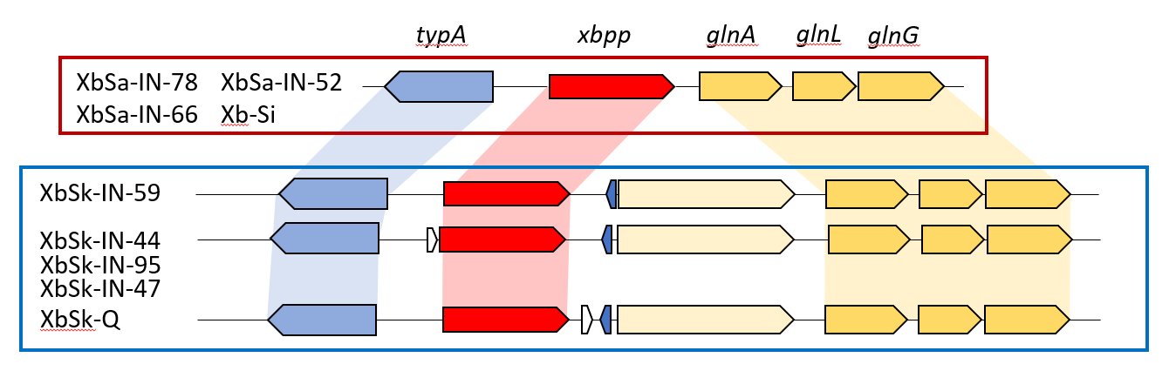
Figure 2.1. Select xbpp gene neighborhoods.
Schematic representations of the xbpp genomic neighborhoods of 9 of the 18 X. bovienii strains examined. The xbpp gene is shown in red. Dark blue and white genes are conserved proteins of unknown function. Figure is to scale. Boxes group similar gene neighborhoods.

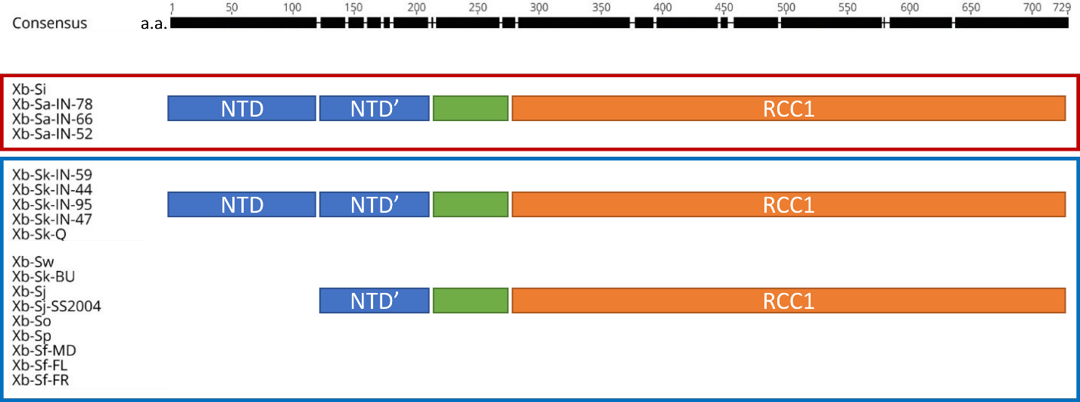
Figure 2.2. Xbpp amino acid and domain structure.
The 18 X. bovienii Xbpp homologs were aligned based on amino acid sequence similarity using Geneious Global alignment with free end gaps. The top bar shows the level of amino acid consensus among the X. bovienii Xbpp homologs that contain that region of the protein, with the black box indicating areas of higher similarity. The alignment and bioinformatics analysis of the primary sequences revealed several domains within the proteins. All 18 Xbpp homologs had common sequence in the N-terminal domain (NTD’; blue) that constituted the N-terminus of 9 proteins. In the remaining 9 proteins, an additional domain (NTD) was present at the N-terminus, with some sequence similarity to the NTD’ domain, possibly representing a duplication. Finally, all homologs had an RCC1-like domain, predicted by InterProScan, though the sequences within this region showed variability in size and amino acid composition. The organization of these domain structures, coupled with the genomic contexts shown in Figure 2.1 allowed grouping of homologs into three general categories.
Note: this figure is a modified version that originally appeared in Appendix I of (Ginete, 2020) of which I am a co-author.
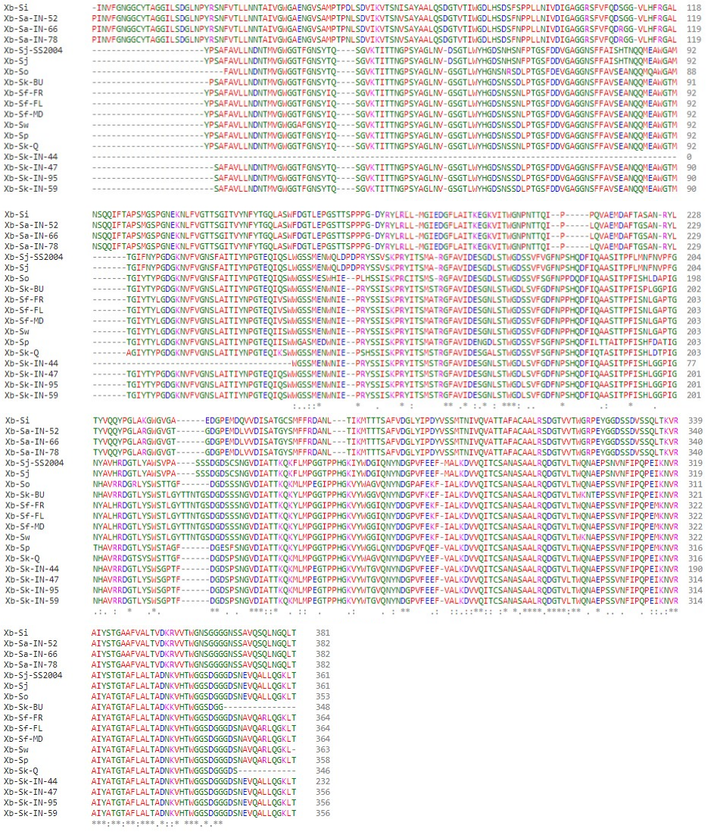
Figure 2.3. Xbpp RCC1 domain alignment.
The 18 X. bovienii RCC1 domains were annotated by InterPro and extracted for multiple sequence alignment with Clustal Omega. Colors indicate amino acid properties as assigned by the program (red=small; blue=acidic; magenta=basic; green= hydroxyl, sulfhydryl, amine, or glycine; grey=others).

Xb-Si, Xb-Sa-IN-52, Xb-Sa-IN-66, and Xb-Sa-IN-78, have an amino acid pattern distinct among themselves. Xb-Sk-IN-44 has a dramatically truncated RCC1 domain, although this finding may be due to a sequencing error. The phylogeny of amino acid changes shown in Figure 2.4 appears to mirror the X. bovienii genomic phylogeny reported by Ginete (2020), which may indicate that the Xbpp RCC1 domain is under similar selection pressure as the bacterium itself, and that it is not being horizontally transferred.
Xbpp showed gene co-occurrence and co-expression patterns with a putative RtxA toxin protein and gene co-occurrence patterns with the insecticidal toxin complex subunits TccA2 (XBJ1_0569) and TccB2 (XBJ1_0568) (Szklarczyk et al., 2019). To test the hypothesis that Xbpp plays a role in virulence against insects, I tested isogenic X. bovienii SaIN78 (hereafter XbSaIN78) wild type and Δxbpp deletion strains carrying an attTn7 in-genome complementation construct of the wild type xbpp gene (+xbpp) or a vector control (eTn7). All newly constructed strains were subjected to various phenotype tests to ensure that they had the same baseline characteristics. Growth curves in LB media were similar among strains (Figure 2.5, Table 3). There was no statistically significant difference in lipase activity or in swimming or swarming behaviors among constructed strains (Figure 2.6).
To test the role of Xbpp in virulence against an insect host, I injected the strains into the hemocoel of Manduca sexta and monitored insect survival. Between July and November 2020, 5 biological replicates of M. sexta were raised from eggs. A total of 819 4th instar M. sexta were randomized among treatments and controls; the per-
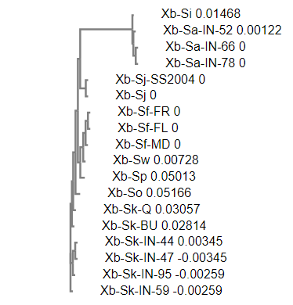
Figure 2.4. Xbpp RCC1 phylogenetic tree.
The 18 X. bovienii RCC1 domains were annotated by InterPro, then clustered into a real phylogenetic neighbor-joining tree without distance corrections by Clustal Omega. Numbers to the right of the strain names show the Multiple Sequence Alignment sequence distance measure as a means of demonstrating the evolutionary distance between sequences.

Figure 2.5. Growth curves of Xbpp mutant strains.
X. bovienii strains were grown in LB in 96 well plates in 200 μL volumes. All strains were grown in biological and technical triplicate. Figure shows technical triplicates averaged and normalized to the media control. The darker dots show the average, and the lighter dots show the standard deviation.

Table 3: XbSaIN78 strain growth curve values in a 96-well plate.
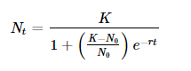
Growth curve values calculated by the R package growthcurver. Each biological replicate was fit with a logistic equation that described the population N_{t} at time t such that

(Sprouffske and Wagner, 2016)
Sample | Biological replicate | K | N₀ | r | t_{mid} | t_{gen} | sigma
WT | 1 | 0.948 | 0.229 | 0.138 | 8.310 | 5.035 | 0.055
WT | 2 | 0.945 | 0.243 | 0.137 | 7.756 | 5.059 | 0.062
WT | 3 | 0.946 | 0.257 | 0.136 | 7.227 | 5.086 | 0.064
WT+eTn7 | 1 | 0.941 | 0.177 | 0.155 | 9.429 | 4.465 | 0.060
WT+eTn7 | 2 | 0.904 | 0.167 | 0.165 | 8.975 | 4.188 | 0.060
WT+eTn7 | 3 | 0.916 | 0.153 | 0.158 | 10.143 | 4.384 | 0.066
WT+xbpp | 1 | 0.847 | 0.141 | 0.163 | 9.889 | 4.245 | 0.056
WT+xbpp | 2 | 0.881 | 0.101 | 0.164 | 12.470 | 4.220 | 0.063
WT+xbpp | 3 | 0.884 | 0.129 | 0.156 | 11.350 | 4.443 | 0.059
where K is the carrying capacity, N₀ is the population size at the start of the growth curve, r is the intrinsic growth rate, t_{mid} is the inflection point where population density is half carrying capacity, and t_{gen} is doubling time. σ is a measure of the goodness of fit where lower values indicate a better logistic curve fit. Biological replicates are the average of two technical replicates.
Table 3 continued
Sample | Biological replicate | K | N₀ | r | t_{mid} | t_{gen} | sigma
Δxbpp+eTn7 | 1 | 0.859 | 0.152 | 0.181 | 8.504 | 3.829 | 0.071
Δxbpp+eTn7 | 2 | 0.826 | 0.108 | 0.200 | 9.471 | 3.459 | 0.072
Δxbpp+eTn7 | 3 | 0.850 | 0.187 | 0.151 | 8.379 | 4.584 | 0.084
Δxbpp+xbpp | 1 | 0.889 | 0.155 | 0.157 | 9.890 | 4.402 | 0.056
Δxbpp+xbpp | 2 | 0.917 | 0.132 | 0.177 | 10.067 | 3.921 | 0.062
Δxbpp+xbpp | 3 | 0.932 | 0.186 | 0.133 | 10.419 | 5.194 | 0.059
Δxbpp+gfp-xbpp | 1 | 0.858 | 0.143 | 0.167 | 9.643 | 4.154 | 0.059
Δxbpp+gfp-xbpp | 2 | 0.879 | 0.151 | 0.168 | 9.368 | 4.124 | 0.059
Δxbpp+gfp-xbpp | 3 | 0.962 | 0.176 | 0.180 | 8.315 | 3.857 | 0.061
Δxbpp+xbpp-gfp | 1 | 0.833 | 0.124 | 0.196 | 8.900 | 3.533 | 0.046
Δxbpp+xbpp-gfp | 2 | 0.871 | 0.138 | 0.156 | 10.707 | 4.450 | 0.056
Δxbpp+xbpp-gfp | 3 | 0.881 | 0.120 | 0.166 | 11.171 | 4.183 | 0.055

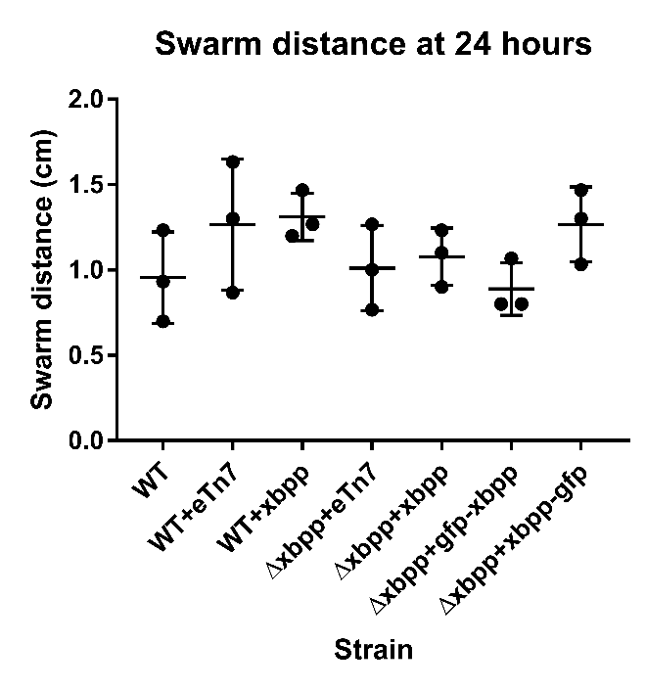
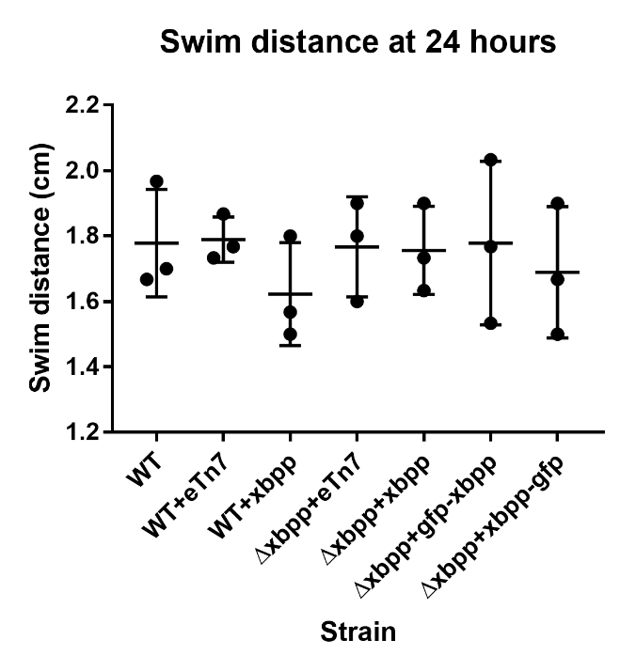
B
p=0.0685
p=0.8744
p=0.2401
C
A
Figure 2.6. No significant phenotypes among XbSaIN78 constructed strains.
A) Swim distance diameter at 24 hours on 0.25% agar plates. B) Swarm distance diameter at 24 hours on 0.9% agar plates. C) Lipase activity ring diameter at 72 hours on Tween20 plates. All replicates were tested with the same plate batch. Each data point is a biological replicate that shows the average of three technical replicates. Error bars show standard deviation. No significant difference was found between any strain under any condition using a Kruskal-Wallis one-way analysis of variance.

protocol population included 720 XbSaIN78-injected insects and 99 PBS injection control insects. While the weight of all insects injected with bacteria was similar, the average weight of a PBS-injected control was slightly higher (Table 4), although this fact may be due to several missing data points. CFU injected by replicate varied and is summarized in Table 5, but the overall average was 207±147 CFU. Of the 99 insects injected with PBS as an injection control measure, only two died. Both insects appeared to die of a non-Xenorhabdus bacterial infection (Figure 2.7). Because of the high survival rate of PBS injected control insects, the injection protocol was considered nonlethal and no further statistical analysis of the PBS injected insects was performed.
In the per-protocol at-risk population injected with bacteria, 496 M. sexta deaths were recorded within 72 hours of injection (Figure 2.8A). A score test comparing the Kaplan-Meier curves of M. sexta injected with XbSaIN78 strains was significant (p=0.015), implying that the Cox regression coefficients in the model were nonzero (Figure 2.8A). Due to the possibility that the coefficients could be nonzero due to a covariate, I ran a right-censored Cox proportional hazards regression model with CFU injected as a covariate. The likelihood ratio test of the final model was 38.47 on 6 degrees of freedom (p=9e-07), confirming that a multivariate analysis was necessary.
M. sexta injected with the Δxbpp+eTn7 strain were statistically significantly more likely to survive when compared to insects injected with the wild-type control (WT+eTn7) (Figure 2.8B; hazard ratio [HR]=0.70; 95% confidence interval [CI]=0.53-0.93; p=0.013). Insects injected with the WT+xbpp strain were no more or less likely to die than the wild-

Table 4: Characteristics of Manduca sexta at baseline

Characteristic | WT+eTn7  (N=150) | WT+xbpp  (N=90) | Δxbpp+eTn7  (N=150) | Δxbpp+xbpp  (N=150) | Δxbpp+gfp-xbpp  (N=90) | Δxbpp+xbpp-gfp  (N=90) | PBS  (N=99) | Total  (N=819)
Weight (g)
Average | 0.432 | 0.412 | 0.432 | 0.448 | 0.442 | 0.459 | 0.510 | 0.446
Range | 0.2-0.86 | 0.2-0.89 | 0.2-0.77 | 0.2-0.78 | 0.2-0.7 | 0.2-0.78 | 0.2-1.19 | 0.2-1.19
Standard deviation | 0.154 | 0.173 | 0.157 | 0.149 | 0.128 | 0.139 | 0.169 | 0.156
Unknown | 1 | 0 | 0 | 0 | 2 | 0 | 8 | 11

Table 5: CFU injected into Manduca sexta in each replicate

In each replicate, each strain was injected into 30 insects, and the PBS control was injected into 20 insects (apart from replicate 1, where only 19 control insects were injected).
Replicate | WT+eTn7  (N=150) | WT+xbpp  (N=90) | Δxbpp+eTn7  (N=150) | Δxbpp+xbpp  (N=150) | Δxbpp+gfp-xbpp  (N=90) | Δxbpp+xbpp-gfp  (N=90) | PBS  (N=99) | Replicate average  (N=819)
1 | 265 | 310 | 210 | 240 | NA | NA | 0 | 256
2 | 270 | 350 | 650 | 395 | 275 | 105 | 0 | 341
3 | 205 | 345 | 205 | 350 | NA | NA | 0 | 276
4 | 81 | NA | 92.5 | 24.5 | 67.5 | 230 | 0 | 99
5 | 60.5 | NA | 33.5 | 90.5 | 49 | 68 | 0 | 60
Strain average | 176 | 335 | 238 | 220 | 131 | 134 | 0

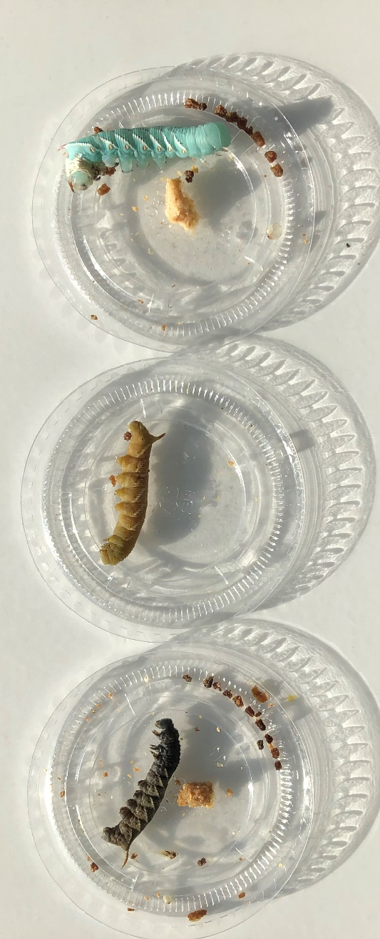
Figure 2.7. PBS injection control deaths.
Two PBS control insects died of non-Xenorhabdus infections. From left to right: PBS control M. sexta dead from a non-Xenorhabdus infection for ~6 hours, M. sexta dead from Xenorhabdus infection for ~6 hours, live M. sexta.

Figure 2.8. Survival of Manduca sexta injected with XbSaIN78 strains.
(A) Kaplan-Meier curves of Manduca sexta survival after injection with 10-1000 CFU of Xb-Sa-78 strains. Score test was significant (p=0.015), showing that Cox regression coefficients are non-zero. Dotted lines show 95% confidence limits.
(B) Cox proportional-hazards model of Manduca sexta survival. Hazard ratio is displayed with the 95% confidence interval in parenthesis. P-values are shown on the right.

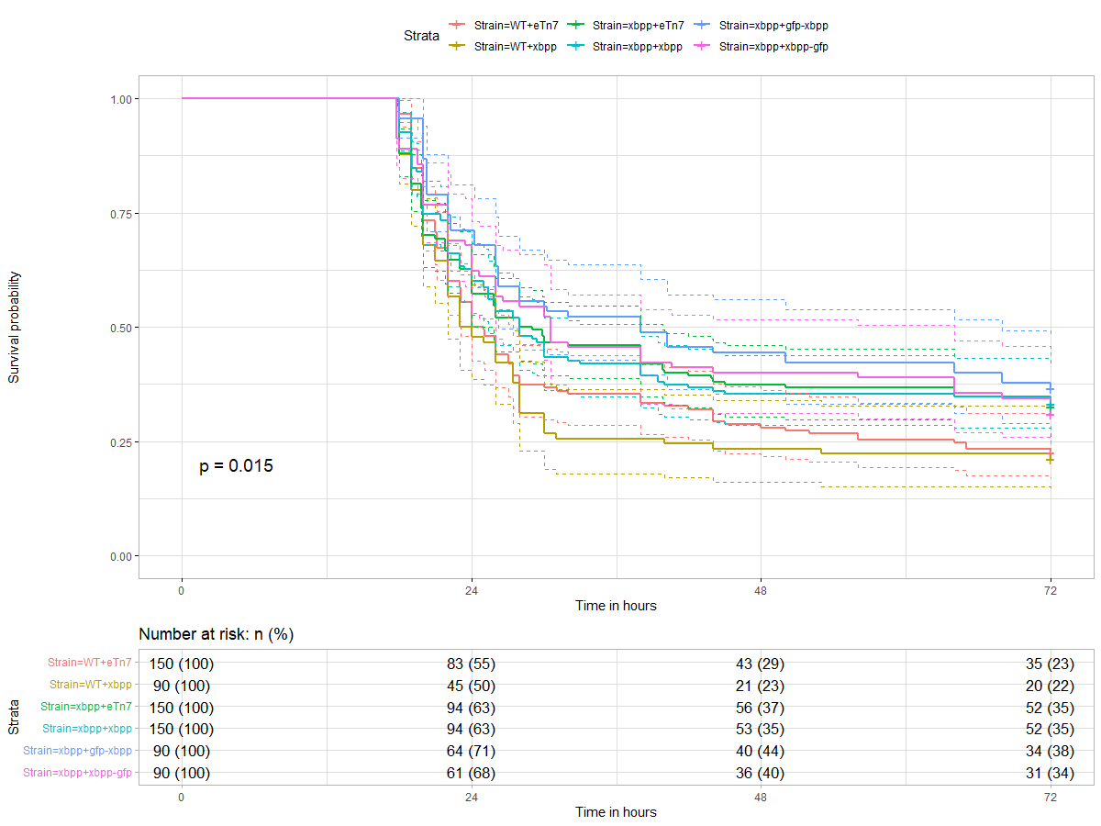
A
Figure 2.8 continued

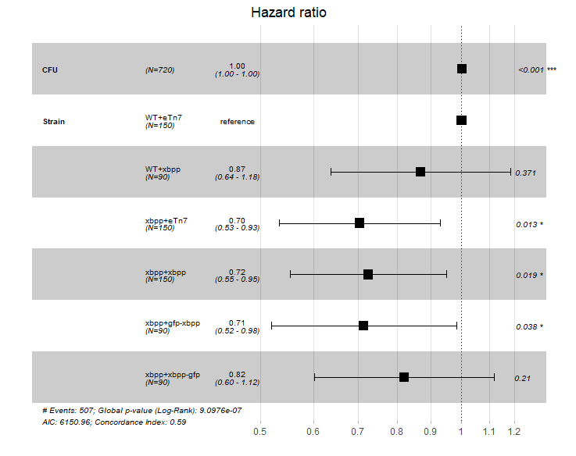
B
Figure 2.8 continued
type (Figure 2.8B; HR=0.87; 95% CI=0.64-1.18; p>0.05). Of insects injected with the complement strains, only Δxbpp+xbpp-gfp was able to fully restore insect virulence to wild-type levels (Figure 2.8B; HR=0.82; 95% CI=0.60-1.12; p>0.05).

Hemocyte killing assay
The data presented thus far indicate that Xbpp may play a role as a virulence factor, contributing to insect death. One potential target of its activity is insect blood cells, or hemocytes. To assess this possibility, a hemocyte killing assay was performed on cell-free supernatants of XbSaIN78 strains grown aerated in LB media to late log phase (OD₆₀₀=~1.0). There was no statistical difference in hemocyte viability, as measured by trypan blue staining when comparing any XbSaIN78 strain supernatant treatment against the LB control (Figure 2.9).

Xbpp expresses within 24 hours of growth
To assess the expression patterns of Xbpp, I investigated the XbSaIN78 strains producing GFP-tagged Xbpp. It should be noted that all strains with xbpp complemented at the Tn7 site, including those with GFP-tagged Xbpp, had the intergenic region upstream of xbpp complete with the predicted promoter included in the complementation. Expression of GFP-tagged Xbpp on solid LB plates could be seen via a fluorescence dissecting microscope after 3 days (Figure 2.10). These findings were further verified using confocal microscopy on 5-day old cells grown on LB plates (Figure 2.11).

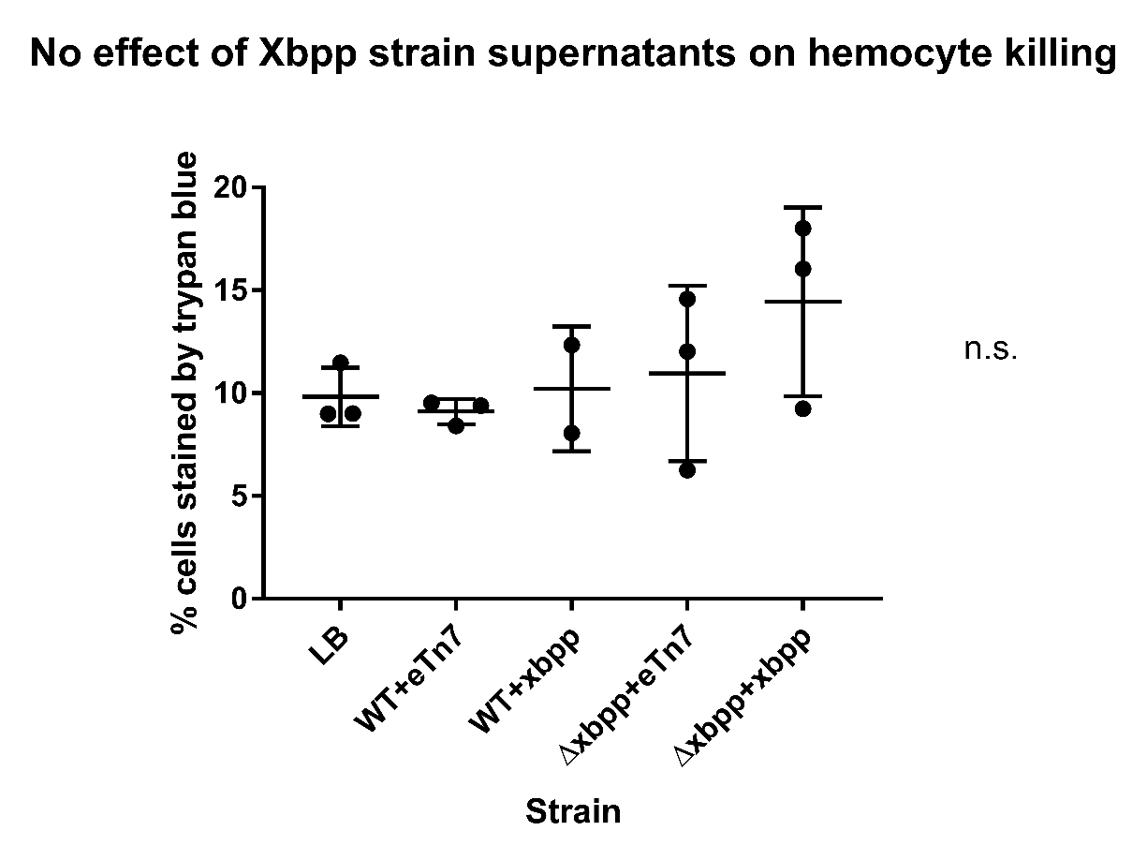
p=0.6173
Figure 2.9. Hemocyte killing assay.
Hemocytes from 4-5 M. sexta insects were incubated with the cell-free supernatant of strains and stained with trypan blue to mark dead cells. Data represents biological triplicate with each point the average of three technical replicates. A Kruskal-Wallis one-way analysis of variance showed no statistical difference. Bars represent standard deviation. LB medium was used as a control.

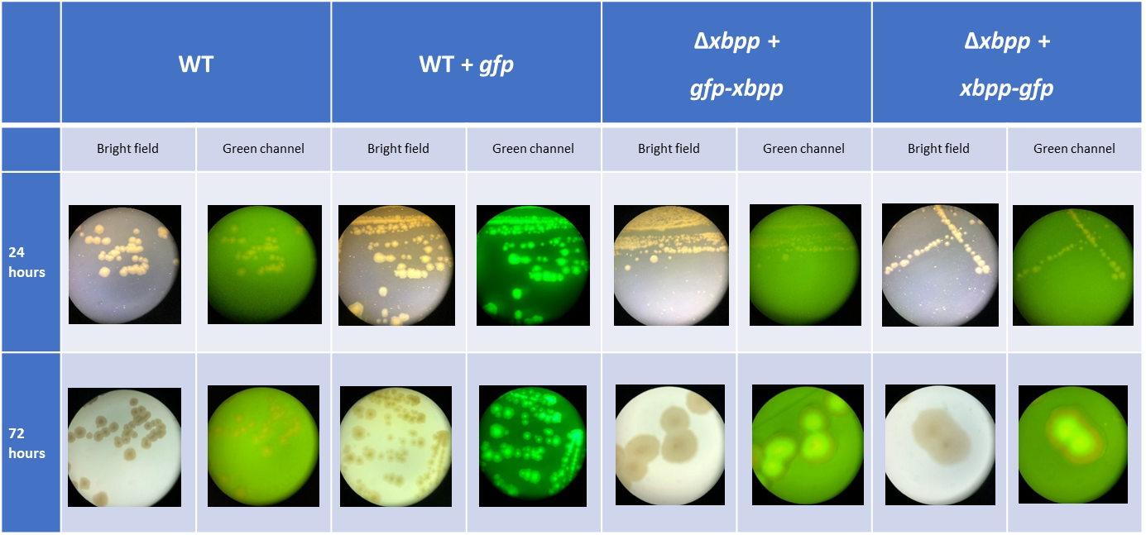
Figure 2.10. Fluorescence of XbSaIN78 strains on LB plates.
Strains were grown on LB plates incubated at 30°C and imaged at 24 or 72 hours using a fluorescent dissecting microscope.
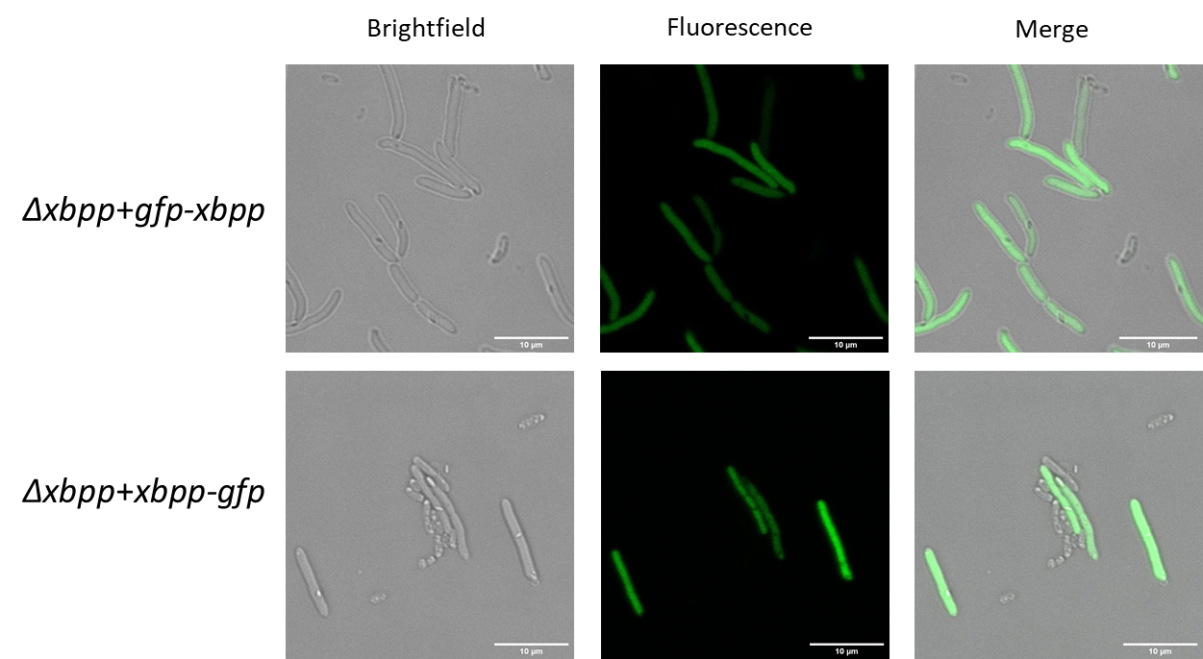
Figure 2.11. Fluorescence observed by confocal microscopy of GFP-tagged Xbpp expressed in individual cells.
Cells were processed after 120 hours of growth on an LB plate and imaged with a Leica SP8 with a 68x objective lens and 5x Zoom with Lightening. Scale bar shows 10 µm.

Western blots using anti-GFP antibody revealed that GFP-tagged Xbpp could be detected within 48 hours in Δxbpp+gfp-xbpp strains and within 24 hours in Δxbpp+xbpp-gfp strains grown on solid LB media (Figure 2.12). A majority of the GFP-tagged Xbpp visible by Western appeared to be a smaller size than expected, indicating possible cleavage. For both GFP-tagged Xbpp, bands at the expected size of 100 kDa were visible, but more intense bands, present earlier in the growth, were visible at ~75 and ~80 kDa for GFP-Xbpp and Xbpp-GFP, respectively.
To assess the expression of Xbpp in liquid media, strains were grown in LB and M. sexta hemolymph in 96-well plates. After normalizing fluorescence values to the non-fluorescing wild-type (WT+eTn7), fluorescence in Δxbpp+xbpp-gfp was significantly higher than the Δxbpp+xbpp control after 34.5 hours of growth and reaching an OD₆₀₀ of 0.89 (Figure 2.4, Figure 2.13). Fluorescence in Δxbpp+gfp-xbpp was significantly higher after 52 hours of growth and reaching an OD₆₀₀ of 0.941 (Figure 2.4, Figure 2.13).

Swim plate assay results
X. bovienii encodes genes for a flagellar export apparatus (Murfin et al., 2015b) that in X. nematophila secretes certain protein factors (Richards et al., 2008). To test if flagellar machinery plays a role in Xbpp expression, a swim plate assay was completed with cells expressing GFP-tagged Xbpp. Cells were sampled and imaged from the edge of the swim plate and the center of the swim plate. The sampled cells were also stained with live/dead dyes to gain more information about the phenotype of cells that are expressing Xbpp. Cells expressing GFP-fused Xbpp and the GFP control cells from the center of the swim plates fluoresced, but only GFP control cells fluoresced when

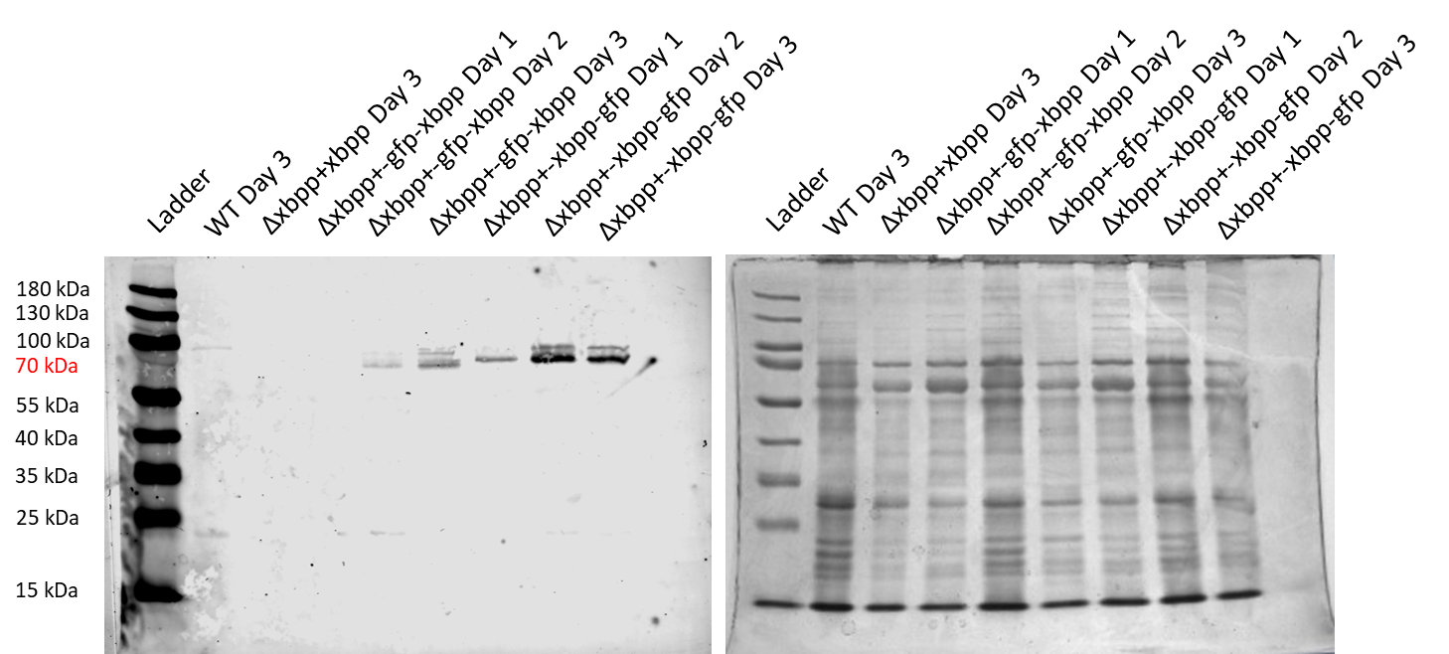
Figure 2.12. Representative Western blot and Coomassie gel of XbSaIN78 strains expressing GFP-tagged Xbpp.
Blue arrows point to 100 kDa bands. Green arrows point to the ~80 kDa bands. Red arrows point to the ~75 kDa bands.

Figure 2.13. Fluorescence of Xbpp mutant strains in a 96-well plate.
X. bovienii strains were grown in a 96-well plate with 200 µL liquid LB media at 30ºC. Fluorescence and OD₆₀₀ measurements were taken every 30 minutes for 72 hours. Values are the average of biological triplicates and technical duplicates. The darker dots show the average relative fluorescence units and lighter dots show the standard error of the mean. Technical duplicates were averaged and normalized to the autofluorescence of an isogenic nonfluorescent strain, WT+eTn7. Δxbpp+xbpp was used as a statistical control because it is genetically identical to the strains of interest except for the absence of the GFP gene and (GGGGS)₂ linker. Data were analyzed with a repeated-measures two-way ANOVA with a post hoc Dunnett’s test.
sampled from the edge of swim plates (Figure 2.14). Analysis of the live/dead stained cells found that Δxbpp+gfp-xbpp cells from the plate edge were statistically longer in length than any other cell type, including Δxbpp+gfp-xbpp cells from the center of the swim plate, although all other cell lengths were similar (Figure 2.15A, one-way ANOVA with Tukey’s multiple comparisons: see Table 6 for statistical details). Overall, most cells from the plate center were dead (Figure 2.15B), and most of the cells from the plate edge were alive (Figure 2.15C).
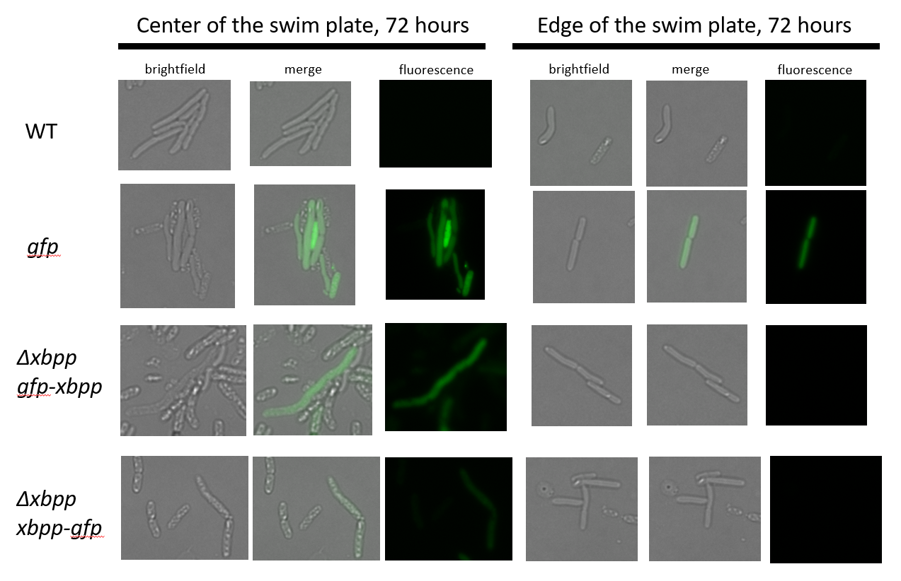
Figure 2.14. Swim plate cells.
Cells sampled from the edge and the center of the swim plates imaged with a Keyence All-in-One Fluorescence Microscope BZ-X800 microscope at 100x magnification.

C
B
A

Figure 2.15. Swim plate cell metrics.
Cells sampled from the edge and the center of the swim plates. (A) Swim plate cell lengths. (B) Live/dead percentages of cells from the center of the swim plate. (C) Live/dead percentages of cells from the edge of the swim plate.

Table 6: ANOVA results of XbSaIN78 swim plate cell length
Data were analyzed with a one-way ANOVA with post hoc Tukey’s multiple comparisons tests.
Tukey's multiple comparisons test | Mean Diff. | 95.00% CI of diff. | Significant? | Summary | Adjusted P Value
WT edge vs. Δxbpp+xbpp-gfp edge | -0.4206 | -1.339 to 0.4976 | No | ns | 0.7785
WT edge vs. WT center | 0.3029 | -0.7161 to 1.322 | No | ns | 0.9575
WT edge vs. Δxbpp+gfp-xbpp center | -0.2532 | -1.239 to 0.7327 | No | ns | 0.9774
WT edge vs. Δxbpp+xbpp-gfp center | -0.408 | -1.333 to 0.5167 | No | ns | 0.8046
Δxbpp+gfp-xbpp edge vs.  Δxbpp+xbpp-gfp edge | 1.307 | 0.4064 to 2.208 | Yes | *** | 0.0006
Δxbpp+gfp-xbpp edge vs. WT center | 2.031 | 1.027 to 3.034 | Yes | **** | <0.0001
Δxbpp+gfp-xbpp edge vs.  Δxbpp+gfp-xbpp center | 1.475 | 0.505 to 2.445 | Yes | *** | 0.0002
Δxbpp+gfp-xbpp edge vs.  Δxbpp+xbpp-gfp center | 1.32 | 0.4124 to 2.228 | Yes | *** | 0.0005

Table 6 continued
Tukey's multiple comparisons test | Mean Diff. | 95.00% CI of diff. | Significant? | Summary | Adjusted P Value
Δxbpp+xbpp-gfp edge vs. WT center | 0.7235 | -0.2983 to 1.745 | No | ns | 0.3284
Δxbpp+xbpp-gfp edge vs.  Δxbpp+gfp-xbpp center | 0.1674 | -0.8214 to 1.156 | No | ns | 0.9967
Δxbpp+xbpp-gfp edge vs.  Δxbpp+xbpp-gfp center | 0.01257 | -0.9152 to 0.9404 | No | ns | >0.9999
WT center vs. Δxbpp+gfp-xbpp center | -0.5561 | -1.639 to 0.5269 | No | ns | 0.6833
WT center vs. Δxbpp+xbpp-gfp center | -0.711 | -1.739 to 0.3167 | No | ns | 0.355
Δxbpp+gfp-xbpp center vs. Δxbpp+xbpp-gfp center | -0.1548 | -1.15 to 0.84 | No | ns | 0.9978

Discussion
Symbiotic bacteria provide many functions alongside and for their host(s), including producing virulence factors that can function in prey killing, bacterial-bacterial competition, and defense. In this study, I explored the contribution to virulence of a previously uncharacterized Xenorhabdus bovienii protein, Xbpp, in insect death. Xbpp is a particularly interesting virulence factor because it was conserved within all known X. bovienii strains in a polymorphic fashion. Toxins and other virulence factors are known to differ at the bacterial strain level (Murfin et al., 2015b; Su et al., 2020), but the importance of amino acid variability at the protein level are less clear.
My findings show that Xbpp plays a role in X. bovienii-mediated insect killing. Insect virulence is well-established as a multifactorial function in Xenorhabdus, as a cascade of virulence factors contribute to insect killing in the Steinernema-Xenorhabdus symbiosis. While the Δxbpp+xbpp strain did not kill insects at the same level as the wild-type strain, the Δxbpp+xbpp-gfp strain did. This finding implies that Xbpp protein expression could be a factor in these findings. While the strains not evaluated for protein expression, Δxbpp+xbpp-gfp produced more Xbpp and at earlier time points than the less virulent Δxbpp+gfp-xbpp. This finding was consistent in microscopy and Western blot analyses and supports the theory that more Xbpp expression leads to greater insect death. The increased insect toxicity of Δxbpp+xbpp-gfp in M. sexta injections could be directly due to this increased protein level.
It is also possible that there are differences at the transcript level. The insertion of xbpp at the Tn7 site could be altering the transcription levels of Δxbpp background strains. Alternatively, the Δxbpp+xbpp-gfp strain could be producing RNA transcripts that are more stable. The large additional of the C-terminal GFP could have prevented the degradation of the carboxy terminal end of the protein, which would be especially important if the RCC1 domain is the toxic domain. Additionally, the N-terminal GFP could have impacted the localization of the translated protein. It has long been shown that proteins with N-terminal GFP fusions are less likely to correctly localize than C-terminal fusions (Palmer and Freeman, 2004). Future experiments should address these questions through quantitative reverse transcription PCR (RT-qPCR) under conditions that model the insect injection time course. Additionally, proteomic analysis could identify if the RNA transcripts are translated into proteins at differing rates when the Xbpp-expressing strains are compared.
While these experiments provide some clues for the mechanism of action of Xbpp, further work remains to establish how Xbpp acts as a virulence factor. X. bovienii genomes have a limited number of secretion systems including type VI and a flagellar export system (Murfin et al., 2015b). Previous work in X. nematophila characterized the contribution of the type VI secretion system in insect virulence using M. sexta hemocyte killing assays (Hillman, 2020). Results from this assay in the context of Xbpp-producing strains suggest that type VI secretion is a less likely mode of export, as there was no difference in hemocyte killing amongst any tested XbSaIN78 strain, although this may be complicated by the presence of other supernatant virulence factors. Further, images of swim plate assay cells show that cells that swam to the edge of the swim zone were not fluorescent but that cells in the center of the swim plate were fluorescent. Roughly 75% of swimming cells were alive compared to ~30% of cells from the swim plate center, which implies that swimming cells are either exporting GFP-tagged Xbpp or not expressing Xbpp at all. This finding could be due to the ability of swimming cells to export Xbpp via the functional flagellar export system. X. nematophila is known to use the flagellar export system to export a complex consisting of a 64 kDa xenocin toxin and a 42 kDa immunity protein as well as lipase (Richards et al., 2008; Singh et al., 2013).
Overall, I have established Xbpp as an insect virulence factor due to its lethality against M. sexta model insects. The prominently and consistently present RCC1 domain may be contributing to this virulence in a yet-undetermined manner. Further questions remain about the mechanism of action of Xbpp, but I have shown that Xbpp contributes to the Xenorhabdus-Steinernema mutualism by providing insect-killing functions. Evolutionarily, Xbpp could be providing fitness benefits to the nematode-bacteria symbiosis via its insect-killing phenotype.

References

Agarwala, R., Barrett, T., Beck, J., Benson, D.A., Bollin, C., Bolton, E., Bourexis, D., Brister, J.R., Bryant, S.H., Canese, K., et al. (2016). Database resources of the National Center for Biotechnology Information. Nucleic Acids Res. 44, D7–D19.
Blum, M., Chang, H.Y., Chuguransky, S., Grego, T., Kandasaamy, S., Mitchell, A., Nuka, G., Paysan-Lafosse, T., Qureshi, M., Raj, S., et al. (2021). The InterPro protein families and domains database: 20 years on. Nucleic Acids Res. 49, D344–D354.
Bourne, R., Schindelin, J., Arganda-Carreras, I., Frise, E., Kaynig, V., Longair, M., Pietzsch, T., Preibisch, S., Rueden, C., Saalfeld, S., et al. (2010). Fiji: An open-source platform for biological-image analysis. Nat. Methods 9, 185–188.
Casanova-Torres, Á.M., Shokal, U., Morag, N., Eleftherianos, I., and Goodrich-Blair, H. (2017). The global transcription factor Lrp is both essential for and inhibitory to Xenorhabdus nematophila insecticidal activity. Appl. Environ. Microbiol. 83, e00185-17.
Ciezki, K., Murfin, K., Goodrich-Blair, H., Stock, S.P., and Forst, S. (2017). R-type bacteriocins in related strains of Xenorhabdus bovienii: Xenorhabdicin tail fiber modularity and contribution to competitiveness. FEMS Microbiol. Lett. 364, 1–8.
Dunphy, G.B., and Webster, J.M. (1984). Interaction of Xenorhabdus nematophilus subsp. nematophilus with the haemolymph of Galleria mellonella. J. Insect Physiol. 30, 883–889.
Farris, M., Grant, A., Richardson, T.B., and O’Connor, C.D. (1998). BipA: A tyrosine-phosphorylated GTPase that mediates interactions between enteropathogenic Escherichia coli (EPEC) and epithelial cells. Mol. Microbiol. 28, 265–279.
Forst, S., and Nealson, K. (1996). Molecular biology of the symbiotic-pathogenic bacteria Xenorhabdus spp. and Photorhabdus spp. Microbiol. Rev. 60, 21–43.
Ginete, D.R. (2020). Antagonistic factors impact strain specificity in host-symbiont associations. The University of Wisconsin - Madison.
Hawlena, H., Bashey, F., and Lively, C.M. (2010). The evolution of spite: Population structure and bacteriocin-mediated antagonism in two natural populations of Xenorhabdus bacteria. Evolution (N. Y). 64, 3198–3204.
Hillman, K. (2020). Xenorhabdus nematophila Type VI secretion systems mediate ecologically relevant interactions in naturally occurring symbiotic hosts.
Hussa, E., and Goodrich-Blair, H. (2012). Rearing and injection of Manduca sexta larvae to assess bacterial virulence. JoVE e4295.
Kim, D.J., Boylan, B., George, N., and Forst, S. (2003). Inactivation of ompR promotes precocious swarming and flhDC expression in Xenorhabdus nematophila. J. Bacteriol. 185, 5290–5294.
Kim, Y., Ji, D., Cho, S., and Park, Y. (2005). Two groups of entomopathogenic bacteria, Photorhabdus and Xenorhabdus, share an inhibitory action against phospholipase A2 to induce host immunodepression. J. Invertebr. Pathol. 89, 258–264.
Madeira, F., Park, Y.M., Lee, J., Buso, N., Gur, T., Madhusoodanan, N., Basutkar, P., Tivey, A.R.N., Potter, S.C., Finn, R.D., et al. (2019). The EMBL-EBI search and sequence analysis tools APIs in 2019. Nucleic Acids Res. 47, W636—W641.
Murfin, K.E., Lee, M.M., Klassen, J.L., McDonald, B.R., Larget, B., Forst, S., Stock, S.P., Currie, C.R., and Goodrich-Blair, H. (2015a). Xenorhabdus bovienii strain diversity impacts coevolution and symbiotic maintenance with Steinernema spp. nematode hosts. MBio 6, 1–10.
Murfin, K.E., Whooley, A.C., Klassen, J.L., and Goodrich-Blair, H. (2015b). Comparison of Xenorhabdus bovienii bacterial strain genomes reveals diversity in symbiotic functions. BMC Genomics 16, 889.
Murfin, K.E., Ginete, D.R., Bashey, F., and Goodrich-Blair, H. (2018). Symbiont-mediated competition: Xenorhabdus bovienii confer an advantage to their nematode host Steinernema affine by killing competitor Steinernema feltiae. Environ. Microbiol. 21, 3229–3243.
Neidig, A., Yeung, A.T., Rosay, T., Tettmann, B., Strempel, N., Rueger, M., Lesouhaitier, O., and Overhage, J. (2013). TypA is involved in virulence, antimicrobial resistance and biofilm formation in Pseudomonas aeruginosa. BMC Microbiol. 13.
Ninfa, A.J., and Magasanik, B. (1986). Covalent modification of the glnG product, NR(I), by the glnL product, NR(II), regulates the transcription of the glnALG operon in Escherichia coli. Proc. Natl. Acad. Sci. U. S. A. 83, 5909–5913.
Palmer, E., and Freeman, T. (2004). Investigation into the use of C- and N-terminal GFP fusion proteins for subcellular localization studies using reverse transfection microarrays. Comp. Funct. Genomics 5, 342–353.
Park, Y., Herbert, E.E., Cowles, C.E., Cowles, K.N., Menard, M.L., Orchard, S.S., and Goodrich-Blair, H. (2007). Clonal variation in Xenorhabdus nematophila virulence and suppression of Manduca sexta immunity. Cell. Microbiol. 9, 645–656.
Richards, G.R., Herbert, E.E., Park, Y., and Goodrich-Blair, H. (2008). Xenorhabdus nematophila lrhA is necessary for motility, lipase activity, toxin expression, and virulence in Manduca sexta insects. J. Bacteriol. 190, 4870–4879.
Ruffner, B., Péchy-Tarr, M., Höfte, M., Bloemberg, G., Grunder, J., Keel, C., and Maurhofer, M. (2015). Evolutionary patchwork of an insecticidal toxin shared between plant-associated pseudomonads and the insect pathogens Photorhabdus and Xenorhabdus. BMC Genomics 16, 609.
Sasse-Dwight, S., and Gralla, J.D. (1988). Probing the Escherichia coli glnALG upstream activation mechanism in vivo. Proc. Natl. Acad. Sci. U. S. A. 85, 8934–8938.
Schneider, C.A., Rasband, W.S., and Eliceiri, K.W. (2012). NIH Image to ImageJ: 25 years of image analysis. Nat. Methods 9, 671–675.
Scott, K., Diggle, M.A., and Clarke, S.C. (2003). TypA is a virulence regulator and is present in many pathogenic bacteria. Br. J. Biomed. Sci. 60, 168–170.
Shrestha, S., and Kim, Y. (2007). An entomopathogenic bacterium, Xenorhabdus nematophila, inhibits hemocyte phagocytosis of Spodoptera exigua by inhibiting phospholipase A2. J. Invertebr. Pathol. 96, 64–70.
Sicard, M., Le Brun, N., Pages, S., Godelle, B., Boemare, N., and Moulia, C. (2003). Effect of native Xenorhabdus on the fitness of their Steinernema hosts: contrasting types of interaction. Parasitol. Res. 91, 520–524.
Sierra, G. (1957). A simple method for the detection of lipolytic activity of micro-organisms and some observations on the influence of the contact between cells and fatty substrates. Antonie Van Leeuwenhoek 23, 15–22.
Singh, P., Park, D., Forst, S., and Banerjee, N. (2013). Xenocin export by the flagellar type III pathway in Xenorhabdus nematophila. J. Bacteriol. 195, 1400–1410.
Sprouffske, K., and Wagner, A. (2016). Growthcurver: an R package for obtaining interpretable metrics from microbial growth curves. BMC Bioinformatics 17, 17–20.
Su, M., Lyles, J.T., Petit III, R.A., Peterson, J., Hargita, M., Tang, H., Solis-Lemus, C., Quave, C.L., and Read, T.D. (2020). Genomic analysis of variability in Delta-toxin levels between Staphylococcus aureus strains. PeerJ 8, e8717.
Szklarczyk, D., Gable, A.L., Lyon, D., Junge, A., Wyder, S., Huerta-Cepas, J., Simonovic, M., Doncheva, N.T., Morris, J.H., Bork, P., et al. (2019). STRING v11: Protein-protein association networks with increased coverage, supporting functional discovery in genome-wide experimental datasets. Nucleic Acids Res. 47, D607–D613.
TaKaRa Biotechnology Co. (2011). TaKaRa Ex Taq Manual.
Thappeta, K.R.V., Ciezki, K., Morales-Soto, N., Wesener, S., Goodrich-Blair, H., Stock, S.P., and Forst, S. (2020). R-type bacteriocins of Xenorhabdus bovienii determine the outcome of interspecies competition in a natural host environment. Microbiol. (United Kingdom) 166, 1074–1087.
Therneau, T.M. (2020). A package for survival analysis in R.
Therneau, T.M., and Grambsch, P.M. (2000). Modeling survival data: extending the Cox model (New York: Springer).
Vallenet, D., Engelen, S., Mornico, D., Cruveiller, S., Fleury, L., Lajus, A., Rouy, Z., Roche, D., Salvignol, G., Scarpelli, C., et al. (2009). MicroScope: A platform for microbial genome annotation and comparative genomics. Database 2009, 1–12.
Vallenet, D., Calteau, A., Dubois, M., Amours, P., Bazin, A., Beuvin, M., Burlot, L., Bussell, X., Fouteau, S., Gautreau, G., et al. (2020). MicroScope: An integrated platform for the annotation and exploration of microbial gene functions through genomic, pangenomic and metabolic comparative analysis. Nucleic Acids Res. 48, D579–D589.
Vivas, E.I., and Goodrich-Blair, H. (2001). Xenorhabdus nematophilus as a model for host-bacterium interactions: rpoS is necessary for mutualism with nematodes. J. Bacteriol. 183, 4687–4693.
Waterfield, N.R., Bowen, D.J., Fetherston, J.D., Perry, R.D., and Ffrench-Constant, R.H. (2001). The tc genes of Photorhabdus: a growing family. Trends Microbiol. 9, 185–191.
Woida, P.J., and Satchell, K.J.F. (2018). Coordinated delivery and function of bacterial MARTX toxin effectors. Mol. Microbiol. 107, 133–141.

Chapter III
Using next-generation sequencing to define the evolving microbiome of an insect-infecting nematode

E. Ransone designed experiments with help from H. Goodrich-Blair and Veronica Brown. Alex Grossman first demonstrated in the HGB lab that S. scapterisci nematodes could be generationally propagated through non-native insect hosts. E. Ransone performed insect nematode infections, collected nematodes, and extracted DNA. E. Ransone and V. Brown performed amplicon PCRs. V. Brown performed library preparation and ran the MiSeq. E. Ransone analyzed the resulting data with technical assistance from I. Ohlsson.

Abstract
Entomopathogenic Xenorhabdus bacterial symbionts provide a number of functions for their Steinernema nematode hosts including the production of virulence factors and immunosuppressants that help kill the insect host they infect. As the pair cannot survive without killing and using insect prey for food, the existence of the low virulence X. innexi and its S. scapterisci host appears to be an evolutionary anomaly. I hypothesized that S. scapterisci is associated with a larger core microbiome outside of its obligate X. innexi symbiont that contributes to insect virulence. In this study, I used next-generation sequencing to investigate the S. scapterisci microbiome. I found that S. scapterisci has an associated microbiome that is similar to the frequently associated microbiome previously ascribed to other entomopathogenic nematodes. While other Steinernema-Xenorhabdus pairs infect and kill a range of insects, S. scapterisci-X. innexi only infects crickets. As such, I compared the microbiome composition and virulence of infectious juvenile (IJ) S. scapterisci nematodes from native cricket prey and non-native waxworm prey. I found there were few differences in the microbiomes of nematode IJs regardless of insect prey identity, further strengthening the concept of a nematode-associated microbiome that is consistent across different environments.

Introduction
Steinernema nematodes and Xenorhabdus bacteria are a valuable symbiosis model system because each organism requires the presence of the other to survive in nature (Murfin et al., 2015a; Sicard et al., 2003), but they can be grown and investigated separately in the laboratory. During the non-feeding, soil-dwelling infective juvenile (IJ) stage, Xenorhabdus bacteria colonize the receptacle, a Steinernema specialized gut tissue that houses the bacterium (Martens and Goodrich‐Blair, 2005). After finding an insect to infect, the nematode-bacteria pair enters a parasitic life stage in which they kill, consume and reproduce inside the insect (Goodrich-Blair and Clarke, 2007). The bacteria provide two primary benefits to the nematode host. First, the bacteria express virulence factors and immunosuppressants that help kill the insect. Second, the bacteria degrade the insect tissue and use the nutrients to increase its population, which the nematode uses for food. When the insect cadaver is spent, the IJ carries a sample of the bacteria with it as it enters the soil stage in search of a new insect host (Stock, 2019).
In theory, insect virulence is a selected trait among Xenorhabdus symbionts because it is a necessary precursor to insect degradation and subsequent use as a food source by both Xenorhabdus bacteria and Steinernema nematodes. However, X. innexi, the symbiont of S. scapterisci nematodes appears to counter this assumption. Unlike other Xenorhabdus, X. innexi is not virulent against prey insects, including Drosophila melanogaster, Manduca sexta, and Galleria mellonella when injected directly into the hemocoel (Kim et al., 2017). Additionally, the S. scapterisci nematode-X. innexi bacterium pair have a relatively restricted range of prey in which they can reproduce, even under laboratory conditions. While most other Steinernema-Xenorhabdus pairs can infect, kill, and reproduce within a wide range of insects, the S. scapterisci-X. innexi pair is specialized for crickets. This suggests that in most prey types, X. innexi bacteria may have limited ability to provide symbiotic functions, including killing and degrading the insect tissue or providing adequate nutritive value as a food source for the nematode (Kim et al., 2017). However, it is possible that S. scapterisci hosts additional microbial community members that provide symbiotic functions, such as insect killing, that are lacking in X. innexi.
Advances in next-generation sequencing have expanded our knowledge of the microbial community present during EPN-mediated insect infection. Investigations of the microbes colonizing EPNs focused primarily on the cognate bacterial symbiont, though there were reports using culture-dependent techniques that suggested there may be additional members of the Steinernema microbiome (Bonifassi et al., 1999; Gouge and Snyder, 2006). Recently, a study using metabarcoding of the V3V4 region of the 16S rRNA gene and the housekeeping rpoB markers showed that both laboratory and wild populations of Steinernema species tested, S. carpocapsae, S. weiseri, S. glaseri, and S. feltiae, are commonly associated with a dozen additional Proteobacteria species, termed the frequently associated microbiome (FAM), in addition to their obligate Xenorhabdus symbiont (Ogier et al., 2020). Several species of Pseudomonas were predicted to play a role in the insect-killing “pathobiome” of Steinernema due to their entomopathogenic nature, but, in general, the function of FAM members and their ubiquity across the Steinernema genus are unknown (Ogier et al., 2020).
I hypothesized that non-Xenorhabdus microbes associated with S. scapterisci can supplement the mutualistic (i.e., attenuated entomopathogenicity) defects of the X. innexi bacterial symbiont. To begin to address this hypothesis, I used the next generation sequencing methodology of Ogier et al., (2020) to investigate microbiome members that may supplement the apparently eroded mutualism between S. scapterisci nematodes and their X. innexi bacteria. In the native cricket host, these other microbes may contribute to insect death. Further, S. scapterisci adaptation to a new insect host may result in the selection of microbiome members that are capable of converting insect biomass into food (Bonifassi et al., 1999; Ogier et al., 2020).
In this study, I investigated and compared the microbiomes of S. scapterisci IJs that had emerged from their native cricket hosts and from non-native waxworm hosts. I also investigated how that microbiome changes over a month. Using in vivo insect virulence experiments, I assessed the ability of cricket and waxworm IJs to kill insects before and after aging. This study has potential relevance in our understanding of the nematode microbiome and its role in the evolutionarily adaptable trait of Steinernema-Xenorhabdus virulence.

Materials & Methods

General S. scapterisci propagation
The starting population of S. scapterisci nematodes used in these experiments are part of the Goodrich-Blair laboratory stock and was originally isolated from Uruguayan mole crickets in 1985 (Nguyen, 1988; Nguyen and Smart, 1990). The nematodes were propagated roughly every two months via infection of Acheta domesticus house crickets. Crickets were purchased from local pet stores (Petsmart, Pet Supplies Plus, or PetCo, Knoxville, TN) and infected within 24 hours of purchase. If storage prior to infection was necessary, the crickets were housed in plastic enclosures with apples, potatoes, or specialty cricket food (Fluker’s Orange Cubes Complete Cricket Diet, Fluker’s, Port Allen, LA, USA) for sustenance. For infection, four live crickets were placed on Whatman Filter paper wetted with 1 mL of infective juvenile stage nematodes at 2 nematodes/µL in a 100mm petri dish. Four holes were bored into the petri dish to allow for airflow. After the crickets stopped moving and developed the dark brown color consistent with S. scapterisci infection, the crickets were transferred to a 60 mm petri dish lined with Whatman filter paper and placed in a water-filled 100 mm petri dish. At this point, any remaining live crickets were sacrificed by freezing. After nematode emergence into the water, samples were stored horizontally in a 25 cm² tissue culture flask with a maximum of 10 mL until use.

Experimental S. scapterisci propagation
The general laboratory nematode propagation protocol was slightly altered to collect the nematodes used in this chapter. One storage flask of S. scapterisci infective juvenile stage nematodes that had emerged from crickets was used to infect both crickets and Galleria mellonella waxworm larvae. Waxworms were obtained from Carolina Biosupply or a local pet store. Cricket infection followed the general laboratory protocol with 4 technical replicates. For waxworms, four larvae were exposed to 1 mL of S. scapterisci nematodes at 2 nematodes/µL in a 60 mm Petri dish lined with Whatman filter paper. Six waxworm technical replicates were infected due to their lower probability of succumbing to a non-native Steinernema infection. After 10 days, any remaining live waxworms were removed from the experiment and sacrificed by freezing, and the 60 mm dish was water trapped by placing in a 100 mm Petri dish filled with water. Nematodes were collected from the water after at least 20,000 nematodes had emerged. Three of the propagation replicates from both crickets and waxworms were used for the following experiments. Half of the nematodes were immediately used in experiments as the early IJ population. The second half were aged in their flasks for 28 days and then used in the same experiments as the late IJ population. At end time point, IJs from each flask were prodded under a microscope with a worm pick to ensure that a vast majority (98%<) of the population was alive. A graphical abstract of the S. scapterisci propagation is shown in Figure 3.1.

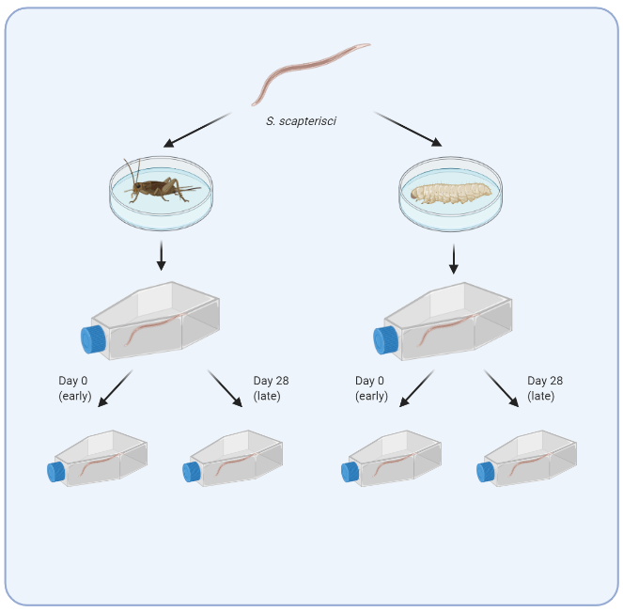
1. Amplicon sequencing (16S V3V4, rpoB)
2. In vivo insect virulence assays
3. Grinding for future culture-dependent analysis

Figure 3.1. Graphical abstract of S. scapterisci IJ microbiome sampling methodology
S. scapterisci IJs from one parent flask were propagated through crickets or waxworms. Three propagations of crickets and three of waxworms were randomly selected as the biological triplicates used in this study. A sample was taken at the time of collection (day 0) and the remainder of the IJ population was aged for 28 days. All sample populations were used for amplicon sequencing, in vivo insect virulence assays, and ground and frozen for any future culture-dependent microbe follow-up work.
This figure was created with BioRender.com.

DNA extraction from IJs
Following the general protocol outlined in Ogier et al. (2020), I collected 5,000 nematodes at the time of IJ collection for early IJ DNA extraction. An additional 5,000 nematodes were collected after 28 days of aging inside of their storage flasks. The nematodes were briefly settled inside Eppendorf microcentrifuge tubes using 2 x 6 second spins in a microcentrifuge, washed three times using sterile water, resuspended in 1 mL of sterile water, and frozen at -80°C until DNA extraction at a later date. Control samples included waxworms and crickets used as insect microbiome controls, IJ storage water, IJ wash water, and extraction control water.
In accordance with the Ogier et al. (2020) IJ microbiome extraction protocol, samples were quickly thawed, heated at 80°C for 20 minutes, and centrifuged to pellet the IJs. The pellet was resuspended in 200 µL of QuickExtract DNA Extraction Solution (Lucigen, USA). IJs were ground with three 3-mm glass beads for three cycles of 40 sec at 6.5 m/s with a minute rest between cycles in a Fastprep-24 Classic (MP Biomedicals, USA). Each sample received 2 µL Ready-Lyse Lysozyme Solution (Lucigen, USA) and was incubated at room temperature for up to 72 hours. Lysis of IJs was checked under a light microscope before proceeding with the DNA extraction. Samples were heated at 80°C for 20 minutes and 20 µL of 20mg/mL RNaseA added. DNA was extracted using phenol-chloroform extraction and precipitated in 70% ethanol. DNA samples were resuspended in 50 µL ultrapure water and stored at -20°C.

Library preparation and sequencing
With the help of the University of Tennessee-Knoxville Genomic Sequencing Core, I amplified two identifying genetic loci, the 16S V3V4 region and rpoB, from the microbial population samples. The first amplification was performed on 10 to 100 ng of DNA with KAPA HiFi Ready Mix (16S; Roche Sequencing Solutions, USA). The universal primers were used to amplify the 16S rRNA V3V4 hypervariable region (Klindworth et al., 2013). The rpoB region was amplified with the universal primers from Ogier et al. (2019). A negative and positive PCR control (ZymoBIOMICS Microbial Community DNA Standard, Zymo Research, Irvine, CA, USA) was included for each primer pair. All samples were amplified with 35 cycles at 60°C and 65°C for 16S and rpoB, respectively. The rpoB primers failed to amplify the target region, and the experiment moved forward with only 16S samples. The University of Tennessee Genomics Core completed single multiplexing with 6 bp index sequences added with the second 8-cycle PCR. Prepared amplicon sequences were spiked with 20% 10 pM PhiX and sequenced on an Illumina MiSeq Reagent Kit v3 (600-cyle) yielding 2x275 bp.

Amplicon sequence data analysis
The Ilumina MiSeq run generated paired-end demultiplexed fastq files which were checked for quality using FastQC (Wingett and Andrews, 2018). Amplicon data were analyzed using QIIME 2 2021.2 (Bolyen et al., 2019). Primers were removed with the q2-cutadapt plugin (Martin, 2011). Forward and reverse reads were trimmed at 253 bp after viewing base quality. Sequences were denoised with DADA2 (Callahan et al., 2016). Within the QIIME environment, all amplicon sequence variants (ASVs) were aligned with mafft (Katoh and Standley, 2013), and the results were used to construct a phylogenetic tree construction with FastTree2 (Price et al., 2010). Assorted diversity metrics were estimated with the q2-diversity plugin after samples were rarefied without replacement to 30,000 sequences per sample. Diversity metrics included: observed features and Faith’s Phylogenetic Diversity alpha-diversity (Faith, 1992); weighted (Lozupone et al., 2007) and unweighted UniFrac (Lozupone and Knight, 2005), Jaccard distance, and Bray-Curtis dissimilarity beta diversity; and Principle Coordinate Analysis (PCoA). Sequences were aligned to a reference alignment derived from a preformatted Silva 138 SSURef NR99 sequence database (Bokulich et al., 2021; Pruesse et al., 2007) using the q2-feature-classifier trained as a naïve Bayes taxonomy classifier specifically for this dataset (Bokulich et al., 2018). Additional data analyses were completed in R with the packages qiime2R, phyloseq, and ampvis2 (Andersen et al., 2018; Bisanz, 2018; McMurdie and Holmes, 2013).

In vivo nematode infection of insects
At both nematode collection time points, a sample of washed S. scapterisci nematodes was used for in vivo infection of insects. Each of the three propagation replicates was used to infect 10 crickets and 10 waxworms though natural injection and 10 crickets and 10 waxworms through direct nematode injection. To simulate a natural infection, insects were placed into a Petri dish lined with filter paper containing 100 nematodes in 200 µL sterile water. This technique was previously established as a reliable way to measure the virulence of S. scapterisci nematodes against a variety of insect hosts (Dillman et al., 2012). In injected infections, insects were injected with 10 nematodes in 4 µL PBS using a Hamilton 50 µL syringe (Model 705 N, Hamilton Company, Reno, NV, USA) (Wang et al., 1994). Ten insects of each species were injected with PBS as a control. Insects were checked every 24 hours for death up to 72 hours when the experiment was ended. For analysis, insects were censored at time of death or at 72 hours, whichever event occurred first. A Cox proportional hazard model was completed in R with the survival package version 3.2-11 (Therneau, 2020; Therneau and Grambsch, 2000).

Culture-dependent microbial community collection
After each nematode collection point, 2,000 IJs were washed three times with sterile water and resuspended in fresh dark LB broth. Disruptor beads (Electron Microscopy Sciences 0.5 mm, Thermo Fisher Scientific, Waltham, MA, USA) were added to roughly the 250 µL mark in a 2 mL Eppendorf minicentrifuge tube. Samples were ground in a Fastprep-24 Classic (MP Biomedicals, USA) at 4 M/s for five cycles of 20 seconds on, 1 minute off. Samples were transferred to a new tube and frozen at -80°C for later use.

IJ supernatant virulence assay
G. mellonella waxworms were exposed to 600 µL of supernatant gathered from three flasks of S. scapterisci IJs that had been stored for 4 months. Each S. scapterisci stock had been propagated separately for several months. After multiple quick spins in a microcentrifuge, the supernatants were pipetted into fresh tubes and checked for the absence of any nematodes under a light microscope. Each supernatant was used on five dishes of four G. mellonella insects each from the same batch. Waxworms were observed for five days for signs of death.

X. innexi IJ colonization assay
S. scapterisci nematodes from the same propagation lineage as those in the microbiome experiments described above were propagated in triplicate through crickets and waxworms as previously described. IJ samples were collected freshly after emerging and after aging in a collection flask for 28 days. To quantify X. innexi bacterial colonization levels, 2 mL of S. scapterisci nematodes were surface sterilized with bleach, ground with a handheld grinder, diluted appropriately, and plated onto LB plates. Plates were incubated at 30ºC for up to one day before counting X. innexi CFUs. X. innexi colonies were distinguished via their distinct colony morphology, including a red-brown color (Aghai, 2014). Three biological and three technical replicates were performed at each time point.

Results & Discussion

S. scapterisci IJ microbiome sequencing diversity measurements
After amplification and sequencing of the 16S rRNA V3V4 region, I generated a total of 28,437,752 forward and reverse reads of which 89.54% passed Illumina’s internal quality control filter and 88.44% had a Q score above 30. An appropriate number of sequences (17.3%) aligned to the PhiX internal control. Index barcode identification was successful for 76.1% of reads, leaving 19,373,100 forward and reverse reads for downstream analysis in QIIME 2. After filtering, denoising, and merging, 7,501,927 reads remained. Of those reads, 6,995,119 (93.2%) were non-chimeric sequences retained for analysis (mean= 145,732 reads per sample; 48 samples). Rarefaction curves showed that an adequate sequencing depth was achieved with roughly 15,000 reads per sample (Figure 3.2).
I originally intended to sequence both the 16S V3V4 region and the 435 bp rpoB marker region for better taxonomic assignment of OTUs per the findings of Ogier et al. (2020). However, the rpoB primers listed in that publication failed to amplify DNA during our library prep, and the experiment was continued with only 16S amplicons. Taxonomic assignment of the 16S reads associated 57.7% and 23.8% of OTUs with a genus and species name, respectively.

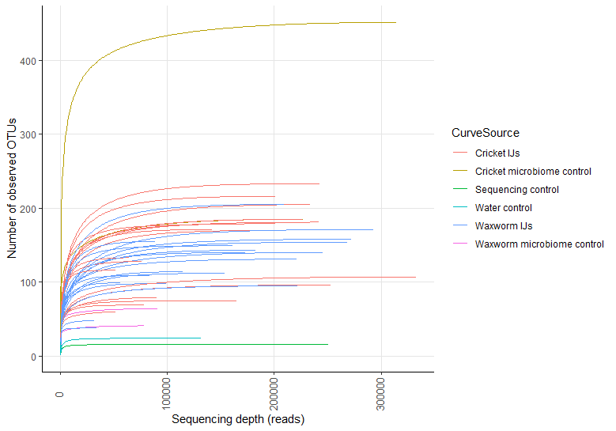
Figure 3.2. Rarefaction curves of S. scapterisci IJ microbiome samples
Rarefaction curves obtained by Illumina amplicon sequencing of the 16S V3V4 marker. All samples, including technical triplicates and controls, are shown.

Alpha diversity measures showed a higher observed diversity and Shannon diversity than previously found in S. carpocapsae nematodes in Ogier et al. (2020) (Figure 3.3A). As expected, both water controls and the PCR negative control had very few observed sequences. In the waxworm insect controls, the number of observed features was similar to the expected waxworm microbiome value derived from Ogier et al. (2020) and reflected the characterized waxworm microbiome (Allonsius et al., 2019). In the cricket insect controls, the alpha diversity spread was greater than expected, in part because only 2 crickets were included in sequencing, and one cricket had roughly twice the number of observed sequences as the other. Because a reliable measure of the A. domesticus cricket microbiome has not been published, it is difficult to determine the expected microbial community members and alpha diversity. Future work should include additional cricket microbiome control samples to cement the expected microbiome in the cricket controls.
Shannon diversity, a measure of abundance and evenness of samples, increased in S. scapterisci IJs derived from crickets after 28 days of aging relative to newly emerged IJs (Wilcoxon signed-rank test: W=0.0, P-value=0.003906, FDR P-value=0.007812; Figure 3.3B). However, the same was not true of S. scapterisci IJs from waxworms (Wilcoxon signed-rank test: W=19.0, P-value=0.734375, FDR P-value=0.734375; Figure 3.3B). When comparing these measures of alpha diversity, each sample’s technical triplicates clustered tightly, demonstrating that the library preparation and sequencing did not greatly distort the samples (Figure 3.3C).

Figure 3.3. Sample microbiome alpha diversity
Plots showing the alpha diversity in the microbiota of S. scapterisci IJs emerging from cricket and waxworm hosts and of controls. All technical replicates are shown. (A) The observed diversity and Shannon diversity of all samples. Early IJ samples are blue, late IJ samples are red, and control samples are green. (B) The Shannon diversity compared between IJ samples taken at early and late timepoints in crickets and waxworms. Pairwise difference Wilcoxon signed-rank test false discovery rate P-value is shown (n.s. = no significance, * = P ≤ 0.05, ** = P ≤ 0.01, *** = P ≤ 0.001). (C) Shannon diversity of each propagation biological replicate for both crickets and waxworms. Plots were generated with the R packages qiime2R and phyloseq.

A
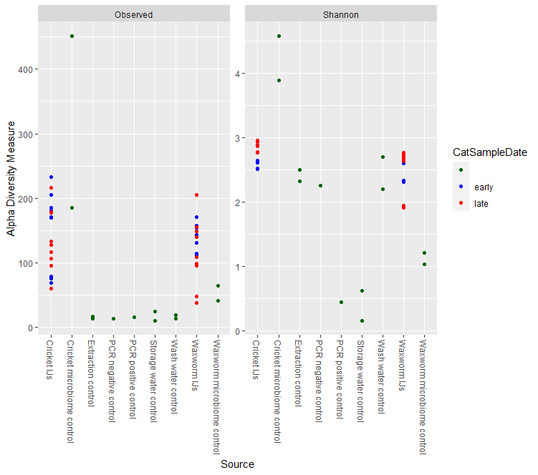
Sample Date

Figure 3.3 continued

B
**
n.s.

C
Figure 3.3 continued

In pairwise distance tests, the microbiome changes between early and late time point samples were not statistically different between S. scapterisci IJs from cricket or waxworms (Kruskal Wallis test: H=0.703704, P-value=0.401542; Figure 3.4). This finding indicates that the microbiome composition stability over time is not statistically different between the two groups.
Together, the alpha diversity measures show that the microbial community in IJs from crickets increased in diversity and richness over time of storage, but that the phylogenetic distance between the communities at the early and late time points was not different. Alpha diversity measures for the waxworm IJ microbiome did not appear to change over time in either test, perhaps because the microbial members present during the early time point did not increase in abundance or because the change in microbial community members over time did not yield a higher microbial community evenness.

S. scapterisci IJ microbiome core members
To determine the S. scapterisci IJ core microbiome, I used the thresholding parameters published in Ogier et al. (2020). This methodology allowed me to compare the S. scapterisci microbiome directly with the S. carpocapsae microbiome published in that paper. The thresholding parameters required a relative abundance of 0.01% and a frequency of 80% (i.e., microbial taxa at the genus level had to be present in 80% of samples and at least 0.01% of the reads in those samples).

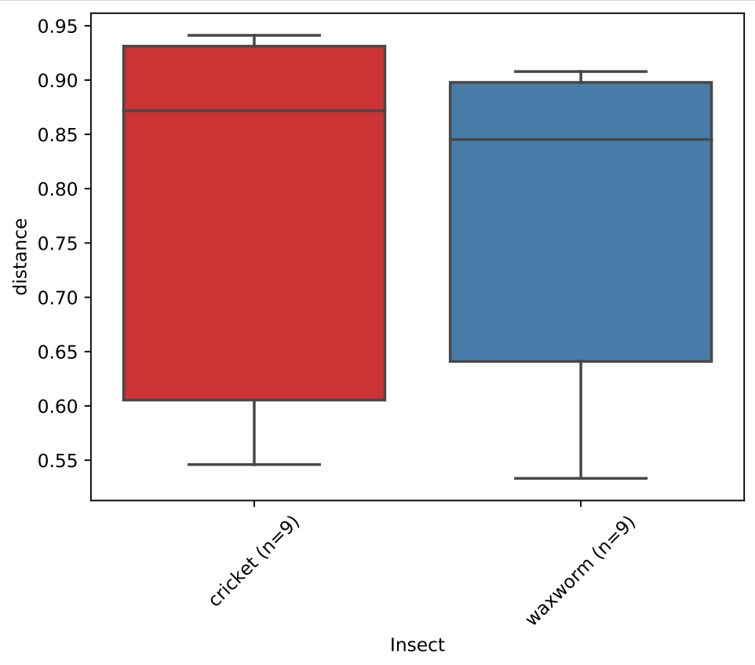
Kruskal Wallis test, H=0.70, p=0.40
Figure 3.4. Pairwise distance test of IJ microbiome Shannon diversity over time
Pairwise distance comparison of the diversity of IJ microbiomes from crickets and waxworms over time. A Kruskal Wallis test was run to compare the groups (H=0.70, p=0.40).

I compared the core microbiomes of all combined (early and late) cricket IJ samples, the cricket microbiome controls, and the control samples (storage water, wash water, extraction, and PCR negative controls) (Figure 3.5A). The groups did not have any overlapping members. Thus, I determined that the samples were not compromised, as any contamination occurring during sample processing and library preparation would have appeared as a core microbiome member shared by all groups. Additionally, there were no members shared between the cricket microbiome control and the cricket IJ microbiome. This finding indicates that the cricket-derived S. scapterisci IJ core microbiome does not include members acquired from the cricket host during propagation.
After establishing the members of the cricket IJ core microbiome, I next studied the microbiome member differences between the early and late cricket IJ populations (Figure 3.5B). Eight and 13 microbiome members were only present at the early and late time points, respectively. These microbiomes only represented 3.8% and 6.2%, respectively, of the total cricket IJ microbial reads. In contrast, the time-stable cricket IJ microbiome consisted of 19 members. These members were 70.2% of all cricket IJ microbial reads. Only 19.7% of reads were assigned to the 989 microbial members that did not reach the thresholding requirements, which could be interpreted to mean that there were many microbes that were both low in abundance and inconsistently present.
Figure 3.6A shows the same core microbiome comparison in waxworm IJs samples, waxworm microbiome controls, and the control samples. Again, the groups did not have any overlapping members, and the samples were deemed uncontaminated
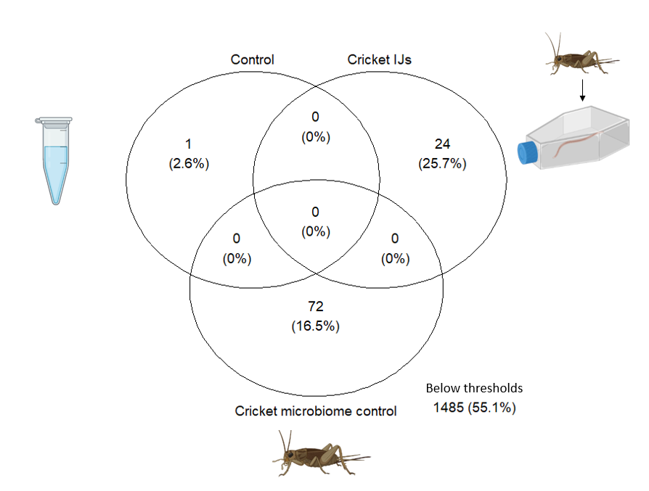
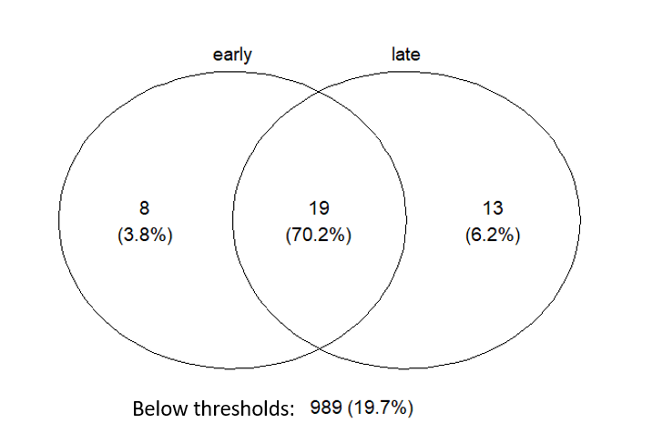
B
A

Figure 3.5. Core microbiomes of S. scapterisci IJs from crickets and control samples
Venn diagrams of core microbiome members were calculated using the 0.01% relative abundance and 80% frequency thresholding values. The number of OTUs in each core microbiome is shown. The percentage of overall reads belonging to the core microbiome for each tested group is listed in parenthesis. A) The number of core microbiome members in the following groups: control, cricket microbiome control, and cricket IJs. No core microbiome members were shared between groups. B) The number of core microbiome members in early, late, or both (center, overlapping section) S. scapterisci IJ samples from crickets.
and uninfluenced by the waxworm host microbiome. Thirteen and 7 microbiome members were exclusively present in the early and late waxworm IJs, respectively, representing 9.3% and 2.9% of all waxworm IJ microbial sequences (Figure 3.6B). Thirteen microbes were present at both time points and made up 75.8% of waxworm IJ microbial sequences.
The time-independent S. scapterisci microbiome was conserved regardless of insect host (Figure 3.7). All 13 members of the waxworm IJ core microbiome were also represented in the cricket IJ core. Six additional taxa were specific to the cricket IJ core microbiome.
The S. scapterisci core microbiome identified in this study had overlapping members with the previously published S. carpocapsae microbiome (Figure 3.8). Each core microbiome included the known Xenorhabdus symbiont of that Steinernema nematode species (X. nematophila and X. innexi symbionts for S. carpocapsae and S. scapterisci, respectively). Five taxa were conserved between the S. carpocapsae core microbiome and the S. scapterisci IJ core microbiome consistently present regardless of IJ age or prey source. These taxa included Stenotrophomonas, Pseudochrobactrum, Delftia, Aceintobacter, and Bosea. Since the S. carpocapsae IJs were stored (aged) longer than the aged S. scapterisci IJs in this study (Ogier et al., 2020), I also compared the core microbiome of S. carpocapsae to just the aged S. scapterisci IJ microbiome and identified two additional overlapping taxa, Pseudomonas and Achromobacter.
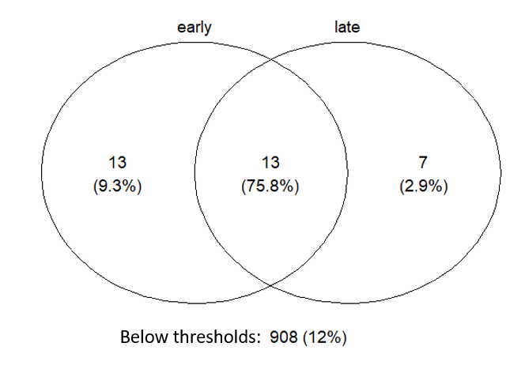
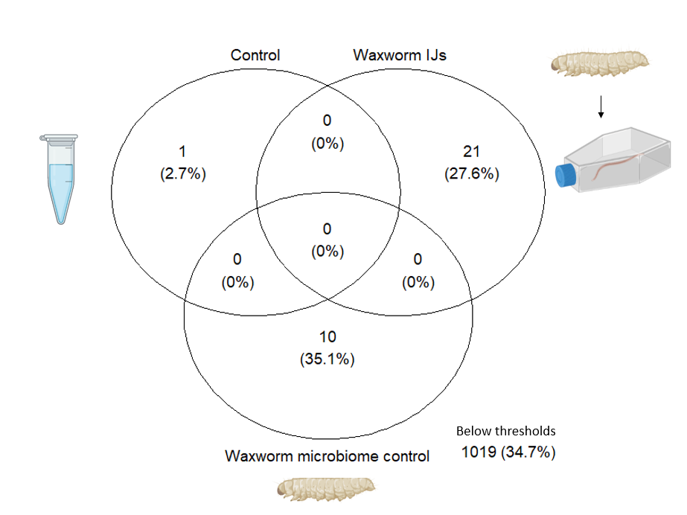
B
A

Figure 3.6. Core microbiomes of S. scapterisci IJs from waxworms and control samples
Venn diagrams of core microbiome members were calculated using the 0.01% relative abundance and 80% frequency thresholding values. The number of OTUs in each core microbiome is shown. The percentage of overall reads belonging to the core microbiome for each tested group is listed in parenthesis. A) The number of core microbiome members in the following groups: control, waxworm microbiome control, and waxworm IJs. No core microbiome members were shared between groups. B) The number of core microbiome members in between the early and late S. scapterisci IJ samples from waxworms. The number of shared core members is shown in the overlapping section.

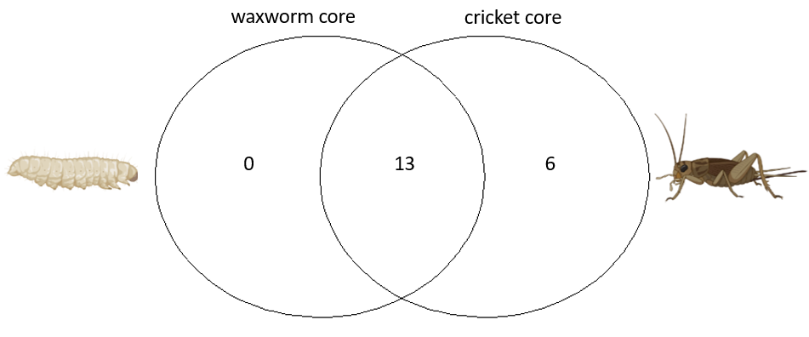
Figure 3.7. Time-independent core microbiomes of S. scapterisci IJs from crickets and waxworms
Venn diagram of the time-independent S. scapterisci core microbiome members from cricket and waxworm IJs. The cores were calculated using the 0.01% relative abundance and 80% frequency thresholding values. The cores are considered time-independent because the microbes met thresholding values at both the early and late time points. The number of OTUs in each core microbiome is shown. The percentage of overall reads belonging to the core microbiome for each tested group is listed in parenthesis. The number of shared core members is shown in the overlapping section.

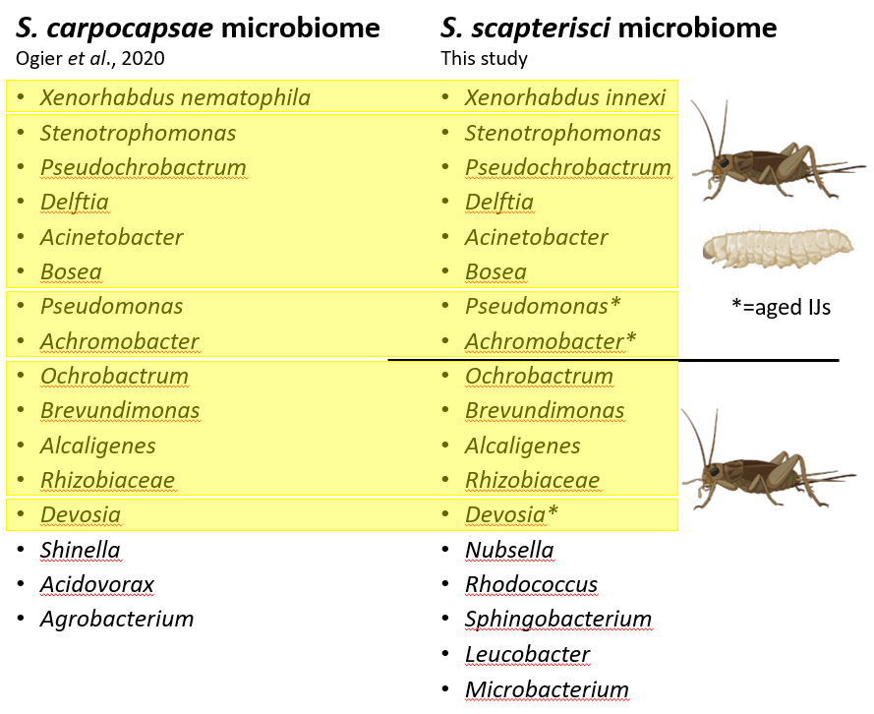
Figure 3.8. Comparison of S. carpocapsae and S. scapterisci core microbiomes
Core microbiome data determined with the thresholding values of 0.01% relative abundance and 80% frequency. S. carpocapsae microbiome data were published in Ogier et al., 2020. Highlighted microbes were shared between S. carpocapsae and S. scapterisci. On the S. scapterisci side, the black line separates microbes found in cricket and waxworm IJ core microbiomes from those only found in cricket IJ core microbiomes. Asterisks show microbes found in the core microbiome of aged IJs. Unhighlighted microbes were not shared between Steinernema species cores.

The S. scapterici IJs propagated through their native cricket hosts harbored 6 taxa distinct from the other S. scapterisci samples (Figure 3.7). Of these, 4 were conserved with the S. carpocapsae core: Ochrobactrum, Brevundimonas, Alcaligenes, and Rhizobiaceae. Devosia was included when the aged S. scapterisci IJs from crickets were considered.
Altogether, 13 of the 18 S. scapterisci IJ core microbes were the same as those found in S. carpocapsae. However, some differences existed. Three microbes in the S. carpocapsae core (Shinella, Acidovorax, and Agrobacterium) were not found in the S. scapterisci core. Five members of the S. scapterisci core were not found (Nubsella, Rhodococcus, Sphingobacterium, Leucobacter, and Microbacterium) in the S. carpocapsae core (Figure 3.8).
There is increasing recognition that the Steinernema nematode-Xenorhabdus bacteria mutualism includes an association with a broader microbial community (Gouge and Snyder, 2006; Ogier et al., 2020). Of the five species of Steinernema on which culture-independent assessment of microbiome membership has been performed, none are associated exclusively with their native Xenorhabdus. Instead, the nematodes carry other Proteobacteria.
The free-living IJ stage of the nematode S. carpocapsae carries a community of a dozen non-Xenorhabdus microbes (Ogier et al., 2020). The data presented above demonstrates that this FAM also dependably exists in S. scapterisci IJs, with members being present regardless of the identity of the insect prey in which the IJs had developed. This finding supports the hypothesis put forth by Ogier et al. that there is a common Steinernema-wide FAM and that each Steinernema nematode-Xenorhabdus bacteria pairing associates with additional members that are tailored to their specific needs. Further and deeper testing of laboratory and wild Steinernema nematodes species would be needed to cement this hypothesis. One additional consideration is the thresholding parameters used in this experiment to determine the core microbiomes. Although the thresholding parameters allowed direct comparison of Steinernema microbiomes from different experiments, they are arbitrary and may have hidden other interesting sequencing findings. This experiment and the Ogier et al. (2020) experiment used a relative abundance level of 0.01%. However, it is possible that rarer OTUs play an important role in the Steinernema microbiome, particularly in mixed microbial communities.
Assembling the microbiome of Steinernema IJs is limited by the technological constraints of amplicon sequencing. The 16S region of microbial sequences can be taxonomically assigned to the genus level, but it can only assign a given OTU to the species level in roughly a quarter of cases because the V3V4 amplicon is only 440 bp and does not have the variation necessary for more finely detailed taxonomic assignment. This disadvantage means that explorations of Steinernema microbiomes can group microbes into genera, but that it cannot provide information about species- and strain-specific impacts. To truly answer the question of what microbes are present in the Steinernema microbiome in a culture-independent way, future studies should use whole genome sequencing technology to define the microbial community without the biasing effects of PCR-based library preparation, which could provide more accurate taxonomic assignments with higher confidence.

S. scapterisci IJ colonization by X. innexi symbionts is influenced by prey-source
X. innexi was detected consistently in every S. scapterisci IJ sample, regardless of age or prey source. To determine if either of these parameters influences the overall levels of X. innexi within the IJ, I tested the colonization levels of early and aged S. scapterisci IJs from crickets and waxworms. Consistent with prior observations of X. innexi colonization of S. scapterisci IJs after co-cultivation on laboratory agar media, the average colony forming units (CFU) per IJ was an order of magnitude lower than typically observed in the association between S. carpocapsae and X. nematophila (Figure 3.9) (Kim et al., 2017). Neither IJ sample had a significant change in X. innexi colonization levels over time, but early cricket IJs were more colonized than early waxworm IJs (Figure 3.9; P=0.0004) and aged cricket IJs were more colonized than late waxworm IJs (Figure 3.9; P=0.0303). This may indicate that X. innexi is more successful in crickets relative to waxworms at achieving sufficient biomass available to developing IJs. Indeed, when injected into D. melanogaster, X. innexi population levels decline rapidly indicating a failure to replicate (Kim et al., 2017). The low levels of average X. innexi CFU/IJ detected through the grinding assay could reflect either relatively high efficiency colonization by a few cells, or very few IJs carrying many X. innexi bacterial cells. Previous data indicate the former scenario occurs in IJ populations derived from

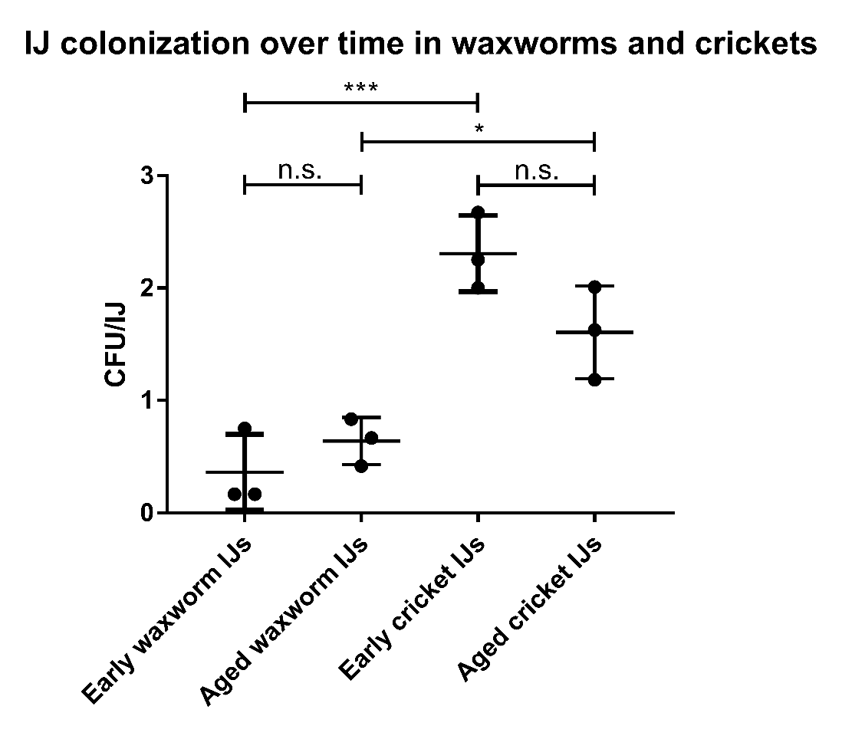
Figure 3.9. IJ X. innexi bacterial colonization over time in IJs from waxworm and cricket
Early IJs were ground directly after collection from water traps, and aged IJs were stored in flasks for 28 days before grinding. X. innexi CFU were counted and differentiated by their distinctive red-brown phenotype and catalase negative test. Asterisks show statistical significance of a one-way ANOVA (n.s. = no significance, * = P ≤ 0.05, ** = P ≤ 0.01, *** = P ≤ 0.001). Each group consists of three biological replicates and three technical replicates; data points represent the average of technical triplicates.

lawns of X. innexi (Kim et al., 2017). Similar experiments could be conducted on IJs insect hosts from insects to determine whether waxworm-derived IJs are less frequently or less abundantly colonized relative to cricket-derived IJs.
Steinernema nematodes can grow without their Xenorhabdus symbiont, but they produce fewer IJs (Aguillera and Smart, 1993; Han and Ehlers, 2000; Mitani et al., 2004). As such, the low level of X. innexi symbionts carried by S. scapterisci IJs could negatively impact the reproduction and development of the nematode. Consistent with this idea, significantly fewer IJs emerged from waxworms than crickets during these experiments (data not shown). Anecdotally, waxworm-derived S. scapterisci IJs consistently appear lethargic and are less active under a light microscope than their cricket-derived IJ counterparts, although these observations are yet to be quantified. If the surviving S. scapterisci waxworm IJs are less robust, this condition could explain the lower hazard ratio of waxworms and crickets exposed to waxworm IJs when compared to those exposed to cricket IJs.

S. scapterisci IJ virulence is influenced by insect prey source
Since I had observed some IJ age-dependent differences in membership of S. scapterisci IJ microbiomes, I next tested if aging influenced entomopathogenicity. I exposed crickets and waxworms to early and late IJs from both cricket and waxworm hosts via two methods: direct IJ injection, which serves as a measure of virulence, and natural IJ exposure, which serves as a measure of both infective behaviors and virulence. Overall, waxworms were less likely to die than crickets after IJ exposure (Figure 3.10; hazard ratio [HR]=0.66; 95% confidence interval [CI]=0.51-0.86; p=0.002). This result mirrors those of other tests of Steinernema nematodes against non-native insect hosts (Dillman et al., 2012). Insects were less likely to die after natural exposure to IJ than when injected with IJs (Figure 3.10; HR=0.36; 95% CI=0.27-0.47; p=<0.001). Insects exposed to IJs from crickets or waxworms were more likely to die than those only exposed to the water control (Figure 3.10; cricket IJs: HR=4.62; 95% CI=3.00-7.12; p=<0.001; waxworm IJs: HR=2.89; 95% CI=1.85-4.50; p=<0.001), although the lower hazard ratio of IJs from waxworms shows that there may be an impact of the non-native insect prey on the virulence of the resulting nematodes. Additionally, insects exposed to early IJs were not more likely to die than those from late IJs (Figure 3.10; HR=0.91; 95% CI=0.70-1.18; p=0.472).
S. feltiae and S. carpocapsae IJs excrete or secrete a core set of 52 proteins including venoms (Chang et al., 2019; Lu et al., 2017). I exposed waxworms to the supernatant of S. scapterisci IJs that had been stored for 4 months. Waxworms that were exposed to S. scapterisci-free supernatant were not more likely to die than the waxworms exposed to water (Figure 3.11; two-tailed unpaired t-test, P=0.1404, t=1.517, df=28). One notable finding in the S. scapterisci microbiome is the absence of Pseudomonas in the early IJ microbiome. Ogier et al. (2020) considered Pseudomonas a core member of the Steinernema FAM and isolated several strains of Pseudomonas protegens and Pseudomonas chlororaphis from laboratory strains of S. carpocapsae, S. weiseri, and S. glaseri. In insect virulence assays against Spodoptera littoralis, a moth larva, all Pseudomonas strains killed 50% of the larvae within 19-29 hours which is similar to the killing ability of X. nematophila, the primary native symbiont of
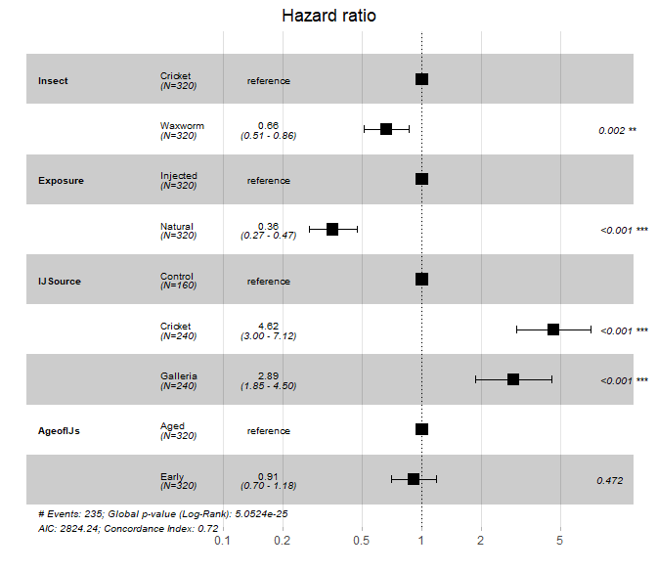
Figure 3.10. Hazard ratio of insects exposed to S. scapterisci IJs
Cox proportional-hazards model of insect survival post-IJ exposure. Black boxes show the average hazard ratio. References values are shown with a hazard ratio of 1 as they represent the null hypothesis that there is no effect of the group tested. The 95% confidence intervals are displayed as bars around the hazard ratio and in parenthesis. P-values are shown in the right column.

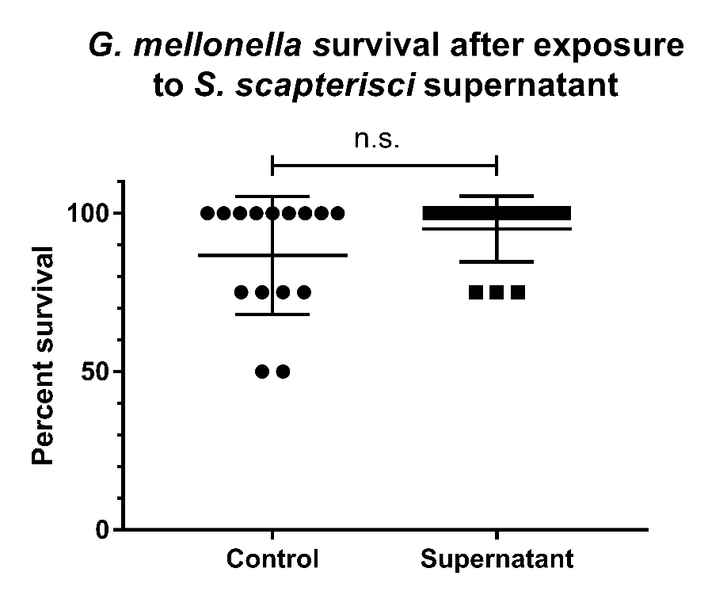
Figure 3.11. IJ supernatant alone does not kill waxworms
Waxworms were exposed to 600 µL of supernatant gathered from flasks where IJs had been stored for 4 months. The supernatant was checked for the absence of any nematodes under a light microscope. Three biological replicates of IJ supernatant were used. Each supernatant was used on five dishes of four G. mellonella insects each from the same batch. Waxworms were observed for five days for signs of death.

S. carpocapsae and a noted high-virulence Xenorhabdus strain (Cowles and Goodrich-Blair, 2005; Ogier et al., 2020). Based on these findings, Ogier et al. (2020) labeled P. protegens and P. chlororaphis part of the Steinernema pathobiome. While my sequencing revealed the presence of many other culturable and unculturable microbes in the S. scapterisci microbe, it is possible that part of the species’ low virulence in the early time point is due to the absence of Pseudomonas strains.
While some trends existed for a shift in the IJ microbiome over time, very few OTUs showed a significant change over the time period measured. In the wild, S. scapterisci IJs exist in the soil until a potential insect host is in the vicinity. While larger questions remain about the viability of Steinernema IJs over time, the existence of the nematodes around the globe, including in environments with harsh winters where insects are presumably scarce, necessitates a survival pathway that keeps a portion of the nematode population viable without food for a several months. A previous study comparing two Steinernema species sampled from the same field site found that Steinernema insect virulence and nematode-nematode competition dynamics shift when IJs are aged for 18 months, although one Steinernema species exhibited increased killing while the other decreased (Bashey et al., 2016). This variability in IJ virulence could explain my findings that IJs aged for 28 days did not change significantly with respect to virulence. It is possible that virulence either does not increase over time in S. scapterisci IJs or that any potential change virulence was not occurring in the time frame of this study.

Conclusion
An important yet outstanding question that was unanswered by this study is whether X. innexi is virulent enough against crickets that its nematode host does not require support from other microbiome members. One reason this important question has not been addressed is that injection assays in crickets are more difficult than in other insects, due to the challenges in husbandry, exoskeleton structures, and source variability. However, I developed a protocol for injection into insects that should facilitate future work to test the virulence of X. innexi, and other core microbiome members, in this host.
Regardless of the virulence potential of X. innexi, it is clear that S. scapterisci and X. innexi are consistently associated with a core group of microbes. Future experiments should explore the roles of these microbes in supporting the entomopathogenic lifestyle of the S. scapterisci-X. innexi mutualism. This effort will be facilitated by the fact that I isolated and stored the culture-dependent microbiome at the time of IJ harvesting for any future studies that may be spurred by the sequencing findings reported here.
The S. scapterisci IJ core microbiome identified in this study may not fully represent the naturally occurring microbiome of this nematode. S. scapterisci nematodes used in this study are derived from a lineage that has been cultivated in the laboratory for years. This laboratory propagation, although it has been through natural infection of insect prey, may have resulted in loss of microbial community members that could contribute to S. scapterisci fitness, such as in non-cricket insect prey. Future studies could reisolate the nematode from its native environments or compare lineages that have been more recently domesticated in the laboratory.
My findings will have real-world relevance for insect-targeted agricultural pest control as well as intellectual relevance for the understanding of microbiome-derived virulence. As we begin to understand the influence of insect prey on the microbiome of entomopathogenic nematodes, industrial scientists will be able to engineer more efficient commercial Steinernema nematode products for use as organic pesticides. Microbiome studies such as this one have begun to help the scientific community form hypotheses about the link between microbial community members and their host’s virulence.

References
Aghai, D.T. (2014). Establishing the Xenorhabdus innexi-Steinernema scapterisci mutualism model. University of Wisconsin-Madison.
Aguillera, M.M., and Smart, G.C. (1993). Development, reproduction, and pathogenicity of Steinernema scapterisci in monoxenic culture with different species of bacteria. J. Invertebr. Pathol. 62, 289–294.
Allonsius, C.N., Beeck, W. Van, Boeck, I. De, Wittouck, S., and Lebeer, S. (2019). The microbiome of the invertebrate model host Galleria mellonella is dominated by Enterococcus. Anim. Microbiome 1, 1–7.
Andersen, K.S., Kirkegaard, R.H., Karst, S.M., and Albertsen, M. (2018). ampvis2: An R package to analyse and visualise 16S rRNA amplicon data. BioRxiv 10–11.
Bashey, F., Sarin, T., and Lively, C.M. (2016). Aging alters interspecific competition between two sympatric insect-parasitic nematode species. Ecol. Evol. 6, 3750–3759.
Bisanz, J.E. (2018). qiime2R: Importing QIIME2 artifacts and associated data into R sessions.
Bokulich, N.A., Kaehler, B.D., Rideout, J.R., Dillon, M., Bolyen, E., Knight, R., Huttley, G.A., and Gregory Caporaso, J. (2018). Optimizing taxonomic classification of marker-gene amplicon sequences with QIIME 2’s q2-feature-classifier plugin. Microbiome 6, 1–17.
Bokulich, N.A., Robeson, M.S., and Dillon, M.R. (2021). bokulich-lab/RESCRIPt 2021.4.0.
Bolyen, E., Rideout, J.R., Dillon, M.R., Bokulich, N.A., Abnet, C.C., Al-Ghalith, G.A., Alexander, H., Alm, E.J., Arumugam, M., Asnicar, F., et al. (2019). Reproducible, interactive, scalable and extensible microbiome data science using QIIME 2. Nat. Biotechnol. 37, 852–857.
Bonifassi, E., Fischer-Le Saux, M., Boemare, N., Lanois, A., Laumond, C., and Smart, G. (1999). Gnotobiological study of infective juveniles and symbionts of Steinernema scapterisci: A model to clarify the concept of the natural occurrence of monoxenic associations in entomopathogenic nematodes. J. Invertebr. Pathol. 74, 164–172.
Callahan, B.J., McMurdie, P.J., Rosen, M.J., Han, A.W., Johnson, A.J.A., and Holmes, S.P. (2016). DADA2: High-resolution sample inference from Illumina amplicon data. Nat. Methods 13, 581–583.
Chang, D.Z., Serra, L., Lu, D., Mortazavi, A., and Dillman, A.R. (2019). A core set of venom proteins is released by entomopathogenic nematodes in the genus Steinernema. PLoS Pathog. 15, 1–29.
Cowles, K.N., and Goodrich-Blair, H. (2005). Expression and activity of a Xenorhabdus nematophila haemolysin required for full virulence towards Manduca sexta insects. Cell. Microbiol. 7, 209–219.
Dillman, A.R., Guillermin, M.L., Lee, J.H., Kim, B., Sternberg, P.W., and Hallem, E.A. (2012). Olfaction shapes host-parasite interactions in parasitic nematodes. Proc. Natl. Acad. Sci. U. S. A. 109, E2324–E2333.
Faith, D.P. (1992). Conservation evaluation and phylogenetic diversity. Biol. Conserv. 61, 1–10.
Goodrich-Blair, H., and Clarke, D.J. (2007). Mutualism and pathogenesis in Xenorhabdus and Photorhabdus: Two roads to the same destination. Mol. Microbiol. 64, 260–268.
Gouge, D.H., and Snyder, J.L. (2006). Temporal association of entomopathogenic nematodes (Rhabditida: Steinernematidae and Heterorhabditidae) and bacteria. J. Invertebr. Pathol. 91, 147–157.
Han, R., and Ehlers, R.U. (2000). Pathogenicity, development, and reproduction of Heterorhabditis bactoriophora and Steinernema carpocapsae under axenic in vivo conditions. J. Invertebr. Pathol. 75, 55–58.
Katoh, K., and Standley, D.M. (2013). MAFFT multiple sequence alignment software version 7: Improvements in performance and usability. Mol. Biol. Evol. 30, 772–780.
Kim, I.-H., Aryal, S.K., Aghai, D.T., Casanova-Torres, Á.M., Hillman, K., Kozuch, M.P., Mans, E.J., Mauer, T.J., Ogier, J.C., Ensign, J.C., et al. (2017). The insect pathogenic bacterium Xenorhabdus innexi has attenuated virulence in multiple insect model hosts yet encodes a potent mosquitocidal toxin. BMC Genomics 18, 1–25.
Klindworth, A., Pruesse, E., Schweer, T., Peplies, J., Quast, C., Horn, M., and Glöckner, F.O. (2013). Evaluation of general 16S ribosomal RNA gene PCR primers for classical and next-generation sequencing-based diversity studies. Nucleic Acids Res. 41, 1–11.
Lozupone, C., and Knight, R. (2005). UniFrac: A new phylogenetic method for comparing microbial communities. Appl. Environ. Microbiol. 71, 8228–8235.
Lozupone, C.A., Hamady, M., Kelley, S.T., and Knight, R. (2007). Quantitative and qualitative β diversity measures lead to different insights into factors that structure microbial communities. Appl. Environ. Microbiol. 73, 1576–1585.
Lu, D., Sepulveda, C., and Dillman, A.R. (2017). Infective juveniles of the entomopathogenic nematode Steinernema scapterisci are preferentially activated by cricket tissue. PLoS One 12, 1–14.
Martens, E.C., and Goodrich‐Blair, H. (2005). The Steinernema carpocapsae intestinal vesicle contains a subcellular structure with which Xenorhabdus nematophila associates during colonization initiation. Cell. Microbiol. 7, 1723–1735.
Martin, M. (2011). Cutadapt removes adapter sequences from high-throughput sequencing reads. EMBnet.Journal 17.
McMurdie, P.J., and Holmes, S. (2013). Phyloseq: an R package for reproducible interactive analysis and graphics of microbiome census data. PLoS One 8.
Mitani, D.K., Kaya, H.K., and Goodrich-Blair, H. (2004). Comparative study of the entomopathogenic nematode, Steinernema carpocapsae, reared on mutant and wild-type Xenorhabdus nematophila. Biol. Control 29, 382–391.
Murfin, K.E., Lee, M.M., Klassen, J.L., McDonald, B.R., Larget, B., Forst, S., Stock, S.P., Currie, C.R., and Goodrich-Blair, H. (2015). Xenorhabdus bovienii strain diversity impacts coevolution and symbiotic maintenance with Steinernema spp. nematode hosts. MBio 6, 1–10.
Nguyen, K.B. (1988). A new nematode parasite of mole crickets: its taxonomy, biology and potential for biological control. University of Florida.
Nguyen, K.B., and Smart, G.C. (1990). Steinernema scapterisci n. sp. (Rhabditida: Steinernematidae). J. Nematol. 22, 187–199.
Ogier, J.-C., Pagès, S., Frayssinet, M., and Gaudriault, S. (2020). Entomopathogenic nematode-associated microbiota: From monoxenic paradigm to pathobiome. Microbiome 8, 1–17.
Price, M.N., Dehal, P.S., and Arkin, A.P. (2010). FastTree 2 - Approximately maximum-likelihood trees for large alignments. PLoS One 5.
Pruesse, E., Quast, C., Knittel, K., Fuchs, B.M., Ludwig, W., Peplies, J., and Glöckner, F.O. (2007). SILVA: A comprehensive online resource for quality checked and aligned ribosomal RNA sequence data compatible with ARB. Nucleic Acids Res. 35, 7188–7196.
Sicard, M., Le Brun, N., Pages, S., Godelle, B., Boemare, N., and Moulia, C. (2003). Effect of native Xenorhabdus on the fitness of their Steinernema hosts: contrasting types of interaction. Parasitol. Res. 91, 520–524.
Stock, S.P. (2019). Partners in crime: symbiont-assisted resource acquisition in Steinernema entomopathogenic nematodes. Curr. Opin. Insect Sci. 32, 22–27.
Therneau, T.M. (2020). A package for survival analysis in R.
Therneau, T.M., and Grambsch, P.M. (2000). Modeling survival data: extending the Cox model (New York: Springer).
Wang, Y., Gaugler, R., and Cui, L. (1994). Variations in immune response of Popillia japonica and Acheta domesticus to Heterorhabditis bacteriophora and Steinernema species. J. Nematol. 26, 11–18.
Wingett, S.W., and Andrews, S. (2018). FastQ screen: A tool for multi-genome mapping and quality control. F1000Research 7, 1–13.

Chapter IV
Conclusions and Future directions

Conclusions
In my thesis, I investigated aspects of the complicated and multifactorial process of insect virulence in a symbiosis system. In Chapter II, I established Xbpp as an insect virulence factor with strain-level protein structural diversity. Xbpp’s virulence was demonstrated by my findings that Xenorhabdus strains with xbpp killed more insects than those without. In liquid and solid media conditions, I found expression of GFP-fused Xbpp, although it was more readily expressed on solid media. Additionally, I characterized the microbiome of a Steinernema nematode host with a notably low virulence symbiont, S. scapterisci. I found that this nematode shares many members of the proposed Steinernema FAM. S. scapterisci IJ microbiomes were different depending on their insect host after one round of propagation, showing that insect prey matters for the IJ microbial community development. After propagation through waxworms, insects exposed to S. scapterisci IJs had a lower hazard ratio, implying that they were less likely to die than insect exposed to S. scapterisci IJs from crickets. This finding shows the in vivo implications of an altered microbiome due to propagation through a non-native host. Overall, my findings show that insect virulence is partially a bacterial species- and strain-dependent process in the Steinernema-Xenorhabdus mutualism. Many unanswered questions remain, some of which I explore in the future directions section below.

Future Directions

Determine the mechanism of action of Xbpp
In these studies, I showed that Xbpp is an insect virulence protein, based on my experimental evidence that its presence in X. bovienii SaIN78 leads to a higher probability of insect death upon injection with this bacterium. Based on my fluorescence microscopy data showing that swimming cells do not visibly fluorescence with GFP-tagged Xbpp, I hypothesize that Xbpp may be secreted from the bacterial cell through the flagellar export apparatus. However, future studies should investigate this hypothesis, including biochemically studying any potential eukaryotic targeting ability of the RCC1/BLIP-II domain present in all Xbpp proteins.
Why Xbpp cleavage is found in immunoblots also is unanswered. I would investigate wild type xbpp transcript levels and Xbpp protein levels, processing, and localization using reverse transcriptase quantitative polymerase chain reaction (RT-qPCR) and Xbpp-specific antibodies to gain an understanding of the Xbpp expression patterns in the absence of the GFP tag, which may be influencing Xbpp homeostasis and localization.
After these questions are answered in XbSaIN78, a future study should investigate the impact of Xbpp from other X. bovienii strains with an initial focus on those lacking the extended N-terminal domain. These proposed experiments will yield additional valuable information about the insect virulence of strain-specific Xbpp proteins with larger implications for the role of strain-specificity in host-microbe mutualisms.

Further characterize the S. scapterisci microbiome
In my thesis work, I used amplicon sequencing to characterize the microbiome of Steinernema scapterisci and to investigate the influence of insect prey identity on the nematode-associated microbiome. My work supported and extended recently reported findings of Steinernema nematode microbiomes by assessing the microbiome of an additional species, S. scapterisci, and confirming that it also contains members of the Steinernema frequently associated microbiome. Further planned work will continue bioinformatic investigation of the findings, including investigating microbiome members for clues about which organisms may be pairing with X. innexi to supplement the relatively attenuated virulence of this symbiont. In follow-up experiments, I would sequence the microbiomes of recent environmental isolates of S. scapterisci, which could be obtained by baiting the soil with both native and non-native insect prey. This experiment would give us more information about the selection pressures of insect prey on the microbiome needed for effective insect virulence in Steinernema-Xenorhabdus.
Together, my thesis work has shown that insect virulence in host-microbe associations is highly variable and that the Steinernema-Xenorhabdus mutualism is a valuable lens from which to investigate these interactions.

Vita

Elizabeth Ransone is from Mathews County, Virginia. She graduated Phi Beta Kappa and with Honors from the College of William & Mary in 2018 with a B.S. in Biology and Geography. She was a 2018-2019 Fulbright Research Scholar at Goethe Universität in Frankfurt, Germany and a 2018-2021 National Science Foundation Graduate Research Fellow at the University of Tennessee-Knoxville. She will be continuing her education in pursuit of a Doctor of Medicine at the Medical College of Virginia at Virginia Commonwealth University.

