Soil Metabolite Succession in Vertebrate Decomposition Impacted Soils

A Thesis Presented for the
Master of Science
Degree
The University of Tennessee, Knoxville

Jennifer Kate Baer
December 2022

Abstract
Vertebrate decomposition results in a pulse of critical nutrients such as nitrogen, carbon, and phosphorus into the environment creating a ‘hotspot’ immediately surrounding the carcass. While many decomposition studies have investigated vertebrate decomposition focused on the carcass itself, fewer studies have focused on the impacts of decomposition products on soils. Gaining a greater understanding of soil processes during decomposition could not only aid in better understanding soil biological activities but could also lead to new insights in nutrient cycling in the environment. The assemblage of soil metabolites, also known as the soil metabolome, exposes not only the breakdown products of decomposition, but also the products of microbial metabolism. Identifying these products can reveal insights into the biological processes occurring in soil during decomposition. This study hopes to garner understanding of the effects of decomposition on soil processes through assessing soil metabolite profiles to gain further insights into soil biological functioning and nutrient cycling. To achieve this goal two experiments were conducted; a field experiment (human decomposition study conducted at the Anthropology Research Facility) and a laboratory experiment (mouse decomposition inside a greenhouse). Two hypotheses were tested: (i) it was hypothesized that carcass decomposition would not only have a significant effect on soil microbial community functional profiles (metabolome) but would lead to variations in metabolite richness and abundance as decomposition progressed, (ii) it was hypothesized that increased cadaver mass (dosing pressure) would lead to faster and larger increases in metabolites associated with decomposition. Between the two studies, soils exposed to decomposition underwent significant changes in electrical conductivity and pH, in addition to microbial community functional profiles. In the human decomposition experiment, there were different soil metabolites dominating control and decomposition-impacted soils that changed over time, suggesting a succession of metabolites occurs in the soil due to decomposition. In the mouse decomposition experiment it was found that metabolic concentrations increased 1.3 times with three-fold dosing pressure. However, the timing of the metabolic concentration maxima did not seem to be affected by increasing dosing pressure. Together, these experiments provide insights into soil biological functions as well nutrient cycling in soils during carcass decomposition.

Table of Contents
Introduction 1
Chapter 1: Literature Review 4
Decomposition 5
Decomposition Hotspots 6
Carcass Decomposition Processes 7
Early Decay Stage 7
Bloat Decay Stage 8
Active Decay Stage 8
Advanced Decay Stage 9
Skeletal Decay Stage 9
Difference in progression of decomposition due to carcass mass 10
Soil Physiochemical Response 12
Metabolomics 15
Soil Metabolomics 16
Opportunities for Metabolomics in Decomposition Studies 19
Appendix 21
Figures 21
Chapter 2: The impact of vertebrate decomposition on soil metabolic profiles over time 26
Contributions 27
Abstract 28
Introduction 28
Objectives 31
Hypotheses 31
Methodology 32
Study Design 32
Soil Analysis 32
Soil Metabolomics Sample Processing 33
Soil Metabolomics Analysis 35
Results 37
Soil Physiochemistry 37
Soil Metabolomic Analyses 38
Control versus Donor 38
Early versus Late Decomposition Stages 39
Discussion 40
Acknowledgements 45
Appendix 47
Figures 47
Tables 60
Chapter 3: Quantifying the effects of carcass mass on soil metabolomes during vertebrate decomposition 82
Contributions 83
Abstract 84
Introduction 84
Objectives 88
Hypotheses 88
Methodology 88
Study Design 88
Soil Analysis 90
Soil Metabolomics Sample Processing 90
Soil Metabolomics Analysis 92
Results 93
Soil Physiochemistry 93
Soil Metabolomic Analysis 94
Discussion 96
Acknowledgements 100
Appendix 102
Figures 102
Tables 114
Discussion and Concluding Remarks 119
Bibliography 125
Vita 132

List of Tables
Table 2.1: Results from the one-way ANOVA and Tukey’s HSD post-hoc analyses of batch effects (Batches A – H) 60
Table 2.2: Results from the one-way ANOVA and Tukey’s HSD post-hoc analyses testing differences between batches (A – H) following attempts of normalization 68
Table 2.3: Results from the ANOVAs ran on soil pH, electrical conductivity (EC), and gravimetric moisture content (GMC) by factor 75
Table 2.4: Results from the t-tests performed to assess the variation in metabolite concentrations between control soils compared decomposition-impacted soils and early decay compared to late decay 76
Table 2.5: Metabolites belonging to each metabolic group (1, 2, 3, or 4) and their classification 80
Table 3.1: Results from the ANOVAs ran on soil pH, electrical conductivity (EC), and gravimetric moisture content (GMC) by factor 114
Table 3.2: Results from the one-way ANOVA and Tukey’s HSD post-hoc analysis on the metabolic variation between treatments (0 = control, 1 = 1 mouse pots, 3 = 3 mice pots) 115
Table 3.3: Metabolites belonging to each metabolic group (1, 2, or 3) and their classifications 118

List of Figures
Figure 1.1: A general mass loss curve highlighting the traditional stages of decay 21
Figure 1.2: Portrayals of Cadaver Decomposition Islands (CDIs) 22
Figure 1.3: The variation in the rate of decay due to carcass mass 23
Figure 1.4: Images depicting the variation in the rate of decay due to carcass mass 24
Figure 1.5: Phases of decomposition based upon soil biogeochemical cycling 25
Figure 2.1: A map of the Anthropology Research Facility (ARF) showing the layout of the facility and the proximity of the plots used in this study 47
Figure 2.2: A diagram of donor placement within plots (F, H, and J) 48
Figure 2.3: 2D scores plots of batch effects in metabolic data 49
Figure 2.4: Graphs of decomposition-induced changes in soil physiochemical characteristics 50
Figure 2.5: A 2D scores plot of control and decomposition-impacted soils 51
Figure 2.6: Metabolites with High Variable Importance in Projection (VIP) scores in control and decomposition-impacted soils 52
Figure 2.7: The pathway analysis showing which metabolic pathways were highly impacted decomposition products 53
Figure 2.8: A correlation heatmap organized by donor trial (D1, D2, D3), treatment (control or donor), and ADH 54
Figure 2.9: A 2D scores plot from a PLS-DA assessing the variation in metabolic profiles between early decomposition (0 ADH – 30,000 ADH) and late decomposition (30,000 ADH – end) 55
Figure 2.10: Metabolites with High Variable Importance in Projection (VIP) scores in early and late decomposition soils 56
Figure 2.11: Metabolite group concentrations as decomposition progresses 57
Figure 2.12: Metabolite groups 1 and 2 concentrations graphed over time 58
Figure 2.13: Metabolite groups 3 and 4 concentrations graphed over time 59
Figure 3.1: Schematic representation of the layout of the pots for each treatment 102
Figure 3.2: Pictures of pots used in this experiment 103
Figure 3.3: A mass loss curve depicting the difference in progression of decomposition between 1 mouse and 3 mice 104
Figure 3.4: Graphs of the soil physiochemical responses to decomposition of different treatments 105
Figure 3.5: The 2D scores plot generated from a PLS-DA analysis assessing the variation of metabolic profiles between treatments (0, 1, 3) 106
Figure 3.6: Metabolites with high Variable Importance in Projection (VIP) scores 107
Figure 3.7: The pathway analyses identifying the metabolic pathways that were the most highly impacted by decomposition products according to the different treatments of 1 mouse (A) and 3 mice (B) 108
Figure 3.8: A correlation heatmap highlighting organized by treatment (0, 1, 3) and ADH 109
Figure 3.9: Metabolite concentrations per group graphed over time 110
Figure 3.10: Metabolite group 1 concentrations graphed over time 111
Figure 3.11: Metabolite group 2 concentrations graphed over time 112
Figure 3.12: Metabolite group 3 concentrations graphed over time 113

Introduction
Decomposition has been a topic of great interest throughout human history, inspired by questions such as; how long after death you can eat meat and how to properly dispose of bodies during the bubonic plague to prevent further spread of disease. Due to this intrigue, there has been a multitude of decomposition-based studies in the fields of taphonomy, forensic science, and entomology. Taphonomy, classically, is geologically-centered and focused on the processes involved in fossilization (Lyman 2010). In the last 40 years, forensic anthropologists have adapted some ideas from taphonomy and created forensic taphonomy in order to do more thorough analyses of the environment surrounding human skeletal remains (Dirkmaat et al. 2008). In addition, it is becoming increasingly common for forensic anthropologists to consult entomologists to aid in the scientific investigations of skeletal remains. Much less emphasis has been placed on the effects of carrion decomposition on biogeochemical processes in the soil thus far, but scientific research has begun to reveal just how critical decomposition is to nutrient cycling in the environment.
In terrestrial ecosystems, decomposition of either plant or animal matter releases a pulse of nutrients into the surrounding environment, including carbon, nitrogen, and phosphorus (Aitkenhead-Peterson et al. 2012; Barton et al. 2013b; Keenan et al. 2018b; Vass 1992). Animals have high levels of moisture and nutrients which enter the soil upon their death creating a ‘hotspot’ of nutrients in the soil. Generally, a ‘hotspot’ is a concentrated area in which there is a high level of microbial activity and biogeochemical cycling. In the biogeochemical sense, specifically in decomposition studies, ‘hotspot’ refers to the area immediately surrounding the carcass that due to the influx of nutrients from decomposition products experiences enhanced microbial activities and increased biogeochemical cycling compared to the area around it (Keenan et al. 2018b). Animal decomposition hotspots are known to increase landscape heterogeneity and affect resource abundance and competition (Keenan et al. 2018b). In addition, the products produced by decomposition have shown to have great impacts on soil characteristics and microorganisms, and even surrounding vegetation (Barton et al. 2013b; Bump et al. 2009a; Carter et al. 2007; Cobaugh et al. 2015; Parmenter & MacMahon 2009).
Characterizing the progression of vertebrate decomposition has traditionally been done by describing decay stages, relying on both morphological traits of the carcass itself and insect activity on, and surrounding, the carcass as well. In recent years, there has been a move towards studying the effects of decomposition products on the surrounding environment. This shift in focus led to a bigger focus on the effects on biogeochemical processes in the soil. It is widely recognized that as the stages of decomposition progress, there will be shifts in soil characteristics and microbial populations (DeBruyn & Hauther 2017; Dent et al. 2004; Hauther et al. 2015; Javan et al. 2016; Wardle et al. 2004). However, the shifts seen in the soil thus far, have not corresponded to the traditional stages of decomposition. This led to the identification of three distinct phases based on biogeochemical cycling in the soil (Keenan et al. 2018b). While this is a huge step forward in this field, there is still more work to do in order to connect vertebrate decomposition, the succession of soil microbial communities, and nutrient cycling in the environment.
While the progression of decomposition has been well documented, the influence of carcass mass on the timing of decomposition and the effects of it on the environment has not been. Studies looking into the effects of carcass mass have had mixed results with some noting faster decomposition associated with larger mass (Hewadikaram 1991; Mann et al. 1990) and others with smaller mass (Archer 2014; Denno 1975; Matuszewski et al. 2016; Matuszewski et al. 2014; Simmons et al. 2010; Spicka et al. 2011; Sutherland et al. 2013). In addition to this, these studies have reported mixed results in regards to the effects of carcass mass with the efficiency of decomposition processes and duration of stages. Matuszewski et al. found that while putrefaction is more efficient (i.e., faster onset of bloat) in larger carcasses, the active decay stage is less efficient. The inefficiency of the active decay stage led to slower decomposition overall when compared to smaller carcasses. Other studies have found similar results, with long “plateaus” in the rate of decay with larger carcasses leading to longer decomposition times overall (Komar & Beattie 1998; Sutherland et al. 2013).
The newly emerging field of metabolomics may be able to aid in connecting vertebrate decomposition to soil microbial communities and nutrient cycling. Metabolomics is a science based around the set of metabolites that exists within a cell, tissue, or organism. Metabolites are responsible for and result from the metabolic interactions within a cell, tissue, or organism and can directly influence the underlying biochemical activity of the system they reside in. When put in the context of soils, this science may allow for new insights into the status of soil biological communities. Thus far, soil metabolomics has already found metabolic profiles associated with certain environmental factors such as pH and salinity (Cao et al. 2019; Withers et al. 2020). Only one study to date has utilized soil metabolomics in the context of decomposition (DeBruyn et al. 2021). This study used an untargeted metabolomic approach to assess soil metabolic profiles during pig and human decomposition. The results revealed that there were differences in metabolic profiles between the control and impacted soils and identified key metabolites present in the soil during decomposition. This study, when coupled with other metabolomics studies, shows that metabolomics may have the potential to not only aid in understanding the effects of decomposition on soil, but may even lead to a greater understanding of soil functioning as a whole.
The goal of this thesis is to better contextualize the effects of decomposition on soil processes and biogeochemical cycling by identifying soil metabolites associated with vertebrate decomposition and assess how they change as decomposition progresses. Two experiments were performed in order to reach this goal: a field human decomposition experiment (Chapter 2) and a mouse decomposition laboratory/greenhouse experiment (Chapter 3). The second chapter, based upon the human decomposition experiment, aims to identify soil metabolic profiles during decomposition and determine they vary over time. It was hypothesized that decomposition would have a significant effect on soil metabolic profiles due to changes in physiochemical characteristics and microbial communities, which would lead to fluctuations in soil metabolite concentrations as decomposition progresses. The third research chapter, centered around the mouse decomposition experiment, assessed how varying dosing pressure (i.e., carcass mass) affected the concentration and succession of metabolites. Here it was hypothesized that increasing dosing pressure by increasing carcass mass would lead to larger maxima of soil metabolic concentrations faster, due to the effects carcass mass may have on the rate of decay.

Chapter 1: Literature Review

Decomposition
Decomposition is the process of breaking down organic substances into smaller compounds over time. One way to measure decomposition is to characterize the rate of decay upon mass lost over time. When considering mass loss over time, the rate and pattern of decomposition between plant and animal matter in terrestrial environments vary. Plant litter tends to decompose at a relatively steady rate over time, while animal decomposition can progress rapidly and typically follows a more sigmoidal progression (Carter et al. 2007; Coleman et al. 2004; Payne 1965; Wardle et al. 1994). The difference between plant and animal matter rates can be seen in figure 1.1. There are many theories as to why plant and animal matter decompose at different rates, but most attribute this discrepancy to differences in moisture, nutrient content, and insect activity (Carter et al. 2007). Vertebrates tend to have higher levels of moisture compared to plant litter, along with thick skin that aids in the retention of said moisture, which has shown to increase the rate of decay (Carter et al. 2007). In addition to higher moisture content, vertebrates also have a narrower C:N ratio, which leads to more efficient decomposition (Carter et al. 2007). Insect activity is an additional accelerant to the rate of decay for vertebrates. When insects are allowed access to the carcass, the rate of decay increases significantly and allows decomposition prodcuts to enter the surrounding environment more efficiently (Carter et al. 2007). In addition to differing rates of decomposition, the time of maximum nutrient concentrations occurs much faster in vertebrate decomposition compared to plant matter decomposition which leads to the effects being felt by the environment much sooner (Carter et al. 2007).
Plant litter decomposition has been thoroughly investigated largely due to the fact that the majority of organic substances in the terrestrial environment that undergo the decay process is plant matter. In general, plant matter decomposition has been found to occur through three major processes: (1) chemical and physical breakdown of litter into smaller sizes, (2) leaching of soluble compounds into the soil, (3) catabolism by decomposer organisms (Giweta 2020). There are several drivers of decomposition that can affect the rate at which plant matter decomposes. The two major driving forces of plant litter decomposition were found to be soil chemical and physical properties and leaf litter quality (Aragao et al. 2009; Zhang et al. 2014). Leaf litter quality, typically defined by carbon to nitrogen ratios, is determined by factors in the natural environment that include elevation, tree species composition, and climate (Aragao et al. 2009; Giweta 2020; Krishna & Mohan 2007; Parsons et al. 2014). When soils have sufficient moisture and large populations of decomposer microorganisms, plant litter that comes in contact with the soil will decompose faster than plant litter that does not (Aragao et al. 2009; Zhang et al. 2014). As mentioned previously, a substance that has a narrow C:N ratio decomposition is more efficient and leads to faster rates of decay as well (Aragao et al. 2009; Zhang et al. 2014). While it is generally understood and accepted that plant matter decomposition plays a significant role in biogeochemical cycling, animal matter is not recognized as a contributor to these cycles nearly as often. A large portion of carbon and other nutrients entering terrestrial ecosystems is indeed from plant matter, but carrion can have large impacts of nutrient pools as well (Keenan et al. 2018b). When considering the narrow carbon to nitrogen ratios of animals, their high nitrogen content, and more efficient rates of decay, vertebrate decomposition may result in larger quantities of nutrients entering the environment per mass faster (Carter et al. 2007). Therefore, understanding the effects of vertebrate decomposition may be highly influential on current understandings of nutrient cycling in the terrestrial environment.

Decomposition Hotspots
A recent trend in carrion ecology studies has been a move towards quantifying the effects of carcass decomposition on the surrounding environment, such as plant and soil response to decomposition fluids. Decomposition of organic matter results in a pulse of critical nutrients into the environment, including labile carbon, nitrogen, and phosphate (Aitkenhead-Peterson et al. 2012; Barton et al. 2013b; Keenan et al. 2018b; Vass 1992). These pulses of nutrients create ‘hotspots’ in the soil and surrounding environment (Keenan et al. 2018b). These hotspots have been found to be important for landscape heterogeneity, biodiversity, and change resource abundance and competition (Keenan et al. 2018b). Previous studies have found evidence that decomposition hotspots result in changes in the types of plants (Barton et al. 2016) and structure of the plant canopy (Bump et al. 2009b), as well as leaf nitrogen enrichment (Bump et al. 2009a). However, a pulse of nutrients at these concentrations is not always beneficial to the surrounding ecosystem. An example of this is the occasional death of vegetation surrounding the carcass most likely due to nutrient toxicity, specifically ammonium, during advanced decay (Carter et al. 2007). Carter et al. (2007) stated that these interactions during decomposition “represent(s) a striking example of the linkage between aboveground and belowground communities whereby the death of aboveground organisms exert positive and negative effects on belowground organisms.”
In forensic and human decomposition studies, hotspots are sometimes referred to as CDIs (cadaver decomposition islands) (Carter et al. 2007). A symbolic representation of the nutrient exchange of a cadaver with the surrounding environment can be seen in figure 1.2 A, while a photograph of a CDI from a beaver from the Keenan et al. 2018b study can be seen in figure 1.2 B with the dotted line representing the boundaries of the CDI. The size and spread of the CDI not only depend on the size of the cadaver, but also the extent of maggot mass migration and soil texture (Carter et al. 2007). Soils with higher percentages of sand allow for greater lateral extent of the CDI (Coe 1978), most likely because sandy soils have higher rates of infiltration compared to soils with higher silt or clay percentages.

Carcass Decomposition Processes
The procession of vertebrate decomposition has traditionally been categorized into various stages based upon morphological traits of the carcass, such as browning of the skin or a bloated appearance, and insect activity on and surrounding the carcass. These stages vary between studies with some having two (Vass 1992), four (Reed 1958), five (Keenan et al. 2018b), or six stages of decomposition (Payne 1965). However, most studies recognize five stages of decomposition: Early, Bloat, Active Decay, Advanced Decay, and Skeletal (figure 1.1). The timing of these stages is highly variable due to the dependency on environmental conditions such as ambient temperature, moisture, insect activity, and predation (Carter et al. 2007; Keenan et al. 2018b).

Early Decay Stage
The first stage of decomposition, which begins immediately after death (i.e., heart stops), is known as the Early Decay stage. During this stage, the rate of decay is relatively slow, and the carcass will appear intact. Cell breakdown, or autolysis, will begin minutes after death and flies will start rapidly colonizing on the carcass (Carter et al. 2007; Payne 1965). During this stage there will be a lack of internal oxygen within the carcass creating an anaerobic environment (Carter et al. 2007). The lack of oxygen creates an ideal environment for anaerobic microorganisms that already exist within the vertebrates and allows them to thrive and carry out anaerobic metabolism (Carter et al. 2007). Through anaerobic metabolism the microorganisms within the cadaver will begin to go through a series of transformations and begin breaking down compounds such as carbohydrates, lipids, and proteins, producing organic acids and gasses such as methane, hydrogen sulfide, and ammonia (Carter et al. 2007). Outside the carcass, soil characteristic such as pH and temperature do not undergo significant variations during this stage due to most activity occurring within the carcass (Carter & Tibbett 2006; DeBruyn et al. 2021; Keenan et al. 2018b; Parmenter & MacMahon 2009).

Bloat Decay Stage
The decomposition fluids and gasses produced by the breakdown of compounds will begin to accumulate within the carcass and signify the next stage of decomposition, the Bloat stage. The accumulation of the gasses and fluids will cause the carcass to have a swollen appearance (Carter et al. 2007; Keenan et al. 2018b). If insects have access to the body during this stage, obvious signs of insect activities such as maggot masses on the carcass and browning of the skin will begin to present (Carter et al. 2007; Payne 1965). Eventually, there will be enough internal pressure within the carcass from the production of gasses that purging of the fluids and gasses will occur releasing them into the surrounding environment. The fluids and gasses will escape through any orifice on the carcass both preexisting holes (i.e., nose, mouth, anus) or newly created holes resulting from insect and predator activity (Carter et al. 2007; Payne 1965). It has been suggested by several studies that the decomposition fluids and gasses that enter the soil will cause a localized increase of microbial activity and shifts in community composition (Barton et al. 2013b; Carter & Tibbett 2006; Carter et al. 2007; DeBruyn et al. 2021; Keenan et al. 2018b; Parmenter & MacMahon 2009).

Active Decay Stage
The release of fluids and gasses into the environment signals the next stage of decomposition, Active Decay. As fluids and gasses exit the carcass, they enter the surrounding environment and soil. The flush of nutrients into the soil leads to the first significant shifts in the soil environment through changes in soil faunal communities and soil chemistry. For example, the Active Decay stage has shown to have the highest level of arthropod activity compared to other decay stages (Parmenter & MacMahon 2009). Decreases in dissolved oxygen and increases in dissolved carbon have been noted in the soil during this stage as well (Keenan et al. 2018b). The holes made in the carcass by insects and predators will allow for oxygen to reenter the carcass and leads to aerobic microbial activity within the carcass (Carter et al. 2007; Putman 1978b). A few papers have cited the return of oxygen into the carcass, as well as the sharp increase in insect activity, as the true transition into Active Decay (Carter et al. 2007; Johnson 1975; Keenan et al. 2018b). Fly, maggot, and larvae activity is largely important to decomposition and serves as the driving force for the loss of soft tissue. For this reason, Active Decay tends to be characterized by rapid mass loss resulting from peak maggot activity (Carter et al. 2007). The quick decline in remaining soft tissue leads to the sigmoidal pattern that vertebrate decomposition follows shown in figure 1.1.

Advanced Decay Stage
The Active Decay stage persists until the maggots begin to migrate away from the cadaver to pupate (Carter et al. 2007). Once this occurs, the carcass will enter the Advanced Decay stage (Carter et al. 2007). During this stage, the rate of decay slows significantly and there will be roughly 80% of soft tissue lost. Mummification of the remaining soft tissues will occur due to most fluids seeping from the carcass into the soil and the extremities will begin to skeletonize (Benninger et al. 2008; Keenan et al. 2018b). Both internal and soil temperatures will reach ambient temperature during this stage (Keenan et al. 2018b). Soil characteristics such as soil pH, electrical conductivity, temperature, and volumetric water content become elevated (Aitkenhead-Peterson et al. 2012; Carter et al. 2007; Keenan et al. 2018b). The soil environment becomes anaerobic and carcass-derived nutrients such as nitrate and carbon dioxide are used for respiration by soil microorganisms (Aitkenhead-Peterson et al. 2012).

Skeletal Decay Stage
Carter et al. (2007) states that the transition from advanced decay into the skeletal stages is not as well defined as the others but can sometimes be attributed to plant regrowth surrounding the carcass. The Skeletal stage is sometimes split into the Early and Late Skeletal stages (Payne 1965). This final stage of decay corresponds to the second period of slow decomposition rates, which will persist until full decomposition has occurred. By the end of this stage soil pH, soil electrical conductivity, and concentrations of soil nitrogen and carbon will begin to return to baseline values. Soil ¹⁵N isotopes, however, have shown to remain elevated well beyond the skeletal decay stage (Keenan et al. 2018a).

Difference in progression of decomposition due to carcass mass
The progression of vertebrate decomposition has been well-studied and the general consensus is that mass loss tends to follow a sigmoidal progression, but the consequences of carcass mass on the timing and progression of the morphological stages of decomposition is not well understood. The few studies that have noted carcass mass have had varied results, some of the earliest forensic and decomposition studies suggested that small carcasses decomposed too quickly to identify the traditional stages of decomposition (Lane 1975; Payne 1965). More recent studies have identified stages in carcasses as small as 1 kg. The relationship of carcass mass to decomposition rates has proven difficult to quantify, resulting in studies having varied results and conclusions. One of the first studies into carcass mass decomposition found that a large pig carcass (15.1 kg) decomposed faster than a small pig carcass (8.4 kg) when exposed to the same environmental conditions (figure 1.3) (Hewadikaram & Goff 1991). There have been a limited number of studies that support this conclusion. For example, a study performed on adult human individuals of various weights found that two individuals weighing more than 110 kg decomposed faster than two individuals weighing 65 kg (Mann et al. 1990). This paper suggested that the difference in the rate of decay was due to the rapid liquefaction of fats that occurs in the obese individuals (Mann et al. 1990).
Other studies report the faster decomposition of smaller carcasses compared to larger carcasses. In a decomposition study using various species of different masses, the authors found that rabbits decayed at a faster rate than sheep did (Denno & Cothran 1975). However, this finding may not be directly comparable to other studies in this section due to differences in experimental designs. Another study looked at the decomposition rates of human infants and adults (Archer 2014). Newborn babies were found to decompose three to five times faster than adult humans (Archer 2014). The scientists proposed that this could be due to the difference in body size and bone composition, while also highlighting the different amount of fat stores and flesh may also affect the rates of decomposition (Archer 2014). In one decomposition study, pigs of 1 kg, 20 kg, 40 kg, and 50 kg were studied to assess the release of ninhydrin-reactive nitrogen into gravesoil (Spicka et al. 2011). The authors found that the smaller carcasses decayed faster than larger carcasses (figure 1.4 A and B) (Spicka et al. 2011). In a study that assessed carcass mass effects with pig carcasses found that the small pig carcasses (< 35 kg) decomposed 2.8 times faster than large pig carcasses (60 – 90 kg) (Sutherland et al. 2013). Carcass mass was an important factor for explaining decomposition rates in a study by Simmons et al. (2010), but only when insects have access to the carcass. When insect access was prevented in this study there was a negligible effect on decomposition rates, but when insects had access to the carcasses there was a difference in the rates of decay (Simmons et al. 2010). Researchers suggested that the slower rate of decay in the larger carcasses may simply be due to the greater body mass that must be consumed (Simmons et al. 2010). Similarly, another study came to the conclusion that carcass mass does not seem to have a significant effect on decomposition rates at all (Brand 2008). This conclusion stemmed from the total body scores (TBS), a quantifiable way of determining the level of decomposition of a carcass based on morphological traits of the carcass (Megyesi et al. 2005), assigned to each carcass did not differ between carcass sizes (Brand 2008). While these studies may not be directly comparable due to differences in species studied, treatments, and experimental designs, some general ideas can be formed. Overall, these findings suggest that while carcass mass does seem to influence the rate of decompositon in some cases, the full effect of the relationship between the two is not well understood.
In addition to carcass mass affecting decomposition rates, it has also been shown to affect certain gross processes during decomposition. In one study, scientists noted that putrefaction was found to be more efficient, meaning more rapid, in larger carcasses (Matuszewski et al. 2014). This resulted in a faster onset and more prolonged bloating of the carcasses (Matuszewski et al. 2014). However, the same study found the Active Decay stage to be less efficient in the larger carcasses leading to a slower rate of decay overall compared to the smaller carcasses (Matuszewski et al. 2016; Matuszewski et al. 2014). Komar & Beattie suggested that the timing of each decomposition stage might change as carcass mass does and their results supported this. They found that smaller carcasses spent less time in advanced decay than larger carcasses did (Komar & Beattie 1998). Sutherland et al. also noted the changes in progression of stages of decay between varying carcass sizes. It was found that the large carcasses (60 kg – 90 kg) showed an extended “plateau” phase during Advanced Decay, medium carcasses (35 kg – 60 kg) showed a short ”plateau”, and the smallest carcasses (< 20 kg) lacked a “plateau” at all (Sutherland et al. 2013). Overall, the stages that appeared affected by carcass mass were those of Active and Advanced Decay. In addition to this, one study even went as far suggested the progression of decomposition of larger carcasses may not be sigmoidal as previously believed, but actually exponential with no lag time due to bloating during the beginning of decomposition and no drop in rate during the final stage of decomposition (Matuszewski et al. 2014). However, no other studies have supported this claim.

Soil Physiochemical Response
Not only are there changes in concentrations of certain soil nutrients such as carbon and nitrogen within the CDI, studies have also reported changes in other soil characteristics such as pH and electrical conductivity (Aitkenhead-Peterson et al. 2012; Benninger et al. 2008; Cobaugh et al. 2015; DeBruyn et al. 2021; Fancher et al. 2017; Hopkins et al. 2000; Keenan et al. 2018b; Meyer et al. 2013; Quaggiotto et al. 2019; Stokes et al. 2013; Szelecz et al. 2016; Wilson et al. 2007). The changes seen within the CDI are not surprising when considering cadavers contain high levels of nutrients and microbial activity which enter the soil at a rapid rate during decomposition (Carter et al. 2007). Previous decomposition studies have had varied results in regard to soil physiochemistry, typically dependent on the species of vertebrate used. Soil pH has been found to be the most variable soil characteristic. Soil pH decreased (Aitkenhead-Peterson et al. 2012) or had no significant change (Cobaugh et al. 2015; Fancher et al. 2017) with human cadavers placed on the soil surface. Decomposition studies, either with rabbits (Quaggiotto et al. 2019), pigs (Benninger et al. 2008; Meyer et al. 2013; Szelecz et al. 2016), or mice (Metcalf et al. 2013) have shown to result in increases in soil pH. However, when a carcass is buried (either animal or human) soil pH has shown to increase (Hopkins et al. 2000; Keenan et al. 2018a; Stokes et al. 2013; Wilson et al. 2007).
Soil physiochemical response to decomposition products have been investigated generally, but very few have empirically tested the effects of carcass mass on these responses. There have been very few studies that have mentioned the effects on pH due to carcass mass. One study found that soil pH of neonatal pig carcasses (1 kg) was statistically higher than the control soils (Spicka et al. 2011). In addition to this, they found that while the soil pH between the larger pig carcasses (20 kg, 40 kg, 50 kg) was not significant, it was significantly higher than both the pH of the neonatal pig carcass and control soils (Spicka et al. 2011). Another study using the data from Spicka et al. also found that pH of the larger pig carcasses was significantly higher than that of the neonatal pig carcass which was higher than the control soils (Weiss et al. 2016). These two studies are the only ones that addressed pH specifically in relation to carcass mass during decomposition, but they seemed to agree that increasing carcass mass led to increases in soil pH. Understanding the effects of decomposition on soil as a whole, not only when considering carcass mass, is highly important due to the fact that soil pH is known to be a predictor of bacterial decomposer communities (Hartman et al. 2008).
Changes in soil nutrient levels within CDIs during decomposition has been relatively well documented. In the early stages of decomposition, not a lot is happening in the soil that is due to decomposition. However, when decomposition fluids and gasses purge from the carcass a sudden and rapid change in soil chemistry has been observed (Keenan et al. 2018b). During the Active and Advanced stages of decomposition, soil oxygen is depleted due to increased metabolic activities of microbial communities that consume oxygen at a rapid rate. The lack of oxygen coupled with increased microbial activities leads to sharp increases in concentrations of ammonium (NH₄⁺), dissolved organic carbon (DOC) and nitrogen (DON), and carbon dioxide (CO₂) (Keenan et al. 2018b). As decomposition progresses, soil chemistry will begin to approach the background levels and oxygen will return to the soil (Keenan et al. 2018b).
The usual approach to categorizing of the stages of decomposition is based on carcass morphological traits. However, it has been found that the effects of decomposition on belowground ecosystems does not necessarily line up with aboveground morphological traits of the carcass. Due to this, Keenan et al. (2018b) identified three distinct decomposition phases based upon biogeochemical cycling in the soil. The first biogeochemical phase corresponds to the traditional Early and Bloat stages of decomposition and is characterized by soils in equilibrium which are not yet affected by decomposition and therefore resemble conditions prior to carcass placement (Keenan et al. 2018b). The second biogeochemical phase occurs during the traditional Active and Advanced stages of decomposition and is characterized by a depletion of soil oxygen, and increases in ammonium (NH₄⁺), dissolved organic carbon (DOC) and nitrogen (DON), and carbon dioxide (CO₂) (Keenan et al. 2018b).The third biogeochemical phases consist of the traditional skeletal stages and is characterized by the return of oxygen to the soil and the return to soil equilibrium (Keenan et al. 2018b). These biogeochemical phases are outlined in Figure 1.5.
The relationship between carcass mass and soil physiochemical characteristics is still unclear. To help quantify this relationship one study used ninhydrin reactive nitrogen (NRN), a compound that changes colors when it reacts with ammonia and primary and secondary amines, to trace the rates at which decomposition products entered the soil in (Spicka et al. 2011). It was found the releasae of NRN into the soil was greater in large pig cacasses than in neonatal pig carcasses (Spicka et al. 2011). In addition to this, it was found that the neonatal pig carcasses released NRN more slowly than the larger carcasses (Spicka et al. 2011). This is surprising since this study found that the neonatal carcasses were decomposing faster overall than the larger carcasses (Spicka et al. 2011). This study concluded that carcass mass does indeed affect the rate of decomposition, the time that it takes for NRN to enter the soil, and the concentration of NRN in the soil (Spicka et al. 2011). Spicka et al. proposed that the differences in NRN may be due to differences in maggot masses between the small and large but did not have significant evidence to say so definitively. Taking the rate at which NRN enters the soil into consideration, one can reasonably suggest that certain nutrient cycling processes that occur immediately surrounding carcasses may be affected. Keenan et al. (2018b) suggested that as a result of vertebrate decomposition there are significant changes in nitrogen and carbon cycling within the soil. Due to increases in ammonia concentrations without increases in nitrate during decomposition, nitrogen fixation and nitrification is suppressed (Keenan et al. 2018b). The variation in rates that NRN enters the soil due to carcass mass coupled can tied to the changes in nutrient cycling mentioned in Keenan et al., giving credence to the idea that carcass mass may affect these processes.
Soil microbial ecology in the decomposition environment had been under increasing investigation in recent years. When first studying microbial communities in decomposition impacted soils, evidence suggested that specific groups or assemblages of microorganisms may be associated with the five stages of decomposition (Howard et al. 2010). Later studies confirmed that there is indeed a pattern in the succession of microbial populations both within the carcass and in the surrounding soil that can be linked to each stage of decomposition (DeBruyn et al. 2021; Metcalf et al. 2016). Results from various studies revealed that microbial activity and succession was predictable across mice (Metcalf et al. 2013), swine (Pechal et al. 2014), and humans (DeBruyn et al. 2021). The succession of microbes induced by decomposition begins to occur quickly once decomposition fluids enter the soil (Carter et al. 2007). Differences in microbiomes of carcasses due to factors such as age have been noted, therefore it is reasonable to assume that when observing a neonatal 1 kg pig carcass and a 50 kg adult pig carcass, that the microbes entering the soil would differ as well, but this topic has not been heavily focused on. Only one study was found to discuss the relationship of microbial communities to carcass mass. In this study looking at pig carcasses of 1 kg, 20 kg, 40 kg, and 50 kg, they found that all decomposition impacted soils were significantly different from the control soils (Weiss et al. 2016). However, there was no observed statistical differences in soil microbial communities between the carcasses of varying mass (Weiss et al. 2016). This is the only study found that assessed microbial communities affected by various carcass masses, therefore no general conclusions can be drawn due to lack of repeated treatments within the study. Further assessment of soil microbial communities may lead to greater understanding of biogeochemical cycling and the effects of decomposition on said cycling.

Metabolomics
Metabolomics is the field of study centered around small molecules, or metabolites, within various entities (cells, tissues, or organisms) that typically have low molecular weight and are anywhere between 50-1500 daltons (Da). These metabolites are responsible for carrying out metabolic interactions within a system and can directly influence the underlying biochemical activity and states of the organism, cells, or tissues where they reside. Metabolites are involved in a series of reactions where the product of one reaction serves as the substrate for the next reaction which forms metabolic pathways. Withers et al. (2020) cited previous studies (Cao et al. 2019; Shelden et al. 2016) that attributed metabolite accumulation either as a response to stress or an imbalance in the kinetics of the steps in a metabolic pathway. The collection of all metabolites and their interactions within a biological system is called the metabolome, which is a highly dynamic entity. Certain metabolites can sometimes be found ubiquitously across organisms and species, but many metabolites are species specific (Roessner & Bowne 2009). There have been around 200,000 metabolites found across the plant kingdom, while humans are thought to be much less diverse and are believed to only have 3,000 endogenous metabolites (Salek et al. 2020). However, humans harbor an incredible number of microbes with studies reporting above 100 trillion microbial cells in each individual (Ursell et al. 2012). The human metabolome is becoming more characterized through certain initiatives such as the Human Metabolome Database (Wishart et al. 2022). However, many environmental conditions and stressors can affect an organism’s metabolome (Bundy et al. 2009) which makes narrowing down an organism’s “normal metabolism” extremely complex, as it is a constantly changing entity responding to stressors and changing resources. While expanding research into single organism metabolomics is revealing incredibly interesting results, community-level metabolomics may be more beneficial in the context of soils and environmental microbiology due to how widespread and complex soils are.

Soil Metabolomics
Decomposition hotspots dramatically alter the soil environment due to chemical components entering the soil environment through processes such as autolysis and putrefaction, which then cause changes in soil microbial biomass and activity (Benninger et al. 2008; Carter et al. 2007; Hopkins et al. 2000). Thus, the relationship between aboveground decomposition and belowground organisms could represent a vital pathway of nutrients for the ecosystem. Metabolomics may allow for the evaluation and characterization of soils and lead to a better understanding of the metabolic status of soil biological communities and help to bridge the gap. Soil metabolic fingerprints have been found to correlate to certain environmental factors such as pH, moisture, and salinity (Cao et al. 2019; Withers et al. 2020). Soil metabolomics has shown great promise to reveal the dynamics of metabolic pathways in soil microbial communities thus far and may even lead to greater understanding of soil functions not only when related to decomposition (Withers et al. 2020).
An untargeted analytical approach to metabolomics is one that is not limited in terms of the amount of small-sized water-soluble molecules that can be detected with the available extraction and detection methods. Typically, untargeted approaches result in large datasets, which result in many detected metabolites. Targeted metabolomic approaches, however, have a higher specificity with an exclusive set of metabolites that are highly precise and accurate (Alonso et al. 2015; Roberts et al. 2012). The higher level of specificity is achieved through measuring a defined group of metabolites which are already present in a reference database. To be considered a known metabolite, a metabolite must have a detectable concentration, a known chemical structure, and previously identified chemical characteristics. Metabolites that are at a detectable concentration but lack a matching compound in a reference database is classified as an unknown metabolite. Targeted approaches can lead to the optimization of sample preparation on the front end and result in clearly defined, previously cataloged known metabolites on the back end. On the other hand, an untargeted approach will lead to the detection of both known and unknown metabolites. Untargeted approaches to community-level soil metabolomic studies may currently be the most promising technique because of how little is understood about metabolite types and dynamics. While soils are known to support many interactions that are fundamental to Earth’s ecosystem functioning, little is known about the small molecule composition of soils and how the molecules are cycled (Swenson et al. 2015; Withers et al. 2020). In addition to this, the various physical properties of soil, such as porosity and mineral composition, can present new challenges to the current approaches to metabolomics (Withers et al. 2020).
Recent studies utilizing untargeted approaches have allowed researchers to take a deeper look into soil metabolite profiles and their possible variation between soil types and land-use. One recent untargeted soil metabolomic study used gas chromatography — mass spectrometry (GC—MS) to characterize metabolome profiles across soil types and the relationship of soil characteristics to the metabolome exposed insights into soil metabolomics (Withers et al. 2020).
Using an untargeted approach allowed for the observation of 405 total metabolites across 9 soil types with an average of 220 metabolites per soil type (Withers et al. 2020). Saline Alluvial Gley Soil 1 had the least amount of observed metabolites at 136 and Non-Calcaric Lithosols had the highest at 319 (Withers et al. 2020). Out of the 405 observed metabolites, 146 were known while 259 metabolites had no match in the reference database used for this study (Withers et al. 2020). The majority of known soil metabolites observed in this study included phenols, organic acids, amino acids and sterols (Withers et al. 2020). When a principal component analysis (PCA) was performed it revealed that there were no significant differences in metabolites between soil types (Withers et al. 2020). Conversely, there was a wide variation in metabolite concentration across altitudinal gradients (Withers et al. 2020). The results also indicated that variation in metabolites may be more closely linked to vegetation cover, soil pH, and organic matter content than soil type (Withers et al. 2020). The discovery allowed researchers to conclude that no isolated soil characteristic can explain metabolic variation, and the variation may be due to combined influences or a characteristic not measured in their study (Withers et al. 2020).
Another study also using GC—MS with an untargeted approach sought to identify specific markers in soil metabolites between different land use sites. Three locations deemed either forest, pasture, or agricultural were utilized as sampling sites (Ueberschaar et al. 2021). Performing a PCA revealed that each site was significantly distinct from the others. Identification of 2 unique markers for the forested soils, 4 for the agricultural soils, and 9 for the soils from the pasture was possible (Ueberschaar et al. 2021). However, all 15 of the unique marker compounds did not match any present metabolites in the reference database and are considered unknown metabolites (Ueberschaar et al. 2021). Through these analyses scientists were able to conclude that there were unique chemical signatures for land uses, which may allow for future identification of spatiotemporal patterns.
Soil root and rhizosphere metabolomic studies have shown that the type and abundance of vegetation can cause fluctuations in metabolomic concentrations. Ultra-high pressure liquid chromatography coupled with quadrupole time-of-flight mass spectrometry (UHPLC-Q-TOF) allowed for the identification of a multitude of enriched metabolites in plant-containing soils (Pétriacq et al. 2017). Samples were taken from soils containing either Arabidopsis thaliana plants or Zea mays (maize). Arabidopsis soils were found to be enriched with flavonoids, lipids, and alkaloids compared to control soils (Pétriacq et al. 2017). When compared to control soils, maize soils were enriched in flavonoids and benzoxazinoids, the latter of which are known to be produced by maize roots (Pétriacq et al. 2017). The differentiation in enriched metabolites between plant types suggests that this untargeted metabolomics approach may be suitable for profiling rhizosphere chemistry across plant types (Pétriacq et al. 2017). In a study using ultra performance liquid chromatography – high resolution mass spectrometry (UHPLC-HRMS) with an untargeted approach (Mueller et al. 2020). Results indicated that root and rhizosphere soil metabolites varied across plant populations and revealed that plant roots have strong impacts on metabolite profiles of soils (Mueller et al. 2020). Yet another important result from this study demonstrated that there is a wide variety in chemical compounds that relate to above- and belowground feedback of plants and soils (Mueller et al. 2020). Conversely, this study also noted that most of the variation in plant-soil metabolomes were in unknown compounds, and that expanding the known compound libraries is key to further link plant and soil function using metabolomics (Mueller et al. 2020).
While most untargeted metabolomic studies are species or organism specific, there are a few focused on more broad topics such as the complex interactions behind carbon cycling. An experiment using GC—MS coupled with an untargeted approach to soil metabolomics sought to analyze extractable organic matter and its relevance to terrestrial carbon cycling (Swenson et al. 2015). This study sought to address the emerging viewpoint that soil organic matter (SOM) is mainly composed of small molecules derived from microbes and plants, resulting from lysed cells, and released metabolites. It was found that fumigation, which is believed to result in microbial cells being lysed, produced significantly increased soil metabolite abundances and ranges (Swenson et al. 2015). The soil metabolites with the highest concentrations present in this study were sugars (sucrose, glucose, trehalose, fructose, and mannitol), fatty acids, dicarboxylic acids, sterols, and nucleobases (Swenson et al. 2015).
Although untargeted metabolomic approaches in decomposition impacted soils has not been widely applied, it has proven to be a feasible technique. One experiment that used an untargeted metabolomic approach was a human and pig decomposition study which utilized LC—MS techniques to assess differences in human and pig decomposition-impacted soils. This study not only observed increased soil respiration, which indicates increased microbial metabolism, it also identified the most consistently detected amino acid metabolites for both pig and human decomposition-impacted soils which were creatine, alanine, proline, taurine, and gamma aminobutyric acid (GABA) (DeBruyn et al. 2021). These results were largely important because it revealed multiple lines of evidence of protein decomposition and ammonification. In addition to this, evidence suggested that when coupled with measured increases in microbial respiration and protease activities, microbially-mediated decomposition was occurring as well (DeBruyn et al. 2021). These studies are just the beginning of the investigation into soil metabolomics using an untargeted approach and show the great benefits in not limiting the analysis to a narrow window of metabolites.

Opportunities for Metabolomics in Decomposition Studies
While metabolomics is being used more and more, there has been very little attention paid to soil microbial communities. Little is understood about the soil metabolome, as a whole, and much less is known about how soil characteristics such as soil class and texture affect the metabolome. For this reason, metabolomics may allow for the identification of soil-specific nutrient pathways and soil microbial community response to stress, as well as revealing information about fundamental soil biochemical functioning. In addition, soil metabolomics may reveal important information regarding soil response to changes in land use, climate, and management. Previous studies have used metabolomics as a snapshot of soil metabolomic profiles which prevents proper observation of possible fluctuations in soil metabolites as well as identification of metabolic pathways (Withers et al. 2020). This study hopes to overcome these challenges by assessing metabolomic profiles across temporal intervals using an untargeted metabolomic approach.

Appendix

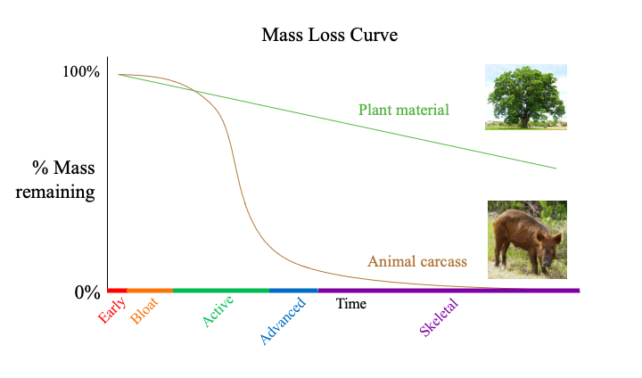
Figures
Figure 1.1: A general mass loss curve highlighting the traditional stages of decay. This curve depicts the typical difference in decomposition rates between plant (green) and animal matter (brown). Graph is a modified version of a graph from Carter et al. 2007. The morphological stages of decomposition are plotted along the x-axis; early (red), bloat (orange), active (green), advanced (blue), and skeletal (purple).

B
A
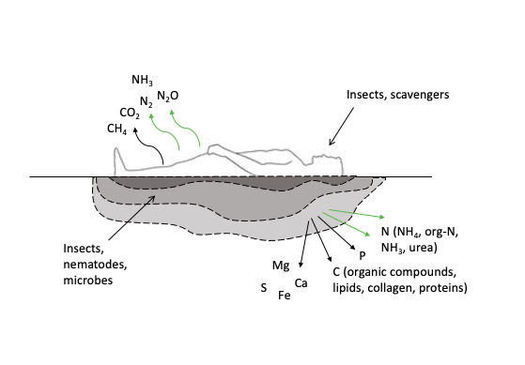
Figure 1.2: Portrayals of Cadaver Decomposition Islands (CDIs). (A) A depiction of the interaction of nutrients and insects within a CDI formed by human decomposition. (B) A CDI formed by a decomposing beaver carcass. The white dotted line symbolizes the boundary of the CDI. Photograph from Keenan et al. 2018b.
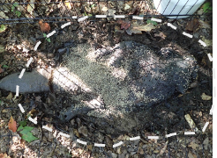
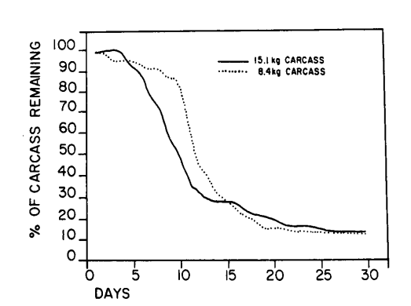

Figure 1.3: The variation in the rate of decay due to carcass mass. This mass loss curve is from Hewadikaram and Goff (1991) and shows the rate of decay in two pig carcasses weighing 8.4 kg (dotted line) and 15.1 kg (solid line).

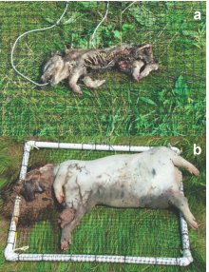
Figure 1.4: Images depicting the variation in the rate of decay due to carcass mass. These images are from Spicka et al. (2011) showing (A) 1 kg neonatal pig carcass five days postmortem, and (B) 50 kg pig carcass four days postmortem.

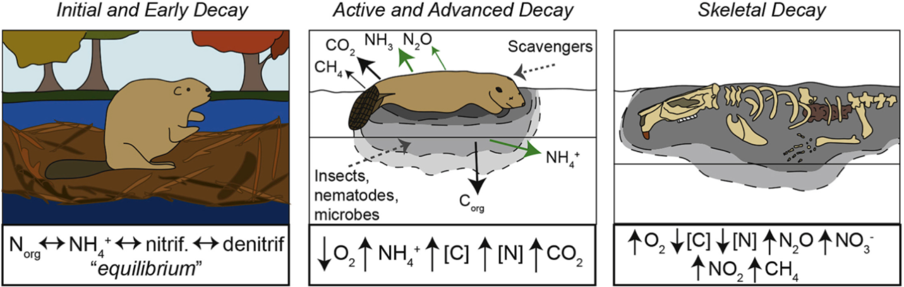
Figure 1.5: Phases of decomposition based upon soil biogeochemical cycling. The diagram provides a summary of the key transformations of total carbon ([C]) and nitrogen ([N]), as well as methane (CH₄), carbon dioxide (CO₂), ammonium (NH₄⁺), nitrous oxide (N₂O), nitrogen dioxide (NO₂⁻), and nitrate (NO₃⁻) through each biogeochemical phase. Schematic is from Keenan et al. (2018b).

Chapter 2: The impact of vertebrate decomposition on soil metabolic profiles over time

Contributions
Field sampling and laboratory processing and analyses were conducted by JMD, ST, MS, MW, and JKB. Assistance during field sampling was provided by AD. Metabolomic processing and extraction was performed by JKB, SH, and ZV. Statistical analyses of data were performed by JKB.

Abstract
Carrion decomposition may currently be undervalued in current nutrient cycle estimations. Upon decomposition of vertebrate remains nutrients are released into the surrounding environment, which has shown to increase landscape heterogeneity and biodiversity and change resource abundance and competition, ultimately altering the local ecosystem considerably. The nutrients from the animal carcass will enter the nutrient cycles and be recycled in the environment. Many studies have delved into carrion decomposition, fewer have investigated the effects of decomposition products on the surrounding environment and even less have assessed the effects on soil biogeochemical cycling. With the use of metabolomics, this study hopes to gain further insights into the effects of vertebrate decomposition on soil biogeochemical functioning and nutrient cycling. To achieve this goal, a human decomposition experiment was performed at the Anthropology Research Facility (ARF) at the University of Tennessee, Knoxville. It was hypothesized that human decomposition would have significant effects on soil metabolic profiles through fluctuations in metabolite richness and abundance, which will vary over time as decomposition progresses. Statistical analyses showed that decomposition caused significant changes in soil physiochemical characteristics such as decreases in soil pH and increases in soil electrical conductivity. Analysis of soil metabolomic profiles of control and decomposition-impacted soils revealed statistically significant differences between the two. In addition to this, the soil metabolites that were dominating the impacted soils varied overtime which suggested the flux of metabolites as the decomposition progressed. From this, metabolites that changed in similar ways were grouped together and graphed over time in order to theorize which metabolic pathways were dominant throughout decomposition. The fluctuations in metabolic profiles found in this study alter soil biogeochemical cycling, which ultimately affects the nutrient cycles at large.

Introduction
In terrestrial ecosystems, carrion decomposition serves as a nutrient source that releases critical nutrients into the surrounding environment. As with any nutrient sink or source, these nutrients will become a part of the nutrient cycle for the environment. This concentrated pulse of nutrients, or ‘hotspot’, that results from decomposition significantly alters the surrounding plants, animals, and soil. Vertebrate decomposition, in regards to the carcass itself, has been well studied throughout history. The effects of decomposition on soil biogeochemical cycling, though, have yet to be quantified fully and are not thoroughly understood. In this chapter, the newly emerging field of metabolomics was utilized in an attempt to characterize the effects of decomposition on the soil environment and how these affects vary over time.
In previous studies, carcass decomposition has been split into stages based upon morphological traits that present themselves in the carcass such as browning of the skin or mummification of soft tissues. While the stages vary between studies, the stages that will be referred to in this paper will be Early, Bloat, Active, Advanced, and Skeletal Decay stages. The progression of these stages is highly variable and are very sensitive to environmental conditions such as temperature and moisture. Additionally, insects and predators, when allowed access to the carcass, can significantly alter the progression of decomposition (Carter et al. 2007).
Soil-focused decomposition studies have linked certain soil physiochemical shifts induced by decomposition products to the decay stages. The pulse of carbon, nitrogen, phosphorus, and other nutrients that generally occurs when decomposition fluids are released from the carcass at the beginning of the Active Decay stage results in shifts in soil chemical characteristics such as pH, electrical conductivity, and microbial community profiles and functioning (Barton et al. 2013b; Carter & Tibbett 2006; Carter et al. 2007; DeBruyn et al. 2021; Keenan et al. 2018b; Parmenter & MacMahon 2009). Increases in electrical conductivity induced by decomposition products is regularly documented, but soil pH has shown to vary (Aitkenhead-Peterson et al. 2012; Benninger et al. 2008; Cobaugh et al. 2015; DeBruyn et al. 2021; Fancher et al. 2017; Hopkins et al. 2000; Keenan et al. 2018b; Meyer et al. 2013; Quaggiotto et al. 2019; Stokes et al. 2013; Szelecz et al. 2016). In human decomposition studies with human donors placed directly on the soil surface, pH has either decreased (Aitkenhead-Peterson et al. 2012) or had no significant change (Cobaugh et al. 2015; Fancher et al. 2017). Other species of vertebrates such as rabbits, pigs, and mice have shown to increase soil pH during decompositon (Benninger et al. 2008; Metcalf et al. 2013; Meyer et al. 2013; Quaggiotto et al. 2019; Szelecz et al. 2016). The soil directly around the carcas will experience sudden increases of microbial activity and shifts in community composition when decomposition fluids are released during Active Decay as well (Barton et al. 2013b; Carter & Tibbett 2006; Carter et al. 2007; DeBruyn et al. 2021; Howard et al. 2010; Keenan et al. 2018b; Pechal et al. 2014). Increases in microbial activity and respiration in the soil, induced by decomposition fluids, lead to the depletion of soil oxygen and sharp increases in ammonium, dissolved organic carbon, dissolved organic nitrogen, and carbon dioxide (Carter et al. 2007). Most of these shifts in soil physiochemistry are experienced during Active and Advanced Decay and will begin to approach baseline levels by the end of decay (Carter et al. 2007; Keenan et al. 2018b). While connecting these stages to the shifts seen in soil chemistry is a huge step forward for the field, connecting the changes in the carcass, plant response, and insect response to shifts seen in the soil microbial populations and biogeochemical cycling has still proven to be difficult. Soil metabolomics may be the missing link to connect vertebrate decomposition and nutrient cycling.
Metabolomics focuses on metabolites and metabolic interactions within a system to better understand the system’s functioning. Narrowing down a system’s ‘normal’ metabolome is highly difficult due to its highly sensitive nature when exposed to various environmental conditions. Therefore, metabolomics has moved from research into a single organism to community-level metabolomics in order to better assess the functioning of a system. There are two approaches to metabolomic sampling: untargeted and targeted (Alonso et al. 2015; Roberts et al. 2012). Targeted metabolomic approaches have a high specificity and result in highly precise and accurate data of an exclusive set of ‘known’ metabolites (Alonso et al. 2015; Roberts et al. 2012). A known metabolite is a metabolite that is at a detectable concentration, whose chemical structure has been identified, is present in a reference database, and has had certain chemical characteristics noted. While targeted approaches offer great benefits, when little is known of the metabolic status of a system, such as soils, an untargeted approach may offer more benefits. An untargeted approach to metabolomic sampling is not limited to the number of water-soluble molecules that can be detected, or any current extraction and detection methods. The lack of limitations results in both known and unknown (a metabolite that is at a detectable concentration but lacks a match in a reference database) metabolites being detected, leading to large datasets. When an untargeted approach to metabolomics is put in the context of soils, it may lead to better evaluation of soils while revealing new insights into soil biological communities.
The few soil metabolomic studies have already made significant progress with metabolomic fingerprints being tied to land-use (Ueberschaar et al. 2021), soil physiochemical properties (Cao et al. 2019; Withers et al. 2020), and certain plant populations (Mueller et al. 2020; Pétriacq et al. 2017). Only one study, thus far, has used metabolomics in a decomposition study (DeBruyn et al. 2021). In this study, they were able to identify specific metabolites related to human and pig decomposition and found evidence of increased microbial respiration and protease activities in soils exposed to decomposition fluids (DeBruyn et al. 2021). These studies suggest that the utilization of metabolomics may indeed lead to a greater understanding of the effects of decomposition on the soil environment.
This chapter aimed to contextualize fluctuations seen in soil chemistry due to decomposition products and assess how this might affect biogeochemical cycling. The physiochemical characteristics, soil pH and electrical conductivity, were significantly affected by human decomposition. Additionally, there was significant variation in metabolic profiles between early and late decay. These results suggest a significant effect on biogeochemical cycling in soils.

Objectives
The overall goal of this project was to analyze soils subjected to carcass decomposition to gain further insights into soil biological functioning and nutrient cycling through the utilization of soil metabolomics. In order to do this, two objectives were identified:
Objective 1
Characterize the soil metabolites that are dominant during vertebrate decomposition when compared to control soils.
Objective 2
Assess the fluctuation in soil metabolic profiles as decomposition progresses to identify how metabolic concentrations vary between decomposition stages.

Hypotheses
Two hypotheses regarding soil metabolites during decomposition were formulated.
- It was hypothesized that carcass decomposition would have a significant effect on the soil metabolome by causing changes in soil microbial community functional profiles through changes in metabolome characteristics such as increases in metabolite richness and abundance.
- It was hypothesized that soil metabolite concentrations would fluctuate over time as decomposition progresses. It was theorized that human-derived metabolites would reach maximum concentrations immediately following fluid release during active decay and slowly return to baseline levels, in a similar fashion to soil physiochemical characteristics.

Methodology

Study Design
Our objectives were addressed by conducting a human decomposition study with nine human individuals performed in an outdoor setting. The human decomposition experiment was conducted at the University of Tennessee Anthropology Research Facility (ARF) in Knoxville, TN (35° 56’ 28” N, 83° 56’ 25” W). The ARF is an outdoor laboratory designed to study human decomposition in various field settings. The ARF resides in a temperate deciduous forest with silt loam soils that are well-drained fine textured soils (DeBruyn et al. 2021). The experiment took place from July 2020 until September 2021. The experiment was done in three donor trials. Donor trial 1 began on 27 July 2020, donor trial 2 began on 18 September 2020, and donor trial 3 began on 09 April 2021. In each trial, 1 deceased individual (“donor”) was placed in each of three plots at the ARF (“J”,” F”, and “H”), for a total three donors per trial, and nine donors. A map of the three plots used in this study are shown in figure 2.1. A control site was preselected for each plot before any cadavers were placed and were used as the control site for that plot throughout the experiment. The locations of the donors and controls sites can be seen in figure 2.2. The control sites were close enough to the cadaver to have similar soil chemistry without being affected by the cadaver. Sampling times were based on the succession of decomposition stages and decided upon based on how fast decomposition was progressing. Because of this, sampling times varied in interval length between seasons. In order to make sampling time points comparable and to account for some seasonal differences between donor trials, all sampling time points were converted to accumulated degree hours (ADHs). The calculation for ADH is as follows: time (hr) + (average temperature for 24 hrs - temperature adjusted for 0 °C threshold). Donor trial 1 was 359 days (132,878 ADHs) long, donor trial 2 was 306 days (99,620 ADHs) long, and donor trial 3 was 103 days (51,430 ADHs) long.

Soil Analysis
Three to four cores of the top 15 cm of soil within the cadaver decomposition island (CDI), the area directly surrounding the carcass that is the most highly impacted, were collected using 3 cm diameter augers. All sampling tools (scoopulas, augers, etc.) were cleaned with 70% ethanol between each sample. The cores were homogenized to create a composite sample that represented the entire CDI. 20 g of the homogenized soil were flash frozen in liquid nitrogen and set aside for metabolomic profiling. The rest of the composite samples were transported back to the laboratory and held at room temperature until further processing. Any plant matter or rocks present in the sample were removed by hand. Subsamples of the soil were subdivided to determine soil pH, electrical conductivity, and gravimetric moisture. Soil gravimetric moisture was found by measuring the mass lost after 72 hours in an oven heated to 105 °C. Soil slurries were made by adding 6 mL of ionized water to 3 g of soil. Electrical conductivity and pH of the slurries were measured using an Orion Star 329 handheld multiparameter meter and separate calibrated pH and electrical conductivity probes. Electrical conductivity was measured immediately after vortexing the soil slurry at maximum speed for 25 s. The pH of the soil slurry solution was measured after allowing fine particles to settle (approximately 15 min). Data analyses of the physiochemical properties of the soils were done in R v4.0.2 using R Studio V1.4.1717. One-way analysis of variance (ANOVA) tests were performed to detect statistically significant differences in the soil physiochemical properties between donor trials (1, 2, and 3), plots (“F”. “H”, and “J”), time (ADH), and treatments (donor or control). Two-way ANOVA tests were then performed to identify significant differences in the soil physiochemical characteristics grouped by trial and plot, ADH and trial, and ADH and plot.

Soil Metabolomics Sample Processing
To prevent degradation of soil metabolites, 20 g of soil were removed from the homogenized core sample in the field and immediately flash frozen in liquid nitrogen. The flash frozen samples were stored at -80 °C until time for further processing. Approximately 100 mg of frozen soil was ground in liquid nitrogen using a mortar and pestle, then transferred to 2 mL tubes for extraction. The following metabolomic extractions took place in a cold room (4 °C) at the Biological and Small Molecule Mass Spectrometry Core Lab at the University of Tennessee, Knoxville following the metabolic extraction protocol detailed in (DeBruyn et al. 2021): 1,300 µl of metabolite extraction solvent consisting of 40:40:20 HPLC grade methanol, acetonitrile, and water with 0.1 M formic acid was added to the ground aliquot of sample in each centrifuge tube. The tube was then vortexed at maximum speed for 5 s and placed in an orbital platform shaker and shaken for 20 min. After, the samples were centrifuged for 5 min at 16,100 rcf until pellet formed and the debris fell out of the solution. Once all debris had fallen from the solution, supernatant was transferred to a new tube and 200 µl more of the metabolite extraction solution was added to the original tube containing the soil sample. The tubes with soil sample and 200 µL extraction solvent were vortexed at maximum speed for 5 s, placed on the shaker and shaken for 20 min, then centrifuged on 16,100 rcf for 5 min. The supernatant from the second round of extraction was combined with the supernatant from the first round and dried under a stream of nitrogen gas for 2 to 3 h. The dried residues were then suspended in 300 µL of milli Q water and transferred to autosampler vials for mass spectrometric analysis. Mass spectrometry protocols were adapted from (Lu et al. 2010) and followed the methods described in (Mueller et al. 2020). Autosampler vials were placed in autosampler trays and held at 4 °C. An aliquot of 10 µl was taken from each vial and injected through a Synergi 2.5 µ reverse-phase HydroRP 100, 100 mm x 2.00 mm liquid chromatography column at 25 °C. Ionizaton of the chromatographic elution was done through electrospray ionization (ESI) with a capillary temperature of 320 °C, spray voltage of 2 kV, and nitrogen sheath gas at 10 units. The ionized elution was immediately introduced to the Exactive Plus Orbitrap mass spectrometer. Liquid chromatography mass spectrometry (LC—MS) analysis was executed in negative ion mode with a full-scan covering a window of 85 to 800 m/z from 0 to 9 min and 110 to 1,000 m/z from 9 to 25 min. Negative ion mode was utilized due to the positive ion mode being suppressed from an ion pairing agent being used in the chromatography (Mueller et al. 2020; Stough et al. 2016). The acquisition gain control target was 3e6 with resolution set to 140,000. Solvent A consisted of 97:3 water:methanol with 15 mM acetic acid and 10 mM tributylamine, while solvent B consisted of 100% methanol. With a constant flow rate of 200 µl min⁻¹ the gradient was as follows: 0 to 5 min: 100% solvent A 0% solvent B, 5 to 13 min: 80% solvent A 20% solvent B, 13 to 15.5 min: 45% solvent A 55% solvent B, 15.5 to 19.5 min: 5% solvent A, 95% solvent B, 19 to 25 min: 100% solvent A 0% solvent B. The mass spectrometry data files produced by Xcalibur were converted to mzML format using the Proteowizard package. Sample nonlinear retention time correction, metabolite identification, and chromatogram integration were performed using El-MAVEN. Manually selected metabolites were identified based on known standards (+-5 ppm mass tolerance and less than or equal to 1.5 retention time tolerance) using reference databases, resulting in identification of “known” metabolites. El-MAVEN’s automatic peak detection algorithm was used to note unidentified spectral features with algorithm settings at: mass domain resolution at 10 ppm, tie domain resolution at 10 scans, and EIC smoothing at 5 scans with 0.5 grouping. This resulted in the collection of “unknown” metabolites, meaning a metabolite with an unidentified chemical structure which does not match any metabolites in the reference database. Baseline smoothing was set at 5 scans, where the bottom 20% of intensities were kept from chromatogram for baseline calculation and the top 80% were dropped. Peaks were scored based on a trained classifier model which looked for 4 minimum peaks per group, 5 scan minimum peak width, 5 minimum signal-to-noise, 5 minimum signal-to-blank, and 10,000 minimum signal intensity. Soil dry weight was used to normalize spectral features. Then, relative intensity for each metabolite was calculated as the intensity in a given sampled normalized to intensities in all samples.

Soil Metabolomics Analysis
Due to timing constraints and machine availability, the metabolomic samples were divided into two sets. The first set of samples were analyzed in February 2021 and the second set in August 2021. All samples were normalized by soil dry weight to find relative
intensities. Each sample set was then further divided into batches which correlate to the day they were analyzed using the mass spectrometer. The first sample set included batches A, B, C, D, and E. The second data set included batches F, G, and H. The relative intensities were uploaded to MetaboAnalyst v5.0, an online statistical analyzer designed specifically for metabolomic datasets (Pang et al. 2021), with the parameters: sample normalization = none, data transformation = log, and data scaling = none. Partial least squares-discriminant analysis (PLS-DA) and one-way analysis of variance (ANOVA) were used to assess batch effects. These analyses revealed that there were significant batch effects present in our data (ANOVA p < 0.05, table 2.1) (figure 2.3 A).
Upon discovering this, certain steps were taken to minimize the effects. First, metabolite peaks were repicked and renormalized using sample dry weight. This, however, did not adequately resolve the variability between batches. A background metabolite that was at a relatively stable concentration throughout the experiment, was chosen to use as the normalization factor. All metabolites were then normalized against the metabolite chosen, aconitate. While this also did not completely resolve the variability present in our data (figure 2.3 B, table 2.2), it reduced it considerably and it was decided to move forward with statistical analyses of the data. Therefore, all metabolomic data analysis included batch as a block effect to ensure that difference reported were due to experimental variables, and not an artifact of a batch effect.
Two sample t-tests and Wilcoxon rank-sum tests were performed using MetaboAnalyst v5.0 (Pang et al. 2021) to determine whether the variation in metabolic profiles between control and decomposition-impacted soils were statistically significant (p < 0.05). MetaboAnalyst was used, again, to perform a PLS-DA to generate a 2D scores plot. From the PLS-DA, a list of variable importance in projection (VIP) scores was produced. The metabolites with the highest VIP scores are those that are the most responsible for driving the variation between control and impacted soils. A VIP score greater than 1.0 was considered high in this study. Pathway analyses were performed using the online statistical analyzer as well to identify which metabolic pathways were the most highly impacted by the metabolites present in the sample (Pang et al. 2021). In order to perform a pathway analysis a reference database must be chosen to compare impacted pathways against. For this study, the KEGG (Kyoto Encyclopedia of Genes and Genomes) pathway library for the prokaryote Pseudomonas putida was used (Kanehisa et al. 2021).
Once there was statistical evidence for differences between control and decomposition-impacted soils, the next focus was assessing the variation in metabolic profiles over time. Heatmaps were generated also using MetaboAnalyst and organized by donor trial, treatment, and ADH to assess the variation in metabolic profiles as decomposition progressed. The heatmap and soil physiochemical analyses showed that even when sampling time points were converted to ADHs, there were still some variations in the progression of decomposition between the donor trials. These variations provided some difficulty in assigning ADHs to decomposition stages. For this reason, it was decided that in this study the metabolomics data would be divided into early (0 – 30,000 ADH) and late (30,000 ADH – end) decay stages. The split between early and late decay stages was decided based upon when the peak concentration of ammonium occurs in hopes to identify metabolic profiles associated with such conditions. The timing of the ammonium pulse has been well documented in previous decomposition studies and generally corresponds with active and early advanced decay stages (Keenan et al. 2018b). This period of increased ammonium concentrations is often accompanied by enhanced respiration and a significant depletion of soil oxygen (Aitkenhead-Peterson et al. 2012; Carter et al. 2007; Cobaugh et al. 2015; Keenan et al. 2018b). A two-sample t-test and Wilcoxon rank-sum test was performed to see the statistical significance between soil metabolic profiles of early and late decomposition soils (p < 0.05). A PLS-DA was performed generating both a 2D scores plot and a VIP scores list, again identifying the metabolites responsible for driving the variation between the metabolomic profiles. Combining information gathered using the VIP scores from the PLS-DA, clusters of metabolites identified in the heat map, and predominant metabolomic profiles identified through the pathway analysis, impactful metabolites which saw changes over time were selected to be graphed by their relative concentrations over time again in R using R Studio. This allowed for the identification of patterns within metabolic profiles associated with the process of decomposition.

Results

Soil Physiochemistry
Because donor trials took place during different seasons, and experienced different amounts of thermal energy, sampling timepoints were converted into accumulated degree hours (ADHs). Comparing treated (decomposition-impacted) soil to control soil, soil gravimetric moisture content was not significantly affected by decomposition in any of the donor trials and generally followed the trends seen in control soils (ANOVA p < 0.05) (table 2.3, figure 2.4A). Soil electrical conductivity (EC) was significantly affected by decomposition products for all trials (ANOVA p < 0.05) (table 2.3, figure 2.4B). In donor trial one the control site had a mean EC of 40.71 μS cm⁻¹, while impacted soils had a mean EC of 177.05 μS cm⁻¹. Donor trial two and three control soils had mean ECs of 46.03 μS cm⁻¹ and 70.8 μS cm⁻¹, while impacted soils had mean ECs of 202.67 μS cm⁻¹ and 266.8 μS cm⁻¹, respectively. Timing of the maxima of EC across the trials varied with donor trial one maximum being 513.6 μS cm⁻¹ at 3,714 ADH and donor trial two maximum of 835 μS cm⁻¹ at 19,894 ADH. Both donor trials one and two soils reached maximum ECs around active decay and slowly approached baseline levels as decomposition continued. Donor trial three soils did not reach maximum EC (696 μS cm⁻¹) until much further into decomposition at 51,430 ADH. In donor trial three EC increased through the end of sampling and did not decline back to control levels. Decomposition products were found to significantly impact soil pH as well (ANOVA p < 0.5) (table 2.3, figure 2.4C). Once fluids escaped the carcass and decomposition fluids entered the soil, the pH decreased significantly in all trails. The pH remained decreased through the duration of the experiment. Control sites for donor trials 1, 2, and 3, had mean a mean pH value of 7.31, 7.4, and 7.35, respectively. Donor trial 1 soils reached a minimum pH of 5.34 twice at 14,611 ADH and 18,574 ADH. Donor trial 2 soils reached a minimum pH of 5.49 twice at 22,451 ADH and 26,630 ADH. Donor trial 3 soils only reached a minimum pH of 5.37, the lowest pH across the three trials, once at 14,260 ADH.

Soil Metabolomic Analyses

Control versus Donor
Any discussion of metabolites in this these refers to known metabolites, no unknown metabolites have been considered at this time. The number of identified “known” metabolites detected between control and donor soils varied (ANOVA F-value = 124, p = <2e-16). Control samples had a mean number of metabolites detected per sample of 54, while donor impacted samples contained a mean of 73 metabolites per sample. Overall, control samples contained anywhere from 25 to 87 metabolites. Donor impacted soils, on the other hand, had a much wider range with some samples having as few as 12 metabolites or as many as 105.
As with pH and electrical conductivity, statistical analyses (PLS-DA, two-sample t-test and Wilcoxon rank-sum test) showed individual soil metabolite concentrations between control soils and impacted soils were significantly different (figure 2.5) (p < 0.05, table 2.4). The metabolites that were the most responsible for driving the variation between control and donor soils in the PLS-DA were identified by variable importance in projection (VIP) scores. There were 32 metabolites with VIP scores > 1.0, with indoleacrylate, 3-methylthiopropionate, xanthine, xanthurenic acid, kynurenic acid, and taurine having the highest VIP scores overall (figure 2.6).
A pathway analysis was performed using MetaboAnalyst. This tool uses p values from a pathway enrichment analysis and pathway impact values from the pathway topology analysis to visualize which metabolic pathways are the most highly impacted (figure 2.7). These pathways included phenylalanine metabolism (p < 0.001, impact value = 0.14622), sulfur metabolism (p < 0.001, impact value 0.04261), alanine, aspartate, and glutamate metabolism (p < 0.001, impact value = 0.04261), phenylalanine, tyrosine and tryptophan biosynthesis (p < 0.001, impact value = 0.98507) and taurine and hypotaurine metabolism (p < 0.001, impact value = 1).
A heatmap using relative intensities of the metabolites was generated using MetaboAnalyst (figure 2.8). The heatmap was organized by treatment (donor or control), donor trial (1, 2, or 3) and accumulated degree hours (ADH). It allowed us to see that the metabolites were changing as the experiment progressed.

Early versus Late Decomposition Stages
The variation in metabolic profiles between early (0 ADH – 30,000 ADH) and late (30,000 ADH – end) stages was assessed. This distinction between early and late decomposition was chosen to reveal soil metabolomic profiles associated with elevated ammonium and anoxic soil conditions that have been previously documented in other decomposition studies during the earlier stages of decay (Aitkenhead-Peterson et al. 2012; Carter et al. 2007; Cobaugh et al. 2015; Keenan et al. 2018b). Two-sample t-tests and Wilcoxon rank-sum tests showed if the difference in concentration for each individual metabolite was statistically significant between early and late decomposition soils (p < 0.05, table 2.4). It was found that 60 metabolites were significantly different between early and late decomposition, while 68 metabolites were not. A PLS-DA generated a 2D scores plot to visualize differences between metabolic profiles of early and late decomposition soils (figure 2.9). A list of metabolites with high VIP scores was generated. There were 44 metabolites with VIP scores > 1.0, with guanine, 2-oxo-4-methylthiobutanoate, tryptophan, creatine, homociltrulline, and allantoate being among the highest (figure 2.10). Of the 44 metabolites with high VIP scores, only two metabolites (creatine and 3-methylphenylacetic acid) were at higher concentrations during early decay compared to late decay.
Using the VIP scores from both PLS-DAs, clusters of metabolites identified from the heatmap, and predominant metabolic profiles identified through the pathway analysis, impactful metabolites which saw changes over time were selected to be graphed by their relative concentrations over time (figure 2.11). To simplify the data only metabolites that were from impacted pathways, those with high VIP scores (VIP score > 1), or amino acid metabolites were chosen. Amino acid metabolites were chosen due to previous decomposition studies noting high concentrations of amino acids in decomposition fluids (DeBruyn et al. 2021; Macdonald et al. 2014). This selection process allowed us to identify patterns within metabolites associated with different stages of decomposition. Group 1 metabolites had a large number of metabolites with high VIP scores (indoleacrylate, kynurenic acid, hypoxanthine, etc.) and some metabolites involved with impacted pathways (shikimate, anthranilate, etc.), as well as some amino acids (taurine, alanine, glutamine, etc.) (table 2.5). The concentrations of the metabolites in this group quickly increase and reach a maximum ~ 14,000 ADH in early decay, slowly decreased until ~70,000 ADH, then increased until the end of the experiment (figure 2.12). The concentration maximum in Group 1 was the highest out of all the groups. Group 2 metabolites had some metabolites with high VIP scores (allantoate, allantoin, creatine, etc.), some amino acids (aspartate, tyrosine, proline, etc.), and some metabolites involved in highly impacted pathways (succinate, phenylpyruvate, pyruvate, etc.) (table 2.5). Group 2 followed a very similar pattern to group 1, reaching a maximum during early decay around 14,000 ADH, decreased, and then increased again later in decay (figure 2.12). Group 2 metabolites had a lower maximum concentration than group 1, but had a greater increase towards the end of the experiment in late decay. Group 3 metabolites only had a few amino acids (lysine, histidine, etc.) along with metabolites from highly impacted pathways (oxaloacetate, fumarate, pephenate, etc.) and with high VIP scores (nicotinate, xanthurenic acid, N-acetylglutamate, etc.) (table 2.5). Metabolite concentrations in this group saw a slight increase during early decay around the time of fluid release (~14,000 ADH) and reached a maximum during late decay (~45,000 ADH) (figure 2.13). Group 4 metabolites only had two metabolites with high VIP scores (sucralose and 2-oxo-4-methylthiopropionate), 2 metabolites from impacted pathways (homoserine and phosphoenolpyruvate), and a few amino acids (valine, glycine, homoserine, and serine) (table 2.5). This group had very low concentrations during early decay with a small increase in concentration that aligns with fluid release (~14,000 ADH). Group 4, however, reached a maximum well into late decay (~70,000 ADH), followed by a decrease towards the end of the experiment (figure 2.13).

Discussion
An untargeted approach to metabolomics coupled with a LC—MS technique was used to assess the effects of mammalian decomposition on soils directly surrounding human cadavers. It was found that compounds produced during decay significantly altered soils in this experiment. That is, when soils were exposed to decomposition there were significant changes in soil physiochemical characteristics, nutrient levels, and metabolic profiles compared to control soils which were not subjected to decomposition. The results of this study support previous findings regarding decomposition fluids leading to changes in microbial activities and enhanced metabolism. Additionally, the results of this experiment show that decomposition products induce a ‘succession’ of metabolites in the soil over time as decomposition progresses. The characterization of the succession of metabolites and the influence that may have over metabolic processes occurring in the soil, may lead to new insights into nutrient cycling in the environment.
Soils metabolomes in this experiment were dominated by organic acids (amino acids, carboxylic acids, etc.), organoheterocyclic and organic oxygen compounds (azoles and carbohydrates), and nucleosides/nucleotides (pyrimidine nucleosides, purine nucleosides, etc.). While not commonly discussed, the presence of nucleosides and nucleotides is unsurprising as previous studies have noted their presence in agricultural and forest soils (Phillips et al. 1997; Pietramellara et al. 2008). While both control and decomposition-impacted soils were dominated by amino acids (leucine/isoleucine, glutamate, and methionine) and organic compounds (allantoin and trehalose/sucrose), statistical analyses revealed that the concentrations of these metabolites were statistically different. Additionally, there were metabolites found in the decomposition-impacted soils that were not detected in the control samples, such as aconitate, dipicolinate, and glyoxylate.
The analyses revealed that 106 metabolites were detected at significantly different concentrations in decomposition soils compared to controls (22 metabolites were found to be insignificant, including frequently detected trehalose/sucrose). The 106 metabolites classified as significantly changed by decomposition included 32 metabolites with high VIP scores. Most of the metabolites changed by decomposition increased in concentration, but acetoacetate, riboflavin, and glycolate decreased in concentration when exposed to decomposition. The most significant metabolites, meaning the metabolites with the biggest difference in concentration between the two treatments, were taurine, indoleacrylate, kynurenic acid, glutamine, and xanthurenic acid. Taurine and glutamine are both classed as amino acids, kynurenic and xanthurenic acids are classed as quinolines, and indoleacrylate is an indole. Kynurenic and xanthurenic acids are produced by tryptophan metabolism and can be found on the skin and in blood, feces, and urine of humans (Kanehisa et al. 2021; Wishart et al. 2022). Indoleacrylate is recognized as a growth hormone in plants, but its function in humans is not yet well understood. However, indoleacrylate has been detected in blood, feces, and urine of humans (Kanehisa et al. 2021; Wishart et al. 2022). Taurine, a sulfur amino acid, does not partake in protein biosynthesis like other amino acids and instead acts as a stabilizer of cell membranes. Taurine can be found in bile and other bodily fluids, as well as in a multitude of human tissues (Kanehisa et al. 2021; Wishart et al. 2022). Glutamine, an alpha-amino acid, is a proteinogenic amino acid meaning it is utilized for protein biosynthesis. It is the most abundant amino acid found in the human body and is found in especially high concentrations in blood and muscles. As an energy source, glutamine is in a multitude of metabolic reactions and pathways such as alanine, aspartate, and glutamate metabolism and in the urea cycle (Kanehisa et al. 2021; Wishart et al. 2022). All of these metabolites can be found can be found abundantly in a healthy adult and in their bodily fluids, as well as being produced by soil microbes; therefore, it is reasonable that the concentrations of these metabolites increased considerably when exposed to human decomposition leading to enhanced microbial metabolisms.
A pathway analysis was performed in order to identify which metabolic pathways were the most highly impacted by decomposition products. The most impacted metabolic pathways were alanine, aspartate, and glutamate metabolism, taurine and hypotaurine metabolism, phenylalanine metabolism, phenylalanine, tyrosine, and tryptophan biosynthesis and sulfur metabolism. The most impacted pathways belonged to metabolisms classed under amino acid metabolism (alanine, aspartate, and glutamate metabolism, taurine and hypotaurine metabolism, phenylalanine metabolism, phenylalanine, tyrosine, and tryptophan biosynthesis) and energy metabolism (sulfur metabolism). Additionally, other pathways were impacted by decomposition but not statistically significantly. There were other pathways impacted by decomposition belonging to amino acid metabolism (cysteine and methionine metabolism, urea cycle, etc.) and energy metabolism (oxidative phosphorylation, carbon fixation, nitrogen metabolism, etc.), as well as those classed under carbohydrate metabolism (glycolysis/gluconeogenesis, citric acid (TCA) cycle, amino sugar and nucleotide sugar metabolism, etc.), nucleotide metabolism (purine, pyrimidine metabolism), metabolism of cofactors and vitamins (nicotinate and nicotinamide metabolism, pantothenate and CoA biosynthesis, etc.), and the biosynthesis of other secondary metabolites (biosynthesis of various alkaloids, glucosinolate biosynthesis, etc.).
Building upon the effects of decomposition of soil metabolic profiles, further statistical analyses of decomposition-impacted soils revealed 60 metabolites had significantly different concentrations in early and late decomposition, including 42 of the 44 metabolites with high VIP scores (3-methylphenylacetic acid and cysteate were insignificant). The majority of the 60 significant metabolites were detected at higher concentrations during late decay, with the captionon of creatine and cystathionine, which were elevated during early decay compared to late. Creatine and cystathionine are both amino acids, though neither are classed as proteinogenic amino acids meaning they are not involved in protein biosynthesis (Kanehisa et al. 2021; Wishart et al. 2022). Cystathionine is involved in glycine, serine, and threonine metabolism and is an intermediate in cysteine biosynthesis. Creatine facilitates the recycling of adenosine triphosphate (ATP), an energy source for all living things. It is produces from the amino acids arginine and proline and is mainly found in muscular tissue of humans (Kanehisa et al. 2021; Wishart et al. 2022). While the differences in concentrations for taurine, xanthurenic acid, kynurenic acid, and indoleacrylate were not significant, their concentrations were higher during early decay compared to late. Coincidentally, these metabolites were the most significant in driving the variation between donor and control soils.
Information garnered from the statistical analyses discussed thus far combined with the hierarchical clustering on the heatmap allowed for the identification of metabolites that were changing in the soil in similar ways (i.e., experienced either increases or decreases in concentration around the same times) as decomposition progressed. Investigating the groups of metabolites in the context of impacted pathways and metabolisms revealed insights regarding the timing of the fluctuations in metabolite concentrations. A list of metabolites belonging to each group can be found in table 2.5. The concentrations of metabolites in group 1 reached a maximum concentration, the highest maximum out of all groups, around 14,000 ADH. The metabolites in the first group were dominated by amino acids and involved in related metabolisms (alanine, aspartate, and glutamate metabolism and phenylalanine, tyrosine, and tryptophan biosynthesis, etc.) as well as nucleotide metabolism (pyrimidine metabolism and purine metabolism). Group 2 metabolites, which were also elevated around 14,000 ADH, were highly involved in the phenylalanine associated impacted pathways as well as other amino acid pathways (urea cycle, arginine and proline biosynthesis, etc.). Additionally, group 2 metabolites had the highest level of interaction in the metabolism of carbohydrates (citric acid (TCA) cycle) and of cofactors and vitamins (nicotinate and nicotinamide metabolism and pantothenate and CoA biosynthesis) and the biosynthesis of secondary metabolites (biosynthesis of phenylpropanoids, biosynthesis of alkaloids derived from shikimate pathway, and biosynthesis of alkaloids derived from ornithine, lysine, and nicotinic acid).
Metabolite groups 3 and 4 reached maximum concentrations much further into decomposition during late decay. The metabolites in the third group experienced a slight increase around the time of fluid release in early decay but did not reach a maximum concentration until late decay (around 45,000 ADH), considerably later than the first two groups. The highly impacted pathways affected by the metabolites belonging to this group included phenylalanine, tyrosine, and tryptophan biosynthesis and alanine, aspartate, and glutamate metabolism. Metabolites in this group were more involved in carbohydrate metabolism (citric acid (TCA) cycle) and the biosynthesis of secondary metabolites (biosynthesis of phenylpropanoids, biosynthesis of alkaloids derived from the shikitmate pathway, from ornithine, lysine, and nicotinic acid, from histidine and purine, and from terpenoid and polyketide). The last group, group 4, first reached a minimum concentration in the beginning of late decay (around 27,000 ADH), then rapidly increased reached a maximum concentration at 70,000 ADH). The pathways enhanced by the metabolites in this group belonged to the highly impacted sulfur metabolism and other energy metabolisms (methane metabolism, nitrogen metabolism, and carbon fixation).
The results discussed thus far can be used to deduce some information about the metabolic succession and related functions occurring in the soil during decomposition. More specifically, the catabolic-related groups (groups 1, 2) containing more amino acids reached maximum concentrations during early decay. This finding supports previous decomposition studies which noted high concentrations of amino acid in decomposition fluids produced from the breakdown of proteins in the body (DeBruyn et al. 2021; Macdonald et al. 2014). The amino acids and various nutrients present in decomposition fluids were further broken down through various catabolic processes, such as amino acid degradation and carbohydrate metabolism, that were occurring during early decay. The enhanced degradation of these compounds leads to the sudden drop in concentrations for both groups after ~14,000 ADH. The metabolites in the anabolic-related groups (group 3,4) were highly involved in biosynthesis and energy metabolisms as well as the metabolism of cofactors and vitamins. The endergonic pathways dominating these groups utilized products of pathways in the catabolic reactions in groups 1 and 2, as well as the energy produced from the citric acid (TCA) cycle. Generally, it seems as though more ‘human’-derived microbes and metabolisms are contained in groups 1 and 2, while groups 3 and 4 seem to be more microbial based metabolisms where microbes are assimilating the new resources.
The relative minima (groups 1, 2) and maxima (groups 3, 4) metabolic concentrations seen between 14,000 ADH and 75,000 ADH align with the depletion of oxygen noted in a previous decomposition study (Keenan et al. 2015). Before the publication of Keenan et al. (2018b), the lack of soil oxygen during this time in the decay process has only been theorized based on the abundant microbial communities (Cobaugh et al. 2015) or the presence of reduced compounds (Carter et al. 2007; Aitkenhead-Peterson et al. 2012). Keenan et al. (2018b) noted the depletion of oxygen was coupled with significantly increased levels of respiration adding additional support to changes seen in soil physiochemical characteristics and metabolic concentrations found in this study. Furthermore, the anaerobic soil conditions in this study may be used as evidence for the switch from catabolic metabolisms to anabolic during this time. That is, many of the catabolic metabolisms and microbial activities dominating during early decay may be dependent on the presence of oxygen and cease when it is depleted. The inhibition of these oxygen-dependent functions then allows for anaerobic, anabolic metabolisms to dominate during this time. The reentry of oxygen into the soil (~75,000 ADH) also explains the sudden increase in concentration levels of metabolic groups 1 and 2 near the end of the experiment, meaning these metabolisms become enhanced again.
In this study, untargeted metabolomics was utilized in order to assess variation in soils induced by the process of vertebrate decomposition. Through statistical analyses, metabolites responsible for driving the variation between control and decomposition-impacted soils were identified and included indoleacrylate, kynurenic and xanthurenic acids, taurine, and glutamine. Additionally, metabolite concentrations that were most significantly impacted by the progression of decay (i.e., experienced the biggest changes in concentration between early and late decay) were identified. Moreover, this study was able to support the growing amount of decomposition-based literature which suggests that mammalian decomposition leads to a depletion of soil oxygen coupled with increased metabolism and microbial activities. The enhanced metabolism and microbial activities of soil microorganisms result in increased levels of respiration as well as initiating a multitude of metabolic pathways. The metabolic pathways that are impacted by decomposition lead to increased rates of nitrogen and carbon cycling, specifically nitrogen fixation and carbon consumption. Therefore, it is reasonable to assume that decomposition does indeed influence nutrient cycling, not only in the soil, but in the environment as well.

Acknowledgements
We would like to thank the University of Tennessee Anthropology Research Facility and Dr. Dawnie Steadman for providing space in the facility for this project. We would like to express our deepest gratitude to the donors and their families for their gifts to the Forensic Anthropology Center donation program. Additionally, we would like to thank Anielle Duncan, Stacy Taylor, Mallari Starrett, and Morgan White for site setup and preparation, sample collection, and sample processing assistance. We would also like to thank the Biological and Small Molecule Mass Spectrometry Core Lab at the University of Tennessee and Dr. Shawn Campagna for providing the instrumentation needed for this project, as well as Sarah Howard and Zane Vickery for assistance in sample processing and analysis. This research was supported by Defense Advanced Research Projects Agency Agreement D20AC00007 and USDA Hatch funding. The views, opinions and/or findings expressed are those of the authors and should not be interpreted as representing the official views or policies of the US Government. Approved for public release; distribution is unlimited.

Appendix

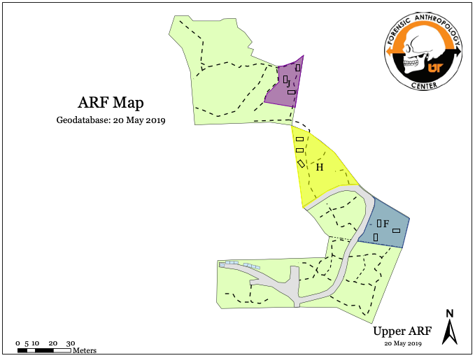
Figures
Figure 2.1: A map of the Anthropology Research Facility (ARF) showing the layout of the facility and the proximity of the plots used in this study. Plot J is highlighted in purple, plot H in yellow, plot F in blue. A black rectangle represents the location of a donor, these are not to scale.

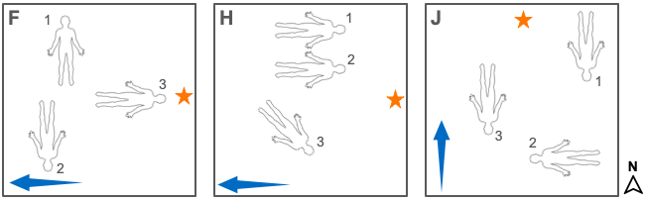
Figure 2.2: A diagram of donor placement within plots (F, H, and J). The placement of the three donors (1, 2, 3) in the three plots used in this study (F, H, J). The numbers refer to the order the donors were placed. The orange star symbolizes the control sampling site for each plot. The blue arrow indicates slope, with the arrow pointing downhill. These are not to scale.

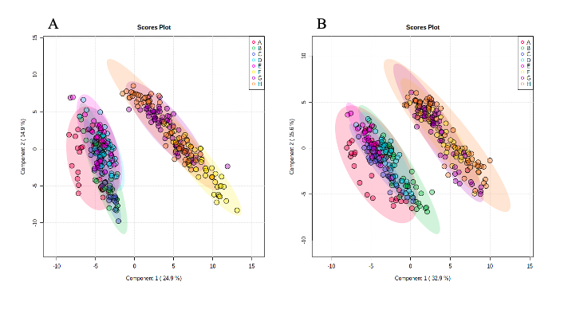
Figure 2.3: 2D scores plots of batch effects in metabolic data. A) A 2D scores plot from a PLS-DA analyzing the variation between batch 1 (A, B, C, D, E) and batch 2 (F, H, G). B) A 2D scores plot from a PLS-DA analyzing variation between batches after normalizing metabolite concentrations to the metabolite aconitate in an attempt to minimize batch effects. The shaded ovals represent the 95% confidence intervals for each batch. Batch A is denoted by red, batch B is green, batch C is dark blue, D is light blue, E is pink, F is yellow, G is purple, and H is orange.

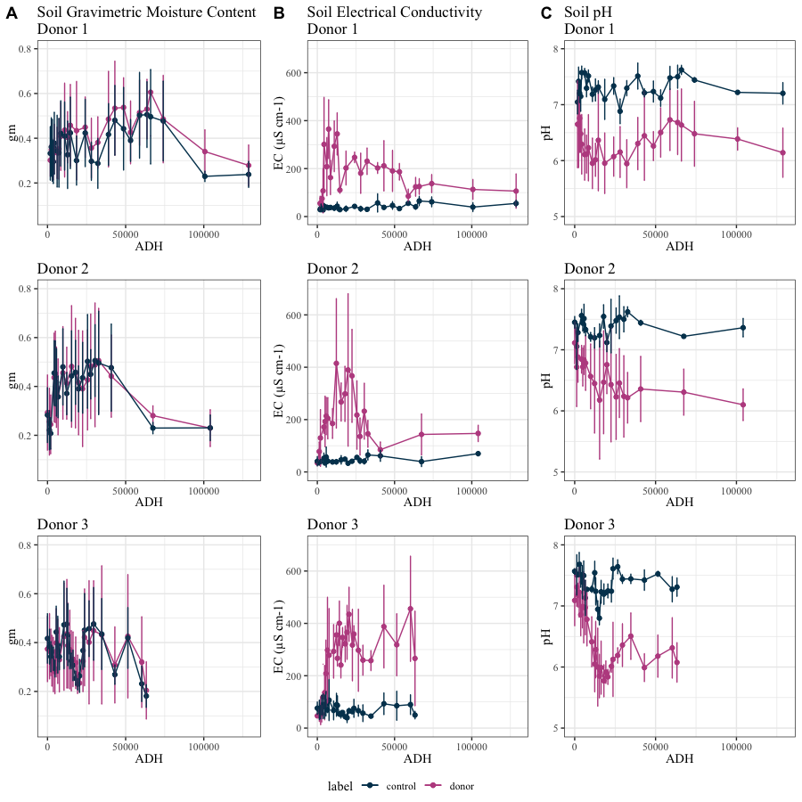
Figure 2.4: Graphs of decomposition-induced changes in soil physiochemical characteristics. Changes in soil (A) gravimetric moisture content, (B) electrical conductivity, and (C) pH when exposed to decomposition. The lines are representative of the mean value for the triplicates across plots (F, H, and J) with appropriate standard deviation bars. The blue line represents the control values and the pink line represents donor impacted soils.

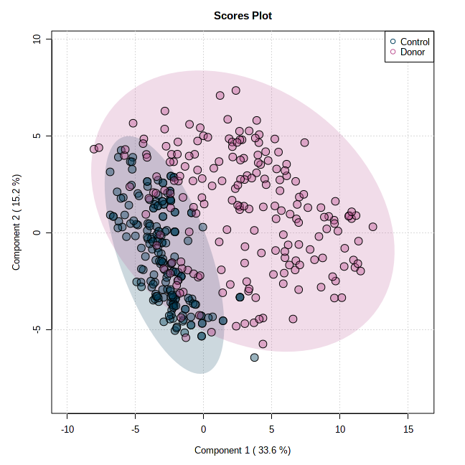
Figure 2.5: A 2D scores plot of control and decomposition-impacted soils. This plot assesses the variation in metabolic profiles between control and decomposition-impacted (donor) soils. Blue represents control values, while pink represents donor values. The shaded areas represent the 95% confidence intervals.

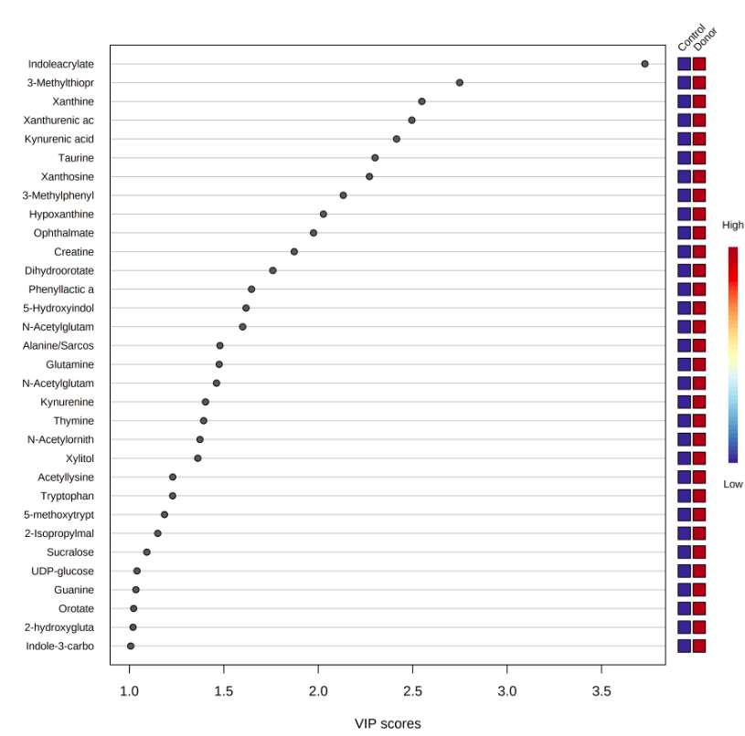
Figure 2.6: Metabolites with High Variable Importance in Projection (VIP) scores in control and decomposition-impacted soils. These metabolites had VIP scores higher than 1 identified through a PLS-DA between control and decomposition (donor) impacted soils. The boxes to the right of the graph symbolize the concentrations of each metabolite in the control and donor sample. All metabolites are higher in donor soils compared to control soils. 3-Methyltiopr = 3-Methylthipropionate, Xanthurenic ac = Xanthurenic acid, 3-Methylphenyl = 3-Methylphenylactic acid, Phenyllactic a = Phenyllactic acid, 5-Hydroxyindol = 5-Hydroculindoleacetic acid (5-HIAA), N-Acetyluglutam = N-Acetylgutamate, N-Acetylglutam = N-Acetylglutamine, N-Acetylornith = N-Acetylornithine, 5-methoxyttryp = 5-methoxytrptophan, 2-Isopropylmal = 2-Isopropylmalate, 2-hydroxyglutaric acid, Indole-3-carbo = Indole-3-carboxylate.

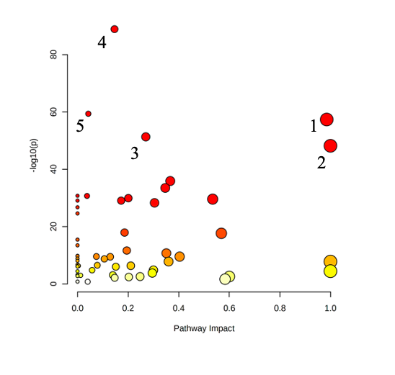

Figure 2.7: The pathway analysis showing which metabolic pathways were highly impacted decomposition products. The color of the node is based on the p value, while the radius is based on pathway impact values. 1) Alanine, aspartate, and glutamate metabolism, 2) Taurine and hypotaurine metabolism, 3) Phenylalanine, tyrosine, and tryptophan biosynthesis, 4) Phenylalanine metabolism, 5) Sulfur metabolism.

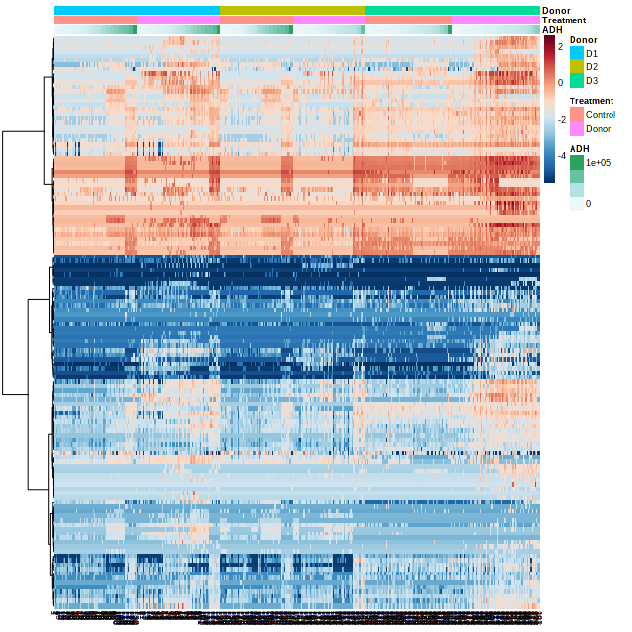
Figure 2.8: A correlation heatmap organized by donor trial (D1, D2, D3), treatment (control or donor), and ADH. Donor trial 1 is denoted by blue, donor trial 2 by gold, and donor trial 3 by aqua green. Samples from control soils are highlighted by peach and donor samples are pink. Finally, as ADH increases the scale moves from white to dark green.

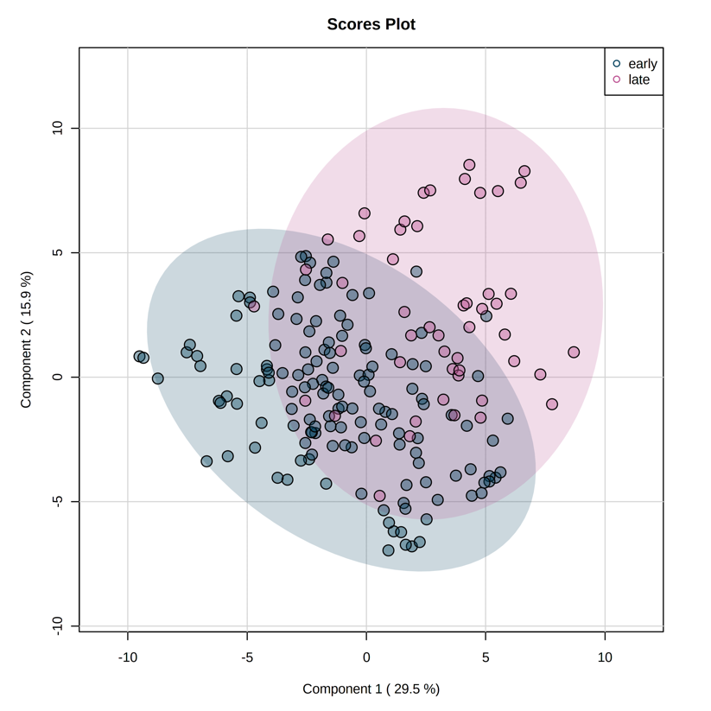

Figure 2.9: A 2D scores plot from a PLS-DA assessing the variation in metabolic profiles between early decomposition (0 ADH – 30,000 ADH) and late decomposition (30,000 ADH – end). The blue dots denote metabolic profiles from early decay and pink denotes those from late decay. The respectively shaded ovals represent the 95% confidence intervals.

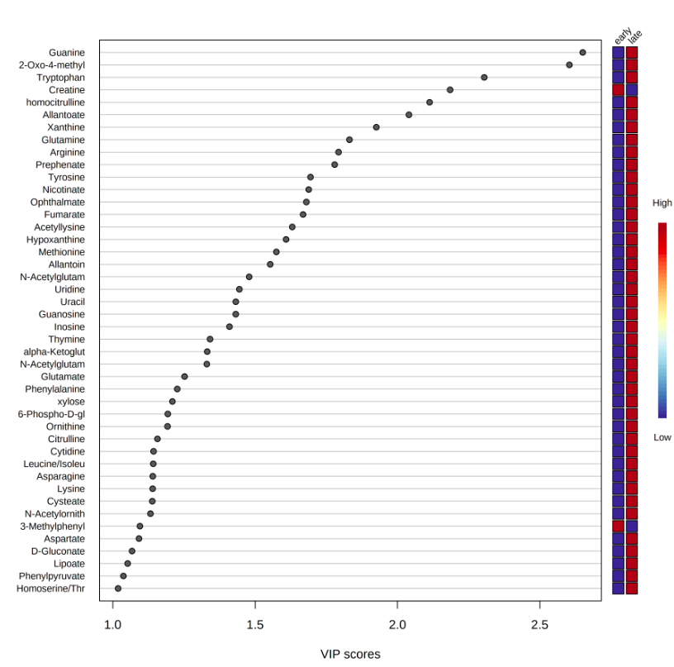
Figure 2.10: Metabolites with High Variable Importance in Projection (VIP) scores in early and late decomposition soils. These metabolites had VIP scores higher than 1, identified by a PLS-DA between early decomposition (0 ADH – 30,000 ADH) and late decomposition (30,000 ADH – END). The boxes to the right of the graph indicate relative concentrations of each metabolite between early and late samples. 2 metabolites (creatine and 3-methylphenylacetic acid) were higher in early decay than in late. 2-Oxo-4-methyl = 2-Oxo-4-methylthiobutanoate, N-Acetylutam = N-Acetylglutamate, alpha-Ketoglut = alpha-Ketoglutarate, N-Acetylglutam = N-Acetylglutamine, 6-Phospho-D-gl = 6-Phospho-D-gluconate, Leucine/isoleu = Leucine/Isoleucine, N-Acetylornith = N-Acetylornithine, 3-Methylphenyl = 3-Methylphenylactic acid, Homoserine/Thr = Homoserine/Threonine.

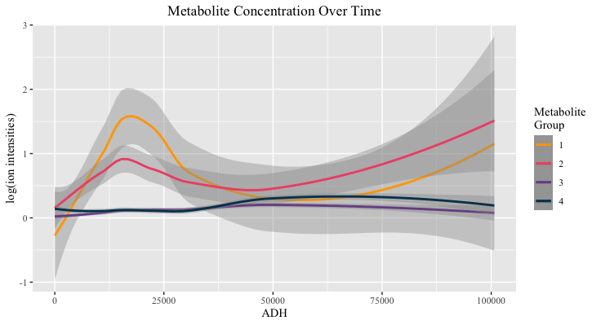Figure 2.11: Metabolite group concentrations as decomposition progresses. The lines represent mean concentration for the metabolites within said group and the shaded area represents the standard deviation. ADH stands for accumulated degree hours, a unit of time that takes thermal energy into consideration. A list of the metabolites belonging to each group can be found in table 2.5. Group 1 metabolites are denoted by the yellow line, group 2 are shown in pink, group 3 in purple, and group 4 in blue.

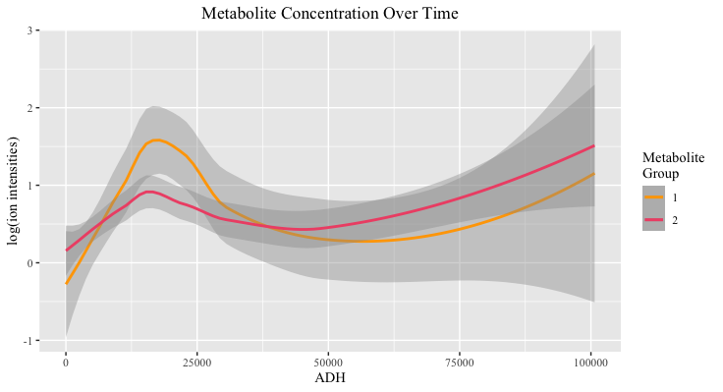
Figure 2.12: Metabolite groups 1 and 2 concentrations graphed over time. The lines represent mean concentration for the metabolites within said group and the shaded area represents the standard deviation. Group 1 (yellow line) metabolites included: indoleacrylate, kynurenic acid, 5-hydroxyindoleacetic acid (5-HIAA), thymine, guanine, 3-methylphenylacetic acid, kynurenine, indole-3-carboxylate, 2-hydroxyglutaric acid, xylitol, anthranilate, shikimate, acetyllysine, ophthalmate, phenyllactic acid, 2-isopropylmalate, taurine, xanthosine, dihydroorotate, N-acetylglutamine, glutamine, glutamate, methionine, hypoxanthine, xanthine, leucine/isoleucine, alanine/sarcosine, and N-acetylornithine. Group 2 (pink line) metabolites included: succinate/methylmalonate, allantoate, allantoin, phenylalanine, tryptophan, aspartate, tyrosine, creatine, orotate, UDP-glucose, phenylpyruvate, proline, homocitrulline, asparagine, arginine, and pyruvate.

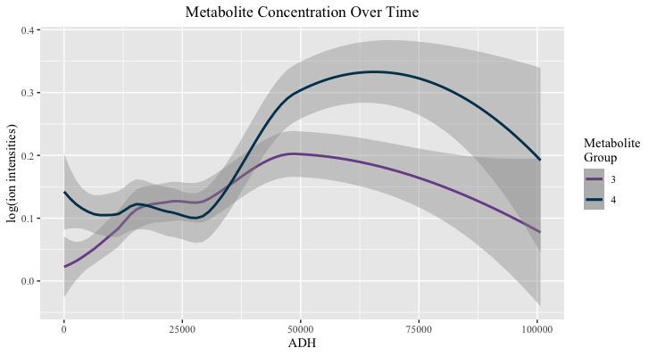
Figure 2.13: Metabolite groups 3 and 4 concentrations graphed over time. The lines represent mean concentration for the metabolites within said group and the shaded area represents the standard deviation. Group 3 (purple line) metabolites included: oxaloacetate, lysine, histidine, fumarate, nicotinate, 5-methoxytryptophan, prephenate, 3-methylthiopropionate, xanthurenic acid, alpha-ketoglutarate, and N-acetylglutamate. Group 4 (blue line) metabolites included: sucralose, valine/betaine, glycine, serine, homoserine/threonine, 2-oxo-4-methylthiobutanoate, and phosphoenolpyruvate.

Tables
Table 2.1: Results from the one-way ANOVA and Tukey’s HSD post-hoc analyses of batch effects (Batches A – H). All metabolites, except for acetyllysine, were found to be at significantly different concentrations between batches (p < 0.05). FDR represents the false discovery rate.
Metabolite | F value | p value | FDR | Tukey's HSD
Homoserine/Threonine | 921.14 | 2.81E-232 | 4.25E-230 | C-A; F-A; G-A; H-A; C-B; F-B; G-B; H-B; D-C; E-C; F-C; G-C; H-C; F-D; G-D; H-D; F-E; G-E; H-E
Trehalose/Sucrose | 493.1 | 4.03E-185 | 3.04E-183 | F-A; G-A; H-A; D-B; F-B; G-B; H-B; F-C; G-C; H-C; F-D; G-D; H-D; F-E; G-E; H-E; G-F; H-F
Cellobiose | 457.16 | 1.40E-179 | 7.06E-178 | G-A; G-B; G-C; G-D; G-E; G-F; H-G
Aminocaproic acid | 284.34 | 6.24E-146 | 2.35E-144 | F-A; F-B; F-C; F-D; F-E; G-F; H-F
N-Acetylglucosamine [1 or 6]-phosphate | 283.4 | 1.05E-145 | 3.17E-144 | C-A; D-A; E-A; F-A; G-A; H-A; C-B; D-B; E-B; F-B; G-B; H-B; F-C; G-C; H-C; F-D; G-D; H-D; F-E; G-E; H-E; G-F; H-F
Ascorbate | 195.83 | 3.21E-121 | 8.07E-120 | F-A; G-A; F-B; G-B; F-C; G-C; F-D; G-D; F-E; G-E; G-F; H-F; H-G
Allantoin | 177.88 | 3.79E-115 | 8.17E-114 | C-A; F-A; G-A; H-A; C-B; F-B; G-B; H-B; D-C; E-C; F-C; G-C; H-C; F-D; G-D; H-D; F-E; G-E; H-E; G-F; H-F
2-Dehydro-D-gluconate | 162.43 | 1.55E-109 | 2.92E-108 | B-A; C-A; D-A; F-A; G-A; H-A; E-B; F-B; G-B; E-C; F-C; G-C; E-D; F-D; G-D; F-E; G-E; H-E; G-F; H-F; H-G
Serine | 160.39 | 9.16E-109 | 1.54E-107 | B-A; C-A; F-A; G-A; H-A; C-B; D-B; E-B; F-B; G-B; H-B; D-C; E-C; F-C; G-C; H-C; F-D; G-D; H-D; F-E; G-E; H-E
Guanine | 156.24 | 3.57E-107 | 5.39E-106 | B-A; C-A; F-A; H-A; D-B; E-B; F-B; G-B; H-B; D-C; E-C; F-C; G-C; H-C; F-D; H-D; F-E; H-E; G-F; H-F; H-G
2-Oxo-4-methylthiobutanoate | 147.91 | 6.95E-104 | 9.54E-103 | B-A; C-A; F-A; G-A; H-A; F-B; G-B; H-B; D-C; E-C; F-C; G-C; H-C; F-D; G-D; H-D; F-E; G-E; H-E; H-F; H-G
Adenosine | 144.64 | 1.48E-102 | 1.87E-101 | B-A; C-A; D-A; E-A; F-A; G-A; F-B; G-B; H-B; F-C; G-C; H-C; F-D; G-D; H-D; F-E; G-E; H-E; G-F; H-F; H-G
Thymidine | 143.41 | 4.75E-102 | 5.52E-101 | F-A; G-A; H-A; F-B; G-B; H-B; F-C; G-C; H-C; F-D; G-D; H-D; F-E; G-E; H-E; G-F; H-F; H-G
Uridine | 132.97 | 1.25E-97 | 1.35E-96 | B-A; C-A; D-A; E-A; F-A; G-A; H-A; C-B; D-B; E-B; F-B; G-B; H-B; F-C; G-C; H-C; F-D; G-D; H-D; F-E; G-E; H-E; G-F; H-F
Table 2.1 continued:
Metabolite | F value | p value | FDR | Tukey's HSD
Xylose | 132.89 | 1.36E-97 | 1.37E-96 | B-A; D-A; E-A; F-A; G-A; H-A; C-B; F-B; G-B; H-B; D-C; E-C; F-C; G-C; H-C; F-D; G-D; H-D; F-E; G-E; H-E; G-F; H-F
Tyrosine | 125.5 | 2.58E-94 | 2.43E-93 | B-A; C-A; F-A; G-A; H-A; F-B; G-B; H-B; E-C; F-C; G-C; H-C; F-D; G-D; H-D; F-E; G-E; H-E; G-F; H-F
Tryptophan | 122.35 | 7.11E-93 | 6.32E-92 | B-A; C-A; D-A; E-A; F-A; G-A; H-A; F-B; G-B; H-B; F-C; G-C; H-C; F-D; G-D; H-D; F-E; G-E; H-E; G-F; H-F
D-Gluconate | 108.16 | 4.69E-86 | 3.93E-85 | D-A; E-A; F-A; G-A; H-A; D-B; E-B; F-B; G-B; H-B; E-C; F-C; G-C; H-C; F-D; G-D; H-D; F-E; G-E; H-E; G-F; H-F
Glutamate | 107.03 | 1.74E-85 | 1.38E-84 | F-A; G-A; H-A; E-B; F-B; G-B; H-B; D-C; E-C; F-C; F-D; G-D; H-D; F-E; G-E; H-E; G-F; H-F
cAMP | 105.65 | 8.62E-85 | 6.51E-84 | B-A; C-A; D-A; E-A; D-B; E-B; F-B; G-B; H-B; D-C; E-C; F-C; G-C; H-C; E-D; F-D; G-D; H-D; F-E; G-E; H-E
Alanine/Sarcosine | 103 | 1.98E-83 | 1.42E-82 | B-A; C-A; D-A; E-A; F-A; G-A; H-A; F-B; F-C; F-D; G-D; F-E; G-E; G-F; H-F; H-G
Cysteate | 99.277 | 1.77E-81 | 1.21E-80 | B-A; C-A; D-A; E-A; F-A; G-A; H-A; D-B; E-B; F-B; G-B; H-B; D-C; E-C; F-C; G-C; H-C; F-D; G-D; H-D; F-E; G-E; H-E; G-F; H-F
Deoxyadenosine | 98.205 | 6.56E-81 | 4.31E-80 | B-A; D-A; F-A; C-B; E-B; F-B; G-B; H-B; D-C; F-C; E-D; F-D; G-D; H-D; F-E; G-F; H-F
Orotate | 97.47 | 1.62E-80 | 1.02E-79 | B-A; C-A; F-A; G-A; H-A; D-B; E-B; F-B; G-B; H-B; D-C; E-C; F-C; G-C; H-C; F-D; G-D; H-D; F-E; G-E; H-E; G-F; H-F
Phenylalanine | 96.538 | 5.15E-80 | 3.11E-79 | B-A; C-A; D-A; F-A; G-A; H-A; E-B; F-B; G-B; H-B; F-C; G-C; H-C; F-D; G-D; H-D; F-E; G-E; H-E; G-F; H-F
Allantoate | 95.766 | 1.34E-79 | 7.81E-79 | E-A; F-A; G-A; E-B; F-B; G-B; H-B; D-C; E-C; F-C; G-C; E-D; F-D; G-D; H-D; F-E; G-E; H-E; G-F; H-F
Oxaloacetate | 94.504 | 6.55E-79 | 3.66E-78 | E-A; H-A; E-B; H-B; E-C; H-C; E-D; H-D; F-E; G-E; H-E; H-F; H-G
Leucine/Isoleucine | 90.846 | 6.93E-77 | 3.74E-76 | C-A; F-A; G-A; H-A; C-B; F-B; G-B; H-B; D-C; E-C; F-C; F-D; G-D; H-D; F-E; G-E; H-E; G-F; H-F
Table 2.1 continued:
Metabolite | F value | p value | FDR | Tukey's HSD
Citrulline | 88.277 | 1.96E-75 | 1.02E-74 | F-A; G-A; H-A; C-B; F-B; G-B; H-B; F-C; G-C; F-D; G-D; H-D; F-E; G-E; H-E; G-F; H-F; H-G
Xanthine | 87.816 | 3.60E-75 | 1.81E-74 | B-A; C-A; D-A; E-A; F-A; G-A; H-A; F-B; G-B; H-B; F-C; G-C; H-C; F-D; G-D; H-D; F-E; G-E; H-E; G-F; H-F
Deoxyinosine | 87.499 | 5.47E-75 | 2.67E-74 | B-A; D-A; F-A; G-A; H-A; C-B; E-B; F-B; G-B; D-C; E-C; F-C; G-C; H-C; E-D; F-D; G-D; F-E; G-E; H-E; G-F; H-F; H-G
Deoxycytidine | 78.263 | 1.63E-69 | 7.71E-69 | F-A; G-A; H-A; F-B; G-B; H-B; F-C; G-C; H-C; F-D; G-D; H-D; F-E; G-E; H-E; G-F; H-F; H-G
Guanosine | 74.063 | 6.75E-67 | 3.09E-66 | B-A; C-A; D-A; F-A; G-A; H-A; E-B; F-B; G-B; H-B; F-C; G-C; H-C; F-D; G-D; H-D; F-E; G-E; H-E; G-F; H-F
Pyroglutamic acid | 72.913 | 3.64E-66 | 1.62E-65 | E-A; F-A; G-A; E-B; F-B; G-B; D-C; E-C; F-C; G-C; F-D; G-D; H-D; F-E; G-E; H-E; G-F; H-F; H-G
Aspartate | 67.858 | 7.14E-63 | 3.08E-62 | E-A; F-A; G-A; H-A; E-B; F-B; G-B; H-B; E-C; F-C; G-C; H-C; E-D; F-D; G-D; H-D; F-E; G-F; H-F
Deoxyuridine | 65.622 | 2.25E-61 | 9.45E-61 | B-A; D-A; F-A; G-A; H-A; C-B; D-B; E-B; F-B; G-B; H-B; F-C; G-C; F-D; G-D; F-E; G-E; G-F; H-F
Glycine | 64.368 | 1.61E-60 | 6.56E-60 | B-A; D-A; F-A; G-A; H-A; C-B; D-B; E-B; F-B; G-B; H-B; D-C; F-C; G-C; H-C; E-D; F-D; G-D; H-D; F-E; G-E; H-E
Homocysteic acid | 63.035 | 1.33E-59 | 5.27E-59 | E-A; F-A; G-A; H-A; E-B; F-B; G-B; H-B; E-C; F-C; G-C; H-C; E-D; F-D; G-D; H-D; F-E; G-E; H-E; G-F; H-F
Cytidine | 61.319 | 2.08E-58 | 8.05E-58 | F-A; G-A; H-A; F-B; G-B; H-B; F-C; G-C; H-C; F-D; G-D; H-D; F-E; G-E; H-E; G-F; H-F
4-Aminobutyrate (GABA) | 59.826 | 2.36E-57 | 8.89E-57 | B-A; C-A; E-A; F-A; G-A; H-A; D-B; F-B; G-B; H-B; D-C; F-C; G-C; H-C; E-D; F-D; G-D; H-D; F-E; G-E; H-E
Uracil | 59.091 | 7.87E-57 | 2.90E-56 | G-A; H-A; G-B; H-B; G-C; H-C; F-D; G-D; H-D; F-E; H-E; G-F; H-F; H-G
Pantothenate | 54.117 | 3.40E-53 | 1.22E-52 | F-A; G-A; H-A; F-B; G-B; H-B; F-C; G-C; H-C; F-D; G-D; H-D; F-E; G-E; H-E; G-F; H-F; H-G

Table 2.1 continued:
Metabolite | F value | p value | FDR | Tukey's HSD
Glucose phosphate | 49.793 | 6.73E-50 | 2.31E-49 | B-A; C-A; D-A; E-A; F-A; F-B; G-B; H-B; F-C; G-C; H-C; F-D; G-D; H-D; F-E; G-E; H-E; G-F; H-F
Deoxyribose phosphate | 49.472 | 1.20E-49 | 4.02E-49 | H-A; H-B; H-C; H-D; H-E; H-F; H-G
UMP | 49.402 | 1.36E-49 | 4.45E-49 | C-A; E-A; H-A; C-B; E-B; H-B; D-C; E-C; F-C; G-C; H-C; H-D; F-E; G-E; H-F; H-G
2-Oxoisovalerate | 49.246 | 1.80E-49 | 5.77E-49 | B-A; D-A; C-B; D-B; E-B; F-B; G-B; H-B; D-C; E-D; F-D; G-D; H-D; F-E; G-E; H-E
D-Glucarate | 46.09 | 5.73E-47 | 1.80E-46 | C-A; E-A; F-A; G-A; H-A; C-B; F-B; G-B; H-B; D-C; F-C; G-C; F-D; G-D; H-D; F-E; G-E; H-F; H-G
Asparagine | 44.749 | 7.02E-46 | 2.16E-45 | F-A; F-B; G-B; E-C; F-C; F-D; G-D; F-E; G-E; H-E; G-F; H-F
Sulfolactate | 43.962 | 3.09E-45 | 9.34E-45 | B-A; D-A; E-A; F-A; G-A; H-A; C-B; D-B; F-B; G-B; H-B; D-C; E-C; F-C; G-C; H-C; F-D; F-E; G-F; H-F
Citrate/isocitrate | 42.923 | 2.24E-44 | 6.63E-44 | B-A; C-A; E-A; F-A; H-A; C-B; D-B; G-B; H-B; D-C; F-C; G-C; H-C; E-D; F-D; H-D; G-E; H-E; G-F; H-F; H-G
Glutamine | 42.197 | 9.03E-44 | 2.62E-43 | C-A; F-A; H-A; F-B; D-C; F-C; F-D; H-D; F-E; G-F; H-F
Cholate | 41.99 | 1.34E-43 | 3.77E-43 | B-A; F-A; G-A; H-A; C-B; E-B; F-B; G-B; H-B; D-C; F-C; G-C; H-C; F-D; G-D; H-D; F-E; G-E; H-E
Xanthosine 5'-phosphate | 41.988 | 1.35E-43 | 3.77E-43 | C-A; C-B; D-C; E-C; F-C; G-C; H-C
dTMP | 40.747 | 1.50E-42 | 4.13E-42 | C-A; E-A; C-B; E-B; D-C; E-C; F-C; G-C; H-C; E-D; F-E; G-E; H-E
Phenylpropiolic acid | 40.089 | 5.48E-42 | 1.48E-41 | B-A; C-A; C-B; D-B; E-B; F-B; G-B; H-B; D-C; E-C; F-C; G-C; H-C
Shikimate | 39.857 | 8.66E-42 | 2.29E-41 | C-A; F-A; H-A; F-B; D-C; F-C; F-D; H-D; F-E; G-F; H-F
N-Carbamoyl-L-aspartate | 38.726 | 8.17E-41 | 2.13E-40 | B-A; C-A; D-A; E-A; F-A; H-A; G-B; G-C; G-D; G-E; G-F; H-G
sn-Glycerol 3-phosphate | 38.077 | 3.00E-40 | 7.67E-40 | C-A; D-A; F-A; H-A; D-B; E-B; F-B; H-B; D-C; E-C; F-C; H-C; G-D; H-D; H-E; G-F; H-F; H-G
Xylitol | 37.944 | 3.92E-40 | 9.86E-40 | B-A; C-A; F-A; G-A; H-A; D-B; F-B; G-B; H-B; F-C; G-C; H-C; F-D; G-D; H-D; F-E; G-E; H-E; G-F
Methionine | 37.89 | 4.36E-40 | 1.08E-39 | C-A; F-A; G-A; H-A; C-B; F-B; D-C; E-C; F-C; F-D; F-E; G-E; G-F; H-F
Table 2.1 continued:
Metabolite | F value | p value | FDR | Tukey's HSD
Abscisate | 37.028 | 2.50E-39 | 6.08E-39 | B-A; C-A; E-A; D-B; E-B; F-B; G-B; H-B; D-C; E-C; F-C; G-C; H-C; E-D; F-E; G-E; H-E
Ribose phosphate | 36.764 | 4.28E-39 | 1.03E-38 | F-A; F-B; F-C; F-D; F-E; G-F; H-F
Lipoate | 35.718 | 3.65E-38 | 8.60E-38 | C-A; E-A; C-B; E-B; D-C; F-C; G-C; H-C; E-D; F-E; G-E; H-E
Fumarate | 35.696 | 3.82E-38 | 8.87E-38 | C-A; F-A; C-B; F-B; H-B; D-C; E-C; F-C; G-C; H-C; F-D; F-E; G-F; H-F; H-G
3,4-Dihydroxyphenylacetate (DOPAC) | 35.432 | 6.58E-38 | 1.50E-37 | C-A; D-A; E-A; F-A; G-A; C-B; D-B; F-B; G-B; D-C; F-C; G-C; H-C; E-D; H-D; F-E; G-E; H-F; H-G
Prephenate | 33.429 | 4.32E-36 | 9.74E-36 | B-A; C-A; C-B; D-B; E-B; F-B; G-B; H-B; D-C; E-C; F-C; G-C; H-C
Homocarnosine | 32.463 | 3.36E-35 | 7.46E-35 | H-A; H-B; H-C; H-D; H-E; H-F; H-G
3-Phosphoglycerate | 32.232 | 5.50E-35 | 1.20E-34 | B-A; H-A; C-B; D-B; E-B; F-B; G-B; H-B; H-C; H-D; H-E; H-F; H-G
Malate | 31.965 | 9.76E-35 | 2.11E-34 | C-A; E-A; F-A; G-A; H-A; C-B; D-B; E-B; F-B; G-B; H-B; D-C; E-C; G-C; E-D; F-D; H-D; F-E; G-E; H-E; G-F; H-G
Jasmonate | 31.913 | 1.09E-34 | 2.32E-34 | B-A; C-A; D-A; E-A; F-A; G-A; H-A
Riboflavin | 31.679 | 1.81E-34 | 3.79E-34 | F-A; G-A; F-B; G-B; F-C; G-C; H-C; G-D; H-D; F-E; G-E; G-F; H-F; H-G
Pikatropin | 31.472 | 2.82E-34 | 5.83E-34 | B-A; C-A; D-A; E-A; F-A; G-A; H-A; H-B; H-C; H-D; H-E; H-F; H-G
Ornithine | 29.776 | 1.13E-32 | 2.31E-32 | F-A; F-B; F-C; F-D; F-E; G-F; H-F
Lysine | 29.038 | 5.78E-32 | 1.16E-31 | D-A; D-B; D-C; E-D; F-D; G-D; H-D
Acetoacetate | 28.533 | 1.78E-31 | 3.53E-31 | B-A; C-B; D-B; E-B; F-B; G-B; H-B
Myo-Inositol | 27.979 | 6.12E-31 | 1.20E-30 | B-A; C-A; H-A; D-B; E-B; F-B; G-B; H-B; H-C; H-D; H-E; H-F; H-G
Dihydroorotate | 26.673 | 1.17E-29 | 2.27E-29 | B-A; D-A; E-A; F-A; G-A; D-B; E-B; D-C; E-C; F-C; F-D; G-D; H-D; F-E; G-E; H-E; G-F; H-F
Taurine | 26.565 | 1.50E-29 | 2.87E-29 | E-A; F-A; F-B; G-B; H-B; F-C; G-C; H-C; F-D; G-D; H-D; F-E; G-E; H-E; G-F; H-F
Glucosamine | 26.361 | 2.39E-29 | 4.51E-29 | B-A; C-A; D-B; E-B; F-B; G-B; H-B; D-C; E-C; F-C; G-C; H-C
Ophthalmate | 25.876 | 7.27E-29 | 1.36E-28 | F-A; G-A; H-A; F-B; G-B; H-B; F-C; G-C; H-C; F-D; G-D; H-D; F-E; G-E; H-E; G-F; H-G

Table 2.1 continued:
Metabolite | F value | p value | FDR | Tukey's HSD
Hydroxybutyrate | 25.693 | 1.11E-28 | 2.04E-28 | B-A; C-A; D-A; E-A; D-B; F-B; G-B; H-B; D-C; F-C; G-C; H-C; E-D; F-D; G-D; H-D; F-E; G-E; H-E
Xanthurenic acid | 25.582 | 1.43E-28 | 2.60E-28 | B-A; C-A; D-A; F-A; G-A; G-B; H-B; G-C; H-C; G-D; G-E; G-F; H-G
Nicotinate | 25.045 | 4.95E-28 | 8.90E-28 | B-A; C-A; F-A; F-B; D-C; E-C; F-C; G-C; H-C; F-D; F-E; G-F; H-F
Arginine | 24.903 | 6.88E-28 | 1.22E-27 | C-A; F-A; G-A; F-B; G-B; F-C; G-C; F-D; G-D; F-E; G-E; G-F; H-F; H-G
Carnitine | 24.46 | 1.93E-27 | 3.39E-27 | B-A; C-A; D-B; E-B; F-B; G-B; H-B; D-C; E-C; F-C; G-C; H-C
Inosine | 24.4 | 2.22E-27 | 3.86E-27 | F-A; E-B; F-B; E-C; F-C; E-D; F-D; F-E; G-E; H-E; G-F; H-F
alpha-Ketoglutarate | 23.019 | 5.75E-26 | 9.86E-26 | B-A; C-A; D-A; E-A; F-A; G-A; H-A; C-B; F-B; D-C; E-C; G-C; H-C; F-D; F-E; G-F; H-F
Valine/betaine | 22.793 | 9.84E-26 | 1.67E-25 | G-A; H-A; G-B; H-B; F-C; G-C; H-C; G-D; H-D; H-E; H-F; H-G
Glycolate | 22.753 | 1.08E-25 | 1.82E-25 | B-A; C-A; F-A; G-A; H-A; C-B; D-B; E-B; F-B; G-B; H-B
Thymine | 22.668 | 1.33E-25 | 2.20E-25 | B-A; F-A; C-B; D-B; E-B; F-B; F-C; G-C; H-C; F-D; F-E; G-E; H-E; G-F; H-F
Pyridoxamine | 21.938 | 7.62E-25 | 1.25E-24 | B-A; C-A; C-B; D-B; E-B; F-B; G-B; H-B; D-C; E-C; F-C; G-C; H-C
Xanthosine | 21.256 | 3.96E-24 | 6.42E-24 | D-A; E-A; F-A; D-B; E-B; D-C; E-C; F-D; G-D; H-D; F-E; G-E; H-E
Cystathionine | 20.839 | 1.09E-23 | 1.75E-23 | F-A; F-B; F-C; F-D; F-E; G-F; H-F
Indole-3-carboxylate | 20.701 | 1.53E-23 | 2.43E-23 | D-A; D-B; F-B; G-B; D-C; F-C; G-C; H-C; F-D; G-D; H-D; F-E; G-E; H-E
UDP-N-acetylglucosamine | 20.126 | 6.24E-23 | 9.82E-23 | F-A; H-A; F-B; H-B; F-C; F-D; H-D; F-E; H-E; G-F; H-F; H-G
Creatinine | 20.013 | 8.25E-23 | 1.28E-22 | B-A; C-A; E-A; F-A; G-A; H-A; D-B; D-C; E-D; F-D; G-D; H-D
N-Acetylglutamate | 18.883 | 1.35E-21 | 2.09E-21 | C-A; F-A; G-A; H-A; C-B; F-B; G-B; H-B; F-C; F-D; H-D; F-E; H-E; G-F; H-F
N-Acetyl-beta-alanine | 18.318 | 5.57E-21 | 8.50E-21 | C-A; F-A; F-B; G-B; H-B; D-C; E-C; F-C; G-C; H-C; F-D; F-E; G-F; H-F
5-Methoxytryptophan | 18.162 | 8.25E-21 | 1.25E-20 | B-A; C-A; H-A; C-B; D-B; E-B; F-B; G-B; H-B; D-C; E-C; F-C; G-C; H-D; H-E; H-F; H-G
Succinate/Methylmalonate | 17.874 | 1.70E-20 | 2.55E-20 | C-A; F-A; C-B; F-B; D-C; E-C; F-C; H-C; F-D; F-E; G-F; H-F

Table 2.1 continued:
Metabolite | F value | p value | FDR | Tukey's HSD
Homovanillic acid (HVA) | 17.533 | 4.04E-20 | 5.97E-20 | B-A; F-A; G-A; H-A; F-B; F-C; H-C; F-D; G-D; H-D; F-E; H-E; G-F; H-F
N-Acetylglucosamine | 17.395 | 5.73E-20 | 8.39E-20 | F-A; G-A; F-B; G-B; F-C; G-C; F-D; G-D; H-D; F-E; G-E; H-E; H-F
dAMP | 17.191 | 9.61E-20 | 1.40E-19 | B-A; C-A; C-B; D-B; E-B; F-B; G-B; H-B; D-C; E-C; F-C; G-C; H-C
Proline | 17.12 | 1.15E-19 | 1.66E-19 | G-A; H-A; G-B; H-B; D-C; F-C; G-C; H-C; H-D; G-E; H-E; H-F; H-G
Vanillin | 17.092 | 1.24E-19 | 1.76E-19 | B-A; G-A; H-A; C-B; D-B; E-B; F-B; H-C; G-D; H-D; G-E; H-E; G-F; H-F
Hydroxyproline | 16.453 | 6.33E-19 | 8.93E-19 | G-A; G-B; G-C; G-D; G-E; G-F; H-G
Dipicolinate | 16.341 | 8.45E-19 | 1.18E-18 | B-A; C-A; E-A; F-A; G-A; H-A; H-B; F-C; H-C; F-D; H-D; F-E; H-E; H-G
Pyruvate | 16.103 | 1.56E-18 | 2.16E-18 | C-A; F-A; F-B; H-B; D-C; F-C; H-C; F-D; F-E; G-F; H-G
Adenine | 15.983 | 2.12E-18 | 2.91E-18 | C-A; C-B; D-C; E-C; F-C; G-C; H-C
Methionine sulfoxide | 15.953 | 2.29E-18 | 3.12E-18 | E-A; F-A; E-B; F-B; G-B; H-B; E-C; F-C; E-D; F-D; G-D; F-E; G-E; H-E; H-F
4-Pyridoxate | 15.509 | 7.24E-18 | 9.76E-18 | F-A; G-A; D-B; F-B; G-B; H-B; D-C; F-C; G-C; H-C; F-D; G-D; F-E; G-E; H-F; H-G
3-Methylthiopropionate | 15.307 | 1.22E-17 | 1.63E-17 | F-A; F-B; E-C; F-C; G-C; H-C; F-D; F-E; G-F; H-F
2,3-Dihydroxybenzoate | 15.084 | 2.18E-17 | 2.89E-17 | C-A; F-A; C-B; D-C; F-C; G-C; H-C; F-D; G-D; F-E; G-E; H-F
Hypoxanthine | 14.89 | 3.62E-17 | 4.75E-17 | B-A; C-A; F-A; G-A; F-B; F-C; F-D; G-D; F-E; G-E; G-F; H-F; H-G
6-Phospho-D-gluconate | 14.886 | 3.66E-17 | 4.77E-17 | C-A; H-A; C-B; H-B; D-C; E-C; F-C; G-C; H-D; H-E; H-F; H-G
Biotin | 14.678 | 6.30E-17 | 8.13E-17 | C-A; C-B; D-C; E-C; F-C; G-C; H-C
Indoleacrylate | 14.479 | 1.06E-16 | 1.36E-16 | F-A; G-A; F-B; G-B; F-C; G-C; F-D; G-D; F-E; G-E; H-F; H-G
Citraconate | 14.179 | 2.34E-16 | 2.97E-16 | B-A; H-A; C-B; E-B; F-B; G-B; H-C; F-D; G-D; H-D; H-E; H-F; H-G
Hydroxybenzoate (methylparaben) | 13.553 | 1.22E-15 | 1.54E-15 | B-A; C-B; D-B; E-B; F-B; G-B; H-B; G-D; G-E
Phenylpyruvate | 13.186 | 3.24E-15 | 4.04E-15 | B-A; C-A; G-A; H-A; F-B; D-C; E-C; F-C; F-D; G-E; H-E; G-F; H-F
Tricarballylic acid | 12.891 | 7.11E-15 | 8.80E-15 | B-A; C-A; D-A; E-A; H-A; F-B; F-C; F-D; G-D; F-E; G-E; H-F; H-G
Lactate | 12.245 | 4.02E-14 | 4.93E-14 | F-A; G-A; E-B; F-B; G-B; H-C; H-D; H-E; H-F; H-G

Table 2.1 continued:
Metabolite | F value | p value | FDR | Tukey's HSD
2-Aminoadipate | 11.586 | 2.38E-13 | 2.90E-13 | D-A; D-B; F-B; D-C; E-D; F-D; G-D; H-D; H-E; H-F
Aconitate | 11.273 | 5.55E-13 | 6.70E-13 | D-A; F-A; D-B; F-B; D-C; F-C; G-C; H-D; F-E; G-F; H-F
Salicylate | 10.349 | 6.90E-12 | 8.27E-12 | G-A; F-B; G-B; F-C; G-C; G-D; G-E; H-G
1-Methyladenosine | 9.4137 | 9.03E-11 | 1.07E-10 | H-A; H-B; H-C; F-D; H-D; F-E; H-E; H-F; H-G
N-Acetylglutamine | 8.7648 | 5.44E-10 | 6.42E-10 | E-A; D-B; E-B; F-C; H-C; F-D; H-D; F-E; G-E; H-E
Sucralose | 8.1519 | 2.99E-09 | 3.50E-09 | C-A; C-B; D-C; E-C; F-C; G-C; H-C
2-Hydroxy-2-methylsuccinate | 7.878 | 6.41E-09 | 7.44E-09 | C-A; F-A; G-A; H-A; F-B; F-D; F-E; G-F; H-F
Uric acid | 7.8066 | 7.82E-09 | 9.01E-09 | C-B; G-B; H-B; D-C; E-C; G-D; H-D; H-E; H-F
Anthranilate | 7.5887 | 1.44E-08 | 1.64E-08 | F-A; G-A; F-B; G-B; F-C; G-C; F-D; G-D; H-F; H-G
Hydroxyphenylpyruvate | 7.5162 | 1.76E-08 | 2.00E-08 | E-A; E-B; E-C; E-D; F-E; G-E; H-E
2-Isopropylmalate | 7.3301 | 2.95E-08 | 3.33E-08 | F-A; F-B; F-C; G-C; F-D; F-E; H-F
Creatine | 7.27 | 3.49E-08 | 3.91E-08 | E-A; F-A; F-D; G-E; G-F; H-F
Methyl succinic acid | 7.1225 | 5.28E-08 | 5.86E-08 | F-A; F-B; F-C; F-D; F-E; G-F; H-F
Phenyllactic acid | 7.0848 | 5.86E-08 | 6.46E-08 | G-A; H-A; F-B; F-C; G-F; H-F
UDP-glucose | 6.6018 | 2.26E-07 | 2.48E-07 | C-A; F-A; E-B; E-C; G-C; E-D; F-E; H-E; G-F
3-Methylphenylacetic acid | 6.1417 | 8.19E-07 | 8.89E-07 | E-A; E-B; F-B; H-C; E-D; G-E; H-E; G-F; H-F
Glyoxylate | 5.7424 | 2.50E-06 | 2.69E-06 | B-A; D-B; E-B; F-B; G-B; H-B; G-C; H-C
Kynurenic acid | 5.6878 | 2.91E-06 | 3.12E-06 | G-C; H-C; G-D; H-D; G-E; H-E; G-F; H-F
Hydroxyphenylacetate | 5.6323 | 3.40E-06 | 3.61E-06 | D-B; E-B; H-D; H-E; H-F
3-Hydroxyisovalerate | 5.2841 | 8.96E-06 | 9.46E-06 | F-A; F-B; H-F
Hydroxyisocaproic acid | 5.2419 | 1.01E-05 | 1.06E-05 | F-A; F-B; G-F; H-F
Methyl glutaric acid | 5.0398 | 1.77E-05 | 1.84E-05 | D-B; E-B; F-B; H-D; H-F
Phosphoenolpyruvate | 4.9607 | 2.20E-05 | 2.27E-05 | B-A; D-B; E-B; F-B; G-B; H-B
trans, trans-Farnesyl diphosphate | 4.7831 | 3.60E-05 | 3.69E-05 | H-A; H-B; H-C; H-D; H-E; H-F; H-G
Glycerone phosphate | 4.6117 | 5.77E-05 | 5.89E-05 | C-A; C-B; D-C; F-C; G-C; H-C
Histidine | 4.1084 | 0.00022976 | 0.00023285 | F-A; F-B; F-C; F-D; F-E; G-F; H-F
Pimelic acid | 4.0859 | 0.00024427 | 0.0002459 | F-B; F-C; H-F
Acetyllysine | 1.9548 | 0.060209 | 0.060209

Table 2.2: Results from the one-way ANOVA and Tukey’s HSD post-hoc analyses testing differences between batches (A – H) following attempts of normalization. All metabolites, except for carnitine and histidine, were found to be at significantly different concentrations between batches (p > 0.05). FDR represents the false discovery rate.

Metabolite | F value | p value | FDR | Tukey's HSD
Pantothenate | 443.58 | 1.46E-168 | 1.87E-166 | F-A; G-A; H-A; F-B; G-B; H-B; F-C; G-C; H-C; F-D; G-D; H-D; F-E; G-E; H-E
N-Acetyl-beta-alanine | 272.1 | 1.63E-136 | 1.04E-134 | F-A; G-A; H-A; F-B; G-B; H-B; F-C; G-C; H-C; F-D; G-D; H-D; F-E; G-E; H-E
Trehalose/Sucrose | 220.41 | 2.21E-123 | 9.43E-122 | D-A; F-A; G-A; H-A; D-B; F-B; G-B; H-B; E-C; F-C; G-C; H-C; E-D; F-D; G-D; H-D; F-E; G-E; H-E; H-F
N-Acetylglucosamine [1 or 6]-phosphate | 185.91 | 3.86E-113 | 1.24E-111 | C-A; D-A; E-A; F-A; G-A; H-A; C-B; D-B; E-B; F-B; G-B; H-B; D-C; F-C; G-C; H-C; E-D; F-D; G-D; H-D; F-E; G-E; H-E
Methyl succinic acid | 170.29 | 5.29E-108 | 1.35E-106 | B-A; F-A; G-A; C-B; D-B; F-B; G-B; H-B; F-C; G-C; F-D; G-D; F-E; G-E; H-F; H-G
Serine | 147.36 | 9.33E-100 | 1.99E-98 | C-A; F-A; G-A; H-A; C-B; F-B; G-B; H-B; D-C; E-C; F-C; G-C; H-C; F-D; G-D; H-D; F-E; G-E; H-E
Pyroglutamic acid | 144.83 | 8.61E-99 | 1.58E-97 | B-A; D-A; F-A; G-A; H-A; C-B; E-B; F-B; G-B; H-B; D-C; F-C; G-C; H-C; E-D; F-D; G-D; H-D; F-E; G-E; H-E; H-F
Acetoacetate | 137.48 | 6.59E-96 | 1.05E-94 | C-A; G-A; C-B; G-B; D-C; E-C; F-C; G-C; H-C; G-D; G-E; G-F; H-G
Cysteate | 124.13 | 2.27E-90 | 3.22E-89 | B-A; C-A; D-A; F-A; G-A; H-A; C-B; D-B; E-B; H-B; D-C; E-C; F-C; G-C; H-C; E-D; F-D; G-D; H-D; F-E; G-E; H-E
Succinate/Methylmalonate | 114.73 | 3.28E-86 | 4.20E-85 | F-A; G-A; F-B; G-B; F-C; G-C; F-D; G-D; F-E; G-E; H-F; H-G
Pimelic acid | 112.89 | 2.27E-85 | 2.64E-84 | B-A; F-A; G-A; H-A; C-B; D-B; E-B; F-B; G-B; H-B; F-C; G-C; H-C; F-D; G-D; H-D; F-E; G-E; H-E
Methyl glutaric acid | 111.13 | 1.48E-84 | 1.58E-83 | F-A; G-A; H-A; F-B; G-B; H-B; F-C; G-C; H-C; F-D; G-D; H-D; F-E; G-E; H-E; H-F; H-G
Lipoate | 109.22 | 1.17E-83 | 1.15E-82 | C-A; E-A; C-B; E-B; D-C; E-C; F-C; G-C; H-C; E-D; F-E; G-E; H-E

Table 2.2 continued:
Metabolite | F value | p value | FDR | Tukey's HSD
2-Dehydro-D-gluconate | 108.34 | 3.02E-83 | 2.76E-82 | C-A; D-A; E-A; F-A; G-A; H-A; C-B; D-B; E-B; F-B; G-B; H-B; E-C; F-C; G-C; H-C; E-D; F-D; G-D; H-D; F-E; G-E; H-E
Glycolate | 97.922 | 3.78E-78 | 3.22E-77 | C-A; C-B; D-C; E-C; F-C; G-C; H-C
Allantoate | 95.554 | 6.10E-77 | 4.88E-76 | B-A; C-A; D-A; F-A; G-A; H-A; C-B; E-B; F-B; G-B; D-C; E-C; F-C; G-C; H-C; E-D; F-D; G-D; H-D; F-E; G-E; H-E; H-F
Citraconate | 91.797 | 5.54E-75 | 4.17E-74 | F-A; G-A; H-A; F-B; G-B; H-B; F-C; G-C; H-C; F-D; G-D; H-D; F-E; G-E; H-E; H-F; H-G
Hydroxyisocaproic acid | 77.966 | 2.65E-67 | 1.88E-66 | F-A; G-A; H-A; F-B; G-B; H-B; F-C; G-C; H-C; F-D; G-D; H-D; F-E; G-E; H-E
4-Pyridoxate | 76.064 | 3.48E-66 | 2.35E-65 | B-A; F-A; H-A; C-B; D-B; E-B; G-B; H-B; F-C; H-C; F-D; H-D; F-E; H-E; H-F; H-G
Phosphoenolpyruvate | 70.612 | 7.03E-63 | 4.50E-62 | B-A; C-A; C-B; D-B; E-B; F-B; G-B; H-B; D-C; E-C; F-C; G-C; H-C
Tyrosine | 67.857 | 3.75E-61 | 2.29E-60 | B-A; C-A; D-A; F-A; G-A; H-A; C-B; F-B; G-B; H-B; E-C; F-C; G-C; H-C; F-D; G-D; H-D; F-E; G-E; H-E
Tryptophan | 66.932 | 1.45E-60 | 8.46E-60 | B-A; C-A; D-A; E-A; F-A; G-A; H-A; F-B; G-B; H-B; F-C; G-C; H-C; F-D; G-D; H-D; F-E; G-E; H-E
Homoserine/Threonine | 64.55 | 5.01E-59 | 2.79E-58 | C-A; F-A; G-A; H-A; C-B; F-B; G-B; H-B; D-C; E-C; F-C; G-C; H-C; F-D; G-D; H-D; F-E; G-E; H-E; H-F; H-G
Allantoin | 60.285 | 3.41E-56 | 1.82E-55 | C-A; E-A; F-A; G-A; H-A; C-B; E-B; F-B; G-B; H-B; D-C; E-C; F-C; F-D; G-D; H-D; F-E; G-E; H-E; G-F
Hydroxybutyrate | 58.301 | 7.72E-55 | 3.95E-54 | B-A; C-A; C-B; D-B; E-B; F-B; H-B; D-C; E-C; F-C; G-C; H-C; H-G
Xylose | 56.611 | 1.15E-53 | 5.66E-53 | C-A; F-A; G-A; H-A; C-B; F-B; G-B; H-B; D-C; E-C; G-C; H-C; F-D; G-D; H-D; F-E; G-E; H-E; H-F
Malate | 56.444 | 1.51E-53 | 7.14E-53 | B-A; F-A; G-A; H-A; C-B; D-B; E-B; H-B; F-C; G-C; H-C; F-D; G-D; H-D; F-E; G-E; H-E; H-F; H-G
2-Aminoadipate | 52.405 | 1.15E-50 | 5.27E-50 | D-A; E-A; F-A; G-A; H-A; D-B; E-B; F-B; G-B; H-B; D-C; E-C; F-C; G-C; H-C; F-D; G-D; H-D; F-E; G-E; H-E

Table 2.2 continued:
Metabolite | F value | p value | FDR | Tukey's HSD
Aspartate | 50.192 | 4.90E-49 | 2.16E-48 | B-A; E-A; F-A; G-A; H-A; E-B; F-B; G-B; H-B; E-C; F-C; G-C; H-C; E-D; F-D; G-D; H-D; F-E; G-E; H-E
Phenylalanine | 49.17 | 2.85E-48 | 1.20E-47 | B-A; C-A; F-A; G-A; H-A; E-B; F-B; G-B; H-B; D-C; E-C; F-C; G-C; H-C; F-D; G-D; H-D; F-E; G-E; H-E
UDP-N-acetylglucosamine | 49.157 | 2.91E-48 | 1.20E-47 | B-A; C-A; E-A; F-A; G-A; H-A; C-B; E-B; D-C; F-C; G-C; H-C; E-D; H-D; F-E; G-E; H-E; H-G
Myo-Inositol | 47.882 | 2.68E-47 | 1.07E-46 | F-A; G-A; H-A; F-B; G-B; H-B; F-C; G-C; H-C; F-D; G-D; H-D; F-E; G-E; H-E; H-G
N-Acetylglutamate | 46.83 | 1.71E-46 | 6.62E-46 | B-A; C-A; D-A; E-A; G-A; H-A; F-B; G-B; H-B; E-C; F-C; G-C; F-D; G-D; H-D; F-E; G-E; H-E; H-F; H-G
Homocarnosine | 46.616 | 2.49E-46 | 9.38E-46 | H-A; H-B; H-C; H-D; H-E; H-F; H-G
Uridine | 44.381 | 1.37E-44 | 5.03E-44 | B-A; C-A; D-A; E-A; F-A; G-A; H-A; F-B; G-B; H-B; F-C; G-C; H-C; F-D; G-D; H-D; F-E; G-E; H-E
Citrulline | 43.347 | 9.07E-44 | 3.22E-43 | F-A; G-A; H-A; C-B; F-B; G-B; H-B; E-C; F-C; G-C; H-C; F-D; G-D; H-D; F-E; G-E; H-E; H-F
Adenosine | 43.299 | 9.90E-44 | 3.43E-43 | B-A; D-A; F-A; G-A; H-A; C-B; E-B; G-B; H-B; D-C; F-C; G-C; H-C; E-D; F-D; G-D; H-D; F-E; G-E; H-E
2-Oxo-4-methylthiobutanoate | 42.279 | 6.50E-43 | 2.19E-42 | C-A; F-A; G-A; H-A; F-B; G-B; H-B; D-C; E-C; F-C; G-C; H-C; F-D; G-D; H-D; F-E; G-E; H-E
Pyruvate | 39.774 | 7.21E-41 | 2.37E-40 | C-A; F-A; G-A; H-A; F-B; G-B; H-B; D-C; E-C; F-C; G-C; F-D; G-D; H-D; F-E; G-E; H-E; H-F; H-G
Uracil | 38.49 | 8.47E-40 | 2.71E-39 | C-A; G-A; H-A; G-B; H-B; D-C; E-C; F-C; G-C; H-C; G-D; H-D; H-E; G-F; H-F; H-G
Valine/betaine | 37.282 | 8.87E-39 | 2.77E-38 | G-A; H-A; G-B; H-B; E-C; F-C; G-C; H-C; F-D; G-D; H-D; H-E; H-F; H-G
Lactate | 37.073 | 1.34E-38 | 4.07E-38 | F-A; G-A; H-A; F-B; G-B; H-B; F-C; G-C; H-C; F-D; G-D; H-D; F-E; G-E; H-E; G-F; H-F
Thymidine | 37.008 | 1.52E-38 | 4.52E-38 | B-A; C-A; D-A; F-A; G-A; H-A; E-B; F-B; G-B; H-B; F-C; G-C; H-C; E-D; F-D; G-D; H-D; F-E; G-E; H-E; H-G
3-Phosphoserine | 35.994 | 1.12E-37 | 3.27E-37 | H-A; H-B; H-C; H-D; H-E; H-F; H-G
Table 2.2 continued:
Metabolite | F value | p value | FDR | Tukey's HSD
2-Isopropylmalate | 34.911 | 9.79E-37 | 2.78E-36 | F-A; G-A; H-A; D-B; E-B; F-B; G-B; H-B; F-C; G-C; H-C; F-D; G-D; H-D; F-E; G-E; H-E; H-F
Fumarate | 34.4 | 2.74E-36 | 7.63E-36 | B-A; C-A; D-A; F-A; G-A; C-B; F-B; H-B; D-C; E-C; F-C; G-C; H-C; F-D; F-E; G-F; H-F; H-G
D-Gluconate | 33.953 | 6.77E-36 | 1.84E-35 | B-A; C-A; F-A; G-A; H-A; D-B; E-B; F-B; G-B; H-B; D-C; E-C; F-C; G-C; H-C; F-D; G-D; H-D; F-E; G-E; H-E
Deoxyinosine | 32.75 | 7.95E-35 | 2.12E-34 | B-A; C-A; E-A; F-A; G-A; H-A; D-B; E-B; F-B; G-B; D-C; E-C; F-C; G-C; H-D; H-E; H-F; H-G
Homocysteic acid | 32.287 | 2.07E-34 | 5.40E-34 | C-A; E-A; F-A; G-A; H-A; C-B; E-B; F-B; H-B; D-C; F-C; G-C; H-C; E-D; F-D; G-D; H-D; F-E; G-E; H-E
3-Hydroxyisovalerate | 31.885 | 4.76E-34 | 1.22E-33 | F-A; G-A; F-B; G-B; F-C; G-C; F-D; G-D; F-E; G-E; H-F; H-G
Deoxyribose phosphate | 30.203 | 1.63E-32 | 4.09E-32 | H-A; H-B; H-C; H-D; H-E; H-F; H-G
Inosine | 29.369 | 9.66E-32 | 2.38E-31 | B-A; C-A; D-A; E-A; F-A; G-A; H-A; C-B; G-B; D-C; E-C
Guanosine | 29.272 | 1.19E-31 | 2.87E-31 | B-A; C-A; D-A; F-A; G-A; H-A; E-B; G-B; H-B; E-C; F-C; G-C; H-C; F-D; G-D; H-D; F-E; G-E; H-E
4-Aminobutyrate (GABA) | 28.975 | 2.25E-31 | 5.33E-31 | C-A; D-A; F-A; G-A; H-A; C-B; D-B; F-B; G-B; H-B; D-C; E-C; F-C; G-C; H-C; H-D
Homovanillic acid (HVA) | 28.575 | 5.34E-31 | 1.24E-30 | F-A; G-A; H-A; E-B; F-B; G-B; H-B; F-C; G-C; H-C; F-D; G-D; H-D; F-E; G-E; H-E; H-F
Arginine | 26.48 | 5.25E-29 | 1.19E-28 | C-A; F-A; G-A; H-A; C-B; F-B; G-B; H-B; D-C; E-C; F-C; F-D; G-D; H-D; F-E; G-E; H-E; G-F; H-F
Citrate/isocitrate | 26.475 | 5.31E-29 | 1.19E-28 | G-A; H-A; H-B; G-C; H-C; G-D; H-D; H-E; H-F; H-G
Shikimate | 26.389 | 6.43E-29 | 1.42E-28 | B-A; H-A; C-B; D-B; E-B; G-B; H-B; H-C; H-D; H-E; H-F; H-G
Tricarballylic acid | 25.63 | 3.50E-28 | 7.59E-28 | H-A; H-B; H-C; H-D; H-E; H-F; H-G
Asparagine | 25.474 | 4.97E-28 | 1.06E-27 | B-A; E-A; F-A; G-A; C-B; F-B; G-B; H-B; D-C; E-C; F-C; F-D; G-D; H-D; F-E; G-E; H-E; G-F; H-F
Glucose phosphate | 24.252 | 7.88E-27 | 1.65E-26 | C-A; D-A; F-A; G-A; C-B; F-B; G-B; F-C; G-C; H-C; F-D; G-D; H-D; F-E; G-E; H-E; G-F; H-F
Table 2.2 continued:
Metabolite | F value | p value | FDR | Tukey's HSD
1-Methyladenosine | 23.755 | 2.46E-26 | 5.08E-26 | D-A; E-A; F-A; H-A; E-B; F-B; H-B; D-C; E-C; F-C; H-C; H-D; H-E; G-F; H-F; H-G
Xanthosine | 23.715 | 2.70E-26 | 5.48E-26 | C-A; D-A; E-A; C-B; D-B; E-B; D-C; F-C; G-C; H-C; F-D; G-D; H-D; F-E; G-E; H-E
N-Acetylornithine | 23.077 | 1.17E-25 | 2.35E-25 | F-A; G-A; H-A; F-B; G-B; H-B; F-C; G-C; H-C; F-D; G-D; H-D; F-E; G-E; H-E
Deoxycytidine | 22.868 | 1.90E-25 | 3.75E-25 | F-A; G-A; H-A; E-B; F-B; G-B; F-C; G-C; H-C; E-D; G-D; F-E; G-E; H-E; G-F; H-G
alpha-Ketoglutarate | 21.927 | 1.71E-24 | 3.31E-24 | B-A; C-A; D-A; E-A; G-A; H-A; C-B; D-C; E-C; F-C; G-C; H-C
Ornithine | 21.497 | 4.70E-24 | 8.97E-24 | C-A; D-A; F-A; G-A; H-A; F-B; G-B; H-B; F-C; G-C; F-D; G-D; F-E; G-E; G-F; H-F; H-G
Leucine/Isoleucine | 20.101 | 1.30E-22 | 2.46E-22 | C-A; F-A; G-A; H-A; C-B; E-B; F-B; G-B; H-B; D-C; E-C; E-D; F-D; G-D; H-D; F-E; G-E; H-E
Sucralose | 19.973 | 1.77E-22 | 3.29E-22 | D-A; E-A; D-B; E-B; D-C; E-C; F-D; G-D; H-D; F-E; G-E; H-E
Pikatropin | 19.017 | 1.79E-21 | 3.28E-21 | H-A; H-B; H-C; H-D; H-E; H-F; H-G
Oxaloacetate | 18.888 | 2.45E-21 | 4.42E-21 | C-A; C-B; D-C; E-C; F-C; G-C; H-C
Glycine | 18.564 | 5.41E-21 | 9.55E-21 | C-A; E-A; C-B; E-B; F-B; G-B; H-B; D-C; F-C; G-C; H-C; E-D; F-D; G-D; H-D; F-E; G-E; H-E
Glutamate | 18.562 | 5.44E-21 | 9.55E-21 | C-A; E-A; F-A; C-B; E-B; F-B; D-C; E-C; G-C; H-C; F-D; G-D; H-D; F-E; G-E; H-E; G-F; H-F
Phenyllactic acid | 18.436 | 7.41E-21 | 1.28E-20 | F-A; G-A; H-A; G-B; H-B; F-C; G-C; H-C; F-D; G-D; H-D; F-E; G-E; H-E
N-Acetylglutamine | 18.273 | 1.11E-20 | 1.89E-20 | B-A; F-A; H-A; C-B; D-B; E-B; F-C; G-C; H-C; F-D; G-D; H-D; F-E; G-E; H-E
Vanillin | 17.222 | 1.49E-19 | 2.51E-19 | H-A; G-B; H-B; G-C; H-C; G-D; H-D; G-E; H-E; G-F; H-F; H-G
3,4-Dihydroxyphenylacetate (DOPAC) | 17.043 | 2.33E-19 | 3.88E-19 | H-A; H-B; H-C; H-D; H-E; H-F; H-G
Acetyllysine | 16.834 | 3.93E-19 | 6.44E-19 | F-A; G-A; H-A; F-B; G-B; H-B; F-C; H-C; F-D; G-D; H-D; F-E; G-E; H-E
Orotate | 16.824 | 4.02E-19 | 6.52E-19 | B-A; C-A; E-A; C-B; E-B; D-C; F-C; G-C; H-C; E-D; F-E; G-E; H-E
Table 2.2 continued:
Metabolite | F value | p value | FDR | Tukey's HSD
Xanthine | 16.516 | 8.72E-19 | 1.40E-18 | B-A; C-A; D-A; F-A; G-A; H-A; H-B; G-C; H-C; G-D; H-D; F-E; G-E; H-E
cAMP | 16.493 | 9.24E-19 | 1.46E-18 | F-A; G-A; H-A; E-B; F-B; G-B; H-B; F-C; G-C; H-C; F-D; G-D; H-D
Ribose phosphate | 16.202 | 1.92E-18 | 3.00E-18 | F-A; G-A; F-B; G-B; F-C; G-C; F-D; G-D; F-E; G-E; H-F; H-G
D-Glucarate | 15.93 | 3.82E-18 | 5.89E-18 | C-A; C-B; D-C; E-C; F-C; G-C; H-C; G-E; H-F; H-G
Cytidine | 15.678 | 7.23E-18 | 1.10E-17 | F-A; G-A; H-A; F-B; G-B; H-B; F-C; G-C; H-C; F-D; G-D; H-D; F-E; G-E; H-E
Dihydroorotate | 15.133 | 2.90E-17 | 4.37E-17 | B-A; F-A; H-A; C-B; D-B; E-B; F-C; G-C; H-C; F-D; G-D; H-D; F-E; G-E; H-E; H-G
Ophthalmate | 14.863 | 5.78E-17 | 8.61E-17 | F-A; H-A; H-B; F-C; G-C; H-C; F-D; H-D; F-E; G-E; H-E; H-G
2-Hydroxyglutaric acid | 14.625 | 1.07E-16 | 1.57E-16 | B-A; G-A; H-A; D-B; E-B; H-B; H-C; G-D; H-D; G-E; H-E; H-F; H-G
Hypoxanthine | 14.002 | 5.33E-16 | 7.75E-16 | C-A; F-A; G-A; H-A; G-B; H-B; G-C; H-C; F-D; G-D; H-D; F-E; G-E; H-E
Alanine/Sarcosine | 13.825 | 8.45E-16 | 1.22E-15 | F-A; G-A; H-A; C-B; F-B; G-B; H-B; D-C; E-C; F-D; G-D; H-D; F-E; G-E; H-E
UDP-glucose | 13.551 | 1.72E-15 | 2.45E-15 | C-A; E-A; C-B; E-B; G-B; D-C; F-C; G-C; H-C; E-D; F-E; G-E; H-E
Deoxyuridine | 13.419 | 2.43E-15 | 3.42E-15 | B-A; C-A; D-A; F-A; G-A; H-A; C-B; E-B; G-C; E-D; G-E; H-E
5-Methoxytryptophan | 13.35 | 2.91E-15 | 4.04E-15 | B-A; C-B; D-B; E-B; F-B; G-B; H-B; H-D; H-F; H-G
Indole-3-carboxylate | 13.202 | 4.28E-15 | 5.90E-15 | H-A; H-B; G-C; H-C; G-D; H-D; G-E; H-E; H-F; H-G
6-Phospho-D-gluconate | 12.655 | 1.80E-14 | 2.45E-14 | C-A; C-B; D-C; E-C; F-C; G-C; H-C
3-Methylphenylacetic acid | 12.178 | 6.35E-14 | 8.55E-14 | C-A; H-A; C-B; H-B; G-C; H-C; H-D; G-E; H-E; G-F; H-F; H-G
3-Methylthiopropionate | 11.793 | 1.77E-13 | 2.35E-13 | F-A; E-B; F-B; G-B; E-C; F-C; G-C; H-C; F-D; G-F; H-F
Taurodeoxycholate | 10.782 | 2.63E-12 | 3.47E-12 | G-A; H-A; G-B; H-B; G-C; H-C; G-D; H-D; G-E; H-E; G-F
Aconitate | 10.494 | 5.72E-12 | 7.47E-12 | H-A; H-B; H-C; H-D; H-E; H-F; H-G
Nicotinate | 9.769 | 4.07E-11 | 5.26E-11 | B-A; C-A; F-A; E-B; H-B; D-C; E-C; G-C; H-C; F-E; H-F
Guanine | 9.4617 | 9.39E-11 | 1.20E-10 | F-A; G-A; H-A; H-B; F-D; G-D; H-D; F-E; H-E
Table 2.2 continued:
Metabolite | F value | p value | FDR | Tukey's HSD
Prephenate | 9.104 | 2.49E-10 | 3.16E-10 | B-A; C-A; H-A; D-B; E-B; F-B; G-B; D-C; E-C; F-C; G-C; H-D; H-E; H-F; H-G
Kynurenine | 9.0553 | 2.85E-10 | 3.57E-10 | C-A; H-B; F-C; G-C; H-C; G-D; H-D; G-E; H-E
Hydroxyproline | 8.8214 | 5.40E-10 | 6.71E-10 | G-A; H-A; H-B; H-C; G-D; H-D; G-E; H-E; H-F
Thymine | 8.5605 | 1.10E-09 | 1.36E-09 | B-A; C-A; F-A; G-A; H-A; D-B; E-B; D-C; E-C; F-D; G-D; H-D; F-E; G-E; H-E
Glutamine | 7.936 | 6.15E-09 | 7.50E-09 | C-A; F-A; H-A; F-B; D-C; E-C; F-D; F-E; G-F
Methionine | 7.6168 | 1.48E-08 | 1.78E-08 | C-A; F-A; G-A; C-B; D-C; E-C; F-E; G-E; H-E
Xylitol | 7.6156 | 1.49E-08 | 1.78E-08 | H-A; H-B; H-C; G-D; H-D; H-E; H-F
Taurine | 7.6107 | 1.51E-08 | 1.79E-08 | F-B; G-B; H-B; F-C; G-C; H-C; F-E; G-E; H-E
Sulfolactate | 7.0728 | 6.67E-08 | 7.83E-08 | H-A; H-B; H-C; H-E; H-F; H-G
Methionine sulfoxide | 6.927 | 9.99E-08 | 1.16E-07 | E-A; F-B; G-B; H-B; E-C; F-E; G-E; H-E
Xanthurenic acid | 6.1282 | 9.13E-07 | 1.05E-06 | F-A; G-A; F-B; F-C; G-C; F-D; H-F
Salicylate | 5.5661 | 4.33E-06 | 4.95E-06 | H-A; H-B; H-D; G-E; H-E
Anthranilate | 5.5295 | 4.79E-06 | 5.42E-06 | H-A; H-B; G-C; H-C; G-D; H-D; H-E
Phenylpyruvate | 5.3201 | 8.54E-06 | 9.59E-06 | C-A; H-A; H-B; D-C; E-C; H-D; H-E; H-G
Lysine | 5.2186 | 1.13E-05 | 1.26E-05 | B-A; C-A; D-A; G-C; H-C; G-D; H-D
Uric acid | 4.5044 | 8.05E-05 | 8.88E-05 | H-A; H-B; H-C; H-D; H-E; H-F; H-G
Proline | 4.3647 | 0.00011785 | 0.00012893 | G-A; G-B; G-D; H-G
Indoleacrylate | 4.2702 | 0.00015244 | 0.00016536 | F-B; F-D; H-E; H-F
Dipicolinate | 3.9643 | 0.00034962 | 0.00037606 | H-A; H-D; H-G
Creatine | 3.9409 | 0.00037237 | 0.00039719 | D-B; D-C; E-D; G-E
Kynurenic acid | 3.8812 | 0.00043747 | 0.00046278 | H-C; H-E; H-F
Riboflavin | 3.7493 | 0.00062388 | 0.00065456 | G-D; H-D; G-F; H-F
5-Hydroxyindoleacetic acid (5-HIAA) | 3.6974 | 0.00071714 | 0.00074629 | H-A; H-C; H-D; H-E; H-F
Cystathionine | 3.6857 | 0.00073993 | 0.0007638 | H-B; H-C
Glyoxylate | 3.6151 | 0.00089378 | 0.00091523 | B-A; D-B; F-B; G-B; H-B
Homocitrulline | 2.9904 | 0.0046395 | 0.0047131 | F-E
Histidine | 2.4935 | 0.016451 | 0.016581
Carnitine | 1.5582 | 0.14683 | 0.14683

Table 2.3: Results from the ANOVAs ran on soil pH, electrical conductivity (EC), and gravimetric moisture content (GMC) by factor. Significant p-values are in bold.

 | pH |  | EC |  | GMC
Factor | F value | p value | F value | p value | F value | p value
Trial (D1, D2, D3) | 2.198 | 0.114 | 9.464 | 0.000115 | 3.294 | 0.039
Plot (F, H, J) | 37.27 | 1.33E-14 | 2.361 | 0.0968 | 158 | <2e-16
ADH | 9.269 | 0.00262 | 0.276 | 0.6 | 0.445 | 0.506
D vs C | 510 | <2e-16 | 296.5 | <2e-16 | 0.543 | 0.462
Trial*Plot | 15.04 | <2e-16 | 6.615 | 1.08E-07 | 46.08 | <2e-16
ADH*Trial | 5.491 | 0.000657 | 15.45 | 4.01E-09 | 2.517 | 0.0592
ADH*Plot | 14.78 | 8.99E-09 | 0.583 | 6.27E-01 | 25.37 | 4.57E-14

Table 2.4: Results from the t-tests performed to assess the variation in metabolite concentrations between control soils compared decomposition-impacted soils and early decay compared to late decay. Significant values are in bold, FDR represents the false discovery rate.
 | Donor vs. Control |  |  | Early vs. Late
Metabolite | t stat | p value | FDR | t stat | p value | FDR
1-Methyladenosine | -1.0513 | 0.29379 | 0.31601 | 0.081817 | 0.93488 | 0.94972
2-Aminoadipate | -6.6804 | 8.44E-11 | 2.64E-10 | -2.8695 | 0.0045769 | 0.011487
2-Dehydro-D-gluconate | -0.85754 | 0.39168 | 0.41434 | -0.7435 | 0.4581 | 0.56381
2-Hydroxyglutaric acid | -9.8525 | 1.48E-20 | 9.03E-20 | -0.78795 | 0.43171 | 0.54712
2-Isopropylmalate | -9.3876 | 5.63E-19 | 3.13E-18 | -0.46117 | 0.64521 | 0.73085
2-Oxo-4-methylthiobutanoate | -2.3019 | 0.02188 | 0.027912 | -4.834 | 2.75E-06 | 2.07E-05
3,4-Dihydroxyphenylacetate (DOPAC) | -8.1001 | 7.47E-15 | 3.19E-14 | -0.23328 | 0.8158 | 0.8775
3-Hydroxyisovalerate | -1.9688 | 0.049704 | 0.059459 | -0.19732 | 0.84379 | 0.8926
3-Methylphenylacetic acid | -12.561 | 1.57E-30 | 2.23E-29 | 2.0966 | 0.037353 | 0.071361
3-Methylthiopropionate | -11.381 | 4.83E-26 | 3.87E-25 | -0.15449 | 0.87739 | 0.91288
3-Phosphoserine | -0.55617 | 0.57842 | 0.59708 | -2.2909 | 0.023067 | 0.049209
4-Aminobutyrate (GABA) | -5.0658 | 6.34E-07 | 1.27E-06 | -0.9361 | 0.35041 | 0.46722
4-Pyridoxate | -6.316 | 7.47E-10 | 2.12E-09 | -2.4012 | 0.017305 | 0.038861
5-Hydroxyindoleacetic acid (5-HIAA) | -12.382 | 7.72E-30 | 7.60E-29 | -1.7714 | 0.078096 | 0.13153
5-Methoxytryptophan | -7.6287 | 1.91E-13 | 7.18E-13 | -1.8552 | 0.065123 | 0.11298
6-Phospho-D-gluconate | -2.4992 | 0.012867 | 0.017157 | -4.4276 | 1.61E-05 | 0.00010275
Acetoacetate | 2.2993 | 0.022025 | 0.027912 | -3.8565 | 0.00015738 | 0.00071944
Acetyllysine | -11.696 | 3.20E-27 | 2.73E-26 | -5.5066 | 1.18E-07 | 1.51E-06
Aconitate | -4.7635 | 2.71E-06 | 5.02E-06 | 1.2247 | 0.22219 | 0.31601
Adenosine | -3.46 | 0.00060111 | 0.00094991 | -1.9399 | 0.053867 | 0.097112
Alanine/Sarcosine | -12.805 | 1.76E-31 | 3.21E-30 | -3.4526 | 0.00068445 | 0.0021447
Allantoate | -2.3773 | 0.01793 | 0.023182 | -3.5305 | 0.00052035 | 0.0017078
Allantoin | -4.6727 | 4.13E-06 | 7.55E-06 | -6.0655 | 6.97E-09 | 1.55E-07
alpha-Ketoglutarate | -7.3488 | 1.22E-12 | 4.35E-12 | -4.4578 | 1.41E-05 | 9.52E-05
Anthranilate | -5.4931 | 7.22E-08 | 1.59E-07 | -0.3969 | 0.69188 | 0.76346
Arginine | -4.8647 | 1.68E-06 | 3.16E-06 | -5.4267 | 1.74E-07 | 2.02E-06
Asparagine | -4.9148 | 1.32E-06 | 2.52E-06 | -4.4833 | 1.27E-05 | 9.02E-05
Aspartate | -5.738 | 1.95E-08 | 4.54E-08 | -3.5889 | 0.00042256 | 0.0014234
cAMP | -0.66148 | 0.5087 | 0.53372 | -0.25313 | 0.80044 | 0.8757
Carnitine | 0.48442 | 0.62837 | 0.64345 | -1.283 | 0.20106 | 0.29581
Citraconate | -1.668 | 0.096137 | 0.10987 | -2.2928 | 0.022956 | 0.049209

Table 2.4 continued:
 | Donor vs. Control |  |  | Early vs. Late
Metabolite | t stat | p value | FDR | t stat | p value | FDR
Citrate/isocitrate | -5.6448 | 3.23E-08 | 7.25E-08 | 0.76373 | 0.44597 | 0.55965
Citrulline | -2.2654 | 0.024046 | 0.030176 | -3.1961 | 0.0016316 | 0.0045402
Creatine | -9.2985 | 1.12E-18 | 5.95E-18 | 3.8393 | 0.00016797 | 0.00074139
Cystathionine | -5.2911 | 2.05E-07 | 4.31E-07 | 2.4558 | 0.014956 | 0.034184
Cysteate | -3.1649 | 0.001676 | 0.0025328 | -2.1211 | 0.035206 | 0.069329
Cytidine | -7.8325 | 4.78E-14 | 1.97E-13 | -3.648 | 0.00034136 | 0.0012254
D-Glucarate | -1.3009 | 0.19408 | 0.21602 | -2.6471 | 0.0087997 | 0.021252
D-Gluconate | -7.1342 | 4.92E-12 | 1.61E-11 | -3.6967 | 0.00028569 | 0.0011428
Deoxycytidine | 1.1851 | 0.23673 | 0.26122 | -0.42078 | 0.67439 | 0.75721
Deoxyinosine | 0.24328 | 0.80792 | 0.81428 | -0.71445 | 0.47583 | 0.58006
Deoxyribose phosphate | -1.6723 | 0.095288 | 0.10987 | -2.1884 | 0.029862 | 0.060671
Deoxyuridine | -2.7635 | 0.0059954 | 0.0086225 | -2.1951 | 0.029366 | 0.060627
Dihydroorotate | -12.471 | 3.51E-30 | 4.49E-29 | -2.1781 | 0.03063 | 0.061259
Dipicolinate | -6.4061 | 4.40E-10 | 1.28E-09 | -3.7535 | 0.0002316 | 0.00098817
Fumarate | -3.0585 | 0.0023809 | 0.0035436 | -5.9449 | 1.30E-08 | 2.08E-07
Glucose phosphate | -2.4707 | 0.01392 | 0.018368 | -2.0194 | 0.044855 | 0.084433
Glutamate | -5.0164 | 8.08E-07 | 1.59E-06 | -6.058 | 7.25E-09 | 1.55E-07
Glutamine | -14.005 | 2.95E-36 | 9.44E-35 | -7.9254 | 1.88E-13 | 1.20E-11
Glycine | -5.18 | 3.60E-07 | 7.43E-07 | -2.6396 | 0.0089902 | 0.02131
Glycolate | 3.7819 | 0.0001806 | 0.00030022 | -1.8966 | 0.059401 | 0.1056
Glyoxylate | -2.7489 | 0.0062628 | 0.0089071 | -3.9765 | 9.93E-05 | 0.00048904
Guanine | -9.4123 | 4.65E-19 | 2.71E-18 | -9.3719 | 2.14E-17 | 2.73E-15
Guanosine | -4.2797 | 2.37E-05 | 4.21E-05 | -3.7088 | 0.00027322 | 0.0011281
Histidine | -2.8823 | 0.0041706 | 0.0060663 | -4.1402 | 5.21E-05 | 0.00029017
Homocarnosine | -6.2577 | 1.05E-09 | 2.92E-09 | -1.585 | 0.11463 | 0.18811
Homocitrulline | -5.4685 | 8.22E-08 | 1.78E-07 | -4.9576 | 1.58E-06 | 1.34E-05
Homocysteic acid | -3.5075 | 0.00050625 | 0.00081 | 0.066233 | 0.94726 | 0.95472
Homoserine/Threonine | -3.9566 | 9.06E-05 | 0.00015468 | -2.968 | 0.0033835 | 0.0088385
Homovanillic acid (HVA) | -6.5615 | 1.74E-10 | 5.29E-10 | -0.83842 | 0.40285 | 0.51565
Hydroxybutyrate | -0.86529 | 0.38742 | 0.41325 | -3.248 | 0.0013743 | 0.0039092
Hydroxyisocaproic acid | -5.8039 | 1.36E-08 | 3.29E-08 | 0.40465 | 0.68619 | 0.76346
Hydroxyproline | -7.3793 | 1.00E-12 | 3.66E-12 | -1.0167 | 0.31057 | 0.42291
Hypoxanthine | -13.578 | 1.53E-34 | 3.26E-33 | -4.1134 | 5.80E-05 | 0.00030948
Indole-3-carboxylate | -10.39 | 1.95E-22 | 1.39E-21 | 0.68576 | 0.4937 | 0.5949
Indoleacrylate | -16.71 | 1.92E-47 | 1.23E-45 | 1.0231 | 0.30754 | 0.42291
Inosine | -1.7699 | 0.077547 | 0.090236 | -3.3873 | 0.00085777 | 0.0026141
Table 2.4 continued:
 | Donor vs. Control |  |  | Early vs. Late
Metabolite | t stat | p value | FDR | t stat | p value | FDR
Kynurenic acid | -14.958 | 3.82E-40 | 1.63E-38 | 0.55611 | 0.57879 | 0.6735
Kynurenine | -8.6042 | 2.02E-16 | 9.24E-16 | 1.3979 | 0.16377 | 0.24955
Lactate | -3.6132 | 0.00034292 | 0.00055561 | -1.5361 | 0.12618 | 0.20189
Leucine/Isoleucine | -6.4588 | 3.21E-10 | 9.57E-10 | -4.9102 | 1.95E-06 | 1.56E-05
Lipoate | -2.1977 | 0.028571 | 0.035164 | -3.6453 | 0.00034464 | 0.0012254
Lysine | -2.9066 | 0.003867 | 0.0056893 | -4.0894 | 6.38E-05 | 0.00032668
Malate | -3.3616 | 0.00085324 | 0.0013158 | -1.4494 | 0.14887 | 0.22959
Methionine | -5.6476 | 3.18E-08 | 7.25E-08 | -6.1457 | 4.58E-09 | 1.47E-07
Methionine sulfoxide | -5.0928 | 5.55E-07 | 1.13E-06 | -1.6278 | 0.10522 | 0.1749
Methyl glutaric acid | -3.6385 | 0.00031191 | 0.00051185 | -0.74786 | 0.45547 | 0.56381
Methyl succinic acid | -2.4174 | 0.016101 | 0.02103 | -0.99678 | 0.32014 | 0.43134
Myo-Inositol | -4.1778 | 3.65E-05 | 6.40E-05 | -2.3944 | 0.01762 | 0.038885
N-Acetyl-beta-alanine | -2.1028 | 0.036137 | 0.043637 | -0.92596 | 0.35564 | 0.4693
N-Acetylglucosamine [1 or 6]-phosphate | -1.1448 | 0.253 | 0.27678 | -0.037689 | 0.96998 | 0.96998
N-Acetylglutamate | -9.1741 | 2.89E-18 | 1.48E-17 | -3.4515 | 0.00068699 | 0.0021447
N-Acetylglutamine | -9.1349 | 3.89E-18 | 1.91E-17 | -2.8978 | 0.0041997 | 0.010751
N-Acetylornithine | -11.124 | 4.33E-25 | 3.26E-24 | -3.9279 | 0.00011985 | 0.00056818
Nicotinate | -7.7876 | 6.49E-14 | 2.60E-13 | -6.793 | 1.37E-10 | 5.85E-09
Ophthalmate | -10.336 | 3.02E-22 | 2.03E-21 | -2.9943 | 0.0031164 | 0.0083105
Ornithine | -5.8778 | 9.07E-09 | 2.28E-08 | -3.6791 | 0.00030471 | 0.0011471
Orotate | -6.183 | 1.62E-09 | 4.31E-09 | 0.13916 | 0.88947 | 0.91288
Oxaloacetate | -0.035272 | 0.97188 | 0.97188 | -0.13661 | 0.89149 | 0.91288
Pantothenate | -1.8959 | 0.058729 | 0.069604 | -1.5444 | 0.12416 | 0.20117
Phenylalanine | -3.9527 | 9.21E-05 | 0.00015506 | -4.1732 | 4.57E-05 | 0.00027001
Phenyllactic acid | -12.386 | 7.47E-30 | 7.60E-29 | -0.54133 | 0.58891 | 0.67911
Phenylpyruvate | -5.8122 | 1.30E-08 | 3.20E-08 | -5.8129 | 2.56E-08 | 3.63E-07
Phosphoenolpyruvate | -0.47562 | 0.63461 | 0.64469 | -3.2755 | 0.0012535 | 0.0037314
Pikatropin | -6.8043 | 3.94E-11 | 1.26E-10 | -1.4546 | 0.14744 | 0.22959
Pimelic acid | -4.9776 | 9.76E-07 | 1.89E-06 | -1.0339 | 0.30251 | 0.42089
Prephenate | -7.1575 | 4.24E-12 | 1.43E-11 | -5.9626 | 1.19E-08 | 2.08E-07
Proline | -7.3296 | 1.39E-12 | 4.80E-12 | -2.0092 | 0.045926 | 0.085196
Pyroglutamic acid | -4.0588 | 5.99E-05 | 0.00010354 | -1.1556 | 0.24931 | 0.35068
Pyruvate | -3.3913 | 0.00076817 | 0.0011991 | -3.2557 | 0.0013395 | 0.0038967
Riboflavin | 2.6978 | 0.0072894 | 0.010253 | 0.22022 | 0.82594 | 0.881
Ribose phosphate | -2.5145 | 0.012329 | 0.016788 | -0.51418 | 0.60773 | 0.69454
Salicylate | -2.5026 | 0.012746 | 0.017157 | -0.56772 | 0.5709 | 0.6735
Table 2.4 continued:
 | Donor vs. Control |  |  | Early vs. Late
Metabolite | t stat | p value | FDR | t stat | p value | FDR
Serine | -2.5576 | 0.010926 | 0.015037 | -1.2488 | 0.21328 | 0.30759
Shikimate | -8.621 | 1.79E-16 | 8.48E-16 | -1.3595 | 0.1756 | 0.26444
Succinate/Methylmalonate | -1.3742 | 0.17017 | 0.19107 | -1.3067 | 0.19289 | 0.28709
Sucralose | -7.7653 | 7.56E-14 | 2.93E-13 | 0.56049 | 0.57581 | 0.6735
Sulfolactate | -5.7677 | 1.66E-08 | 3.94E-08 | 1.8401 | 0.067316 | 0.11489
Taurine | -16.776 | 1.01E-47 | 1.23E-45 | 1.9517 | 0.052443 | 0.095895
Taurodeoxycholate | -2.6133 | 0.0093227 | 0.012971 | 1.8538 | 0.065317 | 0.11298
Thymidine | 1.1166 | 0.26487 | 0.28731 | -2.2047 | 0.028675 | 0.06017
Thymine | -12.008 | 2.10E-28 | 1.92E-27 | -4.1692 | 4.64E-05 | 0.00027001
Trehalose/Sucrose | 0.58553 | 0.55853 | 0.58124 | -2.106 | 0.036515 | 0.070818
Tricarballylic acid | -5.9893 | 4.87E-09 | 1.25E-08 | 0.8843 | 0.37765 | 0.49326
Tryptophan | -6.2035 | 1.44E-09 | 3.91E-09 | -4.9842 | 1.40E-06 | 1.28E-05
Tyrosine | -6.101 | 2.59E-09 | 6.76E-09 | -5.1358 | 6.93E-07 | 7.39E-06
UDP-glucose | -4.3653 | 1.64E-05 | 2.95E-05 | -1.2472 | 0.21387 | 0.30759
UDP-N-acetylglucosamine | -1.4196 | 0.15653 | 0.17731 | -0.24416 | 0.80737 | 0.87579
Uracil | -5.4368 | 9.70E-08 | 2.07E-07 | -3.6839 | 0.00029943 | 0.0011471
Uric acid | -2.1555 | 0.031744 | 0.038698 | -0.86057 | 0.39056 | 0.50496
Uridine | -2.2409 | 0.025609 | 0.031824 | -3.1108 | 0.0021532 | 0.005864
Valine/betaine | -3.1638 | 0.0016819 | 0.0025328 | -2.7806 | 0.0059729 | 0.014703
Vanillin | -8.5259 | 3.57E-16 | 1.58E-15 | 1.4584 | 0.14637 | 0.22959
Xanthine | -12.637 | 7.96E-31 | 1.27E-29 | -3.6138 | 0.00038628 | 0.0013363
Xanthosine | -10.319 | 3.47E-22 | 2.22E-21 | 0.68005 | 0.4973 | 0.5949
Xanthurenic acid | -13.637 | 8.91E-35 | 2.28E-33 | 0.17743 | 0.85936 | 0.90163
Xylitol | -12.403 | 6.44E-30 | 7.49E-29 | -2.4735 | 0.014257 | 0.033179
xylose | -1.8575 | 0.064008 | 0.075165 | -4.983 | 1.40E-06 | 1.28E-05

Table 2.5: Metabolites belonging to each metabolic group (1, 2, 3, or 4) and their classification. Classifications include metabolites with high VIP scores (VIP score > 1), metabolites involved in impacted pathway(s), or amino acid metabolites. Some metabolites met the requirements for multiple classifications.
Group | Metabolite | Classification
Group 1 | Indoleacrylate | VIP score
 | Kynurenic acid | VIP score
 | 5-Hydroxyindoleacetic acid (5-HIAA) | VIP score
 | Thymine | VIP score
 | Guanine | VIP score
 | 3-Methylphenylacetic acid | VIP score
 | Kynurenine | VIP score
 | Indole-3-carboxylate | VIP score
 | 2-Hydroxyglutaric acid | VIP score, amino acid
 | Xylitol | VIP score
 | Anthranilate | Impacted pathway(s)
 | Shikimate | Impacted pathway(s)
 | Acetyllysine | VIP score, amino acid
 | Ophthalmate | VIP score, amino acid
 | Phenyllactic acid | VIP score
 | 2-Isopropylmalate | VIP score
 | Taurine | VIP score, impacted pathway(s), amino acid
 | Xanthosine | VIP score
 | Dihydroorotate | VIP score, amino acid
 | N-Acetylglutamine | VIP score, amino acid
 | Glutamine | VIP score, impacted pathway(s), amino acid
 | Glutamate | Impacted pathway(s), amino acid
 | Methionine | VIP score, amino acid
 | Hypoxanthine | VIP score
 | Xanthine | VIP score
 | Leucine/Isoleucine | Amino acid
 | Alanine/Sarcosine | VIP score, impacted pathway(s), amino acid
 | N-Acetylornithine | VIP score
Group 2 | Succinate/Methylmalonate | Impacted pathway(s), amino acid
 | Allantoate | VIP score, amino acid
 | Allantoin | VIP score
 | Phenylalanine | Impacted pathway(s), amino acid
 | Tryptophan | VIP score, impacted pathway(s), amino acid
 | Aspartate | Impacted pathway(s), amino acid
 | Tyrosine | VIP score, impacted pathway(s), amino acid

Table 2.5 continued:
Group | Metabolite | Classification
 | Creatine | VIP score, amino acid
 | Orotate | VIP score
 | UDP-glucose | VIP score
 | Phenylpyruvate | Impacted pathway(s)
 | Proline | Amino acid
 | Homocitrulline | VIP score, amino acid
 | Asparagine | Impacted pathway(s), amino acid
 | Arginine | VIP score, amino acid
 | Pyruvate | Impacted pathway(s), amino acid
Group 3 | Oxaloacetate | Impacted pathway(s), amino acid
 | Lysine | Amino acid
 | Histidine | Amino acid
 | Fumarate | VIP score, impacted pathway(s), amino acid
 | Nicotinate | VIP score
 | 5-Methoxytryptophan | VIP score
 | Prephenate | VIP score, impacted pathway(s), amino acid
 | 3-Methylthiopropionate | VIP score
 | Xanthurenic acid | VIP score
 | alpha-Ketoglutarate | Impacted pathway(s), amino acid
 | N-Acetylglutamate | VIP score, amino acid
Group 4 | Sucralose | VIP score
 | Valine/betaine | Amino acid
 | Glycine | Amino acid
 | Serine | Amino acid
 | Homoserine/Threonine | Impacted pathway(s), amino acid
 | 2-Oxo-4-methylthiobutanoate | VIP score
 | Phosphoenolpyruvate | Impacted pathway(s), amino acid

Chapter 3: Quantifying the effects of carcass mass on soil metabolomes during vertebrate decomposition

Contributions
This experiment was designed by JKB, JMD, ST, and SL. JH was responsible for plant preparations. ST, MS, AB, MW, and JKB performed soil collection and processing. MS, MW, ST, and JKB conducted sampling and processing. SH, ZV, and JKB performed metabolic processing and extraction. Statistical analyses of data were performed by JKB.

Abstract
Decomposition of plant and animal matter releases nutrients into the environment stimulating soil microbial activity and biogeochemical cycling. Vertebrate decomposition, specifically, produces a localized pulse of nutrients directly surrounding the carcass creating a ‘hotspot’ with stimulated soil biological functioning. While many studies have investigated the progression of decomposition on the vertebrate itself, limited studies have assessed the impacts of decomposition on the surrounding environment and even fewer have investigated the effects of carcass mass on these processes. When taking mass die-off events into consideration, the amount of nutrients entering the soil may be monumental. If the shifts in the soil environment induced by decomposition are better understood, it may lead to not only a better understanding on soil functioning but may also lead to better estimations of the impact of carrion decomposition on nutrient cycling. This study aims to assess the effects of carcass mass on decomposition processes and how those changes affect soil biochemistry and nutrient cycling through utilization of metabolomic analysis. In order to achieve this goal, a mouse decomposition experiment was performed at the University of Tennessee, Knoxville. It was hypothesized that not only would carcass decomposition have significant effects on the soil metabolome, but increased dosing pressures (i.e., carcass mass) would lead to changes in the magnitude and timing of metabolite concentration maxima. Statistical analyses revealed that increasing dosing pressure from one to three carcasses, led to significant changes in soil physiochemistry. Analyses of soil metabolic profiles of control and decomposition-impacted soils revealed statistically significant differences between treatment types. When carcass mass was increased three-fold, the types of metabolites stayed largely similar, but the concentrations were 1.3 – 1.4 times higher. Additionally, concentrations of impacted metabolites varied over time suggesting a fluctuation of metabolites as decomposition progresses. The flux of metabolite richness, as well as the increasing concentrations when exposed to greater carcass mass, allowed us to infer that decomposition alters soil biogeochemical functioning and nutrient cycling.

Introduction
Plant and animal matter decomposition are critical processes that regulate plant production, soil biogeochemical cycling, and ecosystem nutrient cycling. Animal matter decomposition in terrestrial ecosystems, specifically, results in a localized pulse of nutrients into the surrounding environment sometimes called a ‘hotspot’ in environmental studies or a CDI (cadaver decomposition island) in forensic studies. Decomposition CDIs or hotspots have significant effects on surrounding vegetation, animal and insect populations, and soil. Decomposition of mammalian carcasses has been relatively well studied, but the effects of carcass mass on gross processes of decomposition and the subsequent effects on the environment has not been a focus thus far. In this chapter, metabolomic analyses were performed on soils directly surrounding carcasses to assess the strength and timing of the effects on soil biological functioning and nutrient cycling induced by varying carcass mass decomposition.
Decomposition is typically divided into stages based upon morphological traits of the carcass such as a bloated appearance or mummification of soft tissues. Not only are these stages highly sensitive to climatic and environmental conditions, but they are also highly impacted by predator and insect activities when allowed access to the carcass (Carter et al. 2007). The number of stages vary across studies, but the stages in this study are Early, Bloat, Active, Advanced, and Skeletal Decay.
The effects of carcass mass on the timing of decomposition stages, gross processes of decomposition, and the effects on the surrounding environment has not yet been quantified fully. Thus far, the studies assessing the results of various carcass masses have had varied results. Two studies reported faster decomposition in larger carcasses in humans and pigs (Hewadikaram 1991; Mann et al. 1990), but most other mass studies have found the opposite with smaller carcasses decomposing faster than medium- or large-sized carcasses (Archer 2014; Spicka et al. 2011; Sutherland et al. 2013). However, there have been studies that found carcass mass had no effect on the rate of decay at all (Brand 2008) or that carcass mass only had an effect on the rate of decay when insects had access to the carcass (Simmons et al. 2010). The efficiency of certain steps within the process of decomposition have been found to be affected by carcass mass, specifically a decline in the effectiveness, i.e., rate of compound degradation, of the Active Decay (Matuszewski et al. 2014) and Advanced Decay (Komar & Beattie 1998; Sutherland et al. 2013) stages in larger carcasses. While these findings suggest that carcass mass has some effect on the rate of decay, the exact relationship between the two in not fully understood.
Previous studies have been able to link the ramifications of decomposition products entering the soil and the subsequent shifts in soil physiochemical characteristics to specific decay stages. The fluids and gasses released from the carcass during the Active Decay stage leads to changes in soil physiochemical characteristics such as soil pH and electrical conductivity (EC), as well as changes in soil microbial functional profiles (Barton et al. 2013b; Carter & Tibbett 2006; Carter et al. 2007; DeBruyn et al. 2021; Keenan et al. 2018b; Parmenter & MacMahon 2009; Sutherland et al. 2013). While increases in EC are typical during decomposition studies, the effect on soil pH has been inconsistent (Aitkenhead-Peterson et al. 2012; Benninger et al. 2008; Cobaugh et al. 2015; DeBruyn et al. 2021; Fancher et al. 2017; Hopkins et al. 2000; Keenan et al. 2018b; Meyer et al. 2013; Quaggiotto et al. 2019; Stokes et al. 2013; Szelecz et al. 2016). When placed on the soil surface rabbits, pigs, and mice have shown to increase soil pH (Quaggiotto et al. 2019; Benninger et al. 2008; Meyer et al. 2013; Szelecz et al. 2016, Metcalf et al. 2013). Humans, on the other hand, when placed on the soil surface have no significant effect (Cobaugh et al. 2015; Fancher et al. 2017) or result in decreases in soil pH (Aitkenhead-Peterson et al. 2012; DeBruyn et al. 2021). Decomposition fluids also result in increases in microbial activity and respiration in the soil leading to the depletion of soil oxygen and sharp increases in ammonium, dissolved organic carbon and nitrogen, and carbon dioxide (Keenan et al. 2018b).
As anthropogenic activities accelerate climate change and the planet continues to warm, mass die-off events will begin to become more commonplace as evidenced by the increase in these events in both aquatic (Sanderson & Alexander 2020; Shanks et al. 2020) and terrestrial (Ameca y Juárez et al. 2012; Ameca y Juárez et al. 2014; Ratnayake et al. 2019) ecosystems in recent years. Within the last 10 years mass die-off events have been recorded in species across diverse habitats including flying-foxes (Welbergen et al. 2008), migratory birds (Diehl et al. 2014; Yang et al. 2021), antelopes (Fereidouni et al. 2019), elephants (Veerman et al. 2022), and insects (Halsch et al. 2021). Extraordinary volumes of carrion in a single mass die-off event must be decomposed, leading to inordinate amounts of nutrients entering the ecosystem. The increasing frequency in which these events are occurring may lead to exorbitant impacts on both soil biogeochemical cycling and ecosystem functioning. However, since the effect of carcass mass on changes in soil characteristics due to vertebrate decomposition has not been fully quantified, this is conjecture. This study aimed to reveal the connection between carcass decomposition, carcass mass, shifts in soil microbial populations, and biogeochemical cycling by utilizing the newly emerging field of metabolomics.
Metabolomics investigates a system’s ‘metabolome,’ or the collection of metabolites within a cell, tissue, or organism to gain a greater understanding of that system’s functioning. However due to the highly sensitive and variable nature of metabolites and metabolic pathways, narrowing down an organism’s “normal” metabolome is extremely difficult and has led to the move towards community-level metabolomics. A community-level focus reveals information about the system’s functioning without the difficulty of attempting to capture a single organism’s normal metabolome. Two approaches to community-level metabolomic sampling and extraction methods currently exist: targeted and untargeted (Alonso et al. 2015; Roberts et al. 2012). A targeted metabolomic approach collects only ‘known’ metabolites or metabolites that are at a detectable concentration, whose chemical structure is known, and matches a metabolite in a reference database. The collection of only known metabolites leads to highly precise data sets that are extremely accurate. An untargeted approach, conversely, is not limited to the number of water-soluble molecules or any current extraction and detection methods and results in both known and unknown metabolite concentrations being measured. An unknown metabolite is at a detectable concentration, but the chemical structure is not completely identified and does not match any metabolites in a reference database. The lack of limitations in this approach leads to large datasets that may be slightly less precise than a targeted approach. An untargeted approach offers many benefits when not much is known about the system in question, like soils for instance. Since few metabolomic studies have investigated soils, an untargeted approach may lead to better evaluation of soils and their biological communities.
The handful of metabolomic studies investigating soils have already shown great promise in identifying metabolomic profiles with certain soil characteristics. For example, soil metabolic fingerprints have been linked to soil type and properties (Cao et al. 2019; Withers et al. 2020), land management and cultivation practices (Ueberschaar et al. 2021), and rhizospheres of specific plant populations (Mueller et al. 2020; Pétriacq et al. 2017). To date, only one study has investigated soil metabolomics tied to decomposition. In this study, metabolites were linked to human and pig decomposition resulting in the identification of increased microbial respiration and protease activities due to decomposition (DeBruyn et al. 2021). The results from these studies suggest that through untargeted approaches to metabolomics a greater understanding of decomposition on soils and the ecosystem.
This chapter hoped to assess the effects of carcass mass on the effects of decomposition products on soils and determine how this may influence soil biogeochemical cycling and ecosystem nutrient cycling. In this study, mouse decomposition was found to not only cause significant variations in soil physiochemical characteristics, but in metabolic profiles as well. Additionally, increased carcass mass led to metabolites being at 1.3 times the concentration in lower carcass mass soils. The increased enhancement of microbial activities and metabolisms, suggests that mass die-off events may have significant effects on nutrient cycling in the soil and the environment.

Objectives
The overall goal of this chapter is to gain further insights into the impact of vertebrate decomposition, and carcass mass, on soil biological functioning and nutrient cycling through the utilization of soil metabolomics. In order to do this, two objectives have been formed:
Objective 1
Quantify the effects of carcass mass on soil metabolite profiles.
Objective 2
Assess how soil metabolic maxima vary as decomposition progresses when subjected to varying dosing pressures.

Hypotheses
Two hypotheses centered around the soil metabolome throughout decomposition were drawn:
- It was hypothesized that not only would carcass decomposition have significant effects on the soil metabolome, but these effects would intensify when carcass mass is increased.
- It was hypothesized that the timing of the metabolite concentration maxima or minima would be affected when subjected to differing dosing pressures, leading to faster and larger increases or decreases as dosing pressure increases.

Methodology

Study Design
The mouse decomposition experiment was performed in the Racheff Research building, a greenhouse at the University of Tennessee – Knoxville (35° 56' 54" N, 83° 56' 21" W). This experiment was conducted in April and May of 2021. This experiment lasted for 30 days (Day 0 being the day the mice carcasses were placed in the pots). Mice were chosen due to the ease in obtaining more carcasses for repetition and dosing pressure. Large white mice of approximately 19 g were obtained from an online pet food vendor (RodentPro.com). Mice from this vendor are raised in a sanitary environment and humanely euthanized using carbon dioxide following the Institutional Animal Care and Use Committee’s (IACUC) guidelines and recommendations by the American Veterinary Medical Association panel on euthanasia. Soil was acquired from The East Tennessee AgResearch and Education Center – The Plant Sciences Unit (UT ETREC Plant Science Unit). The UT ETREC Plant Science Unit (35° 54’ 16” N, 83° 57’ 11” W) is a 212-acre tract that is used for agricultural research, predominantly plant and soil sciences. The soil was acquired from the Upland/Hill area which largely consists of Townley and Corryton series soils which are both thermic Typic Hapludults.
Once soil was acquired it was taken back to the laboratory to be sieved using a 2.0 mm sieve to remove any plant matter (leaves, roots, grasses, etc.), rocks, and insects from the soil. This also allowed for the homogenization of the soil to remove possible batch bias. 5 cm of vermiculite pellets were placed in the bottom of each pot (127 mm by 127 mm) to ensure proper drainage of soils and 1100 g of sieved soil was placed on top of the vermiculite in each pot. Moisture content of the soil at the beginning of the experiment was 0.26 θg. Four two-week old Arabidopsis thaliana plants were removed from potting media and transferred into each pot. A week passed to allow soil and plants to acclimate before carcass placement. Three temperature sensors were placed next to the pots in order to measure ambient air temperature every hour for the duration of the experiment. Nine temperature sensors were also placed roughly 5 cm deep in the soil in randomly selected pots to measure the soil temperature every hour. At time of placement, either one mouse or three mice were placed in the middle of the pots depending on the treatment. Initially, carcass mass in one mouse pots and three mice pots were approximately 20 g and 60 g, respectively. Destructive sampling techniques were used in this experiment. Therefore, nine pots were set up for each time point: triplicate pots for three treatments: control (no mice), one mouse carcass, or three mice carcasses. Three additional replicate pots were used for initial (Day 0) samples. In total, this experiment consisted of 48 square pots and 72 mouse carcasses. The layout of the pots can be seen in figure 3.1. Photographs of the pots after Arabidopsis transplant can be seen in figure 3.2A and immediately after carcass placement can be seen in figure 3.2B. Sampling timepoints were based upon previous knowledge of the timing of decomposition stages and how fast decomposition was progressing. All sampling timepoints were converted into accumulated degree hours (ADHs) to make the study more comparable to other decomposition studies. The calculation for ADH is as follows: time (hr) + (average temperature for 24 hrs - temperature adjusted for 0 °C threshold).

Soil Analysis
At each sampling timepoint, nine pots (3 replicates of each treatment) were taken from the Racheff greenhouse back to the laboratory. The plants were removed from the pots and set aside for other projects to use. The mice were then removed from the pots and weighed to calculate mass lost over time. The carcasses were placed in a -20° C freezer to be disposed of in the proper manner outlined by the Institutional Animal Care and Use Committee’s (IACUC) guidelines. 100 g of soil was collected from either the center of the pot (control pots) or from directly beneath the mouse or mice within the CDI. Subsamples of the soil were divided to find soil pH, electrical conductivity, and gravimetric moisture. 20 g of each sample were frozen in liquid nitrogen to prevent metabolite degradation, then stored in a -80 °C freezer for later metabolomic processing and analyses. Soil gravimetric moisture was measured by oven-drying soils for 72 hours at 105 °C and determined by mass loss. 1:2 soil:water slurries were made by combining 3 g of soil and 6 mL of ionized water. Electrical conductivity (EC) of the soil was found by using an Orion Star 329 handheld multiparameter meter and calibrated EC probe immediately after vortexing the soil slurries at maximum speed for 25 s. After allowing the soil slurries to settle for approximately 15 min, pH of the soil solution was then measured using the Orion Star 329 handheld multiparameter meter and calibrated pH probe. Analyses of the physiochemical soil data were performed in R v4.0.2 using R Studio V1.4.1717. One-way analysis of variance (ANOVA) tests were performed to identify statistically significant differences in the soil physiochemical characteristics between treatments (control, 1 mouse, or 3 mice) and time (ADH). Two-way ANOVA tests were performed to detect the statistically significant differences when treatment and time were grouped.

Soil Metabolomics Sample Processing
The 20 g of soil that were flash frozen in liquid nitrogen at time of sampling to prevent metabolite degradation were stored at -80 °C until time for further processing. Approximately 100 mg of soil was ground in liquid nitrogen with a mortar and pestle and transferred to a 2 mL tube for metabolite extraction. Metabolomic extractions were performed following the protocol described in (DeBruyn et al. 20201) in a cold room (4 °C) belonging to the Biological and Small Molecule Mass Spectrometry Core Lab at the University of Tennessee, Knoxville. Metabolite extraction solvent (1,300 µl) consisting of 40:40:20 HPLC grade methanol, acetonitrile, and water with 0.1 M formic acid was combined with the ground aliquot of each sample in a centrifuge tube. Tubes were vortexed at maximum speed for 5 s and placed in an orbital platform shaker. After shaking for 20 min on the platform shaker, samples were centrifuged (16,100 rcf for 5 min) until pellet formed and the debris fell out of the solution. Supernatant was removed from the shaken tubes, carefully as to not collect any of the debris, and transferred to a new tube. 200 µl of extraction solution was added to the tubes still containing the soil debris, vortexed at maximum speed for 5 s, shaken for 20 min, and centrifuged at 16,100 rcf for 5 min. The supernatant was then extracted and placed into the tubes containing the supernatant from the first round of extractions. The tubes were dried under a stream of nitrogen gas for 2 to 3 h. After the tube was completely dry leaving residues at the bottom of the tube, 300 µl of milli Q water was added to the tubes and transferred to autosampler vials for mass spectrometric analysis.
The liquid chromatography mass spectrometry (LC—MS) protocols used in this study were an adapted from of the protocols in (Lu et al. 2010), which subsequently followed the methods outlined in (Mueller et al. 2020). A 10 µl aliquot was removed from each autosampler vial and injected through a Synergi 2.5 µ reverse-phase HydroRP 100, 100 mm x 2.00 mm liquid chromatography column at 25 °C. The chromatographic elution was ionized through electrospray ionization (ESI) at a capillary temperature of 320 °C, spray voltage of 2 kV, and nitrogen sheath gas at 10 units. Once the elution was ionized it was immediately introduced to the Exactive Plus Orbitrap mass spectrometer. LC—MS analysis was performed in negative ion mode due to the positive ion mode being suppressed from an ion pairing agent being used in the chromatography (Mueller et al. 2020; Stough et al. 2016). This was performed with a full-scan covering a window of 85 to 800 m/z from 0 to 9 min and 110 to 1,000 from 9 to 25 min. The acquisition gain control target was 3e6 ions with resolution set to 140,000. Solvent A was comprised of 97:3 water:HPLC methanol with 15 mM acetic acid and 10 mM tributylamine and solvent B consisted of 100% HPLC methanol. Under the constant flow rate of 200 µl min⁻¹ the solvent gradient was as follows: 0 to 5 min: 100% solvent A 0% solvent B, 5 to 13 min: 80% solvent A 20% solvent B, 13 to 15.5 min: 45% solvent A 55% solvent B, 15.5 to 19.5 min: 5% solvent A, 95% solvent B, 19 to 25 min: 100% solvent A 0% solvent B.
The mass spectrometry data files produced by Xcalibur were converted to mzML format using the Proteowizard package. Sample nonlinear retention time correction, metabolite identification, and chromatogram integration were performed using Elucidata – Metabolomic Analysis and Visualization Engine (El-MAVEN). Manually selected metabolites were identified based on known standards (+-5 ppm mass tolerance and less than or equal to 1.5 retention time tolerance). This resulted in the collection of metabolic concentrations of known metabolites. Soil sample dry weight was used to normalize the spectral features and used to calculated relative intensities of each metabolite. El-MAVEN’s automatic peak detection algorithm was used to note unidentified spectral features with algorithm settings at: mass domain resolution at 10 ppm, tie domain resolution at 10 scans, and EIC smoothing at 5 scans with 0.5 grouping. Baseline smoothing was set at 5 scans, where the bottom 20% of intensities were kept from chromatogram for baseline calculation and the top 80% were dropped. Peaks were scored based on a trained classifier model which looked for 4 minimum peaks per group, 5 scan minimum peak width, 5 minimum signal-to-noise, 5 minimum signal-to-blank, and 10,000 minimum signal intensity.

Soil Metabolomics Analysis
The relative intensities of the identified (“known”) metabolites were uploaded to MetaboAnalyst v5.0 (Pang et al. 2021), an online statistical analyzer tool that is specifically programmed to process metabolomics datasets. All metabolomic statistical analyses were performed using MetaboAnalyst unless otherwise stated. The number of metabolites in each sample was determined in order to see if the amount present in soils across treatments varied. A one-way analysis of variance (ANOVA) followed by Tukey’s honestly significant difference (HSD) post-hoc analysis was performed to determine if the variation between the soil metabolic profiles differed significantly between control pots, one mouse pots, and three mice pots (adjusted p value (FDR) cutoff: 0.05). A partial least squares-discriminant analysis (PLS-DA) was performed to visualize the variation between control and impacted soils and a 2D scores plot was generated. From the PLS-DA a variable importance in projection (VIP) scores list was generated. Metabolites assigned to the highest VIP scores were the most responsible for driving the variation between treatments. In this study, any VIP score greater than 1.0 was considered high. A pathway analysis, which combines a pathway enrichment analysis and a pathway topological analysis, was used to visualize which metabolic pathways were most affected by decomposition.
Once there was statistical evidence of differences between treatments, a heatmap was then generated to assess how metabolic concentrations varied over time as decomposition progressed. The heatmap was organized by time (ADH) and treatment (0, 1, or 3). Combining information gathered from the PLS-DA, the VIP scores, and patterns identified through the pathway analysis, the most impactful metabolites which saw significant changes over time were selected to be graphed by their relative concentrations over time using R studio. This led to the identification of patterns within the metabolic profiles associated with the process of decomposition.

Results

Soil Physiochemistry
The Racheff greenhouse mean ambient temperature over the course of this study was 24.5 °C. The mean soil temperature varied some between treatments. While the control pots had the lowest mean soil temperature (23.95 °C), then the one mouse pots (24.24 °C), and the three mice pots had the highest temperature (24.49 °C), the variation in temperature was negligible and not significantly different (ANOVA F value = 0.003, p = 0.96). Decomposition rates, i.e., the rate of soft tissue lost, between the treatments was found to be significantly significant (ANOVA F value = 216.9, p = <2e-16) (figure 3.3).
Analyses of the decomposition impacted soils compared to those in pots with no carcasses (control soils not impacted by decomposition products) revealed that the soil physiochemical characteristics measured in this study were significantly affected by decomposition (ANOVA p < 0.5) (table 3.1, figure 3.4). Soil gravimetric moisture content increased significantly when the soils were exposed to decomposition products. In addition to this, gravimetric moisture underwent significant increases when dosing pressure was intensified (ANOVA p < 0.5) (table 3.1, figure 3.4 A): the control pots had a mean gravimetric moisture content of 0.23 θg, while pots with 1 mouse had a water content of 0.29 θg, and pots with 3 mice averaged 0.37 θg. The gravimetric moisture content of the soils remained elevated when exposed to decomposition throughout the experiment. In a similar fashion to gravimetric moisture content, soil electrical conductivity (EC) and pH increased when exposed to decomposition and the effect was intensified when dosing pressure was increased (ANOVA p < 0.5) (table 3.1, figure 3.4 B, C). The control pots had a mean EC of 68.83 μS cm⁻¹, while soils exposed to decomposition of one mouse had a mean of 314.77 μS cm⁻¹ and three mice had a mean of 556.95 μS cm⁻¹. In this experiment, while the change in soil electrical conductivity over time (ADH) was not statistically significant (p = 0.301), EC increased throughout the experiment with the highest measurement being the last sampling timepoint (16,710 ADH). One mouse pots reached a maximum EC of 599 μS cm⁻¹ and three mice pots reached as high as 831.2 μS cm⁻¹ at maximum EC. Similarly, the mean pH of control pots was 5.69, while the one and three mice pots had mean pH values of 6.46 and 7.62, respectively. The change in soil pH over time (ADH) was statistically significant (p = 0.0482), reaching a maximum level at 12,602 ADH and remaining elevated throughout the last sampling timepoint.

Soil Metabolomic Analysis
Any discussion of metabolites in this paper will refer to identified (i.e., ‘known’) metabolites as no unknown metabolites were considered through the course of this study. It was found that the number of metabolites present in the soil increased as dosing pressure increased (ANOVA F value = 36.2, p = 3.46e-07). Control pots had anywhere from 14 to 67 metabolites present with a mean of 46 metabolites per sample. The number of metabolites present in each sample for pots with 1 mouse ranged from 37 to 85, with a mean of 66. Three mice pots had a mean metabolite number of 77 but ranged from 54 metabolites per sample to 89.
The one-way ANOVA followed by Tukey’s HSD revealed that 71 metabolite intensities were significantly different between treatments, while 19 were not significant (ANOVA p < 0.05, table 3.2). Furthermore, the Tukey’s HSD revealed that 28 metabolite intensities were significantly different between the one mouse treatment and three mice treatment. The spread visible in the PLS-DA performed on the metabolomic data revealed that the variation in metabolic profiles increased as dosing pressure increased (figure 3.4). Individual metabolites that were the most responsible for driving the variation between metabolic profiles were identified by variable importance projection (VIP) scores produced by the PLS-DA. There were 34 metabolites with high VIP scores (VIP score > 1.0), which included 3-methylthiopropionate, N-acetylglutamate, and UDP-N-acetylglucosamine (figure 3.6).
Pathway analyses were then performed for both one mouse treatments and three mice treatments in order to see if differing dosing pressures led to different metabolic pathways being affected (figure 3.7 A, B). A pathway analysis uses p values from a pathway enrichment analysis and pathway values from a pathway topological analysis to visualize which metabolic pathways were the most highly impacted. The highest impacted pathways when subjected to the decomposition of one mouse included taurine and hypotaurine metabolism (p < 0.001, impact value = 1.0), amino sugar and nucleotide sugar metabolism (p < 0.001, impact value = 0.16441), sulfur metabolism (p < 0.001, impact value = 0.04261), phenylalanine metabolism (p < 0.001, impact value = 0.14622), and alanine, aspartate, and glutamate metabolism (p = 0.002, impact value = 0.89552). The highly impacted metabolic pathways when exposed to the decomposition of three mice included taurine and hypotaurine metabolism (p < 0.001, impact value = 1.0), alanine, aspartate, and glutamate metabolism (p < 0.001, impact value = 0.89552), arginine biosynthesis (p < 0.001, impact value = 0.53435), arginine and proline metabolism (p < 0.001, impact value = 0.24851), and amino sugar and nucleotide sugar metabolism (p < 0.001, impact value = 0.16441).
A heatmap using relative intensity was generated using MetaboAnalyst (figure 3.8) and was organized by treatment (0 mice, 1 mouse, or 3 mice) and ADH. This organization allowed us to see that metabolite concentrations were indeed changing over time. Information garnered from VIP scores from the PLS-DA, clusters of metabolites identified in the heat map, and impacted metabolic pathways highlighted through pathway analyses, the most impactful metabolites that fluctuated as decomposition progressed were selected to be graphed by their relative concentrations over time using R (figure 3.9, table 3.3). To simplify the data only metabolites involved in the impacted pathways, those with VIP scores > 1.0, or amino acid metabolites were chosen. The choice to include amino acid metabolites was influenced by previous decomposition studies reporting high concentrations of amino acids present in decomposition fluids (DeBruyn et al. 2021; Macdonald et al. 2014). This process allowed us to narrow down the data to only include the metabolites of highest interest which then led to the identification of patterns associated with the different stages of decomposition and mass effects. Group 1 metabolites had a high amount of amino acids detected in the samples (tryptophan, valine, leucine/isoleucine, etc.), as well as some metabolites with high VIP scores (deoxyuridine, hypoxanthine, xanthine, etc.) and some from impacted pathways (ornithine, phenylpyruvate, citrulline, etc.) (table 3.3). Metabolite concentrations in group 1 reach two maxima, the first around 6,000 ADH and the second around 13,000 ADH (figure 3.10). The metabolites in group 2 were largely from impacted pathways (UDP-glucose, glutamine, and fumarate), with one metabolite also having a high VIP score (UDP-N-acetylglucosamine) (table 3.3). Group 2 metabolites concentrations reached a maximum later than Group 1 around 7,000 ADH. Concentrations then decreased reaching a minimum concentration around 13,000 ADH and sharply increased through the rest of the experiment (figure 3.11). Group 3 metabolites consisted of metabolites with high VIP scores (nicotinate, cytidine, xanthosine, etc.) and metabolites involved in impacted pathways (taurine, glutamate, pyruvate, etc.) (table 3.3). Group 3 only had one maximum concentration at 6,000 ADH and steadily decreased as decomposition progressed (figure 3.12). While metabolite intensities in groups 1 and 2 were 1.3 times higher in pots with three mice compared to pots with one mouse, group 3 metabolite intensities were 1.4 times higher.

Discussion
Liquid chromatography-mass spectrometry (LC—MS) techniques coupled with an untargeted approach was utilized to assess carcass mass effects on soil metabolomics during vertebrate decomposition. Vertebrate decomposition products were found to have significant effects on soil physiochemical characteristics such as soil pH, electrical conductivity, and gravimetric moisture content. Moreover, when dosing pressure (i.e., carcass mass) increased by three-fold, stronger effects on these physiochemical characteristics were observed (1.3 times higher in gravimetric moisture content, 1.15 times higher in electrical conductivity, 1.8 times higher soil pH). The decomposition of mice also led to changes in soil metabolic profiles, where the effects of decomposition products were intensified when carcass mass was increased. This experiment tracked the fluctuations in metabolite concentration as decomposition progressed and led to the identification of a succession of metabolites over time. These findings, specifically the effects of carcass mass, may lead to new insights into nutrient cycling into the environment especially in the case of mass die-offs.
The soils utilized in this experiment were analyzed to assess the effects of decomposition of various carcass masses on soil metabolic profiles. The most frequently detected metabolites across all samples belonged to the metabolite classes of organic acids (amino acids, sulfonic acids, etc.) and organoheterocyclic compounds (azoles, imidazopyrimidines, etc.). The five metabolites most commonly detected were taurine (a sulfonic amino acid), glutamine (an amino acid), allantoin (an azole), N-acetylglutamate (a carboxylic amino acid derivative), and tryptophan (an amino acid). While the metabolites dominating the soils across the treatments were similar (i.e., amino acids, azoles, etc.), statistical analyses revealed that the metabolic profiles between the treatments (control, 1 mouse, 3 mice) were significantly different due to both increases in existing metabolite concentrations and the emergence of new metabolites.
The analyses revealed that 71 metabolites were at significantly different concentrations across treatments (19 metabolites were found to be insignificant). The 71 metabolites included all 34 metabolites assigned with high VIP scores by the PLS-DA that was performed. The most significant metabolites, according to the one-way ANOVA, were found to be N-acetylglutamate, nicotinate, UDP-N-acetylglucosamine, alanine/sarcosine, and 2-aminoadipate. N-acetylglutamate, alanine/sarcosine, and 2-aminoadipate are biochemicals classed as amino acids or amino acid derivatives and can be found in all living organisms. N-acetylglutamate is an intermediate in arginine biosynthesis and serves as the main regulator of the urea cycle, which uptakes ammonia (NH₃) and produces urea ((NH₂)₂CO) (Kanehisa et al. 2021; Wishart et al. 2022). Alanine/sarcosine is one of the 20 proteinogenic amino acids, meaning it partakes in the biosynthesis of proteins. Additionally, it can be produced by introducing an amine group to pyruvate from alpha-ketoglutarate, ammonia, and NADH or it can be synthesized from branched amino acids (valine, leucine, and isoleucine). Alanine/sarcosine is either a regulator of or plays a role in numerous metabolic pathways, making it a highly utilized metabolite (Kanehisa et al. 2021; Wishart et al. 2022). 2-aminoadipate is a hydrophobic, insoluble amino acid that is highly important in lysine metabolism (Kanehisa et al. 2021; Wishart et al. 2022). Nicotinate, also known as vitamin B3 or niacin, is a pyridinecarboxylic acid that can be found in several plant and animal tissues (not ubiquitous across all living organisms like the previously mentioned amino acids). The derivatives of this metabolite (NADH, NAD, NAD+, NADP) play hugely important roles in energy metabolism. Nicotinate itself can be produced by the synthesis of tryptophan, but this process is extremely slow and typically only occurs in the presence of vitamin B6 (Kanehisa et al. 2021; Wishart et al. 2022). UDP-N-acetylglucosamine is classed as a pyrimidine nucleotide sugar as it is an acetylated version of an amino sugar. When it is able to bind with oxygen the resulting compound is essential to many metabolic functions (Kanehisa et al. 2021; Wishart et al. 2022). The detection of these metabolites in mouse decomposition-impacted soils mentioned thus far is reasonable and supported by the findings in previous studies assessing the tissues and organs of rats (Marinello et al. 2002) and mice (Burlikowska et al. 2020; Ghazalpour et al. 2014; Ma et al. 2015; Marinello et al. 2001). These studies found high concentrations of amino acids, imidazoles, glycerophospholipids, and carbohydrates mainly in liver and brain tissues, but other tissues as well (Burlikowska et al. 2020; Ghazalpour et al. 2014; Ma et al. 2015; Marinello et al. 2001).
Comparing the one mouse and three mice soils, it was found that 28 metabolites had significantly different concentrations (metabolites with “3-1” in Tukey’s HSD column in table 3.2). The differentiation of these metabolites, specifically, means that these metabolites were highly influenced by the variation in carcass mass. The 28 metabolites sensitive to carcass mass were either the previously mentioned metabolites or derivates of them, and included N-acetylglutamate, UDP-N-acetylglucosamine, alanine/sarcosine, 2-aminoadipate, and N-acetylglucosamine [1 or 6]-phosphate. All of the carcass mass sensitive metabolites were at higher concentrations in 3 mice pots compared to 1 mouse pots.
In order to assess whether carcass mass had effects on the pathways impacted by decomposition fluids, separate pathways analyses were performed on soils from both the one mouse pots and three mice pots. These analyses revealed that while there was some variation in the impacted pathways, they were generally very similar and included pathways belonging mainly to amino acid metabolism (alanine, aspartate, and glutamate metabolism, taurine, and hypotaurine metabolism, etc.), carbohydrate metabolism (amino sugar and nucleotide metabolism, etc.), energy metabolism (sulfur metabolism), nucleotide metabolism (purine metabolism), and glycan biosynthesis and metabolism (lipopolysaccharide biosynthesis, peptidoglycan biosynthesis). Overall, carcass mass does not have an effect on the types of metabolites present or the impacted metabolic pathways but does affect the concentrations of decomposition-related metabolites.
The cumulation of information gleaned from the analyses discussed thus far and clustering within the heatmap led to the identification of groups of metabolites with similar dynamics in the soil throughout decomposition. When these metabolites were grouped together and assessed in the context of impacted pathways and metabolisms, new insights into the fluctuations of metabolite concentrations and the timing of them were revealed. Additionally, it was found that while our results confirmed our first hypothesis, they did not fully support the second hypothesis. That is, carcass decomposition did have significant effects on the metabolic profiles of the soil and the effects were intensified when carcass mass increased, but the timing of the concentration maxima and minima did not seem to be affected. Group 1 metabolites for both treatments reached only one concentration maximum at 6,000 ADH and steadily decreased through the rest of the experiment. Pathways affected by the metabolites in this group belonged to amino acid metabolism (taurine and hypotaurine metabolism, cysteine and methionine metabolism, alanine, aspartate, and glutamate metabolism etc.), carbohydrate metabolism (citric acid (TCA) cycle, glyoxylate and dicarboxylate metabolism, butanoate metabolism, etc.), and energy metabolism (carbon fixation in photosynthetic organisms, sulfur metabolism, oxidative phosphorylation, methane metabolism). The second group of metabolites also behaved in the same way across carcass masses, reaching a concentration maximum later than the first group (7,000 AHD), decreasing until reaching a minimum concentration around 13,000 ADH, and then sharply increasing for the duration of the experiment. This group was also involved in amino acid metabolism (alanine, aspartate, and glutamate metabolism, arginine biosynthesis) and carbohydrate metabolism (citric acid (TCA) cycle, amino sugar and nucleotide sugar metabolism, pyruvate metabolism, etc.), but was more highly involved in pathways belonging to biosynthesis (biosynthesis of phenylpropanoids, and biosynthesis of alkaloids derived from (i) shikimate pathway, (ii) ornithine, lysine, and nicotinic acid, and (iii) histidine and purine). Additionally, this group was highly involved in pathways related to mouse-derived metabolites belonging to glycan biosynthesis (O-antigen nucleotide sugar biosynthesis, teichoic acid biosynthesis, etc.) and lipid metabolism (glycerolipid metabolism). Group 3 metabolite concentrations of both treatments mirror each other reaching two maximums at the same time at two different sampling timepoints (6,000 ADH and 13,000 ADH). The metabolites involved in this group were involved in amino acid metabolism (glycine, serine, and threonine metabolism, cysteine and methionine metabolism, cyanoamino acid metabolism, etc.) and biosynthesis (glucosinolate biosynthesis, phenylpropanoid biosynthesis, and biosynthesis of alkaloids derived from (i) shikimate pathway, (ii) ornithine, lysine, and nicotinic acid, and (iii) histidine and purine). Generally, it appears that group 1 seems to consist mainly of catabolic (exergonic, degradative processes) metabolisms, while group 3 seems to be dominated by anabolic (endergonic, biosynthetic processes) metabolisms. Group 2, however, seems to have metabolites involved in both anabolic and catabolic metabolisms.
Analyses of the metabolic groupings were used to make inferences about the metabolic succession and related functions occurring in the soil during decomposition. More specifically, metabolites in group 1 and those involved in the catabolic-based metabolisms in group 2 were utilized in various degradative processes such as lipid metabolism and amino acid metabolism. These catabolic metabolisms produced energy through pathways such as sulfur metabolism or the citric acid (TCA) cycle through breaking down the complex compounds and proteins released from the mice carcasses during decomposition. The enhancement of the breakdown of these compounds led to the decreases in concentrations of these metabolites. Conversely, the anabolic metabolism-based metabolites in group 2 and 3 were highly involved in biosynthetic processes which assimilate the new resources produced by the degradation discussed previously most likely stimulated energy produced catabolically. Generally, it seems as though the majority of mouse related metabolites are contained in group 1, and some in group 2, while group 3 metabolisms seem to be more microbial based.
Untargeted metabolomics using LC—MS techniques were used in this study to assess the variation in soils induced by varying carcass mass during vertebrate decomposition. Reasonably, it was found that the presence of mice-associated metabolites (per previous studies) and their concentrations increased in the surrounding soil. Through statistical analyses, metabolites responsible for driving the variation between control and decomposition-impacted soils were identified and included N-acetylglutamate, UDP-N-acetylglucosamine, alanine/sarcosine, nicotinate, and 2-aminoadipate. Additionally, metabolic profiles of the soils exposed to decomposition of different carcass masses varied significantly with the metabolites listed previously (excluding nicotinate) and N-acetylglucosamine [1 or 6]-phosphate being at concentrations 1.3 times higher in 3 mice pots. The pulse of N-rich metabolites led to increases in microbial activities and the enhancement of metabolic functioning. The resulting effects of this enhancement led to increased rates of nitrogen and carbon cycling, specifically nitrogen fixation and carbon consumption. Therefore, it is reasonable to assume that decomposition does indeed influence nutrient cycling, not only in the soil, but in the environment as well.

Acknowledgements
We would like to thank Scott Lenaghan for providing space for this project within the Racheff Greenhouse at the University of Tennessee and Jun Hu for plant preparations. Additionally, we would like to thank Stacy Taylor, Mallari Starrett, Andrew Bowen, and Morgan White for assistance with soil collection and processing, sample collection, and sample processing assistance. We would also like to thank the Biological and Small Molecule Mass Spectrometry Core Lab at the University of Tennessee and Dr. Shawn Campagna for providing the instrumentation needed for this project, as well as Sarah Howard and Zane Vickery for assistance in sample processing and analysis. This research was supported by Defense Advanced Research Projects Agency Agreement D20AC00007 and USDA Hatch funding. The views, opinions and/or findings expressed are those of the authors and should not be interpreted as representing the official views or policies of the US Government. Approved for public release; distribution is unlimited.

Appendix

Figures
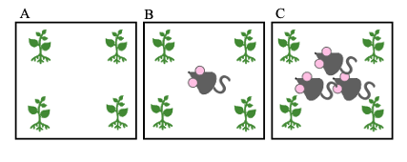
Figure 3.1: Schematic representation of the layout of the pots for each treatment. (A) represents the control, (B) represents the single mouse treatment, (C) represents the 3 mice treatment.

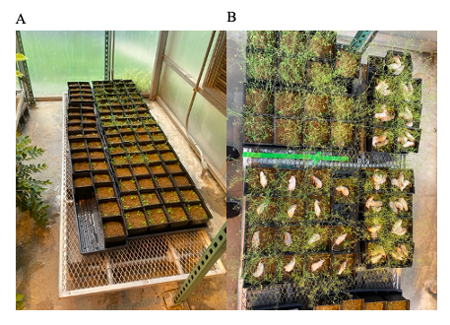
Figure 3.2: Pictures of pots used in this experiment. (A) Freshly transplanted Arabidopsis plants before carcass placement, (B) pots immediately after carcass placement.

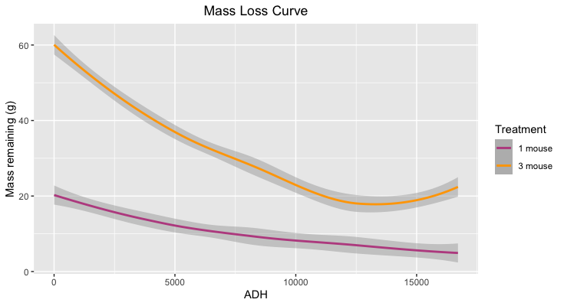
Figure 3.3: A mass loss curve depicting the difference in progression of decomposition between 1 mouse and 3 mice. The pink line represents the decay rate of 1 mouse, while the yellow line represents 3 mice. The shaded area represents the standard deviation of carcass masses per sampling timepoint. ADH stands for accumulated degree hours, a unit of time that takes thermal units into consideration.

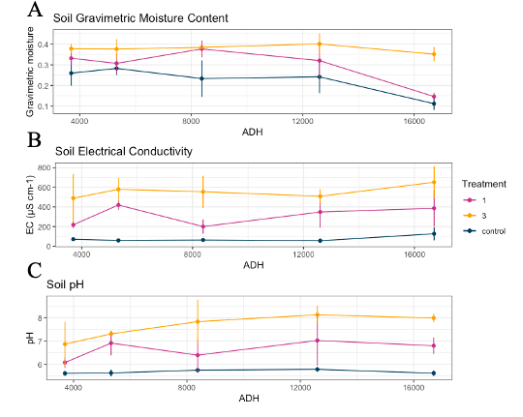
Figure 3.4: Graphs of the soil physiochemical responses to decomposition of different treatments. The graphs show trends in (A) soil gravimetric moisture content, (B) electrical conductivity, and (C) pH. The lines are representative of the mean values for the triplicates per treatment at each timepoint, the appropriate standard deviation bars are present. The blue line represents the control values, pink the one mouse treatment, and yellow the three mice treatment.

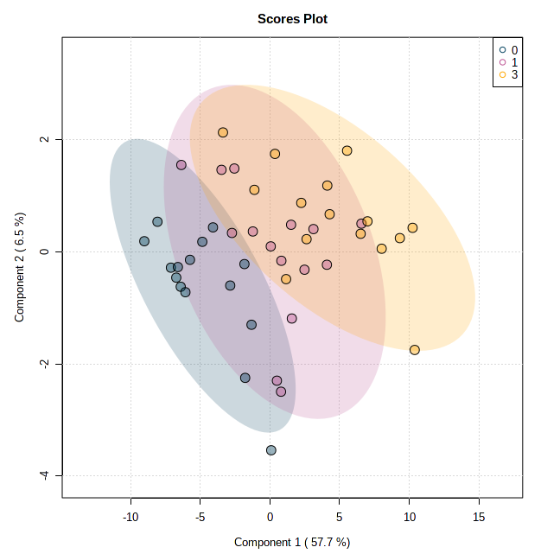
Figure 3.5: The 2D scores plot generated from a PLS-DA analysis assessing the variation of metabolic profiles between treatments (0, 1, 3). Blue represents the control pots, pink the single mouse treatment, and yellow the three mice treatment. The shaded ovals represent the 95% confidence interval.

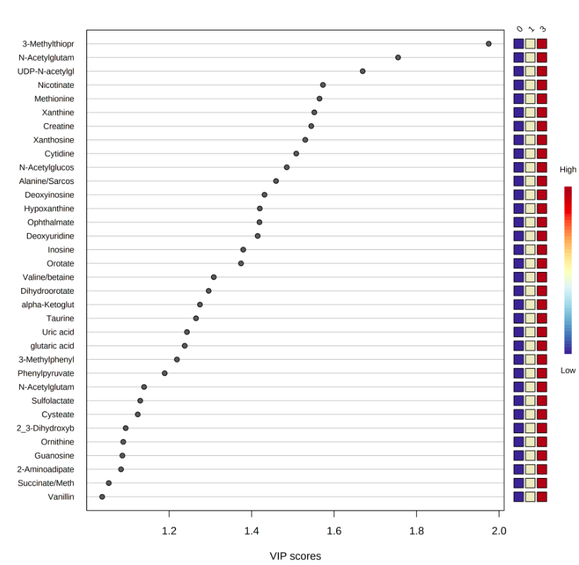
Figure 3.6: Metabolites with high Variable Importance in Projection (VIP) scores. These metabolites had VIP scores higher than 1, identified by a PLS-DA between treatments (0, 1, 3). The colored boxes on the right of the graph represent the relative concentrations of each metabolite due to each treatment (0 = control, 1 = 1 mouse pots, 3 = 3 mice pots). 3-Methylthiopr = 3-Methylthiopropionate, N-Acetylglutam = N-Acetylglutamate, UDP-N-acetylgl = UDP-N-acetylglucosamine, N-Acetylglucos = N-Acetylglucosamine [1 or 6]-phosphate, Alanine/Sarcos = Alanine/Sarcosine, alpha-Ketoglut = alpha-Ketoglutarate, 3-Methylphenyl = 3-Methylphenylacetic acid, N-Acetylglutam = N-Acetylglutamine, 2_3-Dihydroxyb = 2,3-Dihydroxybenzoate, Succinate/Meth = Succinate/Methylmalonate.
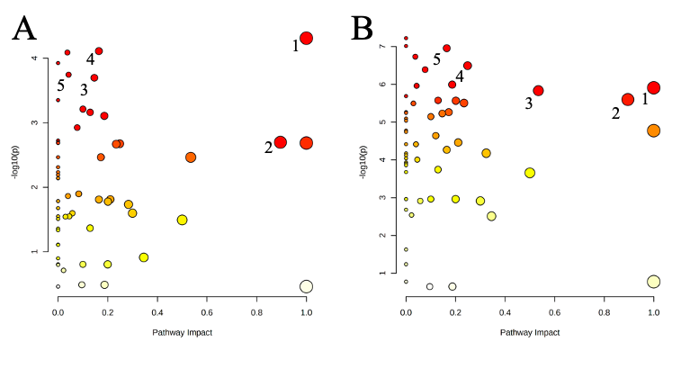

Figure 3.7: The pathway analyses identifying the metabolic pathways that were the most highly impacted by decomposition products according to the different treatments of 1 mouse (A) and 3 mice (B). The color of the node is based on the p-value, while the radius is based on the pathway impact values. The top 5 impacted pathways for single mouse treatment (A) were 1) taurine and hypotaurine metabolism, 2) alanine, aspartate, and glutamine metabolism, 3) phenylalanine metabolism, 4) amino sugar and nucleotide sugar metabolism, and 5) sulfur metabolism. The top 5 impacted pathways for three mice treatment (B) were 1) taurine and hypotaurine metabolism, 2) alanine, aspartate, and glutamate metabolism, 3) arginine biosynthesis, 4) arginine and proline metabolism, and 5) amino sugar and nucleotide metabolism.

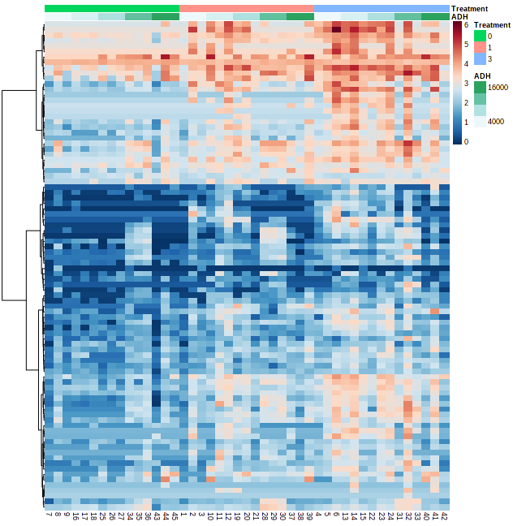
Figure 3.8: A correlation heatmap highlighting organized by treatment (0,1,3) and ADH. The various treatments are denoted by color with control (0) highlighted in green, 1 mouse pots samples (1) highlighted in pink, and 3 mice pots (3) highlighted in blue. As decomposition progresses and ADH increases, the color changes from white to green.

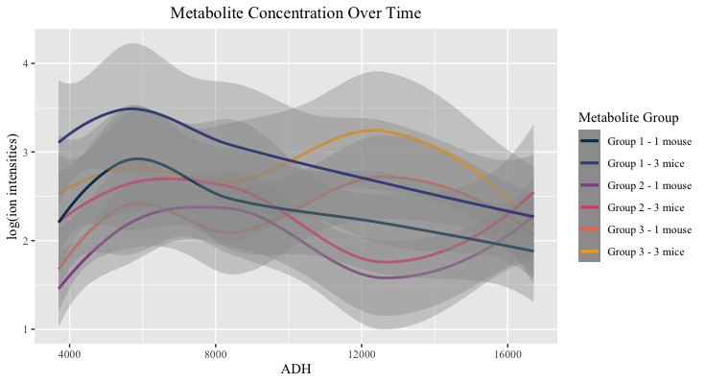
Figure 3.9: Metabolite concentrations per group graphed over time. The lines represent the mean concentration for the metabolites within said group and treatment, while the shaded areas represents the standard deviations. A list of the metabolites belonging to each group can be found in table 3.3. Group 1 metabolites are represented by the blue (1 mouse) and dark purple (3 mice). Group 2 metabolite concentrations are denoted by purple (1 mouse) and pink (3 mice). Group 3 metabolite concentrations are represented by orange (1 mouse) and yellow (3 mice).

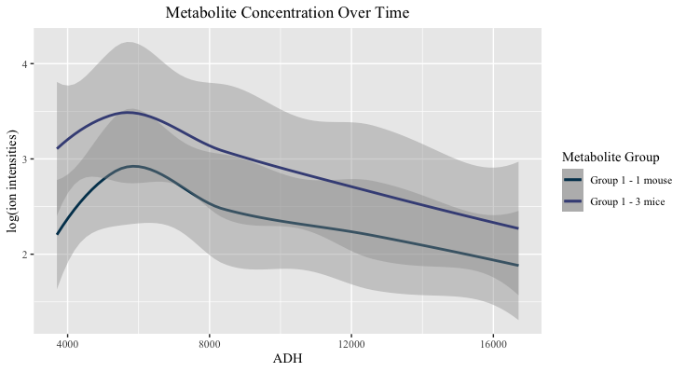
Figure 3.10: Metabolite group 1 concentrations graphed over time. The lines in this graph represent the mean concentration for the metabolites within said group and the surrounding shaded area represents the standard deviation. Metabolites in this group were nicotinate, cytidine, N-acetylglutamate, xanthosine, taurine, N-acetylglucosamine, succinate/methylmalonate, alpha-ketoglutarate, glutamate, creatine, ophthalmate, 3-methylthioproprionate, and pyruvate
The mean concentration of metabolites from the 1 mouse pots are denoted by dark blue and from the 3 mice pots by purple.
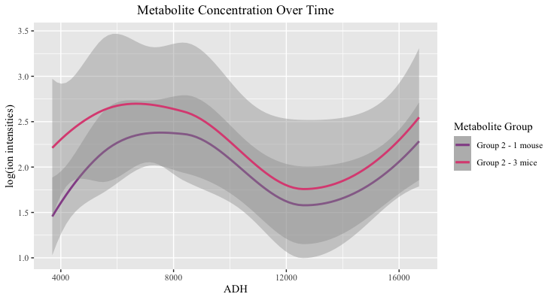
Figure 3.11: Metabolite group 2 concentrations graphed over time. The lines in this graph represent the mean concentration for the metabolites within said group and the shaded area represents the standard deviation. Metabolites in this group include UDP-glucose, UDP-N-acetylglucosamine, glutamine, and fumarate. The concentration of metabolites in soils from 1 mouse pots are highlighted in purple, while those from 3 mice pots are pink.

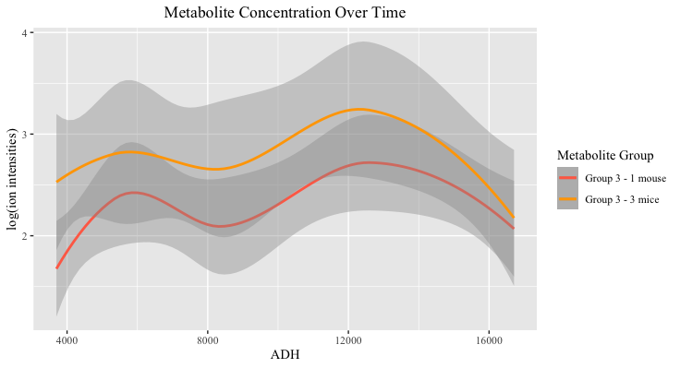
Figure 3.12: Metabolite group 3 concentrations graphed over time. The lines represent mean concentrations for the metabolites within said group and the shaded area represents the standard deviations.. Concentrations of metabolites from pots subjected to the decomposition of one mouse is denoted by orange, while those from three mice mots are yellow. Group 3 includes the metabolites alanine/sarcosine, hypoxanthine, methionine, xanthine, tyrosine, phenylalanine, ornithine, citrulline, aspartate, phenylpyruvate, N-acetylornithine, deoxyuridine, deoxyinosine, homoserine/threonine, tryptophan, valine/betaine, and leucine/isoleucine.

Tables
Table 3.1: Results from the ANOVAs ran on soil pH, electrical conductivity (EC), and gravimetric moisture content (GMC) by factor. Significant p values are in bold.
 | pH |  | EC |  | GMC
Factor | F value | p value | F value | p value | F value | p value
Treatment (0, 1, 3) | 92.67 | 1.35E-12 | 129.8 | 5.45E-15 | 24.44 | 1.06E-05
ADH | 4.269 | 0.0482 | 1.108 | 0.301 | 5.056 | 0.0326
Treatment*ADH | 91.38 | 1.67E-12 | 63.01 | 3.65E-10 | 8.649 | 0.00511

Table 3.2: Results from the one-way ANOVA and Tukey’s HSD post-hoc analysis on the metabolic variation between treatments (0 = control, 1 = 1 mouse pots, 3 = 3 mice pots). 71 metabolites were found to be significantly different across the treatments (bolded), 19 metabolites were unsignificant. Metabolites that were significantly different between 1 mouse pots and 3 mice pots according to the Tukey’s HSD post-hoc analysis (designated by “3-1” in this column) are designated with asterisks.
Metabolite | F value | p value | FDR | Tukey's HSD
N-Acetylglutamate* | 34.68 | 1.28E-09 | 1.15E-07 | 1-0; 3-0; 3-1
Nicotinate | 32.031 | 3.56E-09 | 1.60E-07 | 1-0; 3-0
UDP-N-acetylglucosamine* | 26.384 | 3.79E-08 | 1.08E-06 | 1-0; 3-0; 3-1
Alanine/Sarcosine* | 25.85 | 4.81E-08 | 1.08E-06 | 1-0; 3-0; 3-1
2-Aminoadipate* | 24.104 | 1.07E-07 | 1.92E-06 | 1-0; 3-0; 3-1
N-Acetylglucosamine [1 or 6]-phosphate* | 23.652 | 1.32E-07 | 1.98E-06 | 1-0; 3-0; 3-1
Cytidine* | 21.385 | 3.94E-07 | 4.50E-06 | 1-0; 3-0; 3-1
Inosine* | 21.355 | 4.00E-07 | 4.50E-06 | 1-0; 3-0; 3-1
Orotate* | 19.76 | 8.95E-07 | 8.95E-06 | 1-0; 3-0; 3-1
Uridine* | 19.264 | 1.16E-06 | 9.50E-06 | 1-0; 3-0; 3-1
Guanosine* | 19.117 | 1.25E-06 | 9.50E-06 | 1-0; 3-0; 3-1
Glutamate* | 19.091 | 1.27E-06 | 9.50E-06 | 1-0; 3-0; 3-1
Xanthine | 18.463 | 1.76E-06 | 1.16E-05 | 1-0; 3-0
3-Methylthiopropionate* | 18.426 | 1.80E-06 | 1.16E-05 | 1-0; 3-0; 3-1
N-Acetylglucosamine* | 18.267 | 1.96E-06 | 1.18E-05 | 1-0; 3-0; 3-1
Dihydroorotate* | 17.162 | 3.57E-06 | 2.00E-05 | 1-0; 3-0; 3-1
Hypoxanthine | 17.054 | 3.79E-06 | 2.00E-05 | 1-0; 3-0
Ophthalmate* | 16.432 | 5.35E-06 | 2.58E-05 | 3-0; 3-1
Vanillin* | 16.404 | 5.44E-06 | 2.58E-05 | 3-0; 3-1
Adenosine* | 16.237 | 5.97E-06 | 2.69E-05 | 1-0; 3-0; 3-1
alpha-Ketoglutarate* | 16.122 | 6.37E-06 | 2.73E-05 | 1-0; 3-0; 3-1
Cysteate | 15.986 | 6.88E-06 | 2.82E-05 | 1-0; 3-0
Methionine | 15.51 | 9.03E-06 | 3.53E-05 | 1-0; 3-0
N-Acetylglutamine | 15.296 | 1.02E-05 | 3.83E-05 | 1-0; 3-0
Taurine | 15.172 | 1.10E-05 | 3.95E-05 | 1-0; 3-0
Uric acid | 15.071 | 1.16E-05 | 4.03E-05 | 1-0; 3-0
Tyrosine | 14.958 | 1.24E-05 | 4.15E-05 | 1-0; 3-0
Glutaric acid* | 14.049 | 2.13E-05 | 6.85E-05 | 1-0; 3-0; 3-1
2,3-Dihydroxybenzoate* | 13.939 | 2.28E-05 | 7.06E-05 | 3-0; 3-1
Phenylpyruvate | 13.591 | 2.81E-05 | 8.42E-05 | 1-0; 3-0
Citrulline* | 12.766 | 4.66E-05 | 0.00013535 | 1-0; 3-0; 3-1
Sulfolactate | 12.342 | 6.08E-05 | 0.00017099 | 1-0; 3-0
Xanthosine | 12.244 | 6.47E-05 | 0.00017261 | 1-0; 3-0
Tryptophan | 12.231 | 6.52E-05 | 0.00017261 | 1-0; 3-0
Table 3.2 continued:
Metabolite | F value | p value | FDR | Tukey's HSD
Xylitol | 12.117 | 7.01E-05 | 0.00018014 | 1-0; 3-0
Succinate/Methylmalonate | 11.696 | 9.17E-05 | 0.00022689 | 1-0; 3-0
Aspartate* | 11.669 | 9.33E-05 | 0.00022689 | 3-0; 3-1
Homocysteic acid | 11.445 | 0.00010779 | 0.00025529 | 3-0
Dipicolinate* | 11.234 | 0.0001236 | 0.00028523 | 3-0; 3-1
2-Isopropylmalate* | 10.776 | 0.00016689 | 0.0003755 | 3-0; 3-1
Valine/betaine* | 10.611 | 0.00018618 | 0.00040869 | 3-0; 3-1
Phenyllactic acid* | 10.343 | 0.00022271 | 0.00047574 | 3-0; 3-1
Creatine | 10.312 | 0.0002273 | 0.00047574 | 1-0; 3-0
Hydroxybenzoate (methylparaben) | 10.276 | 0.00023283 | 0.00047624 | 3-0
Phenylalanine | 9.8671 | 0.00030704 | 0.00061408 | 1-0; 3-0
3-Methylphenylacetic acid | 9.6078 | 0.00036654 | 0.00071714 | 3-0
Leucine/Isoleucine | 9.5177 | 0.00038996 | 0.00074673 | 1-0; 3-0
Glutamine | 9.4686 | 0.00040338 | 0.00075634 | 1-0; 3-0
Pyroglutamic acid | 9.3728 | 0.00043094 | 0.00079152 | 3-0
Ornithine* | 9.0669 | 0.00053303 | 0.00095946 | 3-0; 3-1
Homovanillic acid (HVA) | 8.5937 | 0.00074375 | 0.0013125 | 3-0
Pyruvate* | 8.401 | 0.00085309 | 0.0014707 | 3-0; 3-1
2-Hydroxyglutaric acid | 8.3607 | 0.00087804 | 0.0014707 | 1-0; 3-0
Acetyllysine | 8.3537 | 0.00088242 | 0.0014707 | 3-0
Deoxyinosine | 8.2487 | 0.00095143 | 0.0015569 | 3-0
Deoxyuridine | 8.001 | 0.0011375 | 0.0018281 | 3-0
Tricarballylic acid | 7.7187 | 0.0013969 | 0.0022056 | 3-0
Trehalose/Sucrose | 6.9602 | 0.0024505 | 0.0038025 | 3-0
UDP-glucose | 6.3997 | 0.0037493 | 0.0057192 | 3-0
2-Oxo-4-methylthiobutanoate | 6.2989 | 0.0040511 | 0.0060767 | 3-0
Hydroxyphenylacetate | 6.1887 | 0.0044099 | 0.0065064 | 3-0
Homoserine/Threonine | 5.8493 | 0.0057415 | 0.0083344 | 3-0
N-Acetylornithine | 5.448 | 0.007877 | 0.011253 | 3-0
Hydroxyisocaproic acid | 5.2601 | 0.0091491 | 0.012866 | 3-0
Indoleacrylate | 5.1459 | 0.010026 | 0.013883 | 1-0; 3-0
Malate | 4.9362 | 0.011874 | 0.016191 | 3-0
Anthranilate | 4.7625 | 0.013673 | 0.018366 | 3-0
Indole-3-carboxylate | 4.5926 | 0.015711 | 0.020794 | 1-0; 3-0
Kynurenic acid | 4.3726 | 0.018834 | 0.024567 | 3-0
Thymine | 3.9713 | 0.026324 | 0.033846 | 3-0
Citrate/isocitrate | 3.575 | 0.036834 | 0.04669 | 3-0
Table 3.2 continued:
Metabolite | F value | p value | FDR | Tukey's HSD
Methionine sulfoxide | 3.4506 | 0.040974 | 0.051218
3-Hydroxyisovalerate | 3.4324 | 0.041622 | 0.051315
Fumarate | 3.163 | 0.052532 | 0.063891
2-Dehydro-D-gluconate | 2.9977 | 0.060679 | 0.072815
Guanine | 2.2946 | 0.1133 | 0.13417
sn-Glycerol 3-phosphate | 2.1678 | 0.12707 | 0.14852
Uracil | 1.8653 | 0.16745 | 0.19321
Proline | 1.7053 | 0.19405 | 0.22107
Allantoate | 1.6022 | 0.21352 | 0.24021
Xylose | 1.5074 | 0.23323 | 0.25914
Thymidine | 1.383 | 0.26202 | 0.28758
Allantoin | 1.1305 | 0.3325 | 0.36054
Myo-Inositol | 1.0098 | 0.37298 | 0.39861
Aconitate | 1 | 0.37647 | 0.39861
D-Gluconate | 0.94287 | 0.3976 | 0.41609
Deoxyribose phosphate | 0.50984 | 0.60426 | 0.6251
Lactate | 0.37081 | 0.69241 | 0.70815
Deoxycytidine | 0.078038 | 0.92506 | 0.93546
Lysine | 0.032194 | 0.96834 | 0.96834

Table 3.3: Metabolites belonging to each metabolic group (1, 2, or 3) and their classifications. Classifications include metabolites with high VIP scores (VIP score > 1), metabolites involved in impacted pathway(s), or amino acid metabolites. Some metabolites met the requirements for multiple classifications.
Group | Metabolite | Classification
Group 1 | Nicotinate | VIP score
 | Cytidine | VIP score
 | N-Acetylglutamate | VIP score, impacted pathway(s), amino acid
 | Xanthosine | VIP score
 | Taurine | VIP score, impacted pathway(s), amino acid
 | N-Acetylglucosamine | VIP score, impacted pathway(s)
 | Succinate/Methylmalonate | VIP score, impacted pathway(s), amino acid
 | alpha-Ketoglutarate | VIP score, impacted pathway(s), amino acid
 | Glutamate | Impacted pathway(s), amino acid
 | Creatine | VIP score, impacted pathway(s), amino acid
 | Ophthalmate | VIP score, amino acid
 | 3-Methylthiopropionate | VIP score
 | Pyruvate | Impacted pathway(s), amino acid
Group 2 | UDP-glucose | Impacted pathway(s)
 | UDP-N-acetylglucosamine | VIP score, impacted pathway(s)
 | Glutamine | Impacted pathway(s), amino acid
 | Fumarate | Impacted pathway(s), amino acid
Group 3 | Alanine/Sarcosine | VIP score, impacted pathway(s), amino acid
 | Hypoxanthine | VIP score
 | Methionine | VIP score, amino acid
 | Xanthine | VIP score
 | Tyrosine | Impacted pathway(s), amino acid
 | Phenylalanine | Impacted pathway(s), amino acid
 | Ornithine | VIP score, impacted pathway(s), amino acid
 | Citrulline | Impacted pathway(s), amino acid
 | Aspartate | Impacted pathway(s), amino acid
 | Phenylpyruvate | VIP score, impacted pathway(s)
 | N-Acetylornithine | Impacted pathway(s), amino acid
 | Deoxyuridine | VIP Score
 | Deoxyinosine | VIP Score
 | Homoserine/Threonine | Impacted pathway(s), amino acid
 | Tryptophan | Amino acid
 | Valine/betaine | VIP score, amino acid
 | Leucine/Isoleucine | Amino acid

Discussion and Concluding Remarks
When an animal expires, the carcass must be degraded by microbes, bacteria, fungi, and invertebrates in order to decompose resulting in a localized pulse of nutrients or a hotspot, which greatly affects the surrounding plants, animals, and soil. To date, the link between vertebrate decomposition, the effect on soil biological functioning, and effect on nutrient cycling on the environment that follows has not been fully identified. Additionally, the extent of the effects of carcass mas has on these topics has not been quantified. This study hoped to uncover the connection of the effects decomposition has on the surrounding environment, consequently gaining new insights into soil biological functioning and nutrient cycling through the utilization of metabolomics. It was hypothesized that (i) carcass decomposition would have a significant effect on soil metabolomic profiles (through variations in metabolite richness and abundance) over time and (ii) increased dosing pressure (i.e., carcass mass) would lead to faster and larger effects in metabolites associated with decomposition. To address these hypotheses, two decomposition experiments were performed. Across both studies, vertebrate decomposition was found to significantly affect soil physiochemical characteristics as well as soil metabolic profiles. Increased carcass mass three-fold resulted in 1.3 times higher concentrations in decomposition-associated metabolites. Moreover, the metabolites dominating the soil differed as decomposition progressed leading to the identification of a ‘succession’ of metabolites induced by decay.
The two studies performed differed in the species of the subject used, with one being a human decomposition experiment and the other being a mouse decomposition experiment. While humans and mice appear noncomparable, mice are currently the most used proxies for humans in biomedical research due to similarities in genetic, anatomical, and physiological characteristics (Belk et al. 2018; Bryda 2013; Burlikowska et al. 2020; Perlman 2016). One study found that not only were 40% of metabolites are regulated by genetic factors, but that there was a significant overlap in the genes regulating human serum metabolites and genes regulating mouse liver metabolites (Ghazalpour et al. 2014). However, differences between human and mouse metabolomes do exist. Mice have significantly higher levels of lipid metabolites compared to humans, as well as some variation in purine and pyrimidine nucleotides, fatty acids, and alcohols (Burlikowska et al. 2020). It is also reasonable to assume differences in gut microbiomes due to differences in diet. Nonetheless, mice still serve as sufficient proxies to humans allowing the two experiments in this thesis to be comparable.
While mice are acceptable proxies for humans in research studies, one interesting finding of note is the effect of these species on soil physiochemical characteristics. Soil pH was found to be significantly impacted in both studies, but in opposing ways. Human decomposition led to decreases in soil pH, while the decomposition of mice led to increases in soil pH. Previous decomposition studies have found the effect on pH variable as well, with human decomposition typically leading to decreases in soil pH and animals leading to increases. The human-pig decomposition study previously mentioned was a head-to-head comparison of pigs to humans that show this effect of pH under the same environmental conditions (DeBruyn et al. 2021). Soil gravimetric moisture content was significantly increased in mouse decomposition soils, but not significantly affected in the human decomposition experiment. The variation in this characteristic may be explained due to the control of environmental conditions in the greenhouse of the mouse study compared to the lack of control in the outdoor, human decomposition study as well as the greenhouse creating a somewhat closed system for the mouse experiment. The other soil physiochemical characteristic measured in our studies behaved in a similar way to each other. That is, soil electrical conductivity increased significantly when exposed to decomposition in both experiments.
One of the objectives of this thesis was to tie specific metabolites to vertebrate decomposition to serve as a kind of biomarker of decay. The results in this study, though, suggested that generally metabolites already present in soil increased in concentration opposed to novel metabolites being detected in impacted soils. Metabolites across both studies especially sensitive to decay (i.e., significantly affected by decomposition products) largely belonged to organoheterocyclic compounds (imidazopyrimidines) and organic acids and derivatives (amino acids, carboxylic acids), but metabolites classed as nucleotides, nucleosides, and analogues were often affected as well. Amino acid and derivate metabolites were found to be the most highly impacted by decomposition fluids and included taurine, creatine, ophthalmate, N-acetylglutamate, and N-acetylglutamine. Lesser impacted metabolites included carboxylic acids (alanine/sarcosine, methionine, and ornithine), imidazopyrimidines (hypoxanthine, xanthine, nicotinate), and purine and pyrimidine nucleotides (xanthosine and cytidine). Conversely, there were a limited number of metabolites that were unique to one experiment or the other. Metabolites frequently elevated in human decomposition soils compared to mouse decomposition soils included: proline (amino acid), D-gluconate (carbohydrate), and uracil (pyrimidine derivative). Metabolites frequently elevated in mouse decomposition soils compared to human decomposition soils included: UDP-N-acetylglucosamine (pyrimidine nucleotide sugar), N-acetylglucosamine [1 or 6]-phosphate (carbohydrate), and inosine (purine nucleoside). The differences in these metabolites can most likely be attributed to differences between humans and mice internal microbial and metabolic profiles (Burlikowska et al. 2020; Ghazalpour et al. 2014).
Variations in carcass mass in the mouse decomposition study did lead to significant differences in soil metabolic profiles but did not change the types of metabolites present or the timing of concentration minima and maxima. Meaning that, on average, metabolic concentrations in soils exposed to higher carcass masses were 1.3 times higher than in the soils exposed to lower carcass masses but were similar in diversity. Overall, the changes in abundance in most of the classes of metabolites were largely unsurprising given that metabolites previously detected in decomposition fluids (of pigs, mice, and humans) has been documented in other studies. However, one unexpected metabolite that continues to stand out in decomposition studies is the sulfonic amino acid taurine.
Taurine, which is particularly abundant in bile of mammals, was found to be significantly elevated in both studies. As an amino acid metabolite, it is not incorporated into proteins like most common amino acids. Taurine is found to be abundant in most of mammalian tissues and is present in soil as well (Kakumanu et al. 2019; Lambert et al. 2015; Stapley & Starkey 1970; Wishart 2019; Wishart et al. 2022). Interestingly, taurine typically increases as soils are dried (Kakumanu et al. 2019). In most decomposition studies, including our mouse decomposition study, the gravimetric moisture content increases due to the influx of decomposition fluids which would lead one to assume a decrease in taurine. However, there were significant increases in taurine in both experiments. This leads us to conclude that the increase in taurine is most likely carcass derived. Mammals lack the enzyme required to breakdown taurine and must be excreted through urine or feces, meaning mammalian bile and tissue has relatively large concentrations of taurine (Lambert et al. 2015). Having said this, though, aerobic organisms and bacteria are able to utilize taurine for energy, meaning the influx of taurine must be higher than the utilization by these organisms (Stapley & Starkey 1970). The nature of taurine, as well as the elevated presence in mammalian bile acid and skeletal muscles, may allow for taurine to serve as a biomarker for vertebrate decomposition. However, further investigation into taurine specifically needs to be done to say this definitively.
The similarities in significantly impacted metabolites led to similar metabolic pathways being highly impacted in both studies. The pathways most significantly impacted by decomposition across the studies belonged to amino acid metabolism (phenylalanine metabolism, alanine, aspartate, and glutamate metabolism, and taurine and hypotaurine metabolism) and energy metabolism (sulfur metabolism). Other impacted pathways included other amino acid metabolisms (cysteine and methionine metabolism, urea cycle, etc.) and energy metabolisms (nitrogen metabolism, methane metabolism, etc.), as well as carbohydrate metabolisms (glycolysis/gluconeogenesis, citric acid (TCA) cycle, etc.), nucleotide metabolisms (purine metabolism, pyrimidine metabolism, and metabolism of cofactors and vitamins (primary bile acid biosynthesis, pantothenate and CoA biosynthesis, etc.). The largest variation in impacted pathways was the impact on glycan biosynthesis and lipid metabolism in the mouse decomposition impacted soils. These metabolisms were not significantly affected in the human decomposition experiment, but this can be explained by the higher concentrations of lipids in mice previously mentioned.
Another objective of this study was to identify the variations in metabolic profiles over time as decomposition progressed. Through analyses of the dominant soil metabolites throughout the study as well as the identification of highly impacted pathways, a noticeable trend present in both studies was identified. That is, early on decay catabolic metabolisms dominated in the soil environment and once decomposition progresses enough biosynthetic, anabolic metabolisms take over. The high level of amino acids and other nutrients present in decomposition fluids which enter the soil upon decomposition and continued to be degraded and broken down by catabolic processes such as amino acid degradation and carbohydrate metabolism. The intermediates and products of the exergonic, catabolic metabolisms are then used in the endergonic, anabolic metabolisms later on during decay such as various pathways of biosynthesis, energy metabolisms, and the metabolism of cofactors and vitamins. However, it seemed as though at the very end of both experiments (+ 75,000 ADH in the human experiment, +14,000 ADH in the mouse experiment), perhaps when most of the human- or mouse-derived metabolites were fully utilized, some of the catabolic metabolisms begin to take over once again, as evidenced by the sudden increase in concentration of the associated metabolites. These trends in the metabolite groups and dominating pathways led to the declaration of a ‘succession’ of metabolites occurring in the soil due to the progression of decomposition.
Due to the nature of these decomposition studies, a number of limitations were present in these studies. One of the most impactful limitations was the batch effects present in the metabolic data of the human decomposition study. Despite best efforts to normalize the batch effects present, they were still significant in the data. Additionally, as with many studies at facilities like the ARF, there was a lack of control over the environmental conditions, surrounding vegetation, predation, etc. present in the human decomposition study. Finally, a limitation present in both studies exists in the limitations of current metabolomic studies in that some metabolites have not yet been identified that may be playing large roles in the dynamics of the metabolic pathways occurring in the soil during the experiment.
In these studies, untargeted metabolomics was utilized to investigate the effects of decomposition on soils. Metabolites significantly affected by decomposition in both studies included taurine, hypoxanthine, and creatine. Additionally, decomposition was found to highly impact pathways belonging to amino acid metabolisms, carbohydrate metabolisms, and energy metabolisms. Moreover, the identification of the variation of dominating metabolites and pathways as decay progressed led to the identification of a succession of metabolites induced by the progression of decomposition. During early decay, catabolic processes dominate in order to break down the complex compounds and nutrients that enter the soil in decomposition products. However, once these products are degraded, anabolic processes take over where microbes assimilate the newly introduced resources. The enhancement of microbial activities and respiration and specific metabolisms lead to increased rates of nitrogen and carbon cycling (i.e., nitrogen fixation and carbon consumption). Therefore, it is reasonable to assume that decomposition does indeed influence nutrient cycling, not only in the soil, but in the environment as well.
Moving forward further investigation into the effects of carcass mass may be beneficial not only considering nutrient pulses and environmental effects, but also the effects on post-mortem interval (PMI), time since death, estimations. As the field of metabolomics continues to adapt and evolve, studies into the effects of decomposition on metabolic profiles will continue to be incredibly insightful into biogeochemical functioning and nutrient cycling. Additionally, the metabolite taurine, its relationship to vertebrate decomposition, and its possible role as a biomarker for decomposition should be investigated further.

Bibliography
Aitkenhead-Peterson JA, Owings CG, Alexander MB, Larison N, and Bytheway JA. 2012. Mapping the lateral extent of human cadaver decomposition with soil chemistry. Forensic Science International 216:127-134. 10.1016/j.forsciint.2011.09.007
Alonso A, Marsal S, and Julià A. 2015. Analytical methods in untargeted metabolomics: state of the art in 2015. Frontiers in bioengineering and biotechnology 3:23-23. 10.3389/fbioe.2015.00023
Ameca y Juárez EI, Mace GM, Cowlishaw G, and Pettorelli N. 2012. Natural population die-offs: causes and consequences for terrestrial mammals. Trends in ecology & evolution (Amsterdam) 27:272-277. 10.1016/j.tree.2011.11.005
Ameca y Juárez EI, Mace GM, Cowlishaw G, and Pettorelli N. 2014. Identifying species' characteristics associated with natural population die-offs in mammals. Animal conservation 17:35-43. 10.1111/acv.12053
Aragao LEOC, Malhi Y, Metcalfe DB, Silva-Espejo JE, Jiménez E, Navarrete D, Almeida S, Costa ACL, Salinas N, Phillips OL, Anderson LO, Alvarez E, Baker TR, Goncalvez PH, Huamán-Ovalle J, Mamani-Solórzano M, Meir P, Monteagudo A, Patiño S, Peñuela MC, Prieto A, Quesada CA, Rozas-Dávila A, Rudas A, Silva Jr JA, and Vásquez R. 2009. Above- and below-ground net primary productivity across ten Amazonian forests on contrasting soils. Biogeosciences 6:2759-2778. 10.5194/bg-6-2759-2009
Archer M. 2014. Comparative Analysis of Insect Succession Data from Victoria (Australia) Using Summary Statistics versus Preceding Mean Ambient Temperature Models. Journal of forensic sciences 59:404-412. 10.1111/1556-4029.12345
Barton PS, Cunningham SA, Lindenmayer D, and Manning AD. 2013b. The role of carrion in maintaining biodiversity and ecological processes in terrestrial ecosystems. Oecologia 171:761-772. 10.1007/s00442-012-2460-3
Barton PS, McIntyre S, Evans MJ, Bump JK, Cunningham SA, and Manning AD. 2016. Substantial long‐term effects of carcass addition on soil and plants in a grassy eucalypt woodland. Ecosphere (Washington, DC) 7:n/a. 10.1002/ecs2.1537
Belk AD, Deel HL, Burcham ZM, Knight R, Carter DO, and Metcalf JL. 2018. Animal models for understanding microbial decomposition of human remains. Drug discovery today Disease models 28:117-125. 10.1016/j.ddmod.2019.08.013
Benninger LA, Carter DO, and Forbes SL. 2008. The biochemical alteration of soil beneath a decomposing carcass. Forensic Science International 180:70-75. 10.1016/j.forsciint.2008.07.001
Brand H. 2008. The effect of carcass weight on the decomposition of pigs (Sus scrofa) [unpublished MSc thesis]. School of Forensic and Investigative Sciences, University of Central Lancashire, 2007.
Bryda EC. 2013. The Mighty Mouse: the impact of rodents on advances in biomedical research. Missouri medicine 110:207-211.
Bump JK, Peterson RO, and Vucetich JA. 2009a. Wolves Modulate Soil Nutrient Heterogeneity and Foliar Nitrogen by Configuring the Distribution of Ungulate Carcasses. Ecology (Durham) 90:3159-3167. 10.1890/09-0292.1
Bump JK, Webster CR, Vucetich JA, Peterson RO, Shields JM, and Powers MD. 2009b. Ungulate Carcasses Perforate Ecological Filters and Create Biogeochemical Hotspots in Forest Herbaceous Layers Allowing Trees a Competitive Advantage. Ecosystems (New York) 12:996-1007. 10.1007/S10021-009-9274-0
Bundy JG, Davey MP, and Viant MR. 2009. Environmental metabolomics: a critical review and future perspectives. Metabolomics 5:3-21. 10.1007/s11306-008-0152-0
Burlikowska K, Stryjak I, Bogusiewicz J, Kupcewicz B, Jaroch K, and Bojko B. 2020. Comparison of Metabolomic Profiles of Organs in Mice of Different Strains Based on SPME-LC-HRMS. Metabolites 10:255. 10.3390/metabo10060255
Cao Y-W, Qu R-J, Miao Y-J, Tang X-Q, Zhou Y, Wang L, and Geng L. 2019. Untargeted liquid chromatography coupled with mass spectrometry reveals metabolic changes in nitrogen-deficient Isatis indigotica Fortune. Phytochemistry (Oxford) 166:112058-112058. 10.1016/j.phytochem.2019.112058
Carter DO, and Tibbett M. 2006. Microbial decomposition of skeletal muscle tissue ( Ovis aries) in a sandy loam soil at different temperatures. Soil biology & biochemistry 38:1139-1145. 10.1016/j.soilbio.2005.09.014
Carter DO, Yellowlees D, and Tibbett M. 2007. Cadaver decomposition in terrestrial ecosystems. Naturwissenschaften 94:12-24. 10.1007/s00114-006-0159-1
Cobaugh KL, Schaeffer SM, and DeBruyn JM. 2015. Functional and Structural Succession of Soil Microbial Communities below Decomposing Human Cadavers.
Coe M. 1978. The decomposition of elephant carcases in the Tsavo (East) National Park, Kenya. Journal of arid environments 1:71,74a,74b,75-74,74a,74b,86. 10.1016/S0140-1963(18)31756-7
Coleman DC, Crossley DA, and Hendrix PF. 2004. Fundamentals of soil ecology. Amsterdam ;: Elsevier Academic Press.
DeBruyn JM, and Hauther KA. 2017. Postmortem succession of gut microbial communities in deceased human subjects. PeerJ (San Francisco, CA) 5:e3437-e3437. 10.7717/peerj.3437
DeBruyn JM, Hoeland KM, Taylor LS, Stevens JD, Moats MA, Bandopadhyay S, Dearth SP, Castro HF, Hewitt KK, Campagna SR, Dautartas AM, Vidoli GM, Mundorff AZ, and Steadman DW. 2021. Comparative Decomposition of Humans and Pigs: Soil Biogeochemistry, Microbial Activity and Metabolomic Profiles. Frontiers in Microbiology 11:608856-608856. 10.3389/fmicb.2020.608856
Denno RFC, W. R. . 1975. Nice relationships of a guild of necrophagous flies. Ann Ent Soc Am 68:741-754.
Dent BB, Forbes SL, and Stuart BH. 2004. Review of human decomposition processes in soil. Environmental geology (Berlin) 45:576-585. 10.1007/s00254-003-0913-z
Diehl RH, Bates JM, Willard DE, and Gnoske TP. 2014. Bird mortality during nocturnal migration over Lake Michigan: a case study. The Wilson journal of ornithology 126:19-29. 10.1676/12-191.1
Dirkmaat DC, Cabo LL, Ousley SD, and Symes SA. 2008. New perspectives in forensic anthropology. American journal of physical anthropology 137:33-52. 10.1002/ajpa.20948
Fancher JP, Aitkenhead-Peterson JA, Farris T, Mix K, Schwab AP, Wescott DJ, and Hamilton MD. 2017. An evaluation of soil chemistry in human cadaver decomposition islands: Potential for estimating postmortem interval (PMI). Forensic Science International 279:130-139. 10.1016/j.forsciint.2017.08.002
Fereidouni S, Freimanis GL, Orynbayev M, Ribeca P, Flannery J, King DP, Zuther S, Beer M, Höper D, Kydyrmanov A, Karamendin K, and Kock R. 2019. Mass Die-Off of Saiga Antelopes, Kazakhstan, 2015. Emerging infectious diseases 25:1169-1176. 10.3201/eid2506.180990
Ghazalpour A, Bennett BJ, Shih D, Che N, Orozco L, Pan C, Hagopian R, He A, Kayne P, Yang Wp, Kirchgessner T, and Lusis AJ. 2014. Genetic regulation of mouse liver metabolite levels. Molecular systems biology 10:730-n/a. 10.15252/msb.20135004
Giweta M. 2020. Role of litter production and its decomposition, and factors affecting the processes in a tropical forest ecosystem: a review. Journal of ecology and environment 44:81-89. 10.1186/s41610-020-0151-2
Halsch CA, Shapiro AM, Fordyce JA, Nice CC, Thorne JH, Waetjen DP, and Forister ML. 2021. Insects and recent climate change. Proceedings of the National Academy of Sciences - PNAS 118. 10.1073/pnas.2002543117
Hartman WH, Richardson CJ, Vilgalys R, and Bruland GL. 2008. Environmental and Anthropogenic Controls over Bacterial Communities in Wetland Soils. Proceedings of the National Academy of Sciences - PNAS 105:17842-17847. 10.1073/pnas.0808254105
Hauther KA, Cobaugh KL, Jantz LM, Sparer TE, and DeBruyn JM. 2015. Estimating Time Since Death from Postmortem Human Gut Microbial Communities. Journal of forensic sciences 60:1234-1240. 10.1111/1556-4029.12828
Hewadikaram KG, ML. 1991. Effect of carcass size on rate of decomposition and arthropod succession patterns. Am J Forensic Med Pathol 12:235-240.
Hopkins DW, Wiltshire PEJ, and Turner BD. 2000. Microbial characteristics of soils from graves: an investigation at the interface of soil microbiology and forensic science. Applied soil ecology : a section of Agriculture, ecosystems & environment 14:283-288. 10.1016/S0929-1393(00)00063-9
Howard GT, Duos B, and Watson-Horzelski EJ. 2010. Characterization of the soil microbial community associated with the decomposition of a swine carcass. International Biodeterioration & Biodegradation 64:300-304. 10.1016/j.ibiod.2010.02.006
Javan GT, Finley SJ, Abidin Z, and Mulle JG. 2016. The Thanatomicrobiome: A Missing Piece of the Microbial Puzzle of Death. Frontiers in Microbiology 7:225-225. 10.3389/fmicb.2016.00225
Johnson MD. 1975. Seasonal and Microseral Variations in the Insect Populations on Carrion. The American midland naturalist 93:79-90. 10.2307/2424107
Kakumanu ML, Ma L, and Williams MA. 2019. Drought-induced soil microbial amino acid and polysaccharide change and their implications for C-N cycles in a climate change world. Scientific reports 9:10968-10912. 10.1038/s41598-019-46984-1
Kanehisa M, Furumichi M, Sato Y, Ishiguro-Watanabe M, and Tanabe M. 2021. KEGG: integrating viruses and cellular organisms. Nucleic acids research 49:D545-D551. 10.1093/nar/gkaa970
Keenan SW, Emmons AL, Taylor LS, Phillips G, Mason AR, Mundorff AZ, Bernard EC, Davoren J, and DeBruyn JM. 2018a. Spatial impacts of a multi-individual grave on microbial and microfaunal communities and soil biogeochemistry. PloS one 13:e0208845-e0208845. 10.1371/journal.pone.0208845
Keenan SW, Schaeffer SM, Jin VL, and DeBruyn JM. 2018b. Mortality hotspots: Nitrogen cycling in forest soils during vertebrate decomposition. Soil biology & biochemistry 121:165-176. 10.1016/j.soilbio.2018.03.005
Komar D, and Beattie O. 1998. Effects of Carcass Size on Decay Rates of Shade and Sun Exposed Carrion. Canadian Society of Forensic Science Journal 31:35-43. 10.1080/00085030.1998.10757107
Krishna MM, M. 2007. Litter decomposition in forest ecosystems: a review. Energ Ecol Enciron 2:236-249.
Lambert IH, Kristensen DM, Holm JB, and Mortensen OH. 2015. Physiological role of taurine - from organism to organelle. Acta Physiologica 213:191-212. 10.1111/apha.12365
Lane RP. 1975. An investigation into blowfly (Diptera: Calliphoridae) succession on corpses. J Nat Hist 9:581-588.
Lu W, Clasquin MF, Melamud E, Amador-Noguez D, Caudy AA, and Rabinowitz JD. 2010. Metabolomic Analysis via Reversed-Phase Ion-Pairing Liquid Chromatography Coupled to a Stand Alone Orbitrap Mass Spectrometer. Analytical chemistry (Washington) 82:3212-3221. 10.1021/ac902837x
Lyman RL. 2010. What Taphonomy Is, What it Isn’t, and Why Taphonomists Should Care about the Difference. Journal of Taphonomy 8:1-16.
Ma S, Yim Sun H, Lee S-G, Kim Eun B, Lee S-R, Chang K-T, Buffenstein R, Lewis Kaitlyn N, Park Thomas J, Miller Richard A, Clish Clary B, and Gladyshev Vadim N. 2015. Organization of the Mammalian Metabolome according to Organ Function, Lineage Specialization, and Longevity. Cell metabolism 22:332-343. 10.1016/j.cmet.2015.07.005
Macdonald BCT, Farrell M, Tuomi S, Barton PS, Cunningham SA, and Manning AD. 2014. Carrion decomposition causes large and lasting effects on soil amino acid and peptide flux. Soil biology & biochemistry 69:132-140. 10.1016/j.soilbio.2013.10.042
Mann RW, Bass WM, and Meadows L. 1990. Time Since Death and Decomposition of the Human Body: Variables and Observations in Case and Experimental Field Studies. Journal of forensic sciences 35:103-111. 10.1520/JFS12806J
Marinello E, Arezzini L, Pizzichini M, Frosi B, Porcelli B, and Terzuoli L. 2002. Purine nucleotide catabolism in rat liver: Labelling of uric acid and allantoin after administration of various labelled precursors. Life sciences (1973) 70:2931-2941. 10.1016/S0024-3205(02)01532-1
Marinello E, Pizzichini M, Guerranti R, Cinci G, Arezzini L, Porcelli B, and Terzuoli L. 2001. Purine nucleotide catabolism in rat liver Labelling of uric acid and allantoin after treatment with oxonic acid and allopurinol. Life sciences (1973) 68:1131-1142. 10.1016/S0024-3205(00)01015-8
Matuszewski S, Frątczak K, Konwerski S, Bajerlein D, Szpila K, Jarmusz M, Szafałowicz M, Grzywacz A, and Mądra A. 2016. Effect of body mass and clothing on carrion entomofauna. International journal of legal medicine 130:221-232. 10.1007/s00414-015-1145-y
Matuszewski S, Konwerski S, Frątczak K, and Szafałowicz M. 2014. Effect of body mass and clothing on decomposition of pig carcasses. International journal of legal medicine 128:1039-1048. 10.1007/s00414-014-0965-5
Megyesi MS, Nawrocki SP, and Haskell NH. 2005. Using Accumulated Degree-Days to Estimate the Postmortem Interval from Decomposed Human Remains. Journal of forensic sciences 50:1-9. 10.1520/JFS2004017
Metcalf JL, Wegener Parfrey L, Gonzalez A, Lauber CL, Knights D, Ackermann G, Humphrey GC, Gebert MJ, Van Treuren W, Berg-Lyons D, Keepers K, Guo Y, Bullard J, Fierer N, Carter DO, and Knight R. 2013. A microbial clock provides an accurate estimate of the postmortem interval in a mouse model system. eLife 2:e01104-e01104. 10.7554/eLife.01104
Metcalf JL, Xu ZZ, Weiss S, Lax S, Van Treuren W, Hyde ER, Song SJ, Amir A, Larsen P, Sangwan N, Haarmann D, Humphrey GC, Ackermann G, Thompson LR, Lauber C, Bibat A, Nicholas C, Gebert MJ, Petrosino JF, Reed SC, Gilbert JA, Lynne AM, Bucheli SR, Carter DO, and Knight R. 2016. Microbial community assembly and metabolic function during mammalian corpse decomposition. Science (American Association for the Advancement of Science) 351:158-162. 10.1126/science.aad2646
Meyer J, Anderson B, and Carter DO. 2013. Seasonal Variation of Carcass Decomposition and Gravesoil Chemistry in a Cold (Dfa) Climate. Journal of forensic sciences 58:1175-1182. 10.1111/1556-4029.12169
Mueller LO, Borstein SR, Tague ED, Dearth SP, Castro HF, Campagna SR, Bailey JK, and Schweitzer JA. 2020. Populations of Populus angustifolia have evolved distinct metabolic profiles that influence their surrounding soil. Plant and soil 448:399-411. 10.1007/s11104-019-04405-2
Pang Z, Chong J, Zhou G, de Lima Morais DA, Chang L, Barrette M, Gauthier C, Jacques P-É, Li S, and Xia J. 2021. MetaboAnalyst 5.0: narrowing the gap between raw spectra and functional insights. Nucleic acids research 49:W388-W396. 10.1093/nar/gkab382
Parmenter RR, and MacMahon JA. 2009. Carrion Decomposition and Nutrient Cycling in a Semiarid Shrub—Steppe Ecosystem. Ecological monographs 79:637-661. 10.1890/08-0972.1
Parsons SA, Valdez-Ramirez V, Congdon RA, and Williams SE. 2014. Contrasting patterns of litterfall seasonality and seasonal changes in litter decomposability in a tropical rainforest region. Biogeosciences 11:5047-5056. 10.5194/bg-11-5047-2014
Payne JA. 1965. A Summer Carrion Study of the Baby Pig Sus Scrofa Linnaeus. Ecology (Durham) 46:592-602. 10.2307/1934999
Pechal JL, Crippen TL, Tarone AM, Lewis AJ, Tomberlin JK, and Benbow ME. 2014. Microbial community functional change during vertebrate carrion decomposition. PloS one 8:e79035-e79035. 10.1371/journal.pone.0079035
Perlman RL. 2016. Mouse models of human disease: An evolutionary perspective. Evolution, medicine, and public health 2016:170-176. 10.1093/emph/eow014
Pétriacq P, Williams A, Cotton A, McFarlane AE, Rolfe SA, and Ton J. 2017. Metabolite profiling of non‐sterile rhizosphere soil. The Plant journal : for cell and molecular biology 92:147-162. 10.1111/tpj.13639
Phillips DA, Joseph CM, and Hirsch PR. 1997. Occurrence of flavonoids and nucleosides in agricultural soils. Applied and environmental microbiology 63:4573-4577. 10.1128/AEM.63.11.4573-4577.1997
Pietramellara G, Ascher J, Borgogni F, Ceccherini MT, Guerri G, and Nannipieri P. 2008. Extracellular DNA in soil and sediment: fate and ecological relevance. Biology and fertility of soils 45:219-235. 10.1007/s00374-008-0345-8
Putman RJ. 1978b. Patterns of Carbon dioxide Evolution from Decaying Carrion Decomposition of Small Mammal Carrion in Temperate Systems 1. Oikos 31:47-57. 10.2307/3543383
Quaggiotto M-M, Evans MJ, Higgins A, Strong C, and Barton PS. 2019. Dynamic soil nutrient and moisture changes under decomposing vertebrate carcasses. Biogeochemistry 146:71-82. 10.1007/s10533-019-00611-3
Ratnayake HU, Kearney MR, Govekar P, Karoly D, and Welbergen JA. 2019. Forecasting wildlife die‐offs from extreme heat events. Animal conservation 22:386-395. 10.1111/acv.12476
Reed HB. 1958. A Study of Dog Carcass Communities in Tennessee, with Special Reference to the Insects. The American midland naturalist 59:213-245. 10.2307/2422385
Roberts LD, Souza AL, Gerszten RE, and Clish CB. 2012. Targeted Metabolomics. Current Protocols in Molecular Biology 98:30.32.31-30.32.24. 10.1002/0471142727.mb3002s98
Roessner U, and Bowne J. 2009. What is metabolomics all about? BioTechniques 46:363-365. 10.2144/000113133
Salek R, Beisken S, and Emery L. 2020. Metabolomics. 10.6019/TOL.MBS.2014.00001.1
Sanderson CE, and Alexander KA. 2020. Unchartered waters: Climate change likely to intensify infectious disease outbreaks causing mass mortality events in marine mammals. Global change biology 26:4284-4301. 10.1111/gcb.15163
Shanks AL, Rasmuson LK, Valley JR, Jarvis MA, Salant C, Sutherland DA, Lamont EI, Hainey MAH, and Emlet RB. 2020. Marine heat waves, climate change, and failed spawning by coastal invertebrates. Limnology and oceanography 65:627-636. 10.1002/lno.11331
Shelden MC, Dias DA, Jayasinghe NS, Bacic A, and Roessner U. 2016. Root spatial metabolite profiling of two genotypes of barley (Hordeum vulgare L.) reveals differences in response to short-term salt stress. Journal of experimental botany 67:3731-3745. 10.1093/jxb/erw059
Simmons T, Adlam RE, and Moffatt C. 2010. Debugging Decomposition Data-Comparative Taphonomic Studies and the Influence of Insects and Carcass Size on Decomposition Rate. Journal of forensic sciences 55:8-13. 10.1111/j.1556-4029.2009.01206.x
Spicka A, Johnson R, Bushing J, Higley LG, and Carter DO. 2011. Carcass mass can influence rate of decomposition and release of ninhydrin-reactive nitrogen into gravesoil. Forensic Science International 209:80-85. 10.1016/j.forsciint.2011.01.002
Stapley EO, and Starkey RL. 1970. Decomposition of Cysteic Acid and Taurine by Soil Micro-organisms. Journal of general microbiology 64:77-84. 10.1099/00221287-64-1-77
Stokes KL, Forbes SL, and Tibbett M. 2013. Human Versus Animal: Contrasting Decomposition Dynamics of Mammalian Analogues in Experimental Taphonomy. Journal of forensic sciences 58:583-591. 10.1111/1556-4029.12115
Stough JMA, Dearth SP, Denny JE, LeCleir GR, Schmidt NW, Campagna SR, and Wilhelm SW. 2016. Functional Characteristics of the Gut Microbiome in C57BL/6 Mice Differentially Susceptible to Plasmodium yoelii.
Sutherland A, Myburgh J, Steyn M, and Becker PJ. 2013. The effect of body size on the rate of decomposition in a temperate region of South Africa. Forensic Science International 231:257-262. 10.1016/j.forsciint.2013.05.035
Swenson TL, Jenkins S, Bowen BP, and Northen TR. 2015. Untargeted soil metabolomics methods for analysis of extractable organic matter. Soil biology & biochemistry 80:189-198. 10.1016/j.soilbio.2014.10.007
Szelecz I, Sorge F, Seppey CVW, Mulot M, Steel H, Neilson R, Griffiths BS, Amendt J, and Mitchell EAD. 2016. Effects of decomposing cadavers on soil nematode communities over a one-year period. Soil biology & biochemistry 103:405-416. 10.1016/j.soilbio.2016.09.011
Ueberschaar N, Lehmann K, Meyer S, Zerfass C, Michalzik B, Totsche KU, and Pohnert G. 2021. Soil Solution Analysis With Untargeted GC-MS-A Case Study With Different Lysimeter Types. Frontiers in earth science (Lausanne) 8. 10.3389/feart.2020.563379
Ursell LK, Metcalf JL, Parfrey LW, and Knight R. 2012. Defining the human microbiome. Nutrition reviews 70:S38-S44. 10.1111/j.1753-4887.2012.00493.x
Vass AA. 1992. Time since death determinations of human cadavers utilizing soil solution: Thesis (Ph.D.)--University of Tennessee, Knoxville, 1991.
Veerman J, Kumar A, and Mishra DR. 2022. Exceptional landscape-wide cyanobacteria bloom in Okavango Delta, Botswana in 2020 coincided with a mass elephant die-off event. Harmful algae 111:102145-102145. 10.1016/j.hal.2021.102145
Wardle DA, Bardgett RD, Klironomos JN, Setälä H, Van der Putten WH, and Wall DH. 2004. Ecological Linkages between Aboveground and Belowground Biota. Science (American Association for the Advancement of Science) 304:1629-1633. 10.1126/science.1094875
Wardle DA, Nicholson KS, and Rahman A. 1994. Influence of herbicide applications on the decomposition, microbial biomass, and microbial activity of pasture shoot and root litter. New Zealand journal of agricultural research 37:29-39. 10.1080/00288233.1994.9513038
Weiss S, Carter DO, Metcalf JL, and Knight R. 2016. Carcass mass has little influence on the structure of gravesoil microbial communities. International journal of legal medicine 130:253-263. 10.1007/s00414-015-1206-2
Welbergen JA, Klose SM, Markus N, and Eby P. 2008. Climate change and the effects of temperature extremes on Australian flying-foxes. Proceedings of the Royal Society B, Biological sciences 275:419-425. 10.1098/rspb.2007.1385
Wilson ID, Plumb R, Granger J, Major H, Williams R, and Lenz EM. 2007. HPLC-MS-based methods for the study of metabonomics. Journal of chromatography B, Analytical technologies in the biomedical and life sciences 817:67-76. 10.1016/j.jchromb.2004.07.045
Wishart DS. 2019. Metabolomics for Investigating Physiological and Pathophysiological Processes. Physiological reviews 99:1819-1875. 10.1152/physrev.00035.2018
Wishart DS, Guo A, Oler E, Wang F, Anjum A, Peters H, Dizon R, Sayeeda Z, Tian S, Lee Brian L, Berjanskii M, Mah R, Yamamoto M, Jovel J, Torres-Calzada C, Hiebert-Giesbrecht M, Lui Vicki W, Varshavi D, Varshavi D, Allen D, Arndt D, Khetarpal N, Sivakumaran A, Harford K, Sanford S, Yee K, Cao X, Budinski Z, Liigand J, Zhang L, Zheng J, Mandal R, Karu N, Dambrova M, Schiöth Helgi B, Greiner R, and Gautam V. 2022. HMDB 5.0: the Human Metabolome Database for 2022. Nucleic acids research 50:D622-D631. 10.1093/nar/gkab1062
Withers E, Hill PW, Chadwick DR, and Jones DL. 2020. Use of untargeted metabolomics for assessing soil quality and microbial function. Soil biology & biochemistry 143:107758. 10.1016/j.soilbio.2020.107758
Yang D, Yang A, Yang J, Xu R, and Qiu H. 2021. Unprecedented Migratory Bird Die‐Off: A Citizen‐Based Analysis on the Spatiotemporal Patterns of Mass Mortality Events in the Western United States. Geohealth 5:e2021GH000395-n/a. 10.1029/2021GH000395
Zhang H, Yuan W, Dong W, and Liu S. 2014. Seasonal patterns of litterfall in forest ecosystem worldwide. Ecological complexity 20:240-247. 10.1016/j.ecocom.2014.01.003

Vita
Katie Baer grew up in Knoxville, Tennessee and graduated from Hardin Valley Academy in 2016. She then went on to attend Roane State Community College in order to earn an associate degree. While at Roane State, Katie got involved in SCUBA diving and began conducting fish ID surveys for the National Oceanic and Atmospheric Administration and volunteering for the Coral Reef Restoration Foundation. After earning her Associates degree, Katie transferred to the University of Tennessee, Knoxville to earn a bachelor’s in environmental and soil science with a concentration of Environmental Science and a Watershed minor. While in undergraduate school, she interned at Oak Ridge National Laboratory under Dr. Colleen Iversen. At ORNL, Katie helped create the world’s first Fine-Root Ecology Database and worked on the Next-Generation Ecosystem Experiments: Arctic and Spruce and Peatland Responses Under Changing Environments projects. She graduated from the University of Tennessee, Knoxville with her bachelor’s degree in 2020. She then began pursuing a master’s degree in Environmental and Soil Science under Dr. Jennifer DeBruyn. Her research interests include fine roots, soil ecology, climate change, and metabolomics. After graduation, she plans to enter the career force at a research institution. She is incredibly grateful for the outpouring of support her loved ones have given her throughout her schooling.

