An Analog CMOS Particle Filter

A Thesis Presented for the
Master of Science
Degree
The University of Tennessee, Knoxville

Trevor Watson
May 2017

ACKNOWLEDGEMENTS

Thank you to Dr. Jeremy Holleman for guidance in this project and Ashley Smutnik for proofreading and keeping me on task.
ABSTRACT

Particle filters are used in a variety of image processing and machine learning applications. Their main use in these applications is to gather information about a system of objects, by using partial or noisy observations collected from sensors. These observations are used associate points of interest in the observations with objects and maintain this association through a series of observations.

In this paper we will investigate the performance of a particle filter implemented in 130nm analog CMOS hardware. The design goal of the particle filter is low-microwatt power consumption. Using analog hardware, rather than digital ASICs or CPUs we hope to achieve this low power consumption.

Table of Contents

Chapter One Introduction and General Information 1
Particle Filter Introduction 1
Implementation 5
Chapter Two Literature Review 6
Particle Filter 6
Chapter Three System Description 8
3.1 Architecture 8
3.2 Storage 11
3.3 Multiplier 20
3.4 Proposal Generator 21
3.5 Test setup 23
Chapter Four Results and Discussion 25
4.1 Sample and Hold 25
4.2 Multiplier 29
4.3 System Test 31
Chapter Five Conclusions and Recommendations 40
List of References 41
Vita 43

LIST OF TABLES

Table 3.1 Sample and Hold Device Sizes 16
Table 3.2 Op-Amp Device Sizes 19

LIST OF FIGURES

Figure 1.1 10,000 Particle Approximation of Bimodal Gaussian distribution 3
Figure 1.2 Step 1 4
Figure 1.3 Step 2 New observation 4
Figure 1.4 Step 3 Update Particles 4
Figure 3.1 Particle filter block diagram 9
Figure 3.2 Proposal Generator 10
Figure 3.3 Acceptance Ratio Calculator 10
Figure 3.4 Original sample and hold circuit 13
Figure 3.5 Revised sample and hold circuit 15
Figure 3.6 Original Sample and Hold Op-Amp 17
Figure 3.7 Revised Sample and Hold Op-Amp 19
Figure 3.8 Multiplier Schematic 20
Figure 3.9 Proposal Generator 21
Figure 3.10 DAC used in proposal generator 22
Figure 3.11 Transconductor circuit schematic 24
Figure 3.12 Transimpedance amplifier 24
Figure 4.1 Feb. 2016 standalone sample and hold cell test 27
Figure 4.2 Simulated results 28
Figure 4.3 Input DC sweep, Ia/Ic = 3/2 30
Figure 4.4 Multiplier Step Response, Ia/Ic = 3/2 30
Figure 4.5 Proposal Generator Test (Feb 16) 32
Figure 4.6 Proposal Generator Test (Aug 16) 32
Figure 4.7 Proposal Generator tested with random input value (Feb 16) 33
Figure 4.8 Sample and Hold Problem (Feb 16) 35
Figure 4.9 Revised Sample and Hold Test (Aug 16) 35
Figure 4.10 Revise Sample and Hold Step Test (Aug 16) 36
Figure 4.11 MATLAB Recorded Accepted Particles 38
Figure 4.12 Chip Recorded Accepted Particles 38
Figure 4.13 Simulated object location converging as particles are updated 39

Introduction and General Information

Particle Filter Introduction

Particle filters are a series of numerical methods used to estimate the actual state of a system from some partial or incomplete observation of the system. The observations of the system may include noise and other false signals. Determining the state of the system through a series of noisy or incomplete observations is known as the filtering problem.

The filtering problem as used for tracking objects in a series of images can be thought of as modeling lots of guesses about the future location of the object based on its currently assumed location, the probability of the assumed location based on the observed probability distribution, and it’s prior assumed locations. Each guess is represented by a particle, and the distribution of these particles can be viewed as an estimated model for where the object currently is and where it will be in the future. In this paper we will assume a first-order motion model (velocity) to calculate possible future locations.

The estimated future locations can be used to associate detections with objects and maintain this association over a series of observations, even in cases where detections fade in and out or cross over one another.

For a given system the location of an object in the system can be described in a continuous probability function over the entire system. For a two dimensional system, such as the location of an object on a line, this can be visualized as a continuous function over the x-axis as shown by the red trace in Figure 1.1, with the y-axis representing the probability of the object at that x location, the higher the peak the more likely the object is at that x-coordinate. If we observe the system over a series of observations and model the anticipated movement of the object as constant velocity along the x-axis we can estimate the objects future location based on its estimated movement along the x-axis.

The particle filter starts by approximating the supplied probability distribution (the observation) with a series of individual points, or particles, as seen in Figure 1.2 These particles represent a guess about the state of the system and are generated using Markov chain Monte Carlo methods to sample points from the supplied probability distribution. Then on the next observation cycle (Figure 1.3) the probability distribution is updated with a new observation. The particle filter then generates a new set of particles based on the previous particle locations and the new observation. Over several update and resample iterations the particle filter can converge on the objects estimated location, as shown in Figure 1.4.

The two main equations describing the prediction and update process are the Chapman-Kolmogorov equation and Bayes theorem of conditional probability. The Chapman-Kolmogorov Equation (Equation 1) describes the probability of transition from the previous state $x_{n-1}$ to the current state $x_{n}$ through all possible intermediate points, based on all prior measurements $y_{1:n-1}$

For the particle filter with a finite number of particles this becomes the probability of the particle in the current state based on the total probability of all particles in the previous state moving to the location of the particle in the current state. The Chapman-Kolmogorov equation gives the probability of the current state based on all previous states and is recursive. For a first-order Markov process only the previous state is retained and the state transition equation becomes Equation 2.

The system model, $P\left(x_{n} | x_{n-1}\right)$ , describes the expected movement of the particles. The system model for the particle filter chip was chosen to be a first-order, or constant velocity, model. Particles are assumed to move with a constant velocity with a Gaussian noise term added.

$$P\left(x_{n} | y_{1:n-1}\right)=\int{P\left(x_{n} | x_{n-1}\right)P\left(x_{n-1} | y_{1:n-1}\right) dx_{n-1}}$$
Equation 1 Chapman-Kolmogorov Equation
$$P\left(x_{n}\right)=\sum{P\left(x_{n} | x_{n-1}\right)P(x_{n-1})}$$
Equation 2 Chapman-Kolmogorov as used in particle filter chip

After performing the update step, the new observation data $y_{n}$ is incorporated into the current state using Bayes theorem (Equation 3). As with the Chapman-Kolmogorov equation this is recursive and is simplified in Equation 4

$$P\left(x_{n} | y_{1:n}\right)=\frac{P\left(y_{n} | x_{n}\right)P\left(x_{n}|y_{1:n-1}\right)}{P\left(y_{n}|y_{1:n-1}\right)}$$
Equation 3 Bayes Theorem

$$P(x_{n})=\frac{P\left(y_{n} | x_{n}\right)P\left(x_{n}\right)}{P\left(y_{n}\right)}$$
Equation 4 Bayes Theorem as used in particle filter chip

Ideally as the number of particles used to represent the sampling distribution goes to infinity the approximated distribution exactly matches the sampling distribution. Real systems however are limited to a finite number of particles. Analog systems are further limited by the difficulty of analog storage cells. Figure 1.1 shows a representation of a sampling distribution with 10,000 particles The red trace shows the sampling distribution that the particles were drawn from.
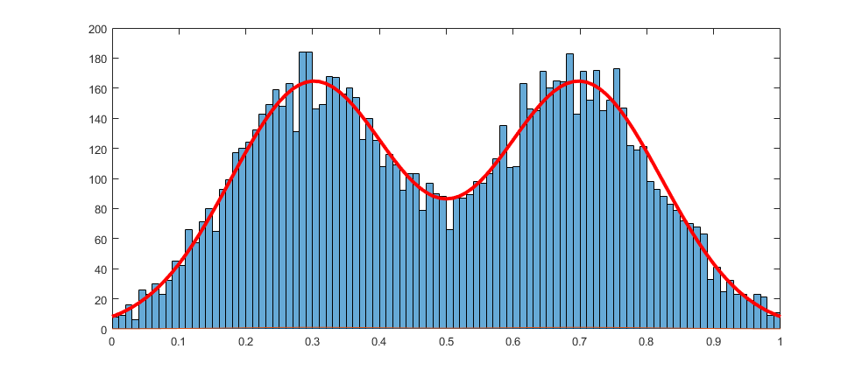
Figure 1.1 10,000 Particle Approximation of Bimodal Gaussian distribution

Figure 1.2 Step 1
Probability distribution in red, approximated distribution in green, and particles in blue.

Figure 1.3 Step 2 New observation

Figure 1.4 Step 3 Update Particles

Implementation

The particle filter in this paper was designed to take input data from a separate correlation filter that identifies areas of interest and generates a probability density function that the particle filter can use as input for the filtering algorithm. The particle filter will then return the location data associated with these areas of interest.

The system described in this paper is designed to be the core of the particle filter algorithm. In its current state it performs the basic particle filtering algorithm for a single frame and an external control system provides the input data to the system and interprets the output data to feed back to the system to operate over multiple frames. The fabricated hardware is used in a hardware-in-the-loop configuration for testing, with a programmable microcontroller used to close the loop.

The tested implementation of the particle filter operates on a 32 particle array. During operation a particle, N, from the array is selected as the current particle. The proposal generator randomly generates a new particle to be tested inside the bounding box (x1,y1) (x2,y2). This is then sent to the external test bench to generate the probability associated with the new particle. The acceptance calculator then decides if the new particle should replace the current particle by computing Pnew/Pcurrent and comparing with a random factor. If the acceptance calculator decides to accept the new particle is stored in place of the current stored particle. The next particle in the array, N+1 is then selected as the current particle and the process is repeated until a sufficiently accurate particle distribution is generated.

For the physical implementation, the signals are represented as currents. Current mode signaling lends itself well to lower voltage applications, as the compliance voltage for currents sources becomes a significant fraction of the supply voltage, which can limit the dynamic range of voltage mode signals. Current mode signaling also makes operations such as addition and subtraction easy to implement by simply wiring the outputs of current mirrors together. Multiplication and division were also easier to implement in current mode as such a cell was already available for use. For this system the multiplier cell is implemented as a subthreshold translinear circuit with three inputs, such that a*b/c, this block can be used for both multiplication and division.

Literature Review

Particle Filter

Much work has been published on the topic of using particle filters to track objects. In [1] the authors describe a system for tracking objects based on detector confidence and [2] describes using a particle filtering algorithm in conjunction with a classifier to track single objects. Most of this work focuses on the particle filter algorithm itself or software implementations of the algorithm. Hardware implementations primarily consist of FPGA designs [3] [4].

While using general purpose computers or FPGAs to implement particle filters is effective, their power draw can be prohibitive in low-power or weight-constrained environments such as drones or other small unmanned aerial vehicles. This paper will explore using analog computation blocks to implement the particle filtering algorithm and provide considerable power savings. By using analog computation blocks instead of digital systems we can trade some accuracy in mathematical operation for much lower power consumption.

The particle filter algorithm description given in [5] was used as the primary reference for the algorithm. The algorithm consists of two major steps, the prediction step and the update step. The prediction step takes the current distribution of particles and updates them based on the state transition model and current particle location. The probability of the new particle distribution is described by the Chapman-Kolmogorov Equation, which gives the probability of the new particle based on the likelihood of the old particle and the likelihood that the old particle could transition to the new particle. For the object tracking application this would be the equivalent of the probability that an object exists at a given location and the probability that the object moves to the proposed location given its prior motion. Ideally the update step should move the particle distribution in the direction of the objects assumed motion.

The update step takes the predicted particle distribution and updates it based on a new observation based on the joint probability of the prediction and observation. The new particle distribution is given by combining the distribution given by the proposed particles from the prediction step and the probability distribution given by the observation. This has the effect that the particles represent objects that are located by the current observations as well as past observations, allowing the system to filter out noise and maintain particle associations with objects.

The architecture used by the analog particle filter is most similar to [4], with similar goals for object tracking. The prediction and update steps are combined in a single propose/evaluate step, which reduces the amount of storage required. The analog particle filter is supplied with input data from an upstream correlator that identifies areas of interest and generates a probability distribution for the particle filter to evaluate. Due to the continuous nature of analog systems, the analog particle filter can scale to any desired video resolution and input data. By changing the input correlator, the analog particle filter can be adapted to many machine learning applications.

System Description

3.1 Architecture

The particle filter chip consists of 3 main subsystems, the proposal generator, the acceptance calculator, and the particle storage array. The particle storage array consists of 32 particles. In each clock cycle one particle is selected for update. The proposal generator then generates a random X/Y location inside an upper and lower bound to test against the probability density function generated by the correlator. The probability density function consists of a 2D array of likelihood measures, when a proposal is generated the probability density function returns the likelihood of that proposal based on the current observation.

The acceptance ratio calculator then takes this likelihood measurement and computes whether or not to accept the new proposal based on the new likelihood and the previous stored likelihood for the selected particle. If the new particle is selected, then the selected particle is updated with the new position and likelihood values.

The random numbers and probability map as well as the system clocks are generated externally by a PSoC 5 development board. The PSoC is a programmable system on a chip with a 60 MHz ARM core and configurable analog and digital blocks, similar to a FPGA. The PSoC development board is also connected to a PC by a USB-UART connection to read test results.

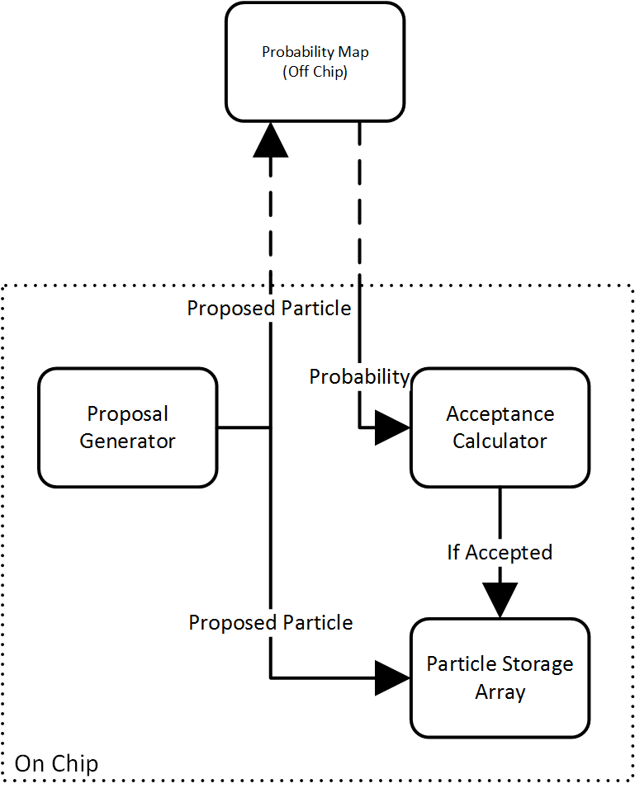
Figure 3.1 Particle filter block diagram

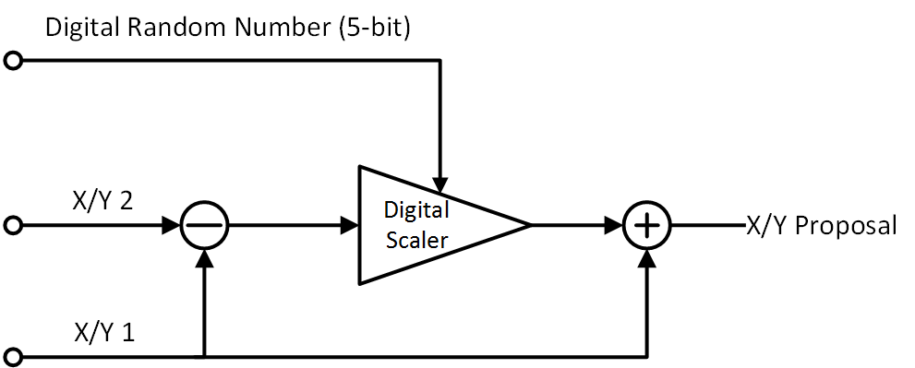
Figure 3.2 Proposal Generator

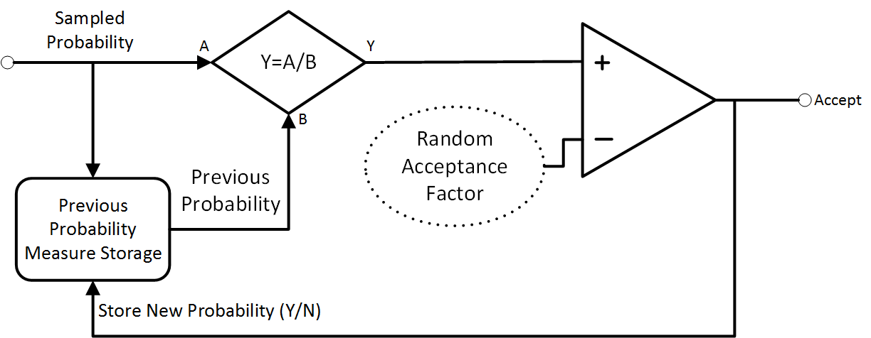
Figure 3.3 Acceptance Ratio Calculator

3.2 Storage

At the core of the particle filter there is an array that stores the location and probability of each particle. With a digital storage system having an array to store each particles location and probability is trivial, thousands of particles can be stored on simple 8-bit microcontrollers. However, with analog hardware the particles must be stored in sample and hold cells. These cells are significantly larger than SRAM or DRAM cells and suffer from leakage effects. Due to the leakage effects a significant amount of time was spent designing a low-leakage high-accuracy current mode sample and hold cell to use for the particle state array.

Most published work focuses on voltage mode sample and hold cells for ADC input buffers, which focus primarily speed and accuracy. There are a few examples of sample and hold cells designed primarily for analog memory applications, one of which is given in [6] which only loses 0.025% in 3.3 minutes, however these results were achieved on a 1.2µm process. In the 130nm process the drain-body leakage current is an order of magnitude greater and the sampling capacitor is an order of magnitude smaller than in the example given. Additionally if a voltage mode sample and hold cell were used to drive a current source the exponential V-I relationship of the subthreshold mosfet would make the ouput current error increase exponentially with the output voltage drift of the sample and hold cell.

The first iteration of the sample and hold cell (Figure 3.4) was a simple cascode current mirror with sample switches and storage capacitors. This iteration was found to lack the accuracy required (5%) due to mismatch in the input and output transistors and insufficient output resistance. The required two capacitors also took up twice the amount of area as a single capacitor design, which became problematic when constructing large storage cell arrays. A revised version of the sample and hold cell had to be fabricated.

The revised sample and hold cell (Figure 3.5) uses a single transistor for both the sample mode and the hold mode as well as a gain-boosted cascode output stage to maximize output resistance. Since only one transistor is used for both input and primary output the effects of mismatch are eliminated for the primary output. The output transistor, as used in this circuit and biased at 60nA drain current has an output resistance of approximately 16M Ω (simulated), thus a 50mV change in output (drain) voltage is sufficient to cause 5% error in the output current. Since the chip is designed to operate from a 1.0-1.2V supply, this could cause a large output current error on the order of 50nA (83% error).

A cascode configuration, as used in the original sample and hold increases the output resistance by a factor of g_{m}r_{o}, which is approximately a factor of 30 for the conditions described above. This greatly reduces the output current error due to output resistance but adds an additional source of error from the variation of threshold voltage and the complexity of biasing the cascode transistor.

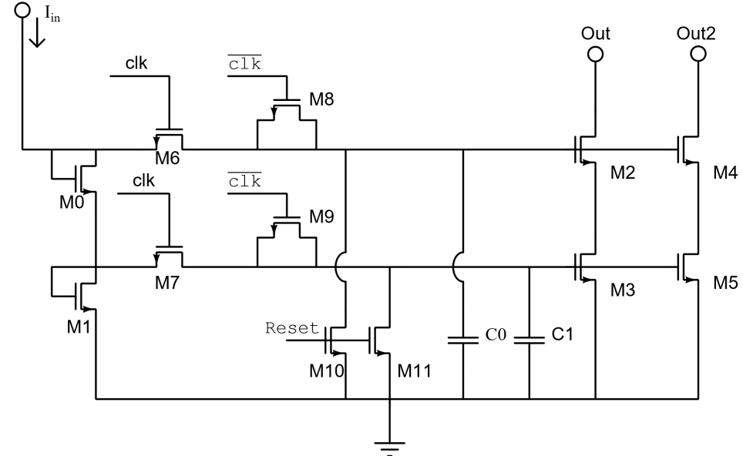
Figure 3.4 Original sample and hold circuit

The gain boosted cascode uses an op-amp to control the voltage at the drain of the output transistor, the output current error is given by
$\left(\frac{A_{o}}{1+Ao}V_{g}+V_{os}\right)g_{ds}$. Since the open loop gain of the op amp is large (Approximately 800 for the op-amp used) then the output current error is dominated by V_{os}g_{ds}. To meet the 5% output error requirement the offset error of the op amp should be less than than 50mV, which is easily achievable. The op-amp used in the sample and hold cell has an average input referred offset of 8.3mV. The gain boosted cascode configuration is self-biasing, setting the drain voltage of the output transistor based on its gate voltage. This greatly reduces the effect of the transistor output resistance.

The sample and hold cell also includes a second output transistor for a secondary output. In the particle filter system sample and hold cells are used to store both the particle location and the probability weight associated with each particle. The second output is only used in the particle location array to compute the average of the particles in the location array. While the secondary output is affected by inaccuracies caused by transistor mismatch, by taking the average of several outputs the error becomes the average error of all the cells, which if we assume some have a positive error and others have a negative error, the average error magnitude is reduced.

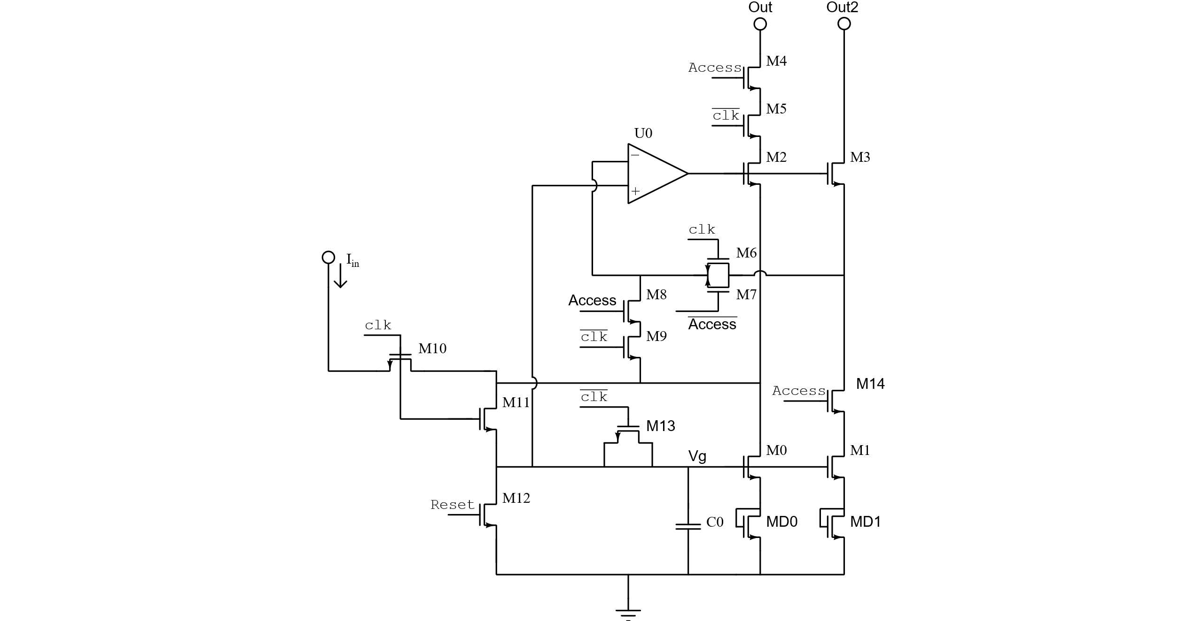

Figure 3.5 Revised sample and hold circuit

Table 3.1 Sample and Hold Device Sizes
Device | Type | W/L | Value
M0, M1 | nfet | 2μ/2μ
M2-M10 | nfet | 160n/120n
M11 | Hi-Vt nfet | 320n/120n, nf=2
M12 | Hi-Vt nfet | 500n/500n
M13 | Hi-Vt nfet | 160n/120n
C0 | MimCap | 17.5μ/8.75μ | ~322 fF
MD0,MD1 | Nfet | 1μ/2μ

The revised sample and hold cell increases accuracy by removing the source of mismatch between input and output transistors (M1 and M3 in original circuit) and consolidating their function into one transistor, M0 in the new circuit. The output impedance is also increased by the gain of the op-amp instead of the gain of the cascode transistor which allows for increased output resistance. The inclusion of MD0 and MD1 in the new circuit also reduces the effects of changes in Vg on the output current. Since the voltage across C0 decreases linearly with time, decreasing Iout sensitivity on Vg increases the time the cell can hold its value before the output error increases above an acceptable level.

The op-amp (
Figure 3.6) in the sample and hold cell is used to boost the output impedance of the primary and secondary outputs. The design goals for this amplifier were low power, inputs near ground, and ability to be completely turned off when the cell is idle. In order to reduce power consumption, the op-amp was designed with as few stages as possible and a low bias current. The input stage was designed for rail-to-rail input. Switches were added to gate the power supply and set the output to high impedance when the op-amp was turned off. The op-amp is stabilized by the feedback capacitors into the input stages. This feedback is amplified by the miller gain of the output stage, allowing for smaller compensation capacitors to be used.
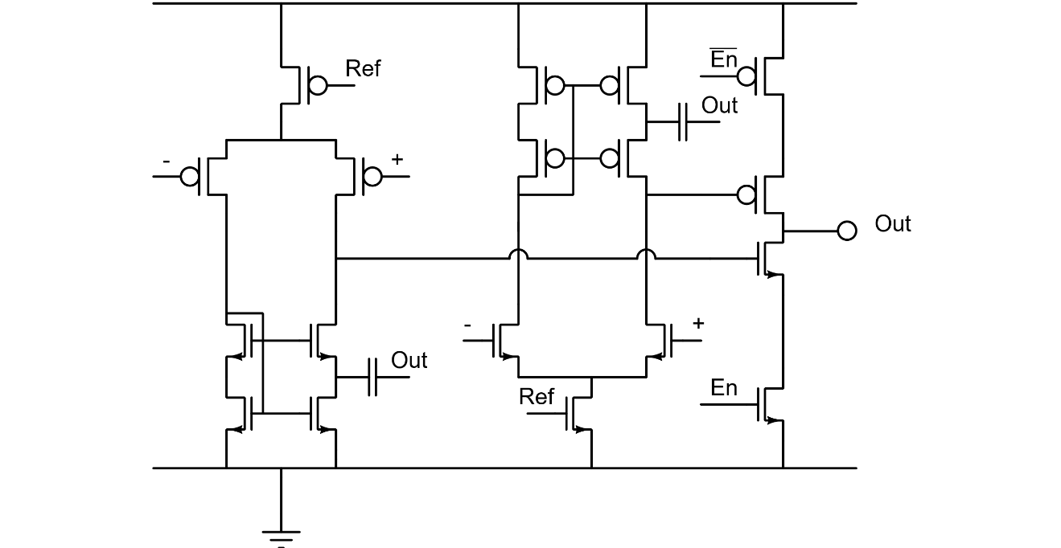
Figure 3.6 Original Sample and Hold Op-Amp

The transistors M6-M8 are used to select either the primary or secondary output as the input to the amplifier. This is used to allow the amplifiers output to settle near its final operating region when the cell is in tracking mode to reduce error in the stored value. If the amplifier input was only connected to the primary output then when the storage cell is tracking the output of the amplifier would rail out, then when the storage cell switched to hold mode the amplifier output would change rapidly. This noise would be fed onto the storage node through Cds of M0, injecting error into the stored value.

The access transistors allow the storage cell to be operated in an array. The access line for each cell is the logical AND of the row access line and the column access line, such that for a given X,Y access line pair (one-hot encoding) only one cell is selected. The clock signal in the cell is only active if the access line is asserted.

Upon receiving the fabricated particle filter chip it was found that the sample and hold cells were not storing the correct values. Through more thorough simulation the cause of the problem was determined to be that the op-amp in the storage cell had poor phase margin in the gain-boosted cascode configuration employed in the sample and hold cell. A revised version of the particle filter chip was fabricated with new op-amps to fix the stability problem.

The new op-amp in the sample and hold cell is a single stage current mirror topology with a single PFET input stage for lower power consumption and common mode input range near ground. A compensation capacitor was added to improve phase margin. Simulation results show that this op-amp has a gain-bandwidth product of 4.26 MHz and a phase margin of 48.2°. When the op-amp tail current is set to 50nA power consumption is approximately 120nA at 1.2v Vdd. The op-amp enable signal is controlled by the access signal in the sample and hold cell, when disabled the op-amps internal Vdd is disconnected and its output is set to high impedance.

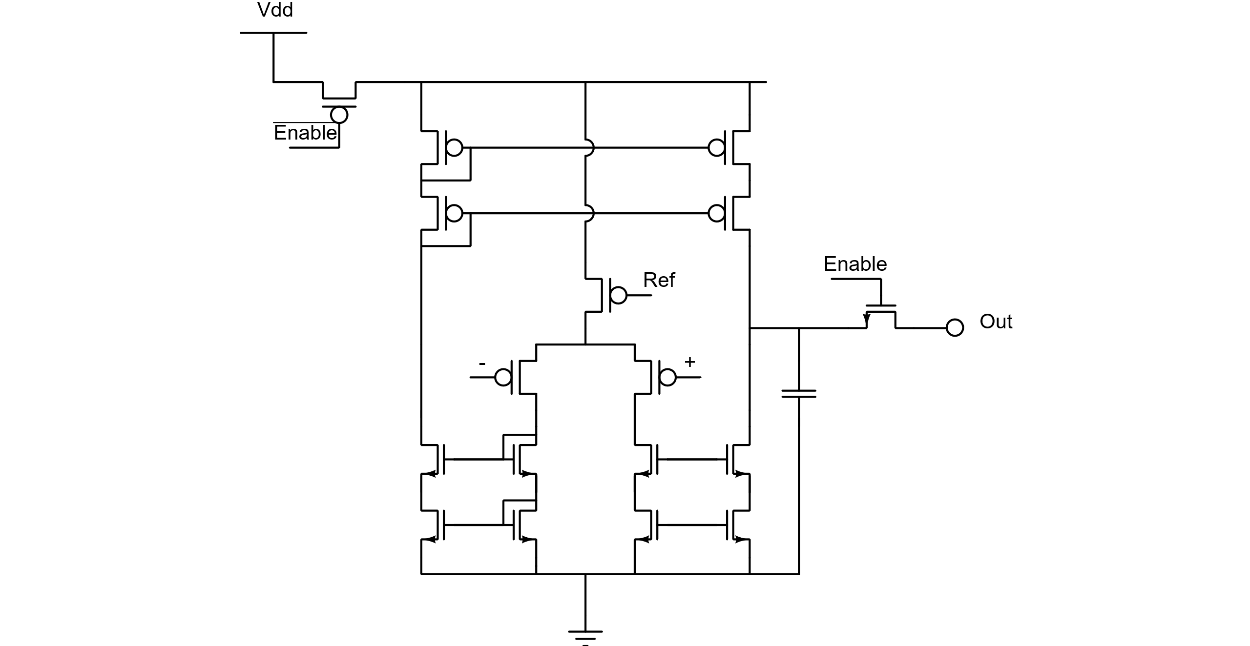
Figure 3.7 Revised Sample and Hold Op-Amp

Table 3.2 Op-Amp Device Sizes
Device | Type | W/L | Value
Input Pair | pfet | 4μ/2μ, nf=2
NMOS Mirrors | nfet | 1μ/1μ
PMOS Mirrors | pfet | 1μ/1μ
Cap | MOS Cap | 2μ/2μ | ~20 fF
Ibias |  |  | 50nA

3.3 Multiplier

Mathematical operations in the particle filter consist of the 4 primary arithmetic operations, addition, subtraction, multiplication, and division. Since signals in the chip are represented as currents, addition and subtraction is achieved by tying two or more currents together, according to Kirchoff’s current law. Multiplication and division however are more complicated and require active devices. The most common way to implement multiplication and division in analog hardware is to utilize the translinear principle of a PN junction. In the 8RF process the diodes are large and not very good for low-power signal processing so instead we turned to the MOSFET operated in the subthreshold region. [7]

In the multiplier circuit used in this chip M1-M4 form a translinear loop. M1, M2 and M3 are used to take the logarithm of Ia, Ib, and Ic, respectively. The voltage at the gate of M4 is given by log(Ia) + log(Ib) – log(Ic) (Vgs2 + Vgs1 – Vgs3). The drain current of M4 is then the antilog of the gate voltage of M4. Thus the output current corresponds to Ia*Ib/Ic. Transistors M5 and M6 are used to minimize the effects of Gds of M2 and M4, respectively.

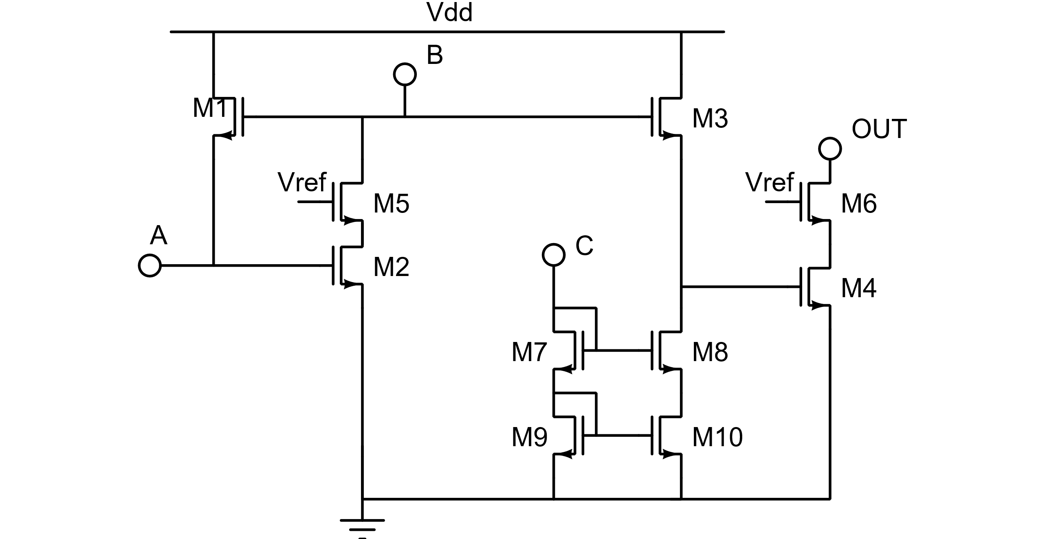
Figure 3.8 Multiplier Schematic

3.4 Proposal Generator

The Proposal generator consists of a 6-bit DAC to supply the scaling factor and two boundary signals to define the upper limit and lower limit of the proposal generator. The purpose of these signals is to limit the particle proposals to an area of interest or control the dynamic range of the system. The DAC is a series of scaled current mirrors used to create power of two fractions of the reference current. By turning on select portions of these scaled current mirrors any fraction of the reference current can be produced. This approach was used instead of a multiplier due to its simplicity and accuracy over large dynamic ranges compared to the multiplier used in this system. It also allows for direct digital inputs, which makes suppling inputs from off chip systems much easier.

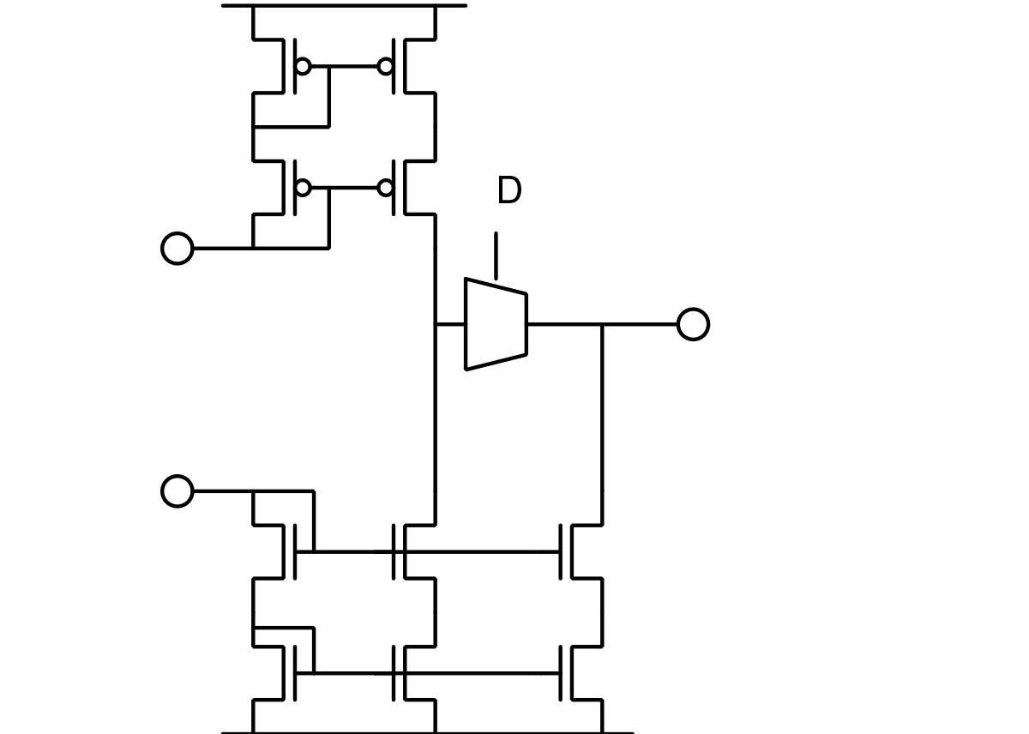
Figure 3.9 Proposal Generator

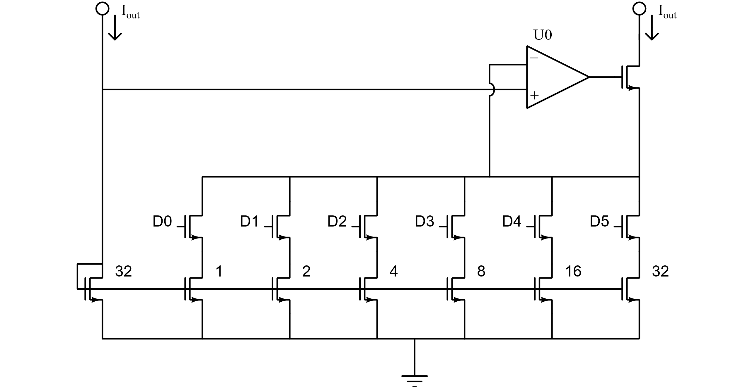
Figure 3.10 DAC used in proposal generator

3.5 Test setup

The test board consisted of the chip to be tested, analog and digital interface systems, and voltage regulators to supply Vdd to the chip. The digital interface consists of level shifters for the digital control signals to the chip. The analog interface consists of transconductance amplifiers to convert analog voltage signals to current signals required by the chip and transimpedance amplifiers for converting current outputs to analog voltage signals. Also included on the board were several second-order low pass filters used as DACs to supply the bias currents to the chip. These low pass filters were fed PWM signals from the PSoC and produced an output voltage proportional to the duty cycle of the PWM signal. The output voltage from these DACs was then fed through a transconductance amplifier to generate the bias currents.

The transconductance amplifiers (Figure 3.11) were constructed with 2 Op-Amps, one serving as a voltage buffer for the output of the transconductor, and the other seving as a summing amplifier to force the voltage across the output resistor to be equal to the supplied input voltage signal. The input voltage is referenced to ground. Thus the transfer function of the transconductor can be given as:

$$I_{out}=\frac{V_{in}}{R_{o}}$$

The transimpedance amplifiers (Figure 3.12) were constructed as inverting amplifiers. The transfer function can be given as:

$$V_{out}=V_{ref}-I_{in}R$$

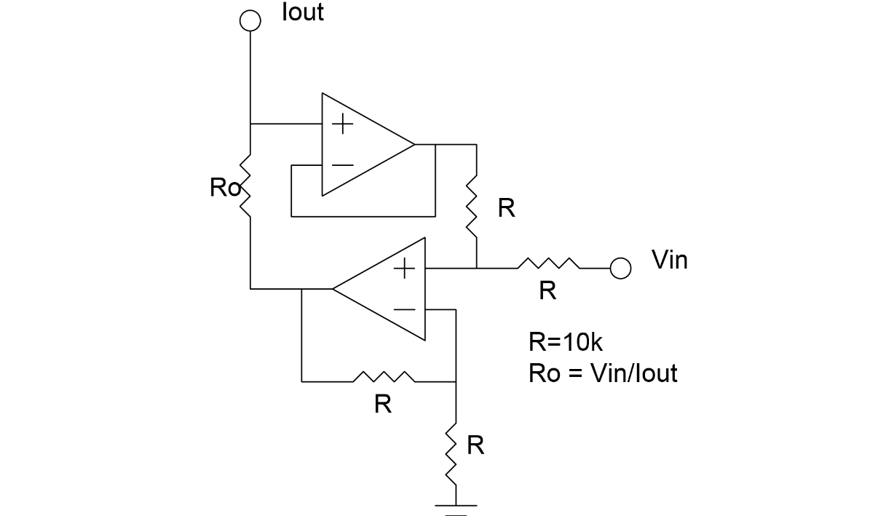
Figure 3.11 Transconductor circuit schematic

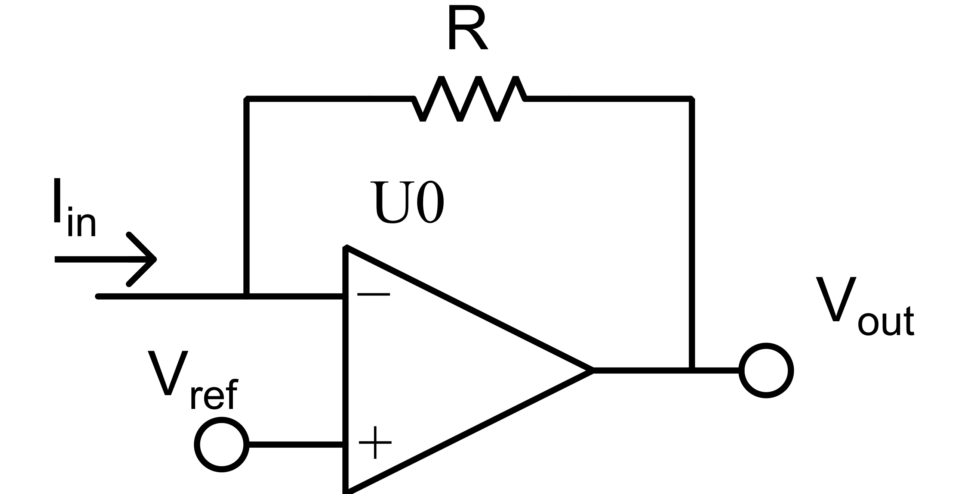
Figure 3.12 Transimpedance amplifier

Results and Discussion

Simulated results show that the particle filter chip is capable of approximating the supplied probability map with the particle locations. The tested chip was unable to do this, as the sample and hold cells in the particle array were not able to store correct values. It was determined that the gain-boosted cascode configuration in the sample and hold cell was unstable, causing the cell to store a random and incorrect value. Since the output of the chip is directly read from sample and hold cells, the chip was unable to produce accurate output. Testing did show the proposal generator working correctly, and the acceptance ratio calculator did appear to work.

4.1 Sample and Hold

As documented in section 3.2 the fabricated sample and hold cells do not function as intended in the particle array. The standalone sample and hold cell taped out in Feb. 2016 did provide some useful results however. Presented here are the test results from Feb. 2016 and the simulation results for the latest revision of the sample and hold cell.

Figure 4.1 shows the test results from the standalone sample and hold cell. The blue trace is the input signal provided to the cell and the yellow trace is the output of the cell. The purple trace is the sample signal and the green trace is reset. This test shows that the cell is capable of storing a value for at least 600µs.

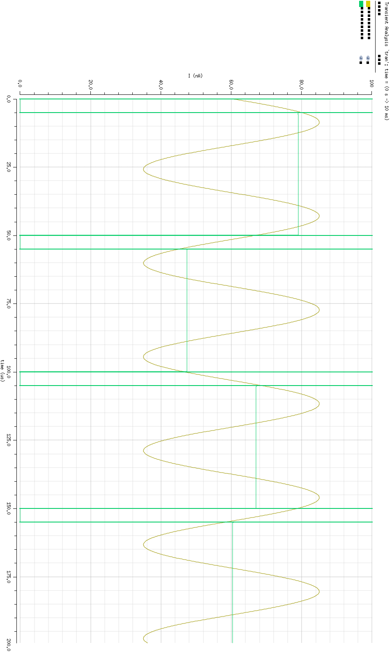
Figure 4.2 shows the simulation results from sampling a 29.1kHz sine wave at 20kHz. Sampling time was 5µs. Measured sampling error was approximately 2.0% for this test. When sampling a 60nA DC input signal the sampling error was approximately 0.3% The DC signal test more accurately represents how the sample and hold cell is used in the particle filter.

For a 200 point monte carlo simulation with a 100nA input signal the mean output error was 0.54% with a 0.39% standard deviation. The secondary output had a mean output error of 6.1% with a 4.9% standard deviation.

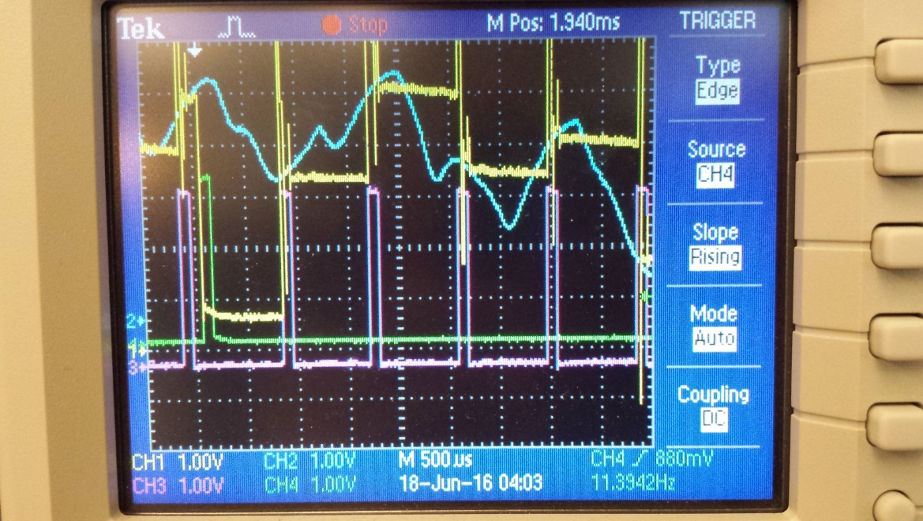
Figure 4.1 Feb. 2016 standalone sample and hold cell test

Figure 4.2 Simulated results

4.2 Multiplier

In simulation, the multiplier was shown to have a settling time of 0.25µs and a linear input range of 0-250nA. The simulation results are shown in Figure 4.3 and Figure 4.4. Due to the construction of the particle filter the multiplier is not able to be directly tested in the system, therefore testing the functionality of the multiplier is done through verification of the acceptance ratio calculator in the system test.
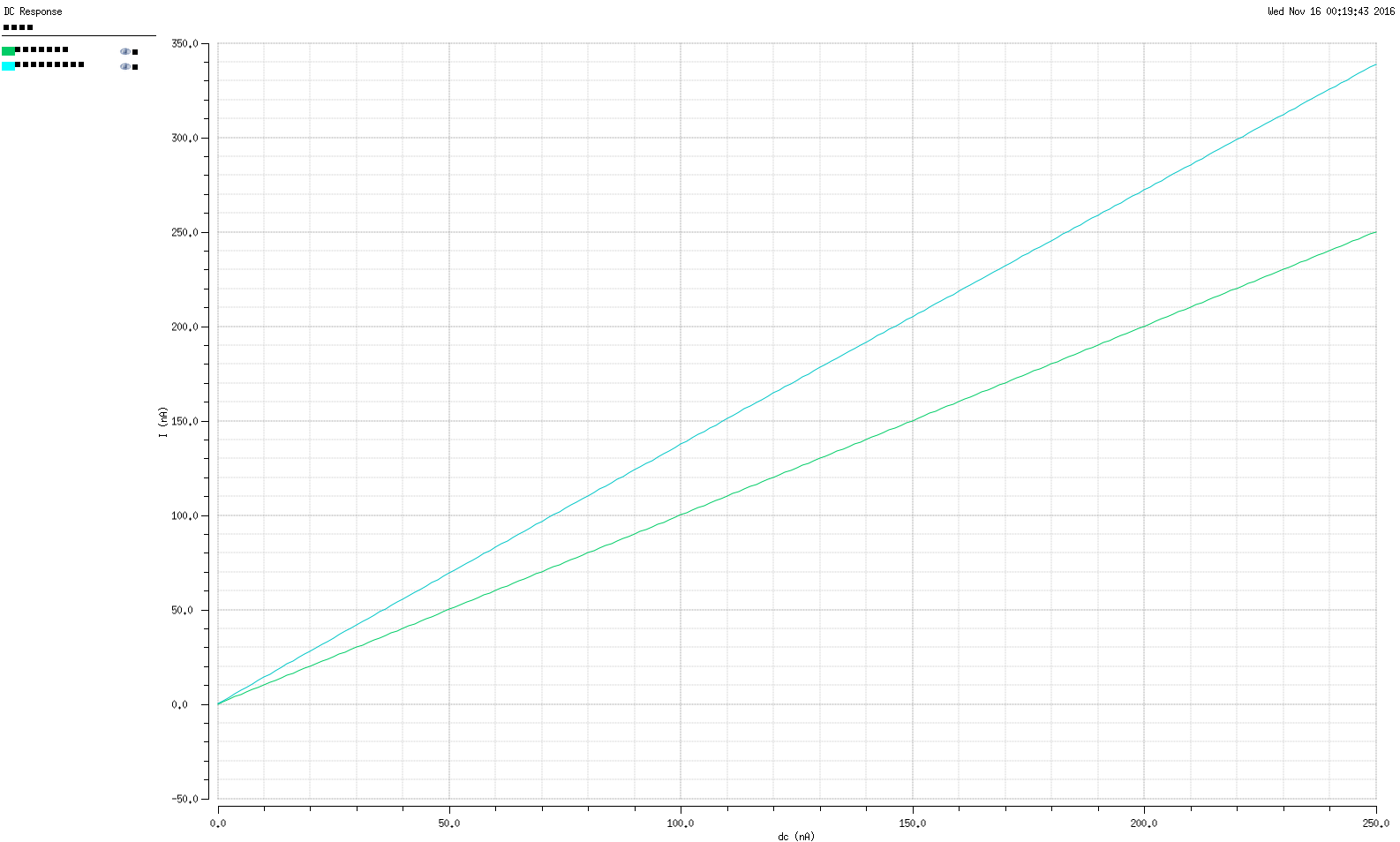
Figure 4.3 Input DC sweep, Ia/Ic = 3/2

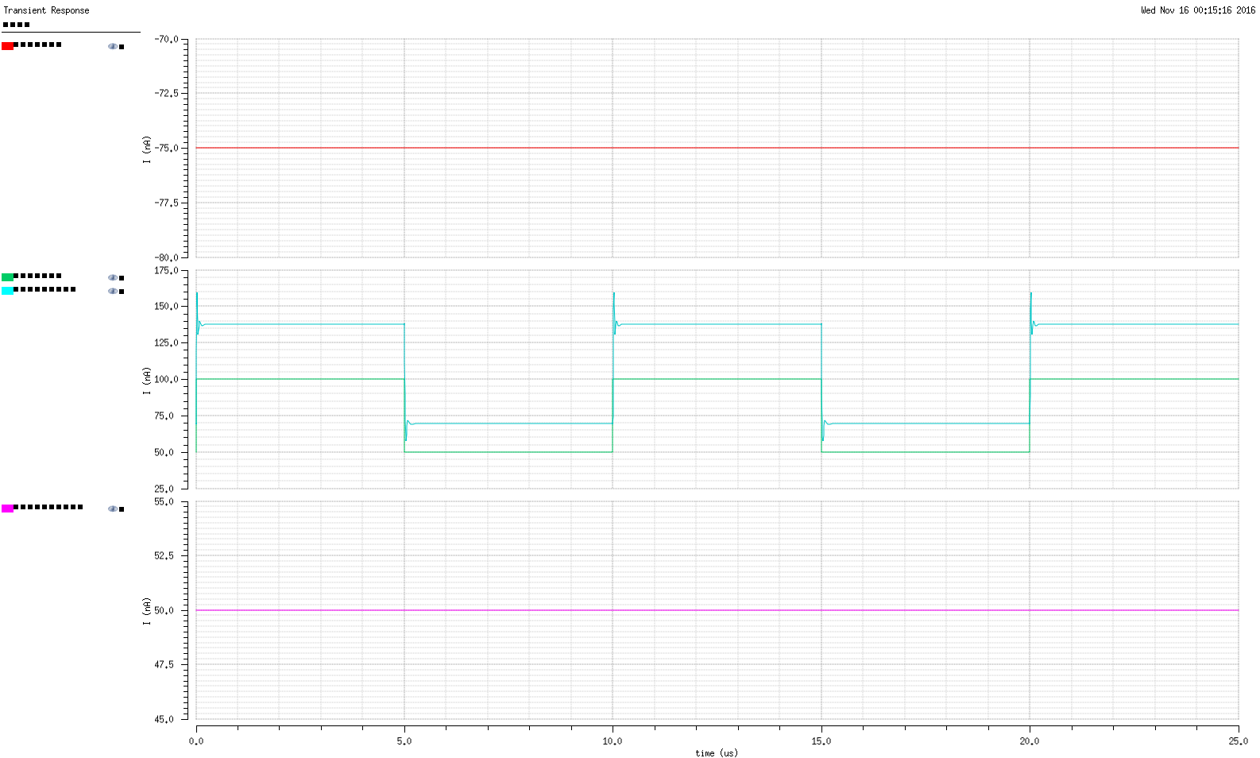
Figure 4.4 Multiplier Step Response, Ia/Ic = 3/2

4.3 System Test

Testing the system started with verifying the capability of the PSoC to drive input signals and read output signal from the test board. After basic functionality tests were completed the first component tested was the proposal generator. The proposal generator was tested by setting the upper and lower bounds of the proposal generator and sweeping the 5-bit input from 0 to 63. The PSoC is also used to supply a probability value for that particle based on the proposed location. A Gaussian probability distribution centered near the middle of the upper and lower bounds was used for this test. The expected result was a linear sweep of the particle location and a Gaussian trace for the probability signal.

Figure 4.5 and Figure 4.6 show the testing of the proposal generator and PSoC proposal probability loop. In Figure 4.5 (Feb 16) the purple trace is the proposed particle location and the blue trace is the particle probability computed by the PSoC. The blue trace resembles a Gaussian “bump” but is noisy. The source of this noise was not able to be located but is most likely due to arithmetic precision or errors on the PSoC (16-bit) or noise in the ADC. The proposal generator test was also ran with random input values as seen in Figure 4.7.

Figure 4.6 (Aug 16) shows the proposal generator test with the revised particle filter chip. The orange trace is the particle location and the blue trace is the particle probability. Additionally included in this test is the average number of particles accepted for the corresponding proposal, represented by the purple trace. These results were the average over 128 runs to get a better representation of the particle acceptance distribution. The proposal generator shows slightly better linearity in the revised particle filter.

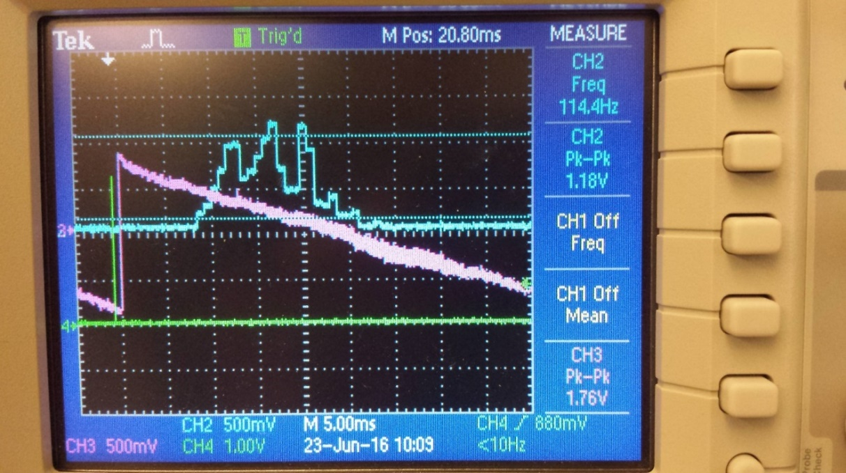
Figure 4.5 Proposal Generator Test (Feb 16)

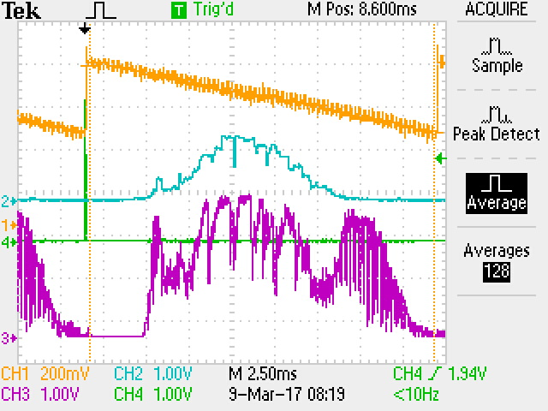
Figure 4.6 Proposal Generator Test (Aug 16)

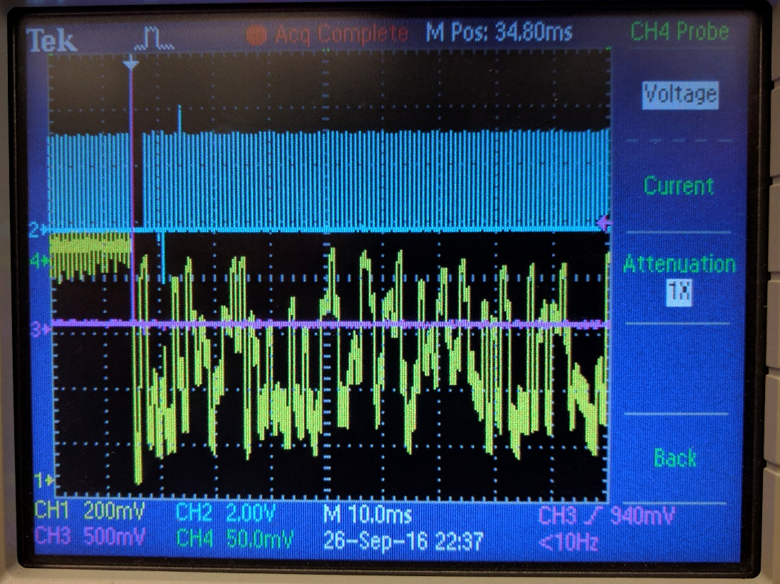
Figure 4.7 Proposal Generator tested with random input value (Feb 16)

Figure 4.8 illustrates the problem of the sample and hold cells in the Feb 16 particle filter storage array. The input to the particle array was supplied with a constant signal but the stored output (Green trace) changes greatly with every clock cycle (Yellow trace). After running several simulations attempting to recreate this behavior and failing, it was determined that the op-amp in the sample and hold cell had poor phase margin and was most likely oscillating, causing the output errors. This behavior did not show up in transient simulations of the full system or the sample-and hold cell. The only way to determine that the op-amp was unstable was stability analysis of the op-amp by itself. This step was overlooked when designing the op-amp and it was assumed that since it worked in transient simulations that everything was working as normal.

After receiving the revised particle filter chip (Aug 16), the sample and hold array test from above was run again on the new chip. Figure 4.9 shows the results of this test with the orange trace as the input and the purple trace as the output. This test was ran at 125Hz to show the ability of the sample and hold cell to maintain value over time. The hold time in this test was 7ms. The revised chip does not suffer from the instability problem of the previous chip and shows slightly improved hold times compared to the standalone test in Figure 4.1.

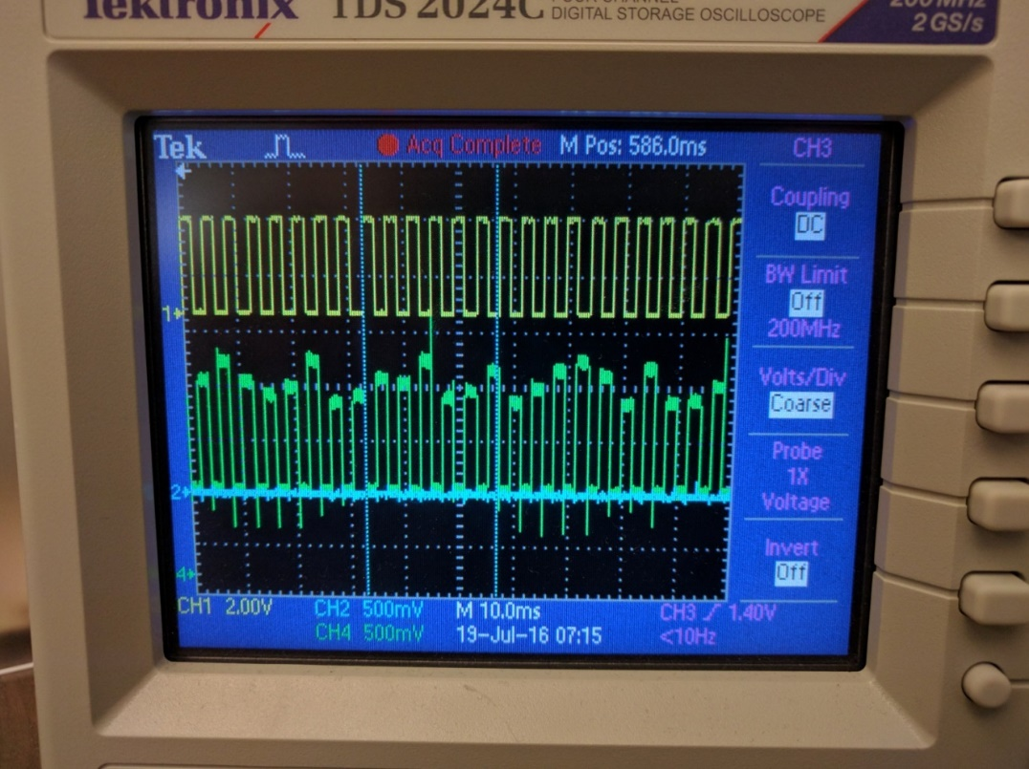
Figure 4.8 Sample and Hold Problem (Feb 16)
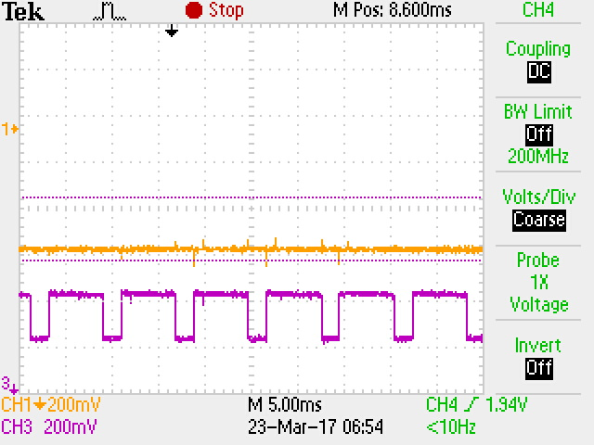
Figure 4.9 Revised Sample and Hold Test (Aug 16)

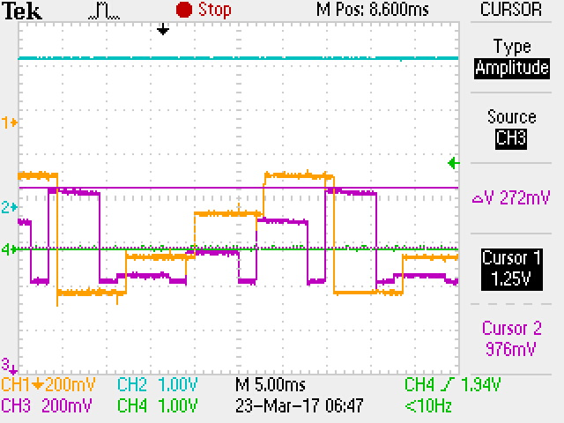
Figure 4.10 Revise Sample and Hold Step Test (Aug 16)

With the revised particle filter chip the complete system was able to be tested. The complete system test consisted of running the particle filter through a series of 1024 propose/accept cycles and observing the particle array values. This was done by recording the proposals and stored particles with the PSoC and exporting them to MATLAB. The data was then processed to evaluate which proposals were accepted and the end values of the stored particles. Figure 4.11 shows the expected state of the particle array based on the proposals and accept signal from the chip. This plot was created by recording the particle slot, accept signal, and the proposal from the chip. If the accept signal was true, the particle array in MATLAB was updated with the current proposal. If the accept signal was false, the particle array was unchanged. This is the same process used on chip, but using MATLAB as the storage array.

Figure 4.12 shows the measured state of the particle array at the end of the test. This plot was generated by recording the values stored in the particle array at the end of the test. This is expected to be similar to the recorded plot, but the measured points appear to be shifted toward the origin due to leakage in the sample and hold cells.

Due to the probabilistic nature of the algorithm, it is possible for a cell to be required to hold its value for a significant portion of the test run. This test was ran at 6.25kHz for 1024 cycles, for a total run time of 164ms. The sample and hold cells were measured to have 10% loss after 10.8ms. Increasing the clock frequency of the chip can reduce the average required hold time for the cells of the particle array, currently the speed of the system is limited by the ability of the PSoC to process the proposal and generate the proposal probability.

A second system test consisted of running the particle filter for ~200 cycles and observing the average particle location. The simulated results for this test can be seen in Figure 4.13. The red trace shows the average particle location, the blue trace shows the location proposal, and the yellow trace shows the accept/reject decision with a high value meaning the proposal was accepted. The particle filter is supplied a Gaussian probability distribution and the expected result is that the average value of the particle location array should approximate the center of the Gaussian distribution, which is represented by a 20nA signal. The simulation converged to an average center signal of 21-23nA depending on the run. In attempting to recreate this simulation in testing the fabricated chip it was found that the average value output of the particle array was not working properly. In the previous test it was verified that the particle array was in fact storing values properly, therefore this is an issue with the average output circuit itself.

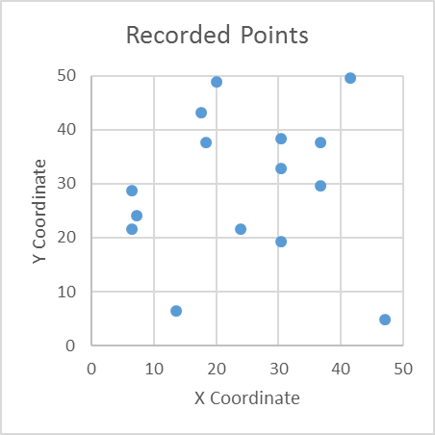
Figure 4.11 MATLAB Recorded Accepted Particles

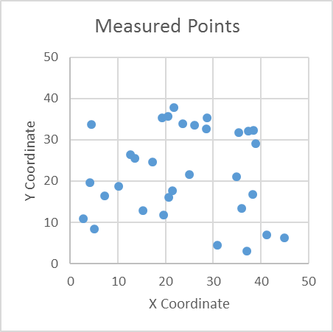
Figure 4.12 Chip Recorded Accepted Particles

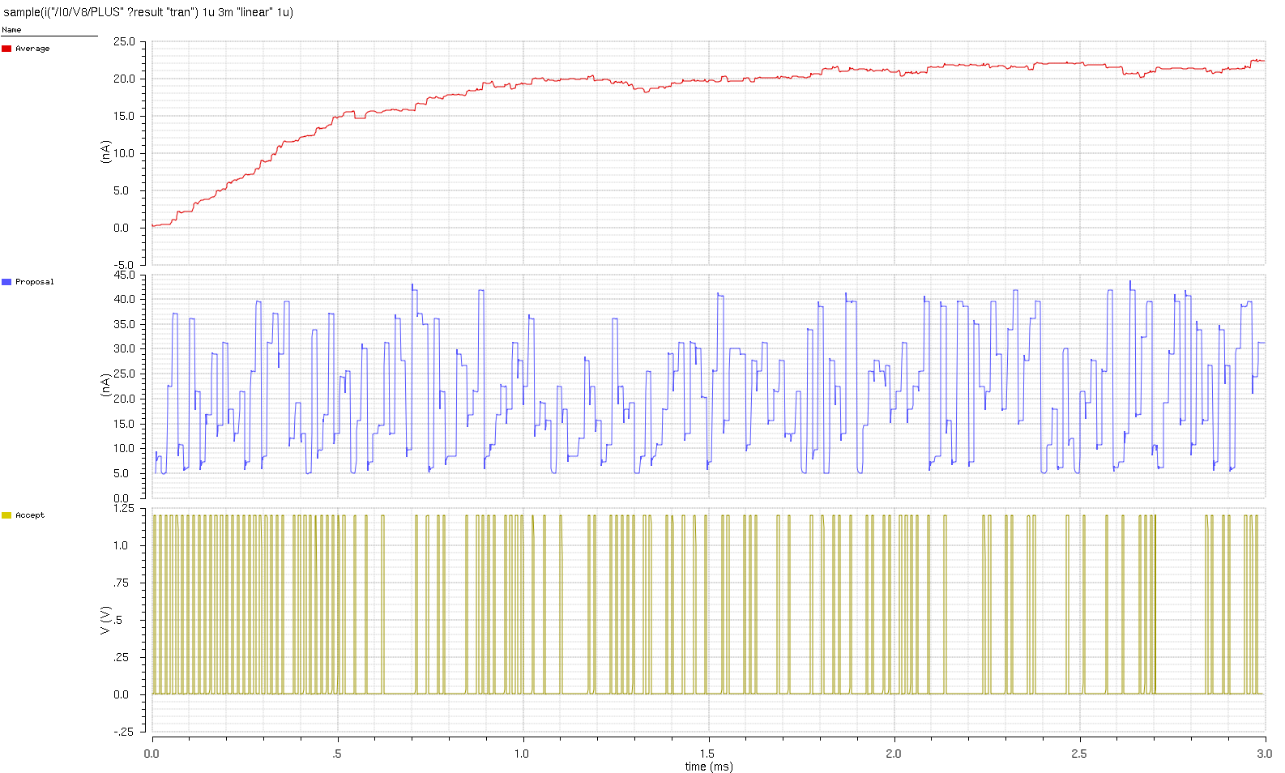
Figure 4.13 Simulated object location converging as particles are updated

Conclusions and Recommendations
While the system was capable of producing results, the fabricated chips were unable to store them, resulting in inconclusive test results. Simulated results showed that the particle filter was able to approximate a probability map using a series of 32 particles.

After testing and analysis of the particle filtering algorithm it was determined that the method described in this paper may not take advantage of the capabilities of analog ASICs. While the approach described in this paper would be appropriate for a sequential digital implementation, for analog systems a massively parallel approach would be much more fitting.

An improved version of this system could consist of an array of uniform computation and storage blocks that stores a guess about the probability map based on the motion of objects. Then for every new frame the stored guess is updated to more accurately reflect the new information. This method would result in a faster and more scalable system, each update would only take one clock cycle and resolution can be increased by adding more computation/storage blocks. This design may increase power consumption due to increased active units however.

List of References

[1] | M. D. Breitenstein, F. Reichlin, B. Leibe, E. Koller-Meier and L. Van Gool, "Robust tracking-by-detection using a detector confidence particle filter," in IEEE 12th International Conference on Computer Vision, Kyoto, 2009.
[2] | S. Avidan, "Ensemble Tracking," IEEE Transactions on Pattern Analysis and Machine Intelligence, pp. vol. 29, no. 2, pp. 261-271, 2007.
[3] | J. U. Cho, S. H. Jin, X. D. Pham, J. W. Jeon, J. E. Byun and H. Kang, "A Real-Time Object Tracking System Using a Particle Filter," IEEE/RSJ International Conference on Intelligent Robots and Systems, pp. 2822-2827, 2006.
[4] | J. Alarcon, R. Salvador, F. Moreno, P. Cobos and I. Lopez, "A new Real-Time Hardware Architecture for Road Line Tracking Using a Particle Filter," IECON 2006 - 32nd Annual Conference on IEEE Industrial Electronics, pp. 736-741, 2006.
[5] | M. S. Arulampalam, S. Maskell, N. Gordon and T. Clapp, "A tutorial on particle filters for online nonlinear/non-Gaussian Bayesian tracking," IEEE Transactions on Signal Processing, vol. 50, no. 2, pp. 174-178, 2002.
[6] | M. O'Halloran and R. Sarpeshkar, "A 10-nW 12-bit Accurate Analog Storage Cell With 10-aA Leakage," IEEE Journal of Solid-State Circuits, vol. 39, no. 11, pp. 1985-1996, 2004.
[7] | A. Andreou and K. Boahen, "Translinear circuits in subthreshold MOS," Analog Integrated Circuits Signal Processing, pp. Vol. 9, pp. 141-166, 1996.

Vita

Trevor Watson graduated high school in 2010. He then attended Roane State Community College and was awarded an Associates in Science degree in 2012. He then transferred to the University of Tennessee where he graduated in December 2014 with a Bachelors of Science in Electrical Engineering.

