A Holistic Approach to Evaluating Ecosystem Decline in Mosquito Lagoon, Florida

A Dissertation Presented for the
Doctor of Philosophy
Degree
The University of Tennessee, Knoxville

Stephanie Insalaco
August 2024
Acknowledgements
I would like to thank my advisor Dr. Hannah Herrero and my committee members and mentors Drs. Kelsey Ellis, Yingkui Li, Augustin Engman, Qiusheng Wu, and Paul Armsworth for their knowledge, expertise, and support throughout my research. The manuscripts in this dissertation would also not have been possible without my co-authors, Dr. Hannah Herrero, Dr. Gabe Schwartzman, Captain William Wolfson, Russ Limber, and Clancy Oliver. The community of Mosquito Lagoon has also been integral in the completion of this research, especially the Lagoon Watermen Alliance, and I hope that the results from this dissertation can assist them in the ongoing recovery of the lagoon.
I would also like to thank my parents for their support throughout my entire academic career and for continually reminding me to “keep the eye on the prize”. It has been an honor to take on the title of Professor Insalaco from my father, who will be retiring in 2026 after a very successful career in academia. Lastly, I would not have been able to get through graduate school without my fiancé Adam, or my dogs Miles and Nala, I love you.

Abstract
Examining the decline of an ecosystem should be done through a holistic and interdisciplinary lens to fully understand all factors which might contribute to this ecosystem imbalance. This dissertation focuses on the declining ecosystem of Mosquito Lagoon, Florida which started to see a significant decrease in health since the early 2010s due to a variety of factors. The dissertation is separated into three papers: quantifying the total decline of seagrass in Mosquito Lagoon from 2000 to 2020, the effects of this seagrass and overall ecosystem decline on stakeholders’ livelihoods, and the regrowth of seagrass in 2023 after the events of Hurricanes Ian and Nicole. Using GeoAI and a mixed-methods approach, there was a large fluctuation in seagrass coverage in Mosquito Lagoon from 2000 to 2023, and it can be used as an indicator of overall ecosystem health. These changing conditions have drastically impacted the stakeholders in the lagoon, as they cannot depend on the ecosystem to be stable enough to support the local fishing industry. These studies demonstrate new methodologies to quantify critical seagrass loss and produce community-engaged results to contextualize the struggles of stakeholders and advocate for change for both people and the environment.

Table of Contents
Chapter 1: Introduction 1
1.1 Introduction 2
1.2 The Dissertation 3
1.3 Study Area 4
1.4 Relevance to current research priorities 6
Chapter 2: Monitoring an ecosystem in crisis: measuring seagrass meadow loss utilizing Deep Learning in Mosquito Lagoon, Florida 10
2.1 Abstract 11
2.2 Background 11
2.3 Data and Methods 15
2.4 Results 20
2.5 Discussion and Conclusion 29
Chapter 3: Evaluating Stakeholder Perception on Ecosystem Health and Livelihoods in a Marine Protected Area: Mosquito Lagoon, Florida 35
3.1 Abstract 36
3.2 Background 37
3.3 Data and Methods 45
3.4 Results 50
3.5 Discussion and Conclusion 64
Chapter 4: Recording Seagrass Growth in Mosquito Lagoon, Florida after Hurricanes Ian and Nicole 69
4.1 Abstract 70
4.2 Background 70
4.3 Data and Methods 76
4.4 Results 81
4.5 Discussion and Conclusion 93
Chapter 5: Conclusions 100
5.1 Dissertation Theme 101
5.2 Major Conclusions and Future Directions 102
5.3 Summary of Contribution 105
References 106
Vita 116

List of Tables
Table 2-1: Pixel Counts/Percentages for Seagrass vs non-Seagrass 23
Table 2-2: Pixel Counts/Percentages for Change Trajectory, where S = Seagrass and N = non-Seagrass 26
Table 2-3: Metric results from DNN Classification per Year 28
Table 2-4: Confusion Matrix for 2000 – 2020 Models 30
Table 4-1: Pixel Counts/Percentages of Non-Seagrass and Seagrass 79
Table 4-2: Confusion Matrix Results 88

List of Figures
Figure 1-1: Study Area (Mosquito Lagoon, Florida) 7
Figure 2-1: Landsat imagery of 2000 with seagrass patch locations highlighted in green (band combination: band 3 (red), band 2 (green), and band 1 (blue), true color composite). 17
Figure 2-2: DNN Classification Output from 2000 to 2020 22
Figure 2-3: Seagrass overlay from the dates 2000, 2007, 2013, and 2020 from the DNN Classification 24
Figure 2-4: Change Trajectory Permutations for the dates 2000 > 2007 > 2013 > 2020, where S = Seagrass and N = non-Seagrass 25
Figure 3-1: Map of Study Area (Mosquito Lagoon, Florida) 40
Figure 3-2: Respondents’ Relationship to Lagoon 51
Figure 3-3: Respondents’ Lagoon Experience 52
Figure 3-4: Number of Fish Caught Before and After the Ecosystem Decline 57
Figure 4-1: Study Area and Location of Washouts in Mosquito Lagoon (Planet imagery from 09/03/23) 75
Figure 4-2: Bar Graph of Seagrass Coverage Over Time 80
Figure 4-3: Random Forest Classifications of Seagrass vs Non-Seagrass in Mosquito Lagoon 82
Figure 4-4: Timelapse of Seagrass Change in ML 86
Figure 4-5: Hurricane Tracks of Ian and Nicole Compared to Mosquito Lagoon 95

Chapter 1: Introduction

Introduction

Ecosystems globally have been collapsing due to a variety of factors, including climate change, deforestation, urbanization, and more (Sato & Lindenmayer, 2017). An ecosystem in decline has consequences for all those living in it, from flora and fauna to stakeholders. Looking at ecosystem decline through a holistic, spatiotemporal, and geographical lens allows for all these factors to be considered and addressed (Dick et al., 2016; Karmarkar, 2023). Research using this approach produces findings that are well-rounded and can be used in tandem with local ecological knowledge (LEK) to support conservation efforts.
While quantifying the collapse of ecosystems around the globe can be difficult, this research strives to bring light to a marine ecosystem in crisis, Mosquito Lagoon (ML), Florida, to introduce novels ways to study ecosystem decline and to promote conservation. Geography and conservation are complementary fields and have become more widely discussed through sub-disciplines like quantitative conservation geography, as we have seen a rise in climate change and globalization (Ackerly et al., 2010; Minin et al., 2022; Zimmerer, 2006). It is crucial to investigate ecosystem collapse through the lens of quantitative conservation geography, as it allows studies to determine when, where, and what conservation strategies should be used to help mitigate threats to biodiversity and to monitor human-environment interactions (Minin et al., 2022).
A decline in ecosystem services can manifest in multiple ways, from a decrease in biodiversity, to habitat loss, to a negative socio-economic impact on a livelihoods (Chapin et al., 1998; Dobson et al., 2006; Moate, 2023). It can be difficult to determine variables related to ecosystem decline and to quantify all the consequences of a collapsing ecosystem, but the importance of highlighting these ecosystems and the challenges they face must be done to begin to address this global decline.

The Dissertation

The overarching goal of this dissertation is to use novel techniques to understand the effect ecosystem decline has had on ML through ecological and socioeconomic lenses. This dissertation uses GeoAI to track seagrass patterns and a survey/workshop to explore the social component.
This dissertation consists of five chapters. Chapter 1 provides a background to the history of ecosystem decline in Mosquito Lagoon and its contributing factors.
Chapter 2 examines the loss of keystone species of seagrass in ML, Florida, which has been exacerbated by factors such as nutrient-overloading and human activities. Using Landsat imagery and Deep Learning techniques, a significant decline in seagrass abundance post-2013 is quantified, emphasizing the need for policy interventions to facilitate ecosystem recovery.
Chapter 3 investigates LEK among stakeholders in ML to understand perceptions of ecosystem health, impacts on livelihoods due to seagrass loss, and potential mitigation actions. Using mixed methods, including an online survey and focus group discussion, findings reveal a decline in ecosystem health, significant loss of seagrass cover, and economic damage to fisheries communities, contrasting with governmental data.
Chapter 4 records the resurgence of seagrass in ML after Hurricanes Ian and Nicole which occurred in Fall 2022. This study uses Harmonized Landsat Sentinel data and the Random Forest methodology from September 2022 to January 2024 to map where and when seagrass returned. Chapter 2 has been accepted for publication in a peer-reviewed journal, Chapter 3 is currently under review, and Chapter 4 will soon be under review.
Chapter 5 summarizes the conclusions from the studies discussed in Chapters 2 through 4. Then connections are drawn to current research efforts relevant to these ideas and discuss possible directions and goals for future research and action.

Study Area

Florida’s Indian River Lagoon (IRL) system consists of a group of estuaries that spans the Atlantic Coast and is one of the most biodiverse system of estuaries in the world due to its unique geography (Dybas, 2002). ML (Figure 1-1) is the northernmost estuary within the IRL and contains shallow water, open water areas, and mangrove islands (Garvis et al., 2015). The lagoon is within both Volusia and Brevard Counties on the mid-Atlantic coast and is a Marine Protected Area (MPA). The northernmost part of ML is designated for aquatic preservation, but most of it lies within the Cape Canaveral National Seashore. The southern part of ML is bordered by NASA’s Kennedy Space Center and the Merritt Island National Refuge.
ML consists of a mix of seagrass, oyster beds, sand, and mud, and has an average depth of four feet. The seagrass species present in ML are shoal grass (Halodule wrightii), manatee grass (Syringodium filiforme), widgeon grass (Ruppia maritime), and star grass (Halophila engelmannii) (St Johns River Water Management District, 2020a). Within the lagoon, seagrass meadows provide high value to local communities. It has been estimated that seagrass meadows provide (adjusted for inflation) a value of $34,850 USD per hectare of area per year in ecosystem services (Costanza, 2020).Each hectare of seagrass brings in tens of thousands of dollars of economic activity and supports around 100,000 fish and 100 million invertebrates, the species’ survival is vital for the surrounding economy and environment (Florida Oceanographic Society, 2019; St Johns River Water Management District, 2020a). The entire IRL system generates approximately 30 million dollars in revenue with its fishery activities and accounts for about fifty percent of fish harvest on Florida’s east coast (St Johns River Water Management District, 2020b). Seagrass in ML has been in severe decline due to human activities and other environmental factors, such as algal blooms.
Human activities in the region have been detrimental to the ecosystem of ML. Since World War II, there has been a large influx of people moving to the “Space Coast” (defined as the area around Cape Canaveral), causing the population to dramatically increase from around 100 individuals to 9,930 (Lethbridge, 2023). The activities of the nearby Kennedy Space Center and the increase in population have caused a major increase in pollutants and nutrients entering the lagoon. This makes ideal environmental conditions for algal blooms, which then leads to a decrease in seagrass meadows and other biodiversity (Phlips et al., 2015; Waymer, 2018). The high presence of the algal bloom A. lagunesis in ML is detrimental to seagrass because it grows at a rapid rate and is very resilient. In this rapid growth, the blooms will take up the nutrients and oxygen needed for other species and cloud the water, blocking the sunlight needed for seagrass to receive vital nutrients (Florida Oceanographic Society, 2019; St Johns River Water Management District, 2020a). The most significant algal bloom (or “superbloom”) occurred in ML from 2011 through 2013 and lasted about seven months in total. It is believed that this superbloom contributed to over a 40% loss of seagrass in the lagoon, and since then, algae presence has been high, and seagrass presence has been low (Lopez et al., 2021).
Efforts to research drastic seagrass loss over the last decade on a larger spatial scale and finer temporal scale in the lagoon have only recently been publicized (largely due to high numbers of manatee deaths), so there is a substantial need to investigate the extent of seagrass meadow decline. It is important to track this decrease in seagrass over time so that baselines can be established, trends can be monitored, and restoration / conservation efforts can be made. There are only limited reports for ML that have monitored seagrass coverage beyond our time period (2000–2024). A report by Morris et. al (2018) that documented seagrass extent using multiple methods from 1943 to 2017 in ML stated a total of 20.25% loss in the whole of ML. When divided up further spatially, the loss was most significant in the most northernmost part of the ML at 93.43%. For the whole of ML, they found that the largest loss (almost 60%) occurred from 1943 to 1992, although a major weakness of this finding is that there was no data between those years. It has been documented from prior research that in the early 2000s, seagrass within the entire lagoon was much healthier than it is now, so those years are useful for comparison when looking at more recent algal blooms and seagrass loss (Florida Oceanographic Society, 2019; Gobler et al., 2013; Phlips et al., 2015). From field observations, almost all seagrass was lost across the whole of ML as of 2022.

Relevance to current research priorities

This dissertation uses a holistic and interdisciplinary approach to analyze ecosystem decline. While most research of ecosystem decline usually focuses only on the physical aspects, such as water quality, aquatic species etc., this work is created through a geographical perspective. Therefore, it is important to consider multiple subdisciplines of geography,

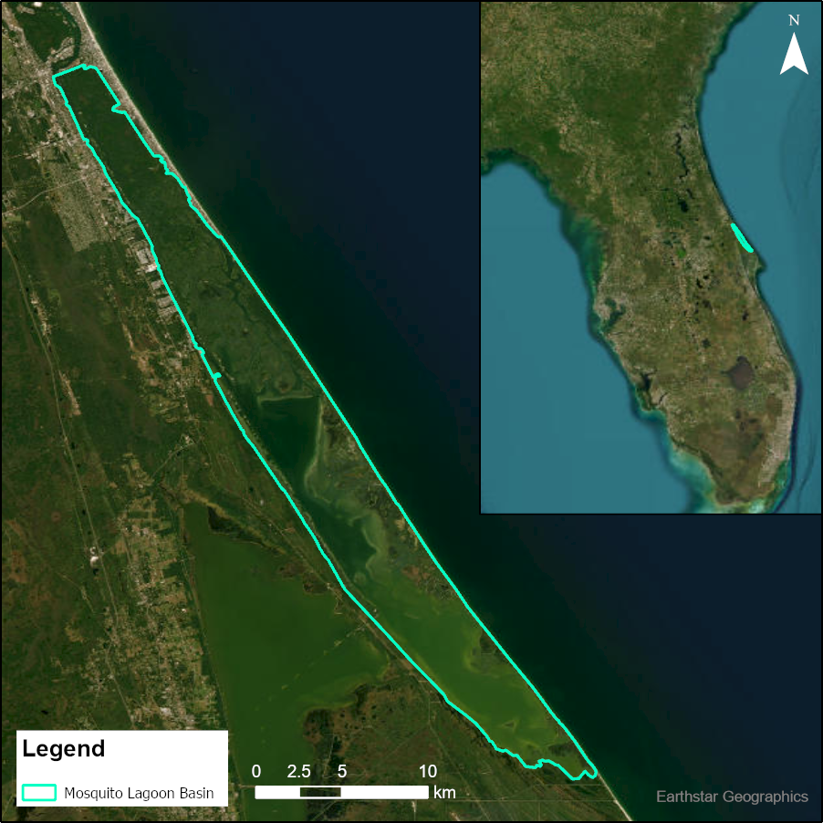

Figure 1-1: Study Area (Mosquito Lagoon, Florida)

including physical, human, and GIST, when evaluating this ecosystem and its conservation (Dick et al., 2016; Karmarkar, 2023).
Conservation of an ecosystem is a difficult task due to the relationship between complex ecological and human systems (Dick et al., 2016). With an increase in climate variability and overall pollution, it is apparent that most ecosystems have been declining because of human influence. Negative changes in ecological systems create negative changes in human systems. Evaluating all these factors holistically through the lens of conservation geography allows for research of this subject to be more well-rounded, which is the goal of this dissertation. (Minin et al., 2022).
Chapters 2 and 4 of this dissertation focus more on the physical impact of ecosystem decline on seagrass in ML, and also considers how this decline was caused by the actions of humans. In addition, these chapters use GeoAI methodologies, which are a set of methodologies increasing in popularity within the geographic discipline, to address this complex ecosystem and species within it. Geographers are starting to use more GeoAI in their GIST research due to its ability to handle complex datasets and provide more accurate predictions. This research supports the use of this methodology because of its capacity to make predictions with limited human input (Gao, 2021).
As one of the five major themes of geography, human-environment interaction is an important topic to discuss in research such as this and the mixed-methods approach used in this dissertation aims to highlight the importance of this theme (Rosenberg, 2019). Chapter 3 demonstrates the utility of an interdisciplinary approach, which demonstrates the impact the ecosystem decline of ML has had on local stakeholders and their livelihoods. By incorporating the seagrass data produced in the other chapters along with a survey and workshop distributed to stakeholders, insights into the human-environment relationship in this study area are gained.
The findings from this work also support the broader research of Florida agencies and organizations that are aiding in the conservation of ML. Specifically, this dissertation contributes to the mission of the Lagoon Watermen Alliance, which is an organization comprised of stakeholders and scientists that aim to “protect the entire Indian River Lagoon system by advocating for science-based solutions that will lead to improved water quality, protection of imperiled habitats, and safeguarding of gamefish populations” (Lagoon Watermen Alliance, 2024). The findings of Chapters 2 and 4 also provide an established record of seagrass loss and recover in ML from 2000–2020 and from 2022–2024, which can be used by the St. John’s River Water Management District, who tracks seagrass throughout the entire Indian River Lagoon system (St Johns River Water Management District, 2017).
Overall, the purpose of this holistic research supports current literature in the field and uses contemporary methods of GeoAI, conservation geography, and human-environment interaction to address a study area in critical need of conservation. The findings provide a well-rounded story of ecosystem decline and will equip other researchers in the use of their interdisciplinary methodology.

Chapter 2: Monitoring an ecosystem in crisis: measuring seagrass meadow loss utilizing Deep Learning in Mosquito Lagoon, Florida

A version of this study was accepted and will be published in July 2024 in collaboration with Dr. Hannah Herrero, Russ Limber, William Wolfson, and Clancy Oliver in Photogrammetric Engineering and Remote Sensing.

2.1 Abstract

The ecosystem of Mosquito Lagoon, Florida, has been rapidly deteriorating since the 2010s, with a notable decline in keystone seagrass species. Seagrass is vital for many species in the lagoon, but nutrient overloading, algal blooms, boating, manatee grazing, and other factors have led to its loss. To understand this decline, a deep neural network was used to analyze Landsat imagery from 2000 to 2020. Results showed significant seagrass loss post-2013, coinciding with the 2011–2013 super algal bloom. Seagrass abundance varied annually, with the model performing best in years with higher seagrass coverage. While the Deep Learning method successfully identified seagrass, it also revealed that recent seagrass coverage is almost non-existent. This monitoring approach could aid in ecosystem recovery if coupled with appropriate policies for Mosquito Lagoon's restoration.

2.2 Background

Seagrasses are vital species to many aquatic ecosystems, as vast species of fauna, including sea turtles, manatees, fish, crabs, and shrimp, depend on seagrasses for shelter, habitat, or as a food source, making the grasses a “foundation species” (Reynolds, 2018; St. Johns River Water Management District, 2020a). However, around the globe, these foundational species of seagrass are disappearing. Seagrass is vital for supporting underwater ecosystems as well as the economy surrounding it, so this loss is detrimental to both biodiversity and socioeconomics (Florida Oceanographic Society, 2019; St. Johns River Water Management District, 2020a). Seagrass is unique in that it is a plant that flowers underwater, and when it forms into a meadow, the area can become a hotspot of biodiversity (Reynolds, 2018). Seagrass has also been identified as an important ecological engineer, meaning it can alter the characteristics of its environment, including water flow and nutrient cycling, in the coastal waters where it grows (Jones et al., 1994). Seagrass forms root systems that help stabilize the sediments on which they grow, facilitating sedimentation and helping prevent erosion (Orth et al., 2006; Hughes et al., 2009; Lefebvre et al., 2009). Seagrass meadows form a structured leaf canopy above the sediment, in areas that would not have much vegetation structure otherwise, providing important habitat for a variety of marine species (Hughes et al., 2009). Juvenile fish and smaller aquatic animals depend on seagrass meadows as a main source of shelter, making them critical for supporting many populations of aquatic animals and fish (Orth et al., 2006; Hughes et al., 2009). Seagrass is a food source for larger marine animals, which graze on its leaves, including manatees, dugongs, and sea turtles (Orth et al., 2006); and it helps provides food for animals that feed on algae growing on the seagrass (Lefebvre et al., 2009). Seagrasses are excellent indicators of overall ecosystem health due to their sensitivity to environmental changes (St. Johns River Water Management District, 2020a). Seagrasses are also an important component of the global blue carbon cycle, which is the carbon sequestration contribution by coastal ecosystems. Seagrass meadows can store up to twice the megagrams of carbon per hectare than terrestrial forests, much of it stored in the sediment and soil under seagrass meadows (Fourqurean et al., 2012). With such extensive potential to sequester carbon, climate change reduction efforts should be prioritized through the protection of seagrass meadows.
There are multiple factors contributing to seagrass decline, including higher temperatures, disease outbreaks, waves and storms, and grazing (specifically from manatees and sea turtles) (Valentine and Duffy, 2006; Reynolds, 2018). There are also several human-driven factors that cause seagrass loss. Boating is a major detriment to many species of life but especially to seagrasses because the propellers can create scars within the seagrass meadows (Reynolds, 2018). Other factors like overfishing and introduction of invasive species have been causing seagrass population to decrease, and humans have also caused high levels of pollutants to be released into waterways globally. Nutrient pollution through releasing excessive nutrients and chemicals in the water can lead to eutrophication. Extensive lawns causing prevalent fertilizer usage and sewage discharge result in such nutrient chemicals reaching extreme levels. High levels of nutrients coupled with high temperatures cause large algal blooms, which have been adding to the environmental crises (Reynolds, 2018). Mosquito Lagoon has experienced a few “superblooms” throughout the past two decades because of these high nutrient levels, which can be tied to the drastic seagrass loss witnessed (Phlips et al., 2015; Lopez et al., 2021). It is apparent that conservation of the ecosystem is needed to mitigate these factors and promote recovery of seagrass and general ecosystem health.
Satellite imagery is a useful tool for mapping seagrass loss due to its historical temporal extent and consistent repeat time. There is availability to map trends over space and time, as well as this being an affordable method with freely available imagery and processing software, which can include the use of Machine Learning classifications (Howard et al. 2014). Some issues that may be encountered with using satellite imagery to view seagrass are water turbidity, color, and sun glint (Howard et al., 2014). Previous studies support that satellite imagery can be used to map seagrass, but more statistically robust methods can improve the accuracy of such classifications. Coarse 30-m resolution imagery used with traditional classification methods will produce accuracies between 60 and 80%, but finer resolution data and/or a more sophisticated classification algorithm can allow these accuracies to increase even further (Roelfsema et al., 2009; Pu et al., 2012; Kovacs et al., 2018). Aerial photography has been used successfully as well, so a combination of aerial photos, satellite imagery, and extensive fieldwork may be the best option for improving the accuracy of seagrass mapping (Roelfsema et al., 2009; Pu et al., 2012; Howard et al., 2014).
Seagrass has been mapped using more conventional classifications (like Random Forest [RF]), but there has been a draw to do species classifications in a way that models the more complex nature of the species (Watanabe et al., 2020). Deep Learning has not been used frequently to map seagrass, but these methods have been used before to map different plants, trees, and other underwater species. The most popular Deep Learning approach, convolutional neural networks (CNNs), have proven to have over a 96% accuracy in an automated classification of fish species, and D-leaf (a CNN-based method) was more effective (94.88% accuracy) at classifying leaf veins than support vector machine and K-Nearest Neighbor classifications (Rathi et al., 2017; Tan et al., 2020).
Although these Deep Learning models are popular, they require a large number of training samples. A Deep Learning model that is used in the field because of its ability to robustly predict with relatively smaller data sets is a deep neural network (DNN) (Arora et al., 2018). This model has been used for a variety of remote sensing applications, including weed mapping for precision agriculture, plant species classification, landcover classification, and crop disease recognition (Sa et al., 2018; Shi et al., 2022) Even though it is not always the most common option, the DNN model has been successful in image classification of remote sensing data sets with promising results, matching or exceeding the image classification metrics of Support Vector Machine and K-Nearest Neighbor classifications (Yuksel et al., 2018). DNNs have been applied specifically to seagrass monitoring in limited studies and were found to be more useful and efficient than U-Nets, SegNet, DeepLab, and other models in identifying seagrass (Wang et al., 2020). It was found that not only are DNNs more accurate than human classification, but they are also faster in annotating seagrass beds (Weidmann et al., 2019).
The purpose of this project is to use a Deep Learning classification for the study area of ML across images dates from 2000 to 2020 (2000, 2007, 2013, and 2020) to understand the trends and spatial extent of the loss of seagrass meadows, in addition to determining whether Deep Learning is a viable method for seagrass meadow classification. This research seeks to evaluate whether DNNs are a useful tool in seagrass coverage classification, as well as creating a published record of seagrass decline in Mosquito Lagoon, Florida. The research questions of this study are (1) Is a DNN classification an effective way to map seagrass loss? (2) What are the trends in seagrass loss within the lagoon from 2000 to 2020?

2.3 Data and Methods

2.3.1 Landsat Imagery
The satellite imagery used to analyze seagrass in ML came from Landsat 5 Thematic Mapper and 8 Operational Land Imager at 30-m resolution to encompass the temporal extent of this study. Four Landsat images were preprocessed and collected in about 7-year increments from Google Earth Engine to span the time period of 2000 to 2020, with the dates for each image being 30 August 2000, 1 July 2007, 17 July 2013, and 1 May 2020 (Gorelick et al., 2017). The dates of the data, across the boreal summers of each year 2000, 2007, 2013, and 2020, were chosen specifically to avoid environmental conditions like water turbidity and sun glint that may affect the image quality. They were also chosen because boreal summer is peak biomass for seagrass here, and because these years aligning with dates that stakeholders identified as being important for change in seagrass (Dawes et al., 1995; Phlips et al., 2015; Herrero, 2021). Due to the difference in the number of bands between Landsat 5 and Landsat 8, the seven bands used in this analysis were blue, green, red, near infrared (NIR), shortwave infrared (SWIR) 1, thermal, and SWIR 2. As shown in Figure 2-1, seagrass can be seen in Landsat imagery as a dark shade within the water (examples are highlighted in green).
2.3.2 Field Data
In addition to the Landsat data, field data were collected during boreal summers of 2020, 2021, and 2022 to validate the seagrass seen on the imagery. This seagrass signature was developed and used to identify seagrass areas in the earlier imagery, as well as the use of a Geographic Information Science (GIS) seagrass layer provided by the St. Johns River Water Management District. For each field season, coordinates of seagrass patch locations throughout the lagoon were recorded through GPS and then entered into Excel. These seagrass coordinates were then made into a shapefile, which was used in training and validating the DNN classifications. In addition, our research team has strong connections with guides and fishermen in ML who have worked on the lagoon for decades and validated the results the model produced in terms of the locations of seagrass.
2.3.3 Background of Deep Neural Network Classifications

Deep Learning is an expansion of Machine Learning, a branch of artificial intelligence that uses data and algorithms to form a model that can learn and adapt with limited human input and that uses hidden layers within the model to look for deeper patterns and features within an artificial neural network (Zhu et al., 2017; Ma et al., 2019; Yuan et al., 2020). This type of learning can use large data sets and can gain insight into underlying nonlinear patterns. It is a method well suited

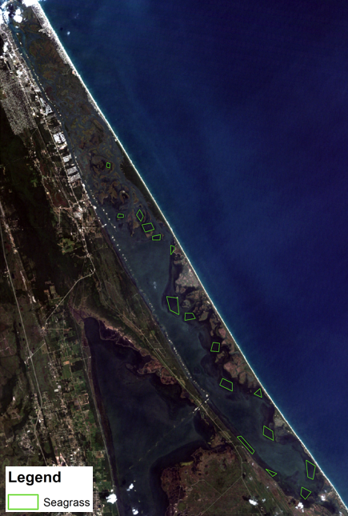

Figure 2-1: Landsat imagery of 2000 with seagrass patch locations highlighted in green (band combination: band 3 (red), band 2 (green), and band 1 (blue), true color composite).

to handling complex situations and ecosystems, but the drawback to this is it requires a large amount of training samples and computational time (Zhu et al., 2017; Yuan et al., 2020). Deep Learning models also suffer from the “black box problem,” because the user is unclear of exactly what is happening throughout the hidden layers. It is difficult to understand how the model came to its conclusion, so the results need to be carefully analyzed (Samek et al., 2017).
There are many different types of Deep Learning models, so selecting the correct one should be done according to the purpose of the model and the data being used. Although as mentioned before, CNNs are widely used for classifications like these, the filtering function from the convolutional aspect of the network does require a large amount of training samples (Arora et al., 2020). Because the training data in this system is relatively limited, a Deep Neural Network was selected instead. A Deep Neural Network is more suited for this classification because it does not need the same amount of data as a CNN, and it is more geared towards dealing with pixels (as our true labels are just by pixel) rather than an entire raster or image.
A Deep Neural Network is a collection of neurons that are organized in multiple layers, in which the neurons receive input from the neurons in the previous layers and then a single computation (like a weighted sum) is performed (Montavon et al., 2018). The model can be programmed to keep improving its accuracy through validation and training data, so in the end it will be as accurate as possible. These networks are successful in image classification, object classification, semantic segmentation, and more functions (Yuan et al., 2020). It is a relatively simple Deep Learning model, but it will be very useful in determining whether Deep Learning is a suitable model for seagrass mapping and classification.

2.3.4 Model Used

The four Landsat images for 2000, 2007, 2013, and 2020 were uploaded into Environmental Systems Research Institute (ESRI)’s ArcGIS Pro, and training samples were made for two classes: seagrass and non-seagrass. This made it so a binary classification could be run and specifically focus on the identification of seagrass by the model. Polygons (example shown in Figure 2-1) were created for each year and class, but they varied in number as seagrass started to decline in 2013. The creation of these polygons was influenced by fieldwork conducted in 2020 through 2022, when seagrass coordinates were sampled to validate the location of the patches on the imagery. These polygons were transformed into arrays and then entered into the DNN code, which was written using Python and TensorFlow because it is a heavily used, open-source, software library that can handle Deep Learning models (Abadi et al., 2016; Pang et al., 2020). A single model was created by one-hot encoding each of the 4 years measured. The data were separated into training, validation, and testing through stratified random sampling in which each stratum is the year the data were collected for. The ratio for training, validation, and testing was 0.6, 0.2, and 0.2 respectively.
The models were compiled using Adam (an optimization algorithm) with binary cross-entropy, or log loss, as the cost function (Kingma and Ba, 2015). This function looks at the log of corrected predicted probabilities and calculates a negative average (Saxena, 2023). The final model for each year had six hidden layers each one using the rectified linear unit (ReLu) activation function, which is a piecewise linear function that will make the output the input directly if it is positive, otherwise the output will be zero (Brownlee, 2020). This function has been rising in popularity in the Deep Learning field because models that use the ReLu function can have better performance and be easier to train (Hara et al., 2015; Brownlee, 2020). The numbers of neurons per layer from first to sixth are: 128, 448, 128, 448, 384, and 32. The final output layer uses the sigmoid activation function, and the learning rate selected was 0.001. These hyperparameters were selected using the KerasTuner API and Bayesian selection was used for hyperparameter tuning (O’Malley et al., 2019). The data were then calculated about precision, accuracy, recall, and the F1 score from the classification, as well as a confusion matrix and change trajectory over the years and models.

2.4 Results

2.4.1 Spatialized results

Figure 2-2 shows the spatial distribution of seagrass produced by the DNN for the four dates. Seagrass has declined over this time period. Seagrass extent was largest around 2007, with a similar percentage in 2013 (~15% seagrass). However, the change from 2013 to 2020 represents an almost complete loss in seagrass (less than 1% seagrass remaining), and this timing coincides with the super algae bloom event (Lopez et al. 2021). Seagrass extent over time is supported by the pixel-by-pixel counts/percentages for our classes (seagrass versus non-seagrass) in Table 1.
Figures 2-3 and 2-4 show the change in seagrass between 2000 and 2020. Figure 2-3 has seagrass layers from each of the years overlaid. This is an efficient way to show seagrass spatial distribution differences over the year. This figure clearly demonstrates that the largest extents of seagrass occurred in 2007 and 2013. The year 2020 had very little seagrass in the DNN. Figure 2-4 is a pixel-by-pixel change trajectory with the different permutations of class change over time. Of the changes that occurred over time, 99.84% of these changes were a seagrass to non-seagrass conversion at some date, whereas only 0.16% of the change that occurred was a conversion towards seagrass (Table 2-2).
The identification of these seagrass patches within the model were validated by fieldwork and history from guides and fishermen who are active in the lagoon, so although there may be some misclassifications, it can be derived that where the model placed seagrass is accurate. It is important to note that in the northernmost part of ML, there is an extreme lack of seagrass throughout all years, but that is normal because there has not been seagrass witnessed there—oyster reefs dominate the lagoon bottom in that area.
2.4.2 Precision

Precision is the metric which measures how precise the model is in predicting a specific category, like seagrass, at what proportion the identifications were actually correct. As evidenced in Table 2-3, precision significantly increased throughout the years of the DNN classification, from 0.786 to 1.0. The 1.0 precision in 2020 is likely due to there being an extreme lack of seagrass in the image for the classification to identify, so it was easier for the classification to identify those patches. This 1.0 value for 2020 signals that the model produced no false positives. The lowest accuracy was recorded in 2000 at 0.786, which had less visible seagrass than 2007 or 2013, so some predictions were missed. Overall, the models had high precision, especially from 2007 on, so a DNN can predict the location of a seagrass meadow.
2.4.3 Accuracy

This metric looks at how correct the model was at identifying all classes (seagrass vs non-seagrass). Accuracy was relatively high for most years (Table 2-3), but especially for 2020 where seagrass was minimal and easier to identify. 2007 and 2013 had the same result at 0.982 although seagrass coverage varied within each image, with 2013 having slightly less seagrass than 2007. As with precision, 2020 had the highest accuracy of all the years with 0.988 which could be correlated

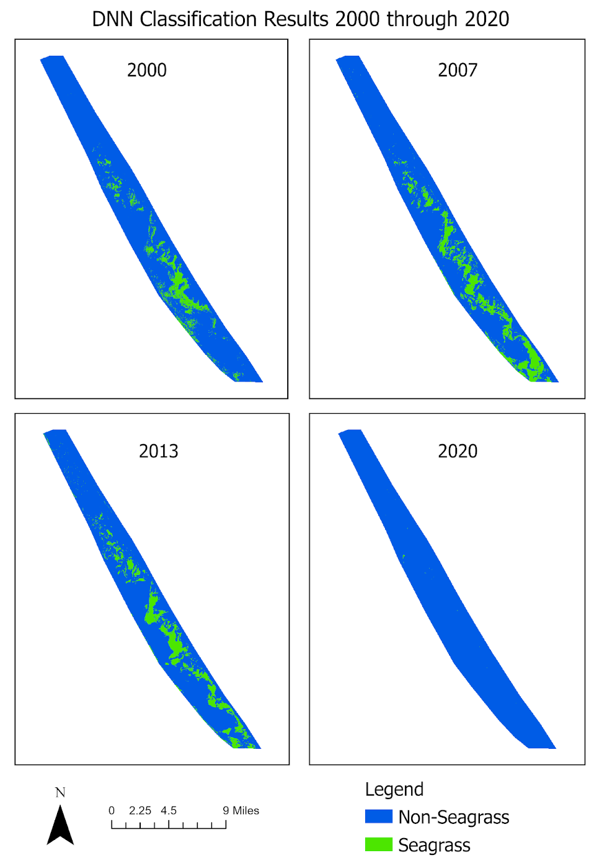

Figure 2-2: DNN Classification Output from 2000 to 2020

Table 2-1: Pixel Counts/Percentages for Seagrass vs non-Seagrass
 | 2000 | 2007 | 2013 | 2020
Non-seagrass | 189,913  (89.9%) | 176,175  (83.4%) | 179,244  (84.8%) | 211,178  (99.9%)
Seagrass | 21,384  (10.1%) | 35,122  (16.6%) | 32,053  (15.2%) | 119  (0.1%)

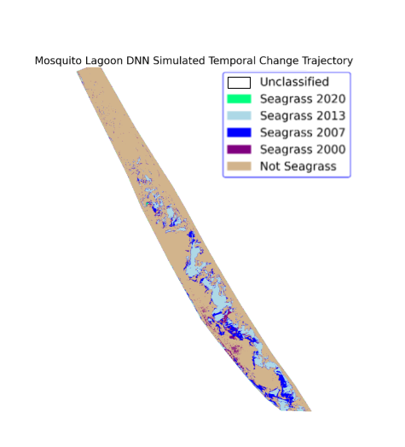
Figure 2-3: Seagrass overlay from the dates 2000, 2007, 2013, and 2020 from the DNN Classification

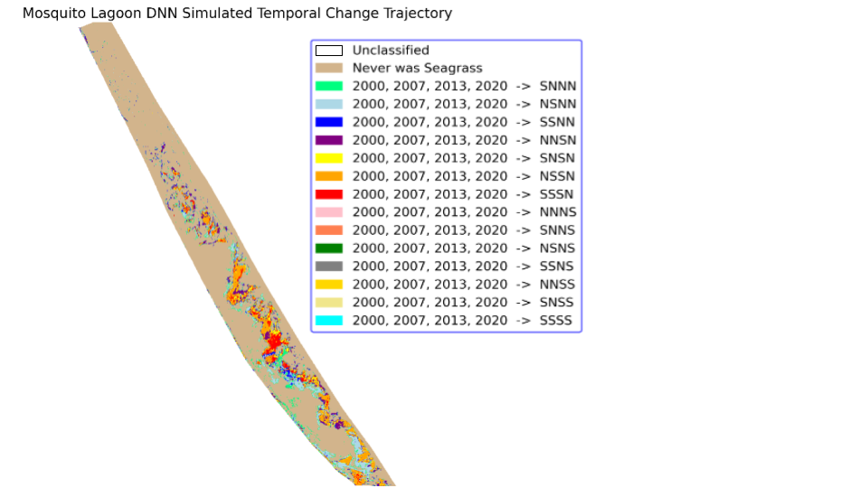

Figure 2-4: Change Trajectory Permutations for the dates 2000 > 2007 > 2013 > 2020, where S = Seagrass and N = non-Seagrass

Table 2-2: Pixel Counts/Percentages for Change Trajectory, where S = Seagrass and N = non-Seagrass
Class Trajectory | Count/Percentage | Conversion to Seagrass | Conversion to Non-seagrass
SNNN | 11,631 (24.82%) | 0.16% | 99.84%
NSNN | 3,086 (6.59%) | 0.16% | 99.84%
SSNN | 7,487 (15.98%) | 0.16% | 99.84%
NNSN | 4,159 (8.88%) | 0.16% | 99.84%
SNSN | 11,914 (25.43%) | 0.16% | 99.84%
NSSN | 8,461 (18.06%) | 0.16% | 99.84%
SSSN | 45 (0.10%) | 0.16% | 99.84%
NNNS | 17 (0.04%) | 0.16% | 99.84%
SNNS | 21 (0.04%) | 0.16% | 99.84%
NSNS | 4 (0.01%) | 0.16% | 99.84%
SSNS | 19 (0.04%) | 0.16% | 99.84%
NNSS | 8 (0.02%) | 0.16% | 99.84%
SNSS | 4 (0.01%) | 0.16% | 99.84%
SSSS | 1 (0.00%) | 0.16% | 99.84%
N = non-seagrass; S = seagrass.

with there being less seagrass to identify, so the model was able to classify most pixels as non-seagrass.

2.4.4 Recall

Recall, or the true positive rate, was also calculated but varied throughout the years to understand the model’s ability to find positive samples. Like with accuracy, 2007 and 2013 had a very high recall with the model correctly classifying 94.6% and 94.5% of positive samples, respectively (Table 2-3). There was a significant drop in recall for 2000 at 0.437 and for 2020 at 0.083. The lack of seagrass in 2020 could be the reasoning for this statistic, but further investigation into the recall of 2020 was conducted. A high precision can sometimes mean that recall is lower, so it is not unheard of for a recall to be this low while high precision is present in this trade-off (Google Developers, 2022).

2.4.5 F1-Score

An F1-Score is another metric which looks at the correctness of the classification, by taking the harmonic mean of precision and recall:

F1 Score = 2 X ((Precision x Recall) / (Precision + Recall))

As this metric is a combination of precision and recall, it is understandable that for 2007 (0.956) and 2013 (0.972) the F1-Score is close to 1 as with the other metrics. 2000 still had a high score at 0.751 but it was brought down compared to 2007 and 2013 because of its lower recall. 2020 had the lowest score at 0.584 as although it had the highest precision at 1.0, it had the lowest recall (0.584).

Table 2-3: Metric results from DNN Classification per Year
 | 2000 | 2007 | 2013 | 2020
Precision | 0.786 | 0.905 | 0.967 | 1.0
Accuracy | 0.869 | 0.982 | 0.982 | 0.988
Recall | 0.437 | 0.946 | 0.945 | 0.083
F1 score | 0.751 | 0.956 | 0.972 | 0.584

2.4.6 Confusion Matrix

In addition to the above results, a confusion matrix (Table 2-4) was produced to look further into the accuracy of the models, and the statistics align to what was reported earlier. The highest overall accuracy (98.77%) was for 2020 which had limited seagrass, followed by 2013 (98.25%), 2007 (98.18%), and then 2000 (86.87%). The Kappa coefficient varied throughout the years and had a similar pattern to the recall results. 2007 and 2013 which have a had a much larger extent of seagrass, had the highest Kappa coefficient (>= 0.915), but there was a decline in the value to 2000 (0.492) and 2020 (0.151). In the most recent date, this Kappa statistic (along with the error of omission) suggested that grass pixels may have been assigned by the classification at chance and that real seagrass may have been missed out on in the classification, however, fieldwork coinciding with this date can verify that this is not the case due to the extremely low extent of observed seagrass in 2020.

2.5 Discussion and Conclusion

The results from the classification support that Deep Learning (specifically DNNs) is a viable method for identifying seagrass in ML because of its efficiency and accuracy, and also support that there is a significant decline of seagrass in ML (Weidmann et al., 2019; Wang et al., 2020). When looking through the available technical metrics, it is evident that precision and accuracy produced the best results, with precision equaling or exceeding 0.786 and accuracy being higher than 86.9% for all years. With those two metrics alone, 2020 produced the best results, which may be due to the very limited amount of seagrass present for the model to identify. The year 2000 produced lower results by most metrics, and this could be due to some seagrass patches being missed because fieldwork was not conducted in that year, so additional

Table 2-4: Confusion Matrix for 2000 – 2020 Models
 | Non-seagrass | Seagrass | Total | Class Commission Error (%) |  | Kappa Coefficient | Overall Accuracy (%)
 |  |  |  | Producer’s Accuracy | User’s Accuracy | Kappa Coefficient | Overall Accuracy (%)
2000 |  |  |  |  |  | 0.492 | 86.87
Non-seagrass | 5172 | 715 | 5887 | 2.84 | 12.16
Seagrass | 151 | 556 | 707 | 56.25 | 21.36
Total | 5323 | 1271 | 6594
2007 |  |  |  |  |  | 0.915 | 98.18
Non-seagrass | 6430 | 48 | 6478 | 1.33 | 0.74
Seagrass | 87 | 833 | 920 | 5.45 | 9.46
Total | 6517 | 881 | 7398
2013 |  |  |  |  |  | 0.945 | 98.25
Non-seagrass | 5873 | 82 | 5955 | 0.81 | 1.38
Seagrass | 48 | 1416 | 1464 | 5.47 | 3.28
Total | 5921 | 1498 | 7419
2020 |  |  |  |  |  | 0.151 | 98.77
Non-seagrass | 8024 | 100 | 8124 | 0 | 1.23
Seagrass | 0 | 9 | 9 | 91.74 | 0
Total | 8024 | 109 | 8133

training samples might be required (Emmanuel et al., 2021). Both 2007 and 2013 produced similar results throughout the different metrics because seagrass coverage was about the same and in relative abundance. However, as discussed, results varied for 2000 and 2020. For 2000, the varied results could be due to a lack of samples, but 2020 had a very low Kappa coefficient, recall, and F1 score most likely due to the drastic loss of seagrass witnessed. With minimal seagrass for the model to look for, it is understandable that these other metrics are low for this year. However, using a binary classification for the models was in favor of the results, because we were able to focus on the identification of seagrass versus non-seagrass solely and did not allow for the complication of other classes (Karabiber, 2023). Training and tuning simply on accuracy appeared to be the most effective method for preparing the model because there was not a great enough discrepancy between the binary classes to require an alternative metric (i.e., recall or precision).
Although the model did successfully identify seagrass throughout our time period, it was still a very time-consuming methodology. This is to be expected with Deep Learning, because it can be computationally costly (Zhu et al., 2017; Yuan et al., 2020). Even though there can be drawbacks to the method, it does allow for the process of seagrass mapping to become automated (Weidmann et al., 2019; Sun et al., 2020). A Random Forest Classification was previously run for the area, but it was found to not be as effective in identifying seagrass. Random Forest cannot capture underlying continuous patterns, whereas a DNN can. Also, a DNN can generalize better to observations that are outside of the range of inputs, which can be misinterpreted by a RF (Yoo et al., 2019; Thompson, 2019). The main benefit of this method is that it is freely available and can be taught to stakeholders and agencies that monitor seagrass in the lagoon, and they can continue the process of mapping seagrass but with limited human input required, which might be appealing to organizations who are already limited on time and resources for conservation.
When looking at the satellite imagery and models, there is a noticeable overall decline in seagrass coverage from 2000 to 2020 in ML. The largest extent of seagrass amount was observed in 2007 (16.6%) and patches continued to decline steadily throughout the years to only 0.1% in 2020, which is detrimental to the surrounding ecosystems and economy (Florida Oceanographic Society, 2019; St. Johns River Water Management District, 2020a). Morris et al. (2018) observed a 20.25% loss of the seagrass of ML from 1943 to 2013, and it is apparent from our study that the loss has been rapidly increasing in the recent years observed from 2013 to 2020 (Morris et al., 2018). This drastic loss of seagrass has caused a loss of habitat, which extends then to a decline in manatees, fish, and other species in the lagoon (Allen, 2021; St. Johns River Water Management District, 2020a). The loss of these subsequent species has lasting implications for the lagoon from an ecosystem biodiversity perspective but also for the economy because stakeholders who rely on the fish population in ML for their livelihood are now struggling to operate their businesses under these poor environmental conditions (Rotne, 2020). This team has also conducted interviews to better quantify the staggering negative effect on livelihoods linked to this seagrass loss.
As stated, many species depend on these seagrass patches to survive, and after observing a significant decline since 2013 and minimal detectable patches in 2020, further research and fieldwork is necessary to determine the effect on other species in the lagoon due to this decline (Florida Oceanographic Society, 2019; St. Johns River Water Management District, 2020a). This drop of coverage between 2013 and 2020 may be linked to the 2011−2013 super bloom event, which would have caused water conditions in the lagoon to decline drastically and coincided with the apparent almost total loss of seagrass, although further investigation is necessary (Lopez et al., 2021). Regardless of factors, it is apparent that conservation of the ecosystem is urgently needed for ML to recover to what it once was, environmentally and economically.
Although ML represents a relatively small area of seagrass, this research supports the findings of other studies that seagrass is declining globally (Orth et al., 2006; Unsworth et al., 2018). Because seagrasses are a keystone and foundation species, it is vital that conservation efforts are made to combat this decline (Reynolds, 2018; St. Johns River Water Management District, 2020a). In addition, we know that seagrass is a gauge of ecosystem health; therefore, this rapid loss is an alarming indicator for this entire ecosystem (St. Johns River Water Management District, 2020a). We know that some variables related to this decline may be nutrient overloading, manatee grazing, boating effects, or other factors that have not been determined yet, but there is a lack of causation research in ML, which this team plans to address in the future (Valentine and Duffy, 2006; St. Johns River Water Management District, 2020a).
The limitations of this study are mainly focused on the drawbacks of a Deep Learning approach. It is not possible to determine what happened within the model to identify the seagrass patches, as the model is a “black box” (Samek et al., 2017). There was also a relatively limited amount of training data, but this can be improved for the future by increasing the number of training classes or adding more satellite imagery/years to the analysis (Emmanuel et al., 2021). Lastly, there can be some confusion in the seagrass patch identification within the classification. This may potentially be a confusion with oyster reefs, because they look similar on the imagery. However, spatially within the lagoon, there is a clear distinction between where these two classes are located, so it was easier to avoid this issue in this study area. One other limitation is related to the spectral resolution of the Landsat data, which can only identify seagrass as a vegetation group, but not the distribution of individual species of seagrass within ML. Some of these limitations did also pose as challenges that are encountered when using a Deep Learning methodology. Other obstacles included this model being a time-consuming methodology to develop, which is expected when using Deep Learning, as well as requiring a significant amount of computational time to run the analysis (Zhu et al., 2017; Yuan et al., 2020). For a data set with limited training samples like this study, a more simplistic method of classification like Machine Learning might be a more applicable and faster method (Southworth et al., 2024).
This study concludes that Deep Learning, specifically DNNs, is successful in seagrass identification and mapping, as well as that the need for conservation of seagrass in ML has reached a crucial point. As an ecosystem in crisis, ML is an excellent environment to deploy a method like this, as the complexity of the ecosystem makes it an ideal candidate for Deep Learning. However, the implementation of a tool of this caliber is only useful if it influences the community and subsequent decisions concerning conservation of the ecosystem. A method like this allows for the automation of seagrass mapping, which gives another tool to stakeholders rather than researchers to continue the monitoring of these species. Although the models varied in accuracy and precision per year, overall, they were able to identify seagrass locations and document the significant decline of seagrass throughout the period. This drastic loss in seagrass can be seen especially from 2013 onward, and this loss will affect other species in the ecosystem as well as the surrounding community. The DNN can be a useful tool for managers to monitor seagrass change at the landscape spatial and consistent temporal scales, so target areas for conservation can be developed given limited resources.

Chapter 3: Evaluating Stakeholder Perception on Ecosystem Health and Livelihoods in a Marine Protected Area: Mosquito Lagoon, Florida

A version of this manuscript is under review at Ecology and Society in collaboration with Dr. Hannah Herrero and Dr. Gabe Schwartzman.

3.1 Abstract

Understanding local community perceptions of biodiversity loss and ecological systems change can better inform scientific study and policy interventions around socio-ecological resilience and adaptation. This study examines the local ecological knowledge (LEK) held by fisheries communities around Mosquito Lagoon, Florida. The objectives of the study are to understand: 1) how community stakeholders perceive the health of the ecosystem; 2) how community stakeholder livelihoods have been impacted by and have adapted to seagrass loss and ecosystem collapse; and 3) what actions community stakeholders think could be helpful to mitigate this environmental crisis and promote recovery. The study used mixed qualitative methods that compared LEK findings with remote sensing methods of studying seagrass changes. The qualitative methods relied on an online survey (n = 105) and a focus group discussion (n = 75). Results from the study show that fisheries stakeholders observed an overall decline in ecosystem health, a precipitous decline in seagrass cover, and overall decline in the size and quantity of culturally valuable fish. These findings contradict some of the findings of governmental agencies data on ecosystem wellbeing of this lagoon. Fisheries communities also reported major economic damage from the ecological change. In sum, the results of this research indicate that communities that once made a living at fishing are having a very difficult time continuing those livelihoods in Mosquito Lagoon. These findings are important for more fully conceptualizing the socio-ecological resilience, transformation, and adaptation of coastal landscapes in a changing climate.

3.2 Background

3.2.1 The Story

Mosquito Lagoon (ML), Florida is no ordinary place. Many that visit the lagoon are taken with its beauty. Locals say that the majesty of the lagoon cannot be adequately described in words. It is teeming with life and has been one of the premiere red fishing destinations in the world, or at least it was until 2010.
ML (Figure 3-1) stretches approximately 50 km along Florida's east coast and is the northernmost portion of the Indian River Lagoon (IRL) system (~250km in total). ML is an incredibly ecologically rich ecosystem that includes an estuary with dense seagrass and oyster bars (in tidal areas), salt marshes, islands dominated by several mangroves species, and a dune system buffering against the Atlantic Ocean. ML is a shallow body of water, with an average depth of four feet (St John’s River Water Management District, 2020). The northern boundary of ML is Ponce Inlet, and the southern boundary is NASA’s Kennedy Space Center / Merritt Island National Wildlife Refuge. Due to its extensive biodiversity of birds, fish, and other marine life, ML is well known for its fishing, duck hunting, birdwatching, and kayaking. It is also home to the beloved keystone species, the Florida Manatee. The lagoon is a protected area at multiple levels of government, including the federal (Canaveral National Seashore) and the county levels. Agencies involved in the management of ML include St. John’s River Water Management District, National Park Service, U.S. Fish and Wildlife Service, Florida Fish and Wildlife Conservation Commission, Volusia County, Brevard County, the Indian River Lagoon National Estuary Program, Brevard Indian River Lagoon Coalition, Save Our Indian River Lagoon, Marine Resources Council, Marine Discovery Center, several other NGOs and academic institutions, and the cities that sit alongside the lagoon. This protected area contributes to Florida's environmental conservation efforts, but for more than a decade, this ecosystem has been in crisis.
Following anomalously cold winters of 2010 and 2011, there was a die off seagrass, which was further compounded by an algae “superbloom” event (Lopez et al., 2021). This led to an algae-dominated system, including an introduced species from Texas, Aureoumbra lagunensis, where seagrass could no longer thrive and all the species that depended on the seagrass, such as various fish, crabs, shrimp, sea turtles, and manatees became in severe decline too. Another major issue in this system that contributes to the algal blooms is nutrient loading, pollution that is both point source and non-point source from outflows such as septic systems, wastewater treatment systems, and lawns. This system has been stuck in a positive feedback loop for more than a decade. However, after back-to-back Hurricanes Ian and Nicole in the late fall 2022, which included both high amounts of rainwater and washouts of the dune system leading to a large influx of saltwater from the Atlantic Ocean, there has now been recovery of seagrass to pre-collapse density and extent. At this time, no studies have been conducted to investigate the exact drivers of this recovery.
One of the authors grew up around ML and has been witnesses to the decline in ecosystem health. They are a co-founder of the stakeholder-based non-profit, Lagoon Watermen Alliance (LWA), whose mission is to educate, inform, and create science-based change to preserve the IRL system for future generations, with a specific focus on reducing nutrient loading (Lagoon Watermen Alliance, 2023). As a member of the ML fishing community, they have personal insight into how seagrass loss was negatively impacting charter captains and recreational fishermen. In total, there are seventy-five permitted fishing guides (charter captains) in ML and after speaking with several of the most experienced guides in the community, it became clear that further study was needed on their perceptions of ecosystem decline and how their livelihoods have been impacted by it. Because of the author’s unique position in the community, which has built rapport over many years, they were able to receive approximately a 45% response from permitted charter captains on the electronic survey, and a great deal more from other lagoon stakeholders.
Based on preliminary data and our remote sensing results (Insalaco et al., 2024), we expected fish populations to have declined along with the loss of seagrass to only 1% of previous coverage, making it very difficult for charter captains to make a living in the ML. This hypothesis was supported by the survey results across a variety of investigative categories.
3.2.2 Literature Review

Political ecologists have long studied how knowledge about ecologies is itself a site of contestation (Blaikie, 1985; Brookfield, 2016; Fairhead & Leach, 1996; Goldman et al., 2011; Neimark et al., 2019; West, 2006). Political ecologists that draw upon science and technology studies have frequently described ecological knowledge as a field of power–one where the ability to claim knowledge over an ecological process can reinforce power relations (Kosek, 2010; Krupar, 2013; Lave, 2012a; Moore et al., 2003). Here we draw on this long lineage in political ecological studies to consider how knowledge about seagrass and fish populations is contested and becomes a site where local knowledge comes into contest with state official accounts.
We also pair physical geography data and research about seagrass with a political ecology approach to inform a critical physical geography research project. Critical physical geography is an emerging field of study that uses social theory to consider the eco-social research questions, examining how power relations, and their material effects, shape and manifest within biophysical systems (Lave et al., 2018). Critical physical geography projects have studied questions about geomorphology and hydrology (Blue & Brierley, 2016; Dufour et al., 2017), and the

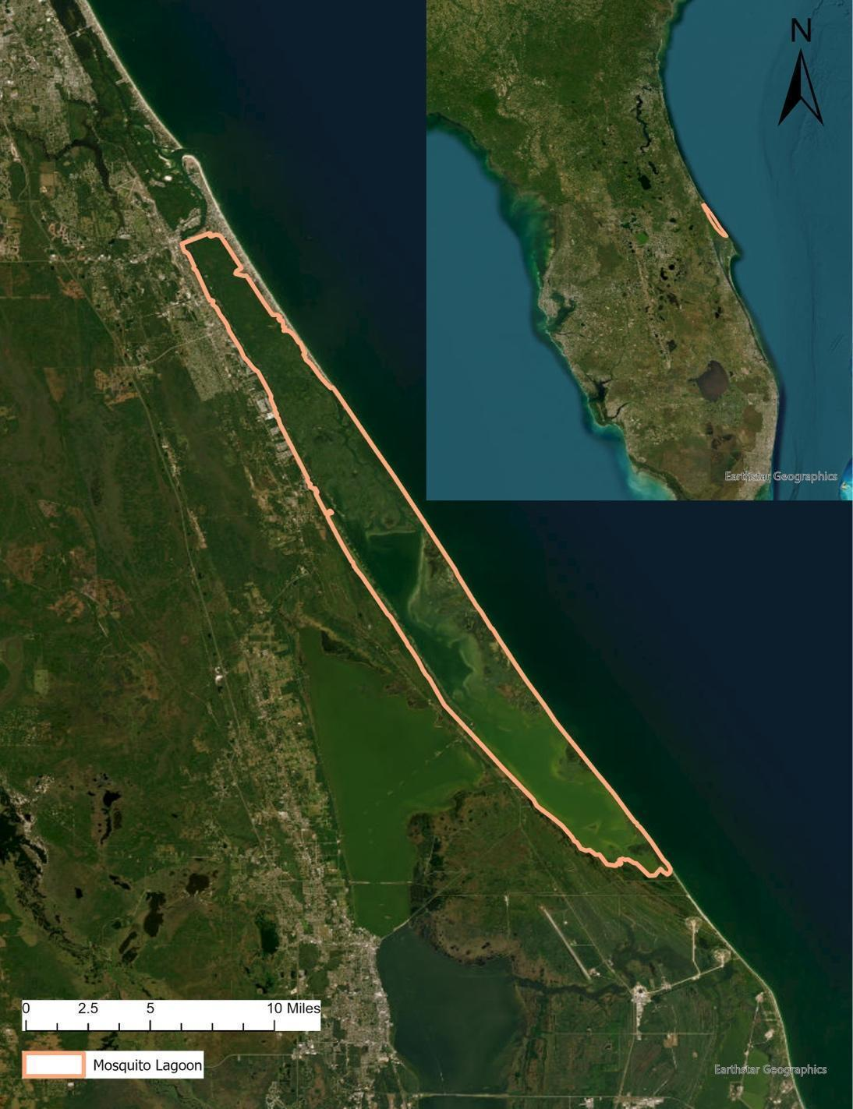

Figure 3-1: Map of Study Area (Mosquito Lagoon, Florida)

implementation of such science in applied ecological restoration work, such as stream restoration (Lave, 2012b). Here we build on other studies of critical physical geography that consider the role of remote sensing in the politics of environmental knowledge (Braun, 2021). Bringing local ecological knowledge (LEK) into our analysis, we consider how at-risk populations that rely on natural resources for livelihoods produce extensive knowledge about fish populations and fisheries ecologies that is incongruent with that of resource managers. We build on a critical physical geography body of scholarship, responding to calls to understand how scientific practices and values underlying measurement influence data outcomes (Braun, 2021), we illustrate how valuing LEK can inform both better science and resource management.
LEK is useful in assessing how communities experience socio-ecological changes, as well as documenting ecological change at localized scales. LEK can be most useful in areas facing ecological transformation, where differing data and lenses of analysis offer divergent or even contradictory results. In such cases, LEK can offer a situated body of knowledge (Haraway, 1988), with the origins and the implications of the knowledge clearly stated, as opposed to frequently more abstract and at times unapproachable dataset offered from scientific bodies and environmental resource management agencies. Furthermore, LEK is useful in understanding how human communities perceive ecological change and what human communities identify as most important for their livelihoods and wellbeing in the ecologies they operate within (Aswani et al., 2018).
LEK has long been a key source of data for researchers seeking to better understand socio-ecological transitions (Anadón et al., 2009; Aswani et al., 2018; Davis & Wagner, 2003). In particular, scholars of climate change have looked to LEK to understand localized perceptions of change and to understand how communities are adapting to climatic changes. Kupika et al. (2019) argue that LEK is a critical way to understand and promote human community resilience in the face of climatic changes, studying LEK and climate changes in the Zambezi Biosphere Reserve.
Scholars argue that LEK can produce better (and far less expensive) results of ecosystem inventories than non-local-community-based methods. For instance, Anadon et al. (2009) found that LEK could be a more effective and far less expensive sampling methodology for low-density populations in extensive landscapes.
LEK can at times provide surprising results that may contradict the knowledge produced from governmental resource managing agencies, and from scientific bodies. In particular, fisheries researchers have long found that LEK provides useful additions to wider bodies of scientific data and can help direct scientific researchers to ask different and more precise questions (Sáenz‐Arroyo et al., 2006). Sivlano and Valbo-Jorgensen argue that more than simply ‘fisherman’s tales,’ data collected with and by fishermen can offer unique and methodologically rigorous insights into often difficult-to-study, and largely unknown underwater ecologies (Silvano & Valbo-Jørgensen, 2008).
It is important, however, to note the difference between LEK and traditional ecological knowledge (TEK). While LEK comes from ecological resource users and individuals that have highly specific knowledge of landscapes, TEK usually comes from Indigenous communities that have developed and maintained non-Western knowledge systems about ecological systems (Chisholm Hatfield et al., 2018; Wyllie de Echeverria & Thornton, 2019). TEK, therefore, offers other ways of knowing and datasets interpreted upon epistemological grounds than scientists and university or government researchers rely. LEK, in contrast, can involve any collected users of ecological resources and relies on their specified knowledge of the ecosystems they inhabit, rather than necessarily the ontological differences between the scientists and the resource users.
LEK fits within a broader body of literature within geographic scholarship that studies the politics of socio-ecological change. As mentioned, geographers have long engaged in political ecological approaches to questions of socio-ecological change (Kosek, 2006; Sundberg, 2011; Neimark et al., 2019; Watts & Peet, 1996), illustrating how the question of whose knowledge is valued and considered valid has widespread implications for issues of equity and human wellbeing in natural resource management (Ahmad-Khan, 2022).
Building on critical physical geography, political ecology, and studies of LEK, this study contributes to a growing body of geographic scholarship on climate change adaption and resilience. As numerous scholars have pointed out, the first step in identifying pathways for community resilience in a changing climate is identifying what changes are most relevant and felt in these communities (Taylor and Bhasme, 2020). Resilience scholars have pointed out that resilience cannot come only from technological or ecological interventions, but must understand the full social implications, histories, and contexts within which communities face vulnerabilities (Derickson, 2016; MacKinnon & Derickson, 2013). As we study the ways that a community that faces significant changes to their livelihood due to novel climatic irregularities (fishermen and fishing communities of ML), we identify the ways that documenting their knowledge and perception of ecological change can influence how best to promote socio-ecological resilient systems in future landscape management.
Finally, we leverage remote sensing science to inform our critical physical approach. Satellite imagery proves invaluable in tracking seagrass loss because of its extensive historical record and consistent periodicity (Insalaco et al, 2024). This approach offers the added benefit of being cost-effective, as it relies on readily available imagery and processing software, often supplemented by Machine Learning techniques (Howard et al., 2014). However, it is worth noting that challenges like water turbidity, color discrepancies, and sun glint can affect the accuracy of seagrass assessments through satellite imagery (Howard et al., 2014). While previous research demonstrates the viability of satellite imagery for seagrass mapping, there is room for enhancement in accuracy through statistically rigorous methods. Traditional classification methods paired with 30-meter resolution imagery yield accuracy rates ranging from sixty to eighty percent. Yet, employing higher-resolution data or advanced classification algorithms can further boost precision (Kovacs et al., 2018; Pu et al., 2012; Roelfsema et al., 2009). Additionally, a comprehensive approach that combines aerial photography, satellite imagery, and extensive fieldwork may be the optimal strategy for enhancing seagrass mapping accuracy (Howard et al., 2014; Pu et al., 2012; Roelfsema et al., 2009). Previous studies have integrated remote sensing data with LEK, which provides us with a unique and better understanding of socio-ecological change (Brown et al., 2018; Del Rio et al., 2018; Egeru et al., 2015; Kong et al., 2015; Naidoo & Hill, 2006; Paltsyn et al., 2019; Takasaki et al., 2022; Tucker et al., 2021). For example, in Eddy et al. (2017), the researchers used vegetation indicators of Normalized Difference Vegetation Index coupled with participatory mapping to identify target areas for conservation due to overgrazing of rangelands of Kyrgyzstan.
Drawing on the above remote sensing approaches and previous knowledge, we paired survey (LEK) data with remote sensing of seagrass in ML to test our hypothesis that local knowledge and seagrass data conflict with ML resource management practices. This research seeks to evaluate and potentially confirm the hypotheses that 1) LEK data collected from stakeholders in ML conflicts with data presented from resource managers 2) LEK confirms that fish populations have drastically declined with seagrass decline, causing economic distress and 3) the economy surrounding ML is suffering due to this ecosystem decline. These data are important findings, not only about the changing ecology of Florida’s coast, but also for policy makers to use when considering economic and ecological adaptation in a rapidly changing landscape.

3.3 Data and Methods

3.3.1 Survey

The survey concerning opinions of the state of the ecosystem of ML was sent to guides, recreational users, and other stakeholders of the lagoon in September 2022 after obtaining IRB approval (UTK IRB-22-07081-XM) and was closed on 1 March 2023. Below are the quantitative and qualitative questions from the survey, separated by question type. The goal of these sections was to collect a variety of information from respondents that spoke to several topics and issues present in the lagoon. Questions within the “General Questions” topic would establish the age and occupation of participants, while questions within the “Health of the Lagoon” section asked participants to give their opinion on the decline witnessed (or not witnessed) in ML with specific follow up questions asking when they noticed the aforementioned decline and what in their opinion caused it.
As the decline in seagrass has been reported to cause a drop in the fish population needed for the majority of participants to maintain their livelihood, the next two sections “Business Questions” and “Fisheries” gather information on this notion. Questions from this section asked about income before and after the noticed decline, travel, adaptations, fish caught before and after decline, as well as the spatial distribution of where fish are located in the lagoon. “Recovery and Policies” prompted participants to think about what practices would need to be put in place depending on the decline they described in above sections. Questions from this section asked about what policies or methods they have seen in place or would like to see, opinions on catch and release policy, and a discussion about their hopefulness for recovery in general. The last section “Seagrass Specific” was created to gather specific information to connect to an ongoing seagrass classification of the lagoon. Answers from this section would confirm or disprove current model predictions of seagrass density in the lagoon throughout the years and gather more feedback about why stakeholders think seagrass is disappearing rather than state agencies and organizations. The specific survey questions for each section are listed in Table 3-1 below.
3.3.2 Survey Questions

General Questions: Age? What type of business or involvement do you have in Mosquito Lagoon (chartering, fishing, etc.)? What year did you start this business?
Health of the Lagoon: Have you witnessed a decline in the health of the lagoon / a decline in the amount of fish? What specifically have you noticed? Around what year did you notice this decline? What factors do you think are causing the drop in ecosystem health / species? What do you think is the most influential factor?
Business Questions: What was your average income before the decline? After the decline, did you notice a drop in income or business? How far did you used to travel for work (in both your truck and your boat)? How far do you now have to travel for work (in both your truck and your boat)? What adaptations have you made because of this decline (different boat, different bait, different location, different target species etc.)? How much have these adaptations cost your business?
Fisheries: How many fish would you catch on a given day before seeing the ecosystem decline? How many fish do you catch per day in the present day? Please specify how many of each species you are catching. Have you noticed any changes in fish spatial distribution?
Recovery and Policies: What methods or practices could be put in place to help restore the ecosystem? Do you know of any current policies that might be influencing the health of the lagoon? If you have seen an ecosystem decline, do you believe that the lagoon will eventually recover? How do you feel about catch and release only policies? Do you think catch and release would have a positive or negative effect on your business? Please explain.
Seagrass Specific: Have you witnessed a decline in seagrass in any parts of the lagoon? Around what year did you start to see a major loss in seagrass? What factors do you think are damaging seagrass?
The survey was initially distributed by obtaining a list of guides from the U.S. Fish and Wildlife Service and those from the list were emailed in Fall 2022, but response to that initial push was slow. Social media was a very helpful tool in advertising this survey to increase the number of responses. In addition, members of the LWA board shared this survey on their pages after the initial email to eventually increase the number of survey responses to 105 from a variety of participants involved with the lagoon.
After survey closure, responses were exported into Microsoft Excel and Word for analysis. For questions that received quantitative responses like age or year that the decline was noticed, the average was calculated for each question along with natural breaks to see the distribution of responses. If needed, pie charts and bar graphs were produced to visually represent the values. The majority of other questions were qualitative so responses from participants varied in length and content. With these questions, general patterns and trends were recorded to look for frequent themes in answers among participants but outliers or significant responses were also noted.
3.3.3 Workshop

To expand on the survey, the 2023 Mosquito Lagoon Stakeholder Workshop was organized to give results back to the stakeholders and gather more feedback. The event was held at Hell's Bay Boatworks in Titusville, Florida on 22 July 2023, as it was a centralized location to a majority of previous survey participants. The event was advertised to participants through the previous guide email list as well as a flier posted on various social media pages, as before. This event was open to the public and was of special interest to all who are involved in the ML to some capacity.
Approximately seventy-five stakeholders attended the workshop from various occupations, agencies, and organizations. The workshop started with a presentation of results from the deep neural network classification of seagrass in ML, which was previously mentioned, as well as another presentation of the results of the survey. After that, discussion was opened to those in attendance to speak on if they agreed or disagreed with the results of the presentation, as well as any other topics they wanted to discuss. After discussion of the survey, participants were asked to break off into groups of approximately 4–6 people for 10–15 minutes to write down on provided pieces of paper what they thought was important to discuss going forward as well as any anecdotes or opinions they wanted recorded.
After the break off groups ended, another general discussion was held where one participant from each group discussed what was written down on their paper. This led to deeper discussion about topics concerning ML, but every participant had a chance to speak to the overall audience if they chose to do so. The data and results gathered from the workshop were recorded on the papers distributed to the participants/groups, as well as from what stood out to the researchers throughout the conversations. This data was compiled into a document for analysis, where major themes/trends were again extracted but strong opinions or personal stories / perspectives were also recorded.
3.3.4 Pairing with Remote Sensing Data

The survey data that we conducted pairs with previously explored remote sensing data in the area (Insalaco et al, 2024). Various agencies and researchers have been monitoring seagrass in ML using satellite and aerial imagery since 1943 (St Johns River Water Management District, 2017; Yarbro & Carlson, 2016). Most reports from managers that mention seagrass tracking only focus on the Indian River Lagoon (IRL) as a whole system, where the most notable finding was that there was a 58% loss in seagrass from 2011-2019 (Morris et al., 2022). But Morris et al. (2018) conducted a study on seagrass extent in ML, employing various methods to assess changes from 1943 to 2017. The overall findings indicated a 20.25% loss in seagrass coverage across ML. Upon spatial analysis, the most substantial loss, amounting to 93.43%, was identified in the northernmost region of ML during this period. The period from 1943 to 1992 marked the most significant decline in seagrass, although data gaps during those years are acknowledged as a limitation. Despite the absence of data, this timeframe still witnessed an approximately 60% loss. An updated report by Morris et al. was published in 2022 though that changed the methodology used to map seagrass extent, and saw findings that were much more severe. Along with the 58% loss in seagrass in the IRL system, the mean coverage extent of seagrass declined from approximately 27.5% to 2.5% from 1994 to 2018 (Morris et al., 2022).
However, these earlier reported numbers differed from what we heard in engaging with stakeholders of the ML region of the IRL specifically. So, in addition to the St. Johns River Water Management district having an ongoing database of seagrass extent in the IRL (including ML), our team has conducted a Deep Learning (Deep Neural Network) classification of seagrass in ML from 2000–2020. Fieldwork data coupled with Landsat imagery was used for the basis of this classification. This study found that by 2020, seagrass covered only ~0.1% of ML (Insalaco et al., 2024). This was a 99.6% decrease since the seagrass extent observed in 2013, showing that seagrass loss in ML might be more severe than previously reported and that further work understanding how this loss has impacted stakeholders is needed (Insalaco et al., 2024).

3.4 Results

This electronic survey received 105 responses. Some basic information about respondents’ relationship and experience with the ML was collected. The median age of the respondents was 34 years old. While there were many different stakeholders represented as shown in Figure 3-2, the primary relationship that respondents had with ML were as fishermen. Based on natural breaks statistics (Figure 3-3), the majority of the respondents have had 10-20 years of experience on ML, with one person having experience back to 1946. These provide perspectives about ML long before the ecosystem collapse around 2010.
The survey then transitioned into addressing the core of the research questions: what are the changes the respondents have observed in ML and how are these changes impacting them? 99% of the respondents noted declines in the ML ecosystem health in various ways. While 1% noted that this past year specifically was “okay”. There was a strong theme of decline and loss of the seagrass, the fish, and the ecosystem. Without any prompting in the question, 63% of respondents mentioned “seagrass” a total of sixty-five times in this response. This was an overwhelmingly unexpected finding for this question, as

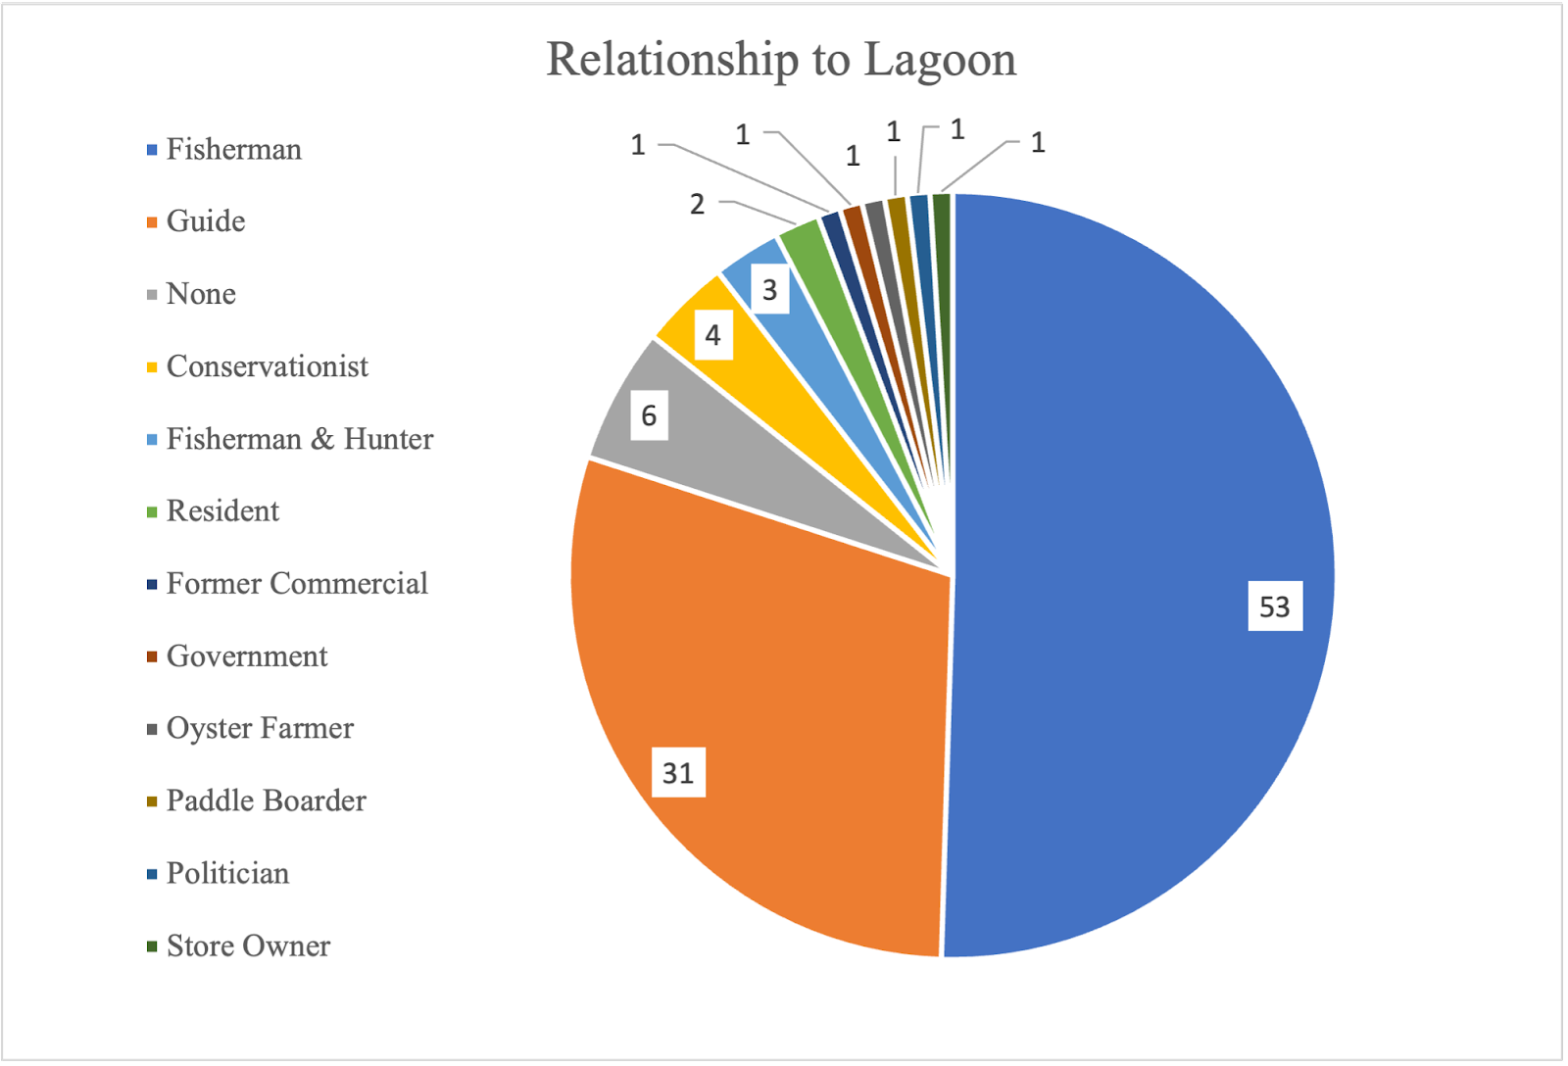

Figure 3-2: Respondents’ Relationship to Lagoon

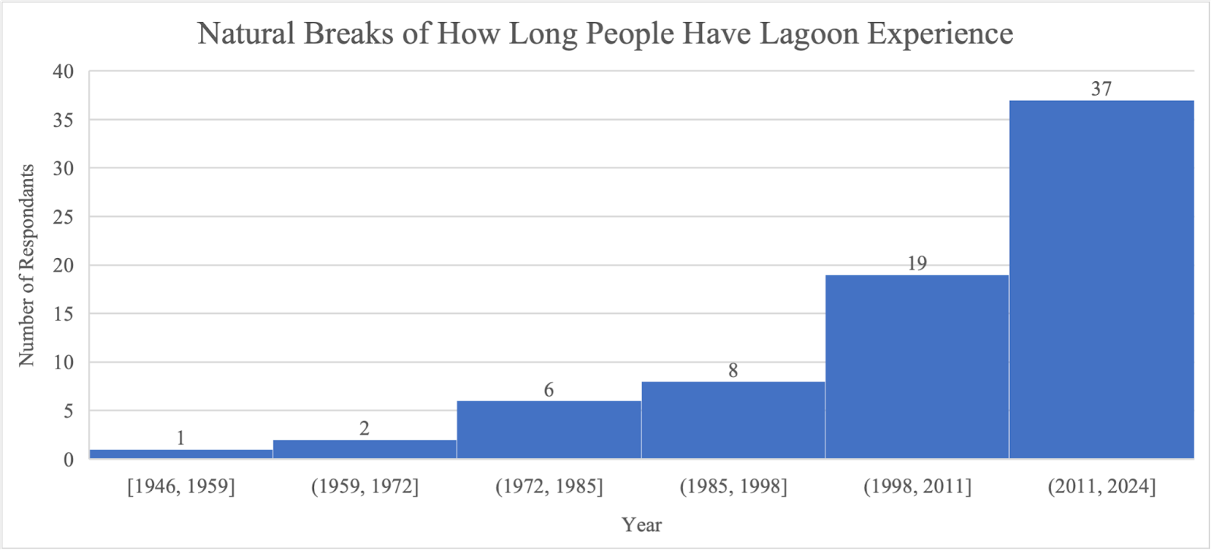

Figure 3-3: Respondents’ Lagoon Experience

it was anticipated that responses would focus on fish due to the livelihoods of the participants. This highlights stakeholder understanding of the direct connection between foundational seagrass and ecosystem decline. The word “decline” was mentioned fifty-nine times throughout this response by 52% of respondents, which further emphasizes the thematic core of these survey results. As was expected, various fish including redfish, snook, trout, black drum, and even bait fish were repeatedly mentioned in the answers. Of interest is that one person noted a shift in species presence with an increase in black drum, which is considered a hardier, but less desirable trophy species. Manatees were also mentioned in 8% of responses, which given anecdotal evidence, was less than expected. Some of the most impactful statements from their responses included:
- “Decline in habitat, decline in fish numbers. Due to the habitat loss fish have been forced to move to different locations for better water quality, better food source, and a place for refuge from predators. Also, most adult redfish have moved to new locations because their old habitats can’t support their pre and post spawning habits.”
- “I noticed a lack of Seagrasses on sand flats, which were shown to have Seagrass on them from satellite images taken in previous years. I primarily targeted redfish on fly spending about 3 days a week on the lagoon for a period of 5 months. Video footage of mosquito lagoon fishing from roughly 2010 or earlier showed large Seagrass beds and schools of redfish seemed abundant: I saw one pond full of Seagrass and 1 agitated school of 15 or more redfish in my entire time on the water.”
- “Incredible loss of seagrass and a much more difficult fishery to perform well in, while working as a guide.”
- “The lagoon has had zero seagrass until this year since I started fishing. In the summer there was significant growth and then the hurricanes killed almost all of the growth.”
- “Total loss of the fishery.”
- “Yes, water quality obviously. I encourage you to look into the sewer line leaks and the events (or lack thereof) that followed by the city (Melbourne specifically). Seagrass is almost nonexistent. Amount of fish and in turn fishing limits.”
- “Yes. Absolutely barren, no seagrass to be seen. Except this year I finally saw by whale tail. Nothing anywhere else.”
- “Yes. Have witnessed complete seagrass die off and a severe decline of fish in those areas that previously has Seagrass from Edgewater to Mims.”
- “Yes. Shortly after the seagrass mostly died, there was a significant decline in red drum and spotted seatrout. I have also witnessed a considerable decline in blue crabs, pompano, and sheepshead within the lagoon.”
When asked about the timing of the decline, most respondents (88%) noted 2010 or later. Fifteen of the respondents referred specifically to the anomalous freeze events of 2010–2011, which can be confirmed with climate data. When asked about what they believe the factors causing this ecosystem decline were, there was a strong theme around water quality, which does align with what is known about ML (Lopez et al., 2021; Phlips et al., 2015). They expressed this in several different ways including runoff, septic tanks, fertilizer, pollution, algal blooms, water quality, and chemicals. But overall, 77% of respondents indicated that the most important factor was nutrient loading. One exception to the answers was manatees which was brought up as an issue in 18% of responses. Given anecdotal evidence, these numbers were similar to what was expected.
The next questions address the impact of ecosystem decline on businesses, the majority of which were charter captains in ML. When asked if they had observed a drop in their business, 69% said yes. This includes one respondent who went out of business altogether. Several respondents mentioned having to warn clients of bad conditions, finding other areas to fish, and having to work much harder to make the same amount of money. 15% of respondents did not observe a drop in business and 13% of stakeholders began their business after the decline and so did not have a perspective on this. This study wanted to gain insight into adaptations business owners took. When asked specifically about how far they had to travel in both their truck and their boat before and after the collapse, 58% of respondents said they had to travel further both by truck and by boat in order to find adequate fish to satisfy clients. 33% of respondents stated that they travel the same amount. And 8% stated that they travel less. This is likely due to a change in spatial distribution of their homes compared to current fish patterns. Several people noted that they now have to travel to different regions or states in order to make ends meet, such as the Florida Keys or Louisiana. This also has impacts on family / social structures (Neef et al., 2018). When asked in an open-ended way about what other sort of adaptations business owners have had to make, which may include strategies such as a different boat, different locations, different target species, it became clear that people have had to make costly adjustments that they had not planned or prepared for in order to achieve the same financial outcomes. 96% of respondents were forced to make significant adjustments that were often expensive. One of the adjustments they specified included traveling to different locations, which included leaving the lagoon seasonally (as noted in the previous question) or altogether. Some other adjustments included pursuing different target species, which was not always the preference of the client, as well as purchasing new bigger non-flats boats, which often came with costs of $60,000 to over $100,000. Several people also changed their careers to guiding only part time or leaving their career in fisheries entirely. Some of the most salient statements from their responses included:
  - “Left commercial blue crabbing due insufficient numbers of crabs. Only fish recreationally for small tarpon. Trout and redfish are gone due to seagrass die off beginning 2015.”
  - “I still spend a lot of time in the lagoon. Probably more than most other guides. Lots of guides bought bay boats and offer a different experience. I now travel to the keys to fish and currently have a second boat on order to fish the keys better.”
  - “Double my normal cost of business since the decline because I’ve had to purchase an additional boat.”
  - “New boat-$60,000 plus travel time.”
  - “Over 100k.”
  - “Harder to find fish so working harder and longer for the same price.”
  - “I went out of business last October.”
During the stakeholder focus group, held six months after this survey closed there was another prospective development from oyster farmers. Due to the poor water quality in the ML system and human health concerns because of algae blooms, all oyster sales were banned starting 1 July 2023, and lasted until the end of September 2023, resulting in the loss of three months of income. Farmers still must work their farms daily and continue to invest capital into their operations, but it was unsafe for them to sell any of their product. They described how they have diversified by selling t-shirts or picking up odd jobs to make ends meet for their families.
The backbone of these charter captains’ careers is their ability to catch fish. One of the authors determined, based on anecdotal evidence and reports from fishermen, that they are suffering significantly in terms of their fish catch numbers. Anecdotally, some charter captains described that a typical day on the lagoon for them meant catching 100+ fish and seeing individual

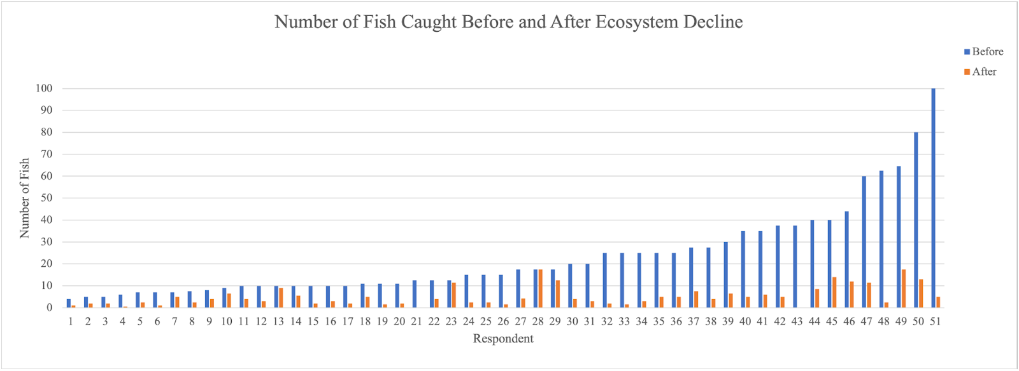

Figure 3-4: Number of Fish Caught Before and After the Ecosystem Decline

schools with hundreds on “tailing” fish. This is a behavior where fish are very near the surface and anglers can see their tails. It means that they can sight fish their targets, and generally is thought to be indicative of “happy” fish. It was noted that fish are rarely seen at the surface anymore and schools are significantly smaller. When asked to compare how many fish they typically caught before vs after the decline (Figure 3-4), before the decline, anglers reported numbers from 4 to 100 (with an average of 23), and after the decline, they reported numbers from 1 to 17 (with an average of 5). 95% of respondents also noted that there was a change in spatial distribution of the fish, indicating that they were sparser, making it more difficult to fish. The survey then asks about seagrass specifically, as it was not expected that the first question would evoke so many answers about seagrass included in ecosystem decline. When asked when respondents observed seagrass loss, the majority said from 2010, which aligns with the results earlier in the survey around overall ecosystem decline. One of the most surprising, but reinforcing results was that not a single respondent estimated seagrass loss to be less than 50%, but 95% of respondents estimated seagrass loss to be more than 75%, with 84% of respondents saying loss was higher than 90%. These numbers support what the authors found in a Deep Learning study of seagrass loss over time using satellite imagery (loss of 99.6% from 2013-2020) and [only] the latest finding from the St John’s River Water Management District (loss of 91% from 1994–2018) (Morris et al., 2022). The intimate knowledge by stakeholders of the system supports our previous findings and suggests that the situation with seagrass loss is dire not only for the ecosystem, but for the stakeholders. Some of the most impactful statements respondents made included:
  - “This fall alone almost all of the grass is dead.”
  - “ALL”
  - “Widespread loss has occurred everywhere I look except a few pockets in the Mosquito Lagoon. I would visually estimate the loss at well over 95%. Many flats are limited to a few isolated blades of seagrass.”
  - “1000s of acres”
  - “The entire lagoon system has lost sea grass, Indian, banana, and mosquito. I would say 95% of grass is gone.”
  - “A ton! Most areas are dry as a desert. I’d say out of the whole lagoon 85% has been lost.”
  - “Just about everywhere became sand / mud bottom.”
  - “All of it at one point. I’ve fished out there over 20 years of my life. I watched every single square inch of seagrass completely die out.”
  - “90% and when I do find any grass there are usually manatees in the area.”
  - “Total loss”
  - “Almost all of it is gone. The green vibrant sea grass is almost all gone.”
Potential Policy Recommendations

Given their knowledge that the respondents have of this system, the survey sought their ideas on methods that could help to restore the lagoon. Here we compile some of those responses as policy recommendations, connecting the LEK of respondents with potential applications in resource management.
There was a recurrent theme around nutrient loading, which was noted earlier in the survey as well. Respondents indicated that government regulation and enforcement of laws to prevent/mitigate nutrient dumping into the lagoon is lacking. 81% of respondents referred to needing better policies and management around nutrient dumping into the lagoon. 16% also mentioned manatee management, which included the restoration of the natural migration of these charismatic mammals. However, it should be noted that manatees are cultural migrators, so if their mothers did not teach them, they won’t know where / when to go (Reynolds & Odell, 1991). 12% of the respondents mentioned using catch and release of all species in the lagoon, and based on conversations with charter captains, this is a practice that has become increasingly in favor. The use of clams and oysters for anchoring sediment was also noted as important, along with replanting seagrass.
- “Cities need to be held responsible, with increasing fine amounts for each "accidental" discharge into the river. New growth should require zero impact on the IRL through Low Impact Development. Muck removal needs to be prioritized in areas where it is still an issue. Herbicide spraying needs to be completely eliminated. HOAs should be banned from requiring yard treatment for any neighborhoods within 1 mile of the river or in areas where drainage ditches run to the river. Finally, the placement of underground pipes in strategic locations in the south Mosquito Lagoon, North Indian River, and the Banana River to allow seawater to enter and help flush the system.”
- “All fish within the refuge should be catch and release only. I also feel we need to reduce the amount of untreated run off that is allowed to flow into the lagoon.”
- “Finish all city and town sewer projects to eliminate all waste unlawfully or lawfully entering anywhere into the Mosquito Lagoon system.”
- “City of Titusville still discharges "treated" sewer water into the river on a daily / weekly basis during the rainy season; an investigation is supposed to be opened as the state gave them funds to eliminate this a few years ago. Several HOAs along the river require homeowners to have monthly yard treatment from companies to maintain "green" yards. The County of Volusia still sprays herbicides (Glyphosate based) to treat all drainage ditches that run into the river.”
- “Oyster mats, plant clams”
- “Reduction in local population expansion and development; the region is becoming too populated. Ban on sale and application of fertilizer with nitrogen and phosphorus. Make wastewater spills have a level of accountability that encourages fixing the problem instead of fine paying. Use retention ponds for stormwater. End thermal pollution from the FPL power plant and Desoto Canal.”
- “Manatee feeding is catastrophic for the lagoon and must stop. They have overgrazed every surviving seagrass meadow down to the nub. Ongoing clam restoration is good as is the catch and release ruling for redfish.”
As mentioned above, catch and release policies in the lagoon could help recovery in the sense that it would take some pressure off the fisheries. Somewhat surprisingly, 95% of respondents fully supported catch and release. Based on speaking with charter captains, this is a different figure than what the same community surveyed a few decades ago would have responded with. Captains have become more in favor of these policies over time, as lagoon health has continued to decline, and the fishing has become more limited. They have recognized that for the sustainability of their careers, these kinds of policies have become increasingly important. In 2022, the Florida Fish and Wildlife Conservation Commission passed regulation that redfish (the ideal primary target for trophy fishing in the lagoon) are now catch and release only. And they will continue to evaluate this as an option for other species as well. 17% of respondents mentioned that they would welcome this expansion of these policies into different species. Two respondents also mentioned the ideas of applying for tags to keep fish in order to raise more money for fisheries conservation. When asked how they view the impact of catch and release on their businesses, 67% of respondents though it would have a very positive or positive effect on their business as well as create long term sustainability in the ecosystem. An additional 12% thought it would have no impact. And 21% thought it would have a negative impact. Overall, the support for catch and release is there.
- “All for it! I only practice catch and release. Even with my clients…. Very positive effect. The lagoon is barely hanging on. We need every breading age fish in the lagoon as possible. There are not the same numbers of redfish like there use to be.”
- “Amazing!... Positive effect. The water is not clean enough to eat the fish yet anyways.”
- “Catch and release is the only thing that has kept this river alive. I believe catch and release should be mandatory for all fish in the Indian and Banana River. No exemptions or exceptions. …Positive. It’s tough to keep fish when you can’t even catch them.”
- “I am in favor of catch and release only. … Positive effect, more fish would be available to catch. People are keeping too many fish, then wonder why they can’t go catch 100 fish every time they go out.”
- “I believe it’s necessary until the habitat is restored and the numbers of fish rebound. I also think that catch and release should stay enforced within the boundaries of the Canaveral National Seashore and Merritt Island Wildlife Refuge. …Positive. It’s simple! The more fish there are the more opportunities we will have on any given day. My clientele are conservationists and could care less about Keeping fish.”
- “I have fully supported and pushed for catch and release long before 90% of the fishing guides. The new regulation on redfish is a start, but it needs to be expanded to include other species, to increase their numbers as well…. My business is 95% catch and release. Therefore, it would have no impact on my business.”
- “100% support. …I have been doing catch and release only for 18 years of guiding and it works just fine. The guys killing all the fish do it mostly to get a tip from people for filleting the fish. There are still some who think saltwater equals unlimited supply, but most cannot possibly believe that killing fish out of a nearly closed system is good for future catching.”
- “It’s a love hate feeling for me. I don’t like to eat redfish in general. I see all fish like my pets and my means of income. I get more enjoyment out of watching them being released. At the same time if I want to keep a redfish, trout, snook, etc. I want to have that option available! …. I try and promote my business for fly fisherman and light tackle artificial bait fisherman. Meaning I fish with individuals who want to release fish regardless of if they’re in season or not. I believe it would have positive impacts for the clients that want to catch that fish again so to say. But for those who have their heart set on keeping and eating what they caught it’ll have a negative impact.”
- “Might help a few fish live to swim another day but will not solve our water quality problems, which is truly the hard issues that we need to be addressing. … I would say neither here nor there. My customers could take it or leave it for the most part and are totally content catch and release fishing in the lagoon.”
- “Practicing it since 2014. … Depends on the client. I do not wish to keep fish caught so I would not have my clients keeping fish either.”
- “Strongly support …Not the solution to recovery, but it is a measure that will help to maintain a better than otherwise fishery.”
Finally, when asked about their attitude towards lagoon recovery, 89% participants did think it could recover, though of those, 70% thought it could only happen conditionally if policies were changed and enforced. It was also noted repeatedly that things could only change if they worked together as a community, which further reinforces the need for having an organization that can be one community voice. 11% did not think that the lagoon would recover stating things like “Not in my lifetime” and “It will never be the same”. These statements from respondents illustrate the depth of the challenges of rapid socio-ecological system changes:
- “It will require radical changes that I do not believe older generations, or the current economic and political system would be willing to embrace. It is possible than younger generations in the future fix the issues. However, the Mosquito Lagoon will lose its unique features and resemble a tidal estuary soon because climate change is causing stronger, slower moving, and poleward hurricanes that will almost certainly punch an inlet.”
- “With a little bit of help I believe the health of the fishery will rebound but not sure if it will ever fully recover.”
- “The lagoon will not recover until the issues associated with the eutrophication are resolved.”
- “I remain hopeful, but my confidence is fading.”
- “Not if we don’t do something about it. Our local and state governments only act reactionary, no proactive plans to protect and build back the lagoon. It’s depressing to think of what might be lost.”

3.5 Discussion and Conclusion
It is evident from these results that ML is in crisis, both environmentally and economically. 99% of respondents to the survey reported seeing a decline in the ecosystem, and this was supported by statements made in the stakeholder workshop. In survey responses, themes of seagrass, fish, habitat, water quality, and more are tied to this decline, with mentions of these topics sometimes being unprompted.
This research documents a mounting ecological crisis that is at risk of going undocumented by resource managers until the effects are perhaps irreversible. 95% of respondents reported that seagrass loss is over three-quarters, and this was reaffirmed by other respondents who stated that “ALL” the seagrass is gone or when asked how much seagrass coverage has been lost “A ton! Most areas are dry as a desert. I’d say out of the whole lagoon 85% has been lost.” These findings support the DNN classification of seagrass study by Insalaco et al. in 2024 that recorded seagrass loss in 2020 at approximately 99.6% and closer to the more recent study from resource managers with updated methodology, but contradict past reports and other existing databases (Morris et al., 2018; Morris et al., 2022; St. John’s River Water Management District, 2017). The St. John’s River Water Management District also provides a database with seagrass maps from 1943–2021, and more recent maps in that dataset show more seagrass coverage than what was reported in the DNN mapping effort (Insalaco et al., 2024; St John’s River Water Management District, 2017). When the results from the Insalaco et al. 2024 study were shown to stakeholders at the in-person workshop, there was widespread agreement that their experiences aligned with the percentages of loss presented and it opened a conversation about seagrass conservation in the community. This discrepancy between agency reports of seagrass coverage mentioned above and those from researchers is alarming and illustrates the need to take stakeholder opinion and LEK into account when collecting data on ecosystems, particularly difficult-to research aquatic ecosystems (Silvano & Valbo-Jørgensen, 2008). This recorded loss and the opinions of it by stakeholders support broader literature that shows seagrass is significantly declining globally, and it will not recover without conservation (Orth et al., 2006; Unsworth et al., 2018).
This research also provides a detailed account of an economic crisis for fisheries stakeholders. This loss in seagrass also led to decrease in habitat and therefore fish as seagrass is a “foundation species” which other species rely on for shelter, habitat, or a food source in ML (Reynolds, 2018; St Johns River Water Management District, 2020). The decline in fish has been most impactful to stakeholders as most rely on catching fish to support their livelihoods. 95% of respondents reported that the spatial distribution of fish was significantly sparser since the decline, and the majority of respondents noted that they catch less fish (on average 78% less). The entire IRL system generates approximately 30 million dollars in revenue with its fishery activities and accounts for about fifty percent of fish harvest on Florida’s east coast, so a decline in fish is detrimental to the overall community but especially these stakeholders (St Johns River Water Management District, 2020).
Climate variability continues to threaten people’s well-being, especially for people who rely on natural resources for their livelihoods (Shaffril et al., 2017). Communities must increasingly adapt to climate variability or they will face dire economic, health and wellbeing consequences. One understudied group that is increasingly facing the socio-ecological effects of climate variability are small-scale fishermen in the United States (Shaffril et al., 2017). As discussed in the results, stakeholders have had to adapt to this dramatic loss of income. 96% of respondents stated that they had to make significant adaptations to continue their business, including targeting new species, purchasing new boats, or even relocating to another location which has a more abundant fish population. Some respondents in the survey and the workshop even mentioned that they have reduced their fishing careers to part-time or even left the industry entirely, and this coupled with the other adaptations will have lasting socio-economic implications. It is evident that this ecosystem decline in ML has changed the balance of the ecosystem, but also altered the livelihoods of the community stakeholders.
Our findings illustrate that while many fisheries stakeholders have been able to adapt, adaptation has come at great personal economic and emotional cost. Furthermore, as they adapt to a new landscape, they are also vocal about intervention they consider necessary for government entities to take in managing the lagoon. A strong theme among respondents when discussing why this environmental decline has been occurring was nutrient loading, which contributes to the algal blooms and therefore the decrease in water quality in ML (Lopez et al., 2021; Phlips et al., 2015). As discussed above, respondents call for cities to be held accountable for the dumping of sewage into the lagoon as well as a call for a more stringent ban of fertilizer usage as that contributes to the overabundance of nutrients (Phlips et al., 2015; Waymer, 2018). Other recommendations concerned more management of the lagoon, with suggestions of manatee management and mainly catch and release policies.
When asked about catch and release policies, 67% of respondents believed it would have a positive impact on the ecosystem and their livelihoods. Many studies and agencies support catch and release because of its proven ability to improve fish populations worldwide, although this policy has to be used in tandem with other policies to promote restoration (Cooke & Schramm, 2007; National Parks Service, 2018). A strong majority (89%) of respondents believe that the lagoon can recover to some extent, but this would require the implementation of conservation-forward practices, like catch and release. Many mention that the lagoon even with positive environmental policies enacted will “never be the same” and lagoon recovery would require “radical changes that I do not believe older generations, or the current economic and political system would be willing to embrace.” It is evident to see any sort of ecosystem restoration, then local governments and agencies need to be proactive in their work and take into account the knowledge of the community (Anadón et al., 2009; Sáenz‐Arroyo et al., 2006; Silvano & Valbo-Jørgensen, 2008).
This study illustrates that LEK is vital in understanding the state of an ecosystem through the lens of community stakeholders. Applying a mixed-methods approach to studying LEK in a study like this allowed for community knowledge to be taken into account in assessing socio-ecological conditions, a key dataset to validate remote sensing studies being conducted in the area. If managing bodies can incorporate more LEK into their decisions, the system may adapt and perhaps even return to pre-collapse state, but at minimum resource management would be better informed provide benefit to both people and the environment.

Chapter 4: Recording Seagrass Growth in Mosquito Lagoon, Florida after Hurricanes Ian and Nicole

4.1 Abstract

Hurricanes Ian and Nicole hit Mosquito Lagoon, Florida in the Fall of 2022 and since then, the ecosystem has greatly shifted. Prior to these storm events, seagrass in Mosquito Lagoon was almost non-existent due to poor ecosystem conditions but made a sudden recovery in 2023. To study this change, a Random Forest Classification was implemented using Harmonized Landsat Sentinel imagery semi-monthly from September 2022 to January 2024. A model was created for each date in the period, and it was evident that while seagrass was still in a significant decline until March 2023, it came back to pre-collapse levels in summer 2023 and beyond. This recovery could be linked with the hurricane events as they would have redistributed seagrass fragments throughout the lagoon to promote growth and altered water conditions, but more research (outside the scope of this investigation) is necessary to determine why exactly seagrass has recovered to this extent. Seagrass density varied throughout each date, as well as the accuracy of each model depending on the amount of seagrass present. This method was successful in identifying seagrass in limited quantities, and this study raises awareness to the bigger picture that constant seagrass monitoring is need in Mosquito Lagoon to promote conservation of the ecosystem.

4.2 Background

On 29 September 2022, and 10 November 2022, respectively, Hurricane Ian and Hurricane Nicole hit the east coast of Florida. Hurricane Ian was initially projected not to directly strike the east coast of Florida, but it changed trajectory as it approached the state, leaving many in its path unprepared. This disaster brought devastation to the communities in the Brevard and Volusia counties as homes and infrastructure were flooded and destroyed due to the winds and rainfall brought by the hurricane. Shortly after Ian, Hurricane Nicole also hit the area, further hindering the recovery of communities and ecosystems on the east coast.
The damage from these storms was far greater than anyone had predicted. After Ian, NOAA reported extensive beach erosion and damage to piers (Bucci et al., 2022; San Antonio et al., 2024). Many neighborhoods in the area suffered extensive flooding and loss, forcing a significant number of residents to move (temporarily or permanently) or rebuild (Carillo, 2023). Although there is a need to study the substantial damage of all the communities and ecosystems affected by these storms, this study will be focusing on the ecosystem of Mosquito Lagoon, Florida, as a few months after these disasters, the ecosystem flourished.
Mosquito Lagoon (ML) before the hurricanes was already suffering from a severe ecosystem decline. Human activities have been detrimental to the ecosystem of ML since the 1960s as the activities of the nearby Kennedy Space Center and the increase in population has caused a major increase in pollutants and nutrients into the lagoon (Lethbridge, 2023). This makes a suitable environment for algal blooms, which then leads to a decrease in seagrass meadows and other biodiversity (Phlips et al., 2015; Waymer, 2018). There was an almost complete loss of seagrass in the lagoon since the 2010s (Insalaco et al., 2024). This loss in seagrass and biodiversity has also caused a significant decrease in the surrounding economy. Stakeholders (guides/fishermen) who used to depend on the ecosystem to fish now are struggling to run their businesses due to the low numbers of fish, and are having to turn to alternative locations or even a different type of business (Chapter 3 above; Rotne, 2020). At the center of all the above issues is seagrass, which almost nonexistent in 2020, but suddenly started to flourish in 2023.
Seagrass, a crucial component of underwater ecosystems and the surrounding economy, is facing a global decline (Florida Oceanographic Society, 2019; St Johns River Water Management District, 2020a). Its unique nature as a flowering plant underwater transforms areas into biodiversity hotspots when forming meadows (Reynolds, 2018). Designated as a "foundation species," seagrasses play a vital role in providing shelter, habitat, and food for numerous species (St Johns River Water Management District, 2020a). Additionally, they act as ecological engineers, influencing the coastal environment's characteristics (Jones et al., 1994). The root systems of seagrass stabilize sediments, preventing erosion and facilitating sedimentation (Hughes et al., 2009; Orth et al., 2006). Seagrass meadows create structured leaf canopies, offering essential habitat for marine species (Hughes et al., 2009). Crucially, juvenile fish and smaller aquatic animals rely on seagrass meadows for shelter, supporting various aquatic populations (Hughes et al., 2009). Larger marine animals, such as manatees, dugongs, and sea turtles, graze on seagrass, contributing to the ecosystem's balance (Orth et al., 2006). Furthermore, seagrasses serve as indicators of overall ecosystem health due to their sensitivity to environmental changes (St Johns River Water Management District, 2020a).
In the context of the global blue carbon cycle, seagrass meadows can sequester significant amounts of carbon, emphasizing their role in climate change mitigation (Fourqurean et al., 2012). However, seagrass is declining due to multiple factors, including higher temperatures, disease outbreaks, storms, and grazing by marine animals (Reynolds, 2018; Valentine & Duffy, 2006). Human activities, such as boating, overfishing, and nutrient pollution, further contribute to seagrass loss, necessitating conservation efforts to protect these vital ecosystems (Reynolds, 2018).
Satellite imagery emerges as a valuable tool for monitoring seagrass loss, offering historical temporal extent and consistent repeat time. Despite challenges like water turbidity and sun glint, satellite imagery provides an affordable and accessible method, with Machine Learning classifications enhancing accuracy (Howard et al., 2014). Combining aerial photos, satellite imagery, and extensive fieldwork can optimize seagrass mapping accuracy, crucial for effective conservation strategies (Howard et al., 2014; Pu et al., 2012; Roelfsema et al., 2009).
Extensive literature about a hurricane's impact on seagrass exist., Most studies support that hurricanes either have a limited impact on seagrass or actually aid in its recovery (Anton et al., 2009; Byron & Heck, 2006). In Alabama, sites of seagrass in the state were surveyed both before and after Hurricane Ivan (2004) and Hurricane Katrina (2005). 82% of sites that had seagrass before Ivan still supported seagrass, and no loss of seagrass was recorded after Katrina, a hurricane that devastated Alabama and the Gulf Coast (Byron & Heck, 2006). Seagrass in the Gulf of Mexico that would have been affected by Katrina was heavily studied, and findings support that seagrass is highly resilient to a category 3 hurricane like Katrina (Anton et al., 2009; Byron & Heck, 2006).
This idea of seagrass resilience to hurricanes extends to Florida as well. A study was conducted following Hurricane Michael, a category 5 storm, in several study areas with seagrass in FL and LA that experienced a gradient of storm intensity: St. George Sound (FL), Cedar Key (FL), and the Chandeleur Islands (LA). Quadrats in these areas were studied to determine estimates of seagrass cover, shoot count, and canopy height before, during, and, after the storm event. While some water quality changes were also observed, seagrass in each location was minimally affected with: seagrass in St. George Sound declining slightly after the hurricane, but rising back to normal levels one year after the storm; percent seagrass cover in Cedar Key remained high pre and post storm; and change in the Chandeleur Islands was insignificant due to there being no storm surge or winds in the area (Correia et al., 2023).
While the majority of studies have found little effect of hurricanes on seagrass, there were some cases where storms to this caliber did significantly damage seagrass. For example, after Hurricane Georges hit Florida in 1998, in the Florida Keys there was an immediate loss of 3% of the density of T. testudinum and 19% loss of S. filiforme (Fourqurean & Rutten, 2004). The seagrass beds at three of the stations studied were “completely obliterated” by the hurricane and even after three years past the storm some of the study areas saw minimal recovery. Overall, Fourqurean and Rutten found that hurricanes could boost the variety of benthic macrophytes (seagrasses) by generating patches of disturbance within the environment. However, moderate storm activity might lower macrophyte diversity by eliminating early successional species from seagrass beds comprising various species (Fourqurean & Rutten, 2004).
Each storm and study area will vary in the extent of its impact on seagrass and its conditions. Specifically for the case of Hurricane Ian, the storm lingered over the ML area for approximately a day, which led to the influx of large amounts of freshwater, and this could have affected the ecosystem and caused coastal erosion (Waymer, 2022). Hurricane Nicole arrived soon after Ian and had a different effect, causing washovers (small delta-like features / fans shown in Figure 4-1) between ML and the Atlantic Ocean where the dunes were destroyed, causing saltwater to enter ML (Hails, 2014). Washovers after a major storm can be expected and can have lasting implications (Rodriguez et al., 2020). How these conditions affected the environment for seagrass in the lagoon is yet to be assessed.
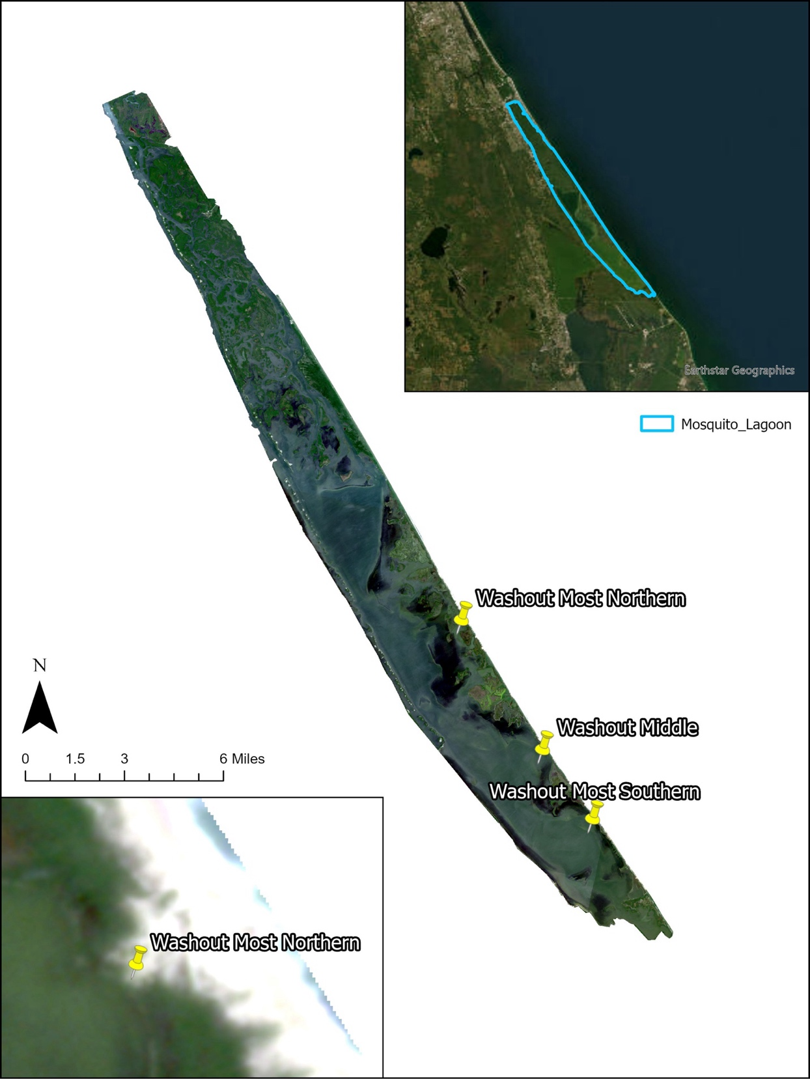
Figure 4-1: Study Area and Location of Washouts in Mosquito Lagoon (Planet imagery from 09/03/23)

The purpose of this project is to understand the spatial extent of seagrass meadows before, during, and after back-to-back Hurricanes Ian and Nicole in ML using a Random Forest Classification. This research seeks to evaluate the density and distribution of seagrass regrowth after the hurricanes in 2022. The overarching research question is: What trends in post-hurricane seagrass resurgence are there in ML?

4.3 Data and Methods

4.3.1 Imagery
Given data constraints due to climate and image availability, the imagery for this project was taken from NASA’s Harmonized Landsat Sentinel (HLS) initiative’s HLSL30 and HLSS30 (Sentinel Hub, 2024). This imagery and approach allowed for a wide variety of dates and images to be analyzed as opposed to other more traditional satellites. HLS is a combination of surface reflectance data from the Operational Land Imager (OLI) from Landsat 8-9 and the Multi-Spectral Instrument (MSI) aboard the Sentinel-2 satellite. The input products from each satellite are Collection 2 Level 1 top-of-atmosphere reflectance from Landsat and L1C top-of-atmosphere reflectance from Sentinel-2. NASA radiometrically harmonizes these products to the maximum extent, resamples to common 30-meter resolution, and then grids using the Sentinel-2 Military Grid Reference System UTM grid (Google, 2024; Sentinel Hub, 2024). This combination allows for observations every 2 to 3 days and the dates chosen for this project are listed below.
The time period selected includes dates before Hurricane Ian (9/12/22), before Nicole (10/25/22), and after Nicole/Ian (11/29/22–1/5/24). Some imagery was also collected that occurred during and right after the storm events, but due to the winds and water turbidity during the events, seagrass was not visible for classification in these images. This time period and the dates chosen allow for the study of the phenology of seagrass throughout the seasons as well. Although the goal was to collect images on a monthly basis, some months were lacking imagery due to cloud cover, sun glint, water turbidity, and more conditions that would not allow for the identification of seagrass (Howard et al., 2014). Images were downloaded as tiffs in 32-bit format, high resolution, within the coordinate system of WGS 84, and with all raw bands from Sentinel Hub. The imagery dates are given in Table 4-1
4.3.2 Field Data
Training samples from the field were collected throughout all seasons in 2022, 2023, and 2024. Locations of seagrass were recorded throughout the entire lagoon, with individual coordinates being recorded through GPS during each fieldwork session and then transferred into a shapefile for reference in building training samples.
4.3.3 Model
The model chosen for this analysis was a Random Forest Classification, which is a Machine Learning algorithm. This method allows for the use of a non-traditional classifier for nonparametric testing with multiple variables, and the most important variables for prediction will be produced as an output. This is a widely popular method in land cover classification that uses multi-spectral imagery and has been used previously to map seagrass (Aydin et al., 2022; Upadhyay et al., 2020). This technique's classification accuracy might surpass that of traditional methods due to its utilization of an ensemble of statistical trees. These trees collectively "vote" for the most prevalent class, enabling the incorporation of a diverse range of variables of any type (Briemen, 2001). Any variable deemed relevant can be introduced to the model, and the Random Forest algorithm will identify the most significant covariates. This method is an easy-to-use algorithm due to its simplicity and low computational costs, which made it an excellent candidate for this study which necessitated a quick turnaround time of results to be given to stakeholders (Gómez-Carmona et al., 2019; Whitfield, 2024).
Each date of imagery was entered into ENVI (Environment for Visualizing Images) in order to stack the layers needed for analysis. A total of 7 bands from the HLS imagery (coastal aerosol, blue, green, red, NIR, SWIR 1, and SWIR 2) were added in the layer stack per each image and then transferred into ESRI’s ArcGIS Pro for analysis. Training samples (informed by previous fieldwork) were created for the study area of ML for the classes of seagrass and non-seagrass, so a binary classification could be run. Training samples had to be created per each image as imagery conditions (algae blooms, cloud cover) greatly varied between dates. These samples were created in ArcGIS Pro and used in the Classification Wizard tool. The random trees classification (pixel based) was chosen within the wizard and the following parameters were chosen: Maximum Number of Trees: 100; Maximum Tree Depth: 30; Maximum Number of Samples per Class: 1000.
Individual classified images per month were produced along with a confusion matrix. To create the confusion matrix, the Create Accuracy Assessment Points tool was used to make 100 random ground truth points sampled within the training samples using the Equalized Stratified Random sampling strategy. After these were analyzed for each class, they were entered into the Compute Confusion Matrix tool where the resulting table was outputted. Confusion matrices allow for the performance of a model to be evaluated by comparing the classified and ground truth data (ESRI, 2021). This matrix produces metrics of user’s accuracy (how often the classes in the resulting classification will be present on the ground) and producer’s accuracy (how often features on the ground are correctly shown on the classified map), both which look at the accuracies of individual classes, as well as the overall kappa index of agreement which can be used to determine overall accuracy (ESRI, 2021; Knudby, 2021). These results were compiled into tables and figures for analysis, and a change trajectory was produced to understand how seagrass coverage fluctuated between each date. These maps were then compared to the paths of each hurricane and information from Tropical Cyclone Reports to potentially link these events and growth of seagrass during the selected time period.

Table 4-1: Pixel Counts/Percentages of Non-Seagrass and Seagrass
Date | Non-Seagrass | Seagrass
9/05/22 | 106377 (95.52%) | 6789 (6%)
10/25/22 | 111237 (98.3%) | 1929 (1.7%)
11/29/22 | 112714 (100%) | 452 (0.4%)
12/29/22 | 113166 (100%) | 0 (0%)
2/7/23 | 113166 (100%) | 0 (0%)
2/27/23 | 113051 (99.9%) | 115 (0.1%)
3/23/23 | 112884 (99.8%) | 282 (0.2%)
5/10/23 | 98450 (87%) | 14716 (13%)
7/22/23 | 90164 (79.68%) | 23002 (20.32%)
8/22/23 | 102056 (90.26%) | 11110 (9.74%)
9/23/23 | 97859 (86.42%) | 15307 (13.52%)
10/20/23 | 105298 (91%) | 7868 (9%)
11/19/23 | 108175 (95.6%) | 4991 (4.4%)
1/5/24 | 108302 (95.7%) | 4864 (4.3%)

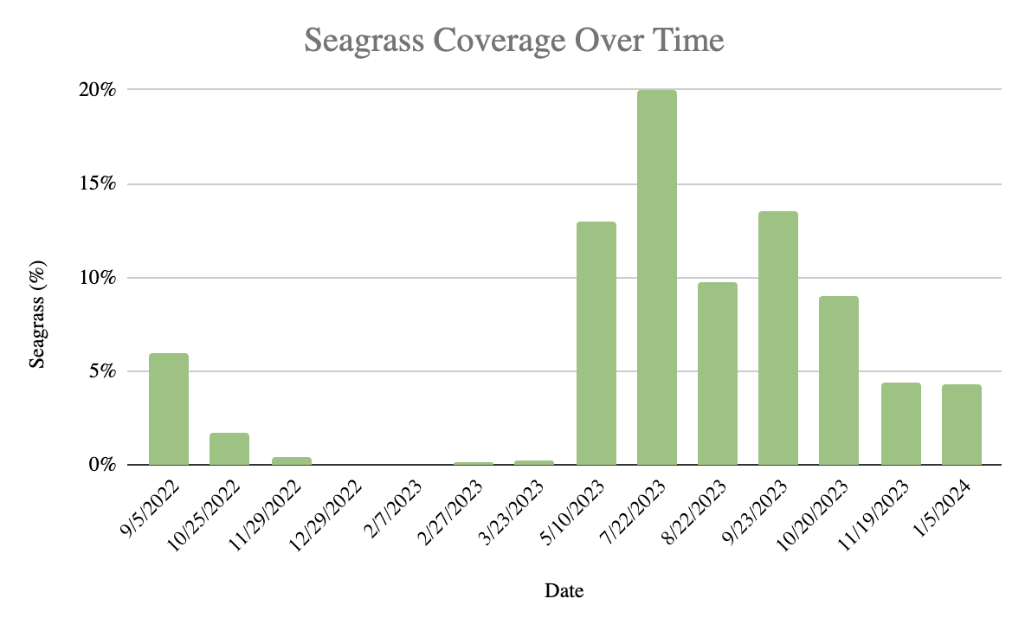
Figure 4-2: Bar Graph of Seagrass Coverage Over Time

4.4 Results

4.4.1 Spatial Distribution and Percentages of Seagrass
Table 4-1 depicts the pixel counts for each date separated into seagrass and non-seagrass, as well as the percent cover which is shown in Figure 4-2 for seagrass. Before Hurricane Ian, there was visible seagrass within the lagoon, but it was an extremely minimal amount (6%); after Ian (10/25/22) there was a 4.3% decrease. After Hurricane Nicole, seagrass in ML went to an extreme decline similar to 2020 levels (0.1%) as only 0.4% of seagrass was seen on 11/29/22, 19 days after Nicole. No visible seagrass was detected on 12/19/22 and 2/27/23, and there was only a slight increase to 0.1% on 2/27/23. This significant decline could be due to a combination of factors, such as the force of the storm disturbing existing grass, or the colder temperatures in the winter season (Joyce et al., 2022; St Johns River Water Management District, 2020a).
As spring arrived with warmer temperatures, there was a small increase in seagrass seen in March (0.2%) but then a very significant increase in May to 13% seagrass coverage. July (7/22/23) saw the highest amount of seagrass at 20.32% which can be attributed to peak biomass for seagrass being during summer months (Dawes et al., 1995; Phlips et al., 2015). The next three dates of imagery fluctuated between 9% to 13.5% of seagrass coverage, but the last two dates (11/19/23 & 1/5/23) saw a decrease to approximately 4% due to winter conditions.
As seen in Figures 4-3 and 4-4, the spatial distribution of seagrass greatly varies between each date and season. Before Hurricane Ian (9/5/22), there was a significant amount in the central part of the lagoon along the shoreline of mangroves. There was some misclassification of seagrass in the northern parts of the lagoon, and that continued on through 11/29/22 (after Nicole) as seagrass in ML decreased. There was no visible seagrass detected on 12/29/22 or 2/7/23, and a small amount was witnessed in the central lagoon on 2/27/23. Seagrass on 3/23/23 was more
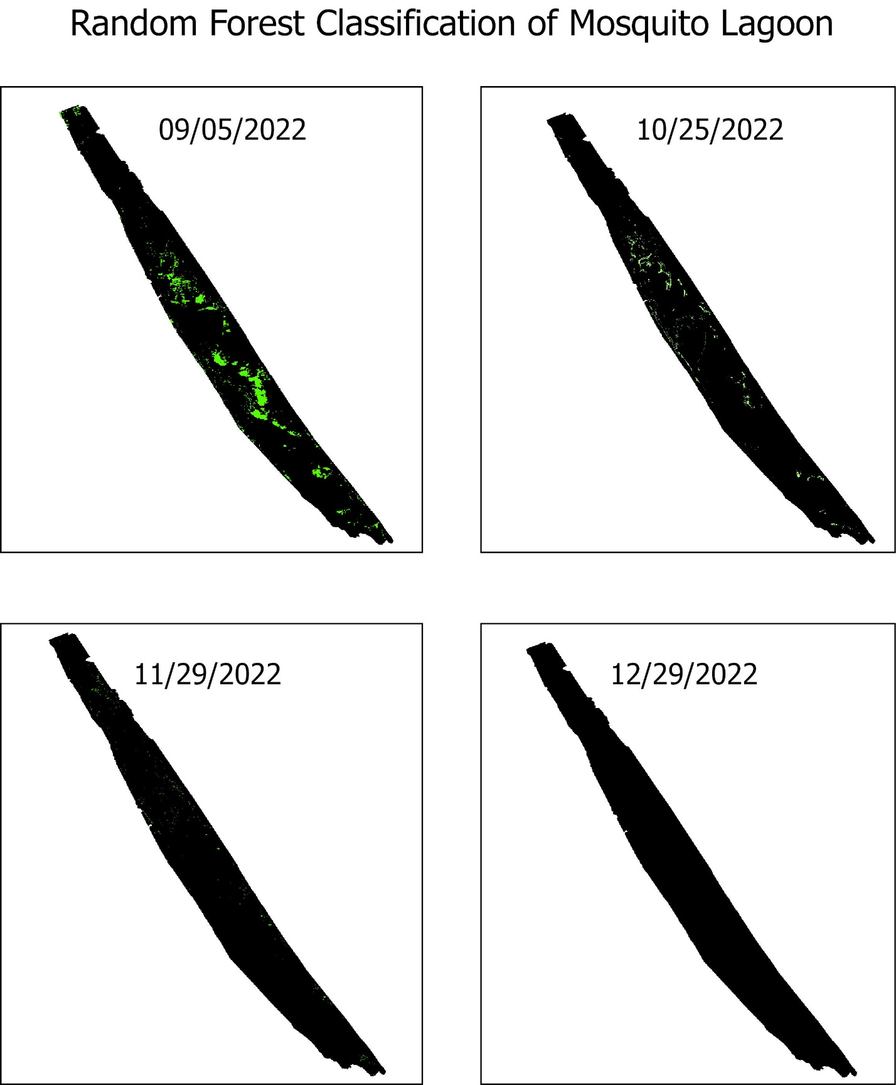
Figure 4-3: Random Forest Classifications of Seagrass vs Non-Seagrass in Mosquito Lagoon

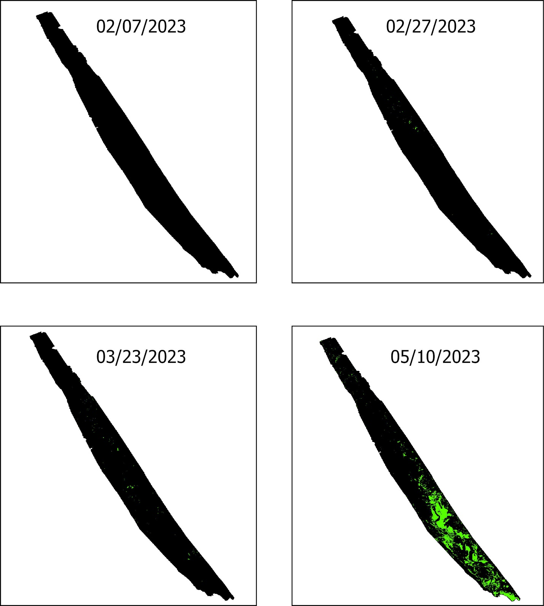
Figure 4-3 Continued
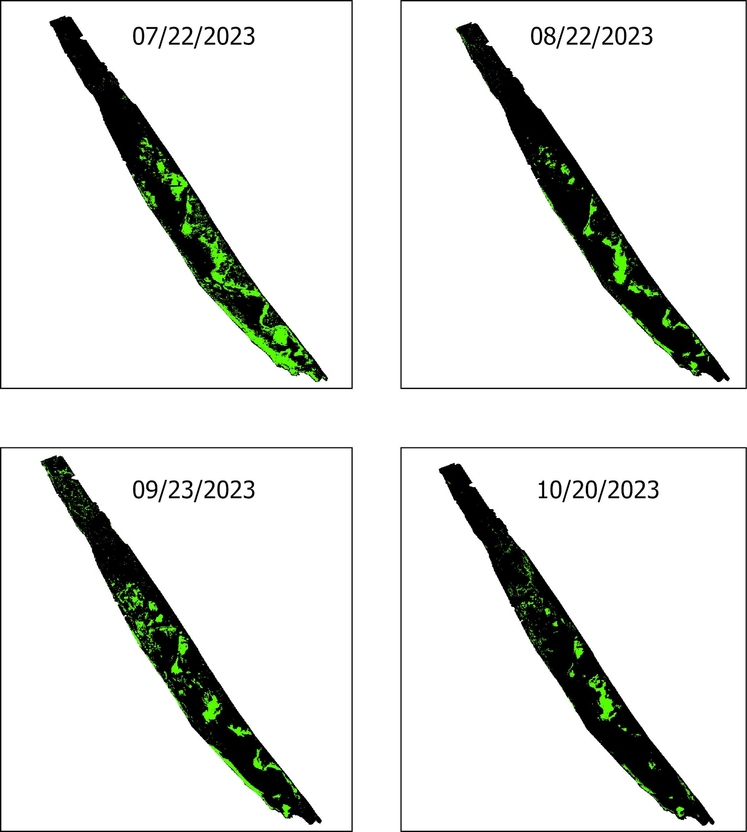
Figure 4-3 Continued
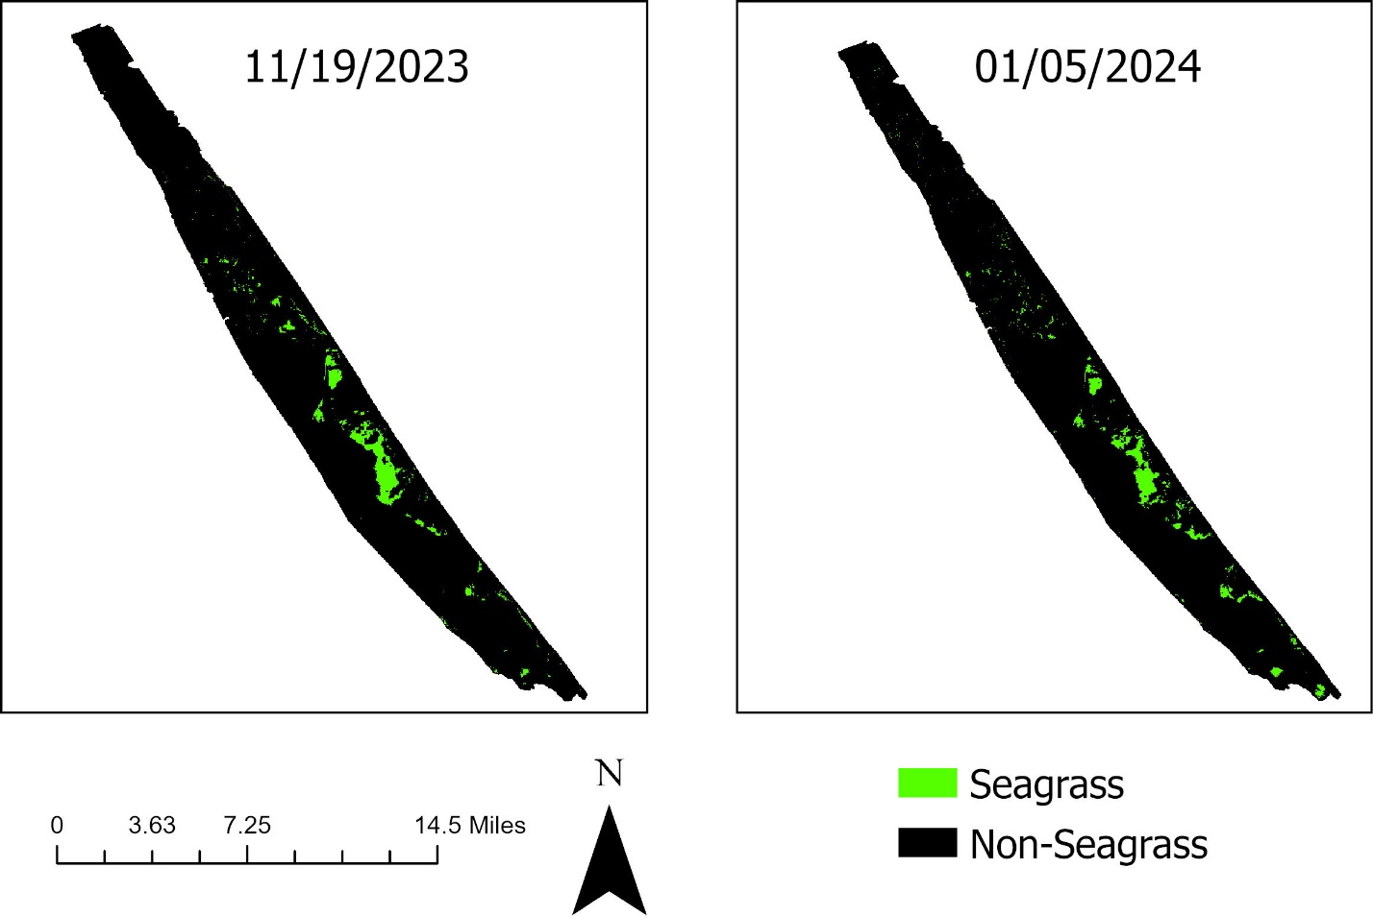
Figure 4-3 Continued

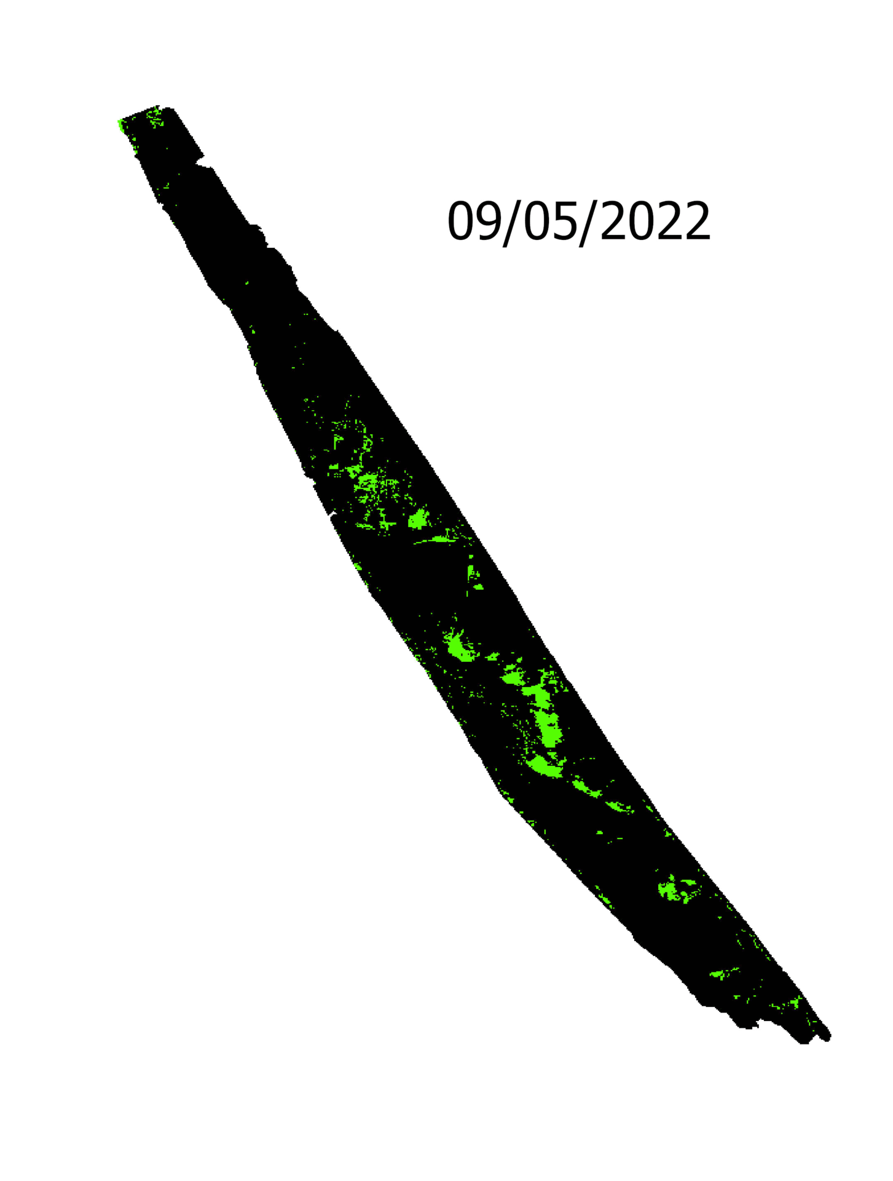
Figure 4-4: Timelapse of Seagrass Change in ML
sporadic throughout ML, with seagrass pixels being seen in areas that charter captains identified as normally having grass. Since 5/10/23, the majority of seagrass for each date is seen in the southern and central parts of ML near mangroves and islands which was also witnessed in the DNN study for 2000 through 2020 (Insalaco et al., 2024).
July had the most amount of seagrass observed, especially in the southern portion of the lagoon. As seagrass started to decrease after July, which some captains suggest could be related to high water levels and temperatures, most of the decline was witnessed in the south, leaving a minimal amount of seagrass in this area on 1/5/24. From these dates with seagrass above 4%, the majority of seagrass was seen in the central lagoon along mangroves but there still was some misclassification of seagrass in the northern ML.

4.4.2 Confusion Matrix Results
Table 4-2 shows results for each date for its resulting confusion matrix. Results vary throughout the dates, mainly because of the differing amounts of seagrass seen in each date. As seen in the previous DNN classification, dates with minimal seagrass (under 1%) had lower accuracy (around 50%) and other results because the algorithm did not have as many training samples to use to inform the analysis, resulting in some misclassification. Dates with minimal seagrass tended also to overestimate seagrass in the northern parts of the lagoon, because of similar spectral signatures in the area from deep water, oyster reefs, or just the imagery itself.
As seagrass percentage rises, so does the resulting Kappa coefficient and overall accuracy for each date. 3/23/23 still has minimal seagrass but was able to correctly identify small patches of grass in the southern lagoon to get an accuracy of 77% The remaining dates all saw an overall accuracy of 84% or above, with the highest accuracy being recorded for 9/5/22 and 11/19/23 at 96%. These dates with accuracy of 84% or higher had seagrass levels of 4% and above, demonstrating that the Random Forest algorithm is more well-suited to handle this classification when a decent amount of seagrass is present. As explained above, there was some misclassification of non-seagrass as seagrass in the northern parts of ML still in these dates, as well as some abnormalities with deep water.

Table 4-2: Confusion Matrix Results
Error Matrix | Non-Seagrass | Seagrass | Total | Producer's Accuracy | User's Accuracy | Kappa Coefficient | Overall Accuracy
9/5/22 |  |  |  |  |  | 0.92 | 0.96
Non-Seagrass | 49 | 1 | 50 | 0.94 | 0.98
Seagrass | 3 | 47 | 50 | 0.98 | 0.94
Total | 52 | 48 | 100
10/25/22 |  |  |  |  |  | 0.68 | 0.84
Non-Seagrass | 49 | 1 | 50 | 0.77 | 0.98
Seagrass | 15 | 35 | 50 | 0.97 | 0.7
Total | 64 | 36 | 100
11/29/22 |  |  |  |  |  | 0.08 | 0.53
Non-Seagrass | 49 | 1 | 50 | 0.52 | 0.98
Seagrass | 45 | 4 | 49 | 0.83 | 0.1
Total | 94 | 5 | 99
12/29/22 |  |  |  |  |  | 1 | 1
Non-Seagrass | 100 | 0 | 100 | 1 | 1
Seagrass | 0 | 0 | 0 | No data | No data
Total | 100 | 0 | 100
Table 4-2 Continued
2/7/23 |  |  |  |  |  | 1 | 1
Non-Seagrass | 100 | 0 | 100 | 1 | 1
Seagrass | 0 | 0 | 0 | No data | No data
Total | 100 | 0 | 100
2/27/23 |  |  |  |  |  | 0.04 | 0.52
Non-Seagrass | 50 | 0 | 50 | 0.51 | 1
Seagrass | 48 | 2 | 50 | 1 | 0.04
Total | 98 | 2 | 100
3/23/23 |  |  |  |  |  | 0.54 | 0.77
Non-Seagrass | 44 | 6 | 50 | 0.72 | 0.88
Seagrass | 17 | 33 | 50 | 0.85 | 0.66
Total | 61 | 39 | 100
5/10/23 |  |  |  |  |  | 0.8 | 0.9
Non-Seagrass | 48 | 2 | 50 | 0.86 | 0.96
Seagrass | 8 | 42 | 50 | 0.95 | 0.84
Total | 56 | 44 | 100
7/22/23 |  |  |  |  |  | 0.84 | 0.93

Table 4-2 Continued
Non-Seagrass | 49 | 1 | 50 | 0.89 | 0.98
Seagrass | 6 | 44 | 50 | 0.98 | 0.86
Total | 55 | 45 | 100
8/22/23 |  |  |  |  |  | 0.74 | 0.87
Non-Seagrass | 46 | 4 | 50 | 0.83 | 0.92
Seagrass | 9 | 41 | 50 | 0.91 | 0.82
Total | 55 | 45 | 100
9/23/23 |  |  |  |  |  | 0.86 | 0.93
Non-Seagrass | 50 | 0 | 50 | 0.88 | 1
Seagrass | 7 | 43 | 50 | 1 | 0.86
Total | 57 | 43 | 100
10/20/23 |  |  |  |  |  | 0.84 | 0.92
Non-Seagrass | 48 | 2 | 50 | 0.89 | 0.96
Seagrass | 6 | 44 | 50 | 0.96 | 0.88
Total | 54 | 46 | 100
11/19/23 |  |  |  |  |  | 0.92 | 0.96
Non-Seagrass | 50 | 0 | 50 | 0.93 | 1
Table 4-2 Continued
Seagrass | 4 | 46 | 50 | 1 | 0.92
Total | 54 | 46 | 100
1/5/24 |  |  |  |  |  | 0.9 | 0.95
Non-Seagrass | 49 | 1 | 50 | 0.92 | 0.98
Seagrass | 4 | 46 | 50 | 0.98 | 0.92
Total | 53 | 47 | 100

4.5 Discussion and Conclusion

From the given results, it is evident that seagrass in ML has gone through great fluctuations throughout the years and seasons. Seagrass in ML hit a significant low in 2020 with only 0.1% of seagrass remaining after the super algal bloom of 2011–2013, and that decline continued into early 2023 as shown in this study (Insalaco et al., 2024; Lopez et al., 2011). Although minimal amounts of seagrass were observed before Hurricane Ian on 9/05/22 (6%) and before Nicole on 10/25/22 (4.09%), very small amounts of seagrass or no visible seagrass could be observed on the imagery from 11/29/22 to 2/27/23. This extreme lack of seagrass could be attributed to the colder temperatures of the season as this species does grow slower and can lose leaves in the winter, but the changing of the ecosystem from the hurricanes could also be a factor (Fourqurean & Rutten, 2004; St Johns River Water Management District, 2020a).
Looking past the date of 2/27/23, we start to see a distinct change in the density of seagrass as spring and summer temperatures approach, creating a more suitable environment for seagrass (Bulthuis, 1987). Some grass started to reappear on 3/23/23, but it came back to a significant amount (13%) on 5/10/23 when higher biomass for seagrass is observed during the summer due to the higher temperatures (Bulthuis, 1987; Dawes et al., 1995; Phlips et al., 2015). The peak amount of seagrass was seen in July at approximately 20%, higher than levels seen prior to the post-2013 loss. Seagrass coverage continued to fluctuate between the dates of 8/22/23 through 01/5/2024, varying between percentages of 4% to 13.5% depending on the season, but the coverage is nothing comparable to what was observed from 2013 to 2020 previously.
The reasoning behind this significant increase in seagrass has not been confirmed. This study seeks to track the regrowth in seagrass post- Hurricane Ian and Hurricane Nicole, but a correlation cannot be established with the available data. The hurricanes may have played a part in wiping out all remaining seagrass in Fall 2022 due to the extreme lack of seagrass after Nicole. Considering the decline of seagrass, the force of the storms and the excess water and debris they brought could have created an unsuitable environment for seagrass (Joyce et al., 2022). Looking at the tracks of the hurricanes as seen in Figure 4-5, ML was not in the direct path of either hurricane (direct path depicted by points and blue line). Hurricane Ian’s track was closest to ML with the eye approximately 28 miles away from the lagoon center, and Hurricane Nicole’s eye 75 miles away. A WeatherFlow station (80 miles from the north from the center of Ian) in New Smyrna Beach, Florida near ML during Hurricane Ian recorded sustained winds of 63 knots and a peak gust of 83 knots on September 29th, making it a Category 1 Hurricane at the time of impact (Bucci et al., 2023). Locations near ML recorded about 10-20 inches of rainfall during the event as well, resulting in flooding of local waterways and roadways (Bucci et al., 2023).
Figure 4-5 also shows that the track of Hurricane Nicole is further away from ML. The WeatherFlow station in New Smyrna Beach recorded a maximum wind gust of 65 knots and sustained winds between 50 and 60 knots, making it closer to a tropical storm by the time it hit ML (Beven & Alaka, 2023). Rainfall (approximately 3-6 inches) and flooding during Nicole was much less than during Ian, with most of the damage and intensity being seen in the Caribbean. It is evident that Hurricane Ian was the stronger storm in comparison, but as outer bands of both storms hit the ML area, they both contributed to the damage of the lagoon and its community.

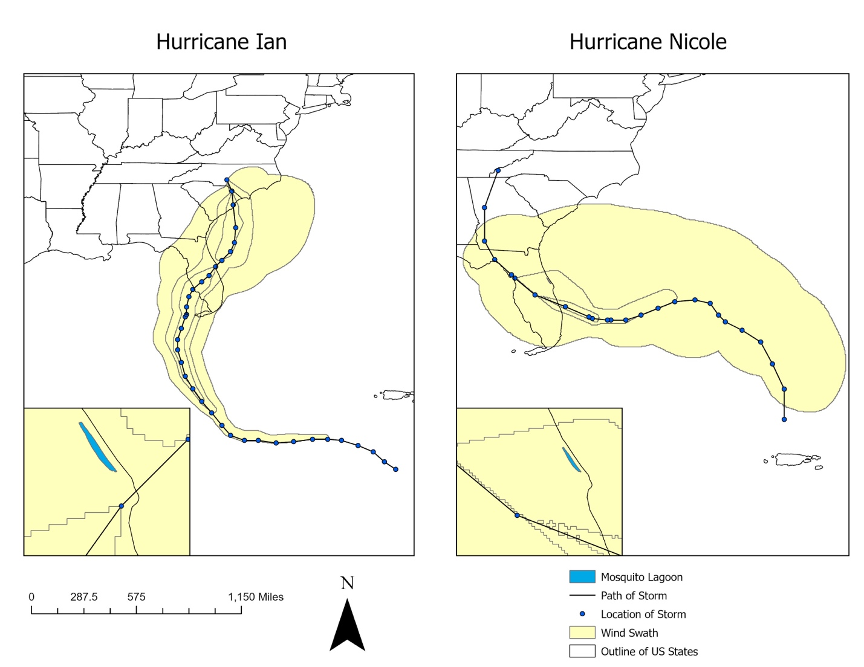
Figure 4-5: Hurricane Tracks of Ian and Nicole Compared to Mosquito Lagoon

The extreme increase of seagrass in Summer 2023 can be attributed to a variety of factors according to a wide range of scientists and researchers. Some believe the hurricanes did have an impact on the rise in coverage. With Hurricane Ian, the large influx of freshwater may have led to a die off in macroalgae like Caulerpa prolifera that has a more difficult time thriving in lower salinity water (Briggs, 2021). And with Hurricane Nicole, the three or more washouts created between the shoreline allowed for the brackish water of ML to mix with the saltwater of the Atlantic, which likely changed the water quality of ML and increased the salinity, which is the environment seagrass prefers (Reynolds, 2018; Potouroglou et al., 2022).
Some other theories about why seagrass has come back have been discussed by local agencies. The St Johns River Water Management District also noticed that seagrass began recovery in summer 2023, and in a local committee meeting they stated it could be because of improved water clarity (caused by increased rainfall and saltwater due to storms) and increased recruitment of seagrass through fragment drift and distribution of seeds (Brevard County Save Our Indian River Lagoon, 2023). It is possible that this series of storms caused seagrass to uproot and some fragments of it to relocate to previously unpopulated areas, root down, and form a new patch (Brevard County Save Our Indian River Lagoon, 2023). The District stated that conditions have to be just right for this to happen, and none of these theories have been scientifically supported at this time. It is evident that further research is needed to determine why seagrass has resurfaced, and how the community can maintain it.
Some marine ecosystems have been resilient to climatic and foundational disturbances, as nearshore ecosystems have the characteristics and conditions necessary to resist and recover from current impacts (Bernhardt & Leslie, 2013; O’Leary et al., 2017). As the frequency of these events is increasing, it is important to study how these ecosystems respond. Literature supports that remaining biogenic habitat, physical setting, recruitment/connectivity, and management of local-scale stressors contribute to resilience of an ecosystem, which is shown in this case of ML (O’Leary et al., 2017). As discussed in the introduction, many ecosystems that have seagrass exhibit resilience after a disturbance like a hurricane, but ultimately resilience and recovery will be dependent on the ecosystem’s current conditions and its management (O’Leary et al., 2017; Fourqurean & Rutten, 2004; Nowicki et al., 2017).
Considering the Random Forest model, the metrics varied throughout the years. With dates that contain minimal seagrass, the model was intensive to train because of the lack of seagrass training samples available. Imagery with less seagrass presence is where lower accuracy (around 50%) is seen, so another algorithm and methodology might be necessary for ecosystems with low amounts of seagrass. The DNN classification was able to avoid some of this confusion for the low amount of seagrass seen in 2020, so Deep Learning, which is a more complex method, might be needed for imagery with low visible seagrass (Insalaco et al., 2024). DNN does include the limitation of higher computational cost and processing time though, so the use of Random Forest in this study allowed for fast and accurate results to be produced. The simplicity and time needed to run this algorithm cannot be matched by a DNN, making it still an excellent choice for the processing of a dataset to this caliber and the resulting dissemination of seagrass mapping to stakeholders (ESRI, 2021; Knudby, 2021).
Besides lack of seagrass impacting resulting metrics, issues with imagery such as cloud cover, algal blooms, and water turbidity (especially for dates near the hurricanes) affected the visibility of seagrass in the lagoon and therefore the accuracy of the methodology (Howard et al., 2014). There was also an issue encountered with non-seagrass pixels in the northern lagoon being confused for seagrass which impacted accuracy, as there are areas that have similar spectral signatures in this region like oyster reef or deep water that can confuse the algorithm. Unfortunately, there was not an abundance of imagery available for the period selected, so this could be improved for other study areas and time periods with different satellite data.
Although there were some limitations encountered, the model performed well for dates with no seagrass and dates with a significant amount of seagrass (4% and higher). With some more tuning of the training samples and parameters, Random Forest can be a reasonable and accessible tool to stakeholders so they can continue to track seagrass loss in ML in the future. Random Forest also requires lower computation demands compared to a more complex method like Deep Learning that needs large amounts of data (Montantes, 2020). The purpose of this study was not purely to evaluate the use of Random Forest in mapping seagrass, but to document the rise of seagrass in ML post-hurricanes for conservation purposes and to add literature to the community. There is also potential to investigate these changes in the context of ecological tipping points. Tipping points signal an abrupt shift from one stable state of an ecosystem to another, when environmental conditions cross a certain threshold, triggered by a disturbance event (Dakos et al., 2019; Milkoreit et al., 2018). As echoed in this study, societal stakes associated with these tipping points can be high due to the impact a declining ecosystem can have on stakeholder livelihoods (Milkoreit et al., 2018). Future research is necessary to determine if ML is experiencing this abrupt ecosystem shift and if the shift occurred due to the severity of the hurricanes, as this information would be invaluable to the community and conservation of the lagoon.
This study concludes that seagrass in ML has recovered significantly since the initial collapse post-2013, and that the storm events of Hurricane Ian and Hurricane Nicole may have had some impact on this recovery. Anecdotally, captains have said that fishing conditions have also improved, but not yet back to their previous state, suggesting there may be a lag in whole system recovery (Lira et al., 2019; Watts et al., 2020). Although a direct link cannot be determined, the amounts of seagrass seen in May and July of 2023 show that there was likely some change in the environment during this time. The accuracy of the Random Forest method varied throughout the analysis depending on the amount of seagrass present so a more complex method like Deep Learning may be more applicable to some imagery. Regardless of accuracy, the methodology used in this study can be easily communicated to stakeholders due to the accessibility of the algorithm in ArcGIS Pro or Google Earth Engine, and then the local community can track seagrass recovery and fluctuations in the future to continue to promote conservation in ML.

Chapter 5: Conclusions

5.1 Dissertation Theme
The overarching goal of this dissertation is to understand the effect ecosystem decline has had on Mosquito Lagoon (ML) through a holistic and interdisciplinary approach. As seagrass is a keystone species in the lagoon and an environmental indicator, this species is used as a proxy of ecological health in two of the chapters to understand the general ecological trends in the lagoon. The first chapter uses Deep Learning, specifically Deep Neural Networks, along with Landsat imagery to map seagrass in 2000, 2007, 2013, and 2020. The results demonstrated that seagrass started to experience a severe decline after 2013, which coincided with a severe freeze event and super algal bloom in the lagoon. The percentage loss of seagrass was evaluated as well as resulting metrics from the model to understand the exact coverage decline of seagrass, as well as the applicability of Deep Learning to a lagoon ecosystem with seagrass species.
As this severe loss of seagrass witnessed in the second chapter would have lasting implications on the ecosystem and local economy, a mixed-methods approach was then used in the third chapter to understand how this decline has impacted the local stakeholders and community. A survey and workshop were conducted with local stakeholders to understand their beliefs on why the ecosystem has entered such severe decline and how exactly it has impacted their business. The survey responses and workshop were examined under the LEK framework, and it was apparent that stakeholders are suffering from this decline, but also that their knowledge of the area will be vital in its recovery.
Lastly, GeoAI methods were used again in the fourth chapter to map seagrass recovery in ML after Hurricanes Ian and Nicole. Random Forest methodology combined with Harmonized Landsat Sentinel imagery was used to record seagrass before, during, and after Ian and Nicole as well as through the seasons. These results were qualitatively compared with data and the tracks from each hurricane to see if there may be a connection with the rise in seagrass witnessed and the storms. Many dates prior to Summer 2023 lacked seagrass and had a resulting lower accuracy, but it is evident that seagrass has made a recovery to pre-collapse levels in ML, but that coverage is also dependent on phenology.

5.2 Major Conclusions and Future Directions
5.2.1 Using GeoAI to Map Seagrass Loss

The research findings from Chapter 2 suggest that Deep Learning, particularly Deep Neural Networks (DNNs), are effective in identifying seagrass in ML, owing to their efficiency and accuracy. Notably, precision and accuracy metrics consistently yielded high results across various years, with 2020 exhibiting the best performance due to the limited presence of seagrass for identification. However, the year 2000 showed lower metrics, potentially attributed to insufficient training samples, as fieldwork was not conducted that year. The binary classification approach favored the results, focusing solely on distinguishing seagrass from non-seagrass areas, without complicating other classes, which indicates that training the model primarily on accuracy was the most effective strategy.
Despite the success of the Deep Learning model in identifying seagrass, the methodology remains time-consuming and computationally intensive. Nevertheless, it offers automation in seagrass mapping which can be advantageous for stakeholders and agencies involved in seagrass monitoring, enabling them to continue the mapping process with minimal human intervention. The observed decline in seagrass coverage from 2000 to 2020 in ML underscores the urgency of conservation efforts to mitigate the detrimental effects on surrounding ecosystems and the economy.
The significant decline in seagrass coverage since 2013 highlights the need for further research and fieldwork to assess its impact on other species in ML. This decline may be attributed to various factors such as nutrient overloading, manatee grazing, and boating impacts, warranting additional investigation. This study emphasizes the importance of seagrass conservation efforts, given their role as keystone and foundation species indicative of ecosystem health. Despite the limitations associated with the Deep Learning approach, such as the "black box" nature of the model and spectral resolution constraints, this research concludes that it presents a valuable tool for seagrass identification and mapping, essential for informing conservation decisions and monitoring ecosystem changes over time.
5.2.2 Community-Engaged Research and Local Ecological Knowledge
The research findings from Chapter 3 about ML and its community brings to light a significant environmental and economic crisis. A staggering 99% of respondents in the survey reported witnessing a decline in the ecosystem. Seagrass loss, a critical component of the lagoon's ecology, was highlighted as particularly concerning, with 95% of participants noting a decline exceeding three-quarters. These findings are echoed by stakeholders' experiences, emphasizing the urgency for resource managers to integrate stakeholder perspectives and local ecological knowledge (LEK) into monitoring efforts. The divergence between stakeholder observations and agency reports emphasizes the necessity of considering local perspectives, especially in complex aquatic environments.
The ecological crisis has profound economic implications for fisheries stakeholders. The decline in seagrass leads to habitat loss and diminished fish populations, with catches down by an average of 78%. This poses a significant threat to livelihoods reliant on the lagoon's fisheries, which play a vital role in the local economy. Climate variability compounds these challenges, requiring stakeholders to adapt, often at significant personal and economic cost. Stakeholders' calls for governmental intervention underscore the interconnectedness of environmental and economic concerns, highlighting the need for proactive management strategies.
The study emphasizes the crucial role of LEK in understanding and managing ecosystem dynamics. By integrating mixed-methods approaches that incorporate community knowledge, managing bodies can better address socio-ecological challenges and potentially facilitate ecosystem recovery. Stakeholders' endorsement of conservation-forward practices, such as catch-and-release policies, demonstrates the potential for collaborative solutions to mitigate ecosystem decline. Ultimately, incorporating LEK into decision-making processes offers hope for fostering resilience and promoting the well-being of both communities and the environment in ML. This approach holds promise for navigating the complex challenges facing the lagoon and offers a pathway towards sustainable management practices that benefit both people and the ecosystem.

5.2.3 Recovery of Seagrass and Possible Connection to Hurricane Events
This study highlights significant fluctuations in seagrass coverage within ML over the years and seasons, as it previously reached a low point in 2020 with only 0.1% remaining after an algal bloom. The decline persisted into early 2023, exacerbated by Hurricanes Ian and Nicole. However, a significant increase in seagrass density was observed from May 2023, coinciding with spring and summer temperatures, peaking at 20% coverage in July 2023, when the highest amount seen in the previous DNN classification was 16.6% in 2007. Despite some fluctuations in later winter months, seagrass never dropped below 4% coverage after the initial recovery.
The reasons behind this resurgence remain uncertain, with hypotheses including the potential impact of hurricanes and improved water clarity. Further studies are needed to scientifically link the rise in seagrass with the hurricanes, however the hurricanes may have created favorable conditions for seagrass growth through freshwater mixing and increased recruitment.
This study also covered the use of a Random Forest model for mapping seagrass, noting challenges such as low accuracy in areas with minimal seagrass and issues with imagery clarity. Despite limitations, the model performed well for dates with significant seagrass presence, suggesting its potential as a tool for stakeholders to track seagrass loss and recovery. This research aims to document seagrass resurgence for conservation purposes and contribute to literature on the topic. Overall while the exact mechanisms remain unclear, the rise in seagrass highlights changes in the environment. The findings emphasize the accessibility of the methodology to stakeholders and calls for continued monitoring to promote conservation efforts in the area. With this recovery there is promise for the future of the ecosystem, but human systems must be vigilant to decrease their negative impacts, such as through nutrient reduction and responsible boating.

5.3 Summary of Contribution
In this dissertation, the ecosystem decline and recovery of ML was examined through a holistic ideology to understand the effect of this severe decline on seagrass in the ecosystem as well as the impact on stakeholders and overall community. To determine these results, a variety of data sources and methodologies were drawn from, including Deep Learning, Machine Learning, various satellite imagery, fieldwork, survey responses from human subjects, and a stakeholder workshop. Each of the three research studies shown in this dissertation are novel contributions to the fields of conservation, GIST / remote sensing, and LEK that will be published in well-respected, peer-reviewed journals for dissemination to stakeholders and researchers. The author hopes to continue to pursue similar research in the future and to promote the conservation of Earth’s valuable ecosystems.

References
Abadi, M., A. Agarwal, P. Barham, E. Brevdo, Z. Chen, C. Citro, G. S. Corrago, A. Davis, J. Dean, M. Devin, S. Ghemawat, I. Goodfellow, A. Harp, G. Irving, M. Isard, Y. Jia, R. Jozefowicz, L. Kaiser, M. Kudlur, J. Levenberg, D. Mane, R. Monga, S. Moore, D. Murray, C. Olah, M. Schuster, J. Shlens, B. Steinder, I. Sutskever, K. Talwar, P. Tucker, V. Vanhoucke, V. Vasudevan, F. Viegas, O. Vinyals, P. Warden, M. Wattenberg, M. Wicke, Y. Yu and X. Zheng. (2016). TensorFlow: Large-scale machine learning on heterogeneous distributed systems. arXiv:1603.04467 [cs.DC]. http://arxiv.org/abs/1603.04467.
Ackerly, D. D., Loarie, S. R., Cornwell, W. K., Weiss, S. B., Hamilton, H., Branciforte, R., & Kraft, N. J. (2010). The Geography of Climate Change: Implications for Conservation Biogeography. Diversity and Distributions, 16(3), 476–487. https://doi.org/10.1111/j.1472-4642.2010.00654.x
Ahmad-Khan, A. (2022). Geography, accountability and capital: An ethnography of ecological
accountabilities in Gilgit-Baltistan [PhD, University of Glasgow]. https://theses.gla.ac.uk/83259/
Allen, G. (2021, June 21). As seagrass habitats decline, Florida manatees are dying of starvation. NPR. https://www.npr.org/2021/06/21/1006332218/as-seagrass-habitats-decline-florida-manatees-are-dying-of-starvationz
Anadón, J. D., Giménez, A., Ballestar, R., & Pérez, I. (2009). Evaluation of Local Ecological
Knowledge as a Method for Collecting Extensive Data on Animal Abundance. Conservation Biology, 23(3), 617–625. https://doi.org/10.1111/j.1523-1739.2008.01145.x
Anton, A., Cebrian, J., Duarte, C., Heck Jr, K., & Goff, J. (2009). Low Impact of Hurricane Katrina on Seagrass Community Structure and Functioning in the Northern Gulf of Mexico. Bulletin of Marine Science, 85(1), 45–59.
Arora, R., Basu, A., Mianjy, P., & Mukherjee, A. (2018). Understanding deep neural networks with rectified linear units. Presented at the International Conference on Learning Representations, 30 Apr–3 May 2018, Vancouver, Canada.
Arora, D., Garg, M., & Gupta, M. (2020). Diving deep in Deep Convolutional Neural Network. 2020 2nd International Conference on Advances in Computing, Communication Control and Networking (ICACCCN). https://doi.org/10.1109/ICACCCN51052.2020.9362907
Aswani, S., Lemahieu, A., & Sauer, W. H. H. (2018). Global trends of local ecological
knowledge and future implications. PLOS ONE, 13(4), e0195440. https://doi.org/10.1371/journal.pone.0195440
Aydin, O., Osorio-Murillo, C., Butler, K. A., & Wright, D. (2022). Conservation planning implications of modeling seagrass habitats with sparse absence data: A balanced random forest approach. Journal of Coastal Conservation, 26(3). https://doi.org/10.1007/s11852-022-00868-1
Bernhardt, J. R., & Leslie, H. M. (2013). Resilience to climate change in coastal marine ecosystems. Annual Review of Marine Science, 5(1), 371–392. https://doi.org/10.1146/annurev-marine-121211-172411
Beven, J. & Alaka, L (2023). (rep.). National Hurricane Center Tropical Cyclone Report (pp. 1–59). NOAA.
Blaikie, P. M. (1985). The political economy of soil erosion in developing countries. Longman.
Blue, B., & Brierley, G. (2016). ‘But what do you measure?’ Prospects for a constructive critical
physical geography. Area, 48(2), 190–197. https://doi.org/10.1111/area.12249
Braun, A. C. (2021). More accurate less meaningful? A critical physical geographer’s reflection on interpreting remote sensing land-use analyses. Progress in Physical Geography: Earth and Environment, 45(5), 706–735. https://doi.org/10.1177/0309133321991814
Braun, B. (2002). Intemperate Rainforest: Nature, Culture, and Power on Canada’s West Coast (First edition edition). Univ Of Minnesota Press.
Brevard County Save Our Indian River Lagoon. (2023, September 15). September - 2023 Save Our Lagoon Citizen Oversight Committee Meeting [Video]. YouTube. https://www.youtube.com/watch?v=YJzSFaedK88&t=1s
Breiman, L. Random Forests. Machine Learning 45, 5–32 (2001). https://doi.org/10.1023/A:1010933404324
Briggs, G. "Inanimate Life" (2021). Milne Open Textbooks. 26.
https://knightscholar.geneseo.edu/oer-ost/26
Brookfield, H. (2016). Land Degradation and Society (P. Blaikie, Ed.; 1st Edition). Routledge.
Brown, M. I., Pearce, T., Leon, J., Sidle, R., & Wilson, R. (2018). Using remote sensing and traditional ecological knowledge (TEK) to understand mangrove change on the Maroochy River, Queensland, Australia. Applied Geography, 94, 71-83.
Brownlee, J. (2020, August 20). A gentle introduction to the rectified linear unit (ReLU). MachineLearningMastery.com. Retrieved May 3, 2023, from https://machinelearningmastery.com/rectified-linear-activation-function-for-deep-learning-neural-networks/.
Bucci, L., Alaka, L., Hagan, A., Delgado, S., & Beven, J. (2023). (rep.). National Hurricane Center Tropical Cyclone Report (pp. 1–72). NOAA.
Bulthuis, D. A. (1987). Effects of temperature on photosynthesis and growth of seagrasses. Aquatic Botany, 27(1), 27–40. https://doi.org/10.1016/0304-3770(87)90084-2
Byron, D., & Heck, K. L. (2006). Hurricane Effects on seagrasses along Alabama’s Gulf Coast. Estuaries and Coasts, 29(6), 939–942. https://doi.org/10.1007/bf02798654
Carillo, B. (2023, September 29). 1 year after Ian: A look back at the day of the storm and its aftermath. Daytona Beach News-Journal Online. https://www.news-journalonline.com/story/weather/2023/09/29/hurricane-ian-one-year-later-a-look-back-at-the-devastating-storm/71002174007/
Chapin, F. S., Sala, O. E., Burke, I. C., Grime, J. P., Hooper, D. U., Lauenroth, W. K., Lombard, A., Mooney, H. A., Mosier, A. R., Naeem, S., Pacala, S. W., Roy, J., Steffen, W. L., & Tilman, D. (1998). Ecosystem consequences of changing biodiversity. BioScience, 48(1), 45–52. https://doi.org/10.2307/1313227
Chisholm Hatfield, S., Marino, E., Whyte, K. P., Dello, K. D., & Mote, P. W. (2018). Indian time: Time, seasonality, and culture in Traditional Ecological Knowledge of climate change. Ecological Processes, 7(1), 25. https://doi.org/10.1186/s13717-018-0136-6
Cooke, S. J., & Schramm, H. L. (2007). Catch‐and‐release science and its application to conservation and management of Recreational Fisheries. Fisheries Management and Ecology, 14(2), 73–79. https://doi.org/10.1111/j.1365-2400.2007.00527.x
Correia, K. M., Alford, S. B., Belgrad, B. A., Darnell, K. M., Darnell, M. Z., Furman, B. T., Hall, M. O., Hayes, C. T., Martin, C. W., McDonald, A., & Smee, D. L. (2023). Hurricane effects on seagrass and associated Nekton communities in the northern Gulf of Mexico. Estuaries and Coasts, 47(1), 162–175. https://doi.org/10.1007/s12237-023-01276-w
Costanza, R. (2020). Valuing natural capital and ecosystem services toward the goals of efficiency, fairness, and Sustainability. Ecosystem Services, 43, 101096. https://doi.org/10.1016/j.ecoser.2020.101096
Dakos, V., Matthews, B., Hendry, A. P., Levine, J., Loeuille, N., Norberg, J., Nosil, P., Scheffer, M., & De Meester, L. (2019). Ecosystem tipping points in an evolving world. Nature Ecology &amp; Evolution, 3(3), 355–362. https://doi.org/10.1038/s41559-019-0797-2
Davis, A., & Wagner, J. R. (2003). Who Knows? On the Importance of Identifying “Experts” When Researching Local Ecological Knowledge. Human Ecology, 31(3), 463–489. https://doi.org/10.1023/A:1025075923297
Dawes, C.J., Hanisak, D., & Kenworthy, J.W. (1995). Seagrass Biodiversity in the Indian River Lagoon. Bull. Mar. Sci. 57, 59–66.
Del Rio, T., Groot, J. C., DeClerck, F., & Estrada-Carmona, N. (2018). Integrating local knowledge and remote sensing for eco-type classification map in the Barotse Floodplain, Zambia. Data in brief, 19, 2297-2304.
Derickson, K. D. (2016). Resilience is not enough. City, 20(1), 161–166. https://doi.org/10.1080/13604813.2015.1125713
Dick, M., Rous, A. M., Nguyen, V. M., & Cooke, S. J. (2017). Necessary but challenging: Multiple disciplinary approaches to solving conservation problems. FACETS, 1(1), 67–82. https://doi.org/10.1139/facets-2016-0003
Dobson, A., Lodge, D., Alder, J., Cumming, G. S., Keymer, J., McGlade, J., … Xenopoulos, M. A. (2006). HABITAT LOSS, TROPHIC COLLAPSE, AND THE DECLINE OF ECOSYSTEM SERVICES. Ecology, 87(8), 1915–1924. doi:10.1890/0012-9658(2006)87[1915: HLTCAT]2.0.CO;2
Dufour, S., Rollet, A., Chapuis, M., Provansal, M., & Capanni, R. (2017). On the political roles of freshwater science in studying dam and weir removal policies: A critical physical geography approach. Water Alternatives.
Dybas, C. L. (2002). Florida's indian river lagoon: An estuary in transition. Bioscience, 52(7), 554-559. doi: https://doi.org/10.1641/0006-3568(2002)052 [0555: FSIRLA]2.0.CO;
Eddy, I. M., Gergel, S. E., Coops, N. C., Henebry, G. M., Levine, J., Zerriffi, H., & Shibkov, E. (2017). Integrating remote sensing and local ecological knowledge to monitor rangeland dynamics. Ecological Indicators, 82, 106-116.
Egeru, A., Wasonga, O., Mburu, J., Yazan, E., Majaliwa, M. G., MacOpiyo, L., & Bamutaze, Y. (2015). Drivers of forage availability: An integration of remote sensing and traditional ecological knowledge in Karamoja sub-region, Uganda. Pastoralism, 5(1), 1-18.
Emmanuel, T., Maupong, T., Mpoeleng, D., Semong, T., Banyatsang, M., & Tabona, O. (2021). A Survey on Missing Data in Machine Learning. https://doi.org/10.21203/rs.3.rs-535520/v1
ESRI. (2021). Compute Confusion Matrix. Compute Confusion Matrix (Spatial Analyst)-ArcMap | Documentation. https://desktop.arcgis.com/en/arcmap/latest/tools/spatial-analyst-toolbox/compute-confusion-matrix.htm
Fairhead, J., & Leach, M. (1996). Misreading the African Landscape: Society and Ecology in a Forest-Savanna Mosaic. CUP Archive.
Florida Department of Environmental Protection (2020). Mosquito Lagoon Aquatic Preserve. Retrieved July 5, 2020, from https://floridadep.gov/rcp/aquatic-preserve/locations/mosquito-lagoon-aquatic-
Florida Oceanographic Society. (2019). Seagrass beds are starting to revive along the Indian River Lagoon; but for how long? Florida Oceanographic Society. https://www.floridaocean.org/news/seagrass-beds-are-starting-revive-along-indian-river-lagoon-how-long
Fourqurean, J. W., & Rutten, L. M. (2004, September 1). The impact of Hurricane Georges on soft-bottom, back reef communities: Site- and species-specific effects in south Florida seagrass beds. Latest TOC RSS. https://www.ingentaconnect.com/content/umrsmas/bullmar/2004/00000075/00000002/art00007
Fourqurean, J. W., Duarte, C. M., Kennedy, H., Marbà, N., Holmer, M., Mateo, M. A., Apostolaki, E. T., Kendrick, G. A., Krause-Jensen, D., McGlathery, K. J., & Serrano, O. (2012). Seagrass ecosystems as a globally significant carbon stock. Nature Geoscience, 5(7), 505–509. https://doi.org/10.1038/ngeo1477
Garvis, S. (2012). Quantifying The Impacts Of Oyster Reef Restoration On Oyster Coverage, Wave Attenuation And Seagrass Fragment Retention In Mosquito Lagoon, Florida (dissertation).
Gao, S. (2021, March 24). Geospatial Artificial Intelligence (geoai). Oxford Bibliographies. https://www.oxfordbibliographies.com/display/document/obo-9780199874002/obo-9780199874002-0228.xml
Gobler, C. J., Koch, F., Kang, Y., Berry, D. L., Tang, Y. Z., Lasi, M., Walters, L., Hall, L., & Miller, J. D. (2013). Expansion of harmful brown tides caused by the pelagophyte, Aureoumbra Lagunensis Deyoe et Stockwell, to the US east coast. Harmful Algae, 27, 29–41. https://doi.org/10.1016/j.hal.2013.04.004
Goldman, M., Nadasdy, P., & Turner, M. (2011). Knowing nature: Conversations at the intersection of political ecology and science studies. University of Chicago Press.
Gómez-Carmona, O., Casado-Mansilla, D., López-de-Ipiña, D., & García-Zubia, J. (2019). Simplicity is best. Proceedings of the 9th International Conference on the Internet of Things. https://doi.org/10.1145/3365871.3365889
Google. (2024). HLSL30: HLS-2 Landsat operational land imager surface reflectance and Toa brightness daily global 30m | Earth Engine Data catalog | google for developers. https://developers.google.com/earth-engine/datasets/catalog/NASA_HLS_HLSL30_v002
Google Developers. (2022). Classification: Precision and recall | machine learning | google developers. Google. Retrieved May 3, 2023, from https://developers.google.com/machine-learning/crash-course/classification/precision-and-recall.
Gorelick, N., M. Hancher, M. Dixon, S. Ilyushchenko, D. Thau and R. Moore. (2017). Google Earth Engine: Planetary-scale geospatial analysis for everyone. Remote Sensing of Environment 202:18–27.
Hails, J. R. (1982). Washover and Washover Fan. Beaches and Coastal Geology, 851–851. https://doi.org/10.1007/0-387-30843-1_481
Hara, K., Saito, D., & Shouno, H. (2015). Analysis of function of rectified linear unit used in deep learning. 2015 International Joint Conference on Neural Networks (IJCNN). https://doi.org/10.1109/ijcnn.2015.7280578
Haraway, D. (1988). Situated Knowledges: The Science Question in Feminism and the Privilege of Partial Perspective. Feminist Studies, 14(3), 575–599. https://doi.org/10.2307/3178066
Herrero, H. V. (2021). Discussion with Lagoon Watermen.
Herrero, H., Southworth, J., & Bunting, E. (2016). Utilizing multiple lines of evidence to determine landscape degradation within protected area landscapes: A case study of chobe national park, Botswana from 1982 to 2011. Remote Sensing, 8(8), 623. https://doi.org/10.3390/rs8080623
Herrero, H. V., Insalaco, S., Wolfson, W.B., & Schwartzman, G. (2023). Evaluating stakeholder perception of ecosystem change in Mosquito Lagoon, Florida. Annals of the American Association of Geographers. (Under Review)
Howard, J., Hoyt, S., Isensee, K., Telszewski, M., Pidgeon, E., & eds. (2014, February 27). Coastal blue carbon: Methods for assessing carbon stocks and emissions factors in mangroves, tidal salt marshes, and seagrasses. CIFOR; International Union for Conservation of Nature (IUCN). https://www.cifor.org/knowledge/publication/5095/
Hughes, A. R., Williams, S. L., Duarte, C. M., Heck, K. L., & Waycott, M. (2009). Associations of concern: Declining seagrasses and threatened dependent species. Frontiers in Ecology and the Environment, 7(5), 242–246. https://doi.org/10.1890/080041
Insalaco, S., Herrero, H. V., Limber, R., Oliver, C., & Wolfson, W. B. (2024). Monitoring an ecosystem in crisis: measuring seagrass meadow loss utilizing Deep Learning in Mosquito Lagoon, Florida. Photogrammetric Engineering and Remote Sensing.
Jones, C. G., Lawton, J. H., & Shachak, M. (1994). Organisms as ecosystem engineers. Ecosystem Management, 130–147. https://doi.org/10.1007/978-1-4612-4018-1_14
Joyce, M. A., Crotty, S. M., Angelini, C., Cordero, O., Ortals, C., de Battisti, D., & Griffin, J. N. (2022). Wrack enhancement of post-hurricane vegetation and geomorphological recovery in a coastal dune. PLOS ONE, 17(8). https://doi.org/10.1371/journal.pone.0273258
Karabiber, F. (2023). Binary classification. Learn Data Science - Tutorials, Books, Courses, and More. https://www.learndatasci.com/glossary/binary-classification/
Karmarkar, D. (2023, October 17). Interdisciplinary geography: Balancing perspectives in a Dynamic Field. Medium. https://medium.com/@karmarkardipesh/interdisciplinary-geography-balancing-perspectives-in-a-dynamic-field-7277c07d7e83
Kingma, D. P. and J. L. Ba. (2015). Adam: A Method for Stochastic Optimization. Presented at the International Conference on Learning Representations, 7–9 May 2015. San Diego, California.
Knudby, A. (2021). Remote Sensing.
Kojola, E. (2018). Extracting Identities and Value from Nature: Power, Culture, and Knowledge in the Contested Politics of Mining. https://conservancy.umn.edu/handle/11299/200316
Kong, T. M., Marsh, S. E., van Rooyen, A. F., Kellner, K., & Orr, B. J. (2015). Assessing rangeland condition in the Kalahari Duneveld through local ecological knowledge of livestock farmers and remotely sensed data. Journal of Arid Environments, 113, 77-86.
Kosek, J. (2006). Understories: The Political Life of Forests in Northern New Mexico. Duke University Press Books.
Kosek, J. (2010). ECOLOGIES OF EMPIRE: On the New Uses of the Honeybee. Cultural Anthropology, 25(4), 650–678. https://doi.org/10.1111/j.1548-1360.2010.01073.x
Kovacs, E., Roelfsema, C., Lyons, M., Zhao, S., & Phinn, S. (2018). Seagrass habitat mapping: How do Landsat 8 OLI, Sentinel-2, ZY-3A, and Worldview-3 perform? Remote Sensing Letters, 9(7), 686–695. https://doi.org/10.1080/2150704X.2018.1468101
Krupar, S. R. (2013). Hot Spotter’s Report: Military Fables of Toxic Waste (1 edition). Univ Of Minnesota Press.
Kupika, O. L., Gandiwa, E., Nhamo, G., & Kativu, S. (2019). Local Ecological Knowledge on Climate Change and Ecosystem-Based Adaptation Strategies Promote Resilience in the Middle Zambezi Biosphere Reserve, Zimbabwe. Scientifica, 2019, e3069254. https://doi.org/10.1155/2019/3069254
Lagoon Watermen Alliance. (2024). Lagoonwatermen.org.
Lave, R. (2012a). Fields and Streams: Stream Restoration, Neoliberalism, and the Future of Environmental Science (Illustrated edition). University of Georgia Press.
Lave, R. (2012b). Neoliberalism and the production of environmental knowledge. Environment and Society, 3(1), 19–38. https://doi.org/10.3167/ares.2012.030103
Lave, R., Biermann, C., & Lane, S. N. (2018). Introducing Critical Physical Geography. In R.
Lave, C. Biermann, & S. N. Lane (Eds.), The Palgrave Handbook of Critical Physical Geography (pp. 3–21). Springer International Publishing. https://doi.org/10.1007/978-3-319-71461-5_1
Lefebvre, A., Thompson, C. E. L., Collins, K. J., & Amos, C. L. (2009). Use of a high-resolution profiling sonar and a towed video camera to map a Zostera marina bed, Solent, UK. Estuarine, Coastal and Shelf Science, 82(2), 323–334. https://doi.org/10.1016/j.ecss.2009.01.027
Lethbridge, C. (2023). History of cape canaveral chapter 1. Spaceline. Retrieved April 19, 2023, from https://www.spaceline.org/history-cape-canaveral/history-of-cape-canaveral-chapter-1/
Lira, P. K., de Souza Leite, M., & Metzger, J. P. (2019). Temporal lag in ecological responses to landscape change: Where are we now? Current Landscape Ecology Reports, 4(3), 70–82. https://doi.org/10.1007/s40823-019-00040-w
Lopez, C. B., Tilney, C. L., Muhlbach, E., Bouchard, J. N., Villac, M. C., Henschen, K. L., Markley, L. R., Abbe, S. K., Shankar, S., Shea, C. P., Flewelling, L., Garrett, M., Badylak, S., Phlips, E. J., Hall, L. M., Lasi, M. A., Parks, A. A., Paperno, R., Adams, D. H., … Hubbard, K. A. (2021). High-resolution spatiotemporal dynamics of harmful algae in the Indian River Lagoon (florida)—a case study of aureoumbra lagunensis, Pyrodinium Bahamense, and pseudo-nitzschia. Frontiers in Marine Science, 8. https://doi.org/10.3389/fmars.2021.769877
Ma, L., Liu, Y., Zhang, X., Ye, Y., Yin, G., & Johnson, B. A. (2019). Deep learning in remote sensing applications: A Meta-analysis and Review. ISPRS Journal of Photogrammetry and Remote Sensing, 152, 166–177. https://doi.org/10.1016/j.isprsjprs.2019.04.015
MacKinnon, D., & Derickson, K. D. (2013). From resilience to resourcefulness: A critique of resilience policy and activism. Progress in Human Geography, 37(2), 253–270. https://doi.org/10.1177/0309132512454775
Mandal, R., Connolly, R. M., Schlacher, T. A., & Stantic, B. (2018). Assessing fish abundance from underwater video using Deep Neural Networks. 2018 International Joint Conference on Neural Networks (IJCNN). https://doi.org/10.1109/ijcnn.2018.8489482
Milkoreit, M., Hodbod, J., Baggio, J., Benessaiah, K., Calderón-Contreras, R., Donges, J. F., Mathias, J.-D., Rocha, J. C., Schoon, M., & Werners, S. E. (2018). Defining tipping points for social-ecological systems scholarship—an interdisciplinary literature review. Environmental Research Letters, 13(3), 033005. https://doi.org/10.1088/1748-9326/aaaa75
Minin, E., Correia, R. A., & Toivonen, T. (2022). Quantitative conservation geography. Trends in Ecology &amp; Evolution, 37(1), 42–52. https://doi.org/10.1016/j.tree.2021.08.009
Moate, M. (2023, June 21). 5 concerning effects of Biodiversity loss. Earth.Org. https://earth.org/effects-of-biodiversity-loss/
Montantes, J. (2020, February 4). 3 reasons to use random forest over a neural network–comparing machine learning versus deep... Medium. https://towardsdatascience.com/3-reasons-to-use-random-forest-over-a-neural-network-comparing-machine-learning-versus-deep-f9d65a154d89
Montavon, G., Samek, W., & Müller, K.-R. (2018). Methods for interpreting and understanding deep neural networks. Digital Signal Processing, 73, 1–15. https://doi.org/10.1016/j.dsp.2017.10.011
Moore, D. S., Pandian, A., & Kosek, J. (2003). Race, Nature, and the Politics of Difference. Duke University Press Books.
Morris, L. J., Hall, L. M., Jacoby, C. A., Chamberlain, R. H., Hanisak, M. D., Miller, J. D., & Virnstein, R. W. (2022). Seagrass in a Changing Estuary, the Indian River Lagoon, Florida, United States. Frontiers in Marine Science, 8, 789818.
Morris, L., Hall, L., Chamberlain, R., Jacoby, C., 2018. Seagrass Integrated Mapping and Monitoring Program Report No. 3. Fla. Fish Wildl. Conserv. Comm.
Naidoo, R., & Hill, K. (2006). Emergence of indigenous vegetation classifications through integration of traditional ecological knowledge and remote sensing analyses. Environmental Management, 38, 377-387.
National Parks Service. (2018, March 9). Catch and release fishing. https://www.nps.gov/subjects/fishing/catch-and-release-fishing.htm
Neef, A., Benge, L., Boruff, B., Pauli, N., Weber, E., & Varea, R. (2018). Climate Adaptation Strategies in Fiji: The role of social norms and cultural values. World Development, 107, 125–137. https://doi.org/10.1016/j.worlddev.2018.02.029
Neimark, B., Childs, J., Nightingale, A. J., Cavanagh, C. J., Sullivan, S., Benjaminsen, T. A., Batterbury, S., Koot, S., & Harcourt, W. (2019). Speaking Power to “Post-Truth”: Critical Political Ecology and the New Authoritarianism. Annals of the American Association of Geographers, 109(2), 613–623. https://doi.org/10.1080/24694452.2018.1547567O'Malley, T., Bursztein, E., Long, J., Chollet, F. and J., Haifeng, & Invernizzi. (2019). KerasTuner API. Keras Tuner. Keras. Retrieved from https://github.com/keras-team/keras-tuner.
Nowicki, R., Thomson, J., Burkholder, D., Fourqurean, J., & Heithaus, M. (2017). Predicting Seagrass Recovery Times and their implications following an extreme climate event. Marine Ecology Progress Series, 567, 79–93. https://doi.org/10.3354/meps12029
O’Leary, J. K., Micheli, F., Airoldi, L., Boch, C., De Leo, G., Elahi, R., Ferretti, F., Graham, N. A., Litvin, S. Y., Low, N. H., Lummis, S., Nickols, K. J., & Wong, J. (2017). The resilience of marine ecosystems to climatic disturbances. BioScience, 67(3), 208–220. https://doi.org/10.1093/biosci/biw161
Orth, R. J., Carruthers, T. J., Dennison, W. C., Duarte, C. M., Fourqurean, J. W., Heck, K. L., Hughes, A. R. A. N. D. A. L. L., Kendrick, G. A., Kenworthy, W. J. U. D. S. O. N., Olyyarnik, S., Short, F. T., Waycott, M., & Williams, S. L. (2006). A global crisis for seagrass ecosystems. BioScience, 56(12), 987. https://doi.org/10.1641/0006-3568(2006)56[987:agcfse]2.0.co;2
Paltsyn, M. Y., Gibbs, J. P., & Mountrakis, G. (2019). Integrating traditional ecological knowledge and remote sensing for monitoring rangeland dynamics in the Altai Mountain region. Environmental management, 64, 40-51.
Pang, B., E. Nijkamp and Y. N. Wu. (2020). Deep learning with TensorFlow: A review. Journal of Educational and Behavioral Statistics 45(2):227–248. https://doi.org/10.3102/1076998619872761.
Phlips, E. J., Badylak, S., Lasi, M. A., Chamberlain, R., Green, W. C., Hall, L. M., Hart, J. A., Lockwood, J. C., Miller, J. D., Morris, L. J., & Steward, J. S. (2015). From Red Tides to Green and Brown Tides: Bloom Dynamics in a Restricted Subtropical Lagoon Under Shifting Climatic Conditions. Estuaries and Coasts, 38(3), 886–904.
Potouroglou, M., Pedder, K., Wood, K., & Scalenghe, D. (2022, March 31). What to know about seagrass, the ocean’s overlooked powerhouse. World Resources Institute. https://www.wri.org/insights/understanding-seagrass#:~:text=Seagrasses%20grow%20mainly%20in%20shallow,total%20extent%20is%20poorly%20mapped.
Pu, R., Bell, S., Meyer, C., Baggett, L., & Zhao, Y. (2012). Mapping and assessing seagrass along the western coast of Florida using Landsat TM and EO-1 ALI/Hyperion imagery. Estuarine, Coastal and Shelf Science, 115, 234–245. https://doi.org/10.1016/j.ecss.2012.09.006
Rathi, D., Jain, S., & Sreedevi, I. (2017). Underwater Fish Species Classification using Convolutional Neural Network and Deep Learning. 1–6. https://doi.org/10.1109/ICAPR.2017.8593044
Reynolds, John E. III., and Daniel K. Odell. 1991, Manatees and Dugongs. Facts on File. New York. 192 pgs.
Reynolds, P. (2018, December 18). Seagrass and Seagrass Beds. Smithsonian Ocean. Retrieved May 3, 2023, from https://ocean.si.edu/ocean-life/plants-algae/seagrass-and-seagrass-beds.
Rodriguez, A. B., Theuerkauf, E. J., Ridge, J. T., VanDusen, B. M., & Fegley, S. R. (2020). Long-term washover fan accretion on a transgressive barrier island challenges the assumption that paleotempestites represent individual tropical cyclones. Scientific Reports, 10(1). https://doi.org/10.1038/s41598-020-76521-4
Roelfsema, C. M., Phinn, S. R., Udy, N., & Maxwell, P. (2009). An integrated field and remote sensing approach for mapping Seagrass Cover, Moreton Bay, Australia. Journal of Spatial Science, 54(1), 45–62. https://doi.org/10.1080/14498596.2009.9635166
Rosenberg, M. (2019, July 13). A quick overview of the 5 themes of geography. ThoughtCo. https://www.thoughtco.com/five-themes-of-geography-1435624
Rotne, B. (2020). Mosquito Lagoon Discussion.
Sa, I., Popović, M., Khanna, R., Chen, Z., Lottes, P., Liebisch, F., Nieto, J., Stachniss, C., Walter, A., & Siegwart, R. (2018). WeedMap: A large-scale semantic weed mapping framework using aerial multispectral imaging and deep neural network for precision farming. Remote Sensing, 10(9), 1423. https://doi.org/10.3390/rs10091423
Sáenz‐Arroyo, A., Roberts, C. M., Torre, J., Cariño‐Olvera, M., & Hawkins, J. P. (2006). The value of evidence about past abundance: Marine fauna of the Gulf of California through the eyes of 16th to 19th century travellers. Fish and Fisheries, 7(2), 128–146. https://doi.org/10.1111/j.1467-2979.2006.00214.x
Samek, W., Binder, A., Montavon, G., Lapuschkin, S., & Müller, K.-R. (2017). Evaluating the Visualization of What a Deep Neural Network Has Learned. IEEE Transactions on Neural Networks and Learning Systems, 28(11), 2660–2673. https://doi.org/10.1109/TNNLS.2016.2599820
San Antonio, K.M., Burow, D., Cho, H.J., McCarthy, M., Medeiros, S.C., Zhou, Y., & Herrero, H.V. Data-Driven Assessment of the Impact of Hurricanes Ian and Nicole: Natural and Armored Dunes in the Aftermath of Hurricanes on Florida’s Central East Coast. Remote Sens. 2024, 16, x. https://doi.org/10.3390/xxxxx
Sato, C. F., & Lindenmayer, D. B. (2017). Meeting the global ecosystem collapse challenge. Conservation Letters, 11(1). https://doi.org/10.1111/conl.12348
Saxena, S. (2023, April 27). Binary cross entropy/log loss for binary classification. Analytics Vidhya. Retrieved May 3, 2023, from https://www.analyticsvidhya.com/blog/2021/03/binary-cross-entropy-log-loss-for-binary-classification/#h-what-is-binary-cross-entropy-or-logs-loss.
Sentinel Hub. (2024). Harmonized Landsat Sentinel. Harmonized Landsat Sentinel - Sentinel Hub Public Collections. https://collections.sentinel-hub.com/harmonized-landsat-sentinel/
Shaffril, H. A. M., Samah, A. A., & D'Silva, J. L. (2017). Climate change: Social adaptation strategies for fishermen. Marine Policy, 81, 256-261.
Shi, Y., Han, L., Huang, W., Chang, S., Dong, Y., Dancey, D., & Han, L. (2022). A biologically interpretable two-stage deep neural network (bit-DNN) for vegetation recognition from hyperspectral imagery. IEEE Transactions on Geoscience and Remote Sensing, 60, 1–20. https://doi.org/10.1109/tgrs.2021.3058782
Shiu, Y., Palmer, K. J., Roch, M. A., Fleishman, E., Liu, X., Nosal, E.-M., Helble, T., Cholewiak, D., Gillespie, D., & Klinck, H. (2020). Deep neural networks for automated detection of marine mammal species. Scientific Reports, 10(1). https://doi.org/10.1038/s41598-020-57549-y
Silvano, R. A. M., & Valbo-Jørgensen, J. (2008). Beyond fishermen’s tales: Contributions of fishers’ local ecological knowledge to fish ecology and fisheries management. Environment, Development and Sustainability, 10(5), 657–675. https://doi.org/10.1007/s10668-008-9149-0
Southworth, J, Smith, A. C., Safaei, M., Rahaman, M., Alruzuq, A., Tefera, B. B., Muir, C.S., & Herrero, H.V. (2024). Machine Learning versus Deep Learning in Land System Science: A Decision-Making Framework for Effective Land Classification. Frontiers in Remote Sensing.
Sun, Z., Di, L., Fang, H., & Burgess, A. (2020). Deep Learning Classification for crop types in North Dakota. IEEE Journal of Selected Topics in Applied Earth Observations and Remote Sensing, 13, 2200–2213. https://doi.org/10.1109/jstars.2020.2990104
St Johns River Water Management District. (2017, March 13). IRL Wetlands Seagrass (Indian River Lagoon). St. Johns River Water Management District (SJRWMD) Geospatial Open Data. https://data-floridaswater.opendata.arcgis.com/maps/50003891254a4f40877a4928a9cb2603/about \
St Johns River Water Management District. (2020a). Seagrasses of the lagoon. SJRWMD. https://www.sjrwmd.com/waterways/indian-river-lagoon/seagrass/
St Johns River Water Management District. (2020b). Fast facts. SJRWMD. https://www.sjrwmd.com/waterways/indian-river-lagoon/facts/
Sundberg, J. (2011). Diabolic Caminos in the Desert and Cat Fights on the Río: A Posthumanist Political Ecology of Boundary Enforcement in the United States–Mexico Borderlands. Annals of the Association of American Geographers, 101(2), 318–336. https://doi.org/10.1080/00045608.2010.538323
Takasaki, Y., Coomes, O. T., Abizaid, C., & Kalacska, M. (2022). Landscape-scale concordance between local ecological knowledge for tropical wild species and remote sensing of land cover. Proceedings of the National Academy of Sciences, 119(40), e2116446119.
Taylor, M., & Bhasme, S. (2020). Between deficit rains and surplus populations: The political ecology of a climate-resilient village in South India. Geoforum. https://doi.org/10.1016/j.geoforum.2020.01.007
Tan, J. W., Chang, S.-W., Abdul-Kareem, S., Yap, H. J., & Yong, K.-T. (2020). Deep Learning for Plant Species Classification Using Leaf Vein Morphometric. IEEE/ACM Transactions on Computational Biology and Bioinformatics, 17(1), 82–90. https://doi.org/10.1109/TCBB.2018.2848653
Thompson, Ben. “A limitation of Random Forest Regression”. Towards Data Science. December 17, 2019. https://towardsdatascience.com/a-limitation-of-random-forest-regression-db8ed7419e9f
Tucker, A. D., Pendoley, K. L., Murray, K., Loewenthal, G., Barber, C., Denda, J., ... & Rangers, N. (2021). Regional Ranking of Marine Turtle Nesting in Remote Western Australia by Integrating Traditional Ecological Knowledge and Remote Sensing. Remote Sensing, 13(22), 4696.
Unsworth, R. K. F., Nordlund, L. M., & Cullen-Unsworth, L. C. (2018). Seagrass Meadows Support Global Fisheries Production. Conservation Letters, 12(1). https://doi.org/10.1111/conl.12566
Upadhyay, A., Singh, R., & Dhonde, O. (2020). Random Forest based classification of Seagrass Habitat. Journal of Information and Optimization Sciences, 41(2), 613–620. https://doi.org/10.1080/02522667.2020.1753303
US EPA, O. (2013, September 5). Climate Change and Harmful Algal Blooms [Overviews and Factsheets]. https://www.epa.gov/nutrientpollution/climate-change-and-harmful-algal-blooms
US EPA, O. (2018, June 6). Causes of CyanoHABs [Overviews and Factsheets]. https://www.epa.gov/cyanohabs/causes-cyanohabs
Valentine, J. F., & Duffy, J. E. (2006). The central role of grazing in seagrass ecology. Seagrasses: Biology, Ecology and Conservation, 463–501. https://doi.org/10.1007/1-4020-2983-7_20
Wang, J., Li, B., Zhou, Y., Meng, Q., Rende, S. F., & Rocco, E. (2020). Real-time and embedded compact deep neural networks for seagrass monitoring. 2020 IEEE International Conference on Systems, Man, and Cybernetics (SMC). https://doi.org/10.1109/smc42975.2020.9283372
Watanabe, S., Sumi, K., & Ise, T. (2020). Identifying the vegetation type in Google Earth images using a convolutional neural network: A case study for Japanese bamboo forests. BMC Ecology, 20(1), 65. https://doi.org/10.1186/s12898-020-00331-5
Watts, M., & Peet, R. (1996). Liberation ecologies: Environment, development, social movements. London ; New York : Routledge. https://trove.nla.gov.au/version/45639584
Watts, K., Whytock, R. C., Park, K. J., Fuentes-Montemayor, E., Macgregor, N. A., Duffield, S., & McGowan, P. J. (2020). Ecological Time Lags and the journey towards Conservation Success. Nature Ecology &amp; Evolution, 4(3), 304–311. https://doi.org/10.1038/s41559-019-1087-8
Waymer, J. (2018). NASA: Toxic chemicals exceed limit at one site; confirmation sampling expected. Florida Today. https://www.floridatoday.com/story/news/local/environment/2018/08/25/nasa-cancer-alligators-dolphins-kennedy-space-center/1088484002/
Waymer, J. (2022, September 28). Hurricane Ian’s could erode Indian River lagoon banks more than Brevard’s beaches. Florida Today. https://www.floridatoday.com/story/news/local/environment/lagoon/2022/09/28/hurricane-ian-brevard-florida-impact-indian-river-lagoon-erosion-beaches-storm-surge-wind-rain/10443277002/
Weidmann, F., Jager, J., Reus, G., Schultz, S. T., Kruschel, C., Wolff, V., & Fricke-Neuderth, K. (2019). A closer look at Seagrass Meadows: Semantic Segmentation for visual coverage estimation. OCEANS 2019 - Marseille. https://doi.org/10.1109/oceanse.2019.8867064
West, P. (2006). Conservation Is Our Government Now: The Politics of Ecology in Papua New Guinea. Duke University Press Books.
Whitfield, B. (2024, March 8). Random Forest: A complete guide for machine learning. Built In. https://builtin.com/data-science/random-forest-algorithm
Wyllie de Echeverria, V. R., & Thornton, T. F. (2019). Using traditional ecological knowledge to understand and adapt to climate and biodiversity change on the Pacific coast of North America. Ambio, 48(12), 1447–1469. https://doi.org/10.1007/s13280-019-01218-6
Yarbro L, Carlson P. Seagrass Integrated Mapping and Monitoring Program Mapping and Monitoring Report No. 2. 2016.
Yoo, C., Han, D., Im, J., & Bechtel, B. (2019). Comparison between convolutional neural networks and random forest for local climate zone classification in mega urban areas using Landsat images. ISPRS Journal of Photogrammetry and Remote Sensing, 157, 155-170.
Yuan, Q., Shen, H., Li, T., Li, Z., Li, S., Jiang, Y., Xu, H., Tan, W., Yang, Q., Wang, J., Gao, J., & Zhang, L. (2020). Deep learning in environmental remote sensing: Achievements and challenges. Remote Sensing of Environment, 241, 111716. https://doi.org/10.1016/j.rse.2020.111716
Yuksel, M. E., Basturk, N. S., Badem, H., Caliskan, A., & Basturk, A. (2018). Classification of high resolution hyperspectral remote sensing data using deep neural networks. Journal of Intelligent & Fuzzy Systems, 34(4), 2273–2285. https://doi.org/10.3233/jifs-171307
Zhu, X. X., Tuia, D., Mou, L., Xia, G.-S., Zhang, L., Xu, F., & Fraundorfer, F. (2017). Deep Learning in Remote Sensing: A Comprehensive Review and List of Resources. IEEE Geoscience and Remote Sensing Magazine, 5(4), 8–36. https://doi.org/10.1109/MGRS.2017.2762307
Zimmerer, K. S. (2006). Cultural ecology: At the interface with political ecology - the new geographies of environmental conservation and Globalization. Progress in Human Geography, 30(1), 63–78. https://doi.org/10.1191/0309132506ph591pr

Vita

Stephanie Insalaco was born on 30 September 1998, and grew up in Palm Harbor, Florida. She attended Tarpon Springs High School from August 2013 to May 2017, then attended the University of Florida from August 2017 to December 2019 and earned her BA in Geography. At the University of Florida, she decided to major in Geography after taking Geography of Africa, and then dived immediately into finding her passions of GIS and conservation. Upon graduation, Stephanie attended Florida Atlantic University and earned her master’s degree in Geosciences with a specialization in GIS in May 2021.
Stephanie began working towards her PhD in Geography at the University of Tennessee-Knoxville (UTK), beginning in the fall of 2021 and is graduating in the summer of 2024. During Stephanie’s time at UTK, she has authored four publications, one as first author, attended eight academic conferences including the American Associations of Geographers, and played an active role in the graduate student body as a co-president of the Graduate Association of Research. She received the Bruce Ralston Geospatial Achievement Award in 2024, as well as the Graduate Student Senate Award for Excellence in Community Engagement and UTK’s Volunteer of Distinction Award. Stephanie completed her dissertation work under the supervision of Dr. Hannah Herrero and has accepted a tenure-track position in Environmental GIS to begin in August 2024 at Southwestern University.

