Incentives for Best Management Practice Adoption among Beef Cattle Producers and Effects on Upland Sediment Loss: A Case Study in Southeastern Tennessee

A Thesis Presented for the
Master of Science
Degree
The University of Tennessee, Knoxville

Laura Jane Medwid
August 2016

ACKNOWLEDGEMENT
This research was supported by the United States Department of Agriculture National Institute of Food and Agriculture Award #2012-51130-20246, "Watershed Scale Project in Oostanaula Creek." Any opinions, findings, and conclusions or recommendations expressed in this publication are those of the authors and do not necessarily reflect the views of the United States Department of Agriculture. This work was in collaboration with Dr. Shawn Hawkins and Hannah McClellan, who generously provided the upland sediment loss data, calibration and simulation output for this thesis.

ABSTRACT
Federal programs incentivize livestock managers to adopt best management practices (BMPs), such as rotational grazing, water tank systems, stream crossings, and pasture improvement to prevent or reduce soil erosion. This thesis addresses the challenge of integrating socio-economic data on rotational grazing (RG) adoption behavior with hydrologic/biophysical models to analyze the association between incentives, BMP adoption, and changes in soil erosion. Using primary survey data of livestock producers in an East Tennessee watershed, the study estimates willingness to adopt BMPs among livestock producers. The propensity to adopt one or multiple management technologies, given an incentive, is estimated with a multivariate probit regression. The likelihood producers adopt RG is integrated into the Soil and Water Assessment Tool (SWAT) hydrologic model to generate upland sediment loss abatement curves for the watershed. Abatement curves specific to each hydrologic response unit (HRU) comprising the watershed are estimated and then aggregated to determine an aggregate abatement curve for the watershed. Based on the abatement curves, HRU are ranked according to programmatic cost efficiency. The maximum upland sediment loss reduction with rotational grazing totals 1,450 tons/year at a cost of $170/ton across the Oostanaula Creek Watershed.

TABLE OF CONTENTS

CHAPTER 1: PROBLEM IDENTIFICATION AND EXPLANATION 1
Research Problem 2
Research Objectives 4
CHAPTER 2: LITERATURE REVIEW 5
Description of Best Management Practices 5
Determinants of BMP Adoption 7
Landscape Effects on BMP Adoption and USL Abatement Rates 9
Modeling BMP Adoption and Program Efficiency 11
Survey-Based BMP Analysis 12
Hydrologic Modeling of BMP Impacts 14
CHAPTER 3: METHODS AND CONCEPTUAL FRAMEWORK 17
Survey Instrument 18
Best Management Practice Scenarios 20
Survey Data Collection 21
Conceptual Framework 23
Multivariate Probit Regression 24
Empirical Model 27
CHAPTER 4: DATA AND METHODS 31
Simulation of the effect of RG on USL 31
Parcel/Typography Layers 32
Land Characteristics 36
Matching Parcels with the HRU Designations 36
Estimation of USL Abatement Levels 40
Imputation Procedure 42
Analysis of BMP Adoption and USL Abatement 44
CHAPTER 5: RESULTS 47
Econometric Results 57
The Impact of Rotational Grazing on USL 59
USL Abatement Curves 62
Aggregate USL Abatement Curves 64
CHAPTER 6: CONCLUSION 73
REFERENCES 75
APPENDIX 86
VITA 88

LIST OF TABLES
Table 1: Hypothetical Cost Share Percentages and Dollar Values 19
Table 2: Best Management Practice Scenarios 20
Table 3: Variable Descriptions and their Hypothesized Effects on BMP Adoption 25
Table 4: HRU Characteristics 37
Table 5: Number of Imputed Values for Variables for USL Abatement Analysis 43
Table 6: Cost/Practice Summary of Raw Survey Data for Pasture Improvement 48
Table 7: Cost/Practice Summary of Raw Survey Data for Stream Crossing 50
Table 8: Cost/Practice Summary of Raw Survey Data for Rotational Grazing 52
Table 9: Cost/Practice Summary of Raw Survey Data for Water Tanks 54
Table 10: Comparison of Costs/Practices of Raw Survey Data Across BMPs 55
Table 11: Description of Variables and Mean Values 56
An increase in one dollar per foot of the cost share for SC increased the likelihood of SC adoption by 17.91%. An increase in one dollar per acre of cost share for RG increased the probability of adopting RG adoption by approximately 1.9%. The results indicate that RG cost-shares could have complimentary effects on the adoption of other BMPs. In addition to contributing to its own adoption, RG cost share was positively correlated with the adoption of WTs and SCs. Therefore, the three technologies could be well suited as a BMP bundle. For instance, the cost-share levels for WT and RG were both positively correlated with theTable 12: Marginal Effect of Variables on BMP Adoption 57
Table 13: BMP Scenarios with Corresponding Maximum USL Abatement and Cost 72

LIST OF FIGURES
Figure 1: Bradley, McMinn, and Monroe Counties in Southeastern Tennessee 22
Figure 2: Surveyed Parcels with Oostanaula Creek Watershed Boundary Overlay 22
Figure 3: Decision Making Structure 26
Figure 4: Attrition of Survey Respondents 28
Figure 5: Pastureland Coverage Across Surveyed Parcels 32
Figure 6: Surveyed Parcels Categorized by Majority Slope Category 33
Figure 7: Surveyed Parcels Categorized by Majority Soil Type 34
Figure 8: Subbasins in the Oostanaula Creek Watershed 35
Figure 9: Fracturing of Parcels Along Subbasin Boundaries 38
Figure 10: Hypothetical Example of Calculating Representative Parcel Size 38
Figure 11: Hypothetical USL Abatement Curves 45
Figure 12: Horizontal Summation of USL Abatement Supply Curves 46
Figure 13: New and Cumulative RG Adoption at Each Cost-Share Level 47
Figure 14: Cost/Practice Summary of Raw Survey Data for PI 49
Figure 15: Cost/Practice Summary of Raw Survey Data for Stream Crossing 51
Figure 16: Cost/Practice Summary of Raw Survey Data for Rotational Grazing 54
Figure 17: Cost/Practice Summary of Raw Survey Data for Water Tanks 55
Figure 18: USL in Absence of RG (tons/acre/year) 60
Figure 19: USL Reduction (tons/acre/year) with Full Adoption of RG 61
Figure 20: USL Abatement by HRU at Various Costs for the RG Scenario 63
Figure 21: Subbasins Represented in the USL Abatement Regression 65
Figure 22: Aggregated USL Abatement Levels (tons/year) for the RG Scenario: Pr(Y_RG=1,Y_WT=0,Y_SC=0,Y_PI=0) 66
Figure 23: Aggregated USL Abatement Levels (tons/year) for the Rotational Grazing, Stream Crossing and Water Tank Scenario: Pr(Y_RG=1,Y_WT=1,Y_SC=1,Y_PI=0) 67
Figure 24: Aggregated USL Abatement Levels (tons/year) for the Rotational Grazing and Stream Crossing Scenario: Pr(Y_RG=1,Y_WT=0,Y_SC=1,Y_PI=0) 68
Figure 25: Aggregated USL Abatement Levels (tons/year) for the Rotational Grazing and Water Tank Scenario Pr(Y_RG=1,Y_WT=1,Y_SC=0,Y_PI=0) 69

CHAPTER 1: PROBLEM IDENTIFICATION AND EXPLANATION
Overgrazing and poor pasture management affect erosion, water quality, and soil fertility. Grazing activities on pastureland are positively correlated with increased levels of upland sediment loss (ULS) (Pimentel et al., 1995; Knowler and Bradshaw, 2007; Smith et al., 2014). Reductions in soil depth decrease soil productivity leading to nutrient runoff and USL, harming aquatic plants and other organisms (Bhattarai and Dutta, 2007; Fu, Ruan and Gao, 2013; Gooday et al., 2014; Jeffrey et al., 2014). Soil erosion on pastureland continues despite increasing awareness of its consequences. Pastures in the United States (U.S.) lose about 2.43 tons/acre/year of soil (USDA-NASS, 2003). More than half of the area on pastureland on non-federal and federal lands is now overgrazed and has become subject to high erosion rates (Campbell, 1998; Pimentel, 2006). Livestock managers can use best management practices (BMPs) such as rotational grazing, water tanks, stream crossings, and pasture improvement to prevent or reduce soil erosion.
Laws and regulations have been enacted, such as the Federal Water Pollution Control Act, as designated by the Clean Water Act of the U.S. Congress, to address water quality problems. The water quality problems addressed by the U.S Congress are linked to discharges from point sources (single, identifiable sources such as wastewater treatment plants and industrial sewage outlets) and nonpoint sources (diffuse sources). Although the U.S. government has primarily relied on regulatory approaches to address water pollution from point sources, voluntary approaches are often used to reduce pollution from non-point pollution sources. A typical voluntary approach for reducing non-point source pollution like USL is to offer incentives to landowners and agricultural producers to and/or adopt BMPs (including installing BMP structures if necessary) that lower upland soil loss. The Environmental Quality Incentives Program (EQIP), a program managed by the United States Department of Agriculture’s (USDA’s) Natural Resources Conservation Service (NRCS) provides producers incentives of 50 to 75% of start-up costs of BMPs (like installing fencing for rotational grazing) (Jensen et al., 2015). The Tennessee Department of Environmental Conservation (TDEC) and the Tennessee Department of Agriculture encourage adoption of BMPs by offering educational training and monetary incentives to agricultural producers with funding from the federal government (USDA, 2015; TDEC, 2015). TDEC supports a Tennessee Healthy Watershed Initiative (THWI), which offers producers incentives that adopt practices to reduce soil erosion and USL (TDEC, 2015; USDA-NRCS, 2015b).
This thesis focuses on pastureland management practice adoption by livestock operators in the Oostanaula Creek Watershed (OCW) in Southeastern Tennessee, which, until May 2015, did not meet national water quality standards largely due to high USL levels (TDEC, 2014). It was estimated that a 59.4% reduction in USL would be needed for the OCW to meet applicable water quality standards. The existing USL load was estimated to be 0.34 tons/acre/year and the target was 0.14 tons/acre/year (Hagen and Walker, 2007). Since the OCW totals 34884.9 acres, the USL load estimates is converted to an estimated USL output of 12000.41 tons/year with a target of 4866.44 tons/year. Therefore the target reduction of USL was approximately 7134 tons/year.

Research Problem
The effect of BMPs on soil loss is specific to the physical characteristics of farm parcels and the hydrology of watersheds. The slope gradient, land use, and soil type affect soil erosion rates differently (Bhattarai and Dutta, 2007). Currently, in many watersheds in East Tennessee, insufficient information is available to address the complex spatial, temporal, soil type and technological impacts on USL reduction with water quality initiative levels. These knowledge gaps may be important for determining how and where to allocate limited funds to encourage BMP adoption and reduce USL. Calculating the cost of USL abatement based on the biophysical characteristics of land is also important for enhancing program efficiency in terms of expenditures and marginal abatement costs. With these calculations, federal and local agencies like the United States Department of Agriculture (USDA) and TDEC could more accurately target the financial incentive levels necessary to achieve critical BMP adoption thresholds to meet local water quality objectives.
Supplementing hydrologic models with primary survey data adds an important context to the recruitment of producers into programs. Incorporating land parcel topography in policy analysis may also facilitate the optimal distribution of incentives to producers who manage livestock on HEL or other sensitive land near waterways. A BMP’s USL abatement potential may be more accurately characterized if the estimate accounts for features specific to the watershed. Estimating the abatement costs associated with specific parcels and their landowners is important to identify where programmatic expenditures could have the greatest marginal impact on USL. With additional information about producer incentives to adopt specific practices, state and federal agencies could more effectively determine the financial incentive levels needed to target and sustain local water quality objectives.
There is extensive research on soil loss, USL (Herr et al., 2002; Khanna et al., 2013; Jang et al., 2014), and BMP adoption (Lambert et al., 2014; Signore, 2014; Jensen et al., 2014). However, additional information is needed to quantify the USL that results from the adoption of BMP practices and determine producer willingness to adopt BMPs given different incentive levels. Topographic characteristics (e.g., soil type and slope) of pastureland must be factored into USL models to determine site-specific USL abatement cost curves and eventually the total costs and benefits of programs designed to conserve soil resources and maintain water quality.

Research Objectives
Thus, the objectives for this research are to:
- Evaluate the effect of incentives on BMP adoption among livestock producers in an East Tennessee Watershed; and
- Quantify the reduction in USL from grazing on pastureland given RG adoption, using the hydrologic-biophysical Soil and Water Assessment Tool (SWAT)

CHAPTER 2: LITERATURE REVIEW
Voluntary BMPs are important to reduce non-point source pollution to supplement point source control efforts under the Clean Water Act. Studies conclude that voluntary programs are effective for mitigating the externalities generated by agriculture and are an important supplement to mandatory compliance programs (Ice, 2004; Feng et al., 2006). Flexibility in voluntary BMP programs is important because pasture management may vary across landscapes, and impacts on USL may also vary across time. Feng et al. (2006) found that BMPs on working land are more cost-effective relative to land retirement for many target levels of environmental benefits like carbon sequestration and soil erosion. Many studies examined factors influencing the adoption of BMPs to achieve environmental goals (Jeffrey et al., 2014; Knowler and Bradshaw, 2007; Prokopy et al., 2008). Studies of BMP adoption patterns examine practice costs and federal and state initiatives including cost-share incentives and educational programs.

Description of Best Management Practices
This thesis focuses on RG, and the reason for the choice of RG will be discussed later. The three other BMPs analyzed are pasture improvement (PI), water tank installation (WT), and stream crossing (SC). Descriptions of the four BMPs are:
- RG [similar to prescribed grazing, NRCS practice # 528 (USDA-NRCS, 2016)] is a BMP that entails partitioning pasture into smaller areas with paddocks. Cattle are rotated between paddocks to rejuvenate forage by providing time for vegetation regrowth, reducing the potential of overgrazing. The benefits of adopting rotational grazing for producers include increased pasture yields, improved forage quality, enhanced water quality, reduced weed growth, and healthier livestock leading to an increase in animal yield (USDA-NRCS, 2009). The environmental effects of overgrazing include the degradation of grasses or changes in the types of grasses on pastureland (palatable tall grasses may be replaced by shorter varieties). Damaged grass increases the area of soil-exposed patches, making soil more vulnerable to erosion. Soil erosion may then also increase USL in watersheds (USDA-NRCS, 1996; Jang et al., 2014). Adopting RG to maintain healthy vegetation on pasture thus reduces soil exposure to weathering and prevents erosion and USL.
- PI [or conservation cover, NRCS practice # 327 (USDA-NRCS, 2016)] also mitigates USL. PI includes planting grasses and/or vegetation to provide shade and soil cover. These grasses protect soil from rain, retain and rebuild pasture soil by decreasing USL rates into nearby water bodies, improve forage quality, reduce gully formation, and improve farm appearance (Ritter, 2012; Lambert et al., 2014). The effectiveness of the pasture cover depends on the intensity of adoption such as the vegetation type and the number of acres covered (Ritter, 2012).
- The installation of WTs [NRCS practice # 614 (USDA-NRCS, 2016)] may include permanent or portable devices to provide sufficient drinking water for maintaining livestock health. WT use dissuades cattle from congregating in a stream and disturbing soil in and around the waterway. WTs are typically required if RG is adopted because livestock may not have direct access to a water source (USDA-NRCS, 2009).
- SCs [NRCS practice #578 (USDA-NRCS, 2016)] provide firm footing for cattle to cross streams. A typical SC involves covering a stream with coarse gravel for livestock to safely cross while discouraging them from congregating in the stream (Hoormand and McCutcheon, 2015). Cattle crossing the river on a solid footing are less likely to disturb sediment on the stream bed. Solar-powered electric fences and woven fence can also be used to exclude livestock from other points of the stream. Restricting stream access to waterways reduces the likelihood of contamination by fecal matter.

Determinants of BMP Adoption
Many agricultural producers in the U.S. are hesitant to adopt BMPs despite increasing awareness of USL and its environmental consequences. One hypothesis about why some agricultural producers are reluctant to adopt BMPs is that erosion impacts occur over a long-term horizon, whereas producers are more sensitive to costs on the farm in one career-span (Kuhlman, Reinhard, and Gaaff, 2010). Second, the benefits are often partially distributed to society as a whole. However, producers do not typically cite these reasons as an explanation for non-adoption in the soil erosion literature. More often, producers list that they are unfamiliar with a BMP, or that they could not afford the installation or maintenance costs associated with BMP adoption (Prokopy et al., 2008).
It is often unclear, and likely context-specific, how producer characteristics such as age, income, land ownership and land use affect WTA and BMP adoption intensity. Prokopy et al. (2008) summarized 55 studies to establish patterns in BMP adoption and concluded that education levels, income, number of acres managed, capital, diversity in agricultural outputs produced, having more access to labor, and access to information generally led to higher adoption rates. They also found that the type of operation impacted likelihood of adoption, as livestock operations were less likely to adopt BMPs compared to other types of farm enterprises such as row crops (Prokopy et al., 2008). Lambert et al. (2007) analyzed the effects that producer characteristics (such as education, experience, age), producer perceptions (e.g., about government incentive programs) and land characteristics (farm size, income, yield) have on participation in incentive programs. The authors used the USDA’s Agricultural Resource Management Survey (ARMS), which provides a nationally representative sample of information on producers’ characteristics and BMP adoption behavior. Lambert et al. (2008) found that the agricultural producer was more likely to adopt BMPs on working land if he/she considered farming as his/her main occupation, was slightly younger, and relied less on off-farm income than farm households that participated in land retirement programs. Another study found that agricultural producer awareness of soil erosion problems and conservation alternatives is critical for BMP adoption (Knowler and Bradshaw, 2007). Prokopy et al. (2008) found that producers with social networks, access to information (such as from the internet), prior experience adopting BMPs, and positive environmental attitudes were positively correlated with BMP adoption, underscoring the importance of building social capital to facilitate interaction between farmers and the community. A study by Jensen et al. (2015) focused on the adoption of prescribed grazing. Their findings coincided with Prokopy et al.’s (2008) conclusions about the effect that age, acreage, education, income, capital and adoption of management-intensive grazing have on BMP adoption. Programs with limited funding constraints may be more cost-effective if incentives were offered only to farm operations with characteristics associated with higher adoption rates (Prokopy et al., 2008; Jensen et al., 2015).
Financial incentives could increase adoption rates, intensify the use of currently employed BMPs, or promote continued use of a BMP technology (Feng et al., 2006; Khanna et al., 2003; Lambert et al., 2014). Farm managers are more likely to adopt BMPs that are profitable (Kuhlman, Reinhard, and Gaaff, 2010; Smith et al., 2014; Knowler and Bradshaw, 2007). Studies have found that operators with a higher percentage of cost sharing achieved greater erosion reductions (Feng et al., 2006; Cooper and Signorello, 2008; Jeffrey et al., 2014). One reason for this is that incentives provided for the adoption of already profitable BMPs often increases the intensity of BMP adoption. For instance, Conservation Reserve Program (CRP) per-acre payments were positively related with the acres supplied to the land retirement component of the CRP (Lambert et al., 2007).
However, even if producers find adopting BMPs to be profitable, risk aversion and payoff uncertainties may require a premium paid to farmers above compensation to any costs incurred by BMP adoption (Feng et al., 2006). An article by Cooper and Signorello (2008) found that risk premiums accounted for approximately 36% of the mean BMP adoption incentive rates that producers would require to adopt BMPs. Therefore, it is reasonable to provide BMP incentives above 100% of the total installation and maintenance cost to compensate for risk to the producer.

Landscape Effects on BMP Adoption and USL Abatement Rates
Information about the landscape and biophysical environment that agricultural producers operate on is important to consider when analyzing BMP adoption and effectiveness. Farmland characteristics may influence producer WTA or affect the USL abatement potential once BMPs are adopted. Operators may initially choose to produce livestock on steep land due to a lack of consideration for soil loss effects (Jang et al., 2014). As a result, producers who initially disregarded soil erosion in their land purchasing decision are likely to be non-receptive to BMP programs targeting soil loss (Jha, Rabotyagov, and Gassman, 2009). Prokopy et al. (2008), found steeper slopes and better soil conditions were associated with higher adoption rates. Also, producers operating on land with streams may be more likely to state they were unfamiliar with a BMP, did not prefer the BMP, or did not adopt the practice due to prohibitive costs (Prokopy et al., 2008).
Differences in landscape features also impact the USL abatement rate and maximum abatement potential of BMPs (Bhattari and Dutta, 2007). Some studies find that less productive, and highly sloping HEL adjacent to streams may be targeted for land retirement or BPM incentive programs to achieve higher rates of USL abatement (Khanna et al., 2003). Location of parcels relative to waterways further impacts USL rates. BMPs used on farm parcels closer to streams often have higher USL reduction impacts. Also, longer and steeper gradients accelerate soil erosion (USDA-NRCS, 1996; Ritter, 2012). It is hypothesized that adopting RG on HEL will lead to a higher absolute value of USL abatement compared to land not designated as HEL (Khanna et al., 2003). High-impact slope or soil type may be a prerequisite for receiving a cost-share, or may qualify livestock producers for increased funding levels, given the higher returns on expected USL abatement. Soil type impacts erosion differently depending on its texture, structure, permeability and organic matter characteristics (USDA-NRCS, 1996; Ritter, 2012). The suitability of a particular BMP, such as tillage practice, depends on the soil characteristics including fertility, salinity, porosity, and other attributes such as closeness to ground water and slope of the land (Färe and Grosskopf, 1998). Heterogeneous soil characteristics often lead to variation in the cost of USL abatement. For instance, it was found the loss in profit due to a one ton increase in soil erosion varied from $0.60 to $6.06/acre (Govindasamy and Huffman, 1993). To adjust for the heterogeneity of costs across soil types, employment of a coupon system, or USL load bidding could also increase the economic efficiency of soil conservation payments (Govindasamy and Huffman, 1993). Therefore, the marginal cost of controlling USL is not the same across different land characteristics including location, slope and soil types (Govindasamy and Huffman, 1993; Ritter, 2012; Jang et al., 2014).

Modeling BMP Adoption and Program Efficiency
The effectiveness of BMPs may be measured according to the USL abatement rate without incorporating WTA decisions in the analysis. A basic approach to measuring the effectiveness of BMPs is to compare levels of environmental indicators before and after BMP adoption. One study (Ice, 2004) estimated management impacts by comparing USL levels with BMP adoption in 2004 to an earlier study conducted in 1979 before BMPs were applied. Ice (2004) estimated that BMPs reduce USL tenfold compared to USL erosion levels with no BMPs in place.
Secondly, studies have estimated the cost-effectiveness of voluntary BMP adoption. A BMP is considered cost-effective if its adoption is price elastic to cost-share incentives. Some studies evaluated cost-effectiveness of BMPs by minimizing the cost per-ton of soil loss given an environmental target (Pimentel et al., 1995; Jang et al., 2014) or maximizing environmental benefits given cost constraints (Feng et al., 2006). Kurkalova, Kling, and Zhao (2006) analyzed the adoption of conservation tillage through observed behavior. The authors estimated the financial incentives required for adopting conservation tillage, differentiating between the expected payoff and premium of adoption based on observed behavior. The conceptual model they used explicitly incorporated an adoption premium to reflect risk aversion and real options. Kurkalova, Kling and Zhou’s study indicated that a premium may play a significant role in farmers’ adoption decisions, and that 86% of the subsidy would be an income transfer to existing and low-cost adopters.
Mathematical programing models have also been developed to analyze environmental management decisions under uncertainty. Some studies applied fuzzy mathematical programming (e.g., Chanas and Zielinski, 2000; Cui et al., 2011; James et al., 2013). Interval mathematical programming (IMP) has also frequently been used (e.g., Liu et al., 2006; Hu et al., 2014; Li et al., 2014). Jianchang et al. (2015) used an interval-fuzzy linear programming (IFLP) model to estimate the costs and benefits between agricultural revenue, pollution control and BMPs in a watershed where the predominant economic activity is agricultural production. Given these estimated costs and benefits, sensitivity analysis ranked cost-effective BMPs. The analysis was conducted with Agricultural Nonpoint Source (AGNPS), a BMP modeling tool that simulates reduction of nonpoint source pollution. The goal was to minimize the cost of achieving reductions in pollution loads (by 10% and 15%) while comparing the cost of pollution abatement of various BMP bundles.

Survey-Based BMP Analysis
A survey-based approach can be used to determine producer WTA BMPs. Producer provision of ecosystem services through the implementation of BMPs, subject to an incentive, is estimated as a supply curve. By adjusting the incentive level, the corresponding supply schedule indicates the cost of achieving a target threshold of an environmental good. For example, agricultural economists have conducted BMP simulations with econometric models (Cooper, 1997; Fu, Ruan and Gao, 2013; McConnell, 1983; Nash and Hannah, 2011; Jensen et al., 2015). In Cooper’s (1997) study, contingent value analysis of survey data was combined with market data from four watershed regions to evaluate the impact of incentives on BMP incentive effectiveness. Cooper found that adoption rates were higher over a larger range of offers with market data information included than with the exclusive use of CVM, indicating overpayment. Cooper concluded that changes in the incentive levels lead to a relatively low impact on BMP participation rates. Lichtenberg (2004) estimated the cost-responsiveness of BMP adoption using a revealed preference approach. Lichtenberg combined multiple practices into a bundled package using survey data and information on BMP start-up costs. The research indicated that adoption of all seven of the BMPs were positively correlated with BMP cost-share levels.
Jang et al. (2014) ranked watersheds based on the potential of BMPs to reduce erosion and USL and calculated the marginal change in conserved area per conservation dollar invested. A prioritization model was used to assess watersheds within the southeastern Coastal Plain eco-region of the U.S. Jang et al. measured the change in total USL as a function of the area conserved, and also the hydrologic response of the watershed. The area conserved was based on survey data from relevant professionals, managers and other stakeholders to obtain information about the social and economic drivers of USL reduction. The findings from Jang et al.’s research indicates that the watershed with the highest marginal water quality return per conservation dollar invested were located in southern Alabama, northern Florida, and eastern Virginia (largely based on positive community perception of water conservation practices).
Another example of an econometric analysis used to measure land use change is a study conducted by Jensen et al. (2015). Willingness to adopt (WTA) prescribed grazing on pasture in the U.S. was estimated based on a hypothetical incentive program with a survey. As well as discussing producer characteristics correlated with adoption, Jensen et al. found that the respondents who had not previously used prescribed grazing, 53% replied that they would adopt prescribed grazing given an incentive based on the NRCS cost estimates of implementing and maintaining prescribed grazing. About 71% of the respondents willing to adopt prescribed grazing were also willing to participate in the incentive program, with the average annual payment offered at just over $50 per acre (Jensen et al., 2015).
Gooday et al. (2014) use the Farmscoper decision support tool to quantify baseline pollutant losses and incorporate an algorithm-based procedure to determine optimal mitigation methods. Different bundles of pollutants were analyzed simultaneously to rank according to the cost-effectiveness of the combinations.

Hydrologic Modeling of BMP Impacts
SWAT is a modeling framework to measure the impact of agricultural practices on water, soil erosion, sedimentation and agricultural yields in watersheds. SWAT is a continuation of approximately 30 years of modeling efforts conducted by the USDA’s Agricultural Research Service. SWAT is a physically-based model developed to simulate land-management and rainfall-runoff processes with a high level of spatial detail by separating land into sub-basins based on soil type, slope, land use and management practices (Hydrologic Response Units, or HRUs) (Gassman et al., 2007). The SWAT model includes regionally-specific components such as hydrology, weather, erosion, soil, temperature, crop growth, and agriculture management time, and can simulate the effects of management practices such as planting, fertilizer use, irrigation, tillage and pesticide use (Santhi et al., 2005).
SWAT has been used to determine minimum-cost solutions for reducing nutrient load levels. Jha, Rabotyagov and Gassman (2009) used SWAT to identify least-cost combinations and placement of BMPs to achieve nitrogen and phosphorus reductions in the Raccoon River Watershed, Iowa. They built objective functions to reduce loadings of nitrogen and phosphorous at the watershed outlet while minimizing cost. Santhi et al. (2005) used SWAT to quantify the impacts of BMP implementation on sediment and nutrients in irrigation districts in the Lower Rio Grande Valley, Texas. SWAT was used to simulate hydrological processes associated with soil, plant and water interactions using location-specific spatial and temporal variability of the exogenous variables. Potential water savings were then measured for three agricultural BMPs (Santhi et al., 2005). Liu and Jun (2015) used SWAT to simulate and evaluate the individual and combined impacts of management practices on total nitrogen and total phosphorous loads in a watershed in China. Liu and Jun (2015) input parameter values such as topography, landscape, land use, and weather data information into SWAT. They concluded that no-tillage offered more environmental benefits than moldboard plowing.
SWAT may be used to simulate the use of BMPs on pastureland by adjusting a parameter called BIO-MIN (White et al., 2003; Sheshukov et al., 2016). The BIO-MIN factor is the minimum dry above ground biomass in the watershed in lbs/acre (White et al., 2003). BIO-MIN can be used to represent the minimum dry forage area in at which grazing is permitted. Setting a high BIO-MIN value could represent BMP use and low BMP may represent overgrazing. A low BIO-MIN value represents an overgrazed landscape, and a higher value represents better land management conditions. Sheshukov et al., (2016) estimated pasture BMP effects in a watershed in eastern Kansas using SWAT. In their study, the BIO-MIN value ranged from 0 – 650 (with BIO-MIN’s default value of 0) to represent fencing off areas designated as high-risk for pollutant output into the watershed. They estimated a 59% reduction in phosphorus, a 19% reduction nitrate loads, but found no significant reduction in suspended solid loads.
Because USL occurs during rainfall events, in the absence of rainfall, the simulated BIO-MIN factor effect does not greatly impact USL rates. However, during simulated rainfall episodes, the changes in USL rates become significant between the baseline simulation and the 500 lb/acre BIO-MIN scenario. Therefore, most of the USL occurs during the summer months with heavy rainfall. To avoid seasonal bias, studies often generate yearly pollution load estimates (White et al., 2003; Sheshukov et al., 2016).
Although the SWAT model is useful for predicting the long-term impacts of BMPs on large and complex watersheds, SWAT has limitations in simulating the effects of BMPs. First, RG is the most straightforward BMP to model with SWAT, but the method for estimating USL impacts of the other BMPs included in the survey, PI, WTs or SCs is not as evident.

CHAPTER 3: METHODS AND CONCEPTUAL FRAMEWORK
This research combines biophysical simulation analysis with a contingent-valuation survey to determine sediment reduction goals given a hypothetical program. A survey was used to conduct a hypothetical choice experiment (CE) in which a producer simultaneously decides whether or not to adopt the 4 BMPs analyzed in this study. Although this research considers four BMPs, the emphasis of this thesis is on rotational grazing (RG). The RG practice was chosen because it often requires the use of other BMPs. For instance, beef cattle producers engaging in RG must also install water tanks if cattle do not have access to water otherwise in the paddocks (USDA-NRCS, 2009). Also, modeling the USL effect of RG is relatively straightforward compared to modeling the USL effect of the other BMPs in this study.
Using responses to the survey, WTA was estimated for bundles of BMPs jointly. Joint estimation (as opposed to isolating the WTA of RG) was necessary because it was hypothesized that unobservable factors affect the decision to adopt all of the BMPs jointly. The second reason for joint estimation is the CE presented the 4 BMPs simultaneously to respondents, so the decision to choose one or several BMPs is correlated. Thirdly, there could be cross-price effects associated with the BMPs that must be factored in with joint probability estimation.
Despite assessing the joint probability of adopting BMP bundles, the USL effect is only measured for RG. In other words, given producer willingness to adopt a specified BMP bundle, only the USL abatement impact from RG was estimated for that bundle. Therefore, the results of the joint WTA analysis were used to estimate the USL effect of RG with the biophysical modeling tool SWAT. Estimating the USL effects of the other BMPs would be a possible direction for future research.

Survey Instrument
The survey of beef cattle producers in the OCW and surrounding watersheds was conducted in 2011 and 2013. The USL abatement analysis in this thesis focused exclusively on the OCW. The surrounding watersheds were included in the regression analysis to bolster the sample size needed to estimate joint adoption decisions. The survey followed Dillman’s Tailored Design Method in which a booklet-type questionnaire, introductory letter, return postcard and return stamped envelope were mailed to potential respondents (Dillman, 2000).
There were four sections in the survey. The questions in the first section, “Your Farm Operation,” focused on producer and operational characteristics, and the value placed on objectives related to BMPs (e.g., improving forage quality, providing cattle access to a year-round supply of clean drinking water).
The second section, “Best Management Practices (BMPs),” asked about previous experience with the BMPs and also included the CE. The sub-section preceding the CE, “Description of Best Management Practices,” outlined the benefits and implementation of the four BMPs. For the CE, there were 4⁷ possible combinations of cost share amounts offered for the BMPs and 49 versions of the survey. The hypothetical costs for the BMPs are included in Table 1. The SAS statistical software package (SAS version 9.2) macro %MkTex was used to determine an optimal factorial design and the optimal number (49) of practice/incentive combinations (Lambert et al., 2014). The survey used NRCS cost estimates of implementation and maintenance for each practice. A hypothetical cost-share was offered to the livestock producer ranging from 50% to 125% of the total estimated cost of each BMP. An excerpt of the CE in the survey is found in the Appendix.

Table 1: Hypothetical Cost Share Percentages and Dollar Values
Cost Share  (% total estimated cost) | Rotational Grazing  ($/acre) | Stream Crossing  ($/square foot) | Water Tank  ($/unit) | Pasture Improvement  ($/acre)
50 | 16 | 1.94 | 767 | 127
63 | 20 | 2.44 | 966 | 159
75 | 24 | 3.00 | 1, 150 | 190
88 | 28 | 3.41 | 1, 349 | 223
100 | 32 | 3.87 | 1, 533 | 253
112 | 36 | 4.33 | 1, 717 | 283
125 | 40 | 4.84 | 1,916 | 316

Questions in the third section, “Your Opinions,” included perceptions on local water quality and causes of water quality degradation. The fourth section, “Information About You” asked several demographic questions (e.g., total household income, off-farm income, age, gender, education, family size).

Best Management Practice Scenarios
It was assumed in the survey that producers could adopt BMPs in bundles, since the survey provided an adoption scenario for all 4 BMPs simultaneously. Examples of possible BMP bundles that may be adopted simultaneously are included in Table 2.

Table 2: Best Management Practice Scenarios
Scenario | Rotational Grazing | Pasture Improvement | Stream Crossing | Water Tanks
1 | ✗
2 | ✗ |  |  | ✗
3 | ✗ |  | ✗ | ✗
4 | ✗ |  | ✗
5 | ✗ | ✗
6 | ✗ | ✗ | ✗
7 | ✗ | ✗ | ✗ | ✗

Assessing the probability of adopting various bundles is important because producer WTA of a BMP may be positively or negatively correlated with the adoption of one or more BMPs. For instance, some form of PI is often used with the implementation of RG. There also may be cross-correlation effects of cost share values of other BMPs. An increased incentive for RG may increase the WTA of WTs so that cattle are provided access to drinking water.

Survey Data Collection
The parcel sample was collected using addresses from a publicly available tax parcel list frame, which includes the physical addresses and land use classifications of land parcels (Clark, Park, and Howell, 2006; Lambert et al., 2014). Survey responses of livestock producers were collected in two survey waves. Wave 1 was sent by mail in March 2011 to 1,480 owners of 1,736 unique (agricultural) land parcels located in portions of the OCW (McMinn County) and the five surrounding watersheds: Sweetwater, Mouse Creek, Middle Creek, Pond Creek and Lower Chestuee Creek. The second wave was sent in February 2013 to 3,678 unique owners of 4,720 agricultural parcels located in the parts of Sweetwater, Mouse Creek, Middle Creek, Pond Creek and Lower Chestuee Creek, Hiwassee, Lower Little Tennessee and Watts Bar Lake watersheds. These waterways are located within Bradley, McMinn and Monroe Counties. A map of the counties is shown in Figure 1 and Figure 2.
There was a pre-survey of 131 parcels, which are not included in the analysis. Therefore, 5,027 unique producers were surveyed during both waves. Figure 2 depicts the surveyed parcels (purple) with an overlay of the boundary of the OCW. There are 34,885 acres within the OCW. Parcels were selected if they were classified as “farm” or “agricultural.” These two classifications differ in that land designated as “agricultural” is not enrolled in Tennessee’s Greenbelt Program (Agricultural, Forest and Open Space Land Act of 1976; Lambert et al., 2014).
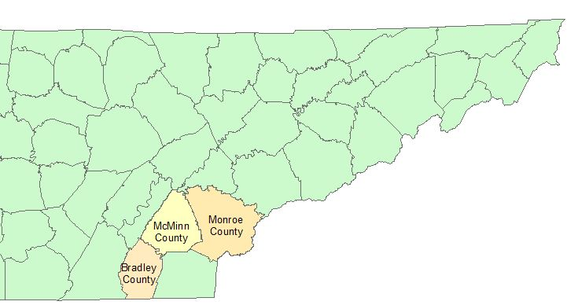

Figure 1: Bradley, McMinn, and Monroe Counties in Southeastern Tennessee

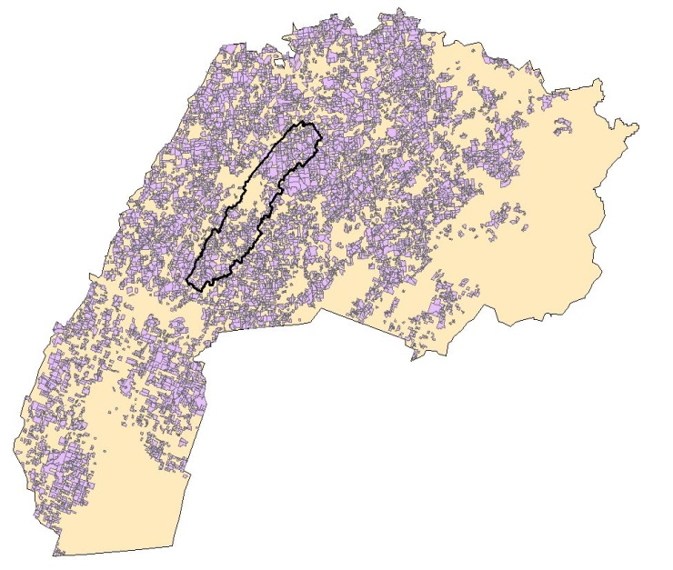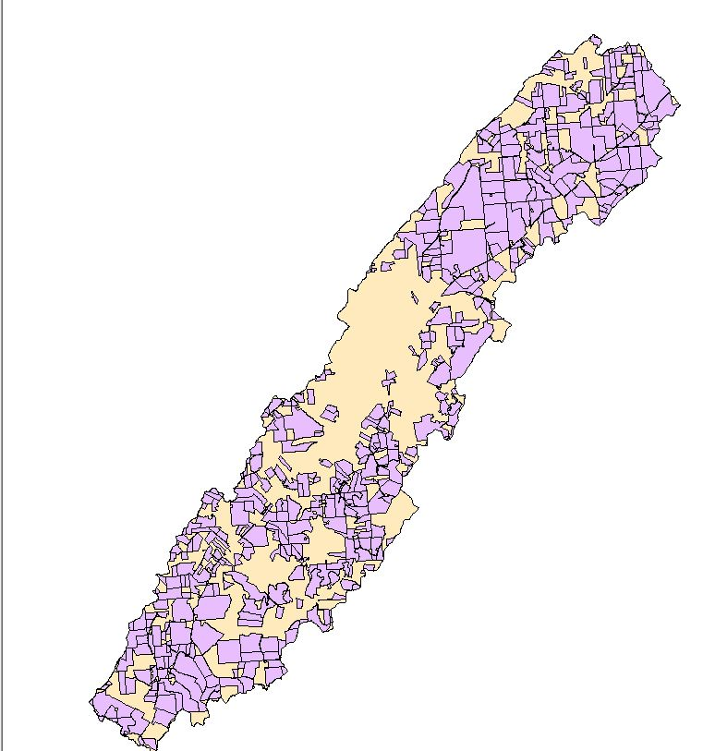

Figure 2: Surveyed Parcels with Oostanaula Creek Watershed Boundary Overlay

Conceptual Framework
Respondents choose to adopt a BMP based on what option provides the most utility. A farmer is willing to accept a cost share incentive c to adopt a BMP j if the farmer’s indirect
utility with the BMP adopted along with the incentive $V_{1j}(x,ε_{1};β)$ is at least as great as the initial state, $V_{0}(x,ε_{0};β)$, i.e., the farmer’s decision to adopt the practice can be expressed as $V_{1j}≥ V_{0}$, where 0 is the base state, 1 is the state with the BMP j adopted, x is a vector of explanatory variables, $ε$ an independently and identically distributed random variable ($ε$) with zero mean and a constant variance, and $β$ parameter vector. Similar to Cooper’s (2003) model, if $c_{j}^{*}$ is the cost share value that solves $V_{1j}\left(x,ε_{1};β\right)= V_{0}\left(x,ε_{0};β\right)$, then $c_{j}^{*}$ is the minimum WTA for adopting BMP j.
The difference: $∆V=V_{1j}- V_{0}$ can be expressed in a probabilistic framework as:

$\operatorname{Pr}\left(∆V≥0\right)$ (1)

$=Pr\left(c_{j} ≥ c_{j}^{*}\right)=Pr⁡(V_{1j}≥V_{0})$ (2)

which indicates $Pr⁡(WTA \text{response is "yes"})$. The parameters necessary to estimate $c_{j}^{*}$ can be estimated with maximum likelihood. The probability a livestock producer adopts a BMP j at $c_{j}$ is $Φ_{4}$ [$∆V(c_{j})$], where $Φ_{4}$ is a cumulative density function (CDF) for a bundle of the 4 BMPs, $G_{\left(4\right)}$ is a joint distribution function.
As an example, suppose a livestock producer is offered cost-shares for four BMPs. The producer indicates “no” to cost-share offers for SCs and PI, and “yes” to WT and RG.
The $Pr⁡("no” to SCs and PI, “yes” to WTs and RG)$ is outlined in equations 3 and 4.

$Φ_{4} =Pr\left(c_{SC}≤c_{SC}^{*},c_{PI}≤c_{PI}^{*},c_{WT} ≥ c_{WT}^{*},c_{RG}≥c_{RG}^{*} \right)$ (3)

$=\int_{0}^{c_{J}}{G_{\left(4\right)}}(c_{SC}, c_{PI}, C_{WT}, C_{RG})d_{c_{WT,RG}}$ (4)

Assuming the $∆V\left(c_{j}\right)$ are distributed normally but are correlated through the error terms, then a multivariate distribution needs to account for the correlation structure, where the $\left(J\text{x}1\right)$ vector $∆V$ is distributed as $∆V\sim Φ_{4}(x_{i}β_{SC }, x_{i}β_{PI }, x_{i}β_{WT }, x_{i}β_{RG }; R)$, and where $ρ$ is the $\left(J\text{x}J\right)$ matrix of correlation between the BMP error terms.

Multivariate Probit Regression
A multivariate probit regression was used to estimate the effect of the incentives on producer adoption of BMPs, holding other variables, including operator characteristics, managerial preferences, landscape features, and land value, constant. The probit regression was also used to estimate the parameters in $Φ_{4}$. Personal attributes include age, gender, and education. Farm managerial characteristics include acres owned, stocking density, acres farmed as a percent of acres owned, pasture as a total share of acres, whether the producer planned on passing on the farm to family members, and if the BMPs are in use already. Economic variables include household income, BMP cost share incentives, and land value from tax assessment records. Landscape features include slope and soil type [STATSGO2 data (USDA-NRCS, 2015d)]. A description of the covariates included in the regression are detailed in Table 3.
Table 3: Variable Descriptions and their Hypothesized Effects on BMP Adoption
Variable | Description | Hypothesized Effect
Cost Share Variables
p_rg | RG cost share ($/acre) | +
p_sc | SC cost share ($/sq. ft.) | +
p_wt | WT cost share ($/800 gallon tank) | +
p_pi | PI cost share ($/acre) | +
Producer Characteristics
age | years | -
male | male = 1 | -
college | has a college degree = 1 | +
passon | plan to pass farm to a family member = 1 | +
tenure | total acres owned as a share of total acres farmed | +
Farm Characteristics
spast | pasture as share of total acres farmed | +
stockden | stocking density (number of cattle per pasture acres farmed) | -
landval | appraised land value/acres owned | +
acown | number of acres owned | -
slope_maj* | slope category (%) with largest (majority) surface area | -
Current use of BMPs
use_pi | currently use PI practices = 1 | +
use_sc | currently use SCs = 1 | +
use_rg | currently use RG = 1 | +
use_wt | currently use WTs = 1 | +
* Slope categories include 0-2%, 2-8%, 8-16% and +16%

Respondents were asked if they produced cattle. Only those who replied “yes” were included in the analysis. The decision making framework is represented in Figure 3.

Have Stream
Survey Respondent
Adopt
Do Not Produce Cattle
Produce Cattle
No Adoption
Cost- Share Incentive
Figure 3: Decision Making Structure

The survey dataset was combined with the list frame to differentiate the slope and soil type values from multiple parcels owned by one respondent. There were also some respondents included in the list frame who did not reply to, or were not included in the survey. The combination of the datasets totaled 6,811 parcels. In total, 6,301 records were removed because respondents did not produce cattle (this also eliminated parcels not included in the survey). A total of 136 parcels were also eliminated that did not have streams, reducing the number of parcels to 374. The land value variable was calculated as appraisal value/number of acres owned as listed in the publicly available tax information list frame. Parcels with very high appraisal values and few acres had unrealistically high land value values (sometimes in the millions of dollars per acre). The variable for land value (landval) included outliers that skewed the data right. The 76 parcels with land value over $8500/acre were removed to achieve a mean land value representative of the three counties surveyed. Parcels missing a response for the adoption variables (23) were dropped. The parcels removed from the analysis due to missing exogenous variables totaled 40 parcels. In total, the statistical analysis included 235 parcels and 204 respondents (some respondents owned more than one parcel). This process is delineated in Figure 4. Variables pi, rg, wt, and sc represent the hypothetical incentive value for the BMPs.

Empirical Model
The empirical model is:
$$y_{ij}^{*}=x_{i}β_{j}+\sum_{j=1}^{4}{α_{j}^{k}c_{ij}+ ε_{ij}}, y_{ij}=\left\{\begin{matrix}1, y_{ij}^{*}>0 \\ 0, y_{ij}^{*}≤0 \end{matrix}\right.$$ (5)

where $y_{ij}^{*}$ is a latent variable indicating the change in utility with the adoption of BMP j, given an incentive level offered for a BMP. In equation (5), k aliases j. The probability $y_{ij}$ = 1 if the utility (equation 2) holds, i.e., the probability that the indirect utility of the producer with BMP adoption, and a cost share is equal or greater compared to the absence of adoption and no cost-share. The subscript i indexes producers, j indexes BMPs, x are exogenous variables, $c$ is the cost share level, 𝛼 is the coefficient associated with a cost share, and $ε$ is an error vector with the $J×J$ correlation matrix R. The errors are assumed to be ~ MVN (0, R). The system of equations were estimated as a multivariate probit regression.
Equation (5) has a structure similar to that of the seemingly unrelated regression (Zellner, 1962). The probit equation (5) consists of several relationships linked by a correlation in
Missing willingness to adopt variables (pi, rg, wt, sc) dropped
(23 responses removed)
Parcels = 275

Outliers for landval
(> $8500/acre) removed
(76 responses removed)
parcels = 298
Does not operate on stream
(136 responses removed)
parcels = 374
Does not produce livestock
(6301 responses removed)
parcels = 510
No response for exogenous variables:
(40 responses removed)
parcels = 235
respondents = 204

age
(7 responses removed)
spast
(22 responses removed)
stockden
(10 responses removed)
tenure
(1 responses removed)
Figure 4: Attrition of Survey Respondents

disturbances. They seem unrelated in the sense that no endogenous (left-hand side) variables appear on the right side of other equations (Roodman, 2011). The difference for equation (5) is the dependent variables are binary (0,1) variables (Cappallari and Jenkins, 2003). Correlation between the error terms (R) indicates that information is lacking on the right hand side of the BMP adoption probability models.
If the error terms are correlated, estimating the BMP probit models simultaneously will increase efficiency because the correlation of the error terms factors into the probability of adopting each BMP bundle (Roodman, 2011). If there is no correlation between the error terms, the probit models may be estimated independently. Failure to reject the null hypothesis, H₀: $ρ_{jk}=0 ∀ j≠k,$indicates that there is no correlation between the error terms. Following the estimation of the multivariate probit model, the marginal effects of the exogenous variables on the willingness to adopt each BMP was calculated with equations 6.1 – 6.4.

$\frac{∂Pr(Y_{RG}=1, Y_{WT}=0, Y_{SC}=0, Y_{PI}=0)}{∂x}$ (6.1)

$\frac{∂Pr(Y_{RG}=0, Y_{WT}=1, Y_{SC}=0, Y_{PI}=0)}{∂x}$ (6.2)

$\frac{∂Pr(Y_{RG}=0, Y_{WT}=0, Y_{SC}=1, Y_{PI}=0)}{∂x}$ (6.3)

$\frac{∂Pr(Y_{RG}=0, Y_{WT}=0, Y_{SC}=0, Y_{PI}=1)}{∂x}$ (6.4)

Estimation of the BMP Scenarios
The multivariate probit regression is estimated with simulated maximum likelihood, an optimization method where the parameter estimates are chosen to maximize the log likelihood function:

$\max_{β,R}$ln L = $\sum_{i=1}^{n}{lnΦ_{4}\left( q_{iRG}∙{x_{i,RG}β}_{RG},{q_{iSC}∙x_{iSC}β}_{SC, }{{ q_{iPI}∙x}_{iPI}β}_{PI}, {{q_{iWT}∙x}_{iWT}β}_{WT}, Q_{i}R\right)}$(7)

where $Φ_{4}$ is the standard normal multivariate cumulative distribution function; i.e., the probability of adopting the specified BMP scenario. For estimation and simulation purposes, the (0, 1) adoption of a BMP is transformed to a (-1, 1) indicator variable:
$q_{ij}$ = 1 if $y_{ij}=1$ and -1 if $y_{ij}=0. β_{j}$ is a vector of regression coefficients, x for each of the BMPs, and $Q_{i}R$ is the matrix of the $q_{ik}∙q_{ij}∙ρ_{ij}$combinations, $j≠k$. For example, the probability of adopting only RG is estimated jointly.

$Pr⁡[Y_{iRG }=1, Y_{iPI}=0, Y_{iSC}=0, Y_{iWT}=$0] (8.1)

= $Φ_{4}\left(q_{i,RG}∙x_{i}β_{RG}, q_{i,PI}∙x_{i}β_{PI},q_{i,SC}∙x_{i}β_{SC},q_{i,WT}∙x_{i}β_{WT}, Q_{i}R \right)$ (8.2)

$=Φ_{4}\left( {x_{i}β}_{RG}, {-x_{i}β}_{SC, }-{x_{i}β}_{PI}, -{x_{i}β}_{WT}, Q_{i}R\right)$ (8.3)

CHAPTER 4: DATA AND METHODS

Simulation of the effect of RG on USL
The SWAT model was used to generate an estimation of USL yield in tons/ha/timestep across the watershed. To streamline the SWAT output with the survey data, annual USL was converted from tons/hectare to tons/acre. USL rates were calculated for HRUs within OCW. HRUs are areas within a watershed grouped according to a unique land use (pastureland in this study), slope, and soil type combination. HRUs are assumed to be homogeneous in their USL response to BMP adoption. The parcels owned by respondents were grouped into HRUs for USL analysis estimated with SWAT. The baseline measurement of USL was estimated to represent USL levels in the absence of RG use across the watershed. The USL effect is averaged over data from 2002 – 2012. Originally, USL was estimated for the years 2000 – 2012, but SWAT requires a warm-up period in which there is a high level of variation in the upland sediment loss estimates. Therefore, information for years 2000 – 2001 were removed.
The effects of RG on USL were simulated by adjusting the BIO-MIN factor. In this analysis, the purpose of the BIO-MIN factor for the analysis is to generate scenarios whereby RG is implemented. An augmented BIO-MIN value is compared to a scenario in which the BIO-MIN level is low, simulating livestock overgrazing. The BIO-MIN level for overgrazing was set to 0 lb/acre, which was compared to a BIO-MIN value 500 lb/acre representing a reduction of forage intensity (i.e., an expected outcome of implementing RG). The SWAT analysis assumes that fertilizer is applied to avoid overestimation of USL rates. The USL was averaged by year to avoid seasonal weather variation.

Parcel/Typography Layers
The coverage of pastureland (fescue grass) across the three counties is shown in Figure 5. The land cover data comes from satellite imaging, so it is reasonable to predict a high degree of error in the pastureland coverage estimate. Pasture acres in Oostanaula (fescue grass land) total 17,045 acres, which accounts for 48.86% of the OCW. Only parcels on pastureland were included in the analysis.

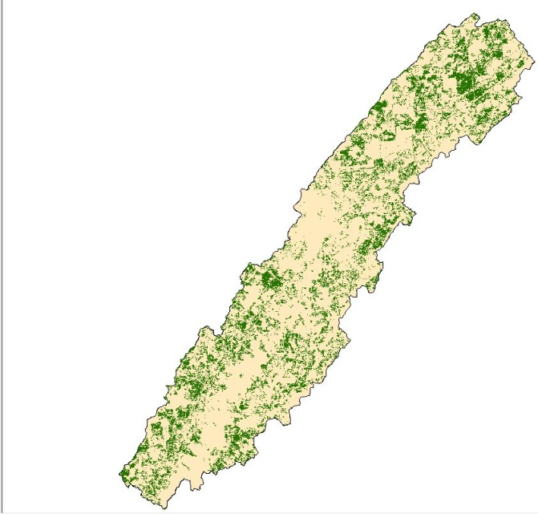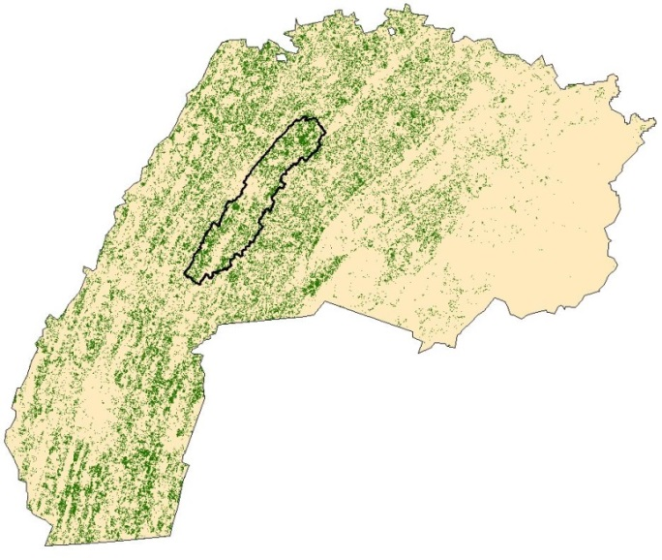
Pastureland
Coverage

Figure 5: Pastureland Coverage Across Surveyed Parcels

The slope and soil data is from the USDA NRCS Geospatial Data Gateway (USDA, 2015a). This data was used to determine the majority soil type and slope of the parcels surveyed. The majority slope and soil type comprises the greatest percent share of each parcel compared to the percent coverage of other slope and soil types respectively within the parcel. Median or mean soil type was not feasible, since soil type is a categorical value and the focus was on area coverage.
Parcels were mapped with Geographical Information System (GIS) software (Srinivasan, Arnold, and Jones, 1998). Using the “Zonal Statistics as Table” tool, each parcel was assigned one slope category based on the slope classification comprising the largest surface area on the parcel (Figure 6). The majority slope category was generated using a GIS digital elevation map (DEM). The slope categories were calibrated with the “Slope” tool in GIS. Slope categories were designated as 0-2%, 2-8%, 8-16%, and ≥16% gradients.

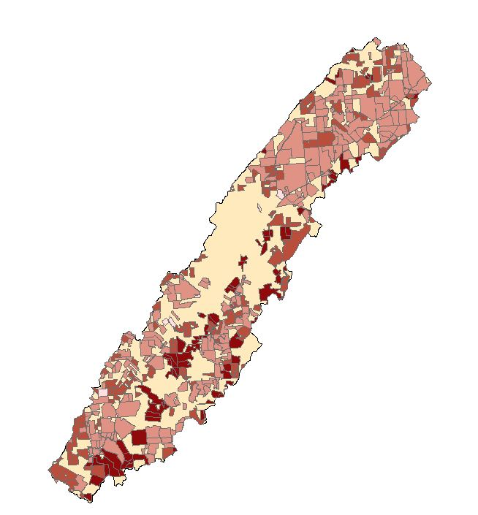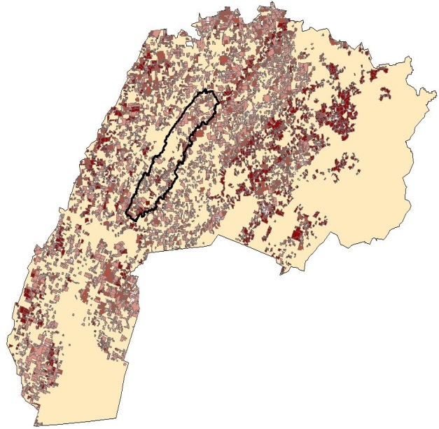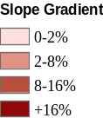
Figure 6: Surveyed Parcels Categorized by Majority Slope Category

Each parcel was assigned to one soil type category based on the soil type that constitutes the largest surface area of that parcel and this information (Figure 7). The “majority soil” of each parcel was calculated based on the USDA-NRCS’ digital general soil map of the U.S. (STATSGO), which is an inventory of soil pattern areas in the U.S. (USDA-NRCS, 2015a).

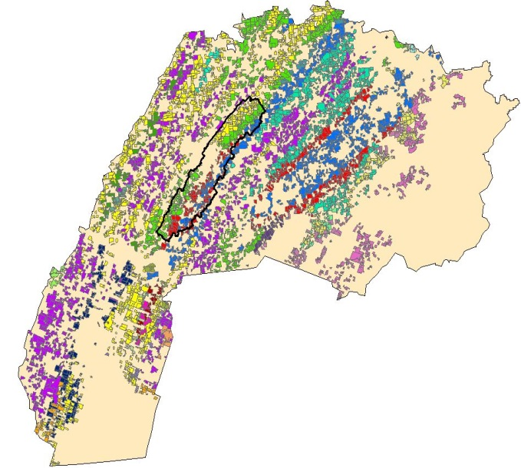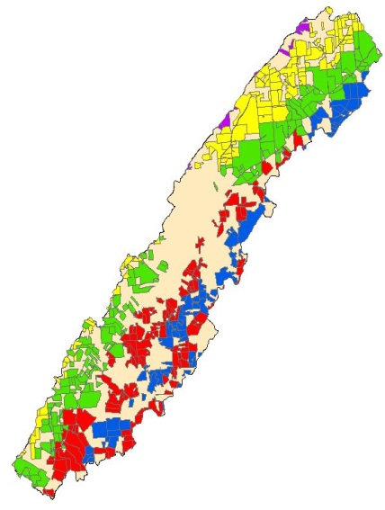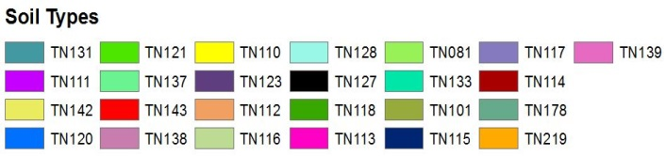
Figure 7: Surveyed Parcels Categorized by Majority Soil Type

Characteristics of each subbasin leads to unique USL effects in the watershed. Parcels with the same slope/soil type combinations that are located on different subbasins are assigned to different HRUs. The 15 subbasins in the OCW are represented in Figure 8, each with a unique color.

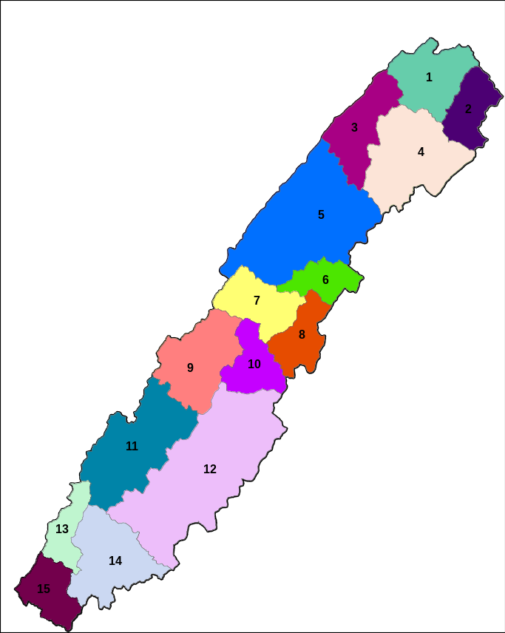
Figure 8: Subbasins in the Oostanaula Creek Watershed

Land Characteristics
Since there are 4 slope categories and 18 soil types in the survey dataset, there were 72 possible slope-soil type combinations. Of the 72 possible combinations, there were 36 unique majority slope and soil type combinations represented by parcels. However, there are 66 unique
HRUs because some parcels with similar slope/soil type combinations are located on different subbasins. The subbasin, majority slope, and majority soil type corresponding to each HRU represented in the survey data within the OCW are listed in Table 4.

Matching Parcels with the HRU Designations
If a parcel spanned more than one subbasin, the area of the parcel was divided, effectively creating multiple parcels with the same producer characteristics, and each producer belonging to a respective HRU. Figure 9 depicts OCW separated by the 15 subbasins (each subbasin in a different color) with the parcels overlaid in red. The exploded area shows parcels that span multiple subbasins, and are accordingly assigned to multiple HRUs. In total, 76 parcels were split because they straddled a subbasin boundary. Each segment of the split parcel are treated as a separate parcel with the same farm and farmer characteristics, and therefore adoption probabilities. It is assumed that the area that could be managed under RG applies to an HRU.
Only the USL output from fescue grass land across the OCW was considered because the focus of the analysis was on livestock producers and RG. The total HRU area with fescue-land is generally larger than the surveyed area by HRU due to unavailable data (e.g., survey non-response). To compensate for this, parcels were reapportioned to compose a representative area of the HRU. Figure 10 provides a didactic example of reapportioned parcels. Suppose the total area of Figure 10 is an HRU categorized by SWAT (labeled as A_{SWAT}) and totals 9 acres. Also,
Table 4: HRU Characteristics
HRU | Subbasin | Soil Type | Slope Gradient (%) | HRU | Subbasin | Soil Type | Slope Gradient (%)
4 | 1 | TN110 | 8-16 | 150 | 9 | TN110 | 2-8
6 | 1 | TN110 | 2-8 | 151 | 9 | TN121 | 2-8
7 | 1 | TN121 | 2-8 | 152 | 9 | TN121 | 8-16
22 | 2 | TN120 | 0-2 | 155 | 9 | TN143 | 8-16
23 | 2 | TN120 | 2-8 | 162 | 10 | TN120 | 2-8
25 | 2 | TN121 | 8-16 | 163 | 10 | TN120 | 8-16
26 | 2 | TN121 | 2-8 | 165 | 10 | TN143 | 8-16
33 | 3 | TN110 | 8-16 | 166 | 10 | TN143 | 2-8
34 | 3 | TN110 | 2-8 | 176 | 11 | TN110 | 2-8
47 | 4 | TN110 | 8-16 | 177 | 11 | TN110 | 8-16
48 | 4 | TN110 | 2-8 | 178 | 11 | TN121 | 2-8
49 | 4 | TN120 | 8-16 | 179 | 11 | TN121 | 8-16
50 | 4 | TN120 | 2-8 | 198 | 12 | TN120 | 16-9999
52 | 4 | TN121 | 2-8 | 199 | 12 | TN120 | 8-16
53 | 4 | TN121 | 8-16 | 200 | 12 | TN120 | 2-8
70 | 5 | TN110 | 2-8 | 202 | 12 | TN143 | 8-16
72 | 5 | TN110 | 8-16 | 203 | 12 | TN143 | 2-8
73 | 5 | TN121 | 0-2 | 204 | 12 | TN143 | 16-9999
74 | 5 | TN121 | 2-8 | 213 | 13 | TN110 | 8-16
75 | 5 | TN121 | 8-16 | 214 | 13 | TN110 | 2-8
76 | 5 | TN143 | 8-16 | 216 | 13 | TN121 | 2-8
77 | 5 | TN143 | 16-9999 | 217 | 13 | TN121 | 8-16
78 | 5 | TN143 | 2-8 | 224 | 14 | TN120 | 16-9999
86 | 6 | TN120 | 8-16 | 225 | 14 | TN120 | 2-8
87 | 6 | TN143 | 16-9999 | 226 | 14 | TN121 | 2-8
88 | 6 | TN143 | 8-16 | 227 | 14 | TN121 | 8-16
89 | 6 | TN143 | 2-8 | 228 | 14 | TN143 | 2-8
129 | 8 | TN120 | 8-16 | 229 | 14 | TN143 | 8-16
131 | 8 | TN120 | 16-9999 | 241 | 15 | TN110 | 8-16
132 | 8 | TN143 | 16-9999 | 242 | 15 | TN121 | 2-8
133 | 8 | TN143 | 2-8 | 244 | 15 | TN121 | 8-16
134 | 8 | TN143 | 8-16 | 245 | 15 | TN143 | 8-16
149 | 9 | TN110 | 8-16 | 246 | 15 | TN143 | 2-8

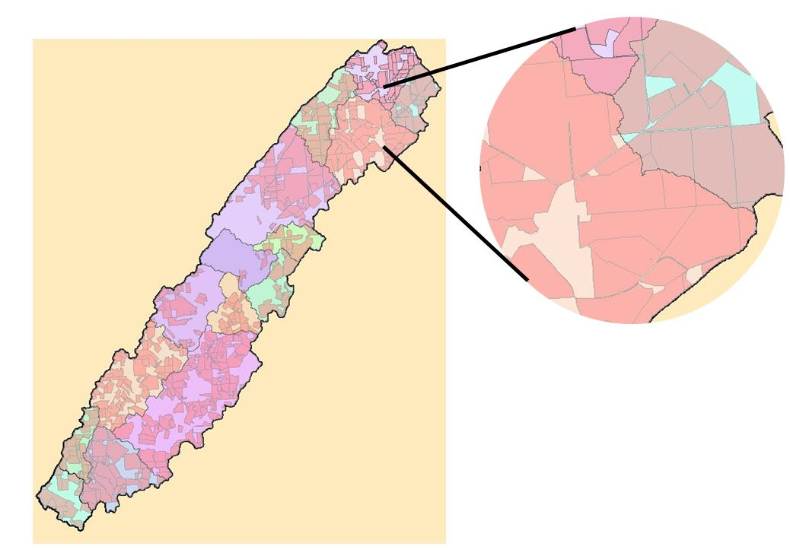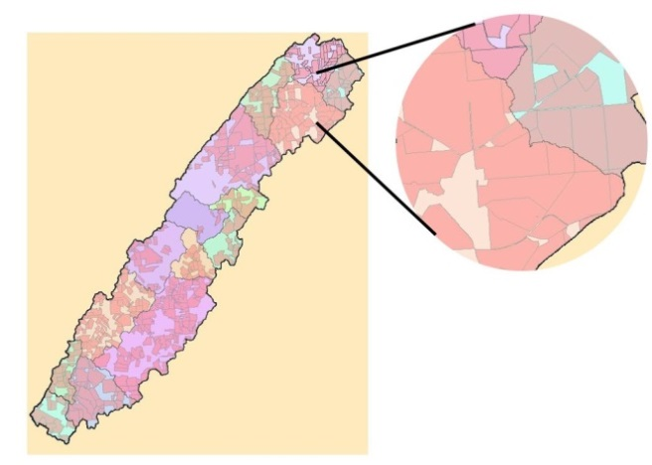
Parcels
Figure 9: Fracturing of Parcels Along Subbasin Boundaries

$A_{HRU}^{{Parcel}_{3}}$ (1 acre)
Parcel 3
$A_{HRU}^{{Parcel}_{1}}$ (1 acre)
$A_{HRU}^{{Parcel}_{2}}$ (1 acre)
$A_{SWAT}$ (9 acres)
Parcel 1
Parcel 2
Figure 10: Hypothetical Example of Calculating Representative Parcel Size

there are 3 equal sized parcels surveyed. The area for each parcel ($A_{h}^{{Parcel}_{i}}$) is 1 acre. The total area of the parcels that completed surveys in this HRU (h) ($\sum_{i=1}^{P}{A_{h}^{{Parcel}_{i}}}$) is 3 acres. Each parcel’s area ($A_{h}^{{Parcel}_{i}}$) was then assigned a weight for coverage of total surveyed land area in that HRU, calculated as $w_{i}^{h}$.

$w_{i}^{h}= \left({A_{h}^{{Parcel}_{i}}}/{\sum_{i=1}^{P}{A_{h}^{{Parcel}_{i}}}}\right)$ (9)

In the didactic example, the weight would be 1/3. The resulting weight was multiplied with the HRU area calculated with SWAT (A_{SWAT}) to create a proportional area representation of each parcel’s coverage ($\sum_{i=1}^{P}{A_{h}^{{Parcel}_{l}}}$) in the HRU:

$A_{i}^{rep}= w_{i}^{h}∙ A_{SWAT}$ (10)

where $A_{i}^{rep}$ is the reapportioned areas of a surveyed parcel. Following Figure 10, the product of the weight (1/3) and the total HRU area (9 acres) is 3 acres. The 3 acre value for each parcel yields a proportionally representative area that could potentially be managed under RG. The adoption probabilities corresponding with each parcel within an HRU ostensibly reflect the proportion of the parcel managed under RG. This relationship is the keystone to bridging the survey data (adoption probabilities and $/unit incentives) and parcels with the USL reduction potential of an HRU.

Estimation of USL Abatement Levels
The probability of adoption is hypothesized to reflect the intensity of adoption of a BMP (i.e., the area managed under a BMP). For example, if the producers’ probability of adopting RG is 50%, it is assumed that 50% of that producer’s pasture will be managed using RG. The management intensity (or area enrolled) of a BMP program by HRU ($P_{i}^{h})$, is denoted as:

$P_{i}^{h}$ = $\sum_{i∈h}{w_{i}^{h}∙Φ_{4}\left(z_{i(h)}^{RG}, z_{i(h)}^{PI}{, z}_{i(h)}^{WT}\text{, }z_{i(h)}^{SC}\text{, }\text{R}\right)}$ (11)

where i indexes producers in HRU h, $w_{i}^{h}$ has already been defined, $Φ_{4}$ is the probability of adopting a technology combination, and $z_{i(h)}^{j}$is a linear index indicating the adoption of practice j; equation $z_{i(h)}^{j}=$ ${q_{j}x}_{i}β_{j}$.
Equation 12.1 is used to estimate the USL in tons per year for each HRU.

${\overline{δ}}_{h}=P_{i}^{h}∙δ_{h}^{1}+\left(1-P_{i}^{h}\right)∙δ_{h}^{0}$ (12.1)

which, rearranged is:

${\overline{δ}}_{h}$ = $P_{i}^{h}∙δ_{h}^{1}- P_{i}^{h}∙δ_{h}^{0}+δ_{h}^{0}$ (12.2)

${\overline{δ}}_{h}$= $P_{i}^{h}∙∆δ_{h}$ + $δ_{h}^{0}$ (12.3)
where $δ_{h }^{1}$is the USL (tons/year) after RG adoption for the number of acres in each HRU, $δ_{h}^{0}$is the USL (tons/year) absent adoption in each HRU, $∆δ_{h}$ is the difference between USL in the absence of adoption and full adoption of RG ($∆δ_{h}≤0$), and ${\overline{δ}}_{h}$ is the expected USL in tons per year per HRU at a given cost share level and an area of the HRU managed under RG. Variables $δ_{h}^{0}$ and $δ_{h}^{1}$ are generated from SWAT under the contrasting BIO-MIN parameterizations. The right hand side of equation (12.1) has two parts. The product of the probability of BMP adoption (the predicted coverage of BMP adoption) and USL with BMP adoption over the entire HRU. The second is the product of the probability of BMP non-adoption and the estimated USL with non-adoption across the entire HRU. The result of equation (12.3) is the expected amount of USL over the HRU. The progression from equation (12.1) to equation (12.3) shows that the expected amount of USL per year is the USL absent RG adoption ($δ_{h}^{0}$) added to the product of the probability of BMP adoption (assumed to be coverage of adoption) and the change in USL from non-adoption to BMP adoption across the entire HRU:

$P_{i}^{h}∙∆δ_{h}^{1}$ (13)

The change in USL from pasture management under RG is expected to yield a negative value. With full implementation (area coverage) of RG, on the parcels surveyed in Oostanaula, it was estimated that there would be 6,522 tons/year of USL generated on the HRUs represented in the survey. In the absence of RG, there would be a USL load of 24,569 tons/year. The total possible reduction in USL was therefore approximately 18,000 tons of USL.

Imputation Procedure
Only parcels in the Oostanaula watershed boundary are used in the USL abatement analysis, which is contrasted with the WTA probability analysis that uses data from OCW and the surrounding counties. To estimate USL levels, only parcels in the OCW were used because the necessary slope, soil type, subbasin information is available for them to be grouped by HRU. There were 329 parcels that fit these criteria (2 of which did not respond to the survey). Parcels from the 2 non-respondents to the survey were included in the analysis because although there was not survey data attributable to these respondents, it was hypothesized that their land may have a USL impact given cost-share scenarios. There were missing responses to some questions in the survey data, so an imputation procedure was used to fill in the data gaps. The imputation procedure was conducted in steps according to the detail of the information available for each HRU and subbasin. For instance, if an age value was missing for a respondent, the age would be replaced with the mean age of the HRU. If there were no age responses for that HRU, the missing value would be replaced with the mean age at the subbasin level. If there was no data available for age at the subbasin level, the missing age variable was replaced with the average age across the Oostanaula watershed. This process was repeated for all explanatory variables with missing information. Once the imputation process was complete, vectors of the explanatory variables for each of the 329 parcels was included in the regression analysis to estimate the USL abatement curves. Table 5 outlines the number of imputed values for each variable out of the 329 responses.

Table 5: Number of Imputed Values for Variables for USL Abatement Analysis
Number of Imputed Values
age | 227
male | 0
college | 0
acown | 224
spast | 288
passon | 0
stockden | 307
tenure | 229
use_pi | 0
use_sc | 0
use_rg | 0
use_wt | 0
landval | 2
Slope_Maj | 0
p_rg | 0
p_pi | 0
p_sc | 0
p_wt | 0
N = 329

Analysis of BMP Adoption and USL Abatement
Generating USL abatement supply curves is the final step in combining the econometric WTA results with SWAT’s generated USL estimates. A USL abatement curve was estimated for each HRU, given the probability of adopting each of the BMPs with SWAT at different cost-share levels.
For each HRU, the USL abatement curves were estimated as a regression of cost of abatement ($/ton) on USL reduction at each of the cost-share values offered to the survey respondents.

$R_{h}= α_{0}^{h}+α_{1}^{h}x+μ_{h}$ (14)

where $R_{h}$ is the cost of reducing USL ($/ton) for a BMP scenario in HRU (h), x are levels of USL reduction estimated at different cost share levels for each HRU, $α_{1}^{h}$ is a (9x1) coefficient
vector. The amount $R_{h}$ ($/t) was calculated as the product of the survey cost-share level ($/acre) for RG and the inverse of the USL reduction in each HRU estimated with SWAT (t/acre)⁻¹: R = $\frac{\$}{acre}∙{\left(\frac{acre}{t}\right)}_{h}={\left(\frac{\$}{t}\right)}_{h}$. This regression was conducted for every HRU. Figure 11 is a didactic example of USL abatement curves for hypothetical HRUs 1-3. The HRU-specific supply curves are aggregated into a single USL abatement supply curve representative of the entire watershed (right panel, Figure 11). The aggregate USL reduction is the horizontal summation of the individual HRU USL abatement supply curves. There are different “choke points” for each HRU

Figure 11: Hypothetical USL Abatement Curves

abatement curve. A choke point is the cut-off point where USL abatement beyond that point for the HRU is unobtainable. For example, provided an area coverage of RG enrolled at some maximum incentive level, HRU 1 would yield 2 tons of USL abatement. Compare that to HRU 2, which would result in 3 tons per year of USL abatement at the same maximum incentive (Figure 11). Because the land characteristics and USL reduction production are heterogeneous across HRUs, the choke points occur at different values of USL abatement potential and at different incentive levels. Although HRU 2 can achieve a higher tonnage of USL abatement than HRU 1, the marginal cost of USL abatement is higher for HRU 2 (Figure 11, left panel). One can measure the price response to USL by the slope of the abatement line. At $1.00/ton abated, 2 tons are abated in HRU 1 compared with 1 ton in HRU 2.
Refer to Figure 12 as an explanation of the horizontal summation procedure. At the $1.00 cost-share level, take the sum of HRU 1 – HRU 3 (0.5 + 1 + 2) = 3.5 tons /year of USL abatement. To horizontally sum the USL abated at each choke point (e.g., at the $3.00 cost-share, the previous abatement level from the $1.00 cost-share level (3.5) is added to the new sum of HRU curves at the $3.00 cost-share level (4.5) to total to 8 tons/acre/year of USL abatement.

Figure 12: Horizontal Summation of USL Abatement Supply Curves

USL abatement is assumed to be positively related to a practice’s own cost share level as well as hypothesized to have a positive cross-price effect among other BMPs; an increase of offered cost share amounts for the BMPs (p_pi, p_rg, p_wt, p_sc) are expected to increase a producer’s probability of adopting RG, assuming these practices complement RG. To the extent that WTs and SC may be necessary features of a RG package on a variety of topographies, this seems a reasonable expectation.

CHAPTER 5: RESULTS
Figure 13 is the cumulative distribution of producers who indicated they would adopt RG for the successive cost share scenarios. The blue portion of the bar chart represents the number of new respondents willing to adopt RG at each cost-share level, and the red represents the number of producers who were WTA at lower cost-share levels. The combination of the blue and red portions is the total number of respondents who replied to the WTA RG question.

Figure 13: New and Cumulative RG Adoption at Each Cost-Share Level

Figure 13 is consistent with the economic literature in terms of a proportional increase of RG given increased of cost-share levels. Increasing the cost share rate from 50% to 63% increases RG adoption by 36 respondents. At 125% of the total RG cost-share rate, there are 227 respondents willing to adopt RG.
Table 6 summarizes the participation rates for PI at the hypothetical cost-share values in the survey (comprising of all 3 counties surveyed, beyond the OCW). For $127 per acre of PI,

Table 6: Cost/Practice Summary of Raw Survey Data for Pasture Improvement
Pasture improvement |  |  |  |  |  |  | Cumulative
Offer | Participation acres | Stderr | L95 | U95 |  | Offer | participation | Slope
$ 127 | 2050 | 365 | 1332 | 2768 |  | 127 | 2050 | 0.017153
$ 158 | 1312 | 339 | 646 | 1978 |  | 158 | 3362
$ 190 | 2157 | 396 | 1379 | 2935 |  | 190 | 5519
$ 222 | 1819 | 432 | 969 | 2669 |  | 222 | 7338
$ 253 | 2112 | 439 | 1248 | 2976 |  | 253 | 9450
$ 285 | 1902 | 306 | 1299 | 2504 |  | 285 | 11351.7
$ 317 | 1219 | 194 | 837 | 1601 |  | 317 | 12570.7
Total cost= | $2,743,447

2,050 acres of PI are adopted. At $158 per acre of PI, 1,312 acres have PI in use. Therefore, the cumulative adoption at $158 is 3,362 acres. At $317 per acre for PI, the cumulative PI adoption is approximately 12,571 acres. The cumulative participation rates in Table 6 are expressed graphically in Figure 14. There is a steady upward trend in adoption across all of the hypothetical cost-share levels.

Figure 14: Cost/Practice Summary of Raw Survey Data for PI

Table 7 summarizes the participation rates for SC at the hypothetical cost-share values in the survey. For an offer of $1.93 per square foot of SC, 2,220 square feet of SCs are implemented. At $2.42 per square foot of SC, 7,420 square feet of SCs are implemented.
Table 7: Cost/Practice Summary of Raw Survey Data for Stream Crossing
Stream crossing |  |  |  |  |  |  | Cumulative  participation
Offer | Participation  (sq ft) | Stderr | L95 | U95 |  | Offer | Cumulative  participation | Slope
$ 1.93 | 2220 | 1393.35 | -524.26 | 4964.26 |  | 1.93 | 2220 | 0.045
$ 2.42 | 7420 | 5077.12 | -2579.58 | 17419.58 |  | 2.42 | 9640
$ 2.90 | 1337 | 649.62 | 57.54 | 2616.46 |  | 2.90 | 10977
$ 3.39 | 24552 | 11122.54 | 2645.74 | 46458.26 |  | 3.39 | 35529
$ 3.87 | 7002 | 3207.71 | 684.29 | 13319.71 |  | 3.87 | 42531
$ 4.35 | 9998 | 3823.15 | 2468.16 | 17527.84 |  | 4.35 | 52529
$ 4.84 | 6221.84 | 3192.64 | -66.18 | 12509.86 |  | 4.84 | 58750.84
Total cost = | $209,987
*Note: slope is $×$ 1000

Therefore, the cumulative adoption at $2.42 per square foot of steam crossing is 9,640 square feet. At $4.84 per square foot of SC, the cumulative SC adoption is approximately 58,751 square feet. The cumulative participation rates in Table 7 are expressed graphically in Figure 15. There is an upward trend in adoption across increases in cost-share levels with the most significant shift upward after $2.90.

Figure 15: Cost/Practice Summary of Raw Survey Data for Stream Crossing

Table 8 summarizes the participation rates for RG at the hypothetical cost-share values in the survey. For $16 per acre of RG, 1,202 acres of RG are adopted. At $20 per acre of PI, 1,438 acres have PI in use. Therefore, the cumulative adoption at $20 is 2,640 acres. At $40 per acre for PI, the cumulative PI adoption is approximately 11,539 acres.
Table 8: Cost/Practice Summary of Raw Survey Data for Rotational Grazing
Rotational grazing |  |  |  |  |  |  | Cumulative
Offer | Participation (ac) | Stderr | L95 | U95 |  | Offer | participation | Slope
$ 16 | 1202 | 326 | 560 | 1844 |  | 16 | 1202 | 0.002195
$ 20 | 1438 | 342 | 766 | 2110 |  | 20 | 2640
$ 24 | 856 | 211 | 441 | 1271 |  | 24 | 3496
$ 28 | 2386 | 593 | 1220 | 3552 |  | 28 | 5882
$ 32 | 1002 | 238 | 534 | 1470 |  | 32 | 6884
$ 36 | 3427 | 1297 | 877 | 5977 |  | 36 | 10311
$ 40 | 1228 | 258 | 720 | 1736 |  | 40 | 11539
Total cost = | $339,900

The cumulative participation rates in Table 8 are expressed graphically in Figure 16. There is a steady upward trend in adoption across increases in cost-share levels.
Table 9 summarizes the participation rates for WTs at the hypothetical cost-share values in the survey. For $767 per WT, 57 WTs will be implemented. At $958 per WT, 25 are used. Therefore, the cumulative adoption at $958 is 82 units. At $1,917 per WT, the cumulative adoption of WTs is approximately 380 units.
The cumulative participation rates in Table 9 are expressed graphically in Figure 17. There is a steady upward trend in adoption across increases in cost-share levels.A summary of the four tables above are outlined in Table 10 for comparison. The average cost per participant for RG in the survey is $1,910. There would be 178 participants at the highest cost-share level ($40.00). To implement this policy, it would cost on average $29.46/acre for RG.
Summary statistics of the variables included in the BMP adoption analysis are included in Table 11. The average age of the producer surveyed is approximately 63 years old. The respondents were predominantly male (90%). Less than half (38%) had a college degree. Since all producers included in this analysis manage livestock, it makes sense that a relatively large proportion (74.08%) of acres farmed was on pastureland. In total, 48 parcels had an appraised value of 0 dollars. As was discussed in the literature review, personal characteristics such as age and education contribute to the WTA a BMP regardless of the level of cost-share provisions. Of the respondents, 91% indicated they intend to pass on their farm operation to the family, indicating many producers have long-term goals for their land, as opposed to potentially prioritizing short-term profits. Long-term planning is consistent with the fairly high degree of adoption of PI:

Figure 16: Cost/Practice Summary of Raw Survey Data for Rotational Grazing

Table 9: Cost/Practice Summary of Raw Survey Data for Water Tanks
Water tank |  |  |  |  |  |  | Cumulative
Offer | Participation (units) | Stderr | L95 | U95 |  | Offer | participation | Slope
$ 767 | 57 | 9.96 | 37.41 | 76.59 |  | 767 | 57 | 3.401
$ 958 | 25 | 8.94 | 7.41 | 42.59 |  | 958 | 82
$ 1,150 | 51 | 11.11 | 29.15 | 72.85 |  | 1150 | 133
$ 1,342 | 61 | 11.58 | 38.21 | 83.79 |  | 1342 | 194
$ 1,533 | 72 | 12.38 | 47.65 | 96.35 |  | 1533 | 266
$ 1,725 | 45 | 9.80 | 25.71 | 64.29 |  | 1725 | 311
$ 1,917 | 69 | 12.31 | 44.78 | 93.22 |  | 1917 | 380
Total cost= | $528,455

Figure 17: Cost/Practice Summary of Raw Survey Data for Water Tanks

Table 10: Comparison of Costs/Practices of Raw Survey Data Across BMPs
Item | Pasture improvement | Stream crossing | Rotational grazing | Water tank
Units | acres | square feet | acres | 800 gal tank
Total units | 12,571 | 58,751 | 11,539 | 380
Total cost | $2,743,447 | $209,987 | $339,900 | $528,455
Marginal cost/unit | $0.0172 | $0.0000 | $0.0022 | $3.40
Average cost/unit | $218.24 | $3.57 | $29.46 | $1,390.67
Average offer/unit | $221.66 | $3.39 | $28.00 | $1,341.71
Participants | 245 | 66 | 178 | 153
Average cost/participant | $11,197.74 | $3,181.63 | $1,909.55 | $3,453.95

Table 11: Description of Variables and Mean Values
Variable | Description |  | Mean Value |  | Min. Value |  | Max. Value
Cost Share Variables
p_rg | RG cost share ($/acre) |  | 27.70 |  | 16 |  | 40
p_sc | SC cost share ($/sq. ft.) |  | 3.34 |  | 1.94 |  | 4.84
p_wt | WT cost share ($/800 gallon tank) |  | 1393.00 |  | 767 |  | 1917
p_pi | PI cost share ($/acre) |  | 217.42 |  | 127 |  | 317
Producer Characteristics
age | years |  | 62.5 |  | 30 |  | 91
male | male = 1 |  | 0.90 |  | 0 |  | 1
college | has a college degree = 1 |  | 0.38 |  | 0 |  | 1
passon | plan to pass farm to family member |  | 0.91 |  | 0 |  | 1
tenure | total acres owned/ total acres farmed |  | 1.31 |  | 0.04 |  | 14
Farm Characteristics
spast | pasture as % of total acres farmed |  | 74.08 |  | 4.65 |  | 100
stockden | stocking density (number of cattle per pasture acres farmed) |  | 0.78 |  | 0.05 |  | 11.67
landval | appraised land value/acres owned |  | 4015.34 |  | 0 |  | 8483.65
acown | number of acres owned |  | 206.5 |  | 8 |  | 1600
slope_maj* | slope category (% gradient) with largest surface area |  | 2.68 |  | 1 |  | 4
use_pi | current use of PI practices = 1 |  | 0.62 |  | 0 |  | 1
use_sc | current use of SCs = 1 |  | 0.41 |  | 0 |  | 1
use_rg | current use of RG = 1 |  | 0.61 |  | 0 |  | 1
use_wt | current use of WTs = 1 |  | 0.43 |  | 0 |  | 1
n = 235
* Slope categories include 0-2%, 2-8%, 8-16% and +16%

74.08% of respondents report use of PI. RG is one of the most frequently reported BMPs in use (61%), which makes sense because RG often requires WTs and/or some form of PI.

Econometric Results
The marginal effects of the multivariate BMP adoption equation are listed in Table 12. The fit of the model was tested using various methods. The H₀: $β_{jk}$ = 0 $∀ jk$ was tested with a Wald test and a likelihood ratio test. The regression yields a Wald $χ_{k}^{2}$ value of 75.85 indicating that the H₀ is rejected (significant at the 1% level). The likelihood ratio test yields a $χ_{k}^{2}$ value of 160.70, so the null hypothesis was again rejected (significant at the 1% level). Therefore, the explanatory variables in the model are jointly statistically different from 0. A second likelihood ratio test was used to test the H_{0:} $ρ_{jk}=0$ $∀ jk$, $j≠k$. There are 6 degrees of freedom ($ρ_{jk}$ terms). The second likelihood ratio test yields a $χ_{k}^{2}$ value of 156.27, indicating that the null hypothesis is rejected (significant at the 1% level). Therefore, there is statistically significant correlation between the error terms in the multivariate probit model. The pseudo R² value is 0.157. The mean VIF value is 1.16 indicating that collinearity is not impacting the standard errors.
An increase in one dollar per foot of the cost share for SC increased the likelihood of SC adoption by 17.91%. An increase in one dollar per acre of cost share for RG increased the probability of adopting RG adoption by approximately 1.9%. The results indicate that RG cost-shares could have complimentary effects on the adoption of other BMPs. In addition to contributing to its own adoption, RG cost share was positively correlated with the adoption of WTs and SCs. Therefore, the three technologies could be well suited as a BMP bundle. For instance, the cost-share levels for WT and RG were both positively correlated with the
Table 12: Marginal Effect of Variables on BMP Adoption
 | Marginal Effect
Variable | WT | RG | SC | PI
Cost Share Variables | 0.0234** | 0.0186* | 0.0207* | 0.0006
p_rg
p_sc | 0.0888 | 0.1750* | 0.1791* | 0.1003
p_wt | 6.6e-05 | 0.0004* | -0.0005* | -0.0002
p_pi | 0.0015 | 0.0003 | 0.0024* | 0.0002
Producer Characteristics
age | -0.0442*** | -0.0178** | -0.0183** | -0.011
male | -0.0626 | -0.1876 | -0.0236 | 0.1470
college | -0.0576 | 0.3064* | 0.4247** | 0.1524
passon | 0.4054 | 0.3044 | -0.1311 | 0.8758***
tenure | -0.1564*** | 0.0514 | -0.069 | -0.0420
Farm Characteristics
acown | 0.0006 | 5.03e-05 | 0.002*** | -0.0009*
spast | -0.0035 | -0.0053 | 0.0052 | -0.0034
stockden | -0.0170 | -0.1175** | 0.1024 | 0.0017
landval | 3.17e-05 | 1.46e-05 | -1.19e-05 | 1.21e-05
slope_maj* | 0.2357** | 0.0056 | -0.0936 | -0.0027
Previous use of BMPs
use_pi | 0.8301*** | 0.6135*** | 0.1857 | 0.5793***
use_sc | -0.2779 | -0.0645 | 0.1243 | -0.2279
use_rg | 0.0735 | 0.1532 | 0.1148 | -0.4186**
use_wt | -0.2385 | -0.2430 | - 0.506** | -0.0128
n = 235
LL_{UR} = -431.32
LL_{R} = -511.70
Wald $χ_{k}^{2}$ = 75.85
LR₁ $χ_{k}^{2}$ = 160.7
LR₂ $χ_{k}^{2}$ = 156.27
*p<0.10, **p<0.05, ***p<0.01

probability of adopting WT and RG. Therefore, policy-makers could provide incentives for producers to adopt both WT and RG.
A number of the covariates had statistically significant marginal effects. Older producers were less likely to adopt WT, and were less likely to adopt RG and SC. An increase of one year in age decreased the probability of adopting RG by approximately 1.2%, WT systems by about 4.4%, and SC by 1.8%. Acres owned decreased the likelihood of SC adoption by approximately 20% per 100 acres and by 9% for WT system implementation. Being college educated increased the probability of adopting SC by 42.5%, and increased the probability of adopting RG by 30.6%. Stocking density had a negative impact on the likelihood of producers adopting RG. For every per head increase in cattle, the probability of adopting rotational grazing decreased by 11.75%. The negative impact on RG adoption is likely due to the labor involved in rotating a large number of cattle between paddocks. If a producer is currently using PI, he/she was more likely to adopt WTs, RG and PI. This result is consistent with the literature in which using PI may be a first step, or “gateway” to using other BMPs (Lambert et al., 2014). The next step entails generating USL estimates with SWAT for different BMP combinations, focusing on RG.

The Impact of Rotational Grazing on USL
Figures 18 and 19 depict simulated SWAT scenarios comparing the USL output. Figure 18 represents the level of USL in tons/acre/year each parcel would emit in the absence of RG. The lightly colored parcels represent lower rates of USL. Darker parcels indicate higher rates of USL. Figure 19 represents the difference: (baseline USL) – (USL with full adoption of RG in tons/acre/year). Lightly colored parcels in Figure 19 indicate little or no reduction in USL. The darker the parcel, the greater the reduction in USL following pasture management with RG.
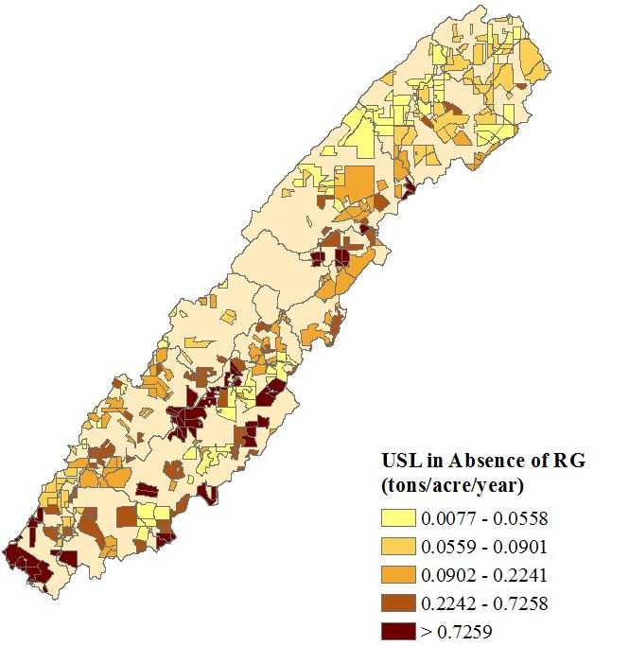
Figure 18: USL in Absence of RG (tons/acre/year)

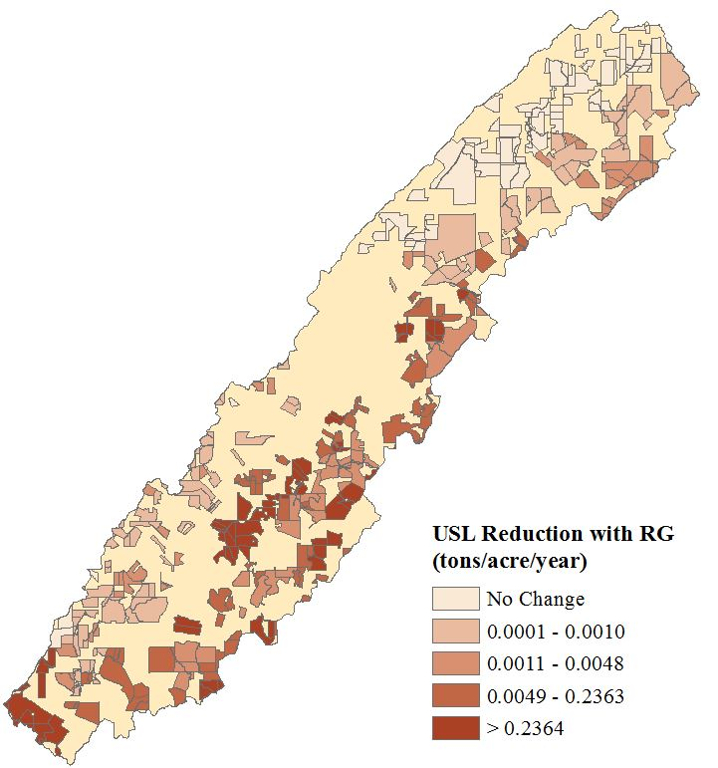
Figure 19: USL Reduction (tons/acre/year) with Full Adoption of RG

The degree of correlation between the USL rate in the absence of RG, and the difference in USL after adoption was 99.98%. As expected, the USL levels were clustered in fairly uniform areas of high and low USL output. For instance, the northernmost area of the watershed has lower USL levels in the presence of overgrazing (as depicted in Figure 18) compared to the rest of the watershed; thus RG slightly reduces USL on these parcels compared to the rest of the watershed, as depicted in Figure 19. The rate of USL is fairly low in OCW (most parcels well below 1 ton/acre/year) compared with the average rates USL rates on pastureland across the United States, which as previously stated totals approximately 2.43 tons/acre/year (USDA-NASS, 2003).

USL Abatement Curves
Figure 20 is an inverted linear regression of USL abatement (tons/year) on the USL that is estimated to occur at each hypothetical cost-share level (equation 14). The x-axis is USL abatement in tons/year. The y-axis is the cost share range. The figure represents the cost of abatement ($/ton) on USL reduction at each of the cost-share values offered to the survey respondents. The HRUs in Figure 20 are ranked according to efficiency based on the slope of each HRU curve. The flatter the slope of the HRU curve, the higher the response to USL abatement according to cost share level. The HRUs that exhibit a weaker USL response to BMP cost-share levels have a steeper slope. Therefore, HRU efficiency may be ranked depending on the slope of each HRU’s linear regression.
Each subbasin included in the USL regression is highlighted in a unique color in Figure 21. The subbasins not represented in the regressions are shaded gray. An issue arises when comparing the USL output aggregated across HRUs for each BMP combination. In the RG and

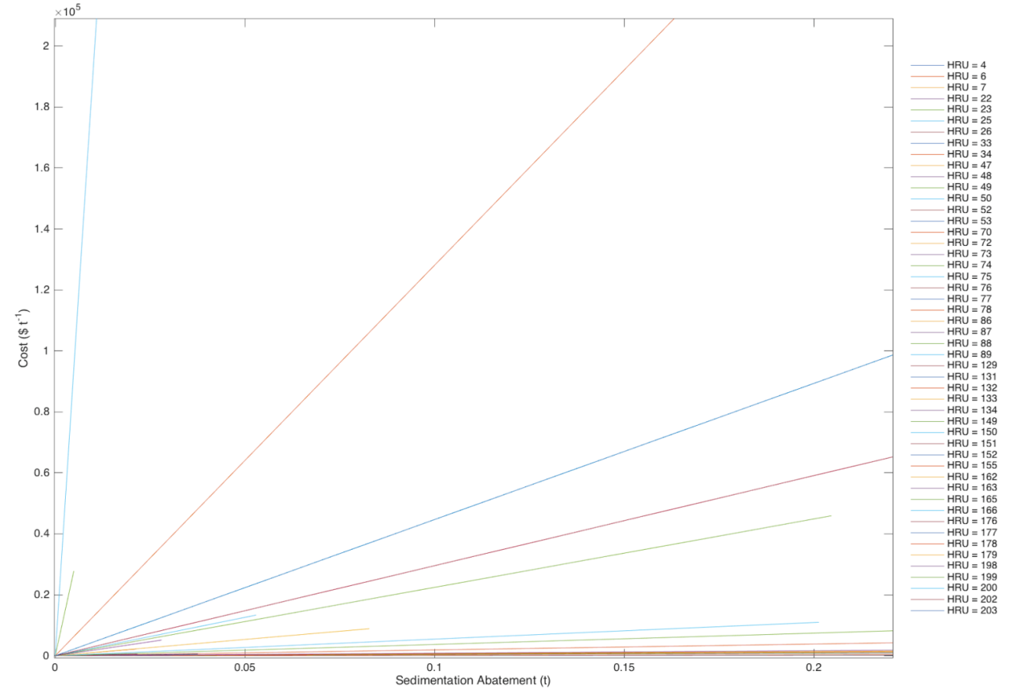
Figure 20: USL Abatement by HRU at Various Costs for the RG Scenario

WT scenarios, 48 HRUs are represented, and 55 HRUs are represented in the other scenarios. The reason for the difference in HRU representation is that HRUs in the RG and WT scenario exhibited a perfectly inelastic incentive response to USL abatement (according to the regression equation 14), and thus HRUs in subbasins 3 and 7 were not included in the analysis.

Aggregate USL Abatement Curves
The USL abatement curves were aggregated by HRUs for each BMP technology combination, focusing explicitly on changing the RG incentive, all else equal. USL abatement was horizontally summed across all HRUs. The following four curves, Figures 22 to 25 are abatement supply curves in the OCW. The cost in $/ton of USL is on the y-axis and USL abatement is on the x-axis. The abatement is measured in $/ton/year of USL because these aggregate abatement curves represent information from the policy-makers’ perspective (who are interested in the total USL effect). Since it is assumed that producers are already maximizing profit by adopting BMP combinations with a cost-share scenario, the economics of adopting BMPs from the producer perspective is not explicitly modeled.
Figure 22 represents the aggregated USL abatement in tons/year for the scenario in which only RG is used: $Pr(Y_{RG}=1, Y_{WT}=0, Y_{SC}=0, Y_{PI}=0)$. There are 55 HRUs included in this scenario. Cost-share levels have the greatest impact on USL abatement going from 0 to 1,370 tons/year abated at a cost of approximately $3/ton/year. Subsequently, the abatement curve becomes steeper; e.g., inelastic to the incentive level. The maximum possible USL abatement is 1,450 tons/year at a cost of $170/ton/year. To achieve a 1,450 ton/year reduction in USL with perfect price discrimination, the total abatement cost would be approximately $8,805 (found by integrating underneath the aggregate abatement curve). Perhaps a more practical estimate of the
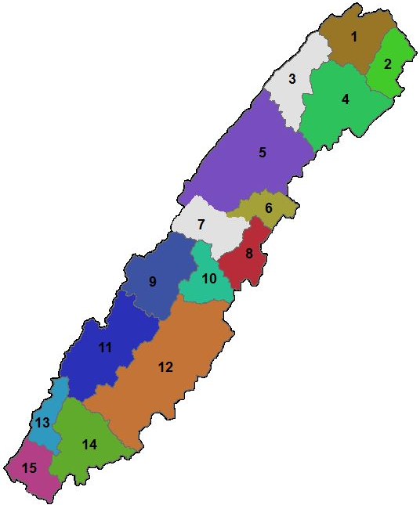
Figure 21: Subbasins Represented in the USL Abatement Regression

Figure 22: Aggregated USL Abatement Levels (tons/year) for the RG Scenario: Pr(Y_RG=1,Y_WT=0,Y_SC=0,Y_PI=0)

Figure 23: Aggregated USL Abatement Levels (tons/year) for the Rotational Grazing, Stream Crossing and Water Tank Scenario: Pr(Y_RG=1,Y_WT=1,Y_SC=1,Y_PI=0)

Figure 24: Aggregated USL Abatement Levels (tons/year) for the Rotational Grazing and Stream Crossing Scenario: Pr(Y_RG=1,Y_WT=0,Y_SC=1,Y_PI=0)

Figure 25: Aggregated USL Abatement Levels (tons/year) for the Rotational Grazing and Water Tank Scenario Pr(Y_RG=1,Y_WT=1,Y_SC=0,Y_PI=0)

total programmatic costs assumes no price discrimination. Without assuming price discrimination, the cost to achieve 1,450 tons/year of USL abatement is $246,500 (a product of 1,450 tons/year and $170/tons/year). The same method could be applied to any target level of USL along the curve. One finding is that although the maximum cost-share level of $40.00/acre for RG achieves a 1,450 ton/year reduction in USL, it falls short of the previously specified 7134 ton/year reduction target (Hagen and Walker, 2007) in the OCW. This shortfall indicates that other actions in the watershed beyond the adoption of RG are needed to achieve government specified USL reduction goals.
Figure 23 represents the aggregated USL abatement in tons/year where RG, SC and WTs are used: $Pr(Y_{RG}=1, Y_{WT}=1, Y_{SC}=1, Y_{PI}=0)$. There are 55 HRUs included in this scenario. This bundled BMP scenario yields a slightly less elastic abatement curve. At a payment of $46/ ton/year, USL is reduced by approximately 165 tons/year. The total possible USL abatement is 170 tons/year at a cost of approximately $130/ton/year. Integrating the curve to represent perfect price discrimination for the scenario in Figure 23 yields a total cost of $1604 to achieve the maximum USL reduction of 170 tons/year. However, assuming no price discrimination, the total cost in providing $130/ton across the watershed, the total cost to reduce the USL by 170 tons is $22,100.
Figure 24 represents the aggregated USL abatement in tons/year where RG and SC technologies are used: $Pr(Y_{RG}=1, Y_{WT}=0, Y_{SC}=1, Y_{PI}=0)$. A total of 54 HRUs are included in this analysis. USL abatement is approximately 370 tons/year for a cost of $50/ton/year. The total possible USL abatement is 380 tons/year at a cost of $163/tons/year. Integrating the curve for the scenario in Figure 24 yields a total cost of $2,370 to achieve the maximum USL reduction of 380 tons/year of USL under perfect price discrimination. Without assuming price discrimination, achieving 380 tons/year of USL would cost $61,940.
Figure 25 represents the aggregated USL abatement in tons/year where RG and WTs are used. There are 48 HRUs included in this scenario. There are fewer HRUs represented in this regression because some HRUs exhibited zero abatement potential (due to negative cross price effects and negative correlation of the error terms). As a result, the USL abatement potential for the RG and WT scenario is less than the other BMP scenarios in this analysis. As an example of policy analysis, Figure 25 indicates that if policy makers were to provide $45/ton/year for USL abatement, the result will be 21 tons/year of USL abatement. The total possible USL abatement is 23 tons/year at a cost of $185/tons/year. Under price discrimination, Figure 25 yields a total cost of $446 to achieve the maximum USL reduction of 23 tons/yr. Where price discrimination is not practical, the total cost of reducing USL by 23 tons costs $4,255.
Policy implications of the BMP scenarios include calculating the total potential of USL abatement, and the cost to achieving the maximum abatement goals. The USL impact of PI was not included in the analysis, since none of the cost-share values had a statistically significant effect on PI adoption. Table 13 details the maximum USL that may be abated for each BMP scenario. Suppose policy makers aimed to reduce over 1,000 tons of USL. The RG scenario would be the optimal BMP scenario because it is the only scenario in which a reduction over 1,000 tons is possible. Using the aggregated USL abatement curves, it is possible to compare the USL reduction possible at a given cost/tons/year. For instance, comparing the cost of USL reduction at the maximum USL abatement seems to indicate that scenario 3 is the most cost effective (170 tons of USL is abated). However, given a budget of $120 ton/year of USL abated,
Table 13: BMP Scenarios with Corresponding Maximum USL Abatement and Cost
Scenario | Rotational Grazing | Pasture Improvement | Stream Crossing | Water Tanks | Cost ($/t/yr) |  | Max. USL  Abatement (t/yr)
1 | ✗ |  |  |  |  | 170 | 1,450
2 | ✗ |  |  | ✗ |  | 185 | 23
3 | ✗ |  | ✗ | ✗ |  | 130 | 170
4 | ✗ |  | ✗ |  |  | 163 | 380

scenario 1 would achieve 1,423 tons/year of USL abatement, scenario 2 would result in approximately 21 tons/year abated, 167 tons/year abated for scenario 3 and 373 tons/year abated for scenario 4.Therefore, if the goal was to abate the maximum tons of USL at $120/ton, the optimal choice is scenario 1.

CHAPTER 6: CONCLUSION
The goals of this research were to 1) propose a methodology to link primary survey data on WTA RG with a biophysical-hydrological modeling system, 2) estimate the relationship between cost-shares for BMPs among livestock producers, and 3) estimate the change in USL associated with RG adoption. To analyze this relationship, first survey data from livestock producers in a watershed in southeastern Tennessee was analyzed. Secondly, the biophysical land characteristics of the watershed were determined to estimate annual USL loads using the biophysical modeling tool SWAT. The willingness to adopt BMPs was estimated using the survey data, to determine the influence of previous BMP use, farmer and farmland characteristics on the future adoption of BMPs. With the willingness to adopt BMPs estimated, SWAT was used to estimate the total USL load by incorporating the physical land characteristics (slope, soil type and land use) of each parcel surveyed.
Younger, higher educated livestock producers who planned to pass on their farm to future generations were more likely to adopt the BMPs included in the survey. The previous use of PI was positively correlated with the adoption of all four of the BMPs. The own cost share effect for implementing PI was not statistically significant, although many producers already have PI in use. The own cost share levels for RG, WTs and SC were statistically significant.
The USL abatement analysis was conducted to examine trade-offs among producer costs for operation and pollution abatement attributed to BMP adoption. By linking WTA estimates from the surveys with the SWAT model, costs and USL reduction benefits from BMP adoption were estimated. As previously stated, the target USL reduction for the OCW was estimated to be 7134 tons/year (Hagen and Walker, 2007). However, setting the BIO-MIN value to the extremes to simulate the effect of rotational grazing (0 lb/acre of dry forage to simulate overgrazing and 500 lb/acre of dry forage to simulate rotational grazing practice) and paying the highest cost-share level ($40.00/acre), only 1,450 tons/year of USL abatement will occur for the RG bundle. Despite a shortfall in achieving the target USL abatement in the OCW with RG alone at $40.00/acre, linking the probability of adoption of RG to the predicted reduction in USL is important in determining the cost of USL abatement, sustainable soil use and healthy watershed maintenance. A limitation of this study is that rather than adopting RG on highly erodible land, a producer may opt to purchase hay to feed to livestock, rather than having the cattle rely on grazing. The option for purchasing hay was not included in this study. Also, favorable environmental factors conducive to forage production may also diminish interest in RG adoption. USL estimates were averaged over a 10 year time period, so the WTA BMPs based on weather patterns was not explicitly addressed.
Future research could more accurately estimate the relationship between cost-shares for BMPs and improvement of water quality in the OCW by incorporating USL estimates of the other BMPs (SC, WT, and PI) in SWAT. Estimating the total USL for all four BMPs will provide policy makers with a total USL estimate for various BMP bundles, taking into account cross price effects and correlation in the error terms. This knowledge will increase efficiency in programs seeking to reduce soil erosion because producers who manage operations on high-impact HRU areas may appropriate targets for cost-share opportunities.

REFERENCES

Arnold J.G., D.N. Moriasi, P.W. Gassman, K.C. Abaspour, M.j. White, R. Srinivasan, C. Santhi, R.D. Harmel, A. van Griensven, M. W. Van Liew, N. Kannan, M.K. Jha. “SWAT: Model Use, Calibration, and Validation.” Transactions of the ASABE 55(2012):1491-1508. http://swat.tamu.edu/media/99051/azdezasp.pdf
Bhattarai, R., and D. Dutta. "Estimation of Soil Erosion and Sediment Yield using GIS at Catchment Scale." Water Resources Management 21(2007): 1635-1647.
Burt, O.R. “Farm Level Economics of Soil Conservation in the Palouse Area of the Northwest.” American Journal of Agricultural Economics 63(February 1981):83-92.
Belknap, J., and W.E. Saupe. “Farm Family Resources and the Adoption of No-Plow Tillage in Southwestern Wisconsin.” North Central Journal of Agricultural Economics 10(January 1988):13-23.
Campbell, L.C. “Managing Soil Fertility Decline.” Journal of Crop Production 1(1998):29–52.
Chanas, S., and P. Zielinski. “On the Equivalence of Two Optimization Methods for Fuzzy Linear Programming Problems.” European Journal of Operational Research 121(2000): 56–63.
Clark, C.D., W.M. Park, and J. Howell. “Tracking Farmland Conversion and Fragmentation Using Tax Parcel Data”. Journal of Soil and Water Conservation 61 (2006): 243 –249.
Clark, E.H. “The Off-Site Costs of Soil Erosion.” Journal of Soil and Water Conservation 40(1985):19-22.
Cooper, J.C. “Combining Actual and Contingent Behavior Data to Model Farmer Adoption of Water Quality Protection Practices.” Journal of Agricultural and Resource Economics 782(July 1997):30–43.
Cooper, J.C., and G. Signorello. “Farmer Premiums for the Voluntary Adoption of Conservation Plans.” Journal of Environmental Planning and Management 785(2008):1–14.
Cooper, J.C. "A Joint Framework for Analysis of Agri-Environmental Payment Programs." American Journal of Agricultural Economics 85(2003): 976-987.
Cui, L., L.R. Chen, Y.P. Li, G.H. Huang, W. Li, and Y.L. Xie. “An interval-based regret-analysis method for identifying long-term municipal solid waste management policy under uncertainty. Journal of Environmental Management” 92(2011):1484–1494.
Dillman, A. 2000. Mail and Internet Surveys: The Tailored Design Method. 2nd ed. New York: John Wiley & Sons, Inc.
Ervin, C.A., and D.E. Ervin. “Factors Affecting the Use of Soil Conservation Practices: Hypotheses, Evidence, and Policy Implications.” Land Economics 58(August 1982):277-92.
Färe, R., and S. Grosskopf. "Shadow Pricing of Good and Bad Commodities." American Journal of Agricultural Economics 80(May 1998):584-590.
Feng, H., L.A. Kurkalova, C.L. Kling, and P.W. Gassman. "Environmental Conservation in Agriculture: Land Retirement vs. Changing Practices on Working Land." Journal of Environmental Economics and Management 52(July 2006): 600-614.
Fu, Y.C., B.Q. Ruan, and T. Gao, “Watershed Agricultural Non-Point Source Pollution Management.” Polish Journal of Environmental Studies 22(2013):367-375.
Gassman, P.W., M.R. Reyes, C.H. Green, and J.G. Arnold "The Soil and Water Assessment Tool: Historical Development, Applications, And Future Research Directions." Working Paper for the Center for Agricultural and Rural Development, Iowa State University, 2007: 1211-1250.
Gooday, R.D., S.G. Anthony, D.R. Chadwick, P. Newell-Price, D. Harris, D. Duethmann, R. Fish, A. L. Collins, and M. Winter. "Modelling the Cost-Effectiveness of Mitigation Methods for Multiple Pollutants at Farm Scale." Science of the Total Environment 468(2014): 1198-1209.
Govindasamy, R., and M. Cochran. "Conservation Compliance Program and the Best Management-Practices-An Integrated Approach for Economic-Analysis." American Journal of Agricultural Economics 75(1993):1296-1296.
Govindasamy, R., and W. Huffman. "Efficiency of United-States Conservation-Compliance Program." Agricultural Economics 8(1993):173-185.
Hagen, J., and F. Walker. “Oostanaula Creek Watershed Restoration Plan.” Department of Biosystems Engineering and Soil Sciences, Extension, University of Tennessee. (November 2007). Internet site: http://ocw.ag.utk.edu/Management-Plan.htm (Accessed April 10, 2015).
Herr, J.W., C. W. Chen, R. A. Goldstein, and J. N. Brogdon. "A Tool for Sediment TMDL Development on Oostanaula Creek." Paper presented at the American Society of Agricultural and Biological Engineers, Chicago, IL July 29-31, 2012.
Hoorman, J., and J. McCutcheon. “Best Management Practices to Control the Effects of Livestock Grazing Riparian Areas.” Ohio State University Extension Fact Sheet - School of Environment and Natural Resources. Internet site: http://ohioline.osu.edu/ls-fact/0004.html (Accessed July 7, 2015).
Hu, Q., G.H. Huang, Y.P Cai, and W. Sun, “Planning of Electric Power Generation Systems Under multiple Uncertainties and Constraint-Violation Levels.” Journal of Environmental Informatics 23(2014):55–64.
Huang, G.H., B.W. Baetz, and G.G. Patry. “A Grey Fuzzy Linear Programming Approach for Municipal Solid Waste Management Planning Under Uncertainty.” Civil Engineering Systems 10(1993):123–146.
Ice, G. “History of Innovative Best Management Practice Development and its Role in Addressing Water Quality Limited Waterbodies.” Journal of Environmental Engineering 130(June 2004):684-689.
James, W. L., Morton, A. B., Joseph, F. D., and Ranjithan, S. R. “A Generalized Multistage Optimization Modeling Framework for Life Cycle Assessment-Based Integrated Solid Waste Management.” Environmental Modelling & Software 50(2013):51–65.
Jang, T., G. Vellidis, L.A. Kurkalova, J. Boll, and J.B. Hyman. "Prioritizing Watersheds for Conservation Actions in the Southeastern Coastal Plain Ecoregion." Environmental management 55(2015): 657-670.
Jeffrey, S.R., S. Koeckhoven, D. Trautman, B. Dollevoet, J.R. Unterschultz, and C. Ross. “Economics of riparian beneficial management practices for improved water quality: A representative farm analysis in the Canadian Prairie region” Canadian Water Resources Journal / Revue canadienne des ressources hydriques 39(2014):449-461.
Jensen, K., D. Lambert, C.D. Clark, C. Holt, B. English, J. Larson, T.E. Yu, and C. Hellwinckel. “Cattle Producers’ Willingness to Adopt or Expand Prescribed Grazing in the United States.” Journal of Agricultural and Applied Economics 50(2015):1-30.
Jha, M.K., S. Rabotyagov, and P.W. Gassman. “Optimal Placement of Conservation Practices Using Genetic Algorithm with SWAT.” Working paper, Center for Agricultural and Rural Development, Iowa State University, 2009.
Jianchang, L., Z. Luoping, Z.Yuzhen, and D. Hongbing. "Trade-Off Between Water Pollution Prevention, Agriculture Profit, and Farmer Practice—An Optimization Methodology for Discussion on Land-Use Adjustment in China." Environmental Monitoring and Assessment 187 (2015):1-13.
Khanna, M., W.H. Yang, R. Farnsworth, and H. Onal. "Cost-effective Targeting of Land Retirement to Improve Water Quality with Endogenous Sediment Deposition Coefficients." American Journal of Agricultural Economics 85(August 2003):538-553.
Knowler, D., and B. Bradshaw. “Farmers' Adoption of Conservation Agriculture: A Review and Synthesis of Recent Research.” Food Policy 32(February 2007):25-48.
Kuhlman, T., T. Reinhard, and S. Gaaff . "Estimating the Costs and Benefits of Soil Conservation in Europe." Land Use Policy 27(January 2010):22-32.
Kurkalova, L., C. Kling, and J. Zhao. "Green subsidies in agriculture: Estimating the Adoption Costs of Conservation Tillage from Observed Behavior." Canadian Journal of Agricultural Economics/Revue canadienne d'agroeconomie 54 (2006): 247-267.
Lambert, D. M., P. Sullivan, R. Claassen, and L. Foreman. "Profiles of US Farm Households Adopting Conservation-Compatible Practices." Land Use Policy 24(2007): 72-88.
Lambert, D.M, C.D. Clark, N. Busko, F.R. Walker, A. Layton, and S. Hawkins. “A study of Cattle Producer Preferences for Best Management Practices in an East Tennessee Watershed.” Journal of Soil and Water Conservation 69(January-February 2014):567- 579.
Lee, Y. W., I. Bogardi, and J. Stansbury. “Fuzzy Decision Making in Dredged-Material Management.” Journal of Environmental Engineering 117(1991):614–628.
Li, Y. P., G.H. Huang, H.Z. Li, and J. Liu. “A Recourse Based Interval Fuzzy Programming Model for Point–Nonpoint Source Effluent Trading Under Uncertainty.” Journal of the American Water Resources Association (JAWRA) 50(April 2014):1191-1207.
Lichtenberg, E. "Cost-Responsiveness of Conservation Practice Adoption: A Revealed Preference Approach." Journal of Agricultural and Resource Economics 29(3):420-435.
Liu, J.C., L.P. Zhang, Y. Zeng, N.W. Chen, W.C. Chen, Y.Y. Li, and H.S. Hong “Mixed Integer Programming for a Swine Manure Handling System in the Jiulong River Watershed.” Aquatic Ecosystem Health and Management 9(2006):33–38.
Loomis, J.B. "Strategies for Overcoming Hypothetical Bias in Stated Preference Surveys." Journal of Agricultural and Resource Economics 39(2014): 34-46.
McConnell, K.E. “An Economic-Model of Soil Conservation.” American Journal of Agricultural Economics 65(February 1983):83-89.
DC., National Research Council, National Academy of Sciences, National Academies Press.
Nash, D., and M. Hannah. “Using Monte-Carlo Simulations And Bayesian Networks To Quantify And Demonstrate The Impact Of Fertiliser Best Management Practices.” Environmental Modelling & Software 26(September 2011): 1079-1088.
Nowak, P. J. "The Costs of Excessive Soil-Erosion." Journal of Soil and Water Conservation 43(July-August 1988):307-310.
Pimentel, D. “Soil Erosion: A Food and Environmental Threat.” Environment, Development and Sustainability 8(2006)119-137.
Pimentel, D., C. Harvey, P. Resosudarmo, K. Sinclair, D. Kurz, M. McNair, S. Crist, L. Shpritz, L. Fitton, R. Saffouri, and R. Blair. "Environmental and Economic Costs of Soil Erosion and Conservation Benefits." Science 267(February 1995):1117-1123.
Prokopy, L.S., K. Floress, D. Klotthor-Weinkauf, and A. Baumgart-Getz. “Determinants of Agricultural Best Management Practice Adoption: Evidence from the Literature.” Journal of Soil and Water Conservation 63(September-October 2008):300-311.
Ritter, J. “Soil Erosion – Causes and Effects.” Ontario Ministry of Agriculture and Rural Affairs. (2012). Internet site: http://www.omafra.gov.on.ca/english/engineer/facts/12-053.htm (Accessed March 19, 2015).
Roodman, D. Fitting Fully Observed Recursive Mixed-Process Models with CMP. The Stata Jounal 11(2011)159-206.
Santhi, C., R.S. Muttiah, J.G. Arnold, and R. Srinivasan. “A GIS-Based Regional Planning Tool for Irrigation Demand Assessment and Savings Using SWAT.” American Society of Agricultural Engineers 48(2005):137-147.
SAS Statistical Analysis Software, Version 9.2. %MkTex Macro. Cary, NC. http://support.sas.com/techsup/technote/mr2010mktex.pdf.
Sheshukov, A.Y., K.R. Douglas-Mankin, S. Sinnathamby, and P. Daggupati. "Pasture BMP Effectiveness using an HRU-Based Subarea Approach in SWAT." Journal of Environmental Management 166(2016): 276-284.
Signore, A.M. “Willingness to Adopt Best Management Practices by Beef Cattle Producers in a Southeastern Tennessee Watershed.” Master’s thesis, University of Tennessee, August 2014.
Smith, C.M, J.R. Williams, A. Nejadhashemi, S.A. Woznicki, and J.C. Leatherman. "Cost-Effective Targeting for Reducing Soil Erosion in a Large Agricultural Watershed." Journal of Agricultural and Applied Economics 46(November 2014):509-526.
Soil Survey Staff, Natural Resources Conservation Service, United States Department of Agriculture. U.S. General Soil Map (STATSGO2). Available online at http://sdmdataaccess.nrcs.usda.gov/ (Accessed July 15, 2015d).
Tennessee Department of Environment and Conservation (TDEC). “Tennessee Healthy Watershed Initiative.” Internet site: http://www.tennessee.gov/environment/water/water_tn-healthy-watershed-initiative.shtml (Acessed March 18, 2015).
Tennessee Department of Environment and Conservation (TDEC): Planning and Standards Unit – Division of Water Resources. “Draft: Year 2014 303(d) List.” (July 2014). Internet site: http://www.tn.gov/environment/water/docs/wpc/2014-draft-303d-list.pdf (Accessed April 10, 2015).
United States Congress. “Federal Water Pollution Control Act.” House of Representatives, Comm. on Transportation and Infrastructure, Senate, Comm. on Environment and Public Work. (2002). Internet site: www.epw.senate.gov/water.pdf (Accessed March 3, 2015).
United States Department of Agriculture – National Agricultural Statistics Service (USDA-NASS) Frontiers in Agricultural Research: Food, Health, Environment and Communities. Washington, DC: National Research Council, National Academy of Sciences, National Academies Press, 2003.
United States Department of Agriculture–Natural Resources Conservation Service (USDA-NRCS). “Soil Quality Resource Concerns: Soil Erosion.” (1996). Internet site: http://www.nrcs.usda.gov/Internet/FSE_DOCUMENTS/nrcs142p2_051278.pdf (Accessed March 15, 2015).
United States Department of Agriculture–Natural Resources Conservation Service (USDA-NRCS) “Rotational Grazing: Small Scale Solutions for your Farm.” (2009). Internet site: http://www.nrcs.usda.gov/Internet/FSE_DOCUMENTS/stelprdb1167364.pdf (Accessed March 15, 2015).
United States Department of Agriculture- Natural Resources Conservation Service (USDA-NRCS). “Geospatial Data Gateway.” https://gdg.sc.egov.usda.gov/. (Accessed June 19, 2015a).
United States Department of Agriculture – Natural Resources Conservation Service (USDA-NRCS). “Environmental Quality Incentives Program.” Inernet Site: http://www.nrcs.usda.gov/wps/portal/nrcs/main/national/programs/financial/eqip/ (Accessed March 18, 2015b).
United States Department of Agriculture – Natural Resources Conservation Service (USDA-NRCS) “National Soil Erosion Results Tables” Internet site: http://www.nrcs.usda.gov/wps/portal/nrcs/detail/national/technical/nra/nri/results/?cid=stelprdb1041678 (Accessed June 20, 2015c).
United States Department of Agriculture-Natural Resources Conservation Service (USDA-NRCS) “Conservation Practices” Internet site: http://www.nrcs.usda.gov/wps/portal/nrcs/detailfull/national/technical/cp/ncps/?cid=nrcs143_026849 (Accessed June 11, 2016).
White, M., Storm, D., Demissie T., Zhang H., and Smolen M., “Pasture Phosphorus Management (PPM) Calculator.” Technical Documentation Version 1.0: Soil Water Assessment Tool, Oklahoma State University, December 31, 2003.
Zellner, A. "An Efficient Method of Estimating Seemingly Unrelated Regressions and Tests for Aggregation Bias." Journal of the American Statistical Association 57(1962):348-368.

APPENDIX

Figure A-1: Excerpt of the Choice Experiment as Outlined in the Survey

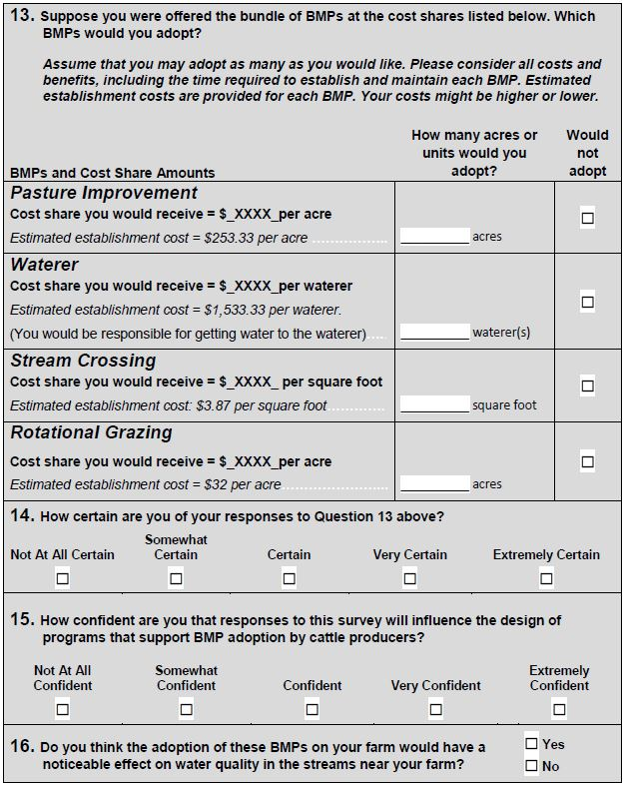

VITA

Laura Jane Medwid is from Pickering, ON Canada. She attended Pine Ridge Secondary School, graduating with honors in 2006. Laura completed her undergraduate course study at the University of Ottawa, earning a Bachelor of Social Sciences in International Development and Globalization. During her degree she worked as a Co-op student for two government agencies: the Financial Transactions and Reports Analysis Centre of Canada (FINTRAC) and the Canadian International Development Agency (CIDA). She also completed an internship abroad in Hohoe, Ghana coordinating youth awareness and education programs. Upon completion of her undergraduate degree in 2011, Laura spent a year in Grenoble, France as an Au-pair and taking French classes. She was as a Compliance Administrator for Laurentian Bank upon returning to Canada. Laura accepted a graduate research assistantship from the Agricultural and Natural Resource Economics Department at The University of Tennessee in the fall of 2014 and expects to graduate with a Master of Science degree in Agricultural Economics and a Minor in Statistics in August, 2016.

Dr. Shawn Hawkins and Hannah McClellan generously provided the data, calibration and simulation output for this thesis.

