Dissolved Organic Carbon and the Potential Role to Stream Acidity
in the Great Smoky Mountains National Park

A Thesis Presented for the
Master of Science
Degree
The University of Tennessee, Knoxville

Jason Robert Brown
August 2021
ACKNOWLEDGEMENTS
I would first like to thank my wife, Candice McQueen, for tolerating my carbonic ramblings, accompanying me on long days in the field, and encouraging me during long nights of data crunching. I would also like to thank Dr. John Schwartz for providing me the opportunity to be a part of this study as well as Dr. Daniel Yoder, Dr. Mike Essington, and Dr. Qiang He for their collective guidance during the chaos of this process. My appreciation also extends to Matt Kulp and Caleb Abramson for their role in connecting me with this research and logistical efforts involved in sample collections in Great Smoky Mountains National Park and Galina Melnichenko for her patience when dealing with a certain temperamental piece of lab equipment. None of this would be possible without each of your efforts and I am deeply thankful.

ABSTRACT
A substantial societal shift towards environmental awareness has focused research efforts on the impacts of pollution on natural landscapes. Improvements to pollutant regulations and technology have resulted in sizeable reductions of atmospheric deposition of anthropogenic acids, especially nitrates and sulfates, which has altered the role of these ions in the environment. As such, understandings of environmental chemistry dynamics have required regular updating.
Through the National Park Service Vital Signs monitoring program, increases in precipitation pH observed in Great Smoky Mountains National Park (GRSM) has been attributed to the reduction of inorganic acid concentrations. Unfortunately, these improvements have not been uniformly reflected in stream waters across the park. As such, intra-soil and stream water chemical interactions require scrutiny for an explanation. Specifically, the dissolved organic carbon (DOC) concentrations are targeted within this research to determine their impact.
GRSM stream waters were monitored on a bimonthly basis throughout the year of 2020. Ambient baseflow DOC concentrations were quantified, ranging from <0.08 mg L⁻¹ to 9.38 mg L⁻¹, and general variations between watersheds were revealed that restrict direct comparisons from one watershed to another. Positive relationships for DOC concentrations with elevation, drainage area, and drainage density were then determined. Additionally, DOC concentrations were found to have correlations with calcium, potassium, nitrate, and acid neutralizing capacity. Stepwise regression analysis then determined a predictive model for DOC concentrations with calcium and potassium having positive relationships and nitrate having a negative relationship.
Overall, this study established a foundational characterization of DOC concentrations in GRSM streams and suggests indirect consequences to reductions in inorganic acid deposition, likely through soil-based interactions. Continued analysis beyond the research presented here is best directed to DOC compositional evaluations to quantify and understand organic acids, soil solution analysis to determine contained DOC interactions, and temporal trends to enhance predictability and appropriate management.
Table of Contents
SECTION A: 1
1. INTRODUCTION: 2
2. METHODS: 6
Study Area 6
Study Design 7
Water Sample Chemistry Analysis 8
Statistical Analysis 9
3. RESULTS: 11
Watershed DOC Concentrations 11
Relationships between DOC and Watershed Conditions 12
Relationships between Stream DOC and Inorganic Chemistry 12
4. DISCUSSION: 14
5. CONCLUSIONS: 20
SECTION B: 22
REFERENCES: 23
APPENDICES: 27
Appendix A: Review of Literature 28
Appendix B: Tables & Figures 34
Appendix C: Supplemental Tables & Figures 43
VITA: 49

List of Tables
Table 1: Field and quality assurance sample and subsample production design and schedule 34
Table 2: Analytical procedures and reference materials 34
Table 3: Summary of dissolved organic carbon concentrations in GRSM separated by watershed, 2020 35
Table 4: ANOVA and Tukey HSD results of watershed comparisons for GRSM DOC data, 2020 35
Table 5: GRSM DOC concentrations according to elevation, drainage area, and drainage density, 2020 36
Table 6: ANOVA results of DOC concentration comparisons for elevation, drainage area, and drainage density subcategories 36
Table 7: ANOVA and Tukey HSD test results from drainage area data 37
Table 8: Data transformations performed for normalization of GRSM 2020 dataset 37
Table 9: Pearson correlation coefficients between 2020 GRSM dataset components 38
Table 10: Linear regression evidence of DOC vs. pH, specific conductivity, and sulfate concentrations 38
Table A1: 2020 GRSM DOC data QA/QC check data – DOC concentration replication difference 43
Table A2: 2020 GRSM DOC data QA/QC check data – blank deionized water DOC concentration 43
Table A3: 2020 GRSM DOC data regression analysis statistics 43
Table A4: 2020 GRSM DOC data regression coefficients 43
Table A5: Chemical component summary for GRSM DOC study, 2020 44
Table A6: Tennessee-side GRSM 2020 DOC concentration study sample site descriptions and locations 44
Table A7: North Carolina-side GRSM 2020 DOC concentration study sample site descriptions and locations 45

List of Figures
Figure 1: Great Smoky Mountains National Park regional location and boundary 39
Figure 2: Targeted watersheds in Great Smoky Mountains National Park dissolved organic carbon study, 2020 39
Figure 3: Great Smoky Mountains National Park dissolved organic carbon study sample site locations, 2020 40
Figure 4: Dissolved organic carbon concentrations in GRSM during calendar year 2020 separated by watershed 40
Figure 5: 2020 GRSM dataset variable transformation histograms 41
Figure 6: Q-Q plot of standardized residuals following stepwise regression analysis of 2020 GRSM DOC dataset 42
Figure 7: Scatterplot of residuals following stepwise regression analysis of 2020 GRSM DOC dataset 42
Figure A1: Dissolved organic carbon vs. test parameters (set 1) 46
Figure A2: Dissolved organic carbon vs. test parameters (set 2) 47
Figure A3: Dissolved organic carbon vs. test parameters (set 3) 48
SECTION A

1. INTRODUCTION
Atmospheric deposition of acid pollutants has significantly impacted stream water quality in forested landscapes of the southeastern United States with base-poor geology (Cai et al., 2011a; Kline et al., 2016; Lawrence & Roy, 2020). Sulfur- and nitrogen-acids being emitted from local power plants, agriculture, and vehicular traffic have compelled legislation such as the Clean Air Act Amendments of 1990, which altered standards in emissions laws and led to as much as 40% reductions in pollutant deposition in the eastern United States (Burns et al., 2006; Kline et al., 2016). The National Park Service (NPS) has monitored these trends through their Vital Signs monitoring programs since 1993 in areas such as the Great Smoky Mountains National Park (GRSM) to ensure proper management of the natural resources available in public lands. Like many trend observations across the eastern United States, watersheds in GRSM are not showing uniform improvements from stream acidification, creating a patchwork of recovered and afflicted watersheds (Bohlke & Michel, 2009; Gonzalez, 2018; Kline et al, 2016; Lawrence & Roy 2020; Lindberg & Lovett, 1992; Rice et al, 2014; Spratt, 1998).
Past research on multiple factors has contributed to our current understanding of stream acidity to varying degrees, including local soil characteristics, broader basin factors, and environmental capacities to compensate for changes in the levels of sulfate and nitrate deposition. Forest composition, disturbance of soils and/or pyritic geology, latent nitrate and sulfate bound in soils, and base cation depletion in soils and water are known causes for continued stream acidity and how base cations are exchanged under the canopy (Draaijers & Erisman, 1995; King et al., 2006; Neff et al., 2013). On a local scale, soil depths are positively correlated with sulfate retention capacities while nitrate retention is negatively correlated with soil depth and indirectly dependent on elevation through variations in forest composition (Moiseenko & Dinu, 2015). Acid neutralizing capacity (ANC) is also of interest since values 20 μeq L⁻¹ and below indicate a waterbody with a particular sensitivity to episodic acidification which threatens populations of local aquatic biota (Sullivan et al., 2007).
Aside from the direct impacts, natural processes within the environment complicate the stream response to reduced inorganic acid deposition through several biogeochemical processes. Intra-soil nitrification can produce more than 93% of internally sourced protons and the mineralization of organic sulfur and desorption of inorganic sulfate have been suggested as hinderances to stream acidity improvements in GRSM (Cai et al., 2011a; Cai et al., 2012; Borken et al., 2011). To counter these conditions, charge balances in soil cation exchange capacities and water ANC are commonly maintained by base cations, such as potassium, calcium, and magnesium. Of course, all these interactions are operating simultaneously which compels a collective consideration. Conversely, no previous explanations can be deemed completely conclusive, further warranting complementary monitoring efforts and research.
A potential factor to stream acidity, naturally occurring carbon sources, specifically organic acids, are possible influencers of stream water chemistry responses, or lack thereof, to decreased atmospheric acidic deposition. Organic acids (OA) are molecules of medium to high molecular weight formed during plant residue decay with various functional groups and structures producing assorted charge densities and hydrophobicity (de Haan, 1992; de Wit et al., 2007; Evans et al., 2005). OA tend to have a brown coloration and are composed of humic and fulvic acids, with the former having a larger molecular weight and lower density of functional groups than the latter (de Wit et al., 2001; Evans et al., 2005; Moiseenko & Dinu, 2015). Studies have found negative relationships between mineral and organic acidity in soils and streams of Europe and North America with indications that ionic strength account for some variation in OA activity (Chapman et al., 2008; Evans et al., 2005; Lawrence & Roy, 2020) This potentially allows OA within GRSM surface waters to negate observable benefits from the reductions in pollutant deposition. Considering the variety in molecular structure and potential for interference in chemical interactions and calculations, OA concentrations can be challenging to define and quantify, therefore requiring alternative measurement procedures.
Dissolved organic carbon (DOC) commonly fulfills this role as a surrogate metric for OA with DOC constructed of a common range of 40% to 80% OA content (Calace et al., 2001; David et al., 1992). Like OA, DOC has been credited as an influence on soil and water acidity partly due to its tendency to act with a wide range of dissociation constants from various molecular constructions (Burns et al., 2006; de Wit et al., 2001; Deyton et al., 2009; Driscoll et al. 1989). The practice of using DOC as representation of OA is further justified by similarities in environmental interactions and trends. For example, DOC and OA are known to be affected by elevation, whether directly or indirectly due to changes in temperature, soil properties, and forest litter (Cai et al., 2010; Deyton et al., 2009). High elevation streams typically have higher DOC concentrations than those in low elevations which some studies have associated with forest composition as coniferous trees produce more DOC than deciduous trees (Borken et al., 2011; Neff et al., 2013). Additionally, and of particular interest here, studies in Europe and the United States have shown a statistically significant but weak negative correlation between DOC and sulfate and failed to show a relationship between nitrate deposition and DOC concentrations, exemplifying a likely lack of benefit from viewing deposition of inorganic acids as a sole predictor of DOC concentrations (Chapman et al., 2008; Evans et al., 2005).
Through all these interactions, concentrations of DOC in natural waters vary widely, from less than 1 mg L⁻¹ to over 100 mg L⁻¹, with the lowest values common to oceans, groundwater, and surface drainage of thin, organic-poor soils (Evans et al., 2005; Moiseenko & Dinu, 2015). Evans et al. (2005) found that waters in Europe and North America have experienced rises in DOC concentrations over a 20 year period although there is not conclusive evidence as to why. There is also a lack of data sufficient enough to support such statements regarding GRSM waters. In 2009, Deyton et al. found baseflow DOC concentrations in low-elevation Middle Prong Little Pigeon River (MPLP) sites ranged from 1.54 mg L⁻¹ to 2.70 mg L⁻¹. Large-scale datasets and/or analyses of DOC concentrations in GRSM are unavailable.
The objectives of this study were to establish the current ranges of DOC concentrations in seven GRSM watersheds identified as part of the NPS’s Vital Signs monitoring program and brook trout (Salvelinus fontinalis) population restoration efforts. Secondarily, relationships of DOC with chemical constituents and watershed physical factors were investigated to present foundational information related to possible influences and roles of DOC in stream sites across GRSM with respect to common components and measurements of acidity. These relationships support the future development of a watershed biogeochemical model to better predict a recovery period to stream acidification and target aquatic resource management practices.

2. METHODS
Study Area:
GRSM is a segment of the southern Appalachian Mountains that includes over 2,000 km² of public lands located in eastern Tennessee/western North Carolina (Figure 1 – see Appendix B for all figures and tables). The GRSM park boundaries lie approximately between latitudes 35.428161 to 35.842193 and longitudes -84.0154077 to -82.997804. GRSM topography ranges in elevation from 256 m at the confluence of Abrams Creek and Little Tennessee River to 2,025 m at Clingman’s Dome. The GRSM park contains roughly 4,700 km of perennial streams and rivers ranging from first- to fifth-order and form a large portion of the headwaters of the Tennessee River (Schwartz et al., 2019).
Mountainous terrain creates dynamic climatic conditions within the park, commonly described as temperate to subtropical. GRSM can exceed 2,500 mm yr⁻¹ in rainfall with a monthly mean range of approximately 100 to 350 mm month⁻¹ (Deyton et al., 2009; Schwartz et al., 2019). Weather patterns in GRSM display a propensity towards flash flooding following intense storms during summer months and more long-term flooding during the winter months, often with higher precipitation levels in upper elevations than those in surrounding areas (Gaffin & Hotz, 2000). These characteristics make for rapid and constant changes to micro-landscapes within the park.
Geology in GRSM also plays a pivotal role in stream water quality (Gonzalez, 2018; Neff, et al., 2013). A detailed soil survey of the park was produced by the United States Department of Agriculture (USDA) (2009) that provides extensive information regarding the geology and soil production within the park. Parent material is largely metamorphic variations of shale, such as slate, phyllite, schist and gneiss, although some sedimentary rocks, mostly sandstone and limestone, are sparsely present in lower elevations. Occurrences of Anakeesta slate are known to contain high levels of sulfur and pose a particular threat to the acidification of stream waters when exposed through rockslides. The USDA soil survey also notes that through inherent climatic variations and respective levels of biotic activity, upper elevation soils tend to be of medium texture with high organic matter content while lower elevations, where warmer temperatures facilitate more rapid organic matter degradation, are more clay-based. However, precise soil content definition fluctuates remarkably from one location to the next.
Affected by the differences in climate and soil types, vegetation composition also changes across the GRSM landscape. High elevations are composed of mixed hardwood and coniferous forests which transitions to predominantly hardwood below 1300 m (USDA, 2009). Common species found within the park include, but are not limited to, hardwoods such as red maple (Acer rubrum), American beech (Fagus grandifolia), yellow birch (Betula alleghaniensis), river birch (Betula nigra), sourwood (Oxydendrum arboretum), black cherry (Prunus serotina), serviceberry (Amelanchier spp.) and various oaks (Quercus spp.) and hickories (Carya spp.) as well as conifers such as red spruce (Picea rubens), Douglas fir (Pseudotsuga menziesii), Eastern hemlock (Tsuga canadensis) and white pine (Pinus strobus). Riparian zones are often densely vegetated with mountain laurel (Kalmia latifolia) and rhododendron (Rhododendron spp.).
Study Design:
Past research within GRSM included correlating basin-scale factors such as topography, geology, vegetation, and pedology with stream chemistry (Neff et al., 2013). Through the various relationships developed utilizing these factors and outside research, many of the considerations necessary in sample site selection are well-established and in practice through the NPS Vital Signs program. This research involved sample collection during ambient conditions on a bimonthly schedule (Table 1). Accompanying quality assurance activities for field sample and laboratory subsample handling included replication at both locations and blank deionized water samples and subsamples transported during field efforts and produced during lab subsampling, respectively, and the use of lab calibration standards of potassium hydrogen phthalate.
Seven watersheds (Figure 2) were targeted due to previous observations by GRSM staff, specifically: Abrams Creek (ABC), Cataloochee Creek (CAT), Cosby Creek (COS), Deep Creek (DPC), Hazel Creek (HAZ), East Prong Little River (EPLR) and Middle Prong Little Pigeon River (MPLP). Within each watershed, sample sites (Figure 3) were distributed to examine variations in elevation, drainage area, and drainage density as defined by length of concentrated channel flow divided by drainage area. This study design created a distribution of sites from each watershed that produced between 20-38 samples each, with the exceptions of 7 samples from MPLP and 10 samples from HAZ due to logistical dilemmas from geographic isolation and a road closure following destruction of a bridge from flooding, respectively, for a total of 170 samples.
Water Sample Chemical Analysis:
Samples were collected using clean polyethylene bottles that were triple rinsed with stream water at the time of collection. Following collection, samples were stored at or below 4°C in a dark setting and analyzed within standard holding period requirements per American Public Health Association, American Water Works Association, and the Water Environment Federation (AWWA) Standard Methods 5310 and Environmental Protection Agency (EPA) Method 415.3 (Table 2).
Chemical analysis was performed with four laboratory instruments in accordance with published methods noted in Table 2. Upon arrival to the lab, unfiltered subsamples were processed in an automated titrator to measure pH, specific conductance and ANC through EPA Method 150.1, EPA Method 120.1 and Gran titration, respectively. Following this, subsamples were filtered through 0.4 µm pore size, polycarbonate membranes before proceeding to a Thermo Scientific Dionex ICS-1100 Ion Chromatography System and Thermo Scientific iCAP 7000 Series Inductively Coupled Plasma Spectrophotometry System per AWWA Standard Methods 3120B and 4110 as well as EPA Method 3005A and 6010B to determine ionic concentrations.
Following initial processing, subsamples were routed through a Shimadzu TOC-VCPH Total Organic Carbon Analyzer. Utilizing non-purgeable organic carbon (NPOC) protocols AWWA Standard Methods 5310 and EPA Method 415.3, subsamples were acidified with 2N hydrochloric acid and sparged with zero air to remove inorganic carbons prior to analysis. This procedure results in a NPOC concentration measurement which, due to the minute concentrations contained within this study, is considered equivalent to DOC concentrations.
Statistical Analysis:
Characterization of stream DOC within this study applied multiple statistical approaches. DOC data were initially grouped according to watershed, elevation, drainage area, and drainage density of km of perennial channel per km² of drainage area. This facilitated necessary comparisons on a geographic scale to control known variables related to soil, vegetation, and climate. For example, some inorganic acid deposition and DOC concentrations are known to increase with a rise in elevation and smaller watershed areas are disproportionately prone to acidification, establishing the requirement of a variety of elevations and basin areas in a sampling effort (Deyton, 2008; Meyer et al., 1998; Neff et al., 2013). Given the diversity of elevation, drainage area, and drainage density within the set of sample sites, elevation data were group as above or below 750 m, drainage area as less than 10 km², 10 to 100 km², and more than 100 km², and drainage density as above or below 2.0 km⁻¹ to produce sample sets with a minimum count of 10 for each parameter and a uniformity between classes capable of producing representative and comparable results from statistical analysis. These categories were then evaluated through Analysis of Variance (ANOVA) tests and Tukey Honest Significant Difference (HSD) tests in IBM SPSS Statistics v.26 (SPSS) software.
Following basin characteristic comparisons, data was evaluated for normality through skewness and kurtosis tests in Microsoft Excel, with thresholds of ± 1 for both, as well as visual analysis of component distribution histograms. Any components not meeting these qualifications were transformed to achieve normal distribution. SPSS software was then utilized to perform Pearson correlation comparisons to filter variables for excess of ± 0.3 correlation with DOC concentrations and limited to ± 0.7 correlation with co-predictors with retention of components that display ± 0.7 correlation to more than one parameter and elimination of those with ± 0.7 correlation to only one other component to maximize efficiency of retained parameters. Qualified parameters were then processed through stepwise regression analysis. To evaluate the relationship to DOC concentrations as a dependent variable, independent variables included in this analysis were elevation (m), drainage area (km²), pH, specific conductivity (µS cm⁻¹), ANC (µeq L⁻¹), and chemical concentrations: nitrate, sulfate, calcium, magnesium, aluminum, potassium, sodium, silicon, and chloride (mg L⁻¹). Produced mathematical models were considered for r²_{adj}-values and statistical significance to select the point of diminishing returns on variable addition. A variable constant was included within model development to account for independence of DOC concentrations.

3. RESULTS
Watershed DOC Concentrations
DOC concentrations ranged from less than 0.08 mg L⁻¹ to 9.38 mg L⁻¹ (Table 3). DOC concentration mean for the total dataset was 1.33 mg L⁻¹ (SD = 1.39 mg L⁻¹). A wide variation in this calculation was contained within ABC data (Figure 4), noticeable in the 0.42 mg L⁻¹ SE of ABC data compared to all other watersheds SE range of 0.07 mg L⁻¹ to 0.12 mg L⁻¹. Omitting ABC data, which lowered the overall SE from 0.11 mg L⁻¹ to 0.04 mg L⁻¹, the total mean of the remaining six watersheds was 0.97 mg L⁻¹ (SD = 0.49 mg L⁻¹). DPC contained the lowest observed concentration below 0.08 mg L⁻¹ in the upper elevations while mean was 0.80 mg L⁻¹ (SD = 0.38 mg L⁻¹) through a total of 25 samples. The 20 samples from COS contained a mean of 0.77 mg L⁻¹ (SD = 0.30 mg L⁻¹). Despite the small sample sizes of HAZ and MPLP, results were still within reasonable proximity of other watershed data. HAZ samples contained a mean of 0.70 mg L⁻¹ (SD = 0.18 mg L⁻¹) and MPLP a mean of 0.53 mg L⁻¹ (SD = 0.31 mg L⁻¹). The overall highest DOC concentration of 2.75 mg L⁻¹ was measured in the lower elevations of EPLR, which was included in the 38 samples from the watershed with a mean of 1.19 mg L⁻¹ (SD = 0.61 mg L⁻¹). Finally, CAT produced 35 samples with a mean of 1.13 mg L⁻¹ (SD = 0.41 mg L⁻¹).
Following laboratory analysis, DOC results were compared across watersheds through ANOVA testing (Table 4). As suggested previously, a significant difference was revealed (p < .001) within the entire dataset which was followed by a Tukey HSD test that showed the variation lying solely with ABC data (p < .001 from all other watersheds) which, when coupled with watershed characteristics known to be unique from the other six watersheds, prompted the removal of ABC data from further analysis to preserve accurate representation of all other watersheds. Following isolation of ABC data, ANOVA and Tukey HSD again presented an incongruity (p < .001) where EPLR data differed from all other watersheds on a .05 α-level except CAT (p = .989). This was again confirmed through ANOVA comparison of just EPLR and CAT, which did not show a difference between the two (p = .599). Finally, ANOVA showed that DPC, COS, HAZ, and MPLP DOC data did not have a significant difference (p = .262). Overall, substantial variations in DOC concentrations for ambient flow conditions were observed among the seven watersheds assessed.
Relationships between DOC and Watershed Conditions
Watershed characteristics were categorized according to elevation, drainage area, and drainage density (Table 5). Elevation classes below and above 750 m above mean sea level (MSL) generated the respective means of 0.88 mg L⁻¹ (SD = 0.44 mg L⁻¹) and 1.09 mg L⁻¹ (SD = 0.53 mg L⁻¹). Drainage area were classified by above, below, and between 10 km² to 100 km². Mean DOC concentrations therein included 0.72 mg L⁻¹ (SD = 0.36 mg L⁻¹) from areas of less than 10 km², 1.06 mg L⁻¹ (SD = 0.52 mg L⁻¹) from 10 km² to 100 km², and areas greater than 100 km² produced a mean of 1.27 mg L⁻¹ (SD = 0.42 mg L⁻¹). Drainage density, as defined by km of perennial channel per km² of drainage area, was also reviewed. Mean DOC concentration was 0.89 mg L⁻¹ (SD = 0.47 mg L⁻¹) in low densities and 1.08 mg L⁻¹ (SD = 0.49 mg L⁻¹) in high densities.
DOC concentrations in high and low elevations (p = .014) and drainage densities (p < .001) were statistically different (Table 6). ANOVA results also presented a difference within drainage area classes (p < .001). From there, drainage area DOC concentrations were analyzed through a Tukey HSD test (Table 7) to determined if inherent variance in drainage area was due to small areas, less than 10 km², which differed significantly from both medium and large drainage areas (p < .001 for both). These significance values were confirmed by independent ANOVA tests between small drainage areas and both medium and high areas. Medium and high drainage area groups were then analyzed independently, which failed to define a significant difference between DOC concentrations of the two groups at the 0.05 α-level (p =0.067).
Relationships between Stream DOC and Inorganic Chemistry
Prior to regression analysis, Pearson correlation distinguished appropriate variables for further analysis (Table 9). An excess of ± 0.3 correlation with DOC was utilized to conduct initial qualification of components. This eliminated aluminum, with a 0.097 correlation, chloride, a 0.141 correlation, sulfate, a -0.097 correlation, silicon, a 0.019 correlation, and pH, a 0.089 correlation, from the dataset. Secondary filtration used a limitation of ± 0.7 correlation between remaining factors, which prevented the inclusion of sodium due to correlation values with ANC of 0.780 and magnesium and specific conductivity due to relationships with calcium with correlations of 0.935 and 0.908, respectively. Remaining parameters included: calcium, potassium, nitrate, ANC, elevation, and drainage area. However, other research on DOC concentrations has established relationships with pH, sulfate, and specific conductivity that required continuation of analysis for individual comparison. Through linear regression (Table 10), pH (p = .304) and sulfate concentrations (p = .261) failed to produce significant results. Specific conductivity did show strong significance (p < .001) but lacked functionality as a predictive variable (r² = .189) which exemplified its exclusion from further analysis.
Stepwise regression was conducted on the primary qualified chemical and physical watershed data and the following model explained the greatest variance (F = 32.865, df = 134, p < .001):

[DOC]* = 1.252[Potassium] – 0.441[Calcium]⁻¹ – 0.317[Nitrate] + 1.205 | r² = 0.429 | r²_{adj} = 0.416
*all concentrations in mg L⁻¹ | r² = 0.429 | r²_{adj} = 0.416

Analysis of residuals indicated no heteroscedasticity (Figure 6) and good model fit between observed values and expected values (Figure 7).

4. DISCUSSION
Throughout the span of collection efforts, the overall sample size reached 170 samples from seven watersheds, with a mean DOC concentration of 1.33 mg L⁻¹ and range of less than 0.08 mg L⁻¹ to 9.38 mg L⁻¹. Mean DOC results from ABC watershed had significantly different concentrations from the other six watersheds. Despite a minimum DOC concentration (0.31 mg L⁻¹) that was comparable to the six other watersheds, the maximum (9.38 mg L⁻¹) and mean (2.72 mg L⁻¹) concentrations were substantially greater (Figure 6). ABC DOC concentrations exceeded those of every other watershed by at least 200% and create a strong distinction between ABC and all other watersheds. Due to this and pre-existing determinations about the ABC watershed including unique characteristics, such as geology, that make it unrepresentative of the remaining dataset, ABC data required separation from the remaining DOC data throughout this analysis (Schwartz et al, 2019). These data do not provide large enough sample sizes to facilitate independent analysis but will contribute to future research seeking information on a temporal scale.
Following the removal of ABC data, ANOVA and Tukey HSD elucidated two subsets within the remaining six watersheds. CAT and EPLR were statistically different (p < .001) than COS, DPC, HAZ and MPLP. With CAT and EPLR located on the eastern and western sides of GRSM, respectively, it is unlikely that geographic or climatic phenomena are defining characteristics separating these watersheds from the others. Dynamics associated with base cation and inorganic acid availability from atmospheric deposition, in-situ production, vegetation uptake and decomposition, and/or soil adsorption and desorption are commonly highlighted as influential to surface water chemistry on a macro- and micro-scale (Burns et al., 2006; Cai et al., 2011b; Deyton et al., 2009; Kline et al., 2016; Lawrence & Roy, 2020; Neff et al., 2013; Robinson et al., 2008). These could explain the variations in DOC concentrations of these watersheds but will require precise investigation to provide substantiating evidence. Ultimately, this finding suggests that trends on a macro-scale require appropriate data for justification before watersheds can be compared.
Additionally, Meyer et al. (1998) found that in-stream DOC concentrations were heavily influenced by allochthonous sources, such as leaf litter, as well as autochthonous sources, such as algal growth, through microbial and chemical degradation. They observed that decomposition in southwestern North Carolina contributed roughly one-third of daily DOC export through channel flows. They also found that seasonality plays an important role with leaf litter breakdown, adding an estimated 37% of DOC input to southern Appalachian mountain streams during autumn with progressively lower contributions until the lowest point in summer. This implies a potential temporal influence that is not visible in the limited dataset presented here that could directly impact trends of DOC concentrations, especially considering the missed sample effort in March 2020 due to the Covid-19 coronavirus outbreak that likely corresponds with an initial annual flush of microbial activity on over-wintered leaf litter and woody debris in lower elevation forests. To that end, Dittman et al. (2007) found DOC concentrations within waterways in coniferous forests in New Hampshire that peaked in March and August and high-elevation hardwood forests peaked in August and October.
Despite a minimal GRSM DOC record, some temporal and geographical comparisons can nonetheless be made utilizing this dataset. Deyton et al. (2009) found low-elevation DOC concentrations ranged from 1.54 mg L⁻¹ to 2.70 mg L⁻¹ in the MPLP watershed. The current low-elevation overall DOC concentration range of less than 0.08 mg L⁻¹ to 2.25 mg L⁻¹, and specifically the low-elevation MPLP range of 0.22 mg L⁻¹ to 1.13 mg L⁻¹, displayed a lower minimum value than previously observed, although this would require testing for statistical significance before a true difference could be determined. Mistick & Johnson (2020) found a forested watershed in British Columbia had a headwater baseflow DOC concentration mean of 4.30 mg L⁻¹ (SD = 0.83 mg L⁻¹). The lower GRSM DOC concentration mean of 0.97 mg L⁻¹ (SD = 0.49 mg L⁻¹) in a similar timeframe could be due to variations in vegetation or climatic factors, such as the presence of coniferous forests, which tend to have higher DOC flux in soil solutions due to decreased organic matter decomposition and mineralization through cooler temperatures limiting microbial activity (Dittman et al., 2007).
Another regional-scale analysis in this research included low elevations of less than 750 m above sea level and high elevations of greater than 750 m. DOC concentrations were found to significantly differ by elevation (p = .014). This is noticeable in the high elevation mean DOC concentration of 1.09 mg L⁻¹ being 20% higher than the low elevation mean of 0.88 mg L⁻¹. These data support previous studies, which suggest that DOC influences could be sourced from variations in vegetation that are inherent in changes of elevation as forest types convert from low-elevation deciduous forests to high-elevation coniferous forests (Borken et al., 2011; Dittman et al., 2007; Neff et al., 2013). Larger DOC concentrations in high elevation GRSM streams could also be influenced in-part by increased local organic matter decomposition due to recent die-off of eastern hemlock trees from infestations of hemlock woolly adelgid.
Drainage area classified as less than 10 km², 10 km² to 100 km², and larger than 100 km² generated a difference, seen in Table 7, in the smaller of the three (p < .001) versus both medium and large areas and no significant difference between the medium and large areas (p = .067). The corresponding means for each category, 0.72 mg L⁻¹ for small, 1.06 mg L⁻¹ for medium, and 1.27 mg L⁻¹ for large areas create a progressive rise of 47% to 20% in DOC concentrations as drainage area increases which indicates a diminishing increase in concentrations and speaks to the lack of a statistical difference between the medium and large areas (p = .067). Increased residence time and homogeneity in soil type and composition exposure buffers waters from large drainage areas and regulates DOC flux (Dittman et al., 2007). This would explain the reduction in drainage area and DOC concentrations ratios while still maintaining a positive relationship between the two components.
Given the previously discussed differences between high versus low elevation and small versus medium and high drainage area, the impact that these two characteristics have on drainage densities explains the significant relationship (p < .001) observed here between DOC concentrations in low-density locations having a mean DOC concentration of 0.89 mg L⁻¹ (SD = 0.47 mg L⁻¹) and a high-density site mean of 1.08 mg L⁻¹ (SD = 0.49 mg L⁻¹). In a setting such as GRSM, increases in elevation are often accompanied by steeper topography which results in the concentration of surface waters in a progressively smaller area. A hypothetically constant stream length variable with a decrease in area creates a larger drainage density calculation, manifesting the agreement between drainage density and elevation as pertains to observed relationships with DOC concentrations. However, this example does not translate to similar comparisons with drainage density and drainage area. This concept is inconsistent with past research that found positive relationships between DOC concentrations and soil water residence time through reducing slopes and increasing area which increases opportunities for biological and photochemical degradation of organic matter (Deyton et al., 2009; Dittman et al., 2007; Mistick & Johnson, 2020). With the suggested diminishing influence of soil water residence time found in the present study, dimensional and situational complexities, and limited range of categorical options from the current dataset to evaluate beyond linear relationships, additional targeted research is necessary before simple topographical components are a reliable sole predictive variable of DOC concentrations.
Following and expanding upon the evaluation of physical characteristics, chemical components were included within this evaluation. Note that drainage density was excluded from regression analysis due to its pre-established relationship with elevation and drainage area creating direct correlation that negates the need of its inclusion. Pearson correlation qualifications were set at a minimum of ± 0.3 correlation to DOC concentrations and a maximum of ± 0.7 between all other parameters, thereby ensuring the inclusion of only components with a moderate to high correlation with DOC and the exclusion of components with high correlations to each other which maximized the effectiveness of all included parameters in constructed predictive models. Weak relationships with DOC served to eliminate aluminum, chloride, silicon, and sulfate from further analysis. The correlation between secondary components also removed sodium, pH, magnesium, and specific conductivity due to relationships with ANC and calcium.
Previous findings support the idea that pH is an unreliable predictor of DOC concentrations in addition to the tangential regression analysis contained here, which failed to show a significant relationship (p = .304) (Chapman et al., 2008; Deyton et al., 2009; Evans et al., 2012). Lawrence & Roy (2020) deduced that specific conductivity has shown potential as a predictive measure for DOC in surface waters of the eastern United States by acting as a surrogate for ionic strength. Although linear regression analysis in this research showed that specific conductivity did have a significant interaction with DOC concentrations (p < .001), the r²-value of .189 indicates specific conductivity explained little variation in DOC concentrations in GRSM stream waters. Past research has found weak correlations between sulfate and DOC concentrations, although it has nonetheless been proposed as a statistically valid DOC predictor variable which was not supported here (p-value = .261) (Evans et al., 2005). The exclusion of chloride, sodium, silicon, and magnesium reflects their high level of mobility and presence in soil profiles as well as known interaction dynamics between calcium and magnesium in soil profiles (Essington, 2015). Ultimately, ANC, elevation, and drainage area also did not contribute sufficiently to the regression results to warrant inclusion. Although the correlations of these variables with DOC and the remaining factors of nitrate, calcium, and potassium were within the individual value qualification limits used here, weak correlations with DOC limited the relevance of elevation and drainage area, as did uniformly strong correlations between ANC and nitrate, calcium, and potassium.
From there, a negative relationship between DOC concentrations and nitrate, determined through regression, is partially explained by DOC sources in soils being consumed by microbes that in turn produce nitrates which is congruent with previous findings that watershed nitrate flux is predominantly biologically driven and not dependent on atmospheric deposition levels (Cai et al., 2012; Evans et al., 2008). DOC relationships with potassium and calcium are also likely to be the result of soil-based interactions. Potassium and calcium are common base cations that have key roles within water acidity and have positive relationships with acidic deposition in soil solutions, being leached from soils in reaction to the introduction of strong acids (Essington, 2015; Evans, 2008). This suggests an impact to stream acidity and a possible consequence of reductions in atmospheric acid deposition. However, more research related to the behavior of DOC within GRSM soils would be required for a definitive statement.
Considering the exclusion of sulfate concentration data from potential DOC influencers due to a lack of correlation and nitrate deposition being indistinguishable from potential soil-based sources, a direct relationship between stream water DOC concentrations and reductions in anthropogenic acidification could not be determined. However, the positive relationship between DOC, calcium, and potassium concentrations indicate the possibility that base cation activities within soils could be participating in the reversal of acidification, producing an indirect response to in the acidity of GRSM stream waters. Research on these hypothetical soil solution dynamics will expand upon this potential explanation. Still, the observation of positive relationships between DOC concentrations and elevation, drainage area, and drainage density, along with the mathematical model that was developed through these observed trends will function as a tool for the assessment of GRSM stream water DOC concentrations in the future without requiring practical DOC analysis as well as in comparisons of present findings to past where data may be limited.

5. CONCLUSIONS:
This research originated to explain trends that have been noticed in the water quality of precipitation and streams in the GRSM. Introductions of anthropogenic inorganic acids, particularly nitrate and sulfate, from fossil fuel burning has declined in previous decades which has resulted in appreciable improvements to precipitation chemical compositions but not caused a proportionate response in GRSM stream water quality. As a noteworthy vacancy in the NPS Vital Signs monitoring program, DOC was targeted in this study to provide foundational information to the current standing of its interactions in GRSM stream water chemistry. An understanding of these water qualities is essential to the management and improvement of GRSM fisheries as well as water resources downstream and beyond.
To better understand this situation, sampling was conducted through seven GRSM watersheds on a bimonthly basis during the calendar year of 2020. Through statistical analysis, DOC concentrations from one watershed to the next were found to vary significantly. ABC was found to differ greatly from all other studied watersheds, which excluded it from the present analysis. Within remaining watersheds, appropriate grouping was found between EPLR and CAT and again between COS, DPC, HAZ, and MPLP. Conversely, the watershed-scale characteristics of elevation, drainage area, and drainage density were found to have significant variations through positive relationships with DOC concentrations. Regression analysis then found DOC concentrations in GRSM stream waters to have a positive relationship with both calcium and potassium concentrations and a negative relationship with nitrate concentrations, with regression coefficients reflecting a 1:0.4 ratio between DOC and calcium, 1:0.8 between DOC and potassium, and 1:3.2 between DOC and nitrate. This potentially exemplifies the role DOC is playing as a weak acid within soil solutions and surface waters.
While the establishment of these relationships does not directly link DOC concentrations to fluctuations in GRSM stream water, or the lack thereof, it does suggest potential soil-based indirect results from reductions in atmospheric nitrate and sulfate deposition. The dynamics between the weak organic acids contained within DOC and the identified components of nitrate, calcium, and potassium concentrations are likely to also have an appreciable impact on soil cation exchange capacities, although the identification of these requires additional research on GRSM soil solutions and DOC compositions. The results of the current characterization study effectively form the foundation of understanding for DOC concentrations in GRSM stream waters and the potential for watershed-scale comparisons and trends. Additionally, the predictive model that was produced through this project will better enable assessment of past, present, and future trends of DOC concentrations to determine any possible temporal effects and better enable natural resource management decisions.

SECTION B

REFERENCES
Bohlke, J.K., & Michel, R.L. (2009). Contrasting Residence Times and Fluxes of Water and Sulfate in Two Small Forested Watersheds in Virginia, USA. Science of the Total Environment 407(14): 4363-4377. doi: 10.1016/j.scitotenv.2009.02.007

Borken, W., Ahrens, B., Schulz, C., & Zimmermann, L. (2011). Site-to-site Variability and Temporal Trends of DOC Concentrations and Fluxes in Temperate Forest Soils. Global Change Biology, 17(7), 2428–2443. doi: 10.1111/j.1365-2486.2011.02390.x

Burns, D. A., Mchale, M. R., Driscoll, C. T., & Roy, K. M. (2006). Response of Surface Water Chemistry to Reduced Levels of Acid Precipitation: Comparison of Trends in Two Regions of New York, USA. Hydrological Processes, 20(7), 1611–1627. doi: 10.1002/hyp.5961

Cai, M., Johnson, A. M., Schwartz, J. S., Moore, S. E., & Kulp, M. A. (2012). Soil Acid-Base Chemistry of a High-Elevation Forest Watershed in the Great Smoky Mountains National Park: Influence of Acidic Deposition. Water, Air, & Soil Pollution, 223(1), 289–303. doi: 10.1007/s11270-011-0858-x

Cai, M., Johnson, A. M., Schwartz, J. S., Moore, S. E., & Kulp, M. A. (2011a). Response of Soil Water Chemistry to Simulated Changes in Acid Deposition in the Great Smoky Mountains. Journal of Environmental Engineering, 137(7), 617–628. doi: 10.1061/(asce)ee.1943-7870.0000354

Cai, M., Schwartz, J. S., Robinson, R. B., Moore, S. E., & Kulp, M. A. (2011b). Long-Term Annual and Seasonal Patterns of Acidic Deposition and Stream Water Quality in a Great Smoky Mountains High-Elevation Watershed. Water, Air, & Soil Pollution, 219(1), 547–562. doi: 10.1007/s11270-010-0727-z

Cai, M., Schwartz, J. S., Robinson, R. B., Moore, S. E., & Kulp, M. A. (2010). Long-Term Effects of Acidic Deposition on Water Quality in a High-Elevation Great Smoky Mountains National Park Watershed: Use of an Ion Input–Output Budget. Water, Air, & Soil Pollution, 209(1), 143–156. doi: 10.1007/s11270-009-0187-5

Calace, N., Fiorentini, F., Petronio, B. M., & Pietroletti, M. (2001). Effects of Acid Rain on Soil Humic Compounds. Talanta, 54(5), 837–846. doi: 10.1016/s0039-9140(01)00334-4

Chapman, P. J., Clark, J. M., Reynolds, B., & Adamson, J. K. (2008). The Influence of Organic Acids in Relation to Acid Deposition in Controlling the Acidity of Soil and Stream Waters on a Seasonal Basis. Environmental Pollution, 151(1), 110–120. doi: 10.1016/j.envpol .2007.03.001

David, M. B., Vance, G. F., & Kahl, J. S. (1992). Chemistry of Dissolved Organic Carbon and Organic Acids in Two Streams Draining Forested Watersheds. Water Resources Research, 28(2), 389-396. doi: 10.1029/91WR02180
de Haan, H. (1992). Impacts of Environmental Changes on the Biogeochemistry of Aquatic Humic Substances. Hydrobiologia, 229(1), 59-71. doi:10.1007/bf00006991

de Wit, H. A., Groseth, T., & Mulder, J. (2001). Predicting Aluminum and Soil Organic Matter Solubility Using the Mechanistic Equilibrium Model WHAM. Soil Science Society of America Journal, 65(4), 1089-1100. doi:10.2136/sssaj2001.6541089x

de Wit, H. A., Mulder, J., Hindar, A., & Hole, L. (2007). Long-Term Increase in Dissolved Organic Carbon in Streamwaters in Norway Is Response to Reduced Acid Deposition. Environmental Science & Technology, 41(22), 7706-7713. doi:10.1021/es070557f

Deyton, E. B., Schwartz, J. S., Robinson, R. B., Neff, K. J., Moore, S. E., & Kulp, M. A. (2009). Characterizing Episodic Stream Acidity During Stormflows in the Great Smoky Mountains National Park. Water, Air, and Soil Pollution, 196(1-4), 3–18. doi: 10.1007/s11270-008-9753-5

Dittman, J. A., Driscoll, C. T., Groffman, P. M., & Fahey, T. J. (2007). Dynamics of Nitrogen and Dissolved Organic Carbon at the Hubbard Brook Experimental Forest. Ecology, 88(5), 1153-1166. doi: 10.1890/06-0834

Draaijers, G.P.J., & Erisman, J.W. (1995). A Canopy Budget Model to Assess Atmospheric Deposition from Throughfall Measurements. Water, Air, and Soil Pollution, 85, 2253–2258. doi: 10.1007/BF01186169

Driscoll, C. T., Fuller, R. D., & Schecher, W. D. (1989). The Role of Organic Acids in the Acidification of Surface Waters in the Eastern U.S. Water, Air, and Soil Pollution, 43(1), 21–40. doi: 10.1007/bf00175580

Essington, M. E. (2015). Soil and Water Chemistry: An Integrative Approach (2nd ed.). Boca Raton, FL: CRC Press.

Evans, C. D., Jones, T. G., Burden, A., Ostle, N., Zieliński, P., Cooper, M. D., . . . Freeman, C. (2012). Acidity Controls on Dissolved Organic Carbon Mobility in Organic Soils. Global Change Biology, 18(11), 3317-3331. doi:10.1111/j.1365-2486.2012.02794.x

Evans, C. D., Goodale, C. L., Caporn, S. J., Dise, N. B., Emmett, B. A., Fernandez, I. J., . . . Sheppard, L. J. (2008b). Does Elevated Nitrogen Deposition or Ecosystem Recovery from Acidification Drive Increased Dissolved Organic Carbon Loss from Upland Soil? A Review of Evidence from Field Nitrogen Addition Experiments. Biogeochemistry, 91(1), 13-35. doi:10.1007/s10533-008-9256-x

Evans, C., Monteith, D., & Cooper, D. (2005). Long-term Increases in Surface Water Dissolved Organic Carbon: Observations, Possible Causes and Environmental Impacts. Environmental Pollution, 137(1), 55-71. doi:10.1016/j.envpol.2004.12.031

Gaffin, D. M., & Hotz, D. G. (2000). A Precipitation and Flood Climatology with Synoptic Features of Heavy Rainfall Across the Southern Appalachian Mountains. National Weather Digest, 24(3), 3-15.

Gonzalez, Adrian Miguel, "Biogeochemistry of Sulfur in Small Forested Catchments of the Great Smoky Mountains National Park. " PhD diss., University of Tennessee, 2018. https://trace.tennessee.edu/utk_graddiss/4901

Kline, K. M., Eshleman, K. N., Garlitz, J. E., & U’Ren S. H. (2016). Long-term Response of Surface Water Acid Neutralizing Capacity in a Central Appalachian (USA) River Basin to Declining Acid Deposition. Atmospheric Environment, 146(1), 195-205. doi: 10.1016/j.atmosenv.2016.07.034

King, H. B., Wang, M. K., Zhuang, S. Y., Hwong, J. L., Liu, C. P., & Kang, M. J. (2006). Sorption of Sulfate and Retention of Cations in Forest Soils of Lien-Hua-Chi Watershed in Central Taiwan. Geoderma, 131(1-2), 143–153. doi: 10.1016/j.geoderma.2005.03.018

Lawrence, G. B., & Roy, K. M. (2020). Ongoing Increases in Dissolved Organic Carbon are Sustained by Decreases in Ionic Strength Rather than Decreased Acidity in Waters Recovering from Acidic Deposition. Science of the Total Environment. doi: 10.1016/j.scitotenv.2020.142529

Lawrence, G. B., Dukett, J. E., Houck, N., Snyder, P., & Capone, S. (2013). Increases in Dissolved Organic Carbon Accelerate Loss of Toxic Al in Adirondack Lakes Recovering from Acidification. Environmental Science & Technology, 47(13), 7095–7100. doi: 10.1021/es4004763

Lindberg, S. E., & Lovett, G. M. (1992). Deposition and Forest Canopy Interactions of Airborne Sulfur: Results from the Integrated Forest Study. Atmospheric Environment, 26(8), 1477–1492. doi: 10.1016/0960-1686(92)90133-6

Mistick, E., & Johnson, M. S. (2020). High-frequency Analysis of Dissolved Organic Carbon Storm Responses in Headwater Streams of Contrasting Forest Harvest History. Journal of Hydrology, 590(1), 1-9. doi: 10.1016/j.jhydrol.2020.125371

Moiseenko, T. I., & Dinu, M. I. (2015). The Phenomenon of Increase in the Organic Acid Content in Natural Waters and its Influence on Water Acidification. Doklady Earth Sciences, 460, 150–153. doi: 10.1134/s1028334x15020105

Neff, K. J., Schwartz, J. S., Moore, S. E., & Kulp, M. A. (2013). Influence of Basin Characteristics on Baseflow and Stormflow Chemistry in the Great Smoky Mountains National Park, USA. Hydrological Processes, 27(14), 2061–2074. doi: 10.1002/hyp.9366

Oliver, B. G., Thurman, E. M., & Malcolm, R. L. (1983) The Contribution of Humic Substances to the Acidity of Colored Natural Waters. Geochimica et Cosmochimica Acta, 47(11), 2031-2035. doi: 10.1016/0016-7037(83)90218-1
Rice, K. C., Scanlon, T. M., Lynch, J. A., & Cosby, B. J. (2014). Decreased Atmospheric Sulfur Deposition across the Southeastern U.S.: When Will Watersheds Release Stored Sulfate? Environmental Science & Technology, 48(17), 10071-10078. Doi: 10.1021/es501579s

Robinson, R. B., Barnett, T. W., Harwell, G. R., Moore, S. E., Kulp, M., & Schwartz, J. S. (2008). pH and Acid Anion Time Trends in Different Elevation Ranges in the Great Smoky Mountains National Park. Journal of Environmental Engineering, 134(9), 800–808. doi: 10.1061/(asce)0733-9372(2008)134:9(800)

Schwartz, J. S., Blackstone, T., Gonzalez, A. M., & Kulp, M. A. (2019). Great Smoky Mountains National Park 2018 Water Quality Annual Report. Natural Resource Data Series NPS/GRSM/NRDS-2019/XXX. National Park Service, Fort Collins, Colorado.

Spratt, H. G. (1998). Organic Sulfur and the Retention of Nutrient Cations in Forest Surface Soils. Water, Air, and Soil Pollution, 105, 305–317. doi: 10.1023/ A:1005047913251

Sullivan, T. J., Webb, J. R., Snyder, K. U., Herlihy, A. T., & Cosby, B. J. (2007). Spatial Distribution of Acid-sensitive and Acid-impacted Streams in Relation to Watershed Features in the Southern Appalachian Mountains. Water, Air, and Soil Pollution, 182(1-4), 57–71. doi: 10.1007/s11270-006-9320-x

United States Department of Agriculture, Natural Resources Conservation Service. 2009. Soil survey of Great Smoky Mountains National Park, Tennessee and North Carolina

Wellington, B. I., & Driscoll, C. T. (2004). The Episodic Acidification of a Stream with Elevated Concentrations of Dissolved Organic Carbon. Hydrological Processes, 18(14), 2663–2680. doi: 10.1002/hyp.5574

APPENDICES

Appendix A: Review of Literature
STUDY TOPIC/GOALS
The current research project is seeking answers to the following:
- What influences the activity of dissolved organic carbon with stream waters of Great Smoky Mountains National Park?
- What is the contribution of dissolved organic carbon to stream acidification in Great Smoky Mountains National Park?
- Can dissolved organic carbon be modeled within Great Smoky Mountains National Park and its watersheds?

LITERATURE DATABASES
Elsevier, ResearchGate, ScienceDirect, Springer, Wiley Online Library

KEYWORDS
Dissolved Organic Carbon, Inorganic Acid, Acidification, pH, Buffering

INORGANIC ACIDS
Previous discussions of anthropogenic influences on soils and waters focused largely on sulfates and nitrates as primary drivers of stream acidification (Deyton et al., 2009). Great Smoky Mountains National Park (GRSM) data have shown long-term reductions in atmospheric deposition levels of both ions. Chemical responses to these reductions have been spotty in the southeastern United States, varying widely from one watershed to the next, which has been speculatively credited to reduced base cation deposition, dissolved organic carbon (DOC) increases, depleted soil and surface water base cation concentrations and soil sulfate sorption (Kline et al., 2016). As such, a meaningful understanding of interactions of these ions in the terrestrial ecosystem is essential.
Beginning with soils, research has shown GRSM soil depth to have positive relationships with sulfate concentrations and negative relationships with nitrate concentrations (Cai et al., 2012; Neff et al., 2013). These traits display the inherent variability in soil horizons with upper soils containing more organic material, with a corresponding capability for nitrogen-cycling and buffering through biotic activity, and lower soils being predominately mineral-based, which facilitates greater capacity to manipulate sulfate concentrations through chemical interaction. Notably, Cai et al. found that Noland Divide watershed (NDW) soils have acted as a “sink for sulfate” but are likely to experience desorption if deposition concentrations were to drop below 50 μeq L⁻¹ (2011b). A positive relationship has also been noted between soil hydraulic conductivity and sulfate and nitrate concentrations, although this is not unique to these ions (Neff et al., 2013). Seasonally, many GRSM stream waters alterations have been attributed to soil-based interactions, particularly pH and ANC, have shown decreases during dormant seasons along with nitrate concentration increases of up to 15 μeq L⁻¹, due to decreased plant uptake and increased residue degradation while sulfate and base cation concentrations remained consistent across seasons (Deyton et al., 2009).
Similar to soils, stream waters are subjected to variations in sulfate and nitrate concentrations. Utilizing a National Atmospheric Deposition Program (NADP) site near the Elkmont area of GRSM, sulfate concentrations in rainfall were recorded from 42 μeq L⁻¹ in 1980 to 22 μeq L⁻¹ in 2004 and corresponding nitrate levels were from 15 μeq L⁻¹ to 12 μeq L⁻¹ which facilitated an increase in precipitation pH from 4.4 to 4.7, with similar trends seen in the NDW precipitation in a similar timeframe (Robinson et al., 2008). Accompanying these observations, sulfate concentrations in the high-elevation waters of NDW were found to be inversely related to the number of dry days between rain events while directly related to forest canopy throughfall flux, defining soil sulfate exports as weather-dependent in the short-term and soil capacity-dependent in the long-term (Cai et al., 2011b). This agrees with other sources that have found trends of all ion concentrations increasing, to varying degrees, during initial stormflows in GRSM streams with storm event size and antecedent dry periods being the defining factors of magnitude, with positive relationships for both factors (Deyton et al., 2009; Neff et al., 2013). GRSM stream water nitrate concentrations are known to increase as storm frequencies are reduced, notably during months of vegetative growth while biotic activities are increased (Burns et al., 2006; Cai et al., 2011b).
These relationships in surface waters reflect the mobility and internal generation capabilities of nitrates in soils as well as the dependency of sulfate concentrations on soil mineral interactions. However, regional factors are still capable of influencing inorganic acid concentrations. Within GRSM, a negative relationship has been established between stream water nitrates and elevation (Deyton et al., 2009).

CATIONS
As a counterpart to the acidic anions regularly analyzed through acid deposition studies, cations such as aluminum and the common base cations calcium, magnesium and potassium are important points of interest. In GRSM soils, calcium is the predominant base cation within the soil profiles (Cai et al., 2012). Similar to nitrates, base cations tend to decline in concentration with progression down in the soil profile, leaving these ions primarily located in upper soil horizons where exposure to atmospheric depositions are maximized which then results in many GRSM soils being nearly devoid of base cations (Cai et al., 2011a). This also increases the likelihood of dynamic responses to decreased anthropogenic acid deposition. Indeed, portions of the eastern United States have seen reduced depletion of base cations from the soil profile but restoration to pre-acidification levels could require decades of geological weathering and sustained reductions in inorganic and/or organic acids (Lawrence & Roy, 2020).
Unfortunately, the improvements being seen in soils do not necessarily extend to surface waters. Decreases in inorganic acid concentrations within some eastern U.S. waterways are accompanied by an equivalent or greater decrease in base cation concentrations (Kline et al., 2016). Despite this, cations remain an important component to surface water chemistry. Their interactions with acidic anions are essential to stream recovery.
Of particular interest to GRSM, toxic forms of aluminum, with average ion charges of +2.1 during baseflow and +2.6 during stormflow, are capable of negatively affecting local fish populations with as little as 4.2 μeq L⁻¹, with complete extirpation occurring when in excess of 15.75 μeq L⁻¹ (Deyton et al., 2009; Lawrence et al., 2013; Neff et al., 2013). Conveniently, complexation of free aluminum with weak acids sourced from DOC can negate contributions of the majority of aluminum ions that are added to the water profile although this can also be counteracted by strongly acidic organic acids within DOC as well (Deyton et al., 2009; Lawrence & Roy, 2020).

ORGANIC CARBON
Dissolved organic carbon is a complex and varied mixture of components which, as noted by Lawrence & Roy (2020), “includes both strongly and weakly acidic functional groups” and “can act as both an acidifier and an acid buffer.” Although considered a minor source of carbon loss within the soil profile, DOC contributions to stream waters are a major portion of the global carbon cycle with a substantial influence on general water parameters, such as acidity and nutrient cycling, as well as more specific components, like organic aluminum compound mobility (Borken et al., 2011; Evans et al., 2005; Lawrence et al., 2013; Wellington & Driscoll, 2004). This versatility makes DOC an important point of consideration within the overall picture of stream water chemistry.
Of specific interest within DOC concentrations, up to 80% of the overall organic matter are the chemically-active components commonly referred to as humic substances, otherwise known as organic acids (OA), which are molecules of medium to high molecular weight formed during plant residue decay with various functional groups and structures, primarily aromatic and/or aliphatic hydrocarbon structures with carboxyl and/or phenolic hydroxyl groups with assorted charge densities and hydrophobicity (Calace et al., 2001; de Haan, 1992; de Wit et al., 2007; Evans et al., 2005). OA tend to have a brown coloration and are composed of humic and fulvic acids, with humic acids having a larger molecular weight and lower density of functional groups than fulvic acids (de Wit et al., 2001; Evans et al., 2005; Moiseenko & Dinu, 2015). Past research has shown surface water carboxyl group to carbon atom ratios of 1:7.8 for fulvic acids and 1:10.9 for humic acids with the carboxyl content of surface waters being composed of 75-95% fulvic acids (Oliver et al., 1983). Through these constructions, anywhere from one-third to nearly all OA behave as strong acids which, when considered with the unreliable buffer ability of weak acid functional groups, makes both pH and ANC inconsistent predictors of DOC (Kline et al., 2016; Lawrence & Roy, 2020; Wellington & Driscoll, 2004). Indeed, it has been stipulated that DOC concentrations above 1 mg L⁻¹ is enough to affect ANC itself while concentrations above 10 mg L⁻¹ could indicate that streamwater acidity is dominated by organic activity (Deyton et al., 2009). Considering this variety in construction and behavior, humic substance concentrations can be difficult to define.
This measurement difficulty results in most research efforts that are interested in OA activity simply using DOC as a surrogate parameter. As noted by Lawrence & Roy, increased ionic strength within the soil matrix during acidification reduced organic carbon solubility by enhancing aggregation of organic matter (2020). Lawrence & Roy go on to explain that the recent reduction in acid deposition creates conditions of reduced ionic strength which facilitates increased carbon solubility and allows the previous stockpiling of soil carbon to reverse. Accompanying this influence from ionic strength, DOC is known to be affected directly with changes in temperature, elevation and soil moisture content as well as indirectly by altered soil properties, such as pH affecting biotic activity and decomposition (Cai et al., 2010; Deyton et al., 2009). For example, DOC concentrations are known to increase by as much as by 3 kg ha⁻¹ yr⁻¹ when mean annual precipitation increases by 100 mm or when elevation rises by 100 m (Borken et al., 2011). Generally, DOC levels increase with areal expansions of first-order stream watersheds although this trait can easily be affected in larger scales or low slopes as increased residence times play a significant role in biological and photochemical degradation (Deyton et al., 2009; Mistick & Johnson, 2020).
Obviously, the complexity and simultaneous occurrence of these interactions also makes DOC a difficult feature to quantify and predict. As stated by Mistick & Johnson, “The complexity of DOC source and transport processes in the context of local vegetation, geology, and climate has prevented the development of generalizable DOC prediction models at regional scale (2020).” For instance, Evans et al. noted that interactions between DOC and strong acid anions are statistically significant but weakly correlated, which suggests that reductions in deposition of anthropogenic acids have some influence on, but are not the sole cause of, recent changes to DOC levels (2005). Additionally, more recent studies show North American waterways with sulfate deposition alterations and seemingly resultant DOC concentration shifts, including many GRSM watersheds, to have little or no change in stream water pH, with the greatest DOC flux between pH 4.0-4.5 (Chapman et al., 2008; Deyton et al., 2009; Evans et al., 2012). This has led to pH being declared an unreliable parameter for the prediction of DOC. Instead, Lawrence & Roy (2020) stipulated that the reverse is in fact true and DOC appears to control pH. They go on to say that ionic strength and specific conductivity have shown remarkable potential as controls of DOC in the eastern U.S. as well as both acidified and highly buffered streams in the Czech Republic where stream water sulfates have shown some of the sharpest declines in the world, adding that this function of ionic strength is resistant to differences in flow rate.

Appendix B: Tables & Figures

Table 1: Field and quality assurance sample and subsample production design and schedule.
Sample Type | Defining Attributes | Frequency
Regional | Watershed and elevation band | Bimonthly
Field Quality Assurance | Blank deionized water sample, replicate collection | One each per watershed per collection effort
Lab Quality Assurance | Replicate subsample, blank deionized water subsample, calibration standard | 1/10 replication,  1/15 blank,  1/15 calibration std

Table 2: Analytical procedures and reference materials
Instrument | Parameter | Procedure | Reference Source
Total Organic Carbon Analyzer | Organic Carbon | Standard Methods 5310 ⁽¹⁾,  and EPA Method 415.3 ⁽²⁾ | ⁽¹⁾ “5310 Total Organic Carbon (TOC)”, Standard Methods For the Examination of Water and Wastewater. doi: 10.2105/SMWW.2882.104  ⁽²⁾ Potter, B B. AND J. C. Wimsatt. Method 415.3 – Measurement of Total Organic Carbon, Dissolved Organic Carbon and Specific UV Absorbance at 254 nm in Source Water and Drinking Water. U.S. Environmental Protection Agency, Washington, DC, 2005.
Automated titration | pH, Specific Conductivity, and Acid Neutralizing Capacity | Automated Gran titrations and EPA Methods 120.1 & 150.1 | United States, Environmental Protection Agency, Office of Research and Development. (1983). Methods for Chemical Analysis of Water and Wastes. Washington D.C.
Ion Chromatography | Anions | Standard Methods 4110 | “4110 DETERMINATION OF ANIONS BY ION CHROMATOGRAPHY”, Standard Methods For the Examination of Water and Wastewater. doi: 10.2105/SMWW.2882.070
Inductively Coupled Plasma Spectrophotometer | Cations | Standard Methods 3120B ⁽¹⁾  EPA Methods 3005A ⁽²⁾ & 6010B ⁽³⁾ | ⁽¹⁾ United States, Environmental Protection Agency, Office of Research and Development. (1992). SW-846 Test Method 3005A: Acid Digestion of Waters for Total Recoverable or Dissolved Metals for Analysis by Flame Atomic Absorption (FLAA) or Inductively Coupled Plasma (ICP) Spectroscopy. Washinton D.C.  ⁽²⁾ United States, Environmental Protection Agency, Office of Research and Development. (1996). Method 6010B: Inductively Coupled Plasma-Atomic Emission Spectrometry, Revision 2. Washington D.C.  ⁽³⁾ Standard Methods, 1999. Standard Methods for the Examination of Water and Wastewater, 20th Edition. Editors: Lenore S. Clesceri, Arnold E. Greenberg and Andrew D. Eaton. American Public Health Association (APHA), American Water Works Association (AWWA), and the Water Environment Federation (WEF). United Book Press, Inc.; Baltimore, MD.

Table 3: Summary of dissolved organic carbon concentrations in GRSM separated by watershed, 2020
Watershed | # Samples | Mean  (mg L⁻¹) | Min  (mg L⁻¹) | Max  (mg L⁻¹) | SE  (mg L⁻¹) | SD  (mg L⁻¹)
Abrams Creek (ABC) | 35 | 2.72 | 0.31 | 9.38 | 0.42 | 2.47
Cataloochee Creek (CAT) | 35 | 1.13 | 0.43 | 1.85 | 0.07 | 0.41
Cosby Creek (COS) | 20 | 0.77 | 0.07 | 1.44 | 0.07 | 0.30
Deep Creek (DPC) | 25 | 0.80 | 0.00 | 1.57 | 0.08 | 0.38
Hazel Creek (HAZ) | 10 | 0.70 | 0.32 | 0.84 | 0.06 | 0.18
Little River (EPLR) | 38 | 1.19 | 0.24 | 2.75 | 0.10 | 0.61
Little Pigeon River (MPLP) | 7 | 0.53 | 0.18 | 1.13 | 0.12 | 0.31
Total | 170 | 1.33 | 0.00 | 9.38 | 0.11 | 1.38
Total (excl. ABC) | 135 | 0.97 | 0.00 | 2.75 | 0.04 | 0.49

 | Table 4: Analysis of Variance and Tukey HSD results of dissolved organic carbon concentrations among watersheds in Great Smoky Mountains National Park.
Analysis Number | Watersheds | ANOVA Results |  |  | Tukey HSD p-values
Analysis Number | Watersheds | F | df | p-value | MPLP | HAZ | DPC | COS | CAT | EPLR | ABC
1 | ABC | 10.68 | 169 | <.001 | <.001 | <.001 | <.001 | <.001 | <.001 | <.001 | n/a
1 | CAT | 10.68 | 169 | <.001 | .891 | .952 | .941 | .938 | n/a | 1.000 | <.001
1 | COS | 10.68 | 169 | <.001 | .999 | 1.000 | 1.000 | n/a | .938 | .863 | <.001
1 | DPC | 10.68 | 169 | <.001 | .998 | 1.000 | n/a | 1.000 | .941 | .859 | <.001
1 | EPLR | 10.68 | 169 | <.001 | .829 | .904 | .859 | .863 | 1.000 | n/a | <.001
1 | HAZ | 10.68 | 169 | <.001 | 1.000 | n/a | 1.000 | 1.000 | .952 | .904 | <.001
1 | MPLP | 10.68 | 169 | <.001 | n/a | 1.000 | .998 | .999 | .891 | .829 | <.001
2 | CAT | 6.415 | 134 | <.001 | .019 | .082 | .060 | .057 | n/a | .989 | -
2 | COS | 6.415 | 134 | <.001 | .821 | .998 | 1.000 | n/a | .057 | .011 | -
2 | DPC | 6.415 | 134 | <.001 | .726 | .990 | n/a | 1.000 | .060 | .010 | -
2 | EPLR | 6.415 | 134 | <.001 | .006 | .025 | .010 | .011 | .989 | n/a | -
2 | HAZ | 6.415 | 134 | <.001 | .975 | n/a | .990 | .998 | .082 | .025 | -
2 | MPLP | 6.415 | 134 | <.001 | n/a | .975 | .726 | .821 | .019 | .006 | -
3 | CAT | 7.251 | 96 | <.001 | .001 | .010 | .006 | .006 | n/a | - | -
3 | COS | 7.251 | 96 | <.001 | .547 | .982 | .999 | n/a | .006 | - | -
3 | DPC | 7.251 | 96 | <.001 | .415 | .940 | n/a | .999 | .006 | - | -
3 | HAZ | 7.251 | 96 | <.001 | .884 | n/a | .940 | .982 | .010 | - | -
3 | MPLP | 7.251 | 96 | <.001 | n/a | .884 | .415 | .547 | .001 | - | -
4 | CAT | 0.279 | 72 | .599 | n/a | n/a | n/a | n/a | n/a | .599 | -
4 | EPLR | 0.279 | 72 | .599 | n/a | n/a | n/a | n/a | .599 | n/a | -
5 | COS | 1.367 | 61 | .262 | .335 | .929 | .993 | n/a | - | - | -
5 | DPC | 1.367 | 61 | .262 | .227 | .832 | n/a | .993 | - | - | -
5 | HAZ | 1.367 | 61 | .262 | .732 | n/a | .832 | .929 | - | - | -
5 | MPLP | 1.367 | 61 | .262 | n/a | .732 | .227 | .335 | - | - | -

Table 5: Great Smoky Mountains National Park dissolved organic carbon concentrations according to elevation, drainage area, and drainage density, 2020
Parameter | Divisions | # Samples | DOC Mean (mg L⁻¹) | DOC Min  (mg L⁻¹) | DOC Max  (mg L⁻¹) | DOC SE  (mg L⁻¹) | DOC SD  (mg L⁻¹)
Elevation | <750 m | 78 | 0.88 | <0.08 | 2.25 | 0.05 | 0.44
Elevation | >750 m | 57 | 1.09 | 0.22 | 2.75 | 0.07 | 0.52
Drainage Area | <10 km² | 55 | 0.72 | <0.08 | 2.25 | 0.05 | 0.36
Drainage Area | 10-100 km² | 51 | 1.06 | 0.22 | 2.75 | 0.07 | 0.52
Drainage Area | >100 km² | 29 | 1.27 | 0.48 | 2.11 | 0.08 | 0.42
Drainage Density | <2.0 km⁻¹ | 77 | 0.89 | 0.07 | 2.75 | 0.05 | 0.47
Drainage Density | >2.0 km⁻¹ | 58 | 1.07 | <0.08 | 2.11 | 0.06 | 0.49

Table 6: ANOVA results of GRSM DOC concentration comparisons for elevation, drainage area, and drainage density subcatergories, 2020
Parameter | Divisions | F | df | p-value
Elevation | <750 m | 6.201 | 134 | .014
Elevation | >750 m | 6.201 | 134 | .014
Drainage Area | <10 km² | 16.805 | 134 | <.001
Drainage Area | 10-100 km² | 16.805 | 134 | <.001
Drainage Area | >100 km² | 16.805 | 134 | <.001
Drainage Density | <2.0 km⁻¹ | 19.157 | 134 | <.001
Drainage Density | >2.0 km⁻¹ | 19.157 | 134 | <.001

Table 7: ANOVA and Tukey HSD test results from GRSM DOC concentration drainage area data, 2020
Analysis Number | Drainage Area | ANOVA Results |  |  | Tukey HSD p-values
Analysis Number | Drainage Area | F | df | p-value | >100 km² | 10-100 km² | <10 km²
1 | <10 km² | 16.805 | 134 | <.001 | <.001 | <.001 | n/a
1 | 10-100 km² | 16.805 | 134 | <.001 | .105 | n/a | <.001
1 | >100 km² | 16.805 | 134 | <.001 | n/a | .105 | <.001
2 | <10 km² | 15.680 | 105 | <.001
2 | 10-100 km² | 15.680 | 105 | <.001
3 | <10 km² | 38.974 | 83 | <.001
3 | >100 km² | 38.974 | 83 | <.001
4 | 10-100 km² | 3.440 | 79 | .067
4 | >100 km² | 3.440 | 79 | .067

Table 8: Data transformations performed for normalization of GRSM 2020 dataset
Parameter | Transformation | Skewness | Adjusted Skewness | Kurtosis
DOC |  | 0.821 | 0.821 | 0.917
Elevation |  | 0.549 | 0.549 | 0.465
Area | $$\ln{(Area)}$$ | 1.900 | -0.579 | 0.234
pH | (10^{-ph})⁻¹ | -1.334 | 0.362 | -0.369
ANC | $$\sqrt{ANC}$$ | 1.244 | -0.145 | 0.348
Conductivity | Conductivity⁻¹ | 1.555 | -0.270 | -0.443
Nitrate |  | 0.894 | 0.894 | 0.402
Sulfate |  | 0.611 | 0.611 | -0.250
Calcium | Calcium⁻¹ | 1.754 | 0.225 | -0.713
Magnesium | Magnesium⁻¹ | 2.380 | 0.095 | -0.462
Aluminum | $$\ln{(Aluminum)}$$ | 2.293 | 0.526 | 1.277
Potassium |  | 0.358 | 0.358 | -0.259
Sodium |  | 0.465 | 0.465 | 0.499
Silicon |  | 0.772 | 0.772 | 0.623
Chloride | $$\ln{(Chloride)}$$ | 2.144 | 0.447 | 2.263

Table 9: Pearson correlation coefficients between 2020 GRSM dataset components

 | ln(Area) | Elevation | Silicon | ln(Aluminum) | Calcium⁻¹ | Magnesium⁻¹ | Potassium | Sodium | Sulfate | Nitrate | ln(Chloride) | √ANC | Conductivity⁻¹ | (10^{-ph})⁻¹
DOC | -0.321 | -0.383 | 0.109 | 0.097 | -0.422 | -0.381 | 0.489 | 0.442 | -0.097 | -0.452 | 0.141 | 0.501 | -0.435 | 0.089
(10^{-ph})⁻¹ | -0.089 | -0.060 | -0.068 | 0.121 | -0.039 | -0.046 | 0.186 | 0.037 | -0.051 | 0.028 | 0.215 | 0.074 | -0.053
Conductivity⁻¹ | 0.045 | 0.489 | -0.180 | 0.215 | 0.908 | 0.909 | -0.335 | -0.495 | -0.346 | 0.032 | -0.041 | -0.610
√ANC | -0.306 | -0.621 | 0.178 | -0.585 | -0.541 | -0.618 | 0.597 | 0.780 | -0.389 | -0.653 | 0.282
ln(Chloride) | -0.252 | 0.032 | 0.148 | -0.221 | 0.103 | 0.098 | 0.542 | 0.414 | -0.381 | -0.299
Nitrate | 0.455 | 0.531 | -0.050 | 0.320 | -0.011 | 0.071 | -0.457 | -0.515 | 0.546
Sulfate | 0.221 | -0.088 | 0.070 | 0.286 | -0.424 | -0.363 | -0.412 | -0.451
Sodium | -0.132 | -0.230 | 0.855 | -0.458 | -0.367 | -0.430 | 0.713
Potassium | -0.236 | -0.257 | 0.675 | -0.193 | -0.246 | -0.253
Magnesium⁻¹ | 0.059 | 0.584 | -0.155 | 0.285 | 0.935
Calcium⁻¹ | 0.077 | 0.538 | -0.146 | 0.150
ln(Aluminum) | 0.141 | 0.286 | -0.094
Silicon | 0.023 | -0.270
Elevation | 0.283

Table 10: Linear regression evidence of DOC concentration vs. pH, specific conductivity, and sulfate concentration
Component / Parameter | Normality Transformation | r² | r²_{adj} | p-value
pH | (10^{-ph})⁻¹ | .008 | .000 | .304
Specific Conductivity | Conductivity⁻¹ | .189 | .183 | < .001
Sulfate | n/a¹ | .097 | .002 | .261

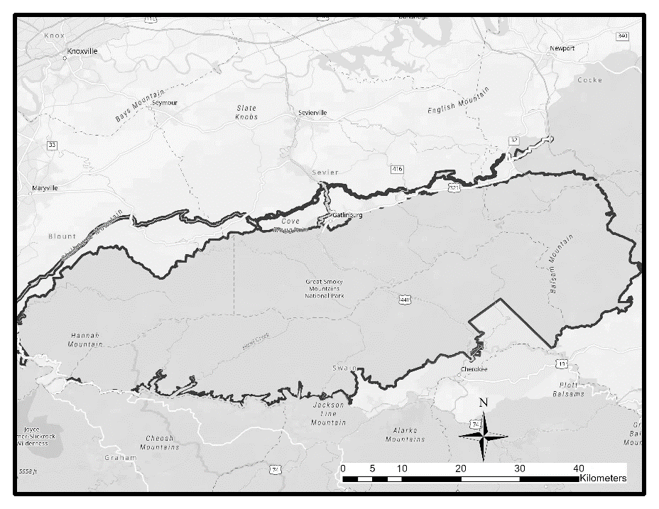
Figure 1: Great Smoky Mountains National Park Regional Location and Boundary

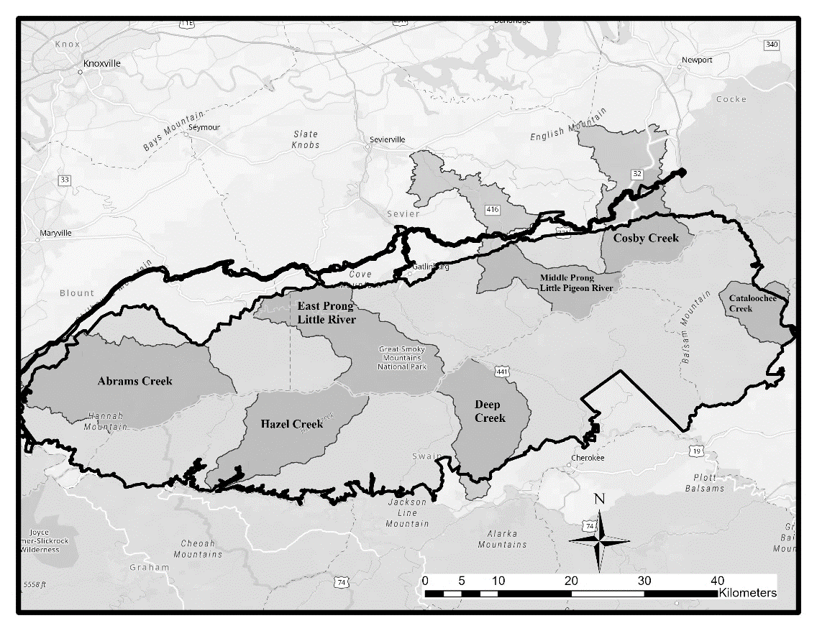
Figure 2: Targeted watersheds in Great Smoky Mountains National Park dissolved organic carbon study, 2020.
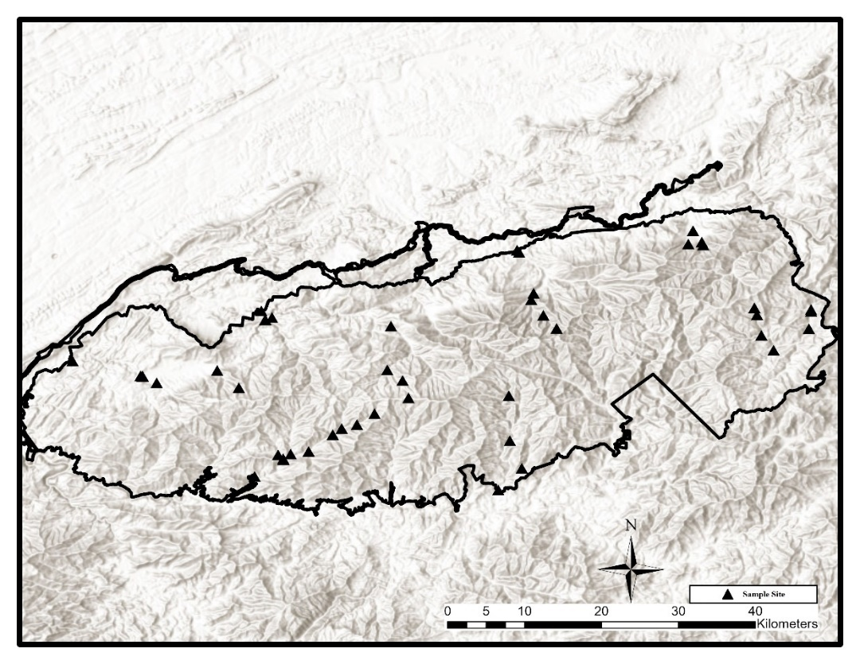
Figure 3: Great Smoky Mountains National Park dissolved organic carbon study sample site locations, 2020.

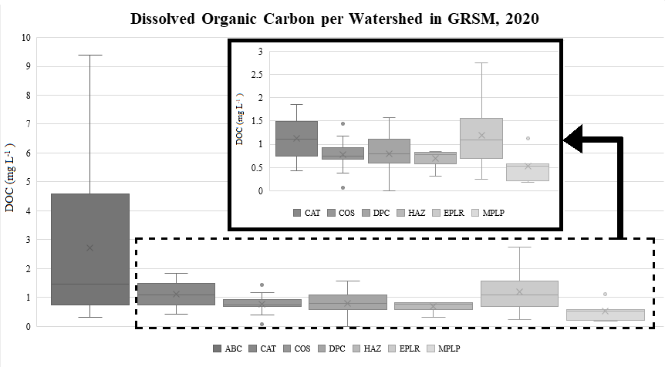
Figure 4: Dissolved organic carbon concentrations within seven watersheds in Great Smoky Mountains National Park during calendar year 2020 separated by watershed.
* all ionic concentration x-axis in uniform units; all y-axis units = number of occurrences

Figure 5: GRSM DOC concentration dataset variable transformation histograms, 2020
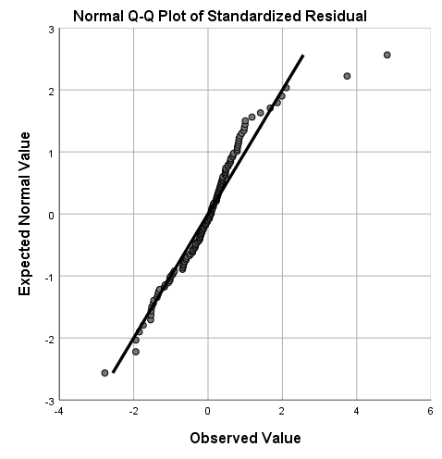
Figure 6: Q-Q plot of standardized residuals following stepwise regression analysis of 2020 GRSM DOC dataset

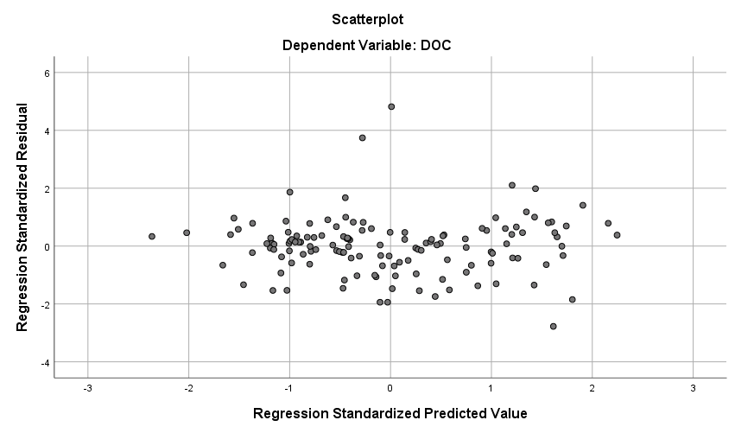
Figure 7: Scatterplot of residuals following stepwise regression analysis of 2020 GRSM DOC dataset

Appendix C: Supplemental Tables & Figures

Table A1: 2020 GRSM DOC data quality assurance / quality check data – DOC concentration replication difference
 | Field (mg L⁻¹) | Lab (mg L⁻¹)
Mean Diff SD | 0.09 | 0.13
Diff SD Range | 0.00 - 0.22 | 0.00 - 0.46
Mean Diff SE | 0.06 | 0.08
SE Range | < 0.01 - 0.15 | < 0.01 - 0.32

Table A2: 2020 GRSM DOC data quality assurance / quality check data – blank deionized water DOC concentration
 | Field (mg L⁻¹) | Lab (mg L⁻¹)
Mean | 0.07 | 0.01
SD | 0.11 | 0.15
SE | 0.02 | 0.02
Range | 0.00 - 0.39 | 0.00 - 0.40

Table A3: 2020 GRSM DOC data regression analysis statistics
 | Sum of Squares | df | Mean Square | F | p-value
Regression | 13.739 | 3 | 4.58 | 32.865 | <.001
Residual | 18.255 | 131 | 0.139
Total | 31.995 | 134

Table A4: 2020 GRSM DOC data regression coefficients
 | Unstandardized Coefficients |  | Standardized Coefficients | t | p-value | Correlations
 | B | Std. Error | Beta | t | p-value | Zero-order
(Constant) | 1.205 | 0.248 |  | 4.853 | <.001
Potassium | 1.252 | 0.402 | 0.241 | 3.117 | .002 | 0.489
(Calcium)⁻¹ | -0.441 | 0.083 | -0.367 | -5.334 | <.001 | -0.422
Nitrate | -0.317 | 0.069 | -0.346 | -4.618 | <.001 | -0.452

Table A5: Chemical component summary for GRSM DOC study, 2020
Component / Parameter | Units | Mean | Min | Max | SE | SD
pH | n/a | 6.37 | 5.19 | 6.84 | 0.03 | 0.31
Specific Conductivity | μS cm⁻¹ | 13.71 | 9.36 | 28.26 | 0.27 | 3.15
ANC | μeq L⁻¹ | 45.30 | 0.00 | 188.07 | 2.81 | 32.65
Chloride | mg L⁻¹ | 0.38 | 0.20 | 0.96 | 0.01 | 0.09
Nitrate | mg L⁻¹ | 0.68 | 0.02 | 2.39 | 0.05 | 0.53
Sulfate | mg L⁻¹ | 1.40 | 0.56 | 3.25 | 0.05 | 0.53
Sodium | mg L⁻¹ | 0.79 | 0.19 | 1.58 | 0.02 | 0.25
Potassium | mg L⁻¹ | 0.42 | 0.18 | 0.66 | 0.01 | 0.09
Magnesium | mg L⁻¹ | 0.28 | 0.14 | 0.96 | 0.01 | 0.12
Calcium | mg L⁻¹ | 0.90 | 0.47 | 2.58 | 0.03 | 0.36
Aluminum | mg L⁻¹ | 0.03 | 0.01 | 0.09 | 0.00 | 0.01
Silicon | mg L⁻¹ | 2.82 | 1.51 | 5.07 | 0.06 | 0.65

Table A6: Tennessee-side GRSM 2020 DOC concentration study sample site descriptions and locations.
Watershed | Latitude | Longitude | Site Description | Elevation (m) | Drainage Area (km²) | Drainage Density (km⁻¹)
Abrams Creek | 35.6090 | -83.9349 | Abrams Creek at Ranger Station | 334.24 | 157.34 | 0.63
Abrams Creek | 35.5917 | -83.8555 | Abrams Creek 300 m Below Trailhead Bridge | 516.58 | 93.50 | 2.04
Abrams Creek | 35.5915 | -83.8532 | Abrams Creek Below Cades Cove | 517.95 | 50.87 | 2.31
Abrams Creek | 35.5909 | -83.8531 | Mill Creek Above Abrams Creek | 518.46 | 42.58 | 1.70
Abrams Creek | 35.5835 | -83.8367 | Mill Creek at Pumphouse on Forge Creek Rd | 545.71 | 11.06 | 1.60
Abrams Creek | 35.5980 | -83.7660 | Anthony Creek at End of GRSM Admin Rd | 638.56 | 10.08 | 1.85
Abrams Creek | 35.5778 | -83.7408 | Anthony Creek Above Campsite 9 | 1013.80 | 1.71 | 1.89
Cosby Creek | 35.7612 | -83.2106 | Lower Rock Creek | 627.19 | 9.71 | 1.46
Cosby Creek | 35.7479 | -83.2003 | Cosby Creek at Log Bridge | 781.69 | 5.96 | 1.88
Cosby Creek | 35.7445 | -83.1987 | Camel Hump Creek Off Low Gap Trail | 837.32 | 2.54 | 1.19
Cosby Creek | 35.7457 | -83.2161 | Upper Rock Creek | 844.11 | 3.19 | 2.17
Little River | 35.6676 | -83.7146 | Little River at GRSM Boundary | 334.94 | 275.24 | 2.09
Little River | 35.6573 | -83.7098 | Lower Middle Prong Little River | 349.61 | 71.51 | 1.89
Little River | 35.6568 | -83.7102 | Lower West Prong Little River | 350.31 | 46.59 | 2.14
Little River | 35.6599 | -83.7021 | Little River Above Townsend, TN "Y" | 351.59 | 155.63 | 2.17
Little River | 35.6498 | -83.5632 | Little River at Old Road Gate | 705.25 | 79.85 | 1.95
Little River | 35.5986 | -83.5675 | Goshen Prong Above Fish Camp Prong | 1010.75 | 7.36 | 2.19
Little River | 35.5842 | -83.5472 | Goshen Prong Just Off Goshen Prong Trail | 1266.55 | 1.66 | 1.84
Little River | 35.5659 | -83.5427 | Double Springs Gap Shelter | 1667.07 | 0.10 | 0.00
Little Pigeon River | 35.7385 | -83.4160 | Middle Prong Little Pigeon at Boundary | 416.87 | 117.72 | 1.89
Little Pigeon River | 35.6881 | -83.3967 | Porters Creek at Admin Rd Gate | 655.75 | 26.18 | 1.61
Little Pigeon River | 35.6805 | -83.3995 | Lower Cannon Creek | 747.58 | 5.02 | 1.49
Little Pigeon River | 35.6624 | -83.3853 | Porters Creek at Campsite 31 | 995.75 | 6.97 | 1.53

Table A7: North Carolina-side GRSM 2020 DOC concentration study sample site descriptions and locations.
Watershed | Latitude | Longitude | Site Description | Elevation (m) | Drainage Area (km²) | Drainage Density (km⁻¹)
Cataloochee Creek | 35.6669 | -83.0727 | Lower Cataloochee Creek | 750.54 | 127.17 | 1.98
Cataloochee Creek | 35.6692 | -83.0728 | Lower Little Cataloochee Creek | 751.61 | 21.91 | 2.15
Cataloochee Creek | 35.6467 | -83.0753 | Middle Cataloochee Creek at Bridge | 776.26 | 121.21 | 1.98
Cataloochee Creek | 35.6216 | -83.1165 | Rough Fork at Caldwell House | 847.04 | 23.36 | 1.85
Cataloochee Creek | 35.6390 | -83.1308 | Palmer Creek Above Pretty Hollow Creek | 918.24 | 21.65 | 1.79
Cataloochee Creek | 35.6630 | -83.1359 | Pretty Hollow Creek at Log Bridge | 1166.23 | 4.92 | 1.84
Cataloochee Creek | 35.6711 | -83.1390 | Onion Bed Branch | 1260.74 | 1.71 | 1.84
Deep Creek | 35.4583 | -83.4379 | Deep Creek at GRSM Boundary | 546.57 | 107.46 | 1.69
Deep Creek | 35.4837 | -83.4104 | Indian Creek above Laney Cemetery | 654.68 | 18.41 | 1.70
Deep Creek | 35.5159 | -83.4244 | Deep Creek at Campsite 58 | 712.74 | 60.35 | 1.59
Deep Creek | 35.5684 | -83.4256 | Deep Creek at 1000 m | 978.35 | 12.77 | 2.02
Deep Creek | 35.5901 | -83.4285 | Deep Creek at 1200 m | 1166.20 | 1.94 | 2.00
Hazel Creek | 35.4742 | -83.7224 | Hazel Creek at Bridge Upstream of Campsite 86 | 524.07 | 115.77 | 2.07
Hazel Creek | 35.4938 | -83.6887 | Hazel Creek Below Haw Gap Creek | 662.18 | 100.49 | 2.03
Hazel Creek | 35.4948 | -83.6890 | Haw Gap Creek at Bridge Near Campsite 84 | 668.24 | 13.16 | 1.88
Hazel Creek | 35.5002 | -83.6803 | Bone Valley Creek | 694.43 | 30.82 | 1.88
Hazel Creek | 35.4994 | -83.6950 | Sugar Fork Above Haw Gap Creek | 698.94 | 4.33 | 1.68
Hazel Creek | 35.5034 | -83.6593 | Hazel Creek at Cold Spring Gap Trail | 749.56 | 45.32 | 2.21
Hazel Creek | 35.5230 | -83.6312 | Walker Creek Above Hazel Creek Trail | 874.56 | 7.54 | 1.69
Hazel Creek | 35.5301 | -83.6207 | Hazel Creek Just Below Proctor Creek Confluence | 925.65 | 23.93 | 1.75
Hazel Creek | 35.5347 | -83.6029 | Hazel Creek at 1000 m | 1030.89 | 8.08 | 1.53
Hazel Creek | 35.5475 | -83.5824 | Hazel Creek Above Cascades | 1222.03 | 2.95 | 1.35

Figure A1: Dissolved organic carbon vs. test parameters (set 1)

Figure A2: Dissolved organic carbon vs. test parameters (set 2)

Figure A3: Dissolved organic carbon vs. test parameters (set 3)

VITA
Jason Brown is a native of central Virginia but has relocated numerous times to Texas, Oklahoma, and later to Tennessee. He attended the University of Tennessee, Knoxville where he graduated summa cum laude with a Bachelor of Science in Environmental and Soil Sciences. He then continued his education and the University of Tennessee, Knoxville by pursuing a Master of Science degree in Biosystems Engineering Technology. His research interests include studying the dynamics of environmental responses to human intervention and the impacts on biota through chemical alterations. After graduation, he will continue his research to a Doctor of Philosophy degree in the Plants, Soils, and Environmental major with a concentration in Environmental and Soil Sciences.

