MULTI-PHYSICS MODELING OF LI-ION BATTERY MODULE:
NON-UNIFORM DEGRADATION AND ITS MITIGATION

A Thesis Presented for the
Master of Science
Degree
The University of Tennessee, Knoxville

Virendra Deepak Talele
December 2024

Copyright © 2024 Virendra Deepak Talele
All rights reserved.

ACKNOWLEDGEMENTS
I wish to convey my heartfelt appreciation to my research advisor, Dr. Peng Zhao, for his invaluable support and guidance throughout my research journey. I sincerely appreciate the opportunity to contribute to the Lab of Advanced Mobility and Power (LAMP) in UTSI, where my work centered on advancing high-fidelity electrochemical models for Li-ion battery thermal safety and management. This experience has played a significant role in shaping my research career.
I am thankful to Dr. Feng-Yuan Zhang, and Dr. Trevor Moeller for serving on the advisory committee. Their constructive feedback and valuable suggestions significantly contributed to the depth of my research.
I am also grateful to Dr. Ankur Jain, and Dr. Dhananjay Mishra for active work collaboration and providing expert guidance in innovating battery technology.
I would like to express my heartfelt gratitude to my colleagues in the LAMP group — Ahmad Hadi Bakir, Keisuke Akita, Han Yu, and Liwen Zhang— for being a constant source of joy and inspiration throughout this journey.
I owe immense thanks to my family and all my friends for their support throughout my masters studies

ABSTRACT
Recent regulatory measures designed to reduce emissions, combined with advancements in alternative fuels, are accelerating the shift towards vehicle electrification. While major original equipment manufacturers (OEMs) have already scaled up the deployment of electric vehicles, addressing the engineering challenges of this technology remains crucial. Lithium-ion batteries, though a promising solution for energy storage, present issues such as thermal management, variability in cell capacity, and the risk of thermal runaway. Their complex behavior and sensitivity to temperature during operation require precise modeling and analysis to accurately predict performance. The objective of this thesis is to comprehensively understand involvement of complex electrochemical process inside lithium-ion batteries (LIBs) and development of high fidelity fully coupled thermal electrochemical model to understand effect of temperature non-uniformity on limiting capacity of battery pack.
Thesis explores a comprehensive guideline in developing high fidelity electrochemical model and its coupling with thermal capacity fade model which has SEI formation and Li dendrite growth as a governing capacity fade mechanism. A strategic benchmarking guideline of validating numerical model with set of experimental results are provided. Further this study explores, issue of thermal non-uniformity existence in cylindrical battery module and its direct effect on cell to cell variable non-uniform capacity fading over time under conventional fluid flow thermal design and mitigation strategy to reduce non-uniform capacity loss using reciprocating fluid flow thermal design is demonstrated.

Table of Contents
CHAPTER 1. INTRODUCTION 1
1.1 General Introduction 1
1.2 Significance of study 1
1.3 Objective and outline of study 2
CHAPTER 2. SIMULATION AND REDUCTION OF NONUNIFORM CAPACITY FADING IN A CYLINDRICAL BATTERY MODULE VIA RECIPROCATING THERMAL DESIGN 6
2.1. Introduction 6
2.2 Modeling methodology 9
2.2.1 Development of electrochemical coupled conjugate heat transfer model 9
2.2.2 Battery module development with reciprocating thermal design. 12
2.2.3 Thermo-Electrochemical model 17
2.2.4 Capacity fade model 22
2.2.5 Numerical Scheme Verification 27
2.3. Model validation 30
2.4. Result and discussion 35
2.4.1 Thermal performance of battery module with unidirectional and reciprocating thermal design 35
2.4.2 Cell-to-Cell variable capacity loss between unidirectional and reciprocating thermal design 45
2.4.3 Loss of lithium inventory and growth of SEI/Li plating thickness on most degraded cell 49
2.5. Conclusion 53
2.6. Future Work 54
APPENDIX 56
LIST OF REFERENCES 60
VITA 68

LIST OF TABLES
Table 1. A123 26650 M1-B Commercial LiFePO₄ battery characteristics 15
Table 2. Thermophysical and design property of assigned materials 15
Table 3. Thermophysical property of coolant (Water) 16
Table 4. Governing equations of the electrochemical-thermal model and corresponding boundary condition. 18
Table 5. Thermo-electrochemical model heat generation 19
Table 6. SEI formation model 25
Table 7. Aging parameters are used to develop SEI formation mechanisms. 25
Table 8. Lithium plating model 26
Table 9. Validation targets at different operating conditions 33
Table A1. List of parameters used to develop electrochemical model 55
Table A2. List of temperature dependent concentration variables fitted in modeling framework. 57

LIST OF FIGURES
Figure 1. Thermal-Electrochemical coupled with capacity fade and conjugate heat transfer 10
Figure 2. Fluid flow thermal design dimensions 14
Figure 3. Fluid flow thermal design schematic 15
Figure 4. Mesh independent study 28
Figure 5. Time independent study for discharge curve comparison on different time stepping cases. 29
Figure 6. Fresh cell a) Charge and b) Discharge Voltage validation under isothermal conditions 31
Figure 7. Fresh cell temperature validation under adiabatic and known cooling conditions 32
Figure 8. Cycled cell validation results a) Capacity and b) Discharge voltage 33
Figure 9. Average temperature of cells with reciprocating flow cooling system over 700 cycles. 37
Figure 10. Comparison of reciprocating flow cooling and unidirectional flow cooling 38
Figure 11. Comparison of reciprocating flow cooling and unidirectional flow cooling (violin plot) 41
Figure 12. Cell to battery module temperature variation results. 42
Figure 13. Temperature contours of the module, cells, and liquid channel at the conclusion of the 700th cycle under unidirectional flow and reciprocating flow 44
Figure 14. Cell-to-cell level remaining capacity v.s. number of cycle 47
Figure 15. Battery module mean capacity and Coefficient of variance comparison for unidirectional and reciprocating fluid flow thermal design. 48
Figure 16. Budget analysis of loss of lithium inventory a) unidirectional: cell 14 and b) reciprocating: cell 2. 51
Figure 17. Change in thickness for most degraded cell in thermal design a) unidirectional: cell 14 and b) reciprocating: cell 2. 52

LIST OF ABBREVIATIONS
BTMS | Battery thermal management system
BEV | Battery operated vehicle
CFD | Computational fluid dynamics
CC | Constant current
CV | Constant voltage
CHT | Conjugate heat transfer
DOD | Depth of discharge
EV | Electric vehicle
ESS | Energy storage system
EOL | End of life
LAM | Loss of active material
LCO | LiCoO₂
LFP | LiFePO₄
LLI | Loss of lithium inventory
LI | Lithium inventory
Li | Lithium
LP | Lithium plating
NMC | Nickel Manganese Cobalt
OCP | Open Circuit Potential
P2D | pseudo-two-dimensional
SEI | Solid electrolyte interface
SOC | State of charge
SOH | State of health
STP | Standard operating temperature and pressure
TIM | Thermal interface material

LIST OF NOMENCLATURE
A_{v} | Specified surface area  (m² m⁻³)
c | concentration  (mol m⁻³)
C_{s} | Solid phase
C_{l} | Liquid phase
C₀ | Ambient condition
C_{p} | Specific heat capacity  (J K⁻¹ kg¹)
D | Diffusion coefficient  (m² s⁻¹)
DMC | Dimethyl Carbonate
EC | Ethylene Carbonate
E_{a} | Activation energy  (J mol⁻¹)
F | Faraday constant  (C mol⁻¹)
f$±$ | Average molar activity coefficient
H | Dimensionless relative expansion factor
HTC or h | Convective heat transfer coefficient  (W m⁻ ² K⁻ ¹)
I | Current  (A)
I_{app} | Applied current density  (A m⁻ ²)
J | Dimensionless exchange current density
j₀ | Exchange current density  (A m⁻ ²)
j_{loc} | Local current density  (A m⁻ ²)
K | Dimensionless expansion factor
k₀ | Reaction temperature constant  (m^{2.5} mol^{−0.5} s⁻ ¹)
L_{neg} | Length of negative electrode  (m)
L_{sep} | Length of separator  (m)
L_{pos} | Length of positive electrode  (m)
M | Molecular weight  (kg mol⁻¹)
$${\dot{Q}}_{Total}$$ | Total heat generation  (W/m³)
$${\dot{Q}}_{Rev}$$ | Reversible heat generation  (W)
$${\dot{Q}}_{Irrev}$$ | Irreversible heat generation  (W)
$${\dot{Q}}_{Ohmic}$$ | Ohmic heat  (W)
R | Gas constant  (J mol⁻¹ K⁻¹)
R_{SEI} | Electrical resistance of SEI  (Ω)
r | Radius of particle
T | Temperature  (K)
T_{avg} | Average temperature  (K)
t | Time  (s)
t₊ | Transfer number
U | Open circuit voltage

GREEK SYMBOLS
$$ρ$$ | Density  (kg m⁻³)
α | Transfer coefficient
α_{a}, α_{c} | Transfer coefficient at anode and cathode
β | Strain energy ratio
$$λ$$ | Thermal conductivity  (W m⁻¹ K⁻¹)
δ | Thickness (m)
ε | Volume fraction
γ | Bruggeman exponent
η | Over potential  (V)
$$ϕ$$ | Potential  (V)
μ | Radial displacement  (m)
ν | Thermodynamic factor
ν_{SEI} | Stoichiometry coefficient of SEI
σ | Electric conductivity  (S m⁻ ¹)
σ_{B} | Stefan-Boltzmann constant  (W m⁻ ² K⁻ ⁴)

SUPERSCRIPTS
amb | Ambient temperature
eff | Effective
Int | intercalation
l | Liquid phase
s | Solid phase
surf | surface
r | Radius

CHAPTER 1. INTRODUCTION

1.1 General Introduction
In the aim of addressing global warming and the energy problem, nations across the globe have made a commitment to attain a reduction in carbon emission [1]. This commitment aims to expedite the transition towards electrification in transportation and energy storage[2]. Due to its high energy density, extended cycle life, and less carbon emission production, lithium-ion batteries (LIBs) have become essential components of electric vehicles (EVs) and energy storage systems (ESS) [2–5]. Nevertheless, lithium-ion batteries (LIBs) possess substantial quantities of active chemicals and stored electrical energy, which might result in temperature rises that exceed the permissible working limits when subjected to charge discharge process, hence if not cool down potentially triggering thermal runaway (TR) events [6–8]. Effectively managing temperature response by using thermal management strategies help increase safety, reliability, and working capability of battery pack.
This thesis presents a comprehensive guide on understanding critical electrochemical reactions intriguing inside the LIBs through a series of electrochemical thermal numerical investigations. Its aim is to reveal electrochemical process governing inside the LIBs when operational under two distinct thermal management strategies such as widely used uni-directional fluid flow and reciprocating thermal design, and the existence of varied thermal boundary conditions experienced by each cell on capacity degradation rate is further evaluated in detail.

1.2 Significance of study
Thermal characterization of Li-ion cells is crucial for the development of an effective thermal management system for EV battery modules. Nevertheless, the necessary infrastructure for rigorous characterization, including a programmable battery cycler, a temperature chamber, and an accelerating rate calorimeter, is not only expensive but also entails extended testing periods from months and years [9,10]. Moreover, these instruments may have constraints in evaluating battery packs throughout a wide spectrum of operational conditions. Furthermore, experimental methods encounter intrinsic limitations when assessing novel designs and optimizing battery thermal management systems [11]. Within this framework, the integration of numerical analysis with small-scale experimental validation can effectively address these uncertainties. Approaches such as thermal modeling, electrochemical-thermal modeling, and electro-thermal capacity fade modeling provide useful options. Validated numerical models offer various advantages over experimental approaches, including the provision of important information on heat generation rates, precise temperature distribution, and coolant flow dynamics. Furthermore, they provide a deeper understanding of battery operational processes, while substantially decreasing the time and expenses linked to testing for different scenarios [11,12].
Optimizing thermal design involves battery health characterization which is one of the crucial parameters since degradation of cell has strong temperature dependency. As the cell ages, the amount of heat generated by each cell keeps increasing, hence enhance it also enhances the effect of cell-to-cell variable capacity loss due to temperature non-uniformity inside battery module. Solution provided with electrochemical-thermal modeling offer great benefits in understanding direct effects of thermal history experienced by each cell inside battery module, while answering the fundamental questions on percentage of loss of lithium channels. In this study, the widely adopted unidirectional fluid flow thermal design is first investigated to determine the impact of temperature non-uniformity on capacity loss experienced by each cell. In later part, a novel reciprocating thermal design architecture is presented in which fluid flow direction is switched from inlet to the outlet periodically for every 50 cycles to reduce temperature non-uniformity experienced by each cell and reduce cell to cell variable capacity loss, while identifying most prominent channels for loss of lithium inventory.

1.3 Objective and outline of study
Thermal management of LIBs are crucial parameters to determine its safety and reliability for energy/power delivery. Till now, as we have understood conducting experimental investigations is expensive, time consuming specially owing to its limitation on conducting module/pack level test. To solve this problem, a series of computational investigations is proposed in present thesis. The primary objective of this study is to investigate the cooling performance characteristics of 15S1P battery module, equipped with 21700 configuration LFP cell. Initially, the test was conducted with conventional unidirectional fluid flow thermal design to understand the direct impact of temperature non-uniformity on cell-to-cell variable capacity fading. Furthermore, Mitigation strategy to reduce this cell-to-cell variable capacity loss by maintaining thermal uniformity inside module, a reciprocating thermal design is proposed in which designated inlet is switched with outlet for every 50-cycle interval. This test is conducted under a high charge discharge rate of 5C.
This thesis is subdivided into three major chapters. Chapter 1 provides a concise summary of the study's importance and defines the requisite topics for investigation. This chapter examines the principles and significance of thermal control in battery packs and sets out the study aims and objectives. Following that in final Chapter 2 we discuss the core strategy of present work on development of electrochemical thermal capacity fade, while outlining the importance of temperature uniformity presented by reciprocating thermal design to reduce capacity loss inside battery module.

Disclosure
A version of this chapter was originally published by:
Virendra Deepak Talele, Mohammad Ahmadian-Elmi, Ankur Jain, Dhananjay Mishra, Thomas A. Zawodzinski Jr, Peng Zhao
Talele V, Ahmadian-Elmi M, Jain A, Mishra D, Zawodzinski Jr TA, Zhao P. Simulation and reduction of nonuniform capacity fading in a cylindrical battery module via reciprocating thermal design. Journal of Energy Storage. 2024 Dec 1;103:114143.
CRediT authorship contribution statement.
Virendra Deepak Talele: Writing – original draft, Visualization, Validation, Software, Investigation, Formal analysis, Data curation. Mohammad Ahmadian-Elmi: Writing – review & editing, Visualization, Formal analysis. Ankur Jain: Writing – review & editing, Supervision, Methodology, Conceptualization. Dhananjay Mishra: Writing – review & editing, Investigation. Thomas A. Zawodzinski: Writing – review & editing, Resources, Project administration, Funding acquisition. Peng Zhao: Writing – review & editing, Writing – original draft, Validation, Supervision, Software, Resources, Project administration, Methodology, Investigation, Funding acquisition, Conceptualization.

Abstract: Operational variability among individual cells in a battery module is known to occur commonly due to the combined effects of manufacturing inconsistency and operating conditions. The resulting nonuniform distribution of temperature is a significant factor contributing to cell-to-cell variation over time, in that cells exposed to different temperature over time exhibit significant variation in degradation, which is undesirable to the health of the battery module. In the present study, nonuniform capacity loss over time due to changes in temperature distribution within a cylindrical battery module is numerically investigated using a coupled thermal-electrochemistry analysis that includes representative degradation models such as solid-electrolyte-interface (SEI) thickening and Li dendrite growth, as well as the effects of conjugate heat transfer. The impact of reciprocating cooling on reducing the nonuniform degradation phenomenon is demonstrated. The numerical findings indicate temperature disparity among the cells has a significant influence on capacity variation over time. Such effect is more pronounced in cells located near the flow outlet region during conventional unidirectional fluid flow thermal design. The implementation of a reciprocating flow thermal design, wherein flow inlet and outlet are periodically switched, is shown to significantly reduce both temperature and temperature gradient within the module, and hence reduce variation in capacity loss among the cells. SEI thickening is identified as a dominant degradation source compared with Li dendrite growth. In summary, this work contributes reducing nonuniform cell to cell capacity loss variation inside the battery module, along with increasing temperature uniformity by the implementing reciprocating battery thermal design.

Chapter 2. SIMULATION AND REDUCTION OF NONUNIFORM CAPACITY FADING IN A CYLINDRICAL BATTERY MODULE VIA RECIPROCATING THERMAL DESIGN

2.1. Introduction
The growing global trend towards decarbonization and electrification has generated considerable attention in the scientific community for the research and development of lithium-ion batteries (LIBs), especially for ground transportation and energy storage applications. However, the performance of batteries is greatly influenced by temperature, with a narrow optimal operating range between 25°C to 55 °C [13,14]. Temperature extremes cause material degradation and trigger undesired side reactions that lead to thermal runaway and affect performance, lifespan and safety [15]. To address these challenges, it is important to design appropriate thermal management to keep cell temperatures below a target value and simultaneously reduce temperature inhomogeneity inside a module or pack [16].
A main goal of thermal design is to ensure that the battery module achieves desired temperature distribution. In general, battery thermal design is classified based on its working principle. If a cooling system relies on external power to operate, it is considered an active battery thermal management system (BTMS), otherwise, it falls under the category of passive BTMS [17]. Active BTMS are the preferred design for heavy automotive and energy storage applications as they provide consistently higher heat transfer rates, especially when using liquid-based coolant [18]. Tube cooling, serpentine design cooling, cold plate cooling, active single phase immersion cooling and cellular cooling jacket (CCJ) are the preferred technologies [19–21]. A primary issue often encountered with this cooling technique is the nonuniform temperature distribution within cells inside battery module/pack arrangement. For example, the cell located near the coolant outlet experiences significantly higher temperature differences compared to the cell near the inlet [22,23]. This is because the effective heat transfer rate of working fluid is reduced as it carries heat generated within the module, causing nonuniform operating temperature and hence degradation among individual cells.
In active cooling strategies, a novel reciprocating air cooling strategy was first proposed by Mahamud et al. [24], to solve this nonuniform cooling problem. Later, Wang et al. [25] show that reciprocating thermal design can notably reduce temperature variation between cells by 3℃ and accounting for total 72% of enhancement when compared with conventional thermal design strategy. Reciprocating flow has been extensively studied for air cooling BTMs, however, there has been limited research on its application in liquid cooling systems. Additionally, given the omnipresent temperature nonuniformity in practical battery module, there is a need to track cell-level nonuniform degradation, by combining electrochemistry, degradation mechanism and conjugate heat transfer in a unified framework. Reciprocating liquid cooling for cylindrical and prismatic battery module have been extensively modeled recently [26–28], however, none of these studies resolve detailed electrochemistry or monitor cell-level degradation, further emphasizing the novelty of the current study.
Recognizing cell-to-cell variability inside the battery module and comprehending its loss performance over time, Schuster et al. [29] proposed a three-year long comprehensive experimental and statistical supported study on two different EV battery packs equipped with in total 1908, IHR 18650 NMC cell with 1.95 Ah rated capacity. Their study presents compelling evidence that temperature nonuniformity within the thermal design can cause substantial nonuniform capacity fading and raise the risk of uneven reactions in each cell. Understanding and addressing cell-to-cell variability within the battery pack is essential for ensuring safe and efficient operation. Recently, Zhang et al. [30] demonstrated that despite similar electrochemical performance, even fresh Li-ion cells can display significant differences in thermal runaway behaviors, which is highly sensitive to potential manufacture inconsistencies. Cell-to-cell variations pose significant challenges for battery management and require improved thermal design to reduce the temperature nonuniformity within the pack.
While crucial life cycle experiments of cell can provide detail insights on cell degradation, yet numerical models are extensively used based on their advantages on reducing cost and time needed of experimentation, while providing detailed insights into the aging characteristics and dominating degradation mechanism that contributes to the loss lithium inventory (LLI) [31–34]. It is well known that degradation patterns are dependent on cell operational temperature. Study by Ramadass et al. [35] found battery capacity loss is more severe in elevated temperatures where SEI formation is the major contributor in LLI, which is reflected in recent numerical models [36–43]. To understand heat generation evolution in aged cells, a recent study performed by Panchal et al. [44] on commercial lithium cobalt oxide cell have found cell degradation tends to boost rate of heat generation, indicating aged cells are more prone to thermal safety issues. A recent numerical model created by Liang et al. [45] examined the degradation performance of cell at various ambient temperatures, ranging from sub-zero to 50℃ which has combined mechanism of Li plating, loss of active material (LAM) and SEI thickening, also confirms that cells degrade at different rates based on their operational temperatures.
It is worth mentioning that none of the existing research focuses on developing a comprehensive multiphysics framework specifically designed to tackle nonuniform capacity fading at the individual cell level, which is crucial for module health management and safety control. The objectives of the present study are four-fold: first, establish a thermal-electrochemical numerical framework by strategically validating electrochemistry, heat generation, degradation, and conjugate heat transfer. Second, adopting this framework to evaluate cell variation in conventional serpentine based battery cooling systems. Third, demonstrate improved performance of reciprocating fluid flow thermal design from the reduction of cell variation. Lastly, provide detailed analysis on separate LLI from each of the two representative degradation models – SEI thickening and Li plating. This study uses electrochemical coupled capacity fading and conjugate heat transfer, configured for 26650 LiFePO₄ (LFP) cathode cells arranged in a 15S1P battery module. To test the effectiveness of both conventional and reciprocating thermal designs, a constant-current constant-voltage (CCCV) condition at a 5C rate will repeat until 90% of battery module degradation is detected. Temperature and capacity loss are tracked at cell level to show the thermal and degradation features of each cooling strategy.
The main objective of the current work is to model and reduce nonuniform degradation in a battery module using a Multiphysics platform, and we select LFP cell chemistry for demonstration. LFP cathodes are certainly recognized for their enhanced thermal stability in comparison to other chemistries such as NMC or LCO. However, it is crucial to also acknowledge that similar to other chemistries, LFP cells also suffer from the risk of thermal runaway, especially for degraded cells. Further, it is also known that extensive H₂ gas production occurs in LFP cells during thermal runaway, causing subsequent propagation and fire hazards. Therefore, with vast application of LFP cells for automotive and energy storage purposes, understanding the safety of LFP cells becomes more and more critical. The proceeding sections are organized as follows: Section 2.2 Describes detailed thermal capacity fade modeling strategy along with SEI thickening and Li Plating (Dendrite) as two major degradation channels. Section 2.3 Describes validation benchmarking strategy for fresh and cycled cells. Section 2 .4 outlines the main results of the study on the impact of proposed thermal designs, including unidirectional and reciprocating designs, on thermal management strategy and the detection of cell-to-cell capacity loss, followed by conclusion in section 2.5, section 2.6 provides concluding remarks and potential future directions.

2.2 Modeling methodology

2.2.1 Development of electrochemical coupled conjugate heat transfer model
This study develops a detailed thermal-electrochemical capacity fade modeling framework for Li-ion batteries with LiFePO₄ cathode. In addition to electrochemistry and heat transfer, this framework considers capacity fading caused by LLI from two dominant mechanisms: solid electrolyte interface (SEI) formation and lithium metal deposition (dendrite) on the graphite negative electrode [38][36]. SEI growth primarily drives capacity fade at normal and high temperatures, while lithium plating has a greater impact at lower temperatures [46]. The battery module, along with its thermal design, is intended to operate at an ambient temperature of 27℃. For simplicity, coolant intake temperatures are also set at 27℃. Figure 1 presents a schematic of the modeling framework including electrochemistry, heat generation, degradation, and conjugate heat transfer.

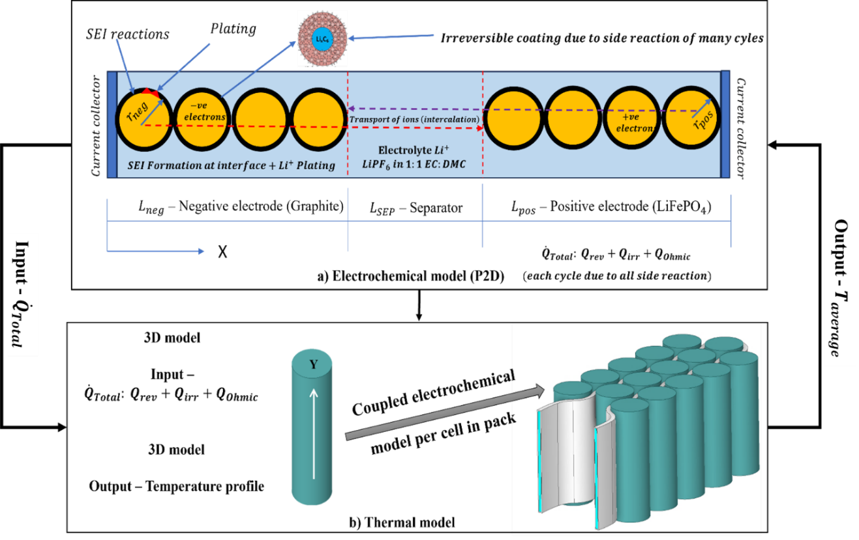
Figure 1. Thermal-Electrochemical coupled with capacity fade and conjugate heat transfer

This Multiphysics approach, which has been widely adopted in battery research [43][47], entails the development of a pseudo two-dimensional (P2D) model that reflects battery internal dynamics before coupled with a 3D conjugate heat transfer (CHT) model. Within this framework, the governing equation incorporates electrochemical kinetics, charge/mass/energy conservation, degradation, and conjugate heat transfer. The total heat generation $({\dot{Q}}_{Total}$) during battery operation includes ohmic, reversible and irreversible heating. The average temperature (T_{avg}) of the CHT framework feeds back into the loop of electrochemical model (P2D), which dynamically monitors the effects of local temperature on unequal capacity loss of each cell.
As depicted in Figure 1, for the P2D model there are three key parts in geometrical configuration: a graphite negative electrode (made of graphite - Li_{y}C₆), a separator, and a positive electrode (made of lithium phosphate cathodic material, Li_{x}F_{e}PO₄), The electrolyte, used here, contains LiPF₆ dissolved in EC and DMC nonaqueous liquid. The P2D (Pseudo Two-Dimensional) method employed here represents charge and species movement within porous electrodes (solid and electrolyte phases), as shown in Figure 1a. This approach simplifies the model by considering time-varying parameters, like lithium-ion concentrations and electrical potentials, dependent on a single spatial coordinate along the cell thickness (x-direction). Furthermore, the conservation equation for a solid intercalant species is represented as a pseudo dimension, indicating its radial position within an active solid particle. The pseudo dimension aligns with the x direction in space and evolves over time t. Figure 1b shows the creation of a coupled thermal-electrochemical framework on module level, which adopts a 3D coordinate system to solve the energy equation accounting for electrochemical heat generation terms and conjugate heat transfer from the coolant.
This Multiphysics approach, which has been widely adopted in battery research [43][47], entails the development of a pseudo two-dimensional (P2D) model that reflects battery internal dynamics before coupled with a 3D conjugate heat transfer (CHT) model. Within this framework, the governing equation incorporates electrochemical kinetics, charge/mass/energy conservation, degradation, and conjugate heat transfer. The total heat generation $({\dot{Q}}_{Total}$) during battery operation includes ohmic, reversible and irreversible heating. The average temperature (T_{avg}) of the CHT framework feeds back into the loop of electrochemical model (P2D), which dynamically monitors the effects of local temperature on unequal capacity loss of each cell.
As depicted in Figure 1, for the P2D model there are three key parts in geometrical configuration: a graphite negative electrode (made of graphite - Li_{y}C₆), a separator, and a positive electrode (made of lithium phosphate cathodic material, Li_{x}F_{e}PO₄), The electrolyte, used here, contains LiPF₆ dissolved in EC and DMC nonaqueous liquid. The P2D (Pseudo Two-Dimensional) method employed here represents charge and species movement within porous electrodes (solid and electrolyte phases), as shown in Figure 1a. This approach simplifies the model by considering time-varying parameters, like lithium-ion concentrations and electrical potentials, dependent on a single spatial coordinate along the cell thickness (x-direction). Furthermore, the conservation equation for a solid intercalant species is represented as a pseudo dimension, indicating its radial position within an active solid particle. The pseudo dimension aligns with the x direction in space and evolves over time t. Figure 1b shows the creation of a coupled thermal-electrochemical framework on module level, which adopts a 3D coordinate system to solve the energy equation accounting for electrochemical heat generation terms and conjugate heat transfer from the coolant.

2.2.2 Battery module development with reciprocating thermal design.
The geometrical structure of battery module thermal design with unidirectional and reciprocating thermal design is shown in Figures 2 and 3, which includes 5 units of cell connected in 15S1P arrangement, contributing 125.95 Wh of electrical energy. Cells are equipped with aluminum casing of 0.3mm and insulated with fire-retardant thermal interface material (TIM) of 0.1mm. Cell are cooled by an aluminum channel that carries water as coolant. In this study two cooling designs are investigated which are categorized based on their fluid flow direction as shown in Figure 3 a) Unidirectional fluid flow thermal design and b) Reciprocating fluid flow thermal design. Tables 1 and 2 show the thermo-physical properties of cells, aluminum channel and thermal interface material. while fluid flow coolant (water) thermophysical property is shown in Table 3.

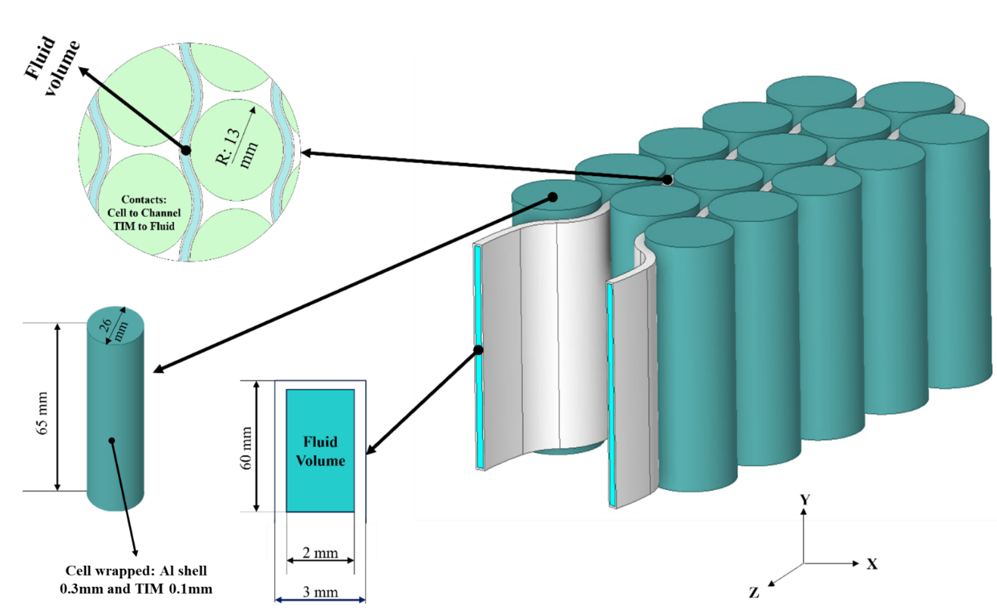
Figure 2. Fluid flow thermal design dimensions

Figure 3. Fluid flow thermal design schematic

Table 1. A123 26650 M1-B Commercial LiFePO₄ battery characteristics [43,50]
Sr no | Property | Value | Unit
1 | Nominal Voltage | 3.2 | $$V$$
2 | Rated Capacity | 2.3 | $$Ah$$
3 | Charge cut-off | 3.65 | $$V$$
4 | Discharge cut-off | 2.5 | $$V$$
5 | Operating temperature charge | 0 to 45 | $$℃$$
6 | Operating temperature Discharge | -20 to 65 | $$℃$$
7 | Internal Resistance (AC) | $≤$15 | $$mΩ$$

Table 2. Thermophysical and design property of assigned materials [43][51][52]
A123 26650 M1-B Commercial LiFePO₄ battery
Sr no | Property | Value | Unit
1 | Specific heat (C_{p}) | 1100 | $$J/(kgK)$$
2 | Thermal conductivity  ($λ$: axial, radial and tangential) | Axial: 36,  Radial and tangential: 0.34, 0.35 | $$W/(mK)$$
3 | Cell density ($ρ$) | 2047 | $$kg/m^{3}$$
Thermal interface material (TIM)
4 | Density ($ρ$) | 1420 | $$kg/m^{3}$$
5 | Thermal conductivity (Isotropic) | 0.3 | $$W/(mK)$$
6 | Specific heat $(C_{p})$ | 1090 | $$J/(kgK)$$
Cell wrapped Al shell and Fluid flow channel (Aluminum)
8 | Density ($ρ$) | 2700 | $$kg/m^{3}$$
9 | Thermal conductivity (Isotropic) | 238 | $$W/(mK)$$
10 | Specific heat $(C_{p})$ | 900 | $$J/(kgK)$$
11 | Thickness | 0.3 (Al shell)  1 (Channel) | mm

Table 3. Thermophysical property of coolant (Water) [53]
Sr no | Property | Value | Unit
1 | Density (ρ) | 997 | $$kg/m^{3}$$
3 | Thermal conductivity | 0.601 | $$W/(mK)$$
4 | Dynamic viscosity ($μ$) | 0.00103 | $$kg/(ms)$$

In unidirectional fluid flow thermal design, the mass flow inlet and outlet are fixed for the whole duration of battery module operation, while in the reciprocating thermal design, the inlet is modified with a switching function that activates every 50 cycles to change the direction of the coolant flow, such that the inlet and outlet of the coolant are switched every 50 cycles of battery operation. In this study, the battery module operates under a standard charge-discharge cycle at 5C rate, enhanced with the conventional constant-current constant-voltage (CCCV) protocol incorporating a 10-second rest period between each charge and discharge cycle [48][49]. Electrical property of cell is shown in Table 1, for A123 26650 LiFePO₄ cathode, which is widely used for electrochemical model development [45]. The thermophysical property of cell which is stacked inside Al shell of 0.3mm and primarily insulated with fire retardant thermal interface material (TIM) having thickness of 0.1mm is shown in Table 2. Thickness which off solid elements making significant heat transfer contact shown below:
- Al Fluid Channel: 1mm
- Al wrapped: 0.3mm
- Tim: 0.1 mm

2.2.3 Thermo-Electrochemical model
Before cell degradation and conjugate heat transfer are considered, standard baseline has been established for the thermo-electrochemical model by validating against charge and discharge process under isothermal and adiabatic conditions. This model includes key physical processes of charge transfer, electrochemical reactions, and heat generation. The validation targets selected include temperature range from subzero to high ambient temperature with current withdrawn as low as 0.5C rate to high as 10C rate.
Below Table 4 summarizes key governing equations and boundary conditions of electrochemical model and Table 5 indicates heat generation evolution from the electrochemical model. The validation of current modeling framework is shown in Section 2.3, which includes detailed thermal capacity fade model validation strategy for the fresh cell and cycled cell.

Table 4. Governing equations of the electrochemical-thermal model and corresponding boundary condition. [43,45,51]
Physics | Equations | Boundary conditions | Equation number
Charge conservation
(a) Electron in solid | $$\frac{∂}{∂x}\left(-σ_{s}\frac{∂ϕ_{s}}{∂x}\right)=-S_{a}j_{loc}$$ | $$ϕ_{s}|_{x=0}=0; -σ_{s}\frac{∂ϕ_{s}}{∂x}|_{x=L}=-i_{app}$$ | 1
 |  | $$\frac{∂ϕ_{s}}{∂x}|_{x=δ_{neg}}=\frac{∂ϕ_{s}}{∂x}|_{x=δ_{neg}+δ_{sep}}=0$$ | 1
(b) ${Li}^{+}$ in electrolyte | $$\frac{∂}{∂x}\left(-κ_{l,eff}\frac{∂ϕ_{l}}{∂x}{-κ}_{D,eff}\frac{∂{lnc}_{l}}{∂x}\right)=S_{a}j_{loc}$$ | $$\frac{∂ϕ_{e}}{∂x}|_{x=0}=\frac{∂ϕ_{e}}{∂x}|_{x=L}=0$$ | 2
 | Ionic conductivity  $κ_{l,eff}=κ_{l}ε_{l}^{β}$ (Bruggeman relation) |  | 3
 | Ionic diffusional conductivity  $$κ_{D,eff}=\frac{2RTκ_{l,eff}}{F}(t_{+}-1)(1+\frac{∂lnf_{±}}{∂c_{l}})$$ |  | 4
Mass conservation
(a) $Li$ in solid | $$\frac{∂c_{s}}{∂t}=\frac{D_{s, eff}}{r^{2}}\frac{∂}{∂r}(r^{2}\frac{∂c_{s}}{∂r})$$ | $$\frac{∂c_{s}}{∂r}|_{r=0}=0 ; {-D}_{s,eff}\frac{∂c_{s}}{∂r}|_{r=R_{s}}=\frac{j_{loc}}{F}$$ | 5
(b) ${Li}^{+}$ in electrolyte | $$ε_{l}\frac{∂c_{l}}{∂t}=\frac{∂}{∂x}\left(D_{l,eff}\frac{∂c_{l}}{∂x}\right)+S_{a}\frac{(1-t_{+})}{F}j_{loc}$$ | $$\frac{∂c_{l}}{∂x}|_{x=0}=\frac{∂c_{l}}{∂x}|_{x=L}=0$$ | 6

Table 4. Continued.
Physics | Equations | Boundary conditions | Equation number
 | Ionic diffusion coefficient  $D_{l,eff}=D_{l}ε_{l}^{β}$ (Bruggeman relation) |  | 7
Electrochemical kinetics
(a) Bulter-Volmer equation | $$j_{loc}=j_{0}\left\{exp\left(\frac{α_{a}Fη}{RT}\right)-exp\left(\frac{-α_{c}Fη}{RT}\right)\right\}$$ |  | 8
 | Exchange current density  $$j_{0}=Fk_{0}c_{l}^{α_{a}}{\left(c_{s,max}-c_{s,surf}\right)}^{α_{a}}c_{s, surf}^{α_{c}}$$ |  | 9
 | Local electrode overpotential  $$η=ϕ_{s}{-ϕ}_{l}-j_{loc}R_{SEI}-U_{eq}$$ |  | 10

Table 5. Thermo-electrochemical model heat generation [43,45,51]
Physics | Equation | Description | Equation number
a) Total heat generation | $$\dot{Q_{total}}= \dot{Q_{rev}}+{\dot{Q}}_{irr}+{\dot{Q}}_{Ohm}$$ | Production of total heat generation. | 11
b) Reversible entropic heat generated | $$\dot{Q_{rev}}=-S_{a}j_{loc}T\frac{∂U}{∂T}$$ | $\dot{Q_{rev}}$ represents reversible entropic heat. $\frac{∂U}{∂T}$ is entropic coefficient, fitted as piecewise cubic function [37]. | 12
c) Irreversible heat generated | $$\dot{Q_{irr}}= S_{a}j_{loc}η$$ | $\dot{Q_{irr}}$is heat generated due to the irreversible reaction (activation and diffusion polarization resistances) | 13
d) Ohmic heat generated | $${\dot{Q}}_{Ohm}= σ_{s}(∇ϕ_{s})^{2}+\left(k_{l,eff}∇ϕ_{l}+k_{D,eff}∇\left(lnc_{l}\right)\right)×{∇ϕ}_{l}$$ | ${\dot{Q}}_{Ohm}$ is heat generated due to ohmic resistance | 14

The energy equation must consider heat generation$\dot{{(Q}_{Total})}$, which includes ohmic, reversible, and irreversible heating, as well as heat loss through the cooling system. The temperature average (T_{average}) of the CHT framework is incorporated as feedback loop into the electrochemical model (P2D) to calculate temperature dependent variables of degradation effect. All 15 units of cells were assigned with the electrochemical governing equations which contributes total amount of volumetric heat generation in energy equation [45][51]. Due to the thermal management system the maximum temperature involved in the current work is far below the self-heating temperature, even for degraded cells. Therefore, no thermal runaway chemistry is involved in the modeling.
To mimic natural convective boundary condition, a convection heat transfer coefficient of $h$ = 7.5 $W/m^{2}K$ is provided at the surface boundary. This value of h is obtained from literature [51] on commercially available A123 26650 LiFePO₄ cathode cell. Eqn 15 represents Newton’s law of cooling, which is used to assign convective boundary condition [43].
${\left.{-k}_{T}∇T\right|}_{surface}=-h({T_{surface}-T}_{amb })$ (15)
The maximum mass flow rate specified for the fluid flow boundary condition in this investigation is 0.002492 kg/s, keeping the Reynolds number of around 1,100, which is within the laminar region. As a result, the governing equations for the laminar model, including continuity, momentum, and energy equations, are presented below.
$∇⋅\vec{ν}=0$ (16)
$\frac{∂}{∂t}\left(ρ\vec{v}\right)+∇⋅\left(ρ\vec{v}\vec{v}\right)=-∇P+μ∇^{2}\vec{v}$ (17)
$\frac{∂}{∂t}\left(ρC_{p}T\right)+∇⋅\left(ρC_{p}\vec{v}T\right)=∇⋅(k∇T)$ (18)
The finite element method (FEM) is employed to simultaneously solve the collection of electrochemical and thermal equations summarized above. The simulation generates results for temperature (T), electric potential (ϕ_{s}, ϕ_{L}), and the concentration of Li⁺ in both solid and liquid phases (C_{S}, C_{L}). The resolution of these interdependent variables can be efficiently achieved by utilizing the PARDISO direct solver. The pivoting perturbation is set to 10⁻⁸ along with the global scaling factor and relative tolerance of 10⁻³. In addition, accuracy of model is tested based on mesh, and time independence conducted.

2.2.4 Capacity fade model
Based on the thermo-electrochemical model, cell degradation model can be constructed and incorporated. Given the complexity of cell degradation mechanisms [54], two dominant degradation mechanisms have considered: the SEI thickening and the Li plating. SEI formation and lithium deposition deplete active lithium ions (Li⁺), resulting in increasing electrical resistance and, over time, a steady decline in battery capacity. The relevant reactions for SEI thickening and lithium plating are depicted in Eqn 19 and 20.
$2EC+{2e}^{-}+2{Li}^{+}→(CH_{2}OCO_{2}{Li)}_{2}↓ + C_{2}H_{4}↑$ (19)
The development of SEI on the surface of the negative electrode is depicted in Eqn (19). Lithium ions (Li⁺) and electrons (e⁻) interact with the electrolyte (ethylene carbonate - EC) during repeated charge-discharge cycles, resulting in gradual formation of the solid electrolyte interphase (SEI) layer.
Consequently, the thickened SEI layer reduces the availability of active lithium ions involved in electrochemical reactions, resulting in capacity decrease and overall performance decline [45].
$Li^{+}+e^{-}⇌Li^{0}$ (20)
Lithium plating happens frequently locally and can coincide with intercalation and degradation mechanisms, synchronizing with the formation of SEI layers. When the anode's local potential falls below 0V vs. Li/Li⁺, lithium plating occurs [55], which deposits metallic lithium (Li) onto the negative electrode.

2.2.4.1 SEI formation and Li Plating model
SEI traps lithium within its compounds, limiting its participation in charge storage, which is referred to as "loss of lithium inventory." Furthermore, the SEI directly enhances impedance by providing higher ionic resistance than the electrolyte, limiting the flow of Li⁺ ions via the SEI [56][54]. The SEI formation mechanism adopted in this study was first introduced by Safari et al. [57], and the equation governing SEI formation mechanism is shown in Table 6. The parameters used to develop the SEI aging model are shown in Table 7.

Table 6. SEI formation model [57]
Physics | Equation | Equation number
Solvent reduction reaction | $$j_{loc,SEI}$$  $$=-\left(1+HK\right)\frac{J_{loc,1C}}{\exp\left(\frac{αη_{SEI^{F}}}{RT}\right)+\frac{Q_{SEI^{fJ}}}{j_{loc,1C}}}\exp\left[\frac{E_{a,SEI}}{R}\left(\frac{1}{T_{ref}}-\frac{1}{T}\right)\right]$$ | 21
Overpotential | $$η_{SEI}=ϕ_{s}-ϕ_{l}-U_{SEI}-j_{loc,t}(δ_{SEI}+δ_{Li})$$ | 22 [45]
Consumed quantity of electric charge | Q_{SEI} = $\frac{{FC}_{SEI}}{A_{v}}$ | 23
Li concentration increase rate in SEI | $$\frac{{∂c}_{SEI}}{∂t}=-\frac{υ_{SEI}j_{loc,SEI}}{nF}$$ | 24
SEI Thickness | $$δ_{SEI}=\frac{C_{SEI}M_{SEI}}{A_{v}ρ_{SEI}}+δ_{SEI,0}$$ | 25
SEI Resistance | $$R_{SEI}=\frac{δ_{SEI}}{σ_{SEI}}$$ | 26 [45]

Table 7. Aging parameters are used to develop SEI formation mechanisms [41,59].
Parameter | Value | Unit
M_{SEI} | 0.162 | kg mol⁻¹
$ρ$_{SEI} | 1690 | kg m⁻³
σ_{SEI} | $$5×10^{-6}$$ | S m⁻¹
H | 11 | -
$$α_{SEI}$$ | 0.69 | -
F | 1100 | 1/s
J | $$1.9×10^{-4}$$ | -
Ea_{SEI} | 35,000 | J mol⁻¹

Eqn 21 is a solvent reduction reaction derived in Tafel form. The term $j_{loc,SEI}$contributes local current density for the spherical particle surface of the SEI formation reaction. Typically, a coupling of contributing governing local current density due to SEI formation is done with total overpotential. Term H is the dimensionless expressed relative expansion factor, term K is an SOC dependent dimensionless expansion factor of graphite particle, J represents non-dimensional exchange current density from the formation of SEI, f is a representation of frequency factor, transfer coefficient is represented by $α$. Typically, value represented for K as a functional local current density is fitted with piecewise linear function as shown in below Eqn 27 [45].
Additionally, it should be noted that, the determination of the parameters J, H, $α_{SEI}$, and f at a certain temperature necessitates a comprehensive experimental approach reported from literature, encompassing both calendar aging and cycle aging studies. This study operates under the assumption that the formation of solid electrolyte interface (SEI) adheres to Arrhenius's Law with varying temperature conditions hence the governing equation on solvent reduction takes the form as shown in Eqn 21 and extensively used in previous literatures [41][45].
$K=\left\{\begin{aligned}-\frac{2i_{loc,int}}{i_{loc,int,1C}} 0≤S<0.3 \\ 0 0.3≤S≤0.7 \\ -\frac{i_{loc,int}}{i_{loc,int,1C}} 0.7<S≤1\end{aligned}\right.$ (27) [47][45]
Another degradation method employed in the current investigation is lithium plating. Lithium plating is an additional process occurring at the negative electrode, whereby ${Li}^{+}$ ions originating from the electrolyte undergo a transformation into Li metal on the graphite surface, instead of undergoing intercalation within the bulk of the graphite. This phenomenon arises when the primary intercalation mechanism experiences a decrease in speed, which can be attributed to factors such as reduced temperatures or the increased flux of Li ions. In addition, circumstances that result in a significant increase in electrolyte potential, such as rapid charging or the obstruction of pores, promote the occurrence of lithium plating. The equation governing Li plating mechanism [58] are shown in Table 8.
Table 8. Lithium plating model [55,60]
Physics | Equation | Equation number
Li Plating | $$j_{loc,LP}=Fk_{LP}C_{l}^{α_{a,LP}}\left[\exp\left(\frac{α_{a,LP}F}{RT}η_{LP}\right)-\exp\left(-\frac{α_{c,LP}F}{RT}η_{LP}\right)\right]$$ | 28
Overpotential | $$η_{LP}=ϕ_{s}-ϕ_{l}-U_{LP}-j_{loc,t}(δ_{SEI}+δ_{Li})$$ | 29
The side reaction current for amount of Platted Li | $$\frac{{∂n}_{Li}}{∂t}=-\frac{a_{n}}{F}.j_{loc,LP}$$ | 30
Thickness of platted Lithium | $$\frac{∂δ_{LP}}{∂_{t}}=-\frac{j_{loc,lp}M_{lp}}{S_{a}ρ_{LP}F}$$ | 31
Resistance of film | $$\frac{δ_{LP}}{σ_{film}}$$ | 32

2.2.5 Numerical Scheme Verification
In this study, an electrochemical coupled thermal model is created using the COMSOL 6.2 software. The Li-ion battery model capability in software is used to create a macroscopic 1D electrochemical pseudo model, which is then coupled with a 3D conjugate heat transfer model. The modeling framework is first validated by mesh and timestep independence.
- Software used: COMSOL 6.2.
- Type: FEA Modeling
- Model used: Battery model (Electrochemistry and sub-ageing), CHT and Fluid flow.
2.2.5.1 Mesh independence study
In the current study, it is necessary to ensure an optimal creation of contact between the cylindrical cell and the aluminum shell, through which fluid flows in a channel. To meet this requirement, an adaptive meshing algorithm is employed. Our mesh independent analysis suggests that using a 1.5 mm element size and a curve factor of 0.6 is the most optimal choice for mesh independence. Reducing the temperature below 1.5 mm does not significantly affect battery module temperature data. Quality was evaluated using maximum skewness, which reached 0.786 with a 1.5 mm of maximum mesh size, and 0.4 mm of minimum mesh size in fluid element, meeting the threshold requirement of below 0.85 for skewness. The findings confirm sufficient mesh generation with 1.5 mm mesh size. In total there are 948252 number of elements in generated tetrahedral grid. This algorithm tracks the surfaces of the contact region and generates an optimized mesh, as depicted in Figure 4a below, while Figure 4b shows the result from mesh independent study. Mesh Feature summarized below:
- Element maximum size: 1.5 mm
- Element minimum size: 0.4 mm
- Quality check: Skewness correlation
- Skewness maximum: 0.85
- Growth curve factor: 0.6
- Grid Type: Tetrahedron

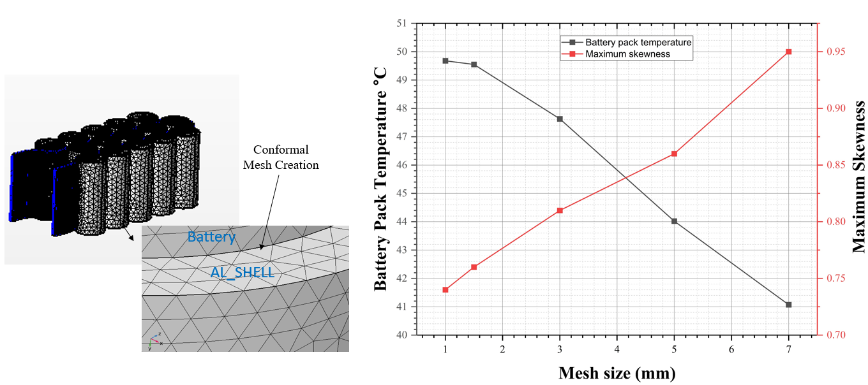
a) Mesh creation b) Mesh study
Figure 4. Mesh independent study

2.2.5.2 Time-step study
In this study, a time-independent analysis was conducted to evaluate the stability of the numerical solver under specific operating conditions. The battery was subjected to a 5C charge-discharge cycle, incorporating a 10-second rest period between charge and discharge phases. Achieving convergence in the output required the time step size to be reduced below 3 seconds. Larger time step sizes, such as 6 seconds, led to solution instability and divergence. To ensure stable solver behavior, a time step of 1 second was adopted for the investigation.
However, when extended to 100 cycles, this choice significantly increased computational demands, with a total clock time of approximately 1.2 weeks. For a longer duration of 700 cycles, the computation time is projected to be between 12 and 15 weeks. The computational resources employed for this study included an AMD Epyc 7313P processor with 62 cores and approximately 125 GB of memory.
Key computational details are summarized as follows:
- Machine Type: AMD Epyc 7313P processor
- Time Stepping Range: 0.5 to 6 seconds
- Optimal Time Step: 1 second
- Operational C-rate: 5C
- Clock Time (100 cycles): 1.2 weeks
- Clock Time (700 cycles): 12–15 weeks
Figure 5 illustrates the discharge curve comparisons for five different time-stepping cases. The results demonstrate that increasing the time step size leads to system divergence, as reflected in the solver's instability. Conversely, smaller time step sizes exhibit consistent trends, ensuring solver stability and accuracy. The discharge curves obtained with smaller time steps align closely with expected theoretical behavior, showcasing the solver's ability to model the battery's charge-discharge cycles effectively. This stability, however, comes with a trade-off: a marked increase in computational time. For instance, at the optimal time step of 1 second, the solver achieves stable and reliable results but demands significantly more computational resources, extending the clock time to 1.2 weeks for 100 cycles and up to 12–15 weeks for 700 cycles.
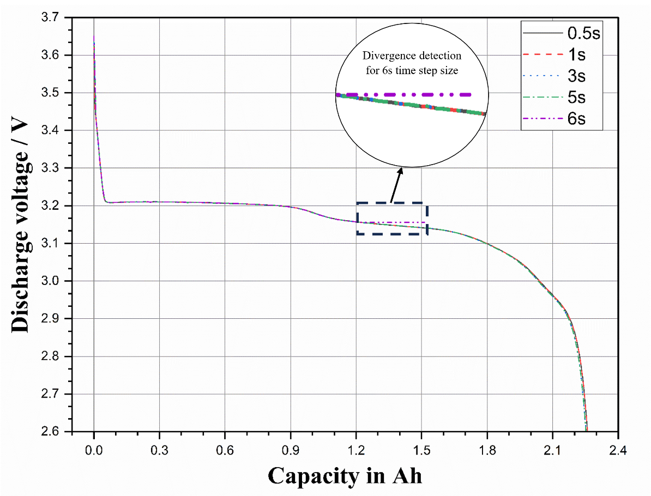
Figure 5. Time step study for discharge curve comparison on different time stepping cases.

2.3. Model validation
In this study, the commercially available A123 26650 M1-B 2.3 Ah capacity cell electrochemical characteristics are used to perform a systematic numerical validation on both new and cycled condition. To begin, firstly the electrochemical properties of these batteries are tested by submitting individual cells to charge and discharge cycles at various C-rates and different ambient operational settings. After confirming the electrochemical voltage profiles for fresh cells, a test is done to assess the numerical model’s ability to capture the temperature changes throughout cell operation. Finally, cell degradation for cycled cells is examined at various cell operational temperatures from sub-zero to high ambient. This validation strategy confirms the correct incorporation of battery electrochemistry, energy equation, and degradation into our model. Figures 6–7 describe the validation for fresh cell charge discharge voltage under isothermal condition, temperature profile under adiabatic and known cooling conditions, to ensure accurate thermo-electrochemical model and robust numerical scheme implementation. Figure 6 demonstrates good accuracy of the electrochemical model, which satisfactorily reproduces the charging and discharging processes under different temperatures. Figure 7 further confirms the accuracy of energy equation by validating against cell temperature evolution under adiabatic and well-controlled cooling conditions. These validations establish the basis to further incorporate cell degradation and conjugate heat transfer.
After evaluating the accuracy of our numerical strategy, which incorporates electrochemical and energy equations through charge-discharge behavior and temperature rise profile assessment, our focus moves to validating the degrading performance of the cycle cell. This validation attempts to confirm that capacity fading techniques are implemented correctly under variable C-rates and ambient temperatures. Figure 8 shows the validation results for a cycled cell. The results obtained indicate satisfactory predictability when comparing our present numerical model with the experimental cell aging data given in literature. This observation underlines the accuracy of the modeling methodology used in our current study since the overall error between numerical model and literature reported experiment in less than 5%. Also below Table 9 summarizes the key validation targets against both fresh and cycle cells.
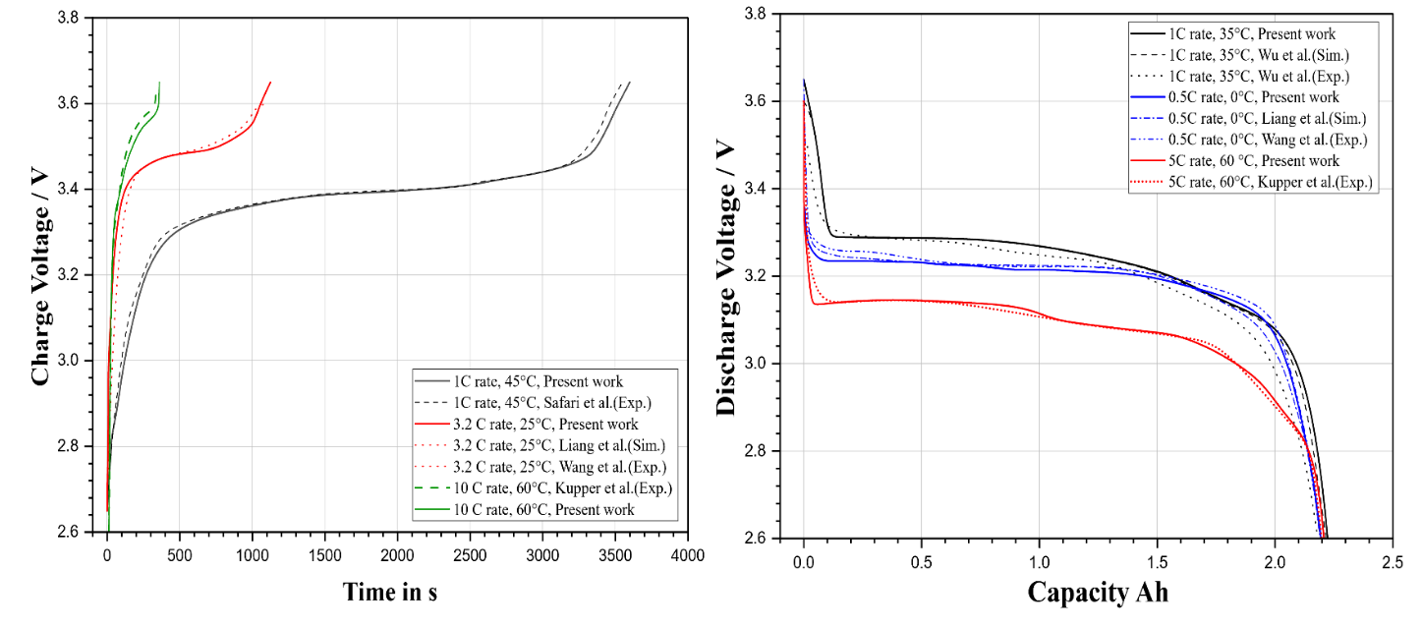
Figure 6. Fresh cell a) Charge and b) Discharge Voltage validation under isothermal conditions [45,50,57,61,62]

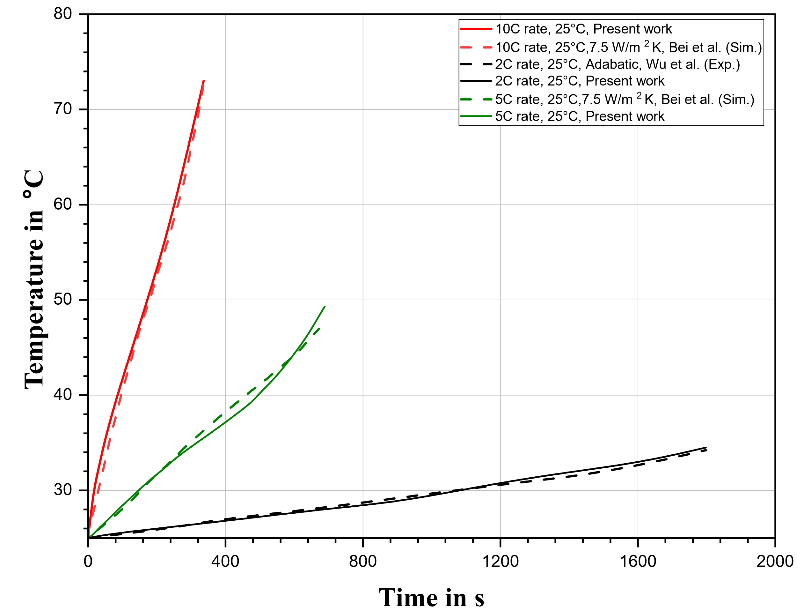
Figure 7. Fresh cell temperature validation under adiabatic and known cooling conditions [51,62]

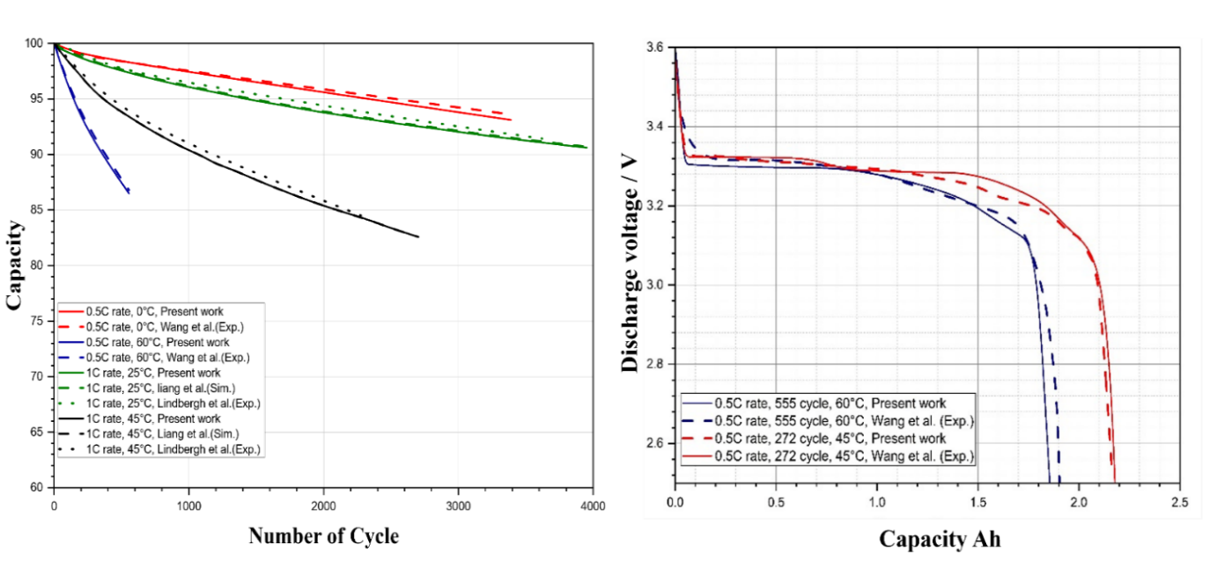
Figure 8. Cycled cell validation results a) Capacity and b) Discharge voltage. [41,45,50]

Table 9. Validation targets at different operating conditions
Fresh cell
REF | C-rate |  | Ambient temperature | Condition | Key setting in model
Safari et al. [57] |  | 1C | 45℃ | Experiment | Isothermal test, fitting of OCP (Open Circuit Potential) functions at cathode and anode, configuring electrochemical parameters.
Liang et al. [45] |  | 3.2C, 0.5C | 25℃ & 0℃ | Simulation | Setting of charge discharge cycle with rest period and fitting of all thermophysical data in ECT framework with convection
Wang et al. [50] |  | 3.2C, 0.5C | 25℃ & 0℃ | Experiment | The upper and lower voltage limit is modified to 3.6 V and 2.0 V. Uncertainty quantification  not reported.
Kupper et al. [61] |  | 10C | 60℃ | Experiment | Modification of transport and thermodynamic properties on electrode pair scale, power cycle and limiting currents.
Wu et al. [62] |  | 1C | 35℃ | Experiment  simulation | Test Conducted in adiabatic condition, modification of electrochemical kinetics parameters, thermophysical property.

Table 9. Continued
REF | C-rate |  | Ambient temperature |  | Condition | Key setting in model
Cycled cell
Wang et al. [50] |  | 0.5C | 0℃, 45℃  60℃ | Experiment |  | Isothermal condition with cycled cell at 272 cycle and 555 cycles on same A123 26650 LFP cell. Two test samples used, capacity loss has been normalized to quantify uncertainty.
Liang et al. [45] |  | 1C | 25℃ & 45℃ | Simulation |  | Inclusion of SEI formation and Li-Plating, OCP, kinetics and transport property tuned, test conducted for cycle life to identify capacity loss.
Ekstrom  Lindbergh [41] |  | 1C | 25℃ & 45℃ | Experiment |  | Test conducted for cell cycle life to identify remaining capacity after 1C cycling at 25℃ and 45℃. Single test sample used.
Thermal Validation
Bei et al. [51] |  | 5C 10C | 25℃ | Simulation Experiment |  | Test conducted for fresh cell, piecewise cubic function is used to fit electrode pair OCP and entropic coefficient data.
Wu et al. [62] |  | 1C | 25℃ | Simulation |  | Test conducted for fresh cell at adiabatic condition on same ETM modeling parameters, OCPs are fitted as polynomial functions.

2.4. Result and discussion
This section outlines the key discoveries from our work on the variable capacity loss observed in individual cells within battery module. Investigation begins by evaluating the thermal performance of the battery module using a typical CCCV charge discharge protocol at a 5C rate with 10-second rest period until it reaches 90% of its original capacity. This decision is made based on research indicating that capacity degradation deviates from a linear pattern beyond 80% and due to the complexity and computational time needed, current model is opted till 10% capacity loss occurrence for both unidirectional fluid flow thermal design and reciprocating thermal design. In Section 2.4.1, firstly the comparative discussion is made between both thermal designs, indicating crucial insights on how temperature evolves in both systems as cell degrades, and answering how reciprocating thermal design is helpful in lowering battery temperature while maintaining temperature uniformity. In Section 2.4.2, results on cell-to-cell variable capacity fade is discussed. In proceeding Section 2.4.3, summary of comparative results on the mean capacity of battery module and the non-dimensional relationship on cell-to-cell variability monitored between both thermal designs. In final Section 4.4, findings on loss of lithium inventory and film growth thickness in the most degraded cells out of both thermal designs are discussed.

2.4.1 Thermal performance of battery module with unidirectional and reciprocating thermal design
This section is devoted to an in-depth examination of battery module operating at 5C rate with unidirectional thermal design against reciprocating thermal design. These tests were conducted under standard atmospheric pressure, with an inlet temperature fixed at 27°C, while the ambient temperature along the battery module is also patched at 27°C. In Figure 9, comparison is made of the average temperature across all cells over 700 cycles between both uni-directional and reciprocating thermal designs, where cell 1 to 5 represents the first row (close to inlet proximity in unidirectional thermal design), cell 6 to 10 represents the second row, and cell 11 to 15 represents the third row (close to outlet proximity in unidirectional thermal design).
Figure 9. Average temperature of cells with reciprocating flow cooling system over 700 cycles.

In both thermal designs, it is observed that cells in the middle row experience notably lower temperatures compared to those in other rows. This advantage arises from their dual-sided contact with the cooling channel, which enhances heat dissipation. In contrast, cells in the remaining rows show significant temperature differences based on their position relative to the inlet and outlet. In unidirectional thermal designs, cells closer to the inlet, such as those in the first row, maintain lower temperatures due to exposure to cooler fluid. Meanwhile, cells in the third row, located further along the channel, experience higher temperatures. This is caused by the progressive increase in fluid temperature as it absorbs heat along its path, which reduces the cooling efficiency and leads to diminished heat transfer rates downstream.
Cell 1, located closest to the inlet, shows the lowest temperature, while Cells 14 and 15, positioned to the outlet, indicate the highest temperatures. Notably, Cell 15 has a larger contact surface with the channel than Cell 14, which helps improve heat exchange and leads to a greater temperature drop in Cell 15, despite having higher fluid temperatures. The main problem with unidirectional flow cooling is the increase in fluid temperature, leading to a rise in temperature in cells along the channel. This effect causes temperature variations within the module, which increases over time. To tackle this problem of temperature nonuniformity and maintain temperature distribution optimality reciprocating thermal design is introduced which is programmed to reverse the flow and switched inlet position with outlet for every 50 cycles. As shown in Figure 9, with the adoption of reciprocating flow temperature uniformity is maintained between the cells while lowering average temperature difference from 11.48°C to 4.24°C.
After careful examination of average temperature distribution of cells within battery module operating at 5C rate, 700 cycles, and recognizing that cooling rate for cell is depends on its proximity inside battery module, now in following Figure 10 comparison of maximum temperatures between the two cooling systems elucidates with their respective capabilities in managing peak temperature levels in thermal design having unidirectional and reciprocating flow.
Figure 10. Comparison of reciprocating flow cooling and unidirectional flow cooling

From the comparison of maximum temperatures between the two cooling systems, we can clearly see with the adoption of reciprocating thermal design, battery peak temperature has substantially reduced due to more effective heat transfer and optimal temperature uniformity inside battery module. Utilizing reciprocating flow resulted in a decrease in the temperature of the module from 53.28°C to 47.65°C, representing a reduction of 10.6% of mean temperature. Differences in mean temperatures between the two cooling systems indicate variations in overall thermal performance. A lower mean temperature signifies better temperature regulation and control, highlighting the system's efficiency in maintaining optimal operating conditions. As depicted in Figure 10, a notable decrease in the mean temperature of the module is evident, with a reduction of 3.67°C observed from 42.21°C to 38.54°C by implementing reciprocating thermal design. Standard deviation reflects the degree of temperature variability or dispersion around the mean within each dataset.
A smaller standard deviation is a key indicator of a more consistent temperature distribution, which directly translates to superior thermal stability and reliability in one cooling system over the other. In this case, the standard deviation for temperatures under the reciprocating flow system is 3.03°C, significantly lower than the 4.02°C observed with unidirectional flow. This reduced variability highlights the ability of the reciprocating design to maintain steadier temperatures across the battery module, which is essential for enhancing performance and extending the lifespan of the cells. In addition to improved consistency, the reciprocating flow design effectively reduces the average temperature differences within the module. These differences drop significantly from 11.47°C in the unidirectional system to 6.64°C with the reciprocating design. This improvement underscores the system's capacity to mitigate thermal gradients, ensuring a more uniform cooling effect throughout the module. A violin plot representation is used, as shown in Figure 11. The violin plot provides a comprehensive view of the temperature distribution for both unidirectional and reciprocating systems, illustrating the marked improvement in consistency and uniformity achieved by the reciprocating thermal design. This visualization helps highlight the design’s ability to maintain stable and predictable thermal behavior, which is crucial for reliable battery operation.
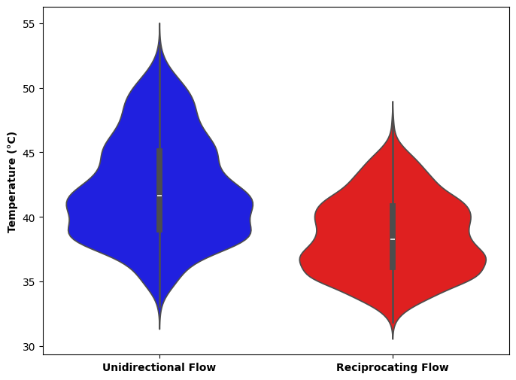
Figure 11. Comparison of reciprocating flow cooling and unidirectional flow cooling (violin plot)

The blue violin symbolizes unidirectional fluid flow, whereas the red color represents reciprocating fluid flow in thermal design. A violin plot is a statistical method used to display the distribution of data points over different values on the x-axis, where wider areas represent more density. In a unidirectional fluid flow system (blue hue), the widest part is at 41.1°C, suggesting that a large number of battery cells function at this temperature. The white dot in the blue violin represents the median temperature, which is 41.6 °C. The Interquartile Range (IQR) is represented by a black bar and ranges from around 38.7°C to 45.2°C, including the central 50% of the dataset.
The red violin plot of the reciprocating flow cooling system exhibits a more symmetrical form than the blue one, indicating a more evenly distributed range of temperatures. The median temperature for reciprocating flow is 38.3°C, and this plot also indicates that central 50% of the dataset are in the range of 35.7 °C to 40.9 °C.
The violin plot provides a clear representation of temperature distribution, with the highest density of data points in the red violin—representing the reciprocating flow—centered around 36.5°C. This concentration indicates that the reciprocating flow system consistently maintains a lower and more stable operating temperature compared to the unidirectional flow system. In contrast, the unidirectional flow violin shows elevated peaks and a wider spread of data points, reflecting less effective cooling and higher cell temperatures, particularly in regions further downstream from the cooling inlet. Expanding the analysis, Figure 12a compares the maximum module temperature and the maximum temperature difference within the module for both cooling systems. This comparison highlights the superior performance of the reciprocating design in mitigating peak temperatures and reducing thermal gradients, which are critical for maintaining module efficiency and reliability. Figure 12b provides a more detailed view by illustrating temperature variations over cycles for specific cells—Cell 1 (first row), Cell 7 (middle row), and Cell 14 (last row). These cells are strategically chosen to represent the temperature dynamics across different module positions under both cooling systems. The analysis clearly shows that reciprocating flow minimizes temperature fluctuations and ensures better uniformity across cells, regardless of their location, while unidirectional
a) Comparison of the maximum module temperature and the maximum temperature difference of the module
b) illustration of the temperature variations in cells 1, 7, and 14 across different cycles under both cooling systems
Figure 12. Cell to battery module temperature variation results.

flow exhibits more pronounced variations, especially in cells positioned farther from the cooling inlet.
As shown in Figure 12a, there is notable reduction in battery module maximum temperature as well as overall temperature difference by implementing reciprocating thermal design. In the case of unidirectional flow, there is a nearly linear increase in both the maximum module temperature and the maximum temperature divergence over time and cycles. However, when reciprocating flow is used, the linear rise is reduced, and the parameters show a fluctuating pattern instead. This comparison highlights the clear differences in thermal performance and efficiency between the two cooling systems in regulating temperature variations within the module over time. Figure 12b shows detailed observation of this trend for in selected cell 1, 7 and 14 considering its proximity to the fluid flow inlet and outlet positions in both thermal designs.
Typically, the temperature change pattern of these three selected cells under unidirectional flow displays a virtually identical linear increase over time. Temperature changes in these cells are more noticeable when subjected to reciprocating flow, showing a non-linear pattern. The study demonstrates how the cooling system setup affects the temperature fluctuations of individual cells. Reciprocating flow leads to increased unpredictability in temperature changes, while unidirectional flow results in a more constant linear temperature increase. To enhance acceptance of the explanations, an overview of temperature contours is provided in Figure 13. Figure 13a, displays the temperature contours of the module, cells, and liquid channel at the end of the 700th cycle with unidirectional flow. Figure 13b shows the same contours for reciprocating flow. Figure 13a shows that the temperature of the cells rises gradually throughout the channel, with cell 1 having the lowest temperature and cell 14 having the greatest temperature, which is consistent with earlier findings. The significant disparities in temperature distribution among the cells is clearly seen. On the other hand, using reciprocating flow results in a significant reduction in both cell temperature and temperature difference between them, as seen by the temperature contours in Figure 13b. The decrease in temperature differences highlights how reciprocating flow helps achieve a more uniform temperature distribution in the system.

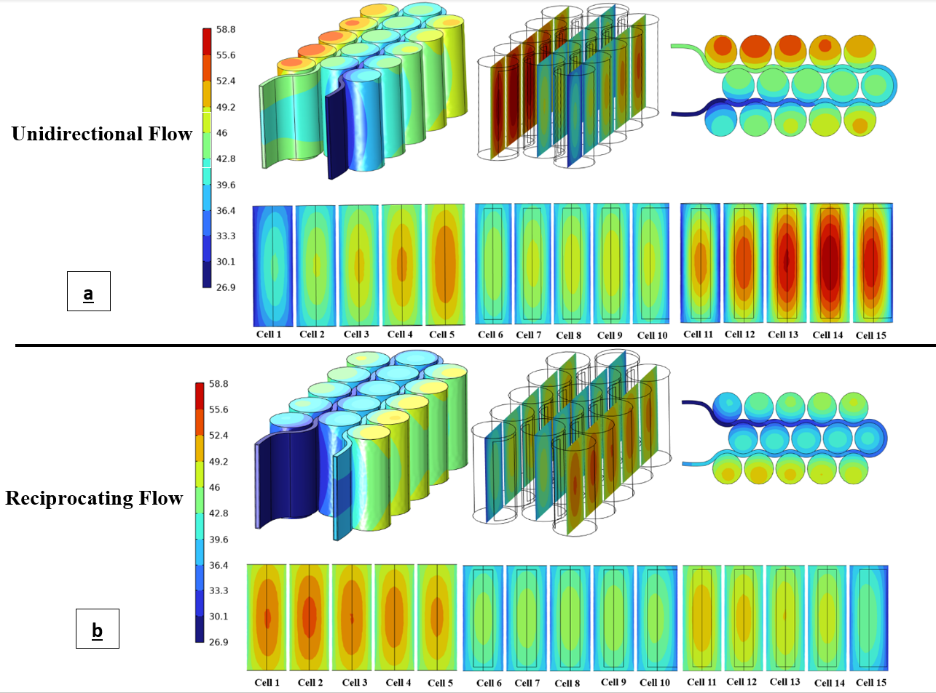
Figure 13. Temperature contours of the module, cells, and liquid channel at the conclusion of the 700th cycle under unidirectional flow and reciprocating flow

2.4.2 Cell-to-Cell variable capacity loss between unidirectional and reciprocating thermal design
Continuing from the previous discussion, we observed varying boundary conditions for each cell in the battery module, leading to uneven temperature distribution. Cells near the inlet have lower temperatures due to higher heat transfer rates, while cells near the outlet have higher temperatures due to lower heat transfer rates. Implementing reciprocating thermal design achieves dual functionality: lowering battery module peak temperature and maintaining temperature uniformity between the cells. This section discusses cell level capacity loss in comparison between two thermal designs, where each cell is subjected to different thermal boundary conditions.
Based on previous discussion aligning with capacity fade results for unidirectional fluid flow thermal design, a noteworthy varying temperature distribution influencing variable capacity within each cell based on its location and proximity to the fluid flow is observed. After analyzing battery capacity fade results for each cell, it has been confirmed that nonuniform cooling conditions are usually responsible for cell-to-cell variable capacity fade. The cells near the inlet (cells 1-5) and middle lane (6-10) show the lowest capacity fade, while the cell near the outlet (11-15) has the highest capacity fade. In this thermal design since cell 14 is the hottest in the module, with an average temperature of 53.28°C, resulting in the lowest available capacity of 0.88 at 700th cycle. In contrast, cell 1, located near the inlet, has a capacity of 0.90 and is the least degraded. Cell 14 is the hottest cell in the battery module, with a capacity loss of 11.61% after 700 charge-discharge cycles. At the start of 100 formation cycle’s a rapid and steady decline in capacity is observed, which is most likely due to significant irreversible capacity loss caused by the creation of SEI.
In Figure 14b with reciprocating thermal design, Cell 2 is identified as the most degraded cell, with a capacity of 0.9133 remaining after 700 charge-discharge cycles. The variation in capacity degradation of each cell is directly related to the temperature history experienced by the cells based on their location within the thermal design. Figure 14a shows results for unidirectional fluid flow thermal design capacity retention as a
a) Capacity loss for Unidirectional fluid flow thermal design
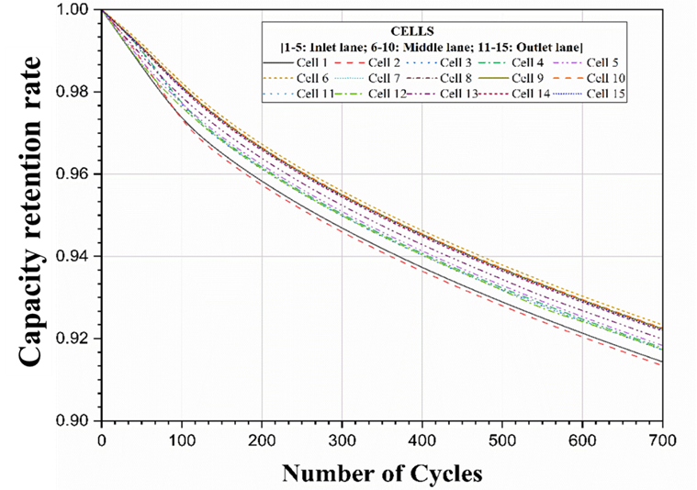
b) Capacity loss for reciprocating flow thermal design
Figure 14. Cell-to-cell level remaining capacity v.s. number of cycle

function of number of cycles, and Figure 14b shows for reciprocating fluid flow thermal design. Furthermore, a direct battery module level test is shown in Figure 15.
Reciprocating flow helps minimize nonuniform temperature distribution among cells while directly resulting in a reduction in cell-to-cell capacity loss variability. In total 8.66% of capacity loss is observed in cell 2, which is identified as most degraded cell with reciprocating flow thermal design.
In the previous section 2.4.1, it has been found that the highest average temperature of the battery module was 53.28℃ with unidirectional flow thermal design and 47.65°C with reciprocating fluid flow thermal design. Introducing reciprocating flow thermal design minimizes temperature differences between cells and maintains minimum capacity loss between each cell. Figure 15 also shows the comparison on mean capacity between both unidirectional fluid flow and reciprocating fluid flow thermal design. With unidirectional fluid flow thermal design, there is a total 10.34% of total mean capacity loss and with proposed reciprocating thermal design it is reduced to 8.0%. It can also be noted that the variability among the cycles is reduced by implementing reciprocating thermal design since coefficient of variance (COV), which is a non-dimensional parameter to represents capacity loss variability among the cell’s is 0.005 for conventional fluid flow thermal design and with proposed reciprocating thermal design it is reduced to 0.0036. Previous analysis revealed a significant decline in capacity between cells during the initial 100 cycles. This is reflected in the COV plot, showing a sharp increase in COV that gradually stabilizes in subsequent cycles.

2.4.3 Loss of lithium inventory and growth of SEI/Li plating thickness on most degraded cell
In line with previous discussion, it is found when battery module is operated with unidirectional thermal design, Cell 14, comes up as the hottest, and most degraded cell in the module. While when it operates with reciprocating thermal design, Cell 2 becomes as the most degraded and hottest cell inside the module. At this point it is interesting to know out of provided two degradation channels which dominates the most for loss of LLI.

Figure 15. Battery module mean capacity and Coefficient of variance comparison for unidirectional and reciprocating fluid flow thermal design.

Figure 16 shows results for LLI in % for SEI thickening and Li plating for a) Unidirectional fluid flow thermal design and b) Reciprocating fluid flow thermal design. Within both thermal designs, we found SEI thickening remains the dominant channel for loss of lithium inventory. Figure 17 shows change in thickness for SEI and Li plating.
When battery module was operated using reciprocating fluid flow thermal design, in total of 8.66% of LLI at the end of the 700th cycle, 8.45% is contributed by SEI thickening (normalized as 98.1%), while 0.21% is contributed by Li plating (normalized as 2.4%). When battery module was operated with unidirectional fluid flow thermal design, out of 11.61% of LLI at the end of the 700th cycle, 11.32% (normalized as 97.50%) is contributed by SEI thickening and 0.28% (normalized as 2.41%) by Li plating.
The most significant thickness growth is observed in the SEI degradation channel, surpassing that of Li plating in both unidirectional and reciprocating thermal designs. This observation is important because the operating temperature of the battery module offers favorable circumstances for SEI thickening, resulting in a large reduction in lithium inventory. At the beginning of the formation cycle, the change in thickness is not very apparent. As the cell degrades more and temperature variations continue, the film growth increases. Cell 14, known as the most degraded cell in the battery module with a unidirectional thermal design, experiences a total film growth of 326.3 nm after 700 cycles. The majority of the increase is due to SEI thickening, which accounts for 325.41 nm, whereas Li plating adds a tiny fraction of 0.89 nm. In the reciprocating thermal design, a total film thickness change of 303.43 nm is observed, mostly due to SEI thickening by 302.63 nm, with the remaining 0.83 nm from Li plating. This analysis highlights the increasing importance of SEI thickness as cells degrade, showing its crucial involvement in the depletion of lithium inventory over time.

2.5. Conclusion
In the present study the impact of two different thermal designs on cell-to-cell variable capacity loss is numerically investigated. First, a fully coupled Multiphysics thermos-electrochemical capacity fade model is developed for $LiFePO_{4}$ cathode A123 26650 cell which has SEI formation and Lithium plating (dendrite) as primary degradation channel

- Unidirectional fluid flow thermal design: cell 14
- Reciprocating fluid flow: cell 2
Figure 16. Budget analysis of loss of lithium inventory a) unidirectional: cell 14 and b) reciprocating: cell 2.

Figure 17. Change in thickness for most degraded cell in thermal design a) unidirectional: cell 14 and b) reciprocating: cell 2.

for a 15S1P battery module operating at 5C charge-discharge rates equipped with widely adopted unidirectional fluid flow thermal design and reciprocating fluid flow thermal design. The main conclusion of present study is summarized below:
a) In battery module, the rate of capacity loss experienced by each cell is based on its proximity near inlet and outlet. Cells located near the outlet section are found to be the hottest in both thermal designs, while the advantage provided by reciprocating thermal design is to limit temperature nonuniformity between cells at lowest as possible.
b) Concisely battery module with unidirectional fluid flow thermal design, cell located near the outlet has higher temperature than the cells located near the inlet section. This directly causes an accelerating rate of capacity loss experienced by the cell located near the outlet proximity.
c) With reciprocating thermal design, which has 50:50 cycle switching function, we can reduce nonuniform temperature distribution experienced by each cell, thus reducing cell-to-cell variable capacity loss.
d) It is concluded, the loss of lithium inventory is dominated by the SEI thickening mechanism when compared with Li plating in the current operating condition. It should be pointed out that 50 cycle switching period is a representative number to demonstrate the usefulness of the reciprocating cooling, which of course can be adjusted in practical applications. Also, the innovative reciprocating thermal design can be achieved by designing a dedicated pumping or valving mechanism that can cyclically reverse the direction of coolant flow. As a result, it can reduce the variability in capacity loss between individual cells and maintain consistent heat transfer routes among them.
There are nevertheless limitations in the current work. Due to constrain in computational power, study is carried out till 90% occurrence of capacity fading. While non-linearity is observed around 80% of EOL. The primary degradation processes studied in this research are lithium plating and SEI formation, where SEI thickening primarily dominates for loss of lithium inventory. Current research does not investigate the degradation pathway of active material loss (LAM), which is considered to be another degradation channel for batteries operating at high temperatures. Further research can focus on testing battery module performance in sub-zero temperatures, requiring an optimal pre-heating thermal design to address variable capacity loss between cells and the potential issue of lithium plating might become the main degradation factor. The methodology and the key findings for different cooling methods are nevertheless easily extendable to larger battery packs and to real world driving cycles.

2.6. Future Work
The following are the future work from present study:
- The degradation model should be expanded with more major channels such as Loss of active material (LAM).
- Thermal design should be tested for sub-zero atmosphere with preheating arrangement where Li-plating is expected to be a dominant channel.
- Modeling capability should be expanded on pack level, and impact of fast charge along with power cycle discharge should be tested for more realistic scenario.

APPENDIX
Table A1 represents parameters used to develop $LiFePO_{4}$ cell electrochemical model. These accounted parameters include design specifications, Lithium-ion concentrations, and kinetic transport factors. Table A2 represents a list of temperature dependent variable fitted in electrochemical model. In present study Bruggeman factor is used to correct electrolyte conductivity, electrode conductivity and the Li⁺ diffusivity in electrolyte.

Table A1. List of parameters used to develop electrochemical model.[43,45,57]
Parameter | Symbol | Unit | Al  collector | Negative Electrode | Separator | Positive Electrode | Cu  Collector
length | L | µm | 10 | 34 | 25 | 80 | 6.2
Particle radius | r | µm | – | 4 | – | 1.15 | –
Volume fraction of solid phase | ε_{s} | – | – | 0.549 | 0.55 | 0.354 | –
Volume fraction of liquid phase | εl | – | – | 0.387 | 0.54 | 0.593 | –
Filler volume fraction | ε_{f} | – | – | 0.0326 | – | 0.0535 | –
Maximum Li concentration in solid | C_{s,max} | mol m⁻³ | – | 30555 | – | 22806 | –
Initial concentration Li in electrolyte | C_{l,0} | mol m⁻³ | – | – | 1200 | – | –
S at SOC = 0 | SOC | – | – | 0.0132 | – | 0.74 | –
S at SOC = 1 | SOC | – | – | 0.811 | – | 0.035 | –

Table A1. Continued.
Parameter | Symbol | Unit | Al  collector | Negative Electrode | Separator | Positive Electrode | Cu  Collector
Transfer coefficient for anodic current | α_{a} | – | – | 0.5 | – | - | –
Transfer coefficient for cathodic current | α_{c} | – | – | 0.5 | – | - | –
Bruggeman tortuosity exponent | $$β$$ | – | – | 2.5 | 3.6 | 2.1 | –
Diffusion coefficient | D_{s,ref} | m² s⁻¹ | – | 3.9 × 10⁻¹⁴ | – | 1.25 × 10⁻¹⁵ | –
Reaction temperature constant | k₀ | m^{2.5} mol^{−0.5}s⁻¹ | – | 3 × 10⁻¹¹ | – | 1.4 × 10⁻¹² | –
Electric conductivity | σ_{s} | S m⁻¹ | – | 100 | – | 0.5 – 10.8 | –
Transference number | t₊ | – | – | – | 0.363 | – | –
Activation energy of diffusion | E_{D} | J mol⁻¹ | – | 20,000 | – | 13,000 | –
Activation energy of reaction | E_{R} | J mol⁻¹ | – | 35,000 | – | 39,000 | –
Table A1. Continued.
Parameter |  | Symbol | Unit | Al  collector | Negative Electrode | Separator | Positive Electrode | Cu  Collector
 | Thermal conductivity | λ | W/(mK) | 237 | 1.04 | 0.5 | 1.48 | 398
 | Density | ρ | kg/(m³) | 2700 | 2223 | 900 | 1500 | 8700
 | Specific heat | C_{p} | J K⁻¹ kg⁻¹ | 897 | 641 | 1883 | 800 | 396

Table A2. List of temperature dependent concentration variables fitted in modeling framework. [59][60]
Physical property | Equation | Description | Equation number
Open circuit potentials | U_{i} = U_{i,ref} + $\left[\frac{∂U}{∂T}\right]$_{i} (T-T_{ref}) | i' stands for LFP cathode and graphite anode. i=negative,y and i=positive,x.  The dependence of OCP on temperature is by the first term of Taylor expansion.  U_{i} is the OCP for negative (graphite) and positive (LFP) electrodes. | 33
Negative electrode Li_{y}C₆ | $$U_{eq,n}\left(y\right)=0.7222+0.13868y+0.028952y^{0.5}-0.017189\left(1/y\right)+0.0019144\left(1/{y^{1.5}}\right)+0.28082\exp\left[15\left(0.06-y\right)\right]-0.79844exp⁡[0.44649(y-0.92)]$$ |  | 34
Positive electrode Li_{x}FePO₄ | $U_{eq,p}\left(x\right)= 2.567462+57.69\left[1-\tanh\left(100x+2.9163927\right)\right]+0.442953tan^{-1}\left(-65.41928x+64.89741\right)+0.097237tan^{-1}(-160.9058x+154.590$) |  | 35
Li diffusion coefficient | $$D_{s,i}=D_{s,ref}exp\left(\frac{E_{act}^{D_{s}}}{R}\left(\frac{1}{T_{ref}}-\frac{1}{T}\right)\right)$$ | Fitted as an analytical function in COMSOL. | 36
Reaction rate constant | K_{0,i} = k_{0,ref} exp$\left(\frac{E_{d,i}}{R}\left(\frac{1}{T_{ref}}-\frac{1}{T}\right)\right)$ | Fitted as an analytical function in COMSOL. | 37
Electrolyte Li⁺ diffusion coefficient | $$D_{l, ref}(c_{l})={10}^{\left(-8.43-\frac{54}{T-229-0.005c_{l}}-0.0022c_{l}\right)}$$ | Fitted as an analytical function in COMSOL. | 38

Table A2. Continued.
Physical property | Equation | Description | Equation number
Ionic conductivity | $$κ_{l}\left(c_{l}\right)=8e^{-11}{c_{l}}^{3}-4e^{-7}{c_{l}}^{2}+0.0006c_{l}+0.0151$$ | Fitted as an analytical function in COMSOL | 39
Thermodynamics factor | $$ν=0.301-0.24\sqrt{{10}^{-3}c_{l}}+ 0.982 \left[1-0.0052(T-294)\sqrt{{10}^{-9}c_{l}^{3}}\right]$$ | Fitted as an analytical function in COMSOL | 40
SOC at Positive and negative | x or y = SOC_{i} = $\frac{C_{s,i}}{C_{s,max,i}}$ | The SOC limit is configured using the Initial Cell Charge Distribution window. | 41
Applied current density at 1C rate | i_{app},1C = $\frac{C_{cell}}{A}$ | This equation is used to describe applied current density at 1C | 42

LIST OF REFERENCES
[1] A. Ghosh, Possibilities and Challenges for the Inclusion of the Electric Vehicle (EV) to Reduce the Carbon Footprint in the Transport Sector: A Review, Energies (Basel) 13 (2020) 2602. https://doi.org/10.3390/en13102602.
[2] Z. Zhu, Y. Wang, M. Yuan, R. Zhang, Y. Chen, G. Lou, Y. Sun, Energy saving and carbon reduction schemes for families with the household PV-BES-EV system, Energy Build 288 (2023) 113007. https://doi.org/10.1016/j.enbuild.2023.113007.
[3] T. Fan, W. Liang, W. Guo, T. Feng, W. Li, Life cycle assessment of electric vehicles’ lithium-ion batteries reused for energy storage, J Energy Storage 71 (2023) 108126. https://doi.org/10.1016/j.est.2023.108126.
[4] X. Xia, P. Li, A review of the life cycle assessment of electric vehicles: Considering the influence of batteries, Science of The Total Environment 814 (2022) 152870. https://doi.org/10.1016/j.scitotenv.2021.152870.
[5] F.M.N.U. Khan, M.G. Rasul, A.S.M. Sayem, N.K. Mandal, Design and optimization of lithium-ion battery as an efficient energy storage device for electric vehicles: A comprehensive review, J Energy Storage 71 (2023) 108033. https://doi.org/10.1016/j.est.2023.108033.
[6] Y.-W. Wang, C.-M. Shu, Energy generation mechanisms for a Li-ion cell in case of thermal explosion: A review, J Energy Storage 55 (2022) 105501. https://doi.org/10.1016/j.est.2022.105501.
[7] S. Ogunfuye, H. Sezer, A.O. Said, A. Simeoni, V. Akkerman, An analysis of gas-induced explosions in vented enclosures in lithium-ion batteries, J Energy Storage 51 (2022) 104438. https://doi.org/10.1016/j.est.2022.104438.
[8] S. Chen, Z. Wang, J. Wang, X. Tong, W. Yan, Lower explosion limit of the vented gases from Li-ion batteries thermal runaway in high temperature condition, J Loss Prev Process Ind 63 (2020) 103992. https://doi.org/10.1016/j.jlp.2019.103992.
[9] C. Xu, H. Wang, F. Jiang, X. Feng, L. Lu, C. Jin, F. Zhang, W. Huang, M. Zhang, M. Ouyang, Modelling of thermal runaway propagation in lithium-ion battery pack using reduced-order model, Energy 268 (2023) 126646. https://doi.org/10.1016/j.energy.2023.126646.
[10] W. Xu, K. Zhou, H. Wang, L. Lu, Y. Wu, B. Gao, C. Shi, X. Rui, X. Wu, Y. Li, Series arc-induced internal short circuit leading to thermal runaway in lithium-ion battery, Energy 308 (2024) 132999. https://doi.org/10.1016/j.energy.2024.132999.
[11] C.M.R. Vendra, A. V. Shelke, J.E.H. Buston, J. Gill, D. Howard, E. Read, A. Abaza, B. Cooper, J.X. Wen, Numerical and experimental characterisation of high energy density 21700 lithium-ion battery fires, Process Safety and Environmental Protection 160 (2022) 153–165. https://doi.org/10.1016/j.psep.2022.02.014.
[12] S. Hoelle, S. Zimmermann, O. Hinrichsen, 3D Thermal Simulation of Thermal Runaway Propagation in Lithium-Ion Battery Cell Stack: Review and Comparison of Modeling Approaches, J Electrochem Soc 170 (2023) 060516. https://doi.org/10.1149/1945-7111/acd966.
[13] L. Sheng, L. Su, H. Zhang, Y. Fang, H. Xu, W. Ye, An improved calorimetric method for characterizations of the specific heat and the heat generation rate in a prismatic lithium ion battery cell, Energy Convers Manag 180 (2019) 724–732. https://doi.org/10.1016/j.enconman.2018.11.030.
[14] Z. Zhang, L. Fu, L. Sheng, W. Ye, Y. Sun, Method of liquid-cooled thermal control for a large-scale pouch lithium-ion battery, Appl Therm Eng 211 (2022) 118417. https://doi.org/10.1016/j.applthermaleng.2022.118417.
[15] W.Q. Walker, K. Cooper, P. Hughes, I. Doemling, M. Akhnoukh, S. Taylor, J. Darst, J. Billman, M. Sharp, D. Petrushenko, R. Owen, M. Pham, T. Heenan, A. Rack, O. Magdsyuk, T. Connolley, D. Brett, P. Shearing, D. Finegan, E. Darcy, The effect of cell geometry and trigger method on the risks associated with thermal runaway of lithium-ion batteries, J Power Sources 524 (2022) 230645. https://doi.org/10.1016/J.JPOWSOUR.2021.230645.
[16] Z. Guo, Q. Xu, S. Zhao, S. Zhai, T. Zhao, M. Ni, A new battery thermal management system employing the mini-channel cold plate with pin fins, Sustainable Energy Technologies and Assessments 51 (2022) 101993. https://doi.org/10.1016/j.seta.2022.101993.
[17] M. Ahmadian-Elmi, P. Zhao, Review of Thermal Management Strategies for Cylindrical Lithium-Ion Battery Packs, Batteries 10 (2024) 50. https://doi.org/10.3390/batteries10020050.
[18] V. Talele, P. Thorat, Y.P. Gokhale, H. Desai, Technical Review on Battery Thermal Management System for Electric Vehicle Application, in: 2023: pp. 177–225. https://doi.org/10.1007/978-981-19-4502-1_9.
[19] L. Sheng, H. Zhang, L. Su, Z. Zhang, H. Zhang, K. Li, Y. Fang, W. Ye, Effect analysis on thermal profile management of a cylindrical lithium-ion battery utilizing a cellular liquid cooling jacket, Energy 220 (2021) 119725. https://doi.org/10.1016/j.energy.2020.119725.
[20] L. Sheng, L. Su, H. Zhang, K. Li, Y. Fang, W. Ye, Y. Fang, Numerical investigation on a lithium ion battery thermal management utilizing a serpentine-channel liquid cooling plate exchanger, Int J Heat Mass Transf 141 (2019) 658–668. https://doi.org/10.1016/j.ijheatmasstransfer.2019.07.033.
[21] L. Sheng, H. Zhang, H. Zhang, L. Su, Z. Zhang, Lightweight liquid cooling based thermal management to a prismatic hard-cased lithium-ion battery, Int J Heat Mass Transf 170 (2021) 120998.
[22] G. Zhao, X. Wang, M. Negnevitsky, C. Li, An up-to-date review on the design improvement and optimization of the liquid-cooling battery thermal management system for electric vehicles, Appl Therm Eng 219 (2023) 119626. https://doi.org/10.1016/j.applthermaleng.2022.119626.
[23] M. Lu, X. Zhang, J. Ji, X. Xu, Y. Zhang, Research progress on power battery cooling technology for electric vehicles, J Energy Storage 27 (2020) 101155. https://doi.org/10.1016/j.est.2019.101155.
[24] R. Mahamud, C. Park, Reciprocating air flow for Li-ion battery thermal management to improve temperature uniformity, J Power Sources 196 (2011) 5685–5696. https://doi.org/10.1016/J.JPOWSOUR.2011.02.076.
[25] C. Wang, J. Xu, M. Wang, H. Xi, Experimental investigation on reciprocating air-cooling strategy of battery thermal management system, J Energy Storage 58 (2023) 106406. https://doi.org/10.1016/J.EST.2022.106406.
[26] W. Zeng, C. Ma, S. Hu, S. Li, Y. Zhang, The performance investigation and optimization of reciprocating flow applied for liquid-cooling-based battery thermal management system, Energy Convers Manag 292 (2023) 117378. https://doi.org/10.1016/J.ENCONMAN.2023.117378.
[27] G. Chang, X. Cui, Y. Li, Y. Ji, Effects of reciprocating liquid flow battery thermal management system on thermal characteristics and uniformity of large lithium‐ion battery pack, Int J Energy Res 44 (2020) 6383–6395. https://doi.org/10.1002/er.5363.
[28] Y. Huang, S. Wang, Y. Lu, R. Huang, X. Yu, Study on a liquid cooled battery thermal management system pertaining to the transient regime, Appl Therm Eng 180 (2020) 115793. https://doi.org/10.1016/J.APPLTHERMALENG.2020.115793.
[29] S.F. Schuster, M.J. Brand, P. Berg, M. Gleissenberger, A. Jossen, Lithium-ion cell-to-cell variation during battery electric vehicle operation, J Power Sources 297 (2015) 242–251. https://doi.org/10.1016/J.JPOWSOUR.2015.08.001.
[30] L. Zhang, S. Yang, L. Liu, P. Zhao, Cell-to-cell variability in Li-ion battery thermal runaway: Experimental testing, statistical analysis, and kinetic modeling, J Energy Storage 56 (2022) 106024. https://doi.org/10.1016/J.EST.2022.106024.
[31] M.M. Forouzan, S. Khaleghi Rahimian, S. Han, Y. Liu, Y. Tang, The Effects of Cell Design on Li Plating in Li-Ion Cells: A Real Insight into Cell Design Optimization for Minimizing Li Plating, ECS Meeting Abstracts MA2019-02 (2019) 275–275. https://doi.org/10.1149/MA2019-02/5/275.
[32] X.-G. Yang, Y. Leng, G. Zhang, S. Ge, C.-Y. Wang, Modeling of lithium plating induced aging of lithium-ion batteries: Transition from linear to nonlinear aging, J Power Sources 360 (2017) 28–40. https://doi.org/10.1016/j.jpowsour.2017.05.110.
[33] W. Zhao, M. Rohde, I.U. Mohsin, C. Ziebert, H.J. Seifert, Heat Generation in NMC622 Coin Cells during Electrochemical Cycling: Separation of Reversible and Irreversible Heat Effects, Batteries 6 (2020) 55.
[34] S.E.J. O’Kane, W. Ai, G. Madabattula, D. Alonso-Alvarez, R. Timms, V. Sulzer, J.S. Edge, B. Wu, G.J. Offer, M. Marinescu, Lithium-ion battery degradation: how to model it, Physical Chemistry Chemical Physics 24 (2022) 7909–7922. https://doi.org/10.1039/D2CP00417H.
[35] P. Ramadass, B. Haran, R. White, B.N. Popov, Capacity fade of Sony 18650 cells cycled at elevated temperatures, J Power Sources 112 (2002) 606–613. https://doi.org/10.1016/S0378-7753(02)00474-3.
[36] F.M. Kindermann, J. Keil, A. Frank, A. Jossen, A SEI Modeling Approach Distinguishing between Capacity and Power Fade, J Electrochem Soc 164 (2017) E287–E294. https://doi.org/10.1149/2.0321712jes.
[37] D.J. Rogers, L.J.M. Aslett, M.C.M. Troffaes, Modelling of modular battery systems under cell capacity variation and degradation, Appl Energy 283 (2021) 116360. https://doi.org/10.1016/J.APENERGY.2020.116360.
[38] X. Lin, J. Park, L. Liu, Y. Lee, A.M. Sastry, W. Lu, A Comprehensive Capacity Fade Model and Analysis for Li-Ion Batteries, J Electrochem Soc 160 (2013) A1701–A1710. https://doi.org/10.1149/2.040310jes.
[39] T.R. Ashwin, Y.M. Chung, J. Wang, Capacity fade modelling of lithium-ion battery under cyclic loading conditions, J Power Sources 328 (2016) 586–598. https://doi.org/10.1016/j.jpowsour.2016.08.054.
[40] F. Zhou, C. Bao, Analysis of the lithium-ion battery capacity degradation behavior with a comprehensive mathematical model, J Power Sources 515 (2021) 230630. https://doi.org/10.1016/j.jpowsour.2021.230630.
[41] H. Ekström, G. Lindbergh, A Model for Predicting Capacity Fade due to SEI Formation in a Commercial Graphite/LiFePO ₄ Cell, J Electrochem Soc 162 (2015) A1003–A1007. https://doi.org/10.1149/2.0641506jes.
[42] S. Gantenbein, M. Schönleber, M. Weiss, E. Ivers-Tiffée, Capacity Fade in Lithium-Ion Batteries and Cyclic Aging over Various State-of-Charge Ranges, Sustainability 11 (2019) 6697. https://doi.org/10.3390/su11236697.
[43] M. Xu, R. Wang, P. Zhao, X. Wang, Fast charging optimization for lithium-ion batteries based on dynamic programming algorithm and electrochemical-thermal-capacity fade coupled model, J Power Sources 438 (2019) 227015. https://doi.org/10.1016/j.jpowsour.2019.227015.
[44] S. Panchal, M. Mathew, R. Fraser, M. Fowler, Electrochemical thermal modeling and experimental measurements of 18650 cylindrical lithium-ion battery during discharge cycle for an EV, Appl Therm Eng 135 (2018) 123–132. https://doi.org/10.1016/J.APPLTHERMALENG.2018.02.046.
[45] J. Liang, Y. Gan, M. Yao, Y. Li, Numerical analysis of capacity fading for a LiFePO4 battery under different current rates and ambient temperatures, Int J Heat Mass Transf 165 (2021) 120615.
[46] X. Tan, J. Qiu, J. Li, Y. Fan, J. Liu, Lithium Plating as Limiting Phenomena for Estimating Safety during Lithium-Ion Battery Charging, Int J Electrochem Sci 15 (2020) 9233–9244. https://doi.org/10.20964/2020.09.27.
[47] Y. Qin, P. Zuo, X. Chen, W. Yuan, R. Huang, X. Yang, J. Du, L. Lu, X. Han, M. Ouyang, An ultra-fast charging strategy for lithium-ion battery at low temperature without lithium plating, Journal of Energy Chemistry 72 (2022) 442–452. https://doi.org/10.1016/J.JECHEM.2022.05.010.
[48] N. Wassiliadis, J. Kriegler, K.A. Gamra, M. Lienkamp, Model-based health-aware fast charging to mitigate the risk of lithium plating and prolong the cycle life of lithium-ion batteries in electric vehicles, J Power Sources 561 (2023) 232586. https://doi.org/10.1016/J.JPOWSOUR.2022.232586.
[49] N. Wassiliadis, J. Schneider, A. Frank, L. Wildfeuer, X. Lin, A. Jossen, M. Lienkamp, Review of fast charging strategies for lithium-ion battery systems and their applicability for battery electric vehicles, J Energy Storage 44 (2021) 103306. https://doi.org/10.1016/J.EST.2021.103306.
[50] J. Wang, P. Liu, J. Hicks-Garner, E. Sherman, S. Soukiazian, M. Verbrugge, H. Tataria, J. Musser, P. Finamore, Cycle-life model for graphite-LiFePO4 cells, J Power Sources 196 (2011) 3942–3948.
[51] X. Bei, Q. Liu, J. Cong, X. Liu, J. Yu, H. Yang, Simulation of electrochemical-thermal behavior for a 26650 lithium iron phosphate/graphite cell, Ionics (Kiel) 25 (2019) 3715–3726. https://doi.org/10.1007/s11581-019-02906-9.
[52] D.S. Jang, S.H. Ham, J. Kim, Y. Kim, Thermal and aging performance characteristics of pouch-type lithium-ion battery using heat pipes under nonuniform heating conditions, Appl Therm Eng 236 (2024) 121891. https://doi.org/10.1016/j.applthermaleng.2023.121891.
[53] M. Lu, X. Zhang, J. Ji, X. Xu, Y. Zhang, Research progress on power battery cooling technology for electric vehicles, J Energy Storage 27 (2020) 101155. https://doi.org/10.1016/J.EST.2019.101155.
[54] S.E.J. O’Kane, W. Ai, G. Madabattula, D. Alonso-Alvarez, R. Timms, V. Sulzer, J.S. Edge, B. Wu, G.J. Offer, M. Marinescu, Lithium-ion battery degradation: how to model it, Physical Chemistry Chemical Physics 24 (2022) 7909–7922. https://doi.org/10.1039/D2CP00417H.
[55] H. Ge, T. Aoki, N. Ikeda, S. Suga, T. Isobe, Z. Li, Y. Tabuchi, J. Zhang, Investigating Lithium Plating in Lithium-Ion Batteries at Low Temperatures Using Electrochemical Model with NMR Assisted Parameterization, J Electrochem Soc 164 (2017) A1050–A1060. https://doi.org/10.1149/2.0461706jes.
[56] C. Delacourt, M. Safari, Life Simulation of a Graphite/LiFePO ₄ Cell under Cycling and Storage, J Electrochem Soc 159 (2012) A1283–A1291. https://doi.org/10.1149/2.049208jes.
[57] M. Safari, C. Delacourt, Aging of a Commercial Graphite/LiFePO4 Cell, J Electrochem Soc 158 (2011) A1123. https://doi.org/10.1149/1.3614529.
[58] R.D. Perkins, A. V. Randall, X. Zhang, G.L. Plett, Controls oriented reduced order modeling of lithium deposition on overcharge, J Power Sources 209 (2012) 318–325. https://doi.org/10.1016/J.JPOWSOUR.2012.03.003.
[59] M. Safari, M. Morcrette, A. Teyssot, C. Delacourt, Multimodal Physics-Based Aging Model for Life Prediction of Li-Ion Batteries, J Electrochem Soc 156 (2009) A145. https://doi.org/10.1149/1.3043429.
[60] S. Yang, Y. Hua, D. Qiao, Y. Lian, Y. Pan, Y. He, A coupled electrochemical-thermal-mechanical degradation modelling approach for lifetime assessment of lithium-ion batteries, Electrochim Acta 326 (2019) 134928. https://doi.org/10.1016/j.electacta.2019.134928.
[61] C. Kupper, W.G. Bessler, Multi-Scale Thermo-Electrochemical Modeling of Performance and Aging of a LiFePO ₄ /Graphite Lithium-Ion Cell, J Electrochem Soc 164 (2017) A304–A320. https://doi.org/10.1149/2.0761702jes.
[62] L. Wu, K. Liu, J. Liu, H. Pang, Evaluating the heat generation characteristics of cylindrical lithium-ion battery considering the discharge rates and N/P ratio, J Energy Storage 64 (2023) 107182. https://doi.org/10.1016/J.EST.2023.107182.

VITA
Virendra Deepak Talele is a master’s student in Mechanical Engineering at the University of Tennessee, Knoxville (UTK), working under the supervision of Dr. Peng Zhao. He specializes in electrochemical modeling of lithium-ion batteries, with a particular emphasis on safety, degradation, and thermal runaway phenomena.

