Investigating subcellular localization of tPA and PAI-1 in the mammalian circadian clock

Tucker Hunley

Biochemistry, Cellular, and Molecular Biology
Graduate Student Mentor: Joanna Cooper
Faculty Mentor: Dr. Rebecca Prosser

Thesis Committee
Dr. Rebecca Prosser
Dr. Jim Hall
Dr. Matthew Cooper

Investigating subcellular localization of tPA and PAI-1 in the mammalian circadian clock
Tucker Hunley
ABSTRACT
Mammalian circadian rhythms are controlled by a central pacemaker located in the suprachiasmatic nucleus (SCN) of the brain. The SCN exhibits endogenous rhythms in neuronal activity and entrains to external stimuli, particularly light. Interestingly, phase shifts in response to light only occur at night and the mechanisms gating phase shifting are not well characterized. Our lab demonstrated that the extracellular protease, tissue-type plasminogen activator (tPA) and its inhibitor, plasminogen activator inhibitor-1 (PAI-1), help gate phase shifting. Total tPA and PAI-1 expression are rhythmic in mouse SCN. These proteins mediate different functions depending on their exact subcellular localization. Therefore, knowing where they are located within the SCN will clarify their actions with respect to SCN clock phase regulation. The immortalized rat SCN2.2 cell culture exhibits rhythms in protein expression in vitro that mirror those found in vivo and can be separated into cellular, extracellular matrix, and media fractions. Here, we investigate tPA and PAI-1 expression using western blotting in the cellular fraction of the SCN2.2 line over a 36-hour timecourse. Preliminary results suggest a rhythm of PAI-1 levels inside the cell with peak expression in the early subjective night while tPA levels possibly increase continuously. Future studies are aimed toward elucidating the subcellular localization and temporal expression patterns of these proteins in the SCN.

INTRODUCTION

Circadian rhythms are daily 24-hour cycles of arousal and rest, as well as a multitude of other physiological cycles, exhibited by a vast number of organisms. These oscillations manifest themselves in multiple ways with examples ranging from changes in gene transcription of chlorophyll in pea plants to the triple Kai protein clock system in cyanobacteria to melatonin regulation and synchronization of peripheral tissue subordinate clocks in mice (Foster, 2005, Johnson, 2007, Peek et al., 2015). Few topics in biology are as ubiquitous between species and as vital to the function and survival of each organism as the circadian rhythm.
This study focuses on the mammalian circadian clock located in an area of the hypothalamus called the suprachiasmatic nucleus (SCN), named so because of its position superior to the optic chiasm. Behaviors such as wakefulness, glucose metabolism, and sleep, among other physiological functions, are all dependent on the SCN’s rhythmic control and the body’s current stage within the cycle (Peek et al., 2015). This brain region serves two main functions: continuously maintain the roughly 24-hour cadence of the internal circadian clock and be able to adapt to external light stimuli in order to synchronize the animal’s circadian rhythm to the environment. Because of the SCN’s ability to maintain and shift this daily pattern, the brain region is often referred to as the master pacemaker.
The endogenous clock characteristics were discovered when experiments were performed on animals placed into constant light or constant dark environments (Halberg, 1959). Despite not being able to detect the time of day based on presence or absence of light, the subjects still maintained a roughly 24-hour cycle of rest and activity. This observation can be described as the free running period which describes any situation where an animal’s endogenous rhythm can cycle at its preferred rate without the influence of the environment. The SCN can endogenously maintain this free-running period through transcription/translation loops of clock genes that cyclically inhibit and stimulate each other during a period of roughly 24 hours (Vitaterna, et al., 1994).
The second characteristic is the SCN’s ability to adapt to the environment and shift the phase, but not the duration, of the circadian rhythm. From its functionally relevant location, the SCN receives input signals from the eye via the retinohypothalamic tract (RHT) whenever light is detected. Light either advances or delays the phase depending whether the stimulus is presented in the late or early night, respectively (Daan et al., 1976). Although not exclusive, light is the most influential zeitgeber, German for “time giver,” that entrains the circadian clock. This allows the animal to adjust its rhythm to seasonal changes in day length or feeding and activity patterns.
This study is focused on the second function of the SCN: phase shifting. Upon stimulation of the retina by light, axon terminals of the RHT release the neurotransmitter, glutamate, onto SCN neurons. If this occurs during the subjective night time, the SCN will shift in phase (Ebling, 1996). Through experimentation, it has been observed that providing glutamate to SCN containing brain slices during the early subjective night will cause a delay of up to 3 hours in the circadian clock. In contrast, exposing the SCN to glutamate during the late subjective night will advance the clock by up to 3 hours (Ding et al., 1994). The stimulus necessary to produce glutamate, light, is present all day yet the SCN cannot shift its rhythm during the day.
Our lab investigates the mechanisms controlling phase shifts and those that gate the ability of the clock to shift. Light induced glutamate transmission to the SCN activates NMDA receptors as seen in Figure 1. Activation of these receptors leads to calcium ion influx into the post-synaptic SCN neuron and subsequent activation of nitric oxide synthase, which both contribute to resetting the transcription and translation loop of clock genes (Ding et al., 1994). These glutamate induced shifts depend on the presence of at least two extracellular proteins: mature brain-derived neurotrophic factor (mBDNF) and tissue-type plasminogen activator (tPA) (Michel et al., 2006 & Mou et al., 2009).
tPA is a serine protease that converts inactive plasminogen into plasmin. It is most commonly known for its role in intravascular thrombolysis; however, studies have shown it is also an important part of the process of long-term potentiation in the hippocampus (Huang, Y. et al., 1996 & Sonderegger, P. et al., 2014). Plasmin, a downstream protease, cleaves the “pro” domain off of inactive proBDNF and converts it to its active form, mBDNF. The activated growth factor then binds to the tyrosine kinase-B (TRK-B) receptor on the post-synaptic membrane which, in conjunction with glutamate, initiates a phosphorylation cascade involving multiple kinases that eventually activate clock gene transcription. It is known that BDNF is rhythmically present in the SCN with higher levels at night than during the day (Liang et al., 1998). In addition, tPA has also been shown to be rhythmically present in the SCN with higher levels during the night (Mou et al., 2009 & Panda et al., 2002). Although studies have shown these proteins are rhythmic in the SCN, the details of their subcellular localizations, which could illuminate the gating mechanism for circadian phase shifting, are still unknown.

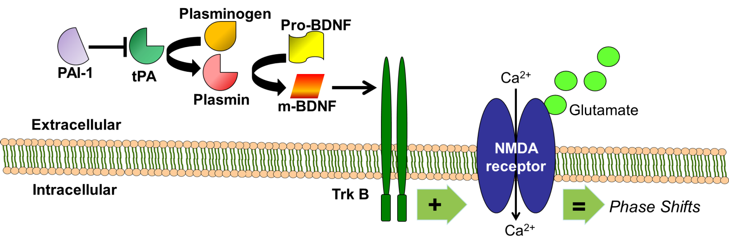
Figure 1. Glutamate from the retinohypothalamic tract activates NMDA receptors in the SCN every time light is detected; however, phase shifts can only occur when mBDNF can concurrently activate the Trk B receptor. PAI-1 inhibits tPA which activates plasminogen into plasmin which converts pro-BDNF into m-BDNF.

Another influential protein is plasminogen activator inhibitor-1 (PAI-1), which inhibits the activity of tPA by binding to its catalytically active small chain (Vehar et al., 1984). This means that the presence of PAI-1 indirectly inhibits the activation of proBDNF to mBDNF. However, PAI-1 requires binding to another protein, vitronectin, in order to remain active and inhibit glutamate induced phase shifting. Vitronectin is usually present in the fibrous network of the extracellular matrix (ECM), which suggests that PAI-1 regulation of tPA likely occurs extracellularly in proximity to the ECM (Preissner, K.T., 1991). Knowing the location of tPA at different time points during the circadian rhythm could enhance our understanding of the regulation of its activation or inactivation to influence phase shifting.
The purpose of this project is to determine the subcellular localization of tPA and its inhibitor, PAI-1, at different time points in the circadian rhythm over a 36-hour period using an immortalized cell culture of rat neurons from the SCN 2.2 line (Earnest et al., 1999 & Hurst et al., 2002). Use of the cell culture allows us to determine whether the proteins of interest are within or associated with the cells versus attached to the ECM versus floating in the extracellular space. The cell culture is preferable to testing mouse SCN brain slices because there is no reliable technique for separating the three different compartments using brain slices.

METHODS AND MATERIALS
Immortalized SCN 2.2 cells were cultured and separated into three separate populations. Each received a different treatment: one cohort was synchronized with fetal bovine serum (FBS), another was synchronized with forskolin, and the third was given the control vehicle (Balsalobre, 1998 & Yagita et al., 2000). FBS synchronizes the eukaryotic cell culture because it contains growth hormones to stimulate cell development (Franke, 2014). Forskolin activates adenylate cyclase which resets the cell cycle and synchronizes all the cells to circadian time 10 (CT 10). Circadian time 0-12 represents subjective day and CT 12-24 represents subjective night
For the first 36 hours immediately following treatment, samples were collected of the media, cells, and ECM every three hours from each of the three cohorts. These were stored at -80ºC until protein assays could be completed. Two 36 hour time course experiments were performed, one in June another in October of 2013.
Proteins were extracted from each of the three synchronization treatments of cell fraction samples using trichloroacetic acid (TCA). In future experiments, proteins from the ECM fraction will also be precipitated using TCA while proteins from the media fraction will be extracted using ammonium (Link et al., 2009 & Nair, 1973).
Proteins from each of the 12 time points plus positive controls for tPA and PAI-1 were loaded into 10% acrylamide SDS-PAGE gels and separated based on molecular weight using electrophoresis. Proteins in the gel were transferred to a polyvinylidene fluoride (PVDF) membrane and washed in 1xPBST phosphate buffered saline with 20% Tween.
Proteins were visualized with immunoblotting. Prior to primary antibody application, a 5% milk/1xPBST solution was applied to the blot for one hour to block non-specific binding of primary antibodies to non-target proteins on the membrane. The blot was exposed to primary antibodies in 2% milk/1xPBST and incubated overnight at 4ºC. The following day, secondary antibodies were applied to the membrane for 90 minutes after 3x5 min washes in 1xPBST according to the concentrations in Table 1. Chemiluminescent luminol/hydrogen peroxide was applied for 3-5 minutes onto the membrane. This solution reacts to the horseradish peroxidase conjugated to the secondary antibody to produce microscopic light radiation. After luminol treatment, the blot was exposed to x-ray film for various periods from 5 seconds to 30 minutes. The fixed and developed film was scanned into the computer and analyzed with ImageJ software from the NIH. The pixel density of each protein band was quantified with ImageJ. Then Microsoft Excel was used to calculate band comparisons. Pixel densities of tPA and PAI-1 were divided by the corresponding lanes of α-tubulin load control. Values were normalized to CT 13.
Primary Antibody Protein of interest | Optimized Primary Concentration | Secondary Antibody type | Optimized Secondary Concentration
tPA  [H27B6] ab28374 Abcam | 1:500 | Mouse | 1:1000
PAI-1  [H135] sc-8979 Santa Cruz | 1:500 | Rabbit | 1:4000
α-tubulin (load control)  [B-5-1-2] sc-23948 Santa Cruz | 1:500 | Mouse | 1:2000
Table 1. Proteins of interest and respective antibodies used to visualize them. Secondary antibody concentration varied slightly for some Western blots.

RESULTS
Preliminary results confirmed the presence of tPA and PAI-1 in the cell fraction of the SCN 2.2 cells. The results also show potentially rhythmic expression in PAI-1 following forskolin and serum synchronization. Conversely, preliminary results show that tPA increases steadily from onset of serum synchronization instead of being expressed rhythmically.
Figure 2 shows that PAI-1 appears to be rhythmically present inside the cell fraction. PAI-1’s potential rhythm begins with high levels during early subjective night (CT 13) that decrease until its lowest expression at early subjective day (CT 1). PAI-1 peaks again just before the beginning of subjective night. However, during the second subjective night, PAI-1 levels appear to increase rather than decrease. Therefore, although expression appears to be rhythmic, it is not fully clear from these data whether the rhythm in intracellular PAI-1 expression is circadian in nature. The PAI-1 positive control did not develop with immunochemiluminescence.
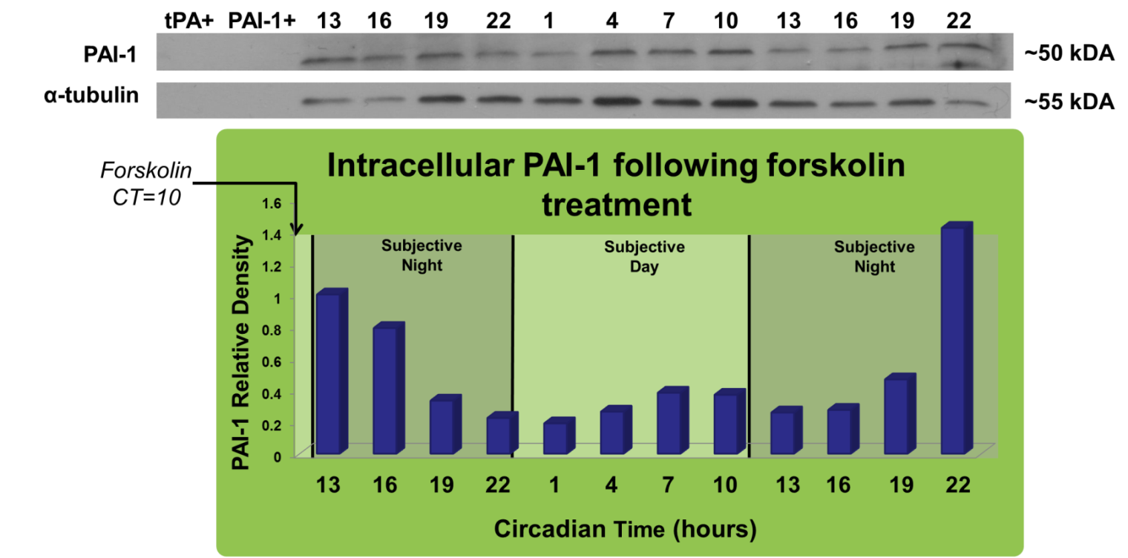
Figure 2. Relative abundance of PAI-1 inside the cell is shown throughout the 36-hour time course following forskolin treatment. There appears to be a rhythm in PAI-1 expression inside the cell after forskolin synchronization. n=1

The results from the FBS synchronized cells (Figure 3) are somewhat consistent with those from the forskolin synchronization. PAI-1 positive control confirms presence of PAI-1; however, the PAI-1 positive control has a different molecular weight than the PAI-1 present in the SCN due to possible glycosylation. PAI-1 expression in the SCN 2.2 cells again decreases throughout the first subjective night, increases during the subjective day, and finally decreases during the second subjective night. This overall pattern is disrupted only by the data from CT 1, which shows a higher expression level than expected. (The data for the second CT 22 was discarded as an outlier because it was of 5.9 times higher than the 1st data point at CT 13).

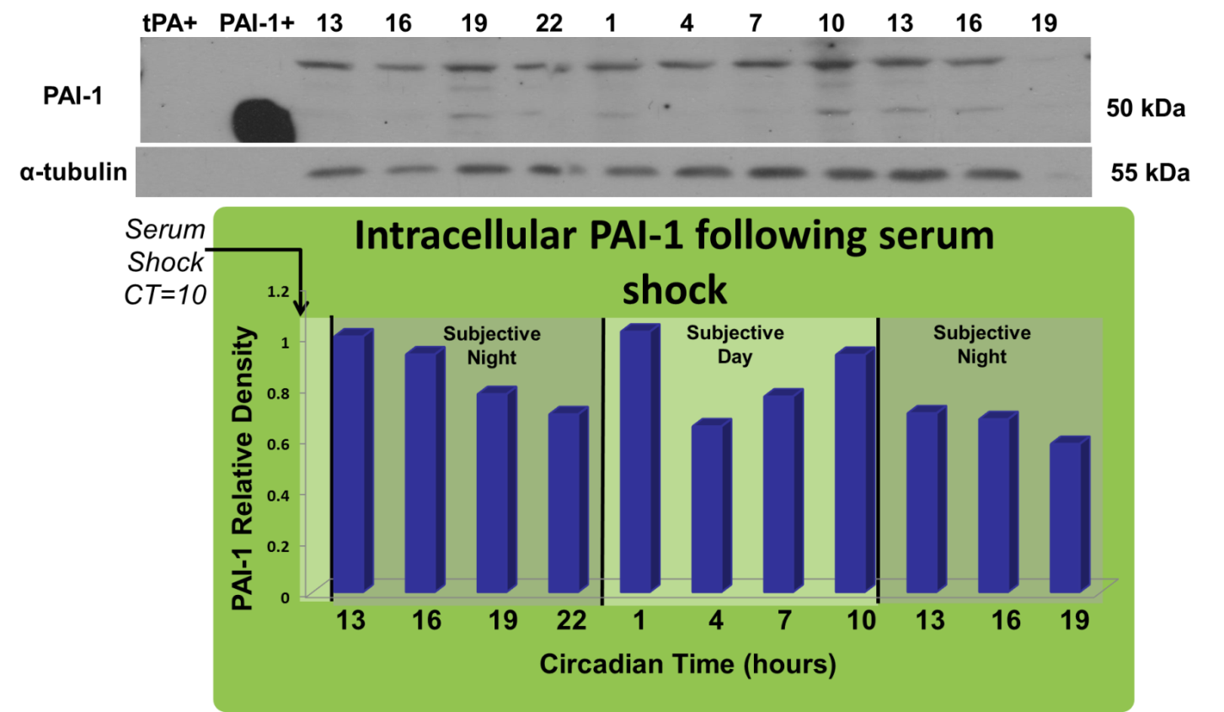
Figure 3. Relative abundance of PAI-1 inside the cell is shown throughout the 36-hour time course after serum shock. There may be a possible rhythm in PAI-1 expression inside the cell after FBS synchronization that mostly accords with forskolin experiment. n=1

In contrast to the two synchronized cohorts, the preliminary results from the non-synchronized cells shown in Figure 4 indicate an arrhythmic pattern of PAI-1 expression. This was expected because a synchronizing treatment is necessary to see a rhythm in protein expression of those related to the circadian pacemaker (Balsalobre et al., 1998). Again, the final time point was omitted because it was 4.7 times higher than the density of PAI-1 at CT 13.
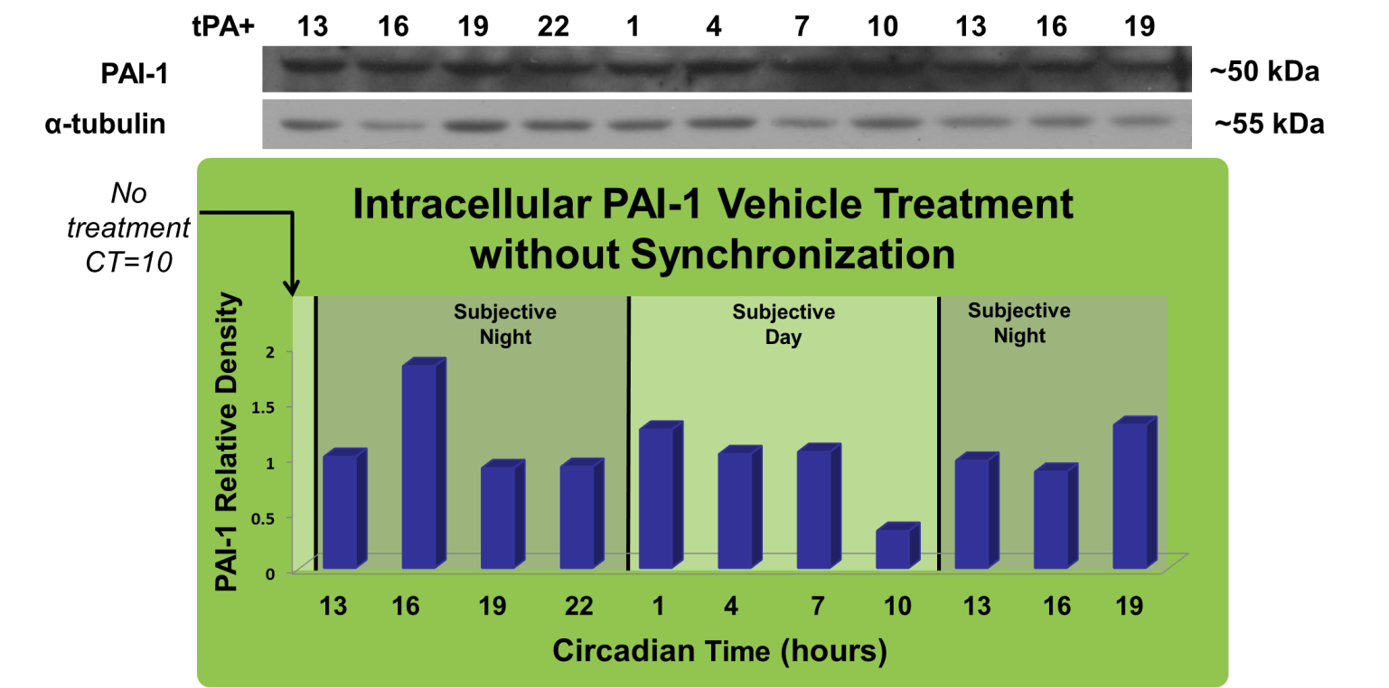
Figure 4. Relative abundance of PAI-1 inside the cell is shown throughout the 36-hour time course after treatment with the vehicle control. There does not appear to be any noticeable rhythm of PAI-1 inside the SCN cells with the vehicle control. n=1

Figure 5 shows the pattern of tPA expression in the SCN 2.2 cells following FBS synchronization. There appears to be a steady increase throughout the 36 hour experiment. The tPA positive control is clearly visible. As in the two previous experiments, the data from the final time point was much higher than the other data points by a factor of 29.5 so it was omitted.

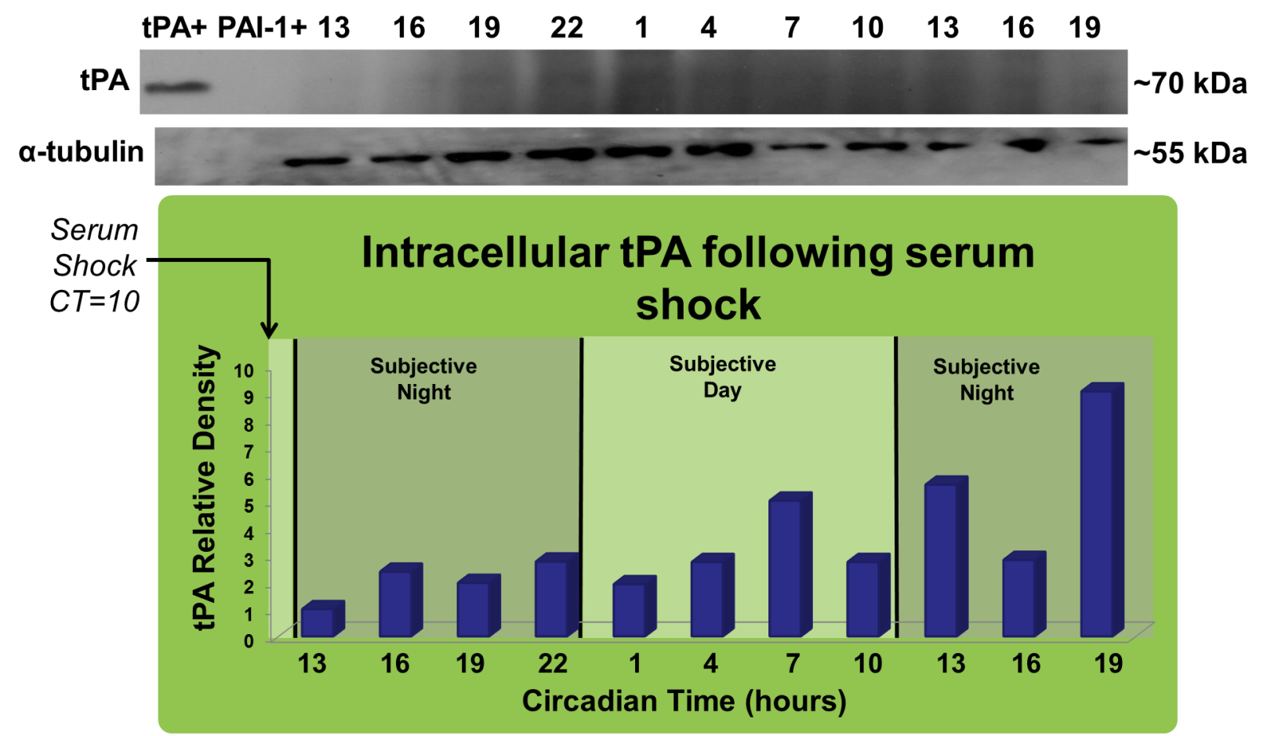
Figure 5. Relative abundance of tPA inside the cell is shown throughout the 36-hour time course. tPA appears to increase over time; however, no circadian rhythms are apparent. n=1

DISCUSSION
These preliminary results (n=1 for each experiment) show that both tPA and PAI-1 are present inside the cell fraction of SCN2.2 cells throughout the circadian cycle. While speculative, intracellular PAI-1 levels may peak during the early subjective night. Previous work in our lab has shown that total PAI-1 expression in brain slices, which includes all three subcellular compartments, similarly peaks during the early night (Mou, 2010). Whether this rhythm is actually in phase with the circadian clock will need to be determined by repeating each of these experiments.
According to our model, PAI-1 inhibition should be greater during the subjective day than during the subjective night. One mechanism through which this could occur would be if extracellular PAI-1 levels are higher during the day than the night. Thus, higher intracellular PAI-1 levels during the subjective night as tentatively shown here could be consistent with less PAI-1 inhibition at night due to PAI-1 movement into the cell. However, it will be important to determine the level of PAI-1 in the extracellular media and associated with the ECM to determine whether this model is correct.
Western blot analysis for tPA shows an increase in intracellular tPA expression throughout the 36 hour time course. This is not consistent with our model for the activation of BDNF to gate photic phase shifting, and it is different from the pattern of expression our lab has observed previously (Mou et al., 2009). Additional replicates may confirm this unexpected expression pattern or show results that support previous data. However, it is possible that the synchronization treatment decreases tPA to unnaturally low levels before it slowly increases to acclimate to its new synchronization environment. This experiment should be repeated using different synchronization techniques to see a clearer picture of the expression and localization of tPA.
Several challenges arose with this project. One involved the need to use variable secondary antibody concentrations due to the low amount of protein in each lane of the acrylamide gel. Sonication was added to the TCA protein precipitation technique, and this allowed the protein pellet to be broken up into much smaller fragments for better homogenization into the loading dye to be injected into the gel. This allowed us to use lower and more consistent secondary antibody concentrations, which led to less non-specific binding. The developed Western blots showed cleaner protein bands that were easier to analyze without nearly as much background noise. This method improved the results for PAI-1 and α-tubulin, but tPA still did not develop without excess background. In addition, both tPA and PAI-1 positive controls were inconsistently present for the last few Western blots.
For analysis of potential circadian rhythms in protein expression, it is important to note that the free-running period for SCN 2.2 cells is not exactly 24 hours but has been shown to be closer to 22.5 hours (Balsalobre, 1998). This means that circadian time should be calculated using an 11.25 hour day: 11.25 hour night rhythm instead of a 12 hour day: 12 hour night rhythm. Although these results are graphed using a 24 hour cycle to be consistent with previous experiments in our lab, measuring the length of daytime and nighttime with the shorter period might be more appropriate in future studies.
Moving forward, we must conduct further experiments investigating PAI-1 and tPA in the cell fraction of both 36 hour time courses. Next, the ECM and media fractions should be studied to draw more conclusions about the temporal localization of tPA and PAI-1 in different compartments. In the future, the cell culture time course could be extended to 48 hours because SCN 2.2 cells can maintain circadian rhythms for up to three days past synchronization (Balsalobre, 1998). This would allow us to improve the quality and accuracy of protein measurements by having multiple replicates of the same circadian time. In addition, allowing the cell culture at least 24 hours prior to initiating sampling could eliminate acute responses to the treatments by allowing the cells to acclimate to the synchronization treatments. This is because it has been shown that certain clock genes have poor rhythmicity for 12-24 hours post synchronization (Ramsey, 2014).
With more information on how the tPA proteolytic pathway affects the ability of the clock to shift phase, we can answer questions that could lead to future drug discoveries to help people with shift workers’ disorder, Alzheimer’s disease, jet lag, insomnia, metabolic disorders, and obesity related to the SCN’s function as the master pacemaker (Taniyama et al., 2015, Landry, 2014, & Eckel-Mahan, 2013). Moreover, tPA’s temporal location in the SCN and how it relates to gating circadian clock phase resetting may yield a greater understanding of the mechanisms behind the overarching phenomenon of metaplasticity. This is defined as the ability for one stimulus to cause a permanent or semi-permanent change in synapses that allows or prevents them from reacting to future stimuli (Abraham, 2008). This is relevant to other parts of the brain such as the hippocampus, where there is evidence that metaplasticity describes the function of gating whether the brain retains or forgets recent memories (Bramham et al., 2005, Iver et al., 2014, & Deisseroth et al., 1995).

Works Cited
Abraham, W. C. (2008). Metaplasticity: tuning synapses and networks for plasticity. Nat. Rev. Neurosci. Vol. 9, p. 387.
Balsalobre, A., Damiola, F., & Schibler, U. (1998). A serum shock induces circadian gene expression in mammalian tissue culture cells. Cell. Vol. 93, p. 929-937.
Bramham, C. R., and Messaoudi, E. (2005). BDNF function in adult synaptic plasticity: the synaptic consolidation hypothesis. Prog. Neurobiol. Vol. 76, pp. 99–125.
Daan, S. & Pittendrigh, C.S. (1976). A functional analysis of circadian pacemakers in nocturnal rodents: II. The variability of phase response curves. J. Comp. Physiol. Vol. 106, pp. 253–266.
Deisseroth, K., Bito, H., Schulman, H., and Tsien, R. W. (1995). Synapticplasticity: A molecular mechanism for metaplasticity. Curr. Biol. Vol. 5, pp. 1334–1338.
Ding, J.M., Chen, D., Weber, E.T., Faiman, L.E., Rea, M.A. & Gillette, M.U. (1994). Resetting the biological clock: mediation of nocturnal circadian shifts by glutamate and NO. Science, Vol. 266, pp. 1713–1717.
Earnest, D. J., Liang, F. Q., Ratcliff, M., and Cassone, V. M. (1999). Immortal time: Circadian clock properties of rat suprachiasmatic cell lines. Science Vol. 283, pp. 693–5.
Ebling, F. J. P. (1996). The role of glutamate in the photic regulation of the suprachiasmatic nuclei. Prog. Neurobiol. Vol. 50, pp. 109–132.
Eckel-Mahan, K. & Sassone-Corsi, P. (2013). Metabolism and the circadian clock converge. Physiol Rev. Vol. 93, pp. 107-35.
Foster, R.G. & Kreitzman L. (2005). Rhythms of life: the biological clocks that control the daily lives of every living thing. New Haven, CT: Yale University Press.
Franke, J., Abs, V., Zizzadoro, C., & Getu, A. (2014). Comparative study of the effects of fetal bovine serum versus horse serum on growth and differentiation of primary equine bronchial fibroblasts. BMC Vet Res. Vol. 10, pp. 119.
Halberg, F. (1959). Physiologic 24-hour periodicity; general and procedural considerations with reference to the adrenal cycle. Z Vitamin- Hormon-u Fermentforsch Vol. 10, pp. 225-296.
Huang, Y.Y. et al. (1996). Mice lacking the gene encoding tissue-type plasminogen activator show a selective interference with late-phase long-term potentiation in both Schaffer collateral and mossy fiber pathways. Proc. Natl. Acad. Sci. U.S.A. Vol. 93, pp. 8699–8704.
Hurst, W.J., Earnest, D., & Gillette, M.U. (2002). Immortalized Suprachiasmatic Nucleus Cells Express Components of Multiple Circadian Regulatory Pathways. Biochemical and Biophysical Research Communications Vol. 292, pp. 20–30.
Iyer, R., Wang, T. A., & Gillette, M. U. (2014). Circadian gating of neuronal functionality: a basis for iterative metaplasticity. Frontiers in Systems Neuroscience Vol. 8: 164.
Johnson C.H. (2007). Bacterial circadian programs. Cold Spring Harbor Symposium Quant Biol. Vol. 71, pp. 395-404.
Landry, G. J. & Liu-Ambrose, T. (2014). Buying time: a rationale for examining the use of circadian rhythm and sleep interventions to delay progression of mild cognitive impairment to Alzheimer's disease. Front Aging Neurosci. Vol. 6: 325.
Lee, M., Yamada, Y., Cantwell, E., & Prosser, R. (2014). Localization and Temporal Expression Patterns of Extracellular Proteases in the Suprachiasmatic Nucleus.
Liang, F.Q., Walline, R. & Earnest, D.J. (1998). Circadian rhythm of brain-derived neurotrophic factor in the rat suprachiasmatic nucleus. Neurosci. Lett. Vol. 242, pp. 89–92.
Link, Andrew J., & LaBaer, Joshua. (2009). Trichloroacetic Acid (TCA) Precipitation of Proteins. Proteomics: A Cold Spring Harbor Laboratory Course Manual. CSHL Press, Cold Spring Harbor, NY.
Michel, S., Clark, J.P., Ding, J.M. & Colwell, C.S. (2006). Brain-derived neurotrophic factor and neurotrophin receptors modulate glutamate-induced phase shifts of the suprachiasmatic nucleus. Eur. J. Neurosci. Vol. 24, pp. 1109–1116.
Mou, Xiang. (2010). Fibrinolytic Proteins and Brain-Derived Neurotrophic Factor Modulation of Suprachiasmatic Nucleus Circadian Clock. PhD diss., University of Tennessee. http://trace.tennessee.edu/utk_graddiss/830
Mou, X., Peterson, C.B., & Prosser R.A. (2009). Tissue-type plasminogen activator-plasmin-BDNF modulate glutamate-induced phase-shifts of the mouse suprachiasmatic circadian clock in vitro. European Journal of Neuroscience, Vol. 30, pp. 1451–1460.
Nair, B. K. & De Orne K. B. (1973). A Growth-stimulating Factor Released by Cultured Mouse Mammary Tumor Cells. Cancer Research, Vol. 33, pp. 2754-2760.
Panda, S., Antoch, M.P., Miller, B.H., Su, A.I., Schook, A.B., Straume, M., Schultz, P.G., Kay, S.A., Takahashi, J.S. & Hogenesch, J.B. (2002). Coordinated transcription of key pathways in the mouse by the circadian clock. Cell. Vol. 109, pp. 307–320.
Peek C.B., Ramsey K.M., Levine D.C., Marcheva B., Perelis M., & Bass J. (2015). Circadian Regulation of Cellular Physiology. Methods in Enzymology, Vol. 552, pp. 165-184.
Preissner, K. T. (1991). Structure and biological role of vitronectin. Annual Rev Cell Biol. Vol. 7, pp. 275-310.
Ramsey, K. M., Affinati, A. H., Peek, C. B., Marcheva, B., Hong H., & Joseph Bass. (2014). Circadian Measurements of Sirtuin Biology. Methods Mol Biol. Vol. 1077, pp. 285–302.
Sonderegger, P. & Matsumoto-Miyai, K. (2014). Activity-controlled proteolytic cleavage at the synapse. Trends in Neurosciences. Vol. 37, No. 8.
Taniyama Y., Nakamura A., Yamauchi T., Takeuchi S., & Kuroda Y. (2015). Shift-work disorder and sleep-related environmental factors in the manufacturing industry. J UOEH. Vol. 37, pp. 1-10.
Vehar, G. A., Kohr, W. J., Bennett, W. F., Pennica, D., Ward, C. A., Harkin, R. N., & Collen, D. (1984). Characterization Studies on Human Melanoma Cell Tissue Plasminogen Activator. BiolTechnology. pp. 1051-1057.
Vitaterna, M. H., King, D. P., Chang, A. M., Kornhauser, J. M., Lowrey, P. L., McDonald, J. D., et al. (1994). "Mutagenesis and mapping of a mouse gene, Clock, essential for circadian behavior". Science Vol. 264, No. 5159, pp. 719–25.
Yagita, K. & Okamura, H. (2000). Forskolin induces circadian gene expression of rPer1, rPer2, and dbp in mammalian rat-1 fibroblasts. FEBS Lett. Vol. 465, pp. 79-82.

