Benefits of Obtaining an Advanced Degree in Engineering Management

A Thesis Presented for the
Master of Science
Degree
The University of Tennessee, Knoxville

Inna Majdalani
August 2014

Copyright © 2014 by Inna Majdalani
All rights reserved.

Acknowledgements

I would like to express my deepest gratitude to my advisor, Dr. James L. Simonton, whose support, encouragement, and continuous guidance have been instrumental to my development of a sound understanding of the subject matter. I thank him for his patience and the long hours that he spent with me to ensure the success of my research. His mentorship in both my research and career will always be treasured; his professionalism and unconquerable optimism have been my inspiration on my way to completing my degree.
I owe my appreciation to my committee members, Dr. James Ostrowski and Dr. Andrew Yu, for the considerable amount of time that they have invested to revise my multiple drafts, and for all of the valuable suggestions that they have provided in order for me to conduct this research effectively.
Special thanks are extended to Charlotte Henley, whose continuous administrative support and prompt reminders have kept me on track; to Mark Cross for videotaping and posting many of our courses; and to Laura Horton for her cheerfulness and assistance whenever it was needed.
Last, but not least, I want to offer my sincere thanks to my dear husband, Dr. Joseph C. Majdalani, who served the University of Tennessee for over ten years; I am deeply grateful to him for his support, encouragement, against all hardships, and for his infinite patience and resolve while I continued my studies. Many times, it is his involvement and advice that have kept me going.

Abstract

In this study, an attempt to evaluate factual benefits of an advanced degree in the field of Engineering Management has been made. The study concentrated on estimation of economic and non-monetary benefits, reported by various groups of Engineering Management alumni of The University of Tennessee. The comparison between age, gender and career variation groups was completed, and the possible reasons for these findings were discussed. Also, additional data pertaining to program cost coverage, demographics, composition of alumni pool, and appreciation of the Engineering Management program in their post-graduation careers was collected and analyzed. The study suggests that, even though there is an economic benefit to obtaining an advanced degree, it takes several years until its potential can be fully realized. Moreover, there appear to be noticeable non-monetary benefits to continuing professional education in the field of Engineering Management.

Table of Contents
Chapter 1 Introduction 1
Objective of the Research 3
Scope of the Problem 4
Definition of Terms 5
Chapter 2 Literature Review 7
Predispositions for Obtaining or Improving a Professional Degree 7
Increasing Demand and Popularity of EM Profession 8
Career Change or Diversification of Skills 9
Fast Linear Career Advancement 11
Entrepreneurship as a Necessary Skill for Modern Graduates 12
Minorities in Pursuit of Graduate Degrees – Benefits for Women 13
Economic Benefits and Advanced Education 15
Background on Survey Development and Administration as a Mechanism of Data Collection 20
Chapter 3 Research Questions and Methodology 24
Research Questions 24
Research Question # 1 24
Research Question # 2 24
Research Question # 3 24
Hypotheses 24
Hypothesis # I 24
Hypothesis # II 24
Hypothesis # III 25
Methodology 25
Chapter 4 Results and Discussion 30
Outlook of Collected Responses 30
Assessment of Reporting Between Groups 38
Salary in Male vs. Female Groups 38
Salary and Work Experience Before EM Program 42
Salary and Work Experience After EM Program 43
Hypothesis I Addressed: 44
Hypothesis II Addressed: 46
Hypothesis III Addressed: 46
Chapter 5 Conclusions and Recommendations 49
List of References 52
Appendices 55
Appendix 1: Survey Questionnaire 56
Appendix 2: Prospective Software Vehicles for Survey Administration 63
Appendix 3: Supporting Figures and Charts 64
Appendix 4: Cross-tabulation and Chi-square Statistic for Economic Benefits 67
Vita 69

List of Figures

Figure 1: Age groups at the time of entry into EM program. 30
Figure 2: Years since bachelor degree completion. 31
Figure 3: Work experience after EM program. 32
Figure 4: Frequency of reasons for EM program choice. 33
Figure 5: Economic benefit: salary increase. 34
Figure 6: Career path in connection with EM degree. 34
Figure 7: Non-tangible benefits, number of entries (out of 57 responses). 35
Figure 8: Coverage of program costs by various benefactors. 36
Figure 9: Usefulness of the courses in workplace, number of entries (out of 55 responses). 37
Figure 10: Salary increase in connection with gender. 39
Figure 11: Salary increase in connection with prior work experience. 42
Figure 12: Salary increase in connection with experience since graduation from EM 43
Figure 13: Non-tangible benefits associated with EM degree among all surveyed (% of entries). 47
Figure 14: Non-tangible benefits associated with EM degree among the group without increased earnings (% of entries). 48
Figure 15: Career path events after EM program in connection with change of employer. 64
Figure 16: Career path events in connection with promotion. 64
Figure 17. Career outcomes as reported per male and female entries. 65
Figure 18. Other benefits of an advanced degree (male vs. female entries). 65
Figure 19. Commitments besides employment (male vs. female entries). 66
Figure 20. Cross-tabulation of different variables versus salary increase. 67
Figure 21. Salary increase versus gender. 68

Chapter 1
Introduction
As recent trends in career development indicate, more and more graduates return to school to pursue advanced degrees (such as MS and PhD degrees), thus clearly demonstrating that individuals place value in continuing their education. The same holds true for Engineering Management programs, the number of which have steadily increased over the past decade. The programs in question seem to provide the necessary managerial tools for fresh graduates and for mature professionals alike. The literature indicates that applicants entering graduate studies mostly fall into two categories: fresh bachelor degree holders, and seasoned mid-career professionals entering into a managerial phase of their career. While various reasons are cited in the literature, of why professionals apply to graduate programs, it would be interesting to uncover what actual benefits those graduates have realized after completing their advanced degree. Since the Engineering Management program is unique in its position at the confluence of engineering and business/management sciences, we expect the pool of applicants to graduate programs in Engineering Management to be as diverse in their age groups as they are in their backgrounds.
While many references indicate that there is a documented economic benefit to obtaining an advanced degree, there seems to be insufficient data pertaining to the actual estimations of compensation increase among Engineering Management graduates, as well as for a comparison on how they stand against their peers from other disciplines. Due to the lack of documented salary figures pertaining to this particular group of degree holders, the comparison should be drawn with other closely related peer groups; in this case, Industrial Engineering graduates, and engineering graduates across all disciplines.
In this work, it is hypothesized that data collection which addresses various aspects of obtaining an advanced degree (i.e. MS or PhD) will enable us to analyze both economic and intellectual changes and advantages that impact the careers of our graduates. Along with that information, other data such as demographics, background, coverage of program costs, and availability of time for study will be accessible for further analysis. Based on the answers collected from a representative population, we are able to estimate the salary percentage increase in different groups, as well as determine how it correlates to general data pertaining to engineers and managers. Moreover, this study will attempt to demonstrate the benefits perceived by particular groups, such as recent graduates versus non-recent, various age and gender combinations, MS degree recipients as opposed to PhD and more. This study will also help to shed light on important non-monetary and intellectual advantages of graduate education, of which we are able to determine which aspects are considered most relevant to Engineering Management graduates.
Addressing the above questions may prove valuable to aspiring professionals who are seeking a career boost, by aiding them in making their professional choices and directing their expectations in line with currently existing outcomes, as reported by present generations of advanced degree holders in Engineering Management.

Objective of the Research
The purpose of this research lies in an attempt to uncover and correctly estimate the benefits that an advanced degree in Engineering Management brings about, as well as to test the capabilities of a survey tool and the information it may generate, based on a sample from one particular institution (UTK). The underlying assumption that the advanced degree brings about more success, as opposed to a bachelor’s degree alone, is generally accepted as true among professionals. A more detailed analysis of actually reported advantages of continuing one’s education in the field of Engineering Management may prove helpful in future career decisions of professionals with either bachelor degrees or advanced degrees from other disciplines.
Based on the results of this pilot study, we are able to estimate salary fluctuations after completion of the degree, and access its variation in different subpopulations, depending on various constraints, such as time passed since graduation, gender, career path, and anticipated promotion frequency. Furthermore, a comparative analysis of a documented salary boost in the engineering discipline and in our results was possible.
Another important objective encompasses the assessment of intellectual gains and non-tangible benefits to our graduates’ careers, such as personal development and self-esteem, the ability to perform research and teaching duties, and overall career advancements, as reflected by various subpopulations.

Scope of the Problem
This study focuses on estimating both economic and intellectual benefits of obtaining an advanced degree in Engineering Management, being reported by various groups of Engineering Management graduates.
To this end, the differences between various age and gender combinations are noted, as well as between groups with different career durations. Naturally, mature graduates with a long career path are expected to report more substantial benefits than fresh graduates. However, it is speculated that when it comes to intellectual and career advancement benefits, the results may not vary as much across different groups.
Ultimately, a comparison between reported salary increases in comparable populations from a reputable source [1] and as suggested through this research is drawn. The salary percentage increase for Engineering Management graduates is summarized across various groups, and a general conclusion as to the relevance of reported earnings increase across all engineering disciplines is arrived at. Also, anticipation of future earnings increase is noted in various groups.
The career path outcomes, as they pertain to promotion and change of employer, are accessed amongst different groups. Factors that influence career outcomes in our study include: age group, gender, level of previous education, work experience, time since graduation from EM; and an overall degree of satisfaction of our graduates who attended the program as a function of frequency of recommending it is mentioned. Other data that is collected, but not extensively analyzed in this study, involves the following:
- type of the institution and EM program (distance education versus in-class);
- employment status of applicants and willingness of employer to accommodate for time constrains during study period;
- various commitments and, indirectly, availability of time for study;
- parties, responsible for coverage of the program costs;
- reasons for selecting their particular program;
- background of applicants; and
- usefulness of particular courses in their daily applications and responsibilities.
The relationship surrounding these findings will not be included in this thesis; however, the collected data provides an opportunity for further analysis as it warrants future exploration.

Definition of Terms
Advanced degree – Master of Science or Doctor of Philosophy;
Benefit – a monetary and/or a non-monetary outcome of receiving an advanced degree in Engineering Management, that results in increased earnings, career advancement, employment opportunities, or personal development. In this thesis, the following will be considered a benefit, if it exists as a direct result of Engineering Management program completion: salary increase, promotion, change of employer, personal development and learning, accomplishment and self-esteem, teaching and travel opportunities, and faster career advancement;
Cross-sectional research – addresses information at a certain point in time, or in a short single session, and evaluates a state of the problem, rather than its progression (as opposed to longitudinal research, which concentrates on problem evolution over time and requires multiple sessions);
Non-monetary benefits – personal development and learning; accomplishment and self-esteem; teaching and travel opportunities; and faster career advancement. Sometimes these are being referred to as “intellectual” or “non-tangible” benefits or advantages;
Representative population – a sample from the entire population of interest that exemplifies the general population in all properties. It is more important than the sample size for the accurate information representation;
Margin of error – an indication of accuracy of the results, usually decreases with the increase of the surveyed pool; and
Binary response – yes/no type of questions, and other single-choice questions, as opposed to rating scale questions; the binary sample size usually remains greater than the rating scale sample size to achieve the same margin of error.

Chapter 2
Literature Review

Predispositions for Obtaining or Improving a Professional Degree
With the rapid development of technology, the world’s markets become progressively dependent on the influx of professionals, who are skilled in science, technology, and engineering as the core disciplines of a flourishing economy. The main cores of this development remain people’s talents and skills. A study Career Pathways of Science, Engineering and Technology Research Postgraduates [2], conducted in Australia, intended to uncover perceptions of graduate students that led them to selecting their degree, and expectations of its outcomes. Among the reasons for undertaking a general graduate coursework in science and engineering, the following points were agreed upon:
- future career benefits;
- enjoyment of knowledge acquisition and research; and
- interest in subjects.
The majority of participants indicated positive experience from their degree, and that they would make the same decision again. However, only half of the participants agreed that it provided them with skills that are necessary for their careers, as an explanation, referring mainly to the shortage of business-oriented courses on administrative functions, project management, leadership and communication, and team management. Among the benefits of a research degree, the following benefits have been addressed:
- critical thinking/analytical skills/scientific skills;
- autonomous operation and problem solving; and
- preparation of technical papers.
A prosperous career appeared to be the most significant motivating factor for degree undertaking; in this vein, compensation, although not a key indicator of success, was related as “important” [2].

Increasing Demand and Popularity of EM Profession
A demand for professionals with advanced education in Engineering Management is ever increasing, as reflected by the development and growth of educational programs in this field, the growing numbers of students, and the expanding Engineering Management conferences [3]. Engineering firms are presently facing globalization, collaboration and networking, spread of engineering management expertise into service industries, and the ever-important role of entrepreneurship – all of which create bases for expansion of the Engineering Management discipline [4]. Australian studies support these predictions for globalization and multi-cultural collaborations in business relationships, and point out the necessity for better and broader training of engineering managers, as well as the importance of improving existing standards for educators themselves [5]. Naturally, with an increasing demand for EM, there appears to be an opportunity for an increased supply: in the past three decades, a significant increase in the number of graduate programs manifested worldwide, offering most often a Master’s degree, either by engineering schools alone or by collaboration with business branches [6].
In actuality, professionals often approach a time in their career when their mastered skills are no longer sufficient to remain competitive, and that is the time when engineers face a decision to enter into graduate studies for mastering new skills and operations. Most commonly the choice is made between an MS in engineering and an MS in management. In practice, the outcomes of both degrees differ, as much as their applications. If a professional undertakes an MS in engineering, he/she will continue to exploit scientific concepts in-depth, though the narrow nature of their pursuit will not allow much deviation from core engineering. On the other hand, more and more data suggests that mere technical expertise is not enough to stay competitive, especially that the engineers of today are expected to be well versed in strategic decision making, financial aspects, global communication, project supervision, and more. Clearly, a formal engineering study will not provide sufficient training, and an advanced degree in management may prove to be just what is needed to acquire the necessary leverage in the workforce [7].

Career Change or Diversification of Skills
The reasons for choosing a management degree vary in accordance with different sources. For some groups, such as mid-career engineers, who are mainly engaged in the fulfilment of technical tasks, a sense of dissatisfaction with their job and a feeling of low achievement and involvement have been reported as early as the end of 1970s. These professionals appeared to be well-educated and highly competent, but following what later became known as a “flat” career path, were “stuck” in their relatively low positions for a lengthy period of time [8]. When professionals are seeking ways to avoid the flattening of a career path, it is important to realize what steps undertaken in a technical career would expedite the transition to a managerial role. Important factors that preceded the advancement to managerial positions in one of the engineering firms included high performance evaluations of technical employees, and exposure to managerial training while occupying a given technical position. However, these steps alleviated but did not entirely eliminate the adjustment performance “drop-off,” which was experienced by recently promoted personnel [9].
In different countries the career progression of engineers varies from what is generally accepted in the United States. In one Canadian study, D. Kennedy reports high attrition rates of mature engineers that are not fully explained by the possibility of some of them transitioning into managerial positions. The assumption that engineers will become managers later in their career did not account for the majority of attrition rates observed. The abandonment and the phasing out of engineering disciplines into different fields seemed to be attributed to a general dissatisfaction with current career progress, a sense of being undervalued by various companies in favor of younger and lower pay grade engineers, and supervisors that were unable to provide guidance and support because of a blatant shortage of leadership skills [10]. We may therefore conclude, based on this article, that such a situation creates conditions for both mature engineers and managers of engineering companies to diversify their capabilities and explore various applications of Engineering Management degrees to the extent that technicians become managers, and managers become industry leaders.
However, according to other sources [11], most of the successful engineers indeed end up fulfilling managerial duties at some point of their career, mostly in mid- and end-career timeframes, along with a greater salary, an attractive title, and a decision making independence. Along with those benefits, the majority of newly promoted attribute “transition stress” connected with new responsibilities to the lack of basic business training. It seems natural that aspiring managers should clearly express to their supervisors their interest in receiving formal training in management in order to be afforded with opportunities to develop new practical skills [11].

Fast Linear Career Advancement
For many of engineers, obtaining a graduate degree played a significant role in shaping their career as they proceeded toward managerial positions. Master’s degree holders in EM experienced a linear career path, bringing them higher in the company hierarchy; moreover, MEM degree holders recognized the influence of this degree on their careers, especially with gaining experience in the workforce [12]. The above study demonstrates that not only people place value in obtaining a higher professional degree, but that this value is based not on empirical “higher is better,” but on actual tangible benefits that pertain to their career path, such as better placement, faster employment, more prestigious and sought after employers, and better financial compensation [12]. In a modern company, technical competence is no longer an assurance of continued employment; being on the edge of technology in the field is becoming a most basic requirement; and to ensure stability and growth, professionals need to embrace a wider array of related skills well beyond purely technical expertise. In some cases, alternative career options should be exploited [13].

Entrepreneurship as a Necessary Skill for Modern Graduates
The rate of technological progress dictates the necessity of skills and abilities that traditional engineering education did not include before [14]. As R. Waters describes in his paper, most engineering and engineering management programs focus on preparing graduates for positions in recognized companies; however, a significant fraction of new jobs are provided by startup companies. Anticipating this, most business schools provide formal training in entrepreneurship, and engineering management programs are lagging behind. Acquisition of basic business-oriented skills would place EM graduates into an advantageous position in comparison to technical advanced degree holders in this respect, and therefore constitutes a benefit to future career and compensation. Dr. Waters advocates for widespread of entrepreneurship courses into EM curricula as a building block for future entrepreneurial-oriented engineers [15]. This point seems to be in concurrence with the data reported in an IEEE survey of students and fresh graduates [16], where the heightened interest in entrepreneurship was expressed by 20% of those surveyed, specifically, those who implied creating a start-up company after graduation; also nearly 30% indicated the possibility of separating from their employers in favor of self-employment. From this perspective, undertaking an entrepreneurship course can be perceived as a valuable asset by future graduates, as it can lead to future career advancement in the direction of independent management and leadership positions, and these, in turn, can bring about recognition and rewarding compensation.
Moreover, as T. Mason mentions in his article, the growth of innovation beyond US is exponential, and, given the high numbers of professional engineers and managers produced oversees, there seems to be a shifting of American R&D dominance [17]. The economic advantage, this author speculates, will stand with those professionals who demonstrate the capability of fast transitioning yesterday’s inventions into today’s profitable products. These capabilities require acquisition of both technical and commercial competencies, which are fundamental attributes of Engineering Management. On the other hand, the disappointing experience in promoting and marketing innovative products often lies in managerial inadequacies, rather than shortages of technical skills [17].

Minorities in Pursuit of Graduate Degrees – Benefits for Women
It is common knowledge that women and ethnic group representatives constitute a minority sector in the engineering discipline [18]; with progression of their careers, it is generally believed that underrepresented groups have less and less presence amongst advanced degree holders. The trend of declining percentage of women-engineers as they advance through their trainings is discussed in many sources. As reported by Nadya Fouad [19], women represent about 18% of engineering graduates, but only 11% of women are actively employed as engineers (as reported by NSF, 2011-2012).
However, as some other sources indicate [18], despite the slight decrease in total enrollment into engineering graduate schools, there remains an increase in enrollment of underrepresented groups. As pointed out, the participation in postgraduate education demonstrates a decline in 1990-1999; the enrollment of women and ethnic minority groups, while still being underrepresented, has significantly increased. The data demonstrates that women beyond baccalaurean degrees are as likely to continue onto MS degrees as men (34.9 % vs. 31.3 %). A similar relationship holds for ethnic minorities, with the exception of Asian groups, who are more likely to advance their professional careers than other groups [18]. The significant exit point for women and ethnic minorities comes at the graduation with a bachelor’s degree. The analysis demonstrates that the number of women participating in graduate studies is significantly lower than in undergraduate work. But among those who remain, both women and ethnic minority groups are prone to continue to advance their academic careers. Therefore, by providing accessible information about available curricula, financial support, inspiration, and mentorship, the rates of enrollment and retention may be boosted considerably. Another approach, the author mentions, would lie in affording meaningful research projects to undergraduates that both spark interest in the subject and build confidence and perseverance. Quality faculty-student interactions also play a pivotal role in a student’s final decision to pursue graduate education. Another important factor mentioned in the above publication is the involvement of professional societies (such as GEM, or the National Consortium for Graduate Degrees for Minorities in Engineering and Science, http://www.gemfellowship.org/) and communities in supporting minority representatives, along with the availability of opportunities for their success through recruitment, research, sponsorship, and professional training [18]. Overall, there exists a positive tendency in advanced degree acquisition by historically underrepresented groups, who may take advantage of the numerous opportunities for career advancement and professional development, offered by Engineering Management. Additionally, as reported in Georgetown University survey [1], the male-to-female ratio across all engineering disciplines remains 84%-to-16% at the bachelor’s degree level; in Engineering and Industrial Management, it is reported to be nearly the same, i.e., 83%-to-17%. Although insufficient data exists for a comparison of earnings between male and female groups in Engineering and Industrial Management, the median earnings for males are reported at $82,000, and the overall female earnings in engineering are expected to remain lower (around $10,000-$17,000 in annual difference). Moreover, there remains insufficient data for promotion rates and earnings increases between males and females in Engineering Management, a gap that will be explored in the remainder of this thesis.

Economic Benefits and Advanced Education
A recent survey (2011) of undergraduates, post-graduate students, and recent graduates has been conducted with the support of IEEE (Institute of Electrical and Electronics Engineers.). The findings as they pertain to graduates, especially advanced degree graduates, are summarized as follows: slightly less than half of the undergraduate students express concerns over their future career path, job security, and compensation; however, overall most of the students admit that they would recommend the engineering major to a friend [16]. Another interesting finding of that survey is that about 75% of the students mention that they would like to pursue an advanced degree. Out of those, about one half intend to pursue a graduate program following graduation, and less than 30% prefer to wait until further employment. Also, about 20% mention a possibility of new venture formation after their graduation, which calls for entrepreneurial skills development. Among recent graduates, around 30% report holding back a job application in favor of first completing an advanced degree, which leads us to conclude that they value their degree and expect to leverage its advantages.
About half of recent graduates who are not currently employed indicate their desire to join large companies, mainly because of perceived monetary and career opportunities. Comparative questioning of their fellow graduates, employed at larger companies, confirms their expectations: the career growth expectation is substantially more prominent in this group, than those employed in smaller firms.
Among important job selection criteria for graduates, the first three items consist of: opportunity for advancement, opportunity to benefit society, and salary.
After analyzing the salaries of established engineers, based on 8000 participating IEEE members, the salary brackets naturally display higher values, which distinctly range by job function: between $119.000 for engineering management (managerial positions), $108,078 for executive/operation management, and $85,000 for other engineering [16].
Another article “Engineering Majors Top-Salary Survey in 2012” [20] mentions that engineering remains a high-paying major, in accordance with Salary Survey, the report of January 2013. The following results summarize the starting accepted salaries of Bachelor’s degree holders across numerous disciplines. The computer engineering discipline is determined as the highest paid, followed by chemical engineering, and then computer science. These findings resonate with another source [21], which advocates for accreditation of EM programs. The Stevens Institute has published a booklet as an outreach activity to prospective employers with the goal of facilitating employment of their graduates and increasing visibility of this discipline in the professional community. Among other factors, it resulted in positioning graduates in EM among the most competitively compensated engineering majors, with consistent occupancy of top positions on the starting salary comparison list. Other sources indicate that accreditation itself may not be the goal of most graduate programs as much as providing additional management training to those professionals who already have an undergraduate degree form accredited institutions [22]. The attending of accredited postgraduate programs would only benefit non-engineers and those who originated from non-accredited programs; however, the majority of graduate students originate from ABET-accredited traditional programs. Even though most graduate programs remain non-ABET accredited, this factor does not seem to affect neither the placement of their graduates in respectable jobs, nor the ability to provide them with essential tools for modern work environment. This article concludes that attending an accredited graduate program does not present a benefit to the prevailing student pool as opposed to a non-accredited program.
Even a considerable time ago, conclusions were made that business-oriented education brings about certain benefits. In Britain, a study of undergraduates and graduate students concentrated on exploring outcomes and properties of additional business training [23]. Even in the early seventies, there appeared distinct advantages to undergoing a graduate business coursework program. The reported findings comprise of the following: students demonstrate increased motivational skills as a likely result of MBA studies; the demand for theirs skills remain; they appear to receive adequate compensation; and they demonstrate a high degree of self-confidence toward job challenges.
When one estimates future earnings associated with any career, there seem to be clear correlations between certain factors and expected salary ranges [24]. The most prominent factors include: extent of control in organization (top managers and directors report higher earnings); experience on the job (commonly, salary rises after a 10-year mark, and even greater after a 20-year career); level of education – the greatest boost is associated with postgraduate studies and training. Professional certifications remain another way of boosting a salary, if one chooses not to receive a complete degree for various reasons, the most prevalent being in the area of human resources, project management, and professional learning and performance.
The above-mentioned findings and trends are supported by the extensive study performed at Georgetown Center [1]. This report affirms the value of seeking an advanced degree: graduate education increases the level of earnings across all disciplines (15 fields of study were included), and aids in job searches. Accordingly, the median yearly income of those with graduate degrees was 38.3% greater as opposed to those with a bachelor’s degree alone [25]. Also, a major in business management and administration appears to be the most popular, followed by general business, accounting, and nursing.
Since data for the Engineering Management field alone remains unavailable throughout this report, other findings from similar or broader fields will be referenced and used for comparison. Accordingly,
- out of the 37% of engineers who obtain a graduate degree, 28% are in the field of Industrial Engineering;
- the earning boost of a graduate degree is reported at 32% across engineering; and at 17% in Industrial Engineering;
- salaries of full-time engineers with bachelor’s degrees are as follows: $79,000 for men, and $62,000 for women, with a gender majority of male engineers (84%). The median salary in Industrial Engineering and Industrial Management is $75,000; similarly, the median salary across the entire engineering discipline is $75,000;
- out of all engineering majors (at the bachelor’s degree), 32% report engineering as their occupation, 22% report management as their occupation, and the rest pursue different occupational fields; and
- approximately 90% of all engineers are employed and work on a full-time basis.
These findings confirm that engineering and its variations remain one of the most popular and attractive career choices, namely, one that carries a strong potential both for employment and compensation, as well as an initiative for undergoing postgraduate education.
So far, we covered literature sources which, in general, advocate for pursuing an advanced degree, or at least indicate that such pursuits would impact one’s career positively, in order to fulfill a prominent need for skill diversification. Interestingly, not all researchers share this idea, and some report findings that lead to a different perspective of current educational trends. For example, some sources communicate an alarming view of college education and graduate education in particular. By way of illustration, Richard Vedder cautions that high enrollment in college programs does not necessarily result in much greater earnings [26].
In Vedder’s paper, it is demonstrated that the number of jobs requiring a college degree is significantly lower than the number of fresh college graduates, and that some jobs have not yet evolved in their task composition, but that the entry level of education necessary for position fulfillment has risen without justification. At the outset, there are those who are forced to settle for lower paying, low-skill jobs, which were previously occupied by holders of a high-school diploma or associate degree, alarmingly in as much as 48% of employed college graduates (recent and non-recent). He also notes that even though the salary averages for mid-career professionals remain attractive, the entry-level salaries for college graduates remain overall lower than it was previously believed. He further speculates that potential declines in economic benefits may result in reduced college enrollments.

Background on Survey Development and Administration as a Mechanism of Data Collection
The background on conducting surveys has been extensively researched in the literature [27]. A survey as a method of collection of the structured interview information from a representative population of interest remains one of the most convenient and least time-consuming methods, especially if administered electronically [28,29]. From the dictionary, the verb “to survey” means “to take a general or comprehensive view” of a subject matter. The surveys differ by way of gathering information: printed questionnaire, mail-in surveys, telephone interviews, in-person interviews, and web-based interviews [30]. The procedures of administering the interviews should be standardized, to ensure that all surveyed populations are presented with the same format, and wording, and that that all populations are able to answer the questions presented to them in the same manner.
The matters of confidentiality and integrity while conducting a survey remain of the utmost importance. Some questions included in surveys call upon sensitive or personal data and opinions, and trust issues may decrease the validity of results; in other words, if the surveyed doubt that the information remains anonymous or inaccessible to the general public, and used only for intended purposes, it may not be possible to expect valid and honest responses [27].
A well-constructed survey should be able to address the problem in question in a simple, understandable, and unambiguous manner. The length and duration of surveys depends on the subject and the type of questions asked; typically, the shorter and more straightforward surveys receive better response rates [31] and lower survey drop rates. Reminders to the surveyed groups result in a second wave of responses.
The questions used in surveys differ as follows: close-ended, with a limited set of responses with one possible choice (e.g. yes/no-type questions); open-ended, where the opinion of the surveyed is being examined, with the answer box provided for short responses; and partially open-ended with multiple entries (“check all that apply”) answers. Likert-scale rating questions solicit a numerical or qualitative rating of the suggested statements [27].
Commonly, close-ended questions are used in descriptive research, which is focused on numbers and other numerically derived data, whereas open- and partially open-ended questions are used in exploratory research, pertaining to opinion forming, and preliminary problem exploration before a full-blown research is conducted in a given area.
While some researchers advocate for randomizing the order of questions in a survey, others prefer to group related questions in clusters. Also, if some sort of information is required that may be viewed as sensitive, it is advised that those questions be placed toward the end of a survey; this way a commitment to survey completion becomes higher.
The well-constructed survey should demonstrate reliability (“do we obtain the same measurement all the time?”) and validity (“does it address what we are looking for?”). Both reliability and validity lead to an unbiased information analysis, and their corresponding elements should be incorporated into the survey structure [27].
Analysis of a survey includes, besides a summary of collected data, several statistical tools for in-depth analysis. One of them is known as a cross-tabulation analysis, which provides information about the possibility of relationships between two variables [32]. The variables in question are combined into a table with the frequency counts and percentages for every cell; subsequently, the statistical significance may be determined with derivation of chi-square statistic [33]. The determination of an expected frequency for each cell is accomplished by multiplying the total for that row by a total for the corresponding column, and dividing the result by a total for the table. Before calculating the chi-square value for the whole table, the individual values for every cell are obtained by using the relationship in Eq. (1):
(Observed Value – Expected Value) ²/ (Expected Value) (1)
The total chi-square statistic will amount to the sum of all individual cells’ chi-square values. The significance of the test is described by a p-value, or the probability of variables being independent; accordingly, a low p-value indicates that these variables are unlikely to be independent [32]. Conventionally, a p-value has to amount to 0.05 or less for a positive determination of dependence, or for a significant chi-square test [34].

Chapter 3
Research Questions and Methodology

Research Questions

Research Question # 1
Is there an economic benefit to earning a graduate degree in Engineering Management and what group of graduates reports the highest earnings gain?

Research Question # 2

Is there a strong correlation between reported salary increases in Engineering Management and salary increases with advanced degrees in engineering in general? The anticipated gain should be set at least at 15%.

Research Question # 3
What non-tangible benefits graduates associate with their advanced degrees? How often are they being reported? Is there any difference between groups?

Hypotheses

Hypothesis # I
There exists a documented economic benefit in earning a graduate degree in Engineering Management.

Hypothesis # II
If the benefit is present, the range of economic benefit should be comparable to the average across engineering specialties, or at least above 15%.

Hypothesis # III
There exist apparent non-tangible benefits to obtaining an advanced degree in EM. Intellectual and career benefits of an advanced degree should be reported even if no apparent economic benefits are present.

Methodology
This cross-sectional research was mostly of a descriptive nature, with some exploratory elements, and addressed insights on statistical information pertaining to particular groups of Engineering Management graduates as primary data sources. The timeframe for the study encompassed a period of several days, where the information was collected once (i.e., no repetitive collection over time). The research method, chosen to answer our questions, was focused on administering a survey to EM program graduates. Statistical tools and calculations were employed for evaluating its results in order to confirm or disprove the hypotheses. In addition to covering the questions of tangible and intangible benefits, this survey furnished other valuable information pertaining to the background of our graduates, their employment status and career progression, the time available for devoting to graduate studies, choices and attitudes toward traditional and distance programs, and usefulness of covered courses for everyday application. All the additional data was summarized and assessed through the construction of graphs and charts, and may be used for further analysis and future work. This study targeted a specific qualified group, and, given that it produced a confirmation concerning the various benefits of the advanced degree, it warranted the conduction of a larger and more extensive research that would incorporate a much broader audience, and would allow for a factual estimation of benefits in dollar amounts instead of percentages. This way, the current study may be exploited as a pilot study for a future larger-scale project.
The descriptive part of the study circumscribed the issues pertaining to demographic information, salary boost estimation, and appreciation of non-monetary benefits; it also comprised of close-ended questions. A number of answers across different groups were utilized for the quantitative statistical analysis and comparison with other historical data. On the other hand, the exploratory part of the research addressed the questions of background, availability of time and funds, usefulness of courses in everyday operations, and overall satisfaction with the program; it included close- and open-ended, as well as partially open-ended (“choose all that apply”-type) questions, where both quantitative and qualitative analysis approaches were employed.
For the purposes of this research, alumni of the graduate program in Engineering Management of The University of Tennessee had been selected as a target audience. We speculated that the population of alumni constituted an accurate qualified representation of overall Engineering Management graduates from advanced programs, since the majority of the programs are offered in public universities, and remain closely tied to engineering, rather than to the business discipline. The primary way of contacting the alumni employed e-mail addresses, associated with their contact information on file with The University of Tennessee. The electronic means of delivering the responses were utilized, where the information remained securely contained and inaccessible to the general public. Therefore, since the electronic means of delivering the responses were utilized, all information gathered remained securely contained.
For the purposes of confidentiality, and enforcement of procedure of responsible conduct of social and behavioral research, all the responses remained completely anonymous through number-coding of responses with no linkage to names, and no identifiable information that could be associated with any entry; furthermore, the act of submission of the completed survey by respondents implied the consent for use and analysis of provided data. The purpose of the survey and use of information was conveyed to the targeted population.
After performing a literature search, the questionnaire had been constructed for targeting UTK/UTSI EM program alumni as a group of interest, which was believed to closely represent the general population of engineering managers (graduate). To allow for a wider answer range, the survey comprised of 22 questions of both close-ended and partially open-ended questions (Appendix 1); these pertained to the following categories of interest:
- demographic information: age group, gender, recent graduate vs. professional in the field, BS degree holder vs. advanced degree holder at the time of entry, etc.;
- salary and non-monetary benefits of receiving an advanced degree;
- type of program attended and opinion of its value and usefulness;
- time available for studying, commitments, and compensation of program costs; and
- career path: years of employment before and after the program, career change, and career advancement.
In this study, the main analysis focused on economic and non-monetary benefits as they pertained to different demographic and career groups. Moreover, this study may be viewed as a pilot study for a similar questionnaire that may be distributed to a broader audience, should the findings prove interesting and useful for future work; from this perspective, the present work could give grounds for assessment and improvement of the current methodology with the aim of applying it to wider circles.
The electronic mechanism of administration was chosen, mostly because of its convenience, speed of communication, safe information storage, and analytic capabilities. Moreover, all graduates were believed to have and use e-mail as their primary job-related method of communication, therefore reducing the inadvertent omission risk (as possible with mail or telephone surveys). Prospective respondents were given a short explanatory notice of reasons for this survey administration, and were unrestricted to choose between undertaking the survey or not. Identifiable information (name, e-mail, address, etc.) was neither collected nor associated with answers. Every answer received a unique numerical code, along with an identifier of a geographical region of response origination.
Before administration, the reliability and validity issues were accessed in applicable ways. Reliability was ensured by inclusion of redundant or similar, reworded questions that call for consistent answers. The validity was addressed by estimating sample representativeness, and using clear question wording. Content validity was addressed by reviewers, in our case the committee members; at the outset, their feedback and valuable suggestions were incorporated into the final draft.
As a vehicle of administration, several survey software providers were compared. Among others, the final choice was narrowed down between three online providers. These were, respectively, SurveyMonlkey, SurveyGizmo, and Qualtrics. The basic packages of each provider were compared and contrasted (Appendix 2). Accordingly, the SurveyMonkey tool included the least number of options, and the capabilities of free or low-cost plan appeared insufficient for research conduction without employing a consecutive analytic tool. SurveyGizmo represented a much more viable option, mostly because of its abundant features, customization, and analytic capabilities; however, the cost had to be absorbed. The final choice resided with Qualtrics, a survey design tool that demonstrated numerous functions, customization capabilities, security protocol, and broad analytic capabilities. Moreover, the University of Tennessee provided access to Qualtrics software through the institutional license, for usage in the academic (non-commercial) research of faculty and students. The secure access to this software was gained through the main university website where the information was stored: https://oit.utk.edu/research/websurveys/Pages/default.aspx. Finally, access to the survey account was password-restricted, to ensure the absence of unauthorized entry.

Chapter 4
Results and Discussion

Outlook of Collected Responses
After administering the survey by providing the anonymous link to the e-mail recipients, the response rate was satisfying: the surveyed pool consisted of 50 alumni of The University of Tennessee, who graduated in various years, along with several faculty of the Engineering Management discipline.
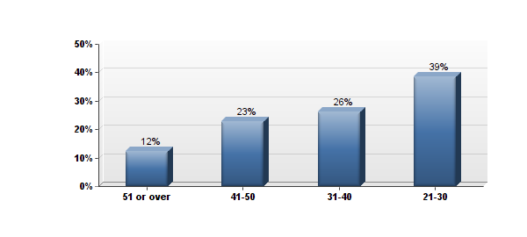
Figure 1: Age groups at the time of entry into EM program.
A total of 58 responses have been received within one week of administration; however, a reminder was necessary to issue. The statistics of survey itself reported the following:
- Survey completion rate 100%, i.e. no dropped surveys reported;
- One invalid entry: a blank survey submitted;
- The duration mean was 5 minutes; and
- The expected margin of error for the sample of 58 (binary response) was expected to be 14% [35].
Overall, the responses demonstrated the following poll results: 39% fell in the age category 21-30; 26% in the age category of 31-40; 23% in the age category of 41-50; and 12% were 51 and older (Figure 1). Therefore, the majority of the EM (Engineering Management) graduate students were represented by fresh bachelor degree recipients, followed by mid-career professionals, and advanced professionals.
In terms of gender, 72% of those surveyed were men, and 28% were women, which demonstrated a better female representation among our alumni than the overall expectation in engineering. Nonetheless, this outcome did not undermine the fact that the majority of men across the engineering discipline reached managerial positions from other engineering branches, and therefore this higher percentage of women from our alumni got diluted by the influx of men, when other disciplines were taken into the account.
The majority of those surveyed (47%) had 7 or more years of experience after their bachelor’s degree, followed by 31% of those with under 3-year experience, and 14% who fell in between. Four surveyed entered directly into the PhD program (Figure 2).
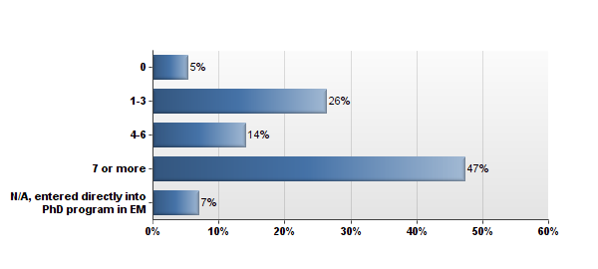
Figure 2: Years since bachelor degree completion.
The majority of those surveyed (84%) did not have a prior advanced degree, and 14% had another advanced degree or a foreign equivalent. Furthermore, the majority (74%) had gained work experience of more than 4 years. The overwhelming number of those surveyed reported their undertaking of either distance education or a combination of in-class and distance experience, while only 4% admitted traditional in-class attendance. Also, 65% mentioned that they were unlikely to attend a traditional program.
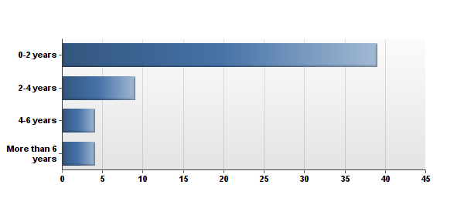
Figure 3: Work experience after EM program.
Regarding the post-degree working experience, most of those surveyed fell into the category of fresh graduates (70% with experience of fewer than 2 years); followed by 16% of those with 2-4 years of experience; 7% with 4-6 years; and, finally, 7% with more than 6 years (Figure 3). The corresponding graph is heavily skewed toward fresh graduates, which is natural and expected, given that the selected population consisted of mostly recent alumni.
We found that 93% of those surveyed were employed full-time when they entered into the EM program, and only 7% were unemployed or full-time students. Interestingly, there was no part-time employment reported; however, other time-consuming activities were mentioned, such as family (67%), community service or volunteer work (35%), church, and miscellaneous other activities.
Among the reasons for selecting their particular program, 82% addressed the flexibility of schedule, which was a natural benefit since the majority of those enrolled were full-time employed. This was followed by almost equal frequency for school reputation and coverage of costs by a third party (58% and 54%, respectively). Moreover, 35% accounted for the proximity to the workplace, which was deemed important by full-time employees, and 32% cited third party recommendations (Figure 4).
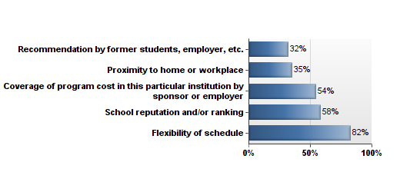
Figure 4: Frequency of reasons for EM program choice.
Regarding the background of those surveyed, 67% belonged to other engineering disciplines, and 26% ascended from Industrial Engineering. The results show that 7% listed other disciplines as their background, among which physics, mathematics, chemistry, and aerospace technology were featured.
Where the benefits of the EM degree were concerned, the following data was obtained (Figure 5): 53% reported that no notable salary increase was obtained, 19% reported an increase of up to 5%, 22% reported an increase between 5 and 15%, and only 7% reported an increase over 15%. The comparison between age groups and length of employment in relation to the salary increases will be showcased later in this thesis. Also, 82% reported a future expectation of a salary increase.

Figure 5: Economic benefit: salary increase.
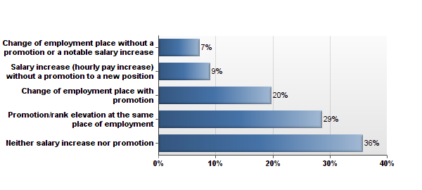
Figure 6: Career path in connection with EM degree.
When asked about their career paths, the majority of those surveyed remained with the pre-degree employer with various outcomes: 36% reported no changes; 29% noted promotion at the pre-degree employment place; and 9% noted just a pay increase (Figure 6). Along similar lines, 20% changed the employer with promotion, and 7% changed the employer without a promotion.
Overall, the majority (65%) reported a change of their career path either by the way of a new employer, or increased pay with the same employer; in contrast, the remaining 36% noted neither salary increases nor promotion with the same employer; which is also consistent with being young or recent graduates.
Based on the reports acquired, the majority of those surveyed stayed with the same employer and about a half of those surveyed reported a promotion (Figures 15 and 16, Appendix 3).
Among non-tangible and career benefits, the following results were obtained:
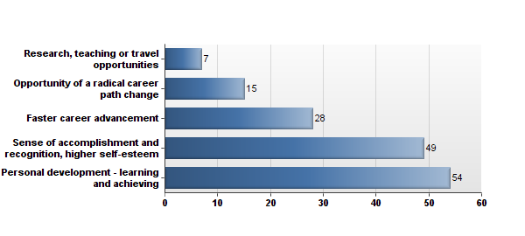
Figure 7: Non-tangible benefits, number of entries (out of 57 responses).
Based on the frequency of reporting, the personal development aspect (learning and achieving) was considered by the most of those surveyed (95%), followed by a sense of accomplishment (86%), and a faster career advancement (49%). Only 26% mentioned a career change opportunity, and 12% admitted teaching, research, and travel (Figure 7). For convenience, the data in this figure was presented using the number of times mentioned, rather than percentages, due to the possibility of multiple answers. These findings demonstrate that people place great value in non-tangible benefits of an EM degree, even in the case where it does not result in immediate economic or career gains.
The costs of the EM program were reported by the majority (64%) as compensated by the employer, whereas 27% covered the program from personal funds, and only 7% utilized a tuition waiver/scholarship/or grant (Figure 8).

Figure 8: Coverage of program costs by various benefactors.
During the study period, most employers kept regular scheduled hours for their graduate students (75%), and only 18% reported having flexible hours for degree completion. While this may not sound significant, we may remember that a majority of students had their programs compensated by their employers, and the compensation alone should be considered a value; furthermore, it was demonstrated that not only employers viewed graduate education of their bachelor degree employees as important, but that some were willing to go to even greater lengths, by granting their employees flexible hours without affecting their wages (i.e., no one reported a wage reduction).
In terms of recovery, the time-to-recovery expectation was split almost evenly between 1-3 years (23%), and 3-6 years (33%); the rest of those surveyed did not admit incurring any program costs. The discrepancy may have occurred in the reported results, where, in question 17, 40 of those surveyed reported a cost coverage by a third party (employer and tuition waver/stipend combined) versus 24 surveyed reporting a third party coverage in question 20. This may be due to the insufficient reliability of the survey, or to the assumption of partial cost coverage in some cases.
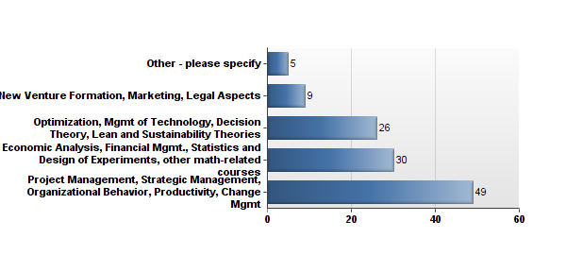
Figure 9: Usefulness of the courses in workplace, number of entries (out of 55 responses).
The courses and subjects that addressed everyday operations of our graduates received the following rankings in popularity (Figure 9), listed in order from the most to the least useful:
- The group of Project Management, Strategic Management, Organizational Behavioral, Change Management, and Productivity, was mentioned in 89% of entries;
- The group of Economic Analysis, Finances, and Statistics was mentioned in 55% of all entries;
- The group of Optimization, Technology, Decision Theory, Lean and Sustainability was mentioned in 47% of all entries; and
- New Venture and Marketing received the lowest rate of 16% of all entries.
Despite the abundance of literature sources emphasizing the importance of entrepreneurial education, the survey results of our alumni suggest that the corresponding topic occupies a lower priority in everyday operations, i.e., found less useful by those surveyed, as opposed to other managerial courses (such as Project Management, Strategic Management, Organizational Behavior, Productivity, etc.). Although entrepreneurial education remains justified among electives, it does not appear to be a priority among mandatory courses for graduate students.
The overall impression of the EM program remains positive, especially that 73% of surveyed still recommend their former program, as opposed to 13% who prefer to consider a different school. A different questionnaire, possibly an exit survey, may be necessary to address the matters of satisfaction and, in the process, uncover areas for improvement.

Assessment of Reporting Between Groups

Salary in Male vs. Female Groups
In order to contrast the findings between different groups, a drill-down analysis was performed, where the results were sorted by a specific group. When we compared male and female groups, the following findings emerged:
The total of those surveyed consisted of 41 (72%) male and 16 (28%) females; the majority of questions answered by females received the same answer distribution as that of their male colleagues.
The data pertaining to age, study and work experience, background, employment status, reasons for choosing the program, salary increase expectation, and use of certain courses in the workplace mirrors those associated with male responses. The difference was noted in economic benefits estimations: overall, women reported a lesser salary increase rate than their male colleagues (Figure 10), as evident from the flattening of the curve, corresponding to women on the figure below.
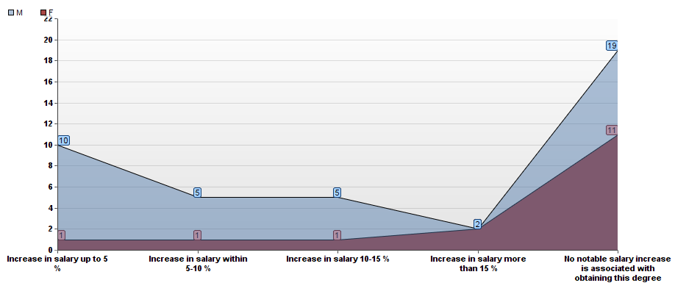
Figure 10: Salary increase in connection with gender.
However, regarding the impact of EM on career paths, women reported promotion and rank elevation more often than men, which indicates a positive influence of the program on their career advancement (Figure 17, Appendix 3); nonetheless, other non-monetary benefits were reported equally frequently by both genders (Figure 18, Appendix 3).
The findings of this survey confirm the common belief that women undertake a larger share of time and effort commitments, besides their regular employment (assuming that employment status does not differ between groups); according to this study, the home commitments of females were proportionate to those of males, but community service, volunteer work, and other commitments by females exceeded the frequency of the male group (Figure 19, Appendix 3).
Moving forward, a cross tabulation analysis was performed in an attempt to further examine relationships between gender and salary. A table with various factors that may have influenced the economic benefits was constructed (Figure 20, Appendix 4). For the purposes of illustration, only analysis of gender and economic benefits would be discussed in detail. The corresponding table (Figure 21, Appendix 4) contained various degrees of economic benefits in rows, and M/F gender in columns, with the totals shown. The chi-square statistic was used as a primary tool for testing the independence of salary and gender. In order to determine a chi-square value for each cell, the expected frequency of every cell was calculated from Eq. (2) as follows:
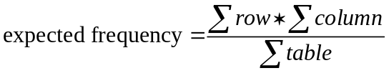 (2)
Subsequently, the differences between observed and expected frequencies were found, and the cells’ chi-square values were determined (Figure 21, Appendix 4) in accordance with Eq. (3):
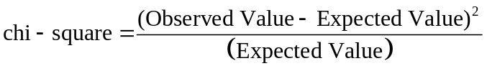 (3)
For example, a chi-square value for a cell of males with up to 5% salary increase was determined to be:
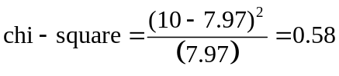 (4)
The values for other cells were calculated in a similar manner. A sum of all individual cells’ chi-square values amounted to a cumulative chi-square value of 5.17. The degrees of freedom were determined by counting the number of rows (5) and columns (2), and using the relationships:
(N of columns – 1) × (N of rows – 1) (4)
We thus realize a problem with (5 – 1) × (2 – 1) = 4 degrees of freedom. The p-value for a chi-square of 5.17 and 4 degrees of freedom was inferred from the chi-square distribution table (equaling 0.27), which was not significant; hence, there seemed to be no relationships between gender and salary based on our observations in this sample group. It should be noted that the calculation of the chi-square may have been inaccurate due to the expected frequencies being often less than 5 (for accurate calculations, the expected frequency must be at least 5).
Conclusion: Overall females reported a lower economic benefit as a result of a graduate degree, especially that the percentage salary increases in their category demonstrated a lag behind their male counterpart; however, this data remains in agreement with the generally accepted findings of a Georgetown University survey, where a gap is reported between compensation levels for men and women in engineering. Regarding the non-monetary benefits, females reported them with the same frequency as males; however, females appeared to experience favorable career advancement in connection with their completion of an EM degree more often than their male peers. The attempt to use cross tabulations failed to demonstrate the dependence between gender and salary variables, but this failure may be attributed to the small expected frequencies which could have given rise to incorrect chi-square values for such a small group.

Salary and Work Experience Before EM Program
When the results were sorted in accordance with the length of employment prior to entering into EM program, the following modifications took place: in order to take a look into economic benefits, only those surveyed who reported earnings increases were included in the graph; also, we excluded those whose graduate studies followed their completion of an undergraduate degree with no employment break in between.
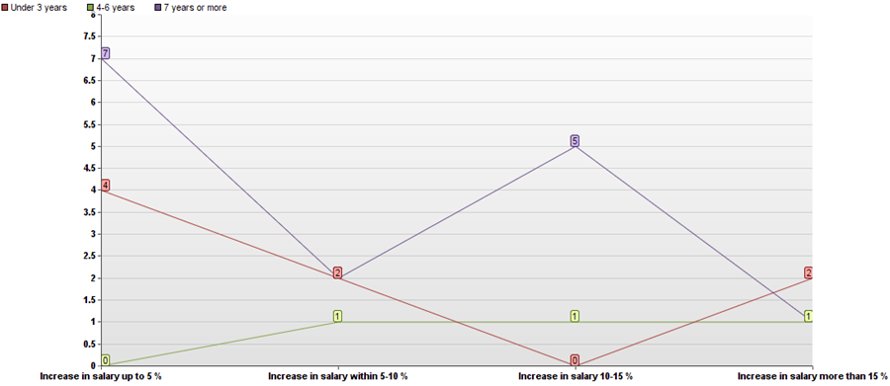
Figure 11: Salary increase in connection with prior work experience.
In this analysis, it was demonstrated that the group with the least work experience was likely to report smaller salary increase (negative slope, Figure 11), the group with 4-6 years of work experience was likely to demonstrate a positive slope, and the group with the longest work experience surprisingly demonstrated a double-peak at 5% and again, at 10-15%. Therefore, the economic benefits of graduates with shorter career spans depended on their work experiences, but those with longer career spans did not follow this trend, which warrants an investigation of other causes. The sample of those surveyed for this particular chart was too small for a reliable conclusion.

Salary and Work Experience After EM Program
Next, we looked into earnings increases reported among groups with various lengths of employment after completion of the EM degree; this was performed while keeping in mind that the majority of those surveyed fell into fresh graduates (under 2 years out) category (Figure 12). The group of fresh graduates (0-2 years) tended to report the absence of salary increases; however, when we excluded those with no salary gain, incremental increases were reported with equal frequency for most choices. Because the greatest salary increase was cited the least in this group, a negative slope was obtained.
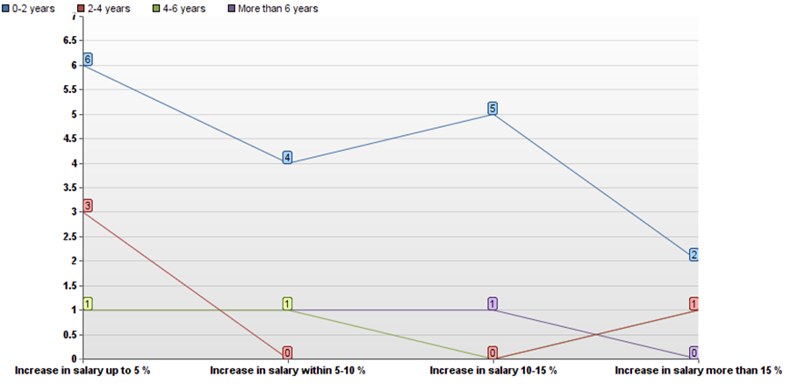
Figure 12: Salary increase in connection with experience since graduation from EM
Those graduates with 2-4 years of experience demonstrated a similar pattern of earning increase distribution (majority with no increase, followed by up to 5% increase and, lastly, over 15% increase); as for the graduates with over 4 years of experience, the group exhibited a tendency to flatten the slope, thus indicating a trend toward increased earnings. However, all groups were statistically too small for a conclusive outcome, and a more comprehensive study needs to be conducted in order to evaluate their earnings increase correctly.
The report of career path benefits did not produce any meaningful results, possibly due to the groups being too small; and though various answers were noted in all groups, no particular pattern could be discerned. Other, non-tangible benefits were reported proportionally with the group size among the groups, which could be an indication that the fractions of answers did not appreciably vary among groups.
Conclusion: the majority of fresh graduates did not report a salary increase; those who did indicated various percentage increases, ranging from 5 to over 15% with the tendency toward 5% (negative slope); however, it may take several years until those graduates could fully appreciate the value of their degree, as indicated by the flattening of the negative slope with experience; various career outcomes were reported and non-tangible benefits were recognized by all groups. However, the groups remained quite small for an accurate representation of the causal relationships.

Hypothesis I Addressed:
The economic benefit to an EM degree has been reported, however only by a conservative 47% of those surveyed. This outcome was most likely due to the fact that the surveyed pool was heavily skewed toward fresh graduates. Among those who reported benefits, there was no apparent group with higher earnings; the reports were distributed somewhat uniformly among similar age and similar experience groups; however, there was a noticeable trend of women, lagging somewhat behind their male colleagues in reporting a salary increase. This behavior was in line with similar reports from reputable sources, which confirm a gap in compensation of male and female engineers. However, due to the limited number of reports from female groups, a larger investigation would be warranted. Prior work experience seemed to play a significant role in compensation increases; the group with under 3 years of work experience was inclined toward a 5% increase, whereas the group with 4-6 years of experience reported higher percentage increases, as reflected in a flattening of the curve on Figure 11. The most experienced group demonstrated a double-peak with no apparent trend at 5% and 10-15%; we concluded that future inquiries were needed in order to determine the corresponding tendency with more accuracy. Concerning the time since graduation, the majority of fresh graduates did not report any salary increase; out of those who indicated increased earnings, no particular group was prominently better compensated than the other; a better representation (i.e., a larger group) of those surveyed across the employment periods may be needed in future inquiries. The attempts to point out a single or a few groups reporting increased earnings compared to others through cross tabulation were unsuccessful because the cross tabulation technique did not yield any significant relationship between the earnings and other factors, such as age, gender, or experience (Appendix 4). This also may be due to the insufficiency of entries, which resulted in expected frequencies being less than five.

Hypothesis II Addressed:
Based on the collected responses, the majority of graduates indicated no salary increase; among those who benefitted, 19% reported increases under 5%; 11% reported increases within 5-10%, another 11% reported increases within 10-15%, and only 7% reported over 15% increases in earnings. Clearly, this data was influenced by the composition of the surveyed pool as opposed to the general population of engineers, as it suggested that recent graduates should expect a conservative-to-moderate increase in earnings; however, with experience, the earnings should significantly improve. These findings did not correlate with general information about the engineering field, where the expected earnings should be estimated at over 15%, and sometimes even at 32%.

Hypothesis III Addressed:
In order to reject or confirm this hypothesis, the general reporting of non-tangible benefits was assessed through a construction of a bar graph displaying the frequencies of occurrence for each notion of benefit among all those surveyed. The results were displayed in Figure 13, thus clearly indicating that EM graduates placed great emphasis on addressing the higher Maslow’s needs of personal development, learning, achievement, sense of accomplishment, and high self-esteem.
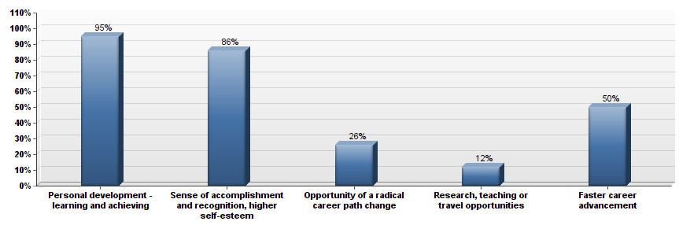
Figure 13: Non-tangible benefits associated with EM degree among all surveyed (% of entries).
The overwhelming frequency of reporting was demonstrated between the need for personal development (95%) and the sense of accomplishment and self-esteem (86%); these were followed by career advancement (50%), career change (20%), and research/teaching/travel opportunities (12%). It seemed that EM graduates placed the most weight on Maslow’s higher needs, with career path advancement as a secondary significant choice. These findings did not change between various groups.
As a next step, another bar chart was constructed, that allowed us to indirectly estimate if the perception of non-tangible benefits changed with economic benefits. For comparison, both graphs were presented in percentages. The fraction that reported economic benefits was excluded from the analysis, hence leaving only graduates who did not report any salary increases (Figure 14).
Both graphs closely resembled each other; the resemblance indicated that graduates appreciated non-tangible benefits in the same way regardless of the salary increase or lack thereof.
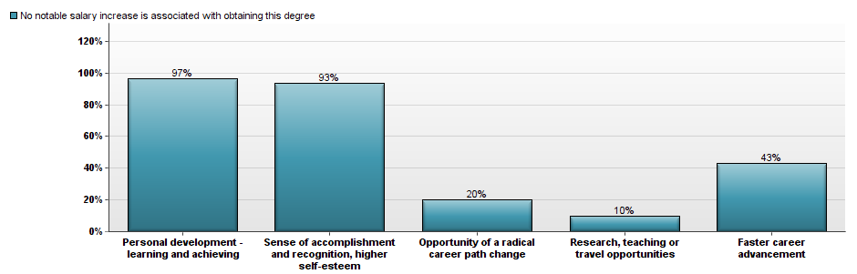
Figure 14: Non-tangible benefits associated with EM degree among the group without increased earnings (% of entries).
Therefore, not only were the non-tangible benefits to an advanced degree in Engineering Management apparent (with nearly all those surveyed indicating two or more benefits), but the overall fractions accounted for each benefit were nearly identical between the two groups, therefore confirming the independence of both intellectual and opportunity appreciation from monetary rewards.

Chapter 5
Conclusions and Recommendations

After analyzing the results of this survey, a collective portrait of typical EM alumni of a particular institution (UTK) may be described as follows: they are males, under 40 years old at the time of application into the program, and holding a Bachelor’s Degree from other engineering fields. They typically have considerable work experience, are employed full-time in a company that provides employer’s compensation of EM program costs, and are appreciative of the convenience that distance education and flexibility of schedule offer. These individuals are generally engaged in family obligations and community service in addition to their commitments to their regular work and continuing education efforts. The coverage of program costs mattered almost as much to them as the school’s reputation, and a limited set pointed out referrals and recommendations by individuals they knew. Only half of them were realizing economic benefits since the time of graduation, and the other half settled at a conservative 5% to 10% increase in salary earnings; nonetheless, all of them maintained a prominent expectation of future improvement in earnings. Their projections appeared to be natural, especially that their majority had just recently graduated, and half of them had already received a promotion. In what concerns non-tangible rewards, they all appreciated a personal development component, followed by a career boost. In their everyday routine, they mostly addressed questions of management and technology, rather than entrepreneurship and marketing. They highly recommended their EM program itself (73%), while greatly appreciating its distance education component.
Overall, the impression of receiving a prominent economic benefit after earning an advanced degree in Engineering Management may have been somewhat overstated in the literature and statistical reports across engineering. While confirmation of its existence has been obtained, the percentage level and encirclement of subpopulations of those surveyed was not nearly as prominent, as within other engineering disciplines. This finding has resonated with the fact that the sample of surveyed individuals mostly consisted of recent graduates, and the larger investigation of the general population of engineering managers, of all career durations, may be warranted to accurately estimate their earnings.
Recent graduates, particularly those with an inclination and potential to improve their earnings, should not expect excessive gains in the few years past graduation. However, with experience and persistence, both the career paths and compensation levels of all EM graduates should gradually improve. On the other hand, it seems that non-monetary benefits have been duly noted by receiving the highest acknowledgement among graduates in all researched groups. There remained an unresolved question of a difference in male and female earnings increases, but the present data proved insufficient to accurately address this problem, as a larger pool of surveyed individuals was needed before drawing definitive conclusions.
In what concerns other data, which was collected, summarized, and noted, but not extensively discussed or cross-compared to uncover correlations, it would be possible to extend its analysis and applicability in future work. This study served its role as a preliminary, pilot research for testing the capabilities of commercial grade survey software, as applied to a small population of graduates from a single institution. In order to overcome its limitations, which are mainly caused by its reliance on small subgroups, a wider audience will be necessary for a future, larger-scale research. Such research could be based on a similar software package with the potential to provide an extensive analysis of the data acquired with no involvement of other statistical programs.

List of References

[1] Carnevale, A. P., Strohl, J., and Melton, M., “What's It Worth?: The Economic Value of College Majors,” Center on Education and the Workforce, 2011.
[2] Giles, M., Ski, C., and Vrdoljak, D., “Career Pathways of Science, Engineering and Technology Research Postgraduates,” Australian Journal of Education, Vol. 53, No. 1, 2009.
[3] Kocaoglu, D., “Engineering Management--Where It Was, Where It Is Now, Where It Is Going,” Engineering Management Journal, Vol. 21, No. 3, 2009.
[4] Farris, G., “Engineering Management Yesterday, Today, and Tomorrow: A Personal Perspective,” Engineering Management Journal, Vol. 21, No. 3, 2009.
[5] Goh, S., Coaker, W., and Bullen, F., “Management Education for the 21(St) Century Engineering Manager: An Australian Perspective,” 2008.
[6] Rubenstein, A., “The Five Decades-Long Development of an Engineering Manager and the Field of Engineering Management,” Engineering Management Journal, Vol. 21, No. 3, 2009.
[7] Kuznia, K., “To a Higher Degree: How Do You Decide Which Advanced Course of Study Is the Best Option for Your Career?,” Mechanical Engineering- CIME, 2008.
[8] Bailyn, L., and Schein, E., Living with Technology: Issues at Mid Career, MIT Press, 1980.
[9] Roberts, K., and Biddle, J., “The Transition into Management by Scientists and Engineers: A Misallocation or Efficient Use of Human Resources? ,” Human Resourse Management, Vol. 33, No. 4, 1994, pp. 561-579. doi: 10.1002/hrm.3930330406
[10] Kennedy, D., “Attrition Rates of Mature Engineers,” Engineering Management Journal, 2006.
[11] Ashley, S., “The Making of an Effective Manager (Engineering Management),” Mechanical Engineering-CIME. American Society of Mechanical Engineers., 1993.
[12] Srour, I., Abdul-Malak, M. A., Itani, M., Bakshan, A., and Sidani, Y., “Career Planning and Progression for Engineering Management Graduates: An Exploratory Study,” Engineering Management Journal, Vol. 25, No. 3, 2013, pp. 85-98.
[13] Borchardt, J., Career Management for Scientists and Engineers Oxford University Press, New York, 2000.
[14] Bugaian, L., “Entrepreneural Education for Engineers,” 6th International Seminar on the Quality Management in Higher Education Paper 2010.
[15] Waters, R., “Time to Think Oputside the Box? Technical Entrepreneurship and Engineering Management Education,” EMJ-Engineering Management Journal, 2010.
[16] McSherry, J., “Engineering Salary Survey 2011: Faces of the Engineering Lifecycle,” Electronic Design, 2011.
[17] Mason, T., “Discovery to Commercialization: Enabling Productive Technology Implementation,” Engineering Management Journal, 2005.
[18] Johnson, M. J., and Sheppard, S. D., “Relationships between Engineering Student and Faculty Demographics and Stakeholders Working to Affect Change,” Journal of Engineering Education, Vol. 93, No. 2, 2004, pp. 139-151. doi: 10.1002/j.2168-9830.2004.tb00798.x
[19] Singh, R., Fouad, N., Fitzpatrick, M., Liu, J., Cappaert, K., and Figuereido, C., “Stemming the Tide: Predicting Women Engineers'intentions to Leave,” Journal of Vocational Behavior, Vol. 83, No. 3, 2013, pp. 281-294. doi: 10.1016/j.jvb.2013.05.007
[20] “Engineering Majors Top-Salary Survey in 2012,” in States News Service Washington, 2013.
[21] Abel, K., and Fernandez, A., “Abet Accreditation of Undergraduate Engineering Management Programs: Established Versus New Programs - the Similarities and Differences,” Engineering Management Journal, 2005.
[22] Farr, J., and Bowman, B., “Abet Accreditation of Engineering Management Programs: Contemporary and Future Issues,” Engineering Management Journal, 1999.
[23] Black, S., “Thoughts on Management Education,” Industrial Relations journal, Vol. 2, No. 4, 1971, pp. 34-62. doi: 10.1111/j.1468-2338.1971.tb00811.x
[24] Mohindra, A., “The 2011 Astd Salary Survey: Learning Pays and It Pays to Learn,” in T & D 2011.
[25] Burnsed, B., “Understand the Value of a Graduate Degree,” 2011.
[26] Vedder, R., Denhart, C., and Robe, J., “Why Are Recent College Graduates Underemployed? University Enrollments and Labor-Market Realities,” Center of College Affordability and Productivity, Washington, DC, January 2013.
[27] Jackson, S. L., Research Methods and Statistics: A Critical Thinking Approach, 3rd ed., Belmont, Wadsworth, CA, 2009.
[28] Cherry, K., What Is a Survey?, 2014, http://psychology.about.com/od/researchmethods/f/survey.htm
[29] Britto, M., “Webct Surveys: Opportunities and Challenges,” Academic Exchange Quarterly, 2004.
[30] Scheuren, F., What Is a Survey, 2004, https://www.whatisasurvey.info/overview.htm
[31] Edwards, P., Roberts, I., Clarke, M., Diguiseppi, C., Wentz, R., Kwan, I., Cooper, R., Felix, L., and Pratap, S., “Methods to Increase Response to Postal and Electronic Questionnaires,” Cochrane Database of Systematic Reviews 2009, 2009, Vol. issue 3. doi: 10.1002/14651858.MR000008.pub4
[32] “Cross Tabulation Analysis,” http://www.qualtrics.com/, 2011.
[33] Koehler, K., Chi-Square Tests. Encyclopedia of Biostatistics., John Wiley & Sons, Ltd, 2005. doi: 10.1002/0470011815.b2a10013
[34] Martz, E., “Using Cross Tabulation and Chi-Square: The Survey Says
” 2012.
[35] Sauro, J., “What Is a Representative Sample Size for a Survey?,” http://www.measuringusability.com/, 2010.

Appendices

Appendix 1: Survey Questionnaire
Benefits of Obtaining an Advanced Degree in EM
Q1 Age at the time of entering EM (Engineering Management) program
- 21-30
- 31-40
- 41-50
- 51 or over

Q2 Gender
- M
- F

Q3 Number of years between bachelor degree completion and entering MS in EM
- 0
- 1-3
- 4-6
- 7 or more
- N/A, entered directly into PhD program in EM

Q4 Did you have a prior MS or PhD degree or their equivalent?
- Yes
- No
- Foreign equivalent

Q5 Work experience prior to entering the EM program
- None, EM program is contingent to undergraduate studies
- Under 3 years
- 4-6 years
- 7 years or more

Q6 Institution where EM program was attended
- Public
- Private

Q7 EM program type
- Traditional "in class"
- Distance Education
- Combined (some courses via distance ed., and some courses attended in class)

Q8 Time passed since your graduation from EM program
- 0-2 years
- 2-4 years
- 4-6 years
- More than 6 years

Q9 Employment status when you entered EM program
- Unemployed or full-time student
- Part-time employment (up to 20 hours/week)
- Full-time employment (40 hours/week)
- Combination part-time employment (between 20 and 40 hours/week)

Q10 Other time commitments (besides employment) while in EM program
- None
- At home (family, elderly, disabled, etc.)
- Community service or volunteer work
- Other commitments - please specify ____________________

Q11 Reason for choosing your particular EM program - choose all that apply
- Proximity to home or workplace
- School reputation and/or ranking
- Flexibility of schedule
- Recommendation by former students, employer, etc.
- Coverage of program cost in this particular institution by sponsor or employer

Q12 If you attended distance or combination type program, how likely you would have attended a traditional program instead?
- Unlikely
- Equally likely
- Preferably
- Not applicable, traditional in-class program was attended

Q13 Your Bachelor's Degree is in
- Industrial engineering or closely related field (i.e. systems, manufacturing, IT etc.)
- Other engineering field (civil, mechanical, electrical, etc.)
- Business or economics
- Other field - please specify ____________________

Q14 The economic benefit to obtaining EM degree is best described as (per year)
- Increase in salary up to 5 %
- Increase in salary within 5-10 %
- Increase in salary 10-15 %
- Increase in salary more than 15 %
- No notable salary increase is associated with obtaining this degree

Q15 Your career path in conjunction with obtaining EM degree
- Promotion/rank elevation at the same place of employment
- Salary increase (hourly pay increase) without a promotion to a new position
- Neither salary increase nor promotion
- Change of employment place with promotion
- Change of employment place without a promotion or a notable salary increase

Q16 Other benefits associated with EM degree - check all that apply
- Personal development - learning and achieving
- Sense of accomplishment and recognition, higher self-esteem
- Opportunity of a radical career path change
- Research, teaching or travel opportunities
- Faster career advancement

Q17 Costs of the program were covered by
- Yourself or your family
- Your employer
- Through tuition waiver/stipend/grant/scholarship/ etc.
- Other party

Q18 Your employer
- Granted you the opportunity to have flexible hours for study while occupying the same position
- Kept your regular scheduled hours
- Placed you onto lower wage/different position or fewer hours during the study period
- You found a different employer for the study period
- You were a full-time student

Q19 Regardless of your salary, do you expect a salary increase in the foreseeable future?
- yes
- No

Q20 How fast would you expect to recover your cost of the program?
- 1-3 years
- 3-6 years
- more than 6 years
- my program was compensated by the third party

Q21 Most useful courses in the program as they relate to your job are - check all that apply
- Economic Analysis, Financial Mgmt., Statistics and Design of Experiments, other math-related courses
- Project Management, Strategic Management, Organizational Behavior, Productivity, Change Mgmt
- New Venture Formation, Marketing, Legal Aspects
- Optimization, Mgmt of Technology, Decision Theory, Lean and Sustainability Theories
- Other - please specify ____________________

Q22 If you were to advise a colleague/ relative regarding a similar program, you would
- Recommend your former program
- Consider trying a different school/program if schedule/location permits
- Advise to choose a different field from EM
- Recommend enrolling into a distance program due to schedule and financial commitments

Appendix 2: Prospective Software Vehicles for Survey Administration
SurveyMonkey | SurveyGizmo | Qualtrics
Basic free plan allows for ten questions/100 responses only; no analysis capabilities | Solo plan $ 15/month*; no encryption security; few analysis tools | Depends on an organizational license; private use is expensive
Select plan: $26 per month | Basic plan $35 /month; professional plan $ 75/month
Unlimited questions in select plan | Unlimited questions | Unlimited questions
URL; secure link | URL; secure link; data encrypted only at professional level | URL; secure link; data encryption
Skip-logic only | Multiple logic settings | Multiple logic settings
Export to Excel and PDF | Export to Excel; CSV; Word | Excel, PDF; CSV; SPSS; Email; Word
No randomization | Randomization | Randomization
Few collection features | Multiple collection features | Multiple collection features
No text analysis | Text analysis | Text analysis
Multiple deployment features | Multiple deployment features | Multiple deployment features
One account user | One to ten users | Set by organizational license
15 question types | 32 question types | Over 90 question types
Few survey formatting options | More formatting options | Most formatting options
Limited ability to edit | Editable after launch | Editable after launch
No looping | No looping | Allows looping
Real-time report | Real-time report | Real-time report
Cross tabulation: count; percentage | Cross tabulation: count, percentage; mean at professional level | Cross tabulation: count, percentage, mean
No statistical analysis | No statistical analysis | Chi-square; t-test; test of proportions
Graphs | Graphs | Graphs
No import from other sources | No import from other sources | Import data from other data sources
No polls | Polls | Polls
E-mail support; no phone support; tutorials | E-mail; phone; tutorial support | E-mail; phone; tutorial support
*Pricing as of May, 2014

Comment: Bolded fields indicate a preferable choice. It is obvious that the Qualtrics column carries the most preferable choices.

Appendix 3: Supporting Figures and Charts

Figure 15: Career path events after EM program in connection with change of employer.
Comment: The fields in green indicate a change of employer (27%).

Figure 16: Career path events in connection with promotion.
Comment: The fields in blue indicate a promotion (49%).

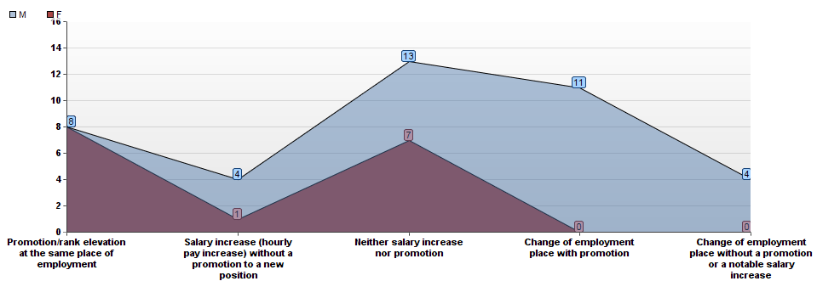
Figure 17. Career outcomes as reported per male and female entries.
Comment: Promotion, as a result of an advanced degree, is reported more often by females.

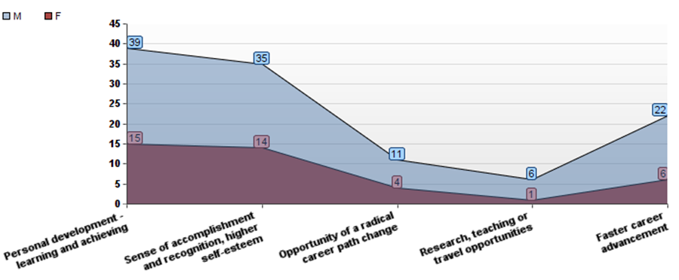
Figure 18. Other benefits of an advanced degree (male vs. female entries).
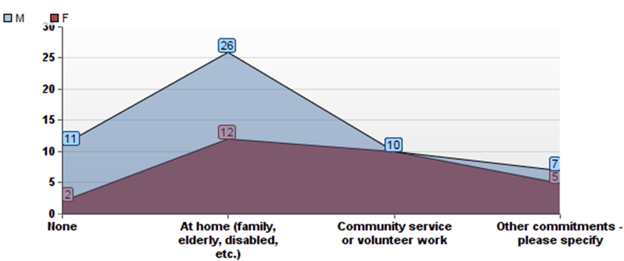
Figure 19. Commitments besides employment (male vs. female entries).
Comment: Female groups admit more commitments that their male peers, especially in the community and volunteer service.

Appendix 4: Cross-tabulation and Chi-square Statistic for Economic Benefits

Figure 20. Cross-tabulation of different variables versus salary increase.
Comment: P-values for all variables fail to be low enough (i.e., 0.05 or less) for chi-square to be significant, hence the variables to be considered dependent; however, the lowest p-value (0.07), although not low enough to be significant, was observed in between “the economic benefit” and “prior work experience” variables.

Figure 21. Salary increase versus gender.

Comment: Calculation of expected frequency and chi-square statistics for individual cells.

Vita
Inna Majdalani was born in Kharkiv, Ukraine, on August 23, 1979. After completing her secondary education with honors at State High School #8, she enrolled into Kharkiv National Medical University (KNMU), formerly known as Kharkiv State Medical University, with a concentration in Pediatrics. In June 2002, she completed her undergraduate degree at KNMU, and then underwent a residency rotation at Kharkiv Maternity House # 4.
In 2004 she immigrated to the United States, where she started a family with Dr. Joseph C. (Joe) Majdalani, in Tullahoma, TN. Inna enjoyed raising their two children, George and Laura, while volunteering to assist in health care services at local medical clinics. These responsibilities led her to appreciate the importance of managerial education in the work line of STEM professionals. Having received a narrow-field education, and in her desire to broaden her capabilities, she joined in 2011 the graduate school of The University of Tennessee Space Institute, where she was admitted in the field of Industrial Engineering (IE) with a concentration in Engineering Management. In May 2014, Inna completed her Master of Science degree in IE/EM. She presently lives in Auburn, AL, with her husband, Dr. Joseph C. (Joe) Majdalani, and their two children, George and Laura.

