The Accuracy of the Progressive Aerobic Cardiovascular Endurance Run to Estimate Aerobic Fitness in Youth

A Thesis Presented for the
Master of Science Degree
The University of Tennessee, Knoxville

Stacy N. Scott
May 2012
DEDICATION

This page is optional

ACKNOWLEDGEMENTS

This page is optional.

ABSTRACT

The FITNESSGRAM’s Progressive Aerobic Cardiovascular Endurance Run (PACER) test is a commonly used field test to estimate peak oxygen uptake (VO_{2peak}) in youth. However, little research has been conducted to determine the influence of weight status on the accuracy of the equations used to estimate VO_{2peak}. Purpose: To assess the agreement between VO_{2peak} measured using indirect calorimetry during the PACER and estimated VO_{2peak} in normal weight and overweight youth and to determine the influence of weight status on the accuracy of estimated VO_{2peak} in 10-15 year old youth. Methods: The study included 101 participants that were classified as normal weight (n=78) or overweight (n=23) according to BMI percentiles for age and sex. Participants completed the PACER, a progressive, multistage, 20-meter shuttle run to volitional exhaustion. VO_{2peak} was measured during the PACER test using a portable gas analysis system (Oxycon Mobile, CareFusion, Inc.). Estimated VO_{2peak} values were calculated based on PACER performance using the Leger et al. and Mahar et al. equations. Paired samples t-tests were used to determine if significant differences existed between estimated and measured VO_{2peak}. Independent t-tests were performed to compare the normal weight and overweight groups. Accuracy was determined using Bland-Altman plots. Results: The Leger et al. (44.3 +4.6 ml•kg⁻¹•min⁻¹) and Mahar et al. (46.8 +4.8 ml•kg⁻¹•min⁻¹) estimated values were significantly lower than measured VO_{2peak} (49.0 +8.7 ml•kg⁻¹•min⁻¹) in the normal weight group. There were no significant differences between measured VO_{2peak} (38.8 +7.1 ml•kg⁻¹•min⁻¹) and predicted values (40.5 +2.5 and 38.2 +6.1 ml•kg⁻¹•min⁻¹; Leger et al. and Mahar et al., respectively) for the overweight group. For the normal weight group, the standard error of the estimate (SEE) was Leger 5.44 ml•kg⁻¹•min⁻¹ (Leger) and 5.33 ml•kg⁻¹•min⁻¹ (Mahar). The SEE was 5.77 ml•kg⁻¹•min⁻¹ (Leger) and 4.54 ml•kg⁻¹•min⁻¹ (Mahar) for the overweight participants.
Conclusions: It appears that the prediction of VO_{2peak} from either equation based on PACER performance varies among weight status group and may be inaccurate for normal weight youth, but acceptable for overweight youth.
TABLE OF CONTENTS

CHAPTER I Introduction 1
CHAPTER II Literature Review 5
INTRODUCTION 5
AEROBIC FITNESS 6
Definition and Importance 6
Aerobic Fitness in Overweight and Obese Youth 6
ASSESSMENTS OF AEROBIC FITNESS 7
Laboratory Testing 8
Field Testing 9
PROGRESSIVE AEROBIC CARDIOVASCULAR ENDURANCE RUN (PACER) 11
Reliability 11
Validity 12
Regression Equations 15
Validity of the Regression Equations 15
The Influence of Weight Status 17
CRITERION REFERENCE STANDARDS 20
FITNESSGRAM Healthy Fitness Zone 21
SUMMARY 22
CHAPTER III Manuscript 24
ABSTRACT 24
INTRODUCTION 25
METHODS 27
RESULTS 30
DISCUSSION 35
LIST OF REFERENCES 39
APPENDICES 45
Appendix A Peak Exercise Responses 46
APPENDIX B Validation Parameters 48
APPENDIX C Parental Permission 50
APPENDIX D Subject Assent 55
APPENDIX E Recruitment Flyers 58
APPENDIX F Institutional Review Board Consent 61

LIST OF TABLES

TABLE 1. Participant characteristics 31
TABLE 2. PACER variables 31
TABLE 3. Measured and estimated VO_{2peak} values 32

LIST OF FIGURES

FIGURE 1. Bland Altman plots for normal weight participants. 33
FIGURE 2. Bland Altman plots for overweight participants. 34

CHAPTER I
Introduction

The increasing population of overweight children continues to be a public health concern in the United States. Body mass index (BMI) percentiles are statistically determined cut-points used to monitor children’s growth status based on an age and sex-specific reference population (22). Children with a BMI at or above the 85th percentile or 95th percentile are classified as overweight or obese, respectively (44). Between 2009 and 2010, 31.8% of U.S. children, aged 2-through 19, were classified as overweight for age and 16.9% were classified as obese (45). Although the cut-points are not based on health risks, BMI is correlated with overfatness predisposing overweight and obese children to risk factors such as elevated blood pressure, dyslipidemia, and insulin resistance that negatively impact cardiovascular health (49).
Aerobic fitness, a reflection of cardiorespiratory function (16) may play a protective role in the cardiovascular health of overweight and obese children. Reduced aerobic fitness during childhood may predict the onset of cardiovascular disease in adulthood, however greater aerobic fitness is associated with risk reduction (24, 26). In youth, peak oxygen uptake or VO_{2peak} reflects the highest rate at which the cardiorespiratory system utilizes oxygen during exercise (16) and is considered to be an objective measurement of aerobic fitness (20). A valid assessment of aerobic fitness, measured by VO_{2peak} is important for properly interpreting cardiovascular function and subsequently determining health related risk.
Several methods can be used to assess aerobic fitness in children. In the laboratory, oxygen uptake, measured continuously through indirect calorimetry during graded exercise testing, is used to determine aerobic fitness; however this requires sophisticated equipment and is not feasible for regularly testing large groups of children. For environments such as physical education classes or community settings, field tests can be used to estimate aerobic fitness. The FITNESSGRAM’s Progressive Aerobic Cardiovascular Endurance Run (PACER) is a field test commonly used to assess aerobic fitness in large groups of children. The PACER test involves running 20-meter shuttles in time with music (16). As a progressive exercise test, the pace increases accordingly in one-minute stages until the running pace can no longer be maintained. VO_{2peak} during the PACER test is estimated using a regression equation developed by Leger et al. (29) based on age and the highest speed achieved at the end of the PACER test.
The PACER has been validated as a field test to estimate aerobic fitness in children of healthy, normal weight status. Estimated aerobic fitness from the Leger et al equation (29) using age and final running speed of the PACER test correlates (r= .54-.87) with VO₂ measured during the final stages of graded treadmill tests (10, 23, 31, 38, 56), maximal heart rate achieved during exercise testing (7, 25, 57), and compared to estimates from other field tests (2, 23, 40, 57). Two studies investigated the influence of weight status on performance during the PACER test. Ihasz et al (25) compared the estimates of aerobic fitness from the PACER test and a modified shuttle test to measured oxygen consumption during treadmill testing and found no significant difference between estimated and measured aerobic fitness levels in overweight boys. Similarly, Suminski et al (54) determined that weight status in Hispanic youth, did not affect the validity of the Leger et al. equation (29) for predicting VO_{2peak} in this population compared to VO_{2peak} measured during a treadmill test. The Leger et al. equation (29) was originally developed and validated in 1988 based on post-shuttle test VO₂ measurements, retroextrapolation techniques, and maximal speed attained during the 20-meter shuttle run. Although there is a correlation between oxygen uptake at the end of the PACER test, the Leger equation underestimates oxygen uptake measured during treadmill exercise (23, 52). The treadmill criterion-related validity may explain the variability of the Leger et al. equation to predict VO_{2peak}. Since the equation was not developed based on treadmill measurements, Ruiz et al. (52) suggests that the variability in the equation results from the differences in exercise modality comparing shuttle running to continuous, forward, motor driven treadmill locomotion. Due to advances in technology, oxygen uptake can be determined outside of the laboratory using portable metabolic system to measure VO_{2peak} during field testing and are similar to methods used in the development of the Leger et al. equation. Wearing a portable metabolic system during the PACER test to measure VO_{2peak} should be used as the criterion-related measure to validate the Leger et al. equation (52). Only three studies have measured VO_{2peak} during the PACER test using a portable metabolic system. Melo et al. (42) compared measured VO_{2peak} during the PACER test to estimated VO_{2peak} from the Leger equation (29) and found estimated VO_{2peak} to be significantly different than measured values in 8 to 10 year old children (d = 4.7). Ruiz et al (52) found a weak correlation (r = .587; p < 0.001) between estimated and measured VO_{2peak} during the PACER test in twenty-six girls aged 13 through 19 years. More recently, Mahar et al. (35) measured VO_{2peak} during the PACER in 10 to 16 year olds to develop a new estimation equation. However, no study has been conducted that investigates the accuracy of the PACER run to determine aerobic fitness in overweight children.
Utilizing a portable metabolic system to measure VO_{2peak} during the PACER test will aid in determining the accuracy of the PACER test and Leger et al. equation to estimate aerobic fitness in overweight youth. The validation of the PACER test in this population would enable researchers and educators to accurately estimate aerobic fitness in overweight youth and thus, determine aerobic fitness level, and associated health risk implications. Therefore, the purpose of this study is to determine the accuracy of the PACER to estimate aerobic fitness in overweight and obese youth aged 10 to 15 years.
Research Question #1: To assess the agreement between VO₂ measured during the PACER and estimated VO₂ derived from the PACER test in normal weight and overweight/obese youth.
Research Question #2: Does accuracy of the PACER differ among normal weight and overweight/obese youth 10 to 15 years old?

CHAPTER II
Literature Review

INTRODUCTION

The Progressive Aerobic Cardiovascular Endurance Run (PACER) is a multi-stage 20-meter shuttle run used as a field test to estimate aerobic fitness. Routinely performed in physical education classes or community settings, the PACER test has been administered in 37 countries and published data exists for over 400,000 children aged 6-19 years (46). Although, the PACER test has been established as a reliable and valid field test of aerobic fitness (5, 32, 37, 57), few studies have addressed the influence of weight status on predicting aerobic fitness in children. There are two equations most commonly used to estimate VO_{2peak} from PACER performance that have been tested against other field assessments and also those performed in a laboratory (29, 35). Children are placed in fitness categories based on the estimated values; therefore, the accuracy of the equations is critical for appropriate classification. Further research is necessary to determine the influence of weight status on the accuracy of predicting aerobic fitness from assessments in the field, specifically the PACER or 20-meter shuttle run.
The purpose of this literature review is to highlight the importance of aerobic fitness assessments in youth and the influence of weight classification on predicting aerobic fitness levels. Because accuracy of aerobic fitness assessments is imperative in determining aerobic fitness levels, this literature review also examines previous research on measuring and estimating aerobic fitness in youth.

AEROBIC FITNESS

Definition and Importance
Aerobic fitness reflects the ability of cardiorespiratory system to transport oxygen during strenuous exercise (50) and is an important element in overall health-related physical fitness (20). Aerobic fitness assessments should be conducted in a manner such that the cardiovascular and pulmonary systems are pushed to their functional limit (51) to determine peak exercise response, uncover deficiencies, or evaluate performance. In adults, maximal oxygen consumption (VO_{2max}) is the highest rate at which active tissue can take up and utilize oxygen for energy during exercise (16, 50) and is used as an objective measure of aerobic fitness. In the pediatric population, criteria used to determine maximal effort are not clearly defined and a low percentage of children exhibit a plateau in oxygen uptake. Therefore, peak oxygen consumption (VO_{2peak}) is used to represent peak aerobic fitness in children compared to VO_{2max} in adults (3, 20). Several factors known to influence VO_{2peak} include sex, age, maximal heart rate, fat free mass, and fat mass (17).

Aerobic Fitness in Overweight and Obese Youth
Aerobic fitness is an important element of health-related fitness. Low aerobic fitness is considered an independent risk factor for cardiovascular disease. Children with low aerobic fitness are at a greater risk for developing cardiovascular disease risk factors including hypertension, dyslipidemia, diabetes, and obesity (16, 20). (26, 33). Currently, 31.9% of U.S. youth (2-9 y) are considered overweight and 16.9% obese based on BMI for age and sex (45).
Overweight and obese children have increased total body mass which includes excess fat mass or metabolically inactive tissue. Their aerobic fitness level are usually lower compared to their normal weight counterparts (26). When aerobic fitness values are allometrically scaled for lean body mass, overweight and obese children appear to have normal levels of aerobic fitness (13). To account for differences in body size (16), peak oxygen uptake is commonly expressed relative to body mass in milliliters of oxygen per kilogram of body mass per minute (ml•kg⁻¹•min⁻¹) (50). Johnson et al. (26) suggests that improving or maintaining aerobic fitness may reduce overweight and obesity rate and decrease the prevalence of cardiovascular disease risk factors...

ASSESSMENTS OF AEROBIC FITNESS
Research involving fitness testing in U.S. youth was first published in the 1950’s, reporting that American youth were less fit than their European counter parts (27). This ignited further research in pediatric exercise testing and the development of the President’s Council on Youth Fitness, American Alliance for Health, Physical Education and Recreation Youth Fitness Test, and later the concept and practice of health-related fitness (62). Since then, health-related fitness testing, specifically aerobic fitness assessment in the pediatric population has become common practice in educational, wellness, and clinical settings. Although fitness testing is conducted in a similar manner for adults and children, it is critically important to choose a test protocol that is physically and developmentally appropriate for the pediatric population. Test administrators should also consider the suitability of test location (laboratory or field-based) and availability of pediatric sized equipment for participant safety and comfort (51).

Laboratory Testing
The measurement of VO_{2peak} is commonly performed in a laboratory or clinical setting with progressive workloads applied during a cycle ergometer or treadmill graded exercise test (GXT) until the child can no longer continue. Cycle ergometer protocols may require the participant to maintain a set pedaling cadence, specific stage duration, or initial and subsequent increases in work rate (51). The McMaster cycle protocol is one of the standard maximal, cycle aerobic fitness tests (47); initial workload and incremental increase is determined by the participant’s height and pedal cadence remains constant throughout the test. If a maximal exercise test is not appropriate, a submaximal cycle test, such as the Physical Working Capacity test (PWC₁₇₀) can be administered to estimate VO_{2peak}. For the PWC₁₇₀, initial workload is set according to the child’s weight and successive workloads are determined by the heart rate (HR) response from the prior stage. Once HR is ≥ 165 beats•min⁻¹, the test is complete; VO_{2peak} is then estimated using heart rate extrapolation techniques (38).
Although cycle protocols may be safer and less intimidating for the pediatric population, local muscle fatigue instead of cardiorespiratory limitations may constrain the test parameters. Research indicates VO_{2peak} is about 10% higher measured during a treadmill GXT compared to a cycle test due to increased amounts of active muscle tissue during walking and running (9, 51). The Bruce treadmill protocol and the modified Bruce protocol are reported to be the most commonly used treadmill GXTs. The Bruce protocol begins at a speed of 1.7 miles per hour (mph) with a 10% grade and increases in both speed and grade at 3- min intervals. The modified Bruce protocol starts at a speed of 1.7 mph with a 0% grade and increase in both speed and grade at 2-min intervals(14). Cumming et al. (14) conducted a study involving 327 participants (7 -14 y) to provide physiologic data and endurance time norms. The mean VO_{2peak} values were reported across four age groups were 40.2+0.4 (7) , 36.5+5.3 (9-11y), 35.2+3.2 (11-12y), and 37.7+3.5 ml•kg⁻¹•min⁻¹ (13-14 y). The Cumming et al. study provides the most comprehensive set of norms for aerobic fitness in terms of subject age. Other studies that focused on more discrete age ranges have also been conducted and have reported similar results. A multitude of aerobic fitness evaluations and norms utilizing the Bruce protocol and other treadmill GXTs for pediatric exercise testing in the laboratory are well documented through out the literature (3, 51, 53).

Field Testing
VO_{2peak} measured in the laboratory or clinical setting during a treadmill GXT is considered the criterion method for assessing aerobic fitness. Although ideal, laboratory testing requires sophisticated equipment, well-trained staff, and can time consuming since tests are performed one at a time. Field tests of aerobic fitness provide an affordable and practical alternative for testing large groups of children. There are several field tests of aerobic fitness, among them some of the most common include the Cooper 12-minute run/walk, the 6-min run, the one-mile walk, the one-mile run, and the PACER test, all of which have been validated and used for testing children and adolescents. (11, 30, 59).
The Cooper 12-minute run/walk and the 6-min run estimate aerobic fitness based on distance covered over the allotted amount of time (11, 30). Correlations of the Cooper 12- minute run/walk with measured VO_{2peak} range from r=0.20 to r=0.90 (56) indicating a wide degree of variability. This could be due to the fact that both of these field tests require high subject motivation, the ability to self-pace running speed, and maintain a near-maximal speed throughout the duration of the test (56).
The one-mile walk and run pose similar limitations in requiring maximal subject effort and appropriate pacing to achieve an accurate estimation of VO_{2peak}. Children may not be willing to maximally exert themselves the entire test which could potentially confound the results (56, 57); however, the one-mile walk and one-mile run are occasionally used as aerobic fitness assessments as a part of the FITNESSGRAM test battery (59, 60). Both tests are used to estimate VO_{2peak} based on sex, age, and the amount of time it takes to cover one mile; additionally the walk test includes body weight and heart rate at the end of the test in estimating aerobic fitness (59).
Research supports the PACER test as one of the better field assessments of aerobic fitness (46, 56, 57) and is the recommendation test of the FITNESSGRAM battery(59). The PACER involves running 20-meter shuttles, back-and-forth, keeping pace with timed audio signals playing from a soundtrack. The PACER starts at a moderate speed of 8.5 km•hr⁻¹ and progressively becomes faster each minute, requiring maximal effort only in the final stage of the test. Similar to the other field tests, the PACER requires minimal equipment and is easily administered. In contrast to the other field tests, the PACER requires less space, maximal exertion only in the final stage, and can be conducted outdoors or indoors (59). The accuracy of aerobic fitness field testing has important clinical and practical applications as it relates to health and fitness. Because the PACER is one of the most widely used assessments (46), its reliability, validity, and application will be further discussed in this review.

PROGRESSIVE AEROBIC CARDIOVASCULAR ENDURANCE RUN (PACER)
The 20 meter shuttle run (20- MST) was developed by Leger and Lambert (28) to simulate a treadmill graded exercise test increasing one MET per stage (31). VO_{2peak} is estimated based upon the highest speed attained, corresponding to the number of completed stages, and the participant’s age. More recently, the 20-MST has been adopted as the FITNESSGRAM’s PACER and is administered like the 20-MST with the addition of background music on an audio CD. Participants perform 20-meter shuttles set to a cadence, increasing each minute, until the participant can no longer continue, or fails to cover the 20-meter distance within the allotted time on two consecutive shuttles.

Reliability
In adults, Leger and Lambert (28) found the 20- MST to be a reliable field test of aerobic fitness. On two separate occasions, the 20- MST was performed with VO_{2max} measured via Douglas Bags with results indicating strong test-retest reliability (r= 0.98; SEE= 2.0 ml•kg⁻¹•min⁻¹). The reliability of the 20- MST or PACER test has been demonstrated in children as well. Leger et al. (29) reported a correlation coefficient of 0.89 for test-retest reliability in 139 children, 6 to 16 years old based on VO_{2peak} determined from the equation for both occasions. Liu et al. (31) conducted the PACER to assess the test-retest reliability among American students aged 12-15 years. Twenty students (12 males and 8 females) performed the PACER twice, one week apart. The investigators reported an intraclass correlation coefficient of 0.93 and no significant difference between mean laps completed at trial one and trial two (T₁= 47.80± 20.3 vs. T₂ = 55.55± 22.4 laps; p ≥ .13). This finding is similar to other PACER reliability studies reporting interclass coefficients of 0.81 and 0.90 for laps completed (7, 38). More recently, Beets, Pitetti, and Fernhall (7) and McVeigh et al. (41) investigated reliability of peak heart rate (HR_{peak}) recorded during multiple PACER trails; both reporting no significant difference between mean HR_{peak} obtained between trials, intraclass coefficients were 0.78 and 0.69, respectively.

Validity
The PACER test has become one of the most commonly used field tests of aerobic fitness in youth (37). Comparisons to a treadmill GXT have also been made to determine the validity of the PACER as an aerobic fitness assessment. Van Mechelen et al. (56) investigated VO_{2peak} measured during a treadmill GXT compared to PACER performance from the number of laps completed in 12 to 14 year old adolescents (n= 82) and found that 57% of the variance in VO_{2peak} could be explained by performance on the PACER. Similarly, in a small, non-Caucasian sample (n= 10), Mahoney (38) found significant positive correlations between treadmill VO_{2peak} and number of laps completed on the PACER for boys (r= 0.83) and girls (r= 0.76). Boreham et al. (10) also investigated the validity of PACER performance using treadmill GXT as the criterion for determining VO_{2peak} in 14 to 16 year old adolescents and reported a slightly higher correlation (r= 0.87). In their study, boys (n= 23) averaged 81.7+15.9 laps completed and VO_{2peak} measured was 53.3+5.9 ml•kg⁻¹•min⁻¹ and girls (n= 18) completed 50.4+12.5 laps and measured VO_{2peak} averaged 42.6+5.8 ml•kg⁻¹•min⁻¹.
To further validate the PACER test as an aerobic fitness assessment, researchers have monitored HR during both the PACER and a treadmill GXT to compare participant effort and peak heart rates (HR_{peak}) elicited from each test. Voss and Sandercock (58) reported that the PACER elicits maximal effort in 11 to 16 year olds. Using HR_{peak} greater than 185 beats•min⁻¹ to indicate maximal effort, Voss and Sandercock reported a mean HR_{peak} of 196 beats•min⁻¹ (95% CI; 194 – 198 beats•min⁻¹) to conclude that maximal effort was achieved. McVeigh et al. (41) found no significant difference between HR_{peak} achieved during the PACER (boys = 203 beats•min⁻¹; girls = 201 beats•min⁻¹) and treadmill GXT (boys = 200 beats•min⁻¹; girls = 204 beats•min⁻¹) in 13 to 14 year-old youth. Boreham et al. (10) reported similar maximal heart rates ranging from 190 to 213 beats•min⁻¹ during a treadmill GXT compared to a range of 190 to 214 beats•min⁻¹ during the PACER test in a sample (n= 41) of 14 to 16 year old adolescents.
It is important to compare validity evidence to other aerobic fitness tests when evaluating the utility of the PACER test. From a study conducted by Vincent et al. (57) HR at the completion of the PACER and 1- Mile Run show a moderate correlation (r= 0.82) in fifth grade elementary students. The investigators reported no significant difference between mean HR_{peak} upon completion of the PACER (195+14 beats•min⁻¹) versus the 1-Mile Run (191+23 beats•min⁻¹). Results reported by Chun et al. (12) show high correlations (r= -0.73 for boys, -0.80 for girls) between the PACER laps and 1-Mile run time supporting the PACER as a comparable field test of aerobic fitness. In one study, in which participants performed the PACER, a 6-minute run test, and a treadmill GXT, VO_{2peak} was more highly correlated with the PACER test than the 6-minute run (r= 0.76 vs. 0.63) (56). Although not statistically different, Van Mechlen et al. (56) discussed the advantages of conducting the PACER test over the 6-minute run because of the PACER’s resemblance to a treadmill GXT and higher subject motivation. The PACER has also been compared to the PWC₁₇₀, a submaximal cycle test. In a small sample (n=18), Mahoney (38) reported a significant correlation between PACER laps and VO_{2peak} from a treadmill GXT (r=0.83, boys; r=0.76, girls) but no significant relationship between the PWC₁₇₀ and VO_{2peak} or the PWC₁₇₀ and PACER laps. Conversely, Boreham et al. (10) found no significant differences between VO_{2peak} prediction values from the PWC₁₇₀ (r=0.84;) and the PACER (r=0.87) compared to VO_{2peak} measured during a treadmill GXT.

Regression Equations
The 20-MST or PACER test was first used as a field test to estimate aerobic fitness in adults by Leger and Lambert in 1982 (28) and later tested for children in 1988 (29). The investigators used regression analysis to develop an equation that predicted VO_{2peak} based on performance during the PACER and the participant’s age. Youth (n=188, 8-19y) performed the test to volitional fatigue and immediately upon completion, expired gases were collected using the Douglas Bag Method to establish the oxygen recovery curve and determine VO_{2peak} (28, 29). A regression analysis yielded age (y) and maximal speed attained (km•h⁻¹) in the final stage of the test to be significant predictors (r= 0.71; SEE= 5.9 ml•kg⁻¹•min⁻¹) of VO_{2peak}[equation: VO_{2peak} (ml•kg⁻¹•min⁻¹) = 31.025 + 3.23 ((km•h⁻¹) – 3.248 (years) + 0.1536 (km•h⁻¹)(years)] (29). More recently, FITNESSGRAM (60) has updated the prediction equation to also include number of laps completed, BMI (kg•m²), and gender (0 for girls, 1 for boys) [equation: VO_{2peak} (ml•kg⁻¹•min⁻¹) = 41.77 + 0.49(laps) – 0.0029(laps)² – 0.62(BMI) + 0.35(gender age)].

Validity of the Regression Equations
Several studies have supported the utility of the Leger et al. equation to estimate VO_{2peak} from PACER performance. However, a wide range of variability exists among the accuracy of VO_{2peak} values estimated from the equation. Leger et al. developed and validated the original equation in 1988 in a sample of 188 boys and girls ages 8 to 19 years. In 2011, Mahar et al. (35) developed a new equation to estimate VO_{2peak} from PACER performance that is now used in the latest edition of the FITNESSGRAM software (59). From a total sample of 244 youth (10–16 years old), 174 participants were used for the development and validation of the new equation and 70 participants for cross-validation. The total number of laps completed was recorded following the PACER test and VO_{2peak} was determined from a treadmill GXT for each participant. A multiple regression analysis yielded PACER laps, gender, age, and BMI to be significant predictors of VO_{2peak}. After cross-validation, VO_{2peak} estimated (44.1 +6.9 ml•kg⁻¹•min⁻¹) from the FITNESSGRAM equation was significantly correlated (r = 0.75, SEE = 6.17 ml•kg⁻¹•min⁻¹) to measured VO_{2peak} (43.9 +9.5 ml•kg⁻¹•min⁻¹). Although, the updated FITNESSGRAM software utilizes the new equation (35), this change has not been reflected in the most recent FITNESSGRAM manual (59); therefore, the Leger et al. equation is still widely used and supported.
Because the PACER involves running and is a multistage progressive fitness test, VO_{2peak} values estimated from PACER performance are most often compared to those measured in the laboratory during a treadmill graded exercise test (GXT) (5, 10, 29, 31). Lui et al. (32) cross-validated the Leger et al. equation in a sample of forty-eight 12 to 15 year olds and reported no significant difference between laboratory measured VO_{2peak} (49.97 +7.59 ml•kg⁻¹•min⁻¹) and PACER estimated values (48.72 +5.72 ml•kg⁻¹•min⁻¹) and a significant correlation of 0.72. Barnett et al. (5) reported similar results in Chinese students (n= 55; 12 to 17 years old). The correlation between estimated and measured VO_{2peak} was 0.72 and a standard error of 5.4 ml•kg⁻¹•min⁻¹; investigators also reported a significant correlation (0.74) between measured VO_{2peak} in the laboratory and maximal speed attained from the PACER. However, a lower correlation (r= 0.54) was reported between VO_{2peak} estimated from the Leger et al. equation and compared to values measured during a treadmill GXT by Armstrong et al. (4) for 11-14 year old males.
More recently, Winsley (61) examined the validity of the Leger et al. equation in youth 5 to 16 years old. VO_{2peak}, estimated from PACER performance, was not significantly different than VO_{2peak} measured during a treadmill GXT. However, Winsely (61) reported an underestimation (-3.0 ml•kg⁻¹•min⁻¹) of VO_{2peak} in boys and overestimation (1.0 ml•kg⁻¹•min⁻¹ ) in girls that could result in a potential error ranging between -19.0 to 13.0 ml•kg⁻¹•min⁻¹ for boys and -9.0 to 11.0 ml•kg⁻¹•min⁻¹ for girls. The equation has also been tested in 132 Japanese children. Matsuzaka et al. (39) reported no significant difference between VO_{2peak} predicted from PACER performance using the Leger et al. equation compared to direct measurement during a treadmill GXT for boys or girls (52.5 +5.7 vs. 54.2 +6.2 ml•kg⁻¹•min⁻¹, 46.4 +6.9 vs. 46.7 +6.7 ml•kg⁻¹•min⁻¹; predicted vs. measured for boys, girls; respectively).

The Influence of Weight Status
While the accuracy of the Leger et al. prediction equation has been validated in various populations (10, 38, 39) and in several age groups (41, 42) only two studies have addressed the influence of weight status on the accuracy of the equation. Suminski et al. (54) tested the validity of the Leger et al. equation in a sample of Hispanic youth where 64.8% (n=81) were normal weight and 35.2% (n=44) were overweight according to BMI-for-age and sex. There was no significant difference for either normal or overweight groups between VO_{2peak} values measured during a treadmill GXT and estimated from the PACER, with the difference between measured and estimated being 0.62 ml•kg⁻¹•min⁻¹ for the normal weight group and 1.07 ml•kg⁻¹•min⁻¹ for the overweight group. Ihaz et al. (25) conducted a study to determine whether a modified PACER would improve the prediction accuracy. Normal weight (n=16) and overweight (n=15) participants completed the PACER test, a modified PACER (15m), and a treadmill GXT. Although VO_{2peak} was significantly higher in the normal weight group (44.6+4.7 vs. 39.4+3.7 ml•kg⁻¹•min⁻¹), there were no significant differences between estimated VO_{2peak} and actual VO_{2peak} for either protocol. Additionally, there were there no significant differences in HR_{peak} across the three tests for either group. It appears that weight status does not affect the validity of the Leger et al. equation to predict VO_{2peak} when compared to measured values attained during a treadmill GXT.
While the Leger et al. equation appears accurate, despite the wide range of correlation coefficients, researchers argue whether the criterion-related validity of the Leger et al. equation has truly been examined (42, 52). Ruiz et al. (52) suggests the variability of the prediction equation could be due to the physiological differences of forward locomotion in treadmill running and the start-stop pattern of shuttle running. To test the accuracy of the prediction equation, VO_{2peak} measured via indirect calorimetry during the PACER is more ecologically valid, since the equation was developed from measured values using the Douglas Bag Method (42). Currently, the three studies (34, 42, 52) involving youth that have used portable gas analyzers to obtain measured VO_{2peak} values during the PACER indicate varying degrees of accuracy and agreement between equations to estimate aerobic fitness from the PACER performance.
In studies conducted by Ruiz et al. (52) and Melo et al. (42), VO_{2peak} was measured while participants performed the PACER test for comparison against predicted values; however, these were not tested against values from a treadmill GXT. In a sample of 48 adolescents (14 -15 y), mean VO_{2peak} measured during the PACER (47.1 +8.1 ml•kg⁻¹•min⁻¹) was significantly different than the mean VO_{2peak} (41.5 +5.2 ml•kg⁻¹•min⁻¹) estimated from the Leger et al. equation (52). The mean difference of 5.5 ml•kg⁻¹•min⁻¹ reported by Ruiz et al. (52) is similar to the 4.7 ml•kg⁻¹•min⁻¹ reported by Melo et al. in a sample of 8 to 10 year old children.
A study conducted by Mahar et al. (2010), has investigated the criterion related validity of the PACER as an assessment of aerobic fitness and the accuracy of the prediction equation compared to a treadmill GXT in youth (n = 40) 15 to 16 years old. VO_{2peak} measured during the PACER was highly correlated (r = 0.84) with measured values from the treadmill GXT and mean values did not differ significantly (d = 1.4 ml•kg⁻¹•min⁻¹; p = 0.17). For the cross-validation of the Leger et al. equation, Mahar et al. (34) reported a correlation of 0.77 and SEE of 10.1 ml•kg⁻¹•min⁻¹.
These researchers caution the use of the Leger et al. prediction equation to estimate VO_{2peak} and note that estimations of group VO_{2peak} may be reasonable, however the accuracy of individual values is unacceptable (42). Both Melo et al. (42) and Ruiz et al. (52) reported an over-prediction in less fit participants and an under-prediction in more fit participants when compared to VO_{2peak} measured during the PACER. If this is the case, less aerobically fit children could be classified inappropriately and necessary interventions may be neglected.

CRITERION REFERENCE STANDARDS
The FITNESSGRAM employs criterion- referenced standards, as opposed to norm- referenced, to set an evaluation standard attainable by any child, as long as an effort is made (62). For health-related fitness testing, the criterion- referenced standard is established at the point where the participant is fit enough to be free of potential health risks and for children and adolescents the likelihood of becoming a healthy adult.
Zhu et al. (62) recognized the importance of accurate classification and its impact on an individual’s perception of his or her health. Using data from the National Health and Nutrition Examination Survey (NHANES) and studies conducted by the National Center for Health Statistics (NCHS) aerobic fitness data was collected for a nationally representative sample of approximately 3300 students, aged 12-18 years (19). Students performed a submaximal treadmill test until a heart rate of 75% - 90% of age-predicted maximum was elicited; HR was extrapolated to age-predicted maximum to predict VO_{2peak}. For boys, VO_{2peak} slightly increased from ages 12 to 15 (42 to 46 ml•kg⁻¹•min⁻¹) and decreased for girls from ages 12 to 18 (39 to 37 ml•kg⁻¹•min⁻¹) (19). Researchers developed age- and gender- specific percentiles of aerobic fitness for U.S. youth aged 12-18 years from the NHANES and NCHS studies that were used to develop the health and fitness criterion- referenced standards for the FITNESSGRAM test battery (62).

FITNESSGRAM Healthy Fitness Zone
The FITNESSGRAM has established standards of aerobic fitness, in which children are classified into one of three categories (Healthy Fitness Zone (HFZ), Needs Improvement - some risk (NI- some risk), Needs Improvement – higher risk (NI- higher risk) based on VO_{2peak} estimated from PACER performance (59). Using scores from the youth NHANES fitness data, changes in aerobic fitness that occur from childhood to adulthood, and adults aerobic fitness values associated with cardiovascular disease risk, Cureton developed the cut-off scores for the HFZ standards to indicate the level of aerobic fitness associated with reduced risk of disease and mortality (15, 62).
These scores have been supported by further research of aerobic fitness and health- risk factors in children (60).
The reliability of the (HFZ) standards for aerobic fitness have been documented in the literature where youth performed the PACER test on two or more occasions and were classified in the HFZ, NI- some risk, or NI- higher risk. In a sample of 165 boys and 76 girls, Beet and Pitetti (6) found that 81% of boys and 79% of girls were classified the same on both occasions.. In a study conducted by Mahar et al. (36), 89% of 10 to 11 year olds (n = 213) were consistently classified after performing two PACER tests. The results from these studies indicated the PACER’s ability to reliably classify fitness in youth.
A few studies have investigated the validity of appropriate aerobic fitness classification from PACER performance. The potential of misclassification, HFZ or Needs Improvement Zone (NIZ) , depends upon the accuracy of the Leger et al. and FITNESSGRAM equations. Mahar et al. (37) examined the criterion-referenced validity by comparing the fitness category associated with the participant’s estimated VO_{2peak} to the appropriate zone for the measured VO_{2peak}. Using the Leger et al. equation a total of 36% of participants were placed in the wrong category. The FITNESSGRAM prediction equation slightly improved the classification with 17% of participants inaccurately placed in the HFZ and 13% in the NIZ (37). Although the majority of youth are classified in the appropriate aerobic fitness category, the error of a false-positive (and unfit individual classified as fit) may be critical to the development of a plan or prescription to either maintain or improve an individual’s aerobic fitness as it relates to health and disease risk (15, 62). Because the equations tend to overestimate VO_{2peak} in unfit youth, the child’s weight status may also influence the classification and potentially lead to a false-positive error. Although the standards shifted the focus to health, instead of performance, additional research is needed to address the validity of the HFZ standards as it relates to aerobic fitness classification and PACER VO_{2peak} estimated from either equation.

SUMMARY
The PACER test is an easily administered, practical, and affordable field-based aerobic fitness assessment. Because of the popularity and prevalent use of PACER test it is critical that test administrators are aware of potential errors in predicting VO_{2peak} in order to provide participants with the most accurate results regarding their aerobic fitness level. Further research is needed to determine the influence of weight status (normal weight or overweight) on the accuracy of the equations used to predict VO_{2peak} and how the accuracy may affect fitness classification.

CHAPTER III
Manuscript

ABSTRACT
The FITNESSGRAM’s Progressive Aerobic Cardiovascular Endurance Run (PACER) test is a commonly used field test to estimate peak oxygen uptake (VO_{2peak}) in youth. However, little research has been conducted to determine the influence of weight status on the accuracy of the equations used to estimate VO_{2peak}. Purpose: To assess the agreement between VO_{2peak} measured using indirect calorimetry during the PACER and estimated VO_{2peak} in normal weight and overweight youth and to determine the influence of weight status on the accuracy of estimated VO_{2peak} in 10-15 year old youth. Methods: The study included 101 participants that were classified as normal weight (n=78) or overweight (n=23) according to BMI percentiles for age and sex. Participants completed the PACER, a progressive, multistage, 20-meter shuttle run to volitional exhaustion. VO_{2peak} was measured during the PACER test using a portable gas analysis system (Oxycon Mobile, CareFusion, Inc.). Estimated VO_{2peak} values were calculated based on PACER performance using the Leger et al. and Mahar et al. equations. Paired samples t-tests were used to determine if significant differences existed between estimated and measured VO_{2peak}. Independent t-tests were performed to compare the normal weight and overweight groups. Accuracy was determined using Bland-Altman plots. Results: The Leger et al. (44.3 +4.6 ml•kg⁻¹•min⁻¹) and Mahar et al. (46.8 +4.8 ml•kg⁻¹•min⁻¹) estimated values were significantly lower than measured VO_{2peak} (49.0 +8.7 ml•kg⁻¹•min⁻¹) in the normal weight group. There were no significant differences between measured VO_{2peak} (38.8 +7.1 ml•kg⁻¹•min⁻¹) and predicted values (40.5 +2.5 and 38.2 +6.1 ml•kg⁻¹•min⁻¹; Leger et al. and Mahar et al., respectively) for the overweight group. For the normal weight group, the standard error of the estimate (SEE) was Leger 5.44 ml•kg⁻¹•min⁻¹ (Leger) and 5.33 ml•kg⁻¹•min⁻¹ (Mahar). The SEE was 5.77 ml•kg⁻¹•min⁻¹ (Leger) and 4.54 ml•kg⁻¹•min⁻¹ (Mahar) for the overweight participants.
Conclusions: It appears that the prediction of VO_{2peak} from either equation based on PACER performance varies among weight status group and may be inaccurate for normal weight youth, but acceptable for overweight youth.

INTRODUCTION
Aerobic fitness is a health-related fitness component associated with cardiovascular disease risk factors and other health outcomes during childhood (18) and adulthood (8). Children with low aerobic fitness are at a greater risk for developing cardiovascular disease risk factors including hypertension, dyslipidemia, diabetes, and obesity (16, 20). Currently, 31.9% of U.S. youth (2-19 y) are considered overweight and 16.9% obese based on BMI for age and sex (45). The aerobic fitness levels of overweight and obese youth are usually lower compared to their normal weight counterparts (26). Improving or maintaining aerobic fitness may reduce overweight and obesity rates and improve their cardiovascular disease risk profiles.
Peak oxygen consumption (VO_{2peak}) reflects the ability of cardiorespiratory system to transport oxygen during strenuous exercise (50) and is considered to be an objective measure of aerobic fitness in youth (52). Because of the related health implications, affordable, non-invasive field tests providing an estimate of VO_{2peak} have been developed and included in youth fitness evaluations.
The FITNESSGRAM’s Progressive Aerobic Cardiovascular Endurance Run (PACER) is a multi-stage 20-meter shuttle run frequently used in physical education classes or community settings to estimate VO_{2peak} and classify aerobic fitness level. There are two equations commonly used to estimate VO_{2peak} from PACER performance. In 1988, Leger et al. (29) developed an equation that predicts VO_{2peak} in youth based on the participant’s age and maximal speed attained in the final stage of the test. More recently, Mahar et al. (35) developed an equation that includes number of laps completed on the PACER, body mass index (BMI), age, and gender. The most recent FITNESSGRAM software (web-based, version 9.2), applies the Mahar et al. equation. However, previous versions still in service utilize the Leger et al. equation.
Although, the PACER test has been established as a valid and reliable field test of aerobic fitness (5, 32, 37, 57), few studies have addressed the influence of weight status on predicting VO_{2peak} in children. Since aerobic fitness values tend to be lower in overweight children compared to values seen in normal weight children (26), the accuracy of predicting VO_{2peak} may be influenced if the child is overweight.
As a part of the FITNESSGRAM test battery, children are placed in fitness categories, Needs Improvement (NI) or in the Healthy Fitness Zone (HFZ), based on the estimated VO_{2peak} values that are compared to criterion-referenced standards. Therefore, the accuracy of the equations is critical for appropriate classification. Melo et al. (42) reported that VO_{2peak} was over-predicted in less fit participants and under-predicted in more fit participants compared to VO_{2peak} measured via indirect calorimetry during the PACER. If this is the case, less aerobically fit children could be classified inappropriately and necessary interventions may be neglected. The error of a false-positive (an unfit individual classified as fit) may be critical to the development of a plan or prescription to either maintain or improve an individual’s aerobic fitness as it relates to health and disease risk (15, 62).
Therefore, the purpose of this study is to assess the agreement between VO_{2peak} measured during the PACER and estimated VO_{2peak} in normal weight and overweight youth and to determine the influence of weight status on the accuracy of VO_{2peak} estimated from the PACER.

METHODS
Subjects
Participants were recruited from the Knoxville community via flyers, word-of-mouth, and discussion forums. The sample included 101 youth, 56 boys (12.4+1.6 y) and 45 girls (13.0+1.7 y) that volunteered for the study. Participants were “apparently healthy” (without diagnosed disease or illness) and free of any orthopedic issues that may limit running performance. Written parental permission and participant assent were obtained prior to data collection. The study was approved by the Institutional Review Board at the University of Tennessee, Knoxville.
Procedures
All participants were required to fast 4 hours prior to testing. Height (to the nearest 0.1 cm) and weight (to the nearest 0.01 kg) were measured, and body mass index was calculated (BMI; kg•m⁻²). Participants with a BMI < 85th percentile for age and sex were classified in the normal weight group (n=78). Due to the low number (n = 2) of participants classified as underweight (BMI < 5th percentile for age and sex), underweight and normal weight groups were combined. Participants > 85th percentile were classified in the overweight group (n=23) (44). Blood pressure was measured prior to the aerobic fitness assessment. Body composition was assessed using air displacement plethysmography (BODPOD; Life Measurement, Inc., Concord, CA), and child specific equations were used to estimate thoracic gas volume (21).
PACER Test
The PACER test was administered according to guidelines in the FITNESSGRAM & ACTIVITIYGRAM Test Administration Manual (43). Participants ran 20-meter shuttles back and forth between cones. The initial speed began at 8.5 km·h⁻¹ and progressively increased by 0.5 km·h⁻¹ each minute. Running pace was kept in time with signals played from an audio CD player; the same CD and CD player were used throughout the study. Participants were encouraged to run as long as possible, and testing was stopped when the participant reached volitional fatigue or could not maintain the required pace for two consecutive shuttles. Using the Children’s OMNI Scale (55), participants were asked to report their peak rating of perceived exertion (RPE_{peak}) upon stopping the test.
The PACER test was conducted in a recreational gymnasium on a wooden floor or in a spacious hallway on a smooth tile surface. If needed, a researcher ran alongside participants to aid with pacing. A single researcher conducted all of the PACER tests and all participants received verbal encouragement from the researcher.
Physiological Measurements
During the PACER test, heart rate was monitored continuously via telemetry (Polar T31 coded transmitter) and inspired and expired gases were analyzed breath-by-breath with the Oxycon Mobile respiratory exchange gas analysis system (CareFusion, Inc., San Diego, CA). Before each test, the gas analyzers were calibrated using a certified calibration gas mixture (4% CO₂, 16%O₂; CareFusion, Inc.). Subjects were fitted with a Hans Rudolph, 8900 series nasal and mouth breathing mask (Hans Rudolph Inc., Kansas City, US) and vest containing the portable device. To determine if peak effort was achieved, at least two of the following criteria had to be fulfilled: (1) peak heart rate (HR_{peak}) greater than or equal to 195 beats per minute, (2) peak respiratory exchange ratio (RER_{peak}) greater than or equal to 1.05, (3) subjective signs of fatigue (excessive sweating, dyspnea, unsteady gait, etc.) (48). HR_{peak} was recorded as the highest value in the final completed stage. VO_{2peak} and RER_{peak} values were averaged over the last 30- seconds of the final completed PACER stage.
Prediction Equations
For comparison purposes, VO_{2peak} was estimated from the PACER test using both the Leger et al. and Mahar et al. equations. [Leger et al. (29) equation: VO_{2peak} (ml•kg⁻¹•min⁻¹) = 31.025 + 3.23 ((km•h⁻¹) – 3.248 (years) + 0.1536 (km•h⁻¹)(years)] (29). [Mahar et al. (35) equation: VO_{2peak} (ml•kg⁻¹•min⁻¹) = 41.77 + 0.49(laps) – 0.0029(laps)² – 0.62(BMI) + 0.35(gender •age)].
Data Analysis
Means and standard deviations were calculated for all variables. Independent t-tests were performed to compare participant characteristics and data collected from the PACER test (HR_{peak}, RER_{peak}, VO_{2peak,} RPE_{peak}, Leger estimated VO_{2peak}, and Mahar estimated VO_{2peak}) between the normal weight and overweight groups.
Paired samples t-tests were used to determine if significant differences existed between estimates of VO_{2peak} and measured VO_{2peak}. The error in predicting VO_{2peak} from the Leger et al. equation and the Mahar et al. equation was described for each group by the standard error of the estimate (SEE). Bland- Altman plots were constructed to assess agreement between VO_{2peak} estimated from both equations and VO_{2peak} measured during the PACER.
The Healthy Fitness Zone (62) criterion referenced standards currently used in the FITNESSGRAM test battery were used to classify VO_{2peak} values as Needs Improvement (NI) or in the Healthy Fitness Zone (HFZ). The percentage of youth who were inaccurately classified based on estimated VO_{2peak} values was also calculated.
Statistical analyses were performed using SPSS version 19.0. An alpha value of p≤ 0.05 was assumed to show statistical significance.

RESULTS
Participant characteristics are presented in Table 1. Independent t-tests indicated weight, BMI, and percent body fat were significantly greater in the overweight participants compared to the normal weight group. Means and standard deviations for the variables assessed during the PACER test are presented in Table 2. There were no significant differences in HR_{peak}, RER_{peak,} and RPE_{peak} between groups. However, measured VO_{2peak} and the number of PACER laps completed were significantly lower in the overweight group. Also, both the Leger et al. and Mahar et al. predicted VO_{2peak} values were significantly lower in the overweight group compared to predicted values for the normal weight group (40.5 and 38.2 vs. 44.3 and 46.8 ml•kg⁻¹•min⁻¹; p ≤ 0.001).

TABLE 1. Participant characteristics [Mean (SD)]
Variables | Normal Weight (n=78) | Overweight (n=23) | Total (n=101)
Age (y) | 12.7 (1.6) | 12.5 (1.6) | 12.6 (1.6)
Height (cm) | 155.2 (12.4) | 156.7 (10.2) | 155.6 (11.9)
Weight (kg) | 46.3 (10.9) | 64.6 (14.7)** | 50.5 (14.1)
BMI (kg•m⁻²) | 18.9 (2.1) | 26.1 (4.6)** | 20.5 (4.2)
Body Fat (%) | 15.9 (8.1) | 31.3 (9.3)** | 19.4 (10.5)
** Significantly different from normal weight group; p ≤ 0.01

TABLE 2. Variables assessed during the PACER test [Mean (SD)]
Variables | Normal Weight (n=78) | Overweight (n=23) | Total (n=101)
HR_{peak} (b•min⁻¹) | 195 (15) | 195 (10) | 195 (14)
RER_{peak} | 1.1 (0.1) | 1.1 (0.1) | 1.1 (0.1)
RPE_{peak} | 7.7 (1.4) | 7.8 (1.4) | 7.7 (1.4)
Measured VO_{2peak} (ml•kg⁻¹•min⁻¹) | 49.0 (8.7) | 38.8 (7.1)** | 46.7 (9.4)
PACER Laps | 41 (18) | 26 (10)** | 37 (17)
** Significantly different from normal weight group; p ≤ 0.01

Measured and predicted VO_{2peak} values for both weight groups are included in Table 3. For the normal weight group VO_{2peak} estimated from both the Leger et al. and Mahar et al. equations were significantly lower than measured VO_{2peak}. In the normal weight youth the Leger et al. equation yielded a SEE of 5.44 ml•kg⁻¹•min⁻¹. The SEE for the Mahar et al. equation was slightly better in the normal weight group (5.33 ml•kg⁻¹•min⁻¹). For the overweight participants, there were no significant differences between measured VO_{2peak} and predicted values from either equation. The SEE for the Leger et al. equation was 5.77 ml•kg⁻¹•min⁻¹ and 4.54 ml•kg⁻¹•min⁻¹ for the Mahar et al. equation. For the total sample, the Leger et al. equation significantly underestimated VO_{2peak} and the SEE was 5.77 ml•kg⁻¹•min⁻¹. The Mahar et al. equation also significantly underestimated VO_{2peak} and the SEE was 5.26 ml•kg⁻¹•min⁻¹ for the groups combined.

TABLE 3. Measured and estimated VO_{2peak} values for each group [Mean (SD)]
Group | Measured VO_{2peak}  (ml•kg⁻¹•min⁻¹) | Leger et al. VO_{2peak}  (ml•kg⁻¹•min⁻¹) | Mahar et al. VO_{2peak}  (ml•kg⁻¹•min⁻¹)
Normal Weight | 49.0 (8.7) | 44.3 (4.6)** | 46.8 (4.8)**
Overweight | 38.8 (7.1) | 40.5 (2.5) | 38.2 (6.1)
Combined | 46.7 (9.4) | 45.3 (4.5)** | 44.8 (6.2)**
** Significantly different from measured VO_{2peak}; p ≤ 0.01

The Bland-Altman plots for both equations are presented for the normal weight (Figure 1) and overweight (Figure 2) groups. The plots show that the Leger et al. equation results in VO_{2peak} values that are 4.77 ml•kg⁻¹•min⁻¹ lower (for normal weight) and 1.69 ml•kg⁻¹•min⁻¹ higher (for overweight) than values measured via gas analysis during the PACER. The Mahar et al. equation estimates VO_{2peak} values that are 2.25 ml•kg⁻¹•min⁻¹ and 0.60 ml•kg⁻¹•min⁻¹ lower than measured values for normal weight and overweight groups, respectively.
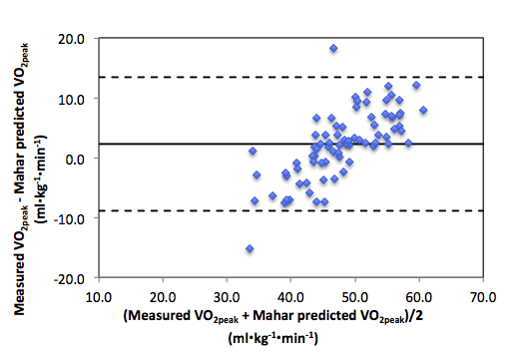
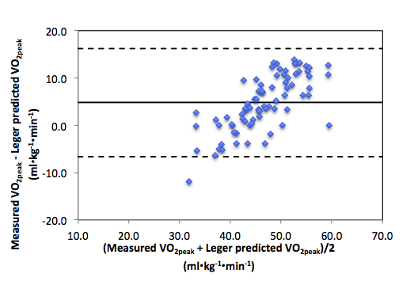
A
B

FIGURE 1. Bland Altman plots depicting agreement between measured VO_{2peak} and (A) Leger predicted VO_{2peak} and (B) Mahar predicted VO_{2peak} for normal weight participants.

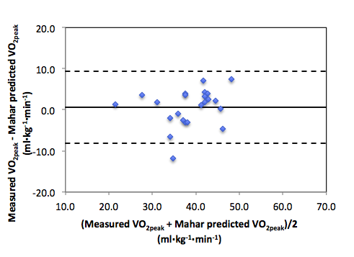
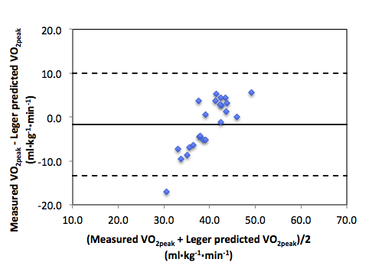
A
B

FIGURE 2. Bland Altman plots depicting agreement between measured VO_{2peak} and (A) Leger predicted VO_{2peak} and (B) Mahar predicted VO_{2peak} for overweight participants.

From the total sample, 76.2% of participants’ measured VO_{2peak} values fell at or above HFZ threshold. A greater percentage of overweight youth (52.2%) fell below the HFZ using measured VO_{2peak} values compared to the normal weight group (15.4%). When participants were classified based on VO_{2peak} estimated from the Leger et al. equation, it was determined that 12.8% of normal weight and 21.7% of overweight youth were classified inappropriately. This error decreased slightly when children were classified based on the Mahar et al. equation; however, 12.8% of normal weight and 17.4% of the overweight children were still misclassified.

DISCUSSION
VO_{2peak} values estimated from PACER performance using the Leger et al. equation and the Mahar et al. equations are commonly compared to VO_{2peak} values measured during a treadmill GXT. Researchers argue whether the criterion-related validity of the equations has truly been examined (42, 52). Ruiz et al. (52) suggests the variability of the prediction equation could be due to the physiological differences of forward locomotion in treadmill running and the start-stop pattern of shuttle running. Therefore, in the current study, VO_{2peak} was measured via indirect calorimetry during the PACER to assess both equations and the influence of weight status on the accuracy of predicting VO_{2peak}.
From the results, it appears that the prediction of VO_{2peak} from PACER performance in youth varies among weight status groups and the use of either the Leger or the Mahar equation. Although the agreement between measured VO_{2peak} and predicted VO_{2peak} indicates reasonable estimations for each group, individual estimations may not be as accurate for normal weight youth compared to their overweight counterparts. The results indicate that both the Leger and Mahar equations significantly underestimate VO_{2peak} in normal weight youth; however, there was no significant difference between measured and predicted VO_{2peak} values for overweight youth.
Previous studies have also found that the Leger equation under-predicts VO_{2peak} in more fit youth. Ruiz et al. (52) reported VO_{2peak} values of 47.1 ml•kg⁻¹•min⁻¹ (measured during the PACER) and 41.5 ml•kg⁻¹•min⁻¹ (Leger estimated) in 14 and 15 year old youth that are similar to the 46.7 ml•kg⁻¹•min⁻¹ (measured) and 43.4 ml•kg⁻¹•min⁻¹ (Leger estimated) values of the current study. In younger participants (8-10 y), Melo et al. (42) reported a SEE of 4.7 ml•kg⁻¹•min⁻¹ for the Leger et al. equation, which is slightly lower than values in the present study (5.44, 5.77, 5.77 ml•kg⁻¹•min⁻¹; normal weight, overweight, combined groups, respectively).
Other studies have reported that VO_{2peak} is overestimated in less fit youth (42, 52, 62). However, these comparisons were made against VO_{2peak} values determined during a treadmill GXT. Our results indicate no significant difference between estimated and measured VO_{2peak} values for overweight youth. Compared to VO_{2peak} measured while the participants performed the PACER, both the Leger and Mahar equations appear to be accurate in predicting VO_{2peak} for overweight youth. In a sample of Hispanic youth, Suminski et al. (54) reported no significant difference between VO_{2peak} values measured during a treadmill GXT and estimated from the Leger equation in overweight participants (d=1.07 ml•kg⁻¹•min⁻¹). This is similar to the mean difference (d) in the current study of -1.69 ml•kg⁻¹•min⁻¹ between VO_{2peak} measured during the PACER and the Leger et al. estimated value.
The accuracy of estimating VO_{2peak} from either prediction equation is crucial for determining the participant’s appropriate fitness classification. The FITNESSGRAM has established standards of aerobic fitness, in which children are classified into the Healthy Fitness Zone (HFZ) or Needs Improvement Zone (NIZ) based on their age, sex, and VO_{2peak} estimated from PACER performance using either the Leger or Mahar equation. If the estimated VO_{2peak} value does not reflect the child’s actual VO_{2peak} there is potential for a classification error. In the present study, 12.8% of normal weight, 21.7% of overweight, and 15.0% of all participants were misclassified based on estimations of VO_{2peak} from the Leger et al. equation. For the whole sample, 7.0% were classified into the HFZ based on the Leger estimate when their measured VO_{2peak} was not in the HFZ. VO_{2peak} estimated with the Mahar et al. equation slightly decreased the error with 12.8% of normal weight, 17.4% of overweight, and 13.9% of the total participants classified incorrectly. However, the Mahar estimate resulted in 8.9% of participants classified within the HFZ when their measured VO_{2peak} was in the NI category. In a field setting, these youth could have potentially been overlooked for an aerobic fitness intervention due to misclassification.
Strengths of the present study include the moderate sample size and demographics representative of the surrounding county (1). However future investigations regarding the influence of weight status and the accuracy of the Leger et al. and Mahar et al. equations are needed across various race/ethnicities and different age groups. A unique aspect of the study is the measurement of VO_{2peak} during the PACER; using portable gas analyzers provides high criterion related validity for comparing measured and estimated values. Although efforts were made to oversample the number of participants with a BMI greater than or equal to the 85th percentile, the small sample of overweight participants is a limitation within the study. Also, each participant completed a single PACER test; multiple assessments would reveal the reliability of PACER performance and estimating VO_{2peak} in this sample. To minimize this weakness, at least two of the established criteria were met to verify participants demonstrated peak effort and a reliable measure of VO_{2peak} was achieved. In addition, previous research indicates that a single test is adequate due to high test-retest reliability of the PACER (32, 59).
In conclusion, both the Leger and Mahar equations provide accurate estimations of VO_{peak} for overweight youth but significantly underestimate VO_{2peak} in their normal weight counterparts. Improving VO_{2peak} estimations for weight status groups should be explored in future research as well as developing strategies to minimize fitness classification error. Test administrators should be cautious when classifying youth aerobic fitness levels based on the predicted values, using both equations to estimate VO_{2peak} and cross checking classification agreement may help minimize the chance of classification error.. Until more accurate estimations are available, administrators and educators should promote the importance healthy aerobic fitness levels for all youth and provide effective programming to improve and maintain aerobic fitness for every student.

LIST OF REFERENCES

1. 2010 Community Health Status Assessment. In: Department KCH, editor. Knoxville2010. p. 208.
2. Anderson GS. The 1600-m Run and Multistage 20-m Shuttle Run as Predictive Tests of Aerobic Capacity in Children. Pediatric Exercise Science1992;4:312-8.
3. Armstrong N, Welsman JR. Assessment and interpretation of aerobic fitness in children and adolescents. Exerc Sport Sci Rev1994;22:435-76.
4. Armstrong N, Williams J, Ringham D. Peak oxygen uptake and progressive shuttle run performance in boys aged 11-14 years. British Journal of Physical Education1988;19(Suppl 4):10 - 1.
5. Barnett A, Chan LYS, Bruce IC. A Preliminary Study of the 20-m Multistage Shuttle Run as a Predictor of Peak VO2 in Hong Kong Chinese Students. Pediatric Exercise Science1993;5:42-50.
6. Beets M, Pitetti K. Criterion-Reference Reliability and Equivalency Between the PACER and 1-MIle Run/Walk for High School Students. Journal of Physical Activity & Health2006;3(Suppl. 2):S21- S33.
7. Beets MW, Pitetti KH, Fernhall BO. Peak Heart Rates in Youth with Mental Retardation: PACER vs. Treadmill. Pediatric Exercise Science2005;17:51-61.
8. Blair SN, Goodyear NN, Gibbons LW, Cooper KH. Physical Fitness and Incidence of Hypertension in Healthy Normotensive Men and Women. JAMA: The Journal of the American Medical Association1984 July 27, 1984;252(4):487-90.
9. Boileau RA, Bonen A, Heyward VH, Massey BH. Maximal aerobic capacity on the treadmill and bicycle ergometer of boys 11-14 years of age. The Journal of sports medicine and physical fitness1977;17(2):153-62.
10. Boreham, #160, G. CA, Paliczka, J. V, Nichols, K. A. A comparison of the PWC[170] and 20-MST tests of aerobic fitness in adolescent schoolchildren. 1990;30(1).
11. Calders P, Deforche B, Verschelde S, Bouckaert J, Chevalier F, Bassle E, Tanghe A, De Bode P, Franckx H. Predictors of 6-minute walk test and 12-minute walk/run test in obese children and adolescents. European Journal of Pediatrics2008;167(5):563-8.
12. Chun DM, Corbin CB, Pangrazi RP. Validation of Criterion-Referenced Standards for the Mile Run and Progressive Aerobic Cardiovascular Endurance Tests. Research Quarterly for Exercise and Sport2000;71(2):125.
13. Cooper DM, Poage J, Barstow TJ, Springer C. Are obese children truly unfit? Minimizing the confounding effect of body size on the exercise response. The Journal of Pediatrics1990;116(2):223-30.
14. Cumming GR, Everatt D, Hastman L. Bruce treadmill test in children: Normal values in a clinic population. The American Journal of Cardiology. [doi: DOI: 10.1016/0002-9149(78)90134-0]. 1978;41(1):69-75.
15. Cureton K, Warren G. Criterion-Referenced Standards for Young Health-Related Fitness Tests: A Tutorial. Research Quarterly for Exercise & Sport1990;61(1):7-19.
16. Cureton KJ, Plown SA. Aerobic Capacity Assessments. In: Welk GJ, Meredith MD, editors. Fitnessgram / Activity Reference Guide. Dallas, TX: The Cooper Institute; 2008. p. 1-25.
17. Dencker M, Thorsson O, Karlsson M, Lind√©n C, Eiberg S, Wollmer P, Andersen L. Gender differences and determinants of aerobic fitness in children aged 8‚Äì11¬†years. European Journal of Applied Physiology2007;99(1):19-26.
18. Eisenmann JC. Physical activity and cardiovascular disease risk factors in children and adolescents: an overview. Can J Cardiol2004 Mar 1;20(3):295-301.
19. Eisenmann JC, Laurson KR, Welk GJ. Aerobic Fitness Percentiles for U.S. Adolescents. American Journal of Preventive Medicine2011;41(4, Supplement 2):S106-S10.
20. Eisenmann JC, Malina RM. Secular trend in peak oxygen consumption among United States youth in the 20th century. American Journal of Human Biology2002;14(6):699-706.
21. Fields DA, Hull HR, Cheline AJ, Yao M, Higgins PB. Child-Specific Thoracic Gas Volume Prediction Equations for Air-Displacement Plethysmography[ast][ast]. Obesity2004;12(11):1797-804.
22. Flegal KM, Tabak CJ, Ogden CL. Overweight in children: definitions and interpretation. Health Education Research2006 December 1, 2006;21(6):755-60.
23. Grant S, Corbett K, Amjad AM, Wilson J, Aitchison T. A comparison of methods of predicting maximum oxygen uptake. British Journal of Sports Medicine1995 September 1, 1995;29(3):147-52.
24. Gutin B, Islam S, Manos T, Cucuzzo N, Smith C, Stachura ME. Relation of percentage of body fat and maximal aerobic capacity to risk factors for atherosclerosis and diabetes in black and white seven- to eleven-year-old children. The Journal of Pediatrics. [doi: DOI: 10.1016/S0022-3476(05)81997-3]. 1994;125(6, Part 1):847-52.
25. Ihasz F, Finn K, Meszaros J. Does a Modified Progressive Aerobic Cardiovascular Endurance Run Test Protocol Benefit Overweight Children. Research Quarterly for Exercise & Sport. [QES: Supplement]. 2006 March 2006;77:77.
26. Johnson MS, Figueroa-Colon R, Herd SL, Fields DA, Sun M, Hunter GR, Goran MI. Aerobic Fitness, Not Energy Expenditure, Influences Subsequent Increase in Adiposity in Black and White Children. Pediatrics2000 October 1, 2000;106(4):e50-.
27. Kraus H, Hirschland R. Muscular fitness and health. JOPERD1953;24(10):17-9.
28. Léger L, Lambert J. A maximal multistage 20-m shuttle run test to predict VO2max. European Journal of Applied Physiology and Occupational Physiology1982;49(1):1-12.
29. Leger LA, Mercier D, Gadoury C, Lambert J. The multistage 20 metre shuttle run test for aerobic fitness. Journal of Sports Sciences1988;6(2):93 - 101.
30. Li AM, Yin J, Yu CCW, Tsang T, So HK, Wong E, Chan D, Hon EKL, Sung R. The six-minute walk test in healthy children: reliability and validity. European Respiratory Journal2005 June 1, 2005;25(6):1057-60.
31. Liu, #160, Y.-S. N, Plowman, A. S, Looney, A. M. The reliability and validity of the 20-meter shuttle test in American students 12 to 15 years old. Reston, VA, ETATS-UNIS: American Alliance for Health, Physical Education, Recreation and Dance; 1992.
32. Liu NY, Plowman SA, Looney MA. The reliability and validity of the 20-meter shuttle test in American students 12 to 15 years old. Research Quarterly for Exercise and Sport1992;63(4):360-5.
33. LOBELO F, PATE RR, DOWDA M, LIESE AD, RUIZ JR. Validity of Cardiorespiratory Fitness Criterion-Referenced Standards for Adolescents. Medicine & Science in Sports & Exercise2009;41(6):1222-9 10.49/MSS.0b013e318195d491.
34. Mahar MT, Guerieri AM, Hanna M, Kemble CD, editors. RC Grant Findings: Development of a Model to Estimate Aerobic Fitness from PACER Performance in Adolescents. AAHPERD National Convention and Exposition; 2010 March 18, 2010; Indianapolis, IN.
35. Mahar MT, Guerieri AM, Hanna MS, Kemble CD. Estimation of Aerobic Fitness from 20-m Multistage Shuttle Run Test Performance. American Journal of Preventive Medicine2011;41(4, Supplement 2):S117-S23.
36. Mahar MT, Rowe DA, Parker CR, Mahar FJ, Dawson DM, Holt JE. Criterion-Referenced and Norm-Referenced Agreement Between the Mile Run/Walk and PACER. Measurement in Physical Education & Exercise Science. [Article]. 1997;1(4):245.
37. Mahar MT, Welk GJ, Rowe DA, Crotts DJ, McIver KL. Development and Validation of a Regression Model to Estimate VO2peak from PACER 20-m Shuttle Run Performance. Journal of Physical Activity & Health2006;3(Suppl. 2):S34-S46.
38. Mahoney C. 20-MST and PWC170 validity in non-Caucasian children in the UK. British Journal of Sports Medicine1992 March 1, 1992;26(1):45-7.
39. Matsuzaka A, Takahashi Y, Yamazoe M, Kumakura M, Ikeda A, Wilk B, Bar-Or O. Validity of the Multistage 20-M Shuttle-Run Test for Japanese Children, Adolescents, and Adults. Pediatr Exerc Sci2004;16:113-25.
40. McClain JJ, Welk GJ. Comparison of Two Versions of the PACER Aerobic Fitness Test. Medicine & Science in Sports & Exercise2004;36(5):S5.
41. McVeigh SK, Payne AC, Scott S. The reliability and validity of the 20-meter shuttle test as a predictor of peak oxygen uptake in Edinburgh school children, age 13 to 14 years. Pediatric Exercise Science1995;7(1):69-79.
42. Melo X, Santa-Clara H, Almeida J, Carnero E, Sardinha L, Bruno P, Fernhall B. Comparing several equations that predict peak VO2 using the 20-m multistage-shuttle run-test in 8–10-year-old children. European Journal of Applied Physiology2010:1-11.
43. Meredith MD, Welk GJ, editors. FITNESSGRAM & ACTIVITYGRAM Test Administration Manual. 4th Edition ed. Champaign, IL: Human Kinetics; 2010.
44. Ogden CL, Carroll MD, Curtin LR, Lamb MM, Flegal KM. Prevalence of High Body Mass Index in US Children and Adolescents, 2007-2008. JAMA: The Journal of the American Medical Association2010 January 20, 2010;303(3):242-9.
45. Ogden CL, Carroll MD, Kit BK, Flegal KM. Prevalence of Obesity and Trends in Body Mass Index Among US Children and Adolescents, 1999-2010. JAMA: The Journal of the American Medical Association2012 January 17, 2012.
46. Olds T, Tomkinson G, Leger L, Cazorla G. Worldwide variation in the performance of children and adolescents: an analysis of 109 studies of the 20-m shuttle run test in 37 countries. Journal of Sports Sciences2006;24(10):1025(14).
47. Paridon SM, Alpert BS, Boas SR, Cabrera ME, Caldarera LL, Daniels SR, Kimball TR, Knilans TK, Nixon PA, Rhodes J, Yetman AT. Clinical Stress Testing in the Pediatric Age Group: A Statement From the American Heart Association Council on Cardiovascular Disease in the Young, Committee on Atherosclerosis, Hypertension, and Obesity in Youth. Circulation2006 April 18, 2006;113(15):1905-20.
48. Pivarnik JM, Coe DP. Aerobic exercise testing in children and adolescents. In: Feigin RD, editor. UpToDate in Pediatrics. Wellesley, MA: UpToDate; 2011.
49. Raghuveer G. Lifetime cardiovascular risk of childhood obesity. The American Journal of Clinical Nutrition2010 May 1, 2010;91(5):1514S-9S.
50. Rowland TW, editor. Children's Exercise Physiology. 2nd ed. ed. Champaign, IL: Human Kinetics; 2005.
51. Rowland TW, editor. Pediatric Laboratory Exercise Testing: Clinical Guidelines. Champaign, IL: Human Kinetics Publishers; 1993.
52. Ruiz JR, Silva G, Oliveira N, Ribeiro JC, Oliveira JF, Mota J. Criterion-related validity of the 20-m shuttle run test in youths aged 13‚Äì19 years. Journal of Sports Sciences2009;27(9):899 - 906.
53. Sabath R, Teason K, Hulse J, Gelatt M, editors. Pediatric Treadmill Testing: Comparison of Peak Exercise Parameters Using the Bruce Protocol and Novel Treadmill Test. The 2nd Joint Meeting of the North American Society for Pediatric Exercise Medicine and the Europena Group for Pediatric Work Physiology; 2010; Niagra-on-the-Lake, Canada.
54. Suminski RR, Ryan ND, Poston CS, Jackson AS. Measuring Aerobic Fitness of Hispanic Youth 10 to 12 years of Age. Int J Sports Med2004 29.01.2004;25(01):61,7.
55. Utter AC, Robertson RJ, Nieman DC, Kang J. Children's OMNI Scale of Perceived Exertion: walking/running evaluation. Medicine & Science in Sports & Exercise2002;34(1):139-44.
56. van Mechelen W, Hlobil H, Kemper H. Validation of two running tests as estimates of maximal aerobic power in children. European Journal of Applied Physiology and Occupational Physiology1986;55(5):503-6.
57. Vincent, #160, D. S, Barker, R., Clarke, M., Harrison, J. A comparison of peak heart rates elicited by the 1-mile run/walk and the progressive aerobic endurance run. 1999;70(1):4.
58. Voss C, Sandercock G. Does the twenty meter shuttle-run test elicit maximal effort in 11- to 16-year-olds? Pediatr Exerc Sci2009 Feb;21(1):55-62.
59. Welk GJ. Fitnessgram / Activity Reference Guide. Meredith MD, editor. Dallas, TX: The Cooper Institute; 2008.
60. Welk GJ. Strengthening the Scientific Basis of the FITNESSGRAM Program. Journal of Physical Activity & Health2006;3(Suppl 2):S1-S4.
61. Winsley RJ. The Suitability of the Multistage Fitness Test to Assess Children's Aerobic Fitness. European Journal of Physical Education2003;8:19-28.
62. Zhu W, Mahar MT, Welk GJ, Going SB, Cureton KJ. Approaches for Development of Criterion-Referenced Standards in Health-Related Youth Fitness Tests. American Journal of Preventive Medicine2011;41(4):S68-S76.

APPENDICES

Appendix A
Peak Exercise Responses

Ability of the PACER to elicit peak exercise resopnses in youth
Table A: Participant Characteristics [Mean (SD)]

 | Boys (n=20) | Girls (n=25) | Total (n=45)
Age (yr) | 12.7 (1.6) | 12.7 (1.8) | 12.7 (1.7)
Weight (kg) | 49.0 (13.8) | 52.7 (16.6) | 51.1 (15.4)
Height (cm) | 157.7 (15.0) | 153.7 (11.2) | 155.5 (13.0)
Body Mass Index (kg•m2) | 19.3 (2.7) | 22.0 (5.6) | 20.8 (4.7)
Body Fat (%) | 12.8 (6.4) | 28.8 (9.3)* | 21.5 (11.4)
* Significantly different from boys, P < 0.05

Ability of the PACER to elicit peak exercise resopnses in youth
Table B: Peak Values during Treadmill GXT and PACER [Mean (SD)]
 | HR_{peak} (b•min⁻¹) |  | RER_{peak} |  | VO_{2peak} (ml•kg⁻¹•min⁻¹) |  | RPE_{peak}
 | Treadmill GXT | PACER | Treadmill GXT | PACER | Treadmill GXT | PACER | Treadmill GXT | PACER
Boys | 196 (9.3) | 199 (6.7) | 1.11 (0.08) | 1.10 (0.04) | 51.0 (6.7) | 52.6 (7.4) | 8.6 (0.96) | 8.6 (1.3)
Girls | 197 (8.4) | 196 (10.3) | 1.14 (0.08) | 1.13 (0.09) | 40.1 (7.9)* | 40.5 (8.9)* | 8.2 (1.1) | 8.0 (1.3)
Total | 197 (8.7) | 197 (8.9) | 1.13 (0.08) | 1.12 (0.08) | 45.0 (9.1) | 45.9 (10.2) | 8.4 (1.1) | 8.3 (1.3)
* Significantly different from boys, P < 0.05

APPENDIX B
Validation Parameters

TABLE A: Validation parameters of estimated VO_{2peak} values by group [Mean (SD)]

 | Measured VO_{2peak} (ml•kg⁻¹•min⁻¹) | Leger et al. VO_{2peak}  (ml•kg⁻¹•min⁻¹) | t | r | d | SEE
Normal Weight | 49.0 (8.7) | 44.3 (4.6)** | 7.23* | 0.78** | 4.77 | 5.44
Overweight | 38.8 (7.1) | 40.5 (2.5) | -1.36 | 0.61* | -1.69 | 577
Combined | 46.7 (9.4) | 45.3 (4.5)** | 5.16* | 0.79** | 3.30 | 5.77
 | Measured VO_{2peak} (ml•kg⁻¹•min⁻¹) | Mahar et al. VO_{2peak}  (ml•kg⁻¹•min⁻¹) | t | r | d | SEE
Normal Weight | 49.0 (8.7) | 46.8 (4.8)** | 3.50* | 0.79** | 2.25 | 5.33
Overweight | 38.8 (7.1) | 38.2 (6.1) | 0.63 | 0.78** | 0.60 | 4.54
Combined | 46.7 (9.4) | 44.8 (6.2)** | 3.45* | 0.83** | 1.87 | 5.26
* Significantly different from measured VO_{2peak}; p ≤ 0.01

APPENDIX C
Parental Permission

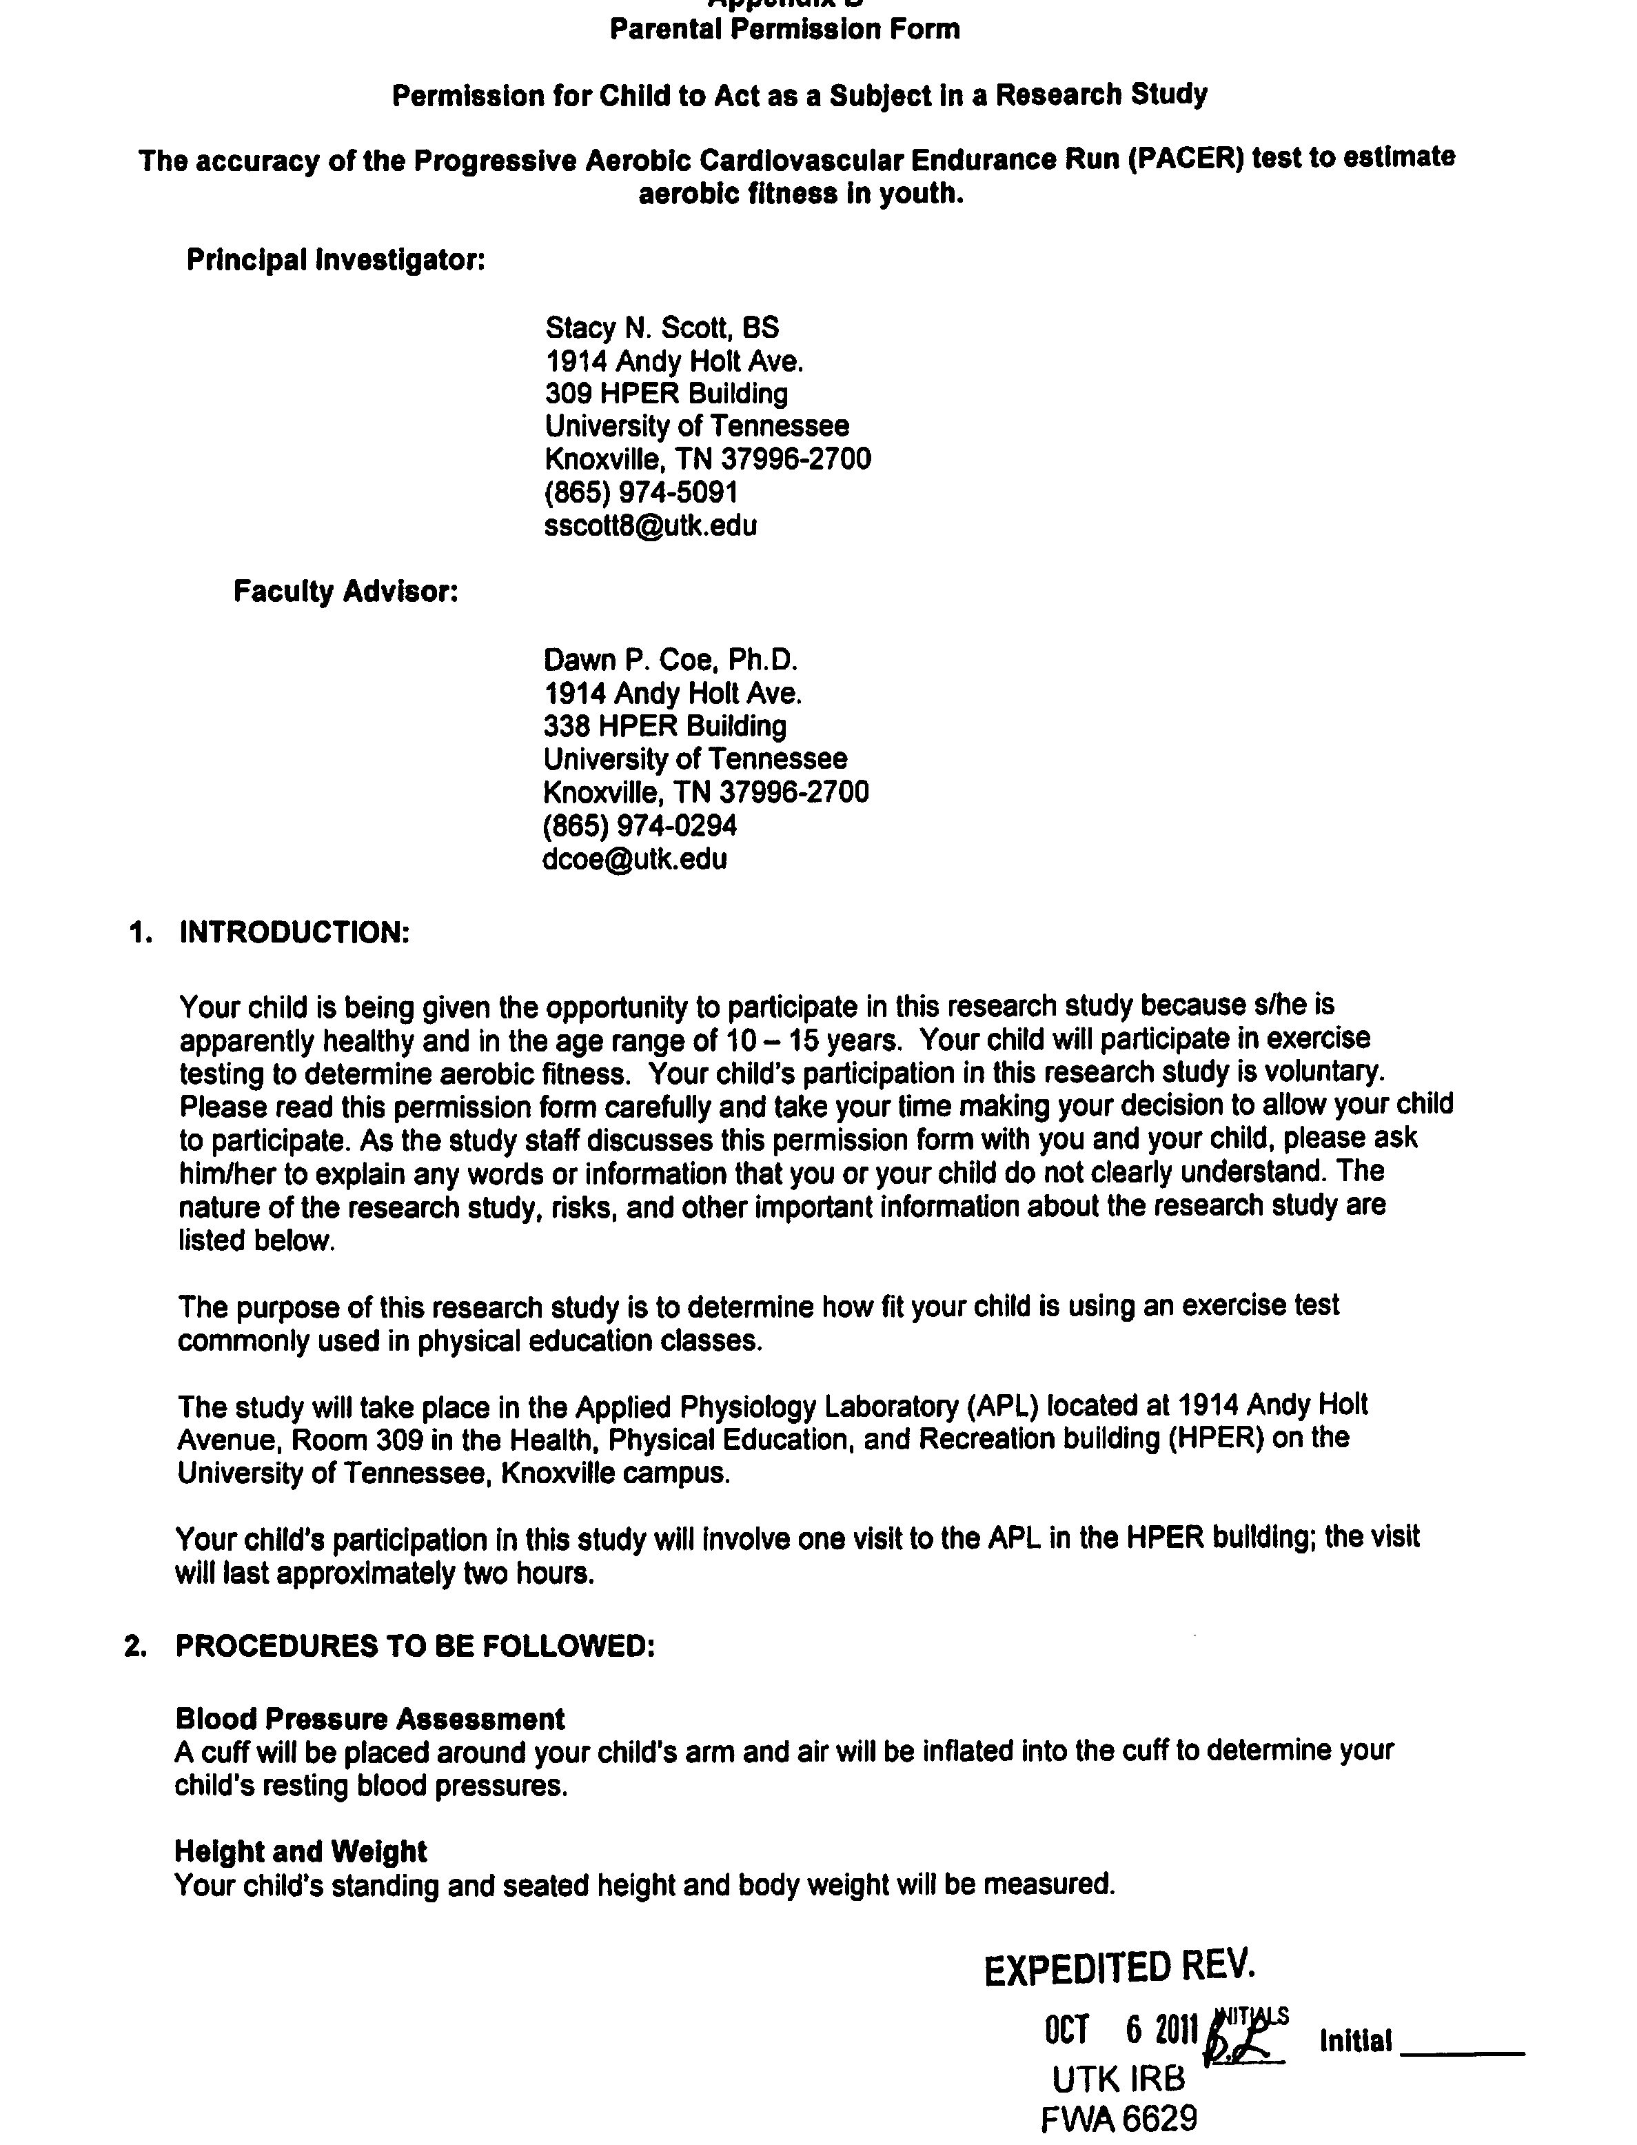



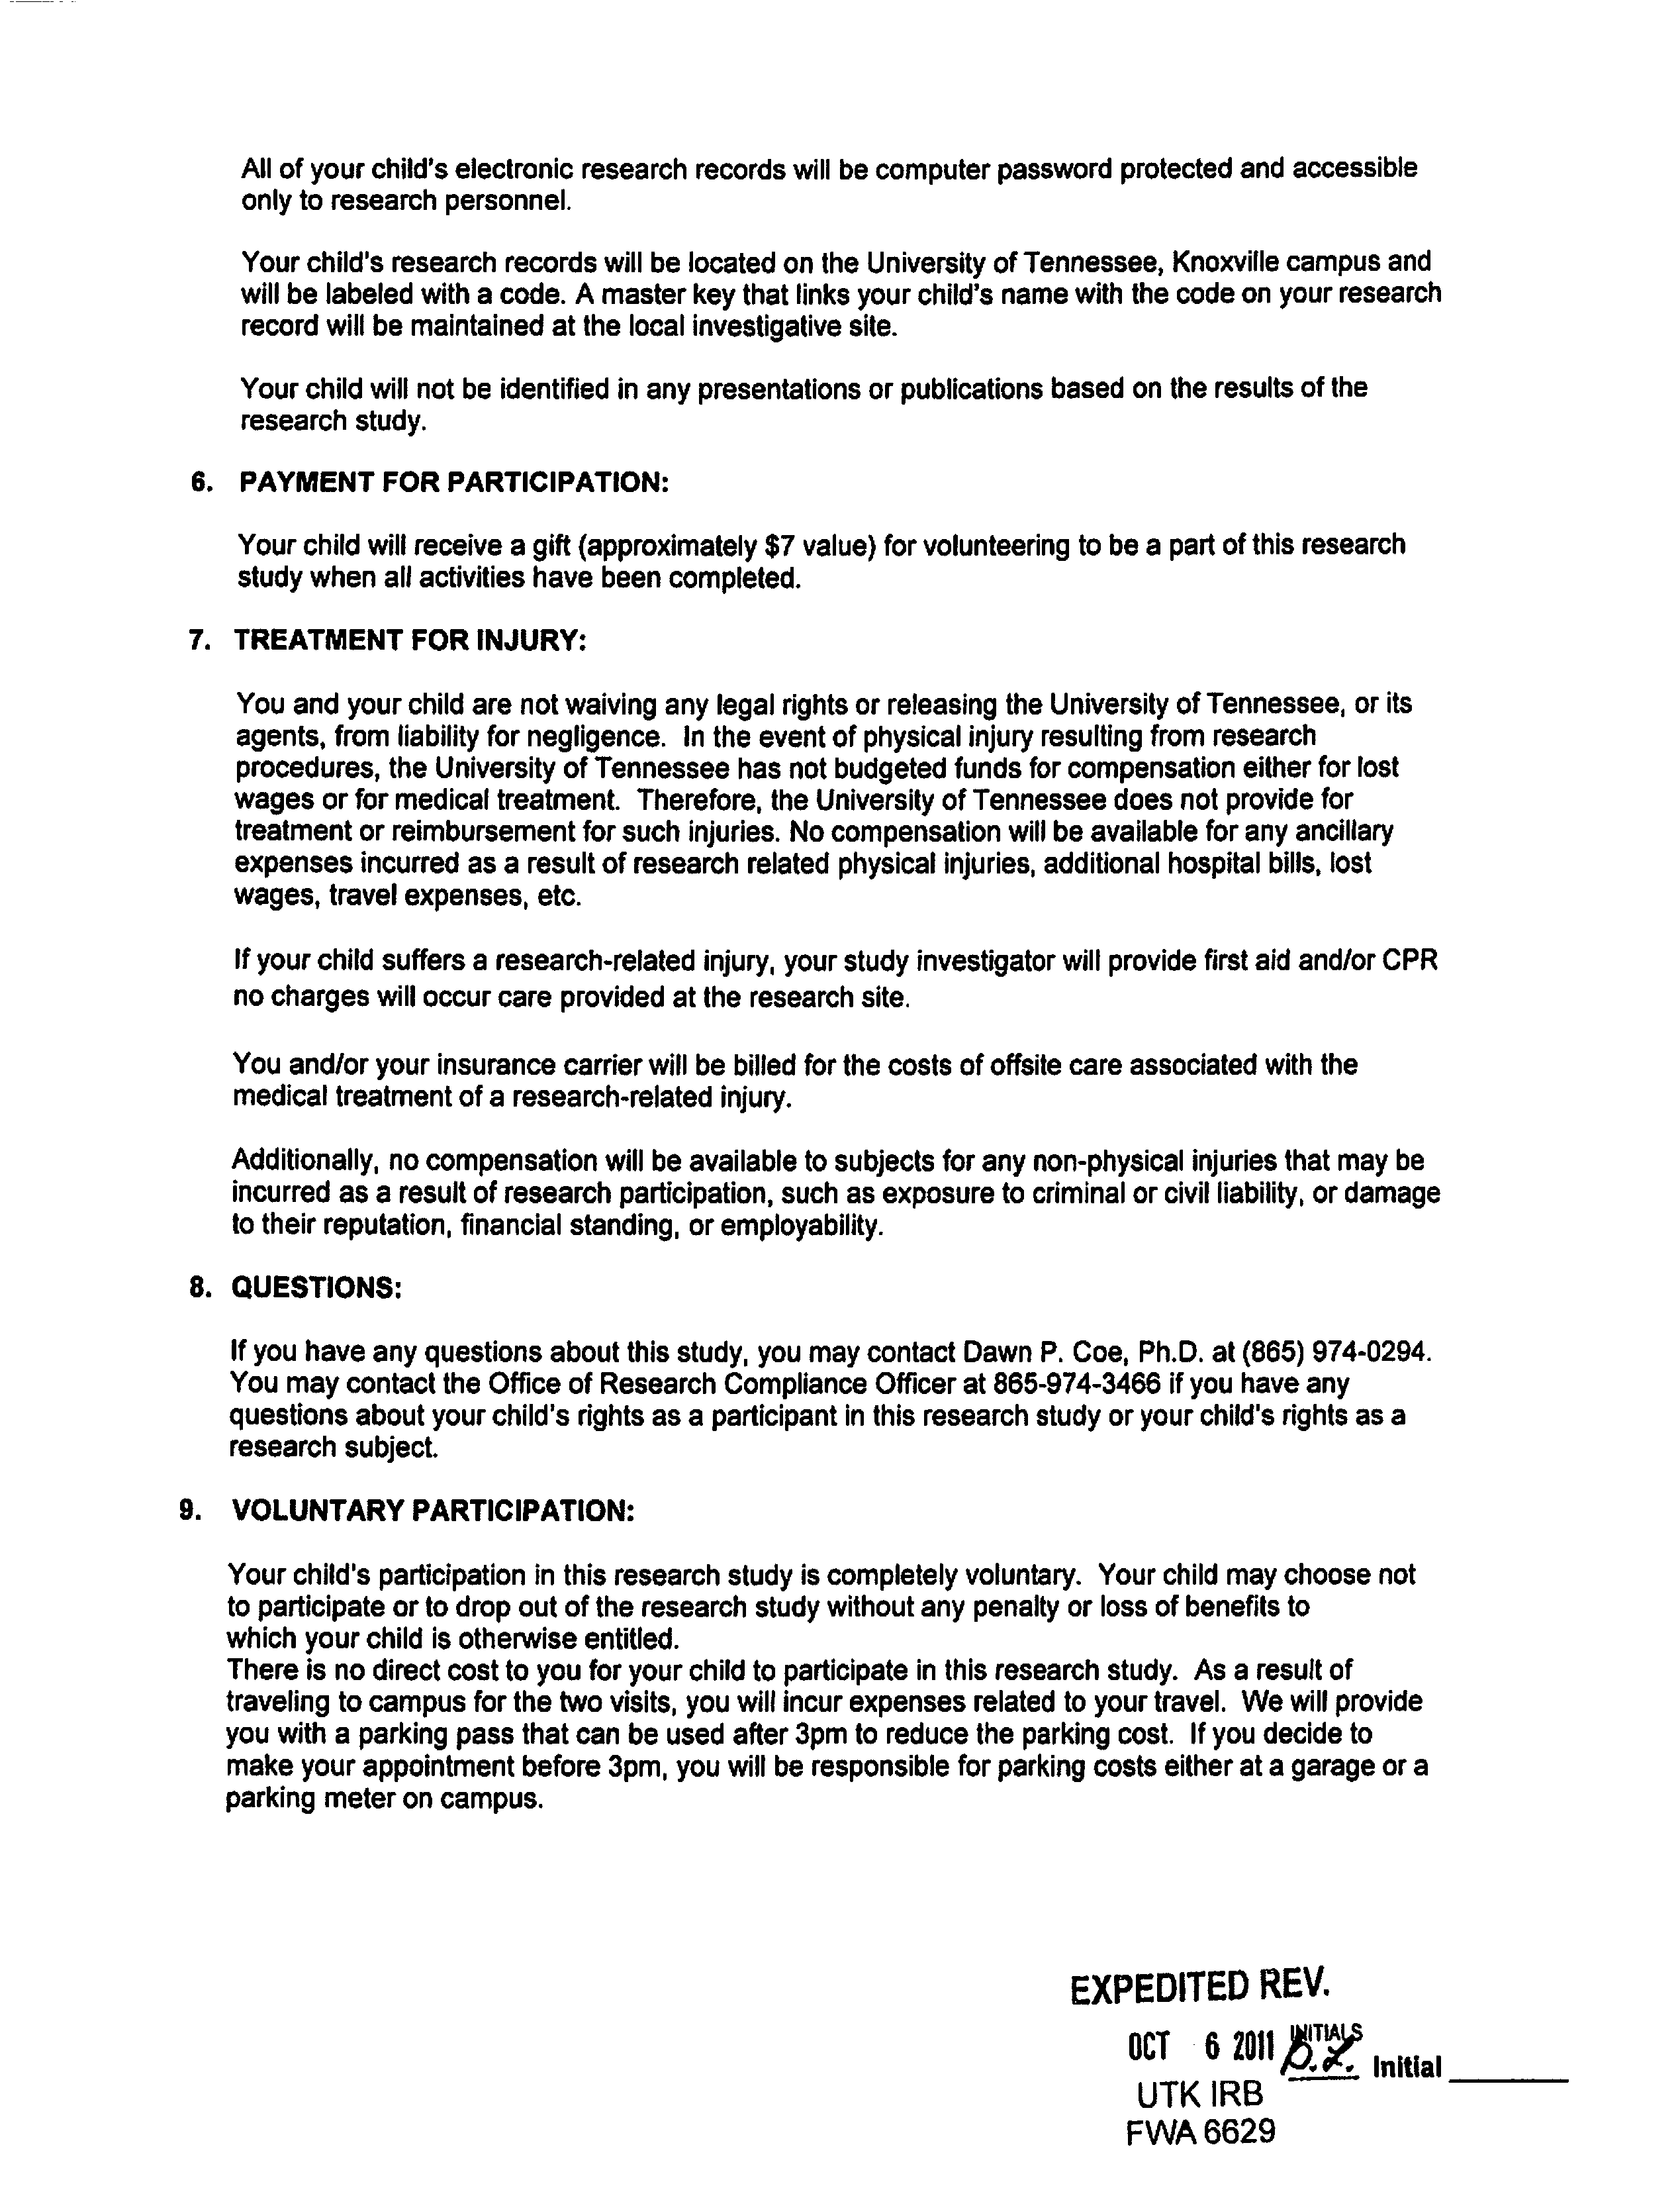



APPENDIX D
Subject Assent

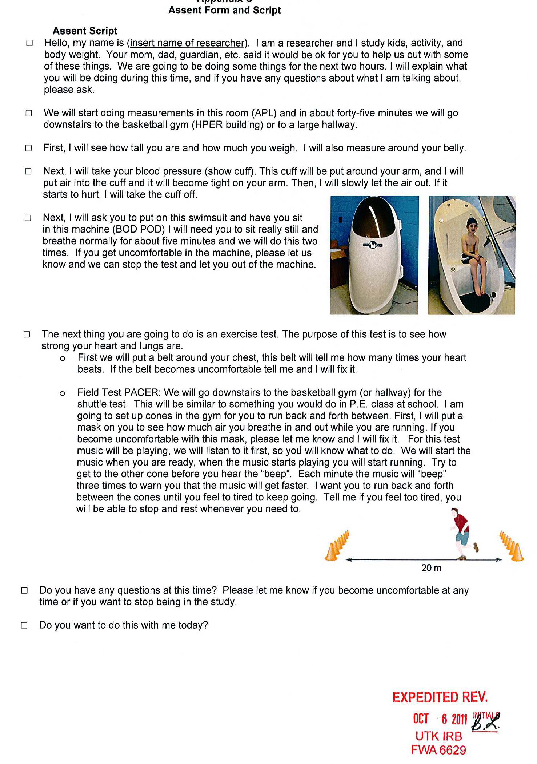
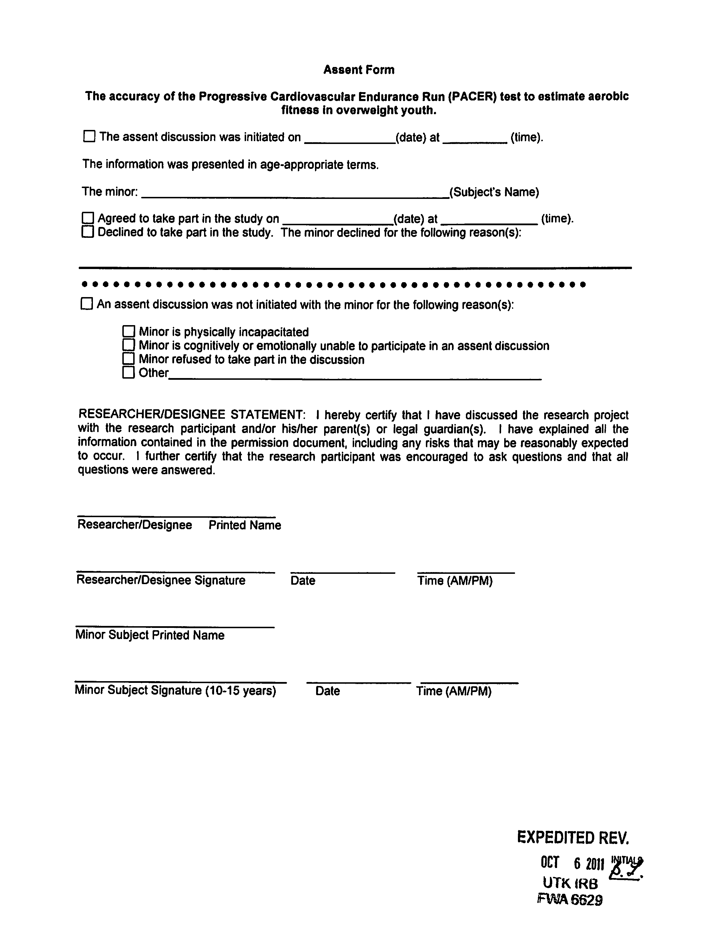

APPENDIX E
Recruitment Flyers



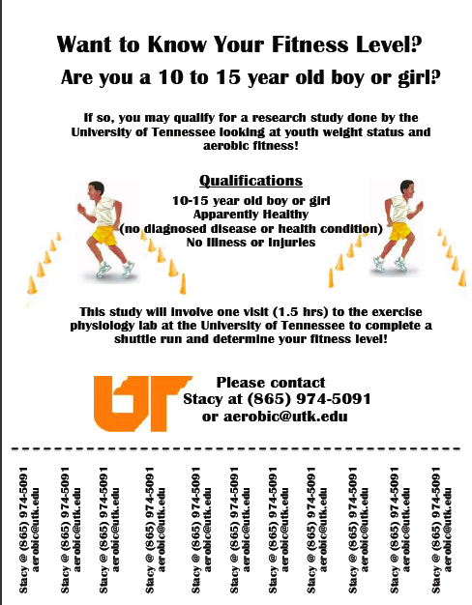

APPENDIX F
Institutional Review Board Consent

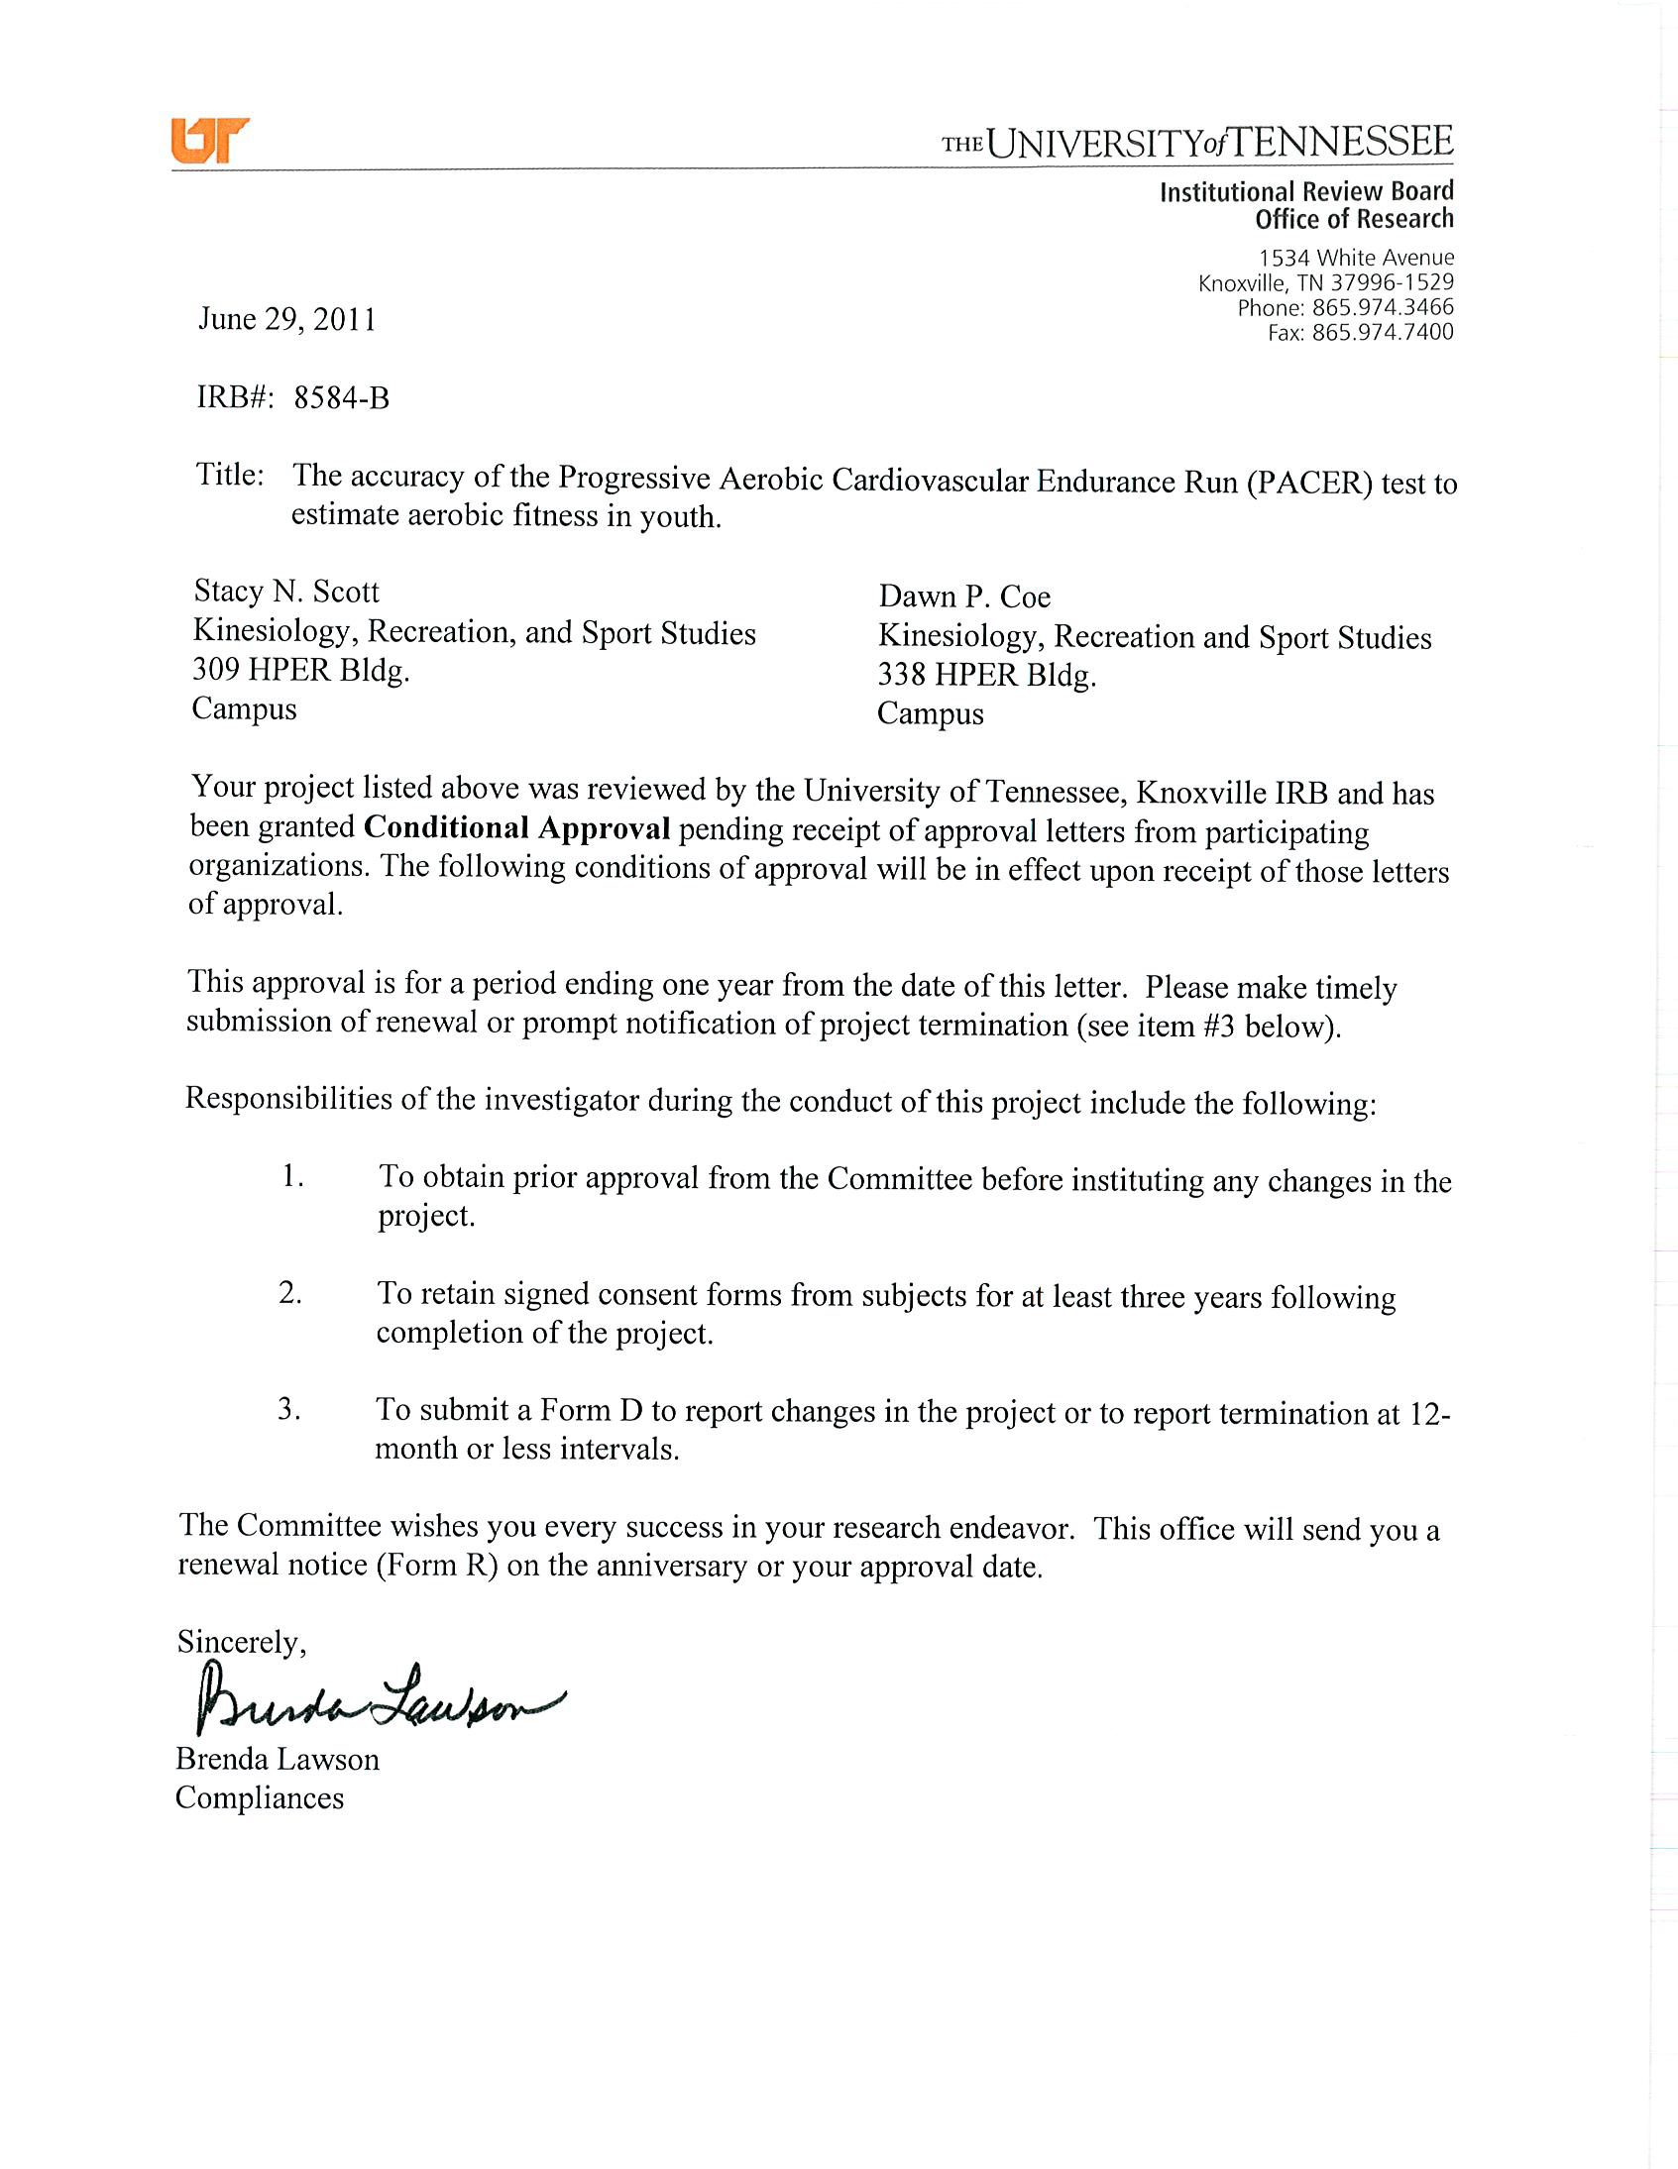

Vita

John X. Doe was born. He wrote a thesis. He graduated. This page really is required.

