Microplastics Exposure in At-Risk Myotis lucifugus Bats of the Northeastern United States
Leah N. Crowley^{1,2,3}

1. University of Tennessee, Knoxville Department of Forestry, Wildlife, and Fisheries
2. Chancellor’s Honors Program Student
3. Author email: lcrowle2@vols.utk.edu

ABSTRACT
This project compares measured microplastics concentrations from stomach contents in Myotis lucifugus (M. lucifugus) bats from natural and manmade caves in the northeastern United States. Samples used in this study were collected from caves in Vermont and from mines in Massachusetts and New York from 2008-2009. Stomach and intestine contents from 92 bats were chemically digested, filtered, and observed; microplastics from each sample were classified based on type and color. A subset of microplastic samples was measured to obtain data on average microplastic size. The objectives of this study are (1) to quantify microplastic concentrations from M. lucifugus bats; (2) to compare microplastic concentrations between male and female M. lucifugus; and (3) to compare microplastic concentrations between juvenile and adult M. lucifugus. Results from this project suggest that while microplastics are present M. lucifugus habitats, no significant difference exists in microplastic concentrations of the stomach contents of male versus female M. lucifugus. Therefore, it is difficult to infer how this may impact M. lucifugus reproduction and/or conservation. This study should be used in conjunction with others to evaluate the role that microplastics play in bats’ response to stressors such as white nose syndrome, habitat destruction/alteration, and other environmental contaminants to assess potential related conservation and reproduction-based consequences.
Keywords: Microplastics, white nose syndrome, contamination, Myotis lucifugus, stress response

INTRODUCTION
Several bat species of the United States are experiencing population declines due to factors including wildlife disease and anthropogenic forces. One specific bat species of the United States is the little brown bat - Myotis lucifugus (M. lucifugus), a small, brown, insectivorous bat that has experienced severe population declines in the last two decades, largely due to wildlife disease white nose syndrome (WNS) and habitat loss. This disease has caused over 90% of three bat species including M. lucifugus populations to experience mortality in less than a decade (Cheng et al. 2021). WNS is caused by the Pseudogymnoascus destructans (P. destructans) fungus, which infects the skin of hibernating bats. This fungal growth causes bats’ hibernation to disrupt, and WNS-related mortality is associated with increased dehydration, starvation, and lower body masses in infected bats. Anthropogenic forces also pose significant threats to bat species of the United States. Habitat loss and alteration, pollution, and climate change are three human-based consequences that endanger wildlife. When multiple factors impact species simultaneously, effects may compound and pose even greater risks. Bat conservation relies heavily on understanding additive effects of stressors such as pathogens and contaminants in bat populations; reproduction, survival, growth, and stress response in bats are important factors to understand when considering compounding impacts of these stressors (Yates et al., 2014).

Environmental contaminants are increasing in abundance as urban and agricultural development increases. Polychlorinated biphenyls (PCBs) and the organic pesticide known as dichloro-diphenyl-trichloroethane (DDTs) are the most found organic contaminants in M. lucifugus bats according to previous studies (Kannan et al. 2010). When exposed to these organic contaminants, the bats showed accelerated weight loss compared to unexposed animals; this may be explained by the notion that increased pollutant exposure may weaken bats’ immune systems, leading to their increased susceptibility to subsequent infections (Kannan et al. 2010). Other contaminants, including inorganic pollutants, may also be reducing M. lucifugus bat health. Microplastic concentrations in M. lucifugus populations should be analyzed to determine the conservation and reproduction-based risks associated with additive contaminant exposure.

Microplastics are inorganic environmental contaminants impacting wildlife populations. Microplastics are produced when larger plastics undergo fragmentation through radiation or degradation and are defined as plastic particles smaller than 5 mm in diameter (Carlin et al. 2020). As this fragmentation occurs, pollutant abundance in the environment increases and plastics become more available to species in the environment; smaller particles are available to smaller organisms, and overall encounter rates between microplastics and wildlife species are elevated (Shim & Thompson, 2015). Many types of animals can ingest particles they encounter in their habitats, including invertebrates, turtles, fish, birds, and mammals (Shim & Thompson, 2015). Several types of microplastics exist, including the following: fragments, spheres, pellets, fibers, fiber bundles, foams, and films (De Frond & Munno, n.d.). Different types (size, shape, color) of microplastics influence their uptake by organisms, and fibers have been found to be the most harmful (Wright, Thompson, & Galloway, 2013). Ingestion of microplastics has been found to harm animals physically and chemically; damage to ecophysiological processes in animals known to ingest microplastic contaminants has been documented (Wright, Thompson, & Galloway, 2013; Browne et al., 2013). For example, consumption may block gastrointestinal tracts in smaller animals and can lead to internal harm (Carlin et al., 2020). Consumption of microplastics by smaller individuals may have trophic implications that are not well documented. Additionally, microplastic contamination accumulation may have population-level impacts (Wright, Thompson, & Galloway, 2013).

It is important to study microplastic contamination in species such as M. lucifugus to improve their conservation status and to potentially do the same for other wildlife species. Bats in general have wide geographical distributions, use a variety of habitats, live relatively long in their habitats, and consume invertebrates from lower trophic levels; these characteristics of bats — and M. lucifugus specifically — make them suitable biological indicators for studies relating to topics other than contaminants as well (Yates et al. 2014). If significant contaminant exposure levels exist in bats, concerning levels may exist in other species as well. Additionally, bats provide ecological benefits; they reduce insect numbers and thus reduce transmission rates of insect-borne zoonotic diseases, and they are effective pollinators and seed dispersers. While conservation of bats is important to an ecosystem’s health, protecting already at-risk bats like M. lucifugus must be done quickly.

Regarding conservation and reproduction of at-risk species, it is relevant to conduct studies comparing contaminant levels in male versus female, as well as adult vs juvenile, bats. If females or juveniles experience higher levels of exposure, their survival, growth, and reproduction may be altered, which could have drastic consequences for the species. While effects of habitat loss, WNS, and few environmental contaminants on M. lucifugus are well-studied, risk assessments regarding additive effects of microplastic exposure in M. lucifugus populations are lacking. This study aims to begin a risk assessment for at-risk populations of little brown bats using caves and mines in the northeastern United States.

MATERIALS AND METHODS
It should be noted that the specific history of the biological samples used in this project is relatively unknown. The University of Tennessee Department of Forestry, Wildlife, and Fisheries inherited bat stomach content samples from Jonathan Reichard of the US Fish and Wildlife Service (USFWS). Samples were collected from deceased bats from three sites in the northeastern United States from 2008-2009. Each site tested positive for WNS at the time of sampling. Of the 92 total samples, 42 were collected from bats in a Bennington County cave in Vermont (n=42), 25 were collected from bats in a Hampden County mine in Massachusetts (n=25), and the remaining 25 were collected from bats in a Warren County mine in New York state (n=25) (Fig. 1). At the time of sample collection, stomach samples were removed from deceased bats, placed into individual test tubes, and preserved via freezing until used for this study, beginning in 2021.

92 samples were randomly selected from the 150+ samples inherited from USFWS. To process each sample, the stomach contents were removed from their preservation tubes, individually weighed using an analytical balance, and then transferred to individual glass tubes. Throughout this process, metal forceps, aluminum foil, and glassware were used to reduce the samples’ contact with plastics. Each weight was recorded.

A 10% solution of potassium hydroxide (KOH) was prepared in the lab using KOH pellets and deionized (DI) water. The KOH was added to each individual sample at a ratio of three times the sample’s mass (3:1) to maximize digestion of the organic particles (Carlin et al. 2020). KOH is known to digest organic matter relatively well and leave most plastics intact (Carlin et al. 2020). After the addition of KOH, aluminum foil was used to cover each glass vial containing the sample and the KOH; a small hole was punctured through the foil to allow for air release while minimizing air contamination. All samples were placed onto a laboratory shaker for 48 hours at room temperature, shaking at a speed of 160 RPM to allow for chemical digestion.

After digestion, a vacuum filtration apparatus was used to isolate any undigested material - including microplastics - from digested, liquid matter. Glassware and 2.7 mm filters were used to carry out the filtration. Used filters were then transferred to clean, rinsed petri dishes using metal forceps. All glassware, samples, and parts of the filtration apparatus were covered with aluminum foil throughout this process to minimize air contamination.

Each filtered sample was then placed under a stereomicroscope at 10x-40x magnification. Each sample was observed, and for each, the number, types, and colors of microplastics examined was recorded. Microplastic locations were marked using a light pencil mark for later identification. Each microplastic could fall into one of the following categories: fiber, fiber bundle, fragment, foam, or film; additionally, each microplastic could be characterized by one of the following colors: black, blue, brown, clear, gray, green, pink, purple, red, white, or yellow (De Frond & Munno, n.d.). Identification of microplastics was completed via visual observation and confirmed via the hot needle test; target particles were nudged with a hot needle, and if the target particle exhibited a conformational change, it was counted as a plastic (Carlin et al. 2020). Figures 1and 2 show different microplastics under the microscope.

In addition to minimizing use of plastic in and around the laboratory and when handling the samples, control blanks were tested with every 10-15 samples to provide knowledge about air contamination within the laboratory. For each blank, the average weight of the group of samples was calculated; this amount was the amount of KOH used for the group’s blank. Using 2.7 mm filters, the plain KOH was filtered using the same techniques as described for the biological samples. Additionally, microplastic examination and identification for blanks occurred the same way as described.

Once all microplastics had been counted and recorded, a random subset of the plastics was pulled aside, and each microplastic in the subset was measured using a Motic Microscope Camera, or Moticam. The subset of particles included about 25% of the microplastics (n=77; 77/306 = 0.2516). Figure 3 shows a measured microplastic.
Statistical analyses were performed using RStudio and Microsoft Excel. A histogram was generated for microplastic concentration per gram tissue for the samples; the data was transformed with a log function to produce a normal distribution curve. Subsets of the data were created to separate the target groups. The following subsets were created: male data, female data, adult data, and juvenile data. Using the transformed data, T-tests were run for each subset for comparison of microplastic concentrations per gram tissue in male versus female M. lucifugus and in adult versus juvenile M. lucifugus. Box plots were created to visualize microplastic presence and microplastic concentrations in each group. Graphs were created to visualize the distribution of microplastic color and type found in the study.

RESULTS
Nearly all samples used in this study contained microplastics (n=85; 92.9313%). The overall average number of microplastics found in M. lucifugus in this study was 3.1739 particles per bat. The overall average concentration of microplastics from this study was 569.3454 particles per gram of tissue. In total, 306 microplastic particles were recorded. Fibers made up over half of the observed plastics (56%), followed by fragments (35%), films (4%), foams (3%), and fiber bundles (2%) (Fig. 5). As for coloration of observed particles, blue particles made up over half of the observed plastics (56%), followed by clear (16%), red (12%), and with the remaining 16% including black, brown, gray, green, pink, purple, white, and yellow particles (Fig. 6).

Male and female M. lucifugus samples did not show a significant difference in microplastic presence nor in microplastic concentrations. Male samples had an average presence of 3.0870 microplastics per sample (lower than overall average), whereas females had an average presence of 3.2609 microplastics per sample (higher than overall average). Male samples had an average concentration of 694.7726 microplastic particles per gram of tissue (higher than overall average); females had an average concentration of 443.9182 microplastic particles per gram of tissue (lower than overall average). Boxplots comparing these values may be found in Figure 7. Results from the T-test performed on the male versus female microplastic concentration data are as follows:
- t = -0.83009: A very small difference exists between male and female samples’ microplastic concentrations
- df = 84.548
- p-value = 0.4088: No significant difference exists between male and female samples’ microplastic concentrations

Similarly, adult and juvenile M. lucifugus samples did not show a significant difference in microplastic presence nor in microplastic concentrations. Adult samples had an average presence of 3.1064 microplastics per sample (slightly lower than overall average), whereas juvenile samples had an average presence of 3.2444 microplastics per sample (slightly above overall average). Adult samples had an average concentration of 771.9436 microplastic particles per gram of tissue (higher than overall average); juveniles had an average concentration of only 357.7428 microplastic particles per gram of tissue (lower than overall average). Boxplots comparing these values may be found in Figure 7. Results from the T-test performed on the adult versus juvenile microplastic concentration data are as follows:
- t = 0.56365: A very small difference exists between male and female samples’ microplastic concentrations
- df = 88.918
- p-value = 0.5744: No significant difference exists between male and female samples’ microplastic concentrations

The control blanks showed that there was some contamination present during this study. The average number of microplastic particles found in blanks was 2.6667, and the average concentration of microplastics per gram of KOH was 57.4036. The mean concentration is significantly lower in the blanks than in any of the samples, suggesting that contamination was present but not inhibitory to the objectives of the study.

Measuring a subset (¼) of the microplastics observed produced a minimum length of 34.81 micrometers and a maximum length of 5857.92 micrometers. Because microplastics are characterized by being less than 5 millimeters in diameter, the one particle observed to be 5.85792 mm is not relevant to this study and is not technically considered to be a microplastic. Since it was an outlier of the subset, it was removed to calculate the average. The average length was around 827.0503 micrometers. Overall, results from this project appear to be relatively uniform throughout.

DISCUSSION
Previous studies have found that blue and clear are the most frequently recovered colors of microplastic particles - in birds, fishes, marine invertebrates, marine mammals, and more (Carlin et al. 2020). Additionally, fibers (microfibers) are commonly the dominant type of microplastic found in wildlife. While these trends are true regarding this study, it is unknown why most animals sampled for microplastics contain mostly blue or clear fibers. This phenomenon may be explained by the trophic interactions within habitats; if small invertebrates consume these plastic types and colors specifically, it would be logical to assume the particles are passed on to the individual that consumes the invertebrate next. It has also been found that microplastic concentrations are greater in predators that eat whole organisms via food web interactions than by direct microplastic consumption (Carlin et al. 2020). To better understand the reason why one type and one (or two) colors of microplastic particles are found much more commonly than others, it may be necessary to sample the prey of one’s target species. Further, determining where microplastics in habitats originate would be valuable information in terms of the conservation and wellbeing of a habitat and the wildlife inhabiting it. Future studies may analyze potential different microplastic concentrations in habitats in varying proximities to urban areas, disease outbreaks, or growing human activity.

Finding no significant difference in the microplastic concentration of the stomach contents of males and females and in the adults and juveniles of three bat populations from WNS-positive areas may suggest that microplastics have little lasting impacts on M. lucifugus. However, samples included in this study were strictly from bat stomach contents; it cannot be inferred that the microplastics found for this project were accumulating in these bats over time. Simply, it is apparent that both males and females, and both adults and juveniles, were exposed to microplastics at similar rates in these habitats at the time of sampling. Because the samples analyzed in this study were from within the stomachs and intestines of the bats, it likely implies that M. lucifugus obtain microplastics through their diet — insects and contaminated water. According to previous studies, if that is the case, the microplastic exposure documented in this study may be higher than it would be if M. lucifugus was consuming microplastics directly, as opposed to trophically.

CONCLUSION
This study was conducted to better understand microplastic contaminant exposure in M. lucifugus bats of the northeastern United States. While no significant difference was found between microplastic exposure in males and females or in adults and juveniles, this study provides a starting point to conduct a risk assessment regarding M. lucifugus - and potentially other at-risk species - and contaminant exposure. Exposure to microplastics and other environmental pollutants may have negative implications for species surviving stressors such as wildlife disease, habitat alteration, or the changing climate. This study should be used in conjunction with others to make judgments relating to bat management and conservation.

REFERENCES

Browne MA, Niven SJ, Galloway TS, Rowland SJ, Thompson RC (2013) Microplastic moves pollutants and additives to worms, reducing functions linked to health and biodiversity. Current Biol 23:2388–2392.

Carlin J, Craig C, Little S, Donnelly M, Fox D, Zhai L, Walters L. (2020) Microplastic accumulation in the gastrointestinal tracts in birds of prey in central Florida, USA. Environ. Pollut. 2020;264:114633.

Cheng TL, Reichard JD, Coleman JTH, Weller T, Thogmartin We, Reichart BE, Bennett A, Broders HG, Campbell J, Etchison K, Feller DJ, Geboy R, Hemberger T, Herzog C, Hicks AC, Houghton S, HUmber J, Kath JA, King AL, Loeb SC, Masse A, Morris KM, Niederriter H, Nordquist GE, Perry RW, Reynolds R, Sasse DB, Scafini MR, Stark RC, Stihler CW, Thomas SC, Turner GG, Webb S, Westrich B, Frick WF (2021) The scope and severity of white-nose syndrome on hibernating bats in North America. Conservation Biology 35:1586-1597.

De Frond H, Munno K (n.d.) Microplastic identification and characterization. Rochman Lab, University of Toronto.

Kannan K, Yun SE, Rudd RJ, Behr M (2010) High concentrations of persistent organic pollutants Including PCBs, DDT, PBDEs, and PFOS in little brown bats with white-nose syndrome in New York, USA. Chemosphere 80:613–618.

Shim, WJ, Thomposon, RC (2015) Microplastics in the Ocean. Arch Environ Contam Toxicol 69:265–268.

Wright SL, Thompson RC, Galloway TS (2013) The physical impacts of microplastics on marine organisms: a review. Environ Pollut 178:483–492.

Yates D, Adams EM, Angelo SE, Evers DC, Schmerfeld J, Moore MS, Kunz TH, Divoll T, Edmonds ST, Perkins C, Taylor R, O’Driscoll NJ (2014) Mercury in bats from the Northeastern United States. Ecotoxicology 23:45–55.

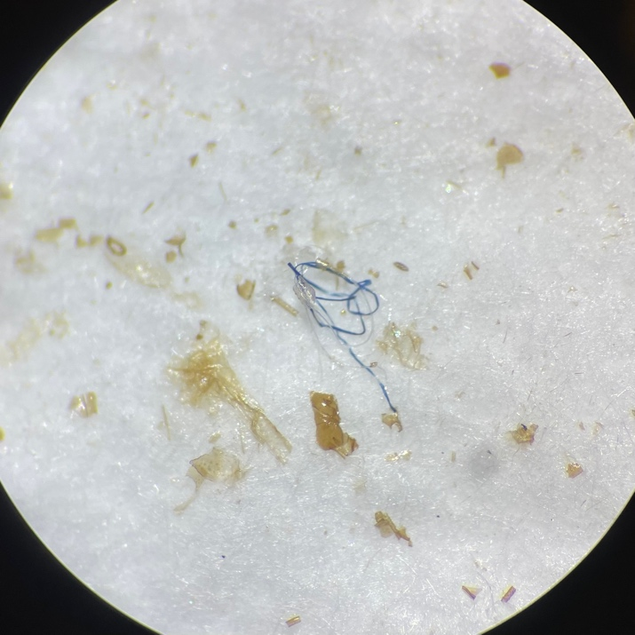
FIGURES AND TABLES
Fig. 2: Blue Fiber in filtered M. lucifugus sample
Fig. 1: Red Fiber in filtered M. lucifugus sample
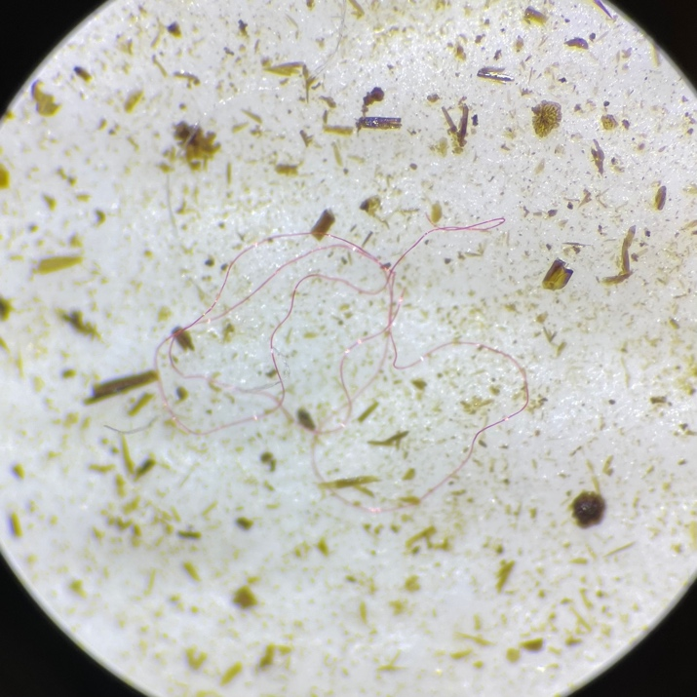

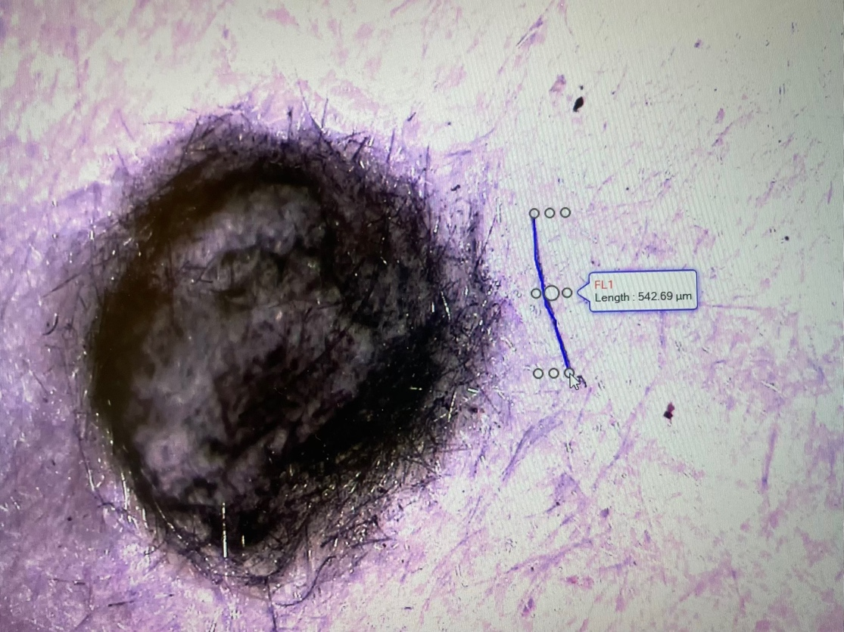

Fig. 3: Measured blue fiber, next to light pencil mark on filter. Plastic measures 542.69 micrometers.

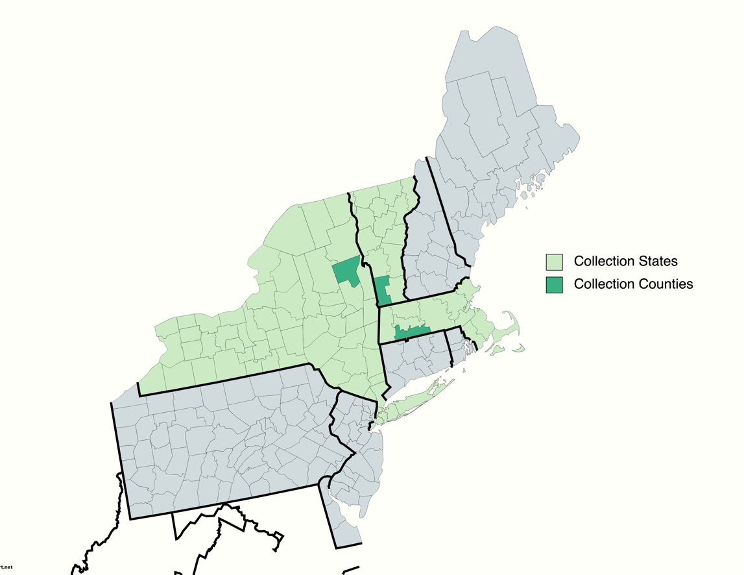

Fig. 4: Collection sites in NY, MA, and VT, including Warren County, Hampden County, and Bennington County, respectively.

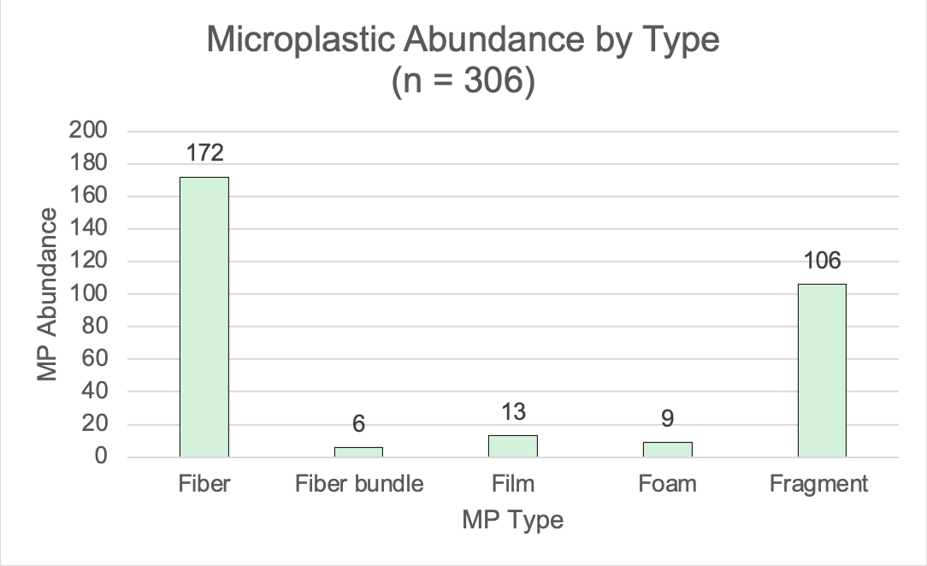

Fig. 5: Microplastic abundance by microplastic type.
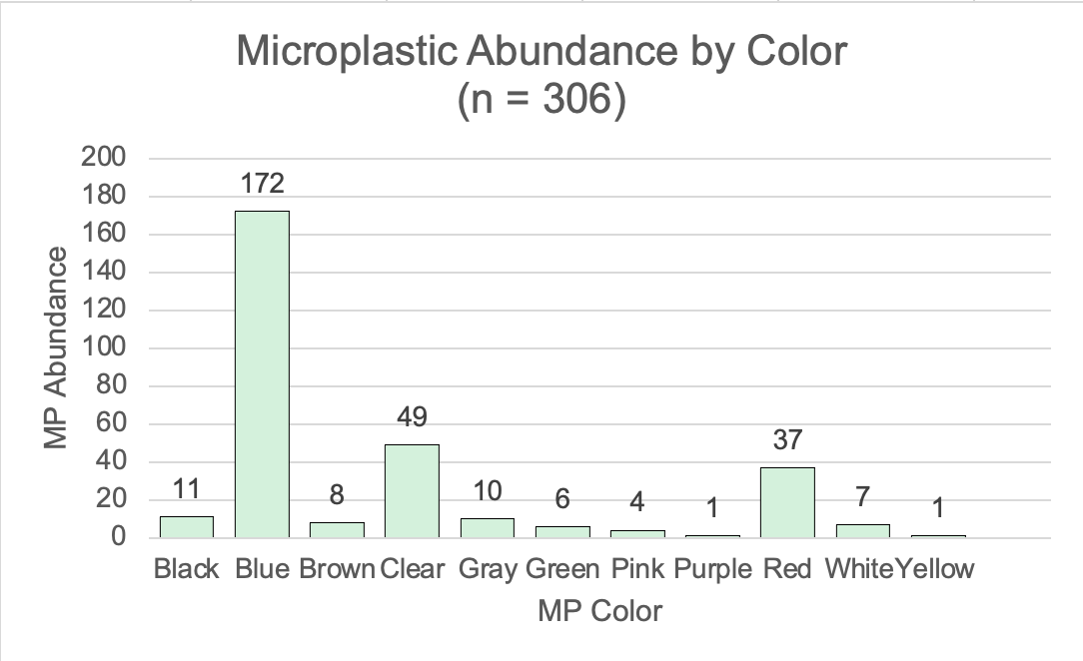

Fig. 6: Microplastic abundance by microplastic color.
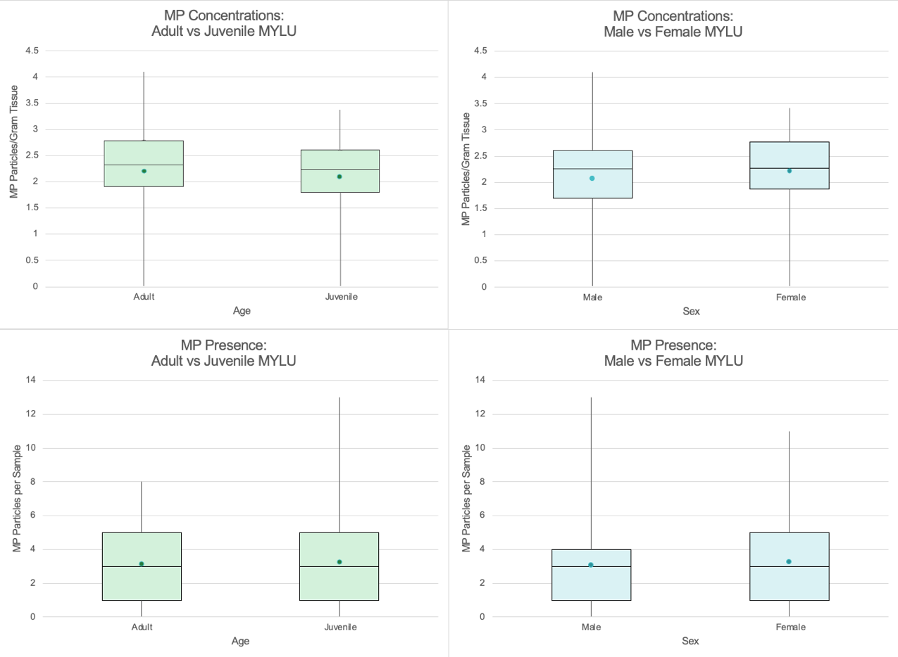

Fig. 7: Boxplots comparing microplastic presence (bottom) and concentrations (top) in male versus female (blue) M. lucifugus and adult vs juvenile (green) M. lucifugus.

