Appendix A

Appendix A contains a figure of the location of Fort Polk Military Reservation with respect to the Kisatchie National Forest. Also contained within Appendix A are figures showing the distribution of the sample of known prehistoric and historic sites across the ranger districts of the Kisatchie National Forest. Dark green areas represent the study area within the Kisatchie National Forest. Relevant district extent emboldened in red by figure.
Figure A.1. Location of Fort Polk Military Reservation with respect to the Kisatchie National Forest. Overlap Occurs with the Vernon Unit of the Calcasieu ranger district and the Kisatchie ranger district (from Anderson and Smith 2003:3; Thomas et al. 1982;2, 47).

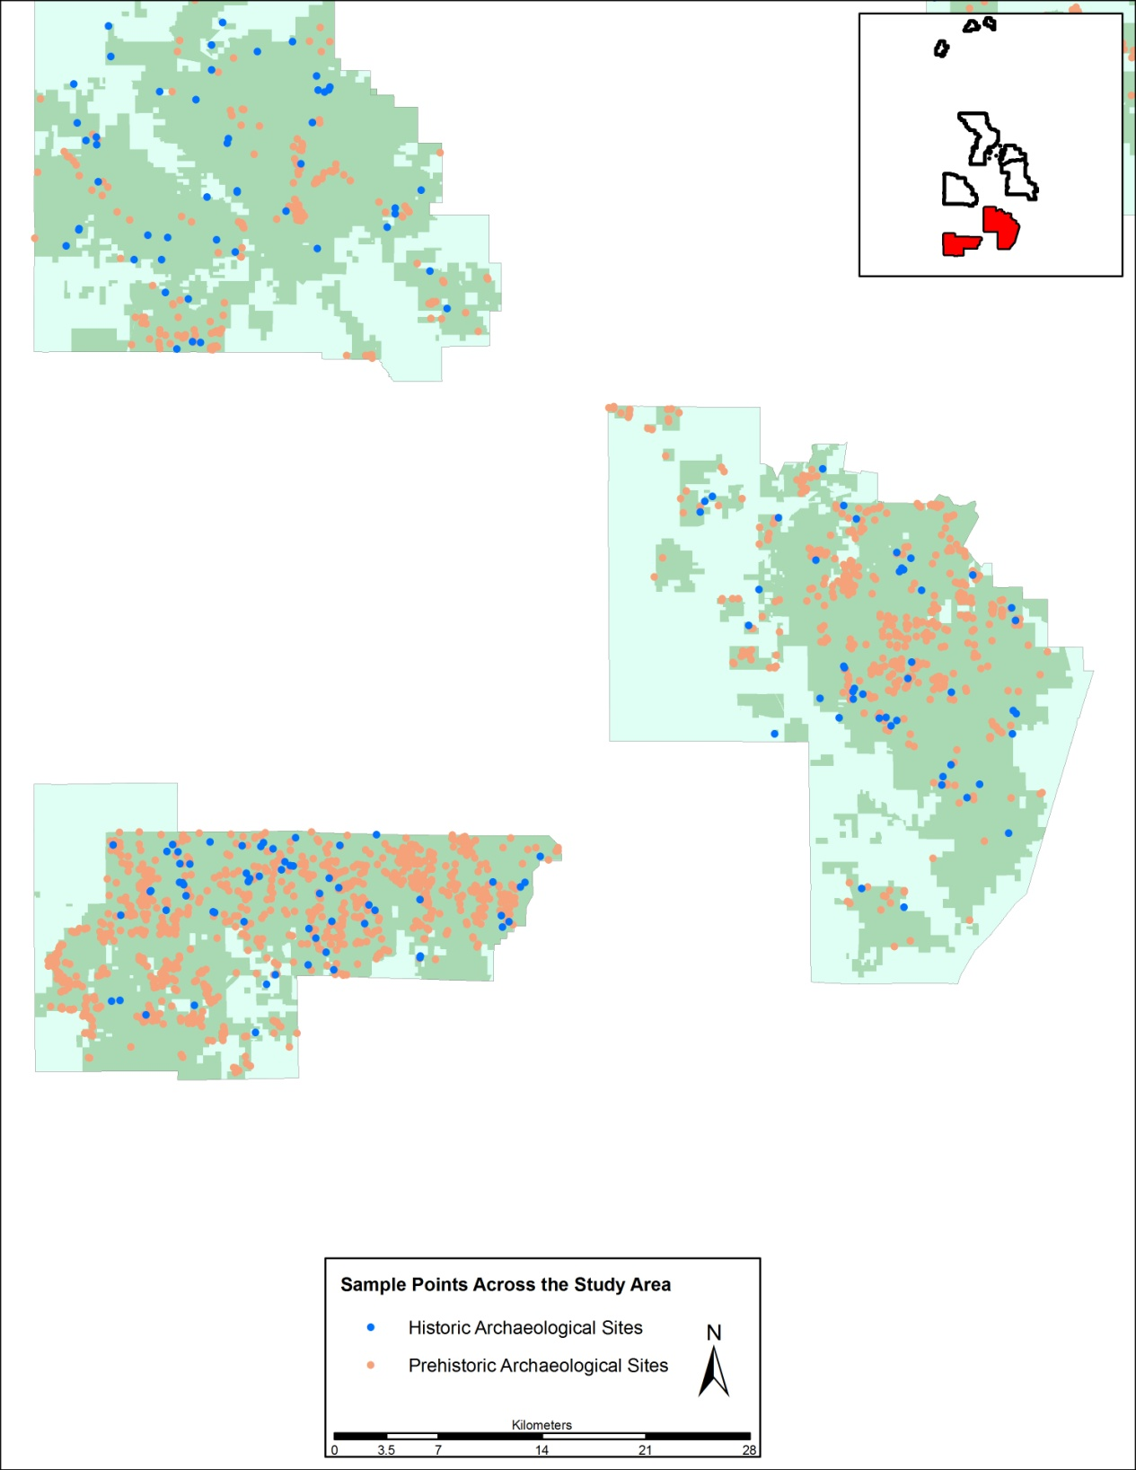
Figure A.2. Distribution of prehistoric and historic archaeological sites across the Kisatchie National Forest study area for the Calcasieu District.

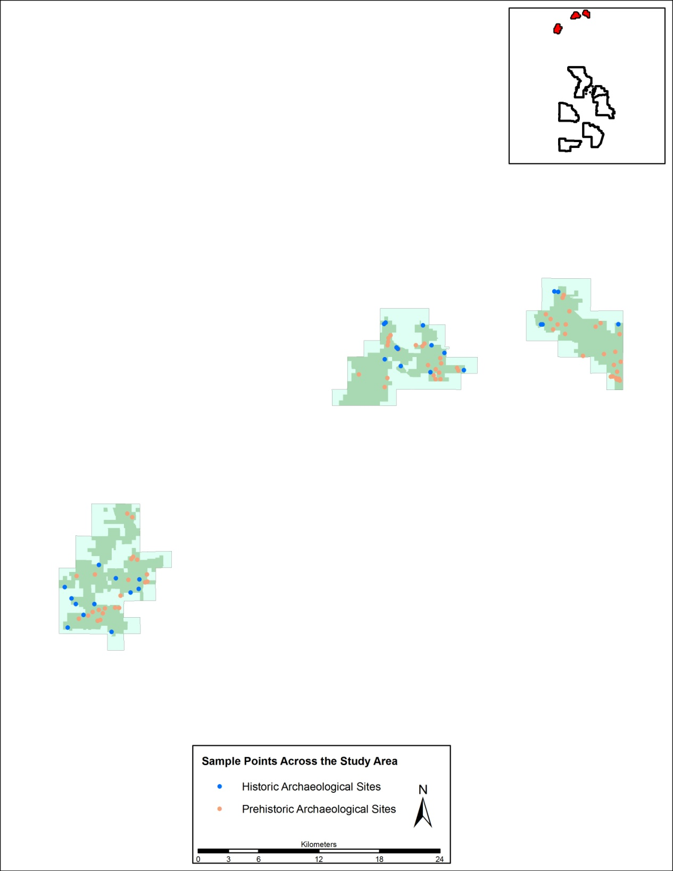
Figure A.3. Distribution of prehistoric and historic archaeological sites across the Kisatchie National Forest study area for the Caney District.

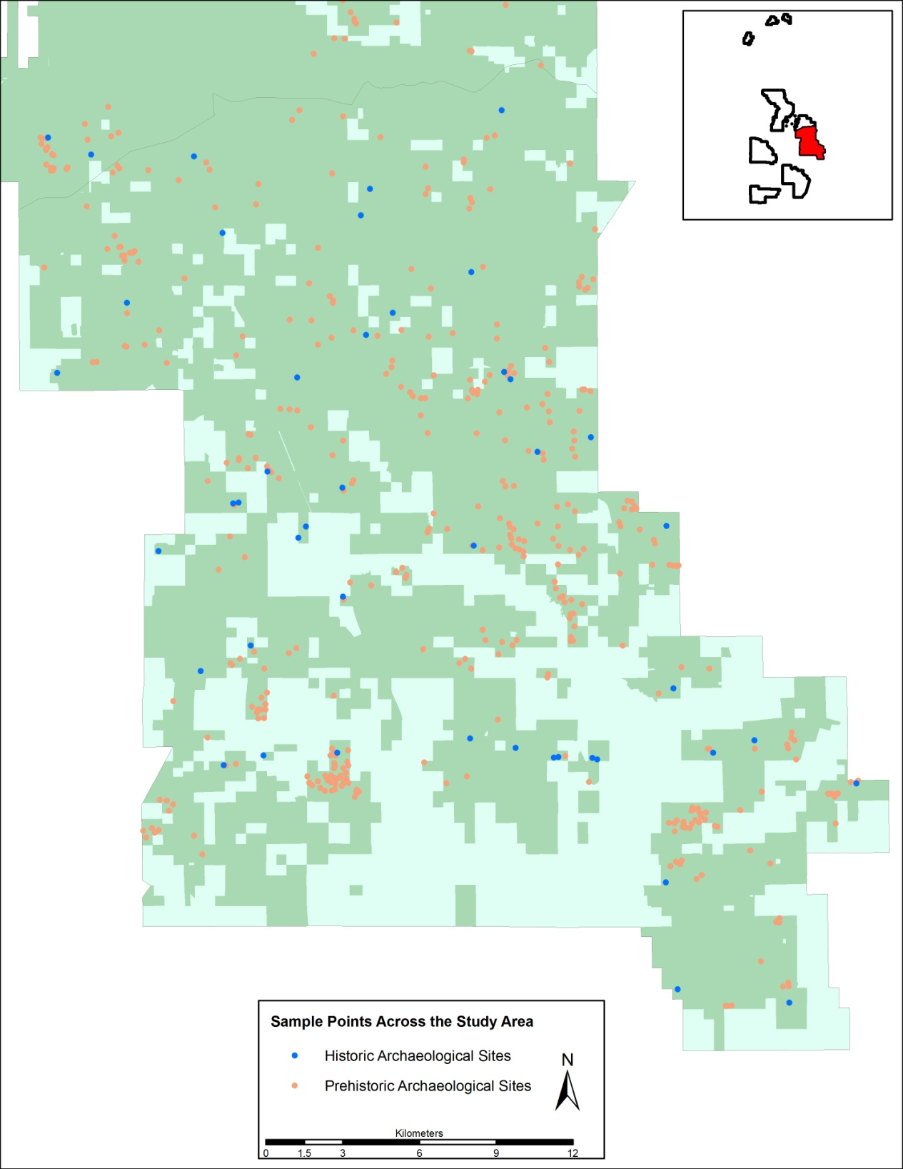
Figure A.4. Distribution of prehistoric and historic archaeological sites across the Kisatchie National Forest study area for the Catahoula District.

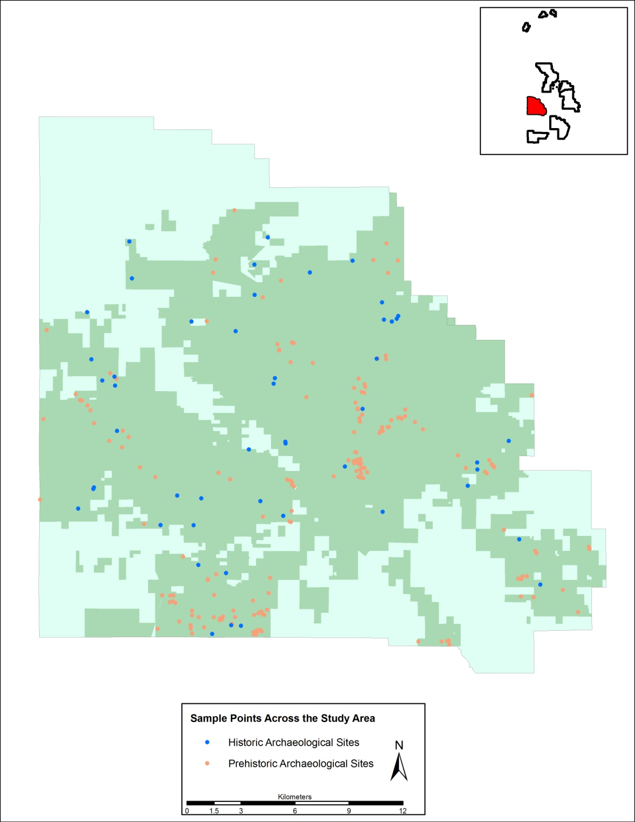
Figure A.5. Distribution of prehistoric and historic archaeological sites across the Kisatchie National Forest study area for the Kisatchie District.

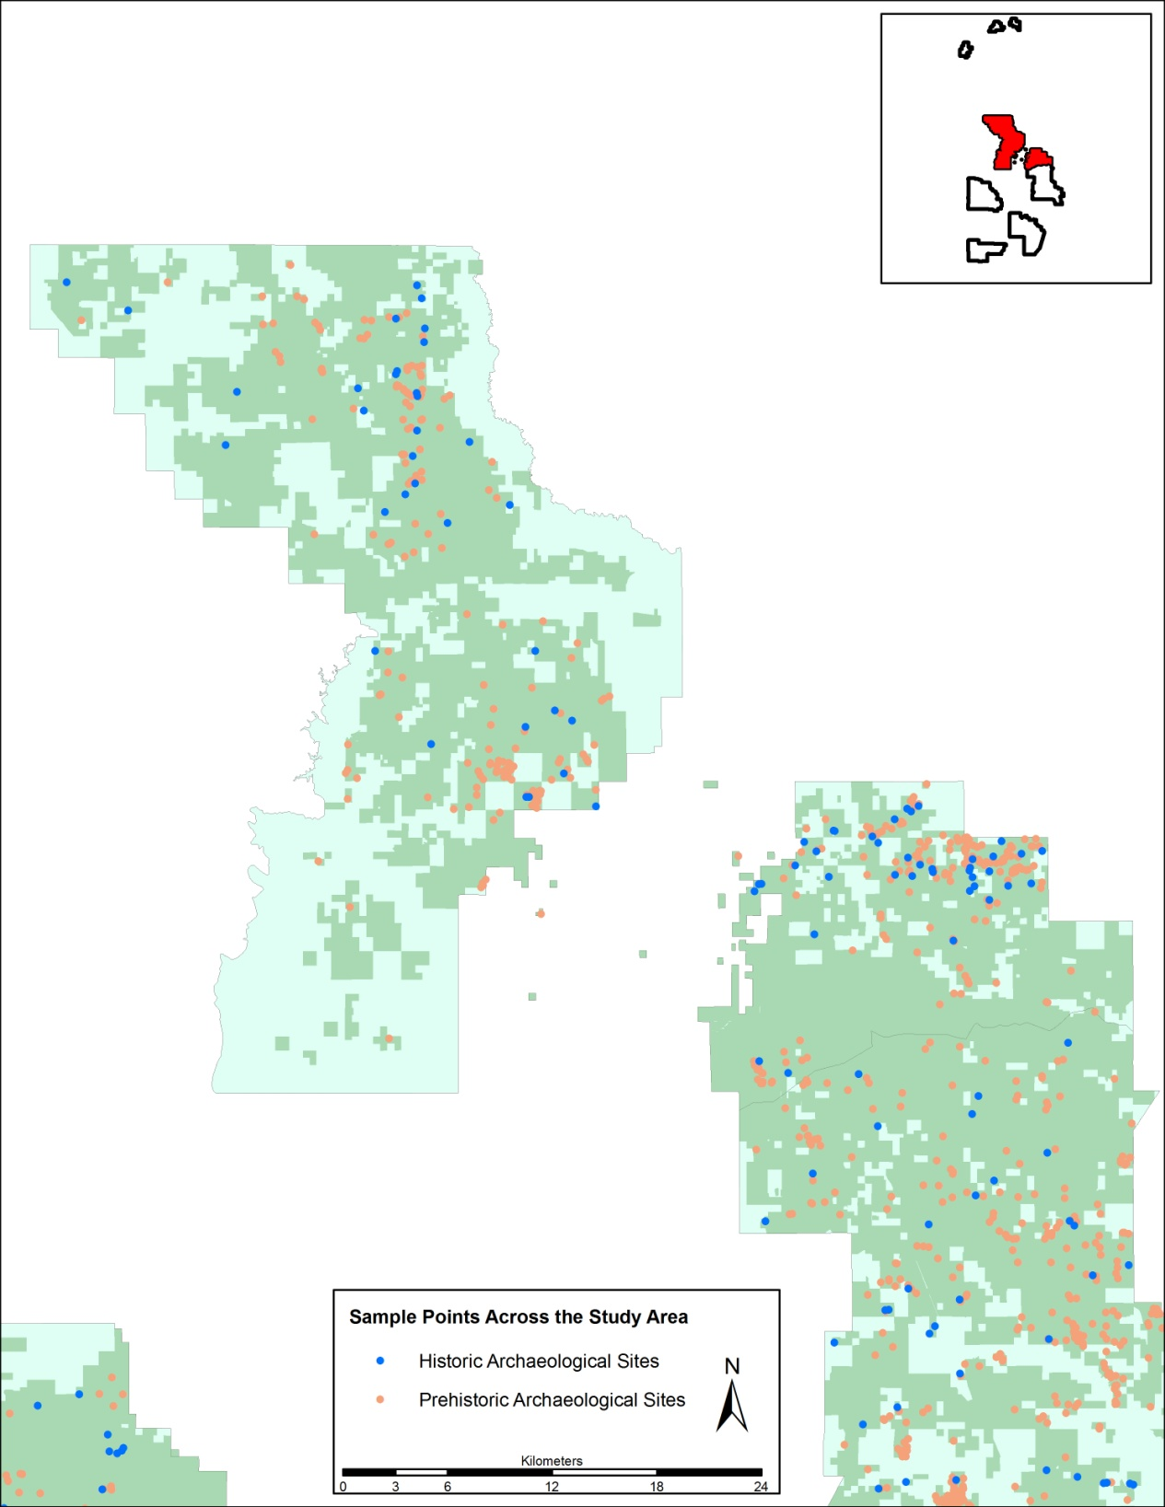
Figure A.6. Distribution of prehistoric and historic archaeological sites across the Kisatchie National Forest study area for the Winn District.

Appendix B

Statistical results for environmental association between known archaeological sites (prehistoric and historic) and sampled random points with additional tests for excluding values of zero.

Table B.1. Descriptive Statistics for Prehistoric Archaeological Sites and Random Sample Points across the entire Study Area (5-meter cells).
Variable | N | Mean | Std. Deviation | Minimum | Maximum
dpoor | 4568 | 250 | 402 | 0 | 4085
dwell | 4568 | 43 | 141 | 0 | 1970
floodf | 4568 | 317 | 352 | 0 | 2795
roadall | 4568 | 181 | 176 | 0 | 2458
stream | 4568 | 78 | 69 | 0 | 912
sseas | 4568 | 103 | 97 | 0 | 1057
sperm | 4568 | 283 | 251 | 0 | 2585
wetl | 4568 | 3421 | 2977 | 0 | 22705
aspect | 4568 | 174 | 103 | 0 | 360
slope | 4568 | 23 | 18 | 0 | 177
elev | 4568 | 198 | 60 | 66 | 445

Table B.2. Mann-Whitney Rank-Sum Results for Prehistoric Archaeological Sites and Random Sample Points across the entire Study Area (5-meter cells).
Variable | Site Class | N | Mean Rank | Sum of Ranks
dpoor | Site | 2284 | 2179.75 | 4978543.50
 | Random Point | 2284 | 2389.25 | 5457052.50
dwell | Site | 2284 | 2225.94 | 5084057.50
 | Random Point | 2284 | 2343.06 | 5351538.50
floodf | Site | 2284 | 2006.03 | 4581783.50
 | Random Point | 2284 | 2562.97 | 5853812.50
roadall | Site | 2284 | 2398.00 | 5477037.00
 | Random Point | 2284 | 2171.00 | 4958559.00
stream | Site | 2284 | 2208.78 | 5044853.50
 | Random Point | 2284 | 2360.22 | 5390742.50
sseas | Site | 2284 | 2266.09 | 5175738.50
 | Random Point | 2284 | 2302.91 | 5259857.50
sperm | Site | 2284 | 1922.97 | 4392073.50
 | Random Point | 2284 | 2646.03 | 6043522.50
wetl | Site | 2284 | 2092.11 | 4778371.00
 | Random Point | 2284 | 2476.89 | 5657225.00
aspect | Site | 2284 | 2290.91 | 5232437.50
 | Random Point | 2284 | 2278.09 | 5203158.50
slope | Site | 2284 | 2379.53 | 5434847.00
 | Random Point | 2284 | 2189.47 | 5000749.00
elev | Site | 2284 | 2298.58 | 5249955.00
 | Random Point | 2284 | 2270.42 | 5185641.00

Table B.3. Significance of the Mann-Whitney Rank-Sum Results for Prehistoric Archaeological Sites across the entire Study Area Compared to Prehistoric Random Sample Points (5-meter cells).
Variableª | Mann-Whitney U | Wilcoxon W | Z | Asymp. Sig. (2-tailed)
dpoor | 2369073.5 | 4978543.5 | -5.418 | .000
dwell | 2474587.5 | 5084057.5 | -3.856 | .000
floodf | 1972313.5 | 4581783.5 | -14.292 | .000
roadall | 2349089.0 | 4958559.0 | -5.817 | .000
stream | 2435383.5 | 5044853.5 | -3.881 | .000
sseas | 2566268.5 | 5175738.5 | -.944 | .345
sperm | 1782603.5 | 4392073.5 | -18.528 | .000
wetl | 2168901.0 | 4778371.0 | -9.860 | .000
aspect | 2593688.5 | 5203158.5 | -.328 | .743
slope | 2391279.0 | 5000749.0 | -4.870 | .000
elev | 2576171.0 | 5185641.0 | -.722 | .471
ª Grouping variable: site vs random point

Table B.4. Mann-Whitney Rank-Sum Results for Prehistoric Archaeological Sites and Random Sample Points across the entire Study Area Excluding Values of Zero (5-meter cells).
Variable | Site Class | N | Mean Rank | Sum of Ranks
dpoor | Sites | 1719 | 1491.83 | 2564452.00
dpoor | Random Point | 1643 | 1879.95 | 3088751.00
dwell | Sites | 571 | 527.28 | 301076.00
dwell | Random Point | 647 | 682.06 | 441295.00
floodf | Sites | 1918 | 1665.77 | 3194940.50
floodf | Random Point | 1990 | 2232.79 | 4443245.50
wetl | Sites | 2262 | 2064.22 | 4669256.00
wetl | Random Point | 2258 | 2457.13 | 5548204.00

Table B.5. Significance of the Mann-Whitney Rank-Sum Results for Prehistoric Archaeological Sites across the entire Study Area Compared to Prehistoric Random Sample Points Excluding Values of Zero (5-meter cells).
Variable | Mann-Whitney U | Wilcoxon W | Z | Asymp. Sig. (2-tailed)
dpoor | 1086112.00 | 2564452.00 | -11.59 | .000
dwell | 137770.00 | 301076.00 | -7.66 | .000
floodf | 1354619.50 | 3194940.50 | -15.71 | .000
wetl | 2109803.00 | 4669256.00 | -10.12 | .000
a Grouping Variable: Site vs Random Point

Table B.6. Descriptive Statistics for Historic Archaeological Sites and Random Sample Points across the entire Study Area (5-meter cells).
Variable | N | Mean | Std. Deviation | Minimum | Maximum
dpoor | 600 | 318 | 519 | 0 | 3987
dwell | 600 | 47 | 170 | 0 | 1709
floodf | 600 | 343 | 340 | 0 | 2153
roadall | 600 | 161 | 190 | 0 | 2647
stream | 600 | 90 | 90 | 0 | 1110
sseas | 600 | 111 | 113 | 0 | 1108
sperm | 600 | 330 | 265 | 0 | 1976
wetl | 600 | 3747 | 3278 | 0 | 18605
aspect | 600 | 183 | 99 | 0 | 359
slope | 600 | 21 | 17 | 0 | 164
elev | 600 | 203 | 58 | 68 | 448

Table B.7. Mann-Whitney Rank-Sum Results for Historic Archaeological Sites and Random Sample Points across the entire Study Area (5-meter cells).
Variable | Site Class | N | Mean Rank | Sum of Ranks
dpoor | Site | 300 | 297.35 | 89204.50
 | Random Point | 300 | 303.65 | 91095.50
dwell | Site | 300 | 297.99 | 89397.00
 | Random Point | 300 | 303.01 | 90903.00
floodf | Site | 300 | 297.99 | 89397.50
 | Random Point | 300 | 303.01 | 90902.50
roadall | Site | 300 | 273.29 | 81986.00
 | Random Point | 300 | 327.71 | 98314.00
stream | Site | 300 | 311.86 | 93556.50
 | Random Point | 300 | 289.15 | 86743.50
sseas | Site | 300 | 299.33 | 89800.00
 | Random Point | 300 | 301.67 | 90500.00
sperm | Site | 300 | 308.19 | 92456.00
 | Random Point | 300 | 292.81 | 87844.00
wetl | Site | 300 | 308.02 | 92406.50
 | Random Point | 300 | 292.98 | 87893.50
aspect | Site | 300 | 311.89 | 93568.00
 | Random Point | 300 | 289.11 | 86732.00
slope | Site | 300 | 296.64 | 88991.50
 | Random Point | 300 | 304.36 | 91308.50
elev | Site | 300 | 321.34 | 96402.00
 | Random Point | 300 | 279.66 | 83898.00

Table B.8. Significance of the Mann-Whitney Rank-Sum Results for Historic Archaeological Sites across the entire Study Area Compared to Historic Random Sample Points (5-meter cells).
Variableª | Mann-Whitney U | Wilcoxon W | Z | Asymp. Sig. (2-tailed)
dpoor | 44054.5 | 89204.5 | -.448 | .654
dwell | 44247.0 | 89397.0 | -.476 | .634
floodf | 44247.5 | 89397.5 | -.355 | .723
roadall | 36836.0 | 81986.0 | -3.845 | .000
stream | 41593.5 | 86743.5 | -1.605 | .109
sseas | 44650.0 | 89800.0 | -.165 | .869
sperm | 42694.0 | 87844.0 | -1.086 | .277
wetl | 42743.5 | 87893.5 | -1.063 | .288
aspect | 41582.0 | 86732.0 | -1.610 | .107
slope | 43841.5 | 88991.5 | -.546 | .585
elev | 38748.0 | 83898.0 | -2.945 | .003
ª Grouping variable: site vs random point

Table B.9. Mann-Whitney Rank-Sum Results for Historic Archaeological Sites and Random Sample Points across the entire Study Area Excluding Values of Zero (5-meter cells).
Variable | Site Class | N | Mean Rank | Sum of Ranks
dpoor | Site | 229 | 225.37 | 51610.00
dpoor | Random Point | 229 | 233.63 | 53501.00
dwell | Site | 71 | 60.89 | 4323.50
dwell | Random Point | 71 | 82.11 | 5829.50
floodf | Site | 269 | 255.07 | 68613.50
floodf | Random Point | 258 | 273.31 | 70514.50
wetl | Site | 300 | 304.02 | 91206.50
wetl | Random Point | 296 | 292.90 | 86699.50

Table B.10. Significance of the Mann-Whitney Rank-Sum Results for Historic Archaeological Sites across the entire Study Area Compared to Historic Random Sample Points Excluding Values of Zero (5-meter cells).
Variableª | Mann-Whitney U | Wilcoxon W | Z | Asymp. Sig. (2-tailed)
Dpoor | 25275.00 | 51610.00 | -0.67 | .504
dwell | 1767.50 | 4323.50 | -3.07 | .002
floodf | 32298.50 | 68613.50 | -1.37 | .169
wetl | 42743.50 | 86699.50 | -0.79 | .431
a Grouping variable: site vs random point

Table B.11. Descriptive Statistics for Historic Archaeological Sites and Random Sample Points across the Caney District Study Area (5-meter cells).
Variable | N | Mean | Std. Deviation | Minimum | Maximum
dpoor | 44 | 1019 | 1257 | 0 | 3987
dwell | 44 | 51 | 150 | 0 | 760
floodf | 44 | 283 | 289 | 0 | 1126
roadall | 44 | 138 | 152 | 0 | 623
stream | 44 | 113 | 68 | 5 | 270
sseas | 44 | 147 | 124 | 0 | 588
sperm | 44 | 353 | 229 | 5 | 850
wetl | 44 | 7209 | 6621 | 0 | 18605
aspect | 44 | 189 | 100 | 0 | 340
slope | 44 | 19 | 15 | 0 | 83
elev | 44 | 235 | 71 | 114 | 448

Table B.12. Mann-Whitney Rank-Sum Results for Historic Archaeological Sites and Random Sample Points across the Caney District Study Area (5-meter cells).
Variable | Site Class | N | Mean Rank | Sum of Ranks
dpoor | Site | 28 | 25.54 | 715.00
 | Random Point | 16 | 17.19 | 275.00
dwell | Site | 28 | 19.71 | 552.00
 | Random Point | 16 | 27.38 | 438.00
floodf | Site | 28 | 27.71 | 776.00
 | Random Point | 16 | 13.38 | 214.00
roadall | Site | 28 | 19.46 | 545.00
 | Random Point | 16 | 27.81 | 445.00
stream | Site | 28 | 20.54 | 575.00
 | Random Point | 16 | 25.94 | 415.00
sseas | Site | 28 | 18.54 | 519.00
 | Random Point | 16 | 29.44 | 471.00
sperm | Site | 28 | 25.34 | 709.50
 | Random Point | 16 | 17.53 | 280.50
wetl | Site | 28 | 24.21 | 678.00
 | Random Point | 16 | 19.50 | 312.00
aspect | Site | 28 | 21.64 | 606.00
 | Random Point | 16 | 24.00 | 384.00
slope | Site | 28 | 24.93 | 698.00
 | Random Point | 16 | 18.25 | 292.00
elev | Site | 28 | 26.21 | 734.00
 | Random Point | 16 | 16.00 | 256.00

Table B.13. Significance of the Mann-Whitney Rank-Sum Results for Historic Archaeological Sites across the Caney District Study Area Compared to Historic Random Sample Points (5-meter cells).
Variableª | Mann-Whitney U | Wilcoxon W | Z | Asymp. Sig. (2-tailed)
dpoor | 139.0 | 275.0 | -2.078 | .038
dwell | 146.0 | 552.0 | -2.988 | .003
floodf | 78.0 | 214.0 | -3.577 | .000
roadall | 139.0 | 545.0 | -2.074 | .038
stream | 169.0 | 575.0 | -1.342 | .180
sseas | 113.0 | 519.0 | -2.708 | .007
sperm | 144.5 | 280.5 | -1.940 | .052
wetl | 176.0 | 312.0 | -1.171 | .242
aspect | 200.0 | 606.0 | -.586 | .558
slope | 156.0 | 292.0 | -1.659 | .097
elev | 120.0 | 256.0 | -2.537 | .011
ª Grouping variable: site vs random point

Table B.14. Mann-Whitney Rank-Sum Results for Historic Archaeological Sites and Random Sample Points across the Caney Study Area Excluding Values of Zero (5-meter cells).
Variable | Site Class | N | Mean Rank | Sum of Ranks
dpoor | Site | 27 | 19.33 | 522.00
dpoor | Random Point | 10 | 18.10 | 181.00
dwell | Site | 1 | 2.00 | 2.00
dwell | Random Point | 6 | 4.33 | 26.00
floodf | Site | 27 | 19.56 | 528.00
floodf | Random Point | 8 | 12.75 | 102.00
wetl | Site | 28 | 22.21 | 622.00
wetl | Random Point | 14 | 20.07 | 281.00

Table B.15. Significance of the Mann-Whitney Rank-Sum Results for Historic Archaeological Sites across the Caney District Study Area Compared to Historic Random Sample Points Excluding Values of Zero (5-meter cells).
Variableª | Mann-Whitney U | Wilcoxon W | Z | Asymp. Sig. (2-tailed)
dpoor | 126.000 | 181.000 | -.308 | .758
dwell | 1.000 | 2.000 | -1.000 | .317
floodf | 66.000 | 102.000 | -1.650 | .099
wetl | 176.000 | 281.000 | -.534 | .594
a Grouping variable: site vs random point

Table B.16. Descriptive Statistics for Historic Archaeological Sites across the Central Cluster District Study Area (5-meter cells).

Variable | N | Mean | Std. Deviation | Minimum | Maximum
dpoor | 556 | 263 | 355 | 0 | 2196
dwell | 556 | 47 | 172 | 0 | 1709
floodf | 556 | 347 | 344 | 0 | 2153
roadall | 556 | 163 | 193 | 0 | 2647
stream | 556 | 88 | 91 | 0 | 1110
sseas | 556 | 109 | 112 | 0 | 1108
sperm | 556 | 328 | 268 | 0 | 1976
wetl | 556 | 3473 | 2679 | 0 | 16627
aspect | 556 | 183 | 99 | 0 | 359
slope | 556 | 21 | 17 | 0 | 164
elev | 556 | 200 | 57 | 68 | 374

Table B.17. Mann-Whitney Rank-Sum Results for Historic Archaeological Sites and Random Sample Points across the Central Cluster District Study Area (5-meter cells).
Variable | Site Class | N | Mean Rank | Sum of Ranks
dpoor | Site | 272 | 267.55 | 72773.50
 | Random Point | 284 | 288.99 | 82072.50
dwell | Site | 272 | 280.30 | 76242.00
 | Random Point | 284 | 276.77 | 78604.00
floodf | Site | 272 | 269.87 | 73403.50
 | Random Point | 284 | 286.77 | 81442.50
roadall | Site | 272 | 255.78 | 69571.00
 | Random Point | 284 | 300.26 | 85275.00
stream | Site | 272 | 291.10 | 79180.50
 | Random Point | 284 | 266.43 | 75665.50
sseas | Site | 272 | 280.45 | 76282.50
 | Random Point | 284 | 276.63 | 78563.50
sperm | Site | 272 | 282.68 | 76889.50
 | Random Point | 284 | 274.49 | 77956.50
wetl | Site | 272 | 282.81 | 76924.00
 | Random Point | 284 | 274.37 | 77922.00
aspect | Site | 272 | 290.76 | 79088.00
 | Random Point | 284 | 266.75 | 75758.00
slope | Site | 272 | 271.49 | 73844.50
 | Random Point | 284 | 285.22 | 81001.50
elev | Site | 272 | 292.67 | 79605.00
 | Random Point | 284 | 264.93 | 75241.00

Table B.18. Significance of the Mann-Whitney Rank-Sum Results for Historic Archaeological Sites across the Central Cluster District Study Area Compared to Historic Random Sample Points (5-meter cells).
Variableª | Mann-Whitney U | Wilcoxon W | Z | Asymp. Sig. (2-tailed)
dpoor | 35645.5 | 72773.5 | -1.584 | .113
dwell | 38134.0 | 78604.0 | -.344 | .731
floodf | 36275.5 | 73403.5 | -1.241 | .215
roadall | 32443.0 | 69571.0 | -3.264 | .001
stream | 35195.5 | 75665.5 | -1.811 | .070
sseas | 38093.5 | 78563.5 | -.280 | .779
sperm | 37486.5 | 77956.5 | -.601 | .548
wetl | 37452.0 | 77922.0 | -.619 | .536
aspect | 35288.0 | 75758.0 | -1.762 | .078
slope | 36716.5 | 73844.5 | -1.007 | .314
elev | 34771.0 | 75241.0 | -2.035 | .042
ª Grouping variable: site vs random point

Table B.19. Mann-Whitney Rank-Sum Results for Historic Archaeological Sites and Random Sample Points across the Central Cluster Study Area Excluding Values of Zero (5-meter cells).
Variable | Site Class | N | Mean Rank | Sum of Ranks
dpoor | Sites | 202 | 201.70 | 40743.50
dpoor | Random Point | 219 | 219.58 | 48087.50
dwell | Sites | 70 | 59.29 | 4150.00
dwell | Random Point | 65 | 77.38 | 5030.00
floodf | Sites | 242 | 235.29 | 56940.50
floodf | Random Point | 250 | 257.35 | 64337.50
wetl | Sites | 272 | 280.81 | 76380.00
wetl | Random Point | 282 | 274.31 | 77355.00

Table B.20. Significance of the Mann-Whitney Rank-Sum Results for Historic Archaeological Sites across the Central Cluster Study Area Compared to Historic Random Sample Points Excluding Values of Zero (5-meter cells).
Variableª | Mann-Whitney U | Wilcoxon W | Z | Asymp. Sig. (2-tailed)
dpoor | 20240.50 | 40743.50 | -1.51 | .132
dwell | 1665.00 | 4150.00 | -2.69 | .007
floodf | 27537.50 | 56940.50 | -1.72 | .085
wetl | 37452.00 | 77355.00 | -0.48 | .633
a Grouping variable: site vs random point

Table B.21. Descriptive Statistics for Prehistoric Archaeological Sites and Random Sample Points across the Caney District Study Area (5-meter cells).
Variable | N | Mean | Std. Deviation | Minimum | Maximum
dpoor | 186 | 881 | 1167 | 0 | 4085
dwell | 186 | 41 | 118 | 0 | 735
floodf | 186 | 225 | 292 | 0 | 1340
roadall | 186 | 143 | 129 | 0 | 716
stream | 186 | 93 | 72 | 0 | 437
sseas | 186 | 128 | 108 | 0 | 589
sperm | 186 | 288 | 226 | 0 | 1015
wetl | 186 | 6798 | 6926 | 0 | 22705
aspect | 186 | 175 | 105 | 0 | 359
slope | 186 | 18 | 15 | 0 | 79
elev | 186 | 224 | 80 | 105 | 445

Table B.22. Mann-Whitney Rank-Sum Results for Prehistoric Archaeological Sites and Random Sample Points across the Caney District Study Area (5-meter cells).
Variable | Site Class | N | Mean Rank | Sum of Ranks
dpoor | Site | 68 | 84.08 | 5717.50
 | Random Point | 118 | 98.93 | 11673.50
dwell | Site | 68 | 94.57 | 6430.50
 | Random Point | 118 | 92.89 | 10960.50
floodf | Site | 68 | 70.82 | 4815.50
 | Random Point | 118 | 106.57 | 12575.50
roadall | Site | 68 | 101.18 | 6880.50
 | Random Point | 118 | 89.07 | 10510.50
stream | Site | 68 | 100.65 | 6844.00
 | Random Point | 118 | 89.38 | 10547.00
sseas | Site | 68 | 102.63 | 6979.00
 | Random Point | 118 | 88.24 | 10412.00
sperm | Site | 68 | 70.78 | 4813.00
 | Random Point | 118 | 106.59 | 12578.00
wetl | Site | 68 | 87.02 | 5917.50
 | Random Point | 118 | 97.23 | 11473.50
aspect | Site | 68 | 99.47 | 6764.00
 | Random Point | 118 | 90.06 | 10627.00
slope | Site | 68 | 84.03 | 5714.00
 | Random Point | 118 | 98.96 | 11677.00
elev | Site | 68 | 76.85 | 5226.00
 | Random Point | 118 | 103.09 | 12165.00

Table B.23. Significance of the Mann-Whitney Rank-Sum Results for Prehistoric Archaeological Sites across the Caney District Study Area Compared to Prehistoric Random Sample Points (5-meter cells).
Variableª | Mann-Whitney U | Wilcoxon W | Z | Asymp. Sig. (2-tailed)
dpoor | 3371.5 | 5717.5 | -1.821 | .069
dwell | 3939.5 | 10960.5 | -.280 | .779
floodf | 2469.5 | 4815.5 | -4.400 | .000
roadall | 3489.5 | 10510.5 | -1.478 | .139
stream | 3526.0 | 10547.0 | -1.374 | .169
sseas | 3391.0 | 10412.0 | -1.756 | .079
sperm | 2467.0 | 4813.0 | -4.369 | .000
wetl | 3571.5 | 5917.5 | -1.246 | .213
aspect | 3606.0 | 10627.0 | -1.148 | .251
slope | 3368.0 | 5714.0 | -1.821 | .069
elev | 2880.0 | 5226.0 | -3.201 | .001
ª Grouping variable: site vs random point

Table B.24. Mann-Whitney Rank-Sum Results for Prehistoric Archaeological Sites and Random Sample Points across the Caney Study Area Excluding Values of Zero (5-meter cells).

Variable | Site Class | N | Mean Rank | Sum of Ranks
dpoor | Site | 51 | 64.11 | 3269.50
dpoor | Random Point | 94 | 77.82 | 7315.50
dwell | Site | 17 | 16.76 | 285.00
dwell | Random Point | 25 | 24.72 | 618.00
floodf | Site | 47 | 43.51 | 2045.00
floodf | Random Point | 91 | 82.92 | 7546.00
wetl | Site | 68 | 82.02 | 5577.50
wetl | Random Point | 113 | 96.40 | 10893.50

Table B.25. Significance of the Mann-Whitney Rank-Sum Results for Prehistoric Archaeological Sites across the Caney District Study Area Compared to Prehistoric Random Sample Points Excluding Values of Zero (5-meter cells).
Variableª | Mann-Whitney U | Wilcoxon W | Z | Asymp. Sig. (2-tailed)
dpoor | 1943.50 | 3269.50 | -1.88 | .060
dwell | 132.00 | 285.00 | -2.06 | .039
floodf | 917.00 | 2045.00 | -5.49 | .000
wetl | 3231.50 | 5577.50 | -1.79 | .074
a Grouping variable: site vs random point

Table B.26. Descriptive Statistics for Prehistoric Archaeological Sites and Random Sample Points across the Central Cluster Study Area (5-meter cells).
Variable | N | Mean | Std. Deviation | Minimum | Maximum
dpoor | 4382 | 223 | 305 | 0 | 1908
dwell | 4382 | 43 | 142 | 0 | 1970
floodf | 4382 | 321 | 354 | 0 | 2795
roadall | 4382 | 183 | 178 | 0 | 2458
stream | 4382 | 77 | 69 | 0 | 912
sseas | 4382 | 102 | 96 | 0 | 1057
sperm | 4382 | 282 | 252 | 0 | 2585
wetl | 4382 | 3277 | 2589 | 0 | 16946
aspect | 4382 | 174 | 103 | 0 | 360
slope | 4382 | 24 | 18 | 0 | 177
elev | 4382 | 197 | 59 | 66 | 393

Table B.27. Mann-Whitney Rank-Sum Results for Prehistoric Archaeological Sites and Random Sample Points across the Central Cluster Study Area (5-meter cells).
Variable | Site Class | N | Mean Rank | Sum of Ranks
dpoor | Site | 2216 | 2102.37 | 4658850.00
 | Random Point | 2166 | 2282.69 | 4944303.00
dwell | Site | 2216 | 2131.79 | 4724044.50
 | Random Point | 2166 | 2252.59 | 4879108.50
floodf | Site | 2216 | 1927.78 | 4271955.00
 | Random Point | 2166 | 2461.31 | 5331198.00
roadall | Site | 2216 | 2294.38 | 5084353.50
 | Random Point | 2166 | 2086.24 | 4518799.50
stream | Site | 2216 | 2115.04 | 4686927.00
 | Random Point | 2166 | 2269.73 | 4916226.00
sseas | Site | 2216 | 2170.73 | 4810346.50
 | Random Point | 2166 | 2212.75 | 4792806.50
sperm | Site | 2216 | 1851.39 | 4102671.00
 | Random Point | 2166 | 2539.47 | 5500482.00
wetl | Site | 2216 | 2009.10 | 4452175.00
 | Random Point | 2166 | 2378.11 | 5150978.00
aspect | Site | 2216 | 2193.63 | 4861079.00
 | Random Point | 2166 | 2189.32 | 4742074.00
slope | Site | 2216 | 2287.83 | 5069836.50
 | Random Point | 2166 | 2092.94 | 4533316.50
elev | Site | 2216 | 2223.36 | 4926972.00
 | Random Point | 2166 | 2158.90 | 4676181.00

Table B.28. Significance of the Mann-Whitney Rank-Sum Results for Prehistoric Archaeological Sites across the Central Cluster Study Area Compared to Prehistoric Random Sample Points (5-meter cells).
Variableª | Mann-Whitney U | Wilcoxon W | Z | Asymp. Sig. (2-tailed)
dpoor | 2202414.000 | 4658850.000 | -4.762 | .000
dwell | 2267608.500 | 4724044.500 | -4.052 | .000
floodf | 1815519.000 | 4271955.000 | -13.977 | .000
roadall | 2171938.500 | 4518799.500 | -5.445 | .000
stream | 2230491.000 | 4686927.000 | -4.047 | .000
sseas | 2353910.500 | 4810346.500 | -1.099 | .272
sperm | 1646235.000 | 4102671.000 | -18.001 | .000
wetl | 1995739.000 | 4452175.000 | -9.653 | .000
aspect | 2395213.000 | 4742074.000 | -.113 | .910
slope | 2186455.500 | 4533316.500 | -5.099 | .000
elev | 2329320.000 | 4676181.000 | -1.686 | .092
ª Grouping variable: site vs random point

Table B.29. Mann-Whitney Rank-Sum Results for Prehistoric Archaeological Sites and Random Sample Points across the Caney Study Area Excluding Values of Zero (5-meter cells).
Variable | Site Class | N | Mean Rank | Sum of Ranks
dpoor | Sites | 1668 | 1436.54 | 2396146.00
dpoor | Random Point | 1549 | 1794.71 | 2780007.00
dwell | Sites | 554 | 510.66 | 282903.50
dwell | Random Point | 622 | 657.83 | 409172.50
floodf | Sites | 1871 | 1614.73 | 3021160.50
floodf | Random Point | 1899 | 2152.28 | 4087174.50
wetl | Sites | 2194 | 1986.03 | 4357349.00
wetl | Random Point | 2145 | 2358.17 | 5058281.00

Table B.30. Significance of the Mann-Whitney Rank-Sum Results for Prehistoric Archaeological Sites across the Central Cluster Study Area Compared to Prehistoric Random Sample Points Excluding Values of Zero (5-meter cells).
Variableª | Mann-Whitney U | Wilcoxon W | Z | Asymp. Sig. (2-tailed)
dpoor | 1004200.00 | 2396146.00 | -10.93 | .000
dwell | 129168.50 | 282903.50 | -7.42 | .000
floodf | 1269904.50 | 3021160.50 | -15.16 | .000
wetl | 1949434.00 | 4357349.00 | -9.78 | .000
a Grouping variable: site vs random point

Appendix C

The predictive modeling zone catchment results of the 2011 Kisatchie National Forest Predictive Model for each ranger district of the Kisatchie National Forest.

Table C.1 Test Statistics for the Probability Zones of the 2011 Kisatchie National Forest Model for the Calcasieu District Study Area and All Archaeological Sites.
Probability Zone | Area (m²) | % of Area | Expected Sites | Observed Sites | % Sites | χ2 | Gain
Zone 1 (High) | 108725291 | 14.5 | 331.2 | 705 | 30.8 | 421.9 | 0.53
Zone 2 (Medium) | 286159981 | 38.1 | 871.7 | 1063 | 46.4 | 42.0 | 0.18
Zone 2 (Low) | 356902565 | 47.5 | 1087.2 | 522 | 22.8 | 293.8 | -1.08
Total | 751787837 | 100.0 | 2290.0 | 2290 | 100.0 | 757.7 | -
df = 2, α = .05, sig of χ2 ≥ 5.99

Table C.2. Test Statistics for the Probability Zones of the 2011 Kisatchie National Forest Model for the Caney District Study Area and All Archaeological Sites.
Probability Zone | Area (m²) | % of Area | Expected Sites | Observed Sites | % Sites | χ2 | Gain
Zone 1 (High) | 22125064 | 16.8 | 27.1 | 42 | 26.1 | 8.2 | 0.35
Zone 2 (Medium) | 48872069 | 37.2 | 59.8 | 74 | 46.0 | 3.3 | 0.19
Zone 2 (Low) | 60489074 | 46.0 | 74.1 | 45 | 28.0 | 11.4 | -0.65
Total | 131486208 | 100.0 | 161.0 | 161 | 100.0 | 23.0 | -
df = 2, α = .05, sig of χ2 ≥ 5.99

Table C.3. Test Statistics for the Probability Zones of the 2011 Kisatchie National Forest Model for the Catahoula District Study Area and All Archaeological Sites.
Probability Zone | Area (m²) | % of Area | Expected Sites | Observed Sites | % Sites | χ2 | Gain
Zone 1 (High) | 54617136 | 10.8 | 59.0 | 143 | 26.3 | 119.5 | 0.59
Zone 2 (Medium) | 216492058 | 43.0 | 233.9 | 297 | 54.6 | 17.0 | 0.21
Zone 2 (Low) | 232333717 | 46.1 | 251.1 | 104 | 19.1 | 86.1 | -1.41
Total | 503442911 | 100.0 | 544.0 | 544 | 100.0 | 222.6 | -
df = 2, α = .05, sig of χ2 ≥ 5.99

Table C.4 Test Statistics for the Probability Zones of the 2011 Kisatchie National Forest Model for the Kisatchie District Study Area and All Archaeological Sites.
Probability Zone | Area (m²) | % of Area | Expected Sites | Observed Sites | % Sites | χ2 | Gain
Zone 1 (High) | 65670404 | 15.6 | 65.9 | 93 | 22.0 | 11.2 | 0.29
Zone 2 (Medium) | 202001137 | 47.9 | 202.6 | 214 | 50.6 | 0.6 | 0.05
Zone 2 (Low) | 154012571 | 36.5 | 154.5 | 116 | 27.4 | 9.6 | -0.33
Total | 421684112 | 100.0 | 423.0 | 423 | 100.0 | 21.4 | -
df = 2, α = .05, sig of χ2 ≥ 5.99

Table C.5 Test Statistics for the Probability Zones of the 2011 Kisatchie National Forest Model for the Winn District Study Area and All Archaeological Sites.
Probability Zone | Area (m²) | % of Area | Expected Sites | Observed Sites | % Sites | χ2 | Gain
Zone 1 (High) | 101989724 | 15.0 | 85.4 | 173 | 30.5 | 89.9 | 0.51
Zone 2 (Medium) | 246464698 | 36.3 | 206.3 | 241 | 42.4 | 5.8 | 0.14
Zone 2 (Low) | 330055277 | 48.6 | 276.3 | 154 | 27.1 | 54.1 | -0.79
Total | 678509699 | 100.0 | 568.0 | 568 | 100.0 | 149.9 | -
df = 2, α = .05, sig of χ2 ≥ 5.99

