Creaky Voice: Interactional Effects in Production and Perception

A Thesis Presented for the

Master of Arts

Degree

The University of Tennessee, Knoxville

Victoria A. Voorhees
May 2021

Copyright © 2021 by Victoria A. Voorhees
All rights reserved.

ABSTRACT
My thesis investigates creaky voice and how it functions interactionally within social situations, as well as how it is perceived by others. “Creaky voice” happens when a person speaks at their lowest pitch range, also known as their “vocal fry.” This causes “a vocal effect produced by a very slow vibration of only one end of the vocal cords” (Crystal, 1997, 98). I am interested in knowing which populations utilize creaky voice most. Additionally, I aim to explore how creaky voice is perceived by others. To conduct this investigation, I have run both a production and perception study. Within the production study, I have analyzed creaky voice within a focus group and an interview in an attempt to answer two questions. Specifically, I explore how gender interacts with creaky voice and investigate the effect of interactional factors such as conversational entrainment and turn-taking on the production of creaky voice. Within the perception study, I explore others’ perceptions of creaky voice by conducting a survey and having the participants rank the speakers they hear. They were presented with a variety of voice recordings exhibiting both modal and creaky voice and were asked to rank the speakers based on attractiveness, intelligence, competency, and other character attributes. Findings for study one reveal that males creaked more overall, but females creaked more in specific points within utterances. Study one also reveals the significant effect both conversational entrainment and turn-taking have on the production of creak. Results from study two indicate that females perceive creaky voice as more attractive overall. Further, it is found that age, education level, and locality impact perceptions of creak.

TABLE OF CONTENTS

CHAPTER 1: Introduction………………………………………………...........1

CHAPTER 2: Literature Review…………………………………………….….9

CHAPTER 3: Study 1………………………………………………………….26

CHAPTER 4: Study 2……………………………………………………….....47

CHAPTER 5: Conclusion………………………………………………...........80

References……………………………………………………………………...91

Appendix A………………………………………………………………….....95

Appendix B………………………………………………………………….....97

Vita………………………………………………………………………….....99

LIST OF FIGURES

Figure 1……………………………………………………………..31
Figure 2……………………………………………………………..34
Figure 3……………………………………………………………..40
Figure 4……………………………………………………………..55
Figure 5……………………………………………………………..58
Figure 6……………………………………………………………..59
Figure 7……………………………………………………………..60
Figure 8……………………………………………………………..61
Figure 9……………………………………………………………..62
Figure 10……………………………………………………………63
Figure 11……………………………………………………………64
Figure 12……………………………………………………………65
Figure 13……………………………………………………………68
Figure 14……………………………………………………………70
Figure 15……………………………………………………………72
Figure 16……………………………………………………………74

LIST OF TABLES

Table 1………………………………………………………………50
Table 2………………………………………………………………53

Chapter One
Introduction

This thesis constitutes a comprehensive literature review surrounding creaky voice, an analysis of the production of creaky voice, and an exploration of the common societal perceptions of creak. Creaky voice is “a vocal effect produced by a very slow vibration of only one end of the vocal cords” (Crystal, 1997, 98). Creaky voice is also commonly referred to as vocal fry and glottal fry (Hollien et al., 1966; Dallaston & Docherty, 2020). This linguistic feature is often correlated with creaky and harsh sounding voices (Abdelli-Beruh et al., 2012). Occurring at 20-70 Hz, creaky voice is the lowest possible register that the human voice can achieve (Parker & Borrie, 2018).
Creaky voice has been considered a speech disorder in past years but is now often conceptualized as a normal vocal feature (Abdelli-Beruh et al., 2014; Hollien et al., 1966). In public discourse, creak is commonly associated with celebrities such as the Kardashians, Zooey Deschanel, and Emma Stone (Ligon et al., 2019). The appearance of this linguistic feature has increased dramatically within the United States in the last ten years in young women, particularly among young American upwardly mobile urban women (Yuasa, 2010; Dallaston & Docherty, 2020). Creak may be increasing dramatically because of the entertainment industry’s strong effect on people’s voices, as people tend to unconsciously mimic the media they consume (Yuasa, 2010). Creak began appearing more widely within public discourse in 2011 and has been referred to as “the vocal fry epidemic” (Lee, 2015). Creaky voice is also often associated with other stylistic features, such as the “Valley Girl persona” and “Mock white girl” (Slobe, 2018). Many popular news articles have been written for the general public regarding creaky voice, such as “Vocal fry: Women changing voices to sound ‘creaky’ like Kim Kardashian” and “Young women, give up the vocal fry and reclaim your strong female voice” (Dallaston & Docherty, 2020).
Gaps in the Literature
While a vast amount of literature exists regarding creaky voice, most linguists and researchers agree that further research needs to be done examining creaky voice across the country and world (Yuasa, 2010; Wolk et al., 2012). It is similarly suggested that more research needs to be done looking at creaky voice across various dialects of American English (Abdelli-Beruh & Slavin, 2014). The research is also lacking about how certain lifestyle choices, such as use of caffeine, alcohol, and drugs may enhance or limit creaky voice (Cantor-Cutiva et al., 2018). Further, a gap exists in the literature regarding the long-term health effects of creaky voice (Wolk et al., 2012). Certain researchers additionally argue for the use of more replicable measures, such as automated creak detection software (Drugman et al., 2020). Future research is needed in determining various social and contextual reasons creaky voice may occur as well (Yuasa, 2010).
Beyond these reasons for future research, more research should also be conducted vis-à-vis creaky voice and its relationship with interactional factors. Some research exists regarding creak and its production within parentheticals and known language, but more studies should be conducted that look at this interaction (Lee, 2015). Further, there are very few studies on creaky voice and how the feature is affected by conversational entrainment (Borrie & Delfino, 2017).
How This Thesis Contributes to the Literature
My thesis aims to add to the current literature regarding the production and perception of creaky voice. Specifically, my research will address some of the following gaps in the current conversation. Study one highlights the importance of analyzing a speaker’s social role and how that impacts their levels of creak. Little research has been conducted looking at the relationship between creaky voice and role. I hypothesize that social role and whether someone is the leader, follower, or simply a participant within a conversation affects the levels of creaky voice they produce. Study one also explores current gaps regarding interactional features and creak. While some research has been conducted on the subject of creak within parentheticals and known language, more data is needed to arrive at strong conclusions. My study seeks to add to the quantitative data surrounding creak within parentheticals and known language. Lastly, study one investigates how conversational entrainment and turn-taking affect the use of creak. Some research has been done that evaluates creaky voice production and its relationship with conversational entrainment, but more studies should be conducted to arrive at conclusive results. I have sought to add to the conversation and reflect the findings of Borrie and Delfino (2017). Lastly, no published research has investigated turn-taking and creak within the English language, though similar research seems to have been performed with Finnish (Ogden, 2001). I provide some results that suggest creaky voice and turn-taking have a positive relationship and that participants tend to creak more frequently when they are trying to end their turn and hand the speaking floor to another person.
In study two, I seek to add to the field’s exploration of how creaky voice is perceived and the various factors that contribute to these perceptions. Basing the perception study on previous successful study designs, I explore perceptions and how they may differ based on gender, age, education level, and locality (Yuasa, 2010; Ligon et al., 2019). Very little research has been conducted on how the position of creak within an intonational unit may affect the perceptions listeners have of the linguistic feature, so I endeavor to address this knowledge gap as well.
Practical Contributions of Research

Production
The following research findings are important in terms of understanding creaky voice and how it functions within discourse. The field still has a lot of unanswered questions regarding the production and perception of creaky voice, so this thesis seeks to reflect some of what has already been said and fill in some of the gaps within the literature. It is important to understand how and why creaky voice is produced because it may illuminate broader social issues. For instance, if it is indeed true that women are creaking their voices more because they are trying to be seen as more authoritative and credible, then that begs the question: Why do they have to alter their voices to be seen as successful? Moreover, why would women need to modulate their voices to sound more like men to achieve success within academia and the workplace? These are important questions to be asked because they illuminate the ways in which society still equates success and professionalism with masculinity. To actually solve pervasive issues of misogyny and male chauvinism within our society, we must understand the beliefs that still exists among individuals, whether subconsciously or consciously. Before beliefs can be changed, they must be understood. That is why it is so important to study which populations utilize creaky voice and the reasons why they produce this linguistic feature.

Perception
The research presented in this thesis is further applicable to speakers of creaky voice within society. The literature seems to present evidence that speakers of creaky voice may subconsciously be adopting this feature to be perceived better by others in some way. Some speakers espouse the feature to sound more professional, intelligent, credible, and authoritative. Conversely, some speakers take on the linguistic feature to sound more attractive, alluring, and desirable. However, many research findings suggest that listeners do not perceive creaky voice positively. Many listeners perceive speakers of creaky voice as more undesirable than speakers of modal voice (Ligon et al., 2019). Therefore, it is important that speakers of creaky voice understand the reality of how this feature is perceived. They often think they are helping themselves, but it may also be possible that they are hurting themselves and making themselves appear less desirable, intelligent, and credible to their audience. The phenomenon that could be happening is a misunderstanding of the rhetorical effectiveness of creaky voice between speakers and listeners of the feature. This could have devastating ramifications, as a person might use this linguistic feature at a job interview to sound better to their audience and subsequently be rejected because their speech style was perceived as unpleasant. That is why this conversation around creaky voice is so important—many people within society seem to use creaky voice as a way to construct their social and professional identities. However, they deserve to know the potentially negative effects and consequences of their implementation of this linguistic feature. If they do not know the authentic perceptions of their vocal style, they may not be able to alter certain ways in which they are perceived by others.
Forthcoming Chapters
In the following chapter, I will provide a more detailed overview of the research surrounding creaky voice and the field’s current position toward this linguistic phenomenon. The comprehensive review defines important terms such as creaky voice, modal voice, and identity. Furthermore, I detail the acoustic properties of creaky voice, the relevant populations who utilize the linguistic feature, gender effects around creak, societal perceptions of creak, Hollywood’s impact on creaky voice production, and specific interactional factors that may be influencing the production of creak within individuals’ speech.
The third chapter includes my first study, a production study that explores the ways both women and men utilize creaky voice within their speech. My research objectives are to add to the current literature surrounding creaky voice production and to fill in some of the knowledge gaps present in the conversation. The literature does not address the ways in which social roles may affect creaky voice production or position within the sentence, so one of my objectives in study one is to further understand how that interaction might function. The literature has been quite mixed regarding which gender produces more creak within speech, so I inquire about gender’s impact on creak production as well. Lastly, I seek to investigate conversational entrainment and its effect on creaky voice. Evidence shows that conversational entrainment may affect production of creak (Borrie & Delfino, 2017), so I aim to add to those findings. In study one, I answer the following questions: Does one gender utilize creaky voice more than the other? How does each gender utilize creaky voice? How does social role impact the use of creaky voice? How do interactional effects influence the usage of creak?
The fourth chapter details my second study, which builds off of study one by exploring common perceptions of creaky voice. The conversation around perceptions of creak is a bit contradictory, with some researchers finding that creaky voice is perceived positively and other researchers finding that creak is perceived more negatively (Yuasa, 2010; Anderson et al., 2014; Ligon et al., 2019). My primary research aims within the perception study are to provide more data that can add to the current conversation and to increase overall knowledge about perceptions of creak. Secondly, I seek to address a gap in the literature vis-a-vis perceptions of creak and how they may differ depending on the location of creak within an intonational unit. My research questions for study two are as follows: Does gender affect perceptions of creak? Does an individual’s level of education affect their perceptions of creaky voice? Does a person’s age affect perceptions of creaky voice? Does locality, or the location of the participant, affect creaky voice perceptions (i.e., small town, big city, rural area)? Does the position of creak within an intonational unit affect overall perception on the part of the listener?
In the fifth and final chapter, I provide a conclusion that synthesizes my findings in both study one and study two. I reiterate my research questions and explain how my various results echo some researchers while disagreeing with others. Additionally, I give future recommendations for research of creaky voice in the field. Lastly, I illustrate how my thesis contributes to overall research and knowledge of creaky voice.

Chapter Two
Literature Review

Creaky voice is “a vocal effect produced by a very slow vibration of only one end of the vocal cords” (Crystal, 1997, 98). Creaky voice has also been called vocal fry, glottal fry, stiff voice, laryngealization, and pulse register (Hollien et al., 1966; Wendahl & Michel, 1966; Dallaston & Docherty, 2020). Other terms closely associated with creaky voice are “irregular phonation,” “pulse phonation,” “glottalization,” or “laryngealization.” Speech pathologists most commonly utilize “vocal fry” and “pulse register,” while linguists are much more likely to use “irregular phonation,” “glottalization,” “creak,” “laryngealization,” and “creaky voice” (Abdelli-Beruh et al., 2016). All the terms mean the same thing, but different professional fields choose to refer to them in various ways. For the purpose of this study, I will only be naming the feature “creaky voice” and “creak” because these are the terms that are utilized most broadly by linguists. Creak is often correlated with creaky and harsh sounding voices (Abdelli-Beruh et al., 2012). Occurring at 20-70 Hz, creaky voice is the lowest possible register that the human voice can achieve (Parker & Borrie, 2018). It has also been noted that those speaking with creaky voice produce a lower air flow rate of 10-100 mL/s, while modal voice produces a higher airflow range of 70-180 mL/s (Ligon et al., 2019). Creaky voice has been marked as a speech disorder in the past but is now often spoken by normal voices (Abdelli-Beruh et al., 2014; Hollien et al., 1966). Based on the research, it is evident that creaky voice can be a speech disorder in certain cases but is often a stylistic vocal choice. The clearest distinction between a pathology and a normal vocal feature is whether the creak is persistent throughout a person’s entire speech or if it occurs more sporadically in certain instances (Abdelli-Beruh et al., 2014; Hollien et al., 1966). Most of the literature seems to suggest that creaky voice occurs sporadically and is not consistent through entire intonational units by the speakers. The linguistic feature has increased dramatically within the United States in the last ten years in young women, particularly among young American upwardly mobile urban women (Yuasa, 2010; Dallaston & Docherty, 2020). In this review, I will be discussing the acoustic properties of creaky voice, the populations who utilize creak the most and the ramifications of popular culture on creak. Further, I will review how an individual’s identity, gender, and physiology may all impact their creaky speech patterns. I will lastly analyze interactional meanings of creak and overall perceptions of creaky voice.
Acoustic Properties of Creak
To discuss creaky voice, the acoustic properties surrounding creak need to be first understood. When creaky voice occurs, it is because the vocal folds are vibrating in an irregular pattern. This vocal feature has been described as a “rapid series of taps, like a stick being run along a railing” or “a rough quality with additional sensation of repeating impulses” (Gibson, 2016; Dallaston & Docherty, 2020, p.2). This is in contrast to modal voice, in which the vocal folds vibrate and make full contact when closed (Gittelson et al., 2021). Its other characteristics include a low fundamental frequency (F0) and semiregular glottal openings (Davidson, 2020). It also involves high levels of adductive laryngeal tension, or the muscular tension created by the feature (Drugman et al., 2016; Yuasa, 2010). Edmonson and Esling (2006) also posit the presence of ventricular incursion with creaky voice, which involves the ventricular folds moving above the vocal folds, thus creating a glottal stop that diminishes the vibration of vocal folds (Edmonson & Esling, 2006). The frequency of the voice lowers as a result of this incursion. The pitch range of creaky voice is generally very similar for both men and women at about 20-80 Hz (Davidson, 2020). This is in contrast with the range of modal voice among genders, with the range being 100-160 Hz for males and 170-260 Hz for females (Blomgren et al.,1998; Keating & Kuo, 2012; Pépiot, 2014; Titze, 1994). It is also theorized that three different types of creak may exist: “protypical creaky voice,” “multiply pulsed creak,” an “nonconstricted creak” (Davidson, 2020, p.22-23). Protypical creaky voice includes a low F0, semiregular periodicity, and strong damping. Multiply pulsed creak features are glottal openings alternating in higher and lower amplitude and a perceived F0. Nonconstricted creak includes a low and irregular F0 with higher airflow instead of constriction (Davidson, 2020).
Relevant Population
I will now review the literature surrounding which populations most frequently utilize creaky voice within their speech. A creaked word in some languages indicates a different meaning compared to the modal word. For instance, Jalapa Mazatec, a language spoken in Mexico, uses creaky voice to convey differences in the literal meaning of words (Garellek & Keating, 2011). It is also used as tone three in Tianjin Mandarin to indicate lexicality (Callier, 2013). However, creaky voice is utilized in English to indicate stylistic changes without changing the meaning. For example, creaky voice is often found within parenthetical expressions, which are giving new but unessential information to the sentence (Lee, 2015). For instance, a parenthetical expression within a sentence might look like this: “Lisa, who wore a blue shirt today, completed her homework.” The meaning of the sentence is not changed by the extra information about Lisa’s clothing presented in the parenthetical.
Research indicates that certain groups of people tend to creak more than others. Yuasa (2010) investigates first order indexicality and second order indexicality of creaky voice by female American English speakers and female Japanese speakers and finds that women do in fact creak their voices more than other groups of people. First order indexicality connotes pragmatic meaning, such as respect, while second order indexicality is concerned with metapragmatic meanings. These metapragmatic meanings include how an individua’s character, personality, intellect, and economic situation are perceived because of their speech patterns. Yuasa (2010) found that women are perceived to be using creaky voice often in the regions of northern California and eastern Iowa and that they perceive creaky voice used by women as more “professional,” “upwardly mobile,” and “urban,” as compared to modal voices. It is often used as a status marker, as those with higher education levels and socioeconomic levels are more likely to use this vocal feature (Yuasa, 2010).
While much research has focused on young women’s usage of creaky voice, it is being used in older populations as well. Oliviera et al. (2016) finds that creaky voice is a linguistic feature appearing in both young women and middle-aged women. Both age groups presented high levels of creak within their speech, and some middle-aged women even produced creaky voice in every sentence they spoke. Middle-aged women may be using this feature because of societal influence and social tendency, similar to young women. These results indicate that the current conversation around creaky voice may not be capturing a full perspective of all the speakers who utilize this feature (Oliviera et al., 2016).
It seems that certain ethnicities may produce creaky voice more than others as well. For instance, Podesva (2010) finds a connection between creak and ethnicity, noting that white women in Washington, D.C., are more likely to creak than their African American counterparts who prefer falsetto (Podesva, 2010).
Popular Culture
Yuasa (2010) further theorizes that because California is at the center of American popular culture and much of the entertainment industry is rooted there, young Americans may unconsciously be using creaky voice more because of the media they consume. Creaky voice is very popular in American films and tv shows, with several celebrities using the feature, such as Britney Spears, the Kardashians, Paris Hilton, Scarlett Johansson, Zooey Deschanel, Emma Stone, Hilary Clinton, Lady Gaga, and Ke$ha (Ligon et al., 2019). Sheer exposure to the linguistic feature may be driving young women to creak unconsciously. This has been a topic of much conversation since 2011 when it began appearing in public discourse, and it has been called “the vocal fry epidemic” (Lee, 2015). This topic is popular in American newspapers and magazines, with online articles such as “Vocal fry: Women changing voices to sound ‘creaky’ like Kim Kardashian” and “Young women, give up the vocal fry and reclaim your strong female voice” (Dallaston & Docherty, 2020). Creaky voice is often associated with other stylistic features, such as the “Valley Girl persona” and “Mock white girl” (Slobe, 2018). While creaky voice is associated with certain identities, is not clear how creaky voice differs regionally in the United States. Yuasa (2010) concludes that further research is needed in analyzing creaky voice in other regions of the country.
Gender Effects
According to Yuasa (2010), creaky voice may be becoming a new linguistic feature among young American women, though the causes are relatively unclear. Henton and Bladen (1988) conducted the first large-scale study of creaky voice and found it to be a “hyper-masculine” linguistic quality. Lower voices are often seen as connected to physical and social dominance, so lowering one’s voice may be a way for women to gain a perception of dominance (Puts et al., 2007). It is subsequently theorized by many that creaky voice may be a way for women to sound more “authoritative” and “credible” (Borkowska & Pawlowski, 2010; Coates, 1986; Dilley et al, 1996; Hollien et al., 1966). Beyond building ethos, Yuasa (2010) and Pennock-Speck (2005) suggest that creaky voice is a common linguistic feature among women because it is often perceived as sexually desirable within American culture, allowing women to be both professional and attractive.
Apart from psychological reasons, Henton and Bladen (1988) suggest there may also be biological reasons as to why women produce creaky voice more than men. They find that creaky voice may be easier for female speakers to produce because they have shorter vocal cords than males, making the bunching of their vocal cords easier.
Another reason for the more frequent use of creaky voice in females could be auditory. The female voice pitch is considered more difficult to be heard when compared to the male pitch. This is because lower voices resonate more, allowing for their words to carry farther (Wolk et al., 2012). Women, conversely, have a bigger gap behind their vocal cords, which makes their voices sound breathier than their male counterparts. For people with hearing loss, they may struggle to hear breathier and higher pitches especially because high-frequency sounds often decrease first (Watson, 2019). Consequently, women are interrupted significantly more than men (Watson, 2019). Many women choose to alter their voices by lowering them in order to be heard. They may utilize creaky voice when “assuming a position of power” (Ligon et al., 2019).
Expanding upon the work of Wolk et al. (2012), Abdelli-Beruh et al. (2013) examine gender differences among users of creaky voice. They evaluate the intersection of gender and creaky voice, using the same methods as Wolk et al. (2012) and recruiting 34 males to the study instead of females. Their findings show that the male participants produced creaky voice at a much lower rate than females; women used creaky voice four times as much as the men in this study. Many researchers find that women produce creaky voice predominantly more than men, but some controversy does exist regarding this topic (Podesva, 2013; Yuasa, 2010). Both genders creak their voices at the end of utterances, which is consistent with previous findings, but there is still much controversy about which gender creaks more in their speech. Alternatively, some researchers posit that there is not enough quantitative evidence of creaky voice for a conclusive stance on which populations utilize the feature more (Podesva, 2013; Yuasa, 2010; Wolk et al., 2012; Lee, 2015; Dallaston & Docherty, 2020; Abdelli-Beruh et al., 2016; Irons & Alexander, 2016). Dallaston and Docherty (2020) claim that there is not enough quantitative evidence among scholarly articles focusing on creaky voice to determine whether creak is most prevalent in young American women. At the same time, they do argue that the evidence does not disprove that fact either. Further, they claim that all of the studies about creaky voice are too methodologically diverse to be compared or replicated. For future research, they recommend studying populations other than college females, such as male speakers, older populations, speakers of other Englishes, and speech recordings throughout history. Moreover, they advocate for an automated acoustic method for identifying creaky voice, as they posit this kind of methodology has a greater chance of being accurate and replicable (Dallaston & Docherty, 2020).
Building upon the work of Abdelli-Beruh et al. (2016), Wolk et al. (2012), and Drugman et al. (2014), Abdelli-Beruh et al. (2016) offer a nuanced perspective of the gender effects as well, and their data analyses reveal that gender does not significantly impact levels of creaky voice. They state that the perception of one gender creaking more than the other might have to do with the pattern of creak being presented by female speakers (Abdelli-Beruh et al., 2016). Many other researchers have also found that gender differences are either small or insignificant (Abdelli-Beruh et al., 2016; Irons & Alexander, 2016; Melvin & Clopper, 2015; Pratt, 2018). While outside the scope of my research, some researchers have found that more male speakers utilize creaky voice in British English (Lee, 2015). These findings are consistent with Gittelson et al. (2021) who conducted a study of creak in the context of British English and found that men produce more creak overall than women. Irons and Alexander (2016) also found that male speakers produced more syllables with creaky voice (26%) than female speakers (8%). While research of creaky voice within the LGBTQ+ community seems somewhat limited, Zimman (2018) finds that transgender men often adopt creaky voice if they do not like the high pitch of their voice and wish to access a lower range.
Identity
Along with researching gender’s association with creaky voice, the research indicates that creaky voice creates certain types of identities (Davidson, 2020; Mendoza-Denton, 2011). These identities include the “mock white girl,” “valley girl persona,” and the “hardcore Chicana gangster” (Slobe, 2018; Mendoza-Denton, 2011). I am defining identity here slightly differently from relevant populations, as identities are made of more than gender, ethnicity, and age. People choose to construct their identities in certain ways, and one of the most prominent ways people do this is with their voice. The voice is an important part of the human body and person, and it often helps construct a person’s identity (Podesva & Callier, 2015). Some linguists claim that the voice is “quasi-permanent,” while others argue that the voice can change throughout a person’s life (Podesva & Callier, 2015; Abercrombie, 1967; Laver, 1968).
Researchers have noted that identity can be grouped into three different categories—demographic, local and cultural, and interactional, temporary roles (Bucholtz & Hall, 2005). Voices can also signal inclusion into a certain kind of social or cultural group (Podesva & Callier, 2015). Mendoza-Denton (2011) finds that a Chicana girl from Northern California utilizes creaky voice to perpetuate her identity of “hardcore Chicana gangster” (Mendoza-Denton, 2011). Creaky voice is also used with women attempting to construct themselves in accordance with the “Valley Girl persona.” The Valley Girl trope appears in multiple movies and television shows from the 1980’s and 1990’s, such as Clueless and Legally Blonde. The typical female persona is portrayed as “young, vapid, expressive, linguistically innovative, attached to her phone, and constantly socializing with her peer social group” (Slobe, 2018). Further, this trope is associated with ideologies such as “cosmopolitanism, consumerism, whiteness, and middle to upper-middle class US culture” (Slobe, 2018). One of the most common linguistic features of “the Valley Girl” is creaky voice. While it is often associated with “the Valley Girl” persona because of the media and Hollywood, women also frequently use it within the workplace, the classroom, and other professional settings.
External factors
There are not many external reasons for creaky voice; the literature seems to index creaky voice as a psychological phenomenon. Cantor-Cutiva et al. (2018) offer some potential external variables that could be influencing creak alongside psychological motives. They have found that creaky voice is strongly correlated with background noise (Cantor-Cutiva et al., 2018). Cantor-Cutiva et al. (2018) examine the intersection of creaky voice and environmental conditions among college students. Forty college students participated in this study, and they were asked to both answer a questionnaire and read the first six sentences of the “Rainbow Passage.” They found that creaky voice decreases as background noise increases, which may be due to the high rate of tension a loud creaky voice would produce. It seems that creaky voice may also be correlated with certain lifestyle habits. In a separate study, Cutiva et al. (2018) conduct a questionnaire with college students in which they enquire into students’ demographics, voice symptoms, creaky voice usage, health-related conditions, and lifestyle habits (e.g., alcohol consumption, caffeinated beverages’ consumption). Their findings show that an association exists between light coffee drinkers and prevalence of vocal fry, positing that people who consume caffeine have a greater chance of having voice problems because of the negative and drying effect the chemical can have on laryngeal tissue (Cantor-Cutiva, Bottalico, & Hunter, 2018).
Internal and Interactional Factors
Much research has been conducted analyzing internal factors associated with creaky voice. Many researchers have studied the most common places creaky voice is likely to occur within utterances (Wolk et al., 2012; Abdelli-Beruh et al., 2013; Cantor-Cutiva et al., 2018). Many researchers have also found creaky voice to occur within phonetic realizations of /t/. Eddington and Taylor (2009) find an abundance of t-glottalization within English speech. Cantor-Cativa et al. (2018) finds an increased prevalence of creaky voice in low-height vowels ([a] and [o]) when compared to high-height vowels ([i] and [u]). Wolk et al. (2012) discusses the prevalence of creaky voice among female college students and interprets the acoustic characteristics of their creaky voices. Thirty-four female speakers were asked to speak the vowel /a/ and read six sentences of the Rainbow Passage at their normal pitch and volume level. Their findings show that more than two-thirds of the female college student participants used creaky voice, and creaky voice most often occurred at the end of sentences.
Researchers have also examined the effects of interactional factors on creak, such as end of utterance, conversational entrainment, parentheticals, and known language. Several linguists have found that creaky voice exists at the end of utterances (Abdelli-Beruh et al., 2014; Henton & Bladen, 1988; Ladefoged, 1982; Podesva & Lee, 2010; Wolk et al., 2012). Conversational entrainment has also become a point of interest among researchers and is cited as another potential reason young women are the highest demographic to be using creak. Borrie and Delfino (2017) analyze “conversational entrainment,” or the natural inclination people have to modulate their voices to match their conversational mate. They hypothesize that participants in their study will use creaky voice more when engaging with a partner who frequently uses creaky voice, as opposed to someone using creaky voice minimally. They further posit that the more entrainment occurs, the more successful the conversation will be in both efficiency and enjoyment. To test these hypotheses, they gave two participants different pictures and asked them to work together to find the ten small differences between their images. One conversational partner utilized creaky voice often, while the other conversational partner did not speak it much. They found that the more participants attempted to mirror their conversational partner in vocal fry, the better the participants were able to communicate successfully. Further, creaky voice entrainment led to greater likeability between the partners.
Lee (2015) finds that creaky voice also exists within parenthetical segments, used to indicate information that is either irrelevant or less important toward the overall meaning of the sentence (Lee, 2015).
Perceptions
Although most of the research seems to be consistent, Anderson et al. (2014) actually reaches different findings regarding perceptions surrounding creaky voice than those of Yuasa (2010). The researchers conducted an online voice perception test by asking 800 participants to listen to either seven randomized male voice pairs or seven randomized female voice pairs. The voice pairs included both creaky voices and modal voices, and the participants were subsequently asked to ascertain which speaker they found more trustworthy, competent, attractive, educated, and hirable. Their results found that listeners generally rated creaky voices more negatively than they did modal voices. Further, they found young adult females using creaky voice sounded “less competent, less educated, less trustworthy, less attractive, and less hirable” (Klofstad et al., 2014).
Ligon et al. (2019) conducted a study in which they analyze creaky voice and desirability among graduate students. They designed a survey that would ask participants to rate eight different vocal qualities: “vocal fry, rough, breathy, strained, loud, high pitch, low pitch, and soft/weak.” They found that creaky voice was weighted as more undesirable on average by most participants. The features ranked as less desirable than creaky voice were a low-pitched voice, a high-pitched voice, and a loud voice (Ligon et al., 2019). Similar to the findings of many other studies, the participants did find creaky voice speakers “nonaggressive,” “informal,” “educated,” “professional,” “graduate student,” and “urban” (31). Some other participants described creaky voice as “cool,” “relaxed/chill,” “confident,” “sophisticated,” and “manly” (31). 64% of the study’s participants ranked the creaky voice speakers with range of desirable and undesirable traits, which is consistent with other studies (Yuasa, 2010; Wolk et al., 2014). Interestingly, however, certain positive perceptions become negative when creaky voice is removed. For example, “confident” became “aggressive” with the removal of creaky voice. “Flirtatious” without creaky voice became “feminine” and “sweet.” With vocal strain in the place of creaky voice, the speaker was seen as “insecure/hesitant.” Ligon et al. 2019 argue that women may be using creaky voice to avoid sounding too feminine, sweet, aggressive, insecure, or hesitant (Ligon et al., 2019, p.34).
It is interesting to find that so many studies have yielded such varying results in terms of how creaky voice is perceived by the listeners. Parker and Borrie (2017) hypothesize the reason for this may be that listeners of creaky voice are influenced perceptually not just by the single linguistic feature but by the acoustic surroundings. They analyzed creaky voice in tandem with speech rate and found that creaky voice was perceived positively when used with fast speaking but perceived negatively when spoken at a slow rate. Creaky voice is also affected by a loud and clear voice. Clear speech, or hyperarticulation, is “a natural speaking style used to enhance intelligibility in adverse listening conditions, such as when talking within high ambient noise levels or with hearing-impaired individuals” (Behrman & Akhund, 2016, p.160). Behrman and Akhund (2016) reveal that creaky voice persisted when voice volume increased in eighty percent of speakers but was not utilized in clear speech. While creaky voice did greatly decrease within loud speech, it did still make an appearance. Consistent with other researchers’ findings, creaky voice decreased significantly with the presence of clear speech. Overall, this research suggests that speakers utilizing creaky voice may continue to use the vocal feature when speaking louder but not when speaking more clearly.
While creaky voice has clearly been studied by many researchers across various fields, a common consensus seems to exist that further research needs to be done examining creaky voice across the country and world (Yuasa, 2010; Wolk et al., 2012). It is similarly suggested that more research needs to be done looking at creaky voice across various dialects of American English (Abdelli-Beruh & Slavin, 2014). The research is additionally lacking about how certain lifestyle choices, such as use of caffeine, alcohol, and drugs may enhance or limit creaky voice (Cantor-Cutiva et al., 2018). Further, a gap exists in the literature regarding the long-term health effects of creaky voice (Wolk et al., 2012). Lastly, further research is needed in determining various social and contextual reasons creaky voice may occur (Yuasa, 2010).
The literature presented here is pivotal in my own research study, as I enter the conversation and explore how young women use creaky voice both contextually and linguistically. My research has been informed by many of the studies discussed in this review. My work builds off of Yuasa (2010), as many of my participants are college students who are seeking professionalization and socioeconomic upward mobility. Further, both my production and perception study’s methodologies are modeled after her work.
Throughout this thesis, I will be addressing gaps of knowledge and unanswered questions within the literature. One of the most prominent unanswered questions is in relation to gender and creak. While many studies have been conducted that focus on the relationship between creaky voice production and gender, a clear answer has not been agreed upon by the field. Many studies contradict each other, with some studies finding that men creak more than women and others finding that women creak more than men (Henton & Bladen, 1988; Lee, 2015; Yuasa, 2010; Wolk et al. 2012). I echo several researchers who have previously posited the need for more quantitative data encompassing the interaction between creak and gender, and I seek to add to the present literature (Dallaston & Docherty, 2020; (Irons and Alexander, 2016; Gittleson, Leemann, and Tomaschek, 2021).
The main research question I will be addressing in both study one and study two is as follows: How does an individual’s gender influence the production and perception of creaky voice? Study one is a production study, so it will focus on how creak may be impacted by gender and whether one gender utilized creaky voice more throughout their intonational units. Study two is a perception study, so it will explore how perceptions of creaky voice may be affected by gender. I hypothesize that I will echo the findings of Yuasa (2010), Henton & Bladen (1988), and Abdelli-Beruh et al. (2013) and that women will produce more creaky voice overall. Further, I speculate that women will find creaky voice more attractive and intelligent than men.
Another gap in the literature that I seek to address is how creaky voice’s position within an intonational unit might be affected by gender and social role. I seek to echo and expand upon the research of Lee (2015), which investigates creaky voice within parentheticals. Very little research has been conducted regarding creaky voice’s interaction with known language, so I will be exploring that as well. In study one, I explore the various positions in which speakers frequently creaked, which include end of utterance, filler word, known language, parenthetical, response words, and creak throughout speech as well. I have evaluated how individuals of different genders and social roles may produce creak at different parts of the sentence. I hypothesize that women will creak more within filler word, response word, known language, and parentheticals. I predict that men will produce more creak within end of utterances and throughout their speech. In study two, I investigate how listeners perceive creaky voice occurring at different points within an intonational unit differently, evaluating end of utterance, parenthetical, and known language. I predict that creaky voice occurring within parentheticals and known language will be recognized as more positive by both genders, and creak within end of utterance will be perceived more negatively by both genders.
Lastly, I seek to add to the literature around conversational entrainment. Because little has been studied of conversational entrainment’s effect on creaky voice, study one aims to address how conversational entrainment may be affecting the producing of creaky voice (Borrie & Delfino, 2017). Further, limited research exists about how turn-taking within a conversation may influence the rate of creaky voice (Ogden, 2001; Ward, 2006). Therefore, I aim to address this knowledge gap and focus on how creaky voice and turn-taking within a conversation may be correlated as well. I hypothesize that both conversational entrainment and turn-taking will influence the production rate of creaky voice among speakers.

Chapter Three
Study One: Production Study

Introduction

In this study, I investigate the ways women and men use creaky voice within their speech. My study builds on the work of several prominent linguists who have successfully investigated and analyzed the production of creaky voice in both men and women (Yuasa, 2010; Borrie & Delfino, 2017). Yuasa (2010) is highly significant for my study, as I base several of my methodologies off of their experiments. Reminiscent of Yuasa (2010), I choose to explore data that discusses an emotionally neutral topic, as some research indicates creak may not occur as much in emotionally charged situations. Further, I count occurrences of creak in my study in accordance with how Yuasa (2010) have coded theirs. Borrie & Delfino (2017) are also very relevant toward my production study, as their research led me to explore interactional effects within my data.
In this study, I seek to answer the following questions: Does one gender utilize creaky voice more than the other? Do the two genders utilize creaky voice differently? How does social role impact the use of creaky voice? How do interactional effects like conversational entrainment and turn-taking affect the usage of creak?
Methods
I conducted this project by gaining IRB access to the Writing Program Study at a major land-grant university in the southern United States. This study asks first-year composition students to reflect upon their experience in English 101, English 102, or other versions of this course such as 118 or 132. It exists to assess the effectiveness of the university’s first-year composition (FYC) program. One of the main questions the researchers are investigating is “How well does our FYC curriculum prepare students to do the kinds of research and writing they’ll need to do to complete their undergraduate degrees?” The overall goal of this study is to evaluate the ways FYC classes are effective and how they can be altered to better accommodate student needs. The study population includes undergraduate students enrolled in FYC courses who agree to participate. The students’ task in this study is to participate in formal surveys, interviews, and focus groups, describing what they learned during their composition courses and how the experience was either beneficial or detrimental for them. The director of the research study sent me via Google Drive four interviews and a recording of a focus group. Because of the scope of this project and the amount of data needed, I chose to analyze the focus group recording and one of the interview recordings for my data collection. I specifically chose this data because I wanted to investigate the role of creak in both men and women’s speech, and the mixed gender focus group recording allowed me to do that. The focus group consists of seven first-year writing students and the interviewer, a PhD student studying English. Since my research question for this study investigates how men and women utilize creaky voice and the ways in which they may differentiate, I chose to analyze the male and female speakers in the group. I analyzed the participants Bob, Lara, Sam, Dan, Martin, Kate, and Beth, as well as the facilitator, Sarah. I further analyzed the dyad consisting of the facilitator, Sarah, and the participant, Jessica. To keep their identities confidential, the participants have been double-pseudonymed throughout this project, meaning that I have changed their pseudonym from the original one they had in the first-year composition study. This further validates the participants’ anonymity in this study.
After receiving this data, I transcribed every participant and facilitator in the focus group and dyad. To begin the process of coding this data, I started an Excel file in which I coded the first fifty intonational units, or pieces of utterances marked by breaths, from the facilitator and each participant in the focus group and dyad. In the excel for both the “Master” sheet and “First50,” I recorded the participant pseudonyms, the startMM (start in minutes), startSS (start in seconds), endMM (end in minutes), endSS (end in seconds), durMM (duration in minutes), and durSS (duration in seconds) of their intonational units. This information was taken straight from Elan, an annotation tool for audio recordings and videos, and inserted into the Excel file. I coded demographic information (gender, age, and locality), linguistic information as independent variables, and then coded creak as a dependent variable. Creaky voice was first counted at the word level, and then I manually found the percentage of words creaked for each participant by inserting a formula into my Excel chart (Yuasa 2010). Because of potential subjectivity, interrater reliability was gathered by sending 10 percent of the voice files via Google Drive to another linguist who coded 50 consecutive segments (10% of total), half from the dyad (25 segments) and half from the focus group (25 segments). Interrater reliability for the presence of creak in the segment is 88%.
After attaining an overall sense of the data, I analyzed the relationship between creak and various factors within the data. I used prominent studies in the field to determine which features were worthy of analysis (Yuasa, 2010; Abdelli-Beruh et al., 2016; Parker & Borrie, 2018). I analyzed differences between the focus group and the dyad, including the participants, sum of words creaked, sum of words, and average percentage creaked. I counted the number of words creaked because of the Yuasa (2010) study in which they counted the occurrences of creaky voice at the word level. I also evaluated the relationship between the speaker’s role (interviewer/facilitator) and creak. Next, I conducted a gender analysis that compares how much females creaked compared to males based on the Abdelli-Beruh et al. (2016) study, which investigated the gender effects of creak. An ethnicity analysis was also performed that dissects the relationship between a participant’s ethnicity and amount creaked, modeling the Yuasa (2010) study. Further, I investigated the potential relationship between creak and age, as Yuasa (2010) finds age an important factor to include in the analysis.
Results
Gender Analysis
A regression was run to compare the percentage of creak produced by gender, and it was found that the percentage males creak is significantly higher (r = 0.03744, p <.01). This regression was conducted because the data is normal, and continuous variables were being explored. The finding came as a surprise because it runs contrary to some previous research in the field (Yuasa, 2010; Henton & Bladen, 1988; Wolk et al., 2012). However, it is a similar finding to Lee (2015) and Irons and Alexander (2016). Some potential reasons for this increased rate of creaky voice in male speakers is men’s proclivity to speak more deeply than women.
Figure 1 presents these results, with the y-axis representing the creaky voice percentage and the x-axis denoting the gender of the speakers. The relationship between creaky voice and percentage creak is very significant. Both genders are creaking more than half of their utterances, with male speakers creaking somewhere between 70% and 90% within their speech.

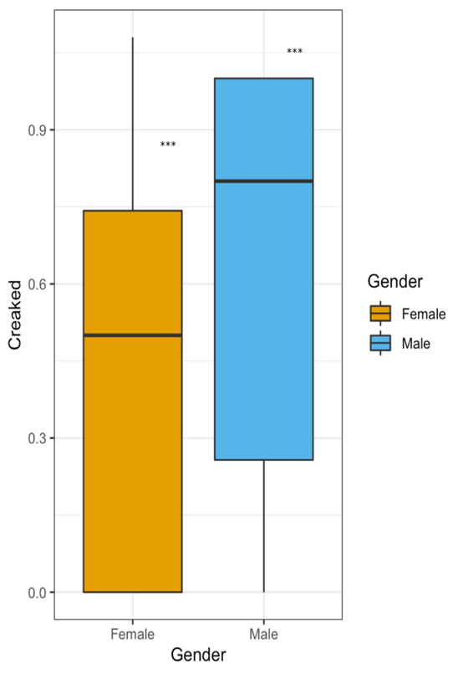
Figure 1. A visual representation of creak by gender

Position Analysis

While men do creak more than women in this study, some interesting results were found regarding the discourse factors of creak. Both genders’ creak percentages were analyzed within end of utterance, filler word, known language, parenthetical, response, and throughout speech. End of utterance refers to words occurring at the end of an intonational units. Known language occurs when the speakers are telling the audience something that is already understood, which may occur for clarification and framing purposes. Parentheticals are segments of speech that are not relevant to the overall meaning of the sentence and are typically set off by commas. Filler words are relatively useless words used between segments of speech that do not convey any new information. They are typically adopted by speakers to fill pauses that occur when deciding what to say next within a conversation. Some examples of filler words are “um,” “so,” “ya know,” and “but.” Response words are utterances occurring in reply to a question or statement. They are typically used as a way to answer questions or affirm the speaker. Examples of response words include “yes,” “okay,” and “great.” Throughout speech is the phrase I used within my coding to indicate creaky voice that is occurring throughout an entire speech segment. Lastly, none indicates that no creaky voices was found within an utterance.
Results show a significant difference between males’ and females’ percentage of creak for filler words (r = 0.6403, p <.05). In this study, males utilize creaky voice more with filler words. It was also found that a strongly significant difference exists between the use of creak within response words. Females adopted creaky voice within response words at a substantially higher percentage when compared to males (r = 0.6403, p <.05). Further, a significant difference is present between male and female use of creak throughout speech (r = 0.6403, p<.05). It was found that males utilize creak much more throughout their entire speech segment, while females utilize creak more in selective parts of discourse. This finding is interesting, as it suggests females may be using creak, either subconsciously or unconsciously, in certain situations or parts of discourse to sound more authoritative or confident. Males, conversely, seem to be using creak throughout their speech instead of at select places. This may simply be due to the fact that their voices are lower and thus creak may be more likely to occur.
No effect was found between percentage creak and end of utterance, known language, and parenthetical speech segments between genders.

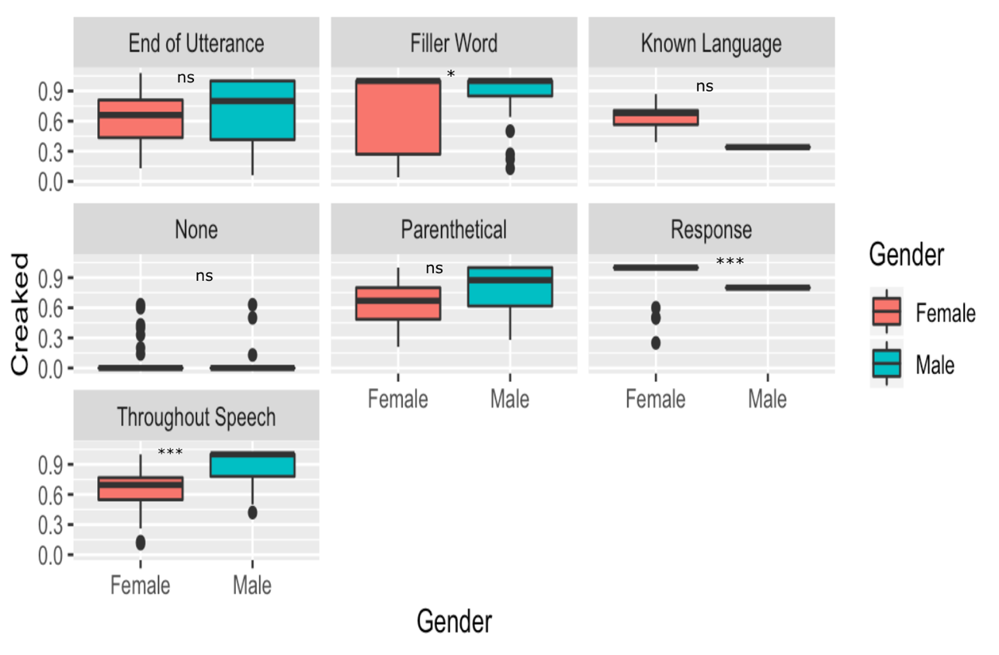

Figure 2. A visual representation of creak within a speech segment

Conversational Entrainment Analysis
Beyond gender and position analyses, the data has presented some interesting findings regarding both the start time and duration of creak. A regression was run to evaluate the relationship between these factors. This test was run because continuous variables were being analyzed. The data shows a strong relationship between the start of speech segments and percentage creak within both the dyad and the focus group (r = 0.01663, p <.001). This result indicates that the later the speech occurs within both groups, the higher percentage of creak there is within the intonational unit. Essentially, this reveals that both the participants and the facilitator were creaking more the longer they were in the interview and the focus group. This effect may be due to conversational entrainment where all speakers are trying to modulate their voices to match their interlocutors. Borrie and Delfino (2017) have posited that conversational entrainment often happens naturally by speakers, as they are trying to be congenial and relatable with their conversational mates. It seems likely that this could be the phenomenon happening in these two settings. It is possible that one person came into the group already creaking throughout much of their speech, and the others in the group were attempting to match their style of speech in order to increase likeability.
The data was further subset by focus group and dyad to evaluate whether a difference presented itself between the two different recordings. A regression was run on both subsets to determine a potential correlation. Results indicate that percentage creak and the start time of a vocal segment are significantly correlated within the dyad (r = 0.05534, p <.05). Further, percentage creak and the start time of a vocal segment presented an even greater relationship within the focus group (r = 0.1382, p<.001). Therefore, conversational entrainment was occurring at a less significant rate in the dyad compared to the focus group. These findings suggest that the number of speakers present may have a positive effect on conversational entrainment. The more speakers there are within a group, the more likely conversational entrainment seems to be. I speculate that this is the result of peer pressure and social conformity, a “type of social influence involving a change in belief or behavior to fit into a group” (McLeod, 2016). I posit that conformity is the underlying reason for the higher percentages of creaky voice within the focus group.
Creak as a Turn-Taking Device

A regression analysis was also conducted to evaluate the relationship between percentage creak and the duration of a speech segment. Like the regression conducted for conversational entrainment, this test was run because continuous variables were being analyzed. The results presented very significant findings between these two factors (r = 0.006915, p <.05). These findings suggest that the longer the speech segment, the more creaky voice was utilized by the speakers. This potentially suggests that speakers creaked as they were trying to figure out how to end their speech segment and give the speaking floor to another speaker. This reveals that creaky voice may be interacting with turn-taking, as the speakers may be utilizing creaky voice while they are attempting to close their own speech segment and give another speaker the opportunity to interact. The reason for greater creak percentages in longer speech segments could also be because the speakers are running out of breath toward the end of their utterances, and their pitch naturally drops as a result. Since creaky voice and pitch drop are strongly correlated, this could be another explanation for this finding.
The data was further subset by focus group and dyad again to evaluate a potential difference in the way those two groups interacted and took turns. A regression analysis was then conducted again on both subsets to evaluate the relationship between the duration of an intonational unit and the percentage creaked. The data reveals that a positive relationship exists between the duration of speech and percentage of creaky voice (r = .006915, p <.05). The regression analysis conducted on the focus group revealed a highly significant relationship between the duration of speech and the percentage creak (r = .7697, p<.001). While a significant relationship is present between these two variables within the dyad, the relationship between them within the focus group presents a much higher significance level. This most likely means that the more speakers present within a group, the more difficult turn-taking between interlocutors becomes. Creaky voice seems to be a technique utilized by speakers when trying to give the speaking role to another converser.
This analysis was taken one step further, and a multiple regression was conducted investigating duration of speech, percentage creak, and percentage of creak within a parenthetical. This test was run because I needed to analyze several different continuous variables at once. Results show a significant relationship between these three variables in the focus group (r = 0.2457, p <.001). This seems to indicate that speakers may be creaking more within parentheticals when they are trying to figure out how to end their speaking turn. Conversely, there was an insignificant relationship present between these factors within the dyad. This further solidifies the theory that turn-taking becomes much more difficult the more speakers there are interacting together.

Role Analysis
Lastly, tests were conducted to determine a potential correlation between use of creak and the position of the speaker. A series of independent samples t-tests were run analyzing the role of the speaker, participant or facilitator, and the percentage of creak utilized within various speech segments. T-tests were conducted because the data is normal, and categorical variables are being analyzed.
No effect was found between percentage creak within filler word, end of utterances, and role.
Despite these insignificant results, a significant difference in the scores for creak within response words between participants (M = 0.0358, SD = 0.185) and the facilitator (M = 0.0922, SD = 0.279) was found in both the focus group and the dyad (t (2.0178) =139.44, p <.05). These findings suggest that the role of the person within the focus group and the dyad affected how much they creaked within response words. While the reason for this is slightly unclear, it could be partly due to the nature of each role. Naturally, the participants were asked more questions and responded more to the facilitator.
A significant relationship was also found between role and percentage creak throughout speech between the participants (M = 0.0380, SD = 0.127) and the facilitator (M = 0.0124, SD = 0.0370) (t (-3.5219) = 507.56, p<.001). This suggests that the participants used creaky voice throughout their entire intonational units more than the facilitator overall. This is a skewed distribution because the facilitator is a female, and it was found that males in this study creak more throughout their speech. Furthermore, a significant relationship exists between role and percentage creak within known language between the participants (M = 0.000905, SD = 0.00841) and the facilitator (M = 0.02, SD = 0.0474) (t (4.2463) = 112.97, p <.001). The facilitator creaked significantly more within known language compared to the participants. This result can be attributed to the fact that the facilitator was often framing questions with known language by repeating information the participants already knew before giving the question.
Lastly, the data shows a strong relationship between role and percentage creak within parentheticals between the participants (M = 0.0219, SD = 0.0841) and the facilitator (M = 0.00375, SD = 0.0184) (t (-3.9771) = 492.33, p <.001). This suggests that participants utilized creaky voice within parenthetical phrases much more than the facilitator. The reason for this is unclear but could be attributed to the fact that the participants often spoke in longer sentences and speech segments. This may have naturally given way to more parentheticals within their speech when compared to the facilitator. It may also be because the participants had to do a lot more work in terms of conversational negotiation as discussed previously, as there were seven participants and only one facilitator. The participants were talking back and forth with each other more than the facilitator was, so this effect could have something to do with turn-taking. Participants may have utilized creaky voice within turn-taking if they were feeling unconfident or hesitant about when to give the floor to another speaker. The next section will highlight this turn-taking phenomenon in greater detail.

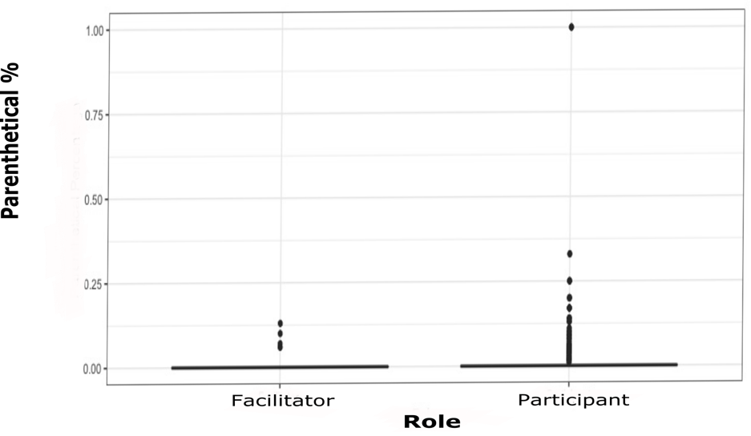
Figure 3. A visual representation of parenthetical percentage by role

Discussion
This study seeks to answer a few questions regarding creaky voice. Namely, these questions are as follows: Do women or men utilize creaky voice within their speech? Do the two genders use creaky voice in different ways? How does a speaker’s role within a conversation influence the use of creak? How do interactional effects such as turn-taking and conversational entrainment affect the utilization of creaky voice? While this study cannot fully answer these questions, the data does provide preliminary information regarding these topics. The findings of this study can be summarized as follows. The male speakers produce a significantly higher percentage of creaky voice when compared to their female counterparts. However, genders do differ in their use of creaky voice within speech segments. For instance, the male speakers utilize creaky voice more within filler words such as “uh” and “um” than the female speakers. Further, the female speakers use creaky voice more than their male counterparts within response words such as “yes” and “yeah.” Interestingly, males are also creaking their voices for the majority of many of their speech segments. Females, on the other hand, seem to be using creak only within select parts of the intonational unit. One possible explanation for this could be that males have naturally lower voices, so their physiological tendency toward creaky voice is greater. Furthermore, females may subconsciously use creak at select parts of the sentence to sound more authoritative or credible, as many researchers have previously posited (Ligon et al. 2019; Henton & Bladen 1988).
In terms of creaky voice and role, a significant relationship was found between role and creak within response words, known language, throughout speech, and parentheticals. The significant relationship between creak percentage and role is particularly interesting, as participants have much higher rates of creak within parenthetical segments. One reason for this may be that participants are having to do more negotiating with fellow interlocutors, so they have a more difficult time at turn-taking. Interestingly, a significant relationship was found between duration of speech, percentage creak, and percentage creak within a parenthetical segment in the focus group. This seems to indicate that speakers may be creaking more within parentheticals when they are trying to figure out how to end their speaking turn.
In terms of the interactional factors, it has been found that conversational entrainment is occurring in both the focus group and the dyad, echoing the findings of Borrie and Delfino (2017). Moreover, conversational entrainment is even more prevalent within the focus group than the dyad. This suggests that the more people within a group, the more prevalent conversational entrainment will be. Creaky voice is also being used as a way to negotiate turn-taking within speakers. This is a finding that has not appeared much in studies of creaky voice in English speakers, with only one known study discussing it (Ward, 2006). However, Ogden (2001) finds that the phenomenon occurs in Finnish. The longer the speech segment, the more creaky voice was utilized by the speakers in both the focus group and the dyad. This potentially suggests that speakers creaked as they were trying to figure out how to close their speech segment and give the speaking floor to another speaker. This relationship between the duration of a segment and creaky voice percentage was even greater within the focus group, indicating that the more speakers present within a group, the more difficult turn-taking between interlocutors becomes. Creaky voice seems to be a technique utilized by speakers when trying to give the speaking role to another converser.
Considerations for further research
The remainder of this chapter discusses the potential for future research regarding creaky voice, gender, and other interactional factors. Important considerations are discussed regarding the participant sample, language, and the method of analysis.
Participants
Further research should include people from a variety of ethnicities and cultural backgrounds into a single study. Because this study is being conducted at a Primarily White Institution (PWI), most of the participants are White. This resulted in an inability to conduct meaningful analyses regarding ethnicity. Future research should include a diverse pool of participants to fully understand how all ethnicities utilize or do not utilize creaky voice. Further, different age groups should be considered in future research. This study includes many people between the ages of 18-20 because the students being interviewed are from a first-year composition course at a university. Only one participant is within another age bracket, so this resulted in the inability to include meaningful analyses of age and generational differences of creaky voice. Lastly, this study can only provide findings for male and female speakers. Further research should be conducted regarding transgender, pangender, and non-binary individuals. There is a limited amount of research that has been done regarding transgender individuals and their use of creak, and more inquiry into this population is needed (e.g., Zimman, 2018).
Locality
Future studies should analyze creaky voice production alongside locality. This study was not able to evaluate locality because not all the participants provided information about where they were from. Many researchers in the field argue that further research is needed regarding creaky voice and diverse localities to understand the function and usage of creak with the United States (Yuasa, 2010; Ligon et al., 2019).
Language and Dialect
Future research should be conducted that analyzes rates of creaky voice in other Englishes, such as British English, Italian English, Chinese English, and Spanish English. Very little research has been done regarding other Englishes outside of American English. There is some research that indicates creak may function differently in languages other than American English, but more research is needed on this topic (Abdelli-Beruh, Wolk, & Slavin, 2014; Garellek & Keating 2011; Callier 2013).
Settings

This study has analyzed creaky voice within the context of a formal setting at a university, which could have impacted the usage of creak among the facilitator and the participants. There is some evidence that suggests women may use creaky voice to sound authoritative or credible, so it is possible that the female participants have higher levels of creak because they are trying to sound more professional or academic. Future research should evaluate creaky voice production within more casual settings, such as a gathering with friends. Conducting studies in a variety of settings would allow creak to be evaluated within both professional and personal spaces.

Method of Analysis

Auditory methods were utilized for this study, with the Principal Investigator (PI) judging whether creak or modal voice was occurring within speech in both the focus group and the dyad. Because of the potential for subjectivity, interrater reliability was gathered by sending ten percent of the voice files via Google Drive to another linguist. Future research may also consider automated acoustic methods as a way to detect creaky voice. A more automated method for detection may be more sustainable and replicable for future research regarding creaky voice (Drugman et al., 2014).
Conclusion

This study seeks to answer important questions surrounding the production of creaky voice. The data here suggests that male speakers creak more overall than female speakers. Males do creak more throughout entire speech segments; but female speakers are more likely to creak at select places, which may reflect the unconscious choice to sound more authoritative or credible. The use of creaky voice is influenced by the social role of the speaker within a conversation. Lastly, conversational entrainment and turn-taking both influence the use of creaky voice.
To more greatly understand creaky voice, it is important to understand how, why, and when it is occurring. While studies have demonstrated that creak is affected by conversation entrainment, little research has been conducted that suggests creak may have something to do with duration of speech and turn-taking. For this reason, my study contributes new ideas to the existing literature regarding creaky voice and interactional features. It seems that the more interlocuters present, the higher the percentage of creak. This relationship between duration and creak is especially present within the focus group where several participants were attempting to engage in discourse together. More studies should be conducted that evaluate the potential relationship between turn-taking and creaky voice, both in dyads and in larger group settings. This study provides some information as to the production of creaky voice, and the next study will analyze the popular perceptions of creaky voice.

Chapter Four
Study Two: Perception Study

Introduction

The previous study evaluated the production of creaky voice and how it is affected by gender, role, and interactional factors like conversational entrainment and turn-taking. In this study, I seek to investigate people’s perceptions of creaky voice and how those perceptions may differ based on demographic factors, as well as certain linguistic features. This study is heavily influenced by the perception studies of Ligon et al. (2019) and Yuasa (2010). I model my perception study in a similar way to Yuasa (2010), as I extracted audio clips and had participants listen and rank the voices. The methodologies of Ligon et al. (2019) shape my study as well. They insert female audio clips into their survey, and I had my participants rank female voices as well. Further, I chose similar adjectives to Ligon et al. (2019) and inserted varying degrees of modal and creaky voice into the survey.
The objective of my study is to determine the public’s perception of creaky voice and whether it is an overall negative or positive one. Specifically, this study asks the following questions: How does gender of the speaker and the listener interact with people’s perceptions of creaky voice? How does age interact with perceptions of creak? Is there a relationship between locality and creak? Does someone’s education level affect how they perceive creak? Are perceptions of creak affected by where the feature is located within an intonational unit?
Methods

This study asks participants to take a survey in which they anonymously evaluate a variety of different voices based on a Likert scale. I first gained IRB approval for use of the audio segments from the Writing Program study audio analyzed in Study one. Next, I extracted audio clips from the Elan transcript through Audacity. I chose to analyze the position of creak within an intonational unit, focusing specifically on parentheticals, known language, and end of utterance. In total, I extracted thirty-six audio files that averaged ten to fifteen seconds each. I gathered an equal number of modal and creaky vocal segments, with six audio segments for each position within the intonational unit. I chose to narrow my study by only inserting audio clips from female speakers into the survey. I narrowed my study in this way because previous research has been primarily interested in how female creaky speakers are perceived, so I followed that line of investigation (Ligon et al., 2019). There is also some evidence within the literature that male and female voices may be perceived differently, so I chose to only analyze female speakers for this reason as well.

Table 1. Table of Intonational Units
Creaky Voice | Modal Voice
End of Utterance | End of Utterance
Parenthetical | Parenthetical
Known Language | Known Language

I then inserted these audio clips into my survey through Qualtrics. The first section of the survey asked participants to enter their demographic information, including age, gender, ethnicity, education level, and locality. I chose these demographic features based on previous literature that indexed the potential importance of these factors (e.g., Yuasa, 2010; Ligon et al., 2019). I then created thirty-six questions that ask the participants to rate the speakers they hear based on several different criteria (Ligon et al., 2019). The questions were randomized, so each participant received ten questions in different order. Only ten questions were given to reduce the prevalence of survey fatigue. Participants were asked to rate these speakers without any knowledge of the vocal features being tested. The survey was distributed to participants through an anonymous link on social media and email. All participant data was anonymized, and an informed consent was given on the first web page preceding the survey.
Within the survey, the participants were asked to listen to the randomized audio segments they were presented and subsequently rate the voices on a Likert scale, with one being the lowest and ten being the highest. They rated the speakers’ voices based on how they perceived their attractiveness, intelligence, capability, trustworthiness, competency, responsibility, accent, likeability, honesty, and studiousness. This study was influenced by Ligon et al. (2019) who conducted a perceptions study based on similar criteria, as they used similar adjectives like “desirable,” “uneducated,” and “confident” (Ligon et al., 2019). After conducting the survey, I summarized the participants’ demographics and answers to each question in a dataset. Ninety-four responses were recorded, and the specific demographics collected were age, gender, ethnicity, education level, and locality i.e., small town, big city, rural area, etc.).
It should be noted that two participants within the 55-64-year-old age group (N = 3) were removed from the data because they presented as outliers. Only three participants within that age group completed the survey, and two of the participants answered with very high numbers for every attribute. The other participant in the group did not start their evaluation of the voices. Because that specific sample was so small, the two participants who ranked the voices were removed to avoid skewing the data. One individual within the 65-74-year-old range (N = 1) responded to the survey as well, but they did not answer any of the questions about voice perceptions. One participant within the study chose not to answer any demographic questions, and they are labeled as “unknown.” The following table outlines the participant demographics, including their gender, age, ethnicity, education level, and locality.

Table 2. Table of Participants
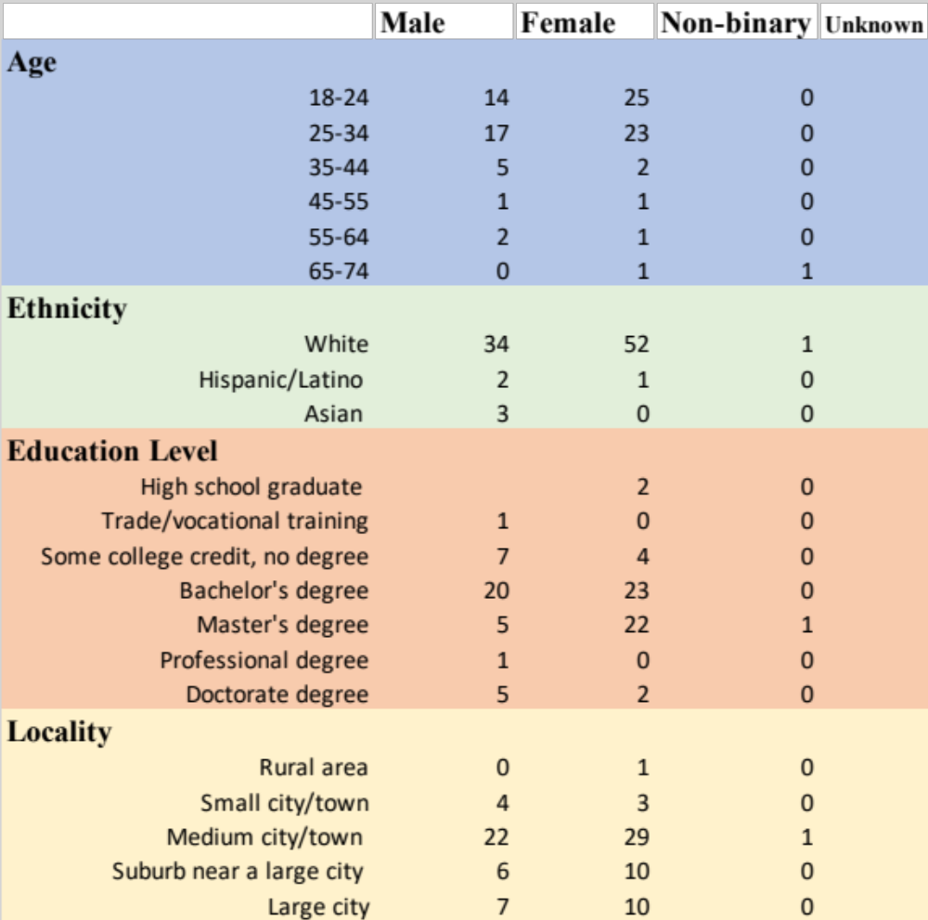

After collecting the data, I conducted an analysis of participants’ responses and how they were affected by their age, gender, education level, ethnicity, and locality. I further investigated whether the position of creak within an intonational unit influenced listeners’ perceptions. Lastly, I built graphs in R that further summarize the data and provide visualizations of my study’s findings.
Results
Correlation
The first test I conducted was a correlation test to verify the validity of the survey responses and determine how the participants were conceptualizing the traits they were being asked to rank. I ran a correlation test and then constructed a correlation graph. The following graph highlights how correlated the participants’ answers were. The strongest correlations are between intelligent and studious; capable and studious; attractive and likeable; trustworthy and capable; trustworthy and competent; trustworthy and responsible; honest and trustworthy; and honest and responsible. Notably, accented is not correlated to any attribute on the chart because it is not a synonym for any of the other traits. Because the participants answered similarly for related characteristics, this test and its corresponding visualization are internal checks verifying that participants answered the questions honestly. These high correlations between attributes authenticate the soundness of the survey because it demonstrates participants understood the task they were being asked to complete.

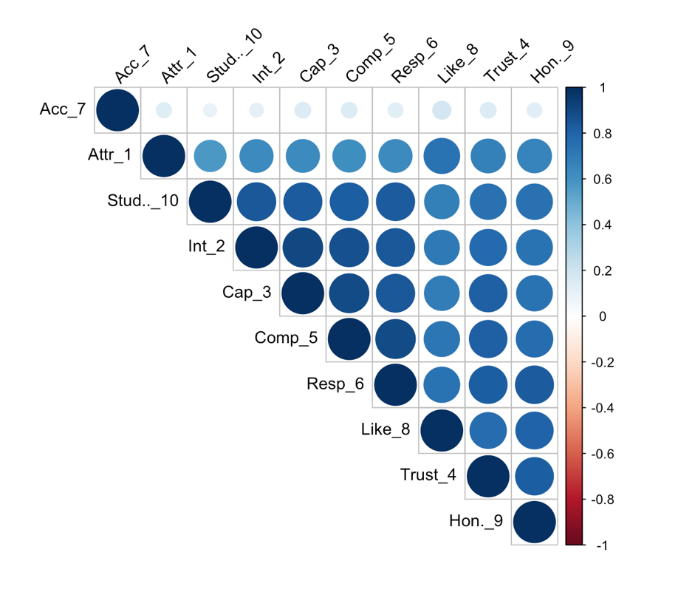
Figure 4. Correlation Plot

Perception and Gender
I next analyzed perceptions of creaky voice regarding gender. A Wilcoxon test was used to determine whether people of different genders perceived creaky voice in different ways. This test was conducted because the data is not normalized, and the variables are categorical. This test result indicated that gender has a significant relationship with every attribute. It was found that gender and attractiveness have a significant relationship, with females (N = 53) perceiving creak as more attractive than males (N =39) (W = 9840.5, p<.05). It was found that gender and intelligence have a significant relationship as well, with females viewing creaky voice as significantly more intelligent when compared to males (W = 9957.5, p<.05). Further, a very significant relationship exists between gender and capability, with female listeners perceiving speakers of creaky voices as more capable when compared to male hearers (W = 10081, p<.01.) A significant difference exists between how the two genders perceive how trustworthy a creaky speaker is as well. The female hearers view creaky speakers as more trustworthy than the male hearers do (W = 9761, p<.05). While this may be partly an effect of creak, it may also be a gendered effect. Since only female voices were used in this survey, it may be an effect of females finding their own gender more trustworthy overall. A significant relationship is additionally present between competence and gender, with females viewing speakers who creak as more competent than their male counterparts (W = 9761, p<.05). In addition, a significant relationship is present between responsibility and gender, with females viewing speakers who creak as more responsible (W = 9718.5, p<.05). No effect was found between accentedness and gender. This is an interesting finding because accentedness is the only attribute that is not related to the other features. A very significant effect was found between likeability and gender, with females perceiving speakers of creak as much more likeable than their male counterparts (W = 10558, p<.001). No effect is present between genders’ perceptions of the speaker’s level of honesty. Lastly, a significant effect is present between genders’ perceptions of a creaky speaker’s studiousness, with females viewing creaky voice as more studious sounding than males (W = 9844, p<.05). The following graphs visualize these findings, with gender labeled on the x-axis and the specific attribute labeled on the y-axis.

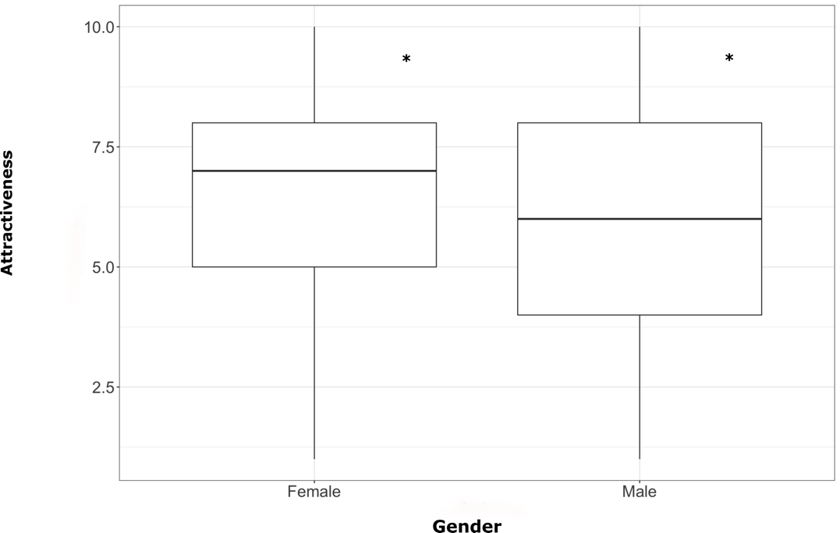
Figure 5. Attractiveness and Gender

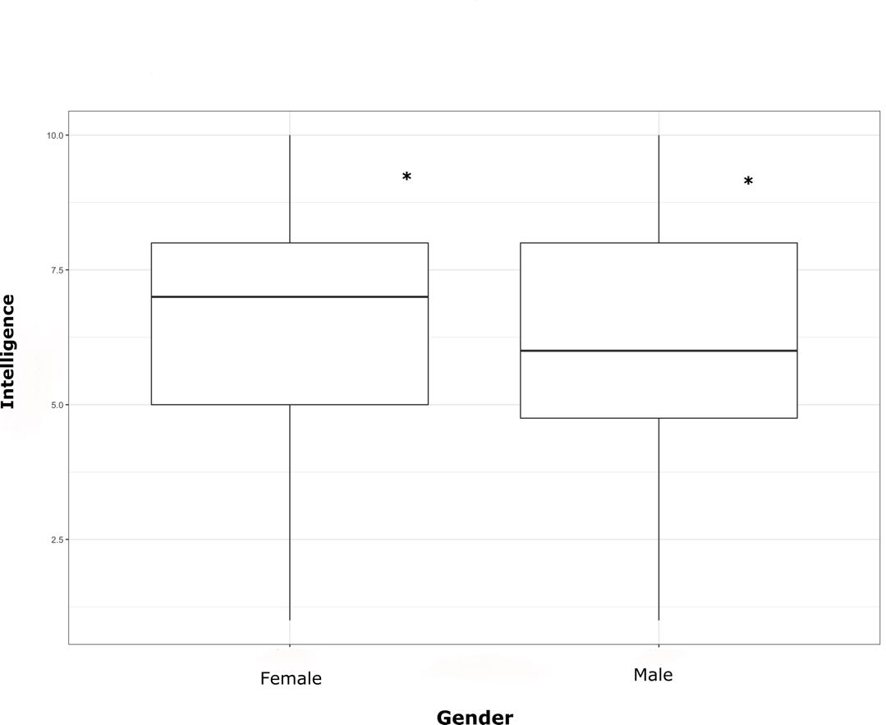
Figure 6. Intelligence and Gender

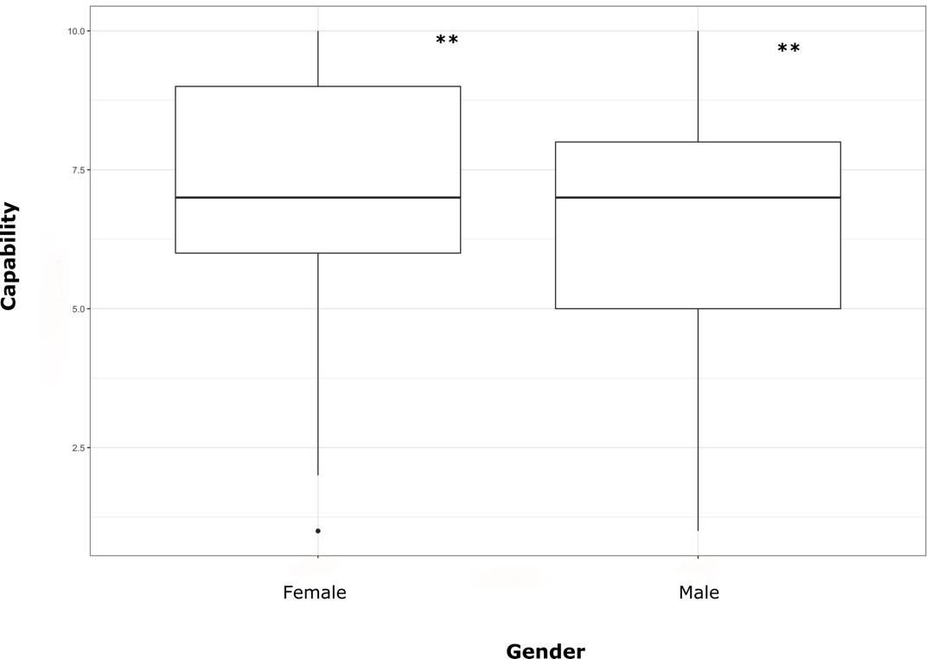
Figure 7. Capability and Gender

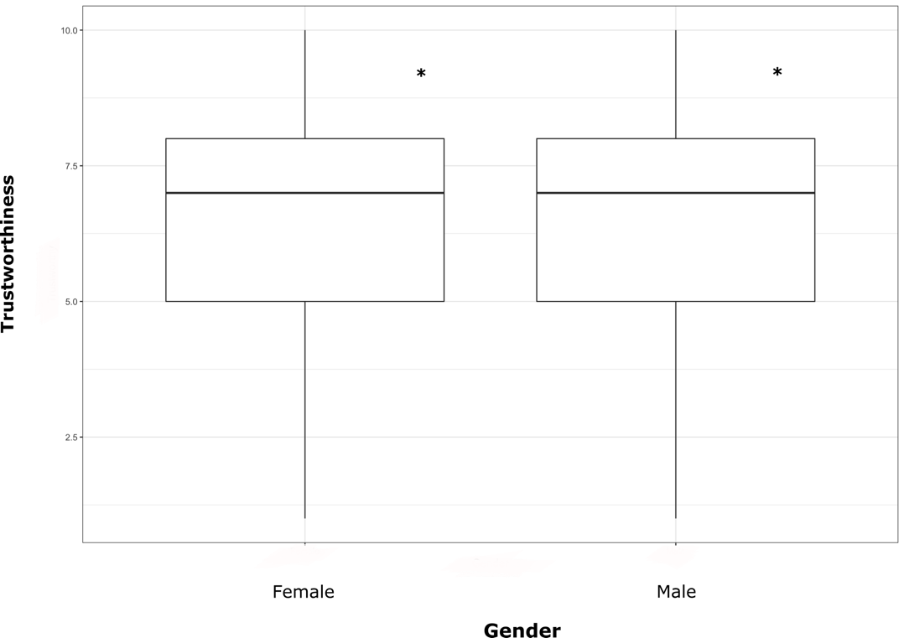
Figure 8. Trustworthiness and Gender

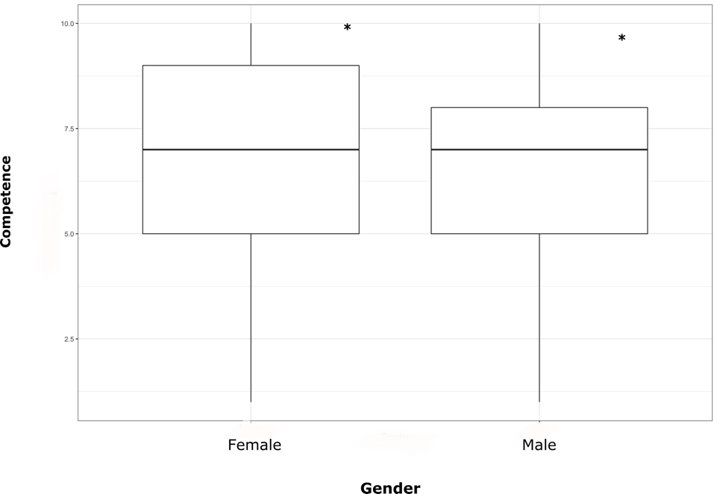
Figure 9. Competence and Gender

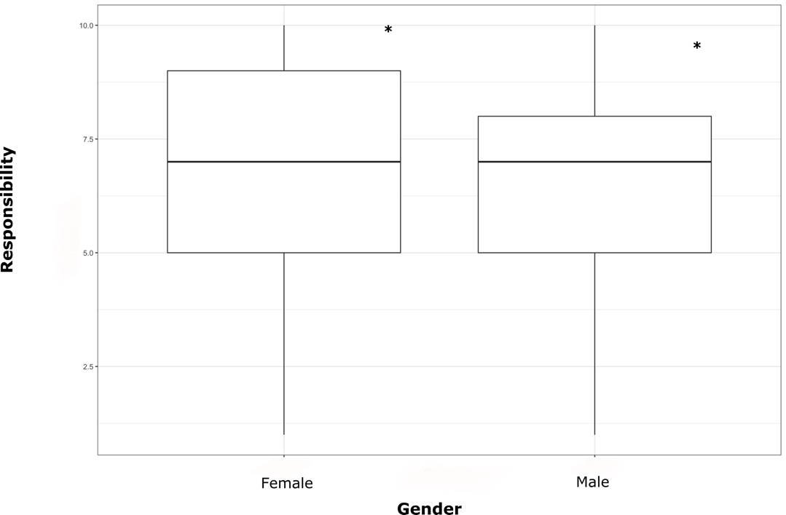
Figure 10. Responsibility and Gender

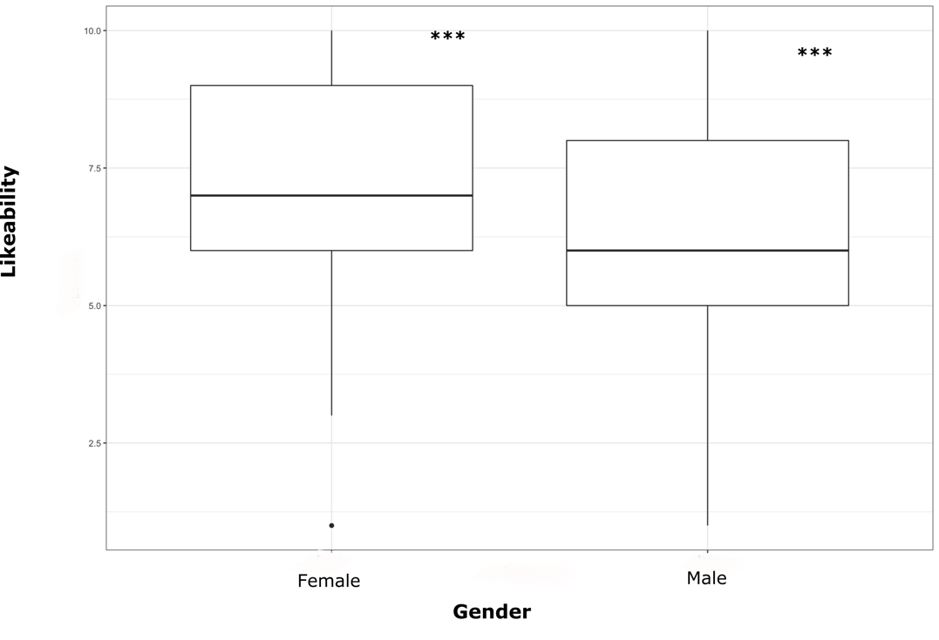
Figure 11. Likeability and Gender

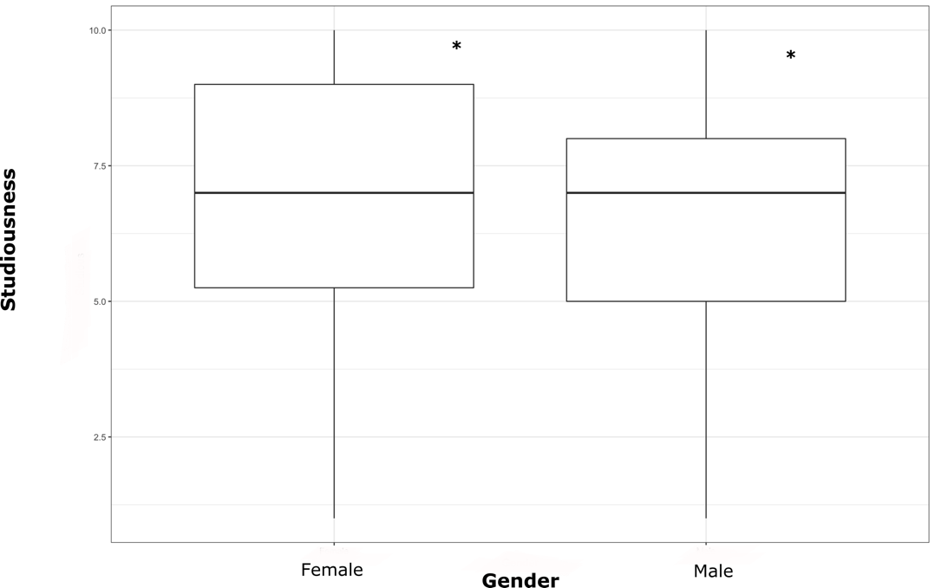
Figure 12. Studiousness and Gender

Gendered Effect or Creak Effect

To determine if females perceiving creaky voice as better than males on nearly all counts is an effect of creaky voice or a gendered effect, I have subset the data for modal and evaluated whether males and females responded differently to modal voice. I ran a Wilcoxon test to evaluate this and found a statistically significant relationship between gender and perceptions of modal voice as well. Females viewed modal voice as significantly more attractive than males did (W = 10182, p<.05). Females also perceived modal voice as significantly more intelligent than their male counterparts (W = 10778, p<.01). The relationship between capability and gender was also significant, with females once again ranking modal voice as more capable than males did (W = 10988, p<.01). The relationship between trustworthiness and gender is highly significant, with females ranking modal voice as more trustworthy than males (W = 11277, p<.001). The relationship between competence and gender is strongly significant, with females ranking modal voice as more competent (W = 10732, p<.01). Females perceive speakers of modal voice as more responsible (W = 10819, p<.01). Females perceive the speakers as more accented, though that is most likely not a gendered effect (W = 11286, p<.001). A strong relationship exists between gender and likeability as well, with female listeners ranking speakers of modal voice as more likeable (W = 10883, p<.01). Further, a statistically significant relationship exists between gender and honesty, with females perceiving speakers of modal voice as significantly more honest than males perceive them (W = 11440, p<.001). Lastly, a statistically significant relationship exists between gender and studiousness, with females viewing speakers of modal voice as more studious (W = 10810, p<.01). These findings suggest that what is taking place is a gendered effect, rather than an effect of creak.
Locality and Perceptions

Perceptions of creaky voice were next evaluated based on participants’ locality, or their place of residence (e.g., small town, big city, suburbs, rural, etc.) Four different localities were analyzed: small city/town (N = 7), medium city/town (N = 52), suburb near a large city (N = 16), and large city (N = 17). A Kruskal-Wallis test was used to evaluate the perceptions of the various attributes based on locality. This was conducted to explore several categorical variables simultaneously within non-normalized data. Interestingly, the only attribute that presented a significant effect was accentedness. The participants were asked to rate how accented they found the creaky speaker, and those from a small town rated the creaky speakers as more accented than the other participants (H (12.629) = 3, P<.01). However, the participants from a small town also found the modal speakers as more accented than the other participants (H (10.575) = 3, P<.05). It is unclear why people from a small town would view participants as more accented, but it is clear that it is not an effect of creak. It could have something to do with location. Since many of my participants are from the South, they may have been unfamiliar with some of the speakers’ northern and midwestern accents. Accents tend to be stronger in smaller towns, so this may be why speakers in smaller towns were more likely to rate speakers with northern accents as accented.

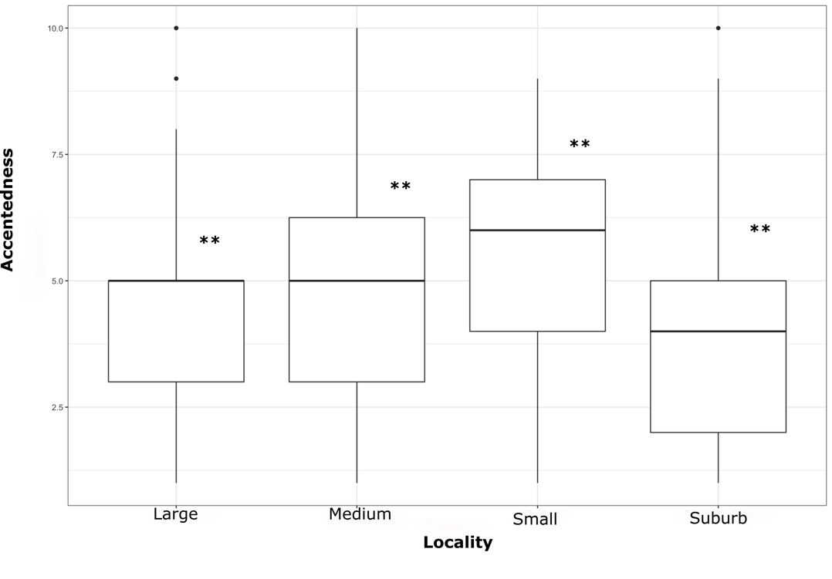
Figure 13. Locality and Accented

Age and Perceptions

Next, perceptions of creaky voice were analyzed based on participants’ ages, with three age groups being compared: 18-24 (N = 39), 25-34 (N = 40), and 35-44 (N = 7). No effect was found for age and participants’ perception of a creaky speaker’s attractiveness, trustworthiness, responsibleness, accent, likeability, honesty, and studiousness. However, a strong effect was found between age and perceptions of intelligence, with 35–44-year-olds finding creak more intelligent than the younger populations (H (7.944) = 2, P<.05).

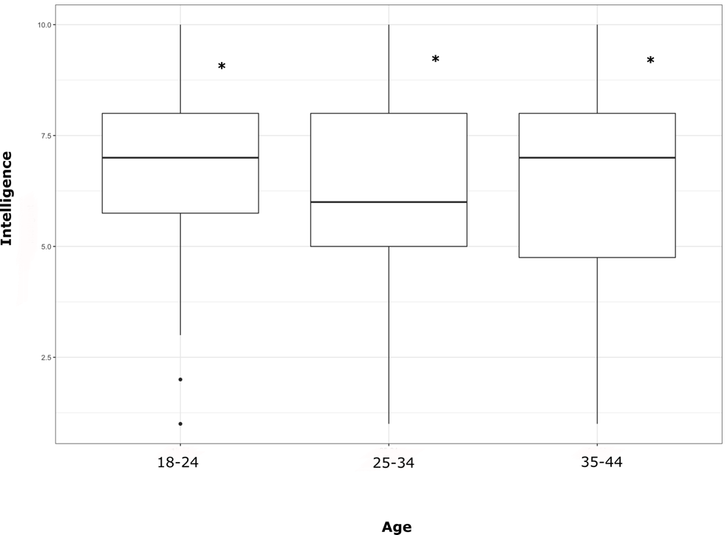
Figure 14. Age and Intelligent

A strong effect was also found between age and perceptions of capability, with 18–24-year-olds viewing creaky voice as more capable than the older populations (H (6.9117) = 2, P<.05).

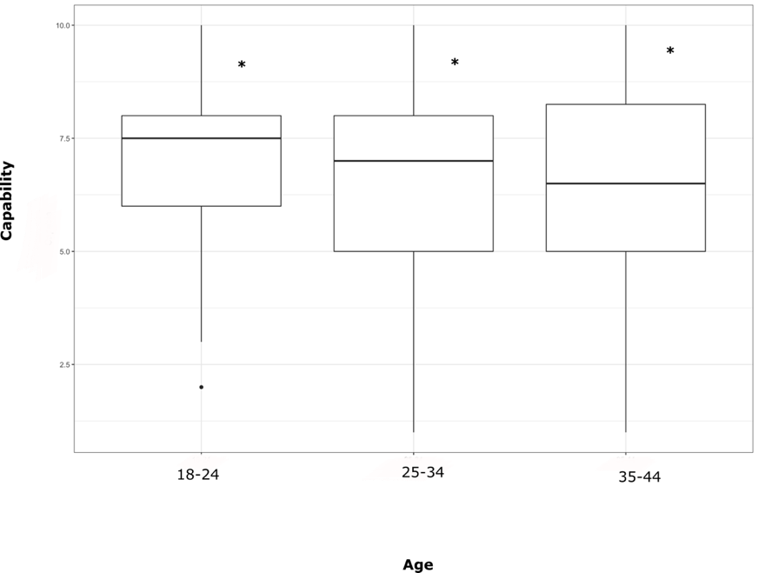
Figure 15. Age and Capable

Education and Perceptions
Next, perceptions of creaky voice were analyzed based on participants’ education levels, with seven different levels being compared: high school graduate (N = 3), some college credit/no degree (N = 11), technical/vocational training (N = 1), bachelor’s degree (N = 43), doctorate degree (N = 7), master’s degree (N = 28), and professional degree (N = 1). No effect was shown for studiousness, responsibleness, competence, trustworthiness, capability, intelligence, or attractiveness. However, a significant effect was found for accented and likeability. The data shows a significant effect between participants’ level of education and how accented they found a speaker using creaky voice, with high school graduates and those with some college credit viewing the creaky speakers as more accented (H (26.62) = 5, P<.001). A statistically significant effect was found between education level and how likeable participants perceived creak as well. High school graduates and those with some college credit perceived creaky voice as significantly more likeable than those in the other education categories (H (11.561) = 5, P<.05).

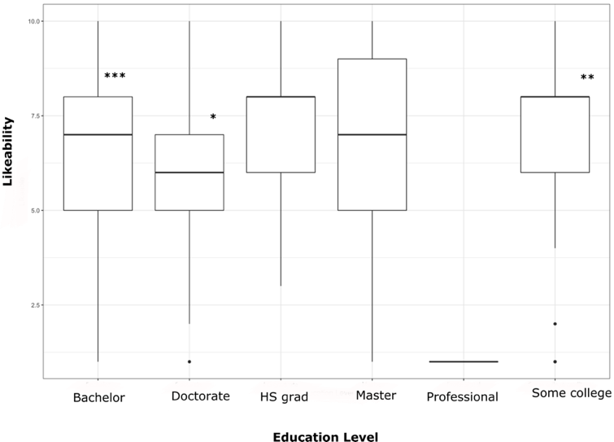
Figure 16. Education Level and Likeable

Position and Perceptions

A t-test was run to explore the relationship between creak position and perception among participants. No significant results were found for creak in known language, end of utterance, and parentheticals. Participants did not perceive creak differently based on its position within an intonational unit.
Discussion

This study has attempted to answer the following questions: Do different genders perceive creaky voice differently? Do people from different education levels and communities perceive creak differently? Do people generally have positive or negative perceptions of creak? This chapter provides a limited exploration of these questions into creaky voice and perception. The findings of this study can be summarized as follows. First, this study has found that females perceive speakers who utilize creaky voice as better on all accounts. They have rated the creaky speakers higher than male participants did according to every attribute. Female participants also perceive modal voice as better in every attribute. Beyond gender perceptions, this study’s findings show that those living in a small town find speakers more accented and perceive creaky voice as more likeable when compared to those living in other localities. The study also finds a few age effects, with 35-44-year-olds perceiving creaky voice as more intelligent. Alternatively, 18-24-year-olds find creaky voice to sound more capable. It is unclear whether these age results demonstrate anything conclusive or comprehensive. Lastly, the data demonstrates that the participants with less education perceive both creaky and modal speakers as more accented and perceive creak as more likeable. It should be noted, however, that the “some college” (N = 11) group and the “high school degree” (N = 3) group are fairly small within my study, so that may slightly affect the efficacy of the results regarding higher education.
Considerations for further research

The remainder of this chapter discusses the potential for future research regarding creaky voice, gender, and other interactional factors. Important considerations are discussed regarding the participant sample, identity of the speaker, accent, and rate of speech.
Participant Pool

More research is needed regarding the perceptions various ethnicities have of creaky voice. My study has very little diversity and is composed primarily of White participants. Therefore, tests were not able to be conducted regarding the effect of ethnicity on perceptions of creak. Further, more research should be conducted with older participants. While my study does have three age groups, it still skews young with every participant being under fifty years old. More research needs to be conducted on older populations’ perceptions of creaky voice. Furthermore, future studies should include a wider array of genders in their participant pool. Only males and females partook in my survey, but it would be interesting to see the perspectives of transgender, pangender, and agender populations (Zimman, 2018). Lastly, most of my participants are highly educated, with the majority being college educated individuals. Future research should include more participants who do not have college degrees.

Content of Speech
This study consists of academic speech, and the participants only discuss their coursework within both the focus group and the dyad. While participants were instructed at the beginning of the survey to only focus on the voices, it is possible that the listeners judged the speakers based on the actual content they heard as well. Future perception studies should include a diverse array of audio clips that cover many different topics.
Speakers’ Identity
For this study, only female voice audio clips were inserted into the survey. This study can provide some liminal findings into perceptions of creaky voice, but future studies should include audio clips from male voices. The study finds that a gendered effect seems to be happening, as females are rating both creaky voice and modal voice as better across all attributes. It would be interesting to see if the inclusion of masculine voices would produce the same results. A future study should evaluate whether male participants rate masculine voices, both creaked and modal, as better across all attributes when compared to the female participants.
Perceptions and Accent
A future study should be conducted that evaluates whether participants perceive accented creaky voice as better or worse overall. It would be interesting to evaluate whether accent is a confounding variable with creak.

Perceptions and Rate of Speech

A future study should also be conducted that evaluates whether rate of speech affects how creaky voice is perceived. Some previous studies have evaluated this phenomenon and found that creaky voice at a faster rate is perceived more positively than creaky voice at a slower rate. Future research should be conducted regarding this singularity (Parker & Borrie, 2017).
Conclusion
This study aims to answer important questions surrounding the perceptions of creaky voice—namely, whether genders perceive creak voice differently, whether education level affects perceptions, whether locality affects opinions of creak, whether age affects perceptions, and whether the position of creak within an intonational unit impacts perception of creak. While the data presented here cannot fully answer these questions, it does provide preliminary information regarding these topics. Interestingly, it seems that a gendered effect may be taking place. Females have ranked creaky voice as more attractive, but they have also rated modal voice as more attractive and better in every attribute. This indicates that it is not an effect of creak happening but rather one of gender. Females may be raking the feminine voices higher because they identify with their own gender.
In terms of education level, it seems that those with less education view creak as more likeable. In relation to age, 35-44-year-olds perceive creak to sound more intelligent. 18-24-year-olds perceive creaky voice to sound more capable. It is unclear why these age differences exist, though they do provide some evidence of age affecting perception of creak. In terms of locality, participants who live in a small town ranked the creaky speakers as more accented. This most likely is not an effect of creak but rather an effect of the participants being unfamiliar with some of the northern and midwestern accents present in the audio clips.
The findings that I have presented here suggest that an individual’s identity does affect the way in which they perceive creaky voice. This study is important and relevant to current scholarship and discourse because it contributes to public knowledge of creaky voice and the ways in which it functions and is perceived in the world. This study provides an alternative answer to the question of perception. Many previous studies have found that creaky voice is perceived as more negative, but this study found that creaky voice is generally perceived as more positive by females (Ligon et al., 2019; Anderson et al., 2014). The research presented in my study raises important questions regarding the intersection of the gender effect and perceptions of creaky voice. Is it that males perceive creaky voice as worse, or is it that they perceive female speakers as worse according to all attributes? Since I found that creaky and modal voice were rated higher by females than males, this indicates that what is really going on here is a gendered effect. It would be fruitful to pursue future research about the gender effect and creaky voice. A future study should be conducted that includes male creaky voice audio clips as well as female audio clips. Then participants’ responses could be compared, and it could be determined whether or not a true gender effect is taking place. Future directions should take this gender effect into account in order to truly understand perceptions of creaky voice.

Chapter Five
Conclusion

The research presented in my thesis aims to address unanswered questions and knowledge gaps concerning creaky voice. I have sought to answer the subsequent questions: How do different genders both produce and perceive creaky voice? In what ways does each gender take up creak within an intonational unit? How does social role impact the use of creaky voice? How do interactional effects like conversational entrainment and turn-taking affect the usage of creak? How do age, locality, and education level interact with production and perception of creak? Are perceptions of creaky voice affected by where the feature occurs within an intonational unit? I will now discuss the findings of both studies, recommendations for my own future research, recommendations for future research in the field, and contributions to knowledge about creaky voice that my work provides.
Overall Findings
Gender
Study one found that males incorporated creaky voice into their speech more than females. However, the data reveals that the position in which each gender creaked is different. There was not a gender effect for creak within parentheticals and end of utterances; both genders produced creak in those two places. However, it was found that males adopted creak more when speaking filler words, such as “um” or “uh.” Females adopted creak more when speaking response words, such as “yes,” “yeah,” and “okay.” Males also creaked their voices more throughout entire segments of speech, rather than just in certain places. This may be because their voices are lower, so it is more natural for them to creak throughout speech. It is also a significant finding because it reveals that while male speakers are creaking more, they are not creaking as much at select places within a sentence. Female speakers, on the other hand, are not creaking as much throughout their entire speech segments. This could be an indication that they are subconsciously deciding when and where to utilize creaky voice within an intonational unit in order to present themselves in certain ways to their audience.
Gender effects were present within study two as well, which evaluated listeners’ perceptions of creaky voice. It was found that female listeners perceived creaky voice as better regarding every single attribute in the survey: attractiveness, intelligence, capability, trustworthiness, competency, responsibility, accent, likeability, honesty, and studiousness. Conversely, the male listeners ranked creaky voice lower on every attribute. Interestingly, however, the female listeners also perceived modal voice as better according to all attributes when compared to the male listeners. This may indicate that what is occurring is more of a gendered effect, rather than one of creak. The female listeners may have ranked the creaky speakers higher on the Likert scale because all of the speakers they listened to were also female. This could be a gendered effect, with females liking the speakers better than males simply because they are the same gender.
Age, Locality, and Education Level
No age effects were found within study one because there was not enough variability within age for it to be tested. Ethnicity effects were also not evaluated for either study because each study consisted of mainly White participants. However, study two did reveal some interesting results in terms of age, locality, and education level. Within the perception study, the data reveals that 18-24-year-olds rated speakers of creaky voice higher in terms of capability than the other age groups. Further, 35-44-year-olds rated creaky speakers as more intelligent than the other age groups. This is a perplexing finding, since capability and intelligence typically connote similar meanings. One possible explanation for this strange finding is that different generations are comprehending the characteristics differently. Perhaps, each age group means similar things, but they have different language to describe a similar trait.
Beyond age, some interesting results were also found regarding locality and education. It was found that participants living in a small town perceived creaky voice as more likeable than those living in a larger and more urban place. Effects of education levels were also analyzed, and it was found that participants with less education perceived creaky voice as more likeable than those with higher levels of education.
Interactional Effects
Conversational Entrainment
Lastly, some interesting interactional effects seem to be taking place within study one. The data has presented a positive relationship between the start time of speech within intonational units and percentage creak. This result indicates that both the participants and the facilitator were creaking more the longer they were in the interview and the focus group. This effect may be due to conversational entrainment where all speakers are trying to modulate their voices to match their interlocutors. Borrie and Delfino (2017) have posited that conversational entrainment often happens naturally by speakers, as they are trying to be congenial and relatable with their fellow conversers. It seems likely that this could be the phenomenon happening in these two settings.
Further, results found that percentage creak and the start time of an intonational unit yielded an even greater relationship within the focus group. Therefore, conversational entrainment was occurring at a less significant rate in the dyad compared to the focus group. These findings suggest that the number of speakers present may have a positive effect on conversational entrainment. The more speakers there are within a group, the more likely conversational entrainment seems to be. This is an interesting finding because it suggests that group dynamics may also be causing greater conversational entrainment; participants are modulating their voices in an attempt to more positively relate with their interlocuters.
Turn-Taking
A positive relationship was found between percentage creak and the duration of an intonational unit. The longer the speech segment, the more creaky voice was utilized by the speakers. This potentially indicates that speakers creaked as they were trying to figure out how to end their speech segment and give the speaking floor to another speaker, revealing that creaky voice may be interacting with turn-taking. The speakers may be utilizing creaky voice while they are unsure of how to end their turn and close their own speech segment. Participants may be subconsciously adopting creak as a way to signal the end of their turn and hand the speaking floor over to another converser.
Moreover, the data reveals an even more positive relationship between the duration of speech and percentage of creaky voice within the focus group. This could indicate that the greater number of speakers present within a group, the more difficult turn-taking between interlocutors becomes. Lastly, the data reveals that duration of speech, percentage creak, and percentage creak within a parenthetical within the focus group have a positive relationship with each other. This may mean that speakers are creaking more within parentheticals when they are trying to figure out how to end their speaking turn. Conversely, there was an insignificant relationship present between these factors within the dyad. This further solidifies the theory that turn-taking becomes much more difficult the more speakers there are interacting together. My findings echo Ogden (2011) who finds creaky voice to be prevalent within turn-taking in Finnish and Ward (2006) who studies creaky voice’s interaction with turn-taking in English.
Recommendations for My Own Further Research
Gender
While these studies have presented some intriguing findings, some limitations are present as well. First, I would like to do more research in terms of the relationship between creaky voice and gender. Study one presents some interesting gender effects, but more studies would need to be conducted that analyze other female and male speakers. It is possible that some of the male speakers’ voices in the focus group were more creaky than the average male speakers. Conversely, it is possible that some of the female speakers within the participant pool were less creaky than some other female speakers. More studies would need to be conducted to come to a robust conclusion. Within study two, a gender effect is present, with female listeners rating the female speakers higher overall. Male audio clips need to be included in a future study to obtain a more accurate picture of how the two genders perceive creak.
Age
Study one is mainly comprised of college-aged students between eighteen to twenty years old because the data was collected at a university. Only one participant from study one was outside of the college-aged range, as the facilitator is a woman in her mid-thirties. Therefore, the results from study one are not representative of the greater population. In future studies, I need to include a greater variety of ages into my participant pool.
Study two is comprised of three age categories: 18-24-year-olds, 25-34-year-olds, and 35-44-year-olds. Two participants above fifty years old had to be removed from data because they were presenting as outliers. While the findings in study two are more representative than study one, the data still skews young. To acquire a comprehensive view of how creaky voice functions in society, future studies need to include older populations as well.
Ethnicity
Both studies primarily consist of White individuals. Study one consists of all White participants except for one Asian individual in the dyad. Since the majority of participants were White, an accurate analysis of the data regarding ethnicity was not able to be conducted. Because this data was extrapolated from a PWI, the participant pool is not as diverse as it could be. Future studies should be conducted that explore how different ethnicities and cultural groups produce creaky voice. Study two’s participant pool is more diverse, but it still skews overwhelmingly White. For this reason, an ethnicity analysis was not run for the perception study. Future studies should attempt to gather a more diverse array of survey participants.
Locality
While a locality analysis was performed for study two, the same analysis was not able to be completed for study one. Participants in the production study did not give accurate information for their locality, as some gave the city they grew up in and some gave the state. Without a way to decipher whether they grew up in a smaller or larger city, the locality analysis was not able to be completed. Future research should evaluate how the locality of the speaker may affect their production of creaky voice (e.g., Yuasa, 2010).
Educational Level
More research should be conducted that evaluates the influence of education level on both production and perception of creaky voice. The production study does not provide a diversity of education levels because every participant is pursuing a college education. To attain a comprehensive view of how education impacts production of creak, more studies should be run that have an equal representation of education levels present among participants. The perception study offers more diversity, as participants are coming from different education levels. However, many of the participants in study two are at least college educated, so the participant pool skews highly educated. To fully understand how education may affect the perception of creak, more studies need to be performed that have an equal representation of education levels.
Interactional Factors
Study one has presented thought-provoking findings, but future studies should evaluate other interactional factors as well. Drawing from Parker and Borrie (2017), future studies I conduct should analyze how rate of speech impacts perception of creak. Parker and Borrie (2017) find that creaky voice is perceived more positive when it occurs alongside faster speech rates, but it is perceived more negatively when it occurs with slower speech rates. I was not able to conduct this analysis because of a limitation of resources, but future studies could account for this interactional factor.
Recommendations for Future Research in the Field
Gender
As I have previously mentioned, several unanswered questions currently exist regrading creaky voice and gender. A consensus as to which gender produces more creak, or if gender is a significant factor in creaky voice production, has not been reached as a field. Much research has been conducted vis-à-vis this topic, but various researchers are coming to vastly different conclusions. More research should continue to be conducted to reach a conclusive standpoint as a field (Podesva, 2013; Yuasa, 2010; Wolk et al., 2012; Lee, 2015; Dallaston & Docherty, 2020).
Social Role
Little research has been conducted regarding creaky voice and its interaction with social role. For instance, does an individual in a position of authority creak more or less than someone who is in more of a deferential position? It would be interesting to see future studies that look at the effect of social and professional roles on creak production (Ligon et al., 2019).
Age
While some studies have certainly evaluated a diverse array of ages, most production and perception studies seem to focus on college students (Oliviera et al., 2016). More diverse studies in terms of age should be conducted.
Other Englishes
Most of the current literature centers around creak production in American English, and very few studies exist that look at other Englishes. A couple of British English studies have been produced recently, but even more studies analyzing various Englishes are necessary to attain a comprehensive view of how creaky voice is utilized in society (Lee, 2015; Gittelson et al., 2021, Abdelli-Beruh, Wolk, & Slavin, 2014). The United States is very diverse, and not everyone speaks American English. A greater sense of how speakers of other Englishes interact with creaky voice is essential.
Methods of Detection
Many of the studies that have been conducted have been run with auditory methods. The auditory method is a valid way of analyzing creak production and is the method I used in my own studies as well, but some researchers argue for more automated methods. However, researchers have suggested that future research should also consider automated acoustic methods as a way to detect creaky voice. A more automated method for detection may be more sustainable and replicable for future research regarding creaky voice (Drugman et al., 2014).
Contributions of Knowledge
Gender
My thesis contributes some interesting findings to overall knowledge of creaky voice in the field. In terms of gender’s interaction with creaky voice, my study one findings echo Irons and Alexander (2016), Abdelli-Beruh, Wolk, & Slavin (2014), Lee (2015), and Gittleson et al. (2021) because like these studies, I have also found that males are creaking more than females. However, my findings are contradictory to the findings of Yuasa (2010), Henton and Bladen (1988), Abdelli-Beruh et al. (2013), and Wolk et al. (2012) who suggest that females creak more than males overall. Even though male speakers creak more than female speakers within study one, I concur with researchers and linguists in the field who claim more quantitative data needs to be collected before the field can arrive at significant and conclusive findings (Podesva, 2013; Yuasa, 2010; Wolk et al., 2012; Lee, 2015; Dallaston & Docherty, 2020; Abdelli-Beruh et al., 2016; Irons & Alexander, 2016). Regarding perceptions of creaky voice, my study two findings are in line with Yuasa (2010) and Dilley, Shattuck-Hufnagel, & Ostendorf (1996) who find perceptions of creak to be mostly positive. My results do not agree with Ligon et al. (2019) and Anderson et al. (2012). who discover perceptions of creaky voice to be neutral to negative. However, I have a gendered effect present within my data that does not appear in the Ligon et al. (2019) study. To come to a more conclusive stance regarding perceptions of creaky voice, I would need to alter my study in the future to account for perceptions of both male and female creak.
Interactional Effects
My study one results confirm and expand upon the work of Borrie and Delfino (2017), as I find that conversational entrainment is most likely occurring in both the focus group and the dyad. Further, I add to the discussion of conversational entrainment, as I note that it is more likely to affect rates of creak production in larger group settings.
My findings in study one also suggest an interactional effect that has been only briefly studied in English and Finnish (Ward, 2006; Ogden, 2001). I find that creaky voice percentage and duration of an intonational unit may be positively correlated due to the effect of turn-taking. Participants seem to be using creaky voice as a way to indicate that their turn is finishing, and they wish to give the speaking floor to another interlocuter. This relationship between creaky voice and duration of a speech segment is even greater within the focus group, which may further suggest that as turn-taking becomes more difficult, more creak is adopted within speech. I also connect these ideas to the position of creak within an intonational unit and find that speakers may be creaking within parenthetical segments while they try to end their talking turns. This study would need to be replicated to confirm that these interactions are indeed taking place; but nevertheless, these findings are significant contributions to the field and current knowledge of creaky voice.
My thesis has aimed to fill in some of the gaps present within the literature, which are namely gender’s interaction with creak production, social role’s interaction with creak production, interactional effects on creak production, demographic factors’ interaction with creak perceptions (e.g., age, locality, educational level), and creak position’s interaction with perceptions. Taken as a whole, these results confirm that gender has an important interaction with creaky voice productions and perceptions and that interactional effects such as conversational entrainment and turn-taking seem to significantly influence the production of creaky voice within speakers.

References

Abdelli-Beruh, Wolk, & Slavin. (2014). Prevalence of vocal fry in young adult male
American English speakers. Journal of Voice. 28. 2. 185-190.

Abdelli-Beruh, Drugman, & Owl. (2016). Occurrence frequencies of acoustic patterns of
vocal fry in American English speakers. Journal of Voice. 30. 6. 12-20.

Abercrombie, David. (1967). Elements of general phonetics. Edinburgh: Edinburgh
University Press.

Anderson et al. (2014). Vocal fry may undermine the success of young women in the
labor market. PLOS One. 9. 5. 1-8.

Behrman & Akhund. (2017). The effect of loud voice and clear speech on the use of
vocal fry in women. Folia phoniatrica et logopaedica. 68. 4. 159-166.

Blomgren et al.(1998). Acoustic, aerodynamic, physiologic, and perceptual properties of
modal and vocal fry registers. The Journal of the Acoustical Society of America. 103. 5. 2649–58.

Borkowska & Pawlowski. (2011). Female voice frequency in the context of dominance
and attractiveness perception. Animal Behaviour. 82. 1. 55-59.

Borrie & Delfino. (2017). Conversational entrainment of vocal fry in young adult female
American English speakers. Journal of Voice. 31. 4. 25-32.

Cantor-Cutiva et al. (2018). Factors associated with vocal fry among
college students. Logopedics Phoniatrics Vocology. 43. 2. 73-78.

Cantor-Cutiva et al. (2018). Vocal fry and vowel height in simulated room acoustics.
Folia Phoniatrica et Logopaedica. 69. 3. 118-124.

Coates, Jennifer. (1986). Women, men, and language: a sociolinguistic account of sex
differences in language. London; New York: Longman.

Crystal. (1997). Dictionary of Linguistics and Phonetics. Oxford:
Blackwell.

Dallaston & Docherty. (2020). The quantitative prevalence of creaky voice (vocal fry) in
varieties of English: A systematic review of the literature. PLoS One. 15. 3. 1-18.

Davidson, Lisa. (2020). Contributions of modal and creaky voice to the perception of
habitual pitch. Language. 96.1. 22-37.

Dilley, Shattuck-Hufnagel, & Ostendorf. (1996). Glottalization of word-initial vowels as
a function of prosodic structure. Journal of Phonetics. 24. 1. 423-44.

Drugman, Kane, & Gobl. (2014). Data-driven detection and analysis of the patterns of
creaky voice. Computer Speech and Language. 28. 5. 1233-1253.

Eddington & Taylor. (2009). T-Glottalization in American English. American Speech. 84.
3. 298–314.

Edmondson & Esling. (2006). The valves of the throat and their functioning in tone,
vocal register and stress: laryngoscopic case studies. Phonology. 23. 2.157.

Fairbanks, Garrett. (1960). Voice and articulation drill book. New York, NY.

Garellek & Keating. (2011). The acoustic consequences of phonation and tone
interactions in Mazatec. Journal of the International Phonetic Association. 41. 2.
185-205.

Gibson, Todd. (2016). Voca fry use in adult female speakers exposed to two languages.
Journal of Voice. 31. 4. 510.

Gittelson et al. (2021). Using crowd-sourced speech data to study socially constrained
variation in nonmodal phonation. Frontiers in Articificial Intelligence. 1-9.

Grivičić & Nilep. (2004). When phonation matters: The use and function of yeah and
creaky voice. Colorado Research in Linguistics. 17. 1. 1-11.

Henton, Caroline, & Anthony Bladen. (1988). Language, Speech, and Mind: Studies in
Honour of Victoria A Fromkin. London: Routledge.

Hollien et al. (1966). On the nature of vocal fry. Journal of Speech Language and
Hearing Research J Speech Hear Res. 9. 2. 245-247.

Irons & Alexander. (2016). The Journal of the Acoustical Society of America.140. 4.
3397.

Keating & Kuo. (2012). Comparison of speaking fundamental frequency in English and
Mandarin. The Journal of the Acoustical Society of America. 132. 2. 1050-
1060.
Ladefoged, Peter. (1982). A Course in Phonetics. Cengage Learning.

Laver, John. (1968). Voice quality and indexical information. International Journal of
Language & Communication Disorders. 3.1. 43-54.

Lee, Sinae. (2015). Creaky voice as a phonational device marking parenthetical segments
in talk. Journal of Sociolinguistics. 19. 3. 275-302.

Ligon et al. (2019). Perceived desirability of vocal fry among female speech
communication disorders. Journal of Voice. 33. 5. 805.e21-805.e35.

McLeod, S. (2016). What is conformity? Simply Psychology.
https://www.simplypsychology.org/conformity.html.

Melvin & Clopper. (2015). Gender variation in creaky voice and fundamental frequency.
Proceedings of the 18th International Congress of Phonetic Sciences. Glasgow, UK: The University of Glasgow. 1–5.

Mendoza, Denton. (2011). The semiotic hitchhiker’s guide to creaky voice: Circulation
and gendered hardcore in a chicana/o gang persona. Journal of Linguistic Anthropology. 21. 2. 261-280.

Ogden, Richard. (2001). Turn transition, creak and glottal stop in Finnish talk-in-
interaction. Journal of the International Phonetic Association. 31. 1. 139-
152.

Oliveira et al. (2016). A comparison of the use of glottal fry in the spontaneous speech of
young and middle-aged American women. Journal of Voice. 30. 6. 684-687.

Parker & Borrie. (2018). Judgements of intelligence and likeability of young adult female
speakers of American English: The influence of vocal fry and the surrounding acoustic-prosodic context. Journal of Voice. 32. 5. 538-545.

Pépiot, Erwan. (2014). Male and female speech: A study of mean f0, f0 range, phonation
type and speech rate in parisian French and American English speakers. Speech Prosody. 7.1. 305-309.

Pennock, B. (2005). The Changing Voice of Women. Actas del XXVII congress
internacional de AEDEAN. 407-415.

Podesva, Robert J. (2007). Phonation type as a stylistic variable: The use of falsetto in
construct a persona. Journal of Sociolinguistics. 11. 4. 478-504.

Podesva & Callier. (2015). Voice quality and identity. Annual Review of Applied
Linguistics. 35. 1. 173-194.

Podesva & Chun. (2010). Voice Quality and Indeterminacies of Social Meaning in
Constructed Dialogue. Paper presented on the panel, Indeterminacy in Sociolinguistics, at Sociolinguistics Symposium (SS) 18, Southampton.

Podesva & Lee. (2010). Voice quality variation and gender in Washington, D.C. Paper
presented at NWAV39, 4–6 November, San Antonio, Texas.

Pratt, Teresa. (2018). Affective Sociolinguistic Style: An Ethnography of Embodied
Linguistic Variation in an Arts High School. Doctoral dissertation, Stanford University. PLoS One.

Puts et al. (2007). Men’s voices as dominance signals: Vocal fundamental and formant
frequencies influence dominance attributions among men. Evolution and Human Behavior. 28. 1. 340-344.

Slobe, Tyanna. (2018). Style, stance, and social meaning in mock white girl. Language in
Society. 47. 4. 541-567.

Titze, Ingo. (1994). Principles of Voice Production. 1st ed. Prentice Hall,
Englewood Cliffs.

Ward, Nigel. (2006). Non-lexical Conversational Sounds in American English.
Pragmatics and Cognition 14. 1. 129–82.

Watson, Stephanie. (2019). The unheard female voice. The ASHA Leader. 24. 2.

Wolk et al. (2012). Habitual use of vocal fry in young adult female speakers. Journal of
Voice. 26. 3. 111-116.

Yuasa, Ikuko Patricia. (2010). Creaky voice: A new feminine voice quality for young
urban-oriented upwardly mobile American women? American Speech. 85.3. 315-337.

Zimman, Lal. (2018). Transgender voices: Insights on identity, embodiment, and the
gender of the voice. Language and linguistics compass. 12. 8. 1-16.

APPENDICES

Appendix A: Sample Survey

  - Which category below includes your age?
- 18-24
- 25-34
- 35-44
- 45-54
- 55-64
- 65-74

  - Please specify your gender.
- Male
- Female
- Non-binary / third gender
- Prefer not to say
c
  - Please specify your ethnicity.
- White
- Black or African American
- American Indian or Alaska Native
- Asian
- Native Hawaiian or Pacific Islander
- Hispanic or Latino
- Other

  - What is the highest degree or level of education you have completed?
- No schooling completed
- Nursery school to 8th grade
- Some high school, no diploma
- High school graduate
- Some college credit, no degree
- Trade/technical/vocational training
- Associate degree
- Bachelor's degree
- Master's degree
- Professional degree
- Doctorate degree
  - What type of community do you live in?
- Large city
- Suburb near a large city
- Medium city/town
- Small city/town
- Rural area

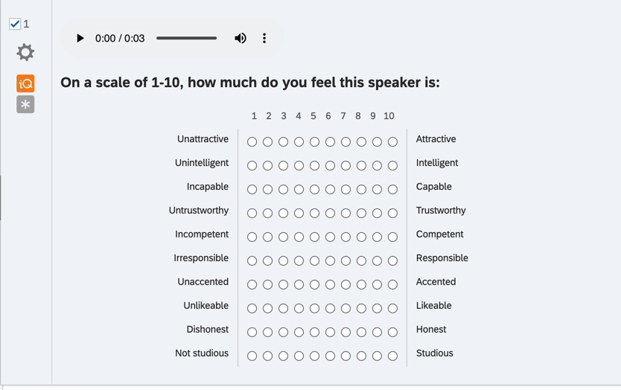

Appendix B: Survey Informed Consent

Research Study Title: Creaky Voice: Positionality and Perceptions

Researchers: Victoria Anita Voorhees, University of Tennessee, Knoxville
Jessica Grieser, University of Tennessee, Knoxville

We are asking you to be in this research study because you are a person who has a voice and listens to other people’s voices on a daily or weekly basis. We are interested in what people think of different voices. You’re going to hear voices and you should rate them based not on what they said, but on what you think your speaker is like, based on their voice. The information in this consent form is to help you decide if you want to be in this research study. Please take your time reading this form and contact the researcher(s) to ask questions, if there is anything you do not understand.

Why is the research being done?
This study is being conducted by researchers at University of Tennessee, Knoxville. The purpose of this research study is to discern and analyze people’s perceptions to various types of voices.

What will I do in this study?
If you agree to be in the study, you will complete an online survey. You will be given ten randomized vocal samples to listen and respond to. You will rank each vocal sample on a scale of 1-10, with 1 being the lowest and 10 being the highest. You will be asked to rank each vocal feature based on the quality traits intelligence, attractiveness, capability, trustworthiness, likeability, and studiousness. This survey should take an average of 10-15 minutes. You can skip questions that you do not want to answer. When you are finished, you may exit your browser.

Can I say “No”?
Being in this study is up to you. You can stop up until you submit the survey. At any time up until you submit the survey, you can end your participation by closing your browser. Your answers will not be stored. After you submit the survey, we cannot remove your responses because we will not know which responses came from you.
Are there any risks to me?
We do not know of any risks to you being in the study that are greater than the risks you encounter in everyday life.
Are there any benefits to me?
We do not expect you to benefit from being in this study. Your participation may help us to learn more about different voices. We hope the knowledge gained from this study will benefit others in the future.
What will happen with the information collected for this study?
The survey is anonymous, and no one will be able to link your responses back to you. Your responses to the survey will not be linked to your computer, email address, or other electronic identifiers. Please do not include your name or other information that could be used to identify you in your survey responses. Information provided in this survey can only be kept as secure as any other online communication.
Information collected for this study will be published and possibly presented at research conferences.
Will I be paid for being in this research study?
You will not be paid for being in this study.
Who can answer my questions about this research study?
If you have questions or concerns about this study, or have experienced a research related problem, contact the researchers, Anita Voorhees (vvoorhe2@vols.utk.edu) or Jessi Grieser (jgrieser@utk.edu).
Statement of Consent
I have read this form, been given the chance to ask questions and have my questions answered. If I have more questions, I have been told who to contact. By clicking the next button below, I am agreeing to be in this study. I can print or save a copy of this consent information for future reference. If I do not want to be in this study, I can close my internet browser.

VITA

Anita Voorhees grew up in Knoxville, Tennessee. After graduating from Bearden High School, she attended the University of Tennessee, Knoxville and received a Bachelor of Arts degree in English and a Bachelor of Arts degree in Psychology. Before graduating with her undergraduate degree, she knew she wanted to attend graduate school. She chose to attend the University of Tennessee, Knoxville to pursue a Master of Arts degree in English: Rhetoric, Writing, and Linguistics. Her research interests include second language acquisition, L2 writing, and sociolinguistics. She has recently earned her TESOL certificate and anticipates graduating with an MA in English and a Graduate Linguistics Certificate. She is incredibly grateful for all the support she has received from her thesis advisor, committee, department, colleagues, friends, and family.

This passage was first written by Grant Fairbanks, author of the Voice and Articulation Drillbook, and it is now a public domain text. It is read by students to test their speaking skills because it contains many of the sounds and phonemes present with the English language. Speech pathologists frequently use it to gather speech data and study a person’s speech patterns. It is useful to linguists as well because the diversity of linguistic elements allows for several different linguistic features to be tested by diverse researchers while utilizing the same text.

