RUMEN BIOGEOGRAPHICAL REGIONS AND THEIR IMPACT ON MICROBIAL AND METABOLOME VARIATION

A Thesis Presented for the
Master of Science
Degree
The University of Tennessee, Knoxville

Macey P. Soltis
December 2022

Copyright © 2022 by Macey P. Soltis
All rights reserved.

ACKNOWLEDGEMENTS

Thank you to my friends, family, and fiancé who have helped and encouraged me to pursue this degree and been there for me every step of the way. From helping me move in, to coming to visit me, and even cheering on the Tennessee volunteers from time to time (a tough ask for Florida gator fans). I know I would not have been able to complete this degree without all of your help and support.

Also, a huge thank you to all of my graduate student friends. Coming to a new state was a bit daunting for me, but everyone was so willing to help and be a friend when I needed one. Maddie, Katie, and Kirsten, I cannot thank you all enough for making my time here in Tennessee so much fun. I could not have imagined making better friends during my program.

I would like to thank my amazing committee members, Dr. Amanda McLean, Dr. Brynn Voy, and Dr. Sarah Moorey. They have worked hard to give me every opportunity to succeed and grow as a researcher and student.

Lastly, I would like to thank Dr. Phillip Myer, for supporting me through this process, even during the height of the pandemic, and agreeing to take me on as graduate student. I have learned so much, and I cannot thank him enough for every opportunity he has given me throughout these past two years.

ABSTRACT

The rumen microbiome is a complex microbial network critical to the health and nutrition of its host, due to their inherent ability to convert low-quality feedstuffs into energy. In rumen microbiome studies, the ventral sac is sampled from due to ease of access and repeatability. However, anatomical musculature demarcates the rumen into five sacs which may support distinct microbial communities. The distinction among the microbes may generate functional variation among the rumen microbiome, thus, specialized tasks within different sacs. The objective of this study was to determine the rumen liquid metabolome and epimural, planktonic, and fiber-adherent bacterial communities among each rumen biogeographical region. It was hypothesized that differences in bacterial species and metabolome would occur due to differing anatomy and physiology associated with the respective regions. To assess this variation, epithelial and content microbial-associated communities were evaluated, as well as the metabolites among various rumen biogeographical regions. A total of 17 cannulated Angus cows were utilized to examine the fiber-adherent (solid fraction), planktonic (liquid fraction), and epimural microbial communities from the cranial, dorsal, caudodorsal blind, caudoventral blind, and ventral sacs. Metagenomic DNA was extracted and sequenced from the hypervariable V4 region of the 16S rRNA gene. Reads were processed using packages ‘phyloseq’ and ‘dada2’ in R. Untargeted metabolomics were conducted on rumen liquid from each sac using UHPLC-HRMS and analyzed in MetaboAnalyst. An analysis of variance (ANOVA) revealed 13 significant differentially abundant metabolites with pairwise comparisons against the five rumen sacs (P < 0.05). Within the bacterial communities, neither alpha nor beta diversity determined significance against the rumen sacs (P > 0.05), although there was significance against the fraction types (P < 0.05) Utilizing MaAslin2, there were significant differential abundances found in fraction type × location (P < 0.05). Knowledge of similarities among fiber-adherent microbial communities provides evidence that single sac sampling is sufficient for this fraction. However, future projects focusing on either planktonic or epimural fractions, may need to consider multiple rumen sac sampling to obtain the most comprehensive analysis of the rumen. Defining these variabilities, especially among the rumen epimural microbiome, are critical to define host-microbiome interactions.

Table of Contents

Chapter One Literature Review 1
Introduction 1
Anatomy of the Rumen Affecting the Microbiome 1
Ruminal Environment Variations and its Impact on Microbial Community Variation 3
Ruminal Papillae Variation Among the Different Sacs 4
Microbial Community Variation, Fractions, and Importance in the Ruminant 7
Epimural Microbial Community 7
Interactions Among the Fiber-adherent and Planktonic Microbial Communities 8
Conclusion 9
Chapter Two Rumen biogeographical regions and their impact on microbial and metabolome variation 11
Abstract 12
Introduction 13
Materials and Methods 14
Animal Use Ethics Statement 14
Experimental Design 14
Solid and Liquid Fraction Sampling 14
Epimural Fraction Sampling and Papillae Biopsies 16
DNA Extraction 16
Liquid and Solid DNA Extraction 16
Epimural DNA Extraction 17
Amplicon Verification using Polymerase Chain Reaction (PCR) and Gel Electrophoresis 17
Amplification, Library Preparation, and Amplicon Sequencing 18
Ruminal Metabolites Extraction 18
Metabolomics Analyses 18
DNA Read Processing and Analyses 19
Statistical Analyses 19
Results 20
DNA Sequencing 20
Bacterial Differences Among the Fiber Adherent, Planktonic, and Epimural Fractions 20
Bacterial Phyla and Genera within the Fiber-adherent Community 21
Bacterial Phyla and Genera within the Planktonic Community 21
Bacterial Phyla and Genera within the Epimural Community 27
Differences in Bacterial Communities Among the Rumen Sacs 27
Analyses of Individual Fractions among Rumen Sacs - Fiber Adherent Bacteria 27
Analyses of Individual Fractions among Rumen Sacs - Planktonic Bacteria 32
Analyses of Individual Fractions among Rumen Sacs - Epimural Bacteria 32
Metabolomics 42
Discussion 42
Conclusions 52
List of References 53
Vita 62

LIST OF TABLES

Table 1 - Differential abundance among the three fraction types and the respective number of taxa found to be significantly abundant. 24
Table 2 - Differential abundant taxa found in the planktonic bacterial community among the five rumen sacs. 35
Table 3 - Differential abundance in the epimural bacterial communities among each of the five rumen sacs. 38
Table 4 - ANOVA table of metabolite differences among the five rumen sacs. 46

LIST OF FIGURES

Figure 1 - Rumen pillars and grooves visualized in a labeled rumen. 2
Figure 2 - Ruminal contraction cycles in a labeled rumen. 5
Figure 3 – Solid, liquid, and epimural samples collected from each rumen sac during day 1 and both solid and liquid samples collected on the second sampling day. 15
Figure 4 - Alpha diversity metrics in the three rumen fractions. 22
Figure 5 - Bray-Curtis principal coordinates analysis among the three fraction types. 23
Figure 6 - Bacterial phyla within each fraction type and their respective relative abundances. 25
Figure 7 - Top 20 Bacterial genera within each fraction type and their respective relative abundances. 26
Figure 8 - Alpha diversity metrics among the five rumen sacs bacterial communities. 28
Figure 9 - Bray-Curtis principal coordinates analysis among each rumen sac and their bacterial community. 29
Figure 10 - Alpha diversity metrics in the fiber-adherent fraction among the five rumen sacs. 30
Figure 11 - Bray-Curtis principal coordinates analysis of the fiber-adherent fraction among the five rumen sacs. 31
Figure 12 - Alpha diversity metrics in the planktonic fraction among the five rumen sacs. 33
Figure 13 - Bray-Curtis principal coordinates analysis of the planktonic fraction among the five rumen sacs. 34
Figure 14 - Alpha diversity metrics in the epimural fraction among the five rumen sacs. 36
Figure 15 - Bray-Curtis principal coordinates analysis of the epimural fraction among the five rumen sacs. 37
Figure 16 - Partial least-square discriminant analysis of metabolites among all five rumen sacs. 43
Figure 17 - Heat map of top 25 metabolites among the five rumen sacs. 44
Figure 18 - One-way ANOVA plot highlighting the significant metabolites through pairwise comparisons. 45
Figure 19 - Box plots from of all significant metabolites from the one-way analysis of variance. 47

LITERATURE REVIEW

Introduction

The beef cattle industry is a segmented system beginning in the cow-calf sector, moving through a grazing/pre-conditioning program, and finally, to a feedlot before harvest. Cattle are foregut fermenters that utilize a synergistic relationship with their microbiome to produce meat and milk during their life cycle. Cattle possess the capability to break down recalcitrant plant material into useable energy, which is due in part to distinct structure and microbial variation observed in the rumen (Sbardellati et al., 2020). With the aid of commensal and symbiotic microbes, the non-glandular, non-secretory rumen (Van Soest, 1994) is continuously fermenting feedstuffs and is kept as an anaerobic chamber with an average pH of 6.5 (Orpin, 1976). However, these conditions are a gross assessment, as each of the five rumen sacs effectively produce further distinct environments. These five different rumen sacs create different niche environments, demarcating specialized internal framework. The pillars, grooves, and folds increase the internal complexity of the rumen and therefore, how various microbial communities settle into these different ecosystems. Not only does anatomy contribute to variability within the rumen, but also diversity of microorganism populations inhabiting the rumen, including bacteria, archaea, protozoa, and fungi (Mizrahi & Jami, 2021). Microbial communities contribute not only to the nutrition of cattle, but also to the health and growth all throughout the production cycle. Over their lifetime, cattle will experience changes in diet, location, and management. However, cattle possess an innate adaptable microbiome that can acclimate to the many changes that will ensue (Weimer, 2015). This adaptable microbiome will guarantee essential microbes outcompete and thrive within the rumen. Commensal and symbiotic microbiota maintain essential roles within both cattle and overall production systems, due to their importance in providing energy for the host to grow and efficiently generate commodities for human-use. Therefore, it is critical to understand the rumen microbiome and how host interaction may affect the ruminal environment. In the future, this data may provide approaches on how to better moderate some of the recognized consequences of the typical production cycle, such as ruminal acidosis or methane production.

Anatomy of the Rumen Affecting the Microbiome

Cattle are essential to the global protein supply due to their unique ability to consume plant material that is indigestible to mammals and convert it into usable energy (C. R. Krehbiel, 2014). The fermentation of plant material is performed within cattle’s four-chambered stomach, which consists of the reticulum, rumen, omasum, and abomasum (C. R. Krehbiel, 2014), where the rumen provides a suitable environment for microbes to reside. Importantly, due to pillars, grooves, and folds demarcating the rumen, there are five distinct rumen sacs, creating variable sub-ruminal environments (Figure 1). Therefore, these distinct sacs may contain microbial communities that have acclimated to the varying biogeographical regions within the rumen.

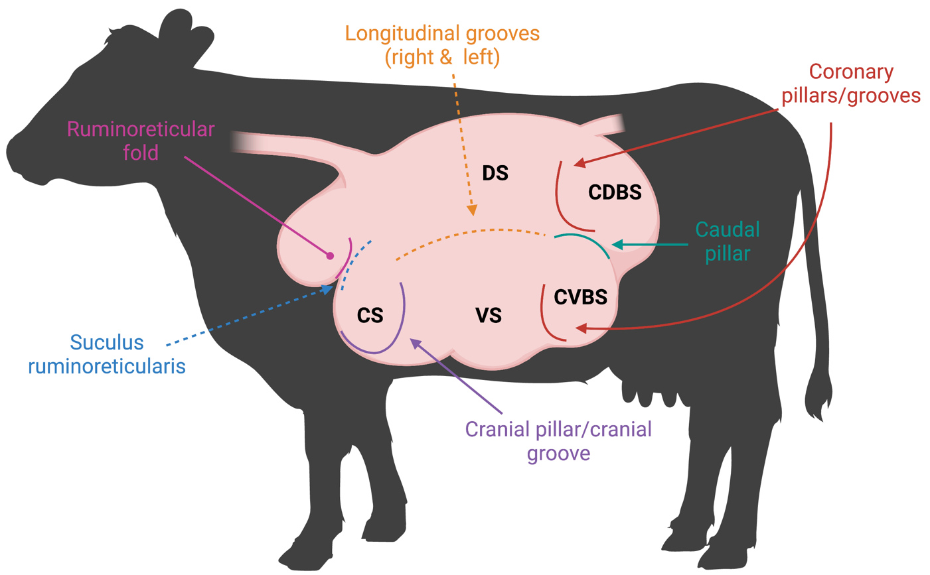
Figure 1 - Rumen pillars and grooves visualized in a labeled rumen.
Visual representation of musculature demarcating the rumen both internally (pillars) and externally (grooves). The rumen sacs are labeled as follows: cranial sac (CS), caudodorsal blind sac (CDBS), caudoventral blind sac (CVBS), dorsal sac (DS), and ventral sac (VS).

Anatomical configuration of the rumen creates functional variation within each rumen sac due to assorted accumulation of feed particles, saliva, and volatile fatty acids (VFAs). Investigation of different ruminal fermentation parameters, such as VFA concentration, pH, ammonia nitrogen (N), and other minerals (sodium, potassium, calcium, chloride, and phosphorus), were observed from different rumen sac sampling (Shen et al., 2012). Cranial, dorsal, caudodorsal, caudoventral, and two different areas within the ventral sac were sampled to obtain a complete assessment of the ruminal environment. Differences were observed in fermentation parameters between the cranial sac and the other four sacs (Shen et al., 2012). Notably, the cranial sac had greater pH and sodium concentration, while also having lower total VFA concentration (Shen et al., 2012), due to the increased amount of saliva and feed particles within cranial sac. Although microbial communities were not investigated, microbial variation may occur, as favorable conditions for certain microbial species were present (Harlow et al., 2017). Amylolytic bacteria favor and thrive in lower pH environments caused by high grain diets while, this environment will inhibit growth of cellulolytic bacterial species (Harlow et al., 2017). Differences observed in rumen fermentation parameters is due to sample site (Shen et al., 2012), which can be attributed to anatomical distinctions made among the ruminal cavity. Pillars, grooves, and folds form the anatomical distinctions and thus, five separate rumen sacs. Environmental conditions of the rumen sacs continuously fluctuate due to ruminal contractions, stratification, and digestibility of feedstuffs occurring throughout beef cattle production. Fluctuations in each ruminal sac environment may instigate ruminal dysbiosis causing adjustments to microbial communities. Improved understanding of the five ruminal sacs, their distinct microbial communities, and the interactions between host and microbiome will reduce undesired consequences caused by unavoidable environmental, diet, and management changes occurring during production.

Ruminal Environment Variations and its Impact on Microbial Community Variation
Significant differences in VFA concentrations were observed when five different positions – dorsal, middle, ventral, reticulum, and dorsal posterior regions – were sampled within the reticulo-rumen (Bryant, 1964). However, pH was only different between ventral and dorsal regions, with an average of 0.43 pH less in the dorsal region compared to the ventral (Bryant, 1964). Sampling time was possibly a confounding factor among these parameters, as the dorsal region consistently contained greater VFA concentrations and was 38% greater than the ventral region (Bryant, 1964). Not only are there specific parameters of the overall ruminal environment, but the five rumen sacs establish unique conditions which favor specific microbial species and therefore, these microbes will inhabit specific sacs with less competition. This interaction among the host environmental conditions and the microbial communities is critical to appreciating the ruminal niches and how they establish.

Beyond differences in ruminal sac chemistry, stratification of rumen digesta occurs based on specific gravity differentiating rumen liquid from rumen solid digesta. The liquid layer is topped by an accumulation of low-density forage particles that form the fiber mat (Schmitz-Esser, 2021). Ruminal stratification is best demonstrated when cattle are fed high forage diets (Church, 1993) due to slower rate of fermentation and greater abundance of low specific gravity feedstuffs that rise above the rumen liquid and create the fiber mat. Vertical stratification of rumen contents can further be explained by the primary contraction cycle which facilitates the flow of denser feedstuffs to the ventral sac, where liquid digesta accumulates (Figure 2) (Tafaj et al., 2004). Less dense plant materials are not cycled during primary contractions, and thus, gather atop the liquid layer forming the fiber mat in the dorsal sac (Grünberg & Constable, 2009). Due to the primary contraction cycle enabling accumulation of low-density plant feedstuffs in the dorsal sac, dorsal locations are more likely to be affected by stratified rumen contents (Millen et al., 2016). When examining whether ruminal bacterial structure, population, and fermentation parameters differed between ruminal locations, rumen digesta samples were obtained from the cranial ventral, cranial dorsal, central rumen, caudal dorsal, and caudal ventral sacs (Li et al., 2009). No differences were observed between bacterial structure and sampling location (Li et al., 2009); however, sampling was limited to the ventral and dorsal sacs. Greater pH was detected in the cranial regions (Li et al., 2009), which influences microbial growth and is an important fermentation variable, although differences were lost due to the analysis technique (Li et al., 2009; Rumsey et al., 1970). Polymerase chain reaction-denaturing gradient gel electrophoresis (PCR-DGGE) was used to discern bacterial communities but is unable to assess bacterial species as in-depth as high-throughput sequencing (HTS). Therefore, use of HTS is ideal to detect minor bacterial species variation between rumen sacs. Although no significant differences were observed between rumen sacs, eight specific bacterial species increased in caudal regions. Ruminal contractions impact the movement and stratification of feedstuffs and therefore microbial species which may have affected the greater populations seen among caudal regions and more basic pH among the cranial regions.

Ruminal Papillae Variation Among the Different Sacs
Ruminal papillae are organs of absorption, extending from the rumen epithelium to optimize surface area for short-chain fatty acid (SCFA) absorption. Short chain fatty acids account for over 70% of the metabolizable energy supply (Bergman, 1990; Church, 1993; Steele et al., 2011). Papillae distribution, size, width, and volume are closely related to host feeding habits, forage availability, forage quality, particle size, and digestibility (Bergman, 1990; Church, 1993; Steele et al., 2011; Wang et al., 2017). Papillae continuously adapt to changes in host diet and stratification of digesta that occur throughout cattle production, which enable its host to better absorb VFAs. In regions of the rumen with greater amounts of digesta, dense lawns of papillae exist, improving the ability to absorb VFAs. In regions such as the dorsal sac, there is a lower density of papillae, as VFA concentrations are reduced due to limited digestion and fermentation activity. As a result of these differences in biochemistry and physiology, papillae from various sacs differ in both size and shape (Dehority, 2002). Variations in papillae density have been observed because of increased proportions of propionate and butyrate produced by the fermentative ruminal bacteria (Niwińska et al., 2017). These VFAs can increase ruminal blood flow, stimulating mucosal mitosis and epithelial proliferation, which increases the size and number of papillae, ultimately enhancing the reticulo-rumen’s ability to absorb VFAs (Church, 1993; Mach et al., 2006; Wang et al., 2017). Papillae VFA absorption contributes to maintaining rumen VFA concentrations and pH, which supports microbial fermentation of forage feedstuffs (Aschenbach et al., 2011; Dieho et al., 2016; Dijkstra et al., 2012; Penner et al., 2009).

Ruminal papillae morphology and count is related to ruminant type. Ruminants can be classified based upon the source of feed, which has evolutionarily impacted their anatomy and physiology. These categories include concentrate selectors, intermediate, and grass/roughage eaters.

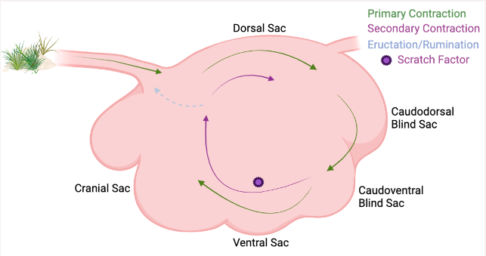
Figure 2 - Ruminal contraction cycles in a labeled rumen.
Labeled rumen sacs with ruminal contractions shown. The primary contraction cycle is shown with the green arrows in the clockwise cycle it follows within the rumen. The secondary contraction cycle is shown with the purple arrows and is not explicitly explained in the text, but is where eructation, rumination, and continual fermentation occurs, and the feedstuffs are not passed onto the omasum.

Importantly, each has varying distributions of papillae based on their diets. Concentrate selectors have a more even distribution of papillae seen throughout their rumen due to the increased passage rate and digestibility of their diet. Some concentrate selectors even have papillae on the pillars within their rumen. Grass/roughage eaters or browsers, including cattle, have a characteristically uneven distribution of papillae throughout the rumen, reflecting the stratification of feed particles and thus regional differences of microbial activity within their rumen (Church, 1993). Generally, within cattle, the rumen is devoid of papillae on the pillars and in the dorsal sac, depending on diet (Church, 1993). With significant differences in papillae configurations among ruminant types, it is consistently noted that the most numerous and extended papillae are located on the cranial and caudodorsal blind sac floor. The caudodorsal blind and cranial sac papillae retain greater surface enlargement factors, (SEF = 2 x papillary surface + basal surface over the basal surface) due to increased VFA concentration (Church, 1993).

Ventral sac papillae structure has been well-defined, due to ease of access and the dense lawn of papillae contained here. However, the ventral sac is unlikely to be a complete representation of the rumen papillae. Due to factors such as digesta stratification, pH, and feedstuff digestibility, there may be distinct differences among the papillae in different rumen sacs. Micro-and macroscopic fluctuations in papillae morphology were observed through dry and lactation periods as an impact of increased dietary concentrates (Dieho et al., 2016). Twelve rumen cannulated Holstein cows were sampled from the ventral, caudoventral blind, and caudodorsal blind sacs. There was an overall greater surface area of papillae with increased concentrates, indicating papillae respond to enhanced microbial breakdown of the easily fermentable organic matter through the increase in papillary growth rate (Dieho et al., 2016). Further differences were identified among the three different rumen sacs, with the ventral sac containing the greatest surface area of papillae. The caudodorsal blind sac also increased in papillae density, but the caudoventral blind sac did not have significant differences after the concentrates were added (Dieho et al., 2016). Increases in papillae density provides greater surface area for absorption of VFA in the rumen. The caudoventral blind sac typically has a greater amount of liquid digesta due to stratification of rumen contents. During acclimation to high grain diets, passage rate increases and therefore, more liquid digesta is cycled through. However, the greater liquid accumulation does not deviate far from the average environment of the caudoventral blind sac, which may explain why no significance was determined.

The increase in added concentrates in the diet are easily fermentable to the microbial communities, and so, greater quantities of VFAs, especially butyrate are produced which increase the surface area of the papillae. Beef cattle have consistent changes throughout the production cycle, whether it is relocation, diet adjustments, stress, or management changes. With these modifications, changes in the ruminal environment occur. Papillae must adapt to the ruminal environmental fluctuations to best perform for the host which is why further investigation into the mechanisms behind the papillary responses from rumen sac to rumen sac may be warranted.

Papillae express a variety of genes facilitating barrier defense, pH, receptors, and transporters for absorption of VFA's. Core genes expressed in papillae remain constant throughout ruminant's life due to their importance in host health. No significant differences in epithelial gene expression were observed in cannulated Holstein cows, fed varying amounts of high-quality hay and decreasing percentages of concentrates (Petri et al., 2018). However, evidence suggests epithelial receptor expression may differ when different diets are fed, such as in Toll-like receptor genes. Increasing dietary starch increased expression of Toll-like receptor genes in goats which may be due to the genes ability to bind lipopolysaccharide and initiate a host immune response (Chen et al., 2012; Liu et al., 2015; Petri et al., 2018). In a study conducted by Kern and others, steers with either high or low intake and high or low gain were examined for differentially expressed genes. There were differentially expressed genes determined in steers with high gain and low intake (HL), against the other efficiency type steers (Kern et al., 2016). One gene upregulated in HH steers was Lipopolysaccharide Binding Protein (LBP), which aids in host defense and contributes to innate immune responses (Kern et al., 2016). It was hypothesized that more efficient steers had less immune response which may drive improved production without wasting energy on inflammation and immune responses (Kern et al., 2016). The gene Regulator of G Protein Signaling 5 (RGS5) was also differentially expressed in HL steers where it was upregulated when measured against the HH steers (Kern et al., 2016). In murine studies, RGS5 knockout mice were observed to have greater fat mass regardless of diet (Deng et al., 2012), which may influence HL steers’ residual feed intake. RGS5 was also shown to be involved with arterial wall development in mice (Cho et al., 2003; Kern et al., 2016), which may facilitate development of a more efficient rumen vasculature arrangement. Papillae are fixed to the rumen epithelium where they aid in absorption of VFAs, metabolic activity, and barrier protection, but they also support the epithelial microbial community. An epimural microbial community establishes throughout the entirety of the rumen given that they are attached to the epithelium or within the papillae which comprises every sac. These epimural microbes are distinct from the other microbial communities in that they inhabit the rumen epithelium, scavenge oxygen, recycle rumen epithelial tissue, and serve as an interface between the host and microbiome.

Microbial Community Variation, Fractions, and Importance in the Ruminant

Conditions of the rumen allow for a diverse community of organisms to grow and individual groups and species to develop complementary and syntrophic relationships (Van Soest, 1994). The rumen consists of primarily anaerobic microbes, but facultative anaerobes inhabiting the epithelium are also present, which scavenge the minimal amounts of oxygen that enter through the esophagus (Schmitz-Esser, 2021). There are consistently highly fermentable feedstuffs entering the rumen, allowing the ruminal environment to favor exceedingly active fermentation through microbial communities and thus, the breakdown of carbohydrates and proteins into energy for both the host and microbes.

Epimural Microbial Community
There are ranges of different ecological regions associated with various microbial communities throughout the rumen (Czerkawski & Cheng, 1988; Czerkawski, 2013; Van Soest, 1994), including the liquid, solid and epimural digesta. Collection and observation of each digesta type allows researchers to better understand different communities and how they interact. Numerous studies have focused on the fiber-adherent and planktonic communities (Cho et al., 2006; Tajima et al., 1999; Tajima et al., 2000; Whitford et al., 1998), but the epimural community, or the microbes residing on the rumen epithelium, has since been overlooked. The minimal investigations conducted on the epimural community may be due to the lesser abundance of these microbes in relation to the whole microbial population and due to the difficulty of sampling. However, there are many vital responsibilities of epimural microbes including oxygen scavenging, epithelial tissue recycling, metabolizing amino acids, and hydrolyzing urea (Cheng et al., 1979; Fay et al., 1979; Mao et al., 2015; McCowan et al., 1978; Wallace et al., 1979; Wetzels et al., 2017), and they serve as the interface between the host and the luminal microbes. Therefore, further research is necessary to fully grasp the extent of epimural capabilities.

A recent study focused on the epimural community among the cranial, ventral, caudodorsal blind, and caudoventral blind rumen sacs in Holstein cattle, which highlighted variation in community structure and composition as a function of sample location indicating intraruminal microbial variation (Sbardellati et al., 2020). Most variation observed among the rumen sacs sampled occurred among the caudodorsal blind sac (CDBS) and the caudoventral blind sac (CVBS) and ventral sac (VS) (Sbardellati et al., 2020). This distinction in microbial structure among the CDBS and the two ventrally located sacs can further be explained due to stratification and continuous contractions in the rumen. Movement through the rumen is expected to affect the dorsal and medial locations, which will generate increased passage of feedstuffs through the CDBS. This may provide an explanation as to why greater differences were observed between the CDBS and the two ventral locations in this study. This study strengthens the concept of multiple rumen sac and digesta type sampling to get an accurate assessment of the complete rumen microbiome.

Interactions Among the Fiber-adherent and Planktonic Microbial Communities
Stratification of feedstuffs, anatomical variation, and constant contractions generate population distinctions in ruminal digesta levels, causing a natural divergence between fiber-adherent and planktonic communities. Contractions within the rumen primarily depend on particle size, intake, and digestibility of the feedstuff, where larger particles with low specific gravity, will settle in the fiber mat, separating the gas and liquid levels (Van Soest, 1994). The fiber-adherent community, consisting of predominantly cellulolytic bacterial species, attaches to solid feed particles in the fiber mat to break them down. There is consistent fermentation and breakdown of these solid feed particles attributing to the fiber-adherent community maintaining the greater percentage of the bacterial biomass in the rumen (Sbardellati et al., 2020; Van Soest, 1994). Forage particles that are too large will return to the mouth via rumination to be re-masticated and increase the surface area for fiber-adherent microbes to attach and break these particles down. The liquid associated or planktonic microbial community regularly obtain a variety of feedstuffs due to the constant redistribution of feedstuffs around the rumen. Planktonic microbes are able to take advantage of soluble carbohydrates floating in the rumen liquid to produce various volatile fatty acids.

Stratification throughout the rumen promotes microbial community diversity among the five rumen sacs (C. R. Krehbiel, 2014; Schmitz-Esser, 2021). For example, the ventral and caudoventral blind sac are comprised of mostly liquid digesta, which leads to the assumption that primarily the planktonic community will inhabit these rumen sacs. The upper portion of the rumen, including the caudodorsal blind and dorsal sac, retain little amounts of liquid and mostly consist of gas and solid feedstuffs (C. R. Krehbiel, 2014). Presumably in this case, predominantly epimural and fiber-adherent communities would reside in these sacs. However, with contractions shifting liquid digesta around the rumen opportunity exists for planktonic microbes to be identified in the dorsal and caudodorsal blind sac. Microbial communities among different ruminal niche environments fluctuate how they interact with the host and where they reside during the inescapable production changes to cattle. Thus, it would be advantageous to improve understanding of these microbial deviations that occur in normal cattle production causing ruminal disorders and decreased efficiency in cattle production to enhance our ability to relieve these disorders.

Many studies have focused on identifying precise differences between the fiber-adherent and planktonic microbial communities. Although, it is unclear whether these distinctions are due to bacterial and methanogen community, based on diet changes, or transition periods for dairy cattle. Bacterial microbial dynamics were characterized during four daily feedings of two cannulated Holstein cows utilizing Automated Ribosomal Intergenic Spacer Analysis (ARISA) which can detect a deeper degree of the bacterial variation (Welkie et al., 2010). Solid and liquid digesta samples were removed from the ventral sac at six different time points during a single feeding cycle. Notable contrasts between the solid and liquid fraction bacterial communities were observed. However, the liquid community generally had greater changes during the feeding cycles (Welkie et al., 2010). Decreased bacterial community shifts in the solid digesta may be due to overall less movement throughout the rumen in this level. Contractions provide greater passage for liquid digesta and thus the liquid associated community may be mixing with other microbial species, causing the increased fluctuations in this community. Bacterial and methanogen communities were investigated from all three digesta levels through cannulated dairy cattle, which highlighted differences in abundance of taxonomic groups in the liquid and solid associated communities (De Mulder et al., 2017). Although no significant differences among the solid and liquid communities were measured, there were significant differences in relative abundance of the major bacterial phyla in the rumen such as Firmicutes, Bacteroidetes, and Proteobacteria (De Mulder et al., 2017). Consistent movements due to the primary contraction cycle, may be further integrating the solid and liquid bacterial communities, yet differences were observed due to abundances between communities. There are well-defined structural differences as well as environmental and chemical differences among the solid and liquid microbial communities. Both interactions and dissimilarities exist among solid and liquid communities, further warranting the necessity to sample from both communities to attain the most comprehensive samples of the rumen. There are a multitude of unavoidable factors contributing to the fluctuations within the ruminal environment such as diet and setting changes when progressing through the beef production cycle. These changes can cause production losses due to health concerns such as acidosis, therefore further investigation into how these changes affect the microbial communities and how to best alleviate the consequences that may transpire is vital.

Conclusion
Ruminants are foregut fermenters that rely on microbial communities to break down feedstuffs into energy through fermentation (Mizrahi, 2013; Itzhak Mizrahi et al., 2021). While the rumen may be viewed as simply a large fermentation vat, it is much more complex than that where distinct anatomical musculature demarcates the rumen into five distinct rumen sacs. Each of these five rumen sacs generates diverse ecological niches due to different ruminal factors such as stratification, contractions, and passage rate. The fiber-adherent, planktonic, and epimural microbial communities are able to inhabit specific environments such as, the solid feed particles, liquid digesta, or rumen epithelium, to thrive and outcompete other species. With variation both anatomically and microbially within the rumen, it is critical to further explore the variation among the five rumen sacs and their respective microbial communities and digesta fractions. This would provide support for the need to sample from multiple ruminal locations to better understand the microbial interactions within the rumen. Also, the microbes identified in these ruminal niche environments may help further define the complex interactions occurring between the rumen microbiome and its host. Continuing research into the complex ruminal environment may lead to discoveries on how the five sacs and the microbiome can impact the host’s feed efficiency, nutrition, and health during the segmented beef production cycle.

Rumen biogeographical regions and their impact on microbial and metabolome variation

Abstract

The rumen microbiome is a complex microbial network critical to the health and nutrition of its host. Rumen microbial communities are able to convert low-quality feedstuffs into energy, providing opportunities to increase productivity and modulate production-relevant phenotypes, such as feed efficiency. In rumen microbiome studies, researchers typically sample from the ventral sac due to ease of access and repeatability. However, internal and external anatomical musculature demarcate the rumen into five sacs which may support distinct microbial communities. The distinction among the microbial communities may generate functional variation among the rumen microbiome, thus, specialized tasks within different sacs. The objective of this study was to determine the rumen liquid metabolome and epimural, planktonic, and fiber-adherent bacterial communities among each of the rumen biogeographical regions. It was hypothesized that differences in the bacterial species and metabolome would occur as a result of the differing anatomy and physiology associated with the respective regions. To assess this variation, the epithelial and solid and liquid content microbial-associated communities were evaluated, as well as the metabolites among various rumen biogeographical regions. A total of 17 ruminally cannulated Angus cows were utilized to examine the fiber-adherent (solid fraction), planktonic (liquid fraction), and epimural microbial communities from the cranial, dorsal, caudodorsal blind, caudoventral blind, and ventral sacs. Metagenomic DNA was extracted from the rumen samples, bacterial 16S rDNA was amplified targeting the V4 region of the 16S rRNA gene and sequenced on an Illumina MiSeq. Reads were processed using packages ‘phyloseq’ and ‘dada2’ in R. Untargeted metabolomics were conducted on the rumen liquid fraction samples from each sac using UHPLC-HRMS and analyzed in MetaboAnalyst. Untargeted metabolomics analyses revealed a clear overlap of the five rumen sacs and their metabolite profiles, as visualized by a PLS-DA. Although when analyzing the heat map of the top 25 metabolites among each rumen sac, the caudoventral blind sac displayed a greater concentration of metabolites. An analysis of variance (ANOVA) revealed 13 significant differentially abundant metabolites with pairwise comparisons against the five rumen sacs (P < 0.05). Within the bacterial communities, alpha diversity indices measuring observed ASVs, chao1, and Shannon diversity measurements, indicated no significance by sac (P > 0.05), but there was significance by fraction type (P < 0.05). Bray-Curtis PCoA was used to assess and visualize beta diversity indices. A PERMANOVA with 999 permutations found no differences among rumen sacs; however, there was a significant difference among fraction types (P < 0.001). Utilizing the MaAslin2 package, there were significant differential abundances found in fraction type × location (P < 0.05). Knowledge of similarities among rumen sac microbial communities and their fermentative environment provides evidence that single sac sampling is sufficient. However, if focusing on either planktonic or epimural fractions, rumen sac is an important consideration when determining sampling location. When investigating different ruminal fractions, future projects may need to consider sampling from multiple rumen sacs to obtain the most comprehensive analysis of the rumen microbial community and its fermentative environment. Defining these variabilities, especially among the rumen epimural microbiome, are critical to define host-microbiome interactions.

Introduction

Cattle are foregut fermenters that are essential to the global protein supply due to their unique ability to consume and convert feedstuffs not suitable for human consumption into meat and milk (Petri et al., 2020b). The conversion to products for human consumption stems from the synergistic relationship between cattle and their resident ruminal microbial communities. This synergistic relationship allows recalcitrant forage particles to be fermented and broken down to produce volatile fatty acids (VFA), providing around 70% of the energy required for cattle (Mizrahi, 2013; I. Mizrahi et al., 2021; Xue et al., 2022). With the ever-growing population, the extensive, adaptable, and symbiotic rumen microbiome is vital to the ruminal environment and in generating an efficient fermentation vat breaking down fibrous feedstuffs that cattle would otherwise not be able to utilize (Mann et al., 2018).

The rumen is a complex organ containing both anatomical and microbial variation. There are a variety of internal and external structures demarcating the rumen into five distinct rumen sacs: the cranial (CS), dorsal (DS), caudodorsal blind (CDBS), caudoventral blind (CVBS), and ventral (VS) sacs. These individual sacs in conjunction with ruminal environmental factors, such as stratification, passage rate, and ruminal contractions, produce differential ecological niches within the rumen (C. Krehbiel, 2014; Schmitz-Esser, 2021; Weimer, 2015). These ecological niches may be grossly observed with more ventral locations comprised of greater liquid digesta components and dorsal locations containing a greater composition of solid feed particles and gaseous space. Due to the variability of rumen content composition, there is evidence as to the differences among specific microbial community structure within the varying fractions of rumen content (Ma et al., 2018; Sbardellati et al., 2020). Specifically, the varying microbial populations, are partitioned into three communities: the fiber-adherent, planktonic, and epimural microbial communities (De Mulder et al., 2016; Ji et al., 2017). The interactions and divisions among the fiber-adherent and planktonic communities have been extensively studied (De Mulder et al., 2016), but there has been limited research regarding rumen epimural microbial communities. This may be due to the difficulty of sampling, decreased density, and reduced relative abundance contrasted to the remainder of the rumen microbiome (De Mulder et al., 2016). Even with the multitude of hinderances when investigating the epimural population, this community possesses specialized functions such as scavenging oxygen, recycling host epithelial tissue, and urea transport (Na, 2022; Na & Guan, 2022; Schmitz-Esser, 2021) which are critical in preserving a healthy rumen environment and microbiome. Importantly, the epimural microbes are located along the rumen epithelium, contributing to their ability to influence host gene expression through host-microbiome crosstalk (Na & Guan, 2022; Petri et al., 2020a; Schmitz-Esser, 2021). The totality of anatomical, physiological, and microbial variation among the five ruminal locations may highlight the necessity for the analysis of the entirety of the rumen to provide a representative and more comprehensive understanding of the rumen microbiome. Further, there may be an indication that sampling from each microbial community further denotes the difference in microbial composition and taxa, but also hints at the interactions allowing the microbiome to continually work synergistically.

The objective of this study was to determine the epimural, planktonic, and fiber-adherent bacterial communities and the rumen liquid metabolome among each of the rumen biogeographical regions. It was hypothesized that differences in the bacterial species and metabolome would occur as a result of the differing anatomy and physiology associated with the respective regions.

Materials and Methods

Animal Use Ethics Statement
This study was conducted at The University of Tennessee following approval of procedures by the campus Institutional Animal Care and Use Committee (2844-0521).

Experimental Design
Four-year-old purebred primiparous cannulated Angus cows (n = 17) with average body weight of 714.42 ± 77.23 kg from the University of Tennessee were utilized for sampling. All cows were located at the University of Tennessee East Tennessee Research and Education Center, Blount Unit. Prior to the study, all cows were adapted to the same diet of ad libitum warm and summer season forages (mixed grass with fescue, bermuda and clover) for 9 weeks. This duration was based on previous research demonstrating the rumen microbiome requires 7-10 weeks to stabilize following dietary changes (Brooke A Clemmons et al., 2019). To determine differences in bacterial communities and the fermentative environment, ruminal solid content, liquid, and epimural samples were taken from each of the five rumen sacs during two sampling days to collect the fiber-adherent, planktonic, and epimural microbial communities, respectively. The sacs sampled included he dorsal sac (DS), cranial sac (CS), caudodorsal blind sac (CDBS), ventral sac (VS), and caudoventral blind sac (CVBS). Rumen liquid content was also retained for metabolomics analyses. Samples were collected and pooled during the two sampling days to reduce individual animal daily variation in the rumen bacterial communities and metabolome.

Solid and Liquid Fraction Sampling
For the two sampling days, the hand grab method was used to obtain solid and liquid digesta from the five rumen sacs via the rumen cannula. A handful of rumen content was squeezed through four layers of cheese cloth, where the liquid run-off was collected into a 15 mL conical tube. Approximately 7 mL of rumen liquid was collected on day one to serve as the pool sample, and the remaining approximately 7 mL was collected on the second day of sampling to complete the pool sample. Solid rumen content was collected from the squeezed rumen digesta in the cheesecloth, and a daily sample was collected in a 50 mL conical tube for both sampling days. The samples were pooled to reduce individual animal daily variation, where the solid fraction was manually pooled from the two daily samples during downstream analysis (Figure 3). To reduce contamination, samples were first taken from the DS, and the rumen was then partially emptied to gain access to the other sacs. Sampling from the sacs then followed the order of VS, CS, CDBS, CVBS. All samples were flash frozen in liquid nitrogen and stored at -80°C until analysis.

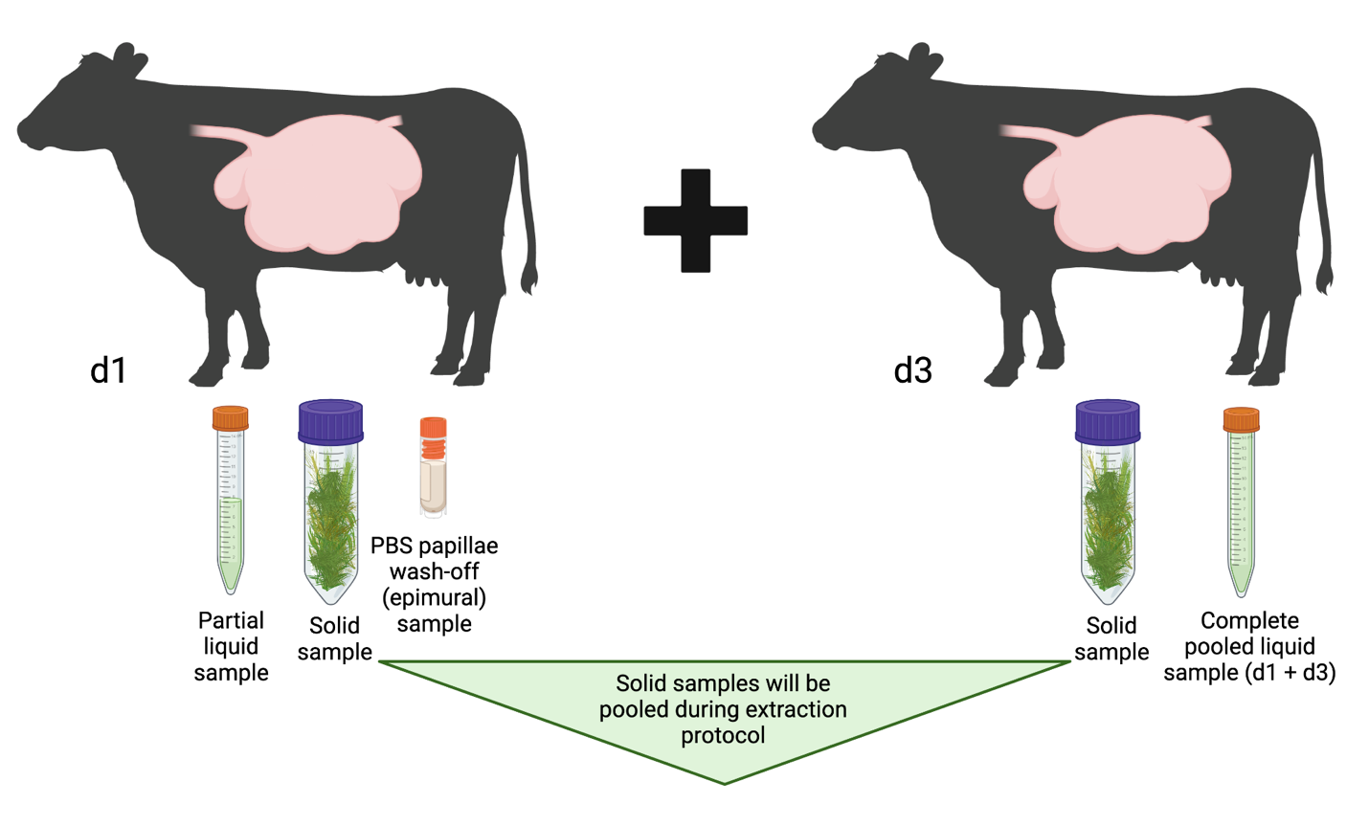
Figure 3 – Solid, liquid, and epimural samples collected from each rumen sac during day one and both solid and liquid samples collected on day three.
The samples from the liquid digesta were pooled within the same 15 mL tube from each day, but due to the difficulty of mixing solid digesta, the solid digesta samples were manually pooled from the two separate daily samples taken during the extraction protocol. The samples were pooled to reduce individual animal daily variation.

Epimural Fraction Sampling and Papillae Biopsies
To collect rumen epithelium associated microbes, partial-thickness samples of the rumen epithelium were collected using a single-action Cushing Rongeur (non-serrated jaw, Sontec Instruments Inc, Centennial, CO, USA) and an arm-length plastic sleeve was used to reduce contamination. Rumen epithelium samples from each rumen sac were collected in the following order: CS, DS, VS, CDBS, and CVBS. To collect the sample, rumen contents from the specific sac were removed, and the instrument was advanced until the rumen wall was identified. The jaws of the rongeur were then opened and applied to the epithelial surface, and then closed to collect the sample in a partial thickness bite. The instrument was rinsed with 70% ethanol after each sample was collected and sleeves were changed after each cow. Once the papillae biopsy was extracted, the papillae were taken with sterilized tweezers and serially washed four times in 1X PBS (pH 7.4) in a four-quadrant petri dish. After thoroughly washing the papillae, 1 mL of the PBS papillae wash was pipetted into 2 mL cryovials to collect epimural bacteria washed from papillae. Samples were flash frozen in liquid nitrogen and stored at -80°C.

DNA Extraction
DNA extractions were performed on solid, liquid, and epimural samples. All raw samples were stored at -80°C freezer and were thawed at room temperature prior to extraction.

Liquid and Solid DNA Extraction
The DNA extraction protocol was adapted with slight modifications from the Yu and Morrison (Yu & Morrison, 2004) protocol and the Qiagen DNeasy Blood and Tissue kit (QIAGEN, Hilden, Germany). All centrifugation was performed at 16,000 x g and 4°C throughout the protocol. For cell lysis, 0.2 g of sample was added to a 2 mL beaded screw cap tube containing 0.6 mL dry volume mixed with 0.5 mm and 0.1 mm ZR BashingBead lysis matrix (Zymo Research, Irvine, CA, USA) and 1 mL of lysis buffer. To obtain 0.2 g of solid fraction sample, forceps were used to obtain 0.1 g of each daily sample to pool. The forceps were sanitized with 70% ethanol between use. The samples were homogenized with the TissueLyser II (QIAGEN, Hilden, Germany) at 21 Hz for 3 min and incubated at 70°C for 15 minutes. Samples were then centrifuged, and the supernatant was transferred to 1.5 mL microcentrifuge tubes. Fresh lysis buffer was then added to the bead beating tubes before repeating the previous steps to aspirate the remainder of the supernatant. For nucleic acid precipitation, 260 µL of 10M ammonium acetate was added, followed by 5 minutes on ice, and 10 minutes of centrifugation. The supernatant was then equally divided between two tubes and an equal volume of isopropanol was added before incubating on ice for 30 minutes. The samples were then centrifuged for 15 minutes to concentrate a nucleic acid pellet. After the supernatant was removed, the nucleic acid pellet was washed with 70% ethanol and allowed to air dry. The time to dry varied based on remaining 70% ethanol observed in the tube after 5 minutes, but samples were allotted no more than 10 minutes to air dry. Following drying, 100 µL of Tris-EDTA (TE) buffer was then added to re-constitute the nucleic acid pellet and the samples were pooled with their respective sample. The QIAGEN DNeasy Blood and Tissue kit was used (QIAGEN, Hilden, Germany) to complete purification of the nucleic acids; 15 µL of Proteinase K and 200 µL of Buffer AL were added to samples and incubated for 10 minutes. A total of 200 µL of 100% ethanol was added before being transferred to the QIAamp filter column. Samples were centrifuged for one minute and the flow through was discarded. To wash the DNA adhered to the filter, 500 µL of Buffer AW1 was added, incubated at room temperature for 1 min, and centrifuged to remove the flow through. The steps were repeated for Buffer AW2. The column was then centrifuged for 2 minutes to completely dry the column and the flow-through was collected in a 1.5 mL microcentrifuge tube for removal. To elute the DNA, a two-step process was conducted to maximize DNA concentrations. In part one, 70 µL of Buffer AE (QIAGEN, Hilden, Germany) was directly added to the column membrane and incubated at room temperature for 2 minutes. Following incubation, the sample was centrifuged for 1 minute. In part 2, 30 µL of Buffer AE was added to the membrane and incubated and centrifuged similar to part 1. to elute the DNA. The DNA quality and concentrations were then analyzed on the DeNovix DS-11 Spectrophotometer (DeNovix, Wilmington, DE, USA) before being stored at -20°C until further analysis.

Epimural DNA Extraction
The epimural DNA extraction method was adapted from (Ault-Seay et al., 2022) for bacterial community analysis and Qiagen DNeasy Blood and Tissue kit protocols (QIAGEN, Hilden, Germany). To obtain 1 g of the sample, the samples were thawed and inverted three times before 1 mL was pipetted into 1.5 mL microcentrifuge tubes. Samples were then centrifuged for 10 minutes at 4°C and 4,700 x g where the supernatant was discarded, leaving the pellet in the tube. Pellets were then resuspended in 180 µL of lysis buffer (500mM NaCl, 50 mM Tris-HCl, pH 8.0, 50 mM EDTA, and 4% sodium dodecyl sulfate [SDS]) and vortexed. The homogenized sample was incubated at 37°C for 30 minutes and 25 µL of proteinase K was added to each sample. Following the Qiagen DNeasy Blood and Tissue kit protocol (QIAGEN, Hilden, Germany), samples were incubated for 30 minutes and 200 µL of 100% ethanol was added. Samples were transferred to a QIAamp column for DNA purification. After adding Buffers AW1 and AW2 to the column membrane as previously described, samples were centrifuged to dry the column and prevent ethanol contamination. The DNA was eluted as previously described for the solid and liquid samples. The DNA quality and concentrations were then analyzed on the DeNovix DS-11 Spectrophotometer (DeNovix, Wilmington, DE, USA) before being stored at -20°C until PCR amplification and library preparation.

Amplicon Verification using Polymerase Chain Reaction (PCR) and Gel Electrophoresis
Gel electrophoresis and polymerase chain reaction (PCR) were performed on epimural samples to ensure eluted bacterial DNA was captured versus host DNA, due to lower DNA concentrations (ng/ µL) seen among these samples. There were two separate runs performed. Run 1 consisted of TE buffer (negative control), a rumen solid sample (positive control), and representative epimural rumen samples. The PCR protocol targeted the 16S V4 hypervariable region, utilizing the forward primer 515F and reverse primer 806R (Apprill et al., 2015) to target the V4 hypervariable region of the gene. The PCR cocktail consisted of PCR Platinum Master mix (12.5 µL per reaction), the forward and reverse primers (0.5 µL of each per reaction), and nuclease free water (8.5 µL per reaction). A total of 22 µL of the PCR cocktail and 3 µL of the template DNA were used for amplification. The thermal cycler (BioRad T100) (Bio-Rad, Berkeley, CA) conditions were set to 94°C for 15 minutes, followed by 35 cycles at 94°C for 30 seconds for denaturation, 55°C for 30 seconds for annealing, 72°C for 1 minute for elongation, with a final extension of 72°C for 5 minutes. Reactions were held at 4°C. A 2% TAE agarose gel was used to confirm bacterial DNA amplicon size and included 5 µL of ethidium bromide. The gel was run at 100 volts (100,000 mAmps) for 45 minutes and observed on the Chemidoc imaging system (Bio-Rad, Berkeley, CA) for visualization.

Amplification, Library Preparation, and Amplicon Sequencing
All library preparation and DNA sequencing was performed at the Genomics Core at The University of Tennessee. The standard operating procedures for the two-step polymerase chain reaction (PCR) library construction was used for these samples. From the extracted DNA, the V4 region of the 16S rRNA gene was amplified using primers 515Fb (GTGYCAGCMGCCGCGGTAA) (Parada et al., 2016) and 806Rb (GGACTACNVGGGTWTCTAAT) (Apprill et al., 2015) (Earth Microbiome Project). The primers were slightly modified with the addition of adaptors for Illumina MiSeq sequencing. The initial PCR cocktail included 2 × KAPA HiFi HotStart ReadyMix Taq (Roche, Indianapolis, IN, United States) and 1.5 µM of each primer. Each tube received 2.5 µL of extracted DNA and 22.5 µL of initial PCR cocktail. The reaction in the thermal cycler consisted of 95°C for 3 minutes, then 25 cycles of 95°C for 30 seconds, 55°C for 30 seconds, and 72°C for 30 seconds, with a final extension of 72°C for 5 minutes. The PCR amplification was confirmed on a 2% TAE agarose gel with gel electrophoresis. To purify the PCR product, 20 uL of AMPure XP beads (Agencourt, Beverly, MA, USA) were used while combining with ethanol washes. The final product was eluted in 50 µL of Tris-HCl. To give each sample a unique combination of forward and reverse indexes, Nextera XT indexes (Illumina, Inc., San Diego, CA, United States) were added to each PCR product and run through a reduced-cycle PCR. The reduced-cycle PCR consisted of 95°C for 3 minutes, then 8 cycles of 95°C for 30 seconds, 55°C for 30 seconds, and 72°C for 30 seconds, and the final extension at 72°C for 5 minutes. For the final PCR purification, 56 µL of AMPure XP beads were used while combining the ethanol washes and the final elution with 25 µL of Tris-HCl. Using the NanoDrop spectrophotometer (Fisher Scientific International, Inc., Hampton, NH, USA), the samples were quantified and then pooled at approximately equal concentrations. To ensure the product concentrations were approximately equal, they were run on the Agilent Bioanalyzer (Santa Clara, CA, USA) using the standard sensitivity kit. The final library was diluted to 4 pM and pooled with 20% of a 10 pM PhiX library control (Illumina, Inc., San Diego, CA, USA), and run paired-end 250 nucleotides on a v3, 600 cycle flow cell of an Illumina MiSeq sequencer at the University of Tennessee Genomics Core.

Ruminal Metabolites Extraction
Using the pooled liquid fraction, which consists of both sampling days liquid fractions, 2 mL were aliquoted into two 2 mL microcentrifuge tubes. Tubes was centrifuged at 6,000 x g for 15 minutes at 4°C. The supernatants from the two corresponding microcentrifuge tubes were pooled into a 3 mL syringe. The pooled sample was then filtered through a 0.22 µm filter tip (Midsci, St. Louis, MO, USA) into the final microcentrifuge tube. The completed samples were then stored at -20°C until further analysis.

Metabolomics Analyses
Metabolomics analysis was performed at the Biological and Small Molecule Mass Spectrometry Core (BSMMSC) at The University of Tennessee, Knoxville, TN (RRID: SCR_021368). Samples were transported and thawed in a 4°C cold room for up to an hour before extracting the water-soluble metabolites. Polar metabolites were extracted from 0.1 mL of rumen content using 1.5 mL of metabolomics extraction solvent (4:4:2 HPLC grade acetonitrile/methanol/water with 0.1 M formic acid)(Dridi et al., 2022). The solvent was evaporated under gaseous nitrogen. Once fully dried the metabolites were suspended in 300 µL HPLC grade water. The HPLC grade solvents used in this protocol were all purchased from Fisher Scientific (Hampton, NH, USA). Using ultra high performance liquid chromatography high resolution mass spectrometry (UHPLC-HRMS) (Thermo Scientific, San Jose, CA, USA) metabolites were identified utilizing a previously validated untargeted metabolomics method (Lu et al., 2010). Reverse-phase (RP) ion chromatography was utilized to separate the metabolites based on the polarity of the small molecules, then a Synergi Hydro RP column (100 mm x 2.1 mm, 2.6 mm, 100 Å) and an UltiMate 3000 pump (Thermo Fisher) were used for the chromatographic separation. The ExactiveTM Plus Orbitrp MS (Thermo Fisher) coupled with the UHPLC system was used for mass analysis. The raw data from Xcalibur MS software (Thermo Electron Corp, Waltham, MA, USA) were converted to mzML format using a tool from MSConverter, ProtroWizaed (Chambers et al., 2012; Martens et al., 2011). Metabolites were identified using MAVEN (Melamud et al., 2010), by comparing the exact mass and retention time ($±5 ppm)$ to an in-house library of verified metabolites. Area under the chromatographic curve was integrated for each identified metabolite (Clasquin et al., 2012). The relative metabolite abundances were exported to Excel for statistical analysis.

DNA Read Processing and Analyses
Fastq sequences were evaluated in R Studio (R version 3.6.2). To analyze the quality of the reads, package ‘fastqcr’ v0.1.2 (Alboukadel, 2019) was used, which was taken into consideration for parameters downstream. With the filterAndTrim package from ‘phyloseq’ v1.40.0 (McMurdie & Holmes, 2013) sequences were filtered and trimmed with parameters at truncLen of 260, and maximum expected error at 2 for forward reads. Due to poor merging downstream, reverse reads were removed from the data set. After the reads were filtered, the quality was then analyzed for greater than or equal to a quality score of 25 (Q25). If reads were less than Q25, they were removed. To learn error rates, the function learnErrors was utilized from ‘dada2’ package v.1.24.0 (Callahan et al., 2016). Within the dada function, sequences were denoised to produce amplicon sequence variants (ASVs). To remove chimeras from the data set the consensus method from removeBimeraDenovo was used. Taxa were assigned to the SILVA 138.1 using assignTaxonomy with the parameter of bootstrap confidence at a minimum of 80. For downstream analysis, metadata, assigned taxa, and ASV table were merged into the phyloseq object. Utilizing phyloseq, the alpha diversity was measured for observed ASVs, Shannon diversity index, and Chao1 metric. To assess beta diversity the package ‘vegan’ v2.6.2 (Oksanen et al., 2022) was used and the sample counts were ordinated and transformed with the Bray-Curtis Dissimilarity which calculated distances for the principal coordinates analysis (PCoA).

Statistical Analyses
Alpha diversity measurements, observed ASVs, Shannon diversity index, and Chao1, were first visually analyzed for normality and then tested against a Shapiro-Wilk test (W), where normality was determined at W > 0.90 and P > 0.05. The Kruskal-Wallis H test was used to test differences among digesta types and rumen sac. For beta diversity measurements, the sample counts were converted out of total counts and then the distances were calculated by Bray-Curtis Dissimilarity Matrix. Following a permutational multivariate analysis of variance (PERMANOVA) with 999 permutations using the adonis function from package ‘vegan’ tested for differences between samples (Oksanen et al. 2007). All analyses had significance determined at P < 0.05.

To analyze differential abundances of the bacterial communities among the three rumen digesta types, the five rumen sacs, and digesta type within rumen sac, the MaAsLin2 package v1.10.0 (Mallick et al., 2020) was used. For the analysis, the phyloseq object was rarefied to normalize the data set due to large differences in library size. Following the recommendations from the developers, the data were transformed with the log function and analyzed through a linear model method (LM). This was recommended due to the consistency found across samples (Mallick et al., 2021 & Nearing et al., 2022). Taxa present in fewer than 50% of total samples were removed from the model. To test differences in fraction types (planktonic, fiber-adherent, or epimural), individual fraction types were set as the reference level to test all pairwise comparisons. The fixed effects included the fraction type and differences within sac were blocked. To test differential abundances among sacs, fraction types were divided into categories and tested within them. For the individual planktonic, fiber-adherent, and epimural analyses ran, the fixed effects were the rumen sacs. All pairwise comparisons were tested for each sac and digesta type. Multiple testing was addressed using Benjamini-Hochberg (Benjamini and Hochberg, 1995). Significance was set at P > 0.05.

For metabolomics analyses, the data were filtered by interquartile range, log-transformed, and Pareto scaled in MetaboAnalyst prior to analysis (Pang et al., 2021). MetaboAnalyst 5.0 was used to generate partial-least-squares discriminant analysis (PLS-DA) plots, variable importance in projection (VIP) scores, and a one-way analysis of variance with a -log¹⁰(p) value of 0.05. Heatmaps were generated using R (version 1.0.153).

Results

DNA Sequencing
Due to low input reads, one sample from the CS in the fiber-adherent microbial community and one sample from the VS in the epimural community were removed. Out of the 253 samples used for analysis, 30,176 taxa were identified. The overall output from the Illumina MiSeq averaged 112,045 paired reads with a minimum read count of 55,220 and a maximum read count of 255,381.

Bacterial Differences Among the Fiber Adherent, Planktonic, and Epimural Fractions
For assessing alpha diversity, the Kruskal-Wallis H test was used to compare the mean ranks of the rumen fractions and examine the observed ASVs (richness), chao1 (anticipated richness), and Shannon diversity index (richness and evenness). Among the fraction types, all measures of richness and evenness significantly differed (P < 0.001; Figure 4). When analyzing beta diversity, there was a significant difference among fraction types after analysis with a PERMANOVA with 999 permutations (P < 0.05; Figure 5). After conducting pairwise comparisons of differential abundances of bacterial communities among rumen fraction types collected with MaAsLin2, when the reference level was set at the fiber-adherent fraction, there were 307 significant differences against the epimural bacterial communities and 490 significant abundance differences against planktonic (P < 0.05; Table 1). When the planktonic fraction was used as the reference level, there were 471 differentially abundant bacterial communities against the epimural communities.

Bacterial Phyla and Genera within the Fiber-adherent Community
Within the 84 fiber-adherent bacterial communities sequenced, there were 26 phyla and 219 genera found among the five rumen sacs. The top three greatest phyla relative abundance were Firmicutes (47.07%), Bacteroidota (37.50%), and Spirochaetota (3.23%). The remaining top ten phyla making up the greatest relative abundance within the rumen were Fibrobacterota (2.97%), Patescibacteria (2.55%), Verrucomicrobiota (1.93%), Thermoplasmatota (0.84%), Desulfobacterota (0.78%), Euryarchaeota (0.55%), and Proteobacteria (0.53%) (Figure 6). The relative abundance of the top ten genera identified in the fiber-adherent community were Prevotella (10.16%), Rikenellaceae RC9 gut group (6.45%), Christensenellaceae R-7 group (5.09%), Succiniclasticum (3.55%), Ruminococcus (3.37%), Fibrobacter (2.97%), Treponema (2.83%), Saccharofermentans (2.57%), Butryvibrio (2.32%), and NK4A214 group (2.24%) (Figure 7).

Bacterial Phyla and Genera within the Planktonic Community
Out of the 85 planktonic samples, there were 28 phyla and 236 genera found among the five rumen sacs. The relative abundance of the phyla Bacteroidota (42.54%), Firmicutes (38.20%), and Verrucomicrobiota (7.57%) were the top three greatest identified within the rumen. The remaining top ten phyla were Patescibacteria (3.28%), Fibrobacterota (2.48%), Spirochaetota (1.99%), Proteobacteria (1.30%), Thermoplasmatota (0.69%), Desulfobacterota (0.55%), and Planctomycetota (0.45%) (Figure 6). The top three greatest relative abundance of genera identified within the five rumen sacs were Prevotella (14.59%), Rikenellaceae RC9 gut group (4.64%), and Succiniclasticum (2.92%). The remaining seven genera with the greatest relative abundance were Christensenellaceae R-7 group (2.78%), Fibrobacter (2.47%), Prevotellaceae UCG-003 (2.41%), Ruminococcus (1.62%), Candidatus Saccharimonas (1.56%), Prevotellaceae UCG-001 (1.47%), and Treponema (1.40%) (Figure 7).

Bacterial Phyla and Genera within the Epimural Community
Within the 84 samples collected from the rumen wall, there were 27 phyla and 297 genera found among the five rumen sacs. The top ten phyla identified with the greatest relative abundance were Bacteroidota (42.15%), Firmicutes (38.23%), Verrucomicrobiota (4.13%), Patescibacteria (3.02%), Proteobacteria (3.00%), Fibrobacterota (1.89%), Spirochaetota (1.56%), Desulfobacterota (1.25%), Thermoplasmatota (0.99%), and Planctomycetota (0.92%) (Figure 6). The greatest relative abundance of genera found were Prevotella (11.17%), Rikenellaceae RC9 gut group (6.26%), and Christensenellaceae R-7 group (4.22%). The remaining genera in the top ten greatest relative abundance were Succiniclasticum (3.66%), Prevotellaceae UCG-001 (2.34%), Ruminococcus (1.95%), Butyvibrio (1.93%), Fibrobacter (1.89%), Prevotellaceae UCG-003 (1.80%), and NK4A214 group (1.77%) (Figure 7).

Figure 4 - Alpha diversity metrics in the three rumen fractions.
Alpha-diversity metrics for bacterial communities. Measures include observed ASVs (richness), Chao1 (expected richness), and Shannon diversity index (richness and evenness) for each digesta fraction. The epimural fraction is represented by orange, the planktonic digesta fraction is represented by red, and the fiber-adherent digesta fraction is represented by purple. Significance in alpha diversity metrics were determined at P < 0.001.
Figure 5 - Bray-Curtis principal coordinates analysis among the three fraction types.
Beta-diversity was measured using the Bray-Curtis distances and visualized with a principal coordinates analysis (PCoA). The epimural fraction is shown in orange, the planktonic digesta fraction is represented by red, and the fiber-adherent digesta fraction is represented by purple. The circles represent a 95% confidence interval around the means of each fraction type. There was significance in beta diversity between the fraction types (P < 0.05).

Table 1 - Differential abundance among the three fraction types and the respective number of taxa found to be significantly abundant.

Reference level | Comparison | Number of taxa
Fiber-adherent | Planktonic | 490
Fiber-adherent | Epimural | 307
Planktonic | Epimural | 471

Figure 6 - Bacterial phyla within each fraction type and their respective relative abundances.
Each phylum is in alphabetical order within each fraction’s column, to aid in corresponding color with the phylum. The epimural community is the left column, the planktonic community is the middle column, and the fiber-adherent community column is on the right.
Figure 7 - Top 20 Bacterial genera within each fraction type and their respective relative abundances.
The genera are labeled in alphabetical order within each fraction’s column, from the top to the bottom of the column. The epimural community is the left column, the planktonic community is the middle column, and the fiber-adherent community column is on the right.

Differences in Bacterial Communities Among the Rumen Sacs
Alpha diversity, beta diversity, and differential abundances among the sacs were initially analyzed by pooling of fiber-adherent, planktonic, and epimural community data, representing the entire bacterial community within the rumen. Richness and evenness did not differ among the five rumen sacs (P > 0.05; Figure 8) when examining alpha diversity. Further, when analyzing the Bray-Curtis distance matrices, there were no differences among rumen sacs after testing with a PERMANOVA with 999 permutations (P > 0.05; Figure 9). Measuring differential abundance with MaAsLin2, no significant differences were identified among the rumen sacs (P > 0.05).

Analyses of Individual Fractions among Rumen Sacs - Fiber Adherent Bacteria
For alpha-diversity metrics, the observed ASVs, chao1, Shannon diversity index were measured for the fiber-adherent community within the rumen sacs to assess for richness and evenness (Figure 10). There were no differences in any alpha diversity measurements when comparing among the five rumen sacs (P > 0.05).

Among the five rumen sacs, there were no significant differences when testing against the fiber-adherent communities (P > 0.05). The resulting PCoA aids as a visualization of the overlap among the fiber-adherent bacterial communities across all rumen sacs (Figure 11).

When using MaAsLin2 to test differential abundances, there were no significant differences among the rumen sacs and the fiber-adherent bacterial communities (P > 0.05).

Analyses of Individual Fractions among Rumen Sacs - Planktonic Bacteria
The alpha-diversity metrics of observed ASVs, chao1, Shannon diversity index were measured and visualized in Figure 12. There were no significant differences in richness or evenness among any of the five rumen sacs within the planktonic bacterial communities (P > 0.05).

Among the five rumen sacs, there were no significant differences within the planktonic communities (P > 0.05). This lack of differences is visualized in the PCoA with the overlap among each rumen sac (Figure 13).

When utilizing pairwise comparisons in MaAslin2 to test differential abundances in bacterial communities among the five rumen sacs within the planktonic samples, there were 4 ASVs that were found to be significantly different when testing against each rumen sac (P < 0.05; FDR < 0.05). The four significant differences among ASVs were only seen when either DS or VS were set as the reference level; i.e., differences only existed between DS and VS. The four ASVs significantly different between the VS and DS were three ASVs belonging to the family Bacteroidales RF16 group and one belonging to genus Christensenellaceae R-7 group (Table 2).

Figure 8 - Alpha diversity metrics among the five rumen sacs bacterial communities.
Alpha-diversity metrics for bacterial communities within each rumen sac (includes all three fraction types within a rumen sac). Measures include observed ASVs (richness), Chao1 (expected richness), and Shannon diversity index (richness and evenness). The CDBS is denoted by orange, CS is denoted by red, CVBS is denoted by light purple, DS is denoted by dark purple, and VS is denoted by black. No significance was determined among the rumen sacs P > 0.05.

Figure 9 - Bray-Curtis principal coordinates analysis among each rumen sac and their bacterial community.
Beta-diversity was measured with the Bray-Curtis distances and visualized with a principal coordinates analysis (PCoA). The CDBS is shown in orange, CS is shown in red, CVBS is shown in light purple, DS is shown in dark purple, and VS is shown in black. The circles represent a 95% confidence interval around the means of each rumen sac. No significant distance measurement was determined among the rumen sacs (P > 0.05).

Figure 10 - Alpha diversity metrics in the fiber-adherent fraction among the five rumen sacs.
Alpha-diversity metrics for fiber-adherent bacterial communities among each of the five rumen sacs. Measures were observed ASVs (richness), Chao1 (expected richness), and Shannon diversity index (richness and evenness). The CDBS is denoted by orange, CS is denoted by red, CVBS is denoted by light purple, DS is denoted by dark purple, and VS is denoted by black. No significance was determined within the fiber-adherent microbial community among the rumen sacs (P > 0.05).

Figure 11 - Bray-Curtis principal coordinates analysis of the fiber-adherent fraction among the five rumen sacs.
Beta-diversity was measured with the Bray-Curtis distances and visualized with a principal coordinates analysis (PCoA). The CDBS is shown in the orange circles, CS is shown in red circles, CVBS is shown in light purple circles, DS is shown in dark purple circles, and VS is shown in black circles. The circles represent a 95% confidence interval around the means of the fiber-adherent bacterial communities within each rumen sac. No significant amount of distance was determined (P > 0.05).

Figure 12 - Alpha diversity metrics in the planktonic fraction among the five rumen sacs.

Alpha-diversity metrics for the planktonic bacterial communities among each of the five rumen sacs. Measures were observed ASVs (richness), Chao1 (expected richness), and Shannon diversity index (richness and evenness). The CDBS is in orange, CS is in red, CVBS is in light purple, DS in dark purple, and VS is in black. No significance was identified within the planktonic microbial community among the rumen sacs (P > 0.05).

Figure 13 - Bray-Curtis principal coordinates analysis of the planktonic fraction among the five rumen sacs.

Beta-diversity was measured with the Bray-Curtis distances and visualized through a principal coordinates analysis (PCoA). The CDBS is shown in the orange circles, CS is shown in red circles, CVBS is shown in light purple circles, DS is shown in dark purple circles, and VS is shown in black circles. The circles represent a 95% confidence interval around the means of the planktonic bacterial communities within each rumen sac. No significant distance measurement was found (P > 0.05).
Table 2 - Differential abundant taxa found in the planktonic bacterial community among the five rumen sacs.
Reference level | ASV | Taxa¹ | Sac Difference | Coefficient | Standard deviation
DS | ASV49 | Family Bacteroidales RF16 group | VS | 0.615 | 0.111
 | ASV23 | Family Bacteroidales RF16 group | VS | 0.540 | 0.123
 | ASV65 | Family Bacteroidales RF16 group | VS | 0.643 | 0.142
 | ASV2 | Genus Christensenellaceae R-7 group | VS | 0.400 | 0.0939
VS | ASV49 | Family Bacteroidales RF16 group | DS | -0.615 | 0.111
 | ASV65 | Family Bacteroidales RF16 group | DS | -0.643 | 0.142
 | ASV23 | Family Bacteroidales RF16 group | DS | -0.540 | 0.123
 | ASV2 | Genus Christensenellaceae R-7 group | DS | -0.400 | 0.0939
¹ Taxa to lowest level available.

Analyses of Individual Fractions among Rumen Sacs - Epimural Bacteria
The epimural alpha-diversity metrics measured were observed ASVs, chao1, Shannon diversity index were measured and visualized in Figure 14. Shannon diversity was significant, measuring richness and evenness among the bacterial communities (P < 0.05). The remaining two measures of observed ASV and Chao1 were not significant (P > 0.05).

When assessing beta diversity among the five rumen sacs, there were significant differences among the epimural communities (P < 0.001). Greater distances among the rumen sacs were observed in the PCoA (Figure 15).

Using MaAslin2 to analyze the differential abundances among rumen sacs in the epimural bacterial community, there was a greater number of significant differences seen among the five rumen sacs contrasted to the other fraction types. Overall, 33 ASVs were found to be significantly differentially abundant among the five rumen sacs and their respective pairwise comparisons (P < 0.05) (Table 3). When the reference level was set at the CDBS, there were five total significant differences where four ASVs were significantly different in the DS, and one ASV was in significantly different in the CVBS. When CS was set as the reference level, there were nine significant ASVs found to be differentially abundant against the DS. There were overall 23 significant differences when the reference level was set at CVBS. With 21 total significant differences against the DS, four ASVs were significantly different against the CDBS, and one ASV in significantly different against the VS. Overall, there were 31 significant differences when the reference level was set at DS, where many ASVs overlapped among the other four rumen sacs. With reference level DS, 24 differences were seen against the CVBS, there were 19 differences when against the VS, there were six differences against the CDBS, there were fourteen significant differences against the CS. There were 14 overall differences seen with the VS set as the reference level. Against the DS there were thirteen ASVs that were differentially abundant and there one ASV that was significantly different against the CVBS.

Metabolomics
Untargeted metabolomics was performed on the 85 rumen liquid samples, where there were 69 overall metabolites identified. When visually assessing the metabolites among the five rumen sacs using a partial least squares determinant analysis (PLS-DA), there was significant overlap among all five rumen sacs indicating similar metabolic profiles among all five rumen sacs (P < 0.05; Figure 16). When examining the heatmap to visualize the top 25 metabolites present within each of the five rumen sacs, there were greater relative abundances of metabolites present within the CVBS contrasted to the other four rumen sacs (Figure 17). When performing an analysis of variance (ANOVA) followed by post-hoc analysis of Fisher’s least significance difference method in MetaboAnalyst, there were 13 metabolites that were different among the five rumen sacs (Figure 18), where many of the differences were seen between the CDBS and CVBS (Table 4). To visualize the differences among the rumen sacs between metabolites, the thirteen significantly different metabolites were displayed via box plots (Figure 19).

Figure 14 - Alpha diversity metrics in the epimural fraction among the five rumen sacs.
Alpha-diversity metrics for the epimural bacterial communities among each of the five rumen sacs. Measures include observed ASVs (richness), Chao1 (expected richness), and Shannon diversity index (richness and evenness). The CDBS is in orange, CS is in red, CVBS is in light purple, DS in dark purple, and VS is in black. Significance was determined at P < 0.05 in the measure of Shannon diversity. No significance was determined for the other two measurements (P > 0.05).
Figure 15 - Bray-Curtis principal coordinates analysis of the epimural fraction among the five rumen sacs.
Beta-diversity was measured with the Bray-Curtis distances and visualized with a principal coordinates analysis (PCoA). The CDBS is shown in the orange circles, CS is shown in red circles, CVBS is shown in light purple circles, DS is shown in dark purple circles, and VS is shown in black circles. The circles represent a 95% confidence interval around the means of the epimural communities in each rumen sac. Significance was determined at P < 0.05.

Table 3 - Differential abundance in the epimural bacterial communities among each of the five rumen sacs.
ASV | Taxa¹ | Sac Difference | Coefficient | Standard deviation | q-value
ASV28 | Family Selenomonadaceae | DS-VS | 0.861 | 0.262 | 0.0496
ASV33 | Prevotella | CVBS-DS | -0.529 | 0.121 | 0.00601
 |  | DS-CVBS | 0.529 | 0.121 | 0.00267
 |  | DS-CS | 0.449 | 0.121 | 0.0168
 |  | DS-VS | 0.405 | 0.122 | 0.0495
ASV50 | Order WCHB1-41 | CVBS-DS | -0.742 | 0.176 | 0.00851
 |  | DS-CVBS | 0.742 | 0.176 | 0.00430
 |  | DS-VS | 0.595 | 0.179 | 0.0473
ASV94 | Order WCHB1-41 | CS-DS | -1.23 | 0.310 | 0.0429
 |  | CVBS-DS | -1.43 | 0.310 | 0.00312
 |  | DS-CVBS | 1.43 | 0.310 | 0.00136
 |  | DS-VS | 1.43 | 0.314 | 0.00151
 |  | DS-CS | 1.23 | 0.310 | 0.00929
 |  | VS-DS | -1.43 | 0.314 | 0.00571
ASV103 | Order WCHB1-41 | CS-DS | -1.50 | 0.312 | 0.00666
 |  | CVBS-DS | -1.66 | 0.312 | 0.000331
 |  | DS-VS | 1.79 | 0.317 | 6.07E-05
 |  | DS-CVBS | 1.66 | 0.312 | 0.000153
 |  | DS-CS | 1.50 | 0.312 | 0.000824
 |  | VS-DS | -1.79 | 0.317 | 0.000136
ASV120 | Family Selenomonadaceae | CS-DS | -1.58 | 0.347 | 0.00779
 |  | CVBS-DS | -1.54 | 0.347 | 0.00559
 |  | DS-VS | 1.72 | 0.353 | 0.000776
 |  | DS-CS | 1.58 | 0.347 | 0.00151
 |  | DS-CVBS | 1.54 | 0.347 | 0.00237
 |  | VS-DS | -1.72 | 0.353 | 0.00233
ASV130 | Family Neisseriaceae | CVBS-DS | 2.75 | 0.710 | 0.0237
 |  | DS-CVBS | -2.75 | 0.710 | 0.0110
ASV141 | Family Selenomonadaceae | CS-DS | -1.62 | 0.385 | 0.0228
ASV141 | Family Selenomonadaceae | CVBS-DS | -1.64 | 0.385 | 0.00791
 |  | DS-CVBS | 1.64 | 0.385 | 0.00395
 |  | DS-CS | 1.62 | 0.385 | 0.00423
 |  | DS-VS | 1.59 | 0.391 | 0.00617
 |  | VS-DS | -1.59 | 0.391 | 0.0202
ASV171 | Ruminococcus | DS-CS | 1.53 | 0.431 | 0.0278
 |  | DS-CDBS | 1.43 | 0.431 | 0.0479
ASV187 | Family Neisseriaceae | DS-CVBS | -1.64 | 0.469 | 0.0308
 |  | DS-VS | -1.66 | 0.476 | 0.0320
ASV229 | [Eubacterium] cellulosolvens group | CS-DS | -2.17 | 0.553 | 0.0429
 |  | DS-CS | 2.17 | 0.553 | 0.00989
ASV256 | Family Neisseriaceae | CVBS-DS | 2.81 | 0.650 | 0.00724
 |  | DS-CVBS | -2.81 | 0.650 | 0.00336
 |  | DS-VS | -2.22 | 0.661 | 0.0443
ASV275 | Prevotella | CVBS-DS | -1.50 | 0.420 | 0.0487
 |  | DS-VS | 1.67 | 0.426 | 0.00998
 |  | DS-CVBS | 1.50 | 0.420 | 0.0264
 |  | VS-DS | -1.67 | 0.426 | 0.0333
ASV287 | Family vadinBE97 | CVBS-DS | -2.21 | 0.584 | 0.0299
 |  | DS-CVBS | 2.21 | 0.584 | 0.0148
ASV343 | Order WCHB1-41 | DS-CVBS | 1.65 | 0.473 | 0.0319
ASV350 | Family Neisseriaceae | CVBS-DS | 2.69 | 0.496 | 0.000256
 |  | DS-CVBS | -2.69 | 0.496 | 0.000128
 |  | DS-VS | -2.15 | 0.504 | 0.00379
 |  | DS-CDBS | -1.63 | 0.496 | 0.0496
 |  | VS-DS | 2.15 | 0.504 | 0.0122
ASV387 | Class Clostridia | CVBS-DS | 1.32 | 0.359 | 0.0400
 |  | DS-CVBS | -1.32 | 0.359 | 0.0200
ASV406 | Famliy Lachnospiraceae | CDBS-CVBS | -1.95 | 0.323 | 4.75E-05
 |  | CVBS-CDBS | 1.95 | 0.323 | 2.37E-05
ASV406 | Family Lachnospiraceae | CVBS-VS | 1.40 | 0.328 | 0.00773
 |  | CVBS-DS | 1.35 | 0.323 | 0.00866
 |  | DS-CVBS | -1.35 | 0.323 | 0.00457
 |  | VS-CVBS | -1.40 | 0.328 | 0.0122
ASV410 | Family Neisseriaceae | CS-DS | 1.88 | 0.477 | 0.0429
 |  | CVBS-DS | 1.71 | 0.477 | 0.0485
 |  | DS-CS | -1.88 | 0.477 | 0.009590
 |  | DS-CVBS | -1.71 | 0.477 | 0.0258
ASV431 | Campylobacter | CDBS-DS | 2.41 | 0.453 | 0.000498
 |  | CS-DS | 2.15 | 0.453 | 0.00666
 |  | CVBS-DS | 3.18 | 0.453 | 5.14E-07
 |  | DS-VS | -3.71 | 0.461 | 4.58E-09
 |  | DS-CVBS | -3.18 | 0.453 | 2.57E-07
 |  | DS-CDBS | -2.41 | 0.453 | 0.000153
 |  | DS-CS | -2.15 | 0.453 | 0.000999
 |  | VS-DS | 3.71 | 0.461 | 6.87E-09
ASV436 | Prevotella | DS-CS | 1.40 | 0.414 | 0.0434
ASV465 | Prevotellaceae UCG-001 | CVBS-CDBS | 1.27 | 0.335 | 0.0295
ASV504 | Family Neisseriaceae | DS-CVBS | -2.23 | 0.631 | 0.0296
ASV544 | Family Comamonadaceae | CVBS-DS | 2.74 | 0.539 | 0.000709
 |  | DS-CVBS | -2.74 | 0.539 | 0.000355
 |  | DS-VS | -2.10 | 0.548 | 0.0125
 |  | DS-CS | -1.78 | 0.539 | 0.0495
 |  | VS-DS | 2.10 | 0.548 | 0.0403
ASV746 | Campylobacter | CDBS-DS | 2.73 | 0.369 | 2.67E-07
 |  | CS-DS | 2.53 | 0.369 | 3.09E-06
 |  | CVBS-DS | 3.32 | 0.369 | 2.03E-10
 |  | DS-CVBS | -3.32 | 0.369 | 2.03E-10
 |  | DS-VS | -3.18 | 0.3748 | 1.07E-09
 |  | DS-CDBS | -2.73 | 0.369 | 5.35E-08
 |  | DS-CS | -2.53 | 0.369 | 4.42E-07
ASV746 | Campylobacter | VS-DS | 3.18 | 0.375 | 2.13E-09
ASV820 | Campylobacter | CDBS-DS | 2.63 | 0.489 | 0.000491
 |  | CS-DS | 2.26 | 0.489 | 0.00730
 |  | CVBS-DS | 3.86 | 0.489 | 1.44E-08
 |  | DS-CVBS | -3.86 | 0.489 | 7.18E-09
 |  | DS-VS | -3.13 | 0.496 | 3.83E-06
 |  | DS-CDBS | -2.63 | 0.489 | 0.000134
 |  | DS-CS | -2.26 | 0.489 | 0.00133
 |  | VS-DS | 3.13 | 0.496 | 1.02E-05
ASV904 | Lachnospiraceae UCG-010 | CDBS | 1.98 | 0.526 | 0.0299
ASV1011 | Family Comamonadaceae | CVBS-DS | 2.52 | 0.525 | 0.00174
 |  | DS-CVBS | -2.52 | 0.525 | 0.000824
 |  | DS-VS | -2.21 | 0.533 | 0.00495
 |  | VS-DS | 2.21 | 0.533 | 0.0173
ASV1102 | Butyrivibrio | CVBS-DS | 2.20 | 0.527 | 0.00866
 |  | CVBS-CDBS | 1.89 | 0.527 | 0.0485
 |  | DS-CVBS | -2.20 | 0.527 | 0.00458
ASV1105 | Prevotellaceae UCG-001 | DS-VS | -1.72 | 0.499 | 0.0342
ASV1126 | Family Comamonadaceae | CVBS-DS | 1.84 | 0.382 | 0.00174
 |  | DS-CVBS | -1.84 | 0.382 | 0.000824
 |  | DS-VS | -1.87 | 0.388 | 0.000824
 |  | DS-CS | -1.33 | 0.382 | 0.0312
 |  | VS-DS | 1.87 | 0.388 | 0.00242
ASV1214 | Family Rhodocyclaceae | CDBS-DS | -2.57 | 0.552 | 0.00527
 |  | DS-CDBS | 2.57 | 0.552 | 0.00126
ASV1316 | Prevotellaceae UCG-001 | DS-VS | -1.52 | 0.402 | 0.0149
 |  | VS-DS | 1.52 | 0.402 | 0.0469
¹ Taxa to lowest level available.

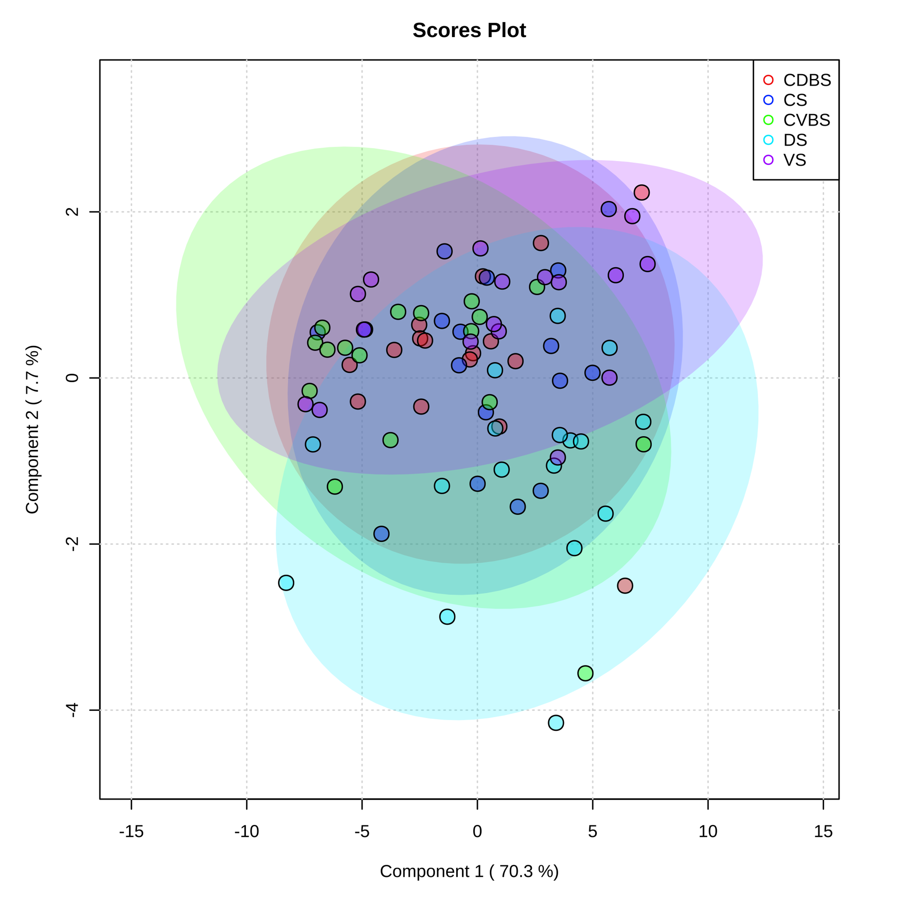
Figure 16 - Partial least-square discriminant analysis of metabolites among all five rumen sacs.

Partial least-square discriminant analysis of the rumen liquid samples, where each individual cow’s rumen sac is denoted by a dot of a specific color. Purple represents the VS, bright blue represents the DS, green represents the CVBS, dark blue represents CS, and red represents the CDBS. The large transparent circles represent a 95% confidence interval of each rumen sac, where the colors correspond with the dot color. There is significant overlap among each of the rumen sacs, indicating no unique metabolic profile among each rumen sac.

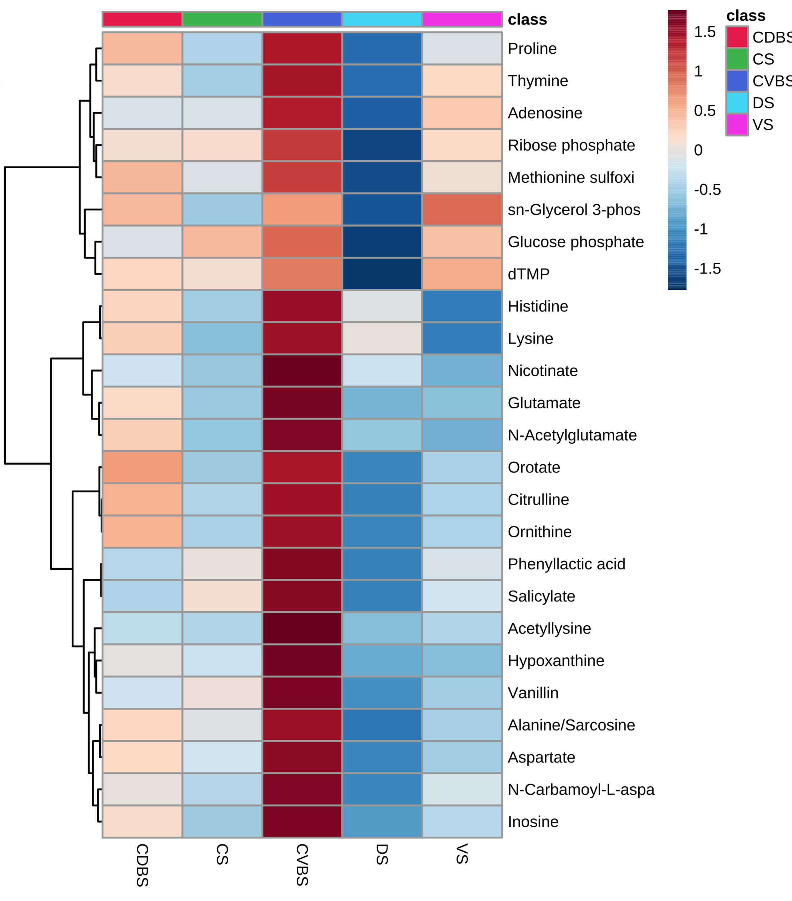
Figure 17 - Heat map of top 25 metabolites among the five rumen sacs.

Heat map of the top 25 metabolites present among each of the five rumen sacs. The darker the red equates to the greater relative abundance of the metabolite present within the rumen sac and the darker the blue equates to a lesser abundance of the metabolite present within the rumen sac. There was a difference in overall abundance of the metabolites in this heat map in the CVBS among the other four rumen sacs.
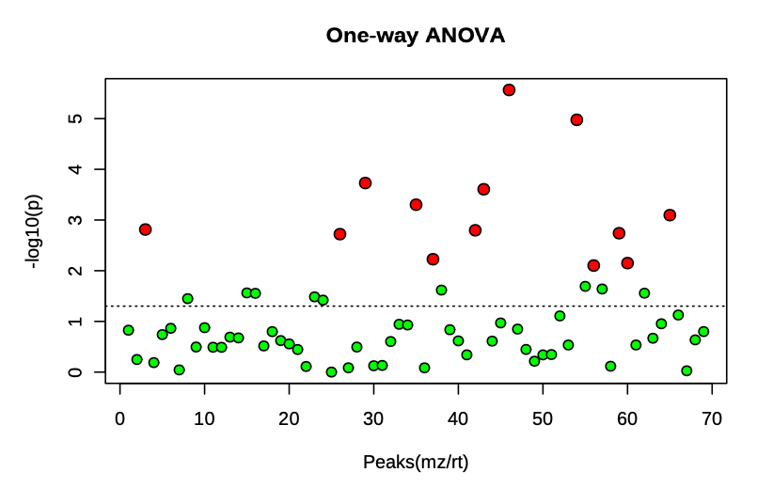
Figure 18 - One-way ANOVA plot highlighting the significant metabolites through pairwise comparisons.
One-way ANOVA scatter plot with the dotted line representing the -log10(p) of 0.05 indicating the thirteen red dots above the dotted line are significantly different in pairwise comparisons among the rumen sacs (P < 0.05). The green dots represent metabolites that were not significantly different among any of the rumen sacs (P > 0.05). The greater the -log10(p), the greater significant difference.

Table 4 - ANOVA table of metabolite differences among the five rumen sacs.
Metabolites | p.value | -log10(p) | FDR | Fisher’s LSD
Citrulline | 0.00 | 5.57 | 0.00 | CDBS – CS; CDBS – DS; CDBS – VS; CVBS – CS; CVBS – DS; VS – DS
Ornithine | 0.00 | 4.98 | 0.00 | CDBS – CS; CDBS – DS; CDBS – VS; CVBS – CS; CVBS – DS
Cytidine | 0.00 | 3.73 | 0.00 | DS – CDBS; CDBS – VS; CS – VS; DS – CVBS; CVBS – VS; DS – VS
N-Acetylglutamate | 0.00 | 3.61 | 0.00 | CDBS – CS; CDBS – VS; CVBS – CS; DS – CS; CVBS – VS
Glucose phosphate | 0.00 | 3.30 | 0.01 | CDBS – DS; CS – DS; CVBS – DS; VS – DS
Glutamate | 0.00 | 3.10 | 0.01 | CDBS – CS; CDBS – VS; CVBS – CS; CVBS – DS; CVBS – VS
Ribose phosphate | 0.00 | 2.81 | 0.01 | CDBS – DS; CS – DS; CVBS – DS; VS – DS
Serine | 0.00 | 2.80 | 0.01 | CDBS – CS; CDBS – CVBS; DS – CS; DS – CVBS
N-Acetylornithine | 0.00 | 2.74 | 0.01 | CDBS – CS; CDBS – VS; DS – CS; DS – CVBS; DS – VS
dTMP | 0.00 | 2.72 | 0.01 | CDBS – DS; CS – DS; CVBS – DS; VS – DS
Xylose | 0.01 | 2.23 | 0.04 | DS – CS; DS – CVBS; DS – VS
N-Acetylglutamine | 0.01 | 2.15 | 0.04 | DS – CDBS; DS – CS; DS – CVBS; DS – VS
Lysine | 0.01 | 2.10 | 0.04 | CDBS – CS; CDBS – VS; DS – CS; DS – VS

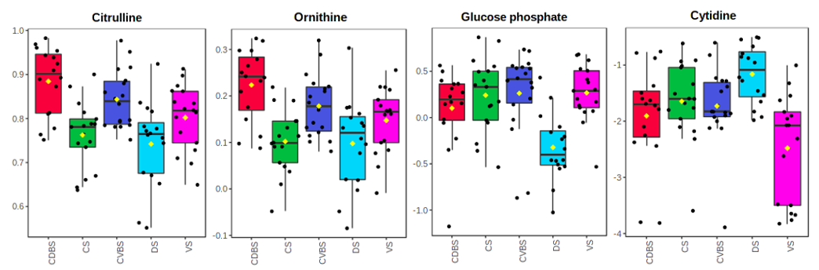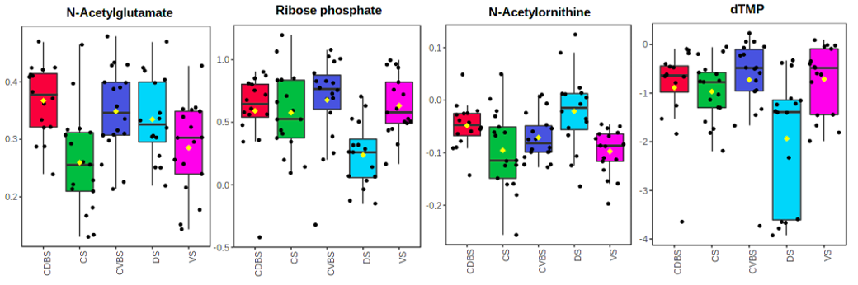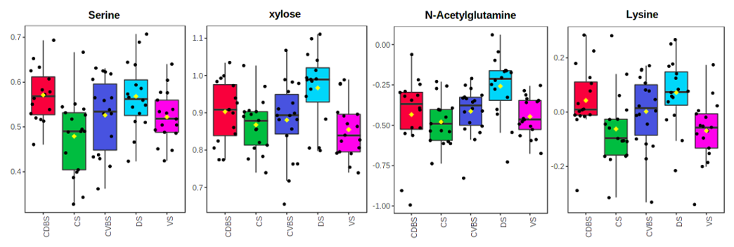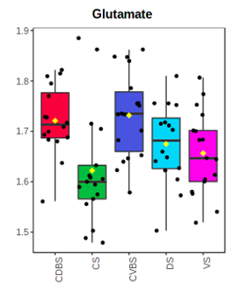
m.
l.
k.
j.
i.
h.
g.
f.
e.
d.
c.
b.
a.
Figure 19 - Box plots from of all significant metabolites from the one-way analysis of variance.

All of these metabolites were significant with normalized concentrations based on a -log10(p) value with significance determined at 0.05. Each of the letters represents one metabolite with the box plot showing all of the pairwise comparisons where they are (a) Citrulline, (b) Ornithine, (c) Glucose phosphate, (d) Cytidine, (e) N-Acetylglutamate, (f) Ribose phosphate, (g) N-Acetylornithine, (h) dTMP, (i) Serine, (j) Xylose, (k) N-Acetylglutamine, (l) Lysine, (m) Glutamate.

Discussion
To achieve the goal of feeding a growing population, cattle and other ruminants will be heavily relied upon due to their inherent ability to break down human inedible products into meat and milk for human consumption. The importance of the rumen microbiome is well recognized for breaking down plant material into energy for the host (Hobson & Stewart, 1988; Itzhak Mizrahi et al., 2021), and numerous investigations into the efficiency of cattle have been conducted regarding the rumen microbiome (Elolimy et al., 2018; Li & Guan, 2017; Myer et al., 2017). Many studies have focused solely on the ventral sac (Neubauer et al., 2019; Petri et al., 2013) due to the ease of access and repeatability to sample this region of the rumen. However, there is evidence that microbial variation exists among the fraction levels within the rumen and among the different rumen sacs (Sbardellati et al., 2020; Schären et al., 2017).

The main objective of this study was to investigate the ruminal biogeographical regions, hypothesizing that differences in bacterial species and metabolome would occur as a result of the differing anatomy and physiology associated with the respective regions. However, neither alpha diversity, beta diversity, nor differential abundance of bacterial communities was significant when analyzing the five rumen sacs, where each rumen sac encompassed the data from each of the three fractions pooled together. When analyzing the distinct three ruminal fractions, there was significance in the measures of alpha-, beta-diversity, and differential abundance. Historically, the dissimilarity among the ruminal fractions has been observed and, therefore, was an expected outcome (Abbas et al., 2020; De Mulder et al., 2017; Ji et al., 2017; Skarlupka et al., 2019). However, when evaluating alpha diversity, the main differences among the three fractions appears to be driven by the epimural community.

The fiber-adherent and planktonic communities work closely together during normal ruminal fermentation and digestion due to the contractions and subsequent mixing of the digesta fractions, resulting in a closer spatial relationship between the communities (Schären et al., 2017). The distinct differences noted apart from the rumen content fractions were especially important when evaluating the epimural community. Differences were observed in Shannon diversity, beta diversity, and differential abundances in the bacterial species were found among the five rumen sacs. Significance in Shannon diversity indicates changes in bacterial species richness and community evenness, whereas no richness metrics were different. This may signify that although richness/abundance may not be influential among the rumen sacs, community diversity and evenness play a larger role in the ruminal environment. This trend has been found in a previous study conducted on cannulated Holstein cows, where epimural samples were taken from four rumen sacs (Sbardellati et al., 2020). In this study, researchers sampled from the CS, CDBS, CVBS, and VS. The CDBS had the greatest Shannon diversity contrasted to our study, where the DS had the lowest Shannon diversity. However, the other four were similar in composition. Had researchers sampled from the DS they may have identified similar results. These data signify that the DS has a less diverse bacterial community, likely as result of the lesser extent of feedstuff digestion occurring in this rumen sac. The extent of the dissimilarity of the DS among the other four rumen sacs provides evidence of the DS dominated by distinct species of microbes which may indicate specific duties conducted by the epimural microbial communities in the DS (Sbardellati et al., 2020).

The epimural community dissimilarity among the five rumen sacs is also highlighted by their beta diversity distance matrices, indicating the different taxonomic composition of the bacterial communities within the epimural fraction. Among the sacs, the DS has greater distinction when measured against the other four rumen sacs. The vertical stratification of the rumen contents may drive these changes, due to the fiber mat and gaseous phase residing in the DS. The DS is significantly less papillated due to lesser blood flow to this rumen sac (Von Engelhardt & Hales, 1977) and the lesser extent of feedstuffs residing. Therefore, the necessity for papillae to develop for the purpose of microbial by-product absorption is reduced. Also, there are no pillars in the DS to prevent gas from the esophagus during normal feeding/rumination to escape into this sac which further increases the gas accumulation (C. R. Krehbiel, 2014). With greater accumulation of gas, oxygen scavenging or urea recycling is an important function for DS bacterial species, while fewer microbes support the breakdown of feedstuffs or absorption of nutrients (Ren et al., 2020).

The epimural fraction’s bacterial communities have many other specialized functions including their innate ability to act as an interface between the host and the rumen microbiome, nitrogen cycling, and rumen epithelial tissue recycling (Ren et al., 2020; Sbardellati et al., 2020; Schären et al., 2017). In this study, there were many significant differences in bacterial differential abundance determined between the DS and the other four rumen sacs, especially within the genus Campylobacter. Campylobacter is a non-fermentative bacterial species (Hassan et al., 2021) that has been identified in other research as part of the epimural bacterial community and has since been determined as both a nitrate-reducing bacterial species and a responder to oxidative stress (Hassan et al., 2021; Mann et al., 2018; Ren et al., 2020; Sbardellati et al., 2020). In a study investigating the epimural community of three Holstein dairy cows, it was found that Campylobacter was a highly abundant genus and had high expression of glutamate dehydrogenase and glutamine synthase, both of which are important in nitrogen metabolism, and thioredoxin reductase, which is a gene participating in the oxidative stress response (Mann et al., 2018). It has been observed that increasing nitrate will increase the abundance of Campylobacter. This response to increased nitrate is important for the rumen microbiome so that optimal usage of nitrate is provided and the toxic effects of nitrite accrual in the rumen are avoided (Ao & Emeritus, 2008; Hassan et al., 2021). As for the oxidative stress response, because our method of sampling was conducted through the rumen cannula, there may have been greater oxygen flow into the rumen through the space between the cannula and the skin during typical circumstances and because of the time that the cannula was left open during sampling (Moate et al., 2013; Wang et al., 2019). This may have caused the resultant increase in the differential abundance of Campylobacter in the DS to aid in returning the rumen to an anaerobic environment.

The rumen liquid metabolome may further support the distinct rumen biogeographical region of the DS. There were thirteen out of 69 metabolites determined to be different among the rumen sacs based on pairwise comparisons, which means that if a metabolite were found significant it implies that there may be multiple significant pairwise differences between the rumen sacs in the single significant metabolite. There were four metabolites that were significantly different in the DS and one metabolite was significantly different in the VS when compared to the other four rumen sacs. Even with only four of the metabolites being different in the DS when compared to the other four rumen sacs, the rest of the thirteen metabolites consistently had pairwise differences against the DS as well. There were numerous significant abundance differences determined among the rumen sacs with regard to the epimural bacterial community and metabolome, suggesting that functional variation (Sbardellati et al., 2020) within the rumen sacs may contribute to the dissimilarity in the epimural community. Further, due to distinctions in the regional conditions of each sac, microbes may be required to perform differently to maintain ruminal homeostasis. This study noted the variability within the epimural community, and how the biogeographical regions are a major factor when sampling. Without examining each rumen sac, valuable data may be overlooked. Research should continue to examine these communities, considering how important the epimural community is to ruminal homeostasis and host-microbe interactions (Zhou, Ghoshal, Stothard, et al., 2021).

When examining the entire bacterial communities within the rumen, all three fractions had both Firmicutes and Bacteroidetes as the top two phyla, which have been historically identified in ruminant and mammalian studies (Hart et al., 2018; Itzhak Mizrahi et al., 2021; Sbardellati et al., 2020). Microbes within these phyla are likely part of the core microbiome of cattle (Wirth et al., 2018). While in this study, Spirochaetota was the third most abundant phyla in the fiber-adherent community and Verrucomicrobiota was the third most abundant phyla for both the planktonic and epimural community. The greater abundance of Spirochaetota in the fiber-adherent community is not atypical due to their ability to degrade pectin, hemicellulose, and lignocellulose within the rumen (Gharechahi et al., 2021). This abundance of this phylum in the fiber-adherent bacterial community may be anticipated in this study, as cattle grazed warm season forages. The identification and higher prevalence of Verrucomicrobiota in both the epimural and planktonic microbial communities has been found less frequently. Verrucomicrobiota have been examined in a lignocellulosic forage studies, where researchers concluded bacteria in this phylum have carbohydrate active enzymes, sulfatases, and peptidases (Gharechahi et al., 2022) which facilitate carbohydrate polysaccharide metabolism and may aid in lignocellulose breakdown within the rumen. In general, having a major phylum in the planktonic community being involved in cellulose degradation is not uncommon (Schären et al., 2017; Tan et al., 2021; Zhou, Ghoshal, & Stothard, 2021), but it is more unexpected for the epimural community where Proteobacteria are typically detected at greater abundances (De Mulder et al., 2016; Pacifico et al., 2021; Sbardellati et al., 2020; Zhou, Ghoshal, Stothard, et al., 2021). Genera within Proteobacteria comprise of aerobes and facultative anaerobes, and thus are able to participate in oxygen scavenging (De Mulder et al., 2017; Zhou, Ghoshal, Stothard, et al., 2021). The ability of Proteobacteria to scavenge oxygen aids in maintaining the anaerobic environment in which oxygen would be toxic to the obligate anaerobic microbes (Sadet-Bourgeteau et al., 2010). Proteobacteria was found as the fifth most abundant phyla in the epimural community in this study. Compared to other studies, this may have been due to rumen fill. In the rumen of the cattle used for this study, the DS had a dense lawn of papillae which is far from average (Membrive, 2016). Due to the greater fill seen throughout the development of these cattle, the greater papillae may have been in greater prevalence to aid in absorption in the DS, causing the shift from the typical microbial phyla profiles.

The absence of differential abundance in the bacterial communities within the fiber-adherent fraction among the five rumen sacs may be attributable to the rumen fill as well. A typical rumen develops vertical stratification of the ruminal contents, where the majority of liquid accumulates in the VS and the fiber mat floats atop the liquid due to lower specific gravity, and gas fills the remainder of the dorsal space (Schmitz-Esser, 2021). When the rumen fill is greater than average, there may be greater dispersion of the forage feedstuffs among the rumen sacs which may have forced forages into uncharacteristic rumen sacs. This uncharacteristically high rumen fill may have caused lesser distinction of microbes among sacs that was determined in this project due to the greater homogeneity of forage feedstuffs among the rumen sacs. This rationale is also supported by the limited differences in the planktonic community bacteria, as only four bacteria were different among the sacs. The primary contractions constantly shift and displace rumen liquid (C. R. Krehbiel, 2014; Roehe et al., 2016), potentially resulting in a more homogenous rumen liquid among the rumen sacs. Further, the significant differential abundances in the planktonic community were only between the VS and DS; although in the metabolome, stark relative abundance differences were determined between CVBS and VS in the top twenty-five metabolites. Contractions throughout the rumen may influence these metabolite differences. The primary contraction cycle moves digesta in a clockwise fashion around the rumen; thus, higher density feedstuffs settle in more ventral sacs (C. R. Krehbiel, 2014; Reece et al., 2015). The feedstuffs settling lower may provide the CVBS with increased time for metabolism and subsequently increasing the abundance of metabolites present in the CVBS (Schmitz-Esser, 2021). It must also be noted the metabolome in the VS is distinct to the CVBS, which is interesting since they are both lower rumen sacs. Research regarding the metabolism and metabolome among the five rumen sacs may facilitate more efficient cattle through better knowledge of how feedstuffs are metabolized throughout the entirety of the rumen.

To date, limited studies have examined the microbial communities and fermentative metabolome among each of the five biogeographical locations and within each of the three fractions within the rumen. There were significant differences found when focusing on the ruminal fraction communities and their differences among the five rumen sacs, further providing evidence that the rumen is not just a homogeneous fermentation vat. The complex rumen microbiome works with differing functions to break down feedstuffs to synergistically provide energy for the host. Variation within the rumen microbiome based on differing diets exists (Loor et al., 2016; Snelling et al., 2019), but the microbiome is able to adapt to these changes to create an efficient microbiome (Brooke A. Clemmons et al., 2019; Snelling et al., 2019). A majority of the rumen biogeographical differences determined were against the DS and may be due to a multitude of causes, including digesta vertical stratification, papillation, and blood flow. The DS distinction may also further highlight the importance of the epimural community. This study provided further evidence to the necessity for sampling from each of the three ruminal fractions, and the critical need to sample from each of the five rumen sacs, especially when focusing on the epimural fraction.

Conclusions

The rumen is a complex organ, demarcated into five distinct rumen sacs due to distinct anatomical structure, and variable host tissue physiology. The distinction in anatomical structure is emphasized by the microbial and fermentative variability determined through the microbial communities in each rumen sac and fraction type and the rumen metabolome that was investigated in this project. The foremost component of the differences was driven by the epimural microbial community and particularly when analyzing the DS against the other four rumen fractions. These insights further indicate that the epimural microbes offer the best opportunity of interacting with the host (Schmitz-Esser, 2021; Zhou, Ghoshal, Stothard, et al., 2021). Future studies should examine host expression among the rumen biogeographical locations to support the microbial and fermentative differences found in this study. Despite the differences found, the microorganisms around the rumen and within different fractions work together to provide the host with the energy and substrates it needs to create an efficient host. Optimizing the structure of the rumen microbiome may continue to provide data on creating an increasingly efficient host, aiding in feeding the ever-growing global population.

List of References

Abbas, W., Keel, B. N., Kachman, S. D., Fernando, S. C., Wells, J. E., Hales, K. E., & Lindholm-Perry, A. K. (2020). Rumen epithelial transcriptome and microbiome profiles of rumen epithelium and contents of beef cattle with and without liver abscesses. Journal of animal science, 98(12), skaa359.
Alboukadel, K. (2019). fastqcr: Quality Control of Sequencing Data. R package version 0.1.2. https://CRAN.R-project.org/package=fastqcr
Ao, R. L., & Emeritus, D. (2008). The potential of feeding nitrate to reduce enteric methane production in ruminants. A report to the department of climate change, Canberra, Australia.
Apprill, A., McNally, S., Parsons, R., & Weber, L. (2015). Minor revision to V4 region SSU rRNA 806R gene primer greatly increases detection of SAR11 bacterioplankton. Aquatic Microbial Ecology, 75(2), 129-137.
Aschenbach, J. R., Penner, G. B., Stumpff, F., & Gabel, G. (2011). Ruminant Nutrition Symposium: Role of fermentation acid absorption in the regulation of ruminal pH. J Anim Sci, 89(4), 1092-1107. https://doi.org/10.2527/jas.2010-3301
Ault-Seay, T. B., Brandt, K. J., Henniger, M. T., Payton, R. R., Mathew, D. J., Moorey, S. E., Schrick, F. N., Pohler, K. G., Smith, T. P., & Rhinehart, J. D. (2022). Bacterial Communities of the Uterus and Rumen During Heifer Development With Protein Supplementation.
Bergman, E. N. (1990). Energy contributions of volatile fatty acids from the gastrointestinal tract in various species. Physiol Rev, 70(2), 567-590. https://doi.org/10.1152/physrev.1990.70.2.567
Bryant, A. (1964). Variations in the pH and volatile fatty acid concentration within the bovine reticulo-rumen. New Zealand Journal of Agricultural Research, 7(4), 694-706.
Callahan, B. J., McMurdie, P. J., Rosen, M. J., Han, A. W., Johnson, A. J. A., & Holmes, S. P. (2016). DADA2: High-resolution sample inference from Illumina amplicon data. Nature Methods, 13(7), 581-583. https://doi.org/10.1038/nmeth.3869
Chambers, M. C., Maclean, B., Burke, R., Amodei, D., Ruderman, D. L., Neumann, S., Gatto, L., Fischer, B., Pratt, B., Egertson, J., Hoff, K., Kessner, D., Tasman, N., Shulman, N., Frewen, B., Baker, T. A., Brusniak, M.-Y., Paulse, C., Creasy, D., . . . Mallick, P. (2012). A cross-platform toolkit for mass spectrometry and proteomics. Nature biotechnology, 30(10), 918-920. https://doi.org/10.1038/nbt.2377
Chen, Y., Oba, M., & Guan, L. L. (2012). Variation of bacterial communities and expression of Toll-like receptor genes in the rumen of steers differing in susceptibility to subacute ruminal acidosis. Vet Microbiol, 159(3-4), 451-459. https://doi.org/10.1016/j.vetmic.2012.04.032
Cheng, K. J., McCowan, R. P., & Costerton, J. W. (1979). Adherent epithelial bacteria in ruminants and their roles in digestive tract function. Am J Clin Nutr, 32(1), 139-148. https://doi.org/10.1093/ajcn/32.1.139
Cho, H., Kozasa, T., Bondjers, C., Betsholtz, C., & Kehrl, J. H. (2003). Pericyte-specific expression of Rgs5: implications for PDGF and EDG receptor signaling during vascular maturation. Faseb j, 17(3), 440-442. https://doi.org/10.1096/fj.02-0340fje
Cho, S.-J., Cho, K.-M., Shin, E.-C., Lim, W.-J., Hong, S.-Y., Choi, B.-R., Kang, J.-M., Lee, S.-M., Kim, Y.-H., & Kim, H. (2006). 16S rDNA analysis 9f bacterial diversity in three fractions of cow rumen. Journal of Microbiology and Biotechnology, 16(1), 92-101.
Church, D. C. (1993). The ruminant animal: digestive physiology and nutrition. Waveland press.
Clasquin, M. F., Melamud, E., & Rabinowitz, J. D. (2012). LC-MS data processing with MAVEN: a metabolomic analysis and visualization engine. Curr Protoc Bioinformatics, Chapter 14, Unit14.11. https://doi.org/10.1002/0471250953.bi1411s37
Clemmons, B. A., Martino, C., Schneider, L. G., Lefler, J., Embree, M. M., & Myer, P. R. (2019). Temporal Stability of the Ruminal Bacterial Communities in Beef Steers. Scientific reports, 9(1), 9522. https://doi.org/10.1038/s41598-019-45995-2
Clemmons, B. A., Martino, C., Schneider, L. G., Lefler, J., Embree, M. M., & Myer, P. R. (2019). Temporal stability of the ruminal bacterial communities in beef steers. Scientific reports, 9(1), 1-8.
Czerkawski, J., & Cheng, K. (1988). Compartmentation in the rumen. Rumen microbial ecosystem/edited by PN Hobson.
Czerkawski, J. W. (2013). An introduction to rumen studies. Elsevier.
De Mulder, T., Goossens, K., Peiren, N., Vandaele, L., Haegeman, A., De Tender, C., Ruttink, T., de Wiele, T. V., & De Campeneere, S. (2016). Exploring the methanogen and bacterial communities of rumen environments: solid adherent, fluid and epimural. FEMS Microbiology Ecology, 93(3). https://doi.org/10.1093/femsec/fiw251
De Mulder, T., Goossens, K., Peiren, N., Vandaele, L., Haegeman, A., De Tender, C., Ruttink, T., de Wiele, T. V., & De Campeneere, S. (2017). Exploring the methanogen and bacterial communities of rumen environments: solid adherent, fluid and epimural. FEMS Microbiol Ecol, 93(3). https://doi.org/10.1093/femsec/fiw251
Dehority, B. A. (2002). Gastrointestinal tracts of herbivores, particularly the ruminant: anatomy, physiology and microbial digestion of plants. Journal of applied animal research, 21(2), 145-160.
Deng, W., Wang, X., Xiao, J., Chen, K., Zhou, H., Shen, D., Li, H., & Tang, Q. (2012). Loss of regulator of G protein signaling 5 exacerbates obesity, hepatic steatosis, inflammation and insulin resistance. PLoS One, 7(1), e30256. https://doi.org/10.1371/journal.pone.0030256
Dieho, K., Bannink, A., Geurts, I. A. L., Schonewille, J. T., Gort, G., & Dijkstra, J. (2016). Morphological adaptation of rumen papillae during the dry period and early lactation as affected by rate of increase of concentrate allowance. J Dairy Sci, 99(3), 2339-2352. https://doi.org/10.3168/jds.2015-9837
Dijkstra, J., Ellis, J., Kebreab, E., Strathe, A., López, S., France, J., & Bannink, A. (2012). Ruminal pH regulation and nutritional consequences of low pH. Animal Feed Science and Technology, 172(1-2), 22-33.
Dridi, J. S., Greene, E. S., Maynard, C. W., Brugaletta, G., Ramser, A., Christopher, C. J., Campagna, S. R., Castro, H. F., & Dridi, S. (2022). Duodenal Metabolic Profile Changes in Heat-Stressed Broilers. Animals, 12(11), 1337. https://www.mdpi.com/2076-2615/12/11/1337
Elolimy, A. A., Abdelmegeid, M. K., McCann, J. C., Shike, D. W., & Loor, J. J. (2018). Residual feed intake in beef cattle and its association with carcass traits, ruminal solid-fraction bacteria, and epithelium gene expression. Journal of Animal Science and Biotechnology, 9(1), 67. https://doi.org/10.1186/s40104-018-0283-8
Fay, J., Cheng, K., & Costerton, J. (1979). Production of alkaline phosphatase by epithelial cells and adherent bacteria of the bovine rumen and abomasum. Canadian Journal of Microbiology, 25(8), 932-936.
Gharechahi, J., Sarikhan, S., Han, J.-L., Ding, X.-Z., & Salekdeh, G. H. (2022). Functional and phylogenetic analyses of camel rumen microbiota associated with different lignocellulosic substrates. npj Biofilms and Microbiomes, 8(1), 46. https://doi.org/10.1038/s41522-022-00309-9
Gharechahi, J., Vahidi, M. F., Bahram, M., Han, J.-L., Ding, X.-Z., & Salekdeh, G. H. (2021). Metagenomic analysis reveals a dynamic microbiome with diversified adaptive functions to utilize high lignocellulosic forages in the cattle rumen. The ISME Journal, 15(4), 1108-1120. https://doi.org/10.1038/s41396-020-00837-2
Grünberg, W., & Constable, P. D. (2009). CHAPTER 6 - Function and Dysfunction of the Ruminant Forestomach. In D. E. Anderson & D. M. Rings (Eds.), Food Animal Practice (Fifth Edition) (pp. 12-19). W.B. Saunders. https://doi.org/https://doi.org/10.1016/B978-141603591-6.10006-5
Harlow, B. E., Flythe, M. D., & Aiken, G. E. (2017). Effect of biochanin A on corn grain (Zea mays) fermentation by bovine rumen amylolytic bacteria. J Appl Microbiol, 122(4), 870-880. https://doi.org/10.1111/jam.13397
Hart, E. H., Creevey, C. J., Hitch, T., & Kingston-Smith, A. H. (2018). Meta-proteomics of rumen microbiota indicates niche compartmentalisation and functional dominance in a limited number of metabolic pathways between abundant bacteria. Scientific reports, 8(1), 10504. https://doi.org/10.1038/s41598-018-28827-7
Hassan, F.-u., Guo, Y., Li, M., Tang, Z., Peng, L., Liang, X., & Yang, C. (2021). Effect of Methionine Supplementation on Rumen Microbiota, Fermentation, and Amino Acid Metabolism in In Vitro Cultures Containing Nitrate. Microorganisms, 9(8), 1717. https://www.mdpi.com/2076-2607/9/8/1717
Hobson, P. N., & Stewart, C. S. (1988). Rumen microbial ecosystem. Springer Science & Business Media.
Ji, S., Zhang, H., Yan, H., Azarfar, A., Shi, H., Alugongo, G., Li, S., Cao, Z., & Wang, Y. (2017). Comparison of rumen bacteria distribution in original rumen digesta, rumen liquid and solid fractions in lactating Holstein cows. Journal of Animal Science and Biotechnology, 8(1), 16. https://doi.org/10.1186/s40104-017-0142-z
Kern, R. J., Lindholm-Perry, A. K., Freetly, H. C., Snelling, W. M., Kern, J. W., Keele, J. W., Miles, J. R., Foote, A. P., Oliver, W. T., Kuehn, L. A., & Ludden, P. A. (2016). Transcriptome differences in the rumen of beef steers with variation in feed intake and gain. Gene, 586(1), 12-26. https://doi.org/10.1016/j.gene.2016.03.034
Krehbiel, C. (2014). Invited review: Applied nutrition of ruminants: Fermentation and digestive physiology. The Professional Animal Scientist, 30(2), 129-139.
Krehbiel, C. R. (2014). INVITED REVIEW: Applied nutrition of ruminants: Fermentation and digestive physiology1. The Professional Animal Scientist, 30(2), 129-139. https://doi.org/https://doi.org/10.15232/S1080-7446(15)30100-5
Li, F., & Guan, L. L. (2017). Metatranscriptomic Profiling Reveals Linkages between the Active Rumen Microbiome and Feed Efficiency in Beef Cattle. Applied and Environmental Microbiology, 83(9), e00061-00017. https://doi.org/doi:10.1128/AEM.00061-17
Li, M., Penner, G. B., Hernandez-Sanabria, E., Oba, M., & Guan, L. L. (2009). Effects of sampling location and time, and host animal on assessment of bacterial diversity and fermentation parameters in the bovine rumen. J Appl Microbiol, 107(6), 1924-1934. https://doi.org/10.1111/j.1365-2672.2009.04376.x
Liu, J. H., Bian, G. R., Zhu, W. Y., & Mao, S. Y. (2015). High-grain feeding causes strong shifts in ruminal epithelial bacterial community and expression of Toll-like receptor genes in goats. Front Microbiol, 6, 167. https://doi.org/10.3389/fmicb.2015.00167
Loor, J. J., Elolimy, A. A., & McCann, J. C. (2016). Dietary impacts on rumen microbiota in beef and dairy production. Animal Frontiers, 6(3), 22-29. https://doi.org/10.2527/af.2016-0030
Lu, W., Clasquin, M. F., Melamud, E., Amador-Noguez, D., Caudy, A. A., & Rabinowitz, J. D. (2010). Metabolomic analysis via reversed-phase ion-pairing liquid chromatography coupled to a stand alone orbitrap mass spectrometer. Anal Chem, 82(8), 3212-3221. https://doi.org/10.1021/ac902837x
Ma, Z., Wang, R., Wang, M., Zhang, X., Mao, H., & Tan, Z. (2018). Short communication: Variability in fermentation end-products and methanogen communities in different rumen sites of dairy cows. J Dairy Sci, 101(6), 5153-5158. https://doi.org/10.3168/jds.2017-14096
Mach, N., Devant, M., & Bach, A. (2006). Rumen fermentation parameters and rumen papillae characteristics in finishing bulls as affected by nonfibrous carbohydrate level and lipid source of the diet. Journal of Animal and Veterinary Advances.
Mann, E., Wetzels, S. U., Wagner, M., Zebeli, Q., & Schmitz-Esser, S. (2018). Metatranscriptome Sequencing Reveals Insights into the Gene Expression and Functional Potential of Rumen Wall Bacteria [Original Research]. Frontiers in microbiology, 9. https://doi.org/10.3389/fmicb.2018.00043
Mao, S., Zhang, M., Liu, J., & Zhu, W. (2015). Characterising the bacterial microbiota across the gastrointestinal tracts of dairy cattle: membership and potential function. Scientific reports, 5(1), 1-14.
Martens, L., Chambers, M., Sturm, M., Kessner, D., Levander, F., Shofstahl, J., Tang, W. H., Römpp, A., Neumann, S., Pizarro, A. D., Montecchi-Palazzi, L., Tasman, N., Coleman, M., Reisinger, F., Souda, P., Hermjakob, H., Binz, P.-A., & Deutsch, E. W. (2011). mzML--a community standard for mass spectrometry data. Molecular & cellular proteomics : MCP, 10(1), R110.000133-R000110.000133. https://doi.org/10.1074/mcp.R110.000133
McCowan, R., Cheng, K., Bailey, C., & Costerton, J. (1978). Adhesion of bacteria to epithelial cell surfaces within the reticulo-rumen of cattle. Applied and Environmental Microbiology, 35(1), 149-155.
McMurdie, P. J., & Holmes, S. (2013). phyloseq: An R Package for Reproducible Interactive Analysis and Graphics of Microbiome Census Data. PloS one, 8(4), e61217. https://doi.org/10.1371/journal.pone.0061217
Melamud, E., Vastag, L., & Rabinowitz, J. D. (2010). Metabolomic Analysis and Visualization Engine for LC−MS Data. Analytical Chemistry, 82(23), 9818-9826. https://doi.org/10.1021/ac1021166
Membrive, C. M. B. (2016). Anatomy and Physiology of the Rumen. In Rumenology (pp. 1-38). Springer.
Millen, D. D., De Beni Arrigoni, M., & Lauritano Pacheco, R. D. (2016). Rumenology (1st 2016. ed.). Springer International Publishing. https://doi.org/10.1007/978-3-319-30533-2
Mizrahi, I. (2013). Rumen Symbioses. In E. Rosenberg, E. F. DeLong, S. Lory, E. Stackebrandt, & F. Thompson (Eds.), The Prokaryotes: Prokaryotic Biology and Symbiotic Associations (pp. 533-544). Springer Berlin Heidelberg. https://doi.org/10.1007/978-3-642-30194-0_1
Mizrahi, I., & Jami, E. (2021). A method to the madness: Disentangling the individual forces that shape the rumen microbiome. EMBO Rep, 22(2), e52269. https://doi.org/10.15252/embr.202052269
Mizrahi, I., Wallace, R. J., & Morais, S. (2021). The rumen microbiome: balancing food security and environmental impacts. Nat Rev Microbiol, 19(9), 553-566. https://doi.org/10.1038/s41579-021-00543-6
Mizrahi, I., Wallace, R. J., & Moraïs, S. (2021). The rumen microbiome: balancing food security and environmental impacts. Nature Reviews Microbiology, 19(9), 553-566. https://doi.org/10.1038/s41579-021-00543-6
Moate, P., Williams, S. R. O., Deighton, M., Jacobs, J., & Wales, B. (2013). Influence of rumen cannulation on feed intake, milk production, enteric methane production and composition of rumen headspace gas (Vol. 4).
Myer, P. R., Freetly, H. C., Wells, J. E., Smith, T. P. L., & Kuehn, L. A. (2017). Analysis of the gut bacterial communities in beef cattle and their association with feed intake, growth, and efficiency1,2,3. Journal of animal science, 95(7), 3215-3224. https://doi.org/10.2527/jas.2016.1059
Na, S. W. (2022). Understanding the role of rumen epithelial host-microbial interactions in cattle feed efficiency. Animal Nutrition.
Na, S. W., & Guan, L. L. (2022). Understanding the role of rumen epithelial host-microbe interactions in cattle feed efficiency. Animal Nutrition, 10, 41-53. https://doi.org/https://doi.org/10.1016/j.aninu.2022.04.002
Neubauer, V., Humer, E., Mann, E., Kröger, I., Reisinger, N., Wagner, M., Zebeli, Q., & Petri, R. M. (2019). Effects of clay mineral supplementation on particle-associated and epimural microbiota, and gene expression in the rumen of cows fed high-concentrate diet. Anaerobe, 59, 38-48. https://doi.org/https://doi.org/10.1016/j.anaerobe.2019.05.003
Niwińska, B., Hanczakowska, E., Arciszewski, M., & Klebaniuk, R. (2017). Exogenous butyrate: implications for the functional development of ruminal epithelium and calf performance. Animal, 11(9), 1522-1530.
Oksanen, J., Simpson, G., Blanchet, F. G., Kindt, R., Legendre, P., Minchin, P., hara, R., Solymos, P., Stevens, H., Szöcs, E., Wagner, H., Barbour, M., Bedward, M., Bolker, B., Borcard, D., Carvalho, G., Chirico, M., De Cáceres, M., Durand, S., & Weedon, J. (2022). vegan community ecology package version 2.6-2 April 2022.
Orpin, C. G. (1976). Studies on the rumen flagellate Sphaeromonas communis. J Gen Microbiol, 94(2), 270-280. https://doi.org/10.1099/00221287-94-2-270
Pacifico, C., Petri, R. M., Ricci, S., Mickdam, E., Wetzels, S. U., Neubauer, V., & Zebeli, Q. (2021). Unveiling the Bovine Epimural Microbiota Composition and Putative Function. Microorganisms, 9(2). https://doi.org/10.3390/microorganisms9020342
Pang, Z., Chong, J., Zhou, G., de Lima Morais, D. A., Chang, L., Barrette, M., Gauthier, C., Jacques, P.-É., Li, S., & Xia, J. (2021). MetaboAnalyst 5.0: narrowing the gap between raw spectra and functional insights. Nucleic Acids Research, 49(W1), W388-W396. https://doi.org/10.1093/nar/gkab382
Parada, A. E., Needham, D. M., & Fuhrman, J. A. (2016). Every base matters: assessing small subunit rRNA primers for marine microbiomes with mock communities, time series and global field samples. Environmental microbiology, 18(5), 1403-1414.
Penner, G. B., Aschenbach, J. R., Gabel, G., Rackwitz, R., & Oba, M. (2009). Epithelial capacity for apical uptake of short chain fatty acids is a key determinant for intraruminal pH and the susceptibility to subacute ruminal acidosis in sheep. J Nutr, 139(9), 1714-1720. https://doi.org/10.3945/jn.109.108506
Petri, R. M., Kleefisch, M. T., Metzler-Zebeli, B. U., Zebeli, Q., & Klevenhusen, F. (2018). Changes in the Rumen Epithelial Microbiota of Cattle and Host Gene Expression in Response to Alterations in Dietary Carbohydrate Composition. Appl Environ Microbiol, 84(12). https://doi.org/10.1128/AEM.00384-18
Petri, R. M., Neubauer, V., Humer, E., Kröger, I., Reisinger, N., & Zebeli, Q. (2020a). Feed additives differentially impact the epimural microbiota and host epithelial gene expression of the bovine rumen fed diets rich in concentrates. Frontiers in microbiology, 11, 119.
Petri, R. M., Neubauer, V., Humer, E., Kröger, I., Reisinger, N., & Zebeli, Q. (2020b). Feed Additives Differentially Impact the Epimural Microbiota and Host Epithelial Gene Expression of the Bovine Rumen Fed Diets Rich in Concentrates [Original Research]. Frontiers in microbiology, 11. https://doi.org/10.3389/fmicb.2020.00119
Petri, R. M., Schwaiger, T., Penner, G. B., Beauchemin, K. A., Forster, R. J., McKinnon, J. J., & McAllister, T. A. (2013). Changes in the Rumen Epimural Bacterial Diversity of Beef Cattle as Affected by Diet and Induced Ruminal Acidosis. Applied and Environmental Microbiology, 79(12), 3744-3755. https://doi.org/doi:10.1128/AEM.03983-12
Reece, W. O., Erickson, H. H., Goff, J. P., & Uemura, E. E. (2015). Dukes' Physiology of Domestic Animals. Wiley. https://books.google.com/books?id=1BjPBwAAQBAJ
Ren, Q., Si, H., Yan, X., Liu, C., Ding, L., Long, R., Li, Z., & Qiu, Q. (2020). Bacterial communities in the solid, liquid, dorsal, and ventral epithelium fractions of yak (Bos grunniens) rumen. Microbiologyopen, 9(2), e963.
Roehe, R., Dewhurst, R. J., Duthie, C.-A., Rooke, J. A., McKain, N., Ross, D. W., Hyslop, J. J., Waterhouse, A., Freeman, T. C., & Watson, M. (2016). Bovine host genetic variation influences rumen microbial methane production with best selection criterion for low methane emitting and efficiently feed converting hosts based on metagenomic gene abundance. PLoS genetics, 12(2), e1005846.
Rumsey, T. S., Putnam, P. A., Bond, J., & Oltjen, R. R. (1970). Influence of level and type of diet on ruminal pH and VFA, respiratory rate and EKG patterns of steers. J Anim Sci, 31(3), 608-616. https://doi.org/10.2527/jas1970.313608x
Sadet-Bourgeteau, S., Martin, C., & Morgavi, D. P. (2010). Bacterial diversity dynamics in rumen epithelium of wethers fed forage and mixed concentrate forage diets. Veterinary microbiology, 146(1), 98-104. https://doi.org/https://doi.org/10.1016/j.vetmic.2010.04.029
Sbardellati, D. L., Fischer, A., Cox, M. S., Li, W., Kalscheur, K. F., & Suen, G. (2020). The bovine epimural microbiota displays compositional and structural heterogeneity across different ruminal locations. J Dairy Sci, 103(4), 3636-3647. https://doi.org/10.3168/jds.2019-17649
Schären, M., Kiri, K., Riede, S., Gardener, M., Meyer, U., Hummel, J., Urich, T., Breves, G., & Dänicke, S. (2017). Alterations in the Rumen Liquid-, Particle- and Epithelium-Associated Microbiota of Dairy Cows during the Transition from a Silage- and Concentrate-Based Ration to Pasture in Spring. Front Microbiol, 8, 744. https://doi.org/10.3389/fmicb.2017.00744
Schmitz-Esser, S. (2021). The Rumen Epithelial Microbiota: Possible Gatekeepers of the Rumen Epithelium and Its Potential Contributions to Epithelial Barrier Function and Animal Health and Performance. Meat and Muscle Biology, 4(2).
Shen, J. S., Chai, Z., Song, L. J., Liu, J. X., & Wu, Y. M. (2012). Insertion depth of oral stomach tubes may affect the fermentation parameters of ruminal fluid collected in dairy cows. J Dairy Sci, 95(10), 5978-5984. https://doi.org/10.3168/jds.2012-5499
Skarlupka, J. H., Kamenetsky, M. E., Jewell, K. A., & Suen, G. (2019). The ruminal bacterial community in lactating dairy cows has limited variation on a day-to-day basis. Journal of Animal Science and Biotechnology, 10(1), 1-5.
Snelling, T. J., Auffret, M. D., Duthie, C.-A., Stewart, R. D., Watson, M., Dewhurst, R. J., Roehe, R., & Walker, A. W. (2019). Temporal stability of the rumen microbiota in beef cattle, and response to diet and supplements. Animal Microbiome, 1(1), 1-14.
Steele, M. A., Croom, J., Kahler, M., AlZahal, O., Hook, S. E., Plaizier, K., & McBride, B. W. (2011). Bovine rumen epithelium undergoes rapid structural adaptations during grain-induced subacute ruminal acidosis. Am J Physiol Regul Integr Comp Physiol, 300(6), R1515-1523. https://doi.org/10.1152/ajpregu.00120.2010
Tafaj, M., Junck, B., Maulbetsch, A., Steingass, H., Piepho, H. P., & Drochner, W. (2004). Digesta characteristics of dorsal, middle and ventral rumen of cows fed with different hay qualities and concentrate levels. Arch Anim Nutr, 58(4), 325-342. https://doi.org/10.1080/00039420412331273259
Tajima, K., Aminov, R. I., Nagamine, T., Ogata, K., Nakamura, M., Matsui, H., & Benno, Y. (1999). Rumen bacterial diversity as determined by sequence analysis of 16S rDNA libraries. FEMS Microbiology Ecology, 29(2), 159-169. https://doi.org/10.1111/j.1574-6941.1999.tb00607.x
Tajima, K., Arai, S., Ogata, K., Nagamine, T., Matsui, H., Nakamura, M., Aminov, R. I., & Benno, Y. (2000). Rumen Bacterial Community Transition During Adaptation to High-grain Diet. Anaerobe, 6(5), 273-284. https://doi.org/https://doi.org/10.1006/anae.2000.0353
Tan, R. S., Zhou, M., & Li, F. (2021). Identifying active rumen epithelial associated bacteria and archaea in beef cattle divergent in feed efficiency using total RNA-seq. Current Research in Microbial Sciences, 2, 100064.
Van Soest, P. J. (1994). Nutritional ecology of the ruminant. Cornell university press.
Von Engelhardt, W., & Hales, J. (1977). Partition of capillary blood flow in rumen, reticulum, and omasum of sheep. American Journal of Physiology-Endocrinology and Metabolism, 232(1), E53.
Wallace, R., Cheng, K.-J., Dinsdale, D., & Ørskov, E. (1979). An independent microbial flora of the epithelium and its role in the ecomicrobiology of the rumen. Nature, 279(5712), 424-426.
Wang, B., Wang, D., Wu, X., Cai, J., Liu, M., Huang, X., Wu, J., Liu, J., & Guan, L. (2017). Effects of dietary physical or nutritional factors on morphology of rumen papillae and transcriptome changes in lactating dairy cows based on three different forage-based diets. BMC Genomics, 18(1), 353. https://doi.org/10.1186/s12864-017-3726-2
Wang, R., Wang, M., Zhang, X. M., Wen, J. N., Ma, Z. Y., Long, D. L., Deng, J. P., & Tan, Z. L. (2019). Effects of rumen cannulation on dissolved gases and methanogen community in dairy cows. Journal of Dairy Science, 102(3), 2275-2282. https://doi.org/https://doi.org/10.3168/jds.2018-15187
Weimer, P. J. (2015). Redundancy, resilience, and host specificity of the ruminal microbiota: implications for engineering improved ruminal fermentations. Frontiers in microbiology, 6, 296.
Welkie, D. G., Stevenson, D. M., & Weimer, P. J. (2010). ARISA analysis of ruminal bacterial community dynamics in lactating dairy cows during the feeding cycle. Anaerobe, 16(2), 94-100. https://doi.org/10.1016/j.anaerobe.2009.07.002
Wetzels, S. U., Mann, E., Pourazad, P., Qumar, M., Pinior, B., Metzler-Zebeli, B. U., Wagner, M., Schmitz-Esser, S., & Zebeli, Q. (2017). Epimural bacterial community structure in the rumen of Holstein cows with different responses to a long-term subacute ruminal acidosis diet challenge. J Dairy Sci, 100(3), 1829-1844. https://doi.org/10.3168/jds.2016-11620
Whitford, M. F., Forster, R. J., Beard, C. E., Gong, J., & Teather, R. M. (1998). Phylogenetic analysis of rumen bacteria by comparative sequence analysis of cloned 16S rRNA genes. Anaerobe, 4(3), 153-163. https://doi.org/10.1006/anae.1998.0155
Wirth, R., Kádár, G., Kakuk, B., Maróti, G., Bagi, Z., Szilágyi, Á., Rákhely, G., Horváth, J., & Kovács, K. L. (2018). The Planktonic Core Microbiome and Core Functions in the Cattle Rumen by Next Generation Sequencing [Original Research]. Frontiers in microbiology, 9. https://doi.org/10.3389/fmicb.2018.02285
Xue, M.-Y., Wu, J.-J., Xie, Y.-Y., Zhu, S.-L., Zhong, Y.-F., Liu, J.-X., & Sun, H.-Z. (2022). Investigation of fiber utilization in the rumen of dairy cows based on metagenome-assembled genomes and single-cell RNA sequencing. Microbiome, 10(1), 11. https://doi.org/10.1186/s40168-021-01211-w
Yu, Z., & Morrison, M. (2004). Improved extraction of PCR-quality community DNA from digesta and fecal samples. Biotechniques, 36(5), 808-812. https://doi.org/10.2144/04365st04
Zhou, M., Ghoshal, B., & Stothard, P. (2021). Distinctive roles between rumen epimural and content bacterial communities on beef cattle feed efficiency: A combined analysis. Current Research in Microbial Sciences, 2, 100085.
Zhou, M., Ghoshal, B., Stothard, P., & Guan, L. L. (2021). Distinctive roles between rumen epimural and content bacterial communities on beef cattle feed efficiency: A combined analysis. Current Research in Microbial Sciences, 2, 100085. https://doi.org/https://doi.org/10.1016/j.crmicr.2021.100085

Vita
Macey Soltis was born February 6th, 1999, in Tampa, FL. Macey graduated from Steinbrenner high school in 2017. She then attended the University of Florida in Gainesville, FL where she received her Bachelor of Science majoring in Animal Science with a focus on animal biology in May 2020. Macey moved to Knoxville, Tennessee in January 2021 to start her Master of Animal Science and the University of Tennessee in Spring 2021. Macey worked as a graduate student under the mentorship of Dr. Phillip Myer for her Master of Science in Animal Science with a focus on rumen microbiology and she graduated with her degree in Fall 2022.

