SYNTHESES OF PRECURSORS TO FLUORINE-18 LABELED PET IMAGING AGENTS

A Thesis
Submitted to the Faculty

of

The University of Tennessee Knoxville

by

Lindsay Brooke Boling

In Partial Fulfillment of the
Requirements for the Degree

of

Bachelors of Science: Chemistry

April 2014
The University of Tennessee Knoxville
Knoxville, Tennessee

Thesis Defense Committee:

Professor George Kabalka, Advisor

Professor John Bartmess

Professor Brian Long

Table of Contents

Table of contents 2
List of Tables and Figures 3
Nomenclature 5
Abstract 6
Chapter 1: Introduction 7
1.1 Fluorine-18 Radiolabeling and Applications in PET Imaging...................................................................7
1.2 Protein Labeling: Carboxyl-, Amine-, and Thiol-Reactive Biofunctional Agents......................................8
1.3 Thiol-Reactive Agent: FPYAM.................................................................................................................11
1.4 Fluorine-18 Labeling for Lignin Depolymerization Detection................................................................12
1.5 Synthesis of Lignin-derived Aromatic Compounds...................................................................................13
Chapter 2: Experimental Procedure 15
2.1 Synthesis of Thiol-Reactive Prosthetic Group: [${}_{}^{18}F]$FPyAM..................................................................15
2.1.1 Substitution of Quaternary Ammonium Salt (Radiofluorination Precursor)..........................16
2.1.2 Triflate/Bromide Exchange (Radiofluorination Precursor)....................................................17
2.1.3 Addition of NBOC Group (Oxamine Precursor).....................................................................17
2.1.4 Addition of Maleimide Group (Oxamine Precursor)..............................................................18
2.1.5 Removal of BOC Group (Oxamine Precursor).......................................................................18
2.1.6 Radiofluorination....................................................................................................................19
2.1.7 Condensation to Create Imine Final Product.........................................................................19
2.2 Synthesis of Lignin-Derived Aromatic Compound...................................................................................20
2.2.1 Benzoylation of Para-Hydroxyl Group...................................................................................20
2.2.2 Addition of Triflate Ester........................................................................................................21
Chapter 3: Measurement, Analysis, and Results.............................................................................22
Chapter 4: Discussion and Conclusions.................................................................................................24
4.1 Synthesis of [${}_{}^{18}F$]FPyAM.........................................................................................................................24
4.2 Synthesis of Lignin-Derived Aromatic Compound...................................................................................24
References..............................................................................................................................................................26
Appendices
I. Published Abstract of [${}_{}^{18}F$]FPyAM............................................................................................................28
II. NMR Spectra..............................................................................................................................................29

List of Tables and Figures

Table 1(pg.22). NMR Shifts and Percent Yields for Syntheses Products of the Various Reaction Schemes
Figure 1(pg.8). Name and Structure for common Amino Reactive Prosthetic Groups
Figure 2(pg.8). Name and Structure for common Carboxylic Acid Reactive Prosthetic Groups
Figure 3(pg.9). Name and Structure for Common Thiol Reactive Prosthetic Groups
Figure 4(pg.11). Structure of [${}_{}^{18}F$] FPyAM.
Figure 5(pg. 12). Structure of Oxamine Precursor.
Figure 6(pg. 14). Structure of Radiolabeling Precusor LDAC Molecule.
Figure 7(pg. 16). Structure for Product of Substitution of Quaternary Ammonium Salt (Radiofluorination Precursor)
Figure 8(pg. 17). Structure for Radifluorination Precursor
Figure 9(pg. 18). Structure for Product of Addition of NBOC Group (Oxamine Precursor)
Figure 10(pg. 18). Structure for Product from Addition of Maleimide Group (Oxamine Precursor)
Figure 11(pg. 19). Sturcture of Radiofluorinated Precursor
Figure 12(pg.21). Structure for Product of Benzoylation of Para-Hydroxyl Group
Figure 13(pg.21). Structure for Product of Addition of Triflate Ester
Figure 14(pg.23). Radio TLC of Radiofluorinated Precursor Molecule for FPyAM Showing 31% Incorporation.
Scheme 1(pg.15). Preparation of [${}_{}^{18}F]$FPyAM Radiofluorination Precursor
Scheme 2(pg.15). Preparation of the [${}_{}^{18}F]$FPyAM Oxamine Precursor
Scheme 3(pg.15). Radiofluorination of the Radiofluorination Precursor
Scheme 4(pg.16). Condensation of Precursor to Yield [${}_{}^{18}F]$FPyAM
Scheme 5(pg.20). Preparation of Lignin-Derived Aromatic Compound (LDAC)
Spectrum 1(pg.29). Proton NMR Bromide Salt of the Ammonium Precursor of Radiofluorination Precursor for FPyAM Molecule
Spectrum 2(pg.30). Carbon-13 NMR of Bromide Salt of the Ammonium Precursor for FPyAM Molecule
Spectrum 3(pg.31). Proton NMR of Triflate Salt of the Ammonium Precursor for the FPyAM Molecule
Spectrum 4(pg.32). Carbon-13 NMR of Triflate Salt of the Ammonium Precursor for FPyAM Molecule
Spectrum 5(pg.33). Proton NMR for Addition of NBOC Group (Oxamine Precursor) for FPyAM Molecule
Spectrum 6(pg.34). Addition of Maleimide Group (Oxamine Precursor) to FPyAM Molecule
Spectrum 7(pg.35). Removal of BOC Group (Oxamine Precursor) for FPyAM Molecule (DMSO).
Spectrum 8(pg.36). Proton NMR for Benzoylation of Para-Hydroxyl Group for Synthesis of Lignin-Derived Aromatic Compound
Spectrum 9(pg.37). Carbon-13 NMR for Benzoylation of Para-Hydroxyl Group for Synthesis of Lignin-Derived Aromatic Compound
Spectrum 10(pg.38). Proton NMR for Benzoylation of Para-Hydroxyl Group for Lignin-Derived Aromatic Compound (CDCl3)
Spectrum 11(pg. 39). Carbon-13 NMR of Benzoylation of Para-Hydroxyl Group for Lignin-Derived Aromatic Compound (CDCl3)

Nomenclature

PET: Positron Emission Tomography
[${}_{}^{18}F$]SFB: N-Succinimidyl-4-[${}_{}^{18}F$] fluorobenzoate
[${}_{}^{18}F$]FBAM: N-[6-(4-[${}_{}^{18}F$]Fluorobenzylidene)aminooxyhexyl]maleimide
[${}_{}^{18}F]$FPyAM: 2-[${}_{}^{18}F$]Fluoropyridine-5-aldehyde-O-[6-(2,5-dihydropyrrol-1-yl)-hexyl]oxime
DABCO: 1,4-Diazabicyclo[2.2.2]octane
DMF:N,N- Dimethylformamide
DCM: Dichloromethane
LDAC: Lignin-Derived Aromatic Compound
TMSOTf: Trimethylsilyl trifluoromethanesulfonate
BocNHOH: tert -butyloxycarbonyl)hydroxylamine
THF: Tetrahydrofuran

DIAD: Diisopropyl azodicarboxylate
EtOAc: Ethyl Acetate
TPP: Triphenylphosphine
FBA: 4-fluorobenzaldehyde

SYNTHESES OF PRECURSORS TO FLUORINE-18 LABELED PET IMAGING AGENTS
Abstract

One of the most widely used diagnostic and investigative research imaging techniques is positron emission tomography (PET) [1,9]. Therefore, there is a large demand for specialized molecules labeled with positron emitting isotopes to perform these tests. One of the most popular PET isotopes is fluorine-18 since it has a half life (110 minutes) long enough to prepare, purify, and study using PET technology [1,12]. This study focused on the synthesis of two precursors to ${}_{}^{18}F$-labeled PET imaging agents. The first is the novel thiol-reactive protein linker molecule, 2-[${}_{}^{18}F$]fluoropyridine-5-aldehyde-O-[6-(2,5-dihydropyrrol-1-yl)-hexyl]oxime ([${}_{}^{18}F]$FPyAM). This synthesis was successfully carried out by preparing two precursor molecules (radiofluorination precursor and oxamine precursor). A 31% incorporation of the ${}_{}^{18}F$ was obtained and a successful condensation reaction has been achieved. The second molecule is the lignin-derived aromatic compound methyl 4-(benzoyloxy)-2-[2(toluene-4-sulfonyloxy)-ethoxy]benzoate, which is a synthesized lignin depolymerization product utilized for research on lignin degradation for biofuel production. This molecule was successfully synthesized via a concise two-step reaction with yields of 48.8% and 14.6% respectively.

Chapter 1: Introduction

1.1 Fluorine-18 Radiolabeling and Applications in PET Imaging

Positron emission tomography(PET) is a widely used imaging technique in the field of nuclear medicine [1,9]. With applications in research and in diagnosis, a PET scan can be used to image tumors, diagnose brain disease, and monitor brain or heart function [8,9,12]. These images are created with the aid of radiotracers that emit positrons which decay via an annihilation reaction to generate two 510 KeV photons that are then detected and used to reconstruct images using the same software utilized in X-Ray CT units. The gamma rays are emitted nearly 180 degrees from each other and their detection allows the ability to pinpoint the source, thus creating an image [1,9]. One of the most popular isotopes used as a positron emitting radiotracer is fluorine-18. This isotope is particularly advantageous due to its short half-life of approximately 109.8 min, its decay being 97% positron emission, its ease of production, and its $β^{+}$ energy being low (0.64 MeV) [1,8].
Fluorine-18 is typically produced by proton bombardment of oxygen-18 enriched water in a particle accelerator [1]. Due to the relatively short half-life, the isotope must be quickly incorporated into a tracer molecule designed for the desired target. These radiotracers generally fall into two main categories--labeled molecules normally used in the body such as water or glucose or labeled molecules that react with or bind to receptors within the body [1,8,12]. One important application in the latter class is the attachment of the ${}_{}^{18}F$ to biologically active proteins and peptides, including antibodies and antibody fragments [2,8,9,17]. This class of radiotracers is of particular interest due to their role in imaging the regulation of cellular growth and function. Consequently, radiolabeling these labeled biologically active proteins and peptides with fluorine-18 to image various physiological processes, including tumors and inflammations, is important in nuclear medicine [1,9].

1.2 Protein Labeling: Carboxyl-, Amine-, and Thiol-Reactive Molecules

Due to the chemically sensitive nature of proteins, the synthesis of ${}_{}^{18}F$-labeled proteins and peptides presents some formidable challenges. The harsh conditions needed for the addition of the ${}_{}^{18}F$ into the biomacromolecule can easily hinder its use in radiolabeling reactions [1]. In order to overcome these obstacles, protein or peptide labeling can be performed through a prosthetic group or bifunctional labeling agent to which the ${}_{}^{18}F$ has been attached [1,2]. This molecule can then be conjugated to the protein or peptide under milder conditions [1].
The three main categories of prosthetic groups are carboxyl-reactive, amino-reactive, and thiol-reactive [19]. Of these three, the carboxyl-reactive group is the least utilized, and the amino-reactive is the most utilized. The thiol-reactive prosthetic groups are the newest class of the three [19]. The choice of method by which the protein is labeled is dependent upon the structure. Thiol-reactive molecules can be used in cases where the amino-reactive prosthetic groups would not work. Below can be seen the structures and names of various prosthetic groups currently being used for protein and peptide labeling.
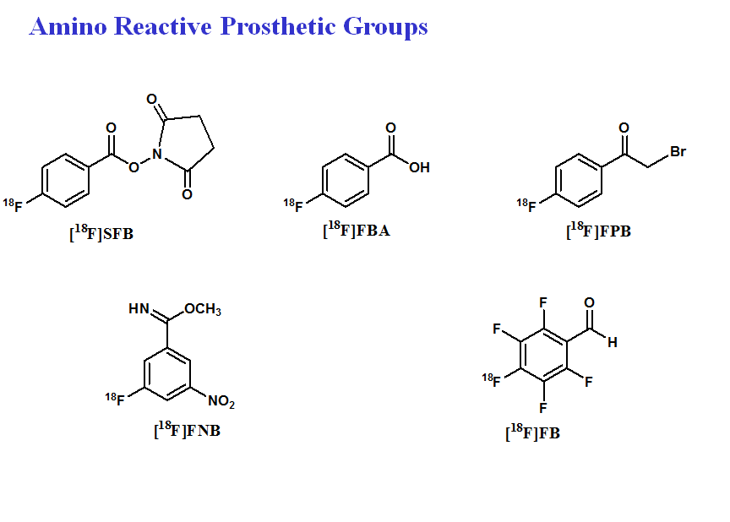
Figure 1. Names and Structures for Common Amino Reactive Prosthetic Groups
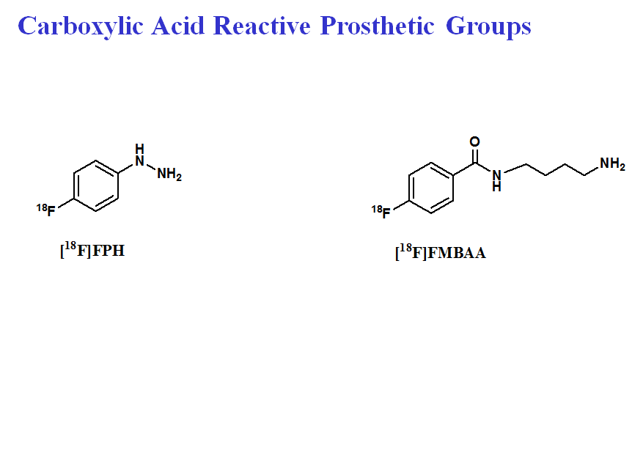
Figure 2. Name and Structure for Common Carboxylic Acid Reactive Prosthetic Groups

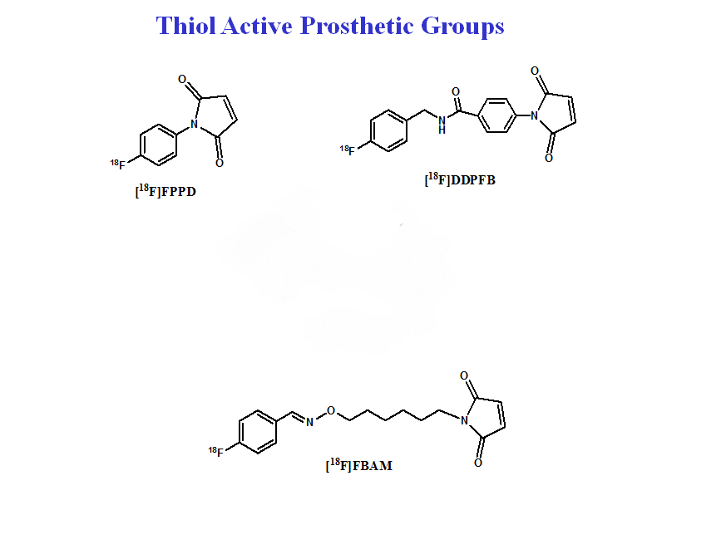
Figure 3. Name and Structure for Common Thiol Reactive Prosthetic Groups
Two such notable molecules are N-succinimidyl-4-[${}_{}^{18}F$] fluorobenzoate ([${}_{}^{18}F$]SFB), Figure 1, and N-[6-(4-[${}_{}^{18}F$]fluorobenzylidene)aminooxyhexyl]maleimide ([${}_{}^{18}F$]FBAM), Figure 3, [1,15,18]. [${}_{}^{18}F$]SFB is a labeling agent for proteins and peptides because of its reaction with the amine group [15,18]. Although it is the most utilized of the above shown prosthetic groups, this reaction is not always a successful labeling agent and can result in a considerably lower percentage of isotope incorporation than is desired [18]. A newer molecule, [${}_{}^{18}F$]FBAM, has a maleimide group that is reactive to the thiol groups in a protein. This molecule can be used when there are no available amine groups for reaction [1]. However, one limitation to the use of this molecule is the possibility of fluoromethylation of the trimethylammonium group on the precursor molecule. This results in undesirable, volatile [${}_{}^{18}F$]fluoromethane [19]. One solution to this problem was found in the novel [${}_{}^{18}F$]FPyAM molecule discussed in the next section. This molecule has a bicyclic ring in place of the trimethylammonium in the synthesis process; thus, it avoids the risk of producing a radioactive gas.
Applications for these molecules are currently being studied. In one study at the University of Tennessee Medical Center in Knoxville, Tennessee, both [${}_{}^{18}F$]SFB and the [${}_{}^{18}F$]FBAM were used to explore the use of PET imaging of amyloid proteins in mice with possible applications in the study of Alzheimer's disease, multiple myeloma, and rheumatoid arthritis. The study yielded positive results and both radiotracers were able to effectively attach to the desired protein and measure amyloid deposits in the mice [16].

1.3 Thiol-Reactive Bifunctional Agent: [${}_{}^{18}F$]FPyAM

Drawing from the [${}_{}^{18}F$]FBAM molecule previously described, a novel derivative molecule 2-[${}_{}^{18}F$]fluoropyridine-5-aldehyde-O-[6-(2,5-dihydropyrrol-1-yl)-hexyl]oxime ([${}_{}^{18}F]$FPyAM) was designed to potentially improve the radiolabeling yields presented by its predecessor. In this molecule the structure of the [${}_{}^{18}F$]FBAM molecule was altered by changing the benzene ring to a pyridine ring with the nitrogen in the ortho position relative to the ${}_{}^{18}F$ atom, Figure 4.
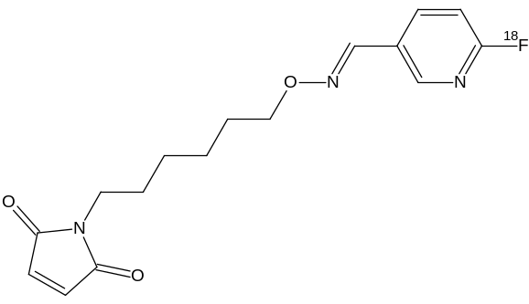
Figure 4. Structure of [${}_{}^{18}F$] FPyAM.
Theoretically, the electron withdrawing effects of the nitrogen would allow a higher percent incorporation of the ${}_{}^{18}F$- by creating a partial positive charge on the reactive carbon. The first experiment of the current study was designed to synthesize this novel [${}_{}^{18}F$]FPyAM molecule and optimize the percent incorporation of the ${}_{}^{18}F$-. This was done through a two-part synthesis. The radiofluorination precursor will be created via a two-step synthesis--first, with DABCO and 2-bromonicotinaldehyde in DCM followed by ion exchange to yield the triflate salt, Scheme 1.
[11]. The oxamine precursor was prepared according to the reported procedure, Figure 5 and Scheme 2 [1,7]. The radiofluorination was performed in DMF at 120 °C for 10 min, Scheme 3, and the condensation of the aldehyde and the oxamine was performed in methanolic HCl at 75 °C for 15 min, Scheme 4.
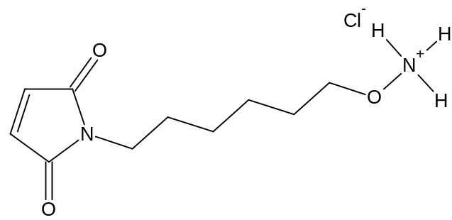
Figure 5. Structure of Oxamine Precursor.

1.4 Fluorine-18 Labeling for Lignin Depolymerization Detection

Another application in the field of radiofluorination chemistry lies in the field of biofuels. Recent interest has been given to the exploration of lignocellulostic material as a biofuel source [5,6,14]. Given that it is the most plentiful renewable carbon source in the biosphere, it is a natural choice for this purpose. The composition consists of three elements--hemicellulose, cellulose, and lignin [14]. It is the last of these three, lignin, that presents the greatest obstacle to the efficient use of such material as a feasible biofuel source. The recalcitrant chemical nature of the lignin molecule currently requires an extensive and expensive process to degrade for bioethanol [6,14]. Current research is being conducted to find more economical ways to breakdown this lignin barrier.
One method of doing this is to look at how fungi in nature are able to breakdown or depolymerize lignin. White-rot and brown-rot are the main lignin depolymerization methods utilized by fungi [10,14]. In white-rot decay, the fungi depolymerizes the lignin by an enzymatic oxidative cleavage of the propyl side chains between the alpha- and beta- carbons [6,10,14. In contrast to this, the brown rot decay degrades cellulose with subtle changes in the lignin in the form of increased ring hydroxylation and demethylation of the ring methoxyls [14]. After the fungal depolymerization of the lignin, the resulting lignin-derived aromatic compounds (LDAC's) are further broken down by bacteria [14]. The ${}_{}^{18}F$ radiochemistry is to be used in this step, by labeling the LDAC's in order to research the lignin depolymerization pathways to lower the cost of lignin degradation for biofuel usage.

1.5 Synthesis of Lignin-derived Aromatic Compounds

The goal for the radiofluorination of the lignin-derived aromatic compounds is to use them as PET scan indicators for bacterial degradation activity. The scope of this involves the location of places of bacterial utilization of the derivative compounds in order to identify and analyze the organisms and their enzymes involved in the initial depolymerization of the lignin [6,14]. Thus, it should be possible to develop methods to improve and optimize the utilization of lignin as a biofuel source.

This study focused specifically on the synthesis of a novel radiolabeling precursor LDAC molecule, methyl 4-(benzoyloxy)-2-[2(toluene-4-sulfonyloxy)-ethoxy]benzoate, Figure 6.

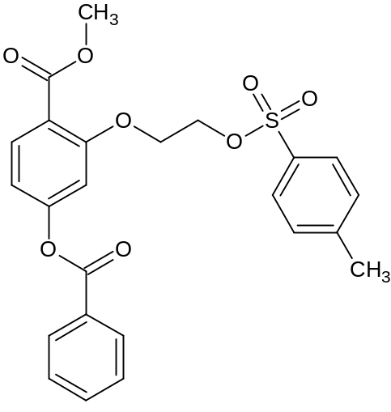
Figure 6. Structure of Radiolabeling Precusor LDAC Molecule.

This was carried out using a two-step synthesis followed by ${}_{}^{18}{F }$radiofluorination, Scheme 5. The first step of the synthesis involved reaction of methyl 2,4-dihydroxybenzoate with benzoyl chloride and potassium carbonate and acetone at 40 °C followed by refluxing for 13.4 hours at 50 °C [13]. This reaction benzoylates the hydroxyl group in the para postition relative to the carboxylic ester. The product is then reacted with ethylene di(p-toluenesulfonate) and potassium carbonate in DMF at 70 °C to yield the final product [5,14]. The added tosylate group can then be substituted by the ${}_{}^{18}{F }$in a nucleophilic radiofluorination.

Chapter 2: Experimental Procedure

2.1 Synthesis of Thiol-Reactive Prosthetic Group [${}_{}^{18}F]$FPyAM as Outlined in Schemes 1-4.

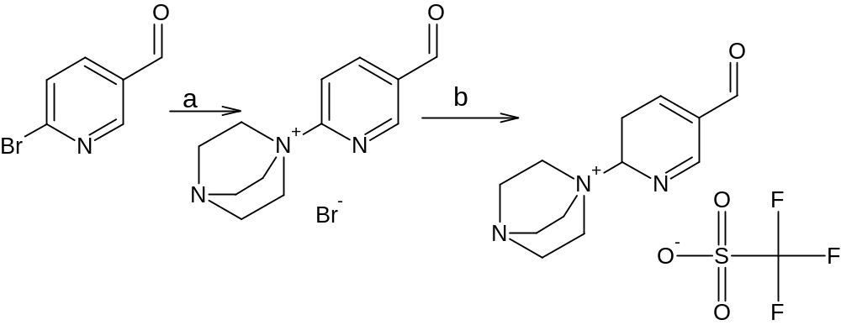
Reaction Scheme 1. Preparation of [${}_{}^{18}F]$FPyAM Radiofluorination Precursor
a. 1.)THF, DABCO, 5°C, 30 min 2.) Warm to RT, 16h.
b. TMSOTf, DCM, 12h.

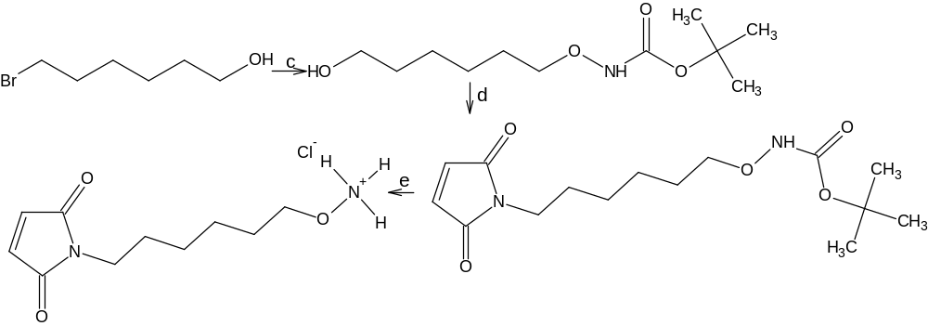
Reaction Scheme 2. Preparation of the [${}_{}^{18}F]$FPyAM Oxamine Precursor
c. BOCNHOH, DBU, DCM, rt, 24h.
d. 1.) TPP, THF 2.) DIAD, 0°C, 30 min 3.) Maleimide, -20°C, warm to rt over 16h.
e. 1.) 3N HCl/EtOAc (50/50), rt, 30min 2.) Methanol, Diethyl Ether

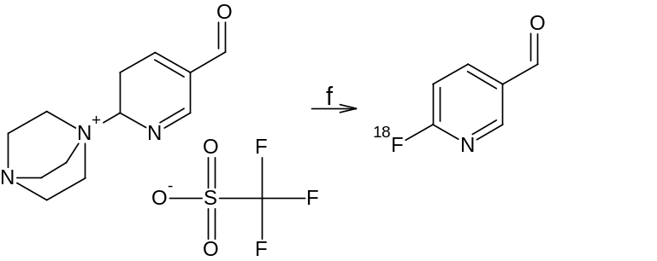
Reaction Scheme 3. Radiofluorination of the Radiofluorination Precursor
f. ${}_{}^{18}F$-, DMF, 120°C, 10 min

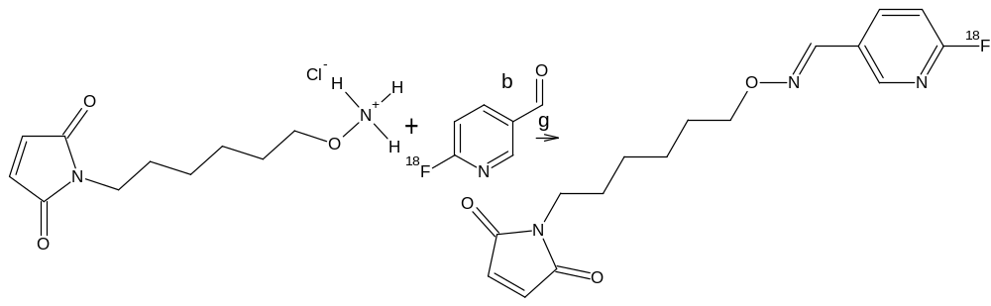
Reaction Scheme 4. Condensation of Precursor to Yield [${}_{}^{18}F]$FPyAM
g. 2N HCl, MeOH, 75°C, 15 min.

2.1.1 Substitution of Quaternary Ammonium Salt (Radiofluorination Precursor)
The initial step for the 2-[${}_{}^{18}F$]fluoropyridine-5-aldehyde-O-[6-(2,5-dihydropyrrol-1-yl)-hexyl]oxime ([${}_{}^{18}F]$FPyAM) synthesis began with the starting material 6-bromopyridine-3-carboxaldehyde. 0.33g of the starting material in 3.55mL of THF was first allowed to react with 0.229g of DABCO @ 5°C under argon and stirred for 30 minutes. The mixture was then warmed to room temperature over a period of 16 hours [11]. The reaction was monitored by thin layer chromatography and 476mg (99%) of the white solid product was formed, Figure 7. Product formation was confirmed by both proton and carbon NMR spectroscopy (Spectra 1, 2),
Scheme 1.
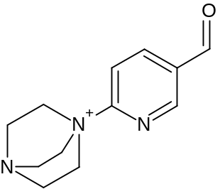
Figure 7. Structure for Product of Substitution of Quaternary Ammonium Salt (Radiofluorination Precursor)

2.1.2 Triflate / Bromide Exchange (Radiofluorination Precursor)

Using the product from the previous reaction (1-(5-formylpyridin-2-yl)-4-aza-1-azoniabicyclo[2.2.2]octane bromide), 403.3mg was allowed to react with 0.725 mL of TMSOTf in 45mL of DCM. The solution was stirred overnight and then vacuum filtered. This resulted in 491mg (99%)of the desired product, Figure 8. Product formation was confirmed by both proton and carbon NMR spectroscopy (Spectra 3,4), Scheme 1.
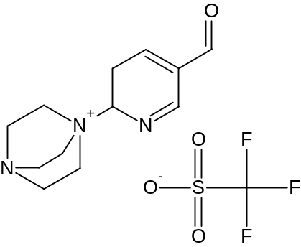
Figure 8. Structure for Radifluorination Precursor

2.1.3 Addition of NBOC Group (Oxamine Precursor)
The synthesis of the second half of the molecule, the oxamine precursor involved the use of 10 g of 6-bromohexan-1-ol. This starting material was stirred in a round bottom flask with 5.184 g of BocNHOH (N-tert-butyloxycarbonyl)hydroxylamine) in 70 mL of DCM. This was followed by the addition of 8.3 mL of DBU over a one minute period [1,7]. The mixture was allowed to react for 24 hours. This yielded 10.24 g of a yellow oil crude product which was then purified by silica column chromatography (40%EtOAc/60%Hexanes) and monitored by TLC. The purified product was obtained as a white/clear oil (4.16 g, 32.3%), Figure 9. Product structure was confirmed by ${}_{}^{1}H$NMR spectroscopy (Spectrum 5), Scheme 2.

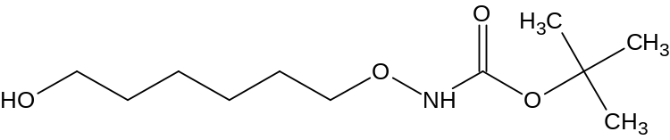
Figure 9. Structure for Product of Addition of NBOC Group (Oxamine Precursor)

2.1.4 Addition of Maleimide Group (Oxamine Precursor)
The tert-butyl [(6-bromohexyl)oxy]carbamate produced as described in part 2.1.3 was then used in a 1.0 g aliquots for the next reaction. The reaction began by dissolving 1.124 g of TPP into 5 mL of THF while stirring. DIAD (1.01mL) was then added slowly at 0 °C. An additional 4 mL of THF were added after a solid formed. This was stirred for 30 minutes. The starting material (1.0 g), dissolved in 4 mL of THF, was added to mixture at -20 °C (ice/salt bath). This was stirred for 10 minutes. Then, maleimide (0.416 g) was added under argon. The reaction was then left to warm to room temperature over 16 hours. The product was purified by two silica columns (1st-20%Ethyl acetate/80%Hexanes, 2nd-1% Methanol/99%DCM). The resulting crude product was a light yellow liquid and the pure product (450 mg, 33.6%) was a clear oil, Figure 10. The production structure was confirmed by ${}_{}^{1}H$NMR spectroscopy (Spectrum 6), Scheme 2.
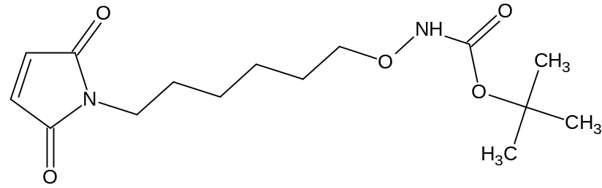
Figure 10. Structure for Product from Addition of Maleimide Group (Oxamine Precursor)

2.1.5 Removal of BOC Group (Oxamine Precursor)
The product (450 mg) formed in part 2.1.4 was then deprotected by stirring it in 13.5mL
of 3N HCl/EtOAc (50/50) for 30 minutes at room temperature. The solvent was then removed under vacuum and the residue dissolved in 2.25 mL of methanol. This was followed by the addition of 45 mL of diethyl ether, and the product precipitated out. It was then washed with diethyl ether and vacuum filtered. This yielded 324 mg (90.4%) of a white chloride salt, Figure 5. Structure was confirmed by ${}_{}^{1}H$NMR spectroscopy (Spectrum 7), Scheme 2.

2.1.6 Radiofluorination
The resulting triflate salt (1-(5-formylpyridin-2-yl)-4-aza-1-azoniabicyclo[2.2.2]octane trifluoromethanesulfonate) from the 2.1.2 reaction was then radiofluorinated with ${}_{}^{18}F$- in DMF at 120 °C for 10 minutes to yield a 31% of the isotopically labeled product, Figure 11, as evidenced radio-TLC (Figure 14), Scheme 3.

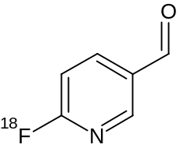
Figure 11. Sturcture of Radiofluorinated Precursor

2.1.7 Condensation to Create Imine Final Product
This was carried out in 2N HCl in methanol at 75 °C for 15 minutes. The condensation was successful; however, reaction conditions will need to be optimized. The yield was ~ 15% following the condensation reaction, Figure 4, Scheme 4.

2.2 Synthesis of Lignin-Derived Aromatic Compound as Outlined in Scheme 5

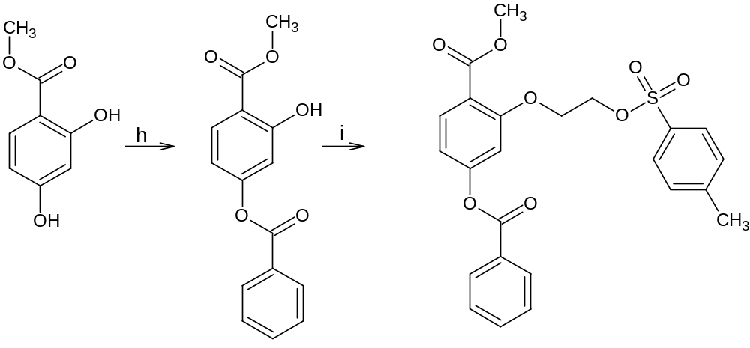

Reaction Scheme 5. Preparation of Lignin-Derived Aromatic Compound (LDAC)
h. 1.) BzCl, Ar, potassium carbonate, acetone, 40°C 2.) reflux, Ar, 13.5h

i. Ethylene di(p-toluenesulfonate), potassium carbonate, DMF, Ar, 70°C

2.2.1 Benzoylation of Para-Hydroxyl Group

The first step of the synthesis of the LDAC began with the starting material methyl 2,4-dihydroxybenzoate (2.000 g) which was allowed to react with benzoyl chloride (1.4 mL). The phenolic ester was dissolved in 9 mL of acetone containing the benzoyl chloride in a round bottom flask. Then, the flask was placed in a water bath. Potassium carbonate (1.742 g) was then added slowly while stirring. This reaction was then fitted with a reflux condenser and flushed with argon. It heated in an oil bath at 50 °C for 13.5 hours [13,14]. The product was purified using silica column chromatography with a solvent of 10% ethyl acetate/hexanes. The final yield was 1.58 g (48.8%) of product, Figure 12. Both proton and carbon-13 NMR spectroscopy were performed to confirm product formation (Spectra 8,9), Scheme 5.
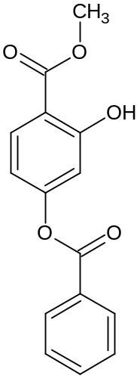
Figure 12. Structure for Product of Benzoylation of Para-Hydroxyl Group

2.2.2 Addition of Triflate Ester

The second step in the synthesis of the LDAC began with the product from the synthesis detailed in part 2.2.1, methyl 4-(benzoyloxy)-2-hydroxybenzoate. The resulting 1.58 g of product were allowed to react with 4.730 g of ethane-1,2-diyl bis(trifluoromethanesulfonate) and 1.604 g of potassium carbonate in 10mL of DMF under argon. The reaction was stirred in a warm water bath of 70 °C overnight. The product was purified by silica column chromatography with a solvent of 60% hexanes/10% DCM/10% ethyl acetate/10% diethyl ether. After purification, 400 mg (14.6%) of product, Figure 13, was obtained and confirmed by ${}_{}^{1}H$NMR and carbon-13 NMR spectroscopy (Spectra 10,11), Scheme 5.
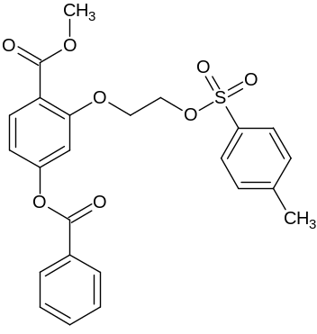
Figure 13. Structure for Product of Addition of Triflate Ester
Chapter 3: Measurement, Analysis, and Results

Product from reaction (as given by reaction scheme) | ${}_{}^{1}H$NMR Shifts  (ppm) | ${}_{}^{13}C$ NMR Shifts (ppm) | % Yield
a | 10.24(s, 1H, CHO)  9.197(d, 1H, pyridine)  8.69(d, 1H, pyridine)  8.30(s, 1H, pyridine)  3.979-3.245(m, 12H, bicyclic ring) | 191.00 (carbonyl)  158.55 (pyridine)  150.32 (pyridine)  141.16 (pyridine)  132.70 (pyridine)  117.46 (pyridine)  53.80 (bicyclic ring)  45.05 (bicyclic ring) | 99%
b | 10.21(s, 1H, CHO)  9.20(d, 1H, pyridine)  8.75(d, 1H, pyridine)  8.289(s, 1H, pyridine)  4.321-3.753(m, 12H, bicyclic ring) | 190.90 (carbonyl)  157.50 (pyridine)  150.42 (pyridine)  141.50 (pyridine)  133.16 (pyridine)  121.95-119.36 (triflate)  117.12 (pyridine)  52.84 (bicyclic ring)  43.98 (bicyclic ring) | 99%
c | 3.848 (t, 2H, C$H_{2}$OR)  3.644 (t, 2H, C$H_{2}$OH)  1.635 (m, 4H, C$H_{2}$)  1.451 (s, 9H, C$H_{3}$)  1.376 (m, 4H, C$H_{2}$ ) | N/A | 32.3%
d | 7.323 (d, 1H, NH)  6.706 (s, 2H, malemide)  4.159 (t, 2H, C$H_{2}$OR)  3.537 (t, 2H, C$H_{2}$NR)  1.540 (m, 4H, C$H_{2})$  1.304 (s, 9H, C$H_{3}$ )  1.253 (m, 4H, C$H_{2})$ | N/A | 33.6%
e | 10.816 (s, 3H, N$H_{3}+)$  7.028 (s, 2H, maleimide)  3.954 (t, 2H, C$H_{2}$OR)  3.362 (t, 2H, C$H_{2}$NR)  1.481 (m, 8H, C$H_{2})$ | N/A | 90.4%
f | N/A | N/A | 31%
g | N/A | N/A | N/A
h | 10.95 (s, 1H, OH)  8.205 (d, 2H, aryl)  8.195 (d, 1H, aryl)  7.653 (t, 1H, aryl)  7.537 (t, 2H, aryl)  6.886 (d, 1H, aryl)  6.771 (d, 1H, aryl)  3.960 (s, 3H, C$H_{3})$ | 170.3 (COOC$H_{3}$)  164.4 (COOR)  162.9 (C=COH)  156.6 (aryl)  134.02 (aryl)  131.26 (aryl)  130.36 (aryl)  129.07 (aryl)  113.4 (CCOOR)  111.14 (aryl)  110.34 (aryl)  51.2 (C$H_{3}$) | 48.8%
i | Complex Structure (See Appendix II for assignment) | Complex Structure (See Appendix II for assignment) | 14.6%
Table 1: NMR Shifts and Percent Yields Products of the Various Reaction Schemes
f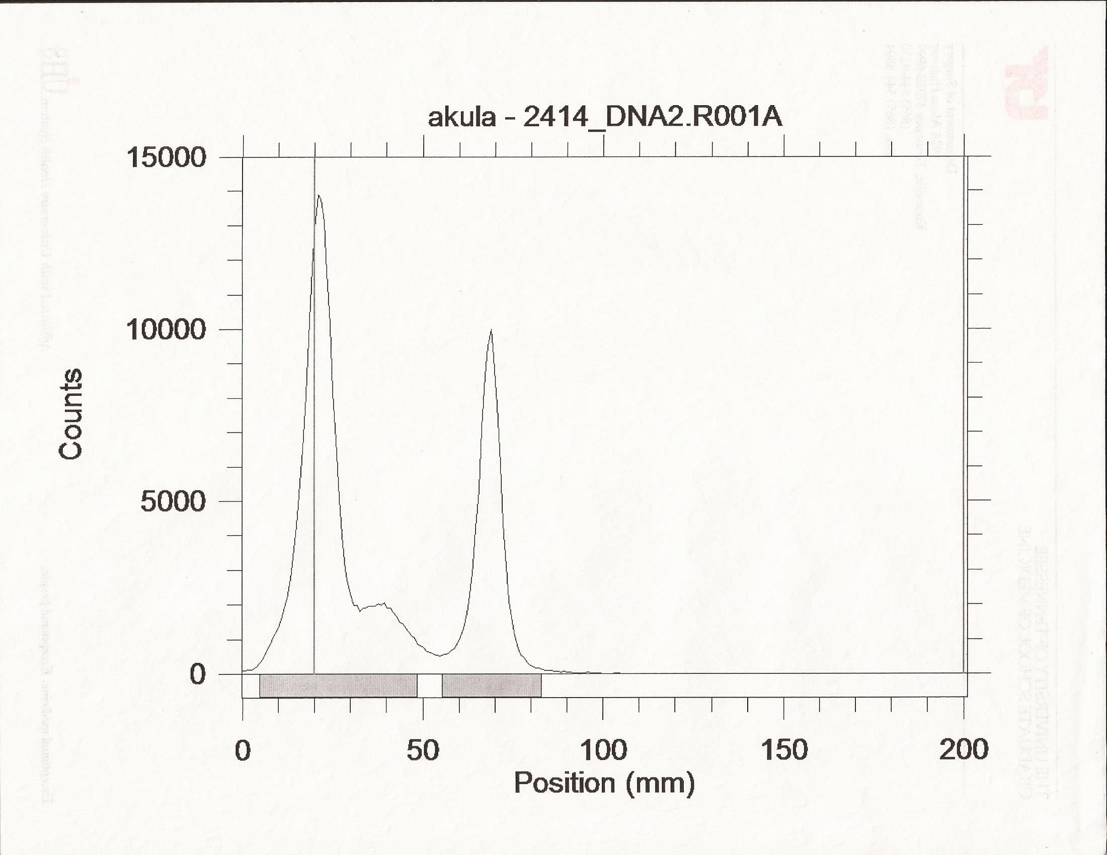
Figure 14. Radio TLC of Radiofluorinated Precursor Molecule for FPyAM Showing 31% Incorporation.

Chapter 4: Discussion and Conclusions
4.1 Synthesis of [${}_{}^{18}F$]FPyAM
The synthesis of the novel thiol-reactive molecule 2-[${}_{}^{18}F$]fluoropyridine-5-aldehyde-O-[6-(2,5-dihydropyrrol-1-yl)-hexyl]oxime ([${}_{}^{18}F]$FPyAM), Figure 4, was successfully completed according to the previously stated procedure. The radiofluorination precursor and the oxamine precursor were both successfully carried out according to the given procedure(See Chapter 3 for percent yields). The condensation of these components was performed and was successful; however, optimization of reaction conditions are currently underway.
As stated in Chaper 1, the thiol-reactive radiotracer molecules are advantageous over their amine-reactive relatives due to the milder reaction conditions as well as the increased reliability of reaction success. Another advantage to the FPyAM molecule over the FBAM derivative is that the starting materials are less costly than those of the FBAM. In addition, due to the change from a benzene ring to a pyridine ring for the radiofluorination precursor, the FPyAM molecule should be more reactive to the radiofluorination and, thus, result in a higher percent incorporation [1]. These trials are currently ongoing.
Future research can be carried out with this molecule by optimizing the conditions for both the radiofluorination and the condensation steps. In addition, trials can be conducted in vitro and in vivo for applications similar to those for the FBAM molecule. Comparisons can then be made between the effectiveness of the FBAM versus that of the FPyAM in labeling via the thiol group for proteins and peptides for PET imaging.

4.2 Synthesis of Lignin-Derived Aromatic Compound

The synthesis of the novel lignin-derived aromatic compound (LDAC), methyl 4-(benzoyloxy)-2-[2(toluene-4-sulfonyloxy)-ethoxy]benzoate, Figure 13, was successfully conducted according to the procedure described in Chapter 2. The concise two-step synthesis resulted in 48.8% and 14.6% yields respectively. This compound undergoes fluorine-18 radiofluorination which should act as a signaling molecule for the bacteria activity of the lignin depolymerization products or LDAC's.
Future research will be conducted in a general two-step approach. After the molecule has been successfully radiofluorinated, the molecule will be used to locate places in which bacteria are able to utilize this type of LDAC molecule using PET scanning [14]. Once these bacteria have been located, research will be carried out on natural ways to depolymerize lignin to these LDAC compounds. The location of LDAC-utilizing bacteria may indicate areas in which lignin is naturally being broken down by fungi [14]. Therefore, perhaps new enzymes can be found in these environments that successfully and efficiently breakdown lignin. Examples are such environments are fungal mixed cultures and termite gut [6,14]. Ultimately, this research may lead to enzymes that can economically breakdown lignin to improve the production of biofuel using lignocellulostic material.

References

1.) Berndt, M., Pietzsch, J., & Wuest, F. (2007). Labeling of low-density lipoproteins using the
${}_{}^{18}F$-labeled thio-reactive reagent N-[6-(4-
[${}_{}^{18}F$]fluorobenzylidene)aminooxyhexyl]maleimide. Nuclear Medice and Biology, 34, 5-
15.
2.) Dolle, F., Hinnen, F., Lagnel, B., Boisgard, R., Sanson, A., Russo-Marie, F., et al. (2003)
Radiosynthesis of a [${}_{}^{18}F$]fluoropyridine-based maleimide reagent for protein labeling. J
Label Compd Radiopharm, 46, S15.
3.) Dow Chemical Company. (1959). U.S. Patent No. 2910454. Midland, Michigan: U.S.
4.) Duckett, S. & Gilbert, B. (2007). Foundations of Spectroscopy. New York, NY: Oxford
Press.
5.) Farrell, R., Tien, M., & Kirk, T.K. (1987). U.S. Patent No. 4687741. Pennsylvania: U.S.
6.) Geib, S.M., Filley, T.R., Hatcher, P.G., Hoover, K., Carlson, J.E., Jimenez-Gasco,
M.D...Tien, M. (2008). Lignin degradation in wood-feeding insects. Proc. Natl. Acad.
Sc.i U.S.A. 105, 12932-12937.
7.) Jones, D., Hammaker, J.R., & Tedder, M.E. (2000). Tetrahedron Letters, 41, 1531-1533.
8.) Namavari, M., Padilla De Jesus, O., Cheng, Z., De, A., Kovacs, E., Levi, J...Gambhir, S.
(2008). Direst Site-Specific Radiolabeling of an Affibody Protein with 4-
[${}_{}^{18}F$]Fluorobenzaldehyde via Oxime Chemistry. Molecular Imaging and Biology, 10,
177-181.
9.) Rennen, H.J., Corstens, F.H., Oyen, W.J., Boerman O.C. (2001). New concepts in
infection/inflammation imaging. Q J Nucl Med, 45, 167-173.
10.) Sato, S., Liu, F., Koc, H., & Tien, M. (2007) Expression analysis of extracellular proteins
from Phanerochaete chrysosporium growth on different liquid and solid substrates.
Microbiology, 153, 3023-3033.
11.) Shi, Y., Humphrey, G., Maligres, P.E., Reamer, A. & Williams, J.M. (2006). Highly
Regioselective DABCO-Catalyzed Nucleophilic Aromatic Substitution (SNAr) Reaction
of Methyl 2,6-Dichloronicotinate with Phenols. Advanced Synthetic Catalysis, 348, 309-
312.
12.) Sosabowski, J., Melendez-Alafort, L., Mather, S. (2003). Radiolabeling of peptides for
diagnosis and treatment of human cancer. In Vivo, 19, 9-29.
13.) Thominet, M.L. (1976). U.S Patent No. 3959477. Paris, France: U.S.
14.) Tien, Ming. (2012). Imaging Lignin Degradation: Bio-prospecting for New Enzymes for
Use in Biofuel Production. (Project Summary) University Park, PA: Penn State
University.
15.) Vaidyanathan, G., Zalutsky, M.R. (1992). Labeling proteins with fluorine-18 using N-
succinimidyl 4-[${}_{}^{18}F$]fluorobenoate. Int J Rad Appl Instrum B, 275-81.
16.) Wall, J.S, Richey, T.A., Stuckley, A., Akula, M.R., Kabalka, G., Macy, S...Kennel, S.
(2013). Preliminary evaluation of [18F]SFB- and [18F]FBAM-labeled amyloidophilic
peptides in mice with visceral amyloidosis. Poster Presentation September 19, 2013.
University of Tennessee Medical Center, Knoxville Tennessee.
http://www.wmis.org/abstracts/2013/data/papers/P163.htm .
17.) Wilbur, D.S. (1992). Radiohalogenation of proteins--an overview of radionuclides, labeling
methods, and reagents for conjugate labeling. Bioconjug Chem, 3, 433-470.
18.) Yang, C., Gu, Z., Yang, M., Lin, S. Garcia-Prats, A., Rogers, L...Smith, C. (1999). Selective
modification of apoB100 in the oxidation of low density lipoproteins by myeloperoxidase
in vitro. Journal of Lipid Research, 40, 686-698.
19.) Banister, S., Roeda, D., Dolle, F., & Kassiou, M. (2010). Fluorine-18 Chemistry for PET: A
Concise Introduction. Current Radiopharmaceuticals, 3, 68-80.

Appendices
Appendix I. ACS Accepted Abstract
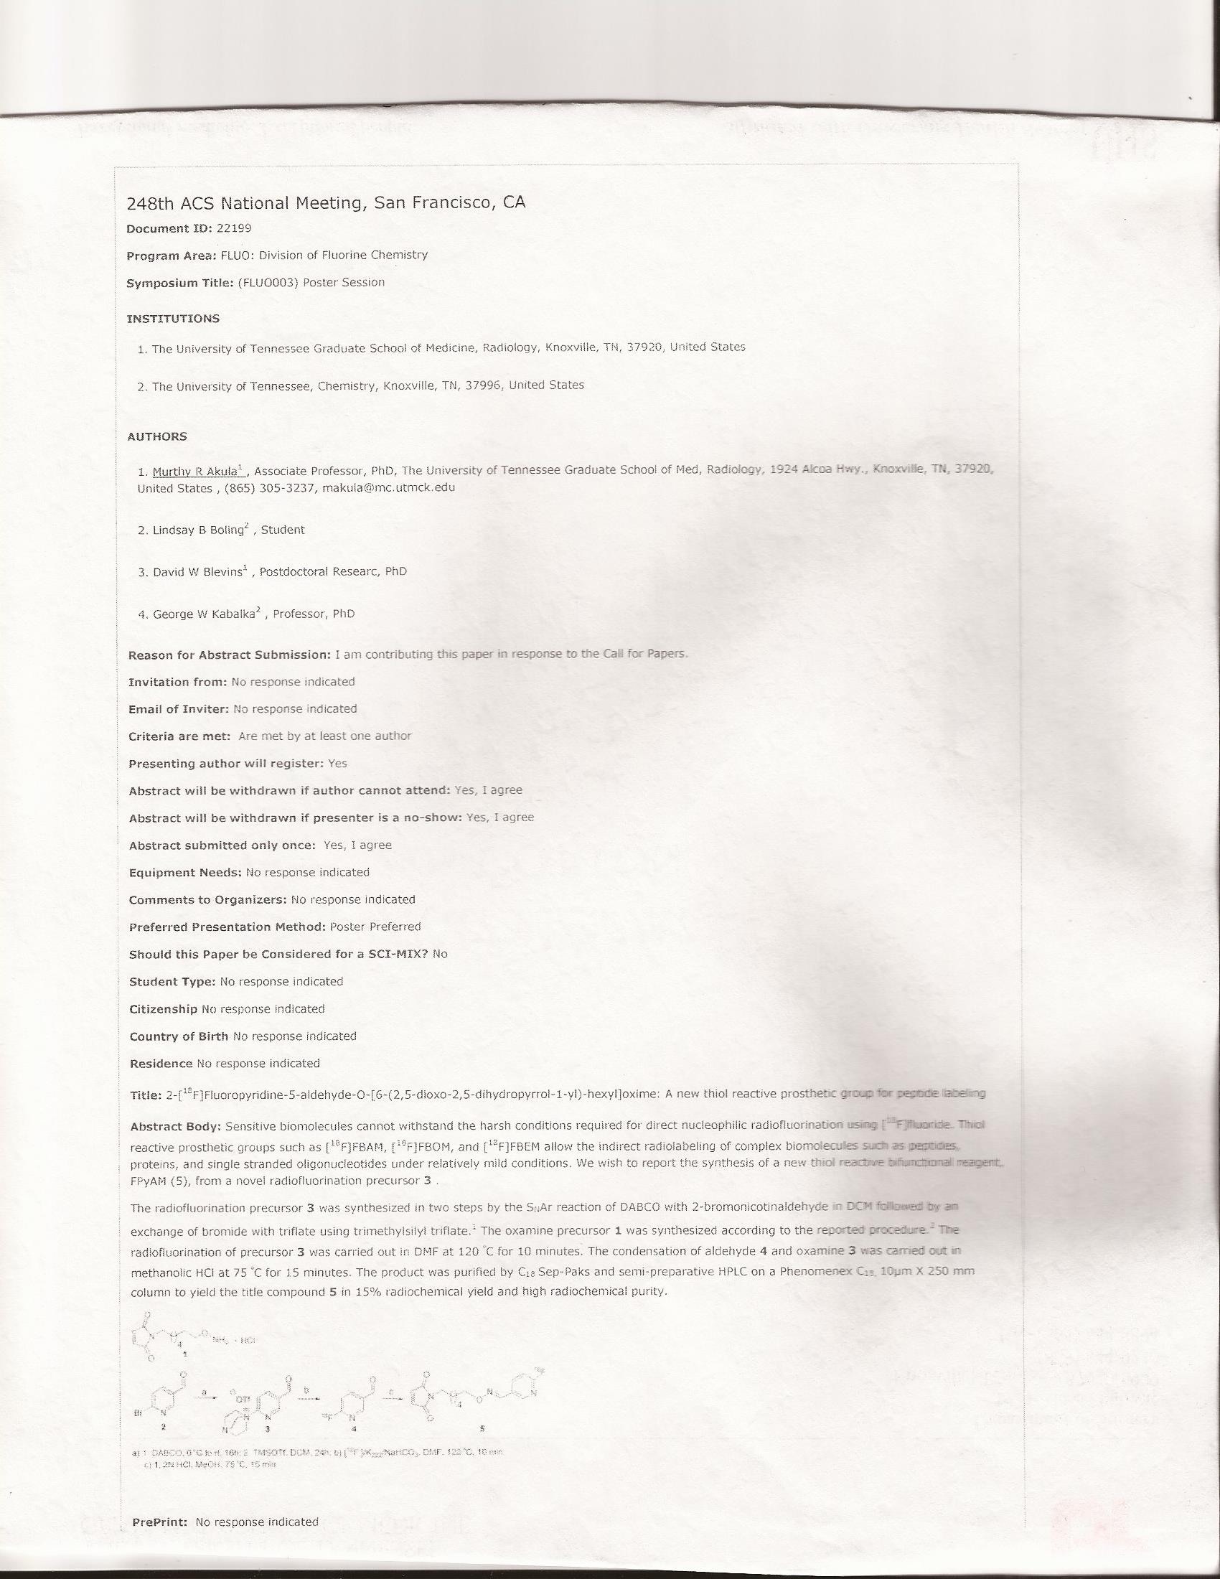
Appendix II. NMR Spectra
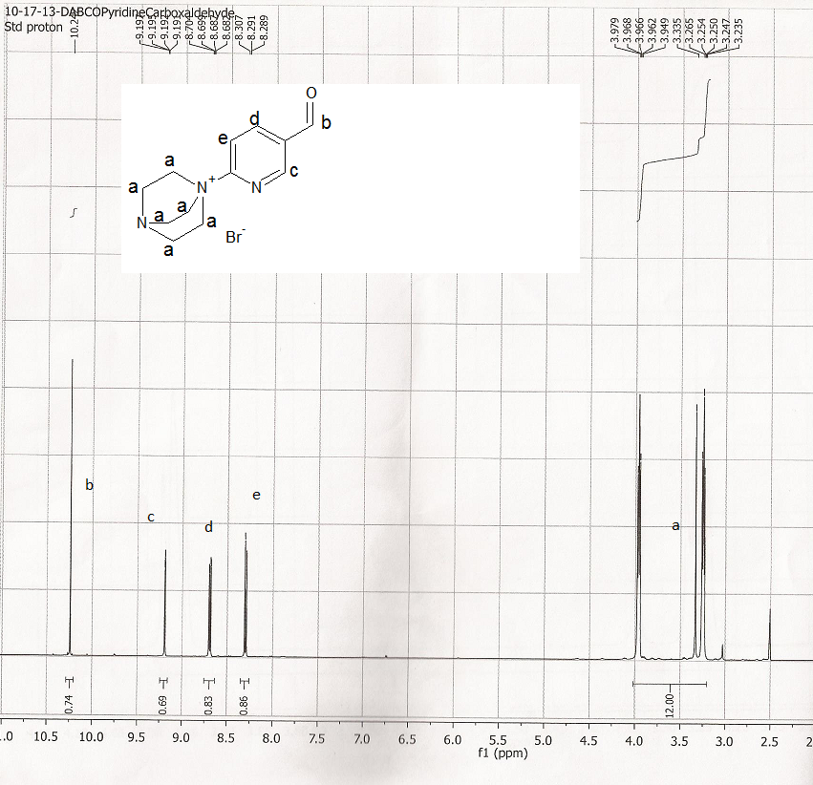
Spectrum 1. Proton NMR Bromide Salt of the Ammonium Precursor for FPyAM Molecule (DMSO 500MHz)

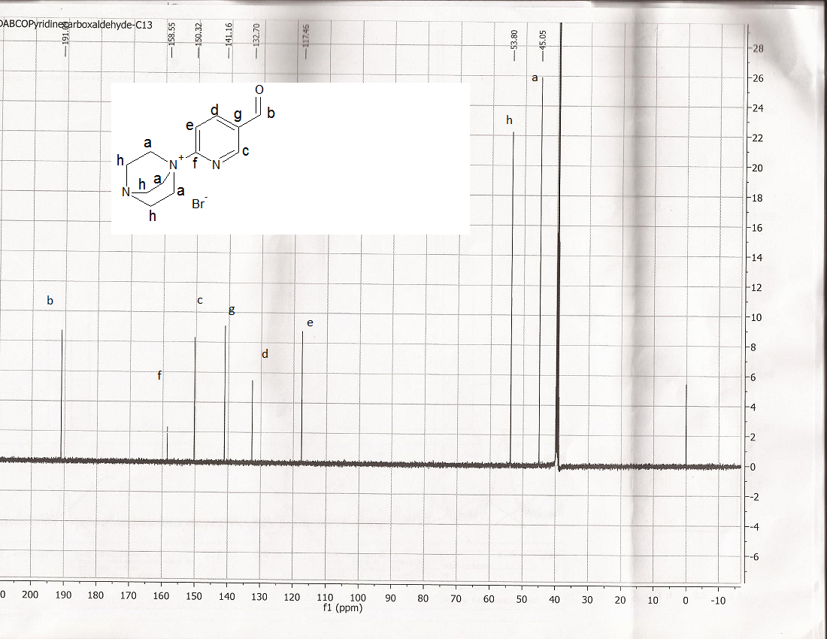
Spectrum 2. Carbon-13 NMR of Bromide Salt of the Ammonium Precursor for Radiofluorination Precursor to FPyAM Molecule
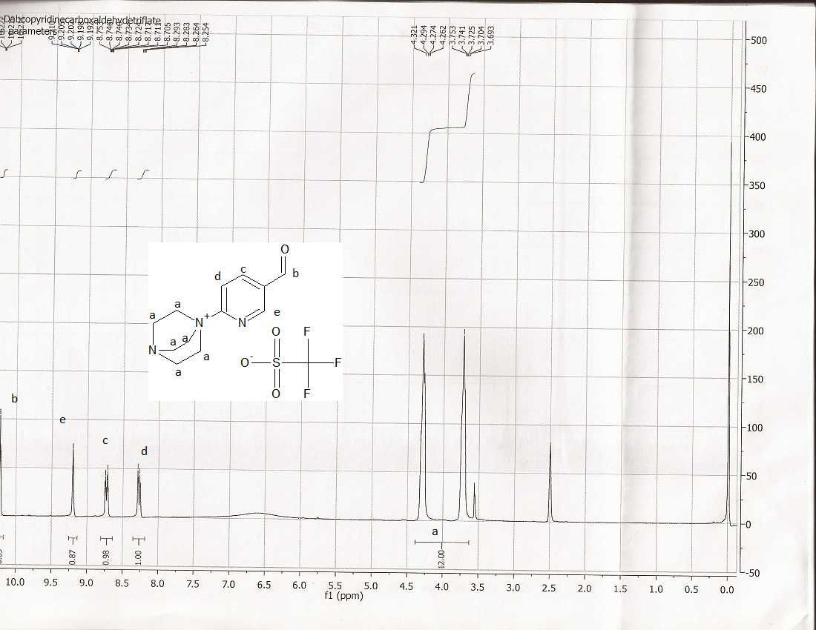
Spectrum 3. Proton NMR of Triflate Salt of the Ammonium Precursor for the FPyAM molecule.
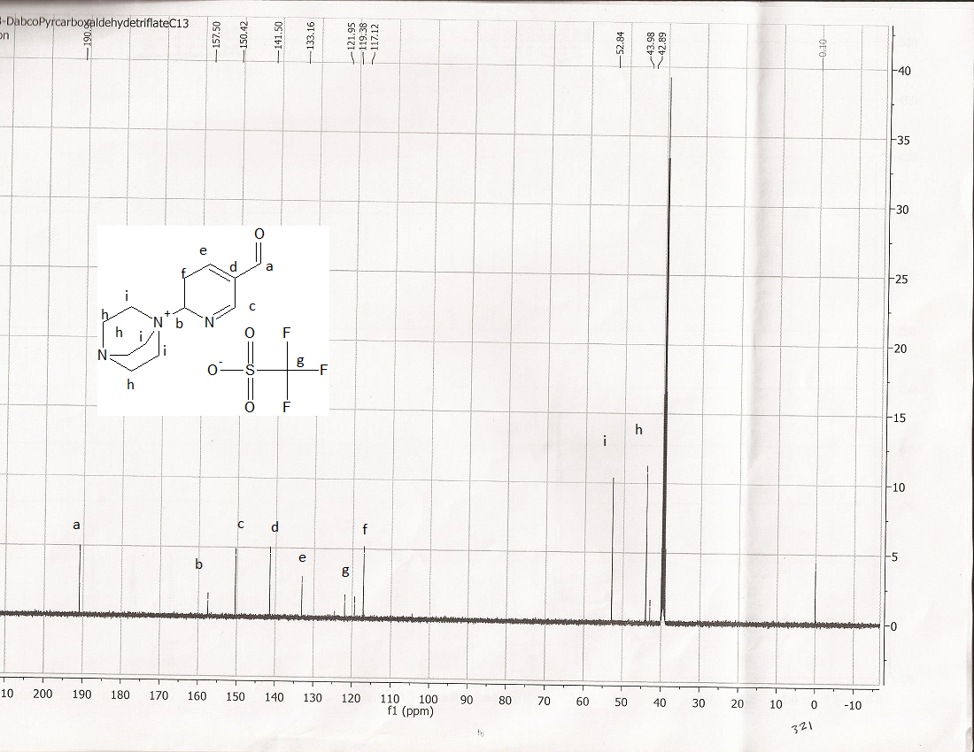
Spectrum 4. Carbon-13 NMR of Triflate Salt of the Ammonium Precursor for FPyAM Molecule.

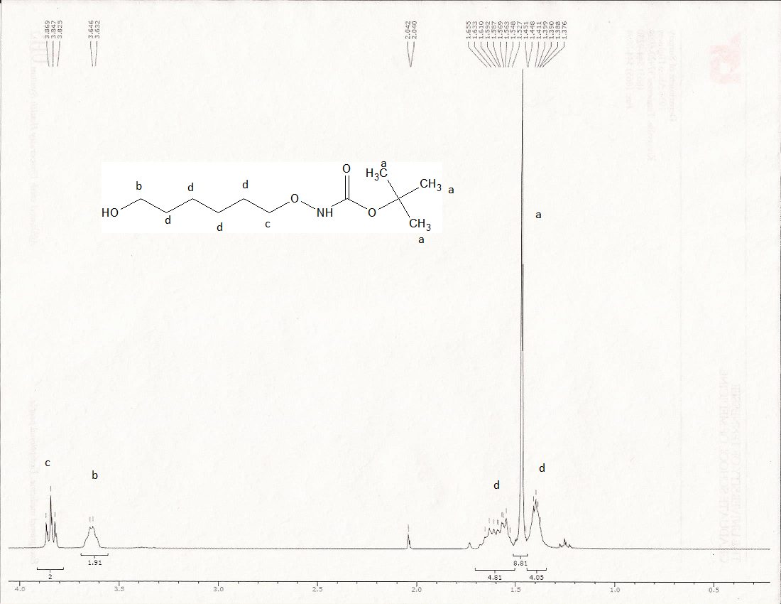
Spectrum 5. Proton NMR for Addition of NBOC Group (Oxamine Precursor) for FPyAM Molecule.

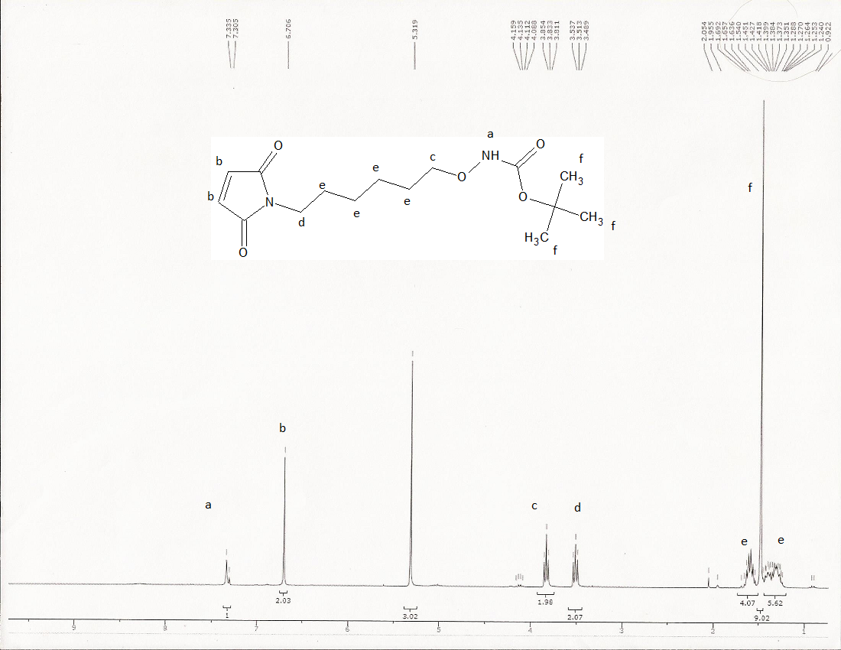
DCM
Spectrum 6. Addition of Maleimide Group (Oxamine Precursor) for FPyAM Molecule.
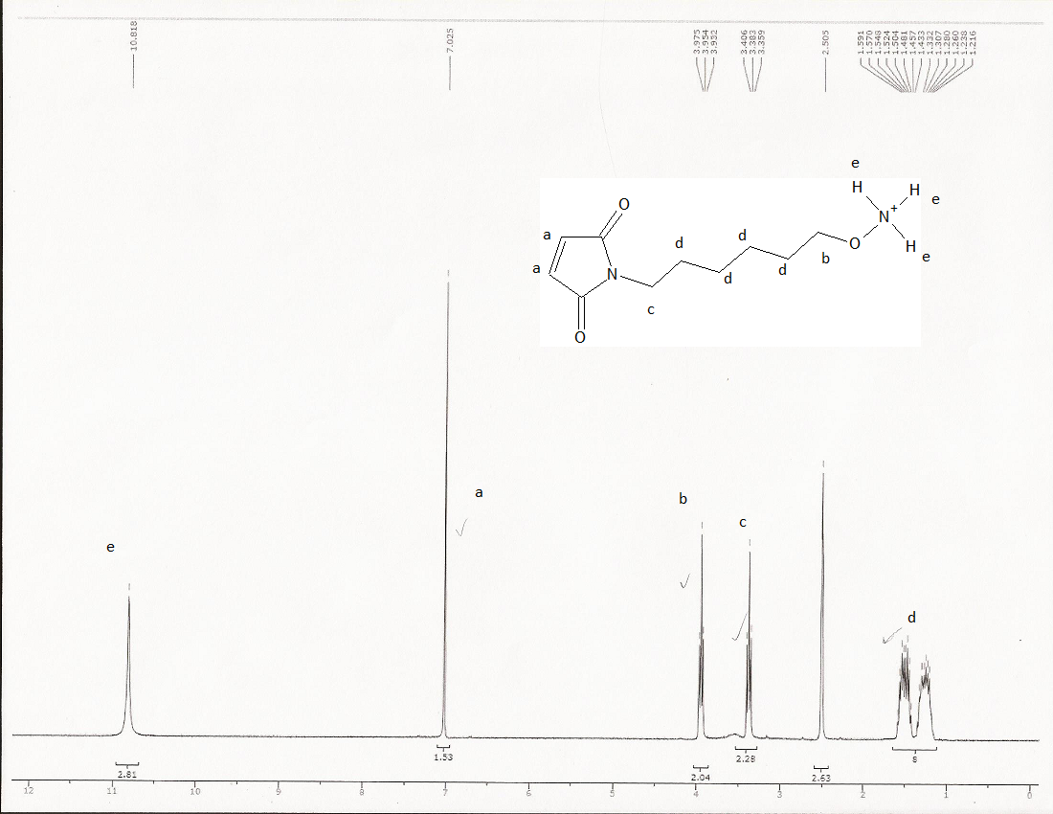
DMSO
Spectrum 7. Removal of BOC Group (Oxamine Precursor) for FPyAM Molecule (DMSO).

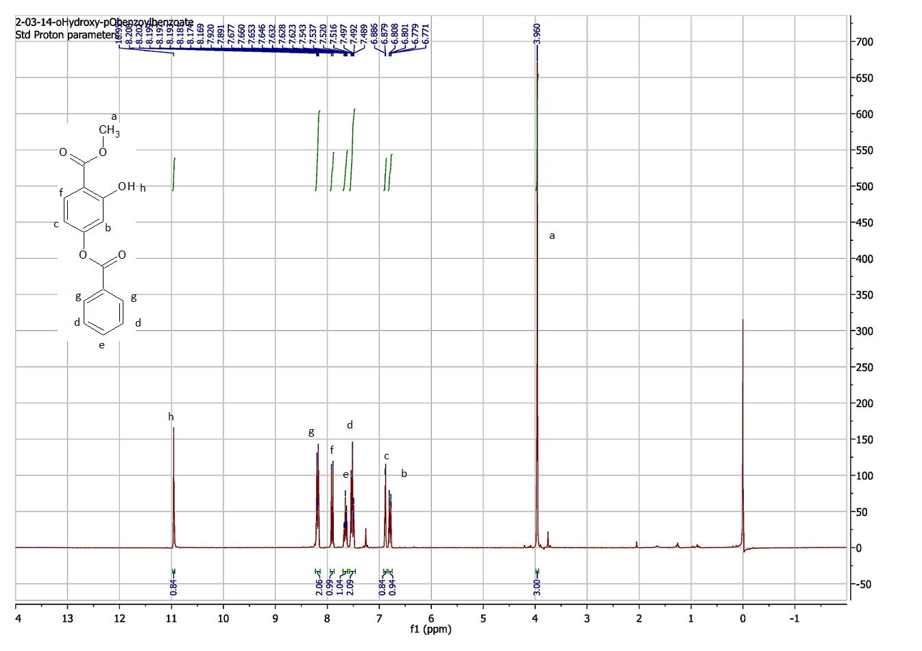
Spectrum 8. Proton NMR for Benzoylation of Para-Hydroxyl Group for Synthesis of Lignin-Derived Aromatic Compound

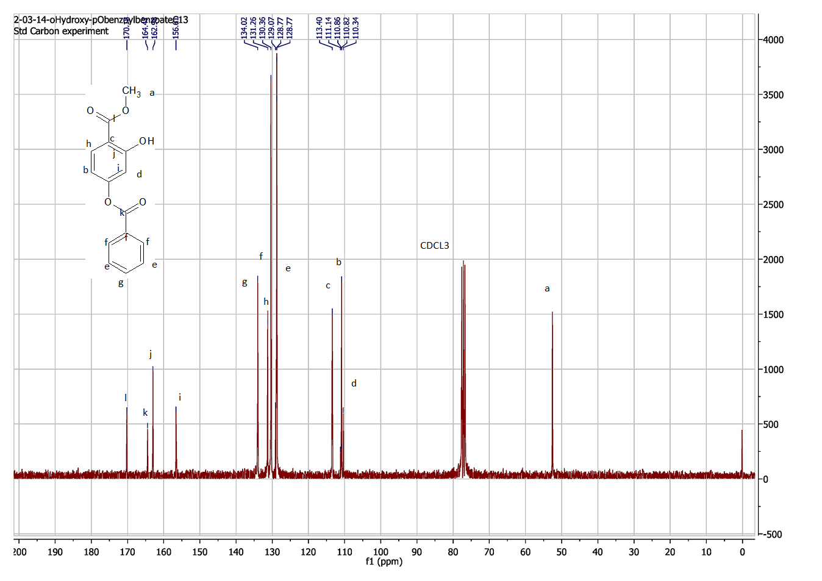
Spectrum 9. Carbon-13 NMR for Benzoylation of Para-Hydroxyl Group for Synthesis of Lignin-Derived Aromatic Compound
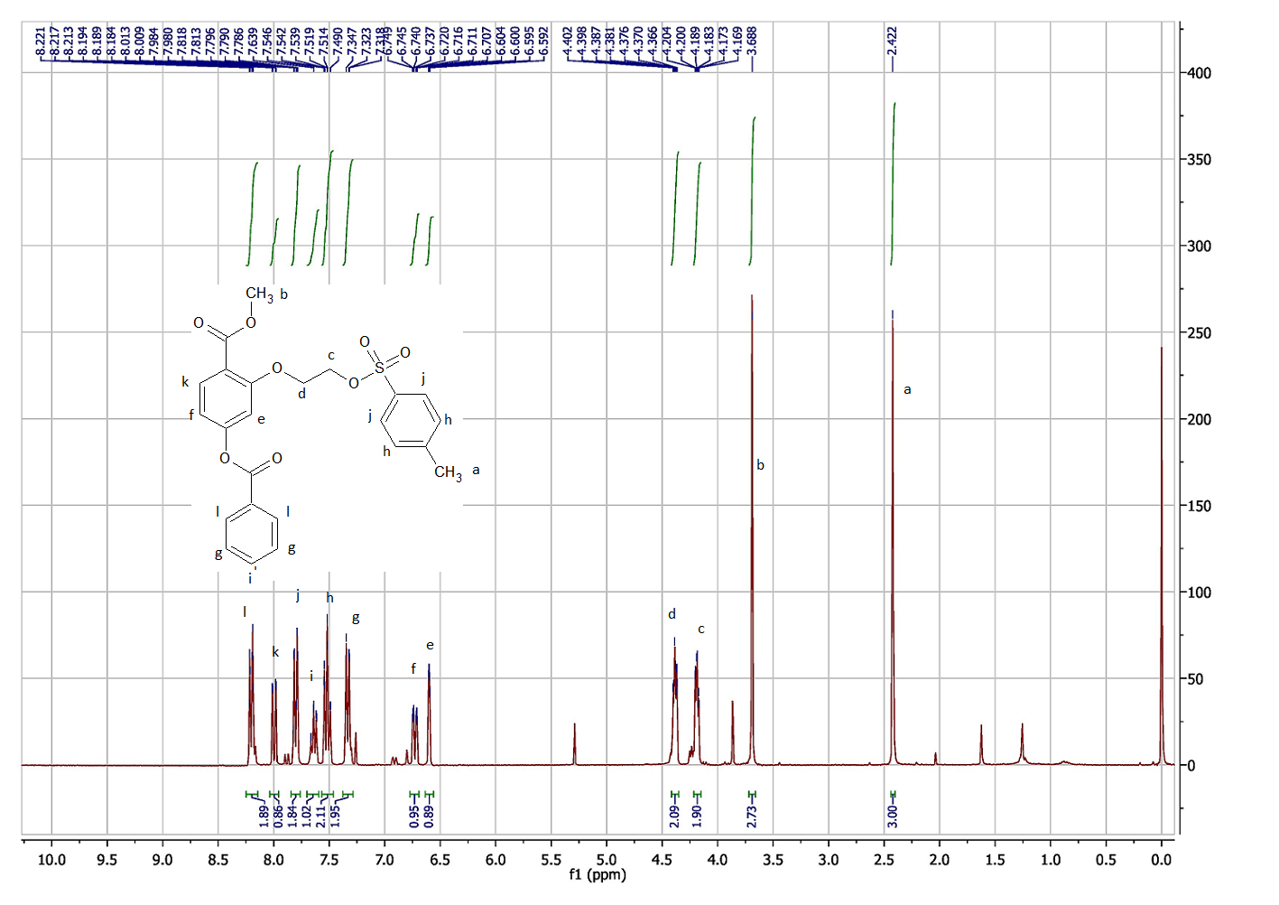
Spectrum 10. Proton NMR for Benzoylation of Para-Hydroxyl Group for Lignin-Derived Aromatic Compound (CDCL3)
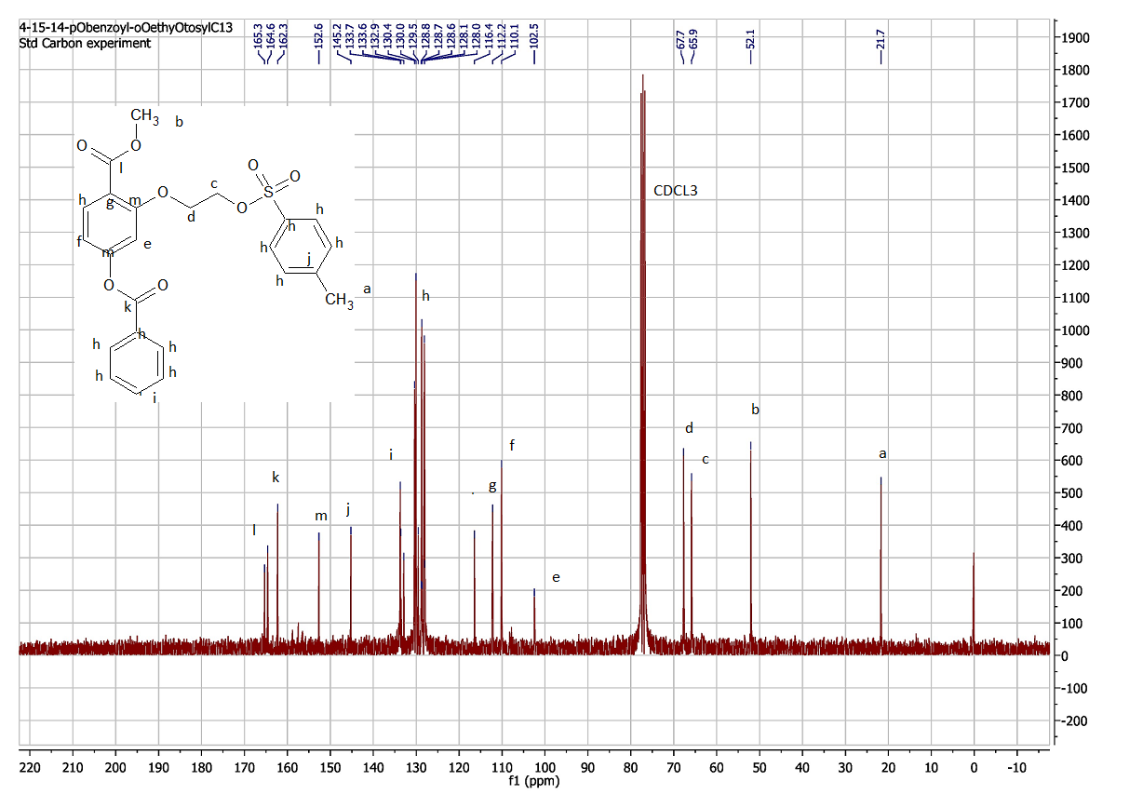
Spectrum 11. Carbon-13 NMR of Benzoylation of Para-Hydroxyl Group for Lignin-Derived Aromatic Compound (CDCL3)

