A Study on the Interactions of Trehalose with Model Folate Compounds

Carolyn Ware
Senior Thesis
BCMB 457
Dr. Elizabeth Howell
Abstract
Folate (vitamin B9) is an essential element in cellular metabolism. Folate is obtained from dietary intake, as the human body is unable to produce it, and it is required for the synthesis of many basic subunits used to compose both DNA and RNA. Previous studies have shown that folate interacts weakly with osmolytes, small molecular weight compounds produced by the cell when under stress, when the cell is crowded. Moreover, it has also been demonstrated that there is weaker binding between dihydrofolate reductase and dihydrofolate in the presence of these osmolytes and when the cell is under osmotic stress. This is an interesting finding when it comes to developing better anti-folate drug therapies that help eliminate unwanted cells from the body (i.e. bacterial and cancer). Because of these results, we are now interested in the mechanisms through which these enzyme-osmolyte interactions occur. This study uses vapor pressure osmometry to determine the type of interactions that occur between trehalose (a common cellular osmolyte) and various compounds that mimic functional groups found on folate. Through our studies, we have found positive preferential interaction coefficients for reactions between trehalose and various amino acids, amino acid salts, amides, carboxylic acids, and carboxylate salts, meaning that these compounds prefer to interact with water rather than trehalose. Using these results we will be able to understand how trehalose interacts with various atom types and how these atoms can contribute to cellular interactions and processes.

Introduction
Enzymes are a vital part of many biochemical processes. These molecules work by binding to a specified substrate and forming an activated complex with them. These interactions result in catalysis of certain chemical reactions by lowering the activation energy required for the reaction to occur. This allows the reaction to occur easier and faster. When osmolytes, small molecular weight molecules produced during the cell during times of stress, are present during this binding process, the formation of this complex may be hindered due to numerous weak interactions between the osmolytes and the substrates of the complex. Commonly, osmolytes are either excluded from the interface of the substrate or interact with it. When these interactions between the osmolyte and the substrates are present, then both the osmolytes and surrounding water molecules must first be removed from the solvation shell if the substrate preferentially interacts with the osmolyte rather than the surrounding water. Due to the additional energy required for the removal process from the surface of the osmolytes, the equilibrium of the overall enzyme complex formation can become shifted in favor of the single molecules rather than towards the formation of the active enzyme-substrate complex (Figure 1).
Folate (also known as folic acid and vitamin B9) is an essential element in cellular metabolism. Folate is obtained from dietary intake, as the human body is unable to produce it, and it is required for the synthesis of many components required to produce DNA and RNA. It is composed of pteridine, p-aminobenzoate (PABA ring), and a glutamate tail and is broken down with the help of various enzymes along a one-carbon metabolic pathway (Figure 2). Previous studies have shown that there are numerous weak interactions between folate and the osmolyte betaine when the cell is crowded with it. When present in excess in cells, betaine interactions with key enzyme substrates can cause a shutdown of the overall folate metabolic pathway preventing the production of vital cellular components and, ultimately, leading to cell death (Bhojane et. al 2016). Moreover, our lab has shown that there is weaker binding between dihydrofolate reductase (DHFR) and its substrate dihydrofolate (DHF), a derivative of folate, in the presence of osmolytes. In order for this complex to bind, both the osmolytes and water solvation shell must first be removed. Our hypothesis for this finding is that osmolytes interact with the substrate DHF weakening its ability to bind to DHFR and shifting the equilibrium away from enzyme-substrate complex formation (Figure 1). Ultimately, cell growth and proliferation becomes hindered because the enzyme substrate complex formation is hindered and less product of the folate pathway is formed. This is an interesting finding when it comes to the development of anti-folate drugs that may be produced to inhibit the growth of bacterial and cancer cells, thus treating a variety of illnesses.
Because of these results, we are now interested in the mechanisms through which these folate-osmolyte interactions occur. This study uses vapor pressure osmometry (VPO) to study the interaction between trehalose and various compounds that model functional groups found on folate in order to determine which fragments of the folate molecule interact most strongly with trehalose. Trehalose was used during this study because it is a highly prevalent osmolyte found in the model organism, E. coli (Unpublished data, Nambiar, 2016). Moreover, these osmotic stress studies show that osmolytes produced in the cell interact with folate enzyme of different redox states thus lowering product formation in the cell. We tested to see whether or not there was an interaction between folate, the primary compound of study in our lab, and trehalose and found that the two molecules do interact (Figure 3) (Unpublished data Nambiar, Arrieta, 2016). Thus, we are now working to characterize and quantify how trehalose interacts with folate and what kinds of interactions are occurring between the two molecules. In this study, we use VPO to study the interactions (or lack thereof) between trehalose and model folate compounds. These model compounds are compounds in which their chemical composition mimics various functional groups found along folate, such as amino acids, carboxylic acids, and various other types of compounds (Figure 4). Through studying the presence or absence between trehalose and these molecules and the types of interactions that may occur, we will better be able to visualize what components of the folate molecule are contributing to its interaction with trehalose.

Methods
Vapor pressure osmometry (VPO) was used for this study in order to quantitatively determine the preferred interaction or exclusion of trehalose and test compounds. The sample solution, containing the osmolyte (trehalose) and test compound in question, is sealed next to a thermocouple within the osmometer where an equilibrium vapor pressure is reached. The thermocouple is then cooled and the gaseous water condenses. The temperature change of the thermocouple as the water condenses is proportional to the vapor pressure of the sample solution, the solution containing trehalose and the compound being studied. This vapor pressure is proportional to the overall osmolality of the solution being tested. The osmolality of the solution is based on the concentration of bulk water in the solution. Three types of solutions were studied in each experiment, trehalose and water, test compound and water, and mixture of trehalose, test compound, and water.
Overall, VPO allows us to quantitatively measure the change in osmolality of the sample solutions and allows us to determine whether or not there is preferential interaction or preferential exclusion between trehalose and the test compound. If the compound preferentially interacts with the surface of trehalose, the overall osmolality of the solution is decreased, relative to the osmolality of the trehalose only solution, because the bulk water concentration will increase due to expulsion of the water solvation at the binding interface. This will lead an overall decrease in osmolality of the solution. Alternatively, if the test compound is preferentially excluded from the surface of trehalose, then the overall osmolality will increase, compared to the osmolality of the trehalose only solution, because the overall concentration of trehalose in the solution will increase while the concentration of bulk water will decrease (Figure 5). The change in osmolality between the sample solutions made of three components (water, test compound, and trehalose) and the trehalose and test compound only solutions, ΔOsm, is plotted against the product of the molality of the trehalose and the test compound, m₂*m₃, and the slope of the linear function that is yielded is referred to as the preferential interaction coefficient (μ₂₃/RT). The equation of this linear function is equation 1 (see references) (Capp et. al, 2009). Solutions with a positive slope (positive μ₂₃/RT) are solutions in which the test compound is being preferentially excluded from the surface of trehalose. Moreover, solutions with a negative slope (negative preferential interaction coefficient) are solutions in which the test compound is preferentially interacting with the surface of trehalose. A slope of near zero will indicate an equal preference by the test compound for water and trehalose.
The experiments were performed on a Wescor Vapro 5520 osmometer. Each osmometer was first standardized using 0.100, 0.290, and 1.000 mol/kg osmolality solutions. 1.8-2 molal stock solutions of trehalose were prepared for each experiment. Moreover, varying molal solutions were made for each test compound depending on the amount of ions present in the compounds tested. For example, sorbitol solutions were made to be around 2 molal because only one ion was present to contribute. However, for NaCl, two ions are present to contribute so a 1 molal solution was made. Solutions containing the test compounds, trehalose, and water were prepared before each experiment. Solutions containing only trehalose and water, both at varying concentrations, were tested first. Next, solutions containing varying concentrations of trehalose and water with a set concentration of test compound were tested. Four different set concentrations of test compound were used for each experiment. The specific volumes of test compound varied with each experiment. High osmolality standards of 1.500 mol/kg and 2.000 mol/kg were also obtained for experiments that had osmolality readings over 1.000 mol/kg. Each experiment was performed twice, both of which were performed simultaneously with two different sets of sample solutions. However, in the repeat experiments of compounds that had been previously tested, only one osmometer was used to perform the duplicate experiment.
The technique was later modified to eliminate high concentration samples after analyzing results from a recent paper regarding trehalose self-association. At molal concentrations of trehalose that are greater than 0.05 mmol/kg, readings from VPO are unreliable as it is at this threshold that trehalose can self-associate (Sapir and Harries, 2010). Thus, we eliminated readings from our previous experiments in which the molality was greater than 0.5 in order to keep self-association interactions at a minimum. In experiments that were performed after this finding, these concentrations were eliminated from the initial samples and smaller increments were taken in regards to varying concentrations of water, trehalose, and test compound. This allowed us to obtain the same amount of data points without including the higher osmolality readings that could potentially skew the data.
The α-values were calculated for each type of functional group tested. The α-values for each functional group take into account each groups overall surface area and determine its contribution to the molecules’ μ₂₃/RT value. The α-values are calculated using equation 2 (see references) using Matlab. Numerous linear equations (one for each test compound) were solved simultaneously to obtain best fits of all the data. In this equation, μ₂₃/RTASA represents the α-value. It is through the α-values that we are able to better visualize the overall contribution of each group to the interaction between trehalose and folate (Bhojane et. al, 2016). It is important to note that just because a certain functional group exhibits a positive preferential interaction coefficient does not mean that it is not contributing at all to the overall interaction. Calculating α-values allows us to create a gradient that shows the varying level of contribution of each functional group to the overall interaction with the smaller/more negative the α-value, the more it is contributing to the interaction.
Partitioning coefficients (Kp) were also calculated for each functional group tested. These values are a ratio of each functional group’s preference for partitioning, or interacting with, water versus trehalose. A value of <1 indicates that the atom partitions bulk water more than trehalose whereas a value of >1 indicates that the atom partitions trehalose more than bulk water. Thus, values of >1 are contributing to the overall interaction between folate and trehalose more than atoms with values of <1. These values are calculated from the α-values (Bhojane et. al, 2016).

Results
Thirty total compounds were tested with trehalose using VPO, five of which were repeat experiments from previous unpublished data. Upon graphing the product of the osmolality of trehalose and the test compound against the change in osmolality, all compounds tested showed positive μ₂₃/RT values in the presence of trehalose. Thus, all compounds tested preferred to interact with water as opposed to trehalose. Upon calculation of Kp and α-values, we are able so see the degree to which each atom of folate is likely contributing to this overall interaction that is occurring between trehalose and folate.
Amino Acids, Amides, and Amino Acid Salts
Four total amino acid compounds were tested. Alanine and isoleucine had non-polar R-groups whereas threonine and glycine had polar R-groups. All amino acid compounds tested had positive interaction coefficients and, thus, preferentially interacted with water rather than with trehalose (Figure 6).
Two amino acid salt compounds were tested during this experiment. Both of these compounds exhibited positive μ23/RT values and preferred to interact with water (Figure 6).
Carboxylate salts and carboxylic acids
All four compounds in this category had positive interaction coefficients and excluded trehalose from their surface (Figure 7). Na3 Citrate was a repeat experiment and the results obtained during this experiment were consistent with the results obtained during the previous experiments by our lab (Unpublished data Nambiar, Arrieta, 2016).
Inorganic Salts
Two inorganic salt compounds were tested as repeats from previous experiments that had only been conducted once, KCl and NaCl. Both compounds had positive interaction coefficients, consistent with previous results for these compounds (Figure 7).
Aromatic Compounds
Variants of the PABA ring were tested including compounds with different orientations of the amino group as well as compounds with hydroxyl groups substituted for the amino group. Of the compounds tested, each exhibited positive preferential interaction coefficients (Figure 8). However, the α-values and Kp values for these aromatic carbons within the pABA ring are likely contributing the most to the overall interaction between trehalose and folate as compared to other atom types present in folate (Tables 1&2).
Aromatic compounds that contained nitrogen within the aromatic ring were also tested. Of the compounds tested, each exhibited positive preferential interaction coefficients (Figure 9).
Other
Sorbitol, glycerol, mannitol, malic acid, and dopamine-HCl all had positive interaction coefficients (Figure 7). Sorbitol and glycerol were repeat experiments and the results from this experiment were consistent with those obtained previously in unpublished data by our lab (Unpublished data Nambiar, Arrieta, 2016).
Partitioning coefficients (Kp) and α-values
Kp values and α-values showed a varying degree of contributions from the various atom types of folate. Among the α-values, phosphate carbon, cationic nitrogen, and aromatic carbons showed the lowest α-values (Table 1). Thus, these atoms are likely contributing to this interaction more heavily than the other atom types. This is confirmed by the Kp values in which the same three atom types had the highest Kp values and, thus, the highest level of solute accumulation (Table 2). From the Kp values, we are able to create a figure that highlights each atom type and visually characterizes the level of interaction from each atom type (Figure 10).

Discussion
Trehalose exhibited positive preferential interaction coefficients for all compounds tested. However, it is important to note that although a specific compound exhibits a positive preferential interaction coefficient, this does not mean that this type of functional group is not contributing to the overall interaction between folate and trehalose. This is demonstrated by the calculations for α-values and partitioning coefficients (Kp). From our results, we are able to conclude that the aromatic carbons and the aromatic nitrogens are likely the portions of folate that are contributing most heavily to this overall interaction. Moreover, the aliphatic carbons located along the glutamate tail and primarily excluded from the interaction. As far as the types of interactions that are occurring, it is impossible to tell from these experiments. However, previous experiments by our lab with the osmolyte betaine and folate suggested that these two molecules demonstrate a high degree of cation-pi interactions between the cationic nitrogen in betaine and the pi electron cloud (Bhojane et. al, 2016). Trehalose has a larger number of hydroxyl groups than betaine does. This leads us to predict that this interaction could be the result of hydrogen bonding and/or van der Waals interactions between the trehalose molecule and the folate compound.
During our experiments, it was brought to our attention that another research group obtained significantly different preferential interaction coefficients for some of the same compounds we tested. Furthermore, Hong et. al obtained several negative preferential coefficients for compounds that we found to have positive interaction coefficients through our experimentation. One compounds in particular, sodium benzoate, was of particular concern to us because their obtained result of -0.004±0.038 was significantly different from the value previously obtained by our lab, 0.259±0.025 (Hong et. al, 2015). Because of this finding we performed several control experiments using sodium benzoate. These included altering concentrations of water, trehalose, and test compound, using freeing-point depression (FPD) osmometry to verify our VPO results (a technique that was utilized by the Hong lab), and repeats of this experiment with this compound in order to troubleshoot. Furthermore, we also repeated experiments with the osmolyte betaine that had been done previously by our lab in order to verify that our technique was correct. From these repeat experiments, we were able to determine that the problem came from some of the higher concentration samples. At high enough concentrations, trehalose will self-associate and this could cause skewing in the data and lead to inaccurate preferential interaction coefficient calculation (Sapir and Harries, 2010). Once we eliminated these samples and added more frequent readings for the lower concentration readings, we were able to obtain much closer results to those found by the Hong lab.
Future directions will include continuing testing with pABA variants as well as compounds that contain aromatic compounds with nitrogen molecules in the ring. We have tested significantly less compounds in these two categories as compared to the other categories. By continuing testing with these types of compounds, we will be able to get a more comprehensive idea of how these aromatic nitrogen and aromatic carbon compounds are contributing to the overall interaction between folate and trehalose. Moreover, it is important to note that all of these experiments have been conducted in vitro. In vivo, osmolyte concentrations will be significantly less than what they are in these experiments (Unpublished data Nambiar, 2016). Although less present, these interactions between osmolyte and folate will still occur and will be just as important in the overall functioning of the cell. However, work is being conducted in our lab currently to better understand exactly the effect that they are having in vivo using titrations in E. coli.
The results of this experiment give us a sizeable idea of the types of compounds trehalose interacts with and how the interaction between folate and trehalose is occurring. In a global context, these results are highly significant for the drug and food industries. Trehalose is used as a binding agent and filler molecule in a large number of drugs. Moreover, it is also used as a sweetener in many different types of foods. Thus, any of these drug or food companies should know exactly how this molecule is going to interact with other compounds before incorporating it into their product. With these results, food and drug companies are able to look at the interaction (or lack thereof) between trehalose and any number of different types of compounds that their product may encounter in their product or within the body and obtain and understanding of how trehalose is going to impact this. In a more specific context related to the overall goal of our lab, these results can be used to create more efficient anti-folate drug therapies for eliminating unwanted cells from the body. Many of the current anti-folate therapies have a tremendous amount of negative side effects. Drug companies will be able to use these results to possibly develop better methods with less side effects and more effective treatment.

Works Cited
Bhojane, P. P., Duff, M. R., Bafna, K., Rimmer, G. P., Agarwal, P. K., & Howell, E. E. (2016). Aspects of Weak Interactions between Folate and Glycine Betaine. Biochemistry, 55(45), 6282 6294. Retrieved April 10, 2017.
Capp, M. W., Pegram, L. M., Saecker, R. M., Kratz, M., Riccardi, D., Wendorff, T., . . . Record, M. T. (2009). Interactions of the Osmolyte Glycine Betaine with Molecular Surfaces in Water: Thermodynamics, Structural Interpretation, and Prediction ofm-Values. Biochemistry, 48(43), 10372-10379. Retrieved April 26, 2017.
Hong, J., Gierasch, L., & Liu, Z. (2015). Its Preferential Interactions with Biopolymers Account for Diverse Observed Effects of Trehalose. Biophysical Journal, 109, 144-143. Retrieved February 20, 2017.
Sapir, L., & Harries, D. (2011). Linking Trehalose Self-Association with Binary Aqueous Solution Equation of State. The Journal of Physical Chemistry, 115(4), 624-634. Retrieved March 5, 2017.
References
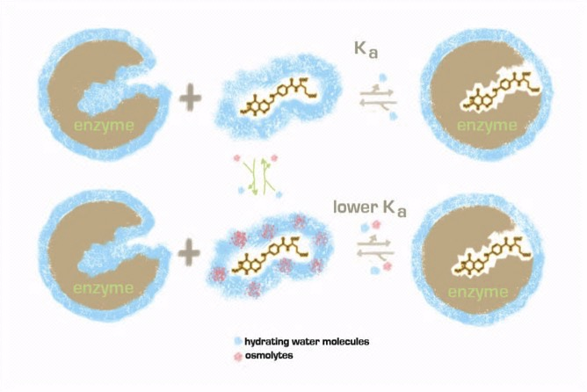
Figure 1. Figure showing the interactions of osmolytes with enzyme substrates and the resulting effect on the kinetics of the reaction. When osmolytes are present, the K_{a} is lowered and the equilibrium is shifted left.
pteridine
Glutamate tail
pABA
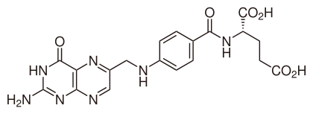
Figure 2. Molecular structure of folate. Folate consists of a pteridine, para-aminobenzoic acid (pABA), and a glutamate tail. These components are pointed out on the structure.
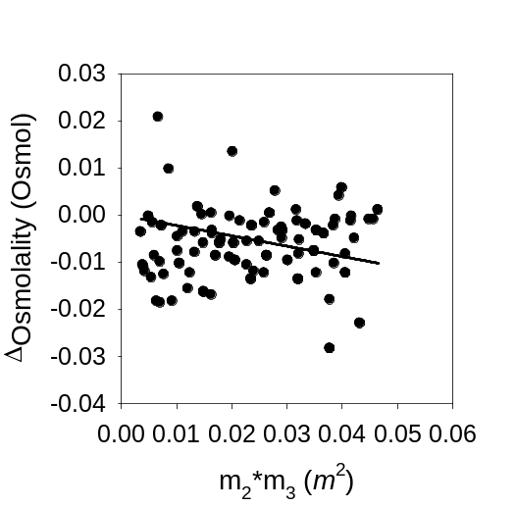
Figure 3. Preferential interaction graph for trehalose and folate. The preferential interaction coefficient was found to be -0.165 ± 0.044 m⁻¹ meaning that folate preferentially interacts with trehalose over water (Unpublished data Nambiar, Arrieta, 2016).
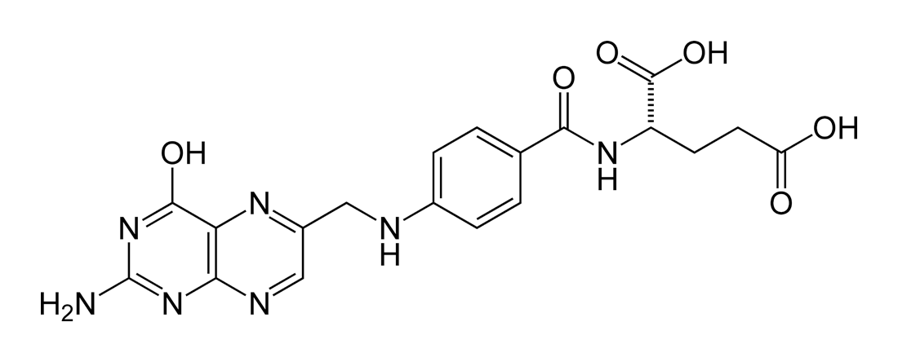
Amino Acids
Inorganic salts

Amides
Amino acid salts
Carboxylate salts and carboxylic acids

pABA variants

Aromatic w/ N in ring

Figure 4. Figure highlighting the various functional group types of folate and their corresponding compound type that was tested in this experiment.
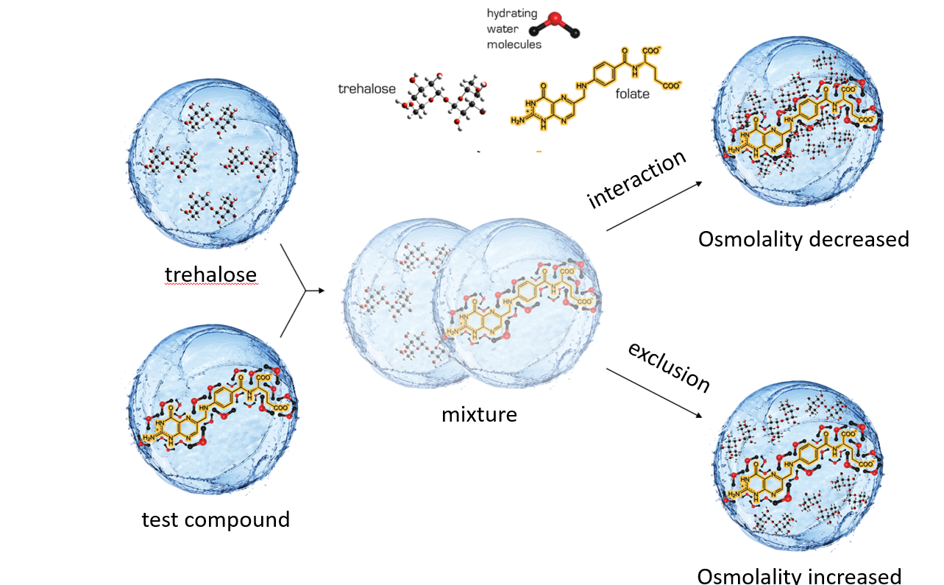
Figure 5. Model showing the theory behind vapor pressure osmometry. If trehalose and the test compound interact, then the osmolality of the overall solution is decreased. If no interaction is present, then the overall osmolality is increased.
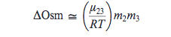
Equation 1. Equation for the linear regression of the ΔOsm vs m₂m₃ plots. The slope of this line gives us the μ₂₃/RT value for the test compound.

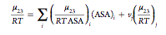
Equation 2. Equation for the calculation of α-values for each type of functional group. In this equation, μ₂₃/RTASA represents the α-value, ASA represents accessible surface area, i represents surface type (with (ASA)_{i} representing the water-accessible surface area in square angstroms), and v_{i}(μ₂₃/RT)_{j} equating to the product of the number of salt ions per salt test compound and the assigned contribution of that ion to μ₂₃/RT.

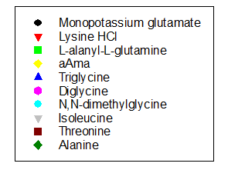
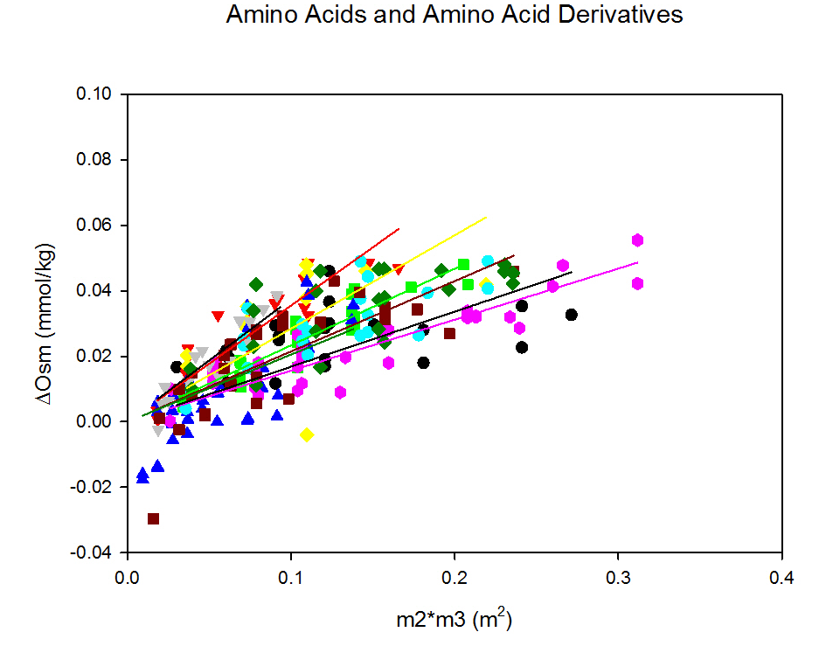
Figure 6. Graph of Δosm versus m2*m3 for amino acids and amino acid salts and their corresponding linear fits.

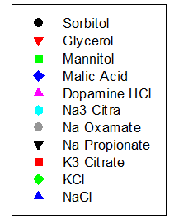
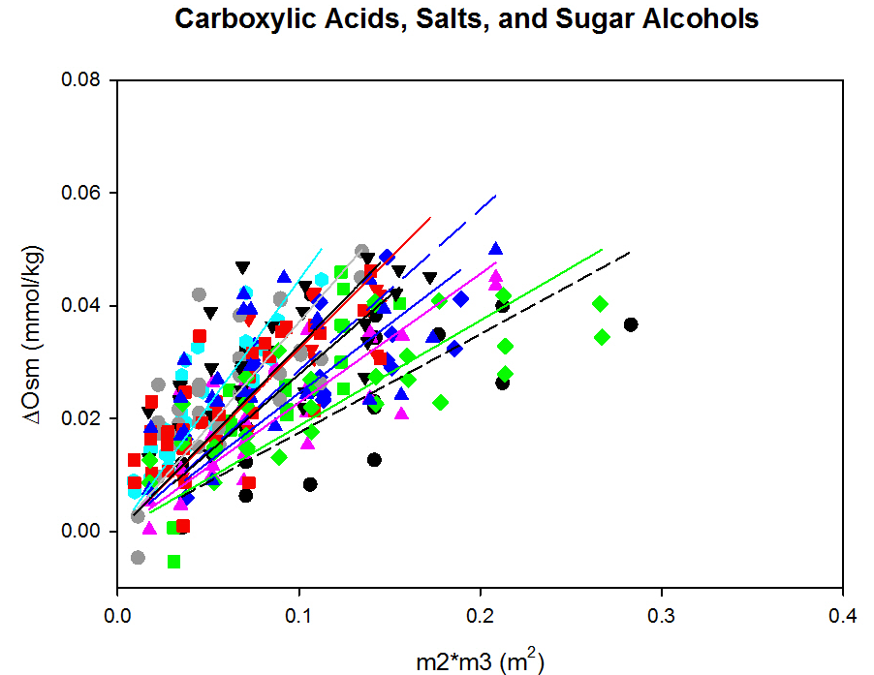

Figure 7. Graph of Δosm versus m2*m3 for carboxylic acids, inorganic salts, and sugar alcohol compounds and their corresponding linear fits.
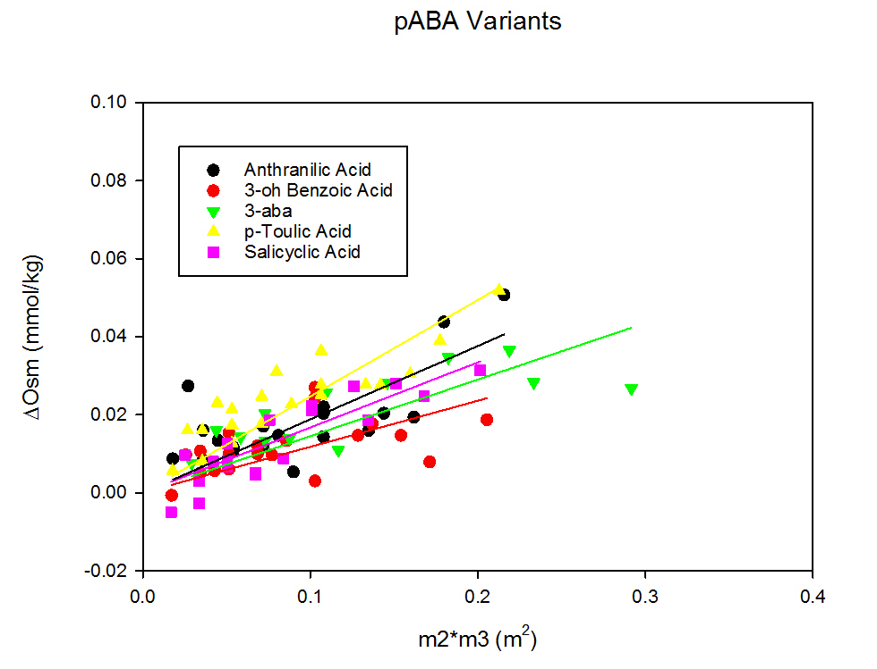

Figure 8. Graph of of Δosm versus m2*m3 for pABA variants and their corresponding linear fits.

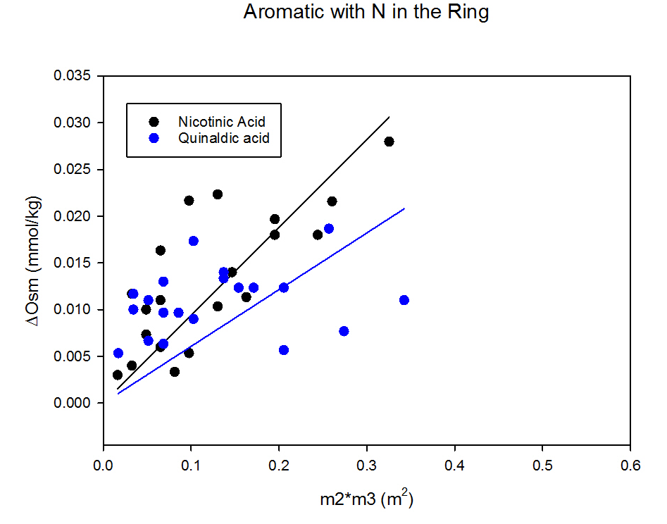
Figure 9. Graph of Δosm versus m2*m3 for aromatic compounds with nitrogen in the ring and their corresponding linear fits.

Table 1. Table showing each atom type and the corresponding α-value calculated for each one.
Atom Type | α-value
Aliphatic Carbon | 0.001311
Aromatic Carbon | -0.00019
OH | 0.000469
Amide Oxygen | 0.00094
Amide Nitrogen | 0.000278
Cationic Nitrogen | -0.0005
Carbonyl Oxygen | 0.000816
Phosphate Oxygen | -0.00121
Aromatic Nitrogen | 0.000384
Amine Nitrogen | 0.000351

Table 2. Table showing each atom type and the corresponding partitioning coefficient (Kp value) calculated for each one.
Atom Type | Kp
Aliphatic Carbon | 0.645444
Aromatic Carbon | 1.052528
OH | 0.873067
Amide Oxygen | 0.830462
Amide Nitrogen | 0.924815
Cationic Nitrogen | 1.135715
Carbonyl Oxygen | 0.779244
Phosphate Oxygen | 1.219007
Aromatic Nitrogen | 0.896173
Amine Nitrogen | 0.905074

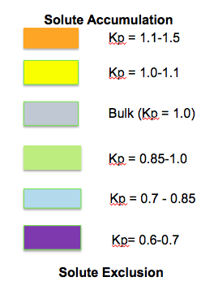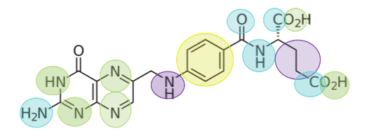

Figure 10. Figure showing the Kp values and their corresponding shading along the folate molecule. This figure helps indicate which atoms are contributing the most to the overall interaction between folate and trehalose. The higher the Kp value, the more that specific atom is partitioning trehalose rather than the bulk water present.

