

Zero Energy Ready Multifamily Dwellings for the
Redevelopment of Downtown Knoxville, TN

VOLUME I

TEAM Tennessee Advisors

James Rose, Architecture and Design
Dr. William Miller, Architecture and Design and Mechanical Engineering

Date Published: March 22 2015




Prepared by
University of Tennessee Graduate and Undergraduate Students
Architecture and Design and Mechanical Engineering

This page intentionally left blank.

table of cONTENTS
Page
LIST OF FIGURES v
LIST OF TABLES vii
ACKNOWLEDGEMENTS ix
TEAM PROFILE AND QUALIFICATIONS AND PROJECT SUMMARY xi
1. DESIGN GOALS AND PROJECT CONTENT 18
1.1 LOCATION 18
1.2 CLIMATE ZONE 18
1.3 LOT SIZE AND CONFIGURATION, HOUSE ORIENTATION 18
1.4 NEIGHBORHOOD AND COMMUNITY SETTING 17
1.5 OCCUPANTS 19
1.5.1 Sustainability 19
1.6 PROJECT TYPE 19
1.7 PROGRAM AND STANDARDS 20
2. ENVELOPE DURABILITY ANALYSIS 22
2.1 ENVELOPE THERMAL ENERGY BALANCE 22
2.1.1 Roof System 22
2.1.2 Wall System 23
2.1.3 Floor System 23
2.2 ENVELOPE MOISTURE BALANCE 24
3. INDOOR AIR QUALITY EVALUATION 26
3.1 12000 MINOTAIR AIR BALANCE 26
4. SPACE CONDITIONING DESIGN AND ANALYSIS 28
4.1 LOAD MODELING 28
4.1.1 ASHRAE Fundamentals 28
4.1.2 BEopt Building Energy Benchmark 28
4.1.3 Validation of Modeling Tools 29
5. HVAC, DOMESTIC HOT WATER, LIGHTING, APPLIANCES 30
5.1 HVAC 30
5.1.1 Air Recirculation 31
5.1.2 Heat Pump Mode/Heating and Cooling 32
5.1.3 Air Exchanger Mode 32
5.1.4 Control and Ventilation 33
5.2 HVAC SYSTEM FOR RETAIL STORES 34
5.3 DOMESTIC HOT WATER (DHW) 34
5.3.1 Benefits and Functionality 34
5.3.2 Cost Analysis 35
5.4 LIGHTING 35
5.5 APPLIANCES 36

6. ENERGY ANALYSIS 38
6.1 PHOTOVOLTAICS 38
6.2 HVAC ENERGY USE FOR TN CONDOMINIUM 41
6.2.1 Energy Breakdown for One Condominium 42
6.2.2 Cost of Energy for One Condominium 42
6.3 AUSTIN, TX, CHICAGO, IL and KNOXVILLE, TN LOAD COMPARISONS 43
6.4 DOMESTIC HOT WATER 45
6.4.1 Plug Loads 46
6.4.2 Clothes Washer and Dryer Control 46
6.4.3 Dishwasher Control 46
7. FINANCIAL ANALYSIS 48
7.1 SIMPLE PAYBACK REVIEW 48
8. CONSTRUCTION DOCUMENTATON 50
8.1 SITE PLAN 50
8.2 BUILDING DRAWINGS 51
8.3 DETAILS 54
9. INDUSTRY PARTNERSHIPS 56
INTERNAL DISTRIBUTION 57
EXTERNAL DISTRIBUTION 57

LIST OF FIGURES
Figure Page
Figure 2.1 Roof System 21
Figure 2.2 Wall System 22
Figure 2.3 Floor System 23
Figure 2.4 Relative Humidity of Wall in Heating Mode – Assumes Steady-state, one-dimensional vapor flow with no storage 24
Figure 5.1 MINOTAIR Boreal 12000 Exhaust Heat pump. (courtesy of MINOTAIR) 30
Figure 5.2 Air Recirculation. (courtesy of MINOTAIR) 30
Figure 5.3 Heat Pump Heating Mode Operation (courtesy of MINOTAIR) 31
Figure 5.4 Air-Exchanger Mode Supporting Comfort Heating of the Unit (courtesy of MINOTAIR) 32
Figure 5.5 MINOTAIR Thermostat and System Controller 32
Figure 5.6 Geospring Heat Pump Water Heater by GE (courtesy of GE) 34
Figure 6.1 Two PV options (shade renderings at summer and winter solstice) 37
Figure 6.2 Shade rendering for Knoxville, TN showing the sun’s altitude angle for both soltices and equinoxes 38
Figure 6.3 Placement of PV on the EPDM rubber roof of East TVA Tower 39
Figure 6.4 Energy breakdown for one condominium 41
Figure 6.5 Average monthly cost breakdown for one condominium 42
Figure 6.6 Monthly DHW flow rate for one condominiuim 43
Figure 6.7 NetZero condominium with exhaust heat pump compared to condominium with IECC 2012 code insulation and SEER 13 air-to-air heat pump 44
Figure 6.8 Monthly DHW flow rate for one condominium in Knoxville, TN 45
Figure 8.1 Site plan 49
Figure 8.2 Second floor building plan 50
Figure 8.3 Gay Street elevation 50
Figure 8.4 Building section 51
Figure 8.5 Unit longitudinal section 51
Figure 8.6 Unit plan 52
Figure 8.7 Window head detail 53
Figure 8.8 Window sill detail 53

This page intentionally left blank.

LIST OF TABLES
Table Page
Table 2.1 Percent improvement of thermal resistance values from IECC 2012 standard 22
Table 2.2 Percent fenestration on exterior wall 23
Table 4.1 ASHRAE chapter 17 and BEopt benchmark load verification 29
Table 5.1 Appliances 38
Table 6.1 PV generation of TVA east tower and total consumed energy with breakdown for HVAC and DHW for one of 20 condominiums 42
Table 6.2 BA formulas for daily water use 44
Table 6.3 Annual electric use 45
Table 7.1 PV payback at 60% coverage and PV payback at 96% coverage 48
This page intentionally left blank.

Acknowledgements
The University of Tennessee (UTK) College of Engineering and the College of Architecture and Design are grateful for the opportunity afforded students to compete in the 2015 DOE NetZero competition. The event has challenged students to work outside their academic paradigms and interact with industry and with students from other academic disciplines. The opportunity was positive and helped enhanced their educational experience.
Students toured manufacturing facilities at Clayton Homes and observed the approach used to build modular homes. Brad Russell, Gavin Mabe, Mark Ezzo and James Harrill, all of Clayton Homes, invited students to make presentation on the design project at the Clayton Homes headquarters. The experience was valuable training in publicly conveying one’s concepts to a prospective client. Jon Kane of Solar Energy USA provided excellent support to the faculty and students. His experience in material cost and setup of PV helped with the credibility the PV design. TRANE invited students to present their concepts and TRANE brought their top experts to the table to provide constructive comment. Kelso-Regan helped with setup of the air distribution system and explained how HVAC ducts are designed and built in industry. Shawn Hern of Climate Master provided faculty and students insight in the practical aspects of geothermal heat pump systems. Victor Zaderej of Moles and Kevin Willmorth of Lumenique provided support with the setup of LED lighting. Brian Partyka of Drexel and Scott Kriner of the Metal Construction Association (MCA) offered assistance with selection of low-slope painted metal roofing. Karl Audet of Minotair educated students on the operation and benefits of exhaust heat pump technology. Darson Buckner helped with the basic understanding of air barriers, vapor barriers and weather resistive barriers. Mike Pappus of Caldwell Banker explained the separate deeds granted to the homeowners and to the potential retail stores that would be a part of the condominium complex. He was extremely helpful with the financial aspects of the housing market and appraisal assessment for residential buildings in an urban setting.
All the above industry representatives served as advisors to the UTK Volunteers and either attended one or two of our weekly meetings and/or participated in Live Meetings hosed by the faculty to help bring good design to the table and complete the project in timely fashion.

This page intentionally left blank.

TEAM PROFILE AND QUALIFICATIONS
The Tennessee Volunteers are comprised of students in Architecture and Design, Mechanical Engineering and Electrical Engineering. The team met weekly and often bi-weekly in evening meetings among themselves and with invited industry advisors. Students have made several presentations to convey their design approach and have received excellent support from their industry advisors.

Team Qualifications — Students
Cody M. Bancroft is a third year BA student in the College of Architecture and Design at the University of Tennessee. He is a blackbelt in Tae-Kwon-Do and a member of Gamma Beta Phi. Cody has an interest in all scales of architectural and industrial design, from the city to the spoon. His career goal is to own a design practice with a focus on individual and community wellbeing.

Jessica Boles is a senior in electrical engineering at the University of Tennessee. She is currently Vice President of Systers: Women in EECS, the leader of her senior design team, and the lead coordinator for Woman Engineers Day (a one-day professional engineering conference for UT's College of Engineering). In January, 2016, she will begin working towards her master's degree at UT in power electronics for photovoltaic systems.

Kirsten Bridges is a third year BA student in the College of Architecture and Design at the University of Tennessee. She is a member of the Beta Alpha chapter of the Tau Sigma Delta Honors Society for architecture and the allied arts, and she will be a part of the Finland Summer Architecture Institute during the summer of 2015.

Kalee Holdren is a third year BA student in the College of Architecture and Design at the University of Tennessee. She is involved in the Appalachia Community Health and Disaster Readiness Project at UT, an interdisciplinary project to study the problems and design solutions for rural areas of the Appalachia region. She is the research assistant in the project and the editor of the publication of work from 2014-2015. She is currently involved in the design-build "Clean Water, Clean Life" project to design and build a water kiosk for the community of Clay County, Kentucky. She is pursuing a minor in Japanese and has interests in Japanese culture and design as well as an interest in acoustical architecture design. She is a member of AIAS and Tau Sigma Delta.

Joey (Joseph) Kutz is a third year BA student in the College of Architecture and Design at the University of Tennessee. Joey is involved with the UTK chapter of AIAS (the American Institute of Architecture Students), as well as serving as TAAST Treasurer (The Annual All-College Spring Thing, a UT architecture tradition.) His interests include sustainability, which he plans to obtain a minor in, education, and Appalachian history.

Nathaniel Midgett is a third year BA student in the College of Architecture and Design at the University of Tennessee. Possessed with a keen interest in building and project based learning, Nathaniel has participated in several design build projects including a Japanese dry garden, a water kiosk for Appalachian Kentucky, and a bridge made from reused utility poles.

Trey Twickler is a senior from Memphis, TN majoring in Mechanical Engineering at The University of Tennessee. During his college experience he has had the opportunity to study abroad in Europe and work in multiple internships. He is involved on campus with the Chancellor’s Honors Program, ASME, ASHRAE, Tau Beta Pi, and the Collegiate Entrepreneurs Organization. He was drawn to work on the DOE Zero Energy Project due to the large, interdisciplinary work environment and his interest in HVAC and envelope design. The project has allowed him to work with architects, people in industry, and different engineering disciplines, while gaining more practical experience. He has gained valuable experience with load calculations and BEopt modeling through the process. Upon graduation in December of 2015, Trey hopes to attend graduate school.

Ben Webb is a senior in Mechanical Engineering at The University of Tennessee. He is currently employed part-time at the Energy Power Research Institute (EPRI) where he works as a student intern testing HVAC equipment. He is highly involved with the local East Tennessee chapter of ASHRAE and currently serves as the UT student chapter President. In the next academic year starting in the fall of 2015, Ben will be enrolled in the Dual Degree program at UT where he will pursue his MBA and Master's in Mechanical Engineering.

Georgia White will graduate in May of 2015 with a Bachelor of Science is Mechanical Engineering and a minor in Reliability and Maintainability from the University of Tennessee, Knoxville. She is a member of ASME, ASHRAE, SWE, and currently serving as the President of Pi Tau Sigma, the honorary mechanical engineering society. After graduation, she plans on joining SABIC Innovative Plastics’ Early Engineering Education Development program.

Gavin Millar is a senior in Mechanical Engineering with a minor in Business Administration set to graduate in December 2015. He plans to become a high school mathematics or science teacher upon graduating. He was also a member of the Phi Mu Alpha fraternity at the University of Tennessee.

Industry Advisors
Jon Kane |Solar Energy USA & Net Zero USA | Operation and Design Analyst |
Email: jonk@solarenergy-usa.net
Jonathan Kane is the lead designer for Solar Energy USA, a national energy services company specializing in renewable energy and commercial lighting solutions. His expertise is getting customers off the grid by advising on Net Zero building design, energy efficient appliances, and designing custom battery backup solar systems. As an environmental activist and educator, Jonathan has worked with a number of schools by providing educational resources and equipment to better prepare the next generation for a career in renewable energy.

Nancy McBee | TRANE |Business Development Manager, LEED®AP |
Email: nmcbee@trane.com
Nancy McBee has 25+ years in the HVAC industry with specialization on energy savings performance-based contracts. She specializes in project development and design, contract negotiations, measurement and verification and energy modeling. Typical projects include – HVAC replacements and retrofits, lighting retrofits, building automation systems, weatherization and plumbing technology upgrades. Her professional affiliations are: USGBC, ASHRAE and AEE.

Jason Land, PE, CEM | Energy Engineer Trane Building Ingersoll Rand |
Email: Jason.Land@irco.com
Jason Land is an Alumni of the University of Tennessee. He received a Bachelor of Science in Mechanical Engineering. He is a licensed Professional Engineer (PE) in the State of TN and a Certified Energy Manager (CEM). He works as an Energy Engineer with TN Trane where he performs and oversees energy analysis and simulation for our Energy Services Performance Contracts.

Jack Hopkins, PE | HVAC Consultant |
Email: jhopkins@appeng.com
Jack Hopkins is a professional engineer and Principal of Applied Engineering in Knoxville, TN. He has 33 years of design experience, including projects in the aerospace, automotive, and health care sectors. He holds a Bachelor of Mechanical Engineering from Georgia Tech, and a Masters of Industrial Engineering from the University of Tennessee. A long-term member of ASHRAE, he has held many leadership positions and is a past chapter president.

Gary T. Bergeron | Kelso-Regen Associates, Inc. | Principal and Co-Owner |
Email: gary@kelso-regen.com
Gary T. Bergeron has been working in the mechanical consulting industry since 1984 and is a principal and co-owner of Kelso-Regen Associates since 1997. Gary is a member of American Society of Heating, Refrigerating and Air Conditioning Engineers (ASHRAE), American Society of Plumbing Engineers (ASPE), Construction Specifications Institute (CSI), US Green Building Council (USGBC), and also a Knox County Science Technology Engineering Math (STEM) academy mentor. The primary research interest is the HVAC, plumbing and fire sprinkler systems for commercial, institutional and residential buildings.

Shawn Hern | Climate Master | Principal Developer |
Email: shern@climatemaster.com
Shawn Hern is a Principal Developer and Engineer at ClimateMaster. He specializes in the design and development of air-to-water and water-to-water geothermal heat pump systems. He played a key role in development of ClimateMaster’s Trilogy™ Q-Mode geothermal heat pump system, which received a 2013 R&D 100 Award. The Trilogy Q-Mode was the first geothermal heat pump to be certified by the Air Conditioning, Heating, and Refrigeration Institute (AHRI) to exceed 40 EER.

Victor Zaderej | Molex | Lighting Engineer |
Email: victor_zaderej@sbcglobal.net
Victor Zaderej is currently the Manager of Advanced Development for Molex in Lisle, Illinois. Victor holds a SB and SM in Mechanical Engineering from MIT and an MBA from Quinnipiac University. Over the past five years, he has specialized in the area of Low Voltage Solid State Lighting and Smart Lighting for both commercial and residential applications. He has a passion for energy efficient building and lives in a home he has built in Oregon Illinois that meets the “German Passive House Standard.” As a “hobby,” he works with clients who are interested in building commercial buildings or homes that can meet the most stringent energy standards on the planet.

Kevin Willmorth | Lumenique, LLC | Lighting Engineer |
Email: kwillmorth@lumenique.com
Kevin has been involved with lighting for 34 years. His experience includes lighting design consulting, product design, marketing, business strategy, and editorial writing. His experience includes positions as VP of Design and Marketing for Kim Lighting, Winona Lighting, and Visa Lighting, VP and Director of Product Management Renaissance Lighting, and VP of Lighting Design for Atlandia Design. He currently owns Lumenique, LLC, offering product design, prototype development, testing, and strategic consulting to manufacturers, application design and technology evaluation for building owners, and SSL editorial for all Construction business media publications including Architectural SSL, Architectural Products, and NZB magazines.

Brian Partyka | Drexel Metals, LLC | President |
Email: bpartyka@drexmet.com
Brian Partyka is a 19-year veteran of the metal construction industry and has been with Drexel Metals from its early days. Brian is an elected member of the Board of Directors of the Metal Construction Association and is actively involved in the industry. He chairs the Statistics Committee, Co-chairs of the Codes and Standards Committee and sits on multiple task groups to help drive growth for the Metal Construction Industry. Brian is also a member of the Cool Metal Roof Coalition, sits on the Industry Advisory Board for the NRCA (National Roofing Contractors Association) as well as the CEO Advisory Council for the Central Bucks Chamber of Commerce and multiple Board seats for small local businesses. Brian has published and contributed to numerous technical trade-articles/white papers relating to metal building products. Partyka also presents nationally, internationally and regionally about sustainable design and the use of metal to reduce heat gain for industrial, commercial and residential structures.

Scott Kriner | Metal Construction Association | Technical Director |
Email: skriner1@verizon.net
Scott Kriner, LEED AP, is President of Green Metal Consulting, Inc. and a Principle in RSK Avanti Partners LLC. He is serving the Metal Construction Association as their technical director. He consults on green, sustainability and energy efficient issues for manufacturers and suppliers of metal roofing and wall systems.

Darson Buckner, CSI CDT | DuPont Tyvek | Senior Weatherization Specialist |
Email: darsonbuckner@hotmail.com
Darson Buckner is a Moisture Management Consultant and a DuPont Tyvek Senior Certified Weatherization Specialist for Dealers Warehouse Corporation. He is certified as an Energy Auditor and as a Masonry Inspector with the Masonry Institute of Tennessee. Darson is a LEED Green Associate (USGBC), Construction Documents Technologist (CSI), and a Master Certified Green Professional (NAHB).

Karl Audet, CSI CDT | MINOTAIR | System Engineer Specialist |
Email: karl.audet@minotair.com
Mr. Karl Audet has an Electrical Engineering degree with over 25 years of combined experience in Information Technologies (IT), System Engineering, and Heating Ventilation and Air Conditioning (HVAC). He has gained most of his experience in the Canadian Forces where he honorably retired as a senior officer at the rank of Major after more than 20 years of service. Following his military career, he used his leadership skills and talents to create a manufacturing company specializing in residential ventilation products such as multifunction air exchangers and exhaust heat pumps. Mr. Audet has assumed the roles and responsibilities of President and CEO of MINOTAIR Ventilation Inc. since 2013.

Brad Russell | Clayton Homes | Modular Specialist |
Email: Brad.Russell@ClaytonHomes.com
Brad is a Modular Specialist with Clayton Homes, a Berkshire Hathaway company. Throughout his career spanning 23 years, he has participated in opportunities in both design and construction activities in a manufacturing environment. His experience includes both residential and light frame commercial projects within a manufacturing environment.

Mark Ezzo | Clayton Homes VP of Engineering | Professional Engineer |
Email: Mark.Ezzo@ClaytonHomes.com
Mark Ezzo, a professional engineer, serves as Clayton Homes’ Vice President of Engineering, with 27 years in the factory built housing industry. His primary function is to direct engineering & design departments to ensure all products, materials, and construction specifications meet applicable building code standards, are cost effective, innovative, and promote production efficiency. Typical projects include Energy Standards development, Energy Star utility rebate programs, and advanced building envelope design. His professional affiliations are MHI and SBRA.

Mike Pappas CRB, CRS, GRI | Caldwell Banker Wallace & Wallace Realtors®| Director and Broker |
Email: mpappas@cbww.com
Mike Pappas joined Coldwell Banker Wallace & Wallace Realtors® in 1996. He served from 1998 to 2000 as the Broker for the company’s Emory Road office, and is presently the company’s Director of Professional Development. He is also an active agent. He has served on the KAAR Board of Directors, Treasurer 2002 and 2013 and as President in 2004 and 2010. Mike is a TAR Division 3 Vice President 2011-2012. He presently serves as the Director for the National Association of Realtors ®.

Team Qualifications — Faculty Advisors
Dr. William Miller is a senior research engineer in the Building Envelopes Program at Oak Ridge National Laboratory (ORNL) and is adjunct faculty in both the UT Mechanical Aerospace and Biomedical Engineering (MABE) program and the College of Architecture and Design.

James Rose AIA is a licensed architect, adjunct assistant professor in the UT College of Architecture and Design and Interim Director of the Institute for Smart Structures.

Faculty members Miller and Rose have worked together on multiple student-driven design build projects including UT’s 2011 DOE Solar Decathlon entry, the Living Light house.

Academic Institution Profile (Building Science)
As a land grant university, The University of Tennessee, Knoxville has a long history of collaboration with industry and governmental partners in support of energy-related research. From the Tennessee Valley Authority (TVA) and the Manhattan Project to the founding of Oak Ridge National Laboratory and the 1982 World’s Fair, East Tennessee has been on the forefront of new developments in energy production, transmission and utilization. Recently, the College of Architecture and Design and the MABE program have partnered on several student built projects focusing on passive solar design, efficient building envelopes, and photovoltaic power. This multidisciplinary approach has resulted in notable successes like the Living Light house, the UT entry for the 2011 DOE Solar Decathlon. The house won first place in Energy Production and finished eighth in the world. Building on projects like these, the College of Architecture and Design has recently secured a Governor’s Chair position for Energy and Urbanism. The inaugural year of this teaching and research position has seen projects partnering with TVA and ORNL covering such diverse topics as whole building reuse and architectural applications of additive manufacturing.
Architecture and Design teaches a two semester sequence in environmental controls. The students learn how to compute the heat transfer and mass transfer occurring in conventional envelope construction where parallel paths through stud walls and insulating materials are prevalent. Students are expected to compute the overall heat transfer coefficient and overall diffusion coefficient for a one-dimension, steady-state process having no storage. They are tasked with estimating building heating and cooling loads. Students are also introduced and instructed in the various styles of heat pumps for residential and commercial applications, recovery ventilator technology and photovoltaic system designs. Lighting, electricity, plumbing, acoustics and fire protection are also covered in the two-semester course.
Efforts are in place to resurrect a thermal environmental option in Mechanical engineering. The local ASHRAE chapter is fully supporting the MABE department to make building science curriculum an option for engineering students. At present, academic study is conveyed to interested students through senior level capstone design projects.

Faculty Advisor Affirmation of Compliance
Dr. Miller affirms that all student participants have satisfied the DOE Building Science Training Course requirement.

Project Summary
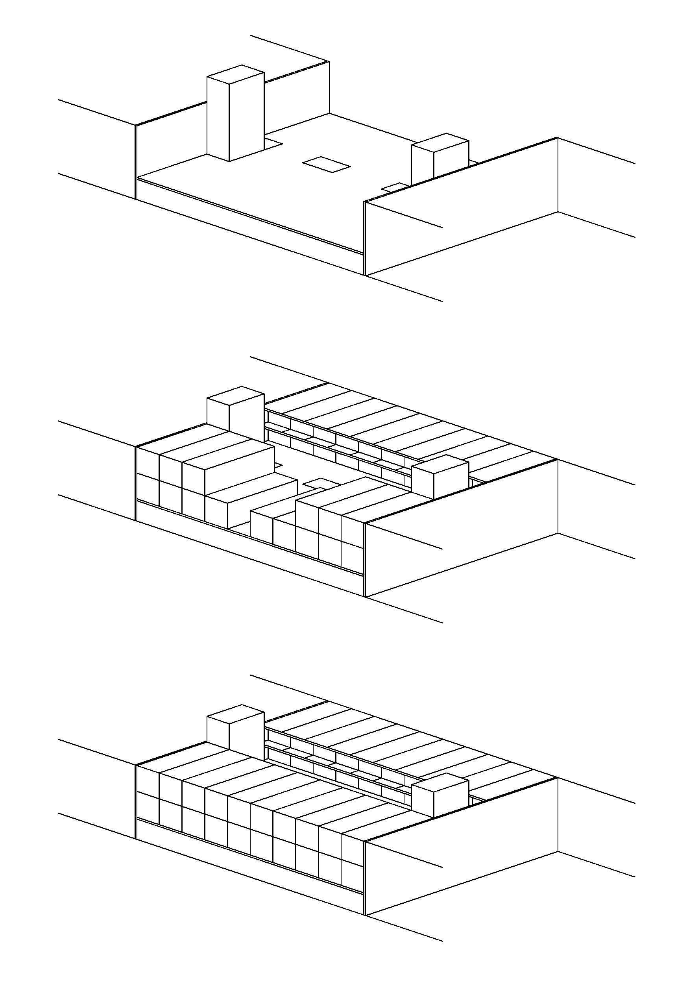
Above all, we want to be a good neighbor. The proposed dwellings leverage the sustainable benefits of urban living, efficient envelope design and construction using modular prefabrication, and high performance HVAC systems. This development of 20 two bedroom units is located in an urban infill site within walking distance of shopping, entertainment, and cultural venues. The building is organized around a central open court set atop a plinth of parking and retail. The efficient unit plans boast minimal exterior surface area and are conditioned with individual high performance exhaust heat pumps. Solar power is provided on the northeast roof of the building and in conjunction with an adjacent utility provider.

Relevance of Project to the Goals of the Competition
From the beginning, the team has embraced a collaborative multidisciplinary approach with weekly meetings bringing together engineering and architecture students and industry representatives. All design decisions were based on the application of a solid first-principles approach and were tailored to the unique conditions of urban character, climate and orientation, regionally available construction typologies, manufacturer’s existing products, and local expertise.

Design Strategy and Key Points
This project began with the intent to develop a new residential typology based on the most sustainable design parameters. To that end, 5 criteria were developed: utilize an urban site to avoid the use of the automobile for most trips, offsite fabricate to minimize material waste, build dense to minimize exterior surface area, employ decentralized high efficiency HVAC, and create novel public/private ownership solutions for PV power.

Project Data
  - Knoxville, TN
  - Climate zone 4
  - 800 square feet per unit
  - 2 bedroom, 2 bath, 1 story units (3 story building)
  - HERS score NA
  - $57.73 per month per unit energy cost [Net $2.27 including PV]

Technical Specifications
  - Wall Insulation = R 31.4
  - Foundation Insulation = R 27
  - Roof Insulation = R 42.4
  - HVAC specifications = MINOTAIR exhaust heat pump, 9000 Btu/hr per unit
  - Window Performance U = 0.23

DESIGN GOALS AND PROJECT CONTENT
The house type is a two bedroom, two bathroom, single story condominium unit. The unit is one of twenty located in the upper two stories of a three story, mixed use urban infill building. The condominiums are approximately 800 square feet each with living/dining room, kitchen, mechanical/laundry, guest bath, two bedrooms with closets, and one master bathroom. Two zones of lower ceiling define the support zones of entry/kitchen/mechanical and bathrooms/closets and provide space to run all ductwork. The ground floor of the building contains parking for twenty automobiles, 3000 square feet of retail space, residential lobby, mechanical space, and vertical circulation. Above this level are two stories of condominiums organized around a central courtyard open to the sky. The residential units are accessed via covered exterior corridors overlooking the courtyard. The outdoor space is provided as an amenity to occupants and serves to provide side day lighting to the units and top lighting to the parking area via light wells.

Location
The project is located on Gay Street in downtown Knoxville Tennessee. The specific site is an empty urban lot with zero-lot-line party walls on north and south. The east property line is the sidewalk of Gay Street, the primary street of Knoxville’s central business district. The west property line is an alley providing parking access and garbage pick-up. The lot is currently owned by TVA and the Knoxville headquarters of the utility provider is located in a pair of office towers directly across the alley. Water, sewer, electric, and data connections are available at the sidewalk of Gay Street.
The East TVA Tower adjoins the specific site for the condominium complex, see Volume II, Section 1, Figure 1.1. The TVA tower will partially shade the roof of the complex and PV is therefore proposed for the roof of the tower, which is one of the taller buildings in the area.

Climate Zone
The project is located in the moist zone of climate zone 4. This location dictated the insulation minimums and influenced design considerations for humidity and envelope water barriers. The exterior insulation and finish system applied to the walls makes use of a Tyvek drainage layer and rot, mold and mildew-resistant Densglass sheathing. The roof assembly makes use of low-slope standing seam metal with high solar reflective index (SRI) values to reduce thermal gain in summer months. For the few days a year when humidity and temperature are optimal, the long plans and open courtyard are conducive to natural ventilation

Lot size and configuration, house orientation
The lot is approximately 110 feet deep and 125 feet long across the Gay street east elevation. The lot slopes approximately 5 feet vertically from a low point at the Gay street sidewalk to the alley at the rear. The grade change is resolved internally to the first floor plan as three flat planes linked with ramps. The site is in an urban environment surrounded by buildings of 3 to 12 stories. This urban density plus the balcony overhangs in the courtyard protect all windows from direct solar gain while allowing enough natural illumination and views.

Neighborhood and community setting
The east elevation and main building entry is on Gay Street, downtown Knoxville’s primary commercial zone. The site is within a fifteen minute walk of grocery, furniture and apparel stores as well as banking, religious, governmental and cultural facilities. In addition to the 20 parking spaces provided, a free downtown trolley runs directly in front of the building and an intermodal transit hub with access to regional buses is within walking distance. The green spaces of the World’s Fair Park and the campus of the University of Tennessee are a trolley ride away.

occupants
The compact 2 bedroom, 2 bath units are designed to appeal to a range of demographics including older students, young professionals and retirees. All condominium units are on one level and all vertical transitions in the building are accommodated with elevators or accessible ramps. Per ADA requirements, one condominium is provided with special consideration given to accessible and barrier-free kitchen and bathroom. Outdoor public spaces like the exterior balcony corridors and courtyard are floored with a raised plaza deck system to avoid standing water. A dedicated van accessible space is provided in the parking area with direct access to the elevator without crossing a vehicular path. The primary elevator is located to act as lift between the Gay Street grade elevation and the parking area.

Sustainability
Five criteria were developed, each with a specific impact on sustainability:

- Utilize an urban site to avoid the use of the automobile. Although one parking space is provided for each unit (and not required by local code in an urban area), the intent of the location strategy is to for occupants to make most daily trips on foot.
- Offsite fabricate to minimize material waste. Local expertise in modular wood-framed construction and precast concrete can be leveraged to avoid the majority of construction waste. In addition, these local techniques support local jobs and the economy.
- Build dense to minimize exterior surface area. The urban site lends itself to a multi floor building whereby most condominium units expose only their short ends to the exterior. This minimizes thermal transfer.
- Employ decentralized high efficiency HVAC for ease of long-term ownership and maintenance. Exhaust heat pumps were chosen to make use of thermal energy usually wasted in the exhaust stream and can work in heating, cooling and ventilation modes. The individual heat pumps are located within each unit to simplify ownership, maintenance and billing in a communal living environment.
- Create novel public/private ownership solutions for PV power. The solar array is located atop the adjacent TVA east tower. It is proposed that this location would avoid shadow on the solar panels and create a localized green power facility to add to the utility provider’s production portfolio. The array could be sized to offset the use of the proposed residential building, or sized to accommodate other downtown green power subscribers.

project type
The project is a 3 story, mixed use building with parking, residential lobby, and retail on the ground floor and twenty 800 square foot condominiums on the two floors above. The condominiums are organized around a central open air courtyard with unit entered off of covered exterior balcony corridors. Prefabricated, modular construction was selected for the primary structural systems. For fire resistance and longevity, an off-the-shelf system of precast columns, beams, decking, and vertical circulation elements was selected for the ground floor structure. This system provides a flat surface upon which to employ a modular prefabricated system of residential units based on a product manufactured by Clayton Homes. Each condominium is composed of two volumetrically identical 12x25 foot wood framed units. These units include the structure for the exterior balcony corridor or overhang and stack two stories tall. Units would ship with framing, finishes, appliances, HVAC, lighting and plumbing installed. Exterior envelope would be applied in the field to maintain a seamless moisture barrier and prevent thermal bridging. Utility and HVAC connections between modules of the same condominium are located together and accessed above a lowered ceiling. Plumbing, sewer, and power connections to each condominium are stubbed out below the floor line of the exterior balcony corridor and connect to vertical chases placed at the joints between units. The chases are insulated and accessible from outside the unit for ease of assembly and maintenance.

program and standards
The project was designed referencing the 2012 International Energy Conservation Code (IECC), the Americans with Disabilities Act (ADC) IECC 2012, and ASHRAE 90.1 and 62.2. The design process made extensive use of energy modeling using BEopt and Energy Plus.
This page intentionally left blank.

ENVELOPE DURABILITY ANALYSIS

ENVELOPE THERMAL ENERGY BALANCE
Table 2.1. Percent improvement of thermal resistance values from IECC 2012 standard
Exterior Item | IECC 2012 R-Value | Unit Design R-Value | Percent Improvement
Roof | R-38 | R-42 | 11%
Wall | R-19 | R-31 | 63%
Floor | R-20 | R-27 | 35%
A goal was set to achieve a system that performed at or above IECC 2012 standards for the complex’s designated climates zone. Thermal resistance values (R-values) were calculated using the basic heat transfer concepts to complete a thermal energy balance. The calculations were always done for the units with the greatest loads within the complex in order to ensure that all units performed at the necessary specifications. This would be the end units on both the first and second level because they have an extra exterior exposed side wall that the interior units lacked. These units were also selected to be on the street side of the complex because the lack of shading conditions lead to the most sun exposer. The R-values for each item can be seen in Table 2.1. Every item exceeded the IECC 2012 minimum R-value.

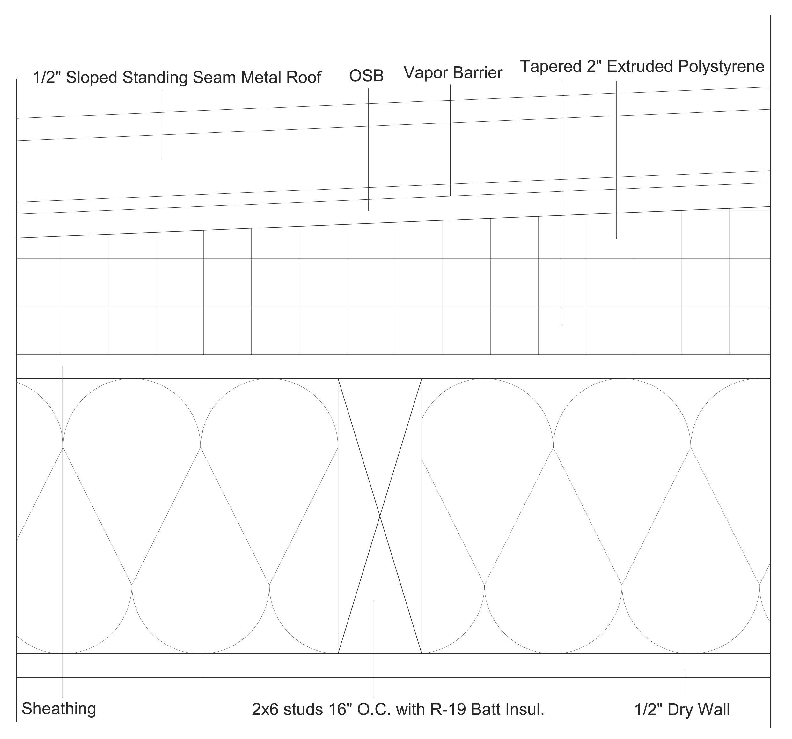
Roof System
The ceiling system can be seen in Figure 2.1 and from the interior consist of 2 by 6 inch wood studs with fiberglass batt insulation in between. This is followed by additional extruded polystyrene insulation that fills the attic cavity. This created a sealed attic so there is no need for ventilation. There is a base layer of 2 inches of insulation across the entire ceiling but it increases to almost 11 inches at the peak of the roof. A layer of DensDeck roof boards made by Georgia-Pacific is used to create a drainage plane for removal of moisture. A solar reflective metal roof pitched at 2/12 (low-slope) protects the underlying structure. The ceiling R-value was designed to be R-42, this is an 11% improvement from the IECC standard of R-38 in ASHRAE climate zone 3.
Figure 2.1. Roof system

Wall System
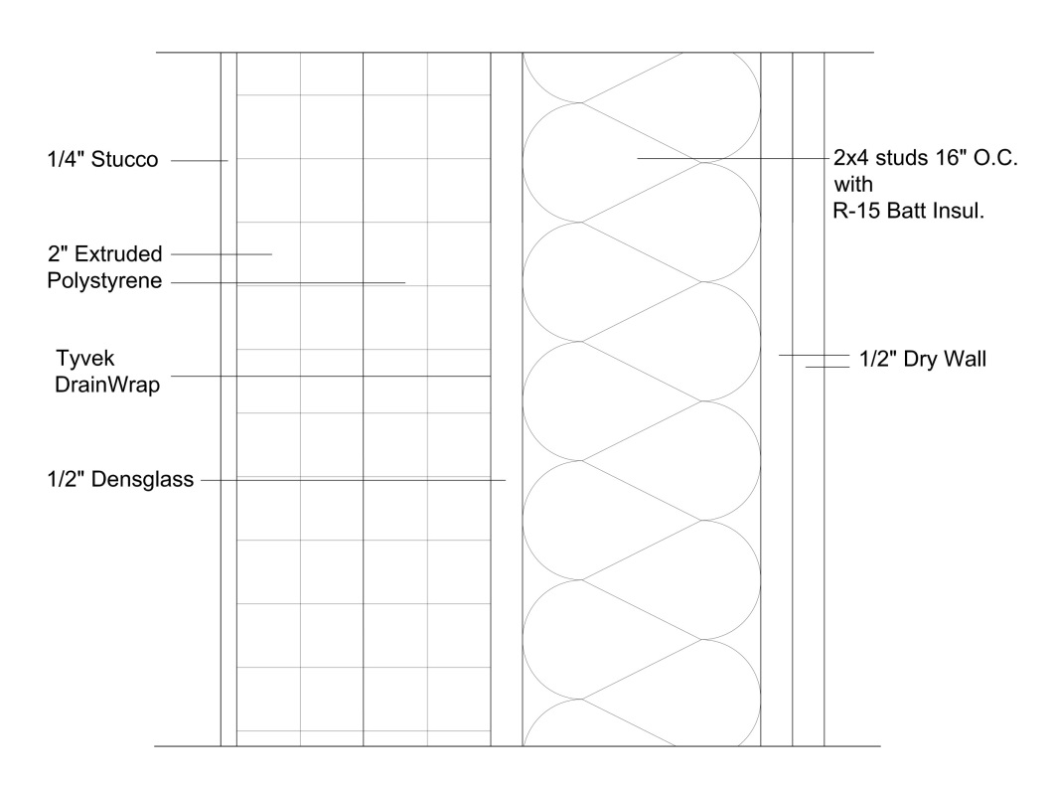
The wall system, Figure 2.2, was designed as an exterior insulation system to eliminate the parallel heat flow path between the insulation and studs. A stud has a lower thermal resistance then insulation and when placed in a parallel path together heat will more rapidly transfer though the stud lowering the overall thermal resistance value of the wall and the insulation. Placing about 4-inches of extruded polystyrene insulation on the exterior of the wall eliminates the parallel path and the thermal resistance value of the insulation is not decreased. This insulation in combined with the insulation within the studs to give a R-value for a unit exterior wall of R-31, a 63% improvement to the IECC 2012 standard of R-19.
Figure 2.2. Wall system

Table 2.2. Percent fenestration on exterior wall
Side | Number of Windows | Percent Fenestration
Front | 1 | 4%
Back | 2 | 8%
Right | 0 | 0%
Left | 0 | 0%
Fenestration in a wall can also lower the overall R-value and increase the load on a building. A window with an R-4 was selected and only a small number of windows were used to increase efficiency of the wall. The number of windows and the percent of wall area that has fenestration for each wall side can be seen in Table 2.2. Also, one door was selected for each unit with an R-value of 3.

Floor System
For the complex, the effective R-value of the floor system on the lower level units was designed to exceed the IECC standards. The IECC 2012 standard for the thermal resistance value of a floor is R-20. Being a modular unit, the joists were larger than normal to allow the unit to be lifted by a crane and placed into the complex. This need resulted in the use of 2 by 12 inch beams seen in floor system in Figure 2.3. After leaving a space for plumbing, the remaining space in between the joist was filled with insulation and resulted in a thermal resistance value of R-27 for the floor of the units. This is a 35% improvement to the minimum thermal resistance value, R-20.

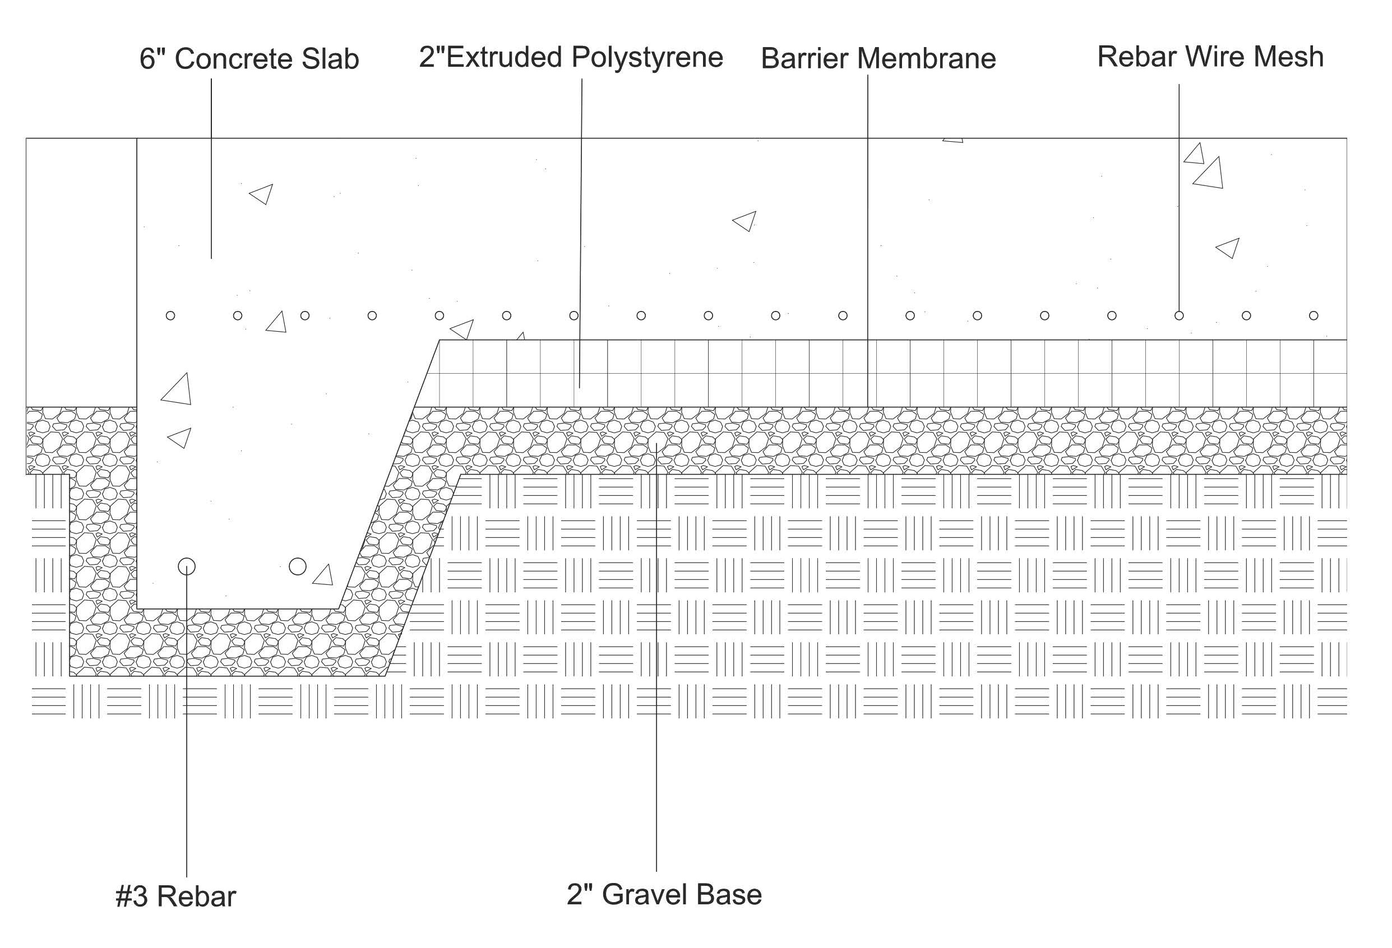
Figure 2.3. Floor system

ENVELOPE MOISTURE BALANCE
One of the most damaging elements to any structure is water. When water is retained in wood it can cause mildew, rotting, and decay. Also water can cause spalling in concrete and brick when water within freezes. Moisture and water control are an important variable to consider in wall systems. A traditional wall system has a weather barrier placed on the exterior of the home directly under the exterior façade. Any OSB or exterior insulations such as extruded or expanded polystyrene are attached to the wall studs directly and the weather barrier is attached to the outer most layers. A weather barrier allows the flow of moisture vapor but prevent the flow of water. It is important to not restrict and trap moisture in a structure. Preventing this flow would not only create uncomfortable conditions for the occupants but it would create excess condensation. During the summer, it is hot and humid outside and water vapor naturally moves inside. Condensation on a barrier exterior to the wood would not cause damage. However, in the winter water vapor moves from the inside out and when condensation occurs on the same barrier it results in wood absorbing water. This wood then does not have the ability to dry because the vapor does not have a way to escape the enclosure.
Water vapor movement is important to a building’s longevity. Although a vapor barrier and the correct wall configuration should eliminate excess condensation, water can still penetrate exterior facades. Limiting water from materials such as wood will increase the longevity of a structure. A weather barrier can allow vapor flow while restricting liquid water flow due to opening size in the material. However restricting water flow is not enough. Liquid water will flow downward, but only if it has a path. Masonry walls are built to leave a small gap between the weather barrier and the brick. This allows the water to run down the wall and exit the wall across the flashing. If this gap was not present water retention in material can cause damage when freezing occurs and the water is expanded.
The selected wall system for the units has a high level of exterior insulation. This method eliminates the parallel wood stud path for heat to move though, but creates a risk of moisture problems. The location of the weather barrier is the key to eliminating water’s access to wood materials. Placement in the traditional location directly under the façade can create moisture problems in the thick outer insulation. Placement outside the OSB but before the exterior insulation is ideal. A gap must be placed to allow water runoff. The weather barrier chosen was the Tyvek Drainwrap. This system acts as a weather barrier, prohibiting liquid water movement but allowing vapor flow. It also has vertical ridges to allow water to flow along the wrap between the ridges to exit the wall. This creates the gap needed so that the insulation can be placed adjacent to the wrap. A gap is also created between the DensGlass and the studs because it has a simpler ridge system and a gap is created between the polystyrene and stucco so that water does not freeze and cause spalling in the exterior façade. Permeability calculations were completed to verify that the temperature and pressure changes at each point between materials do not result in a relative humidity above 100% in the wrong location. As seen in Figure 2.4, the point between the extruded polystyrene and the stucco does reach 100%. There could be condensation at this location, but this is not a problem because the exterior façade has a gap to allow drainage and only occurs in the stud path when the outdoor temperature is lower than 20.8 °F.
These same calculations were completed for each an external system to ensure there would be no long term water damage. In heating mode for the floor insulation path, it was observed that the relative humidity reaches 100% when the outdoor temperature is 20.8 °F or below. This high relative humidity occurs in the fiberglass insulation. It was determined that condensation is not likely to occur in materials that are porous such as batt insulation. The material would have to be completely saturated before water would develop due to the high storage capacity of materials such as this. Completing calculations and analysis such as this ensures material longevity.
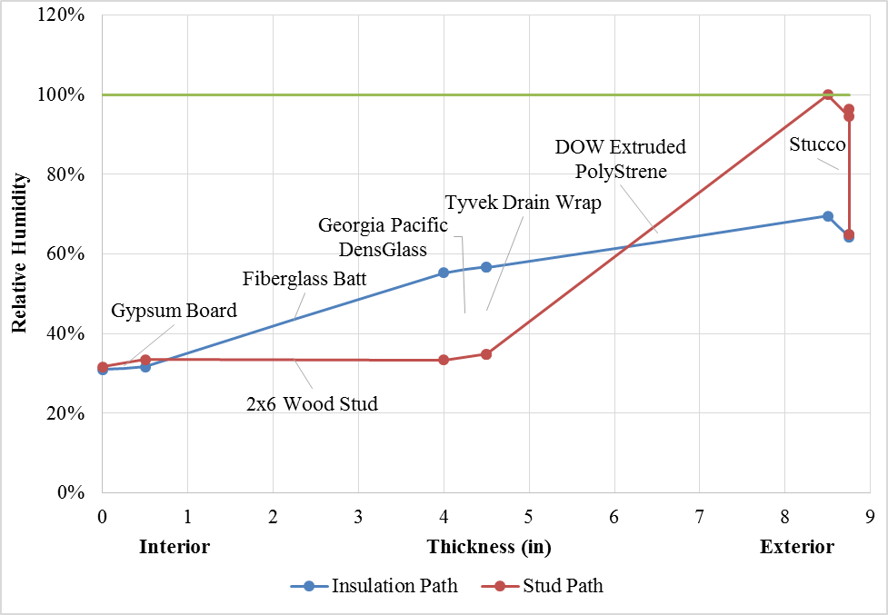
Figure 2.4. Relative humidity of wall in heating mode (assumes steady-state, one-dimensional vapor flow with no storage

INDOOR AIR QUALITY EVALUATION
Ventilation has become a key design issue for the HVAC industry as buildings are built “tighter” from an energy efficiency standpoint. Allergens, humidity and pollutions released from glues off-gassing from carpets, gases from upholstered furniture, gas and cooking appliances, paints and solvents, cleaning products, air fresheners, dry-cleaned clothing and pesticides will all degrade the indoor air quality. Harsh chemicals also emanate from cigarette smoke. Therefore without sufficient ventilation occupants are surrounded by harmful pollutants and humidity that can over time compromise health.
Heat recovery and energy recovery ventilators are popular choices for improving the indoor air quality through dilution ventilation. However, a unique exhaust heat pump was selected to provide intermittent or continuous ventilation while simultaneously providing comfort conditioning with moisture control of the ventilation air. Each of the condominiums is designed with a tightly constructed envelope with infiltration not exceeding 2.5 ACH by IECC 2012. This level of tightness requires the removal of stale air with fresh conditioned outdoor air. By ASHRAE 62.2 each condominium needs about 31 cfm of fresh air, Equation 3.1.

$Q_{vent}=0.01A_{floor}+7.5\left(N_{br}+1\right)=0.01\left(830\right)+7.5\left(2+1\right)=31 cfm$ Equation 3.1

The exhaust heat pump manufactured by MINOTAIR accomplishes the task. It is capable of maintaining continuous or intermittent ventilation for outdoor air temperatures ranging from -22°F to 95°F. The unique feature of this heat pump is its ability to exploit the heat content of the stale indoor air as a heat source for the evaporator of the heat pump operating in heating mode and as a heat sink for the condenser of the heat pump while operating in cooling mode. The ability to switch heat exchanger functions through the reversing valve of the heat pump and to switch the supply and exhaust air streams through a motorized damper enables the heat pump to use the moderate temperature of the stale indoor air as a heat sink and source. The feature enhances the thermal performance of the exhaust heat pump beyond conventional recovery ventilator technology and conventional air-to-air heat pump systems. Air-to-air units used in multi-family dwellings require a stand-alone condenser package. The exhaust heat pump is a self-contained unitary system that can be attached within a drop ceiling. There is no external condenser package placed on the roof, patio or wall. Operation of the exhaust heat pump is fully described in Section 5 where the air exchange mode is used for maintaining the indoor air quality using both ventilation and comfort conditioning.
ASHRAE (2013) shows that 99% of daily temperatures from Knoxville fall between 20.8˚F and 90.6˚F, which is within the design range of the exhaust heat pump operating in a mode that ventilates the home with once through conditioned air. The unit can ventilate and condition air between -22°F and 95°F outdoor temperature. Operating with the heat pump recirculating the conditioned air limits operation to between 5°F and 104°F. It can also run intermittently and alternate to a ventilation mode and back to heat pump mode. See Section 5 for complete details.

12000 MINOTAIR AIR BALANCE
Conventional duct design uses a centralized return placed in the center of the home. Each condominium is fitted with 3 return ducts to pull stale air from the two lavatories and from the utility room. Supply ducts are run to all rooms. All ducts are in the conditioned space but are concealed within the plane of a drop ceiling. The ducts are also wrapped in R-6 insulation to guard against potential sweating during summer operation. An exterior low-emittance foil wrapping is included on the ducts to limit any radiation heat transfer that seeps through as conduction heat transfer from the well insulated ceiling plane. The ducts are in the conditioned space but there is still some heat transfer from the ceiling plane to the ducts. The low-e foil helps minimize the small amount of heat leakage from the ceiling.
Heating and cooling design loads were used to compute the total supply airflow which was about 160 cfm in cooling mode; assumes a supply air temperature of 55°F and a room temperature of 78°F. The MINOTAIR exhaust heat pump is capable of delivering 100 to 250 cfm and is well suited for delivering the airflow needed for comfort conditioning. The main duct’s diameter is set at 8-in. A 6-in diameter duct is adequate; however, the 8-in diameter further reduces ventilation noise level.
Thermal loads were also computed for each room of a condominium from which the airflow was computed based on the design 23F° cooling temperature difference from supply to room. The energy head equation (3.2) was used to estimate the size of the ducts. Ducts of 6-in diameter were determined as adequate for delivering the air while limiting flow noise to a minimal level.

$\frac{∆P}{ρ∙g}=f\frac{L}{D}\left(\frac{V^{2}}{2∙g}\right)$ Equation 3.2

The MINOTAIR heat pump uses electrically commutated variable speed motors to drive the exhaust and supply fans. A microprocessor adjusts and balances the supply and extraction airflows within a stated 1-in water gage (250 Pa). The microprocessor is able to provide a positive indoor air pressure for leakage out rather than leakage into the conditioned space. The exhaust heat pump adjusts the airflow of the extraction fan to about 10% less than that of the fresh air intake fan.

SPACE CONDITIONING DESIGN AND ANALYSIS

LOAD MODELING
Load calculations are important to determine the size heat pump required to maintain a comfortable indoor temperature year round. Important variable that determine the load are the heat transfer through the exterior due to thermal conductivity, air movement and leakage, and solar heat gain through fenestration. Basic heat transfer methods can be used to find instantaneous values for the loads. However, to complete an hour-by-hour simulation to obtain month totals and averages a computer simulation tool is needed. A computer tool can also complete internal gain calculations from the large appliances and occupants. Modeling a benchmark using both hand calculations and a computer tool for comparison was considered the most accurate approach.

ASHRAE Fundamentals
A load model was created to determine and heating a cooling load on a building. The calculations were done using the method described in the 2010 ASHRAE Fundamental Handbook’s Chapter 17, Residential Cooling and Heating Load Calculations. The method used in this chapter was the Residential Load Factor Method, which gave total sensible load values for heating and cooling. The sensible load is a sum of the envelope load, infiltration and ventilation load, internal gain load, and the additional load required due to distribution loss. The envelope load was determined by summing the load values for all exterior exposed surfaces: walls, ceiling, floor, windows, and doors. The heat transfer load through these components equals the heating or cooling factor multiplied by the area of the exposed surface and is presented in BTU per hour. The heating factor is equal to the U-factor times the temperature difference between the indoor and outdoor temperatures. The outdoor temperature and other climate values were found in the ASHRAE Chapter 14, Climate Design Information. The cooling factor was found using estimated equations which factored in the heat gain due to radiation from the sun. The U-factor or the inverse of the thermal resistance value of each exposed component was modeled as to account for thermal bridging and the film coefficient on each exposed surface due to air movement. The R-values were found in ASHRAE Chapter 15, Material Properties. The U-factor calculation for the roof and ceiling assembly was done to include the film coefficients for both the top and bottom exposed surfaces of the attic and the U-factors of the roof assembly. It could be assumed that the attic temperature would be equal to the outdoor air temperature, which would leave out the U-factor values of the roof. However, a complete calculation was done in this case to account for any differences.
The sensible ventilation load was found by multiplying the temperature difference in the outdoor and indoor temperatures by the ventilation flow rate and the specific heat of air and is presented in BTU per hour. The ventilation flow rate was found by determining the required ventilation flow rate based on area of the enclosure and determining the infiltration flow rate by determining the leakage area of the enclosure. The internal gain load is only taken into account for the cooling load because that is the only time the internal gain is working against the air conditioning unit. The internal gain is determined by the number of occupants in the house or the number of bedrooms plus one. The envelope load, infiltration and ventilation load, and the internal gain load were added together and multiplied by the duct lose factor to get the distributed loss load. The total sensible load was then calculated for both heating and cooling.

BEopt Building Energy Benchmark
The NREL’s Building Energy Optimization (BEopt) software with EnergyPlus engine was selected to model and compute the energy due to heating, cooling, lighting, ventilation and water use. The BEopt program is a very user-friendly program that does not require extensive training like other comparable programs. When designing the building, the software has geometry to give the user a rough visual aid to the building and the exterior features. The software uses an option screen that allows a user to pick from common design materials or input a different design feature. This option to input a design feature was ideal for the design of this complex. Modeling one unit meant that some walls would be interior walls and the heat transfer through them would be negligible. BEopt gave the option to make the wall super insulated which gave the same results of zero heat transfer. The software also uses the site screen that allows the user to implement the location of the building for climate, electricity, and cost data. Multiple simulations can be run at one time to evaluate the different energy savings for different options. To evaluate the simulation’s model, NREL’s DView software was used. This software allows the BEopt program to run a year-long simulation on a building at a user defined interval such as hour by hour. Using a computer simulation tool such as BEopt allowed evaluation of not only the load data but the energy consumption to maintain a comfortable indoor temperature.

Validation of Modeling Tools
The ASHRAE Fundamentals Chapter 17 documents a load-calculating algorithm for homes. The algorithm was coded into Microsoft Excel and was checked against the ASHRAE Fundamentals example in Chapter 17 to verify computational accuracy of the procedure. A similar benchmark of the Excel tool was made against the BEopt tool. The goal was to make sure that the BEopt computer simulation tool produced similar, verifiable data to that of the ASHRAE Fundamentals Chapter 17. By using a computer simulation tool, more data was made available such as, visual aid when modeling a building, hour by hour load calculations, and energy consumption evaluation.
The benchmark information from the ASHRAE Chapter 17 calculations was input into a BEopt simulation and run, and a load value comparison was completed. BEopt includes interior gain factors such as lights and large appliances where ASHRAE calculations do not. For the benchmark these variables were removed for the comparison. It was also determined that the fenestration calculations were different for each model resulting in different loads. Therefore, two comparisons were completed, one including fenestration and one excluding fenestration. The percent differences were less than 16% and 2% for including fenestration and excluding fenestration, respectfully. This validated the student’s use of BEopt and provided confidence of its correct usage for the simulations. BEopt and EnergyPlus were therefore the primary tools used for design of the condominium units within the complex.

Table 4.1: ASHRAE Chapter 17 and BEopt benchmark load verification
 | With Fenestration |  | Without Fenestration
 | Heating Load  BTU/Hour | Cooling Load  BTU/Hour | Heating Load  BTU/Hour | Cooling Load  BTU/Hour
ASHRAE Ch. 17 | 23,779 | 14,785 | 21,304 | 11,952
BEopt | 20,051 | 12,560 | 21,572 | 11,754
Percent Difference | 15.68% | 15.05% | 1.26% | 1.66%

HVAC, DOMESTIC HOT WATER, APPLIANCES, LIGHTING

HVAC
The multi-family dwelling considered for this competition is designed for the mixed and humid climate of Knoxville, TN; Zone 4A by ANSI/ASHRAE/IESNA Standard 90.1-2007, Appendix B. For Knoxville, about 99% of the daily temperatures occur between 20.8˚F and 90.6˚F, ASHRAE Fundamentals 2013. The mean coincident wet bulb for cooling is 73.7°F, which with a coincident dry bulb temperature of 90.6°F yields an outdoor relative humidity of about 45.3%. Thus, the HVAC system must provide ample heating, cooling, and sufficient dehumidification for the hot and humid summers in Knoxville. Upon first consideration, the ClimateMaster Trilogy heat pump system was considered for comfort conditioning of the living space while simultaneously providing domestic hot water (DHW). However, the high thermal resistances of the condominium’s envelope and each condominium’s low exterior surface area to internal volume required selection of equipment better matched to our design load calculations, which again were 4,900 Btu/hr heating and 3,700 Btu/hr cooling). Industry advisor Sean Hern of ClimateMaster advised us against oversizing the system to this extent. The team did however recommend the Trilogy for DHW and comfort conditioning of the retail stores.
The majority of American central heat and air systems all are oversized in relation to the design loads the team computed for each condominium. Using an oversized system would cause humidity issues because the unit would short-cycle and not allow adequate time for dehumidification. One would feel cool but damp in the conditioned space. Packaged terminal air conditioning (PTAC) units were briefly considered; this idea was quickly abandoned due to low coefficients of performance (COP) and low seasonal energy efficiency ratings (SEER). European and Canadian systems were considered due to high performance metrics and low load capacities, specifically the Nilan Compact P modular heating unit. Many of these systems, however, do not conform electrically to US power standards; they operate at 208Vac and 50Hz whereas US utilities provide 208/120Vac at 60Hz. Also the NILAN system was not UL approved which eliminated Nilan’s system from consideration, but led the team to the discovery of the MINOTAIR Boreal 12000, a unique, air-exchanger system that ventilates and conditions the living space.
MINOTAIR Boreal 12000 is a compact exhaust heat pump that can heat and cool and also support whole house ventilation continuously or intermittently based on indoor and outdoor ambient conditions. There is no need for an outdoor condensing unit. It is contained within the Boreal 12000. Another unique feature of the MINOTAIR system is its motorized damper that can switch the system’s function from air exchanger to conventional heat pump operation, Figure 5.1. The unit relies on 3 modes of operation to condition and ventilate the home:

- air recirculation mode,
- heat pump mode, and
- the air exchanger mode.

The motorized damper controls the flow of air for the 3 modes of operation. The MINOTAIR system operates with a COP of 4 and an EER of 10 in air-exchanger mode and a COP of 3 and a SEER of 11 in heat pump mode making it much more efficient than conventional PTAC units and commonplace electrical resistance heating methods.

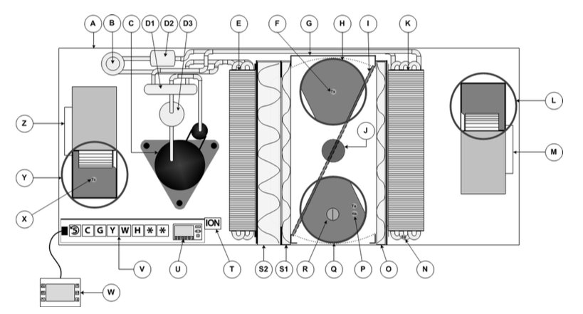
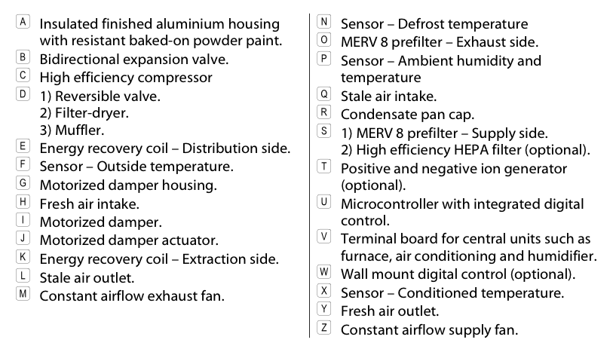
Figure 5.1. MINOTAIR Boreal 12000 exhaust heat pump (courtesy of MINOTAIR)

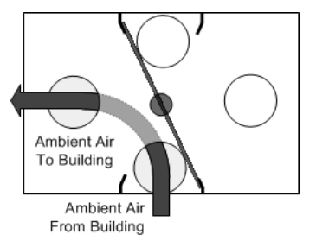
Air Recirculation
Air recirculation is the simplest of system operations and can be seen in Figure 5.2. The indoor air is pulled in through the return ducts and recirculates back into the conditioned space. The motorized damper makes a full counter clockwise rotation until it is in contact with the angled stops as seen in Figure 5.2. The left fan operates at the airflow set by a microcontroller while the right fan remains de-energized as seen in Figure 6.1. This mode is often used during hot summer months where the cooling load is satisfied but the continuous flow of cool recirculating air helps provide a more comfortable sensation for occupants as moisture generated by one’s body evaporates from the skin.
Figure 5.2. Air recirculation
(Courtesy of MINOTAIR)

Heat Pump Mode/Heating and Cooling
The heat pump mode actively heats or cools the conditioned space using conventional recirculation of the indoor air. The heat pump mode can safely operate between 5°F and 104°F outdoor ambient temperatures. To operate in this mode, the motorized damper makes a full counter clockwise rotation until it is in contact with the stop walls, as seen in Figure 5.3. In this mode, the airflows set by the microcontroller are not necessarily identical for the two fans, because the goal is to optimize energy gains. Thus, for tempering the indoor air, the left refrigerant heat exchanger serves as the condenser to recirculate and reheat the indoor air. The right refrigerant heat exchanger becomes the evaporator and extracts heat from the outdoor ambient seen in Figure 5.3. For heat pump cooling the roles of the refrigerant heat exchangers swaps through the redirection of refrigerant by a reversing valve. In turn, the refrigerant heat exchanger, seen in Figure 5.3, becomes the condenser and rejects heat to the outdoor ambient. It serves as the condensing unit on conventionally designed split-system packages.

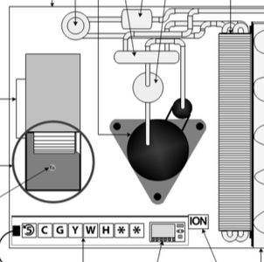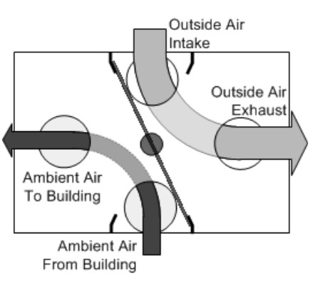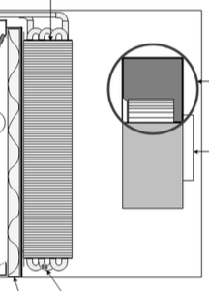

Condenser Evaporator

Figure 5.3. Heat pump heating mode operation (courtesy of MINOTAIR)

Air Exchanger Mode
The third and most novel method of space conditioning is the air-exchanger mode, which actively heats and cools the house between the outdoor temperatures of 25˚F and 85˚F, as shown in Figure 5.4. In this mode the unit operates as an exhaust heat pump and exploits the heat content of the stale indoor air in both heating and cooling modes of operation. The motorized damper changes position to redirect air such that stale inside air is exhausted to the outside and fresh outside air is brought into the conditioned space. Again speaking in terms of heating mode, heat is recovered by the refrigerant heat exchanger acting as evaporator, seen in Figure 5.4, from the inside-stale air and the refrigerant passes the heat to the fresh air coming from the outside using the refrigerant condenser of the heat pump system. Therefore in heating mode, the Boreal 12000 exploits the warmer temperature of the indoor stale air, as opposed to the colder outdoor air, for evaporation of the refrigerant, seen on the right in Figure 5.4. At the same time, fresh, cold air from outside is brought in and passed over the condenser coil seen on the left in Figure 5.4, where the air is heated by the coil and moved into the building. In this manner, up to 132% of sensible heat can be recovered from the stale inside air. The value is over 100% due to the active operation of the heat pump during this process. Typical heat recovery ventilators merely utilize a passive heat exchanger to recover heat, only attaining up to 80% efficiency. By using the compressor to actively move heat from the stale inside air to the fresh outside air, heat recovery can breach 100%.

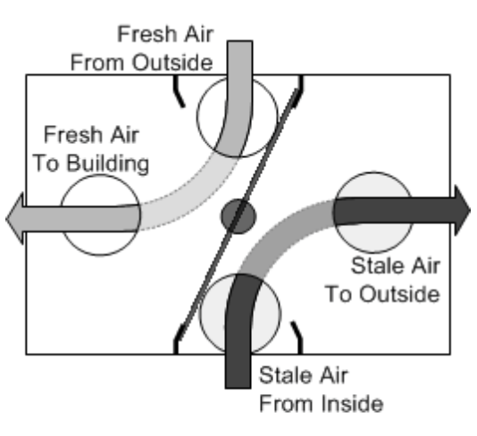
Condenser Evaporator
Figure 5.4. Air-exchanger mode supporting comfort heating of the unit (courtesy of MINOTAIR)
Air-exchanger mode is an excellent system to use for the condominium design proposed for Knoxville, TN where 99% of daily temperatures fall between 20.8˚F and 90.6˚F, ASHRAE (2013). Air exchange mode can operate within the temperature range of -22°F to 95°F. Therefore it is well suited to both the hot-humid and cold East Tennessee climate.

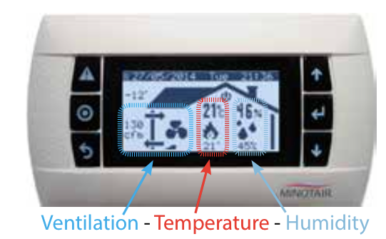
Control and Ventilation
The MINOTAIR thermostat controller, shown in Figure 5.5, gives the user nearly complete control over his or her space conditioning system. It displays information relating to relative humidity, ambient dry bulb temperature, and system air flow. The user can adjust these parameters by choosing heating or cooling mode and selecting specifically desired temperatures and air flow rates. The system has programmed a “Smart Mode” that elects the operation mode based on outdoor and indoor psychometric data and switches the system between air-exchange and heat pump modes. Moreover, Smart Mode’s primary focus is humidity management whereby it will endeavor to maintain a humidity level of no less than 30% in harsh winter days (below -4°F) and around 45-50% in the summer (unless the humidity set point is purposely set higher by the user (max 60%). The controller provides a mixed mode that alternates between Air Exchanger and recirculation modes. It is also possible for mixed mode to replace the Recirculation Mode with the Heat Pump Mode for either comfort heating or cooling.
Figure 5.5. MINOTAIR thermostat and system controller

Airflow is powered by 2 variable-speed and constant-airflow electrically commutated (ECM) fans that pull in fresh air and exhaust stale inside air at a maximum flow rate of 250 cfm. The variable speed fans allow airflow rates to vary with demand loads, which have been shown to reduce system energy usage. The air flow rates provided by the MINOTAIR system easily meet and exceed ASHRAE standard 62.2 which requires 55cfm in a 2-bedroom, 800ft² home in a multi-family dwelling (ASHRAE 62.2, Table 8.2.1a). With the air-exchanger mode as the preferred method of operation, fresh air will be continuously circulated into the dwellings, meeting the IECC 2012 requirement of 2.5 air-changes per hour. Additionally, the MINOTAIR system is standardly fitted with a MERV 8 antimicrobial filter but is also compatible with HEPA filters that remove 99.7% of particles from the air as small as 0.3µm. These considerations greatly increase the indoor air quality for the residents using the MINOTAIR Boreal 12000 conditioning system.

HVAC System for Retail Stores
The ClimateMaster (CM) Trilogy 45-Q mode geothermal heat pump is recommended for comfort conditioning and domestic hot water production for the mercantile businesses to be showcased on the main street of Knoxville, TN. The principal heat source/sink is the ground below the parking garage of the condominium complex. Mercantile function of the retail stores may be boutique or restaurant; it is unknown. However, a 5-ton load is assumed for the ground loop that would account for comfort conditioning and the hot water needs of most mercantile including restaurants, which have intensive cooking and washing activities. The geothermal loop would be stubbed out for later use once the developer and business owners establish functions of the retail spaces.
The Trilogy AWHP provides comfort heating and cooling, domestic hot water and a unique mode for simultaneous cooling and DHW that bypasses the geothermal loop. A variable speed fan, a variable refrigerant volume (VRV) compressor, and a pump with electrically commutated motor (ECM) enables the system to meet demand loads and reduce power usage thus attaining a COP of 5.1 and an EER of 45.
Additional information and design of the geothermal loop are provided in Section 5 of Volume II.

Domestic Hot Water (DHW)
Heat pump water heaters (HPWH) can offer significant energy savings compared to traditional electric resistance water heaters. The benefits can be seen upfront with governmental tax refunds for “going green” and in the long run with the energy efficiencies doubling and tripling when compared to the electrical resistance water heater. Common consumer complaints about heat pump hot water heaters include the amount of noise generation and the heated water recovery time. That being said, the savings reaped from installing one of these units will overwhelm these downfalls over time. For the DOE Race to Zero competition, the selection process had been narrowed to two heat pump water heaters including the Airtap A7 retrofit HPWH and the GE Geospring Hybrid HPWH. The final consideration for selection rested on the more efficient of the two considering space and ambient air temperature constraints. In order to be efficient as a heat pump water heater, there is a minimum ambient temperature, which must be maintained around 45˚F. If the temperature falls below this point, the two units may revert to electric resistance heating, which is highly inefficient. After further research, calculations, and communication with industry advisors, the GE Geospring Heat Pump Water Heater was selected.

Benefits and Functionality
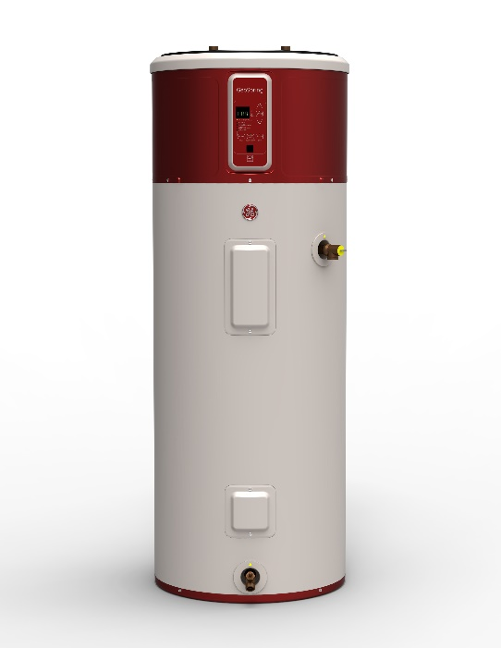
The GE Geospring heat pump water heater received an Energy Factor (overall efficiency based on the amount of hot water produced per unit of fuel consumed in a day) of 2.35, which exceeds that of the Airtap unit by an amount of 0.24. GE states that the unit is capable of reducing water heater operating costs up to 62%. The first hour rating (beginning with a full tank, the amount of hot water in gallons the heater can supply in an hour) of the HPWH was given to be 63 gallons (20.5 gallons higher than the Airtap). An important matter was the increasing inefficiency of the unit due to the lowering of the surrounding air temperature until it reverts to electrical resistance heating. This issue was resolved after contacting a GE representative who stated that the operating temperature of the unit ranges between 45-120˚F. Because the unit is placed in the utility room adjacent a stacked washer and dryer, it is expected that loads will partially cancel one another and the room temperature will easily stay within recommended operating temperatures. Thus, the GE Geospring heat pump water heater is recommended for DHW, Figure 5.6.
When running the GE Geospring Heat Pump Water Heater, there are several settings that the user may select. The user may set the desired temperature within between 100˚F and 140˚F. The heating settings include: eHeat, hybrid, standard electric, and high demand. The eHeat mode is the most energy efficient because it only employs the heat pump to heat the water in the tank. This mode is also the most time consuming mode, requiring several hours to heat the entire tank of water to the user set temperature. Hybrid is the recommended mode for use by the manufacturer because it combines the energy efficiency of the heat pump with the speed of the resistance coils. This is the mode that claims the high first hour rating of 63 gallons. Standard electric mode uses only the resistance coils making it the least energy efficient mode. Using this mode would defeat the purpose of having a heat pump water heater, but if the heat pump requires maintenance, the system will still allow the production of hot water during the repair of the pump. High demand mode uses the resistance coils for speed and employs the heat pump as well, similar to the hybrid mode, but running longer in times of high water demand.
Figure 5.6. Geospring heat pump water heater by GE (courtesy of GE)

Cost Analysis
The market suggested retail price (MSRP) for the GE Geospring Water Heater is $1200. The market suggested retail price of the Airtap unit is $699. This MSRP does not include the price of the hot water tank, as the two do not come together as one unit. This allows the consumer a level of flexibility on choosing a unit for new installation, but may also limit a buyer if a hot water tank is already in place. The Airtap unit is known to attach easily to most tanks, but the geometry of the surrounding space can create issues. Brief research into the cost of an average electrical resistance hot water tank showed a cost somewhere between the range of $350-$1200. The team’s previous research was in favor of utilizing the Airtap unit with the Marathon Rheem 50 gallon tank, which has a MSRP of about $1000. Using this tank and the Airtap A7 unit in conjunction brings the total initial cost to just over $1700. Based on Knoxville area energy rates, the annual energy cost for the Airtap was estimated to be $182, whereas the GE unit was estimated at only $164 ($18 cheaper than the Airtap unit). All things considered, the GE choice was reaffirmed.

LIGHTING
The lighting design for each unit utilizes low-level LED illumination. Fixtures with a 3000 K color temperature and 90+ CRI (color rendering index) for residential purposes were chosen in order to create the desired hue and to make it easier to match companion products. All lighting fixtures meet Energy Star qualifications.
For down-lights, a recessed diffuse light (can light fixture) product from Cree, the LR4E-15C with LT4-15AW trim (wheat diffused trim), provides the main spaces of each unit with a 3500 K and 90+ CRI light. It gives an output of 540 lumens with an input power of 10.5 watts and achieves over 51 lumens per watt. This LED light is also dimmable to 20% with standard incandescent wall box dimmers.
The product used for the close-to-ceiling fixtures is a surface-mount from Kovacs, the UHO P950-084-L. This has a color temperature of 3000 K and 94 CRI. It delivers 1946.32 lumens with 3114.6 initial lumens. This product also has a dimming feature and a rated life of 30,000 hours.
A Kovacs product is also used for the vanity lighting in the bathroom, the Tube P5044-084-L. This dimmable wall sconce utilizes a 20W LED bulb, which is included with the fixture. It has a color temperature of 3000 K and a CRI of 84. It gives 2099.48 initial lumens and 1447.77 delivered. The rated life is 30,000 hours.

APPLIANCES
LG products were chosen for the washer and dryer in each unit, Table 5.1. The dryer, a model DLHX4072V uses a heat-pump exchange system to achieve efficiency ratings that are 50 percent better than a standard dryer. Dryers typically lose 20 to 25 percent of their heat through the dryer vent; however, this dryer uses a heat pump to recycle air in the dryer’s drum and the appliance requires no vent. The elimination of the vent saves energy and also eliminates issues with potential fire due to lent buildups in exhaust vents. The dryer and washer are stack appliances. Other appliances such as the refrigerator, dishwasher, microwave, and range hood come from Whirlpool. All appliances are Energy Star qualified appliances that incorporate advanced technologies and use 10 to 50 percent less energy than standard appliances. Web links to specification sheets for each appliance are listed in Section 5.4 of Volume 2.
Table 5.1. Appliances
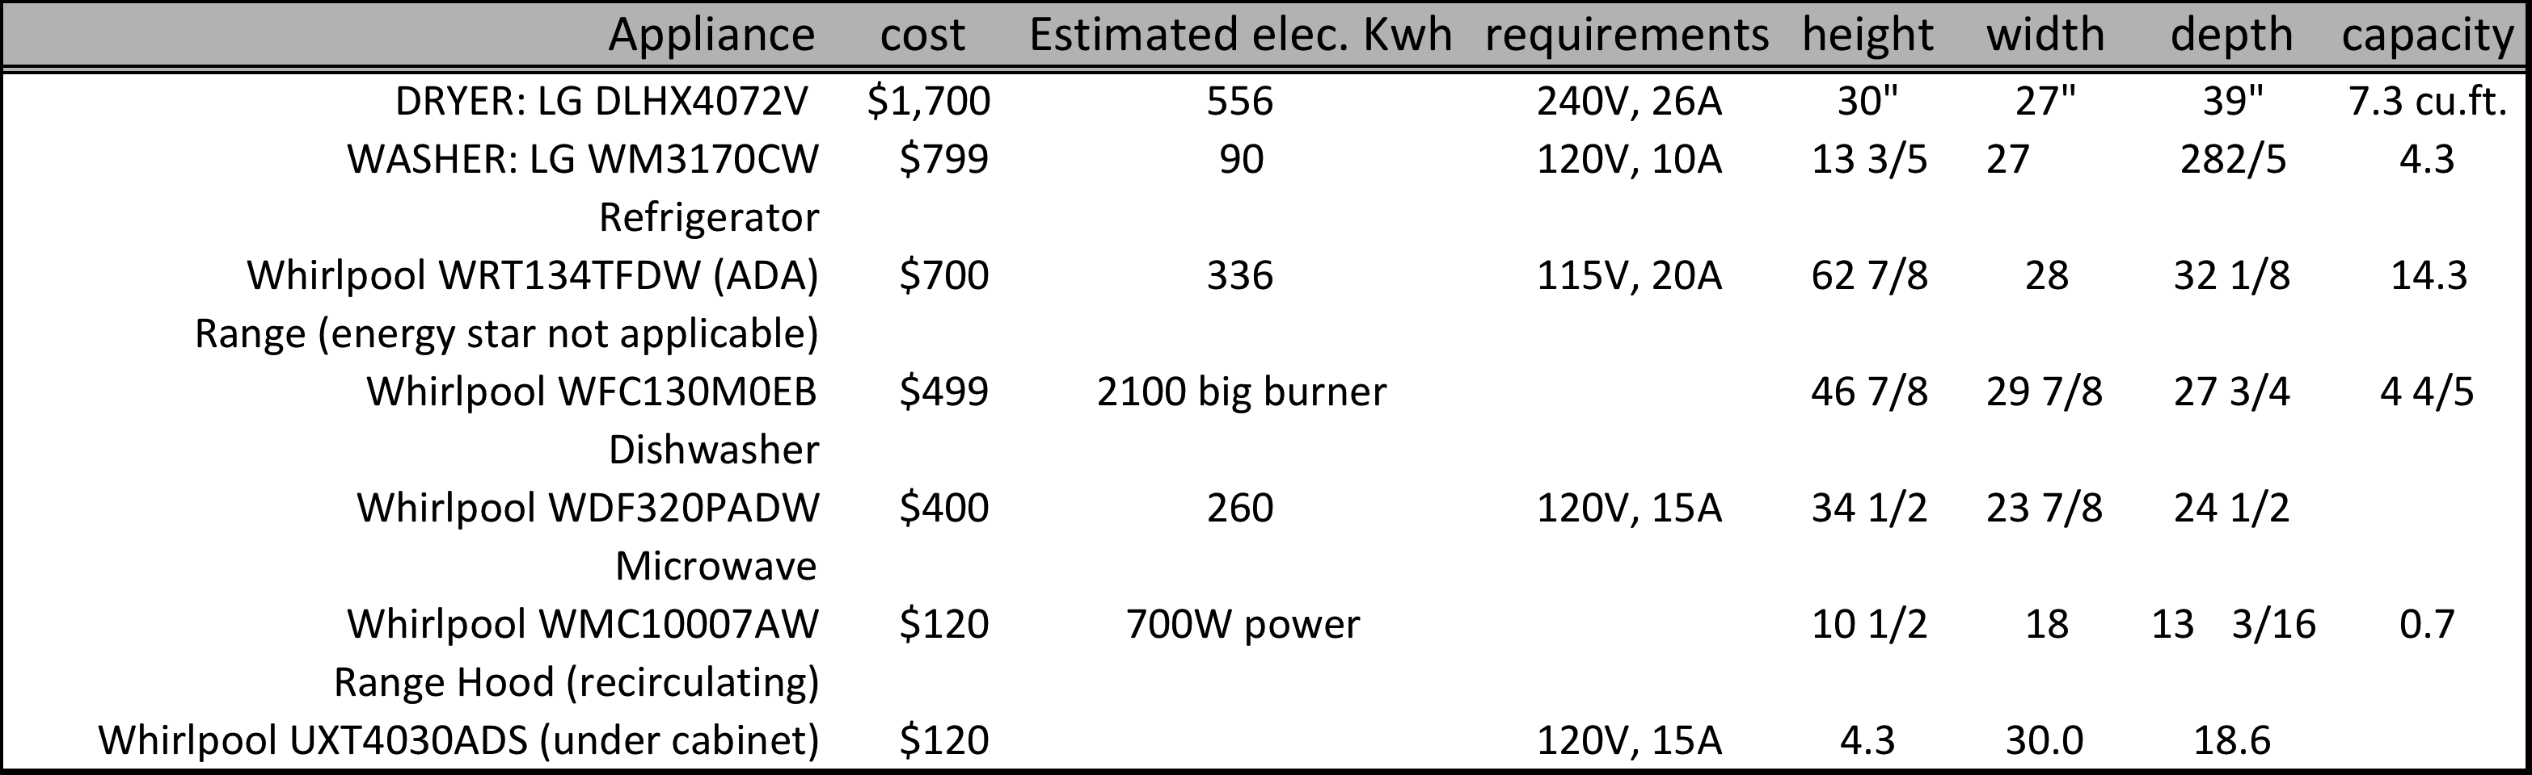

This page intentionally left blank.

ENERGY ANALYSIS
Building America was created by the Department of Energy and has been able to provide information on building science to professionals for more than twenty years. It allows for designers and contractors to create ideal homes that have high performance. They are able to continuously improve home energy efficiency. In each of the units to our complex, we analyzed the Building America benchmark using our BEopt program. The BEopt program uses Building America to calculate performance, such as domestic hot water and plug loads.

PHOTOVOLTAICS
The LG 300 mono crystalline solar collector was selected for generating renewable energy. Its rated conversion efficiency is 18.3% at standard test conditions (STC). Individual modules are 1.6-m by 1.0-m by 35 mm thick. Module weight is about 18 kg. Stated operating temperature range is from -40 to 90°C. The LG 300 collector, if operating at STC, is warranted for a full 10 years of service to produce about 300 watts per module.
Two design options were explored for the condominium’s photovoltaic system. The first design (Option 1) constitutes 220 LG 300 modules placed along the low-slope metal roof installed only on the northeast side of the condominium complex, Figure 6.1. The second design (Option 2) places 198 of the LG 300 modules on the adjoining TVA tower, Figure 6.1. For any photovoltaic system, the slightest amount of partial shading can drastically drop a collector’s output power. Since several cells are connected electrically in series within a single module, one of them being shaded limits the current that all other cells in series with it can produce. Similar degradation occurs if modules in an array are shaded. Typically several modules are wired in series and then groups of modules are connected in parallel to one another for setup of the DC voltage output from the array. In locations where shading is prevalent, the achievable efficiency for any photovoltaic system is degraded. Thus, a second design option involves placing panels on the roof of the adjoining TVA East Tower, as shown in Figure 6.1.
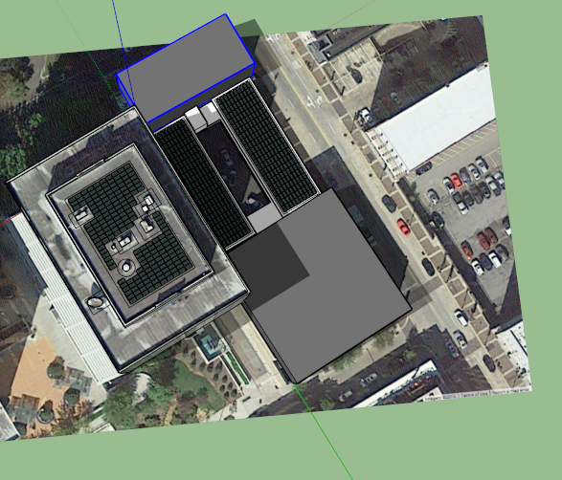
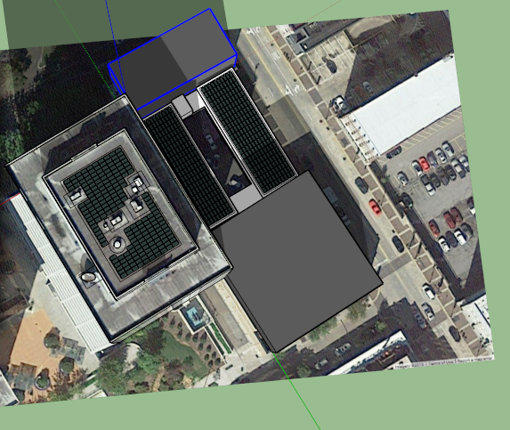
PV Option 1
PV Option 2
Summer Solstice; Jun. 21 at 1:50 PM EDST
Winter Solstice; Dec. 21 at 11:20 AM EST
Figure 6.1. Two PV options (shade renderings at summer and winter solstice)

Shade rendering displayed in Figure 6.1 shows placement of PV on the TVA East Tower as the best option. The southwest portion of the condominium’s metal roof is shaded from about 11:20 AM EST during winter solstice and from about 1:50 PM EDST during summer solstice. Also for the metal roof application the modules are coplanar to the roof and face the non-ideal direction of northeast. For this reason, along with the fact that the buildings surrounding the condominium are taller and therefore shade the roof of the condominium, Option 1 is not ideal. Even during the Spring and Fall Equinox, there is 25% to 50% coverage of the low-slope metal roof around solar noon, Figure 6.2. However, both options are reviewed for potential energy generation to obtain Net Zero.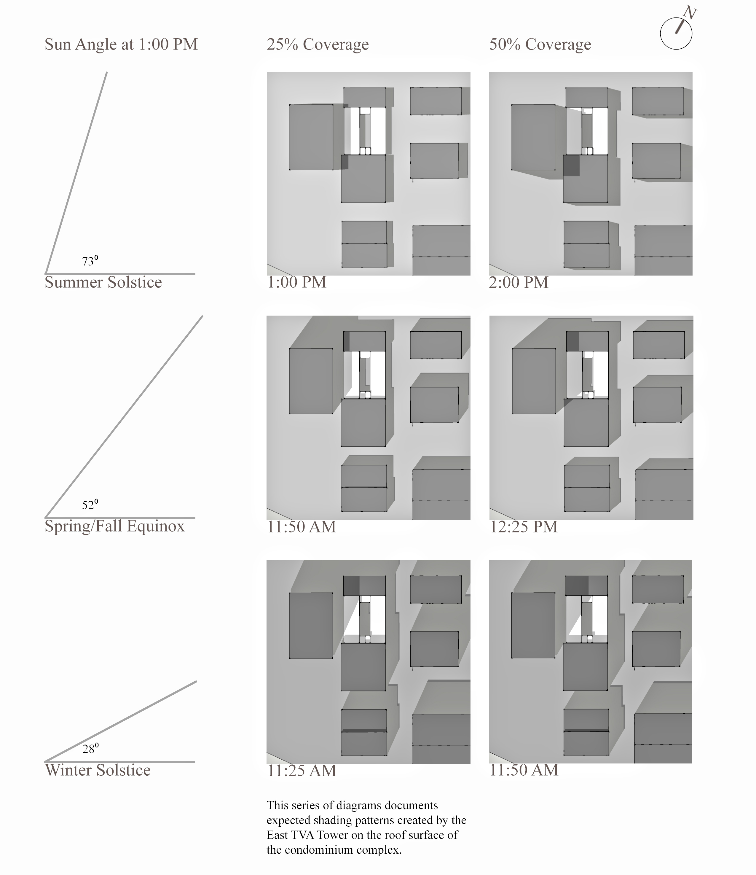
Figure 6.2. Shade rendering for Knoxville, TN showing the sun’s altitude angle for both solstices and equinoxes

Placement of the PV on the TVA East Tower requires setbacks of approximately 9 feet on all perimeters for wind load design, Figure 6.3. The panels are set at a zero degree pitch to further reduce the effects of wind load. The roof of the TVA East Tower is protected by an ethylene propylene diene terpolymer (EPDM) rubber roofing membrane which makes sealing any penetrations through the membrane difficult. Therefore the panels will be attached to the roof with ballast blocks bringing the total weight of the array to 23,849 pounds which will manage wind loading on the PV modules. The distributed loading is about 18 pounds per square foot of roof, which is within design specifications for the roof of the TVA East Tower. The industry advisor, Jon Kane, stated he would, under normal operating procedures, send the ballast calculations and architectural drawings of the building to the company’s structural engineer as a check of the design.

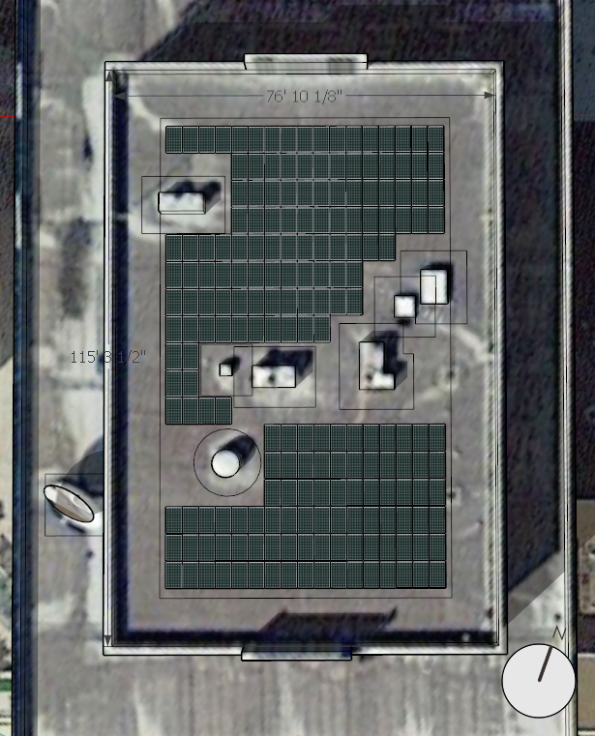

Figure 6.3. Placement of PV on the EPDM rubber roof of East TVA tower

Panels are oriented in the southeast direction to fit the maximum number of panels on the roof and to better support peak demand hours occurring during the late afternoon.

Estimates for the roof setup on the TVA Tower shows the PV system can be expected to produce 75,616 kWh, Table 6.1. The 20 condominiums consume 126,634 kWh of electrical energy. Therefore the PV supplies 59.7% of the total use.

Table 6.1. PV generation of East TVA Tower and total consumed energy with breakdown for HVAC and DHW for one of 20 condominiums

 | Total PV Generation | Total Energy Use One Condominium | Total Energy Use for Cooling, Heating and DHW for One Condominium
 | kWh | kWh | Cooling (kWh) | Heating (kWh) | Hot Water (kWh)
January | 3623.4 | 680.5 | 10.5 | 161.4 | 129.7
February | 4455.0 | 561.2 | 10.5 | 106.0 | 114.4
March | 6593.4 | 498.3 | 13.4 | 47.8 | 130.7
April | 7781.4 | 439.6 | 31.8 | 2.9 | 118.0
May | 8553.6 | 482.7 | 108.4 | 0.4 | 70.9
June | 8791.2 | 540.0 | 176.7 | 0 | 76.9
July | 8850.6 | 582.8 | 220.0 | 0 | 60.0
August | 7840.8 | 567.0 | 200.1 | 0 | 71.5
September | 6355.8 | 502.3 | 144.5 | 0 | 67.7
October | 5702.4 | 439.9 | 41.9 | 6.0 | 85.9
November | 3742.2 | 464.4 | 12.1 | 69.8 | 71.8
December | 3326.4 | 573.1 | 11.7 | 111.0 | 83.6
Total | 75616.2 | 6331.7 | 981.5 | 505.3 | 1081.2
 | 75,616 kWh | 6331.7 kWh | 2567.973 kWh

Analysis was also conducted to review the added placement of PV on the northeast portion of the condominium complex. An added generation of about 46,015kWh per year can be obtained if we install 220 LG 300 modules on the northeast roof.
Summing both PV options yields a total generation of 121,631 kWh per year which is within 4% of being NetZero. Both PV options would provide 96% of the power used by the 20 condominiums.
For purchase and installation, the industry advisor Jon Kane recommended that the PV system should cost no more than $200k. To further complete this cost analysis, balance of system (BOS) items including the inverter string sizing, conduit routing, disconnects as well as the location of grid attachment must be investigated.

HVAC ENERGY USE FOR TN CONDOMINIUM
The Energy Information Agency (EIA) documents the average monthly electricity bill in TN at roughly $123. This is surprisingly high as compared to the nationwide average bill of $107. In Tennessee, the average electricity rate is 10.1 cents per kWh, which ranks 37th in the nation. Tennessee homeowners however are the 2nd highest consumer of electricity of any state in the United States; TN homeowners use 1,217 kWh per month per home. This is actually 35% greater than the national average of 903 kWh per month.

Energy Breakdown for One Condominium
This report describes both state-of-the-art and advanced active and passive subsystems for the multi-family condominium complex intended for installation in downtown Knoxville. Exterior surface area is small compared to the internal volume of the facility and heat gains and losses are kept at a minimum. Fenestration is kept at less than 5% of the footprint and the windows are efficient triple pane with Argon fill. The envelope is designed to incur less than 2.5 ACH (IECC 2012) and the exhaust heat pump provides almost constant whole house ventilation using conditioned air. The major energy uses for a condominium are cast into a pie chart (Figure 6.4) to document and explain the breakdown of energy consumption.
In conventional homes the space-conditioning load makes up the largest fraction of energy usage. However, it is only 24% of the total load; 16% being cooling and 8% being heating. Miscellaneous plug loads from electronic equipment (TV, radio etc) and various electrical duplexes constitute 27% of the unit’s load. DHW and appliances are both 17% each of the total. Lighting is usually near the top of energy use, but the high-efficiency and excellent illuminance from the LED lighting puts its energy use at only 8% of the total consumption.
Figure 6.4. Energy breakdown for one condominium

Cost of Energy for One Condominium
The PV on top of the TVA tower generates enough electricity to cover 60% of the electricity used by the 20 condominiums in the multi-family dwelling. The average monthly energy bill is estimated at $25 per month for the net energy usage of a condominium (includes PV benefit). With respect to the average energy bill in the state of Tennessee, condominium homeowners will save $100 per month on their energy bill. The energy consumption of a unit is about 528 kWh per month as compared to the EIA monthly average of 1,245 kWh for TN. Source: http://www.electricitylocal.com/states/tennessee/

Figure 6.5 shows the breakdown for the homeowner’s utility bill. The greatest expense is due to homeowner conveniences and entertainment. Much of the expense is cause by the standby losses in electronic equipment. Televisions, audio equipment, and telephone answering machines have standby losses as do some refrigerators, dishwasher and electric ranges.

Source: http://standby.lbl.gov/pdf/42108.html

Figure 6.5. Average monthly cost breakdowns for one condominium

AUSTIN, TX, CHICAGO, IL and KNOXVILLE, TN LOAD COMPARISONS
BEopt modeled the condominium units with the largest amount of exterior surface exposed to the elements for computing the largest potential loads. This would be the end unit on both the first and second level because they have an extra exterior exposed sidewall that the interior units lack. These units were also selected to be on the street side of the complex because the lack of shading lends to the most sun exposure. As a goal to make the design meet IECC standards, the first model was performed as a benchmark using the minimum thermal resistance standards for all exterior component set forth by IECC 2012 for the Knoxville, TN climate zone. Another goal was to create an envelope load less than one ton. When using the BEopt simulation software, load values are given hourly and are relative to outdoor temperature. The load values were selected at the outdoor temperature that matched at the 99% percentile outdoor temperatures for Knoxville, TN, 20.8°F and 90.6°F, found in ASHRAE Fundamentals Chapter. At these designated temperatures, it was found that the loads for the condominium were much less than expected. The unit load values came out to roughly equal $4,900 \frac{BTU}{hr}$ for heating and $3,700 \frac{BTU}{hr}$ for cooling, both of which are well less than half a ton. This meant that a much smaller heat pump would have to be selected than initially expected.
The MINOTAIR system selected for each of the condominiums does not align with the IECC 2012 standards. The MINOTAIR system was modeled with a SEER value of 11, a value less than the IECC standard value of 13. In our research of the MINOTAIR, it was found that the ANSI/AHRI Standard 210/240 rating conditions applied to US equipment for the SEER and HSPF values are conducted with an outdoor temperature of 95°F for cooling and 47° F for heating. The MINOTAIR unit is penalized by this rating since the exhaust heat pump uses the stale indoor air at about 70°F for the cooling (condenser air at 70°F not 95°F) and heating (evaporator air at 70°F not 47°F). Therefore, it should be noted that the SEER and HSPF values are penalized by the rating conditions under ANSI/AHRI 210/240 standards.
Envelope thermal performance with and without the MINOTAIR exhaust heat pump was studied in ASHRAE climate zones 2 (Austin, TX), 3 (Knoxville, TN) and 5 (Chicago, IL) representing hot, moderate and cold climates. IECC 2012 code for the envelope and for the SEER of the heat pump was assumed in each climate zone, Figure 6.6. BEopt simulations compared the NetZero condominium with exhaust heat pump against the condominium insulated to IECC 2012 but with a SEER 13 air-to-air heat pump.
The results show improved performance of the NetZero condominium with exhaust heat pump as compared to a condominium with SEER 13 heat pump in the moderate climate of Knoxville and the cold climate of Chicago. The hot climate of Austin, TX shows similar performance. It is interesting that the exhaust heat pump performs better the colder the climate. The equipment is manufactured in Canada and is sold in the Northeast US. The exhaust heat pump would not incur the frosting and defrosting losses prevalent in air-to-air equipment, which is the probable cause of its improved performance in the cold and wet climate of Chicago, IL. For simulation in Austin TX, the exhaust heat pump uses the stale indoor exhaust air for the refrigerant condenser as compared to the hot outdoor air. Here there would be a drop in condensing pressure, which in turn drops compressor power; however, the drop is most likely not accounted for in the BEopt code due to the penalty imposed by the ANSI/AHRI 210/240 standards.

Figure 6.6. NetZero condominium with exhaust heat pump compared to condominium with IECC 2012 code insulation and SEER 13 air-to-air heat pump

The results of Figure 6.6 reveal an advantage of the exhaust heat pump in predominantly cold climates but it also compares well in the hot climate of Austin, TX. In cooling mode, the SEER 13 heat pump slightly outperforms the exhaust heat pump in Knoxville and Austin, Figure 6.6. Again these results may be skewed due to the rating applied to exhaust heat pump systems. Figure 6.7 shows the cost of energy consumed by comfort conditioning, DHW, lighting, appliances and miscellaneous plug loads. A condominium homeowner would spend $57.75 per month for utilities in Knoxville TN for the NetZero unit with exhaust heat pump. In Chicago, the same unit would have only a $63 monthly utility bill. The largest portion of the utility bill is again due to miscellaneous plug loads coming from entertainment and standby losses. Total electrical load in Knoxville is 6331.7 kWh as compared to 7169.1 kWh in Chicago.

Figure 6.7. NetZero condominium with exhaust heat pump compared to condominium with IECC 2012 code insulation and SEER 13 air-to-air heat pump

DOMESTIC HOT WATER
The hot water loads were calculated using BEopt. The formulas for the hot water usage are shown below in Table 6.2, and are based on the Building America. The sum of hot water consumption was calculated using an average supply water temperature of 110°F. The water consumption for a household is dependent on how many people live in the house and their occupant habits. The variable for the number of bedrooms in the house is designated as N_{br}. This determines the amount of hot water consumption for each household. The DHW consumption for one condominium is 12,826 gallons per year, which averages out to about 1,070 gallons per month. Figure 6.6 displays monthly DHR usage.

Table 6.2. BA formulas for water use
End Use | Water usage (gal/day) | Average Temp. (F) | Gallons (N_{br} = 2)
Shower | 14 + 4.67 x N_{br} | Mixed - 110° | 23.3
Bath | 3.5 + 1.17 x N_{br} | Mixed - 110° | 5.8
Sinks | 12.5+ 4.67 x N_{br} | Mixed - 110° | 21.8
Dishwasher | 2.5 + 0.833 x N_{br} | Hot Only | 4.2
Washer | 7.5 + 2.5 x N_{br} | Hot Only | 12.5

Figure 6.8. Monthly DHW flow rate for one condominium in Knoxville, TN.

Plug Loads
The plug loads are calculated using the Building America Benchmark in BEopt. The plug load is calculated using the formula shown below in Table 6.3. The electric loads considered include all plug loads not taken up by the large household appliances. This means that light fixtures and equipment plugged into standard wall outlets will take up the plug load.

Table 6.3. Annual electric use
End Use | Annual Electric Use Formula (kWh/yr) | Number of Bedrooms (N_{br}) | Finished Floor Area (sq. ft) | Annual Electric Use (kWh/yr)
Plug Load | 1108.1 + 180.2*N_{br} + .278*FFA | 2 | 880 | 1713.1

Clothes Washer and Dryer Control
According to the Building America benchmark, the clothes washer cycles (CWC) per year is calculated with the use of Equation 6.1, as shown below.
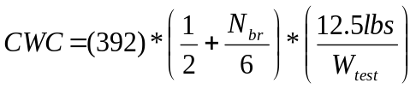 Equation 6.1
The number of bedrooms is shown in the equation as N_{br} and the maximum clothes washer test load weight is noted as W_{test}.

Dishwasher Control
According to the Building America benchmark, the dishwasher cycles (DWC) per year can be found using Equation 6.2. The amount of dishwasher cycles per year is dependent on the amount of people living in the house. This is depicted as the number of bedrooms, N_{br}, in the house.
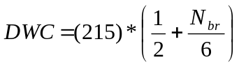 Equation 6.2

Using two bedrooms, the calculated the number of dishwasher cycles for the year as 179 cycles per year. This means that the household typically washes the dishes every other day.

FINANCIAL ANALYSIS
The two PV design options (Section 6.1) constitute the condominium’s photovoltaic distributed energy resource (DER). The first design has panels along the low-slope metal roof installed only on the northeast side of the condominium complex, Figure 6.1. The second design places the LG 300 modules on the adjoining TVA tower, Figure 6.1. Financial analysis was conducted assuming both options were implemented to yield a near NetZero DER that would supply 96% of the energy used by the condominiums, DER Scenario I. Analysis was also conducted for the PV (Option 2, Section 6.1) placed just on the East TVA Tower, which would supplant 60% of the energy used by the 20 condominiums, DER Scenario II. For both scenarios, the condominium homeowners would rent the retail space, located on Knoxville’s main street. There would be a deed for each condominium and a deed for each retail store.
The retail stores have 2,584 square feet of space, which the respective merchant would have under a separate deed with rent due to the building owners at about $20 to $22 per square foot per year. Therefore the financial analysis will be conducted with and without the benefit of revenue from the retail stores to demonstrate the added benefits to the homeowner, the utility, the merchants, the realty and the construction firm.

SIMPLE PAYBACK REVIEW
The low-slope EPDM rubber roof of the East TVA Tower would be fitted with 198 LG 300 mono crystalline solar panels. The northeast low-slope metal roof would hold 220 of LG’s collectors. Therefore under the DER Scenario I each condominium is responsible for costs and revenue associated with 21 of the LG 300 collectors. DER Scenario II allocates 11 PV panels per condominium.
Volume II Section 7.1 documents the excavation, construction, labor, material, and taxes for building one condominium and for constructing the complete structure of the multi-family dwelling including the retail space, geothermal loop and parking garage. Vanhook Enterprises (Somerset, KY) provided the cost estimates. One condominium costs roughly $172k to build. The structure cost is estimated at $435k and the completed complex is estimated at $3.8M.
Caldwell Banker Wallace & Wallace Realtors® stated that prime real estate condominiums in downtown Knoxville sells for $225.00 to $250.00 per square foot of floor space. Therefore the construction firm would earn a profit of about $700k to $1.2M. At $22.00 per square foot, the occupied retail space can generate around $57k per year. Therefore each homeowner receives 1/20th of the rent from the merchants. This nets each homeowner around $2,850 per year or $237.50 per month.
Each homeowner would realize a simple payback of 31 years under DER Scenario I and a 33-year payback under DER Scenario II. However, including revenue from the retail stores significantly improves the economics with simple payback ≤ 6 years for either DER Scenario. Therefore the project shows good financial promise and is an excellent opportunity afforded to the homeowner, the utility, the merchants, the realty, the construction firm and the environment.

Table 7.1. PV payback at 60% coverage and PV payback at 96% coverage

 | DER Scenarioª I | DER Scenario^{b} II
PV Cost Per Condominium | $20,434 | $12,704
Monthly Utility Bill (no PV) | $57.73 | $57.73
Monthly Utility Bill (includes PV) | $2.27 | $25.00
Difference in Monthly Bill (PV only) | $55.46 | $32.77
Payback Due to PV | 31 Years | 33 Years
Monthly Net Income for PV and Retail | $235.23 | $212.54
Difference in Monthly Bill for Retain and PV | $292.96 | $270.27
Payback Due to both PV and Retail | 6 Years | 4 Years
ª Scenario I is NetZero and provides 96% of the total use by the condominiums
^{b} Scenario II assumes PV only on the East TVA Tower and supplants 60% of energy use.

CONSTRUCTION DOCUMENTATION

SITE PLAN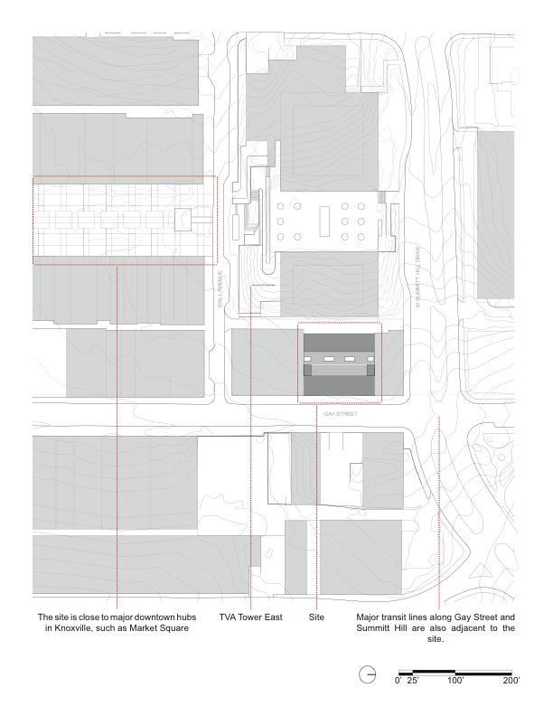

Figure 8.1. Site plan

BUILDING DRAWINGS
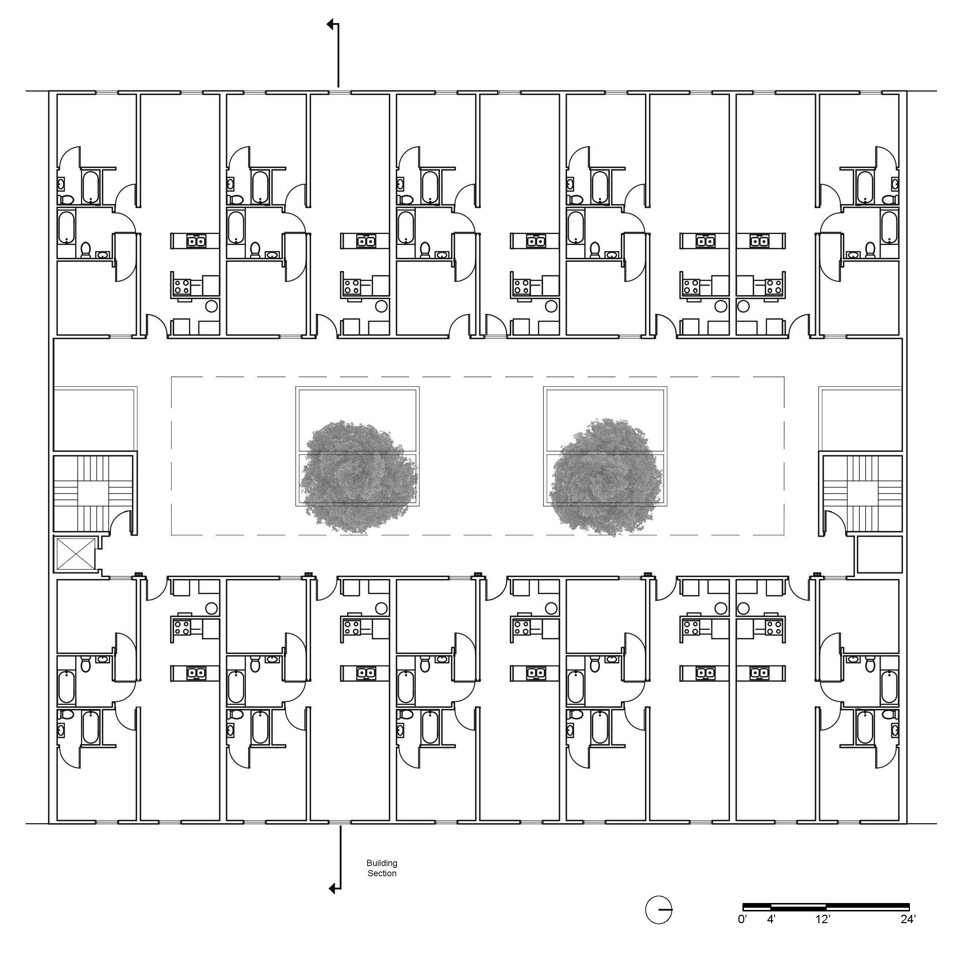
Figure 8.2. Second floor building plan
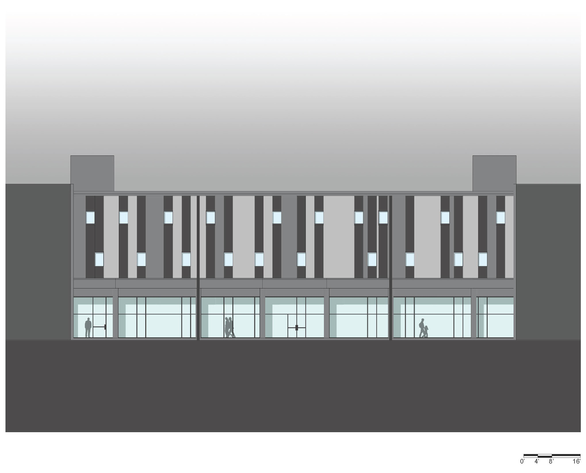
Figure 8.3. Gay Street elevation
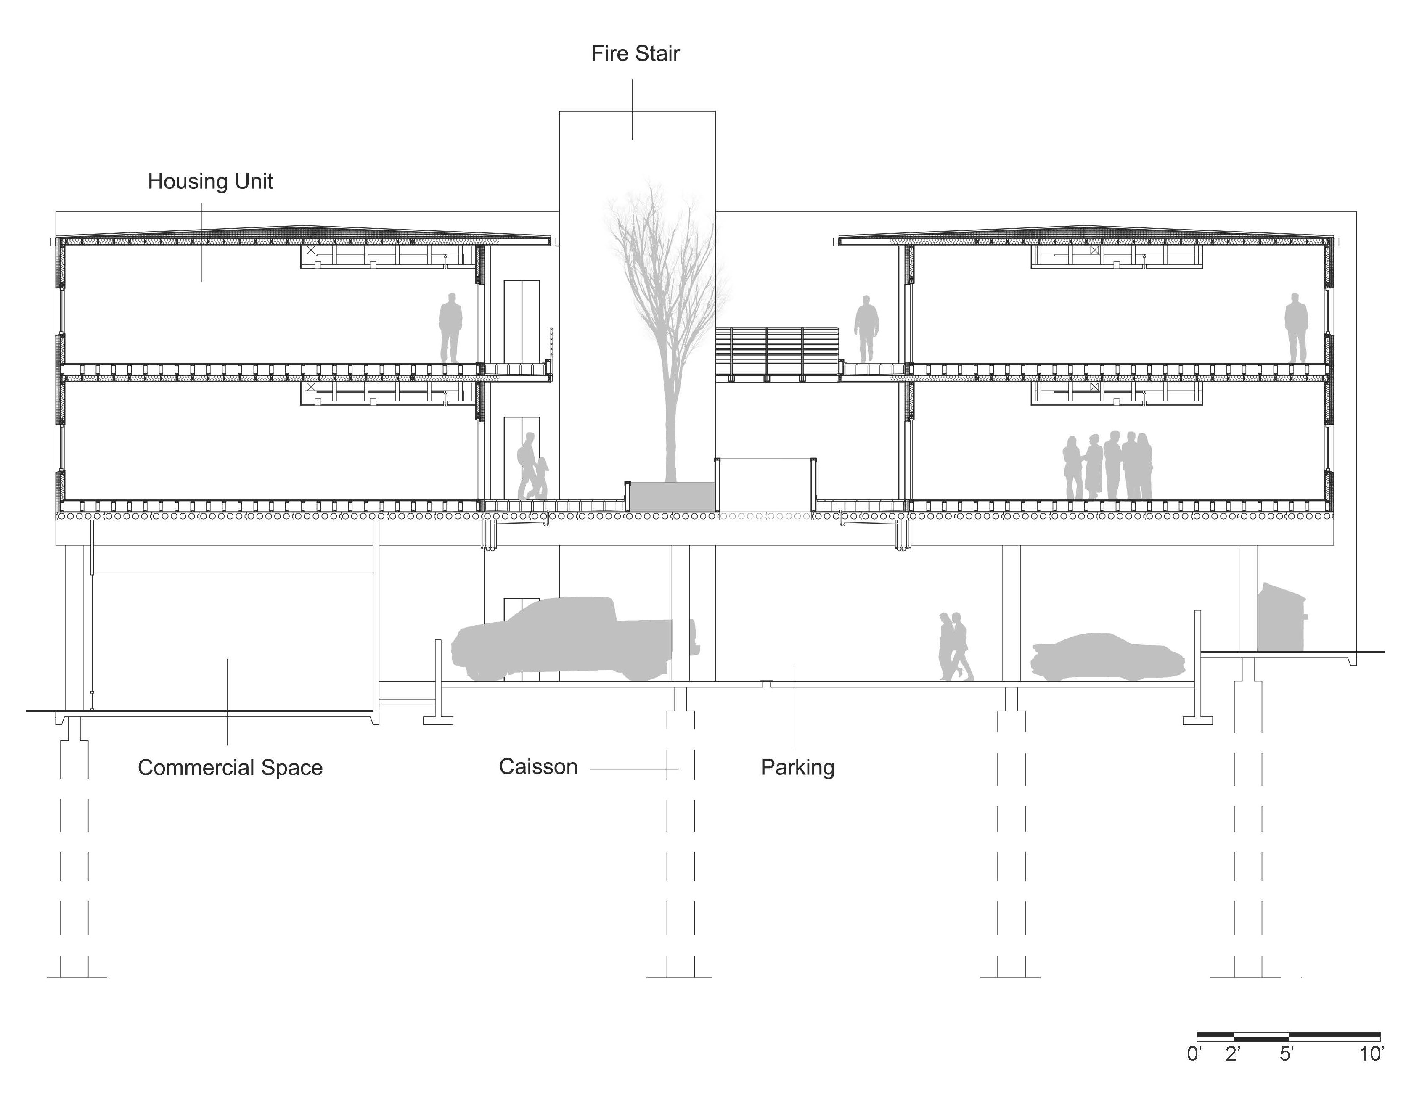
Figure 8.4. Building section
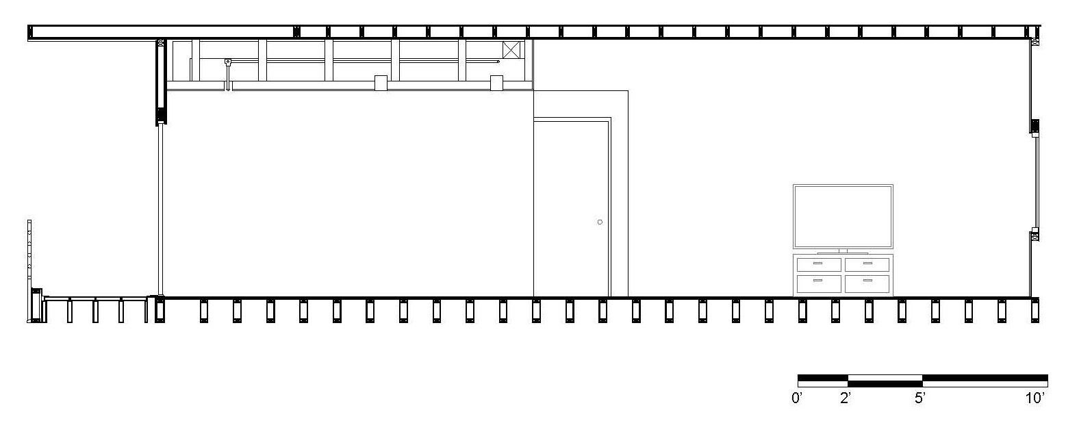
Figure 8.5. Unit longitudinal section

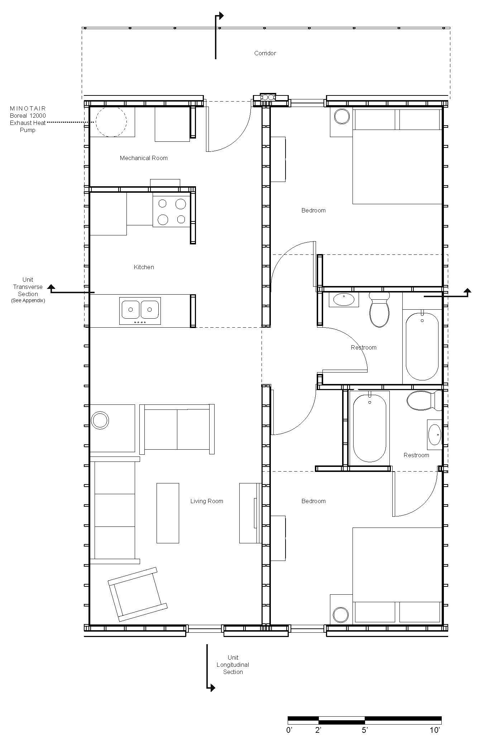

Figure 8.6. Unit plan

DETAILS
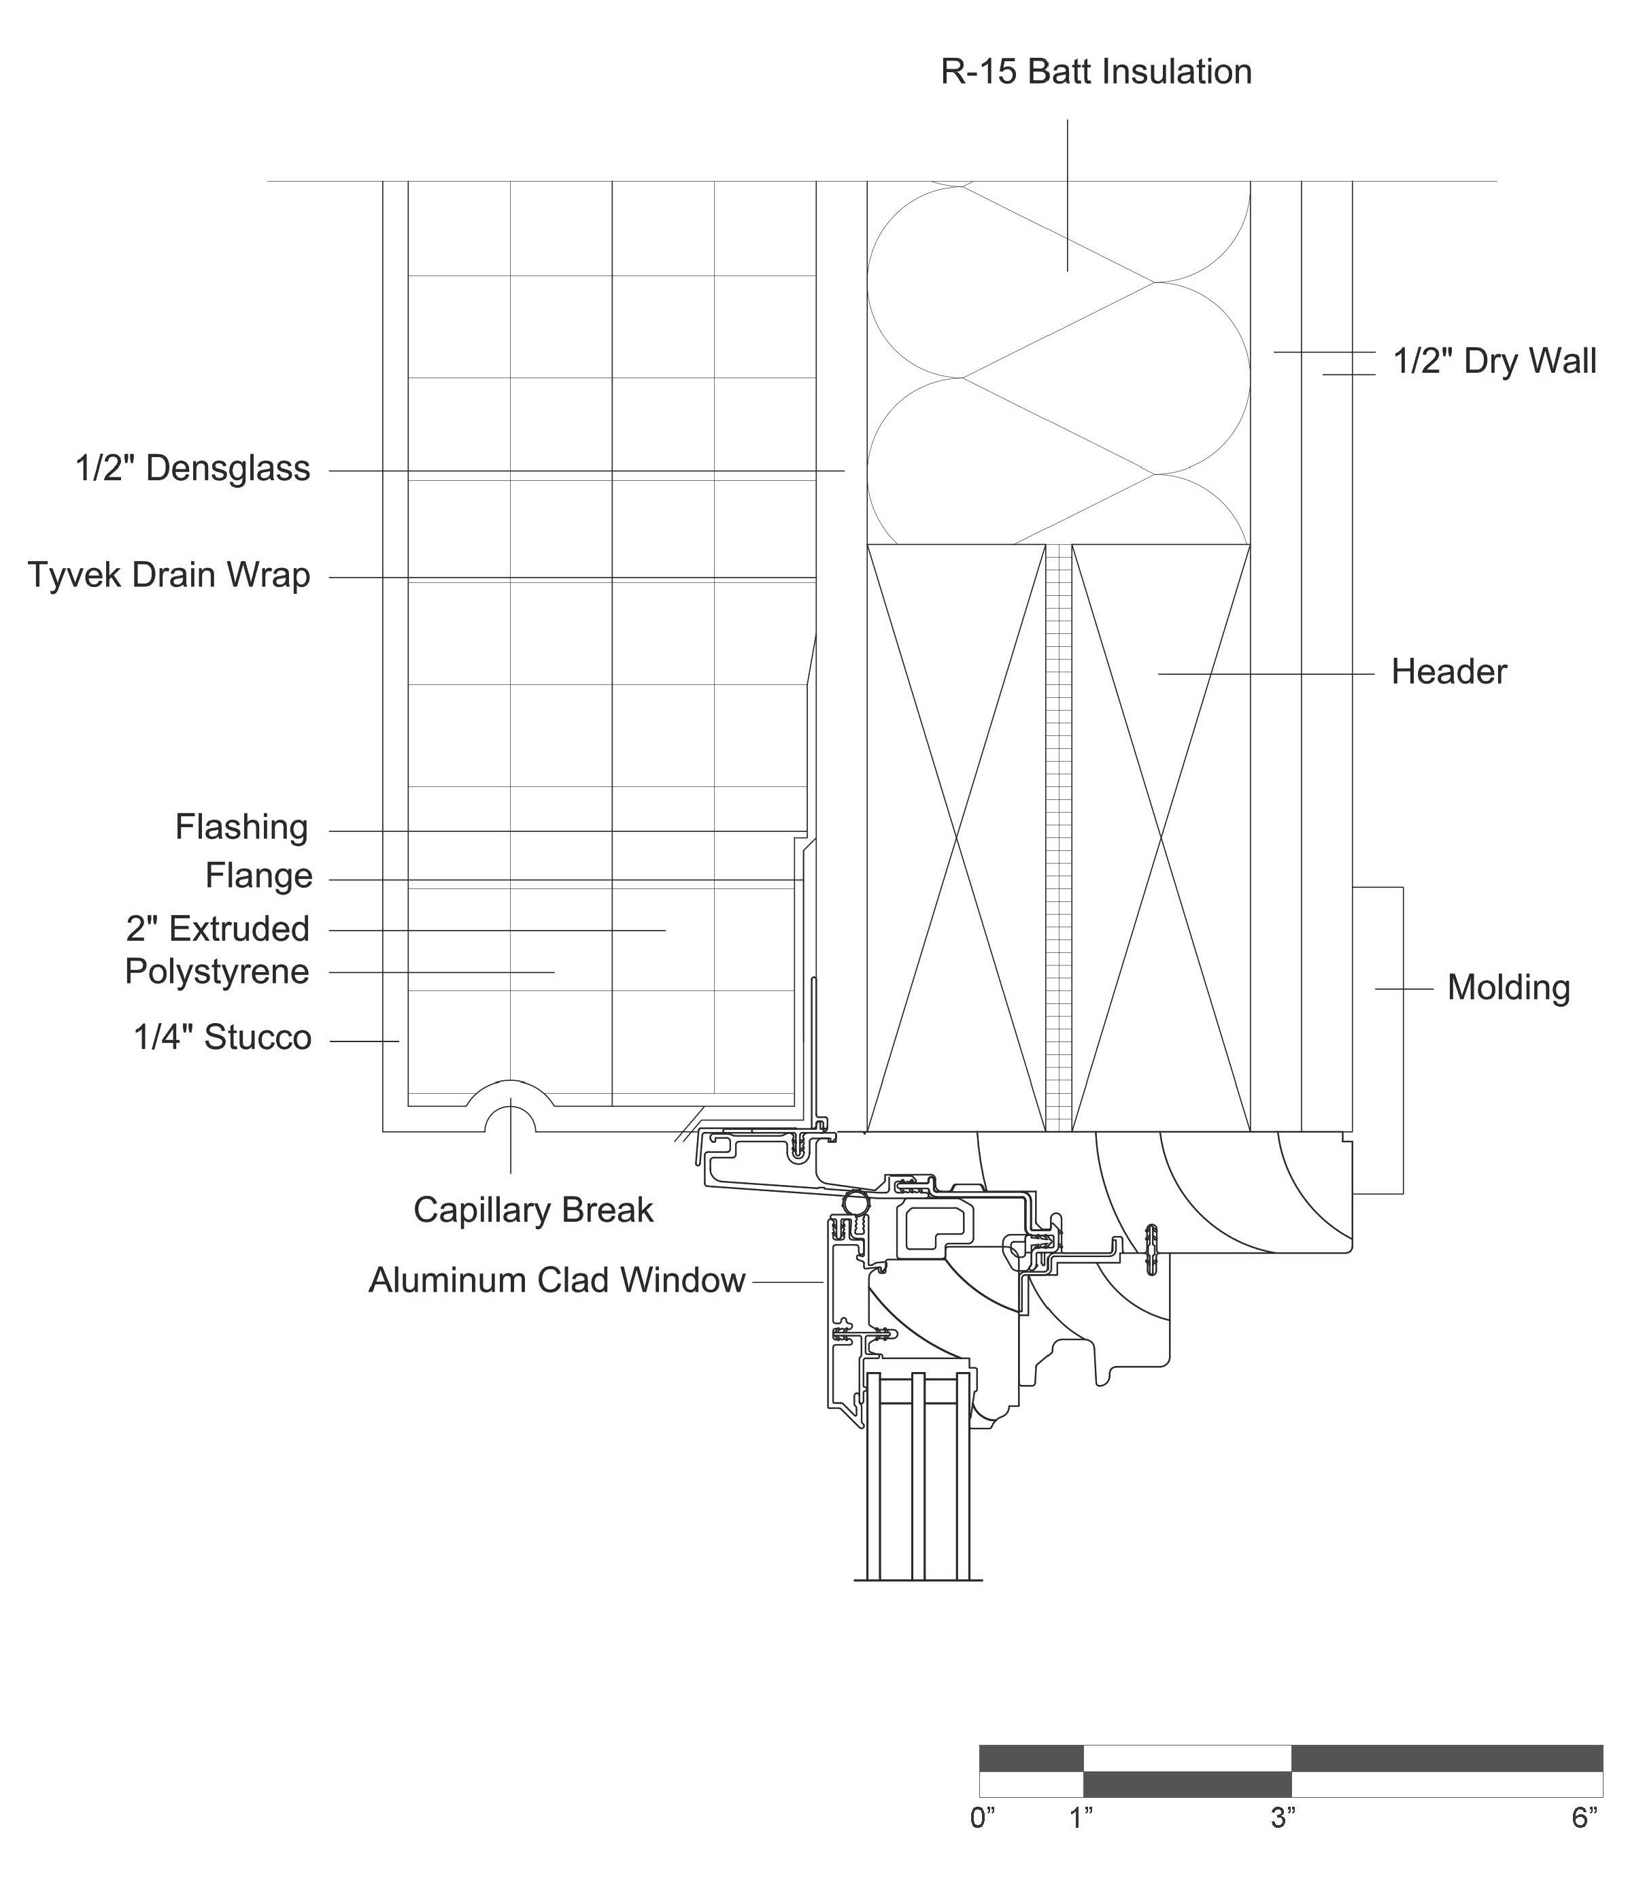
Figure 8.7. Window head detail

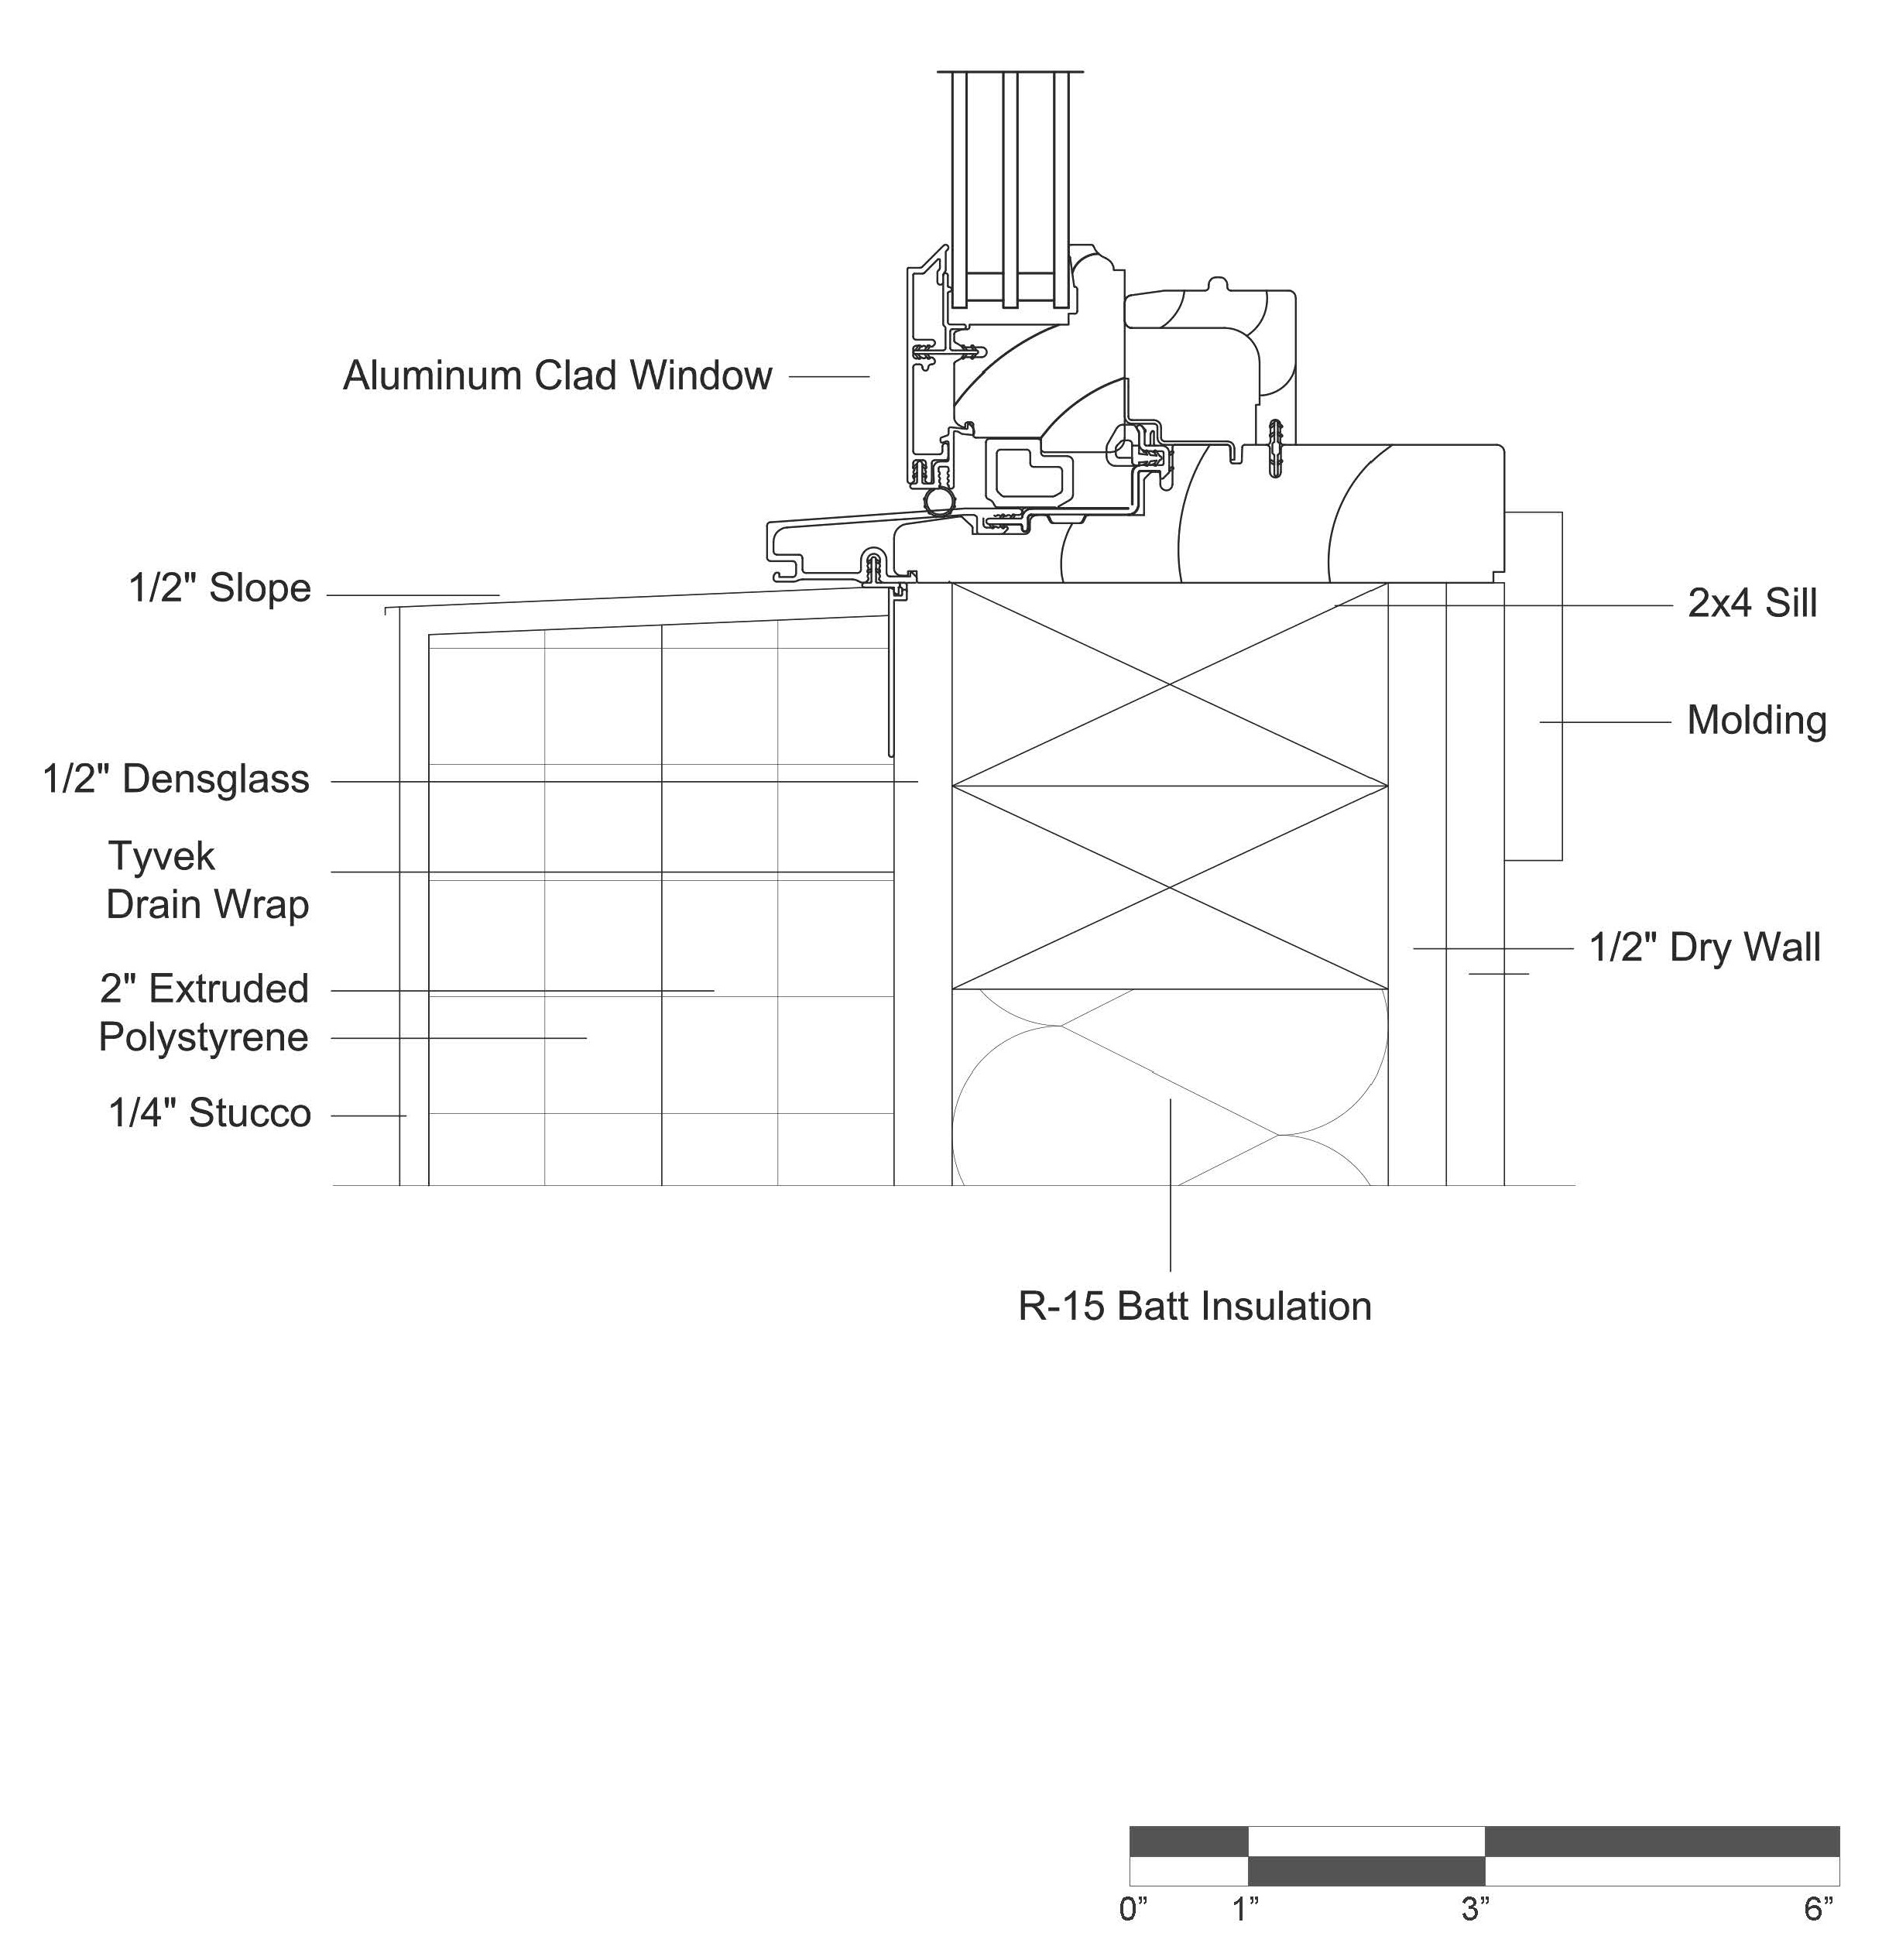
Figure 8.8. Window sill detail

This page intentionally left blank.

INDUSTRY PARTNERSHIPS

This team of engineering and architecture students approached the competition as if it were an actual construction project. Faculty and students called upon construction industry contacts and in-house expertise developed over the past six years of previous design-build collaboration. At multiple points during all phases of the design process, construction industry professionals served as consultants to the architects and engineers. The presence of real estate professionals on the team confirmed the reality of the proposal.
The site for construction of the multi-family dwelling is owned by the TVA, and adjoins the TVA East Tower. It is therefor the intent of the team to make presentations to the TVA and other interested parties to explore the opportunities for constructing a similar project. Faculty and students will work with Tom Graves, UTK Operations Director, Anderson Center for Entrepreneurship and Innovation, to help verify the cost effectiveness and payback and develop a entrepreneurial marketing plan. A presentation is envisioned to propose the business venture to Madeline Rogero, Mayor of Knoxville. She has a Masters Degree in Planning and is keenly interested in sustainable design for renovation of downtown Knoxville.

INTERNAL DISTRIBUTIOn
1. | Dr. Matthew Mench | 8. | Dave Ward
2. | Dr. Wayne Davis | 9. | Brian Shupe
3. | Dr. Scott Pool | 10. | Dr. William Dunn
4. | Dr. Jason Young
7. | Susan Ballentine

EXTERNAL DISTRIBUTION
11. Martin Keller, Oak Ridge National Laboratory, One Bethel Valley Road, Building 4500N, Mail Stop 6253, Oak Ridge, TN 37831-6253
12. Johnney Greene, Oak Ridge National Laboratory, One Bethel Valley Road, Building 5700, Mail Stop 6168, Oak Ridge, TN 37831-6168
13. Patrick Hughes, Oak Ridge National Laboratory, One Bethel Valley Road, Building 4020, Mail Stop 6324, Oak Ridge, TN 37831-6324
14. Philip Enquist, Skidmore, Owings & Merrill LLP, 224 S. Michigan Avenue, Suite 1000, Chicago, IL 60604, USA

Building Science for Building Enclosures by John Straube and Eric Burnett
An exhaust heat pump extracts heat from the exhaust air of a building and transfers the heat to the supply air.
Sensible Heat Recovery Efficiency is the net value efficiency including factors such as energy leaks, power consumption, and defrosting. The Apparent Recovery Efficiency is the gross efficiency obtained by merely taking temperature differential values into consideration.
Though the term thermostat is used, this is merely a remote control box that does not contain any sensors as all the sensor are contained within the unit. Therefore, the thermostat can be located anywhere in the dwelling without worrying about its placement.
Note that the user can select the airflow or the system will adapt it relative to the temperature and humidity conditions to 1) keep the system running within its operating envelope, and 2) to increase efficiency when possible.
http://energy.gov/eere/buildings/building-america-bringing-building-innovations-market
Gregg Vanhook is co-owner of Vanhook Enterprises; web addresss:www.vanhookenterprises.net

