Japanese Foreign Security:
Why Japan Increased Its Defense Budget and Why It Matters
Mary Roark
POLS 488 Honors Thesis
May 2024

Section I. Introduction
On December 16, 2022, the Japan Ministry of Defense (MOD) updated its defense policy for the first time in ten years and released three new documents: the National Security Strategy of Japan (NSS), the National Defense Strategy (NDS), and the Defense Buildup Program (DBP). Citing “historical changes in power balances and intensifying geopolitical competitions,” Prime Minister Fumio Kishida’s administration’s new strategies are a response to the current global situation and various security threats. A major takeaway from the documents is that the defense expenditure budget increased by nearly one-third (27.4 percent) from 2022 to 2023. The 2021 to 2022 expenditures increased by 6.5 percent, while in previous years, they increased by less. By 2027, the total budget is set for 2 percent of the current GDP compared to the 1 percent figure in 2022 and years prior. This “substantial increase of defense budget” has global leaders and Japanese citizens concerned about a new military posture for the peace-loving nation.
After studying in Japan and hearing the perspectives of native scholars and students, I have become more aware of the significance of Japan’s new defense policies for its nation and the world. This paper will consider the causes and consequences of the change in Japanese foreign security policy. My research will ask: Why has Japan recently increased its defense budget so significantly, and what are the implications of this increase? To answer these questions, this paper will first consider Japan’s legacy as a peaceful nation following World War II. In section two, I will explore Japan’s military background before and after the war to give context for its recent developments. In section three, I will explain why Japan has increased its defense spending by analyzing the threats China, Russia, and North Korea pose. The MOD has called out these three actors as major challenges to Japanese security so that I will elaborate on their effects. Based on the conclusions I reach in section three, section four will explore the possible implications of Japan’s new defense plan and budget. Specifically, in this section, I will give additional attention to events of 2023 and 2024 to better convey the consequences. Section five will conclude my research by summarizing my findings and offering their relevance to the reader.
Section II. Background: Japan After World War II
To understand the current context of Japan, it is necessary to look to the past. Much of what we see today has its roots in Japan’s emergence as a new nation immediately after World War II. This section will provide this background information. This section will not, however, deeply consider Japan’s military stance in imperial and dynasty times. I will begin by briefly explaining the transition from imperial to democratic Japan resulting from WWI. Then, I will examine the legacy of foreign defense policies after the war. I will pay special attention to Prime Minister Shinzo Abe because of his crucial role in modernizing Japan’s military.
- Pre-war to 1945
Before identifying as a “peace-loving nation” after World War II, Japan had an imperial legacy and was known for conflict. Although still marked as a monarchy, Japan entered the twentieth century as the leading industrialized Asian nation. Capitalism and a free-market economy grew profoundly as reforms paved the way for a strong private sector. As Japan’s economy became more Western, its government became more democratic. This was realized with the progression of a two-party parliamentary system after WWI. The 1918 election of commoner Hara Takashi as Prime Minister paved the way for democratic change in Japan. However, instability and Hara’s assassination thwarted long-term political peace as different leaders and parties alternated in power. Such government conflict reflected the growing Japanese discontentment for a modernized society.
During this time and after World War I, the emergence of powerful military leaders and the revival of traditional religious Shinto molded the image of Imperial Japan. The Showa period, beginning in 1927, led to a reimagining of traditional Shinto into neo-Shintoism in which the emperor is at the center of religious life and Japanese virtues are to be upheld over Western practices. As a result, increased extremism and nationalism led to numerous domestic acts of violence and military hostility overseas in the 1930s. The Imperial Japanese Army was heavily involved in China as it sought to promote its national interests. Japan ultimately left the League of Nations and moved towards militarism. They exercised their power in numerous offensive engagements in and against China. Its success in this national campaign for power was possible by the various assassinations of current and former prime ministers during the 1930s that put various military leaders in charge. These actions continued to anger the West and distance the West from Japan.
Tensions expanded in the 1940s as Japan attempted to unite and rule “Greater East Asia” and dissolve Western influence. Agreements with the Axis powers further strained relations, leading to American embargos and trade restrictions on Japan. Negotiations between the two nations floundered as each country was fearful of the other and upset with foreign policy. The failure of the negotiations ultimately led to the Japanese bombing of Pearl Harbor in 1941.
Because of its military defeats and the devastation from the atomic bomb strikes in 1945, Japan could not maintain “Greater East Asia” or continue the war, and it surrendered on September 2, 1945. Japan’s “unconditional surrender” meant the total dismantling of the Imperial Japanese Army and complete subjection to the Allied Powers, which included military occupation. Its sovereignty was restricted, and its colonies were taken away due to the agreement. Their surrender would denote the end of Imperial Japan and start the transition towards a peaceful democracy.
- 1945- Abe
The end of Japan’s imperial dynasty began an era of demilitarization and democratization under the leadership of the Supreme Commander for the Allied Powers, General Douglas MacArthur. As I stated earlier, all Japanese military forces were eradicated, and the Allies assumed power over the remaining military units. In addition, the religious order was changed as Emperor Hirohito renounced his divinity and neo-Shintoism dissolved. General MacArthur led economic and political reform, ending the Imperial Constitution of 1889 and the creation of a new Japanese constitution on May 3, 1947.
After being promulgated in November 1946 and taking effect in May 1947, Japan’s new constitution reversed sovereignty from the emperor to the people. General MacArthur created a new democratic government that separated religion from the state and abolished feudalism. Its legislature, the National Diet, would serve the people’s interests and preserve their sovereignty. This new constitution was quickly passed to Prime Minister Shidehara Kijūrō for implementation. It was pronounced official by the uninhibited approval of the emperor in exchange for criminal immunity. The Japanese were minimally involved in the new constitution process but were required to enforce its implementation into Japanese society heavily.
In addition to revolutionizing its system of government as parliamentary with a symbolic emperor, the new constitution completely changed Japan’s state orientation. Arguably, its most famous clause, Article 9 of the Constitution, turned Japan from a militarist to a pacifist country and declared the “renunciation of war.” The entirety of the article and second chapter states:
Article 9. Aspiring sincerely to an international peace based on justice and order, the Japanese people forever renounce war as a sovereign right of the nation and the threat or use of force as a means of settling international disputes.
In order to accomplish the aim of the preceding paragraph, land, sea, and air forces, as well as other war potential, will never be maintained. The right of belligerency of the state will not be recognized.
With the inclusion of this principle, Japan separated itself from its past. The article sparked an agreement that Japan would never again be an offensive threat to other nations, particularly the U.S. and the other Allies. Although there was resistance and debate among some Japanese elites, the majority of the public supported the Constitution’s principles from its inception. Having lost the war and been decimated by its weapons, the Japanese were eager to avoid war while also maintaining the potential for self-defense. Article 9 would serve as a reminder of the consequences of war and maintain “for the preservation of peace” as the new constitution prologues.
Although these pacifist principles were enshrined in its fresh constitution, avoiding war did not last long as the Cold War era emerged and proxy wars launched. Facing US pressure, “Japan was called upon to mobilize a 300,000-man army to support the US effort in Korea” during the Korean War, which occurred between 1950 and 1953. In 1951, the Japanese and US governments agreed to Japan’s inherent right of self-defense and to promote collective security interests. The US-Japan Security Treaty and the military expansion from the Korean War consequently led to the establishment of the Self-Defense Forces (SDF). Ground, Air, and Maritime Self-Defense Forces formed at this time. The SDF challenged the principles of Article 9 and met opposition from some, while others supported the new self-defense policy. These forces and the theory of self-defense were later held up in the Japanese Supreme Court, which affirmed the constitutionality of these new norms and military developments.
As the Cold War continued, public approval also continued for Article 9 and the pacifism it promoted. The SDF grew in popularity despite its seemingly contradictory nature to the spirit of Article 9. The opposing sides either disagreed with the Constitution itself or the government-induced increased military expansion. Aside from the people, the Japanese government continued interpreting the clause to give concessions to the SDF. Expanding military capacity could be justified by looking at international law and bilateral treaties that supplied the necessary context for self-defense. The presence of US troops did not suggest the potential for war as they were not inherently Japanese. The SDF was viewed as a political issue, not a constitutional one, that lessened some of the opposition. Overall, the legitimacy of Japan’s advancing arms power grew as challenges to these policies were routinely defeated.
- The Abe Era
After the Cold and Gulf Wars, the sentiment in Japan grew increasingly in favor of more involvement in international affairs and self-defense measures. North Korea posed threats that qualified for the right to defend preemptive attacks. Peacekeeping efforts in the region also won favor among the Japanese for their honorable actions, if not for self-defense reasons. These attitudes would continue with the election of Liberal Democratic Party (LDP) member and conservative Prime Minister Abe Shinzō.
Coming from a cadre of political elites, Abe entered the Diet as the youngest prime minister post-war at age 52 in 2006. A year later, political scandals and ailing health led him to resign from his position, which halted a modern Japanese history of leadership under the LDP. After six years of multiple prime ministers, Abe returned to his position in 2012. Abe became “the longest-serving prime minister in Japanese history” after his final resignation in 2020. On July 8, 2022, his influence would end after being assassinated while campaigning for the LDP.
Although Abe made many notable policies during his nine total years as Prime Minister, his influence on foreign security was unlike that of any other Japanese prime minister. For the sake of brevity, this section will focus on his major achievements and impacts on national security. Responding to the national calls for a Japanese version of the US National Security Council, Abe created and chaired the new NSC in 2013. Through the executive roles, this agency gave him, Abe effectively restructured Japan’s foreign security policies to more efficiently draft new legislation to respond to new threats and issues. One new piece of legislation was the country’s first National Security Strategy (NSS), which strengthened international cooperation and promoted national stability and peace. Its passage signified a shift “toward a more forward-leaning posture with both the United States and the broader region.” The NSS provided the foundation for Abe’s outlook and future policies.
With these new developments also came changes in notions of self-defense and the SDF’s powers. In 2014, Abe declared a reinterpretation of Article 9 to expand the SDF's abilities and maintain policies of collective security. His interpretation approved using self-defense measures even when Japan was not directly under attack. Japan and the SDF could now enter more situations with a greater, but still limited, use of force. These actions were no longer purely dependent on imminent aggression; their use could be extended to circumstances involving:
1. When an armed attack against Japan has occurred, or when an armed attack against a foreign country that is in a close relationship with Japan occurs and as a result threatens Japan’s survival and poses a clear danger to fundamentally overturn people’s right to life, liberty and pursuit of happiness;
2. When there is no other appropriate means available to repel the attack and ensure Japan’s survival and protect its people;
3. The use of force will be limited to the minimum extent necessary.
The major change mainly applied to the first condition, which shifted Japan’s policies from focusing on individual self-defense to a broader collective self-defense strategy. The Prime Minister’s new approach provoked sharp criticism but opened the door to a new identity for Japan in international affairs.
To effectively implement changes to the new interpretation now approved, Abe approved bills that expanded the operations and designations of the SDF. New missions and international threats could warrant using the SDF in ways the old interpretation could not. Japan could now achieve a greater role in international peacekeeping and strengthen cooperation with nations like the US. The SDF was permitted to become more involved in US situations and respond to anticipated threats. Reactions were mixed as other conservatives like Abe supported policies that allegedly made Japan safer and a better international community member. Others believed these new policies dangerously promoted Japan’s entering others’ wars against the main principles of the Constitution. Overall, Abe successfully evolved the national security framework to make Japan a more decisive leader in its current international context.
Not only did Abe develop Japan’s defense policies, but he also helped to enhance the country’s military and technologies. Abe expanded maritime and air defense weapons during his tenure to strengthen the SDF’s preparedness. He also anticipated modern threats in intelligence and cyberspace and reactively passed legislation to develop these new technologies. Abe’s new defense strategies were implemented to meet the latest challenges posed by growing powers like China and North Korea. The plans emphasized the development of modern precision missiles to anticipate strikes and match them defensively. Abe historically increased Japan’s defense spending in 2013 for the first time in 11 years to achieve these goals. The graph below highlights the change in trends from stagnant or negative spending to a steady increase.
Figure 1 Japanese Defense Budgets (2010-2020)
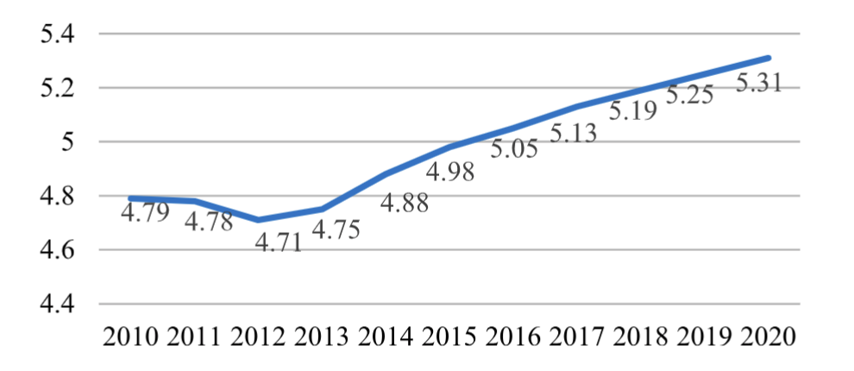
MOD,“Reference 7: Pattern of Defense-Related Expenditures (Original BudgetBasis),”Defense of Japan 2020, Tokyo, 2020, p. 494.

Abe took extraordinary measures to grow and modernize Japan’s foreign security policies. The defense weapons he supplied and the budget to match it stimulated Japan’s image as a global security power.
Although he never accomplished it, Abe’s legacy stemmed from his desire to revise Article 9. Hoping to amend it by 2020, the Prime Minister proposed adding components that constitutionally enforced the SDF and its actions. Instead, Abe achieved the reinterpretations discussed above, which still allowed for new defense measures. Nonetheless, these agencies seriously considered the alteration of Article 9. Abe’s administration and conservative ideology challenged Japan’s pacifist identity and role in the international and Asian community. His critics faulted him for his less-than-strict interpretation of Article 9, but he still upheld the anti-war and peace-loving values of the Constitution. In his final term days, Abe maintained foreign relationships with regional countries and, of course, the US. Abe’s sudden failing health led to his resignation on August 28, 2020, ending the possibility of achieving the constitutional reform he imagined. However, his eight consecutive years in office positioned Japan to meet modern challenges and prepare for a disordered future.
- Present
Following Abe’s recent retirement, Japanese defense policy has significantly developed with the passage of three new security documents at the end of 2022. As prefaced at the beginning of this paper, these documents aimed to address the current international order that Japan finds itself a part. Released under the current Fumio Kishida administration, the updated defense policy outlines its plans in the National Security Strategy of Japan (NSS), the National Defense Strategy (NDS), and the Defense Buildup Program (DBP). The NSS had not been updated since 2013 while the NDS and DBP were new. Like the former NSS, the current NSS’s objective is to act as the “supreme national security policy document” for Japan. The latest NSS, however, expands the diplomatic and defense policy areas to include “economic security, technology, cyber, intelligence, etc.” The NDS replaced the 2018 National Defense Program Guidelines to go beyond basic guidelines for self-defense. The NDS defines the objectives and how they will be accomplished. It focuses on improving defensive abilities and strengthening international relationships, especially with the US. The DBP “sets the level of defense capability that Japan should possess” along with periodic goals and complete expenditure budgets. Significantly, the defense budget was set to increase in the following year by 27.4 percent (excluding US Forces’ additions) compared to 2022’s budget. Likewise, the budget is set to continue increasing, and by 2027, the budget will meet 2 percent of Japan’s current (2022) GDP. The expenditure budget rested around and was capped at 1 percent of Japan’s GDP in 2022 and previous years. The DBP has set forth a substantial increase in spending in the years to come. The figure below, taken from the “Defense Programs and Budget of Japan,” shows the changes in spending and the projected exponential increases over the next five years.
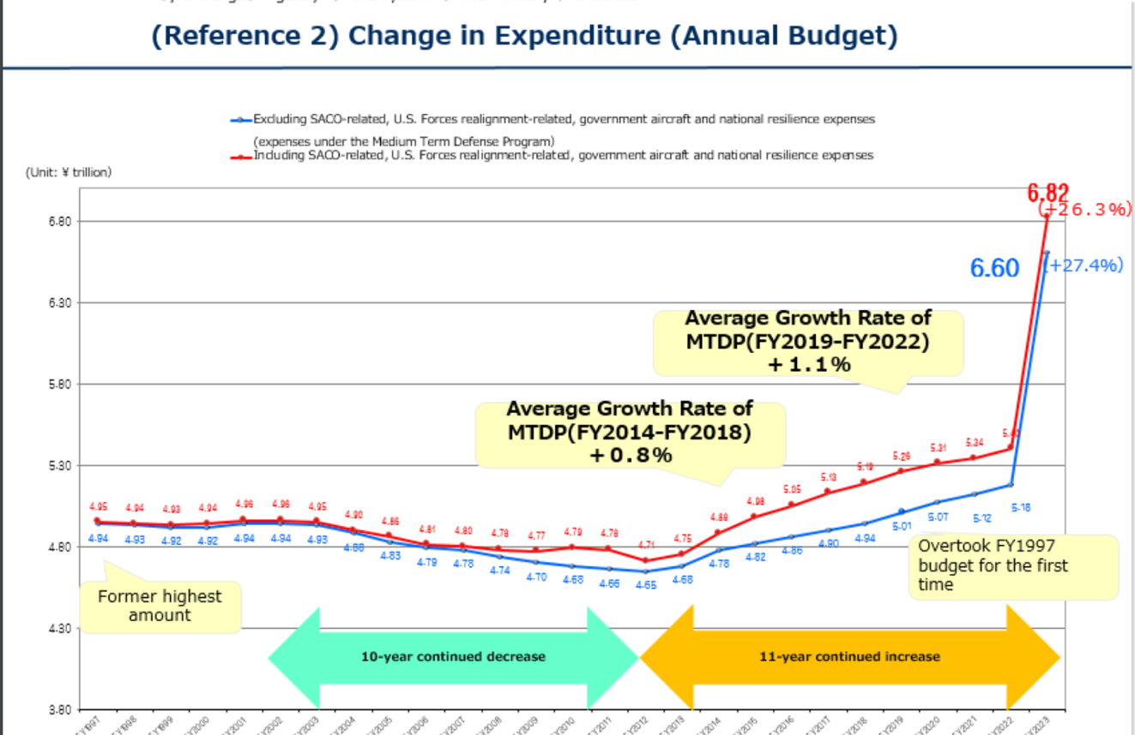
Defined in the NDS, the expenditures will be used to reinforce seven key capabilities for defense. The need for these improvements is derived from the change in global order and rising acts of aggression. They are: “stand-off defense capabilities, integrated air and missile defense capabilities, unmanned defense capabilities, cross-domain operation capabilities, command and control/intelligence-related functions, mobile deployment capabilities/civil protection, and sustainability and resiliency.” With these capabilities, Japan will better be able to deter invasion and eventually have the means to defend itself. Thus, the MOD and current administration approved the substantial expenditure increase to meet these goals.
To summarize, Japan’s government and social identity were transformed after its surrender in WWII. Under pressure from the US and Allied Powers, imperial Japan became a constitutionally peaceful democracy. However, the new US partnership questioned the power of Article 9 as the US engaged in conflict during the Cold War era that drew Japan in. This early precedent led to continual generations of informal and formal reinterpretation of Article 9. Prime Minister Abe radically reinterpreted Article 9 and expanded Japan’s defense system. His legacy and modern global conflicts led to the drastic changes the Kishida administration made in 2022. Once again, the recent developments in Japanese foreign policy are reigniting criticisms and discussions on the future state of peace-loving Japan.
Section III. Why Has Japan Increased Its Defense Spending?
With the release of these documents and the large budget increase, Japanese citizens and the rest of the world are debating the implications of the government’s new stance on foreign defense. Before considering the outcomes of Japan’s new national security plan, it is important to determine why the administration has called for increased defense spending. This section will outline the reasons based on the actors the MOD identifies. The NSS identifies China, Russia, and North Korea as the leading threats requiring a new defense policy. I will divide this section to focus on each of those three actors from the MOD’s leading narratives. I will also elaborate on these claims and further analyze why these actors led to Japan’s budgetary reaction.
- China
China’s recent activities and national posture greatly threaten Japan and the rest of the world, particularly the United States. Competition between China and the US continues to grow in measures that affect Japan as a close US ally. The historic rivalry escalated with the US-China Trade War beginning in 2018. The trade war resulted from Chinese economic policies allowing unfair trade subsidies. China has also been reported to illegally acquire US intelligence, including military intelligence, through forced agreements with tech companies. Its role as a tech giant and bully through manipulated currency practices creates major problems for US markets and users. The competing economic systems of the two countries resulted in the Trump administration imposing extreme tariffs on Chinese goods and tighter legislation on various tech products coming out of China. China heavily retaliated with its trade restrictions. Some negotiations later developed, but the Biden administration continued the restraints on Chinese tech that hurt relations.
Because the US is Japan’s most important ally, problems between the US and China spill over onto Japan. The ripple effects of the US-China Trade War meant that Japanese firms experienced declines in sales and stock prices. Being the world’s third-largest economy, the impact on Japanese markets was heavily felt. Additionally and militarily, tensions between the US and China directly impact Japan because of the longstanding American military base on Okinawa. Pressures coming from multiple sides challenge the US military and Japan’s forces. As author Shiela A. Smith writes, “The old idea that US forces would provide the ‘sword’ and the Japanese the ‘shield’ has become harder to justify.” As risks escalate, new discussions emerge on how much or not the US can rely on Japan. This has led Japan to explore its own measures to provide the “sword.” The defense budget calls for investment in capabilities unsupplied by the US and external contracts. The goal has been to invest in means that improve Japan’s resiliency.
Aside from US-China problems, Chinese activities also pose a direct threat to Japan. Much of the problems have manifested in maritime disputes and violations. China continues to claim rights in the South China Sea contrary to international law. Chinese occupation of these false lands and waters expands their military power and economic control over the region. On manmade and claimed islands, China conducts military exercises and lands bombs that threaten Japanese security. The challenges continue in the East China Sea over Japan’s Senkaku Islands. China refutes this Japanese territory and, since 2008, has continued to make military intrusions into its waters. Chinese vessels threaten existing Japanese vessels and hinder Japanese fishing and trading. With China’s growing military presence in nearby waters and blatant dismissal of international agreements, Japan’s national security and territory are under threat. The MOD image below shows “China intensifying unilateral attempts to change the status quo by force” through maritime and airspace intrusions.
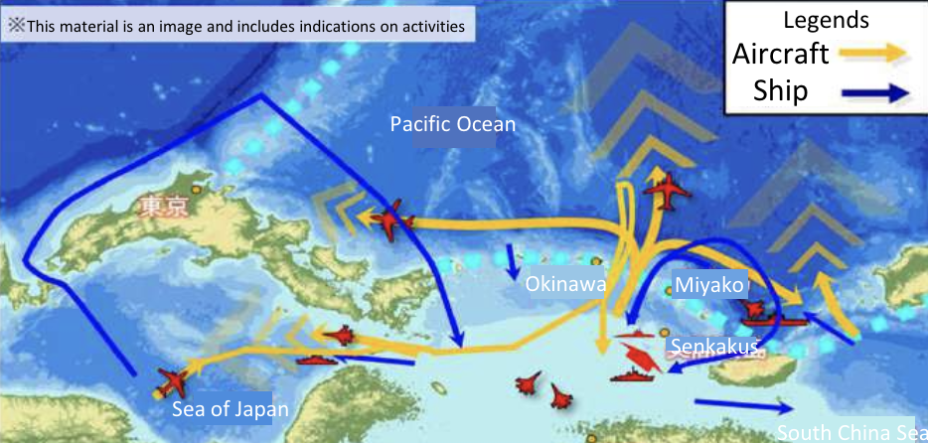
Because of this, the MOD sees it essential to “respond with its comprehensive national power,” which involves new defensive strategies.
The maritime threat persists regarding the Taiwan dispute. On August 4, 2022, the Chinese military engaged in drills that launched nine ballistic missiles near Taiwan, and five landed in Japan’s exclusive economic zones (EEZ). The MOD illustration below maps the location of the five invasive missiles.
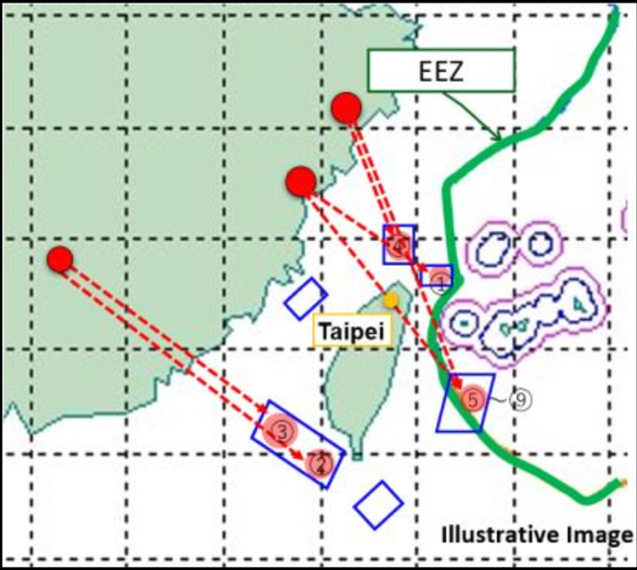
China’s military exercise posed a direct threat to Japanese territory and the region in general. The growing instability in the Indo-Pacific region and Chinese pressure on Taiwan threaten Japan. The question also arises as to whether Japan will directly deter Chinese aggression against Taiwan. Japan continues to support Taiwan economically and politically, but the Chinese force could extend the support militarily and operationally. Thus, this conflict is often cited as another reason China’s forceful posture requires greater defensive measures in Japan. Japan claims it currently lacks the proper operations to combat such a risk and must develop its capabilities. These are to take the form of new, costly counterstrike missiles. These missiles would give leverage to Japan if a missile strike from ships were to occur.
Japan must also develop its capabilities because of China's growing military power. The NSS asserts, “China has been increasing its defense expenditures at a continuously high level and extensively and rapidly enhancing its military power, including its nuclear and missile capabilities, without sufficient transparency.” As the US Department of Defense reports, China has made great strides in strategies to modernize its military. Its government is developing warheads at a fast rate. Their arsenal is paving the way for destructive warfare through advanced technologies. Much of this military power is focused on growing maritime strength overseas. As China shifts towards greater offensive capabilities and away from international cooperation, Japan sees an immediate need to increase deterrence measures that could match China’s growing power. The new counter-strike capabilities serve this purpose and are designed to deter a direct invasion. Japan’s proximity to Chinese firepower poses a major physical threat to its peace and stability.
The MOD’s documents emphasize the role China plays in Japanese security threats. The main threats are considered in this section, but the problems extend beyond those I discuss here. The following section will connect China and Russia to develop the narrative further. China’s recent military excursions and expansions are shifting away from international order and toward enhanced aggression. Maritime incursions and other violations threaten the Indo-Pacific region’s stability economically and militarily. As such, Japan believes it needs to grow its defense measures to stabilize these threats potentially and forcibly in the future.
- Russia
The war in Ukraine sparked by Russian aggression has “shaken the very foundation of the international order” and is a crucial reason for Japan’s redesign of its defense policies. When Russia invaded Ukraine on February 24, 2022, Article 2(4) of the UN Charter was violated, which binds member states from the “use of force against the territorial integrity or political independence of any state.” Russia’s direct aggression goes against the “laws of political morality” on which Japan prides itself. Because of the changes in the European community, Japan argues that it, too, must change its current policies under the threat of potential replication of such events in the Indo-Pacific. Moreover, Russia and China’s growing relationship could extend the threat of Russia into the Indo-Pacific region. Over the last two decades, Russia and China have increased their bilateral military land and sea drills. Such exercises have involved “simulating combined missile defense tasks” that suggest a strengthening alliance between the two nations. The MOD released the following image: "Joint navigation by Chinese and Russian vessels (October 2021).”
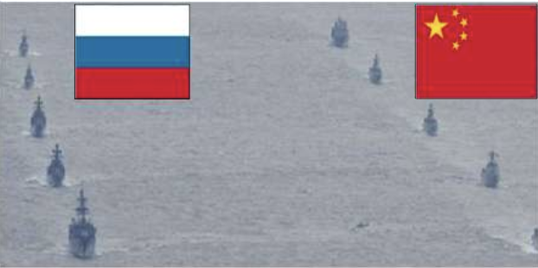
With these collaborations, both nations’ operations are tested and improved to increase their capabilities. As the two nations increase their aggression, a Russia-China partnership creates a large-scale military threat to the Indo-Pacific region. The MOD saw the need to improve its standoff defense capabilities in case of such a partnered invasion.
The threat is amplified because, like China, Russia has also been upgrading its weapons and military. In attempts to modernize since 2008, Russia’s military has transformed and made measurable advancements, especially in naval and aerospace forces. Much attention has been given to its weaponry to increase readiness and mobility. These efforts were shown to the world during the Ukraine invasion, which gave Japan a credible reason to redevelop its military. Likewise, as the MOD defends, Russia has repeatedly alluded to the possibility of employing its nuclear arsenal. At the start of the war in 2022, President Vladimir Putin was televised, stating Russia’s nuclear forces task was on high alert. Putin has been recorded making many similar statements in the past. As a nation devasted by nuclear weaponry, Japan’s government feels compelled to improve the SDF’s capabilities. Russia’s aggression and rhetoric have created insecurity in the international community, so Japan believes it must adapt to the new security concerns.
These concerns have extended closer to home as Russian military events have amplified in proximity to Japan. Russian military presence has grown in the Far East (East Asia). Russia has aimed to strengthen its power and control over the region, including its northern territories. Russia’s activities in the region have been crucial to strengthening its overall military capabilities. Concern grew in 2022 when a large-scale drill was performed in the Far East, including the Sea of Japan, for the first time in 4 years. The image below highlights Russia’s military presence in the region and its proximity to Japan.
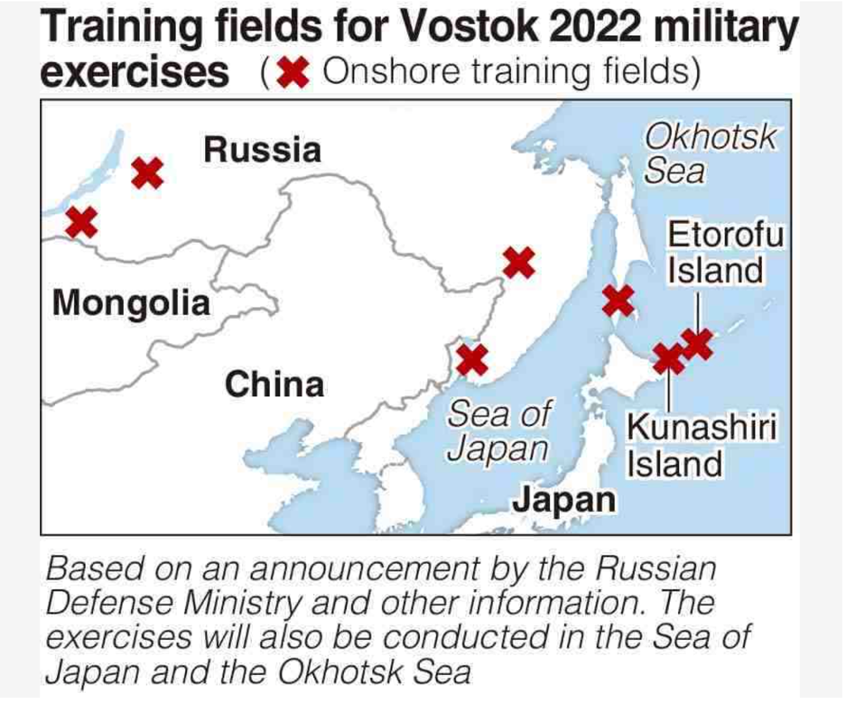
The NSS related these frequent events occurring in “an inherent territory of Japan.” As such, these activities pose security concerns for Japan. To maintain its security in light of the increasing number of Russian companies, Japan needed to refigure its SDF to ensure it could intercept nearby threats. The budget was set to achieve these costly updates and strengthen sensors.
To summarize, Russia, like China, has engaged in activities using force that depart from the cooperative means on which Japan’s defense policies previously relied. The invasion of Ukraine created a new security crisis that required Japan to redevelop its foreign defense plan. This involved plans for advanced weaponry that could stabilize Japan under the possibility of Russia’s modern military power being exercised against Japan. Russia’s growing involvement in the Far East makes the likelihood of this occurrence more pertinent. Therefore, Japan saw fit to modernize its own SDF to deter and defend.
- North Korea
North Korea is the final power the NSS identifies as a key challenge for Japanese and regional security. The MOD openly states, “North Korea's military activities pose an even more grave and imminent threat to Japan's national security than ever before.” The reason for this statement stems from North Korea’s progressively updating missile technologies. In recent years, the country’s long-range missiles have seen a boost, and these missiles can now cross continents and reach the US. Reports show a growing number of finished and in-progress missiles in North Korea. The number of drills and launches has also increased, especially in 2022. The attachment below graphs the influx in missile launches over the last decade and, alarmingly, in the last column, 2022.
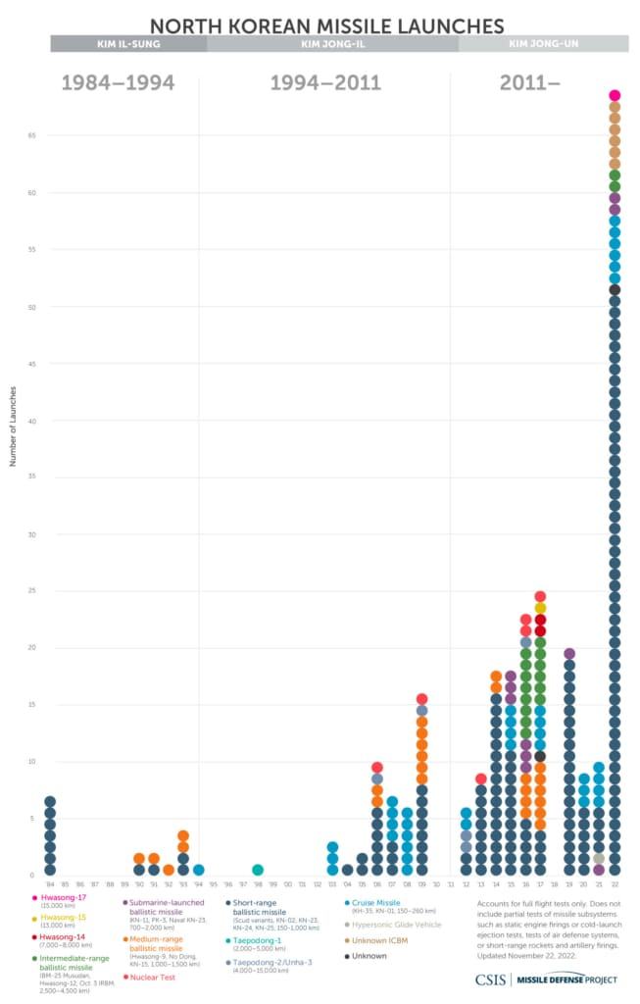
For the first time in five years, North Korea launched a ballistic missile over Japan and into the Pacific Ocean on October 3, 2022. The fifth drill occurred in nine days. At the time, it was also the longest distance one of their missiles traveled. The map below, published by the New York Times and supplied by the Japanese government, tracks the missile's path over Japan.
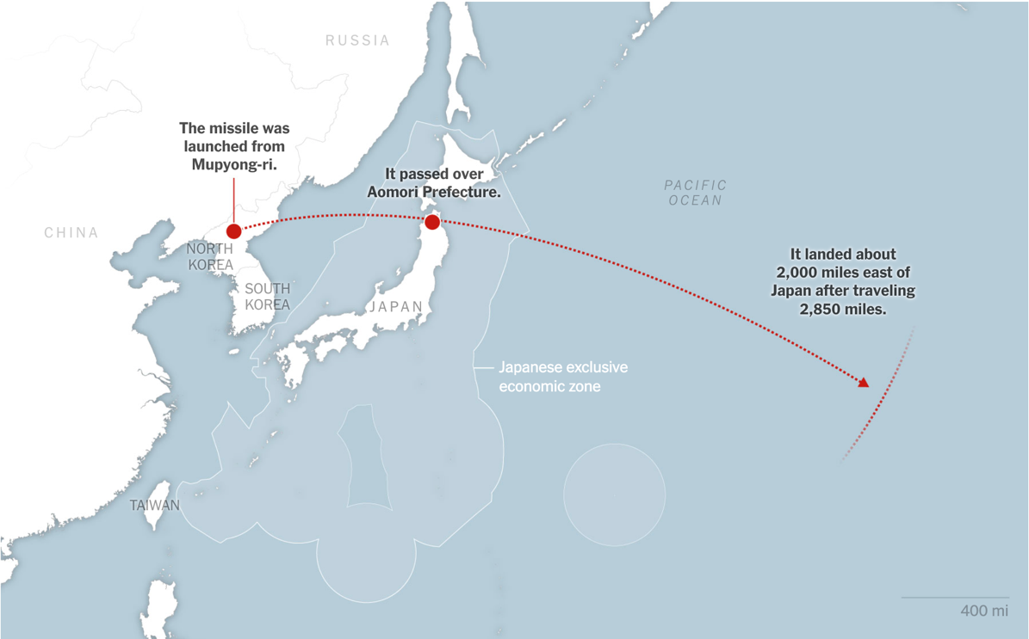
Because of both the advancing technology of the missiles and the indiscriminatory tests, the ability of Japan to defend itself from such North Korean threats could no longer be guaranteed. Once again, the development of counterstrike missiles is crucial for the possibility of one of North Korea’s missiles finally aiming for Japan.
Additionally, North Korea’s possession of weapons of mass destruction was also cited as a security concern for Japan. Although never publicly confirmed by North Korea, it is widely believed the country possesses developed and in-progress nuclear warheads with long-range potential. The tests from smaller nuclear weapons give reason to believe the country holds larger ones as well. The lack of transparency from its government also causes concerns over its true extent of power. Likewise, North Korea continues to fail the UN Security Council’s calls for the dismantling of its nuclear weapons. Despite the UNSC’s sanctions, North Korea has continued to develop weapons of mass destruction. These actions have consequently threatened the international order and caused great risks for nearby Japan. The fear of another nuclear devastation is felt by the MOD’s proposals.
Because of North Korea’s increasing weaponry, Japan needed to improve its deterrence capabilities. Japan’s old technologies could not meet the challenges set by North Korea’s attitude. Japan determined North Korea was a threat, requiring upgraded defense systems that required more expenditures. These expenditures focus on counterstrikes and other deterrence technologies that protect Japan. North Korea’s enhanced missiles made it crucial for Japan to reinforce its defense capabilities by the seven critical capabilities listed previously.
Section IV. Possible Implications
In short, China, Russia, and North Korea have contributed to international instability that challenges the Japanese security system. Increasing aggression and competition from nearby superpowers is dissolving the order and communication Japan and the international community rely on. Japan restructured its foreign defense policies to protect itself from spillover and possibly offensive aggression. The administration proposed modern military solutions that required restructuring and extending the defense budget to meet modern challenges. Because of this recent development and its long-term, five-year goals, the ramifications of the defense buildup have not yet been fully realized. However, much has been theorized and debated on the impact of such an unprecedented move. This section will explore the possible implications of the change in Japan’s defense posture.
The Demise of Article 9
Unlike many other discussions, the debate on the future of Article 9 has persisted since before the December document release. As previously mentioned, the applicability of the article has been questioned from its early inception to Cold War conflicts. Politicians and other government leaders have campaigned for its survival or death to win public support and office. Prime Minister Shinzo Abe was a prominent figure in the debate as he argued for its reinterpretation and amendment. The increase in defense expenditures has added more weight to its potential eradication and has caused a massive public response.
On one side, the actions of the Kishida administration are argued to foreshadow the approaching amendment or end of Article 9. To restate for clarity, the article reads:
Article 9. Aspiring sincerely to an international peace based on justice and order, the Japanese people forever renounce war as a sovereign right of the nation and the threat or use of force as means of settling international disputes.
In order to accomplish the aim of the preceding paragraph, land, sea, and air forces, as well as other war potential, will never be maintained. The right of belligerency of the state will not be recognized.
The NSS’s proposals have continued shifting Japan’s self-defense posture to collective defense. Its objectives emphasize caring for the international community and global interests as much as national security. With this stance, Japan’s pacifist identity could be shrinking, and a modern, militarist system could take its place. If so, the necessity to amend the Constitution to support a more proactive stance grows with the passage of new legislation. Conservatives and the LDP, including Abe, have long made this argument and continue calling for change. Recently, Prime Minister Kishida voiced the urgent need to revise the Constitution to update “insufficient or irrelevant” parts. His party aims for an amendment that plainly conveys the role of the SDF. If the LDP continues to hold its majority, the long-anticipated revision of Article 9 may be on the horizon.
Conversely, the strength of Article 9 is exhibited in public opposition to the new defense policies and especially the new budget. Many are finding issues with whether the latest measures maintain a commitment to peace. Specifically, there is opposition to implementing original counterstrike capabilities that reach enemies far past Japan’s borders. This challenges the commitment to self-defense measures. Likewise, the five-year budget meeting 2 percent of the GDP seems like a radical shift from a historically less-resourced military. The public has expressed criticisms of the administration, which strays from historical and national identity. On the first Constitution Day (an annual holiday celebrating the Constitution’s inception) after the documents were released, Japanese crowds protested and marched to support peace, pacifism, and resistance to the new budget. Persistent citizen support of Article 9 suggests the article’s role will stay strong and constitutionally unchanged despite the efforts of political parties.
My argument rests somewhere in the middle of these two movements. I conclude that Article 9 will not be amended anytime in the near future. Likewise, the complete removal of Article 9 will almost certainly never come to pass. The values Japan embraced with the adoption of Article 9 remain at the heart of Japanese identity. The peace-loving attitudes associated with it are not easily changed. Likewise, the Constitution is not easily changed. Since its inception, the Constitution has never been amended or altered. Politicians have tried to reform it, but all have failed, including Abe. Therefore, it is difficult to argue this change will come anytime soon, especially when the greatest voice of the movement for change failed. Article 9 will remain unchanged for the foreseeable future. However, it will continue to be subject to formal and informal reinterpretation. Just as history shows amendment improbable, history also shows a legacy of reinterpretation to fit the needs of the times. As global order and national security continue to be threatened, presiding administrations will respond with interpretations that promote Japanese, US, and increasingly international interests. As other scholars claim, Japanese militarization will continue to be normalized. The US-Japan alliance will solidify, as will Japan’s defense role in the international community. Increasing military developments will result, but significant amendments to the Constitution will not.
- Deterrence
Under the assumption that the strength of Article 9 persists and the military developments are not unconstitutional, the actions taken by the MOD could be interpreted as deterrence methods. Under these new policies, Japan is on track to have the third-largest military budget in the world. Combined with the US military budget, this budget is an effort to extend deterrence efforts. Promoting nuclear deterrence is an essential element of this because of nearby North Korea’s known possession. Counterstrikes and improved defense capabilities are also at the core of deterrence strategies. The MOD hopes to deter an invasion against Japan through strengthened partnerships and new capabilities.
However, attempts at deterrence could be misinterpreted as growing Japanese aggression. This is already seen in the nation's responses to the report. As Dr. Jingdong Yuan appropriately writes,
For all Tokyo’s insistence that its intentions are entirely peaceful, its neighbours may see its largest military build-up since World War II as a threat. Beijing has already voiced its displeasure at the new NSS, focusing particularly on its characterization of China as ‘an unprecedented strategic challenge’. North Korea and Russia have accused Japan of increasing security risks in the region with its new policies.
Rather than succeed at deterring invasion, Japan’s new policies and, particularly, its new budget could cause more international aggression. An invasion or attack by one of these actors could be blamed on the development of the SDF.
My realist perception is that both of these scenarios will naturally occur from adopting these documents. As the classic problem persists, attempts to deter aggression are seen as acts of aggression. Japan’s new capabilities will hopefully discourage invasion because of its improved ability to retaliate. Counterstrike capabilities are predicted to achieve deterrence. However, these decisions will be considered aggressive moves by Japan’s enemies. Therefore, these nations could be more inclined to use force against Japan.
- Arms Race
Following the deterrence dilemma, an undeniable arms race has ensued across Asia and the Pacific. All the major East Asian powers, including China, North Korea, Russia, Japan, and South Korea, are upgrading their militaries. The Russian invasion of Ukraine and Japan’s new NSS marks a historical turning point for the region and the world. The response has been new counterstrike missiles from Japan and increased missile testing from North Korea. Each country and its allies, like the US, have scrambled to update defense policies and weaponry that could survive in the new international climate.
The arms race does not appear to be slowing down. Instead, I believe the stakes will continue to be raised, and nations will build their militaries. The possession of nuclear weapons in some nations adds to the crisis of how to deter and defend from a nuclear attack without compromising international norms and laws. As stated before, efforts to grow capabilities for defense will be interpreted as acts of aggression. Japan’s counterstrike missiles will likely be seen as such. This means Japan’s enemies will continue to pursue their growth and development as measures for its defense against Japan’s defense methods. The latest arms race in Asia is only accelerating, and the lasting implications are yet to be determined.
- War
The consequences of increased militarization, deterrence efforts, and an arms race will increase the probability of an all-out war. As discussed throughout this paper, Japan could enter a war from various fronts soon. US-Chinese competition may turn violent and start war across the Pacific. Chinese military activity in the waters around Japan, including the Taiwanese Strait, could become a complete maritime invasion. China could finally forcibly enter Taiwan, and Japan and the US might enter the conflict. Russia could turn its aggression towards Japan and its Northern Territories. With China as a Russian partner, Japan could be met with a dual invasion potentially involving nuclear weaponry. Nuclear strikes from North Korea could also be in the future for Japan. As the Kishida administration expresses concerns, the number of powerful nations exhibiting acts of increased aggression towards Japan raises the probability of war for Japan.
Based on these three actors’ behavior, I believe war will erupt within the next decade, and Japan will be a crucial participant. Although I am unsure from which front the war will begin, I am confident Japan will be one of the actors involved. Japan may be the direct target in the war, but more likely, Japan will enter the war using collective defense measures initially rather than out of self-defense. The MOD’s move toward pursuing a more significant role in securing international peace will be realized by its collective involvement in the war to come. Each nation prepares its military for heightened war, and international negotiations fail. This combination is paving the way for a multilateral war in East Asia. If Japan’s proposed capabilities are met, the country will be a powerful player in the looming war.
Section V: Conclusion
The documents of December 16th, 2022, have changed the global order as much as the aggression of East Asian actors have. A growing sentiment away from post-WWII pacifism and towards increased collective militarism has blossomed in the significant rise in defense expenditures. A turning point has been met in the international community and the future of the Indo-Pacific region. Japan's latest security measures have amplified Japan’s role in the situation. Japan faces massive security threats from its neighbors as it seeks to deter aggression and defend itself.
The consequences of a war in the Indo-Pacific region involving Japan extend to the US. The US maintains a critical relationship with Japan economically, politically, and militarily. Likewise, US markets heavily rely on the exports and economies of East Asia. Whatever crisis ensues from the Asian arms race will have profound ramifications in and on the US. Tech restrictions will massively impact our economy, and the American military will be drawn to Asia. Understanding the situation in Japan is crucial to understanding the future well-being of the US, or lack thereof.

References
Brown, James, R. Taggart Murphy, Guibourg Delamotte, Robert Dujarric, Laney Bahan, Benoit Hardy-Chartrand, Masaki Kakizaki, Jeff Kingston, Tosh Minohara, and Hiromi Murakami. The Abe Legacy: How Japan Has Been Shaped by Abe Shinzo. Lanham, UNITED STATES: Lexington Books/Fortress Academic, 2021. http://ebookcentral.proquest.com/lib/utk/detail.action?docID=6801754.
CEPR. “The Impact of the US-China Trade War on Japanese Multinational Corporations,” November 3, 2019. https://cepr.org/voxeu/columns/impact-us-china-trade-war-japanese-multinational-corporations.
Cha, Victor, Ellen Kim, and Andy Lim. “North Korea Tests Missile over Japan,” October 5, 2022. https://www.csis.org/analysis/north-korea-tests-missile-over-japan-0.
“China’s Live-Fire Drills Near Taiwan Send Ballistic Missiles Into Japan’s EEZ.” Accessed May 5, 2024. https://thediplomat.com/2022/08/chinas-live-fire-drills-near-taiwan-send-ballistic-missiles-into-japans-eez/.
“Constitutional Change in Japan.” Accessed May 6, 2024. https://www.cfr.org/japan-constitution.
Council on Foreign Relations. “The Contentious U.S.-China Trade Relationship.” Accessed May 4, 2024. https://www.cfr.org/backgrounder/contentious-us-china-trade-relationship.
Council on Foreign Relations. “Timeline: China’s Maritime Disputes.” Accessed May 5, 2024. https://www.cfr.org/timeline/chinas-maritime-disputes.
Council on Foreign Relations. “What to Know About Sanctions on North Korea.” Accessed May 6, 2024. https://www.cfr.org/backgrounder/north-korea-sanctions-un-nuclear-weapons.
dpeleschuk. “To Decipher Putin’s Nuclear Threats, Watch What He Does—Not What He Says.” Atlantic Council (blog), March 4, 2022. https://www.atlanticcouncil.org/blogs/new-atlanticist/to-decipher-putins-nuclear-threats-watch-what-he-does-not-what-he-says/.
Global Asia. “The Growing Risk for Japan in the US-China Rivalry.” Accessed May 5, 2024. https://globalasia.org/v16no4/cover/the-growing-risk-for-japan-in-the-us-china-rivalry_sheila-a-smith.
Glosserman, Brad. “A Plea and a Promise for 2023: No More ‘Pacifism.’” The Japan Times, January 3, 2023. https://www.japantimes.co.jp/opinion/2023/01/03/commentary/japan-commentary/japanese-pacifism/.
Green, Andrew. “Shinzo Abe.” The Lancet 400, no. 10355 (September 10, 2022): 806. https://doi.org/10.1016/S0140-6736(22)01699-3.
Hook, Glenn D., and Gavan McCormack. “Parchment and Politics: Japan’s Living Constitution.” In Japan’s Contested Constitution. Routledge, 2001.
Hornung, Jeffrey W. “Abe Shinzō’s Lasting Impact: Proactive Contributions to Japan’s Security and Foreign Policies.” Asia-Pacific Review 28, no. 1 (January 2, 2021): 22–48. https://doi.org/10.1080/13439006.2021.1921356.
IISS. “If New Looks Could Kill: Russia’s Military Capability in 2022.” Accessed May 6, 2024. https://www.iiss.org/en/online-analysis/military-balance/2022/02/if-new-looks-could-kill-russias-military-capability-in-2022/.
Japan Ministry of Defense. “Japan Ministry of Defense.” Accessed April 29, 2024. https://www.mod.go.jp/en/.
“Japan’s Article 9: Pacifism and Protests as Defence Budget Doubles | Lowy Institute.” Accessed May 6, 2024. https://www.lowyinstitute.org/the-interpreter/japan-s-article-9-pacifism-protests-defence-budget-doubles.
“Japan’s New Military Policies: Origins and Implications | SIPRI,” February 2, 2023. https://www.sipri.org/commentary/blog/2023/japans-new-military-policies-origins-and-implications.
Kristensen, Hans M., and Matt Korda. “North Korean Nuclear Weapons, 2021.” Bulletin of the Atomic Scientists 77, no. 4 (July 4, 2021): 222–36. https://doi.org/10.1080/00963402.2021.1940803.
Maki, John M. “The Constitution of Japan: Pacifism, Popular Sovereignty, and Fundamental Human Rights.” Law and Contemporary Problems 53, no. 1 (1990): 73–87. https://doi.org/10.2307/1191827.
Ministry of Foreign Affairs of Japan. “Situation of the Senkaku Islands.” Accessed May 5, 2024. https://www.mofa.go.jp/a_o/c_m1/senkaku/page1we_000010.html.
Missile Threat. “Missiles of North Korea.” Accessed May 6, 2024. https://missilethreat.csis.org/country/dprk/.
“National Defense Strategy.” Accessed May 6, 2024. https://www.mod.go.jp/j/policy/agenda/guideline/strategy/pdf/strategy_en.pdf.
“National Security Strategy, National Defense Strategy, and Defense Buildup Program (Outline）.” Accessed March 18, 2024. https://www.mod.go.jp/en/d_act/d_policy/pdf/english.pdf.
“National Security Strategy of Japan.” Accessed March 18, 2024. https://www.mod.go.jp/j/policy/agenda/guideline/pdf/security_strategy_en.pdf.
Nations, United. “United Nations Charter (Full Text).” United Nations. United Nations. Accessed May 6, 2024. https://www.un.org/en/about-us/un-charter/full-text.
NEWS, KYODO. “Japan PM Calls for Speeding up Debate on Revising Constitution.” Kyodo News+. Accessed May 6, 2024. https://english.kyodonews.net/news/2024/05/d85596d08133-japan-pm-calls-for-speeding-up-debate-on-revising-constitution.html.
“Overview of 2022 Budget.” Accessed April 29, 2024. https://www.mod.go.jp/en/d_act/d_budget/pdf/20220420.pdf.
“Overview of 2023 Budget.” Accessed April 29, 2024. https://www.mod.go.jp/en/d_act/d_budget/pdf/230330a.pdf.
“Primary-Sources_archives-Unbound_japan-at-War-and-Peace-1930-1949_u.s.-State-Department-Records-on-the-Internal-Affairs-of-Japan.Pdf.” Accessed April 29, 2024. https://www.gale.com/binaries/content/assets/gale-us-en/primary-sources/archives-unbound/primary-sources_archives-unbound_japan-at-war-and-peace-1930-1949_u.s.-state-department-records-on-the-internal-affairs-of-japan.pdf.
Project, Missile Defense. “North Korean Missile Launches & Nuclear Tests: 1984-Present.” Missile Threat, April 20, 2017. https://missilethreat.csis.org/north-korea-missile-launches-1984-present/.
Rich, Motoko, and Choe Sang-Hun. “North Korea Fires Powerful Missile, Using Old Playbook in a New World.” The New York Times, October 3, 2022, sec. World. https://www.nytimes.com/2022/10/03/world/asia/japan-north-korea-missile.html.
Shimbun, The Yomiuri. “Russia Begins Large-Scale Military Exercises in Far East,” September 2, 2022. https://japannews.yomiuri.co.jp/world/russia/20220902-55602/.
Stallard, Katie. “Asia’s Dangerous New Arms Race.” New Statesman (blog), February 6, 2023. https://www.newstatesman.com/international-politics/geopolitics/2023/02/asia-dangerous-new-arms-race-japan-kishida-fumio.
“Surrender of Japan (1945) | National Archives.” Accessed April 29, 2024. https://www.archives.gov/milestone-documents/surrender-of-japan.
“THE CONSTITUTION OF JAPAN.” Accessed April 30, 2024. https://japan.kantei.go.jp/constitution_and_government_of_japan/constitution_e.html.
U.S. Department of Defense. “China Military Power Report Examines Changes in Beijing’s Strategy.” Accessed May 6, 2024. https://www.defense.gov/News/News-Stories/Article/Article/3230682/china-military-power-report-examines-changes-in-beijings-strategy/https%3A%2F%2Fwww.defense.gov%2FNews%2FNews-Stories%2FArticle%2FArticle%2F3230682%2Fchina-military-power-report-examines-changes-in-beijings-strategy%2F.
Weitz, Richard. “Assessing Chinese-Russian Military Exercises: Past Progress and Future Trends,” July 9, 2021. https://www.csis.org/analysis/assessing-chinese-russian-military-exercises-past-progress-and-future-trends.
———. “Russian Military Power and Policy in the Far East.” THE RUSSIAN MILITARY IN CONTEMPORARY PERSPECTIVE. Strategic Studies Institute, US Army War College, 2019. https://www.jstor.org/stable/resrep20098.24.

“National Security Strategy of Japan,” accessed March 18, 2024, https://www.mod.go.jp/j/policy/agenda/guideline/pdf/security_strategy_en.pdf.
“Overview of 2023 Budget,” accessed April 29, 2024, https://www.mod.go.jp/en/d_act/d_budget/pdf/230330a.pdf.
“Overview of 2022 Budget,” accessed April 29, 2024, https://www.mod.go.jp/en/d_act/d_budget/pdf/20220420.pdf.
“National Security Strategy, National Defense Strategy, and Defense Buildup Program (Outline）,” accessed March 18, 2024, https://www.mod.go.jp/en/d_act/d_policy/pdf/english.pdf.
“Overview of 2023 Budget,” 4.
“Japan Ministry of Defense,” Japan Ministry of Defense, accessed April 29, 2024, https://www.mod.go.jp/en/.
“Primary-Sources_archives-Unbound_japan-at-War-and-Peace-1930-1949_u.s.-State-Department-Records-on-the-Internal-Affairs-of-Japan.Pdf,” accessed April 29, 2024, https://www.gale.com/binaries/content/assets/gale-us-en/primary-sources/archives-unbound/primary-sources_archives-unbound_japan-at-war-and-peace-1930-1949_u.s.-state-department-records-on-the-internal-affairs-of-japan.pdf.
“Primary-Sources_archives-Unbound_japan-at-War-and-Peace-1930-1949_u.s.-State-Department-Records-on-the-Internal-Affairs-of-Japan.Pdf,” 3.
“Primary-Sources_archives-Unbound_japan-at-War-and-Peace-1930-1949_u.s.-State-Department-Records-on-the-Internal-Affairs-of-Japan.Pdf,” 4-6.
“Primary-Sources_archives-Unbound_japan-at-War-and-Peace-1930-1949_u.s.-State-Department-Records-on-the-Internal-Affairs-of-Japan.Pdf,” 6.
“Surrender of Japan (1945) | National Archives,” accessed April 29, 2024, https://www.archives.gov/milestone-documents/surrender-of-japan.
“Primary-Sources_archives-Unbound_japan-at-War-and-Peace-1930-1949_u.s.-State-Department-Records-on-the-Internal-Affairs-of-Japan.Pdf,” 7.
“Primary-Sources_archives-Unbound_japan-at-War-and-Peace-1930-1949_u.s.-State-Department-Records-on-the-Internal-Affairs-of-Japan.Pdf,” 7.
Glenn D. Hook and Gavan McCormack, “Parchment and Politics: Japan’s Living Constitution,” in Japan’s Contested Constitution (Routledge, 2001).
“THE CONSTITUTION OF JAPAN,” accessed April 30, 2024, https://japan.kantei.go.jp/constitution_and_government_of_japan/constitution_e.html.c
Hook and McCormack, “Parchment and Politics.” 7.
“THE CONSTITUTION OF JAPAN.”
Hook and McCormack, “Parchment and Politics,” 17.
John M. Maki, “The Constitution of Japan: Pacifism, Popular Sovereignty, and Fundamental Human Rights,” Law and Contemporary Problems 53, no. 1 (1990): 73–87, https://doi.org/10.2307/1191827.
Hook and McCormack, “Parchment and Politics,” 14–15.
Hook and McCormack, 32–33.
James Brown et al., The Abe Legacy: How Japan Has Been Shaped by Abe Shinzo (Lanham, UNITED STATES: Lexington Books/Fortress Academic, 2021), http://ebookcentral.proquest.com/lib/utk/detail.action?docID=6801754.
Andrew Green, “Shinzo Abe,” The Lancet 400, no. 10355 (September 10, 2022): 806, https://doi.org/10.1016/S0140-6736(22)01699-3.
Jeffrey W. Hornung, “Abe Shinzō’s Lasting Impact: Proactive Contributions to Japan’s Security and Foreign Policies,” Asia-Pacific Review 28, no. 1 (January 2, 2021): 22–48, https://doi.org/10.1080/13439006.2021.1921356.
Hornung, 26.
Hornung, 27.
Hornung, 27.
Hornung, 28–29.
Hornung, 30–31.
Hornung, 31.
Brown et al., The Abe Legacy, 92–93.
Brown et al., 41.
“National Security Strategy, National Defense Strategy, and Defense Buildup Program (Outline）.” 1.
“National Security Strategy, National Defense Strategy, and Defense Buildup Program (Outline）,” 1.
“Overview of 2023 Budget,” 4.
“National Security Strategy, National Defense Strategy, and Defense Buildup Program (Outline）.” 5.
“Overview of 2023 Budget,” 10.
“National Defense Strategy,” accessed May 6, 2024, https://www.mod.go.jp/j/policy/agenda/guideline/strategy/pdf/strategy_en.pdf.
“National Security Strategy of Japan,” 7–10.
“The Contentious U.S.-China Trade Relationship,” Council on Foreign Relations, accessed May 4, 2024, https://www.cfr.org/backgrounder/contentious-us-china-trade-relationship.
“The Impact of the US-China Trade War on Japanese Multinational Corporations,” CEPR, November 3, 2019, https://cepr.org/voxeu/columns/impact-us-china-trade-war-japanese-multinational-corporations.
“The Growing Risk for Japan in the US-China Rivalry,” Global Asia, accessed May 5, 2024, https://globalasia.org/v16no4/cover/the-growing-risk-for-japan-in-the-us-china-rivalry_sheila-a-smith.
“Overview of 2023 Budget,” 8.
“Timeline: China’s Maritime Disputes,” Council on Foreign Relations, accessed May 5, 2024, https://www.cfr.org/timeline/chinas-maritime-disputes.
“Situation of the Senkaku Islands,” Ministry of Foreign Affairs of Japan, accessed May 5, 2024, https://www.mofa.go.jp/a_o/c_m1/senkaku/page1we_000010.html.
“National Security Strategy, National Defense Strategy, and Defense Buildup Program (Outline）,” 6.
“National Security Strategy of Japan,” 9.
“China’s Live-Fire Drills Near Taiwan Send Ballistic Missiles Into Japan’s EEZ,” accessed May 5, 2024, https://thediplomat.com/2022/08/chinas-live-fire-drills-near-taiwan-send-ballistic-missiles-into-japans-eez/.
“Overview of 2023 Budget,” 2.
“The Growing Risk for Japan in the US-China Rivalry.”
“National Security Strategy of Japan,” 18.
“National Security Strategy of Japan,” 8.
“China Military Power Report Examines Changes in Beijing’s Strategy,” U.S. Department of Defense, accessed May 6, 2024, https://www.defense.gov/News/News-Stories/Article/Article/3230682/china-military-power-report-examines-changes-in-beijings-strategy/https%3A%2F%2Fwww.defense.gov%2FNews%2FNews-Stories%2FArticle%2FArticle%2F3230682%2Fchina-military-power-report-examines-changes-in-beijings-strategy%2F.
“National Security Strategy of Japan,” 10.
United Nations, “United Nations Charter (Full Text),” United Nations (United Nations), accessed May 6, 2024, https://www.un.org/en/about-us/un-charter/full-text.
“THE CONSTITUTION OF JAPAN.”
Richard Weitz, “Assessing Chinese-Russian Military Exercises: Past Progress and Future Trends,” July 9, 2021, https://www.csis.org/analysis/assessing-chinese-russian-military-exercises-past-progress-and-future-trends.
“National Security Strategy, National Defense Strategy, and Defense Buildup Program (Outline）,” 2.
“If New Looks Could Kill: Russia’s Military Capability in 2022,” IISS, accessed May 6, 2024, https://www.iiss.org/en/online-analysis/military-balance/2022/02/if-new-looks-could-kill-russias-military-capability-in-2022/.
dpeleschuk, “To Decipher Putin’s Nuclear Threats, Watch What He Does—Not What He Says,” Atlantic Council (blog), March 4, 2022, https://www.atlanticcouncil.org/blogs/new-atlanticist/to-decipher-putins-nuclear-threats-watch-what-he-does-not-what-he-says/.
Richard Weitz, “Russian Military Power and Policy in the Far East,” THE RUSSIAN MILITARY IN CONTEMPORARY PERSPECTIVE (Strategic Studies Institute, US Army War College, 2019), https://www.jstor.org/stable/resrep20098.24.
The Yomiuri Shimbun, “Russia Begins Large-Scale Military Exercises in Far East,” September 2, 2022, https://japannews.yomiuri.co.jp/world/russia/20220902-55602/.
“National Security Strategy of Japan,” 10.
“National Security Strategy of Japan,” 9.
“Missiles of North Korea,” Missile Threat, accessed May 6, 2024, https://missilethreat.csis.org/country/dprk/.
Missile Defense Project, “North Korean Missile Launches & Nuclear Tests: 1984-Present,” Missile Threat, April 20, 2017, https://missilethreat.csis.org/north-korea-missile-launches-1984-present/.
Victor Cha, Ellen Kim, and Andy Lim, “North Korea Tests Missile over Japan,” October 5, 2022, https://www.csis.org/analysis/north-korea-tests-missile-over-japan-0.
Motoko Rich and Choe Sang-Hun, “North Korea Fires Powerful Missile, Using Old Playbook in a New World,” The New York Times, October 3, 2022, sec. World, https://www.nytimes.com/2022/10/03/world/asia/japan-north-korea-missile.html.
Hans M. Kristensen and Matt Korda, “North Korean Nuclear Weapons, 2021,” Bulletin of the Atomic Scientists 77, no. 4 (July 4, 2021): 222–36, https://doi.org/10.1080/00963402.2021.1940803.
“What to Know About Sanctions on North Korea,” Council on Foreign Relations, accessed May 6, 2024, https://www.cfr.org/backgrounder/north-korea-sanctions-un-nuclear-weapons.
“THE CONSTITUTION OF JAPAN.”
“National Security Strategy of Japan,” 1–2.
KYODO NEWS, “Japan PM Calls for Speeding up Debate on Revising Constitution,” Kyodo News+, accessed May 6, 2024, https://english.kyodonews.net/news/2024/05/d85596d08133-japan-pm-calls-for-speeding-up-debate-on-revising-constitution.html.
“Japan’s New Military Policies: Origins and Implications | SIPRI,” February 2, 2023, https://www.sipri.org/commentary/blog/2023/japans-new-military-policies-origins-and-implications.
“Japan’s Article 9: Pacifism and Protests as Defence Budget Doubles | Lowy Institute,” accessed May 6, 2024, https://www.lowyinstitute.org/the-interpreter/japan-s-article-9-pacifism-protests-defence-budget-doubles.
“Constitutional Change in Japan,” accessed May 6, 2024, https://www.cfr.org/japan-constitution.
“Japan’s New Military Policies.”
Brad Glosserman, “A Plea and a Promise for 2023: No More ‘Pacifism,’” The Japan Times, January 3, 2023, https://www.japantimes.co.jp/opinion/2023/01/03/commentary/japan-commentary/japanese-pacifism/.
“National Defense Strategy,” 10.
“Japan’s New Military Policies.”
Katie Stallard, “Asia’s Dangerous New Arms Race,” New Statesman (blog), February 6, 2023, https://www.newstatesman.com/international-politics/geopolitics/2023/02/asia-dangerous-new-arms-race-japan-kishida-fumio.

