Assessment of Soil Health under Native Warm-Season Grasses and Different Grazing Management

A Thesis Presented for the
Master of Science
Degree
The University of Tennessee, Knoxville

Kara Leigh Grosso
May 2022

Acknowledgements
Mentorship from faculty, graduate students, and the Northeast Tennessee AgResearch and Education Center director made this research possible. I would like to thank Dr. Julie Carrier, the head of the department of Biosystems Engineering and Soil Science at the University of Tennessee, for her unwavering kindness throughout my time at UT. I would also like to thank my major professor Dr. Forbes Walker and other committee members, Dr. Neal Eash, Dr. Sean Schaeffer, and Dr. Patrick Keyser, for their mentorship, patience, and support. Faculty and students offered lab space and equipment, input on sampling and analysis, and moral support. I am especially grateful for the time and assistance provided to me by fellow graduate students, who trained me on lab procedures and helped me collect soil samples on hot summer days. I would also like to thank my family for supporting me on my journey, wherever it goes. Additional contributors include Dr. Michael Essington, Dr. Dennis West, Dr. Jaehoon Lee, Dr. Linda Kennedy of Mansfield University of Pennsylvania, Melanie Stewart, Justin McKinney, Aubrey Fine, Daniel Sain, Alexis Gillmore, Shannon Newell, Adam Zimmerman, Mom, Dad, family, and friends. This thesis was written by all of us.

Abstract
This research uses analysis of soil quality indicators (SQIs) to compare vegetation species and grazing management over the 2021 grazing season. The soil health effect of the native warm-season grasses (NWSG) big bluestem (BB) (Andropogon gerardii) mixed with indian grass (IG) (Sorghastrum nutans) (BBIG), and switchgrass (SG) (Panicum virgatum), inter-seeded with a 12 species biodiversity mix was investigated in a 5 pressure grazing system (no graze (NG), no rest (NR), early, middle, and late rest (ER, MR, LR)). Additionally, there is a need for inexpensive tools for land owners to assess soil quality, and a validation study was performed on a new rapid soil test (soil microBIOMETER®) for microbial biomass carbon (MBC) using correlation with chloroform fumigation-extraction (CFE).
Soil quality indicators are a proxy for carbon sequestration and soil resilience. Indicators analyzed included MBC using CFE and soil microBIOMETER®, labile carbon using permanganate oxidizable carbon (POxC), gravimetric water content, wet aggregate stability (WAS), bulk density (BD), and total organic carbon (TOC) over 4 years.
The data showed that when α = 0.1, TOC was increasing but was not significantly different between the years 2018, 2020, and 2022 over the entire NWSG pasture or within vegetation species. There was more TOC under BBIG and no difference in TOC between NG and NR. The BBIG portion of the pasture had consistently better values for SQI than SG. The data suggest that continuously grazing NWSG forage during the warm-season in East Tennessee at a stocking density of 2.4 – 4.2 AU/ha does not result in poorer soil quality than a NG or rotational grazing approach.
Soil microBIOMETER® had weak correlation with CFE at MBC values <150 μgC/g soil. Correlation between the methods improved as measured MBC flush increased. Soil microBIOMETER® distinguished between vegetation species and provided a similar range of values as CFE, especially when adjusted by a factor of 0.55 at values <150 μgC/g soil. Individual data points did not track closely between CFE and microBIOMETER®. Soil microBIOMETER® is a promising tool for rapid soil health assessment in the field when range of MBC or comparison of treatments is of interest.

Table of Contents
Introduction 1
Pasture Management 2
Native and Non-Native Plant Species 10
Soil Quality Indicators 11
Soil Health Assessment Tools 16
Chapter 1: Soil Health Effects of Vegetation Species and Grazing Pressure 18
Climate and Soils 18
Experimental Design 19
Response Variables 27
Sample Collection 27
Methods of Analysis 30
Limitations 37
Statistical Analysis 37
Results and Discussion 40
Chapter 2: Soil microBIOMETER® Validation Study 68
Limitations 69
Statistical Analysis 70
Results and Discussion 71
Conclusions 81
References 84
Appendix 1: Distributions of Soil Quality Indicators with Significant Differences 93
Appendix 2: Pasture Summary for Soil Parameters Analyzed 101
Appendix 3: Total Organic Carbon SAS 9.4 GLM Procedure Output 104
Appendix 4: Freezer Failure 106
Appendix 5: Web Soil Survey Ratings for Dunmore Loam and NRCS Soil Quality Test Kit 109
Vita 110

List of Tables
Table 1: Diversity blend sown in BBIG and SG pastures Spring 2017 (Dr. Patrick Keyser, personal communication, 2021). 20
Table 2: Soil quality indicators analyzed and the information they contribute to the study 27
Table 3: ANOVA sources of variation and degrees of freedom (DF) for soil quality indicators 39
Table 4: ANOVA sources of variation and degrees of freedom (DF) for bulk density 39
Table 5: Summary of spatial and temporal differences in soil quality indicators during the 2021 grazing season due to treatment when α = 0.1. 41
Table 6: Statistical Summary comparing mean microbial biomass carbon (MBC) flush measured using microBIOMETER® and chloroform fumigation extraction (CFE) over the entire NWSG pasture, where units are MBC in µgC/g soil. 72
Table A2.1: Pre-graze statistical summary for soil quality indicators (SQIs) averaged over the entire pasture 101
Table A2.2: Post-graze statistical summary for soil quality indicators (SQIs) over the entire pasture 102
Table A2.3: Statistical summary for total organic carbon (TOC) and soil organic matter (SOM) in no graze (NG) and no rest (NR) paddocks (combined) for the years 2018, 2020, and 2022 103

List of Figures
Figure 1: Annual periods of peak productivity for cool-season and warm-season grasses (Keyser et al. 2015) 7
Figure 2: Annual 12-week grazing regime for biodiversity grazing trial. 21
Figure 3: Experimental Layout of biodiversity grazing trial. 24
Figure 4: Aerial image of biodiversity grazing trial experimental site 25
Figure 5: Post-graze no gaze paddock biomass for switchgrass and big bluestem/indiangrass mix. 26
Figure 6: Eijkelkamp wet aggregate stability analysis unit. 32
Figure 7: Chloroform fumigation-extraction vacuum extraction manifold (top) and LI-COR infrared gas analyzer (bottom) (Photos by Kara Grosso). 34
Figure 8: Soil microBIOMETER® test 36
Figure 9: Mean values of soil quality indicators pre-graze (May 2021) to post-graze (September 2021) among vegetation species (big bluestem/indiangrass (BBIG) and switchgrass (SG)) and grazing treatments (early, middle, late rest (ER, MR, LR), no rest (NR), no graze (NG)). 44
Figure 10: Means separation for change pre to post-graze in gravimetric water content (GravH2O) and microbial biomass carbon (MBC) measured using chloroform fumigation-extraction (CFE). 46
Figure 11: Means separation of pre-graze wet aggregate stability (WAS) among grazing treatments (no rest (NR), no graze (NG), early, middle, and late rest (ER, MR, LR)) 48
Figure 12: Pre-graze means separation for microbial biomass carbon (MBC) measured using chloroform fumigation-extraction (CFE) and soil microBIOMETER®. 49
Figure 13: Means separation of pre-graze permanganate oxidizable carbon (POxC) among vegetation species big bluestem/indiangrass (BBIG) and switchgrass (SG). (Pr > F = 0.0097) 50
Figure 14: Post graze gravimetric water content (GravH2O) distribution and means separation 52
Figure 15: Post-graze means separation for wet aggregate stability (WAS) among grazing treatments and vegetation species 53
Figure 16: Post-graze means separation for microbial biomass carbon (MBC) measured using chloroform fumigation extraction (CFE) and microBIOMETER® (microBIO) among vegetation species (big bluestem/indiangrass (BBIG) and switchgrass (SG). 54
Figure 17: Distribution and means separation of post-graze permanganate oxidizable carbon (POxC) among species (big bluestem/indiangrass (BBIG) and switchgrass (SG)) 55
Figure 18: Bulk density as affected by vegetation species (switchgrass (SG) and big bluestem/indiangrass (BBIG)) and grazing pressure (no graze (NG), middle rest (MR), no rest (NR), early rest (ER), and late rest (LR)). 57
Figure 19: Means separation of bulk density (BD) among species-grazing pressure interactions (big bluestem/indiangrass (BBIG) and switchgrass (SG)) (early rest (ER), late rest (LR), middle rest (MR), no rest (NR), no graze (NG)). 58
Figure 20: Depth to compacted layer in centimeters among big bluestem/indiangrass (BBIG) and switchgrass (SG) portions of the NWSG pasture 59
Figure 21: Means separation of total organic carbon (TOC) among grazing pressure and vegetation species for the combined years of 2018, 2020, and 2022. 61
Figure 22: Distribution and means separation of total organic carbon (TOC) values across the pasture for years 2018, 2020, and 2022 62
Figure 23: Total organic carbon (TOC) distribution by year in switchgrass (SG) pasture (top) and big bluestem/indiangrass (BBIG) pasture (bottom) 63
Figure 24: Distribution of total organic carbon (TOC) across the pasture among species and grazing interaction. 64
Figure 25: Pre and post-graze soil quality indicator correlation matrices 66
Figure 26: Pre and post-graze regression analysis for gravimetric water content and wet aggregate stability 67
Figure 27: Linear regression model for pre-graze, post-graze, and additional samples: microbial biomass carbon (MBC) flush determined by chloroform fumigation-extraction and soil microBIOMETER® 75
Figure 28: Linear regression model for all sample periods: microbial biomass carbon (MBC) flush determined using chloroform fumigation-extraction and soil microBIOMETER® 76
Figure 29: Pearson Correlation Coefficients for microbial biomass carbon (MBC) determined using microBIOMETER® and chloroform fumigation-extraction (CFE) 77
Figure 30: Pre-graze (top) and post-graze (bottom) relationship between microbial biomass carbon (MBC) flush determined using chloroform fumigation-extraction (CFE) and soil microBIOMETER® 78
Figure 31: Additional sample and correction factor relationship between microbial biomass carbon (MBC) flush determined using chloroform fumigation-extraction (CFE) and microBIOMETER® 80
Figure A1.1: Pre to post-graze change distribution for gravimetric water content across grazing pressures early, middle, and late rest (ER, MR, LR,), no graze (NG) and no rest (NR) 93
Figure A1.2: Pre to post-graze change distribution for microbial biomass carbon measured using chloroform fumigation-extraction across vegetation species big bluestem and indiangrass (BBIG) and switchgrass (SG) 94
Figure A1.3: Pre-graze distribution wet aggregate stability (WAS) and microbial biomass carobon (MBC) using microBIOMETER® 95
Figure A1.4: Pre-graze distribution of microbial biomass carbon using CFE and permanganate oxidizable carbon 96
Figure A1.5: Post-graze distribution of wet aggregate stability 97
Figure A1.6: Post-graze distribution gravimetric water content and microBIOMETER® 98
Figure A1.7: Post-graze distribution microbial biomass carbon and permanganate oxidizable carbon across species 99
Figure A1.8: Figure A1.8: Distribution of bulk density (BD) across the species graze interaction 100
Figure A3.1: Total organic carbon analysis of variance 104
Figure A4.1: Means separation for “broken freezer” experiment 108

Introduction
Pasture management includes vegetation type and grazing management. Management impacts soil health factors such as soil organic matter and soil carbon content, which influence quantifiable indicators of soil health. Grazing pressure affects nutrient cycling by altering organic matter and carbon inputs into the soil system (Teague et al., 2011). Vegetation species affect soil health due to characteristics such as root depth, growth habit, and photosynthetic pathway, which affect plant-soil interactions such as nutrient and water acquisition and soil organic matter formation (Ashworth, 2011). Grazing management and vegetation species may have an interaction effect where grazing pressure and plant species synergistically influence soil quality.
The fescue “summer slump” of poor warm-season forage production in tall fescue (Schedonorus arundinaceus) dominated pastures can be addressed by using native warm-season grasses (NWSG) as summer forage (Keyser, 2021) in separate pastures. The objective of this study is to gain understanding of how species of NWSG might impact soil health, how grazing management of NWSG pastures during their productive season impacts soil health, and whether there is a method for farmers to affordably measure soil health in the field. Native warm-season grasses such as big bluestem (Andropogon gerardii), indiangrass (Sorghastrum nutans), little bluestem (Schizachyrium scoparium), switchgrass (Panicum virgatum), and eastern gamagrass (Tripsacum dactyloides) are long-lived perennials that are productive as forage during the summer months.
Soil health, often used interchangeably with soil quality, refers to physical, chemical, and biological metrics that are used to assess and communicate soil characteristics, often as influenced by management decisions (Powlson, 2020). Soil quality indicates suitability of soil for a desired use, while soil health indicates a soil’s capacity for ecosystem functionality (Doran et al., 2000). The United States Department of Agriculture (USDA) Natural Resources Conservation Service (NRCS) defines soil health and soil quality as “the continued capacity of soil to function as a vital living ecosystem that sustains plants, animals, and humans” (USDA NRCS, 2020).
Pasture Management
Beef cattle production is a major industry in Tennessee, with over 3 million acres of pasture land (USDA Census of Agriculture, 2017). Traditionally, pasture systems in East Tennessee are dominated by tall fescue and are grazed year round. Pastures where livestock have continuous access to all areas are referred to as being “continuously grazed” during a defined period of access. Pastures in Tennessee are traditionally grazed year-round due to lower management input required compared to rotational grazing strategies (Brazil et al., 2020).
Continuous grazing can lead to overuse of pastures that can stress the vegetation, leading to decreased stand productivity and bare soil. Repeated grazing and trampling of the same areas can cause compaction, decrease soil structure, and increase erosion loss (Dowhower et al., 2019). Combined, these effects decrease soil organic matter input and carbon storage in the system, ultimately decreasing soil resilience. Soil resilience becomes increasingly important in a changing climate with more frequent droughts and heavy rain events (Yoder et al., 2021).
Tall fescue is planted as the primary forage for cattle across an area of the United States known as the “Fescue Belt”. The Fescue Belt is comprised of roughly 35 million acres and extends from East of the Great Plains to the Atlantic Coast (Brazil et al., 2020). Fescue is popular as forage due to its ability to adapt to a wide range of environmental conditions (Hill et al., 1991), perennial persistence, and a high nutritional value (Wepking, 2017). Fescue is a cool season grass, fixing carbon via the C3 pathway and decreasing productivity during hot, dry conditions (Brazil et al., 2020). This results in an annual period called “the summer slump” (Brazil et al., 2020) when fescue growth slows and producers supplement feed with stockpiled forage or hay. Stockpiling is when a pasture is made inaccessible to livestock so that forage accumulates and is available to graze as needed (Roberts et al., 2009).
Tall fescue and NWSG differ primarily by photosynthetic pathway. Tall fescue performs C3 photosynthesis while NWSG perform C4 photosynthesis. About 85% of plants perform C3 photosynthesis, relying on the Calvin cycle alone (Graham et al., 2006). Grasses that perform C3 photosynthesis perform best within the temperature range of 16 to 25°C (60 to 77°F) (Keyser, 2021). During hot dry conditions, C3 plants close their stomata to reduce water loss, decreasing carbon dioxide concentration in the leaves (Graham et al., 2006). The resulting process is called photorespiration; the release of carbon dioxide from leaves during the stress of hot weather (Graham et al., 2006). As much as half of fixed carbon in the plant may be respired, making this an inefficient process and slowing growth during these periods (Graham et al., 2006). Tall fescue is problematic primarily due to a lack of summer productivity (Brazil et al., 2020) which requires farmers to supplement feed (Boyer and Keyser, 2020).
Native warm-season grasses fix carbon via the C4 pathway and thrive in temperatures above 21°C and up to 48°C (70°F and up to 118°F) (Keyser, 2021), making them ideal forage during May to September (Brazil et al., 2020). About 15% of plants have evolved to have this additional photosynthetic pathway, allowing them to reduce photorespiration and increase productivity during hot, dry conditions (Graham et al., 2006). Thriving in warm conditions has led C4 plants to have high water use efficiency, and NWSG have up to 4 times greater water use efficiency than cool season grasses (Keyser, 2021). Native warm season grasses are up to 2 times more productive than tall fescue when grown under similar conditions, and maintain optimum growth at lower nitrogen concentrations than cool season grasses (Keyser, 2021). Lower water and nutrient inputs are required when using NWSG grasses as forage than tall fescue.
Fescue toxicosis, grass tetany, and a shallow rooting depth of 0.6 to 0.9 meters (2 to 3 feet) are detriments of fescue-dominated pastures. Fescue toxicosis is caused when livestock ingest fescue that is infected by the endophytic fungus Acremonium coenophialum (Thompson et al., 1993). The fungus lives in mutualistic association with tall fescue and produces ergopeptine-alkaloids that cause illness in livestock (Hill et al., 1991). The endophyte spreads on fescue seeds (Hoveland, 2000). It benefits the fescue by increasing resilience when grazed or eaten by insects, resistance to diseases, and improved morphological fitness such as deeper rooting and drought adaptability (Hill et al., 1991). Symptoms of ingestion include rapid breathing and gangrene (Hoveland, 2009), and result in decreased animal production (Thompson et al., 1993). Grass tetany is an illness of ruminants caused by magnesium deficiency (Dua and Care, 1995). The deficiency occurs when potassium competes with magnesium during plant uptake from the soil, resulting in greater plant potassium content and deficiency of magnesium in the ruminant diet (Dua and Care, 1995). Grass tetany occurs as a result of heavy potassium fertilization, which is often required to sustain healthy tall fescue pastures.
Relatively shallow rooting grasses such as fescue do not promote water infiltration during rain events or pull water from deep in the soil profile during drought events as well as deeper rooting vegetation (Ashworth, 2011). Shallow rooting plants also sequester less carbon than deeper rooting plants and have a smaller rhizosphere to support microbial populations (Ashworth, 2011). Rooting depths of tall fescue and NWSG have been well documented. Tall fescue grown in a fine sandy loam in eastern Canada rooted to a maximum depth of 0.7- to 0.9-m (Carter and Gregorich, 2010) which is shallow compared to NWSG rooting depths of 1.8- to 3.0-m (Ashworth, 2011). Carter and Gregorich (2010) indicate that growing tall fescue for 7 years on soil that previously grew barley increased soil organic carbon (23% increase) and soil organic nitrogen (34% increase) to a depth of 60-cm, with the greatest increase in the top 10-cm of the profile and increases below 60-cm being insignificant. Deeper rooting increases depth of carbon storage, and greater than 95% of carbon in NWSG is below ground (Ashworth, 2011). Due to deeper rooting depth, native grasses are well adapted to dry conditions and they help flood water infiltrate and percolate deep in the soil profile. Taller growth habits combined with deep rooting make NWSG valuable for reducing runoff velocity and loss of sediment (Ashworth, 2011).
A potential shortfall of NWSG as forage is the slightly lower nutritive value compared to cool season grasses (Wepking 2017), lack of productivity in winter and the potential need for rotational grazing of these pastures during the warm-season, which is an ongoing research area (Brazil et al 2020). Despite lower nutritive value than cool season grasses, NWSG support adequate animal daily gain (Monroe, 2014) of 0.5-1.1 kg/day (1.06-2.38 lbs/day) depending on NWSG species (Keyser, 2021).
In Georgia, USA, the effect of grazing on soil organic carbon and soil organic nitrogen sequestration was investigated in a 12-year study of the interaction of forage utilization and nutrient source (fertilizer), and how these treatments affected SOC and total nitrogen (Franzluebbers et al., 2009). They found that nutrient source had little effect on either, while grazing had a significant effect. Grazing the forage led to higher soil organic carbon and total nitrogen in the top 15-cm of soil than in un-grazed pasture due to animal behavior of processing vegetation and deposition of excrement (Franzluebbers et al., 2009).
Rotational grazing techniques are modeled after natural grassland systems. They avoid both overstocking and overgrazing, and maintain plant litter and cover to protect the soil from erosion while meeting the needs of soil biota (Dowhower et al., 2019). Rotational grazing between fescue and NWSG pastures rests both the soil and vegetation while filling the fescue summer slump. Research is needed to determine the ideal ratio of fescue to NWSG in NWSG complemented-fescue-dominated grazing systems. An estimated 20-30% (Dr. Forbes Walker, personal communication, 2021) NWSG as forage base may complement fescue well; allowing fescue pastures to rest during the warm months when NWSG is at its peak of productivity and vice versa (Figure 1).

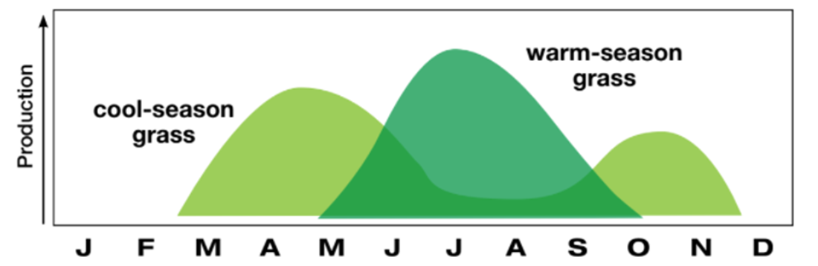
Figure 1: Annual periods of peak productivity for cool-season and warm-season grasses (Keyser et al. 2015).

A recent study conducted in Knoxville, TN investigated the sustainability of May to August continuous grazing on mixed pastures of big bluestem, indiangrass and little bluestem NWSG pastures by comparing stand sustainability, cattle performance, and pasture production between continuous grazing pressure and a modified grazing pressure. The modified grazing pressure followed the growth curve of NWSG to decrease grazing pressure as productivity slowed, and stocking density was decreased to 0.75 times initial stocking density (Brazil et al., 2020). The start-of-season stocking density averaged 1000-kg steers per ha over the 3 year study (Brazil et al., 2020). Stocking was implemented on a 272-kg steer basis. Converting to animal units (AU), 1000-kg steer per ha/272-kg per steer = 3.67 animals per ha (1000-lbs = 1 AU, and 272-kg = 600-lbs). Each steer is 0.6 AU x 3.67 steer per ha = 2.2 AU per ha. Multiplying 2.2 AU per ha by 100-ha = 220 AU per 100-ha. Animal stocking rate is important to consider when comparing studies in different climates and on different soils. There was a slight decline in plant density over the 3 year study for both grazing strategies; however tiller density (rhizomes) increased by 14% over this period (Brazil et al., 2020). The study found that continuously grazing NWSG May to August had similar results to the modified grazing strategy, indicating that it may be sustainable from the perspective of stand sustainability. More research is needed to determine how continuous grazing affects soil quality compared to rotational May to August grazing strategies on NWSG pastures.
Adaptive multi-paddock grazing (AMP), a grazing strategy that rotates a dense herd through paddocks, was compared to heavy and moderate continuous grazing in North Central Texas in a study that investigated the effects of grazing pressure on carbon dioxide emissions and soil quality parameters (Dowhower et al., 2019). Pastures were under prescribed grazing management for 15 years prior to the study. Stocking rates for AMP were 27 animal units (AU) per 100-ha and were adjusted as necessary. Grazing was limited to one day on with 30 to 100 days of recovery depending on vegetation growth period (Dowhower et al., 2019). Moderate continuous graze stocking rate was 14 AU per 100 ha, and heavy continuous graze stocking rate was 27 AU per 100-ha (Dowhower et al., 2019), both lower stocking rates than typical for Tennessee due to differences in rainfall, vegetation species, and vegetation density (the Brazil et al. 2020 study used a stocking density of 220 AU per 100-ha). The vegetation was a native tallgrass prairie on clay loams with limestone parent material (Dowhower et al., 2019). The study found that despite having lower soil temperatures and higher water content, pastures under AMP had higher carbon dioxide (CO₂) emissions than those under moderate continuous and heavy continuous grazing due to higher levels of soil respiration as a result of higher microbial activity. The authors noted that CO₂ emission at ground level does not indicate net sequestration. Increased soil respiration in this case indicates a more productive system due to higher biotic activity, which in turn indicates a higher potential to sequester carbon (Dowhower et al., 2019). The AMP soil had higher soil organic matter (SOM), higher cation exchange capacity (CEC), higher fungal to bacterial ratio, higher water holding capacity, higher nutrient availability, a higher proportion of productive plant species, and higher plant biodiversity (Dowhower et al., 2019). The AMP soil also had less bare soil and better physical properties including bulk density, aggregate stability, penetration resistance, and less sediment loss when compared to soils under moderate and heavy continuous grazing. With consideration of greenhouse gases, soils under AMP had lower nitrous oxide (N₂O) emissions than moderate and heavy continuous grazing, and were found to be a stronger methane (CH₄) sink than heavy continuous grazing. The study concluded that AMP was less ecologically impactful than continuous grazing; further suggesting that complementing fescue with NWSG pastures and implementing rotational grazing has the potential to improve soil quality.
Native and Non-Native Plant Species
Native plants are those that evolved in a given geographic location, while non-native plants, such as tall fescue which is native to Europe (Hoveland, 2009), are defined as those which evolved elsewhere on a continental scale (Tallamy 2004). Non-native or alien plants have been introduced to the United States both intentionally and accidentally, with some becoming well established and even invasive (Tallamy 2004). Over 5,000 species of alien plants grow in the United States, ranging from those that have naturalized in ecosystems to garden ornamentals, those used in urban and engineering applications for erosion control, and those used in agricultural applications (Tallamy, 2004). Due to the evolution of alien plants in different geographic locations with differing co-evolutionary life forms, they do not provide the trophic foundation for the ecosystem that native plants do. Native plants are palatable to the wildlife they evolved with, while alien plant species are unlikely to be palatable to those animals (Tallamy 2004). Research has shown that insect diversity is reduced in an ecosystem with a high density of alien plants (Tallamy 2004) such as tall fescue. Since native insects support higher trophic levels, a decline in insect populations translates to a decline in populations of wildlife that depend on these insects for food. Native plants also provide necessary habitat for wildlife such as birds. Ecosystem function depends on all pieces of the critical zone.
Much like native plants co-evolved with native insects, native grasslands co-evolved with disturbances such as grazers causing moderate defoliation followed by recovery as compensatory regrowth and promoting other ecological functions (Dowhower et al., 2019). Without the disturbance of grazing, the ecosystem responds in ways that decreases biodiversity. Taller vegetation is favored and lower growth is shaded out (Dowhower et al., 2019). Water and nitrogen accumulation combined with a reduction in photosynthesis causes nutrient cycling to slow and ecosystem productivity is reduced (Dowhower et al., 2019). With grazers, defoliation causes nitrogen instead of light to be the limiting factor (Dowhower et al., 2019). Replacement of free range ruminants with captive livestock has resulted in decline of soil productivity, decline of ecosystem resilience, and decline of ecosystem services (Hillenbrand et al., 2019) such as wildlife habitat, soil protection, and greenhouse gas sequestration (Ritten et al., 2010).
Soil Quality Indicators
Effects of soil management can be quantified using soil quality indicators (SQIs). Quantifiable soil quality parameters, or indicators, with a short term response time to changes in land management include but are not limited to microbial biomass carbon, permanganate oxidizable carbon, wet aggregate stability, gravimetric water content, bulk density, depth to compacted layer, and total organic carbon. Soil quality depends on inherent soil properties as influenced by the five soil forming factors, and therefore differs spatially and temporally (Andrews et al., 2004).
Soil quality affects ecosystem functionality. Plant growth, water regulation, gas regulation, energy regulation, soil aggregation, and the buffer/filtering capacity of soil are typically considered soil quality functions (Carter et al., 1999). Soil with ideal quality is suitable for seed germination and growth, is absent of adverse chemical conditions, provides a supply of nutrients, and is suitable habitat for soil microbes which promote root growth (Carter et al., 1999). Water is received, stored, and released as needed for plant use, especially during drought, and infiltration rate and water storage are such that runoff is reduced (Carter et al., 1999). Gasses permeate and diffuse freely in exchange with the atmosphere, and energy is cycled through the system via organic and inorganic matter (Carter et al., 1999). Soil aggregation is readily occurring with stable aggregates present, facilitating fluid movement, carbon storage, and reducing the risk of erosion (Carter et al., 1999). The soil cycles nutrients and adsorbs toxic elements and compounds (Carter et al.,1999).
Soil quality indicators are measurable physical, chemical, and biological soil properties that respond to changes in land management on a time scale sufficient for analysis (Cardoso et al., 2013), and many are a proxy for soil carbon content. “Soil organic carbon is considered a key indicator for soil health” (Trivedi et al., 2018). Soil organic carbon (SOC) concentration takes about a decade to show a statistically significant increase (Nouri et al., 2020). For this reason, it is practical to employ a combination of SQI metrics which will respond rapidly compared to the decade response of SOC (Cardoso et al., 2013).
Soil organic matter (SOM) is generally considered to be 58% carbon (Pribyl, 2010) and it influences plant growth, aggregation, bulk density, water infiltration, cation exchange, and nutrient cycling. Soil organic matter is affected by variables such as management, soil texture, parent material, drainage, and climate (Soil Survey Staff, 2021). Soil organic matter becomes stabilized via biochemical recalcitrance, chemical stabilization, and physical protection (Jastrow and Miller, 1998). It is at risk of loss by soil erosion, contributing to the importance of encouraging land management practices that reduce the risk of erosion (Soil Survey Staff, 2021). Soils on sloped topography are especially at risk of erosion and the resulting loss of SOM (Soil Survey Staff, 2021). Soil organic matter largely controls soil quality due to its contribution to microbial metabolism, plant nutrient input, protection of the soil surface, and soil aggregation. Forms of soil organic matter include biomass carbon which exists in living biomass, organic residue carbon from actively decaying organisms, and humus; the stable carbon fraction (Essington, 2015). Soil organic matter comprises about 0.4-10% of the soil matrix with an average of 3-4% of typical soils in temperate regions (Smith et al., 2014). Dissolved organic matter (DOM) represents less than 0.2% of total organic matter in soil, is labile, and is viewed as the most active fraction of SOM (Chantigny and Angers, 2008). Microbial biomass accounts for about 1-5% of total organic matter (TOC) in arable soils (Voroney et al., 2008) and about 0.06% of total soil volume (Paul, 2015). On average, a 2% SOM soil will have a microbial biomass of about 300 μg C/g soil (Paul, 2015).
Soil organic carbon is more stable when stored in subsoil than surface soil (Singh, 2018) because turnover time and recalcitrance increases with depth (Lorenz and Lal, 2005). Organic carbon ranges in persistence (stable vs. labile SOC). Recalcitrance combined with protection in aggregates determines long term carbon storage (Singh, 2018). Ecosystems reach a soil organic carbon equilibrium; the upper limit of storage possible under that system, which depends largely on vegetation present (Singh, 2018). Land management that encourages carbon sequestration has the potential to mitigate climate change by removing carbon from the atmosphere (Singh, 2018). Land management practices that disturb soils and remove native cover degrade soil and deplete soil organic carbon pools (Singh, 2018).
Analysis of carbon, nitrogen, phosphorus, and sulfur in microbial biomass serves as an indicator for organic matter turnover in soil (Voroney et al., 2008). Microbial biomass has a high turnover rate relative to total organic matter, contributing to its value as an indicator of changes to soil quality (Carter et al., 1999). Microbial biomass is sensitive to soil water content (Carter et. al., 1999) and other soil condition changes that affect porosity, soil structure, and aggregate stability, and serves as an early warning of stress on a soil ecosystem (Voroney et al., 2008). Soil microbial biomass carbon is therefore viewed as a proxy for soil health and a SQI.
Soil microbes live in water films in the soil, and are responsible for decomposition of SOM. Decomposition is controlled by temperature, moisture, soil management, and quality of SOM (Paul, 2015). Microbial decomposition is the pathway for biomass and residual organic matter to become stable, stored carbon. Land management practices can alter soil microbial biomass by shifting chemical cycling, ecosystem stability, and soil ecosystem resiliency; decreasing soil productivity (Paul, 2015). Loss of SOM results in a shortage of energy for microbial biomass, decreased microbial biodiversity, decreased nutrient cycling, reduced aggregate stability, reduced infiltration and drainage, and reduced aeration (Soil Survey Staff, 2021).
Plants move carbon into the soil (rhizodeposition) via photosynthesis as above ground biomass assimilates and stores carbon in both above and below ground biomass (Singh, 2018). Plant species composition affects how much carbon is stored due to differences in resource acquisition strategy and functional traits (Singh,2018). The plant community controls how much carbon is moved into the soil via surface litter, roots with varying degrees of turnover, root exudates, and mycorrhizal inputs (Singh,2018). Plant community composition affects soil microbial biomass by productivity and litter quality (Carter et al. 1999). Plant C:N ratio affects how easily microbes can break down the plant materials. High nitrogen litter increases microbial activity while the material persists, and more recalcitrant, high C litter has lower microbial activity while the material persists (Carter et al., 1999). Plant exudates also influence the microbial community due to recalcitrance (Carter et al., 1999). Carbon moved into the soil system can become microbial or faunal biomass, or it can become protected in soil aggregates.
Soil organic carbon becomes stabilized within soil aggregates by a combination of physical, chemical, and biological mechanisms (Singh, 2018). Factors affecting aggregate formation and stabilization include clay mineralogy, solution pH, cations in solution, organic matter present, iron and aluminum oxides, climate, time, biological factors, and land management (Amezketa, 1999). The first step in aggregation is flocculation, which is influenced by chemical factors, and involves the grouping of mineral particles via bonds between clays; particularly calcium, iron, and aluminum oxides and hydroxides, carbonates, and gypsum (Amezketa, 1999). Once clay particles have flocculated, the flocs begin to aggregate into groupings called peds or soil aggregates (Hillel, 1998). Aggregate size, soil texture, and clay mineralogy influence the carbon sequestration potential of soils (Singh, 2018). Fine soils with high clay and silt content store more carbon due to their sorptive capacity, while 2:1 clays have been found to protect more organic carbon than 1:1 clays (Singh, 2018). Aggregate stability is considered a SQI.
Biological factors are primarily responsible for the cementation of flocs into aggregates. Soil is more likely to be aggregated as organic matter content increases (Cardoso et al., 2013). Soil biota such as bacteria, protists, archaea, fungi, and plant roots all excrete mucilaginous cementing materials that bind aggregates (Hillel, 1998). While native vegetation has symbiotic relationships with bacteria and fungi, non-native vegetation has the potential to decrease microbial biomass (Chaparro et al., 2012). The structures of plant roots and fungi add stability and have been referred to as the skeleton of aggregates (Gupta et al., 2015). Plant roots exert pressure on soil as they grow; compressing aggregates (Hillel, 1998). Stability is added if the cementing agents are encapsulated in the aggregates where they are less likely to decompose (Hillel, 1998). Some of the organic exudates make the aggregates slightly hydrophobic, reducing the impact of wetting/ drying cycles (Hillel, 1998).
Soil water content is considered a SQI due to its impact on other soil health parameters. Soil water affects plant growth, microbial biomass, rate of decomposition of SOM, mechanical soil properties, shrink/swell of clay soils, porosity, bulk density, air content, gas exchange, microbial and root respiration, and redox state (Hillel, 1998). Soil wetness ranges from air dry to saturated, with a wide range of quantitative values dependent upon soil characteristics such as clay minerology and organic matter content (Hillel, 1998).
Soil Health Assessment Tools
Several tools have been developed to assess soil quality with the goal of accurate assessment across a wide range of soil systems and by considering physical, chemical, and biological soil properties. These tools use analysis of SQIs to indicate soil health. Among these tools are the Soil Management Assessment Framework (SMAF), the Comprehensive Assessment of Soil Health (CASH), the Haney soil health test (HSHT), the Soil Health Tool (Singh et al., 2020), and the NRCS soil quality test kit (Mobius-Clune, 2016). The SMAF uses SQIs to evaluate soil response to management, and is intended to be applied to various management practices, soil types, and climates (Andrews et al., 2004). While SMAF has been an effective tool in various locations including North America (Andrews et al., 2004) and Brazil (Cherubin et al., 2016), it requires a scientific background to use and interpret. The CASH is a framework geared toward soils of the northeastern United States. Its aim is to make biological indicators more available to producers (Mobius – Clune, 2016), and requires that soil samples are collected and shipped to a lab for analysis. The Haney Test focuses on biological SQIs and also requires a sample to be shipped to a lab (Singh et al., 2020). The Haney Test has demonstrated inconsistency when measuring management induced soil health changes in the southeast (Singh et al., 2020). The NRCS soil quality test kit provides interpretation guidance for a suite of SQI values. Existing soil quality tests are costly and require lab analyses. Scientists at Prolific Earth Sciences (Montgomery, New York) have developed the soil microBIOMETER® test, which estimates microbial biomass carbon in the field using a kit that can be purchased for approximately $10 per test. Studies are needed to validate this test across various soil systems. The objectives of this study are to assess the effects of NWSG vegetation species and grazing management on soil quality when NWSG is used as summer forage, and to evaluate soil microBIOMETER® as an inexpensive tool for rapid assessment of soil health.

Chapter 1. Soil Health Effects Due to Vegetation Species and Grazing Pressure
It is known that providing NWSG as summer forage can help solve the “summer slump” problem by diversifying the forage base and providing feed during the hot and dry summer months in the southeastern USA. It is not clear which species of NWSG is most beneficial to soil quality or how to best manage grazing of NWSG pastures during the warm-season to maintain or improve soil health.
This chapter details analysis of soil quality indicators (SQIs) to compare big bluestem/ indiangrass (BBIG) and switchgrass (SG) effects on soil health under five grazing management pressures (no graze (NG), no rest (NR), early, middle, and late rest (ER,MR,LR)). The first objective of this chapter is to evaluate the impact of NWSG species on soil health parameters. The null hypothesis is that NWSG species has no effect on soil health, and the alternate hypothesis is that NWSG species influences soil health parameters with the BBIG biodiversity mix having a more positive impact on soil quality due to greater species diversity than SG. The second objective of this chapter is to assess the impact of grazing treatment on soil health parameters. The null hypothesis is that grazing treatment has no effect on soil health, and the alternate hypothesis is that grazing treatment influences soil health with un-grazed paddocks having poorer soil quality than grazed paddocks.
Climate and Soils
The research was conducted as part of an existing experiment at the Northeast Tennessee AgResearch and Education Center in Greeneville, Tennessee. Greeneville has a mean annual high temperature of 20.6° C and a mean annual low temperature of 6.7° C. The average annual precipitation is 1080-mm (U.S. Climate Data, 2021). The soils at the site are fine, kaolinitic, mesic Typic Paleudults. The soil series are Dunmore loam eroded hilly phase and eroded rolling phase (Soil Survey Staff, 2021). The parent material is a clayey residuum weathered from limestone. The eroded hilly phase slopes are 12 to 25 % and the eroded rolling phase slopes are 5 to 12 %. The soil is well drained with an average hydraulic conductivity of 1.5 – 5.1-cm per hour (Soil Survey Staff, 2021). The hydrologic soil group for Dunmore loam is group B, which are soils with a moderate infiltration rate. This rating estimates the potential for runoff which causes soil particle detachment and transport. Group A soils have the lowest runoff potential and group D soils have the highest (Soil Survey Staff, 2022). Organic depletion is rated as moderately high in Dunmore loam and the K factor for whole soil is 0.32, making this soil highly susceptible to erosion (Soil Survey Staff, 2022.) The T factor, which is the estimated acceptable annual soil loss to erosion, is 5 tons/acre/year (Soil Survey Staff, 2022). The pasture was in tobacco (Nicotiana tabacum) for 30 years or more without crop rotation prior to 2008.
Experimental Design
The existing experiment began in 2017 on a NWSG pasture that was established in 2008. Grazing research was done on site until the start of the current research project in 2017, when the native grasses were inter-seeded with a diversity blend similar to that recommended by the NRCS (Table 1). Grazing was initiated in 2018. The paddocks have been under these treatments since 2018 for a total of 4 grazing seasons as of Fall 2021. It is a two-factor factorial design, split block where factor A (NWSG species) has 2 levels (SG biodiversity mix and BBIG biodiversity mix) and factor B (grazing pressure) has 5 levels (NG, NR, ER, MR, LR)(Figure 2).
Table 1: Diversity blend sown in BBIG and SG pastures Spring 2017 (Dr. Patrick Keyser, personal communication, 2021).
Common name | Latin name | Seeding rate (kg/ha)
Maximilian Sunflower | Helianthus maximilian | 0.56
Black Eyed Susan | Rudbeckia hirta | 0.56
False Sunflower | Phoebanthus tenuifolius | 0.28
Lance Leaf Coreopsis | Coreopsis lanceolata | 1.12
Plains Coreopsis | Coreopsis tinctoria | 0.56
Upright Prairie Coneflower | Ratibida columnifera | 0.28
Purple Coneflower | Echinacea purpurea | 0.70
Illinois Bundleflower | Desmanthus illinoensis | 1.26
Partridge Pea | Chamaecrista fasciculata | 0.56
Purple Prairie Clover | Dalea purpurea | 0.56
Tickfoil | Desmodium | 0.56
 | Total kg/ha | 7.01

 | Grazing pressure
Week | No Graze | No Rest | Early Rest | Middle Rest | Late Rest
1
2
3
4
5
6
7
8
9
10
11
12
 |  |  |  | Active Grazing
 |  |  |  | No Grazing

Figure 2: Annual 12-week grazing regime for biodiversity grazing trial. Green blocks represent weeks where assigned paddocks were actively grazed and red blocks represent weeks where assigned paddocks were not grazed.

There is one complete block and factor B is applied randomly within factor A with 4 replications per grazing pressure. The site is comprised of 2-ha, divided into 1-ha of SG biodiversity mix and 1-ha of BBIG biodiversity mix. Each 1-ha area is further divided into 20, approximately 500-m² (10,000 m²/ha) paddocks with dimensions of approximately 27 x 18-m on either side of a central alley. There are 40 experimental units, or paddocks. Paddocks are numbered 101 to 120 for the SG/biodiversity area and 201 to 220 for the BBIG/biodiversity area. The study has two main objectives: to “evaluate establishment, persistence, flowering, seed –set, and utilization by cattle of diverse forbs/legume mix inter seeded into established stands of SG and BBIG” and to “evaluate the grazing and regrowth of a NWSG/forb polyculture” (Dr. Pat Keyser, personal communication, 2021). The research justification is to evaluate the efficacy of diverse native forage which is emphasized as important by the USDA.
Grazing is initiated annually near May 15th and ends near August 7th; a twelve week period. The BBIG and SG pastures were stocked at a rate of 4-7, 272-kg head of cattle/ ha (2.4 – 4.2 AU/ha), with stocking density continuously adjusted depending on forage availability. The no rest paddocks were grazed without rest for the entire twelve week period. All paddocks were grazed for the first two weeks. Each rest period was 3 weeks long. The early rest paddocks were not grazed from May 29th - June 19th, middle rest from June 19th – July 10th and late rest from July 10th – July 31st. All paddocks were then grazed for the final one to two weeks of the summer grazing period (Figure 2). The entire 2-ha pasture had a prescribed burn in early spring of 2017 and 2021. Urea is broadcast annually during the spring at a rate of 67-kg/ha with the first application in 2018.
When sampled in 2018 and analyzed by the UT Soil, Plant and Pest Center, the top 15-cm of soil had mean pH of 6.4 +/- 0.1 across the pasture. Mehlich 1 (Savoy, 2009) double-acid (HCl and H₂SO₄) extractable phosphorus (reported as P₂O₅) averaged 12.5 +/- 1.8 mg/kg in BBIG and 11.4 +/- 0.7 mg/kg in SG. Mehlich 1 extractable potassium (reported as K₂O) averaged 70.3 +/- 7.7 mg/kg for BBIG and 51.9 +/- 3.0 mg/kg for SG. Most paddocks were in the “low” range for phosphorus and potassium. Calcium, magnesium, iron, and zinc were “satisfactory”. Figure 3 shows the layout of each 1-ha section of NWSG pasture. Grazing pressure treatments in paddocks 13 and 14 were accidentally switched in 2019 and these paddocks have undergone two seasons of treatment as switched. The NWSG pasture is situated along a slope (Figure 4). One NR paddock from BBIG and SG is shown in Figure 5 to demonstrate height of biomass and appearance of the pasture.
Response Variables
Soil quality indicators undergoing analysis are listed in Table 2, followed by the information they contribute to the study. Most of the SQIs are linked to soil carbon. High MBC indicates fast nutrient turnover which implies greater potential carbon storage. Microbial biomass carbon is part of what is considered the active or labile carbon pool, which also includes particulate OM and soil carbohydrates (Weil et al. 2003). The active carbon pool is measured by POxC and responds more rapidly to changes in soil management than the recalcitrant or passive carbon pool, which comprises the majority of the soil carbon pool (Weil et al. 2003).

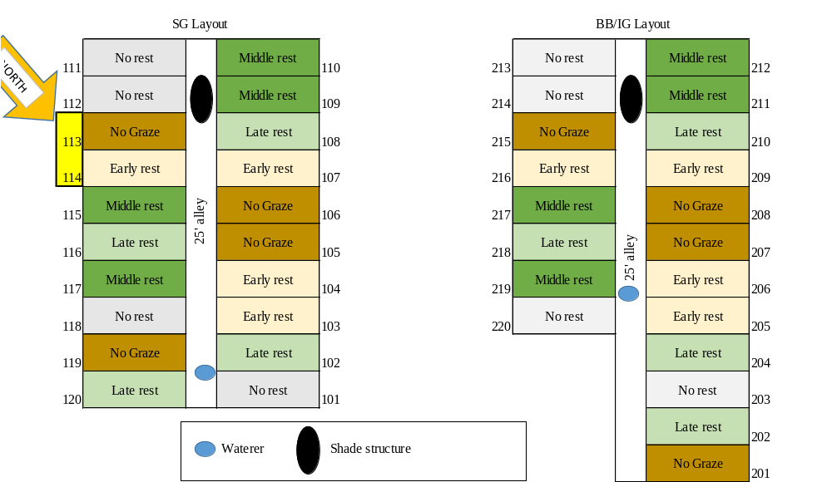
Figure 3: Experimental Layout of biodiversity grazing trial. SG indicates paddocks planted in switchgrass, BB/IG indicates paddocks planted in big bluestem and indiangrass, water and shade structures are provided for cattle, north arrow represents true north, each paddock has a unique number ID, and grazing treatments are indicated by color and labeled accordingly.

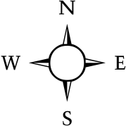
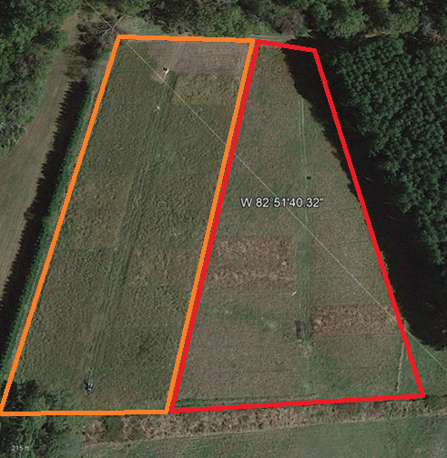
Figure 4: Aerial image of biodiversity grazing trial experimental site. The slope runs downward NW to SE with the SE side approaching toeslope. The area planted in switchgrass is outlined in orange and the area planted in bigbluestem/indiangrass is outlined in red (Google Earth Pro, 2022).

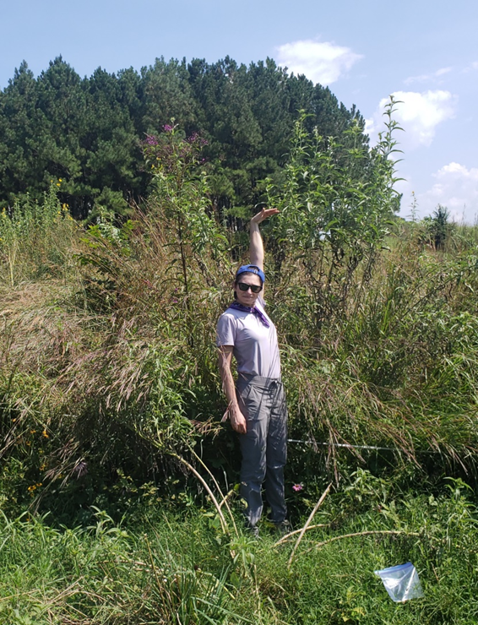
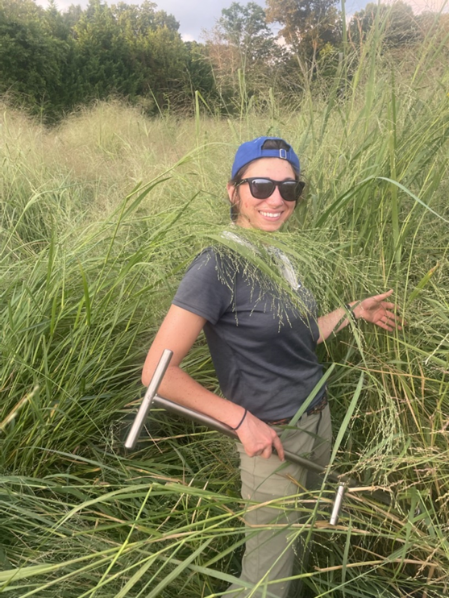
Figure 5: Post-graze no gaze paddock biomass for switchgrass and big bluestem/indiangrass mix. Left: Switchgrass no graze paddock, post-graze (Photo by Daniel Sain). Right: Big bluestem/indiangrass no graze paddock, post-graze (Photo by Alexis Gillmore).
Table 2: Soil quality indicators analyzed and the information they contribute to the study.
Indicator | Provides information about:
Wet Aggregate Stability (WAS) | Exudates and stable C, erodibility
Gravimetric Water Content (%) | Soil water content by mass or volume
Microbial Biomass Carbon (MBC) flush (µgC/g) | Quantifies soil microbes by mass or volume
Permanganate Oxidizable Carbon (POxC) (mg/kg) | Labile C (rapidly cycling carbon)
Bulk Density (BD) (g/cm³) | Pore structure and compaction, OM
Total Organic Carbon (TOC) (%) | C sequestration
Depth To Compacted Layer (cm) | Areas of ponding and root restriction
Soil Color (Munsell) | OM and mineral content, redox status

Labile carbon relates to the ability of soil to form stable aggregates (Culman et al., 2012). Stable soil aggregates indicate a high concentration of microbial and plant exudates and healthy plant biomass, protected stable carbon, and reduced loss of soil to erosion. Gravimetric water content indicates the ability of the soil to infiltrate and hold water. Bulk density and depth to compacted layer were measured to determine whether there are differences between paddocks and along the slope. Total organic carbon is the ultimate indicator that SQIs are proxies for, with an increase in TOC being desirable to build soil resilience. The pasture has been under native grasses since 2008 so it is likely that total carbon has begun to measurably increase.
Sample Collection
For samples that were to be analyzed for SQIs each composite sample was comprised of 10-15 soil cores to a depth of 7.5 cm, collected in a “W” pattern in paddocks using a soil probe with a 1.86-cm diameter. Cores were collected within 30-cm of a bunchgrass to standardize sampling. Bare spots were avoided. Each core was placed into an 18.9-liter (5 gallon) bucket which was cleaned with a paper towel between paddocks to avoid sample cross contamination. Once 10-15 cores were collected, the cores were gently broken up and homogenized in the bucket before being bagged and sealed in an appropriately labeled sample bag. Samples were placed in a cooler to avoid light exposure and to limit microbial processes.

Samples for SQIs were taken in the 2021 NWSG grazing season; pre and post-graze except for BD and penetrometer readings which were only taken during the post graze period. In May 2021, before grazing was initiated, samples from all treatments were collected and analyzed for MBC by chloroform fumigation-extraction (CFE) and microBIOMETER®, WAS, POxC, and gravimetric water content. In August 2021, after grazing was concluded, samples were collected for repeat analysis of the aforementioned SQIs. During fall 2021 bulk density to a depth of approximately 7.5-cm was determined to look for differences across the pasture and between experimental units. Depth to compacted layer was determined near each bulk density sample. Bulk density cores were collected post graze, five times per plot in two plots per grazing pressure per vegetation species, in a straight, centered line down slope. Five readings within 30-cm of the bulk density core location were taken per core to determine depth to compacted layer except in some of the BBIG paddocks where time was limiting and there was consistently no compacted layer.
To determine SOM content, soil samples to a depth of 5-cm were collected in June 2018, September 2020, and January 2022 from the no graze and no rest treatments. Four soil cores were pooled per paddock. In 2018, two depths, A = 0-15 cm, and C = 16-30 cm, were analyzed for pH, buffer, and Mehlich 1 phosphorus, potassium, calcium, boron, copper, iron, manganese, sodium, and zinc.

Methods of Analysis
Total Organic Carbon and Soil Chemistry
Samples were analyzed by the UT Soil, Plant and Pest Center in Nashville, TN in 2018. Values for TOC were determined by loss on ignition where the conversion factor of 1.724 assumes that SOM is 58% carbon (Pribyl, 2010). Phosphorus, potassium, calcium, boron, copper, iron, manganese, sodium, and zinc were measured by inductively coupled plasma mass spectroscopy (ICP-MS) using the Mehlich 1 double-acid extraction.
Permanganate Oxidizable Carbon
Samples were analyzed using a procedure that is similar to that of the active carbon method described by Weil et al. (2003). Duplicate 2.5-gram subsamples of soil sieved to 2-mm were air dried. Potassium permanganate reacts with oxidizable carbon and manganese VII is reduced to manganese II, which lowers its characteristic wavelength of absorbed light below the Mn (VII) characteristic wavelength of 550nm (Weil et al., 2003). A spectrophotometer is used to determine the concentration of remaining manganese that absorbs 550nm light, and carbon oxidized is proportional to the amount of permanganate reduced (Weil et al., 2003).
Wet Aggregate Stability
Wet aggregate stability was determined using an Eijkelkamp wet sieving apparatus (Giesbeek, The Netherlands) using the procedure adapted from the manufacturer. Sample preparation was to shake the naturally occurring < 2-mm fraction of soil through a 2-mm sieve and air-dry samples for at least 12 hours, with no pre-wetting due to hydrophobicity of samples (a procedural adaptation specific to this study). Labeled steel cans for unstable and stable soil were weighed. Four grams of dry soil were placed into the 0.25-mm sieves of the apparatus and wet sieved in 75-mL (volume experimentally determined to be sufficient for this soil) distilled water for 5 minutes (Figure 6). Cans of unstable soil solution were moved to an oven. Remaining stable soil in the sieves were wet sieved in 80-mL (volume determined for this soil) 0.05 M NaOH for 15 minutes (time experimentally determined to deflocculate this soil), agitated while out of solution using rubber tubing, and wet sieved an additional 5 minutes (time and method adapted for this soil). All cans were oven dried at 105°C until water fully evaporated, then weighed. Stable soil masses were corrected for mass of NaOH. Percent wet aggregate stability is equal to ((mass of stable soil)/ (mass of stable soil + mass of unstable soil))*100.
Gravimetric Water Content
Gravimetric water content was determined by drying a known mass of field moist soil sieved to 2-mm at 105 °C for 24 hours and weighing the dry soil. Gravimetric water content is equal to ((mass of field moist soil – mass of dry soil)/mass of dry soil)*100.
Microbial Biomass Carbon
Microbial biomass carbon was determined using chloroform fumigation-extraction (CFE) with triplicate samples followed by infrared gas analyzer (IRGA) CO₂ analysis and by use of a new test, soil microBIOMETER®. The procedure for CFE was adapted from Fierer (2003). Sample preparation for CFE was to sieve samples to 2-mm within a day of collection, and freeze at -20° C.
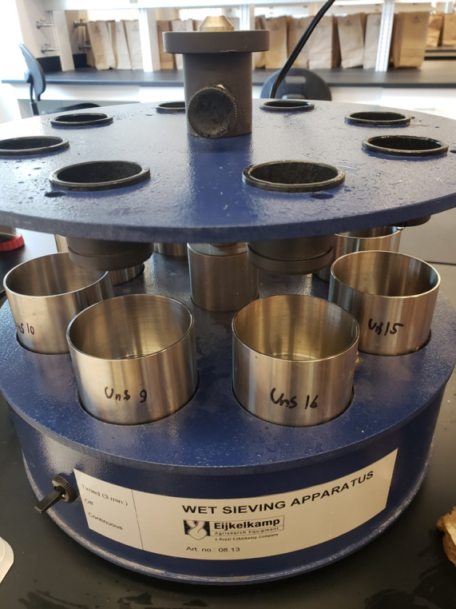
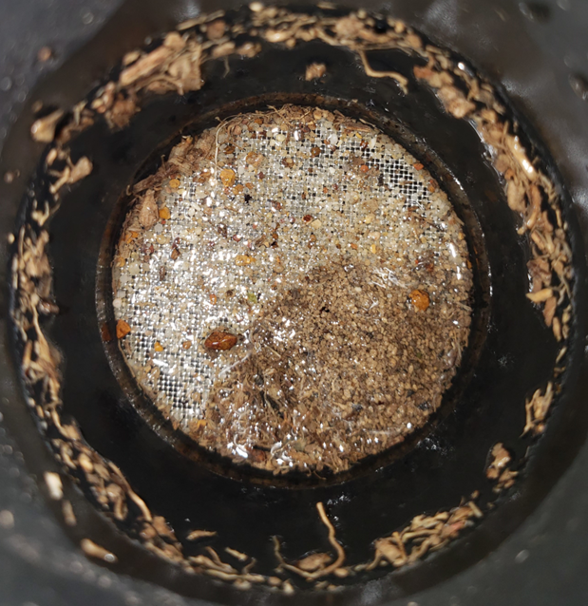
Figure 6: Eijkelkamp wet aggregate stability analysis unit. Left: Sand and organic matter left in sieve of wet sieving apparatus after sieving. Right: Eijkelkamp wet sieving apparatus (Photos by Kara Grosso).

Samples were thawed either at room temperature for 8 hours or in an 8°C refrigerator for 3 days before analysis. Extraction jars were labeled accordingly, then five (pre-graze period) or ten (post-graze period) grams of soil (depending on available soil frozen) per jar was added to six jars per sample. Tools were disinfected between samples. A solution of 0.5-M K₂SO₄ was prepared. Forty or twenty mL of K₂SO₄ (depending on mass soil used) was dispensed into all jars and 0.5-mL of CHCl₃ was added to 3 of the 6 subsamples for each sample. Jars were capped and shaken at 160 RPM for 4 hours. After shaking, the soil slurry settled overnight. A vacuum manifold was used to filter the supernatant through Whatman GF/B filter paper into 50-mL centrifuge tubes (Figure 7). Extracts containing chloroform were air-bubbled for 25 minutes to remove any remaining chloroform. The extracts were frozen at -20 °C until carbon oxidation and analysis. The extracts were oxidized using a potassium persulfate reagent at 80°C overnight. Oxidized carbon collected in the headspace of sealed vials, and 0.5-mL of the gas was injected into a LI-COR IRGA, which determined ppm CO₂. The IRGA readings were calibrated by oxidizing known concentrations of potassium hydrogen phthalate (KHP) with the unknown samples, and these standards were used to build a calibration curve. Measurements taken from unknown sample vials were corrected using the calibration curve. The data output is referred to as MBC flush and is calculated by the equation:
$$MBC Flush= \frac{(STD Adjusted Fumigated-STD Adjusted Unfumigated ppm CO_{2})(Volume 0.5M K_{2}SO_{4}, L)}{(Soil mass, g(1-Soil water content,\frac{g}{g})}$$
(Dr. Sean Schaeffer, personal communication, 2022).
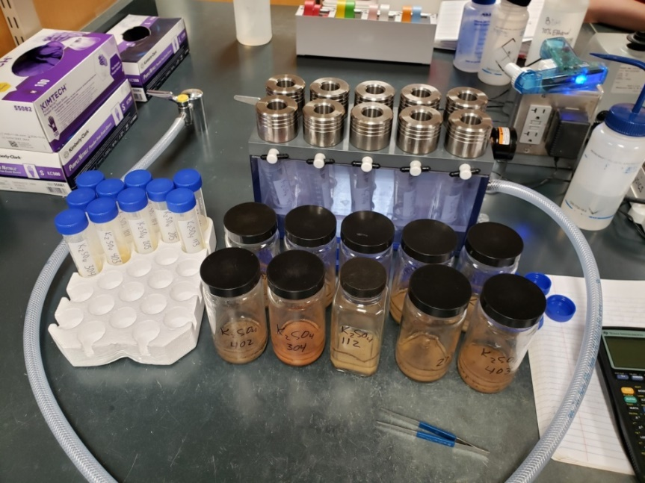
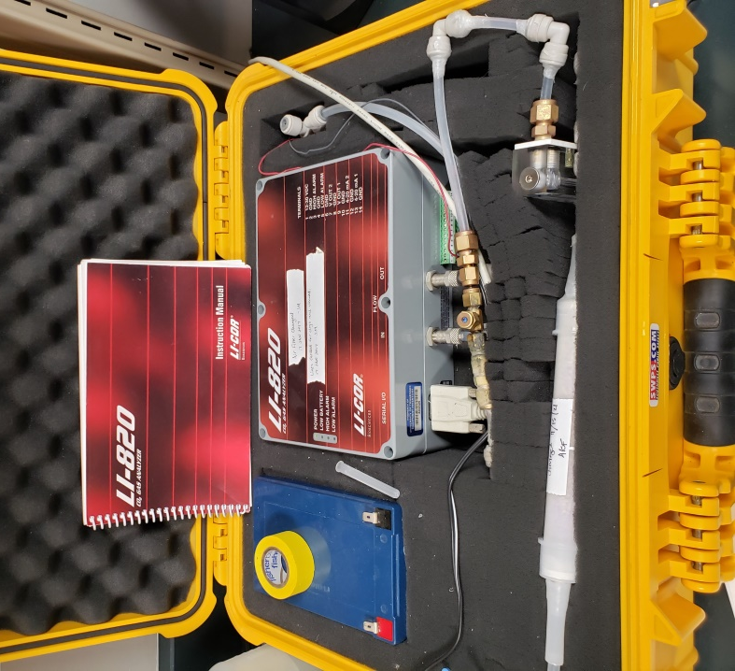
Figure 7: Chloroform fumigation-extraction vacuum extraction manifold (top) and LI-COR infrared gas analyzer (bottom) (Photos by Kara Grosso).

Soil microBIOMETER® sample preparation was to sieve field moist samples to 2-mm and fill a syringe to 1-mL with the sieved soil. Soil in the syringe was then compacted to 0.5-mL, removing excess with a spatula. The provided extraction powder (proprietary calcium and potassium salt) was added to a test tube along with 9.5-mL of water. The solution was whisked for 5 seconds before adding the 0.5-mL of soil; then the solution was whisked an additional 30 seconds. The test tube was left to settle for 5 minutes, and then tapped 4 times on a hard surface to break the surface tension of unsettled material. After 15 additional minutes of settling, a pipet was used to draw solution from the top half inch of the test tube. Three drops were applied to a card with a gray scale (Figure 8) and the card was imaged using a Samsung Galaxy S9 cell phone camera with flash. The data output is μg C/g soil and fungi to bacteria ratio.
Bulk Density
Bulk density was determined by using a soil probe with a diameter of 17.4-mm to take five individual cores per paddock; top slope, midpoint between top and mid-slope, mid-slope, midpoint between mid-slope and bottom slope, and bottom slope, to approximately 7.5-cm, with the exact length of core measured each time to the nearest millimeter. Each sample was weighed, oven dried at 105°C for 24 hours, and reweighed (to include a gravimetric water content determination). Bulk density is equal to mass of dry soil/volume of field moist soil (g/cm³).

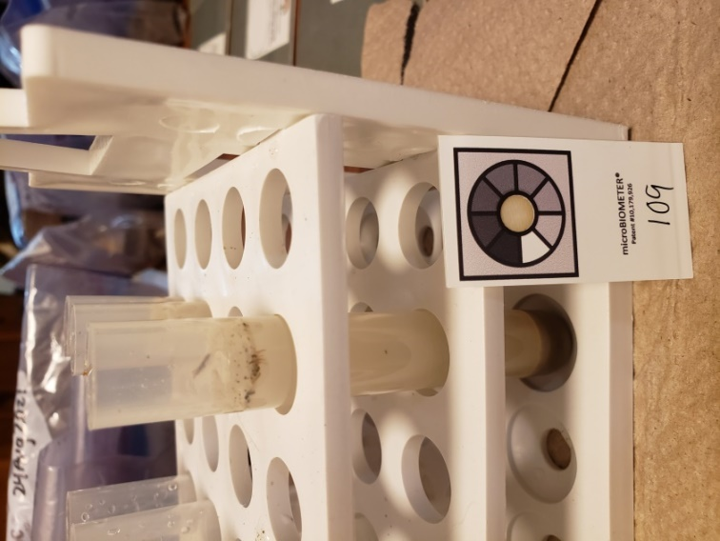
Figure 8: Soil microBIOMETER® test. Left: Drops being added to Soil microBIOMETER® grayscale card on provided green background. Right: Soil microBIOMETER® test tube with settled soil (Photos by Kara Grosso).

Depth to Compacted Layer
Penetration resistance data was obtained using an Agratronix® soil compaction tester (Streetsboro, OH). A reading was taken 5 times per BD sample, within 30-cm of the BD sample, to determine depth in cm to exceed 300 PSI. The maximum depth measurable by the instrument was 68.5-cm.
Limitations
A confounding effect arises from sample timing. Ideally, the soil would be sampled after each of the three rest periods, but time was a limiting factor. Soil quality indicators may fluctuate as time passes since paddocks have been grazed. Compaction and differences in soil properties due to differences in slope location may be limitations to this study. Conversely, the slope of the pasture may prove to be valuable as a critical zone examination of the grazing systems (Yoder et al., 2021) because all systems have inherent variability. Samples for BD are increasingly accurate when a representative volume is sampled, and core edge effects are minimized. Therefore, BD values may have sampling error due to using a soil probe to pull samples, making them comparative in this study but not accurate readings due to core compaction.
Statistical Analysis
The statistical analysis of continuous response variables is analysis of variance (ANOVA) at the 90% confidence interval (α= 0.10) using SAS 9.4. The linear additive model is:
X_{ijk} = µ + A_{i} + B_{j} + AB_{ij} + R_{k} + +E_{ik} + E_{ijk} where:
Xijk = SQI observation receiving the ith plant species and the jth grazing pressure in the kth replication, µ = the true population mean SQI value, Ai = the effect of the ith plant species, Bj = the effect of the jth level of grazing pressure, ABij = the interaction effect of the ith plant species and the jth level of grazing pressure, Rk = the effect of the kth replication, Eik = random error associated with the ith species and the kth replication (error A) and Eijk = random error associated with the ijkth observation (error B). Treatment A (vegetation species)* treatment B (grazing pressure)* replications (4) = 2 x 5 x 4 = 40 observations. Vegetation species were whole plots and grazing management were sub-plots. Due to the expectation that replication effect would differ among whole plots (vegetation species), replication within vegetation species mix was nested for the ANOVA (rep(species)), which was considered error A. A separate F test was conducted for the effect of species using the nested command (error A), which differs from the main ANOVA table and is the true Pr > F for the effect of species. Soil quality indicators per paddock for the 2021 pre and post-graze periods, and change in parameters from the 2021 pre to post-graze periods were analyzed using ANOVA. Differences were statistically analyzed to determine whether the treatments effected the changes. Table 3 and 4 show sources of variation and degrees of freedom for the ANOVA performed on SQIs and BD data. The class “newcode” was used to force the SAS 9.4 software to do means separation on the interaction effect of vegetation species and grazing pressure. Duncan’s multiple range test was used to compare means at the 0.1 probability level.

Table 3: ANOVA sources of variation and degrees of freedom (DF) for soil quality indicators.
Source of Variation | DF
A (Species) | a-1 = 1
B (Grazing) | b-1 = 4
A*B | (a-1)(b-1)=4
Error A (rep(species)) | 6
Error B | 24
Total: | 39

Table 4: ANOVA sources of variation and degrees of freedom (DF) for bulk density.
Source of Variation | DF
A (Species) | 1
B (Grazing) | 4
A*B | 4
Error A (rep(species) | 18
Error B | 63
Newcode | 9
Total: | 99

Results and Discussion
A series of tables and figures summarize the results of soil quality analyses and treatment effects. Table 5 shows spatial and temporal differences in soil quality parameters due to treatment when α = 0.1. Tests for vegetation species effect were done using rep(species) as error A unless indicated as “no nested effect” (NNE). Soil quality indicators are gravimetric water (n=40), WAS (n=40), MBC using soil microBIOMETER® (n=40) and CFE (n=40), POxC (n=40), BD (n=100), TOC (n=45). Gravimetric water, WAS, MBC, and POxC were analyzed over every paddock, BD was analyzed in two paddocks per species per grazing pressure, and TOC was analyzed in each NR and NG pasture. “Change” represents differences in soil quality parameters pre to post-graze (May-September 2021), “Pre” represents the pre-graze period (May 2021), and “post” represents the post graze period (September 2021).
Percent water by mass, WAS, MBC using soil microBIOMETER® and CFE, POxC, BD, and depth to compacted layer had significant differences due to grazing treatment, vegetation species, or their interaction. All soil quality parameters changed during the 2021 grazing season, with trends in which parameters increased and which decreased (Figure 9). A significant increase in TOC was not detected over the 4 year period, but values were trending towards increase. A series of figures showing means separation for significant results during each time period is followed by a discussion of the data. The BBIG paddocks had better overall soil quality and a continuous graze approach to NWSG pasture management for the warm-season is sustainable in terms of soil quality at the stocking rate used for this study. More work is needed to test stocking density and stand sustainability.
Table 5: Summary of spatial and temporal differences in soil quality indicators during the 2021 grazing season due to treatment when α = 0.1. Tests for vegetation species effect were done using rep(species) as error A unless indicated as “no nested effect” (NNE). Soil quality indicators are gravimetric water (n=40), wet aggregate stability (WAS)(n=40), microbial biomass carbon (MBC) by soil microBIOMETER® (n=40) and chloroform fumigation extraction (CFE)(n=40), permanganate oxidizable carbon (POxC)(n=40), bulk density (BD)(n=100), and total organic carbon (TOC)(n=45). Gravimetric water, WAS, MBC, and POxC were analyzed over every paddock, BD was analyzed in two paddocks per species per grazing pressure, and TOC was analyzed in each NR and NG pasture. “Change” represents differences in soil quality parameters pre to post-graze (May-September 2021), “Pre” represents the pre-graze period (May 2021), and “post” represents the post graze period (September 2021). Treatments are grazing management (GM), vegetation species (VS), and the interaction of vegetation species and grazing management (VS*GM). Significant differences are indicated by “yes” and insignificant differences are indicated by “no”. Significant effects noted by an asterisk* denote instances vegetation species is significant when tested with no nested effect (NNE). Probabilities for TOC represent Type III SS.
Time | Indicator | Treatment | Pr > F | Significant (α = 0.1)
Change | Gravimetric Water | GM  VS  VS NNE  VS*GM | 0.0726  0.5025  0.2817  0.3531 | Yes  No  No  No
Change | WAS | GM  VS  VS NNE  VS*GM | 0.1761  0.3539  0.1021  0.4469 | No  No  No  No
Table 5 Continued
Time | Indicator | Treatment | Pr > F | Significant (α = 0.1)
Change | MBC CFE | GM  VS  VS NNE  VS*GM | 0.5828  0.0837  0.1515  0.8030 | No  Yes  No  No
Change | MBC microBIOMETER® | GM  VS  VS NNE  VS*GM | 0.1136  0.1577  0.0459  0.4709 | No  No  Yes*  No
Change | POxC | GM  VS  VS NNE  VS*GM | 0.1161  0.3046  0.1916  0.5481 | No  No  No  No
Pre | Gravimetric Water | GM  VS  VS NNE  VS*GM | 0.2261  0.6542  0.6204  0.2599 | No  No  No  No
Pre | WAS | GM  VS  VS NNE  VS*GM | 0.0585  0.2450  0.0761  0.2007 | Yes  No  Yes*  No
Pre | MBC CFE | GM  VS  VS NNE  VS*GM | 0.4116  0.0120  0.0081  0.6657 | No  Yes  Yes*  No
Pre | MBC microBIOMETER® | GM  VS  VS NNE  VS*GM | 0.1494  0.0090  <0.0001  0.1509 | No  Yes  Yes*  No
Pre | POxC | GM  VS  VS NNE  VS*GM | 0.1451  0.0097  0.0002  0.3574 | No  Yes  Yes*  No
Post | Gravimetric Water | GM  VS  VS NNE  VS*GM | 0.0261  0.6555  0.4339  0.0424 | Yes  No  No  Yes
Table 5 Continued
Time | Indicator | Treatment | Pr > F | Significant (α = 0.1)
Post | WAS | GM  VS  VS NNE  VS*GM | 0.0432  0.0677  0.0032  0.6653 | Yes  Yes  Yes*  No
Post | MBC CFE | GM  VS  VS NNE  VS*GM | 0.8189  0.0374  0.0783  0.4781 | No  Yes  Yes*  No
Post | MBC microBIOMETER® | GM  VS  VS NNE  VS*GM | 0.2367  0.0307  0.0079  0.7285 | No  Yes  Yes*  No
Post | POxC | GM  VS  VS NNE  VS*GM | 0.3802  0.0079  0.0014  0.1544 | No  Yes  Yes*  No
Post | Bulk Density | GM  VS  VS NNE  VS*GM | 0.1545  0.0010  0.0016  0.0114 | No  Yes  Yes*  Yes
Post | Penetrometer | VS | <0.0001 | Yes
June 2018-January 2022 | TOC | GM  VS  VS NNE  VS*GM  Year | 0.1961  0.0031  <0.0001  0.2399  0.4589 | No  Yes  Yes*  No  No

Figure 9: Mean values of soil quality indicators pre-graze (May 2021) to post-graze (September 2021) among vegetation species (big bluestem/indiangrass (BBIG) and switchgrass (SG)) and grazing treatments (early, middle, late rest (ER, MR,LR), no rest (NR), no graze (NG)). Change values above zero represent an increase and values below zero represent a decrease.
Change From 2021 Pre to Post-graze Period
When changes in soil quality indicators from the 2021 pre to post-graze period were analyzed, there were general trends of which parameters increased and decreased. Gravimetric water content, WAS, and POxC increased on average while MBC measured using both CFE and microBIOMETER® decreased on average (Figure). The only changes that were significant and caused by the treatments were gravimetric water content (due to grazing treatment) and MBC CFE (due to vegetation species).
Change in gravimetric water content pre to post-graze due to grazing pressure was significant (Pr > F = 0.0726) (Figure 10), and when rep(species) was used as an error term, the effect of vegetation species was not significant (Pr > F = 0.5025). The NG paddocks had the greatest increase in gravimetric water content. This was attributed to the significant above ground biomass accumulated due to lack of grazing preventing soil from drying. Early rest also had a significant increase in gravimetric water content which has a less clear explanation. No rest paddocks had the least increase in gravimetric water content throughout the grazing season.
Change pre to post-graze in MBC flush measured by CFE was significant due to vegetation species treatment (Pr > F = 0.0837). Soil microBIOMETER® did not detect this change as significant due to treatment. The BBIG paddocks had a larger decrease in MBC as measured by CFE pre to post graze than the SG paddocks (Figure 10). Greater temporal decrease in MBC for BBIG than SG paddocks raises a question of why this occurred. The BBIG pasture had greater plant community diversity than the SG pasture, and this difference in diversity may affect microbial activity during the late summer when the decrease in MBC occurred.
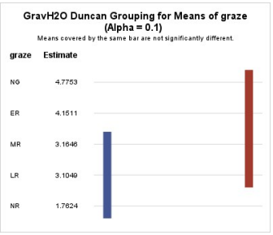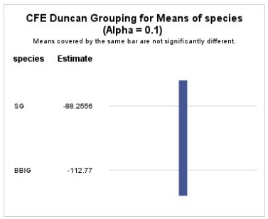
Figure 10: Means separation for change pre to post-graze in gravimetric water content (GravH2O) and microbial biomass carbon (MBC) measured using chloroform fumigation-extraction (CFE). Top: Change in GravH2O among grazing treatments (early, middle, and late rest (ER, MR, LR), no rest (NR), and no graze (NG). Bottom: Change in MBC using CFE among vegetation species switchgrass (SG) and big bluestem/indiangrass (BBIG). Change was significant only with rep(species) tested as the error term; means separation does not show a difference. BBIG MBC decreased more than SG MBC (Pr > F = 0.0837).
Pre-graze Sample Period
Pre-graze WAS was affected by grazing pressure (Pr > F = 0.0585) (Figure 11). This effect was residual from previous grazing seasons, indicating that warm-season grazing pressure has an impact on soil structure that lasts at least 9 months. The NR and NG paddocks had the highest WAS during the pre-graze period and were not different from each other (Figure 11). The three rest periods did not differ from each other. No rest may improve soil structure by altering nutrient cycling and microbial communities (Franzluebbers et al., 2009), while no graze may improve soil structure by increasing soil water content, as the two were found to be moderately correlated. Further research is needed to determine the true cause.
Pre-graze MBC measured by microBIOMETER® was affected by vegetation species (Pr > F = 0.0090). Pre-graze MBC flush determined by CFE also found a significant difference due to species (Pr > F = 0.0120) but not due to grazing pressure. This difference (Figure 12) was detected early in the growing season (May) and may be influenced by vegetation community diversity. The BBIG pasture was more diverse than the SG pasture, with more of the inter-seeded species being successful and having a mix of two native grasses. Whether determined by soil microBIOMETER, CFE, pre, or post-graze, the BBIG pasture consistently had higher MBC than the SG pasture, regardless of grazing pressure. Pre-graze POxC was affected by vegetation species (Pr > F = 0.0097) with BBIG having more biologically active soil carbon (Figure 13).
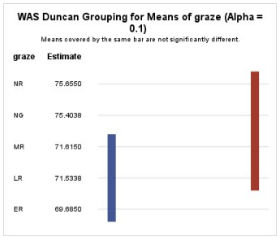
Figure 11: Means separation of pre-graze wet aggregate stability (WAS) among grazing treatments (no rest (NR), no graze (NG), early, middle, and late rest (ER, MR, LR)). Pre-graze WAS was affected by grazing pressure (Pr > F = 0.0585).

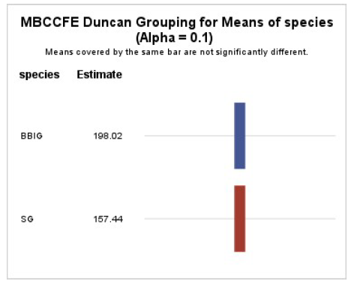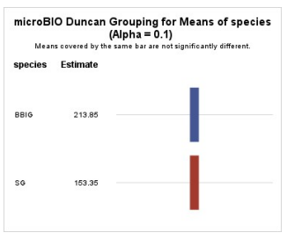
Figure 12: Pre-graze means separation for microbial biomass carbon (MBC) measured using chloroform fumigation-extraction (CFE) and soil microBIOMETER®. Top: Means separation of pre-graze MBC flush determined using CFE (Pr > F = 0.0120) among vegetation species big bluestem/indiangrass (BBIG) and switchgrass (SG). Bottom: Means separation of pre-graze MBC determined by microBIOMETER® among vegetation species BBIG and SG (Pr > F = 0.0120).
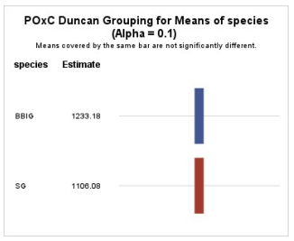
Figure 13: Means separation of pre-graze permanganate oxidizable carbon (POxC) among vegetation species big bluestem/indiangrass (BBIG) and switchgrass (SG). (Pr > F = 0.0097).

Post-graze Sample Period
Vegetation species and grazing pressure effected post-graze wet aggregate stability (Pr > F = 0.0677 and 0.0432). Post-graze gravimetric water content was effected by grazing pressure and the interaction of species and grazing pressure (Pr > F = 0.0261, 0.0424) (Figure 14). All NG paddocks were shaded by 6-8 feet of biomass which prevented the soil surface from receiving direct sunlight and airflow, slowing evaporation. The NG SG paddocks were particularly thick with vegetation. It bears repeating that the SG biomass was dominated by SG and the inter-seeded native biodiversity mix was not successful in this stand of SG. Soil water content that remains close to field capacity long term is not always ideal due to various biological and chemical interactions that are outside the scope of this research. The high soil water content improved soil structure and sustained biomass production. For the purpose of this research, the high soil water content measured in NG paddocks demonstrates the alternative to soil conditions under various grazing pressures, which were not undesirable. Post-graze WAS was affected by vegetation species (Pr > F = 0.0677) and grazing pressure (Pr > F = 0.0432)(Figure 15).
Post-graze MBC measured by microBIOMETER® was affected by vegetation species (Pr > F = 0.0307), and post-graze MBC measured by CFE was affected by vegetation species (Pr > F = 0.0374) (Figure 16). Neither microBIOMETER® nor CFE determined a significant difference in post-graze MBC due to grazing pressure, and both methods determined the mean MBC to be higher in BBIG paddocks than in SG paddocks. Post-graze POxC was affected by vegetation species (Pr > F = 0.0079) with BBIG having more biologically active soil carbon (Figure 17).
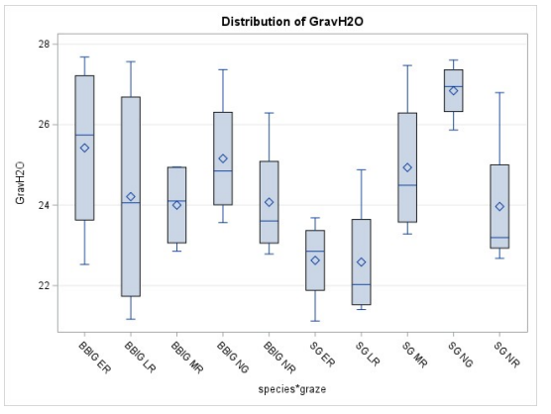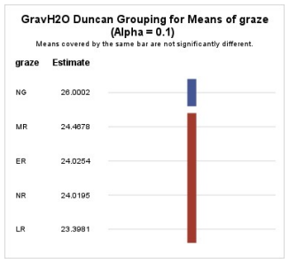
Figure 14: Post graze gravimetric water content (GravH2O) distribution and means separation. Top: Distribution of post-graze GravH2O by species (big bluestem/indiangrass (BBIG) and switchgrass (SG)) and grazing pressure (early, middle, and late rest (ER, MR, LR), no rest (NR) and no graze (NG)) interaction (Pr > F = 0.0424).Bottom: Means separation of post-graze GravH2O by grazing pressure (Pr > F = 0.0261).
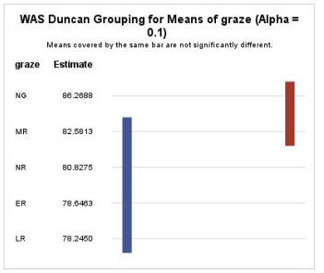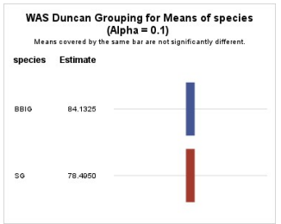
Figure 15: Post-graze means separation for wet aggregate stability (WAS) among grazing treatments and vegetation species. Top: Means separation of post-graze WAS among grazing pressure (no graze (NG), middle rest (MR), no rest (NR), early rest (ER), and late rest (LR)) (Pr > F = 0.0432). Bottom: Means separation of post-graze WAS among vegetation species big bluestem/indiangrass (BBIG) and switchgrass (SG) (Pr > F = 0.0677).
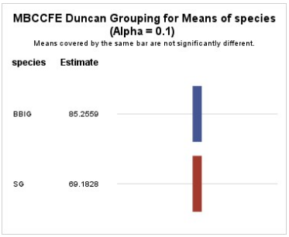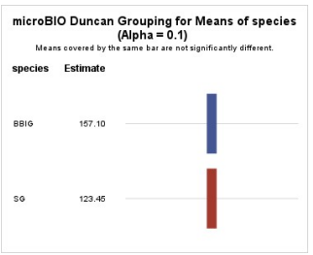
Figure 16: Post-graze means separation for microbial biomass carbon (MBC) using chloroform fumigation-extraction (CFE) and microBIOMETER® (microBIO) among vegetation species (big bluestem/indiangrass (BBIG) and switchgrass (SG). Top: Means separation of post-graze MBC measured using CFE among vegetation species (Pr > F = 0.0374). Bottom: Means separation of post-graze MBC using microBIO among vegetation species (Pr > F = 0.0307). Physical soil quality indicators (WAS and gravimetric water content) were sensitive to grazing management, while MBC and POxC were sensitive to vegetation species.
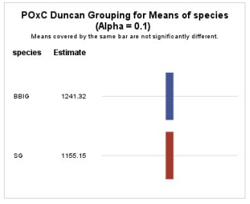
Figure 17: Distribution and means separation of post-graze permanganate oxidizable carbon (POxC) among species (big bluestem/indiangrass (BBIG) and switchgrass (SG)). Pr > F = 0.0079.

Microbial biomass carbon and labile carbon are both fractions of SOM, indicating that SOC is more strongly influenced by vegetation species than grazing management in this system.
Bulk density was affected by vegetation species (Pr > F = 0.0010) (Figure 18) and the species*graze interaction (Pr > F = 0.0114) (Figure 19). Bulk density did differ due to slope position which would appear in the data as a difference due to vegetation species. The BBIG paddocks were located near toeslope and the SG paddocks were located midslope. The potential soil erosion that may have occurred over the entire slope when the pasture was in tobacco may have moved a portion of the A horizon downslope, carrying finer soil particles and organic matter. While this may account for some differences in SQI among vegetation species, bulk density did not differ enough to dismiss differences in SQI as a result of slope position. This finding supports a future determination of whether slope position caused improved soil quality downslope which appeared as BBIG affects.
Depth to compacted layer was significantly different among species which may also mean among slope position (midslope vs toeslope) (Pr > F = < 0.0001) (Figure 20). The mean penetrometer reading for depth to compacted layer for SG was 29.2-cm with a standard deviation of 15.1-cm and a standard error of 2.0-cm (n=60). The mean penetrometer reading for depth to compacted layer for BBIG was 54.7-cm with a standard deviation of 9.1-cm and standard error of 1.8-cm (n=25). There are several possibilities for explaining this difference. First, readings were taken at two time points with different soil water contents. SG readings were taken when soil water content by mass was approximately 24% and BBIG readings were taken when soil water content by mass was approximately 29%.
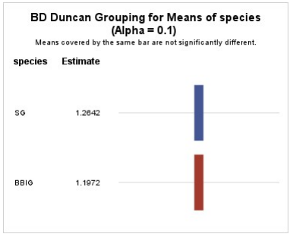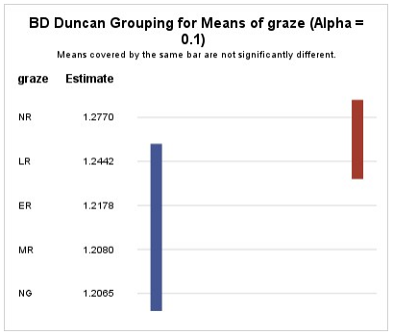
Figure 18: Bulk density as affected by vegetation species (switchgrass (SG) and big bluestem/indiangrass (BBIG)) and grazing pressure (no graze (NG), middle rest (MR), no rest (NR), early rest (ER), and late rest (LR)). Top: Means separation of bulk density as affected by species. Bottom: Means separation of bulk density as affected by grazing pressure.

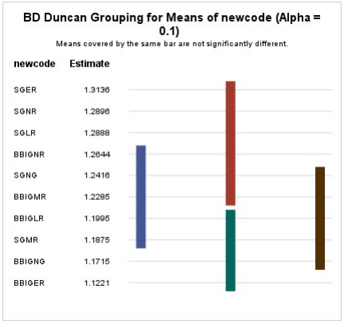
Figure 19: Means separation of bulk density (BD) among species-grazing pressure interactions (big bluestem/indiangrass (BBIG) and switchgrass (SG)) (early rest (ER), late rest (LR), middle rest (MR), no rest (NR), no graze (NG)). Pr > F = 0.0114. The “newcode” technique forces SAS software to do means separation for an interaction effect by giving each treatment its own code.

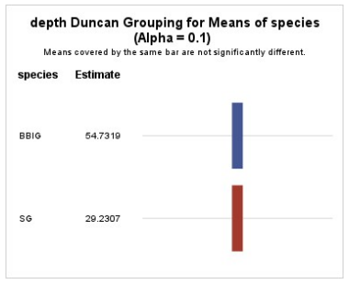
Figure 20: Depth to compacted layer in centimeters among big bluestem/indiangrass (BBIG) and switchgrass (SG) portions of the NWSG pasture.

Penetrometer readings are generally higher and most accurate at field capacity. Another potential explanation is a combination of previous management and erosion. It is possible that a road for farm equipment once existed on the area that is now SG paddocks. It is also possible that the B horizon has become exposed as the A horizon eroded down slope. This could also contribute to differences in organic matter content along the slope.
To determine soil color, two samples from SG and two from BBIG were used. Samples from SG were determined to be 10YR 4/4 (dark yellowish brown) and soils from BBIG were determined to be 10YR 3/3 (dark brown). Darker soil suggests more SOM. Darker soil was consistently observed when sampling BBIG paddocks.
When tested with rep(species) as the error term, the most significant difference in TOC over all years analyzed was caused by species with Pr > F = 0.0031 (Figure 21). Grazing treatment was not a significant effect when α = 0.1 and the type III sum of squares was used (Pr > F = 0.1961). Values of TOC were not different between NR and NG within species. It is possible that given more time, the effect of grazing pressure will become significant. The TOC did not differ across the pasture by year, but is trending toward increasing (Figure 22). It did not differ by year within BBIG and SG (Figure 23) though BBIG had higher TOC each year. The BBIG pasture had higher TOC regardless of grazing pressure (Figure 24).

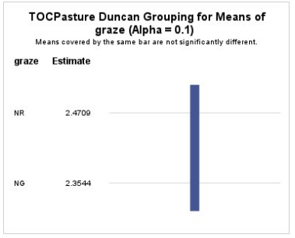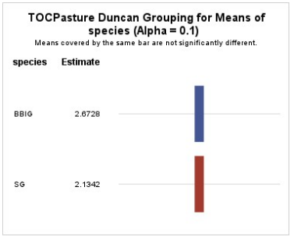
Figure 21: Means separation of total organic carbon (TOC) among grazing pressure and vegetation species for the combined years of 2018, 2020, and 2022. Top: Means separation of TOC among grazing management (no rest (NR) no graze (NG))(not significant). Bottom: Means separation of TOC among vegetation species (big bluestem/indiangrass (BBIG) and switchgrass (SG)).
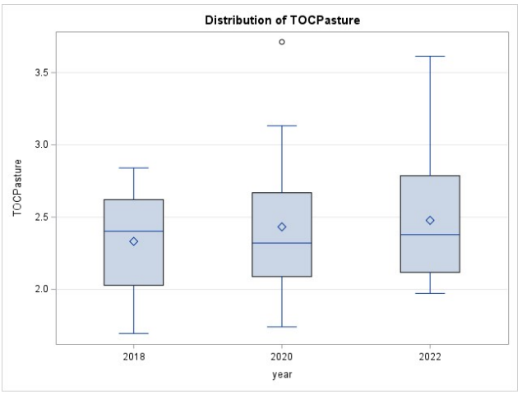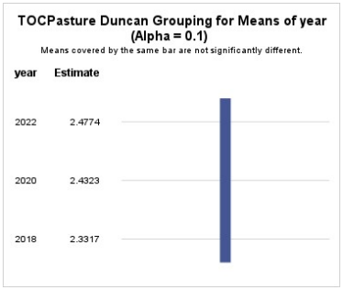
Figure 22: Distribution and means separation of total organic carbon (TOC) values across the pasture for years 2018, 2020, and 2022. Top: Distribution and Bottom: means separation of TOC values for the years 2018, 2020, and 2022.

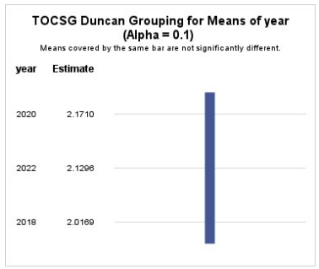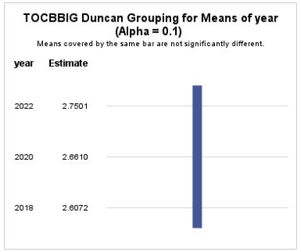
Figure 23: Total organic carbon (TOC) distribution by year in switchgrass (SG) pasture (top) and big bluestem/indiangrass (BBIG) pasture (bottom).
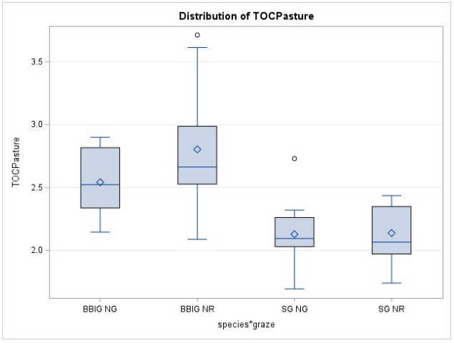
Figure 24: Distribution of total organic carbon (TOC) across the pasture among species and grazing interaction. Values were not different between no rest (NR) and no graze (NG) within species.

Correlation Matrices for SQIs
Correlation is not causation but it can indicate a relationship if variables are responding to a common set of conditions (Dr. Dennis West, personal communication, 2021). The correlation coefficient can subjectively be assigned and arbitrary “strength” of correlation. For the purpose of this study, a correlation of 0-0.39 is weak, 0.40-0.60 is moderate, and > 0.61 is a strong correlation.
Pre-graze, CFE and microBIOMETER® had a weak correlation where r=0.324 however post-graze there was no correlation between CFE and microBIOMETER®. Pre-graze, CFE and WAS had a weak correlation where r=0.394 however post-graze, there was no correlation. Chloroform fumigation-extraction and POxC had a weak pre-graze correlation where r=0.30 but this correlation did not occur post graze. Pre-graze, microBIOMETER® had a weak correlation with WAS where r=0.35 but this correlation did not occur post-graze. Pre-graze, microBIOMETER® correlated weakly with POxC with r=0.30 but this correlation did not occur post-graze (Figure 25). Gravimetric water content and WAS correlated moderately pre-graze (r=0.52) and post graze (r=0.53). Post-graze, gravimetric water content and POxC had a weak correlation where r=0.31 however this correlation did not occur pre-graze. The only correlation that occurred pre and post-graze was that between gravimetric water content and WAS. This was also the strongest correlation among SQIs analyzed. The R² value was low but consistent pre and post-graze at 0.27 pre-graze and 0.28 post-graze (Figure 26). Analysis of residuals may further explain the relationship.

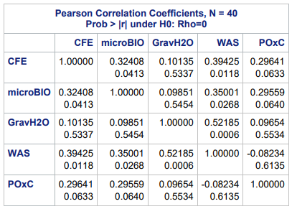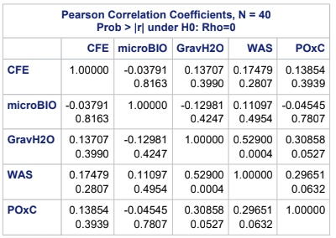
Figure 25: Pre and post-graze soil quality indicator correlation matrices. Top: Pre-graze correlation matrices and bottom: Post graze correlation matrices for chloroform fumigation extraction (CFE), soil microBIOMETER® (microBIO), gravimetric water content (GravH2O), wet aggregate stability (WAS), and permanganate oxidizable carbon (POxC) as soil quality indicators. The top number in each cell is the correlation coefficient and the bottom number is Pr > r. To declare correlation, α = 0.1.

Figure 26: Pre and post-graze regression analysis for gravimetric water content and wet aggregate stability. Top: Pre-graze regression. Bottom: Post-graze regression.
Chapter 2: Soil microBIOMETER® Validation Study
This chapter covers a validation study of microBIOMETER®, a new test developed by Prolific Earth Sciences (Montgomery, NY) for rapid, simple measurement of MBC. The objective of the study was to establish the correlation between microBIOMETER® results and MBC flush determined by CFE for this site. The soil microBIOMETER® test procedure is described in Chapter 1. The data output for both CFE and microBIOMETER® are μg C/g soil. It is noteworthy that the CFE extract is obtained in slurry that is 25% soil while the microBIOMETER® extract is obtained in slurry that is roughly 6% soil.
The developers of microBIOMETER® claim 94% correlation between microBIOMETER® and chloroform fumigation-extraction (CFE), however there is ongoing internal discussion about soils with high iron content, poor structure, and soils with microbial biomass carbon < 200-μgC/g soil, as they caused outliers in the validation study (unpublished Report, Fitzpatrick et al., 2021). Data collected using single and triplicate microBIOMETER® analysis were compared (r) to triplicate data collected using CFE.
Additional samples were taken to increase the range of data for the validation study. There is a forested area directly adjacent to the biodiversity grazing trial on the Dunmore loam, eroded rolling phase soil series. Satellite imagery shows that it has been a native undisturbed forest since before 1997. Three composite samples comprised of 10 to 15 soil cores each were collected from the forest soil during the pre-graze sample period. There is a fescue dominated pasture near the biodiversity grazing trial that has persisted since at least 1997 and has not been grazed. It is on a similar soil series to the biodiversity grazing trial, with a silty clay loam texture. The no graze fescue is on a slope which is designated upper, mid, and lower slope. A composite sample comprised of 10 to 15 7.5-cm cores each was taken per slope designation during the pre-graze sample period. One half mile east of the biodiversity grazing plots is a pasture of continuously grazed fescue that has been continuously grazed since before the native grasses in the biodiversity grazing trial were established in 2008. This pasture is on the Dunmore loam, eroded hilly phase soil series. Three composite samples comprised of 10 – 15, 7.5-cm soil cores each were taken in this area during the pre-graze sample period. The forest and fescue samples increased the range of data for the validation study, but did not serve as sources of data for soil quality parameters in the biodiversity grazing study of SQIs (Chapter 1).
The null hypothesis was that microBIOMETER® has no correlation with chloroform fumigation extraction and the alternate hypothesis was that microBIOMETER® correlates with chloroform fumigation extraction. An inexpensive tool for simple, rapid assessment of soil health would be beneficial to landowners, and soil microBIOMETER® is the first such tool with a focus on biological soil properties.
Limitations
There are two noteworthy potential experimental limitations. First, pre-graze sample analysis using CFE was done on 5-g soil sub samples with all reagents halved while post graze analysis using CFE was done on 10-g soil sub samples (the standard). The reason for this was that not enough soil was frozen for analysis during the pre-graze period. Theoretically, there should not be an effect due to this alteration to the method, but an experiment was not performed to confirm. Second, pre-graze MBC readings using microBIOMETER® were single readings, while post graze readings were done in triplicates. This is due to supply of microBIOMETER® test kits during the pre-graze period. A result of this limitation may be more confidence in post graze data for soil microBIOMETER®.
Site variability may complicate microBIOMETER® readings as a result of soil pigmentation. The BBIG paddocks were near toeslope while the SG paddocks were upslope, and the BBIG soils tended to appear darker due to higher SOM. Topography may influence sediment deposition on the site, and various pigments may interfere with the gray-scale card reading. All soil systems have variability, and soil health tools should aim to minimize the effects of inherent variability.
Statistical Analysis
For microBIOMETER® validation, the models are regression analysis and correlation (α = 0.05) using SAS 9.4, where x = microbial biomass carbon as determined by chloroform fumigation extraction, and y = microbial biomass carbon as determined by soil microBIOMETER®, r is the correlation coefficient which is the statistic that estimates rho, r has a lower limit of -1 and an upper limit of 1, and:
$$r=\frac{\sum_{i=1}^{n}{X_{i}Y_{i}- \frac{\sum{X_{i} \sum{Y_{i}}}}{n}}}{\sqrt{(\sum_{i=1}^{n}{{X_{i}}^{2}}-\frac{\sum{{\left(X_{i}\right)}^{2}}}{n})(\sum_{i=1}^{n}{Y_{i}^{2}- \frac{\sum{{\left(Y_{i}\right)}^{2}}}{n})}}}$$
(Dr. Dennis West, personal communication, 2021).
Correlation analysis produces a matrix of r values where the parameter r represents correlation and Prob > |r| is a t-test that determines whether r differs from 0.
Regression analysis yields the coefficient of determination, R², which is how well the regression line fits the data and is calculated as:
$$R^{2}=\frac{{(\sum_{i=1}^{n}{X_{i }Y_{i}})}^{2}}{(\sum{X^{2})}(\sum{Y^{2})}}$$
(Edwards, 1976).
Results and Discussion
Mean values of MBC determined by CFE and soil microBIOMETER® were closest during the pre-graze period which had a higher mean MBC with a sample number of 40. Mean values for additional samples were not as similar, despite having a better relationship between individual data points. This may be due to smaller sample size and an outlier in the data for microBIOMETER®. As the range of MBC data and the quantity of MBC increased, correlation between CFE and microBIOMETER® increased. Mean MBC measured by CFE and soil microBIOMETER® across the entire NWSG pasture is shown in Table 6.
Pre-graze, microBIOMETER® had a mean reading of 183.6 µgC/g soil with a standard deviation of 49.9, standard error of 7.9, variance of 2,490.0, and coefficient of variation of 26.7%. Chloroform fumigation-extraction had a mean of 177.7 µgC/g soil with a standard deviation of 46.5, standard error of 7.4, variance of 2166.6, and a coefficient of variation of 26.2%. The pre-graze regression analysis of CFE vs microBIOMETER® had an R² value of 0.105 and y=0.3474x+121.85. Calculated Pr > F for the model is 0.0413 and the slope ≠ 0, therefore the slope of the regression line is significantly different from zero and MBC flush determined by CFE has an effect on MBC flush determined by microBIOMETER® when α = 0.05, though it is a weak
Table 6: Statistical Summary comparing mean microbial biomass carbon (MBC) flush measured using microBIOMETER® and chloroform fumigation extraction (CFE) over the entire NWSG pasture, where units are MBC in µgC/g soil.
Sample Time | Mean | Std Dev | Std Error | COV, %
Pre-graze microBIO (n=40) | 183.6 | 49.9 | 7.9 | 26.7
Pre-graze CFE (n=40) | 177.7 | 46.5 | 7.4 | 26.2
Pre-graze “Extras” microBIO (n=9) | 265.6 | 83.6 | 27.9 | 31.5
Pre-graze “Extras” CFE (n=9) | 343.6 | 112.7 | 37.6 | 32.8
Post Graze microBIO (n=40) | 140 | 40 | 6.4 | 28.7
Post Graze CFE (n=40) | 77.2 | 26.3 | 4.2 | 34.1
Post Graze microBIO * 0.55 CF | 77.17 | 22.15 | 3.5 | 28.7

relationship. The correlation coefficient during the pre-graze period for microBIOMETER® and CFE is 0.32408 when significance level is 0.0413. When α = 0.05 there is a weak correlation.
Post-graze, microBIOMETER® had a mean reading of 140.3 ugC/g soil with a standard deviation of 40.3, standard error of 6.4, variance of 1622.3, and coefficient of variation of 28.7%. Post-graze CFE had a mean of 77.2 with a standard deviation of 26.3, standard error of 4.2, variance of 692.8, and coefficient of variation of 34%. The post-graze regression analysis of CFE vs microBIOMETER® had an R² value of 0.0014 and y= -0.058x+144.8. Calculated Pr > F for the model is 0.8162 and the slope ≈ 0, therefore the slope of the regression line is not significantly different from zero and MBC flush determined by CFE has no effect on MBC flush determined by microBIOMETER® when α = 0.05. The correlation coefficient during the post-graze period for microBIOMETER® and CFE is -0.03793 when significance level is 0.8162. When α = 0.05 there is no correlation.
Among the additional samples microBIOMETER® mean was 265.6 μgC/g soil with a standard deviation of 83.6, standard error of 27.9, variance of 6988.0, and coefficient of variation of 31.5%. The mean of additional samples analyzed by CFE was 343.6 μgC/g soil with a standard deviation of 112.7, standard error of 37.6, variance of 12,690, and coefficient of variation of 32.8%. The regression analysis of CFE vs microBIOMETER® had an R² value of 0.3576 and y = 0.4438x + 113.06. This is a significant model at α = 0.10, but not at α = 0.05. Calculated Pr > F for the model is 0.0889 and the slope ≠ 0, therefore the slope of the regression line is significantly different from zero and MBC flush determined by CFE has an effect on MBC flush determined by microBIOMETER® when α = 0.1. The correlation coefficient during the pre-graze period (additional samples) for microBIOMETER® and CFE is 0.59802 when significance level is 0.0889. This small batch only suggests support for the possibility that correlation increases with MBC flush values, but due to the smaller sample size (n=9), more research is needed. Linear regression for separate sample groups (pre-graze, post-graze, and additional samples) (Figure 27) and all sample groups combined (Figure 28) are shown. When all of the data for MBC flush determined by the two methods at three time points was fit to a linear regression model, R² was 0.4305.
As MBC flush measured by CFE increases, correlation with microBIOMETER® may increase (Figure 29). The correlation breaks down at low MBC values. Therefore, as MBC flush increases, microBIOMETER® mean may approach CFE mean. As MBC flush increases, standard deviation and variance for both methods may decrease. Individual time point data points of MBC flush values measured by soil microBIOMETER® and CFE do not track closely in this soil management system on this soil type in this climate, but they do roughly track (Figure 30). MicroBIOMETER® may have high scatter and low bias compared to CFE, explaining some of the variability of the relationship.
When microBIOMETER® measures average values below 150 μgC/g soil, it may be prudent to apply a correction factor to the data by multiplying microBIOMETER® data by the correction factor (Dr. Sean Schaeffer, personal communication, 2022). For analysis using CFE, a correction factor used to be common practice (He et al., 1997). It is called a fumigation efficiency correction and it accounted for the microbes that were not lysed by fumigation.

Figure 27: Linear regression model for pre-graze, post-graze, and additional samples: microbial biomass carbon (MBC) flush determined by chloroform fumigation-extraction and soil microBIOMETER®. The coefficient of determination increased as MBC increased.

Figure 28: Linear regression model for all sample periods: microbial biomass carbon (MBC) flush determined using chloroform fumigation-extraction and soil microBIOMETER®. Sample periods were pre-graze 2021, post-graze 2021, and “additional samples”. The coefficient of determination was higher when the range of MBC increased.

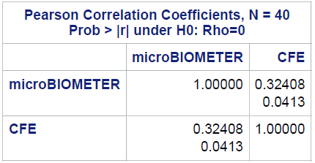
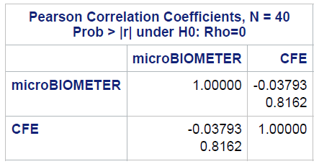
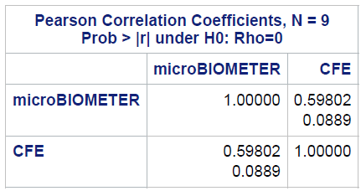
Figure 29: Pearson Correlation Coefficients for microbial biomass carbon (MBC) determined using microBIOMETER® and chloroform fumigation-extraction (CFE). Top: Correlation Coefficients for pre-graze MBC determined using microBIOMETER® and CFE where r= .32408 when α = 0.0413. Middle: Correlation Coefficients for post-graze MBC determined using microBIOMETER® and CFE where r= -0.03793 when α = 0.8162. Bottom: Correlation Coefficients for additional sample MBC determined using microBIOMETER® and CFE where r= 0.59802 when α = 0.0889.

Figure 30: Pre-graze (top) and post-graze (bottom) relationship between microbial biomass carbon (MBC) flush determined using chloroform fumigation-extraction (CFE) and soil microBIOMETER®.

For microBIOMETER®, a correction factor for soils with low MBC may account for some consistent variable. Further investigation is needed. If a correction factor of 0.55 is applied to microBIOMETER® post graze data (Figure 31) which averaged 140 μgC/g soil, microBIOMETER® data falls within the same range as CFE with an average of 77.17 μgC/g (CFE mean was 77.2 μgC/g post graze). Soil microBIOMETER® and CFE values fell within the same range when readings averaged above 150 μgC/g for microBIOMETER®, and a correction factor applied to CFE would change this outcome. The correction factor did not affect the regression analysis, only the range of data. It should be noted that when using microBIOMETER®, if readings are low, the application requests the user to “add 3 more drops” to the grayscale test card. This may be when a correction factor becomes important if accuracy is desired.
It is important to note that both microBIOMETER® and CFE determined significant differences in MBC due to vegetation species during the pre and post-graze periods, as discussed in Chapter 1. As shown in Chapter 1, CFE detected a pre to post-graze change in MBC that was significantly affected by vegetation species (Pr > F = 0.0837), while soil microBIOMETER® did not determine that the change was affected by vegetation species (Pr > F = 0.1577).
There was a noticeable relationship between pigmentation of microBIOMETER ® test tube water columns and MBC determined, with redder and darker soils often giving higher readings than lighter colored soils. The SG pasture always had lighter soil than the BBIG pasture, and the additional samples from the continuous graze fescue pasture had red soil. If the column had more suspended sediment, the readings were higher as well.

Figure 31: Additional sample and correction factor relationship between microbial biomass carbon (MBC) flush determined using chloroform fumigation-extraction (CFE) and microBIOMETER®. Top: Additional samples comparing MBC as determined using CFE and microBIOMETER®. With one potential outlier, the R² (0.3576) indicates a relationship. Bottom: Post-graze relationship between MBC determined using CFE and microBIOMETER® with a correction factor applied to bring the microBIOMETER MBC range to the CFE determined range.
Conclusions
Pre-graze SQIs with significant differences due to vegetation include MBC (Pr > F CFE = 0.0120 and Pr > F microBIOMETER® = 0.0090) and POxC (Pr > F = 0.0097). The BBIG paddocks had higher values than SG for all three metrics (198 μgC/g soil, 213.9 μgC/g soil, and 1233.2 mg/kg for BBIG and 157.4 μgC/g soil, 153.4 μgC/g soil, 1106.1 mg/kg for SG). Wet aggregate stability was the only pre-graze SQI with significant differences due to grazing (Pr > F = 0.0585). The NR and NG paddocks had the highest WAS at 75.7% and 75.4% respectively. There were no significant species-grazing interactions pre-graze.
Post-graze SQIs with significant differences due to vegetation include MBC (Pr > F CFE = 0.0374 and Pr > F microBIOMETER® = 0.0374), POxC (Pr > F = 0.0079), and WAS (Pr > F = 0.0677). The BBIG paddocks again had higher values than SG for MBC using CFE and microBIOMETER®, and POxC (85.3 μgC/g soil, 157.1 μgC/g soil, and 1241.3 mg/kg for BBIG and 69.2 μgC/g soil, 123.5 μgC/g soil, and 1155.2 for SG). The BBIG paddocks had greater WAS than SG paddocks (84.1% and 78.5%). Post-graze SQIs affected by grazing include gravimetric water content (Pr > F = 0.0261) and WAS (Pr > F = 0.0432). The NG paddocks had the highest post-graze gravimetric water content at 26% and the highest WAS at 86.3%. The NR paddocks were mid-range for WAS at 80.8%, while LR was the lowest at 78.2%. Post-graze, the species-grazing interaction resulted in a significant difference in gravimetric water content (Pr > F = 0.0424).
Changes throughout the 2021 grazing season pre to post-graze resulted in significant differences in MBC using CFE due to vegetation (Pr > F = 0.0837) and microBIOMETER did not detect the change as significantly different due to treatments. The MBC values in BBIG decreased more than SG paddocks over the 2021 grazing season. The pre to post-graze change in gravimetric water content was significant (Pr > F = 0.0726) due to grazing with NG and ER paddocks having the highest water content increase (4.8% and 4.2%) and NR paddocks having the least water content increase (1.8%). Bulk density was found to be affected by species (Pr > F = 0.0010) and the species-graze interaction (Pr > F = 0.0114) with the SG paddocks having higher BD (1.26 g/cm³ ) than the BBIG paddocks (1.20 g/cm³) and SG ER, SG NR, and SG LR interactions having the three highest BD values among treatment interactions (1.31 g/cm³, 1.29 g/cm³, and 1.29 g/cm³).
Depth to compacted layer was found to be greater in the BBIG paddocks at 54.7-cm compared to 29.3-cm in the SG paddocks. Total organic carbon over the entire pasture differed due to vegetation species (Pr > F = ) with BBIG paddocks having higher TOC (2.7%) than SG paddocks (2.1%) but did not differ due to grazing pressure among NG (2.4%) and NR (2.5%) paddocks. Total organic carbon did not significantly increase over a 4 year period, but it is trending toward increasing over time across the NWSG pasture.
Among all measurements of SQIs with a significant difference due to vegetation species, the BBIG NWSG mix inter-seeded with 12 native species had better SQI values than SG. Among all measurements of soil quality indicators with a significant difference due to grazing management, the data suggest that continuously grazing NWSG pastures during the warm-season in East Tennessee at a stocking density of 2.4 – 4.2 AU/ha does not differ from results when using management such as ER, MR, and LR and did not lead to decreased soil quality compared to NG.
Wet aggregate stability correlated moderately with soil water content and soil water content was high in NG paddocks, which explains why NG paddocks had the greatest WAS during the post graze period and does not indicate that NG is a more sustainable NWSG soil management than NR during the warm-season. Physical soil quality indicators analyzed (WAS and gravimetric water content) were sensitive to grazing management, while MBC and POxC were more sensitive to vegetation species. Microbial biomass carbon and labile carbon are both fractions of SOM, indicating that SOC is more strongly influenced by vegetation species than grazing management in this system.
Soil microBIOMETER® provides an increasingly accurate range as MBC values increase, and was able to distinguish between vegetation treatments at both high and low MBC values despite poorly tracking with CFE determined MBC data points. Soil pigmentation may affect microBIOMETER® readings with highly pigmented soils increasing MBC determined; further research is needed. Soil microBIOMETER® does not predict MBC as determined using CFE, but it may be a useful tool to determine MBC range and elucidate site specific spatial or temporal differences among treatments. Several replicate samples should be analyzed to improve confidence in microBIOMETER® measurements.
References
Amézketa, E. (1999). Soil aggregate stability: a review. Journal of Sustainable Agriculture, 14(2-3), 83-151.
Andrews, S.S., Karlen, D.L., Cambardella, C.A. (2004). The soil management assessment framework: a quantitative soil quality evaluation method. Soil Science Society of America, 68 (6), 1945-1962.
Ashworth, A. (2011). Native warm-season grass roles in soil and water conservation: a literature synthesis. Center for Native Grassland Management, University of Tennessee. https://nativegrasses.tennessee.edu/wp-content/uploads/sites/184/2020/10/NWSG- white-paper.pdf
Boyer, C. and Keyser, P. (2020). Summary of the economic and production performance of native grasses as forage in the fescue belt. University of Tennessee Department of Agricultural and Resource Economics. https://ag.tennessee.edu/arec/Documents/publications/NativeGrassAsForageFescueBel t.pdf
Brazil, K.A., Keyser, P.D., Bates, G.E., Saxton, A.M., Holcomb E.D. (2020). Continuous grazing of mixed native warm-season grass in the fescue belt. Agronomy, 112, 5067-5080.
Cardoso, E.J.B.N., Leandro, R., Vasconcellos, F., Bini, D., Miyauchi, M.Y.H.M., Santos, C.A., Alves, P.R.L., Paula, A.M.P., Nakatani, A.S., Pereira, J.M., Nogueira, M.A. (2013). Soil health: looking for suitable indicators. What should be considered to assess the effects of use and management on soil health? Scientia Agricola, 70 (4), 274-289
Carter, M.R., and Gregorich, E.G. (2010). Carbon and nitrogen storage by deep rooted tall fescue (Lolium arundinaceum) in the surface and subsurface soil of a fine sandy loam in eastern Canada). Agriculture, Ecosystems and Environment, 136 (1-2), 125-132.
Carter, M.R., Gregorich, E.G., Angers, D.A., Beare, M.H., Sparling, G.P., Wardle, D.A., Voroney, R.P. (1999). Interpretation of microbial biomass measurements for soil quality assessment in humid temperate regions. Canadian Journal of Soil Science, 79(4), 507- 520.
Chantigny, M.H., Angers, A. (2008). Chapter 48 pg 617: Extraction and characterization of dissolved organic matter. Soil sampling and methods of analysis: second edition. Edited by Carter, M.R., Gregorich, E.G. Published by CRC Press.
Chaparro, J.M., Sheflin, A.M., Manter, D.K., Vivanco, J.M. (2012). Manipulating the soil microbiome to increase soil health and plant fertility. Journal of Biology and Fertility of Soils. 48, 489-499.
Culman, S.W., Snapp, S.S., Freeman, M.A., Schipanski, M.E., Beniston, J., Lal, R., Drinkwater, L.E., Franzluebbers, A.J., Glover, J.D., Grandy, S.A., Lee, J., Six, J., Maul, J.E., Mirsky, S.B., Spargo, J.T., Wander, M.M. (2012). Permanganate oxidizable carbon reflects a processed soil fraction that is sensitive to management. Soil Science Society of America, 76, 494-504.
Doran, J.W., Zeiss, M.R. (2000). Soil health and sustainability: managing the biotic component of soil quality. Applied Soil Ecology, 15 (1), 3-11.
Dowhower, S. L., Teague, W. R., Casey, K. D., and Daniel, R. (2019). Soil greenhouse gas emissions as impacted by soil moisture and temperature under continuous and holistic planned grazing in native tallgrass prairie. Agriculture, Ecosystems and Environment, 287, 106647.
Dua, K. and Care, A.D. (1995). Impaired absorption of magnesium in the aetiology of grass tetany. British Veterinary Journal, 151(4), 413-426.
Edwards, A.L. (1976). An introduction to linear regression and correlation. Published by W.H. Freeman and Company, San Francisco. 42.
Essington, M.E. (2015). Soil and water chemistry: an integrative approach: second edition. Published by CRC Press. 155.
Fierer, N. (2003). Stress ecology and the dynamics of microbial communities and processes in soil. Doctoral Dissertation, University of California, Santa Barbara.
Fitzpatrick, J., Davis, T.E., Trexler, E.B. (2021). microBIOMETER® correlates 94% with the chloroform fumigation assay. Unpublished report. https://microbiometer.com/study- shows-microbiometer-correlates-with-the-chloroform-fumigation-extraction-test/
Franzluebbers, A.J., Stuedemann, J.A. (2009). Soil – profile organic carbon and total nitrogen during 12 years of pasture management in the Southern Piedmont USA. Journal of Agriculture, Ecosystems, and Environment, 129, 28-36.
Graham, L.E., Graham, J.M., Wilcox, L.W. (2006). Plant biology: second edition. Pearson/Prentice Hall. Book. 93-94.
Gupta, V.V.S.R., Germida, J.J. (2015). Soil aggregation: influence on microbial biomass and implications for biological processes. Journal of Soil Biology and Biochemistry, 80, A3-A9.
He, Z.L., Wu, J., O’Donnell, A.G., Syers, J.K. (1997). Seasonal responses in microbial biomass carbon, phosphorus, and sulphur in soils under pasture. Biology and Fertility of Soils, 24(4), 421-428.
Hill, N.S., Belesky, D.P., Stringer, W.C. (1991). Competitiveness of tall fescue as influenced by Acremonium coenophialum. Crop Science, 31, 185-190.
Hillel, D. (1998). Environmental soil physics. Published by Academic Press. Book. 101-120.
Hillenbrand, M., Thompson, R., Wang, F., Apfelbaum, S., Teague, R. (2019). Impacts of holistic planned grazing with bison compared to continuous grazing with cattle in South Dakota shortgrass prairie. Agriculture, Ecosystems, and Environment, 279, 156-168.
Hoveland, C.S. (2009). Tall Fescue for the Twenty-first Century: origin of tall fescue. Editors Fribourge, H.A., Hannaway, D.B., West, C.P. Published by American Society of Agronomy, Crop Science Society of America, Soil Science Society of America. Book. 3
Jastrow, J.D., Miller, R.M. (1998). Soil processes and the carbon cycle. Chapter 15: Soil aggregate stabilization and carbon sequestration: feedbacks through organomineral associations. Edited by Lal, R., Kimble, J.M., Follett, R.F., Stewart, B.A. Published by CRC Press.
Keyser, P. (2021). Native grass forages for the eastern U.S. University of Tennessee Extension Publication PB1893.
Keyser, P., Harper, C., Bates, G., Waller, J., Holcomb, E.D. (2015). Native warm-season grasses for mid-south forage production. University of Tennessee, Center for Native Grasslands Management. https://extension.tennessee.edu/publications/Documents/SP731-A.pdf
Lorenz, K., Lal, R. (2005). The depth distribution of soil organic carbon in relation to land use and management and the potential of carbon sequestration in subsoil horizons. Advances in Agronomy, 88, 35-66.
Moebius-Clune, B.N., Moebius-Clune, D.J., Gugino, B.K., Idowu, O.J., Schindelbeck, R.R., Ristow, A.J., van Es, H.M., Thies, J.E., Shayler, H.A., McBride, M.B., Kurtz, K.S.M, Wolfe, D.W., and Abawi, G.S. (2016). Comprehensive assessment of soil health – the Cornell framework, edition 3.2, Cornell University, Geneva, NY. http://www.css.cornell.edu/extension/soil-health/manual.pdf
Monroe, A. P. (2014). Ecological and economic implications of plant diversity and grazing in pasture systems. Thesis. Mississippi State University.
Nouri, A., Lee, J., Yoder, D.C., Jagadamma, S., Walker, F.R., Yin, X., Arelli, P. (2020). Management duration controls the synergistic effect of tillage, cover crop, and nitrogen rate on cotton yield and yield stability. Journal of Agriculture, Ecosystems, and Environment, 301, 107007.
Paul, E.A. (2015). Soil microbiology, ecology, and biochemistry Chapter 1: An exciting present and great future built on basic knowledge and unifying concepts. Elsevier. Book. 6.
Powlson, D.S. (2020). Soil health – useful terminology for communication or meaningless concept? Or both? Frontiers of Agricultural Science and Engineering, 7 (3), 246-250.
Pribyl, D. W. (2010). A critical review of the conventional SOC to SOM conversion factor. Geoderma, 156, 75-83.
Ritten, J.P., Frasier, W.M., Bastian, C.T., Gray, S.T. (2010). Optimal rangeland stocking decisions under stochastic and climate-impacted weather. American Journal of Agricultural Economics, 92(4), 1242-1255.
Roberts, C.A., Lacefield, G.D., Ball, D., Bates, G. (2009). Management to optimize grazing performance in the northern hemisphere. Page 93 of the book Tall Fescue for the Twenty-first Century. Editors Fribourg, H.A., Hannaway, D.B., West, C.P. American Society of Agronomy, Crop Science Society of America, Soil Science Society of America, 93.
SAS Institute Inc. (2013). SAS/STAT® 13.1 User’s guide. Cary, NC: SAS Institute Inc.
Savoy, H. (2009). Interpreting Mehlich 1 and 3 soil test extractant results for P and K in Tennessee. University of Tennessee Agricultural Extension Service, W229.
Singh, B. (2018). Soil carbon storage: modulators, mechanisms, and modeling. Elsevier Science and Technology. Book.
Singh, S., Jagadamma, S., Yoder, D., Yin, X., Walker, F. (2020). Agroecosystem management responses to Haney soil health test in the southeastern United States. Soil Science Society of America, 84, 1705-1721.
Smith, J.L., Collins, H.P., Crump, A.R., Bailey, V.L. (2015). Chapter 18: Management of soil biota and their properties. Soil Microbiology, Ecology, and Biochemistry. Academic Press. Book. 539-572.
Soil Survey Staff, Natural Resources Conservation Service, United States Department of Agriculture. (2021). Web Soil Survey. http://websoilsurvey.sc.egov.usda.gov/.
Tallamy, D.W. (2004). Do alien plants reduce insect biomass? Journal of Conservation Biology, 18(6), 1689-1692.
Teague, W.R., Dowhower, S.L., Baker, S.A., Haile, N., DeLaune, P.B., Conover, D.M. (2011). Grazing management impacts on vegetation, soil biota and soil chemical, physical and hydrological properties in tall grass prairie. Agriculture, Ecosystems, and Environment, 141, 310-322.
Thompson, F.N., Stuedemann, J.A. (1993). Pathophysiology of fescue toxicosis. Agriculture, Ecosystems and Environment, 44, 263-281.
Trivedi, P., Singh, B.P., Singh, B.K. (2018). Chapter 1: Soil carbon: introduction, importance, status, threat, and mitigation. Soil carbon storage: modulators, mechanisms, and modeling. Edited by Singh, B.K. Published by Elsevier.
U.S. Climate Data. (2021). Climate Greeneville Tennessee. https://www.usclimatedata.com/climate/greeneville/tennessee/united- states/ustn0212.
USDA NASS. (2017). 2017 Census of Agriculture – State Data, Tennessee. https://www.nass.usda.gov/Publications/AgCensus/2017/Full_Report/Volume_1,_Chap ter_1_State_Level/Tennessee/st47_1_0007_0008.pdf
USDA NRCS. (2020). Soil Health. Washington, DC: USDA NRCS. https://www.nrcs.usda.gov/wps/portal/nrcs/ main/soils/health/
USDA NRCS. (2022). Soil quality test kit section ii background and interpretive guide for individual tests. https://www.nrcs.usda.gov/Internet/FSE_DOCUMENTS/nrcs142p2_052490.pdf
Voroney, R.P., Brookes, P.C., Beyaert, R.P. (2008). Soil sampling and methods of analysis: second edition. Chapter 49: Soil Microbial Biomass C, N, P, and S. Edited by Carter, M.R., Gregorich, E.G. Published by CRC Press.
Weil, R.R., Islam, K.R., Stine, M.A., Gruver, J.B., Samson-Liebig, S.E. (2003). Estimating active carbon for soil quality assessment: A simplified method for laboratory and field use. American Journal of Alternative Agriculture, 18, 761-771.
Yoder, D.C., Jagadamma, S., Nouri, A., Xu, S., Saha, D., Schaeffer, S.M., Adotey, N., Walker, F.R., Lee, J., Budipradigdo M. (2021). Soil health: meaning, measurement, and value through a critical zone lens. Journal of Soil and water Conservation, 76 (6), 42.

Appendix 1: Distributions of Soil Quality Indicators with Significant Differences
Boxplots were used to show the distribution of data among measured values discussed. Boxplots can be interpreted as follows. The length of the box represents the interquartile range (25th through 75th percentiles), the diamond within the box represents the mean, the line in the box represents the median, vertical lines (whiskers) represent the minimum and maximum values, and circles outside the box are outliers (SAS Institute, 2013). All boxplots were generated by SAS 9.4.
Change Pre to Post-graze for the 2021 Grazing Season
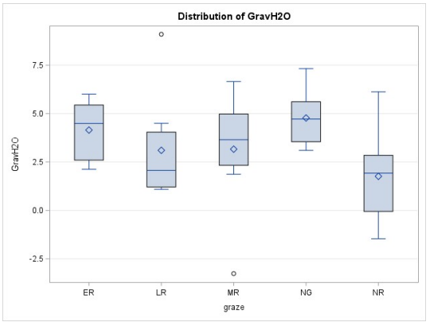
Figure A1.1: Pre to post-graze change distribution for gravimetric water content across grazing pressures early, middle, and late rest (ER, MR, LR,), no graze (NG) and no rest (NR).
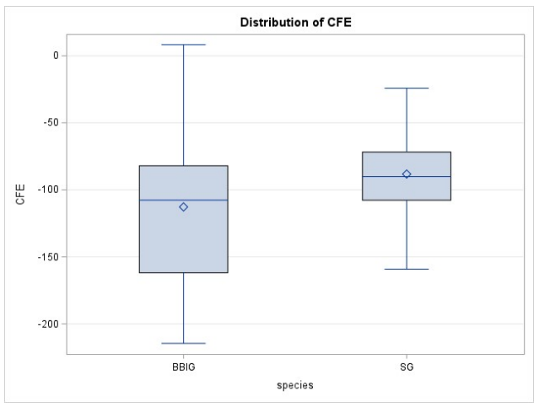
Figure A1.2: Pre to post-graze change distribution for microbial biomass carbon measured using chloroform fumigation-extraction across vegetation species big bluestem and indiangrass (BBIG) and switchgrass (SG).

Pre-graze 2021
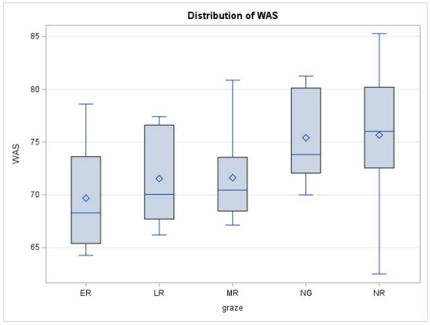
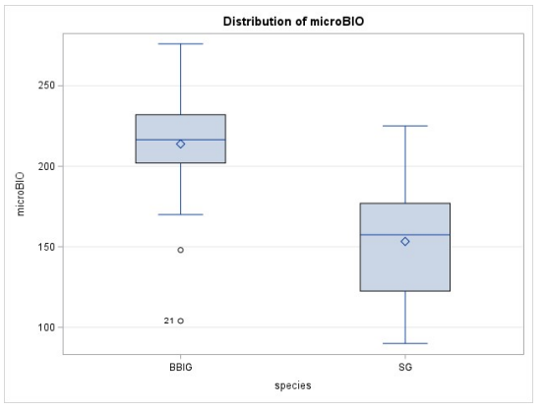
Figure A1.3: Pre-graze distribution wet aggregate stability (WAS) and microbial biomass carobon (MBC) using microBIOMETER®. Top: Distribution of pre-graze WAS across grazing pressures. Bottom: Distribution of MBC across native warm season grass species.
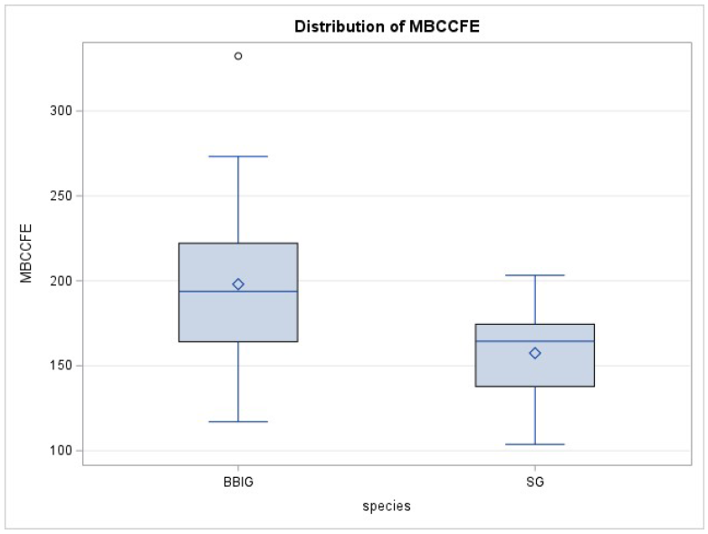
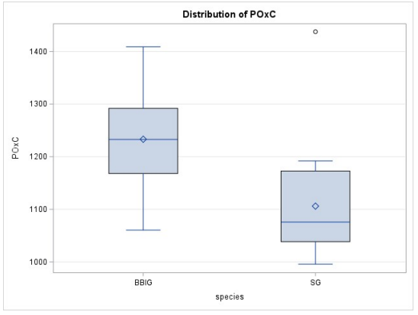
Figure A1.4: Pre-graze distribution of microbial biomass carbon using CFE and permanganate oxidizable carbon. Top: Distribution of pre-graze microbial biomass carbon measured using chloroform fumigation-extraction across species. Bottom: Distribution of pre-graze permanganate oxidizable carbon across vegetation species.
Post-graze 2021
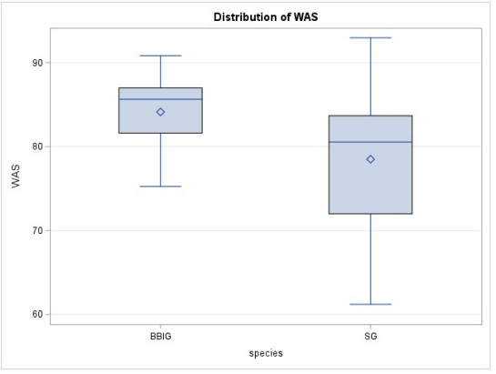
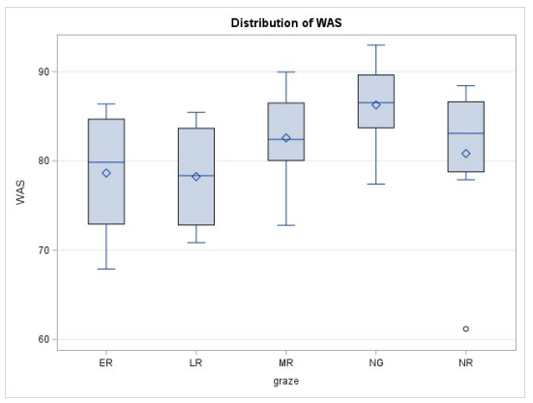
Figure A1.5: Post-graze distribution of wet aggregate stability. Top: Post-graze distribution of wet aggregate stability (WAS) across vegetation species and Bottom: grazing pressure.
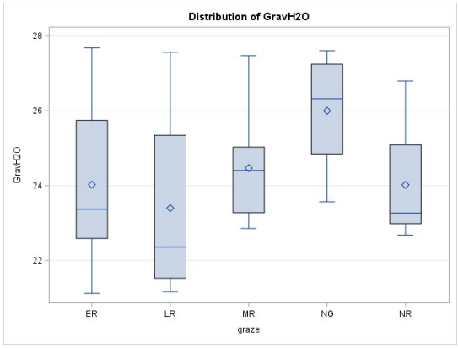
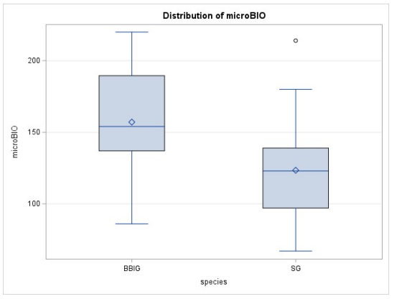
Figure A1.6: Post-graze distribution gravimetric water content and microBIOMETER®. Top: Post-graze distribution of gravimetric water content across grazing pressures. Bottom: Post-graze distribution of microbial biomass carbon measured using soil microBIOMETER® across vegetation species.
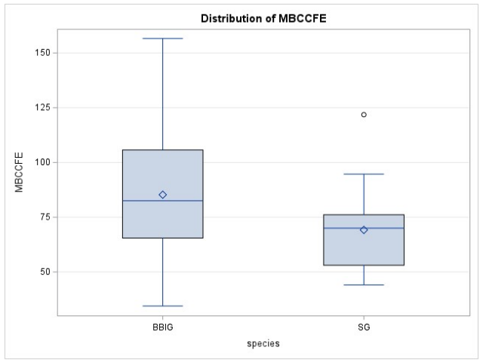
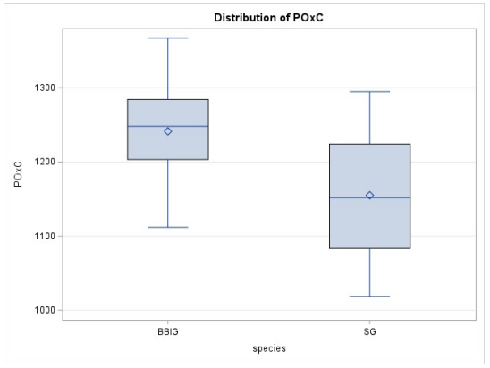
Figure A1.7: Post-graze distribution microbial biomass carbon and permanganate oxidizable carbon across species. Top: Post-graze distribution of microbial biomass carbon measured using chloroform fumigation-extraction across vegetation species. Bottom: Post-graze distribution of permanganate oxidizable carbon (POxC) across vegetation species.
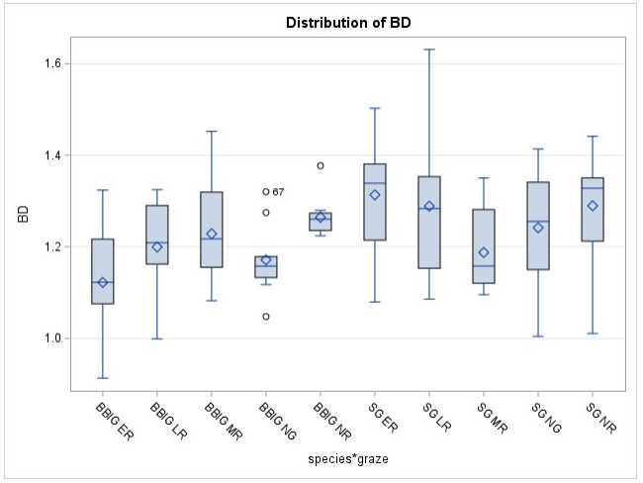
Figure A1.8: Distribution of bulk density (BD) across the species graze interaction.

Appendix 2: Pasture Summary for Soil Parameters Analyzed
Table A2.1: Pre-graze statistical summary for soil quality indicators (SQIs) averaged over the entire pasture. Permanganate oxidizable carbon (POxC) was run with subsample duplicates, chloroform fumigation extraction (CFE) was run with sub sample triplicates, microBIOMETER® (microBIO), gravimetric water content, and wet aggregate stability (WAS) were determined using single subsamples.
SQI | Mean | Std Dev |  | Std Error |  | COV, %
POxC Labile C, mg/kg (n=40) | 1169.6 |  | 117.0 |  | 18.5 | 10.0
CFE Extractable Labile C, mg/kg (n=40) | 494.9 |  | 102.6 |  | 16.2 | 20.7
microBIO MBC, μgC/g soil (n=40) | 183.6 |  | 49.9 |  | 7.9 | 26.7
CFE MBC, μgC/g soil (n=40) | 177.7 |  | 46.5 |  | 7.4 | 26.2
Gravimetric water, % (n=40) | 21.0 |  | 2.2 |  | 0.34 | 10.3
WAS, % (n=40) | 72.8 |  | 5.53 |  | 0.87 | 7.59

Table A2.2: Post-graze statistical summary for soil quality indicators (SQIs) over the entire pasture. Permanganate oxidizable carbon (POxC) was run with subsample duplicates, chloroform fumigation extraction (CFE) was run with sub sample triplicates, microBIOMETER® (microBIO) was run with sub sample triplicates, wet aggregate stability (WAS) and gravimetric water content were determined using single subsamples, and bulk density (BD) was determined using 5 samples per paddock from 20 paddocks, 10 per vegetation species.
SQI (n=40) | Mean | Std Dev | Std Error | COV, %
POxC Labile C, mg/kg (n=40) | 1198.2 | 89.7 | 14.05 | 7.5
CFE Extractable Labile C, mg/kg (n=40) | 272.1 | 58.7 | 9.3 | 21.6
microBIO MBC, μgC/g soil (n=40) | 140.3 | 40.3 | 6.4 | 28.7
CFE MBC, μgC/g soil (n=40) | 77.2 | 26.3 | 4.2 | 34.1
Gravimetric water, % (n=40) | 24.4 | 2.0 | 0.31 | 8.2
WAS, % (n=40) | 81.3 | 6.9 | 1.1 | 8.4
BD g/cm³ (n=100) | 1.23 | 0.1 | 0.02 | 9.6

Table A2.3: Statistical summary for total organic carbon (TOC) and soil organic matter (SOM) in no graze (NG) and no rest (NR) paddocks (combined) for the years 2018, 2020, and 2022.
TOC by Year, % (n=16 each year) | Mean | Std Dev | Std Error | COV, %
TOC 2018 | 2.33 | 0.36 | 0.09 | 15.4
TOC 2020 | 2.43 | 0.50 | 0.13 | 20.4
TOC 2022 | 2.46 | 0.44 | 0.11 | 18.0

Appendix 3: Total Organic Carbon SAS 9.4 GLM Procedure Output

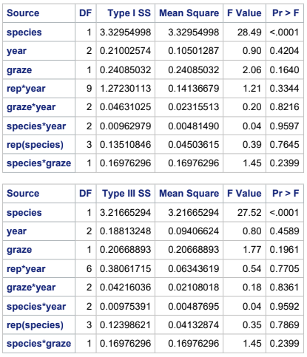
Figure A3.1: Total organic carbon analysis of variance. Top: GLM Procedure information showing inputs and observations read for total organic carbon (TOC) analysis of variance (ANOVA). Middle: Type I sum of squares for TOC ANOVA for the years 2018, 2020, and 2022. Bottom: Type III sum of squares for TOC ANOVA for the years 2018, 2020, and 2022.
Total organic carbon for the years 2018, 2020, and 2022 were analyzed using proc GLM in SAS software, which excludes observations with a “.” in place of a data value and provides a type III sum of squares to account for the missing observations. When using proc GLM, if the type III SS differs from the type I SS, the type III value is considered to be true. The GLM procedure was used because paddocks 113 and 114 were accidentally swapped in 2019. Paddock 113 was originally no graze and paddock 114 was originally early rest. Data was collected from 113 in 2018 as no graze TOC data, but by 2020 the switch had occurred so this has been considered a missing value. Values for SG replicate 4 of no graze are the 2 unread values, with one read value for 2022 after 2 seasons as switched.

Appendix 4: Freezer Failure
A freezer containing soils to be analyzed using CFE failed, causing the samples to rise in temperature from -20°C to 7°C before the failure was discovered. An experiment was performed to determine the effect of the freezer failure on microbial biomass carbon values as measured by chloroform fumigation extraction.
Soil samples to be analyzed by CFE are stored at -20°C to slow microbial metabolic function and preserve microbial biomass as it was at the time of sample collection. Extracts from pre-graze soil samples and unanalyzed post graze soil samples were stored in a freezer that failed, and the internal temperature reached 7°C before the malfunction was discovered, thawing the contents. This may have affected MBC flush determined by CFE. Due to the samples being time point samples, they were irreplaceable until the following grazing season. To test the effect of freezer failure on MBC flush as determined by CFE, four composite samples were collected as they were for SQIs. These samples were from two no graze switchgrass paddocks and two no graze big bluestem/indiangrass paddocks for a total of four composite samples. They were sieved to 2-mm and each sample was split into two sub samples: “freeze” and “thaw”. All 8 samples were frozen at -20°C for 2 weeks. After the 2 week period, the “thaw” samples were moved to an 8°C refrigerator for 10 days, and then returned to the -20°C freezer for an additional 2 week period. All 8 samples were analyzed for microbial biomass carbon using chloroform fumigation extraction. Results were compared to determine whether the “thaw” subsamples differed significantly from the “freeze” samples as a result of being thawed and refrozen before analysis.
Limitations
The sample size used for this study was small, and there were not replicates within paddocks. A larger sample size would give more confidence. Time was a limiting factor in performing this experiment.
Results and Discussion
When tested using ANOVA, Pr>F for freeze or thaw treatment = 0.0836. Duncan’s mean separation was tested when α = 0.1 and 0.05. At the 90% confidence interval the broken freezer influenced MBC with an average of 8.32 less µg C/g soil in thawed samples than in samples that did not undergo thawing and refreezing. At the 95% confidence interval, the treatment differences were not significant. The 95% confidence interval has been selected to interpret this data because the freeze and thaw samples were the same soils treated differently; a more controlled environment than field variability, which used the 90% confidence interval to interpret differences. In the event that soils stored at subzero temperatures to slow microbial metabolism experience a thawing event, returning samples to subzero conditions within a week of thawing yields 95% confidence that MBC flush determined using CFE will not be affected by the thawing event. Therefore, a correction was not applied to samples that were subjected to thawing due to the broken freezer.
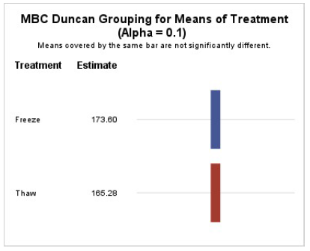
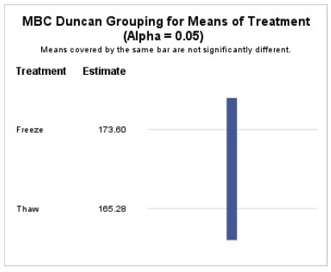
Figure A4.1: Means separation for “broken freezer” experiment. Top: Duncan’s means separation for the freeze-thaw experiment when α = 0.1. Bottom: Duncan’s means separation for the freeze-thaw experiment when α = 0.05.

Appendix 5: Web Soil Survey Ratings for Dunmore Loam and NRCS Soil Quality Test Kit
The Web Soil Survey (WSS) estimates bulk density of Dunmore loam to be about 1.45-g/cm³ and the mean bulk density determined in the NWSG pasture was 1.23-g/cm³ +/- 0.02-g/cm³. Lower bulk density indicates more OM is in the soil than expected. The WSS rates Dunmore loam as about 1.25% OM and among NG and NR paddocks, the pasture was found to have an average of 4.25% OM +/- 0.19%. Water content of Dunmore loam at 15 Bar, generally accepted as wilting point, is rated by the Web Soil Survey as 13.2% water by mass. All determinations of soil water content by mass were above 20% in the NWSG pasture. Water content of Dunmore loam at 1/3 Bar, generally accepted as field capacity, is rated by the Web Soil survey at 26.1%. Pre and post-graze samples were taken at least 3 days after significant rain events. Pre-graze soil water content % by mass, taken late spring, averaged 21% +/- 0.34%. Post-graze soil water content % by mass, taken late summer, averaged 24.4% +/- 0.31%. These values approach the expected field capacity. The samples were not difficult to sieve due to moisture. It is possible that field capacity under this system is higher than the field capacity rating.
The NRCS Soil Quality Test Kit, Section II: Background and Interpretive Guide for Individual Tests was used to interpret soil quality parameters when applicable. Bulk densities for the NWSG pasture (≈ 1.23 g/cm3) ranks as “ideal” (< 1.40-g/cm3 for loam). In January 2022 the average percent OM across the pasture was 4.2% with a range of 3-6.4% and clay content is estimated to be 20% (soil formed a ribbon <1”). The NRCS guide suggests that soils within this range of SOM and clay content should have a WAS of about 70-77%. The average WAS across the pasture was 72.8% pre-graze and 81.3% post graze.
Vita
Kara graduated from high school in 2012 and worked in various factories before deciding to pursue higher education. In 2014 she started her college career at Lehigh Carbon Community College, Schnecksville, Pennsylvania. Here, she earned her Associate of Applied Science in Chemical Technology while co-leading an effort of the STEM club to plant a 9,000-ft² native plant garden. During her four year period of study at Lehigh Carbon Community College, Kara worked part time at Hawk Mountain Sanctuary, Kempton, Pennsylvania and held two consecutive summer internship positions at the Palmerton Zinc Pile Superfund Site as an environmental consulting intern working on site restoration. These experiences amplified Kara’s passion for environmental science.
At Lehigh Carbon Community College, Kara earned an All-PA Academic Team scholarship which provided two years of tuition at any Pennsylvania State System of Higher Education University. She selected Mansfield University where she went on to earn her Bachelor of Science in Geosciences while holding the position of Assistant for the Institute of Science and the Environment. Kara felt there was more to learn before entering the workforce in her desired field of conservation and restoration of degraded lands, so she went on to graduate school at the University of Tennessee, Knoxville, Tennessee. Her research and coursework during her master’s level study of Environmental and Soil Sciences were exactly what she needed to propel her into her career. After graduation, she will begin her new position as a conservation specialist with the West Virginia Conservation Agency. Kara is grateful for the support of all the incredible people she met along the way.

