

Swing Up Stop Pivot Bolt

Accu-Router Inc.

UT Capstone Design Project (ME 450 & 460)
Fall 2015 – Spring 2016

Group Members:
Amy Albaugh (000359718)
Justin Church (000393938)
Lee Collier (000357439)
Jacob Walker (000362068)

Table of Content

Executive Summary:

- Background of Problem....................................................................................................2

- Work Statement.................................................................................................................4

- Design Specifications.........................................................................................................4

- Design Concepts.................................................................................................................5
- Concept A...............................................................................................................5
- Concept B...............................................................................................................5
- Concept C...............................................................................................................6

- Evaluation of Concepts......................................................................................................6
- Evaluation metrics.................................................................................................6
- Scoring Process.......................................................................................................7
- Recommendations..................................................................................................8
- Feedback from Sponsor.........................................................................................8

- Engineering Design............................................................................................................8
- Three Dimensional Model of Design....................................................................8
- Special Features, Benefits, Operations of device....................................8
- Assembly Drawing.................................................................................................9
- Discuss Subsystems....................................................................................9
- Engineering Analysis, Software, Special considerations........................9
- Design of subsystems.............................................................................................9
- Identify off the shelf items to be purchased............................................9
- Identify parts to make (refer to drawings in Appendix)........................9
- Parts List with Prices................................................................................9

- Fabrication of Prototype.................................................................................................10
- Special Considerations, Issues in Building Prototype......................................10
- Design of Test Apparatus and Test Procedure.................................................10
- Test Results..........................................................................................................10

- Economic Impact.............................................................................................................11

- Conclusion and Recommendation..................................................................................11

Appendix......................................................................................................................................12
- Design Methodology................................................................................12
- Engineering Calculations........................................................................13
- Detailed shop drawings...........................................................................14
- Project plan; Gantt Chart.......................................................................18
- Background of Problem

Accu-Router manufactures high performance custom-made CNC routers for multiple industries such as boating, aerospace, molding, and hardwood furniture, etc. Accu-Router’s CNC router is constructed to hold dense, hard to cut, materials that are cut on the CNC router table. The table is designed to hold the material while the machining process occurs. The CNC router table is seen below in Figure 1.

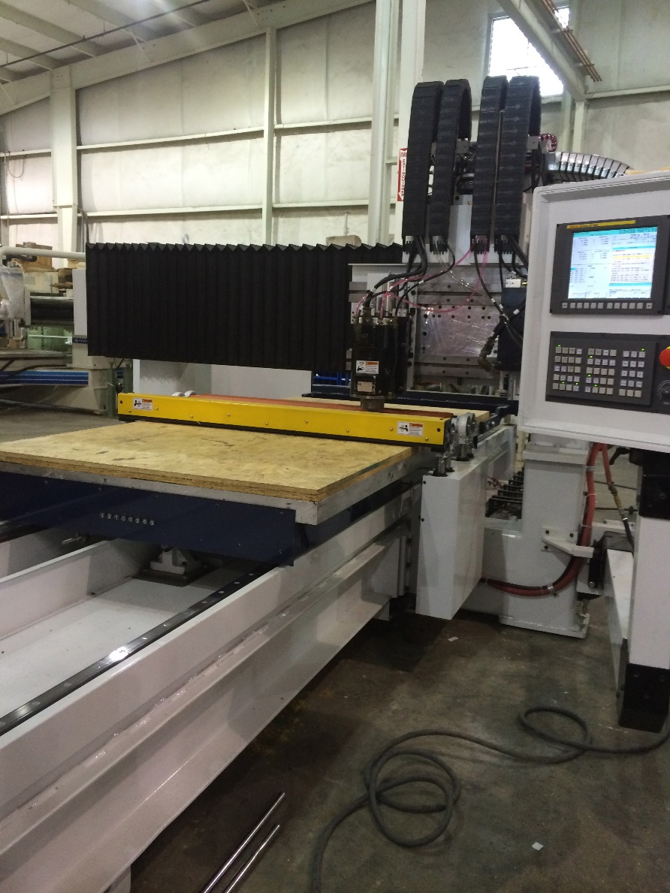

Figure 1: The setup of the CNC router table and its controls.

Swing up stops are strategically placed along the perimeter of the CNC router table to accurately position material on the table so precise cuts can be made. These swing up stops are also used to prevent moving of the material when it is being cut. Two swing up stops were placed both on the left and right lengths of the table, and one larger swing up stop is place on the width of the perimeter on the back of the CNC router table that is shown in Figure 1 above. The schematic setup of the swing up stops on the left and right perimeters can be seen in Figure 2 (a) below. The actual picture of the swing up stop device on the CNC router table is shown below in Figure 2 (b).
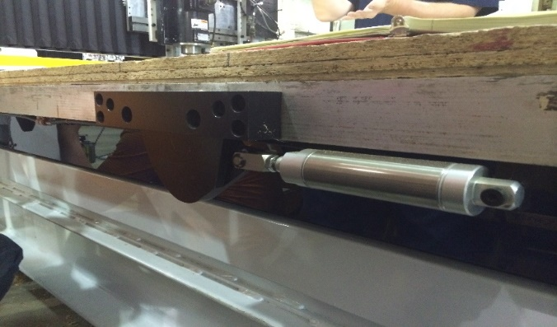
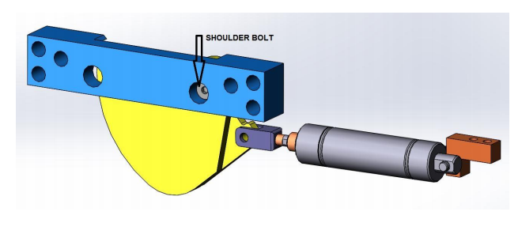
(a) (b)

Figure 2: The setup of the swing up stop. (a) Schematic of swing up stop; (b) The actual swing up stop on the table.

The swing up stop that is used to hold the material being cut in position is shown below in Figure 3.

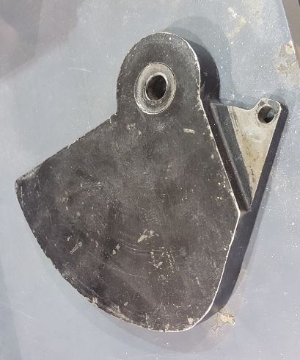

Figure 3: The metal swing up stops used on the router tables.

The swing up stop is connected to the table using a set-band and a shoulder bolt. The set-band is depicted in Figure 4.

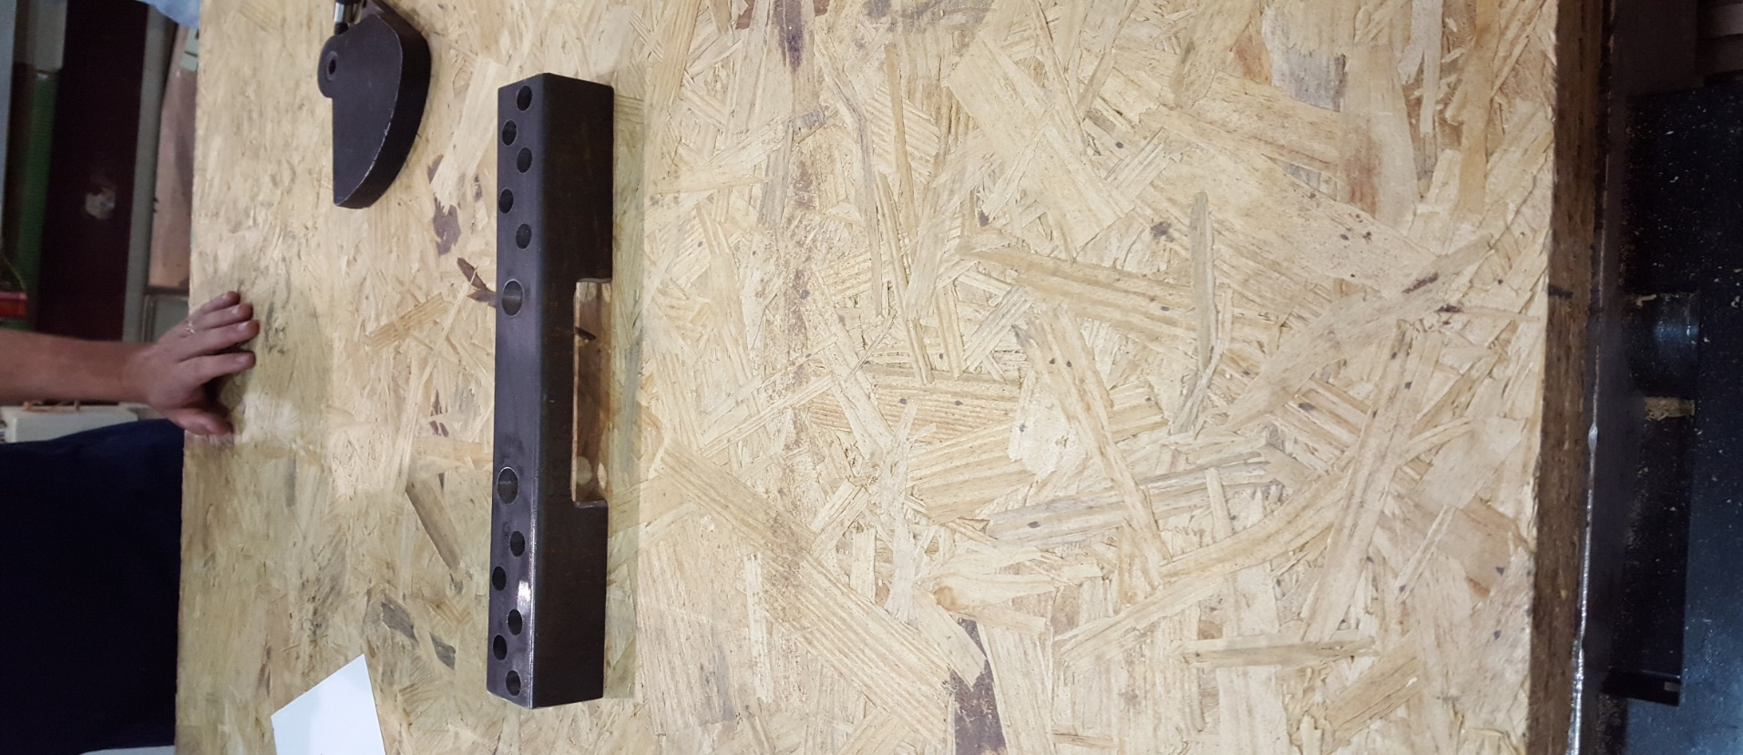

Figure 4: The set-band used to mount the swing up stop on the table.
The shoulder bolt is shown in Figure 5 below. This shoulder bolt is secured using a thread locker (such as Loctite).

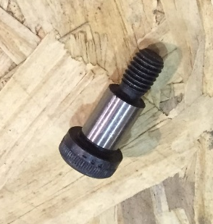

Figure 5: The shoulder bolt used to secure the swing up stop to the table.

Once the material desired to be cut is positioned on the Accu-Router table and secured by the swing up stops, a machine is programmed to operate the spindle to make precise cuts in the desired directions in the x-plane, y-plane, and z-plane. The spindles on the CNC routers are used for high speed machining or cutting of hard materials such as plywood, composites, plastics, and certain metals. The spindles are made by Accu-Router. Since Accu-Router manufactures all aspects of the CNC router, they have a competitive edge by being a single source for the customer to go to if help or assistance is needed. Accu-Router is constantly seeking ways to improve the design of their machines in a highly competitive market.

- Work Statement

With the design of the current swing up stops, the shoulders bolts loosen over time due to overuse from the machine operators. Without proper re-tightening of these bolts, the mounting holes can be damaged and cannot be used again. Thus, Accu-Router requested a redesign of the swing up stops used along the two lengths of the CNC router tables.

- Design Specifications

Designing the optimal swing up stop pivot bolt seemed straightforward, but there were some restrictions the design needed to follow. Accu-Router requested that there would be no design changes that require work be done on parts already in use, such as the router tables. They wanted design changes made only on the parts that could be attached and detached from the table. The design requirements and restrictions were as follows:
- Do not modify or change router table
- Design to avoid resin that may cause the swing up stop to stick
- Ensure that the set-band does not extend out from the table past the clearance limit as the table moves back and forth.
- Consider the repeatability or how easy it is to repeat the attachment of the swing up stop when damage occurs
- Discover the most reliable design
- Keep costs low
The last two requirements in this list are common design restrictions, but they are necessary to reiterate since they are also of great importance to the company’s bottom line.

- Design Concepts

- Concept A – Set Screw

The first concept conceived to solve this problem was fairly straightforward. Two set screws would be drilled into the top and bottom of the set-band that was shown in Figure 2 (b). These set screws would drill through the set-band to the shoulder bolt to help secure and prevent movement of the shoulder bolt. This would be extra support to keep the shoulder bolt in place when continual extra force is applied. Figure 6, shown below, shows the holes for the set screws that would be drilled on the top and bottom of the set-band.

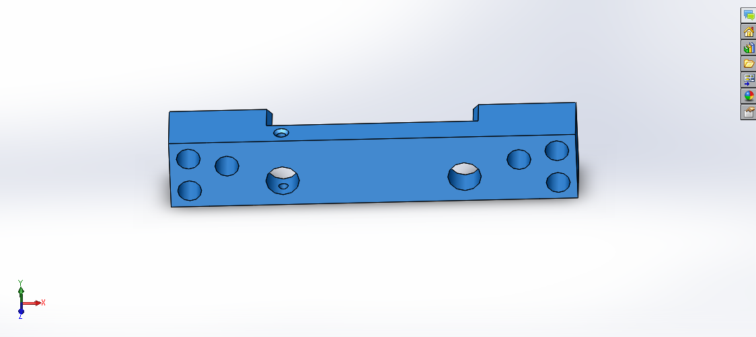

Figure 6: The holes in the set-band for the set screws used for more support.

- Concept B – Needle Bearing and Set Screw

The second solution considered to solve the problem was the use of a needle bearing. The needle bearing would surround the shoulder bolt used to secure the swing up stop. The purpose of the needle bearing was to reduce the friction between the shoulder bolt and the swing up stop. Reducing the friction would help prevent the shoulder bolt from loosening. This solution would require that the swing up stop have a larger bore to fit around the needle bearing. This would require machining the inside pivoting hole of the swing up stop. Two set screws, as described in Concept A above, would be used in tandem with the needle bearing to prevent loosening of the shoulder bolt. Figure 7, below, shows the needle bearing that would be placed over the shoulder bolt and inside the swing up stop.

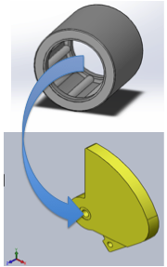

Figure 7: The needle bearing that would be used to reduce the friction between the shoulder bolt and the swing up stop.
- Concept C – Extruding Column Set-band Design

The last design concept involved doing away with the shoulder bolt entirely and replacing it with a cylindrical shaft extruding from the mounting frame that extends into the table. The set-band (mounting frame) would either be redesigned or could have a cylindrical shaft welded onto the current set-band design. The possibility for the cylindrical shaft to go to the table and stop would be more efficient since there would be no required modification on the router table. Figure 8, below, provides a visual of the new set-band.

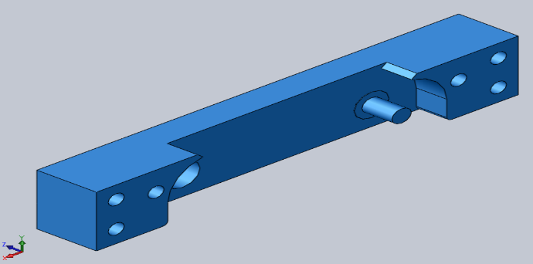

Figure 8: The extruding cylinder on the set-band.

- Evaluation of Concepts

- Evaluation Metrics

The evaluation metrics that were used to determine and choose the best design concept from the three concept options discussed in the Evaluation of Concepts section above are listed below with their weighted values of importance.

- Durability/Reliability (35%)
- Repeatability (20%)
- Manufacturability (15%)
- Simplicity (15%)
- Cost Effectiveness (15%)

The design team determined the weighted percentages of these evaluation metrics. The largest weight percentage of 35%, or the most prevalent metric, was given to the Durability or Reliability of the design. Giving Durability/Reliability such a large weighted percentage helped to determine the concept that will do the most efficient job consistently without breaking. The next prominent concept was determined to be repeatability which was given 20% for weighted importance. A design was desired so that if it broke occasionally, it needed to be easy and as non-time consuming as possible to reinstall a new swing up stop. Manufacturability, Simplicity, and Cost were given the same amount of importance because it was believed that the three design concepts only slightly differed for these three evaluation metric.
- Scoring Process

The scoring process used to select the most efficient and overall best design concept was the Pugh Chart. The design team utilized their unbiased understanding of the problem along with their theoretical and applicable knowledge to choose a rating value from one to three (1-3) for each of the evaluation metrics, which was performed for all three design concepts. For the rating values between one through three (1-3), the value of three was considered the best score, and thus the value of one was the worst score. After the six evaluation metrics were rated for each concept, the rated values were then weighted using the weight percentages shown in the Evaluation Metrics section. Then, the weighted evaluation metric values were summed for each of the three concepts. The concept with the highest weighted sum was then chosen as the best possible recommended design concept. The Pugh Chart that was created for this design project is shown below in Table 1.

Table 1: The Pugh Chart used to select the best design concept.

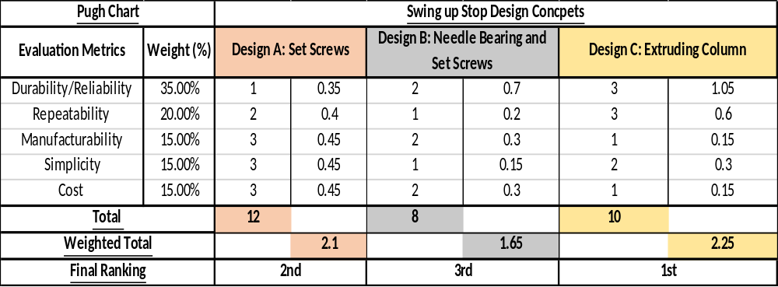

Concept A scored the best in Manufacturability, Simplicity, and Cost. This was due to its simplicity in design. It scored the lowest in Durability because the set screws have a greater chance than the other designs of coming loose and breaking. Concept B scored the lowest in Repeatability and Simplicity because of the complexity of using a needle bearing. Concept B never scored the best in any category, but it scored second best for the remaining three evaluation metrics making it a consistent choice. Concept C ranked best in Durability/Reliability and Repeatability since it would be unlikely to break, and if it were to break, it would not damage the hole in the table making it simple to replace. Hence, the same location could be used and installed with another set-band fairly quickly if the design concept C were to break. Due to the cost of welding the column to the set-band, the cost would be greatest for this concept as compared to the other concepts.

- Recommendations

After the Scoring Process section was complete using the Evaluation Metrics, Design C was designated the best choice. This concept was chosen as the best design in the categories of Durability/Reliability and Repeatability. This was determined using the Pugh Chart shown in Table 1 above. The rating process for these evaluation metrics was a collaborative effort from all the members on the design team. For each evaluation criteria, each team member would give their opinion on what rating each design concept should receive. The design team discussed and debated until an agreed upon rating was assigned to each of the three design concepts. Through this process, Design C was determined to be our team’s recommended choice.

- Feedback from Sponsor

The meeting and presentation with the Accu-Router representatives went very well. They agreed with us that Design C was the best option, and suggested some other options for manufacturing our design. They discouraged us from welding because it would warp the set-band, and they discouraged us from milling the new set-band because it would not be possible. Instead, they suggested that we could purchase one-ended threaded studs from McMaster-Carr that could be screwed into a threaded hole in the set-band in lieu of the shoulder bolt.

- Engineering Design

- Three Dimensional Model of Design

- Special Features, Benefits, Operations of device

The final design of the set-band is an improvement on the original design because the load will be distributed to a much more stable structure. In the original design the load was held only by the shoulder bolt, which had no external support structure other than being threaded into the router table. With the new design the load will be held by the threaded stud, which will be supported by both the table and the set-band. This will distribute the outward force to the entire set-band that is held to the table by six bolts unlike the original design where the entire force was supported by only the one shoulder bolt. A needle bearing will also be put over the one-ended threaded stud so the swing up stop can rotate around it. The swing up stop inner diameter that will fit around the one-ended threaded stud will need to be made larger to accommodate the needle bearing. The final designed set-band with the threaded holes used for the one-ended threaded stud is shown in Figure 9 below.

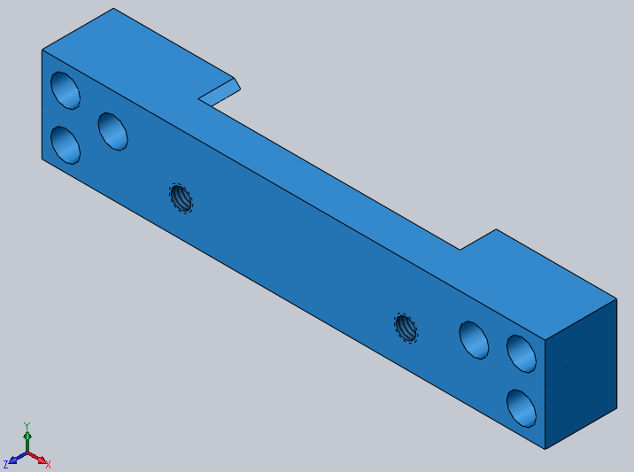

Figure 9: Final Design Set-band for One-Ended Threaded Stud.
- Assembly Drawing

- Discuss Subsystems

The swing-up stop is a subsystem of the router table. The parts of the subsystem that are being modified in this design include: the set-band, the swing up stop, and the one ended threaded stud. The threaded stud is replacing the shoulder bolt that was used in the previous design. The inner diameter of the swing up stop was made bigger in order to add a needle bearing, and the set-band had threaded holes for the one-ended threaded stud.

- Engineering Analysis, Software, Special considerations

The final design sketches and engineering analysis were performed on the one-end threaded stud and the threaded stud set-band using the solid modeling computer-aided design (CAD) and computer-aided engineering (CAE) software program SOLIDWORKS. The final design sketches and drawings were done using SOLIDWORKS. A finite element analysis (FEA) program called Abaqus was also used to model the one-ended threaded stud. The FEA Abaqus model of the stud is shown in Appendix B, and the SOLIDWORKS parts and drawings (that are and are not already shown) are shown in Appendix C. The results from these models (specifically the Abaqus model) seemed to verify that this design will work.

- Design of subsystems

- Identify off the shelf items to be purchased

The off the shelf item that need to be purchased for the threaded stud set-band design is the one ended threaded stud that will go into the set-band. This one end threaded stud can be selected and purchased from McMaster-Carr for $7.29. Its serial number is 97042A540. The dimensions are a ½” – 13 Thread, 3” overall length, and ¾” thread length. The needle bearings are available at Accu-Router so they do not need to be purchased.

- Identify parts to make

The threaded stud set-band and the swing up stop are the two part that needed to be modified. The original set-band will need to be modified to have threads that can be used to secure the one ended threaded stud. The old set-band design never needed threads. Once the one ended threaded stud is secured in the set-band, the non-threaded extension of the stud will go into the table to secure it. Depending on what Accu-Router prefers, they can order smaller studs that will go up to the table and not require drilling holes into the tables. The drawing and pictures of this new threaded set-band are shown above in Figure 9 and below in Appendix C (along with the dimensioned drawing of the part). The swing up stop inner diameter that goes around the one-ended threaded stud was needed to be made bigger to accommodate the added needle bearing.

- Parts List with Prices

The two parts, purchased or fabricated, along with their prices are listed below.

- One ended threaded stud: $ 7.29
- Modifications for the new set-band: $80.00

The total cost of implementing the threaded stud set-band design will be $87.29 per set-band. The cost for making the inner dimeter of the swing up stop larger was so minimal, it was not considered.

- Fabrication of Prototype

- Special Considerations, Issues in Building Prototype

Once the design was finalized, the SOLIDWORKS part and drawing were sent to Accu-Router. Accu-Router then sent the drawing of the new one-ended threaded stud set-band to the shop that makes the set-bands. There were no issues when building the part, but once the one-ended threaded stud set-band was implemented on a CNC router table, there was a problem with one of the new dimensions on the new one-ended threaded stud set-band. The design team decided to extend the length of the set-band going away from the table from 1.5 inches to 1.515 inches total. Thus, the thickness of the set-band where the one-ended threaded stud would be threaded would be longer than the threaded length of the stud. However, because this dimension was made larger, there was no way to tighten the pin so that there was no side to side play. Thus, the length of the band extending away from the table was fixed to be 1.5 inches total and the thickness of the set-band where the stud is threaded was made to be 0.745 inches. The dimensioning is shown in Figure 10 below.

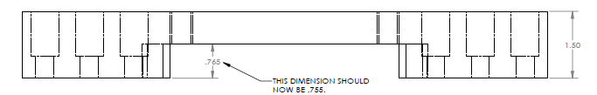

Figure 10: The Dimensioning Adjustments on the One-Ended Threaded Stud Set-Band.

- Design of Test Apparatus and Test Procedure

The design of the test apparatus for testing this newly designed set-band was just like the old set-up of the set-band. The one-ended threaded stud set-band was attached to the side of the CNC router table. Observations for improving the dimensions of the new set-band were made during the installation process. Once the proper adjustments were made and the new set-band apparatus (stud, swing up stop, etc.) was attached, the testing began in order to see if the set-band performed better than the older design. The majority of this testing was to observe when (how long) or if the new set-band design would break while the CNC router table was operating over time. If the new design did break, the ease of reinstallation was necessary to observe for this new design since easier reinstallation was one of the main goals for this project. However, the hope was that the new set-band would not break and the new design would hold for all the forces that are exerted on it during the operations of the machine.

- Test Results

Once the final adjustments, such as dimensioning, where made, the one-ended threaded stud set-band was implemented for future clients. The design worked. It held up better than the shoulder bolt design. Accu-Router continued to use this one-ended threaded stud set-band design for multiple different set-band designs that were specific for differing requirements from customers. Overall, the new set-band design was successfully implemented.

- Economic Impact

The overall economic impact of implementing this new one-ended threaded stud set-band will be miniscule to Accu-Router. The new design, just like the old design, requires the $80 cost to build. Since Accu-Router already incurred the cost to make the old set-band, there is no financial change in order to make the new set-band. The same applies for the swing up stop. The only new cost involved in the new design is the $7.29 for every one-ended threaded stud. The average CNC router table uses four of these set-bands, two on both sides, so the total cost for the studs would be $29.16 per table. If the new set-band will make customers happy, and require less maintenance, the amount for the one-ended threaded stud is worth investing in and miniscule in the overall cost. The cost for the shoulder bolts used in the old design is close to the cost of the studs so this cost is close to being exactly the same as the cost to implement the old design.

- Conclusion and Recommendations

The older design of the shoulder bolt swing up stop was a big concern for Accu-Router’s customers. Finding a solution would help Accu-Router improve their overall usability of their CNC router tables. Overall, the new one-ended threaded stud design was successful. The new design has been implemented in four routing tables, and thus far, the response has been very positive. Our recommendations for Accu-Router regarding this new design would be to continually modify the stud, needle bearing, and set-band (specifically dimensioning of the set-band) so that each design could be more adaptable and durable for various future customer needs. Since the stud design has yet to fail, we would also recommend that Accu-Router investigate the first failure of the new design. Investigation into the failure of the new design is to discover its compromises, determine the actions or process that contributed to the failure, discover ease of re-implementing the design, and determine the adjustments that are needed so that failure does not occur again. We would like to thank Accu-Router for working with us and providing this opportunity.

Appendix A: Design Methodology

The design methodology used throughout this project involved a seven step process. The titles of these seven stages and their detailed explanations are as follows:

- Planning Stage

The Planning Stage involves visiting the customer to gather information about the design project they desired. For this project, a trip was made to Accu-Router to view their facilities, learn about the products they make, and to gain understanding of the performance they desire from our design teams. Data was gathered in this stage from the people and manufacturing building of Accu-Router. Finally, once a better understanding of the project was attained, the restrictions and requirements of the design specified by the customer (Accu-Router) were determined and a path forward was formed. This was the most crucial part in the planning stage because the design project must meet the specifications of our customer for our design team to accomplish the job presented to us.

- Concept Generation Stage

The Concept Generation Stage utilizes the information, restrictions, and requirements of the design project gathered in the Planning Stage to brainstorm and create design concepts, ideas, and theories to solve the problem. Once all the design concepts are discussed, the design engineers must select three concepts to investigate further. This process involves team deliberation, discussion, and debates. For our process, we discussed the main requirements for this project that were presented to us from Accu-Router. Each member of the design team thought about and selected the three ideas that each person thought would be best. Then, our team, as a whole, argued and debated the different design choices, and eventually, the majority of the design team settled on three main design concepts. We discussed if anyone had objections with the three designs that were being discussed and if so, compromises were reached so that everyone agreed that we could finally settle on the best choices to pursue.

- Concept Selection Stage

The Concept Selection Stage used the unbiased understanding and knowledge of the design team to rank, weight, and sum the evaluation metrics to determine the overall best design concept out of the three original concepts presented. For this project, this process was performed using a Pugh Chart which can be seen and is described in detail in the section Scoring Process in the report. After the Pugh Chart was finished, the best design concept emerged with the best overall score. This was the concept that would be presented to Accu-Router to see if they agreed.

- System Level Design

During this stage, hand sketches and simple drawings in CAD help design engineers gain a better visual perspective and enhanced understanding of their project apparatus. For this project, basic SOLIDWORKS sketches were made for the three original concept ideas selected in the Concept Generation Stage. The design team modified the SOLIDWORKS sketches, specifically the set-band sketch, provided by Accu-Router in order to provide simplistic visuals of each of the three concepts. Set screw holes were put in the set-band for the first two concepts, and a cylinder was extruded from the set-band for the third concept. The needle bearing sketch was obtained and downloaded from the McMaster-Carr website for our second concept. The team worked on these as a group as well as divided up tasks and sketches for each concept.

- Detail Design

After presenting the three concept designs to Accu-Router, they directed us to the one-end threaded stud concept. This idea was similar to Concept C, our recommended choice, as it also did away with the shoulder bolt. However, instead of an extruded column being attached to the set-band, Brad Graves from Accu-Router suggested drilling a threaded hole in the set-band and having a one-ended threaded stud extruding from the set-band and into the table. Since there are two set-bands on each side of the router table, two threaded holes will be drilled on both sides of the set-band so any set-band can be used on either side of the table. Thus, more SOLIDWORKS models were made that specified the threaded holes for the stud to be threaded into the set-band. Also, dimensions of the stud and set-band were determined for the final design.

- Build/Test/Refine

The finished detailed drawing of the newly designed set-band were sent to Accu-Router to manufacture the new set-band design. The one-ended threaded stud was ordered from McMaster-Carr. Once the stud was obtained and the set-band was created, the new design was implemented on a CNC router table. After being implemented, there was a slight dimensioning issue with the set-band that Accu-Router requested that we make. After this dimension was changed, the design was observed and proper adjustments were made until the set-band was performing as desired.

- Production

After the newly designed set-band was built, tested, and refined, Accu-Router continued to use the one-ended threaded stud set-band along with modified versions of this. Accu-Router would continue to get the set-band produced through the same machine shop that produced their old design. Accu-Router was also familiar with one-ended threaded studs since they had used them for other assemblies on their router tables. This production process is very similar if not exactly the same to the process that Accu-Router did for the old design so implementing this for the new design was a smooth transition.

Appendix B: Engineering Calculations

The one ended threaded stud was modeled using Abaqus to find the maximum mises stress that the stud will endure. The force applied to the modeled stud was a 500 lb/in² traction force over the area that the swing up stop was located. The value of 500 lb/in² was excessive to the estimated 300 lb/in² that was actually applied to the stud. The stud was also modeled two different ways. The first model of the stud shown in Figure 11 below modeled the stud in the hole of the table so that the stud could not move in the x- and y- direction, but the stud could move in the z-direction. The threads of the stud were bounded in all ways. Using this imported one-ended threaded stud, the maximum stress 19440.2 psi and maximum deflection is 40.1017e-6 in. Assuming the yield stress of the stud is 40,000 psi, the factor of safety (FS) would be 2.057.

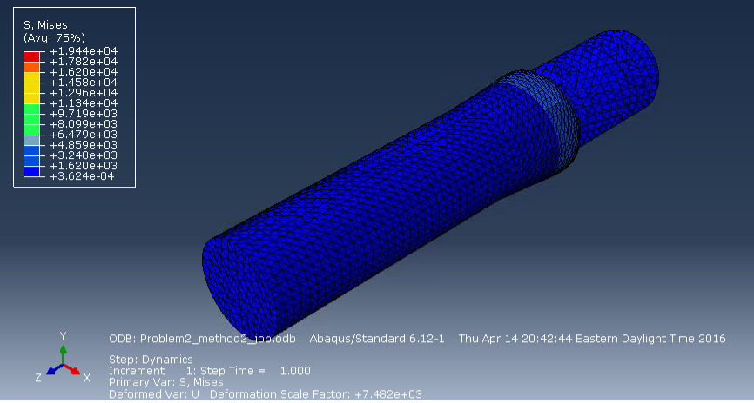

Figure 11: Abaqus modeled One-Ended Threaded Stud with boundary conditions in the x- and y- direction from the table.

The second model of the stud shown in Figure 12 below modeled the stud in the hole of the table so that the stud could not move in all three directions (x, y, and z). The threads of the stud were bounded in all ways. The results for this stud were slightly skewed which is shown by the stretched finite elements. For this model, the maximum stress was 10600.47 psi and maximum deflection is 12.881e-6 in. Assuming the yield stress of the stud is 40,000 psi, the factor of safety (FS) would be 3.773.

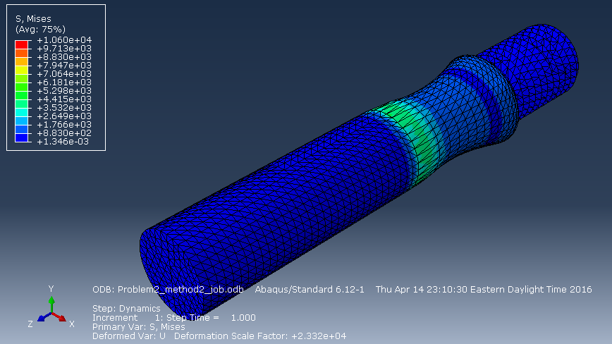

Figure 12: Abaqus modeled One-Ended Threaded Stud with boundary conditions for all direction from the table.

There was no model created for a stud that would touch the table but not go into the table. From the two modeled results, the stud looks very sturdy, and it should be able to withstand the load placed on it. This was a rough model of what the stress looks like on this stud so there are definitely discrepancies in the results. The main issues with the model were defining the boundary conditions for the stud in the table since it was bounded by the hole but it just sits in the hole. Through multiple test, our team discovered that it was better to model the part using U1=0, U2=0, and U3=0 (boundary conditions in all directions) because it produced better factors of safety. Finally, the results are skewed because there were issues with meshing the imported part so the part’s actual results will vary from the model. Because of the issues meshing, along with the large than actual applied load of 500 lb/in², it was believed the factors of safety found from this process are very low compared to the actual performance of the stud.

Appendix C: Detailed Shop Drawings

Figure 13: Final Set-band Configuration with Threaded Holes

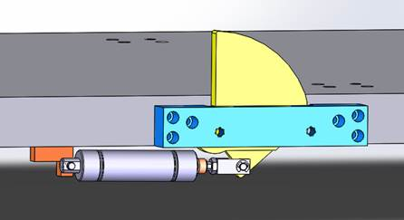

Figure 14: One-Ended Threaded Stud Set-band Attached to the Router Table

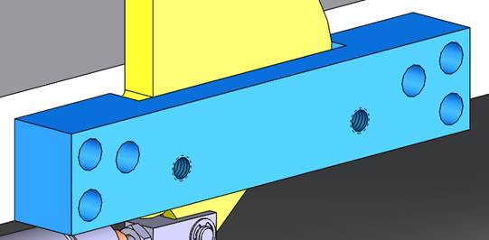

Figure 15: Closer View of the Final Set-band Setup.

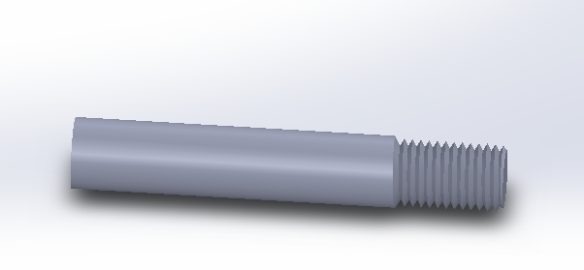

Figure 16: An Approximate Diagram of the One-Ended Threaded Stud.

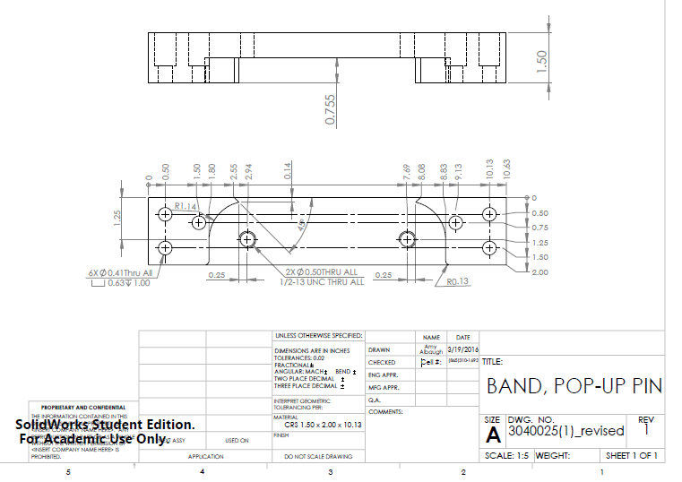

Figure 17: Final Dimensioned Drawing of the Set-band



Figure 18: Final One-Threaded Stud Swing Up Stop Apparatus for Presentation.

Figure 19: Presentation of Design.

Appendix D: Project Plain – Gantt Chart

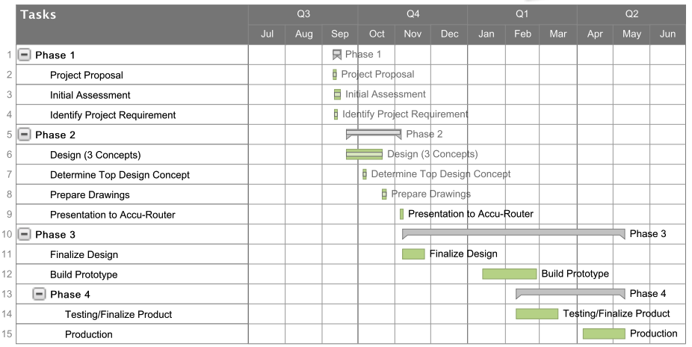

Figure 20: Gantt Chart.

