The Relationship Between Sibling and Peer Attachment Strength
Chancellor’s Honors Program: Senior Thesis
University of Tennessee, Knoxville

Ashley Williams
Advisors: Ashley Russell and Dr. Deborah Welsh
Abstract
Until recently, research has focused primarily on parent and peer or romantic relationship attachments. These have been shown to have implications on mental health, future relationships, and symptoms of depression (Allen, J., Porter, M., McFarland, C., McElhaney, K., & Marsh, P., 2007; Cook, Heinze, Miller, & Zimmerman, 2016; Greenberg, Mark T., & Others, 1983). Recent research has turned toward sibling attachment as well (Noel, Francis, and Tilly, 2018;Stewart, 1983), but this field is getting less attention. This study investigated the relationship between sibling attachment and peer attachment during emerging adulthood, with undergraduate college students. Our hypothesis stated that peer attachment and sibling attachment are positively correlated, including all underlying constructs, and that participants who are closer to older siblings would report stronger attachments to peers than participants with close younger siblings. Results supported the first hypothesis, showing that sibling and peer attachment were significantly correlated. The second hypothesis received mixed results as sibling order presented a negative correlation with peer trust, which is strongly related to peer attachment, but peer order was related to sibling alienation, which contradicts the second hypothesis. Future research presents the opportunity to examine the relationship sibling attachment has to other attachments such as peer, romantic relationship, and parental, and suggestions are discussed.

Introduction
Historically, attachment research has focused on the natural connection between child and primary caregiver. Recently, an emphasis has developed on other attachment bonds such as romantic and peer relationships. Attachment is traditionally accepted to be a significant and close bond formed first between child and parent through proximity maintenance, seeing the other as a safe haven, and using the other as a secure base (Bowlby, 1980). It has since been confirmed that such attachment is prevalent across developmental periods and can have a great impact on future attachments (Fraley & Davis, 1997; Theisen, Fraley, Hankin, Young, & Chopik, 2018). However, research shows that healthy parental and peer attachments are also significant bonds that affect mental health in a positive way (Allen, Porter, McFarland, McElhaney, & Marsh, 2007). Additionally, research suggests that during adolescence, there is an attachment transfer from parents to peers (Hazan & Shaver, 1994), which can later be replaced by romantic relationship attachment (Fraley & Davis, 1997). New evidence suggests that siblings may be some of the earliest attachment figures in addition to primary caregivers as they can adopt a guardian role with younger brothers and sisters (Stewart, 1983; Ainsworth, 1989). Genetic similarities, shared values, and mutual experiences facilitate attachment between siblings (Ainsworth, 1989). Thus, sibling attachment may be equally related to future relationships and attachments. Noel, Francis, and Tilly (2018) analyzed sibling and peer attachment in adolescence and found significant positive correlations between peer and sibling attachment and each construct they measured: trust, communication, and alienation. Additionally, greater sibling trust matched with lower sibling alienation was associated with fewer reports of depression as well as increased subjective feelings of self-worth. Research also suggests that older siblings report weaker attachment security toward their younger siblings compared with younger siblings toward older siblings (Fraley & Tancredy, 2012). As previously mentioned, this could be due to the fact that older siblings commonly inhabit a guardian role while younger siblings are solely recipients of such care.
The current study focused on the emerging adulthood population, which ranges from age 18 to 29. Changes such as residential status, school attendance, relationships, and identity mark this period as one of great exploration and growth (Arnett, 2000). Research has shown that emerging adulthood includes the specific transfer of the secure base aspect of attachment, which has been studied between parent and peer or romantic partner (Hazan & Shaver, 1994; Fraley & Davis, 1997). This logically follows the increase in parental attachment avoidance during adolescence (Theisen, Fraley, Hankin, Young, & Chopik, 2018); therefore, after combining the possibility of a transfer away from parental attachment and an increase in parental avoidance, sibling relationships could be another central source of attachment during emerging adulthood.
The Present Study
The present study focuses specifically on the relationship between sibling and peer attachment and used an adapted version of the revised Inventory of Parent and Peer Attachment, which includes three constructs: trust, communication, and alienation (Armsden & Greenberg, 1987). We sought to expand Noel and colleagues’ (2018) findings concerning the adolescent population to the emerging adulthood population. We gathered data from the emerging adulthood population and formed the following hypotheses:
Hypothesis 1. Peer attachment and sibling attachment are positively correlated, which includes all subcomponents of attachment as defined by the IPPA scale.
Hypothesis 2. Sibling order is negatively correlated with peer attachment, as demonstrated by participants with close older siblings reporting stronger attachments to peers than participants with close younger siblings.
Methods
Participants and Procedure
A total of 235 people participated in the survey. Of these, 55.3% were female (n = 130), 40.4% male (n = 95), and 4.3% preferred not to answer (n = 10). All participants were students at the University of Tennessee, Knoxville and were enrolled in the Psychology 110 course. The mean age was 19 years and 3 months (SD = 1.25 years) and the mean number of siblings was 2.04 (SD = 1.223). Of the total number of participants, 100 had only one sibling, 76 had two, 26 had three, 13 had four, and 19 had five or more siblings. 207 participants reported that the sibling they were closest with was their biological sibling, 20 were closest with half siblings (i.e., siblings who share one biological parent), and 7 were closest with an adopted sibling.
We distributed the study using the SONA database system with the University of Tennessee. Students selected this study from a list of available options of their own accord and received compensation in the form of course credit upon completion. Only students enrolled in the general psychology course were able to participate. Participants were required to be between the ages of 18 and 29 and have at least one sibling. Informed consent was provided at the beginning of the survey, which emphasized voluntary participation and ability to “un-enroll” if they chose to do so. The study was administered via Qualtrics and was comprised of a brief demographic portion and a revised version of the Inventory of Parent and Peer Attachment using “sibling” in place of “parent” and “close friend” in place of “friends” (IPPA; Armsden & Greenberg, 1987). Participants took the survey in a location of their discretion as no formal lab was used. The survey took approximately one hour to complete. In order to test the hypotheses, a bivariate correlation model was used, controlling for various demographic identities such as age, gender, and number of siblings.
Measures
Demographic Questionnaire Participants completed a multi-item demographic questionnaire. Results are shown in Table 1.
Attachment Peer and sibling attachment were measured using an adapted version of the IPPA (Armsden & Greenberg, 1987). This study used a revised version of the IPPA, which consisted of three sections: one addressing mother attachment (25 questions), the next addressing father attachment (25 questions), and the final addressing peer attachment (25 questions). For the purpose of this study, we combined the mother/father attachment scales, which are identical except for the parental description and replaced ‘mother’ with ‘sibling’. In the original peer section, ‘close friend’ replaced peer. Specific items were reverse coded in each section. Due to error, one question was removed from the peer section, leaving 24 questions total. Each question was measured with a Likert scale ranging from almost never or never true (1) to almost always or always true (5). Armsden and Greenberg (1987) defined attachment as having three subscales: trust, communication, and alienation. Each of these subscales is measured by taking the sum of a select number of questions. Both the trust and communication subscales mirror attachment such that a higher score represents stronger feelings of trust and communication. However, the alienation score functions in an opposing manner where a lower alienation score points to a more secure attachment.
Order All questions regarding order were asked from the perspective of the participant such that ‘youngest’ means that the participant is the youngest sibling. Sibling order was assessed using the following markers: youngest, younger middle (4+ siblings), middle of 3, older middle (4+ siblings), and oldest. Peer order was assessed by youngest, same age, and oldest. For each variable, the lowest value was given to the youngest label and the highest value to the oldest label.
Gender Difference Sibling gender difference was found by taking the difference between participant gender and sibling gender. This resulted in 4 options: male/male, male/female, female/male, or female/female. These options were recoded into the following: same gender as sibling or different gender from sibling.
Results
Preliminary Analyses
We examined the correlations between sibling attachment, subscales of sibling attachment, peer attachment, and subscales of peer attachment. We also added gender, age, and order of peers and siblings to the matrix. Finally, we investigated for relationships between peer and sibling attachment and each subscale in relation to difference in age, order, and gender of the participant and sibling. A higher IPPA attachment score equates to a stronger bond whereas a lower score indicates a weaker bond. The same applies to each subscale except for the alienation scale, which pairs a lower score with stronger attachment (low alienation) and a higher score with weaker attachment (high alienation). Sibling and peer attachment descriptive statistics can be found in Table 2.
Statistics
The first hypothesis stated that there would be a positive correlation between friend and sibling attachment. This hypothesis was supported in the correlation between sibling and peer attachment, sibling and peer trust, sibling and peer communication, and sibling and peer alienation (Table 4). There was no significant relationship between age and attachment or number of siblings and attachment. Results did show that length of friendship and gender were positively correlated (Table 6), specifically that this sample contained male participants with longer peer relationships than females. However, it was also found that gender and peer attachment were negatively correlated, suggesting that female participants hold stronger attachments with friends than male participants within this sample (Table 6). There was also a significant positive relationship between sibling gender difference and peer attachment (Table 4), meaning participants with siblings of the opposite gender experienced stronger peer attachment.
The second hypothesis theorized that sibling order would be negatively related to friend attachment. The data showed that sibling order and peer trust were significantly correlated in a negative relationship (Table 5). There was no significance between sibling order and sibling attachment or peer order and peer attachment. It is also interesting to note that peer order and sibling alienation showed a significant negative correlation (Table 5) meaning that participants with younger close friends tended to report lower sibling alienation compared with participants who were closer to older friends.
Discussion
The findings in this study present a higher average mean of sibling attachment (Table 2) compared with findings from previous research studies on parent attachment (M = 60.7, SD = 16.2); there was also a considerable increase in peer attachment (Table 2) compared to previous findings with a mean of 56.6 and standard deviation of 10.4 (Armsden & Greenberg, 1987, p. 438). This could be a result of the final phase transfer of attachment away from the parent during emerging adulthood (Fraley & Davis, 1997, pg. 7; Hazan & Shaver, 1994). However, this transfer has been primarily studied between parental and peer attachment rather than parental and sibling attachment, so an area of future research could analyze the possible transition of attachment between parent and sibling.
Results of this study found that sibling and peer attachment are positively correlated, which included the constructs of each attachment: trust, communication, and alienation. These findings are consistent with some previous research suggesting that peer and sibling attachment are positively related (Noel et al. 2018), though there has been little research looking specifically at the connection between the two. In addition to the base-line attachment correlations, there were significant gender differences in sibling attachment where the gender of the sibling, rather than the participant, was significantly correlated with sibling attachment, suggesting that regardless of the participant’s gender, stronger attachments are reported with female siblings. However, there was a significant correlation between gender difference among siblings and peer attachment, showing that opposite gender sibling relationships demonstrate a stronger attachment with peers than same gender sibling relationships. This could be due results showing female participants reporting stronger attachments with peers than male in addition to the sample containing a higher percentage of female participants with male siblings (see Table 3).
Results confirmed that participants who are closest to a younger sibling reported less peer trust than participants who are closest to an older sibling (Table 5). Because peer trust was found to be highly indicative of peer attachment, this supports previous research suggesting that older siblings may play a parental role which invites attachment from younger siblings rather than showing attachment themselves (Stewart, 1983; Ainsworth, 1989). However, participants who are closest to a younger friend reported lower sibling alienation (Table 5). Since high or low alienation implies the opposite strength of attachment, this suggests that participants with younger close friends tended to report higher sibling attachment, which is an opposite pattern compared to sibling order and attachment. Consequently, there are mixed results addressing the second hypothesis.
Limitations and Implications
This study analyzes the relationship between sibling and peer attachment, which is an area of research that needs more attention, especially in such a crucial period of change as emerging adulthood. As studies have shown, there are mental health results and implications for future relationships that come from parental attachment starting in infancy, both positive and negative (Waters, Merrick, Treboux, Crowell, & Albersheim, 2000). Studies have shown the transition away from parental attachment toward peers or romantic relationships, but future research can focus on sibling attachment as a secure base as well. This study begins the path toward understanding the importance of sibling attachment in relation to and comparison with peer or romantic attachment.
The first limitation in this study occurred because of a miscoding between Qualtrics, the survey building site, and SONA, the survey distribution site. Participants documented issues of completing the survey when the website routed them back to the starting page rather than to the completion page. Thus, during data cleaning, 85 duplicate responses were verified and subsequently removed.
The largest limitation for this study came from using an altered version of the Inventory of Parent and Peer Attachment, where one item had been removed from the peer attachment portion (question 4) and one item was worded in a substantially different manner (question 3). The first item was used in scoring peer attachment and alienation and the second in peer communication. Thus, this study needs to be replicated in order to confirm findings and generalize to other emerging adult populations. Additionally, this study did not investigate twin attachment as an option of sibling attachment, which could offer different results (Fraley & Tancredy, 2012). Furthermore, no demographic information was gathered for step-siblings or foster siblings. This presents opportunities for future research to see if these types of relationships have significant attachments as well, and furthermore if they would relate similarly to peer attachment.
Finally, this study also showed initial findings regarding friend and sibling order, but there was no item to state the sibling order in relation to the closest sibling, so future research could find sibling order to the closest sibling and use it as a moderator between friend and sibling attachment. Because siblings often step in to fill guardian roles for younger siblings, peer relationships could be affected. Younger siblings may feel fully supported by their older siblings and thus gravitate toward peers of a similar age, or younger siblings that feel unsatisfied with older sibling attachment, and in this case, parental attachment as well, thus being drawn toward peers who are similar in age to their older sibling. More research would be beneficial in exploring this subject.
References
Ainsworth, M. (1989). Attachments Beyond Infancy. American Psychologist, 44(4),
709-716.
Allen, J., Porter, M., McFarland, C., McElhaney, K., & Marsh, P. (2007). The Relation of
Attachment Security to Adolescents’ Paternal and Peer Relationships, Depression, and Externalizing Behavior. Child Development, 78(4), 1222-1239.
Armsden, G., & Greenberg, C. (1987). The inventory of parent and peer attachment: Individual
differences and their relationship to psychological well-being in adolescence. Journal of Youth and Adolescence, 16(5), 427-454.
Arnett, Jeffrey Jensen. (2000). Emerging Adulthood: A Theory of Development from the Late
Teens Through the Twenties. The American Psychologist, 55(5), 469-80.
Bowlby, J. (1980). Attachment and loss (Harper colophon books ; CN/5085). New York: Basic
Books.
Cook, Heinze, Miller, & Zimmerman. (2016). Transitions in Friendship Attachment During
Adolescence are Associated with Developmental Trajectories of Depression Through Adulthood. Journal of Adolescent Health, 58(3), 260-266.
Fraley, R., & Davis, K. (1997). Attachment formation and transfer in young adults' close
friendships and romantic relationships. Personal Relationships, 4(2), 131-144.
Fraley, R., & Tancredy, C. (2012). Twin and Sibling Attachment in a Nationally Representative
Sample. Personality and Social Psychology Bulletin, 38(3), 308-316.
Greenberg, Mark T., & Others. (1983). The Nature and Importance of Attachment Relationships
to Parents and Peers during Adolescence. Journal of Youth and Adolescence, 12(5), 373-86.
Hazan, C., & Shaver, P. (1994). Attachment as an Organizational Framework for Research on
Close Relationships. Psychological Inquiry,5(1), 1-22.
Noel, V., Francis, A., & Tilley, S. (2018). An Adapted Measure of Sibling Attachment: Factor
Structure and Internal Consistency of the Sibling Attachment Inventory in Youth. Child Psychiatry & Human Development,49(2), 217-224.
Stewart, R., & Scarr, Sandra. (1983). Sibling attachment relationships: Child–infant interaction
in the strange situation. Developmental Psychology, 19(2), 192-199.
Theisen, Fraley, Hankin, Young, & Chopik. (2018). How do attachment styles change from
childhood through adolescence? Findings from an accelerated longitudinal Cohort study. Journal of Research in Personality, 74, 141-146.
Waters, E., Merrick, S., Treboux, D., Crowell, J., & Albersheim, L. (2000). Attachment Security
in Infancy and Early Adulthood: A Twenty-Year Longitudinal Study. Child Development, 71(3), 684-689.

Appendix
Table 1
Demographic Descriptive Statistics
 | Mean | Standard Deviation | Frequencies % (N)
Gender  Male  Female | N/A | N/A | 55.3% (130)  40.4% (95)
Age  18 – 20  21 – 23  27 | 19 years 3 months | 1 year 3 months | 84.7% (199)  14.5% (34)  0.4% (1)
Number of Siblings  1  2  3  4  5+ | 2.04 | 1.22 | 42.6% (100)  32.3% (76)  11.1% (26)  5.5% (13)  8.1% (19)
Note. Total N = 235

Table 2
Descriptive Statistics: Sibling and Peer Attachment
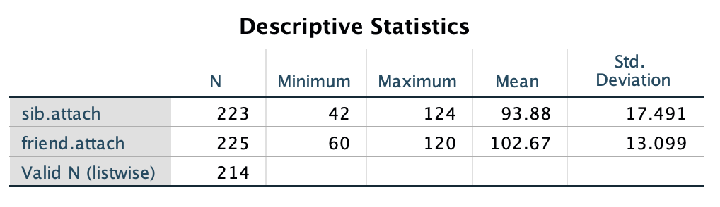

Table 3
Gender Difference: Participant Gender Combined with Sibling Gender
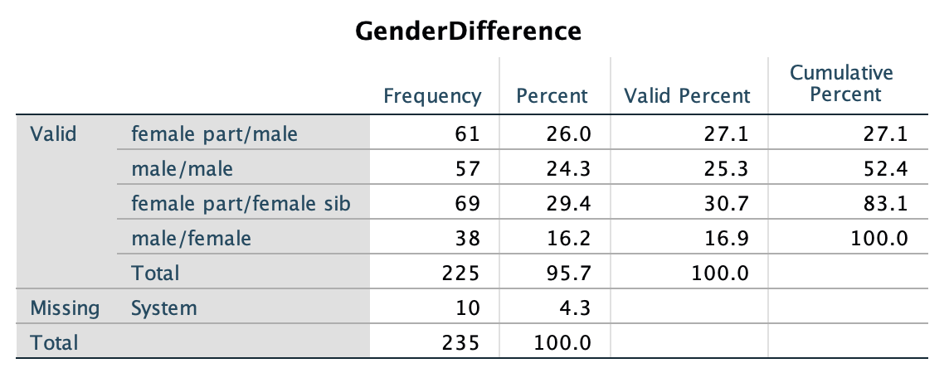
Table 4
Bivariate Correlations Between Gender Difference, Sibling Attachment and Subscales, and Peer Attachment and Subscales
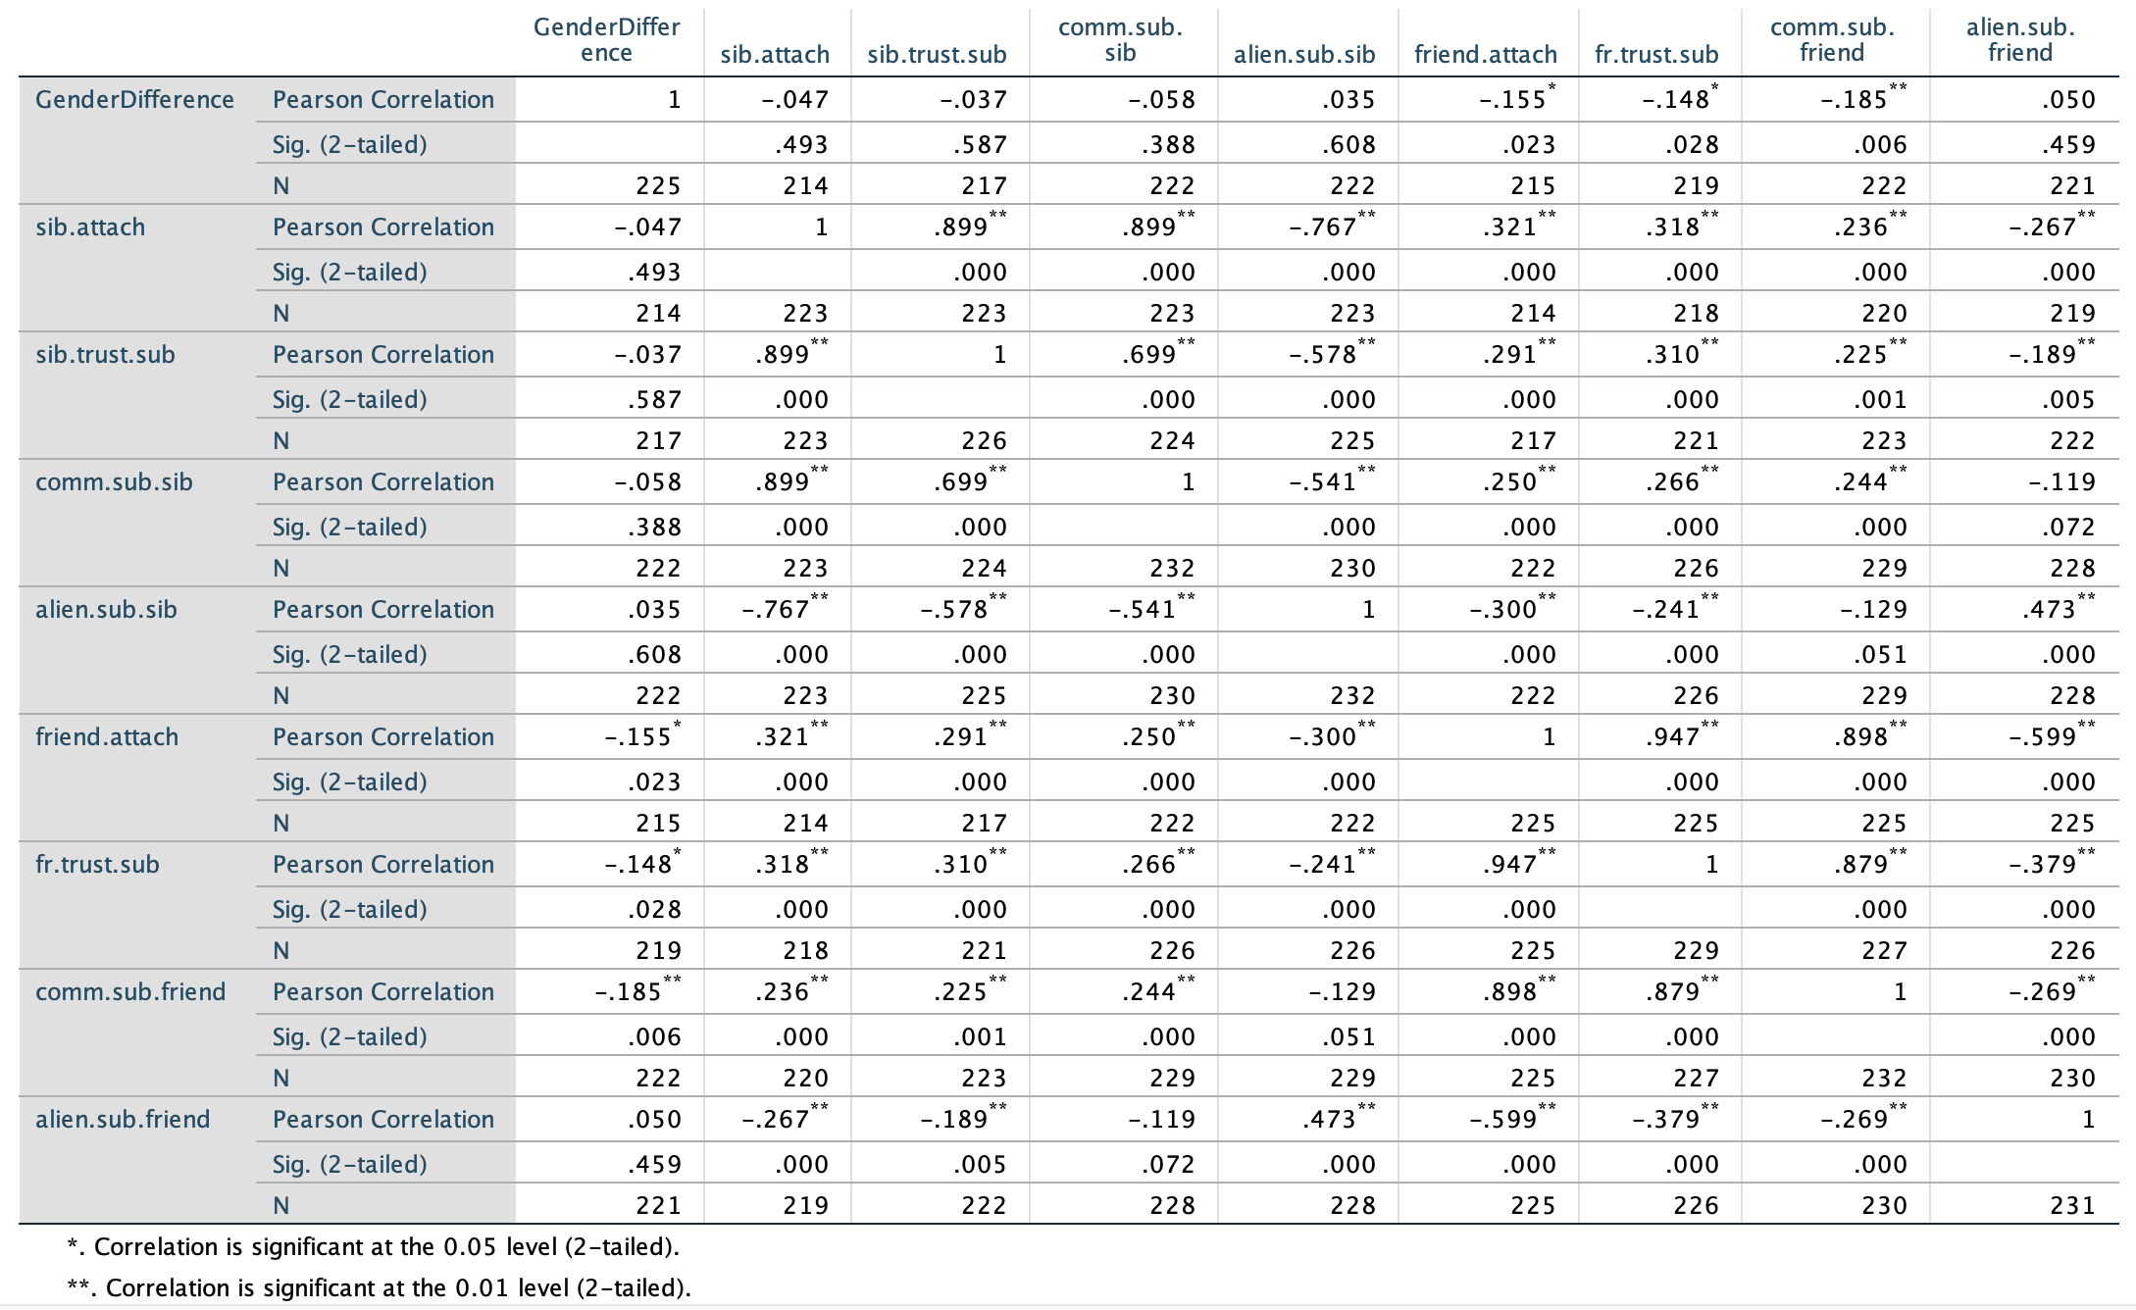

Table 5
Bivariate Correlations Between Sibling Order, Peer Order, Sibling Attachment and Subscales, and Peer Attachment and Subscales
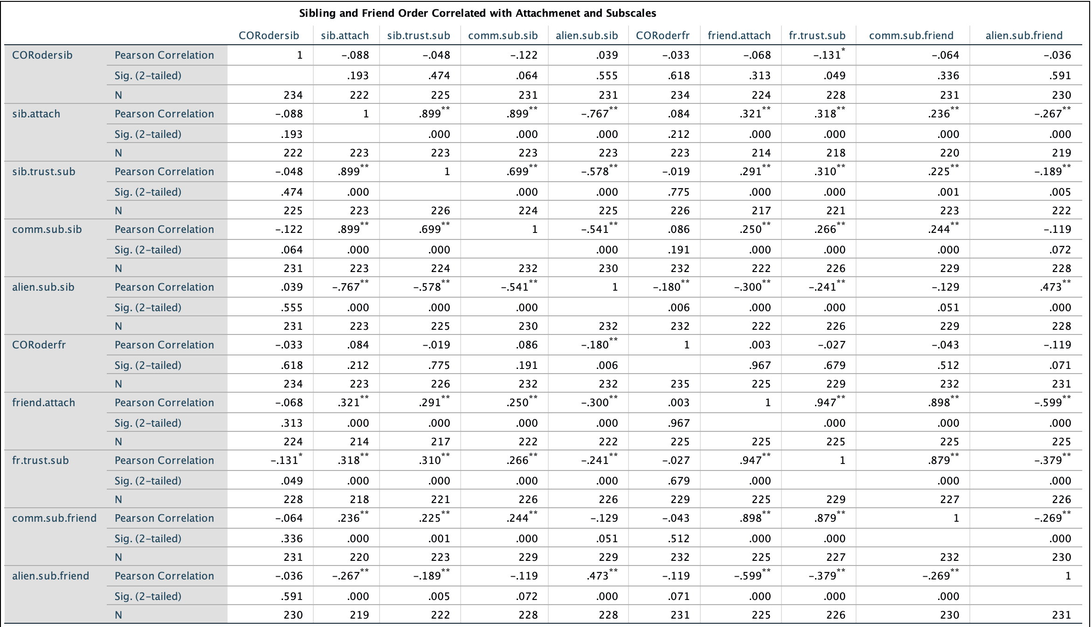

Table 6
Bivariate Correlations Between Participant Gender, Age, Number of Siblings, Sibling Attachment, and Peer Attachment
