Social Support in an Internet-Based Weight Loss Intervention among College Students

A Thesis Presented for the
Master of Science
Degree
The University of Tennessee, Knoxville

Yijia Zhang
December 2014

Copyright © 2014 by Yijia Zhang
All rights reserved.

Acknowledgements

I would like to thank my mentor, Dr. Lauren Gellar for your aspiring guidance and constant support. I am grateful for your belief in me when I had doubts about my abilities. Your encouragement has helped me grow not only as a researcher, but also as a human being.

I would like to thank Dr. Katie Kavanagh for serving as my advisor and committee chair when Dr. Gellar moved to University of South Carolina, Beaufort. I appreciate your thoughtful feedback, guidance and support.

I would like to thank my committee members: Dr. Laura Miller and Dr. Melissa Hansen-Petrik, for your constructive feedback and the assistance you provided at all levels of the project.

I would like to thank my research team, Chrissie Sugimoto and Julie Mathews for your hard work. A special thanks goes out to Chrissie, I appreciate the support and help you provided during the project.

To my friends, Yujia Bai, Xiaomin Jing, Ran Huang and everyone in our weekly discussion club for your inspiration and motivation. A special thanks to my boyfriend, Kai, without your love and encouragement, I would not have finished this project.

I will switch to Chinese to express my gratitude for my family…

欢欢姐姐，我们从小一起长大，再遥远的距离也无法阻隔彼此深深的思念，我知道无论我在哪里，你都是我坚强后盾。我在南京的妹妹和弟弟，你们是我最安心的陪伴。

爷爷奶奶，阿公阿婆，还有太太，谢谢你们让我的童年充满欢乐，我永远爱你们。

爸爸妈妈，感谢你们二十多年来对我的鼓励与支持，你们无私的爱是我脆弱时最需要的拥抱，也是我疲倦时最向往的港湾。

Abstract
Objective: To assess college students’ perceptions regarding online social support in an 8-week Internet-based weight loss intervention.
Participants: Participants were those randomized to the intervention group of an online weight loss intervention targeting overweight and obese college students.
Methods: Members of the intervention group had access to a private discussion forum and weekly live chat sessions, allowing for anonymous interactions. Following the 8-week intervention, intervention group members were invited to complete an online focus group, discussing these tools. The transcripts were directly copied from the live chat conversation history. Using thematic analysis, perceptions regarding online social support were identified, coded and sorted and organized into themes.
Results: Two online focus groups were conducted (n=7, overall). Thematic analysis indicated that participants appreciated the social support provided by the forum and live chat sessions. While many preferred the interactive feature of the live chat sessions, others enjoyed the constant availability of the forum. However, barriers including time restrictions, technology-related preferences, and concerns about online interpersonal relationships were also identified.
Conclusions: Combining forum and live chat sessions may benefit individuals differently, based on preference, and both should likely be incorporated into an online weight loss intervention.

Table of Contents

Chapter 1 Literature Review 1
INTRODUCTION 2
INTERVENTIONS 4
Weight loss interventions for college students 4
Use of the Internet 5
Internet-based weight loss interventions 6
SOCIAL SUPPORT 8
Social support and weight loss 9
Online social support 11
Synchronous and asynchronous online communications 13
Inclusion of social support in Internet-based weight loss interventions 14
STUDY PURPOSE 15
Chapter 2 Manuscript 17
ABSTRACT 18
INTRODUCTION 19
METHODS 22
Procedure 22
Synchronous and asynchronous online social support 23
Qualitative data collection 25
Qualitative data analysis 27
RESULTS 28
Participants 28
Perceptions of the two online social support platforms 28
Types of Interactions 31
Barriers to online interactions 33
COMMENTS 36
Limitations 38
Future directions 38
Conclusions 40
List of References 42
Appendices 44
Appendix A: Weekly Challenges on the Forum 45
Appendix B: Live Chat Session Plans 47
Appendix C: Focus Group Questions 53
Appendix D: The UTK Health Website 54
Appendix E: Intervention Overview 59
Appendix F: Focus Groups Findings from the UTK Health Trial 1 65
Vita 71

List of Figures

Figure 1: Social support pathways 9

Chapter 1
Literature Review

INTRODUCTION
Obesity has a profound impact on society¹. Copious evidence has demonstrated the adverse influence of the obesity epidemic on people’s health, financial status, and overall quality of life². It is estimated that obesity cost the Unites States approximately $147 billion in 2008, including both direct medical bill costs and indirect costs such as job loss and reduced productivity¹. In addition, it increases the risk of developing various medical conditions such as type 2 diabetes, cardiovascular disease, stroke, and certain cancers^{1,3,4}. Despite its increased prevalence in the Unites States, there is still social stigma associated with obesity⁵. It affects individuals’ psychological wellbeing and may cause anxiety, depression, or low self-esteem^{6,7}. In addition, the obesity epidemic impacts individuals across their life span, thus posing a long-term threat to society.
According to the 2013 National College Health Assessment, 21.6% of college students are overweight (25.0 kg/m² ≤ body mass index (BMI) ≤ 29.9 kg/m²), and 13.8% are obese (BMI≥30 kg/m²)⁸. Although the level of overweight has remained steady in this population, the prevalence of obesity has increased approximately 70% since 2000^{8,9}. This is alarming as an individual’s weight status during early adulthood is likely to persist as age increases¹⁰. In addition, a longitudinal study suggests that young adults who are overweight or obese are at greater risk of developing heart diseases in later life¹¹. Thus, it is of great importance to target college students, a subset of young adults, for obesity treatment.
Several longitudinal studies indicate college students’ dietary choices and physical activity patterns are both below the recommended levels, which could partially explain the significant weight gain that occurs between freshman year and senior year¹²⁻¹⁴. College students’ typical eating pattern consists of low consumption of nutrition-dense foods (fruits and vegetables) and high consumption of energy-dense foods (fast foods and sugar-sweetened beverages)¹⁵. While only about 6% of college students reportedly consume the recommended servings of fruits and vegetables daily⁸, the majority have high intakes of sugar-sweetened beverages and saturated fat¹⁵. Furthermore, college students’ physical activity level declines after they enter college¹⁶. Data from the national assessment indicate that 50% of college students partake in physical activity less than three times per week⁸.
The causes of change in college students’ eating and physical activity behaviors are multifaceted^{8,15,17-20}. Firstly, the campus food environment, represented by flavorful, large-portioned and high-calorie food options, is generally not nutrition-friendly¹⁷. Healthy foods usually cost more, which makes them even less accessible to college students, who are typically on a budget. As a result, college students are more likely to eat in fast-food restaurants that serve burgers and fries for their convenience and low cost¹⁵. Secondly, stress, which is the top impediment to students’ academic performance⁸, is also associated with higher energy intake in the form of saturated fat and sugar¹⁸. Furthermore, college students’ health is compromised by a sedentary lifestyle, which may be due to a variety of factors such as heavy academic course loads, employment, and busy social lives^{19,20}. Thus, due to multiple individual and environmental factors, it is extremely challenging for college students to maintain a healthy weight. In order to help remedy the epidemic of obesity among college students and reduce their risk of developing health complications in later life, there is a great need to investigate and design effective strategies that can assist college students in their weight loss efforts.

INTERVENTIONS

Weight loss interventions for college students
Despite the trend of escalating obesity rates on campus, limited research has been done targeting this population²¹. Furthermore, weight loss studies that have targeted college students have had minimal impact on health behaviors and weight status²²⁻²⁴. The results of several exercise programs have shown that intense physical training can lead to significant weight loss¹⁹. However, the sustainability of these programs is unknown due to the lack of follow-up data collected during the weight maintenance phase. Other studies have focused on psychosocial factors^{24,25}. For example, one study tested the effectiveness of Brief Motivational Intervention for obesity among college students²⁵. This type of intervention, which has been proven to be effective in relation to alcohol abstinence, however, did not produce any significant positive change in weight, diet, or physical activity²⁵. In a cognitive-behavioral intervention that focused on participants’ unrealistic weight loss expectations, Ames and colleagues demonstrated improvements in terms of several psychological outcomes such as motivation, perceptions of body image, and self-esteem²⁴. However, participants’ changes regarding diet, physical activity behaviors, and weight status remained insignificant²⁴.
Due to the recurring issue of low retention and low engagement, researchers recommend future interventions utilize college students’ preferred communication mode: the Internet^{19,24,25}. In addition, understanding students’ own attitudes and knowledge toward lifestyle changes is imperative when developing weight loss interventions for this population¹⁹.

Use of the Internet
The Internet, due to its various benefits including expanded reach and relatively low cost, has been used in numerous weight loss interventions targeting middle-aged adults²⁶. A series of studies by Tate and colleagues have shown successful weight loss results when the Internet is used as an alternative channel to deliver weight loss programs²⁷⁻²⁹.
College students, also known as the “net generation,” use the Internet more frequently than do any other populations³⁰. For example, a survey from the 2010 Pew Internet & American life project revealed that over 98% of undergraduate students used the Internet, and almost 90% owned a laptop³¹. Many college students are active on online social networking sites such as Facebook, Twitter, and Pinterest³¹. One unique characteristic of social media is that it enables peer-to-peer communication without the need for in-person meetings³². They build a sense of connectedness as students initiate and maintain relationships with one another on the websites³². In addition, national surveys indicate that the Internet is the predominant source that college students use to gather health-related information,³³ with 32% of young adults reporting searching for weight management related information online³⁴. Thus, the high usage of the Internet and social media among college students suggests that the employment of Internet-based weight loss interventions may be a promising strategy to rectify college students’ poor health-related behaviors and further improve their weight status. Compared to traditional in-person interventions, Internet-based interventions are more applicable to this population as they will not create an extra unnecessary burden in students’ daily lives³⁵. Internet-based interventions minimize the time and costs spent on commuting to the intervention sites and also have the potential to intensify the communication dosage. For example, multiple platforms can be used, including email, discussion forums, and chat sessions, which may amplify the participants’ exposure to the intervention³⁵.

Internet-based weight loss interventions
A variety of Internet-based weight loss interventions have been implemented in the past to reduce the prevalence of overweight and obesity on campus^{36-38,40}. In response to the poor dietary and physical activity habits of college students, “MyStudentBody.com-Nutrition” (MSB-N), an online nutrition and physical activity education program was developed to target the specific resources and challenges faced by this population^{37,38}. MSB-N explores various concepts, such as healthy eating on a budget, healthy meal planning, and body image, and provides an interactive learning experience for the program participants³⁹. Two studies have evaluated the impact of MSB-N in relation to a variety of behavioral and psychological outcomes and suggested that the program has only improved students’ knowledge or intentions toward behavior changes, but has not resulted in significant weight change^{37,38}. For example, Franko and colleagues reported an increased consumption of fruits and vegetables and improved motivation for healthy eating³⁸. However, participants’ physical activity behavior did not change, despite this improvement in attitude³⁸. In another study, by LaChausse, BMI was included in the measures, but no significant change was observed³⁷. Similar to the results of the previous study, there was no change in students’ exercise behaviors³⁷. Notably, researchers from both studies suggested that education alone, which was effective in changing college students’ attitudes and intentions, might not achieve the same success in changing their behaviors^{37,38}.
Davy and colleagues utilized daily email support and monetary incentives to help overweight and obese college students lose weight⁴⁰. The content of the emails was targeted to college students’ physical activity and eating behaviors and included strategies to initiate and sustain positive changes⁴⁰. In addition, the intervention group participants had access to a health coach, who provided individualized help on various issues pertinent to nutrition⁴⁰. The results of the study showed that the intervention group participants had significantly improved their dietary behaviors, especially the intake of fat and added sugar⁴⁰. However, significant changes in physical activity and weight status were not detected at week 12 of the program⁴⁰. The intervention group participants also suggested that the frequency of emails was too high⁴⁰.
Napolitano and colleagues conducted a randomized controlled trial (RCT), utilizing a social network, Facebook, to deliver an 8-week weight loss program for college students³⁶. The researchers incorporated two intervention groups, one being the Facebook group and the other the Facebook Plus group. Both groups had separate access to two private Facebook groups presenting the same weight management materials. However, the Facebook Plus group also received individualized text messaging from the research staff providing assistance in behavioral goal setting and social support. The results suggest that the inclusion of support from the program staff helped participants achieve significantly greater weight loss (-2.4± 2.5 kg)³⁶.
A two-year RCT using both social media and mobile technology for young adults is currently in progress⁴¹. The five program components are 1) a Facebook page, which participants can “like” in order to receive intervention content; participants can also interact with their existing friends on Facebook for social support; 2) a smart-phone application which allows participants to set goals and self-monitor diet or physical behaviors; 3) a website with educational materials and an interactive blog, where participants can read and comment on various intervention topics; 4) weekly text message reminder; and 5) emails for collecting participants’ questions and concerns as well as for providing additional reminders⁴¹. The study is currently in progress. However, the researchers have suggested that the findings from this study will assist in understanding how social and mobile technology can impact participants’ diet and physical activity behaviors⁴¹.
In conclusion, Internet-based interventions can be effective in improving college students’ attitudes and intentions toward weight-related behaviors^{37,38}. In addition, interventions that include a behavioral counseling component are promising in changing college students’ dietary behaviors^{36,40}. However, the key intervention design that could lead to successful weight loss remains unclear. Attention should be directed on determining factors that promote a healthy lifestyle, which could potentially result in participants adopting beneficial behaviors.

SOCIAL SUPPORT
Extensive studies have demonstrated the impact of social support on physical and psychological health outcomes^{42,43}. In general, social support works along two different pathways, which can potentially lead to a protective effect for human health. First, it functions in various biological mechanisms in the human body, directly shaping health outcomes⁴⁴. It is also associated with the maintenance of various health behaviors which are the mediators for the downstream health outcomes⁴³. A model was constructed to facilitate the understanding of these two pathways^{42,43} (Figure 1).

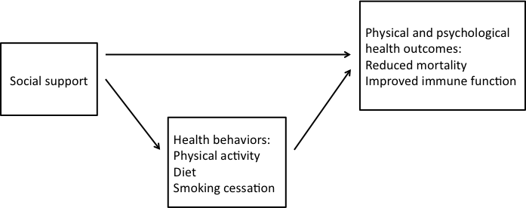
Figure 1: Social support pathways, derived from Berkman et al, and Ozbay et al^{42,43}

The definition of social support varies under different circumstances. In general, social support emerges from interpersonal relationships and has the purpose of providing care, motivation, value, or acceptance⁴⁵. From the recipient’s standpoint, it is defined as a feeling of being cared for and a sense of belonging⁴⁶.

Social support and weight loss
Social support has been linked to a variety of health benefits, including weight loss⁴⁷. It is well known for its buffering effects against stress, protecting individuals from the onset of harmful psychological responses⁴³. Results from previous weight loss interventions indicate that participants who received social support achieved greater weight loss results compared to those who received no social support⁴⁸. Social support is especially important when participants are aiming for a lifestyle change⁴⁹. According to Kelsey and colleagues, social support is a predictor of dietary change⁵⁰. It enhances participants’ motivation toward healthy eating and further leads to actual dietary improvement⁵⁰. It is important to note that the benefits of social support go beyond providing motivation, as people who have social support are more likely to change their dietary behavior as compared to those who have high motivation but no social support⁵⁰. In addition, social support has been associated with physical activity behaviors although factors such as race and the sources of support appear to mediate the behavior outcome⁵⁰.
Current literature has made specific distinctions between structural and functional support⁴⁹. Structural support refers to individuals’ social ties and is irrelevant to the actual exchange of support⁴⁹. For example, an individual may perceive little support even though the person has available all of the possible sources of social support, such as significant others, friends and family, or health professionals and other members in a weight loss program. On the other hand, functional support refers to a subjective perception of social support, which varies among individuals⁴⁹. Linked with individual characteristics such as personality, expectations, and previous history, functional support is believed to be a predictor of health and well-being⁵¹, and thus should be the focus in practice⁴⁹.
One source of social support is support groups established within a health program. People who share similar difficulties and frustrations can connect to one another and provide mutual support⁵². The interactions in these groups assist in the coping process, buffering against the adverse feelings or thoughts associated with the health problem⁵³. In weight loss programs, people with a shared goal connect to one another, sharing past experiences and reaffirming each other’s self-value, which can ultimately enhance their sense of control⁴⁷. Additionally, as these support groups encourage the adoption of the health-enhancing behaviors, participants may feel socially obligated to engage in these behaviors in order to meet their social interaction needs⁵³.
LaRose and colleagues suggest that social support is essential for young adults attempting to achieve weight loss⁵⁴. Receiving support from peers is helpful for maintaining health-related behaviors, especially physical activity⁵⁴. Students with social support generally showed stronger adherence to healthy eating and regular physical activity behaviors⁵⁵.

Online social support
The Internet, with its social networking functionality, offers the possibility of transferring traditional face-to-face support groups to the online environment. In fact, a great number of health-related online support groups have arisen to help individuals in need (e.g.: SparkPeople.com). Online social support occurs in the virtual setting but offers similar benefits as traditional face-to-face social support. LaCoursiere defined online social support as
“the cognitive, perceptual, and transactional process of initiating, participating in, and developing electronic interactions or means of electronic interactions to seek beneficial outcomes in health care status, perceived health, or psychosocial processing ability”⁵⁶.
Research on online social support is relatively new. Hwang and colleagues conducted a series of studies on social support in an online weight loss community^{51,57-59}. The community was formed within a website (SparkPeople.com) where members could share goals and seek out help among one another. Four types of social support were observed: informational, emotional, tangible and appraisal support⁵⁸. Emotional support was the most prominent form in the community, followed by informational support⁵⁸. The results of these studies also indicate that active participation on the website, in terms of engaging in group discussion, is associated with receiving encouragement from other members⁵¹.
A virtual weight loss community built upon social media allows for anonymous communication, reducing the risk of personal information disclosure⁶⁰. This creates a safe space for its members who may feel uncomfortable talking about their current weight status face-to-face. An online community also allows overweight and obese individuals to connect with each other, sharing weight loss tips and exchanging emotional support⁶¹. It is suggested that the non-judgmental comments and encouragement from their peers could potentially help participants to alleviate their weight-related stress⁶². It is important to note the impact the length of participation in the online group has on weight loss, because research has shown that individuals who spent more time in an online weight loss community were more likely to receive support in the form of encouragement, information, and shared experience⁵¹.

Synchronous and asynchronous online communications
The social media platforms utilized by Internet-based interventions facilitate two types of communication: synchronous communication and asynchronous communication⁶³. Synchronous communication occurs in real time and, due to its immediacy, very much resembles normal spoken conversations. Examples of synchronous communication are videoconferences and chat rooms. In an Internet-based obesity treatment program, participants were able to “talk” with one another in chat sessions facilitated by a trained therapist⁶⁴. All the chat sessions were structured around pre-planned topics on nutrition and exercise⁶⁴. Post-intervention assessment revealed a high level of social support perceived by the participants⁶⁴. However, this type of communication may not be flexible, as people need to participate at a set moment which may not always work with their schedules.
On the other hand, asynchronous communication is mediated by the communication tool, which enables individuals to participate in the conversation at different times. In fact, a unique benefit of using social media in the weight loss interventions is that they enable asynchronous communication, which offers constant support. Discussion forums, blogs, and emails are examples of the current popular asynchronous communication platforms⁶⁵. In an online obesity treatment program, Brandt and colleagues utilized a forum to facilitate communication among intervention participants⁶⁶. Qualitative results indicate that participants valued the continuous support from their peers and enjoyed reading successful stories on the forum. However, the drawback associated with this type of communication is the time lag between contributions to conversations, which may discourage people from engaging as has been demonstrated in many studies which were characterized by extremely low usage of the social media platform⁶⁷.
Importantly, it may be that a mixture of synchronous and asynchronous communication is needed in order to increase effectiveness of online interventions. For example, in a pilot study by Gold and colleagues, intervention group participants, who had access to therapist-led, structured synchronous chatting and asynchronous group discussion, lost significantly more weight than ones in the control group⁶⁸. In an ongoing RCT that aims to promote health-enhancing behaviors and weight loss, participants receive both asynchronous and synchronous consultations from the dietitians⁶⁹. The results of this study will provide insights into the effectiveness of Internet-based interventions using both synchronous and asynchronous communication methods.

Inclusion of social support in Internet-based weight loss interventions
Chang and colleagues conducted a systematic review, attempting to study how social media function in weight management programs and their associated impacts⁶⁷. They suggested that bulletin boards/discussion forums are the most popular social media platform currently used in interventions⁶⁷. However, results from these studies generally show no significant difference in weight change between participants in the social media group and the control group. Notably, although widely used, social media have seldom been the object of evaluation in studies, but are rather an embedded feature of the overall intervention⁶⁷. Thus, the effectiveness of social media in weight loss interventions is unknown. In those studies that reported on the extent of social media use, use was generally very low⁶⁷. In one diet intervention, participants used the forum primarily to request information from the research staff, and there were no interactions between the participants themselves⁶⁷. In another physical activity intervention, only 1 message was posted on the forum over the course of the program⁷⁰. However, other studies suggest that social media may benefit those individuals lacking an existing support network, producing positive behavior change⁶⁷. This may explain the reason why recent interventions have always included a social media component regardless of the unknown effectiveness of social media for weight loss. A more recent systematic review by Williams and colleagues suggests low social media participation in most of the interventions, which is consistent with the review by Chang and colleagues⁷¹. Additionally, although a variety of social media platforms were incorporated in the studies reviewed, their effects on weight loss remained modest⁷¹. However, it should be noted that social media remains an important component of daily life and will likely continue to increase in the future. Therefore, continuing to explore this domain in the context of weight loss interventions is critical to understanding how to best design online environments for specific audiences.

STUDY PURPOSE
Although college students are highly engaged in online social media, a careful evaluation of a social network’s effects on weight loss is lacking, as is clear from the review of the current studies⁶⁰. To the author’s knowledge, no study so far has specifically examined how the social media component was actively used by the participants and its associated impact on weight loss. Thus the purpose of this study was to describe, using qualitative methodology, college students’ perceptions regarding online social support within an Internet-based weight loss intervention.

Chapter 2
Manuscript

ABSTRACT
Objective: To assess college students’ perceptions regarding online social support in an 8-week Internet-based weight loss intervention.
Participants: Participants were those randomized to the intervention group of an online weight loss intervention targeting college students.
Methods: Members of the intervention group had access to a private discussion forum and weekly live chat sessions, allowing for anonymous interactions. Following the 8-week intervention, intervention group members were invited to complete an online focus group, discussing these tools. The transcripts were directly copied from the live chat conversation history. Using thematic analysis, perceptions regarding online social support were identified, coded and sorted and organized into themes.
Results: Two online focus groups were conducted (n=7, overall). Thematic analysis indicated that participants appreciated the social support provided by the forum and live chat sessions. While many preferred the interactive feature of the live chat sessions, others enjoyed the constant availability of the forum. However, barriers including time restrictions, technology-related preferences, and concerns about online interpersonal relationships were also identified.
Conclusions: Combining forum and live chat sessions may benefit individuals differently, based on preference, and both should likely be incorporated into an online weight loss intervention.

Keywords: college students, Internet, social support, obesity, weight loss

INTRODUCTION
The prevalence of obesity on campus has increased tremendously over the past decades and is projected to continue to increase for the next twenty years⁷². The 2013 National College Health Assessment indicates that 21.6% of college students are overweight, defined as a body mass index (BMI) of 25.0-29.9 kg/m² and 13.8% are obese (BMI≥30 kg/m²), with obesity increasing by 70% since 2000⁸. Though this rate is below that of the general adult population⁷³, treatment and prevention efforts on campus are critically important, as weight status during early adulthood is likely to persist as age increases¹⁰ and obesity is linked with increased risk for developing various medical conditions including type 2 diabetes, cardiovascular disease, stroke, and certain cancers¹. In addition to the adverse health consequences, overweight or obesity during the college years may have a profound impact on students’ psychological well-being. Struggling with the issues of body image and peer pressure^{3,74}, many overweight or obese students engage in unhealthy weight loss behaviors, and may display the symptoms of depression and anxiety^{6,7}.
Several longitudinal studies show that college students’ fruit and vegetable intake and physical activity patterns are both below the recommendations^{12,16,75}, which may increase the likelihood of becoming overweight or obese¹⁶. It has been reported that college students’ typical eating pattern is low in consumption of nutrient-dense foods (fruits and vegetables) and high in consumption of energy-dense foods (fast food and sugar-sweetened beverages)¹⁵. In addition, 53.8% of college students do not meet the physical activity guidelines and their physical activity level declines significantly from freshman year to senior year^{19,20}. Thus, both nutrition and exercise behaviors may contribute to their weight gain in college, increasing the risk of becoming overweight or obese.
To combat the overweight and obesity epidemic on campus, researchers have developed various weight loss interventions for college students^{19,24,25}. The results of these studies show that understanding students’ own attitudes and knowledge toward lifestyle change are imperative when developing weight loss interventions for this population¹⁹. Additionally, low engagement associated with previous weight loss programs indicates that it is essential to incorporate college students’ preferred communication modes into the intervention^{19,24,25}.
LaRose and colleagues suggested that social influences are important to young adults,⁵⁴ and social support has been associated with successful weight loss⁷⁶. A possible explanation for this relationship is that interacting with and gaining support from peers through social networks may promote health-enhancing behaviors, especially those related to physical activity and healthy eating^{54,55}. Due to the popularity of the Internet among college students, researchers have incorporated this tool into weight loss interventions⁷⁷. Among all the functionalities that the Internet can offer, social media has capabilities to improve participants’ engagement with the weight loss program⁷⁸.
Most Internet-based weight loss interventions for college students have focused primarily on nutrition and physical activity education, which has improved their knowledge or intentions for behavior change, but has not resulted in significant weight change^{37,38,79}. For example, two studies have evaluated the effects of “My Student Body-Nutrition (MSB-N)”, an online nutrition education physical activity education program^{37,38}. Although MSB-N improved students’ attitudes towards healthy eating and physical activity, it had no effect on physical activity behaviors or BMI^{37,38}. The researchers suggested education only, which was effective in changing college students’ attitudes and intentions, might not be as effective in changing their behaviors^{37,38}.
Napolitano and colleagues reported positive weight loss results from their randomized controlled trial, which utilized a social network, i.e. Facebook, to deliver an 8-week weight loss program for college students³⁶. The researchers implemented two intervention groups, with one being the Facebook group and the other one being the Facebook Plus group. Both groups had access to weight management materials via a separate, private Facebook group. However, the Facebook Plus group also received individualized text messaging from the research staff targeting behavioral goal setting, social support, etc. The results suggested that including support from the program staff could help participants achieve a significantly greater weight loss (-2.4 ± 2.5 kg, P < 0.05)³⁶. Therefore, it may be important to include multiple modes of communication in these types of online interventions.
Many Internet-based interventions utilize social media platforms such as bulletin boards/forums, chat rooms and social networking sites⁶⁷ which facilitate two types of communication: synchronous communication and asynchronous communication⁶³. Synchronous communication occurs in real time and resembles in-person conversations due to the immediacy of the content. Some synchronous tools include chat sessions, video conferencing, and instant messaging. However, this type of communication may not be flexible, as it requires people to participate at a set moment. On the other hand, although asynchronous tools such as discussion boards, e-mails and blogs are more popular and flexible than synchronous tools, the associated time lag may discourage some people from taking part in the conversation⁶⁵. Considering the drawbacks of each communication format, research should likely incorporate both synchronous and asynchronous tools in the intervention design with the purpose of enhancing communication among participants.
Social support factors have been included in previous internet-based weight loss programs^{36,67}. However, to the author’s knowledge, no research has been done to investigate how social support among peers is activated and maintained in the online environment. Prior research in our lab has also indicated that the forum alone was not likely to effectively build a support network for the intervention participants. Thus, the purpose of this study was to assess college students’ perceptions regarding two forms of online social support, a forum (asynchronous support) and a live chat (synchronous support), offered as a novel component of an Internet-based weight loss intervention.

METHODS

Procedure
Intervention group participants from a randomized control weight loss trial targeting overweight and obese college students (UTK Health), for which the intervention design has been described in detail elsewhere⁸⁰, were invited to participate in online focus groups regarding their perceptions of the novel social support components available only to those in the intervention group (i.e. online chat sessions and online forum). Intervention group participants were encouraged to use a false display name (such as “fitgirl”) and non-identifiable profile pictures (such as the default ones randomly assigned by the software program) on the discussion forum. Additionally, participants were asked to use only their initials when using the live chat application. Identifying themselves differently on the separate platforms increased the likelihood of maintaining anonymity across the two social support platforms. Thematic analysis was completed on the transcripts from the online focus groups. Approval from the University of Tennessee Knoxville Institutional Review Board was obtained prior to study implementation. The informed consent for the focus groups was obtained along with the intervention, which is at the beginning of the study.

Synchronous and asynchronous online social support
Based on previous work with this population⁸⁰ and evidence from the literature⁶⁷, both synchronous and asynchronous modes of online communication were utilized to create social support. Synchronous support was provided via online live chat sessions and asynchronous support was provided via group discussions in a discussion forum setting.
Discussion forum
The discussion forum supported multiple writers and was designed to facilitate peer communication and build social support among the intervention participants. Invited users could post new threads, delete their own threads, and comment on each other’s threads. Prior to starting the UTK Health program, the research staff posted a statement on the discussion forum, emphasizing the purpose of the forum and the importance of maintaining confidentiality.
Weekly social challenges were held on the discussion forum in an effort to elicit more interactions among participants. Each week, a research assistant posted a new challenge on the discussion forum with detailed instruction and information on the monetary prize, i.e. gift cards that would be mailed to qualified winners of the challenges. Challenges included “Week 1 Icebreaker”, “Pinterest Recipe Tester Challenge”, “Be the Nutritionist Challenge”, “Spring Break Food Journal Challenge”, “Cardio Challenge”, “Green Breakfast Challenge”, and “Name That Photo Challenge” (Appendix A). For example, in the “Green Breakfast Challenge”, participants were asked to incorporate something green into their breakfast. The participants were encouraged to post an image of this incorporation and include a description of how they completed this challenge.
Live chat sessions
Participants in the intervention group were also asked to attend six weekly live chat sessions: once per week for the first four weeks and once every other week for the second half of the program. The first live chat session was used as an orientation to the program and was held twice during the first week. Participants were only required to attend one of these orientation sessions. One graduate research assistant logged on as UTK Health and started a new group conversation by initiating a video-conference with all the participants who had signed up for the orientation. The participants were asked to mute the microphone then answer the voice call instead of the video call. Thus, the research assistant used voice to communicate and the participants typed to respond. The research assistant then shared her computer screen with the participants and led a virtual tour of the website to review each part of the intervention. To reduce technical barriers for the participants, the research assistant demonstrated posting and commenting on the discussion forum. Participants were unable to hear one another, but could hear the research assistant. Participants could communicate with one another in the live chat screen. To emphasize the social support component, the researchers stated the interactive purpose of the discussion forum and live chat sessions at the very end of the session. It is important to note that the audio-component was only used in the orientation. All other chat sessions were conducted only via instant messaging.
For each live chat session, two time slots were offered to accommodate student schedules and they were able to choose either one to attend. The purpose of the live chat sessions was to provide opportunities for the participants to communicate with one another in real-time, allowing the group to develop a bond. For each week, one graduate research assistant chose a discussion topic from a pre-generated list and developed a session plan to guide the discussion if needed (Appendix B). This list of discussion topics included prompts for the researcher to use in case participants had difficulty initiating the conversation. The list included six topics: “healthy eating”, “stress”, “support for weight loss”, “progress”, “eating at restaurants”, and “perceptions of weight”. These live chat conversations were captured for later thematic analysis.

Qualitative data collection
Online focus groups
In alignment with the technological nature of the UTK Health program, assessments of perceptions of social support were made by means of one-sided videoconference-mediated focus groups. In other words, the group video chat function was enabled, but only the moderator’s video camera and microphone were turned on. Thus, the participants could see and hear the moderator, while remaining anonymous to one another. Prior to starting the group discussion, two research assistants logged onto the UTK Health live chat account on two different devices. Research assistant #1, the facilitator of the focus group, spoke directly to the group via microphone. Research assistant #2 typed the same messages into the chat screen ensuring participants whose audio was malfunctioning could also be on track with others. Similar to the live chat sessions, participants’ display names were initials and profile pictures were not identifiable and their microphones were muted.
The live chat software enables multiple individuals to type at the same time and there is system indication on the conversation screen showing that typing is in process. Because typing speed varied by individuals, research assistant #1 usually paused and ensured everyone’s input before proceeding to the next question. Research assistant #1 also spoke up when necessary to keep the responses on target. Concurrently, research assistant #2 monitored the whole process and typed messages, when necessary, to ensure everyone was given the opportunity to talk.
Open-ended questions with probes were developed to assess participants’ perceptions of online social support. In particular, the participants were asked to compare the experiences of gaining support from the forum and from the live chat sessions. Eight items included: (1) “Tell me about your experience using the website” (2) “Tell me about your experience using the forum” (3) “Tell me about your experience with the live chats” (4) “How did you feel about using a forum for social support?” (5) “How did you feel about using live chats for social support?” (6) “How had other members in the forum or live chats helped with your weight loss efforts?” (7) “How do you feel about getting support from an online program in comparison to meeting in person?” (8) “Did you contact other members of the forum for social support? If no, why?” Detailed questions with prompts are available in Appendix C.

Qualitative data analysis
The transcripts for the online focus groups were directly extracted from the live chat conversation history. The conversations from earlier live chat sessions and messages on the forum were also reviewed to identify information in relation to social support. Microsoft Excel (Microsoft Corporation, Redmond, WA, 2011) was used to format and organize the transcripts.
A thematic analysis was used to summarize the focus group findings and relevant weekly live chat conversations⁸¹. Because discussion forum was primarily used by the participants to report the completion of weekly challenges, there was no discussion forum transcript used in the thematic analysis. Two graduate student researchers independently reviewed the transcripts of the two focus groups and live chats and identified codes. Then they met to discuss the agreements and disagreements. After the two researchers reconciled any discrepancies, final codes were compiled and key themes were identified. Supporting concepts (sub-themes) were also identified. Direct quotes from the focus groups are presented below to enhance the narrative.

RESULTS

Participants
Six live chat sessions were held (one each in weeks 1, 2, 3, 4, 6 and 7), and seven challenges were posted to the discussion forum. Twelve students (100% female) were randomly assigned to the intervention condition of the UTK Health program. However, only seven students (1 freshman, 3 sophomores and 3 juniors) completed the 8-week program and were therefore eligible to participate in the post-intervention assessments.
Two online focus groups (three in the first focus group and four in the second one) were conducted post-intervention via live chat software. Three major themes, along with supporting concepts, emerged in relation to social support. These themes included perceptions of the two platforms (the discussion forum and live chat sessions that provided social support), types of interactions, and barriers to online interactions.

Perceptions of the two online social support platforms
Although to a different degree, both online platforms provided the participants with a sense of support and belonging. Participants reportedly enjoyed the ability to connect to a group of people with shared goals and to relate to others with similar experiences:
(Forum)“I liked that it was a group doing something similar that remained anonymous at the same time.”
(Forum)“It was easy to use and being able to see the post of people trying to accomplish the same goal as me was very helpful and encouraging”.
(Live chats)“I definitely felt a sense of support when I got a chance to chat with everyone.”
(Both platforms)”That’s true about knowing I wasn’t alone with my struggles. Just in general the group aspect. They [the live chats] were really good for that”.
As these comments illustrate, the participants were able to use both modes to interact and provide support to each other in a virtual community.
Sub-theme: Perceptions of the live chat sessions
Presumably due to the instantaneous interactions, the live chat component was the favorite part of the program for most of the participants. One participant noted, “The [live chats] were my favorite part. I like being able to have actual conversations with people.” However, because the chats had to occur at a specific time, this format was slightly inconvenient from a scheduling standpoint. Another participant commented, “Without the reminders right before I would’ve miss[ed] them. They do help to feel part of the group.”
Participants’ responses highlighted some advantages of the synchronous form of communication, such as a sense of immediate connection. However, they also pointed out its primary drawback, which is the challenge of scheduling.
Sub-theme: Perception of the forum
Compared to our previous experience⁸⁰, monetary incentives that were offered for completing the challenges boosted the forum usage. However, lack of time was a major hindering factor that prevented some students from participating in the forum activities. One participant reflected, “I didn’t utilize the forum as much as I would have liked to due to time restrictions, but it was nice to see the recipes and workouts that were posted, it gave me motivation to actually pursue those things.”
It is also important to note that, if not for the time issue, the forum might be a promising tool to build support for this population. One participant noted, “I liked having the network and support during the rest of the week”. Some participants found it highly encouraging when people were commenting on each other’s posts, as one participant suggested, “Commenting was the most motivating.”
Similar to the findings of the live chat sessions, both pros and cons of the asynchronous form of communication (forum) were noted in the participants’ responses. The forum seemed to allow for the building of connections for some of the participants, as they could use them at their own convenience and over a period of time. However, college students’ busy schedules may have prevented them from taking the initiative to actually use the forum.
Sub-theme: Comparison between the two social support platforms
In general, participants believed that social support could benefit their weight loss efforts. However, most of the participants preferred the synchronous format to the forum because the former was “… more interactive and more of a support network”. Although the research staff addressed the shared purpose of the two social support platforms at the beginning of the program, it was evident that the live chat sessions were the preferred mode for this population, as the forum was used only to a limited degree after the first week of the program when the challenge was to make the most posts. For the remainder of the intervention, the group communication function of the forum did not attract much traffic; participants only used this feature to report their progress of the challenge and there were no responses under the post. Consequently, one participant felt discouraged to post other topics due to lack of interaction on the forum. She noted, “I felt weird posting extraneous stuff after [the first challenge]. Like if it wasn’t part of whatever current challenge, I didn’t want to post stuff.” In contrast, there were lively group interactions in the live chat sessions where conversations were able to flow. One participant commented, “[Live chats] are more interactive which I really enjoyed.” Besides group dynamics, another difference between the two platforms was the issue of time control. One participant commented, “I like that you could do the forum on your own time but this [live chat session] you have to block out time.” As these responses indicate, the communication on two platforms varied mainly in two aspects. The first is the nature of the interaction, i.e. interaction dynamics. Live chat sessions engaged multiple users at the same time, which allowed for efficient conversations. Conversely, the forum was less interactive which might potentially discourage some participants. While time was less demanding on the forum, it could cause low motivation for the participants to use this feature. However, it also has the benefit of flexibility which some of the participants valued. In line with this time issue, a synchronous form of communication might create an extra burden on this population if not carefully designed.

Types of Interactions
The group aspect of the program enabled participants to share their weight loss struggles with others. It created a sense of being in the same boat. They felt they were “not alone” when “chatting” with a group of people with similar struggles. While they offered weight loss tips and shared successful experiences, they also provided encouragement and motivation. An examination of the conversations from the weekly live chat sessions and forum messages revealed various types of interactions as described below.
Sub-theme: Sharing information
All the participants appreciated others in the group sharing their successful weight-loss strategies such as healthy snacks and motivation tips: “When I posted something on the forum, I got great tips and a lot of support from other people.” One participant commented, “It gave me an insight to things I could improve on.” In addition, receiving information from real people in a social network instead of from an educational source personalized the process, which participants reported to greatly enjoy. As one participant reflected, “I enjoyed their own personal tips.” Another described how she used advice from peers: “One of the times someone on here suggested I start taking measurements along with weighing and I went on to make an excel sheet for it. That way I can see the progress a little better. It was a great suggestion!” As these quotations illustrate, participants liked to adopt innovative ideas from others’ successful experiences, and they incorporated each other’s ideas into their own weight loss efforts³⁶.
Sub-theme: Encouragement and motivation
Encouragement and motivation created a sense of understanding and caring, which could help participants persist with diet and exercise changes and overcome barriers. They enjoyed hearing words of encouragement such as “keep up the great work” and “that is great”. An example of one motivational exchange between participants included reassurance as well as advice:
Participant A—“ I’m too embarrassed to do group classes.”
Participant B—“ That’s how I feel when I do Zumba, but I just get it [in] to the music then I forget people can see me.”
Besides the actual words of encouragement, intervention participants reported also being encouraged by seeing replies on the forum. Their peers’ responses were motivating for them to further engage in the program.
Sub-theme: Absence of tangible interaction
Tangible interactions, in terms of directly reaching out to other participants, did not occur, potentially because most participants did not view it as an option. However one participant recalled, “I made plans with one girl to meet up to go to the gym, but then totally dropped the ball on that and felt bad so never tried again lol”. Thus, although Hwang and colleagues suggested a growing trend of tangible support among members of a virtual community⁵⁸, in-person meetings, which required students taking the initiative, were not observed in this study.

Barriers to online interactions
Analysis revealed barriers including lack of time, technology-related characteristics and preference for in-person meetings. Sub-themes emerged both from the focus groups and the live chat conversations.
Sub-theme: Time
Lack of time appeared to be the most prominent factor that prevented participation in some of the program activities, especially that of the forum. One participant reflected, “Not having time to devote to health or the maintenance of it takes a toll on everything else, physical and mental health”. The majority of the participants suggested that they would have used the forum more if not for time restrictions. One participant stated, “I am taking 18 hrs [of classes] & work over 20 hrs /week, plus try to stay active in the community with volunteer projects so at the end of the day I feel like death & don’t have the energy to do anything”.
The focus groups revealed that participants had a hard time balancing between school, work, and extracurricular activities; participating in forum discussions might be less of a priority. This is reflective of current literature that suggests that “lack of time” is a frequently reported barrier for weight loss effort.
Sub-theme: Technology-related issues
Several technology-related issues emerged from the focus groups. Firstly, utilization of the two platforms revealed the impact of Internet habits and uses of online interactions. One participant described herself as a social media fanatic and, correspondingly, was active on both social support platforms (the forum and live chat sessions). In contrast, others reported using social media sites, such as Facebook, Twitter, and Instagram, infrequently and thus found it difficult to initiate a discussion, especially on the forum. One participant reflected, “Except for things relating to specific challenges, I have trouble thinking of what to post. Personally, I don't even post much on Facebook so maybe that's just a “me” thing. I do get on there and read the stuff though.”
Secondly, participants’ comfort levels with self-disclosure in a virtual community also appeared to influence online communication. While some participants believed that not knowing each other created a safe space to vent, others thought it was awkward to share personal weight issues with a group of people with whom they were not familiar. One participant commented, “It felt weird sharing personal stuff like weight issues on the forum even though we are all anonymous.” Unlike other existing popular weight loss forums including “3 fat chicks on a diet”⁸² and “Spark People”(Cincinnati, OH), where members can chose to post or comment by themselves, participation in the UTK Health program required posting in the discussion forum. It is likely that some of the participants might not have the personality to purposefully connect to an online weight loss community. Thus, it is possible that they felt uncomfortable interacting with strangers in a virtual setting in the first place.
Sub-theme: Preference for in-person meetings
While the online system held the advantage of convenience, lack of accountability was frequently mentioned as an important drawback. Participants believed forming an in-person bond would help with their weight loss efforts. One participant said, “I can look at a forum any time, but having a group of people meeting and getting active would be totally different. It would make me want to work really hard to keep up with the group.” In addition, meeting in person can create a sense of friendly competition, which could further increase the motivation for weight loss. One commented, “I think it would be helpful to meet in person because there is more accountability, more motivation and positive competition.” Thus, participation in traditional in-person meetings after establishing an online community might be helpful for Internet-based weight loss programs targeting this age group.

COMMENTS
While there are studies regarding the importance of social support for college students’ weight loss^{54,55,83,84}, the research on how to effectively build a weight loss community between peer strangers is limited⁶⁷. This study sought to explore social support in an Internet-based weight loss intervention targeting college students. Findings from this study will add to the research on the relationship between online social support and weight loss among this population.
Diverse behaviors in an online weight loss community were observed in this study. Among the social media users, there are generally two types of people: a “poster”, who either regularly initiates a post or responds to other posts, and a “lurker”, who has very limited postings⁸⁵. In the current study, two from a total of seven participants were considered to be “posters” while the rest were “lurkers”. The ratio was consistent with previous literature which suggests that 50-90% of the members from a virtual community are “lurkers”⁸⁵. However, it is important to note that “posters” are not the only group of people that can benefit from the forum. As one participant from the focus group suggested, although not posting frequent posts, she did read others’ posts, which made the forum a learning tool.
In order to keep the recruitment, implementation and assessment within one university semester, the researchers set the program duration as eight weeks. However, this length may not be ideal to establish an online community within, especially considering the busy daily lives of college students. In a study of a large online weight loss community where a large number of posts were generated daily, the existing members had been active on the forum for several months, even years⁸⁶. In addition, empirical evidence suggests that it usually takes months for individuals participating in a weight loss forum to bond and these members usually take the initiative to reach out to the community⁵². On the other hand, the participants from this program may lack the internal drive to join an online weight loss community in the first place. This is important to consider as it might require a good amount of time for the participants of an intervention to become comfortable with one another.
That females were more likely than males to participate in this type of weight loss effort, is consistent with previous research which shows that females are motivated by communicating with peers via social media, whereas males appear to be more independent and likely to succeed in their weight loss efforts regardless of social media use^{87,88}. Thus, the findings from this study could not be generalized to other online weight loss communities with mixed genders.
In this study, each focus group consisted of 3 or 4 participants, which was much smaller than 6-12, the typical number of participants in a focus group (REF needed). However, the researcher found this number to be feasible given the unique characteristics of online focus groups including technical issues and managing the simultaneous typing of participants For example, a couple of students frequently experienced dropped calls, especially at the beginning of the process, due to poor Internet connections. Thus, in order to include everyone in the discussion, the moderators had to pause the focus group, which might alter the pace of the process and add extra time to the schedule. In addition, the live chat software allowed multiple users to type simultaneously, providing responses of various lengths. As a result, longer time was needed for the moderators to read and process each participant’s responses.

Limitations
Findings from this study should be interpreted with caution as there are several limitations. Firstly, there was a limited number of focus groups conducted due to the small sample size in the UTK Health program. Consequently, it is likely that saturation was not achieved for many topics and future studies should employ a larger sample size to understand students’ perceptions regarding online social support. Secondly, the duration of the intervention was 8 weeks, which is shorter than most of the interventions in the literature. Finally, participants’ use of the forum was limited to the completion of weekly challenges, which was lower than researchers’ expectations. There was no active exchange of support on the forum except for the first week of the program, when the challenge winner was whoever made the most posts. Thus, participants’ perception of online social support might have been different if they had access to a more active forum.

Future directions
By exploring participant responses to utilizing the Internet platform, this study yields insights into how an online social support component can be activated before it can execute its function. Firstly, it is important to recruit a sample that is “group-oriented”, meaning they enjoy interacting with people online and have the potential to mobilize support within a community. Given the existence of both “posters” and “lurkers” in an online community and the ratio of these two users, it is vital to have a large sample in this type of study. Considering the low percentage of “posters” in a community (10-50%), a large sample size will likely to benefit the study by increasing the actual number of people who are active in the community. Another strategy is adopting targeted recruitment. For example, a more stringent set of inclusion criteria can be implemented in order to identify students who are actively seeking out help themselves or even potential “posters”. As a result, the researchers can expect improved forum utilization and consequently more dynamic group interactions in the community. Furthermore, recruiting a group of peer leaders, which has been proven to be beneficial in chronic disease management⁸⁹, might be helpful to formulate a new community with an intervention. Peer leaders are those who have participated in the support groups in the past, thus understand the functional purpose of a community. They might help initiate the group discussions on the social support platforms, contributing to building a dynamic community. They may also have experienced the barriers of weight loss specifically to themselves as college students, and have explored various coping strategies in the past. Peer leaders’ expertise is valuable to the program as it could potentially be used to assist others who may be relatively new to the support community.
In addition, future studies should investigate the methods to strengthen group bonding as participants from the focus groups indicated a desire for greater interactions with other members of the intervention. One strategy is to design programs with sufficient duration, including initial period for “relationship cultivation”, during which participants are becoming familiar with one another. Another strategy could be adding the scheduled in-person meetings, which, according to intervention participants, is essential for them to feel accountable.
Finally, gaining support from university officials might be a potential option in order for the weight loss intervention to be sustainable. For example, a university-wide support forum could be created to fulfill this purpose, which not only can reach a wider population, but also serve as a continuous support platform for the college students.

Conclusions
Previous research and anecdotal evidence has demonstrated the ability of a weight loss forum to provide social support^{58,90}. However, previous work in our lab showed the challenge of depending solely on a forum to establish a community for college students in an Internet-based intervention. The addition of weekly live chat sessions in the current study improved participants’ engagement and further increased students’ perceived social support. While participants expressed feelings of community and support with both social support platforms (forum discussions and live chat sessions), most of them favored the immediacy of the latter format. They reported great appreciation for the opportunity to have an instant conversation about diet and exercise tips with their peers and exchanging encouragement/motivation.
The results suggest a blended approach, with both synchronous and asynchronous communication methods might help establish a community in the intervention and enable participants to perceive social support within the support network. This approach might also be promising in designing future weight loss interventions that target college students. There were exchanges of weight loss information and emotional support, which were congruent with previous literature⁵⁸. However, other factors pertinent to this population also had substantial impact on the engagement; it is essential to consider factors such as time, Internet habits and uses, and virtual interpersonal relationship when designing future interventions.

List of References

1. CDC. Overweight and Obesity. Causes and Consequences http://www.cdc.gov/obesity/adult/causes/index.html. Accessed February 14, 2013.
2. Clinic M. Obesity: Complications. 2014; http://www.mayoclinic.org/diseases-conditions/obesity/basics/complications/con-20014834.
3. Desai MN, Miller WC, Staples B, Bravender T. Risk factors associated with overweight and obesity in college students. Journal of American College Health. Jul-Aug 2008;57(1):109-114.
4. Howard S, Hughes BM. Benefit of social support for resilience-building is contingent on social context: examining cardiovascular adaptation to recurrent stress in women. Anxiety, stress, and coping. Jul 2012;25(4):411-423.
5. Carr D, Friedman MA. Body weight and the quality of interpersonal relationships. Soc Psychol Quart. Jun 2006;69(2):127-149.
6. Service USDoHaH. Overweight and Obesity: Health Consequences. http://www.surgeongeneral.gov/library/calls/obesity/fact_consequences.html. Accessed October 19, 2012.
7. Scott KM, McGee MA, Wells JE, Oakley Browne MA. Obesity and mental disorders in the adult general population. Journal of psychosomatic research. Jan 2008;64(1):97-105.
8. Association ACH. American College Health Association-National College Health Assessment II: Reference Group Executive Summary Fall 2013. Hanover, MD: American College Health Association;2014.
9. Association ACH. American College Health Association-National College Health Assessment: Reference Group Executive Summary Spring 2000. Baltimore, MD: American College Health Association;2000.
10. McTigue KM, Garrett JM, Popkin BM. The natural history of the development of obesity in a cohort of young U.S. adults between 1981 and 1998. Annals of internal medicine. Jun 18 2002;136(12):857-864.
11. Reis JP, Loria CM, Lewis CE, et al. Association Between Duration of Overall and Abdominal Obesity Beginning in Young Adulthood and Coronary Artery Calcification in Middle Age. Jama-J Am Med Assoc. Jul 17 2013;310(3):280-288.
12. Racette SB, Deusinger SS, Strube MJ, Highstein GR, Deusinger RH. Changes in weight and health behaviors from freshman through senior year of college. J Nutr Educ Behav. Jan-Feb 2008;40(1):39-42.
13. Wengreen HJ, Moncur C. Change in diet, physical activity, and body weight among young-adults during the transition from high school to college. Nutr J. Jul 22 2009;8.
14. Small M, Bailey-Davis L, Morgan N, Maggs J. Changes in Eating and Physical Activity Behaviors Across Seven Semesters of College: Living On or Off Campus Matters. Health education & behavior : the official publication of the Society for Public Health Education. Dec 10 2012.
15. Larson N, Neumark-Sztainer D, Laska MN, Story M. Young adults and eating away from home: associations with dietary intake patterns and weight status differ by choice of restaurant. Journal of the American Dietetic Association. Nov 2011;111(11):1696-1703.
16. Small M, Bailey-Davis L, Morgan N, Maggs J. Changes in eating and physical activity behaviors across seven semesters of college: living on or off campus matters. Health education & behavior : the official publication of the Society for Public Health Education. Aug 2013;40(4):435-441.
17. Sparling PB. Obesity on campus. Prev Chronic Dis. Jul 2007;4(3):A72.
18. Oliver G, Wardle J, Gibson EL. Stress and food choice: a laboratory study. Psychosomatic medicine. Nov-Dec 2000;62(6):853-865.
19. Poobalan AS, Aucott LS, Precious E, Crombie IK, Smith WC. Weight loss interventions in young people (18 to 25 year olds): a systematic review. Obes Rev. Aug 2010;11(8):580-592.
20. Nguyen-Michel ST, Unger JB, Hamilton J, Spruijt-Metz D. Associations between physical activity and perceived stress/hassles in college students. Stress and Health. Aug 2006;22(3):179-188.
21. Huang TT, Harris KJ, Lee RE, Nazir N, Born W, Kaur H. Assessing overweight, obesity, diet, and physical activity in college students. Journal of American college health : J of ACH. Sep-Oct 2003;52(2):83-86.
22. Kim HD, Park JS. [The effect of an exercise program on body composition and physical fitness in obese female college students]. Taehan Kanho Hakhoe chi. Feb 2006;36(1):5-14.
23. Schmidt WD, Biwer CJ, Kalscheuer LK. Effects of long versus short bout exercise on fitness and weight loss in overweight females. J Am Coll Nutr. Oct 2001;20(5):494-501.
24. Ames GE, Perri MG, Fox LD, et al. Changing weight-loss expectations: a randomized pilot study. Eat Behav. Jun 2005;6(3):259-269.
25. Buscemi JY, A. M.; Dennhardt, A. A.; et al. A randomized trial of a brief intervention for obesity in college students. Clinical Obesity. 2011;1(4/6):131-140.
26. Manzoni GM, Pagnini F, Corti S, Molinari E, Castelnuovo G. Internet-based behavioral interventions for obesity: an updated systematic review. Clin Pract Epidemiol Ment Health. 2011;7:19-28.
27. Tate DF, Jackvony EH, Wing RR. Effects of Internet behavioral counseling on weight loss in adults at risk for type 2 diabetes: a randomized trial. JAMA. Apr 9 2003;289(14):1833-1836.
28. Tate DF, Jackvony EH, Wing RR. A randomized trial comparing human e-mail counseling, computer-automated tailored counseling, and no counseling in an Internet weight loss program. Arch Intern Med. Aug 14-28 2006;166(15):1620-1625.
29. Tate DF, Wing RR, Winett RA. Using Internet technology to deliver a behavioral weight loss program. JAMA. Mar 7 2001;285(9):1172-1177.
30. Junco R, Cole-Avent GA. An introduction to technologies commonly used by college students. New Directions for Student Services. 2008;2008(124):3-17.
31. Smith A, Rainie L, Zickuhr K. College students and technology. 2011; http://www.pewinternet.org/2011/07/19/college-students-and-technology/.
32. DeAndrea DC, Ellison NB, LaRose R, Steinfield C, Fiore A. Serious social media: On the use of social media for improving students' adjustment to college. Internet and Higher Education. 2011.
33. American College Health Association-National College Health Assessment Spring 2008 Reference Group Data Report (abridged): the American College Health Association. Journal of American college health : J of ACH. Mar-Apr 2009;57(5):477-488.
34. Fox S, Duggan M. Health Online 2013. Washington, D.C.: Pew Research Center;2013.
35. Vandelanotte C, Spathonis KM, Eakin EG, Owen N. Website-delivered physical activity interventions a review of the literature. American journal of preventive medicine. Jul 2007;33(1):54-64.
36. Napolitano MA, Hayes S, Bennett GG, Ives AK, Foster GD. Using Facebook and Text Messaging to Deliver a Weight Loss Program to College Students. Obesity. Jan 2013;21(1):25-31.
37. Lachausse RG. My student body: effects of an internet-based prevention program to decrease obesity among college students. Journal of American college health : J of ACH. 2012;60(4):324-330.
38. Franko DL, Cousineau TM, Trant M, et al. Motivation, self-efficacy, physical activity and nutrition in college students: randomized controlled trial of an internet-based education program. Prev Med. Oct 2008;47(4):369-377.
39. Cousineau TM, Goldstein M, Franko DL. A collaborative approach education for college to nutrition education for college students. J Am Coll Health. Sep-Oct 2004;53(2):79-84.
40. Davy BM, Potter KL, Parker EAD, et al. Feasibility, effectiveness, and perceptions of an Internet-and incentive-based behavioral weight loss intervention for overweight and obese college freshmen: A mixed methods approach. Open Journal of Preventive Medicine. 2013:429-440.
41. Patrick K, Marshall SJ, Davila EP, et al. Design and implementation of a randomized controlled social and mobile weight loss trial for young adults (project SMART). Contemp Clin Trials. Jan 2014;37(1):10-18.
42. Berkman LF, Syme SL. Social networks, host resistance, and mortality: a nine-year follow-up study of Alameda County residents. American journal of epidemiology. Feb 1979;109(2):186-204.
43. Ozbay F, Johnson DC, Dimoulas E, Morgan CA, Charney D, Southwick S. Social support and resilience to stress: from neurobiology to clinical practice. Psychiatry (Edgmont). May 2007;4(5):35-40.
44. Reblin M, Uchino BN. Social and emotional support and its implication for health. Current opinion in psychiatry. Mar 2008;21(2):201-205.
45. Teoh AN, Chia MSC, Mohanraj V. The Comparison Between Active and Passive Types of Social Support: The Emotional Responses1. Journal of Applied Biobehavioral Research. 2009;14(2):90-102.
46. Nurullah AS. Received and Provided Social Support: A Review of Current Evidence and Future Directions. American Journal of Health Studies. 2012;27(3):173-188.
47. Parham ES. Enhancing Social Support in Weight-Loss Management Groups. J Am Diet Assoc. Oct 1993;93(10):1152-1156.
48. Wing RR, Jeffery RW. Benefits of recruiting participants with friends and increasing social support for weight loss and maintenance. J Consult Clin Psych. Feb 1999;67(1):132-138.
49. Verheijden MW, Bakx JC, van Weel C, Koelen MA, van Staveren WA. Role of social support in lifestyle-focused weight management interventions. Eur J Clin Nutr. Aug 2005;59:S179-S186.
50. Kelsey KS, Kirkley BG, DeVellis RF, et al. Social support as a predictor of dietary change in a low-income population. Health Educ Res. Sep 1996;11(3):383-395.
51. Hwang KO, Etchegaray JM, Sciamanna CN, Bernstam EV, Thomas EJ. Structural social support predicts functional social support in an online weight loss programme. Health expectations : an international journal of public participation in health care and health policy. Jan 2 2012.
52. Barak A, Boniel-Nissim M, Suler J. Fostering empowerment in online support groups. Comput Hum Behav. Sep 2008;24(5):1867-1883.
53. Wang HH, Wu SZ, Liu YY. Association between social support and health outcomes: a meta-analysis. The Kaohsiung journal of medical sciences. Jul 2003;19(7):345-351.
54. LaRose JG, Leahey TM, Hill JO, Wing RR. Differences in Motivations and Weight Loss Behaviors in Young Adults and Older Adults in the National Weight Control Registry. Obesity. Mar 2013;21(3):449-453.
55. Gruber KJ. Social Support for Exercise and Dietary Habits among College Students. Adolescence. Fal 2008;43(171):557-575.
56. LaCoursiere SP. A theory of online social support. ANS. Advances in nursing science. Sep 2001;24(1):60-77.
57. Hwang KO, Farheen K, Johnson CW, Thomas EJ, Barnes AS, Bernstam EV. Quality of weight loss advice on internet forums. Am J Med. Jul 2007;120(7):604-609.
58. Hwang KO, Ottenbacher AJ, Green AP, et al. Social support in an Internet weight loss community. Int J Med Inform. Jan 2010;79(1):5-13.
59. Hwang KO, Ottenbacher AJ, Lucke JF, et al. Measuring social support for weight loss in an internet weight loss community. J Health Commun. Feb 2011;16(2):198-211.
60. Wright KB, Bell SB, Wright KB, Bell SB. Health-related Support Groups on the Internet: Linking Empirical Findings to Social Support and Computer-mediated Communication Theory. Journal of health psychology. Jan 2003;8(1):39-54.
61. Lewis S, Thomas SL, Blood RW, Castle D, Hyde J, Komesaroff PA. 'I'm searching for solutions': why are obese individuals turning to the Internet for help and support with 'being fat'? Health Expect. Dec 2011;14(4):339-350.
62. Aneshensel CS, Stone JD. Stress and depression: a test of the buffering model of social support. Archives of general psychiatry. Dec 1982;39(12):1392-1396.
63. website TaLE. Asynchronous vs Synchronous Communication. 2014; https://tle.wisc.edu/blend/facilitate/communicate.
64. Gold B, Buzzell P, Leonard H, Pintauro S, Harvey-Berino J. Minimal in-person support as an adjunct to Internet obesity treatment. Ann Behav Med. 2007;33(1):49-56.
65. Ashley J. Syncrounous and Asynchronous Communication Tools. 2003.
66. Brandt V, Brandt CJ, Glintborg D, Arendal C, Toubro S, Brandt K. Sustained Weight Loss during 20 Months using a Personalized Interactive Internet
Based Dietician Advice Program in a General Practice Setting. International Journal on Advances in Life Sciences. 2011;3(1 & 2).
67. Chang T, Chopra V, Zhang C, Woolford SJ. The role of social media in online weight management: systematic review. Journal of medical Internet research. 2013;15(11):e262.
68. Gold BC, Burke S, Pintauro S, Buzzell P, Harvey-Berino J. Weight loss on the web: A pilot study comparing a structured behavioral intervention to a commercial program. Obesity (Silver Spring). Jan 2007;15(1):155-164.
69. Brandt CJ, Brandt V, Pedersen M, et al. Long-Term Effect of Interactive Online Dietician Weight Loss Advice in General Practice (LIVA) Protocol for a Randomized Controlled Trial. International journal of family medicine. 2014;2014:245347.
70. Ferney SL, Marshall AL, Eakin EG, Owen N. Randomized trial of a neighborhood environment-focused physical activity website intervention. Prev Med. Feb 2009;48(2):144-150.
71. Williams G, Hamm MP, Shulhan J, Vandermeer B, Hartling L. Social media interventions for diet and exercise behaviours: a systematic review and meta-analysis of randomised controlled trials. BMJ open. 2014;4(2):e003926.
72. Health TfAs, Foundation RWJ. F as in Fat: How Obesity Threatens America's Future 20122012.
73. Statistics NCfH. Health, United States, 2013: With Special Feature on Prescription Drugs. Hyattsville, MD2014.
74. Harring HA, Montgomery K, Hardin J. Perceptions of body weight, weight management strategies, and depressive symptoms among US college students. Journal of American college health : J of ACH. 2011;59(1):43-50.
75. Wengreen HJ, Moncur C. Change in diet, physical activity, and body weight among young-adults during the transition from high school to college. Nutrition journal. 2009;8:32.
76. Krukowski RA, Harvey-Berino J, Ashikaga T, Thomas CS, Micco N. Internet-based weight control: the relationship between web features and weight loss. Telemed J E Health. Oct 2008;14(8):775-782.
77. Ritterband LM, Thorndike FP, Cox DJ, Kovatchev BP, Gonder-Frederick LA. A Behavior Change Model for Internet Interventions. Annals of Behavioral Medicine. Aug 2009;38(1):18-27.
78. Brindal E, Freyne J, Saunders I, Berkovsky S, Smith G, Noakes M. Features predicting weight loss in overweight or obese participants in a web-based intervention: randomized trial. Journal of medical Internet research. 2012;14(6):e173.
79. Harvey-Berino J, Pope L, Gold BC, Leonard H, Belliveau C. Undergrad and overweight: an online behavioral weight management program for college students. J Nutr Educ Behav. Nov-Dec 2012;44(6):604-608.
80. Sugimoto C, Zhang Y, Gellar L. An evaluation of the feasibility and acceptability of a technology-based pilot program to reduce overweight and obesity among college students. Journal of American Health2014.
81. Braun V, Clarke V. Using thematic analysis in psychology. Qualitative Research in Psychology. 2006/01/01 2006;3(2):77-101.
82. 3 fat chicks on a diet! 2014; http://www.3fatchicks.com/forum/.
83. Napolitano M, Hayes S, Foster G. Using Facebook and Text Messaging to Deliver a Weight Loss Program to College Students. Obesity. Nov 2011;19:S69-S69.
84. Rovniak LS, Anderson ES, Winett RA, Stephens RS. Social cognitive determinants of physical activity in young adults: a prospective structural equation analysis. Annals of behavioral medicine : a publication of the Society of Behavioral Medicine. Spring 2002;24(2):149-156.
85. Walker B, Redmond J, Lengyel A. Are They All The Same? Lurkers and Posters on The Net. eCulture. 2010;3.
86. Hwang K, Ottenbacher A, Green A, et al. Social support in an Internet weight loss community. Int J Med Inform. 2010;79:5 - 13.
87. Forster J, Jeffery R. Gender differences related to weight history, eating patterns, efficacy expectations, self-esteem, and weight loss among participants in a weight reduction program. Addictive behaviors. 1986;11:141 - 147.
88. Johnson F, Wardle J. The association between weight loss and engagement with a web-based food and exercise diary in a commercial weight loss programme: a retrospective analysis. International Journal of Behavioral Nutrition and Physical Activity. 2011;8(1):83.
89. Heisler M. Building Peer Support Programs to Manage Chronic Disease: Seven Models for Success: California HealthCare Foundation;2006.
90. 3 Fat Chicks on a Diet Weight Loss Community. 2014; http://www.3fatchicks.com/forum/.
91. Cloyd BN, Collins N, Randall GK. Food portion sizes consumed by college students. 2008; http://www.kon.org/urc/v7/cloyd.html. Accessed April 27, 2013.

Appendices

Appendix A: Weekly Challenges on the Forum
- Week 1 Icebreaker
This challenge is to see which participant can post posts on the website forum. Participants can win by posting the most number of times during a one-week span. The posts must be at least a complete sentence in length to qualify.
Prize: The person with the most number of complete sentence posts within the one-week span received a gift card for $15.

- Pinterest Recipe Tester Challenge
In this challenge participants must test out a recipe from one of our Pinterest boards (could choose a board for them, like Lunch/Dinner Recipes board or Snack board). Participants can win by posting the most number of tested recipes to the forum in a one-week span. In the forum post the Pin where the recipe was found, the name of the recipe, and a picture of the dish made by the participant must be in the forum post.
Prize: The person with the most eligible posts within the one-week span received a gift card for $15.

- Be the Nutritionist Challenge
In this challenge participants needed to find a recipe (not necessarily from the Pinterest), make the recipe, take a picture of the dish made by the participant, find the nutritional info about the recipe (from putting ingredients into a database or if it’s given in the recipe), and write a short review (at least three sentences) about what they think about the recipe (taste, ease of making, etc).
Prize: Within the one-week span, each person that completes this challenge received a $10 gift card. A person could complete more than one of these challenges within the one-week span but an incentive was only given to the first completion by each participant.

- Spring Break Food Journal Challenge
In this challenge participants were asked to keep an electronic food journal for one week. The food journal must be complete meaning all food and beverage intake including amounts and times of meals. At the end of the week, the participants emailed the food journal to the research staff. By having to write down everything they eat, this may make the participants more aware of what they’re eating when they are on vacation or out of classes and out of their routine.
Prize: Within the one-week span, each person that completes this challenge received a $15 gift card.

- Cardio Challenge
To win the cardio challenge participants must take a photo of their workout machine tracking data (time elapsed, calories burned, distance traveled) at the end of their workout and post it to the forum with a brief explanation of what machine was used. The winner was the person who posted the photos with an explanation to the forum within a one-week span. Administrator of the forum must emphasize to participants that they cannot be in the posted photos.
Prize: Within the one-week span, each person that completed this challenge received $15 gift card.

- Green Breakfast Challenge
In this challenge participants were asked to incorporate something green into their breakfast. This could include spinach in a smoothie, avocado in an omelet, or kiwi in their parfait. The participants posted a picture of their green breakfast concoction on the forum with a description of what they’ve made.
Prize: The person with the most eligible posts within the one-week span received a gift card for $15.

- Name That Photo Challenge
In this challenge the administrator of the forum posted a nutrition/physical activity related photo on the forum. Participants were prompted to create a funny tagline for the photo. Participants could post multiple taglines in separate forum posts within the one-week span. Emphasize that the tagline had to be clean and not hurtful!
Prize: The person with the funniest tagline received a gift card for $15.

Appendix B: Live Chat Session Plans
Week 1— Orientation

Prior to adding everyone to the conversation, make sure that they have changed their usernames and profile pictures.

1. (5 mins)
For the purpose of this group interview, we have asked you to change your names to your initials. If you are going to address another person, please use their initials, for example CS if I want to address Chrissie. Please do not use their real names.

Everyone gets to know each other
e.g: major, year, interesting fact?

2. (15 mins)
Web tour (share screen to demonstrate)
Remind them using a non-identifiable one. Because the forum feature on the website. Every time you comment on someone’s post. They will get notification and they are able to see your email address.

- To get started--Sign up for a username with WordPress (encourage them to do it while I do the demonstration); tell them to send me their usernames after Skype session ends; go over following:
- We’ll next “invite” you to the website. Check your email to accept the invite.
- Sign into utkhealth.com using your username and password.
- Your computer will remember the username and the password
- Go over each feature on the website (nutrition education, exercise videos, forum)
- Mention about smartphone apps
- Take them to Pinterest
- Go over how to post a new thread and how to comment
- Encourage them to post something if they can

3. (5 mins)
State the purpose of the Skype sessions: for them to bond; ask about any topics that they are interested in (for later sessions)
Ask about which days are better for Skype sessions

4.
Inform them about texting reminders
Three times per week –ask for time a time they prefer (late afternoon, morning, late night?)
Week 2

Prior to adding everyone to the conversation, make sure that they have changed their usernames and profile pictures.

1. (talk)
Pick up from last week. “Pinterest” show recipes.
Mention our facebook page. (like to check he recipes)
Mention the first competition—whoever makes the most posts, win 15 bucks!
Let them know that from now on UTKhealth will be typing to response (mention the purpose of

2. (type)
Debriefing (posts on the forum)
- A healthy diet makes you hungry?---tie in with recipes on Pinterest (also mention this post when demonstrating Pinterest)
- Someone was using pedometer, ask everyone else’s thoughts.
- Someone works in Tacobell, ask their suggestions “how to eat healthier at a fast-food restaurant

3. Use these questions as the guide:

- On our forum, someone was asking dining options on campus. Where do you all eat?
- Where do you all eat? home-cooked meals? UC? on the strip?
- How often do you and your family or friends eat out at a restaurant? What about a fast food restaurant?
- How easy is it for you to eat healthy foods at home?
  - [Probe] Do you always have healthy food choices around your house?
- What are some of the healthier restaurants on strip?
- How can you avoid overeating at a fast food restaurant (e.g McDonald)?
- What are some of the healthier options you can choose at the fast food restaurant?

Week 3

Prior to adding everyone to the conversation, make sure that they have changed their usernames and profile pictures.

- Mention the new competition. Encourage them to post on the forum!

- A round of check-in.

- Use these questions as the guide:

- What makes a food healthy?
  - [Probe] Tell me about the characteristics of healthy food.
(Low fat, complex carbs, high fiber content, low glycemic index)
  - [Probe] How do you decide if a food is healthy?

- Why do you eat unhealthy foods?
- How are you feeling when you choose to eat unhealthy foods?
- How do you feel after you eat unhealthy foods?
- Why do you feel good/bad after you eat unhealthy foods?

Week 4

Prior to adding everyone to the conversation, make sure that they have changed their usernames and profile pictures.

1. Mention the new competition. Encourage them to post on the forum!

2. A round of check-in; plans for spring break?

3. Use these questions as the guide:
[Progress]

- What have you been doing to lose weight?
- What has been working?
- What have been some challenges?

Week 5

Prior to adding everyone to the conversation, make sure that they have changed their usernames and profile pictures.

1. Mention the new competition. Encourage them to post on the forum!

2. A round of check-in; spring break?

3. Use these questions as the guide:
[Support]

- What types of support have you been getting to reach your health goals?
- Have any of you worked with an exercise partner, how has that helped or hindered your progress?
- Tell me how your family or friends make it easier to eat in ways that help you feel good about your health.
- What do they do that makes it harder to eat in ways that help you good about your health?

Week 6

Prior to adding everyone to the conversation, make sure that they have changed their usernames and profile pictures.

1. Mention the new competition. Encourage them to post on the forum (the last week!!)

2. A round of check-in

3. Use these questions as the guide:

[Stress]
- How does stress impact the foods you eat?
- What are some strategies you use to avoid eating when you are stressed?
- What are some healthy tasty snacks you can indulge in when you are stressed?

Appendix C: Focus Group Questions
1. Tell me about your experience using the website?

2. How do you feel about this weight loss program being completely online?
-What were the advantages?
-What were the disadvantages?

3. What kept you from using the forum?
-Why didn’t you post more often on the forum?
-What would cause you to post more often on the forum?

4. What did you see as the purpose of the forum?
-Tell us your thoughts about using the forum
-What are your thoughts on interacting with other members on the forum?
-Do you feel comfortable interacting with people you don’t know online? Why?/why not?

5. There is a concept of “social support”, which means that you are in a supportive social network… that you are getting support and assistance while you are trying to do something. So…How do you feel about using social support for weight loss?
-How do you think social support can affect your weight loss?
-How do you feel about getting support on an online weight loss forum in comparison to meeting in person?

6. Did you contact other members on the forum for social support?
-Why?
-(if yes)What was the purpose of your interaction?
-Could you explain that a little bit better?

Appendix D: The UTK Health Website
“Instructions”: The welcome page provides instructions for using the UTK Health website including how to make posts and comments and website layout.
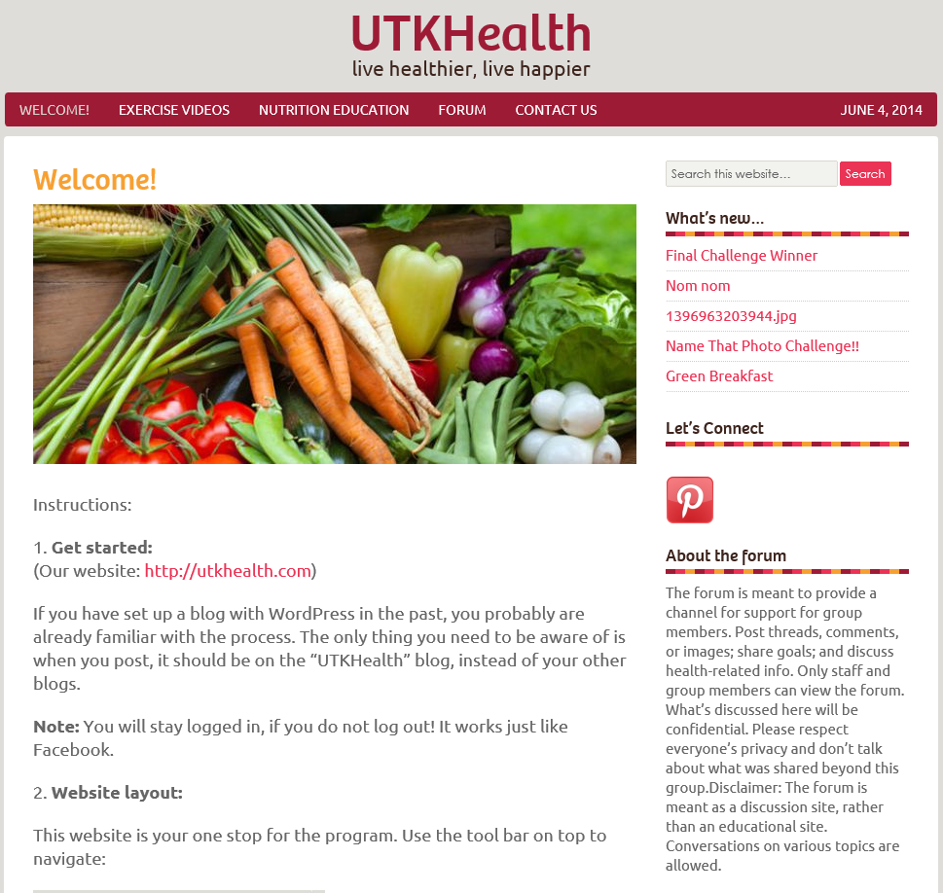
“Physical activity”: Information on physical activity was updated twice per week. While the main page provided educational materials in relation to physical activity, pre-screened YouTube excise videos were archived into three sub-pages according to exercise types.
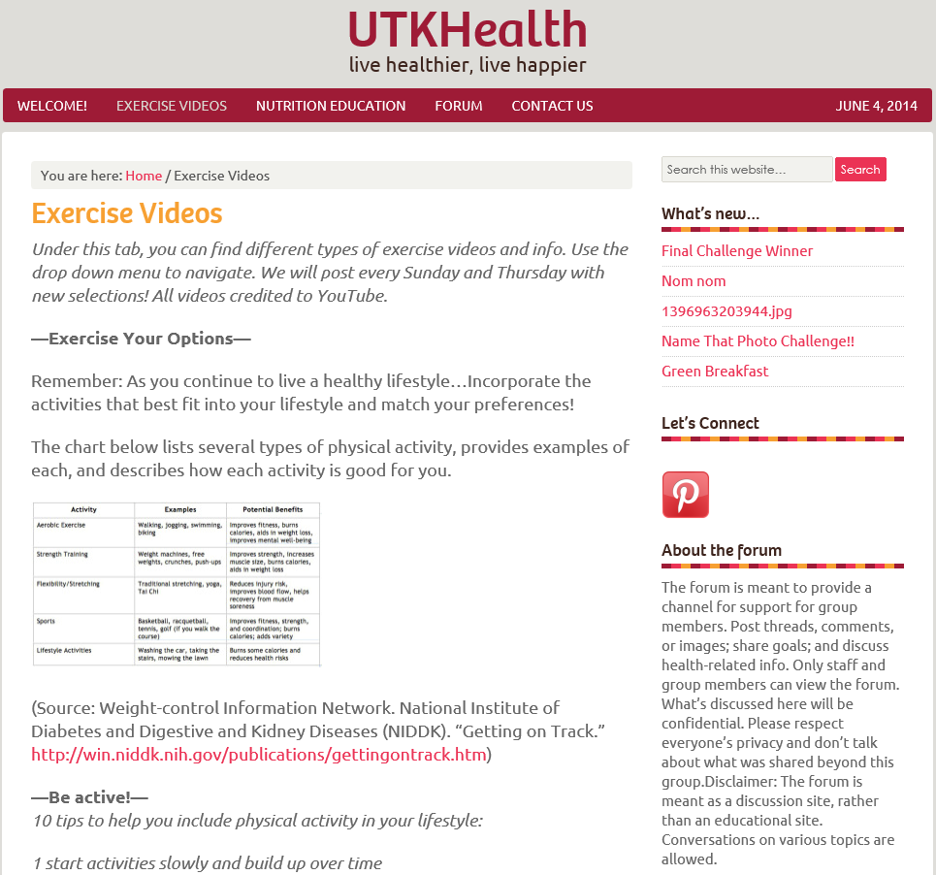
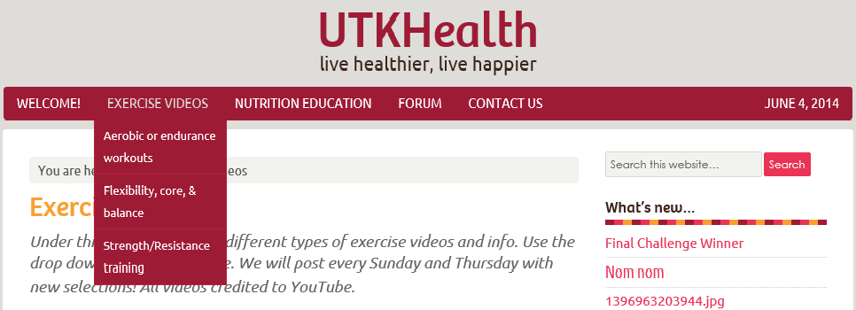

“Nutrition education”: The main page of “nutrition education” listed several smartphone applications that the research team recommended for diet and physical activity tracking. Each week, a subpage containing new nutrition topic was added, with a total of eight at the end of intervention.
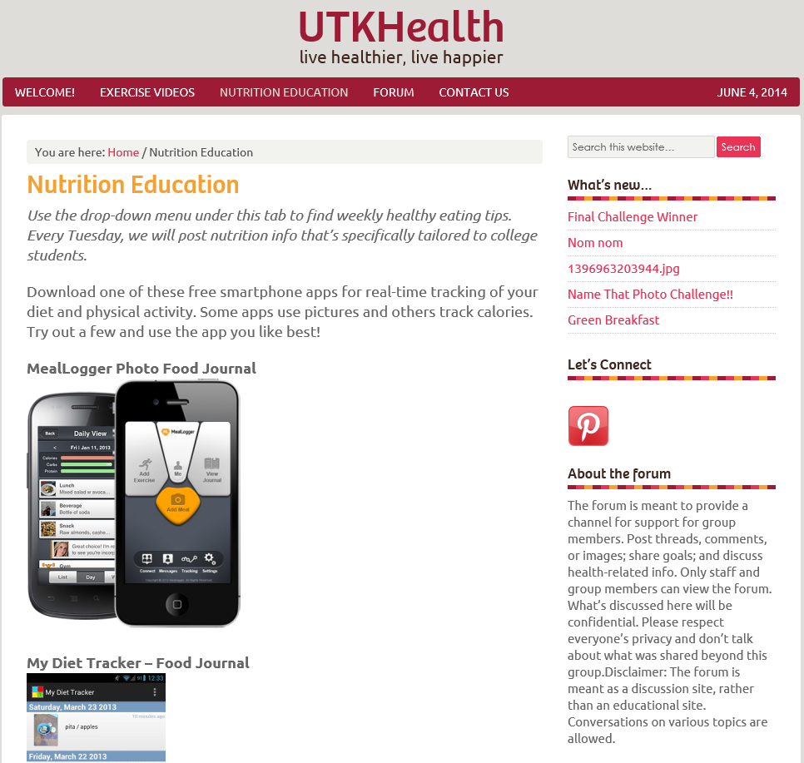
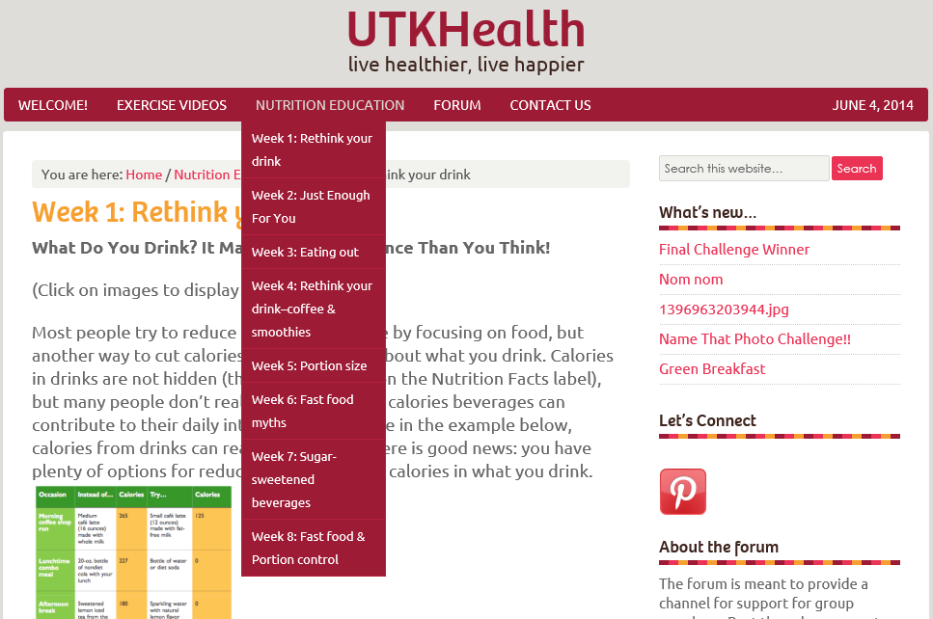

“Forum”: participants participated in anonymous group discussions. They could either make new post or comment on their peer’s posts.
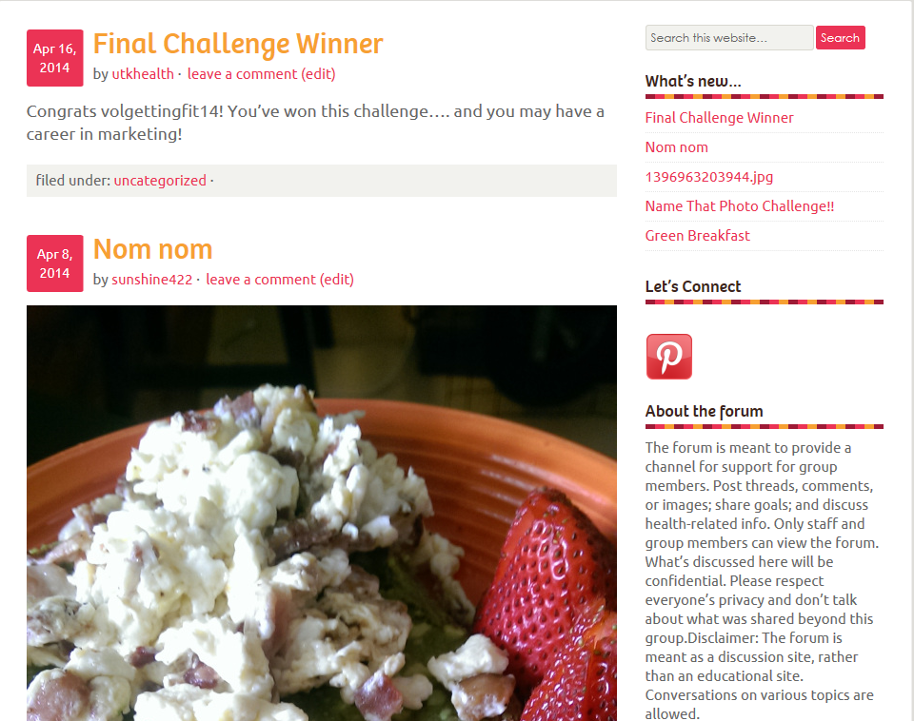
“Contact”: This page provided participants an opportunity to leave anonymous feedback. However, this page was rarely used except one student from Trial 1 commended the layout of the website.
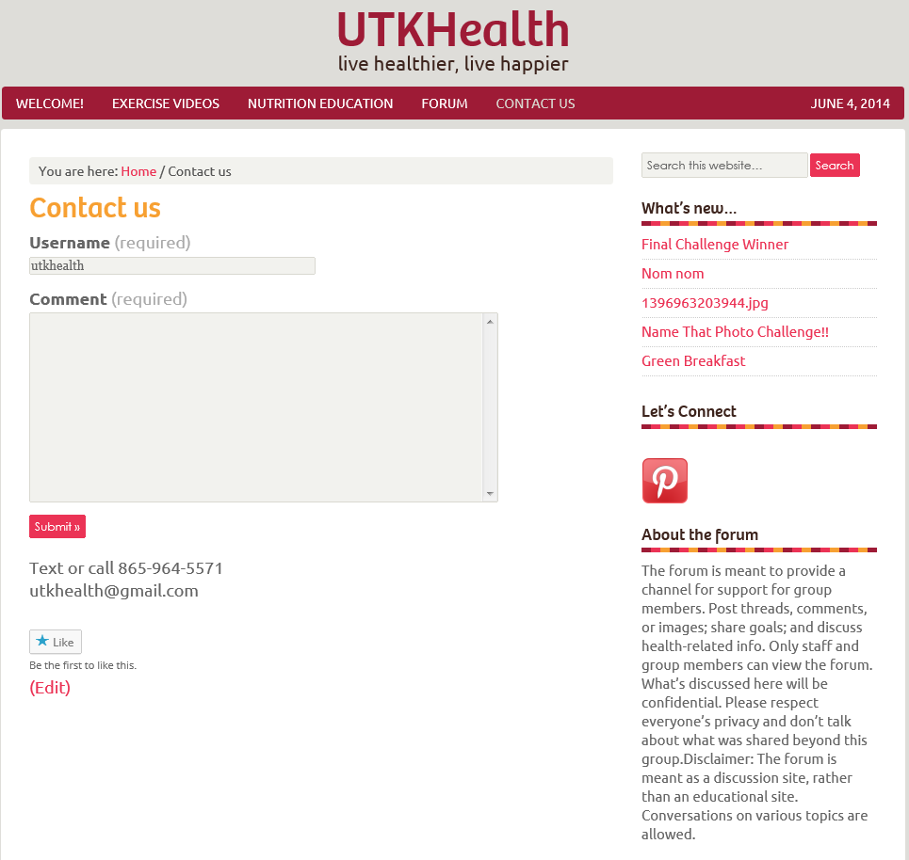

Appendix E: Intervention Overview
1. UTK Health – Trial 1
  - Intervention design
A randomized control trial was used to evaluate the efficacy of the UTK Health program for reducing BMI among overweight and obese college students. Participants were randomized to one of two conditions: (1) Intervention condition, or (2) attention-control condition.
Intervention participants had access to a private website consisting of a forum, YouTube exercise videos, and nutrition materials (described below). The website also contained information on various smartphone applications that could be used to track food intake and physical activity. In addition, the website provided links to the UTK Health Facebook page and a UTK Health Pinterest page created for the participants. Facebook is one of the several useful tools for notifying students of the website updates. The UTK Health Pinterest pages provide a collection of pictures on healthy recipes, motivational sayings, and exercise tips. In order to keep participants up to date with the intervention materials, research staff also texted them when new information was posted on the website. Control participants were sent nutrition information and exercise videos three times per week via emails.
Primary measurement (BMI) was taken twice at baseline and 8 weeks using Skype. Secondary assessments of program feasibility and acceptability were made at the end of the program by means of online questionnaires. Assessments of perceptions of social support were made by means of Skype-mediated focus groups. All participants were given an incentive of $15 for completing the baseline and 8-week assessments, for a total of $30 per participant.
  - Study Participant
Approval from the University of Tennessee Knoxville Institutional Review Board was sought prior to the recruitment. Potential subjects were undergraduate students at the University of Tennessee, males and females, age 18-22 with a BMI (Body Mass Index) ≥ 25 kg/m² who had access to the Internet, a personal computer, and a smartphone. Participants were ineligible if they had major psychiatric diseases (e.g., depression, bipolar disorder, schizophrenia); current, planned, or previous pregnancies within the last 6 months; a medical condition that precluded adherence to dietary recommendations and excise; or dietary restrictions or current medication that could impact body weight. Participants who were currently enrolled in or had plans to participate in a weight loss program were also excluded.
  - Recruitment and screening
The research staff distributed flyers and handouts around the UTK campus. To take advantage of the popularity of social media, a Facebook public page was also created to recruit participants. Interested individuals could access study information and participant eligibility criteria form an electronic flyer that was posted on the Facebook page. To avoid the need for in-person meetings, screening was conducted over Skype. Eligible individuals were mailed a scale and a tape measure for subsequent BMI measurement. The research staff then scheduled another Skype meeting to review the study protocol and obtain an electronically signed consent form. Participants were also instructed to self-measure their weight and height in the same Skype meeting.
Twenty undergraduate students (90% female, age 20.4 ± 1.4 years, BMI 32.1 ± 4.6 kg/m²) were recruited to the study, ten for each condition (intervention group or attention-control group). One student from the intervention group dropped out, and thus 19 (95%) completed the 8-week program.
  - UTK Health website
WordPress.com was used to create the study website. This tool, which does not require coding skills, but instead provides its users with various templates for building websites, allows for multi-user blogging and content publishing and management (ref). The website (UTK Health.com) was set to private, so that only invited users could access the study site with their WordPress username and password. In addition, WordPress has a smartphone application, which added mobile characteristics to the UTK Health program.
The UTK Health website was the central platform for the intervention, containing different tabs for nutrition materials, exercise videos and a forum. Nutrition materials were selected to target the dietary behaviors of college students ^{15,91}. In light of the short duration of the intervention and the frequency of updating the information (once per week), topics were narrowed down to (1) Decreasing intake of sugar-sweetened beverages, (2) Reducing portion size, and (3) Decreasing frequency of dining in fast-food restaurants.
The UTK Health website provided filtered YouTube exercise videos in three categories: aerobic, resistance and muscle strengthening, and balance and stretch. All these videos were manageable in a dormitory setting and no extra supplies were needed.
Unlike the nutrition materials and exercise videos, which were only editable by the web administrator, the forum supported multiple writers and was the most distinctive feature of the intervention. It was designed to facilitate peer communication and build social support among the intervention participants. Invited users could post new threads, delete their own threads, and comment on each other’s threads. In order to make the purpose of the forum clear to the intervention group, the research staff posted the following statement on the forum prior to starting the UTK Health program:
“The forum is meant to provide a channel for support for group members. Post threads, comments, or images; share goals; and discuss health-related info. Only staff and group members can view the forum. What’s discussed here will be confidential. Please respect everyone’s privacy and don’t talk about what was shared beyond this group. Disclaimer: The forum is meant as a discussion site, rather than an educational site. Conversations on various topics are allowed.”
2. UTK Health program – Trial 2
  - Modified intervention design
The second trial was conducted in Spring 2014. While most features of the UTK Health program were maintained, there were several modified components. The UTK Health Facebook was removed from the intervention due to minimum usage in the first trial. In addition, based on participants’ feedback from the focus groups in Fall 2013, three major changes were made to the intervention design to enhance the social support component:
- Adding six weekly Skype sessions: once per week for the first four weeks and once every other week for the second half of the program. Participants in the intervention group were able to choose one from the two Skype session openings. The purpose of the Skype sessions was to provide opportunities for the participants to directly communicate with and support each other. Thus, the research staff in the discussion functioned as the facilitator, initiating the conversation if needed. A list of topics for discussion was developed as prompts for the participants in case they had difficulty initiating the conversation. The list included six different topics on “Healthy eating”, “stress”, “support for weight loss”, progress”, “eating at restaurants”, and “perceptions of weight”. For those weeks with Skype sessions, a research assistant chose one topic from the list in advance and developed a session plan.
- Using the first Skype session as an orientation to the program. Orientations were held twice during the first week. As in the online focus groups, one research assistant logged on as UTK Health and started a new group conversation with all the participants who had signed up for the orientation. Then she video-called everyone in the group. The participants were asked to answer the voice call instead of the video call. The research assistant then shared his/her computer screen with the participants and led a virtual tour of the website to review each part of the intervention. To reduce technical barriers for the participants, the research assistant demonstrated posting and commenting. To emphasize the social support component, the researchers explained the interactive purpose of the forum and Skype sessions at the very end of the session.
- Adding weekly challenges on the forum to elicit more interactions among participants. Each week, a research assistant posted a new challenge on the forum with detailed instruction and information on the monetary prize, i.e. gift cards, that would be mailed to qualified winners of the challenges.
  - Study Participants
Twenty-four undergraduate students were recruited from flyers, handouts and UTK Health Facebook page. One student dropped out at the beginning of the program. At week 2, an issue occurred regarding one student’s physical health, which proved to be irrelevant to the program. Thus, additional screening was implemented for both groups. Ineligible participants were required to obtain a doctor’s note within one week of screening in order to continue the program. However, due to various reasons such as having no insurance, being distant from the doctor, and busy schedules, five students were not able to obtain doctor’s note and were eventually dropped by the program. One student could not be reached for the additional screening and was dropped as well. Thus, a total of 17 students (70.8%) (10 in the attention-control group and 7 in the intervention group) completed the 8-week program. Revised IRB allocation was approved by the University of Tennessee Knoxville Institutional Review Board prior to the recruitment.

Appendix F: Focus Groups Findings from the UTK Health Trial 1
Because the overall study design set the stage for the participants’ use of the forum and subsequently the social support component, findings regarding the UTK Health program are included in this analysis of Trial 1 results. Several themes emerged from the qualitative analysis of the two focus groups.
- The UTK Health program
  - Participants’ perspectives regarding the UTK Health program
The nature of the online format generated both positive and negative feedback about the UTK Health program. Most participants liked the anonymity, accessibility, and lack of shame or guilt afforded by the online system. One commented, “Advantages, is there is no shame. Not feeling like you're doing so bad and no comparing your progress to others”. Another said, “It was easy to get to throughout the day, on your computer, phone, iPad, etc. Also there was the constant flow of information that fought me more about healthy eating and exercising”.
Nevertheless, they also noted several challenges. An interesting theme emerging from the focus group data was that the program did not seem to increase participants’ motivation to make dietary or exercise changes. Most of the participants believed that this was the impersonal characteristic of the program due to a lack of in-person component. They commented that meeting other people who shared the same struggles could encourage their own weight loss efforts. For example, one participant said, “I think when it’s intangible (I don’t know any of you personally), it’s hard to stay fully motivated.” Another commented, “While I did like the program, it just felt too impersonal at times”.
Participants also noted that the program was not able to create a sense of community and therefore the participants felt no accountability, which one participant defined as having someone who can be there to help you when you are struggling versus just you pushing yourself”. The majority of the participants believed that the lack of accountability was a disadvantage of the program. In the words of one participant, it is “discouraging to just to go work out or eat right by yourself without a buddy or group that is doing the same thing.”
  - Suggestions for improvement (UTK Health program)
In response to the proposed challenges, participants offered several strategies that could potentially enhance the program design. While a few participants recommended having group contests and “check-ins” to boost motivation and involvement, most of them emphasized the importance of physical meetings, “buddies”, or group activities:
“Maybe if we had like a fitness pal where you match people together. It can still be by just text but you have someone to rely on.”
“I think adding the meeting part, or at least making it an option. It would make things easier to be in the program when they know who they are doing it with.”
Interestingly, the researcher discovered that most suggestions were actually focused on the social support aspect.
1.3. Perceptions of the forum
The forum enabled the intervention participants to communicate with each other through posting and commenting. However, although the platform was set up, most of the participants did not take advantage of this opportunity. Consequently, given that there was not much traffic on the forum, the social support aspect was inactive. Most participants from the focus groups understood and acknowledged the purpose of the forum: building relationship with and providing support for one another. One participant reflected her opinion on the forum feature, “I think that the forum should be a little more open ended. I get that there need to be prompts, but I think that having the relationship building among us as individuals would have helped our overall goal”. One suggested, “I almost feel like the whole thing should be a forum—at least that people can comment on posts and stuff, maybe have discussions about this week’s exercise or something…” Another commented, “I think for people to get things off their chest. If they have something to say they have a place to do so.”
Their perceptions of the forum function aligned with the researchers’ intention, which was for the forum to provide mutual support.
1.4. Barriers to forum usage
Half of the participants suggested that the forum was not user-friendly, which caused them some trouble in making new posts at the beginning of the program. One participant reflected, “it was definitely tricky to figure out how to post a new thread in a correct place.” Another compared the forum to existing social media such as Twitter and Facebook, which in their opinion they could “just quickly post in”.
A few participants thought their hesitation to use the forum was due to the lack of responses by others. One said, “I felt like no one was going to read them, and if they did, they weren’t going to respond.” Another two suggested that they did not post on the forum because “they had nothing to say”.
1.5. Strategies to increase forum usage
Most of the participants in the first focus group agreed that one reason they neglected the website was the fact that the program did not demand their participation in it or structure any web-tasks for them. They suggested several activities that “would get people invested”. One recommended setting up “polls or a little contest” on the forum.
Additionally, five others in the first focus group suggested, “scheduled chats would have been cool.” They further explained that the method of instant messaging could create guaranteed responses and “[get] people talking to each other”. Regular chats not only could lessen participants’ hesitance and the embarrassment of just posting on the forum, but also could help them build relationship outside of the website.
A few participants also mentioned that seeing “responses” would make them post more often on the forum.
- Social support
The researchers inquired about participants’ knowledge regarding social support in weight loss although this component was not activated in the program. All of the participants acknowledged the positive impact of social support in weight loss except one also mentioned the importance of independence. Further, the participants were asked to give opinions on providing social support using an online platform.
  - Knowing the people?
While most of the participants suggested that knowing their peers was not indispensible for gaining support for weight loss, some believed it was important to know some information about the other participants beyond weight issues. One reflected, “I don’t think it’s important to know personal information about them, but I would have appreciated knowing more about them as a whole (ex. If they like to play sports, then maybe we could try to hang out and play sports to get our workout in)”. One participant preferred gaining support from online who shared the same weight struggle because she “can’t really talk to [her] friends about loosing weight without feeling awkward”.
  - The source of social support
One participant revealed the frustration of gaining support from her friends. She gave an example that resonated with two other participants, “If I had overweight friends that were looking to lose weight too, that’d be great! The reality is that all of my friends have never had to worry about weight loss and working out with them is REALLY discouraging”. This was actually in line with another participant who endorsed the online format: “Personally, the reason I really jumped on board with this program IS the anonymity of it. One of the worse feeling in the world, and also one of the hardest to overcome, is comparing myself to those who exercise comes naturally”.
Some participants noted the benefits of getting support online; one suggested “it can show it is possible by seeing others in the same boat as you doing it”. However, over half of the participants believed adding structured in-person meetings afterwards could help with accountability and motivation. One participant commented, “For me, it was really hard at times keeping myself accountable. Also, I saw that many people also had the same struggles in the forum. I feel like meeting each other would really help out in that aspect”.

  - Tangible interaction
Regarding the option of tangible meetings, over half of the participants did not think other participants were accessible. In addition, one person said the reason for not reaching out to other participants was that she “didn’t know them personally enough to try and find something for us to do together”.
Although two participants reached out to others in the program for in-person meetings, they did not receive any responses. One participant explained, “it was hard to try to get all of my personal and school stuff together before planning some sort of event.” He also suggested that the meetings might be possible if the program staff could plan and organize the activities.

Vita
Yijia Zhang was born and raised in Nanjing, China. She received the Bachelor of Science degree in Biotechnology from Nanjing Forestry University.

In 2012, she started her graduate study in Department of Nutrition at the University of Tennessee, Knoxville. In December 2014, she will graduate with a Master of Science degree in Nutrition and a Master of Public Health degree in Community Health Education.

