Hunter’s Response to the Emergence of Chronic Wasting Disease in Tennessee

A Thesis Presented for the

Master of Science

Degree

The University of Tennessee, Knoxville

Abigail Louise Meeks
December 2020
Abstract
Chronic Wasting Disease (CWD), a neurological disease affecting deer and elk populations, was recently identified in western Tennessee. Wildlife managers, outdoor recreation planners and other stakeholders in this region are interested in examining how hunters perceive the risk of CWD over time and identifying factors determining their hunting behavior. This study conducted a mixed-mode survey of deer hunters in CWD impacted counties of western Tennessee before and after the 2019 deer hunting season. The first study in this thesis used multivariate logistic regression models to investigate factors affecting hunters’ short- and long-term intentions to hunt in CWD region. Hunters’ intention to hunt in CWD region were positively related with previous experience of hunting in CWD-impacted areas, beliefs on herd reduction strategy to control CWD, concerns regarding potential decline in deer quality, changes in hunting regulation due to CWD, trust in wildlife agency, and confidence placed on CWD information being provided. Public land hunters with concerns regarding deer and human health risks associated with CWD were less likely to hunt in CWD region. These results highlight on how these factors impact short- and long-term hunting intentions. The second study used multivariate logistic regression models to evaluate factors affecting hunters’ acceptability of alternative management actions. Hunter’s acceptability of management actions are significantly related to deer and human health, regulatory changes, trust and confidence on wildlife agency, and experience of hunting in other states with CWD. These results demonstrate the role of trust, perceived risk, and hunters’ demographic characteristics on acceptability of CWD management strategies.

Acknowledgements
I am thankful to everyone including my graduate committee members for their help and guidance. I am also grateful to the Tennessee Wildlife Resources Agency (TWRA) and University of Tennessee, Department of Forestry, Wildlife, & Fisheries for funding this project and providing me with financial support to completely my degree.
Table of Contents
Introduction……………………………………………………………………………….……….1
Chapter 1……………………………………………………………………………….………….5
Abstract……………………………………………………………………...…………….6
Introduction……………………………………………………………………..…………7
Literature Review………………………………………………………………………….8
Methodology……………………………………………………………………………..11
Data Analysis ……………………………………………………………………………18
Results and Discussion…………………………………………………………………..24
Conclusion……………………………………………………………………………….31
Appendix…………………………………………………………………………………34
Chapter 2…………………………………………………………………………………………44
Abstract…………………………………………………………………………………..45
Introduction………………………………………………………………………………46
Literature Review………………………………………………………………………...48
Methodology……………………………………………………………………………..49
Data Analysis…………………………………………………………………………….53
Results and Discussion……………………………………………….………………….62
Conclusion………………………………………………………………….……………73
Appendix……………………………………………………………………………..…..76
Conclusion……………………………………………………………………………………….86
References………………………………………………………………………………………..89
Vita……………………………………………………………………………………………….92

List of Tables
Table 1.1: List of hunter concern statements used in preseason and postseason surveys 16
Table 1.2: Factor statements derived from concern and trust statements 20
Table 1.3: Definition and descriptive statistics of variables used in modeling intentions to hunt in CWD impacted counties in Tennessee 21
Table 1.4: Comparison of hunters concerns regarding CWD between before (preseason) and after (postseason) the 2019-2020 deer season 26
Table 1.5: Regression estimates from models predicting short- and long-term hunting intentions in CWD counties in Tennessee 28
Table 2.1: Factors derived from survey responses on statements related to acceptability of management actions, CWD concerns, and wildlife agency trust 55

Table 2.2: Definition and descriptive statistics of variables used in modeling Tennessee hunters’ acceptability of CWD management actions……………………………………………...60

Table 2.3. Comparison of mean acceptability of CWD management actions between preseason and postseason hunter surveys………………………………………………...…………..
64
69

Table 2.4: Regression estimates for acceptability models………………………………….…….

List of Figures
Figure 1.1. Study areas of preseason hunter survey (left) and postseason hunter survey (right) with distribution of CWD positive (dark gray) and CWD high risk (light gray) counties at the time of survey (August 2019 and March 2020)…………………………………...13
Figure 2.1. Study areas of preseason hunter survey (left) and postseason hunter survey (right) with distribution of CWD positive (dark gray) and CWD high risk (light gray) counties at the time of survey (August 2019 and March 2020)………………………………….. 51
Figure 2.2: Potential conflict index associated with CWD management actions in Tennessee…66

Introduction

Wildlife health is an important issue of societal concern, as hunting and non-hunting residents in rural and sub-urban areas can have regular, daily encounters with wildlife. The public may change their usual interactions with wildlife as new diseases emerge. In addition to the potential risk of disease transmission to humans, local residents may be concerned about impacts on livestock and wildlife. Controlling the spread of disease in wildlife population requires understanding public perception of risk associated with the disease and engaging key stakeholders in the process through communication and outreach.
Among the many issues of wildlife health chronic wasting disease (CWD) has received significant amount of attention in recent years. Chronic wasting disease is a spongiform encephalopathy caused by a prion which occurs in cervids, a family of mammals which includes North American mule deer (Odocoileus hemionus), white-tailed deer (Odocoileus virginianus), elk (Cervus canadensis), and moose (Alces alces) (Saunders et al 2012). First identified in the late 1960s, CWD is a fatal disease reported to occur in both captive and wild deer populations (Saunders et al 2012). The symptoms of CWD are behavioral changes, such as pacing, weight loss, and death typically occurring in anywhere from two weeks to one and a half years with the major clinical changes are restricted to the central nervous system (Williams and Young 1980). CWD in deer populations has become a serious threat in wildlife management and rural economies because of the popularity of hunting and wildlife watching.
In the United States, CWD was first identified in a captive facility in Colorado in the late 1960s and has since been detected in as many as twenty-five states as of January 2020 (Centers for Disease Control and Prevention 2020). This was facilitated by the transport of captive cervids to other captive breeding facilities and the movement of deer carcasses (Evans et al 2014). In wild populations, transmission is facilitated by diseased and healthy deer sharing water or food, being in close contact (e.g. nose-to-nose touching), or prions in the environment being taken up by healthy deer (Saunders et al 2012). While CWD is transmissible among cervids, no study has found strong evidence of CWD transmission to humans (Belay et al 2004). The lack of information and potential for transmission may be an issue of concern to the public, especially for those who interact with deer the most.
In Tennessee, CWD was first discovered in Hardeman and Fayette counties in 2018. It has since been detected in five other nearby counties as of January 2020 (TWRA 2020). This is important because of the potential impact on the hunting economy in the region. Tennessee Wildlife Resources Agency, the state wildlife agency, may experience a potential decline in hunting participation and hunting license revenue. This loss would have negative financial impacts for future conservation programs due to loss of participation of hunters and the diversion of funds to other agency programs. Potential decline in spending may lead to loss of jobs and tax revenue in the rural economy which would experience the greatest impact from a decline in hunting. Potential decline in hunting participation due to CWD could result in reduced effectiveness of hunting as a tool for managing the deer population. Awareness of hunters’ intention to hunt in CWD affected counties as well as their acceptability of CWD management actions can be important for long term management of this disease.
To address these issues, the objectives of the research presented in this thesis are to:
- Assess and compare hunters’ concerns regarding CWD impact before and after the first season of CWD discovery; and evaluate the factors impacting short- and long-term intentions to hunt deer in CWD impacted counties.
- Assess and compare the relative acceptability of various management actions for CWD management; and explore the factors influencing hunters’ acceptability of various actions for CWD management.
The above research objectives were met by conducting a mixed-mode survey of deer hunters in the CWD affected region before and after the first deer hunting season since the discovery of CWD. Multivariate regression models were estimated to test specific hypothesis associated with each research objectives. The next two chapters present in-depth details on the research question, relevant literature, methodology, results, and conclusions associated with the two research objectives. The conclusion section presents general conclusions and lessons learned from both studies.

Chapter 1
Hunters Concerns and Intentions to Hunt Deer in CWD Impacted Tennessee

Abstract
Chronic Wasting Disease (CWD), a neurological disease affecting deer and elk populations, was recently identified in western Tennessee. As a result, wildlife managers, outdoor recreation planners, and other stakeholders in the region are interested in understanding how hunters themselves perceive the risk of CWD over time, and what factors influence their intentions to hunt in the CWD region. This study conducted a mixed-mode survey of deer hunters in CWD impacted counties of western Tennessee before and after the 2019 deer hunting season, which was the first hunting season since the discovery of CWD. Hunters’ concerns about various aspects of CWD impact were compared before and after the hunting season. Multivariate logistic regression models were used to investigate factors affecting hunter’s short- and long-term intentions to hunt deer in CWD region. Results showed that hunters’ intention to hunt in the region were positively related with previous experience of hunting in CWD impacted areas, beliefs the effectiveness of herd reduction strategy to control CWD, concerns regarding potential decline in deer quality and changes in hunting regulation due to CWD, trust in wildlife agency action and information provided by them. Hunters who hunt on public land and are concerned with deer and human health risk of CWD were less likely to hunt in CWD region. These results highlight on how these variables may impact hunting intention in the short-term and the long-term in western Tennessee.

Introduction
In Tennessee, CWD was first identified in Hardeman and Fayette counties in 2018. It has since been detected in five other nearby counties by early 2020. This is a significant concern from an ecological and economic standpoint because of the potential impact it may have on the deer population as well as the hunting economy in the region. In Tennessee, 375,000 hunters spent roughly $494,005,000 or an average of $1,168 per hunter in 2011 (U.S. Department of the Interior 2011). The continued prevalence of CWD in the state could cause a percentage of these hunters to stop hunting deer in the state, leading to significant economic ramifications. In addition to a potential shortfall in license revenue for the Tennessee Wildlife Resources Agency (TWRA), a decline in hunting expenditure, jobs, tax revenue, and lease fees may impact local economies that depend on hunting. The potential diversion of funding to combat CWD may also affect other TWRA programs such as habitat management, monitoring of invasive species, and non-game species conservation. Decline in hunting participation due to CWD could also result in a loss of hunting as a rural tradition and reduced effectiveness of hunting as a deer population management tool.
Over the years, human dimensions research has been used to inform adaptive wildlife management decisions. Hunters’ knowledge and perception of risk associated with CWD, and its influence on hunting intentions and behavior may help wildlife agencies and stakeholders understand the potential impact on hunting participation and facilitate the design of programs to mitigate the impact of CWD. Emerging literature on the human dimensions of CWD in several states have shown hunters in each region are different in perceiving and responding to the CWD risk (Needham and Vaske 2008), implying conclusions drawn from studies elsewhere may not be generalizable to hunters in western Tennessee. The objectives of this study were to 1- assess and compare hunters’ concerns regarding CWD impact before and after the first season of CWD discovery and 2- evaluate the factors impacting short- and long-term intentions to hunt deer in CWD impacted counties.
Literature Review
Research in human dimensions of wildlife has measured and analyzed perspectives of wildlife stakeholders (e.g. hunters, landowners) by using a variety of psychological constructs including knowledge, attitudes, values, norms, attitudes, and behavior. For example, the cognitive hierarchy theory (Vaske and Manfredo 2012) posits values form the basis of human cognitive system, which together with the personal and social norms, and attitudes determine an individual’s intentions and behavior. In other words, a hunters’ behavioral response (e.g. hunt or not to hunt) in a situation (e.g. emergence of CWD) can be influenced by their wildlife values, beliefs regarding CWD, attitudes toward CWD, and societal norms regarding CWD. Theory in human dimensions uses this framework to predict the response of a voluntary behavior to an outside stimulus. A voluntary behavior is one that a person chooses to undertake for no reason related to need. Voluntary behavior results from three different factors, predisposing (i.e. preferences of prior motives), enabling (e.g. access to nearby hunting sites), and reinforcing (e.g., rewards, fines) (Holsman et al 2006).
Specific beliefs unique to the situation may also impact hunter’s intentions. In the case of CWD, these could include hunters’ beliefs regarding harvesting a diseased deer or eating infected meat. Such beliefs could have impact on whether the voluntary specific behavior (i.e. hunting in CWD region) is worth the additional negative risk to the hunter.
Another theoretical framework often used in explaining human behavior is the theory of reasoned action, which states one’s behavior or behavioral intentions are predicted by one’s attitude toward performing the behavior and the subjective norms related to performing the behavior (Fishbein 1979). Subjective norms refer to the way perceptions of relevant groups or individuals such as family members, friends, and peers may affect one's performance of the behavior. Similarly, the attitudes impacting the cognitive hierarchy theory towards the emergence of CWD can have an impact on behavioral beliefs or the belief that an action is too much of a risk to undertake (Fishbein 1979). The theory of planned behavior (Ajzen 1991) postulates one’s behavior is influenced by their perceived control over the behavior. A common take-away from these two theories of human behavior imply that hunter’s behavior or intention to hunt in CWD impacted area may depend on their attitude towards CWD, behavioral beliefs, social norms, and perception of behavioral control.
Several studies have explored a hunter’s knowledge and attitude towards CWD. The majority of these studies are based on the cognitive hierarchy theory in modeling hunting intentions and behavior (Lyon and Vaske 2010). Behavior is at the top of the cognitive hierarchy theory and therefore intention may not fully reflect behavior (Vaske and Manfredo 2012). One study used hypothetical scenarios of CWD risk levels to predict when hunters may quit hunting in a CWD impacted area (Lyon and Vaske 2010). While the results from such hypothetical simulations are helpful to managers in understanding how alternative risk of CWD impact hunting participation before the season begins, a better analysis may involve measuring hunters’ actual behavior (e.g., hunted or not, days afield, number of trips) during the season.
Brown et al (2006) studied hunter and general public response to CWD in Oneida County, New York and found the majority of residents were aware of CWD and were concerned with eating deer meat and the potential transmission to humans (Brown et al 2006). Hunters in Illinois (Miller et al 2006) and Wisconsin (Bishop 2004) shared similar concerns regarding consumption of deer harvested in CWD areas. These concerns may have affected hunter drop-out rates in Wisconsin (Vaske et al 2004). The study in Oneida County did not address future hunting participation or trust in management, two factors which may have an impact on hunter perception of the disease.
A study by Miller et al. (2006) in Illinois compared CWD risk perception and hunting behavior between hunters living within and outside a CWD eradication zone and between demographic groups. This perception of risk was determined by asking hunters to evaluate their perception of risk from CWD using a five-point Likert Scale ranging from “none” to “high”. Over the years, more hunters in Illinois perceived CWD as a slight or moderate risk, suggesting hunter perception regarding CWD risk may change over time. Hence, continuous monitoring of hunters’ perception over time may offer valuable information regarding how stakeholders perceive CWD’s impact.
Lyon and Vaske (2010) compared hunters’ intention to hunt among multiple states experiencing CWD. In each state, hunters indicated they would hunt less often if CWD prevalence increased. The study found remarkable differences among states in terms of how hunters respond to the impact of CWD. For example, compared to their Wisconsin counterparts, hunters in North Dakota were more likely to quit hunting due to CWD, suggesting limited generalizability of results from these studies. Other studies have argued inter-state differences in hunters’ response may be attributable to a difference in the trust and confidence hunters place on management agencies. However, the same study found evidence that trust alone is considered a rather minor contributor in hunters’ perception and there are other factors that have higher influence such as perceived health risks from CWD (Needham et al 2008). This is consistent with the finding from the multi-state survey which also concluded that factors other than agency trust can affect hunter perception of risk (Lyon and Vaske 2010). A similar finding was observed in a Wisconsin study where about half of the hunters surveyed did not participate in the hunting season because of CWD (Vaske et al 2004). Hunters that dropped out because of CWD were less likely to believe the information provided by the Wisconsin Department of Natural Resources and were less trusting of the agency (Vaske et al 2004). Hunters that dropped out for non-CWD reasons (e.g., lack of time, moved out of area) gave statistically similar responses on the issue of perceived risk and trust as those who did hunt (Vaske et al 2004).
Both trust in the wildlife agency and the perceived usefulness of provided information have an influence on the perception of risk related with CWD and hunting decisions. Since hunters in different states were found to have significantly different risk perception and hunting intentions (Lyon and Vaske 2010), conclusions drawn from studies in other states may not be generalizable to hunters’ population in Tennessee.
Methodology
Hunter survey
A survey of deer hunters in CWD impacted counties of west Tennessee was conducted to meet the objectives of this research. In order to manage CWD in the region, the Tennessee Wildlife Resources Agency (TWRA) has designated seven counties as CWD positive counties because of confirmed presence of CWD (Chester, Fayette, Hardeman, Haywood, Madison, Shelby, and Tipton). In addition, four adjacent counties (Crocket, Gibson, Lauderdale, and McNairy) have been designated as CWD high-risk counties because of their proximity(within 10 miles) to confirmed CWD cases. Since the discovery of CWD, TWRA has adopted a variety of approaches to control CWD in the region including the change from general surveillance to intensive monitoring effort to determine spatial distribution and prevalence of CWD, a public information campaign, changing hunting seasons and bag limit to incentivize harvest, carcass movement/transportation restrictions, and a feeding and mineral ban (TWRA 2020).
To compare hunters concerns about CWD risk before and after the hunting season, two separate surveys were conducted. The first survey (i.e. preseason survey) was conducted in August-September of 2019 prior to the start of deer season as deer season in Tennessee typically starts in September and ends in mid-January. A total of 5,000 randomly selected deer hunting license holders who reported harvesting deer in CWD positive and high-risk counties during the 2017 and 2018 deer seasons were contacted for the preseason survey. Figure 1.1 shows the distribution of positive and high-risk counties at the time of this survey. The sample was drawn through a stratified random sampling approach to ensure representation from positive and high-risk counties. Contact information for the hunters was obtained from the TWRA license database.
A mixed mode survey involving both email and mail surveys were adopted for data collection. Following a modified tailored designed method (Dillman et al 2014), those with email addresses on file were first contacted by a personalized email containing a link to a survey designed in QuestionPro platform. Three follow-up reminders were sent to non-respondents in a period of two weeks. Those who did not respond to our email invitation or did not have an email address were contacted by mail. The mail survey also followed the modified tailored design method, which utilized a personalized cover letter, business reply envelope and a follow-up reminder with the survey packet. No further reminders were sent because the hunting season had already started.
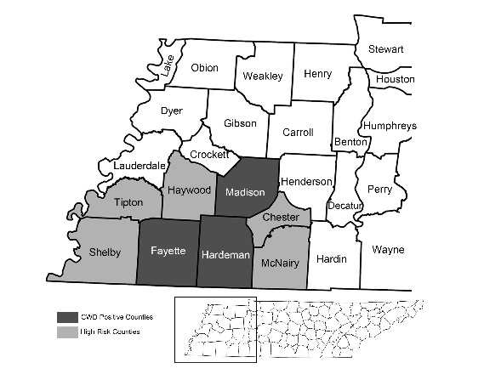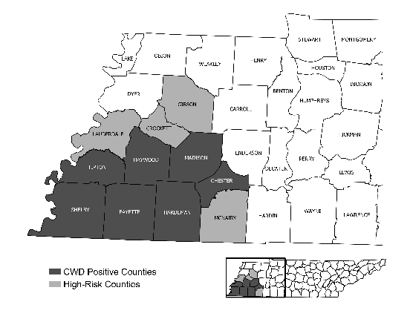
Figure 1.1: Study areas of preseason hunter survey (left) and postseason hunter survey (right) with distribution of CWD positive (dark gray) and CWD high risk (light gray) counties in western Tennessee at the time of survey (August 2019 and March 2020).

The respondents for the preseason survey were asked to indicate if they would be willing to participate in future CWD surveys, and those who agreed to do so were marked as potential participants for the postseason survey.
The second survey (i.e. postseason survey) was conducted after the 2019 deer hunting season which ended in January of 2020. A total of 1,141 respondents from the preseason survey who consented to participate in future surveys on CWD were selected for the postseason survey, which was sent after the end of deer hunting season (February 2020). An additional 3,000 participants were recruited for this survey because new counties had been confirmed to have CWD or were designated as high-risk counties since the preseason survey was implemented. By this time, there were seven positive counties (Tipton, Haywood, Madison, Shelby, Fayette, Hardeman, and Chester) and four high-risk counties (Crockett, Gibson, McNairy, and Lauderdale) as classified by the TWRA. Combining this with those recruited from the preseason survey the total sample size was 4,141 for the postseason survey. This sample size is more than enough for the population of hunting license holders in the region (with the confidence interval of 95% and +5% margin of error). Figure 1.1 shows the distribution of positive and high-risk counties at the time of preseason and postseason surveys.
Similar to the preseason survey, the postseason survey also started with an email survey for those who had email addresses on file. Those without email contacts on file or those who did not respond to the email survey were contacted by mail in late February and March of 2020. Survey administration for the email and mail contacts followed the same procedure as the preseason survey but with a revised initial cover letter, follow-up letter, and a survey instrument. In addition, a pre-notification postcard was used before the first mail invitation to encourage participation.
The survey questionnaires used in this study were developed after an initial consultation with TWRA staff in the summer of 2019 at TWRA headquarters in Nashville. The draft questionnaire was then shared with TWRA staff, human dimension experts, and a few volunteer hunters to provide feedback. Both surveys included questions about basic hunting information about the respondent, such as the number of trips and days of hunting in CWD counties and the length of time spent hunting in CWD counties. A separate section in the survey included questions about the respondent’s awareness of CWD, the perceived risk regarding CWD, beliefs about CWD impact in Tennessee, acceptability of various management actions, and future hunting intentions. Survey questions regarding acceptability of management actions and the level of agreement or disagreement with statements about CWD risk utilized three- or five-point ordinal scale whereas questions about awareness of CWD, intention to hunt deer in the upcoming hunting season utilized dichotomous choice (yes/no). The final section of the survey covered basic demographic information about the respondent.
Data collected from online survey in QuestionPro was merged with mail survey data coded in Microsoft Excel. A codebook was created to check and ensure accuracy and consistency in variables and the dataset. The merged data file was then uploaded into Stata^{R}, a statistical program, for tabulation and statistical modeling.
Measuring and comparing CWD concerns before and after the hunting season
A set of ten statements (table 1.1) was used to measure hunters’ concerns regarding CWD impact. Each statement utilized a 3-point ordinal scale (1-not a concern, 2-minor concern, 3-major concern). The same set of statements were used in both the pre-season survey and post season survey.
Table 1.1: List of hunter concern statements used in preseason and postseason surveys
Deer population declining dramatically
Safety of eating deer meat
CWD spreading throughout Tennessee
Additional regulations affecting my ability to hunt
Not having enough mature bucks to hunt
TWRA has made a reasonable effort to educate the public about CWD
CWD information provided by TWRA is clear
TWRA has taken appropriate actions to prevent spread of CWD
I trust TWRA officials to have an appropriate plan for CWD in Tennessee
TWRA will take timely actions to prevent CWD from spreading

Only for those respondents who completed this set of questions in both surveys, a Chi-squared test was performed to evaluate the significance of differences in concern between preseason and postseason.
Modeling hunting intention
In order to analyze the factors determining hunters’ intention to hunt deer in CWD impacted areas, a conceptual model (Eq. 1) was developed. This model is grounded on the theoretical framework of the Theory of Cognitive Hierarchy (Vaske and Manfredo 2012) where an individual’s intended behavior depends on several factors including their perception, norms, and attitudes. Following previous studies on hunters’ intentions (Miller et al 2006, Holsman et al 2006), the hunting intention model is further expanded by adding relevant psychological constructs which impact hunter behavior.
Eq 1. Hunting intention/behavior = f(cognitive factors, hunting characteristics, demographics)
The model presented in Eq (1) was estimated using logistic regression for two separate scenarios. The first scenario modeled respondent intention to hunt in CWD counties in the future, without mentioning a particular hunting season (i.e. long-term hunting intention). The second scenario modeled hunters’ intention to hunt in CWD counties in the upcoming season (i.e. short-term hunting intention). Since the measurement of a dependent variable, intention to hunt in CWD impacted counties, took categorical data, categorical models (e.g. binomial logit, ordered logit) were preferred to lease square estimators. The criteria of significance for statistics was set at 0.10.

Data Analysis
Dependent variables
The dependent variable in the short-term intention model was a binary dummy variable, which took a value of 1 if the respondent intended to hunt in CWD counties in the upcoming hunting season, otherwise 0. Alternatively, the dependent variable in the long-term intention model measured long-term intentions by asking the respondents to indicate how they expect their hunting will change in future in response to CWD. For this, a five-point Likert scale (1-substantially decrease my hunting, 1- slightly decrease my hunting, 3- not affect my hunting at all, 4- slightly increase my hunting, and 5- substantially increase my hunting) was used.
Independent variables
Consistent with the theoretical model presented in Eq. (1) as well as models used in relevant literature, four groups of independent variables were established. Those groups included 1 - concerns-related variables, 2 - trust in agency communication and actions, 3 - hunting characteristics, and 4 - demographics. Based on past studies, these variables were included to evaluate how concerns regarding CWD impacts (Gigliotti 2010), trust and confidence in the wildlife agency (Vaske et al 2004, Brown et al 2006), hunting characteristics, and demographics (Brown et al 2006) may impact hunter intentions in the region. Psychological constructs such as concern, trust, etc. are typically measured with multiple survey items, which are often correlated and could be problematic if used together in regression models. Hence, multiple items used to measure a particular construct (i.e., concern) are combined by using a multivariate technique known as factor analysis.
As shown in table 1.2, three factors were derived from five statements representing respondent concerns regarding CWD and two factors were derived from five statement correspond into respondent trust in agency and CWD information being provided to them. In particular, deer and human health concerns were loaded into the deer and human health factor (table 1.2). One statement was loaded into the regulatory concerns and one was loaded into the deer quality concerns. Two statements related to information provided by the TWRA were loaded into the one factor, which was named trust in agency communication. Three statements related to responses or actions taken by the TWRA were loaded into a separate factor, named as agency action.
In addition to concern and trust, four variables representing respondents’ hunting characteristics were included in the regression model. Those included the number of years they have been hunting in the region, a dummy variable (coded as 0 or 1) indicating whether they hunt on public land, a dummy variable indicating if they previously hunted outside of the state where CWD was present, a dummy variable indicating whether their response was for CWD positive county or high risk county in the region. Finally, a dummy variable indicating whether the respondent believed relying on hunter harvest for herd reduction would be a viable strategy for CWD management. Hunter attitude towards hunter-based herd reduction has been evaluated in previous studies (Needham et al 2007, Holsman and Petchenik 2006) but the current model builds upon those studies to analyze whether and how a hunter’s perception of its effectiveness may impact their hunting intention. Demographic variables included household income and the total number of people living in the household. Definition and descriptive statistics of variables in the model are presented in table 1.3.

Table 1.2: Factor statements derived from concern and trust statements
Factors | Statement | Mean | Factor loadings | Cronbach’s Alpha
Deer and human health concerns |  |  |  | 0.70
 | Deer population declining dramatically | 2.33 | 0.56
 | Safety of eating deer meat | 2.51 | 0.63
 | CWD spreading throughout Tennessee | 2.69 | 0.67
Regulatory concerns |  |  |  | N/A
 | Additional regulations affecting my ability to hunt | 2.22 | 0.53
Deer Quality concerns |  |  |  | N/A
 | Not having enough mature bucks to hunt | 2.21 | 0.47
Trust in agency communication |  |  |  | 0.77
 | TWRA has made a reasonable effort to educate the public about CWD | 4.12 | 0.51
 | CWD information provided by TWRA is clear | 3.86 | 0.55
Trust in agency action |  |  |  | 0.90
 | TWRA has taken appropriate actions to prevent spread of CWD | 3.47 | 0.76
 | I trust TWRA officials to have an appropriate plan for CWD in Tennessee | 3.67 | 0.88
 | TWRA will take timely actions to prevent CWD from spreading | 3.72 | 0.85

Table 1.3: Definition and descriptive statistics of variables used in modeling intentions to hunt in CWD impacted counties in Tennessee
Variable | Description | Mean (SD) | Standard Deviation
Dependent Variables
Short-term hunting intention | Dummy variable: 1 if respondent intends to hunt in in CWD counties upcoming deer season, 0 otherwise | 0.89 | 0.31
Long-term hunting intention | Respondents intention to change hunting in CWD counties in future  (1-substantially decrease, 5 -substantially increase) | 2.76 | 0.84
Independent Variables
Concern variables
Deer and human health concerns | Factor scores related to deer and human health concerns | -1.82*10⁻⁹ | 0.80
Table 1.3 Continued  Regulatory concerns | Factor scores related to regulatory concerns | 2.13*10⁻⁹ | 0.74
Deer quality concerns | Factor scores related to deer quality concerns | -1.23*10⁻⁹ | 0.56
Agency trust and confidence
Trust in agency communication | Factor score corresponding to respondent trust in the CWD information TWRA has provided | -8.12*10⁻¹⁰ | 0.70
Trust in agency action | Factor score corresponding to respondent trust in actions TWRA has taken to combat CWD | 3.80*10⁻⁹ | 0.93
Hunting-related variables
Years of hunting | Years the respondent have been hunting deer in CWD counties | 20.45 | 13.75
Hunt out of State | Dummy variable: 1 if the respondent previously hunted in other states with CWD, 0 otherwise | 0.24 | 0.43
Hunt public land | Dummy variable: 1 if the respondent primarily hunts on public land, 0 otherwise | 0.61 | 0.25
CWD positive county | Dummy variable: 1 if the response was for CWD positive counties, 0 otherwise | 0.79 | 0.41
Attitude towards herd reduction | Dummy variable 1 if the respondent believed relying on hunter harvest for herd reduction would be a viable CWD management strategy, 0 otherwise | 0.25 | 0.01
Demographics variables
Household size | Number of people in the respondent household | 3.06 | 1.46
Income | A categorical indicator of respondent’s annual household income (1- below $25,000 to 7- > $25,000) | 4.44 | 1.85
Table 1.3 Continued

Results and Discussion
Table 1.3 Continued
Data analysis was conducted in Stata 15 and the output is listed in the appendix A through H.
Survey response
Out of the 5,000 surveys sent out in the preseason survey, six were removed due to the respondent being deceased or unavailable to take the survey which reduced the target sample to 4,994. A total of 1,642 surveys were returned for an adjusted response rate of 33%. A total of 1,083 surveys were returned by email and 559 surveys were returned by mail. Out of the 4,141 surveys sent out in the postseason survey, eleven were removed due to the respondent being deceased which reduced the target sample to 4,130. A total of 1,495 surveys were returned, 784 from email and 711 from mail, for an adjusted response rate of 36%. This is consistent with some of the recently completed surveys of hunters including Watkins et al (2018), a hunters survey in Tennessee which had a response rate of 36% and Poudyal et al (2020) which had a response rate of 30% using a mixed-mode survey.
The average age for the post-season was 48 years old, age data was not collected for the preseason. The preseason was 73% male. The average number of people living in the household in the preseason was 3.02 with an average of 1.62 deer hunters in the household. Ninety eight percent of preseason respondents indicated they had heard of CWD prior to the survey. About 50% of preseason respondents indicated they owned land in either positive or high-risk counties with an average of 159 acres owned. About 24% of preseason respondents indicated they hunted out of state and 23% had hunted in states where CWD was present. Income in the preseason was distributed as 5% reported they made less than $25,000, 14% made between $25,001 and $50,000, 18% reported they made between $50,001 and $75,000, 18% reported they made between $75,001 and $100,000, 14% reported they made between $100,001 and $125,000, 11% reported they made between $125,001 and $150,000, and 21% reported income of 150,000 or more. In terms of the type of land they primarily hunted on, 34% indicated hunt on their own land, 23% indicated they hunt on leased land, 36% indicated they hunt on non-leased private land where they have permission to hunt, and 7% indicated they hunt on public land (WMA).
Comparison of hunters’ concern between preseason and postseason
Results from Pearson’s Chi-squared test of differences in mean concern scores between the preseason and postseason survey are presented in table 1.4. All concerns were found with significant difference in mean response. Significance in difference indicates that hunters concern may change over time, even after just the first hunting season following the emergence of CWD.
The difference in concern over the deer population declining dramatically was significant between the preseason and postseason. The postseason mean was lower than the preseason mean indicating that concerns over the potential decline in deer population decreased over time. This may be attributable to hunters not experiencing major change in deer population. Compared to postseason, mean concern scores over not having enough mature bucks to hunt and the safety of eating deer meat were also significantly lower in the postseason survey. This suggests that hunters may be becoming less alarmed or more tolerant of these concerns. Compared to the preseason, postseason concerns were significantly lower in regard to CWD spreading throughout Tennessee. A casual observation behind this evidence is that hunters may have expected a more rapid expansion of CWD spread.
Table 1.4: Comparison of hunters concerns regarding CWD between before (preseason) and after (postseason) the 2019-2020 deer season.

Concerns | Preseason mean | Postseason mean | Chi-Squared Statistic | p | N
Deer population declining dramatically | 2.38 | 2.30 | 180.82 | 0.00 | 622
Not having enough mature bucks to hunt | 2.27 | 2.18 | 170.51 | 0.00 | 603
Safety of eating deer meat | 2.50 | 2.32 | 199.68 | 0.00 | 614
CWD spreading throughout Tennessee | 2.71 | 2.54 | 189.69 | 0.00 | 611
Local processors stopping processing deer | 1.98 | 2.19 | 175.12 | 0.00 | 598
Additional regulations affecting my ability to hunt | 2.23 | 2.30 | 101.04 | 0.00 | 604
Lack of disposal options for unwanted deer parts | 1.95 | 1.98 | 108.70 | 0.00 | 596
Not being able to legally place mineral licks or feed deer | 1.90 | 1.94 | 298.71 | 0.00 | 597
Potential negative impact on other TWRA programs due to additional funding needed for CWD management | 2.15 | 2.11 | 74.02 | 0.00 | 594

Concerns over local processors stopping processing deer was significant with the postseason mean being higher than the preseason mean. A possible explanation for this observation is that respondents in preseason survey may not have yet realized how local processors may adjust their business in the first season after CWD emergence, whereas the postseason respondents may have reflected on their recent experience or difficulty with finding processors during the hunting season. Similarly, the concern over additional regulations affecting their ability to hunt was also significantly lower in the postseason survey than it was in the preseason. Higher concern over new regulation in preseason may be attributable to uncertainty following the recent emergence of CWD in the region. Postseason survey respondents conversely, may have realized the new regulations had little impact on their hunting. Postseason concerns being lower than preseason concerns for many of the statements aligns with another study which found that time alleviates some of the perceived risk associated with CWD (Holland et al 2020).
The lack of disposal options for unwanted deer parts was also significant indicating that after the hunting season hunters may have become slightly more concerned about this issue. This could indicate more hunters having encountered this concern during the season. Concern over hunters not being able to legally place mineral licks or feed deer was also significantly higher in the postseason. The potential negative impact on other TWRA programs due to additional funding needed for CWD management was also significant but lower in the postseason.
Hunting intention models
Regression estimates from short- and long-term intentions to hunt deer in CWD counties are presented in table 1.5.
Table 1.5: Regression estimates from models predicting short- and long-term hunting intentions in CWD counties in Tennessee
Variable | Short-term hunting intention | Long-term hunting intention
Concern variables | Coefficients | Coefficients
Deer and human health concerns | -1.222 (0.218)*** | -0.423 (0.712)***
Regulatory concerns | 0.331 (0.145)** | 0.007 (0.073)
Deer quality concerns | 0.736 (0.196)*** | 0.402 (0.098)***
Agency trust variables
Trust in agency communication | 0.360 (0.136)*** | 0.163 (0.075)**
Trust in agency action | 0.196 (0.116)* | 0.315 (0.062)***
Hunting-related variables
Years of hunting | 0.038 (0.008)*** | -0.003 (0.004)
Hunt out of state | 0.565 (0.278)** | 0.236 (0.123)*
Hunt public land | -1.057 (0.336)*** | -0.606 (0.210)***
CWD positive county | -0.068 (0.255) | 0.003 (0.130)
Attitude toward herd reduction | 1.019 (0.220)*** | 0.352 (0.107)***
Demographics variables
Household size | 0.308 (0.084)*** | 0.040 (0.035)
Income | -0.002 (0.055) | 0.042 (0.028)
Pseudo R2 | 0.162 | 0.030
Log-likelihood | -373.94 | -1712.11
LR (Chi-square) | 144.67 | 104.74
N | 1,664 | 1,664
*, **, and *** denote significance at p<0.10, p<0.05, and p<0.01 respectively.
Numbers in parenthesis are standard error

Regression coefficients on all three concern variables were significant in the short-term intention model. Concerns regarding regulatory impact on hunting experience and quality of deer population were positively related with intention to hunt in CWD counties during the upcoming deer season whereas concerns regarding potential decline in deer population and human health was negatively related. In the long-term intention model, only two concern variables (deer and human health concern and deer quality concern) were significantly related with long-term hunting intentions in CWD counties. This suggests hunters that are concerned with deer population and safety of eating infected deer are less likely to hunt in CWD counties whereas those concerned with potential impact of hunting regulations due to CWD and with potential decline in deer quality bucks to hunt are more likely to hunt in those counties. The contrasting result of regulatory concern between the two models implies concerns regarding additional regulation affecting hunter ability to hunt may be temporary.
Both factors corresponding to a respondent’s trust in agency communication and actions to contain CWD were positive and significant in the short-term as well as the long-term hunting intention models. These results imply respondents who agreed the TWRA has provided clear CWD information to the hunters and made reasonable effort to educate the public on CWD were more likely to hunt deer in the upcoming deer season and less likely to reduce their future hunting activities in the CWD counties.. This relationship corroborates the findings of other studies which found hunters find agency information to be less trustworthy or unclear are more likely to stop hunting (Vaske and Manfredo 2012, Gigliotti 2004).

Among the hunting-related variables, the number of years the respondent has been hunting in the CWD counties in Tennessee was significantly related with short-term hunting intention but was insignificant in the long-term intention model. This indicates that hunters that have been hunting in the region for a longer period are more likely to hunt in the upcoming deer season in the CWD counties. However, the years of experience of hunting may not have a significant effect on their long-term hunting intentions which may be partly attributable to the “place attachment” and other financial or social capital (e.g., lease, club membership, hunting access to family and friends property) that long-term hunters may value.
Whether the respondent hunts primarily on public land was significant and negatively related with both short-term and long-term hunting intentions. This suggests those who hunt on public land are less likely than their private land hunter counterparts, to hunt deer in the upcoming deer season. In addition, public land hunters are also more likely than private land hunters to decrease their long-term hunting activities in CWD region. This shows hunting demand on public lands may be more sensitive to the risk of CWD than private land. This may be explained by the fact that hunters who hunt on private lands with relatively exclusive hunting access probably feel more confident about the health of deer herd than those who hunt on public land.
Moreover, whether the respondent had previously hunted in other states with CWD was negative and significantly related with the hunting intentions in both models. It is possible that hunters that are already familiar with CWD are better educated on risk involved or better experienced at handling testing and processing would feel more comfortable in hunting in CWD counties. Whether the indicated hunting intention in CWD counties was for CWD positive counties or CWD high-risk counties was insignificant, suggesting that there was no difference in expressed intention between these two types of counties. In other words, respondents indicated similar short-term and long-term intentions of hunting in the region, regardless of whether the county had a confirmed presence of CWD or was located adjacent to a county of CWD presence.
Finally, whether or not the respondents believed relying on hunter harvest would be a viable herd reduction strategy for CWD management was significant and positively related with both short-term and long-term intention to hunt in CWD counties. This indicates hunters who believe in hunters ability to harvest enough deer to effectively reduce herd size and help control CWD were more likely to hunt deer in CWD counties. It is possible that hunters who have such a belief feel they could be part of the solution. This result is in line with a study in Wisconsin, which found that hunter belief about deer reduction achieving CWD eradication had the greatest influence on hunter support for eradication (Cooney and Holsman 2010). Among the demographic variables, the household size was positive and significant in short-term intention model but insignificant in long-term model. Despite the risk of CWD, hunters with bigger family size may still want to hunt in the CWD region at least in the short term for a variety of reasons including need for more protein to feed a bigger family, opportunity to teach hunting and other outdoor adventure skills to family members (e.g. youth). In the long-term, however, they could think of alternatives for sources of proteins. Alternatively, income was insignificant in both models, suggesting that household income has no effect on intention to hunt in CWD counties.
Conclusion
With growing public concern over potential impact of CWD on deer hunting, wildlife agencies are increasingly interested in knowing whether and how hunter perception of CWD may change over time, and what factors may influence their intention to hunt in CWD impacted areas. By utilizing hunter surveys conducted before and after the first hunting season since the discovery of CWD, this study evaluated how hunter concerns change over time, and then evaluated what factors predict short- and long-term hunting intentions. Results have several implications in understanding hunter’s attitudes and in informing education and outreach to aid CWD management.
First, comparison of hunters’ concern before and after the first season since the discovery of CWD indicated that hunters’ concern regarding CWD impact may significantly change over time. While the practical significance of the decrease in concerns needs further investigation, it suggests hunters may develop some level of tolerance with the risk associated with the CWD. It is possible as the news about CWD outbreaks becomes older and public discourse regarding its possible impact gradually fades away, hunters may not be as concerned as when they first heard about the disease. This is also supported by our other finding that hunters who had previous experience of hunting in other states with CWD were more likely to hunt in CWD impacted counties in our study area.
Second, concerns regarding deer population and safety of consuming diseased deer may discourage hunters from hunting in CWD region whereas concerns regarding deer quality (i.e. availability of mature bucks) is likely to encourage them to hunt in CWD impacted areas. However, not all concerns may have long-lasting effect on hunting intentions. For example, concerns over impact of additional regulations put into place to combat CWD were likely to impact hunting intention in the short-term but may not have a long-term effect. Wildlife agencies weary of negative hunter reaction to regulatory changes may benefit from knowing hunters in areas of new CWD discovery may grow tolerant of new regulations and actions that are unpopular at first may gain more public acceptance eventually.
Third, trust among hunters regarding wildlife agency’s ability to communicate CWD information and confidence on agency to effectively control CWD may be critical in CWD management. Agencies interested in sustaining hunting in CWD areas may benefit from investing in hunter education campaign to provide clear and useful information to the hunters and timely communicating updates on agency plans and actions to them.
Fourth, hunters who believed in the herd reduction strategy to control CWD through hunter harvest were more likely to hunt in CWD region. As getting access to private land for targeted removal of deer is challenging for government personnel and their contractors, engaging local hunters may be the most viable option for many wildlife agencies. In this regard, educating hunters about the viability and effectiveness of a hunter harvest and herd reduction strategy may help secure hunter support to effectively reduce herd size and fight CWD.
Finally, our findings that hunting on public land may be more sensitive or elastic to CWD risk indicates that the impact of CWD may be significant to public hunting lands. Future studies may investigate whether it could have any spillover impact on private lands or any incentives may be necessary to encourage hunters to continue harvest on public lands. Public lands such as wildlife management areas are popular destinations for many hunters in the state and decline in hunting on those areas may have significant negative impact on managing deer population and local economy which relies heavily on visitor expenditures.

Appendix
Appendix A

Use "C:\Users\Abigail\Desktop\CWD\Data\CWDPrePostSeasonDataCombineds05272020.dta

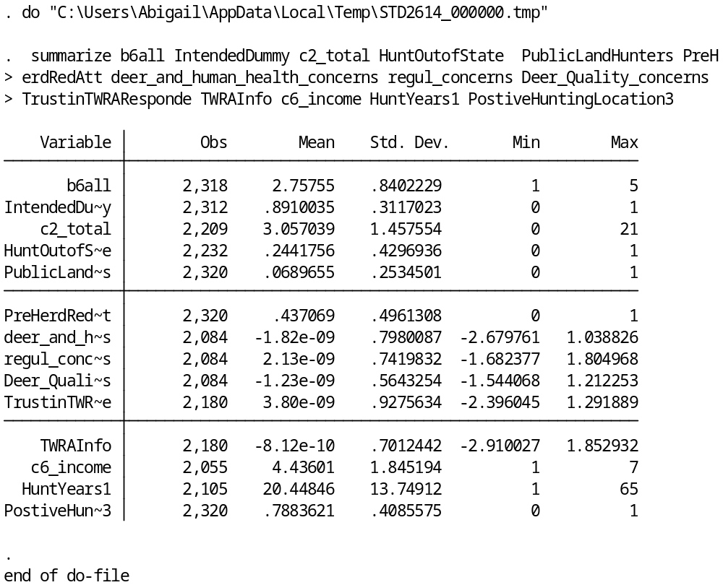

Appendix B
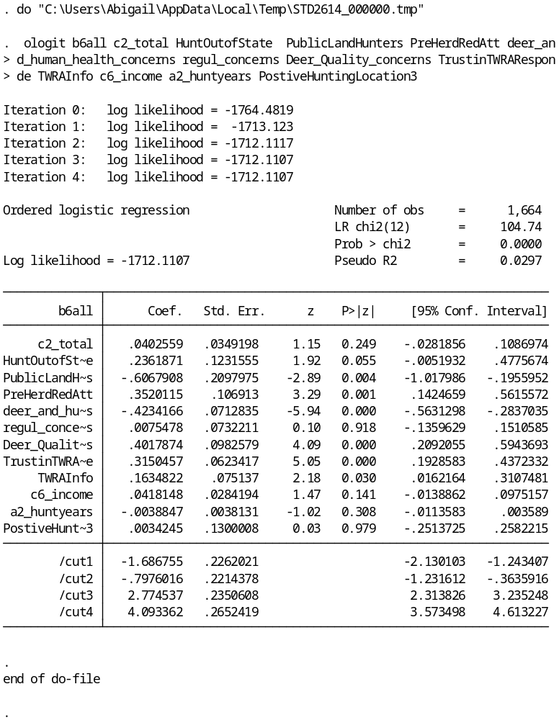

Appendix C
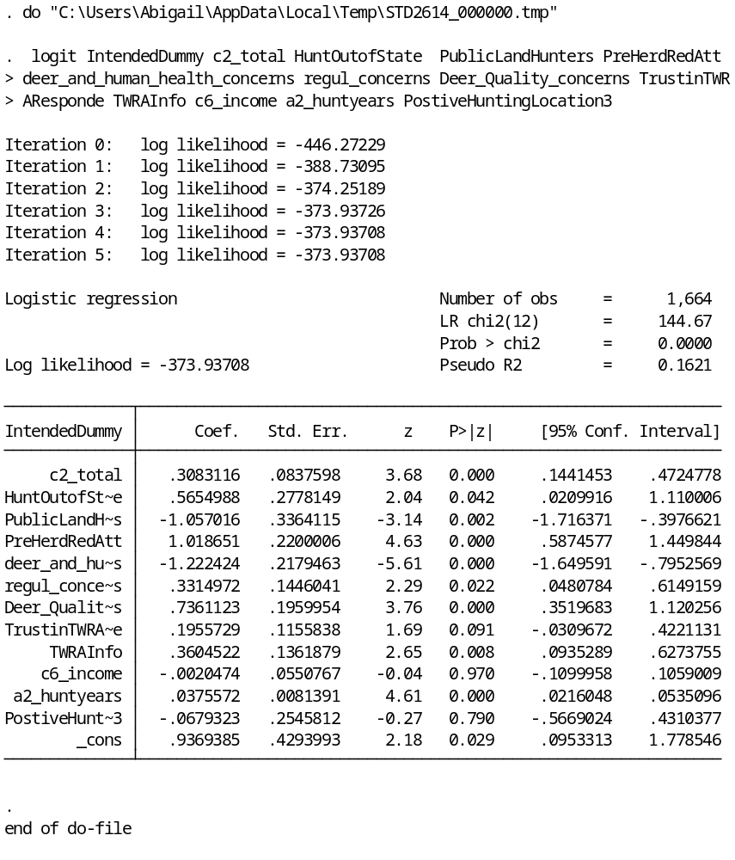

Appendix D
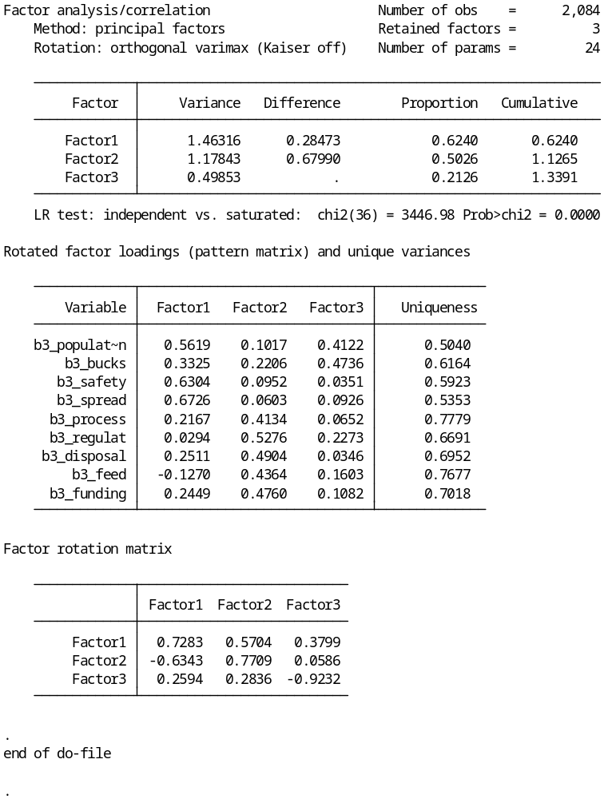

Appendix E
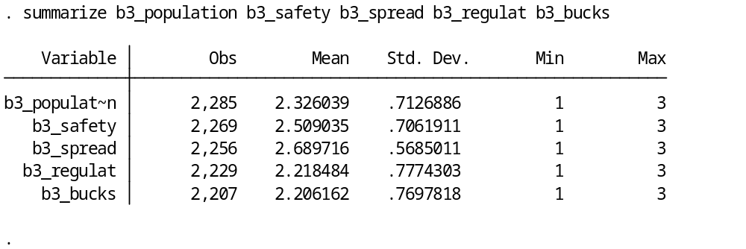

Appendix F
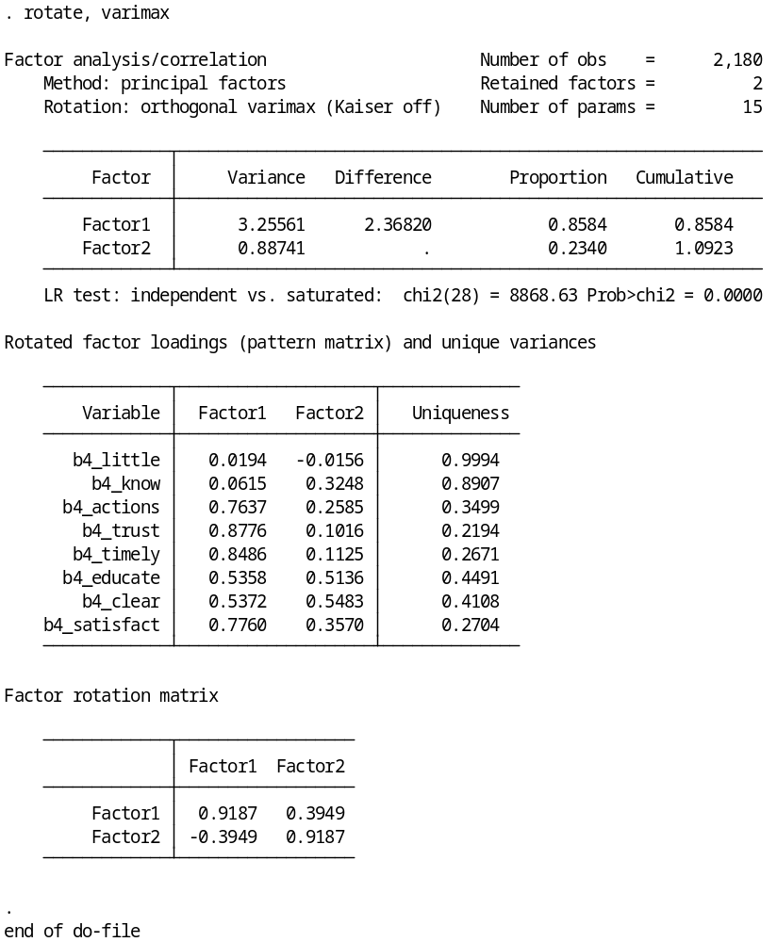

Appendix G
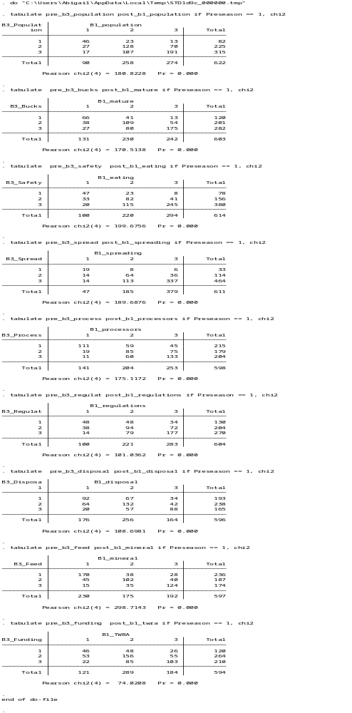
Appendix H

gen HuntOutofState = 0 if Preseason == 1 & pre_c5_cwdstates > 0 & pre_c5_cwdstates < 3

replace HuntOutofState = 1 if pre_c5_cwdstates == 1

gen IntendedDummy = 0 if pre_b7_intend > 0 & pre_b7_intend <= 2
replace IntendedDummy = 1 if pre_b7_intend == 1

gen LandOwnership = 0 if Preseason == 1
replace LandOwnership = 1 if pre_c3_own == 1

factor pre_b4_little pre_b4_know pre_b4_actions pre_b4_trust pre_b4_timely pre_b4_educate pre_b4_clear pre_b4_satisfact,factors(2)
rotate, varimax blanks(0.5)

predict f8 f9

gen TrustinTWRAResponde = f8
gen TWRAInfo = f9

tabulate pre_b3_population post_b1_population if Preseason == 1, chi2

tabulate pre_b3_bucks post_b1_mature if Preseason == 1, chi2

tabulate pre_b3_safety post_b1_eating if Preseason == 1, chi2

tabulate pre_b3_spread post_b1_spreading if Preseason == 1, chi2

tabulate pre_b3_process post_b1_processors if Preseason == 1, chi2

tabulate pre_b3_regulat post_b1_regulations if Preseason == 1, chi2

tabulate pre_b3_disposal post_b1_disposal if Preseason == 1, chi2

tabulate pre_b3_feed post_b1_mineral if Preseason == 1, chi2

tabulate pre_b3_funding post_b1_twra if Preseason == 1, chi2

mean post_b1_economy if Preseason == 1

factor pre_b3_population pre_b3_bucks pre_b3_safety pre_b3_spread pre_b3_process pre_b3_regulat pre_b3_disposal pre_b3_feed pre_b3_funding
rotate, varimax blanks(0.5)

predict f5 f6 f7

gen deer_and_human_health_concerns = f5
gen regul_concerns= f6
gen Deer_Quality_concerns = f7

gen PostiveHuntingLocation = 0 if _merge

replace PostiveHuntingLocation = 1 if post_a2_positive == 1

gen HuntOutofState = 0 if Preseason == 1 & pre_c5_cwdstates > 0 & pre_c5_cwdstates < 3

replace HuntOutofState = 1 if pre_c5_cwdstates == 1

gen HouseAbove2 = 0 if pre_c2_total >= 1 & pre_c2_total <= 21

replace HouseAbove2 = 1 if pre_c2_total > 2 & pre_c2_total <=21

gen IntendedDummy = 0 if pre_b7_intend > 0 & pre_b7_intend <= 2
replace IntendedDummy = 1 if pre_b7_intend == 1

factor pre_b4_little pre_b4_know pre_b4_actions pre_b4_trust pre_b4_timely pre_b4_educate pre_b4_clear pre_b4_satisfact,factors(2)
rotate, varimax blanks(0.5)

predict f8 f9

gen TrustinTWRAResponde = f8
gen TWRAInfo = f9

gen ProcessThemselves = 0 if Preseason == 1
replace ProcessThemselves = 1 if pre_a7_myself == 1

gen LeaseHunters = 0 if Preseason == 1
replace LeaseHunters = 1 if pre_b22_ownership == 2

gen PublicLandHunters = 0 if Preseason == 1
replace PublicLandHunters = 1 if pre_b22_ownership == 4

gen PreNonHuntingAct = 0 if Preseason == 1
replace PreNonHuntingAct = 1 if pre_b12_nonhunt == 1

gen PreHerdRedAtt = 0 if Preseason == 1
replace PreHerdRedAtt = 1 if pre_b13_herdreduct == 1

factor b3_population b3_bucks b3_safety b3_spread b3_process b3_regulat b3_disposal b3_feed b3_funding
rotate, varimax

predict f5 f6 f7

gen deer_and_human_health_concerns = f5
gen regul_concerns= f6
gen Deer_Quality_concerns = f7

gen PostiveHuntingLocation3 = 0
replace PostiveHuntingLocation3 = 1 if postiveanswer == 1

replace PostiveHuntingLocation = 1 if a1_posit == 1

gen HuntOutofState = 0 if c5_cwdstates > 0 & c5_cwdstates < 3

replace HuntOutofState = 1 if c5_cwdstates == 1

gen IntendedDummy = 0 if b7_intend > 0 & b7_intend <= 2
replace IntendedDummy = 1 if b7_intend == 1

factor b4_little b4_know b4_actions b4_trust b4_timely b4_educate b4_clear b4_satisfact,factors(2)
rotate, varimax

predict f8 f9

gen TrustinTWRAResponde = f8
gen TWRAInfo = f9

gen ProcessThemselves = 0
replace ProcessThemselves = 1 if a7_myself == 1

gen LeaseHunters = 0
replace LeaseHunters = 1 if b22_ownership == 2

gen PublicLandHunters = 0
replace PublicLandHunters = 1 if b22_ownership == 4

gen PreNonHuntingAct = 0
replace PreNonHuntingAct = 1 if b12_nonhunt == 1

gen PreHerdRedAtt = 0
replace PreHerdRedAtt = 1 if b13_herdreduct == 1
Chapter 2
Hunter Acceptability of CWD Management Actions in Western Tennessee

Abstract
Chronic Wasting Disease (CWD), a neurological disease affecting the deer and elk populations, was recently identified in western Tennessee. In order to design effective CWD management programs, stakeholders including the Tennessee Wildlife Resources Agency (TWRA) benefit from understanding hunters’ attitudes towards and acceptability of alternative management actions. By conducting a mixed-mode survey of hunters, this study compared the relative acceptability of various management actions before and after the first deer hunting season since the discovery of CWD in Tennessee. Moreover, multivariate logistic regression models were used to evaluate factors affecting hunters’ acceptability of alternative management actions. Regression models indicated hunter’s acceptability of management actions is significantly related with the concerns related to deer and human health, regulatory changes, trust and confidence on wildlife agency, and experience of hunting in other states with CWD. These results shed light on the role of trust, perceived risk and hunters’ demographic characteristics on relatively acceptability of CWD management strategies.

Introduction
In response to discovery of wildlife diseases such as chronic wasting disease (CWD), management agencies often design and implement actions to control the spread of the disease and mitigate its impact in the region. While there is no medical cure for CWD infection, management agencies often consider a variety of strategies in containing CWD including culling of the infected population, reducing carcass transportation, increasing bag limits, requiring samples from hunter harvest and banning baiting or feeding of wildlife (Cooney and Holsman 2010, TWRA 2020, Schroeder et al 2020). While some management actions involve educational and regulatory changes, other actions take more aggressive and lethal approach to reduce herd size in CWD impacted areas. Such herd reduction goals often are met by either adopting liberal bag limits for hunters to harvest more deer during the deer season, or allowing landowners or management agencies to employ contractors to conduct off-season harvest to complement hunter harvest (Wasserberg et al 2009, Schroeder et al 2020). A variety of biological, social, political considerations can determine the specific actions agencies employ in combating CWD in each state.
In Tennessee, CWD was first discovered towards the end of 2018-2019 deer season in two western counties (Fayette and Hardeman) where deer hunting is a very popular outdoor tradition. Between March 2018 and March 2019, 19,272 deer were harvested from both CWD positive (county with a confirmed positive) and high-risk counties (determined by being within 10 miles of a positive deer), accounting for 13% of all deer harvested in Tennessee (TWRA 2020). This suggests the enormity of hunting as popular outdoor activity and its potential economic contribution. In response, Tennessee Wildlife Resources Agency (TWRA) has adopted a variety of approaches to control CWD in the region including the change from general surveillance to intensive monitoring effort to determine spatial distribution and prevalence of CWD, a public information campaign, changing hunting seasons and bag limit to incentivize harvest, carcass movement/transportation restrictions, and a feeding/mineral ban (TWRA 2020).
Continuous success in managing CWD in the region may depend on the agency’s ability to find management actions which are likely to create minimum or no conflict and receive maximum stakeholder support. As stakeholders become more familiar with the CWD impact and adapt with the situation, their perception of risk, impact may change over time. Accordingly, it is reasonable to expect their acceptability of management actions may also change over time. In other words, a management action that is highly unacceptable at the time of discovery of CWD may become more acceptable as hunters learn more about the disease and experience hunting in the impacted region. In this context, human dimension research can be used to evaluate the relatively acceptability of different management actions to hunter and assess whether and how acceptability changes over time. Management actions that are more acceptable to hunters will encounter less resistance as they are the ones primarily affected by the management actions. In addition, direct cooperation of deer hunters is critical for implementation of certain CWD management actions. For example, reducing herd size in CWD impacted area may have to rely primarily on hunters harvesting enough deer to effectively reduce herd size. Many states with CWD have experienced great deal of resistance from hunters regarding herd reduction. These resistances can make the management action difficult to implement and less effective overall.
Over the years, human dimensions research studying attitudes and opinions of hunter and other stakeholders has informed wildlife management decisions. From management and policymaking standpoint, it will also be helpful to understand hunter’s preferences of and potential value conflict associated with possible management actions in effective management of CWD. By conducting a mixed-mode survey of hunters in a CWD impacted region of Tennessee, this study addressed two research objectives; 1- to assess and compare the relatively acceptability of various management actions for CWD management; and 2- to explore the factors influencing hunters’ acceptability of various actions for CWD management.
Literature Review
After the discovery of CWD in several mid-western states, several studies have assessed the human dimension of CWD management (Needham et al 2004, Schroeder et al 2020. These studies suggest hunters’ acceptability of management actions may depend on wildlife values, beliefs regarding CWD, attitudes toward CWD, and societal norms regarding CWD. In an attempt to assess social acceptance of CWD management actions, Vaske et al. (2006) evaluated the potential conflict over implementation of various management actions to control CWD in Wisconsin and found a moderate amount of conflict among respondents regarding severely reducing the deer herd in the eradication zone, however the action was favorable. The same study also found a minor amount of conflict over the state wildlife agency monitoring CWD and waiting for the associated test results before pursuing management actions. Hunters also opposed the agency just letting CWD take its natural course.
A study of deer hunters in eight states (Arizona, Colorado, Nebraska, North Dakota, South Dakota, Utah, Wisconsin, and Wyoming) and elk hunters in three states (Colorado, Utah, Wyoming) concluded that hunters’ acceptability of various management strategies (e.g. deer testing for CWD, herd reduction or targeted removal of deer from high impact areas) improved with an increase in CWD prevalence in the region (Needham et al 2004). Similarly, Cooney and Holsman (2010) analyzed risk perception and hunter support for efforts in Wisconsin and found showing evidence of the effectiveness of the management action is important to increase hunter belief in the effectiveness of the proposed action.
Literature on hunter attitude towards management actions have shown mixed conclusions. For example, a study of hunters’ support for deer eradication effort to manage CWD in Wisconsin found hunters resisted such effort for several reasons including opposition to the population goal, conflicts with traditions, conflicts with consumption norms, the uncertainty of the plan's efficacy, and perceived lack of credibility in the agency (Holsman et al 2010). The same study also concluded for these reasons hunter-based eradication would not be a viable strategy in managing CWD because hunter support was not present and could not be developed. However, this observation was in contrast with a similar study in Illinois, where hunters indicated support for eradication efforts (Lischka et al 2010).
Acceptability of management actions can be affected by the regions and states where hunters live and hunt. Researchers have attributed inter-state differences in hunter attitudes or support for CWD management actions to variation in agency trust as well as trust in information provided by agency (Schrodener 2020). In a multi-state study, Needham et al (2004) noted significant differences between resident and nonresident deer hunters of eight states in terms of their attitudes toward CWD and hunting behavior in CWD regions. These differences indicate conclusions drawn from studies conducted in a state or specific region may not necessarily hold true in other states.
Methodology
Hunter survey
A survey of deer hunters in CWD impacted counties of western Tennessee was conducted to meet the objectives of this research. In order to manage CWD in the region the TWRA has designated several counties as CWD positive counties because of confirmed presence of CWD. In addition, adjacent counties have been designated as CWD high-risk counties because of their close proximity (within 10 miles) to locations of confirmed CWD cases. To compare the hunters’ concerns about CWD risk before and after the hunting season, two separate surveys were conducted. The first survey (i.e. preseason survey) was conducted in August-September of 2019. The second survey (i.e. postseason survey) was conducted after the 2019 deer hunting season. This was the first full deer hunting season since the discovery of CWD in the region.
For the preseason survey, a total of 5,000 hunting license holders and those who reported harvesting deer in CWD positive and high-risk counties during the 2017 and 2018 deer seasons were contacted. Figure 2.1 shows the distribution of positive and high-risk counties at the time of survey. A mixed mode survey involving both email and mail survey was adopted for data collection and was administered using contact information obtained from the TWRA license database. Following a modified tailored designed method (Dillman et al 2014), those with an email address on file were first contacted by a personalized email which contained a link to the survey designed in QuestionPro platform. Three follow-up reminders were sent to non-respondents during a period of two weeks. Those who did not respond to our email invitation or did not have email address on file were contacted by mail. The mail survey also followed the modified tailored design method, which utilized personalized cover letter, business reply envelope and a copy of survey. Non-respondents were sent a follow-up reminder along with a copy of survey and business reply envelope.

Figure 2.1: Study areas of preseason hunter survey (left) and postseason hunter survey (right) with distribution of CWD positive (dark gray) and CWD high risk (light gray) counties at the time of survey (August 2019 and March 2020).

No further reminders were sent because the hunting season had already started and was too late for a preseason assessment for most hunters. The respondents for the preseason survey were asked to indicate if they would be willing to participate in future CWD surveys, and those who agreed to do so were marked as potential participants for the postseason survey.
In the postseason survey, respondents from the preseason survey who consented to participate in future surveys on CWD were contacted. A total of 1,141 respondents from the preseason survey were included in this sample. Additional respondents were recruited for this survey because new counties had been confirmed to have CWD or were designated as high-risk counties since the preseason survey was implemented. Figure 2.1 shows the distribution of positive and high-risk counties at the time of this survey. Hence, a total of 3,000 hunting license holders and successful deer harvesters (i.e., license exempt) from the newly added counties were added into the sample. Combining this with the ones recruited from the preseason survey made the total sample size of 4,141 for the postseason survey. This sample size is more than enough for the population of hunting license holders in the region (with the confidence interval of 95% and +5% margin of error).
Similar to the preseason survey, the postseason survey also started with an email survey for those who had email addresses on file. Those without email contacts on file or not responding to the email survey were contacted by mail in late February and March of 2020. Survey administration for the email and mail contacts followed the same procedure as the preseason survey but with a revised initial cover letter, follow-up letter, and survey instrument. In addition, a pre-notification postcard was used before the first mail invitation to encourage participation. Similar to the preseason survey, mixed mode survey utilizing email and mail was conducted to administer this survey.
Data analysis
Comparison of preseason and postseason acceptability of CWD management actions
Since a segment of the sample participated in both preseason and postseason surveys, a Pearson chi- squared test was utilized to compare the mean acceptability score for management actions.
Assessing potential conflict over management actions
Hunter acceptability of management actions was further evaluated by employing the potential conflict index (PCI₂) (Vaske 2006). The PCI₂ is a data-based tool to measure and map variance in survey response. The PCI₂ technique uses bubbles in a graph space to depict the extent of disagreement (e.g. conflict) among the respondents for a given management action. PCI₂ values range from 0 to 1 and measure the distribution of response frequency on either side of the scale’s center point. A PCI₂ value of 0 indicates the maximum consensus possible regarding a given management action, whereas a value of 1 suggests the greatest potential for conflict (i.e. least consensus). These values are also reported as bubble sizes. The y axis on the graph shows acceptability scales from -2 (completely unacceptable) to 2 (completely acceptable). Therefore, the position of the bubble, relative to the neutral line indicates average acceptability and the size of the bubble indicates the potential conflict. Larger the bubble size, higher the potential for conflict. Management actions represented in bubbles with the center above the neutral line are acceptable whereas those with center below the neutral line are unacceptable. Acceptability reported to seven specific management actions from the preseason survey were evaluated using this technique.

Factor Analysis
Since this study involved measuring several complex psychosocial constructs (e.g. concern, trust), utilization of multiple scales were necessary in measurement. To summarize multiple items into common themes, a data reduction technique called factor analysis was utilized. This multivariate technique is widely used to identify common themes emerging from responses to multiple statements which are conceptually related. In addition, using such factors instead of underlying statement as covariates in regression model is necessary to avoid multicollinearity. Multicollinearity, if present, can impact the standard error and yield misleading results. Cronbach's alpha was used to test the internal consistency in response and reliability of constructs. As shown in table 2.1 below, a single factor was extracted from all management actions to allow for an evaluation of acceptability of all management actions. This factor was named “overall acceptability” because it corresponds to a combined measure of acceptability of all management actions presented in the questionnaire.
Factor analysis was also performed on statements related to CWD concerns and trust in wildlife agency. Three statements representing deer and human health concerns were loaded into the deer and human health factor. One statement was loaded into the regulatory concerns and one was loaded into the deer quality concerns. Likewise, two statements related to information provided by the TWRA were loaded into the trust in TWRA factor. Three statements related to responses or actions taken by the TWRA were loaded into the trust in TWRA response factor.

Table 2.1: Factors derived from survey responses on statements related to acceptability of management actions, CWD concerns, and wildlife agency trust
Factors | Statements | Mean | Factor loadings | Cronbach’s Alpha
Overall acceptability |  |  |  | 0.74
 | Do nothing, let nature take its course | 2.19 | -0.30
 | Use regulated hunting seasons with liberal bag limits to increase the number of deer harvested | 3.61 | 0.66
 | Issue permits to landowners and hunters to harvest deer outside of hunting seasons | 3.48 | 0.73
 | Allow landowner and hunters in CWD counties to use firearms with other areas are limited to archery-only | 3.61 | 0.67
 | Require hunters to provide sample for testing | 4.20 | 0.39
 | With landowner’s permission, TWRA or its permitted contractors employing targeted removal of deer in localized areas after the season to supplement hunter harvest | 2.94 | 0.57
 | Require unused deer parts to be buried, incinerated, or disposed of in a landfill | 3.72 | 0.39
Deer and human health concerns |  |  |  | 0.70
 | Deer population declining dramatically | 2.33 | 0.56
 | Safety of eating deer meat | 2.51 | 0.63
 | CWD spreading throughout Tennessee | 2.69 | 0.67
Regulatory concerns |  |  |  | N/A
 | Additional regulations affecting my ability to hunt | 2.22 | 0.53
Deer quality concerns |  |  |  | N/A
 | Not having enough mature bucks to hunt | 2.21 | 0.47
Trust in agency communication |  |  |  | 0.77
 | TWRA has made a reasonable effort to educate the public about CWD | 4.12 | 0.51
 | CWD information provided by TWRA is clear | 3.86 | 0.55
Trust in agency action |  |  |  | 0.90
 | TWRA has taken appropriate actions to prevent spread of CWD | 3.47 | 0.76
 | I trust TWRA officials to have an appropriate plan for CWD in Tennessee | 3.67 | 0.88
 | TWRA will take timely actions to prevent CWD from spreading | 3.72 | 0.85
Table 2.1 Continued

Modeling acceptability of management actions
Consistent with the theoretical frameworks used in modeling hunter attitudes and behavior (Vaske and Manfredo 2012), and by building upon existing literature on human dimension of CWD (Needham et al 2004, Schroedner et al 2020 ), a conceptual model of hunter’s acceptability of CWD management action was estimated as follows:
Eq. 1 Y_{ij} = b₀+b_{k}X_{ik}+u_{i}
Where, Y_{ij} refers to the dependent variable, characterized as the reported acceptability of jth management action to the ith respondent, b₀ is the intercept, b_{k} is the estimated regression coefficient associated with the kth independent variable, X_{ik} refers to the measure of kth independent variable for the ith respondent, and u refers to the error term. The criteria for statistical significance was set at 0.10.
Dependent Variables
The dependent variables in the regression model were hunters reported acceptability of various management actions as indicated in a 5-point Likert scale (1- completely unacceptable, 5-completely acceptable). One general measure of acceptability and three specific measures of acceptability were considered to construct dependent variables which were modeled separately. Since the acceptability reported for multiple actions were correlated, a factor analysis was used to extract one single factor (i.e. overall acceptability) summarizing respondent’s acceptability of all seven actions pertinent to CWD management. This was considered as the general measure of acceptability of CWD actions. Three additional models were estimated by using specific measures of acceptability for three key management actions as follows:

- Liberal bag limit for hunters: Use regulated hunting seasons with liberal bag limits to increase the number of deer harvested,
- Offseason harvest by landowners: Allow landowners to harvest deer in addition to those taken by hunters during deer season,
- Targeted removal by agency contractors: With landowner’s permission TWRA or its permitted contractors employing targeted removal of deer in localized areas after the deer season to supplement hunter harvest
These three specific management actions were chosen for independent modeling, over other management actions, because these actions involve relatively aggressive and lethal approach to CWD management, which may draw mixed reactions among hunter and landowners’ populations. The other listed actions are nonlethal and more focused on monitoring (sampling) or prevention (not allowing feeding of the deer). Moreover, each of these three actions would involve engaging different stakeholders (e.g. hunters, landowners, agency contractors) in implementation of on the ground actions to achieve deer herd reduction goals that are often considered important in CWD management (Williams and Miller 2002).
Independent Variables
A range of cognitive variables such as concerns related to CWD impacts, trust and confidence in the wildlife agency and other variables describing hunting characteristics and demographic factors were used as independent variables to predict acceptability of management actions. Cognitive variables representing complex psychological constructs such as concern, trust etc. were measured by conducing factor analysis of responses to various statements. Table 2.1 presents the factor loading and correlation of extracted favor with the underlying statements loaded into each factor. Variables representing hunting- related characteristics included years of deer hunting experience in the CWD region of Tennessee, dummy variables to indicate whether the respondent owns land in a CWD positive or high risk county, whether the respondent had previously hunted in other states with CWD, and whether the respondent hunts on CWD positive counties. In addition, a dummy variable was added to indicate hunter’s attitude towards a hunter-based herd reduction strategy, i.e. whether respondent believed relying on hunter harvest is as a viable solution to CWD management. Lastly, demographic variables included income and the total number of people living in the household. Income was a categorical variable measured by using seven discrete categories of annual household income range (1=<$25,000 – 7=>$250,000). The total number of people living in the household was a fill in the blank response from the respondent and did not have any range listed on the survey. Definition and descriptive statistics (mean and standard deviation) for all variables are presented in table 2.2 below.
Estimation technique
Regression model presented in Eq. (1) was estimated with different modeling techniques because of the nature of data in dependent variables. For the first model, where the dependent variable (overall acceptability) involved a factor extracted from seven ordinal scales, an ordinary least square (OLS) estimator was used. For the remaining three models, where dependent variables involved reported acceptability of specific action (5-point Likert scale), ordered logit model technique was used. The use of these different estimation techniques allowed for the best estimation of the model instead of using the same model for the different types of data. The decision criteria for the significance of statistics was set at 0.10.

Table 2.2: Definition and descriptive statistics of variables used in modeling Tennessee hunters’ acceptability of CWD management actions.
Variable | Description | Mean | Standard Error
Dependent Variables
Overall acceptability | A single factor extracted from factor analysis of reported acceptability of seven management actions | 4.02*10⁻¹⁰ | 0.88
Liberal bag limit for hunters | Reported acceptability of “Use regulated hunting seasons with liberal bag limits to increase the number of deer harvested” | 3.61 | 1.19
Offseason harvest by landowners | Reported acceptability of “Allow landowners to harvest deer in addition to those taken by hunters during deer season” | 3.48 | 1.34
Targeted removal by agency contractors | Reported acceptability of “With landowner’s permission TWRA or its permitted contractors employing targeted removal of deer in localized areas after the deer season to supplement hunter harvest” | 2.94 | 1.46
Independent Variables
Concern variables
Deer and human health concerns | Factor scores corresponding to deer and human health concerns | 8.32*10⁻¹⁰ | 0.77
Regulatory concerns | Factor scores corresponding to regulatory concerns | -4.79*10⁻¹⁰ | 0.74
Deer quality concerns | Factor scores corresponding to deer quality concerns | -5.32*10⁻¹⁰ | 0.60
Trust and confidence variables
Trust in agency action | Factor scores relating to trust in TWRA response to CWD | 1.56*10⁻⁹ | 0.93
Trust in agency action | Factor scores relating to trust in the information TWRA has provided | -2.12*10⁻¹⁰ | 0.72
Hunting-related variables
Hunt out of state | Dummy variable: 1 if the respondent hunted in other CWD states, 0 otherwise | 0.23 | 0.42
CWD positive county | Dummy variable: 1 if the hunter hunts on CWD positive counties, 0 otherwise | 0.67 | 0.47
Landownership | Dummy variable: 1 if the respondent owns land in CWD positive or high-risk counties , 0 otherwise | 0.44 | 0.50
Years of hunting  Table 2.2 Continued | The number of years respondents reported they have hunted for in the CWD region | 20.70 | 14.01
Attitude towards herd reduction | Dummy variable 1 if the hunter agrees that hunter supported herd reduction is a viable strategy for controlling CWD, 0 otherwise | 0.39 | 0.49
Demographics variables
Income | A categorical indicator of respondents’ household income (Likert Scale of income 1 to 7) | 4.37 | 1.86
Household size | Household size of the respondent | 3.02 | 1.52

Results and Discussion
Data analysis was conducted in Stata 15 and the output is listed in the appendix A through J.
Survey Response
Out of the 5,000 surveys sent out in the preseason survey six were removed which reduced the target sample to 4,994. A total of 1,642 surveys were returned for an adjusted response rate of 33%. After 147 respondents who indicated never hunting in those counties were removed the final sample size for the preseason survey was 1,495. Out of the 4,141 surveys sent out in the postseason survey, eleven were removed due to the respondent being deceased which reduced the target sample to 4,130. A total of 1,601 surveys were returned for an adjusted response rate of 39%. 288 of those indicated they either had never hunted deer in these counties or do not hunt at all and were removed from analysis resulting in a final sample of 1,313 respondents. This is consistent with other recently completed surveys regarding management actions including a survey focusing on hunters, Watkins et al (2018), which had a response rate of 36%.
The preseason sample was made up of 73% males. The average number of people living in the household in the preseason was 3.02 with an average of 1.62 deer hunters in the household. About 98% of preseason respondents indicated they had heard of CWD prior to the survey. About 50% of preseason respondents indicated they owned land in either positive or high-risk counties with an average of 159 acres owned. About 24% of preseason respondents indicated they hunted out of state and 23% had hunted in states where CWD was present. Annual household income in the preseason sample was distributed as 5% reported making less than $25,000, 14% reported in the range of $25,001 - $50,000, 18% reported in the range of $50,001- $75,000, 18% reported in the range of $75,001 - $100,000, 14% reported in the range of $100,001 and $125,000, 11% reported $125,001 - $150,000, and the remaining 21% reported income of 150,000 or more. In terms of the type of land respondents from both surveys indicated they primarily hunted on their own land (34%), leased land (23%), non-leased private land where they have permission to hunt (36%) and public land such as WMA (7%).
Comparison of preseason and postseason acceptability of CWD management actions
A chi-squared test of acceptability score between the preseason and post season survey indicated that all management actions had a significant difference in acceptability between the preseason and the postseason surveys (table 2.3).
The difference between preseason and post season in acceptability of “Do nothing, let nature take its course” was significant (p<0.01), even though the mean acceptability score in both surveys was below average (i.e. unacceptable). This suggests that hunters generally agree that doing nothing is not an acceptable option and the overall acceptability of this approach was higher in postseason. Acceptability of “Use regulated hunting seasons with liberal bag limits to increase the number of deer harvested” did significantly differ between preseason and postseason surveys with the mean acceptability being significantly higher in the postseason survey. The difference in means for “Allowing landowners to harvest in addition to those taken by hunters during the season” was also significant (p<0.01). Mean acceptability of this action was higher in postseason survey.
Similarly, mean acceptability for “Allowing hunters in CWD affected counties to use guns when other counties are limited to archery /muzzleloader or archery-only” was also significantly higher in the postseason compared to preseason.
Table 2.3: Comparison of mean acceptability of CWD management actions between preseason and postseason hunter surveys
Actions | Preseason mean | Postseason mean | Chi square | p | N
Do nothing, let nature take its course | 2.15 | 2.34 | 240.68 | 0.00 | 620
Use regulated hunting seasons with liberal bag limits to increase the number of deer harvested | 3.65 | 3.69 | 242.13 | 0.00 | 615
Allow landowners to harvest deer in addition to those taken by hunters during deer season | 3.42 | 3.66 | 237.53 | 0.00 | 618
Allow hunters in CWD affected counties to use guns when other counties are limited to archery /muzzleloader or archery-only | 3.68 | 3.96 | 264.68 | 0.00 | 620
Require hunters to provide samples for testing | 4.27 | 3.89 | 170.88 | 0.00 | 619
With landowner’s permission, TWRA or its permitted contractors employing targeted removal of deer in localized areas after the deer season to supplement hunter harvest | 2.89 | 2.58 | 270.70 | 0.00 | 617
Require unused deer parts to be disposed of according to best management practices | 3.76 | 3.85 | 164.09 | 0.00 | 616

In contrast, two management actions “Requiring hunters to provide samples for testing and with landowner’s permission” and “With landowners permission TWRA or its permitted contractors employing targeted removal of deer in localized areas after the deer season to supplement hunter harvest” were found to have significantly lower acceptability in the postseason than in preseason survey. Relatively low level of acceptance of employing contractors is consistent with another study conducted in Illinois (Harper et al 2015). Acceptability for “Require unused deer parts to be disposed of according to best management practices” did significantly differ between preseason and postseason surveys with acceptability being higher in the postseason than in the preseason.
Potential conflict index
There were seven management actions evaluated using PCI₂. The PCI₂ bubble corresponding to “Do nothing, let nature take its course” is located far below the neutral line and has relatively larger bubble size than bubbles of most other actions indicating that the action is generally unacceptable to the respondents and is relatively more controversial. This result aligns with another CWD study which analyzed management actions using PCI also found doing nothing to be unacceptable with a minor/moderate level of conflict (Vaske et al 2006). The PCI₂ bubble associate with “Use regulated hunting seasons with liberal bag limits to increase number of deer harvested” is located above the neutral line and has a moderate size of bubble. This indicates that this action was mostly acceptable and is less controversial than the “do nothing action discussed above.

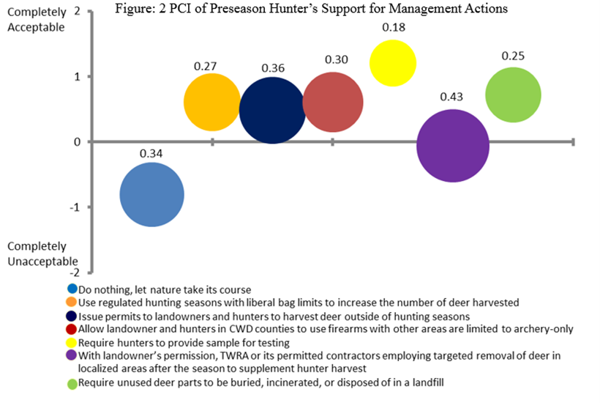

Figure 2.2: Potential conflict index (PCI₂) associated with CWD management actions in Tennessee

Similarly, the PCI₂ bubbles associated with “Issue permits to landowners and hunters to harvest deer outside of hunting seasons” and “Allow landowner and hunters in CWD counties to use firearms with other areas are limited to archery-only” have their centers located above the neutral line, indicating their relatively acceptability among the respondents. However, relatively smaller size of the bubble in the latter (0.30 vs. 0.36) indicates higher level of consensus regarding its implementation
The PCI₂ bubble corresponding to “Require hunters to provide sample for testing” is located at the highest point above the neutral line, suggesting this action is most acceptable to the respondents. Moreover, the smallest size of this bubble also indicates if implemented this action is likely to have the lease potential for conflict among the hunters. In other words, this appeared to be the management action with the highest level of acceptability and had the lowest amount of conflict. This aligns with a similar management action asked by Vaske et al (2006) “monitor CWD and wait for tests before managing” which was moderately favored with minor conflict. On the other hand, the PCI₂ bubble associate with “With landowner’s permission, TWRA or its permitted contractors employing targeted removal of deer in localized areas after season to supplement hunter harvest” is centered slightly below the neutral line and has the largest bubble size of all. These statistics indicate this action is not only unacceptable to the hunters but also likely to have the greater potential for conflict if implemented. Finally, the relatively smaller bubble located farther north from the neutral line for “Require unused deer parts to be buried, incinerated, or disposed of in a landfill” indicates this action may be generally acceptable to hunters and had less potential for conflict.

Modeling acceptability of CWD management actions
Regression estimates from the acceptability model are presented in table 2.4. The first column shows the list of variables in the model and the remaining four columns show the regression estimates for each of the four models of acceptability. It should be noted the first model involves modeling overall acceptability of all seven actions combined whereas the other remaining three model are the acceptability of specific actions.
Regression results were fairly consistent regardless of the model variables used or estimator. All three factors corresponding to CWD concern variables were significant in at least one or more models. Specifically, factors corresponding to deer and human health concern and regulatory concerns were positively related with the overall acceptability of CWD management actions whereas the factor corresponding to deer quality concern was negatively related. Moreover, concern regarding the effect of potential regulation change was significantly related with acceptability of two specific actions (i.e. offseason harvest by landowners and targeted removal by agency contractors). These contrasting relationship of CWD concerns on acceptability of management actions suggest that respondents who are concerned with deer and human health impacts of CWD are more likely to accept CWD management actions whereas those concerned with deer quality impacts of CWD are less likely to accept these management actions. Concerns regarding potential impact of regulatory change due to CWD was either insignificant or mixed depending upon the management action. These results align with the findings from previous studies (Harper et al 2015) that found hunter concerns to be important predictors of hunter support for management actions.

Table 2.4: Regression estimates for acceptability models
Independent Variables | Models
 | Overall acceptability^ | Liberal bag limit for hunters# | Offseason harvest by landowners# | Targeted removal by agency contractors#
Concern variables
Deer and human health concerns | 0.32  (0.04)*** | 0.52 (0.09)*** | 0.46  (0.09)*** | 0.59  (0.09)***
Regulatory concerns | 0.04  (0.03) | 0.11  (0.08) | 0.23  (0.09)** | -0.14  (0.08)*
Deer quality concerns | -0.21  (0.04)*** | -0.62 (0.11)*** | -0.53  (0.11)*** | -0.45  (0.11)***
Trust and confidence
Trust in agency action | 0.20  (0.03)*** | 0.46 (0.07)*** | 0.26  (0.07)*** | 0.31  (0.07)***
Trust in agency communication | 0.09  (0.03)** | 0.49 (0.09)*** | 0.14  (0.08)* | 0.05  (0.08)
Hunting-related variables
Years of hunting | -0.002  (0.002) | 0.00  (0.004) | -0.01  (0.004) | -0.01  (0.004)
Hunt out of state | -0.13  (0.06)** | -0.11  (0.14) | -0.26  (0.14)* | -0.28  (0.14)**
CWD positive county | 0.03  (0.05) | -0.05  (0.13) | -0.10  (0.12) | -0.13  (0.12)
Landownership | -0.02  (0.05) | -0.16  (0.12)* | 0.16  (0.12) | -.17  (0.12)
Attitude toward herd reduction | 0.53  (0.05)*** | 1.25 (0.13)*** | 1.14  (0.12)*** | 0.57  (0.12)***
Demographics variables
Household size | 0.01  (0.02) | -0.08  (0.04)* | -0.001  (0.04)* | 0.04  (0.04)
Income | 0.02  (0.01) | 0.06  (0.03) | 0.03  (0.03) | -0.01  (0.03)
Adj/Pseudo R² | 0.28 | 0.098 | 0.06 | 0.046
N | 982 | 992 | 992 | 992
*p<0.10, **p<0.05, ***p<0.01
Numbers in parenthesis are standard errors
^ estimated with OLS estimator
# estimated with ordered logit estimator
Table 2.4 Continued

Among the trust covariates, coefficients on factors corresponding to trust in TWRA response as well as trust in TWRA information were significant and positive in all models except trust in agency communication in the targeted removal by agency contractors model. This suggest that respondents who placed higher level of trust and confidence in TWRA for its actions and plans to combat CWD as well as communication effort in educating public regarding CWD had a higher level of support for management actions. These results corroborate the findings of previous studies in mid-western US states that found hunter attitude towards and support for CWD management to be related with agency trust, credibility and reliability of information being provided (Holsman et al 2010, Schrodener 2020). Those studies concluded that lack of trust in or shared values with agency resulted in lower public acceptability of agency action for CWD management.
Among the variables related to hunting or hunter characteristics, a dummy indicating whether the respondent previously hunted out of state where CWD was had negative and significant coefficients in all models except the liberal bag limit for hunters. This suggests that those who had prior experience of hunting in CWD region are more likely than their counterparts to reject CWD management actions in general and allowing offseason harvest by landowners and employing agency contractors for targeted removal in particular. It is possible these hunters are more aware of the severity of CWD impacts in other states and feel important to support actions. Coefficients on two other dummies, whether or not the respondent owns land in either CWD positive or high-risk counties and whether the respondent hunts on CWD positive counties were not statistically significant. This implies that acceptability of CWD management actions do not differ between respondents who own land in the area and those that do not, as well as between respondent who hunt on CWD positive counties and those who hunt on high risk counties.
The coefficient on number of years of hunting in the CWD region was not significant, suggesting the length of time hunting in the region is not significantly related with acceptability of any CWD management actions. However, a variable indicating respondent attitude towards herd reduction strategy was positive and significant across the models. This indicates respondents who believed relying on hunter harvest for deer herd reduction would be a viable strategy for CWD management indicated higher level of acceptability for all management actions. Consistent with the notation of beliefs influencing individual’s intention and behavior, this result indicates that respondents who believe in the effectiveness of herd control approach with hunter engagement are likely to accept these management actions. This aligned with Holsman et al (2010) which found that deer hunters are more likely to accept herd reduction as a management action if they supported the idea of deer herd management.
Household income had a positive but insignificant effect and household size had mixed results. The coefficient on household size was significant and negative coefficient on two models only. This suggests respondents with higher numbers of individuals in the household were less likely to accept adopting liberal bag limit for hunters and allowing offseason harvest by landowners. Corresponding coefficient in other two models were positive but statistically insignificant. This aligns with another study which found demographics to be insignificant within the state (Needham et al 2006). Despite the insignificance of some of these variables (e.g. income) across the models examined, they were kept in the final model as control variables because it is possible respondent’s attitudes towards management may differ by underlying variation in household characteristics.
Conclusion
Human dimension research involving assessing and monitoring of stakeholder attitudes and behavior regarding wildlife health can be useful tool in informing management decisions. Understanding stakeholders’ expectation and designing or revising management programs to increase their potential for success is important. By employing a mixed mode survey of hunters in a region that recently experienced CWD emergence, this study provides some useful insights in understanding how hunters perceive the concerns regarding CWD and how those concerns change over time and relate with hunters acceptability of alternative management actions. As it was found hunters’ acceptability of most management actions significantly increased between the preseason and post season surveys, it implies that acceptability may change over time and that hunters may become more tolerant of management actions. Actions that agencies initially are considered to be potentially unpopular may eventually become more acceptable over time.
Management actions did not have the same levels of acceptability. Do nothing was very unacceptable while hunters providing samples was more acceptable. If a management action that is less acceptable is important for overall CWD management, then hunters should be educated on the need for the action in order to increase support.
Hunters that supported hunter-based herd reduction were more acceptable of management actions overall than those that did not support this management action. This indicates that these hunters believe they are part of the solution and are more willing to participate in other management actions. Management agencies interesting in implementing herd reduction as a strategy may want to engage in hunter communication and educate hunters about its importance in effectively controlling CWD.
Hunter acceptability of CWD management actions is influenced uniquely by their specific concerns regarding CWD impacts. For example, concerns regarding deer and human health impacts and deer quality impacts may enhance their support for all kinds of CWD management actions whereas concerns regarding regulatory impacts may negatively impact acceptability of certain management actions. Wildlife agencies may see benefit in adopting management actions that minimize these concerns or by educating hunters on how those concerns would be addressed.
Hunters who have hunted in other states with CWD were less supportive of management actions to control CWD in Tennessee. This could partly be driven by their experiences in those states therefore are still skeptic of any actions for CWD management in Tennessee. Management agencies could learn from those hunters what experiences they had in other states. Focusing on hunter communication, outreach, and education to allow them to understand the importance of these management actions may increase future support.
Demographic variables were not significant in determining the acceptability of management actions indicating demographics attributes may not be reliable indicators to predict hunter response to management actions. That indicates other psychosocial factors such as trust, concern, attitudes are more important in understanding and predicting hunter support. Particularly, trust in state agency provided information and the response by the agency are important in increasing acceptability of management actions. Hunter participation is important for many of these management actions and trust in the agency is important for hunters to participate in them. Agencies should focus on building trust with hunters to allow for management actions to be better received.
Finally, this study can be used as a baseline for acceptability of management actions in the region. There needs to be more research on these management actions to better understand what other factors may influence hunter attitudes and support for CWD management. Also, a future study spanning several years could shed more light on how hunter attitude and behavior may change relative to changes in CWD prevalence, and implementation of agency actions.

Appendix
Appendix A
Use "C:\Users\Abigail\Desktop\CWD\Data\CWDPrePostSeasonDataCombineds05272020.dta
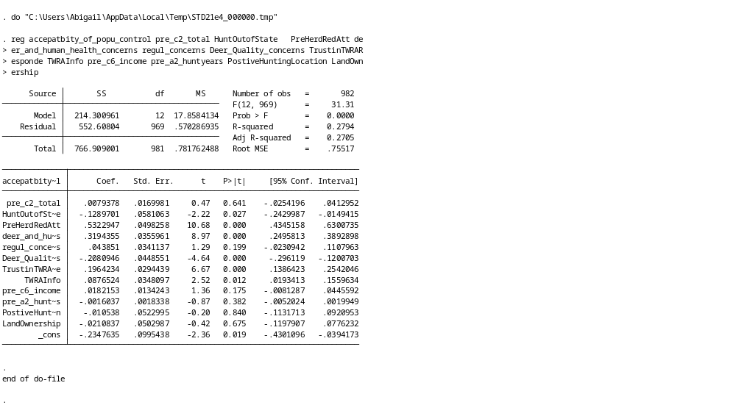

Appendix B
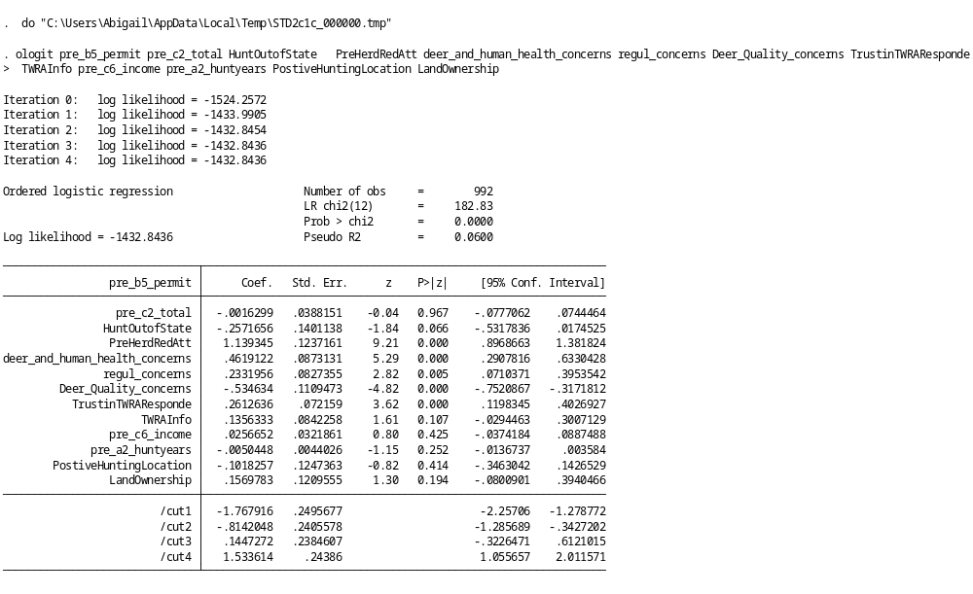

Appendix C
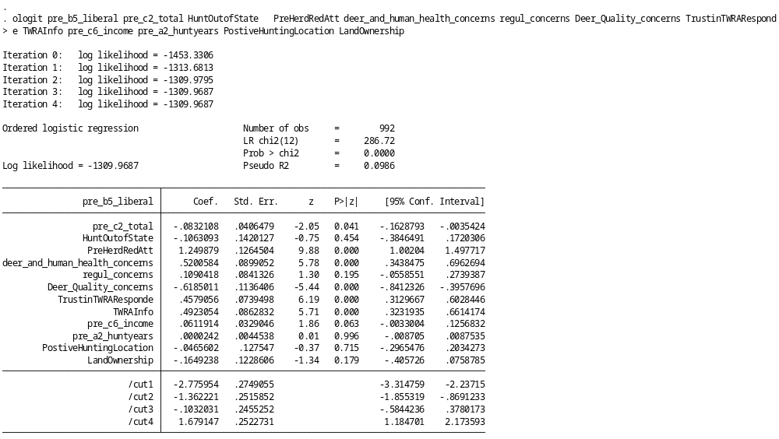

Appendix D
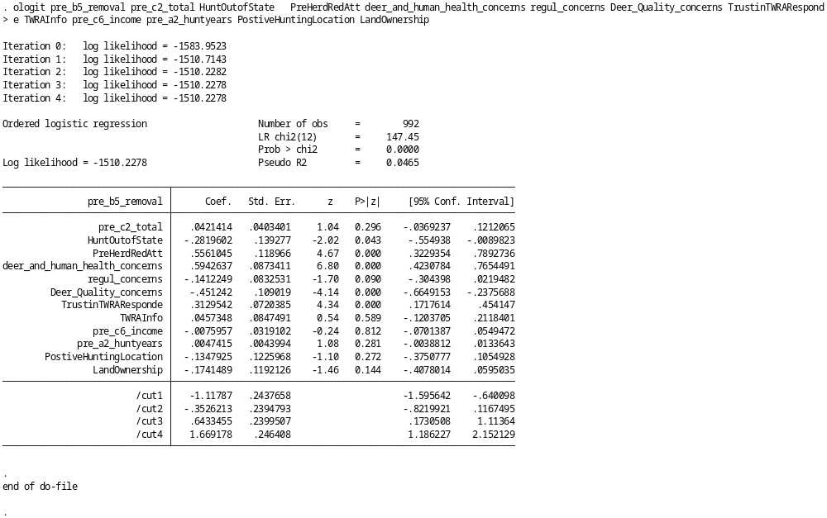

Appendix E

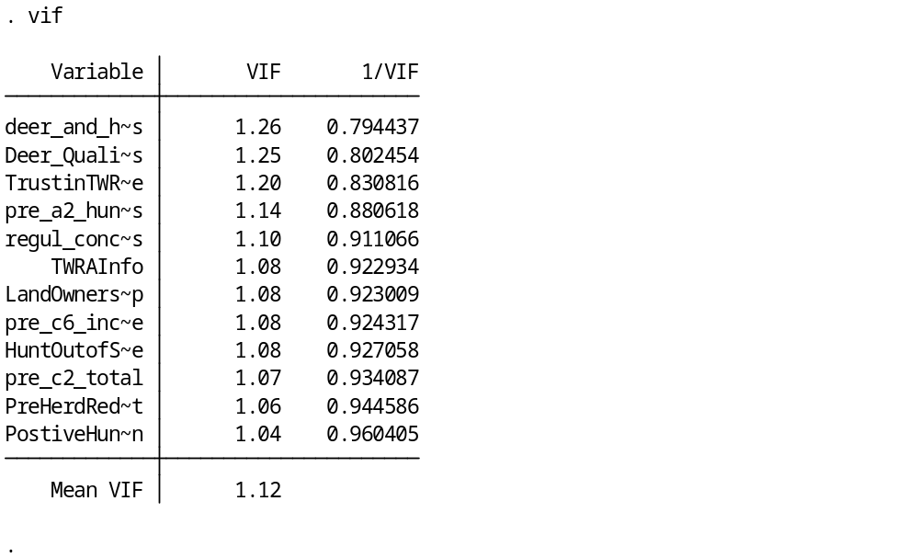

Appendix F

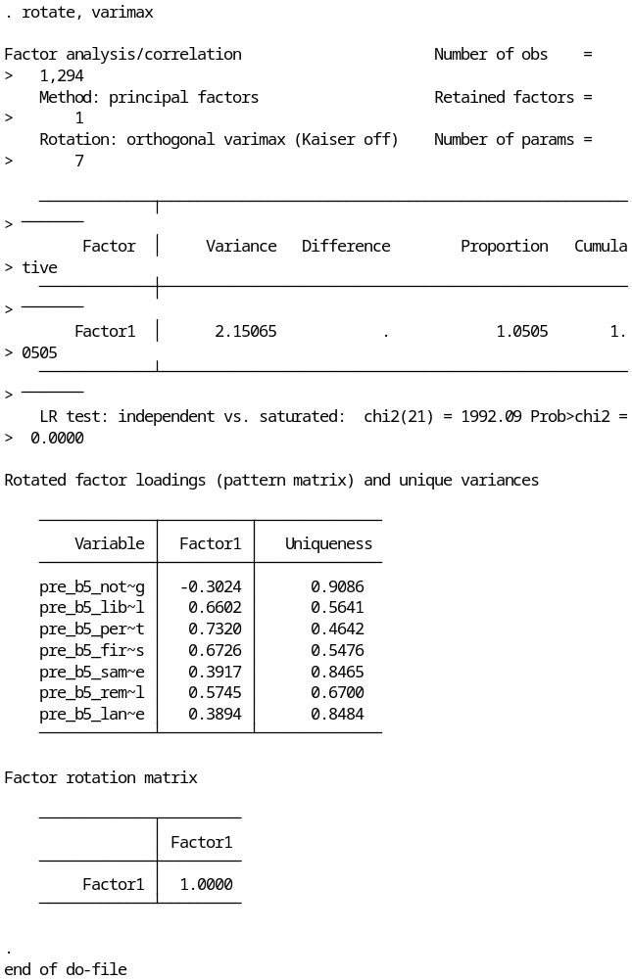

Appendix G
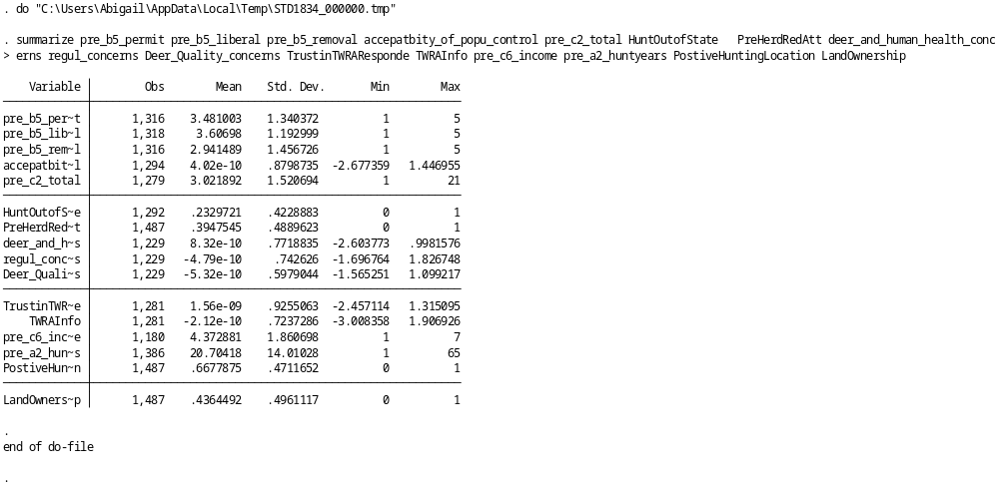

Appendix H
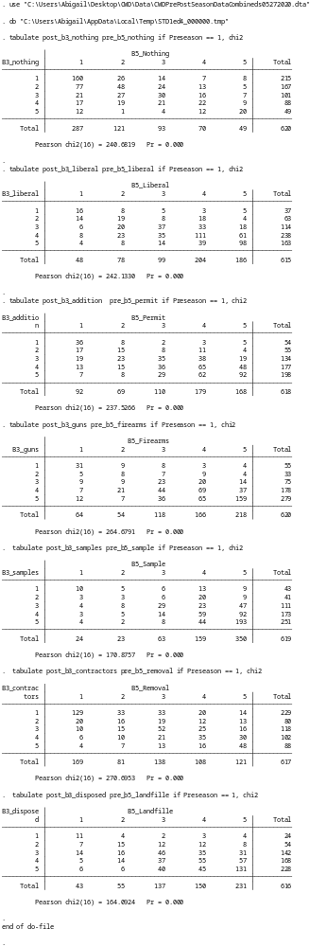

Appendix I
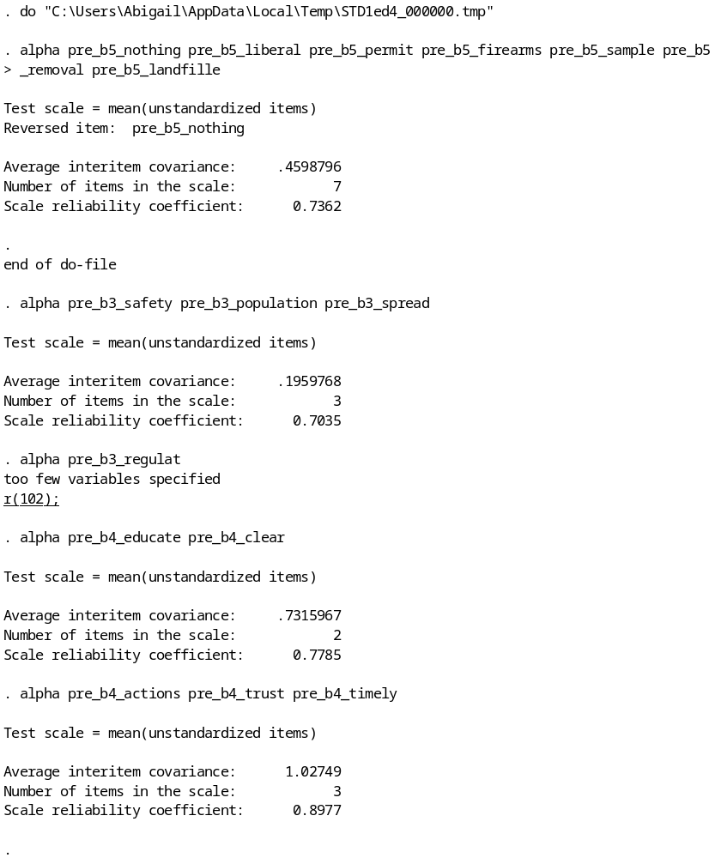

Appendix J
factor pre_b5_nothing pre_b5_liberal pre_b5_permit pre_b5_firearms pre_b5_sample pre_b5_removal pre_b5_landfille, factors(1)
rotate, varimax
predict f14
gen accepatbity_of_popu_control = f14
summarize pre_b5_nothing pre_b5_liberal pre_b5_permit pre_b5_firearms pre_b5_sample pre_b5_removal pre_b5_landfille
factor pre_b5_nothing pre_b5_liberal pre_b5_permit pre_b5_firearms pre_b5_sample pre_b5_removal pre_b5_landfille, factors(2)
rotate, varimax blanks(0.5)
predict f11 f12
gen changing_regulations = f11
gen hunters_engagement = f12
destring age, gen(age1)
gen PostiveHuntingLocation = 0 if Preseason == 1
replace PostiveHuntingLocation = 1 if pre_a1_posit == 1
gen HuntOutofState = 0 if Preseason == 1 & pre_c5_cwdstates > 0 & pre_c5_cwdstates < 3
replace HuntOutofState = 1 if pre_c5_cwdstates == 1
gen LandOwnership = 0 if Preseason == 1
replace LandOwnership = 1 if pre_c3_own == 1
factor pre_b4_little pre_b4_know pre_b4_actions pre_b4_trust pre_b4_timely pre_b4_educate pre_b4_clear pre_b4_satisfact,factors(2)
rotate, varimax blanks(0.5)
predict f8 f9
gen TrustinTWRAResponde = f8
gen TWRAInfo = f9
gen PublicLandHunters1 = 0 if Preseason == 1
replace PublicLandHunters1 = 1 if pre_b22_ownership == 4
gen PreHerdRedAtt = 0 if Preseason == 1
replace PreHerdRedAtt = 1 if pre_b13_herdreduct == 1
factor pre_b3_population pre_b3_bucks pre_b3_safety pre_b3_spread pre_b3_process pre_b3_regulat pre_b3_disposal pre_b3_feed pre_b3_funding
rotate, varimax blanks(0.5)
predict f5 f6 f7
gen deer_and_human_health_concerns = f5
gen regul_concerns= f6
gen Deer_Quality_concerns = f7
summarize pre_b5_permit pre_b5_liberal pre_b5_removal accepatbity_of_popu_control pre_c2_total HuntOutofState PreHerdRedAtt deer_and_human_health_concerns regul_concerns Deer_Quality_concerns TrustinTWRAResponde TWRAInfo pre_c6_income pre_a2_huntyears PostiveHuntingLocation LandOwnership

Conclusion

Emerging wildlife diseases, including CWD can have an impact on populations that they emerge in. Chronic wasting disease is an emerging disease in Tennessee and the potential impact on hunting is a concern among wildlife biologists and other stakeholders. The concern is for the potential economic ramifications and the effect it could have on the cervid population in the area. It also could have an impact on hunter intention to hunt in the area. The presence of CWD in an area could also impact the acceptability of management actions taken to control CWD. Management actions that can be implemented need hunter participation and acceptance for them to be effective.
Hunters’ intentions to hunt and overall acceptability of management actions can be influenced by a variety of factors. One factor that was similar between the two was the need for agency trust in their response and information provided. Hunters’ trust in the agency increased their likelihood of continuing hunting in the region as well as their acceptability of CWD management actions. Wildlife agencies should foster this trust among hunters and focus on maintaining it in the future in order to increase hunter retention and the effectiveness of management actions.
Hunter concerns regarding perceived impact of CWD were also important in increasing overall acceptability of management actions. These concerns also had a significant impact on hunter intention, though not all concerns influenced intention in the same way. This indicates that hunter concerns are important for wildlife agencies to be aware of, however not all concerns may cause the same hunter response.
Lastly, demographic variables were not significant for hunter intention or for the overall acceptability of management actions. This indicates management agencies may not be able to rely solely on demographic characteristics in predicting hunters’ response to CWD. Wildlife agencies need to focus on other factors (e.g. trust, concerns, and attitudes) in order to increase hunter engagement in hunting in CWD region and to increase acceptability of management actions.
Future studies should continue to monitor CWD and hunters attitudes in the region in order to gain a deeper understanding of whether and how hunter behavior and social acceptability of management actions may change over time specially when CWD prevalence changes over time. This will allow for an understanding of hunter concerns and behavior, allowing agencies to design outreach and regulatory tools to better manage CWD. This study provides a baseline for other studies to build off of for future research.

References
Ajzen I. 1991. The Theory of Planned Behavior, Organizational Behavior and Human Processes 50:179-211.
Belay E.D., Maddox R.A., Williams E.S., Miller M.W., Gambetti P., and Schonberger L.B. 2004. Chronic Wasting Disease and Potential Transmission to Humans, Emerging Infectious Diseases. 10(6):977-984.
Bishop R.C. 2004. The Economic Impacts of Chronic Wasting Disease (CWD) in Wisconsin, Human Dimensions of Wildlife. 9(3):181-192.
Brown T.L., Decker D.J., Major J.T., Curtis P.D., Shanahan J.E., and Siemer W.F. 2006. Hunters' and Other Citizens' Reactions to Discovery of CWD in Central New York, Human Dimensions of Wildlife. 11(3): 203-214.
Caplenor C.A., Poudyal N.C., Muller L.I., and Yoest C. 2017. Assessing Landowners' Attitudes Toward Wild Hogs and Support for Control Options, Journal of Environmental Management. 201: 45-51.
Centers for Disease Control and Prevention. 2020. Occurrence. Available online at https://www.cdc.gov/prions/cwd/occurrence.html. Last accessed May 1st 2020.
Cooney E.E. and Holsman R.H. 2010. Influences on Hunter Support for Deer Herd Reduction as a Chronic Wasting Disease (CWD) Management Strategy, Human Dimensions of Wildlife. 15(3):194-207.
Dillman D.A., Smyth J.D., and Christian L.M. 2014. Internet, Phone, Mail and Mixed-Mode Surveys: The Tailored Design Method 4th edition. John Wiley: Hoboken, NJ.
Evans T.S., Schuler K.L., and Walter W. D. 2014. Surveillance and Monitoring of White-Tailed Deer for Chronic Wasting Disease in the Northeastern United States, Journal of Fish and Wildlife Management. 5(2):387-393.
Fishbein M. 1979. A Theory of Reasoned Action: Some Applications and Implications, Nebraska Symposium on Motivation. 27: 65–116.
Gigliotti L. M. 2004. Hunters’ Concerns About Chronic Wasting Disease in South Dakota, Human Dimensions of Wildlife. 9(3):233-235.
Harper E., Miller C.A, and Vaske J.J. 2015. Hunter Perceptions of Risk, Social Trust, and Management of Chronic Wasting Disease in Illinois, Human Dimensions of Wildlife. 20(5): 394-407.
Heberlein T.A. and Stedman R.C. 2009. Socially Amplified Risk: Attitude and Behavior Change in Response to CWD in Wisconsin Deer, Human Dimensions of Wildlife. 14(5): 326-340.
Holland A.M., Haus J.M., Eyler T.B., Duda M.D., and Bowman J.L. 2020. Revisiting Hunter Perceptions toward Chronic Wasting Disease: Changes in Behavior over Time, Animals (Basel).10(2):187.
Holsman R. H. and Petchenik J. 2006. Predicting Deer Hunter Harvest Behavior in Wisconsin's Chronic Wasting Disease Eradication Zone, Human Dimensions of Wildlife. 11(3):177-189.
Holsman R.H., Petchenik J, and Cooney E.E. 2010. CWD After “the Fire”: Six Reasons Why Hunters Resisted Wisconsin's Eradication Effort, Human Dimensions of Wildlife. 15(3):180-193.
Lischka S.A, Shelton P., and Buhnerkempe J. 2010. Support for Chronic Wasting Disease Management Among Residents of the Infected Area in Illinois, Human Dimensions of Wildlife. 15(3):229-232.
Lyon K.M. and Vaske J.J. 2010. Predicting Hunting Participation in Response to Chronic Wasting Disease in Four States, Human Dimensions of Wildlife. 15(3):208-220.
Miller C.A., Anderson W.L., Campbell L.K., and Leiter P.D. 2006. An Assessment of Hunters' Perceptions of Chronic Wasting Disease in Illinois' Deer Herd: Impacts of Hunter Participation in 2002-2003 and 2003-2004, Human Dimensions Program Report HR 03-05. Illinois Natural History Survey. 42p.
Needham M. D. and Vaske J.J. 2008. Hunter Perceptions of Similarity and Trust in Wildlife Agencies and Personal Risk Associated with Chronic Wasting Disease, Society & Natural Resources. 21(3):197-214.
Needham M. D., Vaske J.J., and Manfredo M.J. 2004. Hunters’ Behavior and Acceptance of Management Actions Related to Chronic Wasting Disease in Eight States, Human Dimensions of Wildlife. 9(3):211-231.
Needham M.D., Vaske J.J., and Manfredo M.J. 2006. State and Residency Differences in Hunters' Responses to Chronic Wasting Disease, Human Dimensions of Wildlife. 11(3): 159-176.
Poudyal N.C., Watkins C., and Joshi O. 2020. Economic Contribution of Wildlife Management Areas to Local and State Economies, Human Dimensions of Wildlife. 25(3):291-295.
Saunders S.E., Bartlet-Hunt S.L., and Bartz J.C. 2012. Occurrence, Transmission, and Zoonotic Potential of Chronic Wasting Disease, Emerging infectious diseases. 18(3):369-76.
Schroeder S.A., Landon A.C., Cornicelli L., Fulton D.C., and McInenly, L. 2020. Institutional Trust, Beliefs, and Evaluation of Regulations, and Management of Chronic Wasting Disease (CWD), Human Dimensions of Wildlife.
Tennessee Wildlife Resources Agency. 2020. Information about Chronic Wasting Disease or CWD from the Tennessee Wildlife Resources Agency. Available online at www.tn.gov/twra/hunting/cwd.html.; Last Accessed April 23, 2020.
U.S. Department of the Interior, U.S. Fish and Wildlife Service, and U.S. Department of Commerce, U.S. Census Bureau. 2011. National Survey of Fishing, Hunting, and Wildlife-Associated Recreation. Available online at https://www.census.gov/programs-surveys/fhwar.html; last accessed May 1st, 2020.
Vaske J. J., Timmons N.R., Beaman J., and Petechenik J. 2004. Chronic Wasting Disease in Wisconsin: Hunter Behavior, Perceived Risk, and Agency Trust, Human Dimensions of Wildlife. 9(3):193-209.
Vaske J. J., Needham M. D., Newman P., Manfredo M. J., and Petchenik J. 2006. Potential for Conflict Index: Hunters' Responses to Chronic Wasting Disease, Wildlife Society Bulletin. 34(1):44-50.
Vaske J.J., and Manfredo M.J. 2012. Social and Psychological Considerations in Wildlife Management, Human Dimensions and Wildlife Management. JHU Press, Baltimore.
Watkins C., Poudyal N.C., Caplenor C., Buehler D. and Applegate R. 2018. Motivations and Support for Regulations: A Typology of Eastern Wild Turkey Hunters, Human Dimensions of Wildlife. 23(5):433-445.
Watkins C., Caplenor C.A., Poudyal N.C., Muller L.I, and Yoest C. 2019. Comparing Landowner Support for Wild Hog Management Options in Tennessee, Journal of Environmental Management. 232:722-728.
Williams E.S. and Miller M.W. 2002. Chronic Wasting Disease in Deer and Elk in North America, Revue Scientifique et Technique de l Office International des Epizooties. 21:305–316.
Williams E. S., and Young S. 1980. Chronic Wasting Disease of Captive Mule Deer: A Spongiform Encephalopathy, Journal of Wildlife Diseases. 16(1):89-98.

Vita
Abigail Meeks was born in Rocky Mount, Virginia. She graduated from high school in 2015 and went on to attend Michigan State University (MSU). She graduated from MSU in 2019 with a Bachelor of Science in Animal Science. She then attended the University of Tennessee from 2019-2020 and earned a Master of Science in Wildlife Sciences.

